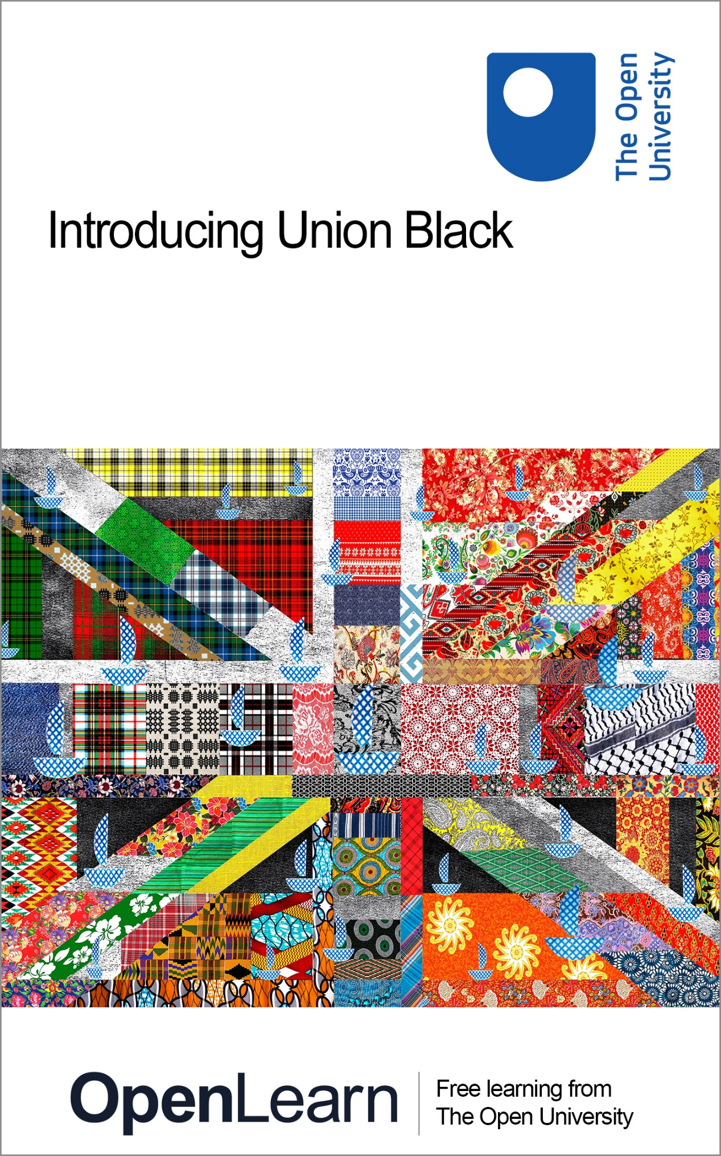

UNI_1 Introducing Union Black

Introducing Union Black

About this free course
This version of the content may include video, images and interactive content that may not be optimised for your device.
You can experience this free course as it was originally designed on OpenLearn, the home of free learning from The Open University: www.open.edu/openlearn/education-development/introducing-union-black/content-section-0
There you’ll also be able to track your progress via your activity record, which you can use to demonstrate your learning.
First published 2024.
Unless otherwise stated, copyright © 2024 The Open University, all rights reserved.
Intellectual property
Unless otherwise stated, this resource is released under the terms of the Creative Commons Licence v4.0 http://creativecommons.org/licenses/by-nc-sa/4.0/deed.en_GB. Within that The Open University interprets this licence in the following way: www.open.edu/openlearn/about-openlearn/frequently-asked-questions-on-openlearn. Copyright and rights falling outside the terms of the Creative Commons Licence are retained or controlled by The Open University. Please read the full text before using any of the content.
We believe the primary barrier to accessing high-quality educational experiences is cost, which is why we aim to publish as much free content as possible under an open licence. If it proves difficult to release content under our preferred Creative Commons licence (e.g. because we can’t afford or gain the clearances or find suitable alternatives), we will still release the materials for free under a personal end-user licence.
This is because the learning experience will always be the same high quality offering and that should always be seen as positive – even if at times the licensing is different to Creative Commons.
When using the content you must attribute us (The Open University) (the OU) and any identified author in accordance with the terms of the Creative Commons Licence.
The Acknowledgements section is used to list, amongst other things, third party (Proprietary), licensed content which is not subject to Creative Commons licensing. Proprietary content must be used (retained) intact and in context to the content at all times.
The Acknowledgements section is also used to bring to your attention any other Special Restrictions which may apply to the content. For example there may be times when the Creative Commons Non-Commercial Sharealike licence does not apply to any of the content even if owned by us (The Open University). In these instances, unless stated otherwise, the content may be used for personal and non-commercial use.
We have also identified as Proprietary other material included in the content which is not subject to Creative Commons Licence. These are OU logos, trading names and may extend to certain photographic and video images and sound recordings and any other material as may be brought to your attention.
Unauthorised use of any of the content may constitute a breach of the terms and conditions and/or intellectual property laws.
We reserve the right to alter, amend or bring to an end any terms and conditions provided here without notice.
All rights falling outside the terms of the Creative Commons licence are retained or controlled by The Open University.
Head of Intellectual Property, The Open University

Contents
- Introduction
- Learning outcomes
- 1 Empathy, sympathy and compassion
  - 1.1 Why talk about empathy?
  - 1.2 So, what is compassion?
- 2 Having difficult conversations about race
  - 2.1 Undoing bias: labelling
  - 2.2 Undoing bias: constructed stereotypes
  - 2.3 Undoing bias: learning about others
- 3 So – what ARE you?
  - 3.1 I am not just one thing
  - 3.2 Pride in your identity
- 4 Stepping stones towards anti-racism
  - 4.1 Where to start
  - 4.2 Empathy as a first step to anti-racism
- 5 Summary
- References
- Acknowledgements
- Descriptions

Introduction
Welcome to this free course, Introducing Union Black. Start by watching the following video which gives an overview of the course.

Video content is not available in this format.
Video 1 Lurraine Jones introduces the course
View transcript - Video 1 Lurraine Jones introduces the course

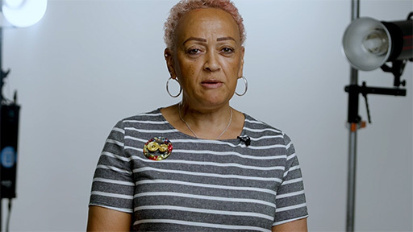

Please note that although the video mentions the course taking an hour to study, it may take you up to three hours.
This course will aim to build your confidence as a change agent for equity, diversity, inclusion and belonging. For many of you, this will be a journey into little-known or misunderstood history and experiences of people racialised as Black (Black*, white and race being racially constructed terms), and, for many others, it will be an affirmation of your rightful place in our diverse twenty-first-century society. Whatever your background, hopefully both experiences will provide you with the opportunity to hear from contributors from a range of backgrounds, lived experiences, thoughts and voices, which are designed to help inform, inspire, challenge and enable you to take steps towards anti-racism. This is just one contribution to a much wider conversation that has been happening between Black scholars, writers, artistes, activists and citizens for many generations.
* Black with a capital B is used as explained here by Associated Press (AP) (2020): ‘AP’s style is now to capitalize Black in a racial, ethnic or cultural sense, conveying an essential and shared sense of history, identity and community among people who identify as Black, including those in the African diaspora and within Africa. The lowercase black is a color, not a person.’
Why was this course created?
The racial uprisings of 2020 forced a global conversation about racism, and more specifically anti-Blackness, and the insidious ways that it has shape-shifted over time. A Universities UK report about racial harassment on campus in 2020, alongside the murder of George Floyd in the US and the stark racial inequities that were highlighted during the COVID-19, led to this course being created by Black UK academics.
Why should I study this course?
The course is, for many people, seen as ‘the right thing to do’. But, let’s face facts – not everyone agrees with that view. Not convinced from the moral standpoint? Well, there are professional benefits to engaging with ‘Union Black’. People doing this course will gain key ‘soft’ employability skills that can make them desirable to an organisation, i.e. empathy, emotional intelligence, cultural awareness, communication, leadership and teamwork. Engaging with the course will contribute to building skills, including empathy, understanding anti-racism, understanding different cultures, diversity, inclusion and allyship – increasingly ‘essential’ in job descriptors and promotion criteria.
Who is this course for?

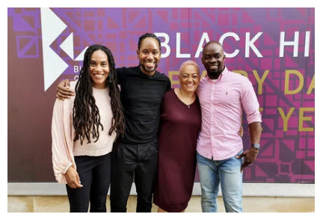
The course authors (from left to right): Professor Marcia Wilson, Professor Jason Arday, Lurraine Jones and Dr Dave Thomas.
View description - The course authors (from left to right): Professor Marcia Wilson, Professor Jason ...
View alternative description - The course authors (from left to right): Professor Marcia Wilson, Professor Jason ...

This course is for everyone, as cultural awareness sets the foundation and context for more insightful, effective and respectful interactions between individuals and communities. Remember, we are individuals with different histories, ages, lived experiences, cultures, perspectives, attitudes and roles. The course authors just hope and ask that you engage with an open mind and with curiosity, that you challenge yourself, you are willing to unlearn and learn, and want to learn even more!
Did you see the ‘new Union Flag’?
The New Union Flag (NUF) re-imagines the Union Jack and celebrates the communities that have contributed to the UK’s cultural legacy. Re-created with fabric designs from all over the world, the New Union Flag transforms the traditional Union Jack from an archetype of uniformity into a dynamic and celebrational on-going performance of diversity. While this flag started as a reflection on the UK’s colonial legacy, its design is ever-changing to reflect the ongoing cultural diversity in the UK.

An important disclaimer
Please acknowledge that various subject matters might be triggering for yourself and for other people. Remember: how we experience the world may not be how another person experiences the world.

Learning outcomes
By the end of this course, you should be able to:
- understand empathy and its value
- understand identity and labels
- explore first steps to anti-racism.

1 Empathy, sympathy and compassion
Empathy is a skill that can help you better relate to whoever you come into contact with. Knowing how to be empathic can help you improve communication with others, making for a positive workplace environment and your relationships inside and outside work.
In general, empathy is when you make yourself vulnerable to share the feelings of another, and you listen without judgement: for example, ‘Can you tell me how this feels for you?’.
On your journey to building empathy skills, you might discover that you are actually being sympathetic rather than empathetic – be aware that they are different. When building empathy, you might think that saying things such as ‘I know how you feel’ or ‘I understand’ are helpful, but these statements express sympathy, not empathy, as you place yourself as centre rather than listening to understand.


Figure 1 Contemplation
View description - Figure 1 Contemplation
View alternative description - Figure 1 Contemplation

A study by Forgiarini, Gallucci and Maravita (2011) found that white people experience weaker empathetic responses to persons racialised as Black. Many instances of biased racialised empathy have been evidenced, for example, medical staff perceiving Black women as being able to stand more pain in childbirth or Black communities being policed more aggressively. ‘Race’ can be defined as an ideological concept and a social construct as humans share 99% of DNA. But, while people continue to perceive humanity as belonging to different races, a racial bias towards empathy can have detrimental effects on individuals, groups and relationships.

1.1 Why talk about empathy?
Well, it is just one way of dismantling racism and starting to tackle unconscious and conscious bias.

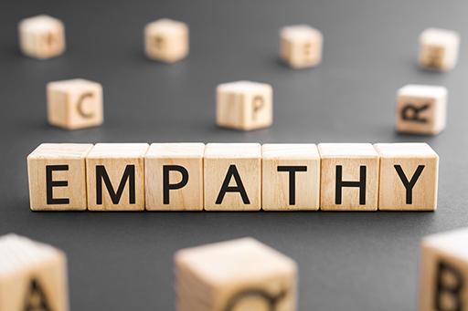
View description - Uncaptioned Figure
View alternative description - Uncaptioned Figure

If people could figuratively ‘put themselves in someone else’s shoes’ it would go some way to reduce prejudices and biases. But, we are born into a world that is already shaped by social factors such as laws, culture, education, beliefs, values, traditions, customs and norms, and we are socialised into ‘our’ world by dint of our birthplace, our primary caregivers and era.

1.2 So, what is compassion?
The major difference between compassion and empathy is that empathy is about understanding the suffering of others, but it stops short of actually helping (Hougaard, 2020), whereas compassion is moving on and taking action to help alleviate someone’s suffering – more often than not by doing something practical.
In summary, sympathy means you understand what someone else is feeling through a lens of judgement. Empathy means that you are open to sharing what a person is feeling without judgement. Compassion is the willingness to relieve the suffering of another by action.

Activity 1
Allow approximately 5 minutes

In this task, you’ll be asked to view media coverage depicting the Russian invasion of Ukraine and the treatment of Black and brown people trying to escape the fighting. If you are concerned this might adversely affect your mental health, you might like to skip this activity or engage with it only very lightly.
As you read this extract and watch the video below, you should reflect on how these made you feel. Below are some questions to consider as you read and watch the below resources:
- Did you feel sympathy or empathy or compassion, or not much at all?
- Did you know about the experiences of Black and brown people in Ukraine? If not – how do you feel now?
The article Why don’t we treat all refugees as though they were Ukrainian? offers some insight. For the purposes of this activity, you only need to read the selected text pulled from the opinion piece below.

Why don’t we treat all refugees as though they were Ukrainian?
But now is the time to clearly call out what human rights groups and independent journalists have for years been saying: That the U.S. and NATO-led wars in Afghanistan, Iraq, Syria, Somalia, and elsewhere are racist, and that the callous dismissals of the resulting humanitarian catastrophes are equally barbaric.
There’s another reason why brown-skinned refugees are seen as undesirable. Welcoming those people fleeing wars that the West has fomented would be an admission of Western culpability. Not only do Ukrainian refugees offer palatable infusions of whiteness into European nations, but they also enable governments to express self-righteous outrage at Russia’s imperialist ambitions and violent militarism. If Ukrainian refugees are evidence of Russian brutality, then Afghan and Iraqi refugees are evidence of the same kind of brutality on the part of the U.S. and NATO.
(Kolhatkar, 2022)

Now watch some footage that was shared on social media.

Watch the video at YouTube.com.
Video 2 Discrimination and racism as people flee Ukraine shared on social media

See also …
Clips from TedEx Palo Alto - Okieriete Onaodowan: Okieriete Onaodowan (2017) in his TED talk ‘you have to walk a mile in my shoes but first you must take off your own’.
Gravitas: Western media’s racist reportage on Ukrainian refugees: Western journalists are being slammed for their racism while reporting on the refugee crisis in Ukraine.
Ukraine refugee crisis exposes racism and contradictions in the definition of human: Not only has the Russian invasion of Ukraine brought to light the awful tragedies that accompany armed conflict, but the subsequent refugee crisis has also uncovered deeply seated racism in the country.
Discrimination and racism as people flee Ukraine shared on social media: Video from The Guardian.

2 Having difficult conversations about race
Having conversations about race, racism, anti-racism and anti-Blackness can be really uncomfortable! So why do it? The next video is why!

Video content is not available in this format.
Video 3 Christian Foley
View transcript - Video 3 Christian Foley

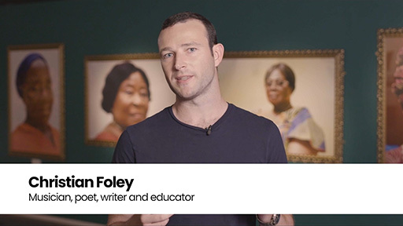

As Christian passionately says, a 10-year-old Black boy received hate mail and death threats from white supremacists for writing a poem entitled ‘Black Lives Matter’. Racists want to shut any positive conversation about race down and this is normally done with real or imagined threats of violence.
After the Black Lives Matter protests in 2020, with many organisations posting black squares in solidarity, Wilson and Jones’ article (2020) ‘Dear senior university leaders: what will you say you did to address racism in higher education?’ directly challenged what is mainly white senior leaders of universities on what they would do to tackle institutional racism when the global light no longer shone on the horrors of George Floyd’s murder and the ensuing protests.
Black feminist writer Toni Morrison (1992) describes the invisibility of whiteness as a fishbowl that contains fish and water. The fishbowl itself provides meaning as ‘a fishbowl’ as it is the ‘thing’ that contains the water and the fish, but one invariably focuses on the fish swimming in the water, and not the constraints or structure of the fishbowl itself.
Although George Floyd’s murder was in the US, anti-Blackness is universal. Statements are often made such as: ‘What has slavery got to do with me/the twenty-first century?’ and ‘What has George Floyd got to do with the UK? It’s different here’.
You’ll next watch a video clip by George The Poet, who challenges the view that racism is worse in the US. Reflect on the example that Christian discusses in the video that you watched earlier in this section.

Activity 2
Allow approximately 5 minutes

As you watch the video below, reflect on how YOU embrace, welcome, enjoy, reject, rebuff, put off, discount or otherwise regard ‘race conversations’.
What are the words you would use to explain how you feel and reflect on why? Do you not feel ready or equipped? What can you do about this? Remember, it is not for marginalised groups to educate others.

Watch the video at YouTube.com.
Video 4 George the Poet on BBC Newsnight discussing #blacklivesmatterUK

See also …
Ken Hardy on making talking about race our work: Ken Hardy explains how the centrality of White America leaves many Black people feeling as though they're trapped in a wall-less prison.
Reverse racism - Uncomfortable conversations with a Black man: Emmanuel Acho sits down to have another uncomfortable conversation, where he directly addresses questions and emails from white brothers and sisters, all over the world.

2.1 Undoing bias: labelling
We stereotype others all the time. When did you last look or listen to someone and give them a label? Was this helpful? Was it because it was easier to make a ‘shortcut’ about someone?
As Boakye says:

as a label [Black], it does the important job of confirming something already very obvious; that a person who isn’t white, isn’t white. But labels don’t just identify what something is; they create meaning. ‘Black’ people predate ‘white’ people, but ‘Black’ has existed only for as long as ‘white’ people decided to call themselves that.
(Boakye, 2019)

As Jamaican Sociologist Professor Stuart Hall said of Britain’s imperialist past: ‘we’re here because you were there’. Black British history IS British history.
In the following video, Jumoke Abdullahi speaks about holding the mirror up to Britishness and what it feels like for Black and Minority Ethnic children to be schooled in the UK about Britain and Empire.

Video content is not available in this format.
Video 5 Jumoke Abdullahi
View transcript - Video 5 Jumoke Abdullahi

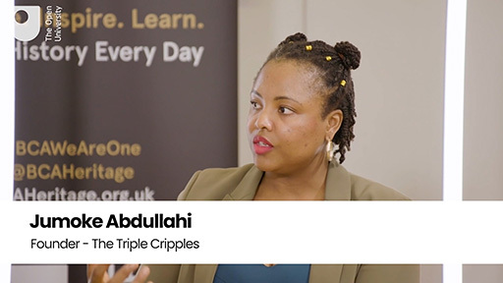

2.2 Undoing bias: constructed stereotypes
Watch the clip from the conversation between Adam Rutherford, a geneticist, and Lurraine Jones, Director of EDI at The Open University, as they discuss the biological and sociological impacts of ‘Black’.

Video content is not available in this format.
Video 6 Adam Rutherford and Lurraine Jones
View transcript - Video 6 Adam Rutherford and Lurraine Jones

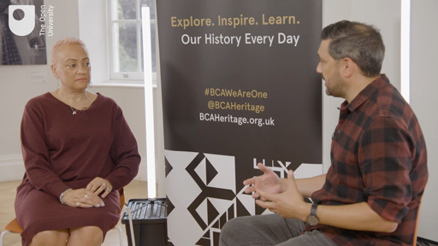

Based on the ethnic group categories on the last census – Black/African/Caribbean/Black British – these individuals only make up 3.5% of the UK population. It may well be that you live in a part of the UK where you do not come into contact with Black people regularly, or perhaps ever. The reference to skin pigmentation as a classifier was still present in the 2021 census for people racialised as Black and white, but other non-white classifications are based on country or continent.

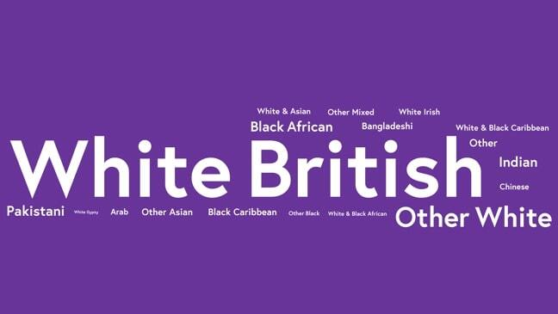
Figure 2 Depiction of the ethnicity based classifications from the 2021 Census based on data from the ONS website.
View description - Figure 2 Depiction of the ethnicity based classifications from the 2021 Census based ...
View alternative description - Figure 2 Depiction of the ethnicity based classifications from the 2021 Census based ...

How did the construction of racial classifications based on skin pigmentation come about, and what was it in service of? Why are only the Black and white skin pigmentation classifications still in use in the UK census?

2.3 Undoing bias: learning about others
Am I learning for myself or learning from labels or stereotyping?
Let’s think for a moment about how you have personally learned about other Black cultures. What was the source of your education? If you were asked to describe what you knew about the cultures of Jamaica, Montserrat, Ghana or Rwanda, what would you say? How is Rwanda referred to in politics and the media? Do you recall the disparaging remarks by Donald Trump referring to the African continent?
How much do you know about the other cultures mentioned beyond surface-level stereotypes? In Jamaica, does everyone look like Bob Marley, run like Usain Bolt, and drink rum? What about in Ghana? Could you locate Montserrat on a map? If you were to draw a diagram with everything you knew about each of the cultures mentioned without an internet search, how much information would be on it and where did that ‘learning’ come from? How much would be from:
- your own family, friends or peers
- the news or newspapers
- the tabloid press
- Western movies or books?
Now ask yourself, did the source of my learning confirm or change my biases?

3 So – what ARE you?
Stories matter. Stories are used to empower and humanise – or to dispossess and harm.

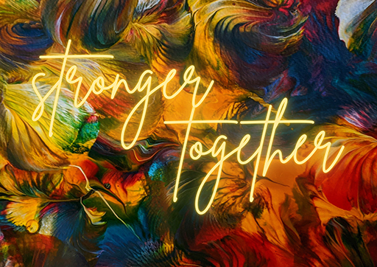
Figure 3 Shared stories from the community
View description - Figure 3 Shared stories from the community
View alternative description - Figure 3 Shared stories from the community

If you think about a label someone has used against you – what narrative or story did that label say about you? Did you agree with the narrative imposed on you?
Like labels, these stories are deliberately simplified. Single labels, single stories. Chimamanda Ngozi Adichie has a TED Talk entitled ‘The Danger of a Single Story’. ‘History is written by the victors’ is said on many occasions. This means that someone’s or a peoples’ story is written for them and not by them. A single story collapses and negates all the complexities of identity and historical experience. Repeatedly telling these simple stories is a way to erase people from history.

3.1 I am not just one thing
None of us are just one thing. Our identities, relationships and roles intersect to shape how we perceive the world and interact with our environment.

Video content is not available in this format.
Video 7 Kym Oliver
View transcript - Video 7 Kym Oliver

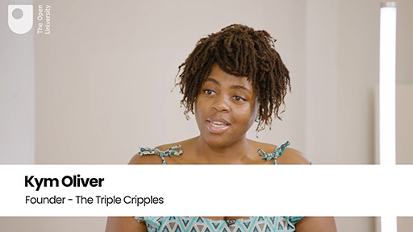

As you heard from Kym Oliver in the video, intersectionality has always existed, though the term itself was first coined in 1989 by Professor Kimberlé Crenshaw. The word is used to describe how racialisation, class, gender and other individual characteristics ‘intersect’ and overlap with one another.
The term is used to highlight that any experience, such as discrimination, would be a different experience for those who identify with different labels – in other words, it would be a different experience for a Black woman, or a white woman. A person from the LGBTQIA+ community will experience the world differently from a heterosexual person. And a trans white person would experience things differently from a trans Black person. Those examples are not even taking into account the many other intersectionalities that affect life experiences like disability, class or age.
Crenshaw’s theory stemmed from her research on discrimination against Black women and described how multiple forms of oppression and social identities overlap to create unique experiences. An intersectional lens recognises that people who experience multiple oppressions will have a greater struggle for equity.

See more …
Professor Jason Arday’s story: Professor Jason Arday talks about growing up, learning to read and write, and overcoming the challenges he faced.

3.2 Pride in your identity
Identity is important to all of us. It can be a great source of pride for many, and of shame for others. Identity is complex, messy and multifaceted.
Pride in our identity is really situated around this sense of belonging in history – what that history represents and where that pride is derived from, particularly in terms of identity. As you will hear in the next video, there is a narrow definition of Western beauty, which, when allowed to dominate, can lead Black people to feel pressure to suppress traditional characteristics that are important to their identity.
Hair means something different to each of us. ‘Black hair’ has a uniquely meaningful history as a symbol of survival, resistance and celebration. It’s been wielded as a tool of oppression and also one of empowerment – and our society’s perceptions of Black hair still influence how Black people are treated today. Eunice shares some of their experiences in the following video.

Video content is not available in this format.
Video 8 Eunice Olumide
View transcript - Video 8 Eunice Olumide

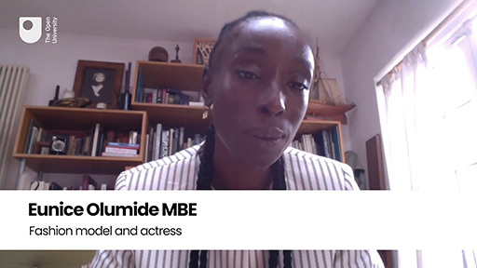

See also …
Good hair: perceptions of racism: Explore this interactive resource.

4 Stepping stones towards anti-racism
How can you be a change maker?

When the well-intentioned white person or faux ‘DEI Expert’ comes with the ‘we all have bias’, inform them: Yes, we all have biases. But, those biases are not equal. Because we don’t all have power. The power to translate that bias into an outcome for those without power.
(Dr Ijemoa Nnodim Opara on X, 2022)

The above quote reminds us that we all play a part in the journey towards equity and inclusion. Recognising that you have influence is part of being a change maker.

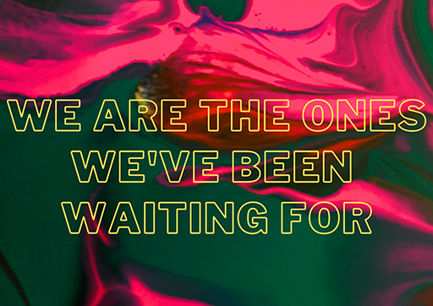
Figure 4 ‘We are the ones we’ve been waiting for’.
View description - Figure 4 ‘We are the ones we’ve been waiting for’.
View alternative description - Figure 4 ‘We are the ones we’ve been waiting for’.

It is important to recognise that you have control over your own thoughts and behaviour. You can be a change maker and choose to model what that looks like on a daily basis. Committing to being anti-racist and working towards being an ally is crucial. However, remember that no-one is born an ally. Allyship is a choice, an action, not an identity. An ally is only an ally in the moment of that action.

4.1 Where to start
- Start with why – understand why change is necessary or desirable, the purpose the proposed change will serve and the people who will be impacted by the change.
- Define the change you wish to see – have a clear vision and message, which you can communicate with clarity.
- Identify your circle of influence – analyse power structures and who needs to be involved in the change process.
- Establish allies – build collaborative intersectional social partnerships with people who are sympathetic to your cause and interest.
- Listen – take a step back and actively listen. This allows you to engage with the important issues that require change.
- Create change that outlives you.

4.2 Empathy as a first step to anti-racism
‘There’s no justice. Just us.’
These words from late author Terry Pratchett (2010) encapsulate the struggle we face in tackling and dismantling racism. No one, no higher power, is going to do it for us. There’s just us. We must do it.
Watch the following video.

Watch the video at YouTube.com.
Video 9 Ken Hardy on making talking about race our work

And we must all do it: Black, brown and white. White people have a responsibility to help solve the problem of racism. This starts by learning to become allies. You don’t become an ally simply by calling yourself one. Becoming an ally is a process, a journey. We become allies not by our intent, but through our actions.
Every journey begins with one step.

5 Summary
Congratulations. You’ve reached the end of the course. You have explored empathy as a professional and personal skill, heard personal stories, views and perspectives from Black contributors and learned how to be an anti-racism change maker.
Hopefully, you will now feel better positioned to have conversations between individuals about their British Black cultures, identity, and history, which can lead to productive discussions about anti-racism. We hope this course has informed, inspired, challenged and empowered you to become an active ally towards anti-racism.
Having worked your way through Introducing Union Black, you might be interested in the course, Introducing Black leadership. The course will develop skills to empower yourself as a leader. Guided by the Five Ps model of leadership (person, process, position, product and purpose), you will learn about the challenges and possibilities of Black leadership. Developing skills in communication, critical analysis and teamwork will promote competence in various contexts – from formal organisations to voluntary groups and social movements. The aim is to help you to communicate effectively within diverse groups to generate impactful leadership.
Finally, check out the Race and Ethnicity Hub, our award-winning content hub offering fresh perspectives on race, racism and ethnicity.

References
Boakye, J. (2019) Black, Listed. London: Dialogue Books
Crenshaw, K. (1989) Demarginalizing the intersection of race and sex: A black feminist critique of antidiscrimination doctrine, feminist theory, and antiracist politics. University of Chicago Legal Forum, 1989(1), pp.57–80.
Forgiarini, M., Gallucci, M. and Maravita, A. (2011) Racism and the empathy for pain on our skin. Frontiers in Psychology, 2, 108. Available at: https://doi.org/10.3389/fpsyg.2011.00108 (Accessed 26 July 2024).
Hougaard, R. (2020) Four reasons why compassion is better for humanity than empathy. Available at: https://www.forbes.com/sites/rasmushougaard/2020/07/08/four-reasons-why-compassion-is-better-for-humanity-than-empathy/?sh=723ab146d6f9 (Accessed 26 July 2024).
Krznaric, R. (2015) Empathy: why it matters, and how to get it. London: Rider Books.
Morrison, T. (1992) Playing in the Dark: whiteness and the literary imagination. Harvard University Press.
Office for National Statistics, Census 2021. Available at: https://census.gov.uk/ (Accessed 26 July 2024).
Oluo, I. (2018) So you want to talk about race?. New York: Seal Press. Available at: https://www.cipd.co.uk/knowledge/fundamentals/relations/diversity/conversations-race-work (Accessed 26 July 2024).
Pratchett, T. (1987) Mort. New York, NY: New American Library.
Segal, E.A. (2021) Does racism mean there’s a lack of empathy? Psychology Today. Available at: https://www.psychologytoday.com/gb/blog/social-empathy/202105/does-racism-mean-theres-lack-empathy (Accessed 26 July 2024).
Wilson, M. and Jones, L. (2020) Dear senior university leaders: what will you say you did to address racism in higher education? Available at: https://www.timeshighereducation.com/blog/dear-senior-university-leaders-what-will-you-say-you-did-address-racism-higher-education (Accessed 26 July 2024).

Acknowledgements
The course author Lurraine Jones, Director of EDI at The Open University, would like to thank Marcia Wilson, Jason Arday and Dave Thomas for their work in creating this course.
Except for third party materials and otherwise stated (see terms and conditions), this content is made available under a Creative Commons Attribution-NonCommercial-ShareAlike 4.0 Licence.
The material acknowledged below is Proprietary and used under licence (not subject to Creative Commons Licence). Grateful acknowledgement is made to the following sources for permission to reproduce material in this free course:
Images
Course image: Gil Mualem-Doron (The New Union Flag Project): With permission of Gil Mualem-Doron. www.gmdart.com
Introduction image: The Open University.
Figure 1: Art by Bokani. With permission of Bokani. www.artbybokani.com
Section 1.1 image: Roman Didkivskyi / Getty
Figure 2: Ethnicity based classifications from the 2021 Census based on data from the ONS website: Office for National Statistics, Census 2021. Available at: https://census.gov.uk/ (Accessed 12 June 2022).
Figure 3: Art by Bokani. With permission of Bokani. www.artbybokani.com
Figure 4: Art by Bokani. With permission of Bokani. www.artbybokani.com
Text
Quote: Why don’t we treat all refugees as though they were Ukrainian?: Kolhatkar, S. (2022) Why don’t we treat all refugees as though they were Ukrainian?, Minnpost. https://www.minnpost.com/community-voices/2022/03/why-dont-we-treat-all-refugees-as-though-they-were-ukrainian/ This file is licensed under the Creative Commons Attribution-No Derivatives Licence https://creativecommons.org/licenses/by-nd/4.0/
Audio-visual
Video 1: The Open University
Video 3: With permission of Christian Foley. www.christianfoley.co.uk
Video 5: With permission of Jumoke Abdullahi. thetriplecripples.uk
Video 6: The Open University and Adam Rutherford: With permission of Adam Rutherford
Video 7: With permission of Kym Oliver. thetriplecripples.uk
Video 8: With permission of Eunice Olumide
Every effort has been made to contact copyright owners. If any have been inadvertently overlooked, the publishers will be pleased to make the necessary arrangements at the first opportunity.
Don’t miss out
If reading this text has inspired you to learn more, you may be interested in joining the millions of people who discover our free learning resources and qualifications by visiting The Open University – www.open.edu/openlearn/free-courses.

Descriptions

The course authors (from left to right): Professor Marcia Wilson, Professor Jason Arday, Lurraine Jones and Dr Dave Thomas.
A photograph of the four course authors.
Back to - The course authors (from left to right): Professor Marcia Wilson, Professor Jason Arday, Lurraine Jones and Dr Dave Thomas.

The course authors (from left to right): Professor Marcia Wilson, Professor Jason Arday, Lurraine Jones and Dr Dave Thomas.
A photograph of the four course authors.
Back to - The course authors (from left to right): Professor Marcia Wilson, Professor Jason Arday, Lurraine Jones and Dr Dave Thomas.

Figure 1 Contemplation
A rear view of the artist Bokani sat on a chair looking at her marbled effect artwork.
Back to - Figure 1 Contemplation

Figure 1 Contemplation
A rear view of the artist Bokani sat on a chair looking at her marbled effect artwork.
Back to - Figure 1 Contemplation

Uncaptioned Figure
The word ‘empathy’ spelled out using wooden blocks with letters on.
Back to - Uncaptioned Figure

Uncaptioned Figure
The word ‘empathy’ spelled out using wooden blocks with letters on.
Back to - Uncaptioned Figure

Figure 2 Depiction of the ethnicity based classifications from the 2021 Census based on data from the ONS website.
A word cloud featuring the words White British, White and Asian, Other mixed, Bangladeshi, White Irish, White and Black Caribbean, Other, Indian, Chinese, Other White, Pakistani, Arab, Other Asian, Black Caribbean, White and Black African, Other Black.
Back to - Figure 2 Depiction of the ethnicity based classifications from the 2021 Census based on data from the ONS website.

Figure 2 Depiction of the ethnicity based classifications from the 2021 Census based on data from the ONS website.
A word cloud featuring the words White British, White and Asian, Other mixed, Bangladeshi, White Irish, White and Black Caribbean, Other, Indian, Chinese, Other White, Pakistani, Arab, Other Asian, Black Caribbean, White and Black African, Other Black.
Back to - Figure 2 Depiction of the ethnicity based classifications from the 2021 Census based on data from the ONS website.

Figure 3 Shared stories from the community
A colourful image with the words ‘Stronger together’.
Back to - Figure 3 Shared stories from the community

Figure 3 Shared stories from the community
A colourful image with the words ‘Stronger together’.
Back to - Figure 3 Shared stories from the community

Figure 4 ‘We are the ones we’ve been waiting for’.
A colourful image with the words‘We are the ones we’ve been waiting for’.
Back to - Figure 4 ‘We are the ones we’ve been waiting for’.

Figure 4 ‘We are the ones we’ve been waiting for’.
A colourful image with the words‘We are the ones we’ve been waiting for’.
Back to - Figure 4 ‘We are the ones we’ve been waiting for’.

Video 1 Lurraine Jones introduces the course

Transcript
LURRAINE JONES:
My name is Lurraine Jones, and I’m the Deputy Dean for Equality Diversity and Inclusion at The Open University. I’m here for lots of reasons.
I’m here because 25% of Black and minority ethnic students have experienced racial harassment. Over 50% of staff who had experienced racial harassment describe incidents of being ignored or excluded because of their race. And nearly a third experienced racist name calling.
I’m here because there are stark degree awarding gaps between Black students and their white peers. And I’m here because I’m absolutely committed to anti-racism.
Over the hour, you’ll be introduced to some of the stories and experiences that we explore in Union Black. And we’ll meet just some of the many contributors that you will hear from in the course. We’ll start by exploring some life skills like empathy that will not only be valuable to you as you get ready for Union Black, but that will also be useful to you in your current or future careers. We’ll look at having difficult conversations about race. We’ll explore the impact of labels and stereotyping. As we’ll discover, it’s not enough to be non-racist. You need to be anti-racist.
Back to - Video 1 Lurraine Jones introduces the course

Video 3 Christian Foley

Transcript
CHRISTIAN FOLEY:
It doesn’t sound frightening does it, a 10-year-old boy writing a poem entitled, Black Lives Matter? Do you know how many people were frightened by that to the point of hate and death threats? Many.
That is the country that we live in, and it’s a country that is kind of like a parallel world. You might not even know it exists. This is one of the best things I’ve ever read. One of the most necessary pieces of work that’s been written. We have to share this. It’s sad that it’s had to have been written, especially by a child.
We were even getting comments on BBC Bitesize, which is a website for children, by white supremacists who would come there, specifically to write these long essays. I learned a lot about white supremacy by responding to these comments. They were talking about the wildest theories I’ve ever heard and attacking a young boy because they were scared of him. And it showed every single point that he was trying to make about the racism that he felt and experienced growing up. It completely proved his point.
Back to - Video 3 Christian Foley

Video 5 Jumoke Abdullahi

Transcript
JUMOKE ABDULLAHI:
Interestingly enough is that you can't actually ask people of the land, the British, the English, what Britishness or Englishness is. Who you can ask are people like me. The Africans, the Indians, the Asians, the people that it was imposed upon them. They’re the ones that can actually tell you what Britishness is, what Englishness is, and also what Scottishness is.
And it’s a case of they are able to hold the mirror up to the nations, like this is actually who you are. Because we’ve been forced to learn about you and this so-called great empire. And the ways that education is taught here in the UK-- we all went to school here in the UK-- it's a case of World War I, World War II, Hitler, a little bit of slavery, job done. It’s like, we're forced to learn all of these little kind of kernels.
Back to - Video 5 Jumoke Abdullahi

Video 6 Adam Rutherford and Lurraine Jones

Transcript
ADAM RUTHERFORD:
There’s plenty of examples of the recognition of different skin pigmentations throughout history. But it’s only really in the 17th, 18th century, what we sort of fondly refer to as the Enlightenment, which is coincident with the Scientific Revolution and the Renaissance-- and I think the Renaissance is a really key idea in there, which we come to in a second-- that is when the construction of pigmentation as a classifier, as a colour palette, on which you can lay other behavioural characteristics.
That becomes solidified, it becomes formalised, by what is emerging at this time, which is science, science as we begin to think of it now. And the reverence towards these-- we didn’t call them scientists then, but sort of natural philosophers and their classification systems is sort of supreme in the West.
And I think what the important thing to recognise in this sort of conversation about Blackness and its construction is that this isn’t good science. It’s easy for us to say that in retrospect. But at the time, it was perceived as being, you know these are taxonomies. This is how we talk about humans. But they’re always hierarchical.
These are not taxonomies which say Homo sapiens is one species, and there are different characteristics which are distributed in the following ways, which might be cultural, or geographical, or physical. They’re very clearly hierarchical. Every person who comes up with a classification system for humans has it hierarchically, and see if you can guess who’s at the top of that hierarchy and who’s at the bottom.
LURRAINE JONES:
Black people in the modern day, they do invest in this idea of Blackness, which I find really interesting because if whilst Black was created, obviously whiteness was created. And they’re both social constructs. But as I said, Blackness sees itself through the eyes of whiteness. But all this sort of negativity around Blackness, that Black people, if they describe themselves as such, A, are forced to describe themselves as Black. Frantz Fanon, Stuart Hall, they speak about coming from other parts of the world and arriving. Stuart Hall speaks about coming from Jamaica, where he was regarded as like a brownie, because again you have the caste system in Jamaica and the pigmentocracy, which is the legacy of slavery, and arriving in England and discovering he was Black.
Back to - Video 6 Adam Rutherford and Lurraine Jones

Video 7 Kym Oliver

Transcript
KYM OLIVER:
So for me, intersectionality is just a phrase that describes something that has existed for time immemorial, right? The idea of being a person existing in a world that has lots of different isms. And so, as a Black person, especially if we think about why Kimberlé Crenshaw coined the phrase-- not that she created the framework in terms of how we understand it but coined the phrase intersectionality to describe how I exist in the world. So I exist as a woman, or I’m perceived at least as a woman based on my gender representation. I’m visibly darker-skinned than who exists in the world minority place I exist in. So I’m Black, I’m racialized as Black, I use a mobility aid, so I’m disabled by the society I exist in.
Then if we even look at the things that we cannot see, and we think about class and we think about sexuality and we think about religion and how those things affect the way that I move through the world, affect the way people perceive me, affect the way I interact with systems, the way I interact with education, the way I interact with whatever, that it describes that experience.
Back to - Video 7 Kym Oliver

Video 8 Eunice Olumide

Transcript
EUNICE OLUMIDE:
For me, personally, in terms of natural hair movement, I was famously dropped from one of the biggest model agencies in the world at a really young age of 15, 16 because I refused to relax my natural hair. So, for me, campaigning for natural hair and the acceptance of Afro-Caribbean hairstyles has always been fundamental to my identity, to the work that I do, and I suppose in all aspects of my life.
I don’t have an issue, for example, with going to a job and wearing my hair a certain way or straightening it or wearing a wig, but I had an issue with society telling me that I was unattractive because I didn’t have European-looking hair. It’s funny how it happened at such a young age, me choosing not to relax my hair. It wasn't political at all, it was literally because a cousin of mine had relaxed their hair and they left it on for longer than a minute. And if you leave on for longer than a minute, it can give you third degree burns. So she actually received quite severe burns, and that had totally put me off.
So when I was asked to do that, I was actually scared. There was a genuine reason why I didn’t want to do it. And I didn’t understand why I couldn’t just use straightening hot irons if I needed my hair to be straight. So I’ve worked with a variety of different organisations and institutions, such as World Afro Day, and we campaign, we go across the entire UK, we go into schools, we talk to headmasters, and we educate them on the fact that our hair is Afro, that’s how it is.
I do understand that that’s difficult to understand because all of the images, particularly recent images of Afro-Caribbean people, they’re always wearing wigs, they’re always wearing weaves, they’re always having their hair straightened. So I think that people don’t really understand that achieving that look is extremely time-consuming, it can completely affect your health, the chemicals are carcinogenic.
Back to - Video 8 Eunice Olumide

