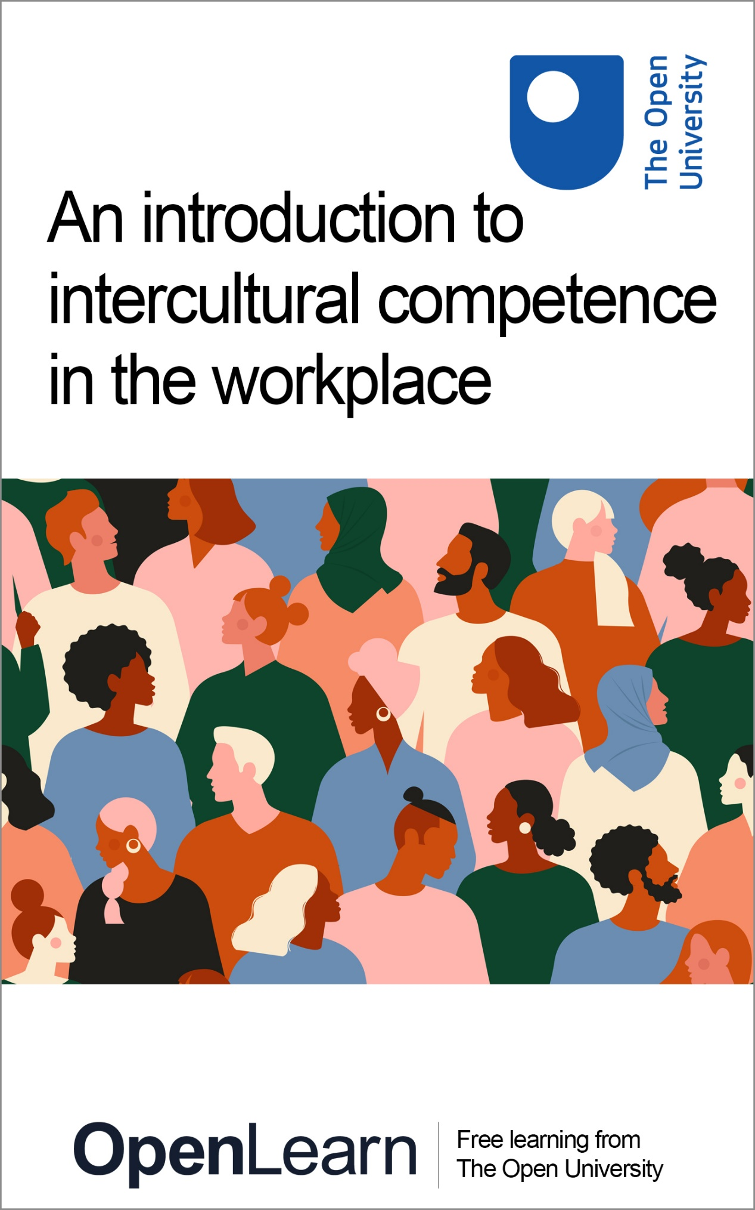

LGXA001_1

Week 1: Introduction to the Arabic alphabet

This publication forms part of the Open University short course Introduction to Arabic Language and Culture by the Open Centre for Languages and Cultures. Details of this and other Open University modules can be obtained from Student Recruitment, The Open University, PO Box 197, Milton Keynes MK7 6BJ, United Kingdom (tel. +44 (0)300 303 5303; email general-enquiries@open.ac.uk).
Alternatively, you may visit the Open University website at www.open.ac.uk where you can learn more about the wide range of modules and packs offered at all levels by The Open University.
The Open University,
Walton Hall, Milton Keynes
MK7 6AA
First published 2023.
Unless otherwise stated, copyright © 2023, 2023 The Open University, all rights reserved.
All rights reserved. No part of this publication may be reproduced, stored in a retrieval system, transmitted or utilised in any form or by any means, electronic, mechanical, photocopying, recording or otherwise, without written permission from the publisher or a licence from The Copyright Licensing Agency Ltd. Details of such licences (for reprographic reproduction) may be obtained from: The Copyright Licensing Agency Ltd, 5th Floor, Shackleton House, 4 Battle Bridge Lane, London, SE1 2HX (website www.cla.co.uk).
Open University materials may also be made available in electronic formats for use by students of the University. All rights, including copyright and related rights and database rights, in electronic materials and their contents are owned by or licensed to The Open University, or otherwise used by The Open University as permitted by applicable law.
In using electronic materials and their contents you agree that your use will be solely for the purposes of following an Open University course of study or otherwise as licensed by The Open University or its assigns.
Except as permitted above you undertake not to copy, store in any medium (including electronic storage or use in a website), distribute, transmit or retransmit, broadcast, modify or show in public such electronic materials in whole or in part without the prior written consent of The Open University or in accordance with the Copyright, Designs and Patents Act 1988.
Edited and designed by The Open University.
Printed and bound in the United Kingdom.

Contents
- Introduction
- Learning outcomes
- 1 Arabic alphabet
  - 1.1 Letters with articulation points
- 2 Vowels in Arabic
- 3 Other signs
- 4 A short history of Arabic
- 5 Standard Arabic and dialects
- 6 This week’s quiz
- Summary of Week 1
- Week 2: Joining letters
- Introduction
- Learning outcomes
- 1 Joining letters
- 2 Long vowels and issues with reading and writing
  - 2.1 At-Tāʾ al-marbūṭah التّاء المَرْبُوطَة
  - 2.2 Al-hamzah الهَمْزَة
  - 2.2 Al-Alif al-maqsūrā الألف المقصورة
- 3 Interrogative particles in Arabic
- 4 The influence of Arabic on other languages
  - 4.1 The influence of Arabic on English
  - 4.2 The influence of Arabic on Spanish
  - 4.3 The influence of Arabic on Turkish
  - 4.4 The influence of Arabic on Persian and Urdu
  - 4.5 The contribution of Arab: Muslim scholars to different science fields
- 5 This week’s quiz
- Summary of Week 2
- Acknowledgements
- Solutions
- Descriptions

Introduction
This is the first session of a two-part pre-course of the short course Introduction to Arabic Language and Culture by the Open Centre for Languages and Cultures. Completing this course will take you about four hours. This course focuses on the most basic steps in learning Arabic: you will learn the alphabet, vowels, and also learn a bit about different dialects and the history of the Arabic language. At this stage, you are encouraged to listen to the audios, and practise writing.
This week you will learn the Arabic alphabet, vowels, and also a little bit about the history of the Arabic language.

Learning outcomes
After studying this course, you should be able to:
- understand the Arabic writing system
- pronounce and write the Arabic alphabet
- understand the influence of Arabic on other languages.

1 Arabic alphabet
The first step to learning any language is to learn the alphabet. The Arabic alphabet consists of twenty-eight letters, which you will find in the following table with the English transliteration. Listen carefully to the audio, and repeat the letters you hear. Before you move to joining letters in the next section, learning to write independent letters is highly recommended.

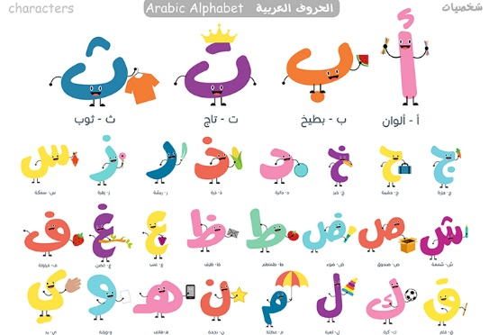
Figure 1 Arabic alphabet
View description - Figure 1 Arabic alphabet

Audio content is not available in this format.
Audio 1

Table 1 Arabic letters
Transliteration | The letter’s name in English | The letter’s name in Arabic | The letter (Independent)
A | alif | أَلِف | ا
B | baʾ | بَاء | ب
T | taʾ | تَاء | ت
Th - ṯ | Tha’ - ṯaʾ | ثَاء | ث
J - ǧ | ǧīm | جِيم | ج
ḥ | ḥaʾ | حَاء | ح
Kh - ẖ | ẖaʾ | خَاء | خ
D | dāl | دَال | د
Th - ḏ | Thal - ḏāl | ذَال | ذ
R | rāʾ | رَاء | ر
Z | zāy | زَاي | ز
S | sīn | سِين | س
Sh - š | šīn | شِين | ش
ṣ | ṣād | صَاد | ص
ḍ | ḍād | ضَاد | ض
ṭ | ṭāʾ | طَاء | ط
ẓ | ẓāʾ | ظَاء | ظ
ʿ | ʿain | عَين | ع
Gh- ġ | ġain | غَين | غ
F | fāʾ | فَاء | ف
Q | qāf | قَاف | ق
K | kāf | كَاف | ك
L | lām | لَام | ل
M | mīm | مِيم | م
N | nūn | نُون | ن
H | hāʾ | هَاء | هـ
W | wāw | وَاو | و
Y | yaʾ | يَاء | ي

Activity 1
20 minutes

To practise, match the letters with the correct English translation.

B
M
N
Y
Q
ب
م
ن
ي
ق
View answer - Part

Listen to the audio and identify the letter you heard.

Audio content is not available in this format.
Audio 2

ج
ع
ف
View answer - Part

Listen to the audio and identify the letter you heard.

Audio content is not available in this format.
Audio 3

ح
د
ش
View answer - Part

1.1 Letters with articulation points
There are several letters that have very close articulation points. Articulation points refer to the location in the vocal tract where a sound is produced. These letters may be a bit more difficult for beginners to pronounce, and to practice you will find these letters along with examples of words they occur in in the table below. Listen carefully and try to notice the difference. Repeat the words you hear.

Audio content is not available in this format.
Audio 4

Table 2 Letters with close articulation points
Examples | Letters
تِلْمِيذ - طَالِب | ت - ط
ثَمَرَة - ذَهَب | ث - ذ
حَدِيقَة - هَدِيَّة | ح - هـ
ذُرَة - زَرَافَة | ذ - ز
سَيف - صَيف | س - ص
ذُرَة - ظَبْي | ذ - ظ
قَلَم - كَلَام | ق - ك

Activity 2
15 minutes

Listen to the audio and choose which of the three words that contain a ح letter.

Audio content is not available in this format.
Audio 5

هِجْرة
حَدِيقَة
حَمَل
View answer - Part

Listen to the next audio and choose which of the three words contain a ق letter.

Audio content is not available in this format.
Audio 6

قَلِيل
كَاتِب
قَمَر
View answer - Part

Listen to the audio and choose which of the following words contain a س letter.

Audio content is not available in this format.
Audio 7

صَدِيق
سَفِير
سَمِير
View answer - Part

2 Vowels in Arabic
Vowels in Arabic are called ‘ḥarakāt’. These vowels are important, not only for reading, but also for the meaning of the sentence, as the meaning is often linked to the vowel on the last letter. For example: the following two sentences contain the same words in the same order, but the meaning is different. The only difference is the vowel above the last letter of each word.
١- سَمِعَ الطَّالِبُ الأُسْتَاذَ
٢- سَمِعَ الطَّالِبَ الأُسْتَاذُ
- The student heard the teacher.
- The teacher heard the student.
The change that occurs at the end of words in Arabic is called إِعْرَاب - Iʿrāb (declensions). Each of these vowels is a sign of a case:
- kasra: is a sign for the genitive case which concerns nouns only.
- ḍamma: is a sign for the nominative case which concern both nouns and verbs.
- Fatḥa: is a sign for the accusative case which concern both nouns and verbs.
- Sukūn: is a sign for the jussive case which concern verbs only.
You are not expected to understand and apply this yet – declensions will be taught later in the Beginners Arabic Course with the Open Centre for Languages and Cultures.
In Table 3 you can find the vowels with examples. Listen carefully and repeat.

Audio content is not available in this format.
Audio 8

Table 3 Vowels in Arabic
Examples in words | Examples with independent letters | Pronunciation | Vowels
عِلْم - حَقِيبَة | عِ - قِ | I | kasraكَسْرَة  below the letter
لُب - نُمُور | لُ - نُ | U | ḍammaضمّة  above the letter
جَمَل - ثَعْلَب | جَ - ثَ | A | Fatḥaفَتْحَة  above the letter
مَفْهُوم - عَمَلْ | فْ - لْ | indicates the consonant | Sukūnسُكُون  above the letter

In addition, there are tanwīn vowels, denoted by doubling the vowel signs ( ـٍ ، ـٌ ، ـً ). These vowels are used for an indefinite noun or adjective for example: قَلَمٌ a pen (a definite noun would translate to “the pen”). It also comes with the last letter of the word. The pronunciation of these vowels is: in - un or an. Alif letter should be added to the end of the word when the tanwīn is double Fatḥa. Listen to the audio file to see how tanwīn is pronounced.

Audio content is not available in this format.
Audio 9

١- طَالِبٍ - طَالِبٌ - طَالِباً
٢- مُعَلِّمٍ - مُعَلِّمٌ - مُعَلِّماً
٣- طَوِيلٍ - طَوِيلٌ - طَوِيلاً
٤- قَلَمٍ - قَلَمٌ - قَلَماً
٥- بَابٍ - بَابٌ - بَاباً

Activity 3
20 minutes

Listen to the audio and choose the letter that contains the Fatḥa vowel.

جُ
مِ
بَ
View answer - Part

Which of the following words contains a tanwīn?

Audio content is not available in this format.
Audio 10

يَعْمَلُ
مَلْعَباً
بَيتٌ
View answer - Part

Interactive content is not available in this format.

Interactive content is not available in this format.

Listen to the next audio and write the letters you hear in independent form, click ‘reveal answer’ to see the letters written down.

Audio content is not available in this format.
Audio 11

View answer - Part

3 Other signs
- Shadda الشّدّة
The sign (ـــّــ) is called ‘shadda’. It is used to indicate doubling of consonant. In the following table you will see words contain ‘shadda’ in column A and see how is it pronounced in column B. Listen carefully and repeat what you hear.

Audio content is not available in this format.
Audio 12

Table 5 Shadda الشّدّة
A | B
الطَّالِب | الطْطَالِبُ
كَذّبَ | كَذْذَبَ
يُدَرِّسُ | يُدَرْرِسُ
حَجٌّ | حَجْجَ
ثُمَّ | ثُمْمَ

- Madda المَدّة
The sign ( آ ) is called ‘madda’. It comes only above the letter ( ا ) to be pronounced as (ā).
Here are some examples of ‘madda’. Listen carefully and repeat.

Audio content is not available in this format.
Audio 13

١- آخِذ
٢- الآمَال
٣- آثَرَ
٤- الآن
٥- مَلْجَآن

Activity 4
20 minutes

Which of the following words contains shadda?

Audio content is not available in this format.
Audio 14

يُفَكِّر
وَرَقَة
الذَّهَب
View answer - Part

Which of the following words contains madda?

Audio content is not available in this format.
Audio 15

الأَمْر
الآدَاب
مُؤْمِن
View answer - Part

Interactive content is not available in this format.

4 A short history of Arabic
It is difficult to pinpoint the exact date of the emergence and development of the Arabic Language, but it was likely around the 7th century BC on the Arabian Peninsula. Arabic belongs to the Semitic Language Family (along with Hebrew, for example) and has been influenced by and impacted other languages over the course of its almost 3000 year long history.

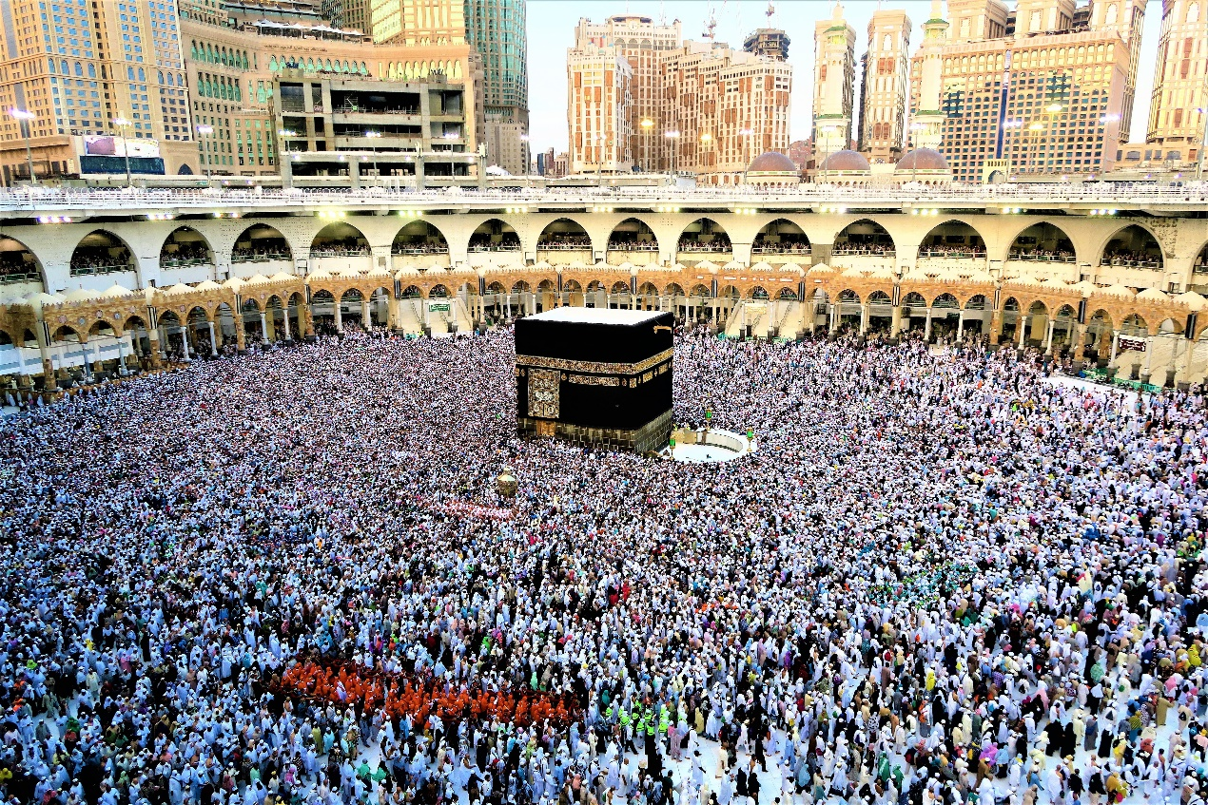
Figure 2 The Ramadan Kaaba

Arabic was chosen to be the Holy Qur'an's language at the advent of Islam (622). Arabic then became an important language of all Muslims, and non-Arab Muslims started to learn it to understand the Qur'an. This situation also transformed Arabic from a language spoken in a relatively small area into a language used worldwide. The Qur'an was also central to the development of Arabic language sciences. The Qur'an as the holy text of God is seen as unlikely to contain any mistakes in linguistics, and Arab linguists therefore regard the language used in the Qur’an as a rule of linguistics based on this belief. You will find that the Qur'an is quoted in most Arabic grammar books not to primarily reinforce religious beliefs, but to teach the language.
Those who is interested in learning Arabic will find it difficult in several stages of learning the language, regardless of their first language. The majority of these difficulties are due to the quite complex grammar of Arabic. In Arabic, as was previously explained, vowels are important in determining meaning. Examples for this are that unlike many other languages, Arabic distinguishes between singular, plural and dual. Nouns, adjectives, pronouns and articles can furthermore be male and female. This is something you might know from European languages like French and German, but unlike in these languages, verbs are also gendered.
The Arabic alphabet will be new to most learners, and Arabic, unlike many other languages, is written right to left. The letters are not written separately within the word. Each letter can take three different forms depending on its position within the word.
While it is important to be aware of these potential challenges, worry not – it is by no means impossible to learn Arabic, but it will take practice!

5 Standard Arabic and dialects
The first thing that new learners often wonder about is the difference between Standard Arabic and its dialects: Where should the learner begin? What are the differences between the standard language and the dialects?
Arabic dialects are as old as the language itself. After the spread of the Arabs to different geographical regions, the dialects also developed further. The dialect of each society that emerged was affected by the languages spoken by their neighbours and from groups who already lived in the area, for example. Don’t forget, the distance between each of these groups was vast – it stretched from North Africa to the Arabian Peninsula and across the Asian continent.
The most important difference between standard Arabic and local dialects is that the dialects are flexible and not bound by the strict rules found in Standard Arabic. Standard Arabic is the language of writing, literature and journalism and has grammar that has not changed for centuries. This makes the Arabic language distinct from other languages, as those who know Arabic can understand the Arabic texts written more than a thousand years ago. If you would like to find out more about this, click on the links to these resources:
- Shou, shinou, ey: Five major Arabic dialects and what makes them unique
- Did you know?: The Evolution of the Arabic language in the Silk Roads
- 18 Ways to Say Thank You in Arabic – Sound Like a Local
The reasons that drive people to learn Arabic are varied, as it is a language with a long scientific, literary, and cultural history, and it is spoken by more than 300 million people as their mother tongue. It is also one of the six official languages of the United Nations.
You have reached this point of the course because you have a reason why you would like to learn the language. There will be ‘lightbulb’ moments as a learner where you are especially passionate about the language, but there will also be times when you will consider giving up on this challenging endeavour. When that day comes, it might be good to remind yourself of why Arabic is a great language to learn. Here are two resources that might be helpful:
- Why should you learn Arabic? An American perspective
- Why should you learn Arabic? A British perspective.

Activity 5
15 minutes
As a last step in this first part of the course, take a few minutes to think about your expectations and motivations for learning a new language.

Why would you like to learn Arabic? How proficient would you like to be?

Provide your answer...
View answer - Part

How much time would you like to spend on learning Arabic each week?

Provide your answer...
View answer - Part

This course is a pre-course for the short course Introduction to Arabic Language and Culture. Based on these reasons, why do you think culture as a subject to teach is included this early on?

Provide your answer...
View answer - Part

6 This week’s quiz
Check what you’ve learned this week by taking the end-of-week quiz.

Activity 6
20 minutes

1. Listen to the audio and identify the letter you heard.

Audio content is not available in this format.
Audio 16

م
غ
و
View answer - Part

2. Listen to the audio and identify the letter you heard.

Audio content is not available in this format.
Audio 17

ل
ت
ظ
View answer - Part

3. Listen to the audio and identify the letter you heard.

Audio content is not available in this format.
Audio 18

ن
ص
ح
View answer - Part

4. Listen to the audio and identify the letter’s vowel.

Audio content is not available in this format.
Audio 19

كَسْرَة
فَتْحَة
ضَمَّة
View answer - Part

5. Listen to the audio and identify the letter’s vowel.

Audio content is not available in this format.
Audio 20

كَسْرَة
فَتْحَة
ضَمَّة
View answer - Part

6. Which of the following information is correct about tanwīn?

It can come with any letter of the word.
It can come with all kinds of words including the verb.
It comes with the last letter of the word.
View answer - Part

7. Which of the following words contains tanwīn?

خَشَبٌ
كُرْسِي
وَلَدٍ
View answer - Part

8. Which of the following words doesn’t contain tanwīn?

مُدِيراً
يَدْرُسُ
سَافَرَ
View answer - Part

9. Which of the following vowels is written below the letter?

كَسْرَة
فَتْحَة
ضَمَّة
View answer - Part

10. Which of the following words contain madda?

الظُهُور
الدُّرُوب
الآمال
View answer - Part

Summary of Week 1
In this week you took the first steps of learning Arabic, namely learning about the alphabet and an introduction to the role vowels. You also read about reasons for learning Arabic and who speaks (or writes!) it, and how dialects differ from Standard Arabic. In Week 2 you will learn how to connect the letters, and you will have a first try at writing in Arabic.
Now go to Week 2.

Week 2: Joining letters

Introduction
In this week you will learn joining letters, long vowels, interrogative particles, and the influence of Arabic on other languages.
Week 2 will be focusing on the further foundations of learning Arabic, like joining letters, long vowels, interrogative particles, and the influence of Arabic on other languages. At this stage, listening repeatedly to the audios, repeating, and writing are highly recommended. This second week forms the basis for further courses on the Arabic language – resources you discover here will prove useful as you continue learning.

Learning outcomes
After studying this course, you should be able to:
- understand the Arabic writing system
- pronounce and write the Arabic alphabet
- understand the influence of Arabic on other languages.

1 Joining letters
In Arabic, joining letters is a fundamental aspect of reading and writing. Arabic is a cursive script, meaning that letters are written in a connected manner. Joining letters correctly is essential to ensure legibility and readability of written Arabic. The first thing you should learn is that Arabic, unlike many other languages, is written from right to left. Each letter has two or three forms in joint writing in addition to its independent form, depending on their position in the word: initial (beginning of the word), medial (in the middle) and final (last). In the tables below you can find a complete list of all Arabic letters, as well as their form in each of the three possible positions in a word, as well as examples. The table is long and you are not expected to know all of it by heart after one session. We recommend that you revisit it as you learn the language. To break the table up, there are activities for you to practice with in-between.
- Meanings of words will not be given because the aim here is to focus on writing exercises.
- Some letters are not connected to the letter that follows them, so they are written in the same way in the middle of the word and at the end of the word.

Table 1 Joining letters part 1
Final | Medial | Initial | The letter (Independent)
ــا | ــا | ا | ا
عصا | ذهاب | الم
ــب | ــبــ | بــ | ب
حب | طبق | بقرة
ــت | ــتــ | تــ | ت
بيت | كتب | تعلم
ــث | ــثــ | ثــ | ث
حث | مثال | ثوم
ــج | ــجــ | جــ | ج
حج | يجب | جمل
ــح | ــحــ | حــ | ح
بلح | الحب | حمل
ــخ | ــخــ | خــ | خ
بطيخ | يخسر | خوف
ــد | ــد | د | د
يد | حديد | دب
ــذ | ــذ | ذ | ذ
لذيذ | هذب | ذهب

Activity 1
15 minutes

How do you write the independent form of the second letter in the word بقرة ?

ف
ق
غ
View answer - Part

Which of the following words contains the خ letter?

Audio content is not available in this format.
Audio 1

يخسر
بطيخ
جمل
View answer - Part

Now, try to write some of the letters yourself. Watch the videos and copy the movement on a piece of paper.

Video content is not available in this format.

Video content is not available in this format.

Video content is not available in this format.

Video content is not available in this format.

Video content is not available in this format.

Video content is not available in this format.

Video content is not available in this format.

Video content is not available in this format.

Video content is not available in this format.

Table 2 Joining letters part 2
Final | Medial | Initial | The letter (Independent)
ــر | ــر | ر | ر
تمر | طائرة | راهب
ــز | ــز | ز | ز
تلفاز | ميزان | زرافة
ــس | ــســ | ســ | س
شمس | السماء | سد
ــش | ــشــ | شــ | ش
عش | الشروق | شمس
ــص | ــصــ | صــ | ص
مقص | الصبر | صباح
ــض | ــضــ | ضــ | ض
أبيض | حضر | ضب
ــط | ــطــ | طــ | ط
خيط | بطريق | طبيب
ــظ | ــظــ | ظــ | ظ
حفظ | محفظة | ظهر
ــع | ــعــ | عــ | ع
بائع | لعب | علم
ــغ | ــغــ | غــ | غ
صائغ | الغروب | غفر

What is the second letter of the word حضر ? Write it in the independent form in the box below.

Provide your answer...
View answer - Part

Which of the following words contains the غ letter?

Audio content is not available in this format.
Audio 2

ظهر
بائع
الغروب
View answer - Part

Now, try to write some of the letters yourself. Watch the videos and copy the movement on a piece of paper.

Video content is not available in this format.

Video content is not available in this format.

Video content is not available in this format.

Video content is not available in this format.

Video content is not available in this format.

Video content is not available in this format.

Video content is not available in this format.

Video content is not available in this format.

Video content is not available in this format.

Video content is not available in this format.

Table 3 Joining letters part 3
Final | Medial | Initial | The letter (Independent)
ــف | ــفــ | فــ | ف
ضعيف | جفاف | فهم
ــق | ــقــ | قــ | ق
أغلق | صقر | قريب
ــك | ــكــ | كــ | ك
سمك | يكتب | كتاب
ــل | ــلــ | لــ | ل
ليل | علم | لعب
ــم | ــمــ | مــ | م
علم | ليمون | منزل
ــن | ــنــ | نــ | ن
غصن | عنب | نمر
ــه | ــهــ | هــ | هـ
وجه | يهتف | هذا
ــو | ــو | و | و
يلهو | الوصول | وصل
ــي | ــيــ | يــ | ي
غني | ثمين | يلعب

Which of the following letters cannot be connected to the next letter in writing?

Audio content is not available in this format.
Audio 3

و
ع
ز
View answer - Part

For this task you need a piece of paper. Below are five words, all written in independent letters only. Can you connect them? Click reveal answer to see the correct answer.
١- ك ت ب
٢- ر س م
٣- ي ذ هـ ب
٤- ق ل م
٥- ب ي ت

View answer - Part

Match the word written by the independent letter with the word written by the same letters in the connected form.

منزل
خريف
عصفور
سنجاب
قميص
م ن ز ل
خ ر ي ف
ع ص ف و ر
س ن ج ا ب
ق م ي ص
View answer - Part

Rewrite the following words as separate letters as in the example.
Example:
تفاح ت ف ا ح
١- طعام
٢- شراب
٣- مطبخ
٤- منزل
٥- سرير

View answer - Part

Now, try to write some of the letters yourself. Watch the videos and copy the movement on a piece of paper.

Video content is not available in this format.

Video content is not available in this format.

Video content is not available in this format.

Video content is not available in this format.

Video content is not available in this format.

Video content is not available in this format.

Video content is not available in this format.

Video content is not available in this format.

Video content is not available in this format.

2 Long vowels and issues with reading and writing
In Week 1 you were introduced to Arabic vowels. In this week you will learn about long vowels in addition to ‘At-Tāʾ al-marbūṭah’ and ‘Hamza’, which are also crucial for reading and meaning-making. As a reminder, have a look at the table from the last week:

Table 4 Vowels in Arabic (repeated from Week 1)
Examples in words | Examples with independent letters | Pronunciation | Vowels
عِلْم - حَقِيبَة | عِ - قِ | I | kasraكَسْرَة  below the letter
لُب - نُمُور | لُ - نُ | U | ḍammaضمّة  above the letter
جَمَل - ثَعْلَب | جَ - ثَ | A | Fatḥaفَتْحَة  above the letter
مَفْهُوم - عَمَلْ | فْ - لْ | indicates the consonant | Sukūnسُكُون  above the letter

Long vowels:
Long vowels in Arabic can appear in three forms:
- Fatḥa followed by Alif : ā
- Kasra followed by yāʾ: ī
- ḍamma followed by wāw: ū
Examples: listen to the following audio and repeat to practice the long vowels in Arabic.

Audio content is not available in this format.
Audio 4

Table 5 Examples of long vowels in Arabic
1 Fatḥa followed by Alif : ā | زَرَافَة - خَالد - مَاجِد
2 Kasra followed by yāʾ: ī | عَلِيم - جَدِيد - طَبِيب
3 ḍamma followed by wāw: ū | خَرُوف - ضُمُور - زُهُور

Activity 2
15 minutes

Which of the following words contain a long vowel?

حُزْن
سَفِير
أَجَابَ
View answer - Activity 2

2.1 At-Tāʾ al-marbūṭah التّاء المَرْبُوطَة
This letter only appears at the end of a word, and it is written (ــة) when the previous letter is connected to the letter before, and (ة)when the previous letter is written separately from the previous letter.
The most important thing to pay attention to with regard to writing is that when a word contains ‘At-Tāʾ al-marbūṭah’ and is connected to a pronoun, the ‘At-Tāʾ al-marbūṭah’ turns into a normal ‘ت’ letter, but is still pronounced in the same way.
For example: سَيَّارة means “a car”, and when you want to say ‘my car’ you need to add a ي letter at the end, so the word should be written: سَيّارَتِي
You are not expected to learn the pronouns in this early stage, the focus should be on writing.
In terms of pronunciation, this letter is pronounced ‘هــ / H’ when it is in the last word of the sentence or in a single word, even though it is written without change.
Listen to the following audio to learn more about the pronunciation of ‘Et-Tāʾ al-marbūṭah’

Audio content is not available in this format.
Audio 5

١- سَيّارَة
٢- اشْتَرَيتُ سَيّارةً جَدِيدَة
٣- مَدْرَسَة
٤- زُرْتُ المَدْرَسَةَ القَديمَة

Activity 3
15 minutes

Interactive content is not available in this format.

Rewrite the following words and connect ‘At-Tāʾ al-marbūṭah’ with the pronoun ي as in the example.
Example:
حَقِيْبَة حَقِيبَتِي
١- مَدْرَسَة
٢- طَاوِلَة
٣- وَرَقَة
٤- مُعَلِّمَة
٥ –شَجَرَة

View answer - Part

2.2 Al-hamzah الهَمْزَة
This signء which is pronounced as a glottal stop and can be written in different forms based on factors like its vowel and the vowel of the previous letter, such as: ‘ أ - إ - ؤ - ئ - ء - ــئــ’. You don’t have to memorise all of these at this stage, but you should pay close attention to the different pronunciations. Listen to the following audio and repeat what you hear.

Audio content is not available in this format.
Audio 6

١- مَبْدَأ
٢- شَاطِئ
٣- البَرَاءَة
٤- الاكْتِئَاب
٥- سَمَاء
٦- أَخَذَ

Activity 4
15 minutes

Interactive content is not available in this format.

2.2 Al-Alif al-maqsūrā الألف المقصورة
This letter only appears in the final position of some words, written (ــى) when the previous letter is connected to the letter before, and (ى) when the previous letter is written separately. It is important at this stage not to confuse ‘Al-Alif al-maqsūrā’ which is pronounced as ‘ā’ with the ‘ya’, which is written similarly with a colon added below it (ي). Listen to the following audio and repeat what you hear.

Audio content is not available in this format.
Audio 7

١- عَلَى
٢- هُدَى
٣- أَحْصَى
٤- فَتَى
٥- قَضَى

Activity 5
15 minutes

Which of the following words contain a long vowel?

إِلى
نَفَى
يَهْدِي
View answer - Activity 5

3 Interrogative particles in Arabic
Interrogative articles like when or who in English are the first step in forming a question to seek information. In the following table you will find a list of interrogative articles. In the activities that follow you will see how interrogative articles are used in a sentence. Listen carefully to the audio.
* Interrogative particles in Arabic comes first at the sentence.

Table 6 interrogative particles in Arabic
English | Arabic | Transliteration
Yes, No questions | هَلْ - أَ | Hal - Aʾ
Who | مَنْ | Man
What | مَاذَا - مَا | Māḏā - Ma
Where | أَيْنَ | Ayna
When | مَتَى | Mata
Why | لِمَاذا - لِمَ | Limāḏā - Lima
How | كَيفَ | Kayfa
How much - how many | كَمْ | Kam
which | أَيّ | Ayyu

4 The influence of Arabic on other languages
In Week 1 you learned a bit about the history of the Arabic language, and how its dialects are influenced by other languages. In this section, you’ll learn a bit about how Eastern and Western languages were affected by Arabic. Some of these languages only adapted a few Arabic words, while some languages even adapted the Arabic alphabet in writing. These changes reflect the relationship that Arabs and locals had with each other.


Figure 1
View description - Figure 1

In English for example, words that are used in the realms of politics, religion or law are usually of French origin (e.g., constitution, to baptize, judge – juge) whereas mundane words stayed Germanic (e.g. to say – sagen, hand – Hand), which reflects that following the Norman Conquest of 1066 the ruling class of Britain was French, spoke in French and only very slowly mingled with the locals.
Here are four examples of languages in which you can spot Arabic in the following sections.

4.1 The influence of Arabic on English
In addition to the influence of Arabic on the current numbering system used in English-speaking countries, when the Roman system was replaced by the Indo-Arabic numbering system, it may be surprising for some people that there are hundreds of Arabic words used in English. According to www.mothertongue.ae there are approximately 10,000 words in English which stem from Arabic. But the Oxford English Dictionary (OED) narrowed it down to about 900 words by omitting speculative derivations and proper nouns. Often it’s not just single words that are borrowed, but full phrases: For example: The expression ‘Straw that Broke the Camel’s Back’ is a translation of the Arabic expression ‘القَشَّةُ الّتِي قَصَمَتْ ظَهْرَ البَعِيرِ’.

Activity 6
15 minutes

The following English words are of Arabic origin. Look each word up in the dictionary and write them in Arabic.
- Lemon
- Sugar
- Alcohol

View answer - Activity 6

4.2 The influence of Arabic on Spanish
Arabs ruled the Iberian Peninsula for a long period of nearly eight centuries (711–1492), and this period was full of cultural, scientific, literary and architectural achievements, some of which we are still witnessing until the present era.


Figure 2
View description - Figure 2

The influence of Arabic on Spanish seems clear in many aspects, as some Spanish cities still retain their Arabic name to the present time, such as: Madrid مجريط and Valladolid بلد الوليد . In addition, Spanish uses a significant number of Arabic words - up to eight thousand.

Activity 7
15 minutes

The following Spanish words are of Arabic origin. Look each word up in the dictionary and write them in Arabic.
- Arroz
- Albuhera
- Hasta

View answer - Activity 7

4.3 The influence of Arabic on Turkish
Naturally, the influence of Arabic on languages spoken in close geographical and cultural proximity is greater. Additional religious links are further incentives for people to learn Arabic language, as it is the language of the Holy Qur’an.
Turkish is one of the languages that was influenced by Arabic the most. The Arabic alphabet was for instance used throughout the Ottoman Empire – it was only in 1928 that Ataturk implemented reforms for the Turkish Republic that introduced Latin script as the official writing system.
According to the Turkish Language Academy, more than 6,000 words are loanwords from Arabic. For example: Saat , سَاعَة ,Saʿa - Kalem قَلَم , Qalam, - Seccade , Saǧǧada, سَجّادَة - Kitap, Kitab, كِتَاب.

4.4 The influence of Arabic on Persian and Urdu
Persian and Urdu are among the languages most affected by Arabic, and they still use the Arabic alphabet to the present day. Persian is spoken in Iran, Tajikistan and Afghanistan. Urdu is mostly spoken in Pakistan. Both languages contain thousands of Arabic loanwords. For example : Silāḥ سِلَاح - Taʾṯīr تَأثِير in Persian, and Ḥawḍ حَوض - Ṣaḥn صَحْن in Urdu.

Activity 8
15 minutes

Are there any words of Arabic origin in your mother tongue? Give examples.

Provide your answer...

4.5 The contribution of Arab: Muslim scholars to different science fields
The influence of the Arabic language was not only confined to some words that other languages borrowed from Arabic, but the Arabic-speaking scholars made great scientific contributions, and their impact can still be felt today.

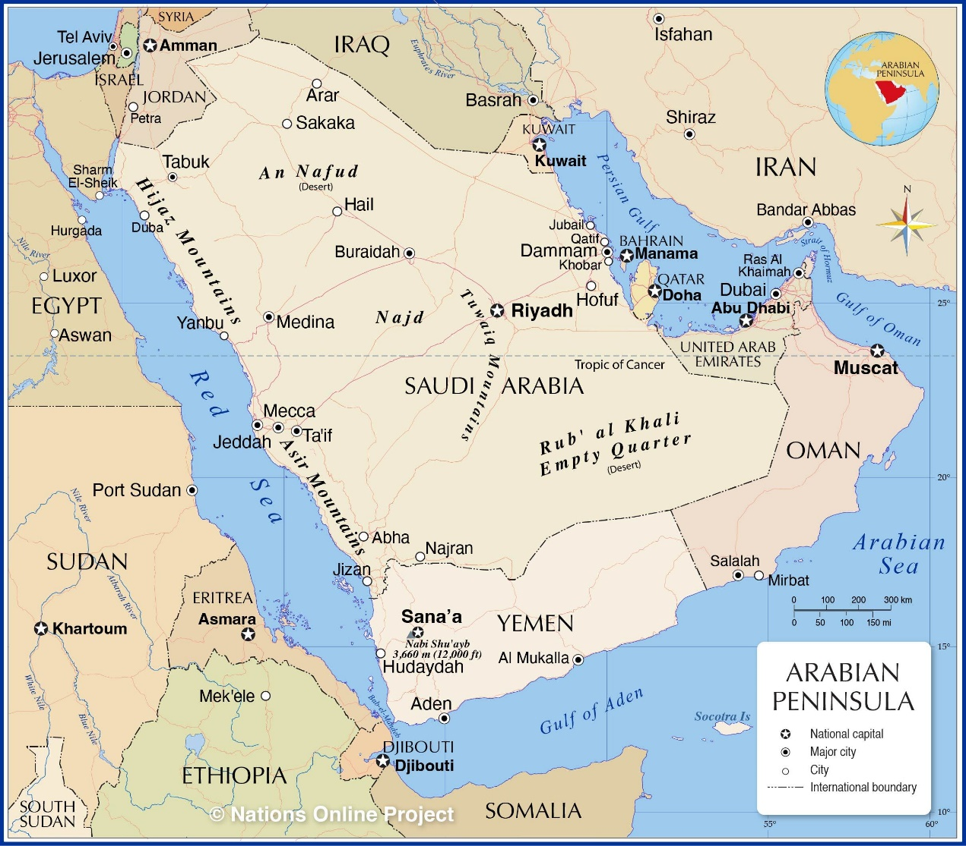
Figure 3 Map of the Arabian Peninsula
View description - Figure 3 Map of the Arabian Peninsula

Activity 9
15 minutes
The Guardian has named six amazing inventions from between the 9th and 15th centuries by Arab - Muslim scholars. Read this article and answer the questions next.

Who is the scholar who has a crater on the moon named after him?

Al-Zahrawi
Ibn Firnas
Al-Idrisi
View answer - Part

What does Al-Idrisi’s world map contain?

Provide your answer...
View answer - Part

In the following video, you will see a condensed summary about ‘The rise and fall of the medieval Islamic Empire’. This will give you an idea of the civilization that used Arabic as an official language. Watch the video and then answer the questions.

Video content is not available in this format.
The rise and fall of the medieval Islamic Empire: Petra Sijpesteijn & Birte Kristiansen

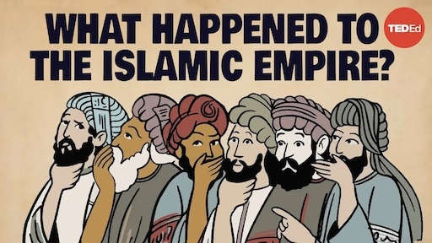

What is the capital of the Umayyad state? Does this city still exist or has it disappeared?

Provide your answer...
View answer - Part

The Abbasids built a new capital for their state, Baghdad. In which Arab country is this city currently located?

Provide your answer...
View answer - Part

5 This week’s quiz
Check what you’ve learned this week by taking the end-of-week quiz.

Activity 10
20 minutes

1. Which of the following letters cannot be connected to the next letter in writing?

م
ز
ع
View answer - Part

2. Which of the following letters should be connected to the next and the previous letter in writing?

ظ
ب
د
View answer - Part

3. How many ك letters are there in the following sentence?
شَرِبَ الكَنْغَرُ كَمِّيّاتٍ كَبِيرَةٍ منَ المَاءِ

2
5
3
View answer - Part

4. How many ع letters are there in the following sentence?
وَضَعَ العَامِلُ البِضَاعَةَ في العُلْبَةِ

1
4
5
View answer - Part

5. Which of the following words contain a long vowel?

طَرِيق
مُنْذُ
صَبَاحَاً
View answer - Part

6. Which of the following words contain ‘At-Tāʾ al-marbūṭah’?

كَأس
طُفُولَة
قَلَم
View answer - Part

7. Which of the following words contain ‘Hamza’?

مَاء
دَفْتَر
الإِمْلاء
View answer - Part

8. Fill in the blank with the appropriate interrogative particle.
…… سَاعَةً تَعْمَلُ فِي اليَوم؟
……… hours do you work daily?

كَيفَ
مَن
كَم
View answer - Part

9. Fill in the blank with the appropriate interrogative particle.
…… اسم الكِتَاب الذِي تَقرَأه؟
……… is the name of the book you are reading?

أَينَ
مَا
لِمَاذَا
View answer - Part

10. Which of the following languages still use the Arabic alphabet?

Turkish
Persian
Urdu
View answer - Part

Summary of Week 2
This second week covered joining letters, long vowels, and interrogative articles. Additionally, the influence of Arabic on other languages, and the history of Arabic empires and scientific achievements were introduced. To continue your journey of learning Arabic, we recommend that you practice how to write and connect letters in a vocabulary book. If you choose to continue to do the full short course with the Open Centre for Languages and Cultures, you will find it useful to continue using a notebook for new grammar rules and vocabulary, too.

Acknowledgements
This free course was written by Dr Ahmed Halil and it was first published in 2024.
Except for third party materials and otherwise stated (see terms and conditions), this content is made available under a Creative Commons Attribution-NonCommercial-ShareAlike 4.0 Licence .
The material acknowledged below and within the course is Proprietary and used under licence (not subject to Creative Commons Licence). Grateful acknowledgement is made to the following sources for permission to reproduce material in this free course:
Images
Course image: eli_asenova / iStock / Getty Images
Figure 1: Freepik
Week 1
Figure 2: Photo by ekrem from Pixabay
Week 2
Figure 1: Photo by: fauxels / Pexels
Figure 2 (and course image): eli_asenova / iStock / Getty images
Figure 3: © Nations Online Project
Activity 9 video: The rise and fall of the medieval Islamic Empire - Petra Sijpesteijn & Birte Kristiansen, TED-Ed, https://creativecommons.org/licenses/by-nc-nd/4.0/
Every effort has been made to contact copyright owners. If any have been inadvertently overlooked, the publishers will be pleased to make the necessary arrangements at the first opportunity.
Don’t miss out
If reading this text has inspired you to learn more, you may be interested in joining the millions of people who discover our free learning resources and qualifications by visiting The Open University – www.open.edu/openlearn/free-courses.

Solutions

Activity 1

Part

Answer
The correct matches are:
B
ب
M
م
N
ن
Y
ي
Q
ق
Back to - Part

Part

Answer
Right:
ف
Wrong:
ج
ع
Back to - Part

Part

Answer
Right:
د
Wrong:
ح
ش
Back to - Part

Activity 2

Part

Answer
Right:
حَدِيقَة
حَمَل
Wrong:
هِجْرة
Back to - Part

Part

Answer
Right:
قَلِيل
قَمَر
Wrong:
كَاتِب
Back to - Part

Part

Answer
Right:
سَفِير
سَمِير
Wrong:
صَدِيق
Back to - Part

Activity 3

Part

Answer
Right:
بَ
Wrong:
جُ
مِ
Back to - Part

Part

Answer
Right:
مَلْعَباً
بَيتٌ
Wrong:
يَعْمَلُ
Back to - Part

Part

Answer

Table 4 answers
1 | 2 | 3 | 4 | 5
ج | د | ش | و | ث

Back to - Part

Activity 4

Part

Answer
Right:
يُفَكِّر
الذَّهَب
Wrong:
وَرَقَة
Back to - Part

Part

Answer
Right:
الآدَاب
Wrong:
الأَمْر
مُؤْمِن
Back to - Part

Activity 5

Part

Answer
There is no right or wrong here, of course. It can be fun to get a basic understanding of how a language works that is very different (or also similar!) to languages you already speak, or if you have holidays booked, it is nice to demonstrate an interest in the local culture by speaking in the local language where possible. If you would like to become fluent enough to hold a conversation, it’s important that you manage your expectations. Studying alone can only get you so far, but finding a tandem learning partner, listening to music and watching films or shows with subtitles can be very helpful, too.
Back to - Part

Part

Answer
There is actually a magic number that the US Foreign Service Institute came up with that tells you how many hours English native speakers need to study in order to become fluent in Arabic: 2200. This means that if you studied the language for 4 hours per week, you could be fluent in 10 years – more dedicated periods or intensive courses would shorten this time, of course. As a comparison, the same institute estimates that if a native speaker of English learned French instead, they could do so in “only” 580 hours, so a quarter of the time. These are of course not reliable numbers, but they do indicate that Arabic is one of the hardest languages to learn. This should not discourage you at all, as it’s highly rewarding!
Back to - Part

Part

Answer
Language and culture cannot be seen as separate entities. Language reflects beliefs, values and worldviews of its speakership. Learning a language while considering why certain phrases and communication styles are preferred in particular contexts allows you to understand people and their ways of being better than by simply learning grammar.
Back to - Part

Activity 6

Part

Answer
Right:
غ
Wrong:
م
و
Back to - Part

Part

Answer
Right:
ل
Wrong:
ت
ظ
Back to - Part

Part

Answer
Right:
ح
Wrong:
ن
ص
Back to - Part

Part

Answer
Right:
ضَمَّة
Wrong:
كَسْرَة
فَتْحَة
Back to - Part

Part

Answer
Right:
فَتْحَة
Wrong:
كَسْرَة
ضَمَّة
Back to - Part

Part

Answer
Right:
It comes with the last letter of the word.
Wrong:
It can come with any letter of the word.
It can come with all kinds of words including the verb.
Back to - Part

Part

Answer
Right:
خَشَبٌ
وَلَدٍ
Wrong:
كُرْسِي
Back to - Part

Part

Answer
Right:
يَدْرُسُ
سَافَرَ
Wrong:
مُدِيراً
Back to - Part

Part

Answer
Right:
كَسْرَة
Wrong:
فَتْحَة
ضَمَّة
Back to - Part

Part

Answer
Right:
الآمال
Wrong:
الظُهُور
الدُّرُوب
Back to - Part

Activity 1

Part

Answer
Right:
ق
Wrong:
ف
غ
Back to - Part

Part

Answer
Right:
يخسر
بطيخ
Wrong:
جمل
Back to - Part

Part

Answer
ض
Back to - Part

Part

Answer
Right:
الغروب
Wrong:
ظهر
بائع
Back to - Part

Part

Answer
Right:
و
ز
Wrong:
ع
Back to - Part

Part

Answer
١- كتب
٢- رسم
٣- يذهب
٤- قلم
٥- بيت
Back to - Part

Part

Answer
The correct matches are:
منزل
م ن ز ل
خريف
خ ر ي ف
عصفور
ع ص ف و ر
سنجاب
س ن ج ا ب
قميص
ق م ي ص
Back to - Part

Part

Answer
١- ط ع ا م
٢- ش ر ا ب
٣- ن ط ب خ
٤- م ن ز ل
٥- س ر ي ر
Back to - Part

Activity 2

Answer
Right:
سَفِير
أَجَابَ
Wrong:
حُزْن
Back to - Activity 2

Activity 3

Part

Answer
١- مَدْرَسَتي
٢- طَاوِلَتي
٣- وَرَقَتي
٤- مُعَلِّمَتي
٥ - شَجَرَتي
Back to - Part

Activity 5

Answer
Right:
إِلى
نَفَى
Wrong:
يَهْدِي
Back to - Activity 5

Activity 6

Answer
- ١- لَيمُون / Laymōn
- ٢- سُكَّر / Sokkar
- ٣- الكُحُول / Alkoḥol
Back to - Activity 6

Activity 7

Answer
- ١- أَرُز / Aroz
- ٢- البُحَيْرة / Al-buḥayra
- ٣- حَتّى / attaḥ
Back to - Activity 7

Activity 9

Part

Answer
Right:
Ibn Firnas
Wrong:
Al-Zahrawi
Al-Idrisi
Back to - Part

Part

Answer
It contained detailed descriptions of the Christian north as well as the Islamic world, Africa and the Far East.
Back to - Part

Part

Answer
Damascus, it is the capital of Syria currently.
Back to - Part

Part

Answer
Iraq
Back to - Part

Activity 10

Part

Answer
Right:
ز
Wrong:
م
ع
Back to - Part

Part

Answer
Right:
ظ
ب
Wrong:
د
Back to - Part

Part

Answer
Right:
3
Wrong:
2
5
Back to - Part

Part

Answer
Right:
4
Wrong:
1
5
Back to - Part

Part

Answer
Right:
طَرِيق
صَبَاحَاً
Wrong:
مُنْذُ
Back to - Part

Part

Answer
Right:
طُفُولَة
Wrong:
كَأس
قَلَم
Back to - Part

Part

Answer
Right:
مَاء
الإِمْلاء
Wrong:
دَفْتَر
Back to - Part

Part

Answer
Right:
كَم
Wrong:
كَيفَ
مَن
Back to - Part

Part

Answer
Right:
مَا
Wrong:
أَينَ
لِمَاذَا
Back to - Part

Part

Answer
Right:
Persian
Urdu
Wrong:
Turkish
Back to - Part

Descriptions

Figure 1 Arabic alphabet
An image contains Arabic letters with names and pictures of animals containing each letter in arabic.
Back to - Figure 1 Arabic alphabet

Figure 1
Smiling person shaking hands
Back to - Figure 1

Figure 2
Two people shaking hands with another person looking on.
Back to - Figure 2

Figure 3 Map of the Arabian Peninsula
A Map of the Arabian Peninsula
Back to - Figure 3 Map of the Arabian Peninsula

