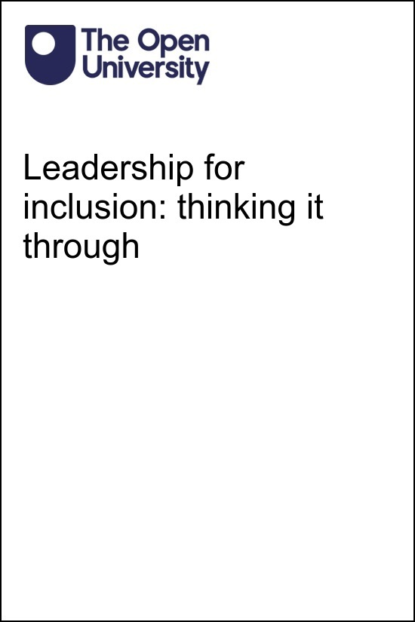

LFI_1

Leadership for inclusion: thinking it through

About this free course
This free course is an adapted extract from the Open University course .
This version of the content may include video, images and interactive content that may not be optimised for your device.
You can experience this free course as it was originally designed on OpenLearn, the home of free learning from The Open University –
There you’ll also be able to track your progress via your activity record, which you can use to demonstrate your learning.
First published 2024.
Unless otherwise stated, copyright © 2024 The Open University, all rights reserved.
Intellectual property
Unless otherwise stated, this resource is released under the terms of the Creative Commons Licence v4.0 http://creativecommons.org/licenses/by-nc-sa/4.0/deed.en_GB. Within that The Open University interprets this licence in the following way: www.open.edu/openlearn/about-openlearn/frequently-asked-questions-on-openlearn. Copyright and rights falling outside the terms of the Creative Commons Licence are retained or controlled by The Open University. Please read the full text before using any of the content.
We believe the primary barrier to accessing high-quality educational experiences is cost, which is why we aim to publish as much free content as possible under an open licence. If it proves difficult to release content under our preferred Creative Commons licence (e.g. because we can’t afford or gain the clearances or find suitable alternatives), we will still release the materials for free under a personal end-user licence.
This is because the learning experience will always be the same high quality offering and that should always be seen as positive – even if at times the licensing is different to Creative Commons.
When using the content you must attribute us (The Open University) (the OU) and any identified author in accordance with the terms of the Creative Commons Licence.
The Acknowledgements section is used to list, amongst other things, third party (Proprietary), licensed content which is not subject to Creative Commons licensing. Proprietary content must be used (retained) intact and in context to the content at all times.
The Acknowledgements section is also used to bring to your attention any other Special Restrictions which may apply to the content. For example there may be times when the Creative Commons Non-Commercial Sharealike licence does not apply to any of the content even if owned by us (The Open University). In these instances, unless stated otherwise, the content may be used for personal and non-commercial use.
We have also identified as Proprietary other material included in the content which is not subject to Creative Commons Licence. These are OU logos, trading names and may extend to certain photographic and video images and sound recordings and any other material as may be brought to your attention.
Unauthorised use of any of the content may constitute a breach of the terms and conditions and/or intellectual property laws.
We reserve the right to alter, amend or bring to an end any terms and conditions provided here without notice.
All rights falling outside the terms of the Creative Commons licence are retained or controlled by The Open University.
Head of Intellectual Property, The Open University

Contents
- Introduction
  - Introduction
- Learning outcomes
- 1 Competing views of school
  - 1.1 Asking questions of education
  - 1.2 What challenges do we face?
- 2 The situation you find yourself in
  - 2.1 Are teachers prepared for this?
- 3 Thoughts on difference
- 4 Engaging with others
  - 4.1 Starting together
  - 4.2 Just for a change
- Conclusion
- Acknowledgements
- References
- Solutions
- Descriptions

Introduction

Introduction
This course will help you to think about your professional educational situation and the ways in which you can develop your practices alongside others. It will provide you with a better understanding of competing values within the school system and how to identify and build upon opportunities to lead and collaborate in this context. You will explore some key conceptual underpinnings of ideas associated with difference. This will help you place your own experiences, views, and beliefs in the context of others, so you are better placed to identify ways to take a lead in providing education for all.
If you haven’t already, you might want to consider exploring the related OpenLearn course Leadership for inclusion: what can you do? You might also be interested in the Open University Inclusive Practice Leadership and Management Masters pathways.

Learning outcomes
After studying this course, you should be able to:
- understand and critically engage with a range of key ideas associated with difference
- identify the challenges of being an effective leader and manager across school contexts
- reflect upon leadership strategies for addressing contemporary challenges of inclusion
- recognise how anyone can effect change within an educational institution.

1 Competing views of school

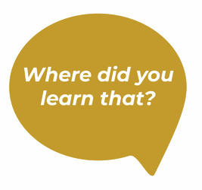
View description - Uncaptioned Figure
View alternative description - Uncaptioned Figure

This course is premised on a belief that we can all take actions within our everyday working lives which contribute to the overall development of equality, participation and inclusion. However, if we wish to explore how to play a leading role in the delivery of inclusive education we have to begin with our understanding of what it is that the education system is trying to achieve. This echoes ideas from a study in Denmark (Thingstrup, Schmidt & Andersen, 2018) which explored how two different groups of educators worked together. One group was largely concerned with qualification (particularly pupils’ academic performance and attainment), the other group focused on broader pedagogic aims that could be seen as more directly related to socialisation and the uniqueness of the individual. Working to achieve competing school goals involved an ongoing negotiation of meaning, a struggle over power, where people took up different positions and adopted different practices dependent upon what was possible (or not) in their particular setting. The researchers concluded that if these people wanted to work together in ways that achieved the intended goals of legislation, they needed to have the space to develop common ground and to explore what they could achieve together.
Many people speak of schooling as if it has some universally understood and agreed values. It is situated, for example, in numerous international conventions and within many countries’ legislation associated with gender, disability, race, equality, rights and ‘the exasperated etc’ (Butler, 1990 p. 143). Consider this quote:

The reasons for providing all the world’s children with high-quality primary and secondary education are numerous and compelling. Education provides economic benefits and improves health. Education is a widely accepted humanitarian obligation and an internationally mandated human right. These claims are neither controversial nor new.
(Cohen, Bloom & Malin, 2006 p. v)

However, despite such claims, delivering education based on equality for all people is neither universal nor historically significant, and it continues to compete with a range of other functions (see Table 1).

Table 1: Examples of driving forces of compulsory education (based on Benavot et al, 2006)
Country/Region | Some of the driving forces
France | Trying to control a powerful catholic church.
Prussia | Supporting the development of the protestant faith.
Scandinavia | Supporting the development of the protestant faith.
Japan | Developing industrial and military competitiveness; reorganising national institutions; creating national solidarity, a central bureaucracy, a skilled labour force and a future elite.
Soviet Russia | Developing a literate nation; establishing meritocracy and the basis for industrial development.
Ecuador | Overcoming parental disinterest and colonial gender bias.
Arab states | Aiming to redress gender disparities.
Spain | Aiming to unify geographically and culturally distinct regions.
Sri Lanka | Aiming to reduce child labour.
India | Aiming to build the nation.

Educational expansion has been an uneven process, with vested political interests having to create educational wholes out of ‘diverse, semi-related, and often non-existent parts’ (Benavot, Resnik and Corrales 2006, p. 4). The impact of respected educational thinkers has been far less influential in initiating education than broader social, political and economic pressures. These social, political and economic processes created administrations which brought together competing interests and loyalties. The mix of priorities and interests meant that the focus of these processes was often not primarily upon what we might now think of as educational targets.

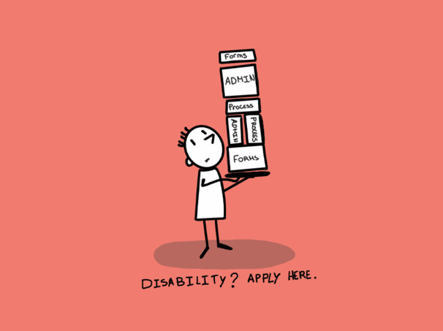
Welcome to disability
View description - Welcome to disability
View alternative description - Welcome to disability

1.1 Asking questions of education
Consider another quote made in relation to education:

Systems and their parts do not develop spontaneously, or in an evolutionary manner, and they do not develop out of purely humanitarian motives. They develop because it is in the interests of particular groups in a society that they should develop and that they should develop in particular ways.
(Tomlinson, 1982, p. 27)

In order to draw out some of these evolved and now taken-for-granted ways of thinking, try a thought experiment suggested by Richard Elmore (1995).

Activity 1: Asking questions of education
45 minutes

Imagine the first day of lessons in a school in which students have not been grouped, teachers have not defined their work according to such groups, no decisions have been made about how much time will be given to content, and no one has decided how student progress will be assessed. Imagine that first morning, imagine hundreds of people arriving of all ages, some to learn, some to teach.
With this in mind, ask yourself these questions:
- Where would you put everybody?
- Do you put everybody in the hall, ask the teachers to stand on one side and the students to stand on the other?
- Do you divide the teachers up first or do you divide the students up?
- Do you create set groups/classes?
  - Are groups you create divided according to demographics, interests or experiences?
  - Are groups defined by number, by space available, by age, by height, by language spoken, by family group?
- Do you expect teachers to teach everything they know or just something they know lots about?
  - Can teachers spend all day teaching something they find interesting?
- Should you expect students to study things they already have some understanding of, or of which they have no understanding?
  - Can students spend all day studying something they find interesting?
- And how do you assess the ability of the teacher to teach and the learner to learn?
- Should you assess what the learner wants to learn or what the teacher wants the learner to learn?
You might want to discuss this thought experiment with a friend or colleague. Make notes about any thoughts you have along the way.

Provide your answer...
View discussion - Activity 1: Asking questions of education

1.2 What challenges do we face?
So what challenges do we face in leading ourselves and others to change our ways to be more inclusive?

Activity 2: A philosopher’s perspective
45 minutes

Read the following extract from: MacIntyre, A. and Dunne, J., (2002) ‘Alasdair MacIntyre on education: in dialogue with Joseph Dunne’, Journal of philosophy of education, 36(1), pp.1–19. (The Open University is not responsible for external content.) Open the link in a new tab or window.
Begin reading from the middle of the last paragraph on page 1 where it begins ‘What the system requires of teachers is the production…’. Then stop reading at the end of third paragraph on page 3 where it ends ‘Some may even become schoolteachers.’
As you are reading make notes about:
- The three areas that MacIntyre believes a successful education should make people ask questions about.
- Whether you have asked yourself these questions or discussed questions of this sort with others.
- The challenge these questions present for a formal social institution.
- How a social institution could encourage people to ask these questions.
When you have finished reading this you may want to have a discussion with friends or colleagues.

Provide your answer...
View discussion - Activity 2: A philosopher’s perspective

In the next section you will explore further the complexity that practitioners are faced with and the nature of the spaces in which you are working.

2 The situation you find yourself in

View description - Uncaptioned Figure
View alternative description - Uncaptioned Figure

Around the world and across the UK, teachers have a responsibility within policy for all the students within their class (Rix, 2020; Messiou et al, 2022). They are being asked to do this at a time of constantly shifting populations and in settings that are becoming increasingly diverse. In England in 2021 for example, over 20% of pupils were on free school meals, over 30% were from a minority ethnic background and over 19% had a language other than English as their first language (ONS, 2021). Similarly, Ireland have a well-established traveller community and have seen a huge growth in immigration with considerable evidence of problematic relationships between students from different groupings (Ní Dhuinn & Keane, 2021). This complexity is global too, so for example, in the Czech Republic concern over the inclusion of the Roma minority led to the government standardising the role of a social pedagogue role within the system (Lorenzova, 2018).
Alongside this increasing complexity (and perhaps as a response) there has been a continual growth in numbers of children identified with Special Educational Needs across the British Isles and in most other countries. This has not necessarily resulted in increased inclusion, however; for example, only 64.77% of pupils with a formal decision of Special Educational Needs are in EU mainstream classes for more than 80% of the week (EASNIE, 2020), while in Mexico and Chile over 70% of disabled children are being educated in special schools (Marchesi, 2019). Given this range of diverse needs and student characteristics and the constraining nature of the education systems that they must fit into, it is perhaps not surprising that across nations children are marginalised from schooling for a raft of reasons beyond their control, such as gender, location, disability, wealth and ethnicity (UNESCO, 2022).
Schools are not just representative of a diverse society through the pupils who attend. The staff within schools can be equally diverse. This is not always the case with the teaching and management of schools, though. In many countries, there are concerns about the homogeneity in the teacher training population, for example, and about the lack of data around this (Bellacicco & Demo, 2019). It is often suggested that the overall education system reflects middle class values and is biased towards this dominant culture. However, this does not mean that everyone working with a school comes from a middle-class background or have universally agreed values about education.

Activity 3: It’s alright for some
60 minutes

These next readings are an opportunity to spend some more time thinking about the different perspectives within a school from a staff perspective. Read these abstracts and then choose at least one extract to read in more detail. As you are reading consider:
- What barriers are these people facing within the school context?
- What are the positive aspects of these experiences as they are presented?
- What kinds of opportunities are there within schools to explore the issues which are identified as being important to the people?
- How does the school experience reflect the wider social context?
- What challenges do these experiences present for someone working in a school?
- Are there perspectives you would like to hear from in relation to experiences in school?
When you have finished reading you may want to have a discussion with friends or colleagues.

Table 2: Abstracts
Bradbury, A., Tereshchenko, A. and Mills, M., (2022) Minoritised teachers’ experiences of multiple, intersectional racisms in the school system in England: ‘carrying the weight of racism’. Race Ethnicity and Education, pp. 1–17.
Abstract: This paper recounts the experiences of 24 primary and secondary teachers from a number of minoritised groups in the education system in England, using interview data collected for a project exploring the retention of minority teachers. The teachers’ experiences of racism are discussed alongside other intersectional aspects of their identities – including gender, class, accent, and the subject they taught – to emphasise the variety of racisms experienced by these teachers. The stories of teachers, both early in their careers and with decades of teaching experience, provide powerful evidence of the cumulative effects of racism experienced by teachers and the continued power of race with the education system in England.
Read: from the start of The research study (p5) to the start of the Conclusion (p. 12)
Ware, H., Singal, N. and Groce, N., (2022) The work lives of disabled teachers: revisiting inclusive education in English schools. Disability & Society, 37(9), pp. 1417–1438.
Abstract: Globally there is a focus on ensuring a more diverse teaching workforce ensuring representation across gender, sexual orientation, race and ethnicity. However, little attention is paid to ensuring the inclusion of disabled teachers. This paper examines the work lives of ten disabled teachers in schools across England. Their experiences suggest that whilst there is a strong discourse on inclusive education within English schools and policies this does not necessarily extend to disabled teachers themselves. Whilst the disabled teachers participating in this research demonstrated ways in which their presence disrupted normative notions of able-bodiedness in education and they actively created spaces for inclusive learning, the majority also reported facing significant discrimination and barriers whilst at work. Urgent change is needed to support disabled teachers to access effective training as well as the removal of barriers to enable disabled teachers to remain in the workforce and progress their careers.
Read: from the start of Our participants and research approach (p. 3) to the start of Discussion (p. 12)
Clarke, E. and Visser, J., (2019) ‘Is a good Teaching Assistant one who ‘knows their place’?’ Emotional and Behavioural Difficulties, 24(4), pp.308–322.
Abstract: Teaching Assistants’ (TAs’) roles in mainstream English primary schools continue to evolve. Research suggests TAs play a vital role in managing behaviour and can have benefits for both teachers and children in relation to supporting positive behaviour in the classroom. However, there is a lack of clarity in what constitutes TAs’ role, particularly when their pedagogical contribution outweighs any other form of support provided to schools. With a lack of clarity in what constitutes the teachers’ and the TAs’ role, TAs’ responsibilities for managing behaviour are opaque. As a result, opportunities for TAs to manage behaviour can be reduced due to their concerns over undermining teachers. The research this paper draws on found TAs were often passive observers in relation to behaviour management as they did not understand how their role correlated to that of teachers’. The concept of what TAs in this research described as ‘knowing their place’ in relation to managing behaviour will be introduced and discussed. Strategies to support TAs in ‘knowing their place’ in a positive, as opposed to pejorative way in managing behaviour will be considered through a range of different approaches to their direct work with children and teachers. The paper then concludes with some ‘next steps’ for schools to consider in supporting TAs to affirmatively find their ‘place’ in managing behaviour.
Read: from the start of Methodology (p. 7) to start of Conclusions (p. 20).
Li, F., 2021. A Narrative Inquiry Into Beginning Teachers’ Meaning Making of Self as a Teacher and Teaching as a Career (Doctoral dissertation, ResearchSpace@ Auckland).
Abstract: This longitudinal study used a qualitative, narrative inquiry approach to examine the influences on beginning teachers’ meaning making of teaching and themselves as teachers. Of particular interest was the process of meaning construction and reconstruction that participants experienced over time. The five participants were all first-year teachers in urban Auckland schools, New Zealand. Data were primarily collected through semi-structured individual interviews conducted five times; once at the end of participants’ initial teacher education (ITE) programme, and four times over their first year of teaching. Interview data were supplemented with field notes and information collected through social media. The data were analysed thematically and presented in two ways: stories that illustrated individual participant’s lived experience and a cross-case analysis of the five participants’ data.
You will be reading about Sophie, a 30-year-old European New Zealander. Prior to entering the Masters teaching programme, Sophie had a bachelor’s degree double majoring in marketing and advertising and worked as an account manager.
Read: from The paragraph which begins: ‘In terms of the kind of teacher she would like to be’ (p. 104) to the start of The Lived Experience of Annie (p. 110)

View discussion - Activity 3: It’s alright for some

2.1 Are teachers prepared for this?
Given the diverse context in which schools exist, it may seem unsurprising that many teachers say (and have said for a long time) that they do not feel well prepared for such a challenge, that they lack resources, time, skills or training (Scruggs & Mastropieri 1996; Rowan & Townend 2016) or that they generally feel under too much pressure in their role.

Activity 4: Are teachers prepared for this?
45 minutes

Read the extracts suggested below and consider the following questions:
- How does teacher training prepare them to work with a wide range of learners and families?
- How does workload impact upon their capacity to respond to diversity?
- What are their experiences of the ways others respond to these pressures?
- How does this influence your attitude towards planning for the involvement of all?
- First read an extract from an Australian paper which explores new teachers’ preparedness for diversity and in particular students who would be identified as gifted.
Rowan, L. and Townend, G., (2016) ‘Early career teachers’ beliefs about their preparedness to teach: Implications for the professional development of teachers working with gifted and twice-exceptional students’, Cogent Education, 3(1), p. 1242458.
Read: from the section on Results (pp. 12–15) and the Sections 7–9, the Discussion, Notes and Conclusion (pp. 19–21)
- Compare this formal report with these informal perspectives upon the reality of a teacher’s life, one from Scotland and one from India. As you read, consider what is said about the time available to work in ways that teachers recognise is the most effective.
Are Indian teachers burning out?
Scots teachers ‘at burnout’ with seven in 10 stressed ‘most or all’ of the time
When you have finished this task, you may want to have a discussion with friends or colleagues about the issues raised.
Optional reading: You might also want to look at an article that shows it is not like this everywhere! Here is one about how a move to work in East Africa made a teacher realise the stress she was under working in England. Secret Teacher: I moved to Africa – and realised how flawed British education is

View discussion - Activity 4: Are teachers prepared for this?

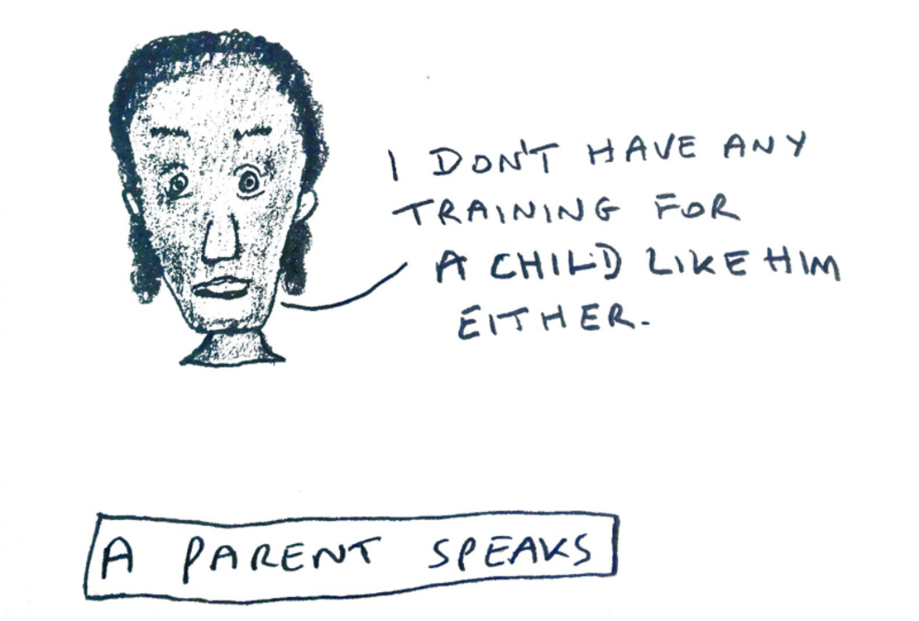
View description - Uncaptioned Figure
View alternative description - Uncaptioned Figure

3 Thoughts on difference

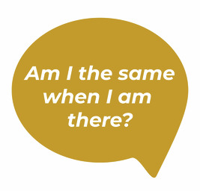
View description - Uncaptioned Figure
View alternative description - Uncaptioned Figure

At the heart of inclusion are our attitudes; in particular (in the complex, diverse world of education) the attitudes which inform our responses to what might be seen as difference. This is because our understandings of difference are central to how we understand and evaluate ourselves, our social situation and our life experiences. The ‘self’ arises as a result of social processes of which we are part. Our sense of who we are is aligned to the reactions of others (Mead, 1934; Cooley, 1962; Becker, 1963). We judge ourselves against the ‘other’ beyond our boundaries; as a consequence, boundary setting is a key dimension in defining and giving meaning to ourselves and our society (Vislie, 2006). The ‘other’ has a broad range of meanings. For Hat Rosenthal (2001) it means any other person. Edward Said (1978) identified how for the ‘the West’ ‘the Orient’ had been a site of contestation, colonisation and cultural resource, and its most enduring image of the other. Simone Du Beauvoir (1949) suggested:

The category of the Other is as primordial as consciousness itself. In the most primitive societies, in the most ancient mythologies, one finds the expression of a duality – that of the Self and the Other. This duality was not originally attached to the division of the sexes; it was not dependent upon any empirical facts. … Thus it is that no group ever sets itself up as the One without at once setting up the Other over against itself (p. xxii–xxiii).

Du Beauvoir noted that identifying the other was usually about the majority imposing ‘its rule upon the minority’ (p. xxiv). She then went on to question this observation by saying it did not apply where women were concerned; but othering also allows the values and ideas of a minority of nations and elites within them to dominate policies and practices. The other is therefore not just to be seen as someone who is not me or a minority, but it is more generally associated with those who are being discursively positioned as being in some way inferior or dangerous or marginal or outside.
When thinking about the ways in which we other people (and how this might influence relationships with all members of a school community), it is helpful to consider how you view difference. Avtar Brah (1996) talks about four ways in which difference can be conceptualised:
- Experience – lived relationships as we perceive them.
- Social Relations – the cultural and historical circumstances and practices producing the conditions from which group identities and shared narratives form.
- Subjectivity – how you make sense of your relationship (your subject position) with the social, cultural and physical environment.
- Identity – your sense of self, a ‘self’ that is situated in a multiplicity of social situations, and is required to present/understand its ’self’ in different (and frequently contradictory) ways.
In this short course it is not possible to explore these issues as broadly and deeply as you might wish; but it should give you the opportunity to explore ways to understand views on difference and people’s experiences of difference.

Activity 5: A different difference?
45 minutes

Read the short article: Thinking Differently About Difference (Martin, 2012) (The Open University is not responsible for external content.)
As you are reading consider particularly what is meant by the three models she proposes for thinking about difference:
- Sameness and difference in binary terms.
- Sameness-difference understood as aspects of diversity.
- Difference-sameness understood as relational.
Then consider how these models might play out in the context of Brah’s 4 conceptualisations of difference (Experience; Social Relations; Subjectivity; Identity). Can you think of examples from your own life and how the models might apply for them? For example, where a binary view of sameness and difference has produced a particular life experience or shaped social relations.
When you have finished this task you may want to have a discussion with friends or colleagues.

Provide your answer...
View discussion - Activity 5: A different difference?

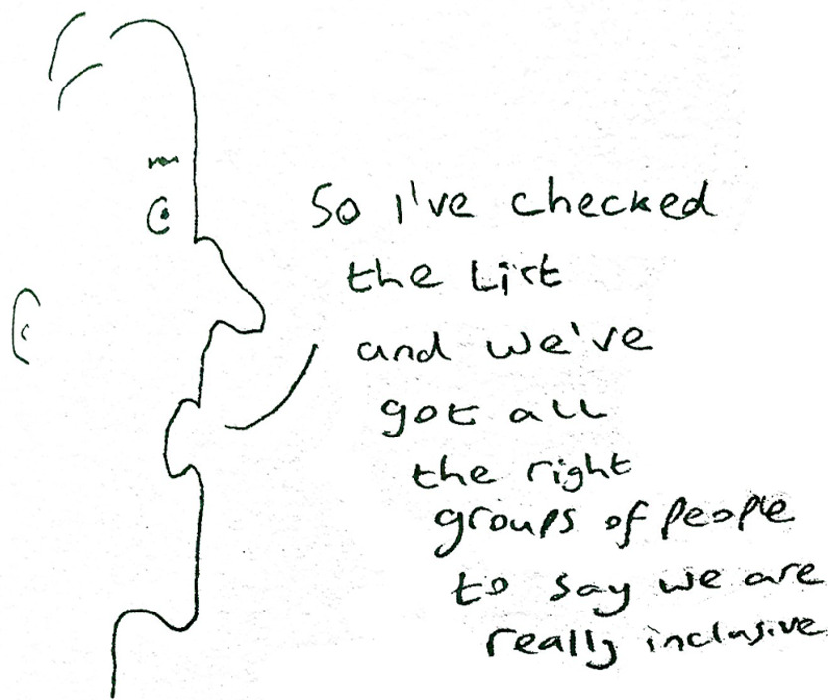
View description - Uncaptioned Figure
View alternative description - Uncaptioned Figure

Activity 6: In the beginning
75 minutes

Stories can help us to understand why things are the way they are, how people feel about them and the nature of the actions which people have undertaken. Storytelling educates because it allows us to translate individual private experience of understanding into a more public culturally negotiated structure (Bruner, 1986). Stories can therefore be a powerful means of explaining and understanding the culture and biases of any institution, as well as providing a tool for disrupting preconceptions and challenging the status quo.
Below are three readings, with suggested extracts to focus upon. The first reading helps you to understand how telling stories about people and institutions can reveal new ways of understanding. The second story focuses upon the way counter-stories can reveal the day-to-day challenges faced in the school situation. The third suggests that counter-stories can be accessible representations used in a variety of ways.
As you read consider the ways the use of such stories could be a tool within the formal and informal moments of the school day to encourage change.
- Dornbrack, J. (2007) ‘Reflecting on difference: an intervention at a public high school in post-apartheid South Africa’, Journal of Education, 41(1), pp. 97–111. Start at: Disrupting stereotypes: focus group 8 (pp. 102–109). (The Open University is not responsible for external content.)
- Martell-Bonet, L., Parenti, T., & Perez, J. I. (2021) ‘Bravery Against Silence: A Composite Counter-Story of Minoritized Students’, Florida Journal of Educational Research 59, 1, pp. 136–149 . Start at: A Latinx Educational Journey (pp. 138–145). (The Open University is not responsible for external content.)
- Dadkhahfard, S. and Takeuchi, M. A. (2020) ‘Visual Counter-Storytelling Toward Equity and Teaching’. In Gresalfi, M. and Horn, I. S. (Eds.), ‘The Interdisciplinarity of the Learning Sciences’, 14th International Conference of the Learning Sciences (ICLS) 2020, vol. 4 pp. 2373–2374. Accessed from https://repository.isls.org/bitstream/1/6566/1/2373-2374.pdf (The Open University is not responsible for external content.)

Provide your answer...
View discussion - Activity 6: In the beginning

4 Engaging with others

View description - Uncaptioned Figure
View alternative description - Uncaptioned Figure

A real challenge for delivering change within school systems is the way schools encourage a view of certain people as ‘other’. This is because so many school practices and their underlying conceptualisations are individually framed. Consider for example the assumptions and ways of supporting people based upon notions of intelligence, development, ability and behaviour. There is a long history of recognising these notions as being socially constructed and socially situated, however within most education systems they are seen as individual characteristics or potentials. As a consequence, you might find yourself evaluating children against these individualised measures or viewing their actions as being based in/on personal characteristics. Our systems do not encourage us to view them as a response to any number of social, contextual factors. Consequently, practices are based around these individualised understandings. For example,
- grouping children according to these assessments, in sets or streams, and then teaching them accordingly
- delivering individual interventions and measuring individual responses to these interventions.
Viewing learners individually creates a barrier by ignoring the involvement (within any learning moment) of complex multiple relationships, cultures and understandings. It ignores how:
- The capacity to shape the circumstances in which we live, our agency, is co-joined with the social, cultural and historical context; and our self is in collaboration with others through the past, present and future (Bruner, 1996).
- Development always involves changing participation within the different communities of which people are a part of (Rogoff, 2003).
- Learning involves coming to understand different possibilities in relationships with others (Lave & Wenger, 1991).
The individual focus encourages us to treat children and young people as isolated individuals. This individualised approach objectifies and quantifies needs, knowledge and skills. It turns the children into ‘units of analysis’ (McDermott & Varenne, 1995, p. 337). This may be convenient for managerial systems, but it creates wider institutional challenges for equality, participation, inclusion and everyday teaching. Not only are ‘individuals’ competing with other economic priorities within administrative budgets (Jóhannesson, 2006), but they are also being seen as individuals in a space that is designed for collective practice. This restrains innovation, even when policy controls are lifted (Ahl, 2007). It also ignores the importance of social engagement as an effective pedagogic approach (Rix et al., 2009) and bypasses the need to plan for social interactions in the learning context.
Perhaps the oddest thing about the dominance of the individualised approach is that practitioners frequently demonstrate a different theory in action. Most practitioners, according to the research, are fully aware of the importance of relationships, the context in which the child is in, and their support activities that take place (Rix, 2023).
Consider how you might build on this recognition of the importance of context, and explore how you can engage with relational opportunities when planning for people identified with difference.

Activity 7: One by one?
30 minutes

Internationally, there are a range of support or inclusion plans in evidence (for example: Individual Education Plans (IEPs)) that operate at different levels of the system (Rix et al, 2013a). There is evidence in a few countries of local development plans or school plans in relation to inclusion and/or special educational needs, and of school pedagogical plans. In some countries, there is also evidence of individualised teaching plans and integration plans. These can outline the actions a school will take over a longer period for an individual child or may co-ordinate support plans across services. However, plans rarely focus upon the broader systems and structures for all pupils. They are generally focused upon individual children. Consider an example of this.
Explore this document which aims to help teachers facilitate student participation. The complete text is interesting, but make sure you read the red, italicised text and spend some time considering the tables.
Kurth, J. A., Miller, A. L. and Toews, S. G. (2020) ‘Preparing for and Implementing Effective Inclusive Education With Participation Plans’, Teaching exceptional children, 53(2) p. 0040059920927433. (The Open University is not responsible for external content.)
As you read, make notes and consider the following questions:
- In what ways does the model proposed in this paper focus upon the individual and what ways upon the collective learning environment? (You might reflect on: the practices advocated; the nature of targets; the involvement of relationships, peers and social interaction.)
- How does this approach to planning reflect your experiences of schooling?

Provide your answer...
View discussion - Activity 7: One by one?

4.1 Starting together
This tendency of paperwork to constrain actions and ignore the possibilities inherent in the context is not just an issue with IEP targets, of course. Consider some ways you might use planning to disrupt the tendency of individualised focus to exclude the individual.

Activity 8: Starting together
20 minutes

Watch this video by Paula Kluth, as you watch consider the following questions:

Video content is not available in this format.
Video 1: Ask autism expert Paula Kluth: Can inclusion work for my child in high school? (Brookes Publishing Co. 2010)
View transcript - Video 1: Ask autism expert Paula Kluth: Can inclusion work for my child in high school? ...

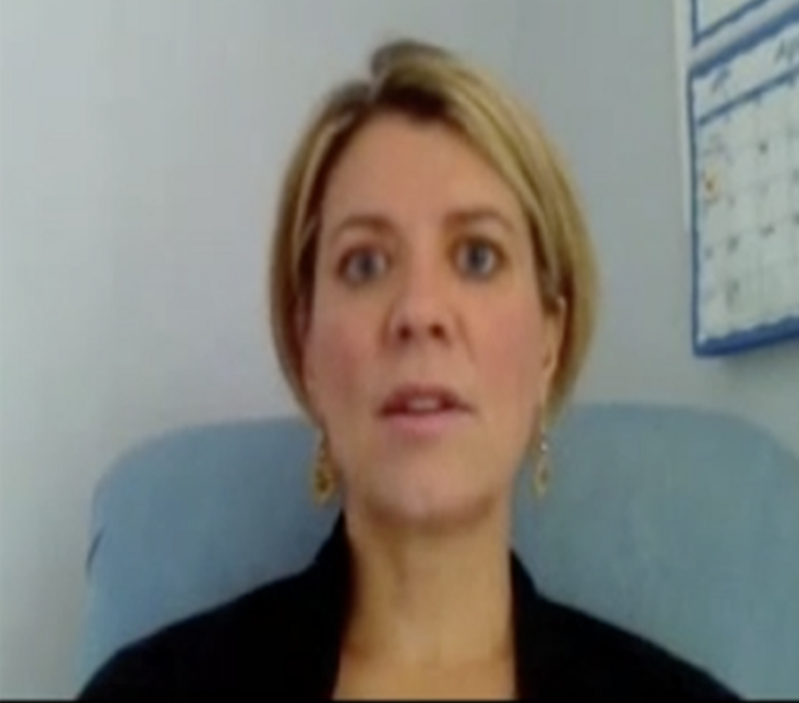

- What are your own views on this issue? Do you share the speaker’s enthusiastic tone?
- Are there other groups or ‘types’ of person to whom similar arguments need to be made to convince people that they should be in school?
- What is your view on the starting premise that the child was included prior to secondary education?
- In what ways might a creative response be possible in an early years or primary setting?
- How creative do you feel you can be in planning your practice and working context?
- Thinking about your working context, are there opportunities which might be available to you and young people you know?

Provide your answer...
View discussion - Activity 8: Starting together

4.2 Just for a change
This final activity is an opportunity to bring together a range of issues raised in this course and to provide another example of possible ways of disrupting our everyday practices. Choose one of the three papers below.

Activity 9: Just for a change
30 minutes

As you read consider:
- What strategy is the paper suggesting will enable a greater sense of participation, inclusion and/or belonginess?
- How might practitioners you know be able to develop this way of working?
- How might you be able to engage in this way of working?
- What would you look for to be supported and to support others to develop this way of working?
The first extract presents a systematic review of pedagogy which is situated in the lives and experiences of indigenous communities, with a particular focus upon the use of drama in various forms. The second extract presents a process of bringing Maltese students together with a group of African unaccompanied minor asylum seekers. This process aimed to encourage the fostering of dialogue and of understanding among themselves. The third extract presents an exploration of simple mechanisms which effected school belongingness in the context of a mathematics classroom over the course of one academic year.
- Hradsky, D. and Forgasz, R., (2022) ‘Possibilities and problems of using drama to engage with First Nations content and concepts in education: A systematic review’ The Australian Educational Researcher, pp. 1–25. (Read the section Drama-based pedagogies from p. 10–12 and then from pp. 14–21. Starting at Outcomes and ending when you reach ‘Conclusion’.)
- Spiteri, D. (2013). ‘Can my perceptions of the “other” change? Challenging prejudices against migrants amongst adolescent boys in a school for low achievers in Malta’, Research in Education, 89(1), pp. 41–60. (Read from pp. 50–59 starting at Results.)
- Booker, K. C., & Lim, J. H. (2018) ‘Belongingness and pedagogy: Engaging African American girls in middle school mathematics’, Youth & Society, 50(8), pp. 1037–1055. (Read from pp.1044–1050 starting at Findings.)

View discussion - Activity 9: Just for a change

If you want to explore these issues further there is a second course on Leading for Inclusion which explores our individual and collective role and capacity to lead through our everyday actions.

Conclusion
This course has explored the competing purposes of schools and the ways in which school structures work against the goals of inclusion while being the means by which inclusion needs to be achieved. It has outlined the complex environment of contemporary schools, not just in relation to the lived experiences of students but also the identities and day-to-day realities for practitioners; and the enormous pressures this brings to bear. It has considered how views on difference and ‘the other’ are at the heart of so many of the experience of marginalisation that arise in this complex context; this has included recognising how our own views on difference affect how we respond, affecting other people’s everyday experiences in school.
As part of this you have considered ways of sharing life stories and how these stories can be used to set up new ways of thinking and understanding, encouraging you to engage with ‘the other’. The course has also suggested ways to build this broader contextualised understanding into everyday planning, seeking creative engagement opportunities spread throughout the day that build personal connections which make school more meaningful and personally relevant.
The relative everydayness of the kinds of actions being described in this course suggest that practitioners are in a good place to be able to support each other to work in these ways. The starting point is not with outside experts and extensive resources, but it is in recognising that the possible is within collective reach, and that everyone has a role in leading each other to where the possible can take us.
If you haven’t already, you might want to consider exploring the related OpenLearn course Leadership for inclusion: what can you do?
If you enjoyed this course, you might be interested in the Open University Inclusive Practice Leadership and Management Masters pathways.

Acknowledgements
This free course was written by Jonathan Rix and published in April 2023.
Except for third party materials and otherwise stated (see terms and conditions), this content is made available under a Creative Commons Attribution-NonCommercial-ShareAlike 4.0 Licence.
The material acknowledged below is Proprietary and used under licence (not subject to Creative Commons Licence). Grateful acknowledgement is made to the following sources for permission to reproduce material in this free course:
Course image: Courtesy: Caroline Rix.
Text
Table 2: Bradbury, A., Tereshchenko, A. and Mills, M., (2022) Minoritised teachers’ experiences of multiple, intersectional racisms in the school system in England: ‘carrying the weight of racism’. Race Ethnicity and Education, pp. 1–17. https://bura.brunel.ac.uk/ bitstream/ 2438/ 25120/ 2/ FullText.pdf Open Access Creative Commons Attribution-NonCommercial-NoDerivs (CC BY-NC-ND
Table 2: Ware, H., Singal, N. and Groce, N., (2022) The work lives of disabled teachers: revisiting inclusive education in English schools. Disability & Society, 37(9), pp. 1417–1438. https://discovery.ucl.ac.uk/id/eprint/10138498/
Activity 4: Rowan, L. and Townend, G., (2016) Early career teachers’ beliefs about their preparedness to teach: Implications for the professional development of teachers working with gifted and twice-exceptional students’ Cogent Education, 3(1), p. 1242458. © 2016 The Author(s). This open access article is distributed under a Creative Commons Attribution (CC-BY) 4.0 license.
Activity 4: Are Indian Teachers Burning out? 6 September 2018 Courtesy: https://brainfeedmagazine.com/are-indian-teachers-burning-out/
Activity 9: Possibilities and problems of using drama to engage with First Nations content and concepts in education: A systematic review (2022) Danielle Hradsky1 · Rachel Forgasz2 © The Author(s) 2022 Open Access This article is licensed under a Creative Commons Attribution 4.0 International License, http://creativecommons.org/licenses/by/4.0/ .
Illustrations
Activity 4: ‘A Parent Speaks’ Courtesy: Jonathan Rix
Activity 5: ‘So I’ve checked the list…’ Courtesy: Jonathan Rix
Video
Video 1: Q & A with Paula Kluth Brookes Publishing Co. (2010) https://www.youtube.com/watch?v=nsivrT4dX4M
Every effort has been made to contact copyright owners. If any have been inadvertently overlooked, the publishers will be pleased to make the necessary arrangements at the first opportunity.
Don't miss out
If reading this text has inspired you to learn more, you may be interested in joining the millions of people who discover our free learning resources and qualifications by visiting The Open University – www.open.edu/openlearn/free-courses.

References
Ainscow, M, & Sandill, A. (2010) ‘Developing inclusive education systems: the role of organisational cultures and leadership.’ International Journal of Inclusive Education, 14 (4), 401-416
Amaral M do & Zelinka, J. (2019) ‘Lifelong learning policies shaping the life courses of young adults. An interpretative analysis of orientations, objectives and solutions’, Comparative Education, 55(3), pp. 404–421,
Bannink, F., Nalugya, R. and Van Hove, G., (2019). ‘They Give Him a Chance’-Parents’ Perspectives on Disability and Inclusive Primary Education in Uganda. International Journal of Disability, Development and Education, pp. 1–19.
Benavot, A., Resnik, J. & Corrales, J. (2006) Global Educational Expansion: historical legacies and political obstacles, American Academy of Arts and Sciences, Cambridge, MA
Biesta, G. (2010) Good Education in an Age of Measurement. London: Paradigm. Biesta, G. (2013) The Beautiful Risk of Education. London: Paradigm.
Biesta, G., 2009. Good education in an age of measurement: On the need to reconnect with the question of purpose in education. Educational Assessment, Evaluation and Accountability (formerly: Journal of Personnel Evaluation in Education), 21(1), pp. 33–46
Biesta, G., 2020. Risking Ourselves in Education: Qualification, Socialization, and Subjectification Revisited, Educational Theory, 70(1), pp. 89–104.
Booth, T., 2011. The name of the rose: Inclusive values into action in teacher education. Prospects, 41(3), pp. 303–318.
Brah, A. (1996) Cartographies of diaspora, Routledge, London
Bruner, J. (1986) Actual Minds, Possible Worlds. Cambridge, MA, Harvard University Press.
Bruner, J. S. (2001). The Culture of Education. Cambridge, Mass.: Harvard University Press.
Butler, J. (1990) Gender Trouble. Feminism and the subversion of identity, New York, Routledge.
Cohen, J., Bloom, D. & Malin, M. (2006) Preface in Benavot, A., Resnik, J. & Corrales, J. Global Educational Expansion, the American Academy of Arts and Sciences, Cambridge, MA.
Committee on the Rights of Persons with Disabilities (CRPD) (2016) Convention on the Rights of Persons with Disabilities, General comment No. 4 (2016) Article 24: Right to inclusive education, United Nations.
Cooc, N., & Kiru, E. W. (2018). Disproportionality in special education: A synthesis of international research and trends. The Journal of Special Education, 52(3), pp. 163–173.
Cooley, C. H. (1902) Human Nature and the Social Order; New York, Charles Scribner’s sons.
Dorn, S. & Johanningmeier, E. (1999) Dropping out and the Military Metaphor for Schooling, History of Education Quarterly, 39(2), pp. 193–198.
Du Beauvoir, S. (1949) The Second Sex, Jonathan Cape, London.
Elmore, R., (1995) ‘Teaching, learning, and school organisation: principles of practice and the regularities of schooling’, Educational Administration Quarterly, 31(3), pp. 355–74.
Gellner, E. (1983) Nations and Nationalism. New York: Cornell University Press.
Hart, C. (2011) Poverty and History, Milton Keynes: AuthorHouse.
Hart, S. (2010) ‘Learning without limits’. In Rix, J., Nind, M., Sheehy, K., Simmons, K., Parry, J. & Rajni, K (eds) Equality, Participation and Inclusion 2: Diverse Contexts, Oxon, Routledge.
Hausstätter, R (2014) ‘In Support of Unfinished Inclusion’, Scandinavian Journal of Educational Research, 58(4), pp. 424–434.
Love, H. R. and Beneke, M. R., (2021) ‘Pursuing justice-driven inclusive education research: Disability critical race theory (DisCrit) in early childhood’, Topics in Early Childhood Special Education, 41(1), pp. 31–44.
Lucas, B. and Spencer, E., (2016) Response to Commons Select Committee Inquiry: Purpose and Quality of Education in England: Written Evidence Submitted by the Centre for Real-World Learning at the University of Winchester and Others. Available at: http://data.parliament.uk/writtenevidence/committeeevidence.svc/evidencedocument/education-committee/purpose-and-quality-of-education-in-england/written/27451.pdf (Accessed: 7 December 2022).
MacInnes, J. and J. Diaz (2009) ‘The Reproductive Revolution’, The Sociological Review 57(2), pp. 262–284.
MacIntyre, A. and Dunne, J., (2002) ‘Alasdair MacIntyre on education: in dialogue with Joseph Dunne’, Journal of philosophy of education, 36(1), pp. 1–19.
Mangan, J. & Galligan, F. (2011) ‘Militarism, Drill and Elementary Education’, The International Journal of the History of Sport, 28, 3–4, pp. 568–603.
Marchesi, A. (2019) ‘Salamanca 1994-2019: there is still a long way to Latin America’, International Journal of Inclusive Education, 23:7–8, pp. 841–848.
McDermott, R., & Varenne, H. (1995) ‘Culture as Disability’, Anthropology & Education Quarterly, 26(3), pp. 324–348.
Mead, George Herbert. 1934. Mind, Self and Society. Chicago: University of Chicago Press.
Messiou, K., Bui, L. T., Ainscow, M., Gasteiger-Klicpera, B., Bešić, E., Paleczek, L., Hedegaard-Sørensen, L., Ulvseth, H., Vitorino, T., Santos, J. and Simon, C. (2022) ‘Student diversity and student voice conceptualisations in five European countries: Implications for including all students in schools’, European Educational Research Journal, 21(2), pp. 355–376.
Partnership for 21st Century Skills (2007a) Learning for the 21st Century. Retrieved 3 May 2009: http://www.21stcenturyskills.org/downloads/P21_Report.pdf
Partnership for 21st Century Skills (2007b) The Intellectual and Policy Foundations of the 21st Century Skills Framework. Retrieved 3 May 2009: http://www.21stcenturyskills.org/
Pellicano, E., Dinsmore, A., & Charman, T. (2014) ‘What should autism research focus upon? Community views and priorities from the United Kingdom’, Autism, 18(7), pp. 756–770.
Rieffer, B. ( 2003) ‘Religion and Nationalism’, Ethnicities, 3(2) pp. 215–242.
Rix, J. (2023) ‘Re-examining special needs – What could be better?’ In: Tierney, R. J., Rizvi, F., Erkican, K. (Eds.), International Encyclopedia of Education, vol. 9. Elsevier.
Rix, J. (2020) ‘Our need for certainty in an uncertain world: the difference between special education and inclusion?’ British Journal of Special Education, 47(3), pp.283–307.
Rix, J. (2015) Must Inclusion be Special? Rethinking Educational Support in a Community of Provision, Routledge, London.
Rix, J. (2010) 21st Century Skills...All dressed up in the technology of the Knowledge Age in K. Sheehy, R. Ferguson & G. Clough (Editors) Controversies at the Frontier of Education (Education in a Competitive and Globalizing World) New York. Nova Science. (pp. 103–124).
Rosenthal, H. (2001) Discussion Paper—Working Towards Inclusion: ‘I am another other’, Educational Psychology in Practice, 17(4).
Said, E. (1978) Orientalism, Pantheon Books, New York.
Slee, R. & Allan, J (2001) ‘Excluding the Included: a reconsideration of inclusive education.’ International Studies in Sociology of Education, 11(2), pp. 173–191.
Thingstrup, S., Schmidt, L. & Andersen, R. (2018) ‘The purpose of education: pedagogues’ and teachers’ negotiations in Danish primary schools’, Educational Action Research, 26(3), pp. 354–364.
Tomlinson, S. (1982) A Sociology of Special Education Routledge & Kegan Paul. London.
Trilling, B. (2003). The Once and Future Kingdom of Learning. Retrieved 8 October 2007: http://www.siia.net/upgrade/archive/1011_03/trilling.pdf
Trilling, B., & Hood, P. (1999). Learning technology and education reform in the Knowledge Age or 'We're wired, webbed and windowed, now what?' Educational Technology, 39 (3), 5-18. Retrieved from http://www.wested.org/online_pubs/learning_technology.pdf
Tyack, D. B., & Tobin, W. (1994) ‘The ‘Grammar’ of Schooling: Why Has It Been So Hard to Change?’ American Educational Research Journal, 31(3), pp. 453–479.
Vislie, L. (2006), ‘Special education under the modernity. From restricted liberty, through organized modernity, to extended liberty and a plurality of practices’, European Journal of Special Needs Education, 21(4), pp. 395–414.
Walton, N. (2017). Worldwide educating for the future index. (M. Gold, Ed.) Retrieved from The Economist Intelligence Unit: http://dkf1ato8y5dsg.cloudfront.net/uploads/5/80/eiu-yidan-prize-educating-for-the-future-wp-final.pdf

Solutions

Activity 1: Asking questions of education

Discussion
In answering the questions in Activity 1 you are beginning to explore broader issues which underpin how we create our educational spaces. For example:
- Should, and can, all children learn and play together?
- In what ways are children different (or similar) and how should this affect the opportunities they are presented with?
- To whom should we allocate limited resources?
- What education and social care system is best for the country and its economy?
- What expectations should we have of practitioners?
In answering these questions, you are also likely to have looked back at your own experiences, and reflected upon where your ideas and beliefs have come from. This might involve looking back on your own education, or forward to the education you’d like for future generations; or experiences you have had in other settings. If you are a practitioner, it could have reflected the kinds of environments you have worked in or the challenges and opportunities you have experienced in different contexts. If you have felt marginalized by experiences, you may have wanted to disrupt the structures that supported your marginalisation in order to create new possibilities.
It is perfectly possible that in responding to the last activity, you suggested spreading all the students who arrived at the ‘school’ amongst knowledgeable people in their local community. You might have wanted to work against a simplistic notion that one group of people has something to learn and another group of people has something to teach. You may feel that everyone has the ability to learn and everyone has the ability to assist others to learn, or that teaching and learning is not neatly assessable; maybe you want us to see them as hand-in-hand, that through teaching something we learn from it, and through learning something we become teachers. After all, in many languages, the word for teaching and learning is the same.
Your thinking may also have been influenced by the theoretical statement at the start of Activity 1. You may have considered how your answers to these questions reflect ‘the interests of particular groups in a society’. When examining and proposing the kinds of challenges at the heart of a course such as this, it is always useful to note who is beneﬁting and who is being disadvantaged. Whose version of events are you listening to? Whose voice is being heard? The official history rarely includes the experiences of the people on the margins or who have been the targets of intervention and what has been perceived as its solutions and innovations. For example, Pellicano et al (2014) identified that over a 10-year period in the UK, over half of the funding associated with autism went to studies focused on biology, brain and cognition, and just over 1% on societal issues and explorations of people’s lived experience.
These questions are particularly relevant in a consideration of inclusive education, because across a broad sweep of literature, inclusive Education can be seen as an ‘assault on oppressive vestiges of the past’ (Slee and Allan, 2001, p. 176). The call is for transformation, evolving and changing continually (Hausstätter, 2014), involving a commitment to proactively eliminate barriers, to respond flexibly and to create change in the policies, practices and cultures of ‘regular’ schools (CRPD, 2016), as well as changing the ‘behaviour’ of adults (Ainscow & Sandhill, 2010).
Back to - Activity 1: Asking questions of education

Activity 2: A philosopher’s perspective

Discussion
A key challenge which MacIntyre seems to be setting before us is how education can transform itself through itself. As the psychologist Bruner (2001) suggested this is much more than a discussion about ‘conventional school matters like curriculum or standards or testing’ (pp ix). This touches upon what society wants to achieve through educating its young, how it conceives of itself and its wider aims. Bruner makes the point that education is a reflection of societal ambitions, not merely that school should deliver what society wants. He asks his reader to consider cultural aims. Later in his book, Bruner makes it clear that a prime cultural aim of education should be transformative and moral:

Nobody doubts that it would be desirable for us to compete in world markets, and that being first in one [international academic results] would help us to be first in the other [competing in world markets]. But what does it mean to be ‘first’ if we do not address the countervailing ideal of developing human potential as fully as we can? And how does it speak to the sense of socioeconomic jeopardy into which families feel they have been put by the increasingly unjust distribution of wealth in the broader community? If the broader culture took on the challenge of becoming a mutual community, perhaps our boasts about our future prowess might be accompanied by the guarantee that making the country richer by working hard in school would not just make the rich richer and the poor poorer, but would result in a new pattern of distributing the national wealth more equitably. In a word, we would not simply be trying to reproduce the culture as it has been. (Bruner, 2001, pp. 82–83)

As you read this, you may think that responding to the issues discussed by Bruner and MacIntyre is beyond the control of practitioners. You may feel we just have to work with what we have got and do the best we can. You may see the curriculum and school goals within which you operate as our best means of delivering change in individual pupils’ lives at this point in time. This would exemplify the competing views which exist in our school systems of course, but it would also bring us back to the key problem with which these philosophical ideas are grappling. A very simple practical problem. If we exist in a system full of complex, contradictory values, creating exclusionary experiences and we see inclusive education as the means to transform that system, how do we work through that system to create greater inclusion?
Back to - Activity 2: A philosopher’s perspective

Activity 3: It’s alright for some

Discussion
A key barrier across the papers was stereotypical presumptions about who people were, in relation to such things as sexuality, gender, leadership style and competence. In all the stories, people found themselves excluded from various school networks or opportunities within the school, being judged against different criteria to others, or against values which they did not agree with, whilst being required to compromise who they might be in other contexts. In many ways they lacked a voice, and had limited opportunities, often pushing them to work in particular ways or particular areas of the school. This limited their choices. It had an effect on their sense of self, making them at times vulnerable. The stories tell of people who were situated in some way against the dominant narratives of the school, having limited scope to make a difference; for example, being offered token appointments or limited access to training or constraining the kinds of communications they could have with students and colleagues. Many people felt that they had to move to another work place.
Across all these papers, there was also a positive sense of people who had a strong commitment to the learners with whom they worked, to being meaningfully involved in their learning. They also wished to challenge the kinds of inequitable responses they faced, but they required a degree of self-resilience and a capacity to resist. This capacity was often rooted in their identity and networks beyond the school.
In telling these stories, the researchers highlighted the need to listen and to include case studies like these in training. They wanted us to explore both what is said and what is so often left unsaid in relation to these issues and experiences. They encouraged us to challenge presumptions in how we recruit, support and evaluate the contributions of people, to look beyond stereotypes and established – unquestioned – practices. These stories of people’s day-to-day interactions can inform your reflections upon your own role, the challenges you and others face, and how lived school experiences are situated within wider social justice agendas.
It is also interesting to consider the kinds of voices that are not here. When developing this activity, the authors spent time seeing if there was research into the experiences of Premises Manager or Kitchen Staff or School Cleaners. These seem to us to be very important voices in schools. Some historical documents were found, related to Dinner Ladies and Janitors but no contemporary material and nothing that related to their role in a community which is intended to focus upon learning. This encourages the question of what this says about researcher’s priorities, the shared understanding of who supports learning in schools, how learning is understood and how it happens.
Back to - Activity 3: It’s alright for some

Activity 4: Are teachers prepared for this?

Discussion
It seems fairly clear that many teachers do not feel they are well prepared to deal with a wide range of learners and families. They also seem to feel that the pressure of workload limits their capacity to work ways which (they feel) require new knowledge. However, teaching is not just an intellectual exercise. It is also about interpersonal interactions, which are deeply tied up with our emotional responses. In 2006, a research report came out in the UK which had been commissioned by one of the main teacher unions, the National Union of Teachers (Macbeath, Galton, Steward, Macbeath, & Page, 2006). In this report the authors noted how the challenges of delivering the national curriculum to a diverse group, is inherently tied up with being able to control that class, but rather than admit this fear (which is understandable response given that they have to deal with the reality on a regular basis) they tend to blame external factors beyond their control for their current practice. They feel justified if they can focus the blame upon resources, space, time or training, rather than upon their sense of vulnerability.
But as was evident in the experiences of teachers, there are also a great many unspoken biases within the system. Many of these represent discriminatory views and practices of that people may be unaware of or which they do not examine. This does not require a malevolent act, but just an unquestioning one; perhaps accepting something or responding to something in a particular way because it is the majority view or the traditional way or ‘just how it is’. So, for example, unequal treatment can emerge through disrespectful and micro-aggressive responses on the basis of ethnicity and gender even with a highly respected and experienced teacher who in other circumstances is held up as an exemplar of good practice (Beaulieu, 2016). There are a great many reasons therefore why our behaviours may not always match up to our expressed beliefs.
The intention of the statistics and readings presented in this section is to demonstrate the complex landscape in which we must manage the relationships which are at the heart of successful inclusion. If we wish to lead change we cannot begin where people are not: we have to accept that many people feel they do not have the time, space and skills to start working in new ways. We have to begin with where people are.
Back to - Activity 4: Are teachers prepared for this?

Activity 5: A different difference?

Discussion
When carrying out this activity, you considered labels and where they would fit in relation to these models; after all we attach labels to children and colleagues which position them in all kinds of categories related to knowledge, skills, life experiences, personal characteristics, abilities and so forth. You could see the first model in play when labels are used to define people in binary terms, placing people in one group or another – making them insiders and outsiders. But we could also see the second model in action when labels have a role to play as an aspect of diversity; with the label perhaps being understood as one identity among many.
However, in both instances you saw how such a label might constrain how an individual experienced the social context of a school. The label could frame that person’s position in that context and therefore their sense of self and the role they played within the school community. You will hopefully have recognised that anything which encourages the practitioner to view the child in separation from the others risks separating them in practice, thus removing them from collective planning and collective learning opportunities. In contrast, holding the third model of difference would mean that labels themselves would be understood as social constructions and the characteristics and behaviours they described could be seen not as aspects of an individuals but as things that emerged from the relationships with which they were engaged.
It is this latter approach which reflects the views and values underpinning much of the literature associated with inclusive education and how systems can be transformed. In seeking to encourage and support the delivery of inclusive education, a key role everyone can play therefore is in disrupting categorical views of difference. These views position people as other, limit our understandings of each other and constrain our imagining of possible futures.
So, now consider some ways to disrupt our notions of difference and the categories you might use to understand that difference.
Back to - Activity 5: A different difference?

Activity 6: In the beginning

Discussion
Stories are not inherently positive. It is quite possible, as a result of deficit-storytelling, for people to internalise negative stereotypic images that more powerful groups have constructed through stories (for example, stereotypes about gender roles or characteristics associated with a type of impairment). Such cultural stereotypes can both suppress someone’s performance, their perception of their own abilities and other people’s views of their capabilities. However, counter-stories can work against this. They are powerful because they offer a lens for reviewing discrimination, prejudice, inequity, racism and intolerance. They make us question the everyday representations of people in the media, within policy, within paperwork or in our collective and individual understandings. They help people to explore and explain their oppression, and because they are stories, they are also readily accessible.
Stories also enable you to understand other people’s ways of doing things. They are a means to explore alternative ways of working, without having to develop a deep theoretical understanding or specialist knowledge base. A tale about who someone is, their interests and capacities, is a means to opening up possibilities; to offer new ways forward. It can provide a space for thinking about that person, the context they are in and the relationships you and others have with them. If you listen to a story, you are included; and by listening to someone tell a story you too are including them.
A challenge, perhaps, is how to enable counter-stories to be heard. Given the human love of telling tales, it is something people are likely to find rewarding, and they are relatively simple to share. Inevitably, there are ethical issues which may need to be resolved, but they can, for example, be formally collected and shared as a professional development or a curriculum activity. They are also something that can be easily engaged with and encouraged in far less formal circumstances.
Back to - Activity 6: In the beginning

Activity 7: One by one?

Discussion
The intention of this document seems good. It really wants to encourage the involvement of ‘students with disabilities’ to ensure that they ‘have access to, and make progress in, the general education’. But how they wish to do this does not focus upon the socially interactive, collectively situated context in which the plans exist. The participation plan template on page 9, for example, focuses almost entirely on skills to teach or be supported. The only mention of other children is as a group or as part of a group. The use of terms such a social and peers is always linked to a predetermined goal. There is no real consideration of the people around, about enjoyment or relevance to the learner.
There is no sense that what is being expected of the whole class or the teachers is going to be changed in any meaningful way, either. Even the ‘universal supports’ are largely in the established chalk and talk tradition. This plan is about seeking opportunities to insert individual targets into everyday class routines. It is about people identifying what the learner needs to know and then looking for ways to focus on this.
The widespread use of Individual Education Plans (IEPs) internationally exemplifies this individualised focus of school approaches. Despite serving multiple purposes IEPs primarily focus on the deficit in the child (for example Isaksson, Lindqvist, & Bergström, 2007). Similarly, practices intended to support children’s participation, such as differentiation, programmes of learning or behaviour modification, typically serve to separate them (Rix, 2015). They tend to position children as passive recipients of interventions, based on the dominant institutional expectations, routines and practices, in ways that both exclude many children’s life experiences and create fixed notions of their abilities (Love & Beneke 2021).
When reflecting on this document the authors recalled observing a young man in Norway, in a research project, whose curriculum called for him to study English; so he did this while the rest of the class did Norwegian folk tales; something he could have participated in. A planning document like the one you have just read might help to avoid such extreme exclusion but in highlighting each IEP goal as it does, it is perfectly possible to create multiple moments of equivalent exclusion. It would be simple for the focus-child’s possible interaction to become predetermined, separating them out from other people’s activity, marking out their difference and imposing a top-down social order.
Back to - Activity 7: One by one?

Activity 8: Starting together

Discussion
As you watched, you might have wondered why some secondary schools do successfully engage with learners who fall outside schools established ‘norms’ of behaviour and identity, but others struggle to do so? This is not a comfortable contradiction for anyone involved in education. The opportunity to make a difference through creative thinking of the sort suggested by Paula Kluth seems available to people working in all kinds of school roles too. In opening up thinking, you are also encouraged to think beyond the formal structures and to consider the wider school context. In doing so, you are more likely to consider the possibilities for social interactions which can arise throughout the day and beyond the typical classroom constraints.
The speaker seemed to base her guidance on a collective response to difference, seeing collaborative social interactions as the means for achieving an effective school response. Consequently, the approaches described were not focused upon individual challenges or subject areas but across the curriculum and across the range of difficulties pupils face in schools. You might have been aware too that this approach to opening up possibilities was much more than a single category issue. Disability categories as used in schools show strong gender and race bias in many systems (Cooc & Kiru, 2018). Gender is still a clear barrier to attendance for a range of cultural reasons in many countries, while the explicit racist policies of the United States (e.g. Jim Crow Laws), South Africa (e.g. Group areas act) and Empire (e.g. the slave trade) live on in the memory and understandings of many and are still exerting an influence in less formalised ways. In many countries it would still be necessary to fight for an openly gay person to attend school and their lives would be put at risk if they did so; and issues around how individuals define their gender are still hotly contested. Issues of religion, ethnicity, faith and economic well-being are also major barriers in many countries, as are difficulties arising from migration and language use. There are examples in all these instances where currently and historically the argument would be made that ‘they’ could not be educated and were in some way too much of a threat or too vulnerable to be included.
Back to - Activity 8: Starting together

Activity 9: Just for a change

Discussion
These readings were examples of practitioner-friendly proactive classroom practices, which can challenge exclusionary practices, while operating in locally-meaningful, accessible and flexible ways. You might have noted how simply engaging with an issue can open up routes to greater empathy and understanding. These create points of reference in our own lives which help to consider the challenges others face and the ways in which responses may marginalise or challenge that marginalisation.
You might also have noted how the practices in these papers can help to build bridges for students and enhance their sense of well-being and participation. You may also have noted that they did not require:
- extensive training programmes
- knowledge about a type of student
- deep theoretical shift in the approach to teaching and learning.
They involved having conversations with students and colleagues, making personal connections and finding ways to make learning relevant to people’s lives. There is a focus upon the need for the teachers to reflect upon their practice and the lives of the people they are working with. This suggested an idea which is central to many education systems, the notion of Bildung. Bildung recognises that the focus of education is the teacher and learner interaction, and through this interaction we seek the emergence of a student’s agentive, owned state of learning. This is why the student has to value what they are being asked to engage with and in some way has to share values with the teacher.
Back to - Activity 9: Just for a change

Descriptions

Uncaptioned Figure
Speech bubble with the text: ‘Where did you learn that?’
Back to - Uncaptioned Figure

Uncaptioned Figure
Speech bubble with the text: ‘Where did you learn that?’
Back to - Uncaptioned Figure

Welcome to disability
A stick figure carrying a plate of large boxes stacked up high. They are labelled ‘forms’ ‘admin’ and ‘process’.
Back to - Welcome to disability

Welcome to disability
A stick figure carrying a plate of large boxes stacked up high. They are labelled ‘forms’ ‘admin’ and ‘process’.
Back to - Welcome to disability

Uncaptioned Figure
speech bubble image with the text: ‘Is this everyone?’
Back to - Uncaptioned Figure

Uncaptioned Figure
speech bubble image with the text: ‘Is this everyone?’
Back to - Uncaptioned Figure

Uncaptioned Figure
Cartoon of a talking head with a speech bubble ‘I don’t have any training for a child like him either’ ‘A parent speaks’.
Back to - Uncaptioned Figure

Uncaptioned Figure
Cartoon of a talking head. It shows a person with a speech bubble saying ‘I don’t have any training for a child like him either’. It is captioned ‘A parent speaks’.
Back to - Uncaptioned Figure

Uncaptioned Figure
speech bubble image with the text: ‘Am I the same when I am there?’
Back to - Uncaptioned Figure

Uncaptioned Figure
speech bubble image with the text: ‘Am I the same when I am there?’
Back to - Uncaptioned Figure

Uncaptioned Figure
Cartoon of a talking head with a speech bubble ‘So I’ve checked the list and we’ve got all the right groups of people to say we are really inclusive’.
Back to - Uncaptioned Figure

Uncaptioned Figure
Cartoon of a talking head. It shows a person with a speech bubble saying ‘So I’ve checked the list and we’ve got all the right groups of people to say we are really inclusive’.
Back to - Uncaptioned Figure

Uncaptioned Figure
speech bubble with the text: ‘Can I start from here?’
Back to - Uncaptioned Figure

Uncaptioned Figure
speech bubble with the text: ‘Can I start from here?’
Back to - Uncaptioned Figure

Video 1: Ask autism expert Paula Kluth: Can inclusion work for my child in high school? (Brookes Publishing Co. 2010)

Transcript
PAULA KLUTH:
Today's question is about secondary education. Specifically the question is, my child was included for middle school. Can inclusion still work in high school? My answer is an enthusiastic yes. There are some things that we have to do differently or think differently about. But I think actually high school is one of the best environments to think creatively about inclusion.
There are at least three reasons for that. One is that in high school, you have a wide range of classes offered. In elementary school, this isn't true. Everyone does the same thing. And there's one kind of math to take. In high school, you have to take advantage of the entire catalog. You have to look across grade levels. You have to be creative. Some kids may need physical education twice a day.
Some kids may want to sample a course that you wouldn't typically pick for them. Maybe they're struggling academically, but you choose a really high level social studies course like a Russian history course because the child has a specific interest or knows information about Russia that could be an area of fascination or something. So really think creatively about what's available.
A second way to think about making high school inclusion successful is to use the peer. So a lot of high schools already have peer tutors available. They have a peer tutoring system. And think in two ways about this, first, that you can substitute typical classes for a peer tutor relationship in math, in reading skills, in a number of areas where instead of going and sitting and getting, you can work on these social skills and relationships while kids are getting what they need.
The other thing is there may be some kids with Asperger's and autism who want to be tutors. And that can be another good use of their classroom time. Finally, look at experiences beyond classroom walls like mentorships and work experiences and service learning and project-based learning. A lot of these are available in certain programs. Like maybe in business education, they have these or maybe in certain extracurriculars. They're connected to extracurriculars, or maybe there are certain classes that have clubs attached where kids can work at a school store.
And there's a whole host of possibilities in schools if you really look at every single learning experience. But you have to ask questions, talk to the kids themselves. And oftentimes you'll find that planning for a student in high school inclusion can be even a bit, if not easier, certainly can bring out your creativity a little bit more.
Back to - Video 1: Ask autism expert Paula Kluth: Can inclusion work for my child in high school? (Brookes Publishing Co. 2010)

