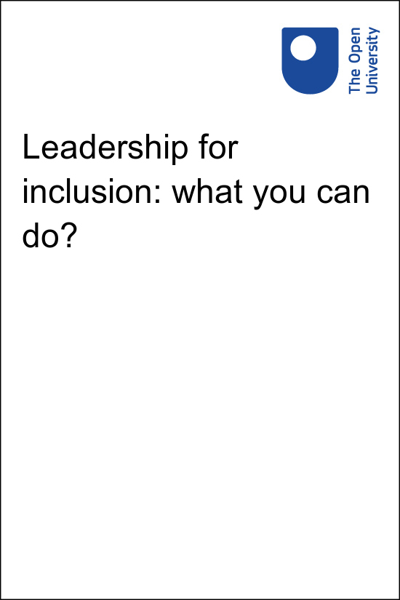

LFI_2

Leadership for inclusion: what you can do?

About this free course
This free course is an adapted extract from the Open University course .
This version of the content may include video, images and interactive content that may not be optimised for your device.
You can experience this free course as it was originally designed on OpenLearn, the home of free learning from The Open University –
There you’ll also be able to track your progress via your activity record, which you can use to demonstrate your learning.
Copyright © 2022 The Open University
Intellectual property
Unless otherwise stated, this resource is released under the terms of the Creative Commons Licence v4.0 http://creativecommons.org/licenses/by-nc-sa/4.0/deed.en_GB. Within that The Open University interprets this licence in the following way: www.open.edu/openlearn/about-openlearn/frequently-asked-questions-on-openlearn. Copyright and rights falling outside the terms of the Creative Commons Licence are retained or controlled by The Open University. Please read the full text before using any of the content.
We believe the primary barrier to accessing high-quality educational experiences is cost, which is why we aim to publish as much free content as possible under an open licence. If it proves difficult to release content under our preferred Creative Commons licence (e.g. because we can’t afford or gain the clearances or find suitable alternatives), we will still release the materials for free under a personal end-user licence.
This is because the learning experience will always be the same high quality offering and that should always be seen as positive – even if at times the licensing is different to Creative Commons.
When using the content you must attribute us (The Open University) (the OU) and any identified author in accordance with the terms of the Creative Commons Licence.
The Acknowledgements section is used to list, amongst other things, third party (Proprietary), licensed content which is not subject to Creative Commons licensing. Proprietary content must be used (retained) intact and in context to the content at all times.
The Acknowledgements section is also used to bring to your attention any other Special Restrictions which may apply to the content. For example there may be times when the Creative Commons Non-Commercial Sharealike licence does not apply to any of the content even if owned by us (The Open University). In these instances, unless stated otherwise, the content may be used for personal and non-commercial use.
We have also identified as Proprietary other material included in the content which is not subject to Creative Commons Licence. These are OU logos, trading names and may extend to certain photographic and video images and sound recordings and any other material as may be brought to your attention.
Unauthorised use of any of the content may constitute a breach of the terms and conditions and/or intellectual property laws.
We reserve the right to alter, amend or bring to an end any terms and conditions provided here without notice.
All rights falling outside the terms of the Creative Commons licence are retained or controlled by The Open University.
Head of Intellectual Property, The Open University

Contents
- Introduction
- Learning outcomes
- 1 Who are leaders?
  - 1.1 Is it just a small thing?
- 2 In this together
  - 2.1 Do traditional classrooms constrain collaboration?
  - 2.2 What is the cost?
- 3 Embracing uncertainty
  - 3.1 Institutional and personal spaces
- 4 Advocating for others
  - 4.1 Understanding the best option
- Conclusion
- References
- Acknowledgements
- Solutions

Introduction
This course will help you to develop your understanding of how to promote and support learning for all, within classrooms with a diverse student and staff population. It will encourage you to embrace your own capacity to lead at any level of an organisation. You will explore the tensions around collective responses and individualised challenges, consider these alongside the need to embrace risk and recognise the opportunities that arise from everyday uncertainty. By engaging with these inclusive principles, you will be invited to seek out ways in which you can support others and so enhance collective learning opportunities.
If you haven’t already, you might want to consider exploring the related OpenLearn course Leadership for inclusion: thinking it through. You might also be interested in the Open University Inclusive Practice Leadership and Management Masters pathways.

Learning outcomes
After studying this course, you should be able to:
- understand a range of perspectives on the nature of educational leadership
- engage more positively with collective learning opportunities and individualised challenges
- reflect upon the unfinished nature of inclusion
- recognise how anyone can effect change within an educational institution.

1 Who are leaders?

View description - Uncaptioned Figure
View alternative description - Uncaptioned Figure

This course is premised on the view that if we want to achieve an inclusive school we cannot rely upon bureaucratic processes or the school leadership team or others in the system to deliver it. Inclusive practice has to be situated in our day-to-day relationships and the trust we build amongst ourselves. In many ways we will only achieve inclusion despite our systems and what they throw at us. To achieve our inclusive goals we have to lead the change, accepting that we are part of ‘a society which organises itself without authority, is always in existence, like a seed beneath the snow’ (Ward, 1966). As Osiname (2018) recognised in their 5-school study, sharing leadership responsibilities helps schools become more inclusive and self-reflective. This is because of the exchange of information and ideas alongside a cross-community involvement in decision making. Their study supported the notion that leadership is a social process, one that is shared among all members of a group and not restricted to a particular person, position or role.

Activity 1: A model leader?
20 minutes

Explore two notions which are frequently mentioned when talking about how to encourage inclusionary change without simply relying upon top-down processes; in particular:
- distributed leadership
- middle leadership
Watch these two videos:

Watch the video at YouTube.com.
Video 1: Distributed leadership – Education Scotland (The Open University is not responsible for external content.)

Video content is not available in this format.
Video 2: Middle Leadership – National Academy for Educational Leadership Wales
View transcript - Video 2: Middle Leadership – National Academy for Educational Leadership Wales

As you watch make notes about:
- The roles of people and context in these models.
- The relationship between these leadership approaches and top-down leadership goals.
- Ideas and language that suggest barriers or support for inclusion and suggest leadership emerging from a ‘seed beneath the snow?’

Provide your answer...
View discussion - Part

An alternative model to describe the everyday leadership which is part of inclusive school practice is grassroots leadership. Davidson and Hughes (2021) suggest three characteristics of grassroot leaders. These leaders see conflict and injustice as a springboard for change and improvement; they recognise the need to earn and maintain trust to exert an influence; they understand that leadership does not arise from formal authority but can arise from any individual or group within any given context.
Read the following extract from Davidson, F. D., & Hughes, T. R. (2021) Grassroots Leadership Models: A Conceptual History of Thought and Practice.
As you read, make notes about and consider:
- What ideas associated with grassroots leadership are also evident in other leadership models?
- In what ways do you think that practitioners can act as grassroot leaders within a school context?

Provide your answer...
View discussion - Part

1.1 Is it just a small thing?
Within the school context it may seem highly unlikely that reforming and conflictual approaches (see Table 1 in Activity 1 discussion) are going to gain much traction, while the consensual refining approaches are far more likely to garner support. However, it is not uncommon for profoundly divisive grassroots issues to arise within a school context over the oddest of things (for example: the author of this course recalls the disruption caused when school managers introduced new rules around the use of the school main entrance). Out of unexpected opportunities or challenges, significant change can emerge; while planned changes emerging from refined and consensual processes can simply lead nowhere. Ehrich & English (2012) believe that grassroots leadership strategies can lead to practical actions, informed by theory, that attempt to change social conditions. Bottom-up leadership of this kind can encourage ongoing enquiry and activity, so schools do things differently because people are thinking differently about them.

Activity 2: Is it just a small thing?
20 minutes

Consider the everyday space that practitioners can play an ‘informal’ leadership role. Watch the following video.

Watch the video at YouTube.com.
Video 3: Why You Should Thank A Teacher Today (The Open University is not responsible for external content.)

As you watch make notes about:
- The examples of leadership that you note within this school context.
- Thoughts you have on possible ways practitioners in a context you know could lead change and the nature of that change.
- In what ways do the models of leadership help you to consider the examples you have identified?

Provide your answer...
View discussion - Activity 2: Is it just a small thing?

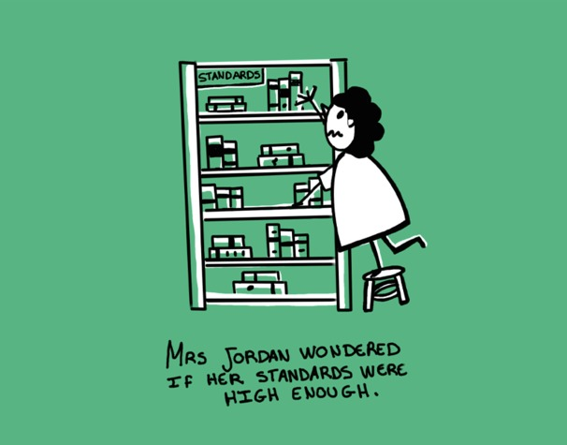
View description - Uncaptioned Figure
View alternative description - Uncaptioned Figure

2 In this together

View description - Uncaptioned Figure
View alternative description - Uncaptioned Figure

A key element of effective inclusive provision is that the teacher community collaborate around:
- a shared model of how children learn
- a shared philosophy of respecting everyone in the class
- a focus on everyone’s learning, including that of the adults (Rix et al, 2009).
Sharing values is never certain, however, and neither is collaboration. Perhaps it is not surprising that there is much confusion over what the term ‘collaboration’ means as well as little robust research into its impact and effective delivery. What research there is suggests that its implementation is inconsistent (Kennedy & Stewart 2011) or limited (Salter et al, 2017).
Developing the capacity to relate to each other is not a simple matter. There is no unified agreement about what it involves. For example, in a study examining how collaboration was framed by special education programmes for US teachers (Brownell, Ross, Colón, & McCallum, 2005), half took a traditional, special education style, competency-based approach and the rest sought a collective examination of multiple knowledge bases. In another US study of teacher education programmes, they concluded that many of the problems related to collaboration were evident and exacerbated by the relationship between special and general education training. This study recognised that the differences and limitations in training meant many would see collaboration as merely an adjustment to practice rather than as a more profound shift in shared values and ways of working (McKenzie, 2009). It is also important to consider collaboration with a wider community too. In nearly every country there is a need for schools to work with people from health, social care, youth services and so forth. This is set against widespread evidence of deeply entrenched professional boundaries and the need to manage different professional languages across communities (Rix et al, 2013).

Activity 3: Is it just us?
20 minutes

Consider how people understand the process of working together. Watch this video that presents a model of collaboration in the classroom, one they call Co-Teaching. As you watch consider:
- How are the practitioners labelled?
- What knowledge does it suggest the practitioners need?
- Is the film saying some children are not suited to co-teaching? What are your views on this?
- What views of learning do you recognise in the film?
- What opportunities for leadership do you think are evident in this kind of model of co-teaching?
- Is this your understanding of collaboration in the class room? How do you envisage working and leading in a collaborative class?

Watch the video at YouTube.com.
Video 4: A model of collaboration in the classroom (The Open University is not responsible for external content.)

View discussion - Activity 3: Is it just us?

2.1 Do traditional classrooms constrain collaboration?
So let’s consider further how the structure and traditional organisation of classrooms can act to constrain collaboration.

Activity 4: Here I am
30 minutes

Read the following quotes taken from a study by Teresa Lehane (2016).
As you read consider what the 8 experienced secondary school teaching assistants say about their work. Consider how they talk about planning, communication and their relationships with teachers. Consider too how this equates to your understanding of collaboration and what opportunities you see for them to play a leadership role.
Quotes taken from Lehane, (2016)

Provide your answer...
View discussion - Activity 4: Here I am

2.2 What is the cost?
In addition to the constraints of traditional roles and attitude, another barrier to an increase in co-teaching is cost. Generally, people are the greatest cost within the education system. If you double up the number of paid adults within the class or provide them with planning time you invariably increase the cost. However, there are administrations using contracts to define collaborative roles and to require some collaborative working.

Activity 5: There are others doing it too
30 minutes

There are also models of practice undertaken around the globe which encourage collaboration and involve relatively simple reorganisation of staff and teaching groupings, without great cost increases. For example, the author of this course has seen examples of:
- three or four teachers to two classes
- interconnected classrooms so staff and students can move between them
- a support teacher linked to a subject teacher
- support teachers allocated to a class regardless of identified support needs
- a flexible mix of teaching, support staff and students working across several classes depending upon curriculum and learning needs.
Collaborative practice can also take place beyond the classroom, for example through shared lesson planning which builds upon teachers personal, professional and practical resources. It is also possible to engage in these processes in informal ways, which is probably something that teachers have been doing down the ages.
Watch these two videos and as you do so consider the table which lays out challenges and strategies identified in a study of teacher collaboration in joint lesson planning (Yuan & Zhang, 2016).

Video content is not available in this format.
Video 5: Teacher Collaboration- Spreading Best Practices School-Wide
View transcript - Video 5: Teacher Collaboration- Spreading Best Practices School-Wide

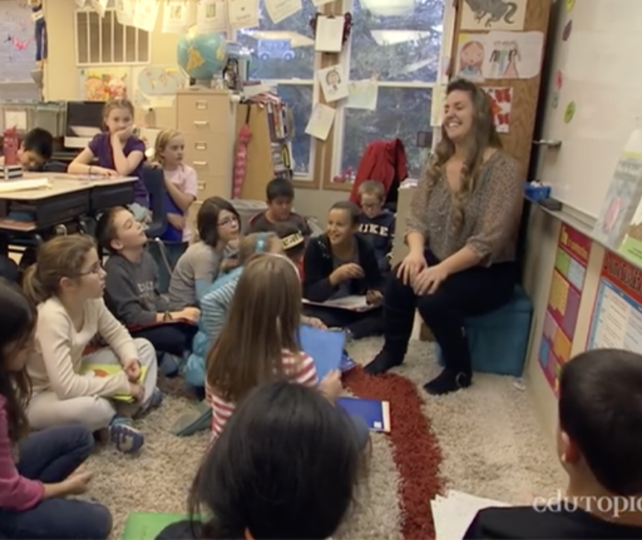

Watch the video at YouTube.com.
Video 6: Collaborative working - Kingussie High School & Aviemore Community Sport Hub (The Open University is not responsible for external content.)

Table 2: Challenges and strategies for teacher collaboration in joint lesson planning (based on Yuan & Zhang, 2016).
Challenges | Coping strategies
- Busy work schedule.  - Too many ‘assignments’ from the district office.  - A lack of collaborative awareness.  - A lack of in-depth discussion.  - Reluctance to critique others.  - Teacher conformity in terms of thinking modes and teaching approaches. | - Rearranging teaching schedule to provide common meeting time.  - Reducing and integrating ‘assignments’.  - The reform of teacher appraisal system to focus on group performance.  - Guidance from a think tank.  - Transforming teachers’ attitude towards giving comments from passiveness to positivity.  - Inviting a teaching-research officer to provide guidance.

Now consider these two questions:
- To what degree do you feel there is a need to have a commitment from school leaders to provide support to enable and motivate collaboration?
- What opportunities can you see within these two videos which can be led in a bottom-up way?

View discussion - Activity 5: There are others doing it too

3 Embracing uncertainty

View description - Uncaptioned Figure
View alternative description - Uncaptioned Figure

There are two overarching ways to frame how we respond to the challenges of inclusion; one is based on a model of certainty and the other on a model of uncertainty (Rix, 2020). The former model is governed by the drive to divide things up into manageable parts (Toulmin, 2001); this is associated with traditional methods and special education where processes and structures seek and construct relative certainties for their systems to function; the latter is associated with inclusive approaches, which embrace ideas of doubt and accept that any position we take is momentary and shifting. The former model builds upon the grammars of schooling, those regular structures and rules that have traditionally organised the work of instruction, such as single teachers, subjects, classes, lessons, age-grades and testing (Tyack & Tobin, 1994); while in contrast the latter model represents an active, continuously incomplete and ongoing process (for example Flem & Keller, 2000; UNESCO IBE, 2008). As it appears in the literature, inclusive education reflects an ontological position which views practice as fundamentally uncertain and knowledge as being emergent and situated (Rix, 2020). From this perspective, understanding is always incomplete, there is no single correct way to support the learning of any child, and our thinking and conclusions must be questioned (Hart, 1996). It can be seen as a commitment to proactively eliminate barriers, to respond flexibly and to create change in the policies, practices and cultures of ‘regular’ schools (CRPD, 2016). It involves a change in the ‘behaviour’ of adults (Ainscow & Sandhill, 2010), adopting a pedagogy underpinned by a principle of transformability (Hart, 2010), evolving and changing continually (Hausstätter, 2014). Individual needs should not be ignored but addressed ‘within a larger framework of ‘we’ as a class’ (Bannink et al, 2019 p. 15). Inclusion can be regarded as a matter of how we define good education, with a beautiful risk at its heart (Biesta, 2010, 2015). This recognition of the uncertain fits with the notion of leadership as distributed across the context (and situation) in which it takes place; it fits with a notion of leadership emerging through interaction with other people and the environment, as a moment of agency which is supported within the context.

Activity 6: In support of doubt?
40 minutes

Read the following extract from:
Kraft, M. A., Papay, J. P., Johnson, S. M., Charner-Laird, M., Ng, M., & Reinhorn, S. (2015) ‘Educating amid uncertainty: The organizational supports teachers need to serve students in high-poverty, urban schools’ (Read pp. 9–14 from Findings – stop at the reference Johnson et al., 2014).
As you read consider these questions:
- What is the nature of the uncertainty recognised in the study? What other areas of uncertainty do you think might be relevant in schools of which you have experience?
- Do you feel that that there can be greater certainty in some settings? Why or why not?
- In what way can more challenging circumstances open a wider variety of opportunities to take the lead?
- How should an understanding and recognition of uncertainty effect our practice? Spend some time thinking about how you could use uncertainty and doubt as a frame for resolving a school-based challenge.
- For example: How would you approach a problem?
  - How would you resolve a problem?
  - How would you view people involved within that situation?

View discussion - Activity 6: In support of doubt?

3.1 Institutional and personal spaces
Everyone involved in a school situation will be inhabiting a different institutional and personal space. A key component in any taking-a-lead will involve negotiating a place within such institutional and personal spaces. The production of these spaces is achieved through human practices, through representation, regulation and organisation, as well as through social, cultural, political, and economic practices and their associated meanings (Lefebvre, 1991).
A valuable tool for exploring spaces is the notion of ‘boundaries’. This is partly because we come to understand who we are by comparing ourselves to others and other groupings, but also because boundaries are the spaces in which different practices, values, knowledge and resources come together. It is at boundaries that we bring together different interpretations of multi-faceted tasks and can gain insights into the ways of others so as to enable collaboration (Edwards, 2011).

Activity 7: And the same to you?
40 minutes

Let’s consider an example of how these different world views can influence our practices and our capacity to collaborate.
Read the following pdf which is an extract taken from Waitoller, F. R., & Kozleski, E. B. (2013) ‘Working in boundary practices: Identity development and learning in partnerships for inclusive education’, Teaching and Teacher Education, 31, pp. 25–45. (Sections 3.3–3.6 – pp. 19–29.)
In this paper there are two acronyms:
- UITE – This stands for Urban Initiative for Teacher Education, a project involving 3 schools and a University in the United States.
- CHAT – This stands for Cultural Historical Activity Theory, an approach that explores the socio-cultural, historical, and political contexts of partnerships; allowing researchers to focus on rules, divisions of labour, and the tools that orient participants towards objects or outcomes.
As you are reading consider the following questions. Make notes about your thoughts.
- What aspects of the boundary (or boundaries) does this paper draw attention to?
- What is the importance of consensus around boundary objects for co-operation?
- Can you think examples of these aspects of boundaries that you have experienced in your own life?
- Why do you think it is useful (or not useful) in finding ways to lead, to think of boundaries as socially created?

View discussion - Activity 7: And the same to you?

4 Advocating for others

View description - Uncaptioned Figure
View alternative description - Uncaptioned Figure

Drawing on a range of literature Bradley-Levine (2021) suggests a variety of advocacy roles that teachers can take up. They can:
- create democratic and caring learning spaces
- use place-based and culturally-relevant instructional approaches that aim to empower students
- build connections to those who share similar cultural backgrounds or educational experiences
- seek solidarity with other teachers through collective struggle on behalf of their students
- knowingly act toward social change
- take an interest in social issues at all levels of the school, the local community, and wider world
- challenge themselves to do what is right rather than do what is uncomplicated
- challenge colleagues to put students’ needs first and not their own self-interests.
These advocacy roles can be undertaken across the full range of areas in which teachers (and other practitioners) play a leadership role. This, for example might include classroom and instructional improvement, parental involvement, school–community relationships and school organisation. It may involve formal roles or informal activities, involving participative decision making, collaboration, initiating and implementing improvements, cultivating a professional community, or supporting others individually and/or collectively (Smylie & Eckhart, 2018).

Activity 8: Speaking up
45 minutes

Watch the following videos, which cover a wide range of ways in which practitioners can advocate for others. As you watch make notes about:
- the different kinds of advocacy you see in evidence
- the capacities which are (perhaps) needed to work this way
- other areas and approaches to advocacy which might be possible.

Video content is not available in this format.
Video 7: How ESOL teachers and specialists can advocate for their students
View transcript - Video 7: How ESOL teachers and specialists can advocate for their students

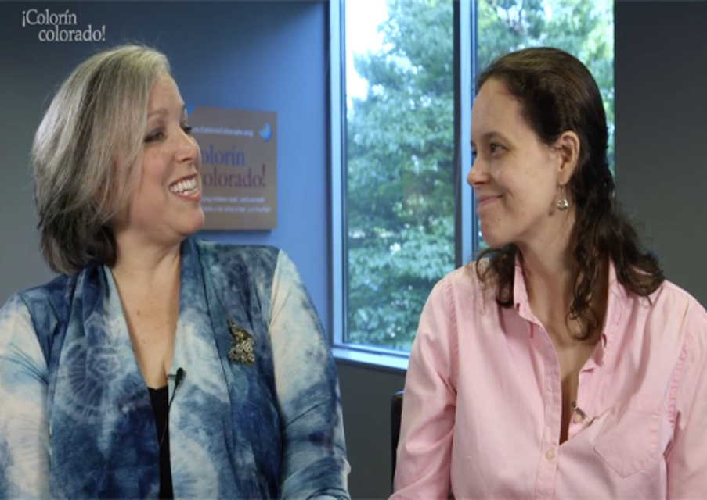

Video content is not available in this format.
Video 8: Advocacy in Action: Speaking Up for Students and the Teaching Profession
View transcript - Video 8: Advocacy in Action: Speaking Up for Students and the Teaching Professio ...

Video content is not available in this format.
Video 9: Bullying: Teachers share their stories in video for pupils
View transcript - Video 9: Bullying: Teachers share their stories in video for pupils

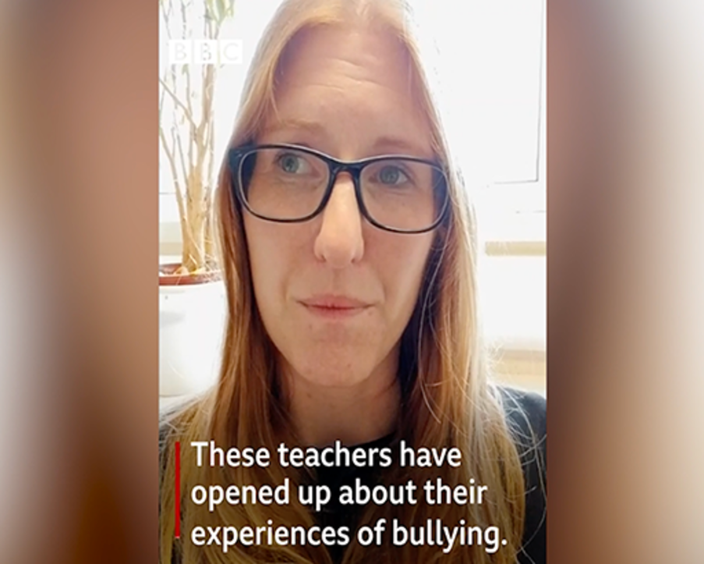

Video content is not available in this format.
Video 10: Domestic violence education
View transcript - Video 10: Domestic violence education

Video content is not available in this format.
Video 11: Diversity in the classroom
View transcript - Video 11: Diversity in the classroom

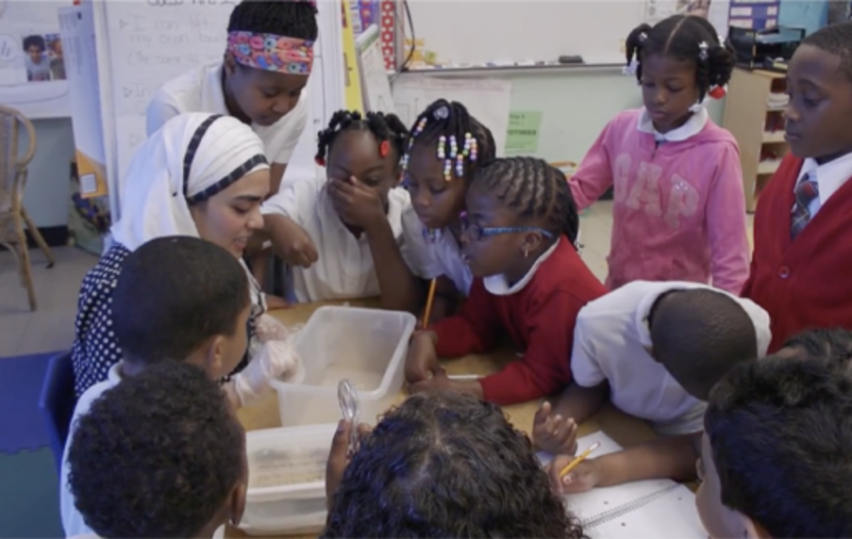

View discussion - Activity 8: Speaking up

4.1 Understanding the best option
There are various terms which can be applied to practitioners who are seeking to lead on issues of equity in their everyday lives. One such is Teacher activist. Teacher activists often draw upon feminist and critical pedagogies with a strong focus on social justice. For example, a study by Marttinen et al. (2020) explored how an activist approach could name, critique, and transform inequities associated with school-aged girls’ understanding of themselves and the world around them and the effect it has on their involvement in physical activities. They concluded that at heart of the activist approach was a depth of trust and a capacity to cultivate that trust, and a recognition that it was a process of small steps.
Such activism can be undertaken individually within a learning context but it can also be experienced in a wider, collective context. Let’s consider an example of ‘pedagogical resistance’ from an early years setting in Scotland. The practitioners named their approach ‘Lived Stories’, and it was intended to serve as an alternative to the local authority’s top-down ‘tick-box’ methods for assessing the children. They wished to capture a holistic and more impressionistic portrait of children, illustrating the richness and complexity of their educational experiences.

Activity 9: Knowing best
60 minutes

Read the following article: McNair, L. J., Blaisdell, C., Davis, J. M., & Addison, L. J. (2021) ‘Acts of pedagogical resistance: Marking out an ethical boundary against human technologies’, Policy Futures in Education, 19(4), pp. 478–492. (Read from p. 483 – p. 489 starting at: Research methods.)
As you read make notes about:
- The competing values which are at play.
- The necessity to compromise to achieve goals.
- The ways in which voices are silenced.
- The fears you might have in working in a way that subverted what was being expected of you by central authorities.
- How simple it would be to introduce a new way of working in a system with which you are familiar.

View discussion - Activity 9: Knowing best

Conclusion
In this course you have considered the nature of leadership and the ways in which it is fundamentally a key part of everyday school practice. As members of a school community we are expected to work closely with each other, creating a range of opportunities to explore our own understandings and to engage with opportunities for change. At its core this requires that we accept that we cannot control our educational experiences; they will be involved in a fundamentally uncertain relationship even within formal structures designed to deliver greater certainty. The uncertainty however opens up spaces in which everyone can explore the needs and priorities of others; it opens up opportunities to seek ways of engaging with positive change. In thinking about your involvement with activism you will also have to think about your own values and the nature of the change you wish to take place. The context in which this change is situated will be full of diverse cultural, political or historical influences, however it seems fair to suggest that in most educational contexts people will share a common concern for other people’s well-being.
When considering how you can contribute to individual or collective well being, it may be helpful to reflect back on the broad range of issues and examples of activism highlighted in this course. There have been examples of larger numbers of people joining together to drive change. But leading others to be empowered and/or championing equality, inclusion and participation is often embedded in the small, localised activities that occur within our everyday routines. Raising issues with a group of colleagues, pausing to reflect upon the ways in which things are done, even that random act of kindness can be the building blocks that lead to change.
In many ways, studying this course and staying with it to the end is an example of one small step, an engagement with activism. It would suggest that you have a commitment to understanding issues associated with equality and how you can support others to move towards a better lived experience.
Making a difference requires we take that first step…and then keep on going.
If you haven’t already, you might want to consider exploring the related OpenLearn course Leadership for inclusion: thinking it through.
If you enjoyed this course, you might be interested in the Open University Inclusive Practice Leadership and Management Masters pathways.

References
Allan, J. (2008) Rethinking Inclusive Education: the philosophers of difference in practice, Dordrecht: Springer.
Aydarova, E., Rigney, J., & Dana, N. F. (2022). ‘If You’re Not at the Table, You’re on the Menu’: Learning to Participate in Policy Advocacy as a Teacher Educator. Action in Teacher Education, 44(2), pp. 143–159.
Bacon, J. K., & Causton-Theoharis, J. (2013). ‘It should be teamwork’: a critical investigation of school practices and parent advocacy in special education. International Journal of Inclusive Education, 17(7), pp. 682–699.
Bannink, F., Nalugya, R. & van Hove, G. (2020) ‘“They give him a chance” – parents’ perspectives on disability and inclusive primary education in Uganda’, International Journal of Disability, Development and Education, 6(4), pp. 357–375.
Benjamin, S., Nind, M., Hall, K., Collins, J., & Sheehy, K. (2003). Moments of inclusion and exclusion: Pupils negotiating classroom contexts. British Journal of Sociology of Education, 24(5), pp. 547–558.
Biesta, G. (2010) Good Education in an Age of Measurement. London: Paradigm.
Biesta, G. (2013) The Beautiful Risk of Education. London: Paradigm.
Bradley-Levine, J. (2021). Examining Teacher Advocacy for Full Inclusion. Journal of Catholic Education, 24(1), pp. 62–82.
Brownell, M., Ross, D., Colón, E., & Mccallum, C. (2005). Critical Features of Special Education Teacher Preparation, The Journal of Special Education, 38(4) pp. 242–252.
Cook, M. P. (2021). Adopting Hands-Off Approaches to Activism: Examining PSTs’ Experiences Navigating Visibility and Vulnerability as Teacher Activists. Journal of Teacher Education, 72(5), pp. 538–550.
Davidson, F. D., & Hughes, T. R. (2021) ‘Grassroots Leadership Models: A Conceptual History of Thought and Practice’, The Palgrave Handbook of Educational Leadership and Management Discourse, pp. 1–16.
Derrington, M. L., & Anderson, L. S. (2020). Expanding the Role of Teacher Leaders: Professional Learning for Policy Advocacy. Education Policy Analysis Archives, 28(68).
Devecchi, C., Dettori, F., Doveston, M., Sedgwick, P., & Jament, J. (2012) ‘Inclusive classrooms in Italy and England: The role of support teachers and teaching assistants’, European journal of special needs education, 27(2), pp. 171–184.
Edwards, A., (2011) ‘Building common knowledge at the boundaries between professional practices: Relational agency and relational expertise in systems of distributed expertise’, International Journal of Educational Research, 50(1), pp. 33–39.
Flem, A. & Keller, C. (2000) ‘Inclusion in Norway’, European Journal of Special Needs Education, 15(2), pp. 188–205.
Florian, L. (2015) ‘Inclusive pedagogy: an alternative approach to difference and inclusion’, in F. Kiuppis and R. Hausstätter (eds) Inclusive Education Twenty Years after Salamanca. New York: Peter Lang.
Hammersley-Fletcher, L., & Strain, M. (2011) ‘Power, agency and middle leadership in English primary schools’, British Educational Research Journal, 37(5), pp. 871–884.
Hart, S. (2010) ‘Learning without limits’, in J. Rix, M. Nind, K. Sheehy, K. Simmons, J. Parry and K. Rajni (eds) Equality, Participation and Inclusion 2: diverse contexts. Abingdon: Routledge.
Hartley, D. (2009) ‘Education policy, distributed leadership and socio‐cultural theory’, Educational Review, 61(2), pp. 139–150.
Hausstätter, R. (2014) ‘In support of unfinished inclusion’, Scandinavian Journal of Educational Research, 58(4), pp. 424–434.
Jordan, A., & Stanovich, P. (2001) ‘Patterns of Teacher‐Student Interaction in Inclusive Elementary Classrooms and Correlates with Student Self-Concept’, International Journal of Disability, Development and Education, 48(1), pp. 33–52.
Jordan, A., Glenn, C. and McGhie-Richmond, D. (2010) The Supporting Effective Teaching (SET) project, Teaching and Teacher Education 26(2), pp. 259–266.
Kennedy, S. & Stewart, H. (2011) ‘Collaboration between occupational therapists and teachers: definitions, implementation and efficacy’, Australian Occupational Therapy Journal, 58(3), pp. 209–214.
Kraft, M. A., Papay, J. P., Johnson, S. M., Charner-Laird, M., Ng, M., & Reinhorn, S. (2015) ‘Educating amid uncertainty: The organizational supports teachers need to serve students in high-poverty, urban schools’, Educational Administration Quarterly, 51(5), pp. 753–790.
Lefebvre, H. (1991) The production of space Oxford/Cambridge, MA: Wiley-Blackwell.
Lehane, T. (2016) ‘“Cooling the Mark Out”: Experienced Teaching Assistants’ Perceptions of Their Work in the Inclusion of Pupils With Special Educational Needs in Mainstream Secondary Schools’,Educational Review, 68(1). pp. 4–23.
Leigh Star, S., (2010) ‘This is not a boundary object: Reflections on the origin of a concept’, Science, Technology, & Human Values, 35(5), pp. 601–617.
MacBeath, J. (2005) ‘Leadership as distributed: A matter of practice’, School leadership and management, 25(4), pp. 349–366.
Marttinen, R., Johnston, K., Flory, S. B., & Meza, B. (2020) ‘Enacting a body-focused curriculum with young girls through an activist approach: Leveraging the after-school space’, Physical Education and Sport Pedagogy, 25(6), pp. 585–599.
McKenzie, R. G. (2009) ‘A national survey of pre-service preparation for collaboration’, Teacher Education and Special Education, 32(4), pp. 379–393.
McNair, L. J., Blaisdell, C., Davis, J. M., & Addison, L. J. (2021) ‘Acts of pedagogical resistance: Marking out an ethical boundary against human technologies’, Policy Futures in Education, 19(4), pp. 478–492.
Osiname, A. T. (2018) ‘Utilizing the Critical Inclusive Praxis: The voyage of five selected school principals in building inclusive school cultures’, Improving Schools, 21(1), pp. 63–83.
Philip, T. M., Way, W., Garcia, A. D., Schuler-Brown, S., & Navarro, O. (2013) ‘When educators attempt to make “community” a part of classroom learning: The dangers of (mis) appropriating students’ communities into schools’, Teaching and Teacher Education, 34, pp. 174–183.
Rix, J. (2020) ‘Our need for certainty in an uncertain world: the difference between special education and inclusion?’, British Journal of Special Education, 47(3), pp. 283–307.
Rix, J. (2021) Inclusive relationships – Creating the space for each other in Beaton, M., Codina, G. and Wharton, J. (Eds) Leading on Inclusion: The Role of the SENCO. London: Routledge.
Rix, J. (2022) Re-examining special needs – What could be better? In Slee, R (ed) International Encyclopedia of Education, 4th Edition, Elsevier.
Rix, J., Carrizosa, H. G., Sheehy, K., Seale, J., & Hayhoe, S., (2020) ‘Taking risks to enable participatory data analysis and dissemination: A research note’, Qualitative Research Published online 30 October. https://doi.org/10.1177/1468794120965356
Rix, J., Hall, K., Nind, M., Sheehy, K. & Wearmouth, J. (2009) ‘What pedagogical approaches can effectively include children with special educational needs in mainstream classrooms? –A Systematic literature review Support for Learning’, 24(2), pp. 85–93.
Rix, J., Sheehy, K., Fletcher-Campbell, F., Crisp, M. & Harper, A. (2013b) Continuum of Education Provision for Children with Special Educational Needs: Review of International Policies and Practices National Council for Special Education, Dublin. Vol 1 p. 230 & Vol 2: p. 208
Rix, J., Sheehy, K., Fletcher-Campbell, F., Crisp, M. & Harper. A. (2013) ‘Exploring provision for children identified with special educational needs: an international review of policy and practice’, European Journal of Special Needs Education, 28(4), pp. 375–391.
Salter, J., Swanwick, R. & Pearson, S. (2017) ‘Collaborative working practices in inclusive mainstream deaf education settings: teaching assistant perspectives’, Deafness & Education International, 19(1), pp. 40–49.
Smylie, M. A., & Eckert, J. (2018) ‘Beyond superheroes and advocacy: The pathway of teacher leadership development’ Educational Management Administration & Leadership, 46(4), pp. 556–577.
Solis, M., Vaughn, S., Swanson, E. & Mcculley, L. (2012) ‘Collaborative models of instruction’, Psychology in the Schools, 49(5), pp. 498–511.
Star, S. L. and Griesemer, J. R., (1989) ‘Institutional ecology,translations’ and boundary objects: Amateurs and professionals in Berkeley’s Museum of Vertebrate Zoology’, 1907-39 Social studies of science, 19(3), pp. 387–420.
Toulmin, S. (2001) Return to Reason Cambridge, MA: Harvard University Press.
Tyack, D. & Tobin, W. (1994) ‘The “grammar” of schooling: why has it been so hard to change?’, American Educational Research Journal, 31(3), pp. 453–479.
UNESCO (2020) Inclusive teaching: Preparing all teachers to teach all students, Policy Paper 43.
UNESCO IBE (United Nations Educational, Scientific and Cultural Organization International Bureau of Education) (2008) ‘Inclusive education: the way of the future.’ Conclusions and recommendations of the 48th session for the International Conference on Education (ICE), Geneva, 25–28 November.
Veck, W. (2009) ‘From an exclusionary to an inclusive understanding of educational difficulties and educational space’, Oxford Review of Education, 35(1), pp. 41–56.
Ward, C. (1966) Anarchism as a Theory of Organization. In L. Krimerman & L. Perry (Eds) Patterns of Anarchy. Anchor Books, New York.

Acknowledgements
This free course was written by Jonathan Rix and published in April 2023.
Except for third party materials and otherwise stated (see terms and conditions), this content is made available under a Creative Commons Attribution-NonCommercial-ShareAlike 4.0 Licence.
The material acknowledged below is Proprietary and used under licence (not subject to Creative Commons Licence). Grateful acknowledgement is made to the following sources for permission to reproduce material in this free course:
Course image: courtesy: © Caroline Rix
Text
Activity 1: extract: Grassroots Leadership Models: A Conceptual History of Thought and Practice Section: Elements of Grassroots Leadership that can be Transferred to Educational Leadership, pp.11–13 in Davidson, F.D. & Hughes, T.R.(2021) ‘Grassroots Leadership Models: A Conceptual History of Thought and Practice’, The Palgrave Handbook of Educational Leadership and Management Discourse, pp. 1–16. Publisher Palgrave Macmillan.
Activity 4: Quotes taken from: Lehane, T. (2016) “Cooling the mark out”: experienced teaching assistants’ perceptions of their work in the inclusion of pupils with special educational needs in mainstream secondary schools, Educational Review, 68(1), pp. 4–23.
Activity 7: Waitoller, F. R., & Kozleski, E. B. (2013) ‘Working in boundary practices: Identity development and learning in partnerships for inclusive education’, Teaching and Teacher Education, 31, pp. 25–45. © The Author(s)
Activity 9: Acts of pedagogical resistance: Marking out an ethical boundary against human technologies 2021 The Author(s) McNair, L. J., Blaisdell, C., Davis, J. M., & Addison, L. J. This article is distributed under the terms of the Creative Commons Attribution 4.0 License (https://creativecommons.org/licenses/by/4.0/) which permits any use, reproduction and distribution of the work without further permission provided the original work is attributed as specified on the SAGE and Open Access pages (https://us.sagepub.com/en-us/nam/open-access-at-sage).
Table 1: A model of change goals and grassroot leadership actions and strategies (based on Ehrich & English, 2012) Springer International Publishing
Illustrations
Activity 3: ‘Dolores has finally found a school she can get into’ courtesy Jonathan Rix
Activity 8: ‘Strangely, Kevin rather liked maths exams courtesy’ Jonathan Rix
Videos
Video 2: Middle Leadership: courtesy: National Academy for Educational Leadership Wales Home - National Leadership Wales (nael.cymru)
Video 5: Teacher Collaboration: Spreading Best Practices School-Wide. Courtesy: https://www.edutopia.org/
Video 7: How ESOL teachers and specialists can advocate for their students. Courtesy: Colorin Colorado How ESOL teachers and specialists can advocate for their students - YouTube
Video 8: Advocacy in Action: Speaking Up for Students and the Teaching Profession. Courtesy: International Literacy Association https://www.literacyworldwide.org
Video 9: Bullying: Teachers share their stories in video for pupils Courtesy: Perins School https://www.perins.net/
Video 10: Domestic violence education: Public Service Broadcasting Trust (Fixers UK) https://www.fixers.org.uk/
Video 11: Diversity in the classroom. Courtesy The City University of New York The City University of New York (cuny.edu)
Every effort has been made to contact copyright owners. If any have been inadvertently overlooked, the publishers will be pleased to make the necessary arrangements at the first opportunity.
Don’t miss out
If reading this text has inspired you to learn more, you may be interested in joining the millions of people who discover our free learning resources and qualifications by visiting The Open University – www.open.edu/openlearn/free-courses.

Solutions

Activity 1: A model leader?

Part

Discussion
Both of these videos are saying that the nature of the model varies according to the priorities of the senior leadership and overall context of the setting. They suggest an association between formal roles within the school and delivering the priorities of the institution. When thinking about ideas and language that might have a bearing on inclusion:
- In the distributed leadership film you might have noted several supportive terms: ‘leadership for all’, everybody having a key piece of work to lead, the mention of learning together and collective responsibility,
- In the middle leadership film the focus had the potential to be less inclusive: what leaders were willing to share, that middle leaders were important in their own right and could know what was happening in the class but that the school was a hierarchy and becoming a senior leader was about personal progress.
These comments, particularly those associated with distributed leadership, can be seen to link to notions of a flexible, collaborative community. However, both videos talked about people having this space because they played a key role or were leading a pre-determined area of work. What was far less evident was the idea that we are all leading in our day-to-day practice.
The videos recall the idea that leaders can neither fully lead nor can individuals be fully led (Hammersley-Fletcher & Strain, 2011). The ability to shape the circumstances in which we live, our agency, requires us to engage in collective activity. To be a ‘seed in the snow’, whatever leadership model is being adopted, your agency as a leader needs to overlap with the agency of others. Being a leader therefore requires taking a risk, requiring you to offer your leadership and for others to risk accepting it. Leadership in whatever form requires you to seek a point of agreement (probably unspoken) to serve as collective motivation.
Back to - Part

Part

Discussion
The following ideas that arise within a model of grassroots leadership are also associated with other models; particularly authentic leadership, servant leadership, transformational leadership, distributive leadership and moral leadership:
- the importance of civic responsibility and community engagement,
- building capacity in others,
- being attentive to the needs of others in ways that mean they follow,
- offering creative, hopeful, open responses that envision alternative social circumstances,
- recognising that there is wisdom within the collective and that authority needs to be shared,
- prioritising of issues of equity and social justice.
In considering the second question and how practitioners can act as grassroot leaders, we recalled a model developed from a wide body of literature by Ehrich & English (2012), which represents grassroot leader’s goals for change, their actions and strategies. This model positions these leaders as being consensual or conflictual, who aim for change that is reforming or refining (see Table 1).

Table 1: A model of change goals and grassroot leadership actions and strategies (based on Ehrich & English, 2012)
Approaches to change
Categories of change |  | Conflictual | Consensual
 | Reforming | Tactics of confrontation  Requires conflict to build group solidarity and provoke the enemy’s response and possible overreaction. | Collaborative/democratic distributive  Tries and constructs a common ‘win-win’ agenda with the opponent on a common vision. Generates reciprocal relationships.
 | Refining | Conflict Avoidance  Selects one’s fights, avoids some but focuses on those deemed essential to maintain solidarity and which have a good chance of succeeding. | Collaborative/democratic distributive  Regards change as so small that it is not significant.

Back to - Part

Activity 2: Is it just a small thing?

Discussion
On watching this light-hearted video you could consider examples such as dressing up or supporting an upset child or sitting with a lonely child as moments of leadership. Being proactive is a central aspect of effective classroom practice; through such actions practitioners can serve as role models for the young people they are working with and for the colleagues around them. The act of being alert to a student’s situation, responding to that situation and engaging others in that process, is involving many of the attributes identified by Davidson & Hughes in the last reading. It is about a sense of equity, responsibility and engagement, while being attentive and creative, with the hope that you will build capacity in others.
An important shift in such activity would be recognising the influence upon others in these ‘small’ ways. If you wish to lead others towards ways that you recognise as enabling equity and social justice, you can reflect upon how your actions build trust, motivate people and practices. You could also consider how they encourage collaborative responses to opportunities and challenges. For example, a practitioner who knowingly builds upon extensive research into teachers and their classroom interactions might lead by example when they:
- maximise instructional time through their preparation of lessons
- clearly communicate expectations that all students will be engaged in learning to a high standard
- instruct individuals and small groups for large parts of the teaching time
- work with all pupils
- engage in interactions intended to foster student understanding and development of thinking skills
- engage in prolonged interactions with pupils identified with additional support needs
- offer learners the opportunity to problem-solve, to discuss and describe their ideas
- encourage learners to make connections with their own experiences and prior understandings (Jordan et al 2001; 2010).
They may embed this practice within the wider school culture by encouraging colleagues who work alongside them to work in these ways and seek to build processes that enable it to happen more widely.
Another example is the way leadership can arise by showing respect for other people’s perspectives. In another course within this series (see Leadership for Inclusion: thinking it through) the importance of story is explored. This is a very effective way to engage people by connecting them with needs other people commonly feel or perceive. Grassroots leaders recognise the value of narratives that create ruptures in people’s understanding, forming different viewpoints to amplify a message. By creating opportunities to share counter-stories we can lead in the development of new understandings and so influence people’s expectations of others, opening new possibilities for practice. Telling stories and encouraging people to share their tales does not require a formal managerial role; it is just something everyone can do as part of their everyday lives.
Another consideration is the value of the models introduced in this course to accurately represent the kinds of bottom up everyday process being described. Perhaps it is more useful to not think about our leadership as being about a particular role or function within the hierarchy or following one type of model. Perhaps it is better to recognise it as distributed across the context (and situation) in which it takes place. Leadership can be seen as emerging through interaction with other people and the environment (Hartley, 2009). This means there is an ongoing interaction between our thinking, behaviour, and their situation. If we go back to our ideas about agency and the relational nature of its enactment, we can suggest that being seen as a leader is not what is important; the significance is the activity or practice we are engaged in, and the way that moves people towards greater inclusion. In this context leadership is about supporting others in the moment; it is about our capacity to enable people’s participation in the collaborative space which schools utilise for learning.
Back to - Activity 2: Is it just a small thing?

Activity 3: Is it just us?

Discussion
The system required practitioners to be licensed, and there was a suggestion that staff will either come with subject expertise or expertise in relation to special education. This seems to support the divide between ‘types’ of teachers. Experience from other countries would suggest that this mindset will work against collaboration. You might have been surprised to learn co-teaching is deemed to be for some children only, but this seemed to be explained by a belief that you can slot children into a continuum and that support is based upon an individualised notion of need. In many ways, co-teaching is presented here as a collaborative way of delivering traditional knowledge, which is ironic since co-teaching is widely regarded as a flexible approach which is responsive to the diversity of pupils and the learning context. The aims of the whole system represented in the video also seemed to constrain what was possible. There was a focus upon results, academic skills and career goals, for example, while the clear definition of roles reinforced hierarchical relationships even though the video talked about the sharing of expertise.

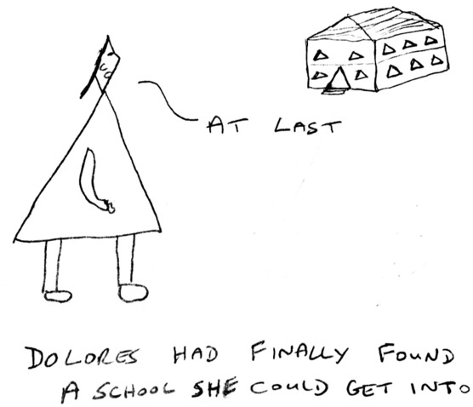
View description - Uncaptioned Figure
View alternative description - Uncaptioned Figure

Back to - Activity 3: Is it just us?

Activity 4: Here I am

Discussion
The teaching assistants (often abbreviated to TAs) felt that they knew the students well and were sensitive to their needs as well as their desire for privacy. Generally, they recognised that collaboration and communication depended upon their relationship with each teacher in each class. However, they had little or no sight of lesson plans, experienced communication ‘on the hoof’ and felt that they had to initiate discussions with the teachers. Reflecting the limited differentiation by teachers, and a sense that the TA’s standard of inclusive practice was not being met by teachers, TAs had a sense of being a go-between, echoing a general separation between the Mainstream space and the additional support space. This did not describe a collaborative practice. Rather it was a hierarchical relationship, based on convenience. It was a role in which people did not feel managed or organised, where they felt aware of being undervalued by the system, powerless and not fully prepared. This echoes findings by Salter et al., (2017) who looked at the learning experiences of Deaf students in mainstream secondary classrooms, from teaching assistants’ perspectives. They concluded that a lack of collaboration (particularly teacher engagement with teaching assistants, specialist teachers and students) meant that teachers had incorrect expectations of Deaf learners. They also had misplaced understandings of the challenges they face and of the opportunities to resolve those challenges.
If the aim is to lead the development of a collective response to collective learning challenges, then it makes sense to do so within a collaborative framework. However, it would seem to be more complicated than just wanting to do things together or having structures and processes in place to allow this to happen. In Italy, for example there are class councils, plans for the class and time for collaboration within the contracts of teachers. There are also simple, formal agreements between services, yet in the study undertaken by the author of this course (Rix et al., 2013b) one head teacher still stated that only 20 to 30 per cent of teachers plan and teach in the appropriately collaborative manner. Another head said that 50 to 60 per cent struggle with collaboration. Consequently, even though the organisation of special educational training is very different between Italy and England, both countries evidence the practices suggested by the TAs in Lehane’s study. In both countries support is frequently provided in isolation, without collaboration with the class teacher. Consequently, the practitioners experience unclear and inequitable status in the class and in the organisation of the school (Devecchi et al., 2012). In both countries, the role of this additional adult reinforced the class teacher’s view that certain children require specialist knowledge which they did not have access to. Consequently, the additional adult is not an equal collaborator but the deliverer of an individualised or small group support package separated from the collective learning context. In such a situation, it is very hard for both parties to play a leading role since a key potential collaborator does not recognise the value of the other.
Back to - Activity 4: Here I am

Activity 5: There are others doing it too

Discussion
These videos recalled the personal nature of working with others. You might have thought about how frustrating it can feel when someone seems to be focused on something else or seems to be missing the point. You might have recognised the importance of understanding other people’s priorities and how anyone can easily be preoccupied. The need to understand each other seems so obvious but it is not always clear when or if people are misunderstanding each other, and it is easy to just let such misunderstandings pass by unchallenged. The comment in the table about conformity of thinking was particularly interesting, given the earlier suggestion about the need to share values. Go back to the Yuan and Zhang paper and read this quote from a teacher:

We have been working together for so long. I think the high level of interdependence among us became an impediment to our collaborative learning because our ways of thinking and teaching were quite alike.

This made a great deal of sense. Collaboration is not of itself a panacea if it just means replicating old exclusionary ways. Part of leading is challenging ourselves. This was clearly what had happened in the class in the video.
Mel Ainscow (2016), an academic who has spent many years advocating and supporting collaborative practice to enhance school effectiveness and inclusion, talks about it being relatively easy to maintain cooperation until those moments when hard decisions must be made. The challenges people face emerge within their teaching and leadership practices alongside their relationships with the broad range of external and internal partners with whom they work (other schools, parents, support staff, teachers, community groups, universities, employers and public services). Ainscow notes that the most likely point of breakdown regards the setting of priorities and the allocation of resources. These moments can of course arise at all levels of the system and in relation to all the partners involved in the potential collaboration. It was clear in the videos that the participants needed to feel they had available workload and not too much to do. This seemed to be a systemic issue. The points in the table about a shift to a collective appraisal system was also systemic.
It was clear that practitioners are supported to work together if the leadership of the organisation recognise this as a priority. However, if we recognise leadership as a moment of agency within a particular context, then collaboration seems likely to present more opportunities for such moments to emerge. For example, the engagement with the wider community both in the strategies and the community sport hub opened up many interesting ideas and possibilities for leading new practices and relationships within and beyond the school setting. These could be supported by top-down management processes too but could build upon personal interests and understandings. Part of this process seemed a willingness to take a risk. This issue of risk taking seemed fundamental to the collaboration on view. This encourages thinking about the notion of risk that is central to participatory practices, where developing new ways of working not only involves taking risks in relation to the nature and quality of what you are producing but also in terms of the relationships between participants (Rix, 2020).
Back to - Activity 5: There are others doing it too

Activity 6: In support of doubt?

Discussion
In this paper the uncertainty is situated very much in the lives of the students and their communities, however it is also something which arises for numerous other reasons. Everyday relationships in the classroom are affected by all kinds of inter and intrapersonal factors as well as by issues arising from the physical space. There are also a great many institutional opportunities for uncertainty. An interesting example arises from the profoundly contradictory messages underpinning formal requirement for responding to a diverse classroom. Practitioners for example, have to deal with policy makers, teacher trainers and organisations like UNESCO (2020) saying they need to use methods for planning based on individual educational needs while at the same time calling for them to focus on all children. Allan (2008) identified a range of similar irresolvable contradiction that teachers face around: competencies, ways of working, the classroom focus, understandings about learners and how to support learning. All of these create the space for uncertainty and require teachers to accept that any semblance of certainty is either a mirage or will be short-lived. The teachers in the Kraft paper seemed to feel that there was less challenge in working in better resourced environments; another implication being that these spaces provided greater certainty. This notion of certainty however is not one which equates neatly to the uncertainty at the heart of inclusive practice or the beautiful risk which Biesta refers to.
Drawing on the model of uncertainty outlined by Rix (2020):
- Approaches associated with inclusion often begin with a presumption of uncertainty; perhaps accepting it or recognising it for what it is; perhaps seeking to confront it or thinking through it. This means you arrive wanting to question preconceptions about the situation and the context in which it has arisen. You acknowledge a situation’s uncertain relational nature and the interdependence of people within it. In seeking to explore or confront difficulties, challenges and opportunities you try to critically engage and reflect on the situation. This involves thinking in hypothetical ways, seeing the dilemmas which surround you or seeking pragmatic, proactive, reactive or radical pathways. One can recognise difficulties within a system as an experience for all involved. As Florian (2015) suggests an experience can be individualised but it will be primarily socially-situated.
- To move beyond doubt you need to find possibilities. These possibilities can only arise from the situation in which you are. This requires developing an understanding of the context, accepting its relational nature – both in terms of personal and cultural relationships. This is perhaps why Allan (2008) talks of the unpredictability of learning, the search for something undecidable taking place within an ethically rich drama. It is perhaps why she calls for teachers to create openings for inclusion.
- To enable the creation of these openings, we benefit from the perspectives of others who have an insight into the experience. This develops a collective view of the experience, and it involves us in asking questions of the people and the systems. This is perhaps why approaches associated with inclusion call for collaborative models of teaching and learning, though this comes in many forms (Solis et al, 2012). It is also perhaps why educators and learners need to move from being ‘participators within’ to ‘contributors to’ educational spaces (Veck, 2009).
- Out of this collective focus, a possible way forward will emerge, one that is not defined in a fixed way, but has expectations and recognises the uncertainty of any solution and the need to continue questioning. Conclusions which we may come to will be recognised as momentary positions (Benjamin et al., 2003). Things will not fit neatly. They will be positioned amongst opportunities and risks. Responses will need to be flexible within the possible disorder. We will be dealing with shifting positions with porous boundaries.
It is hopefully clear, why at the heart of such an approach is a constant engagement with risk. ‘Valid’ participation is not situated in a singular or neatly defined space. It is based on continual negotiation, with participants needing to move to where others are. To lead in this situation requires a willingness to embrace the risk inherent in being open to the power of participants, in how one conceives of and delivers support, and in how one recognises the voice of all those within that learning context (Rix, 2021).
The Kraft article also concludes that individual teachers could not single-handedly manage the challenges they faced, but that organisational responses varied greatly. This meant that in some schools teachers’ ideas and expertise was drawn upon to develop solutions, while in others there was a top-down, instrumental approach to their contributions and they had to follow practices identified by senior management. This variability seemed to be another example of uncertainty in practice. You will explore this issue of context a little more.
Back to - Activity 6: In support of doubt?

Activity 7: And the same to you?

Discussion
The authors of this paper focus upon four aspects of the boundary: practices, brokers, identities and objects. The coming together of services to provide support is an excellent example of boundary practices with overlapping activity systems; while the practitioners can be seen as boundary brokers who are trying to deal with the ambiguities of their different systems. Another example occurred around identities, and how the process of studying a course such as this one, serves to enable people to reform themselves around cultural tools that come from other arenas. In this latter context, the paper you have just read is serving as a boundary object. It exists between different social spaces with varying interpretations and functions; for instance, it is functioning as a means of reporting research, as a tool for teaching, and potentially as a tool to effect schools practices.
Viewing the boundary in this way provides a focus to reflect upon experiences, and different socially-situated perspectives. Exploring boundary objects seems a particularly rich focus for such reflection since experience of them depends upon the use of them. These objects exist between different social spaces with varying interpretations and functions; they do not come with an inherent nature. Groups working with an object will frequently need to shift back-and-forth between their different interpretations. In scaling an object up, however so that a standardised approach is taken to that object, there seems to be a danger of dominance around one group’s interpretation of any given object, reflecting the relative importance of that grouping in the wider social space. For example, medical labels (such as autism, down syndrome, PMLD: profound and multiple learning disabilities, PTSD: Post-traumatic stress disorder) carry with them a particular power which arises from their function both in medical and administrative spaces. But the power allotted to these functions, carries over into educational or family spaces where alternative interpretations and responses are equally in evidence. These interpretations might, for example, be associated with advocacy and relational understandings of learning (and labelling) which have less influence than the dominant interpretation from the space beyond.
The originators of the notion of boundary object stated in their first paper (Star and Griesemer, 1989) that boundary objects are both robust enough to maintain an identity across sites but fluid enough to adapt to local needs and constraints which arise from several parties using them. In the school context you could consider such objects as: a school library, a timetable, a lesson plan, or a formalised support plan. These may serve to structure or support communications and the development of practices, but how we understand them (their form, their value to us and how we interact with them) will vary hugely across spaces and contexts.
A leading role everyone can play when thinking about marginality and people’s membership in different social spaces is to reflect upon the objects associated with these spaces and to use these reflections to inform practise. There are, for example, tensions between multiple membership across group, alongside problems of identity and loyalty, which can be experienced through our uses of objects across those spaces.
Meanings attached to objects are fundamentally uncertain. They do not neatly transfer across different systems and arenas of use. For example, understandings of an impairment, a religious symbol, a type of food and so forth; as they move across boundaries (between spaces), particular interpretations come to dominate, and minority interpretations can create vulnerabilities. Consequently, people can easily find themselves oscillating between ways of presenting themselves and their understandings. They can feel a pressure to compromise their other interpretation or to take a risk in revealing their own interpretation.
Such responses are particularly significant in a diverse learning space such as a classroom, where students and staff can have a wide variety of cultural and socio-economic backgrounds and widely varying responses to everyday boundary objects. The role of leadership in this context, would seem to be about raising possible other interpretations. It is about challenging presumptions about standardised or residual categories and advocating for other people’s understandings and experiences.
Back to - Activity 7: And the same to you?

Activity 8: Speaking up

Discussion
People advocated in ways that ranged from the very mundane to the very proactive and political; their actions could simply involve them being themselves to sharing life experiences; they might just require them to share practices with colleagues but they could also open up profound, troubling issues and personal positions. The people in these videos seemed to show a range of capacities, including a willingness to collaborate and share ideas, a capacity to take risks and put themselves in the public spotlight, as well as to explore their own identity, understandings and life histories, and to be open to issues which may be beyond their experience. You might have spotted that there was no mention of the need for teachers to go on training courses or transform their identity and practices, but that the advocacy on show was very much a result of having a concern for others and being an engaged citizen, with an interest in creating change.
There were a great many issues that were not in evidence; for example, issues of disability or additional support were largely missing, as were issues of gender or sexuality. People will be campaigning about these issues too. The authors of this course, for example, have seen films about issues such as advocating for refugees, children of military personnel and people experiencing hunger and poverty.
The breadth of advocacy is not something which can be defined by categories, issues or types. It requires ongoing flexibility which can respond to the numerous and fluid issues that arise in a school context. Advocating for others (or yourself), therefore, is not always simple and there are times where the process can bring people into contact with new understandings and practices. For example, policy advocacy can require that practitioners acquire the language and procedures used by policymakers (Aydarova et al., 2022). These practitioners may also need to push against barriers when attempting to make a policy difference beyond the school, where their expertise can be doubted or they can lack the support or time required to be fully involved in the various stages of policy making (Derrington & Anderson, 2020).
Another challenge is ensuring that the manner or nature of what you are advocating for is in the best interests of the people you are advocating for. For example, many would suggest that viewing disability as a deficit in the child is very much against the interests of the child. Yet this is the dominant discourse used by schools and parents in talking about children’s interests and needs (for example Bacon & Causton-Theoharis, 2013). In seeking to support people in school we can easily be advocating for practices which actually marginalise them further.
The unintentional capacity for practitioners to misrepresent people is evident in an interesting study which looked at how teachers understand the community that their students come from. The disparities and injustices they identified did not properly reflect the students’ authentic communities and meant practitioner solutions placed responsibility on members of a presumed ‘community’. In order to properly understand the issues they were engaging with the researchers suggested: ‘teachers must be able to facilitate conversations to understand these disparities within the larger systemic-historical context’ (Philip et al., 2013, p. 182).

View description - Uncaptioned Figure
View alternative description - Uncaptioned Figure

Back to - Activity 8: Speaking up

Activity 9: Knowing best

Discussion
The practitioners’ had a different view of how to evaluate learning and development and their values were therefore in conflict with the dominant national model. The power of the system to evaluate and judge the setting however made them pull back from a full engagement with the possibilities presented by the Lived Stories approach, including not engaging with the voice of children within the process. This acceptance of compromise allowed them to enact processes that concerned them and to develop their practice. The Author of this course recalled a more extreme version of this stepping back from the challenge in a study about 6 English Language Arts pre service teachers in the United States (Cook, 2021). They recognised injustice and inequity and wished to address such issues as teacher-activists. However, they soon adopted a hands-off approach that the researchers called ‘passive activism’. This allowed them to shield and distance themselves from the visibility and vulnerability that accompanies activist work. As their initial topic became more concrete, they became less directly involved and put themselves at less personal risk. Cook recognises however that such passivity was not necessarily a bad thing but could be seen as a necessary first step into civic engagement; a step which mediates the potential risks.
The Author reflected on the times when they have put their necks on the line for something they believed in. The nature of risk is something which has come up repeatedly in this course. Risk is a fundamental aspect of any consideration of formal and informal leadership; after all even seeking to avoid risk is itself a risky undertaking.
In seeking to put ourselves forward as advocates we put our own sense of identity on the line; we are aligning ourselves with others or with an idea, which by its nature is not the dominant idea of the time – otherwise why would we be having to advocate for it?
It is likely that there will be push back of some kind or further complications in moving a proposal forward. This can have an impact upon our relationships with others in ways which may not be predictable. However, the purpose of taking such a risk is the possibility of a positive outcome. It is also about one’s own sense of empowerment; a moment in which you are agentive in search of a broader social ambition. Of course, the range of issues which need confronting is huge. Our systems are, after all, profoundly unfair for many people. In many ways the things which need challenging may feel overwhelming. This perhaps is part of the problem identified in the paper by Cook; people want to make profound and significant changes, but the reality is that this may be nearly impossible to achieve. This brings us back to the notion of the possible; the importance of small steps and small victories.
Back to - Activity 9: Knowing best

Uncaptioned Figure

Description
speech bubble image with the text: ‘Do I have to be in charge?’
Back to - Uncaptioned Figure

Uncaptioned Figure

Description
Illustration of a bookcase with books and at the top the label ‘standards’. A person is on a stool trying to reach for it. At the bottom of the image is the text: Mrs Jordan wondered if her standards were high enough.
Back to - Uncaptioned Figure

Uncaptioned Figure

Description
speech bubble image with the text: ‘What do you mean we don’t agree?’
Back to - Uncaptioned Figure

Uncaptioned Figure

Description
This is a cartoon of a triangular person looking at a school with triangular windows and doorway. They are saying ‘At last’. The caption says: Dolores had finally found a school she could get into.
Back to - Uncaptioned Figure

Uncaptioned Figure

Description
speech bubble image with the text: ‘Are you sure you are sure?’
Back to - Uncaptioned Figure

Uncaptioned Figure

Description
speech bubble image with the text ‘Could you speak up?’
Back to - Uncaptioned Figure

Uncaptioned Figure

Description
This is a cartoon of a young person looking very messy, with ragged clothes, messy hair, a cut on their face and a very thin right leg. They are saying ‘They always told me the chances were I’d fail’. The caption for the cartoon is ‘Strangely, Kevin rather liked Maths exams’.
Back to - Uncaptioned Figure

Video 2: Middle Leadership – National Academy for Educational Leadership Wales

Transcript
[MUSIC PLAYING]
CHRISTINE FORDE
The term middle leadership is quite generalised. It’s not a specific role. It covers a layer of leadership.
KATHLEEN KERRIGAN
The rule of the middle leader and the extent to which they can contribute to those whole school matters is actually determined by the senior leaders and the school, how much are they willing to share of their roles, their responsibilities? How do they conceptualise the role of the middle leader? And therefore, how is the school organised as a result of that?
CHRISTINE FORDE
Different school contexts and size will impact upon how middle leadership is exercised.
KAREN WATHAN
Lots of schools now have different terms for their leaders within their schools. So they’ll be branded actually as quite different things in different schools.
CHRISTINE FORDE
The task is to build middle leadership. And that’s a role that contributes. It’s not a staging post on a journey. It is a place that is really important. And I think we have to get away from the idea that it’s simply about moving up a hierarchy.
SUE ROBERTS
When you decided about where you want to go as a teacher from a teacher, there’s two ways. You might want to be a middle leader who wants to progress to lead a school of their own to become a head teacher. But then there are others who don’t want that. But they want to be a middle leader. They want to be leading a team possibly with an AoLE, as it is for us now developing the new curriculum.
TANIA RICKARD
Leading in the middle grounds theory at the site of practice. And I think that’s really absolutely true because as senior leaders, we tend to be in that helicopter pilot mode, overseeing strategically. And we really need to rely on those middle leaders and the practice that they’re seeing and the influence that they can have, not just on the teaching in the classroom but also on how we lead our schools.
KATHLEEN KERRIGAN
Middle leaders are the closest to what goes on in the classrooms. They are working day to day with those teams. And they are quite often classroom teachers themselves. So with that in mind, they’ve got their finger on the pulse, if you like, of what’s going on. And they can make assessments about what needs to change. And they can be the drivers of that change for improvement.
CHRISTINE FORDE
If we are looking to improve the learning outcomes of young people, middle leadership has not just got a role to play. It’s got a crucial role to play.
Back to - Video 2: Middle Leadership – National Academy for Educational Leadership Wales

Video 5: Teacher Collaboration- Spreading Best Practices School-Wide

Transcript
[CHATTER]
KARL WIEDEGREEN
When we work together, we are able to create something great for our students. That collaboration creates an amazing school environment.
[MUSIC PLAYING]
MARY BETH CUNAT
One of the biggest challenges of any school is people go into their rooms and they close their doors and that’s the way teaching used to be, right? So you have to begin making it not OK to close your door.
KARL WIEDEGREEN
So often we hold all the good things we do to ourselves because it becomes kind of like a competition.
GEORGIA MELIDIS
But when you’re able to collaborate with your colleagues, it really affects the student’s education. We’ll make sure we’re having the exact same homework?
In terms of building a team, you have to think about where are the strengths. Our principal saw that I have this strength and he has that strength so when she put us together, it was hard at first.
OK, there are differences in opinion.
KARL WIEDEGREEN
Yeah, big time. The truth is that we didn’t really like each other.
GEORGIA MELIDIS
Because we were very different people, different styles.
KARL WIEDEGREEN
But when we started working together, we were both passionate about working, we were both willing to put the time in.
MARY BETH CUNAT
They started talking to each other. Well, what text are you using? How are you making that connection? How are you going to run your writing conference? It was like the conversation of the month.
KARL WIEDEGREEN
We’re both understanding that the main goal as a teacher is to get those students to learn. Yeah, there new opinion.
GEORGIA MELIDIS
Got it.
KARL WIEDEGREEN
Got it? Teacher collaboration at Wildwood is really intentional. In our schedule when we have our preps, they’re aligned to each other.
GEORGIA MELIDIS
I wanted to also talk to you about our current budgeting activity. Do you think they’re ready to take a whole four day three night vacation and with a $1,000 budget?
KARL WIEDEGREEN
We didn’t do this last year as far as doing the activity. We did the questions, we did everything like that. But we didn’t do the activities--
GEORGIA MELIDIS
We didn’t prep them as much.
KARL WIEDEGREEN
Right. Like that whole area in that project was what struggled on.
GEORGIA MELIDIS
Remember because last year we also had a few issues with the itemised lists that they weren’t being specific enough with the cost?
KARL WIEDEGREEN
And what we can do to help them out with that is like every morning we can have a little mini activity that will have budgeting that they have to do. And then moving on into the big activity, which is this vacation.
GEORGIA MELIDIS
Yeah, perfect, I like that because it’s just a little bit more building every day. So that’s a good idea.
[MUSIC PLAYING]
That relationship when you can bounce ideas off of each other? It’s to the benefit of the students.
KARL WIEDEGREEN
All you can about these balls. We should be helping each other out and stop holding in all the things that we do great and sharing it with others so that they can make those same gains within their classroom. And that’s really what’s important about is that the collaboration creates that equality for all students.
[MUSIC PLAYING]
Back to - Video 5: Teacher Collaboration- Spreading Best Practices School-Wide

Video 7: How ESOL teachers and specialists can advocate for their students

Transcript
ANNE MARIE FOERSTER LUU
I was honored when a teacher would come and say, I’m doing this lesson today. How do I make this make sense to my students? And then she might go, oh, well, why can’t I do that for all my kids? And all that I’ve done is weave in the language objective with the content objective.
So that’s advocating on a very quiet and incremental basis. I think that ESOL teachers, if given the platform, should feel comfortable helping people discuss data in the school and how data is not always the full picture for an ESOL student. We have to have data. It doesn’t always give us good feelings when we get the data. But there’s reasons why the data reflects what it does. And having that critical conversation with school leadership is important.
Another thing is at the high school level, we have so many other teachers that interact with English learners. Helping them feel confident working with English learners I think is important. I’ve only been teaching for one year in high school. But in middle school, they felt comfortable working with English learners because it was an open conversation. It wasn’t a, those are your kids. It was a shared accountability. It was what can we do together to help these students?
I think that when teachers feel success with their English learners, they want more. It’s like a piece of candy. When you are successful with some of your harder students to teach, it feels good when you’re successful. So if you can reach out and find people to help you be successful, you’ll enjoy it more.
SPEAKER
It’s great.
ANNE MARIE FOERSTER LUU
And the kids will benefit.
Back to - Video 7: How ESOL teachers and specialists can advocate for their students

Video 8: Advocacy in Action: Speaking Up for Students and the Teaching Profession

Transcript
[MUSIC PLAYING]
JULIE RAMSAY
You don’t have to take huge steps, but you do have to take that first step.
[MUSIC PLAYING]
Many legislators across our country, it’s been 30, 40, 50 years since they’ve been in a classroom themselves as a student, and they have an unrealistic expectation of what learning looks like. It became apparent to me that I needed to speak with legislators and policymakers.
And so there were five of us that went to our Capitol in Montgomery, Alabama, and we met with our legislators. We set up some appointments. We talked to people in the hallways. We had an elevator speech.
And what we were really doing is we were sharing our students’ stories. We were sharing the amazing things going on in our classrooms and how every child, regardless of their zip code or their parent’s bank account, deserve the same learning opportunities and what learning looks like.
This last spring, in March, I was extended an opportunity to testify in front of the Alabama legislature. As a result of that, there’s been an outpouring of teachers from across the country who have started asking us, how did you do this?
We organised an EdCamp NBCT for National Board Certified Teachers and candidates who are pursuing certification so that we could not only pursue and push our teaching practices, but we could elevate our profession, find our voices, and positively impact student learning. What I’m most proud of in advocacy is the fact that my students have seen what I do. And as a result, they’ve become advocates themselves.
[MUSIC PLAYING]
Advocacy is something that’s important for every teacher, every educator, regardless of your role or level of expertise, needs to embrace. Because if you’re not willing to stand up and share your students’ stories, people from the outside will. As teachers, we’re role models. We have to demonstrate. We have to live and practice what we preach to them.
And if you don’t speak up, who will? You are the expert in your classroom. You know your students. You know what they need. You need to be the one to stand up and share that.
I don’t have any special gifts or talents to do what I’ve done. I’ve simply shown up, and I’ve shared stories because I was determined that every student deserved a high-quality education.
[MUSIC PLAYING]
Back to - Video 8: Advocacy in Action: Speaking Up for Students and the Teaching Profession

Video 9: Bullying: Teachers share their stories in video for pupils

Transcript
SPEAKER 1
Your head’s on fire.
SPEAKER 2
Ugly.
SPEAKER 3
Ginger. And then any vulgar word you could put in there.
ANDEE JORDAN
They would deface my work.
[MUSIC PLAYING]
SPEAKER 3
I’ve had bust lips. I’ve had black eyes. I’ve been kicked.
ANDEE JORDAN
They’d deliberately turn away from me.
SPEAKER 1
They would whisper under their breath or giggle whenever I spoke in class.
SPEAKER 2
She found my weaknesses and then she just chipped and chipped and chipped and chipped.
ANDEE JORDAN
It wasn’t until my drama teacher actually kept me back at the end of a lesson one day and just asked me how I was. If she hadn’t done that, I don’t think I would be here.
How you carry it is kind of different to each other. What kind of tension level is he going to have in his body? [INAUDIBLE] voice, which is much more like this.
It was really hard, and I didn’t actually realise how hard it was going to be until I started. And then just as the story came out, as it poured out, as I was remembering other things that were going on at the time, it just-- yeah, I think I don’t think you ever get over it. You learn to deal with stuff, but as you’re talking about it, it kind of hits home again.
SPEAKER 3
It leaves you feeling empty. Alone, despite the fact that there’s loads of different people can talk to about it.
SPEAKER 1
I felt like I’d rather not go to school. That I didn’t want to see anyone. That people could find all these faults with me.
ANDEE JORDAN
A number of students in my Year 10 drama class actually pulled me to one side and they were like, ‘Miss, thank you so much for sharing. It’s great to hear your story. I hope you’re OK now.’
And since then, you see a marked difference in their behavior in the lesson. They’re much more encouraging. They can see how just a small world, a small action can really impact on someone else’s life.
MELANIE COTTON
I thought that if I could get a group of staff that the students know quite well to talk about things that they’ve never talked about before in front of the students, it might just change that relationship to one that’s even more communicative so that they can use us if they need us.
SPEAKER 4
It just makes you feel like they’re doing this because they want to do it for you to protect you and to help you.
SPEAKER 5
And the fact that they stood up in front of the whole school shows that they really are amazing people and that anyone can get through bullying.
SPEAKER 6
And a couple of children came in, and we [INAUDIBLE]
[MUSIC PLAYING]
SPEAKER 1
I’m happy in my life now. I’ve achieved a lot.
SPEAKER 2
I don’t speak to the toxic girl at all.
SPEAKER 3
I shouldn’t hate myself for the reasons that other people treat me badly.
SPEAKER 1
So I’m all right with it now, and I’ve been all right with it for a long time.
ANDEE JORDAN
I would like to be able to be that friendly face that someone else’s and people can come and talk.
SPEAKER 3
The way I see it is, I’m Ginger til I die, go grey, or go bald. So I’ve got to enjoy it while I can.
[MUSIC PLAYING]
Back to - Video 9: Bullying: Teachers share their stories in video for pupils

Video 10: Domestic violence education

Transcript
SPEAKER 1
Kindly separate your ingredients, please. Please lift that a little more. And you say so?
[MUSIC PLAYING]
SPEAKER 2
Look at the state of this place. What have you been doing all day? So many hours doing nothing! What have you been doing all day?
SPEAKER 3
I had to take the kids to school.
SPEAKER 2
And a disgrace. Look at the state of this place.
SPEAKER 3
Just give me five minutes.
SPEAKER 2
What the hell have you been doing all day? What the heck is all this mess? What have you been doing? Look at the state of this place.
SPEAKER 3
Give me five minutes, please.
SPEAKER 2
What have you been doing all day?
SPEAKER 3
I had to go to my mom.
SPEAKER 2
Your mom!
SPEAKER 3
To school and then I have to go to my-- I have to go to my mom’s.
SPEAKER 2
Your-- your mom’s!
SPEAKER 3
It’s all right. I had to go get some prescription. Promise, I’ll take it tomorrow, I swear.
SPEAKER 2
You did not!
SPEAKER 1
Sarah? Are you OK?
[MUSIC PLAYING]
Back to - Video 10: Domestic violence education

Video 11: Diversity in the classroom

Transcript
STUDENT 1
Well, we found that they have
MS. BELAYET
In our classrooms, we have a whole diverse group of students who come to us. I have the opportunity to really broaden their understanding so that when they step outside, they approach every situation, every person with an open mind because the person that they see in front of the classroom, she’s different.
STUDENT 2
This?
MR. MANNY
That’s nice, Flower.
Children, especially at this age, need positive role models. A lot of students come from single-parent household. Maybe they don’t have a male figure at home, and they need someone to look up to, especially the boys.
Was that airplane, ruler?
MR. JABDUIN
And to see successful minority teacher who’s reflective of them, I think it’s a powerful message.
TEACHER
The teachers wear so many other hats, we’re like coaches, we’re counselors, we are father figures, we’re all these different things, because these are what our students need.
MS. BELAYET
We need a thin area.
It’s not only about teaching students content and taking tests. It’s about growth as a person.
Back to - Video 11: Diversity in the classroom

Uncaptioned Figure

Alternative description
speech bubble image with the text: ‘Do I have to be in charge?’
Back to - Uncaptioned Figure

Uncaptioned Figure

Alternative description
Illustration of a bookcase, at the top the label ‘standards’. A person is trying to reach for it. At the bottom is the text: Mrs Jordan wondered if her standards were high enough.
Back to - Uncaptioned Figure

Uncaptioned Figure

Alternative description
speech bubble image with the text: ‘What do you mean we don’t agree?’
Back to - Uncaptioned Figure

Uncaptioned Figure

Alternative description
Cartoon of a triangular person looking at a school with triangular windows and doorway. ‘At last’. ‘Dolores had finally found a school she could get into.’
Back to - Uncaptioned Figure

Uncaptioned Figure

Alternative description
speech bubble image with the text: ‘Are you sure you are sure?’
Back to - Uncaptioned Figure

Uncaptioned Figure

Alternative description
speech bubble image with the text ‘Could you speak up?’
Back to - Uncaptioned Figure

Uncaptioned Figure

Alternative description
Cartoon of a messy young person ‘They always told me the chances were I’d fail’. ‘Strangely, Kevin rather liked Maths exams’.
Back to - Uncaptioned Figure

