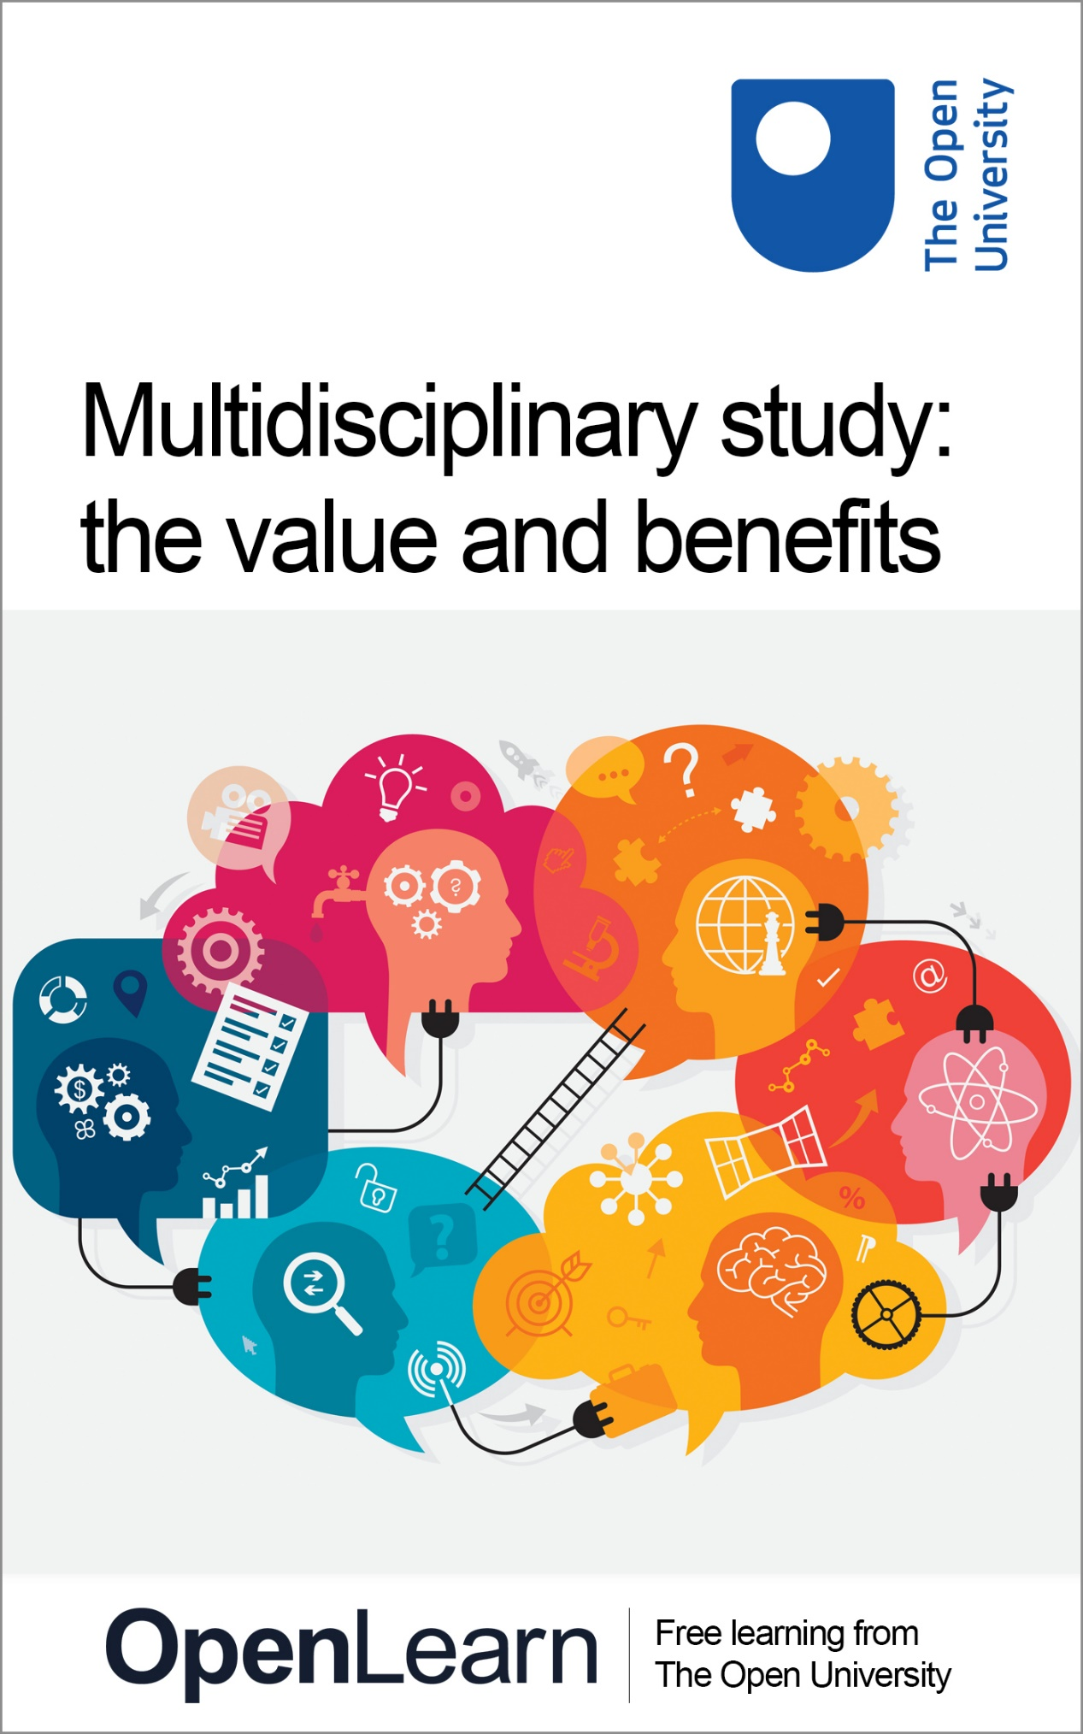

**MSS\_1**

**Multidisciplinary study: the value and benefits**

This publication forms part of the Open University module [MSS\_1 - Multidisciplinary study: the value and benefits](https://www.open.edu/openlearn/education-development/multidisciplinary-study-the-value-and-benefits/content-section-0?active-tab=description-tab). Details of this and other Open University modules can be obtained from Student Recruitment, The Open University, PO Box 197, Milton Keynes MK7 6BJ, United Kingdom (tel. +44 (0)300 303 5303; email general-enquiries@open.ac.uk).

Alternatively, you may visit the Open University website at www.open.ac.uk where you can learn more about the wide range of modules and packs offered at all levels by The Open University.

The Open University,  
Walton Hall, Milton Keynes  
MK7 6AA

First published 2018.

Unless otherwise stated, copyright © 2023 The Open University, all rights reserved.

All rights reserved. No part of this publication may be reproduced, stored in a retrieval system, transmitted or utilised in any form or by any means, electronic, mechanical, photocopying, recording or otherwise, without written permission from the publisher or a licence from The Copyright Licensing Agency Ltd. Details of such licences (for reprographic reproduction) may be obtained from: The Copyright Licensing Agency Ltd, 5th Floor, Shackleton House, 4 Battle Bridge Lane, London, SE1 2HX (website www.cla.co.uk).

Open University materials may also be made available in electronic formats for use by students of the University. All rights, including copyright and related rights and database rights, in electronic materials and their contents are owned by or licensed to The Open University, or otherwise used by The Open University as permitted by applicable law.

In using electronic materials and their contents you agree that your use will be solely for the purposes of following an Open University course of study or otherwise as licensed by The Open University or its assigns.

Except as permitted above you undertake not to copy, store in any medium (including electronic storage or use in a website), distribute, transmit or retransmit, broadcast, modify or show in public such electronic materials in whole or in part without the prior written consent of The Open University or in accordance with the Copyright, Designs and Patents Act 1988.

Edited and designed by The Open University.

ISBN XXX X XXXX XXXX X

1.0

# Contents

* [Introduction](#Introduction1)
* [Learning outcomes](#LearningOutcomes1)
* [How to get your badge](#Session1)
* [1 Definitions](#Session2)
* [2 Which definition should I use?](#Session3)
* [3 The evolution of interdisciplinary approaches](#Session4)
* [4 Why study multiple subjects?](#Session5)
* [5 The benefits of studying a multidisciplinary qualification](#Session6)
* [6 Skills developed through multidisciplinary study](#Session7)
* [7 Introducing ‘multipotentiality’](#Session8)
* [8 Choosing which subjects to study](#Session9)
* [9 What are my career options with a multidisciplinary qualification?](#Session10)
* [10 End-of-course quiz](#Session11)
* [11 Conclusion](#Session12)
* [Tell us what you think](#Session13)
* [References](#References1)
* [Acknowledgements](#Acknowledgements1)
* [Solutions](#Solutions1)

## Introduction

You might be studying, or considering learning about, more than one subject as part of your studies. Combining different subjects provides an exciting opportunity to find ways in which those subjects intersect and influence each other, across different subject boundaries. ‘Multidisciplinary’ study at The Open University includes our [‘Open’ qualifications (BA/BSc (Hons) Open degree, Diploma of Higher Education Open and Certificate of Higher Education Open)](http://www.open.ac.uk/courses/open-qualifications), as well as our [BSc (Combined STEM)](https://www.open.ac.uk/courses/combined-studies/degrees/bsc-combined-science-maths-technology-engineering-r28) and our [MA/MSc Open (F81) Open masters](https://www.open.ac.uk/postgraduate/qualifications/f81) which provide you with an opportunity to choose from a range of different subjects, allowing you to learn in different ways. At other universities, multidisciplinary qualifications may include combined honours and interdisciplinary degrees.

Watch the following video, featuring Peter Taylor and Helen Cooke from The Open University, and Open University students Cherry Day, Kathleen Bruce and Claire Davey, introducing what it’s like to study a multidisciplinary degree with the OU and what the benefits might be as a learner.

Start of Media Content

Video content is not available in this format.

Studying a multidisciplinary qualification at The Open University.

[View transcript - Studying a multidisciplinary qualification at The Open University.](" \l "Transcript1)

Start of Figure

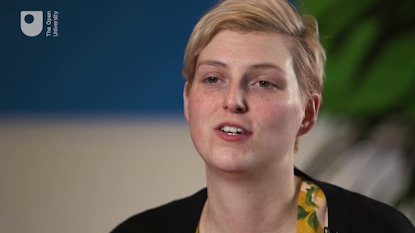

End of Figure

End of Media Content

The Open University would really appreciate a few minutes of your time to tell us about yourself and your expectations for the course before you begin, in our optional [start-of-course survey](https://www.surveymonkey.co.uk/r/multidisciplinary_study_start). Participation will be completely confidential and we will not pass on your details to others.

## Learning outcomes

By the end of this course, you should be able to:

* identify and explain the difference between multidisciplinary and interdisciplinary study
* recognise the benefits of applying different subject approaches or views to different contexts
* explain the skills gained from studying multi-subject qualifications to employers
* recognise the concept of ‘multipotentiality’ and reflect on how it might apply to you
* identify potential career pathways from studying a multi-subject qualification.

## How to get your badge

While studying this course you have the option to work towards gaining a digital badge.

Badged courses are a key part of The Open University’s mission to promote the educational well-being of the community. The courses also provide another way of helping you to progress from informal to formal learning.

To complete a course you need to be able to find about 5 hours of study time, over a period of about 2 weeks. However, it is possible to study them at any time, and at a pace to suit you.

Badged courses are all available on The Open University’s [OpenLearn](http://www.open.edu/openlearn/about-openlearn/try) website and do not cost anything to study. They differ from Open University courses because you do not receive support from a tutor. But you do get useful feedback from the interactive quizzes.

## What is a badge?

Digital badges are a new way of demonstrating online that you have gained a skill. Schools, colleges and universities are working with employers and other organisations to develop open badges that help learners gain recognition for their skills, and support employers to identify the right candidate for a job.

Badges demonstrate your work and achievement on the course. You can share your achievement with friends, family and employers, and on social media. Badges are a great motivation, helping you to reach the end of the course. Gaining a badge often boosts confidence in the skills and abilities that underpin successful study. So, completing this course should encourage you to think about taking other courses.

## How to get a badge

Getting a badge is straightforward! Here’s what you have to do:

* read each section of the course
* score 50% or more in the badge quiz at the end.

For the quiz, you can have three attempts at most of the questions (for true or false type questions you usually only get one attempt). If you get the answer right first time you will get more marks than for a correct answer the second or third time. If one of your answers is incorrect you will often receive helpful feedback and suggestions about how to work out the correct answer.

For the badge quiz, if you’re not successful in getting 50% the first time, after 24 hours you can attempt the whole quiz, and come back as many times as you like.

We hope that as many people as possible will gain an Open University badge – so you should see getting a badge as an opportunity to reflect on what you have learned rather than as a test.

If you need more guidance on getting a badge and what you can do with it, take a look at the [OpenLearn FAQs](http://www.open.edu/openlearn/about-openlearn/frequently-asked-questions-on-openlearn). When you gain your badge you will receive an email to notify you and you will be able to view and manage all your badges in [My OpenLearn](http://www.open.edu/openlearn/my-openlearn) within 24 hours of completing the criteria to gain a badge.

## 1 Definitions

Understanding the terminology used to describe studying in more than one subject and the differences between them is important, as you will often come across these terms used interchangeably. For example, the word ‘discipline’ itself used to be related to the specific rules and processes that had to be followed in order to become an expert in a particular subject. Now, however, the terms ‘subject’ and ‘discipline’ are used interchangeably, as you will learn throughout this course.

Firstly, let’s explore meanings of, and differences between, the terms ‘multidisciplinarity’ and ‘interdisciplinarity’.

**Multidisciplinarity** is where two or more academic disciplines collaborate for a specific purpose, for instance, when computer scientists, psychologists and sociologists cooperate in the design of human/computer interfaces. Although a multidisciplinary approach uses the skills and knowledge from more than one academic discipline, the use of knowledge from different disciplines remains distinct, even though the differences between the disciplines can be quite subtle. For example, architects, engineers and quantity surveyors commonly work together on construction projects, each applying their specialist knowledge to their own area of expertise. When a project is completed, each of the specialists return to their own area of expertise to start other projects.

A multidisciplinary approach is also often used in healthcare and social work, where patients’ clinical and healthcare needs are met by a multidisciplinary team; for example, nurses, social workers, general practitioners and psychotherapists may work together in multidisciplinary teams to address such problems as the rehabilitation of stroke patients (SIGN, 2002).

Start of Figure

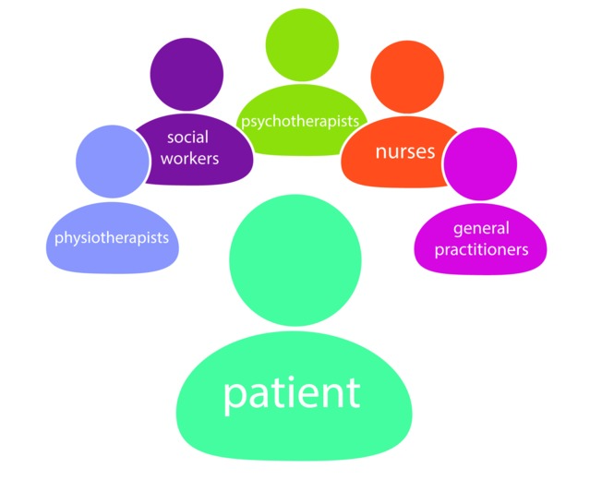

**Figure 1** An example of a multidisciplinary approach in healthcare

[View description - Figure 1 An example of a multidisciplinary approach in healthcare](" \l "Session2_Description1)

End of Figure

In the context of The Open University, our ‘Open’ qualifications are considered to be multidisciplinary, as you study individual courses independently of each other. There is no formal requirement for students to bring together the knowledge and skills gained from each course, but they can all contribute to their overall qualification).

**Interdisciplinarity** differs from multidisciplinarity because the different disciplines work together to produce new knowledge and understanding. This can yield new understandings that would not have been possible if different experts had worked only in their own discipline area. For example, sociologists may work with psychologists and economists to examine issues affecting women returning to work after having children and the impact of this on society. Researchers from different disciplines therefore bring their own methods and insights to a particular project, or to solve a particular problem.

Studying in this way offers a unique opportunity to understand how this knowledge could be brought together in an interdisciplinary way and applied in different contexts, and the importance of this to real-life scenarios. It is therefore important for you to be able to make these connections, even if you are not technically studying in an interdisciplinary way.

## 2 Which definition should I use?

Figure 2 shows that there is an even wider range of definitions that are used to describe studying more than one subject, and each of these has their own place in different circumstances. However, it is important not to worry too much about the detail of these definitions at this stage; the most important thing to remember is that there are benefits (and challenges) in applying the knowledge and skills gained from more than one subject. You’ll cover these in more detail in the following sections.

Start of Figure

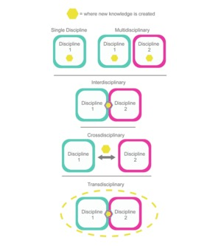

**Figure 2** Knowledge creation in relation to studying more than one subject.

[View description - Figure 2 Knowledge creation in relation to studying more than one subject.](" \l "Session3_Description1)

End of Figure

Now complete Activity 1 to consolidate your understanding.

Start of Activity

**Activity 1 Defining multidisciplinary and interdisciplinary learning**

Allow about 5 minutes

Start of Question

In your own words, write down what you have understood by the terms ‘multidisciplinary’ and ‘interdisciplinary’ learning.

End of Question

*Provide your answer...*

[View discussion - Activity 1 Defining multidisciplinary and interdisciplinary learning](" \l "Session3_Discussion1)

End of Activity

## 3 The evolution of interdisciplinary approaches

It can be helpful to understand the long-standing place in history that interdisciplinary studies has. Throughout history, there have been a number of well-known individuals who have applied a multi-subject approach to their work. For example, the following animation features a number of famous people throughout history who have been involved with interdisciplinary study, from Greek philosophers, Beatrix Potter (author of the well-known children’s book series about Peter Rabbit and friends) to Einstein.

Start of Media Content

Video content is not available in this format.

Interdisciplinarity through history

[View transcript - Interdisciplinarity through history](" \l "Session4_Transcript1)

Start of Figure

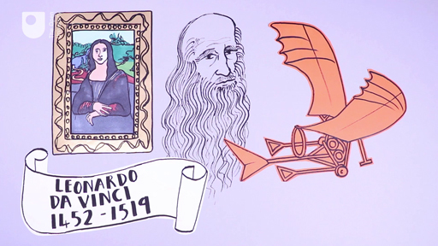

End of Figure

End of Media Content

Historically, some argue that the term ‘interdisciplinary’ dates right back to the ideas of Greek philosophers, such as Plato and Aristotle, who have been associated with the term ‘interdisciplinary thinkers’. Others say that it is from the twentieth century, borne from educational reforms, research and the transfer of knowledge across subject boundaries.

Interdisciplinarity in the twentieth century is thought to have emerged from the social sciences and the many problems following the end of the First World War. It is argued that understanding post-war problems, such as population shifts, housing, social welfare, war, labour and crime, needed to be addressed by a range of different disciplines, rather than through the lens of just one, to work towards the ‘unity of knowledge’.

In 1959, the celebrated novelist C. P. Snow delivered an influential lecture titled The Two Cultures and the Scientific Revolution at the University of Cambridge. Snow argued that ‘the intellectual life of the whole of western society’ was split into two cultures – the sciences and the humanities – and that this was a major hindrance to solving the world’s problems. Snow argued that practitioners in both areas should instead build bridges to further the progress of human knowledge and to benefit society.

At a similar time, the mid-twentieth century saw the introduction of ‘general education’, which shaped the way interdisciplinarity is viewed today (Klein, 1990). However, in the UK, it is sometimes argued that children are required to specialise from a relatively early age. In contrast, some countries allow students to continue studying in an interdisciplinary way throughout their compulsory education. For example, schools in Finland have moved away from teaching lessons focusing on classic school subjects like mathematics or English, towards teaching these subjects in the context of broader, cross-cutting topics, such as food safety and climate change.

In the following section, you will begin to explore why it can be important to apply multidisciplinary or interdisciplinary learning to a variety of topics.

## 4 Why study multiple subjects?

Start of Quote

We should encourage arts and science to meet. I studied ancient history not technology, but you can get a long way just by being curious and asking questions.

Martha Lane-Fox, Chancellor of The Open University (Gale, 2016)

End of Quote

It is important to remember that the traditional academic subjects that are referred to today, such as chemistry, music and geography, are simply artificial boxes used to understand the growing awareness of our lives and universe. People have always tried to make sense of our world by trying to organise our knowledge into compartments. Over time, these compartments have changed and multiplied, and as a result, we have ended up with distinct subjects such as history, mathematics and business.

Some subjects have developed so much that they have now been divided up into new areas of knowledge. History, for example, can be broken down into fields such as archaeology, European history and Roman history. Sometimes, new areas of knowledge develop at the boundaries of more than one subject. For example, biochemistry, which applies elements of both chemistry and biology.

When a new subject is created, groups of ‘experts’ form around one particular area of knowledge, which can lead to a different style of language and specific notations that are unique to that area. These are used by experts in the field, as well as by teachers and students, as a shorthand for discussing a particular subject efficiently. However, this also creates barriers that prevent others from easily understanding the subject and its discussion. Learning the different languages and notations of more than one subject and bringing them together is therefore a key challenge when adopting a multidisciplinary approach to study.

Most study undertaken in an undergraduate degree is within a single subject area, for example chemistry or history. There are sound reasons for this. Any subject becomes more complex as the body of knowledge accrues over time, therefore to gain an in-depth understanding, it is necessary to study within the confines of that subject and build up your knowledge of it. However, to get the most out of the different ways each subject looks at an issue, it can often be useful to combine two or more academic subjects, taking elements from each to create a new understanding or insight.

Studying different subjects can therefore bring a different perspective to many different issues. For example, climate change can be examined through a range of different subject ‘lenses’, as shown in Figure 3.

Start of Figure

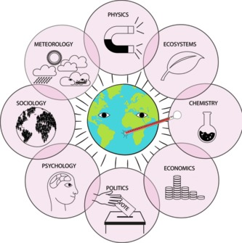

**Figure 3** The problem of climate change demands an interdisciplinary approach.

[View description - Figure 3 The problem of climate change demands an interdisciplinary approach.](" \l "Session5_Description1)

End of Figure

Although knowledge is often organised into clearly defined, subject-specific ‘boxes’, there is still a lot of knowledge that falls between these discrete categories. It is within these gaps that multidisciplinary experts work as it is clear that many of the world’s greatest challenges cannot be solved by a single subject alone. This is one of the great strengths of studying in this way, because people who have a breadth of knowledge across more than one subject can provide the glue to bring together those subjects and address these challenges.

Start of Activity

**Activity 2 Applying interdisciplinary learning to different contexts**

Allow about 10 minutes

Start of Question

What other examples can you think of where studying different subjects could help to answer a global issue? Write down one problem and the subjects that could contribute to investigating this issue further.

End of Question

*Provide your answer...*

[View discussion - Activity 2 Applying interdisciplinary learning to different contexts](" \l "Session5_Discussion1)

End of Activity

## 5 The benefits of studying a multidisciplinary qualification

Moving on from looking at how key issues can be addressed by more than one subject, you will now go on and explore the benefits of studying a single, multidisciplinary qualification, like [The Open University’s Open qualifications](http://www.open.ac.uk/courses/open-qualifications). A multidisciplinary qualification provides you with a unique opportunity to gain a knowledge and understanding of a range of different subjects and their approaches. You can then apply the skills that you gain from a multidisciplinary qualification to help you to understand connections between different subjects and how to transfer that knowledge across subject boundaries.

This approach leads to a deeper learning and understanding, and ultimately interdisciplinary thought and understanding, which can be beneficial in many areas of life, including the workplace. It is that building of knowledge that can allow for deeper understanding and highlight the patterns that are common between different subjects.

Part of the reason some people choose to study single-subject qualifications is to become an ‘expert’ in that particular subject and they believe that this will be more valued by employers because many jobs require specific expertise. However, the disadvantage of this is that they join a group of similarly trained experts who are also competing for those roles.

One of the strengths of multidisciplinary study is that you choose the subjects that you want to study and therefore you become a particular type of expert in your own right. For example, at The Open University, there are very few students studying towards an Open qualification who do the same combinations of courses and therefore each student is unique, with their own set of specialities. You will meet some of these students later in the course. So, rather than being a ‘generalist’, you become an ‘individual specialist’. The challenge of this is to be able to explain your unique expertise to potential employers so that you stand out from the crowd. Again, you will explore this in more detail later on.

For now, here are some of the wider benefits of choosing to study more than one subject that apply to a range of personal and career-related contexts:

* **Motivation** – learners are highly motivated as they have a vested interest as they are usually pursuing topics that are of personal interest to them. As a result, the content is often rooted in life experiences, giving an authentic purpose for the learning and connecting it to a real world context. Consequently, this can lead to more meaningful, purposeful and deeper learning experiences.
* **Breadth of knowledge** – students are able to consider the many and varied perspectives across different subjects from which a topic can be explored.
* **Acquiring new knowledge** – exploring topics across a range of subject boundaries motivates students to pursue new knowledge in different subject areas.
* **Creativity** – knowledge and application of different subjects can lead to greater creativity.
* **Making connections** – worthwhile topics of research can fall in the ‘spaces’ between the traditional academic subject areas.

Start of Activity

**Activity 3 Identifying the benefits that are important to you**

Allow about 10 minutes

Start of Question

In the following space, note down which of these benefits are most important or relevant to your own situation, and why. You may wish to revisit and add to these notes after you have completed the course.

End of Question

*Provide your answer...*

[View discussion - Activity 3 Identifying the benefits that are important to you](" \l "Session6_Discussion1)

End of Activity

## 6 Skills developed through multidisciplinary study

What makes multidisciplinary students stand out to employers is the rich view of the world that they develop, the wide range of perspectives they will have encountered during their studies, and the combination of subject areas they have studied that could offer more flexible career choices. In fact, many vacancies don’t specify the subject knowledge required for the role; it’s the skills you have developed in your studies as well as your other life experiences that employers are interested in. Studying more than one subject, therefore, helps you to develop important transferable skills, which are continually developing at all stages of life (Table 1).

Start of Table

Table 1 Some examples of the transferable skills gained through multidisciplinary study

|  |  |
| --- | --- |
| **Skill** | **Explanation** |
| **Critical thinking** | Critical thinking skills are used and developed as students look across disciplinary boundaries to consider other viewpoints and also begin to compare and contrast concepts across subject areas. |
| **Self-management** | Choosing which subjects to study – and why – can be challenging, and requires students to think carefully about how to identify their priorities and manage their study choices. |
| **Adaptability** | Different subjects may need to be viewed through different lenses which means an individual needs to be able to switch to the appropriate lens at the appropriate time for whichever subject they are looking at. It requires careful self-management to be able to do this. |
| **Analysis and problem solving** | By studying across different subject boundaries and by studying a wider range of subjects, students develop deeper skills of evaluation as they learn a number of different logical and methodical approaches and are able to select the best one to use for particular circumstances. For example, students can draw on their range of academic or subject knowledge to identify solutions of a practical or technical nature. |
| **Communication and literacy** | Students’ written and verbal communication skills are well developed amongst multi-subject students as they learn to revert to the appropriate communication style for a particular subject area. For example, multi-subject students might encounter a range of different assessment methods, including essays, laboratory reports, written and oral examinations, as appropriate to different subject areas. |
| **Application of information technology** | Using technology across a range of subjects means that students can be more practised in displaying and presenting information in a range of ways. |
| **Flexibility** | The ability to adapt to different contexts and environments is a strong skill gained from multi-subject study as you will be switching from one subject to another. |
| **Synthesis of ideas** | Students begin to consolidate learning by combining ideas from many perspectives and consider an alternative way of acquiring knowledge. |

End of Table

Building your own multidisciplinary approach to learning and developing these important skills will enable you to study in a way that suits your own style of learning, motivations for study and personal interests.

Having a portfolio of different subjects within your degree profile can therefore be marketed to employers in a very positive light and help you to ‘stand out’ against other applicants. Your adaptability and versatility in being able to follow very different disciplines successfully, and developing a full range of skills, can be particularly attractive to employers. However, it can seem challenging to work out how to explain these skills to a potential employer. If you are studying for career reasons, you need to consider how you articulate the skills developed and experiences gained in your CV, job application forms and interviews.

Remember too that many employers will also be interested in other life experiences outside of your studies and these can be just as helpful in demonstrating your skills or competencies for a particular job.

Start of Activity

**Activity 4 Explaining skills to an employer**

Allow about 5 minutes

Start of Question

Write down three reasons why an employer might value the skills of a multidisciplinary learner.

End of Question

*Provide your answer...*

[View discussion - Activity 4 Explaining skills to an employer](" \l "Session7_Discussion1)

End of Activity

## 7 Introducing ‘multipotentiality’

By choosing to study this course, you have already demonstrated an interest in learning about multi-subject study. You are not alone! In fact, many people choose to have a range of different careers over their lifetime (or at any one time) and may also be interested in a wide variety of leisure activities.

As you have already explored earlier in this course, multi-subject study has very much been part of society for a long time, and the way this is described and demonstrated keeps evolving. There are many ways in which this type of approach can be defined and in the following sections we will look at one example of this.

The term ‘multipotentialite’, coined by Emilie Wapnick, the founder and Creative Director of Puttylike, is one way to describe someone with many interests and creative pursuits. Emilie and her organisation support multipotentialites to integrate their many interests into all aspects of their life and to recognise that this is a strength, not a weakness.

Multipotentialites tend to need variety in their lives, but how much variety depends on the individual. Knowing how much variety you need can really help you to avoid feeling too overwhelmed by taking on too much, or feeling bored because you don’t have enough projects on the go. Multi-subject study can help satisfy the need for variety which multipotentialites tend to have.

A multipotentialite is someone with many interests and creative pursuits, rather than someone who is only focused on a particular subject or hobby. How much does this sound like you?

Start of Media Content

Video content is not available in this format.

Multipotentiality

[View transcript - Multipotentiality](" \l "Session8_Transcript1)

Start of Figure



End of Figure

End of Media Content

Start of Activity

**Activity 5 How much of a multipotentialite are you?**

Allow about 10 minutes

Start of Question

Now take a few minutes to think about the extent to which this description of a multipotentialite sounds like you. You may feel that it does sound just like you, but remember to reflect on why this might be. Conversely, you may feel like it doesn’t sound like you at all, but do still take some time to think about why this might be. Regardless, this activity will hopefully help you to understand the different way in which you, and others, may choose to approach your study-life and work-life balance.

End of Question

[View discussion - Activity 5 How much of a multipotentialite are you?](" \l "Session8_Discussion1)

End of Activity

Recognising and embracing the fact that you may be a multipotentialite can be an incredibly positive experience because it can give you the confidence to explore other areas that you may not have considered previously. By applying some elements of multipotentiality to your learning, you are exposing yourself to diverse subjects and allowing yourself the opportunity to study, and potentially work, in a truly multidisciplinary way. This can be incredibly exciting and rewarding.

Even if you don’t define yourself as a multipotentialite, studying a variety of subjects can still help you to demonstrate an even wider range of transferable skills than you looked at earlier in the course.

Before you start to think about which specific subjects you might be interested in studying as part of your inter/multidisciplinary qualification, it is important to reflect on why studying in a multidisciplinary way might be the right decision for you and how you might be able to use this to your advantage when making academic or important life decisions, such as choosing your career.

## 8 Choosing which subjects to study

So far in this course, you have learned about the terms ‘interdisciplinarity’ and ‘multidisciplinarity’, explored the historical context of these terms, and examined both the differences and many benefits of studying this way. You have also considered a range of skills that multidisciplinary students can develop through the study of different subjects, from critical thinking to adaptability and flexibility. What does this mean to you in terms of the subjects you might choose to study and your personal or career-related interests? In the following video, students who have studied [The Open University’s BA/BSc (Hons) Open degree](http://www.open.ac.uk/courses/open-qualifications) explain which subjects they have chosen to study and why.

Start of Media Content

Video content is not available in this format.

Why do Open University students choose to study in a multidisciplinary way?

[View transcript - Why do Open University students choose to study in a multidisciplinary way?](" \l "Session9_Transcript1)

Start of Figure

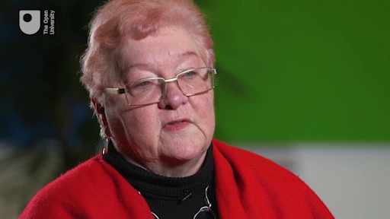

End of Figure

End of Media Content

Choose and read through at least one of the following OpenLearn articles to explore how different combinations of subjects can be applied to specific, interdisciplinary contexts:

* [Should economics and the environment work together?](http://www.open.edu/openlearn/society-politics-law/geography/should-economics-and-the-environment-work-together?in_menu=461075)
* [Brexiteers and Broflakes: how language frames political debate](http://www.open.edu/openlearn/languages/linguistics/brexiteers-and-broflakes-how-language-frames-political-debate)
* [Can science make you a better leader?](http://www.open.edu/openlearn/money-business/leadership-management/can-science-make-you-better-leader)

You can also explore a wide range of other subjects on [OpenLearn](http://www.open.edu/openlearn/subject-information) using audio, videos and interactive content. All of this may help inform the subjects you decide to choose.

Start of Activity

**Activity 6 Choosing which subjects to study**

Allow about 5 minutes

Start of Question

Which subjects have you already chosen, or might choose to study, as part of a multi-subject qualification, and why? For example, are you choosing to study each of these for personal interest and/or career reasons? Write your preferred subjects in the left-hand column below and then add Yes or No in the other two columns.

Start of Table

|  |  |  |
| --- | --- | --- |
| **Subject** | **Personal** | **Career** |
| *Provide your answer...* | *Provide your answer...* | *Provide your answer...* |
| *Provide your answer...* | *Provide your answer...* | *Provide your answer...* |
| *Provide your answer...* | *Provide your answer...* | *Provide your answer...* |

End of Table

End of Question

[View discussion - Activity 6 Choosing which subjects to study](" \l "Session9_Discussion1)

End of Activity

## 9 What are my career options with a multidisciplinary qualification?

Not all students pursue a multidisciplinary qualification for career reasons; many choose this option as a way to build on personal interests and expand their knowledge in a range of different areas. However, multidisciplinary students that are studying for career reasons have the opportunity to pursue a wide range of careers, as a result of their varied personal and professional interests and the wide choice of subjects available to study.

If you are undecided about whether to study courses in science or arts subjects in a career context, it will depend very much on the type of role that you are interested in pursuing. For example, if you want to work in a science-based industry, you may find that employers are more familiar with the content and format of science-related qualifications. It is therefore important that you carry out your research as early as possible to ensure that you are taking the most appropriate subjects.

However, even if you are not currently studying for career reasons, it is important to realise that a multidisciplinary qualification does not limit your career choices in the future. Quite the opposite in fact, as it can prepare you for a range of different careers at any one time, or during your working life. Research reveals that around a third of employers surveyed have no preferred degree subject when recruiting graduates (CBI/Pearson, 2017). This means that multidisciplinary students have the opportunity to consider a wide variety of different careers and are able to choose an approach to work that specifically addresses their interests in a wide range of subject and career options.

Next, you will explore career coach Emilie Wapnick’s four work models. In order to appreciate how one or more of these might apply to you, you first need to understand the importance of money, meaning and variety to a multipotentialite, as they can be important factors to consider when thinking about potential careers.

According to Wapnick, some amount of money is necessary to live, whatever your beliefs or issues might be about it. Money can be seen as one ingredient to a happy life, however, on its own money isn’t enough. Money can help multitpotentialites to pursue their passions after essential survival needs have been met. Often multipotentialites like to feel like they are doing something that matters. Working out what motivates us, and why it motivates us, can help us to identify what activities are those which matter and give us a sense of meaning. And variety, which can be an essential requirement for multipotentialites when choosing a career. Having enough variety at the right level – not too much and not too little – is really important, however, this can, of course, be different for everyone.

Many multipotentialites use one of the four work models:

* The Group Hug Approach
* The Slash Approach
* The Einstein Approach
* The Phoenix Approach

Start of Figure

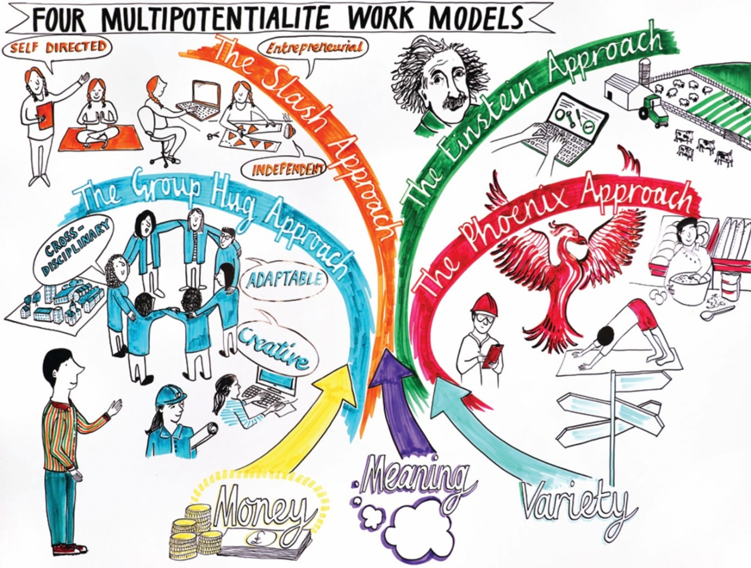

Figure 4 Four multipotentialite work models

[View description - Figure 4 Four multipotentialite work models](" \l "Session10_Description1)

End of Figure

Money, meaning and variety needs can be met in a single career with the Group Hug Approach. It is a multifaceted job or business where you do many things. Working in an interdisciplinary field, working for forward-thinking organisations or starting your own business are all ways of creating or finding a group hug career. Buzz words include: ‘creative’, ‘cross-disciplinary’, ‘adaptable’. If running your own business, choose one where multiple subjects can be combined. A trained architect is a good example of this approach as architecture is an interdisciplinary field by nature as it brings together art and science.

The Slash Approach is a great option for multipotentialites who like to juggle lots of projects all at the same time (e.g. Actor/Director/Tutor/Manager/Pianist). This approach is all about having more than one part-time job and/or businesses that you move between fluidly and frequently. Each ‘slash’ is one that you love doing but you wouldn’t want to do any one of them full-time. Boredom and burn-out are avoided with this approach as you work across a range of different specialised fields. Buzz words include: self-directed, independent and entrepreneurial.

If you prefer stability and routine, or involve yourself in your interests for amusement only, then the Einstein Approach might be for you. This is where you have a single job or business that meets your need for money, but also leaves you with enough time to follow your other interests, in your own time. It’s about finding a ‘good enough’ job or business which gives you enough spare time to do the other things you want to. A multipotentialite adopting this approach may find themselves in a career or business for many years, while also following meaningful and unrelated hobbies on the side. An example here might be a multipotentialite who has been a computer programmer all their life while living on a farm where they were able to pursue their personal interests in their own time.

Finally, the Phoenix Approach is ideal for a multipotentialite who can balance variety with the need to submerge themselves in a job or business. This approach may seem like someone has chosen to have a career in one field for a long time and then switches to a different one a few months, or years, later. This model works well for individuals who prefer doing one thing at a time. Quite often the different career paths share a common meaning, even though this may not appear to be obvious. Someone may start out teaching yoga for many years until they change career to work in the sciences and then finally set up their own craft business.

Start of Activity

**Activity 7 Which is your preferred work model and why?**

Allow about 10 minutes

Start of Question

Based on the descriptions provided above, how much do you associate with any one (or more) of these multipotentialite work models, and why? How might you apply this to possible careers?

End of Question

*Provide your answer...*

[View discussion - Activity 7 Which is your preferred work model and why?](" \l "Session10_Discussion1)

End of Activity

## 10 End-of-course quiz

Now it’s time to complete the compulsory badged quiz. There are 7 questions.

[End-of-course quiz](http://www.open.edu/openlearn/ocw/mod/oucontent/olinkremote.php?website=MSS_1&targetdoc=End-of-course%20quiz)

Remember, this quiz counts towards your badge. If you’re not successful the first time, you can attempt the quiz again in 24 hours.

Open the quiz in a new tab or window then come back here when you’ve finished.

## 11 Conclusion

By now, you should be in a good position to articulate the skills and benefits of interdisciplinary and multidisciplinary study, and become your very own Beatrix Potter or modern day Aristotle!

In this course you have explored the different terminology used to describe studying more than one subject and how this can be a strength when examining issues through a range of different subject ‘lenses’. You have also considered the different skills that can be gained from multi-subject study and had the opportunity to reflect on how you might explain these skills to a potential employer. You have also been introduced to the concept of multipotentiality and multipotentialites and their particular work approaches (Wapnick, 2017) as well as having identified potential career pathways.

You should now be able to:

* identify and explain the difference between multidisciplinary and interdisciplinary study
* recognise the benefits of applying different subject approaches or views to different contexts
* explain the skills gained from studying an inter/multidisciplinary qualification to employers
* reflect on the benefits of studying a multidisciplinary or interdisciplinary qualification.
* recognise the concept of ‘multipotentiality’ and reflect on how it might apply to you
* examine a range of interdisciplinary and multidisciplinary subjects.

We hope you feel encouraged to think more deeply about why, and how, studying a multidisciplinary qualification is a good option for you to develop academically, personally and professionally.

## Tell us what you think

Now you've come to the end of the course, we would appreciate a few minutes of your time to complete this short [end-of-course survey](https://www.surveymonkey.co.uk/r/take_teaching_online_end). We’d like to find out a bit about your experience of studying the course and what you plan to do next. We will use this information to provide better online experiences for all our learners and to share our findings with others. Participation will be completely confidential and we will not pass on your details to others.

## References

Appleby, M. (2015) What are the Benefits of Interdisciplinary Study? [online]. Available at [http://www.open.edu/openlearn/education/what-are-the-benefits-interdisciplinary-study](http://www.open.edu/openlearn/education/what-are-the-benefits-interdisciplinary-study?in_menu=461075) (Accessed 6 December 2017).

BBC (2017) Monkman and Seagull’s Polymathic Adventure, BBC Radio 4, Wednesday 23 August 2017 [online]. Available at <http://www.bbc.co.uk/programmes/b091szlz> (Accessed 6 December 2017).

CBI/Pearson (2017) Helping the UK Thrive, CBI/Pearson Education and Skills Survey 2017 [online]. Available at <http://www.cbi.org.uk/insight-and-analysis/helping-the-uk-thrive/> (Accessed 1 December 2017).

Cooke, H. J., Lane, A. and Taylor, P. G. (2018, forthcoming) ‘Open by degrees: a case of flexibility or personalization?’, in Enhancing Education through Open Degree Programs and Prior Learning Assessment, IGI Global.

Gale (2016) ‘Martha Lane Fox: “When I joined the M&S board I was still pretty broken”’, Management Today [online]. Available at <https://www.managementtoday.co.uk/martha-lane-fox-when-i-joined-m-s-board-i-pretty-broken/article/1388661> (Accessed 6 December 2017).

Kemp, I. (2016) Interdisciplinary Learning – Getting the Most out of Multi-subject Degrees [online]. Available at [http://www.open.edu/openlearn/education/interdisciplinary-learning-getting-the-most-out-multi-subject-degrees](http://www.open.edu/openlearn/education/interdisciplinary-learning-getting-the-most-out-multi-subject-degrees?in_menu=461075) (Accessed 6 December 2017).

Klein, J. (1990) Interdisciplinarity: History, Theory and Practice, Wayne State University Press.

Lear, L. (2007) Natural History: A Scientist’s Eye [online]. Available at <http://www.bpotter.com/article1.aspx> (Accessed 31 November 2017).

Marr, L. (2015) Interdisciplinary Study: Disciples of Disciplines? [online]. Available at <http://www.open.edu/openlearn/education/interdisciplinary-study-disciples-disciplines> (Accessed 6 December 2017).

Open University (2017) ‘Learning to learn: Planning for personal change’ [online]. Available at <http://www.open.edu/openlearn/education/learning-learn-planning-personal-change/content-section-2> (Accessed 7 December 2017).

Scottish Intercollegiate Guidelines Network (SIGN) (2002) Management of Patients with Stroke. Guideline 64, November, Edinburgh, SIGN.

Smith, M. K. (2003, 2009) ‘Jean Lave, Etienne Wenger and communities of practice’, The Encyclopedia of Informal Education [online]. Available at [www.infed.org/biblio/communities\_of\_practice.htm](http://www.infed.org/biblio/communities_of_practice.htm) (Accessed 6 December 2017).

Vgotsky, L. (1978) ‘Interaction between learning and development’, From Mind and Society, Cambridge, MA, Harvard University Press, pp. 79–91.

Wapnick, E. (2015) Why Some of us Don’t Have One True Calling, Recorded April 2015 at TEDxBend [online]. Available at <https://www.ted.com/talks/emilie_wapnick_why_some_of_us_don_t_have_one_true_calling> (Accessed 1 December 2017).

Wapnick, E. (2017) How to Be Everything: A Guide for Those Who (Still) Don’t Know What They Want to Be When They Grow Up, HarperOne.

## Acknowledgements

This course was written by Helen Cooke and Rehana Awan.

Except for third party materials and otherwise stated (see [terms and conditions](http://www.open.ac.uk/conditions)), this content is made available under a [Creative Commons Attribution-NonCommercial-ShareAlike 4.0 Licence](http://creativecommons.org/licenses/by-nc-sa/4.0/deed.en_GB).

The material acknowledged below is Proprietary and used under licence (not subject to Creative Commons Licence).

## Images

Course image: © DrAfter123/iStockphoto.com.

Every effort has been made to contact copyright owners. If any have been inadvertently overlooked, the publishers will be pleased to make the necessary arrangements at the first opportunity.

**Don't miss out**

If reading this text has inspired you to learn more, you may be interested in joining the millions of people who discover our free learning resources and qualifications by visiting The Open University – [www.open.edu/openlearn/free-courses](http://www.open.edu/openlearn/free-courses?LKCAMPAIGN=ebook_&MEDIA=ol).

## Solutions

## Activity 1 Defining multidisciplinary and interdisciplinary learning

#### Discussion

You might have thought of something along these lines:

**Multidisciplinarity** is where two or more academic disciplines collaborate for a specific purpose, for instance, when computer scientists, psychologists and sociologists cooperate in the design of human/computer interfaces.

**Interdisciplinarity** differs from multidisciplinarity because the different disciplines work together to produce new knowledge and understanding.

[Back to - Activity 1 Defining multidisciplinary and interdisciplinary learning](" \l "Session3_Activity1)

## Activity 2 Applying interdisciplinary learning to different contexts

#### Discussion

Here are some of the global issues that you may have listed in your answer. This list is not exhaustive and there are lots of other global issues that you may have considered that aren’t detailed here.

Start of Table

|  |  |
| --- | --- |
| **Issue** | **Subjects may include** |
| Withdrawal of the UK from the European Union (Brexit) | Politics, history, economics, finance, geography, business, sociology, modern languages |
| Nuclear armament | International relations, history, politics |
| Natural disasters | Physical geography, physics, history, anthropology |
| Over population | Human geography, healthcare, history of medicine, sociology |
| Poverty | Psychology, childhood studies, sociology, economics, history |
| Sustainable agriculture | Biology, chemistry, earth Sciences, technology, economics, politics, geography, business studies |
| Future pandemics | Chemistry, Biology, medicine, politics, economics, logistics, business studies |
| Refugee crises | Politics, economics, geography, history, business studies, logistics, law, education |

End of Table

[Back to - Activity 2 Applying interdisciplinary learning to different contexts](" \l "Session5_Activity1)

## Activity 3 Identifying the benefits that are important to you

#### Discussion

As is often the case when reflecting on our own situation, there isn’t a right or wrong answer but hopefully you have identified what is important to you in terms of the benefits of studying different subjects.

[Back to - Activity 3 Identifying the benefits that are important to you](" \l "Session6_Activity1)

## Activity 4 Explaining skills to an employer

#### Discussion

You may have included any of the following in your answer:

1. They can show that they are more flexible and are able to adapt to a variety of different situations with ease. This can be particularly helpful in an organisation where there may be lots of change taking place.
2. They are used to managing different deadlines and categorising what ideas belong where, and therefore are good at managing themselves and their time.
3. They are able to bring together a number of ideas and perspectives from across different subjects, and therefore may be able to offer alternative ways of looking at issues or problems. This can help identify new, innovative solutions to particular situations.
4. They have well-developed communication and literacy skills, having been exposed to different terminology across a number of subjects.
5. They are able to consider and understand different viewpoints and different approaches to tackling a particular problem.

[Back to - Activity 4 Explaining skills to an employer](" \l "Session7_Activity1)

## Activity 5 How much of a multipotentialite are you?

#### Discussion

Even if you don’t define yourself as a multipotentialite, studying a variety of subjects can still help you to demonstrate an even wider range of transferable skills than you looked at earlier in this course.

[Back to - Activity 5 How much of a multipotentialite are you?](" \l "Session8_Activity1)

## Activity 6 Choosing which subjects to study

#### Discussion

Remember, there are no right or wrong answers here. Reflecting on the reasons you might like to study a subject or the reasons for having chosen a subject can help you to identify your motivation for studying particular subjects and/or may help if/when you might seek employment opportunities in the future.

[Back to - Activity 6 Choosing which subjects to study](" \l "Session9_Activity1)

## Activity 7 Which is your preferred work model and why?

#### Discussion

Remember that these work models simply provide a starting place to help you make sense of your preferences, and to help you develop your personal and/or professional interests.

[Back to - Activity 7 Which is your preferred work model and why?](" \l "Session10_Activity1)

# Figure 1 An example of a multidisciplinary approach in healthcare

## Description

This illustration shows a number of figures represented. At the centre is the patient, and around the patient are physiotherapists, social workers, psychotherapists, nurses and general practitioners.

[Back to - Figure 1 An example of a multidisciplinary approach in healthcare](" \l "Session2_Figure1)

# Figure 2 Knowledge creation in relation to studying more than one subject.

## Description

This image is made up of a number of boxes with text. At the top is ‘single discipline’, with a box labelled ‘discipline 1’. Next to this is the text ‘multidisciplinary’ with two boxes labelled ‘discipline 1’ and ‘discipline 2’. Underneath this is the text ‘interdisciplinary’ with two boxes labelled ‘discipline 1’ and ‘discipline 2’. Underneath this is the text ‘crossdisciplinary’ with two boxes labelled ‘discipline 1’ and ‘discipline 2’, in between which is a double-ended arrow. Underneath this is the text ‘transdisciplinary’ with two boxes labelled ‘discipline 1’ and ‘discipline 2’. There is a dotted line going around these two boxes.

[Back to - Figure 2 Knowledge creation in relation to studying more than one subject.](" \l "Session3_Figure1)

# Figure 3 The problem of climate change demands an interdisciplinary approach.

## Description

In the centre of this image is a globe, having its temperature taken. Around this are a number of circles. In these outer circles are the following: physics, ecosystems, chemistry, economics, politics, psychology, sociology and meteorology.

[Back to - Figure 3 The problem of climate change demands an interdisciplinary approach.](" \l "Session5_Figure1)

# Figure 4 Four multipotentialite work models

## Description

This shows a mindmap of Emily Wapnick’s four work approaches: the Group Hug approach, the Phoenix approach, the Slash approach and Einstein approach. It shows how money, meaning and variety all feed into the different approaches and each model is illustrated further. The Group

Hug approach shows a group of people hugging and an architect along with a person at a computer. It also has the buzz words of creative and adaptable included in the image. The Phoenix approach shows a signpost with arrows pointing in different directions and the careers of a yogi, scientist an chef. All different but connected. The Slash approach shows a teacher, yogi, computer programmer and person at a sewing machine representing the different jobs one multipotentialite might have along with the buzz words of self-directed and independent. Finally, the Einstein approach shows a farm and a computer representing how this type of multipotentialite may have a career for years with an unrelated hobby or interest on the side.

[Back to - Figure 4 Four multipotentialite work models](" \l "Session10_Figure1)

# Studying a multidisciplinary qualification at The Open University.

## Transcript

SPEAKER 1

The first year was Design Essentials. Last year was Working with Children and Young People. And this year is Teaching Young People and Children.

SPEAKER 2

So students studying more than one subject have the benefit of being able to develop a qualification that's unique to them so they can choose modules that are of interest to them, or are relevant to them in terms of their personal interests, but also their career ambitions. So they get flexibility in terms of what they choose.

SPEAKER 3

Nowadays, people tend to change jobs and their careers throughout their lives. And so having a range of different subjects that will actually could be used in a number of different career settings will be important. And also, people actually change their career while they are studying. So to have that flexibility to be able to move into a different subject is quite unique.

SPEAKER 4

It gives you wonderful choices to adapt you're studying to your interests, to your career, that doesn't demand you get a doctorate or a PhD or study law. You can switch around between courses that interest you.

SPEAKER 2

Multi subject students have the benefit of being able to apply knowledge from a range of different subjects to a particular job. So a student, for example, might be interested in working in a recording studio. So they might choose to study modules in music and a bit of business management and technology, which they can do within an Open degree.

SPEAKER 1

When people ask me what I do at the Open University, I go design technology, and childcare. And it's a look on their face, and they go, really? My end goal is to be a design technology teacher, so to me it flows and it works quite well.

SPEAKER 4

I started with the Introduction Foundation Arts and Humanities module.

SPEAKER 5

I've done the S103 and SXR. I've attempted a couple modules where I wasn't successful with, but a couple of them were kind of more leisure, something that I wanted to have a go at.

SPEAKER 4

But it gives you a taste every month with a TMA-- Tutor Marked Assignment. And a lot of students think they want to do maybe sociology or psychology, and they will switch from the idea of having done that first foundation module. So that can lead you into areas you never thought you'd be interested in.

SPEAKER 5

I think I like having that flexibility. I mean, that's what the Open degree is all about.

SPEAKER 3

So students can pretty much study any modules they like, because they're all online so they can all be studied consecutively without too many problems. There are a few little rules, like having to do stage one first, stage two, and then stage three. And also there may be some prerequisites for particular modules. But apart from that, students can pretty much study any subjects they want.

SPEAKER 4

It can be challenging. I'll be quite honest-- I chose the social sciences module, and realised about a month into it I've made a huge mistake. It didn't make me want to read on and do it, so that personal excitement I wanted wasn't there. So I dropped it, and re-registered with something else.

SPEAKER 3

Multi subject study is really something that students like doing. The most popular degree across the university. Almost 20% of our students are studying the Open Programme.

SPEAKER 2

So we have a website specifically dedicated to Open degree students, which includes information about modules that work well together within a particular subject area. So that's to help students navigate our curriculum, which can seem quite overwhelming at times.

SPEAKER 4

I think it all depends what you want it for. Be quite clear about that. Is just like me, for purely selfish personal development reasons? Or will it help your career, if you are in a job that you want to progress in or do you want to change career? Do your research. Go to the OU, go to the library, look at the prospectus. But get clear in your mind what you want it for.

SPEAKER 1

Doesn't matter what your age is or what your background history is. If you've got the enthusiasm, do it. End of the day, if you've got it, you can do it.

[Back to - Studying a multidisciplinary qualification at The Open University.](" \l "MediaContent1)

# Interdisciplinarity through history

## Transcript

[MUSIC PLAYING]

NARRATOR

Plato was a famous philosopher in classical Greece and founder of the first institution for higher learning in the Western world. He laid the foundations for Western philosophy, science, and maths, along with being one of the founders of Western religion and spirituality, a very early adopter of interdisciplinary studies.

His student Aristotle was also a philosopher and scientist. His writings cover many areas, including physics, biology, zoology, poetry, theatre, music, psychology, and politics and government.

Abu Rayhan Al-Biruni, a Persian polymath regarded as one of the greatest scholars of the mediaeval Islamic era, and was well versed in physics, mathematics, astronomy, and a natural scientist, and also distinguished himself as a historian, chronologist, and linguist.

Leonardo da Vinci, regarded by many historians and scholars as a universal genius. His areas of interest spanned a wide range of subjects, from invention, painting, and sculpting, to architecture, science, music, mathematics, and engineering. The list goes on.

Beatrix Potter's inspiration was drawn from a range of different disciplines, from recording observable data, art, and she was a student of natural history from a young age. She was also interested in geology, archaeology, entomology, and mycology. "What was rare was how Potter used her gifts in diverse areas, from stories for children and animal husbandry to the preservation of land, farms, and watersheds in the English Lake District," Lear, 2007.

Albert Einstein, the most famous scientist from the 20th century, was a theoretical physicist who won the Nobel Peace Prize in 1921 for his work contributing to the evolution of quantum theory. He wrote over 150 scientific works, including writing about socialism. Einstein was also a lover of music and a keen violinist.

And now, you.

[MUSIC PLAYING]

[Back to - Interdisciplinarity through history](" \l "Session4_MediaContent1)

# Multipotentiality

## Transcript

[MUSIC PLAYING]

NARRATOR

A multipotentialite is someone with many interests and creative pursuits. It's a mouthful to say, and it might help if you break it up into three parts, multi, potential, and ite. You can also use one of the other terms that mean something similar, such as Polymath, the Renaissance person.

During the Renaissance period, it was considered the ideal to be well-versed in multiple disciplines. Multi potentialities have super powers. The first of these super powers is idea synthesis. That is, combining two or more fields and creating something new at the intersection. This means innovation can happen at intersections. That's where new ideas come from. And multipotentialites, with all of their backgrounds, are able to access a lot of these points of intersection.

The second multipotentialite super power is rapid learning. When multipotentialites become interested in something, they go hard. They observe everything they can get their hands on. They're used to being beginners because they've been beginners so many times in the past. And this means that they're less afraid of trying new things and stepping out of comfort zones. What's more, many skills are transferable across disciplines, and multipotentialites bring everything they've learned to every new area they pursue, so they're rarely starting from scratch.

The third multipotentialite super power is adaptability. That is, the ability to morph into whatever is needed in a given situation. Idea synthesis, rapid learning, and adaptability, three skills that multipotentialites are very adept at, and three skills that they might lose if pressured to narrow their focus.

As a society, we have a vested interest in encouraging multipotentialites to be themselves. We have a lot of complex, multidimensional problems in the world right now, and we need creative, out-of-the-box thinkers to tackle them. Wapnick 2017.

[Back to - Multipotentiality](" \l "Session8_MediaContent1)

# Why do Open University students choose to study in a multidisciplinary way?

## Transcript

STUDENT

When I was at my brick University, they chose everything for me. And I didn't think that was a great idea because I know I picked the degree name, but I wasn't quite interested in the modules that they chosen.

STUDENT

Having to take early retirement due to being diagnosed with cerebellar ataxia, I was housebound and looking for something that would keep my brain active. And my first modules came down to what would make me go to the computer and be interested, like reading an excellent novel or watching a series on TV. I wanted to feel like I couldn't wait to get back to it and see it and get into it again. So you need that incentive. And if you've got a subject that really interests you, you really can't wait to get the text book and get into module forums. That excitement for somebody that had been very busy, has a very full life, and need that spur again.

STUDENT

I left that university and decided to go with The Open University because I could feel like I could work my job and do my university at the same time, and yet, still get the same outcome.

STUDENT

I've had stuff like health issues as well. And I've had stuff like issues with stuff like learning, stuff from early childhood. I really struggled at school, didn't really pass my GCSEs at school. I'd gone back to college a few years later and done a GCSE package, and it eventually led me to applying to the Open University.

STUDENT

Unlike a lot of OU students who are in work and are probably tailoring their degree, be opened or named, to their career, to their job progression, even change of job even. Mine was purely an indulgent, I want to do it for me, and enjoy it. So that's why I'm abroad. And the Open degree let's you do that.

FACULTY

Online, we have a student forum, so all students are able to connect via that that forum and create a community themselves where they can seek advice from each other about which modules work well together, the kind of careers that they want to go into, why they're choosing to study in a multi subject way.

STUDENT

When I first started my degree with Open University, it was to be a design technology teacher. But the more I'm doing it, the more I'm thinking of doing a master's and then going on to design technology. But that's the beauty of Open University. I don't have to decide at this moment in time.

FACULTY

Like all Open University students, students on the Open degree have access to a tutor based on the module that they're studying.

STUDENT

My tutor is quite helpful, yes, especially the one I've got now. She's really, really good. She knows I don't have the experience, but she still guides me towards what I need to do. And I can still do the TMEs without the practical experience, which is quite good as well.

FACULTY

The student support team is able to help give the students advice and guidance on which modules they want to study. If they have any difficulties with their studies, the student support team can help them address those issues and steer them in the right direction.

STUDENT

And the last thing about the OU, you can have a little taste of courses through OpenLearn to access course. Just dip your toe in the water. Don't rush into it.

STUDENT

I guess it's given me a wider perspective of what the Open University can do, like the doors it can open.

STUDENT

Look at the amount of time you can get to it. Now will you have to be starting at 2 o'clock in the morning because that's the only time when your children are in bed, your husband's in bed, and you can have that quiet time on your own. Because you do have to devote, I think, it's 10 hours for every credit point. So if you're doing a six credit module over six months, that is 600 hours of studying minimum. So you have to carve out that time for your personal life.

STUDENT

I'd say go and look at the Open Learn site to start with because that gives you an idea of what the full modules would be like and see what your personal interests are.

STUDENT

And my own off, honestly, it would just be just do it. Because my aunt recently just started an Open University degree, and I think she's 40-ish, and she spent ages going on going to go do a degree, and she eventually this year decided she was going to start her degree. And I'm quite proud of her.

STUDENT

Very best of luck. You'll love it. Once you're in, you'll love it, absolutely love it.

[Back to - Why do Open University students choose to study in a multidisciplinary way?](" \l "Session9_MediaContent1)