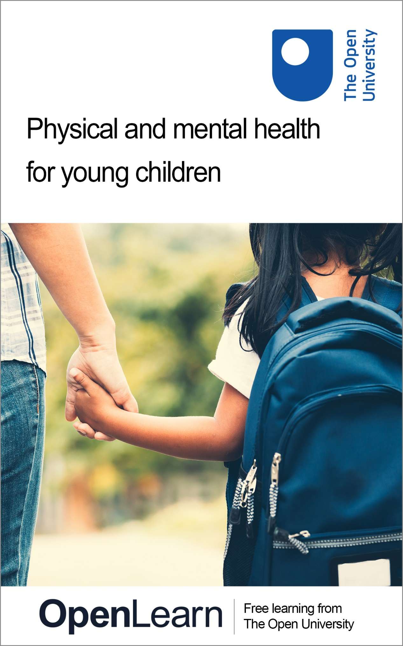

BYC_1 Physical and mental health for young children

Physical and mental health for young children

About this free course
This free course is an adapted extract from the Open University course .
This version of the content may include video, images and interactive content that may not be optimised for your device.
You can experience this free course as it was originally designed on OpenLearn, the home of free learning from The Open University –
There you’ll also be able to track your progress via your activity record, which you can use to demonstrate your learning.
First published 2023.
Unless otherwise stated, copyright © 2023 The Open University, all rights reserved.
Intellectual property
Unless otherwise stated, this resource is released under the terms of the Creative Commons Licence v4.0 http://creativecommons.org/licenses/by-nc-sa/4.0/deed.en_GB. Within that The Open University interprets this licence in the following way: www.open.edu/openlearn/about-openlearn/frequently-asked-questions-on-openlearn. Copyright and rights falling outside the terms of the Creative Commons Licence are retained or controlled by The Open University. Please read the full text before using any of the content.
We believe the primary barrier to accessing high-quality educational experiences is cost, which is why we aim to publish as much free content as possible under an open licence. If it proves difficult to release content under our preferred Creative Commons licence (e.g. because we can’t afford or gain the clearances or find suitable alternatives), we will still release the materials for free under a personal end-user licence.
This is because the learning experience will always be the same high quality offering and that should always be seen as positive – even if at times the licensing is different to Creative Commons.
When using the content you must attribute us (The Open University) (the OU) and any identified author in accordance with the terms of the Creative Commons Licence.
The Acknowledgements section is used to list, amongst other things, third party (Proprietary), licensed content which is not subject to Creative Commons licensing. Proprietary content must be used (retained) intact and in context to the content at all times.
The Acknowledgements section is also used to bring to your attention any other Special Restrictions which may apply to the content. For example there may be times when the Creative Commons Non-Commercial Sharealike licence does not apply to any of the content even if owned by us (The Open University). In these instances, unless stated otherwise, the content may be used for personal and non-commercial use.
We have also identified as Proprietary other material included in the content which is not subject to Creative Commons Licence. These are OU logos, trading names and may extend to certain photographic and video images and sound recordings and any other material as may be brought to your attention.
Unauthorised use of any of the content may constitute a breach of the terms and conditions and/or intellectual property laws.
We reserve the right to alter, amend or bring to an end any terms and conditions provided here without notice.
All rights falling outside the terms of the Creative Commons licence are retained or controlled by The Open University.
Head of Intellectual Property, The Open University

Contents
- Introduction and guidance
  - Introduction
- Session 1: Promoting the health of all children
  - Introduction
  - Learning outcomes
  - 1 Definition of terms
  - 2 Exploring health for babies and children
    - 2.1 Factors that influence babies and children’s health
    - 2.2 Microsystem: factors within the child
    - 2.3 Mesosystem: the family or carers
    - 2.4 Exosystem: the child’s wider community
    - 2.5 Macrosystem: society
  - 3 A child’s view of health
  - 4 Health promotion in education settings
  - 5 The role of adults
  - 6 Summary of Session 1
- Session 2: Patterns in young children’s health
  - Introduction
  - Learning outcomes
  - 1 Children’s health since the 1870s
    - 1.1 Development of services
    - 1.2 Progress and patterns in low- and middle- income countries
    - 1.3 Preventable health conditions
  - 2 Inequalities in health: socio-historical perspective
    - 2.1 Patterns of child health in the past 50 years
    - 2.2 Case studies of child-health promotion work in Birmingham
    - 2.3 Access to services for babies and young children to support health
  - 3 Current health issues for babies and children
    - 3.1 Persistent inequalities in health for young children
    - 3.2 Contemporary child health concerns
    - 3.3 Protecting babies’ and young children’s health
  - 4 Summary of Session 2
- Session 3: The benefits of promoting children’s health
  - Introduction
  - Learning outcomes
  - 1 Definition of health promotion
  - 2 Promoting children’s health: benefits to different stakeholders
  - 3 Living in poverty and the effect on children’s health
    - 3.1 Childhood poverty in inner-city Birmingham
    - 3.2 Rural poverty in Hampshire
  - 4 Exploring the effects of poverty on babies’ and children’s health
  - 5 Summary of Session 3
- Session 4: Preventable communicable and non-communicable health conditions
  - Introduction
  - Learning outcomes
  - 1 The current state of children’s health
  - 2 Contemporary child health conditions
    - 2.1 Contemporary health issues around the world
  - 3 Preventable health conditions
  - 4 Prevention of communicable health conditions
    - 4.1 Preventable and communicable health conditions
    - 4.2 Parasites and infestations
    - 4.3 Effective handwashing
    - 4.4 Childhood immunisations
    - 4.5 Preventing parasitic infestations
  - 5 Prevention of non-communicable health conditions
  - 6 Inadequate nutrition
    - 6.1 Malnutrition in Rwanda: a low-income country
    - 6.2 Dietary deficiency in high-income countries
  - 7 Childhood obesity
    - 7.1 Causes of childhood obesity
  - 8 Dental caries (decay)
    - 8.1 Effects of poor oral health
  - 9 Mental health
  - 10 Chronic health conditions
  - 11 Physical and mental health
  - 12 Summary of Session 4
  - Further reading
- Session 5: Policies and curricula: global and national initiatives to promote babies and children’s health
  - Introduction
  - Learning outcomes
  - 1 Legislation and policy: the different levels
  - 2 Global initiatives
    - 2.1 United Nations Convention on the Rights of the Child
    - 2.2 Sustainable Development Goals
  - 3 National legislation and policies
    - 3.1 Examples from around the world
    - 3.2 UK Curricula
  - 4 Communities
  - 5 Education settings
  - 6 Bringing it all together: Community and global influence
  - 7 Summary of Session 5
- Session 6: Introducing the Toolkit to identifying health priorities
  - Introduction
  - Learning outcomes
  - 1 Introducing the Early Childhood Health Promotion Toolkit
    - 1.1 A 5 step programme for early childhood health promotion
  - 2 Early childhood setting health profile
  - 3 The early childhood health promotion target tool
    - 3.1 Identifying a health promotion priority
  - 4 Identifying the aims and drivers of the health promotion intervention
    - 4.1 Identifying key dates
  - 5 Mid-way progress: review Steps 2 and 3
  - 6 Summary of Session 6
- Session 7: Professionals and parents working together
  - Introduction
  - Learning outcomes
  - 1 Working with parents
  - 2 Exploring home practices relating to health
    - 2.1 Creating a questionnaire for parents: Karen’s tips
    - 2.2 The importance of an understanding and non-judgemental approach
  - 3 Identifying a health promotion intervention
    - 3.1 Examples of healthy eating education interventions
  - 4 Working together to make a difference
  - 5 The ‘Rs’ of health promotion in Early Childhood education and Care settings
  - 6 Summary of Session 7
- Session 8: Challenges and solutions to working together to promote children’s health
  - Introduction
  - Learning outcomes
  - 1 Challenges and solutions
  - 2 Solutions to some of the challenges
    - 2.1 Working with parents
    - 2.2 Educating parents and staff of the benefits of promoting health
    - 2.3 Setting goals and being realistic
  - 3 What can be done about other contemporary child health conditions?
    - 3.1 What can be done to reduce levels of childhood obesity?
    - 3.2 What can be done to improve children’s oral health?
    - 3.3 What can be done to reduce the spread of communicable diseases?
    - 3.4 Preventing infection: what can be done to encourage parents?
    - 3.5 What can be done to promote good mental health for children?
  - 4 The responsibilities of adults in promoting children’s health
  - 5 Summary of Session 8
  - References
  - Acknowledgements
- Solutions
- Descriptions

Introduction and guidance

Introduction
This free course, Physical and mental health for young children, lasts 24 hours, with 8 ‘sessions’. You can work through the course at your own pace, so if you have more time one week there is no problem with pushing on to complete a further study session. The eight sessions are linked to ensure a logical flow through the course. They are:
- Session 1: Promoting the health of all children
- Session 2: Patterns in young children’s health
- Session 3: The benefits of promoting children’s health
- Session 4: Preventable communicable and non-communicable health conditions
- Session 5: Policies and curricula: global and national initiatives to promote babies and children’s health
- Session 6: Introducing the Toolkit to identifying health priorities
- Session 7: Professionals and parents working together
- Session 8: Challenges and solutions to working together to promote children’s health

Video content is not available in this format.
Video 1 Introduction to the course
View transcript - Video 1 Introduction to the course



Children across the world are precious, and it is up to the adults in their lives to do all they can to support and promote their health so that they can live the best life possible. However, the health of babies and young children is at a critical point; increased levels of poor mental health, high levels of childhood obesity and concerns about infectious diseases all make for a worrying picture of the state of our children’s health. However, there is a great deal that adults who care for and educate babies and young children can do to support and promote good health in practical and low-cost ways. This free course will increase your knowledge and skills in showing you ways that adults, both parents and professionals, can play an active role in supporting and promoting good health in babies and young children.

Learning outcomes
After completing this course, you will be able to:
- explain why health promotion is important for babies and children
- explore the contemporary conditions affecting babies and children’s mental and physical health
- understand how early childhood pre-school settings can work with professionals and parents to promote children’s health
- appreciate the factors that can impact on babies’ and children’s mental and physical health
- identify and plan interventions to improve the health of babies and children.

Moving around the course
In the ‘Summary’ at the end of each session, you will find a link to the next session. If at any time you want to return to the start of the course, click on ‘Full course description’. From here you can navigate to any part of the course.
It’s also good practice, if you access a link from within a course page, to open it in a new window or tab. That way you can easily return to where you’ve come from without having to use the back button on your browser.
There are text boxes within the activities for you to make notes where it would be helpful. This saves for you to refer back to, and only you can access these notes, no one else is able to see them. Alternatively, you are welcome to make notes offline instead, for example in a notebook.
The Open University would really appreciate a few minutes of your time to tell us about yourself and your expectations for the course before you begin, in our optional start-of-course survey. Participation will be completely confidential and we will not pass on your details to others.

Session 1: Promoting the health of all children

Introduction
Health can be a complicated subject, and the terms used can sometimes feel like a different language which can lead to confusion or misunderstandings. Therefore, the first section of the course starts by looking at definitions of some terms that are frequently used when referring to health.
This course looks at children’s physical and mental health, which may be thought of as being different to each other, however physical and mental health can interrelate, and this is explored in this first session.
Many of the conditions that affect children’s health can be prevented, ways of preventing these conditions are explored in this course. You’ll also learn more about the sorts of conditions that are passed on, that are communicable, such as infectious diseases. And the non-communicable conditions, so-called because they are caused by other factors that can’t be communicated, or passed on, such as genetic inheritance. Health promotion needs to start when children are young and this course will outline some of the responsibilities of adults including parents, educators in nurseries, pre-schools and childminders. And of course, it is vitally important to consider the needs of children with additional needs, such as disability or on-going health conditions.
A thread throughout the course will be the need to be aware of and sensitive to, the individual situations of children and families and the factors that can influence health beliefs and practices.
The Open University would really appreciate a few minutes of your time to tell us about yourself and your expectations for the course before you begin, in our optional start-of-course survey. Participation will be completely confidential and we will not pass on your details to others.

Learning outcomes
By the end of Session 1, you should be able to:
- define terms relating to health
- describe factors that can influence babies and children’s health
- list some of the responsibilities for adults in supporting children’s and babies’ health.

1 Definition of terms
You will begin by looking at language and definitions associated with health. But what do children think ‘being healthy’ means? In order to hear a child’s views, take a look at the thoughts of 8-year-old Oscar.

Activity 1 Terms
5 minutes

Take a few minutes to think of words or terms that you’re aware of that relate to children’s health. Make some notes in the response box below.

Provide your answer...
View discussion - Activity 1 Terms

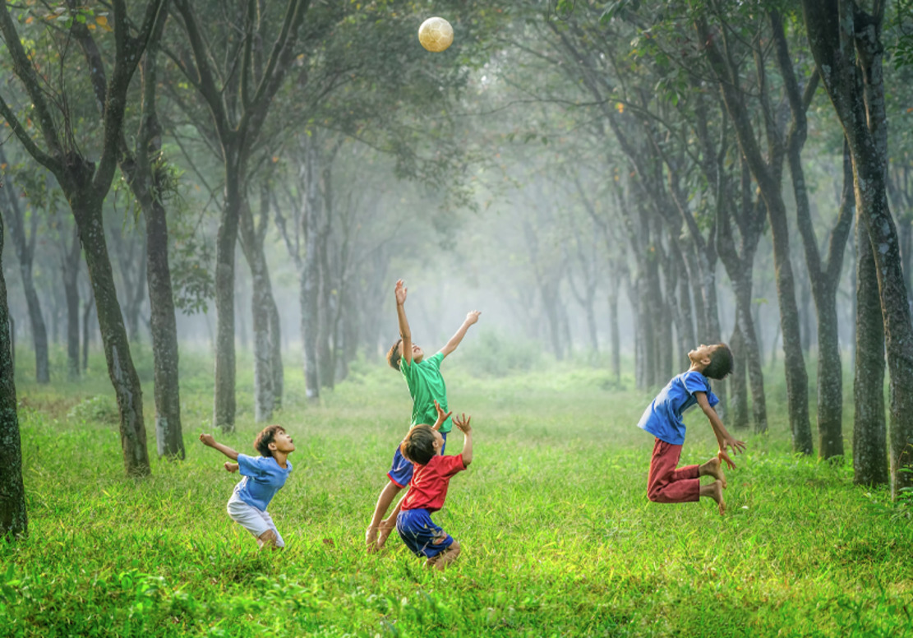
Figure 1 Happy, healthy children
View description - Figure 1 Happy, healthy children
View alternative description - Figure 1 Happy, healthy children

Here are some of the terms used in relation to health, and their definitions. The terms ‘health’ and ‘wellbeing’ are often used together, but look at the definitions for these terms separately.

Table 1: Definitions
Term | Definition
Health | The World Health Organisation (WHO) define health as ‘a state of complete physical, mental and social wellbeing and not merely the absence of disease or infirmity’ (WHO, 2022).  This definition of health is more than 70 years old and despite the many medical advances that have happened in that time, the definition is still the same. It states that physical and mental health are of equal importance, it also suggests that where people live, who they live with, and the quality of their lives – which all link to wellbeing – are important factors that contribute to overall health. And importantly, the definition states that health isn’t merely the absence of disease or infirmity, suggesting that an individual can have a disease, or a condition, but it doesn’t necessarily mean that they are unhealthy.
Wellbeing | Wellbeing can be defined in many ways. The Oxford English Dictionary defines wellbeing as ‘the state of being comfortable, healthy or happy’. Statham and Chase (2010, p. 2) define wellbeing as ‘generally understood as the quality of peoples’ lives … it is understood … in relation to objective measures, such as health status’ … You may find other definitions.
Physical health | Physical health is often used as a term that relates to a physical condition that affects a particular part of the body. For example, an infection can affect one part of the body, such as pneumonia that affects the lungs, but it can also have other physical symptoms such as extreme tiredness, pain and a high temperature. The term physical health can be used in relation to an individual’s level of fitness, strength and ability to move around.
Mental health | Mental health can be defined in various ways:  - A state of wellbeing in which every individual realises his or her own potential, can cope with the normal stresses of life, can work productively and fruitfully, and is able to contribute to her or his community (World Health Organisation, 2018).  - Child mental health, the complete wellbeing and optimal development of a child in the emotional, behavioural, social and cognitive domains (NHS, 2019)  The definition of mental health in the national ‘No Health without Mental Health’ policy is that it is a positive state of mind and body, feeling safe and able to cope, with a sense of connection with people, communities and the wider environment. This point was described by Dr Geraldine Strathdee (2015) as a ‘defining moment in mental health care’. She made this claim because this definition acknowledged that some mental health difficulties can be prevented. Everyone has mental health, and the state of mental health is heavily influenced by environment and events in people’s lives. Mental health can be likened to a windscreen wiper because it can oscillate between a state of being good or poor, as illustrated in Figure 2 (in the next section).
Mental health difficulties | These can be defined as ‘an interpretation of illness and the medicalisation of behaviours considered to be beyond the norm (Burton et al., 2014, p. 4). This term is used to describe a variety of conditions children may experience, including mild, moderate to severe, and ensuing conditions ranging from anxiety or depression through to bipolar disorder, schizophrenia and eating disorders.
Health promotion | The World Health Organisation (2018) define health promotion as the process of enabling people to increase control over, and to improve, their health. It moves beyond a focus on individual behaviour towards a wide range of social and environmental interventions.  This definition has informed many health promotion models, most famously, the Ottawa Charter on Health Promotion (WHO 1986), which include actions such as building healthy public policy; creating supportive environments, strengthening community actions, developing personal skills and reorienting health services. Health promotion models require individuals to learn how to promote their health by engaging with health education.
Health education | Health education is any combination of learning experiences designed to help individuals and communities improve their health, by increasing their knowledge or influencing their attitudes (WHO, 2018). Educating people about health has been seen as important for the last 150 years or so, before that, little was known about the causes of poor health and diseases.  As knowledge and understanding about the causes of illnesses and poor health has increased, there has been a great deal of attention given to how to promote health by the provision of better living conditions. And importantly, improved knowledge of how to prevent diseases and illnesses has meant that there is a stronger focus on educating people about their lifestyles in order to develop health promoting habits.
Preventable health conditions | As the title suggests, there are conditions that can be prevented in a range of different ways. Preventable health conditions are described as being communicable or non-communicable.
Communicable preventable health conditions | Those that can be passed on, or communicated, between humans (and sometimes animals and insects) via fungi, bacteria or viruses. For example, measles or COVID-19.
Non-communicable preventable health conditions | Conditions that are not passed on, but are caused by genetic inheritance, or can be caused by lifestyle choices. For example, maintaining a healthy weight may prevent, or at least minimise the possibility of heart disease, or the development of diabetes, as well as other conditions that are associated with excessive weight and obesity.
Acute health conditions | A generic description of an illness that appears suddenly and affects a child’s health usually for a short period of time. Illnesses can vary in severity, such as a common cold which can come and go within a few days, or a more severe illness such as meningitis.
Chronic health conditions | Chronic health conditions can be described as a health condition that affects a child for longer than three months. Children are increasingly being diagnosed with chronic health conditions.  The most common, chronic conditions that affect young children in high income countries include asthma, diabetes and eczema. As many as 10–15% of children have asthma, which means that in a class of 30 children, between 3–5 of those children are likely to have asthma. Eczema is thought to affect 11% of young children and the number of children with Type 1 and Type 2 diabetes is also increasing. Sickle cell anaemia is a common serious genetic chronic condition that affects children’s quality of life.  Chronic conditions can have a profound impact on children’s lives. For instance, they may have dietary restrictions, or they may need to have inhalers or other medications, such as injections, to manage the symptoms. The symptoms of chronic conditions can be painful and unpleasant, and in some cases, life-threatening; asthma attacks are still a cause of child deaths in the UK.

All of these health conditions will be looked at in more detail as you progress through the course.

2 Exploring health for babies and children
As you can see, there is an extensive language associated with ‘health’, and there are many different facets to what health is and how it affects individuals.

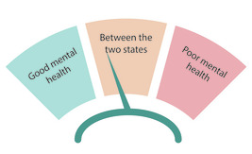
Figure 2 The windscreen wiper of mental health
View description - Figure 2 The windscreen wiper of mental health
View alternative description - Figure 2 The windscreen wiper of mental health

As an adult, some of our understanding of what health is relates to previous experiences. Therefore, if you have felt unwell, or experienced a period of poor health, perhaps caused by an ongoing medical condition, you may only then appreciate what it is to feel ‘healthy’. As an adult, the problems that can affect health in a negative way, are often based on the signs and symptoms of a condition. For instance, if adults have a viral illness, they can explain that they have a headache, feel exhausted and can usually explain exactly how they feel. This is partly based on the use of language.
So, feeling unwell could be regarded as being different to feeling unhealthy. Feeling unwell can make everybody feel unhealthy, but health is not just about being unwell, it is also about developing an understanding of how you can develop lifestyles that promote health. Leading a healthy life can be a challenge for adults, you may find it difficult to maintain a healthy weight, a way of life or the work you do may mean you have limited access to physical activity. Limited income and time may mean that choosing and preparing healthy food is a challenge. As an adult, even though you understand the health-related reasons why you shouldn’t drink more than the recommended alcohol intake, or why you shouldn’t smoke cigarettes, you may continue to do so.
Health is a complex issue and, for many reasons, it is even more complex when babies and children are considered.

Activity 2 Health for babies and children
5 minutes

Explaining what health is, and what needs to be done to be healthy, can be challenging for adults. However, it can be even more complex for babies and children. Before you read on, take a moment to have a think about why this may be the case and write down a few of the reasons that you can think of.

Provide your answer...

The next sections unpack some of the factors that you may have written down.

2.1 Factors that influence babies and children’s health
There are many factors that can influence children’s health, either in a positive or negative way. Some of the factors are within the child, others are factors within the family, wider community or society.
To explain the factors that can influence children’s health, Figure 3 is adapted from Urie Bronfenbrenner’s (1979) theory of bioecological systems. Bronfenbrenner developed his theory to explain how you must look at the child and their immediate and wider environment, to identify the factors that affect their development. However, the different influences can’t be neatly separated out because the interaction between the different systems influence development and health.

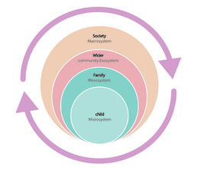
Figure 3 Adapted from Bronfenbrenner’s (1979) Bio-ecological systems
View description - Figure 3 Adapted from Bronfenbrenner’s (1979) Bio-ecological systems
View alternative description - Figure 3 Adapted from Bronfenbrenner’s (1979) Bio-ecological systems

Now look at some of the factors within each of the systems.

2.2 Microsystem: factors within the child
There are factors that happen before conception and during pregnancy that can affect a child’s health. Such factors can include the lifestyle choices of the parents, whether they smoke, drink alcohol or take drugs, and the quality of their diet. Ante-natal care for pregnant mothers helps to keep mother and baby as healthy as possible.
Some health conditions are passed on genetically from parents. Each cell of the human body contains the genes that a child inherits from their parents which is a powerful influence on their health. The genetic material that a baby receives from their biological parents can predispose them to inherit a condition that effects their health in a range of different ways. Common inherited health conditions include sickle cell anaemia, cystic fibrosis or Down Syndrome. Chronic health conditions such as asthma and eczema are likely to affect children if other members of the family have these conditions.
Babies or children may develop a disability because of genetic inheritance, their experience before or during birth, or as a result of an infection or injury. For some children, the effects or disability can be so extensive that they have complex medical needs. Having complex needs or a disability can be a factor that predisposes children to poor health, such as being vulnerable to infections.
A child’s age has a profound impact on the state of their health. Babies and children under the age of two are especially vulnerable to the causes of poor or less than optimal health. This is partly because of their immature immune systems which can make them susceptible to infection.

Language and stage of development can affect a child’s health.
Children may not have had such an experience of being unwell or feeling unhealthy. Therefore, they may not have the language to describe how they feel. This is especially the case for babies, their spoken language is limited, although they can communicate that they feel unwell through crying or changes in their behaviour.
Even when children have language, how they describe signs and symptoms can be different to adults. For instance, a child may say that they have ‘tummy aches’ and when asked where it hurts, they may point to their head!
A child who has additional needs caused by disability or complex medical needs, may have limited language. They may also have limited physical mobility. However, in a similar way to babies, they will be able to communicate how they feel to adults.

2.3 Mesosystem: the family or carers
The family that a child is born into has a profound influence on their health. and to a large extent the ability to control such factors are likely to be beyond the control of children. For example, a baby may spend a great deal of their time in ‘containers’ such as a car seat, a buggy or a highchair, and consequently have limited opportunities for physical activity which can impact on their health.
There are many social, economic, religious and cultural factors that can influence children’s health.
Social and economic factors are often interrelated. A family’s socio-economic status can have a positive or negative impact on children’s health. Families that can provide the everyday routines that meet children’s physical and mental needs, such as adequate sleep, good nutrition and hydration, and a loving and nurturing environment immediately provide a health advantage to their children. In contrast, families that are living in unstable environments and in chaotic circumstances may be less able to provide the basic requirements of health to their children. Put simply, the poorer the child and family, the poorer the child’s health is likely to be. Conversely, better off children are more likely to have better health. The effect of poverty on children’s health is discussed in more detail later in the course.
The approach that parents take to parenting children can have a direct influence on their health. If parents are permissive, they may not set boundaries for their children, this may apply to household routines which could affect when children are fed.
If parents are neglectful, this can affect children’s safety, or it can lead to children not being provided with the basic needs of life, such as nourishment, sleep and hygiene. Parents who neglect their children and can’t or don’t provide their basic physical needs may also neglect children’s emotional needs which can have a negative impact on their wellbeing and mental health.

Religious beliefs and cultural practices also affect children’s health
Culture and religion are different concepts, however they can both exert strong influences on parents’ beliefs and this, in turn, can affect children’s health. For example, some religions encourage their believers to refuse certain medical interventions. Parents may have an objection to their child receiving childhood immunisations on religious grounds. This can make children susceptible to contracting preventable communicable diseases, such as measles.

Gypsy, Roma and Traveller families have a way of life that is deeply rooted in a long cultural history. Some of their cultural beliefs influence the way that they access health services, and in turn, this can affect their health. To illustrate this point, infant mortality is 4 times higher in Irish Traveller families.
(NHS, 2021)

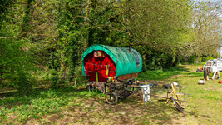
Figure 4 Traditional Gypsy, Roma, Traveller caravan
View description - Figure 4 Traditional Gypsy, Roma, Traveller caravan
View alternative description - Figure 4 Traditional Gypsy, Roma, Traveller caravan

Looked-after children
It’s important to remember that many children don’t live in a family with biological parents. Some children are taken from their parents and are ‘looked-after’ by the state. Looked-after children can be cared for by foster or adoptive parents, or they may live in a children’s home. The health outcomes for looked-after children are often not as good as for children who live with their birth families (Department for Education, 2024).

2.4 Exosystem: the child’s wider community
This exerts powerful factors that can influence health. For example, poor quality housing can cause respiratory problems, and in extreme cases can cause death. This was illustrated by the case of two-year-old, Awaab Ishak, who died in 2020 following respiratory difficulties. At the inquest into his death, the coroner ruled that his death was as a consequence of coming into contact with the mould that appeared on the walls of the poorly ventilated one bedroom flat he lived in with his family (BBC, 2022). The amenities that are available within a child’s community can have an impact on children’s health. Outdoor spaces that are well-maintained and safe give the opportunity for children to be active, which helps with physical and mental health.

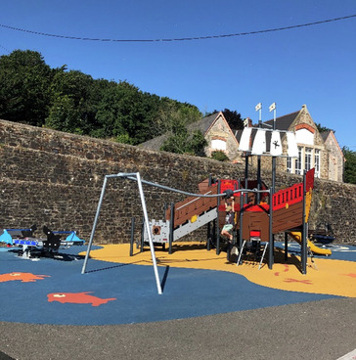
Figure 5 A well-maintained and safe playground
View description - Figure 5 A well-maintained and safe playground
View alternative description - Figure 5 A well-maintained and safe playground

The quality and availability of services for children impacts on their health. Children’s centres offer education and health services to babies and young children. Pre-school settings and schools provide health promoting activities to children.

2.5 Macrosystem: society
This impacts on health, and can include the country or part of the world where a child lives. Climate change, air pollution and pandemics are global issues that impact on everybody’s health but can have a disproportionate impact on young children. There are economic, political and geographic factors that can all influence children’s health, and in many cases these factors can interrelate. Countries that are unstable politically impact on children and their health, many countries of the world that are war-torn recruit children as soldiers, this abuse of children has negative effects on the mental and physical health of children.
As already mentioned, the most profound negative impact on children’s health is living in poverty. This is the case whether a child is living in poverty in a high income country, such as England, or living in a low income country such as many countries in sub-Saharan Africa. In many countries, very young children are part of the workforce and are routinely involved in heavy and dangerous physical work, such as mining and construction. Exposure to strenuous activity, excessive noise, toxic substances and dust can all have negative impacts on growing and still developing bodies.
A country’s policies relating to health for children influences the services that are funded and available. Health services that are accessible and affordable are essential to promote good health. However, many people live in remote parts of the planet, and therefore travelling to access health services that provide immunisations may be difficult for some parents.
The infrastructure and geography of a country impacts on children’s health, for example the availability of clean water and sanitation. Areas of the world that are prone to extreme weather conditions such as flooding can affect sanitation and the safe preparation of food for children. Areas of the world that are prone to events such as earthquakes, such as New Zealand, have shown to have a negative impact on young children’s mental health.


Figure 6 Earthquake in Christchurch, New Zealand
View description - Figure 6 Earthquake in Christchurch, New Zealand
View alternative description - Figure 6 Earthquake in Christchurch, New Zealand

This section has summarised a range of different factors that can and do influence children’s health. Although the factors have been separated out, it’s important to remind ourselves that many factors will over lap and can’t always be easily separated out. It’s also important to bear in mind that each child and their view of health is influenced by their age, stage of development, and their personal experiences. Therefore, each child can be regarded as being unique. To move back to considering the individual child, the next section explores the views about health expressed by Oscar, an eight-year-old boy.

3 A child’s view of health
The content of the course so far has illustrated some of the factors that influence children’s health. There are many factors that impact on health, and many overlap and interrelate, all of which mean that health is a complex concept. This highlights the importance of adults, whether you are a parent or working in a professional capacity with children being aware of their role in relation to supporting and promoting children’s health. The following section examines health promotion in education settings.
Surprisingly little is known about children’s views of health. In this audio, Oscar, aged 8, is asked a series of questions about what health means to him.

Audio content is not available in this format.
Audio 1
View transcript - Audio 1

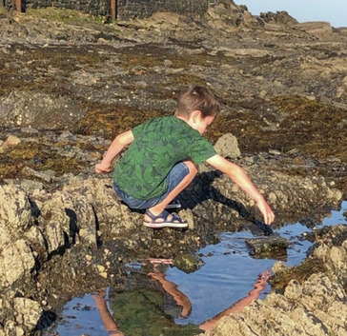
Figure 7 Oscar, aged 8
View description - Figure 7 Oscar, aged 8
View alternative description - Figure 7 Oscar, aged 8

In the audio, you’ll have heard that Oscar appears to have a very well-developed understanding of what makes him healthy. Oscar talks about health in terms of having a condition such as cancer. But he also talks about the importance of health promoting activities such as getting enough exercise and having a healthy diet. Interestingly he has a very heightened understanding of how to avoid becoming unwell because of an infection. This understanding was probably developed because of the attention that was given to the importance of handwashing during the pandemic. You may have found it interesting that he mentions how using a hand sanitiser dries his skin out, and to avoid this, he uses the hand washing station. If a child has eczema, or sensitive skin, it’s important to bear in mind that the uncomfortable feeling that hand sanitisers, or indeed, harsh soaps can have on children’s skin, may be a deterrent to them using hand washing facilities. In turn, this can increase the risk of the spread of infection, so alternative measures and close supervision are important.

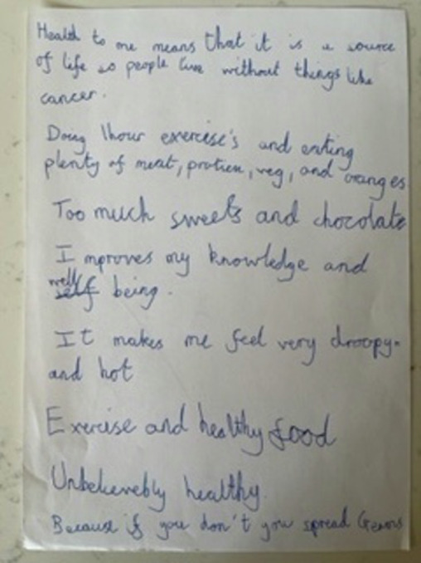
Figure 8 Oscar’s thoughts about what health means to him
View description - Figure 8 Oscar’s thoughts about what health means to him
View alternative description - Figure 8 Oscar’s thoughts about what health means to him

From this brief exchange, it can be surmised that Oscar has formed his view of health by making connections with what he has learned from factors within the context of his life. He has more than likely been influenced by the adults around him, and the media. Importantly, he appears to have been influenced by his school environment and recognised that being at school improved his knowledge and wellbeing. You may draw other conclusions from Oscar’s responses.

Activity 3 Asking children
15 minutes

Perhaps you would like to do a similar exercise and ask children (with the child’s and their parents’ permission) these questions. Consider asking children of similar or different ages.
- What are the differences or similarities between their responses?
- How do their insights help to increase your awareness about children’s views of health?

Provide your answer...

4 Health promotion in education settings
As many babies and children attend an education setting and spend many hours each day either in a pre-school or school setting, this is an ideal place to promote children’s health.
If you are an Early Childhood Education and Care educator, you will already have many activities or interventions that promote health built into the routines of your setting. In England, the EYFS, which stands for Early Years Foundation Stage (Department for Education, 2024), statutory guidance includes many aims that are linked to promoting the health of children; the aims are summarised in Session 5. Therefore, some of the activities will be influenced by the need to comply with the EYFS.
Around 90 per cent of children around the world attend primary school (World Health Organisation 2023), therefore delivering interventions that promote health in schools means that positive messages about health can target a large audience. The World Health Organisation website Health Promoting Schools has many useful resources. In Session 5, there is more about the ways that health is promoted through curricula.

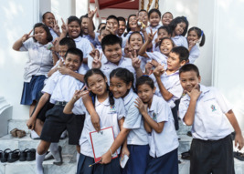
Figure 9 children in school are a target audience for health promotion interventions
View description - Figure 9 children in school are a target audience for health promotion intervent ...
View alternative description - Figure 9 children in school are a target audience for health promotion intervent ...

When children start primary school, their health is promoted through the school nurse services.

5 The role of adults
As adults, we may have more control over our lifestyles and the choices we make about health. However, for babies and children, it’s not so easy for them to make healthy choices. Therefore, it is the responsibility of adults to know what to do to ensure that children are given the best possible chance of developing good health. To conclude Session 1, consider some of the ways to achieve this goal.

Activity 4 Reflection
15 minutes

- What aspects of this session’s learning did you find most and least helpful? Why?
- What do you consider to be your three main learning points from the session?
- What further reading or research might you like to do before the next session?

Provide your answer...

It is the responsibility of adults to provide an environment in which children’s health can thrive. Adults can ensure that they provide interventions that can promote good health, whether this is at home or in an education setting.
It’s important to be aware that not every child is born into a family that is equipped to offer the best start for long term health to their children, as educators, you can learn how to try to compensate. We can equip ourselves with knowledge relating to health and develop an understanding of the factors that influence children’s health and work with families in supportive and non-judgemental ways. Children deserve no less.
Session 2 explores some of the history of child’s health, the intention being to help us understand some of the contemporary issues relating to children’s health.

6 Summary of Session 1
In this session, you have explored:
- how to define some key terms relating to health
- some of the factors that can influence babies and children’s health
- some of the responsibilities for adults in supporting children’s and babies’ health.
You should now go to Session 2.

Session 2: Patterns in young children’s health

Introduction
How healthy a young child is might, at first glance, seem like an individual thing: the child’s genetics, making the child more susceptible to various illnesses and conditions, or the ‘luck of the draw’ in contracting an infection or disease. These are of course true to an extent. But the likelihood of young children suffering from ill-health follows identifiable patterns that are not simply related to the individual person. In Session 2, you will look at the patterns of young children’s health and ill-health across time, place and across groups living in different socioeconomic circumstances. How have we arrived at the current situation for young children’s health and illness? Exploring this question will help us to understand how we can play a part in supporting babies’ and young children’s health and wellbeing.
Session 2 has three sections. In Section 1 you will learn about children’s health since the 1870s and how it differs in high-, middle- and low- income countries. Section 2 explores the inequalities in health that have existed, and still exist, for young children socially and historically. Case studies bring to life what inequalities mean for families and children. In the final part, Section 3, we bring those patterns up to the present day to help you to understand the current health issues for babies and children, the risk factors involved and what can help protect babies’ and children’s health.

Learning outcomes
By the end of Session 2, you should be able to:
- appreciate the historical development and patterns of children’s and babies’ health over the last 150 years
- understand geographic and socioeconomic inequalities in the health of young children
- describe current issues in young children’s health physically and mentally
- identify some of the ways in which the physical health and mental health of young children are linked
- identify broad risk factors and protective factors for babies’ and young childrens’ health.

1 Children’s health since the 1870s
Before you read on, take 10 minutes to think about your current impressions of the main concerns for young children’s health.

Activity 1 Your main concerns for young children’s health
5 minutes

Make a note of your immediate thoughts on:
- the main physical and mental health challenges facing babies and young children today
- how those challenges may have changed over the years.
You can refer to your notes later to see how your thinking has developed.

Provide your answer...

The health of babies and young children has changed dramatically over the last 150 to 200 years in the United Kingdom, a high-income country. In 1800, one in three children died before their fifth birthday, yet by 2020 there were just four deaths per 1000 births (O’Neill, 2019, cited at Statista). Much of this progress was made during the twentieth century.
Infectious diseases have been a particular threat to babies and young children. Measles was the most common cause of death among young children aged up to four years in Victorian Britain between 1860 and 1915, and remained in the top four causes of death for children aged four years and under until 1945 (see Table 1 below). It and other infectious diseases were such a threat to children because of their ability to spread among overcrowded populations.

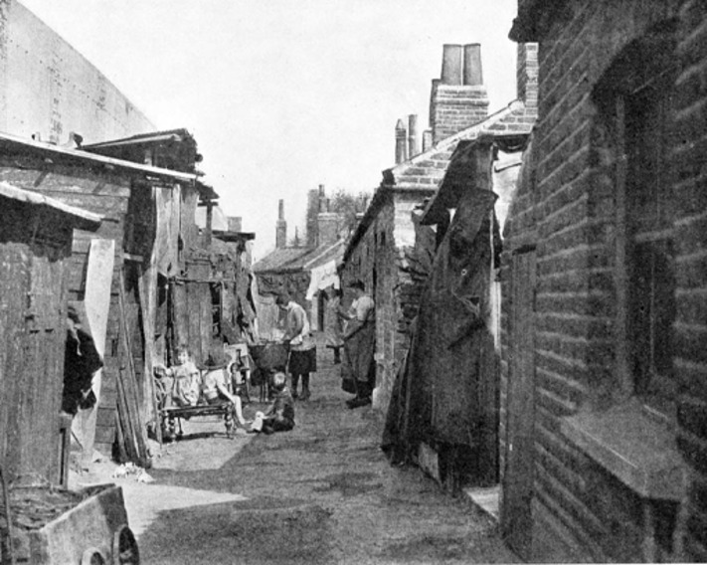
Figure 1 Conditions in early twentieth century Britain
View description - Figure 1 Conditions in early twentieth century Britain
View alternative description - Figure 1 Conditions in early twentieth century Britain

In addition: ‘…poor facilities for nursing care, and the predisposition of poorly nourished small children with existing respiratory disease to severe respiratory complications, probably explain the failure of the measles death-rates to fall in any real degree before 1916’ (Hardy, 1993, cited in Woods and Shelton, 2000, p. 75).

Table 1 Causes of deaths of children aged 1–4 years in 1915 (adapted from ONS, 2017)
Ranked causes of death in males aged 1–4 years in 1915 | Ranked causes of death in females aged 1–4 years in 1915
- measles  - broncho-pneumonia  - other bronchitis  - whooping cough  - diphtheria  - tuberculous meningitis  - pneumonia  - meningitis – other forms  - infective enteritis  - scarlet fever | - measles  - broncho-pneumonia  - whooping cough  - other bronchitis  - diphtheria  - tuberculous meningitis  - pneumonia  - meningitis – other forms  - infective enteritis  - scarlet fever

Infections were still the leading cause of death for children between 1915 and 1945 and, for those aged one to four years, infections remained the leading cause until 2005, except for 1975 and 1985 (ONS, 2017). However, there was a dramatic decline in the number of deaths from infectious diseases in the later twentieth century. Once childhood immunisation was introduced in the second half of the twentieth century, poliomyelitis (polio), diphtheria, tetanus, whooping cough, measles, mumps and rubella were all virtually wiped out (ONS, 2017).

1.1 Development of services
Services, often charitable services initially, developed in response to the great need for support with child health. The Ladies Sanitary Association, which began in Manchester and Salford in 1860, was the forerunner to health visiting. It involved door-to-door visiting with advice, information, cost-price cleaning products and carrying out minor domestic and nursing duties (Heggie, 2008). By 1905, health visitors were employed in around 50 towns, focusing on preventing ill-health and promoting public health. Health visiting became a universal service run by the Ministry of Health in 1929 (Adams, undated).

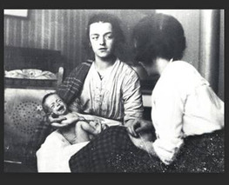
Figure 2 A health visitor with a mother and newborn baby, c.1920s
View description - Figure 2 A health visitor with a mother and newborn baby, c.1920s
View alternative description - Figure 2 A health visitor with a mother and newborn baby, c.1920s

Between the two World Wars, the poor state of health of the working classes and particularly of children came once again into the spotlight. Rates of neonatal deaths (up to 28 days after birth), postneonatal deaths (from one month to a year after birth), and maternal morbidity (illness) and mortality (death) were highlighted as being very poor, while new diagnostic techniques revealed appalling levels of chronic and sub-clinical disease (meaning disease that had not yet surfaced as having apparent symptoms) in urban children (Bivins, 2014).
During the Second World War, it became evident that families under siege needed help with feeding themselves. Evacuation also highlighted the poor health and nutrition status of many of the young children from inner-city areas. In addition to rationing, a national feeding programme emerged through the development in several local authorities of Community Kitchens. By 1941, a chain of ‘British Restaurants’ were operating across the country, providing cafeteria style nutritious hot food at affordable prices (Atkins, 2011). At the height of the war ‘about half a million people a day (including children) received a cheap but nutritious meal that supplemented their rations’ (Atkins, 2011, p. 151).

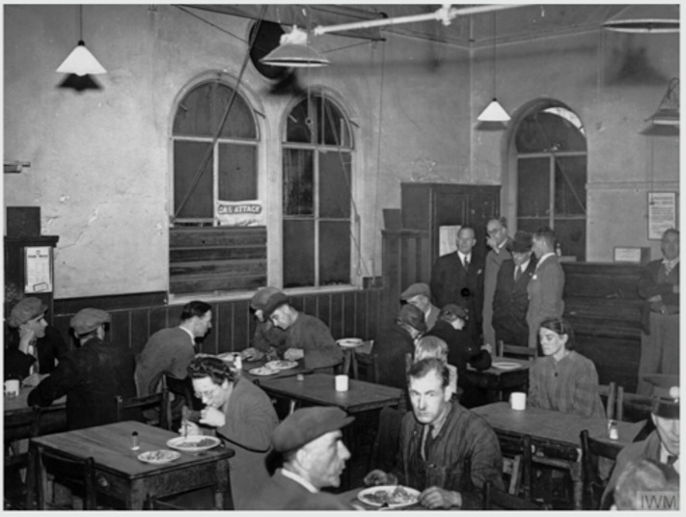
Figure 3 A restaurant in London during the Second World War
View description - Figure 3 A restaurant in London during the Second World War
View alternative description - Figure 3 A restaurant in London during the Second World War

Following the Second World War, universal services based on a system of National Insurance and taxation were created to support families during times of need, including the National Health Service with its principle of being free at the point of need (Beveridge, 1942).

1.2 Progress and patterns in low- and middle- income countries
Worldwide childhood mortality (death) rates have reduced in recent decades. The 50-year mortality trends tell us that in 1955, mortality was highest in the 1–4 year age group, but that since that time death rates in children aged 1–4 years have fallen by between 85 and 93 per cent (Viner et al., 2011; p. 1162).
Although there has been substantial progress in reducing childhood deaths across the world, some middle- and low-income countries continue to have childhood death and illness rates at alarming levels (WHO, n.d.). Eighty per cent of under-fives’ deaths in 2020 took place in Sub-Saharan Africa and Southern Asia, even though they only accounted for 53 per cent of live births. The leading causes of death for young children remain as infectious diseases (pneumonia, diarrhoea and malaria), pre-birth and birth complications, and congenital abnormalities (WHO, n.d.). Lack of access to healthcare, poor sanitation and hygiene facilities, unclean water and insufficient food as well as limited education and information all contribute to the risk of death in children (Rau, 2015).

Malnutrition
Malnutrition contributes to poor health experiences and outcomes for young children. It is concentrated in low- and lower-middle-income countries with 1 in 3 children suffering from stunted growth. It can occur at any age but has the most devastating effect on the youngest children.

Malnutrition makes children more vulnerable to severe diseases. Chronic malnutrition or stunting—when children are too short for their age because they have not been adequately nourished, received inadequate care and/or live in unhygienic environments—can leave a devastating and permanent impact on a child’s physical and cognitive capabilities.
(Save the Children, 2022)

Undernourishment of pregnant and breastfeeding mothers also adds to the risk of malnutrition and birth complications for babies up to age two years, the first 1000 days.

Conflict
In countries with prolonged conflicts, babies and young children are at the greatest risk of stunted growth due to malnutrition and to death before the age of five years. At least 240 million children live in countries affected by conflict. Children in countries such as South Sudan, Syria and Yemen, which have been experiencing conflict for a considerable time, are subject to acute malnutrition and lack access to health care and education (Save the Children, 2022).

Activity 2 Different perspectives
10 minutes

Read the testimony below from Claire Nicoll, who works for the Humanitarian Operations Team at Save the Children and worked in Yemen in 2019. Consider what the feelings of Rayah (the mother) and Claire (Humanitarian worker, Save the Children) must have been in this situation.

Today, we visited a health facility in rural Hajjah, northern Yemen. … I met 18-month-old Leila and her mother Rayah, and their story is one that I know will stay with me. Leila is suffering from Severe Acute Malnutrition – the deadliest form of extreme hunger that can easily claim the lives of young children. In Yemen, it often does.
When Rayah took Leila’s shirt off to be examined, I struggled to keep my expression neutral. I was shocked at how painfully thin she was.
‘What would you do – take one child to the hospital or feed the others?’
This is the question that Rayah asked when telling me about how the brutal four-year conflict has impacted her life. It shows the impossible choices many mothers in Yemen face every day. She didn’t take Leila to the health facility earlier, when recovery would be guaranteed, as the transport costs would have left her with no money to feed her other children.
Rayah has already lost two children, one from hunger and the other from cancer. She told me in a matter-of-fact tone that cancer was easier to bear, as the death was faster, and she felt less responsible.
I had no answer to her question.
(Save the Children, 2022)

1.3 Preventable health conditions
Improvements in medicine and living conditions over the last 150 years have resulted in improved life expectancy and reduced child mortality, with more children surviving infancy. Significant medical developments included the discovery of vaccines and penicillin. Improved living conditions in countries like the UK, such as sanitation and access to clean water, have been important in improving health.
However, since the start of this twenty-first century, other threats to children’s health have emerged, many of which are preventable, and which are of great concern to global and national organisations. The Royal College of Paediatrics and Child Health’s State of Child Health Report in 2017 stated that:

The health of infants, children and young people in the UK has improved dramatically over the last 30 years. Many will lead happy and healthy lives, but the future health and happiness of a significant number is in jeopardy. The bottom line is that the UK could do far more to improve child health and wellbeing.
(Viner et al., 2017, p. 4)

Communicable and non-communicable diseases
Health conditions can be categorised into those that are ‘communicable’ (can be from person to person), and ‘non-communicable’. During the COVID-19 pandemic, people became more familiar with communicable illnesses spread by micro-organisms – viruses, bacteria or fungi. On the other hand, health conditions can be caused by factors that are non-communicable, or not passed on by micro-organisms, some of which are also preventable. Table 2 summarises the two categories of health conditions and gives examples of the illnesses they cause, ways of preventing them, and the impact in adulthood.

Table 2 Summary of areas of preventable health conditions
Preventable health conditions
Communicable: passed on by micro-organisms (viruses, bacteria and fungi) | Non-communicable: not passed on through contact with micro-organism; many caused by poor nutrition, physical inactivity, unhealthy lifestyle and poor dental hygiene
Examples: some can be prevented by immunisation, e.g., poliomyelitis, diphtheria, tetanus and whooping cough.  Some can be prevented or minimised by good hygiene, especially handwashing, hygienic food preparation and a healthy environment, e.g., norovirus.  Impact in adulthood: infections can leave a legacy of disability, e.g., poliomyelitis | Examples: childhood obesity; inadequate nutrition; dental caries; mental ill health  Impactin adulthood: coronary heart disease, diabetes, cancers, poor mental health

Prevention of communicable health conditions
Thorough handwashing is one of the single most effective ways of reducing the risk of infections that are caused by bacteria, viruses and fungi that cause a range of infections.
Childhood immunisations are offered to most children in the UK and prevent serious infections, including measles, mumps and poliomyelitis. These conditions can be life-threatening but are preventable by giving children the full immunisation schedule (NHS, 2019). See the full regularly updated schedule here: NHS vaccinations and when to have them. Remember that children arriving in the UK from other countries may not have been offered all vaccinations.

Prevention of non-communicable health conditions
The causes of such conditions can be influenced by factors in the child’s environment, such as social, economic, cultural and other lifestyle determinants. Living in poverty is a significant determinant of a children’s health.
Poor mental health is also a cause of concern. The presence of adverse childhood experiences can impact negatively on children’s emotional and social development, which can reduce their sense of wellbeing and increase the risk of mental ill health in childhood or later life.

2 Inequalities in health: socio-historical perspective
Next, you will watch the video Patterns of child health in the past 50 years.

Activity 3 Patterns of child health in the past 50 years
10 minutes

While you are watching, think about and note:
- What is meant by the term ‘inequalities in health’?
- What it means for babies and children born into families in different circumstances and different geographic areas.

Video content is not available in this format.
Video 1 Patterns of child health in the past 50 years
View transcript - Video 1 Patterns of child health in the past 50 years

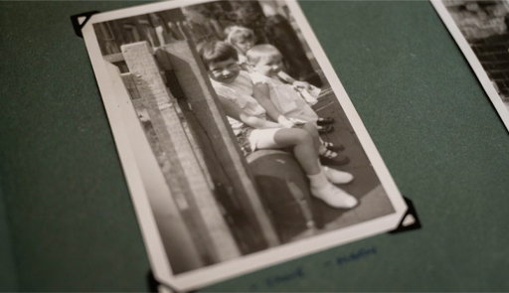

Provide your answer...

Socio-economic inequalities in health
You will see on the video that we have known about the differences in illness and death rates between children and adults from richer and poorer families in the UK for a very long time. Babies, children and adults from families with lower incomes in this country are much more likely to suffer from ill health and early death than babies, children and adults from wealthier families. This is what is meant by socio-economic inequalities in health.
The video refers to two important reports. The first one from 1976, the Court Report, Fit for the Future, reviewed children’s health and health services across the country. It found that the poorest children living in inner cities had the highest rates of illness and death, including cot deaths affecting the youngest babies. These children were physically smaller. It pointed out the connection between ill health, especially respiratory and infectious diseases, and poor housing conditions such as overcrowding, lack of access to sufficient water supply, toilet facilities and heating.
The second report, the Black Report, was commissioned in 1977 by the Labour government as the Research Working Group on Inequalities in Health under the chairmanship of Sir Douglas Black, President of the Royal College of Physicians. Its report in 1980, Inequalities in Health, was largely dismissed by the new Conservative government and very few copies were made available. However, Penguin later published a paperback version, meaning it reached a wider readership (Townsend et al., 1992).
The report showed that the lower the socioeconomic status people had, the higher their risk of ill-health and early death. This affected babies and children as much as adults. For example, babies aged from one month to a year of fathers working in unskilled jobs had death rates four to five times higher than those of fathers working in professional jobs. Not only that, but the inequalities were widening. And the causes were still the same: low income, poor nutrition, poor living conditions especially overcrowding, and poor working conditions. However, the racial aspects of inequalities in health were poorly examined and the report did not do race justice. While the authors acknowledged skin colour as a significant factor in ‘social and economic disabilities’, ‘race’ is only discussed on a few of the report’s pages (Redhead and Olszynko-Gryn, 2020).

2.1 Patterns of child health in the past 50 years

Geographic inequalities
Parallel to socioeconomic inequalities affecting the health of babies and children, there are inequalities according to where a child lives. You have already read in Section 1 how babies in low- and middle-income countries suffer more ill-health and higher death rates than those in wealthier nations.
In wealthier countries like the UK, too, there are within-country differences in children’s illness and death rates and in access to good health services. Research such as Health and deprivation: inequality and the North (Townsend et al., 1988; Phillimore et al., 1994) highlighted that where people lived affected how healthy they were. For example, in one electoral ward (small geographic area linked to the local authority) six per cent of babies were of low birth weight, while in another it was four times higher. The studies used two indicators to compare health with deprivation:
- The Overall Health Index included, among other things, low birthweight and delayed development rates in children.
- The Overall Deprivation Index including unemployment, overcrowding, car ownership and home ownership.
Their conclusion was the following: ‘The association between poor health and material deprivation is statistically highly significant’ (Phillimore et al., 1994). Two-thirds of the difference in health between these populations was linked to differences in their standard of living.

2.2 Case studies of child-health promotion work in Birmingham
You will now look at two local case studies of past work to support young children’s health, plus that of the wider community. One of the authors of this course, Professor Jane Payler, was involved in both cases.

Central Birmingham community health council 1982
In the video in Section 2, you saw Jane talking about the work she did at Central Birmingham Community Health Council (CHC) from 1982–83. CHCs were set up to provide a voice for the public in the National Health Service. At this time, a new health authority, Central Birmingham Health District led by Edwina Currie (who went on to become a health minister in the Conservative government), had been set up to run the health services in the central parts of the city. The CHC wanted to give the new health authority an overview of the population of the electoral wards in the Central area and to make them aware of factors relevant to planning health services. The population’s age structure and ethnic mix, the environmental conditions and indicators of relative affluence or poverty were all included.
It was clear that Central Birmingham at that time had electoral wards that were wealthier to the west, south and further out from the centre, whereas areas nearer to the centre – the inner-city areas - were poorer. Indicators showed that in the inner-city areas (Sparkbrook, Sparkhill and Nechells) over 45 per cent of households either had to share or did not have access to an inside toilet. Over 8 per cent of the households also did not have access to, or had to share, a fixed bath or shower (see Table 3) (Harding, 1982).

Table 3 Percentage of households with exclusive use of fixed bath, inside WC and hot water supply in 1971 in electoral wards in Central Birmingham. (Harding, 1982)
Quinton | 81–95%
Harborne | 81–95%
Hall Green | 81–95%
Edgbaston | 66–80%
Fox Hollies | 66–80%
Sparkhill | 50–65%
Sparkbrook | 50–65%
Nechells | 50–65%

Some of the indicators of child health from that time show the pattern of inequalities replicated. In the poorer areas, babies were more likely to be born at low birth weight and were more likely to die in the perinatal period (deaths from birth to age six days), than in the wealthier areas. The rates of paediatric deaths and discharges for children aged 2–13 years were also highest in the poorest area, at that time Sparkhill, but lowest in the wealthier areas of Harborne, Hall Green and Fox Hollies.
Action by the Central Birmingham Community Health Council helped to highlight the needs of children and babies living in the poorest areas in Central Birmingham at that time.

East Birmingham patterns of health mid-1980s
From 1985, Jane worked in the health education service at East Birmingham Community Health Authority. The health education service worked closely with local community leaders, health visitors, school nurses and the East Birmingham Community Health Council to address difficulties faced by families, babies and children in the area. In electoral wards now known as Bordesley Green, Small Heath and Heartlands in the west of East Birmingham, child health statistics at that time demonstrated a strong link between higher rates of infant and child illness and death and families living in disadvantage. The health education team worked with local people to produce culturally sensitive infant weaning leaflets in a variety of community languages. It made pregnancy, baby and child health advice videos and leaflets in community languages available to health professionals and community leaders to use widely in the community. The team also went into primary schools to talk with teachers and children about health promotion.
Sadly, recent statistics from Birmingham Public Health (2019, p. 7) tell us that the health of babies and children is still worse than it should be in these areas. For example, Birmingham has the worst infant mortality rate of all local authorities in the country. The wards of Bordesley Green and Heartlands have infant mortality rates that are even higher than the Birmingham average.

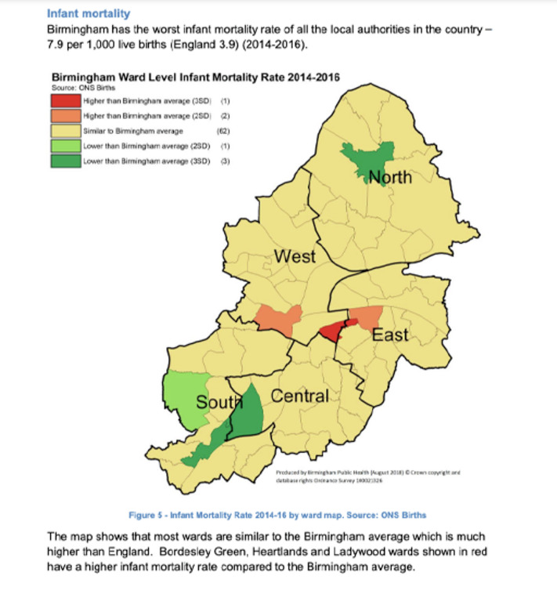
Figure 4 Infant mortality rates in Birmingham, 2014–2016
View description - Figure 4 Infant mortality rates in Birmingham, 2014–2016
View alternative description - Figure 4 Infant mortality rates in Birmingham, 2014–2016

2.3 Access to services for babies and young children to support health

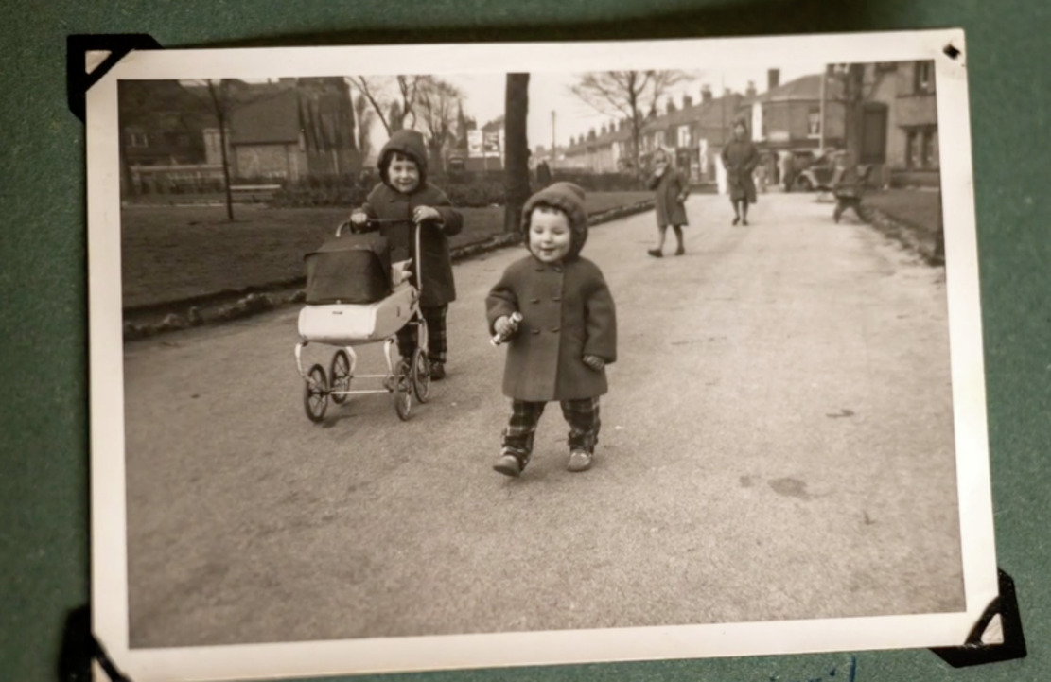
Figure 5 Growing up in Birmingham
View description - Figure 5 Growing up in Birmingham
View alternative description - Figure 5 Growing up in Birmingham

In 1971, Julian Tudor-Hart wrote about the fact that the people who were most in need of medical care or health support were the least likely to have good access to it. He called this ‘the inverse care law’. But it can be possible to design services that are more readily accessible to those who need them most. The Derby community paediatric service decided to tackle ways to improve access for children from the most disadvantaged areas (Maharaj et al., 2014). Added to this, the service monitored how well families and children from those areas were finding and using the service.

Activity 4 How well is access monitored?
5 minutes

As you read the case study below, think about services that you run or use. How effectively do they help families living with disadvantages and how well is that access monitored? Make a note of what works and what could be improved, using the ideas below.

What makes the community paediatric service in Derby work well for those in need?
Multi-agency working: Our service has a strong ethos of multi-agency working. Unusually for a specialist health service, 50 per cent of our referrals come from agencies outside health, including education, social care, police, and voluntary agencies.
Staff awareness: One of our main objectives is to provide a service that is accessible to and used by vulnerable and deprived children. We made our focus on these children explicit by including it in staff training, including administrative staff. As a result of this all our staff are aware of and sensitive to the difficulties faced by deprived families.
Accessibility: Our service has removed many of the barriers that deprived families often find difficult to navigate: we see children in local clinics close to home; our referral and booking process is simple and inclusive as we accept referrals from all agencies and prioritise on the basis of need rather than source of referral; we offer families a choice of time and dates for appointments, and provide telephone reminders; for families who are likely to struggle to attend we enlist the help of other agencies to support attendance; we see children in non-health settings when appropriate, for example in schools and children’s centres.
Acceptability: Community paediatricians provide care that is available to all and covers a wide range of conditions, so we do not carry the perceived stigma of services aimed specifically at poor children.
Comprehensive service provision: Comprehensive services that can address many issues at once are more likely to be successful at reducing health inequalities due to poverty. Community paediatricians have broad-based training and work in multi-agency and multidisciplinary networks. Consequently, they can manage a wide range of issues across the physical, learning, emotional and psychosocial domains (meaning issues at the intersection of psychological and social life, such as anxiety, enuresis, aggression). They provide a comprehensive and co-ordinated service for their patients via local community paediatric clinics.
(adapted from Maharaj et al., 2014, pp. 224–5)

Provide your answer...

Review your learning
10 minutes

Look back at your earlier notes. What are your thoughts now on the two questions you considered at the start of Section 2?
- What is meant by the term ‘inequalities in health’?
- What does it mean for babies and children born into families in different circumstances and different geographic areas?

Provide your answer...
View discussion - Review your learning

3 Current health issues for babies and children

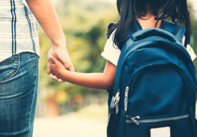
Figure 6 Family support
View description - Figure 6 Family support
View alternative description - Figure 6 Family support

In 2010 and in 2020, a team led by Sir Michael Marmot reviewed and reported on recent health inequalities in England (Marmot et al., 2010; Marmot et al., 2020). They found that yet again inequalities in the health of families were not only still evident, but that they were getting worse. While England had continuous improvements in life expectancy from the start of the twentieth century, these had slowed down significantly from 2011.

For part of the decade 2010–2020 life expectancy actually fell in the most deprived communities outside London for women and in some regions for men. For men and women everywhere, the time spent in poor health is increasing. This is shocking.
(Marmot et al.,2020, p. 5)

Unfortunately, it is still true that in poorer areas, people’s health is worse than in wealthier areas. People in poorer areas spend ‘more of their shorter lives in ill health’ (Marmot et al., 2020, p. 13). This is also the case for children and is indeed shocking.

The most deprived 10 percent of children are nearly twice as likely to die (5.3 per 1,000) as the most advantaged 10 percent of children (3.1 per 1,000), and children in more deprived areas are more likely to face a serious illness during childhood and to have a long-term disability.
(Marmot et al., 2020, p. 37)

3.1 Persistent inequalities in health for young children
Child poverty continues to be one of the most important factors contributing to child ill-health. The Marmot review (2020) highlights which children are most likely to be living in poverty, particularly those living in lone-parent families and minority ethnic children.

Table 4 Percentage of children living in poverty in 2017/18 in the UK. Adapted from Marmot et al., 2020, p. 42
In lone-parent families | 47%
Minority ethnic children | 45%
White British children | 20%

Children in lone-parent families are ‘particularly at risk of low outcomes and poor health, both in childhood and throughout life.’ (Marmot et al., 2020, p. 42). Minority ethnic children living in poverty in the UK ‘experience cumulative impacts of the intersections between poverty and exclusion and discrimination, which harms health and life chances even from the earliest age’ (Marmot et al., 2020, p. 42).

Tackling racism
While it is tempting to despair at the difficulties some children face, there is an important part for early childhood education and care (ECEC) to play in helping children to have healthier lives. Early years services of high quality make an enduring impact on children’s health and other outcomes, especially for children from disadvantaged backgrounds (Marmot et al., 2020, p. 36). One aspect of ECEC that can help young children is to tackle racism and to provide an environment in the early years that is culturally sensitive, valuing and welcoming all children’s family heritage, within an anti-racist framework. See for example guidance by Liz Pemberton, a Black Nursery Manager (Pemberton, 2022a, 2022b, 2022c and 2022d). Pemberton proposes the ‘4 Es of anti-racist practice’ for early years provision (Pemberton, 2022d).

The 4 Es of anti-racist practice
- Embrace all children’s racial, cultural and religious backgrounds, especially when they differ from your own.
- Embed a culture of belonging and value among practitioners and children.
- Ensure that your practice is culturally sensitive and places the child as the expert of their cultural, racial and religious identity.
- Extend learning opportunities for the child by showing interest, expanding conversations and using diverse resources.

Books such as My Skin, Your Skin by Laura Henry-Allain also provide excellent tools for talking with all young children about race and racism in ways that they can understand and embrace (Henry-Allain and Iwu, 2021).
There is always something that can be done in ECEC to help young children fulfil their health potential. The Toolkit outlined in Sessions 6, 7 and 8 ahead will help you to plan for action.

3.2 Contemporary child health concerns
What are the main concerns for young children’s health in the UK today? This section will highlight some of the biggest health challenges that children face. Later in the course, in Session 4, each of these challenges will be examined in more detail. For now, Table 5 gives an overview of the key issues.

Table 5 Preventable non-communicable and communicable physical child health concerns
Obesity and poor nutrition | The UK currently faces a childhood obesity epidemic, with almost 1 in 5 children leaving primary school obese (Royal Society for Public Health (RSPH), 2015). Obesity in children is serious and can lead to later physical health conditions including asthma and diabetes (Musgrave, 2017, p. 96). As the RSPH explains, health and early years practitioners are perfectly placed to have healthy conversations with expectant and new parents, but they need support and training (RSPH, 2015).
Poor dental health | Around one in four (23%) 5-year-olds in the UK have had dental decay, affecting an average of three teeth (Public Health England, 2020). The consumption of foods and drinks containing sugar are a particular problem.
Pollution | Air pollution is a serious threat to children’s health. Nine-year-old Ella Adoo-Kissi-Debrah, who lived near the South Circular Road in Lewisham, south-east London, died in 2013. In 2020, she was the first person in the UK to have air pollution listed as the cause of death on their death certificate (BBC News 2021). Air pollution ‘can stunt the lung growth of children which means they run a higher risk of developing chronic illnesses as they grow’ (Royal College of Physicians (RCP), 2022).
Infectious diseases | Although infections are less of a risk of death for children since immunisations were introduced, they can still cause illness and distress (Musgrave, 2017, p. 104). We have all become aware of the importance of reducing the spread of infections throughout the Covid-19 pandemic, and we all have a role to play in preventing the spread of infections such as the common cold and norovirus, too.
Mental ill-health | The stresses and strains of family life, particularly where there are additional factors of poverty or breakdown of relationships, can impact on a young child’s mental health. One in six children aged 5–16 are likely to have a mental health problem (Children’s Society, 2022). In the next section, you will look at the links between physical and mental health, and ways to support good physical and mental health in young children.

3.3 Protecting babies’ and young children’s health
Marmot et al. (2020) are very clear on how to help every child to have a good start in life.

Recommendations for giving every child the best start in life
- Increase levels of spending on early years and as a minimum meet the OECD average and ensure allocation of funding is proportionately higher for more deprived areas.
- Reduce levels of child poverty to 10 per cent – level with the lowest rates in Europe.
- Improve availability and quality of early years services, including Children’s Centres, in all regions of England.
Increase pay and qualification requirements for the childcare workforce.
(Marmot et al., 2020, p. 49)

Further ways in which you can help young children and their families to have healthier lives include:
- Signposting to or using other services and advice to offset stress and the impacts of poverty, such as available financial benefits, debt management support, freely available voluntary organisations that can offer help, e.g. Step Change Debt charity, Citizens Advice Bureau, Homestart UK.
- Maintaining or using contact details of local services such as health visitor services, children’s library services, accessible outdoor play spaces. Inviting other professionals in to your setting to talk to parents or to leave information can also be helpful.
- Making use of free health-related training for yourself and staff, see for example the excellent online resources as part of the Anna Freud Centre, Early Years in Mind. It is a free online network for early years practitioners. The network provides easy to read and easy to use guidance on supporting the mental health of babies, young children and their families.
- Seeking support and referrals for services on behalf of parents and their children where appropriate and with their permission or supporting them to do so themselves.
In later sessions of this course, especially Session 6, you will be guided through a five-step plan of the Toolkit in which practitioners and parents can work together to set self-chosen, meaningful, health-related goals to maintain or improve young children’s health in your care.

4 Summary of Session 2
In Session 2, you have outlined the historical development and patterns of children’s and babies’ health over the last 150 years. We have seen the patterns of geographic and socioeconomic inequalities in the health of young children. You should now be able to describe current issues in young children’s health; and identify some of the ways in which the physical health and mental health of young children are linked. You should also be able to identify some of the risk and protective factors for babies’ and young children’s health.

Activity 5 Questions for reflection
15 minutes

- What aspects of this session’s learning did you find most and least helpful? Why?
- What do you consider to be your three main learning points from the session?
- What further reading or research might you like to do before the next session?

Provide your answer...

You should now go to Session 3.

Session 3: The benefits of promoting children’s health

Introduction
In this session you will explore health promotion and start by looking at defining what this means. The content looks at the benefits of promoting babies and young children’s health and look at the benefits in relation to the individual child, all children, families and all of society. You will return to the issue of poverty and identify some of the reasons living in poverty causes health inequalities. You will compare living in poverty in an inner-city area with a rural area.

Learning outcomes
By the end of this session, you will be able to:
- define the aims of health promotion
- explain the benefits of promoting health for children
- be aware of the health inequalities that exist for children and families
- explain the effect of living in poverty on babies, young families and children.

1 Definition of health promotion
Health promotion seeks ways to educate people about behaviours that will maximise their health. A guiding principle of health promotion is to prevent poor-health or diseases from occurring. Good levels of health can be achieved by avoiding some of the factors that can contribute to diseases occurring. Health promotion is defined by the World Health Organisation (WHO) as the process of enabling people to increase control over, and to improve, their health. It moves beyond a focus on individual behaviour towards a wide range of social and environmental interventions (2021).
Therefore, health promotion is the process of adopting behaviours and a lifestyle that helps to prevent some of the illnesses that can cause poor health from occurring. In England, the Department of Health and Social Care published the Prevention is better than cure document in November 2018, which outlines the government’s vision of investing in the prevention of illnesses occurring, rather than spending on curing illnesses. The Secretary for State outlines the government’s vision of how ‘prevention creates the right conditions for good health and wellbeing – helping everyone to live well for longer’ (2018, p. 5). Within the document, the features of prevention are described as:

- Prevention creates the right conditions for good health and wellbeing.
- Prevention is about helping people stay healthy, happy and independent for as long as possible. This objective is as relevant at seventy years old as it is at age seven.
- Prevention means stopping problems from arising in the first place.
- This means giving people the skills, knowledge and confidence to take full control of their lives and their health and social care and making healthy choices as easy as possible.
(Department for Health and Social Care, 2018, p. 5)

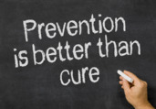
Figure 1 Preventing poor health is better than curing illness
View description - Figure 1 Preventing poor health is better than curing illness
View alternative description - Figure 1 Preventing poor health is better than curing illness

Clearly, this approach raises considerations when applied to health promotion in very young children and some of these considerations will be discussed in the following sections.

Activity 1 The benefits of health promotion
10 minutes

Before you read on, take 10 minutes to think about what you think the benefits are of health promotion to individuals and to society, that is the different ‘stakeholders’. Use the table below to make notes of your responses:

Table 1
List of stakeholders | Benefit to each stakeholder
Each child | Provide your answer...
All children | Provide your answer...
Parents and family | Provide your answer...
Adults | Provide your answer...
Society | Provide your answer...
Early Childhood Education and Care settings and schools | Provide your answer...
Any other stakeholders you can think of? | Provide your answer...

As you read the following section, consider your responses and compare them with the points made about how promoting children’s health has benefits for many stakeholders.

2 Promoting children’s health: benefits to different stakeholders
This section summarises the benefits to children, adults, society and education settings of promoting children’s health right from the start of life. Figure 2 summarises the different stakeholders who can benefit from promoting good health and avoid illnesses that are preventable.

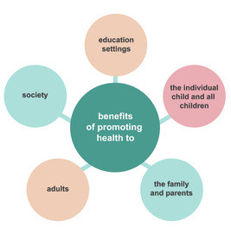
Figure 2 summary of the benefits of promoting children’s health in Early Childhood
View alternative description - Figure 2 summary of the benefits of promoting children’s health in Early Childho ...

The document Prevention is better than cure was published by the Secretary of State for Health and Social Care in November 2018. The content outlined the need to make health promotion a priority for all people, stating that:

greater focus, and spending, is needed on prevention, not just cure…this means services which target the root causes of poor health and promote the health of the whole individual, not just treating single acute illnesses. In practice this requires greater funding for pre-primary, primary and community care – and support for the staff who work in these services.
(Department for Health and Social Care, 2018, p. 1)

This statement acknowledges that promoting health and preventing the causes of poor health needs to start in the early years. Early years practitioners working with young children have an important role to play in working with children right from the start which will have positive benefits to the whole of society.

The individual child
There is increased awareness that healthy habits need to be encouraged right from the start of life, and the early years are important ones in which to give babies the opportunity to experience and learn what will help to promote their health. For example, simply giving babies the opportunity to move around can help them to develop physically which promotes good health. Good habits start right at the beginning of life: nobody is born hating broccoli and only wanting to drink high-sugar, fizzy drinks. However, it is important to be aware that there are many reasons why introducing good habits can be a challenge for many children and their families.


Figure 3 Babies need opportunities to be physically active to help promote good health
View description - Figure 3 Babies need opportunities to be physically active to help promote good ...
View alternative description - Figure 3 Babies need opportunities to be physically active to help promote good ...

Improving the health of each individual child has many benefits. Feeling healthy, both physically and mentally, mean that children are likely to flourish and have an increased sense of wellbeing. In contrast, a child who experiences poor health is likely to have a reduced sense of wellbeing. Poor health can result in absence from their education setting and can reduce their ability to take part in educational and social activities. In turn, children can feel excluded and may start to fall behind in their development and educational achievement.
It is important to consider the short- and longer-term benefits of promoting children’s health. Health promotion activities and interventions that are effective in the short-term include handwashing to help minimise the risk of spreading communicable diseases. Such diseases include common infections such as the norovirus, other ‘germs’ that can cause diarrhoea and vomiting, and the common cold. These conditions may be regarded as having a short-term impact because they only affect children for hours, or in some cases for days, but they can result in periods of absence for children from their setting. Such absences mean that children are missing out on their early education. The nature of infectious diseases is that they are indiscriminate in who they infect, meaning that the conditions are spread among staff and can of course be spread to others beyond the setting.
There are many examples of how promoting health in children can have long-term influences. For instance, the consequences of a poor diet in childhood can have profound effects, for example obesity in childhood can impact on health in later life because of the increased risk of heart disease.

All children
Promoting health for each child will have positive benefits for all children. For example, minimising the spread of infectious diseases will help to reduce levels of sickness, this in turn will have a positive impact on their wellbeing and increase their participation in their setting and improve their enjoyment of life. It is especially important to consider how reducing the incidence and impact of an infectious disease in children will help to protect children who have complex medical needs or a chronic health condition such as asthma or diabetes.

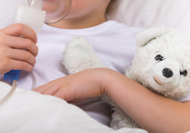
Figure 4 Infectious diseases may affect a child with asthma to have an attack
View description - Figure 4 Infectious diseases may affect a child with asthma to have an attack
View alternative description - Figure 4 Infectious diseases may affect a child with asthma to have an attack

The presence of an ongoing medical condition can make children more vulnerable to becoming seriously unwell with an infection that can have less impact on children who don’t have an existing medical condition.

Parents and families
For families there are several benefits of promoting good health in children and avoiding poor health. A child who is experiencing either short or long-term ill health can place an additional layer of strain on parents and families. When a child feels unwell, this can impact on their behaviour, often making them miserable and difficult to please. In turn, this can cause frustration and upset which can affect relationships.
Short-term illnesses can mean that parents need to miss time from work which can impact on their income. Parents may need to make alternative childcare arrangements which may be distressing for parents and even more importantly, for their children. Long-term poor health or illnesses can mean that children need on-going medical attention, which can mean that parents may not be able to work. Therefore, children’s poor health can create financial hardship.

Adults
The benefits of promoting good health in childhood can continue across the age range into and across adulthood. Put simply, a healthy child is more likely to become a healthy adult. Life expectancy is greater now than it was in the past, a child who is born today is likely to live for 81 years (ONS, 2021). However, illnesses that can develop because of childhood obesity (such as diabetes or heart disease), the long-term impact of receiving poor nutrition or the long-term consequences of an infectious disease, can mean that adulthood can be spent in poor health. Having poor health in later age because of early childhood health is a reason why teaching children about behaviours that promote good health is important for a better quality of later life.

Society
Healthy adults who have less reliance on the need for medication and health services reduce the strain on health budgets. Good health in adulthood can mean that individuals play a positive role in society and make a positive contribution to the country’s economy. As stated in the Prevention is better than cure document, ‘a healthy nation is vital for a strong economy’ (Department for Health and Social Care, 2018, p. 5) because having healthy adults means they can continue to work and make a positive contribution.

Education and care settings
Promoting babies and children’s health in education settings can help children to be as healthy as possible so they feel fit and are able to take part in all activities. Babies and children who feel fit and healthy are more likely to have good wellbeing. Feeling unfit and unwell can affect children’s concentration levels and behaviour, and this can affect their learning.
Education settings generally have large numbers of babies and children in a relatively small space, this can be a challenge in preventing the spread of infection. However, minimising the risk of the spread of infection is beneficial so that children and babies are less likely to become unwell. Absence because of staff illness puts additional pressure on all staff and can impact negatively on their wellbeing.
There are many benefits to promoting good health to the individual child and to all members of society, and every adult has a responsibility to understand what they can do to contribute to making children’s health as good as it can be. However, as already discussed in Sessions 1 and 2, there are many factors that can influence children’s health, and the most potent and negative factor is living in poverty. The following sections explore the issue in more depth.

3 Living in poverty and the effect on children’s health
As discussed in Session 2, poverty is a global issue that affects children in low- and high-income countries, it profoundly impacts on children’s health and is a cause of inequality. People who lived during the Second World War (1939–45) and were alive before the creation of the National Health Service (1948) may be surprised that we still have an unacceptable number of children living in poverty in high-income countries like those of the UK. Figures from the Social Metrics Commission (2020) state that 4.5 million children in the UK, that is 33% of the population, are living in poverty. This means that in an average class of 30 children, as may as 10 children are affected by poverty, and in turn, their health is being negatively affected.

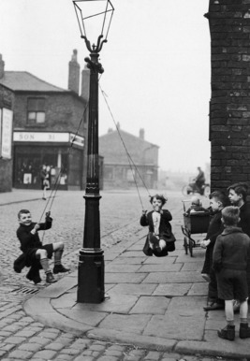
Figure 5 Children playing in the street in a poor inner-city area
View description - Figure 5 Children playing in the street in a poor inner-city area
View alternative description - Figure 5 Children playing in the street in a poor inner-city area

Understanding poverty
Understanding the concept of poverty in contemporary times is a complex issue. Statistics that help to quantify the number of people who live in poverty frequently look at economic status and the amount of money that a family has available to spend. There is no universal definition of poverty (UK Parliament, 2022) and this can lead to misunderstandings about what living in poverty can mean for those affected. Instead of looking at poverty simply in terms of the amount of money that is available, the Social Metric Commission (cited in UK Parliament, 2022) suggest that we view the level of poverty as being ‘the extent to which someone’s resources meet their needs’.
Defining poverty and understanding its effect on children’s health may be less important than understanding how and why children who live in poverty have poorer health than children who live in affluent families who have resources to meet the needs of their children. The following section looks at poverty in an inner-city of England.

3.1 Childhood poverty in inner-city Birmingham
In Jane Payler’s video in Session 2, she discusses the poor health of children in the central Birmingham area in the 1980s. To explore the impact of poverty on children’s health 40 years on, we returned to the area and visited a Children’s Centre in the inner city of Ladywood in Birmingham. In the following video, Dr Helen Lyndon talks about the influence of the environment on children’s health.

Activity 2 The effect of the environment on children’s health
15 minutes

As you watch the video, consider the following questions:
- What, if anything, has changed in Ladywood since the 1980s?
- How does Helen describe the effect of the environment on children’s health?
- What are the contemporary health issues affecting children’s health?

Video content is not available in this format.
Video 1 Interview with Dr Helen Lyndon, the Centre for Research in Early Childhood, Birmingham UK
View transcript - Video 1 Interview with Dr Helen Lyndon, the Centre for Research in Early Childhood, ...

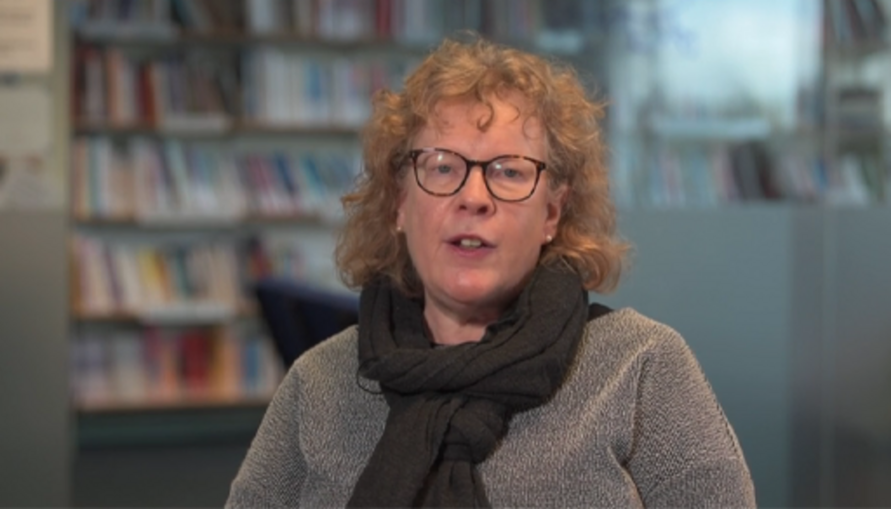

Provide your answer...
View discussion - Activity 2 The effect of the environment on children’s health

Helen talks about the introduction of the clean air zone in the area surrounding Ladywood. The aim of the clean air zone is to reduce the emissions from cars by deterring drivers from going into heavily populated and busy areas of a built-up city. However, the cost of driving into the clean air zone is targeted on older cars, which are more likely to be owned by people on low incomes, consequently, the clean air zone fee is more likely to have a negative impact on poorer people.

Contemporary child health issues in Ladywood
Ladywood remains an area of high deprivation despite the regeneration that happened from the 1990s onwards. Birmingham has 28 per cent of families living in poverty, however this number is as high as 50 per cent in Ladywood. The higher rate of infant mortality and the higher number of babies who are born with a low birth weight indicates that poverty remains a threat to babies’ lives, and low birth weight can have a negative impact on children across their lifespan. This is a situation that is similar to the 1980s as described in Session 2.
Other contemporary health issues that affect children include increased obesity and higher levels of children living with poor mental health and mental health difficulties. These conditions will be explored in greater depth in Session 4.

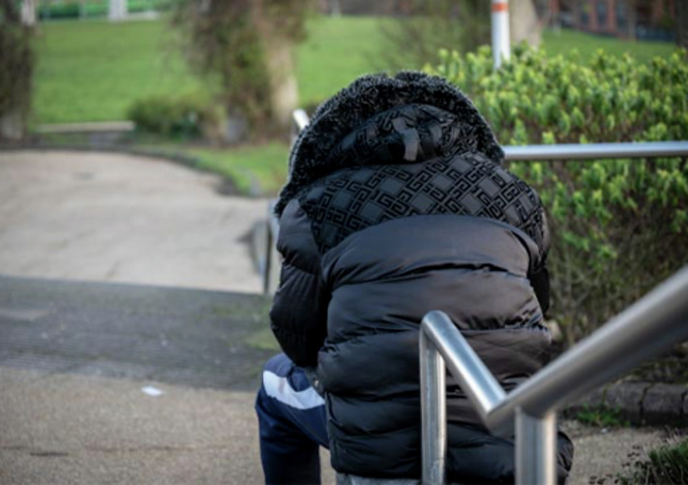
Figure 6 The importance of well-maintained open spaces in urban areas
View description - Figure 6 The importance of well-maintained open spaces in urban areas
View alternative description - Figure 6 The importance of well-maintained open spaces in urban areas

3.2 Rural poverty in Hampshire
Living in poverty is often associated with living in urban inner-city areas, like Ladywood. However, rural poverty is often over-looked. In the following video, Jane Payler talks with Clare Collins. Clare works at Home Start in the New Forest in Hampshire. Home Start is a national charity that supports vulnerable families.

Activity 3 Living in poverty in rural areas
10 minutes

As you watch the video, consider the ways in which living on a low income in a rural area affects families.

Video content is not available in this format.
Video 2 Child health and rural poverty
View transcript - Video 2 Child health and rural poverty

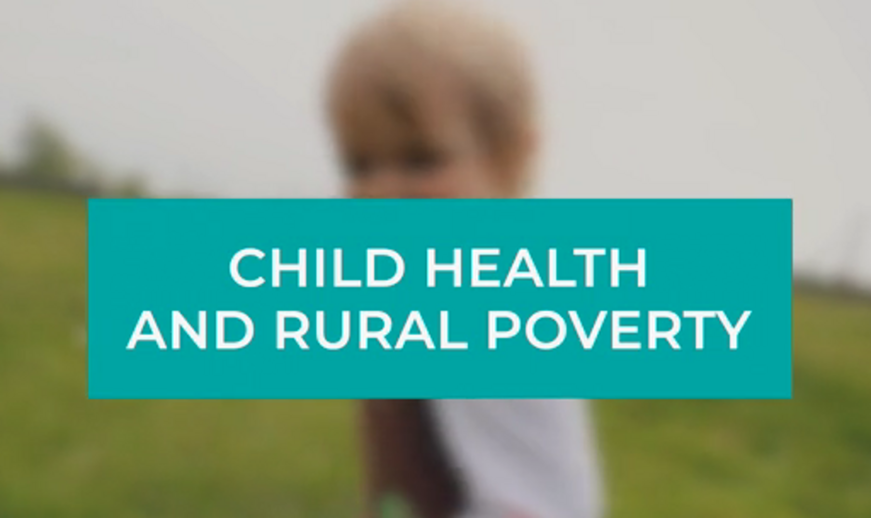

The previous sections explored some of the ways that living in poverty in an inner-city area and in a rural area can impact on children’s health. Pause for a few minutes and write down your thoughts about how living in poverty in an inner-city can be different, or similar, to living in poverty in a rural area.

Provide your answer...
View discussion - Activity 3 Living in poverty in rural areas

4 Exploring the effects of poverty on babies’ and children’s health
In the two videos you heard Helen and Claire describing the impact that living in poverty in two different contexts, that is an inner-city area and a rural area, can have on children’s health. The following case study looks at how other factors which are frequently associated with poverty can affect the health of children.

Activity 4 Case study: Simone, Aleesha and Jerome
15 minutes

As stated in Session 1, children’s health is a complex issue. There are many factors that influence health, and each factor is like a piece of a jigsaw puzzle. And it’s only when the pieces are put together that a clearer picture emerges.

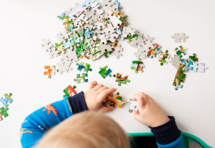
Figure 7 Putting the pieces of the jigsaw together to get a clear picture
View description - Figure 7 Putting the pieces of the jigsaw together to get a clear picture
View alternative description - Figure 7 Putting the pieces of the jigsaw together to get a clear picture

Bearing in mind that the case study of Simone, Aleesha and Jerome is meant to show pieces of a jigsaw and when put together, they will produce a picture. Please read the following case study, considering each piece of information and making some notes about:
- The factors that are having a negative impact on the children’s health.
- What can you identify as having a positive impact on the children’s health?
- What choices does Simone have about ways to improve her children’s health?
Aleesha is 18 months and Jerome is 5. Aleesha and Jerome’s mum, Simone is a young single parent and the family live in a dilapidated block of flats in an inner-city housing estate. Simone’s mum lives around the corner with Simone’s brother and sisters, they all support each other. Although the housing the family live in is run down, the area has had some investment, and there is a green area with play equipment. There is also a Children’s Centre that Simone takes Aleesha to, and there is a good primary school for Jerome.
Aleesha has almost a constant cold, runny nose and a troublesome cough at night, Simone has asthma, and it runs in her family, so she is concerned that Aleesha is showing signs of asthma. Jerome has recently been diagnosed with autism. Simone has a cleaning job at a fast-food restaurant, she relies on her sister to look after the children while she goes to work. Although the job isn’t well paid and is an informal arrangement, a major benefit of having the job is that the owner allows Simone to take some food home and he doesn’t charge her. The owner occasionally allows her to take fizzy drinks or a milkshake This food and the small amount of income helps to supplement her benefits.
Simone realises that her family situation is precarious, if she lost her job, she would no longer have the food that ensures the family know where their next meal is coming from and don’t go hungry. She is also aware that the food is not healthy, and she wishes she could spend more money on fresh food to prepare hot nutritious meals. However, the cooker is unreliable, and despite asking the landlord to fix it, nothing has been done. In addition, Jerome is becoming obsessive about food and will only eat pizza and chips. Any attempt to encourage him to eat other food provokes a major tantrum. So, Simone gives in to Jerome and gives him the food that he will eat and enjoy. However, the situation is worrying Simone because she is having to get clothes for an 8 year old rather than for a 5 year old.

Provide your answer...
View discussion - Activity 4 Case study: Simone, Aleesha and Jerome

5 Summary of Session 3
The case for promoting children’s health right from the start is a compelling one. The content in this session highlights the impact that poverty can have and the inequalities that it can cause in relation to health. There are examples of how children’s services and charities play a critical role in reducing the factors associated with living in poverty. There are many benefits of maximising health that can improve how a child experiences their childhood.
The benefits last into adulthood and can mean that there is a positive impact on society and the economy. But as early years educators, our concern is to ensure that all can be done to promote good health for all children so they have the best chance to thrive and flourish.

Activity 5 Questions for reflection
15 minutes

- What aspects of this session’s learning did you find most and least helpful? Why?
- What do you consider to be your three main learning points from the session?
- What further reading or research might you like to do before the next session?

Provide your answer...

You should now go to Session 4.

Session 4: Preventable communicable and non-communicable health conditions

Introduction
In this session you will focus on some of the contemporary health conditions, some of which have already been mentioned in previous sessions. Many of these conditions are preventable. The content will give an overview of some of the causes and will look at some of the short- and long-term impacts of these conditions on babies’ and children’s lives. It will also examine some of the ways that health conditions can be prevented, for example through immunisation programmes. The benefits of health promotion will be explored in relation to the individual conditions.
This course aims to look at ways to support all children, and it’s important to bear in mind that many are more vulnerable than others. For example, many children ‘catch’ a cold, they usually feel unwell for a few days but make a quick recovery. However, a child who has complex medical needs, disability or a chronic health condition, may be more vulnerable to the effects of an infection.
A list of resources to support health promotion interventions that settings have found useful is included at the end of this session.

Learning outcomes
By the end of this session, you will be able to:
- name the contemporary child health issues affecting children today
- explain the difference between communicable and non-communicable health conditions
- identify the causes of some contemporary health conditions
- appreciate some of the ways that health conditions can be prevented.

1 The current state of children’s health
Advances in medicine and living conditions over the last 150 years or so have resulted in improved life expectancy and reduced child mortality, meaning that many more children survive infancy. The medical discoveries that have been significant in preventing death and improving the quality of lives includes the discovery of vaccines (to prevent or reduce the impact of some infectious diseases) and penicillin (to treat infectious diseases caused by bacteria). Improved living conditions in countries like England, such as sanitation and access to clean water, have been significant in improving health.
Since the start of the twenty-first century, other threats to children’s health have emerged which are of great concern to global, national and professional organisations. The Royal College of Paediatrics and Child Health State of Child Health Report stated that:

The health of infants, children and young people in the UK has improved dramatically over the last 30 years. Many will lead happy and healthy lives, but the future health and happiness of a significant number is in jeopardy. The bottom line is that the UK could do far more to improve child health and wellbeing.
(RCPH, 2017, p. 4)

The COVID-19 pandemic may not have caused the same numbers of illness and deaths in babies and young children as it did in older and vulnerable people. However, there are unforeseen consequences that have had, and still are impacting, on children’s health. As the world is recovering from the impact of the restrictions that were put in place to limit the spread of coronavirus during the pandemic, the impact on children, especially those living in poverty and disadvantage, is becoming evident. For example, many children were unable to access outdoor spaces that enabled them to be physically active, which in turn could have contributed to increased childhood obesity.
The following section describes the contemporary health conditions that are affecting children.

2 Contemporary child health conditions
Health conditions tend to be put into categories under an umbrella term which largely link back to the cause or origin of the condition. Figure 1 illustrates the contemporary health issues that are affecting babies and children.

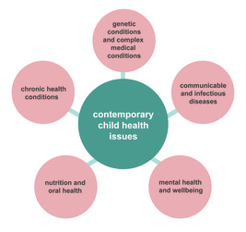
Figure 1 Summary of contemporary child health issues
View description - Figure 1 Summary of contemporary child health issues
View alternative description - Figure 1 Summary of contemporary child health issues

Table 1 gives further detail to the umbrella terms given to the description of contemporary child health issues. The table includes examples of the health conditions and a comment about the conditions.

Table 1 Examples of health conditions affecting babies and children
Child health issue | Examples of conditions and/or causes of conditions | Comment
Genetic conditions and complex medical conditions | Poor ante-natal health care, inherited conditions; birth trauma | Many babies survive pregnancy and childbirth but may have complex medical needs and/or disabilities.
Communicable and infectious diseases | Viruses and bacteria  Parasites and infestations | Many communicable diseases are avoidable by immunisation and infection control measures.  Parasites and infestations can cause minor or more severe effects. The spread can be reduced or prevented with good hygiene measures.
Mental health and wellbeing | Anxiety, depression, post-traumatic stress disorder | It is estimated that there has been a 5-fold increase in mental health problems since 1998.
Nutrition and oral health | Inadequate nutrition  Obesity  Poor oral health | Malnutrition and inadequate nutrition are global problems causing a variety of health conditions.  Increased levels of obesity are a global problem. Deprived boys are most likely to be obese.  Largely preventable. Extraction of decayed teeth is a significant cause of hospital admission.
Chronic health conditions | Asthma, diabetes mellitus, eczema, sickle cell disease | Chronic health conditions can be managed with correct treatment, but can still be a cause of child mortality.

Health conditions can vary in their impact on children. For example, a child may have a condition that is genetically inherited, and the impact of the health condition on the child may be minimal. On the other hand, there are genetic conditions that can result in the child living with a range of complex medical needs.
It is also important to bear in mind that children may have several health conditions, although the impact on children can vary, which is why each child should be regarded as unique.

2.1 Contemporary health issues around the world
The previous content relates to the health conditions that prevail in high-income countries. In low-income countries, children can have similar health conditions. However, low-income countries will have higher numbers of children and families living in poverty, which increases the chances of poorer health. The impact of communicable diseases in low-income countries affects children disproportionately with diarrhoea and pneumonia the leading causes of death in babies and young children. There are several reasons why this is the case, for example, lack of clean water and poor sanitation and lack of access to immunisation programmes all contribute to children being more vulnerable. In addition, inadequate nutrition can make children susceptible to infection. Interestingly, childhood obesity is a health concern in low-income countries.

3 Preventable health conditions
As already mentioned in Session 2, preventable health conditions can be communicable or non-communicable. Table 2 summarises some of the main differences between communicable and non-communicable conditions that are preventable; as well as including some examples of specific conditions.

Table 2 Summary of areas of preventable health conditions
Preventable health conditions
Communicable: conditions which are passed on by micro-organisms and parasites | Non-communicable: not passed on through contact with micro-organism; caused by poor diet, physical inactivity, lifestyle and poor dental hygiene
Infectious diseases such as poliomyelitis, diphtheria, tetanus and whooping cough; common cold and influenza  Parasites and infestations include worms and head lice | Examples:  - inadequate nutrition causing malnutrition  - childhood obesity  - dental caries (decay)  - mental health difficulties

Activity 1 Communicable health conditions in babies and children
10 minutes

Before you read on, take a few minutes to think about why children are experiencing communicable health conditions, and what you think is, or could be, done to prevent them from affecting children’s health. You may find the table below helpful to summarise your thoughts.
Communicable health conditions in babies and children

 | What can be done to prevent the spread of this communicable condition? | Any other comments/thoughts you may have
Infectious conditions:  Polio  Typhoid  Diphtheria  Colds/influenza  Viral or bacterial infections causing diarrhoea and vomiting  Any others? | Provide your answer... | Provide your answer...
Parasites and infestations  Headlice  Threadworms  Malaria  Any others? | Provide your answer... | Provide your answer...

The following sections return to some of the content that you have already read about in Session 2. The focus in this session will be to learn more about these conditions and explore what can be done to prevent them.

4 Prevention of communicable health conditions
You will start by examining some of the causes of conditions that are described as communicable and look at what can be done to prevent them from occurring.

4.1 Preventable and communicable health conditions
Communicable illnesses include infections that are spread by micro-organisms, that is, viruses, bacteria or fungi. These are so small that they are not visible to the naked eye. Other communicable health conditions include those caused by parasites.

Infectious diseases
These were a significant threat to children’s health in the past and were frequently life-threatening. Many infectious diseases, such as polio, diphtheria and tetanus were common among children, causing them to have a long period of illness, and if they did survive the infection, they were often left with a legacy of disability.
The threats to health caused by infectious diseases has reduced during the last century, partly as a result of improvements in public health as well as because of increased levels of knowledge and understanding about the ways of reducing the spread of infection. The COVID-19 pandemic did a great deal to help understand how infections are spread and what we can all do to prevent this.
However, there are still many infections, such as the common cold, that are spread by viruses and are often regarded as ‘mild’ illnesses. Such infections are almost taken for granted illnesses and are regarded as inevitable in a setting where there are lots of people in close proximity. However, they can make children and adults feel unwell, albeit for a short period of time, and they can result in absences and sick leave. And importantly, so-called mild infections can have a disproportionately negative impact on children who are more vulnerable. For example, a common cold virus can provoke an attack in children with asthma.

Figure 2 Child sneezing
View description - Figure 2 Child sneezing
View alternative description - Figure 2 Child sneezing

4.2 Parasites and infestations
Parasites live off a host, and depending on the type of parasite, they can be a significant cause of ill health.
A common parasite that causes infestations in the UK is headlice. Outbreaks are common in education settings where large numbers of children are in close contact. They can be removed effectively and need not affect children’s health in the long term. However, in the short term, the presence of headlice can cause itching and sleep disturbance and, in turn, this can make children feel miserable.
Worms, such as threadworms, can cause children to lose their appetite and result in weight loss. In some areas of the world, guinea worms that can grow up to a metre long cause malnutrition leading to significant health problems.
Malaria is a significant health challenge in many parts of the world. It is caused by the plasmodium parasite and can be spread to humans by a single mosquito bite. Malaria is a significant cause of death and chronic poor health, especially for children.
The following sections look at two of the most effective ways of reducing the spread of infection, which are handwashing and childhood immunisations.

4.3 Effective handwashing
This is one of the single most effective ways of reducing the risk of infections that are caused by ‘germs’, that is, by bacteria, viruses and fungi that cause a range of infections. Good hand hygiene can also help to reduce the spread of worms. For handwashing to be effective, children need to be taught a good technique.

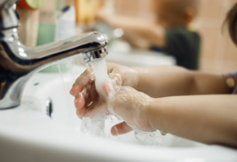
Figure 3 Access to handwashing facilities and effective handwashing techniques are important ways to prevent communicable disease
View description - Figure 3 Access to handwashing facilities and effective handwashing techniques are ...
View alternative description - Figure 3 Access to handwashing facilities and effective handwashing techniques are ...

Now watch the video that shows how adults encourage children to wash their hands. While thorough hand washing is important, it is also very important to remember that there is a need to use water responsibly. Please teach children not to waste water by leaving the tap running for long periods of time.

Video content is not available in this format.
Video 1 PACEY handwashing
View transcript - Video 1 PACEY handwashing

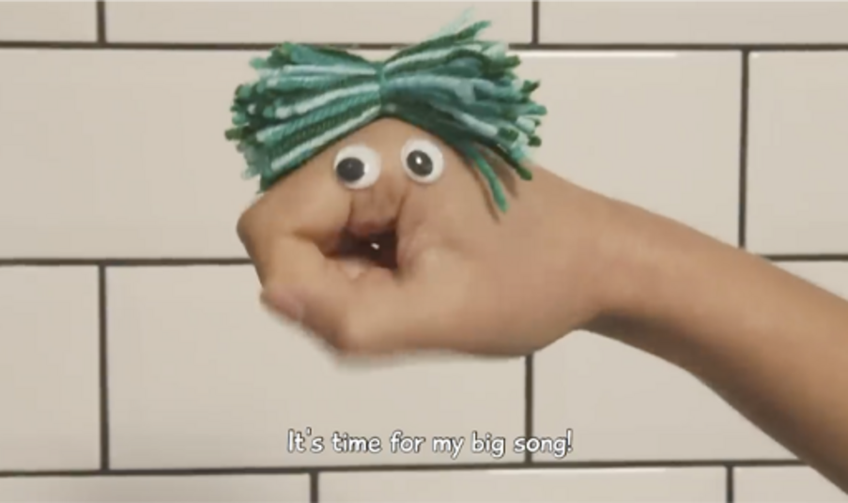

Useful handwashing requires you to supply the resources, such as warm water, soap and towels or driers, all of which are freely available in all settings in England. Handwashing can become an activity that we take for granted, because it is a natural part of our routine to include handwashing after visiting the toilet and before eating, that we may not think about how we do it. This can be a threat to the effectiveness of handwashing because if it is not carried out well, it can be ineffective, and this is when the danger of spreading infection can increase. For children, the chance of them remembering to wash their hands, let alone to use an effective approach, is a routine that requires adult supervision.

4.4 Childhood immunisations
Immunisations are offered to most children in the UK to protect against a wide range of infections, such as measles, mumps and polio. These are examples of conditions that are life-threatening or that can leave long-term side-effects, but they are preventable if children receive the full immunisation schedule. This is as a result of the National Health Service childhood immunisation programme (UK Health Security Agency, 2022).
The current government policy regarding childhood immunisations supports the view that most children should be protected from infectious diseases by receiving immunisations. Under the policy, children who should not receive routine immunisations include those who are receiving treatment for conditions that affect the immune system. This can include cancer treatment or medication which suppresses immunity to avoid rejection of a transplanted organ, such as a kidney or heart.

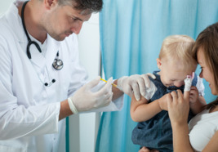
Figure 4 Child receiving an immunisation
View description - Figure 4 Child receiving an immunisation
View alternative description - Figure 4 Child receiving an immunisation

There are many parents who choose not to have their children immunised, either because of their health beliefs or because of their living situation. Some of the reasons why parents may not get immunisations for their children will be looked at in Session 8.

4.5 Preventing parasitic infestations
Worms such as threadworms are common parasites and can be easily spread on toilet seats.
Good hygiene, including keeping fingernails short, are ways of preventing their spread. However, they can be tricky to eradicate. And in areas of the world where there is limited access to safe water and handwashing facilities, preventing and eradicating the spread of parasites such as worms is even more challenging.
The main way of preventing the spread of malaria is the use of mosquito nets which have been treated with insecticides. However, in low-income countries, obtaining insecticide treated bednets can be expensive.

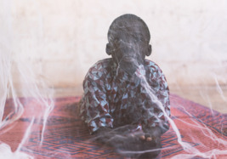
Figure 5 Child in mosquito nets malaria can be prevented by avoiding mosquito bites
View description - Figure 5 Child in mosquito nets malaria can be prevented by avoiding mosquito bi ...
View alternative description - Figure 5 Child in mosquito nets malaria can be prevented by avoiding mosquito bi ...

This section has looked at some of the common conditions that can be passed on between humans. You have also been given an overview of some ways their spread can be reduced. In the following section (after a reflective activity), you will look at the causes and prevention of non-communicable health conditions.

Activity 2 Reflection
15 minutes

Take ten minutes to go back to Activity 1 and make notes about what you have learned in this section. Think about your role in relation to supporting children’s health, considering what else you could do to prevent the spread of infections or parasites.

Provide your answer...

5 Prevention of non-communicable health conditions
In this section you will explore the causes of and some preventative measures relating to:
- inadequate nutrition, including malnutrition
- childhood obesity
- dental caries (decay)
- mental health difficulties.
Before you read on, take ten minutes to complete Activity 3.

Activity 3 Non-communicable health conditions in babies and children
10 minutes

In a similar way to Activity 1, think about the questions in the table below. Draw on what you already know, and what you have already learned during this course and then make some notes.

 | What can be done to prevent the spread of this non-communicable condition? | Any other comments/thoughts you may have
Inadequate nutrition/malnutrition | Provide your answer... | Provide your answer...
Childhood obesity | Provide your answer... | Provide your answer...
Dental caries (decay) | Provide your answer... | Provide your answer...
Mental health difficulties | Provide your answer... | Provide your answer...

View discussion - Activity 3 Non-communicable health conditions in babies and children

The following sections start to look at these conditions in more detail.

6 Inadequate nutrition
This section examines the subject of inadequate nutrition from a global perspective, looking at the contemporary issues within high-income countries, such as the UK, but also in low-income countries. You will start by examining the reasons why children are malnourished in a low-income country.

6.1 Malnutrition in Rwanda: a low-income country
Rwanda is a small, land-locked African country where many children are affected by malnutrition.

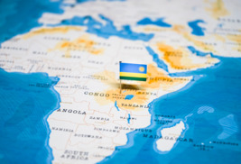
Figure 6 Rwanda’s position in Africa
View description - Figure 6 Rwanda’s position in Africa
View alternative description - Figure 6 Rwanda’s position in Africa

Activity 4 Battling malnutrition
20 minutes

To learn more about the impact of malnutrition on children’s health, watch the video ‘Battling malnutrition’. As you watch the video, consider the following question:
What are the reasons given for malnutrition in Rwanda?

Video content is not available in this format.
Video 2 Battling malnutrition
View transcript - Video 2 Battling malnutrition

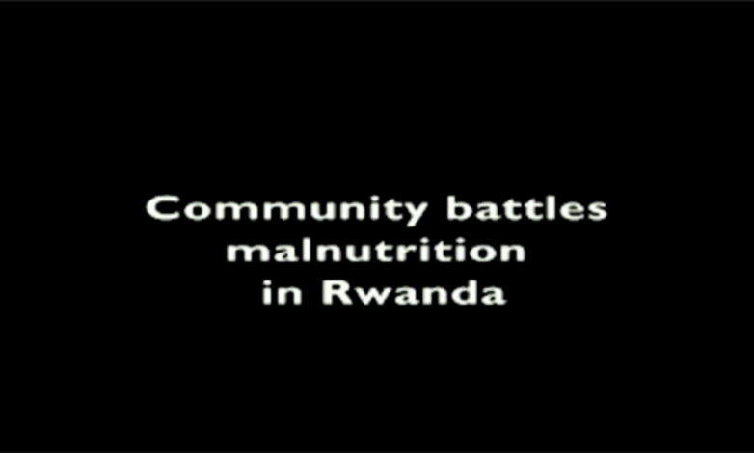

Provide your answer...
View discussion - Activity 4 Battling malnutrition

6.2 Dietary deficiency in high-income countries
There are many reasons why children’s diets can be insufficient for their health needs in high-income countries, such as England. The following section explores some common reasons.

Vitamin D deficiency
Babies and children can experience the effects of dietary insufficiency wherever they live in the world, and not just because of living in poverty. Vitamin D is provided from sunlight and from certain foods. Its function in absorbing calcium means that it plays a vital role in the development of healthy bones. Insufficient levels of Vitamin D can cause rickets. Rickets leads to poor skeletal development and deformities which, if not corrected, are irreversible and lead to lifelong problems. Children living in countries where there are fewer days where the sun shines, or those who have limited access to the outdoors are more prone to developing rickets. The NHS in England recommends that babies and children should have a daily supplement throughout the year (NHS, 2020).

Anaemia
Red blood cells carry oxygen around the body, and red blood cells are produced by foods containing iron, such as red meat. Anaemia can cause a range of symptoms which include tiredness and shortness of breath (NICE, 2021). A common cause of anaemia in young children is late weaning or a diet that is deficient in iron-rich foods.

Underweight children
One reason for children being underweight can be from neglect. Children who aren’t provided with a healthy diet at regular intervals may not receive the nutrients that are necessary for them to thrive. A diet that contains high levels of wholegrain foods or carbonated drinks may make a child feel full which can lead to them not eating enough calories. In addition to this, children who have an eating disorder may be underweight. Other causes of children being underweight can include an underlying health condition.

7 Childhood obesity
Childhood obesity is a global concern affecting 38.3 million children under the age of five. New Zealand has some of the highest rates in the world (Shakleton et al., 2018).
The following statistics from the Office of Health Improvement and Disparities (2023) reveal the worrying levels of obesity in children in the UK.
- The National Child Measurement Programme (NCMP), established in 2006, collects annual measurements of the height and weight of over one million children in Reception (age 4–5 years) and Year 6 (age 10–11 years) in primary schools across England.
- In 2021 to 2022, more than 1 in 5 children in Reception (aged 4–5 years) were overweight or living with obesity (boys 22.5%, girls 22.0%, all children 22.3%).
- In 2021 to 2022, 1 in 10 children in Reception (aged 4–5 years) were living with obesity (boys 10.3%, girls 9.9%, all children 10.1%).
- There are large disparities in child obesity. Children living in the most deprived areas in England are more than twice as likely to be living with obesity compared to those living in the least deprived areas.
- Reception aged children living in the most deprived areas in England are more than three times as likely to be living with severe obesity compared to those living in the least deprived areas.
- Severe obesity prevalence in Reception aged children is highest among children from Black other, Black African, and Asian Bangladeshi ethnic groups.
Obesity that starts in childhood has a negative impact on physical and mental health, and children who are obese are more likely to remain obese into adulthood. There are compelling reasons for reversing the trend for children and across the age span, however finding ways to do so aren’t straightforward. Part of the reason why this is the case is because there are many factors that contribute to the epidemic of childhood obesity. The following section explores some of these reasons.

7.1 Causes of childhood obesity
The causes of obesity are complex and identifying interventions to reverse obesity are challenging. As is often the case, there isn’t one reason, and many of the reasons overlap and affect each other.
As well as the intake of too many calories being a major cause of obesity, societal changes that have influenced childhood are thought to have contributed to the increase in obesity. Fears about children’s safety have meant that children are kept under closer adult supervision, and this has reduced children’s opportunities to play and take part in outdoor physical activity. Much of children’s play and entertainment activities take place indoors and are likely to be more sedentary.
Additionally, the restrictions caused by the global pandemic meant that for many children their access to outdoor space was limited, meaning that their physical activity was curtailed. This led to an increase in obesity for children living in homes with no or limited outdoor space, and no access to outdoor areas in their education setting because of closures. Many children live in an obesogenic environment, that is an environment that encourages weight gain rather than is conducive to weight loss; the influence of living in obesogenic environment is explored further in Session 5.
As already stated, the reasons why so many children are obese and overweight are complex, and this makes finding solutions to reversing and preventing childhood obesity very difficult. While there is a need for adults to take responsibility for achieving this aim, it is critical that interventions are conducted in sensitive ways and without judgement. This will be explored further in Session 7.

8 Dental caries (decay)
Dental caries, or tooth decay, is a mostly preventable physical health condition that can have a profound impact on children’s health and wellbeing, both in childhood and across their lifespan.
Despite dental caries being a mostly avoidable health condition, the oral survey of health in 2020 found that 11 per cent of children had visible tooth decay, and the average number affected was 3 (Office for Health Disparities and Improvement, 2022). In England, children from deprived areas living in poverty experience twice the level of dental decay compared to children in less deprived areas (Public Health England, 2019).

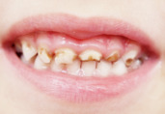
Figure 7 Dental decay is a significant cause of poor health in young children
View description - Figure 7 Dental decay is a significant cause of poor health in young children
View alternative description - Figure 7 Dental decay is a significant cause of poor health in young children

Although dental decay is avoidable for most children, those who have complex medical needs or special educational needs may find it difficult to avoid dental decay. For example, children who need medication for some epilepsy may develop gum disease as a side effect of the medication which can lead to poor oral health

8.1 Effects of poor oral health
Despite the amount of information about the importance of a healthy diet, regular and effective toothbrushing from babyhood and free dental care, poor dental health is a significant cause of concern. Poor oral health and dental decay can impact significantly on children’s day-to-day lives, causing pain, school absence and loss of sleep. In turn, this can affect children’s behaviour, making them irritable and less able to concentrate.
Teeth removal is a major reason that children are admitted to hospital, thus they are having an anaesthetic and surgery which is completely avoidable. Not only is this an unnecessary expense for the NHS but, very importantly, this has an impact on children’s mental health. For a child, being admitted to hospital and enduring a painful procedure is an example of how a physical condition can have an impact on their wellbeing and mental health. You will return to the challenges associated with promoting good oral health and avoiding dental decay later in the course.

9 Mental health
Poor mental health is also a cause of concern in very young children. Understanding why there has been an increase in the number of children who have a diagnosable mental health difficulty, such as anxiety or depression, is a complex issue because there isn’t just one reason. Greater awareness and acceptance of the fact that children are just as prone to developing mental health conditions is needed when taking care of young children’s health.

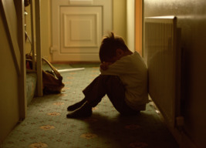
Figure 8 An increasing number of children are being diagnosed with mental health conditions
View description - Figure 8 An increasing number of children are being diagnosed with mental health ...
View alternative description - Figure 8 An increasing number of children are being diagnosed with mental health ...

Many families live in adverse conditions and, consequently, children can be negatively affected by the experiences of that adversity. Adverse childhood experiences (ACEs) include domestic violence, bereavement, substance abuse and neglect. Children who go through adverse childhood experiences (ACEs) are more likely to experience mental health difficulties. This is partly because of the negative impact on children’s emotional and social development, which can in turn reduce their sense of wellbeing and increase the risk of mental health conditions emerging. Children who are looked after (by the state) have often experienced disrupted childhoods and are especially predisposed to developing diagnosable mental health conditions.
Despite the alarming state of children’s mental health, there is a great deal that can be done to support children’s wellbeing which, in turn, can improve their mental health. These points will be returned to later in the course.

10 Chronic health conditions
Ongoing, or chronic, health conditions affect as many as 27 per cent of children (Wijlaars, Gilbert and Hardelid, 2016). To illustrate this point, in a class of 30 children, on average 9 children will have a chronic health condition. The most common chronic health conditions affecting children in high-income countries include asthma, eczema, diabetes, epilepsy and sickle cell anaemia. It is not unusual for children to have a combination of chronic conditions. For example, asthma, eczema and allergy are all conditions that frequently affect children.
As already mentioned, children with chronic health conditions can be more vulnerable to the preventable health conditions that have been considered in this session. Consequently, there is even more of an imperative to ensure that we are doing what we can to minimise the effects.
Although health conditions are often separated into those that affect physical or mental health, in reality, a physical health condition can impact on mental health too, and this is the focus of the next section.

11 Physical and mental health
Physical health conditions can cause significant pain and discomfort to children. Managing the conditions can require a lot of planning ahead, for example ensuring that medication and suitable food are both available. Therefore, it is not surprising that for a child the presence of a chronic condition, or conditions, can be a source of great anxiety for them. To illustrate this point, read the case study about Mason.

Case study: Mason, aged 6
Mason is 6, and has had eczema since he was a baby. Large areas of his skin are covered in red and angry looking blisters. When the blisters burst, they dry out and his skin becomes incredibly itchy meaning he often scratches himself until his skin bleeds. His skin is very sensitive, and there are numerous everyday substances that can ‘trigger’ or provoke a reaction. Common triggers are soap, washing powder and pollen. Some foods, such as oranges or tomatoes, trigger a skin response when they come into contact with his skin.
Mason’s mum works hard to try and keep his eczema under control. Every night she bathes him and applies cream, prescribed by the family doctor. She also applies wet wraps to help sooth his skin. Despite all the efforts to make Mason comfortable, he often wakes up in the night and starts to scratch himself, and he can’t get back to sleep.

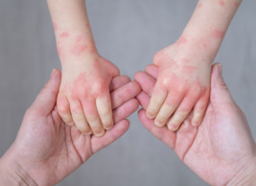
Figure 9 Eczema can be a cause of physical and mental health difficulties for children
View description - Figure 9 Eczema can be a cause of physical and mental health difficulties for children ...
View alternative description - Figure 9 Eczema can be a cause of physical and mental health difficulties for children ...

At school, Mason is having a miserable time. He often feels exhausted because of his interrupted sleep, and this is making him feel grumpy. Some of the children he has been friends with since nursery are beginning to make comments about his skin, and are calling him names. Additionally, he found out that he hadn’t been invited to a party. Even small everyday things are affecting his skin – the soap and paper towels at school trigger his eczema, and he has stopped washing his hands after he goes to the toilet.
Mason is finding that many of the activities that he used to love are becoming difficult. For example, playing football is affecting his skin because his sore hands are becoming worse when he picks the ball up after it has been on the grass.
Mason’s situation illustrates how having a physical condition such as eczema, a condition that affects the skin, therefore visible to everyone, is having a profound impact on him physically as well as mentally. It illustrates the important role that adults have in supporting children with a physical condition such as eczema. Such support includes ensuring that Mason has access to handwashing equipment that doesn’t provoke his eczema. By doing so he is likely to wash his hands and thus reduce the possibility of spreading infection.

Activity 5 Reflection
15 minutes

- What aspects of this session’s learning did you find most and least helpful? Why?
- What do you consider to be your three main learning points from the session?
- What further reading or research might you like to do before the next session?

Provide your answer...

12 Summary of Session 4
In this session, you have looked at some of the communicable and non-communicable conditions that are affecting children’s health around the world, as well as some of the causes and ways some conditions can be prevented.

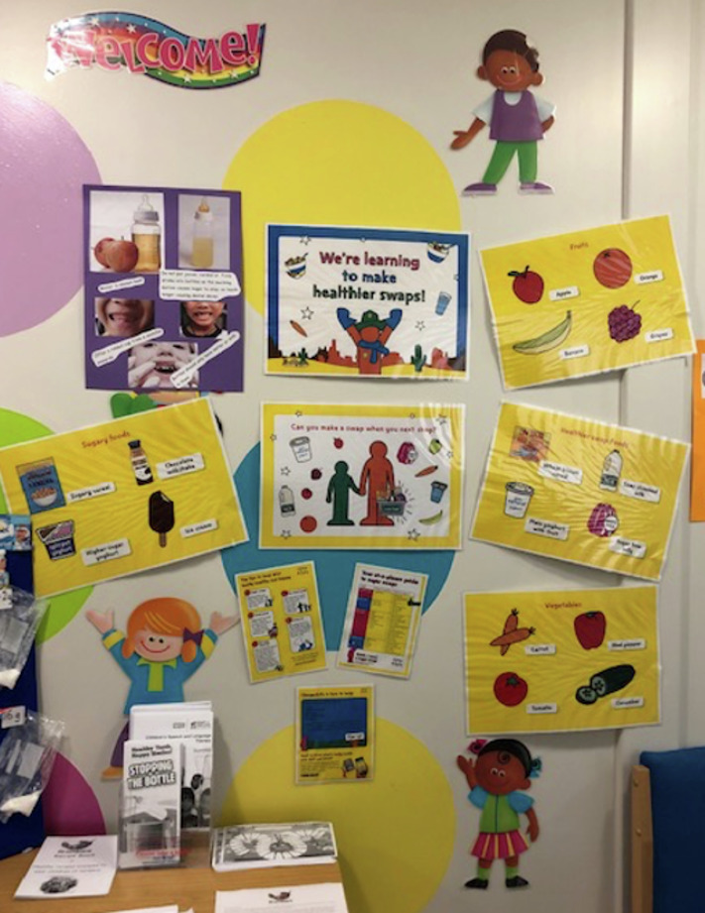
Figure 10 Displays using resources that are available from websites can help to support health promotion work in settings
View description - Figure 10 Displays using resources that are available from websites can help to support ...
View alternative description - Figure 10 Displays using resources that are available from websites can help to support ...

You should now go to Session 5.

Further reading
There are many resources that are available to support you in your health promotion interventions. Below, are some that have been used successfully in settings. You may have other resources that you find useful.
1 Healthy eating
Healthy eating guidance published for the early years sector from the Department for Education and published on the Gov.uk website: https://www.gov.uk/government/news/healthy-eating-guidance-published-for-the-early-years-sector
Influencing healthy eating habits through early years settings guidance published on Public Health England website: https://publichealthmatters.blog.gov.uk/2017/11/28/influencing-healthy-eating-habits-through-early-years-settings/
2 Physical activity
National Day Nurseries Association ‘Healthy Body, Happy Me’ nursery resources: https://www.ndna.org.uk/NDNA/Campaigns/Healthy_Body_Happy_Me/HBHM.aspx
UK Chief Medical Officers’ Physical Activity Guidelines – September 2019. Available from https://assets.publishing.service.gov.uk/media/5d839543ed915d52428dc134/uk-chief-medical-officers-physical-activity-guidelines.pdf
Free course produced by The Open University in partnership with the UK Health Security Agency and Active Matters Supporting Physical Development in Early Childhood: https://www.futurelearn.com/courses/supporting-physical-development-early-childhood
Free course produced by The Open University on the importance of the outdoors and nature in child development: https://www.open.edu/openlearn/education-development/young-children-the-outdoors-and-nature/content-section-overview
3 Dental health
Child oral health: applying All Our Health guidance that is available on the Public Health England website. In particular scroll down to look at the top 3 interventions for preventing tooth decay: https://www.gov.uk/government/publications/child-oral-health-applying-all-our-health/child-oral-health-applying-all-our-health
4 Prevention of infection
Health protection in schools and other childcare facilities: guidance available on the Public Health England website: https://www.gov.uk/government/publications/health-protection-in-schools-and-other-childcare-facilities
Managing specific infectious diseases guidance available on the Public Health England website: https://www.gov.uk/government/publications/health-protection-in-schools-and-other-childcare-facilities/chapter-9-managing-specific-infectious-diseases
5 Mental health
The mental health of children and young people in England guidance available on the Public Health England website: https://assets.publishing.service.gov.uk/government/uploads/system/uploads/attachment_data/file/575632/Mental_health_of_children_in_England.pdf
Anna Freud Centre: Early Years in Mind is a free online network for early years practitioners. https://www.annafreud.org/early-years/
Free course produced by Early Childhood at The Open University Supporting children’s health and wellbeing: https://www.open.edu/openlearn/education-development/supporting-childrens-mental-health-and-wellbeing/content-section-overview
Free course produced by Early Childhood at The Open University Supporting children’s mental health and wellbeing: https://www.open.edu/openlearn/education-development/supporting-childrens-mental-health-and-wellbeing/content-section-overview
PACEY Starting school together: preparing your child for starting school: https://www.pacey.org.uk/Pacey/media/Website-files/school%20ready/12977-Pacey-Starting-School-Together-Booklet-A5.pdf

Session 5: Policies and curricula: global and national initiatives to promote babies and children’s health

Introduction
Improving the health of babies and children is a global endeavour. As discussed in Session 1, encouraging good habits that promote health has many benefits to children and society. This session, you will look at some key initiatives aimed at improving children’s health from across the planet. Global initiatives such as the United Nations Convention on the Rights of the Child; the Sustainable Development Goals; non-governmental organisations and the World Health Organisation will be discussed. Many countries address the health of babies and children through education, both in pre-school education and care settings and school settings. The content will explore examples of highly regarded early childhood curricula, such as New Zealand’s Te Whariki, and explain how this curriculum promotes babies and young children’s health. Some examples of how the curricula of the four nations of the UK address health will be included.
As well as exploring the policies that are in existence, you will look at suggestions of how the introduction of new policies could help to promote children’s health. The role and influence of the food industry and advertising is examined.

Learning outcomes
By the end of this session, you will be able to:
- identify global initiatives aimed at improving the health of babies and children
- explain how the child’s environment can affect their health
- examine how curricula can support and promote children’s health.

1 Legislation and policy: the different levels
As already stated, we all need to take responsibility for supporting, promoting and ultimately, playing our part in improving children’s health. This responsibility needs to be a global endeavour, because improving the health of babies and children requires the support of adults in every community in countries around the world. To help individuals to achieve this goal, babies and children’s health is addressed in legislation and policy. Legislation relates to the creation of laws that are made at national or global level. Policy can be described as a course of action that implements legislation. Figure 1 illustrates where legislation and policy exist, which can be described as global, national, within a community and within education settings.

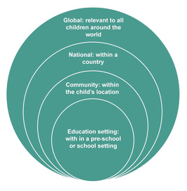
Figure 1 Legislation and policy at different levels

The following sections explore some examples of legislation and policies that are aimed at improving children’s health within the different levels, starting with global initiatives.

2 Global initiatives
The following sections summarise some of the global approaches to improving children’s health, including:
- the United Nations Convention on the Rights of the Child (UNCRC, 1989)
- charities and non-governmental organisations.

2.1 United Nations Convention on the Rights of the Child
The need to support, promote and ultimately to improve children’s health has been recognised by the United Nations Convention on the Rights of the Child (UNCRC, 1989).
The first Declaration on the Rights of the Child was adopted by the League of Nations in 1924 inspired by the work of Eglantyne Jebb who founded the organisation Save the Children. This important declaration stressed various key rights for all children such as right to food, health care, education and protection from exploitation which, at the time, were not seen to be the priority in many policy making decisions. Even though not a legal document there was a duty placed on the international community to put children’s rights at the centre of all planning in matters that affected children’s daily lived experiences which was clearly a major shift in thinking.
The Convention on the Rights of the Child, subsequently adopted in 1989, has been approved by all but one nation (the United States of America) (UNICEF, 2017). This Convention has had a further significant effect on the way that children are both seen and treated. They are now viewed as human beings with their own independent set of rights, and sense of agency, instead of the passive recipients of adult care and charity (Save the Children, 2019).
The process of changing attitudes on a global scale has undoubtedly been slow. However more nations and governments recognise the importance of education for children. Many countries provide free, compulsory schooling for all children, regardless of their gender, race, refugee status or special needs. However, many children are still part of the workforce, often in dangerous occupations, or are forced into marriage at a young age, experiences which have negative effects on their physical and mental health.

2.2 Sustainable Development Goals
Children who live in low-income countries are less likely to have access to health services and education. In order to improve this situation, the Millennium Development Goals (MDGs) were launched in 2000. In 2015, an update to the MDGS resulted in the ‘Sustainable Development Goals’ (SDGs). In the following activity you will explore more about the importance of the SDGs in relation to children’s health.

Activity 1 The Sustainable Development Goals
15 minutes

This activity is in two parts.
First of all, watch the Video ‘Transitioning from the MDGs to the SDGs’ which gives a summary of the MDGs and explains the transition to the SDGs.

Video content is not available in this format.
Video 1 Transitioning from the MDGs to the SDGs
View transcript - Video 1 Transitioning from the MDGs to the SDGs



As you watch the video, consider the ways that you think the SDGs are helpful to improving children’s health

Provide your answer...

The video explains that there are 17 goals. Access the following link: Health: United Nations Sustainable Development. On the right-hand side of the website, there are icons that explain the aim of each goal. Goal 3 is related to ‘Good health and wellbeing’. Take a look at the 17 goals and the details of Goal 3 and think about how the goals will help to improve children’s health and wellbeing.

Provide your answer...

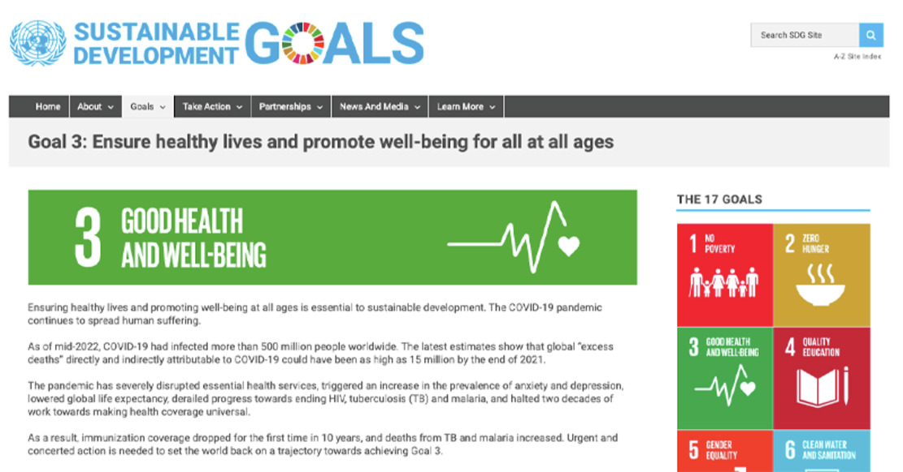
Figure 2 The Sustainable Development Goals: Goal 3 Good Health and Wellbeing
View description - Figure 2 The Sustainable Development Goals: Goal 3 Good Health and Wellbeing
View alternative description - Figure 2 The Sustainable Development Goals: Goal 3 Good Health and Wellbeing

The aim of the goals is to improve the lives of all people in low-income countries and to ‘address the global challenges we face, including those related to poverty, inequality, climate, environmental degradation, prosperity, and peace and justice’ (United Nations, 2019).
You will see in the content about Goal 3 that the impact of the global pandemic has had a negative impact on children’s health and made the challenge of improving the global health of our children even more difficult to achieve. Being presented with such alarming factors, it can feel overwhelming and difficult to identify what we can do to improve the situation. However, there are some relatively simple actions that we can all do that make a significant contribution to better health. One example of something that we can all do is to ensure that we all take on board the importance of handwashing.

An example of a global initiative: UNICEF Handwashing Day
As mentioned in Session 4, effective handwashing is regarded as being critical in preventing the spread of infection and, to reflect this, UNICEF dedicate a day to promoting global handwashing.

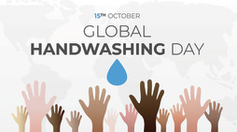
Figure 3 Global Handwashing Day
View description - Figure 3 Global Handwashing Day
View alternative description - Figure 3 Global Handwashing Day

Providing the equipment needed for handwashing, warm water, soap and clean towels can be challenges for many people, regardless of where they live in the world. For example, remote areas that have limited water supply, refugee camps, areas that have been affected by natural disasters such as earthquakes, you may have other examples.

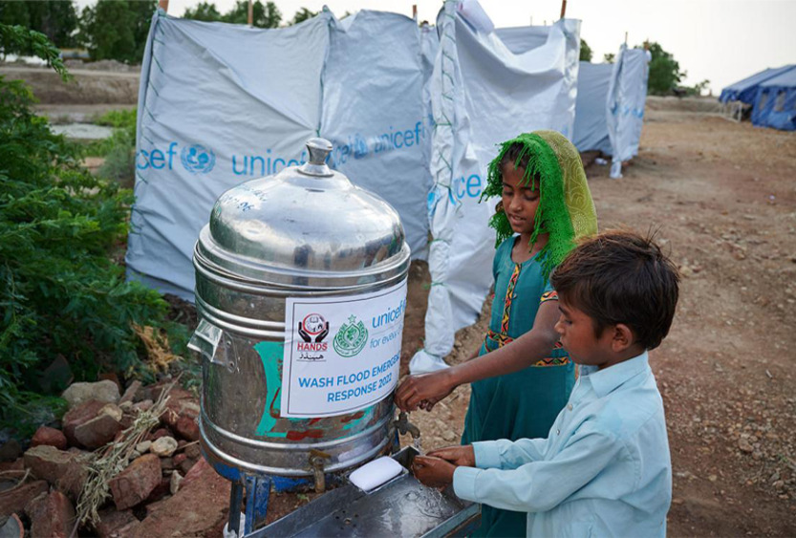
Figure 4 Gaining access to handwashing equipment can be a challenge in some parts of the world
View description - Figure 4 Gaining access to handwashing equipment can be a challenge in some parts ...
View alternative description - Figure 4 Gaining access to handwashing equipment can be a challenge in some parts ...

Even in higher-income countries, people may not have easy access to handwashing equipment. For example, many families live in poor housing, or have very limited income. Again, you may think of other instances where access to handwashing equipment can be difficult, and this in turn means that children’s health can be negatively affected because of the increased risk of a communicable disease.

3 National legislation and policies
Within different countries around the world, there are examples of how governments and organisations are addressing children’s health. There are various responses to how individual countries demonstrate their commitment to addressing the Rights of the Child. At the time of writing, the United States of America have still yet to sign their agreement to the Rights of the Child.
This section gives some examples of how health is addressed in different countries, focusing on education legislation and policies, as well as some examples of national initiatives.

3.1 Examples from around the world
Around the world, many countries include health education aimed at promoting good health in the curriculum. Ghana is one example of a national curriculum that has a statutory requirement for 10 minutes of health education each day.
Many high-income countries have a curriculum that is specifically designed for the care and education of infants and pre-school children. In 1996, New Zealand was one of the first countries to create its curriculum for the education and care of very young children. Te Whariki is Maori for ‘woven mat’. Te Whariki is underpinned by a vision for children who are competent and confident learners and communicators, healthy in mind, body and spirit, secure in their sense of belonging and in the knowledge that they make a valued contribution to society.
The Te Whariki document (Ministry of Education, 2017) goes on to emphasise the importance of developing good wellbeing in children by promoting their sense of belonging, providing routines and giving opportunities for communication.

3.2 UK Curricula
In the UK, each of the four nations has curricula for pre-school and school aged children which include aims and principles related to physical and mental health.

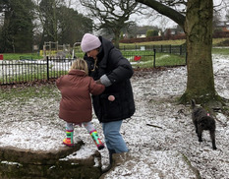
Figure 5 The importance of being outside
View description - Figure 5 The importance of being outside
View alternative description - Figure 5 The importance of being outside

Northern Ireland
Curricula for pre-school and school aged children includes aims that are intended to address children’s health.

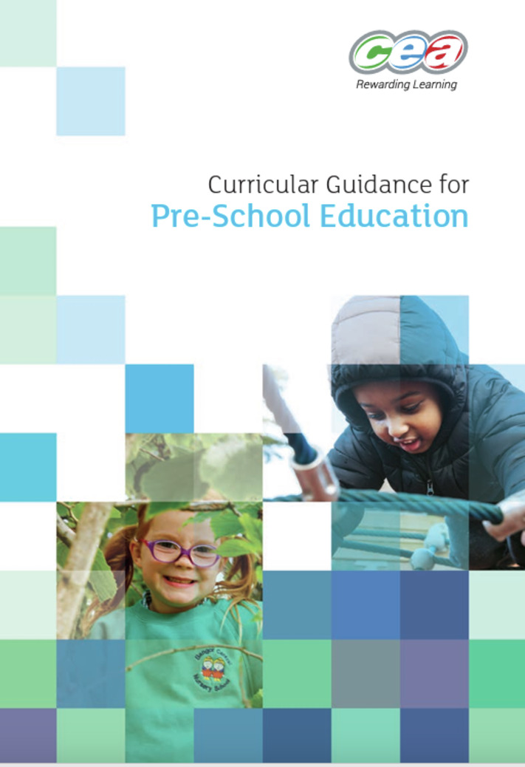
Figure 6 Wellbeing in Pre-School: Curricular Guidance for Pre-School Education
View description - Figure 6 Wellbeing in Pre-School: Curricular Guidance for Pre-School Education
View alternative description - Figure 6 Wellbeing in Pre-School: Curricular Guidance for Pre-School Education

The curricular Guidance for Pre-school Education (Council for the Curriculum, Examination and Assessment) includes a focus on wellbeing. The document states that the focus should be that children are enabled to learn at their own pace, to have a breadth of learning experiences and gain a positive image of themselves as resilient learners able to cope with uncertainty, and to learn through trial and error.
The aims of the pre-school curriculum are to:
- promote emotional, social, physical, creative and intellectual development.
- develop self-esteem, self-control and positive attitudes towards others
- develop language and communication skills to encourage the sharing of thoughts and feelings
- create confident, eager, enthusiastic, independent, curious learners with a positive and problem-solving attitude to learning.
In the Foundation Stage, which is the curriculum for school aged children, the aims for wellbeing state that it will provide a learning programme which will:
- promote children’s personal development
- promote positive attitudes and dispositions to learning
- promote children’s thinking skills and personal capabilities
- encourage creativity and imagination
- enable children to develop physical confidence and competence
- develop children’s curiosity and interest in the world around them
- enable children to communicate in a variety of ways
- motivate children to develop literacy and numeracy skills in meaningful contexts.

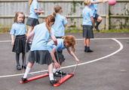
Figure 7 Promoting good health in school curricula
View description - Figure 7 Promoting good health in school curricula
View alternative description - Figure 7 Promoting good health in school curricula

Scotland
Scotland has focused on early education since 2013 and ‘Realising the Ambition’ (Education Scotland, 2020) provides guidance aimed at supporting the provision of high-quality care and education so that Scotland can be the best place for children to grow up in and learn.

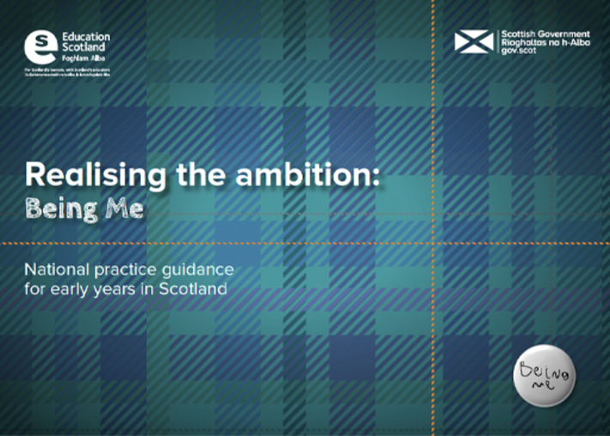
Figure 8 Realising the ambition
View description - Figure 8 Realising the ambition
View alternative description - Figure 8 Realising the ambition

The Health and Social Care Standards (Scottish Government, 2017) include indicators of quality that relate to the provision of practice that if achieved can improve children’s health. For example, 1.12: ‘I am fully involved in assessing my emotional, psychological, social and physical needs at an early stage, regularly and when my needs change’. This standard highlights the importance of seeing the uniqueness of each child and having routines that meet their physical health needs, such as sleep and rest. The development of warm relationships between practitioners and children can affect wellbeing and contribute to them developing good mental health.
As children reach the age of 3, the Curriculum for Excellence (Education Scotland, 2010) includes guidance that is relevant until they reach the age of 18. The guidance aims to provide children with the knowledge that can help with good health, such as learning about healthy eating.

Wales
Wales has introduced several initiatives aimed at improving children’s health through curricula. September 2022 saw the introduction of a new curriculum in Wales, based on 6 Areas of Learning and Experience that form the basis of teaching and learning for all age groups from nursery to GCSE.

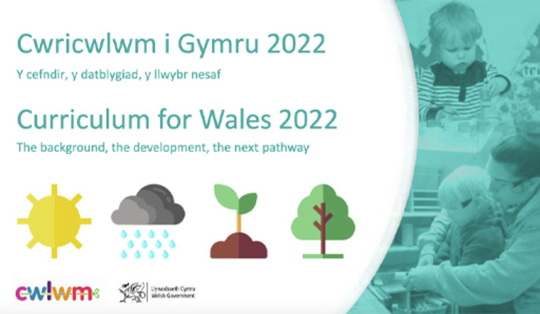
Figure 9 Curriculum for Wales 2022
View description - Figure 9 Curriculum for Wales 2022
View alternative description - Figure 9 Curriculum for Wales 2022

As part of guidance relating to Health and Wellbeing, there are five ‘What Matters’ statements that all pupils will learn about, no matter what phase of education they are in. The statements are:
- developing physical health and wellbeing has lifelong benefits
- how we process and respond to our experiences affects our mental health and emotional wellbeing
- our decision making impacts on the quality of our lives and the lives of others
- how we engage with social influences shapes who we are and affects our health and wellbeing
- healthy relationships are fundamental to our wellbeing.

England: The Early Years Foundation Stage (EYFS)
The EYFS is the statutory guidance from the Department for Education for providers of Early Childhood Education and Care providers in England. The most recent version of the EYFS was published by the Department for Education in 8 December 2023 and came into effect 4 January 2024.

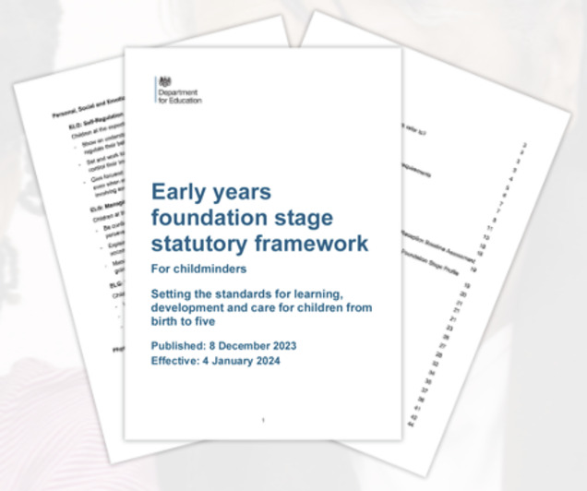
Figure 10 The Early Years Foundation Stage statutory framework for the early years foundations stage
View description - Figure 10 The Early Years Foundation Stage statutory framework for the early years ...
View alternative description - Figure 10 The Early Years Foundation Stage statutory framework for the early years ...

The Early Years Foundation Stage states that ‘providers must promote the good health, including the oral health, of children attending the setting’ (Department for Education, 2024, p. 34). This statement conveys the understanding that children’s health is linked to their learning. The EYFS also states that ‘children learn best when they are healthy, safe and secure’ (p. 23). Therefore, improving the quality of children’s health is a way of improving the quality of children’s learning.
The play-based pedagogy of the EYFS is highly beneficial to children’s health and wellbeing, although this may not be immediately evident. The opportunities for indoor and outdoor play can be an important way to promote children’s health by offering opportunities that may prevent physical and mental health difficulties from developing.
As of January 2024, there are two versions of the EYFS available; version one is the statutory guidance for childminders (Department for Education, 2024a) and the other version is the statutory guidance for group and school based providers (Department for Education, 2024b). The guidance relating to the health of babies and children are similar in both documents. The page numbers in the content below relate to the EYFS for group and school based providers (Department for Education, 2024b).
There are over 50 pages of guidance in the current version of the EYFS and 35 aims that relate to supporting and promoting children’s health. The areas of health promotion fall into broad themes which include:

Table 1 The child health promotion themes in the EYFS
Theme 1 | Healthy eating and drinking | which aims to provide children with a diet that is balanced, meaning that the food and drink includes the essential nutrients for health, as well as offering food that is of the correct calorific content for children’s energy needs. Fluids that are included in the diet should supply the hydration that children require and not necessarily supply additional calorific content. Healthy eating and drinking play a significant role in preventing and reducing the incidence of childhood obesity.
Theme 2 | Promoting physical activity | which is essential to good health and the prevention of obesity.
Theme 3 | Preventing the spread of infection | by providing a safe environment which is hygienic, in particular, the guidance highlights the care and attention that must be given to ensuring that the preparation of food (and drink) to children and babies is conducted in an appropriate environment. In addition, the guidance highlights the importance of teaching children to become responsible for their self-care and personal hygiene needs in order to prevent the spread of infection.
Theme 4 | Promoting wellbeing and preventing poor mental health | The prime area of personal, social and emotional development within the EYFS are directly linked to promoting good mental health in children. The requirement for each child to have a key person is aimed at ensuring ‘every child’s care is tailored to meet their individual needs… (and to) offer a settled relationship for the child’ (p. 29). Such a relationship is aimed at offering security to each child so that they have a special person who knows and understands their needs.
Theme 5 | Safeguarding and promoting children’s health and wellbeing | The Working together to safeguard children statutory guidance states that the legal responsibilities of early years providers to safeguard children are outlined in the EYFS, this was a requirement that was made explicit in Section 40 of the Childcare Act in 2006. Section 3 of the EYFS includes the safeguarding and welfare requirements which must be followed in order to comply with the law. The first sentence states that ‘children learn best when they are healthy, safe and secure (p. 23), thus making explicit links between the importance of promoting the health of children as part of the legal duty of safeguarding children. Failing to promote the health of children can therefore be seen as a failure to safeguard children.

Now reflect on what you have learned.

Activity 2 Reflecting on how health can be addressed through curriculum
15 minutes

In the previous sections you’ve looked at some examples of how the content of curricula taught in pre-school and education settings can help to improve the physical and mental health of babies and children. Consider the following questions and make some notes about your thoughts:
- What are the benefits of promoting and supporting children’s health through the curriculum in education settings?
- Are there any challenges or considerations that you can think of?

Provide your answer...
View discussion - Activity 2 Reflecting on how health can be addressed through curriculum

The following section looks at legislation and policy within communities.

4 Communities
The ways that children’s health needs can be provided for within communities varies, and for families living in areas of deprivation there is usually a greater need to provide services and amenities. In Wales, the Flying Start programme was launched in 2006/7 to put services in deprived communities for children aged up to 4.
In England, Family Hubs were launched in March 2021 as part of the best start in life programme (HM Government, 2022). The programme starts during pregnancy and offers support with infant nutrition, parent and infant relationships and parenting programmes. As well as offering universal services for all children, such as access to health visitors, specific services that can help to provide for the needs of the community can be available.

5 Education settings
Education and care settings can be an ideal environment for improving children’s physical and mental health. For children experiencing negative experiences in their lives, a pre-school or school setting can be a place of refuge for them. Well-ordered daily routines that are aimed at addressing and meeting all children’s needs as well as policies and practice aimed at delivering high-quality care and education play an important role in promoting good health and positive wellbeing.

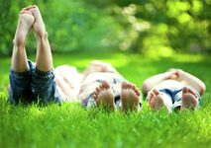
Figure 11
View description - Figure 11
View alternative description - Figure 11

Within education settings that are many policies that help children’s health. Such policies include those aimed at ensuring good standards of healthy eating, control of infection, sickness and administration and storage of medicines. Other policies that can support children’s mental health include safeguarding and anti-bullying.

6 Bringing it all together: Community and global influence
Although Figure 1 (in Section 1) separates out the global, national and community legislation and looks at the place of policies in education settings, the reality is that there is overlap between and relationships between each of the different levels.
The community that a child lives in can influence their food choices and, in turn, their nutritional status. Children’s food choices can be affected by the community they live in. Many communities don’t have access to shops that sell affordable, fresh produce such as fruit and vegetables. And for people living in remote rural areas, access to a reliable public transport system can restrict access to affordable shops.
Many multi-national fast-food chains produce ultra-high processed foods that are often more affordable than fresh produce; and powerfully influence eating habits around the world. In Tatlow-Golden and Boyland’s 2021 study about digital food marketing in the Philippines, which was commissioned by the United Nations Children’s Fund (UNICEF), they reported: ‘This food marketing monitoring study found that in the Philippines, social media is almost 100% saturated with marketing for unhealthy foods and non-alcoholic beverages. Advertising is appealing to 84% of adolescents. an almost entirely unhealthy “advertised diet” is promoted to children and families, creating emotional associations of fun, love, sharing and health with these foods, and draws on the “star” power of local sporting and media celebrities’ (Tatlow-Golden and Boyland, 2021, p. 5).
The powerful influence of advertising and its association with children’s food is evident in many food products, and there are numerous products that are packaged in ways to appeal to children. This environment is making a significant contribution to children’s health, specifically in relation to the number of children who are overweight and obese.
In the following activity, you will watch a video and explore the ways that the ‘food environment’ influences eating habits.

Activity 3 Video review
20 minutes

In this video, the importance of the ‘food environment’ in relation to changing our eating habits and reducing the consumption of unhealthy ‘junk’ food is discussed. The video highlights the influence of such food on children’s health, specifically on the contemporary levels of obesity and children who are overweight.
As you watch the video, make notes about the following:
- Which factors need to be in place to help families make healthy eating choices?
- What can be done to change the food environment?

Video content is not available in this format.
Video 2 children and food
View transcript - Video 2 children and food

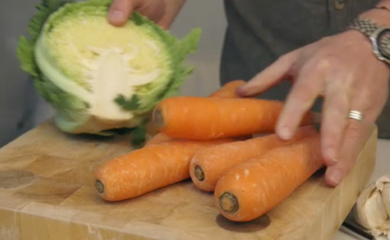

Provide your answer...
View discussion - Activity 3 Video review

7 Summary of Session 5
There are many global initiatives aimed at supporting and promoting the health of children. However, there are differences in how individual countries address children’s health. Many countries address children’s health through curriculum in pre-school education and care settings and also in schools.
Education settings are ideally placed to provide an environment that promotes the health of babies and children. However, children’s health is not only the responsibility of practitioners in education settings, but there is also a need for societal changes that support policies aimed at supporting children’s health.

Activity 4 Reflection
15 minutes

- What aspects of this session’s learning did you find most and least helpful? Why?
- What do you consider to be your three main learning points from the session?
- What further reading or research might you like to do before the next session?

Provide your answer...

Now go to Session 6.

Session 6: Introducing the Toolkit to identifying health priorities

Introduction
So far in the course, you’ve looked at some of the factors that influence young children’s health, examined the historical background and explored how the situation is similar or different to times gone by. You then turned to the contemporary state of children’s health and looked in detail at preventable and non-preventable health conditions. In the last session you examined policies from some other countries that support children’s health. This session you’re going to look at how practitioners can support children’s health in their education and care setting.
When seeking to locate suitable resources about how practitioners support and promote children’s health, it became apparent that there was a need to create a resource that was specifically aimed at practitioners working with babies and young children in pre-school education and care settings. For this reason, the Early Childhood Health Promotion Toolkit was developed to help guide practitioners. The first part of the Toolkit includes background health-related information and resources. The second part of the Toolkit includes five steps which have been designed to be used to identify, implement and evaluate a health promotion intervention.
The Toolkit was developed with a pre-school nursery with 106 babies and children on roll. The nursery is in an area of high deprivation. The nursery used the Toolkit in a pilot study to test how useful it was in supporting the practitioners to examine how they supported and promoted the health of all the children in their setting. The pilot research findings (Musgrave and Payler, 2021) have helped to refine the Toolkit, and some of the content in this session is drawn from that research.
The content of this session introduces the ‘5 step plan’ and how parents and practitioners can complete this step together.

Learning outcomes
By the end of this session, you will be able to:
- explain the five steps of the Early Childhood Health Promotion Toolkit
- identify a health promotion need for the children in your setting
- consider how you could use the 5 steps to help put an intervention in place.

1 Introducing the Early Childhood Health Promotion Toolkit
This section explains how the Early Childhood Health Promotion started. Take a look at the video where Jackie introduces and explains the origins of the Early Childhood Health Promotion Toolkit.
In the video, Jackie describes how when she came to look for some resources or publications that were relevant to and specifically written for practitioners in early childhood settings, there was almost nothing available. There are many very useful websites from a range of organisations which do include relevant information and guidance, but there was a need to bring the resources into one location to make access easier. As well as bringing resources and information together in one place, there was also a need to create an approach that would support and guide practitioners to identify the health priorities in their settings. And this is how the Toolkit was born!

Video content is not available in this format.
Video 1 Introducing the Early Childhood Health Promotion Toolkit
View transcript - Video 1 Introducing the Early Childhood Health Promotion Toolkit

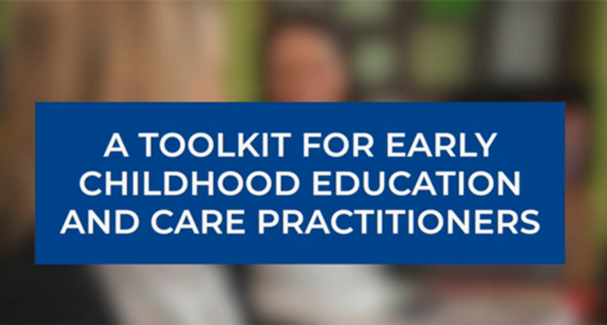

The following is a summary of the points Jackie makes in the video:
- Health promotion is looking at ways that behaviour can be shaped or changed to promote the best possible outcomes, so that people feel well and can reduce the risk of developing illnesses and health problems. Health promotion is often associated with health education campaigns that are aimed at adults. However, it is really important that babies and children have opportunities to promote their health, and of course, babies and children can’t do this by themselves – they need support from the adults around them
- We need to work together, all adults who have responsibilities for educating and caring for children. It’s not just the responsibility of parents or of early years practitioners in nurseries, pre-school settings or childminders, we can all make a contribution.
- Child health promotion is embedded in early childhood education and care practice, for example the English EYFS states that ‘providers must promote good health’. However, there is a lack of research and resources that supports practitioners to carry out this. Because there is a lack of guidance and research, with her colleague, Professor Jane Payler at The Open University, Jackie developed a Toolkit to help support practitioners to identify how they can promote the health of babies and young children.
- The Toolkit includes information and resources about health promotion, and the Toolkit also includes the 5 steps, which are a series of steps that have been designed to guide practitioners about how they can carry out an audit of the health issues relating to babies and children in their setting. This will help them to gain a clear picture of the health issues that are a priority in their setting, and from this information they can identify a health promotion intervention that is relevant and realistic. And very importantly, at the end of the intervention, there is a final step that helps practitioner to evaluate how effective the Toolkit and the 5 steps were in supporting them with promoting health.
- Jackie says in the video that she was very privileged to be given the opportunity to test out the 5 steps in a nursery. Later in the course you’ll meet Jackie’s co-researcher and also with the managers of the nursery to hear their views about the use of the Toolkit.
The 5 steps of the Toolkit are summarised in the next section.

1.1 A 5 step programme for early childhood health promotion
As you heard in the video, the 5 step programme aims to support you to seek ways to promote the health of the children in your setting. Figure 1 is a diagram which illustrates each of the steps.

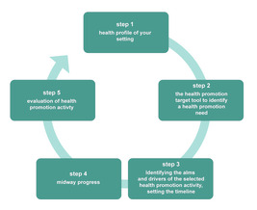
Figure 1 Summary of the 5 Step Programme for Early Childhood Health Promotion
View description - Figure 1 Summary of the 5 Step Programme for Early Childhood Health Promotion
View alternative description - Figure 1 Summary of the 5 Step Programme for Early Childhood Health Promotion

Below is a detailed explanation of the purpose of each step and how each step will be achieved.

Table 1 A 5 step programme for Early Childhood Health Promotion
Step 1 | Early childhood health profile | The content of the EC Health Profile is designed to assist you to consider the health needs of the children and families in your setting. On completion of this stage, you are encouraged to decide on a health promotion priority for the children in the setting.
Step 2 | Early childhood health promotion tool | The purpose of this step is to focus on identifying the benefits of the health promotion intervention and for you to reflect on how you are going to implement and evaluate the intervention.
Step 3 | Illustrative diagram of the aim and drivers for the intervention (adapted from Bryk et al., 2010) | The purpose of this step is to focus on the chosen intervention. The questions in the diagram will encourage you to select a specific health promotion aim. You are encouraged to consider what the primary and secondary drivers of the aim will be. This will be discussed and completed during the initial interview. Step 3 includes a discussion of the timeline for the selected intervention.
Step 4 | Mid-way progress: questions to assess the progress made and next steps | The purpose of this step is to take stock of how the intervention is going; to reflect on progress, identify any barriers or challenges to success, identify solutions.
Step 5 | End of implementation of HP intervention: questions to evaluate how the intervention went and to identify next steps | The purpose of this step is to identify the end of intervention impact on children, families and practitioners; to assess the sustainability of the intervention and to identify the findings and how they can be disseminated to inform best practice in promoting children’s health.

The following sections will look at each of the steps in detail, giving explanations of their aims. The sections will include videos from the practitioners in the nursery that used the 5 steps in the pilot research.

2 Early childhood setting health profile
This section looks at Step 1 of the Toolkit. In the previous sessions of the course, you’ve looked at the factors within the child, their family, their community and the country that they live in that can influence babies and children’s health. The questions in Step 1, see Table 2 below, are designed to help you learn more about the factors that may influence the health of the children and families in your setting.

Activity 1

Using the early childhood setting health profile
15 minutes

Take a look at the questions in Step 1 and, if you work in a setting, consider the answers to the questions. As you respond to the answers, make a list of the reasons why developing a profile of your setting is helpful when considering the health of babies and children.

Table 2
Description of your setting
Type of setting | - privately owned  - nursery school in the state maintained sector  - children’s Centre  - voluntary  - other
Location of setting: what description fits where your setting is located | An area of:  - affluence  - deprivation  - other
Number of children in each age band | - 0–1 years  - 1–2 years  - 2–3 years  - 3–4 years
Number of staff in the setting | - practitioners  - cleaning staff  - other staff
Parents of the children in your setting | - in employment  - not employed
Number of children receiving funding | - 2 year old funding  - 3 year old funding
Ethnicity of children and families: How many parents describe themselves as | - white  - Black  - other race
Minority groups | Do you have any children who are living in families who are:  - Refugee/asylum seeking  - Gypsy/Traveller/Roma
English as an additional language | Do you have children who belong to families who have English as an additional language?  If so, how many children?  Which languages, other than English are spoken by children and families in your setting?
Children not living with their biological parents | Do you have any children who are:  - looked-after by the state  - living with kinship carers, for example grandparents?
Health priorities in your setting
What are the children’s health issues that are of most concern?
What aspects of health improvement do you promote in your setting?
What aspect of children’s health would you most like to improve?
What resources do you use to promote children’s health?
Health issues that affect the children in your setting
Chronic Health Conditions | Are any of the children in your setting affected by any of the following health conditions. If so, how many?  - asthma  - diabetes  - eczema  - epilepsy  - sickle cell anaemia
Children with dietary restrictions/requirements | Number  Type of restriction and reason
Allergies | - Do any of the children have an allergy?  - How many children?  - What are they allergic to?  - How would you describe the severity of their allergy: mild/moderate/severe?  - Do they require to have an Epipen injection?
Complex medical conditions | Complex medical conditions, Yes/No how many children?  Please name the condition(s)  Does the child(ren) require any support such as  - Tube-feeding  - Any other clinical procedure?
Infectious illnesses | Do the children in your setting ever have infectious illnesses such as:  - colds  - diarrhoea and vomiting  - conjunctivitis  - hand, foot and mouth  Absence because of being ill with an infectious disease?  How often are children absent because of an infectious disease? frequently/occasionally/never  How often are staff absent because of being ill with an infectious disease? frequently/occasionally/never
Mental health conditions | Do any of your children have any of the following:  - behavioural difficulties  - attention-deficit hyperactivity disorder  - autism  - anxiety  - depression  - phobias  - any other mental health conditions
Other child health conditions | How many children in your setting have one, or more, of the following health conditions:  - overweight or obese  - dental decay
Education health care plans (EHCPs) | Do you have any children with an EHCP? How many?
Working with other professionals | Do you work with other professionals or agencies to support children’s health?  Please specify:  - Health visitor  - School Nurse  - Hospital Staff  - Speech and Language Therapist  - Dentists/Dental Nurses  - Physiotherapist  - other

View discussion - Using the early childhood setting health profile

Practitioner’s perspective on using the Toolkit
5 minutes

In the following video, Karen Neal – Family Support Worker at the Nursery and co-researcher for the pilot – explains how the 5 steps helped the practitioners in her setting to learn more about the health needs of the children in her setting. As you listen to Karen, think about how much of what she says is helpful to your work with children.

Video content is not available in this format.
Video 2 Practitioner’s Perspective on using the ToolKit.
View transcript - Video 2 Practitioner’s Perspective on using the ToolKit.

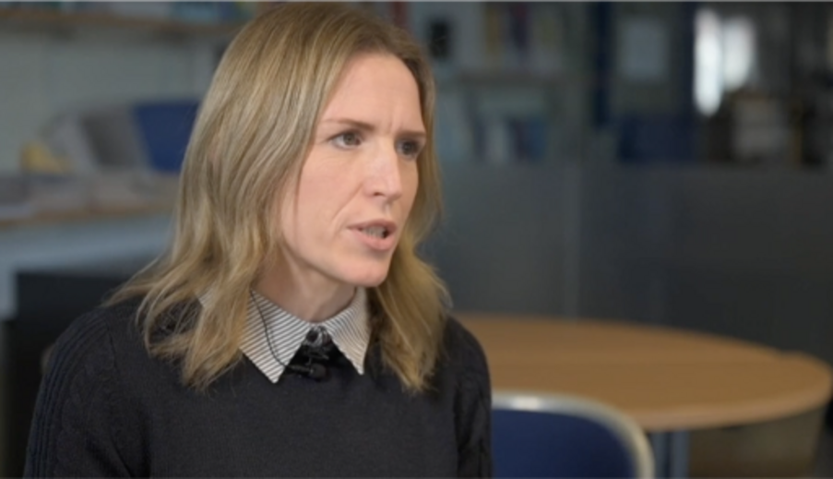

Provide your answer...
View discussion - Practitioner’s perspective on using the Toolkit

The following section looks at Step 2, the early childhood health promotion target tool.

3 The early childhood health promotion target tool
Following completion of Step 1, Step 2 is ‘the early childhood health promotion target tool’. The purpose of this step is to identify the benefits of an intervention to the setting and the children and family.
The purpose of this step is to focus on identifying the benefits of the health promotion intervention and for you to reflect on how you are going to implement and evaluate the intervention.

Table 3 The early childhood health promotion target tool
Aim of the health promotion activity
Questions to consider | Response | Challenges/barriers/solutions
- Why have you selected this as a health promotion priority? | Provide your answer... | Provide your answer...
- How did you select the health promotion priority? | Provide your answer... | Provide your answer...
- Who is going to benefit from this Health Promotion activity? | Provide your answer... | Provide your answer...
- Why is it important to your setting? | Provide your answer... | Provide your answer...
- What evidence supports your selected health promotion activity? | Provide your answer... | Provide your answer...
- How do you propose to approach your target? | Provide your answer... | Provide your answer...
- What resources will you use? | Provide your answer... | Provide your answer...
- Who can help you to achieve your target? | Provide your answer... | Provide your answer...
- How are you going to involve/appoint them to work with you? | Provide your answer... | Provide your answer...
- What are the possible barriers to achieving your target? | Provide your answer... | Provide your answer...
- How can you keep track of your progress? | Provide your answer... | Provide your answer...
- How are you going to measure the success or the impact of your intervention? | Provide your answer... | Provide your answer...

3.1 Identifying a health promotion priority
After the nursery had completed Step 1, and they had extended the scope of Step 1 to find out more from the parents, the nursery wanted to do more to promote healthy eating in the nursery. In the next video, Karen and Nicola, the managers in the setting who carried out the pilot research, explain their motivation for choosing healthy eating as a focus.

Activity 2 Managers’ perspectives of using the Toolkit
5 minutes

In the following video, Karen and Nicola talk about their motivation for taking part in the research. As you listen, pick out the reasons they give.

Video content is not available in this format.
Video 3 Karen and Nicola explaining their motivation for taking part in the research piloting the Toolkit
View transcript - Video 3 Karen and Nicola explaining their motivation for taking part in the research ...

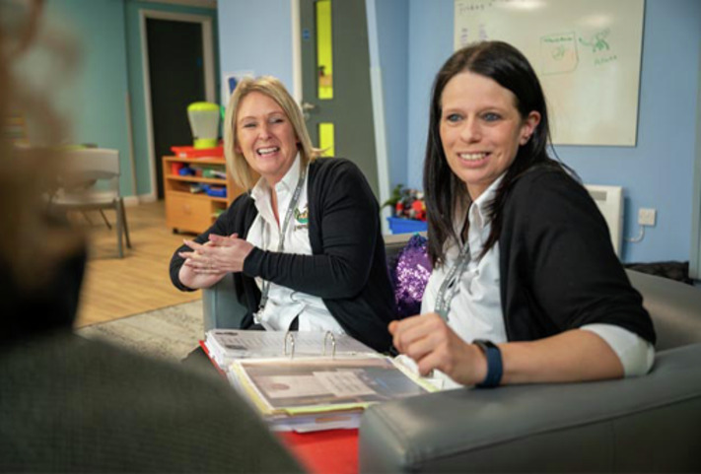

Provide your answer...
View discussion - Activity 2 Managers’ perspectives of using the Toolkit

The following section explains how Step 3 can help to identify the main aims of a selected health intervention, as well as the secondary, less obvious ones.

4 Identifying the aims and drivers of the health promotion intervention
After completing Step 2, there may be a main reason for selecting an intervention that is selected to support children’s health. As Nicola and Karen explained in the video, they were motivated to look at ways to support children to eat healthily. Step 3 is to support practitioners and parents to identify the main aim of the intervention. It can also help to think of the primary drivers, meaning what are the reasons for focusing on the aim. The questions can also provoke thinking about the secondary drivers of the health promotion intervention.
The following section is a case study of how Step 3 can be used to identify the primary and secondary drivers behind the aim of a health promotion intervention. The case study focuses on how Ayeesha, the manager of a large nursery used Step 3 to identify the reasons why she needed to tackle the amount of sickness caused by communicable diseases in her setting.

Case study: using Step 3 to reduce the incidence of communicable diseases
Ayeesha is the manager of a large nursery. She has noticed that there is an increasing number of absences among the children and the staff in the setting. This is causing concern because it’s affecting everyone in the nursery and also the parents.
When Ayeesha looks into the cause of absences, she realises that the main causes are communicable diseases, such as viral illnesses causing common colds and tummy upsets. There are also cases of hand, foot and mouth infections and conjunctivitis.
The nursery is in an area close to the centre of a large city. The children and families who attend the nursery are ethnically, socially and economically diverse. About a third of the parents work in professional roles in the business area of the city. Many of the children live in a council housing estate which has benefited from regeneration but most of the families live in poverty.
Many of the children who attend the nursery have pre-existing health conditions: in particular, about 10% have asthma. There are four children with complex medical needs. a significant number of children belong to families who have recently arrived in the UK and are in temporary housing while their immigration status is decided.
Ayeesha realises that she needs to look at ways to reduce the incidence of communicable diseases that are causing so much absence. She also realises that she needs to be able to demonstrate to the staff and families the benefits of doing so.

Figure 2 is an example of how Ayeesha can use Step 3 to think about how the aim of the intervention can help her to identify the primary and secondary drivers which will benefit the children’s and adults in the setting.
Take a look at Table 3 and the points made in boxes 2 and 4, and make some notes about your thoughts about the benefits of the primary and secondary drivers.

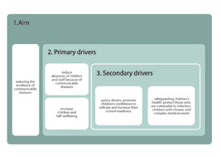
Figure 2 Illustrative Driver Diagram for Child Health Promotion Activity (adapted from Bryk et al., 2010)
View description - Figure 2 Illustrative Driver Diagram for Child Health Promotion Activity (adapted ...
View alternative description - Figure 2 Illustrative Driver Diagram for Child Health Promotion Activity (adapted ...

Take a look at the comments in the right hand side of Table 3 for more explanation about the aim of the chosen intervention.

Table 4 Primary and secondary drivers of Ayeesha’s health promotion aim
Aim: Reducing the incidence of communicable diseases | Comment
Primary drivers:  - reduce absences of children and staff because of communicable diseases  - increase children and staff wellbeing. | Frequent absences are causing problems for all the adults. Many parents rely on the care the nursery provides. Many families are vulnerable and find it hard to cope with unexpected absences. Working parents find it difficult to find emergency childcare and are concerned about the impact on their work commitments. Staff absences put additional stress on colleagues, as well as financial strain on the setting because of the need to employ temporary staff so that the staff to child ratios are legal.  Reducing the children’s absences means they are accessing their early education and not missing out on opportunities to progress their development. This is especially important fo the children of the families who are regarded as being vulnerable and benefit from attending the setting.  Not feeling unwell because of a common cold or other infection helps children’s wellbeing and emotions and helps them to be able to concentrate and interact in positive ways with others  Regular attendance and regular and predictable routines with familiar adults help to improve children’s wellbeing.  If staff are feeling well, they too will have improved attendance and be able to do their job well.
Secondary drivers  - policy drivers: promote children's confidence in self-care and increase their school-readiness  - safeguarding children's health: protect those who are vulnerable to infection, children with chronic and complex medical needs. | Supporting children’s to learn about hygiene, and teaching them about how they reduce the spread of infection, especially effective handwashing at appropriate times will mean that gain confidence in their ability to self-care. This is an advantage for when they move to school.  Common cold viruses can be especially problematic for children with a chronic health condition. The virus that causes colds can provoke an asthma attack. Children with complex medical needs can become very unwell with infections.

The comments on the right hand side of Table 3 are just a few ideas of the primary and secondary drivers of the aim to reduce the incidence of communicable diseases. You may have thought of other drivers.

Activity 3 Using Step 3
15 minutes

As you’ve read through the content of this session, and following completion of Steps 1 and 2, you may have identified an intervention to put in place to help support and promote the health of the children in your setting. To help you to assess the primary and secondary drivers of the intervention, have a go at answering the questions in relation to what you have selected.
Questions to guide your thinking:
- What is the overall aim of the intervention?
- What are the primary drivers, or the main reasons, for selecting the intervention?
- What are the secondary drivers, or other reasons, for the chosen intervention?
- How can the health promotion intervention improve quality in your setting?

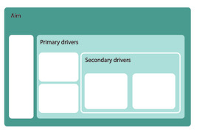
Figure 3 template to use for identifying aims and divers for health promotion intervention

Provide your answer...
View discussion - Activity 3 Using Step 3

4.1 Identifying key dates
Planning the timeline for the ‘life’ of the chosen health promotion intervention will be helpful to ensure that the research goes to plan and that the aims are met. During the pilot research, the practitioners drew up a timetable of dates of the key dates.
Table 5 lists the key dates for you to decide.

Table 5 Timeline for the Health Promotion intervention
Steps | Key Dates | Comment
Step 1: Early childhood health profile:
Step 2: Early childhood health promotion tool
Step 3: Illustrative diagram of the aim and drivers for the intervention
Step 4: Mid-way progress
Step 5: Evaluation of HP intervention

As part of the planning process, the practitioners decided on activities and events aimed at working with all colleagues, the families and the children to put the intervention into practice. How they did this, and examples of activities are discussed in Session 7.
Having planned dates and events and then having moved on to implement the health promotion intervention, it’s a good idea to take stock, to stop and reflect on what is going well, identify anything that needs changing. For this reason, Step 4 is a series of questions that have been designed to review progress mid-way through.

5 Mid-way progress: review Steps 2 and 3
When planning a health promotion intervention that is designed to take place over a period of time, decisions about dates and activities can seem realistic. However, as we know, other events can happen that make dates unachievable. Colleagues may hand in their notice, or there may be staff absence, or any other event that comes along can all affect the best-laid plans. Sometimes, plans can become too ambitious, or they simply may not work in the way that was intended. For this reason, Step 4 is a mid-way review of the progress of the intervention, it’s an opportunity to stop and take stock of how the intervention is going; to reflect on progress, identify any barriers or challenges to success, identify solutions, for us to work together and if necessary, for the researcher to offer further support and plan next steps.
- What has gone well?
- Is there anything that could have gone better?
- Were there any specific barriers or challenges?
- If so, how were they resolved?
- What do you think the children think about the intervention?
- How have you worked with parents and carers?
- What are your predictions about the success of the intervention?
- Any other comments?
Evaluating an intervention is important to identify what worked and what didn’t work so well. The views of the practitioners who used the Toolkit and the 5 steps will be returned to in the following two sessions.

6 Summary of Session 6
The content of this session has introduced you to the Child Health Promotion Toolkit which includes the 5 steps which was developed to provide guidance to practitioners who are involved in supporting and promoting children’s health. The content has drawn on the experiences of the practitioners who were involved in piloting the Toolkit. You were also given the opportunity to engage with the Toolkit and relate it to your own practice. Before moving on to Session 7, consider the following questions.

Activity 4 Questions for reflection
10 minutes

- What aspects of this session’s learning did you find most and least helpful? Why?
- What do you consider to be your three main learning points from the session?
- What further reading or research might you like to do before the next session?

Provide your answer...

In Session 7, you will look in more detail at how professionals and parents can work together to identify health promotion priorities. The content gives practical ideas drawn from the pilot research. When you are ready, move on to Session 7.

Session 7: Professionals and parents working together

Introduction
This session encourages you to consider the ways that professionals, including practitioners in early childhood settings as well as Health Visitors and school nurses, can work together to promote the health of babies and young children. You will be encouraged to consider each child, and to learn more about practices and beliefs about health at home. To achieve this, it is important to consult parents and work together to be successful in identifying a relevant, realistic and low-cost intervention. An example of a questionnaire that can be adapted by practitioners to use as a way of learning more about home practices is included.
This session gives examples from the pilot study (Musgrave and Payler, 2021) of how the setting worked with parents. There are examples of the practical ways that health promotion interventions can be implemented in settings and includes some of the resources that were created by the practitioners. Some of the key features that can contribute to successfully promoting health in setting are examined. Such features include the importance of adults being positive role models for babies and young children. It will highlight the importance of interventions being realistic and relevant to the children and families. Also conveying the sensitive ways that the practitioners approached working with the families to identify, implement and evaluate their chosen health promotion intervention. It will highlight how they embedded opportunities into everyday routines and events to send health promotion messages to parents.

Learning outcomes
By the end of this session, you should be able to:
- explain why working with parents is important to promote babies and young children’s health
- describe the key features to successful health promotion
- give examples of resources needed to promote children’s health
- list reasons why working together is important to promote children’s health.

1 Working with parents
Throughout the course, the importance of working with parents has been discussed. Before continuing with this session, take a few minutes to reflect on the reasons why you think it is important to work with parents to promote children’s health.

Activity 1 Working with parents
5 minutes

Watch the following video, which is an interview with Karen. In the video she explains some of the reasons why working with parents is so important. She talks about how building relationships and gaining the trust of parents helps them to work with the staff to identify realistic interventions aimed at improving children’s health.

Video content is not available in this format.
Video 1 Promoting health and working with parents and staff – interview with Karen Neal
View transcript - Video 1 Promoting health and working with parents and staff – interview with Karen ...

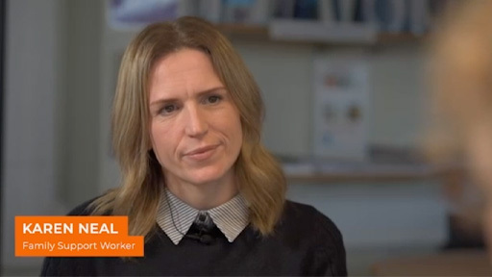

Provide your answer...
View discussion - Activity 1 Working with parents

The next section will look at how Karen worked with parents to find out more about health habits within families. Later sections will explore some of the tactics that Karen used to educate parents about health, especially in relation to healthy eating.

2 Exploring home practices relating to health
Health practices and what parents do to support and promote children’s health can be a sensitive area. Many parents may not have the means or resources to provide the foundations of health for children.


Figure 1 Parents may not be able to afford food for their children
View description - Figure 1 Parents may not be able to afford food for their children
View alternative description - Figure 1 Parents may not be able to afford food for their children

However, what you do in your setting can have a significant impact on children’s health. This can be strengthened by building bridges between home and setting. To help Karen find out more about health practices at home, she created a questionnaire. In the following section, she gives some tips that can help to create a questionnaire that parents may feel comfortable in completing.

2.1 Creating a questionnaire for parents: Karen’s tips
If you want to create a questionnaire to send home with parents, to make the responses as helpful as possible, it will be important to ask for some personal details, such as the age of the child. However, to increase the chances of parents responding, avoid asking for any information that could identify the child and family. And make sure that you provide a space where parents can drop their returned questionnaires rather than handing them to staff, thus reducing the chances of the parent being identified.
The following is a list of questions that could be used to find out more about what parents do at home.
- Do you have any concerns about your child’s health?
- Does your child enjoy eating?
- If yes, what sorts of food do they enjoy most?
- What do they dislike?
- Do you think they have a healthy diet?
- Do you have any difficulties in providing a healthy diet to your child?
- Do you think that they are a healthy weight?
- What sorts of drinks does your child have at home?
- Does your child enjoy drinking water?
- Does your child drink from a cup or a bottle?
- How healthy are your child’s teeth?
- Do you have any concerns about the appearance of their teeth?
- Does your child visit the dentist?
- How many hours of sleep does your child get each night?
- What is their bedtime routine?
- Does your child have a bottle at night?
- Does your child have a dummy/pacifier?
- Is your child physically active?
- How does your child come to nursery: in a car/bus/walking/other?
- Does your child use a buggy?
- What is your child’s favourite sort of play? For example, solitary play, doing what? Or playing with others? Doing what?
- Does your child use an electronic device. If so, what is it?
- How much screen time do they have each day?
- Does your child have a medical condition?
- A special or educational need?
- Difficulties with mobility?

Activity 2 Finding out about home practices in your setting
10 minutes

Having read the parent questionnaire, think about your response to the following questions:
- Why do you think it’s helpful to find out the answers to these questions?
- Thinking about your setting, are there questions you would add or remove from this list?
- Why do you think that it’s important to give parents the opportunity to complete the questionnaire anonymously?

Provide your answer...
View discussion - Activity 2 Finding out about home practices in your setting

The information that you gather from the questionnaires may produce some surprising facts, and it is important that all practitioners are able to be non-judgemental in response to the information.

2.2 The importance of an understanding and non-judgemental approach
The family environment creates what becomes the norm for children. The norm for many families may not be what professionals advocate, and may not comply with current research findings, government policy, the policies in your setting or with your own beliefs. There are many reasons why parents do not create ‘health-promoting’ lifestyles for their children. Such reasons may be influenced by living in poverty; although, poverty is not simply a lack of money. Food poverty, meaning a lack of nutritious food and a well-balanced diet, can be a feature of families who have sufficient money to provide a healthy diet, but may not have much spare time to give to buying and preparing nutritious meals.

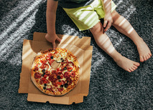
Figure 2 many parents are unable to provide the resources for healthy meals
View description - Figure 2 many parents are unable to provide the resources for healthy meals
View alternative description - Figure 2 many parents are unable to provide the resources for healthy meals

However, many children do have an unhealthy diet, and many go hungry because of lack of money. In addition, there are social, cultural, religious and other economic influences that can affect how parents promote or inhibit the health of their children. Many parents will hold very strong health beliefs, therefore your role in working with parents to gain their cooperation and trust may be challenging. You may find that you need to be especially sensitive and non-judgemental in your approach to parents.
The following section explores how Karen and colleagues used the information they had gathered about the health priorities in their setting, and how they identified a focus, or intervention, aimed at improving the health of the children.

3 Identifying a health promotion intervention
In Session 6, in the video ‘Practitioners’ perspectives of using the toolkit’, Karen described how she used the information she gathered from using Steps 1, 2 and 3 of the Toolkit to learn more about a focus for a health promotion activity. Karen considered the comments and feedback from parents about their concerns about healthy eating. She had consulted her colleagues’ views too, and they had expressed their concerns about the content of some of the food provided for children’s packed lunches. Therefore, the staff decided that they wanted to plan a health education campaign aimed at improving parents’ knowledge about healthy eating and drinking.
The following sections looks at some of the resources Karen created to help promote the healthy eating messages.

3.1 Examples of healthy eating education interventions
Karen wanted to capture the interest and attention of as many parents as possible, so she planned to launch the campaign at the setting’s parents’ evening. The decision to use this opportunity was because 96 per cent of parents attended the evening. As parents would need to wait in the entrance hall until it was their appointment time, and they were less likely to be rushing in and out of the setting as on a normal day. This would give them the time to look at the information provided.
Karen thought carefully about how to present the information, and thinking about the diversity of the families, she wanted to develop an inclusive approach to the resources used in the campaign.
Karen produced several visual displays aimed at educating parents about healthy eating and drinking for children.
The following images illustrate some of the displays.

Sugar content display

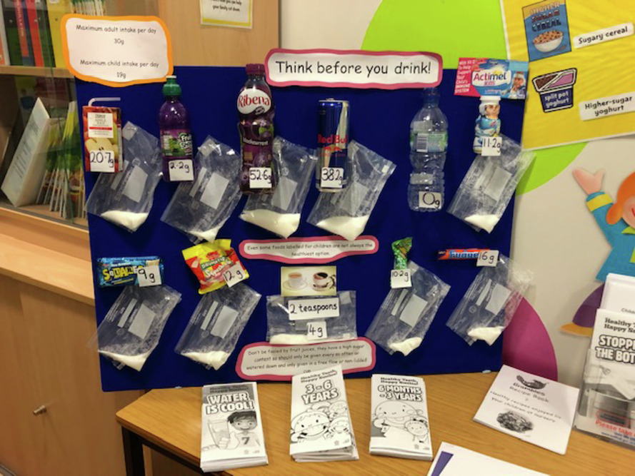
Figure 3
View description - Figure 3

The image is a photo of a display prepared by Karen to illustrate to parents the sugar content of food that was included in children’s lunch boxes. She wanted to produce something that was designed to give what she described as a ‘shock tactic’ to parents. This was because the practitioners in the setting had noticed that many of the food and drink items that were included in the children’s lunch were very high in sugar content. To illustrate this fact, she displayed some of the items that were frequently included, and then she measured out the amount of sugar and poured it into a plastic bag as Figure 3 shows.
To gain maximum impact, the display was erected just inside the entrance to the setting where parents needed to wait until their appointment. Many of the parents expressed their surprise. Karen was able to pick up on comments that the parents made, and in an informed and sensitive way she was able to open up the conversation with the parents.
Karen had also extended the information to include leaflets about healthy drinking and oral health. This is because she had noted in the response to the parent questionnaire that some parents had demonstrated that they needed to know more about oral health She had prepared leaflets to give to parents.
Karen included the cost of the day’s eating and drinking, an important consideration for parents, especially as the setting was in an area of deprivation and many parents were living in poverty.

Recipe card display

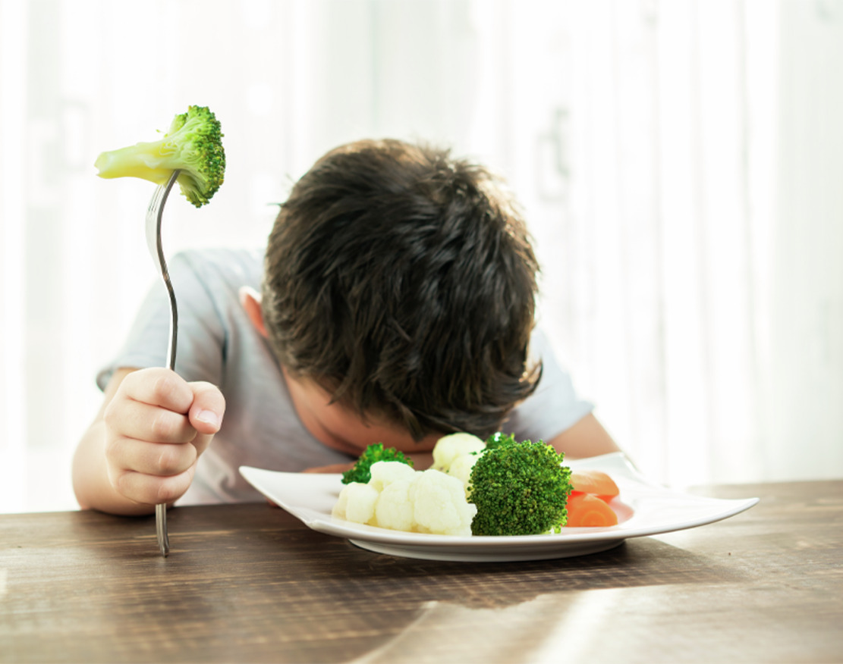
Figure 4
View description - Figure 4

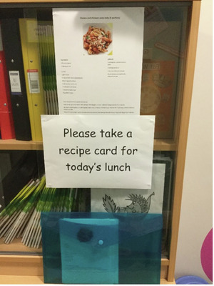
Figure 5
View description - Figure 5

Some parents claimed that their children didn’t eat vegetables at home and they didn’t have the time or money to waste on buying and preparing food that would be wasted and their children would still need feeding. To counter the parents’ scepticism about eating new and different dishes, the practitioners sent photos to parents via their electronic communication system of their children eating the meals at nursery. This caused surprise, but also gave some parents confidence to give the recipes a go.
The second main reservation about introducing different recipes was that parents were concerned that preparation and cooking would take up a lot more time. To counter this objection, as already mentioned, the setting had selected recipes that required a small number of ingredients. Karen gave suggestions about cooking larger batches in one go and then freezing small portions for later use. However, she was conscious that many parents may not have a freezer, and may not have suitable cooking facilities, therefore, knowing the family and sensitivity and not making assumptions was something they kept in mind.
Karen then produced a handout of each day’s recipe for the parents to take with them to try it at home, as illustrated in Figure 5. Many parents were very responsive to the healthy eating approach taken and claimed that it had helped them to change their eating habits.

The Eat Well Plate

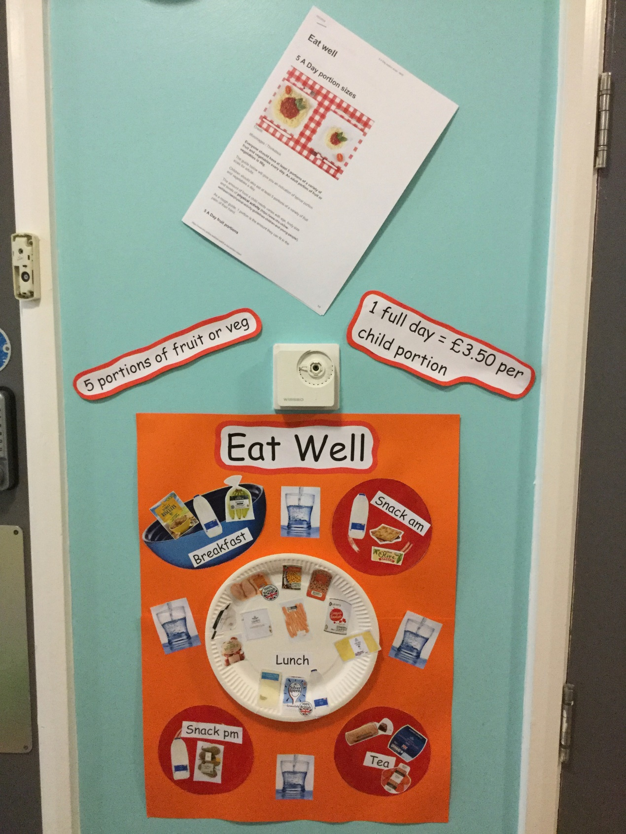
Figure 6
View description - Figure 6

Karen prepared a poster which showed very clearly recommended food that would be regarded as healthy for young children. Using images meant that the information was more accessible for all parents. This was especially important because of the diverse nature of the parents, some had English as an additional language, were illiterate, had learning difficulties or had low levels of education. Karen also addressed healthy drinking, illustrating this with milk and water.
Clearly Karen and the practitioners worked hard to educate parents about healthy eating and drinking. The approach taken demonstrates a sensitive, realistic and supportive approach. They gave a great deal of thought to how they could make the information and resources as accessible to the diverse needs of the parents. And at the heart of the success of this campaign was the positive relationships that the practitioners had developed with their parents.

Activity 3 Reflections on Karen’s approach to the healthy eating campaign
15 minutes

- What are your thoughts about Karen’s approach to educating parents about healthy eating and drinking?
- What, if anything, would you do differently?

Provide your answer...
View discussion - Activity 3 Reflections on Karen’s approach to the healthy eating campaign

In the following section, Karen gives some of her thoughts about the important considerations.

4 Working together to make a difference
In the next video Karen gives some of her reflections about the healthy eating and drinking activities that were put in place using the 5 Steps in the pilot research.

Activity 4 Promoting children’s health: working together to make a difference
10 minutes

As you watch the video, consider the key messages that Karen gives.

Video content is not available in this format.
Video 2 promoting children’s health, working together to make a difference
View transcript - Video 2 promoting children’s health, working together to make a difference

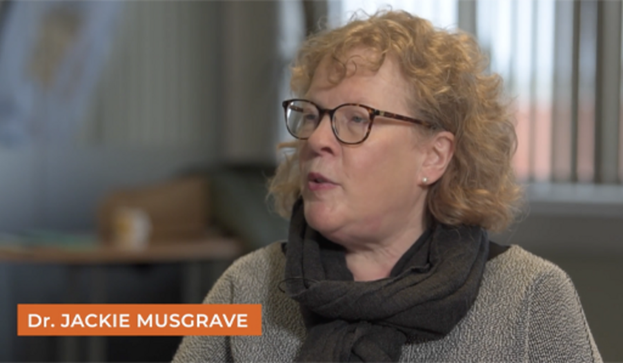

Provide your answer...
View discussion - Activity 4 Promoting children’s health: working together to make a difference

In the next section, you will pick up on Karen’s comments in the video about the ‘Rs of health promotion.

5 The ‘Rs’ of health promotion in Early Childhood education and Care settings
This section discusses some of the points that emerged from this research that are useful to bear in mind when identifying, implementing and evaluating health promotion activities. The themes that emerged were all words starting with ‘R’, hence the ‘Rs of health promotion’ as illustrated in Figure 7.

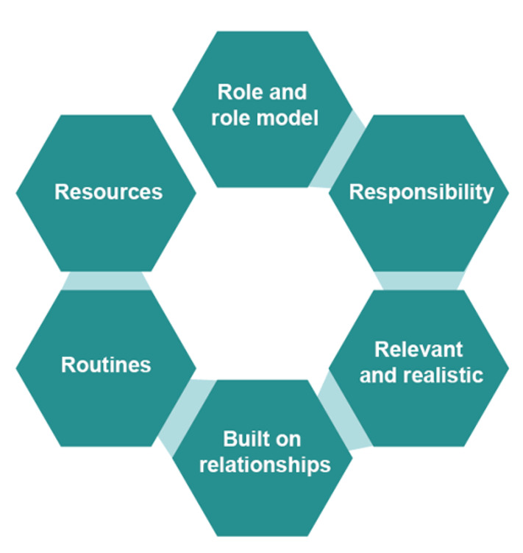
Figure 7 The Rs of health promotion
View description - Figure 7 The Rs of health promotion
View alternative description - Figure 7 The Rs of health promotion

Figure 8 describes the ‘Rs of health promotion’ in more detail. Click on the boxes on the left-hand side to reveal the explanatory text.

Interactive content is not available in this format.
Figure 8 (interactive)
View description - Figure 8 (interactive)

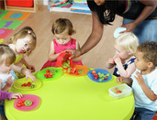
Figure 9 Healthy eating opportunities can be introduced during everyday routines in your setting
View description - Figure 9 Healthy eating opportunities can be introduced during everyday routines ...
View alternative description - Figure 9 Healthy eating opportunities can be introduced during everyday routines ...

6 Summary of Session 7
This session has looked at some of the reasons why working with parents is important to promote babies and young children’s health. In the videos, you have heard Karen’s thoughts about some of the keys to success in carrying out an intervention, and a main point highlighted is the importance of working together. Working together means not only working with parents, but all who work in the nursery and sometimes can include other agencies, such as including a dental nurse. And the final section looked at the ‘Rs of health promotion’.

Activity 5 Questions for reflection
15 minutes

- What aspects of this session’s learning did you find most and least helpful? Why?
- What do you consider to be your three main learning points from the session?
- What further reading or research might you like to do before the next session?

Provide your answer...

Now go to Session 8.

Session 8: Challenges and solutions to working together to promote children’s health

Introduction
In the final session of this course, you will look at some of the challenges that are associated with promoting the health of babies and young children. And very importantly, you’ll look at some of the solutions to remove barriers that can cause challenges. There are case studies that are aimed at exploring some of the contemporary child health conditions that are causing concern and need to be addressed. The case studies focus on childhood obesity, oral health, communicable diseases, specifically looking at vaccine hesitancy and mental health. Challenges and possible solutions are discussed, taking into account the different perspectives of those involved, that is children, parents, and professionals.
The session will conclude with suggested next steps that need to be taken by individuals, including professional and parents, government and globally, to take responsibility for actions to improve, support and promote children’s health.
In the following section, you will hear from Karen and Nicola, the managers at the nursery where the Toolkit and the 5 Steps were piloted. In the video, they give an overview of the challenges they faced in relation to introducing healthy eating and drinking in their nursery.

Learning outcomes
By the end of this session, you will be able to:
- describe some of the challenges associated with promoting the health of babies and children
- identify possible solutions by exploring case studies
- consider the responsibilities of adults in relation to improving, supporting and promoting the health of babies and children.

1 Challenges and solutions
This section looks at some of the challenges that Karen and Nicola, the managers at the nursery, came across during the nursery’s healthy eating and drinking campaign.

Activity 1 Challenges and benefits to promoting health – Managers’ perspective
10 minutes

In the following video, Karen and Nicola describe some of the challenges. As you watch the video, make a note of the challenges that Karen and Nicola describe in the video.

Video content is not available in this format.
Video 1
View transcript - Video 1

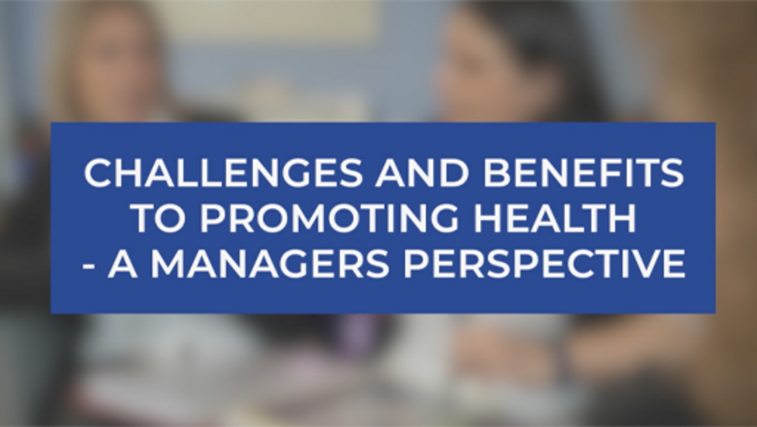

Provide your answer...
View discussion - Activity 1 Challenges and benefits to promoting health – Managers’ perspective

The following section looks at some possible solutions to removing barriers and challenges.

2 Solutions to some of the challenges
This section looks at some of the solutions to the challenges that emerged from the nursery introducing and implementing healthy eating and drinking in the nursery. The solutions fall into 3 broad themes:
- The importance of working with parents.
- Educating parents and staff on the benefits of promoting health.
- Setting goals and being realistic.
The following sections explores the themes in more detail.

2.1 Working with parents
Throughout this course, the importance of working with and not against parents has been a familiar theme.
Karen and Nicola emphasise that key to the success of what they do at their nursery in relation to promoting health, is the importance of developing positive relationships with parents. Good relationships help to set the scene to enable staff to get to know parents. In Session 6, Karen Neal, the Family Support Worker in the nursery described how she sent out questionnaires to the parents to help her learn more about home practices. If parents felt that the staff were disinterested or if they were going to be judgemental, they would be less likely to respond with truthful responses.
Developing good relationships with families sets the scene for educating parents. However, Karen and Nicola found that it was also important to educate the staff.

2.2 Educating parents and staff of the benefits of promoting health
An important solution to getting parents’ cooperation to work with the nursery to promote their children’s health was through education. The importance of working with parents to educate them about the benefits of healthy eating and drinking has been looked at in detail throughout the course and is a focus of Session 7. Education about healthy eating for families helps to dispel some of the myths that need ‘busting’ as described by Karen Neal on the video in Session 7. Education can also help to allay parents’ fears, for example, the fears that many parents have about children choking if they’re given crunchy foods that need careful chewing as described in Section 1.
Karen and Nicola mentioned that it’s important to use a range of different approaches to educating parents. Not one size fits all, some parents benefit from visual health promotion information, such as the examples in Session 7. Other parents may benefit form a one-to-one chat.
Staff may also need to be educated about the benefits of healthy eating and drinking. They may also need to think about the ‘Rs of health promotion’, which are outlined in Session 7.
Staff can also reflect on the changes that they feel have come about because of the health promotion activities. For example, Karen and Nicola described how they observed that by encouraging the children to be more physically active helped them to concentrate better, and in turn this helped their learning.
Other benefits of healthy eating and drinking resulted in fewer illnesses and, therefore, fewer absences in the nursery. They also noticed positive changes in the children’s behaviour.

2.3 Setting goals and being realistic
Sometimes knowing where to begin with health promotion in a setting can be a challenge. Staff may feel that they don’t have time to take on what may seem like additional work. This is where good communication can help to solve this challenge. To illustrate this point, in Session 5, you looked at how health promoting activities are embedded in many of the aims and principles in the curricula and frameworks of each of the 4 nations of the UK. Conveying the message to staff that implementing such aims and principles can have a positive effect in promoting children’s health may be helpful.
Outlining some of the possible benefits to children, such as positive changes in behaviour, and less illness, can help to gain buy in from staff.
And as you heard in the video, it’s important to look at what is already being done to promote children’s health. You may already be doing more than you realise.
When planning health promotion activities be realistic and don’t try to do too many things at the same time. The 5 Steps in the Toolkit, as discussed in more detail in Session 6, have been created to help you to identify aims.
Outlining the benefits to parents and staff can help to overcome some of the challenges that may arise in relation to gaining cooperation. It’s important to be realistic and be aware that there is a need to dedicate time and resources to health promotion. This is another reason why it’s helpful not to try and do too many new things at the same time.
So far, the content of this session has looked at some of the challenges and possible solutions experienced by Karen and Nicola when looking at ways to improve and make children’s eating and drinking healthier. The following section looks at other contemporary conditions relating to children’s health, focusing on childhood obesity, oral health, communicable diseases, specifically looking at vaccine hesitancy, and poor mental health.

3 What can be done about other contemporary child health conditions?
Throughout the course, it’s been highlighted how important it is to take into consideration the factors that influence health within the child, the family, wider community and society. The content of Session 6 introduced the Toolkit which includes the 5 Steps that have been created to support early years pre-school care and education settings to improve the health of their children. In Session 7, the content focused on how one setting used the Toolkit to identify an intervention aimed at making eating and drinking healthier.
In Session 4, you looked at some of the preventable communicable and non-communicable conditions that are having a negative impact on children’s health in the UK today. Also in Session 4, you looked at the causes, some statistics and possible prevention of some communicable health conditions, as well as non-communicable conditions such as oral health, some conditions caused by inadequate nutrition, such as obesity and mental health.
In the following section, you’ll look at suggestions of how to approach improving some of these conditions.

3.1 What can be done to reduce levels of childhood obesity?
Session 4 looked at some of the statistics that show the extent of this worrying health trend. You also looked at some of the causes of childhood obesity. As discussed in Session 4, the causes of childhood obesity are complex, and this means that finding solutions to reverse the trend and identifying interventions that will prevent children from becoming obese is challenging.
Contemporary thinking about ways to tackle the problem points towards the need for all to take responsibility. This includes children, parents and professionals, community, and society as a whole. This is similar to the content of Session 4 where the food environment was discussed. In relation to steps to prevent childhood obesity, the Royal Society for Public Health (RSPH) (2019) reported that there is a need to address the factors that influence children’s eating habits. The RSPH state that we live in an ‘obesogenic environment’, meaning that many environments are influencing and promoting obesity. Such influences include advertising and ready availability of junk food.
Changing the environment beyond the child’s home and education setting may be an unrealistic aim. However, within education settings, encouraging physical activity and healthy eating can be helpful to address obesity. As with all health-related challenges, understanding the child and their families and understanding why obesity is a problem is important.

3.2 What can be done to improve children’s oral health?
There is a pressing need to address the causes of poor oral health and to work with children and families to develop sustainable, realistic and affordable ways of preventing poor oral health. Increasing adults’ knowledge about healthy eating and drinking and addressing ways to introduce healthy options that contribute to good oral health and hygiene can make a positive contribution. Some families, especially families who may move from home to home regularly, may be described as ‘hard to reach’. However services such as dentists can be hard to reach for some families.
The statutory curriculum for children aged 0–5 years in England requires nurseries to take responsibility for children’s oral health, it states in the Early Years Foundation Stage( that ‘providers must promote the good health, including the oral health, of children attending the setting’ (Department for Education, 2024, p. 31). Therefore, to comply with this statutory requirement and to contribute to children’s good oral health, it is important that they know why and how to do this, and how to work with parents to ensure children have good levels of oral health to avoid short- and long-term damage to physical and mental health.

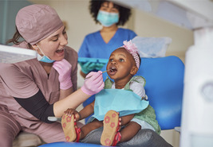
Figure 1 The importance of dental care
View description - Figure 1 The importance of dental care
View alternative description - Figure 1 The importance of dental care

The following case study explains how Juweirya, a practitioner working in an early years setting, has approached this requirement.

Case study: oral health in early years settings
As children are still coping with the new transition to different rooms, we felt it was very important we create a warm loving environment where children are being taught how to regulate their emotions, understand behavioural expectations and create strong bonds between the practitioners and children before we engage in such an important topic. As we feel this is the basis to then be able to introduce important topics such as oral health.
The introduction of oral health in preschool has begun by bringing awareness to oral health language and vocabulary such as germs, healthy gums, unhealthy gums. We implement strategies such as reading stories and singing songs which will help children gain more knowledge and help to create opportunities to discuss oral health. We hope this will encourage them to take care of their mouths. We will then start to incorporate activities such as brushing teeth, brushing away germs and building a mouth using papier-mache so children become familiar with the different components of the mouth. Also changing our role play into a dentist. This will support children's understanding of oral health.

Yet again, the importance of positive relationships is highlighted by Juweirya as being the foundation to promoting children’s health. Juweiriya has described what she does in the nursery setting to help develop children’s understanding of oral health, as well as addressing the statutory requirement within the EYFS to improving children’s oral health. She describes the playful approaches they have develop. In addition to Juweirya’s suggestions, in Session 7 Karen talked about how she invited a dental nurse into the setting to talk with the children.
Although there are many ways of working with parents and other professionals to improve oral health and prevent dental decay, there is a need for the wider influences on oral health to be addressed across society, such as poor diet.

3.3 What can be done to reduce the spread of communicable diseases?
In Session 4 you explored some of the ways that the spread of communicable diseases can be prevented. The main ways of doing so include effective handwashing and through immunisation. All children in the UK are eligible for free immunisations against several communicable diseases, however, many parents are hesitant about having their child immunised: so-called ‘vaccine hesitancy’. In the next activity, you’re asked to list as many reasons as you can as to why some parents may decide not to take their child for immunisation.

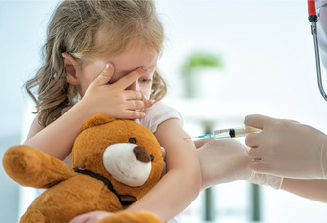
Figure 2 The importance of immunisation
View description - Figure 2 The importance of immunisation
View alternative description - Figure 2 The importance of immunisation

Activity 2 Why do some parents not take their child to be immunised?
10 minutes

Make a list of as many reasons as you can think of that help to explain why some parents may decide not to have their child immunised.

Provide your answer...
View discussion - Activity 2 Why do some parents not take their child to be immunised?

Lack of knowledge among adults, especially parents, is a significant factor in whether they choose to have their children immunised. So, what can be done to help parents to understand the reasons why immunisation is important in preventing their child contracting a communicable disease that is largely preventable?

3.4 Preventing infection: what can be done to encourage parents?
As said many times during this course, working with parents in supportive, sensitive and non-judgemental ways to promote children’s health is important. You may choose to ask parents about their child’s immunisation records before they start attending your setting. However, this may be something that you are doing for your current cohort, in which case, Step 1 of the Toolkit (as discussed in Session 6) may be help you to find out more from parents about the immunisation status of their children.
If you find that not all of the children are immunised, or if there is an outbreak of an infectious disease that could be prevented by immunisation, you may consider developing a health education campaign for your setting.
Such a campaign could include producing resources that are aimed at informing parents of the reasons why immunisation is important. The poster that is available on the Government website may be a helpful starting point: Immunising nursery school children, poster
Educating parents by thinking about the issue from the children’s perspective may be helpful. Some parents who choose not to immunise their child against preventable diseases may not be aware that they are denying their child their right to health by leaving them more vulnerable to contracting an infectious disease.
Parental choice to not immunise their children can impact on other children, not just their own children. Ensuring that as many children as possible are immunised will help to achieve what is described as ‘herd immunity’ and this will help to protect vulnerable children who cannot receive immunisations. There are few reasons why children should not receive immunisations. One example is children who are receiving immune suppressing drugs following an organ transplant, or those receiving cancer treatment. Giving immunisations to immune-suppressed children is potentially dangerous, but if the majority of children are immunised, this will reduce the chance of infectious diseases being spread. Thus, achieving herd immunity will help to confer the right to health on such children.
Education and health settings who can reduce the incidence of communicable diseases are going to have higher attendance by staff and children. This will contribute to the wellbeing of children, parents and staff.
Depending on the sort of setting you are working in, and the location, it may be possible to work with other professionals to promote the health messages about immunisation for children.

3.5 What can be done to promote good mental health for children?
The features of high-quality Early Childhood Education and Care can be effective in promoting children’s wellbeing and reducing the incidence of poor mental health. For example, the requirement of the EYFS that each child must have a key person who knows and understands each child and can develop a positive relationship which can help with attachment.

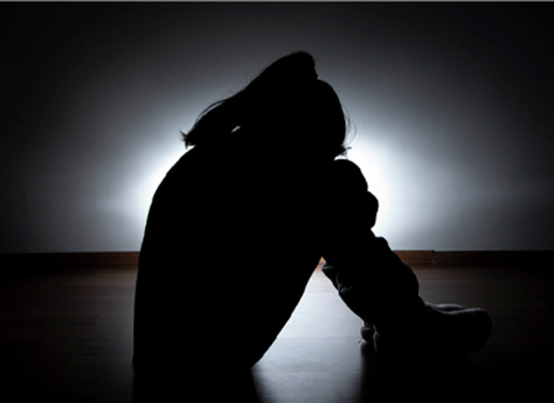
Figure 3
View description - Figure 3
View alternative description - Figure 3

For many children, their home environment can provide some of the ‘ingredients’ that can help to promote good wellbeing, such ingredients include predictable routines where they experience warm relationships, are listened to, and have interesting and stimulating play opportunities. In turn, this can help with developing good mental health. However, many children live in chaotic homes where their parents find the struggles of daily life overwhelming, and this may mean that their children’s wellbeing and needs are not given sufficient attention. For some families, this can be an on-going situation, for other families, they may go through periods of uncertainty and chaos because of bereavement, loss and other events that can impact on children’s wellbeing. At such times, early care and education settings and schools can play a compensatory role for children, providing a secure and predictable environment.
For all children, early education and education settings can have a positive impact on their mental health. The aims and principles of early childhood curricula lend themselves to supporting children’s wellbeing. For young children, having the opportunity to engage with different play can be therapeutic and the persistence that is required by children when engaging with some activities can help them to develop resilience. Outdoor play helps to stimulate the release of endorphins which are chemicals that promote a sense of wellbeing. Consequently, children who do not have the opportunity to take part in outdoor physical play may be predisposed to a reduced sense of wellbeing and, consequently, poorer mental health. However, as discussed in the following section, it is essential that all adults involved in the care of and providing services to children share this responsibility.

4 The responsibilities of adults in promoting children’s health
Babies and children rely on the adults in their lives to support and promote their health; therefore, we all have a responsibility to understand what we can do to achieve the aim of improving their health. However, all adults, parents, carers and professionals need to share this responsibility and work together.
In the following video, you return to Dr Helen Lyndon who you first met in Session 3. Helen talks about how she sees adults’ responsibilities in relation to promoting children’s health.

Activity 3 The responsibilities of adults in promoting children’s health
5 minutes

Video content is not available in this format.
Video 2
View transcript - Video 2

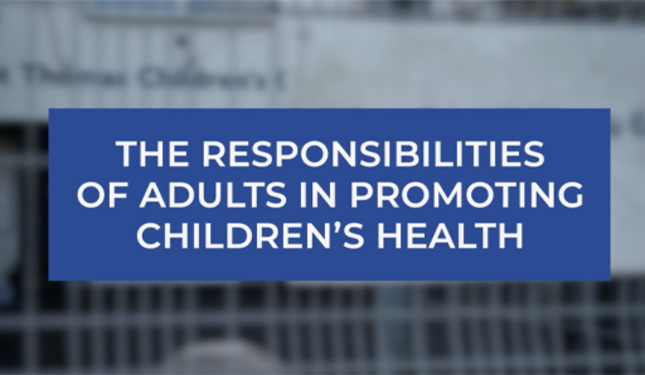

As you listen to Helen, write down some key points about what adults can do to promote good health in children

Provide your answer...
View discussion - Activity 3 The responsibilities of adults in promoting children’s health

Activity 4 The benefits of stay and play sessions
10 minutes

Stay and play sessions are aimed at parents and carers of babies and children aged 0–5 years. They are frequently held in local community spaces. A variety of play options can be available, which can include messy play that involve crafts and paints, a range of different toys and games. Read about Mylene and how attending Stay and play weeks can help support and promote her children’s health.

Mylene lives with her partner in a house close to the university where he is employed on a short-term research project. They have recently moved to the area with Arlo, who is 18 months and Minni who is 4 weeks old. Mylene’s’ family are 200 miles away and her partner’s family live overseas. Mylene is finding parenting tough with two children. She found it difficult to breastfeed Arlo because he some difficulties after he was born and had to remain in hospital. Mylene is very keen to successfully breastfeed Minni. Arlo has not taken well to having a small sister. He has become tearful and, in some respects, he has regressed in his development.

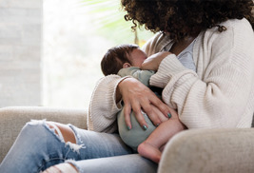
Figure 4
View description - Figure 4
View alternative description - Figure 4

The Health Visitor suggests to Mylene that they may all benefit from attending a local ‘Stay and Play’ session. The sessions are held in a local health centre which also provides baby clinics and Health Visitor services.

Write a list of the reasons why doing so could help with the children’s physical and mental health.

Provide your answer...
View discussion - Activity 4 The benefits of stay and play sessions

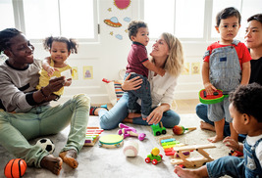
Figure 5
View description - Figure 5
View alternative description - Figure 5

Practitioners who run the Stay and Play sessions can support children’s and parents’ mental health by modelling and encouraging behaviour that can promote infant and parental attachment. They can encourage parents to talk to and communicate with tiny babies, helping them to become responsive to their babies’ cues and learning how to meet their needs. For older children, language can develop through interaction with other people.
To conclude, Stay and Play sessions are a highly valuable service that can support parents, taking part in sessions can reduce isolation and offer the opportunity to be with other parents who are facing the same challenges. The idea of stay and play can appear deceptive, and the benefits of how they can support and promote different areas of health in a non-threatening and supportive way should not be under-estimated.

5 Summary of Session 8
As Helen says in the video, all adults have a responsibility to do what they can as a parent, carer, educator or other professional to support and promote children’s health. Parents need to be aware that the professionals working closest to children and families will walk alongside them to achieve this aim. Cuts to services, such as Sure Start Children’s Centres, have seen a reduction in their number, with many facing closure.

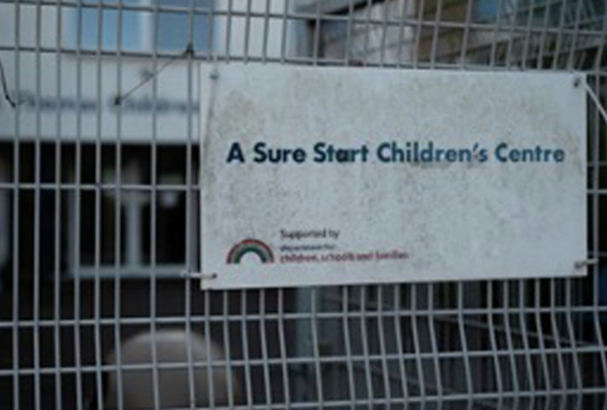
Figure 6
View description - Figure 6
View alternative description - Figure 6

Policy makers need to make children’s health a priority. To successfully work together to promote children’s health, government and local authorities need to fund children’s services so that agencies can work collaboratively. Our children are our future, and they deserve to have the best opportunity to have the best physical and mental health they can.

Activity 5 Questions for reflection
10 minutes

- What aspects of this session’s learning did you find most and least helpful? Why?
- What do you consider to be your three main learning points from the session?
- What further reading or research might you like to do to further develop your knowledge and understanding?

Provide your answer...

References
BBC (2022) Awaab Ishak: Mould in Rochdale flat caused boy’s death, coroner rules. Available at: https://www.bbc.co.uk/news/uk-england-manchester-63635721 (Accessed: 3 February 2024).
Bronfenbrenner, U. (1979) The ecology of human development. Cambridge, MA: Harvard University Press.
Burton, M., Pavord, E. and Williams, B. (2014) An introduction to child and adolescent mental health. London: Sage
Department for Education (2024a) Statutory framework for the Early Years Foundation Stage for childminders: setting the standards for learning, development and care for children from birth to five. Available at: https://assets.publishing.service.gov.uk/media/657825a90467eb001355f552/EYFS_statutory_framework_for_childminders.pdf (Accessed: 3 February 2024).
Department for Education (2024b) Statutory framework for the Early Years Foundation Stage for group and school based providers: setting the standards for learning, development and care for children from birth to five. Available at: https://assets.publishing.service.gov.uk/media/65aa5e42ed27ca001327b2c7/EYFS_statutory_framework_for_group_and_school_based_providers.pdf (Accessed: 3 February 2024).
Statham, J. and Chase, E. (2010) Childhood wellbeing: a brief overview. Childhood Wellbeing Research Centre Briefing Paper 1. Available at: https://assets.publishing.service.gov.uk/government/uploads/system/uploads/attachment_data/file/183197/Child-Wellbeing-Brief.pdf (Accessed 18 May 2024).
Strathdee, G. (2015) ‘A defining moment in mental health care’. NHS England, 13 February. Available at: https://www.england.nhs.uk/blog/geraldine-strathdee-8/#:~:text=The%20definition%20of%20mental%20health,communities%20and%20the%20wider%20environment. (Accessed: 18 May 2024).
World Health Organisation (2018) Health Promotion. Available at: https://www.who.int/health-topics/health-promotion#tab=tab_1 (Accessed: 18 May 2024).
World Health Organisation (2022) Health Promoting Schools. Available at: https://www.who.int/health-topics/health-promoting-schools#tab=tab_1 (Accessed: 5 March 2024).
World Health Organisation (2022) What is the World Health Organisation?: Frequently Asked Questions. Available at: https://www.who.int/about/frequently-asked-questions#:~:text=The%20preamble%20to%20WHO's%20constitution,absence%20of%20disease%20or%20infirmity.%E2%80%9D (Accessed: 18 May 2024).
Adams, C. (n.d.) A paper by Cheryl Adams on the History of Health Visiting. Available at https://ihv.org.uk/about-us/history-of-health-visiting/a-paper-by-cheryll-adams/ (Accessed : 7 June 2024).
Atkins, P. J. (2011) ‘Communal feeding in war time : British restaurants, 1940–1947.’, in Zweiniger-Bargielowska, I. and Duffett, R. Food and war in twentieth century Europe. Farnham, England: Ashgate, pp. 139–53.
BBC News, (2021) Air pollution: Coroner calls for law change after Ella Adoo-Kissi-Debrah's death. Available at https://www.bbc.co.uk/news/uk-england-london-56801794. (Accessed: 16 May 2024).
Beveridge, W. (2000 [1942]) Social insurance and allied services. Bulletin of the World Health Organization, 78(6), p. 847. Available at:https://www.ncbi.nlm.nih.gov/pmc/articles/PMC2560775/pdf/10916922.pdf. (Accessed 26 May 2024).
Birmingham Mail (2016) Small Heath and Sparkbrook through time. Available online at https://www.birminghammail.co.uk/news/nostalgia/gallery/small-heath-sparkbrook-through-time-10976525 (Accessed: 16 June 2024).
Birmingham Public Health (2019) Birmingham Health Profile. Birmingham City Council. Available at https://www.birmingham.gov.uk/downloads/file/11845/birmingham_health_profile_2019 (Accessed 12 May 2024).
Bivins, R. (2014) ‘Ideology and disease identity: the politics of rickets, 1929–1982’, Medical Humanities, 40(1), pp. 3–10.
Black, D., Morris, J.N., Smith, C., Townsend, P., Davidson, N. and Whitehead, M. (1980) Inequalities in Health: The Black Report. London: DHSS.
Children’s Society (2022) Children’s mental health statistics. Available at: https://www.childrenssociety.org.uk/what-we-do/our-work/well-being/mental-health-statistics. (Accessed: 16 May 2024).
Court, D. (1976) Fit for the Future. Report of the Committee on Child Health Services. London, HMSO.
Harding, J. (1982) ‘Cradle to Grave’: Population and environmental characteristics of the Central Birmingham Health District. Published by Central Birmingham Community Health Council.
Hart, J. T. (1971) ‘The inverse care law’, The Lancet, 297(7696), pp. 405–12.
Heggie, V. (2008) ‘Lies, Damn Lies, and Manchester’s Recruiting Statistics: Degeneration as an “Urban Legend” in Victorian and Edwardian Britain’, Journal of the History of Medicine and Allied Sciences, 63(2), pp. 178–216.
Maharaj, V., Rahman, F. and Adamson, L. (2014) ‘Tackling child health inequalities due to deprivation: using health equity audit to improve and monitor access to a community paediatric service’, Child: Care, Health and Development, 40(2), pp. 223–30.
Marmot, M., Allen, J., Boyce, T., Goldblatt, P. and Morrison, J. (2020) Health equity in England: The Marmot Review 10 years On. London: Institute of Health Equity. Available at: https://www.health.org.uk/publications/reports/the-marmot-review-10-years-on (Accessed: 26 June 2024).
Marmot, M., Allen, J., Goldblatt, P., Boyce, T., McNeish, D., Grady, M. and Geddes, I. (2010) The Marmot review: Fair society, healthy lives. London: UCL.
Musgrave, J. (2017) Supporting Children's Health and Wellbeing. London, Sage.
Office for National Statistics (ONS) (2017) Causes of death over 100 years. Available at: https://www.ons.gov.uk/peoplepopulationandcommunity/birthsdeathsandmarriages/deaths/articles/causesofdeathover100years/2017-09-18 (Accessed: 8 June 2024).
O’Neill, A. (2019) Statista. Available at: https://www.statista.com/statistics/1041714/united-kingdom-all-time-child-mortality-rate/ (Accessed: 8 June 2024).
Pemberton, L. (2022a) ‘Anti-racist leadership: Part 1: Think again’, Nursery World Select, 2022(1), pp. 44–5.
Pemberton, L. (2022b) ‘Anti-racist leadership: Part 2: Looking inward’, Nursery World Select, 2022(2), pp.44–5.
Pemberton, L. (2022c) ‘Anti-racist leadership: Part 3: What we say’, Nursery World Select, 2022(3).
Pemberton, L. (2022d) ‘Anti-racist leadership: Part 4: Do I belong?’, Nursery World Select, 2022(4).
Phillimore, P., Beattie, A. and Townsend, P. (1994) ‘Widening inequality of health in northern England, 1981–91’, BMJ, 39(6937), pp. 22–8.
Public Health England (2020) Oral Health Survey Of 5-Year-Old Children 2019. Available at: https://www.gov.uk/government/statistics/oral-health-survey-of-5-year-old-children-2019. (Accessed: 16 June 2024).
RCP (2022) Senior health leaders say the government must set more ambitious targets to reduce the health impacts of air pollution. Available at: https://www.rcplondon.ac.uk/news/senior-health-leaders-say-government-must-set-more-ambitious-targets-reduce-health-impacts-air (Accessed: 16 May 2024).
Rau, A. (2015) Causes of child mortality in developing countries. Available at https://borgenproject.org/main-causes-child-mortality-developing-countries/ (Accessed: 16 June 2024).
Redhead, G. and Olszynko-Gryn, J. (2020) Radical Object: The Black Report. Available at: https://www.historyworkshop.org.uk/radical-object-the-black-report/ (Accessed: 16 May 2024).
Royal Society for Public Health (2015) Tackling the UK’s childhood obesity epidemic. Available at https://www.rsph.org.uk/static/uploaded/de21cde9-a77d-4ce6-bf9342c51f2beb08.pdf (Accessed: 16 May 2024).
Save the Children (2022) What is malnutrition in children? Available at https://www.savethechildren.org/us/charity-stories/what-is-malnutrition-in-children (Accessed: 21 June 2024).
Townsend, P. and Davidson, N. (eds) (1982) Inequalities in Health: The Black Report. Harmondsworth: Penguin.
Townsend, P., Phillimore, P. and Beattie, A. (1988) Health and Deprivation: Inequality and the North. Routledge.
Townsend, P., Whitehead, M. and Davidson, N. (1992) Inequalities in Health: The Black Report & the Health Divide (new third edition). Penguin Books Ltd.
Viner R. M., Coffey C., Mathers C., Bloem P., Costello A., Santelli J. and Patton G. C. (2011) 50-year mortality trends in children and young people: a study of 50 low-income, middle-income, and high-income countries’. Lancet, 377(9772), pp. 1162–74. Available at: https://pubmed.ncbi.nlm.nih.gov/21450338/ (Accessed: 21 June 2024).
Viner, R.M., Hargreaves, D. and Cheung, C. (2017) State of Child Health Report 2017. London: Royal College of Paediatrics and Child Health.
Woods, R. and Shelton, N. (2000) ‘Disease Environments in Victorian England and Wales’, Historical methods, 33(2), pp. 73–82.
World Health Organisation (WHO) (n.d.) Global Health Observatory. Child mortality and causes of death. Available at: https://www.who.int/data/gho/data/themes/topics/topic-details/GHO/child-mortality-and-causes-of-death (Accessed: 21 June 2024).
Department for Health and Social Care (2018) Prevention is better than cure: our vision to help you live longer. Available at: https://www.gov.uk/government/publications/prevention-is-better-than-cure-our-vision-to-help-you-live-well-for-longer (Accessed: 5 January 2024).
Office for National Statistics (2018) National Life Tables, UK: 2015 to 2017. Available at: https://www.ons.gov.uk/peoplepopulationandcommunity/birthsdeathsandmarriages/lifeexpectancies/bulletins/nationallifetablesunitedkingdom/2015to2017#no-improvement-in-uk-life-expectancy-at-birth (Accessed: 4 January 2024).
Social Metric Commission (2020) Measuring poverty. Available at: https://socialmetricscommission.org.uk/wp-content/uploads/2020/06/Measuring-Poverty-2020-Web.pdf (Accessed: 5 January 2024).
UK Parliament (2022) Poverty in the UK Statistics. Available at: https://commonslibrary.parliament.uk/research-briefings/sn07096/ (Accessed: 5 January 2024).
UK Health Security Agency (2023) Complete routine immunisation schedule from 1 September 2023. Available at: https://www.gov.uk/government/publications/the-complete-routine-immunisation-schedule/the-complete-routine-immunisation-schedule-from-february-2022(Accessed: 3 January 2024).
World Health Organisation (2023) Health promoting schools. Available at: https://www.who.int/health-topics/health-promoting-schools#tab=tab_1 (Accessed: 10 February 2024).
NHS (2020) Vitamin D. Available at: https://www.nhs.uk/conditions/vitamins-and-minerals/vitamin-d/ (Accessed: 16 February 2024).
National Institute for Health and Care Excellence (NICE) (2021) Anaemia – iron deficiency. Available at: https://cks.nice.org.uk/topics/anaemia-iron-deficiency/ (Accessed: 16 February 2024).
Office for Health Improvement and Disparities (2022) Guidance Child oral health: applying All Our Health. Available at: https://www.gov.uk/government/publications/child-oral-health-applying-all-our-health/child-oral-health-applying-all-our-health (Accessed: 16 February 2024).
Office for Health Improvement and Disparities (2023) Patterns and trends in child obesity in England. A presentation of the latest data from the National Child Measurement Programme and Health Survey for England.
Wijlaars, L. P. M. M., Gilbert, R. and Hardelid, P. (2016) ‘Chronic conditions in children and young people: learning from administrative data’, Archives of Disease in Childhood, 101(10). Available at: https://adc.bmj.com/content/archdischild/101/10/881.full.pdf (Accessed: 22 June 2024).
Department for Education (2024a) ‘Statutory framework for the Early Years Foundation Stage for childminders: setting the standards for learning, development and care for children from birth to five’. Available at: https://assets.publishing.service.gov.uk/media/657825a90467eb001355f552/EYFS_statutory_framework_for_childminders.pdf (Accessed: 6 June 2024).
Department for Education (2024b) ‘Statutory framework for the Early Years Foundation Stage for group and school based providers: setting the standards for learning, development and care for children from birth to five’. Available at: https://assets.publishing.service.gov.uk/media/656f23550f12ef07a53e024e/EYFS_statutory_framework_for_group_and_school_based_providers.pdf (Accessed: 6 June 2024).
Education Scotland (2020) ‘Realising the Ambition’. Available at: https://education.gov.scot/media/3bjpr3wa/realisingtheambition.pdf (Accessed: 6 June 2024).
Her Majesty’s Government (2018) ‘Working together to safeguard children: a guide to inter-agency working to safeguard and promote the welfare of children’. Available at: https://assets.publishing.service.gov.uk/government/uploads/system/uploads/attachment_data/file/729914/Working_Together_to_Safeguard_Children-2018.pdf (Accessed: 6 June 2024).
Her Majesty’s Government (2022) Family Hubs and Start for Life programme Guide. Available from https://assets.publishing.service.gov.uk/government/uploads/system/uploads/attachment_data/file/1096786/Family_Hubs_and_Start_for_Life_programme_guide.pdf (Accessed: 6 June 2024).
Ministry of Education - Government New Zealand (2017) Te Whariki. Available from https://www.education.govt.nz/early-childhood/teaching-and-learning/te-whariki/ (Accessed: 6 June 2024).
Northern Ireland Curriculum Primary https://ccea.org.uk/downloads/docs/ccea-asset/Curriculum/The%20Northern%20Ireland%20Curriculum%20-%20Primary.pdf (Accessed: 6 June 2024).
Scottish Government (201) ‘Curriculum for Excellence: Health and Wellbeing’. Available at: https://education.gov.scot/education-scotland/scottish-education-system/policy-for-scottish-education/policy-drivers/cfe-building-from-the-statement-appendix-incl-btc1-5/curriculum-areas/health-and-wellbeing accessed (Accessed: 6 June 2024).
Scottish Government (2017) ‘Health and Social Care Standards: my support, my life’. Available at: https://www.gov.scot/publications/health-social-care-standards-support-life/ (Accessed: 6 June 2024).
United Nations (2019) ‘Sustainable Development Goals’. Available at: https://www.un.org/sustainabledevelopment/sustainable-development-goals/ (Accessed: 6 June 2024).
Bryk, A. S., Gomez, L. M. and Gomez, A. (2010) ‘Getting ideas into action: building networked improvement communities in education. Reorganising Educational Research and Development’. Carnegie Perspectives. Stanford: Carnegie Foundation for the Advancement of Teaching. Available at: https://files.eric.ed.gov/fulltext/ED517575.pdf (Accessed: 3 June 2024).
Department of Health and Social Care (2020) ‘Tackling obesity: empowering adults and children to live healthier lives’. Available at: https://www.gov.uk/government/publications/tackling-obesity-government-strategy/tackling-obesity-empowering-adults-and-children-to-live-healthier-lives (Accessed: 16 June 2024).
Musgrave. J. and Payler, J. (2021) ‘Proposing a model for promoting Children’s Health in Early Childhood Education and Care Settings’, Children and Society, pp 766–83. Available at: https://onlinelibrary.wiley.com/doi/full/10.1111/chso.12449 (Accessed: 16 June 2024).
Department for Education (2024a) Statutory framework for the Early Years Foundation Stage for childminders: setting the standards for learning, development and care for children from birth to five. Available at: https://assets.publishing.service.gov.uk/media/657825a90467eb001355f552/EYFS_statutory_framework_for_childminders.pdf (Accessed: 24 June 2024).
Department for Education (2024b) Statutory framework for the Early Years Foundation Stage for group and school based providers: setting the standards for learning, development and care for children from birth to five. Available at: https://assets.publishing.service.gov.uk/media/656f23550f12ef07a53e024e/EYFS_statutory_framework_for_group_and_school_based_providers.pdf (Accessed: 24 June 2024).
Musgrave. J. and Payler, J. (2021) ‘Proposing a model for promoting Children’s Health in Early Childhood Education and Care Settings’, Children and Society, pp. 766–83.
Royal Society for Public Health (2019) Routing out childhood obesity. Available at: https://www.rsph.org.uk/static/uploaded/5194975e-89a1-4dff-9e8aa68da4836231.pdf (Accessed: 24 June 2024).

Acknowledgements
This free course was written by Jackie Musgrave.
Except for third party materials and otherwise stated (see terms and conditions), this content is made available under a Creative Commons Attribution-NonCommercial-ShareAlike 4.0 Licence.
The material acknowledged below is Proprietary and used under licence (not subject to Creative Commons Licence). Grateful acknowledgement is made to the following sources for permission to reproduce material in this free course:
Introduction and guidance
Images
Course image: Courtesy: Phoebe via parent/Guardian
Audio/Video
Video 1 Introduction to the course © The Open University
Session 1
Figures
Figure 1: Robert Collins/Unsplash
Figure 3 Adapted from Bronfenbrenner’s (1979) Bio-ecological systems
Figure 4: PJ photography/Shutterstock
Figure 5: courtesy: Jackie Musgrave
Figure 6: NigelSpiers/Shutterstock
Figure 7: Courtesy; Jackie Musgrave
Figure 8: courtesy: Oscar via Jackie Musgrave
Figure 9: MeSamong/Shutterstock
Audio/Video
Audio 1: A child’s view of health: courtesy: Jackie Musgrave
Session 2
Figures
Figure 1: The Problem of the Distressed Areas: 1937 https://www.historyworld.co.uk/
Figure 2: A health visitor with a mother and new-born baby, c 1920s. Reproduced with the permission of Glasgow City Council, Glasgow Museums. ©CSG CIC Glasgow Museums and Libraries Collections
Figure 3: https://www.iwm.org.uk/collections/item/object/205191908 Imperial War Museums https://creativecommons.org/licenses/by-nc/4.0/
Figure 4: Infant Mortality Rate 2014-16 by ward map (figure 5). Source: ONS Births. in p7 Birningham Health Profile 2019 Produced by Birmingham Public Health (c) Crown Copyright and database rights 2019
Figure 5: from Open University video: PATTERNS OF CHILD HEALTH IN THE PAST 50 YEARS. Used with permission
Figure 6: A3pfamily/Shutterstock
Audio/Video
Video 1: Patterns of child health in the past 50 years with Jane Payler ©The Open University
Session 3
Figures
Figure 1: Zerbor/Shutterstock
Figure 3: sawasdee/Shutterstock
Figure 4: Aleksey Kurguzov/Shutterstock
Figure 5: Trinity Mirror/Mirrorpix/Alamy Stock Photo
Figure 7: Len44ik/Shutterstock
Audio/Video
Video 1: The Influence of the child’s development on children’s health: with Dr Helen Lyndon and Jackie Musgrave. Images by Getty Images ©The Open University
Video 2: Child health and rural poverty: with Clare Collins and Jane Payler, Image by Getty Images; intro clip by Pexels. ©The Open University
Session 4
Figures
Figure 2: DDurrich/Getty Images Plus
Figure 3: Sergey Zaykov/Shutterstock
Figure 4: Ground Picture/Shutterstock
Figure 5: Riccardo Mayer/Shutterstock
Figure 6: hyotographics/Shutterstock
Figure 7: RusN/Getty Images plus
Figure 8: fiorigianluigi/Getty Images
Figure 9: vYuliya Shevtsova/ EyeEm/Getty Images
Figure 10: courtesy: Jackie Musgrave
Audio/Video
Video 1: How to wash your hands NHS song | NHS https://www.youtube.com/watch?v=S9VjeIWLnEg&ab_channel=NHS
Video 2: Battling Malnutrition in Rwanda Courtesy World Vision International https://www.wvi.org/
Session 5
Figures
Figure 2: extract Good Health and Wellbeing: Goal 3: Ensure healthy lives and promote well-being for all at all ages https://www.un.org/sustainabledevelopment/health/U © United Nations
Figure 3: Angela Cini/Shutterstock
Figure 4: UNICEF/UN0708461/Noorani https://www.unicef.org/supply/stories/handwashing-around-world
Figure 5: Courtesy: Jackie Musgrave
Figure 6: Cover image https://ccea.org.uk/pre-school/curricular-guidance-pre-school-education#section-4929 https://ccea.orgCEA Rewarding Learning
Figure 7: davidf/Getty Images
Figure 8: Education Scotland Foghlam Alba https://www.playscotland.org/resources/realising-the-ambition-being-me/
Figure 9: Curriculum for Wales 2022. Mudiad Meithrin
Figure 10: Cover page: Early years foundation stage statutory framework For childminders. Published 8 December 2023 https://www.gov.uk/government/publications/early-years-foundation-stage-framework--2 https://www.nationalarchives.gov.uk/doc/open-government-licence/version/3/n
Figure 11: yaruta/Getty Images
Videos
Video 1: Transitioning from the MDGs to the SDGs: United Nations Development Programme: United Nations Development Programme (UNDP) https://www.youtube.com/watch?v=5_hLuEui6ww
Video 2: Children and food ©The Open University and its licensors
Session 6
Text
Early Childhood Health Promotion: A Toolkit for Early Childhood Education and Care Practitioners. A resource to support your practice in improving the health of children in pre-school settings by Jackie Musgrave Jane Payler. Early Childhood at The Open University © The Open University 2023
Figures
Figure 2: adapted from: Bryk, A. S., Gomez, L. M. and Gomez, A. (2010) Getting ideas into action: building networked improvement communities in education. Reorganising Educational Research and Development. Carnegie Perspectives. Stanford: Carnegie Foundation for the Advancement of Teaching. Available from https://files.eric.ed.gov/ fulltext/ ED517575. (adapted from Bryk et al 2010)
Audio/Video
Video 3: Practitioner’s perspective on using the Toolkit With Karen Neal and Jackie Musgrave. ©The Open University
Session 7
Figures
Figure 1: mrdoomits/iStock/Getty Images Plus
Figure 2:it:Pofuduk Images/Getty Images
Figure 3: courtesy: Jackie Musgrave
Figure 4: pinstock/Getty Images
Figure 5: courtesy: Jackie Musgrave
Figure 6: courtesy: Jackie Musgrave
Figure 9: lostinbids/Getty Images
Audio/Video
Video 1: Promoting health and working with parents and staff – Jackie Musgrave with Karen Neal ©The Open University
Video 2: promoting children’s health, working together to make a difference -Jackie Musgrave with Karen Neal ©The Open University
Session 8
Figures
Figure 1: LaylaBird/Getty Images
Figure 2: Choreograph/Getty Images
Figure 3: AHMET YARALI/Getty Images
Figure 4: Credit:SDI Productions/Getty Images
Figure 5: Rawpixel/Getty Images Plus
Figure 6: Image: ©The Open University
Audio/Video
Video 1: Challenges and benefits to promoting health – Managers’ perspective Jackie Musgrave with Karen Nash and Nicola Farmer © The Open University
Video 2: The responsibilities of adults in promoting children’s health Jackie Musgrave with Helen Lyndon ©The Open University. Image (mothers and babies): MachineHeadz/Getty Images
Every effort has been made to contact copyright owners. If any have been inadvertently overlooked, the publishers will be pleased to make the necessary arrangements at the first opportunity.
Don't miss out
If reading this text has inspired you to learn more, you may be interested in joining the millions of people who discover our free learning resources and qualifications by visiting The Open University – www.open.edu/openlearn/free-courses.

Solutions

Activity 1 Terms

Discussion
You may have come up with words such as health, health promotion, health education, mental health or wellbeing. You may have included a list of health conditions, such as eczema or asthma, or terms that relate to whether it is short-lived and sudden (acute) or on-going (chronic).
But what do some of these terms mean in relation to children’s health?
Back to - Activity 1 Terms

Activity 4 How well is access monitored?

Review your learning

Discussion
‘Inequalities in health’ means differences in the expected levels of illness and death between people based on their incomes, living circumstances, geographic location (where they live) and environments. People on lower incomes, in more deprived areas and living in poorer housing conditions die earlier and have more ill-health than people with higher incomes and better living conditions.
Babies and children living with families in those poorer circumstances and areas also suffer more ill-health, lower birth weights and have higher rates of infant mortality than babies and children in wealthier circumstances.
Back to - Review your learning

Activity 2 The effect of the environment on children’s health

Discussion
In the video, Helen talks about the influence of the environment on the health of young children. She describes how housing has changed over the years, the demolition of poor housing, for example, the back-to-back houses that were built in the 1800s to accommodate the large increases in population during the Industrial Revolution that started more than 200 years ago. In the 1950s, they were replaced with high rise tower blocks, and even though they had individual indoor toilets, baths and running water, they were not conducive to healthy living. The regeneration of the Ladywood area during this century has improved housing and the outdoor areas, making them more hospitable places in which to live. There has been increased awareness of the importance of outdoor spaces for children. Many Local Authorities have invested in improving play areas, an example of such a playground is illustrated in Figure 3.
Back to - Activity 2 The effect of the environment on children’s health

Activity 3 Living in poverty in rural areas

Discussion
In the video, Clare explains that the New Forest covers a large area and is a popular tourist area. This can have a negative impact on families on low income, and in turn, this can impact negatively on children’s health.
Housing is expensive, like London prices, and affordable rental properties are usually beyond the reach of many families. Living in a tourist area impacts on jobs and income work in the New Forest relies on the tourist season which is from April to October. Consequently, employment may only be available during these months, and money can be in short supply during the time when there aren’t opportunities to earn money. Heating is expensive, and families often can’t heat their homes adequately.
Clare talks about a family that was moved into the area, an hour and a half away from their previous house, and because of the move, they lost their social network and support. She explains that they moved back because the loss of support was causing social isolation and the negative impact this can have on wellbeing and mental health. Parental mental health can have a profound impact on children’s health.
Living in a rural area can mean that people live long distances from health services and many can struggle with transport. Lack of reliable and frequent bus services, the cost of running a car and the cost of taxis can mean that getting to the doctor or the hospital is difficult. These factors can impact on accessing appointments for health services.
Claire explained how Home Start has helped families to support children’s health by providing transport for medical appointments. For example, the grandfather who needed to get his children to attend health care appointments that required a journey on two buses.
Even though children who live in rural areas may be surrounded by more open spaces and fields than children who live in urban spaces, Claire describes how they may be ‘kept in’ because parents fear judgment from other adults. Therefore, screens are being used to manage their children’s behaviour, which in turn means children are less active.
Home Start can help to get children out to playgrounds, this gives support to parents and helps to reduce parental anxiety. Importantly, getting children outdoors helps them to increase their levels of physical activity which helps with mental and physical health.
Back to - Activity 3 Living in poverty in rural areas

Activity 4 Case study: Simone, Aleesha and Jerome

Discussion
You may have decided that the family have quite a lot of factors that are, or could have, a negative impact on the children’s health. And there are also many positives. Let’s consider some of them.
The family live near to their extended family, who give a lot of support to the family. This support means that Simone can get out of the house and even though the work is physically demanding, she meets people and enjoys her job.
The Children’s Centre provides services that will be able to offer support to Simone with the children’s health issues. Attending the Children’s Centre and taking Aleesha to ‘stay and play’ sessions while Jerome is at school gives Simone time to interact and bond with her daughter, as well as the opportunity to meet other parents.
The family live in poor housing and this may be provoking some of Aleesha’s asthma-like symptoms. The lack of reliable cooking facilities means that Simone can’t always cook hot food. The family have become overly reliant on the food that Simone brings back from work, and whilst this is not healthy food, at least they know when they will be having their next meal. The highly calorific food and Jerome’s refusal to eat anything else is causing him to gain weight.
Simone, Aleesha and Jerome live as many families do, and this case study illustrates that there are many factors that can impact on children’s health and sometimes it’s not easy to make changes that can make a difference. Simone has insight into her children’s health conditions, and she is concerned, especially about Jerome’s behaviour and his weight. Jerome’s eating habits are probably connected with having autism. And the combination of eating a high calorie diet, increasing weight and special educational needs are likely to impact his health in childhood and into adulthood.
Simone is also concerned about Aleesha and what may be emerging asthma, and she wishes they could move away from the damp flat which has mould in the bathroom. However, to some extent, she feels that she has limited options of what she can do to improve their living situation and lifestyle.
Simone’s situation highlights the need for understanding all of the parts of the jigsaw when considering how families address their children’s health. It is also intended to demonstrate the need for sensitivity towards families.
You may have found other pieces of the jigsaw puzzle!
Back to - Activity 4 Case study: Simone, Aleesha and Jerome

Activity 3 Non-communicable health conditions in babies and children

Discussion
You may have written that the causes of the above conditions are influenced by a range of factors in the child’s environment, such as social, economic, cultural and other lifestyle determinants. This has been explored previously in this course; the most negative determinant on children’s health are the factors that are associated with living in poverty. Living in poverty can mean that children do not receive healthy, well-balanced food and drink. This can lead to a range of health problems such as vitamin deficiency, childhood obesity and dental caries (decay). Lifestyle changes in childhood have meant that many children are less physically active than they used to be. The toxic combination of high energy food and drink and low levels of activity have led to the worrying levels of childhood obesity.
Back to - Activity 3 Non-communicable health conditions in babies and children

Activity 4 Battling malnutrition

Discussion
In Rwanda, as many as 80 per cent of children are underweight and as many as 33 per cent of deaths are linked to malnutrition.
The reasons given in the film to explain the reasons for these high numbers reflect the factors that influence children’s health that have been discussed in this course, in particular in Session 1.
The film explored how societal factors have contributed to the high levels of malnutrition in children. Such factors include the geography of the country, that is, it is small and densely populated with limited agricultural space to grow food. The country has also endured many years of conflict and war. Poverty isn’t the main reason given for the high levels of malnutrition in Rwanda, despite the fact it is a low-income country. The film states that ‘ignorance’ is one of the main reasons for the persistence of malnutrition. This is linked to the fact that education isn’t widely available, and when children do attend school, they aren’t able to concentrate and learn at school, and are more likely to be illiterate. Therefore, lack of education compounds the problems associated with malnutrition and poor health.
The content of this film highlights the difficulties that the people in Rwanda have in relation to providing nourishment to children, and many of the challenges outlined here are not faced in other countries, especially high-income ones such as England. However, many children experience dietary deficiency which contributes to poor health, and you will look at this in the following sections.
Back to - Activity 4 Battling malnutrition

Activity 2 Reflecting on how health can be addressed through curriculum

Discussion
You may have thought that providing health promoting activities and routine for young children while they are in the care of an education and care setting is an inclusive approach. As children become older, curricula guidance can provide opportunities to teach children the skills and knowledge that help them to develop their understanding of what they can do to be healthy. However, it is important to consider how broad guidance can meet the needs of each unique child. For example, how do you address the needs of children with health conditions, special educational needs or complex medical needs? How can the concept of ‘healthy eating’ be applied to children who have dietary restrictions because of a medical need (such as diabetes)? And how may diet be restricted because of religious teachings? Continuing to use the example of healthy eating, how can this issue be addressed with parents in ways that are sensitive to the parent’s wishes, capabilities and their family situation?
Curricula guidance can help our thinking in relation to how children’s health can be improved in many ways. For example, children’s mental and physical mental health can be addressed by encouraging children to practise self-care and manage their own hygiene needs. Thus, children can develop their independence, which in turn can promote their self-esteem and confidence. These are concepts linked to social and emotional development. Supporting children to develop confidence in these areas can be empowering for children and can help children make the transition between pre-school and school education settings.
You may have thought of other challenges or considerations.
Back to - Activity 2 Reflecting on how health can be addressed through curriculum

Activity 3 Video review

Discussion
Your list for the first question may have included some of the following points:
- Parents need knowledge and skills about healthy food.
- Healthy food can be more expensive, more difficult to access, and many parents don’t have the spare cash to spend on changing a diet to include healthier choices.
- Shops may not be easy to get to.
- Cooking facilities may not be available to families living in inadequate housing.
What can be done to change the food environment?
- From a global perspective, individual countries need to ensure that children’s rights to health are met. This can be partly addressed by ensuring there are ways to provide healthy and affordable food.
- There needs to be a move away from putting the responsibility on families and there needs to be a societal change. This can be achieved through a community approach to reduce childhood obesity (Public Health England, 2018) which includes the layers around children to include home, education setting and services.
- Address the influence of advertising on children’s food choices and habits. Advertising normalises foods, however restrictions to advertising on children’s programmes is not entirely effective because children watch other programmes where advertising isn’t restricted. Children are accessing digital media at a young age; however, advertising isn’t regulated in digital media. Children are heavily influenced by their exposure to advertising, and families can become influenced by children’s ‘pester power’.
- Countries can play an important part in making healthy and affordable food available.
- Taxes on unhealthy food to make them more expensive and unaffordable. In England, certain soft drinks are liable for a sugar tax which is aimed at reducing the consumption of high calorie and high sugar drinks (HM Revenue and Customs, 2021).
- Changes to agriculture and the farming subsidies that could make growing healthy food crops more attractive for farmers.
- Investing in agriculture so that mechanisation can be introduced and this in turn reduces labour costs and can make fruit and vegetables more affordable.
- Promote a society where children’s rights to health and healthy food are a priority.
Clearly there are many challenges to implementing the changes summarised above because all have financial implications. Some involve financial investment and others would result in financial loss. However, investing in creating a healthy eating environment will have benefits not only on obesity, but also to children’s oral health, as well as their long-term health into adulthood.
Back to - Activity 3 Video review

Activity 1

Using the early childhood setting health profile

Discussion
Step 1 asks wide-ranging questions which are designed to learn more about the social, economic, ethnic and cultural factors that may influence the health of children and families. The questions link back to the content of Session 3, and also link to the video where Helen Lyndon speaks about the influence of the child’s environment on their health. Consider how the questions in Step 1 above, will help to find out more about the health conditions that children may already have.
In the next part of the activity, the video gives a practitioner’s view of using the 5 steps.
Back to - Using the early childhood setting health profile

Practitioner’s perspective on using the Toolkit

Discussion
As you listened to Karen in the video, it may have struck you how she explains that it became clear very quickly that the practitioners in the setting didn’t have all the answers to the questions; this highlighted to them that they needed to involve parents. In Sessions 7 and 8 there is more about the importance of working with parents to support children’s health. Having looked at the questions in Step 1, you too may have further or different questions that you think would be helpful to learn about the factors that influence the health of the children and families in your setting.
Back to - Practitioner’s perspective on using the Toolkit

Activity 2 Managers’ perspectives of using the Toolkit

Discussion
In the video, you’ll have heard Nicola and Karen explain that they were motivated to take part in the research because they had a desire to improve children’s health. They realised that as educators of young children, they’re well placed to help the children to make good choices. In relation to the children in their setting they wanted to look at what they could ensure all children learned how to enjoy healthy eating. This was especially important to them because obesity is one of the issues that affects children in their nursery. The level of deprivation that many of the children live with in their local community makes eating healthily and avoiding obesity more challenging.
Another motivation for taking part in the research was their awareness of legislation, and at that time the obesity plan (Department of Health and Social Care, 2020) had been launched. Karen and Nicola realised that they had a responsibility to work with parents and practitioners to put the aims of the plan into practice. Interestingly, Karen makes the comment that having legislation helps them to explain to staff and parents why it’s important to make changes.
Thinking about your responses to Step 2, it is likely that you may have other, or different, motivations to identify ways that you can support children to make healthy choices and improve their health. However, you may find that selecting an appropriate focus for a healthy promotion activity can improve children’s health in other areas.
Back to - Activity 2 Managers’ perspectives of using the Toolkit

Activity 3 Using Step 3

Discussion
Now that you have learned about Steps 1, 2 and 3, you may be ready to put your ideas into practice. To help do this, it will be important to identify key dates as discussed in the following section.
Back to - Activity 3 Using Step 3

Activity 1 Working with parents

Discussion
In the video, Karen talks about how some parents need support in learning about how to promote good health habits in their children. She goes on to say that building relationships with parents right from the start will help parents to feel relaxed, and this will help to build trust. Karen talks about the need to find out more about what happens at home.
You may have identified other reasons why working with parents is so important.
Back to - Activity 1 Working with parents

Activity 2 Finding out about home practices in your setting

Discussion
The answers to these questions can give an overview of some of the health practices within a child’s home. Parents may be concerned about being judged about their practices, therefore ensuring anonymity for parents is a way of gaining an honest response. Depending on the children and families in your setting, you may have other questions that you think would be helpful to include. On the other hand, there may be some in the above list that are not so helpful.
After completing Step 1 of the 5 Steps of the Toolkit (see Session 5) co-researcher, Karen, who was employed as the Family Support Worker, had built up a picture of the parents of the 105 children in the setting. This helped her to become aware of the diversity of the families and some of the factors that needed consideration. For instance, she became aware that some parents did not have English as a first language. some were illiterate, and on the other hand, some parents were engaged in higher education courses. Some children were in the care of the state and didn’t live with their biological parents. The findings from the completed questionnaires illustrated that careful consideration needed to be given to the ways that the setting approached working with parents.
The findings from the questionnaire revealed that many parents were short of time, and many were very honest about the mealtime routines and content of food at home. Their responses revealed that some parents lacked knowledge about what healthy eating is, or how to go about providing healthy food and hydration. Many stated that they did not have the time to make meals from scratch, and some parents didn’t have the spare cash to spend on food that their children may not eat.
Back to - Activity 2 Finding out about home practices in your setting

Activity 3 Reflections on Karen’s approach to the healthy eating campaign

Discussion
You may have other thoughts about what you would do, or possibly already do in relation to promoting healthy eating. This reminds us that each child and each setting is unique, and the approaches taken need to be specific to children, families and the setting. However, there are some basic principles and important considerations to bear in mind.
Back to - Activity 3 Reflections on Karen’s approach to the healthy eating campaign

Activity 4 Promoting children’s health: working together to make a difference

Discussion
Karen says that looking back, she would like to have included more feedback and input from the parents. This emphasises the importance of working with parents
Karen highlights the importance of the role that practitioners can play in making a difference to children’s health. However, they need to feel empowered to do so. She makes the point that in order to feel empowered in their role, they need to have the knowledge about health-related matters. Karen describes how doing a weaning course helped her to develop her knowledge which in turn helped her to increase her confidence.
By increasing knowledge, Karen explained how practitioners can provide information for parents. She describes part of her role as ‘myth busting’, for example, she can dispel the belief that oral health isn’t so important for babies and young children because they’re ‘only their baby teeth’. She describes how she was able to inform parents and children of the importance of oral health by inviting a dental nurse to come into the nursery.
Karen highlights that not all parents will find it easy to make changes that will promote and support their children’s health, but by working together, and sometimes including outside agencies, together a difference can be made.
Back to - Activity 4 Promoting children’s health: working together to make a difference

Activity 1 Challenges and benefits to promoting health – Managers’ perspective

Discussion
Karen and Nicola talk about how it was challenging to become a water or milk only nursery. Karen and Nicola point out that changing people’s mindsets and routines can be difficult.
They described how the differences between what happens at home compared to what happens in nursery became more apparent when they introduced the change to a water, or milk, only nursery. Similarly, the different approaches between home and nursery became evident in what was included in lunch boxes that were sent in from home. They often included lots of different choices of food and frequently included less healthy options.
They realised that some of the parents’ reluctance to try healthier options was because of their fears that some foods may put their child at risk of choking. Such fears meant that parents were keen to give their child pureed foods, and were reluctant to give them crunchy foods, for example, carrot sticks. However, as Karen says, if children don’t have the opportunity to eat crunchy foods, this can have an impact on their oral health and can be a cause of tooth decay. A lack of crunchy food means that children aren’t having the opportunity to develop the jaw muscles that are needed to develop speech and language.
Back to - Activity 1 Challenges and benefits to promoting health – Managers’ perspective

Activity 2 Why do some parents not take their child to be immunised?

Discussion
Public Health England commissioned a national survey of parental attitudes to the national childhood immunisation programme. The survey reported in 2018 that confidence is high for the majority of parents. However, there are several reasons why parents may not take their children for immunisations, they include:
- cultural and religious reasons
- hard-to reach parents
- parents who work may have difficulty getting time to attend clinics
- parental concerns about ‘overloading’ their child’s immune system
- concerns about the safety of immunisations
- lack of knowledge.
In addition to these reasons, some parents may not like taking seeing their child in discomfort following an injection. You may have identified other reasons. Table 1 explains more about the above reasons.

Table 1 Reasons why parents choose not to immunise their child
Cultural and religious resistance to immunisations | Despite the evidence of the effectiveness of immunisations in reducing the number of cases of infectious diseases, there are groups of people who believe that they should not be given to their children. In July 2019, Public Health England reported concerns about the possible low uptake by some Muslim parents of a new influenza vaccination for their children because it has been reported to contain gelatine derived from pigs which of course is not halal.  Concerns about the suitability of vaccinations for some religious groups is a global issue, for example the United States has a policy that makes it mandatory for children to have received immunisations before they start school. However, there has been a rise in the number of cases of measles in some parts of Brooklyn, a suburb of New York City. The extent of the number of cases has resulted in the mayor of the city declaring a public health emergency and has ordered all residents to be vaccinated. The outbreak started in the Orthodox Jewish community and has been ‘fuelled by a small group of anti-vaxxers’ (Kendall-Raynor, 2019, p. 8). Anti-vaxxers are people who are against vaccination.  A research study conducted in the Netherlands found that the orthodox Protestant religious leaders interviewed believed that giving immunisations ‘interfered with divine providence’ (Rijs, Hautvast, Kerrar, Ven der Velden and Hulscher, 2013). This is interpreted as meaning that giving immunisations is challenging the will of God.
Reaching parents | Some parents are regarded as being ‘hard to reach’, meaning that they are often unable or reluctant to access health services for their children. Again, this is a global issue. For example, in Australia the uptake of immunisations by parents for their children is a concern (Pelag, 2018). Immunisation is a free service in Australia, and despite there being reports of children dying as a consequence of preventable infection, it was found that half the number of children who were eligible to have immunisations were receiving them. Reasons cited for low uptake of immunisations included a lack of access to services. In a country that is as large and areas that are geographically difficult to access, this is a major challenge. In some parts of the UK, many parents find it difficult to access services. For instance, as discussed in Session 3, living in poverty, especially in a remote rural area, can be a factor that mean it can be difficult to attend an immunisation session.
Parental concerns about immunisation | Parental concerns about immunisation included fears about ‘overloading’ their child’s immune system. However, immunisations have been available for many years and are very effective in helping to prevent, or at least reduce the severity of an infectious disease. Children may have a short-term response to receiving immunisations, which is simply their immune systems working effectively.  Concerns about the safety of immunisations came to the fore in the 1990s when Andrew Wakefield had a paper published in the prestigious medical journal, The Lancet. The paper raised concerns about a link with autism and the measles, mumps and rubella (MMR) immunisation. The study was based on a small number of participants, 12 in total, and the findings were inconclusive. The findings were discredited, and the paper was subsequently withdrawn. Despite the findings being discredited, the publicity led to a drop in parental confidence in the MMR immunisation and many chose not to have their children immunised.  The legacy of the MMR scandal is still evident today and continues to influence parents’ decisions about whether to have their child immunised.

Back to - Activity 2 Why do some parents not take their child to be immunised?

Activity 3 The responsibilities of adults in promoting children’s health

Discussion
In the video, Helen talks about the holistic nature of early childhood and development, meaning that there are many factors that can contribute to children’s health. This means that not just one professional can be responsible, it has to be shared responsibility.
However, practitioners who work In Early Childhood Education and Care settings work directly with families, therefore, they are well placed to make connections. Think about how a child may have several professionals working with them to support their health. The practitioner can be the professional who gathers the information, communicates with the professionals from a range of different services and helps all adults, including parents to see the various pieces together as one picture. This approach can help professionals and parents to work in a participatory way to address health outcomes.
Helen mentions that, as discussed in Session 5, education frameworks and curricula have many health related aims that can be embedded within routines. And as discussed in previous sessions, practitioners have a responsibility to model health promoting activities.
Families can be encouraged to use services that are available. Helen gives the example of the benefits of ‘Stay and Play’ sessions. Such sessions have several benefits which are explored in the following activity.
Back to - Activity 3 The responsibilities of adults in promoting children’s health

Activity 4 The benefits of stay and play sessions

Discussion
The activities provided for Arlo will give him an opportunity to play with a range of different play experiences. Doing so will help his physical development and help him to be physically active. Play helps children to manage their emotions. Playing with other, or alongside, other children will give Arlo the opportunity to develop his social skills. Stay and Play offers play activities that may not be easy to provide at home, and therefore he will be occupied and interested in the different games and toys. All of these benefits can positively impact on his wellbeing and, in turn, his mental health.
Mylene will benefit from meeting other mums and hopefully making friendships with them. Breastfeeding didn’t go so well for her when Arlo was born because of his medical needs, but she can get the support from professionals about breastfeeding Minni which is so important to Mylene and will benefit Minni’s long-term health. Advice can be sought from other professionals such as Health Visitors about healthy eating for babies and young children contributes to their physical health.
Some Stay and Play sessions are held at similar times and in the same location as baby and child immunisation clinics, which can make it more convenient for parents to have their children immunised. This has the important benefit of protecting children from communicable and preventable illnesses, such as measles, mumps and rubella.
Back to - Activity 4 The benefits of stay and play sessions

Descriptions

Figure 1 Happy, healthy children
An image of four children jumping up and down in a green space
Back to - Figure 1 Happy, healthy children

Figure 1 Happy, healthy children
An image of four children jumping up and down in a green space
Back to - Figure 1 Happy, healthy children

Figure 2 The windscreen wiper of mental health
This shows a windscreen wiper moving between three possible options: ‘Good mental health’ on the left; ‘Poor mental health’ on the right and ‘Between the two states’ in the middle.
Back to - Figure 2 The windscreen wiper of mental health

Figure 2 The windscreen wiper of mental health
This shows a windscreen wiper moving between three possible options: ‘Good mental health’ on the left; ‘Poor mental health’ on the right and ‘Between the two states’ in the middle.
Back to - Figure 2 The windscreen wiper of mental health

Figure 3 Adapted from Bronfenbrenner’s (1979) Bio-ecological systems
This is a diagram with a set of circles inside one another. In the smallest, inner circle are the words ‘Child Microsystem’. In the next circle are the words ‘Family Mesosystem’. In the next circle are the words ‘Wider community Exosystem’ and in the largest, outer circle are the words ‘Society Macrosystem’.
Back to - Figure 3 Adapted from Bronfenbrenner’s (1979) Bio-ecological systems

Figure 3 Adapted from Bronfenbrenner’s (1979) Bio-ecological systems
This is a diagram with a set of circles inside one another. In the smallest, inner circle are the words ‘Child Microsystem’. In the next circle are the words ‘Family Mesosystem’. In the next circle are the words ‘Wider community Exosystem’ and in the largest, outer circle are the words ‘Society Macrosystem’.
Back to - Figure 3 Adapted from Bronfenbrenner’s (1979) Bio-ecological systems

Figure 4 Traditional Gypsy, Roma, Traveller caravan
A photograph of a traditional Gypsy, Roma, Traveller caravan
Back to - Figure 4 Traditional Gypsy, Roma, Traveller caravan

Figure 4 Traditional Gypsy, Roma, Traveller caravan
A photograph of a traditional Gypsy, Roma, Traveller caravan
Back to - Figure 4 Traditional Gypsy, Roma, Traveller caravan

Figure 5 A well-maintained and safe playground
A photograph of a playground
Back to - Figure 5 A well-maintained and safe playground

Figure 5 A well-maintained and safe playground
A photograph of a playground
Back to - Figure 5 A well-maintained and safe playground

Figure 6 Earthquake in Christchurch, New Zealand
A photograph showing the devastation caused by an earthquake
Back to - Figure 6 Earthquake in Christchurch, New Zealand

Figure 6 Earthquake in Christchurch, New Zealand
A photograph showing the devastation caused by an earthquake
Back to - Figure 6 Earthquake in Christchurch, New Zealand

Figure 7 Oscar, aged 8
A photograph of Oscar
Back to - Figure 7 Oscar, aged 8

Figure 7 Oscar, aged 8
A photograph of Oscar
Back to - Figure 7 Oscar, aged 8

Figure 8 Oscar’s thoughts about what health means to him
A handwritten list
Back to - Figure 8 Oscar’s thoughts about what health means to him

Figure 8 Oscar’s thoughts about what health means to him
A handwritten list
Back to - Figure 8 Oscar’s thoughts about what health means to him

Figure 9 children in school are a target audience for health promotion interventions
A photograph of a group of children, smiling
Back to - Figure 9 children in school are a target audience for health promotion interventions

Figure 9 children in school are a target audience for health promotion interventions
A photograph of a group of children, smiling
Back to - Figure 9 children in school are a target audience for health promotion interventions

Figure 1 Conditions in early twentieth century Britain
A black-and-white photograph of a street in early twentieth century Britain
Back to - Figure 1 Conditions in early twentieth century Britain

Figure 1 Conditions in early twentieth century Britain
A black-and-white photograph of a street in early twentieth century Britain
Back to - Figure 1 Conditions in early twentieth century Britain

Figure 2 A health visitor with a mother and newborn baby, c.1920s
A black-and-white photograph of a woman holding a baby, in conversation with another woman.
Back to - Figure 2 A health visitor with a mother and newborn baby, c.1920s

Figure 2 A health visitor with a mother and newborn baby, c.1920s
A black-and-white photograph of a woman holding a baby, in conversation with another woman.
Back to - Figure 2 A health visitor with a mother and newborn baby, c.1920s

Figure 3 A restaurant in London during the Second World War
A black-and-white photograph of people eating in a restaurant
Back to - Figure 3 A restaurant in London during the Second World War

Figure 3 A restaurant in London during the Second World War
A black-and-white photograph of people eating in a restaurant
Back to - Figure 3 A restaurant in London during the Second World War

Figure 4 Infant mortality rates in Birmingham, 2014–2016
A map of Birmingham showing infant mortality rates
Back to - Figure 4 Infant mortality rates in Birmingham, 2014–2016

Figure 4 Infant mortality rates in Birmingham, 2014–2016
A map of Birmingham showing infant mortality rates
Back to - Figure 4 Infant mortality rates in Birmingham, 2014–2016

Figure 5 Growing up in Birmingham
A black-and-white photograph of two young children
Back to - Figure 5 Growing up in Birmingham

Figure 5 Growing up in Birmingham
A black-and-white photograph of two young children
Back to - Figure 5 Growing up in Birmingham

Figure 6 Family support
A photograph of a young child holding the hand of an adult
Back to - Figure 6 Family support

Figure 6 Family support
A photograph of a young child holding the hand of an adult
Back to - Figure 6 Family support

Figure 1 Preventing poor health is better than curing illness
The words ‘Prevention is better than cure’ written on a chalkboard
Back to - Figure 1 Preventing poor health is better than curing illness

Figure 1 Preventing poor health is better than curing illness
The words ‘Prevention is better than cure’ written on a chalkboard
Back to - Figure 1 Preventing poor health is better than curing illness

Figure 2 summary of the benefits of promoting children’s health in Early Childhood
This graphic features a number of circles containing text. The one in the centre has the text ‘benefits of promoting health to’ and the options in the other circles are ‘education settings’, ‘the individual and all children’, ‘the family and parents’, ‘adults’ and ‘society’.
Back to - Figure 2 summary of the benefits of promoting children’s health in Early Childhood

Figure 3 Babies need opportunities to be physically active to help promote good health
A photograph of a baby laying on its stomach
Back to - Figure 3 Babies need opportunities to be physically active to help promote good health

Figure 3 Babies need opportunities to be physically active to help promote good health
A photograph of a baby laying on its stomach
Back to - Figure 3 Babies need opportunities to be physically active to help promote good health

Figure 4 Infectious diseases may affect a child with asthma to have an attack
A photograph of an ill child holding a stuffed toy
Back to - Figure 4 Infectious diseases may affect a child with asthma to have an attack

Figure 4 Infectious diseases may affect a child with asthma to have an attack
A photograph of an ill child holding a stuffed toy
Back to - Figure 4 Infectious diseases may affect a child with asthma to have an attack

Figure 5 Children playing in the street in a poor inner-city area
A black-and-white photograph of children playing in the street
Back to - Figure 5 Children playing in the street in a poor inner-city area

Figure 5 Children playing in the street in a poor inner-city area
A black-and-white photograph of children playing in the street
Back to - Figure 5 Children playing in the street in a poor inner-city area

Figure 6 The importance of well-maintained open spaces in urban areas
A photograph of an outdoor space
Back to - Figure 6 The importance of well-maintained open spaces in urban areas

Figure 6 The importance of well-maintained open spaces in urban areas
A photograph of an outdoor space
Back to - Figure 6 The importance of well-maintained open spaces in urban areas

Figure 7 Putting the pieces of the jigsaw together to get a clear picture
A photograph of a child playing with a jigsaw puzzle
Back to - Figure 7 Putting the pieces of the jigsaw together to get a clear picture

Figure 7 Putting the pieces of the jigsaw together to get a clear picture
A photograph of a child playing with a jigsaw puzzle
Back to - Figure 7 Putting the pieces of the jigsaw together to get a clear picture

Figure 1 Summary of contemporary child health issues
A graphic featuring a set of circles containing text. The circle in the middle contains the text ‘contemporary child health issues’. The circles going around this centre circle have the following text: ‘genetic conditions and complex medical conditions’, ‘communicable and infectious diseases’, ‘mental health and wellbeing’, ‘nutrition and oral health’, ‘chronic health conditions’.
Back to - Figure 1 Summary of contemporary child health issues

Figure 1 Summary of contemporary child health issues
A graphic featuring a set of circles containing text. The circle in the middle contains the text ‘contemporary child health issues’. The circles going around this centre circle have the following text: ‘genetic conditions and complex medical conditions’, ‘communicable and infectious diseases’, ‘mental health and wellbeing’, ‘nutrition and oral health’, ‘chronic health conditions’.
Back to - Figure 1 Summary of contemporary child health issues

Figure 2 Child sneezing
A photograph of a child sneezing, with visible germs leaving their mouth
Back to - Figure 2 Child sneezing

Figure 2 Child sneezing
A photograph of a child sneezing, with visible germs leaving their mouth
Back to - Figure 2 Child sneezing

Figure 3 Access to handwashing facilities and effective handwashing techniques are important ways to prevent communicable disease
A photograph of a child washing their hands
Back to - Figure 3 Access to handwashing facilities and effective handwashing techniques are important ways to prevent communicable disease

Figure 3 Access to handwashing facilities and effective handwashing techniques are important ways to prevent communicable disease
A photograph of a child washing their hands
Back to - Figure 3 Access to handwashing facilities and effective handwashing techniques are important ways to prevent communicable disease

Figure 4 Child receiving an immunisation
A photograph of a child with its parents, receiving an injection from a healthcare worker
Back to - Figure 4 Child receiving an immunisation

Figure 4 Child receiving an immunisation
A photograph of a child with its parents, receiving an injection from a healthcare worker
Back to - Figure 4 Child receiving an immunisation

Figure 5 Child in mosquito nets malaria can be prevented by avoiding mosquito bites
A photograph of a child with a mosquito net over them
Back to - Figure 5 Child in mosquito nets malaria can be prevented by avoiding mosquito bites

Figure 5 Child in mosquito nets malaria can be prevented by avoiding mosquito bites
A photograph of a child with a mosquito net over them
Back to - Figure 5 Child in mosquito nets malaria can be prevented by avoiding mosquito bites

Figure 6 Rwanda’s position in Africa
A map of Africa, with a flag of Rwanda showing its position on the continent
Back to - Figure 6 Rwanda’s position in Africa

Figure 6 Rwanda’s position in Africa
A map of Africa, with a flag of Rwanda showing its position on the continent
Back to - Figure 6 Rwanda’s position in Africa

Figure 7 Dental decay is a significant cause of poor health in young children
A photograph of a child with decaying teeth
Back to - Figure 7 Dental decay is a significant cause of poor health in young children

Figure 7 Dental decay is a significant cause of poor health in young children
A photograph of a child with decaying teeth
Back to - Figure 7 Dental decay is a significant cause of poor health in young children

Figure 8 An increasing number of children are being diagnosed with mental health conditions
A photograph of an upset child
Back to - Figure 8 An increasing number of children are being diagnosed with mental health conditions

Figure 8 An increasing number of children are being diagnosed with mental health conditions
A photograph of an upset child
Back to - Figure 8 An increasing number of children are being diagnosed with mental health conditions

Figure 9 Eczema can be a cause of physical and mental health difficulties for children
An image of a child’s hands with red marks
Back to - Figure 9 Eczema can be a cause of physical and mental health difficulties for children

Figure 9 Eczema can be a cause of physical and mental health difficulties for children
An image of a child’s hands with red marks
Back to - Figure 9 Eczema can be a cause of physical and mental health difficulties for children

Figure 10 Displays using resources that are available from websites can help to support health promotion work in settings
Photograph of a classroom display
Back to - Figure 10 Displays using resources that are available from websites can help to support health promotion work in settings

Figure 10 Displays using resources that are available from websites can help to support health promotion work in settings
Photograph of a classroom display
Back to - Figure 10 Displays using resources that are available from websites can help to support health promotion work in settings

Figure 2 The Sustainable Development Goals: Goal 3 Good Health and Wellbeing
A screenshot from the UN’s Sustainable Development Goals website showing Goal 3 Good health and wellbeing
Back to - Figure 2 The Sustainable Development Goals: Goal 3 Good Health and Wellbeing

Figure 2 The Sustainable Development Goals: Goal 3 Good Health and Wellbeing
A screenshot from the UN’s Sustainable Development Goals website showing Goal 3 Good health and wellbeing
Back to - Figure 2 The Sustainable Development Goals: Goal 3 Good Health and Wellbeing

Figure 3 Global Handwashing Day
A poster celebrating Global Handwashing Day
Back to - Figure 3 Global Handwashing Day

Figure 3 Global Handwashing Day
A poster celebrating Global Handwashing Day
Back to - Figure 3 Global Handwashing Day

Figure 4 Gaining access to handwashing equipment can be a challenge in some parts of the world
A photograph of children washing their hands
Back to - Figure 4 Gaining access to handwashing equipment can be a challenge in some parts of the world

Figure 4 Gaining access to handwashing equipment can be a challenge in some parts of the world
A photograph of children washing their hands
Back to - Figure 4 Gaining access to handwashing equipment can be a challenge in some parts of the world

Figure 5 The importance of being outside
A photograph of a child and adult exploring outside
Back to - Figure 5 The importance of being outside

Figure 5 The importance of being outside
A photograph of a child and adult exploring outside
Back to - Figure 5 The importance of being outside

Figure 6 Wellbeing in Pre-School: Curricular Guidance for Pre-School Education
The cover of ‘Curricular Guidance for Pre-School Education’
Back to - Figure 6 Wellbeing in Pre-School: Curricular Guidance for Pre-School Education

Figure 6 Wellbeing in Pre-School: Curricular Guidance for Pre-School Education
The cover of ‘Curricular Guidance for Pre-School Education’
Back to - Figure 6 Wellbeing in Pre-School: Curricular Guidance for Pre-School Education

Figure 7 Promoting good health in school curricula
A photograph of children playing in a school playground
Back to - Figure 7 Promoting good health in school curricula

Figure 7 Promoting good health in school curricula
A photograph of children playing in a school playground
Back to - Figure 7 Promoting good health in school curricula

Figure 8 Realising the ambition
The cover of ‘Realising the ambition: being me. National practice guidance for early years in Scotland’
Back to - Figure 8 Realising the ambition

Figure 8 Realising the ambition
The cover of ‘Realising the ambition: being me. National practice guidance for early years in Scotland’
Back to - Figure 8 Realising the ambition

Figure 9 Curriculum for Wales 2022
The cover of ‘Curriculum for Wales 2022: the background, the development, the next pathway’
Back to - Figure 9 Curriculum for Wales 2022

Figure 9 Curriculum for Wales 2022
The cover of ‘Curriculum for Wales 2022: the background, the development, the next pathway’
Back to - Figure 9 Curriculum for Wales 2022

Figure 10 The Early Years Foundation Stage statutory framework for the early years foundations stage
The cover of ‘Early years foundation stage statutory framework for childminders: Setting the standards for learning, development and care for children from birth to five’
Back to - Figure 10 The Early Years Foundation Stage statutory framework for the early years foundations stage

Figure 10 The Early Years Foundation Stage statutory framework for the early years foundations stage
The cover of ‘Early years foundation stage statutory framework for childminders: Setting the standards for learning, development and care for children from birth to five’
Back to - Figure 10 The Early Years Foundation Stage statutory framework for the early years foundations stage

Figure 11
A photograph of a group of children laying in the grass
Back to - Figure 11

Figure 11
A photograph of a group of children laying in the grass
Back to - Figure 11

Figure 1 Summary of the 5 Step Programme for Early Childhood Health Promotion
The 5 steps are: 1. Health profile of your setting; 2. The health promotion target tool to identify a health promotion need; 3. Identifying the aims and drivers of the selected health promotion activity, setting the timeline; 4. Midway progress; 5. Evaluation of health promotion activity
Back to - Figure 1 Summary of the 5 Step Programme for Early Childhood Health Promotion

Figure 1 Summary of the 5 Step Programme for Early Childhood Health Promotion
The 5 steps are: 1. Health profile of your setting; 2. The health promotion target tool to identify a health promotion need; 3. Identifying the aims and drivers of the selected health promotion activity, setting the timeline; 4. Midway progress; 5. Evaluation of health promotion activity
Back to - Figure 1 Summary of the 5 Step Programme for Early Childhood Health Promotion

Figure 2 Illustrative Driver Diagram for Child Health Promotion Activity (adapted from Bryk et al., 2010)
There are boxes of text under three categories. The first category is ‘Aims’ and the text in the box reads: ‘reducing the incidence of communicable diseases’. The second category is ‘Primary drivers’ and the text in the boxes read: ‘reduce absences of children and staff because of communicable diseases’ and ‘increased children and staff wellbeing’. The third category is ‘Second drivers’ and the text in the boxes read: ‘policy drivers: promote children’s confidence in selfcare and increase their school-readiness’ and ‘safeguarding children’s health: protect those who are vulnerable to infection, children with chronic and complex medical needs’.
Back to - Figure 2 Illustrative Driver Diagram for Child Health Promotion Activity (adapted from Bryk et al., 2010)

Figure 2 Illustrative Driver Diagram for Child Health Promotion Activity (adapted from Bryk et al., 2010)
There are boxes of text under three categories. The first category is ‘Aims’ and the text in the box reads: ‘reducing the incidence of communicable diseases’. The second category is ‘Primary drivers’ and the text in the boxes read: ‘reduce absences of children and staff because of communicable diseases’ and ‘increased children and staff wellbeing’. The third category is ‘Second drivers’ and the text in the boxes read: ‘policy drivers: promote children’s confidence in selfcare and increase their school-readiness’ and ‘safeguarding children’s health: protect those who are vulnerable to infection, children with chronic and complex medical needs’.
Back to - Figure 2 Illustrative Driver Diagram for Child Health Promotion Activity (adapted from Bryk et al., 2010)

Figure 1 Parents may not be able to afford food for their children
Photograph of a Food Bank sign
Back to - Figure 1 Parents may not be able to afford food for their children

Figure 1 Parents may not be able to afford food for their children
Photograph of a Food Bank sign
Back to - Figure 1 Parents may not be able to afford food for their children

Figure 2 many parents are unable to provide the resources for healthy meals
A photograph of a child sat with a pizza.
Back to - Figure 2 many parents are unable to provide the resources for healthy meals

Figure 2 many parents are unable to provide the resources for healthy meals
A photograph of a child sat with a pizza.
Back to - Figure 2 many parents are unable to provide the resources for healthy meals

Figure 3
A photograph of a classroom display of sugar content for different drinks.
Back to - Figure 3

Figure 4
Photograph of a shelving unit with a piece of paper in front, with the text: ‘Please take a recipe card for today’s lunch.’ Below is a plastic wallet with recipe cards inside.
Back to - Figure 4

Figure 5
A photograph of a wall display demonstrating different portions and food types.
Back to - Figure 5

Figure 6
A photograph of a wall display demonstrating eat well tips.
Back to - Figure 6

Figure 7 The Rs of health promotion
Hexagonal shapes with text inside them. The centre hexagon has the text: the R’s of health promotion. Then surrounding this hexagon are 6 further hexagons. From the top, going clockwise, they have the following text: 1. role and role model 2. responsibility 3. relevant and realistic 4. built on relationships 5. embedded in routines 6. resources needed
Back to - Figure 7 The Rs of health promotion

Figure 7 The Rs of health promotion
Hexagonal shapes with text inside them. The centre hexagon has the text: the R’s of health promotion. Then surrounding this hexagon are 6 further hexagons. From the top, going clockwise, they have the following text: 1. role and role model 2. responsibility 3. relevant and realistic 4. built on relationships 5. embedded in routines 6. resources needed
Back to - Figure 7 The Rs of health promotion

Figure 8 (interactive)
Role and role model: the participants recognised that they had an important role to play in promoting children’s health. They also recognised that they needed to be positive role models for the children. They modelled positive behaviour by changing their own habits, for example substituting their usual drinks for water. As mentioned already, the adults in children’s lives are the people who are going to teach them about health habits, either consciously or unconsciously. Children will copy adults, and you may not be aware of the powerful influence that you have on them; as professionals with responsibility for their education and care, you may need to consider how you can model positive health behaviours for children when in your care.
Responsibility: as well as a moral responsibility for the children, the participants were aware that they had a legal responsibility to implement high quality care and education as a requirement of the Early Years Foundation Stage (Department for Education, 2024). And as there are over 30 aims and principles that relate to promoting and supporting children’s health, delivering high quality ECEC can make a useful contribution to children’s health.
Relevant and realistic: to ensure that the health promotion intervention was relevant to the children and families, the participants carried out Step 1 of the 5 Step Approach, this was an audit of the health needs and details of the families’ circumstances. This step helped them to gain a greater understanding of the children and the context of their lives and the factors that may influence their health. The information gathered about the families helped the participants to learn more about the families and helped to decide what sorts of intervention would be realistic.
Built on relationships: at the heart of the success of the healthy eating and drinking campaign, was the relationship with the families. The participants were mindful of the World Health Organisation’s warning that health promotion should not be done to, but should be done with people, therefore, they worked with the parents as partners. The positive relationships that they had developed with their parents meant that they were able to have sensitive and helpful conversations with parents.
Routines: the participants realised that many health promoting activities can and already are embedded in everyday routines. For example, routines that include adequate time for mealtimes that offer healthy food, drink and sleep and rest times are examples of some of the foundations that children need for good health. Supporting children to develop self-care with good hygiene practices are also part of toileting and handwashing routines. Improving awareness of the importance of handwashing is a global aim, as discussed in Session 5. The participants sought playful approaches to building in the handwashing routines by singing ‘the handwashing song’
Resources: the research highlighted the need to ensure that resources are available to that support health promotion activities. Examples of resources include time needed to invest in carrying out the activities. Other resources include paper and printing.
Back to - Figure 8 (interactive)

Figure 9 Healthy eating opportunities can be introduced during everyday routines in your setting
Photograph of children sat around a table eating fruit.
Back to - Figure 9 Healthy eating opportunities can be introduced during everyday routines in your setting

Figure 9 Healthy eating opportunities can be introduced during everyday routines in your setting
Photograph of children sat around a table eating fruit.
Back to - Figure 9 Healthy eating opportunities can be introduced during everyday routines in your setting

Figure 1 The importance of dental care
A photograph of a child being checked by a dentist
Back to - Figure 1 The importance of dental care

Figure 1 The importance of dental care
A photograph of a child being checked by a dentist
Back to - Figure 1 The importance of dental care

Figure 2 The importance of immunisation
A photograph of a child being vaccinated
Back to - Figure 2 The importance of immunisation

Figure 2 The importance of immunisation
A photograph of a child being vaccinated
Back to - Figure 2 The importance of immunisation

Figure 3
A photograph of an upset child
Back to - Figure 3

Figure 3
A photograph of an upset child
Back to - Figure 3

Figure 4
A photograph of a baby being breastfed
Back to - Figure 4

Figure 4
A photograph of a baby being breastfed
Back to - Figure 4

Figure 5
A photograph of a group of children and adults surrounded by toys
Back to - Figure 5

Figure 5
A photograph of a group of children and adults surrounded by toys
Back to - Figure 5

Figure 6
A photograph of a Sure Start Children’s Centre
Back to - Figure 6

Figure 6
A photograph of a Sure Start Children’s Centre
Back to - Figure 6

Video 1 Introduction to the course

Transcript
Jackie Musgrave:
Hello. I’m Jackie Musgrave, and I’m one of the co-authors of this course. Even though I’ve been in education for many years, I still align with being a nurse, and specifically with being a sick children’s nurse. I did two months placement at a paediatric hospital as part of my general training, and I met many children who spent huge chunks of time in the hospital, often on their own, sometimes in pain, away from their family, and they were often very bored.
I often used to wonder what the impact was on them in the long term. I only have to listen to a song from that era to be transported back, remembering all of those children. This experience made me develop a lifelong interest in children’s health and well-being. And then when I moved into education, I was asked to teach a child health module.
This was with experienced practitioners who were doing their foundation degree. And they had developed ways that made the environment as inclusive as possible for children with chronic health conditions, such as diabetes, asthma or eczema. I learned so much from them, and as a consequence, I chose the area of looking at how they supported children’s health for my doctoral research.
Children's health is not as good as it could be or as good as they deserve. They have a right to good health. And it is up to the adults in their lives to do what they can to promote good health for children.
This course brings together contemporary research and current knowledge about children’s health, and it is aimed at parents, professionals and educators. There are eight sessions in this course, and they’re approximately three hours each. We have commissioned original audio and visual resources to capture the wisdom of practitioners and other professionals who work in children’s services.
There are activities that will help to deepen your knowledge and encourage you to consider how you can support children’s health. We consider the needs of all children, babies, young children, those with disabilities, those with chronic ongoing conditions.
In Session 1 we set the scene by looking at what we mean by health. You'll meet Oscar, an eight-year-old, who will describe what health means to him.
In Session 2, we'll look at the historical perspective of child health, because it's really important to understand where we were in order to understand why we are where we are now.
In Session 3, we'll look at health promotion in relation to babies and young children.
And in Session 4, we'll look in greater depth at communicable and non-communicable conditions that are preventable.
And in Session 5, we'll examine policy and initiatives that can promote and support children's health, not just from England, from around the four countries of the UK, and also across the world.
Session 6 will focus on child health promotion, and we'll be looking at the toolkit and how this can help to promote children's health.
Session 7 will look at specific ways of working with parents and professionals.
And the final session will look at challenges and solutions.
The course will give you knowledge and resources to help you work towards ways of supporting and promoting children's health.
Thank you very much for registering for the course, and I hope you enjoy it.
Back to - Video 1 Introduction to the course

Audio 1

Transcript
JACKIE
Oscar, tell me what health means to you please.
OSCAR
Health to me means that it is a source of life so people live without things like cancer.
JACKIE
And how do you stay healthy?
OSCAR
Doing one-hour exercises and eating plenty of meat protein, veg, and oranges.
JACKIE
And what makes you feel unhealthy?
OSCAR
Too much sweets and chocolate.
JACKIE
How does your school help you to stay healthy?
OSCAR
Improves my knowledge and wellbeing.
JACKIE
What makes you feel unwell?
OSCAR
I mean, it makes me feel very droopy and hot.
JACKIE
So how important is washing your hands to your health?
OSCAR
Unbelievably healthy.
JACKIE
And why is that?
OSCAR
Because if you don't, you spread germs.
JACKIE
And how does eating affect your health?
OSCAR
It affects my health by making my heart just want to go and run around like to get-- to get my one-hour exercising. So I think-- I think that everyone could stay healthy now, but from COVID is social distance by like at least a one meter distance and wash your-- wash your hands more than it-- more than sanitizing because sanitizing makes your hands go very dry sometimes.
JACKIE
When you were at school do they have lots of hand wash and towels available?
OSCAR
No, it's more sanitizing than washing hands at school.
JACKIE
And you don't like using the sanitizer because it dries your hands out?
OSCAR
Yeah, I have to go into the wash station to wash my hands at school.
JACKIE
Do you always remember to wash your hands?
OSCAR
Yes.
JACKIE
When do you think it's most important to wash your hands?
OSCAR
After I've handled my gecko--
JACKIE
Your lizard--
OSCAR
--because he spreads off germs. And if you like touch your face, you'll get like a really bad tummy ache and you'll feel sick.
JACKIE
And are there any other times when you think it's important to wash your hands?
OSCAR
I would say before you have dinner.
JACKIE
Yeah.
OSCAR
And when-- I would say also-- I would also say when-- after you've eaten. And well, Jackie, what makes you feel healthy? What do you do to stay healthy?
JACKIE
I like drinking lots of water.
OSCAR
That's always a good thing.
JACKIE
And I do like to watch what I eat. I don't like eating processed foods.
OSCAR
Yes, so like cheese strings.
JACKIE
Yeah. I like going for walks.
OSCAR
Yes, me too. Me too. I get most of my one hour-- my one-hour exercising by doing football in the garden, so that affects my health by making me healthier because I'm doing exercise. Because if I was just sitting down and watching TV all day, I'd be like-- I'd feel like really unwell because everyone needs to put in exercise at least once a day-- at least once a day. It's better, better over once a day?
JACKIE
I think, you're absolutely right, sorry to interrupt, but I can-- if I spend a lot of hours at the computer, the whole day can go by and I won't have done anything. So I have to get out.
OSCAR
So maybe to make it work, you could spend a bit of time off taking Maggie for a walk, because well, she needs her hour in his wallet. It's the same for animals than humans.
JACKIE
Can I just ask you about drinking water at school, do you have access to water?
OSCAR
Yes, I fill my water bottle up, and I at least fill it up twice a day. But once when I had really spicy cheese-- once when I had really spicy crisps, chips, whatever you call it, I went through four bottles of water at lunchtime. They were like so spicy.
JACKIE
What kind of foods do they serve at school?
OSCAR
Well, we did have school dinners, but until you get to year three, you just have a pack lunch box.
JACKIE
And what do you have in your pack lunch box?
OSCAR
Usually like a sandwich, some kiwi in a pot. Usually I've-- I usually have like a packet of biscuits or I have two biscuits with raisins in them. Also I have an ice pack in there usually because I've got to keep my stuff fresh. I usually have like some sort of bar for my snack, a sticker cheddar cheese for my calcium-- for my calcium.
JACKIE
And why is calcium so important?
OSCAR
It's because it keeps your teeth and your bones strong. And kids out there, remember to brush your teeth-- twice a day, if not three, three times-- if not three times a day not once a day because you'll just get teeth like and-- like a squirrel.
JACKIE
And why do you think it's important to keep your teeth clean and to clean them at least twice a day?
OSCAR
Because once they go yellow they will start getting less strong, and they'll wobble and they'll keep on wobbling. But I've got a wobbly adult tooth on the top and bottom here, because I chipped both those teeth so they're wobbly. But I think they're just going to wobble into place next, so I might have braces, I don't know
JACKIE
Thank you, Oscar.
Back to - Audio 1

Video 1 Patterns of child health in the past 50 years

Transcript
[MUSIC PLAYING]
SPEAKER 1
We've known for years about the long standing differences in health for children and adults in wealthier areas in this country compared to children in poorer areas. Way back in 1976, we had the court report fit for the future which looked at the physical health of children in inner city areas. That report told us that children in poorer areas, in inner city areas, were physically smaller and had higher rates of illness and death, including deaths than children in other areas. And not only did they have higher rates of illness and death, but they also had poorer access to health facilities.
The court report described childhood illness and disadvantage as casting long shadows forward because not only did they affect children's health, but it also affected them into their adult health as well. Then in 1980, the report Inequalities in Health was published for a major report on the health and well being across the country. That report told us that not only were those inequalities in health between poorer and wealthier areas still there, but actually they were getting worse.
There's a statistic from that report that's really stark and brings to life what that meant for babies and children at that time. It told us that babies born to unskilled fathers had death rates four to five times higher than for babies of professional fathers. And the causes were still the same for those inequalities in health. They were caused by poor living conditions, particularly overcrowding, they were caused by poor working conditions. And they were caused by poor nutrition.
Around that time in 1982, I worked for Central Birmingham Community Health Council for a year as part of my undergraduate degree. I was asked to research and health, environment, and population profiles of the new Central Birmingham Health District so that we could give a report to that health authority to let them know the needs of the people in their area.
Central Birmingham Health District at that time had areas of distinct wealthier areas, wealthier parts, including out to the West, and to the South of the city further out from the centre. Whereas the poorer areas tended to be concentrated in the centre and up to the North. If we look at a couple of figures from the report from that time, we can see those wealthier and poorer areas reflected in the data. So we can see that exclusive use of sanitation facilities, exclusive use of bath and shower, inside toilet and hot water were concentrated in the outer wealthier areas. Whereas the levels of overcrowding were concentrated in the poorer areas in the centre and North.
I was born in inner-city Birmingham in the Ladywood area at the Dudley Road Children's Hospital many, many years ago. And so this work had real resonance for me. If we look at some of the indicators of Child Health from that report all that time ago, it gives us a real sense of how those inequalities played out in that central Birmingham Health District at that time.
Here we can see that in the poorer areas, babies were more likely to be born at low birth weight, which has a real influence on their health risks. And similarly for perinatal mortality we can see those differences. And that means deaths from birth through to age six days.
The rates of pediatric deaths and discharges for children from age 2 to 13 years also shows us that those were higher at that time in the poorest areas, particularly Sparkhill, and much lower out to the West and to the South in Holborn, Hall Green, and Fox Hollies.
Back to - Video 1 Patterns of child health in the past 50 years

Video 1 Interview with Dr Helen Lyndon, the Centre for Research in Early Childhood, Birmingham UK

Transcript
[MUSIC PLAYING]
JACKIE
We know that improving children's living conditions is key to improving their health, not just in the home, but in the local community. And this is one of the reasons why having services in the community is really helpful to improving children's health. And this is especially important if children live in areas of high deprivation.
So Helen, thank you ever so much for your time today. And really pleased that you've been able to join us to talk about children's health. So the first question I'd really like to ask you, Ladywood is described as an area of deprivation. So how do you think that the child's local environment can enhance or diminish their health?
HELEN
Well, yes, so Ladywood in Birmingham is certainly considered to be an area of high deprivation. It's one of the 10 Birmingham constituencies. This particular area that we're in today in the 1950s was subject to great renovation. The back to backs were all demolished on a very, very large scale.
Families and communities were moved out of this particular area. And purpose built flats were built primarily because the back to backs obviously didn't have those indoor bathrooms and the like. There was overcrowding and high incidences of poverty and the like in the area.
The flats that replaced the back to backs very, very quickly also fell into a state of disrepair and poverty remained very much in the area. And actually this particular area of Ladywood that's known-- was known locally as Lee Bank at the time. The residents were very, very vocal, very, very unhappy about their living conditions. Protested at events that were taking place within the city center. And actually people heard their protests.
And the 1990s flats were then torn down, and the area was again renovated. But this constituency in this particular area remains an area of high deprivation. Poverty is prolific.
Many of the children in Birmingham live in poverty anyway. I think it's around about 28% I think of Birmingham. Households have got children living as part of a low income family. And obviously areas like this the deprivation is much, much higher.
So some of the relatively old now data for Ladywood constituency has almost 50% of the children here living in poverty. And that's indicative of this particular area. In terms of the impact of that, I think obviously early childhood development is really, really complicated. Isn't it? It's very complex.
And we know that the social emotional as well as the geographic and the physical environment that the child is in has an impact within the family. But that's the case as well within that local community. So the physical local community, the social emotional local community, and the economics of the local community are equally going to impact on children's health outcomes.
JACKIE
That's really interesting. Thank you. So the next question is what are the current issues that are affecting children's health.
HELEN
Yeah, first and foremost, Jackie, this is the poverty. Poverty is obviously linked very much to poorer health outcomes for children. Birmingham in particular is focusing I suppose on infant mortality. We've got higher infant mortality rates. And that in my understanding tends to be indicative of poorer health of the population.
Equally, the impact of low birth weight on long-term health outcomes for children is there, and relevant to Birmingham as a city and then more so obviously to Ladywood as a constituency because of the deprivation in the area. And we're thinking about issues such as obesity. We're thinking about poorer mental health. We're seeing more and more of the young children seeking support around mental health and well being.
So yes, the poverty really is the overriding issue for the children that live in this particular locality. And on a much more local level, Birmingham's introduced a clean air zone. And this particular area sits just on the outskirts of that.
So whilst the children themselves are living just inside a clean air zone, they're living right next to a very, very busy dual carriageway that circles our city. So a number of health elements for us to work on as a city.
Back to - Video 1 Interview with Dr Helen Lyndon, the Centre for Research in Early Childhood, Birmingham UK

Video 2 Child health and rural poverty

Transcript
[MUSIC PLAYING]
SPEAKER
So we've been talking about disadvantage as being concentrated in urban areas. But people on low incomes live in all sorts of places. And we're going to talk now to Home-Start Hampshire in the New Forest which is a charity that works with vulnerable families. And we're going to talk about what it's like for families and the impact on their health of living in rural areas if you're on a low income, something we call rural poverty.
I'm here with Claire. Claire is one of the coordinators for Home-Start Hampshire in the New Forest. Claire, can you tell me first of all, what health issues do you see people facing in the New Forest if they're on a low income.
CLAIRE WOOLDRIDGE
So from the New Forest point of view we're quite a large area. And one of our biggest issues is social isolation for families. So we do have families that really struggle. They may not have any transport. And this can lead to problems with health care, just accessing health care.
So sometimes just getting to the doctors, getting to the hospital can be massively difficult in terms of taxis. Having to order taxis, which can be very expensive, particularly around here and actually there's quite a shortage of taxis. And public transport buses not very many buses running things like that.
Another issue it can be housing. So some of the housing can be very, very expensive round here in the New Forest. Some of our house prices are similar to London, and have gone up due to the pandemic. So just finding an affordable rental property.
Some of the properties I visited have damp and issues like that, which I'm sure probably other properties experience as well. We have a lot of landlords who've put in heaters which cost lots of money rather than standard boilers. So families are often paying more for their gas and electricity, which is on the increase. And therefore, they can't heat their homes as much, which can again lead to health issues.
SPEAKER
Can you now give us a couple of examples of families that you've worked with and how Home-Start Hampshire has helped what difficulties they've needed support with.
CLAIRE WOOLDRIDGE
We have a family who actually the children are living with grandfather. And again, the grandfather had no car, no transport. So just for him to get the children some of which did need medical appointments, they had to get on two buses to get to those appointments. Again, struggling financially, and the buses can be expensive. So needing help with those.
Another family that moved into the area, we have this quite a lot where with the council housing. To get a larger house they might have to move a long way, maybe an hour to an hour and a half, and then they don't know anyone. They've lost their social networks. So in this case actually the family decided to go back to a smaller house but in an area where they had support because that isolation was so bad for them.
SPEAKER
And Claire, can you tell us what sort of impact do you think those difficulties had on the children in those families. What impact on their health do you think that's happening.
CLAIRE WOOLDRIDGE
For me the biggest impact I see on Children's Health is through their behavior. And I'm sure all know that behavior of children is them showing their emotions or frustrations often. There's a reason behind the behavior.
So I see a lot of children who are kept in nowadays, and often families I don't feel are going out so much. It can be because of the behavior of the children. They're actually afraid to take the children out because their behavior can be so bad, that fear, that worry of judgment.
And so often when I'm visiting families they're using probably screens a lot more to control behavior, and the children are getting quite frustrated and very emotional. And one of the lovely things if we can get those children out to playgrounds and out to group is to see them running around. And you can see that happiness and that joy in them getting out, running around, having support from other adults so that the parents aren't quite so anxious and supporting those parents. And that can then lead to issues of anxiety within the family home. Unhappiness with them in the family home.
SPEAKER
So living in a rural area, how does that impact on people's jobs and access to income?
CLAIRE WOOLDRIDGE
So a lot of our families have the difficulty that work in the New Forest is very seasonal. We're very tourist-reliant. And the majority of our tourists are coming through from April to October. So some of the jobs actually are only six months jobs. And therefore families can only get work for that summer season.
SPEAKER
That's. Great. Thank you very much, Claire. It's a real insight.
Back to - Video 2 Child health and rural poverty

Video 1 PACEY handwashing

Transcript
SPEAKER 1
This video helps make the proper hand-washing technique more memorable for little hands so wet those hands and apply some time.
It's time for my big song.
(singing) Rub the palms, one, two. Rub the knuckles, one, two. Rub the insides of your fingers on the back of them too. Rub the thumbs, one, two, and the nails, one, two. Now time to rinse happy clean hands for you.
Back to - Video 1 PACEY handwashing

Video 2 Battling malnutrition

Transcript
[NON-ENGLISH SINGING]
BARBARA UMUHOZA
Jeannette, five years, old has experienced severe malnutrition. A year ago, she couldn't stand, neither play with other children. She was unable to eat nor to talk. Always crying, thin, and very weak. She was malnourished, struggling not to become one of the hundreds of children who die before their fifth birthdays.
Jeannette Imana Nogueira's parents understand the worst effects of malnutrition. 2 of their 12 children died of kwashiorkor. The five-year-old Jeannette is the family's second last born. Short for her age, she suffers from stunting.
[NON-ENGLISH SINGING]
BARBARA UMUHOZA
She lives in the rural Northern mountainous Rwanda in a village where 68% of all the children experience chronic malnutrition. The outstanding sight of the green land, waters in valleys, terraces on the mountains, fields of wheat and sorghum, and faces of smiling children is incomparable to the health condition in Gicumbi.
[NON-ENGLISH SINGING]
BARBARA UMUHOZA
This Northern East Rwanda District is one of the poorest areas with high levels of malnutrition in the country. Malnutrition is widespread. There is a shortage of land, big sized families without enough to eat.
[NON-ENGLISH SINGING]
BARBARA UMUHOZA
Esperance has seen armed conflicts and people’s tensions in her area, but thinks that malnutrition remains her most dangerous enemy. She recalls her children who died due to hunger, war, and malnutrition.
[NON-ENGLISH SINGING]
ESPERANCE IKIZANYE [NON-ENGLISH SPEECH - INTERPRETER]
I gave birth to 12 children. Two out of 12 children I gave birth to died of malnutrition. One, who was actually a young adolescent boy, died of an unknown disease. And the fourth child, a girl, died during the war. I now have eight children. One of them has gone to Kigali to look for a better life. In my home, I take care of seven people, excluding my husband and myself.
One of the two children who passed away of malnutrition, Mukagachinya, suffered from stomach ache and had a strong diarrhea. And after a while, she died. I felt very sad because even her sister, whom I had conceived in a refugee camp, followed her. She also suffered from malnutrition. She was swollen and she failed to eat. We tried to look for fishes and porridge for her, but we couldn't provide it enough and not regularly. She was sick for three years. And at the end, she died of malnutrition.
BARBARA UMUHOZA
In the last years, the family has been living in fear, sorrow, anger, bitterness, and mourning.
[DIGGING]
[OVERLAPPING NON-ENGLISH SPEECH]
BARBARA UMUHOZA
Today, close to 85% of Rwandans still practice subsistence agriculture in the most densely populated country in Africa.
[MUSIC PLAYING]
BARBARA UMUHOZA
Esperance's parents and her husband, Diogene Nagamatsu, are farmers. With their eight children, two boys and six girls, they hardly get 10,000 Rwandan francs per year, which is approximately $20. They survive on farming for money or renting neighbors fields. They grow sweet potatoes, wheat, beans, sorghum, and green vegetables.
[MUSIC PLAYING]
BARBARA UMUHOZA
Malnutrition is a critical problem in Rwanda, and it has had a bad impact on children.
AGNES MUKAMANA [NON-ENGLISH SPEECH - INTERPRETER]
Malnutrition is a critical problem in Rwanda. It is unfortunate that the incidence of stunting continues to rise. A recent research done by World Vision UNICEF and the World Food Program revealed that about 52% of children in Rwanda are stunting. 80% are underweight, and 3.2% are severely malnourished. The projections showed that if nothing is done to eradicate malnutrition, about 40,000 children might die between 2009 and 2012.
[MUSIC PLAYING]
BARBARA UMUHOZA
Despite other progresses made by Rwanda to attain the Millennium Development Goals, or MDGs, the country is still lagging behind to achieve MDG 4 to reduce child mortality.
[MUSIC PLAYING]
BARBARA UMUHOZA
The Demographic Health Survey 2005 showed that the main causes of malnutrition in Rwanda is lack of knowledge rather than poverty. For example, only 41% of women breastfeed their newborn babies within one hour of birth. This is far below the international target of 100% for their indicator. Agnes says that malnutrition ravages not only the body, but also affects the children psychologically.
AGNES MUKAMANA [NON-ENGLISH SPEECH - INTERPRETER]
Malnutrition has a negative impact on all levels of life. The child mortality rate in Rwanda is high with 103 deaths per 1,000 live births. 33% of these deaths are linked to malnutrition. The situation becomes worse when a malnourished child suffers from another disease, such as malaria.
Malnutrition also affects children's studies. Children with empty stomachs can't follow very well in a class. They fell asleep during class. And sometimes, they drop out and they don't pursue their education. Malnutrition makes people economically poor, and it has an adverse effect on the country's progress. We should all work in partnership to eradicate malnutrition.
BARBARA UMUHOZA
World Vision works hard to reduce prevalence of malnutrition and child mortality in all its projects.
GEORGE GITAU
Looking at the progress we have made for the last two years, we have rehabilitated 7,000 children in the communities where we work.
BARBARA UMUHOZA
World Vision uses the approach of positive deviance hearth to address the problem of malnutrition. It trains and assists a network of community mothers, and the latter trained their neighbors as well. This approach is successful and made easier the peer-to-peer learning and nutrition follow up at the household level.
The trainings are practical, and use the local available food. Mothers meet to cook and feed their children at least six days a week under the supervision of a nutritionist. Within 12 weeks, mothers are able now to prepare balanced diets for their homes using the local food. Mothers are also trained on family planning, HIV/AIDS, hygiene and sanitation, infant diseases and on first aid emergency for children.
[MUSIC PLAYING]
BARBARA UMUHOZA
Louise Nabada, a 29-year-old mother of three, is a community health worker in Khajuraha village. She has been following up the life of Jeannette and partners with World Vision in its endeavor to fight malnutrition.
[MUSIC PLAYING]
BARBARA UMUHOZA
Louise went to every Hill, as communities are called in Rwanda, to meet with malnourished children and sensitize their parents to go to maziko, which is a Kinyarwanda word that translates to stove. It is used to mean the positive deviance cooking and child feeding session.
LOUISE NABADA [NON-ENGLISH SPEECH - INTERPRETER]
I saw a big transformation in the life of Jeannette. Before she was weighting 10 kilograms, which is about 22 pounds. I took her to the nutrition program that we call maziko several times. And it was only for the fourth time that I saw her standing and playing with other children. She gained weight, and I'm very thankful for the training we have received. Now Jeannette weights almost kilograms.
[MUSIC PLAYING]
BARBARA UMUHOZA
Food that contains proteins, energies, fat, minerals, and vitamins are available in the area. Louise was trained and explains to the mothers what type of food they should prepare.
[MUSIC PLAYING]
BARBARA UMUHOZA
In the past few months, things have gotten better for Jeannette.
ESPERANCE IKIZANYE [NON-ENGLISH SPEECH - INTERPRETER]
When the community health worker advised me how to cook for Jeannette and follow up with her growth, Jeannette started to gain more weight every day. Her appetite increased. Now as she is becoming strong, she will start nursery school soon. I'm very grateful for the training I have received.
BARBARA UMUHOZA
Esperance has become an active campaigner for that nutrition program. She's very happy for the progress seen in the life of Jeannette. Inside their three room mud house, Esperance has hanged two big pieces of papers. She knows she can't read neither, or write. But on the papers, there are important instructions. Her son, Ildefonse, who is in primary six reads for her. If the baby has diarrhea, put two spoons of salt and one spoon of sugar in a liter of water. Give your child that water as often as you can and hurry him to the hospital.
[MUSIC PLAYING]
BARBARA UMUHOZA
She got these papers from one of the trainings she attended.
[MUSIC PLAYING]
BARBARA UMUHOZA
Wild Vision is determined to ensure the fullness of life to all Rwandan children.
[MUSIC PLAYING]
GEORGE GITAU
Children should not be dying in the 21st century given that we can be able to partner together and do something to be able to save the lives of our children. Enough is enough.
[MUSIC PLAYING]
Back to - Video 2 Battling malnutrition

Video 1 Transitioning from the MDGs to the SDGs

Transcript
[MUSIC PLAYING]
SPEAKER
In the year 2000, leaders from 189 countries agreed on a vision for the new millennium. They wanted to end extreme poverty in all of its forms. So they made a list of eight goals called the Millennium Development Goals. And they wanted to achieve these goals in 15 years.
One of the leading organizations working to fulfill these goals has been the United Nations Development Program, or UNDP. We're present in more than 170 countries and territories. We championed the goal so that people everywhere would know what they were and how people could do their part. We funded projects that help fulfill the goals. We helped countries accelerate MDG progress by breaking down the silos and working across sectors. We acted as scorekeeper, helping countries to track progress.
As a result, the number of people that live on less than $1.25 per day has dropped by more than half. The number of primary school age kids who don't go to school down by almost half. The number of people getting life-saving treatment for HIV increased by over 15 times. Child mortality down by almost half.
As much progress as we've made together, there's still a lot more to do. Over 800 million people are still living on less than $1.25 a day. 1 in 9 people on our planet goes to sleep hungry each night. Deforestation remains alarmingly high in many countries. Oceans are becoming more acidic, threatening food security and marine ecosystems. And about one of every six adults in the world is illiterate. 2/3 of them are women.
We think those are tough numbers, and so do leaders from the countries where we work. So in September 2015, they agreed on a new set of goals to help finish the work we all started in 2000. The new goals are called the Sustainable Development goals, or SDGs. We have made significant progress in the last 15 years, and we think there's plenty of room for hope for action in the next 15 years.
Today, the world is more connected by technology. We know more about how to balance the three pillars of sustainable development, social progress, economic growth, and environmental protection. However, our climate is changing. Our planet is transforming. And there are more people on Earth than ever before.
We at UNDP believe everyone can have enough of what they need living within our planetary boundaries. And we are working around the world to make this happen. Our goal is to reach by 2030 are to eradicate extreme poverty, protect our environment, and much more. UNDP has 50 years of experience working with countries to make this a more prosperous, healthy, inclusive, and sustainable world. Join us.
[AUDIO LOGO]
Back to - Video 1 Transitioning from the MDGs to the SDGs

Video 2 children and food

Transcript
[MELLOW MUSIC]

ANNA TAYLOR
We have really a national crisis of overweight and obesity. One in five of our primary school-aged children start school already overweight or obese. By the time they've left primary school, that's turned to one in three, and if you're poor and living in Britain, your chances of being obese as a child are double those of children who are in very wealthy parts of the country.
[MELLOW MUSIC]

AMANDINE GARDE
Very often in public discourses there is this idea that children have to make healthy choices, that parents have to make healthy choices on their behalf, and so on, and so forth. But this shift the emphasis and the onus for health on children, their families, et cetera.
A children's rights approach places children and their interests at the heart of the policy process, and in so doing, it helps shift the emphasis from a purely personal responsibility approach to a more societal approach to obesity and its underlying causes and the response that is therefore required.
[MELLOW MUSIC]
ANNA TAYLOR
At the end of the day you can make lots of great healthy choices, parents can do that on behalf of their children. And I think we don't want to take away from people's individual agency in saying, Yes, if you have got the knowledge, you've got the money, you've got the right shops available to you, you've got the cooking facilities you need at home, the skills to prepare that food in the right way, yes, you can really carve your furrow and there are households in the UK on extremely low incomes who are managing to do that, and a huge credit to them.
However, that whole idea that you just have to make healthy choices is dependent on all of those different assets and resources being in place. And at the end of the day, it relies on us as consumers, or children as consumers, doing all of the heavy lifting.
AMANDINE GARDE
States have an obligation to ensure that children's rights to health is protected, that children's rights to nutritious food is protected. So as far as obesity is concerned, that requires that states should promote a nurturing environment where healthy food is easily accessible and affordable.
[MELLOW MUSIC]
ANNA TAYLOR
Children are vulnerable to food marketing for a few reasons. One is, marketing and advertising helps to normalize things. One of the tricks of the trade, if you're an advertiser, is that you want to present your product as being something that everybody uses and that you're kind of missing out, you're not like everybody else if you're not using it. They normalize these products and they also build in a degree of aspiration into those products as they present them to children.
[MELLOW MUSIC]
AMANDINE GARDE
In the UK some restrictions on unhealthy food marketing to children were introduced, and they applied to children's programs on television. They were evaluated a few years after they entered into force, and it came out that these regulations were ineffective in a range of ways. So even though this move is to be welcomed as a recognition that unhealthy food marketing is problematic because food marketing contributes to childhood obesity, nevertheless, in practice, the effect of such regulations were insufficient.
Firstly, because children do not only watch children's programs. In the UK, nearly 70% of a program that children watch fall outside the definition of children's programs, so they were still exposed to an awful lot of unhealthy food marketing whilst watching television. Secondly, children are not exposed only to television marketing, they are exposed to a whole array of other forms of marketing on other media, and in particular digital media now has become more popular with children than television.
And therefore if unhealthy food marketing is not regulated on digital media, then this is obviously problematic. People are pressured, children in particular, to prefer unhealthy food, and once again the evidence is unequivocal. It is very clear that unhealthy food marketing influences children's preferences, children's purchase requests, and the pester power that goes with it and ultimately children's dietary choices.
[MELLOW MUSIC]

ANNA TAYLOR
We did a report called Force-Fed a couple of years ago now, which really tells the story of the food system in Britain through the lens of an average income family in the UK, and the conclusion from that report we looked at what the health outcomes are, what their typical shopping basket is, where they're eating out, what are the nutrients in their diet and what's the food environment that they experience.
So by the food environment, I mean where we as individuals interact with the food system. So it's what we see when we walk into a takeaway, it's what we see on a billboard in the street, it's what we see on telly when we are seeing adverts between something we're watching, it's what the environment's like when we walk into the supermarket. That's all of our food environment. And what we found with Force-Fed is that food environment is so stacked against us making healthy choices. This is not a level playing field.
AMANDINE GARDE
If we think, for example, about the affordability of food and healthy food, states should put in place subsidies so that healthier food becomes more affordable, and whether or not people consume such food does not depend on whether or not they can afford such food, they should be able to afford such food.
Similarly, if we want people to consume less unhealthy food, we should increase the price of unhealthy commodities by, for example, taxing sugar sweetened beverages, such as sodas, milk bars, sugary drinks, et cetera, et cetera.
[MELLOW MUSIC]

ANNA TAYLOR
In agriculture policy, at the moment if you're growing fruit and veg in the UK, you benefit very little from the Common Agricultural Policy, which has been the policy which has provided subsidies 3 pounds billion worth of subsidies every year to our farmers here in the UK. But because those subsidies are given on the basis of the size of the land that you have, and people who grow fruit and veg tend to have much smaller farms, fruit and veg growers don't really benefit from those subsidies.
What if we were to think about subsidies and that funding in a slightly different way? And think for example, about the fact that actually technology is moving incredibly fast in horticulture, labor is a massive cost if you're growing fruit and veg compared to if you're growing wheat, for example, where it's largely mechanized. What could we be doing to reduce labor costs? For example, by supporting investments in robotization, what about capital investment funding? Matched funding facilities for farmers to be able to make those capital investments, whereas at the moment the returns on investment are so far ahead they're not able to make those capital investments.
[MELLOW MUSIC]

AMANDINE GARDE
I'm hoping, and this is perhaps very naive of me, that a children's rights approach will remind states of their obligations towards children, and will ensure that children's best interests are indeed recognized as a primary consideration, and in so doing, hopefully the political will develop to translate evidence into action.
ANNA TAYLOR
We think that vegetables in the UK needs an entirely new transformation in the image that they have. At the moment they're associated with something
Worthy, that your mom makes you eat, you have to eat it, it's good for your health, it's not something you want to eat, we want to change that. So we are trying to mobilize a bit of resource to run and do some pilot campaigns, which get kids really excited about eating veg.
Can you imagine a situation where children were pestering their parents to get them to buy them certain vegetables to try? It's sort of unimaginable at the moment for most parents that their children would be asking for those things rather than junk food, but what we want to try and do is change that and actually drive the pester power towards veg.
[MELLOW MUSIC]
[SLURPING]
Back to - Video 2 children and food

Video 1 Introducing the Early Childhood Health Promotion Toolkit

Transcript
SPEAKER 1
Health promotion is looking at ways that we can improve health, preventing illnesses, and encouraging people to develop really good habits in relation to health promoting activities throughout life. Health promotion is often associated with health education campaigns aimed at adults, but it's really important that babies and young children learn really good habits early on in life, and of course, they can't do this on their own. They need support.
All adults have a responsibility to support and promote good health habits for children. This includes parents, teachers, pre-school nursery settings, health professionals and anybody who's working with children in children's services. Child health promotion is embedded in curricula relating to preschool and school. For instance, in England we have the early years foundation stage, and many of the aims and principles will naturally develop good health promotion behaviors.
However, there wasn't a great deal of information available to support practitioners to achieve these aims and principles that are linked to health promotion activities. So for this reason I worked with Jane Paylor, one of the professors at the Open University, to produce a toolkit which is a document that has lots of information in it, but importantly, it has five steps within the toolkit that are aimed at supporting practitioners to really look at how they can improve the health of the children and the babies in their setting.
So within the toolkit, the five steps are laid out very clearly. The first step encourages settings to do an audit of the health issues that are within their setting. And then when they have a clear overview of what the issues are, step two, helps them to identify an intervention that will improve the health of all the babies and children.
Step three, helps the practitioners to look at how they aim to implement the intervention. What are the hoped for outcomes from putting this intervention in place. Step four, is the midway evaluation. How is it going? What could be done better? What could be done differently? And then the step five, is looking at the value of what has been done, and again how can they carry this work forward because it's really important that it doesn't just stop.
So I wrote the toolkit and then I wanted to trial it out, so I was really privileged and very pleased when Nicola and Karen, who the managers of a preschool setting, agreed to work with me and trial out the five step and the tool kit.
Back to - Video 1 Introducing the Early Childhood Health Promotion Toolkit

Video 2 Practitioner’s Perspective on using the ToolKit.

Transcript
[MUSIC PLAYING]
JACKIE MUSGRAVE
We're going to talk about the tool kit now, looking at it in more depth and finding out how it worked in practice. And I'm very lucky today that Karen's come to join me to talk about it. She was my co-researcher while we carried out the pilot. But first of all, just tell us a little bit about what your role was when we were doing the research.
KAREN NEAL
So whilst I was in nursery, I was third in charge. So I worked alongside the management team. And I was also the family learning coordinator. So I used to support in providing parents with more information on various different things that they wanted to know about their children within the early years to help them with things relating to speech and language, health, and lifestyle. I also worked with the babies for quite a while and did a weaning course. So I offered lots of support to parents with weaning with their babies.
And I've also worked whilst there within all the different ages. So it's nice to see across the board how children grow and develop throughout all of the rooms within nursery.
JACKIE MUSGRAVE
So you had a real focus on health promotion anyway. How did you go about using the five steps? And how did they help you to decide on the focus for health promotion within the nursery?
KAREN NEAL
Yeah. So as you say, we've always strived to be a healthy nursery. We look at healthy eating. We've always had our meals cooked freshly on a daily basis. We have a cook on site. And the children have always enjoyed our meals. And we've adapted them, tried to improve them. We work with the Early Years Nutrition Partnership as well to see if we could improve them in any way on top of what we'd already done. But there's always things that you can do to make that better.
So when we looked at the tool kit, it just highlighted how everything was so interlinked. So healthy eating linked with healthy hydration which then linked to oral health and better health in general, with mental health. We looked at how obviously childhood obesity rates were on the increase and the impact that was having later then in life for things such as heart disease and type 2 diabetes. It just led to so many different things. The talk, it just highlighted how important it was for us as early years practitioners to try and make a difference now early on.
JACKIE MUSGRAVE
So thinking about the five steps in the tool kit, how did they help you to identify what you wanted to do, that the healthy eating intervention?
KAREN NEAL
It just gave us a chance to take a step back and look at who we were providing for. Obviously, we were in an area of deprivation. And we already knew that. But it was looking more deeply into who and where our families were. So we did use the tool kit to do questionnaires. And just to find a little bit more background about our families first. Because until you know who you're providing for within more depth, you can't really provide the best service you can. So it gave us a chance to really pick apart our practice with our families that were within the setting at that time.
Back to - Video 2 Practitioner’s Perspective on using the ToolKit.

Video 3 Karen and Nicola explaining their motivation for taking part in the research piloting the Toolkit

Transcript
SPEAKER 1
Karen and Nicola, thank you for joining me today to talk about your health promotion work here in the setting. And it was absolutely invaluable having you agree to use the toolkit and do the five steps. So I'm really interested in knowing what your thoughts are now. It's been a couple of years since we did the research. So I'm going to ask you some questions. And the first one is, what motivated you to take part in the research, please?
SPEAKER 2
I think we've always had a commitment, haven't we? To healthy eating and--
SPEAKER 3
Investing in children's health and wellbeing, promoting healthy eating, healthy lifestyles for the children in our care.
SPEAKER 2
Yeah. And then the government introduced the obesity plan. So that sort of spearheaded it a little bit more--
SPEAKER 3
Yeah, the aim to reduce obesity levels for young children. I think 1 in 5 children at the moment attending school, going into schools, who are obese. So it just promoted us-- well, instigated us to do a bit more for the children and families that we have here in the nursery.
SPEAKER 2
And I think it also gives you that there's legislation then as well that you need to follow. So it's something that you've got to do as well, isn't it? That which helps them with staff and parents to be able to say that to them.
SPEAKER 3
We had two members of staff that had already completed training. It was more important for us to help children make better choices, and to introduce them to living healthier lifestyles.
SPEAKER 2
We are in an area of deprivation as well, aren't we? So that comes into it as well. And it's being able to make those choices, but being able to afford that as well. So we had to look at that, didn't we?
SPEAKER 3
Yeah. So staff sharing their knowledge with the children and the families, and just being good role models. I think that's-- and that's why we really wanted to take part in the project. It linked with everything that we've already been doing in the nursery.
SPEAKER 1
Yeah.
Back to - Video 3 Karen and Nicola explaining their motivation for taking part in the research piloting the Toolkit

Video 1 Promoting health and working with parents and staff – interview with Karen Neal

Transcript
[MUSIC PLAYING]
JACKIE MUSGRAVE
Working with parents is really important. And it seemed that identifying ways to improve the health of children in your setting became a shared goal in the nursery. So what steps did you take to involve the parents and to get them on board?
KAREN NEAL
So with working with the parents, you need to start from as soon as they enter the setting. They need to feel relaxed with you as a member of staff and know that their children are safe. Once you've made those relationships with the parents, then the support that you offer becomes key in all parts of their child's learning and development. It's not all about whether they can start to learn to put their own clothes on as they grow up. It's about the impact that you have with them on a daily basis within their little bits of routine that they do.
We looked at-- first of all, we did the questionnaire with the parents, so that then gave them an idea of what we were doing. We sent a letter out to the parents so they were aware of the toolkit that we were looking at using, and how that might impact them and their children. We then used the questionnaire information to see where we felt they needed the support so that they were being listened to as parents because often some parents feel like they just get lost in the system. They need that support from someone else. And it was nice to know that we could offer that support.
We then looked-- so when they came into the setting we used almost shock tactics. So we made a sugar display board, and it drew the parents in automatically. They all walked in and were absolutely appalled to see that some of the products they think were healthy choices for their child, that are advertised as healthy choices, were actually full of sugar and really unhealthy for them. I think that then, once they'd seen that board, it just drew them in to understand that something did need to change, and something needed to happen, and that we all need to take responsibility for providing that for the children.
JACKIE MUSGRAVE
You kindly invited me along to parents' evening when you put the display up with the little bags of sugar. And yeah, the parents were just absolutely appalled, weren't they? But it was such a strong message.
KAREN NEAL
Yeah.
JACKIE MUSGRAVE
And then you were able to offer alternatives. It wasn't as if you were taking away the food, but you were then offering other food and drink that was going to be healthier but also realistic and affordable. And that was the real skill and strength of what you did.
KAREN NEAL
Yeah, so we also obviously when we'd find this information out, lots of our parents had come back to us often saying to us, oh, I can't believe my child's eaten that today at nursery. They'd never eat that at home. I'd never be able to provide that for them. And it highlighted how our menus that we'd provided offered so much to children and that maybe if parents had that tried and tested menu available to them, that that could actually be put in place in the home.
It was cost effective for parents. Obviously, in the area that we are, it needed to be something that they wouldn't be wasting their money on. And it was also things that were really simple to cook. Parents are often scared of trying to cook these various dinners, and they think that they're quite difficult.
But they-- obviously, the menu that we provide needed to be easy enough for us to make it for such a high number of children. So it was something then that we reduced down and made a small menu, just a sample of a week worth of food that we found were our most popular meals. And we offered that then out to parents as well so that they could use these at home, even just simple techniques such as cooking twice as much, and then freezing them so that you've got these meals readily available without the hassle. It's got to be realistic for parents.
Parents are really busy nowadays. The world is non-stop. So if you can make these things readily available to them so that they become part of routine without causing extra work for parents.
Back to - Video 1 Promoting health and working with parents and staff – interview with Karen Neal

Video 2 promoting children’s health, working together to make a difference

Transcript
[UPBEAT MUSIC]
DR. JACKIE MUSGRAVE
What would you do differently, if anything?
KAREN NEAL
It would be really interesting to get more feedback regularly from parents, I think, and also staff. And I think part of what we noticed was empowering the staff to feel like they were really making a difference when we did some staff training. We looked at the Prevention is Better Than Cure document, and that really, really supported them in realizing that they are noted in documentation and the importance of their role within nurseries is high.
It's a lot of the time you feel like day-to-day you get forgotten within early years settings. But the role that we all play is crucial, and if we don't embed these practices at such a young age, it has such a big impact later in life. So yeah, I think it's just checking in and trying to make staff feel more empowered with what their responsibilities are and the massive impact that they can make.
DR. JACKIE MUSGRAVE
Right. Finally, I'm going to ask you, what are your three tips for leading colleagues to develop a strategy to improve the health of children, please?
KAREN NEAL
I think the first one was knowledge. When we explained to the staff what it was that the parents-- parents' understanding of how the eating and healthy hydration was. And also looking at what their opinions of healthy eating and hydration was, it opened everybody's eyes to see that, Well actually, we could all make a change.
And it actually changed the staff's outlook on how they were managing their healthy eating and drinking within the nursery, and highlighted the fact that they needed to make more of a prominent role within the children day-to-day to make a change. So I think the first one was really just making sure the staff were really educated in what they were trying to promote, and role modeling that every single day to the children.
Secondly, information for parents. I think sometimes the shock tactic really works. They need to see the impact it can have, not just now but later in life. There's often myths saying, Well, oh, it doesn't matter if I give them a bottle of juice that's OK because. It's only their baby teeth, and later in life they'll have their big teeth.
And it's myths like that then where parents don't realize the damage they're actually doing with their child's oral health, but it's providing it in a way where parents don't feel like they're being told. They just need it highlighted to them so that they can see. And then simple little changes that can be put in place for them to realize that they can do that themselves, and we can support them through that as well. That's what we're there for as a nursery, to support them as parents.
And then the last one is, not all children are going to-- and parents, not all families, will find this an easy step to make. It takes everybody to work together and support one another to achieve the goal, and that's where we all need to come together and take responsibility as a collective to make a difference. So sometimes this includes working with outside agencies to find extra support for parents when needed, and being willing and open for the parents and for the students.
And that could mean to take a look as a bigger picture and seek support for these things that they're struggling with. We looked at asking a dental nurse to come in, and she was absolutely overjoyed to be invited in because she knows the need within the community that there was. And she was absolutely overwhelmed that we'd invited her in. And it was something that the parents were really happy because that was one area that they all agreed they didn't have enough knowledge in so.
DR. JACKIE MUSGRAVE
So you've really summarized the importance of a shared responsibility, making any intervention relevant, being a good role model, embedding these interventions wherever possible into normal everyday routine.
KAREN NEAL
Yeah. We kept coming back to it through the research where we were looking at the [INAUDIBLE] of the toolkit. So it needs to be realistic, it needs to be relevant to the area that you're working with. Each area that your nursery is based will be slightly different so you need to see what suits you, and what's realistic to your nursery and early years setting. And then how you can role model it within that setting.
DR. JACKIE MUSGRAVE
Yeah. That's such an interesting conversation that we've had. And thank you very much for your time.
Back to - Video 2 promoting children’s health, working together to make a difference

Video 1

Transcript
[MELLOW MUSIC]

NICOLA FARMER
We had a couple of challenges definitely. The main one I think was the water. We wanted to be a water-only or milk-only nursery. But parents, and staff, and children found that difficult. Didn't they?
KAREN NASH
Yes.
NICOLA FARMER
So we had to try and find ways to overcome that.
KAREN NASH
Give lots of encouragement, I think to the children. I think the staff as well. One of the main things was everybody staff, parents, and children, they've already got established routines, established lifestyles already. And I think some of the information that we were sharing with them highlighted certain things. So I think for us, one of the challenge was changing people's mindsets.
NICOLA FARMER
Yeah.
KAREN NASH
Getting your staff on board.
NICOLA FARMER
And parents as well. It wasn't--
KAREN NASH
The parents.
NICOLA FARMER
It wasn't-- Yeah. Because then another challenge was the lunchboxes that were coming in. So we could control what we were giving out here, but obviously then lunchboxes coming in from home was a different matter. And some of those weren't always the healthiest of choices, but trying to change parents' mindsets without being too-- we didn't want to be judgmental. So it's trying to help and support them, but in a nice kind way. And giving them ideas and activities and ways of doing that.
KAREN NASH
So to remove the barriers, isn't it?
NICOLA FARMER
Yes.
KAREN NASH
So with the leaflets, and information sharing, giving them examples of what they could put in their lunchboxes, I think that's helped. And talking to children when you're having the meals. Talking to them what's healthy, what's good for them, what nutrients and things do to their bodies. Especially including oral health, because that's the big one at the moment, especially with the revised EYFS--
NICOLA FARMER
Yeah.
KAREN NASH
--promoting drinks that don't have lots of sugar in them.
NICOLA FARMER
Yeah. Even down to the parents with the purees and things like that with the babies, and making sure that they're developing their muscles in their mouth by actually starting to chop up the food and not always being pureed. So that was even a challenge as well, that they're frightened that they might choke. So those sorts of things. Wasn't it really talking to parents?
KAREN NASH
And I think having the time. Having the time to develop this research and project with the families.
NICOLA FARMER
Yeah.
KAREN NASH
I think that was one of the biggest challenges as well. Having the time to get the information together, to do displays. We held events for parents to come in and take part in activities with their children, just to encourage healthy eating and healthy lifestyles.
NICOLA FARMER
That was knowing our families, wasn't it?
KAREN NASH
Yes.
NICOLA FARMER
We had to know our families, you know who you can talk to in certain ways, or you might not be able to talk to that parents in that way because it wouldn't work with them. So it's knowing your families first and foremost. And that comes with the staff in the room, the key person, approach. They know their families, don't they? And their children and their parents and that. And getting to those positive relationships, building those up, I suppose, to begin with, and then finding a way over the barriers, I suppose, and over [INAUDIBLE].
KAREN NASH
One of the benefits for the parents was building stronger relationships with them being able to feel confident enough to share information with them without being, as we say--
NICOLA FARMER
Judgemental.
KAREN NASH
Yeah, judgmental with them having some information to give them. Some parents, rather than having something to read, we did lots of visual activities. So we did a display board with sugar contents of all foods and drinks that some of the children are bringing in from home, just to show parents how much sugar is actually in a little carton of orange juice that they buy in the shops that they think is healthy to go in their child's lunchbox.
The visual stimulants and things for children and families. We got lots and lots of feedback with that.
NICOLA FARMER
Yeah, I think it shocked them, didn't it?
KAREN NASH
It did, yes.
NICOLA FARMER
It really shocked everybody actually, I think.
KAREN NASH
And they were all laughing [INAUDIBLE] just something that goes in the lunchboxes, or a yogurt, one of the squeeze pouches.
NICOLA FARMER
Yeah.
KAREN NASH
The sugar content was astonishing, I think.
NICOLA FARMER
And that was our family support worker, wasn't it? Actually, at the time, she helped us with that.
KAREN NASH
Yes.
NICOLA FARMER
And she did that. She created all of that, didn't she? And she sort of ran with it, and really built up that parent relationship. And then empowering parents as well, to then go home and look for themselves and see if they can do something themselves. Rather than just always telling them what to do, isn't it?
KAREN NASH
I think especially with the what we've given up the squash in the nursery, and going to a water-only setting. That played a huge impact with parents, and we had lots of feedback from parents where children were going home-- we developed a water song--
NICOLA FARMER
Yes.
KAREN NASH
--for the children. And they going home-- we sent the song sheet home for the parents, so they could learn it at home.
NICOLA FARMER
We even videoed it, didn't we?
KAREN NASH
We did, yes.
NICOLA FARMER
The staff videoed themselves doing it, which was really good of them, wasn't it?
KAREN NASH
Yes, and sent it out to parents.
NICOLA FARMER
And sent it out to parents, which they loved that. And the children loved it as well, didn't they?
KAREN NASH
Yes.
NICOLA FARMER
So it got them on board. And we made it into a fun thing, didn't we? That they were drinking water, it was a competition or--
KAREN NASH
Every time they had a cup of water rather than a cup of squash or something, they put a little counter in a pot so they could see the level building up as well.
NICOLA FARMER
It's the whole approach, isn't it really?
KAREN NASH
I think even staff. They always used to bring in bottles of squash to drink in the room, and it was changing their mindsets as well.
NICOLA FARMER
Yeah.
KAREN NASH
I think we did come across a couple where sometimes children who have got medical conditions. So we'd got one child who suffered a lot from water infections, and needed to drink constantly. So their parent had quite a few concerns with regards to just being water, because of a concern they weren't going to drink enough. So for some, there are exemptions.
NICOLA FARMER
Yeah.
KAREN NASH
So we do take that on board as well, and take that into consideration.
INTERVIEWER
Right. Thank you, very much. And the benefits-- obviously there were benefits, for the children, the parents, and for the staff. And what do you think they were?
KAREN NASH
I think it encouraged them to be physically active--
NICOLA FARMER
Definitely.
KAREN NASH
--to take more of an interest on what they eat and drink, and the impact that it has on them for developing.
NICOLA FARMER
And actually, I think, the eating healthy as well, and going outside more, getting that exercise, it actually enables them to be better learners as well, I think. Doesn't it, with their development?
KAREN NASH
Yeah, I think we noticed a big engagement, didn't we?
NICOLA FARMER
Yes.
KAREN NASH
So they're better off going outside first before they're ready then to come back inside and sit down to do focused activities.
NICOLA FARMER
Get lots of fresh air, wasn't it? And that helped them too.
KAREN NASH
And it did.
NICOLA FARMER
Yeah.
KAREN NASH
I think it improved their attendance. We seem to have fewer illnesses in the nursery as well.
NICOLA FARMER
And I think for parents as well, it benefited them at home then as well, because obviously they noticed a difference in children's behavior at home. And even they were just talking about it. I know, you said didn't you with the water? It's that they were talking to the parents about what they do at nursery, so it's engaging them with the home learning as well.
KAREN NASH
And again, just forming stronger relationships with our families.
NICOLA FARMER
Our families.
INTERVIEWER
And so were there any other benefits of the parents? I mean, that's a huge one what you're saying about improving behavior.
NICOLA FARMER
Yeah.
KAREN NASH
I think for us as well, when we did a big push on the healthy lunchboxes, it did have a benefit for the families as well. And I think cost wise.
NICOLA FARMER
Yes.
KAREN NASH
Because I think parents don't always know what to put in their children's lunchboxes, and they tend to put lots and lots of different choices in there. But with the information that was shared, I think it probably saved--
NICOLA FARMER
Saved to cut down on that.
KAREN NASH
Saved them financial cost as well.
INTERVIEWER
And what about the staff? How did it benefit the staff, do you think?
NICOLA FARMER
I think they changed their lifestyles, some of them didn't they?
KAREN NASH
Yes.
NICOLA FARMER
We've got a lot of staff now that are-- they're drinking water throughout the day. So obviously that's better for them [INAUDIBLE].
KAREN NASH
I think it also increased their knowledge and awareness of being healthy, and that it does have an impact on your life so especially now and in your future.
NICOLA FARMER
Yeah. Now we've got staff that have joined gyms, they're looking at how they eat, how they-- and role modeling to the children as well then. So they are being better role models too. Doing the exercises with the children.
KAREN NASH
I think some of them did actually look at what they eat as well. So I think that that's benefited them.
NICOLA FARMER
Yeah.
INTERVIEWER
So what would your advice be to other settings who are planning to develop their work in health promotion? What are the key factors that will make this succeed?
KAREN NASH
It's going to be-- look at what you already do in your setting. Set goals, but make sure that they're realistic.
NICOLA FARMER
They're realistic.
KAREN NASH
Don't try and do too much at a time, do one thing. If you're going to focus on maybe giving up water, or promoting healthy eating, or physical activities, just focus on one thing at a time.
NICOLA FARMER
Because I think sometimes, if you put too much to a parent, they don't get on board with it then because it's too there's too much going on. I think if you single something out, it's a lot better, isn't it? Then you can really, really plow into it. Like oral health, that's something we really want to get into, and promote to our parents.
So that's our next big thing. Again, we have done it before, but we're going to do it again. So we'll have a look at that, won't we?
KAREN NASH
Know your families, I think, know your families. Know how to be able to interact with them. Some parents are better if you have a one-to-one conversation. Some parents are better if you do it in little groups, or you do workshops. So really know your families and build up that relationship with them, I think that's key.
NICOLA FARMER
Yeah. And time.
[LAUGHS]
Make sure you've got enough time to do these things. Set yourselves the targets that are not too time consuming and do one little bit at a time.
KAREN NASH
I think--
NICOLA FARMER
--rather than rushing in.
KAREN NASH
Yeah. And I think the information that you share, so make sure it's not all leaflets and things. Make sure that you do have visual things as well because we find that really, really useful for our parents.
INTERVIEWER
Thank you, Karen and Nicola. It's been really great coming back and hearing what your thoughts are about your health promotion work, and how the toolkit and the five steps helped. Really appreciate your time. Thank you.
Back to - Video 1

Video 2

Transcript
[MELLOW MUSIC]
DR. JACKIE MUSGRAVE
What do you see as the role of adults in supporting and improving children's health?
DR. HELEN LYNDON
I think those of us that work in early childhood services understand the holistic nature of children's development. So I think first and foremost, we know that we all need to work together, whether we are in social care, whether we're in health, or whether we're in education, because we kind understand the holistic nature of that development.
I think the EYFS goes some way to dealing with health outcomes for children. I think they are, and they're there, and they're apparent in terms of health and self care and the more recent emphasis on oral hygiene and things like that. So that's all part of the EYFS. I think those of us that work in early childhood know that we're going to get to meet with families, we're going to see families, and they'll be through the door and we'll be able to make those connections and impact there. Which is helpful.
And also the way we work in early years is very much about working in a participatory way with the children and the families. So it's about working with them to try and impact on some of those health outcomes. I think it's embedded, I think there's more that we could do to make it more of a promotion. And perhaps those of us that work in early childhood could see ourselves as perhaps promoters of early health outcomes for children. Which would perhaps take it to a next step.
DR. JACKIE MUSGRAVE
Can you give an example of an initiative that you think you could see working really well that would improve children's health outcomes?
DR. HELEN LYNDON
Yes, certainly. I think encouraging families to use those services before children are actually attending settings. So maybe thinking about connecting with new mums and inviting mums to stay in play sessions and things like that. And where those sorts of sessions happen, we can incorporate health visiting services to be there alongside those that are working in Family Services that kind of multi-agency working there.
And babies can be weighed, advice can be sought around breastfeeding, around weaning, and that's certainly in my own experiences in children's centers that was one of the more successful services that we used to offer to have those integrated. Stay and play sessions if you like.
DR. JACKIE MUSGRAVE
And how does stay and play help a child's health?
DR. HELEN LYNDON
I think providing support initially for parents, stay and play can make sure that parents don't feel necessarily isolated particularly those that are new to parenthood. Knowing that you're not on your own and that other people are facing similar problems, if you like, or challenges to yourself.
But equally, being able to demonstrate healthy bonding and attachment, and perhaps looking at healthy eating and being able to almost model things like that. Early communication and language, being able to model that kind of initial talking with even the youngest of babies and responding to their needs in that group environment will provide new parents with a bit of confidence and a bit of support as they move forward.
DR. JACKIE MUSGRAVE
So what you're saying, something like stay and play can be deceptively simple, can't it? But to use your word it addresses the complexity of child development and parent child interaction. And also is holistic because you're looking at every area of a child's development and at the same time educating the parents and giving parenting advice, but in a very non-threatening low-key way.
DR. HELEN LYNDON
Absolutely. And that's where it's participatory. You want the children, and the families, to feel that they're walking alongside you on this journey rather than a bit more of a done to approach, I think.
DR. JACKIE MUSGRAVE
Thank you, that's really interesting. And finally, what messages do you have for policymakers about what needs to be done to support, promote, and improve babies and children's health?
DR. HELEN LYNDON
I think early childhood is vital. I think it should be policy priority. And I think sometimes as a non-statutory sector overall in terms of education, it can get a little bit left behind. I think the multi-agency services that I certainly experienced in Birmingham some years ago, where I could actually see tangible differences being made for children and families. I think investment in that kind of multi-agency approach is essential.
I understand that with austerity measures funding can be problematic, but I do think that needs to be a priority rather than sitting further down the list for central government.
DR. JACKIE MUSGRAVE
Thanks. Yeah. I absolutely agree with you. And thank you so much for your time today.
Back to - Video 2

