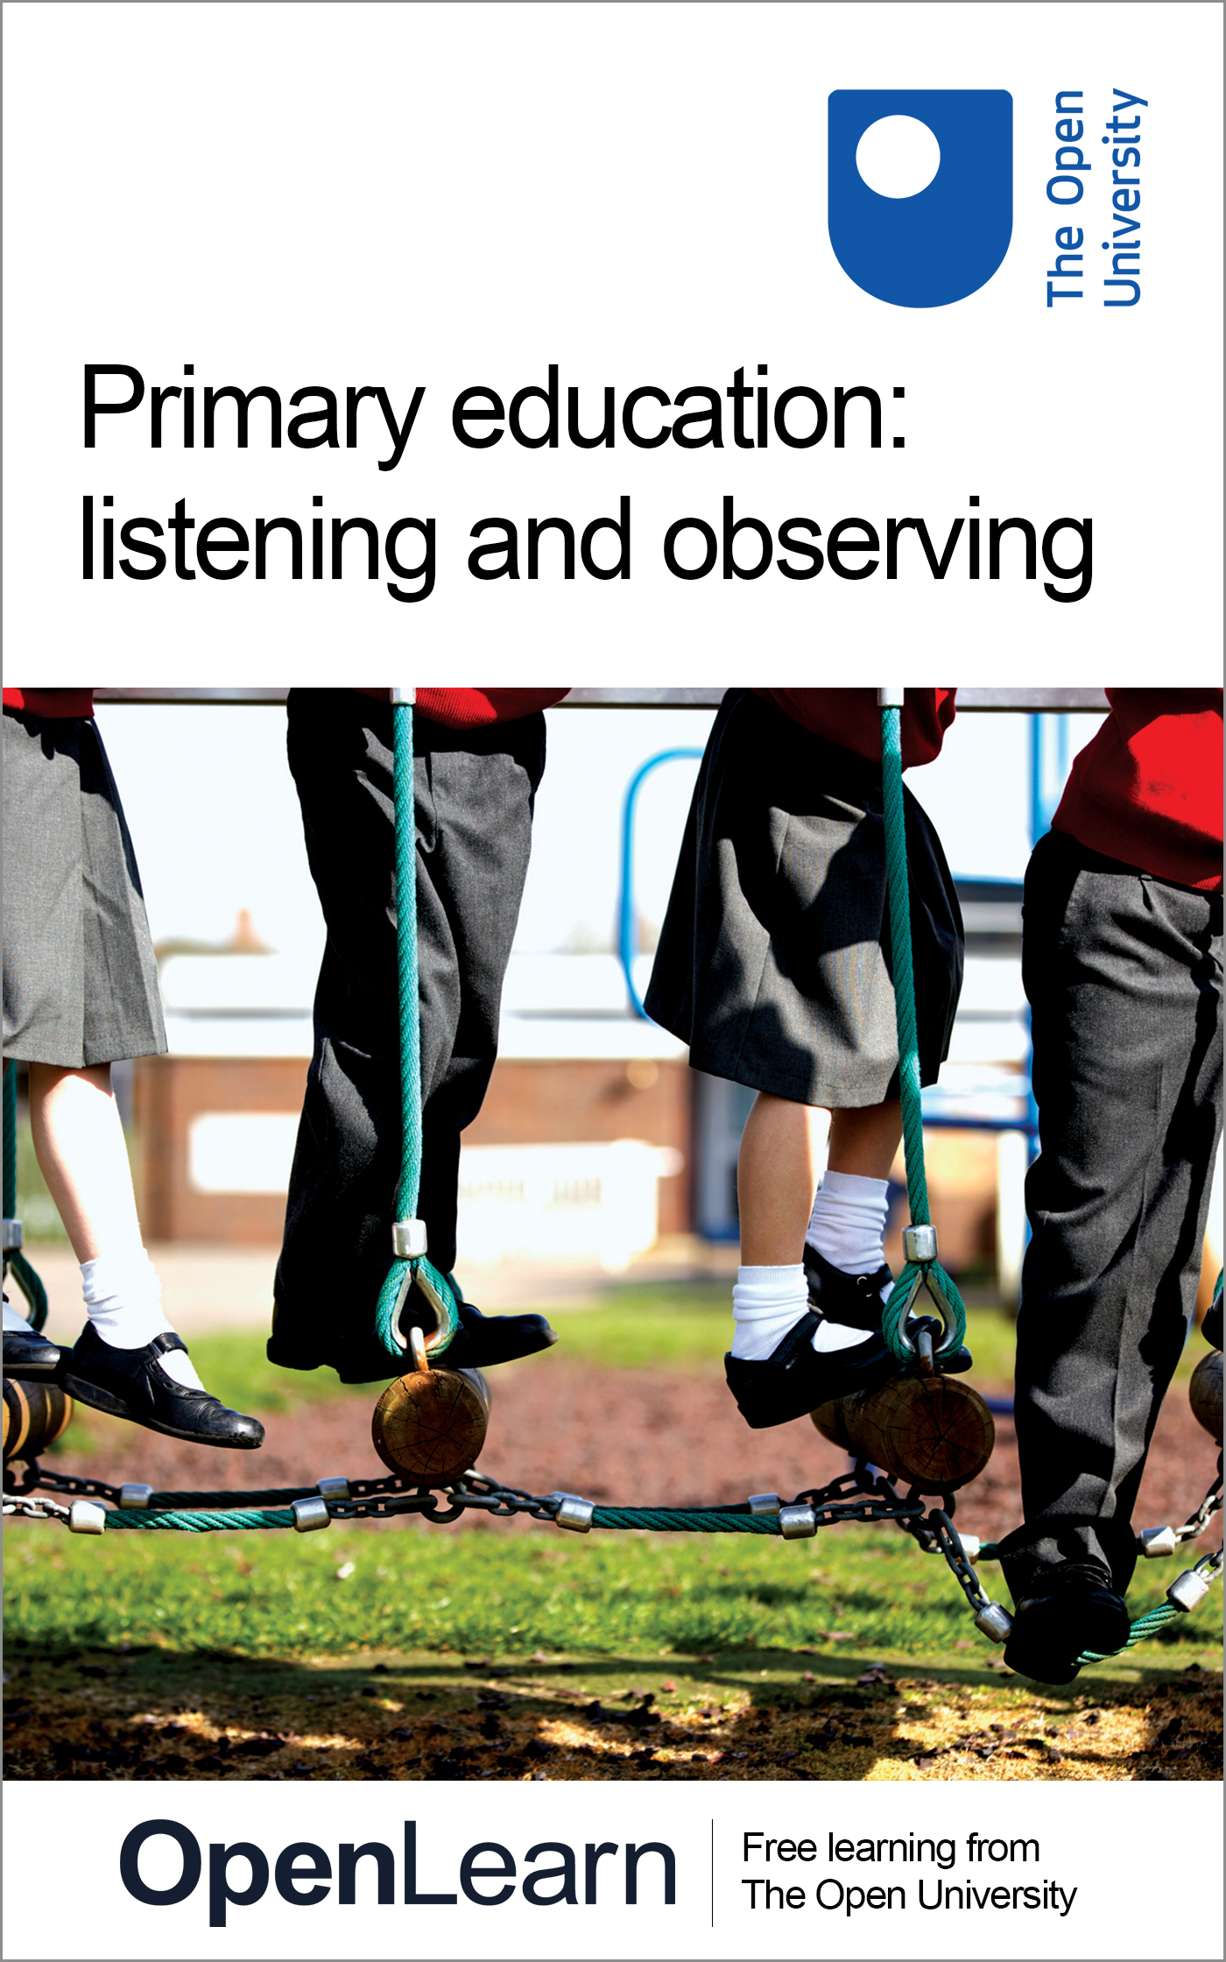

ALT_1

Primary education: listening and observing
About this free course
This free course provides a sample of level 1 study in Science
Education, childhood and youth
This version of the content may include video, images and interactive content that may not be optimised for your device.
You can experience this free course as it was originally designed on OpenLearn, the home of free learning from The Open University:
There you’ll also be able to track your progress via your activity record, which you can use to demonstrate your learning.
Copyright © 2019 The Open University
Copyright © 2019 The Open University
Intellectual property
Unless otherwise stated, this resource is released under the terms of the Creative Commons Licence v4.0 http://creativecommons.org/licenses/by-nc-sa/4.0/deed.en_GB. Within that The Open University interprets this licence in the following way: www.open.edu/openlearn/about-openlearn/frequently-asked-questions-on-openlearn. Copyright and rights falling outside the terms of the Creative Commons Licence are retained or controlled by The Open University. Please read the full text before using any of the content.
We believe the primary barrier to accessing high-quality educational experiences is cost, which is why we aim to publish as much free content as possible under an open licence. If it proves difficult to release content under our preferred Creative Commons licence (e.g. because we can’t afford or gain the clearances or find suitable alternatives), we will still release the materials for free under a personal end-user licence.
This is because the learning experience will always be the same high quality offering and that should always be seen as positive – even if at times the licensing is different to Creative Commons.
When using the content you must attribute us (The Open University) (the OU) and any identified author in accordance with the terms of the Creative Commons Licence.
The Acknowledgements section is used to list, amongst other things, third party (Proprietary), licensed content which is not subject to Creative Commons licensing. Proprietary content must be used (retained) intact and in context to the content at all times.
The Acknowledgements section is also used to bring to your attention any other Special Restrictions which may apply to the content. For example there may be times when the Creative Commons Non-Commercial Sharealike licence does not apply to any of the content even if owned by us (The Open University). In these instances, unless stated otherwise, the content may be used for personal and non-commercial use.
We have also identified as Proprietary other material included in the content which is not subject to Creative Commons Licence. These are OU logos, trading names and may extend to certain photographic and video images and sound recordings and any other material as may be brought to your attention.
Unauthorised use of any of the content may constitute a breach of the terms and conditions and/or intellectual property laws.
We reserve the right to alter, amend or bring to an end any terms and conditions provided here without notice.
All rights falling outside the terms of the Creative Commons licence are retained or controlled by The Open University.
Head of Intellectual Property, The Open University

Contents
- Introduction and guidance
  - Introduction and guidance
    - What is a badged course?
    - How to get a badge
- Session 1: Observing and listening to primary school children
  - Introduction
  - 1 Why observe in the primary school?
  - 2 Meet a primary school headteacher
  - 3 Listen to an early childhood educator and observe children
  - 4 Observation and listening case studies
    - 4.1 Observing and listening: case study 1
    - 4.2 Observing and listening: case study 2
  - 5 Child protection and safeguarding
    - 5.1 Definitions of safeguarding
    - 5.2 Safeguarding and school life
    - 5.3 Vetting volunteers and staff in primary schools
  - 6 Ethical practices in education settings
  - 7 Interviews and conversations
    - 7.1 Interview schedules
    - 7.2 Case study: a teacher interviews parents and children
  - 8 This session’s quiz
  - 9 Summary of Session 1
- Session 2: Observing in the playground
  - Introduction
  - 1 The importance of the playground
  - 2 What do children think about the school playgrounds and playtime?
    - 2.1 Reading: football pitches and Barbie dolls
  - 3 Playtime supervisors
  - 4 Playground design principles
  - 5 This session’s quiz
  - 6 Summary of Session 2
- Session 3: Observing learning
  - Introduction
  - 1 Observing play, observing learning
    - 1.1 A teacher on observing children
  - 2 Dispositions for learning
    - 2.1 Observing dispositions for learning
  - 3 Systematic observation
  - 4 Observing teaching and learning
  - 5 This session’s quiz
  - 6 Summary of Session 3
- Session 4: Learning at home
  - Introduction
  - 1 Primary school children and homework
    - 1.1 What do children think about homework?
    - 1.2 Homework: beneficial or boring?
  - 2 Creative homework
  - 3 Home–school communication
    - 3.1 Homework case study
  - 4 Homework around the world
    - 4.1 Parents’ hopes
  - 5 This session’s quiz
  - 6 Summary of Session 4
- Session 5: Connected children
  - Introduction
  - 1 Technology in children’s lives
  - 2 Technology affects how children learn
  - 3 Schools in the digital age
  - 4 Children and the internet
    - 4.1 Risks and opportunities
    - 4.2 E-safety in school
  - 5 Play and learning online
  - 6 Games in education
  - 7 Digital literacy and twenty-first-century skills
    - 7.1 The impact of technologies on children’s reading and writing
    - 7.2 Children using multimedia in school
  - 8 This session’s quiz
  - 9 Summary of Session 5
- Session 6: Computing in schools
  - Introduction
  - 1 What do we mean by computing?
    - 1.1 Computing and the school curriculum
    - 1.2 Computing programmes of study for children
  - 2 Why is computing important?
    - 2.1 Why learn about computing?
    - 2.2 Children and coding
    - 2.3 Children and computational thinking
  - 3 Programming
    - 3.1 ‘Unplugged’ computing in schools
    - 3.2 Try out unplugged computing
  - 4 Learning through exploring and making
    - 4.1 Navigation and algorithms
    - 4.2 Tinkering and making things
  - 5 This session’s quiz
  - 6 Summary of Session 6
- Session 7: Creative support for children’s learning
  - Introduction
  - 1 Cross-curricular projects
    - 1.1 One theme, many subjects
    - 1.2 Cross-curricular case study
  - 2 Planning and assessing cross-curricular projects
  - 3 Creative support for children’s learning
  - 4 Creative support in action
  - 5 This session’s quiz
  - 6 Summary of Session 7
- Session 8: Adults and lifelong learning in the primary school
  - Introduction
  - 1 A headteacher talks about lifelong learning
  - 2 Workplace learning
  - 3 Learning Lives
    - 3.1 A Learning Lives case study
  - 4 Learning lives in the primary school
  - 5 Children and adults learning together
  - 6 Sketch your learning life story
  - 7 This session’s quiz
  - 8 Summary of Session 8
  - Where next?
  - Tell us what you think
- References
- Acknowledgements

Introduction and guidance

Introduction and guidance
This free badged course, Primary education: listening and observing, lasts 24 hours, with 8 sessions. Each session should take you around 3 hours. The eight sessions are linked to ensure a logical flow through the course. They are:
- Observing and listening to primary school children
- Observing in the playground
- Observing learning
- Learning at home
- Connected children
- Computing in schools
- Creative support for children’s learning
- Adults and lifelong learning in the primary school.
The course is for anyone who wants to upgrade their knowledge of the primary school sector and ethical practices in education settings. It presents a set of practice-focused readings and observational readings. You will learn about small-scale research in the primary school and observe children’s play and classroom learning, and listen to interviews with school staff and children. You will also explore cyber bullying and the primary school curriculum.
You will be able to test your learning in the interactive quizzes, of which Sessions 4 and 8 will provide you with an opportunity to earn a badge to demonstrate your new skills. You can read more on how to study the course and about badges in the next sections.
After completing this course, you will be able to:
- show knowledge of how to plan and carry out sensitive observation and information gathering appropriate to educational settings
- use appropriate small-scale research methods to understand and support children’s learning
- understand ethical practices in educational settings
- use online and digital technologies for personal and professional learning.

Moving around the course
In the ‘Summary’ at the end of each session, you will find a link to the next session. If at any time you want to return to the start of the course, click on ‘Full course description’. From here you can navigate to any part of the course.
It’s also good practice, if you access a link from within a course page (including links to the quizzes), to open it in a new window or tab. That way you can easily return to where you’ve come from without having to use the back button on your browser.
The Open University would really appreciate a few minutes of your time to tell us about yourself and your expectations for the course before you begin, in our optional start-of-course survey. Participation will be completely confidential and we will not pass on your details to others.

What is a badged course?
While studying Primary education: listening and observing you have the option to work towards gaining a digital badge.
Badged courses are a key part of The Open University’s mission to promote the educational wellbeing of the community. The courses also provide another way of helping you to progress from informal to formal learning.
Completing a course will require about 24 hours of study time. However, you can study the course at any time and at a pace to suit you.
Badged courses are available on The Open University’s OpenLearn website and do not cost anything to study. They differ from Open University courses because you do not receive support from a tutor, but you do get useful feedback from the interactive quizzes.

What is a badge?
Digital badges are a new way of demonstrating online that you have gained a skill. Colleges and universities are working with employers and other organisations to develop open badges that help learners gain recognition for their skills, and support employers to identify the right candidate for a job.
Badges demonstrate your work and achievement on the course. You can share your achievement with friends, family and employers, and on social media. Badges are a great motivation, helping you to reach the end of the course. Gaining a badge often boosts confidence in the skills and abilities that underpin successful study. So, completing this course could encourage you to think about taking other courses.



How to get a badge
Getting a badge is straightforward! Here’s what you have to do:
- read each session of the course
- score 50% or more in the two badge quizzes in Sessions 4 and 8.
For all the quizzes, you can have three attempts at most of the questions (for true or false type questions you usually only get one attempt). If you get the answer right first time you will get more marks than for a correct answer the second or third time. Therefore, please be aware that for the two badge quizzes it is possible to get all the questions right but not score 50% and be eligible for the badge on that attempt. If one of your answers is incorrect you will often receive helpful feedback and suggestions about how to work out the correct answer.
For the badge quizzes, if you’re not successful in getting 50% the first time, after 24 hours you can attempt the whole quiz, and come back as many times as you like.
We hope that as many people as possible will gain an Open University badge – so you should see getting a badge as an opportunity to reflect on what you have learned rather than as a test.
If you need more guidance on getting a badge and what you can do with it, take a look at the OpenLearn FAQs. When you gain your badge you will receive an email to notify you and you will be able to view and manage all your badges in My OpenLearn within 24 hours of completing the criteria to gain a badge.

Session 1: Observing and listening to primary school children

Introduction
Welcome to the first session of this free course which looks at observation in the primary school.
Observation in primary schools is not a detached, ‘scientific’ exercise. It can be standing back to watch and listen to children, but it can also be working alongside children and talking informally with them, to understand how they’re thinking. For instance, do you ever:
- notice what your own children, or other children that you know, say and do as they play?
- have conversations with a child or children, where they express their feelings and thoughts about their school friends or their teachers?
- help a child with homework, or sit nearby and watch as they try to work it out for themselves?
- talk to children or their parents about their experiences of a school?
In this course, you will extend these kinds of skills in a conscious way. If you are thinking about becoming a teacher in the future, or if you plan to work or volunteer in a school, these skills will help you to work more effectively with children and other adults.
When you observe and listen to children, you become a learner yourself, so this course will also develop your skills as an adult professional learner.
By the end of this session, you should be able to:
- understand some of the requirements to volunteer or begin to work in a primary school and basic ethical and safeguarding practices in education settings
- recognise the value and purposes of observing and listening to children in primary schools
- develop skills in sensitive information gathering for educational purposes.
The Open University would really appreciate a few minutes of your time to tell us about yourself and your expectations for the course before you begin, in our optional start-of-course survey. Participation will be completely confidential and we will not pass on your details to others.

1 Why observe in the primary school?

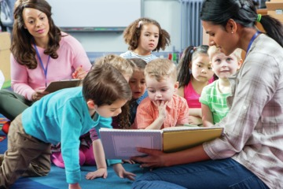
Figure 1
View description - Figure 1

Observation involves looking and listening closely. The aim is to understand better. Observations in schools can take place within day-to-day routines, as children do normal activities inside or outside the classroom. This can tell you more about children as learners than observations of them in one-off or contrived situations. Observation and listening can tell you what children know and what they can do – not just what they don’t know, and what they can’t do.
There are many aspects of children’s learning that you could observe in a busy primary school. A single moment may be filled with a dozen incidents of behaviour, learning and interaction. Primary school teachers and teaching support staff make ‘in the moment’ observations of children, individuals and groups, throughout the school day.
Primary school staff will observe what children say and do, and children’s expressions and body language. They observe children’s behaviour in the classroom, in the playground and in the dinner hall. They may ask children to talk about a particular topic, their likes and dislikes, their friendships, their learning at school and at home, and their thoughts about the curriculum. In this process, adults try to identify children’s understandings and their misunderstandings.
Observations can be of a single child, or a group of children to see how they communicate and work or play together. Child observations often include more than one perspective, for example, the views of parents or grandparents, and sometimes the views of other professionals such as social workers or paediatricians.
In the next section, you’ll meet a primary school headteacher. You will find out what he looks for in the adults who work and volunteer in his school, and how adults should observe and listen to children.

2 Meet a primary school headteacher
Mark Millinson is the headteacher at a primary school in Cambridgeshire. He’s been a teacher since 1987, and a headteacher since 1996. He says that if you want to support children’s learning, first of all, you must be a good listener – and even be a bit of a ‘detective’. In the following video, he explains what he looks for.

Video content is not available in this format.
Video 1
View transcript - Video 1

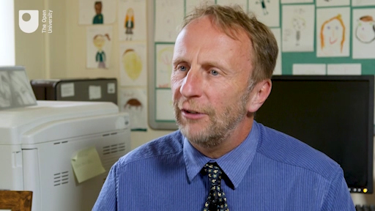

You’ll hear from Mark again throughout this course.
Next, you’ll listen to part of a lecture by a professor of Childhood Studies.

3 Listen to an early childhood educator and observe children
In the previous section, Mark Millinson said that every child is different and unique. In the lecture you are about to hear, Priscilla Alderson, Professor of Childhood Studies at the University of London Institute of Education, makes a strong argument that when we observe and listen to children, we must see them as individual people.
In this audio, Priscilla Alderson talks about how we should treat children as people, not ‘puppets’. This is an important idea when you think about observing and listening to children so you can understand their learning and their needs. People are complex and interesting, and sometimes unpredictable. It takes time to know and understand a person well, and it’s important not to make assumptions.

Activity 1 The focus of observations
Allow about 15 minutes

Listen to the extract from Alderson’s inaugural lecture.
In the lecture, Alderson argues for an end to ‘compulsory’ schooling. As you listen, think about her reasons for this. Make some notes in the box below.

Audio content is not available in this format.
Audio 1
View transcript - Audio 1

Provide your answer...
View discussion - Activity 1 The focus of observations

Next, you will read two case studies of observing and listening to children.

4 Observation and listening case studies
In the mid-1970s A Language for Life (Department for Education and Science, 1975), also known as the Bullock Report, captured the fundamental importance of language in our learning and our lives. This report surveyed 2,000 schools and produced findings related to reading, writing and spelling, and language, but it chose to highlight language in its title, and stated that many children need ‘opportunities for talk with a sympathetic adult’ (p. 67) and recommended that there should be ‘additional adults’ and ‘teachers’ aides’ to do this, as well as teachers. Teaching Assistants, Pupil Support Assistants and Additional Needs Assistants in primary schools today often fulfil this talking and listening role with children.
In the two case studies that follow, the adults are examples of the Bullock Report’s idea of sympathetic ‘others’ who provide children with opportunities for talk in an informal way. One of the examples involves children who are learning English as an additional language. The transcripts provide practical examples of how adults in school can learn about children, such as listening nearby while children work, or by working alongside children and talking with them.

4.1 Observing and listening: case study 1


Figure 2
View description - Figure 2

In this activity, you will imagine you are listening to a conversation between three children.

Activity 2 Observing children drawing pictures
Allow about 20 minutes

In the following transcript, Sarah, Mia and Michaela (ages 5 and 6) are drawing pictures of rainforest animals – an activity organised by their teacher. They are working independently. Their teacher is nearby, listening but not participating. As the girls work, they comment on the transformation of their drawings.
Imagine you are listening in on these conversations. What do you learn about the children from ‘eavesdropping’ on them?

Sarah: I draw the tree like THAT [draws].
Michaela: Oh, that’s a nice tree. You drawed a tree beside it.
Mia: I can’t draw a tree. I have to draw a branch. These are the leaves. We did one smaller to this yesterday.
Sarah: You can’t really see it [a bird] because of the branches. It’s hairy. In fact it has fur all around it… [continues drawing] Then a little bit of white.
Michaela: That looks a bit silly. I put the legs all wrong. When you colour it in you won’t see that bit.
Mia: I’ve got a kitten cat at home.
Sarah: I could change this [bird] into a lizard… how do you draw leopard feet?
Mia: Like a cat.
Sarah: Oh, claws!
Michaela: [laughing] I was about to do another leg, a fifth leg!
Sarah: I done a jaguar, a lizard like that, and a chameleon.
Mia: If you come to my house this summer I won’t be there. I’ll be in Serbia. My family is in Serbia and I speak Serbian.
(from Safford and Barrs, 2005, p. 71)

Provide your answer...
View discussion - Activity 2 Observing children drawing pictures

4.2 Observing and listening: case study 2

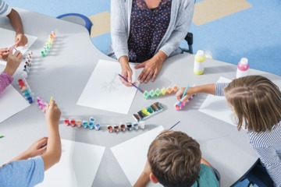
Figure 3
View description - Figure 3

A good way to learn a language and to practise using it is by doing something with others: cooking, walking, building, painting, drawing, sewing, craft work, learning the rules of a game or the words of a song, shopping, role play or storytelling. In your home or your community, you may be responsible for organising such activities for children, where they will have opportunities to talk with you and with each other.

Activity 3 Observing children who use English as an additional language
Allow about 20 minutes

In the following transcript, a teacher and Year 6 children (ages 10–11) are painting farm animals and farm scenery together. The four children (two boys and two girls) are recent arrivals from Portugal and are at the early stages of learning and using English in school. Note down your observations.

Boy 1: Was there paint in the olden days?
Teacher: Yes, but it was always made from natural materials.
Girl 1: My mum has farm in Portugal, she has one pig and the floor is all dirty.
Boy 2: When I went to Portugal, we had a pig, I was holding the legs, the rope broke. I had to throw the knife at him!
Teacher: What! You held a pig? Why were you doing that?
Boy 2: To kill him.
Teacher: Oh I don’t know if I could do that!
Girl 2: My Nan has a donkey on her farm, behind her house she grows grapes. Everyone knows my Nan and me! One morning I got up early and picked grapes and corn.
Teacher: I love grapes.
Boy 1: My Nan has a horse. Do you know why?
Teacher: No, why?
Boy 1: To put with the cart [mimes a horse and cart, shaking the reins].
Teacher: And do you think you prefer the city [here] or the country like Portugal?
Boy 1: I like the country.
(from Safford and Barrs, 2005, pp. 72–3)

Provide your answer...
View discussion - Activity 3 Observing children who use English as an additional language

The teacher in this transcript later said:

Talk is so directed in the classroom. It’s only when you talk with them [children] that you find out where they are. Otherwise you never know where they are. It’s by listening to them that you find out how they learn, what they need to know.

When you observe and listen, you can learn specific information based directly on what children say or do. For example, from the transcript you know that the mother of Girl 1 has a farm in Portugal.
You can also infer, or make educated guesses, based on your observations. For example, reading the transcript, you could infer that all four children have experiences of rural life.
Next, you’ll learn about two important aspects of adult work in primary schools: safeguarding and ethical conduct.

5 Child protection and safeguarding
People who work and volunteer in schools have a legal duty of care to protect children. Every school will have a clear policy on child protection and safeguarding, and will make this available to visitors. Think of ‘safeguarding’ as the overall concept or plan to keep children safe and cared-for, and think of ‘child protection’ as the specific steps or actions within the overall plan. Schools will also have explicit processes for reporting any concerns about children, and a named person, usually a senior member of staff, who is responsible for safeguarding.
You met headteacher Mark Millinson in Activity 1. He says that any person who wants to work or volunteer in a school will need to have a formal check on their identity and their background. This is appropriate, because primary school staff have close contact with children.
Watch the following video in which Mark talks about the importance of safeguarding.

Video content is not available in this format.
Video 2
View transcript - Video 2

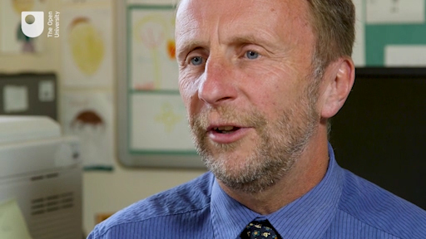

How is safeguarding defined, and what does it cover in a primary school? Find out in the next section.

5.1 Definitions of safeguarding
In England, The Children Act (2004), the schools inspectorate Ofsted (2015a, 2015b) and education departments (for example, DfE 2014) provide extensive and detailed guidance on safeguarding which can be summarised as:
- protecting children from physical or emotional maltreatment
- preventing impairment of children’s physical, emotional and mental health and development
- ensuring that children are growing up in circumstances consistent with the provision of safe and effective care
- taking action to enable all children to have the best outcomes.
Every country has legislation and a protocol for child protection. Look for the relevant agencies in your country, for instance: Safeguarding Board for Northern Ireland (SBNI), Estyn the schools inspectorate in Wales, and Safeguarding Scotland.

5.2 Safeguarding and school life


Figure 4
View description - Figure 4

Safeguarding is not just about protecting children from deliberate harm. It relates to all aspects of school life including:
- children’s health and safety
- the use of reasonable force (for example, what is appropriate and safe to contain a child who is exhibiting violent behaviour)
- meeting the needs of pupils with medical conditions
- providing first aid
- educational visits (out of school, for example when children go to a museum; and in school, for example, when professional musicians give workshops or perform)
- intimate care (such as changing a child’s clothes after an accident, or helping children dress for PE)
- Internet safety/e-safety
- appropriate arrangements to ensure school security, taking into account the local context.

Activity 4 Safeguarding issues
Allow about 10 minutes

What kinds of issues in schools do you think safeguarding covers? Think for a moment and jot down your ideas.

Provide your answer...
View discussion - Activity 4 Safeguarding issues

If you volunteer or work in a primary school, you must be aware of safeguarding procedures and know who to report to if you have a concern. Furthermore, the school has a legal requirement to vet you, to make sure you are safe to be in the school with children. The next section reviews these vetting procedures.

5.3 Vetting volunteers and staff in primary schools


Figure 5
View description - Figure 5

Disclosure and Barring Service (DBS) checks help to prevent unsuitable people from working or volunteering with children and vulnerable adults. You may have heard this process formerly referred to as Criminal Records Bureau (CRB) checks. In Scotland, this checking process is managed by Safeguarding Scotland.
DBS checks in England, Wales and Northern Ireland, and Safeguarding Scotland checks, help schools screen potential employees and volunteers, to make sure that such people will not put any child at risk. The checks search an applicant’s criminal record history. This helps headteachers to make informed recruitment decisions. Headteachers, school governors and local government authorities are responsible for safe recruitment in the school.
There are three levels of DBS check: basic, standard and enhanced. A basic disclosure is available for anyone living within the UK, and can be requested by individuals and employers. An enhanced check can find out whether an applicant is legally barred from working with children.
Any person who wants to work or volunteer in a school is eligible for an enhanced DBS check. This is appropriate, because primary school staff (paid and volunteer) will be in regular contact with children.
In addition to adhering to safeguarding and child protection protocols, adults who work and volunteer in primary schools follow ethical guidelines.
Adults in schools do informal observations of children and have informal conversations with children every day. They do this as part of their ‘detective’ work, as headteacher Mark Millinson put it earlier, to find out how children think or feel, what children know, and how children learn. These observations and conversations can be spontaneous or planned. This is not, strictly speaking, considered ‘research’. But adults in these situations do follow certain principles for conduct and behaviour when they observe and listen to children.
In the next section, you will learn about these ethical guidelines for research with children.

6 Ethical practices in education settings


Figure 6
View description - Figure 6

There are ethical requirements for adult behaviour and research in education settings. The British Educational Research Association (BERA 2018) has published specific guidelines for this, and if you work or volunteer in a school it is very useful to be aware of BERA guidance. Some of the key elements can be summarised as follows.
Voluntary and informed consent: You must take the steps necessary to ensure that children and adults understand the research process in which they are participating, including why their participation is necessary, how it will be used, and how and to whom it will be reported.
Openness and disclosure: Securing voluntary and informed consent must happen before research gets underway.
The right to withdraw: Researchers must recognise the right of any child or adult to withdraw from the research for any or no reason, and at any time, and researchers must inform participants of this right.
The interests of the child: Researchers in education settings must comply with the United Nations Convention on the Rights of the Child (United Nations, 1989). This requires that in all actions concerning children, the best interests of the child must be the primary consideration. Children who are capable of forming their own views should be able to express their views freely in all matters affecting them, and should be facilitated to give fully informed consent to do so. Researchers must also recognise that children may experience distress or discomfort in the research process, and must take all necessary steps to put children at their ease. Researchers must desist immediately from any actions, ensuing from the research process, that cause emotional or other harm.
Privacy: Researchers must recognise children’s and adults’ rights to privacy, confidentiality and anonymity, unless they or, in the case of children, their guardians or responsible others, specifically and willingly waive that right. Researchers must also ensure that data is kept securely and that the form of any publication, including publication on the Internet, does not directly or indirectly lead to a breach of agreed confidentiality and anonymity.
Now you will return to ways of observing and listening to children in primary schools, looking at techniques for interviews and conversations. As you continue through this course, pay attention to how teachers and other adults follow BERA ethical guidelines when they work with children.

7 Interviews and conversations
You will recall that the teacher in Activity 2 was having a conversation with the children about farm animals. They were chatting as they worked on painting scenery for a school event. A teacher or a teaching assistant can learn a lot about the children in this process.

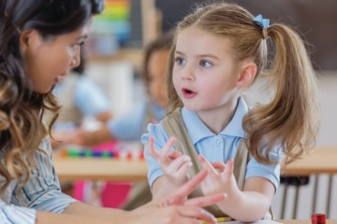
Figure 7
View description - Figure 7

Talking with children informally is far from a formal ‘interview’, but interviews can take the form of open-ended conversations. Throughout this course, you will hear interviews with adults and with children.
There are many types of interview in the education sector, ranging from very formal to very informal. Here are some types of interview that are carried out in education settings:
- structured interview, with preset questions that do not change
- survey interview with a group, which asks ‘yes/no’ questions such as ‘Do you agree or disagree that the new school dinners are much worse than the old ones?’
- counselling interview, which offers support and guidance to the person being interviewed
- diary interview, a series of interviews to find out about changes or perceptions over time
- life history interview, an in-depth interview about a person’s experiences
- semi-structured or unstructured interview, where questions are flexible and can change depending on how the interviewee responds, making it more like a conversation, where unexpected themes can emerge and be discussed.
The aim of any of the above is to achieve an understanding of another person’s point of view.

7.1 Interview schedules


Figure 8
View description - Figure 8

Interviews with children should be informal, semi-structured and conversational. They are more like chats with a specific purpose. If you have an opportunity to interview children, parents or school staff, you will have a clear idea of what you want to ask and you will want to use the time effectively, but you will also want them to feel relaxed and confident about sharing their thoughts with you.
If you have an opportunity to do an interview in a school, you would devise a list of questions you wish to ask. This is called an interview schedule. It is good practice to share the questions with those you are interviewing, so that they have a chance to think about how they might answer. At the start of the interview, you should talk with the other person about what you are trying to find out. Try to keep your list of questions brief, so you and the person you are talking with have time to discuss other, unexpected questions that might arise over the course of the interview. Ethically, you are obligated to allow the interviewee to stop at any time and not continue the interview. If this happens, the interviewee may also have the right to delete or destroy anything that was recorded or written down.

7.2 Case study: a teacher interviews parents and children
Denise is a Year 2 teacher (ages 6–7). She wants to find out more about two children and their reading, because in her observations of them in the classroom they seem to dislike reading and avoid having to do it.
Denise plans to do very informal interviews with the two children, and with their parents. As you read the case study, notice how Denise follows BERA guideline for openness, disclosure and privacy.

Activity 5 How a teacher follows BERA guidelines
Allow about 25 minutes

Jot down where you think Denise refers to these guidelines – not by naming them, but in her descriptions of what she does. Denise wants to carry out these interviews to improve her professional understanding, and specifically to help two children get more pleasure from reading.

I want to find out what J (a boy) and S (a girl) like to read, so I can suggest books which they will enjoy. I want to do this because these two children often tell me they ‘hate’ reading and I see them trying to avoid reading when I observe them in ‘free reading’ time in class and in literacy lessons.
J and S are chatty and confident about talking to me. Also, I want to invite their parents to give me some insights into what the children read at home. I hope this process can widen my own knowledge about children’s books and help me to recommend different kinds of reading for J and S, and for other children who are ‘reluctant readers’.
I made two sets of questions, one for the parents and one for the children. I tried to make the questions informal and conversational, for example, for the parents:
- Tell me about what S/J likes to read at home.
- Does he/she have a favourite book or story at the moment?
- I’ve noticed that in school she/he doesn’t care to read much, but I wonder if at home she/he likes different kinds of reading (computer, comics, lyrics, catalogues, magazines, games).
- What words would you use to describe J/S as a reader?
- Why would you describe him/her that way?
And for the children:
- Tell me about what you’re reading at home just now.
- I noticed you brought your football magazine into school the other day. Can you tell me about that? I don’t know much about footie magazines. What do you like about them?
- I saw you doing the word search puzzle at playtime. I find them so tricky! What do you like about doing them?
- What do you like to do on the computer at home?
- Which face shows how you feel about reading? (Smiley face, indifferent face, unhappy face?)
- Tell me why you chose this face.
I explained to each of them why I wanted to talk with them, and I also let them know that they didn’t have to do this if they didn’t want to. I said that I wouldn’t need to audio record anything, and that the information was just to help me as a teacher, and I wouldn’t share it with anyone else.

Provide your answer...
View discussion - Activity 5 How a teacher follows BERA guidelines

8 This session’s quiz
Now that you’ve completed Session 1, you can take a short quiz to help you reflect on what you’ve learned.
Session 1 practice quiz
Open the quiz in a new tab or window and come back here when you’ve finished.

9 Summary of Session 1
In this first session, you learned about some of the requirements to volunteer or begin to work in a primary school. You began to learn about the processes of observing and listening to gain insights into children’s experiences, and the appropriate and ethical ways adults can observe and listen to children. There are ethical requirements for behaviour and research in education settings, and you learned about British Educational Research Association (BERA) guidelines for observing and interviewing children and adults.
You should now be able to:
- understand some of the requirements to volunteer or begin to work in a primary school and basic ethical and safeguarding practices in education settings
- recognise the value and purposes of observing and listening to children in primary schools
- develop skills in sensitive information gathering for educational purposes.
In Session 2, you will take these ideas into the primary school playground.

Session 2: Observing in the playground

Introduction
Most children and young people will spend around 1,500 hours of their life in their school playground. For many children, this will be more time than they spend in any other outdoor play setting. This unstructured outdoor time is more than double the time that children spend in PE lessons.

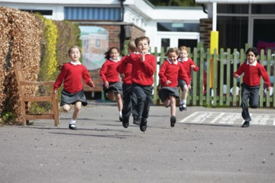
Figure 1
View description - Figure 1

The focus of this session is observing children in the school playground and finding out what children and adults think about school playtimes.
By the end of this session, you should be able to:
- recognise some basic design principles for school playgrounds
- understand children’s views of the school playground
- develop skills to evaluate play spaces.

1 The importance of the playground

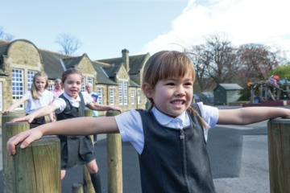
Figure 2
View description - Figure 2

Not every child has access to a private garden, a park or an area of woodland. But almost every child has access to school grounds. There’s something significant about the daily experience of an outdoor space, experiencing it in all weathers and throughout the seasons.
If you ask children which part of the school day they enjoy the most, many will say ‘playtime’. Nowadays, adults are much more aware of the importance of playtime for children’s physical and social development and their well-being. Adults who are playtime supervisors in primary schools will confirm that the playground can be educational and directly supportive of classroom learning.
There are two places in primary schools where children can talk whenever they like and about whatever they like – one is the dinner hall (although adults often control the volume of talk) and the second is the playground.
Clearly, playgrounds and classrooms are very different kinds of designed spaces. To a large extent, children decide what happens in a playground; whereas, in the main, adults decide what happens in a classroom. Playgrounds provide children with opportunities for activity and spontaneous bodily movement that would be problematic in a classroom. If you want to have a sense of how children truly are when they are free, you should observe them at playtime.
In Session 1, you looked at two transcripts of children’s talk, and you explored what this talk revealed about them. It is important to remember that non-verbal communication and ‘body language’ can be observed too. Body language includes facial expressions, particularly the use of eyes, hand and arm gestures, body posture, movements, as well as the clothes we wear and even the colours we choose. Even children at the earliest stages of language learning use their hands when they speak, especially if their parents do. Gestures often mirror speech.
Next, you’ll hear from headteacher Mark Millinson again, about his perspectives on the playground and what happens there.

Activity 1 A head teacher talks about the playground
Allow about 15 minutes

Adults who work and volunteer in primary schools often find themselves in the playground during breaktimes or lunchtimes. It’s a great opportunity to observe children moving freely, talking, singing, playing games, or simply sitting and watching. Adults often use this time to observe children’s friendship groups and how children get along with each other. Headteacher Mark Millinson says the playground is part of the school day.

Video content is not available in this format.
Video 1
View transcript - Video 1

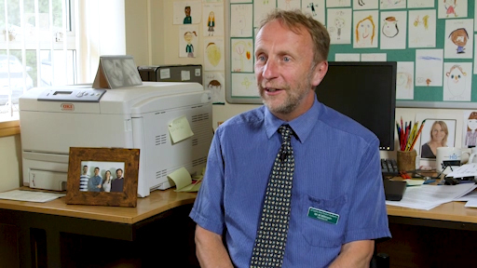

Mark says it’s fun to be in the playground, because sometimes children ask him and other teacher to play with them. Later, you’ll hear two children confirm this.
But what about problems and conflicts that arise in the playground? Mark explains his school’s way of dealing with these, and why adults in the school need to help children resolve disagreements at playtime.

Video content is not available in this format.
Video 2
View transcript - Video 2

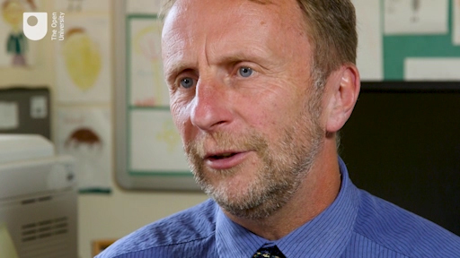

Provide your answer...

In the next activity, you’ll observe a primary school playground and children’s use of the spaces in it.

Activity 2 Observing a playground
Allow about 20 minutes

Watch this video of a primary school playground. This playground has two parts: a tarmac area, and a field area.
As you watch, scan the two playground spaces. Notice their physical and environmental characteristics. Look at how children are moving and gesturing, on their own and in relation to each other.
From what you can see in the sequences, sketch a rough plan of these areas. Include any distinctive playground markings, surface areas, objects or boundaries.
As you watch, also listen for the sounds of these playground spaces. What do you hear? Jot these down as well. Notice what the adults are doing in the playground too.
You can watch the sequence a few times and pause the video in order to record the details.

Video content is not available in this format.
Video 3
View transcript - Video 3

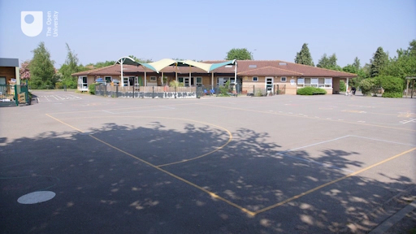

Provide your answer...
View discussion - Activity 2 Observing a playground

Later in this session you will use some criteria to evaluate the playground spaces.
Next, you will listen to two children talk about the school playground that you have just seen.

2 What do children think about the school playgrounds and playtime?
Now you’ll hear from two playground experts.
Daniel is 6 years old, and Isla is 7 years old. In this audio recording, they talk about their school playground, with Kimberly Safford from The Open University. The playground they talk about is the same one you watched in Activity 2.
In the interview, Daniel and Isla talk about what they like and don’t like about the playground and playtimes in school. You’ll hear them talk about the differences between the tarmac playground and the field area that you watched earlier. They talk about the playground tarmac artwork that you saw in the video, and they mention a ‘Trim Trail’ in the field area. They also describe things they wish they could have in their playground, like a ‘quiet’ area and a ‘friend bench’. They talk about games they like to play such as ‘It’, ‘Conga Line’, and ‘Everybody Sunbathe’, and team games like handball and football. They talk about what makes them happy and what makes them sad in the playground. They also talk about what they would like to have in their ‘dream’ playground.

Activity 3 Children talking about the playground
Allow about 20 miunutes

As you listen to the interview, notice how Daniel and Isla seem very shy at first, but they but warm-up to the discussion after a little while. Note down your observations.

Audio content is not available in this format.
Audio 1
View transcript - Audio 1

Provide your answer...

2.1 Reading: football pitches and Barbie dolls
Next, you will read an extract from a research study of a different playground that goes a bit deeper into some of the issues that Daniel and Isla mentioned, such as what girls and boys play, sadness and loneliness at playtime, and what children perceive as the risks of the playground space.

Activity 4 Social play, physical activity play, risk and gender
Allow about 30 minutes

Now read a short extract from the article ‘Football pitches and Barbie dolls: young children’s perceptions of their school playground’ by Gemma Pearce and Richard P. Bailey:
Football pitches and Barbie dolls
These two researchers went into an inner city primary school to ask children what they thought about their school playground and playtimes. They asked children to talk about what they do during playtimes, and to talk about their positive and negative experiences of the playground. The researchers also asked children to draw pictures of what they do in their playground.
This reading has four themes which the research identified in children’s comments and drawings: social play, physical activity play, risk, and gender.
As you read the research extract, notice how the researchers interview the children in a very informal and conversational way, and how the children’s ideas and experiences are presented very clearly. Following BERA guidelines, the children are anonymous, identified only by the first letter of their names, or simply as ‘Year 3 boy’ or ‘Year 2 girl’. The school and the city are not identified.
As you read, make some notes about the themes. Does any of these chime with your own experiences of the school playground, as a child or for children that you know? Does it reflect what you heard Isla and Daniel talk about in their interview?

Provide your answer...

In the following sections, there will be extracts from this article under themed headings.

2.1.1 Social play

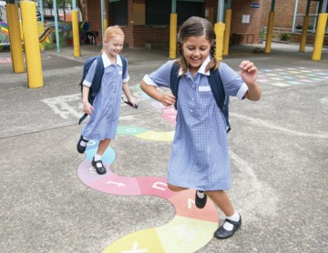
Figure 3
View description - Figure 3

Conversations with the children about their playgrounds were littered with references to friends. Some comments simply related enjoyment of certain types of activities with friends’ enjoyment – ‘Because I kind of like football … And my friends do’ (Y3 boy) – while others portrayed complex dances of interactions in which the game and roles taken within it became inextricably bound together:

It’s a special game of It and someone was It, like Christian was first and we had to hide. If someone, if Christian gets out of the bench we have to run to the bench. After that, well Oliver was it and he saw Antonio there and he just came and punched him in the tummy.
(Y2 boy)

Not surprisingly, perhaps, the social context of playground activities meant that some children felt isolated and alone. Loneliness was the most frequently cited negative association with the playground, and there were no evident differences according to gender or age:

I drawed [sic] me how I was crying … Because I want to play with someone and they said go away.
(Y1 boy)

and

I’m drawing myself on the bench because I’m Lonely.
(Y2 girl)

The failure of peers to follow rules, roles and conventions of play were often cited as reasons for games coming to an end or, at least, for becoming less enjoyable than they might otherwise have been. One boy spoke about the need for a referee or ‘judge’ as an arbitrator in the relatively complex games of the older children:

It’s kind of bad because one time there was a … because everyone was in a row. It happens every single day. See we don’t have a judge who is going to actually do things for us and he’s not going to help us.
(Y3 boy)

Teaching assistants (TAs) were often called in to take on peace-keeping roles, but even then success was not guaranteed:

Also sometimes the TAs, sometimes the other children think that the TAs will forget its blah-blahs turn we can just get another turn by standing outside the gate and saying it’s our turn. So they go to the gate and say it’s their turn and then they get two or three goes in the week, which means that some classes don’t get their turn.
(Y4 girl)

2.1.2 Physical activity play

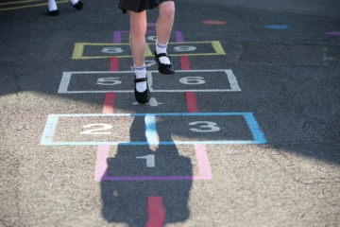
Figure 4
View description - Figure 4

The children were asked to draw themselves in the school playground. Not surprisingly, perhaps, almost all of them drew themselves engaging in some sort of activity. These accounts are fairly representative:

I’ve drawn some hopscotch and I’m going to draw some people queuing up behind the tent because they’re going to do it backwards because I can’t just start here and draw all the people here so everyone’s going to be there and in the sandbox people are digging and putting the sand into the buckets, but I didn’t get to draw that … So here is going to be me hula-hooping and then I’m going to have the sun here and I’m going to have two butterflies flying and then I’m going to have Thelma skipping and then when I go into the garden I’m going to draw collected plants and things that have fallen on the floor.
(Y2 girl)

This one was holding a rope and it went around when it came to you, you jumped over it but these are all the people. This is Gary who’s running away. He’s going to jump over the rope when it came.
(Y1 girl)

The children’s accounts of physical activity play generally took one of two forms: creative and locomotor play. The first type of play involved imagination and the creation of characters: ‘Maybe spies or something, and policemen’ (Y1 boy). In one discussion, two boys were asked who they liked to be when they were pretending:

M: Policemen. T: Soldier, one two three four, one two three four. M: Firemen.

Locomotor play was much more frequently cited, however, especially by the boys. Younger children talked about hula hoops, hopscotch and climbing frames. And children of all ages spoke about the joys of running and chasing, such as this Year 4 girl: ‘And also I like the playground when some people are chasing after Pete the TA and then there’s most of the playground free to just walk around’. However, by far the most frequently discussed form of playground activity amongst this group of children was football:

Ok, I’m playing football. I scored a goal. When I finished football Oliver locked Christian in the door. I came back to play another game of football and then I scored another goal and then after that game of football we went to line up.
(Y2 boy)

Only a few children used ‘fun’ to explain their reasons for playing: ‘I like skipping because it’s fun’ (Y1 girl), and only one other child spoke of values intrinsic to an activity when asked why they played such games: ‘What I like about football is – I don’t know – scoring goals’ (Y2 boy). Everyone else spoke in rather instrumental ways about the benefits of activity. Health was the dominant discourse underlying the children’s rationales for playing physically active games. For example, these comments were representative of numerous other statements:

Well it’s because then we can take equipment outside and play sports so we can be healthy.
(Y3 boy)

So not just running around, we can run, climb on things – cause climbing is a very exercises thing. Like if you climb high, if you go fast that will be very good because it’s exercise thing.
(Y3 girl)

2.1.3 Risk

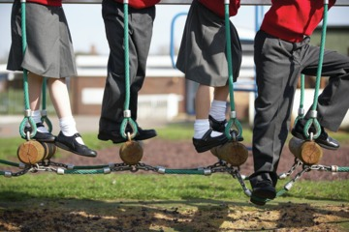
Figure 5
View description - Figure 5

It seemed to be the case that most children’s references to the dangers of their playground were to either the nature of the space (e.g. it was concrete) and objects on it (e.g. like a climbing frame) or to fears of injury. There were numerous stories of injuries resulting from falling on the floor, such as:

And I don’t like it when they hurt me. When someone hurts me … if I trip over somewhere or someone hurts me.
(Y1 boy)

That’s just the concrete where we’re playing it on…. It’s rough … Sometimes we get over and … ow! …That means we get hurt.
(Y3 boy)

The climbing frame, which appeared in many of the children’s pictures of the playground, was seen by some as the source of greatest danger:

And they get injured, they hurt your elbow. I fell off a climbing frame and broke my arm.
(Y4 boy)

I don’t really like the climbing frame because it’s really crowded and they play lots of really weird and unsafe games and I never go on it and some things like when everyone’s on – I’ve seen some people do this a few times – there’s a bar, it’s like here to the roof, which is pretty high and people just jump off it and they could get really hurt.
(Y4 girl)

2.1.4 Gender
Both boys and girls spoke about quiet and still games, such as board games. However, there were a far greater number of girls who spoke about non-physically active games than boys. Only one boy drew a picture of a non-active game: ‘I did draw a picture of me and my friends doing a puzzle’ (Y1 boy), whereas many girls drew and talked about similar activities. Some of the girls spoke enthusiastically about the introduction of a new ‘quiet area’, away from the main play area: ‘I like it at some parts it’s quiet and you can sit down on the decking and read a book’ (Y4 girl).
There was an overwhelming sense in the conversations with the children at this school that gender segregation and stereotyping was simply taken for granted. On the whole, there was a shared perception that boys and girls had different interests and played different types of games:

Well the boys play basketball…and they play soccer, cricket… [Girls] just play hula hoping and skipping…. Mums and Dads, like that.
(Y1 girl)

A similarly clear division of activities was also upheld by a Year 2 boy:

The girls don’t like to join boys’ games they just like to do their own games like Catch.

A consequence of such a clean split between girls’ and boys’ activities was that when the genders did come into contact with each other on the playground, their presence was usually seen as an annoyance. Girls, in particular, complained about interference of boys:

When the boys are annoying you, you can rub your hands on the caterpillar [a plastic tube in the playground] and you can go shock them.
(Y4 girl)

There was only one instance of boys speaking about the importance of meeting the needs of girls. In this case, however, their understanding of girls’ interests seems rather less sophisticated!

I: And why can’t girls and boys play together then?
A: Because boys are better.
I: Because boys are better at football?
A: And we’re stronger and every time a girl does a mistake we get a bit angry at them because they just muck up a chance and do their own goals.
E: Because girls don’t really get the idea of football.
A: But we don’t really get the idea of Barbies.
E: Yes. It’s just like football and Barbies.
(Y4 boys)

2.1.5 What do children’s comments and drawings tell us?
In this research extract, it seems that boys and girls have very different playtime experiences. What is your own experience of this, for your own children or for children that you know?
The research shows that playground friendships are important to children, who express strong feelings about being included or excluded. The research also shows that some children might be cautious or even fearful about playtimes.
The reading refers to ‘locomotor play’, that is, movement in any direction for its own sake. Locomotor play appears to be a key feature of playtime, when children can run about without adult intervention. Tag, chasing games, ‘It’ and hide and seek, are all ways for children to express control over their physical environment.

3 Playtime supervisors

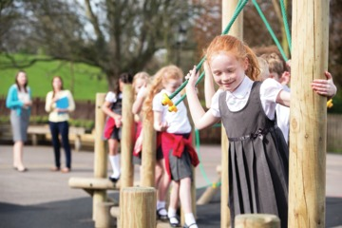
Figure 6
View description - Figure 6

In the interview with Daniel and Isla, and in the reading ‘Football pitches and Barbie dolls’, you heard children express their likes and dislikes about their school playground and playtimes.
If you were an adult playtime supervisor in the playground, how would you use this information to make playtime a better experience for more children?

Activity 5 The views of two playtime supervisors
Allow about 15 minutes

Now you’ll hear two playtime supervisors give their views.
In the video, Jackie Pratt and Carole Lowry talk about what they do as playtime supervisors and the learning environment in the playground that they try to provide. As you watch and listen, notice their shared approach to their jobs, how they organise play activities for the children, and how they relate to the children and to each other. How do they use observation and listening in their jobs?
Please note that the video contains some still images alongside the audio and some children’s faces have been blurred to protect their identities.

Video content is not available in this format.
Video 4
View transcript - Video 4

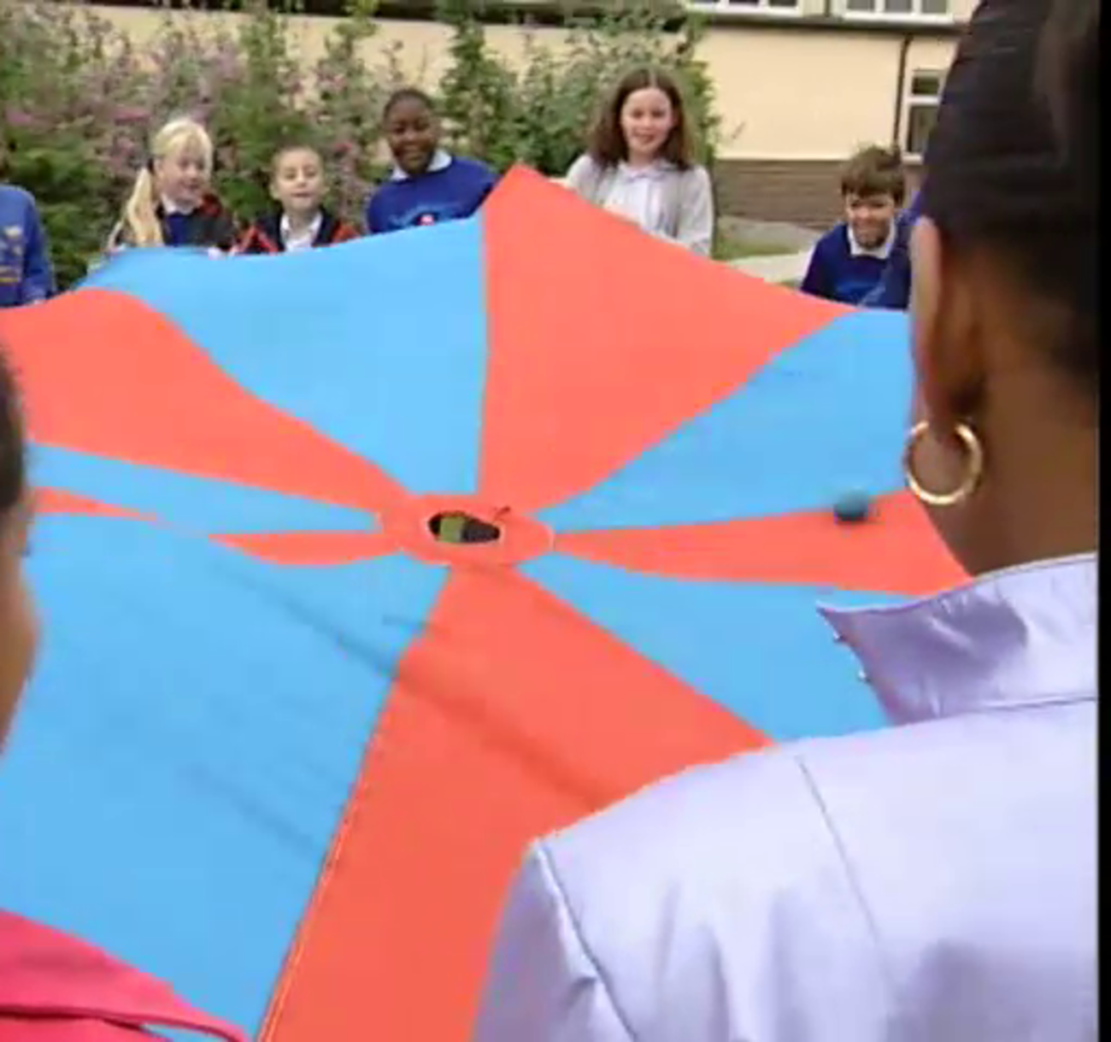

Provide your answer...
View discussion - Activity 5 The views of two playtime supervisors

Next, you’ll look at playground design.

4 Playground design principles
The organisation Learning Through Landscapes (LTL) suggests that school staff should ask themselves: ‘Is the school playground a place to enjoy, or a place to endure?’
LTL developed a set of design principles for school playgrounds which you’ll look at now.

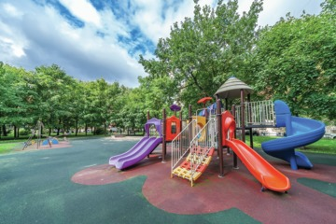
Figure 7
View description - Figure 7

According to Learning Through Landscapes (2013), the most important playground design concept is ‘possibility’, so that children can choose and self-direct their play in a wide variety of ways. Another important concept for playground design is the use of ‘non-prescriptive’ features, so that children can use their imaginations in ways that are not directed by adults.
Natural materials and landforms provide both ‘possibility’ and ‘non-prescriptive’ elements. LTL says it can be helpful to think about fixed elements, often related to landform, and loose materials that can be moved and manipulated.
Examples of fixed elements are: mounds, tunnels, slopes, trees, shrubs and woodland, climbing frames, mazes, dens and shelters. These can break up large open spaces into more interesting child-friendly spaces that can be used for imaginative play.
Examples of loose materials are pebbles, seeds, grass, twigs, leaves, pruned branches and flowers, shells, cones, hazel rods or wooden discs. In addition to natural materials, playgrounds can have ‘man-made’ resources such as tarpaulins, pipes, rope, plastic crates, hoops, small toy figures and vehicles, chalk, planks and joinery offcuts. These materials can stimulate a wide range of play activities including den building, construction and the creation of fantasy or ‘small world’ play scenarios. They can stimulate children’s creativity and encourage team work and collaboration.
According to Learning Through Landscapes:

Variety is a key principle in designing a school playground. Any outdoor space will have learning opportunities, but a more varied space will present a wider range of options.
Aesthetics are important; we learn well when we’re in an attractive environment that’s well cared for.
Comfort is a consideration; to be able to sit outdoors, to have a surface to lean on and to find shelter from the wind or shade from the sun.
It’s useful for a playground to have a gathering space where teaching staff can give instructions.
The design of the school building is important. How easy is it for pupils to access the outdoors from their classroom? How easy is it to change into or store outdoor clothing? How feasible is free flow access between indoor and outdoor areas?
(Learning Through Landscapes, 2013, p. 11)

LTL says that adults in the playground should be:

…observing closely to gain an understanding of what is happening – not just what children are physically doing but what is going on in their minds and relationships as they do it – and what the impact of this is on children.
(Learning Through Landscapes, 2013, p. 6)

Activity 6 Evaluating a playground space
Allow about 15 minutes

Think back to the video of the tarmac and field playground spaces you observed in Activity 2. List what you see that you think demonstrates any of the following:
- possibilities for play
- non-prescriptive features
- variety
- aesthetics
- comfort
- fixed elements
- loose materials
- boys’ play
- girls’ play
- adult supervision or intervention.

Provide your answer...
View discussion - Activity 6 Evaluating a playground space

5 This session’s quiz
Now that you’ve completed Session 2, you can take a short quiz to help you to reflect on what you’ve learned.
Session 2 practice quiz
Open the quiz in a new tab or window and come back here when you’ve finished.

6 Summary of Session 2
In this session you observed a school playground and used some design criteria to evaluate what you observed. You heard from children and from playtime supervisors about what makes for good playtimes. You also looked at some basic design principles for school playgrounds.
You should now be able to:
- recognise some basic design principles for school playgrounds
- understand children’s views of the school playground
- develop skills to evaluate play spaces.
In the next session, you will observe children in their classrooms.

Session 3: Observing learning

Introduction
In this session, you’ll continue to develop knowledge and skills to observe and listen to children in the primary school. You will make your own observations of children’s behaviour, using videos recorded in primary schools.

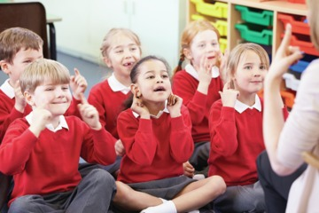
Figure 1
View description - Figure 1

By the end of this session, you should be able to:
- know about some observational tools appropriate to education settings
- understand and identify dispositions for learning
- develop skills to make observations in education settings.

1 Observing play, observing learning
Primary schools are busy places, where children play and learn. For young children, play IS learning. When children sing, for instance, this familiar counting and rhyming song, and make gestures as they count and sing, they are learning in a playful way:

One, two, three, four, five, once I caught a fish alive.
Six, seven, eight, nine, ten, then I let it go again.
Why did you let it go? Because it bit my finger so!
Which finger did it bite? This little finger on my right.

Activity 1 Children learning from song
Allow about 15 minutes

List what you think children learn from this song, and see if your ideas match the 13 ideas of a teacher.

- Number names

Provide your answer...

- Number sequence

Provide your answer...

- Counting from one to ten

Provide your answer...

- Rhyming words: five, alive, ten, again, go, so, bite, right, it, bit

Provide your answer...

- Position words: on my right

Provide your answer...

- Question words: why, which

Provide your answer...

- Action words (verbs): catching and throwing

Provide your answer...

- Describing words (adjectives): little

Provide your answer...

- Time words (adverbs of time): once, again

Provide your answer...

- Giving reasons and causes (conjunctions): because

Provide your answer...

- Fish live in water and are alive when you catch them

Provide your answer...

- Learning to join in and participate with others

Provide your answer...

- Learning in an enjoyable, playful way

Provide your answer...
View discussion - Part

Next, you’ll listen to a primary school teacher talk about why she takes time to stand back and observe children as they play and learn.

1.1 A teacher on observing children
Sarah Johnson has been a primary school teacher for 15 years. She currently teaches the youngest children in the primary school, ages 4 and 5. She explains how she uses observation and listening to evaluate what children know and plan the next steps for their learning. She says that by observing children, you can think about how to move their learning forward.

Video content is not available in this format.
Video 1
View transcript - Video 1

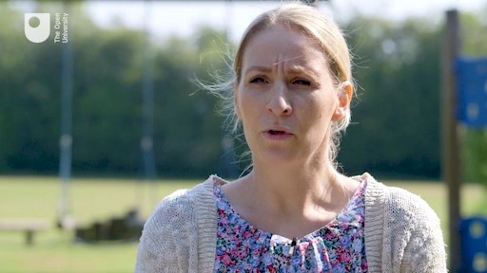

Sarah says that observing a child can tell you many things – about a child’s interests and abilities, whether there are gaps in their learning, and above all it informs her planning and assessment.

2 Dispositions for learning
In the video in the previous section, Sarah Johnson talked about how she looks for ‘characteristics of effective learning’ when she observes and listens to children. These characteristics are also sometimes called ‘dispositions for learning’.
Dispositions are habits of the mind. They are not the same as skills or knowledge. Think of dispositions as similar to personality and the way someone learns. For example, some children can be positive about certain activities like playing in a group and learning with friends. Some children can be negative, giving up quickly when they can’t work out a problem. Some children start tasks with enthusiasm, while others may worry and become anxious.
Dispositions of effective learners include independence, confidence, curiosity and persistence. Other dispositions for learning are self-control, optimism, self-motivation, resilience, problem-solving and, in some cases, courage and risk-taking. All these habits of the mind are important for lifelong learning.
Dispositions affect how children feel about learning in school, and can affect their educational outcomes. Children who see themselves as able to try out new things, keep going when things get difficult, know when to ask for help, and learn from making mistakes, will be successful in school and in life. Teachers, teaching assistants and of course parents all play a part in helping children to develop positive dispositions for learning, by encouraging children and by being role models who demonstrate positive habits of the mind.

2.1 Observing dispositions for learning
Many teachers and teaching assistants record observations using post-it slips or their own personal form of shorthand. There is no particular format required to make classroom observations, but many professionals use a form to remind them of what they are looking for.
The image below is an example of a flexible observation form that a teacher created. It could be used to observe any activity in a classroom, or in the playground. The teacher will write notes in the large box and will use the words in the smaller box to remember the aim of the form: to observe dispositions for learning.

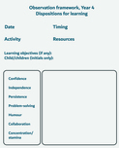
Figure 2
View description - Figure 2

Next, you’ll try out using this observation framework.

Activity 2 Observing ‘Kevin’
Allow about 25 minutes

Now watch the video of a boy in a classroom lesson. ‘Kevin’ (not his real name) is 11 years old. In line with BERA guidance, which you learned about in Session 1, real names of children are not used.
This is an edited sequence of an art lesson that lasted one hour. In the lesson, children are observing a live snake (safely in a terrarium). A camera in the terrarium is projecting a magnified, highly detailed image of the snake’s skin. The teacher has asked the children to draw the patterns, shapes and shades that they can see on the snake’s scales.
As you watch, use the descriptions in the observation form above to identify the child’s dispositions for learning. You may see other dispositions that are not listed on the form – so make a note of these too.

Video content is not available in this format.
Video 2
View transcript - Video 2

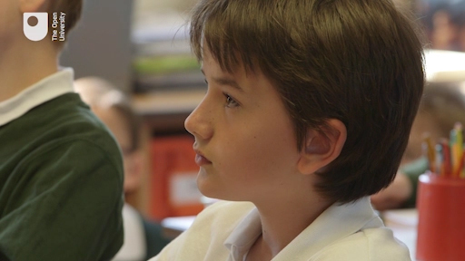

Provide your answer...
View discussion - Activity 2 Observing ‘Kevin’

Next you will look at a different way to observe, using codes.

3 Systematic observation
You can make more systematic observations using ‘codes’. Codes are pre-assigned numbers (or letters, or symbols) that represent specific actions, behaviours or words. When you observe using codes, for example, you log a number each time the child shows a specific behaviour.
For example, you could use these codes to describe a child’s behaviour in a classroom lesson:
- 1 = on task (listening, speaking, reading or writing)
- 2 = not concentrating, looking around
- 3 = out of seat, moving around
- 4 = behaving inappropriately, physically or verbally
Then, as you watch the child carefully for 10 to 15 minutes in the classroom, logging each time the child shows each behaviour, you might create a picture of the child like this in Figure 3.

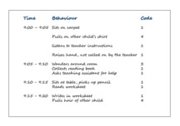
Figure 3
View description - Figure 3

Looking at the example codes, you can see that the child is on task just as often as she is off task, and there seems to be one incident of on task behaviour which is not rewarded by the teacher: the child raises her hand but is not called on to answer.
With this kind of systematic minute-by-minute observation, you can identify when and how a child begins to go ‘off task’ and to use this information to help prevent this from happening in lessons.
This type of observation can yield very specific information. Teachers and teaching assistants can use this information to develop action plans for children who find classrooms challenging.
But this type of observation can be more difficult to do than ‘naturalistic’ observation. You need to pay attention to the child’s behaviour, your codes, and the time.
In the next activity, you will observe a child who sometimes presents challenging behaviour in the classroom. His teacher has learned how to help him, by allowing him to move around the classroom and learn in a way that suits him.

Activity 3 Observing ‘Jack’
Allow about 20 minutes

‘Jack’ (not his real name) is 4 years old. Watch the video of Jack and his teacher in the classroom. Observe how Jack behaves as he goes about his work in school. Pay attention to his body language and his facial expressions, the way he moves around the classroom, and how he interacts with his teacher and with other children.
As you watch, try to apply the following codes to Jack’s behaviour, using the time code on the video:
- interacts with teacher
- works alone
- interacts with other children
- works alongside other children but does not interact with them.
It is recognised that the video is edited and not continuous, but it gives you an opportunity to try out using codes for a short observation. There is a short interview with Jack’s teacher towards the end of the video.

Video content is not available in this format.
Video 3
View transcript - Video 3

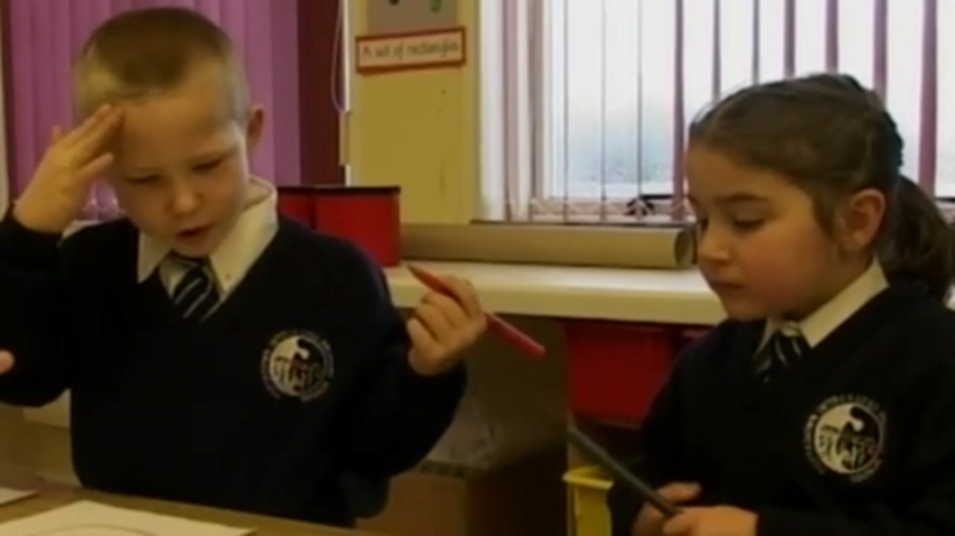

Provide your answer...
View discussion - Activity 3 Observing ‘Jack’

Jack as an individual
The comments that Jack’s teacher makes about him echo the views of Professor Alderson that you heard in Session 1, about children as people. Jack’s teacher sees him as an individual with his own preferences about how and what to learn. She says that Jack can be a very unhappy child if he doesn’t see the point of what he is learning. Jack seems focused and persistent in the number activity we see in the video, but he seems sometimes distracted when talking to his teacher. He seems to like to move around the classroom, and you see him moving between the number line and his worksheet.
In some ways, Jack’s behaviour (given his young age of 4 years) is well within expectations for a lower primary or reception classroom. Jack tries to find his own personal way to learn, and this can be a positive disposition. His teacher has found ways to help him make progress in the classroom. The curriculum the teacher refers to is Northern Ireland’s Enriched Curriculum (Northern Ireland Council for Curriculum, Examinations and Assessment, 2007). This helps Jack because it is play-based and, to some extent, flexible in terms of what children must do and when they must do it in school.
In the next section, you’ll observe a whole classroom, the teacher and the children.

4 Observing teaching and learning
In this activity you’ll observe a whole class.

Activity 4 Observing a whole class
Allow about 25 minutes

The video sequence of a lesson you are about to watch is approximately 10 minutes, but the entire lesson is around 40 minutes.
The teacher has planned a lesson for Year 2 children (ages 6–7) on 2 dimensional and 3 dimensional shapes.
First, listen to the teacher talk about the class, her plans for the lesson, and what she wants to observe in the lesson.

Video content is not available in this format.
Video 4
View transcript - Video 4

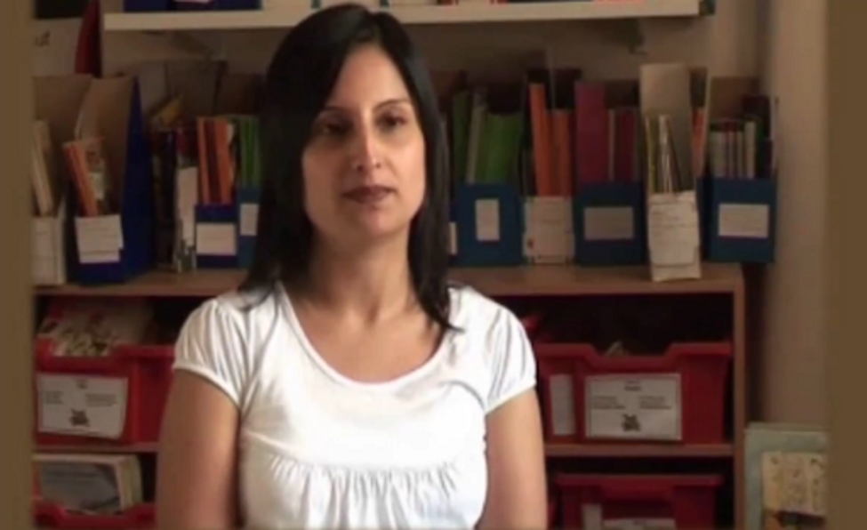

Now observe part of the lesson. As you observe, or afterwards, jot down your answers to these questions:
How are the children organised?
What does the teacher do?
Are all the children doing the same thing?
What dispositions for learning can you see in the children?
Did you mainly observe the teacher – was it difficult to observe the children?

Video content is not available in this format.
Video 5

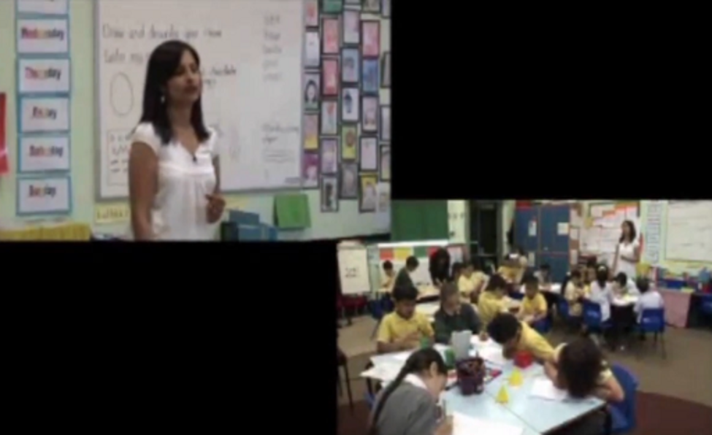

Provide your answer...

Now listen to the teacher’s evaluation of the lesson:

Video content is not available in this format.
Video 6
View transcript - Video 6

View discussion - Part

5 This session’s quiz
Now you’ve completed Session 3, you can take a short quiz to help you to reflect on what you’ve learned.
Session 3 practice quiz
Open the quiz in a new tab or window and come back here when you’ve finished.

6 Summary of Session 3
In this session you learned about some appropriate tools and methods to observe children, their dispositions for learning and their behaviour for learning, in education settings. You applied this knowledge to observe individual children and a whole classroom.
You should now be able to:
- know about some observational tools appropriate to education settings
- understand and identify dispositions for learning
- develop skills to make observations in education settings
In the next session, you’ll learn about children’s views of homework, and the different forms that homework can take. You will also learn what a global survey of parents finds out about homework and what’s most important to parents when they choose a school for their children.

Session 4: Learning at home

Introduction
In this session you’ll learn about children’s views of homework and about the important part that parents play in children’s learning. You’ll listen to children talk about their homework, and hear from a headteacher about the purpose of homework. You’ll also read some findings about homework from a global survey of parents.
By the end of this session, you should be able to:
- understand parental support for children’s learning in school
- perceive children’s views about homework
- develop skills to identify creative homework.

1 Primary school children and homework
In the UK, at the moment, there are no requirements in national education policies for children to do homework. Governments have left it to headteachers to decide how much homework to give children. Headteachers usually decide this in consultation with teaching staff, and sometimes parents.
In the following video, primary school headteacher Mark Millinson gives his views about homework. He says homework should be an opportunity for children to learn, and to involve parents in their learning.

Video content is not available in this format.
Video 1
View transcript - Video 1

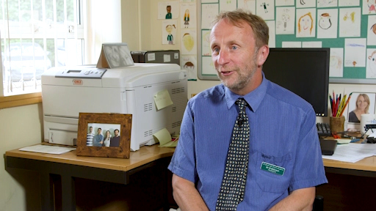

Mark says homework is, literally, ‘learning at home’, where children continue to develop their knowledge of the world by involving others in their learning. He also says it’s an opportunity for parents to hear children’s opinions about what they’re learning in school.
In the next section you’ll meet two children from Mark’s school and hear about their views on homework.

1.1 What do children think about homework?
Now meet Luke and Esme. They are are both 11 years old. They get homework once a week, and longer projects over the holidays which they record in a ‘learning log’. They are preparing for their end of primary school assessments, called the SATs.
Kimberly Safford from The Open University started by asking them what was their most recent homework.

Audio content is not available in this format.
Audio 1
View transcript - Audio 1

In the next sections, you’ll meet other children from schools across the UK and find out what they think about their homework.

1.2 Homework: beneficial or boring?
Who do you think should decide what kind of homework, and how much homework, children get: government, headteachers, teachers, parents or children themselves?

Activity 1 What do children tell us about homework?
Allow about 15 minutes

In the video that you’re about to watch, children tell you what they think.
As you watch and listen, jot down their ideas.
The video is on the following page of the Newsround website. It is the second video on the webpage and is called ‘What do you think of homework?’.

Provide your answer...
View discussion - Activity 1 What do children tell us about homework?

2 Creative homework
In Section 1, you heard headteacher Mark Millinson say that interesting homework can be ‘tasks’ and ‘investigations’ that children do over several weeks, and this can get parents involved and enthusiastic about homework.

Activity 2 What are they learning?
Allow about 15 minutes

In this video, you’ll meet children who can choose what kind of homework they do. As you watch, jot down their choices and their reactions, and also the reactions of their families. See if you can link their homework activities to a curriculum subject like mathematics or science.
The video is on the following page of the Newsround website. It is the fifth video on the webpage and is called ‘Homework but not as you know it’.

Provide your answer...
View discussion - Activity 2 What are they learning?

3 Home–school communication

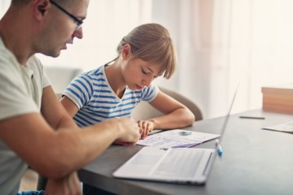
Figure 1
View description - Figure 1

Homework is a daily activity for most children that takes their time, energy and emotion, not only for them but for their families as well. One reason for giving children homework is to help schools communicate with parents, and for parents to know more about what their children are learning in school.
Parents and teachers can, and should, work together to support children’s learning. Good teachers know that parents are children’s first and most significant educators. For effective homeschool partnerships, teachers need to keep parents well-informed. Digital and online technologies have made communication between home and school must faster and easier. Most primary schools now have websites, and even Twitter accounts where parents can see children’s homework and get quick updates on their progress.
One reason many parents do not get involved in their children’s homework is that they lack confidence in, for example, maths or writing. Creative homework, like the examples you saw in the video of Activity 2, are more inviting for parents. Most parents would be happy, for instance, to help their child cook, draw, observe the local environment, or build a simple model with recycled materials.
Homework should be a beneficial learning experience, where parents can participate. Teachers can design homework assignments where children interact with their family or their community. Read the case study in the following section for an example.

3.1 Homework case study
This is an example of homework that a child and a family member do together. It could be with a parent, a grandparent, or an older sibling.

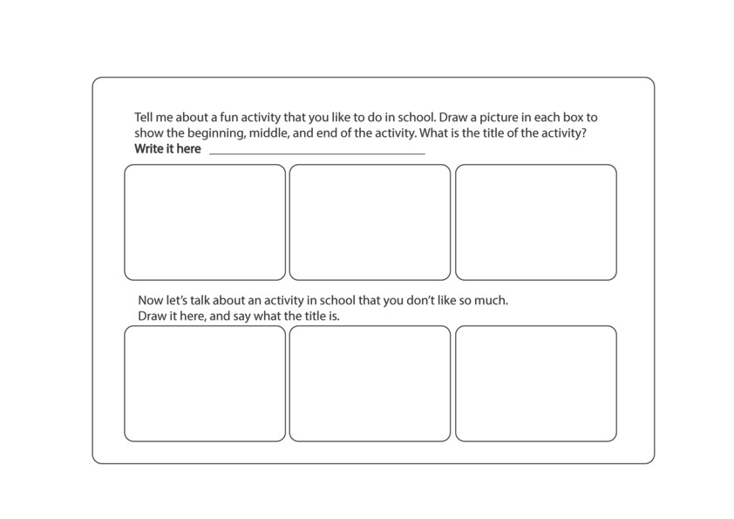
Figure 2
View description - Figure 2

Now let’s talk about an activity in school that you don’t like so much. Draw it here, and say what the title is.
This homework develops a child’s vocabulary and expressive language skills, and an understanding of narrative structures (beginning, middle, end). The homework develops these language skills through conversation, not drilling. It creates an opportunity for the child and an adult to talk together about school, and for the child to share their thoughts and feelings. It is a chance for the adult to ask questions such as ‘Why do you like, or not like, doing this so much?’, ‘Tell me more about this part’ and ‘What happened next?’ Talking and drawing are, for young children – and for many older children, and adults too – good ways to ‘draft’ or prepare for writing.
Next, you will learn about parents’ involvement in children’s homework around the world.

4 Homework around the world
A survey of more than 27,000 parents in 29 countries found a quarter of parents worldwide spend seven or more hours a week helping their children with homework (Varkey Foundation, 2018).
Parents in India helped the most, spending an average of 12 or more hours each week helping with homework and reading to their children. Parents in Japan spent the least, at about 2.6 hours. Parents in the USA spent 6.2 hours, just below the global average of 6.7 hours.
But the survey also found that children whose parents help a lot with their homework did not perform any better on tests than children who do their homework all by themselves. Educationalists generally agree it's important that parents at least know what their children are working on and how much time it's taking them to complete it. Taking an interest in a child's homework also helps to create a home in which learning is valued.
While a quarter (25%) of parents worldwide spend 7 or more hours a week helping their children with their education, this figure rises to 62% in India, 50% in Vietnam and 39% in Colombia. Parents in richer nations are spending less time, with only 5% spending 7 or more hours a week in Finland, 10% in France and Japan, and 11% in the UK. Parents in lower income economies are more likely to spend significant amounts of time helping their children outside the classroom than those in established economies. The most commonly occurring reason that parents don’t help their children – cited by over half of parents (52%) across the survey – is lack of time.

4.1 Parents’ hopes

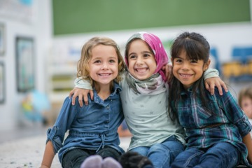
Figure 3
View description - Figure 3

Almost two-thirds (64%) of parents in the 2018 Varkey Foundation survey believe their child’s school is preparing them well for the world of 2030 and beyond. Asia has some of the highest levels of confidence (India, Indonesia, China and Vietnam), and some of the lowest levels of confidence (Japan and South Korea).
Almost two-thirds (60%) of parents are optimistic about their child’s future. Some of the highest levels of optimism were in lower income economies. Richer nations (such as Japan, France, South Korea and Germany) were generally gloomier.
Children’s happiness is the most important thing to parents, according to the global survey, with 43% of parents worldwide selecting this as one of the top three factors that cause them the most anxiety about their child at school. This is closely followed by concerns of mental wellbeing and bullying. According to the global survey, when parents choose a primary school for their children the most important factor in their decision is the distance of the school from home. The next two most important factors for parents in choosing a primary school are the quality of teachers and whether the school has a happy environment.

5 This session’s quiz
It’s now time to complete the Session 4 badge quiz. It’s similar to previous quizzes but this time, instead of answering 5 questions, there will be 15.
Session 4 compulsory badge quiz
Remember, this quiz counts towards your badge. If you’re not successful the first time, you can attempt the quiz again in 24 hours.
Open the quiz in a new tab or window and come back here when you’ve finished.

6 Summary of Session 4
In this session, you looked at children’s views of homework and how homework can be made more creative and engaging for children and for parents. You also learned what a global survey of parents found out about what matters most to parents about school and homework.
You should now be able to:
- understand parental support for children’s learning in school
- perceive children’s views about homework
- develop skills to identify creative homework.
In the next two sessions, you will learn about computing and the primary curriculum, and children’s safety online.
You are now halfway through the course. The Open University would really appreciate your feedback and suggestions for future improvement in our optional end-of-course survey, which you will also have an opportunity to complete at the end of Week 8. Participation will be completely confidential and we will not pass on your details to others.

Session 5: Connected children

Introduction
This is the first of two sessions on children and technology. Children’s use of technology tends to generate much debate, and some anxiety. Digital technologies offer many opportunities for children to learn and to play, but there can be risks to children in online environments, and ‘e-safety’ has become an important topic in primary schools.
By the end of this session, you should be able to:
- understand digital literacy and twenty-first century skills
- recognise the impact of technologies and digital literacy on children’s lives and their learning
- identify some of the opportunities and risks that the connected world brings for children.

1 Technology in children’s lives
Children today are born into a world where digital technologies are more prevalent than ever before. There is no aspect of our lives that is unaffected by technology – how we work, shop, socialise, communicate and entertain ourselves. From the moment young children become aware of the world around them, they witness the use of technology in one form or another. It is only natural, then, that they will be keen to explore this aspect of their world, as they would any other. Young children may feel less cautious than adults about making mistakes with technology.

Activity 1 What technologies are children using?
Allow about 10 minutes

Think about the range of technology in some homes today. What kind of devices might children of primary school age see being used by those around them? What might they have access to on their own? Jot down your ideas.

Provide your answer...
View discussion - Activity 1 What technologies are children using?

What is clear is that when children go to school, they will bring with them their own unique set of experiences with technology. Not just in the devices, tools or toys they have access to, but in the experiences they have in using them.
According to a recent survey, 53% of UK children aged 3–4 go online for nearly 8 hours a week, 35% of 5–7 year olds have their own tablet and 39% of 8–11 year olds have their own smartphone, with nearly a quarter having a social media profile (Ofcom, 2017).

Activity 2 Children’s increasing use of digital technologies
Allow about 15 minutes

Look at the statistics in the infographic in Figure 2. It’s a snapshot of children’s digital lives (Ofcom, 2017).

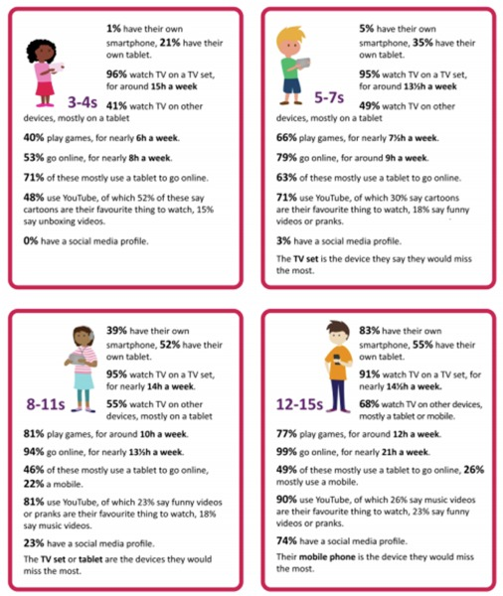
Figure 2
View description - Figure 2

Add your responses to the following questions.

How do the figures compare to your experiences of technology when you were a child?

Provide your answer...

How do these figures compare with your ‘digital life’ now?

Provide your answer...

How do they compare with that your own children, or children that you know?

Provide your answer...

Next, you will read about the impact technology can have on children’s learning.

2 Technology affects how children learn
Advances in technology and the internet revolution are driving a pace of change that would have been unimaginable 30 years ago. Schools are trying to balance the use of technology to develop children’s learning, and also ensure that children are prepared to engage safely and effectively with technology.

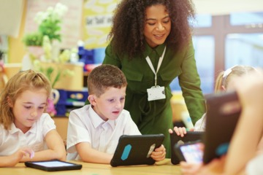
Figure 3
View description - Figure 3

Activity 3 The digital age and children’s learning
Allow about 10 minutes

Read this extract from the Cambridge Primary Review’s report, ‘The Digital Age and its Implications for Learning and Teaching in the Primary School’ (Burnett, 2016). The report draws on a range of research related to children’s lives in the digital age in school and beyond school.

For many children digital devices and the possibilities they enable are threaded through everyday life from the earliest days, and their early experiences and understandings are patterned by technology use... much of ‘children’s out-of-school learning is electronic and beyond the reach of either parents or teachers’ (Alexander, 2010: 269). In education, therefore, there is a need to explore the significance of the digital age not just in terms of preparing children for an uncertain future, but in ensuring they are confident, safe and discerning users of digital technologies now…
…understanding children’s lives in a digital age is a complex task, and considering the implications for primary education is fraught with tensions. On one hand there are calls to recognise the sophistication of children’s everyday uses of digital media and for much greater integration of technology in education to equip children effectively for their current and future lives. On the other hand there are anxieties about the implications of extensive screen-time and about what or whom children may encounter in digital environments that are hard to police and difficult to confine.
(Burnett, 2016, p. 3)

3 Schools in the digital age


Figure 4
View description - Figure 4

The needs of the digital age raise key questions about the role of school. It is clear that schools need to be able to support children’s engagement with digital technologies now, as well as look to the future and ensure they are well prepared to participate effectively in society as adults in the workplace and beyond.
There is also a need to consider how different subjects are understood and taught in the light of digital technologies. For example, later you will consider what is meant by literacy in the twenty-first century. How should the English curriculum adapt as a result? What about other subject areas? And how do digital technologies relate to other school priorities such as social justice and citizenship?
While surveys (Ofcom, 2017) suggest that technology is all around us, children will vary in what they know about technology and their experiences of it, when they come to school. There are issues of equal access to technology. Internet-enabled devices and high-speed internet connections are unevenly distributed across the UK and many other countries. The role of the school therefore is key in ensuring children have access to a range of digital technologies and, importantly, ensuring the experiences they have in using it are wide-ranging.
Next, you will look at children and how they use the internet.

4 Children and the internet
Children are going online at an increasingly young age. Ofcom (2017) reports that in 2017 over half (53%) of 3–4 year olds are now online, as are 79% of 5–7 year olds, 94% of 8–11 year olds and 99% of 12–15 year olds. For the two youngest age groups, the figures are up by 10% on the previous year.
The EU Kids Online Network project, Zero to Eight, illustrated how pervasive technology is becoming for younger children. The seven-year project, which focused on investigating children’s engagement with the internet, identified a significant increase over a five-year period of children under nine years old going online (Holloway et al., 2013). They also noted a particular trend for pre-schoolers to use tablets and smartphones to access the internet.


Figure 5
View description - Figure 5

In the next section, you will watch a video about the risks and opportunities the internet brings to young children.

4.1 Risks and opportunities
Sonia Livingstone, the lead author of the EU Kids Online Network project, has warned that the lack of technical, critical and social skills among younger children puts them at real risk online. Older children and teenagers are seen as more resilient and able to cope with the dangers they may face (Livingstone et al., 2011, p. 3). This is a risk that both parents and schools need to manage.

Activity 4 How children engage with the internet
Allow about 30 minutes

Listen to Sonia Livingstone taking about the risks and opportunities access to the internet brings. As you listen consider the following:
- note the range of experiences of children (for example, some report no negative experiences; age and gender are mentioned)
- consider how well acquainted you are with guidance about how to support children’s use of the internet
- can you think of ten great websites, apps or educational computer games for children as the audience are challenged to?

Watch the video at YouTube.com.
Video 1

It is easy to understand why some fear for children, with stories of cyberbullying and grooming peppering news headlines. But Sonia Livingstone argues that we need to balance our reactions, and not necessarily impose more restrictions. She notes that as a society we always fear change and in particular technological revolutions, whether that be the invention of writing, ‘moving pictures’ or the internet. She argues that opportunities and risks are inextricably linked. By limiting their exposure to risk, we are limiting their opportunities to develop skills such as independent thinking and resilience.

Provide your answer...

4.2 E-safety in school
By better understanding what children do online outside of school, teachers are better positioned to support both children and their parents and manage the risks appropriately.

Activity 5 Thinking about e-safety
Allow about 20 minutes

Watch this video of Luke Crickwood, a teacher, e-safety and IT coordinator at All Saints Inter-Church Academy in Cambridgeshire, England. Every year he leads an audit to find out how their pupils use the internet, as part of the school’s e-safety review.

Video content is not available in this format.
Video 2
View transcript - Video 2

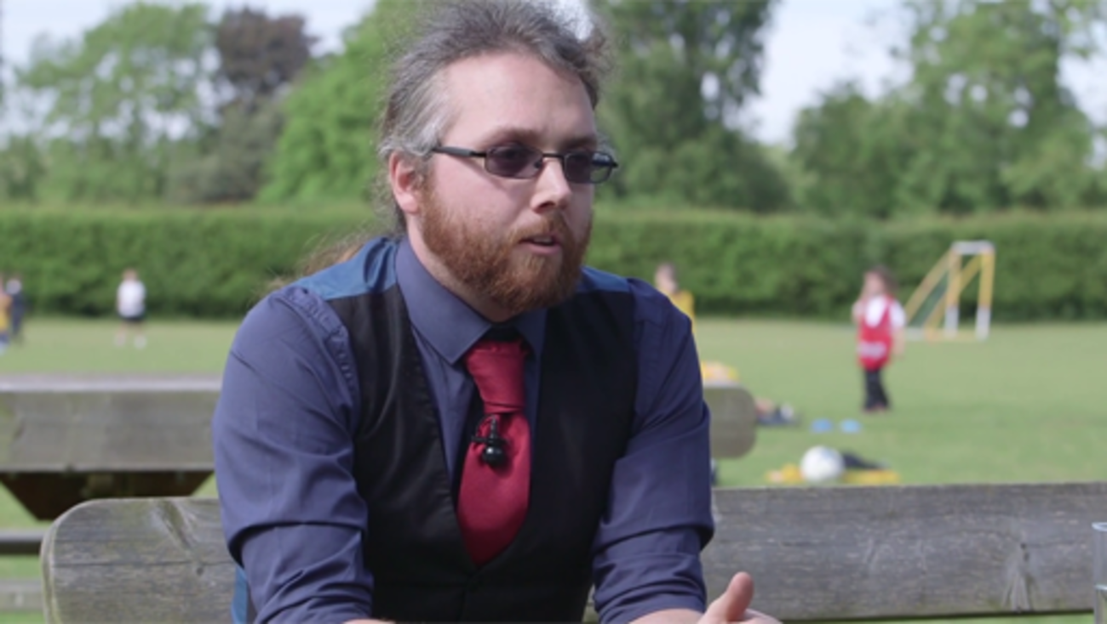

Notice the difference Luke highlights between the girls’ and boys’ perception of cyberbullying, as well as how it seems to be more prevalent the older the children get.

According to Ofcom (2017) just 12% of 8–11 year olds say they have been bullied, with this more likely to have been face to face (6%) than on social media (1%). These numbers do rise to 12% respectively for children aged 12–15. There are clearly more risks in being online than just cyberbullying, but it is worth noting that nearly all internet users (97%) aged 8–15 report having been taught how to use the internet safely by a teacher, parent or both (Ofcom, 2017).
Next, you will read about a research study of children and how they play and learn online in ‘virtual worlds’.

5 Play and learning online
Children love to play with new technologies, with and without adult support. Jackie Marsh has studied and reported extensively on how young children play and learn with technology. She carried out an enquiry into primary children’s use of virtual online worlds and social networking websites, and she deliberately chose to study profit-making commercial websites rather than those developed for educational purposes in and for schools. Marsh chose to study two commercial websites (Club Penguin and Barbie Girl) because, in her words, ‘these worlds are becoming increasingly prevalent in children’s out-of-school lives and it is important that educators become familiar with the way in which children use these environments in order to build upon these experiences further’ (Marsh, 2010, p. 26).


Figure 6
View description - Figure 6

One hundred and seventy-five children aged from 5 to 11 years took part in Marsh’s enquiry, where they accessed the two websites and reported (in questionnaires and interviews) on what they did there. Playing games featured strongly in their responses. Ewan, aged 5, for example, said: ‘It’s all games. I like the games’ (Marsh, 2010, p. 30).
Marsh observed the types of play that children engage in within these virtual worlds:
- Fantasy play, where they develop characters, roles and narratives, ‘dressing up’ and adopting imaginary personas (known in online worlds as ‘avatars’).
- Socio-dramatic play, where they enact everyday or domestic scenarios which involve communication via text messaging.
- Games with rules mirroring real-world play such as ‘hide and seek’.
- ‘Ritualised’ play where children use actions and symbols to demonstrate feelings and participate in group activities.
Shopping with virtual tokens/money and caring for virtual pets were other popular forms of play for children in this study. Unlike the virtual worlds of older children and adults, however, Club Penguin and Barbie Girl did not offer children opportunities to create their own ‘in-world’ objects or customise their avatars.
For the children in this study, there were many similarities between offline and online play, and Marsh argues that their activities in the websites are not ‘virtual’ but ‘real’ play – pointing out that much online play is, like face-to-face play, a social practice constructed through interactions with others. An important difference, the study notes, between face-to-face and online play, is that in the virtual world children do not always know who they are playing with. Marsh argues that this presents an opportunity to teach children about online safety, and she concludes: ‘[children in virtual world play] have opportunities to construct, re-construct and perform identities and learn how to engage with others in online forums ... Children’s engagement in online virtual worlds might offer useful opportunities to develop skills that will enable them to navigate online environments more safely and appropriately’ (Marsh, 2010, p. 36).

Activity 6 Children’s virtual online worlds
Allow about 15 minutes

Here are some suggested websites; you might be familiar with these and with others. When you access your chosen website, you will need to sign up and create your own profile (this should be free to do on all the sites listed below). Spend some time exploring the website. You should not communicate with others on the website.
Disney UK
Moshi monsters
Bin weevils
Reflect on your experience, using the following questions to help you.

- To use this website, what do you need to understand and know how to do?
- What are the ethical issues of adults accessing websites designed for children to use?
- What did you do in the virtual world you selected?
- What did you find interesting, fun, challenging or worrying?
- Can you see it being appropriate for school in any way?
- Did you have any concerns about children’s safety on the website?
- Did you feel that the website offered opportunities to play? Describe these.
- Did you feel it offered opportunities to learn? What were these?

Provide your answer...
View discussion - Part

In supporting children’s learning, teachers and teaching assistants may experience a gap between what children know and do outside school with technology and what they learn to do in school with technology. Educators like Jackie Marsh try to find commonalities across these experiences, so that adults can support children to apply what they know to their learning in school.

6 Games in education
Games are increasingly appearing in classrooms and there is a trend of creating education-specific versions of well-known games. For example, Minecraft is a hugely popular game among children, with over 60 million players worldwide at the time of writing. Minecraft is considered a ‘sandbox’ or open-world game, in which are there are no given tasks or objectives to complete and instead players are free to explore and interact with the world in their own way, much like young children would if playing in a real sandbox. Players can build or explore, play alone or with others. Every world (or map) the players explore is entirely unique; there are no rules or even guidelines for play so there are infinite possibilities.
The education-specific version of Minecraft, MinecraftEdu, provides teachers with additional extras including: camera and portfolio tools to assess or record activities and document progress; the ability to act as a guide rather than a player in the game; and moderation tools to manage or restrict collaborations.

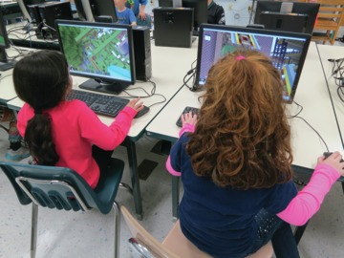
Figure 7
View description - Figure 7

Activity 7 Parents, children and ‘Minecraft’
Allow about 35 minutes

Read The parents’ guide to Minecraft. Think about the kinds of skills children could develop while playing. Next, watch this video of Nathaniel Bott, a grade 10 student from Tasmania talking about the Minecraft in Schools Transforming education (MIST) project that took place in his school.

Watch the video at YouTube.com.
Video 3

Having read the guide and listened to Nathaniel’s experiences, think about the following questions and note down your responses.
How might Minecraft be used to support teaching and learning, particularly of STEM (science technology engineering and maths) subjects in the primary years?
What kind of environment for learning does Minecraft create?

Provide your answer...
View discussion - Activity 7 Parents, children and ‘Minecraft’

7 Digital literacy and twenty-first-century skills
How digital technologies are referred to in the primary school curriculum has changed significantly in recent years and varies from country to country. Terminology varies too and confusingly, people often use different terms to refer to the same thing. Some refer to IT (information technology), some to ICT (information and communication technology) and others to computing or computer science. In recent years there has been a global shift towards the discipline of computer science, in countries including India, the USA, Australia, England and South Korea (University of Edinburgh, 2016). As a result language has shifted and you may see terms such as ‘computational thinking’, ‘logical reasoning’ and ‘algorithms’ used in primary schools.
The development of children’s ‘digital literacy’ is regarded as key to developing what are often referred to as ‘twenty-first century skills’ (ATC21S, 2012; Binkley et al., 2012). These twenty-first century skills are not tied to particular subject areas, but apply across the curriculum and include skills such as digital information literacy, collaboration, problem solving and critical thinking (ITL Research, 2011).
Digital literacy can be interpreted in a variety of ways, but Hague and Payton’s (2010) definition provides an effective summary:

Digital literacy involves critically engaging with technology and developing a social awareness of how a number of factors including commercial agendas and cultural understandings can shape the ways in which technology is used to convey information and meaning.
It means being able to communicate and represent knowledge in different contexts and to different audiences (for example, in visual, audio or textual modes). This involves finding and selecting relevant information, critically evaluating and re-contextualising knowledge and is underpinned by an understanding of the cultural and social contexts in which this takes place.
Digital literacy gives young people the ability to take advantage of the wealth of new and emerging opportunities associated with digital technologies whilst also remaining alert to the various challenges technology can present.
In short, digital literacy is the ‘savvyness’ that allows young people to participate meaningfully and safely as digital technology becomes ever more pervasive in society.
(Hague and Payton, 2010)

ATC21S (2012) defined ten twenty-first century skills, which fit into four broad categories: ways of thinking; ways of working; tools for working; and ways of living in the world (Figure 8). The successful development of these skills does not rely on the technologies alone, but on the digital literacy of the educators making use of ICT and their capacity to engage with new ways of teaching and learning.

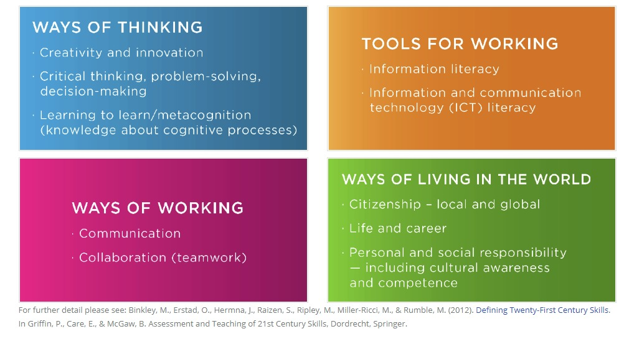
Figure 8
View description - Figure 8

How well do you think school prepares children to live and work in an ever-changing society?
Now watch this video of Grant Lichtman, a US-based former teacher and senior leader sharing what he has learned about teaching twenty-first-century skills in schools:
Video 4 What 60 schools can tell us about twenty-first-century skills
Next, you will consider how digital literacy impacts on how children read and write.

7.1 The impact of technologies on children’s reading and writing
Children develop different kinds of reading and writing skills to make meaning from the array of multimedia and virtual worlds they now encounter. From your own experiences, you may be aware of children who use technology for a range of reading and writing – accessing, for instance, online worlds, authors’ homepages and homework revision websites.
There are six ways in which digital literacy and twenty-first century skills have influenced how children read and write (Merchant, 2013):
- Being multi-modal: mixing words, images, video, audio, animation and using digital and other media.
- Linguistic innovation: for example ‘text speak’, the use of abbreviations and acronyms, for character-limited tools such as Twitter or the use of emoticons.
- Remixing: the creative use of digital tools to remix, edit or recombine existing media: for example, sampling audio and adding it to existing video.
- Being playful: for example, creating a ‘meme’ by adding humorous or playful text to an image that is then spread via social media.
- Participating: sharing information and media in online environments, and getting feedback.
- Connecting: social relationships formed in online spaces with both known and unknown users.

Activity 8 Merchant’s six characteristics
Allow about 15 minutes

Now watch this video about the STEAM week at Bridgewater Primary School in England. As you watch, look for examples of Merchant’s (2013) six characteristics and note them down.

Watch the video at YouTube.com.
Video 5

Provide your answer...
View discussion - Activity 8 Merchant’s six characteristics

7.2 Children using multimedia in school
In schools, children often use software and apps to write stories, poetry and non-fiction reports, and incorporate sounds, interviews, photographs or video into their writing. Tools include VoiceThread which allows for text, narration and sounds to be sequenced alongside images, and PuppetPals in which photos can be used to make scripted on-screen puppet shows. With programs such as Photoshop, children can digitally play with and change their own artwork and photographs, and incorporate these into their writing. In Session 4, you heard a child talk about his homework to make a PowerPoint presentation on the scientist Charles Darwin.

Photoshop and stories
A class of 8–9 year old children created a series of images in paint, pastel and clay, and they also took photographs of themselves: all of these images were processed using Photoshop and then put into a presentation. Children then wrote stories describing adventures in the imaginary landscapes of their artwork, adding music and sound effects.
Figure 9 is an example of a child’s Photoshop collage.

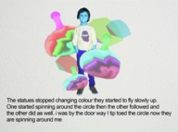
Figure 9
View description - Figure 9

The teacher said that writing stories based on their Photoshop collages inspired the children to draw together a range of their communication resources (words, artwork and images) to create a complete text, putting considerable visual and digital literacy skills to work in their writing.

PowerPoint report
‘Ben’ (age 11) created a PowerPoint presentation (Figure 10) all about James Bond (the character, the movies, the actors, the cars, the gadgets, the villains, the Bond girls and so on). His use of sound effects (loud gunshots and creeching cars), moving images and animated text created a lively piece of writing driven by his obvious expertise and enthusiasm for his subject.

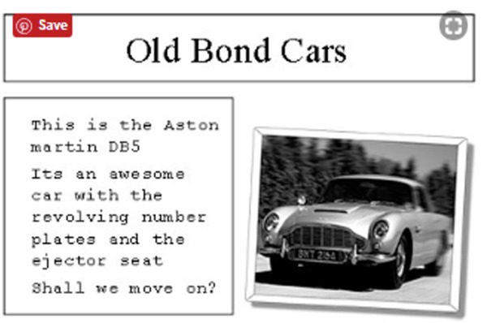
Figure 10
View description - Figure 10

You can observe how Ben’s play, media and book interests are fully expressed in his writing, and how he is gaining experience as a writer in this process. Ben created his PowerPoint presentation entirely at home, and brought it into school. His teacher, however, was uneasy with some of the content of the text (guns and Bond girls) and was reluctant to share it with the class – an example of the tensions that may exist between home and school literacy practices.
Digital texts such as Ben’s can involve considerable research, and they can link to further fiction and non-fiction writing. If children are creating stories using digital technology – say, about bears – they could create hyperlinks to files of other writing, so for example about the habitats of bears, poems about bears, how hibernation works, or a discussion forum about the pros and cons of keeping wild animals in zoos. The whole class could also contribute diverse written and visual elements to the larger digital text, and this could be shared with parents using tools such as Edmodo or Showbie or presented at an assembly or put on to the class or school website.

8 This session’s quiz
Now that you’ve completed Session 5, you can take a short quiz to help you to reflect on what you’ve learned
Session 5 practice quiz
Open the quiz in a new tab or window and come back here when you’ve finished.

9 Summary of Session 5
In this session you learned about technology in children’s lives, digital literacy and twenty-first-century skills, how children use the internet, e-safety, and how digital technologies have changed the ways children read and write.
You should now be able to:
- understand digital literacy and twenty-first century skills
- recognise the impact of technologies and digital literacy on children’s lives and their learning
- identify some of the opportunities and risks that the connected world brings for children.
In the next session on digital technologies, you will learn about computing as a school subject, why it is considered important, and some ways to teach computing in primary schools.

Session 6: Computing in schools

Introduction
Following on from Session 5, where you learned about children and technology, in this session you will learn what computing is, and about computing as a school subject. You will learn why computing is important and look at some ways of teaching computing in primary schools.
In this session you will be introduced to some vocabulary and ideas that might be unfamiliar to you, such as ‘algorithms’, ‘coding’ and ‘unplugged computing’. In some activities, you will be asked to think about your own responses to what you read and see. This might feel a bit challenging at times, but stick with it and you should feel a lot more confident about this topic.
By the end of this session, you should be able to:
- appreciate computing and its role in the primary curriculum
- understand some ways to support children’s learning of computing
- develop your own skills for computing.

1 What do we mean by computing?
As you saw in Session 5, the way we talk about digital technologies varies depending on how and where they are used, and this is also true for computing.
Computing in primary schools is also known as ‘computer science’ or ‘informatics’. Countries including Australia, India, Finland, France, South Korea and the UK have integrated computing into the primary curriculum in recent years (Euractiv, 2015).


Figure 1
View description - Figure 1

Definitions vary, but, for example, in schools in England computing is made up of three core strands: computer science, information technology and digital literacy.

The core of computing is computer science, in which pupils are taught the principles of information and computation, how digital systems work and how to put this knowledge to use through programming. Building on this knowledge and understanding, pupils are equipped to use information technology to create programs, systems and a range of content. Computing also ensures that pupils become digitally literate – able to use, and express themselves and develop their ideas through, information and communication technology – at a level suitable for the future workplace and as active participants in a digital world
(Computing at School, 2014)

In Session 5 you looked at digital literacy for children, and in this session you will focus on aspects of computing for children. Computing is a subject that has lots in common with mathematics, and you can think of computing as a way for children to understand the world.

1.1 Computing and the school curriculum

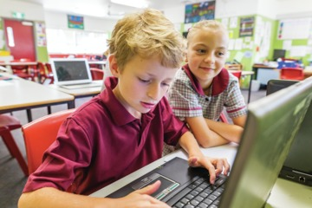
Figure 2
View description - Figure 2

In England, computing replaced ICT as a national curriculum subject for all age groups. Similar changes have taken place across other UK countries, Europe and beyond. Read the table to see these similarities.

Table 1 Computing in schools
England | The first country in the European Union to make computing compulsory for 5 to 16 year olds.
Northern Ireland | Using ICT is a statutory cross-curricular skill in the primary curriculum.
Scotland | Technologies is a primary curriculum area and includes computing as a distinct aspect of knowledge.
Wales | A Digital Competence Framework includes computer science as a subject in the primary curriculum.
Finland | Programming is a mandatory element of the primary curriculum.
New Zealand | Digital Technologies curriculum for primary schools.
Australia | National Curriculum in Digital Technologies for primary schools.
Sweden | Computing is introduced from the first year of primary school.

As the table shows, computing is increasingly seen as an important subject. But this presents some challenges. Teachers report that they are unsure about their own computing subject knowledge, and what are the best ways to support children’s computing learning (Sentence and Csizmadia, 2017).

1.2 Computing programmes of study for children
Read the Computing programmes of study for primary school children from the National Curriculum in England.
After you read, ask yourself:
- Am I surprised by what is on the computing curriculum for children?
- Are there areas that I already know about? Would I feel confident explaining these areas to other adults or to children?
- Are there aspects that I am not familiar with?
For the rest of this session, you will learn more about computing as a subject and some effective ways for children to learn about it.

2 Why is computing important?


Figure 3
View description - Figure 3

The Royal Society’s 2012 report, ‘Shut down or restart? The way forward for computing in UK schools’, reported that ‘Computer Science is a rigorous academic discipline of great importance to the future careers of many pupils’ and that ‘Every child should have the opportunity to learn Computing at school’. In England, the Department for Education (DfE) says children who understand computing will be able to change the world:

A high-quality computing education equips pupils to use computational thinking and creativity to understand and change the world. Computing has deep links with mathematics, science and design and technology, and provides insights into both natural and artificial systems. The core of computing is computer science, in which pupils are taught the principles of information and computation, how digital systems work and how to put this knowledge to use through programming. Building on this knowledge and understanding, pupils are equipped to use information technology to create programs, systems and a range of content. Computing also ensures that pupils become digitally literate – able to use, and express themselves and develop their ideas through, information and communication technology – at a level suitable for the future workplace and as active participants in a digital world.
(Department for Education, 2013)

Education Scotland takes a similar view on the importance of studying computing:

Children and young people will develop their creativity and entrepreneurial skills and be encouraged to become innovative and critical designers of the future. These attributes are essential if, in the future, our children and young people are to play a major part in the global economy and embrace technological developments in the 21st century.
(Education Scotland, 2013)

Activity 1 Computer science is changing everything
Allow about 20 minutes

Now watch this video from Code.org on computing. The vision presented in the film is that computing plays a role in almost every aspect of life.

Watch the video at YouTube.com.
Video 1

After you watch, ask yourself:
- How does this compare with the vision of technology in society when I was in primary school?
- Do I think that the vision presented in the film is accurate?

Provide your answer...

2.1 Why learn about computing?
While the introduction of computing into the primary school curriculum has been welcomed by many, some question the value of it.
One criticism is that it isn’t necessary for all children to learn computing, because only a fraction of children will go on to become computer programmers.
This idea is based on a commonly held misconception that computing is just about learning to program or to code. In fact, computing is about problem solving, thinking analytically, and finding ways to tackle complex tasks creatively or efficiently. These skills are transferable to many aspects of life and learning.
There is also an economic argument for studying computing. Livingstone and Hope’s Next Gen. report (2011) focused on the importance of high-tech and creative industries in the UK and other countries’ economies. Even in 2011, the UK video game sector alone was worth over two billion pounds. The authors believed that the UK’s position as a leader in technology, innovation and creativity was at risk due to a skills gap. They argued that schools need to fill this gap by equipping the next generation of young people with the knowledge and skills necessary for these industries. Their solution? That computing should be in the school curriculum.
Transferable skills and economic arguments aside, there is almost no aspect of life today that is not touched by technology: we use it for working, socialising, studying, shopping, accessing healthcare, playing, travelling and communicating.
An overriding argument for including computing in the curriculum is about equity and social justice. If we don’t equip all children with the skills to use technology in an informed way, and the knowledge and skills to influence what the technology is, what it does and how it is used, we are denying children an opportunity.
Liukas (2015) argues that we need to imagine ‘a world where the stories we tell about how things get made don’t only include the twentysomething-year-old Silicon Valley boys’ and Naughton (2012) said that without educating children about computing we will ‘be breeding generations of hamsters for the glittering wheels of cages built by (Facebook founder) Mark Zuckerberg and his kind’. The inventor of the World Wide Web agrees:

I want you to know that you too can make new programs which create new fun ways of using computers and using the Internet. I want you to realize that, if you can imagine a computer doing something, you can program a computer to do that. Unbounded opportunity … limited only by your imagination. And a couple of laws of physics.
(Tim Berners-Lee, n.d.)

Consider the following questions:
- What do you know about computing?
- How would you go about convincing others – children, parents or teachers – that computing is important?


Figure 4
View description - Figure 4

As you learned earlier, computing is a relatively new addition to the primary curriculum in many countries. What they have in common is a focus on two key areas of computing: computational thinking and coding. These form the basics of much of children’s initial learning about computing or computer science.
In the next activities you will learn about children and coding, and about children and computational thinking.

2.2 Children and coding
Coding is creating a set of instructions for a device to carry out. It is also called ‘programming’. Coding is one strand of computing.

Activity 2 Should everyone learn to code?
Allow around 20 minutes

Watch this video about why children should learn to code.
Video 2 What most schools don’t teach
After you watch, answer the following question:
- How much do you agree with the argument that learning how to code is a universal skill that should be taught to all children? Is it as important as literacy or numeracy?

Provide your answer...
View discussion - Activity 2 Should everyone learn to code?

2.3 Children and computational thinking
Computational thinking is a way of thinking to solve problems.
It allows you to take a complex problem, analyse it, break it down and develop possible solutions.
The term was popularised by Jeanette Wing, Professor and Head of Computer Science at Carnegie Mellon University. She was keen to emphasise that computational thinking is not about developing software, interrogating data or writing a game – although that might be the end result – but it is the development of thinking skills that support learning and understanding.

Computational thinking is a fundamental skill for everyone, not just for computer scientists. To reading, writing, and arithmetic, we should add computational thinking to every child’s analytical ability… Computational thinking involves solving problems, designing systems, and understanding human behavior, by drawing on the concepts fundamental to computer science. Computational thinking includes a range of mental tools that reflect the breadth of the field of computer science.
(Wing, 2006)

Computational thinking is a logical thought process by which problems can be solved (Csizmadia et al., 2015). It covers key areas or steps in problem-solving.

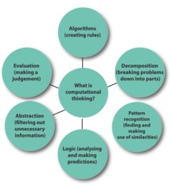
Figure 5
View description - Figure 5

Logic (or logical reasoning) is the process by which we make sense of and understand why things happen. Children often do this instinctually. For example, a child may watch an adult use a tablet, begin to experiment for themselves and very quickly begin to develop a mental model of how it works, swiping or tapping on the screen to get the response they want. It is about connecting action and reaction or, in terms of computing, connecting an ‘input’ to an ‘output’ and using your knowledge about a system to predict how it will behave, or why it is not behaving quite as it should.
Decomposition involves taking a problem and breaking it down into a series of small and more manageable parts. These smaller parts can then be analysed and solved separately. This is an approach that children use, for example, when they write a story: the teacher might encourage them to break it down and think about plot, characters and setting. It also involves thinking about and recognising the importance of sequencing, for example, when baking a cake children will quickly learn that the eggs must be broken before they can be beaten with the sugar.
Once a problem has been decomposed, you look for similarities and patterns in the smaller parts that will help you solve them quickly and more efficiently. You try to generalise. Can the solution to one part be used or adapted to solve another part? Patterns can very quickly lead to rules. For example, in maths children may explore the angles in a triangle and eventually discover that they always add up to 180 degrees. Once that pattern has been discovered, subsequent problems are easier to solve.
Abstraction is the process by which you ignore the irrelevant parts of a problem and remove unnecessary detail. It is a way of dealing with complexity. For example, when teaching young children about the solar system, adults may ignore many of the complexities and create a more abstract and simple model of the planets orbiting around the sun. One of the most famous examples of abstraction is the 1933 London Underground Map. This ignored the actual distances between stations and instead focused on the key areas necessary to help people navigate the system and see how the lines and the stations connect.


Figure 6
View description - Figure 6

An algorithm is a set of step-by-step instructions used to solve a problem or complete a task. Think about the steps to tie a shoelace, plant a seed or make a cup of tea. These are all simple examples of algorithms and there can be many different algorithms to complete the same task. In making a cup of tea for example, most algorithms will start with boiling the kettle but will then vary as to when the milk is added or if sugar is used.
Boil kettle → put teabag in cup → add boiling water to cup → wait 1 minute → remove teabag → add milk
In computing, computer programs are created using algorithms. The programmer will try to find the quickest and most efficient way of completing a task. For example, numerous algorithms are used to decide the order of results when you search the internet, to ensure what the user most likely wants is at the top of the list.
Evaluation and de-bugging the solution to a problem will ensure it works as it should and does so efficiently. For example, the route you have plotted to get to the museum may get you there, but could it be done more quickly? Evaluation may also be about whether the solution is elegant or pleasing. For example, when children write a story they are not simply making sure that it has a plot, characters and setting; they are also evaluating whether it’s funny, sad or suspenseful. In computing, evaluation is the process of refining and ‘optimising’ the solution. When applied to computer programming, evaluation usually leads to ‘debugging’, the process by which mistakes or ‘bugs’ in the algorithm (the program) are found and fixed.

3 Programming
Programming (or coding) is essentially about applying computational thinking to solve a problem using a computer.
A program is a set of instructions (code) to complete a task, written in a language (the programming language) a computer can understand. Programs can be incredibly simple, for example instructing a toy car to drive forwards, or highly complex, like predicating which search results you want to see when searching the internet or calculating the flight path of a space shuttle. The various aspects of computational thinking – applying a logical approach, decomposing a task, abstracting it and looking for patterns and developing and evaluating an algorithm – are used as the basis of the program. Programs are written using code and there are many languages in which it can be written.

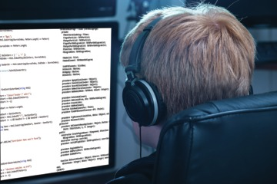
Figure 7
View description - Figure 7

In primary schools, programs tend to be written using simple visual languages such as Scratch, Alice, Logo or Kodu.

3.1 ‘Unplugged’ computing in schools
‘Unplugged’ computing is taught without the use of computers.
The term originates from the Computer Science Unplugged project (Bell et al., 2009) that was based at Canterbury University in New Zealand. The goal was to focus on the development of computational thinking skills, without either the distraction of digital technology or an unintentional focus on learning to program or write code. In the hands-on unplugged classroom, children learn though problem-solving.

Activity 3 Problem solving in context
Allow about 25 minutes

Watch this video of a lesson in which children are exploring how to ‘program’ their teacher. This lesson focuses on supporting learners to construct a simple set of instructions to program a teacher robot to make a jam sandwich.

Watch the video at YouTube.com.
Video 3

What aspects of computational thinking are on display here?

Provide your answer...
View discussion - Part

Now watch this video of a lesson in which children are exploring how numbers can be sorted into order.

Watch the video at YouTube.com.
Video 4

What aspects of computational thinking are on display here?

Provide your answer...
View discussion - Part

These lessons were carried out without any digital technology and show that teaching computing does not require any expensive equipment. In the ‘Jam Sandwich’ video the children can be heard supporting and collaborating with each other as they try to refine or debug the algorithm. They show resilience and a determination to get the algorithm to work. As they program the human robot, they are learning that programming is about giving clear instructions and having someone or something carry out the instructions. It is easy for the children to watch their program being executed in real life and then to evaluate the effectiveness of their algorithm. Humans can make good robots because they can interpret (and misinterpret) natural language instructions. The human robot misinterpretations can add a good deal of humour to a lesson and make the process of debugging entertaining and memorable. This example enables the teacher to quickly and easily demonstrate how much ‘extra’ understanding humans typically bring to such interactions.

3.2 Try out unplugged computing
In the next activity, you will try an unplugged activity for yourself. It has been adapted from the Barefoot Computing Company activity Crazy Character Algorithms (Barefoot Computing, 2014a) and is aimed at introducing algorithms to young children.

Activity 4 Going ‘unplugged’
Allow about 15 minutes

You are going to be asked to follow a set of instructions from an illustrator to draw a particular game character. Carry them out by yourself, without consulting others.
- Draw a circle for the body
- Add two eyes
- Add a crown
- Add wings
- Add legs

View answer - Activity 4 Going ‘unplugged’
View discussion - Activity 4 Going ‘unplugged’

Unplugged activities help children to develop a mental model of how technology works. They will recognise the need for instructions to be clear and precise, at the appropriate level of detail and sufficiently flexible to deal with different but related situations. The focus is on developing an understanding that computing is about logical and creative problem solving. In such activities, children develop their ability to talk about how they are applying computational thinking skills to devise workable solutions. They use their existing knowledge of a system to predict future behaviours. Exploring these concepts in a relatable context, such as making a sandwich or drawing a picture, can be a good way of introducing concepts to children before introducing them to programming software.

4 Learning through exploring and making
Children are usually willing to explore and experiment. Just observe what happens when a very young child is given a tablet or smartphone. This willingness to try things out is key in learning computing. For very young children, playful learning is an essential stage in their development. For older children, play can be a way of understanding how something works and of connecting cause and effect. This process of experimentation and exploration in computing is often referred to as ‘tinkering’ (Barefoot Computing, 2014b). Tinkering is not a mindless exploration; it’s a way for children to construct a mental model of how something works. Children and adults will explore systems (a digital device, a computer program or a game) in different ways, following what interests them, trying things out and making connections.
Computing is a creative subject and is often about making things – a game, a tool, an animation or a robot. In school, helping children to design and make things can be particularly rewarding. Learning to program allows children to become ‘digital makers’. Programming can be described as:

…the process of designing and writing a set of instructions (a program) for a computer in a language it can understand …
(Barefoot Computing, 2014)

Computing at School (2014) describes programming as a two-step process:
- Analysing a problem or task and designing a solution. This process draws on the full range of computational thinking skills (logical reasoning, decomposition, pattern recognition, abstraction, generalisation and evaluation) to design an algorithm to solve or model the problem.
- Translating these ideas to a programming language that a computer can understand. This is ‘coding’ and the instructions that make the program are called ‘code’.
In the next activities you will learn about practical ways of teaching computing in the primary school.

4.1 Navigation and algorithms
Programmable toys such as Bee-Bots can be a good starting point for young children. Bee-Bots are simple devices that can be programmed to move around and can be used in a wide variety of ways, from treasure hunts to storytelling.

Activity 5 Making use of robots
Allow about 25 minutes

Read Kristine Kopelke’s Making your classroom buzz with Bee-Bots: Ideas and Activities for the Early Phase.
What aspects of computational thinking can you identify in some of Kopelke’s examples?

Provide your answer...
View discussion - Activity 5 Making use of robots

4.2 Tinkering and making things
Another way to introduce computational thinking can be through a programming environment such as Scratch. Scratch was created by the Lifelong Kindergarten Group at the IT Media Lab to enable children to create their own interactive stories, games and animations. It was inspired by the work of Papert (Papert, 1980) who suggested that children should be given the opportunity to experiment and explore ideas by tinkering with things. The intention is that learning is self-directed, with children free to tinker and build their own mental model of how the environment works. As they do this, children develop computational thinking and programming skills (Maloney et al., 2010). Using Scratch, children are free to open, explore and ‘see inside’ tens of thousands of programs shared by others and ‘remix’ them, that is, adapt them or use parts of them in any way they like.

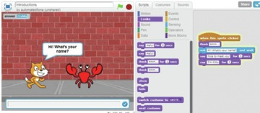
Figure 9
View description - Figure 9

Scratch is a visual programming language in which programs are written by fitting together blocks. The blocks contain individual instructions that program on-screen elements such as characters and objects. In the very simple program shown in Figure 9, the cat character asks the crab character his name and on receiving a reply, introduces herself as Kitty. The program that does this can be seen to the right of the figure. A key feature in the design of Scratch is that you don’t need to have any previous programming experience to use it. You can use it without direct support or guidance. Making it ‘tinkerable’ in this way encourages hands-on learning and supports children to start with simple actions and build complexity. This is often referred to as a bottom-up approach (Maloney et al., 2010).

Activity 6 Using Scratch for programming
Allow about 15 minutes

Watch this video from Carolside Primary School in Scotland. The school felt that there was a gap in their support of programming for their students and so decided to partner with their local high school to devise a programme of study focused on programming using Scratch.

Watch the video at YouTube.com.
Video 5

If you are interested in learning more about Scratch, visit the Scratch website, the Scratch Educators group or access this free 4-week course on Learning to programme with Scratch.

5 This session’s quiz
Now that you’ve completed Session 6, you can take a short quiz to help you to reflect on what you’ve learned.
Session 6 practice quiz
Open the quiz in a new tab or window and come back here when you’ve finished.

6 Summary of Session 6
In this session you learned about computing and why it is important for children to learn about it. You learned about computational thinking, ‘unplugged’ computing and algorithms, and you saw some practical ways of teaching computing in schools.
You should now be able to:
- appreciate computing and its role in the primary curriculum
- understand some ways to support children’s learning of computing
- develop your own skills for computing.
In the next session, you will learn about cross-curricular projects and creative ways to help children’s learning.

Session 7: Creative support for children’s learning

Introduction
You’re into the final two sessions of this course.
You’ve learned about ways to observe and listen to children in primary schools, and about IT and computing in the primary school curriculum. In this session, you will explore creative and cross-curricular learning.
By the end of this session, you should be able to:
- understand cross-curricular thematic planning in primary schools
- recognise cross-curricular links across academic subjects
- identify some creative ways to support children’s learning.

1 Cross-curricular projects
In Session 4, you heard children talking about homework. They said they would like to have homework that is fun and interesting. Children are very likely to say the same about their classroom learning.
In primary schools there is an emphasis on literacy (reading and writing) and numeracy (calculating and number work), but there is also an emphasis on cross-curricular thematic projects or ‘topic’ work, where children learn a number of different curriculum subjects under one theme.
You met teacher Sarah Johnson in Session 3. Watch her now as she talks about cross-curricular work and how she plans it. At the moment, she is teaching a wide range of subjects to 4 and 5 year old children, all linked to the story of Peter Pan.

Video content is not available in this format.
Video 1
View transcript - Video 1

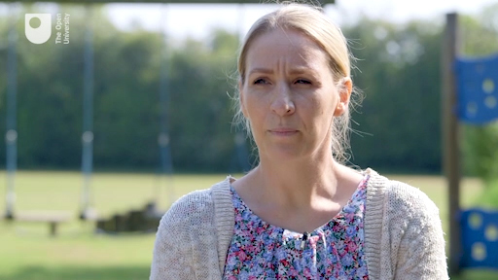

Which curriculum subjects do you think children are learning in the Peter Pan topic and the trip to the sea life centre? Take a moment to jot these down, and then check your ideas with what Sarah says.

Video content is not available in this format.
Video 2
View transcript - Video 2

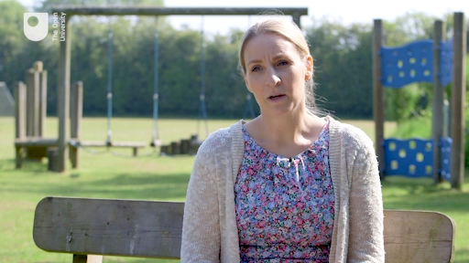

Were you surprised that when Sarah plans play and exploration activities for young children that she has curriculum subjects such as literacy and numeracy in mind, and that she blends different curriculum subjects into children’s play?
Sarah uses a couple of terms that you may not be familiar with:
- PSED stands for Personal, Social and Emotional Development.
- Julia Donaldson is a children’s author.

1.1 One theme, many subjects
Remember in Session 4 you heard headteacher Mark Millinson talk about a homework project on the Egyptians, where children made pyramids at home from recycled materials. As children learned about the ancient Egyptians over several weeks, they covered a range of academic subject areas.


Figure 1
View description - Figure 1

Activity 1 How does cross-curricular learning work?
Allow about 10 minutes

See if you can work out which subjects link to the activities in the theme of ‘Egyptians’. Type your answers into the right-hand column of the table. Some activities may have more than one related subject.

Activities to learn about the Egyptians | Academic subjects
When pyramids were built  How ancient Egyptians lived  The Pharoahs, King Tut, Queen Nefertiti | Provide your answer...
Egypt is on the world map  Egypt’s deserts and rivers  The Nile | Provide your answer...
Timeline of ancient Egypt  Egyptian mathematical and number system  Ancient Egyptian board games | Provide your answer...
Reading information books, historical accounts and diaries of archaeological expeditions, Howard Carter and discovery of Tutankhamun’s tomb  Making information books about Egypt  Writing diaries ‘in role’ as (pretending to be) Howard Carter  Learning hieroglyphics meanings  Rosetta Stone languages and deciphering  Writing own hieroglyphics | Provide your answer...
How bodies are mummified and preserved  Making papyrus  Pyramid forces | Provide your answer...
Egyptian art and monumental statues | Provide your answer...
Making models of pyramids | Provide your answer...
Creating dance and movement based on Egyptian art  Ancient Egyptian sport and games | Provide your answer...
Egyptian deities, rituals and afterlife | Provide your answer...
Exploring the British Museum Egyptian collection online  Listening to archival recording of Howard Carter | Provide your answer...

View discussion - Activity 1 How does cross-curricular learning work?

This is why cross-curricular thematic projects or ‘topic’ work is often referred to as ‘integrated learning’. When children can make connections between subjects, and are involved in their learning through hands-on activities, they are more likely to remember what they have learned.

1.2 Cross-curricular case study
Cross-curricular teaching means children are not learning subjects in isolation. When children see meaningful connections between subjects, they become skilled in applying their learning to different problems and situations, and they have a more holistic experience of learning.

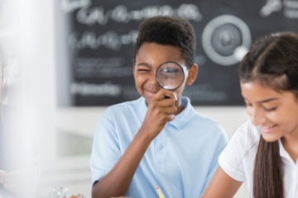
Figure 2
View description - Figure 2

Activity 2 Playful learning
Allow about 20 minutes

Read the account by Deborah Whitehouse, a primary school teaching assistant, about a cross-curricular project in her school. As you read, try to identify the subjects children are learning.

We had a ‘forensic morning’ in our school, a brilliant cross-curricular morning devised by one of our youngest and more creative teachers. The local community police sent three of their officers along for the morning and 90 children (the whole school) had to solve a crime. We roped in a willing parent to don balaclava and swag bag, who proceeded to ‘nick’ a laptop and make a getaway through the playground, dropping clues as she did. The children then spilt into groups and dusted for fingerprints and took casts of footprints and proceeded to eliminate suspects using clever detecting. They produced wanted posters, collected evidence in evidence bags, putting on protective gear in true CSI fashion.
They made their own police notebooks and kept detailed timings and records of evidence found. One child who struggles with handwriting was overheard to say ‘we have to be neat, we can’t use the evidence in court if it isn’t neat writing’. At this moment, I saw this child make the link between what he was learning in school and the ‘real’ world. He saw the point of it all. That’s what a creative curriculum does, makes learning meaningful.

In the make-believe ‘forensic’ activities, children are learning a number of things: some are related to academic subjects, and others are about skills and dispositions (you read about dispositions for learning in Session 3).
Jot down your ideas about the subjects children are learning, and then check your ideas.

Provide your answer...
View discussion - Activity 2 Playful learning

2 Planning and assessing cross-curricular projects
Next you will watch a video on cross-curricular planning.

Activity 3 Observing children in cross-curricular learning
Allow about 15 minutes

The video has several sections, so you can pause and watch at different times.
Listen to how the teachers and headteachers describe their work, and their observations of children. Are you familiar with any of the ideas they talk about, from your own experiences of school or the experiences of children you know?

Video content is not available in this format.
Video 3
View transcript - Video 3

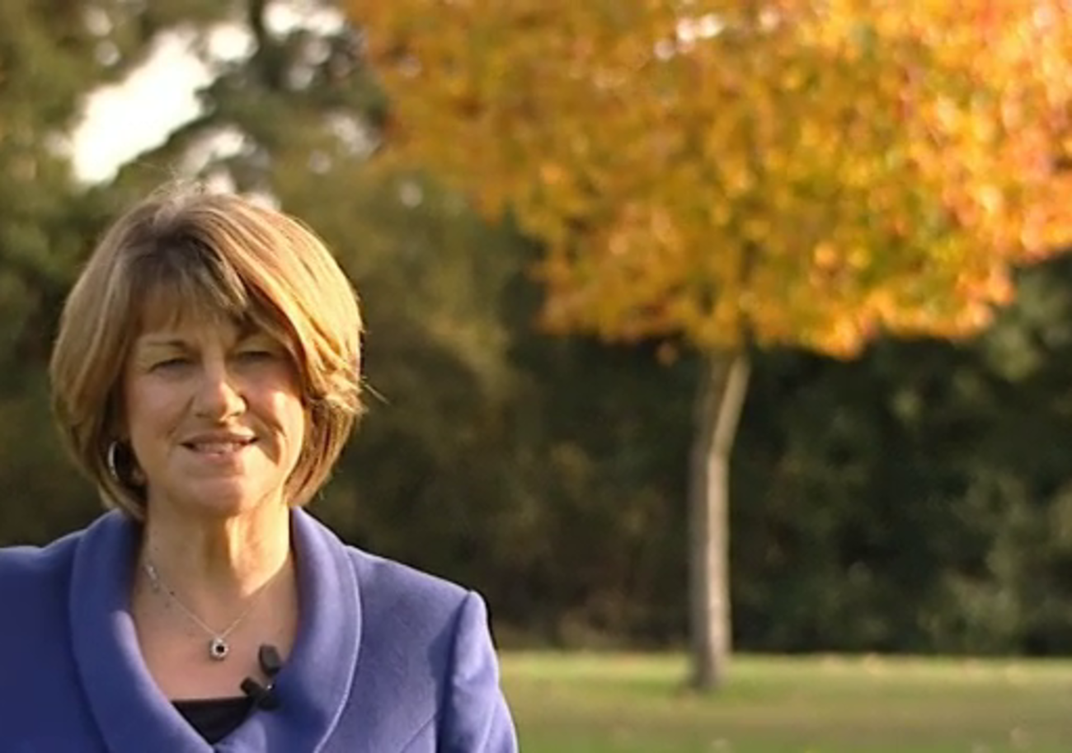

Provide your answer...
View discussion - Activity 3 Observing children in cross-curricular learning

Teacher Sarah Johnson, who you met in Session 3, says an important aspect of cross-curricular projects is that they allow teaching staff to observe and listen to children, and learn what makes them ‘tick’. She also says cross-curricular work lets children take on different ways to learn and participate.

Video content is not available in this format.
Video 4
View transcript - Video 4

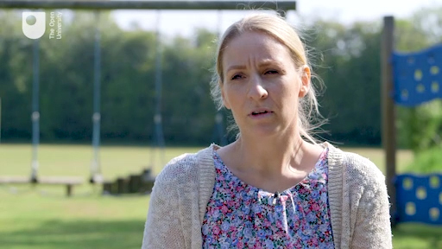

Teachers also talk about the value of shared experiences in topic work, where there is no assumed knowledge, and there is an atmosphere of mutual encouragement where no one is afraid to ask questions.
In the video that you watched, a teacher says it’s a good idea to find out what children know before you begin to teach them anything. These kinds of comments show that adults in primary schools can consider themselves as learners too.
In the next section, you will look at specific aspects of creative support for children’s learning in the primary school and listen to teaching assistants talk about their work.

3 Creative support for children’s learning
In primary schools, creative support for children’s learning is exploratory, imaginative and resourceful. It is an investigative and problem-solving approach to children’s learning which is based on observation and listening.
Read these definitions of creative support. Think about how you have used these kinds of skills, with children or in any other situation.
Practice speculations. These are ‘in-the-moment’ decisions based on first-hand knowledge and understanding of a child’s individual needs, deciding what might work most effectively in specific situations and observing the impact of these decisions. Practice speculations can involve trying something out, based on what you know about a child’s dispositions and development.
Diagnostic thinking. This involves using prior knowledge, observation, evidence and close work with a child to make an informed evaluation of that child’s needs. Diagnostic thinking is possible when you know a child well, and can understand a child’s meaning from verbal and non-verbal cues. Diagnostic thinking enables you to analyse a problem and devise an approach to solve it.
Possibility thinking. Sometimes this is known as ‘blue skies’ thinking, asking ‘what if?’ questions and making genuine investigations. Possibility thinking encourages prediction and improvisation. It involves a shift from ‘What is this?’ to exploration – ‘What can we do with this?’ It is thinking which is open to change and experimentation.
Creative approaches. Creative approaches to supporting learning can involve play, making connections, innovation, being imaginative and sometimes taking risks. Creative approaches value processes as well as outcomes. Creative approaches will involve possibility thinking and encourage self-determination.
Headteacher Mark Millinson says creative support is also about building trust with children, and their families.

Video content is not available in this format.
Video 5
View transcript - Video 5

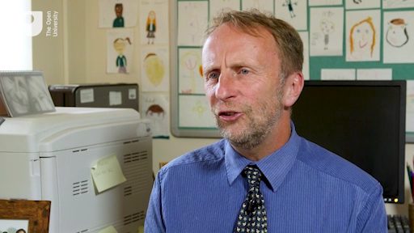

In the next section, you will hear from primary school teaching assistants about how they work with children, individually and in groups. As you watch and listen, think about how these practitioners illustrate what Mark says about building trust with children.

4 Creative support in action
In this video, primary school teaching assistants talk about their work with children.

Activity 4 Adult support for children’s learning
Allow about 20 minutes

You will not hear them use the specific terms ‘creative practice’, ‘practice speculations’, ‘diagnostic thinking’ or ‘possibility thinking’, the terms you have learned about. But as you watch and listen, see if you can apply these concepts to what they say and to their practical work with children.

Video content is not available in this format.
Video 6
View transcript - Video 6

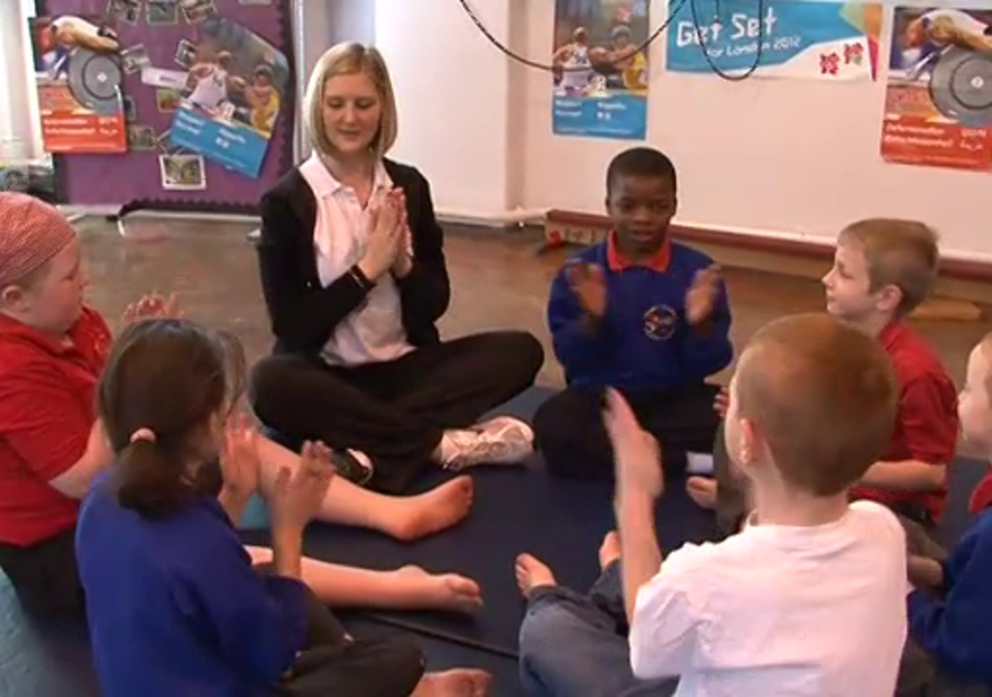

Provide your answer...
View discussion - Activity 4 Adult support for children’s learning

5 This session’s quiz
Now that you’ve complete Session 7, you can take a short quiz to help you to reflect on what you’ve learned.
Session 7 practice quiz
Open the quiz in a new tab or window and come back here when you’ve finished

6 Summary of Session 7
In this session you learned about creative support for children’s learning and basic elements of cross-curricular thematic work in primary schools.
Observing and listening are a big part of creative support for children’s learning. In Session 1 of this course, you heard Professor Alderson talk about ‘co-construction’, and cross-curricular, creative approaches can open possibilities for children to take an active part in their learning with adults.
You should now be able to:
- understand cross-curricular thematic planning in primary schools
- recognise cross-curricular links across academic subjects
- identify some creative ways to support children’s learning.
In the final session of this course, you will look at how adults who work or volunteer in primary schools are learners themselves.

Session 8: Adults and lifelong learning in the primary school

Introduction
You have nearly completed this course. Hopefully this final session will be useful to your thinking and your planning to work or volunteer in a primary school.
In primary schools, we expect children to be learning and developing. What about the adults in school? How are they learning and developing as education workers and professionals?
In this session’s activities, you will explore how you have learned in the past, and how you may be currently learning, whether that’s in your home, the place where you work or volunteer, or in your community.
By the end of this week, you should be able to:
- recognise specific elements of lifelong learning
- understand adult professional learning in the primary school
- develop skills to encourage children to be lifelong learners.

1 A headteacher talks about lifelong learning
For this final session, headteacher Mark Millinson was asked about the learning of adults who work and volunteer in his school. He says he sees many similarities between children and adults as learners.

Video content is not available in this format.
Video 1
View transcript - Video 1

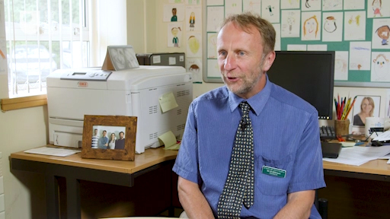

2 Workplace learning
Learning happens in school and outside of school. If you think of yourself as a learner, where do you think you have done the most learning? What learning was most important or memorable to you?


Figure 1
View description - Figure 1

If you have ever learned in a workplace, or ‘on the job’, this probably felt different to how you learned when you were in school. Perhaps it felt more meaningful and motivating. Although you learn as an individual, of course, you are also very likely to learn collaboratively with others in a workplace situation. These may be colleagues who are more experienced than you, or those who share your level of experience. You also learn when you support less experienced adults, or children.
Research (such as Hodkinson and Hodkinson, 2004) has identified four overlapping dimensions to workplace learning:
- Your prior knowledge, understanding and skills.
- Your dispositions (habits of mind, or attitudes, which you learned about in Session 3).
- Your sense of identity and belonging to the workplace community.
- Your opportunities for learning in or through the workplace.
The first two dimensions are what you bring to any new work or volunteer situation. The third and fourth dimensions develop over time as you gain experience as a worker or volunteer.

3 Learning Lives
The Learning Lives project was a large-scale, four year study by the Economic and Social Research Council (ESRC). Its aim was to increase understanding about formal and informal learning. The project involved in-depth interviews with 117 adults, aged between 25 and 85 years. The project took a ‘biographical’ approach by asking adults about their learning biographies and life learning ‘trajectories’ or pathways.


Figure 2
View description - Figure 2

The project found that constructing a ‘life story’ or a ‘life narrative’ is a helpful way to identify what and how you have learned from events in your personal life and in your work life.
The Learning Lives project suggests that a life narrative or a life story has a ‘plot’ that the author (you) uses to select, organise and present life events in a particular order. This order might be as a sequence of events, but it might be presented as a series of themes. In short, constructing a plot enables you to make sense of your life in a coherent way and to identify patterns of learning in your experiences.
Next, you will read a case study from the Learning Lives project.

3.1 A Learning Lives case study
Anne was a participant in the Learning Lives project. She was interviewed six times between 2004 and 2007, during a significant period of change in her life. With her husband and three children, Anne had uprooted in 2002 from one part of the country to another. The Learning Lives project gave Anne the opportunity to tell stories about this life-changing transition.
This reading is in the following sections:
- meet Anne and find out a bit about her
- the themes of Anne’s ‘life story’
- how her life story creates potential for learning
- how her life story creates potential for action and change.

Meet Anne
Anne, aged 38 and married for 16 years, was the mother of a teenage daughter and two infant sons. The family came originally from the urban Midlands of England where Anne had lived all her life until she and her husband decided to move to a village in the rural South West. She came from a close-knit family where she was accustomed to visiting parents, grandparents and sisters regularly and, despite close family ties and an established pattern of life, Anne and her husband took the risks involved in making a major change. They had no previous connection with the village they moved to and yet were willing to leave behind their familiar lives for the sake of living somewhere new that was close to the sea.
When she left school, Anne had trained and worked for several years as a hairdresser. She described herself as being a ‘people person’ who found enjoyment in that profession. In the village and through her son’s primary school, Anne came into contact with the government initiative Sure Start, becoming a volunteer mentor for the scheme. Subsequently she was invited to become ‘parent rep’ for the village at Sure Start organisational meetings and became active in a number of community groups. In time Sure Start employed her as a community development ofﬁcer with responsibility for leading several projects for parents and children. Alongside her workplace learning were elements of formal education, including an NVQ 3 in Early Years Education. When the Sure Start initiative came to an end, Anne continued to be employed by her local authority as a community development ofﬁcer.

Anne’s ‘story’
The ‘plot’ that emerges from Anne’s narrative is of a wife and mother resuming her career after moving to a different part of the country. She presented as a vigorous, active, enthusiastic and sociable person engaged in an exuberant quest to engage in life’s opportunities. Even the interviews were scarcely episodes of quiet reﬂection: she emerged as the epitome of the uninhibited multitasking mother, attending to her toddler, taking care of a pet, dealing with phone calls from work and phone calls about house improvements. She was excited by life and its possibilities and this exuberance characterises her stories about her own life, even when talking about family problems and conﬂicts.
Most striking during the research period was Anne’s resumption of her identity as a woman with a career. This resulted in stories about changes to routines, knowledge and skills and in her physical change. The clue to Anne’s perspective on the existence of a plot in her narrative is contained in the frequently used comment that she sees herself as a ‘people person’. In her new location, becoming a community development worker enables Anne to pursue her interest in people in new ways – going into housing estates and caravans to locate small children and ensuring their carers are aware of their rights and responsibilities. Anne relishes ‘being on a mission’ and meeting the challenge of coordinating people and resources in projects. She loves doing this in a work environment where she can co-operate with others she ﬁnds congenial. However, she has a daily challenge of reconciling her aspirations and preferences with her concerns about her domestic life.

Anne’s learning potential
In early interviews we heard many stories about Anne’s learning as a result of moving to a new home. Some adjustments were material such as how to cope with everyday matters like transport and shopping in a rural area. Others involved the way she related to her husband and children as she started to develop a new sense of identity in her new home and community. We heard of the skills and knowledge she gained from her voluntary and then her employed work for Sure Start. Anne’s stories were of the experiences in which and from which she learned.
During the ﬁnal interview Anne was asked to reﬂect on the experience of taking part in the project and this shifted the quality of her responses, away from a descriptive account to a more reﬂective stance. She commented on what a rare opportunity it had been:

I’ve really enjoyed doing it. I’ve enjoyed doing it because it’s, it’s not very often that somebody sits there and lets you tell them about what you are and what you do and how you do your [pause] how your life has been, has been really.
(Interview 6, June 2007)

It was suggested that perhaps the experience was like talking with friends or with relatives. While she agreed that friends may well get together and reminisce, it was never to the extent that someone talks about themselves at length. She added that family members have so many interests and commitments that they would not listen to each other for long.

Anne’s action potential
There was an embodied manifestation of the changes that Anne had experienced by our ﬁfth interview. Anne had started attending a slimming club and lost three stone in weight. She resembled far more the glamorous young hairdresser featured in photographs in the family home. She spoke of having regained interest in buying new clothes and caring once more about her appearance.
A change in Anne’s approach to telling stories was in the way she reported chronology: in our early interviews, Anne’s sense of time was mainly ‘family-centric’ – she recalled chronology in terms of when things had happened to family members. By the ﬁnal interviews she was ‘organisation-centric’. She said she enjoyed taking part in the interviews and reading the transcripts and found they offered an important insight into herself and the changes she had experienced:

I’m doing more for a starter. I’m completely different in what I do. I’m working now. More conﬁdent in myself as I was three years ago, and more knowledgeable in what I do as well. The different outlook on things, you know, in my work, because I’d only ever been, as I say I’d only ever been a hairdresser.
(Interview 6, June 2007)

However, in the ﬁnal interview Anne communicated some of her underlying anxieties about getting older and the personal costs that were involved in pursuing her job. She said it was a ‘horrible feeling that I’ve no baby in the house anymore’. She was moving beyond her motherhood identity to becoming someone who enjoys being at work and sees it as necessary to fulﬁl herself as a ‘people person’. At the same time she recognises the personal cost of being no longer available for her children in the way she was. Nevertheless her narrative justiﬁes a departure from her established norms and patterns of belief:

I would have been a right miserable bugger or, you know, I don’t know how I’d have been. So life takes you in such funny ways you never know what’s there… so just go with it.
(Interview 6, June 2007)

Learning through reflection
The case study of Anne illustrates that the act of putting together a longitudinal version of your life story offers you a chance to learn about yourself. The Learning Lives project researchers say that the ‘stories’ you tell about yourself can have a big impact on how you see yourself as a learner and how you make choices as a learner:

Perhaps our most signiﬁcant ﬁnding is that the differences between the stories people tell about their lives do indeed connect with ways in which people learn from their lives and that such learning affects how they conduct their lives. This not only suggests that life-stories and life-storying are important ‘vehicles’ or ‘sites’ for learning from life. It also suggests that the differences between stories matter for such learning.
(Tedder and Biesta, 2008, p. 26)

4 Learning lives in the primary school
In the video that you will watch in a moment, the following six people talk about how they came to be in their roles in a primary school and how they continue to learn 'on the job':
- Vicky, a teaching assistant who is also training to be an occupational therapist
- Tina, a higher level teaching assistant (HLTA), who began working in the primary school after her own children had started school
- Jean, a pupil support assistant, who also began work in a school after being a full-time mum for many years
- Hugh, a grandparent and retired police janitor, who helps with Primary 1 children, especially the younger children who sometimes require a bit more support
- Lucy, a teaching assistant who used to work in a supply capacity in schools, often having to learn on the spot
- Pam, a volunteer parent studying for a teaching assistant certificate and with a particular interest in special needs.

Activity 1 Different starting points for learning
Allow about 20 minutes

As you watch and listen to these six people talk about their backgrounds and their learning lives, think about the questions that follow.

Video content is not available in this format.
Video 2
View transcript - Video 2

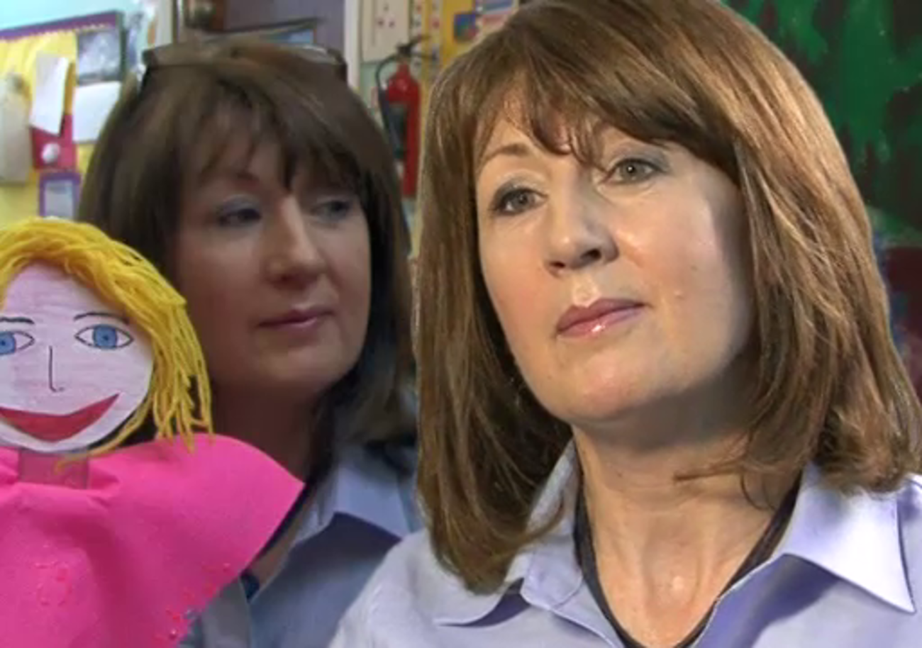

- What kinds of formal learning can you identify in the teaching assistants’ comments?
- What kinds of informal learning can you identify?
- What knowledge, skills and understanding have the teaching assistants developed through formal and informal learning?
- How do the teaching assistants apply their learning to their current jobs in the schools?
- How are they continuing to learn in their workplaces? What knowledge, skills and understanding are they developing in their current roles?
- Linking to the reading you did earlier about Anne and the Learning Lives project, can you identify how each of the teaching assistants creates a ‘story’ about her or his learning?

Provide your answer...
View discussion - Activity 1 Different starting points for learning

5 Children and adults learning together
Good teachers and education workers know that they don’t have all the answers all the time, so it’s important to see yourself as a learner if you want to support the learning of children.
Headteacher Mark Millinson says adults who see themselves as curious, lifelong learners will be able to help children develop these dispositions for learning.

Video content is not available in this format.
Video 3
View transcript - Video 3

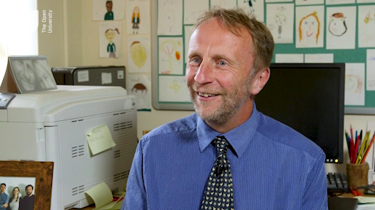

In the final sections of this session, you will begin to sketch your own learning life story.

6 Sketch your learning life story
Have a go and start to construct your own learning life narrative.

Activity 2 Developing your profile
Allow about 25 minutes

Thinking about what you have read and seen so far, answer the following questions. Please note that some of the questions refer to a ‘workplace’, but these questions can equally apply to what you do in your home or in your community.
Now write a short paragraph about your learning life. Where did you learn, when, why and how? Describe your journey. What have you noticed? What are the key elements of your ‘plot’?
- How does your current role influence the ways in which you create or access opportunities for your own learning and development?

Provide your answer...

- What prior skills, knowledge and understanding do you have in your current role that you could bring to a primary school?

Provide your answer...

- How does your thinking and behaviour influence the life of your home, your current workplace or your community?

Provide your answer...

- How does the home, workplace or community (people, ways of working, relationships) influence how you see yourself?

Provide your answer...
View discussion - Part

7 This session’s quiz
Congratulations on almost reaching the end of the course.
It’s now time to complete the Session 8 badge quiz. It is similar to the badged quiz that you took at the end of Session 4, with 15 questions in total.
Session 8 compulsory badge quiz
Open the quiz in a new tab or window and come back here when you’ve finished.

8 Summary of Session 8
In this final session you explored lifelong learning and how adults in primary schools are learners as they support children and work alongside children.
You should now be able to:
- recognise specific elements of lifelong learning
- understand adult professional learning in the primary school
- develop skills to encourage children to be lifelong learners.
Hopefully you have enjoyed this badged course on observing and listening to children in the primary school.
Good luck in developing your future career.

Where next?
If you’ve enjoyed this course you can find more free resources and courses on OpenLearn.
New to University study? You might be interested in our courses on education studies.
Making the decision to study can be a big step and The Open University has over 40 years of experience supporting its students through their chosen learning paths. You can find out more about studying with us by visiting our online prospectus.

Tell us what you think
Now you’ve come to the end of the course, we would appreciate a few minutes of your time to complete this short end-of-course survey (you may have already completed this survey at the end of Session 4). We’d like to find out a bit about your experience of studying the course and what you plan to do next. We will use this information to provide better online experiences for all our learners and to share our findings with others. Participation will be completely confidental and we will not pass on your details to others.

References
Alderson, P. (2003) ‘Institutional rites and rights: a century of childhood’ (inaugural lecture), London, Institute of Education.
BERA (2018) Ethical Guidelines for Educational Research, London, British Educational Research Association.
Department for Education (2014) Keeping Children Safe in Education, London, DfE.
Department for Education and Science (1975) A Language for Life (The Bullock Report), London, DES.
Her Majesty’s Government (2004) Children Act 2004, London, HMSO.
Malaguzzi, L. (1993) The Hundred Languages of Children: The Reggio Emilia Approach to Early Childhood Education, New Jersey, Ablex Publishing Corporation.
Ofsted (2015a) Inspecting Safeguarding in Maintained Schools and Academies, London, Ofsted.
Ofsted (2015b) Working Together to Safeguard Children, London, Ofsted.
Safford, K. and Barrs, M. (2005) Many Routes to Meaning: Children’s Language and Literacy Learning in Creative Arts Projects, London, Centre for Liberary in Primary Education.
United Nations (1989) Convention on the Rights of the Child. See the child-friendly version: https://www.unicef.org/rightsite/files/uncrcchilldfriendlylanguage.pdf (Accessed 6 November 2019).
Learning Through Landscapes (2013) The Good School Playground Guide: Developing School Playgrounds to Support the Curriculum and Nurture Happy, Healthy Children, Edinburgh, Scottish Government Grounds for Learning.
Pearce, G. and Bailey, R. (2011) ‘Football pitches and Barbie dolls: young children’s perceptions of their school playground’, Early Child Development and Care, vol. 181, no. 10, pp. 1361–1379.
Northern Ireland Council for Curriculum, Examinations and Assessment (2007) Enriched Curriculum, Belfast, NICCEA.
Varkey Foundation (2018) Global Parents’ Survey 2018, London, Varkey Foundation.
Alexander, R. (ed.) (2010) Children, Their World, Their Education: Final Report and Recommendations of the Cambridge Primary Review, Abingdon, Routledge.
ATC21S (2012) Home page [Online]. Available at http://www.atc21s.org/ (Accessed 7 May 2019).
Binkley, M., Erstad, O., Herman, J., Raizen, S., Ripley, M., Miller-Ricci, M. and Rumble, M. (2012) ‘Defining twenty-first century skills’, in Griffin, P. and Care, E. (eds) Assessment and Teaching of 21st Century Skills, Dordrecht, Springer.
Burnett, C. (2016) ‘The Digital Age and its Implications for Learning and Teaching in the Primary School, Cambridge Primary Review Trust’ [Online]. Available at http://cprtrust.org.uk/wp-content/uploads/2016/07/Burnett-report-20160720.pdf (Accessed 4 June 2019).
Dezuanni, M. (2015) Tapping into kids’ passion for Minecraft in the classroom [Online]. Available at https://theconversation.com/tapping-into-kids-passion-for-minecraft-in-the-classroom-43461 (Accessed 1 October 2018).
Graham, J. and Kelly, A. (eds) (2010) Writing Under Control (3rd edn), London, Routledge, pp. 34–5.
Hague, C and Payton, S. (2010) Digital Literacy across the Curriculum, Bristol, Futurelab [online]. Available at https://www.nfer.ac.uk/publications/FUTL06/FUTL06.pdf (Accessed 15 August 2019).
Holloway, D., Green, L. and Livingstone, S. (2013) Zero to Eight. Young Children and Their Internet Use, London, LSE, London, EU Kids Online [Online]. Available at http://eprints.lse.ac.uk/52630/1/Zero_to_eight.pdf (Accessed 4 June 2019).
ITL Research (2011) Innovative Teaching and Learning Research: 2011 Findings and Implications [Online]. Available at https://www.european-agency.org/sites/default/files/itlresearh2011findings.pdf (4 June 2018)
Marsh, J. (2010) ‘Young children’s play in online virtual worlds’, Journal of Early Childhood Research, vol. 8, no. 1, pp. 23–39.
Merchant, G. (2013) ‘The trashmaster: literacy and new media’, Language and Education, vol. 27, no. 2, pp. 144–60.
Ofcom (2017) Children and Parents: Media Use and Attitudes Report [Online]. Available at https://www.ofcom.org.uk/__data/assets/pdf_file/0020/108182/children-parents-media-use-attitudes-2017.pdf (Accessed 4 June 2019).
Safford, K. and Barrs, M. (2005) Creativity and Literacy: Many Routes to Meaning, London, Centre for Literacy in Primary Education, p. 83
Twining, P. (2013) ‘ICT is dead – long live ICT’ [Online]. Available at http://www.edfutures.net/ICT_is_dead_-_long_live_ICT (Accessed 7 May 2019).
University of Edinburgh (2016) Digital Education, Election Briefing 2 [Online]. Available at https://www.ed.ac.uk/files/atoms/files/electionbriefing2-digital-education-29-03-16.pdf (Accessed 4 June 2018)
Barefoot Computing (2014a) ‘Crazy Character Algorithms Activity: An introduction to sequences of instructions’ [Online]. Available at https://barefootcas.org.uk/programme-of-study/understand-algorithms/ks1-crazy-character-algorithms-activity/ (Accessed 13 June 2019). Please note that you need to register to access this.
Barefoot Computing (2014b) ‘Tinkering’ [Online]. Available at: https://barefootcas.org.uk/barefoot-primary-computing-resources/computational-thinking-approaches/tinkering/ (accessed 18 June 2019). Please note that you need to register to access this.
Bell, T., Alexander, J., Freeman, I. and Grimley, M. (date) ‘Computer Science Unplugged: school students doing real computing without computers’ [Online]. Available at http://grorichome.dyndns.org/oldsite/groricorssgoo/web/pdf/unplugged.pdf (Accessed 10 June 2019).
Berners-Lee, T. (n.d.) ‘Answers for Young People’ [Online]. Available at https://www.w3.org/People/Berners-Lee/Kids.html (accessed 14 June 2019)
Bruner, J. (1996) Towards a Theory of Instruction, Cambridge, MA, Harvard University Press.
Computing at School (2013) ‘Computing in the national curriculum: A guide for primary teachers’ [Online]. Available at http://www.computingatschool.org.uk/data/uploads/CASPrimaryComputing.pdf (Accessed 18 June 2019)
Computing at School (2014) ‘Programming’ [Online]. Available at http://community.computingatschool.org.uk/files/8222/original.pdf (Accessed 16 June 2019)
Csizmadia, A., Curzon, P., Dorling, M., Humphreys, S., Ng, T., Selby, C. and Woollard, J. (2015) ‘Computational Thinking: A guide for teacher’ [Online]. Available at http://community.computingatschool.org.uk/files/8550/original.pdf (Accessed 10 June 2019)
Department for Education (2013) ‘Computing programmes of study: key stages 1 and 2’ [Online]. Available at https://assets.publishing.service.gov.uk/government/uploads/system/uploads/attachment_data/file/239033/PRIMARY_national_curriculum_-_Computing.pdf (Accessed 2 July 2019).
Education Scotland (2013) ‘Curriculum for excellence: Technologies: Principles and practice’, © Crown Copyright. Contains public sector information licensed under the Open Government Licence v3.0 [online]. Available at https://education.gov.scot/Documents/technologies-pp.pdf (Accessed 16 June 2019)
Euractiv (2015) ‘Coding at school: How do EU countries compare?’ [Online]. Available at https://www.euractiv.com/section/digital/infographic/infographic-coding-at-school-how-do-eu-countries-compare/ (accessed 10 June 2019)
House of Commons Science and Technology Committee (2016) ‘Digital skills crisis, House of Commons, 13 June 2016’. Available at https://publications.parliament.uk/pa/cm201617/cmselect/cmsctech/270/270.pdf (accessed 6 November 2019)
Liukas, L. (2015) ‘A delightful way to teach kids about computers’ [Online]. Available at https://www.ted.com/talks/linda_liukas_a_delightful_way_to_teach_kids_about_computers (accessed 18 June 2019).
Livingstone, I. and Hope, A. (2011) ‘Next Gen. Transforming the UK into the World’s Leading Talent Hub for the Video Games and Visual Effects Industries, NESTA’ [Online]. Available at: https://media.nesta.org.uk/documents/next_gen_wv.pdf (Accessed 6 June 2019).
Maloney, J., Resnick, M., Rusk, N., Silverman, B. and Eastmond, E. (2010) ‘The Scratch programming language and environment’, ACM Transactions on Computing Education (TOCE), 1 November 2010, vol. 10, no. 4, pp. 1–15.
Naughton, J. (2012) ‘Why all out kids should be taught how to code’, The Guardian [online). Available at https://www.theguardian.com/education/2012/mar/31/why-kids-should-be-taught-code (Accessed 17 June 2019)
Papert, S. (1980) Mindstorms: Children Computers and Powerful Ideas, Brighton, UK, Harvester Press.
Piaget, J. (1950) The Psychology of Intelligence, Cambridge, MA, Harvard University Press.
The Royal Society (2012) Shut Down or Restart? The Way Forward for Computing in UK Schools [Online]. Available at https://royalsociety.org/~/media/education/computing-in-schools/2012-01-12-computing-in-schools.pdf (Accessed 7 May 2019).
Sentence, S. and Csizmadia, A. (2017) ‘Computing in the curriculum: Challenges and strategies from a teacher’s perspective’ [online]. Available at https://link.springer.com/article/10.1007/s10639-016-9482-0 (Accessed 7 May 2019).
Wing, J. (2006) ‘Computational thinking’, Communications of the ACM, vol. 49, no. 3 [Online]. Available at https://www.cs.cmu.edu/~15110-s13/Wing06-ct.pdf (Accessed 6 November 2019).
Barnes, J. (2015) ‘An introduction to cross-curricular learning’, in Driscoll, P., Lambirth, A. and Roden, J. (eds) The Creative Primary Curriculum [Online]. Available at https://www.researchgate.net/publication/274313611_An_Introduction_to_Cross-Curricular_Learning (Accessed 7 June 2019).
Jeffrey, B. and Craft, A. (2004) ‘Teaching creatively and teaching for creativity: distinctions and relationships’, Educational Studies, vol. 30, no. 1, pp. 77–87 [Online]. Available at https://oro.open.ac.uk/425/2/CT-TFC-Final-Ed_Studies.pdf (Accessed 7 June 2019).
Hodkinson, H. and Hodkinson, P. (2004) ‘Rethinking the concept of community of practice in relation to schoolteachers’ workplace learning’, International Journal of Training and Development, vol. 8, no.1, pp. 21–31.
Tedder, K. and Biesta, G. (2008) adapted from the original paper ‘Learning without teaching? Opportunities and limitations in biographical learning for adults’, written for the European Conference ‘Educational Research from Teaching to Learning?’ in Gothenberg, Sweden, 10–12 September 2008. In Safford, K., Stacey, M. and Hancock, R. (2011) Small-scale Research in Primary Schools: A Reader for Learning and Professional Development, London, Routledge in association with The Open University.

Acknowledgements
This free course was written by Kimberly Safford. It was first published in December 2019.
Except for third party materials and otherwise stated (see terms and conditions), this content is made available under a Creative Commons Attribution-NonCommercial-ShareAlike 4.0 Licence.
The material acknowledged below is Proprietary and used under licence (not subject to Creative Commons Licence). Grateful acknowledgement is made to the following sources for permission to reproduce material in this free course:

Introduction and guidance
Course image: © bowdenimages/iStock

Session 1
Figure 1: DGLImages/iStockphoto.com
Figure 2: maximkabb/iStockphoto.com
Figure 3: kali9/iStockphoto.com
Figure 4: AndreyPopov/iStockphoto.com
Figure 5: kyoshino/iStockphoto.com
Figure 6: dragana991/iStockphoto.com
Figure 7: Steve Debenport/iStockphoto.com
Figure 8: PeopleImages/iStockphoto.com

Session 2
Extract from: ‘Football pitches and Barbie dolls: young children’s perceptions of their school playground’; Dr Gemma Pearce and Richard Bailey
Figure 1: bowdenimages/iStockphoto.com
Figure 2: SolStock/iStockphoto.com
Figure 3: JohnnyGreig/iStockphoto.com
Figure 4: SolStock/iStockphoto.com
Figure 5: bowdenimages/iStockphoto.com
Figure 6: SolStock/iStockphoto.com
Figure 7: olga_sweet/iStockphoto.com

Session 3
Figure 1: bowdenimages/iStockphoto.com
Videos 4, 5 and 6: taken from: http://archive.teachfind.com/ttv/www.teachers.tv/videos/uncut-classrooms-maths-a-lesson-on-shapes.html

Session 4
Figure 1: Imgorthand/iStockphoto.com
Figure 3: Fat Camera/iStockphoto.com

Session 5
Figure 1: pixabay.com/Pexels; Alexandr Borecky/Pexels; pixabay.com/Pexels; Clem Onojeghuo/Pexels
Figure 2: Children and Parents: Media Use and Attitudes Report 29 November 2017; © Ofcom
Figure 3: sturti/iStockphoto.com
Figure 4: dolgachov/iStockphoto.com
Figure 5: (a) SolStock; iStockphoto.com (b) dolgachov; iStockphoto.com (c) Ridofranz; iStockphoto.com (d) mikkelwilliam; iStockphoto.com
Figure 6: da-kuk/iStockphoto.com
Figure 7: Kevin Jarrett; flickr; https://creativecommons.org/licenses/by/2.0/
Figure 8: Assessment and Teaching of 21st Century Skills ; https://creativecommons.org/licenses/by-nc-nd/4.0/
Figure 9: Victoria Borodinova; Pexels; Sharon McCutcheon; Pexels; Anni Roenkae; Pexels; Sasha Martynov; Pexels
Figure 10: taken from: Graham, J. and Kelly, A. (eds) (2010) Writing Under Control (3rd edn), London, Routledge, pp. 34–5.
Videos 1 and 3: TED; https://creativecommons.org/licenses/by-nc-nd/4.0/
Video 5: courtesy of Bridgewater Primary School

Session 6
Figure 1: Geber86/iStockphoto.com
Figure 2: davidf/iStockphoto.com
Figure 3: shironosov/iStockphoto.com
Figure 4: monsitj/iStockphoto.com
Figure 5: taken from: https://barefootcas.org.uk/barefoot-primary-computing-resources/concepts/computational-thinking/
Figure 6: TfL from the London Transport Museum collection; http://www.ltmuseum.co.uk
Figure 7: Andrey_Popov/Shutterstock.com
Video 1: Code.org; https://creativecommons.org/licenses/by-nc-sa/4.0/
Video 3: courtesy of Philip Bagge
Video 4: UC Computer Science Education; https://creativecommons.org/licenses/by-sa/4.0/
Video 5: © Crown Copyright http://www.nationalarchives.gov.uk/doc/open-government-licence/version/3/

Session 7
Figure 1: karimhesham/iStockphoto.com
Figure 2: Steve Debenport/iStockphoto.com
Video 3: courtesy of Teachers Media International

Session 8
Figure 1: jeffbergen/iStockphoto.com
Figure 2: Michail_Petrov-96/iStockphoto.com
Every effort has been made to contact copyright owners. If any have been inadvertently overlooked, the publishers will be pleased to make the necessary arrangements at the first opportunity.
Don't miss out
If reading this text has inspired you to learn more, you may be interested in joining the millions of people who discover our free learning resources and qualifications by visiting The Open University – www.open.edu/openlearn/free-courses.

Activity 1 The focus of observations

Discussion
When children are at school, Alderson says, they are immersed in an adult-controlled world. She refers to the Italian educationalist Loris Malaguzzi (1920–1994) who said that children have ‘one hundred languages, a hundred thoughts, a hundred ways of listening, marvelling, loving, singing and understanding’. Alderson argues that, too often, schools take away children’s joy and their innate abilities to wonder and to explore. Alderson points out that, as learners, children and adults are the same because, whether we are young or old, we prefer to learn voluntarily rather than being forced to learn.
Alderson talks about how much children value their teachers, and how children and teachers can ‘co-create’ learning when teachers treat children as people rather than ‘puppets’. Co-creation involves collaboration, with children having more input and decision-making in the learning process. Adults who listen to children can find out what children understand and feel, what they already know and what they want to learn.
It is unlikely that school will become non-compulsory for children, but Alderson is arguing for greater awareness of how children experience school. Observation and listening can help you to become more aware.
Back to - Activity 1 The focus of observations

Activity 2 Observing children drawing pictures

Discussion
The girls give running commentaries as they see ideas in their heads become reality on paper, and talking together seems to help them carry out the work. They make frequent evaluative comments on each other’s work and on their own work, and Mia also offers information about her family life, her language and her summer plans. The children concentrate on the technical demands of the task, and reveal their awareness of techniques they could use. They are confident about fixing any mistakes, and they are aware of what is ‘correct’. They also refer to their previous learning. They are working independently – asking and answering their own questions without going to the teacher. The transcript highlights the amount of self-evaluation, learning and reflection which goes on as children play, talk and work.
Back to - Activity 2 Observing children drawing pictures

Activity 3 Observing children who use English as an additional language

Discussion
In this conversation, the adult is not directing the children and talking ‘at’ them but is working alongside and talking with them. The activity itself (painting farm animals) sustains a discussion where children talk at length about something that is of direct interest to them; they are not answering ‘closed’ (‘yes’ or ‘no’) questions, and so they have opportunities to produce and use spoken English in a meaningful, relevant way. The collaborative activity creates a space where the children and the adult can ask each other questions and learn about one another. Notice that Boy 1 asks about whether there was paint in the ‘olden’ days. He learned that English word in classroom storytelling sessions.
Back to - Activity 3 Observing children who use English as an additional language

Activity 4 Safeguarding issues

Discussion
Safeguarding can involve a range of potential issues such as:
- bullying, including cyberbullying (by text message or on social networking sites) and prejudice-based bullying
- racist, homophobic or transphobic abuse
- disabilities
- radicalisation and extremist behaviour
- child sexual exploitation
- sexting
- substance misuse
- issues that may be specific to a local area or population, for example gang activity and youth violence
- particular issues affecting children including domestic violence, sexual exploitation, female genital mutilation and forced marriage.
Back to - Activity 4 Safeguarding issues

Activity 5 How a teacher follows BERA guidelines

Discussion
Denise has made an informal, semi-structured interview schedule which is appropriate for parents and children. She explains the purpose of the interviews to parents and children so she can have their informed consent for the process. She also tells children how she will record the interviews, and lets them know that they do not have to participate if they don’t want to. Although Denise does not refer to privacy, she is clear that the interviews are for her professional understanding and not for wider publication.
Denise tries to ask about experiences and behaviours before she asks questions about opinions or feelings. She makes sure she is asking ‘open’ questions that do not have a single ‘yes’ or ‘no’ answer. This helps children or adults to express themselves, and children and parents can respond in their own words. She includes a way for children to answer a question visually, using illustrations. Denise also starts from her own observations, using phrases such as ‘I noticed…’ and ‘I saw…’. This allows the interview to feel more informal and conversational, and balanced between the participants.
The phrase ‘tell me’ is always a useful beginning for a question that will help children and adults to speak freely. Her lists of questions are not long, giving time for children and parents to respond thoughtfully and without pressure. Over the course of a semi-structured, informal, conversational interview, Denise might find out other things that could help her teach the children more effectively.
Back to - Activity 5 How a teacher follows BERA guidelines

Activity 2 Observing a playground

Discussion
The seemingly disorganised sounds that arise from playgrounds are not unlike the cacophony of sound that can be heard on a crowded beach. The detail of what is being said, and the reasons for individual interactions, will change over the years but the ‘chorus’ of combined and disparate sounds is timeless.
The children in the video that you watched seem to use all of the available space in the two play areas, tarmac and field. They have freedom and space to run and climb, and play team games. There are also quiet spaces, and a semi-wild woodland area. In the video sequence, you can hear a child ask ‘Can I play?’ and later you can hear children singing. The adults are circulating and watching, not participating in children’s activities but ready to step in if necessary.
One benefit of playtime is that children of different ages can mix, and you may have noticed children playing a game at a table with older boys from a local secondary school who are acting as playground helpers.
Back to - Activity 2 Observing a playground

Activity 5 The views of two playtime supervisors

Discussion
The two playtime supervisors talk about how they observe children’s moods and feelings as they come out of the classrooms for playtime. They adjust their playtime plans and activities based on their observations. They encourage children to participate, share and respect one another. They emphasise that children must trust the adults in the playground and see the adults as impartial and fair.
Back to - Activity 5 The views of two playtime supervisors

Activity 6 Evaluating a playground space

Discussion
The two playgrounds – field and tarmac – are very different in what they offer for children’s play, and aesthetically they are very different in look and feel.
The field area seems to present more possibilities and non-prescriptive features, such as the wild area and the open grass areas. The tarmac playground has markings which are fixed and suggest what children could do, for example, ‘hop on one foot’. These markings seem to offer scope for involvement, and might help children who are unsure what to play on their own or with friends. Children could also take these actions elsewhere, for instance to the field area, and improvise on them. The tarmac markings also encourage children to read and use language in their play.
Both spaces have fixed elements: the tarmac area has ground markings and a climbing wall, and the field has climbing apparatus and benches for children to sit comfortably. Neither area, on the day of filming, had ‘loose materials’ as described by Learning Through Landscapes, although some children have skipping ropes, and there is a table top game and football with pitches.
Both areas encourage locomotor play for girls and for boys. They run freely, walk, skip, and many of them talk as they play. The climbing frame and wobbly bridge seem to encourage gathering and chat. Adults are very present, but standing back and observing.
Back to - Activity 6 Evaluating a playground space

Activity 1 Children learning from song

Part

Discussion
You can easily observe and listen to children when they are doing something they enjoy and are interested in. Even when something is difficult for children to do, they will keep at it if they are enjoying the challenge.
Back to - Part

Activity 2 Observing ‘Kevin’

Discussion
What you have done is sometimes called ‘naturalistic’ observation. You looked carefully and jotted down your impressions of the child’s attitudes, actions and behaviours. You used some criteria to guide your observation – you weren’t looking at everything, but at the child’s dispositions for learning. Your notes may have been words or phrases, or even drawings, to record what you saw.
The video you watched is an interesting observation of a child who has been identified as gifted and talented. He shows concentration, focus and perseverance in the drawing task, looking carefully and for long periods of time. He seldom speaks. When he does talk it is either to the teacher or to the child sitting next to him. By way of context, other children in the classroom (who you do not see in the video) chat and laugh quietly with each other as they do the drawing activity.
Kevin appears to be a confident and independent learner, and he shows considerable stamina in sustaining the drawing task. But he also shows some insecurity, and perhaps even some anxiety, checking with the teacher to make sure he has understood what to do and that he is doing it correctly. The teacher asks him if he feels confident and reassures him. He is cautious and careful in his drawing, working silently. He looks intently at the image of the snake’s skin, projected onto a screen, and asks the teacher to clarify the instructions for making the drawing. At one point, he shows a great deal of patience, keeping his hand raised for over two minutes, waiting for the teacher to respond, and he asks the teacher what the drawing is meant to look like. He draws with very small, precise movements, using a tiny corner of his art sketchbook. He looks at the projection of the live snake, the teacher’s drawing on the whiteboard, and at his own sketchbook, making connections between these three sources. The teacher encourages him to make some of his drawing larger, and comments that he is very methodical. Towards the end of the lesson, he looks at his friend’s drawing and chats with the friend about it. When he is allowed to hold the snake in his hands, he smiles with pleasure.
Back to - Activity 2 Observing ‘Kevin’

Activity 3 Observing ‘Jack’

Discussion
- 4 (00:00 – 00:08)
- 1 (00:08 – 00:53)
- 2 (00:53 – 00:58)
- 3 (00:58 – 01:12)
- 1 (01:12 – 01:25)
- 2 (01:27 – 02:23)
The codes present Jack as working mainly on his own, or in one-to-one interaction with his teacher. These two codes cover the majority of the time in the video. Jack appears persistent and focused on the number activity, moving between the numbers on the board to his worksheet. His teacher describes him as independent and wanting to do things his own way.
Although Jack interacts with his teacher, he does not always look directly at her when he listens and answers her questions. This could mean that he is easily distracted, or that he is not interested in what she is saying. He answers her questions quickly and briefly.
There is one instance in the video where Jack makes his own, unprompted comment in conversation with his teacher. He notices similarities between the number 9 and the letter q (‘quarrelsome queen’ – from a commercial phonics (letters and sounds) scheme). You can also see Jack make this type of comparison when he sits next to another child and notices where an insect’s antenna should go and says a letter card looks like ‘bouncy bear’ (from the alphabet scheme).
Back to - Activity 3 Observing ‘Jack’

Activity 4 Observing a whole class

Part

Discussion
Observing a whole class can be a challenge. There is so much going on, with different groups doing different activities.
The teacher has organised the whole class into ability groups and given each group a different activity. Children are grouped by ability, and it seems that the more able groups are named for more complex shapes: pentagons and hexagons. A teaching assistant is working with one group but we do not see her. There are differentiated tasks: some groups are writing, and other groups are constructing, sorting and matching.
The teacher’s goal is to observe children using the correct vocabulary to describe 2d and 3d shapes. She also says that she wants to see the children working independently. The teacher moves around the classroom throughout the lesson, checking on each group’s progress and giving extra work to those who finish quickly. The teacher is very much in charge of the lesson, but she also talks to the children in a kind and warm way. She never raises her voice.
The children show persistence, independence and confidence in the tasks that the teacher has set. They follow her instructions and move as and when she directs them.
The video sequence shows the teacher teaching, but how much can you tell from the video about children’s learning? The teacher does almost all of the talking, and directs all of the activities. The teacher is observing how much children use specific vocabulary, but she admits herself at the end of the lesson that many children found their activity too easy.
Although the children are not all doing the same activity – some are writing, others are making shapes – we do not gain insights into how they feel about their tasks. The children are allowed to talk quietly to each other as they work, and it would be interesting to know whether they are talking about shapes or about something else.
Imagine you could sit at a table with one group of children in this lesson and ‘eavesdrop’ on their talk as they do what the teacher is asking them to do. You would get a fuller picture of their learning and their understanding. Remember the Session 1 transcripts of Mia and Sarah, and the Portuguese children, and what you found out about them as they worked on tasks set by their teachers.
In the maths lesson on 2d and 3d shapes, you can get an occasional glimpse of what children know and understand. For instance, when a child says to the teacher that a right angle is ‘like an L-shape’, it shows the child can make visual comparisons and can see similarities and patterns, and knows alphabet letters. When another child names his shape ‘Michael’ for Michael Jackson, he shows humour, imagination and creativity, as well as his knowledge of popular music and culture.
Back to - Part

Activity 1 What do children tell us about homework?

Discussion
The children have positive and negative views about their homework. They dislike it because it puts them under pressure and it can be stressful. Homework also takes away from leisure activities and time with family. But they also acknowledge that homework is beneficial because it helps them to feel more confident that they understand their school work, and it might help children who are struggling with school learning.
One boy notes that homework should be more fun and interesting to do. In the next activity you will look at some examples of creative homework.
Back to - Activity 1 What do children tell us about homework?

Activity 2 What are they learning?

Discussion
The girl who bakes cookies at home is learning maths (measuring, weighing, timing), science (combining ingredients and changing their properties from liquid to solid) and literacy (reading the recipe). Other homework the children talked about covered some of these curriculum subjects:
- Design a board game: maths and art.
- Nature walk: science, geography and sustainability.
- Fit body through piece of A4 paper: design and technology.
The homework to make a board game and fit your body through a piece of A4 paper also develops problem-solving skills and creative thinking. The homework to do a nature walk develops appreciation of the environment and observational skills.
This kind of homework also seems to increase children’s enjoyment of learning and of school. The children in the video seem to take a lot of interest and pride in their homework tasks. This kind of homework can be fun for parents, too, because they can have interesting conversations with children as they help.
Back to - Activity 2 What are they learning?

Activity 1 What technologies are children using?

Discussion
The range of devices available to children in the home is ever-growing, but can include: smartphones, tablets, laptops, desktop computers, ebook readers, smart TVs, games consoles and smart speakers that channel voice assistants such as Alexa, Google Assistant, Siri or Cortana. There are also ‘embedded’ devices such as microwaves, central heating systems, dishwashers and coffee machines that form part of everyday routines, or entertainment devices such as music systems, wireless headphones, surround sound speakers, electronic keyboards, DJ decks or drum kits. Not to mention the increasingly large range of electronic toys on the market, from simple light and sound toys to build-your-own-robot kits and toy drones. The list will continue to grow.

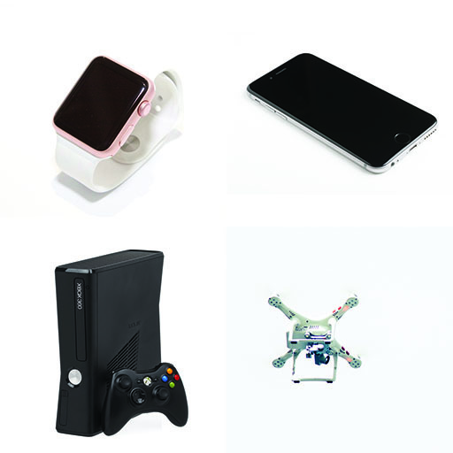
Figure 1
View description - Figure 1

Back to - Activity 1 What technologies are children using?

Activity 6 Children’s virtual online worlds

Part

Discussion
Children’s use of technology often seems to blur the boundaries between play and learning, perhaps because much of children’s technology is linked to leisure, commercial culture and consumer products, which may sit uncomfortably in the school ‘learning’ context. Like children’s real-life play and popular culture, there is perhaps something subversive and ungovernable about their online culture and play.
Back to - Part

Activity 7 Parents, children and ‘Minecraft’

Discussion
Minecraft provides an immersive environment and one what learners have control over – they can choose their own level, the way they engage and the challenges they take up. For some learners the space may feel ‘safer’ than the real world, an environment in which they can experiment and explore without the fear of being wrong, or the anxiety of speaking to or in front of others.
The immersive and interactive nature of Minecraft means that learners can engage with mathematical or scientific problems in a more authentic or exciting way. The ecology of the world is reflected and ecosystems modelled and experimented with, the effects of gravity can be observed, iron or gold can be smelted to produce pure metals and sand transformed into glass. Mathematical operations can be visualised, concepts of area and perimeter explored, symmetrical structures created and more abstract geometrical concepts visualised.
Back to - Activity 7 Parents, children and ‘Minecraft’

Activity 8 Merchant’s six characteristics

Discussion
There are many examples of the six characteristics throughout the video, but some specific incidents have been highlighted here.
The playfulness in the children’s activities was evident throughout the video, for example in their interviews with invented characters.
Year 1’s work creating animals for their virtual world is an example of remixing, their work being inspired by the nest of strange eggs. They made prints, created digital mind-maps, took photos of their work and used these for an online puppet show and going on to create a video with audio overlay which they shared on the community blog.
The wider school community was connected via the blog and twitter feed and the use of Edmoto, an online networking tool, to ‘twin’ classes enabled the sharing of ideas further afield.
The multimodality of the work produced by Year 4, who invented people for the virtual world, was evident as they combined filming using green-screen techniques, with animated drawings and interview scripts.
The linguistic innovation was particularly apparent in Year 3’s soundscapes of the virtual world, where they invented their own method of notation so they could play their own compositions.
Back to - Activity 8 Merchant’s six characteristics

Activity 2 Should everyone learn to code?

Discussion
Teaching computing is not about training future software engineers (although some argue that increasingly many more people will be employed the tech industry), but on equipping young people with the transferable problem-solving skills that are applicable across all walks of life. You will read more about such computational thinking skills shortly.
Some, including the House of Lords Digital Skills Committee (2016), argue that teaching coding is an economic imperative, and that there is already a significant gap in the skills required by a technology-driven economy and those focussed on in schools.
Back to - Activity 2 Should everyone learn to code?

Activity 3 Problem solving in context

Part

Discussion
The children have applied their logical reasoning to decompose the task of making a sandwich into its constituent parts. They continually evaluate, simplify and refine their instructions (algorithm) as the ‘program’ runs.
Back to - Part

Activity 3 Problem solving in context

Part

Discussion
The problem of sorting several numbers has been decomposed into sorting pairs of numbers. A pattern is quickly established and the same rule – a simple algorithm – is applied to sort each pair of numbers until the process is complete.
Back to - Part

Activity 4 Going ‘unplugged’

Answer
Look at what you have drawn. Now look at some examples of what others drew following the same instructions.

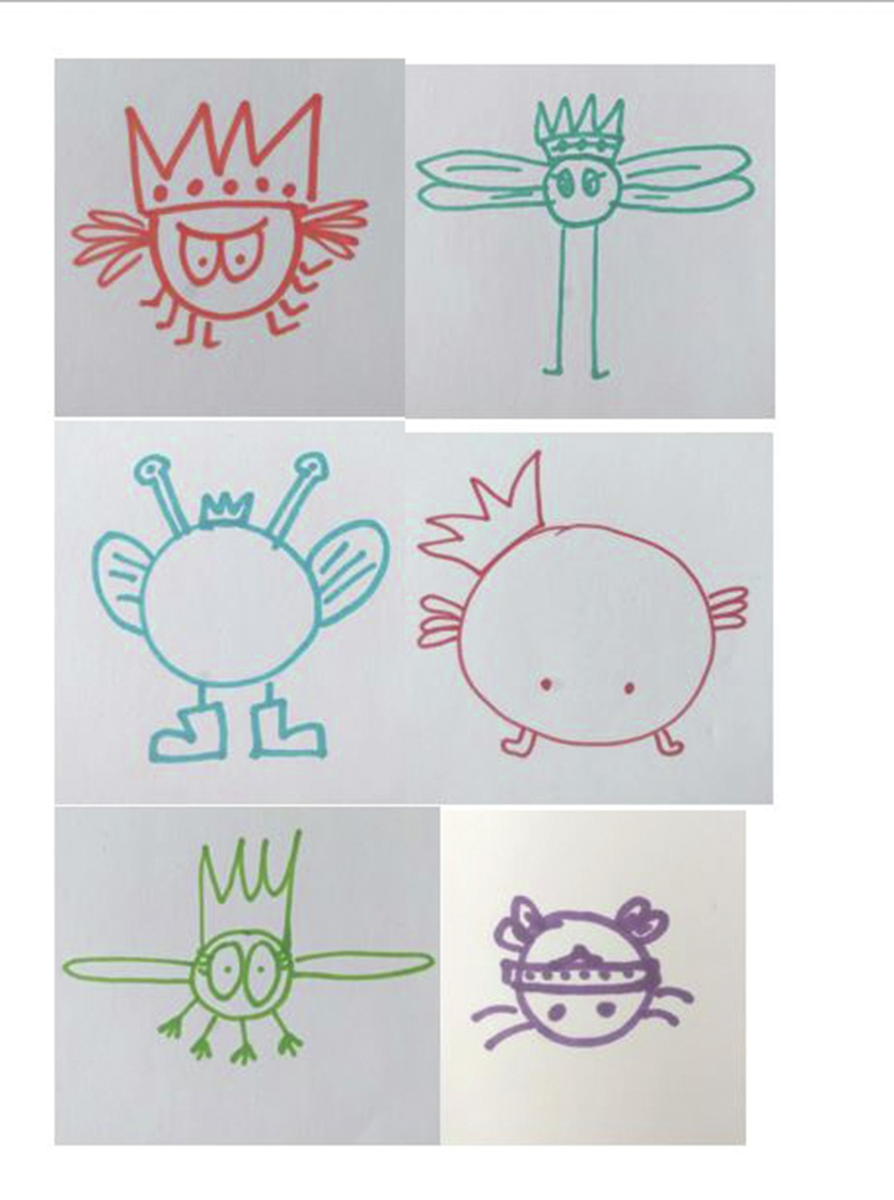
Figure 8
View description - Figure 8

What aspects of computing does this activity touch upon? What teaching points might the difference in the pictures highlight?
Back to - Activity 4 Going ‘unplugged’

Activity 4 Going ‘unplugged’

Discussion
These instructions are an example of an algorithm, albeit a poorly written one. The instructions are unclear and open to interpretation, so it is unlikely they were evaluated effectively before use. Whilst all the drawing were created following the same set of instructions, the ‘outputs’ vary. Questions about whether this variation is acceptable could be explored. If the illustrator wrote the instructions to help draw a specific character it is likely they had something particular in mind. The children could be asked to refine the algorithm, test it out, evaluate it and refine it again.
Back to - Activity 4 Going ‘unplugged’

Activity 5 Making use of robots

Discussion
Children who are designing and creating their own games and scenarios such as Bot Detectives or Pollen Hunts are exploring algorithms as they continually come across problems that require decomposing, solving and evaluating. Navigation is a task that even very young children understand and is a simple and effective introduction to programming. If children are challenged to navigate the garden or treasure map, they will be required to use their logical thinking and decomposition skills as they write an algorithm. They will need to continually ‘debug’ their program, considering different possibilities to make it to the treasure as quickly as possible.
Back to - Activity 5 Making use of robots

Activity 1 How does cross-curricular learning work?

Discussion

Activities to learn about the Egyptians | Academic subjects
When pyramids were built  How ancient Egyptians lived  The Pharoahs, King Tut, Queen Nefertiti | History
Egypt is on the world map  Egypt’s deserts and rivers  The Nile | Geography
Timeline of ancient Egypt  Egyptian mathematical and number system  Ancient Egyptian board games | Mathematics
Reading information books, historical accounts and diaries of archaeological expeditions, Howard Carter and discovery of Tutankhamun’s tomb  Making information books about Egypt  Writing diaries ‘in role’ as (pretending to be) Howard Carter  Learning hieroglyphics meanings  Rosetta Stone languages and deciphering  Writing own hieroglyphics | Language and literacy
How bodies are mummified and preserved  Making papyrus  Pyramid forces | Science
Egyptian art and monumental statues | Art
Making models of pyramids | Design Technology  Maths  Art
Creating dance and movement based on Egyptian art  Ancient Egyptian sport and games | PE (Physical Education)  History
Egyptian deities, rituals and afterlife | RE / RS (Religious Education / Religious Studies)
Exploring the British Museum Egyptian collection online  Listening to archival recording of Howard Carter | Computing and IT

As you matched the subjects to the activities, you were probably aware that in most cases children are learning more than one subject at a time. Children make better sense of their learning when it’s connected, in other words, when they are not learning isolated ‘bits’ of information.
For instance, when children read and write about archaeological expeditions they are developing their language and literacy skills. At the same time, they are learning history, science, geography, biographies of historians and explorers, and about the science of archaeology. When children write ‘in role’, pretending to be Howard Carter, they are also using their imaginations and their creativity to describe entering King Tut’s tomb. Likewise, when children design and make models of pyramids, they are learning about mathematics and physical forces.
Back to - Activity 1 How does cross-curricular learning work?

Activity 2 Playful learning

Discussion
- Police notebooks: literacy and language development
- Wanted posters: art and design
- Recording timings: mathematics
- Dusting for fingerprints and making casts: science and technology
- Finding clues: evaluating information
- Sharing ideas: collaborative working
- Eliminating suspects: inference and deduction
Back to - Activity 2 Playful learning

Activity 3 Observing children in cross-curricular learning

Discussion
The teachers and headteachers in the video say that there is a world of difference between a cross-curricular project or topic that is well-planned, achieves its curriculum objectives and engages children, and unfocused topic work which, at its worst, makes forced connections between subjects that are confusing for children and adults alike.
The comments by teaching staff in the video illustrate how they observe children’s enthusiasm and enjoyment of cross-curricular topic work. The teaching staff use their observations to assess children’s learning and plan new learning experiences. But they also comment on how they use such observations to reflect on their own teaching and how much children are benefiting from it. They recognise, as one teacher says, that children don’t learn in small boxes. Cross-curricular work helps teachers to create exciting learning environments which children can get involved in.
Back to - Activity 3 Observing children in cross-curricular learning

Activity 4 Adult support for children’s learning

Discussion
Sam organises playground activities. She recognises and draws on the skills and experiences of older children to be role models for younger children. She encourages fairness, turn-taking and sharing. She gives responsibility to children and stands back to observe their interactions. She takes decisions to change or adapt activities based on what she sees and hears.
Billie supports a child who has Down’s syndrome. She makes moment-to-moment decisions in order to balance close 1-1 support for Zoe with encouraging her to be independent. She manages her close proximity to Zoe by observing her closely and stepping in when necessary.
Vicki says awareness and problem-solving are important in her physical work with children who have a range of individual needs. Her awareness of what is going on all around, and problem-solving to respond to behavioural problems, help Vicki to ensure all children are included and can participate. She says you have to know the children very well.
Suzanne supports a child with a visual impairment. Her observations of Aaron as he works in the classroom help her to support and evaluate his development. She understands the challenges of abstract concepts for Aaron, and uses resources specifically to help him understand
Justine supports children in a literacy group. She says listening, communication and sympathy are important skills to support children’s learning. Justine knows the children very well, and she uses this knowledge to decide when and how to adapt the teacher’s lesson plan to suit their needs.
Back to - Activity 4 Adult support for children’s learning

Activity 1 Different starting points for learning

Discussion
The six people who work and volunteer in the primary school all had different starting points as learners. Some had formal academic qualifications or training when they began to work in the primary school – sometimes from quite different professions to primary school education. Others learned informally, at home or in the community. They draw on the skills and knowledge they developed in other walks of life and bring these to the primary school. Crucially, they all have an interest in children’s learning and development. They use this interest to reflect on their own learning, attitudes and behaviour as adults.
As they work alongside children and other professional adults, they develop skills in observation, sensitive listening, and knowing when and how much to intervene. They get to know children well, and this knowledge enables them to provide appropriate levels of support for children’s individual needs. They are developing knowledge of curriculum subjects like maths and literacy. They are also developing ‘soft’ skills for communication, team working and collaboration.
They can all describe their ‘story’ as adult learners, identifying where and how they learned and how they made decisions as learners. All this helps them to work in a productive and professional way with other adults and with children.
Back to - Activity 1 Different starting points for learning

Activity 2 Developing your profile

Part

Discussion
Use these notes to create, or add to, your LinkedIn or your Facebook profile, or your CV.
A lot of professional learning happens informally, although there can be a complementary relationship between formal and informal learning.
When you apply for a voluntary role or a job in a primary school, you do your best to present your experiences and skills and how these are relevant to the primary school. You would talk about your formal and informal learning, where and how this happened, and what you gained from it.
Once you are in a primary school, in addition to the experience and skills that the headteacher and other staff know about, you might start to bring more of your ‘self’ and talents to shape the way you work or volunteer. If this helps increase your motivation to do a job and enables you to do it more effectively, this personal expression is an important aspect of effective working.
Back to - Part

Figure 1

Description
This is a photograph of woman reading to children, with another teacher observing.
Back to - Figure 1

Figure 2

Description
This is a photograph of two children drawing.
Back to - Figure 2

Figure 3

Description
This is a photograph of a woman and a group of children painting.
Back to - Figure 3

Figure 4

Description
This is a photograph of a ring of paper figures holding hands.
Back to - Figure 4

Figure 5

Description
This shows a piece of paper with ‘Approved’ stamped on it.
Back to - Figure 5

Figure 6

Description
This shows the word ‘Ethics’ written on a blackboard.
Back to - Figure 6

Figure 7

Description
This is a photograph of a woman talking to a child.
Back to - Figure 7

Figure 8

Description
This is a photograph of a woman writing on a pad of paper.
Back to - Figure 8

Figure 1

Description
This is a photograph of a group of school children running in the playground.
Back to - Figure 1

Figure 2

Description
This is a photograph of a group of girls playing in a playground.
Back to - Figure 2

Figure 3

Description
This is a photograph of two girls playing in a playground.
Back to - Figure 3

Figure 4

Description
This is a photograph of a child playing hopscotch.
Back to - Figure 4

Figure 5

Description
This is a photograph of a group of children playing.
Back to - Figure 5

Figure 6

Description
This is a photograph of children in a playground.
Back to - Figure 6

Figure 7

Description
This is a photograph of some play equipment in a playground.
Back to - Figure 7

Figure 1

Description
This is a photograph of a group of children singing in the classroom.
Back to - Figure 1

Figure 2

Description
This is a form titled ‘Observation frame work, Year 4: dispositions for learning. It includes the following behaviours to be observed: confidence, independence, persistence, problem solving, humour, collaboration and concentration/stamina.
Back to - Figure 2

Figure 3

Description
This is a completed observation form. It includes the following: 9:00-9:05 Sits on carpet, pulls on other child’s shirt, listens to teacher instructions, raises hand, not called on by the teacher. 9:05-9:10 Wanders around room, collects reading book, asks teaching assistant for help. 9:10-9:15 Sits at table, picks up pencil, reads worksheet. 9:15-9:20 Writes in worksheet, pulls hair of other child.
Back to - Figure 3

Figure 1

Description
This is a photograph of a man helping a girl with homework
Back to - Figure 1

Figure 2

Description
The text the top of this sheet is ‘Tell me about a fun activity that you like to do in school. Draw a picture in each box to show the beginning, middle and end of the activity. What is the title of the activity? There are then three empty boxes. Then there is the following text: ‘Now let’s talk about an activity in school that you don’t like so much. Draw it here and say what the title is. There are then three empty boxes,
Back to - Figure 2

Figure 3

Description
This is a photograph of three young girls.
Back to - Figure 3

Figure 1

Description
This shows four items: a smart watch, a smart phone, a games console and a drone.
Back to - Figure 1

Figure 2

Description
This is an infographic in four parts. In the first part (3-4 year olds) is the following information: 1% have their own smartphone, 21% have their own tablet. 96% watch TV on a TV set, for around 15 hours a week. 41% watch TV on other devices, mostly on a tablet. 40% play games, for nearly 6 hours a week. 53% go online, for nearly 8 hours a week. 71% of these mostly use a tablet to go online. 48% use YouTube, of which 52% of these say that cartoons are their favourite thing to watch, 15% say unboxing videos. 0% have a social media profile. In the second part (5-7 year olds) is the following information: 5% have their own smartphone, 35% have their own tablet. 95% watch TV on a TV set, for around 13.5 hours a week. 49% watch TV on other devices, mostly on a tablet. 66% play games, for nearly 7.5 hours a week. 79% go online, for nearly 9 hours a week. 63% of these mostly use a tablet to go online. 71% use YouTube, of which 30% of these say that cartoons are their favourite thing to watch, 18% say funny videos or pranks. 3% have a social media profile. The TV set is the device they say they would miss the most. In the third part (8-11 year olds) is the following information: 39% have their own smartphone, 52% have their own tablet. 95% watch TV on a TV set, for around 14 hours a week. 55% watch TV on other devices, mostly on a tablet. 81% play games, for nearly 10 hours a week. 94% go online, for nearly 13.5 hours a week. 46% of these mostly use a tablet to go online, 22% a mobile. 81% use YouTube, of which 23% say funny videos or pranks are their favourite thing to watch, 18% say music videos. 23% have a social media profile. The TV set or tablet are the devices they would miss the most. In the fourth part (12-15 year olds) is the following information: 83% have their own smartphone, 55% have their own tablet. 91% watch TV on a TV set, for around 12 hours a week. 68% watch TV on other devices, mostly a tablet or mobile. 77% play games, for around 12 hours a week. 99% go online, for nearly 21 hours a week. 49% of these mostly use a tablet to go online, 26% mostly use a mobile. 90% use YouTube, of which 26% say music videos are their favourite thing to watch, 23% say funny videos or pranks. 74% have a social media profile. Their mobile phone is the device they would miss the most.
Back to - Figure 2

Figure 3

Description
This shows a woman with a group of children who are all holding smart devices.
Back to - Figure 3

Figure 4

Description
This shows a group of children using tablets.
Back to - Figure 4

Figure 5

Description
This shows four separate images of children using technology.
Back to - Figure 5

Figure 6

Description
This is a photo of a boy using a virtual reality device.
Back to - Figure 6

Figure 7

Description
This is a photograph of children playing Minecraft on computers.
Back to - Figure 7

Figure 8

Description
This is an infograph split into four parts. In the first part (Ways of thinking) is the following information: creativity and innovation; critical thinking, problem-solving, decision-making; learning to learn/metacognition (knowledge about cognitive processes). In the second part (Tools for working) is the following information: information literacy; information and communication technology (ICT) literacy. In the third part (Ways of working) is the following information: communication; collaboration (teamwork). In the fouth part (Ways of living in the world) is the following information: citizenship - local and global; life and career; personal and social responsibility - including cultural awareness and competence.
Back to - Figure 8

Figure 9

Description
This is a colourful montage, including an image of a child surrounded by some shapes. It includes the following text: The statues stopped changing colour they started to fly slowly up. One started spinning around the circle then the other followed and the other did as well. I was by the door way I tip toed the circule now they are spinng around me.
Back to - Figure 9

Figure 10

Description
There is a heading of ‘Old Bond Cars’ and the following text alongside an image of a car: This is the Aston Martin DB5. It’s an awesome car with the revolving number plaets and the ejector seat. Shall we move on?
Back to - Figure 10

Figure 1

Description
This shows someone using a computer.
Back to - Figure 1

Figure 2

Description
This is a photograph of children using computers.
Back to - Figure 2

Figure 3

Description
This shows children using computers.
Back to - Figure 3

Figure 4

Description
Coding is displayed on a screen.
Back to - Figure 4

Figure 5

Description
In a central circle is the text ‘What is computational thinking?’. From this circle are lines to other circles. The text in these is as follows: Algorithms (creating rules); Decomposition (breaking problems down into parts); Pattern recognition (finding and making use of similarities); Logic (analysing and making predictions); Abstraction (filtering out unnecessary information); Evaluation (making a judgement).
Back to - Figure 5

Figure 6

Description
This is an image of a London Underground map from 1933.
Back to - Figure 6

Figure 7

Description
This is an image of a child coding
Back to - Figure 7

Figure 8

Description
This is a collection of six drawings of a game character, all looking slightly different.
Back to - Figure 8

Figure 9

Description
This is a screenshot from a computer game.
Back to - Figure 9

Figure 1

Description
This is an image of the Egyptian pyramids.
Back to - Figure 1

Figure 2

Description
This is a photograph of a child looking through a magnifying glass.
Back to - Figure 2

Figure 1

Description
This is a photograph of a group of people, and one person has their hand up.
Back to - Figure 1

Figure 2

Description
This shows a typewriter with the words ‘Story begins’ written on a sheet of paper.
Back to - Figure 2

Video 1

Transcript
MARK MILLINSON
When a volunteer comes to me to ask what they should be and the characteristics that they might have in order to be somebody who a school will be interested in, within that role-- Immediately, I'm looking at their body language and their enthusiasm for what they're asking about. We need people in primary schools who are inspirational-- need people who are enthusiastic, bubbly. If I was to think of a literacy character, I might think a little bit of Tigger, without being overbearing. Because children have got to be interested in these people. They've got to be, more than anything else, probably approachable. And when I meet somebody who wants to come to be a volunteer, it's so important that I get that impression that children are actually going to be-- to enjoy their company and to learn something from them. It's a very important role within school, even as a volunteer because you bring something else. Every adult that comes into school brings something for these children. And it's a great opportunity for the school to bring a wide variety of experience to the children because we need that, the children need that. And it's good fun, too. To really support a child in school, fundamentally you've got to be a really good listener. And you've got to be very approachable. So it's very important that we move children on from where they're at, rather than where, perhaps, they should be, or expected to be, or presumed to be. And there's only one way to find that out. And that's to look very carefully at the child and to listen to the clues that they give us. Yes, we have a curriculum. We have a national curriculum in England. And that directs us as to what could be taught, should be taught, at various ages and stages. However, that does not mean that it's a one-size-fits-all. Because children are very different. We're all unique. And those children are sitting next to a unique person, in a unique class, in a unique school. Every place is different. So, actually, I think in terms of finding the next steps for every child's learning. And by finding what those are, well, to do that, you need to know where they're at now. So being a really good listener, and in that, and working at being a detective. Are there any barriers that are preventing this child from learning? Are there any misconceptions that could have occurred? And that doesn't mean telling the child what it is. That means listening to what the child is telling you and working the clues out for yourself. And then, perhaps, gently directing them in a different way to the one they originally started on.
Back to - Video 1

Audio 1

Transcript
PRISCILLA ANDERSON
I want to say that the main message of this lecture is can we shut away the idea that children are puppets? They’re not. They are people. As the great Italian educationalist said, ‘They have one hundred languages, a hundred thoughts, a hundred ways of listening, marvelling, loving, singing and understanding,’ and he added, ‘School and culture steal 99 of these and tell the child to listen and not speak, to understand without joy. But, despite this,’ he added, ‘young children are strong and powerful.’ So why do we treat these remarkable people as if they’re puppets who must be forced to go to school and forced to learn? I would like to argue that we’ve got to rethink compulsory schooling. After all, most young people would go to school willingly. They work very hard and creatively. In one school, we gave cameras to the children and said will you take pictures of the things that you most value in your school and the way you think your rights are most respected, and one of the subjects they created were pictures to express their affection for their teachers. Adults, we assume, work and learn better voluntarily; not when they’re forced to. Are children and young people so very different? So, in conclusion, I hope you will agree that in some ways adulthood and childhood overlap; that many of the differences result much more from the way we misperceive, mistreat children than from children’s actual incapacities; that a rigid double standard of respect and rights for adults and compulsion and control for children is not principled or productive. And so, how can children be responsible agents within enforced helpless dependence; and an eight-year-old succinctly told me, summing up how rights in school tend to be either trivialised or made very remote and distant, “It’s so boring when they keep telling you that making the world a better place means picking up litter and not killing whales.” Where does children’s rights come in there? This is called an inaugural lecture and I suppose the idea came from a youngish professor inaugurating or instituting a program of work over the next 20 years or so. Well, I haven’t got that long time ahead of me, so instead I hope that the Institute will inaugurate a program for the next 100 years. I hope it will be led by Marion Richardson faith in sincere free relationships; and the nineteenth-century working people’s views that learners go first and the master would follow, as is already practiced in many earlier centres and schools and colleges around the world. I hope the programme will explore the problems and the creative solutions and the many advantages of non-compulsory schooling. It would cut layers of management. That would release resources for much better student–teacher ratios and relationships. Then, learners and teachers could be far more co-creators of education. This would be based on valuing the intrinsic rewards of learning, rather than having to have forcing or bribing people, but it would involve rethinking the meaning and relevance of childhood, children’s competencies and rights, and it would change society’s attitudes towards children. Schools can’t do it on their own as little islands in society, and the programme will be informed by the UN convention principle that respecting the inherent worth and dignity and the inalienable rights of all members of the human family promote social progress and better standards of life in larger freedoms, and lays foundations for justice and peace in the world that we so desperately need. Thank you.
Back to - Audio 1

Video 2

Transcript
MARK MILLINSON
It's very, very important that our children in school are safeguarded. And so a volunteer coming to school to say, please, may I come in. Well, we need assurance that that person is the right person to be in contact with our children. We wouldn't open the front door and say, do come in, all of you. Come and work with our children, because there are evident safeguarding concerns there. So as it stands at the moment, a check is required-- an identity check. And through the questions that are asked such as proving who you are via your passport or your driving licence and your date of birth and where you've lived, the authorities can actually check against your name that there are no criminal convictions that would prevent you, most reasonably, from working with children. That does not mean to say that somebody with a criminal conviction cannot, but there are obviously some misdemeanours, shall we say, or crimes, even, that would prevent you from working alongside a child. And so as your interest in becoming a volunteer, the school would actually ask you to come in to take that, to give those pieces of information so it can be forwarded via a website. And then the school gets information that actually, absolutely everything is fine. Do invite them in. So please don't let that deter you, but I'm sure everybody's in a position to understand why it is so necessary.
Back to - Video 2

Video 1

Transcript
MARK MILLINSON
I view the school day as being an extension of learning, or an opportunity to learn. So the playground is a big part of that. Because learning isn't just about what people call the three Rs and extra bits associated with that. It's about how to interact. It's how to be social. It's how to sort issues out and problems. It's about supporting each other. So, very often I've had children on the playground come to me and mentioned something that's been going on in the classroom because they wanted-- they weren't quite sure about that something. More often than not though, it's "it's not fair because he's not letting me play" or whatever. And my response, then, is not to charge into the situation, to solve the issues for the children, but to teach them how to discuss disagreements. Because that type of opportunity to learn is so important because it's a lifelong skill. When I'm on the playground, which is frequent, I observe children quite closely. Because what I'm looking for, fundamentally, is are the children happy? The flip side of that is who looks lonely? Who looks sad? Because that's the opportunity for me to gently stroll over and say, "Hi, how are you?" And if there is something that the child needs help with, then I'm there. It may be that they just want to be by themselves, as well. And it may be their personality that they don't look as happy as the other children. We're all different and we need to celebrate those differences.
Back to - Video 1

Video 2

Transcript
MARK MILLINSON
There are times when an adult does need to intervene because children are indignant and there is a position where they feel that they're aggrieved, and they need to-- and they're angry. And although that's rare, when that does happen, then an adult will move into the situation. And in this school, we try and use something called restorative justice. So, again, it's about listening and it's about not having value statements in the questioning that the adult makes. So instead of saying, who started this problem? Who is at fault? We will say things such as-- it's quite open-ended-- such as, what happened? Yeah, who's been affected by this? How are you feeling about this now? How can we put this right? And with those questions punctuated with the children's responses, it doesn't always resolve issues, but the children calm down. Nobody is being blamed, certainly not in the first instance. And there's a greater awareness of actually what happened during that because we all see the world from our own point of view, and this is a way of encouraging children to listen to somebody else's point of view. So actually those conflicts are quite useful in developing resilience and developing an appreciation that somebody else has a different point of view, and also learning how to work with conflict resolution, even over whose turn was it to be it. You know, it's early days, but it's a step in the right direction for our learning within society and how we need to conduct ourselves as adults.
Back to - Video 2

Video 3

Transcript
[NO SPEECH]
[MUFFLED CHILDREN'S VOICES]
[BIRDSONG]
[LOUDER CHILDREN'S VOICES]
[CLAPPING]
[LOUD CHILDREN'S VOICES
IN PLAY]
[INTERPOSING CHILDREN'S VOICES]
[CHILDREN SINGING]
Back to - Video 3

Audio 1

Transcript
KIMBERLEY SAFFORD
What do you like about your playtime, when you have playtime at school? What do you like about playtime? Let's start with Isla, and then we'll go to Daniel. Isla, what do you like about playtime?
CHILD
When we get to be with our friends.
KIMBERLEY SAFFORD
CHILD
What do you do with your friends?
CHILD
Run around and have fun.
KIMBERLEY SAFFORD
CHILD
Daniel, what do you like about playtimes?
CHILD
Having fun with my friends.
KIMBERLEY SAFFORD
When you go out to your playground, tell me, what does it look like? What do you do in it?
CHILD
It's really big, and there's colours on the floor. There's hopscotch, and you can keep your balance on it and run. And there's like squares where It tells you what to do, and then you have to do it in the box.
KIMBERLEY SAFFORD
What kind of things does it tell you to do?
CHILD
Like hop and stretch and that.
KIMBERLEY SAFFORD
Were you going to say something?
CHILD
And it tells you to do-- it tells you to bounce on one of your legs 10 times.
KIMBERLEY SAFFORD
Can you do that?
CHILD
Yes.
CHILD
We normally run around it, and we have fun and play games and do hand claps and that.
KIMBERLEY SAFFORD
And sometimes do you go out into the field?
CHILD
Yes.
CHILD
Yes, at lunchtime.
KIMBERLEY SAFFORD
What do you-- and is that different to the morning playtime?
CHILD
Yes.
KIMBERLEY SAFFORD
What's different about the field?
CHILD
Because at lunchtime, if you're in the playground, we get to bring our balls out on the field. But if you're on the playground, you can only-- you can't kick. But if you're on the field, you can kick. You can only bounce it on the playground. And on the field, there are two football goals, and there's no football goals on the playground.
CHILD
And in the field, there's grass, and on the playground, there's not. And there's a trim trail on the field.
KIMBERLEY SAFFORD
What's that?
CHILD
A trim trail?
KIMBERLEY SAFFORD
What do you do on that?
CHILD
Well, there's like a bridge you can walk across. There's a balance beam when you walk across and there's this ramp where you can go up and you can pose. And there's a climbing wall.
KIMBERLEY SAFFORD
And which do you like better, the field or the playground?
CHILD
Field.
KIMBERLEY SAFFORD
Which do you like better, Daniel?
CHILD
I like field because I like playing football.
KIMBERLEY SAFFORD
Why do you like the field better?
CHILD
Because you can skip on it, and you won't touch other people, because it's much more bigger.
KIMBERLEY SAFFORD
And sometimes are there problems in the playground at all? Are there sometimes things that go wrong or things you don't like about it?
CHILD
Yeah, because if you-- if someone accidentally trips you over, it'll hurt you more than the field because the playground's really rocky, and the field's only made out of grass.
KIMBERLEY SAFFORD
I saw some children playing conga-- congo lines?
[LAUGHTER]
Conga.
KIMBERLEY SAFFORD
Will you tell me about that? I don't know what that is.
CHILD
Some people just start a conga line, where you just go around doing the conga. And then more people come.
CHILD
Yeah, you hold each other's shoulders. But if you don't want them to hold your shoulders, they could hold somewhere else, because if they're really little and you're really tall, they have to hold somewhere lower down. Like my little sister, she has to hold my hips and pull her shirt. She's just like, yay!
KIMBERLEY SAFFORD
[LAUGHS] So you play It, there's the conga line, what else do you play in the playground sometimes?
CHILD
Hmm, well, my friends, when it was just year two outside, everyone kept on saying, everybody sunbathe.
KIMBERLEY SAFFORD
Everybody sunbathe? And then what would you do?
[CHUCKLES]
CHILD
And they were skipping around singing, everybody sunbathe. Then they were there and cardigans or coats on the floor and sunbathe.
CHILD
And at lunchtime, we like playing handball. It's like football, but you have to use your hands instead. It's really fun, because it's bigger and you get to get spaced out and have your own bit of it. So you can get-- and you can go with your friends and talk when-- like, in the classroom, you're not allowed to talk. So on the playground and the field, you are.
CHILD
I think what's nice about the playground is you can see children from other classes, because otherwise, you're always in your own class. So you get to see younger children, older children.
CHILD
Yeah, like in Year 6, Year 5, Year 4, Year 3.
CHILD
And on the playground, you can see the littler children that haven't even made in the Year. Like, you can see preschool.
CHILD
We like playing with the teachers, because some of the teachers know how to do hand claps.
CHILD
Yeah and sometimes, me and my friends, we like it's a teacher, and when then they'll start chasing us.
KIMBERLEY SAFFORD
When we were in the playground this morning, I was noticing that girls were playing with girls and boys were playing with boys. And do you think girls and boys play separately, or do you play together sometimes?
CHILD
Sometimes we play together. Sometimes they don't because they want to be with their own friends. Like, if I don't have anyone to play with, I might go and play with the boys. So it would be nicer if you played with the boys for some time and then the girls so you can be together.
CHILD
Mostly when we play games, mostly the girls will play with them. Like, the girls will come and play with boys. But only sometimes the boys play with the girls.
KIMBERLEY SAFFORD
And why is that, do you think?
CHILD
I do not know. Maybe-- I don't know.
KIMBERLEY SAFFORD
So what happens sometimes in the playground that's not so nice or goes wrong sometimes?
CHILD
When you don't have any friends to play with. It's just then you feel lonely, and you won't have anything to do. And this is the bit like I don't like, because if your friend play a game, and then you want to join in, but they don't let you, it's really unfair, because then you won't have anyone to play with.
CHILD
Just feel really upset, because if your friend doesn't want to play with you, then you've got no one to play with.
KIMBERLEY SAFFORD
If you could have anything you wanted in the playground, if you could have your dream playground, what would be in it?
CHILD
A friend bench-- when you don't have any friends, you could sit on it, and then if someone else doesn't, and it's your friend, you could go and play with them.
CHILD
Like, if you had just loads of friends, like there's everyone, like if there's too much people in the school for like having any friends, and then no one will get sad. And they don't fall out or do anything. That is really happy.
CHILD
--quiet corner too.
KIMBERLEY SAFFORD
So sitting?
CHILD
We could have a quiet corner.
KIMBERLEY SAFFORD
What would be in the quiet corner? What would it be like?
CHILD
If you want to have some peace and quiet, you can sit there and have it, because the playground is normally really noisy, because everyone's really spread out and really noisy, because they're outside. So you could have a corner where that's not much people going around. You could sit there. If you've got a headache, you could.
CHILD
Yeah, and if you were in the quiet corner if you just wanted to rest, and and you had everyone, but you can't hear everyone, you can do meditation. And you should have a place like-- if you were really, really guilty of some sin, then you'll just take away the guilt, and then you will just forget about it instantly.
Back to - Audio 1

Video 4

Transcript
[CHILDREN PLAYING]
CAROL
When on the playground, you've got to make sure they have a good play time and good lunch times. Because if they had a bad moment in the classroom, and they come out and they're in bad moods and they don't want to play, and you've got to get them to get over that and join in all the games. And some days you can spend quite a while just talking them around, oh, come on. Go on and play. Yeah, maybe you didn't do so well at your maths this morning, but that doesn't really matter. Because you're allowed to get things wrong. Look at your friends over there. They want you to play. Shall we go over and play with them? And you do, you coax them all the time. And then hopefully, they go back up to the classroom in a better mood. It's hard work at times, because you wonder if they will they're not strollops and they don't want to. They won't go back. But you can manipulate them a little bit do things you want to.
[CHILDREN PLAYING]
JACKIE
Carol and I actually make a very good team.
CAROL
I'll have to agree there, I think.
JACKIE
There's lots of dinner ladies in the playground. But you always get two that, perhaps, think alike, which we do. We both feel the same about the children. We're both silly enough to get down and play with the children.
CAROL
You've got to come to their level.
JACKIE
Yes.
CAROL
You must come down to their level.
JACKIE
Definitely.
CAROL
To make it all worthwhile, haven't you? You play the games with them. It doesn't matter if you make a fool of yourself. Because they don't care, the children don't care because you're joining in with them.
JACKIE
Sometimes it's important that you get in there and you play with them, so that the ones that aren't so up front will come along and ask and say, can I play? And you say, well of course you can! And once you let one in, they all start coming in then.
CAROL
And it's good for the older children to learn to look after them a little.
JACKIE
Yeah, to respect them.
CAROL
Yeah, yeah. And they know they have to be gentler with them. You, know they can't rush about, knocking them over. They've got to be more careful.
CHILD
Keep it steady.
JACKIE
Leave it steady. That's it. You've got the idea. That's it. That's it. That's it.
We've got it. Pick up this end a little bit.
[CHILDREN PLAYING]
Down your end, quick!
[CHILD LAUGHS]
CAROL
The parachute game, I think that's a favourite one at lunchtime. That is the one they all love to be --
Yeah, they all-- we try to not get it too overcrowded.
CAROL
But it doesn't work.
JACKIE
They just, yeah they just went mad today. They just all wanted to have a go on it. And I thought to myself, there's no way I'm going to have control over this today. I've lost this one. But, no. They were good. I mean, considering how many there was playing, they were good. Only one person under there today, because there's so many of us, it's going to get dangerous. So--
CAROL
We're going to need to trust them all, though. We've got to understand that if you get them into trouble for something, tell them all that they can still come back to you, and that you won't, you know, hold it against them. You know, you could have a couple of boys fighting, and you send them in. Say, you've gotta go in for five minutes, you know, think about what you've done and come back outside. Come and see me and we'll sort it out. And they've got to know that you're not going to take sides, that you're going to hear both points of view.
JACKIE
We never label anybody naughty. We're always encouraging them. Of course, there were so many on the parachute, yeah. But it was--
CAROL
I was watching you, I was watching you, love.
JACKIE
I think, it's good. When you work as a team, you watch out for one another.
CAROL
Yeah, you do.
JACKIE
And I think the kids benefit more. Because obviously, you know, you usually have two to each thing.
CAROL
I mean both of--
JACKIE
If you've got one playing, one sort of going around looking for the lonely child or--
CAROL
Yeah.
JACKIE
--but we do, we try and get involved and look out and chat with them as well.
CAROL
And then we decide what games we're going to bring out. And say, look we have this game today. There weren't too many playing with the hoops yesterday, let's try something new. And it's just ideas all the time.
Back to - Video 4

Video 1

Transcript
SARAH JOHNSON
Observing the child takes on different forms. So you may decide that you want to observe a child by standing back, and giving them space, and just watching and seeing what kind of learning comes out of that. There are times where you will ask to play alongside your child, as well, and you will ask to be invited into their play. And if you're invited into their play, it's important to be sensitive to their play and go alongside it, as well. And not try and force what you have-- your take on that play and how you want that play to-- what direction you want that play to go into. So you have to be quite sensitive to the play. So I would say it's about standing back, observing children, but also playing alongside a child, as well. I think observing the child tells you again, about their interests and about friendships, as well. You may have a child who is maybe struggling to interact with other children, and you may have concerns over a couple of children. So actually just taking a step back and watching how a child solves problems or deals with problems is a very good method. And above all else, I always look for characteristics of effective learning. So I look for active learning. Is a child engaged? Are they motivated? I look for, is a child thinking and-- thinking critically? Are they problem solving? And have they got that creativity within their play, also? Observing children can make me a better teacher, and it does make me a better teacher because above all else, it feeds into my assessment and my planning cycle. If I observe a child and I see that the engagement is not there within the classroom, that the classroom is not set up in the correct way and it allows me to reflect on that. And it allows me to make changes so that the children are engaged. Because if the child is engaged, that's when you get the best learning. And if a child is not engaged, you're not going to get any effective learning whatsoever.
Back to - Video 1

Video 2

Transcript
[BELL RINGING]
TEACHER
Anything else? Any other ideas why it might have scales? And--
STUDENT
Is it something to do with the shedding?
TEACHER
Well, not really. They do shed their scales, but they shed as a whole skin. So they don't shed them individually. So hatching like this, OK? Series of parallel lines, it just helps to give some shading, OK? Now you might want to do them quite far apart, if it's a lighter scale. Or you might want to do them very close together, which gives the impression of a darker scale. Cross-hatching is when we then go the other way. So I've got my hatching, and then I'm going the other way. And can you see how it starts to give me different depths of shade? So again, have a little practise, find a different area in your sketchbook. Try this. So hatching and cross-hatching, try making the lines closer together. You'll find that it's darker. Spreading them out, it's lighter. That's good. Try doing a mixture so maybe one area is slightly darker. It's better like that. Oh, I like those scales. Is it? Good.
[TEACHER SPEAKS QUIETLY TO A CHILD]
STUDENT
Is it possible to get this bit?
TEACHER
OK. But well, you've got the right idea. I think if you try and get your lines closer together, then it's going to make it more even. And also, can you see this one, that's a bit more pointy, isn't it? So that one's a bit pointy, and that one's quite curved. So try and keep them parallel. Yeah? Like that. And try keeping them the same distance apart.
STUDENT
I'll just do the same as that, just the other way around on top of it.
TEACHER
Yes. Yeah. Try that. This is nice. I like that. So with these, try doing them like this. I would like you to use a whole page, please. So these scales are going to be big. All right? Scales are going to be big, but I really want you to focus on the shading. Look at the shape. Look at where the shade is. Look at those colours. Think about the hatching and the cross-hatching, and the pattern. Yeah. Thank you very much. Right. OK. Alright Michael? Have you tried doing some of the scales with more shapes like the diamonds? Yeah? Let's do that. And also, you look at these ones over here, where the scales themselves are darker, the lines in between are actually quite light, aren't they? So it's almost as if you've got to draw the inside bit of the scale. And then you leave the outside as a border. Does that make sense?
STUDENT
Try doing this.
TEACHER
Shall I show you?
STUDENT
[INAUDIBLE]
TEACHER
Yeah? So try and get the overall shape so that it's just like a--
STUDENT
In 3D?
TEACHER
It's going to be 3D, yes. That's fine. That's why you do the shading. Have a go. Have a go. Yeah? Yes. Yep. You practicing doing those ones? So you make sure to press down too hard at this point. Do you want a different pencil or sharpen that one. Yeah? Sharpen that one. Oh, yes, I like that. That's looking good. It's looking good. So what I want you to do then. So think about shape-- got an shape, because you look. It's like a squashed S, isn't it? That's it. That's it. Got the idea, then you can go the opposite way. OK. I think you can make it a bit bigger. You might find it easier. Yeah? So draw it out so that it is slightly-- make it quite chunky. Yeah? I think because it's so narrow, it is difficult to put it in. So draw a cylinder, essentially. Make it quite big. Perhaps there. OK. So just to remind you that it's a cylinder, just do a rounded end there. You all right?
STUDENT
Yeah, is it like this?
TEACHER
I'll come and have a look in a moment, yeah? Just-- right, OK. And then again. Do another go-around. Right. So if it helps you, imagine if it was totally flat, it would just be double that, OK? Its consistency, OK? Right. OK, I'm coming around. Oh, I like that.
[INTERPOSING VOICES]
OK. Well, that was just going to help you. So when you do your outline, you can put those lines in there, if you wish to, as a guideline. OK, that's nice and [INAUDIBLE] pencil, because then you do scales at the top. I really like the shades you've got there. What we need to do is just put shading in the end of each one. You look here. Yeah. It's-- just remember, we're going in the same direction, so whichever end you do, do it in the same end. That's it. And so pretend.
TEACHER
No, don't [INAUDIBLE] properly. So going in the same direction.
STUDENT
Below it.
TEACHER
Oh, the one below, yes. Yeah, so the one below will be the same place.
TEACHER
Yeah. That's it. I like it.
STUDENT
OK.
TEACHER
OK. What?
STUDENT
So what is the finished picture supposed to look like?
TEACHER: Right. So it's going to look like this, as near as possible. So we've got the shape, OK, which is your cylinder. I mean, he's coiled round there. But can you see if you take that part there? That's your cylinder shape, which is why, if you then want to put those very faint pencil lines, because that's going to sort of help to guide you to where the scales need to go. And then you put the detail in. So look at each scale, put the shading in. Think about where the colours are so you've got patches. Yeah. Yeah.
STUDENT: [INAUDIBLE]
TEACHER: Are you feeling comfortable with that?
STUDENT: Yeah.
TEACHER: You'll be all right. You'll be all right.
TEACHER: Yeah, of course. How are you doing? Fabulous. OK, so I like this. I thought that's exactly the shape. So can you see you've got different sizes of scales? Wait a minute. Different sizes of scales as well, some of them slightly smaller, some of them slightly larger. OK? Don't make them too small all over. Because I'm just having a look. Some of those are quite small. They're not all small is what I'm saying. Yeah? OK? But I really like you've got lines in there. It's helping you to get the direction? Remember to put your shading, as well, because that makes the 3D effect. OK? Yes?
STUDENT
I'll do this bit and I'll shade it. And I'll do this bit, and I'll shade it.
TEACHER
Yeah. Yeah, OK, very methodical. I like that. Yeah. Well, actually, when you look.
[INTERPOSING VOICES]
So I like that, yeah.
STUDENT
Yeah, it's like almost what see there.
TEACHER
That's nice. I like that.
STUDENT
And almost what we've just done that to the--
TEACHER
They're a little irregular, aren't they?
TEACHER
How they're spaced out. [INTERPOSING VOICES]
TEACHER
That's nice. Good, you've got the shape.
TEACHER
It does. It does.
STUDENT
He's smelling you.
STUDENT
He can't smell me.
TEACHER
Ashton. OK, so we've got that. And I've got to get the scales at the top, so two hands. So you can stroke him. Do you want to hold him?
STUDENT
Hold him.
TEACHER: It'll just be a quick hold. So there you go. He's heavy, isn't he?
STUDENT
Yeah.
TEACHER
Yeah?
STUDENT
You can kind of see [INAUDIBLE].
TEACHER
Yeah. There we go. Well done.
STUDENT
[INAUDIBLE]
TEACHER
There we go. Yeah, well done. That's a good idea, actually. As soon as you held him.
STUDENT
Feels so weird.
TEACHER
Yeah. Very rubbery isn't he. Would you like to hold him or would you like to stroke him?
TEACHER
You don't have to.
STUDENT
I'll hold him.
TEACHER
You want to hold him?
STUDENT
Yeah.
TEACHER
Yeah? That's the substrate.
STUDENT
Are you going to hold him?
TEACHER
Well done.
STUDENT
It's around his mouth, detect [INAUDIBLE].
TEACHER
The heat. That's it there.
[INTERPOSING VOICES]
Back to - Video 2

Video 3

Transcript
[CHILDREN TALKING]
TEACHER
Where's 10, Jack?
JACK
There.
TEACHER
And where is three, Jack? Good boy. What number is this, Jack?
JACK
Six.
TEACHER
Six, so how many stamps will you put there?
JACK
Six.
TEACHER
Good boy. What number is this?
JACK
Four.
TEACHER
How old are you, Jack?
JACK
Four.
TEACHER
You're still four. When will you be five?
JACK
On my birthday.
TEACHER
When is your birthday?
JACK
May.
TEACHER
In May, and you'll be five in May? Jack is a wonderful child. He's very much an individual. All children are individuals, but Jack very much stands out on his own.
JACK
Five. That's like quarrelsome crane.
TEACHER
That is a bit like quarrelsome queen. What does she need to make her into quarrelsome queen?
JACK
Flick.
TEACHER
A little kick bag isn't it?
JACK
[INAUDIBLE]
TEACHER
Where would you put the kick bag? Just there. Good boy.
[CHILDREN TALKING]
JACK
One, you've got one.
STUDENT
No.
JACK
This is where his antenna-- that looks like bouncy bear.
TEACHER
If you have six, you put six counters down, yes?
JACK
Like that one?
TEACHER
Why is four your favourite number?
JACK
Because I like fours.
TEACHER
Because you're four?
JACK
Yeah.
TEACHER
Is it because you're four?
JACK
Yeah.
TEACHER
OK. So you're going to do your work now, Jack? Yes? Jack has very fixed ideas. And if he wants to do something, he's going to do it his way. And it doesn't matter what I say or what anyone else does. He's going to do it his own way. With this curriculum, Jack is encouraged to work in the way that suits him. If I tried to make Jack sit down and complete a worksheet that meant nothing to him, he would absolutely rebel. And he would be a very unhappy child. He wouldn't want to come to school. And he wouldn't-- if they're not happy, they're not going to learn at all. He carries out the task in the end, but in his own way. Jack is a highly intelligent boy, but he has an awful lot of problems with fine motor skills. He really isn't interested in writing at the moment. And he's still very much at the scribbling stage. But because we have allowed him to work and develop at his own pace, we can say that there has been a good improvement. This was Jack in September. And here, he was supposed to be practising the letter C. And as you can see, we have a lovely colourful scribble. He was not interested in that at all. But he could tell me what the letter C, who it was in letter land, the sound the letter made. And he knows lots of things that start with that letter. Four months later when we were covering the letter T, Jack had been asked to produce some lowercase ts on this sheet of paper. But Jack had it in his head that he was going to produce capital Ts. And this is a very definite capital T. And for Jack, that is a big improvement. It really was a breakthrough. And I was very pleased with that. I think this shows that given encouragement and time, children will produce the goods in the end.
Back to - Video 3

Video 4

Transcript
PRITTI POOLE
Today I'm going to be teaching a shape lesson based on sorting, making, and describing shapes. We have previously done shape lessons. So this is one in a series of three units. So the children are quite knowledgeable about shapes. They can name 2D and 3D shapes. Today we're moving that on. So there's a range of activities. For the less able, it is a sorting activity, looking at curved and straight edges. The middle ability are actually-- they've looked at nets before. And this time they're recreating them back into 3D shapes using everyday objects. And higher abilities are actually going to be looking at right angles for the first time. There are 30 children in my class. There are 17 boys and 13 girls. And my TA, Zachary Malik, will also be there to help support me. There's a very wide range of ability levels in the class ranging from some children who are very able, more year three than year two. And then I have children who are very low level. The lesson today is very much based on the discussion that the children are having. So it's very important that I am going around the different groups and I'm listening to what they are saying. So I won't just be looking at the end project. It's not what's just recorded in their books, but it's the language they're using and the way they are going about their task that is the success criteria.
Back to - Video 4

Video 6

Transcript
PRITTI POOLE
I felt the lesson went really well. I was very pleased with the children walking around and listening to what they were saying. I got a real good feel for their understanding. I was pleased with the middle ability group, actually. They worked very well. There was a group that worked with minimal adult support or intervention, and every time I approached them, I could hear fantastic shape vocabulary, and the work that they produced was a very good standard. I think for a lot of lessons where the teacher is guiding them for most of it, I think the real treat comes for children when they can just carry out an activity on their own. And if they make a mistake, they've got to rectify it themselves. They've got to work more with the children that are in their group rather than having to put their hand up and ask the teacher what to do. So I think the real pleasure for the children was being independent and showing me what they could do. If I was going to do it differently, I'd, perhaps, put some more challenging activities in for the more able as they did very well today.
Back to - Video 6

Video 1

Transcript
MARK MILLINSON
I think homework is a great opportunity to explore what the children have learnt, and a great opportunity to assess anything that they're currently not sure of. However, homework is an opportunity to support children in the joy and love of learning. I want these children leaving primary school, going into secondary school, enthused about learning, and hopefully that continues into their adult lives. To do that, we have to make learning interesting. It has to be vibrant, it has to be-- we have to develop that curiosity. So instead of sheets, and sheets, and sheets of photocopies going home, that perhaps haven't gone through the mind of the adults before the child looks at them and may not be relevant to their learning. I much prefer to offer the children tasks and investigations. And then the children work on those for a number of weeks. Hopefully with their families, with a view to-- what did we have recently? With Egyptians, we've had a variety of pyramids coming in and a deepening understanding of the lessons that they've undertaken during their history lessons because they're now explaining to their parents why something is significant. But that said, there's still the spellings that we're hoping will be learned, and there's still the multiplication tables that can be learned. And parents play a significant role in that because that's the type of rote learning that can happen which can then be applied as the children are in school. I mean, to understand your multiplication tables is a skill which enables other mathematical concepts to be engaged with. And parents can play a lovely role in that respect. There are opportunities to listen to what children's opinions are about things, and to engage them in learning. And I want our parents here to do exactly that because it's yet another opportunity that children have to learn from adults around them. Just because we have the title of teacher doesn't mean to say we're the only teachers.
Back to - Video 1

Audio 1

Transcript
LUKE
There were 10 maths questions and they were with different calculations. So like I have that 60 divided by 320. And there'd be 10 of them, and you'd get a mark for each, and then it'd be sent off to Mr. Crickwood, who's a year six teacher, and he'd mark it and then you'd get a mark out of 10.
INTERVIEWER
And do you think homework is helpful? Do you think it helps you-- your learning?
ESME
I think it's really helpful, because sometimes at home, some people don't have things to practise and revise on, so I think it's really helpful.
LUKE
I think it's helpful because it tells mum and dad like what we're doing at school and how we work it out.
INTERVIEWER
Do you think you need homework?
ESME
I think you do need it, because like some people don't have things to do at home, like to revise and things. So I think it's helpful because-- like to help you at school. So like if you don't have things to practise it's helpful, because you have things to practise.
LUKE
I think yes as well, because we had our SATs recently, and I think it really helped me do my SATs and to help me improve.
INTERVIEWER
And how much time do-- would you say you spend on homework on average?
LUKE
It depends. If we've got-- if we've got like six weeks holiday and we get like a learning log-- I usually do a bit each day. But if we do home-- like we get normal homework, it's just like maths and English are usually due at Friday nights, and then I can just relax at the weekend.
ESME
It takes me about 10, 20 minutes. Sometimes it's just that.
INTERVIEWER
And what do you think is good homework?
ESME
I think like if it was English, like writing, like-- if-- sometimes we get like questions, and then we have to rewrite it like correct. Like sometimes it's incorrect, then we have to write it correct, which is like a paragraph. So it's quite good because if they don't understand it, then mums can understand it, and dads and things and siblings and yeah.
LUKE
Well I quite like the maths because it gives you like various calculations. So like one week you could get loads of multiplication, multiplication in column methods, or it could be division one week and then multiplication the next.
INTERVIEWER
Do you ever get different kinds of homework? Like, oh, I don't know, not maths or literacy, but something else?
LUKE
Sometimes when we do-- when we-- like have the six weeks holiday, we sometimes get like history work to do like we do in class and geography.
INTERVIEWER
Yeah. What kind of work would that be?
ESME
Sometimes doing research. Like if you wanted to do like, say, the Victorians, and there would sometimes be a question sheet and you had to answer it from the internet.
LUKE
And sometimes when we have like Ms Orba, our teacher, she set us some recent homework which was the Charles Darwin homework, and we had to make like a PowerPoint and then bring it on a memory stick and then we can show it to the class.
ESME
Sometimes there's like a project. So like, say, if someone asked us to make-- like in year four we used to do things like if someone said, oh, make a lighthouse with a working light at the top, we used to make it with like boxes and things. So that was good.
LUKE
And soon we're doing World War 2 soon, and I think we're going to be making like base camps for like the-- like trenches and that, about how they did it, some modelling.
INTERVIEWER
Do you ever have homework that's-- you think is too hard for you? Have you ever been really challenged by your homework?
ESME
Sometimes I get distracted personally by things at home, like-- like if my mum asked me to do something and I was busy doing homework, I wouldn't know what to pick. So sometimes it's difficult because you get distracted. When you have an opportunity, like really big opportunity, and you have to do your homework and it's like you left it til last minute, you can't take the opportunity, you have to do your homework.
INTERVIEWER
Can your parents do your homework, keep up with your homework?
LUKE
They can help.
ESME
My mum doesn't understand the maths, but she understands the English. So English-- so sometimes I have to ask my sister with the maths. So-- and she sometimes helps.
INTERVIEWER
If you could set your own homework, what would it be?
ESME
If I would set my own homework, it would be like science and experiments, because we don't usually do that at school, like doing things, experimenting. So I would like to do it on science and experimenting.
LUKE
I'd probably do like tea or something like that. So activities for you to do, like-- aim is like try and run a mile or something like that.
Back to - Audio 1

Video 2

Transcript
LUKE CRICKWOOD
So every year we do an audit of children's uses of the internet as part of our e-safety review. We look into things like how long the children use the internet for, what their concept of the internet are, whether or not they use social media, and looking at what social media they're using, what sort of games they're playing, whether they know they're playing games that are deemed as being above the age rating, and whether they have a mobile phone, and the safety rules behind that along with their understanding of how they stay safe, who they can go to if there's a problem both at home and at school. It's done anonymously. So the children don't feel pressured that if I put down I'm using Facebook, then Mr. Crickwood is going to shut it down. By having it anonymous, we can tell you that 78% of the children in Year Six have some form of social media. Only 68% of the parents know about it. So it's a good way of then using the information so that when we have a parent consultation evening, we can share this sort of thing. And we can also target specific newsletters for a year group. So say, a year five class, a lot of them were using Whatsapp, for example. We can send out information on Whatsapp for parents. I believe the Children's Commissioner has done some updated terms and conditions. So it's more parents and child-friendly. We send out these sorts of things. So from the audit, we can see that when it comes to children's perception of cyberbullying, that sort of thing, we have a tendency that the girls more than the boys tend to say that they have seen some sort of behaviour. Definitely as you go up the school, the tendency of it increases. But for the boys, they tend to spend more of their time playing either their XBoxes or the video consoles by themselves or online with the voice settings turned off so that they don't pick up on it. Where the girls tend to use more social media. All social media has an age rating of 13-plus. That's due to the American COPA Rule. Whatsapp recently, as of the 1st of May, is now 16-plus. So that means any child at primary school should not be using things like Facebook, or Whatsapp, or Snapchat, or even YouTube. To have an account on YouTube, you should technically be 13. We do have our own social media sites that we buy into, which is called Stars Online, which is a safe, school-based system where teachers can monitor what's going on, and children can learn these social media, like the rules of how to use it, in a safe way. So that when they go to secondary school or even at primary school when they end up getting a social media account on some app or website, they know the rules behind it and they know the behaviours that will keep them safe.
Back to - Video 2

Video 1

Transcript
SARAH JOHNSON
I'd say cross-curricular work, it's quite a creative approach to teaching. It's a way where you can develop a child's skills, knowledge, and understanding through topics which are interconnected. At the moment in reception, we have been learning about Peter Pan. So through Peter Pan we've been able to talk about the past and look at old time London and talk about how London has changed. And through that, the children have been able to interview their parents at home and talk about how toys have changed over time and then link it back to their own experiences. We've also then moved on to talk about Mermaid Lagoon and underwater creatures and sea creatures and sea animals. And so tomorrow, we're actually going to go to the Sea Life Centre and investigate that a little bit further, which takes us quite nicely onto our next topic in the summertime, which is all about mini beasts and super worms. So we start with the Julia Donaldson text Superworm. And we talk about mini beasts. But in the Sea Life Centre, there is a section which is or is called a ranger section, and there's lots of mini beasts there. So that kind of prepares the children for their new learning which is going to take place after the holiday.
Back to - Video 1

Video 2

Transcript
SARAH JOHNSON
So we are covering history. Because we're talking about how things have changed over time. We have been covering literacy. Because the children will be able to write about what their favourite part of the trip was, or their favourite animal. We're also going to get some clay out, which encourages that expressive arts and design. And the children will be able to use different materials. So they'll use their clay to recreate one of their favourite sea animals. With their maths, we do things like, we put sea creatures in water. And we can do things like estimate, and how many animals do you think are in the water? Are you correct? Can we sort them out? So there's lots of links that you can make just round taken an interest that you think the child will like. In addition to that, we obviously have our role play area, which is Peter Pan's hideout. So we get their PSED side of it. And we get the communication and language. And we get note make kind of signs that you put on the role play.
Back to - Video 2

Video 3

Transcript
STEPHEN SPOONER
Cross curriculum.
SARAH KENNEDY
Cross curriculum. Oh, OK.
STEPHEN SPOONER
Even the heads can't keep up to date with it.
REBECCA STANLEY
Merging together subjects to--
PETER WILKES
Joining subjects together in a cl--
CHRIS BLACKBURN
Cross curriculum, learning being creative with the curriculum, linking science and numeracy and literacy with other subjects.
KATHERINE BULTITUDE
I think it is worth assessing cross curricular work. In fact, I think it's essential.
REBECCA STANLEY
I think you have to, because the idea of cross curriculum working isn't that it's something that's not assessed or it's outside of what they should be learning. It's fundamental to what they should be learning, but you're linking things together.
SARAH KENNEDY
I think it gives you a picture as to whether a child can transfer skills throughout different subjects and not just apply them within one subject.
RICHARD DUNNE
I think when you do assess in cross curricular areas, we need to look at creative ways of doing it. So it might be making it a quiz. It might be in the skills that we're developing and observing how they're interacting with each other through those cross curricular experiences.
KATHERINE BULTITUDE
Assessing how well they're doing with those skills and what level they've achieved, not necessarily in terms of national curriculum levels, but how well they can actually put those skills into practise. I think it's essential.
RICHARD DUNNE
We might get them to step back and really evaluate their performance in something, evaluate each other's performance. That's a very effective tool. And they appreciate, if it's done in the right way, what they have to say about each other's work.
SUE SHOVELLER
Creativity is all about making new connections. And cross curricular activities are about making connections across the subjects.
SARAH KENNEDY
Can become stale if you don't sort of play about with it and mix things up.
KATHERINE BULTITUDE
Well, I think of the really good things about cross curriculum work is that it does allow you to be much more creative.
CHRIS BLACKBURN
But it can be great to be teaching geography and literacy or teaching science and maths. And you know, it kills two birds with one stone, A, and it can make maths lessons more interesting if you're talking about science.
PETER WILKES
For me, that's one of the huge benefits of cross curriculum learning. It gives you a chance to create exciting learning environments, which the children get involved in and are completely committed to.
RICHARD DUNNE
I think shared experience is core to-- an essential to good learning. And perhaps we don't do it enough.
REBECCA STANLEY
I think you can do cross curriculum work without having a trip or a speaker or whatever. But it just adds an extra dimension to it.
PETER WILKES
It completely engages them. It gets them really completely involved in the learning. And it's real for them. You know, you can't talk about seaside without going to it. And you shouldn't.
STEPHEN SPOONER
And I remember, a few years ago, on a coach, driving towards the seaside. And the girl burst into tears. And I said, well, what's wrong? She's never seen the sea before. She's never been out of her local area before.
RICHARD DUNNE
In year six, they learn about Antarctica. One of the things they do is, in winter, to stand in this playground as a penguin colony in a huddle. And the outside group move in. The inner group moves to the back. And they truly experience how they keep warm in the cold of Antarctica.
STEPHEN SPOONER
So having those shared experiences and bringing them back to school will actually develop children's thinking skills and learning skills and ideas and concepts.
PETER WILKES
And sometimes it just might be in your classroom. You know, we were doing traditional tales. And I changed my classroom into a place that the Three Bears had basically wrecked. And the children walked in and were like, oh my word. What's going on here? And then, we had to investigate it and take the story from there.
FIONA MACCORQUODALE
I mean, we turned our classroom into a rainforest. The children really enjoyed it. They were going home and finding things out about the rainforest. Their parents said they were talking to them more than they ever have about what was going on at school. So it wasn't just a shared experience with the children. It was involving the parents in their children's learning and what was going on at school
PETER WILKES
You're all starting at the same point and you're not expecting anything. There's no assumed knowledge. So they all learn from the same point.
KATHERINE BULTITUDE
I think it's always a good idea to get the children to share what they already know and have the kind of classroom culture where everything's very relaxed about giving information in front of other people.
SARAH KENNEDY
And I think as long as you're cross referencing your objectives between your discrete teaching and your cross curriculum teaching, then you're not going to miss anything. And you're giving repeated experiences for children to try things out and to consolidate their knowledge and their skills.
STEPHEN SPOONER
When I was a classroom teacher, I'd been in the classroom saying to the children, what do you know about this particular subject? And what do you want to know?
SUE SHOVELLER
You might do data handling and mathematics. You might use that knowledge in geography or in science.
FIONA MACCORQUODALE
So when you put it in a context, it makes it a lot more meaning for the children. So they actually almost sometimes don't realise they're learning something or they're doing something.
SUE SHOVELLER
So it's a using of the skills and knowledge that the children have acquired previously, taking it across and broadening it out.
FIONA MACCORQUODALE
It's got a lot more meaning. I was about to say, do you know what I mean?
SARAH KENNEDY
To be honest, I can't think of a subject that I couldn't link at some point in some way.
PETER WILKES
Everything could be linked. There's loads of links. But it's how tenuous there.
FIONA MACCORQUODALE
It is about, common sense, what goes really well together. If you're looking at the ancient Greeks, then you can look at mosaic as art.
KATHERINE BULTITUDE
I don't think there are subjects you shouldn't link together. In fact, I was trying to think. I don't think there are any subjects that you can. I think the trouble is, when you start linking subjects together for the sake of it.
SARAH KENNEDY
For example, RE, we do teach quite discreetly. But sometimes that fits in with science, for example, festivals of light.
FIONA MACCORQUODALE
So it's meaningful and natural links. Otherwise, it's kind of forcing something that doesn't fit. And it will be as confusing to the children as it is for you.
SARAH KENNEDY
Never say never.
SUE SHOVELLER
We plan our lessons in the subject areas of the national curriculum. And as we plan, we look for really strong--
[SCHOOL BELL]
SARAH KENNEDY
You start with objectives. And then, you look at what's common amongst the subjects that you have to teach.
REBECCA STANLEY
Possibly, I would start with the science plan first and then feed that into the literacy plan, rather than the other way around.
SUE SHOVELLER
We plan in subject areas. But whilst we plan, we are always looking for the links that can move across the curriculum. And we find that a more productive way of planning, because it keeps the focus very, very clear.
PETER WILKES
That's where we start from, looking at that the renewed framework. The units are great. They offer loads and loads of opportunities for cross curriculum links. So we sort of use that as a backbone.
REBECCA STANLEY
You've got the science objectives already covered. But then, you know specific knowledge you can use and feed into the literacy tasks.
SARAH KENNEDY
And you can start to look at certain topics, which might act as an umbrella for all the others. And then, you've got some sort of topic that you can slide your subjects into, inside the objectives into.
REBECCA STANLEY
Does that make sense?
RICHARD DUNNE
We try and make the topics relevant to these children here in this school.
REBECCA STANLEY
I think cross curriculum working allows children to see links across the subjects. And I think that's part of making it relevant to them. These aren't things they're learning in isolation.
SARAH KENNEDY
If you can get parents to come in and talk about their own experiences, that's also making it a little bit more relevant for the children in the class.
RICHARD DUNNE
We're very close to Hampton Court Palace. So I know Tudors is a history topic that will be taught, but it's one that we definitely need to teach in this school.
REBECCA STANLEY
We've sold our plants that we've grown in the past in an enterprise day activity. Makes it relevant then. We're not just growing plants for the sake of it, we're growing plants and understanding how to grow plants so that we can sell them. So we need to grow healthy plants. And we've become like little florists and green grocers and things.
SUE SHOVELLER
Cross curricular topics are all about children applying prior knowledge in a more open way, if you like, across a range of subjects.
PETER WILKES
We've compared in Cotgrave to see where the children live with a seaside location, which is Skegness.
SARAH KENNEDY
Great Fire of London is a great topic to web and use in amongst lots of other subjects.
RICHARD DUNNE
If we take, for example, the Tudors, we might look at Tudor dance. We might look at Tudor portraits.
PETER WILKES
And we're linking our art into it now, where we're actually making a model village of a sort of mixture of Skegness and Cotgrave.
SARAH KENNEDY
It's also something that if you ask a year six child who's been in year two, they'll always the Great Fire of London. It's one of those topics that just works.
PETER WILKES
I think the reason for doing it is to make learning more exciting and more meaningful for children.
STEPHEN SPOONER
Because children don't learn in small boxes.
SARAH KENNEDY
Sometimes when they're learning things for the sake of learning it, it becomes quite dull and it's not as relevant as it could be to them. And I think the minute you start to link things together, they start to have a more holistic view of what you're trying to teach them.
PETER WILKES
By having cross curriculum learning, it means that you are a bit more freer with your time. One of the main reasons that we've sort of looked at it is because staff were getting really frustrated with the compartmentalising subjects.
REBECCA STANLEY
Because you're pulling time cross curriculum areas, you've got longer to look at initiate than perhaps you would normally have. So I think if you sometimes get deeper learning, rather than if you dealt with all of these things separately.
FIONA MACCORQUODALE
I used to find I had piles and piles and piles of things that were started but not finished, because I did my hour long slot and some of them maybe got some of it done. But now, I spend as much time as I need to spend making sure that a task, an activity has been completed thoroughly, that the understanding is there, and that they've applied these skills effectively.
PETER WILKES
It gives teachers more freedom. It allows you to be more creative with your teaching. And for the children, they can see their learning journey.
REBECCA STANLEY
From a teacher perspective, that's what I like about cross curriculum working. What else?
RICHARD DUNNE
I don't know. What shouldn't they do? You'll have to ask the others this.
PETER WILKES
The big no-no's, for me, are being careful that we don't slip back into some sort of old fashioned type of teaching that doesn't have any rigour, doesn't have any progression, it doesn't really pay any attention to the national curriculum.
SARAH KENNEDY
I think you have to be careful that you're still achieving the objectives that you set out to achieve, because there's a danger if you're not careful with your monitoring that you either skipped some out or you overdo the same ones.
SUE SHOVELLER
I think what doesn't work is if you think of a topic, say a bus, and you're going to look at buses and then you try and link in all the areas of the curriculum to one particular area. Because that way, you're going to be trying to look for links that might be spurious or weak. And you're going to spend a lot of time trying to explain what the link is when, actually, it's not supporting the learning that you want the children to have at the end.
KATHERINE BULTITUDE
I think sometimes you can overdo it. When they come in and they are saying, oh, not the Aztecs again, then you know you've gone too far.
REBECCA STANLEY
It's probably making sure that you've got enough time rather than things going really badly.
RICHARD DUNNE
No. I honestly can't think of a time when we have done cross curriculum work and thought, oh, no. That didn't work at all.
Back to - Video 3

Video 4

Transcript
SARAH JOHNSON
In cross-curricular projects, you learn about a child's interests and about a child's strengths. So if you link all of your topics together, a child who may normally withdraw from, say, maths or English because they don't feel confident or they don't feel that that's their strength, if you link a topic together, they may be a little bit more vocal. They may take on more of an active role. You may see children taking on different roles, such as observer or scribe or reporter. And it just allows you to sit back, take a little look. Find out what makes a child tick. What's their interest? What is their strength? And then that feeds into that planning and assessment process as well.
Back to - Video 4

Video 5

Transcript
MARK MILLINSON
To create a good, viable working relationship with a child, the child's sixth sense is consistently there. They know that they can trust you or not. And as a result of that-- well, how do you gain a child's trust? Well, you're consistent. You're approachable. You're a good listener. You're kind. You're gentle. You're firm and fair. Children like to know where they are and that they understand that you will support them when they need you. And they will challenge them when they need that too. Part of that consistency and trust is built with the family as well. Because as a practitioner in school, your name will be mentioned around the dinner table that evening. And it needs to be a positive endorsement, really working towards that. So when you're working with children, you're actually working with the whole family.
Back to - Video 5

Video 6

Transcript
[INTERPOSING VOICES]
SAM POWELL
I organise playground activities. I also then help play leaders and organise where they will be in the playground. Our play leaders are from years five and six. And they can range from maybe five to sometimes 15 on the playground at the one time. They will then supervise the younger children and encourage them to learn through play, which they don't realise that they're actually learning because they're playing. And so they find it fun and they enjoy it.
[CHILDREN LAUGHING AND PLAYING]
The play leaders, they're also assigned so that if there is a wet play or an instance where the children can't go out on the playground, they will come into the classroom then and organise physical activities so the children are not just sat there watching films or doing something boring. They're actually physically active. Because we find that once they've had a play, and they come in, their behaviour's a lot better then once they've let off a bit of steam. They're good role models for the children to look up to. Because they will teach them new skills-- sharing, playing fairly, taking turns. So they are an asset to the school, really, when we have the play leaders.
TEACHER
What colour is it?
STUDENT
Red.
TEACHER
If it is a red--
BILLIE HUDSON
I've been a teaching assistant at Oakfield for eight years. I have two children at the school as well. I work with Zoe on a one-to-one basis daily all week in Foundation. I support Zoe in the classroom. She does exactly what everybody else does, but obviously I will support her alongside the activity she has to do. I also have to support her in areas where-- because there are lots of outside agencies that come in to help to support speech and language, occupational therapists. And so I have to go away and do one-to-one work with her on the plans that they actually give us, which is over a six week period. A one-to-one is quite a demanding-- it can be quite demanding role, especially if you have a child with behaviour who issues, which Zoe can have at times. Listen …
ZOE
Yeah, yeah, yeah.
BILLIE HUDSON
You ready to go and find a different game?
ZOE
Yeah.
BILLIE HUDSON
Come on then, put the book back. That's better. It's hard to support a child, because you try to give them as much independence, although with Zoe, you do find that you will have to give her the instructions again, and you have to explain the activity again. So also, she needs to learn the whole idea of taking turns. But once she knows, you can then step away from her. But there are free flow activities, where we have the toys and the sand and the water-- I let her go off and play. And then all the adults in the room will watch her. I'm not just always with her so she doesn't feel like she's got someone following her all the time.
[CHUCKLES]
Don't want to play this game? Let's play a new game?
ZOE
Yeah, a new game.
VICKI GRANT
Right, Jacob, you ready? I want you clapping forwards, clapping backwards. I'm a teaching assistant at Herbert Thompson Primary. And I work within year 3 and year 4. And also, I do a play-to-learn group. Excellent, get right on your tippy-toes, right on your tippy-toes. We call it Wednesday group, and they come along. And I think they probably describe it as extra PE, just a bit of extra PE. And it's just part of the fun and part of the range of activities that are around at lunchtimes. We have a wide range of equipment out and table tennis tables and things for them to use. So this is just another alternative for them to use on a Wednesday. Go on, not so fast, soldier crawl. Excellent. Ready? Good. You just need to be aware of what's going on around you, using your peripheral vision a lot. It's just checking, because they do tend to get overexcited, but I tend to structure the lessons, to a certain extent, so that they know exactly what's going to happen next. We do have group rules and boundaries, so they know that if I give them one warning and they don't perhaps listen to what's happening, they know there are going to be some consequences of that, like you're going to have to sit out for a minute. And because of the nature of the difficulties that these children have, sometimes they do have behaviour difficulties as well. And a lot of their self-esteem is quite low, so if they find they can't do something, often you'll have some temper tantrums or different responses to people. Some of them aren't very aware of their personal space and tend to get very close to other children. And because of the autistic spectrum disorders, that can upset them a lot. So you do have to be mindful of it. You have to know your children very well and just make sure that your problem solving as you go along, really. Opposite.
[LAUGHTER]
Opposites. Right. So fantastic, here we go.
SUZANNE HUNT
I'm a TA, one-to-one with Aaron. Aaron is registered blind, has visual impairment to quite a severe degree. And a lot of my work is spending time doing one-on-one activities with him. But some of my role is observation, where Aaron is allowed to freely flow between activities. And at this time, I also work with the other children in the class. He has a wonderful set of resources from the Royal National Institute of the Blind, some wonderful maths materials which are very tactile. And a lot of it with Aaron is concepts, which may be quite obvious to children with vision, as for example, thick and thin, rough and smooth, small and large. These concepts, even though he has some vision, he often will feel things before deciding what they could be. So it's wonderful to see. And some of the resources would be wonderful with every child. But it's especially interesting to see Aaron using them and enjoying them. Difficulty becomes more with literacy materials, because when you're looking at letters, it's just a letter. We do use the sandpaper letters, and we do do things, for example, making letters out of Play-Doh or using sand and flour. But it makes-- that's more of a difficulty for Aaron, with his vision. It's more of a vision-based thing. If he was completely blind, he would probably have started learning Braille by now. But as he has some sight, it isn't proper. He is able to see the letters. It's just whether he can differentiate between the different lines and shapes.
JUSTINE RODD
You now are going to go off, and you are going to write a play script about Molly and Peter. We'll go into Miss Hawkins' office to show them the work. And you need to think carefully about what I want to see. The actual group that I support, one of them is statements, so we work towards his statement. Right. OK, Jacob? Then I think that the stage directions through Jacob a little bit. So just told him then to forget about the stage directions and just focus on the characters and their speech, and it seemed to work. He seemed to come around pretty quick. Is it a question? Is she asking a question? Does she seem to use a similar question? Wow, look at my work. Well done. Just remember, it's Peter and Molly in the first scenes. Usually, within my group, we don't tend to do a lot of writing. Ours is just normal like throwback, back and forth questions. And I'll scribe them on the board. They'll come and scribe themselves. Because we need to think about putting their speech in there now, OK? To Miss Hawkins' office. So finish your stage directions off? What are they saying? What's Peter saying? He's gone down to Miss Hawkins' office. What do you think he's going to say? Are you writing your stage directions?
STUDENT
No.
JUSTINE RODD
Dylan, that's fine. What you're going to do is just put your brackets around. We have PPA once a week, where we sit down and we plan literacy maths for the next few weeks. And within my group for literacy, we'll go over what's going to be happening, what I'm going to be doing. And I do have a lot of input because I know the children. I work with them. Sometimes I will have to adapt the planning. But obviously, I would say to Emma, then, I think they will be better off doing this. And then together, we'll come to a compromise. Peter knocks on the door.
STUDENT
How do you spell knocked?
JUSTINE RODD
Sound it out. "N". So you're right. That's "oh" next. And then a "k", there you are. I'm fairly easy going. You have to listen, communicate well with the children. You have to come over, be sympathetic to them, just to get everything across, really. Remember what the left-hand column does? That's the person's name.
Back to - Video 6

Video 1

Transcript
MARK MILLINSON
Adults learning in a primary school, fundamental to the success of a primary school. I would like to think that every adult learns something every day, and that you start your career not knowing how to do it, because there's a lot of learning to happen. And you might put the word yet into that sentence, not learning how to do it yet. However, as I get to the other end of my career, I still don't know everything that I've come across. And I think that's very healthy, because a good teacher, a good teaching assistant, is the curious one, is the reflective one, the one that wants to know why, because this one size fits all idea does not work, because the children are different. The schools are different. The adults are different. Everything's different. So therefore, you have to adapt continually. You have to reflect. What works this year for a group of children may not work next year because, once again, they're different children. So that might sound onerous in some respects. But you know what? It's actually what makes it fun, what makes it really interesting, what makes it appropriately challenging. You know, you're driving to work in the morning thinking, how am I going to help Bill to actually achieve this? How do I help Emily to achieve that? And you're being very creative in yourself. It's not doing the same thing day in day out. Having been in primary schools now for more than 30 years, I haven't had two days the same. Do I see similarities between adults and children as learners? Every day. Every day. There's the next steps in learning, be you adult or be your child. There's a reflection upon what you know and what you need to know, again for both adults and for child. And there's developing curiosity, developing interest, developing a hunger for learning, which I want to see and everybody associated with this school, because learning, it doesn't stop at a particular age. I see insecurities in adults like I see insecurities in children. And it's my role as the head teacher to encourage them through those insecurities, to accept them for what they are, and to reassure them that actually this is wonderful. And can you do the same for me too, please? Because I'm going to have insecurities about my learning. And that creates a learning community, where you have learning conversations, that are mutually supportive. Just because we're adults, doesn't mean to say we need to stop learning. And just because we are adult, doesn't mean to say there isn't a reason for learning.
Back to - Video 1

Video 2

Transcript
VICKI GRANT
So laying down flat on your backs with your arms outstretched on the mats. Some of them have coordination difficulties. Some of them have communication difficulties. Basically, the group is formed with model children as well so that children can learn from each other. And it's to develop their gross motor skills, which hopefully will have an impact on their learning. Excellent! And roll the other way! All across the mats! So we use the Play to Learn programme. And I take it a little bit further than that, using my occupational therapy skills. At the moment, I'm studying part time to become an occupational therapist. Stretch as high as you can! Stretch your legs out, Ryan! Oops! Where are you going? Excellent! That is fantastic. I left school at 16 and went and did A-levels, sort of sixth education. And then went to university for a few months to study law and Spanish. Found that wasn't for me. I didn't enjoy it at all. So then I went into NatWest Bank and worked my way up there. I became an in-house financial advisor and lasted about four years there until I really don't want to do this anymore. So I went to work for a specialist learning disabilities company that helped remediate learning difficulties through exercise. Unfortunately, I was made redundant there, so I came to Herbert Thompson as behaviour support. And then have decided to stay. Stop and freeze. I've decided to study occupational therapy. So I do that part time. Let me do this again.
STUDENT
You'll never guess what I did. I went off the ball onto the mat.
VICKI GRANT
Wow, did you? You had a soft landing. That's it! So leaning backwards. Excellent. I haven't really done a teaching assistant course. But I think because I have worked with children through work experience at school and college and through my last job as well, I was taught a lot of safety techniques within my last role, which I've transferred here. And also school policies, being involved in PE lessons, things like that. You can also model what the teacher does, which will help you, then, to develop your own style of dealing with the children. You like this, don't you? Try leaning-- try turning around and facing forward. Are they? That's OK. We won't be long.
TEACHER
We're going to have some silent thinking time while we're on the carpet. If you want to close your eyes--
TINA BLUNDELL
Well I've been working with children for the last 20 years starting off with preschool children. And then I decided I I wanted to sort of broaden my horizon and work within a school environment. So once my own children started school, I approached other schools. I sent a CV all around to schools in Windsor expressing my wanting to work in schools.
What else can you do with a ball, Harrison?
HARRISON
Glide.
VICKI GRANT
Glide. Well done, good boy. So you going to write that down? Yeah. I started off as a general TA in the mornings. And then after various courses, I've done the TA introduction course. I've done the NVQ level two, NVQ level 3, the maths literacy courses, and then on to HLTA. I also just recently finished my course on PSHE and got a certificate from the university for that. And I enjoy my job very much. I think the more courses you go on and the more qualifications you get on, I think it helps you to enhance and help children with their learning abilities, as well as my own learning abilities.
JEAN IONTA
Quite hard to earn things. Because you're not get them for just doing good work. You're getting them for being kind.
STUDENT
Being honest.
JEAN IONTA
Honest is very good. I came into it. I had been off work for several years to have my family. I've got two daughters. So I was a full time mum. Very lucky to be able to stay at home and be a full time mum until they were of age in secondary school, I felt I could go back to work in a part time role. Before I had the children, I worked in clerical, in an office. So I applied to work in the office at St Patrick's and was very lucky to get the job. After a while, I decided I loved working with the children and I soon realised at that point, the children-- I kind of got-- had a good relationship with the children. And a post came up for a pupil support assistant in the school. And I went to the head teacher and asked her would it be for me to still keep my role as clerical and do the pupil support assistant. And she thought, yeah, wouldn't see that as a problem. I had to go in training and do the additional support for learning part and learn all about what these children-- you know, are about what my role was going to be. And I worked in particular with one wee boy who had huge emotional and behavioural problems in class. And I really was with him the whole time. And then time moved on and this position came up to be full time and I had to make a decision. And I decided I definitely wanted to be doing the role as a pupil support assistant. Stop. Stop. Stop. Stop. I hear a lot of bickering. You know, in here that's not what we do. What we do, Vinny?
VINNY
Well, me and Ethan are taking turns.
JEAN IONTA
Take turns, but don't argue.
HUGH KELLY
What insects should we start with-- I was a police janitor for 12 years. I retired through ill health. I was asked if I would like to volunteer to help with the children in St. Patrick's Primary. My PNC check through working with the police still covered me. Which meant I was allowed to come and work with the children. After a check, Miss Campbell requested if I would like to come and help with the primary ones with Miss Kelly, which I was more than happy to do. I know. Can you show me? Can you show me? Let me see. We've got to write... Before we started the lesson, I was requested to work with one of the children on a one-to-one to bring them on a bit. And good, OK? All right, Naomi. That's a bike. That's correct. So fill it in the one for bike, the bike one. That's it. Good boy. I'm helping a couple of the children who need-- who require extra help through no fault of themselves. They're the youngsters in a class. They have just turned five and joined when they were four. We have ones that have come in that were five, actually, when they come into Primary One, they are more advanced. Miss Kelly works with them. The ones who are younger, I tend to work with those to help her. And I'm bringing the ones through my group. He's coming on. He's getting there. His mind wanders. But most children's do. You're not watching my hand. Where's your alphabet? See? The feedback I get off of the children is great. I enjoy interacting with young children, which you get great back. You can see them coming on. And you see them when they come to you that they're learning while listening to you.
LUCY ALLEN
I've been a teaching assistant now for about four years. And I started working in the nursery and I secured a job through doing supply work, actually, which was really brilliant. I signed up with New Directions and they just would phone you up at sort of 7:00 in the morning and say, can you get halfway across Cardiff or into the valleys. And I would have to say yes I can make it or no I can't. And then you get to the school. And you're really thrown in the deep end, actually, doing supply. It's a real steep learning curve, you know. You don't know what to expect. They don't give you any information on the phone, what class you're going to be in, what the situation is. There was a couple of times where I would go to a school and I'd be working one on one with a child with quite a severe disability. And I don't have experience working with disabled children and I just had to learn on the spot. And I would be asked to do things like change a nappy of sort of a 10-year-old child. And I've got no experience with that. But you actually just had to get on with it. Ask all the questions that you needed to, get support from the staff. I think that's one thing I learned quite quickly was to ask when I wasn't sure, just to ask for support or ask for someone to come and show me what I needed to do.
PAM CRAWFORD
I am a volunteer. I came straight into the classroom and I've been learning bits and pieces. It was mainly, to start with, to help support my son who's got a special needs statement. And along the way, I decided this is really what I want to do now. It made sense, spare time to come in here and also get background to his learning and how I may be able to help. So that's how I started out. Decided I liked it and thought this is the path for me. And decided to start a college course to support that. While I'm here, I'll get a qualification and enjoy myself along the way. The course I'm studying is a certificate in teaching assistance. It's level two. And its a new found qualification, what they call a QCF, which is a qualification certificate framework. I have learned how the curriculum has changed over the years. And having left school 30 years ago, it's sort of coming back to me slowly. And also I'm learning along the way with the children, maybe things I've forgotten, maybe new things. But I'm learning all the way. At the moment, I've just got my sights on the level two and the level three teaching assistant. But I'm going to see how it goes and see where it takes me and see what parts around that I can take. And maybe do some special needs courses alongside that.
TEACHER
Mrs Crawford, can you give us two numbers?
PAM CRAWFORD
I think we should start at 19 down to 9.
Back to - Video 2

Video 3

Transcript
MARK MILLINSON
One of the things I learnt very early on in my teaching career was when to shut up. Because an adult can be very secure in their own knowledge. And think they know where they're going in the right direction, but children don't need a constant barrage from an adult in order to be able to learn. They need space, they need time, they need to be able to reflect. They need to test it out. And to be able to do that, they need an environment that encourages that. So we purposely hope children will fail at things, that they will become resilient. That they will find their own solutions by being thinkers rather than people who are expecting always to get something right. I know, myself, as a learner, I need to fail in order to be able to learn something new. Or to reflect upon it, or to seek help and assistance from somebody who knows more than I do. Whatever it is, whatever the subject is, that's fine. And by encouraging children to be good learners-- to develop those skills, not to be anxious about not knowing something, but to seek help and reassurance from an adult who can help them to discover new and wonderful things-- that's what teaching is. Although, it's not a lecture for children in a primary school. It's not sit and listen so everybody then absorbs new knowledge. No, young children need to explore and experiment. I'm very mindful of once a young child in reception had a magnifying glass in her hand. On her hands and knees, outside. And I said to her, "Oh, that's really interesting. What are you looking for? What are you doing?" And she said, "I'm looking for dinosaurs." Which was so endearing. Why would you look for a dinosaur with a magnifying glass? But I didn't say that to her. I said, "Wow, what does they look like, then? Tell me about these. Are they creatures? Tell me about them." So I could have corrected her and stopped her being an explorer, somebody interested in learning. Course, she was being very playful and creative at the same time. By telling her she's wrong and dinosaurs are much-- et cetera, and moving forward in that way, I gave her the opportunity to become-- hopefully, have the skills to become a lifelong learner. Because we don't stop, do we? Let children be creative. Give them the space to do it. Help to direct them, steer them in a direction. But don't take over. Let the learning come.
Back to - Video 3

