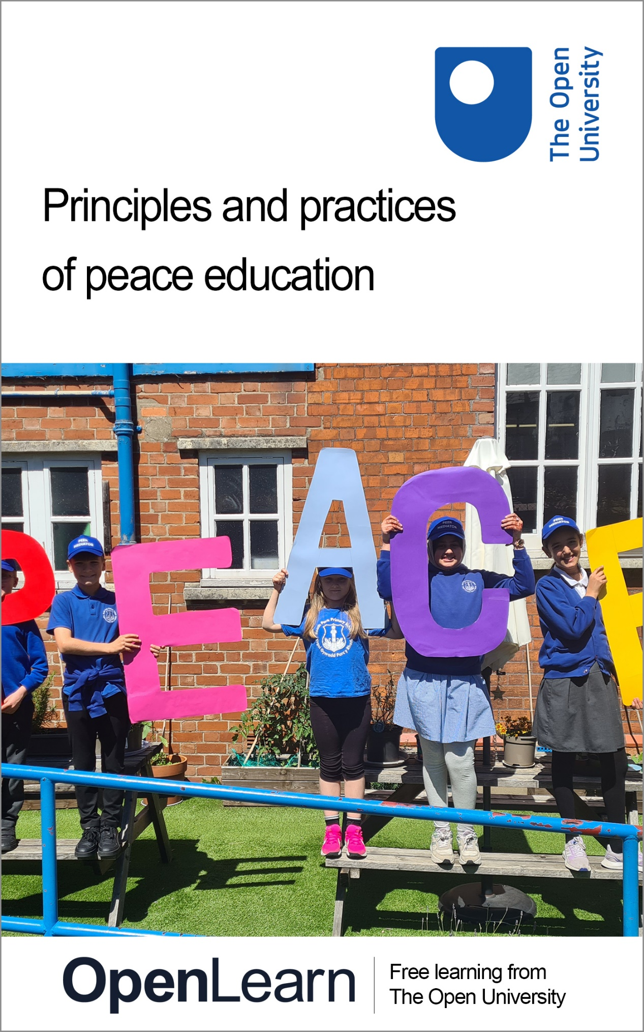

PPE_1

Principles and practices of peace education

About this free course
This free course is an adapted extract from the Open University course .
This version of the content may include video, images and interactive content that may not be optimised for your device.
You can experience this free course as it was originally designed on OpenLearn, the home of free learning from The Open University –
There you’ll also be able to track your progress via your activity record, which you can use to demonstrate your learning.
First published 2024.
Unless otherwise stated, copyright © 2024 The Open University, all rights reserved.
Intellectual property
Unless otherwise stated, this resource is released under the terms of the Creative Commons Licence v4.0 http://creativecommons.org/licenses/by-nc-sa/4.0/deed.en. Within that The Open University interprets this licence in the following way: www.open.edu/openlearn/about-openlearn/frequently-asked-questions-on-openlearn. Copyright and rights falling outside the terms of the Creative Commons Licence are retained or controlled by The Open University. Please read the full text before using any of the content.
We believe the primary barrier to accessing high-quality educational experiences is cost, which is why we aim to publish as much free content as possible under an open licence. If it proves difficult to release content under our preferred Creative Commons licence (e.g. because we can’t afford or gain the clearances or find suitable alternatives), we will still release the materials for free under a personal end-user licence.
This is because the learning experience will always be the same high quality offering and that should always be seen as positive – even if at times the licensing is different to Creative Commons.
When using the content you must attribute us (The Open University) (the OU) and any identified author in accordance with the terms of the Creative Commons Licence.
The Acknowledgements section is used to list, amongst other things, third party (Proprietary), licensed content which is not subject to Creative Commons licensing. Proprietary content must be used (retained) intact and in context to the content at all times.
The Acknowledgements section is also used to bring to your attention any other Special Restrictions which may apply to the content. For example there may be times when the Creative Commons Non-Commercial Sharealike licence does not apply to any of the content even if owned by us (The Open University). In these instances, unless stated otherwise, the content may be used for personal and non-commercial use.
We have also identified as Proprietary other material included in the content which is not subject to Creative Commons Licence. These are OU logos, trading names and may extend to certain photographic and video images and sound recordings and any other material as may be brought to your attention.
Unauthorised use of any of the content may constitute a breach of the terms and conditions and/or intellectual property laws.
We reserve the right to alter, amend or bring to an end any terms and conditions provided here without notice.
All rights falling outside the terms of the Creative Commons licence are retained or controlled by The Open University.
Head of Intellectual Property, The Open University

Contents
- Introduction and guidance
  - Introduction
  - Guidance for participants and facilitators
  - Quakers in Britain
  - Moving around the course
- Session 1: What is peace?
  - Introduction
  - 1 What does peace mean to you?
    - 1.1 Peace and peace educators
  - 2 Positive peace
    - 2.1 Is it peace for everybody?
  - 3 Violence
    - 3.1 Structural violence
  - 4 Conflict
  - 5 Introducing Peace at the Heart
  - 6 Summary of Session 1
- Session 2: Peace with myself
  - Introduction
  - 1 Wellbeing and peace building
    - 1.1 What does wellbeing mean?
  - 2 What’s good in me – Affirmations
    - 2.1 Affirming others
  - 3 Managing myself in difficult situations
    - 3.1 Self regulating
    - 3.2 Recognising needs
  - 4 Summary of Session 2
- Session 3: Peace between us
  - Introduction
  - 1 Working in circles
    - 1.1 Planning a circle session
  - 2 Approaches to conflict
  - 3 Empathy and peace competencies
    - 3.1 Using empathy as a curriculum tool – touching on peace in the wider world
    - 3.2 Competencies for peace
  - 4 Summary of Session 3
- Session 4: Peace among us
  - Introduction
  - 1 Children and young people in their communities
    - 1.1 Making a start
  - 2 Developing peace in educational settings
    - 2.1 Peer mediation
    - 2.2 School aspirations and pupil responsibility
    - 2.3 Training peer mediators
    - 2.4 Competencies and peer mediation
  - 3 Acting for change – Rights Respecting Schools
  - 4 The United Nations Convention on the Rights of the Child
  - 5 Summary of Session 4
- Session 5: Peace in the world
  - Introduction
  - 1 Hope
    - 1.1 Understanding hope
    - 1.2 Thinking about non-violence
  - 2 Wangari’s Trees of Peace – starting with a story
  - 3 Selecting stories for peace education
  - 4 Working in the community: Glasgow Girls
    - 4.1 Finding suitable books
  - 5 Teaching for peace in the wider world
  - 6 Upstanding and privilege
  - 7 The role of the educator
  - 8 Teaching controversial issues
  - 9 Summary of Session 5
- Session 6: Your journey as a peace educator
  - Introduction
  - 1 Your development as a peace educator
    - 1.1 Making a personal development plan
  - 2 What makes peace education quality education
    - 2.1 Working towards a coherent ethos of peace
    - 2.2 Resources to support your peace journey
    - 2.3 Evaluating peace resources
  - 3 Next steps
  - 4 Summary of Session 6
  - Further learning
  - References
  - Acknowledgements
  - Course resources and recommendations
    - Course further reading
- Solutions
- Descriptions

Introduction and guidance

Introduction
This Principles and practices of peace education course is a collaboration between the Open University and Quakers in Britain. The course introduces the core principles of peace education to those working with children and young people. As well as practical ideas for everyday classroom practice, it links to materials for further study and curriculum planning.
The course is divided into six sessions. Each session should take approximately two hours to complete.
Session 1: What is peace?
Session 2: Peace with myself
Session 3: Peace between us
Session 4: Peace among us
Session 5: Peace in the world
Session 6: Your journey as a peace educator
Learning outcomes
After studying this course, you should be able to:
- describe concepts underpinning peace education
- understand pedagogical approaches to building peace in the classroom
- be aware of the competencies that can be developed through peaceful education practices with children and young people
- begin to develop self-reflective practice as a reflective peace educator.

Guidance for participants and facilitators
You can complete this course as an individual learner on a computer or smartphone. Principles and practices of peace education can also be used as a basis of Continuing Professional Development (CPD) sessions with a larger group.
If you are intending to use the materials to facilitate a CPD course, you are encouraged to work through the materials yourself before using them to plan CPD. You will be able to familiarise yourself with the core concepts of the course and select the materials that will be the most helpful for you to use in your professional context. You’ll find alternative approaches and versions of some of the activities that can be used with a larger group (these appear in boxes titled ‘CPD sessions’).
External links: we recommend that you open links in a new tab or window by holding down Ctrl [or Cmd on a Mac] when you click on the link. This will make it easier to return to the page of the course you were reading.

Quakers in Britain
There are many organisations working for peace and peace education in the UK and beyond. The Open University is collaborating with Quakers in Britain who co-chair the Peace Education Network, a collection of organisations and individuals working in peace education, with Pax Christi. Quakers support alternative ways of resolving conflict and global disarmament. They believe education is key to building a compassionate, peaceful world and are pioneers in peace education.
The Religious Society of Friends (Quakers) is a radical faith group with its roots in Christianity. It emerged in the mid-seventeenth century as a group with no separate priesthood, and with a form of worship based in silence. It believes there is ‘that of God in everyone’. This has inspired Quakers to take a clear stand for peace and non-violence.
Quakers in Britain published the 2022 report Peace at the Heart: A relational approach to education in British schools, on which this course draws.

Moving around the course
In the ‘Summary’ at the end of each session, you will find a link to the next session. If at any time you want to return to the start of the course, click on ‘Full course description’. From here you can navigate to any part of the course.
It’s also good practice if you access a link from within a course page, to open it in a new window or tab. That way you can easily return to where you’ve come from without having to use the back button on your browser. You can do that by holding down Ctrl [or Cmd on a Mac] when you click on the link.
You will probably want to make notes as you go along, so choose your preferred method for this, either writing in a notebook or on your computer or tablet. There are free response box options inside some of the activities. Please note: anything you add into these boxes will be saved for you to return to, provided you are signed into OpenLearn and enrolled on the course. But the information saved is only accessible to you and cannot be viewed by anyone else. You can collate and download all of your answers and notes for the course by clicking ‘Download your answers for the documents on this course’, which is on the left-hand column of the course.
The activities have individual timings, this is an approximate, suggested time that the activity might take. If working through the course as a group rather than individually, you might want to consider doubling the suggested timings, to allow for discussions.
Enrolling on the course will track your progress and give you the opportunity to earn your OpenLearn statement of participation. Statements are not accredited by The Open University but they’re a great way to demonstrate your interest in the subject and commitment to your learning and your career, and to provide evidence of continuing professional development. Once you are signed in, you can manage your OpenLearn statement of participation online from My OpenLearn. In addition, you can download and print it.
To gain a statement of participation, you need to read every page of the course, including the introduction and guidance section. You will be notified by email if you have received a statement of participation but please allow up to 24 hours for this to happen.
The Open University would really appreciate a few minutes of your time to tell us about yourself and your expectations for the course before you begin, in our optional start-of-course survey. Once you complete the course we would also value your feedback and suggestions for future improvement, in our optional end-of-course survey. Participation will be completely confidential and we will not pass on your details to others.
You can now go to Session 1.

Session 1: What is peace?

Introduction
Welcome to this free online course, Principles and practices of peace education, which will support your development as a reflective peace educator.
In this first session, you’ll reflect on the values and beliefs you bring to peace education. You’ll be introduced to some general principles and concepts that inform this course, including the principle that peace can be understood in diverse ways.
By the end of this session, you should be able to:
- articulate what you think of when you think of peace
- begin to understand models and concepts of peace
- begin to think about peace in school as being founded in positive relationships
- consider how these concepts might apply in your personal or professional context.

CPD sessions
If you are planning to use these materials as CPD, look out for these boxes. They indicate suggestions for adapting an activity to working with a larger group as part of a CPD session.

1 What does peace mean to you?
In this section, you’ll consider your own and others’ perspective on peace. This will help you think about the ideas presented in this first session in relation to your own context.

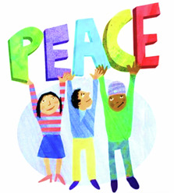
Figure 1 Perspectives on peace
View description - Figure 1 Perspectives on peace

1.1 Peace and peace educators
You’ll begin by watching an introduction to peace education by peace educators Izzy and Ellis from Quakers in Britain. As well as working with schools, youth organisations and national governments, Izzy and Ellis co-ordinate the UK’s Peace Education Network, a collection of organisations and individuals working in peace education.

Activity 1 Introducing peace education
Allow approximately 5 minutes for this activity

In this video Izzy and Ellis discuss their ideas about peace and how it informs their approach to peace education.

Video content is not available in this format.
Video 1
View transcript - Video 1

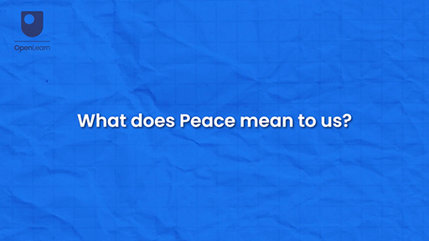
Video 1

View discussion - Activity 1 Introducing peace education

In the video, Izzy and Ellis talked about what peace means to them. In the following activities you’ll consider what peace means to you as you begin to work through these course materials.

Activity 2 Your ideas about peace
Allow approximately 20 minutes for this activity

Part 1

Use the box below to note down your initial ideas about what peace means to you. If you like, you might draw your ideas in a notebook, or capture them in a photograph (but you won’t be able to add images or draw in the response box).

Provide your answer...

Part 2

Now look at the ideas about peace captured in the quotes and images below (Figures 2-5). What might peace mean in each example?

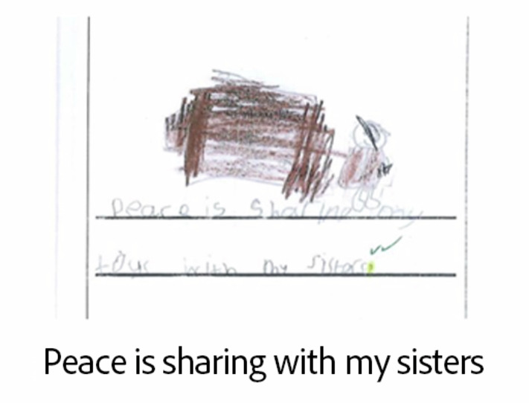
Figure 2 A child’s idea of peace
View description - Figure 2 A child’s idea of peace

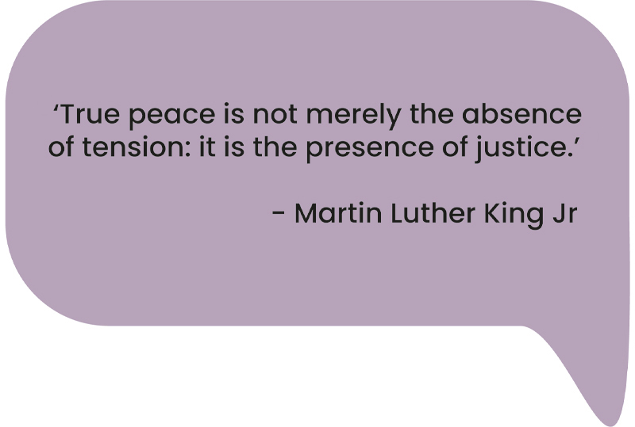
Figure 3 Famous quote attributed to American civil rights activist Martin Luther King Jr
View description - Figure 3 Famous quote attributed to American civil rights activist Martin Luther ...

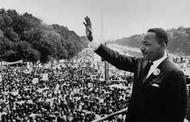
Figure 4 Martin Luther King Jr
View description - Figure 4 Martin Luther King Jr

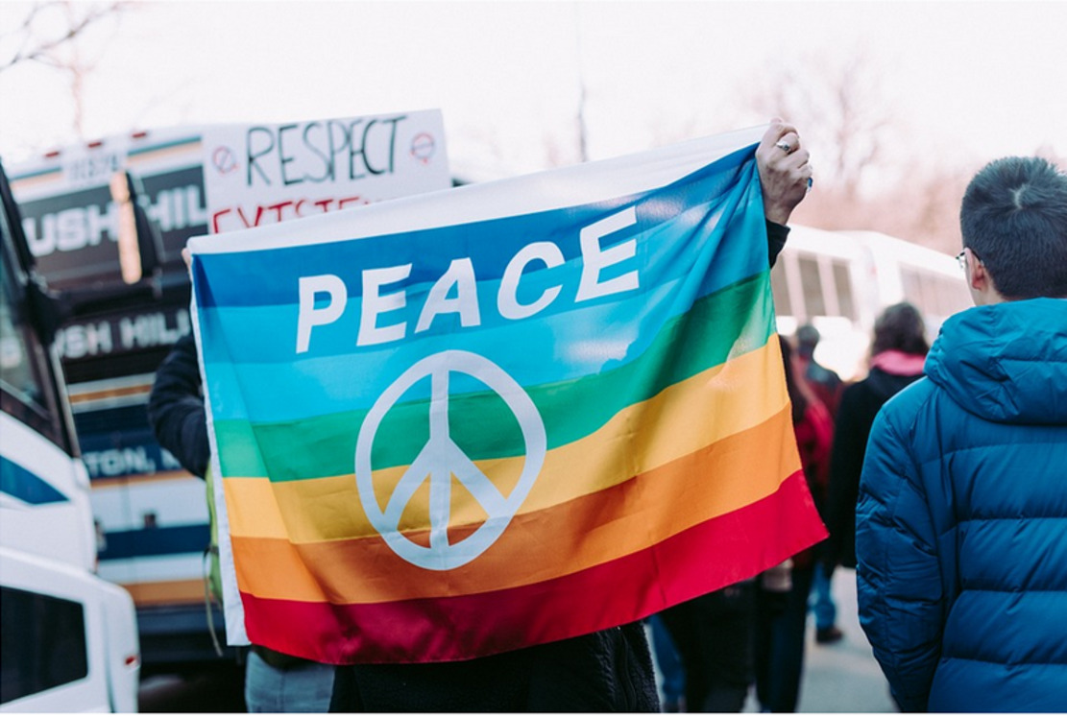
Figure 5 Demonstrators at a peace protest
View description - Figure 5 Demonstrators at a peace protest

View discussion - Part 2

Part 3

Now return to your own ideas about peace. Is there anything you might add?
Think about these questions:
- What might inform your perspective on peace?
- Which aspects of your life experience do you draw on when you think of peace?

Provide your answer...

CPD sessions
With a group, you might use the quotes and images above to start the discussion. However you could use images and objects that capture different ideas of peace that are more relevant to your own context.
Invite your participants to express their ideas in any way they wish. They might draw, find an image on their smartphone or write. You might display the different ideas around the room you are working in to come back to as you work through the session.

There are no right or wrong answers to definitions of peace. As you work through this course, keep your personal ideas in mind. In Session 4 you’ll be asked to consider what peace might mean for your school community or group setting. Activities such as these help communities create shared visions and consider how they might build communities where they can thrive together.

2 Positive peace
There are many paths to peace and many approaches to peace education. However, a commitment to non-violence is at the heart of the work of peace educators. Johan Galtung was a Norwegian theorist in the field of peace studies who has had an enormous influence on the work of peace educators. An idea popularised by Galtung is that of positive and negative peace.

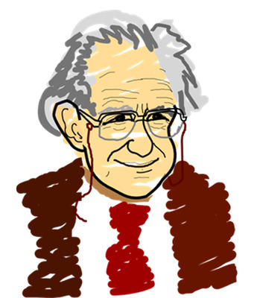
Figure 6 Johan Galtung
View description - Figure 6 Johan Galtung

In Galtung’s theory, positive peace means not only an absence of all types of violence (and the fear of violence), but also the presence of social justice and institutions that support and further harmony (Cremin and Bevington, 2017). When Martin Luther King Jr talks about peace as the presence of justice he is talking about positive peace. It is not just about the absence of something (in this case racial tension), but the presence of something positive (in this case justice).

Activity 3 Positive and negative peace in schools
Allow approximately 10 minutes for this activity

Click on the terms below to read how Jackie Zammit, a peace educator working in the West Midlands, explains how Galtung’s ideas of positive and negative peace might look in schools. As you read, consider why the example Zammit gives might illustrate the concept of negative peace, and how the problem of football arguments might be approached from a perspective of positive peace.
Jackie Zammit:

View discussion - Activity 3 Positive and negative peace in schools

2.1 Is it peace for everybody?
Where there are power imbalances, such as those between adults and children and young people in schools, peace educators need to be careful of imposing a peace that is not understood or welcomed by the people they work with. Philippine researcher Cristina J. Montiel discusses issues around peace and power imbalances that she has explored in her research on global peace. She examined instances where more powerful countries negotiate peace with those less powerful, as in instances of colonialism. She argues that in such situations, the powerful coloniser focuses peace negotiations on the cessation of violence. But the less powerful group are often seeking justice and their needs are not met. Whilst the visible violence might be reduced, the underlying causes of that violence are not addressed (Montiel, 2022).
You might think about this in relation to the quotation from Martin Luther King Jr in Activity 1, about peace being more than the absence of tension, or the children and young people who are no longer able to play football in school in Activity 3.
Pause for a moment to consider the extent to which school policies and practices can impose a particular notion of peace on their students (and perhaps their wider communities) without first building relationships that foster shared perspectives and understanding.

3 Violence
In the previous section peace is referred to as an absence of all types of violence. Galtung argued that understanding violence and the forms it might take is important to achieve and maintain positive peace.
Returning to the football example, the arguments the school might wish to prevent might be seen as examples of direct violence. This type of violence includes physical and verbal fights. Direct violence might arise from deeper, less immediately visible violence. For example, cultural violence describes the beliefs and assumptions that affect the ways in which particular groups of people are treated. Racism, homophobia and ableism are examples of cultural violence that can become most clearly visible when they result in direct violence, but they also involve ongoing attitudes and behaviours that might take some reflective work to identify.

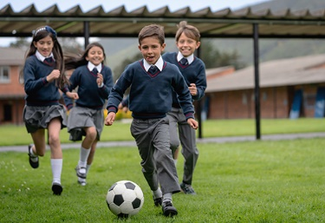
Figure 7 Football in school
View description - Figure 7 Football in school

Case study: Types of violence in school
In a London school which session co-author Lucy Henning worked at some years ago, there were many staffroom discussions about managing the children’s often heated arguments that occurred when playing football, which occasionally resulted in physical violence. And, yes, the school leadership team did ban football for a time. This dealt with the direct violence of the arguments as breaktimes became easier for school staff to manage.
However, as school staff discussed reinstating football other issues emerged. This may sound strange now, but at that time, both staff and children in the school viewed football as something boys played. This is an example of cultural violence as, without realising it, the school community was making a sexist assumption that football was for boys.
Furthermore, the space taken up by the football matches meant that the play for the children who were not footballers was confined to the edges of the playground, leaving non-footballers (the majority of whom were girls) less space to play, prioritising the needs of one group of children over others.
When football was reinstated, there were special times for girls to play as well as times where football was not allowed, to allow greater access for all children to make the most of the playground space.

3.1 Structural violence
A third type of violence identified by Galtung is structural violence. Like cultural violence, structural violence is not always easily visible, but can result in long term, deep injustices and inequities. An example of structural violence in schools might be a requirement for students to pay for a school trip that is beneficial to their course. This might prevent students from low-income families engaging in important educational activities that are more accessible to their wealthier peers. Another example of structural violence in education is found in research showing how Black British Caribbean students are more likely to be excluded from school than white British students and British Indian students (Cremin and Bevington, 2017, p. 21). This structural violence disproportionately excludes young people from particular social groups from education and its potential benefits.
Cultural and structural violence are more difficult to discern than direct violence. They can be ongoing and insidious but nonetheless deeply felt by those who are adversely affected. Both cultural and structural violence can be a factor in direct violence. Standish writes about how cultural violence makes other forms of violence permissible (Standish, 2015, p. 10). For example, racist assumptions becoming a factor in greater exclusions for Black children (structural violence), or students who are not Black feeling emboldened to name call or physically attack Black students (direct violence).

Activity 4 Exploring different types of violence
Allow approximately 10 minutes for this activity

Look at the diagram below which uses the iceberg metaphor to illustrate how structural and cultural violence might be less visible (that is, under the waterline) than direct violence. Think about the football example described in the case study earlier and answer the following questions (type your thoughts into the boxes in the diagram).
- Which types of violence does the football example illustrate?
- How are the different types of violence connected?

Interactive content is not available in this format.
Figure 8 Iceberg diagram
View description - Figure 8 Iceberg diagram

View discussion - Activity 4 Exploring different types of violence

In the next activity you’ll build on these ideas, considering further examples of direct, cultural and structural violence.

Activity 5 Examples from experience
Allow approximately 5 minutes for this activity

Take a moment to reflect on any further examples of cultural, structural and direct violence. Annotate the diagram below with your examples and consider how each type of violence might be linked to another.

Interactive content is not available in this format.
Figure 9 Iceberg diagram
View description - Figure 9 Iceberg diagram

Being able to identify violence and its effects is an essential critical tool for reflective action to build peace. In the next section you will consider the concept of conflict and how it can be applied in peace education.

CPD sessions
If doing the activity above as a group, it is very important to remind participants to recognise and acknowledge the hurt and injustice that violence causes in all its forms, even if they have not experienced certain types of cultural or structural violence themselves. You might divide your group into smaller groups and allow participants to choose who they work with.
Allow participants to choose whether to feed back. As a group you might reflect on ideas and life experiences of types of violence. You might notice the different ways in which violence might manifest itself in different areas of everyday life, particularly the context in which the group is working.

4 Conflict
Peace does not necessarily mean an absence of conflict. But it does mean developing skills and competencies in managing conflict effectively in order to work towards positive outcomes.

Activity 6 Children’s perceptions of conflict
Allow approximately 10 minutes for this activity

Watch this short video of children from a school in the West Midlands giving definitions and examples of conflict. As you watch consider:
- What examples of conflict do the students give?
- What role might violence take in each example?
Use the box below to record your thoughts.

Video content is not available in this format.
Video 2
View transcript - Video 2

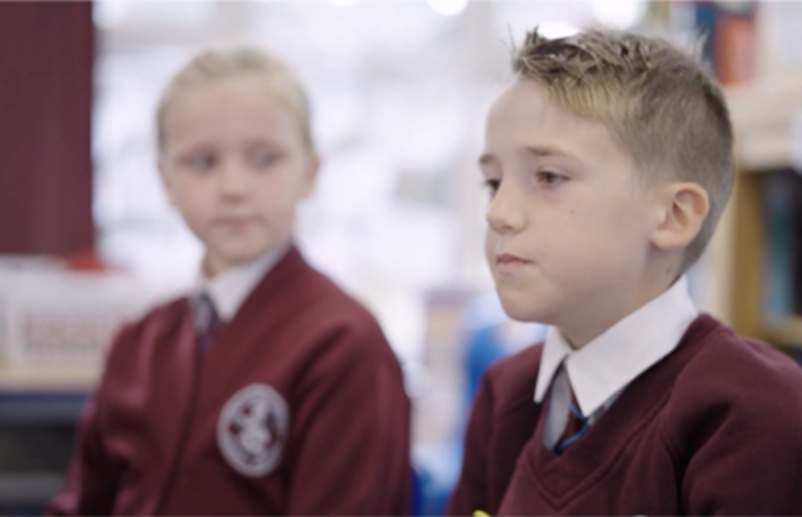

Provide your answer...
View discussion - Activity 6 Children’s perceptions of conflict

Whilst each young person in the clip describes a conflict, this need not result in negative outcomes. Conflict is part of everyday life. A well-managed conflict can be a creative force, allowing people to discuss ideas they may not have considered before and try new approaches to challenges. An aim of peace education is to support children and young people in developing their competencies in managing conflict for themselves. This might involve skills such as regulating emotions (before an argument becomes a ‘really big problem’), communicating clearly and listening to each other empathetically, as well as knowing when to call on a third party for help.

5 Introducing Peace at the Heart

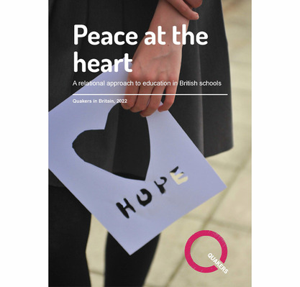
Figure 10 Front cover of the report Peace at the Heart, published by Quakers in Britain
View description - Figure 10 Front cover of the report Peace at the Heart, published by Quakers in ...

This last section of Session 1 introduces Peace at the Heart, which brings together the work of educators, schools and young people to describe peace education as a process of building and maintaining positive relationships at different levels.
In the report, the complexity of peace is captured in the idea of overlapping layers:
- Individual wellbeing and development (‘peace with myself’)
- Positive peer relations (‘peace between us’)
- Inclusive school community (‘peace among us’)
- Global citizenship and sustainable development (‘peace in the world’)
As you work through the remainder of this course, you’ll explore each of these layers in more detail and consider how you might work with this model of peace in your practice. The last activity in this session will help you familiarise yourself with the layers and start thinking about how this relates to your personal and professional concepts of peace.

Activity 7
Allow approximately 10 minutes for this activity

Explore the diagram below, reading the definitions of the different layers of peace taken from Peace at the Heart. Note the emphasis on building and maintaining positive relationships, a core message of the report.
As you explore the diagram, think about:
- Which layer might the definition of peace that you thought of at the start of the session fit into?
- What might each layer of peace look like in a classroom or school?
- How do the layers overlap?
Use the response box below to record your thoughts.

Interactive content is not available in this format.

Provide your answer...
View discussion - Activity 7

6 Summary of Session 1
In this session you have looked at some important concepts that peace educators build from in their work. You have seen that positive peace involves not just an absence of violence and fear, but a presence of qualities such as equity and justice. You’ve touched on the different forms that violence might take and how being able to recognise and counter them is an important part of peace education. As well as this, you’ve looked at conflict and its potential to develop in positive and negative ways. This session also touched on competencies that enable children and young people to manage conflict effectively. You’ll return to these themes and ideas throughout this course.
This course uses a particular model developed in the report Peace at the Heart, but you should uphold your own perspective on peace as well as those you live and work with as you consider developing your practice in the light of these materials.
You can now go to Session 2.

Session 2: Peace with myself

Introduction
This session follows the model of peace that you read about in Session 1, introducing some principles of ‘peace with myself’ which cultivate individual wellbeing and development. This is the first of the four layers of peace laid out in Peace at the Heart that you read about in the last session.
By the end of this session, you should be able to:
- understand peace building as a long-term practice of development
- articulate the relationship between wellbeing and peace building
- plan to teach strategies for peace building through wellbeing.
There are a wealth of activities related to wellbeing in schools. This session will help you understand how you might incorporate such activities into your peace building practice.
Watch this video where Izzy introduces Session 2.

Video content is not available in this format.
Video 1
View transcript - Video 1

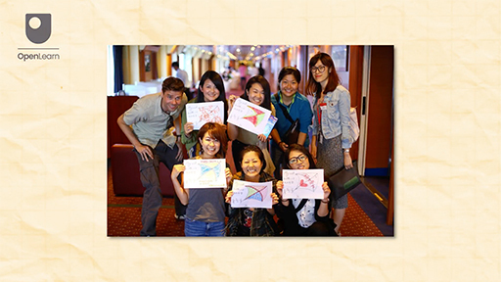

1 Wellbeing and peace building
Johan Galtung, who you met in Session 1, defined three kinds of peace work: peace keeping, peace making and peace building. For Galtung, peace keeping is primarily concerned with keeping antagonists apart; peace making focuses on getting rid of the source of tension; and peace building is concerned with both removing social structures that give rise to violence and war and offering alternatives (Galtung, 1976). Remember that violence takes different forms and includes identity violence such as racism and misogyny.
This session focuses on peace building. The organisation Conciliation Resources supports people living in areas of violent conflict to find resolutions to that conflict. They describe peace building as:

...a long-term process of encouraging people to talk, repairing relationships, and reforming institutions. For positive change to last, everyone affected by a destructive conflict has to be involved in the process of building peace.
(Conciliation Resources, 2024)

In this definition, peace building forms part of the work to resolve conflict and manage the effects of violence. However, peace building can also mean work to prevent conflict becoming violent in the first place. In the context of peace education, peace building is described by Cremin and Bevington as ‘…the forward looking, preventative dimension…’ of peace (Cremin and Bevington, 2017, p. 103). This view of peace building is focused on preventing conflicts becoming violent and destructive rather than rebuilding peace when violent conflict has already occurred. These authors explain that peace building ‘…requires imagining how things could be and working towards that vision…’ (ibid). For this kind of peace building, Cremin and Bevington argue that wellbeing is essential. Wellbeing also forms an important part of ‘peace with myself’ – a section in Peace at the Heart.

1.1 What does wellbeing mean?
Care and attention to everyone’s wellbeing is essential for the development of the first layer of peace – ‘peace with myself’ – outlined in Peace at the Heart. This section continues to follow the work of Cremin and Bevington (2017) to explore what wellbeing means in the context of peace building.

Activity 1 What does wellbeing mean?
Allow approximately 10 minutes for this activity

Read Cremin and Bevington’s descriptions of different aspects of wellbeing in the box below (Cremin and Bevington, 2017, pp. 111–12). Click on one of the options below to match the aspect of wellbeing they are describing.

Once you have reviewed the definitions, reflect on what you might need to support each of these aspects of your own wellbeing. Record your ideas in the table below. You may wish to come back to these in Session 6.

Emotional wellbeing | Provide your answer...
Psychological wellbeing | Provide your answer...
Social wellbeing | Provide your answer...
Spiritual wellbeing | Provide your answer...

View discussion - Part

As well as helping children and young people develop peace with myself, attention to and care of wellbeing is a key asset in the culture and environment of an educational community. Peace at the Heart explains the benefits of developing an educational environment where ‘…students believe that adults in the school care about their learning and about them as individuals.’ It draws on research to describe how such schools ‘… have seen benefits to student satisfaction and personal development, reduced violence and exclusions, and higher grades’ (Peace at the Heart, p. 15). Attentive care to wellbeing might be developed in any and all aspects of the educational community. Embedding such care has benefits for everyone.
This course focuses on wellbeing in the context of building positive relationships and managing conflict. However, there are many different services and approaches to supporting the mental health of all members of school communities. For example, at the time of writing (2024) UK governments have been investing resources in exploring and developing trauma-informed practice. This approach is informed by key principles of: safety, trust, choice, collaboration, empowerment and cultural consideration (Office for Health Improvement & Disparities, 2022). Schools might also wish to explore educational and healthcare resources related to working with children with Adverse Childhood Experiences (ACEs).

2 What’s good in me – Affirmations

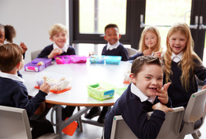
Figure 1 Children enjoying their packed lunch
View description - Figure 1 Children enjoying their packed lunch

Learning for Peace by West Midlands Peacemakers explains that part of developing inner peace (peace with myself) is to ‘learn to affirm others and accept affirmation for themselves’ (Zammit & Hagel, 2016, p. 44). Affirmations help people see what’s good in themselves, something that is important for every member of the school community. In this session you will concentrate on children and young people, but you will return to wellbeing for educators in Session 6.
Learning to give and receive affirmations is most effective if it is a regular classroom activity as it takes time and practice to develop these skills.

Activity 2 Affirming myself
Allow approximately 15 minutes for this activity

Here you’ll use the activity It’s good to be me from West Midlands Peacemakers as a starting point for working on affirmations. Read the activity and then think about how you might adapt it for the context in which you work, remembering that it may take time and patience to build up to the point where you and your class can participate confidently in giving and receiving affirmations.
Note that the activity is intended to be carried out with the group seated in a circle and a ‘talking piece’ is an item that a participant holds that indicates it is their time to speak. You can use the response box below to note down your ideas. If you have signed into OpenLearn, your ideas will be saved for returning to later.

Activity:
It’s good to be me
Aim: For children to be able to affirm themselves
Skills: Listening, affirming, communicating, self awareness, looking
Age: 5-11 and beyond
Model this by going first. Holding the ‘talking piece’ say ‘it’s good to be me because… ’ and finish the sentence with something you are proud of, or something you have achieved. For example:
‘It’s good to be me because I’m learning how to bake cakes.’
You then pass the ball to a child next to you. The child then repeats what the adult has said:
‘It’s good to be you because you are learning how to bake cakes.’
And adds their own affirmation statement:
‘And it’s good to be me because I’m good at literacy.’
The ball is then passed all around the circle with people repeating what the person said before them and adding their own sentence.

Provide your answer...
View discussion - Activity 2 Affirming myself

2.1 Affirming others
Being able to affirm oneself is important for children and young people’s self-esteem. Part of social wellbeing is to be able to affirm others, to establish and maintain positive, supportive relationships.
Below are images of ‘Pick Up Cards’, used in an example of an activity for younger children from the Quakers in Britain Peace Week Pack. This activity works well for younger children.

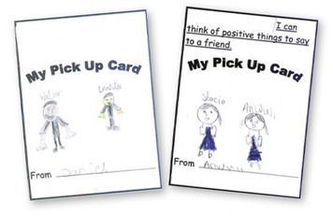
Figure 2 ‘Pick Up Cards’ from a Peace Week activity
View description - Figure 2 ‘Pick Up Cards’ from a Peace Week activity

The card on the right shows the learning intention. In an activity like this, children work in pairs to create a card for another child that they can use as a ‘pick up’ whenever they need it.
Developing skills in affirming the self and others can be more challenging for young people of secondary school age. The image below is a screenshot from a video of students at Elizabeth Garrett School which you will watch in full in Session 5. In this activity the students explore the many facets of their identities in ways that create opportunities for self-affirmation and offering affirmations to others. As you will see when you watch the full video in Session 5, the session was carefully planned with the teacher first modelling her expectations to the students. It is also important that Elizabeth Garrett School actively promotes and maintains positive and affirming relationships in the context of their work to be an explicitly anti-racist school.

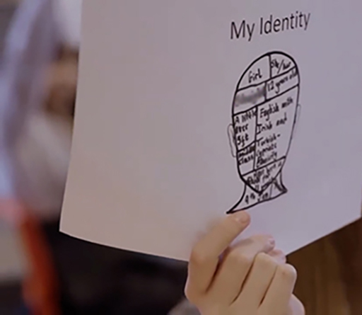
Figure 3 A secondary school student explores their identity
View description - Figure 3 A secondary school student explores their identity

Activities that ask children and young people to share personal information, such as their sense of their identity, their feelings or family circumstances should take place in carefully managed safe spaces where all participants have agreed ground rules of respect and confidentiality. No one should be expected to share any aspect of their identity that they wish to remain private, and children and young people should be supported in making careful decisions about how much they wish to participate. Here, steady, patient and careful work to build strong and trusting relationships between all members of educational communities is essential.
Educators often affirm children and young people, but the skill of affirming others can also be modelled by adults in school, thanking each other and demonstrating an appreciation of colleagues’ work. These everyday actions can help build that positive ethos of social wellbeing where affirming oneself and others is part of the everyday practice of the school community.

3 Managing myself in difficult situations
The last part of this session introduces you to research into the science of human emotions. Such knowledge can help us understand what is happening when we experience strong feelings, increasing our capacity to manage difficult situations. However, you should remember that the brain is a hugely complex structure, and everyone’s biology and experience is distinct. Strategies for helping children regulate their emotions should be conscious of that diversity and work with who children and young people are, rather than ideas of what they ‘should’ be.

Activity 3 An introduction to emotions and the human brain
Allow approximately 20 minutes for this activity

Watch this video Welcome to the brain’s amazing drugs cabinet from the charity Scottish Centre for Conflict Resolution.
As you watch, think about:
- How might understanding emotions help the children and young people you work with?
- Why is it important to be able to ‘stand in another’s shoes’?

Video content is not available in this format.
Video 2
View transcript - Video 2

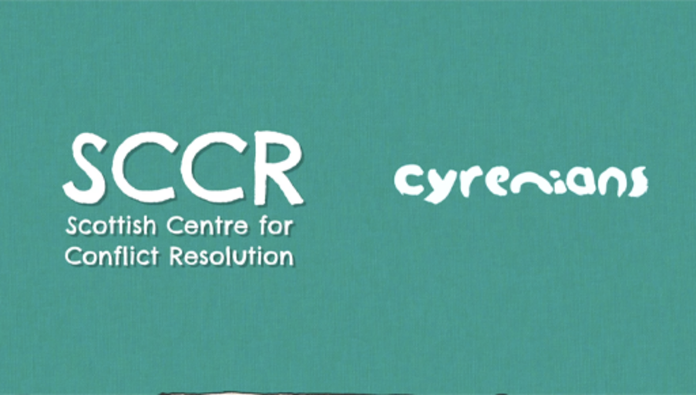
Video 3

View discussion - Activity 3 An introduction to emotions and the human brain

In the next activity, you will plan a session to support children and young people in exploring their emotions.

Activity 4 Recognising feelings in oneself and others
Allow approximately 20 minutes for this activity

Now you will plan a series of activities for a session on feelings with the children and young people you work with.

Part 1 Developing vocabulary to talk about feelings

The feelings map activity below is a suggested starter activity for helping a group develop vocabulary for talking about feelings. The ‘map’ is a circle (or other shape) divided into four quarters. Each quarter is labelled with a category of feelings, in this case ‘Happy’, ‘Scared’, ‘Angry’ and ‘Sad’. Participants have a set of cards with different feelings on them and are asked to sort the cards into the feelings category they agree is most appropriate. It’s important that this process allows plenty of time for exploration and discussion.
Begin by trying the activity for yourself in the interactive below, by moving the cards around into the categories you think they belong in. Then use the response box below to consider how you might adapt it to use with your class or group.

Provide your answer...
View discussion - Part 1 Developing vocabulary to talk about feelings

Part 2 Recognising and describing feelings

Now read through the following two activity outlines for describing and recognising feelings. How might you adapt them for your own class or group?
Feelings postcards – describing your own feelings
Add to your feelings map by giving each participant a small piece of card. They can choose a feeling from the map and illustrate it however they wish. They might use words to describe it, draw a picture or look up images on the internet. Participants might discuss the similarities and differences between the postcards to think about their own and others’ experiences of each feeling.
Feelings detective – recognising feelings in others
In this activity there are two sets of feelings cards. Choose 1 to 4 members of the group to be feelings detectives. Give one set of the feelings cards to the ‘detectives’.
Give each of the remaining players a feelings card. Each of these players then acts out the feeling on their card. The detectives then place their feelings cards next to the person they think is showing that feeling. Remember, places where actor and detective disagree offer opportunities to discuss the different ways in which people might express their emotions.

Provide your answer...
View discussion - Part 2 Recognising and describing feelings

CPD sessions
If doing the activity with a group, you might create your feelings map on the floor in the centre of a circle. You could use preprepared cards or ask participants to write an emotion they’ve experienced recently on a piece of card and sort it on to the circle.

In Session 3 of this course, you’ll look more closely at the principles of working in circles and you may wish to return to your ideas after that. Remember, if you are signed in to OpenLearn, your responses are saved as notes so you can return to them later to develop further.

3.1 Self regulating
Being able to recognise one’s feelings is an important step towards regulating emotions. In situations of conflict, powerful emotions act on both the physical and mental state. Recognising what is happening gives people a space to act and think differently.
In this next activity you will start to think about the kinds of emotions that arise in situations of conflict, and consider ways of recognising and managing them.

Activity 5 How does conflict affect my mind and body?
Allow approximately 20 minutes for this activity

Part 1

Watch this short video where Ellis outlines some of the ways in which children and young people describe their experiences of conflict situations.

Video content is not available in this format.
Video 3
View transcript - Video 3

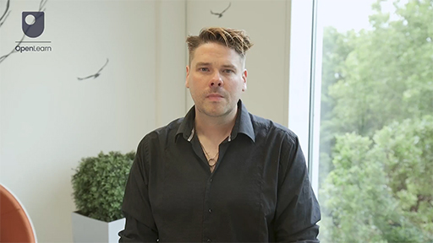

Part 2

Now write in the boxes below the different ways in which responses to conflict can affect your body and mind. As well as considering the ideas from the video, you might also think back to a situation where you experienced anger or another strong emotion as a result of a conflict.

Responses to conflict
Head

Chest

Stomach

Hands and feet

Arms and legs

Mind/thoughts

Anything else?

View discussion - Part 2

CPD sessions
If doing this activity with a group, you might prepare an outline of a figure for participants to annotate. They might add post-it notes or draw on the figure itself to show the effect of the emotions arising from conflict on their bodies.

As discussed, recognising powerful emotions such as anger, stress and anxiety in oneself and others is a step towards being able to regulate these emotions and lessen the risks of becoming overwhelmed by them.
Below is a simple activity that you might try to help children and young people begin to calm themselves when things feel overwhelming.

Hand tracing
Take a look at the video below that explains a technique to use for a very quick way of feeling a bit calmer.
Hand tracing video

3.2 Recognising needs
At the heart of most conflicts are unmet needs (Cartwright, 2019). Being able to regulate one’s emotions in challenging situations of conflict can support the practical work of managing conflict, but peace building in the longer term involves more than this. For example, managing the strong emotions and distress caused by bullying may help those affected cope with the situation in which they find themselves, but this should not detract from work to ensure bullying is addressed and educational communities meet each member’s need to feel safe and valued. Working with a greater sense of deeply felt needs connects individual peace and wellbeing to the wider community, as it can help people recognise and address the roots of conflict.
Long-term conflict resolution involves peeling back layers to reach an understanding of the unmet needs that deeply affect the wellbeing of conflict participants. Figure 4 was developed by Quaker Peace Education. It uses the metaphor of layers of an onion to help individuals think through the layers of a conflict to the unmet needs that can lie at its source.

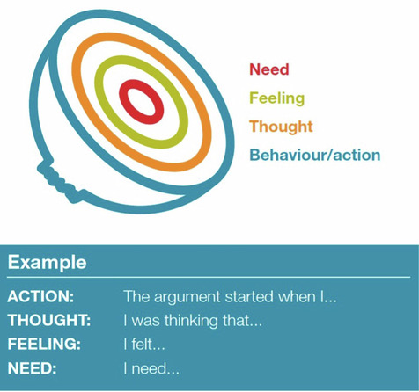
Figure 4 Onion diagram illustrating layers of conflict
View description - Figure 4 Onion diagram illustrating layers of conflict

Peace educator Isabel Cartwright uses this metaphor to offer an example of how an unmet need can be at the heart of a conflict:

…the argument started when I pushed her work off the desk’ (ACTION); ‘I was thinking that she deserved it’ (THOUGHT); ‘I felt hurt and angry that she’d laughed at my ideas’ (FEELING); ‘I need to be listened to’ (NEED).
(Cartwright, 2019, p. 20)

Needs might be anything from the desires for fairness and equality discussed in Session 1 of this course, to the practicalities of food, water and shelter, or the need for self-fulfilment, recognition, and love. For school communities to build strong peaceful relationships, each member can learn to understand their own and others’ needs, enabling them to maintain their wellbeing and build peace in their community.

4 Summary of Session 2
This session introduced the concept of peace building and the part that attention to wellbeing can play in the first layer of peace – peace with myself. Children and young people can practise different strategies to help them find ways of regulating their emotions and managing difficult situations. Members of school communities should take time to recognise the deeper needs within each person and work to build relationships in which these needs might be met. In Sessions 3 and 4 you’ll explore building strong educational communities in more depth.
You can now go to Session 3.

Session 3: Peace between us

Introduction
In this session you will be introduced to the ways in which circle sessions can be used to explore convivial peer relations – termed ‘peace between us’ in Peace at the Heart. You’ll consider the principles of using circle sessions as part of educational peace building before taking a deeper look at approaches to conflict.
By the end of this session, you should be able to:
- understand the principles behind teaching in a circle
- articulate the concept of empathy and its uses in supporting positive relationships and resolving conflict
- begin to develop strategies for building peace through resolving conflict fairly.
Before you start, watch this video where Izzy introduces the session.

Video content is not available in this format.
Video 1
View transcript - Video 1

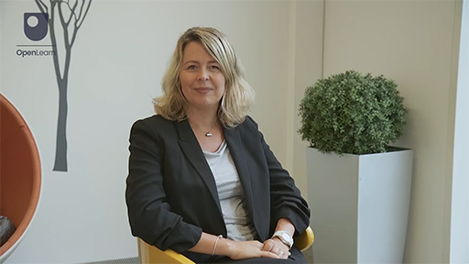

1 Working in circles

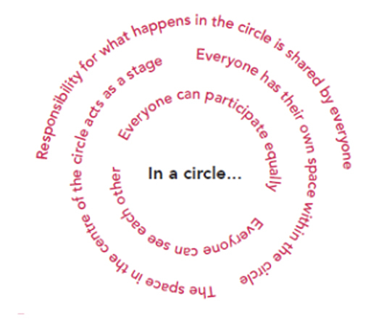
Figure 1 Explanation of a circle from Peacemakers
View description - Figure 1 Explanation of a circle from Peacemakers

Circle time is an established pedagogical technique that has many benefits for a range of areas of education. Working in a circle can reduce hierarchies between students and educators, support children in thinking through problems and issues together and help sustain positive relationships of collegiality, all of which can help build peaceful practice in educational settings. Such positive outcomes depend on patient, careful and reflective classroom work.

Activity 1 Benefits of circle time
Allow approximately 10 minutes for this activity

Watch the video via the link below on quality circle time from Watercliffe Meadow Community Primary School.

Video content is not available in this format.
Video 2
View transcript - Video 2

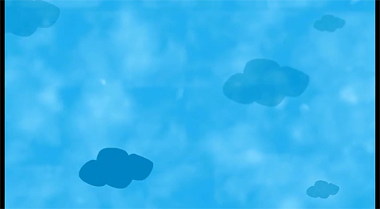

Use the box below to identify the more general benefits of groups working in circles. Are there any that relate specifically to peace building?

Provide your answer...
View discussion - Activity 1 Benefits of circle time

It’s essential that all members of the community feel a sense of safety and belonging in the circle, and everyone works together to achieve this. This means participants learn to value a diversity of communicative approaches and develop strategies to engage with those whose communicative approaches might differ from their own. It also means paying careful attention to the accessibility of the sessions. For example, if a member of the group finds it difficult to sit on the floor, all participants should sit on chairs. If circle sessions are dominated by particular voices (including the educator’s) and reduce access for some participants, the resulting inequalities mean that peace building cannot occur.

1.1 Planning a circle session

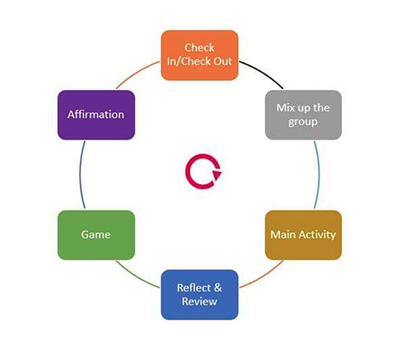
Figure 2 Diagram of a circle session from Peacemakers
View description - Figure 2 Diagram of a circle session from Peacemakers

In a circle session, adults act as facilitators rather than leaders and everyone takes responsibility for listening to each other and supporting the interaction.
The book Learning for Peace describes a tried and tested format for a peace building circle session that you might adapt for your own use (Figure 2). This format breaks the session into a variety of activities including opening the circle as a space for working together, acknowledging everyone’s presence, breaking the ice, establishing ways of working, engaging participants in the main activity, reflections, and affirmations.
A ‘talking piece’ is used to indicate whose turn it is to express their thoughts. Only the person using the talking piece can express their ideas (and that includes the adults in the room) and other participants must commit to engaging with their ideas.

Activity 2 Exploring elements of a circle session
Allow approximately 20-30 minutes for this activity

Use the table below, adapted from Learning for Peace, to explore different possible elements of a circle session.
You will find some links to websites that suggest activities for each part of a circle session.
As you explore these resources, use the response box provided to make notes about how you might implement circle sessions in your classroom. You might consider:
- How your group might build routines for forming and opening circles in your classroom.
- Any adaptations you might need to make for your group’s needs.
- What might be a good time of day for circle sessions.

Part of the session | Kind of activity | Links and possibilities
Check in | Establishes the circle, allows participants to share how they are feeling and how the group will work together. | Pass the talking piece around the circle. Ask a simple question that each participant can answer when it’s their turn. You might try ‘What’s been your favourite part of the week/day so far?’
Mix the group | Play a game to mix up participants, encouraging working with different members of the group. | Fruit salad  Give each member of the circle a piece (or a picture) of fruit. Participants swap seats when their fruit is called.  This game can be used with multiple languages as described in the OpenLearn article Pineapples and Pashto where it is used with speakers of Dari and Pashto.
Main activity | The key focus of the session. The adult should take a facilitating role here – try not to lead the session! | This will depend on what the participants want to develop as a group.
Reflect and review | A group reflection, sharing learning and responses to the activity. | See links on the Course resources and recommendations page.
Game | Refreshes the group, if possible linked back to the main activity. | See links on the Course resources and recommendations page
Affirmation | A chance for a few members of the group to hear positive things about each other. | It’s good to be me from Session 2 Activity 2 of this course.
Check out | Looking forward, closing the session and helping the participants to transition to the next part of their day. | Again, this could be a simple question that each person answers when they hold the talking piece. You might try ‘What are you looking forward to after school?’

On the Course resources and recommendations page you will find links to websites with activities that might be used in circle time sessions.
Remember that circles need time to settle and allow for a meaningful exchange of ideas. They may take a while to become established as part of the classroom routine.

Provide your answer...

Circles can be used to explore a number of issues. In the next section you will explore a circle activity that introduces approaches to conflict.

2 Approaches to conflict
Developing ‘peace between us’ means developing children and young people’s capacity to manage conflict situations, ‘…thus developing their emotional self-awareness and regulation, social skills, and accountability before others’ (Peace at the Heart, 2022, p. 4).
Managing conflict when it arises might be seen as peace making rather than peace building, which you focused on in Session 2. Whereas peace building is long term and preventative, peace making is reactive and involves developing skills in managing conflict non-violently and constructively when it inevitably arises (Cremin and Bevington, 2017). Thus the successful development of competencies in managing conflict can depend on the capacity to regulate emotions and recognise strong feelings and deeply felt needs in oneself and others, which were topics you read about in Session 2.
The Save the Children resource Conflict Management and Peace Building in Everyday Life (Giertsen and O’Kane, 2015) offers sessions for understanding and managing conflict. This involves becoming aware of one’s preferred approach to conflict, as well as different approaches that might be adopted.
The following activities are adapted from the session Conflict Styles from Conflict Management and Peace Building in Everyday Life.

CPD sessions
This makes a good main activity for a circle session. Prepare cards with animal pictures, behaviours, and conflict styles (see below). You might also use soft toys. Participants begin by working to match the cards to create the definition of the conflict style. They can then discuss the benefits and limitations of each conflict style in pairs, before feeding back to the group as the facilitator notes their ideas on further pieces of card.
The outcome of the session would be a large table of the conflict styles in the centre of the circle which can be photographed and used as a resource for developing the discussion further.

Activity 3 Matching conflict styles
Allow approximately 10 minutes for this activity
This activity, and variations of it, can help children and young people (and adults) think about different ways of managing a conflict. Using animals to represent conflict styles can help people remember what each involves. You may find other ways of representing the styles more useful in your context. The focus should be on deepening participants’ understanding of the ways in which conflict might be managed non-violently.

Part 1 Recognising different conflict styles

Begin by selecting the conflict style and behaviour of each of the animals below (make sure you click on ‘check’ before moving onto the next screen). Some screens have more than one correct answer.

View discussion - Part 1 Recognising different conflict styles

Part 2 Your preferred conflict style

Now read through the definitions of each conflict style and behaviour. Which is your preferred conflict style? Type your thoughts into the box below.

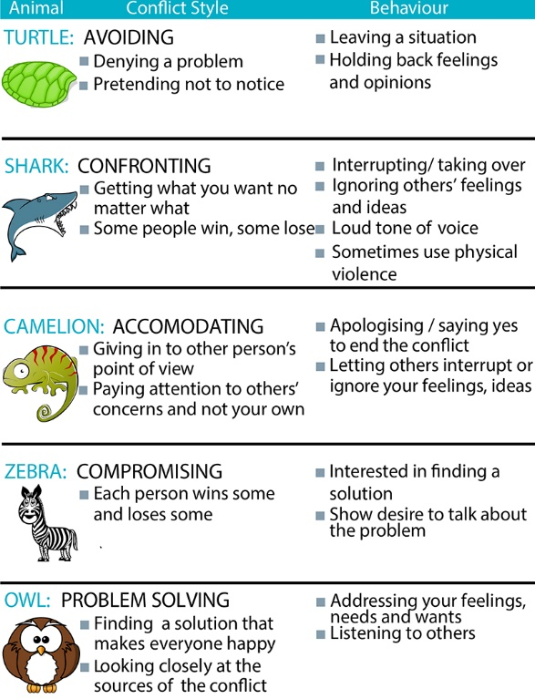
Figure 3 Animal conflict style segment, taken from a Save the Children resource
View description - Figure 3 Animal conflict style segment, taken from a Save the Children resource

Provide your answer...
View discussion - Part 2 Your preferred conflict style

Part 3 Benefits and limitations

Now you have read through the definitions of each learning style, and the behaviours associated with them, what might the benefits and limitations be to each style? Would you use the same style in every conflict situation?

Animal | Conflict style | Benefits | Limitations
Turtle | Avoiding | Provide your answer... | Provide your answer...
Shark | Confronting | Provide your answer... | Provide your answer...
Camelion | Accommodating | Provide your answer... | Provide your answer...
Zebra | Compromising | Provide your answer... | Provide your answer...
Owl | Problem Solving | Provide your answer... | Provide your answer...

View discussion - Part 3 Benefits and limitations

Part 4

Now consider the following scenario. Which conflict style would help you reach a peaceful solution?
Scenario
When it is time to clear up after an activity, some people work hard to help whilst others take the time to talk with friends and enjoy some ‘free time’. This is causing resentment amongst the helpers.

Provide your answer...
View discussion - Part 4

This activity is based on a Save the Children resource. Different organisations teach conflict styles using different animals, so you might see other versions elsewhere, or you may want to devise something that would work well in your context. The main thing is to think about the variety of ways in which people might respond to a conflict, and to consider how different approaches might work in different contexts.

CPD sessions
If carrying out this activity with a group, you could prepare a range of scenarios for them to discuss, either in pairs or smaller groups, before coming back into the circle to discuss their thoughts.

3 Empathy and peace competencies
In this section, you’ll consider what empathy is and its application in peace education. This is the starting point for thinking about peace competencies.
Scholars Mukhopadhyay and Kundu propose a global academic framework for education focused on developing peace and harmony. Within this model, empathy is listed as an essential life skill – something that one does or performs – alongside skills such as problem-solving, critical thinking, creativity, and communication. They argue that, although it is possible these skills might be ‘picked up’, their development should not be left to chance and their teaching should be part of a clearly articulated curriculum (Mukhopadhyay and Kundu, 2023, p. 17).
Polat and Halçe draw on a range of scholars to define empathy as a process where the individual can understand how another might feel, put themselves in their place, look at events from their viewpoint and communicate with another by whatever means necessary based on this empathetic work (Polat and Halçe, 2023, p. 277). From their perspective, empathy is more than just understanding another’s perspective, it is acting with that understanding, moderating one’s own actions and communicating clearly with the other. They say that being able to understand the world from another’s point of view can help people establish healthy relationships without ‘judging, humiliating [or] blaming, thus lessening the need for conflict’ (Polat and Halçe, 2023, p. 281). The development of empathy was therefore the focus of a peace building programme that Polat and Halçe ran in Gölcük, Kocaeli (a diverse area of Turkey), with some success.
All this research stresses that empathy can be taught. Such teaching can take place through a range of activities and curriculum areas as well as through the everyday activities of school life, such as managing playground disputes or charity fundraising days. However, for such teaching to be successful, children and young people need regular opportunities to practise their developing empathy.

Activity 4 Teaching empathy
Allow approximately 10 minutes for this activity

In this activity you will read about another activity used by Peacemakers and consider how you could adapt it in your own classroom.
In this instance ‘empathy footsteps’ is being used as part of a lesson about conflict resolution. Remember though that empathy is a skill that can be developed across the curriculum as a way of enhancing understanding of human behaviour in a range of contexts.
Read through this explanation of empathy footsteps as it appears in the Peacemakers book Learning for Peace, and make notes in the response box below about how you might use it in the classroom.
Empathy Footsteps

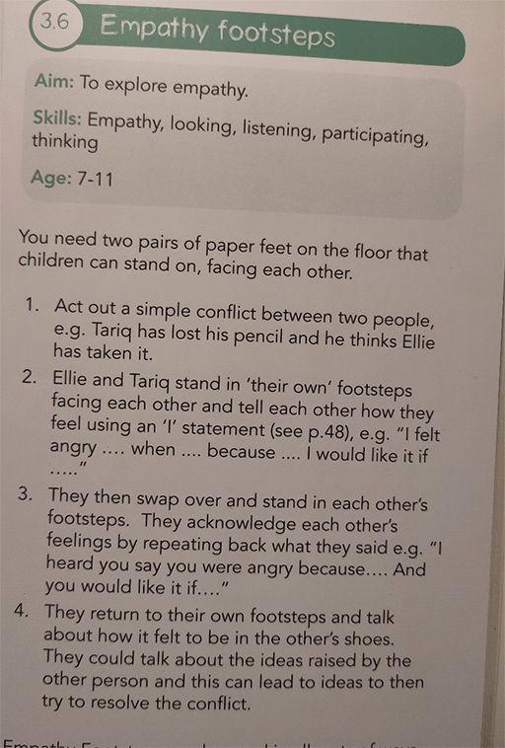
Figure 4 An extract from Learning for Peace
View description - Figure 4 An extract from Learning for Peace

View discussion - Activity 4 Teaching empathy

3.1 Using empathy as a curriculum tool – touching on peace in the wider world
An activity such as empathy footsteps might be used as part of curriculum learning in topics such as history and literature, helping children and young people understand the experiences of people with very different life experiences to their own. Flores and Albornoz Muñoz (2022) describe the importance of care when engaging pupils and students in such activities. They discuss the use of historical empathy in history lessons with a group of Chilean children exploring difficult passages in their nation’s past.
These authors explain that historical empathy requires contextualisation – deeper knowledge of the life experiences of others. They explain that perspective-taking and making effective connections with others are important parts of empathy. However, they also emphasise that, to truly be able to understand another’s perspective one needs detailed information about their circumstances, and this might involve a range of skills, from listening to being able to research and think critically about other life-worlds.
For children and young people to empathise they need to understand key differences between their own and the other’s circumstances, as well as their shared humanity. So an activity such as ‘empathy footsteps’ might work well as part of role play to understand the perspective of others, but it would need careful situating in a curriculum that gives children and young people as much information as necessary to understand lived experiences that differ from their own.

Activity 5 Developing skills for empathy
Allow approximately 10 minutes for this activity

Return to the activity ‘empathy footsteps’. Imagine that you are using this activity to resolve a classroom conflict. Below is a list of peace education competencies from the report Peace education: Making the Case from the Quaker Council for European Affairs. The list is divided into ‘knowledge, attitudes and skills’. You will notice that empathy is in the ‘attitudes’ column here. This differs from the idea of empathy as a process or a skill that you read about earlier in this section.

Peace education competencies
Knowledge | Attitudes | Skills
Direct, structural and cultural violence | Open-mindedness and inclusiveness | Constructive cooperation
Causes and dynamics of violent conflict | Respect for self, others and the environment | Dialogue
Peaceful alternatives to violence | Empathy | Mediation
International human rights / gender / racial standards etc. | Solidarity | Non-violent communication (including inquisitive, assertive communication)
Current affairs | Social connectedness | Understanding, managing, and expressing emotions
Environment and sustainability | Self-awareness | Active listening
Civic processes | Tolerance | Intercultural cooperation
Positive peace and negative peace | Desire to promote justice | Teamwork
Inclusion and exclusion | Social responsibility | Analytical skills
Conflict management, prevention, resolution, and transformation | Curiosity | Critical thinking
Interfaith and intercultural learning | Gender sensitivity | Negotiation
 | Cooperativeness | Reflection

What skills and attitudes will children and young people need for an activity such as ‘empathy footsteps’ to build peace in a situation of classroom conflict? Use the response box below to note down your ideas.

Provide your answer...
View discussion - Activity 5 Developing skills for empathy

As you can see, an activity such as empathy footsteps is invaluable for helping children and young people develop their capacities to build peace. However, for it to be effective, there is a need for careful attention to the development of a range of skills, attitudes and knowledge in a range of activities across the curriculum, requiring patient and focused teaching. You’ll explore this further in the next activity, which looks at an account of a literature activity in a US elementary school.

Activity 6 Understanding another’s experience through literature
Allow approximately 10 minutes for this activity

Read through this account of a literature activity intended to raise children’s awareness of issues around immigration and Muslim culture, carried out with a group of children in a US school (Aziz, 2016, p. 180). The children are reading the book My name is Sangoel in order to explore the experiences of a Sudanese refugee in the US.

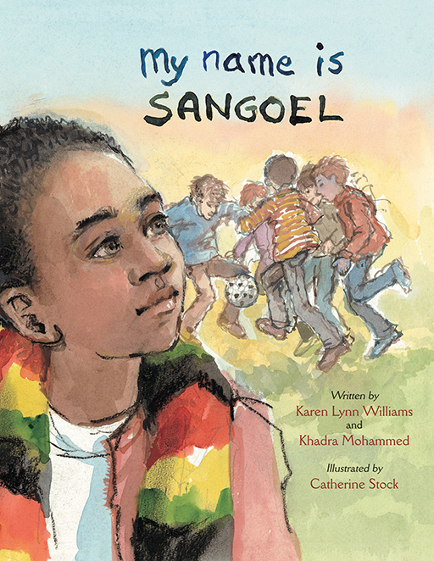
Figure 5 Book cover for My name is Sangoel
View description - Figure 5 Book cover for My name is Sangoel

What additional information do you think the children needed to understand Sangoel’s point of view? Use the response box to record your ideas.

Extract 1
Melanie and Zainab [the class teachers] sent home a survey asking parents to share the meaning of their child’s name, its origin and why they had selected it for the child. The first book we decided to use was My name is Sangoel (Williams and Mohammed, 2009) in which Americans struggle to accurately pronounce a boy’s name, a key part of his cultural identity as a Sudanese refugee. Students initially thought he was from America because he was playing soccer. We discussed new terms from the book: sky boat, the moving stairs at an airport and the doors that open magically when a person walks by. Students immediately knew that his lack of knowledge came from living in a refugee camp where these items were not present. Even though their response was that of sympathy for Sangoel and his situation, they thought that if they were in his place, they would change their own names to something easier to pronounce. With further interactions and discussions they came to realise the emotional attachments people have to their given names. After reading about how Sangoel represented his name as a sun and a soccer goal to help others pronounce it, students thought about their own names and created pictorial representations of them. I [Seema Aziz, the researcher] represented mine with an eye signifying ‘see’ and added the word me.
(Aziz, 2016, p. 180)

Provide your answer...
View discussion - Activity 6 Understanding another’s experience through literature

Aziz describes how this activity led the children to ask others in their class how their names should be pronounced, deepening their understanding of the importance of pride in one’s name.
This section discussed the importance of empathy as an attitude or skill for fostering peace between us. It considered how empathy can be developed as part of a wider peace curriculum involving attention to a range of knowledge, attitudes and skills for peace.

3.2 Competencies for peace
In the last section of this session, you will think further about the competencies children and young people might develop to be successful peace builders. Thinking about competencies for peace should not lead to tick-box assessment, but rather be used as a reflective tool for children and young people to think about what they as individuals (or the group as a whole) might work on to continue building peace in their educational environment.

Activity 7 Reviewing peace competencies
Allow approximately 20 minutes for this activity

Begin by reflecting on what you have covered in the course so far. Note down your thoughts about the skills, knowledge and attitudes children and young people might need to be successful peace builders.
Now return to the peace competencies from the Quaker Council for European Affairs. Consider these questions:
- Which of these are on your own list?
- Which have been covered so far on the course?
- In your view, are there any missing?
- What aspects of your current educational practice could you draw on to help develop these competencies?

Peace education competencies
Knowledge | Attitudes | Skills
Direct, structural and cultural violence | Open-mindedness and inclusiveness | Constructive cooperation
Causes and dynamics of violent conflict | Respect for self, others and the environment | Dialogue
Peaceful alternatives to violence | Empathy | Mediation
International human rights / gender / racial standards etc. | Solidarity | Non-violent communication (including inquisitive, assertive communication)
Current affairs | Social connectedness | Understanding, managing, and expressing emotions
Environment and sustainability | Self-awareness | Active listening
Civic processes | Tolerance | Intercultural cooperation
Positive peace and negative peace | Desire to promote justice | Teamwork
Inclusion and exclusion | Social responsibility | Analytical skills
Conflict management, prevention, resolution, and transformation | Curiosity | Critical thinking
Interfaith and intercultural learning | Gender sensitivity | Negotiation
 | Cooperativeness | Reflection

Provide your answer...
View discussion - Activity 7 Reviewing peace competencies

There are many other activities and approaches that can be drawn on to develop peace competencies. For example, you might consider aspects of your school’s Religious Education or PSHE curriculum for emotional and spiritual wellbeing, or perhaps history and geography curriculum topics. As you continue through the course, consider how you might build peace competencies in all areas of classroom life.

4 Summary of Session 3
In this session, you have looked at circle sessions and managing conflict as part of ‘peace between us’. You have also begun to think about the kinds of competencies children and young people might develop to build peace in their lives.
The next session takes a further look at interpersonal peace, moving from ‘peace between us’ to ‘peace among us’, which considers the ways in which young people might foster peace within and between the communities they are a part of. Later in Session 5 you’ll look at peace in the (wider) world.
You can now go to Session 4.

Session 4: Peace among us

Introduction
‘Peace among us’ is concerned with developing schools as learning communities where each member can thrive. This includes staff as well as the children and young people, and can extend to families and the wider community over time.
Developing a whole school approach to peace among us can be a daunting task, so it is helpful for schools to explore the range of initiatives and approaches that are available. This session looks at peer mediation and UNICEF’s Rights Respecting Schools programme. However, other approaches are available. For example, there is a Schools of Sanctuary scheme for schools wishing to understand and support children and young people who are forced to flee their homes, and the Peace Schools scheme run by the Welsh Centre for International Affairs which offers a range of resources to support schools in Wales on their peace journey. Links to both these schemes are provided in the Course resources and recommendations pages of this course.
By the end of this session, you should be able to:
- consider what peace might mean within your school community
- understand the core principles of peer mediation and its place in peaceful communities
- extend your understanding of QCEA’s Peace Competencies
- develop an overview of UNICEF’s Rights Respecting Schools programme.
Start with this video where Ellis introduces the session.

Video content is not available in this format.
Video 1
View transcript - Video 1

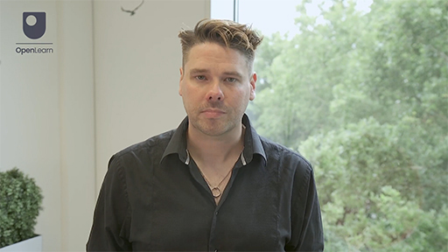

As you work through this session, think about what you could do within your sphere of influence in your school community. Whatever your role in the school – whether parent, meals supervisor, class teacher, headteacher – you might use this session to think about what you could do to help develop ‘peace among us’ in your community.

1 Children and young people in their communities
Session 1 of this course discussed how peace can mean different things to different people. In any context ‘peace’ initiatives can become unequal and unjust if one group of people impose their vision for peace on another. This means that developing peace among us in a school should begin with a conversation about peace with a range of groups within the school community.

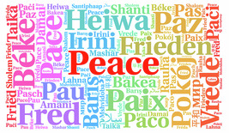
Figure 1 A word cloud for ‘Peace’
View description - Figure 1 A word cloud for ‘Peace’

In How to be a Peaceful School, a collection of writing from educators developing peace education, school leader Pali Nahal describes her primary school’s peace journey. Nahal’s description shows how peace among us can be achieved through focused and strategic development that involves different members of the school community and reaches into every aspect of the life of a school.
The journey began by asking the children: ‘When you close your eyes and think of peace, what do you see?’ She writes:

We were surprised by some of the responses:
‘Peace is when we trust, not hate.’
‘Peace is sitting under my bed because it’s where I feel safe.’
‘Peace is having calm, happy feelings and not thinking bad about anything or anyone.’
(Nahal, 2018, p. 34)

Nahal goes on to describe how her school’s peace initiatives took these responses into account as it involved children, staff and parents developing a peaceful school ethos. For example, school staff developed a set of seven values for the school that could be easily remembered and communicated, and parents and children redesigned the school’s logo to reflect those values.
Nahal also describes developing pupil leadership teams where children can apply to be members of committees that work collaboratively to develop particular areas of school life. She explains that these leadership teams mean that:

The children have a significant role to play in whole school strategies decisions. And I can honestly say that sometimes we have felt quite uncomfortable with their requests. However, we have always been proven wrong, as their decisions and requests have always turned out to be successful, despite taking the risk.
(Nahal, 2018, p. 38)

Nahal’s experience is just one way of developing a peaceful school. Sharing such experiences and working collaboratively can help educational communities develop their own approaches to peace education, grounded in their own aspirations for peace and the needs of all members.

1.1 Making a start
In Session 1 you considered what peace meant to you. The next activity invites you to find out what peace means for other members of your educational community.

Activity 1 What does peace look like for us?
Allow approximately 10 minutes for this activity

Take a moment to think deeply about the three questions below. You might sketch some initial thoughts here, but you can also return to the questions over a much longer time period, giving yourself an opportunity to reflect on them as you engage with your everyday activities in your setting.
Once you have carried out this activity for yourself, consider how you might encourage others in your educational community to engage with these questions. This will depend on your role in the school and sphere of influence.
- What would peace look like in your educational community?
- What can disrupt the peace of your educational community?
- Where does the energy for peace come from in your community (peace-making/keeping/building)?

Provide your answer...
View discussion - Activity 1 What does peace look like for us?

CPD sessions
If doing this activity with a group, you might allow time for participants to begin working with the questions independently before sharing in pairs, then pairs joining into fours, then eights and so on until you are back to working as a whole group.

Remember that all school communities are diverse in terms of their communicative needs, so questions might need adapting or translating into different languages. Responses to questions should be accepted in whatever form participants are comfortable with. The time it may take to fully understand what members of a school community are saying is time well spent.
Exploring what peace might mean for a whole school community can also be a great opportunity for a school council to work meaningfully together with senior leaders and parents. So, whilst these questions may seem small, they can be used to spark peace in a school community in a range of inspiring ways.

2 Developing peace in educational settings
The remainder of this session introduces two initiatives that are well supported by organisations working across the UK – Peer Mediation and UNICEF’s Rights Respecting Schools. These are both well-established approaches that can offer resources and support for schools developing peace among us. As schools develop their approaches to peace education, they may draw on more than one initiative. For example, Rights Respecting Schools provides a broad framework for understanding and respecting rights within which a peer mediation programme would work well. However, educational settings should consider carefully what is suitable for them and continually evaluate the extent to which wider initiatives support the community’s aspirations for peace building.

2.1 Peer mediation

Peer mediation works well in schools that take restorative approaches to managing in-school relationships. Restorative approaches to addressing harm involve bringing people together to discuss how the harm or wrongdoing can be best addressed.
(EFRG, 2024)

There are many parallels between peace education and restorative approaches to education, as both seek to embed positive relationships between all members of a school community in an atmosphere where everyone can thrive. You can explore more about restorative practice in this course’s Resources and recommendations page which includes links to information about restorative schools.

Activity 2 Introducing peer mediation
Allow approximately 5 minutes for this activity

Watch this short video made by CRESST with Greystone’s Primary School, Sheffield, who were joint winners at the National Mediation Awards 2022, where parents, staff, pupils and peer mediators talk about peer mediation in their school. As you watch, note down your initial thoughts on what peer mediation involves.

Video content is not available in this format.
Video 2
View transcript - Video 2

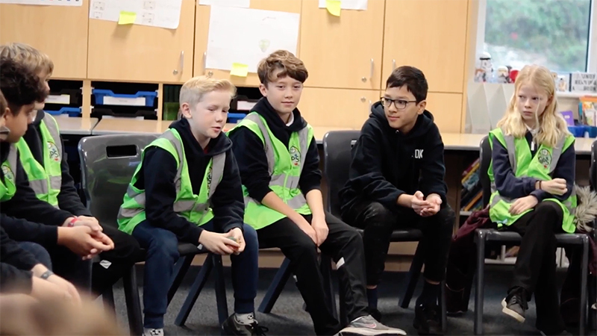

Provide your answer...
View discussion - Activity 2 Introducing peer mediation

There are many schemes run by a variety of organisations and services that support peer mediation in the UK and beyond. In 2023, a National Peer Mediation Co-ordinator was appointed, reflecting the growing recognition of peer mediation as a valuable approach to managing conflict in schools. However, Isabel Cartwright (2018) stresses that all members of the school community, including the headteacher and lunchtime supervisors, need to support peer mediation if it is to succeed.

Activity 3 Exploring peer mediation at Bacon’s College
Allow approximately 20 minutes for this activity

Watch this video made in Bacon’s College, London, which has had a peer mediation service run by sixth formers in a secondary school for almost 20 years. In the video you will see footage from when the service was established in 2006, as well as young people talking about the impact of the service in their school lives and beyond. As you watch the video make brief notes around these questions.
- What benefits might peer mediation have for the school community?
- What is the role of adults in the school community in helping develop peer mediation?

Video content is not available in this format.
Video 3
View transcript - Video 3

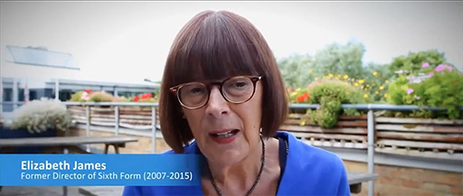

View discussion - Activity 3 Exploring peer mediation at Bacon’s College

2.2 School aspirations and pupil responsibility


Figure 2 There are no limits to what children can achieve

Successful mediation helps all participants to move forward and encourages them to make commitments that will enable them to manage conflict effectively in the future (Peace at the Heart, 2022). In this sense it can support children and young people’s development of personal capacities to interact peacefully with themselves, their communities and the wider world. As peer mediator Kezia Herzog explains:

Mediation is a core part of our school… we value it so much and all the teachers are on board… Mediation should be implemented into schools and education because you’re educating a whole generation of people who don’t go straight to fighting….
Kezia Herzog quoted in Peace at the Heart (2022, p. 19)

Elizabeth James, former Director of the Sixth Form at Bacon’s College, notes the school considers there to be ‘no limits’ to what the students can achieve. In the long term and as part of a whole school strategy, Peer Mediation might be seen as building peace by supporting the aspirations of schools for their pupils and students to lead peaceful lives both within and beyond the school.

Activity 4 Being a peer mediator
Allow approximately 10 minutes for this activity

Watch this video where former Bacon’s College peer mediator Kezia Herzog talks about her role and the impact it has had on her life beyond school. As you watch make notes on:
- How young people learn to support each other through peer mediation.
- The impact peer mediation has had on Kezia’s life beyond school.

Video content is not available in this format.
Video 4
View transcript - Video 4

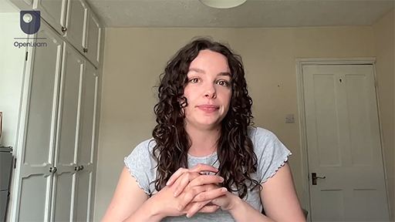

View discussion - Activity 4 Being a peer mediator

2.3 Training peer mediators
A crucial role for adults who are establishing peer mediation in a school is training children and young people as mediators. The initial training can take 2–3 days, and support for mediators continues with ongoing supervision and check-ins. This means it’s important for school communities beginning their work on peer mediation to seek support from specialist agencies in the early stages. The box below contains links to some of the specialist agencies working in this area.

Agencies offering peer mediation training
Organisations such as Southwark Mediation Centre (part of Calm Mediation since 2020), which you saw in the video, or Peacemakers, whose resources you began to explore in the previous session, have a wealth of experience and expertise in training children and young people in mediation. There are many organisations across the UK with this experience, such as Scottish Mediation. The Civil Mediation Council has a Peer Mediation Working Group, which is a UK-wide network of organisations that work to promote peer mediation. UNICEF also describes peer mediation programmes in schools outside the UK, such as these in Kosovo and Belarus.

2.4 Competencies and peer mediation
Below is a poster from Scottish Mediation which is used to outline some of the skills peer mediators need. These skills might be learned through the training offered by peer mediation services such as those in the box in Section 2.3, but they can also be taught to the whole school population through everyday classroom activities such as those you are reading about as you work through this course.

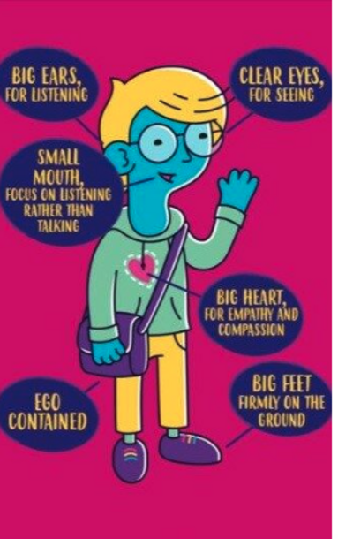
Figure 3 A poster from Scottish Mediation
View description - Figure 3 A poster from Scottish Mediation

Activity 5 Building skills and competencies for peer mediators and their ‘clients’
Allow approximately 10 minutes for this activity

Below is the list of competencies from the QCEA report Making the Case, which you saw in Session 3.

Peace education competencies
Knowledge | Attitudes | Skills
Direct, structural and cultural violence | Open-mindedness and inclusiveness | Constructive cooperation
Causes and dynamics of violent conflict | Respect for self, others and the environment | Dialogue
Peaceful alternatives to violence | Empathy | Mediation
International human rights / gender / racial standards etc. | Solidarity | Non-violent communication (including inquisitive, assertive communication)
Current affairs | Social connectedness | Understanding, managing, and expressing emotions
Environment and sustainability | Self-awareness | Active listening
Civic processes | Tolerance | Intercultural cooperation
Positive peace and negative peace | Desire to promote justice | Teamwork
Inclusion and exclusion | Social responsibility | Analytical skills
Conflict management, prevention, resolution, and transformation | Curiosity | Critical thinking
Interfaith and intercultural learning | Gender sensitivity | Negotiation
 | Cooperativeness | Reflection

Watch this video made by Young Talk, The Scottish Peer Mediation organisation in partnership with Quakers in Britain. As you watch, think about the skills and competencies the Peer mediators are developing.

Video content is not available in this format.
Video 5
View transcript - Video 5

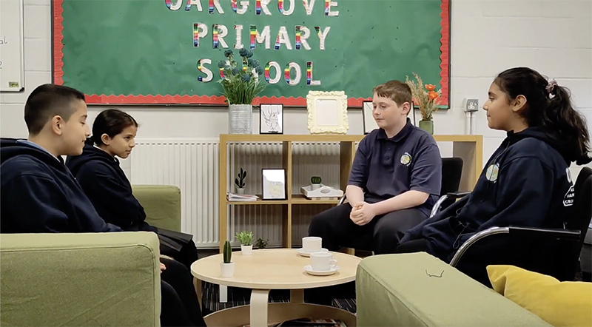
Video 4

Now, thinking about what you have learned so far about peer mediation, use the box below to note down the competencies young peer mediators and their clients are developing. You might want to use three categories as shown below: one for mediators, one for participants (clients), and one for both.

1. Mediators:
2. Participants:
3. Both
View discussion - Activity 5 Building skills and competencies for peer mediators and their ‘client ...

As you can see, peer mediation is just one area of school life that can support the development of peace competencies for all members of school communities. However, as you have also seen, this is most successfully achieved within strategic work to develop the capacity of educational settings to build strong communities where every member can thrive.

3 Acting for change – Rights Respecting Schools

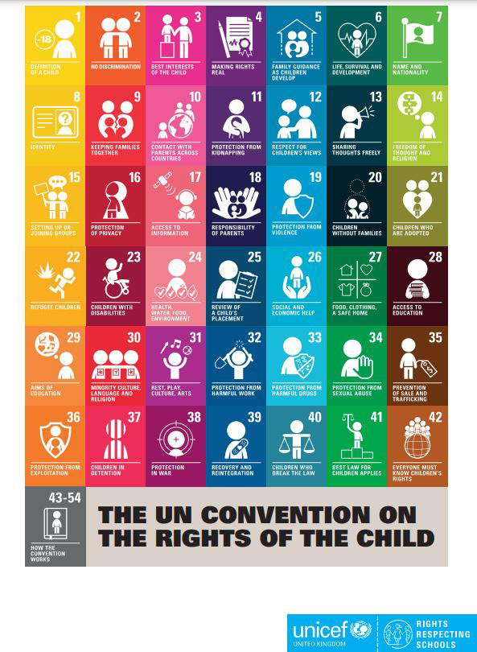
Figure 4 UNICEF’s Rights Respecting Schools poster
View description - Figure 4 UNICEF’s Rights Respecting Schools poster

The final part of this session offers a very brief introduction to the UNICEF initiative Rights Respecting Schools (UK). Like peer mediation, this is another strongly supported national initiative that can support the development of peace among us in school communities.
UNICEF’s work is underpinned by The United Nations Convention on the Rights of the Child, adopted by the UN General Assembly in 1989 (UNCRC). Every human child has these rights. Rights Respecting Schools seek to ensure that children are aware of their rights, and empower children to claim their rights and uphold the rights of others. A summary of the convention can be found on the UNICEF website.
Becoming a Rights Respecting School depends on the everyday practices of both children and adults in the school community (UNICEF, 2024). In such schools learning about rights is part of the curriculum and those rights are practised in every aspect of school life.

Activity 6 Building peace in a Rights Respecting School
Allow approximately 10 minutes for this activity

Watch this short video made by Crystal Class in UNICEF Rights Respecting School Mount Stewart Infants, via the link below.
As you watch, think about:
- What peace competencies might the children be developing?
- What might the children be learning about their role in building peace in the world?
Mount Stewart Infants School video

Provide your answer...
View discussion - Activity 6 Building peace in a Rights Respecting School

A project to make a video such as this allows the children to explore what such rights mean for different people in different contexts. In Rights Respecting Schools the curriculum explicitly covers teaching about each article of the UNCRC. Embedding teaching about rights in the school curriculum and wider school life can help children and young people build an in-depth understanding of both their own rights and what they can do to uphold the rights of others.

4 The United Nations Convention on the Rights of the Child
Learning about peace and justice from a perspective of (universal) human rights can be an inclusive way of helping all members of a school community participate in peace among us.

Activity 7 Beginning to explore the UNCRC
Allow approximately 20 minutes for this activity

Follow the link below to find a summary of Articles 1–42 of the UN Convention on the Rights of the Child:
Articles 1–42
Take a moment to read through the titles of each article to get a sense of what each one covers. Are there any that give you pause for thought about your own school community? Where can you celebrate your existing practice, what foundations do you have to build on and what could you work towards?

Provide your answer...
View discussion - Activity 7 Beginning to explore the UNCRC

The final section of this session has given a brief overview of UNICEF’s Rights Respecting Schools programme in the UK. You can find out more about the initiative by following the links to UNICEF’s own website on the Resources and recommendations page of this course, where you’ll find information and support.

5 Summary of Session 4
In this session you considered how peace among us might be developed across whole school communities, beginning with in-depth work to understand what peace might mean for different people involved in school life. You were introduced to two national initiatives that can be embedded in the fabric of school life as part of work to build peace that extends beyond the classroom walls to the whole school community, and beyond.
You can now go to Session 5.

Session 5: Peace in the world

Introduction
Hope is a concept that can help people engage positively and constructively with the complexities of the wider world. This session begins from the concept of hope in exploring how children and young people can learn to take a non-violent stand when managing the conflicts that arise from inequalities and injustices.
By the end of this session, you should be able to:
- understand the essential role of hope in peace education
- understand how young people might be supported to become non-violent upstanders
- consider the role of the adult as a peace educator
- know where you might go for resources and support in developing young people’s engagement with peace in the wider world.
Watch this video where Izzy introduces Session 5.

Video content is not available in this format.
Video 1
View transcript - Video 1

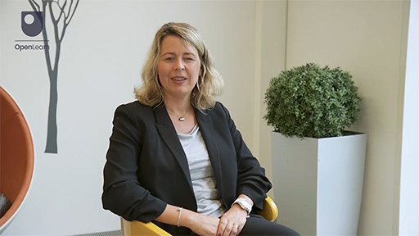

1 Hope

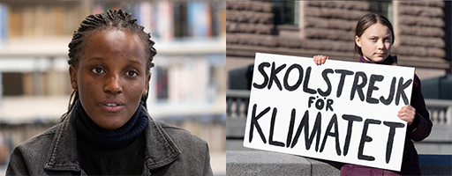
Figure 1 Climate activists like Vanessa Nakate (left) and Greta Thunberg (right) inspire hope and movements for change
View description - Figure 1 Climate activists like Vanessa Nakate (left) and Greta Thunberg (right) ...

In 2018, at the age of 15, environmental activist Greta Thunberg wrote a column for The Guardian, a UK newspaper. Thunberg explained that her frustration at the inaction of adults in Sweden over climate change prompted her to begin a school strike, leaving her classroom to sit outside the Swedish parliament.
In the column, Thunberg made the point that:

If I live to be 100, I will be alive in 2103. Adults often don’t think beyond the year 2050. But by then, I will, in the best case, not have lived half of my life. What we do or don’t do right now will affect my entire life and the lives of my friends, our children and their grandchildren.
(Thunberg, The Guardian, 2018)

Thunberg’s comment reminds us that children and young people are concerned with, and directly affected by, issues in the world around them. Supporting them to develop skills and attributes that enable them to take a non-violent stand can help them become national and global citizens with hopes for a positive future.

1.1 Understanding hope
Peacebuilding involves fostering hope that not only supports people’s wellbeing but also empowers them with the means to work towards their goals for change. Scholar Katrina Standish explains that:

Hope… is a tool against many of the forms of violence that directly or indirectly affect the fulfilment of human needs.
(Standish, 2019, p. 12)

Standish argues that loss of hope can result in violence as people lose their capacity to imagine a world where things might be different. In this next activity you will explore Standish’s multidimensional model of hope and consider how it might be used as a practical tool for peace.

Activity 1 The multidimensional nature of hope
Allow approximately 10 minutes for this activity

Below is a diagram of the interconnecting dimensions of hope (Standish, 2019). Match the definitions in each of the boxes below by dragging them to each of the dimensions of hope in Standish’s model.
As you carry out this activity, consider how hope links each layer of peace explored in this course. You might also consider how hope might be infused through all the aspects of wellbeing outlined in Session 2.

View discussion - Activity 1 The multidimensional nature of hope

To manage the complexity of issues that children and young people face today hope is needed (Peace at the Heart, p. 31). For Standish, hopeful thinking enhances critical thinking, developing people’s capacity to take steps towards the changes they feel are needed in the world. Being able to hope can support people in seeing the potential for positive change in even the smallest of actions.

1.2 Thinking about non-violence
Together with hope, a commitment to non-violence is at the heart of peace education. Sociologist Stellan Vinthagen argues that non-violence might be seen as using non-violent means to attain (non-violent) goals, as well as actively working against violence itself (Vinthagen, 2015). This includes all the ways in which violence might manifest itself – direct, cultural and structural. Research has shown that non-violent action is often more effective than people might expect (Stephan and Chenoweth, 2008).
In the following activity, drawn from a resource created by the Development Education Centre South Yorkshire (DECSY), you’ll consider the deeper meaning of non-violence.

Activity 2 Exploring non-violence
Allow approximately 10 minutes for this activity

This activity was originally developed for use by groups of children and young people between the ages of 8 and 14. The original activity can be found on DECSY’s website. Before completing this online version, you might wish to revisit the different forms of violence that you read about in Session 1.
Sort the following statements on a continuum from those you consider violent to those that might be considered non-violent (do ignore the scoring system here as answers to this question will be completely subjective). As you sort and place them in the white area above, consider these questions:
- What do you draw on when making a judgement?
- What contextual factors might be considered when making a judgment?

View discussion - Activity 2 Exploring non-violence

CPD sessions
If doing this activity with a group, encourage discussion on each of the actions on the cards. Participants should explore any statements that they are not sure of and be prepared to listen to different views. The aim is not to achieve consensus, but to explore the questions raised.

As you have seen, there are many factors affecting whether an action might be seen as violent or non-violent. Carefully managed activities such as this can be used to help children and young people develop the critical skills to make well-informed judgements. As you continue through this session, you might consider the teacher’s role in such an activity and how you might adapt it for the children and young people that you work with.
In the rest of this session, you will explore examples of curriculum work for peace in the wider world from primary and secondary schools in the UK.

2 Wangari’s Trees of Peace – starting with a story
Wangari Maathai was the founder of the Kenyan Green Belt Movement, which inspires communities to look after the environment and improve livelihoods. She was the first African woman to win the Nobel Peace Prize and the movement she founded is flourishing today.

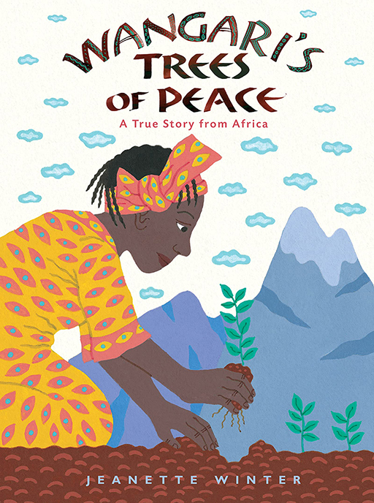
Figure 2 Wangari’s Trees of Peace
View description - Figure 2 Wangari’s Trees of Peace

Wangari Maathai (2003) famously said, ‘When we plant trees, we plant the seeds of peace and seeds of hope. We also secure the future for our children.’
Staff and pupils at Oakgrove Primary School in Glasgow used the book Wangari’s Trees of Peace as the inspiration for an environmental play which they presented to the Scottish Parliament. In Activity 3, you’ll explore their work.

Activity 3 Using stories in the peace curriculum
Allow approximately 10 minutes for this activity

Watch this video about Oakgrove Primary School in Glasgow and their project inspired by the story of Wangari Maathai as told in the book Wangari’s Trees of Peace.
As you watch, consider:
- How does the project fit into the wider curriculum and school ethos?
- What peace competencies do you think the children might be developing?

Video content is not available in this format.
Video 2
View transcript - Video 2

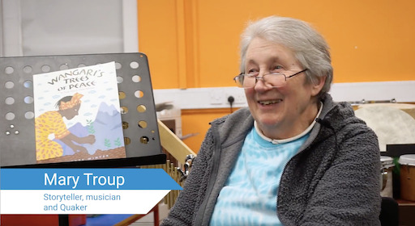
Video XX

Provide your answer...
View discussion - Activity 3 Using stories in the peace curriculum

Participants on the day of the children’s performance at the Scottish Parliament felt that it played a part in inspiring MSPs (Members of the Scottish Parliament) to sign Michelle Thomson’s MSP motion in support of peace education in Scotland (Waddell, 2023). At the time of writing (November 2024) this motion has achieved cross-party support. Thus the children’s participation in a hopeful peace curriculum has empowered them to effect changes both in their local communities and at national level.

3 Selecting stories for peace education
Creating a hopeful peace curriculum requires careful discernment when selecting books and other resources to tell stories and support learning. For example, there are many books like Wangari’s Trees of Peace which explore the work of prominent activists. Such books can form a valuable starting point for children and young people to learn about taking a stand in the world.
However, some biographies can leave children and young people with the impression that individual activists change the world, without paying attention to the ways in which whole movements of people contribute to positive change (Moriarty, 2021). Sinead Moriarty reviewed a number of books about Greta Thunberg and noted that:

Rather than being positioned as one of a large number of young people who passionately campaign for the environment, she [Greta Thunberg] is seen as unique. This focus on Thunberg’s uniqueness is not wrong but tends to elide the work of other young climate activists, in particular young activists of colour, indigenous activists, and activists from the Global South.
(Moriarty, 2021, p. 202)

Moriarty argues that children and young people need to engage with books which show not only the founders of movements, but the movements themselves and how people in those movements work together for change. Such literature might help children and young people find the connections they already have in their families and communities, and explore ways of working together to address issues that concern them (Moriarty, 2021).

4 Working in the community: Glasgow Girls

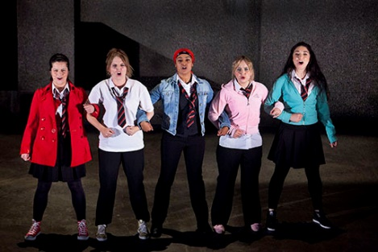
Figure 3 A photograph from theatre production Glasgow Girls
View description - Figure 3 A photograph from theatre production Glasgow Girls

An example of young people engaging with their community is the ‘Glasgow Girls’, a group of young women from Drumchapel High School in Glasgow. As Education Scotland explains, the women campaigned for the release of their friend Agnesa and her family when they were detained by the British Home Office. The group’s work raised awareness about the treatment of asylum seekers (Education Scotland, 2018). In the Further learning section at the end of this session you can find out more about their activities and the people and groups they worked with.

4.1 Finding suitable books
There are organisations that recommend books that might be used in peace education. Some of these are listed in the course Resources and recommendations page of this course. Educators should ensure the books they use are appropriately representative of diversity within the UK. The English Centre for Literacy in Primary Education (CLPE) produces a regular report, Reflecting Realities, which looks at ethnic representation within UK children’s literature. Each report includes a set of questions to guide considerations for choosing books that reflect the diversity of UK communities.

5 Teaching for peace in the wider world
Elizabeth Garrett Anderson School in London works hard to maintain a positive, anti-racist learning environment. Headteacher Sarah Beagley explained to Quakers in Britain the importance of teaching about issues which might be regarded as challenging. She says of her pupils:

They do live in communities where they deal with violence, they deal with racism. Whilst the school can’t necessarily change what’s outside its gates, we very clearly set out to say that in this school, in this place, in this community, something will be different.
(Beagley, 2022)

In this section, you’ll look at how students at the secondary school explore concepts and information that help them understand the effects of injustice and discrimination, and their role in countering them.

Activity 4 Learning about injustice
Allow approximately 15 minutes for this activity

Watch the following video of a workshop tackling issues of class, race and sexuality in Elizabeth Garrett Anderson School.
As you watch, think about:
- How do school staff act as role models for the young people?
- What peace competencies are the young people developing?

Video content is not available in this format.
Video 3
View transcript - Video 3

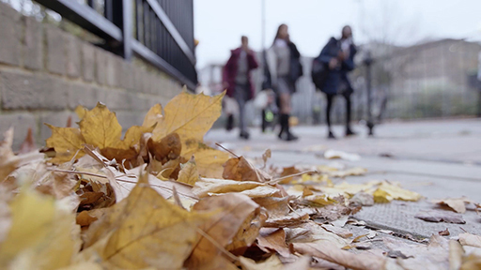

View discussion - Activity 4 Learning about injustice

The video showed the students reflecting on their own assumptions and why they might hold them. These reflections had led some of the young people to think about privilege, creating a greater understanding of experiences that differed from their own.

6 Upstanding and privilege
A great deal of violence – direct, cultural and structural – is identity-based. Developing peace competencies can equip children and young people to be upstanders for their own rights and those of others. The ‘Facing History and Ourselves’ website records how the term ‘upstander’ became included in the Oxford and Merriam-Webster Dictionaries (US versions) after a campaign by two US High School students (FHAO, 2015). The dictionary now defines an upstander as: ‘A person who speaks or acts in support of a cause, esp. one who intervenes on behalf of a person being attacked or bullied’ (OED, 2024).
The concept of privilege helps people understand the ways in which some people may gain an advantage over others owing to an aspect of their identity, such as race or gender. The book Know Your Rights and Claim Them: A Guide for Youth explains that:

Being aware of privileges, whatever they are, helps us understand difference and why some people don’t enjoy the same opportunities as others. It makes it easier to identify and challenge discrimination, which lies at the heart of many abuses of rights all over the world.
(Amnesty International, 2021)

Identity is complex and multifaceted, and privilege works in different ways for different aspects of identity in different times and spaces. A critical and informed understanding of the ways that privilege works in different contexts can support upstanding, enabling people to actively recognise and counter inequalities and injustices which might arise in everyday life.

7 The role of the educator
One of the commitments of peace education is for educators to be valued in wider society. The wellbeing and development of children and young people depends on educators feeling supported in creating spaces where they and their students can think through sometimes difficult issues together. In the next activity you will explore how the wider culture of Elizabeth Garrett Anderson School plays a part in helping teachers create such spaces.

Activity 5 Exploring challenging topics
Allow approximately 10 minutes for this activity

Watch this video, again from Elizabeth Garrett Anderson School, where Head of History, Hamidah Siddiqua, explores the challenging topic of genocide with her students. At the time the genocide of Muslim minority groups in Xinjiang was a concern to many students.
As you watch, consider:
- In what ways does the school support teachers teaching challenging topics with their students?
- In what ways can the teaching of such challenging topics be seen as hopeful?

Video content is not available in this format.
Video 4
View transcript - Video 4

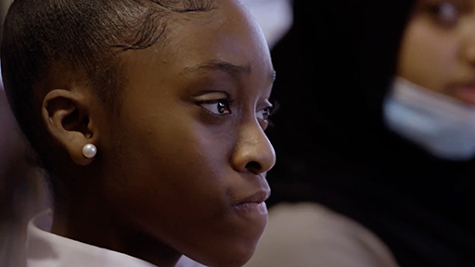
Video 4

View discussion - Activity 5 Exploring challenging topics

8 Teaching controversial issues
The Oxfam publication Teaching Controversial Issues includes helpful advice for teachers working with young people on what the publication terms ‘controversial issues’. The following advice is drawn from this publication, and you are strongly advised to read the full document as part of your development as a peace educator.

Activity 6 What is a controversial issue?
Allow approximately 15 minutes for this activity

Part A

What might make an issue ‘controversial’? Note your thoughts in the box below and compare your response to the ideas from Oxfam.

Provide your answer...
View discussion - Part A

Part B

Now take a moment to reflect on what you have read so far in this session.
Why teach controversial issues?
Use the box below to note down your responses.

Provide your answer...
View discussion - Part B

What might be considered ‘controversial’ might differ between educational settings. It’s important to be sensitive to the needs and wellbeing of all members of the school community, ensuring that everyone feels upheld, even during learning that is challenging. Teaching ‘controversial’ issues requires careful research, thought and planning. If you are in the early stages of your development as a peace educator, you are strongly advised to seek further training and guidance, such as that offered by the organisations referred to throughout this course, as well as the support of your colleagues.

9 Summary of Session 5
This session began with work on the concept of hope, which is the foundation of peace education. It introduced you to the work of peace educators in their school communities, and you saw examples of the positive work children and young people can do in their worlds. The last part of the session turned to the role of the educator, and you will explore this further in Session 6.
You can now go to Session 6.

Session 6: Your journey as a peace educator

Introduction

One little person, giving all of her time to peace, makes news. Many people, giving some of their time, can make history.
(Peace Pilgrim, 1964, p. 22)

Every member of the school community can be seen as a peace educator in some way, including the children and young people themselves. In this final session of the course you will consider adults as peace educators. For this it’s important to think carefully about your starting point as well as the support you have from colleagues and wider organisations. As you grow as a peace educator, take each step at a time, celebrating each achievement on the way.
By the end of this session, you should be able to:
- have a greater awareness of yourself as a peace educator and where you might develop further
- have an idea of where to start in your journey as a peace educator or peace school
- have an idea of who you might contact, or what you might read to support that development.
Watch this video where Ellis introduces this final session of the course.

Video content is not available in this format.
Video 1
View transcript - Video 1

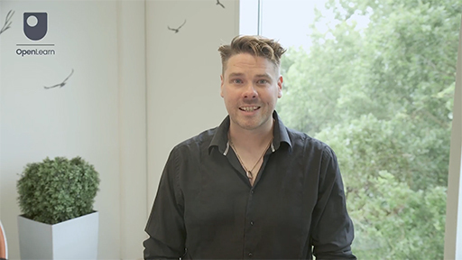

1 Your development as a peace educator
Cremin and Bevington stress the importance of valuing the wellbeing of educators both in society and educational communities. They remind us that peace educators need to take good care of themselves, recognising their achievements and remembering that peace building practice requires ‘care, dynamism and compassion’ (Cremin and Bevington, 2017, p. 113). Throughout the course you have encountered the professional practice of peace educators. In this section you’ll use the peace competencies to celebrate your current practice and identify areas where you might further develop as a peace educator.

Activity 1 The qualities of a peace educator
Allow approximately 20 minutes for this activity

Being a peace educator can be challenging, so you will need to develop competencies that help you take care of your own wellbeing. In this activity, you will think about the competencies you might need as a peace educator.

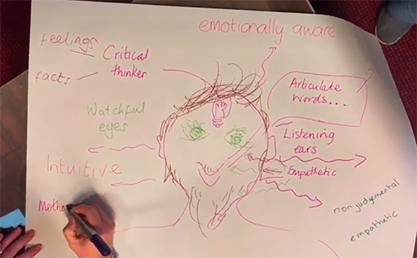
Figure 1 Qualities of a peace practitioner activity
View description - Figure 1 Qualities of a peace practitioner activity

Part 1

Begin by returning to the peace competencies that you have studied throughout this course. Read them through again, this time with yourself as a peace educator in mind.
- Which competencies are especially relevant to peace educators?
- What other competencies do you think might be needed?

Peace education competencies
Knowledge | Attitudes | Skills
Direct, structural and cultural violence | Open-mindedness and inclusiveness | Constructive cooperation
Causes and dynamics of violent conflict | Respect for self, others and the environment | Dialogue
Peaceful alternatives to violence | Empathy | Mediation
International human rights / gender / racial standards etc. | Solidarity | Non-violent communication (including inquisitive, assertive communication)
Current affairs | Social connectedness | Understanding, managing, and expressing emotions
Environment and sustainability | Self-awareness | Active listening
Civic processes | Tolerance | Intercultural cooperation
Positive peace and negative peace | Desire to promote justice | Teamwork
Inclusion and exclusion | Social responsibility | Analytical skills
Conflict management, prevention, resolution, and transformation | Curiosity | Critical thinking
Interfaith and intercultural learning | Gender sensitivity | Negotiation
 | Cooperativeness | Reflection

Provide your answer...
View discussion - Part 1

Part 2: My wellbeing as a peace educator

Here are the definitions of wellbeing given by Cremin and Bevington, which you first encountered in Session 2 of the course. Read through the definitions of wellbeing again before attempting the next stage of this activity.

Now consider: what additional competencies will help you look after yourself as a peace educator? (For example, knowing when to seek support from your colleagues.)

Provide your answer...
View discussion - Part 2: My wellbeing as a peace educator

Part 3

Now take a look at all the competencies you have thought of and think about the following questions:
- Which am I strongest at?
- What is most supported in my setting?
- What do I need to develop?
- What can I realistically achieve?

Provide your answer...
View discussion - Part 3

CPD sessions
If doing this activity with a group, in Part 1 of this activity, you might draw round one of the participants or have a pre-prepared silhouette of a person on paper that everyone can annotate with sticky notes to gather ideas (see Figure 1). Make sure you leave time for discussion about the kinds of competencies that people feel that peace educators might need.
For Part 2, you might think about how you will look after each other on your peace journey together.

1.1 Making a personal development plan
Your responses to the questions in Activity 1 should help you make a plan for your next steps on your journey as a peace educator. For example, identifying areas where there is support within your setting will help you think about who to approach and where you might start in your development. Choose perhaps one or two of these points to act on and use the last question – What can I realistically achieve? – to help you decide where to start and the steps you could take.
Whatever you decide to do, keep a record of your progress, and celebrate every achievement, however small.
In the next part of the session you will start to think about the development of peace education within the whole school community.

2 What makes peace education quality education
In this section you’ll consider how the commitments of peace education can support schools in delivering quality education for their communities.

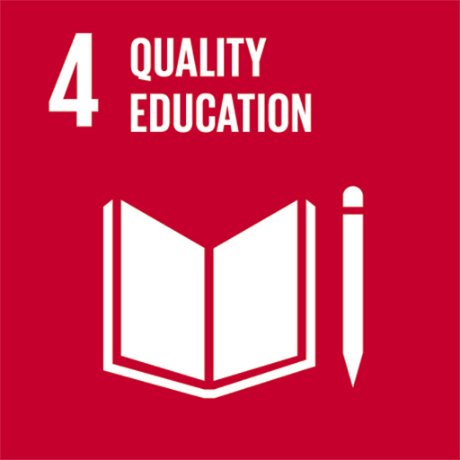
Figure 2 UN logo for quality education
View description - Figure 2 UN logo for quality education

The United Nations Sustainable Development Goals were created in 2015 by Member States of the United Nations. Although the goals aim for a specific year, they set ambitious targets for nations to work towards to build a sustainable future and remain relevant for understanding what that future might comprise. There are 17 sustainable development goals. None of the goals can stand alone, they are all interconnected. However, it’s useful to know that SDG 4 is concerned with quality education and includes targets such as: ensuring all children have access to primary and secondary education by 2030 (target 4.1); and to eliminate inequalities in education, including gender disparities and for persons with disabilities, indigenous peoples and children in vulnerable situations (target 4.5).
In the next activity you will look closely at target 4.7 for quality education, and consider how it aligns with the principles and practices of peace education.

Activity 2 Quality education (Sustainable Development Goal 4) and peace education
Allow approximately 40 minutes for this activity

Part 1

Begin by watching this short video, aimed at secondary school students, about Sustainable Development Goal 4.

Video content is not available in this format.
Video 2
View transcript - Video 2

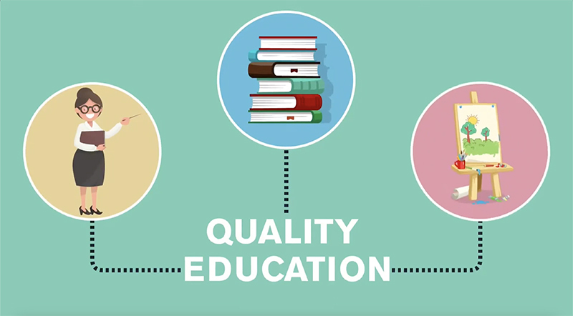

Below is target 4.7 under quality education which relates to a curriculum for sustainable development.

4.7 … ensure that all learners acquire the knowledge and skills needed to promote sustainable development, including, among others, through education for sustainable development and sustainable lifestyles, human rights, gender equality, promotion of a culture of peace and non-violence, global citizenship and appreciation of cultural diversity and of culture’s contribution to sustainable development.
(Quality Education, 2024)

How does target 4.7 align with the principles and practices of peace education that you have learned about during this course?
You might use the response box below to note down your initial thoughts.

Provide your answer...
View discussion - Part 1

There are links to further information about the sustainable development goals in the Resources and recommendations page of this course.

Part 2

The work of peace educators is grounded in a core set of commitments and principles that drive practice. Such principles inform the choices educators and educational communities make in all aspects of their settings, from curriculum and pedagogy to behaviour policies to work with the wider community.
This next part of the activity will help you consider the commitments of peace education as quality education. Take your time to work through it as it will help you to identify the foundation on which you might build your peaceful educational community, however small.
Begin by reading through the common commitments of peace education in the box below. These commitments, outlined in Peace at the Heart, put relationships at the heart of peace education. These relationships form an interconnected web that builds into a coherent educational community where everyone feels empowered to engage constructively and confidently with both the school and the wider world beyond.
As you read the commitments, reflect on your current educational practices and, if appropriate, those of your wider school community. Use the boxes to note down how much these current practices align with the commitments of peace education. Take time over this. You might note down something as small as exchanging hellos and small conversations with children and their families in the mornings and after school, or something as large as running a school council which has real impact on management decision-making.

 | Common commitments of peace education | Where am I in my personal practice? | Where is my educational community?
To every student | The voice, needs, and agency of every student are worthy of attention, irrespective of their behaviour. | Provide your answer... | Provide your answer...
To every teacher | The wellbeing of students depends on the wellbeing, commitment, and competence of teachers, as professionals supported and encouraged by their managers, by one another, and by a society that values them. | Provide your answer... | Provide your answer...
To the school as a community | A flourishing educational community depends on a wide ecology of relationally constructive practices, to which every member of the community may contribute. | Provide your answer... | Provide your answer...
To society in its diversity | Students are supported to navigate their world, face society’s challenges with understanding, and discern their commitments within it. | Provide your answer... | Provide your answer...
To every relationship | An effective peace pedagogy will touch on all relationships between and among students, teachers, and school managers, and also on the ethos and policies of the school community. Striving for peaceful relationships means striving for fair relationships. | Provide your answer... | Provide your answer...
To hope | Peace educators recognise that all relationships may become injured, but look for what is nonetheless promising in them and aim to work with them constructively. | Provide your answer... | Provide your answer...
To mutuality | Good learning is a community endeavour that values the commonalities of, and differences between, all involved. Teachers retain their authority and keep safe boundaries for their students, but both have roles as educators and learners. | Provide your answer... | Provide your answer...
To creativity | Peace education values creativity and experimentation, making use of mistakes as opportunities for growth. | Provide your answer... | Provide your answer...

View discussion - Part 2

CPD sessions
For CPD sessions, you can complete Part 2 of the activity above with a group, exploring the foundation on which you might build a peaceful educational community. Divide into smaller groups that take one commitment each to consider in detail. Remember to celebrate existing positive practice as well as identifying areas for development.

Now take a moment to celebrate what you are already doing to build positive peace in your current role and setting. There are many aspects of school practices that could be seen as part of peace building, and it is always encouraging to see where existing school practices already align with the commitments of peace education.
These commitments sometimes ask educational communities to challenge deeply held beliefs and long-standing practices. For example, in Session 1 you read about a school that realised their everyday practices of playground football were rooted in a belief that football was for boys. Part of the critical work of the peace educator is to be able to recognise culturally and structurally violent practice in the educational setting itself. Working for changes to such practices can be long-term and challenging.

2.1 Working towards a coherent ethos of peace
The diagram below is a representation of the overlapping layers of peace that contribute to an interconnected web of relationships – a coherent ecology – of peace in an educational community. Note that ‘learning to relate’ is at the core of the diagram with each layer describing the interlinked components of this. Each layer represents one of the four aspects of peace that you have studied in this course.

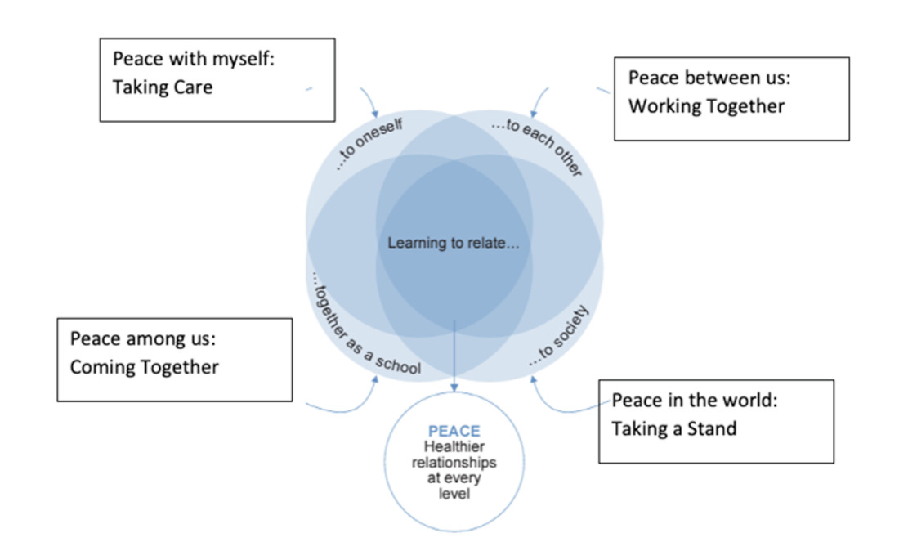
Figure 3 The overlapping layers of peace
View description - Figure 3 The overlapping layers of peace

As you can see, the layers of peace education that you have covered during this course interrelate, and a peaceful school community depends on every member feeling empowered to play their part, however small. Peace at the Heart reminds us that:

A ‘peace school’ is not so much a place where the principles of peace are fully accomplished, but where they are practised and learnt every day.
(PATH, 2022, p. 38).

Sustainable peaceful communities endure amongst the comings and goings of staff, students and families. It can take many years of carefully planned work to establish a long-lasting ethos of peace throughout every aspect of the school.

2.2 Resources to support your peace journey
Schools and educators are not alone in their peace work. Throughout this course you have been introduced to organisations that support aspects of peace building in school. These range from charities such as Oxfam, faith groups such as Quakers in Britain (the co-authors of this course) and national initiatives like Scottish Peer Mediation and Ideas For Global Citizenship (IDEAS). These groups offer a range of resources which might be used for supporting schools’ development in all aspects of peace education. You’ll find links to these organisations on the resources and recommendations page.
With Pax Christi, Quakers in Britain also co-chair the Peace Education Network. Many of the organisations you have met during this course are members of the Peace Education Network. On their website you will find Teach Peace Packs for primary and secondary schools, which have a wealth of activities for peace education. The website also has links to other helpful groups.
There are also organisations (such as Facing History and Ourselves) which offer lesson plans, training and ways of approaching topics in peace in the wider world. Philosophy for Children (P4C) offers an approach for exploring some of the themes that have been discussed in this course. As well as this there are schools accreditation schemes that support peace education, such as UNICEF’s Rights Respecting Schools, and the Welsh Centre for International Affairs, which has a Peace Schools Award scheme and offers training and curriculum materials for schools in Wales. Such schemes also offer resources to support schools on their peace journeys. Once more, the resources and recommendations page of this course contains links to these organisations.
Whilst there can be cost implications for some of the resources and training that these sites offer, there are also often free resources that you might explore as you begin your peace journey.

2.3 Evaluating peace resources
As you saw in Session 5, care must be taken when evaluating resources for your peace curriculum. When using resources from external organisations in your peace curriculum, you might consider...
Does this resource:
- address the current needs of our educational setting?
- support the commitments of peace education?
- promise to inspire educationally productive queries and exchanges?
- offer balanced and impartial information?
- offer a good balance of activities that allow for a range of teaching approaches and opportunities (reflective/dialogic/fun/participatory)?
When thinking about seeking training or a service to help you develop as a peace school, you might ask:
- Are we ready for this training/service?
- Is there any groundwork we need to do before engaging with this training or service?
- How will we follow up the training, ensuring everyone feels supported and included in implementing the new initiative?
Whatever resources you draw on to support your peace journey, remember to take it at a pace that allows all members of the school community to feel involved and empowered.

3 Next steps

A critical middle step between identifying spaces in need of transformation and working for change is the capacity to move from the perceived to the possible—the ability to imagine other than what is.
(Standish, 2018, p. 3)

In this last section you will draw up a plan for what you might do on the next stage of your development as a peace educator or peaceful school community. If planning for your school community, you should begin by considering your own sphere of influence and what you might usefully do within that as a first step. You might also consider how your aspirations for peace education might align with any plans you or your educational setting already have in place.

CPD sessions
If working with a group, you might finish by formulating a plan together using the suggested questions. Participants might begin by making a ‘wish list’ of areas they might want to concentrate on, then agree priorities and responsibilities as a group. You might also consider what you spend most of your time on – peace making, peace keeping or peace building as a starting point.

Activity 3 Making a plan
The timing for this activity is up to you, and you may find yourself returning to it as you reflect on the course

Part 1

Use the response box below to start sketching out your first ideas about what you would like to work towards as a result of taking this course. You can download all of the notes you have made to help you think about this [navigate down the left-hand side of any page and click on the link under ‘My answers’].

Provide your answer...

Part 2

Use the responses to the activities you have carried out in this session to prioritise a particular area for development.

Provide your answer...

Part 3

Next, decide on a format for creating your action plan. It helps to create timelines for actions and to break them down into small, realistically achievable steps. Try and avoid overly complicated formats that might become onerous. Your plan should be a useful tool on your peace journey rather than a form to fill in! If your school has a tried and tested planning format, use that.

Provide your answer...

Part 4

Now create your plan for the next steps on your peace journey.
Think about what you might achieve within your current sphere of influence, whatever that might be. Your plan may be for you as a peace educator, or for the team or group you work with. The following is a list of questions that might help you formulate your plan.
Researching
- What do we want to achieve?
- What do we need to find out?
- Who do we need to talk to?
- What issues might need to be resolved?

Acting
- What actions do we need to take?
- Why will these actions support our goals?
- What are the risks and barriers?
- How will we mitigate these?
- Who will be responsible?
- What is a realistic time scale?

Evaluating
- How will we know if it’s working?
- What might we need to adjust?
Above all, remember to pay attention to the wellbeing of all those on your peace journey, and celebrate every achievement.

Provide your answer...

Some final words from course co-authors Izzy and Ellis...

Video content is not available in this format.
Video 3
View transcript - Video 3

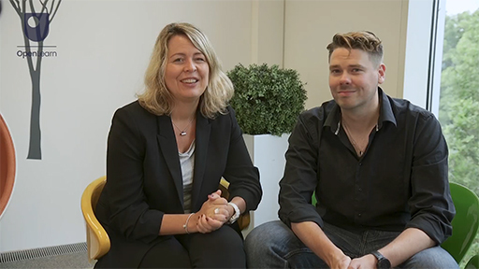

4 Summary of Session 6
In this last session of this course you’ve started to consider yourself as a peace educator, and how peace education can be considered quality education within the United Nations Sustainable Development Goals. You’ve considered the commitments of peace education in relation to your existing practice and begun to think about what you might do next and where you might go for support.
We hope you have enjoyed studying this course and wish you all the best for the next stage of your peace journey. This course is freely available on OpenLearn and you can return to it at any time.
Tell us what you think
Now you’ve come to the end of the course, we would appreciate a few minutes of your time to complete this short end-of-course survey. We’d like to find out a bit about your experience of studying the course and what you plan to do next. We will use this information to provide better online experiences for all our learners and to share our findings with others. Participation will be completely confidential and we will not pass on your details to others.

Further learning
Session 1
Something to read
1. Give peace (education) a chance
Peace educators Shelley McKeown Jones, Janet Orchard and Julia Paulson consider the similarities and differences between peace education and the UK’s Prevent programme.
Something to watch
1. Education for Global Peace
This video, on the Education for Global Peace website, was created by PATRIR (Peace Action Training and Research Institute of Romania). It gives a brief history of peace education in the Global North and revisits many of the concepts you have covered in this session. As you watch, consider how the ideas in the video compare with those you have encountered in this course.
Session 2
Something to read
1. The Museum of Peace at the University of St. Andrews in Scotland has been founded to help people explore and visualise peace. Their website notes that:

We aspire to peace, we idealise it – but we don’t spend as much time exploring and reflecting on it as we do with war.

The website has much to explore, but for now you may find it helpful to explore the section Pockets of Peace, an idea that might be useful as you and your educational community explore what peace means to you.
Something to watch
1. This video from Peacemakers gives an overview of peace education, including an explanation of peace keeping, peace making and peace building:
Peace Education Overview
2. This video about feelings and mindfulness was made for BBC Children in Need in 2021. If the video itself is not suitable for your group to watch, it explains three mindfulness strategies that you might like to share with them.
Mindfulness
Session 3
Something to read
1. Page 12 of the report Peace education: making the case contains more information about the peace competencies developed for this report and used in this course.
Something to watch
1. This TED Talk by neuroscientist V.S. Ramachandran explains the concept of the mirror neuron and how it relates to human empathy.
The Neurons that Shaped Civilization
Session 4
Something to read
1. The full version of the United Nations Convention on the Rights of the Child can be found here:
Convention on the Rights of the Child | OHCHR
Further information on UNICEF’s Right Respecting Schools initiative can be found here:
UNICEF’s Right Respecting Schools
2. The UNICEF site includes case studies of Rights Respecting Schools across the UK which can be found here:
Rights Respecting Schools case studies
Something to watch
1. This multilingual video, from UNESCO, contains young people’s reflections and opinions on human rights from 10 countries around the world. It’s a useful starting point for thinking about how rights are understood by young people. As you watch, consider how the young people discuss some of the topics you have encountered in the course so far, and what human rights means to you as a peace educator.
Education for Human Rights… Young People Talking
Session 5
Something to read
1. To support this session, you are recommended to read pages 32–37 of Peace at the Heart. This section offers a valuable overview of peace education as a critical pedagogy.
Peace at the Heart
2. The Oxfam publication Teaching Controversial Issues: A guide for teachers is available as a download from the Oxfam website.
Something to watch
1. Watch this video from Education Scotland where two of the seven Glasgow Girls talk about their experiences of campaigning for better treatment of asylum seekers in the UK.
Glasgow Girls
You can find education resources to support the use of this story in the classroom at Education Scotland . Further resources about the girls’ work can be found on the Educational Institute of Scotland website.
Session 6
Some of these resources require a fee to access.
Something to read
1. For an introduction to the theories and practices of Peace Education:
Positive Peace in Schools (2017) Hilary Cremin and Terence Bevington
2. This is a useful book for middle to senior school managers with chapters written by many leading figures in education and peace about their experiences building peace in schools.
The Peace Education Network is a fantastic resource. It includes the Teach Peace packs for primary and secondary schools
Learning for Peace: A Guide to Developing outstanding SMSC in your Primary School
3. School level book from Peacemakers (also known as West Midlands Quaker Peace Education Project). Includes a toolkit of activities, a whole school curriculum for Peace for the primary age range and activities for five layers of Peace.
4. This book by Kristine Høeg Karlsen and Margaretha Häggström has stories which can be used in peace education.
Teaching through Stories: Renewing the Scottish Storyline Approach in Teacher Education
5. The Peaceful Schools website includes resources to help schools plan their peace journey. They also run a Peaceful Schools Award Scheme.
6. Peer Mediation Network (PMN)
7. How to be a Peaceful School: practical ideas, stories and inspiration (2018) edited by Anna Lubelska.
8. Amnesty Learning Activity
Something to watch

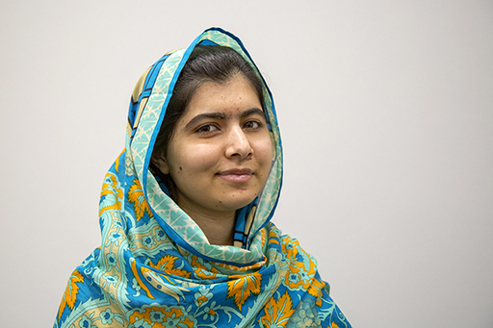
Figure 4 Malala Yousafzai
View description - Figure 4 Malala Yousafzai

Malala Yousafzai began her activism for girls’ education in 2009 aged 12. Despite being shot for her activism in 2012, Malala continues her activism now, having won a Nobel Peace Prize in 2014. You can watch an interview with Malala Yousafzai on the importance of education:
1. Malala Yousafzai interview

References
Cremin, H. and Bevington, T. (2017) Positive peace in schools: tacking conflict and creating a culture of peace in the classroom. London: Routledge.
Gee, D. (2022) Peace at the Heart: A Relational Approach to Education in British Schools. London: Quakers in Britain.
Montiel, C.J. (2022) ‘Decolonising the Quaker Peace Testimony in the Global South’, Quaker Religious Thought, 139, pp. 18–26.
Standish, K. (2015) Cultural Violence in the Classroom: Peace, Conflict and Education in Israel. Newcastle-upon-Tyne: Cambridge Scholars Publishing.
Zammit, J. (2018) ‘Peaceful Relationships in Primary Schools’, in A. Lubelska (ed) How to be a Peaceful School: Practical Ideas, stories and inspiration. London: Jessica Kingsley.
Cartwright, I. (2019) Peace Week: Transforming activities for whole school engagement in human rights, citizenship and peacemaking. London: Religious Society of Friends (Quakers).
Conciliation Resources (2024) What is peacebuilding?. Available at: https://www.c-r.org/who-we-are/why-peacebuilding/what-peacebuilding (Accessed: 18 November 2024)
Cremin, H. and Bevington, T. (2017) Positive peace in schools: tacking conflict and creating a culture of peace in the classroom. London: Routledge.
Galtung, J. (1976) ‘Three realistic approaches to peace: peacekeeping, peacemaking, peacebuilding’, Impact of Science on Society, 26, pp. 103–115.
Office for Health Improvement & Disparities (2022) Working definition of trauma-informed practice. Available at: https://www.gov.uk/government/publications/working-definition-of-trauma-informed-practice/working-definition-of-trauma-informed-practice (Accessed: 9 December 2024).
Zammit, J. and Hagel, S. (2016) ‘Learning for Peace: A guide to developing outstanding SMSC in your primary school’, Peacemakers.
Aziz, S. (2016) ‘Encouraging Cultural Awareness Through an Exploration of Muslim Cultures’, in K.D. Short and J. Schroeder (eds) Teaching Globally: Reading the World Through Literature. Portland, Maine: Stenhouse Publishers.
Cremin, H. and Bevington, T. (2017) Positive peace in schools: tacking conflict and creating a culture of peace in the classroom. London: Routledge.
Gee, D. (2022) Peace at the Heart: A Relational Approach to Education in British Schools. London: Quakers in Britain.
Giertsen, A. and O’Kane, C. (2015) ‘Conflict Management and Peace Building in Everyday Life: A resource kit for children and youth’. London: Save the Children.
Mukhopadhyay, M. & Kundu, A. (2023) Academic Framework for 21st-Century Schooling: Promoting Global Peace and Harmony. USA: Hershey, PA.
Palma Flores, E. and Albornoz Muñoz, N. (2022) ‘Between identification and empathy to elaborate the difficult past: an experience of a classroom debate with Chilean children’. Journal of peace education, 19, 25–46.
Polat, S. & Halçe, B. (2020) ‘Peace Education and Empathy: The Effect of Peace Education Program on the Empathy Trends of Primary School Students,’ Empowering Multiculturalism and Peacebuilding in Schools, Turkey: Kocaeli University.
West Midlands Quaker Peace Education (2016) ‘Learning for Peace: A guide to developing outstanding SMSC in your primary school’. Edited by J. Zammit and S. Hagel. Birmingham: Lifeworlds Learning.
Williams, K.M. & Stock, C. (2009) My Name is Sangoel. Grand Rapids, Michigan, Wm. B. Eerdmans Publishing Co.
Zwart, D. (2019) Peace Education: Making the case. Brussels: QCEA.
Cartwright, I. (2018) ‘Peace Education for a Better World’, in A. Lubelska (ed) How to be a Peaceful School: Practical Ideas, Stories and Inspiration. London: Jessica Kingsley Publishers.
European Forum for Restorative Justice (2024) Restorative Justice in a Nutshell. Available at: https://www.euforumrj.org/en/restorative-justice-nutshell (Accessed: 18 November 2024).
Gee, D. (2022) Peace at the Heart: A Relational Approach to Education in British Schools. London: Quakers in Britain.
Lubelska, A. (2018) How to Be a Peaceful School: Practical Ideas, Stories and Inspiration. London: Jessica Kingsley Publishers.
Nahal, P. (2018) ‘Developing Inner Peace’, A. Lubelska (ed) How to be a Peaceful School: Practical ideas, Stories and Inspiration. London: Jessica Kingsley Publishers.
UNICEF (2024) Rights Respecting Schools: Creating Safe and Inspiring Places to Learn. Available at: https://www.unicef.org.uk/rights-respecting-schools/ (Accessed: 18 November).
Zwart, D. (2019) Peace Education: Making the case. Brussels: QCEA.
Amnesty International (2021) Know your rights and claim them. Rotterdam: Andersen Press.
Centre for Literacy in Primary Education (2020) Reflecting Realities: Survey of ethnic representation within UK children’s literature 2019. London.
Education Scotland (2018) Glasgow Girls - Campaigning for the rights of asylum seekers (learner participation). Available at: https://education.gov.scot/resources/glasgow-girls-campaigning-for-the-rights-of-asylum-seekers-learner-participation/ (Accessed: 18 November 2024).
FHAO (2016) Facing History & Ourselves, “What Difference Can a Word Make?”. Available at https://www.facinghistory.org/resource-library/what-difference-can-word-make (Accessed: 17 December 2024).
Moriarty, S. (2021) ‘Modeling Environmental Heroes in Literature for Children: Stories of Youth Climate Activist Greta Thunberg’, The Lion and the Unicorn, 45, pp. 192–210.
Oxfam (2018) Teaching Controversial Issues: A guide for teachers. Oxford: Oxford Education.
Standish, K. (2019) ‘Learning How to Hope: A Hope Curriculum’, Humanity & Society, 43, 484–504.
Stephan, M.J. and Chenoweth, E. (2008) ‘Why Civil Resistance Works: The Strategic Logic of Nonviolent Conflict’, International Security, 33, pp. 7–44.
Thunberg, G. (2018) ‘I’m striking from school to protest inaction on climate change – you should too’, The Guardian, 26 November. Available at: https://www.theguardian.com/commentisfree/2018/nov/26/im-striking-from-school-for-climate-change-too-save-the-world-australians-students-should-too (Accessed: 18 November 2024).
Vinthagen, S. (2015) A Theory of Non-Violent Action: How Civil Resistance Works.London: Zed Books Ltd.
Waddell, B. (2023) ‘Glasgow school pupils perform play at Scottish Parliament’, Glasgow Times, 22 September. Available at: https://www.glasgowtimes.co.uk/news/scottish-news/23806616.glasgow-school-pupils-perform-play-scottish-parliament/ (Accessed: 18 November 2024).
Winter, J. (2008) Wangari’s Trees of Peace. Harcourt Children’s Books.
Cremin, H. and Bevington, T. (2017) Positive peace in schools : tacking conflict and creating a culture of peace in the classroom. London: Routledge.
Gee, D. (2022) Peace at the Heart: A Relational Approach to Education in British Schools. London: Quakers in Britain.
Peace Pilgrim (1964) Steps Towards Inner Peace. Available at https://drive.google.com/file/d/12QcByyIjI4DnIelmzkT6hu654vp2y-wM/view (Accessed: 17 December 2024).
Standish, K. (2019) ‘Learning How to Hope: A Hope Curriculum’, Humanity & Society, 43, pp. 484–504.
United Nations (2019) The Sustainable development goals report 2019. Available at: https://www.undp.org/sustainable-development-goals (Accessed: 18 November 2024).
Zwart, D. (2019) Peace Education: Making the case. Brussels: QCEA.

Acknowledgements
This free course was written by Lucy Henning, Isabel (Izzy) Cartwright and Ellis Brooks and was first published in December 2024. The course authors would like to acknowledge Woodbrooke Study Centre who created peace education programmes run in partnership with Quakers in Britain, that provided ideas and inspiration that fed into this course. Thanks also to Mirjam Hauck, Dominic Servis and the team at the OCLC for their support in creating this course.
OpenLearn course editor: Dale Harry.
Except for third party materials and otherwise stated (see terms and conditions), this content is made available under a Creative Commons Attribution-NonCommercial-ShareAlike 4.0 Licence.
The material acknowledged below (including any Proprietary material referenced in the course) is Proprietary and used under licence (not subject to Creative Commons Licence). Grateful acknowledgement is made to the following sources for permission to reproduce material in this free course:
Introduction and guidance
Images
Course Image: Courtesy Quakers in Britain, www.quaker.org.uk
Session 1
Images
Figure 1: Courtesy: Quakers in Britain www.quaker.org.uk
Figure 2: Courtesy: Quakers in Britain www.quaker.org.uk
Figure 3: Quote: Martin Luther King
Figure 4: Geopix/Alamy Stock Photo
Figure 5: Stocksnap – Pixabay
Figure 6: Courtesy: Quakers in Britain www.quaker.org.uk
Figure 7: andresr/Getty Images
Figure 10: Front cover of the report Peace at the Heart, commissioned by Quakers in Britain. Courtesy: Quakers in Britain www.quaker.org.uk
Video
Video 1: introducing peace education: ©The Open University (2024) with thanks to Quakers in Britain www.quaker.org.uk for images and video.
Video 2: Children’s perceptions of conflict (extract) from Peace Building in Schools https://www.youtube.com/watch?v=XuX5h112ML4&list=PLPeUpt2GsDX5F7VRuh3zxwVUDyDy0_S4O&index=3 Courtesy: Quakers in Britain www.quaker.org.uk
Session 2
Images
Figure 1: monkeybusinessimages iStock/Getty Images Plus
Figure 2: ‘Pick Up Cards’ from a Peace Week activity from Peace Week Primary core lesson (p. 3 ) plans a resource from Quakers in Britain, Courtesy: Quakers in Britain www.quaker.org.uk
Figure 3: Courtesy: Quakers in Britain www.quaker.org.uk
Figure 4: from Transforming activities for whole school engagement in human rights, citizenship and peacemaking ideas and resources for use in primary and secondary schools p. 20. London, NW1 2BJ © Religious Society of Friends (Quakers) in Britain 2019
Videos
Video 1: ©The Open University (2024) with thanks to Quakers in Britain www.quaker.org.uk for images and video
Video 2: Welcome to the brain’s amazing drugs cabinet from the charity Scottish Centre for Conflict Resolution. Courtesy: Scottish Centre for Conflict Resolution www.scottishconflictresolution.org.uk. This video was produced by SCCR to be part of, Cranial Cocktails – www.scottishconflictresolution.org.uk/homunculus
Video 3: ©The Open University (2024) with thanks to Quakers in Britain www.quaker.org.uk or images and video
Session 3
Images
Figure 1: Explanation of a circle from Peacemakers from: Learning for Peace :A guide to developing outstanding SMSC in your Primary School peacemakers.org.uk/resources/learning-for-peace-book/ Used with permission
Figure 2: Diagram of a circle session from Peacemakers diagram from: peacemakers educating for peace (p. 2) peacemakers.org.uk//wp-content/uploads/2019/07/Online-safety-CT-sessions2.pdf peacemakers.org.uk
Figure 3: adapted from (p. 12) Conflict Management and Peace Building in everyday life. resourcecentre.savethechildren.net/pdf/resourcekit-web.pdf/Save the children, resourcecentre.savethechildren.net, creativecommons.org/licenses/by-nc-sa/3.0/deed.en
Figure 4: An extract from Learning for Peace (p. 59) Learning for Peace , Peacemakers, Lifeworlds Learning, lifeworlds.co.uk
Figure 5: Book cover: My Name is Sangoel (2009) by Karen Williams and Khadra Mohammed (illustrated by Catherine Stock) Wm. B. Eerdmans Publishing Co., www.eerdmans.com/ Used with permission
Session 4
Images
Figure 1: ricochet64/iStock/Getty Images Plus
Figure 2: Eoneren/Getty Images
Figure 3: Alex Scottish Mediation poster: courtesy of Scottish Mediation www.scottishmediation.org.uk
Figure 4: UNICEF’s Rights Respecting Schools poster The child rights ICONS poster Courtesy: Unicef www.unicef.org.uk www.unicef.org.uk/rights-respecting-schools/resources/teaching-resources/our-rights-poster/
Figure 5: Article 39 of the UNCRC www.unicef.org.uk/rights-respecting-schools/wp-content/uploads/sites/4/2017/01/uncrc_su_unicef https://www.unicef.org/
Videos
Video 1: Introduction: ©The Open University (2024) with thanks to Quakers in Britain, www.quaker.org.uk, for images and video
Video 2: marked as 1 CRESST with Greystone’s Primary School, Sheffield. Peer mediation scheme www.youtube.com/watch?v=k2Yq62oazbI&t=11s Courtesy: Quakers in Britain www.quaker.org.uk
Video 3: listed as video 2 Mediation Skills for Life | Building Peace in Schools www.youtube.com/watch?v=5G7sLRkkkUE&ab_channel=QuakersinBritain.Courtesy: Quakers in Britain www.quaker.org.uk
Video 5: listed as video 4: Peer Mediation in Scotland | Young Talk. Peer Mediation in Scotland/Young Talk. Courtesy: Quakers in Britain www.quaker.org.uk
Session 5
Images
Figure 1: Climate activists Vanessa Nakate and Greta Thunberg. Vanessa Nakate: used under licence from Reuters News and Media Ltd ; Greta Thunberg Per Grunditz/Shutterstock.
Figure 2: Book Cover, Wangari’s Trees of Peace: A True Story from Africa by Jeanette Winter , Harper Collins (2018).
Figure 3: A photograph from theatre production Glasgow Girls. Glasgow Girls, 2012, a National Theatre of Scotland Production. Photo credit: Drew Farrell.
Activities
Activity 1: diagram adapted from: Standish, K. (2019) (p. 6) ‘Learning How to Hope: A Hope Curriculum’, Humanity & Society, 43, p. 484–504.
Activity 6: extract from Teaching Controversial Issues: A guide for teachers (p. 3). Teaching Controversial Issues: A guide for teachers – Oxfam Policy & Practice, published by Oxfam Education.
Videos
Video 1: Introduction, © The Open University (2024) with thanks to Quakers in Britain for images and video, www.quaker.org.uk
Video 2: Never give up: Retelling Wangari’s Trees of Peace https://www.youtube.com/watch?v=VKdWEkOPLkw&t=1s0 courtesy Quakers in Britain, www.quaker.org.uk
Video 3 and video 4: Elizabeth Garrett Anderson School. ‘Something will be different’ Building Peace in Schools, courtesy Quakers in Britain, www.quaker.org.uk
Session 6
Images
Figure 1: Courtesy Quakers in Britain, www.quaker.org.uk
Figure 2: United Nations quality education logo: sdgs.un.org/goals
Figure 3: Adapted from Peace at the Heart (p. 38). A relational approach to education in British schools Quakers in Britain, 2022 Courtesy: Quakers in Britain www.quaker.org.uk
Videos
Video 1: ©The Open University (2024) with thanks to rights holders of logos and Quakers in Britain for other images,
Video 2: Sustainable Development Goal 4: Quality Education (Secondary) copyright:2019 by Participate, Inc. This work is licensed under the Deed – AttributionshareAlike 4.0 International – Creative Commons
Video 3: ©The Open University with thanks to Quakers in Britain www.quaker.org.uk for images
Every effort has been made to contact copyright owners. If any have been inadvertently overlooked, the publishers will be pleased to make the necessary arrangements at the first opportunity.
Don’t miss out
If reading this text has inspired you to learn more, you may be interested in joining the millions of people who discover our free learning resources and qualifications by visiting The Open University – www.open.edu/openlearn/free-courses.

Course resources and recommendations

Peace at the Heart: A Relational Approach to Education in British Schools
Teaching Controversial Issues: A Guide for Teachers
Addysgu Pynciau Llosg: Canllaw I Athrawon
Peace Education animation from Peacemakers

Session 1
Peace Education Network (Group of organisations working for peace from a range of perspectives. The network has produced Teach Peace Resources for Primary and Secondary schools.)
Session 2
Peace Week pack (Resources for primary and secondary schools to run their own peace weeks. They include a staff training session as well as activities for different age groups.)
Session 3
Circle Time Resources – Toolkit for Peace: Approaches and Games (Peacemakers resources for primary school circle sessions.)
Circle Time Resources – Warm Up Activities (Suggested activities from Oxford Health NHS Trust.)
Managing Conflict (Resources for Save the Children to help children and young people develop skills in managing conflict.)
Session 4
Restorative Schools (Information on restorative schools from the European Forum for Restorative Justice.)
Schools of Sanctuary (For Primary and Secondary Schools wishing to understand and support children and young people who are forced to flee their homes.)
Peace Schools Wales (Peace Schools initiative run for schools and settings by the Welsh Centre for International Schools. It offers resources, training and conferences and runs a schools accreditation programme.)
The Welsh Centre for International Affairs (A resource pack for teachers working with the United Nations Sustainable Development Goal for Peace, Justice and Strong Institutions.)
CRESST (Conflict Resolution for Young People by Young People) (Resources for Primary and Secondary schools in conflict resolution, especially peer mediation. This organisation runs conferences and training for staff and pupils.)
Scottish Peer Mediation (Has a section for working with young people that offers training and resources.)
UNICEF Rights Respecting Schools (UK website of the UNICEF Rights Respecting Schools initiative. It runs a well established award scheme for schools and offers training, resources and accreditation.)
Session 5
Development Education Centre South Yorkshire (DECSY) (Educational organisation that promotes Global Learning. Includes training, resources and links to Philosophy for Children (see Session 6 links, below.))
Websites recommending books for classroom use: Amnesty International (A range of books and suggested activities for teaching about human rights.); The BookTrust themed booklist (Booklists addressing themes for exploration by children and young people including refugees and asylum seekers.); Centre for Literacy in Primary Education (A London-based organisation for primary schools that publishes the annual Reflecting Realities report into diversity in children’s books.)
Using stories for global issues (West of Scotland Development Education Centre. Educational organisation creating resources for global citizenship. The centre worked with Oakgrove Primary School on their Wangari’s Trees of Peace project.)
Session 6
United Nations Sustainable Development Goals: fast facts; goals; sustainable development
Oxfam (Oxfam has an education section with resources for educational settings.)
International Development Education Association Scotland (IDEAS) (Classroom resources on themes such as human rights, slavery, justice and equity and sustainable development for primary and secondary education.)
Facing History and Ourselves (Resources for taking a critical approach to teaching history. Includes lesson plans and articles.)
Philosophy for Children (Teaching approach that develops skills including critical thinking and evaluation.)
Peaceful School Awards (Free scheme for accrediting schools as Peaceful Schemes. Their website offers resources and guidance.)
West Midlands Peacemakers (West Midlands Quaker Peace Education Project or Peacemakers offer training and resources for teaching peace and developing restorative practice. Areas covered include curriculum development and peer mediation. Resources include a starter pack for schools setting out on their peace journey – they carry out lots of whole school restorative work.)
Global Campaign for Peace Education (A global movement of individual peace educators and education NGOs committed to fostering cultures of peace through peace education.)

Course further reading
General peace
- An introduction to the theories and practices of peace education:
Cremin, H. and Bevington, T. (2017) Positive peace in schools: tacking conflict and creating a culture of peace in the classroom. London: Routledge.
- A useful book for middle to senior school managers with chapters written by many leading figures in education and peace about their experiences building peace in schools:
Lubelska, A. (ed) (2018) How to Be a Peaceful School: Practical Ideas, Stories and Inspiration. London: Jessica Kingsley Publishers.
- School level book from West Midlands Quaker Peace Education project. Includes a toolkit of activities, a whole school curriculum for peace for the primary age range and activities for five layers of peace:
Zammit, J. & Hagel, S. (2016) ‘Learning for peace: a guide to developing outstanding SMSC in your primary school’, Peacemakers. Lifeworlds Learning.
Using stories for peace education
- An anthology that supports pedagogy for teachers within in-service education.
Karlsen, K.H and Häggström, M (2020) Teaching through Stories: Renewing the Scottish Storyline Approach in Teacher Education. Available at: https://www.pedocs.de/volltexte/2021/21352/pdf/Karlsen_Haeggstroem_2020_Teaching_through_stories.pdf (Accessed 18 November 2024).

Solutions

Activity 1 Introducing peace education

Discussion
In the video Izzy and Ellis introduced several ideas that you will become familiar with throughout the course. They talked about the relationship between their life experiences and the peace work they have done in different contexts. You might have noticed references to ‘layers of peace’ including personal, community and global peace. You’ll return to this idea of layers of peace at the end of the session.
Back to - Activity 1 Introducing peace education

Activity 2 Your ideas about peace

Part 2

Discussion
There are lots of ways of understanding peace, and to some extent these will arise from people’s life experiences. For example, Martin Luther King Jr spent a lifetime working for the rights of Black people in the US and so the perception of peace in the quote above is related to that struggle. Similarly, the image and writing from the child who wishes to share with their sisters reflects life in their family and what makes them feel peaceful there. The last image of a peace banner at a demonstration might feel a little less ‘peaceful’ but some people might associate peace with activism for social and political change.
Back to - Part 2

Activity 3 Positive and negative peace in schools

Discussion
Banning football to tackle the problem of arguments is an example of negative peace for several reasons. Firstly, it is a peace that is imposed by the more powerful (adults) without exploring what a peaceful solution might look like to the people directly affected by the arguments (not just the argumentative football players, but also the people whose breaktime is disrupted). Secondly, imposing a solution misses an opportunity for children and young people to develop social and emotional attributes that help them manage challenging experiences as well as their skills in conflict resolution – part of the hard work Zammit says is needed to secure positive peace in schools (Zammit, 2018). Thirdly, whilst banning football might address the immediately visible violence in the arguments, it may not address underlying issues around what the children and young people see as ‘just’ and ‘fair’ in their school lives. Notice that here, positive peace goes beyond classrooms, into breaktimes and indeed every part of school life.
Back to - Activity 3 Positive and negative peace in schools

Activity 4 Exploring different types of violence

Discussion
Thinking of football as being a game for ‘boys’ exemplifies cultural violence, whilst organising the playground space around football is an example of structural violence. The cultural violence in this example separates childhood into girlhood and boyhood and associates particular preferences and attributes to each group. This links to the structural violence that organises the physical space to prioritise activities associated with boyhood. This affects both the girls whose perceived needs are afforded less value than those of boys, as well as the boys who do not conform to the stereotype of boyhood. As Standish (above) explains, cultural violence can make it seem more ‘permissible’ for direct violence to be used against groups perceived to have less value, particularly when they assert their needs or refuse to behave as expected. This violence might arise from the bullying of children who don’t conform to stereotypes, the opposition of the prioritised group to any challenge to their privileged position, or the frustrations of the group asserting their needs.
Back to - Activity 4 Exploring different types of violence

Activity 6 Children’s perceptions of conflict

Discussion
Three children gave examples of conflict in the clip. The first talked about differences of opinion over what to eat or a game to play, exemplifying conflicting needs or wants. The second explained how a conflict, in this case an argument, might escalate, becoming more than a disagreement. The third child’s example was of a violent conflict when a more powerful group of people, in this case teenagers, bully a more vulnerable person, a primary school child.
Violence plays a role most clearly in the third example, where cultural and direct violence are evident in the power differentials between older and younger people resulting in bullying. Violence has the potential to emerge in the second example, where, as the young person explains, an argument ‘can turn into a really big problem’. In the first problem, the conflicts described have the potential to yield positive outcomes. For example, one person might try something different for dinner and discover they like it, or the group of players might decide to explore a new game together.
Back to - Activity 6 Children’s perceptions of conflict

Activity 7

Discussion
You may have found that your personal ideas about peace fit into more than one layer. For example ‘peace with myself’ involves children and young people exploring what matters to them and what is good in themselves. This relates to ‘peace in the world’ – knowing what matters to you might relate to the way you navigate a complex society.
In terms of what each layer might look like in a classroom or school, the following sessions will give you some ideas. For now, keep your initial ideas in mind and continue developing them as you work through the materials.
Back to - Activity 7

Activity 1 What does wellbeing mean?

Part

Discussion
As you can see, wellbeing is a relatively complex term, relating to the personal, interpersonal and spiritual. This session focuses on emotional, psychological and social wellbeing.
Back to - Part

Activity 2 Affirming myself

Discussion
Peacemakers suggest starting this activity with a small group working with an adult rather than the whole class. Once children are beginning to develop confidence in talking positively about themselves and others, these small groups could join other groups until the whole class feels comfortable talking together. In a multilingual classroom, you might encourage children to express their ideas in different languages, offering a translation for the next child or group.
You might also consider giving children cards with a sentence starter that will help them articulate their thoughts. For example you could use ‘It’s good to be me’ as a sentence starter or work on an alternative with the group to find something that everyone is comfortable with using.
Whatever adaptation you make, it’s important to keep sight of the learning and to support children in developing their capability to give and receive affirmations, as well as seeing the good in themselves.
Back to - Activity 2 Affirming myself

Activity 3 An introduction to emotions and the human brain

Discussion
Teaching children and young people to understand and regulate their emotions can support their development responses to conflict, helping them find ways to build just and positive outcomes. They can learn to understand what happens to them in situations involving powerful emotions such as anger. ‘Standing in another’s shoes’ is a metaphor for being able to understand the responses and needs of others as well as their own – a fundamental part of building positive relationships.
Back to - Activity 3 An introduction to emotions and the human brain

Activity 4 Recognising feelings in oneself and others

Part 1 Developing vocabulary to talk about feelings

Discussion
You’ll notice there are no right or wrong answers in this activity. This is because the aim is to think – either by yourself or with others (if you are completing the course with a group) – about how emotions feel to you, and how this might be the same or different for others. For example, being angry can be exciting for some people and upsetting for others. An activity such as ‘Feelings Postcards’ below can help develop these discussions when working with a group.
Back to - Part 1 Developing vocabulary to talk about feelings

Part 2 Recognising and describing feelings

Discussion
Any activity should allow plenty of time for children and young people to discuss their feelings, thinking about their mental and physical responses and how their feelings might relate to their behaviour. As well as being able to express their own feelings, children will need to listen carefully in order to understand others’ experiences.
Back to - Part 2 Recognising and describing feelings

Activity 5 How does conflict affect my mind and body?

Part 2

Discussion
Building up a picture of how strong emotions can affect different parts of your mind and body can help to recognise these emotions and find ways of managing them. However, all of this takes practice and, if you try any of these activities with children and young people, you should consider them as part of a long-term curriculum approach to wellbeing
Back to - Part 2

Activity 1 Benefits of circle time

Discussion
Cremin and Bevington explain that circles can be used for activities that build inclusion, citizenship and wellbeing, going on to say that circle time:

...focuses on speaking, listening and the social and emotional aspects of learning. There are two fundamental ground rules for the circle: one person speaking at a time: and equal respect for all contributions.
(Cremin and Bevington, 2017, p. 105)

These aspects of circle time make it a useful tool for peace building.
Back to - Activity 1 Benefits of circle time

Activity 3 Matching conflict styles

Part 1 Recognising different conflict styles

Discussion
Remember that being able to identify one’s own preferred style should be the first step to exploring a range of potentially helpful approaches to conflict. It’s important to avoid imposing values on the styles. Instead, try and think of them as approaches that might be used depending on the situation. For example, many people are brought up to believe that confrontation is aggressive, however if managed with careful attention to one’s own and others’ responses and rights, it can bring about a swift solution to a conflict.
Back to - Part 1 Recognising different conflict styles

Part 2 Your preferred conflict style

Discussion
With an activity like this you might explore different approaches, perhaps role-playing different conflict styles to experiment with ways of managing the conflict.
Back to - Part 2 Your preferred conflict style

Part 3 Benefits and limitations

Discussion
Here are some suggested benefits and limitations to the five conflict styles: turtle, shark, chameleon, zebra, and owl. You may have thought of others.

Animal | Benefits | Limitations
Turtle | *When confronting seems dangerous  *When you need more time to prepare | *The problem may never be resolved  *Emotions may explode later
Shark | *When immediate action is needed  *When you believe in the absolute rightness of your actions and don’t see any other choice | *This style can make people defensive and can make a conflict worse  *This style can make it hard for others to express how they feel
Camelion | *When you think you've made a mistake or that you don't really understand the situation  *When smoothing over is important for keeping a relationship | *You may work hard to please others but never be happy yourself  *Being nice doesn't always solve the problem
Zebra | *When you need a fast decision on small issue  *When nothing else works | *You may fix the immediate conflict but not the bigger problem  *Each person may not end up happy
Owl | *Can make someone who is stubborn move towards resolving a problem | *This requires time and good communication skills

Back to - Part 3 Benefits and limitations

Part 4

Discussion
You might want to repeat this activity, choosing another conflict style and thinking about how that might work in the situation. If doing the activity with a group you might explore different approaches, perhaps role-playing different conflict styles to experiment with ways of managing the conflict.
Back to - Part 4

Activity 4 Teaching empathy

Discussion
Peacemakers propose using an activity such as ‘empathy footsteps’ as a way of teaching empathy as part of a wider peace curriculum. You may have thought about using empathy footsteps as a strategy for helping children and young people explore classroom conflicts, and considering how peaceful solutions might be negotiated. Children and young people with different viewpoints on the conflict could try occupying each other’s footsteps as a way of placing themselves in their shoes.
As with all the activities suggested in this course, ‘empathy footsteps’ can form part of a repertoire of teaching techniques that could be employed in a wider curriculum. You may have thought about how this activity could be used as part of curriculum learning, perhaps with students role-playing different characters in scenarios from literature and history lessons, so they might learn to understand the different viewpoints around particular topics.
Back to - Activity 4 Teaching empathy

Activity 5 Developing skills for empathy

Discussion
You may have considered that a key skill required for empathy is that of active listening. This skill is supported within the empathy footsteps by requiring the participants to repeat back and acknowledge what the other has said. You may also have considered other skills, such as the ability to communicate non-violently (that is, without judging, accusing or blaming). Skills in managing emotions would be helpful here, as might attitudes of self-awareness. Of course, you may have noted other skills and attitudes that might be required for children and young people engaging in this activity.
Back to - Activity 5 Developing skills for empathy

Activity 6 Understanding another’s experience through literature

Discussion
Aziz describes how the students initially responded to Sangoel’s situation, thinking that the dilemma could be resolved with a straightforward name change. This would make the situation easier for the Americans that Sangoel met, but the class does not yet demonstrate an understanding of the implications this might have for Sangoel’s identity. The teachers then helped contextualise the story, deepening the pupils’ understanding of the character’s situation by recognising both similarities (the importance of the children’s own names) as well as differences (Sangoel’s experience as a refugee) between their situations.
Back to - Activity 6 Understanding another’s experience through literature

Activity 7 Reviewing peace competencies

Discussion
In this activity you are thinking about the competencies that children and young people might develop as peace builders. You might have connected the affirmations section in Session 2 to the attitude of respect for the self and the skill of managing emotions. You might have considered how constructive cooperation and active listening are essential for circle activities.
In Session 6 you will carry out a similar activity as you think about the competencies that peace educators need.
Back to - Activity 7 Reviewing peace competencies

Activity 1 What does peace look like for us?

Discussion
Peace might mean different things to different people, so exploring what peace might look like for the people in your educational community is a helpful first step in a peace journey. Depending on your role in the school, this step might be taken in a small way, perhaps just in your classroom or immediate setting, or it might be a much bigger endeavour, involving a range of groups in the school community.
It’s impossible to predict the kinds of challenges that school communities might face, so activities such as these are important for starting reflections and conversations about peace in school settings.
Back to - Activity 1 What does peace look like for us?

Activity 2 Introducing peer mediation

Discussion
Peer mediation involves training children and young people to support people who are in conflict to find positive solutions to that conflict. As such it might be seen as part of peace making — managing conflict constructively when it arises.
Back to - Activity 2 Introducing peer mediation

Activity 3 Exploring peer mediation at Bacon’s College

Discussion
Peer mediation can empower children and young people to take an active role in building peaceful relationships within schools. In the video, former peer mediators discussed the training and experience they received and the kinds of activities they carried out as peer mediators.
A crucial role for adults in developing peer mediation is in training children and young people as mediators (see next section). However, the video also shows how important it is for mediation to be supported both within the school and the community beyond.
Back to - Activity 3 Exploring peer mediation at Bacon’s College

Activity 4 Being a peer mediator

Discussion
Kezia describes how there is ‘power in peer work’. She describes how the young people took responsibility for training the new peer mediators, adding further to their experience and developing the empowered activities of the pupils at the school.
Kezia describes how her skills in peer mediation were used both within Bacon’s College and beyond, helping the school community engage with the community around them. Kezia also talks about how she took the skills she learned into her personal and professional life after school, establishing a peer mediation scheme in the school she now works in as a teacher.
Back to - Activity 4 Being a peer mediator

Activity 5 Building skills and competencies for peer mediators and their ‘clients’

Discussion
You will have noticed that ‘mediation’ is explicitly listed as a skill in the peace competencies table. Active listening is central to peer mediation and is highlighted by the young people in the video. This will be important both for young mediators and those involved in any conflict who need space to listen to each other.
You may also have noted the skills and attitudes that you discussed while considering empathy in Session 3 – active listening, analytical skills, listening carefully and gathering information. From the videos you have watched, you may have noticed the emphasis on working through difficulties rather than judging and blaming, so that all involved might develop their skills in social connectedness and teamwork.
As well as these, the video from Young Talk, and the poster in Figure 3 emphasised controlling emotions and containing the ego, so self-awareness and understanding, managing and expressing emotions are also important competencies for mediators.
Back to - Activity 5 Building skills and competencies for peer mediators and their ‘clients’

Activity 6 Building peace in a Rights Respecting School

Discussion
You will have spotted the reference to Article 39 of the UNCRC in the video. The full article states that:

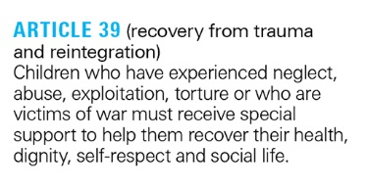
Figure 5 Article 39
View description - Figure 5 Article 39

Whilst you can’t be sure what kinds of activities led to the making of this video, you might have considered that the children were developing their knowledge about human rights and the effects of violent conflict. You might have also considered that they were developing attitudes of social responsibility, social connectedness and solidarity as they thought about how they might welcome refugees into their school. Here they are beginning to encounter aspects of peace in the wider world, which you will read more about in Session 5.
Back to - Activity 6 Building peace in a Rights Respecting School

Activity 7 Beginning to explore the UNCRC

Discussion
You may have found yourself paying attention to Articles 28 and 29, which deal directly with children’s rights in respect of education. Article 30 can be thought-provoking for schools with multilingual communities as they consider the extent to which children and young people feel able to use their preferred languages as part of their learning. Article 12 chimes with the goals of peace among us in schools, as it calls for children’s views and opinions to be listened to and taken seriously. This is important in peer mediation as both sides of the conflict have the opportunity to be heard. You might also think of this in relation to Nahal’s description of ‘pupil leadership teams’ that you met in the first part of this session.
Back to - Activity 7 Beginning to explore the UNCRC

Activity 1 The multidimensional nature of hope

Discussion
Hope is infused through all aspects of peace education and is an essential aspect of wellbeing. Standish emphasises that hope is holistic and its elements cannot be separated out from each other. For example cognitive hope, where individuals and groups feel they have agency to achieve their goals, can both arise from and support emotional hope, and this can have a positive impact of physical wellbeing.
Back to - Activity 1 The multidimensional nature of hope

Activity 2 Exploring non-violence

Discussion
There are many considerations that might affect a discussion on what might be considered violent or non-violent. An essential consideration is to fully understand the consequences of an action and the harm it might cause to the lives involved (environmental as well as human). Another is to be sure that one’s actions did not contain the seeds of further injustice and violence.
DECSY, who developed the activity, suggest that participants might also consider:
- whether the people involved were acting with violent or non-violent intentions
- whether there was an element of deception in the action
- whether damage was done to property or living beings.
Additional contextual factors might include legal frameworks, such as those affecting the right to protest, and the safety and wellbeing of all involved.
Back to - Activity 2 Exploring non-violence

Activity 3 Using stories in the peace curriculum

Discussion
Oakgrove Primary School explicitly teaches children about wider global issues and their impact on their community. The Trees of Peace project linked to the science curriculum where children were learning about nature in their local environment, and the ways in which it might be at risk. Through the project, the children explored how they could engage with such issues, from talking to their immediate communities to presenting their work to the Scottish Parliament.
The most notable peace competency spoken of by the teachers was empathy, but additional competencies were revealed in the children’s discussions. You may have noticed a desire to promote justice, non-violent communication, and respect for the environment.
Back to - Activity 3 Using stories in the peace curriculum

Activity 4 Learning about injustice

Discussion
Class teacher Niquelle Latouche’s work with her students was supported by the deeper ethos of the whole school community, including its strong anti-racist policies. In the video, you saw Latouche introducing vocabulary to talk about identity. She was open about the choice of language for the session, creating space for students to think deeply about the meanings of the terms used. The carefully planned session allowed Latouche to pay close attention to and build from the young people’s responses. There was an atmosphere of mutual respect, and the openness and willingness of the teacher to listen contributed to this.
Latouche modelled several peace competencies, demonstrating self-awareness and pride in her identity, as well as respect for herself and others in her engagement with her students. Students were invited to think critically as they explored their assumptions. Latouche talked about the vulnerability of the educator opening up to their students in this way, however the students’ comments on the session demonstrated how her approach facilitated their engagement.
Back to - Activity 4 Learning about injustice

Activity 5 Exploring challenging topics

Discussion
Head of History Hamidah Siddiqua talks about the ways in which she and other school leaders support staff by encouraging them to discuss topics of concern and become aware of the emotions and questions that they raise. This helps staff and students feel heard and seen, especially those who may have felt their own experiences were not sufficiently listened to in the past.
Siddiqua chose her resources carefully and made the humanity of the Uyghur clear to the students. Hope is evident in the students’ thoughtful responses to the discussion and their concern for the issues raised. As well as this, Headteacher Sarah Beagley reminds the students that they are empowered to work together to do something about such terrible things happening in the world.
Back to - Activity 5 Exploring challenging topics

Activity 6 What is a controversial issue?

Part A

Discussion
Oxfam’s publication Teaching Controversial Issues offers the following definition. How do your ideas compare?
- Evoke strong feelings and views.
- Affect the social, cultural, economic, and environmental context in which people live.
- Deal with questions of value and belief and can divide opinion between individuals, communities and wider society.
- Are usually complicated, with no clear ‘answers’ because they are issues on which people often hold strong views based on their own experiences, interests, values and personal context.
- Arise at a range of scales affecting local, national and global communities.
- Include a wide range of topics such as human rights, gender justice, migration and climate change.
- Can vary with place and time, and may be long-standing or very recent. For example, an issue that is controversial in one community or country may be widely accepted in another.
Back to - Part A

Part B

Discussion
Oxfam suggest many reasons for teaching topics such as human rights, gender justice, migration and climate change. You have seen examples of teaching on this topic throughout this course. Teaching Controversial Issues stresses the importance of children and young people gaining knowledge and understanding of issues that affect their lives, as well as learning to listen to the ideas of others and evaluating their own stances. You saw examples of all of these developing competencies in the videos from Oakgrove Primary School and Elizabeth Garrett Anderson School. However, the publication stresses the importance of carrying out such discussions in a safe space. As you have seen, the peace educator has an essential role in this.
Back to - Part B

Activity 1 The qualities of a peace educator

Part 1

Discussion
Peace educators need many competencies, some specific to peace education but others that align with the general competencies of a committed educator, such as an ability to research and plan engaging lessons, build good relationships with teams (children and young people as well as adults) or manage challenging discussions. Professional competencies displayed by the adults in the videos you have watched throughout this course include a commitment to hearing the voices of children and young people, to understanding the local community or taking creative approaches in daily practice. Additional competencies for peace educators might also include values such as a commitment to equality, to non-violence and engaging positively with conflict.
Back to - Part 1

Part 2: My wellbeing as a peace educator

Discussion
Competencies for wellbeing might include being able to manage emotions, especially when teaching topics that could be considered challenging, or when dealing with conflicts that might arise amongst children or adults in the school. Peace educators might develop strategies to safeguard their own happiness and security as a teacher, including making sure they have enough leisure time outside school, or that they eat lunch every day. Another useful strategy can be to find quiet spaces in busy days to sit and think for a while, with or without other members of the school community.
Back to - Part 2: My wellbeing as a peace educator

Part 3

Discussion
You will have identified many strengths in your existing educational practice that you can draw on in your work as a peace educator. Don’t forget the competencies you will have developed by doing this course, such as knowledge about the different forms of violence and an understanding of peaceful alternatives to violence. You could say that your desire to promote justice is evident in having reached the final session!
You might like to note your existing competencies down somewhere and use them for self-affirmations when you’ve had a tough day. Then turn your attention to the other questions which will help you to think about where you might develop, what you could prioritise and what help might be available.
Back to - Part 3

Activity 2 Quality education (Sustainable Development Goal 4) and peace education

Part 1

Discussion
The principles and practices of peace discussed during this course are elements of target 4.7, a ‘commitment to a culture of peace and non-violence’. Understanding emotions, managing conflict and developing mediation skills can all be seen as part of the knowledge and skills needed to promote a culture of peace and non-violence, both within the school and beyond.
The practices and initiatives you have read about also align with target 4.1. For example, becoming a UNICEF Rights Respecting School supports an understanding of human rights and gender equality, while a commitment to wellbeing, supporting the self-affirmations of others, and exploring the diversity of ideals around peace in school communities can contribute to an appreciation of cultural diversity within the school community and the wider world beyond.
Back to - Part 1

Part 2

Discussion
A commitment to relationships means that every person in an educational setting has a role to play in building and sustaining a peaceful community. You will have found much in your current practice that already aligns with the commitments of peace education. For example, positive relationships with your students and other members of staff, assemblies which celebrate the achievements of children and young people, lessons in citizenship and PSHE where pupils learn to build healthy relationships with themselves and the world. Such activities are a starting point towards building peace as part of an educational community.
Back to - Part 2

Descriptions

Figure 1 Perspectives on peace
A colourful drawing which shows three people holding up five letters spelling the word ‘PEACE’.
Back to - Figure 1 Perspectives on peace

Figure 2 A child’s idea of peace
An image of a child’s drawing. It shows a toy with the words ‘Peace is sharing my toys with my sisters’ written underneath.
Back to - Figure 2 A child’s idea of peace

Figure 3 Famous quote attributed to American civil rights activist Martin Luther King Jr
A Martin Luther King quote displayed in a speech bubble: ‘True peace is not merely the absence of tension: it is the presence of justice.’
Back to - Figure 3 Famous quote attributed to American civil rights activist Martin Luther King Jr

Figure 4 Martin Luther King Jr
An image of American civil rights activist Martin Luther King Jr, standing with his hand raised, addressing a large crowd.
Back to - Figure 4 Martin Luther King Jr

Figure 5 Demonstrators at a peace protest
An image of protestors holding a rainbow banner that says ‘PEACE’. We see the protestors from behind.
Back to - Figure 5 Demonstrators at a peace protest

Figure 6 Johan Galtung
A drawing of scholar Johan Galtung.
Back to - Figure 6 Johan Galtung

Figure 7 Football in school
An image of four children wearing school uniform playing football on school grounds. There are two boys and two girls.
Back to - Figure 7 Football in school

Figure 8 Iceberg diagram
An image of an iceberg. Three quarters of the iceberg are beneath the water level. The top of the iceberg is labelled ‘Direct violence’ whilst the part below is labelled ‘Structural violence’ and ‘Cultural violence’.
Back to - Figure 8 Iceberg diagram

Figure 9 Iceberg diagram
An image of an iceberg. Three quarters of the iceberg are beneath the water level. The top of the iceberg is labelled ‘Direct violence’ whilst the part below is labelled ‘Structural violence’ and ‘Cultural violence’.
Back to - Figure 9 Iceberg diagram

Figure 10 Front cover of the report Peace at the Heart, published by Quakers in Britain
Image of the front cover of the report Peace at the Heart, published by Quakers in Britain. The cover includes the full title of the report Peace at the Heart: A relational approach to education in British schools and the date of publication, October 2022. The symbol of Quakers in Britain is in the bottom left hand corner. The cover features the lower body of a child holding a card with a cut-out heart shape and the word 'hope'.
Back to - Figure 10 Front cover of the report Peace at the Heart, published by Quakers in Britain

Figure 1 Children enjoying their packed lunch
A diverse group of primary school children are eating their packed lunches around a table. One has turned to smile at the camera.
Back to - Figure 1 Children enjoying their packed lunch

Figure 2 ‘Pick Up Cards’ from a Peace Week activity
Two ‘Pick Up Cards’ from a Peace Week activity. Each has a drawing of children on the front, likely drawn by children.
Back to - Figure 2 ‘Pick Up Cards’ from a Peace Week activity

Figure 3 A secondary school student explores their identity
A student holds a completed card entitled ‘my identity’. On it, they have divided an outline of a head into sections and annotated it with different aspects of their identity.
Back to - Figure 3 A secondary school student explores their identity

Figure 4 Onion diagram illustrating layers of conflict
A diagram of an onion showing four rings indicating ‘Need’, ‘Feeling’, ‘Thought’, ‘Behaviour/action’. A box below provides an example of each.
Back to - Figure 4 Onion diagram illustrating layers of conflict

Figure 1 Explanation of a circle from Peacemakers
This is a digram with short sentences circulating around the words ‘In a circle’. The sentences are: Responsibility for what happens in the circle is shared by everyone; The space in the centre of the circle acts as a stage; Everyone has their own space within the circle; Everyone can participate equally; Everyone can see each other
Back to - Figure 1 Explanation of a circle from Peacemakers

Figure 2 Diagram of a circle session from Peacemakers
This is a diagram which has six boxes set in a circular pattern. The boxes are different colours. The box at the top reads ‘Check In / Check Out’. The following boxes, in a clockwise direction, read ‘Mix up the group’, ‘Main Activity’, ‘Reflect & Review’, ‘Game’ and ‘Affirmation’.
Back to - Figure 2 Diagram of a circle session from Peacemakers

Figure 3 Animal conflict style segment, taken from a Save the Children resource
A table of conflict style and behaviour for five ‘animals’. TURTLE, Conflict style; Avoiding, Denying a problem, Prentending not to notice. Behaviour, Leaving a situation, Holding back feelings and opinions. SHARK, Conflict style, Confronting, Getting what you want non matter what, Some people win, some lose. Behaviour, Interrupting / taking over, Ignoring others’ feelings and ideas, Loud tone of voice, Sometimes use physical violence. CAMELION, Conflict style, Accommodating, Giving in to other person’s point of view, Paying attention to others’ concerns and not your own. Behaviour, Apologising / saying yes to end the conflict, Letting others interrupt or ignore your feelings, ideas. ZEBRA, Conflict style, Compromising, Each person wins some and loses some. Behaviour, Interested in finding a solution, Show desire to talk about the problem. OWL, Conflcit style, Problem Solving, Finding a solution that makes everyone happy, Looking closely at the sources of the conflict. Behaviour, Addressing your feelings, needs and wants, Listening to others.
Back to - Figure 3 Animal conflict style segment, taken from a Save the Children resource

Figure 4 An extract from Learning for Peace
An extract from Learning for Peace. The page is titled ‘Empathy footsteps’. This is followed by the activity ‘Aim: To explore empathy’, ‘Skills: Empathy, looking, listening, participating, thinking’ and ‘Age: 7-11’. There then follows a list of activity instructions, showing four parts: You need two pairs of paper feet on the floor that children can stand on, facing each other. 1. Act out a simple conflict between two people, e.g. Tariq has lost his pencil and he thinks Ellie has taken it. 2. Ellie and Tariq stand in ‘their own’ footsteps facing each other and tell each other how they feel using an ‘I’ statement (see p. 48), e.g. “I felt angry… when… because…I would like it if…” 3. They then swap over and stand in each other’s footsteps. They acknowledge each other’s feelings by repeating back what they said e.g. “I heard you say you were angry because…And you would like it if…” 4. They return to their own footsteps and talk about how it felt to be in the other’s shoes. They could talk about the ideas raised by the other person and this can lead to ideas to then try to resolve the conflict.
Back to - Figure 4 An extract from Learning for Peace

Figure 5 Book cover for My name is Sangoel
Book cover for My name is Sangoel. The cover is an illustration showing a close-up of a boy watching a group of other boys playing football.
Back to - Figure 5 Book cover for My name is Sangoel

Figure 1 A word cloud for ‘Peace’
A word cloud which has ‘Peace’ in the centre surrounded by the translation of that word across numerous languages, such as ‘Frieden’ (German), ‘Heiwa’ (Japanese), and ‘Paix’ (French).
Back to - Figure 1 A word cloud for ‘Peace’

Figure 3 A poster from Scottish Mediation
A poster showing a cartoon image of a child with various labels indicating the skills of a peer mediator. They are: ‘big ears for listening’, ‘clear eyes for seeing’, ‘small mouth, focus on listening rather than talking’, ‘big heart, for empathy and compassion’, ‘ego contained’, ‘big feet firmly on the ground’.
Back to - Figure 3 A poster from Scottish Mediation

Figure 4 UNICEF’s Rights Respecting Schools poster
UNICEF’s Rights Respecting Schools poster. A colourful poster broken up into 43 blocks. Each block carries an illustration indicating an article of the UN Convention on the Rights of the Child, with a short description below.
Back to - Figure 4 UNICEF’s Rights Respecting Schools poster

Figure 5 Article 39
An image of the text comprising Article 39, which reads: ‘ARTICLE 39 (recovery from trauma and reintegration) Children who have experienced neglect, abuse, exploitation, torture or who are victims of war must receive special support to help them recover their health, dignity, self-respect and social life.’
Back to - Figure 5 Article 39

Figure 1 Climate activists like Vanessa Nakate (left) and Greta Thunberg (right) inspire hope and movements for change
The left-hand side of the figure shows a close-up photograph of climate activist Vanessa Nakate. The right-hand side shows climate activist Greta Thunberg holding a placard.
Back to - Figure 1 Climate activists like Vanessa Nakate (left) and Greta Thunberg (right) inspire hope and movements for change

Figure 2 Wangari’s Trees of Peace
The illustrated cover of Wangari’s Trees of Peace .
Back to - Figure 2 Wangari’s Trees of Peace

Figure 3 A photograph from theatre production Glasgow Girls
A photograph from theatre production Glasgow Girls. It shows five girls on stage with their arms locked together, facing the audience.
Back to - Figure 3 A photograph from theatre production Glasgow Girls

Figure 1 Qualities of a peace practitioner activity
A screenshot from a video which shows a sketch used in an activity discussing the qualities of a peace practitioner. The sketch is on a large piece of paper and in the middle there is a drawing of a face. There’s a heading above the face which reads ‘emotionally aware’. Other headings pointing to and away from the face read ‘articulate words’, ‘listening ears’, ‘critical thinker’, ‘watchful eyes’, ‘intuitive’, and others.
Back to - Figure 1 Qualities of a peace practitioner activity

Figure 2 UN logo for quality education
A logo which carries an illustration of a book and a pen. At the top of the logo it reads ‘4. QUALITY EDUCATION’.
Back to - Figure 2 UN logo for quality education

Figure 3 The overlapping layers of peace
A diagram illustrating the overlapping layers of peace. At the centre is an oval shaped section with the words ‘learning to relate’, which is overlapped by other sections: ‘to oneself’, ‘to each other’, ‘together as a school’, ‘to society’. There is an arrow pointing down from those ovals to the bottom of the diagram which reads: ‘PEACE Healthier relationships at every level’. Around the outside of the diagram are four rectangular boxes. The box top left reads: ‘Peace with myself: Taking Care’. The box top right reads: ‘Peace between us: Working together’. The box bottom left reads: ‘Peace among us: Coming Together’. The box bottom right reads: ‘Peace in the world: Taking a Stand’.
Back to - Figure 3 The overlapping layers of peace

Figure 4 Malala Yousafzai
A picture of Malala Yousafzai
Back to - Figure 4 Malala Yousafzai

Video 1

Transcript
IZZY
Welcome to session 1 of Principles and practices of peace education. My name is Ellis Brooks and this is Isabel Cartwright and we work as peace educators for Quakers in Britain. We’re the co-authors of this course with Lucy Henning from the Open University, and you’ll meet us again.
ELLIS
So, I’ve worked as a teacher, and for various charities doing human rights and peace work, and I’m fortunate to bring a lot of those things together in my current peace education work for the Quakers. Sometimes it’s focused on interpersonal peace – training people in ways to respond to conflict on a day-to-day basis, and sometimes it’s had a more global focus, developing resources and approaches to enable the teaching of challenging topics in the classroom like war and armed conflict – things that can often be daunting for teachers.
IZZY
And I’ve worked in schools and informal community settings. Part of my motivation comes from my Quaker upbringing, the belief that there’s that of God, or good, in everyone, and the opposition to war, and the commitment to non-violence and finding peaceful ways to resolve conflict. My work with young people at risk of exclusion and other risks outside the school gates, made me realise the importance of feeling ok about yourself, that kind of peace, which can be nurtured by engaging with your community and work involving peace and global issues more widely. I’ve also worked with young people from countries torn apart by war on board the Peace Boat. In working for Quakers now, I’m interested in how we can teach children the skills, values and attitudes for peace, but also help schools as a whole develop as peaceful communities where young people’s rights are recognised.
ELLIS
Something you’re going to think about in this session is what does peace mean to you?
IZZY
So, we thought we’d start by asking ourselves, what does peace mean to us?
ELLIS
So, I think it can mean different things at different times, but for me it is about transforming things and overturning injustice.
IZZY
Yes, and I think it’s about living in good relations, with yourself, each other, your community, the world around you, and the earth. It’s about being able to deal with conflict well and trying to address injustice and harmful structures and processes, like racism and the arms trade
ELLIS
And you will have your own thoughts!
IZZY
Through the following sessions, you will work your way through the layers of peace, starting with the inner and working outwards to the global. At the end, there will also be a chance for you to reflect on it all, and your role as a peace educator.
Back to - Video 1

Video 2

Transcript
TEACHER
What is conflict?
PUPIL 1
I think what causes conflict could be when two different people have a different opinion on a certain topic.
TEACHER
Can you give me an example of that?
PUPIL 1
Maybe just what to have for dinner or what game to play.
TEACHER
Thank you.
PUPIL 2
People have an argument, and it can escalate. And then it can turn into a really big problem.
PUPIL 3
What causes conflict is sometimes, when you’re walking home, there are some teenagers from a high school, and they just start to bully you.
Back to - Video 2

Video 1

Transcript
IZZY
Welcome to Session 2, wellbeing, what does it mean? Over the next few sessions, we’re going to work our way outwards through the layers of peace, so in this session we’ll start with intrapersonal peace – peace with myself.
You will be introduced to some principles of inner peace, in other words a healthy relationship with yourself or personal wellbeing. This is at the centre of the layered model of peace that you learnt about in Session 1.
Some children will need particular help with their wellbeing, and for many there are wider family or structural issues, such as poverty, that impact upon them, but managing your own emotional state and being able to respond empathetically to others, is a foundation for building positive relationships for all of us. Developing peace with yourself therefore contributes to the other layers of peace in our model, to interpersonal peace and building a peaceful school community.
There’s been a huge development in awareness of the importance of wellbeing, and many schools are taking a trauma-informed approach, some are using practices such as mindfulness, meditation and yoga. For some, inner peace may also be rooted in their faith and spirituality.
There’s a growing emphasis on creating peaceful spaces in schools such as peace gardens and sensory areas, and on developing emotional literacy and metacognition – understanding our thought processes and the patterns behind them.
In this session you will consider some aspects of inner peace, including emotional, psychological, social and spiritual wellbeing, and you’ll discover activities to help your children learn to affirm and accept affirmation, building self-esteem. This enhances wellbeing and contributes to a peaceful culture. But it can take time for ‘pick-ups’ rather than ‘put-downs’ to become the norm. Children need to see and experience affirmation and to be given practice and to be supported when they make slip-ups.
Children who are supported to develop an emotionally healthy relationship with themselves tend to be more involved in the life of the classroom and are more likely to achieve academically. Students who really enjoy school, point to strong friendships, a sense of belonging, and the confidence that teachers believe in them. These are all connected with wellbeing, and this session will help you to think about how you can prioritise this in your classroom, and help children to feel peaceful inside.
In the next sessions we'll be looking more at peace between people, but it’s useful to hold on to these ideas about what’s going on inside.
Back to - Video 1

Video 2

Transcript
SARA WATKIN
The Scottish Centre for Conflict Resolution are really happy to work together on a project about the connections we believe exist between your bodily energy and your thinking mind, what role that plays in relating to one another. Because, ultimately, the SCCR is about helping us have better relationships and stay together in our families.
This project took me back to the very beginnings of medical school where you understand how the nervous system develops, and you learn that the outer layer of cells forms the central nervous system, nerves that control your legs and your arms and your facial muscles, how you smile, and controls everything from the basic brain areas that keep you breathing and your heart beating to the very high levels that allow you to think and work out problems and look before you leap. The Glasgow Science Centre’s has got a wonderful sculpture of the beautiful, eccentric sensory homunculus. It’s something that makes us curious about, how on earth can we have a virtual self within our self? From that came the idea, well, can we depict visually a sort of virtual emotional self within our self, and how many emotional selves do we have? And can they all be alive at the same time? What part does each have to play? So coming up with the sort of emotional homunculus, different emotional state, it seemed like a magical idea that we could build upon. Our emotional experience of what’s going on within and around us can create changes in the mind that create changes in the brain that are translated to changes in neurochemicals and neuron firing and messages to the body.
We all have an amazing drugs cabinet in our brain. It’s phenomenal. Our natural service to ourselves is more powerful than anything you could get really from a pharmacist. We make our own lovely neurochemical diet all the time. You can encourage, through the way you use your body and through relationships, release of really good chemicals in your body and mind. How are we self-regulating? How do we achieve that balance? We can almost sit in a variety of emotional states, but one or other might be playing a more dominant part at any point in time. It’s almost like you can be thinking about different things at the same time. It’s that idea. Your head might be busy at times with thoughts, but your body might feel quite floppy and relaxed. It’s not as simple as you’re either in rest-and-digest mode or alert and engaged. Things are very close together. The neurochemicals mix up. And if you’ve got more of one than the other at one point in time, you might be tipping towards, say, rest and digest. Are you going to move into a more alert state of mind? It’s happening unconsciously, and other people are doing it around me. It’s not just me regulating my state or trying to. It’s as if you’ve got a telephone operator, and they’re going to disconnect things from one area and connect them in another part of the brain. So all the memory of the person you’re arguing with, actually someone that you love and is normally really reasonable and thinking about them as a whole person and trying to put yourself in their shoes and imagine why they’re behaving this way, because perhaps they are being unreasonable. If, in an ideal world, you’re able to notice ‘I am so angry right now’ and just register it, if you’re that angry, it’s probably not a good time. Your emotional homunculus is going to be your fight-or-flight mode. So noticing that you’re really angry, perhaps registering context so that you can later make more sense of why.
Make a decision about whether or not you’re ready and in a state to have dialogue with yourself and then even the other person. Whether they’re ready, whether they’re ready to discuss something that was really upsetting, painful, hurtful if you are ready to talk but they’re not, then you’re going to have to wait, and you’re going to have to find a way to put those emotions on hold, but not forget the whole scenario. And then choosing a time when you’re both in your alert-and-engaged to rest-and-digest emotional states, where all the drug cabinets are flowing and there’s a little bit of oxytocin coming out now, and you’re probably therefore able to see a broad perspective and stand in their shoes for a moment. It doesn’t mean you have to agree. Learn something from it. We are an embodied mind within other embodied minds who are constantly relating to each other. Some people talk about an autobiographical self, a continuous life story that you have to make sense of things. The child will string together events and try and come up with a story that explains these events. They'll create links, events happened that you can remember, and you’re trying to understand why you live as you do and why you have certain habits and why certain things trigger certain emotions and behaviors in you. And, at times, the fragments you’ve had to put together have probably not sat easily, but they’ve made sense, which feels better.
Back to - Video 2

Video 3

Transcript
ELLIS
You can think of conflict in terms of neuroscience and parts of the brain.
You can also talk about conflict in terms of the ideas and agendas at stake.
But perhaps a useful starting point is how it feels – in your body – because those sensations are very immediate and powerful. Humans may be a smart animal, but we are still an animal, and some of our responses aren’t really a choice.
When you ask children and young people what happens in your body when you get angry or fall out with a friend, they can explain in terms of the physical effects of those feelings.
So, when you get angry you might clench your fists. You might frown and clench your jaw. Your whole body may be stiff. Children and young people talk about feeling hot, feeling sick, sometimes. They describe being hyper alert about their surroundings. They might notice their heart is beating fast, or that they are holding their breath.
Children and young people, and everybody, can reflect on times when we might have had those feelings. How often does it happen? What was happening at the time? Or just before it started? How long did it last?
This can help gain consciousness about how you feel in conflict situations so you can notice when it’s happening.
From that self-awareness, people can start to think about the strategies for regulating themselves when they feel this way.
Back to - Video 3

Video 1

Transcript
IZZY
Welcome to Session 3, Peace between us. In this session you are continuing your journey through the layers of peace. You’ll think more about inter-personal peace, peace between us and how educators can cultivate cooperation and conflict resolution.
You’ll look at circle time, a useful way to deliver peace education. Many educators are familiar with circle time and might use this teaching approach when there’s a problem to discuss, or something difficult to explore.But it’s an approach that can offer much more than that. You can do interactive activities, games and group work. A circle has a space in the middle for sharing and even drama. It can be exciting as well a great way to learn.
It does take time to build up the habits of a successful circle time. Initially people will have different levels of comfort in a large group, but you can help the group work together, so everyone feels valued. As a group becomes accustomed to working in a circle, it becomes a regular way of being and doing together, creating an inclusive and reflective space that helps to strengthen relationships in a peaceful class community.
This session draws lots on the work of Peacemakers, an organisation that supports lots of schools with this work. In schools where they’ve worked a long time, the students don’t see a circle and think ‘uh-oh, has something bad happened?’ – they think ‘Yes!’ They know from experience it is fun and a fun way of working and will actually help them.
A big part of how human beings connect is empathy, so later in the session you’ll consider what empathy is and how you can cultivate it through peace education. You'll consider the question - Can empathy be taught?
You’re also going to learn about how to teach about conflict. This word can sometimes make people feel uncomfortable. But conflict is part of everyday life – you could say that we sometimes need conflict. But conflict can escalate to become harmful, but it doesn’t have to! You’re going to look at ways to help young people understand and respond to conflict in positive and creative ways, and at the competences that help them handle conflict constructively.
Children will at times of course need support from adults to resolve conflicts, and it’s important they know who they can turn to, but sometimes we might jump in as a figure of authority instead of empowering children to resolve conflict themselves. Children and young people need encouragement to take responsibility for resolving their own conflicts. That’s the cultural shift that peace education seeks.
We’ll be continuing some of these themes in the next session, Peace among us, as you think about peace and conflict at a school and community level, you’ll discover that given the chance, young people are great at making peace.
Back to - Video 1

Video 2

Transcript
[MUSIC PLAYING]
PUPIL 1
Another important part of school life is circle time. Everyone in our school does it from the very youngest kids right up to the teachers. And in class, we do it a lot.
PUPIL 2
We use circle time to discuss anything and to solve problems together. Our teachers are specially trained to make sure everyone is involved and has a chance to have their say. And we all come away from the circle time feeling good and ready to get back to our learning.
PUPIL 3
Do you want to know how it works? Here are five steps to successful circle times at Watercliffe Meadow. One, we start with a game to get everyone thinking together. Two, we open up the issue so everyone understands what the circle is all about. Three, we talk in round so everyone can choose to say what they think.
We use a talking object for this, and everyone listens to the person who’s holding the object. Four, we have another round or compliments, positive ideas, or solutions. Five, and finally, we finish with a calm game or exercise to bring our circle time to an end and get ready for learning.
TEACHER
It’s a time for the children all to get together as a class and a community, and solve problems, and give each other advice. And we do it basically because the children are so much better at solving their own problems and working together than us as adults.
It develops a whole range of skills in the children, listening skills, concentrating skills, thinking skills, and speaking skills, which then are all transferable to all different areas of the curriculum. And so assists with their learning through the circle time, you can build the self esteem and really get them ready for their learning.
[MUSIC PLAYING]
Back to - Video 2

Video 1

Transcript
ELLIS
Welcome to Session 4 where you’ll be looking at peace among us. This relates to inter-personal peace, but we’ll be thinking about it more in terms of a community – particularly a school community, although many of the ideas are transferrable to other settings.
Communities develop shared ideas and behaviours – cultures of their own. How can we infuse that culture with peace? How can you do that in a way that encourages children and young people to be the peacebuilders in their community?
It’s useful to think in terms of a whole school approach – how does everything work together in a school community?
An example approach you’ll look at in this session is peer mediation – conflict resolution for young people by young people. Often we assume an adult has to address every conflict children encounter, and as we saw in Session 3, we teach children they need to seek an authority figure. Sometimes they will need that kind of help, but often, young people are best placed to be peacemakers in their community, given the right support. Peer mediators are one way to put this into action, not just learning about peace but putting into practice as part of community life.
You’ll also begin thinking about peace among us from the perspective of children and their rights. Lots of UK schools are UNICEF Rights Respecting Schools. The United Nations Convention on the Rights of the Child includes the right to education, to freedom from abuse, as well as the right to play. It also crucially says children have the right to be listened to. In this session you’ll be introduced to what this means and what it might look like in a rights respecting school. You’ll start to ask questions like How do schools develop a community culture in which students not only understand these rights, but live them out? How can every member of the school community build peace in your school?
Back to - Video 1

Video 2

Transcript
CHRIS JENNINGS
A number of years ago now, possibly ten years. A member of staff heard about peer mediation, heard about the role that CRESST had came excitedly in to school, spoke to me about it, and we investigated it. And thought, so this sounds really positive.
ALISON MURRAY
Peer mediation is where we have a group of six children, who were all trained, to be able to think about, consider and support other children in resolving their conflicts. So we have been running the scheme for many, many years now. We’ve seen a lot of success with the scheme over the years, and every year I’m surprised by how many children we get apply.
ROB UNWIN
Parents talk about, pupils talk about it is a known thing. Pupils in younger year groups look forward to it in all the year groups and it’s just sort of part of the ethos and the the life of the school and it’s really, really good to see it’s so well embedded and so supported not just by senior leadership and individual teachers, but by a vast majority of the school community.
HANNAH
I think peer mediatio in school is important because it gives children the opportunity to talk with other children and their peers about issues that they might be having at school, but also could be it could be at home or anywhere. And often it’s talking to peers that will help them resolve these problems.
SAM
Children have a lot of worries,a lot of concerns. I think as time goes on that gets more apparent and more of a problem. It’s definitely something that I didn’t think of, but I think the children, really benefit from being aware of what’s going on and being aware of what other people are dealing with and issues that are going on in friendship groups. I think it helps with their empathy. It helps them to mature and just become what quite well rounded children really, that aren’t just focused on themselves.
ROME
Peer mediators are basically, kids schools that help other kids resolve the conflict and disagreement
ASSAD
Because the mediation, the school is more calm and nobody says, I don’t want to go to school because of that and that we’re here to help people.
JESSE
Once, I had an argument with my best friend over like football. And like. Last year’s Year 6 brought me and my friend into a room to sort it out. Me and my friend thought of an idea that we both agreed on, and then that made me feel better. I think that it made me want to be a peer mediator more. Because if you can just help two people in the world it will make it a better place.
AVA
I wanted to be a peer mediator because I like the idea of helping kids like normally younger than me, solving their own problems, sorting their problems out by themselves.
ASSAD
I wanted to be a mediator because I wanted to help people, not cause conflict.
EMILY
I wanted to be a mediator so I could help other people solve their problems. Because I’ve been in an argument before, and I know that it’s not nice being in an argument and they’re not being able to solve it. But if I could help some people solvetheir arguments, I think I’d like it.
ISHKA
The skills it’s given me is probably to listen more, understand, and to keep it inside more. Because my teachers have told me day after day I’m really loud and I talk. But it’s touch me too. I have to listen, understand? And even if I want to say something that could probably help them, I can’t because that’s not part of peer mediation. So it’s taught me to more self control
ASSAD
To be honest, I’m very shy to be asking people and helping people, but I’ve gone better with mediation.
AVA
The skills that peer mediating has given me are that it helps me solve my own problems. If like my friends get into an argument or a disagreement. I can sort of, as a friend, help them out, solving that problem.
CHRIS JENNINGS
if they’ve had a fall out. They’re very adept at vocalising. Now what’s happened? What’s going on? Finding solution to move forward. Or they’re developing and have developed the ability to see that they may not reconcile their views, but they can move forward with that. They don’t have to be in conflict because they have a different viewpoint.
ROME
When I’m grown up these skills could help with, like there’s an argument somewhere where I’m going or like in a queue or something. I could use the skills to try and calm it down.
Back to - Video 2

Video 3

Transcript
ELIZABETH JAMES
We had the aim of the sixth form being an aspirational place where there were no limits to what the students could achieve. Each of the students, having discovered his or her own pathway.
MEL BRUCE
So I think the difference with Bacon’s two other schools was that they asked us to, train a group of sixth form students, which we’ve never done before, we’ve always trained uniform students in the past. And so we was unsure. But to be honest, it’s it’s the best thing to do. And I think the sixth formers have got the free periods. And we could also take them out to the community and work on cases there too.
STUDENT
And it was quite exciting with something new. No one really knew what we were getting us into. So my strongest memory would have been that that day when they came and did the speech for us sixth formers to join mediation.
DAVE WALKER
We’re conscious that in schools, disputes happen all the time. Bullying takes place. People fall out with friends, fights take place. It becomes a very difficult situation because you’re not prepared to stand down. You’re not prepared to lose face, and that becomes difficult. Ultimately, what happens then? If it gets too heavy, people get excluded. The objective for this project is to train 16 people as apprentice mediators so they set up their own project within the school.
DILEK HALIL
I think people were like fascinated to see what was happening in. So they wasn’t afraid to come to us because they wanted to see what it was. I was actually really surprised that the reception that we got and how sort of the whole school folded into it and really took it on board.
DAVE WALKER
This course is about learning about yourself. So whatever happens today, you’ve all said that you can take something away from that. Okay. So it’s not for those for everybody about winning or losing. It’s about the skills that you’ve learned and how you feel about certain situations now.
JAMES AFOLAYAN
Having a mediation service has been incredibly useful. It means that a lot of the low level-- arguments between students can be addressed very simply, and restorative justice can be in place. And then if that is in place, then we can work on some of the more challenging long standing issues.
LOUISA HARRIS
Even from very from from from that point of view, something that seems very big. It can then be kind of, reduced, to have something that’s a bit more manageable. And then, like I said, so they can be resolved and they can move on from the situation.
JAMES AFOLAYAN
A lot of things which I would have to mediate with the students have been done by experienced students and obviously made my workload a little bit lighter.
YASMIN VAUGHN-WILLIAMS
It’s not as limited as other opportunities are to deal with the situation in this, like in mediation. You know, we try to get the students to talk more first. So it’s an opportunity for them to say how they feel, to speak up about what they think personally. And, you know, it’s an opportunity for them to not do it when all the other students are around who are going to make it more crazy, more hyped up. So for the students, it’s definitely a big opportunity of how to deal with it in their own way, in the way that benefits them the best.
LOUISA HARRIS
I don’t believe any of the Year 8s who’ve had mediation have come away sort of negatively about it.
HARRY KINGSBURY
Every time I go into mediation and that it always works and but there’s never been once that it hasn’t worked. I don’t want to. Not like we follow the rules or not like we do what we’re asked to do? If there were more rules we would probably follow it. And, it’s just a good thing to have, because if we don’t have that, then there’ll be fights on occasions all the time.
SERENA IBO
They help you to not get angry easily and give you advice. And when they say, whatever stays in this room stays in this room they mean it.
Back to - Video 3

Video 4

Transcript
KEZIA HERZOG
Hello I’m Kezia Herzog. During Session 4, you’ve been learning about peace among us, and how children and young people can act as peer mediators – and I was a peer mediator.
I used to attend Bacon’s College – you can watch a video showing how peer mediation worked there as well. In our school, the peer mediators were 16-18 year olds, helping with conflicts for students aged 11 and up. We were Sixth Formers and we mediated cases between students in the secondary school. However, some of us also worked on community cases, working alongside the then called Southwark Mediation Centre, now Calm Mediation.
I learnt so much in the week long training which I did almost ten years ago. We learnt active listening skills, team work, the importance of body language and how to facilitate an effective conversation between clients, with the aim of resolving the conflict.
What made the training work was the fact that everyone there was so passionate and dedicated and took it very seriously. We were treated like professionals by Mel and Dave, who trained us, and this made the mediators take it very seriously. But of course, we had lots of fun too!
The most exciting part of it for me was when the year 13 mediators joined us on the training. This is known as ‘peer apprenticeship’ and is when more experienced peer mediators support the training of the new ones. We watched them do role plays and got to ask them questions about how the service runs. There is power in peer work!
Sometimes it was challenging because we dealt with cases where the clients were quite reluctant to move forward. However, we always worked in pairs, sometimes more depending on how many clients were involved, and therefore we were never on our own.
What made it work in our school was because the staff members completely understood mediation and it was such a core part of our school. Because we would take the children out of their lesson time and conduct the cases during our free periods, the teachers had to be supportive of us. When coming to the door and asking if it was okay to take so and so out of their lesson time, the teachers always said yes because they realised the bigger picture: if a child is having a conflict, they will not be listening in the class anyway.
Society needs mediation conflict skills because we need to educate a whole generation of people that see conflict as something to collaborate in and resolve and not something to be shied away from.
Since leaving school, the peer mediation skills stayed with me. I still use them in my life every day. Mediation built my confidence, developed my listening skills and my ability to work as a team and make solutions.
I’m now a primary school teacher and in September 2023, I set up a peer mediation service in my school. I have just trained the second cohort of peer mediators. I’d encourage all schools to find ways to empower students and train young people to be peer mediators.
Back to - Video 4

Video 5

Transcript
VARIOUS PUPILS
Conflict and disagreement are part of life, and sometimes we need help to make peace. Peer mediators are there to help young children and young people around the school respond to conflict. When we’re on duty, other pupils can come and find us if they experience a on it. We have to be calm and patient. It’s about listening really well to what everyone involved has to say we stay impartial. We don’t take sides. We respect people’s privacy. We keep everything we’ve been told in peer mediation a secret, unless we think anyone is at risk of harm. We help people in conflict find their own solutions. We enjoy being peer mediators because we like to help people. Our teachers say that peer mediation helps them because they don’t need to sort any problems after a break. We’ve noticed breaktimes and lunchtimes are less stressful since introducing peer mediation the difference mediation makes to our whole school. As we are learning skills to solve problems and improve relationships. To become peer mediators we had training from Scottish mediation, which really helped us develop the skills.The best part of training was the game we played to control our emotions and not there. Other skills you’d use peer mediation because it made skill a happier place. Find out more at Scottish mediation.org.uk slash young talk.
Back to - Video 5

Video 1

Transcript
IZZY
Welcome to Session 5, peace in the world. We’re going global we’ve reached the outer layer.
So far on this course, you’ve reflected on what peace is, then started working out through those layers of Peace. We hope you’ve started to notice how the layers connect and complement each other. In this session, you’ll look at how peace education helps people engage with global issues, to become ethical informed citizens of their countries and the world.
A lot of what you’re going to learn is how people stand up for justice using alternatives to violence. You’ll think about how you can bring their stories to life in ways that enable children and young people to see themselves making their own stories as change agents and peacebuilders.
An exciting area which you’ll look at is non-violence which you can think of as both a set of values, but also a strategy for change. Non-violence means rejecting fighting, but it’s also a force for change that has transformed the world time and again. As you’ll see, it might even be more powerful than violence. You’re going to try out education activities where you reflect on what nonviolence means, exploring ethical and critical reasoning.
Stories are a powerful way both to explore global issues and to highlight upstanders. In particular you’re going to look at the Tale o’ the Glasgow Girls, who stood up for their friend’s human rights, and the story of Wangari Maathai, the Kenyan activist whose story was brought to life by primary school students also in Glasgow.
Stories can bring us inspiration, but they are also rich with moments of uncertainty, dilemmas, and ethical questions. You’ll have a chance to think about the stories you want to share as a peace educator, and how children and young people can become storytellers themselves.
We’ll explore how peace educators can address controversial issues, using different teaching stances to broaden students’ understanding, and build up a sense of shared humanity. Global issues can be a source of disagreement in the classroom, and yes conflict but as peace educators, you’ve already learnt that conflict doesn’t need to be scary.
Before all that though, you’ll start with the concept of hope. Children and young people will experience anxiety about some global issues like armed conflict or climate breakdown. Such anxiety is pretty rational – I feel it sometimes. But ignoring the big issues is not a strategy for reducing anxiety. As peace educators we work practically with hope and it is useful to think how we can empower young people with hope as both a value and a tool.
Back to - Video 1

Video 2

Transcript
KAREN TAYLOR
So we have been working on retelling the story of Wangari’s Trees of Peace through music, drama and dance.
JANE CEREXHE
The project has grown out of our partnership with Mary Troup, and Mary Troup, who is obviously involved in Quakers.
MARY TROUP
I’m Mary Troup. I’m a storyteller, musician. I’ve been working in community music for all the last 22 years.
KAREN TAYLOR
We were lucky enough to have Mary, come in and read a story to the children.
MARY TROUP
I told them a story about the Amazon Rainforest. And I put some music with it, and the children were interested to know. How do you tell stories with music? How do you develop the music? How do you, begin to own the story?
KAREN TAYLOR
That kind of inspired myself and Mary to think about working together to create, a project where the children could retell a story, creating songs, creating dances, relating to that.
MARY TROUP
I wanted to find a story that combined issues to do with climate justice and with peace. And I came across the story of Wangari.
JUDY
There was a lot of emotions packed into this story. So it’s it’s kind of it’s very nice, it’s very cheery at the start. She goes to America, she’s doing well, but then she comes back and it all crumbles because all the trees have gone.
NIHAL
Well Wangari is, like really confident and she wants to save the world. Not like the men that have been cutting down the trees.
MARY TROUP
Then the whole world hears of Wangari’s trees and of her army of women who planted them.
CALUM
She was even put in prison. But her work had already inspired so many people across Kenya and not just Kenya, actually Africa itself.
JUDY
She was the first African woman to be awarded the Nobel Peace Prize. So I think it was really good that it was someone of her gender and her heritage just making a stand.
DIANE FIRTH
What we’ve been working with with Oakgrove, over many years in different forms, has been the story line approach. So we call it global story lines and each of the stories, they look at a global issue that has local consequences as well, and explores peace and justice through that lens.
KAREN TAYLOR
The performance is made up of lots of different scenes which retell the story, and we did this through initially reading the story to the children and then getting them to summarise and chunk it down into different segments. We then built those scenes around music that Mary and the students had brought to us. There’s opportunities for the children to create words. You would give them one verse and then they work on the second, the third and the fourth verse.
NIHAL
The journey of making this performance is like, you’re really in the story and you’re re-enacting it like you’re Wangari and you’re planting trees.
MARY TROUP
I’ve seen them really take ownership of this story. They really know the story, and they’re really passionate about the issues that they’re exploring.
CALUM
We have developed a lot since we first started. We started off with one song and that was it. And then it became a dance. And now we’ve got half the story written and we’re still going.
NIHAL
I think the scariest part for her is when she was wanting to plant trees, but the men didn’t let her. I think how she overcome that fear is she thought in her head, I will not give up. I’m still going, going to do this for my family and my friends and everyone else that’s supporting me while I am doing this.
KAREN TAYLOR
These things are tricky even for us as adults. You know, we can sort of be paralysed by fear around them. So when we do them through a character, there’s enough emotional distance that we can engage and then step out and discuss objectively how it felt for our character, not for us, but for our character. So we find drama is a really powerful tool for exploring those issues, of sort of peace and justice, that can be very, very challenging.
MARY TROUP
But what Wangari did, was she really stood up for the need to preserve the forests, to preserve the irrigation of the land, to grow the crops, and the children really understand.
CALUM
She made sure never to give, give up. She was always just... I can’t find the words. It’s just amazing.
KAREN TAYLOR
They really like the message of never give up and the determination and doing the right thing, even though some people may be telling you not to.
SADHIL
My favourite part during the performance was when we do like the Jambo dance.
KAREN TAYLOR
This is giving the children a voice to share these important issues with their schoolmates, with their families, and with the wider community as well. It worked really well with my class this year because term one, we had a project called Garden Detectives and we learned all about trees and planting and why that’s so important, why the trees are so important. So they already had the kinda scientific knowledge, but being able to link it in to the Wangari story and, you know, educating them around that and how it’s not just ‘oh this is a project we do at school’, it’s like this is a real life issue that is going to affect your future. And you can take charge of this. You can have an impact.
CALUM
I think it’s important that young people’s voices are heard in places like the Scottish Parliament.
MARY TROUP
It’s just such a voyage of discovery, working with the children, helping them to find their voice, honouring their voices as young people and young citizens of Scotland.
Back to - Video 2

Video 3

Transcript
SARAH BEAGLEY
Good morning, all. Good morning. Our community is drawn from our local environment. And we live in London. And London brings with it huge benefits, but also challenges. And our young people have to navigate that. So they do live in communities where they deal with violence, they deal with racism. So we very clearly set out to say that in this school, and in this place, and in this community, something will be different.
Now, I can’t change what happens, once they set foot outside, to them, but I can change and help to give them the skills so that when those things do happen, they have a language, they have a vocabulary, they have a confidence to know that actually they are right, and what’s happening to them is wrong, and they know what to do.
NIQUELLE LATOUCHE
Today, we want to be able to think about what things make us unique as people, which things we do as people that are kind of special to us, how things make us feel included, what things make us feel like we belong.
SARAH BEAGLEY
These workshops are absolutely important in helping young people shape and form who they are and knowing that whatever their choices are, which can change, that is valid, and that is to be respected, and that is to be celebrated. And sometimes they don’t know that. They can walk into a room, they can do a workshop, they can have conversations with their friends, and they can walk out transformed, feeling really powerful and empowered by the experience.
NIQUELLE LATOUCHE
OK, so first thing we are going to do is look at the words in which we are using across the school, so words like race, ethnicity, gender, sex and class. What do you think these words mean?
PUPIL 3
Higher class.
PUPIL 4
Yeah, higher class.
PUPIL 3
Yeah. You’re in higher class, and you’re really rich. You have a lot of money.
PUPIL 5
Say, me, compared to Janai, just because Janai is light-skinned don’t mean she’s not Black.
PUPIL 3
I think sex is the thing that we’re like, born with.
PUPIL 6
For gender, it’s who you say you feel you are, that’s who you identify as.
PUPIL 5
On paper, that’s the thing. It’s like, say your ethnicity, African-British female. I don’t know what it means, but I’m pretty sure that’s what ethnicity means.
NIQUELLE LATOUCHE
OK, interesting. So we’re thinking about maybe when you have to tick on a census form. In terms of our definitions, these are not fixed terms. Like we always say, language is something that changes over time. Socially, it will change what the words mean and how we use them. But for us, these are what we think best fits for our definition as a school now.
PUPIL 6
A lot of people who are more privileged than others don’t really think about what other people might go through. So this puts it into perspective that not everybody has it the same as you. And you need to realise and understand that you have certain privileges that some people don’t. And it just lets everybody know and creates like an unjudgmental space for everyone.
[CROWD CHATTER]
NIQUELLE LATOUCHE
This person works in a socially respected job. They have dyslexia. Their parents are immigrants. And English is their second language. In your head, you should be thinking, what kind of person is that, that presents in your mind? They have three degrees, including a master’s.
PUPIL 3
At first, I was thinking, it’s definitely a White man. Because in society, females are always portrayed as people that are not supposed to be higher than men.
PUPIL 7
I feel like it was a teacher because I think the master’s employee hours is how much a teacher works. And they have three degrees, including a master’s. And you need a high education to be a teacher.
PUPIL 8
But what came to my mind was non-White because, like, socially respected made me think they were Brown. Because I felt like in our culture, like, I’m Brown, and I can, my culture, I feel like socially respected is very key.
NIQUELLE LATOUCHE
The point of this exercise is obviously to think about the assumptions we make subconsciously. Because we were talking about education on that table. And then we were talking about the information we had on there because I’ve done the same amount of degrees. But I don’t know if I would say I’m middle class, even though that education is there.
I was raised in a working class family. I would still call myself working class. So that was a question mark. Religion, I was on, I think these tables, we were talking about religion a little bit. I was born Catholic, but then my mom’s Muslim, my brother’s Muslim. And I believe in a lot of things.
With these kinds of conversations, it takes a level of vulnerability for the staff engaged in these kinds of conversations. Because you put yourselves at the scrutiny of the students. It takes a lot for a staff member to offer up those character bits of information, which is about them letting a roomful of people assume things about them and be shocked.
PUPIL 9
I’m 12. I’m a girl with she/her pronouns. I’m straight.
PUPIL 7
Over here, I’m middle class. But in my home country, I’m wealthy. I speak English and Dari, which is my home language. This has made me really confident about myself. And there are many things I never thought that I could share with other people. And I always kept my opinions to myself. And I always like feared judgment. But from today, I really feel like this was really my chance to open up.
NIQUELLE LATOUCHE
If you don’t feel like your race or gender have enough representation in the media, put your finger down. If someone has made an uncomfortable joke relating to your race, gender, or class, and you have stayed silent, put your finger down. If you have ever been diagnosed as having a disability, mental health, or mental health concern, put your finger down.
SARAH BEAGLEY
For our young people, they have to see themselves in the curriculum. They have to see themselves represented positively. And you will see that all around the school building, in the displays, in the choices of texts, in the people that we hold up, to aspire to, in the people that come into the school building to talk.
All of those things are hugely important. But I don’t think, and I think what’s quite interesting is the culture is now established to such a degree that the young people would not allow us not to engage in this work. And I think that is really powerful, in and of itself.
Back to - Video 3

Video 4

Transcript
HAMIDAH SIDDIQUA
Today’s topic is Muslim minority groups in Xinjiang, China. So instead of putting their images of them being persecuted, I thought, let’s humanise these people. They do have a history, they do have a culture. Cultural genocide is the idea that you don’t have the intention of killing off the entire group.
What you want to do instead is wipe out their cultural or religious identity completely and make them adopt the whatever identity that you prefer them to have. Personally, what it was like when I was at school and the issues that happened and affected students like myself who came from ethnic minority backgrounds but were generally ignored you end up feeling quite invisible.
And so when I became a teacher, I wanted to do something where I don’t just stick to the curriculum, but we talk about things that concerns our students where they feel heard and where they feel seen. And for me, I feel satisfied when I know that I’ve done things like this. When students at the end say, thank you for doing this, Ms. I was able to share my opinions, share my thoughts, and I feel more empowered doing something like this.
So first of all, what does that word mean, genocide? What does it mean? Random.
PUPIL 1
Mass killings of groups of people.
HAMIDAH SIDDIQUA
Mass killings of groups of people. What’s the aim?
PUPIL 1
To just wipe them all out.
HAMIDAH SIDDIQUA
Wipe them all out. Can anyone give me an example of groups that have been victims of genocide?
PUPIL 2
The Europeans went to America and killed many of them to make America and make a new country for themselves.
PUPIL 3
The Jewish genocide.
HAMIDAH SIDDIQUA
They got the Jewish genocide. The Nazis genocide of the Jewish people in Europe.
PUPIL 4
There was a mass killing of Muslims in Bosnia by the Serbians.
HAMIDAH SIDDIQUA
Very good. That’s another good example. The policy of the school is that we’re openly antiracist and initiatives have been taken to explore what it actually means, not just say we’re an antiracist school and just have a wishy-washy statement about that, but actually practically, what does that actually mean. And the fact that from a leadership perspective they have encouraged our headteacher, Sarah Beagley, she’s encourage teachers to first of all explore the issues that concern us and then encourage that teachers to explore those issues with students.
How many of you would say you’ve learned something you didn’t know before about this?
SARAH BEAGLEY
What I wanted to say is, well, first of all, how remarkable you are and that the hope is in this generation. And I was recalling a quote from Martin Luther King who said, ‘An injustice anywhere is a threat to justice everywhere.’ For me, every single one of us has a power and that power is we can commit to live our lives in peaceful ways.
We can commit to make sure that the people who we surround ourselves with, we are part of their journey, that we can be educators, we can make change, and change happens right here. It happens with the relationships that we form with each other. So never think that you are powerless, we are all stronger and more powerful than we know.
[MUSIC PLAYING]

Back to - Video 4

Video 1

Transcript
ELLIS
Welcome to Session 6, the last part of this course. And what a journey you’ve been on! You’ve delved into what peace means to you and others, explored the layers of peace and lots of activities and approaches that help learning for peace.
This session is about you. It’s a chance to reflect on your role as a peace educator and where you are heading.
You might want to reflect on what excited or scared you from this course? What aspect of peace do you want to focus on? What are you confident about? What do you still want to learn more about? What support do you need?
Lots of these questions don’t have one answer, you’ll probably need to keep returning to them. And as peace educators we need to keep educating ourselves about peace, as well as trying to create the conditions for learning about it.
You’ll look at these questions in a few ways. One is through the peace competences you’ve been looking at along the way. Which ones would you prioritise and why? Which ones do you think the world – and the people you work with, would get the most from?
You will also think about resources that will help you address your priorities.
You need to think about these questions in the context of your community. We all work in a context- perhaps you’re a schoolteacher, a home educator, a campaigner or a youth worker. Perhaps you will feel like a radical change agent in your community, or perhaps everyone is already focused on peace education. Either way, some of this might be challenging!
Another way to reflect on your peace education is to draw on the frameworks recommended by United Nations and agencies such as UNICEF and UNESCO.
Tony Jenkins from the Global Campaign for Peace Education, says peace educators often go through three stages: first epiphany, when you have the thrill of learning and sharing new ways of learning. Second you can feel overwhelmed with a sense of responsibility that peace education needs to fix the world, which can lead to anxiety. Third, as you develop your practice, you can move from separateness to interconnection, developing a cosmopolitan ethic where you are ready to take your next learning step, big or small, as a peace educator. Where are you on that journey of co-creating peace education with your learners? Where do you want to be?
Back to - Video 1

Video 2

Transcript
NARRATOR
Everyone deserves the right to a quality education with access to trendy teachers, learning resources and opportunities beyond basic literacy and numeracy skills. When we learn about the world around us and our place in it, we can create a world where everyone is equal. But while most students have access to school than ever before, the quality of the education varies widely across the world.That's why the UN have made quality education for all one of their 17 Sustainable Development Goals.
When children are able to learn, they grow to provide for themselves and become valuable members of their community. Through education, their minds and imaginations evolve. They become creative, analytical and empathetic and are given the best possible start in their life. In some parts of the world, lots of money is spent on making sure that schools have access to the internet, computers, books, and everything they need to help students learn. In the 1940s, Costa Rica ended their military program and decided to spend that money on education, leading to a literacy rate of almost 98%. These countries not only believe that education forms the cornerstone for democracy and modern society, they also have the resources to invest in this commitment.
Have you ever thought about what it would be like if you couldn't go to school? All around the world, millions of children and adults are starving for education. They are refused access to information they cannot afford to learn, and some have to leave school to earn money for their family. All the schools they do have don't have enough materials. The class sizes are too large and there is a shortage of teachers.
Thankfully, good people everywhere are working together and progress is being made. Global literacy levels have risen 17% in the last 30 years, and the projects like E-Rate in the US are connecting rural schools to the internet.
The UN are working with governments and charities to build schools and libraries in developing countries, and provide safe spaces where students can learn about creating sustainable lifestyles that help with planning and develop technical and trade skills for future employment. We can continue this great work together and achieve quality education for all. By 2030.
Back to - Video 2

Video 3

Transcript
IZZY
Congratulations on completing this course. We hope you found it useful thinking about your role as a peace educator in the last session!
ELLIS
Now, there are so many possibilities for peace education, you can’t do it all, but perhaps you’ve had a chance to do some of it for yourself.
IZZY
Your journey isn’t over of course, maybe it’s just beginning! You might think your work is small, but we can all help educate for a culture of peace and nonviolence.
ELLIS
Remember, as a peace educator, you’re not alone. You’re part of a global endeavour with many fellow travellers, all of them teachers and learners.
IZZY
As Paulo Freire taught, if you are open to learning in dialogue with your students, you become jointly responsible for a process in which everyone grows.
ELLIS
So, enjoy the journey and thank you for bringing all your knowledge, experience and wisdom to this course.
ELLIS
Bye!
IZZY
Byeee!
Back to - Video 3

