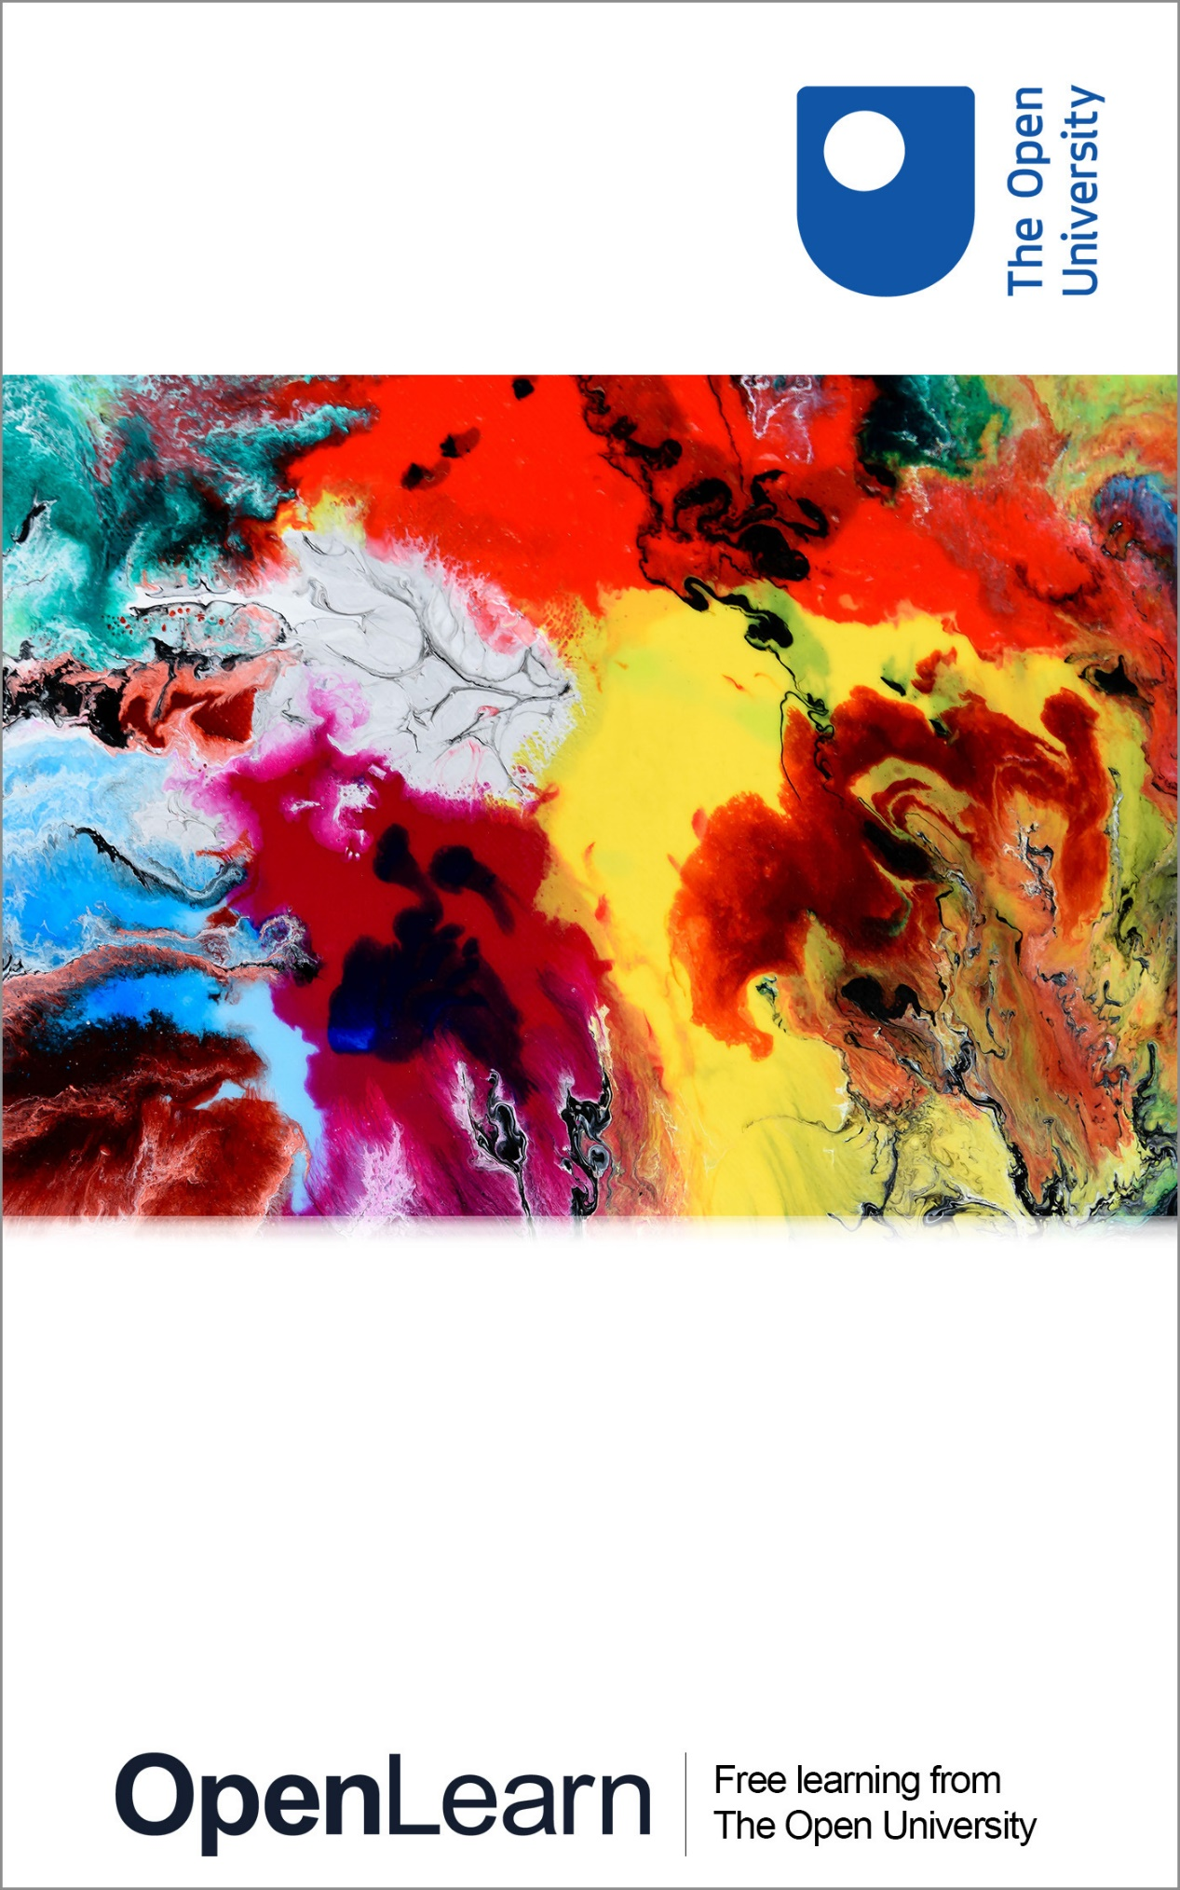

SFG_1

Safeguarding: a key consideration for students

About this free course
This free course is an adapted extract from The Open University course .
This version of the content may include video, images and interactive content that may not be optimised for your device.
You can experience this free course as it was originally designed on OpenLearn, the home of free learning from The Open University –
There you’ll also be able to track your progress via your activity record, which you can use to demonstrate your learning.
Copyright © 2015 The Open University
Intellectual property
Unless otherwise stated, this resource is released under the terms of the Creative Commons Licence v4.0 http://creativecommons.org/licenses/by-nc-sa/4.0/deed.en_GB. Within that The Open University interprets this licence in the following way: www.open.edu/openlearn/about-openlearn/frequently-asked-questions-on-openlearn. Copyright and rights falling outside the terms of the Creative Commons Licence are retained or controlled by The Open University. Please read the full text before using any of the content.
We believe the primary barrier to accessing high-quality educational experiences is cost, which is why we aim to publish as much free content as possible under an open licence. If it proves difficult to release content under our preferred Creative Commons licence (e.g. because we can’t afford or gain the clearances or find suitable alternatives), we will still release the materials for free under a personal end-user licence.
This is because the learning experience will always be the same high quality offering and that should always be seen as positive – even if at times the licensing is different to Creative Commons.
When using the content you must attribute us (The Open University) (the OU) and any identified author in accordance with the terms of the Creative Commons Licence.
The Acknowledgements section is used to list, amongst other things, third party (Proprietary), licensed content which is not subject to Creative Commons licensing. Proprietary content must be used (retained) intact and in context to the content at all times.
The Acknowledgements section is also used to bring to your attention any other Special Restrictions which may apply to the content. For example there may be times when the Creative Commons Non-Commercial Sharealike licence does not apply to any of the content even if owned by us (The Open University). In these instances, unless stated otherwise, the content may be used for personal and non-commercial use.
We have also identified as Proprietary other material included in the content which is not subject to Creative Commons Licence. These are OU logos, trading names and may extend to certain photographic and video images and sound recordings and any other material as may be brought to your attention.
Unauthorised use of any of the content may constitute a breach of the terms and conditions and/or intellectual property laws.
We reserve the right to alter, amend or bring to an end any terms and conditions provided here without notice.
All rights falling outside the terms of the Creative Commons licence are retained or controlled by The Open University.
Head of Intellectual Property, The Open University

Contents
- Welcome
- 1. Looking after yourself when working through this course.
- 2. What is safeguarding?
  - 2.1 The OU’s commitment to safeguarding
  - 2.2 The Open University’s commitment to safeguarding is set out in our policy statement:
  - 2.3 What the Safeguarding Policy says
- 3. What do we mean by Safeguarding?
- 4. The OU’s commitment to safeguarding and the 4Rs model i.e. recognise, respond, record and report.
  - 4.1 Recognise
  - 4.2 Respond
  - 4.3 Record
  - 4.4 Report
- 5. Identify safeguarding concerns within the Open University
  - 5.1 Why information sharing and confidentiality are so important.
- 6. Confidentiality
- 7. Thinking about safeguarding
  - 7.1 Physical Abuse
  - 7.2 Sexual Abuse
  - 7.3 Psychological Abuse
  - 7.4 Neglect and acts of omission
  - 7.5 Organisational Abuse
  - 7.6 Financial or Material Abuse
  - 7.7 Discriminatory abuse:
  - 7.8 Domestic Abuse or Gender Based Violence
  - 7.9 Modern Slavery
- 8. Promoting the very highest standards in safeguarding
- 9. Spotting the signs and taking advice
  - 9.1 Information sharing
- Summary
- Final thought
- Quiz
- Acknowledgements
- Solutions

Welcome

Audio content is not available in this format.

Welcome to this bespoke e-learning course, which has been designed by The Open University for students to develop a better understanding of safeguarding and how to support other students who may find themselves needing assistance.
Thank you for investing your time in undertaking how The Open University approaches safeguarding. Safeguarding is everyone’s responsibility, and by working through this course you will understand your role in safeguarding at The Open University.
We recognise that for some people learning about safeguarding, which includes considering different types of abuse, can be a reminder of individuals own experiences. If this is the case, you may wish to seek support so you can talk about your experiences.
Remember you can access Togetherall or talk to the Samaritans 24 hours a day 7 days a week

1. Looking after yourself when working through this course.

Audio content is not available in this format.

Thinking about safeguarding can raise sensitive issues. This short course should take no more than 30 minutes. Please make sure you embark on this learning at a time when you will be sitting quietly and will be uninterrupted.
If this course raises any issues you wish to discuss, please speak to The Safeguarding Referrals Team (safeguarding-referrals@open.ac.uk) , or with your Student Support Team (SST) about this. Alternatively, you may wish to seek support from your GP who can sign post you to localised support and make any referrals to specialist services for you.
Upon completing this course, should you come across something in your Student/Peer mentor work, or your time as an OU Student which you feel is a safeguarding concern please reach out for support for yourself as well as following the actions outlined within this course.
Dealing with safeguarding concerns can feel stressful and you can seek support from The Open Universities Safeguarding Referral Team, your Student Support Team (SST) whenever you need advice.

2. What is safeguarding?

Audio content is not available in this format.

The Open University follows the definition below defines safeguarding in this education context.
‘Safeguarding’ means: The actions taken to promote the welfare of children and vulnerable adults and protect them from harm. This involves putting into place a number of measures to create a safe environment in which individuals can thrive and achieve.

2.1 The OU’s commitment to safeguarding
This short course sets out to build your confidence in understanding what safeguarding is and to ensure you are aware of where you can obtain additional support.
The key areas covered in this programme are concerned with you being able to: -
- Demonstrate an understanding of safeguarding within The OU context.
- How to recognise and respond to concerns linked to safeguarding
- A basic awareness of legislation and guidance underpinning safeguarding processes.
- What to do if you have concerns about an individual at risk.
By the end of this short course, you will: -
- Understand the OUs commitment to Safeguarding
- Feel comfortable and confident about the OU Safeguarding process and the 4Rs model i.e. recognise, respond, report and record
- Be able to identify safeguarding concerns using case studies
- Be able to demonstrate your knowledge and understanding via a short quiz.

2.2 The Open University’s commitment to safeguarding is set out in our policy statement:
The University recognises that it has a duty of care in creating a safe environment for children, young people and vulnerable adults for their studies or employment, and, by working with appropriate external agencies, is committed to ensure that they are safeguarded and protected from harm.
The OU also recognises that dealing with safeguarding concerns can be stressful and can have a negative impact on the individual.
The Open University safeguarding policy says that all OU staff and students will be made aware of the institution’s commitment to the safety of vulnerable/protected groups and will be directed to the Policy and to relevant codes of conduct and know what to do if a concern arises.
The Safeguarding Policy can be found here https://help.open.ac.uk/documents/policies/ensuring-the-safety-of-children-and-vulnerable-protected-adults/files/105/safeguarding%20-%20%28Jan21%20upload%29.pdf

2.3 What the Safeguarding Policy says
The Open University policy outlines everybody’s responsibilities regarding safeguarding: -
- The safety of vulnerable/protected groups is accorded utmost priority and is the shared responsibility of all at The Open University.
- Vulnerable/protected groups should be free to work, learn and develop their potential without fear of violence, abuse, or exploitation. Within The Open University environment, irrespective of their age, gender, disability, racial origin, religion, belief and sexual orientation, they will be valued and their rights to protection and safety fully respected.
- The Open University will take all reasonable steps to ensure that those who have regular and significant contact with vulnerable/protected groups, whether through paid and unpaid work do not have a known history of harmful behaviour.
- All suspicions and allegations of abuse or inappropriate behaviour will be taken seriously by The Open University and responded to appropriately.
- This Policy will be kept up to date and reviewed at least annually to ensure that any changes in legislation or guidance across the four national jurisdictions of the UK and in Ireland are considered.

Task 1

Take a moment and think about the following questions, and write your answers in the box if you wish
- What does safeguarding mean to you?
- Who might have care and support needs?
- When may an individual be at risk of abuse?

Provide your answer...
View answer - Task 1

3. What do we mean by Safeguarding?

Audio content is not available in this format.

As mentioned earlier, ‘Safeguarding’ means: The actions taken to promote the welfare of children and vulnerable adults and protect them from harm. This involves putting into place a number of measures to create a safe environment in which individuals can thrive and achieve.
The UN Convention on the Rights of the Child defines a child as any human being under the age of 18, (Up to the eve of their 18th birthday) unless the age of majority is attained earlier under the relevant national legislation. The UK has ratified this convention and although there are several different laws across the 4 nations which specify different age limits whereby young people may be permitted to do different things, England, Wales, Scotland and Northern Ireland all agree that anyone who is under 18 should be protected via child protection guidance. However, it is unlikely that in your Mentoring role you will be asked to Mentor Under 18s.
Adults who may be vulnerable or at risk and need support and intervention to be protected, includes any person aged 18 years or over, who has care or support needs and who as a result of these needs, are unable to protect themselves from either the risk of, or the experience of abuse or neglect. This may for example be because of their age, learning or physical disability, mental or physical ill health.

Case study 1
- A student shares that they are in a relationship with a younger individual. There is reference to the other individual being 15 almost 16. Is this a safeguarding concern?
Yes
No
- Yes, this is a safeguarding concern. You may not know whether what has been shared is true or not, but it has rightly concerned you. It is not appropriate for an adult to have a relationship with a young person even if they say the teenager is consenting.

Task 2

Take a moment to consider who might abuse or neglect children and vulnerable adults? Use the box below to type any thoughts you may have had.

Provide your answer...
View answer - Task 2

4. The OU’s commitment to safeguarding and the 4Rs model i.e. recognise, respond, record and report.

Audio content is not available in this format.

Through this course we will consider: what safeguarding is, the importance of safeguarding and your role in safeguarding others. We will also consider the different types of abuse and how these might be shared.
To help you remember what to do if any of the circumstance arise, the OU follows the 4Rs approach. The four steps below will explain what action you need to take.

4.1 Recognise
The first thing you can do is play an important part in RECOGNISING or spotting the signs that a child or vulnerable adult might be at risk of abuse and know what to do if you are worried. By doing so you can help keep people safe.
RECOGNISING or identifying the safeguarding concern.
From the previous tasks, you will see that children, young people and adults can be abused in many different ways. More often than not people are abused by someone they know and trust. Individuals can be abused by anybody who has power or control over them, including a family member, an advocate, a carer or a trusted professional.
You may also be told about abuse which has happened to another student which happened in the past or is currently happening. Abuse can have long term impacts, which might mean some module material can be triggering for some students. Support for this can be found in the SSTs, the Safeguarding Team and also by accessing Togetherall.

4.2 Respond
Listen to what you’re being told, and let the individual know that you are concerned about them and need to speak with someone about the circumstance which have been shared with you. Do not try and resolve the issue yourself. Encourage the individual you are concerned about, where possible, to remove any immediate risk of harm and make sure they are safe, over the phone and via email you need to be direct and can ask the question “Are you safe?” and ‘Is anyone else in danger?’ (for example young people/children)
Sometimes you may need to respond in an emergency. In such situations consider whether you need to: -
Call the Police: You must contact the police if you think that a child or vulnerable adult is at immediate risk of harm or danger. Call 999 in an emergency to speak to the Police.
Call an Ambulance: If someone has come to physical harm and has been injured.
Be mindful that sometimes our own attitudes and values can prevent a child or individual from being protected. In the past children have been seriously injured or died because professionals felt that the behaviour they observed may be down to cultural differences, or they were frightened of being called a racist.

4.3 Record
You must share everything you have seen or heard or any information that has been shared with you which has caused concern. On a safeguarding referral form (these forms are available from the Safeguarding Referrals Team on safeguarding-referrals@open.ac.uk )
It is important to ensure that the all the facts and details from the situation are shared with the Safeguarding Referrals team, to enable them to handle the referral and support the student.
You should include the date and time you became aware of the information, and answer as many questions on the referrals form as possible.
Try and use the student’s own words where you can recall them, and complete a Safeguarding referral form within 24 hours of the concerns arising so that you can remember as much detail as possible

Remember:
If you have a worry or concern that an individual may be at risk of significant harm you must report it to the Safeguarding Referral Team (safeguarding-referrals@open.ac.uk )
If you are concerned that a child, young person or vulnerable adult may be at risk of significant harm at a time when the Safeguarding Referral Team are unavailable (weekends for example) then it is advisable to err on the side of caution and refer the concern to the police.

4.4 Report
If you’re worried about a child, young person or vulnerable adult, it is essential that you share these concerns with the Safeguarding Referrals Team who have a responsibility to follow up on your concerns or to advise on what action should be taken.
You can seek support from togetherall or the Samaritans if what you have heard or been told has upset you but be mindful of confidentiality and that you should respect people’s privacy.
Report If you’re worried about someone whom you think might be suffering from abuse, unless you think there is anyone in immediate danger then you need to call 999 share your concerns with a colleague on the Safeguarding Referral Team. The email address is: safeguarding-referrals@open.ac.uk

Case study 2
- A student shares with you they are very behind with their studies and does not think they will be able to finish the course due to being so far behind. Student says they have been feeling really down about it and just can’t motivate themself. Is this a safeguarding concern?
Yes
No
- No This is not a safeguarding concern but is a case where the student needs some support. It is not necessary to contact the Safeguarding Referral Team. Signpost this student to their student support team who will be able to provide academic advice

5. Identify safeguarding concerns within the Open University

Audio content is not available in this format.

Safeguarding concerns can present in a variety of ways.
Within the OU you are unlikely, due to the nature of our learning environment, to come face to face with a safeguarding concern.
Students communicate in a variety of ways whilst studying with the OU, and as a student, you could become aware of a concern through any of these channels although some may be more likely than others. Below are several ways in which potential safeguarding concerns could be shared -
- Over the phone or via messaging services such as WhatsApp.
- Face-to-face – Tutorials or study related events
- Social media (e.g. Twitter/Facebook)
- Emails
- Assignments related forums
- Online tutorials or Tutor Group Forums
- Student forums
- Events run by the OU Students Association (OUSA)
It is likely you may witness a disclosure direct from another students via messaging services or on Social media – WhatsApp and Facebook for example, or you might see something within a forum posting, which gives you cause for concern and leaves you feeling unsure whether you are dealing with a safeguarding matter you need to report. It is important to note here that if you do receive a disclosure, the interaction ceases to be completely confidential, and it is important that you report it. Please see below ‘Confidentiality’ section for more information on this.
Remember if in doubt you should discuss your concerns with The Safeguarding Referral Team (safeguarding-referrals@open.ac.uk ) or your SST. Discussing your concerns with the Safeguarding Referrals Team or your SST, does not mean the team will make a referral to the local social services or the police, the Safeguarding Referrals Team are best placed to make the decision on what action should be taken next.

5.1 Why information sharing and confidentiality are so important.
When you contact the Safeguarding Referrals Team, or the SST, they may ask for evidence of the information you are sharing – screen shots of chats/text messages and so on. This Information sharing is critical to good safeguarding. This is because it allows us to: -
- Determine if there is a need to gather any further information or clarify any issues before determining if there is a safeguarding concern which should be reported.
- Determine whether an issue needs to be referred to an external agency – local child or adult protection agencies or police.
- Ensure accurate information is available and recorded such that it can accurately be shared when a referral is made.
- Contribute to the multiagency arrangements to safeguard children and vulnerable adults.
- Confidentiality

6. Confidentiality
This is always an area of concern for anyone working with children and vulnerable adults. In safeguarding the following applies and you must understand this.
Confidentiality can be overridden if there is evidence that sharing information is necessary in exceptional circumstances. For example, when there is a danger of:
- Abuse or neglect of an individual at risk
- Threat to a person’s life
- Preventing a serious crime
- Thinking about safeguarding

Case study 3
- You notice that a student has small cuts on their wrist. You enquire and they tell you that they cut themselves now and again- they tell you they have done this for a long time, and it helps them to cope. Is this a safeguarding concern?
Yes
No
- No, this is not a matter you need to refer. This may be a coping strategy for the student and as long as they are well and safe and not harming thier life this is not something you need to refer to the Safeguarding Referral Team. Signpost the student to Mental health and wellbeing support on their student home page if they require signposting to support

7. Thinking about safeguarding

Audio content is not available in this format.

Before we start to think about different types of abuse, it is important to note, and remember that –
- Abuse is often (but not always) a crime.
- Abuse can be perpetrated by anyone, anywhere.
- There is often more than one type of abuse in any situation.
- Abuse is not always intentional – it can often be a result of well-meaning ignorance.
- We all have a duty to report any concerns or suspicions that an individual at risk may have been or may be being abused.
Individuals can be abused in many ways. The diagram (Figure 1) below names some of the ways in which children or adults may be abused. You may never come across some of these, but it is useful to be aware of the range of ways in which abuse can take place.

Case study 4
- A student tells you that they have been finding a particular piece of work difficult to complete because of the theme which is “family life”. They tell you that it has caused them to think back about their own family life, which was awful. The student shares with you that they suffered abuse as a child via their grandfather, but they are ok now. Is this a safeguarding concern?
Yes
No
- Yes, this is a safeguarding concern because there has been a clear disclosure of historic abuse. The student themself may not want to report the matter but should be given advice that they can do so and that the abuse they suffered was an offence. The Safeguarding Referral Team will support you by advising on how best you can respond to the student and will determine if any further action needs to be taken.

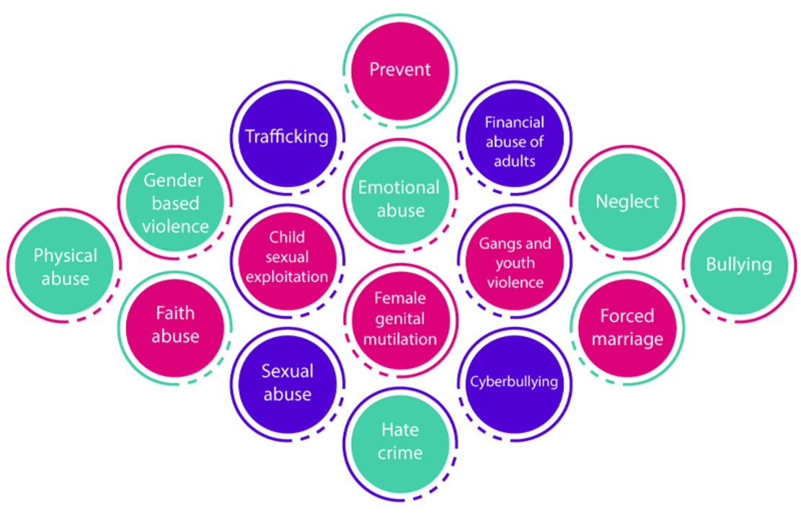
Figure 1: The language for forms of abuse

Case study 5
- A 17-year-old student tells you that they will not be available over the next month because they are going overseas to get married. In conversation student confides in you that they do not want to, but it has been arranged by their family. Student explains that its part of their family tradition. Is this a safeguarding concern?
Yes
No
- Yes, This is a safeguarding concern; essentially this is not an arranged marriage but a forced one, which is against the law. This individual needs to be protected.

Within this course there is space to think about the following categories of abuse, these are:
- Physical
- Sexual
- Psychological
- Neglect
- Organisational
- Financial or material
- Discriminatory
- Domestic Abuse and Gender Based Violence
- Modern Slavery
Please note the lists and examples given to the tasks below is not exhaustive.

7.1 Physical Abuse

Task 3

Below we have provided you with some space for you to type in what you think physical abuse might include, if you wish

Provide your answer...
View answer - Task 3

7.2 Sexual Abuse

Task 4

Take a moment to think about what you think sexual abuse would include? You can write these thoughts into the box below if you wish.

Provide your answer...
View answer - Task 4

How did you do? You may have put comments similar to the above, and well done if you did

7.3 Psychological Abuse
This includes- Emotional abuse, threats of harm or abandonment, deprivation of contact, humiliation, blaming, controlling, intimidation, coercion, harassment, verbal abuse, cyber bullying, isolation or unreasonable and unjustified withdrawal of services or supportive networks.

Task 5

Take a moment to think about how an individual might act, or present themselves if they are a victim of psychological abuse. You may wish to write your ideas down in the box below

Provide your answer...
View answer - Task 5

7.4 Neglect and acts of omission

Task 6

Take a moment to consider what you might notice when someone is neglected, below is space for you to write these thoughts if you wish.

Provide your answer...
View answer - Task 6

7.5 Organisational Abuse

Task 7

Think about how, when, and where organisational abuse (abuse related to working in or being supported by an organisation/institution) might occur. Below is a box you may wish to type your thoughts into.

Provide your answer...
View answer - Task 7

7.6 Financial or Material Abuse
This includes- theft, fraud, internet scamming, coercion in relation to an adult’s financial affairs or arrangements, including connection with wills, property, inheritance or financial transactions, or the misuse or misappropriation of property, possessions or benefits.

Task 8

Consider what the indicators of this type of abuse might be? You can write these thoughts into the box below if you wish.

Provide your answer...
View answer - Task 8

7.7 Discriminatory abuse:
This includes- forms of harassment, slurs or similar treatment, because of race, gender and gender identity, age, disability, sexual orientation or religion.

Task 9

Consider how an individual may react to discriminatory abuse and how you would identify this? You can use the box below if you wish.

Provide your answer...
View answer - Task 9

7.8 Domestic Abuse or Gender Based Violence

Task 10

Using the space below you may wish to write down what you think the possible signs are of domestic abuse?

Provide your answer...
View answer - Task 10

Case study 6
- Student shares they have left their partner due to domestic abuse/Gender based violence. Student states they have needed to take their young children with them as they are worried for their safety. Student and children are currently homeless. Is this a safeguarding concern?
Yes
No
- Yes, the student involved has shared they have young children and have needed to leave an unsafe environment. Make a referral to the safeguarding team who will support student and their children.

7.9 Modern Slavery
This encompasses slavery, human trafficking, forced labour and domestic servitude. Traffickers and slave masters use whatever means they have at their disposal to coerce, deceive and force individuals into a life of abuse, servitude and inhumane treatment.

Task 11

Using the space below you may wish to write down what you think the possible signs are of modern slavery might be?

Provide your answer...
View answer - Task 11

8. Promoting the very highest standards in safeguarding

Audio content is not available in this format.

You can help promote the very highest standards in safeguarding by:
- Always acting in the best interests of children and vulnerable adults you encounter whilst an OU Student
- Being accountable for your actions – Ensuring that should you need to make a referral, that it contains all the correct and accurate information on it to help the Safeguarding Referrals team understand why you are concerned.
- Challenging and reporting dangerous, abusive, discriminatory or exploitative behaviour or practice – this could be from students and staff
- Being vigilant about avoiding placing yourself in vulnerable situations
- Spotting the signs and taking advice

9. Spotting the signs and taking advice

Audio content is not available in this format.

Within your Student/Peer mentor role, you will build trusting and supportive relationships with students, who in turn may share information with you about their personal circumstance which you feel puts them at risk and requires them to be supported.
You may be the only person who notices or spots the signs that another student may be in danger, distressed about a situation or has spotted something written or said about a safeguarding matter. If you are in any doubt about the information you have seen or had shared with you, reach out to the Safeguarding Referrals Team (safeguarding-referrals@open.ac.uk) to receive advice to determine what to do if this happens.

9.1 Information sharing
Below are what the OU expect as good practice in sharing information. Be open and honest with the individual about why, what, how and with whom information will, or could be shared, and seek their agreement. UNLESS it is unsafe or inappropriate to do so
- Seek advice from the safeguarding referrals team (safeguarding-referrals@open.ac.uk ) if you are in any doubt to if you should make a referral or not.
- Share with informed consent where appropriate and, where possible, respect the wishes of those who do not consent to share confidential information. But remember you may share information without consent if, for example, you believe there is a risk any child, young person or vulnerable adult will be harmed as a result of not sharing this information.
- Consider safety and well-being – Base your information sharing decisions on considerations of the safety and well-being of the person concerned and others who may be affected by their actions (including staff).
- Necessary, proportionate, relevant, adequate, accurate, timely and secure – Ensure that the information you share is necessary for the purpose for which you are sharing it, that it is shared only with those who need to have it, that the information is accurate, and shared in secure timely fashion.

Summary

Audio content is not available in this format.

The Safeguarding Referrals Team can be contact Monday to Friday on safeguarding-referral@open.ac.uk to discuss any concerns you may have regarding a student or staff member. Should you have concerns you wish to seek immediate support on please call the emergency services 999 or 112 from a mobile.

Final thought
We recognise that for some people learning about safeguarding and abuse can be a reminder of individuals own experiences. If this is the case, you may wish to seek support so you can talk about your experiences.
Remember you can access Togetherall or talk to the Samaritans 24 hours a day 7 days a week
Dealing with safeguarding concerns can feel stressful and you can seek support from The Open Universities Safeguarding Referrals Team, or your Student Support Team (SST) whenever you need advice.

Quiz
You are now going to do a short quiz to demonstrate your learning this module.
Quiz

Acknowledgements
Except for third party materials and otherwise stated (see terms and conditions), this content is made available under a Creative Commons Attribution-NonCommercial-ShareAlike 4.0 Licence.
The material acknowledged below is Proprietary and used under licence (not subject to Creative Commons Licence). Grateful acknowledgement is made to the following sources for permission to reproduce material in this free course:
Every effort has been made to contact copyright owners. If any have been inadvertently overlooked, the publishers will be pleased to make the necessary arrangements at the first opportunity.
Don't miss out
If reading this text has inspired you to learn more, you may be interested in joining the millions of people who discover our free learning resources and qualifications by visiting The Open University – www.open.edu/openlearn/free-courses.

Solutions

Task 1

Answer
Task 1 answers could include -
One of the definitions of safeguarding means protecting an individual’s right to live in safety, free from abuse or neglect. It also includes how people and organisations work together to prevent and stops the risks and the experiences of abuse or neglect. At the same time, we need to work with the adult to ensure their wellbeing is promoted and allow them to have control over their own decisions.
Care and support needs includes:- learning disabilities, physical disabilities, mental ill health problems, adults with dementia, those with acquired brain injuries, adults with drug or alcohol problems, those with sensory disabilities and those with some types of physical illnesses (not exhaustive list).
An individual may be at risk when they do not recognise their own care needs or that what is happening is actually abuse, or they struggle to access mainstream services, they may have communication needs, feel there is no one to tell, their carer may be the abuser or they may physically be unable to raise the alarm
Back to - Task 1

Task 2

Answer
Task 2 answers could include - anyone: spouses/partners, friends, neighbours, other residents, volunteers, staff, strangers, etc. patterns of abuse can vary, and it can be a one off event, ongoing or opportunistic.
Back to - Task 2

Task 3

Answer
Physical abuse is described as: Including assault, hitting, slapping, pushing, misuse of medication, restraint or inappropriate sanctions.
In task 3 you may have identified some or all of the following :-
- Hitting/punching/slapping/pushing
- Stabbing
- Bruising/ fractures
- Poisoning
- Suffocating
- Drowning
- Over/under medicating or withholding medication
- Holding someone inappropriately
Back to - Task 3

Task 4

Answer
Sexual abuse, covered in task 4, includes: Rape, indecent exposure, sexual harassment, inappropriate looking or touching, sexual teasing or innuendo, sexual photography, subjection to pornography or witnessing sexual acts, indecent exposure and sexual assault or sexual acts to which the adult has not consented or was pressurised into consenting.
Back to - Task 4

Task 5

Answer
Your answers to task 5, covering signs of psychological abuse, might include -Individuals may become withdrawn, confused, aggressive, depressed, fearful, and anxious.
Back to - Task 5

Task 6

Answer
Neglect and acts of omission includes- ignoring medical, emotional or physical care needs, failure to provide access to appropriate health, care and support or educational services, the withholding of the necessities of life, such as medication, adequate nutrition and heating.
Here are some examples of indicators you might have noted in task 6:
- Weight loss/malnutrition
- Pressure ulcers/sores
- No/absence of mobility aids
- Withholding food, medication, heating
Back to - Task 6

Task 7

Answer
Organisational abuse includes: Neglect and poor care practice within an institution or specific care setting such as a hospital or care home, for example, or in relation to care provided on one’s own home. This may range from one off incidents to on-going ill-treatment. It can be through neglect or poor professional practice as a result of the structure, policies, processes and practices within an organisation.
Examples you may have given in response to task 7 include:
- poor staff attitudes
- staff poorly supervised or receive inadequate guidance
- no or inadequate person-centred care
- lack of privacy
Back to - Task 7

Task 8

Answer
Domestic Abuse is defined by the Westminster government as ‘any incident or pattern of incidents of controlling coercive or threatening behaviour, violence or abuse between those aged 16 or over who are or have been intimate partners or family members, regardless of gender or sexuality’. The abuse can encompass but is not limited to, psychological, physical, financial, or emotional abuse.
Back to - Task 8

Task 9

Answer
Gender Based Violence (GBV) - The Open University has adopted the Scottish Government’s description of GBV which includes behaviours recognised in as being both the cause and consequence of gender inequality. GBV is largely, although not exclusively, perpetrated by men and experienced by women. It is acknowledged that, although GBV mostly affects women it can and does also affect individuals of any age, gender, sexual orientation, faith or ethnicity.
Back to - Task 9

Task 10

Answer
Answers you may have included in response to task 10 are:
- Physical violence
- Forced marriage
- Sexual abuse
- Being stopped from seeing friends and family
- Being constantly criticised
- Being deliberately isolated
- Made to account for whereabouts all the time
- Given limited access to funding
- Walking on ‘eggshells’ all the time
- Being threatened
Back to - Task 10

Task 11

Answer
Back to - Task 11

