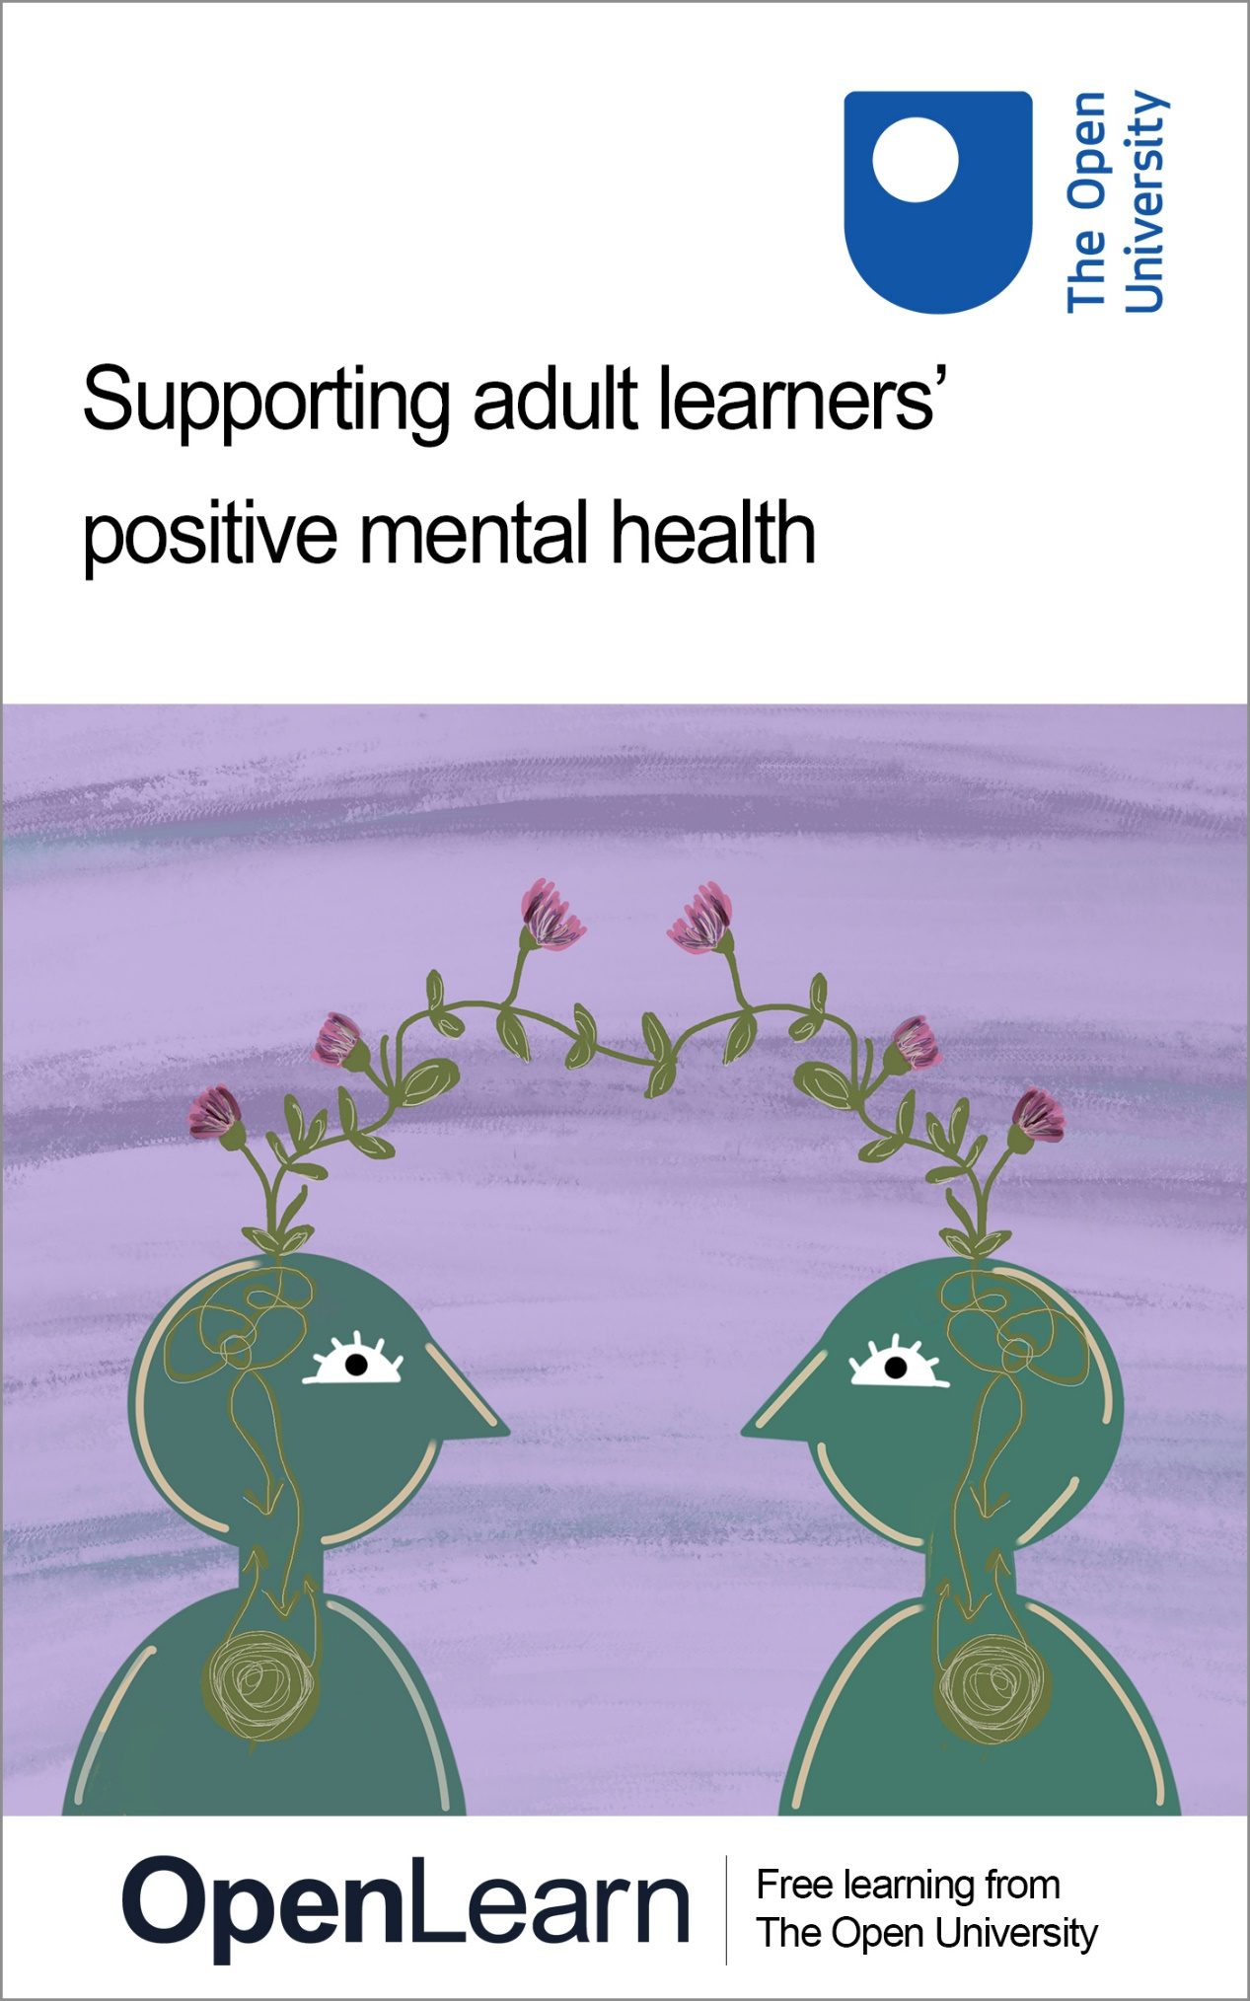

PMH_1

Supporting adult learners’ positive mental health

About this free course
This free course is an adapted extract from the Open University course .
This version of the content may include video, images and interactive content that may not be optimised for your device.
You can experience this free course as it was originally designed on OpenLearn, the home of free learning from The Open University –
There you’ll also be able to track your progress via your activity record, which you can use to demonstrate your learning.
Copyright © 2023 The Open University
Intellectual property
Unless otherwise stated, this resource is released under the terms of the Creative Commons Licence v4.0 https://creativecommons.org/licenses/by-nc-sa/4.0/deed.en. Within that The Open University interprets this licence in the following way: www.open.edu/openlearn/about-openlearn/frequently-asked-questions-on-openlearn. Copyright and rights falling outside the terms of the Creative Commons Licence are retained or controlled by The Open University. Please read the full text before using any of the content.
We believe the primary barrier to accessing high-quality educational experiences is cost, which is why we aim to publish as much free content as possible under an open licence. If it proves difficult to release content under our preferred Creative Commons licence (e.g. because we can’t afford or gain the clearances or find suitable alternatives), we will still release the materials for free under a personal end-user licence.
This is because the learning experience will always be the same high quality offering and that should always be seen as positive – even if at times the licensing is different to Creative Commons.
When using the content you must attribute us (The Open University) (the OU) and any identified author in accordance with the terms of the Creative Commons Licence.
The Acknowledgements section is used to list, amongst other things, third party (Proprietary), licensed content which is not subject to Creative Commons licensing. Proprietary content must be used (retained) intact and in context to the content at all times.
The Acknowledgements section is also used to bring to your attention any other Special Restrictions which may apply to the content. For example there may be times when the Creative Commons Non-Commercial Sharealike licence does not apply to any of the content even if owned by us (The Open University). In these instances, unless stated otherwise, the content may be used for personal and non-commercial use.
We have also identified as Proprietary other material included in the content which is not subject to Creative Commons Licence. These are OU logos, trading names and may extend to certain photographic and video images and sound recordings and any other material as may be brought to your attention.
Unauthorised use of any of the content may constitute a breach of the terms and conditions and/or intellectual property laws.
We reserve the right to alter, amend or bring to an end any terms and conditions provided here without notice.
All rights falling outside the terms of the Creative Commons licence are retained or controlled by The Open University.
Head of Intellectual Property, The Open University
978-1-4730-2973-6 (.kdl)
978-1-4730-2974-3 (.epub)

Contents
- Introduction and guidance
  - Introduction and guidance
  - Positive mental health
  - What is a badged course?
    - How to get a badge
- Week 1: Common mental health challenges and signals displayed by adult learners
  - Introduction
  - 1 The difference between mental health, mental conditions and wellbeing
    - 1.1 ‘Mental health’ and ‘wellbeing’
    - 1.2 Mental illness and mental health conditions
  - 2 Common mental health problems and their possible impact on learning
    - 2.1 What influences our mental health?
    - 2.2 Common mental health problems
  - 3 Language, behaviour and emotions displayed by learners who are struggling with their mental health
    - 3.1 What can you look out for?
    - 3.2 Study-related behaviours
  - 4 Introducing strategies to support learners’ mental health
    - 4.1 Ask twice
    - 4.2 Validating feelings and experiences
    - 4.3 Creating ‘safe’ places
    - 4.4 Knowing where to signpost
    - 4.5 Your wellbeing is important too!
  - 5 Wellbeing activity for this week
  - 6 This week’s quiz
  - 7 Summary of Week 1
- Week 2: The relationship between mental health and adult learning
  - Introduction
  - 1 How positive mental health supports learning
  - 2 The difference between positive and negative mental health
  - 3 The mutual relationship between mental health and learning
  - 4 How to look after learners’ wellbeing
    - 4.1 Institutional support
    - 4.2 Early warning signs
    - 4.3 How involved should you be?
    - 4.4 Maintaining effective relationships
  - 5 How to support learners with mental health challenges to become independent learners
    - 5.1 Setting boundaries
    - 5.2 Encouraging independent learning
    - 5.3 Encourage SMART goals
    - 5.4 Identify and support learning preferences
  - 6 Reflective practice
    - 6.1 Gibbs’ Reflective Cycle
  - 7 Wellbeing activity for this week
  - 8 This week’s quiz
  - 9 Summary of Week 2
- Week 3: Communication and conversations about mental health
  - Introduction
  - 1 Learning from history
  - 2 How to start a conversation about mental health
  - 3 Effective active listening skills through understanding non-verbal and verbal cues
    - 3.1 Non-verbal cues
    - 3.2 Verbal cues
  - 4 Developing active listening skills
  - 5 Communicating and demonstrating empathy
  - 6 Holding non-judgemental conversations
  - 7 Wellbeing activity for this week
  - 8 This week’s quiz
  - 9 Summary of Week 3
- Week 4: Accessing and providing the right support at the right time for your learners
  - Introduction
  - 1 Early indicators of mental health challenges and difficulties in adult learners
    - 1.1 What are early indicators?
    - 1.2 Avoiding labels
    - 1.3 Interpreting non-engagement
  - 2 Identifying appropriate professional support and information available to adult learners
    - 2.1 What do we mean by ‘professional support’?
    - 2.2 What type of support might be available?
  - 3 What can prevent learners from accessing support?
  - 4 Increasing awareness of mental health crises in adult learners and knowing how to respond appropriately
    - 4.1 Panic attacks
    - 4.2 Self-harm
    - 4.3 Identifying an emergency situation with suicidal risk
    - 4.4 Identifying and talking about suicidal thoughts and behaviours
    - 4.5 Responding to a learner with suicidal thoughts
    - 4.6 What else can help?
  - 5 Further help and support
  - 6 Wellbeing activity for this week
  - 7 This week’s quiz
  - 8 Summary of Week 4
- Week 5: Overcoming stigma associated with mental health
  - Introduction
  - 1 Being aware of stigmatising language and behaviours
    - 1.1 Stigmatising language and behaviour
    - 1.2 Racist stigma
  - 2 Challenge stigmatised beliefs within the learning community
    - 2.1 How to challenge stigma in practice
  - 3 Avoiding stigma in learning materials and terminology
  - 4 Stigma-free curriculum design
  - 5 Wellbeing activity for this week
  - 6 This week’s quiz
  - 7 Summary of Week 5
- Week 6: Social and cultural dimensions of mental health in learning environments
  - Introduction
  - 1 Belonging, difference and mental health
    - 1.1 Ethnicity and race
    - 1.2 Religious stereotyping
    - 1.3 Specific challenges to belonging: international learners
  - 2 Varied cultural perspectives of mental health
    - 2.1 Cultural competence
    - 2.2 Cultural competence and mental health difficulties
    - 2.3 Socio-economic effects on learner mental health
  - 3 Supporting socially and culturally diverse learners’ wellbeing
    - 3.1 Promoting help-seeking behaviour
    - 3.2 Addressing unconscious bias and microaggressions
    - 3.3 Using microinterventions to stop microaggressions
    - 3.4 Decolonising the curriculum
  - 4 Wellbeing activity for Week 6
  - 5 This week’s quiz
  - 6 Summary of Week 6
- Week 7: Promoting wellbeing and building resilience
  - Introduction
  - 1 Barriers and enablers to learner wellbeing as well as the consequences of resilience and stress
    - 1.1 Understanding barriers and enablers to wellbeing
  - 2 Taxonomy of wellbeing: understanding barriers and enablers to wellbeing
    - 2.1 Recognise the wellbeing value of assessment choice and feedback
    - 2.2 Effective feedback
  - 3 Summarise strategies to ensure group work supports learner wellbeing
  - 4 The negative impact of emotive and triggering content on learners’ wellbeing and resilience
  - 5 Developing further meaning and resilient skills for learners
    - 5.1 Going further: wellbeing models, external resources and their possible application in the learning environment
  - 6 Wellbeing activity for Week 7
  - 7 This week’s quiz
  - 8 Summary of Week 7
- Week 8: Educators’ self-care strategies
  - Introduction
  - 1 Recognising your own support needs
    - 1.1 Capacity to cope
    - 1.2 Evaluating stressors
    - 1.3 Boosting your mental wellbeing
  - 2 Establishing and maintaining professional boundaries: what is meant by ‘boundaries’?
    - 2.1 The characteristics of boundaries
  - 3 Self-compassion and mindfulness
    - 3.1 Exploring the concept of self-compassion
    - 3.2 Mindfulness
    - 3.3 Burnout
  - 4 Self-care approaches
    - 4.1 Diet and nutrition
    - 4.2 Hydration
    - 4.3 Exercise
    - 4.4 Sleep
    - 4.5 Mental stimulation and socialisation
    - 4.6 Finding time for you
  - 5 This week’s quiz
  - 6 Summary of Week 8
  - 7 End-of-course summary
  - Where next?
  - Tell us what you think
  - References
  - Further reading
  - Acknowledgements
- Solutions
- Descriptions

Introduction and guidance

Introduction and guidance
This free badged course, Supporting adult learners’ positive mental health, is designed to help educators explore different approaches to help the mental health and wellbeing of adult learners. The course lasts 24 hours and is organised into 8 weeks of study. You can study at your own pace and drop in and out of the content at times to suit you, your workload, and any other commitments you may have. This will enable you to manage your own mental health and wellbeing while studying.
The eight weeks of content are linked to ensure a logical flow through the course. They are:
- Common mental health challenges and signals displayed by adult learners
- The relationship between mental health and adult learning
- Communication and conversations about mental health
- Accessing and providing the right support at the right time for your learners
- Overcoming stigma associated with mental health
- Social and cultural dimensions of mental health in learning environments
- Promoting wellbeing and building resilience
- Educators’ self-care strategies
Each week should take you around 3 hours. There are a number of activities throughout the course where you are asked to note down your response. A text box is provided for you to do this, however if you would prefer to record your answers in another way that is fine. If you choose to use the text boxes, please be aware that no one else will be able to see what you write. Your answers are only visible to you.
Throughout the course, you will be directed to work with a variety of case studies to help you reflect on the course content and apply what you have learned to practical examples.
Each week also has a wellbeing activity at the end. These are designed to promote good wellbeing for yourself as you study the course. They also contain activities which you can use with your learners to support their wellbeing if you would like to.
At the end of each week there is also a quiz to help you check your understanding. And, if you want to receive a formal statement of participation and digital badge, at the end of Weeks 4 and 8 there is a quiz which you need to pass. The quizzes for Weeks 1–3 and 5–7 are designed to help you practice and gain confidence in the types of questions used in the badge quizzes.
This course includes a wide range of language descriptors which illustrate the diverse linguistic approach used, and demonstrates the inter-changeable language used to describe mental health; such as condition, and illness, and poor mental health. You will also see ‘trigger warnings’, represented with the icon below, to alert you to potentially sensitive topics which are discussed, such as mental health crisis situations. Do be aware of the trigger warning icon and take some time to identify ways in which you can support your own positive mental health appropriately.

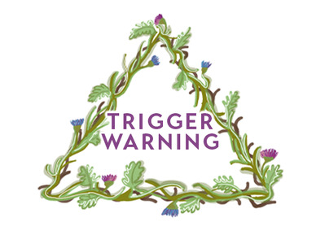

Identifying sources of support and self-care can be important for your wellbeing, whether you are an educator or a learner, so you might want to do this, and access support as needed, at regular points during the course. If at any time you feel uncomfortable during the course, try taking some time away, invest time in some self-care strategies, and return to the course when you feel comfortable.
After completing this course, you should be able to:
- recognise barriers to learning which can occur as a result of adult learners’ poor mental health
- recognise the signs of adult learners’ poor mental health and apply appropriate methods to engage in discussions about their mental health, including signposting to relevant support
- identify stigmatised behaviours and common misconceptions about adult learners’ mental health and develop skills which equip educators to reduce stigma in educational practice
- encourage adult learners to use appropriate coping strategies which support positive wellbeing and mental health
- create self-care strategies and skills which support personal positive wellbeing.

Moving around the course
In the ‘Summary’ at the end of each week, you will find a link to the next week. If at any time you want to return to the start of the course, click on ‘Full course description’. From here you can navigate to any part of the course.
It’s also good practice, if you access a link from within a course page (including links to the quizzes), to open it in a new window or tab. That way you can easily return to where you’ve come from without having to use the back button on your browser.
The Open University would really appreciate a few minutes of your time to tell us about yourself and your expectations for the course before you begin, in our optional start-of-course survey. Participation will be completely confidential and we will not pass on your details to others.

Positive mental health
Awareness and understanding of the need for resilient mental health has increased dramatically in recent years. A sign of progress is that mental imbalance is now discussed more openly and is becoming less of a taboo subject, encouraged by national and local initiatives such as, in the UK, Headstogether and Student Minds, and other campaigns in various countries. In adult learning environments, there is now an increased focus on supporting adult learners’ mental health where it impacts on their studies so that learner success can be achieved. This course aims to equip educators with the knowledge and skills to recognise barriers to learning which can occur as a result of adult learners’ poor mental health, and to ensure adult learners can access appropriate support. Educators will also learn how to create self-care strategies and skills which support their personal positive wellbeing.
The prevalence of mental health issues has increased globally, with the World Health Organisation reporting in 2019 that 1 in 8 adults experienced mental health problems. This trend has been reflected in the UK where British Medical Association data has shown increasing numbers of adults experience common mental disorders and seek professional treatment, with 1 in 4 young people aged 17–19 accessing mental health treatment. Educators of adult learners are not required to, and should not, provide treatment for learners with mental health illness. However, being in regular contact with learners provides excellent opportunities to promote mentally healthy learning environments and signpost to mental health support, with the aim of reducing barriers to learning and facilitate achievement.
Adult learners who experience poor mental health may experience a range of learning challenges including difficulties in engaging with their studies or participating in learning environment activities. Concentration may be negatively affected, and learners can become withdrawn, and their attendance may decline. Peer relationships may suffer, resulting in a reduced sense of belonging. These barriers can impact on learner success, potentially limiting retention, progression and achievement as well as the overall learning experience. This, in turn, can impact on educators’ sense of job satisfaction and fulfilment.
Educators of adults have a duty of care to all learners but can often feel under-confident when their learners experience mental health challenges which in turn impact on their learning. This course can help build educator confidence, and enable educators to ensure that adult learners have access to receive the right support at the right time.



The Open University is delighted that the Charlie Waller Trust endorses this course. The Charlie Waller Trust was set up in memory of Charlie Waller, who sadly took his own life in 1997. Charlie was just 28 years old and had depression. In response to this tragedy, his family founded the Charlie Waller Trust. Their aim was to open up the conversation around depression and to help ensure that people are able to understand and look after their mental health, and to spot the signs of common mental health problems in others.
Julie is a consultant trainer for the Charlie Waller Trust with 20 years of experience as an integrative counsellor and over 10 years as an educator for mental health awareness and suicide prevention, including experience as team lead for a university counselling and mental health service. Julie says:

The importance of taking care of our mental health cannot be overestimated. Learning environments present both challenges and opportunities for educators and students alike in relation to mental wellbeing. This course takes a straightforward, engaging and positive approach to addressing these; it will be an invaluable resource for anyone working with adult learners.

Michael is student involvement coordinator for the Charlie Waller Trust and recently obtained a doctorate from Durham University exploring student wellbeing in a whole university approach. Michael adds:

The course content is clear and comprehensive and will really give educators the knowledge, confidence, and skills to consider the mental health of their learners within their educational practice. Vitally it also offers invaluable guidance to enable educators to take care of their own mental wellbeing.

The course also addresses educator self-care strategies. Course author Sarah Mander makes the most of being outdoors in nature to look after her mental health while author Neill Boddington also enjoys getting outside to run and cycle, but also to escape into a great movie. You will have the opportunity to explore wellbeing strategies for yourself each week too.

What is a badged course?
While studying Supporting adult learners’ positive mental health you have the option to work towards gaining a digital badge.
Badged courses are a key part of The Open University’s mission to promote the educational well-being of the community. The courses also provide another way of helping you to progress from informal to formal learning.
Completing a course will require about 24 hours of study time. However, you can study the course at any time and at a pace to suit you.
Badged courses are available on The Open University’s OpenLearn website and do not cost anything to study. They differ from Open University courses because you do not receive support from a tutor, but you do get useful feedback from the interactive quizzes.

What is a badge?
Digital badges are a new way of demonstrating online that you have gained a skill. Colleges and universities are working with employers and other organisations to develop open badges that help learners gain recognition for their skills, and support employers to identify the right candidate for a job.
Badges demonstrate your work and achievement on the course. You can share your achievement with friends, family and employers, and on social media. Badges are a great motivation, helping you to reach the end of the course. Gaining a badge often boosts confidence in the skills and abilities that underpin successful study. So, completing this course could encourage you to think about taking other courses.

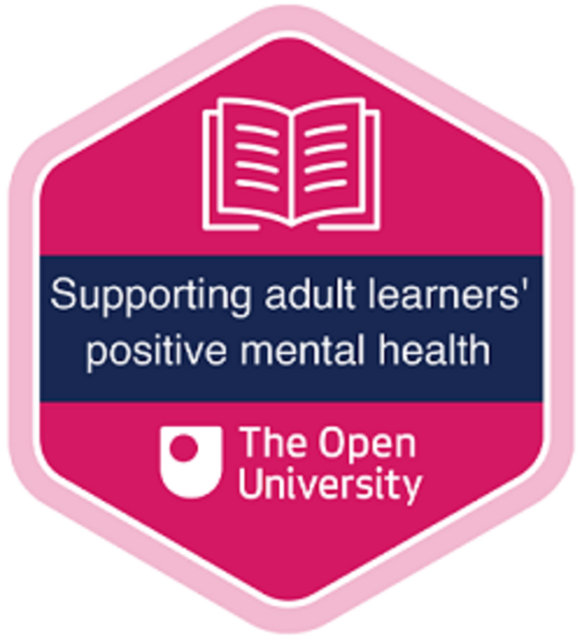

How to get a badge
Getting a badge is straightforward! Here’s what you have to do:
- read each week of the course
- score 50% or more in the two badge quizzes in Week 4 and Week 8
For all the quizzes, you can have three attempts at most of the questions (for true or false type questions you usually only get one attempt). If you get the answer right first time you will get more marks than for a correct answer the second or third time. Therefore, please be aware that for the two badge quizzes it is possible to get all the questions right but not score 50% and be eligible for the badge on that attempt. If one of your answers is incorrect you will often receive helpful feedback and suggestions about how to work out the correct answer.
For the badge quizzes, if you’re not successful in getting 50% the first time, after 24 hours you can attempt the whole quiz, and come back as many times as you like.
We hope that as many people as possible will gain an Open University badge – so you should see getting a badge as an opportunity to reflect on what you have learned rather than as a test.
If you need more guidance on getting a badge and what you can do with it, take a look at the OpenLearn FAQs. When you gain your badge you will receive an email to notify you and you will be able to view and manage all your badges in My OpenLearn within 24 hours of completing the criteria to gain a badge.
Get started with Week 1.

Week 1: Common mental health challenges and signals displayed by adult learners

Introduction
This week you will explore some of the definitions of mental health and associated terminology as well as the concepts of ‘poor’ or ‘optimal’ mental health and wellbeing. You will be introduced to common mental health problems and their possible impact on learning and will learn about the types of language, behaviour and emotions that may be displayed by learners who are struggling with their mental health. You will also be given an overview of some strategies that can be used to support learners’ mental health and your own wellbeing.


View description - Uncaptioned Figure
View alternative description - Uncaptioned Figure

By the end of this week, you should be able to:
- appreciate the difference between mental health, mental conditions and wellbeing
- identify common mental health problems and their impact on learning
- recognise the language, behaviour and emotions that may be displayed by learners struggling with their mental health
- employ some strategies to support learners’ mental health and your own wellbeing.
Before you start the course, make sure you have read the Introduction and guidance which contains important information about possible content triggers as well as the language and terminology used. It also gives advice on navigating through and completing the course.
The Open University would really appreciate a few minutes of your time to tell us about yourself and your expectations for the course before you begin, in our optional start-of-course survey. Participation will be completely confidential and we will not pass on your details to others.

1 The difference between mental health, mental conditions and wellbeing
This section will help you identify the different terms that can be used around mental health, mental health conditions and wellbeing. It will explain why it is important to distinguish between them and will explore why it is necessary to be consistent in your use of terms in education settings.


View description - Uncaptioned Figure
View alternative description - Uncaptioned Figure

1.1 ‘Mental health’ and ‘wellbeing’
The terms ‘mental health’ and ‘wellbeing’ are often used interchangeably. In reality, both these terms have different meanings but also overlap – with wellbeing often thought of as a wider-ranging term, of which mental health is one element. While there is no single definition of mental health used by all organisations, most definitions are variations on the same theme. The World Health Organisation (WHO) defines mental health as:

… a state of mental well-being that enables people to cope with the stresses of life, realize their abilities, learn well and work well, and contribute to their community.
(World Health Organisation, 2022a)

You might notice that this specifically refers not just to how someone is feeling, but also how their mental state may affect their education, work or interaction with other people in their community.

Activity 1 Defining mental health and wellbeing
Allow about 15 minutes

Do a quick internet search for mental health definitions in the country you live in. You might want to limit this to different adult education settings, such as universities, colleges and community education organisations. While you do this, think about the following issues:
- Does your country, or language, have a variety of terms which define mental health or wellbeing?
- What are the similarities in the definitions; for example, do they focus on the same or different things, and why?
- Do these definitions make distinctions between mental health, wellbeing and mental illness?
- Are these definitions heavily influenced by who they are written by, or for, and could they be applied in different contexts?
- Now, try to come up with your own definition of ‘mental health’ and write it down. This is not something you need to share but gives you the opportunity to explore your own understanding.
Note your response in the box below. Your answer will only be visible to yourself.

Provide your answer...
View discussion - Activity 1 Defining mental health and wellbeing

As educators, a key thing to remember is that everyone has ‘mental health’, and anyone’s mental state can change over the course of a day. Mental ill-health is not something that you can ‘catch’ and, as humans, we are all situated somewhere on a continuum from healthy to unhealthy, both physically and mentally, at any given time (Antonovsky, 1984). However, mental health is something we can grow in awareness of and work on to improve. The next activity will help you think more about what this might mean in educational practice.

Activity 2 Exploring ‘optimal’ and ‘poor’ mental health
Allow about 10 minutes

- Draw a vertical line on a page, with ‘optimal mental health’ at the top and ‘poor mental health’ at the bottom.
- Take two minutes and think of anything you feel might indicate if a learner is experiencing ‘optimal’ or ‘poor’ mental health and put them on your line. If you can, try to avoid just putting two lists at either end of the line and instead, see if you can spread them over the line, according to how strongly you feel each one indicates if someone is towards one end or the other.

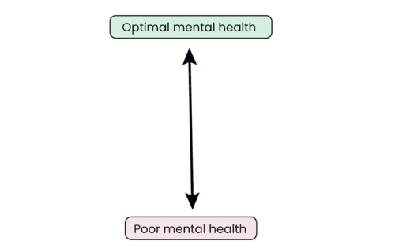
Figure 1 A continuum of mental health
View description - Figure 1 A continuum of mental health
View alternative description - Figure 1 A continuum of mental health

View discussion - Activity 2 Exploring ‘optimal’ and ‘poor’ mental health

1.2 Mental illness and mental health conditions
The World Health Organisation estimates that 1 in 8 people globally are living with mental ill-health (2022b). When someone is experiencing poor mental health, this can sometimes lead to a diagnosis of mental illness or a mental health condition. A diagnosis is assessed by a mental health practitioner (a counsellor, psychologist, psychiatrist or other qualified health professional), with relevant training, and usually registered with a professional body, that enables them to make these assessments. Professional accreditation pathways set standards to which their members must adhere when making diagnoses – some of which are international and some of which relate to the country where they work. These standards are there to ensure everyone receives safe and high-quality, evidence-based standards of care. This also means you can acknowledge as an educator why it would not be your role to diagnose mental illness in learners or colleagues.

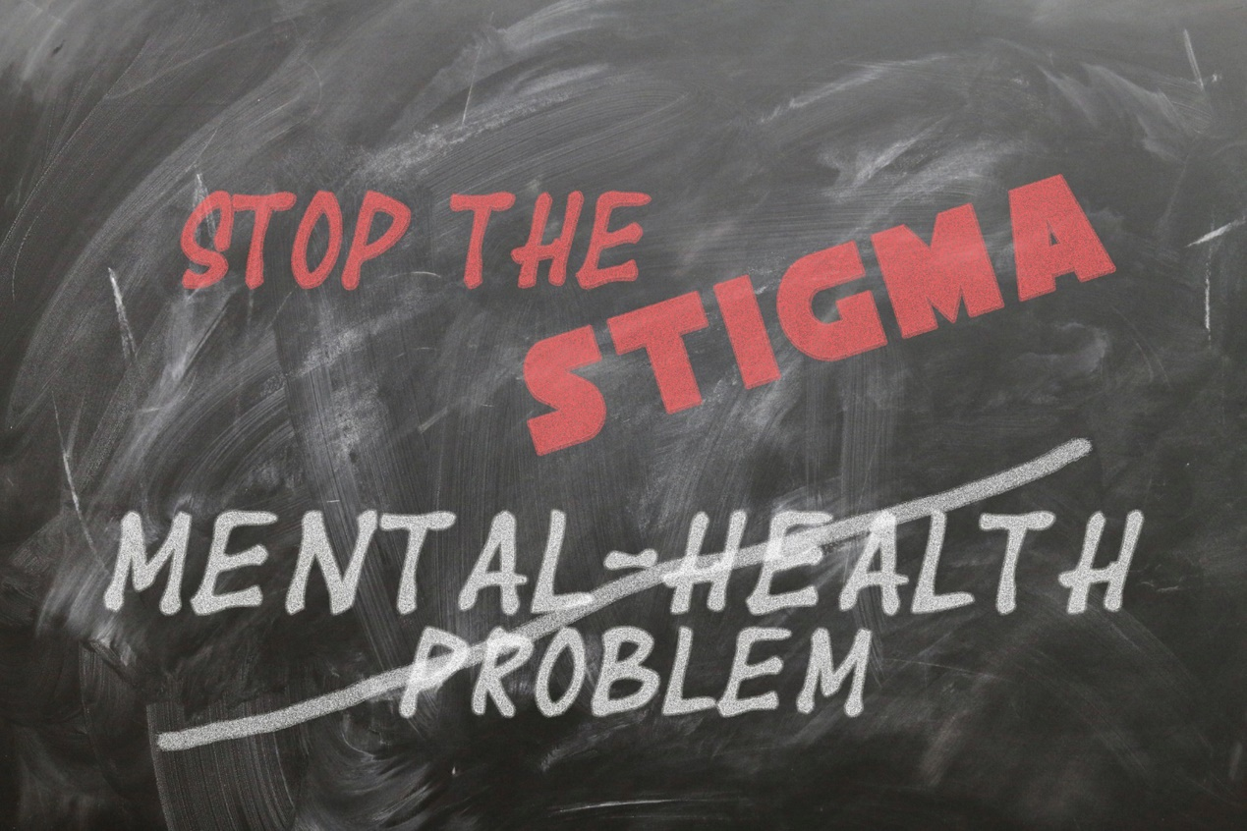
View description - Uncaptioned Figure
View alternative description - Uncaptioned Figure

There can be a lot of stigma associated with assessment, especially the medical diagnosis and the ‘label’ of a mental health condition, and you will explore this further in Week 5. As an educator you are well placed to help reduce stigma in the learning environment, to assist when stigmatising views are present and to signpost available support. Stigma can often prevent a learner from seeking help and assessment or contribute to their resistance to an actual diagnosis and the treatment associated with it.
However, within the education setting, a medical diagnosis can open the door to support. A medical diagnosis can lead to the release of funding to promote inclusive education for learners with mental health issues and ensure provision for reasonable adjustments in learning environments.

2 Common mental health problems and their possible impact on learning
So far you have been introduced to the terminology used for mental health and the idea of mental health existing on a continuum, which can fluctuate over time and in response to different situations. Now you will explore other factors that may impact on mental health and some common mental health conditions.


View description - Uncaptioned Figure
View alternative description - Uncaptioned Figure

2.1 What influences our mental health?
There are a range of influences on physical and mental health – some of which we can be conscious of, and others of which we may not be aware.


View description - Uncaptioned Figure
View alternative description - Uncaptioned Figure

Different models have been proposed to help explain what influences our mental health. One of these is the medical model which views mental ill health as something which can be ‘fixed’ through medication, treatment or therapy. A psychological model considers how an individual thinks and feels and the impacts this can have on their subsequent behaviours. Taking a social model view means considering the impact of various external factors, such as employment status, educational background or social and community relationships, on health and wellbeing.
However, these factors are rarely present in isolation and Engel (1977) and others have proposed a biopsychosocial model of wellness that looks at how biological, social and psychological factors all interact to influence the physical and mental health of the individual.

Dahlgren and Whitehead’s model for the social determinants of health
First devised in 1991, the Dahlgren and Whitehead model of the social determinants of health (Figure 2) has become widely used and maps out the social, economic, environmental and lifestyle factors that can influence the health of a person. Individual factors are at the centre of the diagram while wider social, economic and other factors are represented on the outside.

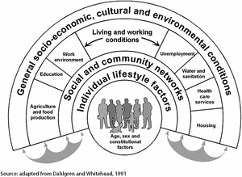
Figure 2 The social determinants of health (source: Dahlgren and Whitehead, 2021).
View description - Figure 2 The social determinants of health (source: Dahlgren and Whitehead, 2021 ...
View alternative description - Figure 2 The social determinants of health (source: Dahlgren and Whitehead, 2021 ...

This model is considered useful (and is promoted by a range of national and international governments and organisations) as it helps us think beyond the idea that our health outcomes are just governed by personal decisions. As an educator you may notice how certain factors represented in the diagram might affect your learners’ ability to fully engage with their studies and have an effect on their performance and attainment.

Activity 3 Exploring the impact of social determinants of health

Part 1
Allow about 15 minutes

- Choose two of the course case studies from the following document: Case studies (open the link in a new tab or window so you can easily find your way back to the course).
- Read each one in turn and use the Dahlgren and Whitehead model to note which determinants you think could be influencing their mental health.
- You might want to start with the individual factors first, working out to wider social factors relevant to each person.
- Take a moment to consider how this model might apply to you yourself.

Provide your answer...
View discussion - Part 1

Part 2
Allow about 10 minutes

- Revisit the case studies you chose for Part 1.
- Can you identify any factors about each person which could represent ‘intersectionality’?

Provide your answer...
View discussion - Part 2

2.2 Common mental health problems

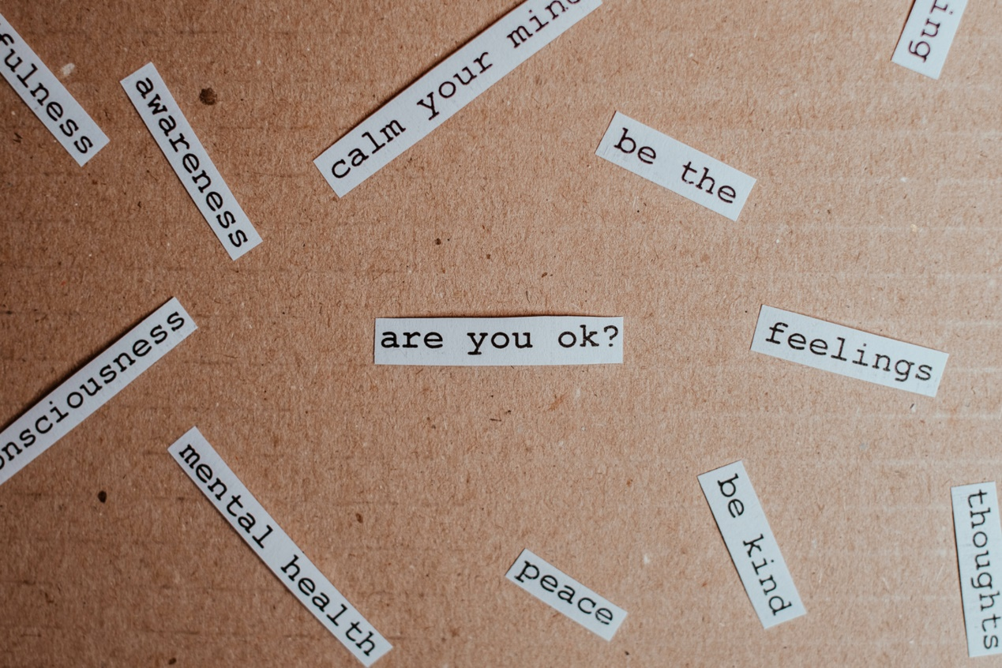
View description - Uncaptioned Figure
View alternative description - Uncaptioned Figure

There are many common mental health problems, and you might know more about some than others. In the sections that follow you will explore:
- depression and low mood
- anxiety (and stress)
- self-esteem.

Depression and low mood
It is worth noting that symptoms of depression can be experienced without that necessarily leading to mental illness. Some people may experience periods of depression but return quickly to the top end of the mental health continuum (see Figure 1 and Activity 2), without long-lasting issues, by means of, for example, coping strategies, or peer or family support.
However, if individual factors and/or circumstances exceed an individual’s coping strategies or support systems, for example due to being particularly vulnerable and/or externally triggered, this may lead to significant low mood with longer lasting effects, or mild, moderate or severe depression (American Psychiatric Association, 2013). By accessing support and/or making use of available treatment options, it is possible to recover from, or learn to live with, depression in a comparable way to experiencing some physical health conditions.
Figure 3 summarises some symptoms of depression and low mood, alongside suggestions for coping mechanisms. While this does not replace clinical support when needed, it has been designed to be used in education settings.

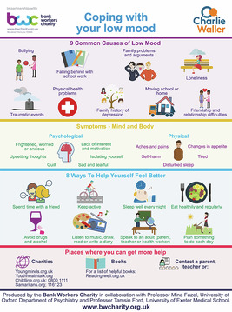
Figure 3 Coping with low mood (Source: Charlie Waller Trust and Bank Workers Charity, 2022)
View description - Figure 3 Coping with low mood (Source: Charlie Waller Trust and Bank Workers Charity, ...
View alternative description - Figure 3 Coping with low mood (Source: Charlie Waller Trust and Bank Workers Charity, ...

Anxiety (and stress)
Anxiety and stress are two of the most widely reported, and commented on, mental health conditions relating to learners in recent years – in particular following peoples’ experiences of the COVID-19 pandemic. Broadly speaking, stress is not a mental health condition per se, more of a physical response to factors around you. The Mental Health Foundation (2018) defines it as ‘the degree to which you feel overwhelmed or unable to cope as a result of pressures that are unmanageable’. Some stresses, such as preparing for and taking tests or exams, or responding to an emergency, can be motivating and not necessarily unmanageable, and are therefore not necessarily related to mental health problems.
Anxiety is something which can be experienced fleetingly as a normal response to a life event or circumstance, but when it becomes uncontrollable and excessive, interfering with daily life and activities, it can be considered a mental health issue or condition (Mental Health Foundation, 2023). In educational settings, anxiety can show itself in quite specific ways. For example, much research has been conducted on experiences such as maths anxiety (Khasanweh, Gosling and Williams, 2021) and test anxiety (von der Embse et al., 2018). The Charlie Waller Trust (2021) has summarised the different ways anxiety can be felt in Figure 4.

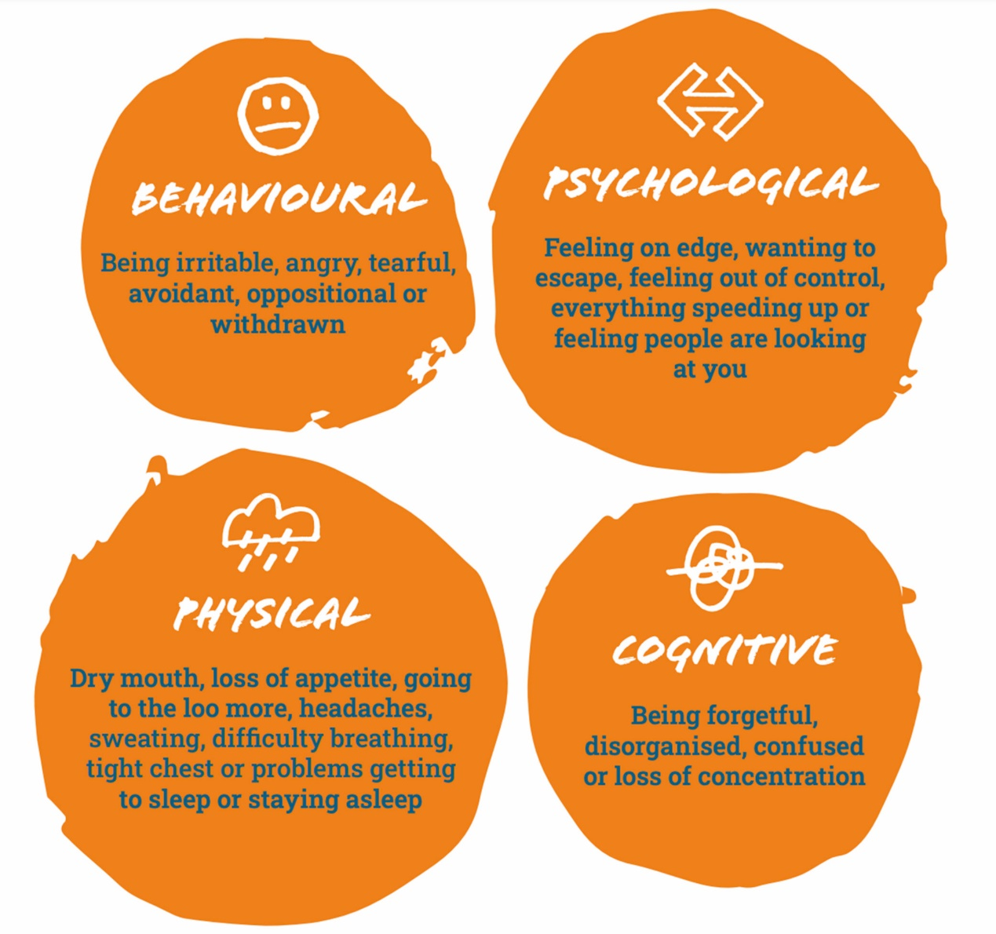
Figure 4 What does anxiety look and feel like? (Source: Charlie Waller Trust, 2021)
View description - Figure 4 What does anxiety look and feel like? (Source: Charlie Waller Trust, 20 ...
View alternative description - Figure 4 What does anxiety look and feel like? (Source: Charlie Waller Trust, 20 ...

Some of the signs and symptoms described above may be only temporary and could be considered as understandable reactions to the people, environment or events around us in certain circumstances. However, where these signs and symptoms are experienced for extended periods of time, more frequently or to extremes, then further support and assessment may be needed.

The relationship between mental health and self-esteem
Self-esteem relates to how you value yourself and is based on different opinions and beliefs that you may have about yourself, some of which can be negative and quite difficult to change (Mind, 2019). For a learner experiencing low self-esteem, this could be displayed as feelings of worthlessness, unfairly blaming themselves for mediocre performance, worrying about being unable to accomplish study tasks, avoidance of engagement in study activities or not feeling able to speak up during learning sessions. Importantly this can be context specific – so learners may display these feelings in all aspects of life or just some of them e.g., work, study and/or home life.
You can listen to people talking about their experiences of self-esteem in the video below, produced by the UK mental health charity, Mind.

Watch the video at YouTube.com.

You can find out more about the work Mind does in the UK on their website.
Low self-esteem can be considered a barrier to success in a learner’s studies, and therefore academic success can be positively influenced by increasing feelings of self-esteem (Marsh et al., 2006). In Week 7 you will specifically look at how you can support confidence and self-belief in learners through different elements of practice in your own learning environment.

3 Language, behaviour and emotions displayed by learners who are struggling with their mental health
Having explored some influences on mental health and different common mental health conditions, you will now look in more detail at what kinds of language, behaviour or emotions may help you identify when learners are experiencing periods of poor mental health.


View description - Uncaptioned Figure
View alternative description - Uncaptioned Figure

3.1 What can you look out for?
It is especially important to note that as an educator you are not expected to be an ‘expert’ in mental health or mental illness, nor are you in a position to offer any diagnosis or treatment. Rather, you can acknowledge that you are in a unique position to notice when learners may not be feeling OK and to be able to offer some supportive conversations or to help them access further support. This latter role will be explored more in Week 4.

Activity 4 Behaviours and emotions as a reflection of mental health
Allow about 20 minutes

- Take a look back at Activity 2 where you drew a model for the continuum of mental health.
- Now choose two of the case studies in the following document: Case studies.
- Using the information from Section 2, what signs or symptoms of common health problems might you expect to see in your chosen case studies if they may be experiencing poor mental health? Place these on a continuum for each case study.
- Note where you may place these signs in various places on the continuum for either case study.

Provide your answer...
View discussion - Activity 4 Behaviours and emotions as a reflection of mental health

An important consideration about signs you may notice within your learners, is whether this demonstrates a change in how that individual usually behaves or expresses themselves. For example, some people may be naturally shy and quiet in group activities. If this is what you have come to expect from them, then this may not be cause for concern. However, if a learner who is normally quite vocal and active in group tasks suddenly becomes quiet and withdrawn, then that change in behaviour may be something that gets your attention.
There may also be a change in the language being used by a learner, such as repeated expressions of hopelessness or despair, or displays of emotions such as episodes of tearfulness or outbursts of anger.
If these changes become more profound, and last for longer periods of time, this may indicate something more problematic and raise concerns further.

3.2 Study-related behaviours
Learners may exhibit specific behaviour changes in relation to their study that can alert you to potential mental health issues. Some common changes to look out for are described in the following sections.


View description - Uncaptioned Figure
View alternative description - Uncaptioned Figure

Attendance or punctuality issues
With some learners you may notice changes in their attendance patterns. If they are experiencing poor mental health, their motivation and the ability to organise themselves can be affected. This could be reflected in either non-attendance or increased lateness, either in person or online. It is important to recognise that even turning up late could be a real achievement for a learner experiencing anxiety or depression, so viewing that as a positive, rather than a negative for being late, can demonstrate support on your part.
With adult learners it is also important to recognise that they may be more likely to be impacted by other commitments outside of their study. This could be related to work, childcare commitments or wider caring responsibilities. So, although a change in attendance could reflect mental health issues, it could also be due to a range of other factors.

Activity 5 Support strategies for late attendance
Allow about 5 minutes

From the table below, highlight some strategies you feel would be supportive to a learner who has started turning up late for sessions.

Silently acknowledging them entering the session, even if this is just with a welcoming smile. | At the end of the session, asking to see this learner so the rest of the group know that lateness is not accepted.
Checking in with them at the end of the session to see how they are doing and if anything is getting in the way of their studies right now. | Silently acknowledging them entering the session, but letting them know you are disappointed.
Giving the group a short task to work on so you can discretely explain to the learner what they may have missed so far. | Highlighting their lateness to the rest of the group in the hope it will make them be on time for the next session.
Saying it is ‘OK’ and to take their time if you notice them struggling to settle. | Waiting until they have settled in their chair before you continue the session in the hope this will mean they will settle quickly.

Provide your answer...
View discussion - Activity 5 Support strategies for late attendance

Presenteeism


View description - Uncaptioned Figure
View alternative description - Uncaptioned Figure

The term ‘presenteeism’ in an educational setting refers to the idea due to poor mental or physical health, a learner can be present in a learning environment but not be fully engaged, or performing productively (Centre for Mental Health, 2011). Van der Feltz-Cornelis et al. (2020) found that in a large UK university during the COVID-19 pandemic, 26 per cent of staff and 40 per cent of learners experienced presenteeism. The researchers also found that there were links between presenteeism and levels of stress, anxiety and depression, while diverse cultural backgrounds also influenced presenteeism levels (van der Feltz-Cornelis et al., 2020).
Factors such as additional caring responsibilities, social isolation, gender and urban living were all associated with increased psychological distress. Therefore, you may find it useful to check in with any learners who are not as engaged, or performing as usual to explore if they may be experiencing challenges that are interfering with their learning.

Withdrawal
You may also notice learners who show signs of social withdrawal. They may show a lack of willingness, or enthusiasm, to participate in tasks or group activities, or may be interacting less with other learners at the start and end of sessions. As previously highlighted, this behaviour could be particularly concerning if it represents a marked change in what you are used to. As an educator, knowing your learners, and noticing how they usually behave, are powerful tools in identifying when an individual may be struggling.


View description - Uncaptioned Figure
View alternative description - Uncaptioned Figure

With all these behaviours, the only way you may truly know if a learner is experiencing poor mental health is by opening up conversations and promoting a safe space for them to talk. The rest of this week (along with Weeks 3 and 4) will help you look at strategies to help with this.

4 Introducing strategies to support learners’ mental health
In other weeks of this course, you will explore ways to support learner wellbeing through your everyday practice, including assessment feedback and curriculum design. This week you will be introduced to some general approaches that can be used ‘in the moment’ to support learners who you think may be struggling.


View description - Uncaptioned Figure
View alternative description - Uncaptioned Figure

A key thing to remember is the need to be patient when someone is experiencing poor mental health and, where possible, to offer practical study advice. This could be allowing themselves more time for certain tasks or thinking about the time of day that might be more conducive to study.
Reflecting on your own experiences as a learner can help inform your practice as an educator. Was there a time when an educator supported you well or could have done more to help you as a learner?

4.1 Ask twice
In the UK, Time to Change (2007–2021) was a national campaign aimed at reducing the stigma surrounding mental health and at promoting earlier conversations around it. One key element, which has also been promoted elsewhere, and in various countries, is the idea of ‘asking twice’.

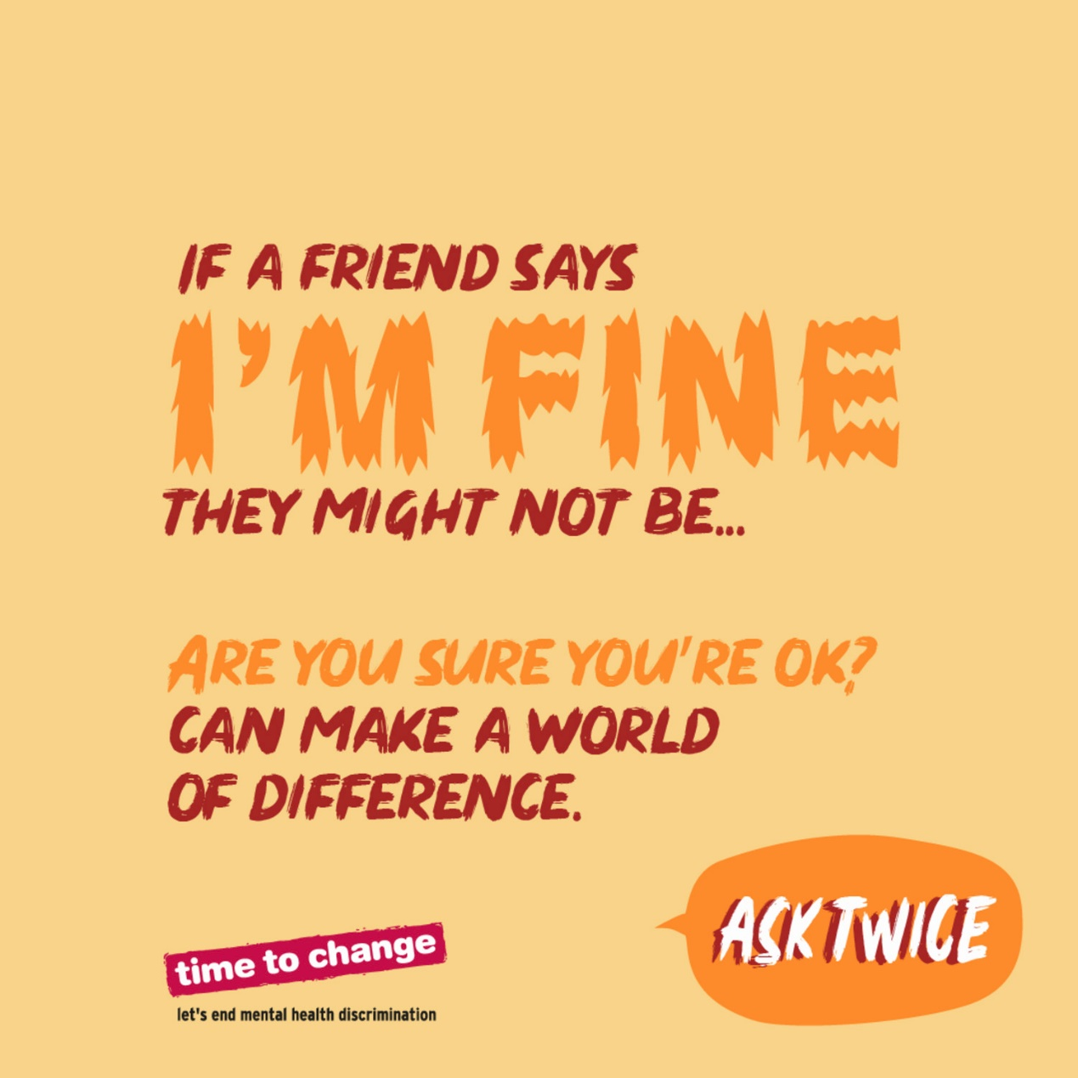
Figure 5 AskTwice (Source: Time to Change).
View description - Figure 5 AskTwice (Source: Time to Change).
View alternative description - Figure 5 AskTwice (Source: Time to Change).

Figure 5 highlights that asking how someone is may not elicit a true response. For example, how many times do you ask, ‘How are you?’ and just use it as a common way of greeting someone? We all do this! Asking a second time implies more meaning behind the question and is therefore more likely to elicit a truthful response from the recipient. As the image suggests, asking ‘Are you sure you’re OK?’ can make a world of difference to the recipient and open up conversation rather than shutting it down.

4.2 Validating feelings and experiences
Even if you find it hard to totally agree with what a learner is telling you, it can be valuable to still validate their feelings and experiences. Let them know that they have been ‘heard’ by using phrases such as ‘I can see how that must be tough for you’ or ‘I can see why that might make you feel upset or sad’. This can be powerful acknowledgement for a learner, conveying a level of understanding and empathy. When you want to ‘make things right’ for someone you may unintentionally minimise their experiences and feelings. Instead you can focus on validating their experience to help them know it is OK and understandable to feel the way that they do.


View description - Uncaptioned Figure
View alternative description - Uncaptioned Figure

Once you have validated their experiences, one of the most powerful things you can do as an educator is to remain hopeful with your learner. Giving hope that even if they are not feeling OK at this time these feelings can pass, and they can feel better. This aligns with the idea of a continuum of mental health that was introduced earlier in this week’s content.
Week 5 will help you explore other elements of your language around mental health when trying to challenge stigma within the learning environment and the curriculum.

4.3 Creating ‘safe’ places
Perryman et al. propose that:

Feeling safe is essential for mental wellbeing and every educator has a responsibility to ensure their classroom [learning environment] is a safe space for learners. This can help with the development of positive relationships that are conducive to learners’ wellbeing.
(Perryman et al., 2022)


View description - Uncaptioned Figure
View alternative description - Uncaptioned Figure

Just like other concepts that you have explored in this week’s content, ‘feeling safe’ can of course mean different things to different people. Maslow’s (1943) hierarchy of needs (see Figure 6) is a common model used in education as it highlights the importance of both physical and psychological safety.

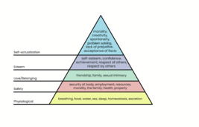
Figure 6 Maslow’s hierarchy of needs
View description - Figure 6 Maslow’s hierarchy of needs
View alternative description - Figure 6 Maslow’s hierarchy of needs

Perryman et al. (2022) further suggest that educators can help promote learning environments as places of safety through:
- the design of the learning environment: for example, the level of background noise or potentially distracting visual stimulation
- the design of the session: for example, the pace of work, length of work sessions, availability of breaks or sequence of activities
- the facilitation of collaboration, including group work, and engagement (this is touched on in Week 7).


View description - Uncaptioned Figure
View alternative description - Uncaptioned Figure

By creating safe and inclusive spaces for your learners, you can help foster a supportive environment where they feel free from judgement, critical opinions or micro-aggressions (indirect, subtle or unintentional discrimination against members of a marginalised group) from others. This is of particular importance for those learners who may already feel marginalised (Yee, 2019). Ideally, with this in place, learners will also feel supported to ask for help when needed.

Activity 6 Creating a safe and inclusive space for your learners
Allow about 10 minutes

Consider the learning environment in which you work. Does it provide a safe and inclusive space for your learners? Are there ways in which you might adapt the environment to support a safe space or ways in which you could help your learners feel safe?
For the physical environment, think about things like furniture, noise levels, comfort and adaptability. For feelings of safety, think about things like establishing ground rules, addressing challenging behaviours, promoting acceptance and inclusivity.

Provide your answer...
View discussion - Activity 6 Creating a safe and inclusive space for your learners

4.4 Knowing where to signpost
Within your organisation or educational setting there are likely to be support services that can offer advice and guidance when learners are feeling low or struggling with their mental health.


View description - Uncaptioned Figure
View alternative description - Uncaptioned Figure

Activity 7 Accessing support services
Allow about 10 minutes

- Take some time to search your organisation’s website or facilities to see what learner support services can be accessed internally. Make a note of these, and how learners can get in touch and access them. This may include locations, times, what information they can provide, etc. Your organisation may also have a mental health or learner support strategy or policy that you can locate, or obtain a copy of, to pass on to your learners.
- There are also likely to be services accessible in your local community or nationally in your country. Take a few minutes more to explore what may be on offer, either online or in person. Again, make a note of these and how learners can access them.

Provide your answer...
View discussion - Activity 7 Accessing support services

4.5 Your wellbeing is important too!
As an educator it can be easy to forget that your own wellbeing is just as important as that of your learners, and research has clearly shown the ‘intrinsic interconnection between staff and learner wellbeing’ (Brewster et al., 2022). If you have time, do a quick search of your organisation’s staff information to see to what extent they are working towards a ‘whole institution approach’ to mental health – including what services staff can access. You may find information on a staff wellbeing strategy, guidance on how to maintain your wellbeing, or specific support such as staff wellness groups or an Employee Assistance Programme (EAP) that can be accessed.


View description - Uncaptioned Figure
View alternative description - Uncaptioned Figure

5 Wellbeing activity for this week
At the end of each week you can find a wellbeing activity. Here you will be directed to useful resources.

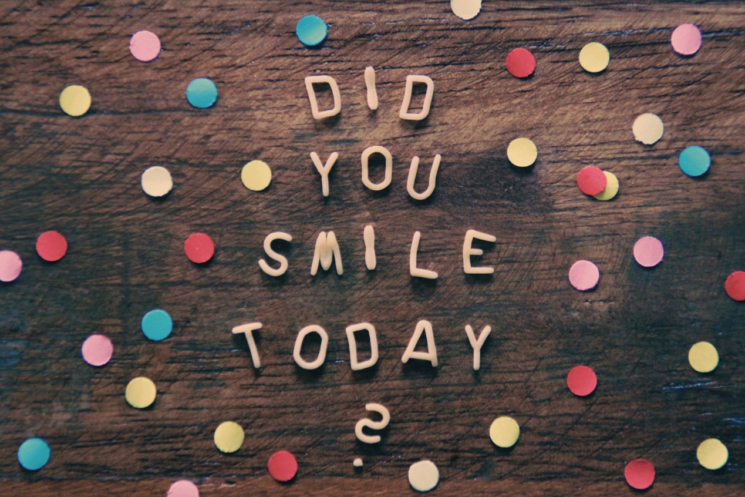
View description - Uncaptioned Figure
View alternative description - Uncaptioned Figure

This week, sign up to receive a monthly Action for Happiness calendar. These calendars are available in 31 different languages, plus in an accessible version. They can be shared digitally and printed. Each calendar is themed and provides positive activities which can promote good levels of wellbeing.

6 This week’s quiz
Well done – you have reached the end of Week 1. You can now check what you’ve learned this week by taking the end-of-week quiz.
Week 1 practice quiz
Open the quiz in a new or window and come back here when you have finished.

7 Summary of Week 1
Over this week you have been introduced to the concept of ‘mental health’ and some of the language used to describe how people feel and what their health status is. You have also been introduced to some of the considerations within a learning environment towards supporting good mental health, what behaviours to look out for and what you can do when you have concerns about a learner.
The main learning points of this week are:
- There are different definitions and understanding of the terms mental health and wellbeing.
- Common mental health problems, such as depression, anxiety and low self-esteem, can profoundly impact on learning.
- Learners struggling with their mental health may display certain types of behaviour such as lateness, withdrawal and presenteeism.
- You can use various strategies and approaches, such as listening, asking twice, and creating safe spaces to support learners’ mental health.
- Taking care of your own wellbeing, such as by identifying and utilising support services and using strategies to promote personal happiness is also important.
In Week 2 you will go on to look at the relationship between mental health and adult learning and how optimal mental health can be supported.
You can now go to Week 2.

Week 2: The relationship between mental health and adult learning

Introduction
Positive mental health, incorporating positive emotions and good mental functioning, enables a person to be productive, to cope with life stresses and to utilise their potential. This also enables them to be a good learner. On the other hand, if a person’s mind is dominated with negative thoughts that interfere with their ability to function, their learning will undoubtedly be negatively affected.
Last week you looked at the definitions of mental health, terminology, explored common mental health challenges and the impact of social and cultural factors. This week you will look further at the relationship between mental health and learning and will learn more ways to best support your learners with mental health issues to reach their potential. You will investigate how to provide learners with mental health challenges with a positive learning experience to help them overcome barriers to continue their learning.
By the end of this week, you should be able to:
- appreciate the difference between positive and negative mental health
- understand the mutual relationship between mental health and learning
- support learners with empathy mapping
- set boundaries and maintain effective relationships with learners
- use reflection to enhance your competency in supporting learners with mental health issues.

1 How positive mental health supports learning
In Week 1 you were introduced to Dahlgren and Whitehead’s (2021) model for the social determinants of health. You looked at two of the course case studies and considered what factors from their social, economic and physical environments might be affecting their mental health and learning capability. This week you will be focusing more on the individual characteristics of learners that may play a part in their mental health function. This includes their thinking processes and attitudes to life as well as the meaning that they feel in their life. In particular you will explore the potential power of positive thinking, positive attitudes and a sense of meaning and purpose on mental wellbeing and learning.

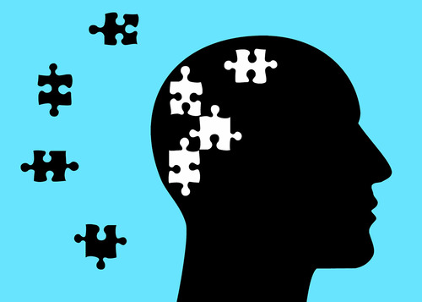
View description - Uncaptioned Figure
View alternative description - Uncaptioned Figure

2 The difference between positive and negative mental health
Positive mental health refers to positive emotions and good mental functioning. This means that an individual is able to be productive, cope with the ordinary (or usual) ups and downs and stresses of life and to use their abilities to realise their potential. Negative mental health is when someone is not able to function well and experiences negative thoughts. These can, sometimes increasingly, dominate their life and impair their functioning in everyday life.
In relation to adult learners, positive mental health means the individual is able to make a positive contribution within studying environments by forming relationships, feeling connected, being confident and able to engage with their study. These capacities have been shown to increase the individual’s peace of mind, happiness and sense of contentment (The Faculty of Public Health, 2022).
However, positive mental health is not necessarily about feeling happy all of the time but is more about being able to cope with the life stresses that may occur on a daily, weekly or monthly basis and being able to continue to live well, study well and work well (World Health Organisation, 2022).

Activity 1 Exploring positive mental health
Allow about 10 minutes

- Look again at Case study 2 (Nicola’s situation) in the following document: Case studies. In Week 1 you may have explored the social determinants that were potentially affecting her mental health, such as being a single mother and unable to afford her own home.
- This time consider her individual characteristics. Do you think her ability to cope with daily stresses is likely to be weak or strong? Do you think that overall she is likely to have positive or negative mental health? What impact do you think her characteristic may have on her learning?

Provide your answer...
View discussion - Activity 1 Exploring positive mental health


View description - Uncaptioned Figure
View alternative description - Uncaptioned Figure

Mental health is therefore more than just the absence of mental disorders and, as you have seen, it exists on a complex continuum, experienced differently from one learner to the next. Learners with mental health conditions may experience lower levels of mental wellbeing, but this is not always the case (World Health Organisation, 2022). With the right support, anyone can live well and work towards their goals (Jacob, 2015; Canadian Mental Health Association BC Division, 2022; Kroeker, 2022). This includes the pursuit of educational achievements and highlights the importance of your role as an educator.

3 The mutual relationship between mental health and learning
Learning is often associated with childhood, or being a young adult, but nowadays many adults return to studying in later life. A lot of adult learners have families, and may be juggling work and caring commitments on top of any child-care or home responsibilities they may have. Given such pressures, some learners are opting for online learning as it eliminates the need to travel, saves time and money and often means they can study in their own time and at their own pace. Other learners may choose online study because of social anxiety or because they are neurodivergent, as it reduces the pressure of face-to-face interactions.


View description - Uncaptioned Figure
View alternative description - Uncaptioned Figure

Learning and mental health can be mutually beneficial. Good mental health can support learning via good brain functioning and memory. Learning new information and skills can also change the physical structure of the brain by stimulating neurones and creating new neural pathways. The more neural pathways in the brain, the faster that connections can be made (Doidge, 2008). This is like creating shortcuts through an overgrown wilderness, rather than taking the long path around; the more the shortcuts that are used, the quicker your route will be, in this case to cognition and understanding.
The coping skills used to deal with different life stresses are also useful in education because undertaking a course of study can be a long and demanding journey, likened to a marathon rather than a sprint.
Good mental health is often linked with good physical health, which can help learners study effectively and retain information well (Fusar-Poli et al., 2020; Canadian Mental Health Association, 2022). Such learners are also better positioned to effectively balance different aspects of their life and manage their time effectively (Vidourek and Burbage, 2019). Furthermore, learning new skills through studying can improve mental wellbeing by building self-confidence and improving self-esteem, helping provide a sense of purpose and connection with other people (National Health Service, 2022).

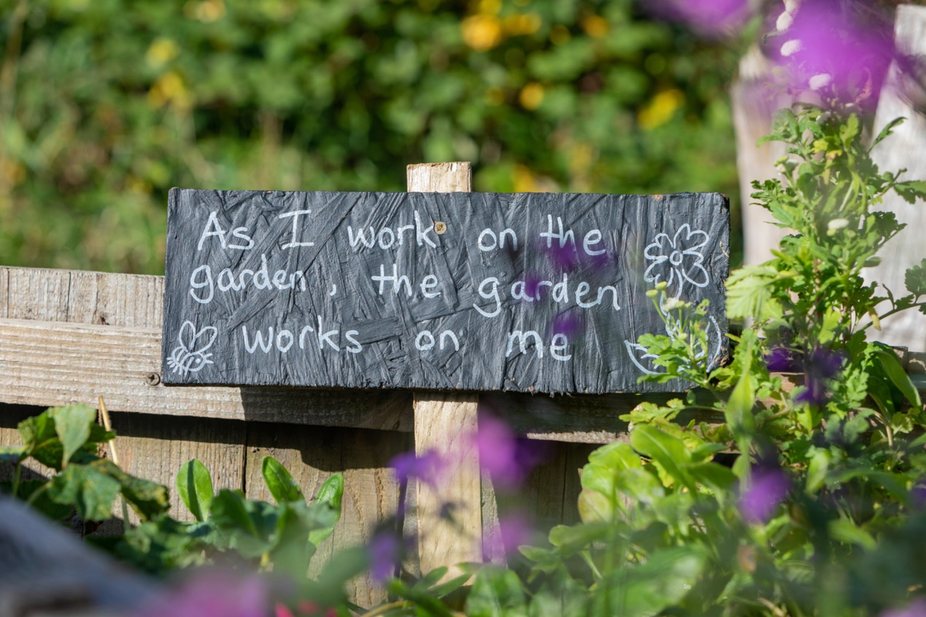
View description - Uncaptioned Figure
View alternative description - Uncaptioned Figure

Adult learners engaging in some sort of learning have reported feeling more positive about themselves and more able to cope with stress and anxiety. Setting targets and achieving them seems to help create feelings of accomplishment and achievement and can act as a motivating factor. Learning something new can release the ‘feel good’ chemical dopamine. This can increase energy levels, boost immunity, and help people cope with stress. Studying also helps people learn up-to-date and relevant information which can improve employability. Learning can also be a good distraction from life’s worries (Buchanan and Warwick, 2020). Learners who complete their studies have shown better levels of wellbeing and less intense symptoms of depression and anxiety, and these effects were maintained for at least twelve months (Robotham, Morgan and James, 2011).

Activity 2 Exploring the mutual relationship between mental health and learning
Allow about 10 minutes

- Read Case studies 1 and 4 from the following document: Case studies. Write down in what ways you think the mutual relationship between mental health and learning could be present for each learner.
- Consider such factors as: distraction; self-esteem; ability to cope with life stresses; isolation or ability to make friends; and motivation.

Provide your answer...
View discussion - Activity 2 Exploring the mutual relationship between mental health and learning

Research shows that positive mental health is associated with increased learning and engagement. In turn, this can lead to improved creativity and productivity, more pro-social behaviour – which also benefits others – positive social relationships, and better physical health and life expectancy (Charles Darwin University, 2020).

4 How to look after learners’ wellbeing
The types and levels of support available for learners varies between different organisations, but there are some key things to look for. In this section, you will explore how to look after learners’ wellbeing.


View description - Uncaptioned Figure
View alternative description - Uncaptioned Figure

4.1 Institutional support
Some ways of supporting learners’ wellbeing are institutionally based, such as classes or online sessions on self-care, or the development of personal skills such as time-management and good organisation. Support may be offered via individuals, or personal tutors, or by dedicated teams. Some institutions and courses may also have peer-mentoring, or ‘buddy’, schemes, whereby more experienced learners help support those who are less experienced. Sometimes the smallest things can make a big difference, such as sharing past experiences, or checking in on learners with an email.


View description - Uncaptioned Figure
View alternative description - Uncaptioned Figure

As an educator, to gain a good understanding of the needs of individual learners, you should pay close attention to any formal self-declaration of a mental health disability provided by the learner or contained in the course/module learner data. You can then be proactive and contact learners at the start of their study with you to check their circumstances and ask them about any specific support needs they may have. This approach can be particularly useful if you have distance learners being taught online. It is essential to maintain good lines of communication and to keep learners motivated, especially if they are feeling vulnerable, or are at risk of poor mental health, or you do not meet with them regularly or in person. It is also important to know what to do in a mental health crisis and who is available in your organisation to support both you and your learners. This is covered in more depth in Week 4.

Activity 3 Exploring your institution’s resources
Allow about 5 minutes

- In Week 1 you explored your institution or organisation’s policies and procedures and support services for learners (and staff) with mental health issues and also looked at community and national support services.
- Now go back and look again but this time focus on any classes or workshops designed to support the development of coping, or study, skills for learners who may be struggling. For example, your student services may offer sessions on boosting self-esteem and confidence or reducing anxiety, or your library may offer training in time-management or study skills that can reduce anxiety and enhance confidence.
- Note down a list of courses, workshops or online programmes that you find which relate to supporting learners with mental health problems.

Provide your answer...
View discussion - Activity 3 Exploring your institution’s resources

4.2 Early warning signs
In Week 1 you identified some of the behaviours and emotions that you can look out for in learners as a reflection of their mental health (Sections 3.1 and 3.2 and Activity 4). Now consider more early warning signs that may be identified, perhaps in a follow-up conversation in person, on the phone or online with your learner.


View description - Uncaptioned Figure
View alternative description - Uncaptioned Figure

There may be a need for some mental health support if one, or more, of the following are being experienced:

- mood swings or constantly feeling low
- lack of care for personal appearance or personal responsibilities
- increased use of mood enhancing substances including alcohol or drugs
- expressing thoughts that life is not worth living
- losing interest in things they used to enjoy
- withdrawing from social activities and spending less time with friends and family
- disturbed sleep, either not getting enough or sleeping too much
- eating less than normal or overeating, perhaps losing or gaining significant weight
- being irritable, over-sensitive or aggressive
- having difficulty concentrating or remembering things
- experiencing recurring physical symptoms such as aches and pains or other unexplained illnesses
- a drop in academic performance
- doing things that do not make sense to others
- hearing or seeing things that no one else can hear or see.
(NI Direct, 2021)

If you identify any of these warning signs in learners, then it is important that you explore possible means of support with them.

4.3 How involved should you be?
One question to ask yourself is how much space you should give your learners. Should you give them plenty of freedom, so as not to cramp them, or should you monitor them closely, so you know how they are? This raises questions about how much you should be involved as an educator. How much time do you have? What are the contact preferences of you and your learners? Where are your boundaries?


View description - Uncaptioned Figure
View alternative description - Uncaptioned Figure

Good communication can facilitate the learner–educator relationship, especially for someone with mental health issues. Imagine a learner and educator who communicate frequently, the educator providing clear, constructive guidance, and the learner feeling able to freely ask questions to clarify queries. The learner is likely to trust the educator more, by knowing what is being aimed for, and may therefore achieve more. The educator can see the progress of the learner, can initiate and maintain clear lines of communication, and can encourage utilisation of the learner’s own knowledge and experience. Positive educator–learner relationships are based on honest and open communication and the sustained engagement and interest of both parties. Communication techniques will be covered in more depth in Week 3.

4.4 Maintaining effective relationships
An effective relationship may begin with you sharing some information about yourself with your learner to help create a trusting environment (Bennett, Stone and Payne, 2022). Knowing the learner, any specific support needs, and how they like to be contacted, can be established in enrolment documents, a learner record, initial email or conversation. At initial contact you may ask learners how they prefer to be contacted and discuss their specific support needs.
Mental health problems can influence how a learner prefers to study. Some learners may not want to give presentations or may have a preferred place to sit in face-to-face sessions or could need additional help in the period up to assessment deadlines.
Other learners may want to discuss assessment feedback or might find additional reassurance useful because of a lack of confidence or being unable to attend in-person sessions or online tutorials.
A key consideration is to always ask learners what support has worked well for them in the past, and what help they feel they need. They know themselves best and are their own ‘experts’. Such enquiry can also help to make learners feel listened to, valued, included and empowered.
Empathy, the ability to imagine and share in what a person is thinking and feeling, is another important element of effective relationships with your learner. This quality will be discussed in more detail in Week 3, but the next activity introduces the idea of empathy charts, maps or grids that can be used as a tool for exploring learners’ thoughts and feeling (the empathy map will also be covered in a bit more detail in Week 3).

Activity 5 Supporting learners with empathy mapping
Allow about 10 minutes

Empathy charts, or grids, like the ones below are often used to help explore what you think a person may be thinking or feeling and how you might respond.
Read Case studies 2 (Nicola) and 3 (Sam) again in the following document: Case studies. In this activity you will complete one of the empathy mapping diagrams provided. This will enable you to explore what the learners may be thinking and feeling and what you, as an educator, could do to support them.
- Using the below mapping diagram, write into each of the three sections to show what you think Nicola may be thinking and feeling. Then in the ‘Does’ section, write what you think you could do as an educator to support Nicola.

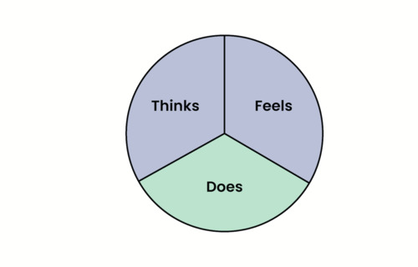
View description - Uncaptioned Figure
View alternative description - Uncaptioned Figure

- Now do the same for Sam, using the diagram below.

View description - Uncaptioned Figure
View alternative description - Uncaptioned Figure

View discussion - Activity 5 Supporting learners with empathy mapping

Remember, there are many different definitions of mental health so it’s important to know what your learner’s understanding is and to know how to identify warning signs for poor mental health. Utilise resources and support services and encourage your learners to support themselves by developing coping skills, as appropriate. However, if you have any serious concerns about a learner’s mental health and safety always seek support from relevant colleagues, such as the designated safeguarding and/or welfare officer or your line manager.

5 How to support learners with mental health challenges to become independent learners
One way to view the process of a learner becoming more independent is as a journey along a path, with yourself as mentor/facilitator. There is the past to reflect on and the future unknown, but planned for (with signposts to follow), and with skilful scaffolding (to reach out for, grab or climb on, or not) along the way. Some of the time, it is appropriate for you to join the path and develop a manageable landscape for and with them. However, sometimes you step back off the path, and the learner can explore and find their way through the landscape alone for a time.


View description - Uncaptioned Figure
View alternative description - Uncaptioned Figure

5.1 Setting boundaries
Part of the boundary-setting process is a recognition of the need for flexibility about when, and how, you support learners with mental health challenges. Setting boundaries can be difficult because you want the best for your learners and sometimes those with poor mental health are facing demanding challenges. Setting clear boundaries allows both you and your learners to establish realistic expectations and ensures that neither of you take on too much (Wyrick, 2022)
You can set boundaries by communicating your availability when you first meet or contact your learners. Whatever your teaching environment, it is good practice to send an email prior to contacting them to let them know the nature of your initial communication (such as an individual tutorial or telephone conversation) and what you will be discussing. Boundaries include letting your learners know the kind of support you can and cannot offer, e.g. support with assignments and curriculum content, but not for financial difficulties, which would need referral to other support services. Setting these kinds of boundaries is useful for learners, enabling them to know what support they can access and when, and also helps you to maintain your own work–life balance. Establishing boundaries also helps you be clear about when to involve colleagues for additional support or referrals.
Setting boundaries may involve some negotiation between you and your learners to clarify the boundaries and ensure that you both maintain them. Stepping back is also important, realising that you are not able to help learners with everything and you need to strike a balance between providing support and hindering the learner’s ability to work independently (Wyrick, 2022). In some situations, such as when you feel the learner needs more support than you can offer, it may be appropriate to use other services in your organisation. In other situations, such as if a learner is contacting you with a series of minor questions, you might instead just signpost them to where they can find the answers for themselves or post the questions on a discussion forum. This will help reduce the number of times the learner contacts you unnecessarily and help build their independent learning. However much you want to support your learners, remember that you are there to support their academic needs, so you need a disciplined focus on this, as well as helping them develop a more independent study life away from you.

5.2 Encouraging independent learning
Gently challenge learners at times along the studying pathway to test out different approaches, including their own ideas. Even if they occasionally stumble, encourage active learning, that is less dependent on you leading, but always remain encouraging.


View description - Uncaptioned Figure
View alternative description - Uncaptioned Figure

From the empathy mapping exercise, with Case study 2, you may have created a study timetable together and then jointly reviewed how effective it was in practice. The next task is to help your learner move on, a little more independently. For example, you might advise that they challenge themselves to devise a revised timetable for the next week(s), using the points that worked in the first week(s) timetable, but dropping any that did not work. Perhaps the learner can choose whether to share this with you first or whether they feel confident and able to go ahead and try it out.

5.3 Encourage SMART goals
With any learning-related activity, encourage the learner to make their task or goal SMART (Doran, 1981), as this can help them become independent learners. SMART is the acronym for Specific, Measurable, Achievable, Realistic and Time-limited. The headings can be written on a single A4 piece of paper and then details filled in.

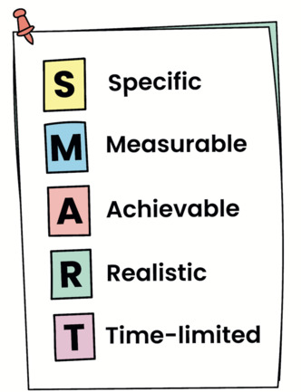
View description - Uncaptioned Figure
View alternative description - Uncaptioned Figure

Experiment with having the paper in either portrait or landscape orientations to see if this enables different ways of expressing and structuring initial ideas for the task, assignment or goal.

5.4 Identify and support learning preferences
The act of completing the paper to identify SMART goals, or tasks, may also reveal any learning preferences. These could be affinities for visual images, audio, speaking thoughts, touch/feeling-based learning, or combinations of these, such as in podcasts and videos. Facilitating learning preferences can be another way in which you can support a learner with mental health issues.
For example, if your learner is found to have a visual preference for learning then you might encourage the use of colour or symbol coding, underlined subheadings, or images that can be easily recognised, to enhance their feelings of comfort, safety and inclusion or make learning easier.

6 Reflective practice
When you learn new information, it is important to think about applying it to your work, studies or personal life, rather than just learning passively. The reflective cycle developed by Graham Gibbs (Gibbs, 1988) provides a structure for learning from experiences. His framework has six stages to help you consider how you reacted to different situations by thinking about what went well or did not go well, and how you might plan for the future.


View description - Uncaptioned Figure
View alternative description - Uncaptioned Figure

Here are Gibbs’ stages:
- Description of the experience.
- Feelings and thoughts that you had about the experience.
- Evaluation of the experience, to identify positive and negative things about it.
- Analysis to make sense of the situation.
- Conclusion about what you learned and what you could have done differently.
- Action plan for how you would deal with similar situations in the future or changes you might find appropriate when you consider what you have learned.

6.1 Gibbs’ Reflective Cycle
You can find Gibbs’ Reflective Cycle in Figure 1.

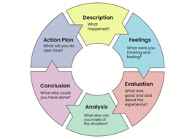
Figure 1 Gibbs’ Reflective Cycle.
View description - Figure 1 Gibbs’ Reflective Cycle.
View alternative description - Figure 1 Gibbs’ Reflective Cycle.

Activity 6 Reflecting on your learning
Allow about 10 minutes

- Take some time to consider how you will apply information that you have learned this week and write down some key learning points for each of the boxes above.
- Use the framework in the free text box below to note each part of Gibb’s cycle, your learning and action points.
Gibb’s Reflective Cycle:
- Description of the experience.
- Feelings and thoughts that you had about the experience.
- Evaluation of the experience, to identify both good and bad things about it.
- Analysis to make sense of the situation.
- Conclusion about what you learned and what you could have done differently.

Key learning points
1.
2.
3.
4.
5.
Now prioritise what action you will take
1.
2.
3.
4.

7 Wellbeing activity for this week
Many of us struggle to maintain good levels of motivation and concentration. Life happens, and sometimes our priorities need to shift. We can help ease pressures by working smarter and not harder. Learning some tips to enhance our abilities to concentrate can reduce stress, aid concentration and prevent procrastination.
The Pomodoro Technique is a popular strategy which focuses on efficient time-management and productivity. Many successful academics use personalised versions of the Pomodoro Technique. Watch the following video to learn how and why to use this tried and trusted approach to enhance productivity.

Video content is not available in this format.
View transcript - Uncaptioned interactive content

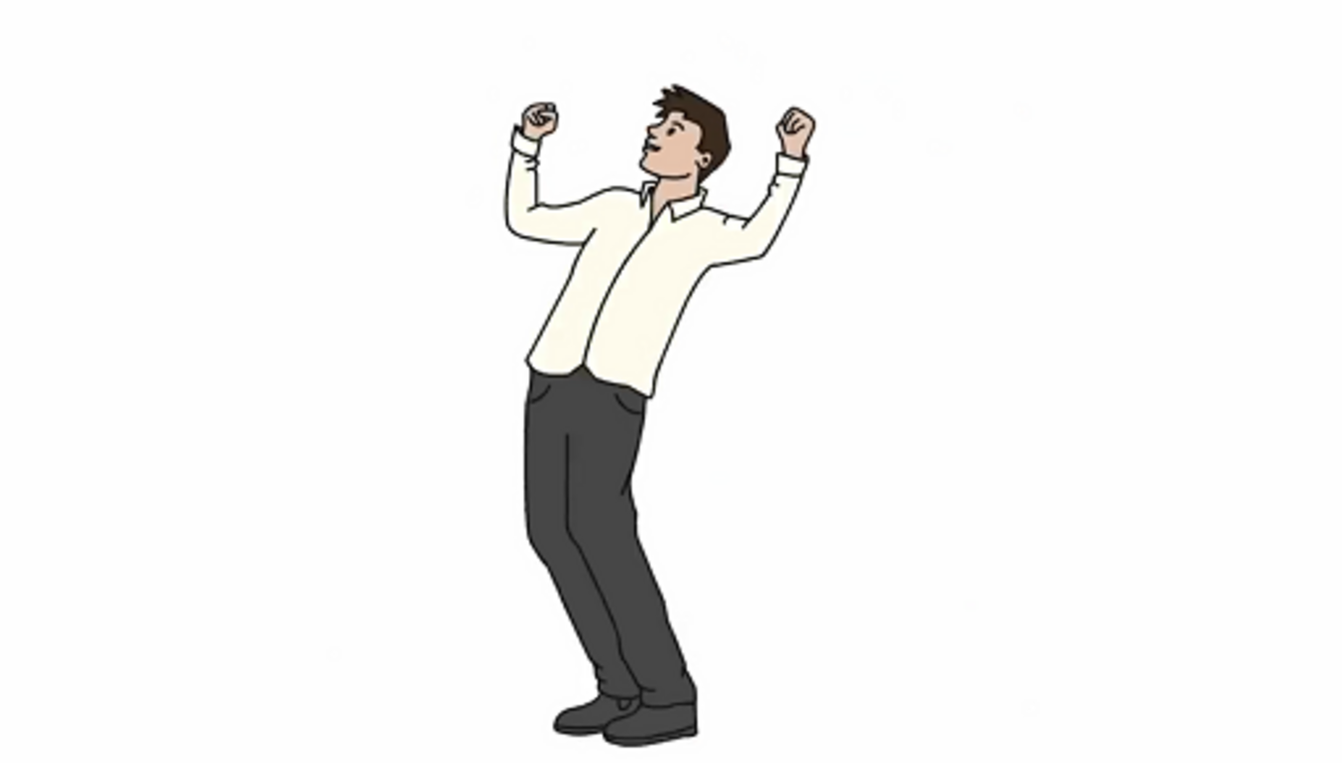

You can find the links mentioned in the video on YouTube.

8 This week’s quiz
Well done – you have reached the end of Week 2. You can now check what you’ve learned this week by taking the end-of-week quiz.
Week 2 practice quiz
Open the quiz in a new or window and come back here when you have finished.

9 Summary of Week 2
Well done! You have started to understand the relationship between mental health and adult learning. There is always more to understand about your individual learners and next week’s content will build on what you have already learned.
The main learning points of this week are:
- There are differences between positive and negative mental health.
- There is a mutually beneficial relationship between mental health and learning.
- Learners can be supported with empathy mapping.
- It’s important to set boundaries and maintain effective relationships with learners.
- Reflective practice can be used to enhance your competency in supporting learners with mental health issues.
In Week 3, you will find out how best to initiate and conduct conversations about mental health, how to develop active listening and how to respond to a crisis situation.
You can now go to Week 3.

Week 3: Communication and conversations about mental health

Introduction
Week 3 considers communications and conversations about mental health. Public attitudes to mental health have recently become more positive resulting in social barriers being broken down and conversations about mental health becoming more normalised. This means that adult learners might be familiar with and expectant of discussions about mental health and wellbeing. For some of you, starting conversations with adult learners about mental health is relatively straightforward. You may feel confident and at ease, have personal and/or professional experience of conversing about mental health and possess a virtual toolbox of strategies and language which you can confidently rely on. There may have been opportunities to engage in professional development about effective communication and/or perhaps mental health and wellbeing which has equipped you to initiate conversations in your learning environment.

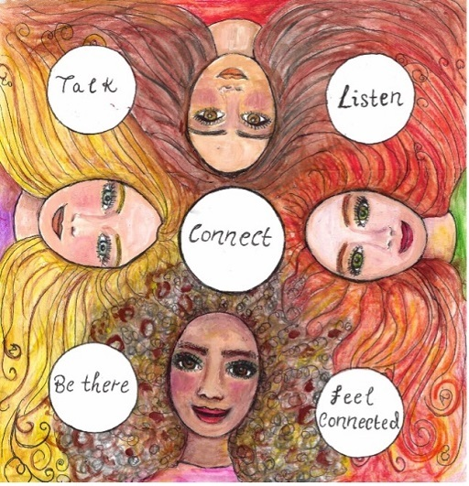
View description - Uncaptioned Figure
View alternative description - Uncaptioned Figure

Alternatively, some educators may not feel comfortable about starting conversations with adult learners about mental health. These conversations might be out of your realm of experience, and you may feel ill-equipped to engage in the more personalised and potentially emotive aspects of learners’ mental health. You may fear getting it wrong. Some adult learners may also feel reticent about discussing their mental health with their educator. There is potential fear of stigmatisation or concerns that disclosing poor mental health might negatively influence learners’ educational progression and grades. Power dynamics, which constantly influence educators’ relationships with learners, are therefore highly relevant in conversations about mental health.
Whatever your level of comfort and skill in having conversations with learners about mental health, this week aims to improve your confidence and capabilities for such communication. It specifically provides skills and tools that you can use to aid learners in talking about their mental health. Most importantly, the aim is to enable you to facilitate adult learners in feeling supported, listened to and empowered to seek the external support they need.

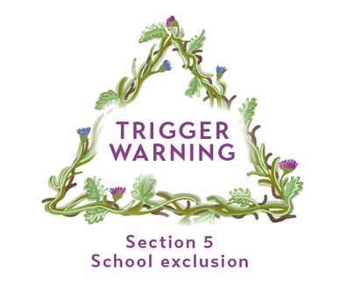
View description - Uncaptioned Figure
View alternative description - Uncaptioned Figure

By the end of this week, you should be able to:
- appreciate how perceptions of holding conversations about mental health are influenced by socially constructed influences, including time and culture
- identify the appropriateness of starting conversations about mental health with learners and feel confident discussing mental health
- apply effective active listening skills in your communications with learners
- understand the importance of empathetic communications with learners and develop your ability to demonstrate empathy
- recognise how bias can impact your ability to conduct non-judgemental conversations.
Week 3 begins by exploring how societal and cultural influences have informed our understanding and experience of mental health conversations.

1 Learning from history
Conversations about mental health have traditionally been difficult and challenging, and often consciously avoided. Historically, this can be traced back to the ways in which society used to deliberately segregate and silence those with poor mental health. A notable example of this is how, in Victorian times, people experiencing mental health illness and learning disabilities were admitted to asylums, segregated from their families and communities and hidden from the public eye (NICE, 2018). This segregation, which has continued in many forms over the years, meant society had no need to initiate conversations about mental health, and a culture evolved where people did not know how to start such conversations. The stigma surrounding mental health was exacerbated, and conversations about mental health may have been avoided for fear that they might lead to institutionalisation by the relevant authorities.
Educational provision reinforced this stigma through its use of derogatory language in educational policy and the lack of differentiation between mental health and learning disabilities. For example, those with learning difficulties such as dyslexia, or who were assessed as below average intelligence, were classified as educationally sub-normal (ESN) and this language was formalised in the 1944 Education Act in the UK. The label ‘ineducable’ was also introduced in the 1944 Education Act regarding children with learning disabilities (The Open University, 2022). This highly offensive language was used both about and to learners, and promoted an unfounded belief that children and young people who experienced mental illness, or learning difficulties, were less intelligent than others. Ethnic minority pupils were disproportionately classified as ESN, and this contributed to educational inequalities for this group. It was not until the updated Education Act in 1981 that ESN was abolished as a defining category, and inclusive education became enshrined in legislation.
The legacy of the treatment of children, young people and adults experiencing mental health illness by public bodies, such as in health and education, continues to influence the ways in which mental health is, or isn’t, talked about. Societal and cultural norms establish over decades, and it is good that conversations about mental health are now more frequent and familiar. It is perhaps shocking, but relevant, to consider that adult learners whom you teach might be first- or second-generation learners of children classified as ESN when they attended school or may even have directly experienced ESN classification themselves. Self-perceptions acquired from such derogatory labels are likely to have negatively impacted on educational perspectives and aspirations for learning success.
More recently, educational institutions have established organisational cultures and policies which promote transparency and openness in starting conversations about mental health with adult learners. These aim to encourage disclosure so that supportive arrangements can be discussed, agreed and established. However, these changes are a work in progress and can be variable in success. Research undertaken by The Open University has revealed that learners experiencing mental ill-health are very reticent to ask for support from their educator (Lister et al., 2021). Learners reported that knowing their educators were supportive and genuinely cared about their mental health needs made a big difference to their sense of attachment to their learning organisation. As a result of completing this course, you may be able to trailblaze mental health conversations for both learners and staff within your organisation.

Activity 1 Cultural influences in talking about mental health
Allow about 10 minutes

Consider your own starting point when talking about mental health. Complete the following activity utilising a mind map to order your thoughts.
- The society and culture that you live in can influence your openness and ability to discuss mental health. Reflect on what kinds of mental health conversations you may have had within your family and friendship groups. (Cultural norms and expectations regarding mental health will be explored in more detail in Week 6.)
- Now reflect on your feelings about mental health conversations with your learners. Consider how comfortable you feel: (1) Very comfortable; (2) Slightly comfortable; (3) Neither comfortable nor uncomfortable; (4) Sightly uncomfortable; (5) Very uncomfortable.
  - What do you feel may have contributed to this level of comfort/discomfort?
- Start to compile a list of the influences and support which could, or do, enable you as an educator to start conversations about mental health. Keep your list nearby as you continue to study Week 3, referring and updating, so that it becomes an aide memoir for your learning on this course and to apply in your teaching practice.

Provide your answer...

2 How to start a conversation about mental health
Nowadays, mental health is talked about more openly and positively. Starting conversations about mental health with adult learners can be done in a range of ways; a best practice model does not exist. Rather than a ‘one size fits all’ approach, conversations are best started by considering individual needs and circumstances.


View description - Uncaptioned Figure
View alternative description - Uncaptioned Figure

Activity 2 Facilitating mental health conversations
Allow about 20 minutes

Part 1 How to support mental health conversations

Think about how you might start a conversation with adult learners about their mental health. From the grid below, note the elements which you feel are important. Are there any which particularly resonate with you? Why do you think that is?

Providing an interruption-free environment | Employing gentle persistence | Ensuring safe, non-triggering conversations | Using positive language
Sharing of anonymised examples of similar situations | Using inclusive language | Having knowledge of support systems for signposting | Ensuring both educator and learner have sufficient time
Providing reassurance and encouragement to continue talking | Conveying belief that recovery is possible | Considering the boundaries of your educator role | Considering power imbalances between educator and learner
Pro-actively addressing confidentiality | Avoiding comparison and competition | Using open questions | Focusing on feelings and psychological aspects of mental health

Provide your answer...
View discussion - Part 1 How to support mental health conversations

Part 2 Practising with a case study

Select one of the Case studies and think about how you might start a conversation about mental health with that person. Revisit the grid above and consider how you might apply these elements to support your selected Case study learner.

Provide your answer...

Part 3 Mental health disclosure

Watch the following Open University video ‘We did it! The role of study support in student success’ and observe how mental health illness and associated educational barriers are disclosed by learners to their peers. Focusing on the dialogue between the learners, try to identify elements from the grid above that have been applied to make these conversations supportive.

Watch the video at YouTube.com.

Provide your answer...

A useful resource can be found in the charity MIND’s ‘Mental health champions toolkit’: see the section on How to have conversations about mental health (Annex F of the Toolkit document).

3 Effective active listening skills through understanding non-verbal and verbal cues
Active listening involves listening attentively to what a person is saying, while also noticing what verbal and non-verbal messages may be being conveyed and then providing appropriate feedback to the speaker. The concept was developed in the 1940s by American psychologist Carl Rogers as part of his client-centred therapy and continues to be utilised today in a range of caring and psychoanalytical settings and services (Rogers and Farson, 2015).


View description - Uncaptioned Figure
View alternative description - Uncaptioned Figure

Effective active listening in an educational context requires the educator to be fully attentive to the learner’s conversation. It involves listening with a purpose, such as to find out more about the learner’s mental health needs. It promotes respect for, and consideration towards, the learner and aims to utilise both non-verbal and verbal cues to better understand the learner’s feelings. It is very different to the noteworthy observation that ‘most people do not listen with the intent to understand; they listen with the intent to reply’ (Covey, 2017).

3.1 Non-verbal cues
Non-verbal cues are an integral part of communication and paying attention to such cues is important for active listening to be effective. As an educator you can gain a great deal of information about your learners through observing their body language. Learners may sometimes communicate their mental health needs through body language, rather than words.


View description - Uncaptioned Figure
View alternative description - Uncaptioned Figure

Non-verbal cues can be identified through observing and evaluating the following:

- Are facial expressions animated or static?
- What are facial expressions saying?
- Is eye contact being made and maintained?
- Is the learner’s posture upright or collapsed, tense or relaxed?
- Has there been a deterioration in clothing appearance and/or personal grooming?
- What gestures is the learner making?
(The Charlie Waller Trust, 2022)

Non-verbal cues may be early identifiers of changes in a learner’s behaviour and can be observed over time, to help you decide whether, and when, to initiate a conversation about a learner’s mental health. Your observations can inform the questions you ask and can help you to better understand the learner and their needs.

Activity 3 Silent viewing
Allow about 15 minutes

Switch on a TV drama or soap opera, or watch a film, but mute the volume. Try to ascertain what the characters are communicating just by observing their non-verbal cues, such as gestures and facial expressions. Of course, you are observing actors here, which is not the same as in an educational setting, but your observation skills can still be transferred to a learning environment.

Provide your answer...
View discussion - Activity 3 Silent viewing

Effective active listening skills also necessitate self-awareness of your own body language as this can communicate both positive and negative messages to learners that you are trying to support. Conscious awareness of proximity to your learners, for example, can be indicative of the level of trust between you. However, levels of comfortable proximity can vary. For some, close proximity may be expected, accepted and perceived as supportive. For others, such as learners who experience specific learning difficulties and identify as neurodiverse, close proximity, and the making and sustaining of eye contact, may be uncomfortable. In these situations, individuals may prefer more distance and personal space and less exposure to direct gaze.
It is important to acknowledge that non-verbal cues may be influenced by many factors, including disability, social norms, and cultural preferences as well as poor mental health. It can be challenging to assess causal influences on non-verbal cues, and intersectionality may hamper your ability to attribute non-verbal cues to learners’ poor mental health. To assist with this, non-verbal cues should be interspersed with verbal cues and dialogue to achieve effective, active communication. This is especially important where education is delivered online, as there may be more limited opportunities to observe non-verbal cues.

3.2 Verbal cues
Attuning yourself to your learners’ conversations about their mental health requires you to both listen and to facilitate the conversation by asking relevant questions. In general, open questions – that is questions that cannot be answered with just a ‘yes’ or ‘no’, or with a static response – are best utilised to stimulate a conversation. Conversations may be in person, or virtually if education is delivered online via email, forums and virtual rooms and/or platforms. Open questions provide opportunities for learners to tell you more about their mental health needs. On the other hand, closed questions usually only elicit a yes/no response and so are limited in their ability to kindle further information.

Activity 4 Identifying open questions
Allow about 5 minutes

The following grid contains examples of both open and closed questions (in the left-hand column). In the right-hand column, add if the question is open or closed.

Question | Open or closed?
Are you OK? | Provide your answer...
What support do you have? | Provide your answer...
How long have you been feeling like this? | Provide your answer...
Where can you access support? | Provide your answer...
How are you? | Provide your answer...
Did you feel like this before starting your course? | Provide your answer...
Tell me more about how you feel. | Provide your answer...
Has that helped? | Provide your answer...
Share some more of your anxious thoughts with me. | Provide your answer...

View discussion - Activity 4 Identifying open questions

Take note of the closed questions as well as the open questions in the activity above. Closed questions are helpful when trying to clarify what you have heard from the learner is correct, and that it is the full story. This is called paraphrasing, which is a powerful method with the ability to improve the effectiveness of the communication. Paraphrasing is an active listening technique utilised to identify what is being said, agree with the learner, summarise the conversation and establish next steps which may include signposting to support and/or a referral for specialist support. In some situations, it may lead to a safeguarding referral which could otherwise have been missed through lack of information and/or recognition of the seriousness of a learner’s mental health. Educators should be informed of organisational safeguarding procedures in advance and able to act on them.
Throughout your conversations with your learners, it is helpful if you can communicate that you are listening and have heard what is being said. This can be achieved by providing short affirmations such as ‘I see’, ‘Go on’, ‘OK’, etc. It is also useful to observe learners’ vocal cues, and consider the appropriateness of their pitch, volume, speed and tone of voice. Emotions are communicated through changes to the voice and can be difficult to hide. At the end of any mental health conversation, thank the learner for disclosing and talking so openly and acknowledge that these conversations might be difficult for them.

Activity 5 Active listening
Allow about 5 minutes

Watch the following video on tips for active listening. The tips include being comfortable with silences. Reflect on times when you have felt compelled to fill gaps in conversations with learners. How might you make best use of silences which occur in future conversations?

Video content is not available in this format.
View transcript - Uncaptioned interactive content

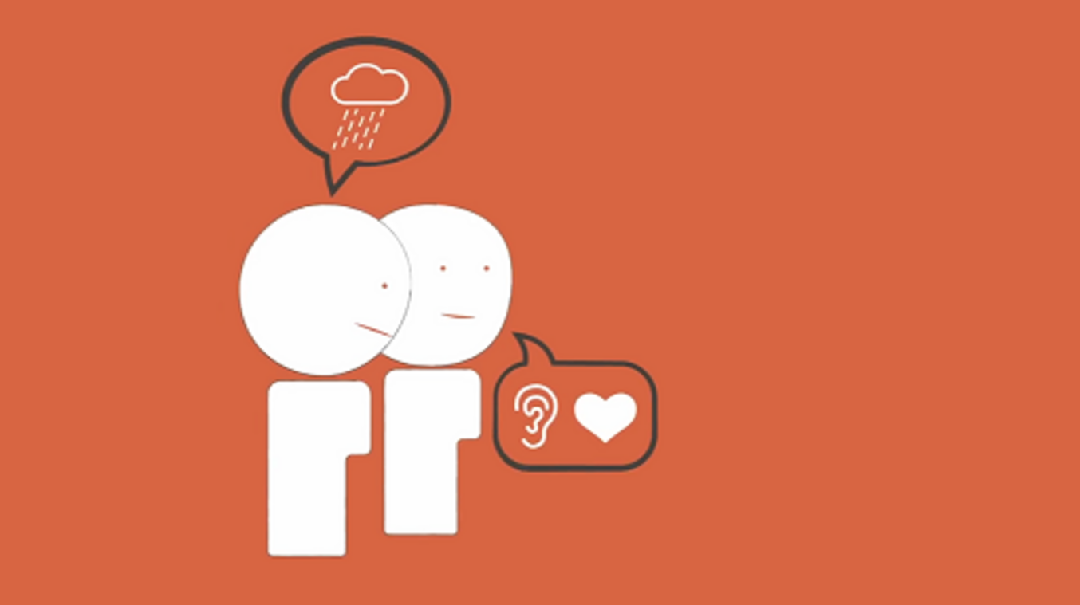

Provide your answer...
View discussion - Activity 5 Active listening

4 Developing active listening skills
The Samaritans (2022) have developed a model for effective active listening called SHUSH.
To become a better listener, they recommend that you:
- Show you care
- Have patience
- Use open questions
- Say it back
- Have courage.
You might also find it useful to look at their poster on Top tips for becoming a better listener.

5 Communicating and demonstrating empathy

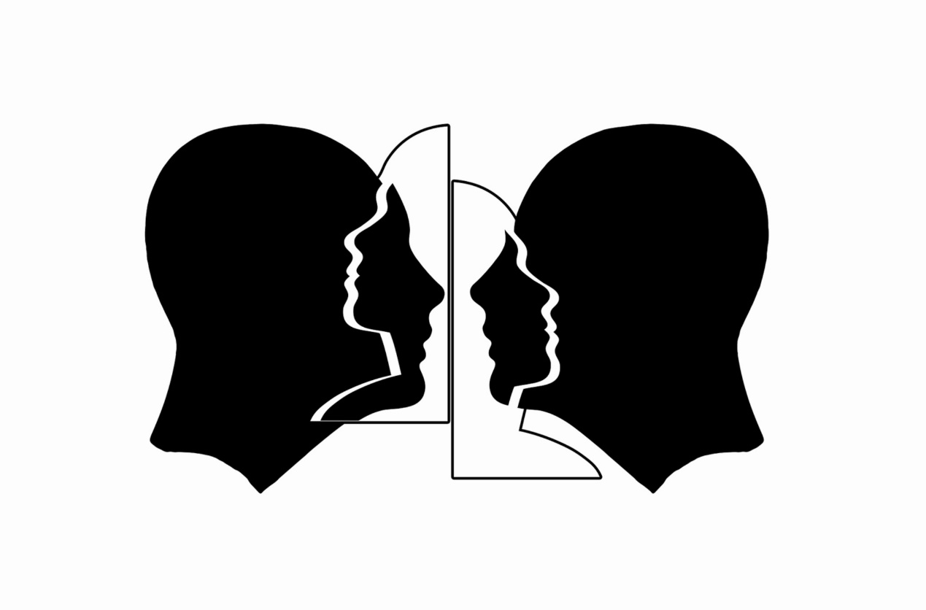

Empathy is an emotional competence which improves communication. Matravers (2017) describes empathy as a tool for peoples’ imaginations which enables us to adopt different perspectives. Different perspectives enable understanding of how others are feeling. So, in relation to learners’ mental health, applying empathy to our communication helps us to appreciate the impact of poor mental health, how this influences learners’ lives and how it can be a catalyst for barriers to learning. In Section 3 of this week, you were introduced to the work of Carl Rogers, and it is Rogerian theory which includes empathy as a core condition of the helping relationship. Rogers theorised that listening to feelings and emotions behind words enabled effective active listening (Rogers, 1957).
Empathy is often described as the experience of walking in someone else’s shoes, having the ability to feel the aches and pains of their personal journey and listening to the feelings and emotions being expressed behind their words.
It is sometimes confused with sympathy as the words and ways we use them are similar. Both sympathy and empathy are characteristics of a supportive relationship. Sympathy tends to be more about feeling pity while empathy conveys a deeper understanding of the problems discussed in the conversation.
One of the tools for effective active listening is the empathy map, first introduced in Week 2. This model was originally created by Dave Gray and colleagues including Scott Matthews to facilitate innovation and change in business (Gray, Brown and Macanufo, 2010). Now also applied in social science settings, the empathy map involves a staged process of empathic imagining and can help you to empathise with the learner’s thoughts and feelings and experiences by imagining yourself in their place.
Here is a model empathy map: Empathy Map Canvas.

Activity 6 Communicating empathy
Allow about 20 minutes

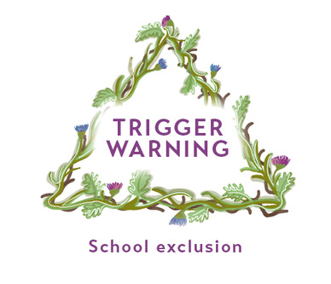
View description - Uncaptioned Figure
View alternative description - Uncaptioned Figure

Watch the video ‘Brené Brown on empathy’ to learn more about the difference between empathetic and sympathetic conversations.

Video content is not available in this format.
View transcript - Uncaptioned interactive content

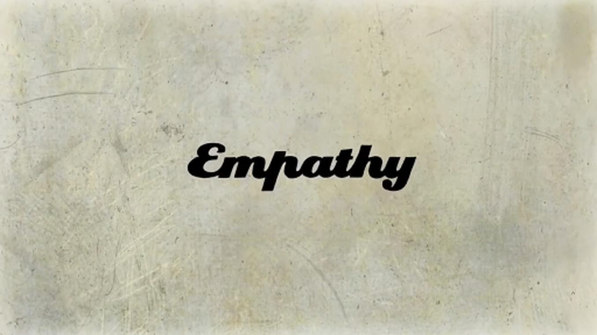

Select and reread two of the Case studies through an empathic lens.
Utilising the empathy map to structure your thoughts, make notes of ways in which you could empathise with the case study learners’ situations. Write a list of questions you might ask each of the case study learners. Remember the open and closed question technique learned in Activity 4.

Provide your answer...

6 Holding non-judgemental conversations
Educators are decision makers. For example, when assessing learners’ work, when adapting teaching and learning methods to be more inclusive and responsive to learners’ needs, or when planning curriculum and tuition approaches. Judgements are intrinsically bound within these types of decisions in order to cultivate the best outcomes for learners. Transitioning judgements into non-judgemental conversations requires self-awareness of the unconscious biases inherent within us all and which are integral to human cognition. Unconscious bias occurs when the judgements we make are informed by our personal experiences, preferences and assumptions (The University of Edinburgh, 2020). A risk of unconscious bias when communicating with learners about their mental health needs is that you may be disproportionately concerned, or similarly be unduly dismissive. This may result in stereotyping or discrimination and the learner being reticent to continue to discuss their needs. Consequently, learners may not access support.
Reflecting on personal unconscious bias, you need to consider how societal expectations and cultures influence the ways in which you may unconsciously judge learners. For example, there have been, and continue to be, significant differences in the ways in which gender influences our conversations about mental health. Luke, a Young Minds activist, tweeted about this (Young Minds, 2022).

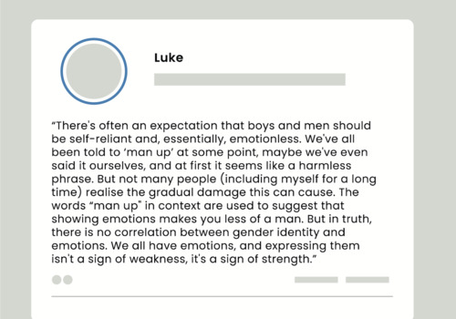
View description - Uncaptioned Figure
View alternative description - Uncaptioned Figure

As you learned in Section 1, cultural norms influence the ability to start conversations about mental health. Luke highlights how cultural norms about gender are translated into gendered language and phrases and explains the associated negative impact on male mental health. He rationalises how language can convey judgement by the listener, even if this is not consciously done. This can further distance men from seeking support and this is concerning because men are far less likely to disclose mental health challenges than females. Data from the most recent national survey of the mental health of the general population in England, carried out in 2014, reported that only 9% of men are likely to seek support for mental health conditions, compared to 15% of women (McManus et al., 2016). Conscious awareness of potential for gender bias can make a significant difference to conversations with male learners about their mental health and subsequently improve the quality of your professional practice.

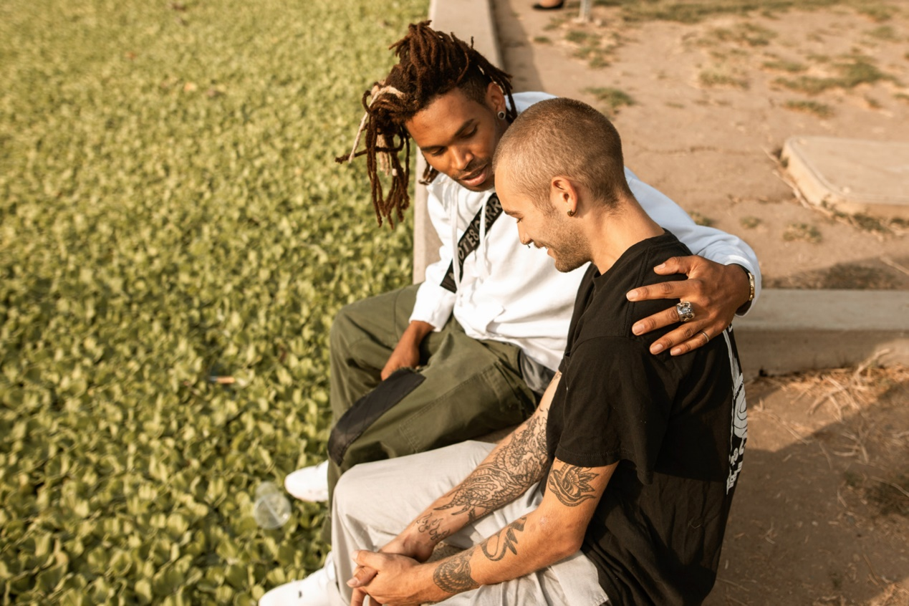
View description - Uncaptioned Figure
View alternative description - Uncaptioned Figure

Activity 7 Exploring gender bias
Allow about 15 minutes

Read the following Young Minds article: Toxic masculinity and mental health.
Revisit the list you started at the beginning of this week in Activity 1 and add your perceptions about gender and mental health.
Through a lens of gender inequality, identify changes that you could make to starting conversations and developing effective communications.

Provide your answer...
View discussion - Activity 7 Exploring gender bias

Gender biases are just one example of judgemental bias. You will go on to learn more about this in Week 5 on overcoming stigma and Week 6 on social and cultural dimensions of mental health in learning environments.

7 Wellbeing activity for this week
Listening to emotive experiences of learners can be triggering and evoke strong emotions of your own. Therefore, while listening to and supporting learners, it’s important to also pay attention to your own wellbeing.
Take time to decompress by creating a transitional routine which will take you from one part to the next part of your day. This may involve taking a short walk, or engaging in a short meditation by Headspace (2020), or perhaps catching up with a colleague. You may also wish to set up your own support system via supervision or coaching. Looking after yourself in this way ensures you can sustain your role as an educator, continuing to support learners who share mental health concerns with you, without becoming overwhelmed or ‘burnt out’.
Further techniques for supporting your own wellbeing are given at the end of each week and will be the focus of Week 8.

8 This week’s quiz
Well done – you have reached the end of Week 3. You can now check what you’ve learned this week by taking the end-of-week quiz.
Week 3 practice quiz
Open the quiz in a new or window and come back here when you have finished.

9 Summary of Week 3
This week you have learned how conversations about mental health have been influenced by socially constructed influences of time and culture. You have developed knowledge and skills to build your confidence in having appropriate conversations about mental health with learners. These skills include active listening skills, empathy and being non-judgemental.
The main learning points of this week are:
- Perceptions about holding conversations regarding mental health are influenced by socially constructed influences, including time and culture.
- Learners feel supported by the appropriateness of how the conversation about their mental health is started and are also supported by the confidence displayed in starting these conversations.
- Applying effective active listening skills supports meaningful conversations with learners.
- It is important to display empathy in your communications with learners.
- Unconscious bias can impact non-judgemental conversations.
Week 4 goes on to introduce more ways that you can access and provide support for learners experiencing poor mental health or other types of mental health crisis.
You can now go to Week 4.

Week 4: Accessing and providing the right support at the right time for your learners

Introduction


View description - Uncaptioned Figure
View alternative description - Uncaptioned Figure

Developing your knowledge of the professional support available for learners is the focus of Week 4. In this week, you will also explore how to signpost and refer learners to appropriate support services and how you can best provide support in crisis situations until professional support is available.

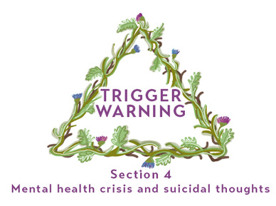
View description - Uncaptioned Figure
View alternative description - Uncaptioned Figure

This week’s content makes reference to some topics including mental health crisis and suicidal thoughts (Section 4), that you may find difficult, or which may trigger emotional responses. If you wish to avoid reading about these topics consider skipping Section 4 (it also carries a trigger warning at the start so that it is easily signposted) and moving on to Section 5, which details further help and support.
By the end of this week, you should be able to:
- recognise early indicators of mental health challenges and difficulties in adult learners
- identify appropriate professional support and information available to adult learners
- increase your awareness of potential serious mental health crises in adult learners and know how to respond appropriately.

1 Early indicators of mental health challenges and difficulties in adult learners
Your learning this week starts with how to recognise indicators of early mental health challenges and identify ways in which they might present in the learning environment.


View description - Uncaptioned Figure
View alternative description - Uncaptioned Figure

You will explore possible verbal and non-verbal indicators and their range of interpretations, consider two case study examples, and think about the impact that labelling can have for an individual struggling with their mental health.

1.1 What are early indicators?
Indicators are signs and symptoms that a learner presents. They provide moments of insight into how a learner is coping. This may be related directly to their studies, or more broadly to their real-life circumstances. Indicators can show the emotional and psychological state of learners and therefore communicate to you that a learner is experiencing mental health challenges.


View description - Uncaptioned Figure
View alternative description - Uncaptioned Figure

Such indicators may present as verbal and/or non-verbal signs. Verbal indicator signs may be seen through changes to speech and language, or expressions of distress or irritability. Non-verbal indicators include facial expressions, body language and gestures, which are not always easy to interpret. Non-verbal indicators also include changes to study-related habits that you learned about in Week 1, such as poor attendance and punctuality; presenteeism and withdrawal from learning; avoidance of contact with yourself or other learners. Other non-verbal indicators might be reports of problems sleeping, significant weight loss or gain, or atypical uncontrolled alcohol intake or substance abuse.
Human beings are already wired to be able to interpret social cues, but it doesn’t necessarily always mean your interpretation is correct. Sometimes it can be difficult to work out whether something is usual behaviour for an individual, whether they have a physical illness or whether they are showing early signs of mental health challenges.
As an educator working with adult learners, you may experience situations where you have worked with a learner for some time and start to notice something different. Or you may have just met a learner, but you pick up on something that seems ‘out of place’, and you aren’t quite sure how to interpret it.

Activity 1 Interpreting indicators
Allow about 10 minutes

Think about the following scenarios and write down what you think might be the potential causes underlying the learner’s behaviours. Might they indicate a mental health difficulty, or could it be something else?
- A learner arrives for the session and is trembling and shaking, appears to be short of breath and is sweating.
- You have noticed that one of your learners has started to arrive late and seems to be tired all the time and is finding it increasingly difficult to focus. The learner has also been seen crying in the library.
- In an online learning environment, you notice that a usually pro-active and outgoing student is posting negative comments in the chat, alluding to being behind with their work and sharing that they are feeling overwhelmed about their learning.

Provide your answer...
View discussion - Activity 1 Interpreting indicators

1.2 Avoiding labels
When working with learners, you will notice that how they present themselves generally remains fairly consistent throughout their learning if they are coping well. However, when someone is not coping, some behavioural changes might be displayed. It is important to try to identify any such indicators, no matter how small, in order to offer support.


View description - Uncaptioned Figure
View alternative description - Uncaptioned Figure

As you saw in Activity 1, being able to interpret indicators might not always be easy. The important learning from these scenarios is that, as an educator, you have a duty of care to learners which starts with noticing when changes to usual behaviour occur. This may, or may not, be linked to a mental health difficulty, but you are still able to identify at an early stage if a learner is struggling and signpost to appropriate support.
It’s important to re-enforce earlier messages that you should not attempt to label or diagnose a specific mental health difficulty. Rather it is to an opportunity to spot difficulty or concern, to offer initial support and/or refer or signpost them to appropriate services within – or outside of – your learning environment.
As an educator you are a primary contact for your learners and are therefore well positioned to recognise potential indicators of mental health difficulties and to progress support for learners.

1.3 Interpreting non-engagement


View description - Uncaptioned Figure
View alternative description - Uncaptioned Figure

As previously stated, when you notice a behaviour change in a learner that may be an early indicator of difficulties, you need to be careful how you interpret that change as the underlying causes may be multi-faceted and very varied. An example of this is how you might interpret non-engagement.

Activity 2 Interpreting learner non-engagement
Allow about 15 minutes

Part 1 Non-engagement scenario

You have recently noticed that one of your learners has become very quiet in face-to-face, or online, sessions and appears to have stopped engaging with their peers in those sessions.
What might you interpret from this behaviour? Make a list of what you think might be potential underlying causes for this behaviour change.

Provide your answer...
View discussion - Part 1 Non-engagement scenario

Part 2 Case studies


View description - Uncaptioned Figure
View alternative description - Uncaptioned Figure

Now read through Case study 1 (Viraj), and Case study 4 (Jolanta) in the following document: Case studies. Apply the same scenario to these two specific individuals. Having reflected on the possible responses listed above for Part 1 and your own notes, how might you interpret their non-engagement?

Provide your answer...
View discussion - Part 2 Case studies

From the case studies of Viraj and Jolanta you can see that some of the reasons for non-engagement are not necessarily caused by mental health difficulties. They may be due to financial pressures, bereavement or other personal circumstances, illness or disability, family pressures or other stresses. However, if unresolved, these barriers to learning could over time also contribute to a deterioration in mental health for the learner.
You may wish to start a conversation to explore identified changes in your learner, and the possible impact on their mental health. To do this, revisit and draw on the skills introduced in Week 3 on how to communicate and have conversations about mental health.


View description - Uncaptioned Figure
View alternative description - Uncaptioned Figure

In this section you have explored some signs and symptoms that can indicate when someone may be experiencing mental health difficulties. You have understood that caution is needed in interpreting indicators and that you, as an educator, are not required to diagnose mental health conditions. Rather, you are well positioned to signpost professional, and other, support services and to recognise when this might be beneficial.
In the next section you will learn about signposting adult learners to appropriate professional support and information.

2 Identifying appropriate professional support and information available to adult learners
In this section you will explore what support may be available for those who need it – ranging from information and advice, to facilitating professional support. You will also learn about some barriers that may prevent adult learners from accessing support and how to encourage adult learners to ask for, and access, help for their mental health when needed.


View description - Uncaptioned Figure
View alternative description - Uncaptioned Figure

2.1 What do we mean by ‘professional support’?
When it comes to receiving support for mental health problems, society’s views of what this looks like can be quite troublesome. Our views can be influenced by our own experiences or the experiences of friends and family, by cultural norms, or even by how mental health is discussed and presented in the media, film and television programmes. This can be problematic, as these factors can be heavily influenced by historic stigma surrounding mental health, which will be covered in more detail next week.
This section discusses types of professional support and advice that could be offered to adult learners who may be starting to experience poor mental health – such support is often referred to as ‘early intervention’. Support offered to learners at higher risk, or experiencing severe distress or crisis, is covered further on in this week’s content.

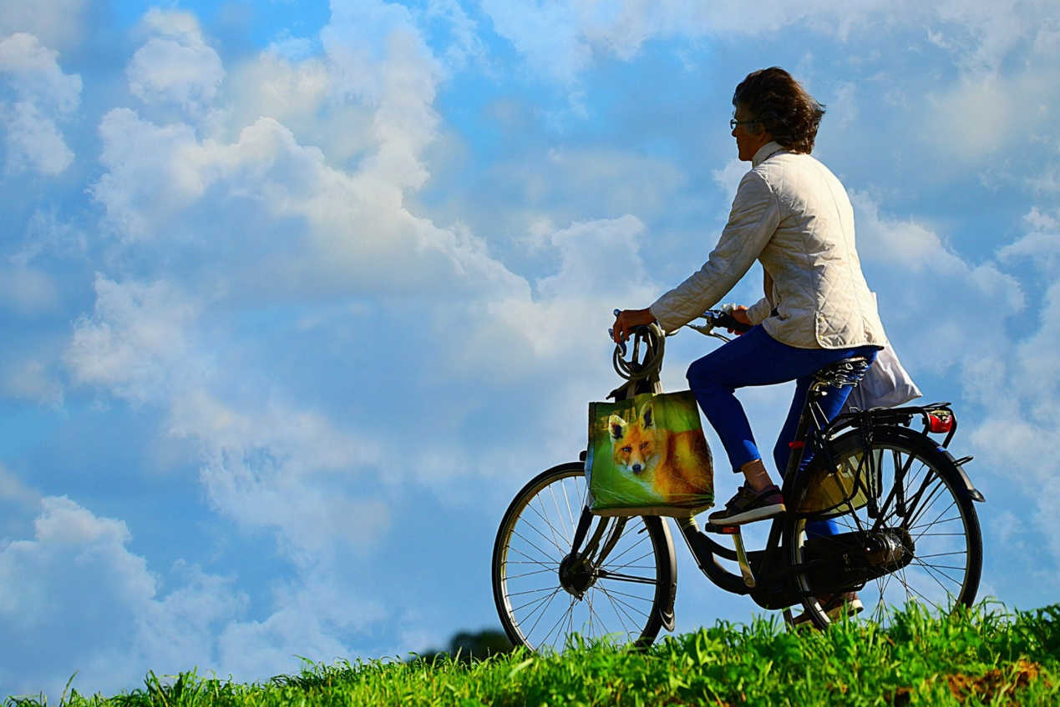
View description - Uncaptioned Figure
View alternative description - Uncaptioned Figure

To help us understand what we mean by professional support, we can look at the level of help a learner needs, who might provide that support, and where it might take place. You will look at these aspects in the rest of this section. In Week 1 you looked at how mental health can be viewed as a continuum, rather than a binary of being either ‘healthy’ or ‘ill’. We can think of professional support in a similar way, moving away from seeing that support as either not needed at one end, or intense intervention/treatment at the other end. The reality is that a range of support or intervention can be offered at various stages in between, ideally being led by the specific needs of each learner. Remember, too, that it is not your responsibility as an educator to identify the level of support a learner might need, but rather your role is to be equipped to signpost your learner to appropriate professional support.

Activity 3 Exploring self-directed support
Allow about 10 minutes

- Revisit the ‘mental health continuum’ activity you undertook in Week 1.
- This time make a list of the things that you sometimes do to help yourself move up the continuum when your level of mental health may be lower than you would like, such as talking to a friend, undertaking a relaxing activity, engaging in mindfulness or meditation, preparing healthy food or exercising.
- Look at Mind UK’s information on the ‘5 Ways to Wellbeing’.
- Look at the list you have developed and see how many of your answers fall under each of these ‘5 Ways’.
- Now consider, are there things that you could add to your list in line with these 5 categories?

Provide your answer...
View discussion - Activity 3 Exploring self-directed support

2.2 What type of support might be available?
When signposting learners to mental health support, it is important to ask what support they may already be accessing. This helps to ensure that support and care are coordinated, rather than multiple avenues of support being accessed and potentially conflicting with each other. The support available may differ from place to place.


View description - Uncaptioned Figure
View alternative description - Uncaptioned Figure

In the following sections are some examples of support available in the UK and via its National Health Service (NHS). If you are a learner in another part of the world you may have similar or different services to explore.

Talking therapies, including Cognitive Behavioural Therapy (CBT)
A common example of early intervention support comes in the form of different talking therapies. You can read more about the different types of talking therapy on the NHS website.


View description - Uncaptioned Figure
View alternative description - Uncaptioned Figure

One of the most common and popular forms of talking therapy is Cognitive Behavioural Therapy (known as CBT). It is widely recommended by professional medical bodies (NICE, 2022) and aims to support individuals to change the way they think, or behave (NHS Choices, 2019).
In the UK, learners can directly access NHS psychological talking therapies themselves, without having to go through their GP. The video below explains a bit more about these services and this is the web page where learners (England only) can find out about services in their area: Find an NHS talking therapies service.

Video content is not available in this format.
View transcript - Uncaptioned interactive content



Here is the link mentioned in the video: Talking Therapies.

Social prescribing
‘Social prescribing’, also known as ‘community referral’, involves referral by a person’s doctor, nurse or other healthcare professional to local, non-clinical services, such as exercise classes, art therapy, or other community resources. The aim is to address some of the wider social determinants of mental health that you learned about in Week 1.

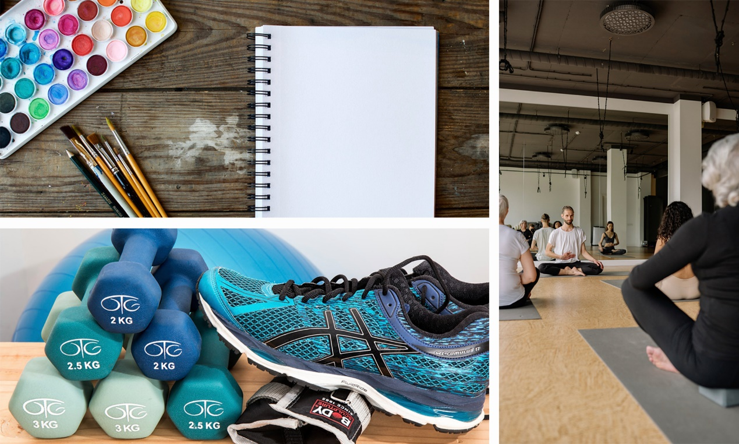
View description - Uncaptioned Figure
View alternative description - Uncaptioned Figure

Such activities can be useful in reducing isolation and may often be combined with CBT or other talking therapies. Watch the video below to learn more about social prescribing.

Video content is not available in this format.
View transcript - Uncaptioned interactive content

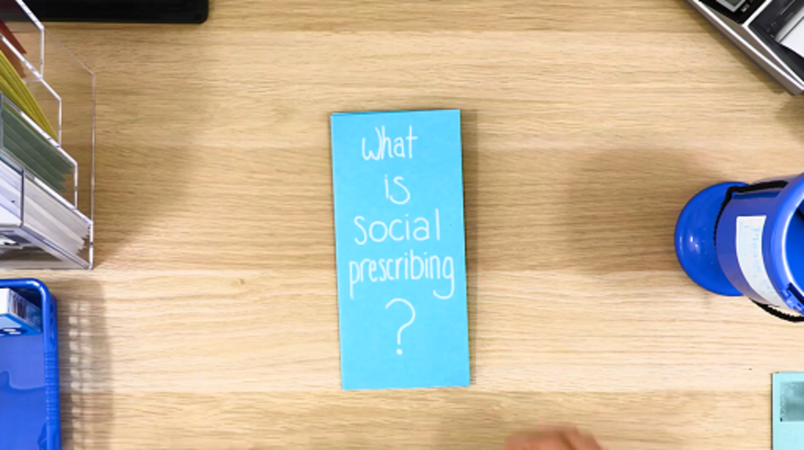

You might consider informing your learner about social prescribing that they might be able to access via their doctor or community support worker, in your own locality or health service. Depending on availability, this could even include free gym membership or free access to creative classes or local support groups that could help promote learners’ positive mental health.
In a learning context, Nair and Otaki (2021) have developed a model for combining such interventions as mindfulness and movement to support learners’ physical, psychological emotional and social needs in an integrated way. Their model is also transferable to other learning environments. You may wish to explore if any of these types of activities are available for learners in your educational setting (see also Activity 4 in the next section).

Online tools
In educational settings, online tools are increasingly being made available to both learners and educators. These services can range from self-help and self-directed activities, to live web chats with professionals, access to peer support programmes, or even computerised CBT (Brown, 2022). The benefits of these tools are that they are easily accessible and free of charge, and an example of this is their increasing use as a support for those with conditions such as anxiety (Pauley et al., 2021).


View description - Uncaptioned Figure
View alternative description - Uncaptioned Figure

The effectiveness of these tools is still being evaluated. For some, online access to support services may help overcome the barriers which prevent them from seeking face-to-face support when needed (Gericke et al., 2021). However, others may feel excluded by digital interventions, and unable to easily access them, so online tools are not necessarily suitable for all.

Activity 4 Identifying online tools
Allow about 5 minutes

Do a quick search on your organisation’s website and identify any online mental health support tools that may be available and suitable for your learners. You might consider the following questions:
- Are there any online activities to support positive mental health?
- Is there any access to live support chat, such as counselling services?
- Are these services available on specific days or at specific times?
- Are there online forums where learners can chat and support one another? Are these moderated, safe online spaces? (You may want to look back at Week 1, Section 4.3.)

Provide your answer...
View discussion - Activity 4 Identifying online tools


View description - Uncaptioned Figure
View alternative description - Uncaptioned Figure

Whatever support is offered to a learner, it is important that they have information about what is being offered, what it may involve and how it can be accessed. Such knowledge and reassurance can take away some of the fear a person may experience when first considering accessing professional support. This anxiety may be heightened if the person has previously experienced stigma around their mental health.

3 What can prevent learners from accessing support?
Learners may be reluctant to access support for fear of being labelled or because of the stigma around mental health, as mentioned in the earlier sections of this week (and which will be discussed in more detail in Week 5). When signposting and supporting learners to access available support, it is important to be aware of these kinds of barriers in order to understand why learners may find it difficult to access such help.


View description - Uncaptioned Figure
View alternative description - Uncaptioned Figure

Learners may also find conversations about mental health intimidating and difficult. They may not know who to speak to, or how to ask for help, or may lack confidence that support will be forthcoming or helpful. Sometimes, even finding appropriate words to articulate feelings can feel challenging for learners. As an educator you can help learners know how to ask for help and who to go to. You may wish to refer back to Week 3 for guidance on conducting supportive conversations on mental health. In the activity below the focus is on supporting learners in being confident to ask for help themselves.

Activity 5 How to ask for help with mental health
Allow about 20 minutes

- Look at the resource How to ask for help with your mental health produced by the Charlie Waller Trust in the UK. You can either download this as a PDF document or view the web-based version.
- Read through the various steps and think about how you could facilitate them in your role as an educator.
- Think about how you might share this, or similar, information with your learners, to encourage them to be able to speak out and access support. What might be the best time, place and setting for this? Could it be during the course induction, or a pastoral session, or tied in with any curriculum content where mental health is, or could be, discussed?

Provide your answer...
View discussion - Activity 5 How to ask for help with mental health

4 Increasing awareness of mental health crises in adult learners and knowing how to respond appropriately

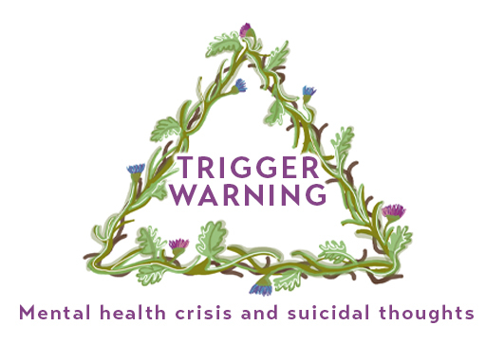
View description - Uncaptioned Figure
View alternative description - Uncaptioned Figure

This section makes reference to topics which may be hard to read and may trigger unexpected emotional responses. There is reference to mental health crises where suicidal thoughts and behaviours might be present. Mental health crises can incur safeguarding situations. Do ensure you are pro-active in identifying safeguarding procedures for your learning environment. Bookmark a copy of the current safeguarding policy and procedures, and if you feel it would be helpful, print a hard copy. Regularly update your own safeguarding professional development, identifying any areas you might find beneficial to learn more about and take steps to learn more about these
Take care of yourself when reading this section and if you feel unable to read about these topics then you can move onto the next section, or to Section 5, which details further help and support, or come back to this section at a later stage, if appropriate.


View description - Uncaptioned Figure
View alternative description - Uncaptioned Figure

In Section 1 you explored ways in which you can recognise mental health challenges and difficulties in adult learners, and how sometimes the indicators can be interpreted in different ways. This section includes various crisis situations, including panic attacks, self-harm and suicide. Now you will look at indications that a learner may be having a serious mental crisis, such as thoughts towards ending their own life, and how to best respond appropriately. This builds on your learning in Week 3 of how to facilitate mental health conversations and active listening, and you may wish to review Week 3 again. It is possible that mental health crises, or potentially suicidal situations, will not arise in your educator role but, if they should occur, then it is useful to be prepared and to know how best to respond.

4.1 Panic attacks
Panic attacks are perhaps one of the more common crisis situations you might encounter. A panic attack can be brought on by anxiety and stress, so a learning environment with presentations, exams and tests can be a triggering place for anyone who experiences them. For some learners, being fearful of having a panic attack can make them feel anxious and stressed, which in turn can increase the chances of a panic attack happening. So being mindful of your learning environment, the activities and learning situations is important for educators. Measures to support learners are often simple and do not impact on the overall learning experience for everyone. Sometimes just allowing a learner to be seated with easy access to an exit, or to work in group situations with people they feel comfortable with, is all it takes to appropriately support them.
The ‘expert in the room’ is very often the person themselves, and quite often they will know what can trigger a panic attack and will have strategies to help mitigate and lessen the impact of it. Being empathetic could mean you find out more about how it feels to experience a panic attack, the likely causes and what a learner’s coping strategies are. Equipped with this understanding you will be better placed to provide the right support.
If you would like to understand more about panic attacks and recommended treatments, you can find out more in this free OpenLearn course: Panic attacks: what they are and what to do about them.

4.2 Self-harm
Self-harm, like suicide, is not a mental health problem in itself, but is more of a symptom of a learner’s emotional distress. Self-harm is not suicide; it is a way for some people to manage and cope with their emotions and becomes a means to deal with, and sometimes communicate, their internal emotional ‘pain’. Suicide situations occur when someone wants to escape from their emotions and emotional ‘pain’. However, it is important that people who are using self-harm behaviour to cope get the help they need. Perceptions that self-harm is attention seeking can deter help-seeking and increase risk. Self-harm can take many forms including cutting, burning, hitting, hair pulling and also self-destructive behaviours such as abusing alcohol or putting oneself into dangerous situations (Mind, 2020).

Activity 6 Conversations about self-harm
Allow about 10 minutes

Watch the Mind (2020) video What is self-harm?, which provides insight into peoples’ lived experience and note down potential supportive statements and responses you might use when discussing self-harm with a learner.

Provide your answer...
View discussion - Activity 6 Conversations about self-harm

When initiating a conversation with a learner about potential self-harm useful phrases might be similar to those set out in the following figure.

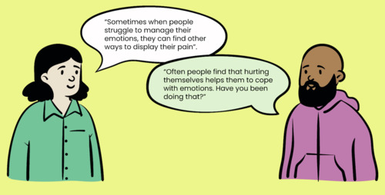
View description - Uncaptioned Figure
View alternative description - Uncaptioned Figure

Within your role as an educator, it will be useful to consider the feelings of learners who self-harm, or who may have self-harmed in the past, within the context of their peers and the learning environment. For example, a learner might prefer to wear certain clothing, or have wound dressings on, in order to hide scars.
As self-harm is a behaviour linked to the person’s emotions, understanding the causes of these negative feelings is key to helping resolve the self-harming behaviours. There are some resources available that you might want to share with a learner who opens up about self-harm:
- Expert Self Care: distrACT app: The award-winning distrACT app is free to download and provides trusted information and links to support for people who self-harm and may feel suicidal (Expert Self Care, 2022).
- Harmless: The centre of excellence for self-harm and suicide prevention (Harmless, 2022).

4.3 Identifying an emergency situation with suicidal risk

View description - Uncaptioned Figure
View alternative description - Uncaptioned Figure

A mental health crisis occurs when an individual experiences mental health problems that become so significant that they can no longer cope, or function or they can’t control their symptoms. While a mental health crisis means different things to different people, specifically it is a situation where someone needs urgent help. The words ‘mental health crisis’ and ‘mental health emergency’ may be used interchangeably and both mean that urgent attention is required. You’ve just learned about two types of crisis situation: self-harm and panic attacks. In this section you will now focus on an emergency crisis situation where the learner’s thoughts and feelings have turned into behaviours associated with an intention to end their own life.


View description - Uncaptioned Figure
View alternative description - Uncaptioned Figure

Activity 7 Phrases and feelings linked to suicidal thoughts
Allow about 20 minutes

Watch this video from the UK mental health charity, Mind, where individuals describe their experiences of having suicidal thoughts.
Suicide: talking about mental health
Make a list of the phrases and feelings that are linked to their thoughts of ending their own life.

Provide your answer...
View discussion - Activity 7 Phrases and feelings linked to suicidal thoughts

4.4 Identifying and talking about suicidal thoughts and behaviours

View description - Uncaptioned Figure
View alternative description - Uncaptioned Figure

The content in this section mentions suicidal thoughts and suicide so please read with care or skip to Section 5, which details further help and support.
Thoughts of suicide are more common than many people might think. Around a fifth of adults will at some point have thoughts about ending their own life (McManus et al., 2016). However, this does not mean that the person will go on to do it. A strong correlation has also been found between self-harm and future suicide (Geulayov et al., 2019) but self-harm and suicide are not the same and do not always carry the same risk. Suicidal thoughts are just that; they are thoughts and do not necessarily have any specific actions or intentions associated with them. For many, these thoughts will be fleeting and pass. For others they might be more persistent and enduring and when they are, an individual can go on to display behaviours associated with these thoughts.
Suicidal behaviours are demonstrated in learners when they start to make plans to explore their desire or intention to end their own life. These behaviours can include researching methods and places, being active on pro-suicide websites and making arrangements around personal matters, which is sometimes referred to as ‘putting your affairs in order’.


View description - Uncaptioned Figure
View alternative description - Uncaptioned Figure

Identifying when a learner is having these thoughts or behaviours is not always easy and, as an educator, you are not responsible for identifying them. However, various things that a learner says, or ways in which they act, could be an indicator. Having this awareness can help you to communicate within the boundaries of your role and appropriately with a learner to identify relevant support.
It may be difficult for learners to disclose that they are having suicidal thoughts, and cultural issues and stigma (explored in more depth in Weeks 5 and 6) can make it even harder. Some may find it easier to share such thoughts with those they feel close to, or with someone they know well and trust. As an educator, this might mean that your learner opens up to you, or possibly other learners.
Suicidal thoughts and feelings might be communicated by learners in their written work, or verbally, but the communication may not necessarily be clear; their language may be ambiguous, tentative or very subtle and open to interpretation. However, there are some commonly expressed sentiments, which you can look out for. Next, you’ll explore some of the language that someone might use if they are having suicidal thoughts.

Activity 8 Statements that may reflect suicidal thoughts
Allow about 15 minutes

Read through the sentences below and make a note for yourself which statements might indicate that a person is having suicidal thoughts:

I just can’t go on anymore
I can’t see any way out of this
I don’t want to be around anymore
I feel hopeless
I give up
I feel trapped
I want to hurt myself
There is no point to life
Nothing matters any more
People don’t want me around
I’m just a burden to people

Provide your answer...
View discussion - Activity 8 Statements that may reflect suicidal thoughts

4.5 Responding to a learner with suicidal thoughts

View description - Uncaptioned Figure
View alternative description - Uncaptioned Figure

Attempting to support a learner who has suicidal thoughts or intentions can feel scary and while you are not responsible for them, being able to help to keep them ‘safe for now’, by identifying coping strategies, others they can talk to or any appropriate professional support, can make a big difference. One such professional support is SHOUT. SHOUT offers immediate text support that is free in the UK and does not show on ‘phone records’; just text SHOUT to 85258. Watch Richard’s video from the Samaritans to better understand the importance of being able to help learners who are contemplating suicide and key ways in which this can be done.
Your own organisation might have specific guidance for dealing with a situation like this and we would encourage you to familiarise yourself with their guidance and processes. They might also provide training that will help with your understanding and confidence to deal with a crisis situation. You may well have a mental health or wellbeing team established in your organisation, or there may be trained Mental Health First Aiders who could be contacted to provide support.
There is also guidance, taken from widely accepted practice, that you could draw on when with someone who is feeling suicidal. In addition to the guidance given in Week 3 on how to conduct supportive conversations on mental health you may find the following useful:
- Ask the learner if they are having suicidal thoughts. By asking someone directly about suicide, you give them permission to tell you how they feel and let them know that they are not a burden (Samaritans, 2022). Take what they say seriously.
- Ask them if they have a plan or intent to carry out their suicidal thoughts. This is very important as a clear plan indicates that the person is at a high risk of carrying out their thoughts. You may ask questions like:
  - Do you have a plan?
  - When do you intend to carry out your plan?
  - How do you intend to carry out your plan?
  - What means do you have to carry it out?
If you identify that the learner cannot guarantee that they will be able to keep themselves safe, it is important to consider the following steps:
- Do not leave the learner alone and ideally have support from another staff member at all times.
- Ask the learner if they have a crisis contact and contact them if established.
- If not, explain to the learner that you need to get them some support and phone 999 and explain the situation. Stay with the person until their emergency contact, or emergency services, arrive.
- If the learner has left, or is uncooperative, then call the police explaining the situation and the last place you saw them.
If the learner does not have a clear plan or intent and is willing to talk to trained professionals you could help them to phone the Samaritans, a charity which offers support to anyone experiencing suicidal thoughts or in emotional distress and struggling to cope. They can be phoned for free on 116 123 and are contactable 24 hours a day, 365 days a year. If you are not UK based, then equivalent organisations in other countries, or that operate internationally, can be found here on the Samaritans website.
In the aftermath of the situation, it is important to follow any processes you have and to make appropriate notes on the learner’s record. You might also need to notify senior staff and/or your safeguarding or wellbeing team, if there is one. Remember to also take care of yourself throughout such encounters and ensure that you seek your own support following the incident. Depending on your organisational setting, either a member of the Human Resources team, or your line manager, should be able to help with a debriefing conversation and further support could be available to you through an Employee Assistance Programme.

4.6 What else can help?

View description - Uncaptioned Figure
View alternative description - Uncaptioned Figure

So, how else can you best support a learner who is experiencing suicidal thoughts?
One of the most important actions you can take is to just be there for the learner, to be willing to just listen, and to give undivided care and attention. While this may not feel as though you are doing much, being willing and able to support your learner can be very valuable. You might consider some of the following actions:
- Suggest going somewhere that is a safe space, quiet and away from distractions. However, if the learner doesn’t want to move, don’t force this.
- Tell the learner they are not alone, and that you are there for them. Offer lots of reassurance and encourage them to talk to you. They may not wish to talk about their feelings but, by giving gentle reassurances, they may be more likely to open up.
- Use open questions (questions that cannot be answered with just a ‘yes’ or ‘no’ – see Week 3, Section 3.2 and Activity 9) and listen with your full attention to what is said in reply.
- Stay calm and breathe slowly. Looking after yourself is very important too and staying calm will show the person that you are in control of yourself and may also help them to model this behaviour.
- You can ask the learner if they’ve experienced their current feelings before. If so, ask whether they have a safety plan that they use.
- Ask whether the learner already has a GP, psychiatrist or community psychiatric nurse contact who knows about their mental health. If they do, ask if they can be reached by phone.
- If the learner has self-harmed, use visual cues to determine if medical attention is required and if it is urgent. If you think the person is in immediate danger, then you should call an ambulance on 999 without delay and seek assistance from others.


View description - Uncaptioned Figure
View alternative description - Uncaptioned Figure

Further guidance on developing confidence in talking about suicidal thoughts and intentions can be found on the following page of the Charlie Waller website: Being confident to talk about suicide.

5 Further help and support
This session has only been able to touch on the fundamentals of supporting learners who are in suicidal distress.

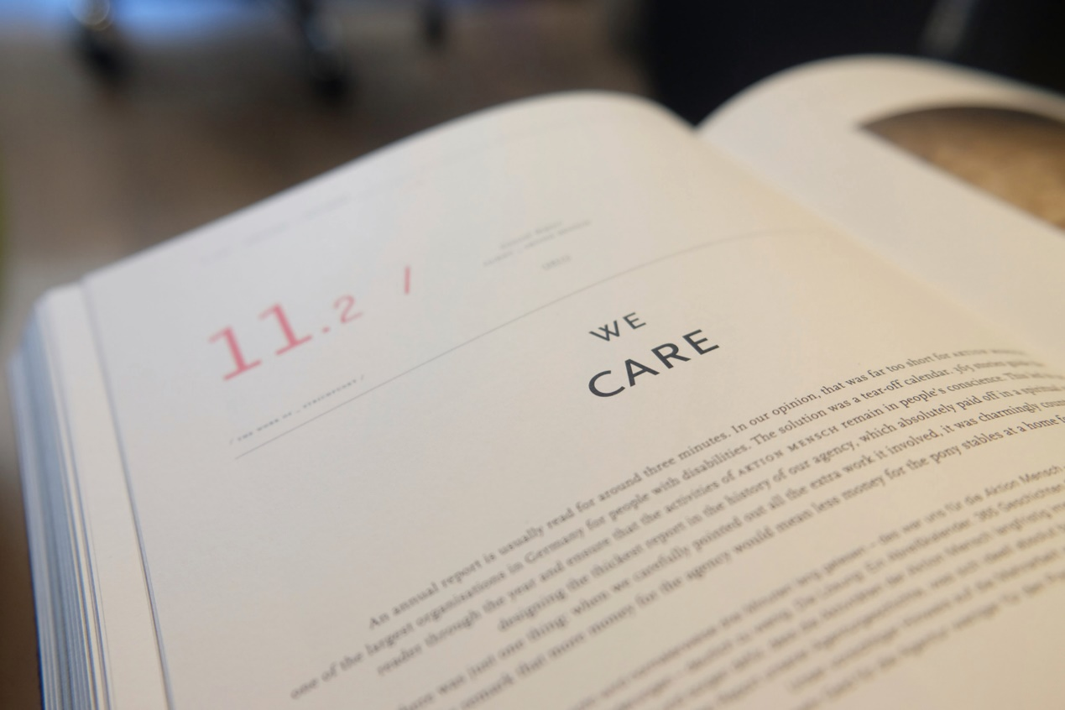
View description - Uncaptioned Figure
View alternative description - Uncaptioned Figure

If you would like to learn more about mental health difficulties, crisis and supporting someone with suicidal thoughts, including further online training, you can go to the following websites for more information:
- Free online training from Zero Suicide Alliance
- Guide on conversations about suicide for University staff (charliewaller.org)
- Guide on conversations about suicide for college staff (charliewaller.org)
- Helping someone in a mental health emergency: How to help someone seek mental health support (Mind)
- Common myths about suicide: Myths about suicide (Samaritans)
- Supporting someone who you are worried about: If you’re worried about someone else (Samaritans)
- HOPELINE UK Call 0800 068 4141. For children and young people under the age of 35 who are experiencing thoughts of suicide.
- Samaritans Call 116 123.
- Mental Health First Aid (MHFA): If you are interested in taking your learning further, you could consider training as a Mental Health First Aider. MHFA is a global programme providing training in mental health first aid skills to support people with mental health problems. For details of MHFA training in the UK look at the following resource: Become a Mental Health First Aider. For details in other countries you might find this resource useful: What is Mental Health First Aid?.

6 Wellbeing activity for this week
Stress can manifest through acute causes, and more chronic situations, and left unmanaged it can cause a range of negative biological, emotional and behavioural effects. These negative responses to stress, sometimes called our ‘stress signature’, can go on to cause additional problems and create further stressful feelings. How often have you been stressed and annoyed only to argue with someone and get further annoyed by the argument, or felt tired and unmotivated and so much so that a deadline gets missed?
The Stress Container concept can help you consider the things in your life that cause you to feel stressed. Once you have created your ‘stress list’, you will be guided through actions and considerations to help you better manage them.
Explore the following resources:
- Stress Container Exercise (BBC)
- Neil explains the Stress Container (MHFA England)
- Stress Container (MHFA England)

7 This week’s quiz
It’s now time to take the Week 4 badge quiz. It’s similar to previous quizzes but this time, instead of answering 5 questions, there will be 15.
Week 4 compulsory badge quiz
Open the quiz in a new or window and come back here when you have finished.
Remember, this quiz counts towards your badge. If you’re not successful the first time, you can attempt the quiz again in 24 hours.

8 Summary of Week 4
This week has enabled you to gain knowledge and skills for accessing and providing the right support at the right time for your learners. You have considered how best to support learners with a range of varying mental health difficulties, from early indicators of mental illness through to responding effectively to certain emergency situations. Your learning will equip you with the confidence to signpost appropriately to relevant support and services.
The main learning points of this week are:
- It is important to recognise the early indicators of poor mental health in adult learners.
- To help support recovery, you can identify appropriate support and information.
- Being aware of and how to respond to a potentially serious mental health crisis in your adult learner might be rare but is an important skill to have.
You are now halfway through the course. The Open University would really appreciate your feedback and suggestions for future improvement in our optional end-of-course survey, which you will also have an opportunity to complete at the end of Session 8. Participation will be completely confidential and we will not pass on your details to others.
In Week 5 you will go on to explore the stigma associated with mental health and how to overcome it.
You can now go to Week 5.

Week 5: Overcoming stigma associated with mental health

Introduction
Stigma, involving holding negative views of others based on their characteristics or behaviours (Dudley, 2000), is often applied to mental health. This week you will explore definitions of stigma, as well as stigmatising language and behaviours and their impact on learners. You will also learn how you can promote a stigma-free learning environment to ensure stigma-free learning materials and learning practice, in order to support your learners’ mental health.

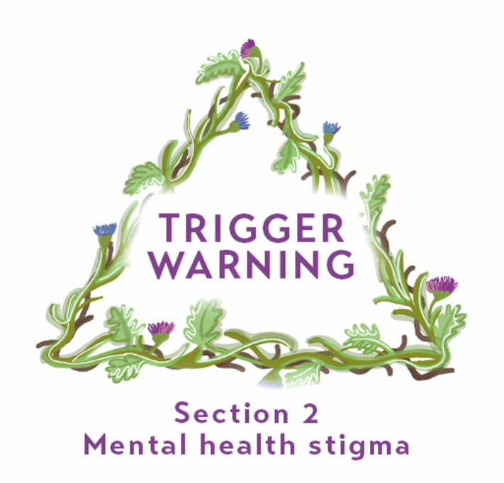
View description - Uncaptioned Figure
View alternative description - Uncaptioned Figure

By the end of this week, you should be able to:
- recognise stigmatising language and behaviours
- know how to challenge stigmatised beliefs and behaviours in a learning setting
- develop a stigma-free learning environment.

1 Being aware of stigmatising language and behaviours
When reading about mental health outside of this course, you may have come across the idea of ‘stigma’. This relates to negative views and attitudes others may have around mental health and mental illness. In the UK, the Mental Health Foundation describe the potential impact of this:

Stigma and discrimination make many people’s problems worse. It can come from society, employers, the media, and even our own friends and family. You may even experience internalised stigma, where you come to believe the negative messages or stereotypes about yourself.
(Mental Health Foundation, 2021)

This description is helpful as it demonstrates the various sources of stigma and the impact that it can have on a person’s wellbeing. Stigma and discrimination differ from each other in that stigma relates to a person’s negative and stereotypical beliefs and attitudes whereas discrimination is the actual behaviour that results from this belief.


View description - Uncaptioned Figure
View alternative description - Uncaptioned Figure

It is estimated that nearly nine out of ten people with mental health problems experience stigma in some shape or form in their lives (Change Your Mind, 2023). This can have further negative impacts on their lives and make it harder to find work, maintain relationships, feel included in their communities, and access education (Mental Health Foundation, 2021). Worryingly, we also know that where stigma is felt by individuals or groups of people experiencing poor mental health, they are also less likely to access specialist support services (Bracke et al., 2019; Gronholm et al., 2018). Therefore, it is important for you to understand what is meant by stigma, the impact it can have on learners, and how stigmatising views can be challenged within education.


View description - Uncaptioned Figure
View alternative description - Uncaptioned Figure

Activity 1 Exploring types of stigma
Allow about 20 minutes

Part 1 Stigma definitions

Match each type of stigma to its definition

Personal stigma
Perceived stigma
Internalised stigma
People’s beliefs about mental illness.
Beliefs people with mental illness have about the beliefs that others have about them.
When people with mental illness believe the negative beliefs that others have about them are true.
View answer - Part 1 Stigma definitions
View discussion - Part 1 Stigma definitions

Part 2 Stigma examples in your setting

Now take some time to consider how each type of stigma may be present in your own educational setting. Think about how learners may experience this, as well as your own experiences. How might stigma be consciously or unconsciously perpetuated? How can it be prevented?
Make a note of the examples, and your thoughts about them, or any questions that arise in your mind, so that you can refer back to these as you progress through this week.

Provide your answer...
View discussion - Part 2 Stigma examples in your setting

1.1 Stigmatising language and behaviour
Stigmatising language and behaviour about mental health often comes from outdated stereotypical views about what mental illness is and how it effects people (Mental Health Foundation, 2021). This was explained in Week 3, where you learned how historical perspectives of mental illness resulted in negative labelling within education systems. It can also include potentially harmful views that people experiencing mental illness are violent and dangerous. This is particularly stigmatising as those with mental illness are actually more likely to be harmed by others, or to harm themselves, than to cause harm (Mental Health Foundation, 2021).
Such stereotypes are often exacerbated by media use of stigmatising language, which can increase these stigmatised beliefs among the public (Ross et al., 2021). However, it is also important to note that the media can be a powerful source for challenging stigma and creating positive portrayals of those experiencing mental illness (Stewart, 2006).


View description - Uncaptioned Figure
View alternative description - Uncaptioned Figure

Stereotypical views may be particularly visible at specific events, or times of year, such as Halloween, and may have additional cultural significance. For example, writing for the UK-based charity Mind, Nicole Williams describes her experiences of seeing mental illness as a focus for costumes which are sold and worn around the community during Halloween:

Sadly, it isn’t the first upsetting costume I’ve seen – during my recovery I have seen ‘Mental Patient’ and ‘Psycho Ward’ costumes and even witnessed friends of friends choosing to wear them, and been told ‘it’s only a joke’, or ‘a bit of fun’.
(Mind, 2016)

The idea that ‘it is only a joke’ or ‘a bit of fun’ is a common one when people are challenged for displaying stigmatising beliefs around mental health and mental illness. Perhaps you noted this as one example in Activity 1. Did you also think about how such stigmatising beliefs might be challenged? This will be considered in the next section.

1.2 Racist stigma


View description - Uncaptioned Figure
View alternative description - Uncaptioned Figure

Stigma related to mental health may be particularly strongly experienced and felt among learners from specific racial backgrounds. For example, the UK’s ‘Black Students Talk’ peer support group, part of ‘Black People Talk’ social enterprise, has highlighted how stigma can be keenly felt among Black learners and how this can prevent them from seeking out help (Black People Talk, 2023). Here is an example of a summary social media post released in 2021 as part of Mental Health Awareness Month that clearly describes this lived experience of stigma.

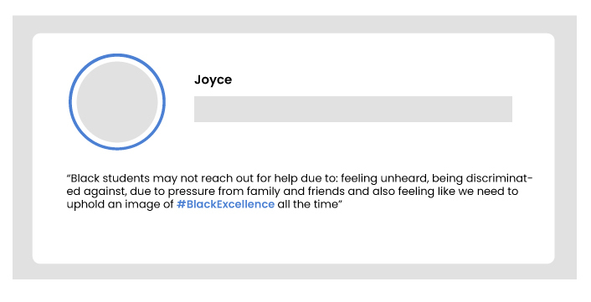
View description - Uncaptioned Figure
View alternative description - Uncaptioned Figure

Other ethnically diverse learners have reported similar experiences of stigma and its impact on help seeking (Maeshima and Parent, 2022).
This section has shown you why the idea that ‘it is only a joke’ is not OK for learners experiencing stigma and has put the case forward that such beliefs and behaviours need to be challenged within learning environments. You have also been prompted to return to the concept of intersectionality and to consider how different elements of someone’s identity can not only impact their wellbeing, but also their capacity to seek help. The next sections will explore how you can challenge stigma in your setting and support your learners’ help-seeking behaviour.

2 Challenge stigmatised beliefs within the learning community
Stigmatised beliefs can arise from a variety of factors. They may develop from a difference in cultural experiences and expectations, or from a lack of understanding or education about mental ill-health, or even from a misguided ‘fear’ about what mental illness entails. Such views may also be exacerbated by sensationalised media reporting which can reduce complex mental illnesses to simplistic ‘soundbites’ or may inappropriately highlight mental illness in stories focusing on crime or violence.


View description - Uncaptioned Figure
View alternative description - Uncaptioned Figure

In educational settings, where open discussion takes place, you may encounter stigmatised comments made by either learners or colleagues. Later in this week’s content you will look at how learning materials may be used to challenge some of this stigma, and to avoid reinforcing it, but first the focus will be on day-to-day conversations.

Activity 2 Personal experience of stigma
Allow about 10 minutes

- Watch the following video of James talking about his experiences of stigma, and how he has taken some steps to challenge this.

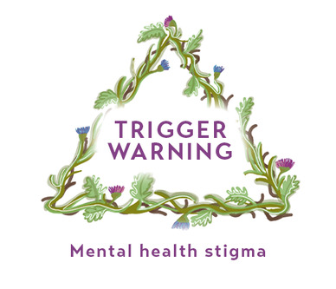
View description - Uncaptioned Figure
View alternative description - Uncaptioned Figure

Please note, this video involves an individual talking about his experiences of mental health stigma. Sometimes hearing other people’s accounts of their experiences of stigma and mental health can stimulate personal memories or feelings that may be upsetting. If you think this may be the case for you, skip to the next section.
James’s experience of challenging attitudes
- After listening to James’s comments take a look back at your list from Activity 1 to see if you have noted anything similar to the language and behaviours that he describes.

Provide your answer...
View discussion - Activity 2 Personal experience of stigma

2.1 How to challenge stigma in practice
James (from the video in the previous section) represents a successful programme of ‘Champions’ from Time to Change, a UK campaign aimed at challenging stigma in mental health, which ran until 2021. The Time to Change Champions devised a useful list of suggestions for challenging stigma around mental health (Time to Change, 2022). These can be applied by educators in learning environments and are listed below.
- Checking out what the person has said and asking them to explain, e.g. ‘What do you mean?’.
- Saying what you’d like to be different, e.g. ‘I would like you to stop describing people as “mad”’ rather than blaming the person or telling them their behaviour is wrong.
- Concentrating on the behaviour rather than the person, e.g. avoiding phrases like ‘You’re discriminatory’.
- Sharing facts about mental health which contradict (or challenge) what they’re saying.
- Sharing facts about your own experience which contradict what they’re saying, e.g. ‘I have schizophrenia and I don’t have a split personality’.
- Sharing your feelings about what the person is saying, e.g. ‘I feel hurt that you think people with depression are lazy’.
- Making comparisons with physical health to help people understand that mental health is just as important and serious.
- If the person is talking about people with mental health problems without knowing that you have one, it can really help to change what they think if you tell them ‘You’re talking about me at the moment’.
You may want to reflect on the suggestions above to consider how confident you might feel in using them to challenge stigmatising comments in your own learning environment. Would you feel confident to use them or would you find it difficult? If you wish, look back again at your list from Activity 1 and see if any of these suggestions might apply.


View description - Uncaptioned Figure
View alternative description - Uncaptioned Figure

Another Time to Change Champion, Micha, explains how challenging stigma can be difficult but is often effective:

When challenging stigma for the first time, it can be really scary. However, in my experience I have found that because, as a society, talking in a certain way about mental health has become the norm, sometimes people do not realise what they are saying … [But] I really do believe the more we challenge stigma the closer we get to gaining acceptance. Not just for the stigmatisers, as I call them, but for ourselves. Because hearing that language can be hurtful. So, the next time you hear something or see something, don’t be afraid to speak up. It’s really not so bad, just make sure you are calm, diplomatic and that at the end you know you will be ok.
(Time to Change, 2022)

Considering experiences like these can make you more aware of the presence of stigma and its impact on your learners as well as the importance they place on feeling supported and safe in their learning environment. In Week 1 (Section 4.3) you were introduced to the importance of creating ‘safe spaces’, and a key element of this is the creation of study and work environments that are free from stigma and discrimination.
It is not just words that can be used to challenge stigma, but also your actions and behaviours. These will be explored in the next activity.


View description - Uncaptioned Figure
View alternative description - Uncaptioned Figure

Activity 3 Actions to challenge stigma
Allow about 5 minutes

Aside from the actual words that you use in conversations, what other actions or behaviours could you adopt to challenge stigma?
You may like to think about things like:
- body language and posture
- tone of voice
- being constructive
- position and layout
- modelling.

Provide your answer...
View discussion - Activity 3 Actions to challenge stigma

3 Avoiding stigma in learning materials and terminology
In an educational context, the language and terminology used in learning materials, or course publicity materials, can powerfully communicate concepts, or stereotypes, around mental health. Materials that reflect stigma can create barriers to learning from the outset, or even before learners commence their chosen course (Coughlan and Lister, 2018). Such materials often fail to include the views and perceptions of diverse individuals in a meaningful way, for example in terms of their ethnicity, gender, sexuality, cultural background mental or physical health, or disabilities/differences (Lister et al., 2020). It has further been suggested that where learners are unable to identify with the language being used around their condition, disability or experiences, this becomes a key barrier to them seeking help (Lister et al., 2020). Historic examples of the use of stigmatising labels and language were also given in Week 3, Section 1.
The terminology that you yourself use can also be unintentionally stigmatising. For example, when talking about mental health the term ‘suffering from’ is often used without thinking. However, this risks pathologising everyday experiences like anxiety, stress or depression, which are commonly experienced and do not necessarily imply ‘illness’ (Kutcher, 2017). A more appropriate phrase might be to say ‘experiencing’ as this is a different concept to ‘suffering from’.
It is also worth considering the above in terms of any external visitors or guests that you invite into your learning sessions. It may be worth having a conversation with your guest beforehand to confirm that no materials to be used, or discussed, are stigmatising, particularly in terms of mental health. External visitors may inadvertently deliver content which can cause distress and harm if their presentation is poorly planned, or they are not appropriately prepared.


View description - Uncaptioned Figure
View alternative description - Uncaptioned Figure

Activity 4 Identifying stigma in learning materials and terminology
Allow about 10 minutes

Carefully examine, or think about, learning materials that you are currently using to see if any content expresses mental health stigma or is discriminatory. If so, had you noticed this before? Can such content be removed, replaced or challenged?
Think about your own use of terminology in your role as an educator. Are there any instances where you might unconsciously be using terminology that could be stigmatising? If so, could that be changed?
Look back again at your notes from Activity 1, Part 2 to see if you already included stigma in learning materials and terminology in any of your examples or wish to add it in for further consideration.

Provide your answer...
View discussion - Activity 4 Identifying stigma in learning materials and terminology

4 Stigma-free curriculum design
Watch the first two minutes of the following video entitled ‘Education for Mental Health’; feel free to watch the rest if you have more time. Consider how the curriculum, and those who deliver it in your setting, could potentially be impacting on the wellbeing and mental health of learners. Stigma is not specifically mentioned here, but there is emphasis on the importance of a sense of belonging to wellbeing; stigma can create a significant barrier leading to a damaging sense of isolation in place of belonging.

Video content is not available in this format.
View transcript - Uncaptioned interactive content

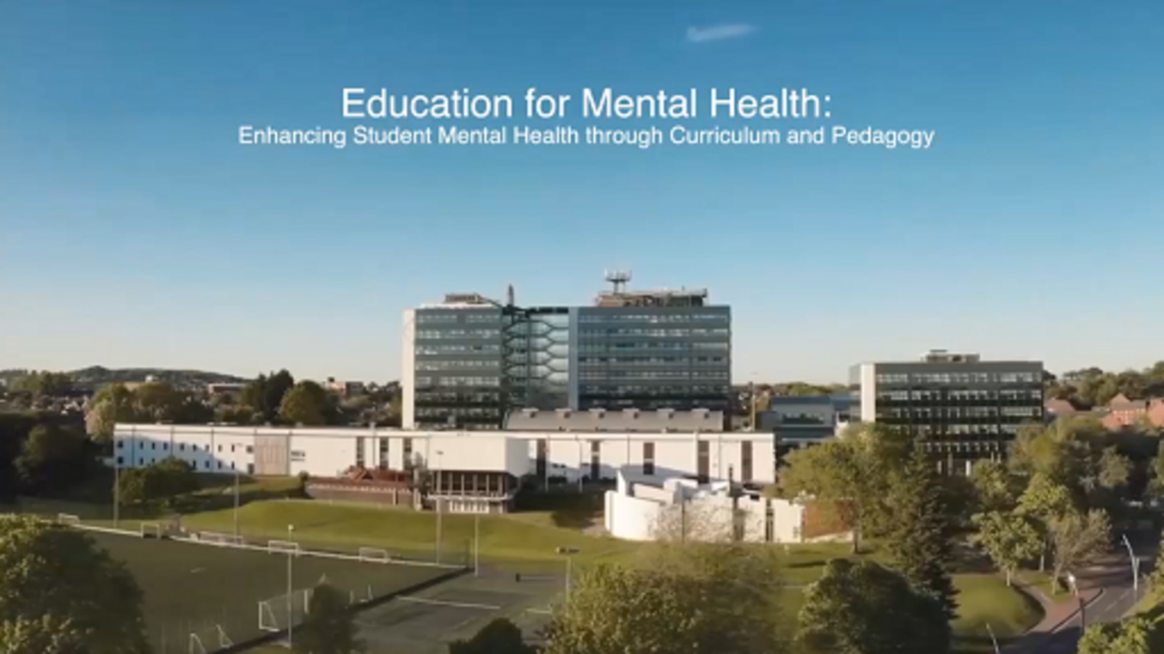

This video clip can help you reflect on the impact of mental health in terms of the curriculum. You may have noted the following points:
- Thinking about curriculum and mental health doesn’t mean lowering standards or ‘making things easier’.
- When learners are properly prepared for academic challenges, this can be conducive to wellbeing. This is enhanced when learners find their learning meaningful and engaging; to be so, the learning needs to be stigma-free.
- Staff development can help challenge incorrect assumptions about these issues. This can include being confident to challenge stigmatising beliefs, behaviours and learning materials.

5 Wellbeing activity for this week
Almost everyone feels overwhelmed at times with tasks that need to be done in their life including work tasks, study, jobs that need doing at home, personal or caring duties and so on.
When you find yourself feeling overwhelmed, and struggling to know which way to turn, the 4D method can provide a route out of the chaos.
The four Ds stand for:
- Do
- Defer (Diary in)
- Delegate
- Delete (Drop)
Start by writing a list of everything you have to do. It’s best to be specific rather than just listing general issues and don’t forget to include your everyday tasks as well.
Now you can start to consider:
- Which of these tasks do you need to get done? (Do)
- Which tasks can be postponed for a later date? (Defer)
- Which tasks could someone else help you with? (Delegate)
- Which tasks don’t really need to be done? (Delete)
Once you have narrowed your tasks down to the ones that you must do, you can then prioritise them using the Eisenhower method (see the links below for more information).
Forbes: How To Use The 4 Ds Of Effective Time Management
FourWeekMBA: The Four Ds of Time Management
MindTools: Eisenhower’s Urgent/Important Principle - Using Time Effectively, Not Just Efficiently

6 This week’s quiz
Well done – you have reached the end of Week 5. You can now check what you’ve learned this week by taking the end-of-week quiz.
Week 5 practice quiz
Open the quiz in a new or window and come back here when you have finished.

7 Summary of Week 5
This week you have explored definitions of stigma, as well as the impact of stigmatising language and behaviours on learners. You have also considered how to promote a stigma-free learning environment, stigma-free learning materials and learning practice, and how to create confidence and self-belief in your learners to support their mental health, progress and achievement.
The main learning points of this week are:
- Stigmatising language and behaviours need to be recognised and challenged.
- Effective challenge can be achieved by means of appropriate words and actions.
- The promotion of a stigma-free learning environment, learning materials and learning practice can significantly enhance learner confidence, wellbeing and success.
In Week 6 you will go on to look at the social and cultural dimensions of mental health in learning environments.
You can now go to Week 6.

Week 6: Social and cultural dimensions of mental health in learning environments

Introduction

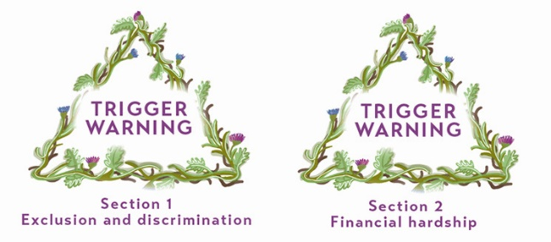
View description - Uncaptioned Figure
View alternative description - Uncaptioned Figure

Some of the content for this week may be triggering, potentially reminding you of experiences you have of being excluded or discriminated against. Such experiences can be painful to recall, so if you would rather avoid such content you can skip over Sections 1 and 2 and go directly to Section 3 which focuses on support.
We are all shaped by the cultures in which we are born and raised and societies in various parts of the world have very different perspectives and attitudes towards mental health. These socio-cultural influences can profoundly impact learners, both in their own culture and if they find themselves in a new culture for their study, for example as an international learner.
This week you will reflect on various cultural perspectives about mental health, consider the impact of cultural and social factors on wellbeing and explore the relevance of the concept of ‘belonging’ to mental health. You will also look at how you can support the wellbeing of socially and culturally diverse learners.


View description - Uncaptioned Figure
View alternative description - Uncaptioned Figure

By the end of this week, you should be able to:
- understand the importance of belonging in mental health and how belonging can be influenced by culture
- be aware of varied cultural ideas about mental health
- recognise the impact of stereotyping, prejudice and discrimination in terms of characteristics such as race, ethnicity and religion (in the UK these are protected characteristics as identified under the Equality Act, 2010)
- know more about how to support the wellbeing of diverse learners.

1 Belonging, difference and mental health
The importance of social belonging has long been recognised as a key element of wellbeing and mental health (Baumeister and Leary, 1995). It can be defined as the desire to feel part of a group and to have meaningful social relationships, and is linked to friendship, trust and feelings of acceptance (Gijn-Grosvenor and Huisman, 2020). A sense of belonging is a significant aspect of Maslow’s (1943) Hierarchy of Needs that you were introduced to in Week 1. In an educational setting, feelings of belonging or difference can be closely influenced by social and cultural similarity or difference.


View description - Uncaptioned Figure
View alternative description - Uncaptioned Figure

Every learner’s cultural identity is multi-layered, based on factors such as their upbringing and family background, their community, peer or other groups that they are part of, or would like to be part of, their national identity and ethnicity. Belonging provides a sense of safety and comfort (Gilbert, 2013) so learners who feel isolated, ‘different’ or unrepresented in their learning environment can feel particularly vulnerable and this may negatively affect their mental health (Brandt et al., 2022).


View description - Uncaptioned Figure
View alternative description - Uncaptioned Figure

Activity 1 Considering cultural identity
Allow about 15 minutes

Make a list of significant groups that you currently belong to, or have belonged to in the past, such as family, community, sports, religious or hobby-related groups. Think about the customs, habits, routines, celebrations or religious practices of these groups and note how they may have shaped your own cultural identity and sense of belonging.
Now consider the case study of Viraj (from the Case studies), and/or think of your own group(s) of learners. How might your own sense of cultural identity be similar or different from his, or from your group(s) of learners? What impact might that have on your teaching and on their learning?

Provide your answer...
View discussion - Activity 1 Considering cultural identity

1.1 Ethnicity and race
Ethnicity and race underpin specific types of belonging that are often associated with significant differences in learners’ experiences of mental wellbeing. For example, Lazaridou and Fernando (2022) have shown how institutional racism, and ingrained ‘white’ perspectives in society, can increase the mental health burden on learners.


View description - Uncaptioned Figure
View alternative description - Uncaptioned Figure

Ethnicity and race differ from cultural identity in that cultural identity is associated with particular practices, concepts and worldviews. Whereas ethnicity and race are based on being categorised on the basis of characteristics that you have no control over, such as your skin colour or family/place of birth.
People may be categorised and unfairly treated in a particular way purely because of those characteristics, even though they have no control over them, as demonstrated in some of the examples of stigma and racism against Black learners, given in last week’s materials. Another example is how those with learning differences, such as dyslexia, used to be inappropriately classified as ‘educationally sub-normal’ (ESN), as highlighted in the historical section of Week 3. Such categorisation is no longer acceptable.
Nowadays, it is generally recognised that categorising individuals on the basis of attributes such as race or ethnicity is based on ideas created and accepted by societies for a specific purpose which need to be critically examined. For example, the Law Society UK (2022) has described how race categorisation is seen as ‘rooted in white supremacy and efforts to prove biological superiority and maintain dominance over others’. This type of categorisation, the assumptions behind it and the negative impacts for many, is therefore rightly being challenged. However, despite negative experiences of racism, racial identity can also remain an important and positive part of an individual’s cultural identity and wellbeing.
In an educational context, learners may experience any or all of the following:
- stereotyping: for example assuming they have shared attributes based solely on race or ethnicity
- prejudice: beliefs based on stereotyping, such as negative attitudes towards Black or Asian learners
- discrimination: that is action(s) based on prejudiced beliefs, such as an educator wrongly assuming that a learner is more, or less, likely to succeed based simply on their race.
Such stereotyping, prejudice and discrimination do not only apply to race or ethnicity; they may also be inappropriately based on other attributes such as class, or regional accents, and may also be targeted at learners based on their sexuality, gender identification or those with disabilities. In the UK, the Equality Act (2010) legislates to prevent discrimination of individuals because of their characteristics which include sex, gender, ethnicity and disability. As an educator it is important to not only recognise but also to challenge such stereotyping, prejudice and discrimination in order to provide a safe, supportive and inclusive learning environment for diverse learners. This is also addressed elsewhere in this course including in the creation of safe spaces (Week 1), in the challenging of stigmatising beliefs (Week 5) and throughout Week 3.

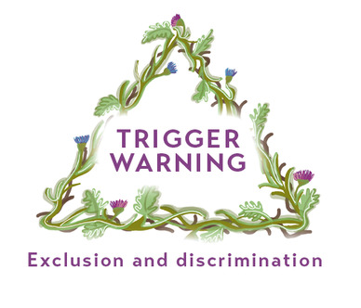
View description - Uncaptioned Figure
View alternative description - Uncaptioned Figure

This activity may be triggering, potentially reminding you of experiences you have had of being stereotyped or discriminated against. Such experiences can be painful to recall, so if you would rather avoid such content you can skip this activity and go to the next section or go directly to Section 3 which focuses on support.


View description - Uncaptioned Figure
View alternative description - Uncaptioned Figure

Activity 2 Ethnicity and race in an educational setting
Allow about 10 minutes

Can you think of, or do you have personal experience of, ethnic or racial stereotyping, prejudice or discrimination within your educational setting? Have you also identified these in educational materials (you may want to refer back to Week 5, Section 3 for more on this)?
Can you think of ways in which this might impact on a learner’s mental health?
How could such stereotyping, prejudice and discrimination be prevented? What policies and procedures does you institution have in place to support this? How effective are they?

Provide your answer...
View discussion - Activity 2 Ethnicity and race in an educational setting

1.2 Religious stereotyping
Learners with diverse religious beliefs may experience religious stereotyping and discrimination that can profoundly affect their learning experience. In one research project in the USA, 69% of Muslim women who wore a hijab (headscarf) reported an incident of discrimination compared to 29% of Muslim women who did not wear one (American Civil Liberties Union, 2023). Muslim learners in UK university student forums have also talked about the impact of receiving negative comments about their clothing, lack of flexibility in exam and lecture scheduling during fasting periods, such as Ramadan, and about being stereotyped as ‘terrorists’.

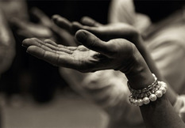
View description - Uncaptioned Figure
View alternative description - Uncaptioned Figure

The UK Muslim comedian, Guz Khan, describes his own experience of this stereotyping in comic fashion in the following short video: We need to talk about the whole Muslim/terrorist/stereotype thing/Live at the Apollo. Please be aware that some swear words appear in the video.
This was recorded at the Apollo Theatre in London and one viewer wrote the following caption after viewing it:

People say we should not make jokes about sensitive matters, but comedy puts people together, and makes us realise how ridiculous it is to judge people by their culture, religion skin colour, etc.

Activity 3 Religious stereotyping
Allow about 5 minutes

Reflecting on Guz Khan’s video can you think of instances of religious stereotyping that you have witnessed, experienced or heard about in your learning environment?
What impact do you think they might have on a learner with poor mental health?
How might such religious stereotyping be prevented in your setting?

Provide your answer...
View discussion - Activity 3 Religious stereotyping

1.3 Specific challenges to belonging: international learners
International learners may experience specific challenges to belonging for, not only are they far away from their home community, but they may also be unfamiliar with educational practices in their host country. For example, learners who are used to rote-learning, listening rather than talking, and not questioning lecturers, which is accepted practice in their own culture, may find more direct communication styles and presentation requirements particularly challenging or anxiety-provoking (Forbes-Mewett and Sawyer, 2016).


View description - Uncaptioned Figure
View alternative description - Uncaptioned Figure

Being unfamiliar with aspects of everyday life in a new cultural environment, such as renting a room, accessing the health system or language difficulties can also increase the pressures being felt. There may also be acute financial pressures, for although international learners are sometimes seen as wealthy, they or their families may have taken out substantial loans in order to join a course abroad, or they may be tied to government schemes with reporting and performance duties, all of which can adding to the mental stress being experienced (Forbes-Mewett and Sawyer, 2016).
Many educational organisations helpfully provide a variety of social opportunities, familiarisation activities and other events for international learners, to provide advice and information and facilitate the development of new support networks. In-person social events may particularly benefit some personality types. In universities, Thomas (2012, in Mander and Brown, 2021) found social events can enhance learners’ sense of belonging. This in turn enabled learners to develop their social identity which can have a positive impact on retention and academic success. However, more introverted learners may avoid these and feel more comfortable obtaining help and support online, or even anonymously.
Feeling alienated by educational practices and systems is not an experience exclusive to international learners. Many home learners may also feel unfamiliar with their educational institution’s ways of working, depending on its inclusivity and ability to adapt to specific learner needs.

Activity 4 Challenges facing international learners
Allow about 5 minutes

Look back at the case study of Viraj (from the Case studies) and make a list of the specific challenges that you think he might be facing as an international learner who has come to study in the UK, and the impact these might have on his mental health. What might you, as an educator, or your institution, provide to support him in dealing with these challenges and promote his positive mental health?

Provide your answer...
View discussion - Activity 4 Challenges facing international learners

Further information on how to support international learners during their transition to university is available from The Charlie Waller Trust.

2 Varied cultural perspectives of mental health


View description - Uncaptioned Figure
View alternative description - Uncaptioned Figure

Cultural perspectives of mental health, and mental health conditions, vary over time and between environments. As an educator, you can support learners who experience poor mental health through demonstrating cultural competence.

2.1 Cultural competence


View description - Uncaptioned Figure
View alternative description - Uncaptioned Figure

Cultural competence requires that, as an educator, you possess interpersonal awareness, an interest in cultural knowledge and the skills to provide learning conditions conducive for learners coming from cultures other than your own, and/or the mainstream culture in which your educational institution exists (Seeleman et al., 2009). This involves a willingness to understand cultural beliefs, values, attitudes, traditions and language preferences which may differ from your own. It requires a curiosity about the learner’s position and background, and how these may impact on their mental health, and any mental health conditions they may experience, as well as a willingness for ongoing reflection on your own cultural background and assumptions. Without cultural competence, it can be challenging to build effective professional relationships for education, and inclusion can be compromised.
Figure 1 is a model for cultural competence originally used in health care. It demonstrates the attributes necessary to achieve cultural competence, namely cultural awareness, cultural skill, cultural desire, cultural encounters and cultural knowledge.

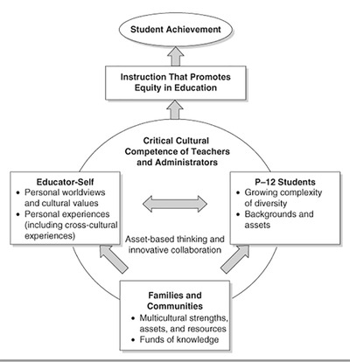
Figure 1 Critical Cultural Competence Model from Cooper et al. (2011).
View description - Figure 1 Critical Cultural Competence Model from Cooper et al. (2011).
View alternative description - Figure 1 Critical Cultural Competence Model from Cooper et al. (2011).

The knowledge and skills for inclusively involving other cultures that are embodied in cultural competence also involves ‘cultural humility’. This refers to the need to reflect on your own cultural background and assumptions, including your values, practices and responses. It also requires a willingness to be open to learning new things about unfamiliar cultures and not assuming that one is ‘better than’ or ‘superior to’ another. Your cultural humility can help learners to consider and communicate their needs and practices and to view them not so much as ‘other’ than the mainstream, but as equally valid and worthy of exploring and communicating. This can support the levelling up of cultural inequalities for learners. More recent models of cultural competence, such as Cooper et al.’s (2011) Critical Cultural Competence model, include the need for self-reflection, and consider cultural knowledge exchange as a dynamic process, which cannot be learned from books, but which requires dialogue and an open attitude with learners and communities.

Activity 5 Reflecting on your cultural competence
Allow about 10 minutes

This activity invites you to reflect on your own cultural competence, and cultural humility, by thinking about and writing notes on the following.
Do you enjoy teaching learners from other cultural backgrounds to your own or do you find it challenging? (Answer honestly, as this is for your own reflection and learning and you do not need to share this with anyone else.) If you answer positively, what enables your enjoyment and how could you further develop your competence and skills in this area? Or, if you find it challenging, what might be the particular challenges and how might you resolve them?
Considering Cooper et al.’s (2011) model above, reflect on your own level of cultural awareness, cultural skill, cultural desire, cultural encounters and cultural knowledge. Consider your ‘cultural humility’. What are your cultural assumptions, including your values, practices and responses, and how open are you to learning about cultures that may be unfamiliar to you?

Provide your answer...
View discussion - Activity 5 Reflecting on your cultural competence

2.2 Cultural competence and mental health difficulties
Watch the following video of Patrice, a learner with The Open University in the UK, who describes attitudes towards mental health in her culture and her experiences of studying with a mental health condition. Listen to how her cultural background made it hard for her to seek help initially, but also note her positive experiences after feeling able to be open about her mental health.

Video content is not available in this format.
View transcript - Uncaptioned interactive content

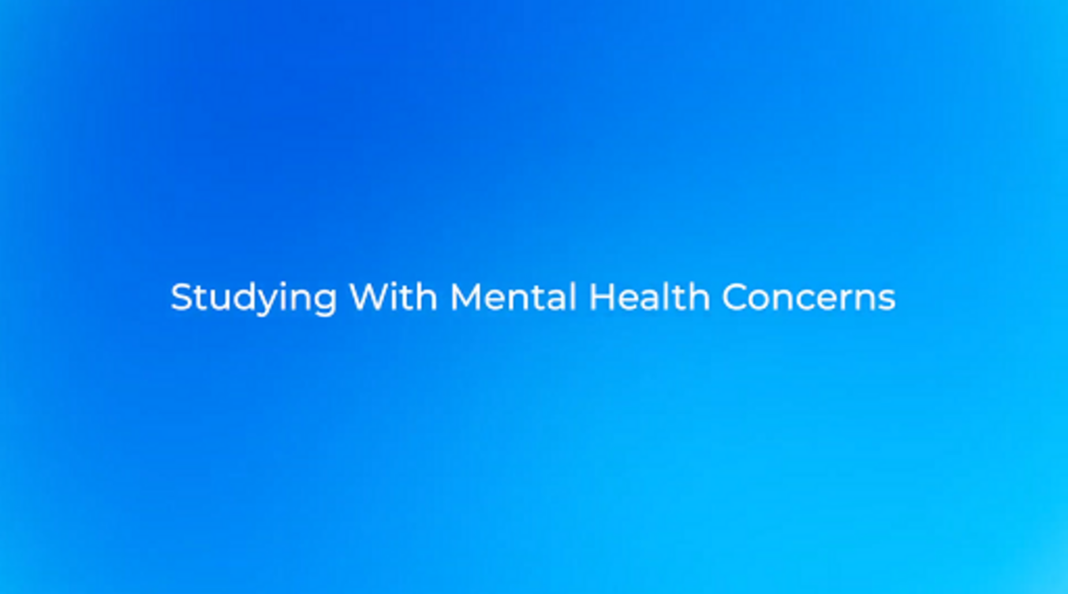

Patrice’s background experience is not unique; many societies and cultures describe people with mental health needs as if they are outside of the so-called ‘normal’ population. These ‘stigmatising discourses’ can cause unhelpful and unjustified feelings of shame, as someone who needs support for their mental health are made to feel different to others, and that they do not belong, or even do not deserve to belong. For example, Zolezzi et al. (2018) note that in many Middle Eastern Arab countries stigmatising views relate mental health difficulties to being ‘God’s punishment’. They also report how, in many Western countries, people experiencing poor mental health are viewed as being potentially dangerous and violent.


View description - Uncaptioned Figure
View alternative description - Uncaptioned Figure

In Week 5 you learned how language can be stigmatising and so will appreciate how both these types of stigmatising beliefs are likely to cause affected learners to feel ashamed, or uncomfortable, about their difficulties, and to be less likely to open a conversation about their mental health and support. Section 1.1 of this week, on ethnicity and race, also showed how this can lead to stereotyping, prejudice and discrimination of minoritised people who may be experiencing poor mental health.
As a result, learners who feel uncomfortable talking openly about their mental health may instead express poor mental health via emotional or bodily symptoms. They may state that they feel generally unwell, have a stomach condition or a headache, which is more accepted in their own culture and suppresses any feelings of shame (Helman, 2007).
Nowadays there is more awareness of a body–mind connection (see for example Bullmore, 2018), and so it is more generally recognised that physical symptoms may also be linked to poor mental health.

Activity 6 Considering cultural concepts of mental health
Allow about 5 minutes

Take a moment to reflect on the attitudes and beliefs around mental health that Patrice describes growing up with.
You may also want to replay the video from Week 5, Activity 2, where James talks about his Western cultural experience of being labelled ‘crazy’ and a ‘nutter’, which he describes as unhelpful and ‘not who I am’. Reflect on how labelling of this nature can impact on a learner’s identity.
Now make some brief notes on the attitudes towards mental health in your own culture and/or organisation. Have they changed over time? Could they be improved?

Provide your answer...
View discussion - Activity 6 Considering cultural concepts of mental health

2.3 Socio-economic effects on learner mental health
In Week 1 you were introduced to Dahlgren and Whitehead’s model for the social determinants of health and the concept of intersectionality. According to that model and concept, financial difficulties can interact with the social and cultural ones previously described to increase learner disadvantage (Crenshaw, 1989). Financial strain is common among adult learners who often have to pay significant course fees and may also need to reduce their working hours, or pay for additional childcare, while studying. This can create additional financial pressures, despite the longer term aim of increasing their earning potential through their educational qualification.


View description - Uncaptioned Figure
View alternative description - Uncaptioned Figure

The added stress of financial worries, even temporarily, may affect decision-making, problem-solving and creative thinking and, as a result, learning generally becomes harder (Mani et al., 2013). Under performing may add to feelings of failure and guilt that can negatively impact on confidence and self-esteem. This may be reinforced by social stigmas which falsely assume that people in poverty are abdicating responsibility for their lives or are less intelligent (Mullainathan and Elder, 2013). These authors have also shown that financial stress leads to impaired performance on various cognitive and life tasks. Although brief experience of different types of scarcity may be useful in focusing the mind, longer term shortage – for example in terms of lacks in job security, housing, finance and food – can be very damaging (Diggle et al., 2017; Mullainathan and Elder, 2013). In learners, such scarcity and financial, or other, economic deprivation can result in increased levels of anxiety and impaired performance in academic tasks.

Activity 7 Support for learners in financial difficulty
Allow about 5 minutes



This activity refers to financial hardship, which may be triggering if this has been a difficult memory or experience for you. If you would rather avoid recalling this you can skip this activity or go directly to Section 3 which focuses on support.
Think of a time when you were short of money. What short- and/or long-term effect did this have on your stress levels and physical and mental health? Did it impair your decision-making and problem-solving skills and ability to cope?
How might you become aware that a learner is experiencing financial difficulties?
What financial support services does your institution offer?

Provide your answer...
View discussion - Activity 7 Support for learners in financial difficulty

3 Supporting socially and culturally diverse learners’ wellbeing


View description - Uncaptioned Figure
View alternative description - Uncaptioned Figure

In the previous sections, some ways of supporting diverse learners have been introduced. Now some practical examples will be explored in more detail. They are how to:
- promote help-seeking behaviour
- address unconscious bias and microaggressions
- use microinterventions to stop microaggressions
- decolonise the curriculum.

3.1 Promoting help-seeking behaviour

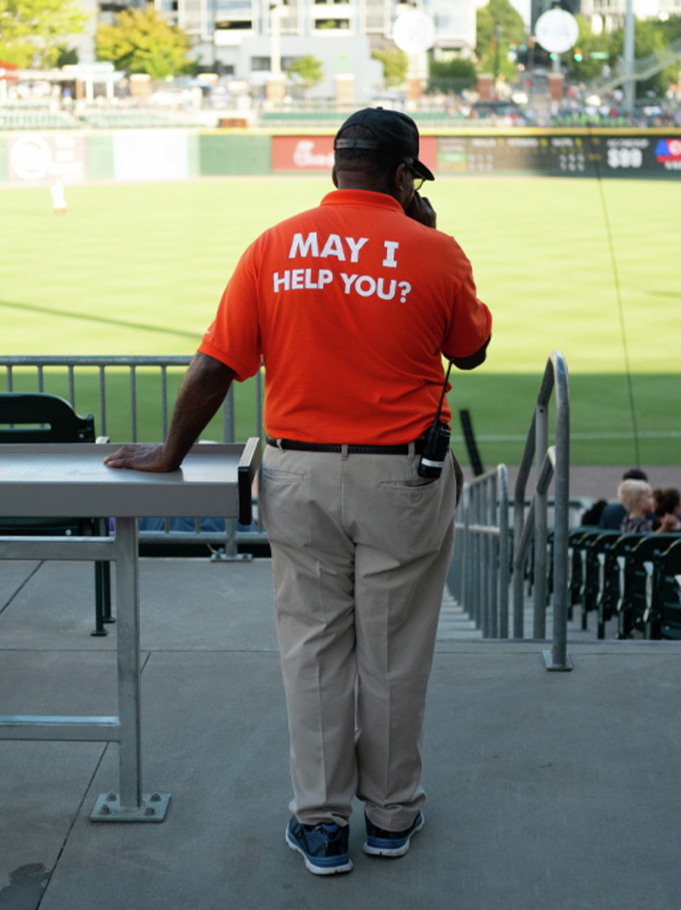
View description - Uncaptioned Figure
View alternative description - Uncaptioned Figure

Butcher, Awan and Gray (2021) explored why Black Open University learners are less likely to declare mental health needs and how this could be facilitated. They recommend reassuring Black, and other minority ethnic learners, that there is no need to be anxious or embarrassed about discussing their needs. Good practice recommendations include inviting Black and other minority ethnic learners to consider their emotional responses at critical points during their study and providing good access to mental health resources. Alongside cultural competence training, these actions can promote help-seeking behaviour for those with undeclared mental health conditions.

3.2 Addressing unconscious bias and microaggressions


View description - Uncaptioned Figure
View alternative description - Uncaptioned Figure

Unconscious bias can be defined as acting on the basis of false assumptions and beliefs. Sue and Spanierman (2020) argue that it must be identified and addressed to prevent ‘microaggressions’, that is subtle slights that are consciously, or unconsciously, targeted at marginalised groups, such as a person of a specific race or ethnicity. Section 3.3 includes a thought-provoking video which can also aid your understanding of microaggressions. Such microaggressions could be reflected in an educator who has low expectations of certain learners’ academic or language ability or who gives a learner inappropriate praise for simple everyday tasks.

Activity 8 Increasing awareness of unconscious bias
Allow about 5 minutes

Consider the case study of Jolanta (from the Case studies). Jolanta is middle aged, single, left school early, has a disability, is low in confidence, and lives in a deprived area. What potential biases and expectations might you have when trying to support her with her upcoming assignment? What impact might these have on her learning experience?

Provide your answer...
View discussion - Activity 8 Increasing awareness of unconscious bias

3.3 Using microinterventions to stop microaggressions
Microinterventions are actions or words used to call out, or stop, instances of microaggressions when they occur. An example might be to point out the unintentional nature of a perpetrator’s microaggression, for example by stating ‘I don’t think you realise this, but your comment could be interpreted as implying xyz’. In the example above, this could relate to low expectations of the learners’ aspirations or abilities. It can then also be useful to point out any potential implications of the comment made, such as ‘Such a comment might make people feel they do not belong/are not understood/valued’.


View description - Uncaptioned Figure
View alternative description - Uncaptioned Figure

Furthermore, the potential effect or impact of the microaggression can be discussed, such as ‘It may make it hard for people to trust/collaborate’, or in the example above ‘This might demotivate the learner and not bring out her full potential’. Section 2.1 in Week 5, which gave examples of how to conduct conversations to challenge stigma, can also help inform such interventions.
It can also be useful to point out the advantages of awareness of microaggression, for example how it can lead to more effective educators and teams and safer learning spaces for all.
Watch this video showing examples of microaggression and ideas for effectively combating it.

Watch the video at YouTube.com.

3.4 Decolonising the curriculum
A particular form of microaggression is the exclusion of cultural or ethnic groups from representation in learning resources. For learners to feel they belong, their lifeworld needs to be represented in teaching materials and examples. This can be achieved by decolonising your curriculum, that is, ensuring that diverse voices and perspectives are well represented and that knowledge and information from alternative sources has not been marginalised or omitted (Arshad, 2021).


View description - Uncaptioned Figure
View alternative description - Uncaptioned Figure

Some educators lack confidence in approaching decolonisation of the curriculum. For example, it is recognised that white educators may experience discomfort, or a sense of ‘imposter syndrome’, and may be criticised for their lack of lived experience, when they attempt to address, or teach, issues of racism with their learners (Smith et al., 2017). However, this is not a reason for inaction. Smith and her colleagues advocate an honest position, and an opening of debate, in which educators can express that they don’t know everything and need to keep learning themselves. Being open to differences and opinions, and adopting a non-defensive stance, is most likely to contribute to non-racist identities and experiences for all learners.

Activity 9 Facilitating curriculum decolonisation
Allow about 15 minutes

Look through the learning resources that you will use this week or next week or that represent your programme in general and consider the following questions.
- Which groups are represented?
- How are they represented?
- Is the representation diverse?
- Is a specific group represented in a stereotypical way?
- Are any groups from among your learners unrepresented or under-represented?
- How will you address this in your teaching session(s)?

Provide your answer...
View discussion - Activity 9 Facilitating curriculum decolonisation

4 Wellbeing activity for Week 6

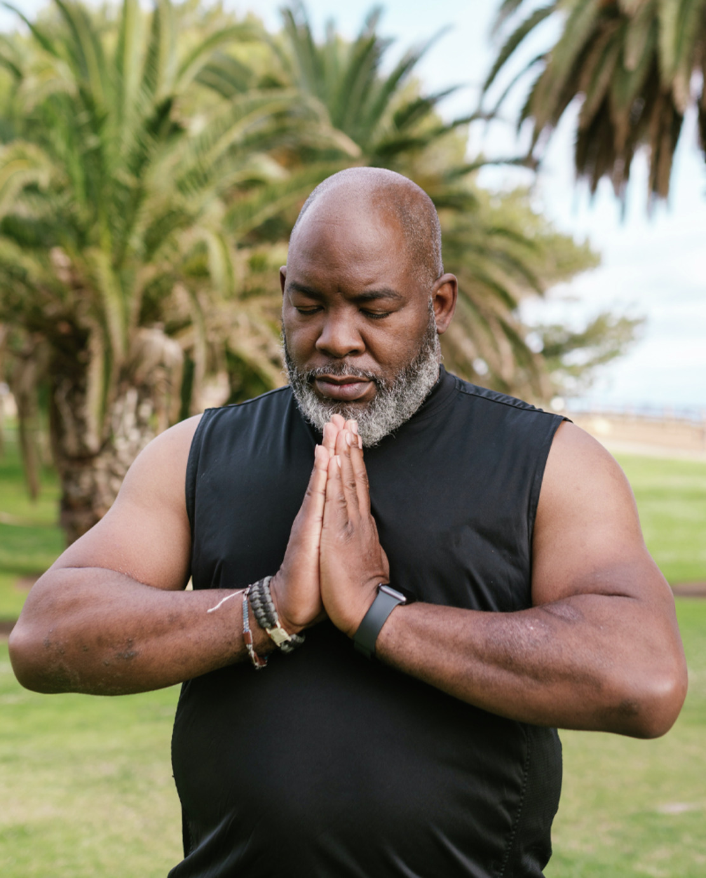
View description - Uncaptioned Figure
View alternative description - Uncaptioned Figure

Anyone who plays a sport, or is serious about their fitness, knows that rest and recovery are an important part of any training plan. If there is inadequate rest the person will soon become tired and run down and performance will drop. Similarly rest and recovery are important for educators in order to maintain optimal performance and ‘re-charge batteries’. This can be achieved by building in different forms of ‘down time’, relaxation or ‘switching off’ into your working and everyday life.
Take some time to reflect on what helps you to feel calm, relaxed and re-energised. Then consider how much time each relaxation or re-energising activity takes and if any require any special arrangements – for example, maybe some can only happen with certain people or in certain places, or at specific times.
Finally, think about when in your day, week and month you could appropriately fit such relaxation and recovery activities into your schedule. For example, a brief coffee and chat with a colleague(s), some deep breathing or a mindfulness activity, may only take up 10 minutes but could provide a useful break giving you a chance to relax your mind and body. These might therefore be good actions for when you quickly need to de-stress and re-focus in between academic work and teaching or at the end of the day.
Just like the pre-flight checks on a plane, where you are asked to fit your own air supply first before helping others, you need to prioritise your own relaxation, recovery and wellness. If you are not OK, how will you be able to support others?

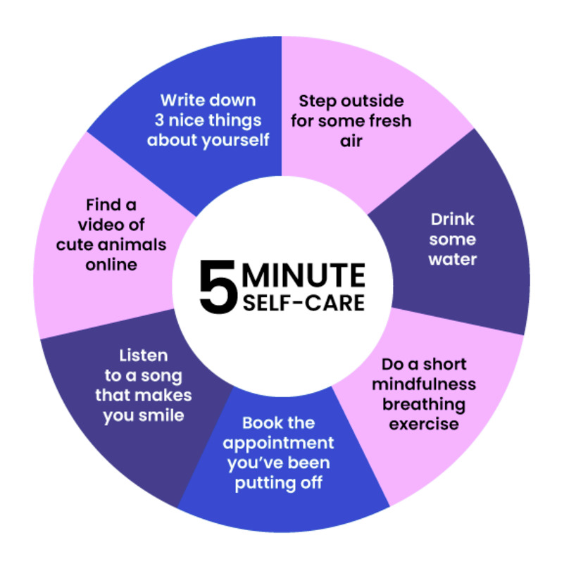
View description - Uncaptioned Figure
View alternative description - Uncaptioned Figure

5 This week’s quiz
Well done – you have reached the end of Week 6. You can now check what you’ve learned this week by taking the end-of-week quiz.
Week 6 practice quiz
Open the quiz in a new or window and come back here when you have finished.

6 Summary of Week 6


View description - Uncaptioned Figure
View alternative description - Uncaptioned Figure

This week you have learned about varying cultural and social perspectives on mental health and considered the relevance of belonging and issues such as racial discrimination and religious stereotyping. You have also explored ways to support the wellbeing of socially and culturally diverse learners.
The main learning points for this week are:
- A sense of belonging is a key determinant of mental health.
- Varied cultures represent mental health in different, often negative, ways.
- Cultural perceptions can make it difficult for some learners to speak up about their mental health difficulties, declare them and/or seek help.
- Cultural competence, alongside increased awareness of unconscious bias, the promotion of help seeking and decolonising of the curriculum, can all support diverse learner wellbeing.
In Week 7 you will go on to look at how to create everyday wellbeing strategies for adult learning environments and how to build resilience.
You can now go to Week 7.

Week 7: Promoting wellbeing and building resilience

Introduction
In Week 7 you will explore opportunities to promote wellbeing within your everyday teaching and ways of supporting learners to develop resilient behaviours, especially in dealing with their study challenges.
By the end of this week, you should be able to:
- identify barriers to and enablers for learner wellbeing
- recognise the wellbeing value of assessment choice and feedback
- summarise strategies to ensure group work can support learner wellbeing
- understand the negative impact of emotive and triggering content on learners’ wellbeing and resilience
- encourage the development of resilience skills in learners.


View description - Uncaptioned Figure
View alternative description - Uncaptioned Figure

Promoting positive wellbeing with your learners is not only beneficial for their overall life, but also provides benefits for their academic achievement (Suldo et al., 2011). Greater levels of wellbeing in learners also correlates with personal attributes such as self-confidence and a growth mindset (King, 2017). The past six weeks have already touched on some approaches for reducing and coping with stress and anxiety, but this week there will be more of a focus on general learner wellbeing and on the prevention of mental health imbalance via the promotion of resilience skills.

1 Barriers and enablers to learner wellbeing as well as the consequences of resilience and stress
What is really meant by ‘wellbeing’? If you think back to Week 1, defining wellbeing was the first activity that you were asked to complete. In Week 1 you were also introduced to how displayed emotions can be an indicator of mental health status. Similarly, personal wellbeing, rather than being defined by a set of rules or requirements, is impacted by emotions in response to different situations. To help you explore how emotions are associated with wellbeing, you may find looking at the Warwick and Edinburgh Wellbeing Scale a useful guide. It is also important to note that wellbeing, and more specifically poor wellbeing, is not the same as experiencing a mental health condition. While the two might hold a relationship with each other, someone diagnosed with a mental health condition can experience positive wellbeing.
Resilience is different to wellbeing, but the two are linked and can impact each other. There are various definitions of ‘resilience’, and many include the themes of overcoming some form of adversity and ensuring that the emotional strain of a particular situation does not result in long-lasting detrimental effects on the individual. Neither of these resilient outcomes are surprising as ‘resilio’ is a Latin word meaning ‘rebound’ or ‘spring back’. Resilience can help someone to manage the practical, as well as emotional, challenges of a situation (Herrman et al., 2011) and is eloquently explained in the American Psychological Association (2022) definition: ‘the process and outcome of successfully adapting to difficult or challenging life experiences, especially through mental, emotional, and behavioural flexibility and adjustment to external and internal demands.’
Resilience is dynamic and can change over time and in response to different situations (Connor and Davidson, 2003). To help explain how resilience can be developed and strengthened, the resilience skills model below, based on a resource produced by Baker et al. (2021), identifies key components of resilience and provides structure and guidance on how to promote and maintain resilience skills over time. You may identify with some of these as you progress through this week’s content.

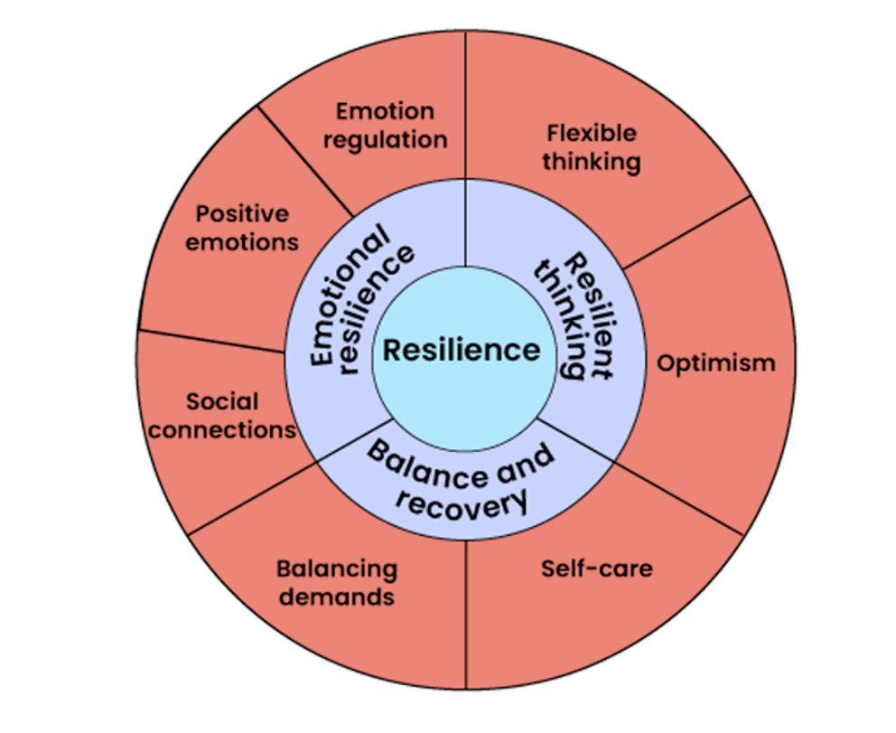
Figure 1 A skills-based model of personal resilience (based on Baker et al., 2021).
View description - Figure 1 A skills-based model of personal resilience (based on Baker et al., 202 ...
View alternative description - Figure 1 A skills-based model of personal resilience (based on Baker et al., 202 ...

Stress, defined by the charity Anxiety UK (2023) as ‘the feelings that people experience when the demands made on them are greater than their ability to cope’, is another factor that impacts both resilience and wellbeing. Herrman et al. (2011) have shown that exposure to frequent, or prolonged, stress is a significant risk factor that reduces the ability to maintain resilience and mental health. This is therefore also an important consideration for educators: What influence do you have over learners’ stressors? How can you boost learners’ ability to perceive that they can cope? As you progress through this week you will see that even stressors related to your choice of assessment process, or how you provide feedback, can affect your learners’ wellbeing and resilience.
Learner stress can also be experienced, or exacerbated, when factors such as gender identity, or other protected characteristics, are not understood and respected. It is therefore essential to be mindful of your actions, words and behaviours, as well as those of other learners, and of the learning environment to prevent eroding an individual learner’s wellbeing.

1.1 Understanding barriers and enablers to wellbeing
There are ‘barriers’ and ‘enablers’ present within situations and experiences in the learning environment that have the potential to compromise or support wellbeing, induce or remove stress and limit or bolster resilience, contributing to learners either struggling or being able to cope well. The activities that follow will enable you to explore these.

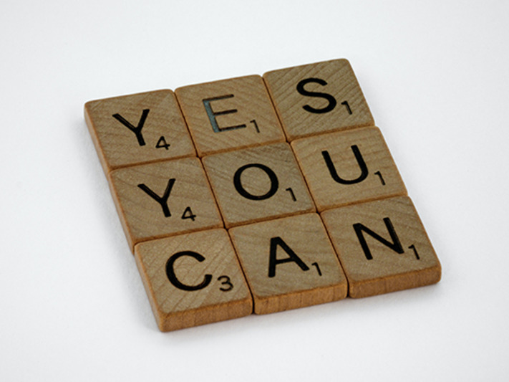
View description - Uncaptioned Figure
View alternative description - Uncaptioned Figure

Activity 1 What can support or compromise learner wellbeing?
Allow about 10 minutes

Within your learning environment, note 5–10 activities or factors that have the potential to support or compromise your learners’ wellbeing.

Provide your answer...
View discussion - Activity 1 What can support or compromise learner wellbeing?

There are many factors impacting how your learners feel that are outside of your control. Think back to Week 1 and the model for the Determinants of Health (Dahlgren and Whitehead, 2021). However, as an educator you have many opportunities to provide your learners with positive educational experiences, boost their resilience and enhance their wellbeing. The next section will consider in more detail how you might make the most of such opportunities.

2 Taxonomy of wellbeing: understanding barriers and enablers to wellbeing
Lister et al.’s (2021) ‘taxonomy of wellbeing’ provides a helpful model for considering various potential barriers and enablers to wellbeing in an educational context. Although the model was formulated in terms of distance learners, its findings can be applied to all learning environments. If you look closely, you can see that the barriers in the bottom half of the wheel are directly linked to enablers in the upper half of the wheel. The data presented around the wheel of enablers and barriers was collated from distance learner participants at The Open University in the UK.

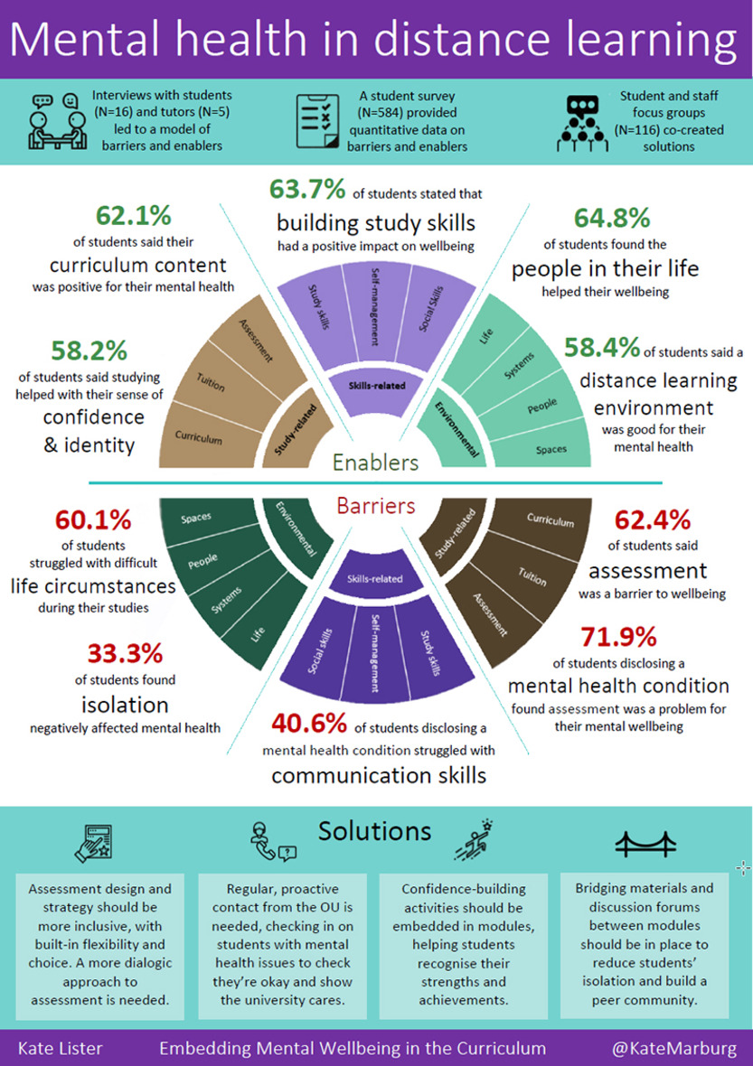
Figure 2 Taxonomy of barriers and enablers to wellbeing in distance learning (Lister et al., 2021).
View description - Figure 2 Taxonomy of barriers and enablers to wellbeing in distance learning (Lister ...
View alternative description - Figure 2 Taxonomy of barriers and enablers to wellbeing in distance learning (Lister ...

Activity 2 Identifying barriers and enablers which promote resilience
Allow about 15 minutes

- Look at the study-related and skills-related ‘barriers’ in the bottom half of the taxonomy wheel above and note down how you think your current learning setting could impact negatively on learner wellbeing. These ‘barriers’ are things which can prevent someone from being able to access and succeed in their education.
- Now, look at the study-related and skills-related ‘enablers’ in the upper half of the wheel and note down how these enabling approaches may already be in place in your learning environment, or could be developed. These are pedagogical and social aspects of learning which can enhance learners’ capacity to progress and achieve in their studies. Consider the extent to which these are common practice, or not, in your setting.

Provide your answer...
View discussion - Activity 2 Identifying barriers and enablers which promote resilience

After you have completed this OpenLearn course, you may like to progress your knowledge of this model, and further concepts, through the micro-credential course Teacher Development: Embedding Mental Health in the Curriculum.

2.1 Recognise the wellbeing value of assessment choice and feedback


View description - Uncaptioned Figure
View alternative description - Uncaptioned Figure

The methods you use to assess your learners’ knowledge and/or skills are a key aspect of their learning experience. Assessment may be essential for the certification process, or it might be an informal method used to check that learners are progressing. Whatever the reason for using assessment methods, they can have consequences for your learners’ wellbeing. For example, certain types of assessment, such as formal exams, test or essays, or more practical task or group-based assessments, may make individual learners feel anxious or overwhelmed or impact their confidence. However, the assessment process can also provide positives for wellbeing as it can offer the opportunity for knowledge and skills to be recognised, can provide reflective moments to acknowledge progress and, for many, is the gateway to successfully achieving their educational goals.
When it comes to choosing an assessment method, academic needs are usually pivotal to the choice. However, how many times are the wellbeing needs of your learners also a consideration? The following activity will encourage you to consider how different forms of assessment can present positives and negative outcomes for learners’ wellbeing.

Activity 3 The influence assessment can have on wellbeing
Allow about 10 minutes

This activity takes inspiration from Jones et al. (2020) and Wilson (2014) and collates various barriers and enablers to wellbeing based around five types of assessment methods. Drag the statements into the boxes that they correspond to
Match the potential barriers to wellbeing to the form of assessment it relates to.

Potential for bunching of deadlines
Stressful for learners who are less confident in public speaking
Can be challenging for less socially confident learners
Time-consuming
Tests the ability to remember, which requires the commitment of time and appropriate revision skills.
Essays (open book, later submission)
Presentations
Group activities
Projects
Short answer questions (time bound, exam format)
View answer - Part

Now match the potential enablers to wellbeing to the form of assessment it relates to.

Removes immediate timebound pressures created by and exam room situation
Removes pressure from students with lower literacy levels
Individual strengths can be maximised
Allows for individual creativity across the breadth of the assessment
Familiarity with this format, how to prepare and an awareness of what is expected.
Essays (open book, later submission)
Presentations
Group activities
Projects
Short answer questions (time bound, exam format)
View answer - Part
View discussion - Part

For some learners, issues with their mental health may contribute to specific assessment-related feelings and behaviours, such as low self-esteem or consistently asking for work to be checked (sometimes referred to as ‘anxious checking’). Where there is a lack of confidence, and self-doubt is present, learners may delay the start of assignments or revision, which then leads to additional time pressures and further anxieties (McManus et al., 2017). Addressing these concerns, especially at a very early stage, can help to alleviate stressful feelings in the build-up to the assessment and can help the learner develop resilience.
You may also want to consider the potential wellbeing impact of different assessment methods on you as an educator, for example as identified by Jones et al. (2020), as part of your own reflective process and skills assessment.

2.2 Effective feedback


View description - Uncaptioned Figure
View alternative description - Uncaptioned Figure

Feedback helps to guide and steer learners, to know what they have done well and what can be further developed. The feedback process can also be a good opportunity to help learners identify their own success in overcoming particular challenges. Resilient skills, and the encouragement to use these skills in the future, can be developed when individuals reflect on their challenges and success (Baker et al., 2021). So, it is worth considering the style and nature of the feedback you provide, and the way in which this is presented to learners.
Fear of judgement might cause learners to ignore or reject their feedback and it may evoke a negative emotional response (Ryan and Henderson, 2018). To support learners in responding positively and feeling less stressed about the feedback process you could also focus on the ‘invisible outcomes’ (more on these later) of the assessment process. For example, such an outcome could be that a learner has developed a revision timetable or improved their writing style. Ensuring that learners’ efforts are recognised has been shown to encourage more positive emotions (Lynam and Cachia, 2018).
Cath Brown, a former President of the Open University Students Association who, at the time of writing, is an Associate Lecturer for the University, has developed a series of useful tips on providing learner feedback. Below is a summary of the main ones:

- Ensure that feedback focuses on the work, rather than using personalised language. For example, instead of ‘You haven’t understood X’ consider ‘The answer hasn’t shown your grasp of X’.
- Give specific feedback with examples, such as explaining exactly where an error is and how it can be corrected.
- Recognise improvement to motivate your learner.
- Offer hope, by including suggestions, tips and resources on what the learner can do to improve.
- Create an open environment to encourage opportunities to discuss feedback.
(Brown quoted in Lister and Coughlan, n.d.)

No matter how good your feedback is, sometimes learners will be disappointed to receive a low score or grade. In situations such as this, Lister and Coughlan (n.d.) suggest making your feedback gentle but to the point and providing practical examples of where the learner can improve. They also go on to suggest that strengths should be identified and with explaination, of why they were positive, and that scheduling catch-up, confidence-boosting or supportive activities can also be beneficial.

3 Summarise strategies to ensure group work supports learner wellbeing
Group work can be a highly effective pedagogical tool which brings variety to the curriculum and enables peer learning. This may be something you have experienced as a learner and utilised as an educator. When planning group work activities, it is important to acknowledge that not all learners will experience group work in the same way. Although some may find it enjoyable and stimulating others may find it stressful. They may have had previous negative experiences and may experience low self-esteem and negative feelings such as social anxieties. These experiences, feelings and anxieties can make social situations and communication difficult in a group context (McManus et al., 2017) and may create internal conflict for the learner between a need to engage with the curriculum and their peers and a real fear of being exposed and embarrassed by the situation (Topham and Russell, 2012).


View description - Uncaptioned Figure
View alternative description - Uncaptioned Figure

McPherson et al. (2019) suggest some key strategies that can be used to support learners, helping to remove barriers to learner self-belief and confidence, and that can facilitate turning group work from a barrier into an enabler for promoting resilience:

- Offer opportunities to discuss any concerns with learners prior to a group work activity – especially if this is assessed. Try not to make assumptions based on any disclosed disability and treat each learner as an individual with their own needs.
- Be clear on the purpose of the activity and be prepared to offer an alternative if a learner cannot participate. It might be that you can offer a dedicated role within the group which is less exposing but still allows for their participation.
- Allow extra time for reading and thinking around the task – this will help learners with specific conditions, such as dyslexia or dyspraxia, as well as those who may experience ‘brain fog’ due to medications, etc.
- Allow learners to choose from a range of communication types – this could include verbal, written or, in online environments, the use of text boxes and polls.
- Acknowledge success once an activity has finished – this can be about the process of the activity as much as the output of it.
(McPherson et al., 2019)

Activity 4 Enabling group work
Allow about 20 minutes

Spend some time looking at an interactive resource on group work from the Positive Digital Practices (PDP) project in the UK.
Now consider a recent group work activity that you have used, or one that you have coming up, or imagine planning a group work task. What could you do, or change, to promote learner wellbeing? What have you learned from this resource and some of McPherson et al.’s (2019) suggestions?

Provide your answer...
View discussion - Activity 4 Enabling group work

4 The negative impact of emotive and triggering content on learners’ wellbeing and resilience

View description - Uncaptioned Figure
View alternative description - Uncaptioned Figure

You may have noticed that throughout this course, trigger warnings have been provided about content that might be distressing, or that could cause negative emotions. Similarly, your learners’ various lived experiences could potentially mean that some of the educational content you are using could be emotive and ‘triggering’. Of course, it is not possible to know the background experience of all of your learners but carefully considering educational content from different perspectives in advance could help you to guide your learners through potentially emotive situations.
Emotive content could be anything that triggers negative emotions for a learner. These could be linked to negative life experiences, issues close to someone’s personal identity, or any current struggles that a learner is experiencing. You, or your organisation, might already have processes in place that enable learners to identify, and inform, if any content might be emotive. Even if you do not, just applying some common sense and sensitivity towards potential issues may resonate on a personal level with your learners. Facilitating learner wellbeing is about both the actions taken to create positive emotions and the preventative steps implemented that can reduce, or remove, negative emotions.
To discover more about some topics that might be emotive for learners, explore the guidance document produced by the Positive Digital Practices project.

Activity 5 Retaining positive emotions when faced with emotive content
Allow about 15 minutes

Review the case studies of Nicola and Jolanta: Case studies. Based on what you know about their lives, what might be potential causes for triggering content? Remember to consider not just the direct specifics of their lives, but also how certain life aspects that each person identifies with may be portrayed through lesson content. For example, the content may contain stereotypical characterisations of certain ethnicities, or old and historically inaccurate information.
In the text box below, use bold to highlight the individual characteristics of each case study which are relevant.

Name: NICOLA
Identifies as female and is in her early 20s.
Studying for a National Diploma course at her local college.
Returning to education after a gap due to pregnancy and child-care responsibilities.
Is a single Mum, living with her parents.
Diagnosed with mild-moderate depression two years ago. Symptoms fluctuate with occasional periods of depressive episodes.
Course work assessment.
Study motivations; To gain a formal qualification to be able to work part time and be able to afford her own home.
Name: JOLANTA
Identifies as female and is in her late 50s.
Studying an online degree course and is in her 2nd year of study.
Recent bereavement of her husband.
Has a physical disability affecting her mobility.
Left school early to support family due to financial pressures, living in a deprived area.
Assignment based assessment.
Study motivations; Personal achievement – no previous formal qualifications, Low in confidence and wants to achieve something and then to be able to volunteer in the office of the disability charity she has received support from.
View discussion - Activity 5 Retaining positive emotions when faced with emotive content

5 Developing further meaning and resilient skills for learners
Traditionally, at the end of a programme of study learners receive a grade, or some form of confirmation of their progress or completion. But is that enough? There may also be non-intended but beneficial, yet invisible, outcomes of the learning experience that go unrecognised or unrewarded by both the learner and educator. Examples could be an improved sense of determination to succeed, or study related skills such as researching, or transferable skills such as time management.
These invisible outcomes have the potential to support a wider sense of achievement with learners (which could be especially useful if they do not receive the academic outcome they hoped for) and these are also likely to be key skills that create greater resilience in any further study and their life in general. For example, a learner who improves their time management by using a study diary or study planner, has opportunities to transfer this skill into their everyday life and employment. Such new-found skills can also be something a learner can fall back on when faced with challenging situations. A determination to succeed, or the willingness to ask for help, that the learner used when studying, can also be deployed in further academic situations or into aspects of their personal life. It can be valuable for a learner to recognise and identify these skills for their wider and repeated use.


View description - Uncaptioned Figure
View alternative description - Uncaptioned Figure

Activity 6 Identifying invisible outcomes
Allow about 15 minutes

Think about your learning environment and what it provides your learners, beyond the new knowledge or qualification they acquire. Note down 3–5 potential invisible wellbeing outcomes that learners may achieve from their time on your course. Consider wider aspects such as study skills, research skills, confidence building, presentation skills, other learning, e.g. environmental or political awareness.
Next, choose any one of the Case studies and consider how any of these invisible outcomes could be of benefit to the individual in their wider life.

Provide your answer...
View discussion - Activity 6 Identifying invisible outcomes

5.1 Going further: wellbeing models, external resources and their possible application in the learning environment
Many wellbeing models exist that can provide specific guidance and direction on how the promotion of wellbeing can be incorporated into educational contexts. A useful model that you may like to explore is the PERMA model of wellbeing. This model is a research-based approach developed by the American psychologist, Martin Seligman (2011) that focuses on five key elements that he identified for promoting wellbeing: Positive emotions, Engagement, Relationships, Meaning, Accomplishment.

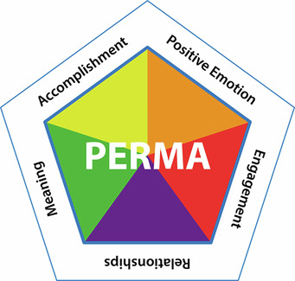
Figure 3 Seligman’s (2011) PERMA model for wellbeing.
View description - Figure 3 Seligman’s (2011) PERMA model for wellbeing.
View alternative description - Figure 3 Seligman’s (2011) PERMA model for wellbeing.

Seligman has argued that these five elements can all be seen as building blocks for generating greater happiness and wellbeing (Seligman, 2018). You may like to think about how you could build these five elements into your own educational setting or look at how components of different models could inspire and encourage small changes within your teaching practice.
Another role you have as an educator is to share relevant external resources and information with your learners. You may like to compile your own list of useful resources, including organisations such as Student Minds and that offer learners support, ideas and inspiration for their wellbeing. You may wish to just share these contacts with your learners or you could get involved in some of their specific campaigns aimed at supporting learners’ mental health. Finally, in line with next week’s focus on your own wellbeing as an educator, you may find it useful to explore the website of the charity Education Support, which is dedicated to supporting the mental health and wellbeing of educators.

6 Wellbeing activity for Week 7
Valuable and meaningful aspects of work and life are often overshadowed by problems. Expressing gratitude demonstrates appreciation for positives and allows you to ‘press the pause button’, enabling you to notice and acknowledge things to be grateful for. Showing gratitude can brighten your outlook and help create feelings of positivity in the face of challenges.

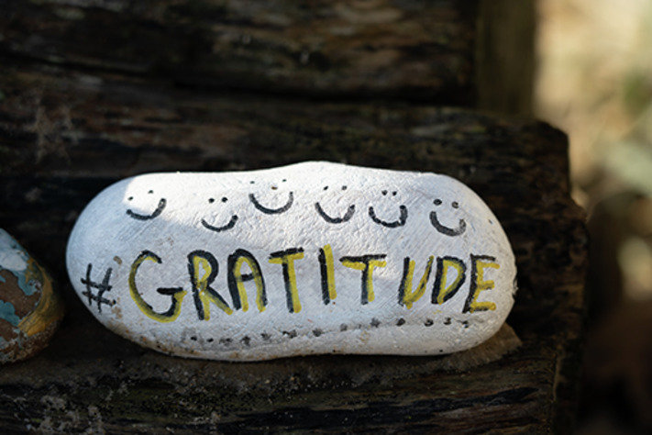
View description - Uncaptioned Figure
View alternative description - Uncaptioned Figure

Practising gratitude helps shift your thoughts away from negative emotions and can boost mood. Stress hormones can be decreased, as the brain chemicals associated with happiness and pleasure, serotonin and dopamine, are released. In the long term, this may lead to changes in brain function which enable you to feel more grateful in the future.
Try creating a digital Gratitude tree to regularly record your appreciation.

7 This week’s quiz
Well done – you have reached the end of Week 7. You can now check what you’ve learned this week by taking the end-of-week quiz.
Week 7 practice quiz
Open the quiz in a new or window and come back here when you have finished.

8 Summary of Week 7
This week you have explored approaches that you can use as an educator to maintain and develop your learners’ wellbeing and resilience. Many of these can be simple, small steps that you incorporate within your education environment, which could nevertheless have a profound impact on your learners. This is because less stressed and more emotionally healthy and resilient learners will have greater capacity to fully engage in their learning, to form beneficial relationships with their peers and to overcome any hurdles in their learning experience. The aim has been to give you an insight into a range of factors that can strengthen resilience and protect learners’ wellbeing. You could refer back to this week when considering assessment choices or giving feedback. You might also like to refer to some of the models that have been introduced, like the taxonomy of wellbeing or PERMA, when planning strategically for learner wellbeing.
The main learning points for this week are:
- It is important to identify barriers to and enablers for learner wellbeing.
- In your role as educator you should recognise the wellbeing value of assessment choice and feedback.
- There are strategies to ensure that group work can support learner wellbeing, rather than hinder it.
- As educator, it is vital that you understand the negative impact of emotive and triggering content on learners’ wellbeing and resilience
- There are various ways in which you can encourage the development of resilience and resilience skills in learners.
This week’s content also incorporated skills that you can utilise for promoting your own wellbeing as an educator, which is the focus of the next and final week of this course.
Next week you will explore educator self-care strategies and how to create a mentally healthy learning environment for yourself and your learners.
You can now go to Week 8.

Week 8: Educators’ self-care strategies

Introduction
This final week of the course is slightly different from the previous weeks in that it focuses solely on you, the educator. It builds on wellbeing elements that have been introduced in earlier weeks to enable you to develop comprehensive self-care strategies to support your own mental, physical and emotional health. For this week it is suggested that you develop a personal reflective diary in which you can note, and reflect on, each of the self-care related activities.
A frequently used reflective model in education is Kolb’s learning cycle, and you may wish to apply this within your own Week 8 reflections.

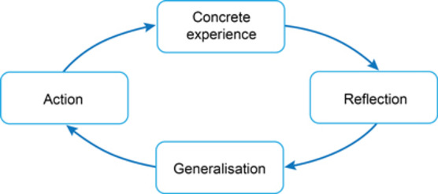
Figure 1 Kolb’s experiential learning cycle (adapted from Kolb, 1984).
View description - Figure 1 Kolb’s experiential learning cycle (adapted from Kolb, 1984).
View alternative description - Figure 1 Kolb’s experiential learning cycle (adapted from Kolb, 1984).

Watch the video below on the cycle of learning from experience to refresh yourself in reflective practice for your journal.

Video content is not available in this format.
View transcript - Uncaptioned interactive content

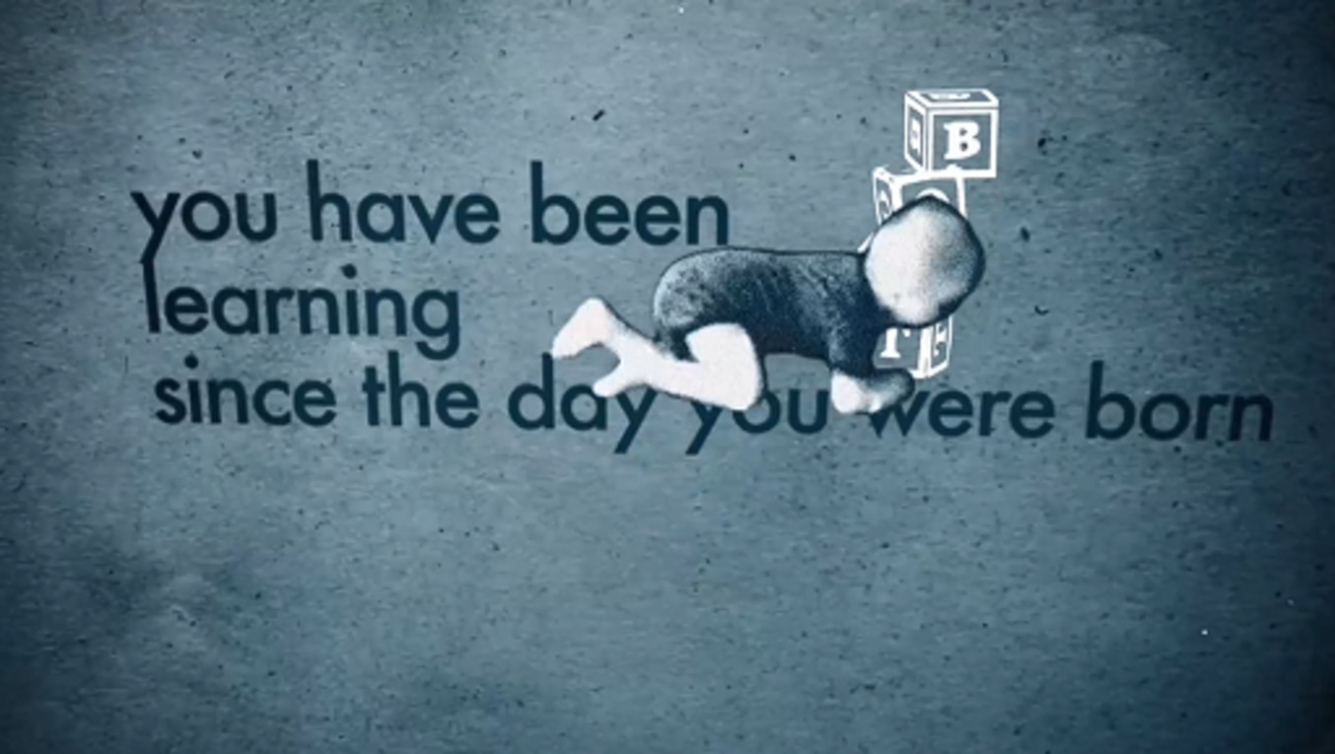

By the end of this week, you should be able to:
- reflect on and review your own wellbeing and identify personal stressors
- better understand how to establish and maintain professional boundaries
- apply self-compassion and mindfulness to help rebalance your wellbeing
- develop personalised self-care activities.
You will also find an additional resources section at the end of the week which can support your self-care.

1 Recognising your own support needs
In your role as an educator, keeping mentally healthy involves being able to identify when things are getting too much, or you are not coping well. As has been covered earlier in this course, identifying a lack of coping, and any emotional or psychological needs, can be the first step towards getting support if needed.


View description - Uncaptioned Figure
View alternative description - Uncaptioned Figure

Work-related stress, depression or anxiety accounts for half of work-related ill health in the UK (HSE, 2022). Professional and personal lives are intertwined and so feelings can easily cross over from one to the other. At times you might feel that you are not coping well at work while at other times there may be a situation in your personal life that impacts on your resilience at work. Furthermore, concurrent stressors can be experienced at the same time and this intersection can have a cumulative effect on general resilience. An example of this is the COVID-19 pandemic, which led to isolation and the need for home schooling of many children. Research undertaken during the pandemic found lower wellbeing rates for parents on days that they home schooled their children (Schmidt et al., 2021).


View description - Uncaptioned Figure
View alternative description - Uncaptioned Figure

The impact of supporting others who experience poor mental health can be significant. You may be dealing with day-to-day situations at work alongside crisis scenarios that can sometimes be distressing, and this can take its toll. It doesn’t matter how resilient you are, everyone has a limit to their capacity to cope.

1.1 Capacity to cope
One way of thinking about your capacity to cope is to regard your capacity as a bucket, and day-to-day stressors as water. As water starts to fill the bucket, eventually it will overflow and so the bucket’s capacity has been reached. Similarly with your own capacities, if you keep taking on more and more, you will eventually no longer be able to cope, or to continue taking on the support needs of others.

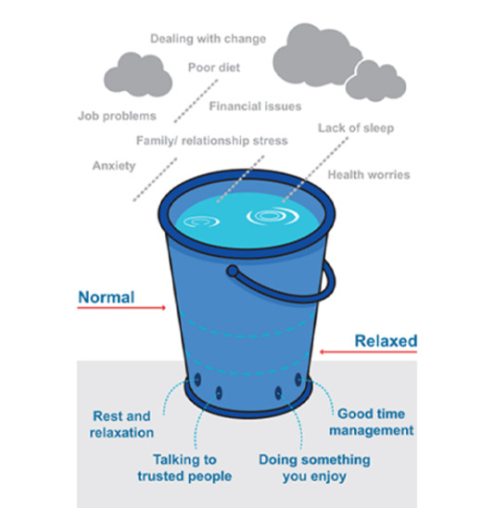
Figure 2 The Stress Bucket, originally developed by Brabban and Turkington (2002).
View description - Figure 2 The Stress Bucket, originally developed by Brabban and Turkington (200 ...
View alternative description - Figure 2 The Stress Bucket, originally developed by Brabban and Turkington (200 ...

To be able to retain some capacity, you need to be able to allow some of the stressors to be dissipated or to ‘flow out’, as in the bucket image above. This can be achieved through many different types of activities that enable you to manage stress, such as engaging in hobbies, spending time with friends, or taking ‘time out’.
Watch MindWell’s ‘Stress Bucket’ video to better understand its function.

Video content is not available in this format.
View transcript - Uncaptioned interactive content

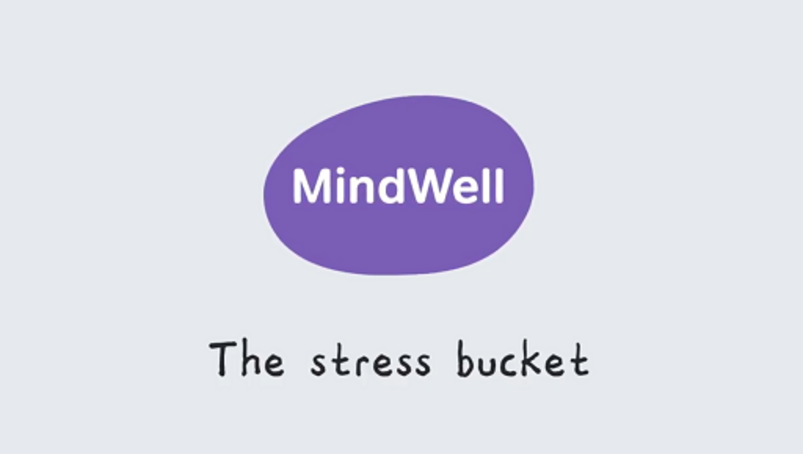

1.2 Evaluating stressors
You’ll now start to think about how you can identify signs of stress in your own life.

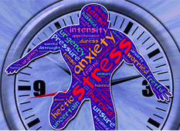
View description - Uncaptioned Figure
View alternative description - Uncaptioned Figure

Activity 1 Identifying signs of stress
Allow about 5 minutes

Thinking about yourself, identify which of the following may indicate you are feeling over-stressed and/or not coping:

- feeling anxious
- worrying excessively about things
- over-thinking or rumination
- avoidant behaviour – e.g. not engaging or volunteering to participate
- tiredness or listlessness
- digestive problems
- feeling detached
- difficulty breathing
- blurred eyesight and/or sore eyes
- poor concentration
- sleeping difficulties
- muscle aches and headaches
- loss of motivation
- irritation and frustration
- ongoing irregular, or disordered, eating
- low mood
- deterioration in existing health conditions.
(Mind, 2023)

Provide your answer...
View discussion - Activity 1 Identifying signs of stress

1.3 Boosting your mental wellbeing
Being aware of, and able to reflect on, your own feelings, psychological pain or even physical manifestations of stressors building up, means you can then determine and choose how to reduce them. In addition to the strategies identified in the stress bucket model, shown in Section 1.1, you may have other specific strategies that work for you, such as going to the gym, meditating or watching TV. The important thing is to be willing to challenge and change entrenched habits, behaviours and self-beliefs. For example, you may feel you do not have enough time to engage in stress-relieving activities because you are extremely busy at work and home. This perspective is, however, short-sighted because failure to address stress can lead to long-term health problems, which may then lead to time away from work.


View description - Uncaptioned Figure
View alternative description - Uncaptioned Figure

The NHS provides an approach for reducing stressors which you may already be familiar with, the 5 Steps to Mental Wellbeing.

Activity 2 Five steps to mental wellbeing
Allow about 10 minutes for each chosen activity

Read the NHS 5 Steps to Wellbeing and identify some time this week when you can choose and then apply one or more of the suggested activities. Keep a reflective journal and score your mood before you engage in the activities, and afterwards. Record your feelings and set small goals for incorporating these activities into your daily life to enable a stress release.

Provide your answer...
View discussion - Activity 2 Five steps to mental wellbeing

2 Establishing and maintaining professional boundaries: what is meant by ‘boundaries’?

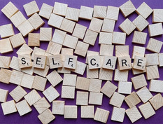
View description - Uncaptioned Figure
View alternative description - Uncaptioned Figure

Establishing professional boundaries, as you learned in Week 2, is a key aspect of educators’ roles and can support your own as well as your learners’ mental health. Boundaries enable positive and healthy professional relationships and bring clarity in what is acceptable, and what is not acceptable, behaviour within professional relationships. Boundaries are described by Barnett (2008) as ground rules which provide the basis of the professional relationship and according to Mckay and Macomber ‘relationships are more than just knowing the learner’s names; they encompass mutual respect, building trust, and feelings of safety’ (2021, p. 1).

2.1 The characteristics of boundaries
Professional relationships develop gradually over time and establishing boundaries can strengthen relationships between you, the educator, and your learners and can also support your own self-care. The role of an educator is to facilitate learning, and a tendency to over-support learners can impact negatively on an educator’s mental health. Saying ‘no’ can be hard, but clear, consistent communication can assist. It is more difficult for you if learners are told ‘yes’, when the answer which protects your mental health needs to be ‘no’. This can erode trust and distance learners from their studies, which may incur more stress for you, the educator.


View description - Uncaptioned Figure
View alternative description - Uncaptioned Figure

Boundaries work best when they are pro-actively established and may need to be drawn more closely when mental health is challenged. Establishing boundaries pro-actively enables you to think through what works for both your learners and you. Identifying organisational policies and procedures which inform boundaries, such as safeguarding policies or codes of conduct which outline acceptable behaviour in the learning environment, can assist with pro-active boundary setting. It is also worth remembering that learner difficulties might be the responsibility of another department, for example pastoral support teams or specialist disability teams, and do not necessarily sit with you as their educator. Reflecting on the boundaries of your role, and identifying when others have responsibilities to learners, can help reduce stress.
Boundaries therefore enable you to be in better control of the learning environment, and therefore feel more in control overall. Feeling in control of your learning environment can assist with stress management. A direct consequence for the educator of boundary setting is the ability to manage stress and to understand when the learning environment is becoming more stressful because boundaries have been over-stepped.

Activity 3 Identifying boundaries to support self-care
Allow about 10 minutes

Part 1

Identifying boundaries that are not only appropriate and supportive for you and your learners, but that also support your self-care, takes careful thought and planning. Watch the video How to have boundaries when teaching adult education and list boundaries you can identify with, or have had experience of, that might impact on your own self-care and wellbeing.

Video content is not available in this format.
View transcript - Uncaptioned interactive content

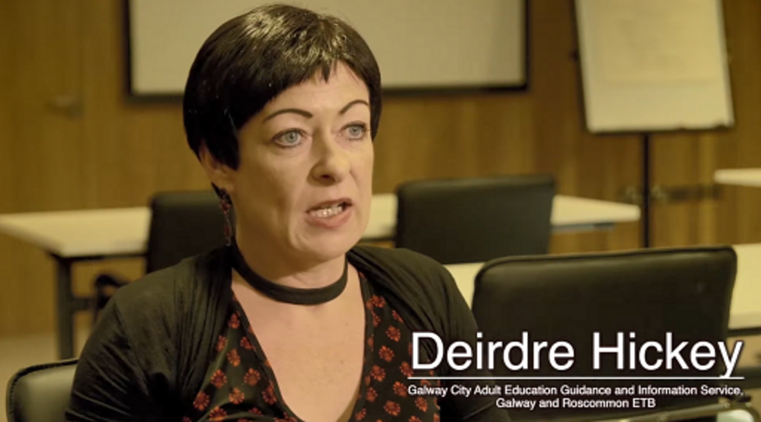

Provide your answer...
View discussion - Part 1

Part 2

Now reflect on some of these boundary issues and consider what strategies you can apply in your own learning environment and professional context to support your own self-care. For example, could you familiarise yourself with organisational policies and procedures on boundaries in relation to receiving gifts from learners so that you could handle such a situation comfortably? Or could you draw on equality, diversity and inclusion policies to help you establish boundaries that recognise and respect your own and your learners’ culture and religious beliefs?
Developing such strategies in advance can help you confidently cope with situations that arise and can serve to make your workplace environment a mentally healthy, safe space for you.

Provide your answer...

In summary, boundaries provide the structure and the parameters of a professional educator–learner relationship and help manage expectations in that relationship. This provides emotional safety for you as an educator and can give you the confidence to speak up, when necessary, rather than something happening against your better judgement. Clarity of expected behaviours enables positive mental health, potentially leading to reductions in stress in your workplace role as an educator.

3 Self-compassion and mindfulness
This section introduces the self-help techniques of self-compassion and mindfulness, strategies commonly recommended by the health sector to promote better mental health. They share similarities in that they require reflection, with subsequent potential for reviewing how you prioritise your self-care routine. The section also considers possible consequences of failure to prioritise self-care when work stress is challenging. This is known as burnout.


View description - Uncaptioned Figure
View alternative description - Uncaptioned Figure

3.1 Exploring the concept of self-compassion
Self-compassion is a particularly helpful self-care strategy when under stress. It involves recognising and acknowledging that you are having a difficult time, and identifying ways you can care for yourself, ‘giving oneself the same kindness and care we would give to a good friend’ (Neff, 2023). The benefits of self-compassion include lower levels of anxiety and depression (Harvard Health, 2022).
Research evidence shows that a greater sense of wellbeing also relates to increased physical benefits, such as lower incidences of cardiovascular disease, stroke and sleeping problems (Warburton and Bredin, 2019). Wellbeing can also increase productivity and creativeness and promote resilience, enabling increased ability to cope with – and adapt to – new situations.

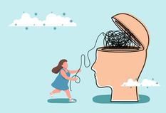
View description - Uncaptioned Figure
View alternative description - Uncaptioned Figure

Activity 4 Developing your self-compassion
Allow about 30 minutes

Watch Dr Kristin Neff's video introducing the concepts of self-compassion and self-esteem. Take some notes, perhaps adding to the reflective journal you started in Activity 2, as reminders. Identify three steps that you can take to be more self-compassionate.

Video content is not available in this format.
View transcript - Uncaptioned interactive content

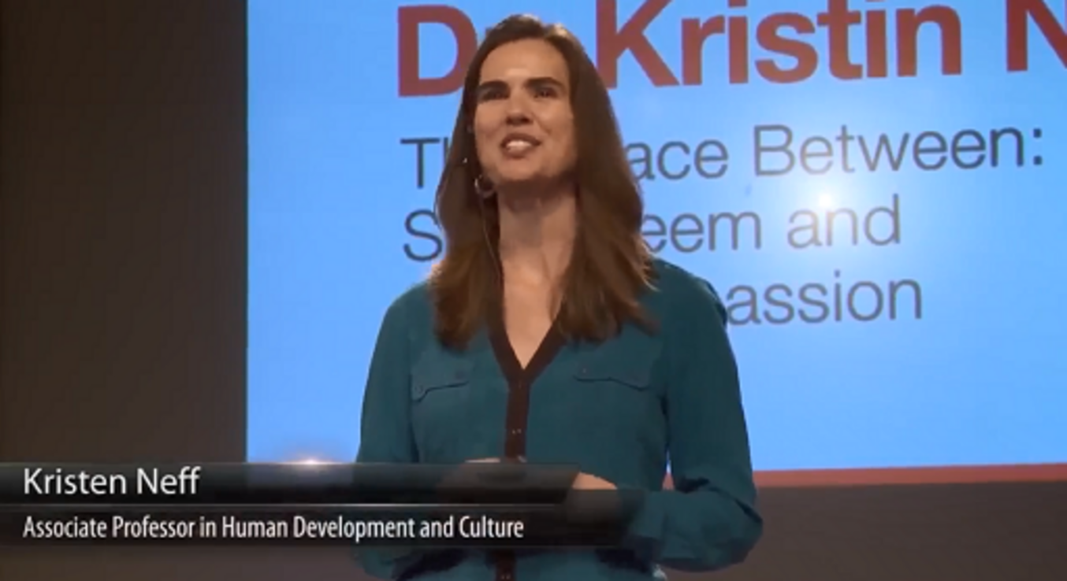

Provide your answer...
View discussion - Activity 4 Developing your self-compassion

3.2 Mindfulness
Finding time for yourself as part of self-compassion activities might include time where you can recalibrate your mind; this can be achieved through practising mindfulness. Mindfulness can be defined as: ‘… a non-judgmental, receptive mind state in which one observes thoughts and feelings as they are, without trying to suppress or deny them’ (Neff, 2023). Mindfulness is also considered to be a way of moving away from your automatic pilot to consciously make changes for more positive behaviours (Vseteckova et al., 2021). Mindfulness approaches, sometimes formalised into structured programmes, are widely available and can be used as universal mental training tools which may be helpful to maintain positive levels of wellbeing. Targeted mindfulness programmes which focus on supporting specific mental health conditions are often delivered by the health sector in the UK and aim to manage and prevent recurrent depression (Crane, 2017).

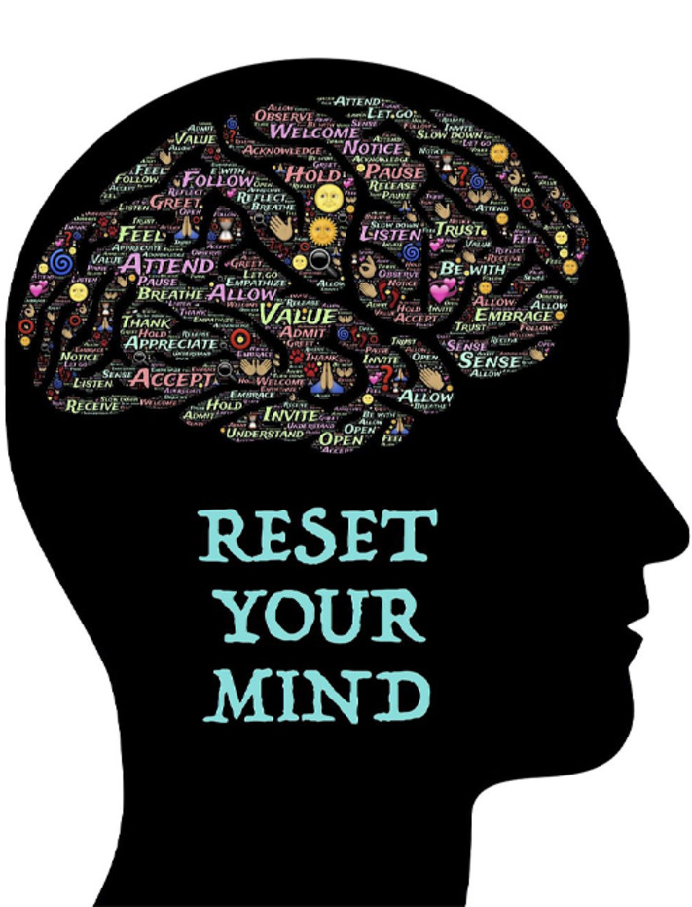
View description - Uncaptioned Figure
View alternative description - Uncaptioned Figure

To better understand mindfulness and its potential, and to perhaps resolve concerns that you may have, it might be good to address five common myths:

- Mindfulness is not the same as meditation, as there are many ways of being mindful that do not involve formal meditation. You can be mindful outdoors among nature, or in any of your daily activities – even the basics of doing the washing up or making a meal.
- While there are mindfulness practices or features within every major religion there are also lots of ways to practice mindfulness without being a ‘religious person’.
- Mindfulness is not the same as relaxation, as you can be mindful in any situation, even those that are really challenging. This makes it a useful approach for people who experience stress in their busy lifestyles. Its practice does not need to be time-consuming either; even just a few minutes of mindfulness exercises every day should help you feel more settled or better able to be in the moment.
- Mindfulness is not about controlling your thoughts or being happy all the time – mindfulness is a way to experience all thoughts and experiences, both positive and negative, so it can be helpful even in complex situations.
- People who have experienced traumatic events can benefit from mindfulness, provided it is tailored to meet their needs, feels safe and is provided using support from a mental health professional.
(Vseteckova et al., 2021)

Activity 5 Practising mindfulness
Allow about 15 minutes

Read more about mindfulness from the NHS. Then watch the following video from the NHS (2022a). Identify opportunities where you could practise mindfulness, for example when you are feeling stressed.
(If you are already experienced in mindfulness re-visit the techniques which are familiar to you in the light of what is shown in the video.)

Video content is not available in this format.
View transcript - Uncaptioned interactive content



Find an opportunity to practise mindfulness in a mildly stressful situation, then reflect on it and write your reflections in the journal you have been compiling this week. Did the mindfulness practice help? If so, how? And if not, why, and what other strategies could you apply to reduce that particular stress?

Provide your answer...
View discussion - Activity 5 Practising mindfulness

3.3 Burnout
Burnout is typified as a state of exhaustion; both physical and emotional. Within the workplace, long-term stress and/or working in a physically, or emotionally, draining role for a prolonged period can cause burnout (Mental Health UK, 2020). Common signs of burnout include:

- feeling tired or drained most of the time
- feeling helpless, trapped and/or defeated
- feeling detached/alone in the world
- having a cynical/negative outlook
- self-doubt
- procrastinating and taking longer to get things done
- feeling overwhelmed.
(Mental Health UK, 2020)

In 2019, the World Health Organisation (WHO) re-classified burnout as ‘a syndrome conceptualised as a result of chronic workplace stress that has not been successfully managed’ (WHO, 2019). The WHO contextualise burnout as a distinct occupational phenomenon. Revised dimensions of burnout were identified, which include feelings of energy depletion or exhaustion. This was found to incur distancing from one’s job, and feelings of negativity. As a result, professional efficacy was reduced. Burnout isn’t something which goes away on its own. Burnout is often misunderstood and stigmatised and can impact severely on your physical and mental health. This can result in losing ability and energy to effectively meet the demands of your role as an educator, which can subsequently impact on other areas of your life (Mental Health UK, 2020). You might perceive that you need to support everyone else before thinking of yourself, but this is not something that usually works well. Looking after yourself should not be a luxury it should be part of what you do every day. It is very easy for educators to burn out.

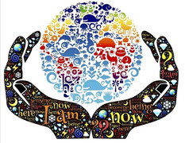
View description - Uncaptioned Figure
View alternative description - Uncaptioned Figure

Activity 6 Create your wellbeing plan
Allow about 15 minutes

Download the Wellbeing plan template (Mental Health UK, 2023b) or access a workplace wellbeing template if your organisation has one. Complete the three sections as a reflective and planning exercise. Retain the completed template with your reflective journal for future use; you can use this as an ongoing working document to support your personal mental health.

View discussion - Activity 6 Create your wellbeing plan

4 Self-care approaches
Self-care means looking holistically at various aspects of your life that can affect your wellbeing. This section enables you to consider and reflect on your diet and nutrition, hydration, exercise, sleep, mental stimulation and socialisation and the impact of each on your mental and physical wellbeing.
Wellbeing can also increase productivity and creativeness and promote resilience, enabling an increased ability to cope with, and adapt to, new situations. Work can provide a sense of meaning and purpose in our life, especially if it means working with others and supporting others to thrive and achieve. Making daily efforts to stay well and resilient will enable you to enjoy your work as an educator and gain fulfilment. Staying motivated, well and fit situates you as a good role model for the wellbeing of those you work with. The way you understand and care for yourself may become a cornerstone of inspiration for others. This can further motivate the people you work with to do the same for themselves and towards others. You then initiate the co-creation of mentally and physical healthy communities and environments in practice.

4.1 Diet and nutrition
Diet and nutrition are a key aspect of self-care that can directly affect your own mental health and ability to cope with stress. For example, magnesium (found in nuts, seeds and green leafy vegetables) aids muscle relaxation; B vitamins found in wholegrains help to reduce anxiety and nervous tension; healthy fats (found in fish and plant and seed oils) support healthy brain function and aid concentration; live yoghurt and fermented food and drinks, such as sauerkraut, kefir and kombucha, support healthy gut bacteria, which in turn support general health and brain function (Holford, 2005). Therefore, it can be useful to review and reflect on your diet and eating habits and the impact they may be having on both your general health and your ability to cope at work.


View description - Uncaptioned Figure
View alternative description - Uncaptioned Figure

Activity 7 Nutrition and health care
Allow about 10 minutes

Write down everything that you have had to eat and drink in the last 24 hours and any foods and drinks that you consume on a regular basis.
Review and reflect on what proportion of your diet is made up of fresh, natural or wholefoods or what might constitute ‘junk food’ eaten ‘on the go’. For example, do you make packed lunches for days working on site, or select healthy salads or soups at your place of work, or do you get through the day on sugary coffees and teas, carbonated drinks, snacks and/or slices of pizza? To what extent do fruit and vegetables contribute to your regular diet? Do you get at least the government recommended ‘Five a Day’? Do you keep hydrated with water during the day especially when the heating is on, or the weather is hot? What small changes could you make to support your mental and physical health?

Provide your answer...
View discussion - Activity 7 Nutrition and health care

4.2 Hydration
Your daily hydration, the absorption of liquids, especially water, as well as fluids in foods affects all your bodily processes as well your nervous system and brain function, thereby impacting on your physical, mental and emotional wellbeing.


View description - Uncaptioned Figure
View alternative description - Uncaptioned Figure

The average recommended quantity of daily liquid intake for an adult varies according to the size and weight of the person, the level of activity, the temperature and environment, etc. A general rule of thumb is 6–8 glasses of liquids per day and ideally most of this from water. However, an excess intake of fluids can be as dangerous as dehydration so it may be useful to seek professional advice from a qualified nutritionist or nutritional therapist on the best amount, and type, of fluids for you to consume (British Nutrition Foundation, 2024).

Activity 8 Keeping hydrated to support mental and physical health
Allow about 10 minutes

Watch the video which looks at what would happen if you didn’t drink water. Make a note of how much water you routinely drink over the next week. Ascertain whether it would be good to increase your water consumption and identify ways in which you could do this. For example, you might start each day with a glass of water or take a water container with you to work.

Video content is not available in this format.
View transcript - Uncaptioned interactive content



Provide your answer...
View discussion - Activity 8 Keeping hydrated to support mental and physical health

4.3 Exercise
Research evidence shows that a greater sense of wellbeing relates to increased physical benefits, such as lower incidences of cardiovascular disease, stroke and sleeping problems (Warburton and Bredin, 2019). Physical activity does not always means running, swimming, going to the gym or attending exercise classes. As an educator, even just being physically active, for example walking to colleagues’ desks instead of emailing them, taking the stairs instead of a lift, taking regular breaks from screens to stretch and breathe, or walking outside in lunchbreaks, can all help to build and maintain physical and mental resilience.


View description - Uncaptioned Figure
View alternative description - Uncaptioned Figure

The benefits of outdoor activities, and being in nature for more than 120–150 minutes a week, can be explored in the OpenLearn article ‘The benefits of outdoor green and blue spaces’ which shows why these are so important for your mental health.


View description - Uncaptioned Figure
View alternative description - Uncaptioned Figure

Activity 9 Getting moving
Allow about 10 minutes

In your reflective diary note down any physical activity taken today and this week, estimating the time spent on each activity, your level of enjoyment and the impact on your physical and mental health. Decide if your activity levels are sufficient or, if not, note down three ways in which you could build in more activity and/or access to green and blue spaces in your lifestyle and/or work environment.

Provide your answer...
View discussion - Activity 9 Getting moving

4.4 Sleep
Sleeping well is essential for managing stress, coping with daily demands and maintaining mental and physical health. Living with a mental health problem can affect how well you sleep, for example anxiety can cause repetitive thoughts and worries. Depression and seasonal affective disorder can make you want to sleep more; staying in bed for longer or sleeping more often, but depression can also cause insomnia (Mind, 2020). Sleep problems can create a vicious cycle of poor mental health, which is exacerbated the more sleep problems continue, as depicted in the following diagram adapted from Mind (2020).

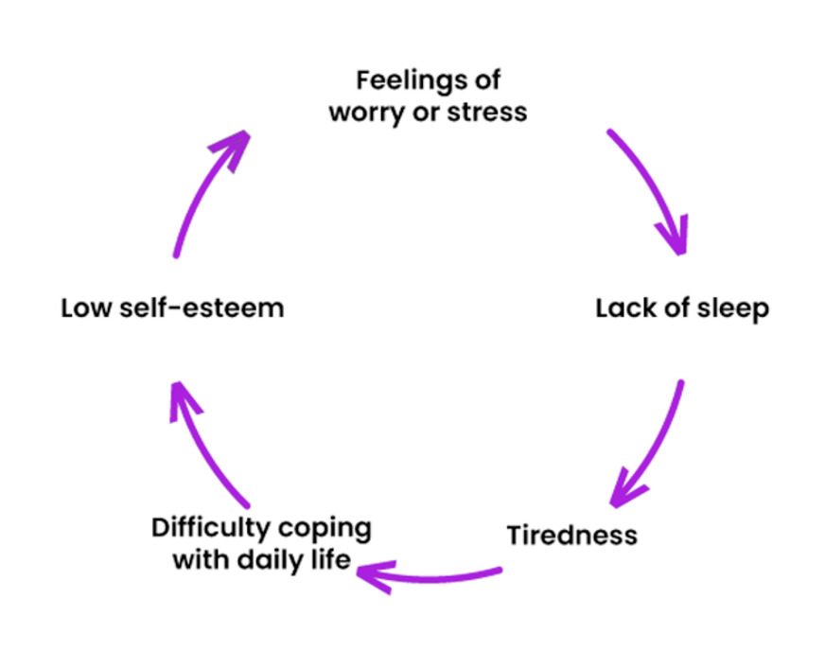
View description - Uncaptioned Figure
View alternative description - Uncaptioned Figure

Sleep allows your brain and body to rest, recharge and self-repair. Lack of sleep, or poor sleep, directly affects mood, patience, resilience and overall feelings of wellbeing. The sleep-wake cycle is affected by circadian rhythms, 24-hour cycles that are part of the body’s internal clock. Different systems of the body follow circadian rhythms which are synchronised with a biological clock in the brain. This internal clock is directly influenced by light, and when properly aligned, a circadian rhythm can promote consistent and restorative sleep, and similarly when the circadian rhythm is misaligned, insomnia can ensue (Sleep Foundation, 2023a). Research has shown circadian rhythms have an integral role in aspects of mental health (Brainard et al., 2015).
Good-quality sleep is influenced by sleep hygiene, which involves creating appropriate environments and routines to promote consistent, uninterrupted sleep. You can read more in this Sleep Foundation resource Why Do We Need Sleep? (2023b).

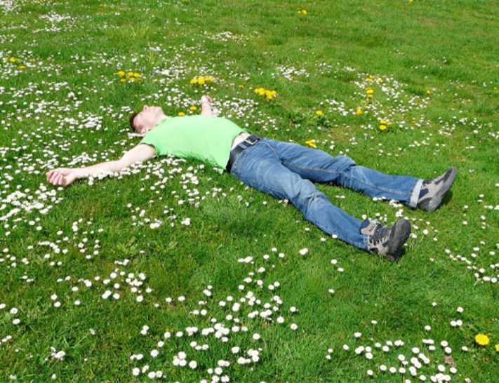
View description - Uncaptioned Figure
View alternative description - Uncaptioned Figure

Activity 10 Sleeping well
Allow about 15 minutes

Watch the video 5 Simple Tips For Getting a Good Night's Sleep.
In your reflective diary note down how many hours sleep you got last night and the typical amount each night over the last week. How easy was it to get to sleep/wake up? What is your typical sleep routine? Identify three steps that you could take to improve your sleep

Provide your answer...
View discussion - Activity 10 Sleeping well

4.5 Mental stimulation and socialisation
Engaging in different types of cognitive activities, such as mental challenges, puzzles and crosswords, have been shown to benefit mental function, enhance brain plasticity, ward off dementia and improve mood (Mental Health Foundation, 2023). Furthermore, meeting and interacting with others is known to enhance mood, mental wellbeing and cognitive function. At the turn of the nineteenth century, the sociologist Durkheim, discussing the industrial revolution, postulated that poor social ties with family, community and work would be detrimental to psychological wellbeing, concluding that those with weaker social ties can be more prone to mental health crises such as suicide (Durkheim, 1897). More recently, research continues to reveal emotional support provided by social ties can enhance mental health and wellbeing (Kiecolt-Glaser et al., 2002; Thoits, 1995; Uchino, 2004). Therefore, to stay in good physical and mental health it is vital to incorporate mental challenges and social activities into daily life.


View description - Uncaptioned Figure
View alternative description - Uncaptioned Figure

Activity 11 Cognitive and social stimulation
Allow about 10 minutes


View description - Uncaptioned Figure
View alternative description - Uncaptioned Figure

In your reflective diary note down any non-work activities that you engage in for cognitive stimulation, such as undertaking crosswords or Sudoku or learning a new language. Do the same for social stimulation such as meeting with friends, or engaging in clubs. Identify three steps that you could take to boost your cognitive and/or social stimulation to support your mental and physical health.

Provide your answer...
View discussion - Activity 11 Cognitive and social stimulation

4.6 Finding time for you
Do you make time for yourself to engage in what helps you, recharges you and makes you more resilient? Sometimes this might involve physical activity while at other times the focus may be more on resting, thinking or consolidating.
The sooner you embed looking after your health on a daily basis and find time for yourself, the better your overall physical, emotional and mental health is likely to be. As you have been learning in this week so far, creating healthier habits at any age is a powerful way to prevent ill health, build resilience, improve self-esteem and boost physical, as well as mental, health and wellbeing.


View description - Uncaptioned Figure
View alternative description - Uncaptioned Figure

It is a myth that you need a lot of time to apply self-care; self-care can be practised in many ways and its activities may be quick and easy – for example, taking a minute here or there to relax, focus on your breathing and notice the sounds around you, or just taking a short break to walk in nature. Other ways may involve more time and planning but, when routinely practised, can bring you closer to a good state of physical and mental health and wellbeing.

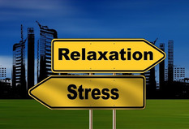
View description - Uncaptioned Figure
View alternative description - Uncaptioned Figure

Activity 12 Taking time for yourself
Allow about 20 minutes

In your reflective diary note down any way in which you made time for yourself and your self-care today or over the last week; this will help you identify where self-care improvements could be made. Then, populate your own self-care wheel diagram, similar to the example below, noting 10 things that are very important to you in your life and then add a number 0–10 on how well you think you are doing in each of the 10 areas you have entered on the wheel.

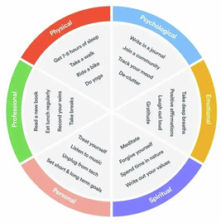
View description - Uncaptioned Figure
View alternative description - Uncaptioned Figure

You can then reflect on the following questions:
- What area do you feel you are already doing well in?
- What area would you like to work on?
- What actions can you do over the next week?
- What actions can you do over the next month?
- What support do you need for these actions?
- Are there any potential barriers?
- How will you know that you have achieved your specific goals?

Provide your answer...
View discussion - Activity 12 Taking time for yourself

5 This week’s quiz
It’s now time to take the Week 8 badge quiz. It’s similar to previous quizzes but this time, instead of answering 5 questions, there will be 15.
Week 8 compulsory badge quiz
Open the quiz in a new or window and come back here when you have finished.
Remember, this quiz counts towards your badge. If you’re not successful the first time, you can attempt the quiz again in 24 hours.

6 Summary of Week 8
This week you have learned the importance of self-care in order to keep you mentally healthy and have utilised a reflective journal to review your own wellbeing. You have explored personal stressors, learned how to identify ‘burnout’, and developed knowledge of how, where and when to seek professional support. The importance of professional boundary setting has been considered. Finally, you have been introduced to, and explored, a range of self-care activities including mindfulness and self-compassion. This learning should equip you with the knowledge and skills to promote your own wellbeing and achieve good levels of mental health.

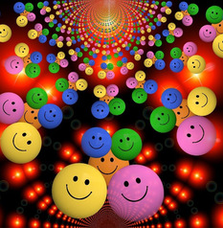
View description - Uncaptioned Figure
View alternative description - Uncaptioned Figure

The main learning points for this week are:
- Reducing and tackling stress enables both improved physical and mental health and helps prevent burnout.
- Establishing and maintaining professional boundaries supports your mental health.
- Protecting time for yourself and prioritising your own wellbeing and mental health with self-care strategies can assist you in your role as an educator.
- Self-care is essential to maintain positive wellbeing and good levels of mental health, and techniques of self-compassion and mindfulness are effective self-help strategies.
- Positive actions to achieve good diet, nutrition and hydration are effective self-care activities. Similarly, engaging in exercise and physical activity, ensuring good sleep hygiene to improve sleep quality and incorporating cognitive and social stimulation promote good levels of wellbeing. Finding time for yourself is also an important self-care strategy.

7 End-of-course summary
During this course, you have become better equipped to support your adult learners with positive mental health and wellbeing. You also know how to ensure adult learners receive the right support at the right time through active signposting to support services and resources. Your learning enables you to recognise how adult learners’ poor mental health impacts on their learning experience, and as a result of completing this course you feel more confident to engage in discussions with them about their mental health needs.
You are more aware of stigmatised behaviours and common misconceptions about adult learners’ mental health in the education sector and have developed skills which help you to reduce stigma in educational practice. Importantly, you have learned a range of appropriate coping strategies which support positive wellbeing and mental health and had opportunity to reflect on the prioritisation of self-care for you as an educator. Your learning will undoubtedly support you in both your professional and personal life, and we wish you very good mental health and wellbeing for the future.

Additional resources
Now that you have come to the end of this course here are some additional resources that you may wish to utilise.
In support of Mental Health Awareness Week, which is held annually, The Open University co-produced two BBC Ideas short films, which are available to view on the award-winning BBC Ideas website.
- The first, How to help someone struggling with their mental health, features OU academic Will Murcott and outlines five useful approaches to make mental health discussions easier and more helpful.
- The second, How does therapy work?, explores how ‘talking therapy’ can help with a range of issues and how it actually helps.
The Charlie Waller Trust have produced a range of online learning resources for college and university staff to support students experiencing poor mental health that can be found on their website. The Trust have also designed an additional resource specifically for university educators involved in developing mental health strategy and policy, the University Mental Health Policy Toolkit, which provides a comprehensive review of existing evidence in a range of areas related to mental health policy and practice. (Please note, you will need to register your details with the Trust to download this resource.)

Where next?
If you’ve enjoyed this course you can find more free resources and courses on OpenLearn.
New to University study? You may be interested in our courses on Education.
Making the decision to study can be a big step and The Open University has over 40 years of experience supporting its students through their chosen learning paths. You can find out more about studying with us by visiting our online prospectus.

Tell us what you think
Now you’ve come to the end of the course, we would appreciate a few minutes of your time to complete this short end-of-course survey (you may have already completed this survey at the end of Week 4). We’d like to find out a bit about your experience of studying the course and what you plan to do next. We will use this information to provide better online experiences for all our learners and to share our findings with others. Participation will be completely confidential and we will not pass on your details to others.

References
American Psychiatric Association (2013) Diagnostic and statistical manual of mental disorders, 5th edn. London: American Psychiatric Association.
Antonovsky, A. (1984) ‘The sense of coherence as a determinant of health’, in J.D. Matarazzol (ed.) Behavioural Health. New York: Wiley, pp. 114–29.
Brewster, L., Jones, E., Priestley, M., Wilbraham, S.J., Spanner, L and Hughes, G. (2022) ‘“Look after the staff and they would look after the students” cultures of wellbeing and mental health in the university setting’. Journal of Further and Higher Education, 46(4). Available at: https://www.tandfonline.com/doi/full/10.1080/0309877X.2021.1986473 (Accessed: 5 January 2025).
Centre for Mental Health (2011) Managing presenteeism: a discussion paper. Available at: https://www.centreformentalhealth.org.uk/publications/managing-presenteeism/ (Accessed: 5 January 2025).
Charlie Waller Trust (2021) How parents and carers can support a child with anxiety. Available at: https://charliewaller.org/resources/supporting-a-child-with-anxiety (Accessed: 5 January 2025).
Charlie Waller Trust and Bank Workers Charity (2022) Coping with low mood. Available at: https://charliewaller.org/resources/low-mood-poster/ (Accessed: 5 January 2025).
Crenshaw, K. (2017) On intersectionality: essential writings. New York: The New Press.
Dahlgren, G and Whitehead, M. (2021) ‘The Dahlgren-Whitehead model of health determinants: 30 years on and still chasing rainbows’, Public Health, 199, pp. 2–24. Available at: https://www.sciencedirect.com/science/article/abs/pii/S003335062100336X (Accessed: 5 January 2025).
Engel, G.L. (1977) ‘The need for a new medical model: a challenge for biomedicine’, Science, 196(4286), pp. 129–36. Available at: https://pubmed.ncbi.nlm.nih.gov/847460/ (Accessed: 5 January 2025).
Khasanweh, E., Gosling, C. and Williams, B. (2021) ‘What impact does maths anxiety have on university students?’ BMC Psychology, 9(37). Available at: https://bmcpsychology.biomedcentral.com/articles/10.1186/s40359-021-00537-2 (Accessed: 5 January 2025).
Marsh, H.W., Trautwein, U., Lüdtke, O., Köller, O. and Baumert, J. (2006) ‘Integration of multidimensional self‐concept and core personality constructs: Construct validation and relations to well‐being and achievement’, Journal of Personality, 74(2), pp. 403–56. Available at: https://pubmed.ncbi.nlm.nih.gov/16529582/ (Accessed: 5 January 2025).
Maslow, A.H. (1943) ‘A theory of human motivation’, Psychological Review, 50(4), pp. 370–96. Available at: https://psycnet.apa.org/record/1943-03751-001 (Accessed: 5 January 2025).
Mental Health Foundation (2018) What is stress? Available at: https://www.mentalhealth.org.uk/a-to-z/s/stress (Accessed: 5 January 2025).
Mental Health Foundation (2023) What is anxiety? Available at: https://www.mentalhealth.org.uk/our-work/public-engagement/mental-health-awareness-week/anxiety-report/what-anxiety (Accessed: 5 January 2025).
MIND (2019) Self-esteem. London: Mind. Available at: https://www.mind.org.uk/information-support/types-of-mental-health-problems/self-esteem/about-self-esteem/ (Accessed: 5 January 2025).
Perryman, L., Lister, K., Ball, S., Coughlan, T. and Harrison, G. (2022) Teacher development: embedding mental health in the curriculum. Available at: https://www.futurelearn.com/microcredentials/teacher-training-embedding-mental-health-in-the-curriculum (Accessed: 5 January 2025).
Rethink (2023) Time to change: three quarters of Brits would say they are ‘fine’ even if struggling with a mental health problem. Available at: https://www.rethink.org/news-and-stories/media-centre/2018/oct/time-to-change-three-quarters-of-brits-would-say-they-are-fine-even-if-struggling-with-a-mental-health-problem/ (Accessed: 5 January 2025).
Van der Feltz-Cornelis, C.M., Varley, D., Allgar, V.L. and de Beurs, E. (2020) ‘Workplace stress, presenteeism, absenteeism and resilience among university staff and students in the COVID-19 lockdown’. Frontiers in Psychiatry, 11. Available at: https://pubmed.ncbi.nlm.nih.gov/33329135/ (Accessed: 5 January 2025).
Von der Embse, N., Jester, D., Roy, D. and Post, J. (2018) ‘Test anxiety effects, predictors, and correlates: A 30-year meta-analytic review’, Journal of Affective Disorders, 227, pp. 483–93. Available at: https://www.sciencedirect.com/science/article/abs/pii/S0165032717303683?via%3Dihub (Accessed: 5 January 2025).
WHO (World Health Organisation) (2022a) Mental health: strengthening our response. Available at: https://www.who.int/news-room/fact-sheets/detail/mental-health-strengthening-our-response (Accessed: 5 January 2025).
WHO (World Health Organisation) (2022b) Mental disorders. Available at: https://www.who.int/news-room/fact-sheets/detail/mental-disorders (Accessed: 5 January 2025).
Yee, M. (2019) ‘Why “safe spaces” are important for mental health – especially on college campuses’, Healthline. Available at: https://www.healthline.com/health/mental-health/safe-spaces-college#1 (Accessed: 5 January 2025).
Bennett, R., Stone, C. and Payne, A.L. (2022) The importance of trust in nurturing student engagement online - NCSEHE. Available at: https://www.ncsehe.edu.au/trust-nurturing-student-engagement-online/ (Accessed: 5 January 2025).
Buchanan, D. and Warwick, I. (2020) ‘Supporting adults with mental health problems through further education’, Health Education Journal, 79(8), pp. 863–74.
Canadian Mental Health Association (2022) Benefits of Good Mental Health. Available at: https://cmhato.org/understanding-mental-health/benefits-of-good-mental-health/#:~:text=Nurturing%20our%20mentl%20health%20can,positive%20impact%20on%20heart%20disease (Accessed: 5 January 2025).
Canadian Mental Health Association BC Division (2022) What’s the difference between mental health and mental illness?, Questions and Answers. Available at: https://www.heretohelp.bc.ca/q-and-a/whats-the-difference-between-mental-health-and-mental-illness (Accessed: 5 January 2025).
Charles Darwin University (2020) Why good mental health is important for study, Study tips. Available at: https://www.cdu.edu.au/launchpad/student-life/why-good-mental-health-important-study (Accessed: 5 January 2025).
Dahlgren, G. and Whitehead, M. (2021) ‘The Dahlgren-Whitehead model of health determinants: 30 years on and still chasing rainbows’, Public Health, 199, pp. 2–24. Available at: https://www.sciencedirect.com/science/article/abs/pii/S003335062100336X (Accessed: 5 January 2025).
Doidge, N. (2008) The brain that changes itself: stories of personal triumph from the frontiers of brain science. London: Penguin Books.
Doran, G.T. (1981) ‘There’s a S.M.A.R.T. way to write management’s goals and objectives’, Management Review, 70(11), pp. 35–6.
Fusar-Poli, P., Salazar de Pablo, G., De Micheli, A., Nieman, D.H., Correll, C.U., Kessing, L.V., Pfennig, A., Bechdolf, A., Borgwardt, S., Arango, C. and van Amelsvoort, T. (2020) ‘What is good mental health? A scoping review’, European Neuropsychopharmacology, 31, pp. 33–46. Available at: https://www.sciencedirect.com/science/article/pii/S0924977X19318693?via%3Dihub (Accessed: 5 January 2025).
Gibbs, G. (1988) ‘Learning by Doing: A guide to teaching and learning methods.’ Oxford, United Kingdom: Further Education Unit, Oxford Polytechnic.
Jacob, K. (2015) ‘Recovery model of mental illness: A complementary approach to psychiatric care’, Indian Journal of Psychological Medicine, 37(2), pp. 117–19.
Kroeker, K.H. (2022) ‘The effect of health on self-identity: an autoethnography’, Journal of Sociology and Christianity, 12(1), pp. 77–84.
National Health Service (2022) 5 steps to mental wellbeing, Guides, tools and activities. Available at: https://www.nhs.uk/mental-health/self-help/guides-tools-and-activities/five-steps-to-mental-wellbeing/ (Accessed: 5 January 2025).
NI Direct (2021) Introduction to mental health, Health and Wellbeing. Available at: https://www.nidirect.gov.uk/articles/introduction-mental-health#toc-3 (Accessed: 5 January 2025).
Robotham, D., Morgan, K. and James, K. (2011) Learning for life: adult learning, mental health and wellbeing. London.
The Faculty of Public Health (2022) Concepts of mental and social wellbeing. Available at: https://www.fph.org.uk/policy-advocacy/special-interest-groups/public-mental-health-special-interest-group/better-mental-health-for-all/concepts-of-mental-and-social-wellbeing/ (Accessed: 5 January 2025).
Vidourek, R.A. and Burbage, M. (2019) ‘Positive mental health and mental health stigma: A qualitative study assessing student attitudes’, Mental Health and Prevention, 13, pp. 1–6.
World Health Organisation (2022) Mental health: strengthening our response. Fact sheets. Available at: https://www.who.int/news-room/fact-sheets/detail/mental-health-strengthening-our-response (Accessed: 5 January 2025).
Wyrick, A. (2022) ‘How to define boundaries with your students and stick to them’, Harvard Business Publishing. Available at: https://hbsp.harvard.edu/inspiring-minds/how-to-define-boundaries-with-your-students-and-stick-to-them (Accessed: 5 January 2025).
Covey, S.R. (2017) The 7 habits of highly effective people: powerful lessons in personal change. New York: Simon & Schuster Ltd.
Gray, D., Brown, S. and Macanufo, J. (2010) Gamestorming: a playbook for innovators, rulebreakers and changemakers. California: O’Reilly Media Inc.
Headspace (2020) 10 minute meditation to reframe stress. Available at: https://www.youtube.com/watch?v=sG7DBA-mgFY (Accessed: 5 January 2025).
Lister, K., Seale, J. and Douce, C. (2021) ‘Mental health in distance learning: a taxonomy of barriers and enablers to student mental wellbeing’, Open Learning: The Journal of Open, Distance and e-Learning, 38(2), pp. 102–16.
Matravers, D. (2017) Empathy. Cambridge: Polity Press.
McManus, S., Hassiotis, A., Jenkins, R., Dennis, M., Aznar, C. and Appleby, L. (2016) ‘Chapter 12: suicidal thoughts, suicide attempts and self-harm,’ in McManus, S., Bebbington, P., Jenkins, R. and Brugha, T. (eds) Mental health and wellbeing in England: Adult Psychiatric Morbidity Survey 2014. Leeds: NHS Digital. Available at: https://files.digital.nhs.uk/publicationimport/pub21xxx/pub21748/apms-2014-suicide.pdf (Accessed: 5 January 2025).
National Institute for Health and Care Excellence (2018) Mental health and the NHS: What’s changed and what’s to come?Available at: https://indepth.nice.org.uk/mental-health-and-the-nhs/index.html#:~:text=The%20Mental%20Health%20Act%20of,care%20with%20the%20wider%20NHS (Accessed: 5 January 2025).
Rogers, C.R. (1957) ‘The necessary and sufficient conditions of therapeutic personality change’, Journal of Consulting and Clinical Psychology, 21, pp. 95–103.
Rogers, C. and Farson, R. (2015) Active Listening. Martino Publishing: Connecticut.
The Charlie Waller Trust (2022) Available at: http://learning.charliewaller.org/ (Accessed: 5 Janaury 2025).
The Open University (2022) Timeline of learning disability history. Available at: https://www.open.ac.uk/health-and-social-care/research/shld/timeline-learning-disability-history (Accessed: 5 January 2025).
The Samaritans (2022) How to support someone you’re worried about. Available at: https://www.samaritans.org/how-we-can-help/if-youre-worried-about-someone-else/how-support-someone-youre-worried-about/what-do-if-you-think-someone-struggling/ (Accessed: 5 January 2025).
The University of Edinburgh (2020) Equality, Diversity and Inclusion Availabe at: https://equality-diversity.ed.ac.uk/students/unconscious-bias (Accessed: 5 January 2025).
Brown, S. (2022) Clinician-supported computerised CBT effective in US primary care, but what about digital exclusion? Available at: https://www.nationalelfservice.net/treatment/digital-health/clinician-supported-computerised-cbt-effective-in-us-primary-care-but-what-about-digital-exclusion/ (Accessed: 5 January 2025).
Expert Self Care (2022) DistrACT app. Available at: https://www.expertselfcare.com/health-apps/distract/ (Accessed: 5 January 2025).
Gericke, F., Ebert, D.D., Breet, E., Auerbach, R.P. and Bantjes, J. (2021) ‘A qualitative study of university students’ experience of internet-based CBT for depression’, Counselling & Psychotherapy Research, 21.
Geulayov. G., Casey, D., Bale, L., Brand, F., Clements, C. and Farooq, B. (2019) ‘Suicide following presentation to hospital for non-fatal self-harm in the Multicentre Study of Self-harm: a long-term follow-up study’, The Lancet Psychiatry 6(12), pp, 1021–1030.
Harmless (2022) Self harm doesn’t discriminate. Available at: https://harmless.org.uk/ (Accessed: 5 January 2025).
McManus, S., Bebbington, P., Jenkins, R, and Brugha, T. (eds) (2016) Mental health and wellbeing in England: Adult Psychiatric Morbidity Survey 2014. Leeds: NHS Digital. Available at: https://webarchive.nationalarchives.gov.uk/ukgwa/20171010183932tf_/http://content.digital.nhs.uk/catalogue/PUB21748/apms-2014-full-rpt.pdf (Accessed: 5 January 2025).
Mind (2020) Self-harm. Available at: https://www.mind.org.uk/information-support/types-of-mental-health-problems/self-harm/about-self-harm/ (Accessed: 5 January 2025).
Nair, B. and Otaki, F. (2021) ‘Promoting university students’ mental health: a systematic literature review introducing the 4M-model of individual level interventions’, Frontiers in Public Health.
NHS Choices (2019) Overview - Cognitive behavioural therapy (CBT). Available at: https://www.nhs.uk/mental-health/talking-therapies-medicine-treatments/talking-therapies-and-counselling/cognitive-behavioural-therapy-cbt/overview/ (Accessed: 5 January 2025).
NICE (2022) NICE guideline NG222 - Depression in adults: treatment and management. Available at: https://www.nice.org.uk/guidance/ng222 (Accessed: 5 January 2025).
Pauley, D., Cuijpers, P., Papola, D., Miguel, C. and Karyotaki, E. (2021) ‘Two decades of digital interventions for anxiety disorders: a systematic review and meta-analysis of treatment effectiveness’, Psychological Medicine.
The Samaritans (2022) How to support someone you’re worried about. Available at: https://www.samaritans.org/how-we-can-help/if-youre-worried-about-someone-else/how-support-someone-youre-worried-about/what-do-if-you-think-someone-struggling/ (Accessed: 5 January 2025).
Black People Talk (2023) Black Students Talk. Available at: https://blackpeopletalk.co.uk/activities (Accessed: 5 January 2025).
Bracke, P., Delaruelle, K. and Verhaege, M. (2019) ‘Dominant cultural and personal stigma beliefs and the utilization of mental health services: a cross-national comparison’, Front. Sociol.. Available at: https://www.frontiersin.org/articles/10.3389/fsoc.2019.00040/full (Accessed: 5 January 2025).
Brown, C. (2020) ‘Effective feedback for diverse sectors’, HZFM883 Teacher Development: Embedding Mental Health in the Curriculum. Available at: https://www.futurelearn.com/courses/embedding-mental-health-pg/4/steps/1299374 (Accessed: 5 January 2025).
Change Your Mind Northern Ireland (2023) Time to Talk Day Mental Health Quiz. Available at: https://www.changeyourmindni.org/media/1532/mental-health-quiz.pdf (Accessed: 5 January 2025).
Coughlan, T. and Lister, K. (2018) ‘The accessibility of administrative processes: Assessing the impacts on students in higher education’, ACM Press.
Dudley, J.R. (2000) ‘Confronting stigma within the services system’. Social Work. 45, pp. 449–455. Available at: https://pubmed.ncbi.nlm.nih.gov/11029900/ (Accessed: 5 January 2025).
Gronholm, P.C., Nye, E. and Michelson, D. (2018) ‘Stigma related to targeted school-based mental health interventions: a systematic review of qualitative evidence’, Journal of Affective Disorders, 240.
Houghton, A.-M. and Anderson, J. (2017) Embedding mental wellbeing in the curriculum: maximising success in higher education. York: Higher Education Academy. Available at: https://www.advance-he.ac.uk/knowledge-hub/embedding-mental-wellbeing-curriculum-maximising-success-higher-education (Accessed: 5 January 2025).
Kutcher, S. (2017) Is mental malaise the psychological equivalent of obesity? Available at https://www.nationalelfservice.net/mental-health/depression/is-mental-malaise-the-psychological-equivalent-of-obesity/ (Accessed: 5 January 2025).
Lister, K., Coughlan, T. and Owen, N. (2020) ‘Disability or “additional study needs”? Identifying students’ language preferences in disability-related communications’, European Journal of Special Needs Education, 35(5), pp. 620–35.
Maeshima, L.S. and Parent, M.C. (2022) ‘Mental health stigma and professional help-seeking behaviors among Asian American and Asian international students’, J Am Coll Health, 70(6), pp. 1761–1767. Available at: https://pubmed.ncbi.nlm.nih.gov/33048652/ (Accessed: 5 January 2025).
Mental Health Foundation (2021) Stigma and discrimination. Available at: https://www.mentalhealth.org.uk/a-to-z/s/stigma-and-discrimination (Accessed: 5 January 2025).
Ross, A., Paton, E. and Blanchard, M. (2021) ‘Media reporting on mental illness, violence and crime needs to change’, The Conversation. Available at: https://theconversation.com/media-reporting-on-mental-illness-violence-and-crime-needs-to-change-144856 (Accessed: 5 January 2025).
Stewart, H. (2006) ‘Media portrayal of mental illness and its treatments: what effect does it have on people with mental illness?’, National Library of Medicine. Available at: https://pubmed.ncbi.nlm.nih.gov/16478286/ (Accessed: 5 January 2025).
Time to Change (2022) ‘Challenging stigma in conversations’. Available at: https://www.time-to-change.org.uk/ (Accessed: 5 January 2025).
Williams, N. (2016) ‘Choose not to fuel stigma this Halloween’, Mind. Available at: https://www.mind.org.uk/information-support/your-stories/choose-not-to-fuel-stigma-this-halloween/ (Accessed: 5 January 2025).
American Civil Liberties Union (ACLU) (2023) Discrimination against Muslim women fact sheet. Available at: https://www.aclu.org/other/discrimination-against-muslim-women-fact-sheet#9 (Accessed: 5 January 2025).
Arshad, R. (2021) ‘Decolonising the curriculum: How do I get started?’, Times Higher Education.
Baumeister, R.F. and Leary, M.R. (1995) ‘The need to belong: Desire for interpersonal attachments as a fundamental human motivation’, Psychological Bulletin, 117(3), pp. 497–529.
Brandt, L., Liu, S., Heim, C. and Heinz, A. (2022) ‘The effects of social isolation stress and discrimination on mental health’, Translational Psychiatry, 12(398), pp. 1–11.
Bullmore, E. (2018) ‘The art of medicine: inflamed depression’, The Lancet, 6(392), pp. 1189–1190.
Butcher, J., Awan, R. and Gray, D. (2021) ‘How do we talk about race … and mental health?’, Widening Participation and Lifelong Learning, 23(3), pp. 147–62.
Cooper, J., He, Y. and Levin, B. (2011) Developing critical cultural competence: a guide for 21st-century educators. Thousand Oaks, California: Corwin Press.
Crenshaw, K. (1989) ‘Demarginalizing the intersection of race and sex: a black feminist critique of antidiscrimination doctrine, feminist theory and antiracist politics’, University of Chicago Legal Forum, (1) Article 8. Available at: http://chicagounbound.uchicago.edu/uclf/vol1989/iss1/8 (Accessed: 5 January 2025).
Diggle, J., Butler, H., Musgrove, M. and Ward, R. (2017) ‘Brick by brick: a review of mental health and housing’. London: Mind. Available at: https://www.mind.org.uk/news-campaigns/campaigns/housing/ (Accessed: 5 January 2025).
Equality Act (2010) Available at: https://www.legislation.gov.uk/ukpga/2010/15/contents (Accessed: 5 January 2025).
Forbes-Mewett, H. and Sawyer, A. (2016) ‘International students and mental health’, Journal of International Student, 6(3), pp. 661–77.
van Gijn-Grosvenro, E.L. and Huisman, P. (2020) ‘A sense of belonging among Australian university students’, Higher Education Research & Development, 39(2), pp. 376–89.
Gilbert, P. (2013) The compassionate mind. London, UK: Robinson.
Helman, C.G. (2007) Culture, health and illness, 5th edn. London: CRC Press.
House of Commons Library (2023) Equality of access and outcomes in higher education in England. Available at: https://commonslibrary.parliament.uk/research-briefings/cbp-9195/#:~:text=Black%20learners%20are%20more%20likely,or%20upper%20second%2Dclass%20degree (Accessed: 5 January 2025).
Lazaridou, F. and Fernando, S. (2022) ‘Deconstructing institutional racism and the social construction of whiteness: a strategy for professional competence training in culture and migration mental health’, Transcultural Psychiatry, 59(2), pp. 175–87.
Mander, S. (2021) ‘Well-being, mental health and the student population’, in Williams-Brown, Z. and Mander, S. (eds) Childhood well-being and resilience: influences on educational outcomes. Abingdon: Routledge.
Mani, A., Mullainathan, S., Shafir, E. and Zhao, J. (2013) ‘Poverty impedes cognitive function, Science, 34 (6149), pp. 976–80.
Maslow, A. (1954) ‘Hierarcy of needs’, Motivation and personality, Washington: Harpers.
Mullainathan, S. and Sharif, E. (2013) Scarcity. London: Allen Lane.
Robertson, A., Mulcahy, E. and Baars, S. (2022) What works to tackle mental health inequalities in higher education? Report commissioned by the Centre for Transforming Access and Learner Outcomes in Higher Education (TASO). Available at: https://s33320.pcdn.co/wp-content/uploads/Report_What-works-to-tackle-mental-health-inequalities-in-higher-education_AW-Secured-1.pdf (Accessed: 5 January 2025).
Seeleman, C., Suurmond, J. and Stronks, K. (2009) ‘Cultural competence: a conceptual framework for teaching and learning’, Medical Education, 3(43), pp. 229–37.
Smith, L., Kashubeck-West, S., Payton, G. and Adams, E. (2017) ‘White professors teaching about racism: challenges and rewards’, The Counseling Psychologist, 45(5), pp. 651–68.
Sue, D. and Spanierman, L. (2020) Microaggressions in everyday life. 2nd edn. Hoboken, New Jersey: Wiley.
Sullivan, K., Morrill, A., Britt, K., Babin, C., Abel, C., Lenehan, K. and Dunican, K. (2022) ‘Fostering cultural sensitivity amongst learners of pharmacy through an interprofessional book club activity’, Currents in Pharmacy Teaching and Learning, 14(3), pp. 379–86.
The Law Society (2022) A guide to race and ethnicity terminology and language. Available at: https://www.lawsociety.org.uk/topics/ethnic-minority-lawyers/a-guide-to-race-and-ethnicity-terminology-and-language (Accessed: 5 January 2025).
Zolezzi, M., Alamri, M., Shaar, S. and Rainkie, D. (2018) ‘Stigma associated with mental illness and its treatment in the Arab culture: a systematic review’, International Journal of Social Psychiatry, 64(6), pp. 597–609. Available at: https://pubmed.ncbi.nlm.nih.gov/30019976/ (Accessed: 5 January 2025).
Anxiety UK (2023) Stress: What is it? Available at: https://www.anxietyuk.org.uk/anxiety-type/stress/ (Accessed: 5 January 2025).
Baker, F.R.R., Baker, K. and Burrell, J. (2021) ‘Introducing the skills-based model of personal resilience: drawing on content and process factors to build resilience in the workplace’, Journal of Occupational and Organizational Psychology, 94(6), pp. 458–81.
Connor, K.M. and Davidson, J.R.T. (2003) ‘Development of a new resilience scale: the Conner-Davidson Resilience Scale (CD-RISC)’, Depression and Anxiety,18, pp. 76–82. Available at: https://onlinelibrary.wiley.com/doi/pdfdirect/10.1002/da.10113 (Accessed: 5 January 2025).
Dahlgren, G. and Whitehead, M. (2021) ‘The Dahlgren-Whitehead model of health determinants: 30 years on and still chasing rainbows’, Public Health, 199, pp. 2–24. Available at: https://www.sciencedirect.com/science/article/abs/pii/S003335062100336X. (Accessed: 5 January 2025).
Herrman, H., Stewart, D.E., Diaz-Granados, N., Berger, E.L., Jackson, B. and Yuen, T. (2011) ‘What is resilience?’, Canadian Journal of Psychiatry, vol. 56(5), pp. 258–65. Available at: https://journals.sagepub.com/doi/pdf/10.1177/070674371105600504 (Accessed: 5 January 2025).
Jones, E., Priestley, M., Brewster, L., Wilbraham, S.J., Hughes, G. and Spanner, L. (2020) ‘Student wellbeing and assesment in higher education: the balancing act’, Assessment and Evaluation in Higher Education, 46(3), pp. 438–50. Available at: https://www.tandfonline.com/doi/abs/10.1080/02602938.2020.1782344?journalCode=caeh20 (Accessed: 5 January 2025).
King, R.B. (2017) ‘A fixed mindset leads to negative affect: the relations between implicit theories of intelligence and subjective well-being’, Zeitschrift für Psychologie, 225(2), pp. 137–45.
Lister, K., Seale, J. and Douce, C. (2021) ‘Mental health in distance learning: a taxonomy of barriers and enablers to student mental wellbeing’, Open Learning: The Journal of Open, Distance and e-Learning, 38(2), pp.102–16. Available at: https://www.tandfonline.com/doi/full/10.1080/02680513.2021.1899907 (Accessed: 5 January 2025).
Lister, K. and Coughlan, T. (n.d.) ‘Designing for student mental wellbeing’.
Lynam, S. and Cachia, M. (2018) ‘Students’ perceptions of the role of assessments at higher education’, Assessment and Evaluation in Higher Education, 43(2), pp. 223–34.
McManus, D., Dryer, R. and Henning, M. (2017) ‘Barriers to learning online experienced by students with a mental health disability’, Distance Education, 38(3), pp. 336–52.
McPherson, E., Collins, T. and Gallen, A.M. (2019) ‘Enabling inclusive group work’. In: Proceedings of the 12th annual International Conference of Education, Research and Innovation (ICERI 2019). IATED: Available at: http://oro.open.ac.uk/68480/3/68480.pdf (Accessed: 5 January 2025).
Ryan, T. and Henderson, M. (2018) ‘Feeling feedback: students’ emotional responses to educator feedback’, Assessment and Evaluation in Higher Education, 43(6) pp. 880–92.
Seligman, M. (2011) Flourish. New York, NY: Free Press, pp. 16–20.
Seligman, M. (2018) ‘PERMA and the building blocks of well-being’, Journal of Positive Psychology. Available at: https://ppc.sas.upenn.edu/sites/default/files/permawellbeing.pdf (Accessed: 5 January 2025).
Suldo, S., Thalji, A. and Ferron, J. (2011) ‘Longitudinal academic outcomes predicted by early adolescents’ subjective well-being, psychopathology, and mental health status yielded from a dual factor model’, The Journal of Positive Psychology, 6(1), pp. 17–30. Available at: https://www-tandfonline-com.libezproxy.open.ac.uk/doi/pdf/10.1080/17439760.2010.536774?needAccess=true (Accessed: 5 January 2025).
The American Psychological Association (2022) Resilience. Available at: https://www.apa.org/topics/resilience/ (Accessed: 5 January 2025).
Topham, P. and Russell, G. (2012) ‘Social anxiety in higher education’, The Psychologist, 25, pp. 280–3.
Wilson, L. (2014) Practical teaching: a guide to teaching in the education and training sector, 2nd edn. Andover: Cengage Learning (EMEA) Ltd.
Barnett, J.E. (2008) ‘The ethical practice of psychotherapy: easily within our reach’, The journal of clinical psychology, 64(5), pp. 569–75.
Brabban, A. and Turkington, D. (2002) ‘The search for meaning: detecting congruence between life events, underlying schema and psychotic symptoms’, in A.P. Morrison (ed.) A casebook of cognitive therapy for psychosis, pp. 59–75.
Brainard, J., Gobel, M., Scott, B., Koeppen, M. and Eckle, T. (2015) ‘Health implications of disrupted circadian rhythms and the potential for daylight as therapy’, Anaesthesiology, 122(5), pp. 1170–1175.
British Nutrition Foundation (2024) Hydration. Available at: https://www.nutrition.org.uk/nutritional-information/hydration/?level=Health%20professional (Accessed: 5 January 2025).
Crane, R. (2017) Mindfulness-based cognitive therapy. 2nd edn. London: Routledge.
Durkheim, E. (1897) Suicide: A Study in Sociology. New York: The Free Press.
Harvard Health Publishing (2022) The power of self-compassion. Available at: https://www.health.harvard.edu/healthbeat/the-power-of-self-compassion#:~:text=Self%2Dcompassion%20yields%20a%20number,their%20anxiety%20and%20related%20depression (Accessed: 5 January 2025).
Health and Safety Executive (2022) Work-related stress, anxiety or depression statistics in Great Britain, 2022. Available at: https://www.hse.gov.uk/statistics/causdis/stress.pdf (Accessed: 5 January 2025).
Healthline (2020) Who am I? How to find your sense of self. Available at: https://www.healthline.com/health/sense-of-self (Accessed: 5 January 2025).
Holford, P. (2005) The new optimum nutrition bible, Toronto: Crossing Press, Penguin Random House Canada.
Kiecolt-Glaser, J.K., Mcguire, L., Robles, T.F. and Glaster, R. (2002) ‘Emotions, morbidity and mortality: new perspectives from psychoneuroimmunology’, Annual Review of Psychology, 53, pp. 83–107.
Kolb, D. (1984) Experiential learning: experience as the source of learning and development, Englewood Cliffs, NJ, Prentice Hall.
Lally, P., Van Jaarsveld, C.M.H., Potts, H.W.W. and Wardle, J. (2010) ‘How habits are formed: modelling habit formation in the real world’, European Journal of Social Psychology, 40, pp. 998–1009.
McKay, C. and Macomber, G. (2023) ‘The importance of relationships in education: reflections of current educators’, Journal of Education, 203(4), pp. 751–8.
Mental Health Foundation (2023) How to look after your mental health using exercise. Available at: https://www.mentalhealth.org.uk/explore-mental-health/publications/how-look-after-your-mental-health-using-exercise (Accessed: 5 January 2025).
Mental Health UK (2020) Burnout. Available at: https://mentalhealth-uk.org/burnout/ (Accessed: 5 January 2025).
Mental Health UK (2023a) The Stress Bucket. Available at: https://mentalhealth-uk.org/blog/the-stress-bucket/ (Accessed: 5 January 2025).
Mental Health UK (2023b) Wellbeing Plan worksheet. Available at: https://euc7zxtct58.exactdn.com/wp-content/uploads/2021/04/26122110/MHUK-My-Wellbeing-plan.pdf (Accessed: 5 January 2025).
Mind (2020) How to cope with sleep problems. Available at: https://www.mind.org.uk/information-support/types-of-mental-health-problems/sleep-problems/about-sleep-and-mental-health/ (Accessed: 5 January 2025).
Mindwell Leeds (2021) The Stress Bucket. Available at: https://www.mindwell-leeds.org.uk/myself/exploring-your-mental-health/stress/ (Accessed: 5 January 2025).
Nacamulli, M. (2019) What would happen if you didn’t drink water? Available at: https://www.youtube.com/watch?v=9iMGFqMmUFs (Accessed: 5 January 2025).
Neff, K. (2023) What is self-compassion? Available at: https://self-compassion.org/ (Accessed: 5 January 2025).
NHS (2022a) Mindfulness. Available at: https://www.nhs.uk/mental-health/self-help/tips-and-support/mindfulness/ (Accessed: 5 January 2025).
NHS (2022b) Why 5 a day? Available at: https://www.nhs.uk/live-well/eat-well/5-a-day/why-5-a-day/ (Accessed: 5 January 2025).
NHS (2023) 5 Steps to mental wellbeing. Available at: https://www.nhs.uk/mental-health/self-help/guides-tools-and-activities/five-steps-to-mental-wellbeing/ (Accessed: 5 January 2025).
Nieman, D.C. and Wentz, L. M. (2019) ‘The compelling link between physical activity and the body’s defense system’, Journal of Sport and Health Science, 8(3), pp. 201–17.
Schmidt, A., Kramer, A., Brose, A., Schmiedek, F. and Neubauer, A. (2021) ‘Distance learning, parent-child interactions, and affective well-being of parents and children during the COVID-19 pandemic: a daily diary study’, Journal of Developmental Psychology, 57(10), pp. 1719–1734.
Sleep Foundation (2023a) Circadian rhythm. Available at:https://www.sleepfoundation.org/circadian-rhythm (Accessed: 5 January 2025).
Sleep Foundation (2023b) Why do we need sleep? Available at: https://www.sleepfoundation.org/how-sleep-works/why-do-we-need-sleep (Accessed: 5 January 2025).
Thoits, P. (1995) ‘Stress, coping and social support processes: where are we? What next?’, Journal of Health and Social Behaviour, 35, pp. 53–79.
Uchino, B.N. (2004) Social support and physical health: understanding the health consequences of selationships. New Haven, Connecticut. Yale University Press.
Vseteckova, J. (2019) Five pillars for ageing well. Available at: https://www.open.edu/openlearn/health-sports-psychology/mental-health/five-pillars-ageing-well (Accessed: 5 January 2025).
Vseteckova, J., Methley, A. and Lucassen, M. (2021) The benefits of mindfulness and five common myth surrounding it. Available at: https://www.open.edu/openlearn/health-sports-psychology/mental-health/the-benefits-mindfulness-and-five-common-myths-surrounding-it (Accessed: 5 January 2025).
Warburton, D.E.R. and Bredin, S.S.D (2019) ‘Health benefits of physical activities: a strengths-based approach’, Journal of Clinical Medicine, 8(12), p. 2044.
World Health Organisation (2019) Burn-out an ‘occupational phenomenon’ International Classification of Diseases. Available at: https://www.who.int/news/item/28-05-2019-burn-out-an-occupational-phenomenon-international-classification-of-diseases (Accessed: 5 January 2025).

Further reading
Week 3
Coard, B. (2021) How the West Indian Child is made educationally sub-normal in the British School System, 5th edn. Grenada: McDermott Publishing.
Male specific mental health communities: Menssheds
Mental health at work: starting the conversation
The Mental Health Foundation: What is recovery
NHS: Help for suicidal thoughts

Acknowledgements
This free course was compiled by Sarah Mander and Neill Boddington. The authors of individual weeks are credited in the Acknowledgements for the relevant week.
Sarah and Neill would like to thank all those who have contributed content, critical reading and editing for this course as well as the Open University’s OpenLearn team who have brought it to fruition, especially the editor, Hannah Parish; Ana Collins, who designed the unique trigger warning icon; and Catherine Halliwell who assisted with quiz questions.
They are grateful to Charlotte Minton, an OU learner, for allowing the reproduction of her impressive artwork in Week 3. Thanks also to Michael Priestley and his colleagues at the Charlie Waller Trust; the authors appreciated your input and are honoured to have the Trust’s endorsement for this course.
Editors
Neill Boddington
Sarah Mander
Jacqueline Young
Authors
Jonathan Baldwin
Tania Barnett
Neill Boddington
Simone Bol
Craig Clancy
Alison Craig
Ben Hughes
Ian Macdonald
Sarah Mander
Linzi Morris
Jitka Vseteckova
Jacqueline Young
Critical readers
Kate Breeze
Catherine Carden
Julie Castleman
Sue Creed
Carolyn Cooke
Ola Fadoju
Helen Lee
Mychelle Pride
Michael Priestley
James Roy
Except for third party materials and otherwise stated (see terms and conditions), this content is made available under a Creative Commons Attribution-NonCommercial-ShareAlike 4.0 Licence.
The material acknowledged below (and/or reference in the course) is Proprietary and used under licence (not subject to Creative Commons Licence). Grateful acknowledgement is made to the following sources for permission to reproduce material in this free course:
Introduction and guidance
Images
Course badge: © The Open University
Charlie Waller Trust logo: courtesy Charlie Waller Trust https://www.charliewaller.org/
Week 1
Images
Introduction image: Pexels
Section 1 image: luizclas/Pexels
Section 1.2 image: canva/Pixabay
Section 2 image: cottonbro studio/Pexels
Section 2.1 image: Tim Gouw/Pexels
Figure 2: adapted from Dahlgren and Whitehead (1991) in Review Paper The Dahlgren-Whitehead model of health determinants: 30 years on and still chasing rainbows Goran Dahlgren, Margaret Whitehead, Department of Public Health, Policy, and Systems, University of Liverpool
Section 2.2 image: Vie Studio/Pexels
Figure 3: Charlie Waller Trust & Bank Workers Charity, 2022. Copyright © 2025 The Charlie Waller Trust https://www.charliewaller.org/
Figure 4: from: Supporting a child with anxiety. A guide for parents and carers https://www.charliewaller.org/resources/supporting-a-child-with-anxiety https://www.charliewaller.org
Section 3 image: Pixabay/Pexels
Section 3.2 image: Ono Kosuki/Pexels
Presenteeism section image: cottonbro studio/Pexels
Withdrawal section image: Tome Louro/Pexels
Section 4 image: Yan Krukau/Pexels
Figure 5: https://www.time-to-change.org.uk/ 2023 BrandStencil - Version 3.1.3 https://brandstencil.com/ All rights reserved 2023
Section 4.2 image: Gratisography/Pexels
Section 4.3 image: Lisa Fotios/Pexels
Section 4.3 image: Alena Darmel/Pexels
Section 4.4 image: Kampus Production/Pexels
Section 4.5 image: nappy/Pexels
Section 5 image: canva/Pixabay
Week 2
Images
Section 1 image: canva/Pixabay
Section 2 image: Finn/Unsplash
Section 3 image: Ketut Subiyanto/Pexels
Section 3 image: Mike Erskine/Unsplash
Section 4 images: Icons8 Team/Unsplash (left); Wes Hicks/Unsplash (right)
Section 4.1 image: krakenimages/Unsplash
Section 4.2 image: Breana Panaguiton/Unsplash
Section 4.3 image: Angel Ceballos/Unsplash
Section 5 image: James Wheeler/Pexels
Section 5.2 image: Christina Morillo/Pexels
Section 6 image: artsysolomon/Pixabay
Audio/Video
Section 7 video: https://www.youtube.com/watch?v=mNBmG24djoY courtesy Med School Insiders https://medschoolinsiders.com/
Week 3
Images
Introduction image: Courtesy: Charlotte Minton
Section 2 image: Canva/Pixabay
Section 3 image: smrm1977/iStock/Getty Images
Section 3.1 image: fauxels/Pexels
Section 5 image: Canva/Pixabay
Section 6 image: Luke, Young Minds (Young Minds, 2022)
Section 6 image: Mental Health America (MHA)/Pexels
Audio/Video
Section 3.2 video: https://www.youtube.com/watch?v=oWe_ogA5YCU&ab_channel=spunout courtesy: Spunout https://spunout.ie/
Section 5 video: Reproduced with kind permission of the RSA: www.theRSA.org
Week 4
Images
Introduction image: Canva/Pixabay
Section 1 image: cottonbro studio/Pexels
Section 1.1 image: Canva/Pixabay
Section 1.2 image: Canva/Pixabay
Section 1.3 image: Canva/Pixabay
Section 1.3 image: Katerina Holmes/Pexels
Section 1.3 image: Canva/Pixabay
Section 2 image: Pexels
Section 2.1 image: cottonbro studio/Pexels
Section 2.2 image: Christina Morillo/Pexels
Talking therapies section image: cottonbro studio/Pexels
Social prescribing section images: Canva/Pixabay (top left); Canva/Pixabay (bottom left); Yan Krukau/Pexels (right)
Online tools section image: Marcus Aurelius/Pexels
Online tools section image: Mustata Silva/Pexels
Section 3 image: Lucas Souza/Pexels
Section 4 image: Canva/Pixabay
Section 4.3 image: Canva/Pixabay
Section 4.4 image: cottonbro studio/Pexels
Section 4.6 image: srini/Pexels
Section 5 image: Aleksandar Spasojevic/Pexels
Audio/Video
Talking therapies section video: NHS Talking Therapies: https://www.nhs.uk/mental-health/talking-therapies-medicine-treatments/talking-therapies-and-counselling/cognitive-behavioural-therapy-cbt/overview/ NHS England and NHS Improvement
Social prescribing section video: Social Prescribing: https://www.transformationpartners.nhs.uk/programmes/personalised_care/social-prescribing/ https://www.transformationpartners.nhs.uk/
Week 5
Images
Section 1 image: Ahmed Nishaath/Unsplash
Section 1 image: Keira Burton/Pexels
Section 1.1 image: AbsolutVision/Unsplash
Section 1.2 image: lascot studio/Pexels
Section 1.2 image: Summary of social media posts (2021) (X) as part of Mental Health Awareness Month https://x.com/BPTwellbeing/status/1396768167092006912
Section 2 image: Sincerely Media/Unsplash
Section 2.1 image: akitada31/Pixabay
Section 2.1 image: Lukas/Pexels
Section 3 image: Kelly Sikkema/Unsplash
Audio/Video
Section 4 video: Education for Mental Health: enhancing student mental health through curriculum and pedagogy: https://youtu.be/VqApjDwxUOY courtesy © 2022 Advance HE. All rights reserved.
Week 6
Images
Introduction image: fauxels/Pexels
Section 1 image: THIS IS ZUN/Pexels
Section 1 image: Alex Azabache/Pexels
Section 1.1 image: Keira Burton/Pexels
Section 1.1 image: Matheus Bertelli/Pexels
Section 1.2 image: Pixabay/Pexels Creative Commons Zero
Section 1.3 image: photograph cytis/Pixabay
Section 2 image: Alex Green/Pexels
Section 2.1 image: Andrea Piacquadio/Pexels
Figure 1: adapted from: Critical Cultural Competence Model from Cooper, et al. (2011) Developing Critical Cultural Competence: A Guide for 21st-Century Educators, Corwin Press, 2011
Section 2.2 image: Yan Krukau/Pexels
Section 2.3 image: Andrea Piacquadio/Pexels
Section 3 image: RDNE Stock project/Pexels
Section 3.1 image: Skyler Gerald/Unsplash
Section 3.2 image: fauxels/Pexels
Section 3.3 image: Arif Riyanto/Unsplash
Section 3.4 image: Pexels
Section 4 image: RDNE Stock project/Pexels
Section 4 image: adapted https://www.loopsofgray.com/blog/5-minute-self-care
Section 6 image: Moaid Mefleh/Pexels
Audio/Video
Section 2.2 video: © The Open University
Section 3.3 video: https://www.youtube.com/watch?v=wh8Gf18eNzw. Made by Team Sass Productions BBC Ideas © BBC
Week 7
Images
Introduction image: Rita Seneca/Unsplash
Figure 1: adapted from Figure 1 The three modules and key skill sets covered in the Skills-Based Model of Personal Resilience in Baker, F.R.R., Baker, K., Burrell, J. (2021) ‘Introducing the skills-based model of personal resilience: Drawing on content and process factors to build resilience in the workplace’, Journal of Occupational and organizational Psychology, 94(6), pp. 458–481
Section 1.1 image: Brett Jordan/Unsplash
Figure 2: Taxonomic wheel of barriers and enablers to mental wellbeing in distance learning in Kate Lister, Jane Seale and Chris Douce (2023) Mental health in distance learning: a taxonomy of barriers and enablers to student mental wellbeing, Open Learning: The Journal of Open, Distance and e-Learning, 38(2), pp. 102–116
Section 2.1 image: athree23/Pixabay
Section 2.2 image: athree23/Pixabay
Section 3 image: Anna Shvets/Pexels
Section 5 image: Schäferle/Pixabay
Figure 3: Seligman’s (2011) PERMA model for wellbeing Seligman in M. (2018) ‘PERMA and the building blocks of well-being’, Journal of Positive Psychology.
Section 6 image: Nick Fewings/Unsplash
Audio/Video
Section 4 video: from the Digital Practice Project, accessible via YouTube https://youtu.be/CkI29AD5f8M ©The Open University
Week 8
Images
Figure 1: adapted from Kolb, D. (1984) Experiential Learning: Experience as the Source of Learning and Development
Section 1 image: geralt/Pixabay
Section 1 image: Alexas_Fotos/Pixabay
Figure 2: Mental Health UK (2023) The Stress Bucket, originally developed by Brabban and Turkington (2002).
Section 1.2 image: johnhain/Pixabay
Section 1.3 image: geralt/Pixabay
Section 2 image: WOKANDAPIX/Pixabay
Section 2.1 image: GDJ/Pixabay
Section 3 image: Justin Paget/Getty Images
Section 3.1 image: RosZie/Pixabay
Section 3.2 image: johnhain/Pixabay
Section 3.3 image: johnhain/Pixabay
Section 4.1 image: PublicDomainArchive/Pixabay
Section 4.2 image: congerdesign/Pixabay
Section 4.3 image: cmolens/Pixabay
Section 4.3 image: fotorech/Pixabay
Section 4.4 image: adapted https://www.mind.org.uk/information-support/types-of-mental-health-problems/sleep-problems/about-sleep-and-mental-health/
Section 4.4 image: Hans/Pixabay
Section 4.5 image: MoMo Productions/Getty Images
Section 4.5 image: Ben_Kerckx/Pixabay
Section 4.6 images: Mascot/Getty Images (left); Justin Paget/Getty Images (middle); d3sign/Getty Images (right)
Section 4.6 image: geralt/Pixabay
Section 4.6 image: Self care wheel: https://bestself.co/blogs/the-bestself-hub/6-areas-of-selfcare-wheel; https://bestself.co/blogs/articles/how-to-prioritize-selfcare-to-cultivate-mental-emotional-resilience-during-tough-times
Section 6 image: geralt/Pixabay
Audio/Video
Introduction video: https://www.youtube.com/watch?v=46UkXjbAqG8 Courtesy: Alice and David Kolb Experience Based Learning Systems, LLC https://learningfromexperience.com/
Section 1.1 video: https://www.youtube.com/watch?v=FrfYcNFKi3A courtesy: Mindwell https://www.mindwell-leeds.org.uk/
Section 2.1 video: https://www.youtube.com/watch?v=Xuw5_TBvEUA courtesy National Adult Literacy Agency (NALA Ireland) https://www.nala.ie/
Section 3.1 video: Kristin Neff at TEDxCentennialParkWomen https://www.youtube.com/watch?v=IvtZBUSplr4; https://creativecommons.org/licenses/by-nc-nd/4.0/deed.en
Section 3.2 video: https://youtu.be/wfDTp2GogaQ; Every Mind Matters https://www.nhs.uk/every-mind-matters/
Section 4.2 video: Mia Nacamulli https://www.youtube.com/watch?v=9iMGFqMmUFs
Every effort has been made to contact copyright owners. If any have been inadvertently overlooked, the publishers will be pleased to make the necessary arrangements at the first opportunity.
Don't miss out
If reading this text has inspired you to learn more, you may be interested in joining the millions of people who discover our free learning resources and qualifications by visiting The Open University – www.open.edu/openlearn/free-courses.

Solutions

Activity 1 Defining mental health and wellbeing

Discussion
Your exploration should have identified different definitions of mental health terminology and given you the chance to think about how these may influence your own understanding. The impact of this on your practice as an educator, and on learners, will be explored in more detail as this course progresses. Keep your own definition to hand as you work through this course and see if it changes as you progress through your learning. You will be invited to return to it at the end of Week 4 to reassess.
Back to - Activity 1 Defining mental health and wellbeing

Activity 2 Exploring ‘optimal’ and ‘poor’ mental health

Discussion
This activity demonstrates what is meant by a ‘continuum of mental health’. On your line you may have written a range of different emotions or behaviours, that could be apparent to other learners and educators or not, and some of these may have been very personal to you. You may have noticed that there will be different emotions or behaviours at different points of your line, and you may even have thought these might be different for different people.
We can all experience feelings at different points on the line over the course of a day, often in response to ‘normal’ interactions with people and the environment around us. These fluctuations are common for us all, and in many ways are an indicator of good mental health themselves. If, however, a learner is experiencing lots of the feelings and emotions at the bottom of the line in the diagram, or spends sustained time in those experiences, this may indicate that they need further support or may be likely to experience poor mental health.
What you can acknowledge is this: moving up and down this continuum is what is meant by ‘mental health’ in practice – and so this can include mental ill-health in some contexts and times too.
Back to - Activity 2 Exploring ‘optimal’ and ‘poor’ mental health

Activity 3 Exploring the impact of social determinants of health

Part 1

Discussion
As we are all individuals with our own experiences, social connections and different circumstances, this model helps us appreciate how people in seemingly similar situations can experience quite different mental health outcomes. For example, siblings, or even twins, growing up in the same household can experience different health outcomes despite growing up in the same environment. Sometimes our circumstances may make us more, or less, likely to experience poor mental health if some individual and social factors result in us experiencing adversity or trauma. You may hear this called ‘intersectionality’ (Crenshaw, 2017), which refers to how a combination of factors can interact and further increase the likelihood of changes in mental health. This could be where someone experiences adversity because of intersectionality of, for example, their ethnicity, religion, sexuality and/or disability status.
Back to - Part 1

Part 2

Discussion
Combined factors of gender, sexuality, ethnicity, disability, environment, education, access to healthcare and/or socioeconomic status may all compound an individual’s disadvantage or inequity and can profoundly affect their mental and/or physical health.
Back to - Part 2

Activity 4 Behaviours and emotions as a reflection of mental health

Discussion
Periods of poor mental health can be experienced in response to a range of circumstances, often in response to events and the surrounding environment. When these periods are longer lasting, they have a greater impact on a learner’s ability to study, among other things. As an educator you can sometimes notice the signs and symptoms of poor mental health and be able to offer supportive conversations and signpost to other services if needed. You will learn more about these types of conversations in Week 3.
Back to - Activity 4 Behaviours and emotions as a reflection of mental health

Activity 5 Support strategies for late attendance

Discussion
Hopefully, you have identified that the strategies in the left-hand column will be more conducive to learner wellbeing than those in the right-hand column. We sometimes think that choosing strategies on the right-hand side will set the ‘standards’ that we expect of learners and will help in the long run. However, if you consider the factors which may be behind these attendance issues, you can also see that those approaches could increase anxieties for some learners and sometimes actually disrupt the session more for others. Next time you are in this position in a session, try focusing on the strategies from the left-hand column and reflect on what that might mean for both the learner in question, and the group as a whole.
Back to - Activity 5 Support strategies for late attendance

Activity 6 Creating a safe and inclusive space for your learners

Discussion
To create a safe environment, you may have considered aspects such as the following:
- Furniture: Is there somewhere comfortable to sit, rather than a less comfortable plastic chair? Can the furniture arrangement be adapted to facilitate group and individual work and make it less threatening. For example, in a one-to-one session can you and the learner sit next to each other to reduce feelings of anxiety rather than at opposite ends of a table?
- Quiet: Is the learning space free from loud noises or external disruptions?
- Comfort: Does the space have windows, fresh air, a comfortable temperature? Can learners make a drink if needed?
- Adaptability: If preferred, is it possible for you and the learner to ‘walk and talk’ rather than staying seated somewhere; this can sometimes help reduce barriers to conversations.
- Online environments: If your learning environment is online, consider establishing guidelines for safety and comfort at the start of each session, such as when to enable use of microphones, cameras and chat boxes; the use of anonymous whiteboards, polls and breakout rooms for opinions to be safely expressed as well as the recording or non-recording of elements of sessions.
To create feelings of safety and inclusivity, you may have considered aspects such as:
- Establishing ground rules: For example to cover courtesy, acceptable language and behaviour towards one another, confidentiality, etc.
- Addressing challenging behaviours: How will you deal with micro-aggressions, racist or sexist remarks, inappropriate behaviour? Is there a Diversity and Inclusion or Anti-harassment policy for your institution that can be referred to?
- Promoting acceptance and inclusivity: Have you learned to pronounce the names of your learners correctly? Do you use gestures of interest, inclusion and caring to boost learners’ confidence and self-esteem?
Back to - Activity 6 Creating a safe and inclusive space for your learners

Activity 7 Accessing support services

Discussion
When signposting learners to support services, it can be helpful to outline what the service provides and how to access it, rather than just handing over a phone number or leaflet. A short conversation on what the learner might expect can help reduce barriers to accessing any service. As noted earlier, as an educator it is not your role to provide direct mental health support or intervention, but you can encourage learners to access appropriate support services when needed.
Back to - Activity 7 Accessing support services

Activity 1 Exploring positive mental health

Discussion
We know that Nicola experiences mild depression (often described as persistent or reoccurring low mood that interferes with everyday activities, relationships and behaviours) and there are occasions (possibly days or weeks) when her mental health may not be good. You can find more information on Mind’s website. However, we also know that she has been able to cope as a young, single mother, as she is caring for her child, and that she has accepted living back with her parents so that she can study. She is highly motivated to study for a qualification because in the longer term she wants to be able to work part-time to afford her own home and support her child.
In this example, Nicola’s mental health may fluctuate and be poor at times, but her overall mental wellbeing could be positive because of her ambitions and progress towards them. Therefore, as you saw in Week 1, mental health may best be understood as just one component of mental wellbeing, as it is possible for Nicola to experience episodes of poor mental health but still having good mental wellbeing overall.
Nicola’s case also illustrates the concept of a continuum of mental health, as introduced in Week 1 (Section 1.1 and Activity 2). Nicola may be high up towards the ‘optimal mental health’ end of the line some of the time and further down towards the ‘poor mental health’ end at others.
Back to - Activity 1 Exploring positive mental health

Activity 2 Exploring the mutual relationship between mental health and learning

Discussion
The relationship between mental health and learning can be identified in the two case studies as follows:
- Case study 1, Viraj, is motivated to study and could utilise learning as a useful distraction from feeling isolated. He may make new friends through studying and learn that talking about mental health is culturally more acceptable in learning environments within the UK than in his own culture and country. In this way he will be well situated to access support. Therefore, the mutually beneficial relationship between his mental health and learning can be seen in terms of distraction, reduced isolation, making friends, boosting self-esteem and accessing support.
- Case study 4, Jolanta, has a desire to succeed and that personal motivating factor may help give her a ‘dopamine/feel good’ effect. Despite having low confidence, studying may help boost her self-esteem and help her develop coping strategies in other areas of her life, such as helping her cope with her bereavement by focusing her mind on study matters. Thus, the mutually beneficial relationship between her mental health and learning can be seen in terms of motivation, boosting self-esteem and confidence and potentially the development of coping skills.
Back to - Activity 2 Exploring the mutual relationship between mental health and learning

Activity 3 Exploring your institution’s resources

Discussion
It’s a good idea to keep a list of your findings, and to update it a few times a year, so that you can readily provide such information and contact details to learners in need.
Back to - Activity 3 Exploring your institution’s resources

Activity 5 Supporting learners with empathy mapping

Discussion
In Case study 2, Nicola has been diagnosed with mild or moderate depression. As her educator you could discuss which specific academic skills may be helpful for her to develop, such as essay planning and writing, to make the completion of assignments easier. You could also work together to create a study timetable, identifying times when she feels more energy and/or motivation for studying, as well as times for rest, taking breaks, and spending time with her family. If appropriate, you could also offer additional support sessions or tutorials, or extra time to complete assessments. Sometimes flexibility is a required adjustment by law. In the UK, the Equality Act 2010 requires that education and training providers make reasonable adjustments in terms of facilities, assistive technology, or support services to ensure learners are able to make the most of their education and training (Disability Rights UK, 2022). It would be helpful to search for any relevant laws and policies regarding reasonable adjustments in your own country if you live outside the UK.
In Case study 3, Sam has been diagnosed with Generalised Anxiety Disorder (GAD), characterised by constant worrying, a sense of dread and difficulty concentrating (see the Mind website for more information) but also a clear motivation to study. You might explore with Sam potential stressful situations that could trigger anxiety, such as impending exams or assignment deadlines, and what anxiety-reducing or relaxation strategies Sam has found helpful in the past. You could discuss other probable educational scenarios, such as how comfortable Sam is with being asked perceived ‘on the spot’ questions, or asked to participate in group activities, and how best to manage any group work. You could also discuss strategies for managing extreme anxiety and/or a panic attack, such as seating preferences and how to leave the session quickly without causing disruption. In this way you are showing that you take Sam’s anxiety seriously and, by keeping lines of communication open, you can help identify ongoing support needs.
Back to - Activity 5 Supporting learners with empathy mapping

Activity 2 Facilitating mental health conversations

Part 1 How to support mental health conversations

Discussion
As you will have discovered, all these elements influence conversations about mental health with adult learners. There are no right or wrong answers and neither is this list inexhaustible. Your priorities are personalised to your own journey in learning about mental health needs so do take time to consider what you have prioritised, and why these are important to you.
Back to - Part 1 How to support mental health conversations

Activity 3 Silent viewing

Discussion
Non-verbal cues can indicate levels of stress, distress or ease and it is useful to see if they match what is being said. For example, learners may say that they are ‘fine’ but if they are unconsciously tensing their fists, wringing their hands or distractedly tapping their feet, these signs may indicate underlying tension and suggest that all is not well.
Back to - Activity 3 Silent viewing

Activity 4 Identifying open questions

Discussion

Question | Open or closed?
Are you OK? | Closed
What support do you have? | Open
How long have you been feeling like this? | Open
Where can you access support? | Open
How are you? | Open
Did you feel like this before starting your course? | Closed
Tell me more about how you feel. | Open
Has that helped? | Closed
Share some more of your anxious thoughts with me. | Open

Back to - Activity 4 Identifying open questions

Activity 5 Active listening

Discussion
Actively listening, and allowing for silences, can facilitate difficult conversations and allow the learner to express difficult experiences, thoughts and feelings.
Back to - Activity 5 Active listening

Activity 7 Exploring gender bias

Discussion
Young Minds (YM) advise that those experiencing gender identity inequality or prejudice, or those experiencing differences in sex development (DSD), often experience loneliness and can feel that they are being judged and treated differently from others. YM recommend that being encouraged to talk openly and safely about feelings, to write them down or express them creatively, to find role models, to clean up personal social media and to identify supportive groups and communities can all be of help.
Back to - Activity 7 Exploring gender bias

Activity 1 Interpreting indicators

Discussion
What conclusions did you draw from the scenarios? It can be very difficult to differentiate between what might be usual behaviour, physical illness, short-term responses to stress or mental health difficulties. All of the above could be any of these. The key factor is to be observant and to look out for changes in usual behaviour which will be discussed next in this section.
Back to - Activity 1 Interpreting indicators

Activity 2 Interpreting learner non-engagement

Part 1 Non-engagement scenario

Discussion
Your list may have included possibilities such as these:
- The learner may have something going on at home.
- The learner is experiencing low mood.
- The learner has fallen out with the rest of the group.
- The learner has personal issues and doesn’t want their peers to notice.
- The learner has been feeling unwell.
Back to - Part 1 Non-engagement scenario

Part 2 Case studies

Discussion
You may have considered some of the following factors as potentially relevant:
- Viraj may be experiencing loneliness and isolation, performance anxiety, and/or financial worries.
- Jolanta may be experiencing grief, isolation and loneliness, pain/impairment linked to her physical disability, and/or financial worries.
Back to - Part 2 Case studies

Activity 3 Exploring self-directed support

Discussion
The Five Ways to Wellbeing (New Economics Foundation, 2011) is a model that has been adopted internationally to support the population in looking after their own mental health and wellbeing. Models like this are used to help people adopt healthy ways of coping when they are not feeling good, to promote self-care, and to prevent periods of low mood developing into more problematic mental illness. These ‘early intervention’ or ‘prevention activities’ approaches are aimed at helping people manage their own wellbeing, through easy, short and everyday behaviours. These activities occupy the middle ground for learners who are not currently accessing support and learners who might benefit from, or currently access, more intense intervention and professional help, referred to in the first paragraph of this section.
Back to - Activity 3 Exploring self-directed support

Activity 4 Identifying online tools

Discussion
It is a good idea to bookmark, or keep a note of, relevant web pages or web links that you have identified and to periodically check that they are still live, in order to have them ready to pass on to your learners when needed.
Back to - Activity 4 Identifying online tools

Activity 5 How to ask for help with mental health

Discussion
Introducing all learners to the steps outlined in the above resource can help to de-stigmatise talking about mental health and can encourage individuals to ask for help, as appropriate and when needed, and to access the support they may need.
Back to - Activity 5 How to ask for help with mental health

Activity 6 Conversations about self-harm

Discussion
If you believe a learner is self-harming, then it is important to be calm and non-judgemental when talking to them. Often, people who self-harm can feel ashamed about what they do and might struggle to communicate with you about how they are feeling. Patience is important and you might need to emphasise you are willing and able to discuss self-harming behaviours at a time when they feel ready.
Back to - Activity 6 Conversations about self-harm

Activity 7 Phrases and feelings linked to suicidal thoughts

Discussion
Some of the phrases and feelings you picked up on might include a sense of worthlessness, being a burden to others and a lack of hope. Some of these experiences were explained as darkness that comes over them and a great deal of negativity about themselves. You may be surprised to hear about the complete lack of control that the person had when it came to these thoughts and feelings.
In the video, there was also a great deal of hope and many expressions of positive feelings that helped the individuals to cope. Some spoke of using writing to help express themselves, of talking more positively to themselves and of making sure that enjoyable experiences are regularly a part of their life.
Back to - Activity 7 Phrases and feelings linked to suicidal thoughts

Activity 8 Statements that may reflect suicidal thoughts

Discussion
The above statements, of course, may not necessarily be linked to a crisis or suicidal thoughts. For example, ‘I just can’t go on anymore’ could simply be a statement about not being able to continue an activity or course. However, all of these statements are commonly made by individuals who are having suicidal thoughts so it is good for you to be aware of them.
Back to - Activity 8 Statements that may reflect suicidal thoughts

Activity 1 Exploring types of stigma

Part 1 Stigma definitions

Answer
The correct matches are:
Personal stigma
People’s beliefs about mental illness.
Perceived stigma
Beliefs people with mental illness have about the beliefs that others have about them.
Internalised stigma
When people with mental illness believe the negative beliefs that others have about them are true.
Back to - Part 1 Stigma definitions

Discussion
These definitions (adapted from Steele, 2014) show us that people can experience stigma in a range of ways, and that this is a complex issue to overcome. Importantly though, we do know that, broadly speaking, anti-stigma campaigns can be quite successful.
Back to - Part 1 Stigma definitions

Part 2 Stigma examples in your setting

Discussion
It can be helpful to periodically review and repeat this activity to increase awareness of the prevalence of different types of stigma in your educational setting, which may vary, and its potential impact on learners as well as yourself as an educator.
Throughout this week you will be asked to go back to your notes on this activity as different aspects of mental health stigma are considered. So keep it handy!
Back to - Part 2 Stigma examples in your setting

Activity 2 Personal experience of stigma

Discussion
James describes how derogatory language such as ‘crazy’, ‘nutter’ and ‘lunatic’ is deeply stigmatising and how a confident exterior may hide internal anxiety linked to poor mental health.
Back to - Activity 2 Personal experience of stigma

Activity 3 Actions to challenge stigma

Discussion
You may have considered some of the following:
- Body language: Keeping your body language open and relaxed can prevent the person or group you are challenging from feeling threatened.
- Tone and volume of voice: Keeping your voice low and engaging is more effective than shouting or being aggressive.
- Being constructive: This is more effective than criticising or accusing. Focus on the behaviour or language rather than the person.
- Position: Avoiding positioning yourself too close, or directly opposite, the person or group you are challenging to reduce the level of perceived confrontation or threat.
- Modelling: Check that your own language and behaviour is free from stigma so that this can be modelled by others.
It is also helpful to familiarise yourself with, and refer your learners to, any organisational policies or legislature that may address stigma and discrimination.
Back to - Activity 3 Actions to challenge stigma

Activity 4 Identifying stigma in learning materials and terminology

Discussion
Identifying and removing stigma in learning materials and terminology is essential to support a sense of inclusion and safety for your learners to promote good mental health and to prevent barriers to their learning. This is also considered next week in terms of the effect of decolonising the curriculum on mental health.
Back to - Activity 4 Identifying stigma in learning materials and terminology

Activity 1 Considering cultural identity

Discussion
This activity aims to increase your awareness of how your cultural identity has been formed and how it may be similar to, or different from, those of your learners.
Viraj has moved to the UK to study and feels isolated as he is far from his friends, family, local community and people who support him, and he has not yet made friends at his place of study. He is therefore unlikely to yet feel any sense of belonging and this may be impacting on his wellbeing and mental health, especially as he feels under a lot of pressure to succeed.
If you happen to share certain aspects of cultural identity with Viraj, or your learners, you could use these similarities to support relationship building and a sense of safety, facilitating your learners’ wellbeing and ability to learn. Or, if you are not familiar with your learners’ culture, you could support them by showing an interest in learning more about it, and its possible impact on both learning and wellbeing. More ways of supporting diverse learners will be considered further in Section 3
Back to - Activity 1 Considering cultural identity

Activity 2 Ethnicity and race in an educational setting

Discussion
Learners’ experiences of stereotyping, prejudice and discrimination on the basis of race, ethnicity or culture not only affect their sense of wellbeing but have also been shown to affect progression and achievement in their studies in terms of ethnic and degree awarding gaps. For example, Black learners have higher drop-out rates and are less likely to attain first or upper-class degrees than white learners or those from other minority ethnic groups (House of Commons, 2023) despite feeling more pressure to succeed (Stoll et al., 2022). Black and Asian learners have also been found to have the lowest levels of mental health disclosure, which means they are least likely to be provided with appropriate support for their learning (Robertson, Mulcahy and Baars, 2022). Stereotyping, prejudice and discrimination can all have a negative impact and should not be ignored.
Back to - Activity 2 Ethnicity and race in an educational setting

Activity 3 Religious stereotyping

Discussion
Guz Khan makes the point in his video that he believes we all ‘just want to live and get along’ but that stereotyping, such as in media narratives that portray Muslims, minority ethnic groups and Black Lives Matter in unhelpful ways, has a divisive effect. The media are influential when representing minoritised ethnic groups and can utilise their power in both positive and negative ways which creates normalised, but not necessarily accurate, perceptions. Promoting an inclusive environment is essential for changing this narrative and its negative impact on your learners.
Back to - Activity 3 Religious stereotyping

Activity 4 Challenges facing international learners

Discussion
You may have noted that although Viraj is very motivated to succeed with his course, he is experiencing financial pressures, does not yet have any local friends and may be unfamiliar with educational practice and local services. He is feeling under a lot of pressure, and this may be linked to poor sleep, poor diet, anxiety and perhaps affecting his confidence, self-esteem and mood. Increasing your awareness of the culture-specific nature of the learning, as well as support structures in your organisation, ranging from the use of acronyms, to how to make a presentation or address an educator, or how to access study or mental health support, can help you to stay alert to the needs of learners who are not familiar with these practices.
Back to - Activity 4 Challenges facing international learners

Activity 5 Reflecting on your cultural competence

Discussion
Based on your reflections and Cooper’s model, think about ways in which you might develop your cultural competence knowledge and skills and ways in which this might enhance your support for learners from diverse backgrounds. This will also be covered in the final section of this week.
Back to - Activity 5 Reflecting on your cultural competence

Activity 6 Considering cultural concepts of mental health

Discussion
Being sensitive to the beliefs and stigmas that your learners with mental health needs may have experienced within their families, communities, or even with previous educators or in previous educational contexts, can help to build bridges and open communication about any current needs for support.
Back to - Activity 6 Considering cultural concepts of mental health

Activity 7 Support for learners in financial difficulty

Discussion
Your institution may offer practical support for those in financial difficulty such as childcare, advice on finance and time management, food vouchers, or small grants and financial aid. It’s useful to familiarise yourself with internal and external services like this that may be available for your learners, and which they may not be aware of or know how to access. It can also be helpful to gather knowledge about local and community financial support services, such as food banks, to share with learners. Do remember discretion when raising awareness of financial support services with learners to avoid embarrassment. Cultural competence is also important here, for example demonstrating awareness that some religions do not support loans or interest on loans.
Back to - Activity 7 Support for learners in financial difficulty

Activity 8 Increasing awareness of unconscious bias

Discussion
You may have thought about the risk of underestimating Jolanta’s academic abilities, due to ableism, that is assuming that her disability may limit her performance, or assumptions about her limited early education and living in a deprived area. Ageism and sexism may also play a part. Based on these assumptions, an educator might unnecessarily suggest a weaker assignment or perhaps suggest preliminary activities, such as making or reading notes, that Jolanta has already carried out independently and well. Such conscious or unconscious subtle communication of low expectations can potentially undermine Jolanta’s confidence, self-esteem and aspirations. One strategy to reduce bias could be to ask Jolanta how best you can support her, and you can draw on your learning from Week 3 to inform your conversations.
Ableism, ageism, sexism, and negative stereotypes about living in a deprived area or early school leavers, are all potential parts of one’s own cultural lenses that have been acquired throughout life. Increasing awareness of unconscious bias can help stop microaggressions occurring.
Back to - Activity 8 Increasing awareness of unconscious bias

Activity 9 Facilitating curriculum decolonisation

Discussion
You may have noticed examples such as:
- gender stereotypes (which emotions do men and women display, which tasks do they do, does either gender take a visually different position?)
- heteronormativity (no examples of same-sex relationships)
- a lack of inclusion of people from different races in materials, or a lack of inclusion in positions of power/knowledge/skill/health
- limited cultural and social diversity in case studies
- assumptions about familiarity with cultural practices likely to be associated with a small section of learners
- non-inclusion of cultural practices representing your learners’ various communities and so on.
You may also find it useful to refer back to last week’s Section 3 on avoiding stigma in learning materials and terminology, and Section 4 on stigma-free curriculum design, to see how these can also relate here.
If possible, also ask your learners for feedback on this activity. They may identify things that you have not noticed, and it is useful for you to learn what stands out for them.
This can be a useful activity for everyone!
Back to - Activity 9 Facilitating curriculum decolonisation

Activity 1 What can support or compromise learner wellbeing?

Discussion
Due to the nature of your learning environment, your learners, or even the subject matter being taught, your answers will vary. However, some common themes might include the following:
- assessments and exams
- receiving feedback and celebrating success
- working in groups
- relationships with other learners
- study skills such as taking notes, referencing, and creating a study timetable
- speaking in front of the class and giving a presentation
- supporting specific health needs of students
- classroom rules and expectations
- offering culturally relevant lessons
- respecting individual identity and appropriately considering this within the environment
- valuing students’ choices
- overall academic success of learners
- learners’ ability to balance study with other pressures in their life.
However, as an educator you have many opportunities to provide your learners with positive educational experiences, boost their resilience and enhance their wellbeing. The next section will consider in more detail how you might make the most of such opportunities.
Back to - Activity 1 What can support or compromise learner wellbeing?

Activity 2 Identifying barriers and enablers which promote resilience

Discussion
You may have noticed that in many cases the barriers in place in the bottom half of the model have the potential to be converted to enablers in the top half, and vice versa. One of the key factors in this is how you as an educator frame these experiences for your learners, as well as how you ‘plan for wellbeing’. For example, do you focus on what learners have done incorrectly or on what they have done well and can further improve? You may want to consider how your own practice fits into the model of barriers and enablers. Sometimes there are organisational factors which you cannot change, but there may also be aspects of your own practice that you can change which could make a significant difference to learners’ experiences and their ability to develop resilience.
Back to - Activity 2 Identifying barriers and enablers which promote resilience

Activity 3 The influence assessment can have on wellbeing

Part

Answer
The correct matches are:
Potential for bunching of deadlines
Essays (open book, later submission)
Stressful for learners who are less confident in public speaking
Presentations
Can be challenging for less socially confident learners
Group activities
Time-consuming
Projects
Tests the ability to remember, which requires the commitment of time and appropriate revision skills.
Short answer questions (time bound, exam format)
Back to - Part

Part

Answer
The correct matches are:
Removes immediate timebound pressures created by and exam room situation
Essays (open book, later submission)
Removes pressure from students with lower literacy levels
Presentations
Individual strengths can be maximised
Group activities
Allows for individual creativity across the breadth of the assessment
Projects
Familiarity with this format, how to prepare and an awareness of what is expected.
Short answer questions (time bound, exam format)
Back to - Part

Discussion
These are only intended as a few examples of what could be barriers or enablers to a learner’s wellbeing. However, it is important to remember that for a learner with a mental or physical health condition, or a disability or learning difference, certain types of assessment might present very real practical concerns and impacts. It is therefore important to carefully consider your assessment strategy in terms of potential barriers and enablers for different learners, especially as making reasonable adjustments could be legally required to ensure equality.
Back to - Part

Activity 4 Enabling group work

Discussion
The PDP resource hopefully helped you understand some of the feelings and experiences that certain learners may have around group work. It provides lots of hints and tips for facilitating comfortable, safe and enjoyable engagement for all types of learners.
Back to - Activity 4 Enabling group work

Activity 5 Retaining positive emotions when faced with emotive content

Discussion
You may have selected the following terms (in bold).
Name: NICOLA
- Identifies as female and is in her early 20s.
- Studying for a National Diploma course at her local college.
- Returning to education after a gap due to pregnancy and child-care responsibilities.
- Is a single Mum, living with her parents.
- Diagnosed with mild-moderate depression two years ago. Symptoms fluctuate with occasional periods of depressive episodes.
- Course work assessment.
- Study motivations; To gain a formal qualification to be able to work part time and be able to afford her own home.
Being a single parent and having a diagnosis of depression may not necessarily be emotive when referenced or mentioned within the context of the learning environment. However, if the way these issues are presented is stereotypical, negative, or patronising, then this could potentially cause an emotive reaction from Nicola.
Name: JOLANTA
- Identifies as female and is in her late 50s.
- Studying an online degree course and is in her 2nd year of study.
- Recent bereavement of her husband.
- Has a physical disability affecting her mobility.
- Left school early to support family due to financial pressures, living in a deprived area.
- Assignment based assessment.
- Study motivations; Personal achievement – no previous formal qualifications, Low in confidence and wants to achieve something and then to be able to volunteer in the office of the disability charity she has received support from.
Jolanta’s recent bereavement may well be a trigger for a negative emotional reaction if the topic of illness or death is being covered. As with Nicola, aspects of her life, such as being disabled or under financial pressures, could also be triggering if such topics are covered in a negative or unsympathetic way.
If you have time, you may like to watch this video from the Digital Practice Project, produced by a learner whose resilient mindset helped them to overcome emotive content on their course.
Back to - Activity 5 Retaining positive emotions when faced with emotive content

Activity 6 Identifying invisible outcomes

Discussion
How you approached the task above will reflect your own values and context, so there are no specific correct answers. You may have come up with a list that is clearly linked to the subject that you teach, or you may have identified skills that are transferable into other areas of your learners lives.
Awareness of invisible outcomes can enable you to identify elements within your teaching that extend beyond the learning aims and outcomes and promote resilience and positive wellbeing.
Back to - Activity 6 Identifying invisible outcomes

Activity 1 Identifying signs of stress

Discussion
All of these symptoms can be indicators or signs that you are stressed and/or not currently coping. Do remember, though, that stress is a fluid state, and strategies to reduce stress (see further on in this week’s content) can be really effective; this does not need to be a forever situation.
Back to - Activity 1 Identifying signs of stress

Activity 2 Five steps to mental wellbeing

Discussion
It can take between 18 and 254 days to change a habit, with 66 days being the average time (Lally et al., 2010), so be kind to yourself if you plan to undertake stress relieving activities but end up being distracted and not keeping fully on task. The saying ‘practice makes perfect’ is key to making these valuable changes.
Having identified your signs of stress in Activity 1, you may find it beneficial to also explore your workplace mental health support. Set some time aside, as you would do to support your learners, to support yourself and research which resources and services are available. They might be useful now, or in the future.
Back to - Activity 2 Five steps to mental wellbeing

Activity 3 Identifying boundaries to support self-care

Part 1

Discussion
Some of the boundaries identified in the video include use of personal mobile phones; linking on social media; giving learners a lift home; receiving money/gifts from learners; disclosure; and misunderstanding the role of the educator. The video introduced you to examples of how being clear with learners from the outset is one way of dealing with potential boundary issues, so being proactive in stating what is acceptable before it becomes an issue. This is given in the example of the connecting with learners on Facebook. Another example relates to the issue of disclosure and the need for learners to share various issues which may blur your role as their educator. This is especially important for self-care and so in this instance, being clear about what you can support the learner with is important, while also advising them of where they can access the appropriate support elsewhere.
Back to - Part 1

Activity 4 Developing your self-compassion

Discussion
The video introduces the three components of self-compassion: self-kindness, common humility and mindfulness. You were introduced to several real-life situations which applied self-compassion to manage stress. Your reflective diary should enable you to explore how these could be applied in your own life.
Further reading is available on Dr Neff’s website: Self-compassion.
Back to - Activity 4 Developing your self-compassion

Activity 5 Practising mindfulness

Discussion
Mindfulness can be a successful practice to help you slow down and take notice of what isn’t working for your mental health and wellbeing. It can take some time to familiarise yourself with mindfulness practice so do give yourself permission to pay more attention to your thoughts and feelings. This may necessitate perseverance, but be reassured, there are many different styles of mindfulness techniques so find one which is a good fit for your personality, circumstances and wellbeing.
Back to - Activity 5 Practising mindfulness

Activity 6 Create your wellbeing plan

Discussion
Writing plans down, rather than just thinking or discussing them, has been shown to make them more likely to be realised. This plan can enable you to pro-actively manage your mental health, and to also identify potential sources of support that can be utilised in periods of increased stress. The plan incorporates a holistic approach to your mental health, taking into account the impact on both your professional and home life.
Back to - Activity 6 Create your wellbeing plan

Activity 7 Nutrition and health care

Discussion
Identify some websites or apps that you can use to assess the mental and physical health-giving properties of your diet such as the NHS 5 a day (NHS, 2022b). The Mind web pages on Food and Mental Health also contain a lot of tips for simple and small changes that you can make to benefit your mental and physical health.
Back to - Activity 7 Nutrition and health care

Activity 8 Keeping hydrated to support mental and physical health

Discussion
Dehydration affects how you feel mentally and emotionally. It might also reduce your attention span and cognitive function, thereby impairing your memory and mental processing. These effects could impact on your role as an educator, so staying hydrated can assist you in your professional life.
Back to - Activity 8 Keeping hydrated to support mental and physical health

Activity 9 Getting moving

Discussion
Through exercise you increase your fitness, and feelings of physical and mental health and wellbeing. You also increase your physical, as well as mental, resilience, improve your mood and boost your immune system (Nieman and Wentz, 2019). Have you been sitting for a while now? Why not get up, grab yourself a drink of water, take a few steps or perhaps go for a short walk?
Back to - Activity 9 Getting moving

Activity 10 Sleeping well

Discussion
Sleep research has shown that developing a good night-time routine can enhance sleep, for example switching off all electronic devices at last an hour before bed, taking a warm bath, and avoiding large meals, caffeine and alcohol before bedtime. Good sleep quality can also be improved through ensuring your bedroom is quiet, dark, relaxing and at a comfortable temperature. Try keeping a sleep diary for a week, including your learning for effective sleep hygiene from this course, and review how you can make long-term changes to help improve the quality of your sleep.
Back to - Activity 10 Sleeping well

Activity 11 Cognitive and social stimulation

Discussion
Adding some new cognitive and/or social challenges, trying new activities and learning new skills all enhance brain plasticity by requiring new learning or the development of new cognitive strategies. Activities such as music lessons, singing in choirs, learning a new language, crafting, new sports activities – such as aqua aerobics or dancing – all bring about cognitive stimulation and also have beneficial social aspects. Why not aim to try a new activity each month/term to promote positive mental health; you can reflect on the benefits in your journal.
Back to - Activity 11 Cognitive and social stimulation

Activity 12 Taking time for yourself

Discussion
Exercise patience with yourself when making these changes. Remember in Activity 2, you learned that it could take between 18 and 254 days to change a habit, with 66 days being the average time (Lally et al., 2010). Therefore, consider these actions as long-term, sustainable positive habits which can be effectively implemented over time.
Back to - Activity 12 Taking time for yourself

Descriptions

Uncaptioned Figure
A person holding a post-it with a drawing of a smiley face
Back to - Uncaptioned Figure

Uncaptioned Figure
A person holding a post-it with a drawing of a smiley face
Back to - Uncaptioned Figure

Uncaptioned Figure
A person smiling.
Back to - Uncaptioned Figure

Uncaptioned Figure
A person smiling.
Back to - Uncaptioned Figure

Figure 1 A continuum of mental health
A vertical line with an arrow at each end. At the top is ‘Optimal mental health’ and at the bottom is ‘Poor mental health’
Back to - Figure 1 A continuum of mental health

Figure 1 A continuum of mental health
A vertical line with an arrow at each end. At the top is ‘Optimal mental health’ and at the bottom is ‘Poor mental health’
Back to - Figure 1 A continuum of mental health

Uncaptioned Figure
The words ‘Mental health problems’ with a line through them, with the words ‘Stop the stigma’ above them.
Back to - Uncaptioned Figure

Uncaptioned Figure
The words ‘Mental health problems’ with a line through them, with the words ‘Stop the stigma’ above them.
Back to - Uncaptioned Figure

Uncaptioned Figure
A person balancing a book on their face.
Back to - Uncaptioned Figure

Uncaptioned Figure
A person balancing a book on their face.
Back to - Uncaptioned Figure

Uncaptioned Figure
A person using a laptop in a library.
Back to - Uncaptioned Figure

Uncaptioned Figure
A person using a laptop in a library.
Back to - Uncaptioned Figure

Figure 2 The social determinants of health (source: Dahlgren and Whitehead, 2021).
At the top of the image is the text ‘General socio-economic, cultural and environmental conditions’. Underneath this are sections labelled as ‘Living and working conditions’. These are ‘Agriculture and food production’, ‘Education’, ‘Work environment’, ‘Unemployment’, ‘Water and sanitation’, ‘Healthcare services’ and ‘Housing’. Underneath these sections is the text ‘Social and community networks’ and ‘Individual lifestyle factors’. Underneath this is the text ‘Age, sex and constitutional factors’.
Back to - Figure 2 The social determinants of health (source: Dahlgren and Whitehead, 2021).

Figure 2 The social determinants of health (source: Dahlgren and Whitehead, 2021).
At the top of the image is the text ‘General socio-economic, cultural and environmental conditions’. Underneath this are sections labelled as ‘Living and working conditions’. These are ‘Agriculture and food production’, ‘Education’, ‘Work environment’, ‘Unemployment’, ‘Water and sanitation’, ‘Healthcare services’ and ‘Housing’. Underneath these sections is the text ‘Social and community networks’ and ‘Individual lifestyle factors’. Underneath this is the text ‘Age, sex and constitutional factors’.
Back to - Figure 2 The social determinants of health (source: Dahlgren and Whitehead, 2021).

Uncaptioned Figure
A number of cut out bits paper with phrases and words on, such as ‘are you ok?’, ‘feelings’, and ‘mental health’.
Back to - Uncaptioned Figure

Uncaptioned Figure
A number of cut out bits paper with phrases and words on, such as ‘are you ok?’, ‘feelings’, and ‘mental health’.
Back to - Uncaptioned Figure

Figure 3 Coping with low mood (Source: Charlie Waller Trust and Bank Workers Charity, 2022)
This graphic is split into four sections. The first is titled ‘9 common causes of low mood’ and contains the following: bullying’ traumatic events; falling behind with school work; physical health problems; family history of depression; family problems and arguments; moving school or home; loneliness; friendship and relationship difficulties. The next section is titled ‘Symptoms - mind and body’ and contains the following: frightened, worried or anxious; upsetting thoughts; guilt; lack of interest and motivation; isolating yourself; sad and tearful (these are grouped under ‘psychological’) and aches and pains; self-harm; disturbed sleep; changes in appetite; tired (these are grouped under ‘physical). In next section is titled ‘8 ways to help yourself feel better’ and contains the following: spend time with a friend; avoid drugs and alcohol; keep active; listen to music, draw, read or write a diary; sleep well every night; speak to an adult (parent, teacher or health worker); eat healthily and regularly; plan something to do each day. The next section is titled ‘Places where you can get more help’ and contains the following: charities; books; contact a parent or teacher.
Back to - Figure 3 Coping with low mood (Source: Charlie Waller Trust and Bank Workers Charity, 2022)

Figure 3 Coping with low mood (Source: Charlie Waller Trust and Bank Workers Charity, 2022)
This graphic is split into four sections. The first is titled ‘9 common causes of low mood’ and contains the following: bullying’ traumatic events; falling behind with school work; physical health problems; family history of depression; family problems and arguments; moving school or home; loneliness; friendship and relationship difficulties. The next section is titled ‘Symptoms - mind and body’ and contains the following: frightened, worried or anxious; upsetting thoughts; guilt; lack of interest and motivation; isolating yourself; sad and tearful (these are grouped under ‘psychological’) and aches and pains; self-harm; disturbed sleep; changes in appetite; tired (these are grouped under ‘physical). In next section is titled ‘8 ways to help yourself feel better’ and contains the following: spend time with a friend; avoid drugs and alcohol; keep active; listen to music, draw, read or write a diary; sleep well every night; speak to an adult (parent, teacher or health worker); eat healthily and regularly; plan something to do each day. The next section is titled ‘Places where you can get more help’ and contains the following: charities; books; contact a parent or teacher.
Back to - Figure 3 Coping with low mood (Source: Charlie Waller Trust and Bank Workers Charity, 2022)

Figure 4 What does anxiety look and feel like? (Source: Charlie Waller Trust, 2021)
There are four circles containing text. The first is ‘Behavioural: Being irritable, angry, tearful, avoidant, oppositional or withdrawn.’ The second is ‘Psychological: Feeling on edge, wanting to escape, feeling out of control, everything speeding up or feeling people are looking at you.’ The third is ‘Physical: Dry mouth, loss of appetite, going to the loo more, headaches, sweating, difficulty breathing, tight chest or problems getting to sleep or staying asleep.’ The fourth is ‘Cognitive: Being forgetful, disorganised, confused or loss of concentration.’
Back to - Figure 4 What does anxiety look and feel like? (Source: Charlie Waller Trust, 2021)

Figure 4 What does anxiety look and feel like? (Source: Charlie Waller Trust, 2021)
There are four circles containing text. The first is ‘Behavioural: Being irritable, angry, tearful, avoidant, oppositional or withdrawn.’ The second is ‘Psychological: Feeling on edge, wanting to escape, feeling out of control, everything speeding up or feeling people are looking at you.’ The third is ‘Physical: Dry mouth, loss of appetite, going to the loo more, headaches, sweating, difficulty breathing, tight chest or problems getting to sleep or staying asleep.’ The fourth is ‘Cognitive: Being forgetful, disorganised, confused or loss of concentration.’
Back to - Figure 4 What does anxiety look and feel like? (Source: Charlie Waller Trust, 2021)

Uncaptioned Figure
A box covered in emojis containing two smiling emoji cushions.
Back to - Uncaptioned Figure

Uncaptioned Figure
A box covered in emojis containing two smiling emoji cushions.
Back to - Uncaptioned Figure

Uncaptioned Figure
A person walking outside
Back to - Uncaptioned Figure

Uncaptioned Figure
A person walking outside
Back to - Uncaptioned Figure

Uncaptioned Figure
Two people at a table covered with books and notepads. One is resting their head on their hands and the other is reading a book.
Back to - Uncaptioned Figure

Uncaptioned Figure
Two people at a table covered with books and notepads. One is resting their head on their hands and the other is reading a book.
Back to - Uncaptioned Figure

Uncaptioned Figure
A person from behind, with their hood up.
Back to - Uncaptioned Figure

Uncaptioned Figure
A person from behind, with their hood up.
Back to - Uncaptioned Figure

Uncaptioned Figure
A group of people with their thumbs up.
Back to - Uncaptioned Figure

Uncaptioned Figure
A group of people with their thumbs up.
Back to - Uncaptioned Figure

Figure 5 AskTwice (Source: Time to Change).
A poster with the following message: ‘If a friend says “I’m fine” they might not be. Are you sure you’re OK? Can make a world of difference. Ask twice.
Back to - Figure 5 AskTwice (Source: Time to Change).

Figure 5 AskTwice (Source: Time to Change).
A poster with the following message: ‘If a friend says “I’m fine” they might not be. Are you sure you’re OK? Can make a world of difference. Ask twice.
Back to - Figure 5 AskTwice (Source: Time to Change).

Uncaptioned Figure
Two images of the same person. In one image they are smiling and in the other they are not.
Back to - Uncaptioned Figure

Uncaptioned Figure
Two images of the same person. In one image they are smiling and in the other they are not.
Back to - Uncaptioned Figure

Uncaptioned Figure
A person under a blanket holding a mug containing a hot drink.
Back to - Uncaptioned Figure

Uncaptioned Figure
A person under a blanket holding a mug containing a hot drink.
Back to - Uncaptioned Figure

Figure 6 Maslow’s hierarchy of needs
A pyramid with five sections. The top one is labelled ‘Self-actualization’ and contains the following: ‘morality, creativity, spontaneity, problem solving, lack of prejudice, acceptance of facts’. The next is labelled ‘Esteem’ and contains the following: ‘self-esteem, confidence, achievement, respect of others respect by others’. The next is labelled ‘Love/Belonging’ and contains the following: ‘friendship, family, sexual intimacy’. The next is labelled ‘Safety’ and contains the following: ‘security of body, employment, resources, morality, the family, health, property’. The bottom one is labelled ‘Physiological’ and contains the following: ‘breathing, food, water, sex, sleep, homeostasis, excretion’.
Back to - Figure 6 Maslow’s hierarchy of needs

Figure 6 Maslow’s hierarchy of needs
A pyramid with five sections. The top one is labelled ‘Self-actualization’ and contains the following: ‘morality, creativity, spontaneity, problem solving, lack of prejudice, acceptance of facts’. The next is labelled ‘Esteem’ and contains the following: ‘self-esteem, confidence, achievement, respect of others respect by others’. The next is labelled ‘Love/Belonging’ and contains the following: ‘friendship, family, sexual intimacy’. The next is labelled ‘Safety’ and contains the following: ‘security of body, employment, resources, morality, the family, health, property’. The bottom one is labelled ‘Physiological’ and contains the following: ‘breathing, food, water, sex, sleep, homeostasis, excretion’.
Back to - Figure 6 Maslow’s hierarchy of needs

Uncaptioned Figure
Two people with two dogs.
Back to - Uncaptioned Figure

Uncaptioned Figure
Two people with two dogs.
Back to - Uncaptioned Figure

Uncaptioned Figure
Two people looking at a laptop.
Back to - Uncaptioned Figure

Uncaptioned Figure
Two people looking at a laptop.
Back to - Uncaptioned Figure

Uncaptioned Figure
A person outside, smiling.
Back to - Uncaptioned Figure

Uncaptioned Figure
A person outside, smiling.
Back to - Uncaptioned Figure

Uncaptioned Figure
Letters on a table spelling out ‘Did you smile today?’
Back to - Uncaptioned Figure

Uncaptioned Figure
Letters on a table spelling out ‘Did you smile today?’
Back to - Uncaptioned Figure

Uncaptioned Figure
A side profile of a head with some puzzle pieces inside and some outside.
Back to - Uncaptioned Figure

Uncaptioned Figure
A side profile of a head with some puzzle pieces inside and some outside.
Back to - Uncaptioned Figure

Uncaptioned Figure
A tall brick building with a poster on the side with the text ‘How are you, really?’
Back to - Uncaptioned Figure

Uncaptioned Figure
A tall brick building with a poster on the side with the text ‘How are you, really?’
Back to - Uncaptioned Figure

Uncaptioned Figure
A person sitting at a table with a laptop, with two young children in the background.
Back to - Uncaptioned Figure

Uncaptioned Figure
A person sitting at a table with a laptop, with two young children in the background.
Back to - Uncaptioned Figure

Uncaptioned Figure
A sign in a garden saying ‘As I work on the garden, the garden works on me.’
Back to - Uncaptioned Figure

Uncaptioned Figure
A sign in a garden saying ‘As I work on the garden, the garden works on me.’
Back to - Uncaptioned Figure

Uncaptioned Figure
A montage of two people: one holding a folder and the other using a laptop.
Back to - Uncaptioned Figure

Uncaptioned Figure
A montage of two people: one holding a folder and the other using a laptop.
Back to - Uncaptioned Figure

Uncaptioned Figure
Four people’s hands interlocking.
Back to - Uncaptioned Figure

Uncaptioned Figure
Four people’s hands interlocking.
Back to - Uncaptioned Figure

Uncaptioned Figure
A sign outside saying ‘Warning ahead’ with illustrations of bees.
Back to - Uncaptioned Figure

Uncaptioned Figure
A sign outside saying ‘Warning ahead’ with illustrations of bees.
Back to - Uncaptioned Figure

Uncaptioned Figure
A bridge going over a large area.
Back to - Uncaptioned Figure

Uncaptioned Figure
A bridge going over a large area.
Back to - Uncaptioned Figure

Uncaptioned Figure
A circle in three sections: thinks, feels and does.
Back to - Uncaptioned Figure

Uncaptioned Figure
A circle in three sections: thinks, feels and does.
Back to - Uncaptioned Figure

Uncaptioned Figure
A circle in three sections: thinks, feels and does.
Back to - Uncaptioned Figure

Uncaptioned Figure
A circle in three sections: thinks, feels and does.
Back to - Uncaptioned Figure

Uncaptioned Figure
A path going off into two individual paths going in different directions.
Back to - Uncaptioned Figure

Uncaptioned Figure
A path going off into two individual paths going in different directions.
Back to - Uncaptioned Figure

Uncaptioned Figure
Three people sitting next to each other on their laptops.
Back to - Uncaptioned Figure

Uncaptioned Figure
Three people sitting next to each other on their laptops.
Back to - Uncaptioned Figure

Uncaptioned Figure
A list explaining SMART goals: Specific, Measurable, Achievable, Realistic, Time-limited.
Back to - Uncaptioned Figure

Uncaptioned Figure
A list explaining SMART goals: Specific, Measurable, Achievable, Realistic, Time-limited.
Back to - Uncaptioned Figure

Uncaptioned Figure
A person with their hand on their chin, looking intently.
Back to - Uncaptioned Figure

Uncaptioned Figure
A person with their hand on their chin, looking intently.
Back to - Uncaptioned Figure

Figure 1 Gibbs’ Reflective Cycle.
A circular diagram with six sections. The first is labelled ‘Description’ and contains the following: ‘What happened?’ The next is labelled ‘Feelings’ and contains the following: ‘Where were you thinking and feeling?’ The next is labelled ‘Evaluation’ and contains the following: ‘What was good and bad about the experience?’ The next is labelled ‘Analysis’ and contains the following: ‘What else can you make of the situation?’ The next is labelled ‘Conclusion’ and contains the following: ‘What else could you have done?’ The next is labelled ‘Action Plan’ and contains the following: ‘What will you do next time?’
Back to - Figure 1 Gibbs’ Reflective Cycle.

Figure 1 Gibbs’ Reflective Cycle.
A circular diagram with six sections. The first is labelled ‘Description’ and contains the following: ‘What happened?’ The next is labelled ‘Feelings’ and contains the following: ‘Where were you thinking and feeling?’ The next is labelled ‘Evaluation’ and contains the following: ‘What was good and bad about the experience?’ The next is labelled ‘Analysis’ and contains the following: ‘What else can you make of the situation?’ The next is labelled ‘Conclusion’ and contains the following: ‘What else could you have done?’ The next is labelled ‘Action Plan’ and contains the following: ‘What will you do next time?’
Back to - Figure 1 Gibbs’ Reflective Cycle.

Uncaptioned Figure
A colourful illustration of four people with their heads touching, and circles containing the following words: talk, listen, connect, be there, feel connected.
Back to - Uncaptioned Figure

Uncaptioned Figure
A colourful illustration of four people with their heads touching, and circles containing the following words: talk, listen, connect, be there, feel connected.
Back to - Uncaptioned Figure

Uncaptioned Figure
Trigger warning. Section 5: school exclusion.
Back to - Uncaptioned Figure

Uncaptioned Figure
Trigger warning. Section 5: school exclusion.
Back to - Uncaptioned Figure

Uncaptioned Figure
Two people walking in a green open space.
Back to - Uncaptioned Figure

Uncaptioned Figure
Two people walking in a green open space.
Back to - Uncaptioned Figure

Uncaptioned Figure
A dog with one ear up.
Back to - Uncaptioned Figure

Uncaptioned Figure
A dog with one ear up.
Back to - Uncaptioned Figure

Uncaptioned Figure
A group of people around a laptop.
Back to - Uncaptioned Figure

Uncaptioned Figure
A group of people around a laptop.
Back to - Uncaptioned Figure

Uncaptioned Figure
Trigger warning. School exclusion.
Back to - Uncaptioned Figure

Uncaptioned Figure
Trigger warning. School exclusion.
Back to - Uncaptioned Figure

Uncaptioned Figure
A social media post: ‘There’s often an expectation that boys and men should be self-reliant and, essentially, emotionless. We’ve all been told to “man up” at some point, maybe we’ve even said it ourselves, and at first it seems like a harmless phrase. But not many people (including myself for a long time) realise the gradual damage this can cause. The words “man up” in context are used to suggest that showing emotions makes you less of a man. But in truth, there is no correlation between gender identity and emotions. We all have emotions, and expressing them isn’t a sign of weakness, it’s a sign of strength.’
Back to - Uncaptioned Figure

Uncaptioned Figure
A social media post: ‘There’s often an expectation that boys and men should be self-reliant and, essentially, emotionless. We’ve all been told to “man up” at some point, maybe we’ve even said it ourselves, and at first it seems like a harmless phrase. But not many people (including myself for a long time) realise the gradual damage this can cause. The words “man up” in context are used to suggest that showing emotions makes you less of a man. But in truth, there is no correlation between gender identity and emotions. We all have emotions, and expressing them isn’t a sign of weakness, it’s a sign of strength.’
Back to - Uncaptioned Figure

Uncaptioned Figure
Two men in conversation.
Back to - Uncaptioned Figure

Uncaptioned Figure
Two men in conversation.
Back to - Uncaptioned Figure

Uncaptioned Figure
Scrabble tiles spelling out the word ‘Support’.
Back to - Uncaptioned Figure

Uncaptioned Figure
Scrabble tiles spelling out the word ‘Support’.
Back to - Uncaptioned Figure

Uncaptioned Figure
Trigger warning. Section 4: Mental health crisis and suicidal thoughts
Back to - Uncaptioned Figure

Uncaptioned Figure
Trigger warning. Section 4: Mental health crisis and suicidal thoughts
Back to - Uncaptioned Figure

Uncaptioned Figure
A hand with the word ‘OK?’ written on the palm.
Back to - Uncaptioned Figure

Uncaptioned Figure
A hand with the word ‘OK?’ written on the palm.
Back to - Uncaptioned Figure

Uncaptioned Figure
A sad looking statue.
Back to - Uncaptioned Figure

Uncaptioned Figure
A sad looking statue.
Back to - Uncaptioned Figure

Uncaptioned Figure
A blank label.
Back to - Uncaptioned Figure

Uncaptioned Figure
A blank label.
Back to - Uncaptioned Figure

Uncaptioned Figure
A person looking out of a rainy window.
Back to - Uncaptioned Figure

Uncaptioned Figure
A person looking out of a rainy window.
Back to - Uncaptioned Figure

Uncaptioned Figure
A desk with papers on it.
Back to - Uncaptioned Figure

Uncaptioned Figure
A desk with papers on it.
Back to - Uncaptioned Figure

Uncaptioned Figure
A head in profile drawn on a chalk board.
Back to - Uncaptioned Figure

Uncaptioned Figure
A head in profile drawn on a chalk board.
Back to - Uncaptioned Figure

Uncaptioned Figure
Two people in conversation.
Back to - Uncaptioned Figure

Uncaptioned Figure
Two people in conversation.
Back to - Uncaptioned Figure

Uncaptioned Figure
A person riding a bicycle outside.
Back to - Uncaptioned Figure

Uncaptioned Figure
A person riding a bicycle outside.
Back to - Uncaptioned Figure

Uncaptioned Figure
Two people in conversation.
Back to - Uncaptioned Figure

Uncaptioned Figure
Two people in conversation.
Back to - Uncaptioned Figure

Uncaptioned Figure
Two people in conversation.
Back to - Uncaptioned Figure

Uncaptioned Figure
Two people in conversation.
Back to - Uncaptioned Figure

Uncaptioned Figure
A montage of three images: art materials; a yoga class; weights.
Back to - Uncaptioned Figure

Uncaptioned Figure
montage of three images: art materials; a yoga class; weights.
Back to - Uncaptioned Figure

Uncaptioned Figure
A person using a laptop.
Back to - Uncaptioned Figure

Uncaptioned Figure
A person using a laptop.
Back to - Uncaptioned Figure

Uncaptioned Figure
A pedestrian crossing with the green man showing.
Back to - Uncaptioned Figure

Uncaptioned Figure
A pedestrian crossing with the green man showing.
Back to - Uncaptioned Figure

Uncaptioned Figure
A fence.
Back to - Uncaptioned Figure

Uncaptioned Figure
A fence.
Back to - Uncaptioned Figure

Uncaptioned Figure
Trigger warning. Mental health crisis and suicidal thoughts.
Back to - Uncaptioned Figure

Uncaptioned Figure
Trigger warning. Mental health crisis and suicidal thoughts.
Back to - Uncaptioned Figure

Uncaptioned Figure
A set of blocks falling over but being stopped by a person’s hand.
Back to - Uncaptioned Figure

Uncaptioned Figure
A set of blocks falling over but being stopped by a person’s hand.
Back to - Uncaptioned Figure

Uncaptioned Figure
Two people in conversation with their conversation shown in speech bubbles. The first person says ‘Sometimes when people struggle to manage their emotions, they can find other ways to display their pain.’ The second person says ‘Often people find that hurting themselves helps them to cope with their emotions. Have you been doing that?’
Back to - Uncaptioned Figure

Uncaptioned Figure
Two people in conversation with their conversation shown in speech bubbles. The first person says ‘Sometimes when people struggle to manage their emotions, they can find other ways to display their pain.’ The second person says ‘Often people find that hurting themselves helps them to cope with their emotions. Have you been doing that?’
Back to - Uncaptioned Figure

Uncaptioned Figure
Trigger warning. Mental health crisis and suicidal thoughts.
Back to - Uncaptioned Figure

Uncaptioned Figure
Trigger warning. Mental health crisis and suicidal thoughts.
Back to - Uncaptioned Figure

Uncaptioned Figure
A typewriter with the word ‘Crisis’ typed on a piece of paper.
Back to - Uncaptioned Figure

Uncaptioned Figure
A typewriter with the word ‘Crisis’ typed on a piece of paper.
Back to - Uncaptioned Figure

Uncaptioned Figure
Trigger warning. Mental health crisis and suicidal thoughts.
Back to - Uncaptioned Figure

Uncaptioned Figure
Trigger warning. Mental health crisis and suicidal thoughts.
Back to - Uncaptioned Figure

Uncaptioned Figure
A person sitting in between two statues.
Back to - Uncaptioned Figure

Uncaptioned Figure
A person sitting in between two statues.
Back to - Uncaptioned Figure

Uncaptioned Figure
Trigger warning. Mental health crisis and suicidal thoughts.
Back to - Uncaptioned Figure

Uncaptioned Figure
Trigger warning. Mental health crisis and suicidal thoughts.
Back to - Uncaptioned Figure

Uncaptioned Figure
Trigger warning. Mental health crisis and suicidal thoughts.
Back to - Uncaptioned Figure

Uncaptioned Figure
Trigger warning. Mental health crisis and suicidal thoughts.
Back to - Uncaptioned Figure

Uncaptioned Figure
Two people with thumbs up.
Back to - Uncaptioned Figure

Uncaptioned Figure
Two people with thumbs up.
Back to - Uncaptioned Figure

Uncaptioned Figure
An open book with the words ‘We care’.
Back to - Uncaptioned Figure

Uncaptioned Figure
An open book with the words ‘We care’.
Back to - Uncaptioned Figure

Uncaptioned Figure
Trigger warning. Section 2: Mental health stigma.
Back to - Uncaptioned Figure

Uncaptioned Figure
Trigger warning. Section 2: Mental health stigma.
Back to - Uncaptioned Figure

Uncaptioned Figure
A shadow of a child.
Back to - Uncaptioned Figure

Uncaptioned Figure
A shadow of a child.
Back to - Uncaptioned Figure

Uncaptioned Figure
Two people whispering to each other while another person looks on.
Back to - Uncaptioned Figure

Uncaptioned Figure
Two people whispering to each other while another person looks on.
Back to - Uncaptioned Figure

Uncaptioned Figure
A pile of newspapers.
Back to - Uncaptioned Figure

Uncaptioned Figure
A pile of newspapers.
Back to - Uncaptioned Figure

Uncaptioned Figure
A person with their finger in front of their lips.
Back to - Uncaptioned Figure

Uncaptioned Figure
A person with their finger in front of their lips.
Back to - Uncaptioned Figure

Uncaptioned Figure
The post says: ‘Black students may not reach out for help due to: feeling unheard, being discriminated against, due to pressure from family and friends and also feeling like we need to uphold an image of #BlackExcellence all the time.’
Back to - Uncaptioned Figure

Uncaptioned Figure
The post says: ‘Black students may not reach out for help due to: feeling unheard, being discriminated against, due to pressure from family and friends and also feeling like we need to uphold an image of #BlackExcellence all the time.’
Back to - Uncaptioned Figure

Uncaptioned Figure
A group of people taking notes.
Back to - Uncaptioned Figure

Uncaptioned Figure
A group of people taking notes.
Back to - Uncaptioned Figure

Uncaptioned Figure
Trigger warning. Mental health stigma.
Back to - Uncaptioned Figure

Uncaptioned Figure
Trigger warning. Mental health stigma.
Back to - Uncaptioned Figure

Uncaptioned Figure
An empty speech bubble.
Back to - Uncaptioned Figure

Uncaptioned Figure
An empty speech bubble.
Back to - Uncaptioned Figure

Uncaptioned Figure
A suited man holding out his hand.
Back to - Uncaptioned Figure

Uncaptioned Figure
A suited man holding out his hand.
Back to - Uncaptioned Figure

Uncaptioned Figure
A binder containing files.
Back to - Uncaptioned Figure

Uncaptioned Figure
A binder containing files.
Back to - Uncaptioned Figure

Uncaptioned Figure
Trigger warning. Section 1: exclusion and discrimination. Trigger warning. Section 2: financial hardship.
Back to - Uncaptioned Figure

Uncaptioned Figure
Trigger warning. Section 1: exclusion and discrimination. Trigger warning. Section 2: financial hardship.
Back to - Uncaptioned Figure

Uncaptioned Figure
A group of people standing in a line.
Back to - Uncaptioned Figure

Uncaptioned Figure
A group of people standing in a line.
Back to - Uncaptioned Figure

Uncaptioned Figure
A group of people standing in a circle, with their fingers interlinked.
Back to - Uncaptioned Figure

Uncaptioned Figure
A group of people standing in a circle, with their fingers interlinked.
Back to - Uncaptioned Figure

Uncaptioned Figure
A person kneeling in a temple.
Back to - Uncaptioned Figure

Uncaptioned Figure
A person kneeling in a temple.
Back to - Uncaptioned Figure

Uncaptioned Figure
Three people studying together.
Back to - Uncaptioned Figure

Uncaptioned Figure
Three people studying together.
Back to - Uncaptioned Figure

Uncaptioned Figure
Trigger warning. Exclusion and discrimination.
Back to - Uncaptioned Figure

Uncaptioned Figure
Trigger warning. Exclusion and discrimination.
Back to - Uncaptioned Figure

Uncaptioned Figure
A group of people sitting together in a room.
Back to - Uncaptioned Figure

Uncaptioned Figure
A group of people sitting together in a room.
Back to - Uncaptioned Figure

Uncaptioned Figure
A close-up of someone’s hands.
Back to - Uncaptioned Figure

Uncaptioned Figure
A close-up of someone’s hands.
Back to - Uncaptioned Figure

Uncaptioned Figure
A passport in a pocket.
Back to - Uncaptioned Figure

Uncaptioned Figure
A passport in a pocket.
Back to - Uncaptioned Figure

Uncaptioned Figure
Two people in conversation.
Back to - Uncaptioned Figure

Uncaptioned Figure
Two people in conversation.
Back to - Uncaptioned Figure

Uncaptioned Figure
A person giving a thumbs up.
Back to - Uncaptioned Figure

Uncaptioned Figure
A person giving a thumbs up.
Back to - Uncaptioned Figure

Figure 1 Critical Cultural Competence Model from Cooper et al. (2011).
At the bottom of this diagram is a box containing the text ‘Families and communities. Multicultural strengths, assets and resources. Funds of knowledge’. There are then two arrows going to two more boxes. The first contains the text ‘Educator-self. Personal worldviews and cultural values. Personal experiences (including cross-cultural experiences)’ and the second contains the text ‘P-12 students. Growing complexity of diversity. Backgrounds and assets’. There is also an arrow going between these two boxes. Above these boxes is the text ‘Critical cultural competence of teachers and administrators’. Above this is a box containing ‘Instruction that promotes equity in education’ and above this a circle containing ‘Student achievement’,
Back to - Figure 1 Critical Cultural Competence Model from Cooper et al. (2011).

Figure 1 Critical Cultural Competence Model from Cooper et al. (2011).
At the bottom of this diagram is a box containing the text ‘Families and communities. Multicultural strengths, assets and resources. Funds of knowledge’. There are then two arrows going to two more boxes. The first contains the text ‘Educator-self. Personal worldviews and cultural values. Personal experiences (including cross-cultural experiences)’ and the second contains the text ‘P-12 students. Growing complexity of diversity. Backgrounds and assets’. There is also an arrow going between these two boxes. Above these boxes is the text ‘Critical cultural competence of teachers and administrators’. Above this is a box containing ‘Instruction that promotes equity in education’ and above this a circle containing ‘Student achievement’,
Back to - Figure 1 Critical Cultural Competence Model from Cooper et al. (2011).

Uncaptioned Figure
A group of students and a lecturer in a lecture hall.
Back to - Uncaptioned Figure

Uncaptioned Figure
A group of students and a lecturer in a lecture hall.
Back to - Uncaptioned Figure

Uncaptioned Figure
A person sitting in front of a laptop.
Back to - Uncaptioned Figure

Uncaptioned Figure
A person sitting in front of a laptop.
Back to - Uncaptioned Figure

Uncaptioned Figure
Four people with letters on their clothing spelling out the word ‘TEAM’.
Back to - Uncaptioned Figure

Uncaptioned Figure
Four people with letters on their clothing spelling out the word ‘TEAM’.
Back to - Uncaptioned Figure

Uncaptioned Figure
A person with the words ‘May I help you?’ on their back.
Back to - Uncaptioned Figure

Uncaptioned Figure
A person with the words ‘May I help you?’ on their back.
Back to - Uncaptioned Figure

Uncaptioned Figure
A group of people around a table.
Back to - Uncaptioned Figure

Uncaptioned Figure
A group of people around a table.
Back to - Uncaptioned Figure

Uncaptioned Figure
A person with their head in their hands.
Back to - Uncaptioned Figure

Uncaptioned Figure
A person with their head in their hands.
Back to - Uncaptioned Figure

Uncaptioned Figure
A person using a laptop.
Back to - Uncaptioned Figure

Uncaptioned Figure
A person using a laptop.
Back to - Uncaptioned Figure

Uncaptioned Figure
A person meditating.
Back to - Uncaptioned Figure

Uncaptioned Figure
A person meditating.
Back to - Uncaptioned Figure

Uncaptioned Figure
A graphic showing some ideas for 5 minute self-care: Write down 3 nice things about yourself; Step outside for some fresh air; Drink some water; Do a short mindfulness breathing exercise; Book the appointment you’ve been putting off; Listen to a song that makes you smile; Find a video of cute animals online.
Back to - Uncaptioned Figure

Uncaptioned Figure
A graphic showing some ideas for 5 minute self-care: Write down 3 nice things about yourself; Step outside for some fresh air; Drink some water; Do a short mindfulness breathing exercise; Book the appointment you’ve been putting off; Listen to a song that makes you smile; Find a video of cute animals online.
Back to - Uncaptioned Figure

Uncaptioned Figure
A person wearing graduation clothing.
Back to - Uncaptioned Figure

Uncaptioned Figure
A person wearing graduation clothing.
Back to - Uncaptioned Figure

Uncaptioned Figure
A single poppy.
Back to - Uncaptioned Figure

Uncaptioned Figure
A single poppy.
Back to - Uncaptioned Figure

Figure 1 A skills-based model of personal resilience (based on Baker et al., 2021).
A graphic. At the centre is a circle containing the word ‘Resilience’. There is then a circle outside of this split into three: ‘Emotional resilience’, ‘Resilient thinking’ and ‘Balance and recovery’. There is another circle outside this one with the following text: ‘Flexible thinking’. ‘Optimism’, ‘Self-care’, ‘Balancing demands’, ‘Social connections’, ‘Positive emotions’, ‘Emotion regulation’.
Back to - Figure 1 A skills-based model of personal resilience (based on Baker et al., 2021).

Figure 1 A skills-based model of personal resilience (based on Baker et al., 2021).
A graphic. At the centre is a circle containing the word ‘Resilience’. There is then a circle outside of this split into three: ‘Emotional resilience’, ‘Resilient thinking’ and ‘Balance and recovery’. There is another circle outside this one with the following text: ‘Flexible thinking’. ‘Optimism’, ‘Self-care’, ‘Balancing demands’, ‘Social connections’, ‘Positive emotions’, ‘Emotion regulation’.
Back to - Figure 1 A skills-based model of personal resilience (based on Baker et al., 2021).

Uncaptioned Figure
Scrabble tiles spelling out ‘Yes you can’.
Back to - Uncaptioned Figure

Uncaptioned Figure
Scrabble tiles spelling out ‘Yes you can’.
Back to - Uncaptioned Figure

Figure 2 Taxonomy of barriers and enablers to wellbeing in distance learning (Lister et al., 2021).
This is a poster entitled ‘Mental health in distance learning’. There is a banner at the top containing three bits of text: ‘Interviews with students (N=16) and tutors (N=5) let to a model of barriers and enablers’; ‘A student survey (N=584) provided quantitative data on barriers and enablers’; ‘Student and staff focus groups (N=116) co-created solutions’. There is a section titled ‘Enablers’ with the following statistics: ‘58.2% of students said studying helped with their sense of confidence and identity; 62.1% of students said their curriculum content was positive for their mental health; 63.7% of students stated that building study skills had a positive impact on wellbeing; 64.8% of students found the people in their life helped their wellbeing; 58.4% of students said a distance learning environment was good for their mental health. There is another section titled ‘Barriers’ with the following statistics: 60.1% of students struggled with difficult life circumstances during their studies; 33.3% of students found isolation negatively affected mental health; 40.6% of students disclosing a mental health condition struggled with communication skills; 71.9% of students disclosing a mental health condition found assessment was a problem for their mental wellbeing; 62.4% of students said assessment was a barrier to wellbeing. Underneath this is a section titled ‘Solutions’. Four solutions are offered: The first is ‘Assessment design and strategy should be more inclusive, with built-in flexibility and choice. A more dialogic approach to assessment is needed.’ The second is ‘Regular, proactive contact from the OU is needed, checking in on students with mental health issues to check they’re okay and show the university cares.’ The third is ‘Confidence-building activities should be embedded in modules, helping students recognise their strengths and achievements.’ The fourth is ‘Bridging materials and discussion forums between modules should be in place to reduce students’ isolation and build a peer community.’
Back to - Figure 2 Taxonomy of barriers and enablers to wellbeing in distance learning (Lister et al., 2021).

Figure 2 Taxonomy of barriers and enablers to wellbeing in distance learning (Lister et al., 2021).
This is a poster entitled ‘Mental health in distance learning’. There is a banner at the top containing three bits of text: ‘Interviews with students (N=16) and tutors (N=5) let to a model of barriers and enablers’; ‘A student survey (N=584) provided quantitative data on barriers and enablers’; ‘Student and staff focus groups (N=116) co-created solutions’. There is a section titled ‘Enablers’ with the following statistics: ‘58.2% of students said studying helped with their sense of confidence and identity; 62.1% of students said their curriculum content was positive for their mental health; 63.7% of students stated that building study skills had a positive impact on wellbeing; 64.8% of students found the people in their life helped their wellbeing; 58.4% of students said a distance learning environment was good for their mental health. There is another section titled ‘Barriers’ with the following statistics: 60.1% of students struggled with difficult life circumstances during their studies; 33.3% of students found isolation negatively affected mental health; 40.6% of students disclosing a mental health condition struggled with communication skills; 71.9% of students disclosing a mental health condition found assessment was a problem for their mental wellbeing; 62.4% of students said assessment was a barrier to wellbeing. Underneath this is a section titled ‘Solutions’. Four solutions are offered: The first is ‘Assessment design and strategy should be more inclusive, with built-in flexibility and choice. A more dialogic approach to assessment is needed.’ The second is ‘Regular, proactive contact from the OU is needed, checking in on students with mental health issues to check they’re okay and show the university cares.’ The third is ‘Confidence-building activities should be embedded in modules, helping students recognise their strengths and achievements.’ The fourth is ‘Bridging materials and discussion forums between modules should be in place to reduce students’ isolation and build a peer community.’
Back to - Figure 2 Taxonomy of barriers and enablers to wellbeing in distance learning (Lister et al., 2021).

Uncaptioned Figure
A smiley face, a sad face and a face in between, each with tick boxes next to them.
Back to - Uncaptioned Figure

Uncaptioned Figure
A smiley face, a sad face and a face in between, each with tick boxes next to them.
Back to - Uncaptioned Figure

Uncaptioned Figure
A smiley face, a sad face and a face in between, each with tick boxes next to them. The box next to the happy face is ticked.
Back to - Uncaptioned Figure

Uncaptioned Figure
A smiley face, a sad face and a face in between, each with tick boxes next to them. The box next to the happy face is ticked.
Back to - Uncaptioned Figure

Uncaptioned Figure
A group of people around a table.
Back to - Uncaptioned Figure

Uncaptioned Figure
A group of people around a table.
Back to - Uncaptioned Figure

Uncaptioned Figure
Trigger warning.
Back to - Uncaptioned Figure

Uncaptioned Figure
Trigger warning.
Back to - Uncaptioned Figure

Uncaptioned Figure
A person standing with their arms crossed. On a board behind are drawings of arms with large muscles.
Back to - Uncaptioned Figure

Uncaptioned Figure
A person standing with their arms crossed. On a board behind are drawings of arms with large muscles.
Back to - Uncaptioned Figure

Figure 3 Seligman’s (2011) PERMA model for wellbeing.
In the centre is the word ‘PERMA’. Around this are the words ‘Positive emotion’, ‘Engagement’, ‘Relationships’, ‘Meaning’ and ‘Accomplishment’.
Back to - Figure 3 Seligman’s (2011) PERMA model for wellbeing.

Figure 3 Seligman’s (2011) PERMA model for wellbeing.
In the centre is the word ‘PERMA’. Around this are the words ‘Positive emotion’, ‘Engagement’, ‘Relationships’, ‘Meaning’ and ‘Accomplishment’.
Back to - Figure 3 Seligman’s (2011) PERMA model for wellbeing.

Uncaptioned Figure
A rock with the word ‘Gratitude’ written on it.
Back to - Uncaptioned Figure

Uncaptioned Figure
A rock with the word ‘Gratitude’ written on it.
Back to - Uncaptioned Figure

Figure 1 Kolb’s experiential learning cycle (adapted from Kolb, 1984).
Four boxes containing the following text: ‘Concrete experience’, ‘Reflection’, ‘Generalisation’ and ‘Action’.
Back to - Figure 1 Kolb’s experiential learning cycle (adapted from Kolb, 1984).

Figure 1 Kolb’s experiential learning cycle (adapted from Kolb, 1984).
Four boxes containing the following text: ‘Concrete experience’, ‘Reflection’, ‘Generalisation’ and ‘Action’.
Back to - Figure 1 Kolb’s experiential learning cycle (adapted from Kolb, 1984).

Uncaptioned Figure
A sign with the words ‘Success’ and ‘Stress’. with ‘Stress’ crossed out.
Back to - Uncaptioned Figure

Uncaptioned Figure
A sign with the words ‘Success’ and ‘Stress’. with ‘Stress’ crossed out.
Back to - Uncaptioned Figure

Uncaptioned Figure
A model frog carrying a pile of files.
Back to - Uncaptioned Figure

Uncaptioned Figure
A model frog carrying a pile of files.
Back to - Uncaptioned Figure

Figure 2 The Stress Bucket, originally developed by Brabban and Turkington (2002).
At the centre of this graphic is a bucket containing water. Above the bucket are the following: job problems, anxiety, family/relationship stress, dealing with change, poor diet, financial issues, lack of sleep, health worries. There are two lines indicated on the bucket: ‘normal’ and then underneath that ‘relaxed’. There are holes at the bottom of the bucket where water is escaping. These are labelled as ‘Rest and relaxation’, ‘Talking to trusted people’, ‘Doing something you enjoy’, ‘Good time management’.
Back to - Figure 2 The Stress Bucket, originally developed by Brabban and Turkington (2002).

Figure 2 The Stress Bucket, originally developed by Brabban and Turkington (2002).
At the centre of this graphic is a bucket containing water. Above the bucket are the following: job problems, anxiety, family/relationship stress, dealing with change, poor diet, financial issues, lack of sleep, health worries. There are two lines indicated on the bucket: ‘normal’ and then underneath that ‘relaxed’. There are holes at the bottom of the bucket where water is escaping. These are labelled as ‘Rest and relaxation’, ‘Talking to trusted people’, ‘Doing something you enjoy’, ‘Good time management’.
Back to - Figure 2 The Stress Bucket, originally developed by Brabban and Turkington (2002).

Uncaptioned Figure
A figure of a person in front of a clock. The figure has words written across, such as ‘anxiety’, ‘stress, ‘pressure’, ‘fretful’ and ‘unsure’.
Back to - Uncaptioned Figure

Uncaptioned Figure
A figure of a person in front of a clock. The figure has words written across, such as ‘anxiety’, ‘stress, ‘pressure’, ‘fretful’ and ‘unsure’.
Back to - Uncaptioned Figure

Uncaptioned Figure
A door with the words ‘Open’ and ‘Time for change’ on it.
Back to - Uncaptioned Figure

Uncaptioned Figure
A door with the words ‘Open’ and ‘Time for change’ on it.
Back to - Uncaptioned Figure

Uncaptioned Figure
Scrabble tiles spelling out ‘Self care’.
Back to - Uncaptioned Figure

Uncaptioned Figure
Scrabble tiles spelling out ‘Self care’.
Back to - Uncaptioned Figure

Uncaptioned Figure
The word ‘Yes’ formed by lots of small ‘No’s.
Back to - Uncaptioned Figure

Uncaptioned Figure
The word ‘Yes’ formed by lots of small ‘No’s.
Back to - Uncaptioned Figure

Uncaptioned Figure
A person holding a hot drink standing against a van, looking into the distance.
Back to - Uncaptioned Figure

Uncaptioned Figure
A person holding a hot drink standing against a van, looking into the distance.
Back to - Uncaptioned Figure

Uncaptioned Figure
A person pulling on a ball of string which is inside a model of a head.
Back to - Uncaptioned Figure

Uncaptioned Figure
A person pulling on a ball of string which is inside a model of a head.
Back to - Uncaptioned Figure

Uncaptioned Figure
A figure of a head with the words ‘Reset your mind’.
Back to - Uncaptioned Figure

Uncaptioned Figure
A figure of a head with the words ‘Reset your mind’.
Back to - Uncaptioned Figure

Uncaptioned Figure
A pair of hands holding a sphere.
Back to - Uncaptioned Figure

Uncaptioned Figure
A pair of hands holding a sphere.
Back to - Uncaptioned Figure

Uncaptioned Figure
A basket of fruit and vegetables.
Back to - Uncaptioned Figure

Uncaptioned Figure
A basket of fruit and vegetables.
Back to - Uncaptioned Figure

Uncaptioned Figure
Water being poured from a bottle into a glass.
Back to - Uncaptioned Figure

Uncaptioned Figure
Water being poured from a bottle into a glass.
Back to - Uncaptioned Figure

Uncaptioned Figure
A person stretching.
Back to - Uncaptioned Figure

Uncaptioned Figure
A person stretching.
Back to - Uncaptioned Figure

Uncaptioned Figure
A pair of legs wearing trainers.
Back to - Uncaptioned Figure

Uncaptioned Figure
A pair of legs wearing trainers.
Back to - Uncaptioned Figure

Uncaptioned Figure
A cycle of words: ‘Feelings of worry or stress’, ‘Lack of sleep’, ‘Tiredness’, ‘Difficulty coping with daily life’, ‘Low self-esteem’.
Back to - Uncaptioned Figure

Uncaptioned Figure
A cycle of words: ‘Feelings of worry or stress’, ‘Lack of sleep’, ‘Tiredness’, ‘Difficulty coping with daily life’, ‘Low self-esteem’.
Back to - Uncaptioned Figure

Uncaptioned Figure
A person laying down on the grass.
Back to - Uncaptioned Figure

Uncaptioned Figure
A person laying down on the grass.
Back to - Uncaptioned Figure

Uncaptioned Figure
An adult and a child playing a computer game together.
Back to - Uncaptioned Figure

Uncaptioned Figure
An adult and a child playing a computer game together.
Back to - Uncaptioned Figure

Uncaptioned Figure
A hot drink and a puzzle.
Back to - Uncaptioned Figure

Uncaptioned Figure
A hot drink and a puzzle.
Back to - Uncaptioned Figure

Uncaptioned Figure
A montage of three people relaxing.
Back to - Uncaptioned Figure

Uncaptioned Figure
A montage of three people relaxing.
Back to - Uncaptioned Figure

Uncaptioned Figure
Two signs labelled ‘Relaxation’ and ‘Stress’ pointing in different directions.
Back to - Uncaptioned Figure

Uncaptioned Figure
Two signs labelled ‘Relaxation’ and ‘Stress’ pointing in different directions.
Back to - Uncaptioned Figure

Uncaptioned Figure
This is a circle divided into six wedges. The first is ‘Physical’ and contains the following: Get 7–8 hours of sleep; Take a walk; Ride a bike; Do yoga. The next is ‘Psychological’ and contains the following: Write in a journal; Join a community; Track your mood; De-clutter. The next is ‘Emotional’ and contains the following: Take deep breaths; Positive affirmations; Laugh out loud; Gratitude. The next is ‘Spiritual’ and contains the following: Meditate; Forgive yourself; Spend time in nature; Write out your values. The next is ‘Personal’ and contains the following: Treat yourself; Listen to music; Unplug from tech; Set short and long term goals. The next is ‘Professional’ and contains the following: Read a new book; Eat lunch regularly; Record your wins; Take breaks.
Back to - Uncaptioned Figure

Uncaptioned Figure
This is a circle divided into six wedges. The first is ‘Physical’ and contains the following: Get 7–8 hours of sleep; Take a walk; Ride a bike; Do yoga. The next is ‘Psychological’ and contains the following: Write in a journal; Join a community; Track your mood; De-clutter. The next is ‘Emotional’ and contains the following: Take deep breaths; Positive affirmations; Laugh out loud; Gratitude. The next is ‘Spiritual’ and contains the following: Meditate; Forgive yourself; Spend time in nature; Write out your values. The next is ‘Personal’ and contains the following: Treat yourself; Listen to music; Unplug from tech; Set short and long term goals. The next is ‘Professional’ and contains the following: Read a new book; Eat lunch regularly; Record your wins; Take breaks.
Back to - Uncaptioned Figure

Uncaptioned Figure
Lots of smiling faces.
Back to - Uncaptioned Figure

Uncaptioned Figure
Lots of smiling faces.
Back to - Uncaptioned Figure

Uncaptioned interactive content

Transcript
JAY
The Pomodoro Technique is one of my favourite techniques to fight procrastination and maintain focus and productivity throughout the day. Stay tuned for tips on how to incorporate this into your study routine.
What’s going on guys? This is Jay from medschoolinsiders.com. First, I want to talk to you a little bit about the history of the Pomodoro Technique. So it was invented back in the early 1990s by Francesco Cirillo. I don’t know if I’m pronouncing that right. He named it the Pomodoro Technique after the tomato-shaped timer that he used to actually track his work as a university student. Since then, this technique has gained much popularity in various productivity and self-improvement circles. So the theory behind it is that any large task or any series of tasks can be broken down into short timed intervals called Pomodoros. Each is separated by a short break. This takes advantage of the fact that our brains have limited attention spans.
So as to how to use it, the only item you really need is a timer. You can go old-fashioned or use your phone or computer with an app. My favourite app is called 30/30 on the iPhone. It’s my favourite because of its clean interface and customisability, thus making it easy to do the traditional Pomodoro or customise it to your liking. More on that in a little bit.
So first, choose a task or series of tasks that you need to accomplish. Next, set the timer to 25 minutes. Continue to work on the task until the timer goes off. Avoid constantly checking the timer. Once the timer goes off, take a short break for five minutes. Get up during this time. Do not take the break at the same spot that you were working. I personally like getting up, holding a third world squat, stretching, moving around. Now is also the time to use the bathroom and grab a refill for your water. After four Pomodoro cycles, take a longer break of 20 minutes. Rinse and repeat.
Distractions. During your Pomodoro cycles, do your best to limit distractions. The whole point is 25 minutes of intense focus. Don’t be checking Facebook or Reddit or the Med school insiders website on and off. Focus on the task at hand. So I personally put my phone on either airplane mode or do not disturb mode, but be careful because do not disturb mode can actually affect the notifications on your timer app, if you are using your smartphone app. If someone else comes knocking for help, use the inform, negotiate, callback strategy, which was suggested by Francesco Cirillo himself. So inform the distracting party that you’re in the middle of something. Negotiate a time when you can get back to them. And call back when your Pomodoro is complete, and you’re ready to address their need.
When to use it? I only found out about the technique in medical school. And if you’ve checked my first video ever link above right here, then you’ll know that it is one of the key strategies that I wish I started using as an undergrad in college. So I often use this when I can’t get myself motivated to study for a subject that is either particularly dull or boring.
So anyways, I get my Pomodoro app started, and I tell myself I just need to do one cycle of 25 minutes. By making this commitment small to just do a small amount of work, it’s easier to get started. And once I finish that cycle, it always feels less daunting, as I’ve built momentum. At this time, it’s usually not a problem to keep moving forward with my work. I’ve also found it useful for reading textbook chapters, going through my anki deck, and getting started on background reading for research projects.
Remember, though, that Pomodoro is ultimately a productivity system to serve you. Therefore, don’t feel obligated to always take a break, if you’re in the groove. For longer days where you’ll be studying for most of the day, such as the day before a final exam, I recommend you do take breaks as this sustains your stamina and prevents burnout. Sometimes, though, it’s best to just keep chugging along, once you’ve built momentum.
I often stop the Pomodoro app and continue my work without breaks when I’m either reviewing lectures or doing research, data analysis, and writing. So with reviewing lectures, I generally review one lecture, take a brief break after finishing the lecture, and then move on to the next. These breaks feel more natural to me than taking timed breaks. But as always, figure out what works best for you.
So going on to research. While Pomodoro has been conducive to background research reading for myself, I find that the writing and the analysis part of research requires prolonged periods of concentration, and therefore, I prefer to not take the break after 25 minutes. At this time, I either modify my Pomodoro or I just go for long stretches without taking a break.
So then going on to modifications. Again, because Pomodoro is a template to help you increase your productivity, you may want to actually alter the timing scheme. So for some tasks, it may be best to alter the timing intervals from a 25/5 minute allocation, which is the default, to something like a 50/10.
I’ve used the 50/10 minute intervals with good results. Figure out what works best for you. You can change it up however you please. Again, the 30/30 app allows for flexibility in this regard and has a great interface.
All right, guys, that is it for this video. If you found any of these tips helpful, please press the like button below. New videos every week. Hit the subscribe button if you have not already, and I will see you guys in that next one.
Back to - Uncaptioned interactive content

Uncaptioned interactive content

Transcript
SPEAKER
When someone reaches out to you, you want to be able to support them and help them through whatever they’re facing. Listening well is a skill, so we’ve put together six tips on how to actively listen and help a friend going through a tough time.
Ask open questions. Instead of asking yes or no questions, try and keep them open ended. These are the how, what, where, who, and why questions. For example, instead of saying, has this been going on a long time? Ask, how long has this been going on?
Summarise. Summarise what they’ve said and say it back to them. This helps to show the person that you’ve been listening and that you understand their situation.
Reflect. Repeating back a word or a phrase can encourage people to go on and expand their thoughts. If someone says, it’s been really difficult recently, you can keep the conversation going by simply repeating a word they used in their sentence. This really helps people to open up.
Clarify. Sometimes a friend can gloss over an important point. Saying something as simple as tell me more about that can not only clarify the point for you, but for them as well.
Give words of encouragement. It sounds obvious, but a go on or I see can really give much needed encouragement and help the person to continue talking. Don’t feel the need to fill the silences in a conversation though as quiet moments are good and give the person time to think about their feelings or what they’d like to say next.
React. You don’t have to be completely neutral. If whoever you’re talking to has been having a dreadful time, simply acknowledging this as important. Don’t be afraid to say, you’ve had an awful time. You need to show that you’ve understood the situation by reacting to it.
There are times when your friend or loved one may need to seek help urgently. If they are at risk of harming themselves or feel that they may act on suicidal thoughts they are experiencing, it’s important that you help them seek medical attention as soon as possible. You can accompany them to any hospital or A&E department, or ring 999 or 112 for emergency services. You can read our fact sheet on suicide here to get more information.
[MUSIC PLAYING]
Back to - Uncaptioned interactive content

Uncaptioned interactive content

Transcript
BRENE BROWN
So what is empathy and why is it very different than sympathy? Empathy fuels connection. Sympathy drives disconnection.
Empathy, it’s very interesting. Theresa Wiseman is a nursing scholar who studied professions, very diverse professions where empathy is relevant, and came up with four qualities of empathy. Perspective taking, the ability to take the perspective of another person or recognise their perspective as their truth. Staying out of judgement-- not easy when you enjoy it as much as most of us do. Recognising emotion in other people, and then communicating that.
Empathy is feeling with people. And to me, I always think of empathy as this kind of sacred space when someone’s kind of in a deep hole and they shout out from the bottom and they say, I’m stuck, it’s dark, I’m overwhelmed. And then we look and we say, hey, we climb down. I know what it’s like down here, and you’re not alone. Sympathy is, ooh. It’s bad, huh? No, you want a sandwich?
Empathy is a choice. And it’s a vulnerable choice because in order to connect with you, I have to connect with something in myself that knows that feeling. Rarely, if ever, does an empathic response begin with at least.
I had it-- yeah. And we do it all the time because you know what? Someone just shared something with us that’s incredibly painful, and we’re trying to silver lining it. I don’t think that’s a verb, but I’m using it as one. We’re trying to put the silver lining around it. So John’s getting kicked out of school. At least Sarah is an A student.
But one of the things we do sometimes in the face of very difficult conversations is we try to make things better. If I share something with you that’s very difficult, I’d rather you say, I don’t even know what to say right now. I’m just so glad you told me. Because the truth is rarely can a response make something better. What makes something better is connection.
Back to - Uncaptioned interactive content

Uncaptioned interactive content

Transcript
SPEAKER: Are you finding life a struggle? Perhaps you’ve been feeling stressed, anxious, or depressed. The NHS is here for you. Our Talking Therapies services can help. These provide a range of psychological therapies that are effective for anxiety or depression, which are mental health problems that lots of us experience. You can refer yourself or talk to your GP. Go to nhs.uk/mentalhealth to find your local Talking Therapies service.
To be eligible, you just need to be registered with a GP. You can either fill in an online form, phone the service up, or email. Someone from the service will get in touch. They’ll ask for more details about the problems you’ve been having. This is called an assessment.
The assessment helps them understand what sort of help would be recommended for the particular problems you’re facing. They will discuss options for you to consider, which could include, for instance, working through self-help materials with guidance from a practitioner, practical exercises, or one-to-one sessions. You may be offered cognitive behavioural therapy, which is based on understanding and making changes to the way you think and behave.
There may be a choice of different therapy options too. The treatment options offered by NHS Talking Therapies are practical and can help with a range of problems with anxiety and depression, including phobias, panic attacks and agoraphobia, obsessive compulsive disorder, social anxiety, generalised anxiety, health anxiety, body dysmorphia, and post-traumatic stress disorder. They can also help to support you to cope with long-term health conditions like diabetes, heart disease, or cancer.
If you’re struggling with your mental health, the NHS Talking Therapies services are here for you. Click the link to refer yourself to NHS Talking Therapies today.
Back to - Uncaptioned interactive content

Uncaptioned interactive content

Transcript
NARRATOR
Many things affect your health and wellbeing. GPs tell us that a lot of people visit them feeling isolated, lonely, or stressed out by work, money and housing problems. These are issues that can’t be fixed by doctors and medicine alone. At its most basic, a social prescription offers the kind of help that doesn’t come in a tube or a bottle. The idea behind social prescribing is to help you to have more control over your health care and find ways to manage your needs in a way that suits you.
There are lots of different ways of providing social prescribing services. It often starts with a conversation, perhaps with a link worker, a support broker, or a community navigator. Whatever they are called, they are there to listen to you and put you in touch with whatever it is you might need in order to feel better.
That might mean being introduced to a community group, a new activity or a local club. It could be legal advice, volunteers to help around the house. It might just be information and guidance, a bit of inside knowledge on your situation, and what local resources there are available. It could even be some support in how to create something new.
Studies show that individuals with social prescriptions get better and feel better faster than those treated with medicine alone. And because it works, it’s happening more and more. To find out how it can work for you, talk to your doctor, health professional, or Local Authority today.
Back to - Uncaptioned interactive content

Uncaptioned interactive content

Transcript
[MUSIC PLAYING]
JOANNA BAKER: Research has shown that improving student mental health and well being requires whole University responses. The curriculum plays a vital role in any whole University response as it’s the only guaranteed contact point between students and their University. The Education For Mental Health toolkit has been created to provide evidence informed guidance on how the curriculum can support being and learning.
GARETH HUGHES: So we’ve designed this toolkit specifically to support academic staff, academic teams, curriculum development staff, and University leadership to help them really think about curriculum that can support learning of students so that students are learning more, but that can also support the mental health and well being of students right across their University.
TAMSIN BOWERS-BROWN: So we focused right from the start on thinking about how the toolkit could support student learning and welleing. We wanted to make sure that everything in the toolkit was underpinned by research, evidence, and guidance from the literature.
CHRIS WILSON: An important part of staff development in higher education is to challenge some of the assumptions that staff can bring to what academia means and what learning and teaching means in higher education. And there are some common patterns and perspectives that tend to emerge in working with different constituent groups, different disciplinary perspectives.
GARETH HUGHES: I think some people are worried that when we think about curriculum and mental health, that this means we have to lower the academic challenge, that we have to make it less stressful for students by making it easier. But in fact, what the research shows and hopefully what the toolkit shows is that’s not the case at all. Academic challenge can actually be really good for students when they’re properly prepared for it, when there’s appropriate scaffolding in place. And when their learning is meaningful. So that they’re able to gain positive wellbeing from their learning.
SALLY BRADLEY: When students find curriculum content and activities meaningful, it can enhance psychological and behavioural engagement and lead to positive emotions and experiences.
TAMSIN BOWERS-BROWN: So that really helps with imposter syndrome or avoiding imposter syndrome.
[MUSIC PLAYING]
JOANNA BAKER: Our curriculum supports social belonging is particularly important for being and learning and is a key focus for the toolkit.
JULIET FOSTER: There’s been a great deal of research recently looking at how belonging correlates very highly not just with student well-being in general, but also with student outcomes, attainment, transition, continuation, and so on as well.
GARETH HUGHES: So one of the key factors for students, whether you’re learning online or you’re learning in the classroom, is that sense of psychological safety. That you feel that you belong to a community. That you are in a safe place where you can make mistakes, where you can get things wrong. And that’s just regarded as part of your learning, and that you’re not at risk of being humiliated or feeling stupid, or that you don’t deserve to be where you are because you’ve got something wrong.
TAMSIN BOWERS-BROWN: When students come into higher education, they come from a variety of different backgrounds, different educational settings, different places of origin. And therefore, we need to be aware of that in thinking about their experience and how different that experience might be. So in order to ensure really good learner development and engagement, we need to recognise from the outset that those experiences are really different.
So we need to remember that when students arrive in higher education, that they may not have any understanding of the process or procedures of the institution. And that we start from that point. Rather than assuming what they might know, we assume that they don’t know anything about these processes and procedures.
JULIET FOSTER: Another theme that runs right the way through this is the importance of setting clear expectations, clear norms around learning, around the learning environment, and so on. And an important theme and an important part of that as well, of course, is how we co-produce those norms and ensure they’re embedded along with our students.
TAMSIN BOWERS-BROWN: So there are three things that are really important-- good preparation, not making any assumptions about what learners might know, and thirdly, really strong curriculum design. And that curriculum design needs vertical and horizontal scaffolding to make sure that there are no surprises in the curriculum.
[MUSIC PLAYING]
JOANNA BAKER: Our curriculum is designed and focused has clear implications for student well-being and learning. As evidence shows, curriculum design needs to take account of the spectrum of experiences and the preparation that students receive prior to University. Its focus should be on learning or mastery, and ensure that students are supported to become successful.
[MUSIC PLAYING]
CHRIS WILSON: Another aspect of staff development that I think is quite important is the extent to which staff who may not be involved in formally developing, crafting, writing, or producing curriculum design-- writing modules, writing programme specifications, therefore may not need to be actively involved in studying or being supported in understanding the key principles associated with that.
I think the research evidence demonstrates that not to be the case. And that every member of staff involved in any form of role that has a form of responsibility in supporting students has significant opportunity or there is value in them having that opportunity to study, reflect, and to understand how effective curriculum design operates
TAMSIN BOWERS-BROWN: So when curriculum design happens at a programme level rather than with a silo of the module, we can see that vertical and horizontal alignment. And that means that all the academics that are teaching the programme are aware of what comes before and what comes next. And therefore, for learners, there’s that consistency and expectation about what they’re going to learn and where they’re going to learn it.
[MUSIC PLAYING]
JOANNA BAKER: One of the key messages in the toolkit is that learning can support good well-being. When designed and delivered well, the curriculum can result in students building their confidence and feeling excited, being really interested and engaged, and believing in their ability to meet the future.
[MUSIC PLAYING]
SALLY BRADLEY: The approach adopted by a student can impact on academic learning, persistence, and success, but also psychological well-being.
GARETH HUGHES: One of the key things we’re looking at within all of this is that it’s not just about avoiding stress. It’s actually that learning can be good for us. Learning has the potential to be really positive for our mental health and well being overall.
SALLY BRADLEY: There is an indication that students who perceive their studies to be meaningful have greater life satisfaction.
JOANNA BAKER: The process by which curriculum is designed has a real bearing on how well it can consider wellbeing and learning. The toolkit explores a number of underpinning aspects to curriculum design, including who should be included in the design process itself, and how quality systems work. It also looks at staff development and the relationship between academics and student services. And also, the importance of staff wellbeing.
CHRIS WILSON: Staff development is fundamentally important in higher education. Subject expertise will take you so far beyond subject expertise the need to explore and understand how student learning and teaching can best and most effectively support student learning requires time and energy to develop that expertise.
GARETH HUGHES: From previous research we’ve done, one of the other things that’s really important is the link between academic staff and student support-- and support services in universities. And making sure that signposting and that through flow happens really easily and that academics are able to maintain their boundaries.
CHRIS WILSON: Teaching and supporting students is not a theoretical exercise. So the development of staff for teaching roles needs to cover both underpinning theory, but also some very practical elements. Understanding the principles of constructive alignment and the reason why the way in which curriculum is expressed, described and presented to students as important is fundamental. But also, understanding the impact that teaching can have both through formal sessions but also informal support for students is fundamentally important.
TAMSIN BOWERS-BROWN: So we know that many academics are already doing fantastic work to support student learning and wellbeing. And we really hope that this toolkit will support you in that endeavor and making sure that you’re aware of the links between curriculum and wellbeing.
JULIET FOSTER: As I say, I’m really excited about what I think this toolkit can do. I personally feel that this section is a particularly important one. So do take a look, and I hope you will find it of benefit. Thanks very much.
[MUSIC PLAYING]
Back to - Uncaptioned interactive content

Uncaptioned interactive content

Transcript
PATRICE BELTON
For me, growing up in the Caribbean, mental health was often stigmatised. It was taboo. And it was shunned if you so experienced it. So those who really needed the help often went unsupported or did not receive the support that they deserved.
For me, coming to the Open Uni, it was the same. I was unfamiliar with getting support around my mental health because I hadn’t declared it in such a way. And I had a lot of lack of confidence, a lot of self-doubt, a lot of self-loathing, and definitely isolated myself, which placed a lot of pressure on my studies.
However, what changed or broke that chain was my dad falling ill with cancer, which caused me to report my mental health and to defer. My advice to you as a student is if you are challenged with mental health, don’t delay. Report it. Seek help. It’s here for you. And there’s lots of it.
And I’ve never felt better knowing that I was open about that and that I could get help when I really needed it the most. My study’s been great. I’m in my final year of study. And I am just one EMA away from graduation. If I can do it, so can you.
[MUSIC PLAYING]
Back to - Uncaptioned interactive content

Uncaptioned interactive content

Transcript
You have been learning from your life experiences since the day you were born. As human beings, we are born to learn and our process of learning goes on all the time without much awareness. But the awareness and understanding of how you learn can increase your learning power. One way to describe the process of learning is called the experiential learning cycle. What you are experiencing in a particular situation is a gateway to learning about it.
Imagine a sailor lost at sea, reflecting begins the process of learning from the experience by working to notice and understand key aspects of it. Our sailor begins to notice the movement of the stars and thinks, maybe I can use the stars to navigate. Thinking analyses these aspects to create conclusions and evaluate decision choices. Our sailor developed some tools to help analyse the stars and applies it to his map.
Acting to implement a chosen decision, leads back to a new situation with emergent consequences to deal with. With map and navigation tools in hand, he sets off on a new journey, but there is always still more to learn as he encounters new experiences. The learning cycle is an idealised model through which we touch all the bases in a learning situation, experiencing, reflecting, thinking, and acting.
Individuals, however, differ in their preferences for the four phases of learning. Their preferences are related to many factors: culture, personality type, life experiences, educational specialisation, career choice, and current job. Differences in preference usually lie somewhere between opposing phases of the learning cycle, thinking versus experiencing. Two opposite ways of taking in the world, either through direct sense experience or by concepts about it.
And acting versus reflecting, two opposite ways of dealing with ideas and experiences, by an inward search for their meaning or by external action in the world. The more deliberate you are about embracing the opposing phases of the learning cycle, the more effective you will become as a learner.
Back to - Uncaptioned interactive content

Uncaptioned interactive content

Transcript
Stress is something that we all experience sometimes. When problems and pressures get too much, we can start to feel overwhelmed and struggle to cope. Everyday pressures like work, money, and family worries can place huge demands on us. As can big life events, like losing your job, family breakdown, or the death of someone close.
The stress bucket is a helpful way of thinking about your problems and finding different ways of looking at what’s causing your stress. Imagine that you carry a bucket with you. As the day goes by, different problems and demands fill up your bucket. When your bucket overflows, the stress can make you angry, anxious, or sad. The good news is, there are things that you can do to manage these problems and stop your bucket overflowing.
Try and exercise a bit more, eat well, and get more sleep. Get support by talking to someone you trust and telling them how you feel. Make a list to help break problems down and think about your priorities, what smaller tasks should you tackle first. Try the relaxation ideas on the MindWell website, take a short break, practice breathing techniques, and find the things that work for you.
Making these small changes can feel good, like turning on a tap to release some of the pressure you’re feeling. Explore the MindWell website for more helpful tools and ideas for coping with stress and keeping your buckets from overflowing.
Back to - Uncaptioned interactive content

Uncaptioned interactive content

Transcript
[MUSIC PLAYING]
DEIRDRE HICKEY
Well, the typical issues that come up basically in adult education between a tutor and a student can be things like use of personal mobile phone, can be things like a student wanting to link with you on Facebook, that in many cases isn’t really very appropriate because that’s quite a personal thing. And it’s a good example of where boundaries come in because you might be embarrassed. You get a Facebook request to be a friend with a student, and you’re there going, I don’t want to do this. What do I do? So in most cases, you’ll just ignore it and hope it’ll go away, which of course it won’t. Where you could just say at the start of your class, look, lads, I don’t actually link in with students on Facebook. It’s nothing personal. I just don’t like to do it. Problem solved, in that sort of instance. Things like giving students lifts home, receiving presents from students. If a student wants to give you a bunch of flowers for all the work you’ve done when they’re finishing up, great. But we had a situation recently where a student gave a tutor 100 euros in an envelope. Now, you can’t have that. That’s just completely inappropriate. So all those sorts of issues. And a big one also I think is disclosure. Students become quite friendly with their tutors, and they may put their tutor into the role, I suppose, of being an advisor or a therapist on occasion. So you might have students disclosing issues about feeling depressed, feeling suicidal, or. That’s very important that you know what the boundaries are there. That has to be referred on to an appropriate agency. It’s not your job to be a psychiatrist or a therapist or what have you. So all those sorts of issues very much as a result because the relationship is both professional and personal. So that’s where boundaries come in. You draw your line, basically. I suppose you know what the rules are about. What is it that you’re there to do? You’re there to teach.
Back to - Uncaptioned interactive content

Uncaptioned interactive content

Transcript
[MUSIC PLAYING]
KRISTEN NEFF: I guess you could say that I am a self-compassion Evangelist. I love spreading the good word about self-compassion. I’ve devoted the last 10 years of my research career to studying the mental health benefits of self-compassion, and more recently, I’ve been working on developing interventions to help people learn to be more compassionate to themselves in their lives.
And the reason I’m so passionate about self-compassion is because I’ve really seen its power in my own life. I first learned about self-compassion in 1997, when I was finishing up my PhD at UC Berkeley, and I was going through a really hard time. I had just gotten out of a very messy divorce.
I was feeling a lot of shame and self-judgement. I was feeling a lot of stress. Would I finish my PhD? And then if I did, would I get a job? So I thought it would be a good time to learn how to practice meditation. So I signed up with a local Buddhist meditation group.
And the very first evening, the very first course, the woman leading the group talked about the importance of compassion not only for others, but also for ourselves. The importance of including ourselves in the circle of compassion, of treating ourselves with the same kindness, care and concern that we treat a good friend. And it was like a light bulb went off over my head at that moment.
I realised, well, first I thought, what? You know, you’re allowed to be nice to yourself and this is being encouraged? But I realised it was exactly what I needed in that difficult moment in my life. So really, from that day forward, I can say I intentionally tried to be more compassionate to myself and it made a huge difference almost immediately.
And then luckily I did get a job. I did two years of postdoctoral study with one of the country’s leading self-esteem researchers. And while working with her, I started to realise that self-compassion offered a lot of benefits that self-esteem didn’t.
All right, so let me start by defining what I mean by self-esteem. Self-esteem is a global evaluation of self-worth, a judgment, am I a good person or am I a bad person? And for many years, psychologists really saw self-esteem as the ultimate marker of psychological health. And there’s a reason for that.
There’s lots of research that shows if you have low self-esteem, if you hate yourself, you’re going to be depressed. You’re going to be anxious. You’re going to have all sorts of psychological problems. If it gets really bad, you might even consider suicide.
However, high self-esteem also can be problematic. The problem is not if you have it. It’s how you get it.
So in American culture, to have high self-esteem, we have to feel special and above average. OK, if I told any one of you your work performance, oh, it’s average, or you’re an average mother. Or if you told me afterwards that this talk was average, I’d be crushed, right?
It’s not OK to be average. It’s considered an insult to be average. So what’s the problem with that, if all of us have to be above average at the same time, right? Are the words logical impossibility springing to mind here, right?
OK, so what happens if we all have to feel above average is we start playing these little games. We start subtly finding ways to puff ourselves up and to put others down so we can feel better about ourselves in comparison. And some people actually take this to an extreme.
You may or may not know, but there is an epidemic of narcissism in this culture. They’ve been tracking the narcissism levels of college undergraduates for the past 25 years, and they are at the highest levels ever recorded. And actually, a lot of psychologists believe this is because of the self-esteem movement in the schools.
And there are a lot of nasty social dynamics that can stem from needing to feel better than others to feel good about ourselves. We also have an epidemic of bullying in our culture and our schools. Well, why do kids bully? Why do kids, who are forming their sense of self, feel they’ve got to bully others?
It’s partly to build their own sense of self-esteem, to feel that they are stronger, more powerful than these other kids that they’re picking on. Or why are people prejudiced? Why do we feel that our religious group, or our ethnic group, or our political party is better than the other group? Partly in order to enhance our own self-esteem.
Another problem with self-esteem is that it’s contingent. It’s contingent on success. We only feel good about ourselves when we succeed in those domains of life that are important to us. But what happens when we fail? What happens when we don’t meet our ideal standards? We feel lousy. We feel terrible about ourselves.
And for women, this is especially hard because what do you think research shows around the world, the number one domain in which women invest their self-esteem? Right? Our perception of how attractive we are. And the standards for women are so high.
How can we feel above average in looks when we’re looking at all these supermodels. Even the supermodels feel insecure compared to other supermodels, right? It’s very interesting, if you look at this developmentally, around third grade, boys and girls both think they’re pretty attractive and they have fairly high levels of self-esteem.
And then for boys, about the end of sixth grade, yeah, looking pretty good, feeling pretty good. End of high school, looking good, feeling good about myself. But for girls, after third grade, their perception of how attractive they are, and therefore their self-esteem, starts to take a nosedive. OK, it starts very young.
So how do we get off this treadmill, this constant need to feel better than others so that we can feel good about ourselves? Well, that’s where self-compassion comes in, OK? Self-compassion is not a way of judging ourselves positively. Self-compassion is a way of relating to ourselves kindly, embracing ourselves as we are, flaws and all.
I actually define self-compassion in my research as having three core components. The first, you might say, is the most obvious. And that is treating ourselves with kindness versus harsh self-judgement. Treating ourselves like we treat a good friend with encouragement, understanding, empathy, patience, gentleness.
But if you stop to check in with how we treat ourselves, especially on a bad day when things aren’t going so well, we are often harsher and more cruel to ourselves in the language we use. We say things to ourselves we would never say to someone we cared about. We say things to ourselves that we probably even wouldn’t say to someone we didn’t like very much. OK, we are often our own worst enemy. So with self-compassion, we reverse that pattern and start treating ourselves like we treat our good friends.
The second component of self-compassion is common humanity. All right, where self-esteem asks, how am I different than others, self-compassion says, well, how am I the same as others? And one of the ways we are the same as others, what does it mean to be human? To be human means to be imperfect.
All of us, everyone in the entire globe, we are imperfect as people and our lives are imperfect. That is the shared human experience. Often what happens though, irrationally, when we notice something about ourselves, we haven’t reached our goal or we’re struggling in life, we feel as if something has gone wrong here. This is abnormal.
This shouldn’t be this way. I shouldn’t be failing to reach my goals. And it’s that feeling of abnormality, of separation from others that is so psychologically damaging. We make it so much worse by feeling we’re isolated in our suffering and our imperfection, when, in fact, that’s precisely what connects us to other people.
And then the third component of self-compassion is mindfulness. Mindfulness means being with what is in the present moment. And we need to be able to turn toward, acknowledge, validate and accept the fact that we are suffering in order to give ourselves compassion.
Now, actually, oftentimes we aren’t aware of our own suffering, especially when that suffering comes from our own harsh self-criticism. We get so lost in the role of self-critic so identify with it. So identify with the part of ourselves, and the back is straight, saying you are wrong, you should have done better, that we don’t even notice the incredible pain we’re causing ourselves. And if we don’t notice what we’re doing to ourselves with our harsh self-criticism, we can’t give ourselves the compassion we need.
So you might be asking, why do we do it? Self-criticism, we know, it’s painful. Why do we do it? What we’ve actually found in research, there’s a lot of reasons we’re self-critical. But the number one reason is that we believe we need our self-criticism to motivate ourselves. That if we are too kind to ourselves, we will be self-indulgent and lazy.
OK, so the question is, is it true? Is it true? Actually, the research shows just the opposite. Self-criticism undermines our motivation, and here’s why.
When we criticise ourselves, we are tapping into our body’s threat defence system, the reptilian brain. OK, this system evolves so that if there is a threat to our physical person, we would release adrenaline and cortisol and prepare for the fight or flight response.
Now the system evolved for threats to our actual bodily self. But in modern times, typically the threat is not to our actual selves but to our self-concept. So when we think a thought about ourselves that we don’t like that’s some imperfection, we feel threatened. And so we attack the problem, meaning we attack ourselves.
And with self-criticism, it’s a double whammy because we are both the attacker and the attacked. So self-criticism releases a lot of cortisol. If you are a constant self-critic, you will have constantly high levels of stress, and eventually the body to protect itself will shut itself down and become depressed in order to deal with all the stress. And as we know, depression is not exactly the best motivational mind state, all right?
Luckily, we aren’t just reptiles. We’re also mammals. OK, there’s another way we can feel safe. And that is by tapping into the mammalian caregiving system. What’s unique about mammals is they are born very immature, which means that the system had to be evolved, in which the infant would want to stay close next to the mother and stay safe, which means our bodies are programmed to respond to warmth, gentle touch, and soft vocalisations.
So when we give ourselves compassion, the research shows we actually reduce our cortisol levels and release oxytocin and opiates, which are the feel good hormones. And when we feel safe and comforted, we are in the optimal mind state to do our best. And it’s actually very easy to see when we think about how to best motivate our children.
So let’s say there is a father whose son comes home from high school with a failing math grade. The father has two different ways to try to motivate his child. The first is with harsh criticism.
The son comes in and shows the father the math grade, and the father says, I’m ashamed of you. What a loser. You’ll never amount to anything. Doesn’t that make you cringe?
And yet, isn’t that often precisely the type of language we use with ourselves. And what’s going to happen to that son? Will he try harder? Well, yes, he will for the short term. But eventually he’s going to lose faith in himself.
He’s going to become depressed, and he will become afraid of failure and probably give up math because the consequences of failing again are just too dire. But what if the father takes a compassionate approach?
The son shows him the failing math grade and the father says, ooh, ouch. Wow, you must be hurting. I’m sorry. Hey, give me a hug. I still love you. It happens to everyone.
I know you want to get your math grades up because you want to go to college. Here’s what compassion says. What can I do to help? How can I support you? And the more encouraging, loving, compassionate the father is, the better place emotionally the son will be in to do his best.
And luckily, research strongly supports everything I’ve been saying. The last few years, especially, have seen a sharp uptick in the number of research studies conducted on self-compassion. And the bottom line is, unequivocally, self-compassion is very strongly related to mental wellbeing. It’s strongly related to less depression, less anxiety, less stress, less perfectionism. It’s equally strongly related to positive states like happiness, like life satisfaction. It’s linked to greater motivation, taking greater self-responsibility, making healthier lifestyle choices. It’s also linked to having more sense of connectedness with others, better interpersonal relationships.
We’ve also done some research comparing directly self-esteem and self-compassion and what we find, what you can say is that self-compassion offers the benefits of self-esteem without the pitfalls. So it’s associated with strong mental health, but it’s not associated with narcissism or constant social comparison or ego defensive aggression. It also provides a much more stable sense of self-worth and self-esteem does, because it’s there for you precisely when you fail.
Just when self-esteem deserts you, self-compassion steps in and gives you a sense of being valuable not because you've reached some standard or you judge yourself positively, but because you are a human being worthy of love in that moment. And again, this is something I really know from my personal life. The greatest challenge I faced in my life so far was when my son, Rowan, was diagnosed with autism.
And luckily, when he was diagnosed, I had a long practice of self-compassion under my belt. So when I first got the diagnosis, I felt incredible grief. I even felt some shame and it was very hard to feel that, to admit that to myself. Because how could I feel grief about the child who I love more than anyone else in the world?
But the thing is, I was feeling that, and I knew that what I needed at that moment was to embrace how difficult it was. And the more I could embrace my own grief, the more quickly I moved through it, and then the more able I was to turn toward him and accept and love him for who he was. It also helped me over and over again in the heat of the moment.
So, as you may know, one issue with autistic children, especially when they’re young, is they can throw very terrible tantrums. So imagine being on a plane to England. This is a true story. Rowan was four years old.
I don’t know what set him off, but he throws a doozy of a tantrum, right? Flailing. Screaming. Everyone on that plane looking at us like they wished we were dead.
You know, he’s four years old. He looks normal. People are thinking, what’s wrong with this kid? Why is he acting this way? And what’s wrong with this mother? Why can’t she control her child?
OK, lots of fear. What do I do? What do I do? Jumping out the window sadly wasn’t an option. So, OK, I know I’ll take him to the bathroom. I can try to comfort him there. Maybe it’ll muffle the screams.
So I’m kind of taking this four-year-old flailing child to the bathroom, which was, of course, occupied, right? So imagine being in that little space outside the bathroom door with this tantruming child. And I knew in that moment the only refuge I had was self-compassion.
So I put my hands over my heart and I tried to comfort him, but I was mainly focusing on myself. This is so hard right now, darling. I’m so sorry you’re going through this, but I’m here for you. And you know what, it got me through.
And by allowing myself to be open-hearted toward myself, I could remain open-hearted to Rowan. People sometimes think self-compassion is self-indulgent or selfish. It’s not. Because the more we are able to keep our hearts open to ourselves, the more we have available to give to others.
So I would like to invite you to try to be more compassionate to yourself. Especially as women, you know how to do it. You know how to be a good friend. You know what to say to comfort someone when they’re in need.
You just have to remember to be a good friend to yourself. It’s easier than you think, and it really could change your life. And that’s why I think self-compassion is an idea worth spreading. Thank you.
[APPLAUSE]
Back to - Uncaptioned interactive content

Uncaptioned interactive content

Transcript
SPEAKER
So often, we’re caught up in life’s demands with no time to stop. But becoming more aware of your own thoughts and feelings and what’s around you and accepting the present moment can help improve your mental health and wellbeing. Doing this affects both the mental and the physical you. Some people call this being more mindful. Focusing on the present means paying attention to your thoughts and feelings right here, right now. Breathing exercises are a great way to focus on the present and be more mindful. Doing this can also help when you’re feeling stressed or anxious. This short video will take you through how to do a mindful breathing exercise.
Firstly, settle into a natural, comfortable position. When you’re ready, take a deep breath in and a deep breath out. Breathe naturally, noticing the sensations of the breath, entering and leaving the body as best you can. Allow your shoulders and neck to relax. Focusing on your breathing, just being aware of it. Focus on how your body feels. What sensations do you notice? Do you feel your feet on the floor, or the feeling of your clothes on your skin? Take this time to pay close attention to physical sensations-- from the top of your head, right down to your toes. Notice what you’re thinking about right now and how you’re feeling. Just take the time to notice your thoughts and feelings without judgement and without trying to change them. When you’re ready, take one more breath and try to bring this awareness with you into the next moments of your day. Breathing techniques like this one can help to centre you in the moment at any time; and connect you with the present, which can help if you’re feeling stressed or anxious.
Back to - Uncaptioned interactive content

Uncaptioned interactive content

Transcript
SPEAKER
Water is virtually everywhere, from soil moisture and ice caps to the cells inside our own bodies. Depending on factors like location, fat index, age, and sex, the average human is between 55 and 60% water. At birth, human babies are even wetter, being 75% water. They are swimmingly similar to fish, but their water composition drops to 65% by their first birthday. So, what role does water play in our bodies? And how much do we actually need to drink to stay healthy? The H2O in our bodies works to cushion and lubricate joints, regulate temperature, and to nourish the brain and spinal cord. Water isn’t only in our blood. An adult’s brain and heart are almost 3/4 water. That’s roughly equivalent to the amount of moisture in a banana. Lungs are more similar to an apple at 83%. And even seemingly dry human bones are 31% water.
If we are essentially made of water and surrounded by water, why do we still need to drink so much? Well, each day, we lose 2 to 3 litres through our sweat, urine, and bowel movements, and even just from breathing. While these functions are essential to our survival, we need to compensate for the fluid loss.
Maintaining a balanced water level is essential to avoid dehydration or overhydration, both of which can have devastating effects on overall health. At first detection of low water levels, sensory receptors in the brain’s hypothalamus signal the release of antidiuretic hormone. When it reaches the kidneys, it creates aquaporins-- special channels that enable blood to absorb and retain more water, leading to concentrated dark urine.
Increased dehydration can cause notable drops in energy, mood, skin moisture, and blood pressure, as well as signs of cognitive impairment. A dehydrated brain works harder to accomplish the same amount as a normal brain, and it even temporarily shrinks because of its lack of water. Overhydration, or hyponatremia, is usually caused by overconsumption of water in a short amount of time. Athletes are often the victims of overhydration because of complications in regulating water levels in extreme physical conditions.
Whereas the dehydrated brain amps up the production of antidiuretic hormone, the overhydrated brain slows or even stops releasing it into the blood. Sodium electrolytes in the body become diluted, causing cells to swell. In severe cases, the kidneys can’t keep up with the resulting volumes of dilute urine. Water intoxication then occurs, possibly causing headache, vomiting, and in rare instances, seizures or death. But that’s a pretty extreme situation.
On a normal day-to-day basis, maintaining a well hydrated system is easy to manage for those of us fortunate enough to have access to clean drinking water. For a long time, conventional wisdom said that we should drink eight glasses a day. That estimate has since been fine tuned.
Now, the consensus is that the amount of water we need to imbibe depends largely on our weight and environment. The recommended daily intake varies from between 2.5 to 3.7 litres of water for men and about 2 to 2.7 litres for women-- a range that is pushed up or down if we are healthy, active, old, or overheating.
While water is the healthiest hydrator, other beverages, even those with caffeine like coffee or tea, replenish fluids as well. And water within food makes up about a fifth of our daily H2O intake. Fruits and vegetables, like strawberries, cucumbers, and even broccoli, are over 90% water and can supplement liquid intake while providing valuable nutrients and fibre.
Drinking well might also have various long-term benefits. Studies have shown that optimal hydration can lower the chance of stroke, help manage diabetes, and potentially reduce the risk of certain types of cancer. No matter what, getting the right amount of liquid makes a world of difference in how you’ll feel, think, and function day to day.
[MUSIC PLAYING]
Back to - Uncaptioned interactive content

