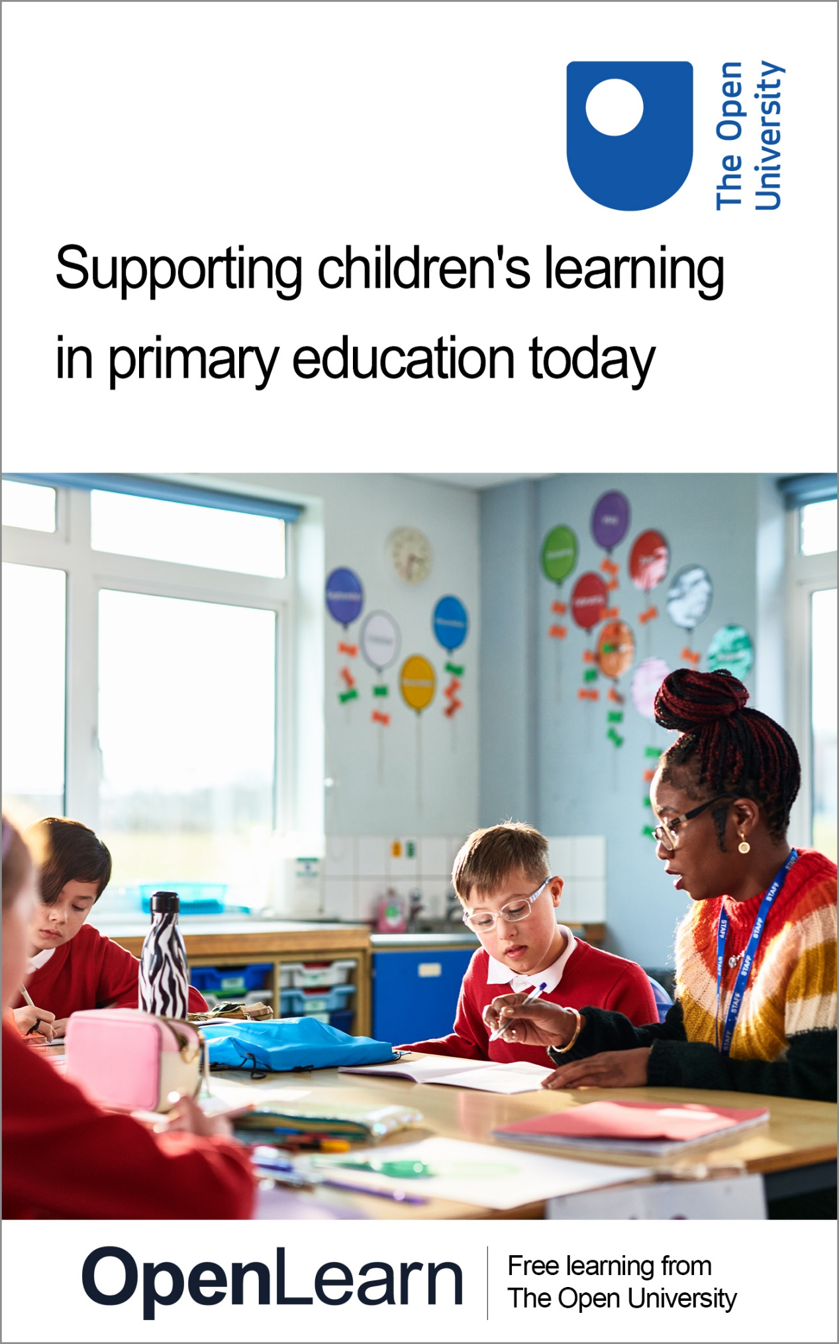

E103_2

Supporting children’s learning in primary education today

About this free course
This free course is an adapted extract from the Open University course E103 Learning and teaching in the primary years: www.open.ac.uk/courses/modules/e103.
This version of the content may include video, images and interactive content that may not be optimised for your device.
You can experience this free course as it was originally designed on OpenLearn, the home of free learning from The Open University –
www.open.edu/openlearn/education-development/supporting-childrens-learning-primary-education-today/content-section-0
There you’ll also be able to track your progress via your activity record, which you can use to demonstrate your learning.
First published 2025.
Unless otherwise stated, copyright © 2025 The Open University, all rights reserved.
Intellectual property
Unless otherwise stated, this resource is released under the terms of the Creative Commons Licence v4.0 http://creativecommons.org/licenses/by-nc-sa/4.0/deed.en. Within that The Open University interprets this licence in the following way: www.open.edu/openlearn/about-openlearn/frequently-asked-questions-on-openlearn. Copyright and rights falling outside the terms of the Creative Commons Licence are retained or controlled by The Open University. Please read the full text before using any of the content.
We believe the primary barrier to accessing high-quality educational experiences is cost, which is why we aim to publish as much free content as possible under an open licence. If it proves difficult to release content under our preferred Creative Commons licence (e.g. because we can’t afford or gain the clearances or find suitable alternatives), we will still release the materials for free under a personal end-user licence.
This is because the learning experience will always be the same high quality offering and that should always be seen as positive – even if at times the licensing is different to Creative Commons.
When using the content you must attribute us (The Open University) (the OU) and any identified author in accordance with the terms of the Creative Commons Licence.
The Acknowledgements section is used to list, amongst other things, third party (Proprietary), licensed content which is not subject to Creative Commons licensing. Proprietary content must be used (retained) intact and in context to the content at all times.
The Acknowledgements section is also used to bring to your attention any other Special Restrictions which may apply to the content. For example there may be times when the Creative Commons Non-Commercial Sharealike licence does not apply to any of the content even if owned by us (The Open University). In these instances, unless stated otherwise, the content may be used for personal and non-commercial use.
We have also identified as Proprietary other material included in the content which is not subject to Creative Commons Licence. These are OU logos, trading names and may extend to certain photographic and video images and sound recordings and any other material as may be brought to your attention.
Unauthorised use of any of the content may constitute a breach of the terms and conditions and/or intellectual property laws.
We reserve the right to alter, amend or bring to an end any terms and conditions provided here without notice.
All rights falling outside the terms of the Creative Commons licence are retained or controlled by The Open University.
Head of Intellectual Property, The Open University

Contents
- Introduction
- Learning outcomes
- 1 The purpose of primary education today
  - 1.1 Purpose of education
  - 1.2 An overview of primary education today
  - 1.3 The knowledge and understanding children bring to their primary school learning
  - 1.4 Summary of Section 1
- 2 The role of talk, creativity and play in the primary classroom
  - 2.1 Talk in the classroom
  - 2.2 The role of creativity and play in the classroom
  - 2.3 Summary of Section 2
- 3 Learning environments, health and wellbeing, inclusive practice and specialist provision
  - 3.1 Learning environments outside the classroom
  - 3.2 Health and wellbeing
  - 3.3 Supporting learning: inclusion and specialist provision
  - 3.4 Supporting individual learners
  - 3.5 Summary of Section 3
- 4 Learning in literacy, maths and science
  - 4.1 Literacy
  - 4.2 Maths
  - 4.3 Science
  - 4.4 Summary of Section 4
- Conclusion
- References
- Acknowledgements
- Solutions
- Descriptions

Introduction
Welcome to this free course, Supporting children’s learning in primary education today.

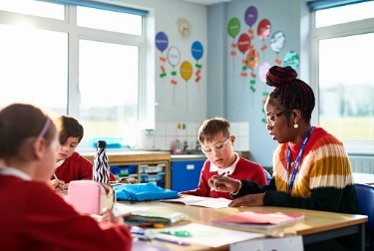
Figure 1 Supporting learners in primary teaching today.
View description - Figure 1 Supporting learners in primary teaching today.

Each section of the course invites you to explore a different aspect of learning and teaching in primary education. You will have opportunities to engage with different types of activities that are designed to develop your understanding of learning and teaching in primary education, and importantly to reflect on and connect this material to your own experiences. These experiences may include: being a pupil; being a parent/carer of a child or children in primary school; being a volunteer/paid member or staff in a primary school.
Terminology and age range for primary education varies across the four nations of the United Kingdom (UK) and internationally. The terms ‘primary education’, ‘primary schools’ and ‘primary-aged children’ will refer to the education of children aged between three and twelve years old. You may be aware of other terms that also refer to primary school education and different stages within that, including ‘nursery’, ‘elementary school’, ‘early years’, ‘foundation stage’, ‘infant’, ‘middle and junior school’.
You’ll start by considering the following questions:
- How might we understand primary schools today?
- How do primary schools support young learners?
- How can schools be inclusive and offer specialist provision?
- What are your experiences of primary education – your own or from your work/volunteering in a primary setting?
This OpenLearn course is an adapted extract from the Open University course E103 Learning and teaching in the primary years. The OU course offers a range of different perspectives taking into consideration differences in education systems in the UK and opportunities for learning and teaching beyond the school gates.

Learning outcomes
After studying this course, you should be able to:
- understand the different aims of primary education today
- articulate different ways in which learners are supported in primary school
- demonstrate an understanding of inclusion and specialist provision
- reflect on and consider personal experiences of primary education in relation to current practice.

1 The purpose of primary education today

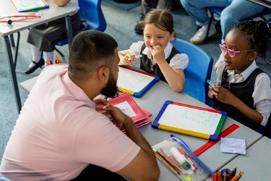
Figure 2 Learning in a primary classroom.
View description - Figure 2 Learning in a primary classroom.

Starting with the question ‘what is education?’, in this section you will reflect on the broad aims of education and the relevance of creating a vision and set of values in primary schools. You’ll also consider the importance of understanding individual learners’ experiences as significant in fostering learning in the primary classroom. This will encourage everyone working or volunteering in primary education to think broadly and critically about supporting primary learners.

1.1 Purpose of education
What is education? Across the world, politicians, policy makers, academics, educationalists, parents and children alike all grapple with this question in different ways and for different reasons.
The way you think about education is influenced by your own values and beliefs, the values and beliefs of others, political ideologies, socio-economic climate, religion, culture, acquisition of knowledge or life experiences, yet views are rarely fixed and change over time. Read this short quote from the Department for Education (DfE):

Education is the great leveller. Every single child should have access to an education that equips them with the knowledge, skills and experiences needed to fulfil their potential.
Primary education is critical to a child’s development and it is where they lay the foundations for their futures.
(DfE, 2022)

And this from the United Nations:

States Parties agree that the education of the child shall be directed to:
a. The development of the child’s personality, talents and mental and physical abilities to their fullest potential.
b. The development of respect for human rights and fundamental freedoms, and for the principles enshrined in the Charter of the United Nations.
c. The development of respect for the child’s parents, his or her own cultural identity, language and values, for the national values of the country in which the child is living, the country from which he or she may originate, and for civilizations different from his or her own.
d. The preparation of the child for responsible life in a free society, in the spirit of understanding, peace, tolerance, equality of sexes, and friendship among all peoples, ethnic, national and religious groups and persons of indigenous origin.
e. The development of respect for the natural environment.
(United Nations (UN), 1989)

Activity 1
Allow 10 minutes

What do you believe the purpose of education to be?
Here are some statements about the purpose of primary education. Number these statements in an order of most important (1) to least important (10) in your view. Add the number in the text box next to the statement. The aim of this activity is to encourage you to think about the different purposes of education and your own experiences. There are no right or wrong answers here.
Education is to …

Statement | Your order
… prepare children for future employment | Provide your answer...
… ensure everyone has basic skills to a certain level | Provide your answer...
… develop children’s ability to empathise | Provide your answer...
… help children become lifelong learners | Provide your answer...
… develop children’s moral values | Provide your answer...
… prepare children to contribute to society | Provide your answer...
… develop children’s understanding of the world | Provide your answer...
… foster children’s skills in literacy, science and mathematics | Provide your answer...
… help children discover creativity | Provide your answer...
… reduce crime and antisocial behaviour | Provide your answer...

Thinking about your own experiences, write three bullet points that capture what you think influences your ideas about the purposes of education.

Provide your answer...

1.2 An overview of primary education today
In each UK nation – England, Northern Ireland, Scotland and Wales – children aged three to four years old are entitled to free early education from the school term after they turn three years old. This might be part of a primary school, which has provision for younger children, or it may be in a private, voluntary or independent (PVI) setting, for example, a nursery or preschool. The number of hours children can attend ranges from 10–22.5 hours per week, depending on the nation’s offer. Hours may be extended, and the starting age lowered for children living in low-income families. Unlike primary schools, attendance in an early years setting is not compulsory and is a parental choice.
Throughout the UK there are over 20,000 primary schools (Statista, no date). Every primary school is different depending on where it is located and who attends. The smallest primary schools may have fewer than 10 pupils, and the largest providing education for over 1,000 pupils. Each school’s characteristics will also vary based on the pupils attending and the characteristics of the pupils, i.e. their age, sex, languages spoken, ethnicity and whether pupils are identified as living in poverty (socio-economic disadvantage).
The vision and values of the school, crafted by the Senior Leadership Team, often in collaboration with the children and parents, reflect a school’s unique characteristics.

Activity 2
Allow 15 minutes

Task 1

First watch the following video in which two Headteachers outline a vision statement and a set of values that have been developed in their individual primary schools.

Video content is not available in this format.
Video 1 Visions and values
View transcript - Video 1 Visions and values

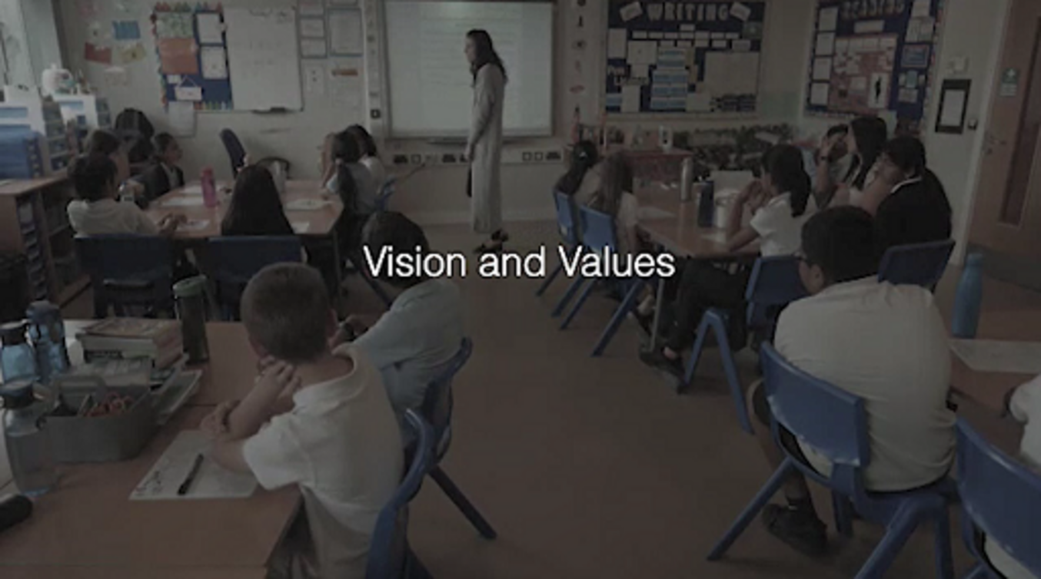

Write a vision statement or a set of school values for a primary school.
Using your knowledge of a school in which you work/volunteer or you know well for different reasons, think about the core characteristics of the school – location, size, family backgrounds of those attending. Use these sticky notes to capture these thoughts and other ideas.

Interactive content is not available in this format.

Task 2

Using your notes from Task 1, now write your vision statement and school values.

Vision: ‘Be the best that you can be’ | Values: ‘Enjoyment, kindness, perseverance, cooperation’
Provide your answer... | Provide your answer...

How does your vision statement/values reflect the values of the local community of the school?
How would you want your vision statement/values to influence the way in which the school community (children, staff, parents) interacts?

Provide your answer...

Schools can attune their vision and values to the needs of their children, families and communities. Making connections with home experiences is an important way of supporting learning, as you will see in Section 1.3.

1.3 The knowledge and understanding children bring to their primary school learning
When a child or an adult engages in new learning, they rarely, if indeed ever, start from a ‘blank sheet’, but instead draw on their previous knowledge, understanding and life experiences.
A learner’s previous knowledge and understanding are developed through their daily lived experiences, active participation and social interaction within their households and communities over their life. The activities include assisting with household chores, caring for family members, undertaking religious practices, engaging in hobbies, or sharing stories, literature or other forms of media. Knowledge and understandings are also developed as part of social networks that go beyond the individual household to their wider communities in which they participate. The knowledge and understandings that children and adults bring with them to learning have been described as ‘funds of knowledge’ (González and Moll, 2005).

Activity 3
Allow 10 minutes

Task 1

Read this short case study written by an Open University academic.

I grew up in England, with English-speaking parents. In addition, I also learned a small number of Spanish words and phrases, as my father was born and grew up in Chile and would occasionally use Spanish expressions at home. My mother is from an Irish and Scottish family, so I also learned many Irish and Scottish expressions and used these regularly. While we occasionally ate South American food that my father would cook, we usually ate traditional English, Irish or Scottish food. My parents would regularly read to me and my brother and so we knew a wide range of stories. My mother is Catholic, and my brother and I went to church with her every Sunday and took part in daily religious rituals such as saying grace before eating. My father did not attend church or say grace, so I learned that not everyone believes in God.

Now make some notes on your own knowledge and understandings that you brought with you to your primary education. Were there any key influences that you remember? Use the following prompts to guide your thinking:
- your family background, e.g. culture, religion, languages spoken at home
- your hobbies, e.g. sporting clubs, sewing, cooking
- your interests/activities, e.g. the natural world, family trips to museums/galleries
- your family members and family friends.

Provide your answer...

Task 2

What is the value of getting to know children’s experience outside the classroom? Complete this fill the gap activity.

Interactive content is not available in this format.

1.4 Summary of Section 1
Considering the purposes of education, visions and values for primary schools and children’s lived experiences outside the classroom is relevant to everyone working in primary education today. This reflective work alongside thinking about your own experiences will help broaden your understanding of primary education today.
In the next section, you’ll explore the role of talk, creativity and play in the primary classroom.

2 The role of talk, creativity and play in the primary classroom

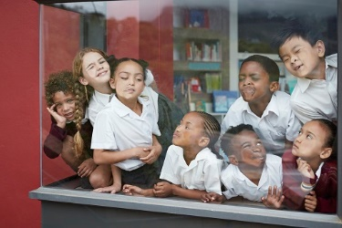
Figure 3 Children at play.
View description - Figure 3 Children at play.

Through talk and other forms of communication a child connects with the primary practitioners, other school staff and their peers in the primary setting. These important skills for children and adults alike, underpin creativity and play. For everyone working or volunteering in primary settings, talk, creativity and play are important foundations to support children in accessing the primary curricula.

2.1 Talk in the classroom
Talking and listening are important elements of education. Through these, children develop a sense of their place within the social world, gaining confidence and valuing their own ideas. Children develop language and communication skills before formal education in the home, but schools play an important role in fostering children’s talking and listening skills. Through listening, individuals can begin to understand others’ perspectives. Through talking they may share their ideas and feelings. Of course, communication also occurs without talking and listening and a wide range of non-verbal forms exist, such as sign language, touch, gesture, movement, gaze, facial expressions facilitated by visual or electronic aids.
Developing oracy skills has a positive impact on children and underpins learning in all areas. Oracy can support literacy skills and wider achievement at school and beyond. It may also contribute to social relationships and wellbeing. It has the potential to empower children as citizens who are better prepared for participation in society and support social mobility therefore enhancing life chances (Oracy APPG, 2021).
Talk between teachers and learners is a crucial part of classroom life. For those children who speak English as an additional language and are not confident in using English, encouraging spoken interactions is a way to develop their confidence and capabilities. Skilled practitioners who value and support children’s home languages encourage children through different activities to allow them to learn language and learn through language.
Some schools have access to staff who are bilingual. Their support for oral language extends beyond translation. They support home language development, English skills and conceptual understanding. They can supplement classroom talk with explanations (vocabulary or concepts) in the home language.
Staff can use the first language to give instructions or check children’s understanding – this is especially important when content is conceptually demanding, and cognitive load high.

Activity 4
Allow 10 minutes

In this video, you’ll watch Zamurd, a classroom volunteer, working with a group of children who do not speak English as their first language. Watch the video and think about how Zamurd supports the children’s learning through dialogue and interactions. Read through the list below, watch the video again and in the right-hand column add a cross if you noticed the behaviour in the left-hand column happening to support the children’s learning.

Video content is not available in this format.
Video 2 Bilingual support
View transcript - Video 2 Bilingual support

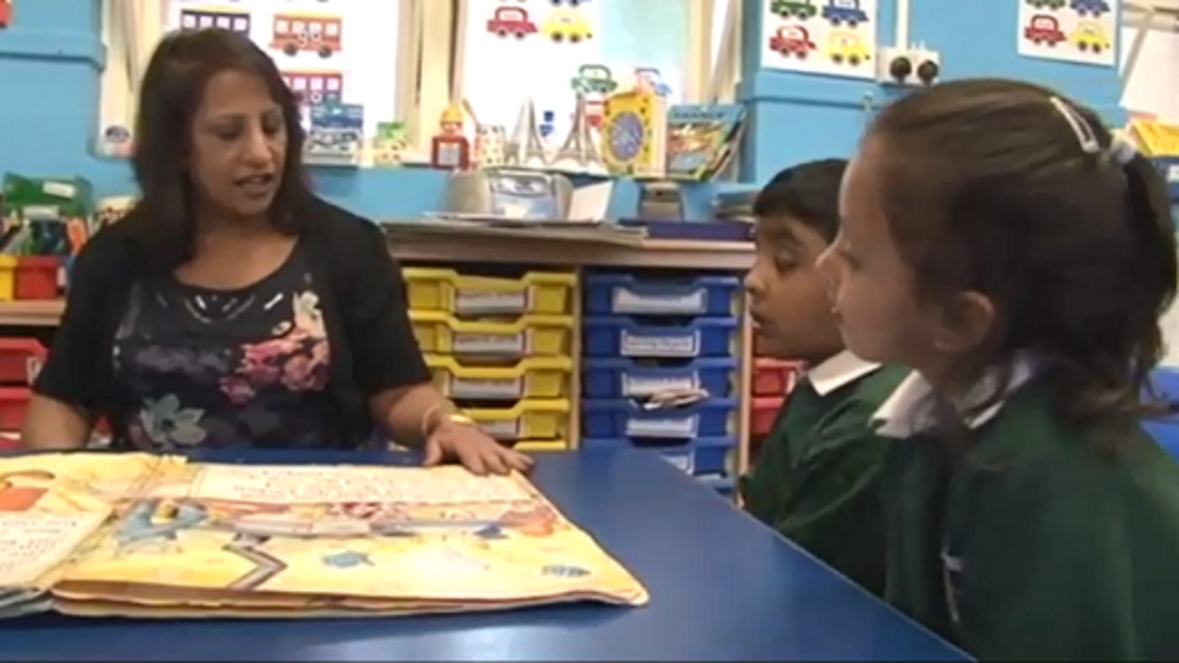

Questions to the children in home language | Provide your answer...
Repetition of child’s responses | Provide your answer...
Offers of encouragement | Provide your answer...
Eye contact | Provide your answer...
Reading from the book in English | Provide your answer...
Translations into home language | Provide your answer...
Checking understanding of story details in home language | Provide your answer...

View discussion - Activity 4

2.2 The role of creativity and play in the classroom
Creativity is a concept that is often associated with the expressive arts, such as drama, painting or music, and in particular the ‘product’ of that creativity. However, this narrow view can lead to creativity being neglected in educational practice, and educators who do not consider themselves to be ‘creative people’ may lack confidence in their ability to teach creatively or develop the creativity of learners.
Creativity can also be linked to play in the classroom. A famous quote by Lev Vygotsky captures the opportunities that play offers:

In play a child is always above his average age, above his daily behaviour; in play, it’s as though he were a head taller than himself.
(Vygotsky, 2016, p. 18)

So, what does this mean in the context of the primary classroom? How do children become ‘a head taller’? What are the benefits of this?
Taking the example of classroom role play, children are able to ‘be’ older than they are. They can take on adult roles and use language that constructs the scenarios of, for example, a doctor’s surgery (as a doctor, a patient), a classroom (as a teacher) and the like. In so doing, children create opportunities to try out new words and phrases associated with the particular role and scenarios they choose to enact. Through the social and dialogic interaction that comes with role play, children come to understand how others respond to their words and phrases, while also hearing how others use language to enact their own role.
Play in the classroom extends of course to digital play. Children are often exposed to some form of digital play before they start school. However, as with any experiences, these will vary between children. In the case of digital experiences, socio-economic disadvantage can lead to a digital disadvantage, known as the ‘app gap’ (Kolak et al., 2021). Not all families can afford access to the internet, digital devices, or are able to purchase paid-for apps.
While many resources encourage children’s digital skills alongside wider curriculum outcomes (e.g. literacy and numeracy), the extent to which the activities can be considered play, alongside their creativity and educational value has also been examined critically. Selecting a quality educational app is not straightforward (Kolak et al., 2021). Research into apps that promise gains in children’s literacy and numeracy skills (e.g. Meyer et al., 2021) reveal that often they are designed to offer right or wrong answers (Vaala, Ly and Levine, 2015) and narrow possibilities for play (Plowman, 2020).
Understanding what children think is play is important for educators as they design playful ways to support learning. For example, a teacher might introduce what they think is a playful maths activity, but will the children see it as play?

Activity 5
Allow 10 minutes

Task 1

In a study about play and learning (Mukherjee et al., 2022; Bugallo et al., 2024), 5-year-old and 7-year-old children in England were invited to sort cards to indicate whether the activities depicted on the cards represented play, learning or play and learning.
Look at the table below. In each cell there is a ‘card’ with a line drawing depicting an activity, and each column represents one category. How do you think the children categorised the activities?
Using the labels, ‘only play’, ‘only learning’ and ‘play and learning’ assign one label to each column.

Provide your answer... | Provide your answer... | Provide your answer...
Cooking 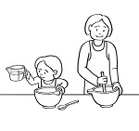 | Hula hoop 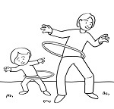 | Dressing up 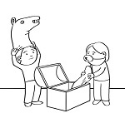
Planting 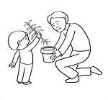 | Lining up numbers 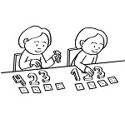 | Farm figurines 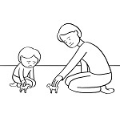
Writing 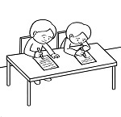 | Dominoes 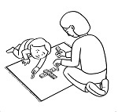 | Hide and seek 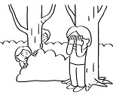
Tying shoes 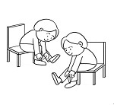 | The guitar 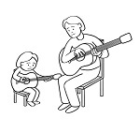 | Swinging 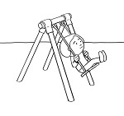

View discussion - Task 1

Task 2

Make some notes using the following prompts to guide you:
- Were you surprised by the way in which the children categorised these activities?
- Has Task 1 encouraged you to think differently about activities commonly found in primary school? What playful activities have you previously experienced in the classroom yourself or included in your teaching?
- If you work in a school, would you include different playful activities now?

Provide your answer...

2.3 Summary of Section 2
Understanding the positive influences of talk, creativity and play is important for those working and volunteering in primary schools. Greater understanding in these areas can motivate primary practitioners to maximise the opportunities for talk, creativity and play across the primary curriculum, which can lead to happy and well-supported learners.

3 Learning environments, health and wellbeing, inclusive practice and specialist provision

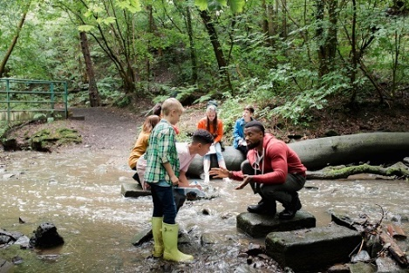
Figure 4 Learning environments.
View description - Figure 4 Learning environments.

While the classroom remains a central site for learning in the primary years, other environments, such as the beach or a local museum, can offer rich learning opportunities. In these other environments, outside typical school routines and expectations, children’s health and wellbeing are supported in different ways. However, across all, inclusive practices ensure every child, regardless of their background or specific needs, receives equal access to quality education. Identifying students and providing individual support where needed is a critical aspect of creating an inclusive and equitable learning environment.

3.1 Learning environments outside the classroom
One learning environment far outside the classroom is Forest Schools (FS), first conceived by Gösta Frohm in Sweden in the 1950s. FS came to England in 1995 (Pound, 2014) and while originally for early years (EY), the approach has been taken up across the primary years with around 10,000 FS across the UK (McCree and Cree, 2017, cited in Waite and Goodenough, 2018, p. 27). Taking part in FS offers children the chance to interact with their peers and trained practitioners in an outdoor area with trees – this can be a local wooded area or managed park. Children are taught practical skills, such as how to saw logs, make fires and cook food outside. Carrying a level of risk unacceptable in a traditional classroom, the activities are carefully scaffolded and supervised.

Activity 6
Allow 15 minutes

Watch this video of a child making a mallet in Forest Schools. Then respond to the points which follow, capturing what the child and the adult is doing and saying and how this dialogic interaction and activity is supporting learning.

Video content is not available in this format.
Video 3 Forest schools
View transcript - Video 3 Forest schools

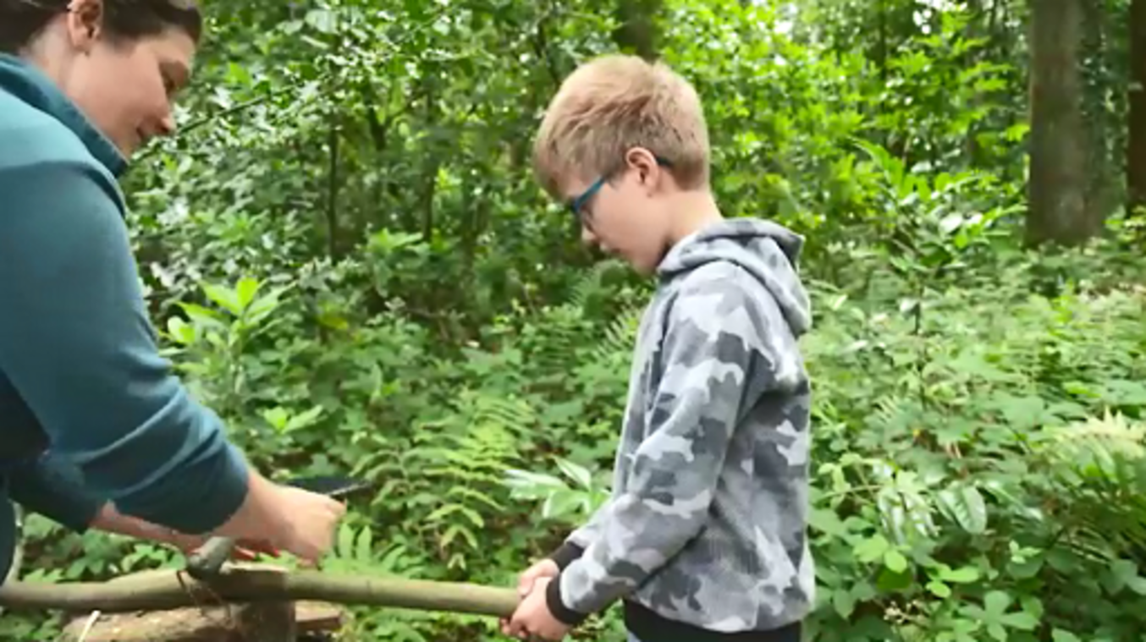

- What is the child doing and saying?
- What is the adult doing and saying?
- Interpretation of learning

Provide your answer...
View discussion - Activity 6

If you’d like to know more about learning environments, you might like to explore this OpenLearn course: Young children, the outdoors and nature.

3.2 Health and wellbeing
Children spend a signiﬁcant proportion of their time at school (approximately 190 days in each school year), which means that schools are well positioned to support all children’s health and wellbeing through the learning opportunities and the learning environment itself.
Policy makers in the UK recognise the importance of personal, social, health and economic (PSHE) education and, from 2020, governments across the four UK nations introduced new statutory curricula to provide education on health and wellbeing. A ‘whole school approach’ in this area recognises the importance of working collaboratively with all parts of the school community – children, families and staff – and may include behaviour policy, curriculum design, care and support for children and engagement with parents.
At times this health and wellbeing is supported in schools through collaborations with specialist external agencies, e.g. for physical health needs a school may refer to the school nurse, General Practitioner (GP) and Community Paediatricians; for mental health needs a school may refer to school nurses, GPs, school counsellors, clinical or educational psychologists and specialist services such as the Children and Adolescent Mental Health Service (CAMHS).

Activity 7
Allow 15 minutes

Task 1

Drawing on your own experiences, what opportunities have you had or are there for supporting children’s health and wellbeing in a primary setting?

Provide your answer...

Task 2

Watch the following video. How is playing and learning outdoors said to support children’s health and wellbeing?

Video content is not available in this format.
Video 4 Health and wellbeing through outdoor learning
View transcript - Video 4 Health and wellbeing through outdoor learning

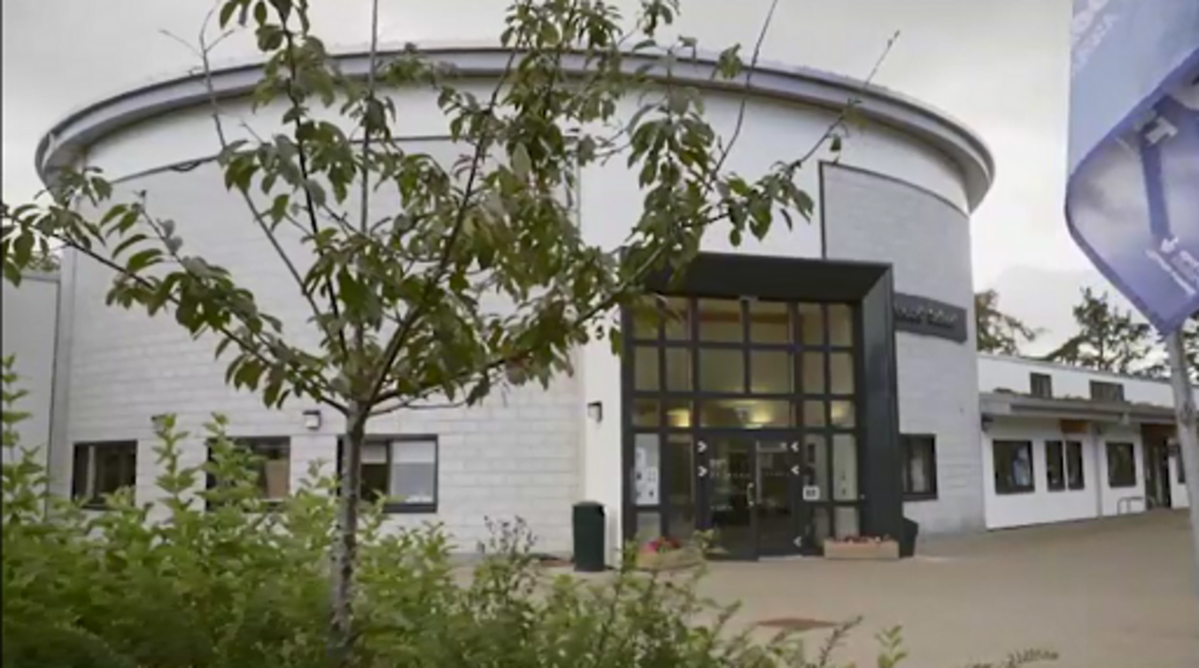

Provide your answer...
View discussion - Task 2

If you’d like to know more about mental health among children, you might like to explore this OpenLearn course: Supporting children’s mental health and wellbeing.

3.3 Supporting learning: inclusion and specialist provision
Inclusive practice is a fundamental principle that aims to ensure every child, regardless of their background or specific needs, receives equal access to quality education in UK primary schools.
In effective inclusive environments, the learning space, teaching practices and curricular materials will cater to the diverse needs of students. If schools embrace diversity and promote understanding, inclusive learning environments not only support the academic progress of all pupils but also cultivate empathy, respect and social cohesion.
Inclusion can be misunderstood as shorthand for special education or additional-support needs or special provision, yet inclusion encompasses diversity, participation, equity and equality, and relates to all groups who may be marginalised within education and social systems.
For anyone interested in learning in primary schools, developing an understanding of the barriers to inclusion and practices and behaviours that can promote inclusion is important.

Activity 8
Allow 10 minutes

Watch the following video with Liz Pemberton, known as The Black nursery manager, where Liz is answering the question ‘So how can educators create environments that encourage play and learning in an anti-racist way?’

Video content is not available in this format.
Video 5 Anti-racism in play and learning
View transcript - Video 5 Anti-racism in play and learning

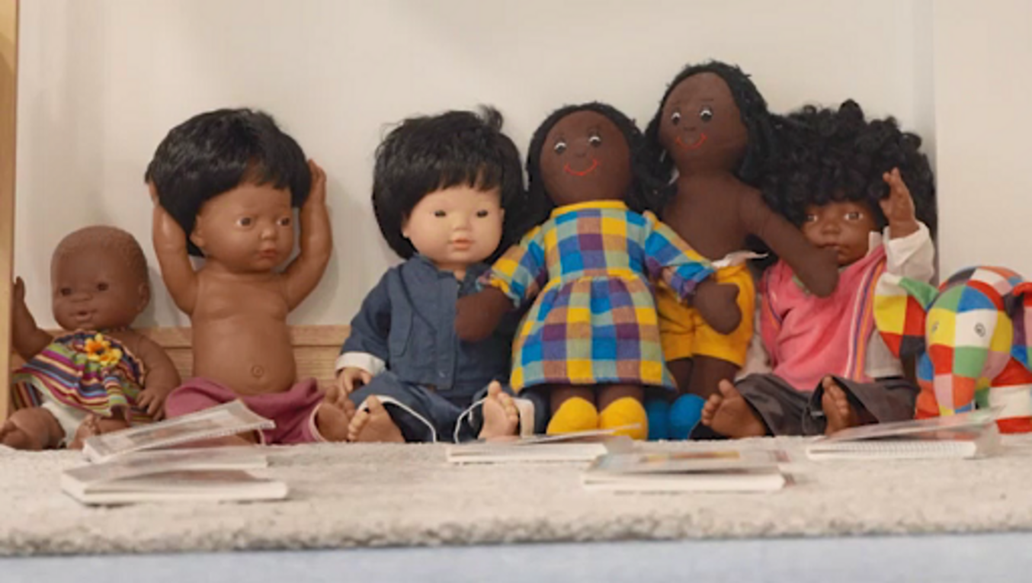

Liz says that celebrations are sometimes reduced to ‘flat pack’. What is your response to this claim? What can practitioners do so that celebrations are not ‘flat pack’?
How can primary educators learn more about the children in their classroom? Why is this important in your view?

Provide your answer...
View discussion - Activity 8

3.4 Supporting individual learners
Identifying students who require individual support to access the curriculum fully is a critical aspect of creating an inclusive and equitable learning environment.
Supporting each individual learner to achieve their full potential requires a deep understanding of pupils’ unique needs, abilities and backgrounds, as well as the ability to adapt teaching strategies and resources to meet diverse learning requirements. In this context, listening to learners explain their own experiences is of key importance and can help in future interactions with learners who need specialist provision.

Activity 9
Allow 15 minutes

Listen to the following audio where Aqsa, a year 5 pupil at Joseph Clarke School, is talking about her experiences as a visually impaired pupil at a specialist provision. As you listen to the audio, make notes on the points below.

Audio content is not available in this format.
Audio 1 Asqa’s voice
View transcript - Audio 1 Asqa’s voice

- How does Aqsa describe her experience of using assistive technologies in their learning? What specific benefits does she mention?
- In what ways does the Aqsa’s visual impairment impact her school life and learning?
- What do her responses lead you to think educators should consider when supporting students with specialist provision?

Provide your answer...
View discussion - Activity 9

3.5 Summary of Section 3
For people working in primary settings, understanding that outside environments can deepen and extend learning opportunities can strengthen their overall appreciation of the ways in which children can learn. Knowing that children’s health and wellbeing are supported in non-traditional environments means practitioners may consider potential alternatives to the classroom in some instances. Being aware of the importance of inclusive practice and specialist provision ensures that adults working in primary settings across all environments can support children ensuring all enjoy equal access to quality education.

4 Learning in literacy, maths and science
English, mathematics and science are subjects that should be enjoyed by children in their own right. There is enormous pleasure to be found in solving a mathematical problem, writing a poem and watching a seed grow. Within these distinct but overlapping curriculum foci, skills are applied across the curriculum. For example, in physical education (PE) children will need to know about distance and time; in history and geography children will use a range of literacy skills to explore their local area; and through consideration of scientific evidence, children become ethical and informed citizens. In this section, you will consider some of the challenges for primary schools in these three broad fields of learning.

4.1 Literacy

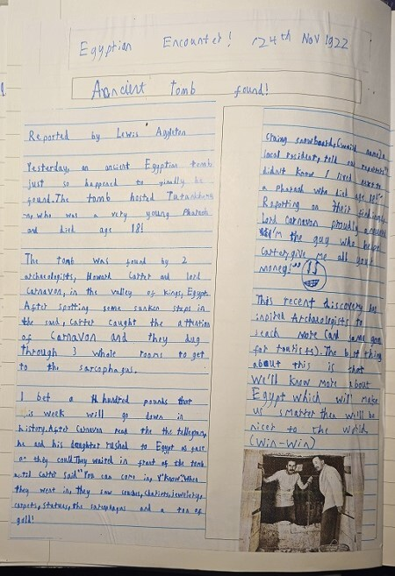
Figure 5 Egyptian Encounter! 24 November 1922.
View description - Figure 5 Egyptian Encounter! 24 November 1922.

To be literate is to be able to understand and apply language to communicate meaning, yet what it means to be literate and ideas about language and literacy differ across place and time. Literacy is culturally dependent, with different individuals and cultural ascribing different values to elements of literacy. The concept of ‘multiliteracies’ includes visual literacy and digital literacy alongside the more familiar idea of literacy relating to reading and writing words.
Literacy curricula and school guidance in the UK encompasses oracy (speaking and listening) writing, handwriting, spelling, punctuation and grammar (also known as SPaG) and reading, including comprehension and phonics (the study of sounds).

Activity 10
Allow 15 minutes

Task 1

The following newspaper report writing is by Lewis, an eight-year-old boy living in London. Read the report and assess the writing using a checklist commonly seen in primary classrooms.

Ancient tomb found! Reported by Lewis Aggleton
Yesterday, an ancient Egyptian tomb just happened to finally be found. The tomb hosted Tutankhamen who was a very young Pharoah and died age 18!
The tomb was found by 2 archaeologists, Howard Carter and Lord Carnavon, in the valley of kings, Egypt. After spotting some sunken steps in the sand, Carter caught the attention of Carnavon and they dug through 3 whole rooms to get to the sarcophagus.
I bet a hundred pounds that this week will go down in history. After Carnavon read the the telegram, he and his daughter rushed to Egypt as fast as they could. They waited in front of the tomb until Carter said ‘You can come in, y’know’. When they went in, they saw couches, chariots, jewelery, carpets, statues, the sarcophagus and a ton of gold!
Ctaing Snowboard, (weird name), a local resident, told our reporter ‘I didn’t know I lived next to a Pharoah who died age 18!’ Reporting on their findings Lord Carnavon proudly announced ‘I’m the guy who helped Carter, give me all your money!’
This recent discovery has inspired Archaeologists to search more (and same goes for tourists). The best thing about this is that we’ll know more about Egypt which will make us smarter then we’ll be nicer to the world. (win-win)

How would you describe the success of Lewis’s use of the following features?
Add a tick or cross into the following table.

Feature | Always correct | Sometimes/  partially correct | Incorrect/not present
Newspaper article features
Headline, reporter name, date of report | Provide your answer... | Provide your answer... | Provide your answer...
Opening paragraph containing the 5 Ws (what, where, when, who, why) | Provide your answer... | Provide your answer... | Provide your answer...
Information about the main events in chronological order | Provide your answer... | Provide your answer... | Provide your answer...
Images with captions | Provide your answer... | Provide your answer... | Provide your answer...
Direct speech | Provide your answer... | Provide your answer... | Provide your answer...
Reported speech | Provide your answer... | Provide your answer... | Provide your answer...
Written in the third person and past tense | Provide your answer... | Provide your answer... | Provide your answer...
General writing features
Capital letters/full stops | Provide your answer... | Provide your answer... | Provide your answer...
Exclamation/speech marks/parentheses | Provide your answer... | Provide your answer... | Provide your answer...
Adjectives/adverbs, connectives | Provide your answer... | Provide your answer... | Provide your answer...
Spelling | Provide your answer... | Provide your answer... | Provide your answer...

View discussion - Task 1

Task 2

Now reflect on the following three points and consider whether you think that the way the writing features have been used has made the piece of writing more effective as a newspaper report, or less effective, and why.

Feature | More, less, or sometimes effective | Reason
Information about the main events in chronological order | Provide your answer... | Provide your answer...
Direct speech | Provide your answer... | Provide your answer...
Parentheses (in brackets) | Provide your answer... | Provide your answer...

View discussion - Task 2

For the educator, what counts as ‘present’ or ‘absent’ will depend heavily on the learning goals of the activity and the direction set out in the curriculum. While some activities may be narrow in their focus, it is important to remember that whatever these expectations, Lewis needs to receive positive feedback to be motivated to continue to write and supportive guidance to help him to improve. It is important for the learner to understand the goal of the activity to recognise that there may be many positive aspects of their writing outside the focus of the set task. Thus the adult role and their communication is crucial.

4.2 Maths
Mathematics can be described as the study of quantity, shape and measures through a network of knowledge, concepts and skills. Beyond the school ‘subject’, mathematics is part of daily lives and is used in a range of practical ways. A numerate person is someone who is confident in their ability to use mathematical ideas needed in their life. However, mathematics is not just a collection of knowledge and skills, it is a way of thinking and a way of ‘doing’.
The National Curriculum in England talks about the ‘beauty and power of mathematics’ (DfE, 2013, p. 99). You may have been struck by the power of ‘mathematics’ in the real world, e.g. the ‘beauty’ of the motorway bridge approaching the River Severn, or the power of mathematics that allows us to put hundreds of cars, lorries and buses onto a boat without it sinking.




Figure 6 (a) The beauty of the Severn Bridge; (b) The power of mathematics.
View description - Figure 6 (a) The beauty of the Severn Bridge; (b) The power of mathematics.

Mathematics can be described as a language in itself. This may seem surprising but consideration of mathematics as language can provide some insight into implications for learning and teaching. It has its own vocabulary, structure and notation understood across the world. This means that children who understand mathematical ideas but do not speak English as their first language can engage successfully with some mathematical activities in school.
Dyscalculia is an additional learning need specific to mathematics with difficulties including: comparing quantity, remembering facts, problems with sequence and ordering, slow processing speed. However, in some cases learners develop negative attitudes or maths anxiety towards mathematics that stem from poor learning and teaching experiences, influences from others e.g. parents, grandparents, friends or societal influence. It’s important for practitioners to support young learners to develop enjoyment of and confidence in using maths alongside ability.

Activity 11
Allow 10 minutes

Set a timer for 5 minutes and try to answer the questions below. Stop when you have been working for 5 minutes.
It doesn’t matter how many questions you answer in that time – nobody is going to check or ask you for the answers.

Task 1

Use the numbers in the left column in the table below to make 42. Note down your answers in the right column.

Digits to be used | Answers
1 2 4 8 | Provide your answer...
1 2 4 6 | Provide your answer...
3 4 5 6 | Provide your answer...
2 5 3 7 | Provide your answer...

Task 2

Reflect on undertaking Task 1 using the questions below as prompts. In the discussion you can read an example of a student’s written reflections.
- Did you work on the questions for the full 5 minutes? If no, why not?
- Did the time seem to pass quickly or slowly? Why do you think that was?
- How did the instruction to time the activity make you feel?

Provide your answer...
View discussion - Task 2

4.3 Science
Studies show that for some children, their curiosity for science diminishes early in a child’s primary school career. This diminishing curiosity first becomes apparent at ages 5–7 and worsens throughout primary and secondary school (Wellcome Trust, 2014). The national curriculum for science in England talks about children being encouraged to ‘develop a sense of excitement and curiosity about natural phenomena’, while the curriculum in Northern Ireland, called ‘The World Around Us’, is explicitly focused on encouraging natural curiosity and questioning. Discouraging a ‘science isn’t for me’ attitude is important to maintain children’s natural curiosity and questioning about the world around them. Here are some points that help explain why children may lose interest in science in their primary years:
1 Science isn’t perceived as relevant

Children don’t always recognise the usefulness of science in their lives and future career, and may only see recognise the roles of ‘scientist’ and doctor as professions using science.

2 Limited or poor teaching and learning experiences

In some primary schools, a focus on English and mathematics has taken precedence over science, resulting in less teaching time. If primary teachers lack confidence and skills in science, this can lead to teachers who are unable to foster children’s own confidence and enjoyment of science and in misconceptions going uncorrected.

3 Lack of science capital

Science capital is a concept that refers to the total science-related knowledge, attitudes, ideas and experiences that a child might have. The more science capital a child has (knowledge and understandings from family and friends as well as school), the more likely they are to identify as a ‘science person’. The less science capital a child has, the less likely they are to continue studying science at secondary school and consider a career in the sciences (Archer et al., 2014).

4 Issues of equity

Despite improvements in the area, stereotypes in science continue to exist. The scientific contributions of women, those from working-class backgrounds and minority ethnic backgrounds are often ignored or excluded in books and resources. Societal norms and popular culture continue to reinforce long-standing, pervasive stereotypes of scientists as being white, male, middle class and based in a lab (e.g. Carli et al., 2016).

Activity 12
Allow 15 minutes

Look at this image of a ‘chemist’ drawn by a child. Make notes on the stereotypes that you notice in this picture.

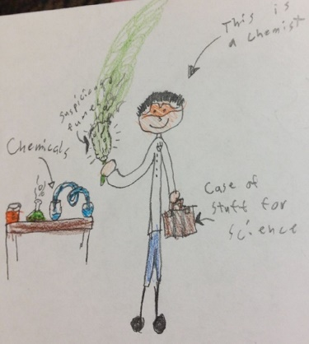
Figure 7 What does a scientist look like?
View description - Figure 7 What does a scientist look like?

Provide your answer...
View discussion - Activity 12

4.4 Summary of Section 4
The areas of literacy, science and maths are broad, overlap and impact a child’s connection with the rest of the school curriculum alongside their understanding of the social and physical world around them. For some children these areas are fascinating fields of study and discovery, yet for others their enjoyment wanes early in their schooling. A narrow skills-based approach to literacy may obscure the potential of a playful and creative engagement and its relevance across the curriculum. With some overlap with feelings about mathematics, science also suffers from damaging stereotypes about what ‘it’ is outside the classroom, and who it is for. The lack of confidence passed from family member or teacher to the child can lead to a lack of confidence that is similar to the maths anxiety described. For practitioners, a reflection about their own experiences, confidence and enjoyment of these key elements of the curriculum may help as they seek to foster not only skills but delight and wonder.

Conclusion

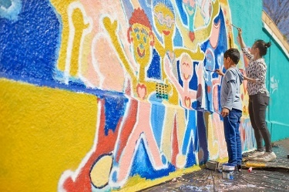
Figure 8 Painting smiles.
View description - Figure 8 Painting smiles.

In completing this free course, you have read about a range of perspectives in learning and teaching and reflected on your own experiences in primary education. You have considered the purpose of education and specifically primary education in the UK today. You’ve explored the value of understanding children’s lived home experiences. To extend your understanding of supporting learning goals, you read about the importance of talking and listening in the primary classroom, in particular when educators support children who speak languages other than English in their homes. In addition, the activities highlighted how creativity and play can support learning, and that understanding children’s own conceptions of play and learning offers educators greater insights into creating playful provision.
Learning outside the classroom, such as in the forest, or at the beach, supports children’s wellbeing and mental health, so primary educators can support children’s learning and development by using different learning environments and creating an inclusive learning culture.
You have been introduced to some ways in which educators can embrace diversity and promote understanding, supporting academic progress and fostering empathy and respect.
Finally you considered the areas of literacy, mathematics and science including the problems of narrow conceptualisations of these broad fields of study. You also read that children often do not understand the relevance of maths and science outside the classroom, and may hold damaging stereotypes that can limit their career and study aspirations. This alongside subject-related anxiety passed from adult to young learner can prevent children from enjoying these subjects and reaching their potential.
In summary, getting to know children and responding to their interests and needs is key to making a difference in primary schooling. Understanding learning and teaching as a complex interaction of the whole child, supportive adults, home and school experiences can afford primary educators opportunities to maximise the learning and teaching in their classrooms to give all children chances to be happy and well supported throughout their primary years.
This OpenLearn course is an adapted extract from the Open University course E103 Learning and teaching in the primary years. The OU course offers a range of different perspectives taking into consideration differences in education systems in the UK and opportunities for learning and teaching beyond the school gates.

References
Archer, L., DeWitt, J. and Wong, B. (2014) ‘Spheres of influence: what shapes young people’s aspirations at age 12/13 and what are the implications of education policy?’, Journal of Education Policy, 29(1), pp. 58–85. Available at: https://doi.org/10.1080/02680939.2013.790079 (Accessed: 25 April 2025).
Bugallo, L., Mukherjee, S.J., Scheuer, N., Cremin, T., Montoro, V., Golinkoff, R., Cheng, D.P.W. and Popp, J. (2024) ‘Children’s and mothers’ understanding of play and learning: repertoires across five cultures’. Learning and Instruction, p. 94. Available at: https://doi.org/10.1016/j.learninstruc.2024.101981 (Accessed: 25 April 2025).
Carli, L.L., Alawa, L., Lee, Y., Zhao, B. and Kim, E. (2016) ‘Stereotypes about gender and science: women ≠ scientists’, Psychology of Women Quarterly, 40(2), pp.244–60. Available at: https://doi.org/10.1177/0361684315622645 (Accessed: 25 April 2025).
Department for Education (DfE) (2022) ‘How we’re raising standards in our schools and colleges – what the Schools White Paper means for you’, The Education Hub, 28 March. Available at: https://educationhub.blog.gov.uk/2022/03/how-were-raising-standards-in-our-schools-and-colleges-what-the-schools-white-paper-means-for-you/ (Accessed: 25 April 2025).
González, N., Moll, L.C. and Amanti, C. (eds) (2005) Funds of knowledge: theorizing practice in households, communities and classrooms. Mahwah, NJ: L. Erlbaum Associates, pp. 29–46.
Mukherjee, S.J., Bugallo, L., Scheuer, N., Cremin, T., Montoro, V., Ferrero, M., Preston, M., Cheng, D., Golinkoff, R. and Popp, J. (2022) ‘Conceptions of play by children in five countries: towards an understanding of playfulness’. Journal for the Study of Education and Development. Available at: https://doi.org/10.1080/02103702.2022.2133401 (Accessed: 25 April 2025).
Pound, L. (2014) How children learn. London: Practical Pre-School Books.
United Nations (UN) (1989) Convention on the Rights of the Child. General Assembly resolution 44/25. Available at: https://www.ohchr.org/en/instruments-mechanisms/instruments/convention-rights-child (Accessed: 25 April 2025).
Waite, S. and Goodenough, A. (2018) ‘What is different about Forest School? Creating a space for an alternative pedagogy in England’, Journal of Outdoor and Environmental Education, 21, pp. 25–44. Available at: https://doi.org/10.1007/s42322-017-000502-2 (Accessed: 25 April 2025).
Wellcome Trust (2014) Primary science: is it missing out? Recommendations for reviving primary science. London: Wellcome Trust. Available at: https://cms.wellcome.org/sites/default/files/primary-science-is-it-missing-out-wellcome-sep14.pdf (Accessed: 25 April 2025).

Acknowledgements
This free course was written by Sarah Jane Mukherjee and Helen Hendry based on original content from E103 module authors Sarah Adams, Paula Addison Pettit, Jen Aggleton, Fiona Henry, Liz Hewitt, Mel Green, Jonathan Rix and Claire Tope.
We would also like to thank all the educators and children who contributed to the audio visual content of the E103 module included in this course.
Except for third party materials and otherwise stated (see terms and conditions), this content is made available under a Creative Commons Attribution-NonCommercial-ShareAlike 4.0 Licence.
The material acknowledged below is Proprietary and used under licence (not subject to Creative Commons Licence). Grateful acknowledgement is made to the following sources for permission to reproduce material in this free course:
Images
Figure 1: 10’000 Hours; Getty Images
Figure 2: SolStock; Getty Images
Figure 3: Klaus Vedfelt; Getty Images
Figure 4: SolStock; Getty Images
Figure 5: courtesy Lewis Aggleton
Figure 6 (a): Peter Adams; Getty Images
Figure 6 (b): canaran; Getty Images
Figure 7: courtesy Laura Beth Kelly
Figure 8: Caia Image; Getty Images
Audio/Video
Audio 1: The Open University
Video 1: The Open University
Video 2: The Open University
Video 3: The Open University
Video 4: Used with permission from Learning through Landscape
Video 5: The Open University
Every effort has been made to contact copyright owners. If any have been inadvertently overlooked, the publishers will be pleased to make the necessary arrangements at the first opportunity.
Don't miss out
If reading this text has inspired you to learn more, you may be interested in joining the millions of people who discover our free learning resources and qualifications by visiting The Open University – www.open.edu/openlearn/free-courses.

Solutions

Activity 4

Discussion
Zamurd’s bilingual interactions with the children in her group can be seen to support the children’s literacy skills including their spoken English language development (with vocabulary and grammar), their confidence in speaking, answering questions and reading, their enjoyment of stories. In schools where bilingual support is not possible, staff may learn some simple words and phrases in children’s home language, and draw on digital translation and resources, other bilingual children and volunteers. The key is to value children’s home language and culture and help them to build on this as a foundation for English learning.
Back to - Activity 4

Activity 5

Task 1

Discussion
This is how the children in the study categorised the activities.

Only learning | Play and learning | Only play
Cooking | Hula hoop | Dressing up
Planting | Lining up numbers | Farm figurines
Writing | Dominoes | Hide and seek
Tying shoes | The guitar | Swinging

Understanding what children consider to be play and what children consider as learning is important when working in the primary classroom. For example, the children saw writing as learning, so educators might want to think carefully about the ways in which they can make writing fun and playful. The children’s selection of dressing up and figurines as play, suggests that educators may be able to introduce these creative activities to support learning goals.
Back to - Task 1

Activity 6

Discussion
- The child is sawing a branch to make a wooden mallet. The child struggles to maintain the saw’s blade in the first shallow groove that the practitioner has made. He also struggles to create a smooth rhythm for the saw, and it slips from the groove.
When the child retakes the saw, he has more confidence in his sawing motion and is successful in sawing through the branch.
- The practitioner holds the end of the branch to allow the child to focus on the sawing.
When the child fails to make progress, reaching his initial capability, the practitioner takes the saw, modelling how to hold the saw and the rhythm of the sawing movement, creating a deeper groove to make it easier for the child.
The practitioner reminds the child to concentrate.
- The child is first offered support to hold the branch and then the adult models how to hold the saw and the action required to make a cut. The adult verbalises their actions alongside showing the child. This support is enough to complement the child’s existing understanding of the activity, and his understanding of using a saw, he is able to apply his new understanding and use the saw effectively and safely to achieve the aims of the activity. The child can be seen to reach the limit of their understanding and then, with support, learn the basic skills to master sawing the wood.
Back to - Activity 6

Activity 7

Task 2

Discussion
You may have noted that the educators in the video clip promote the outdoors as a ‘natural experience’, suggesting that the outdoors can enrich children’s health and wellbeing. The educators remark that children do not have the same opportunities to play and experience the outdoor world and taking the children outside they have a freedom to run and climb trees that they don’t have in the classroom. One educator described a young girl who in the classroom was quiet but outside had a different level of confidence allowing her to engage in in-depth conversations. These opportunities are described as helping the children to build resilience and confidence that has positive impacts in the classroom.
Back to - Task 2

Activity 8

Discussion
Liz encourages practitioners to reflect on the way in which they describe celebrations, to think carefully and critically about the resources and how they’re used, and to consider the impact on the children. In being more aware and more reflective, practitioners avoid reproducing misunderstandings. Observing children and allowing them more autonomy in their environment means practitioners can develop an understanding and appreciation of the children’s individual identities. These changes can make a classroom more inclusive and improve the learning environment for all children.
Back to - Activity 8

Activity 9

Discussion
Aqsa describes using assistive technologies, like Braillers, as empowering and enabling her to access writing information independently.
Aqsa identified many challenges she had in previous schools and in her day-to-day life, such as difficulties with reading printed materials, navigating physical spaces, or participating in visual-based activities. You may have highlighted that these challenges have led to a need for alternative formats and adaptations to support learning and accessibility.
There are implications for classroom practice beyond Aqsa’s individual experience of school. Educators should consider how to support a student who requires specialist provision so that they can access the curriculum giving the student agency and independence where appropriate. Listening to the voices of children is important so that practitioners understand the lived experience of the children and can source the resources that are needed.
Back to - Activity 9

Activity 10

Task 1

Discussion
Your completed table may look something like this:

Feature | Always correct | Sometimes/  partially correct | Incorrect/not present
Newspaper article features
Headline, reporter name, date of report |  | ✓
Opening paragraph containing the 5 Ws (what, where, when, who, why) |  | ✓
Information about the main events in chronological order | ✓
Images with captions |  | ✓
Direct speech | ✓
Reported speech |  |  | ✓
Written in the third person and past tense |  | ✓
General writing features
Capital letters/full stops |  | ✓
Exclamation/speech marks/parentheses | ✓
Adjectives/adverbs, connectives | ✓
Spelling |  | ✓

Back to - Task 1

Task 2

Discussion
Your views as to whether the features you analysed made this piece of writing more or less effective will have depended on your personal views as to what makes a good newspaper report. Below is an example of some things you may have noticed, however your views may differ from those presented here.

Feature | More, less, or sometimes effective | Reason
Information about the main events in chronological order | More effective | A key part of a newspaper report is relaying what happened. By reporting on what happened, in the order it happened it, it was clear to me as a reader what had taken place.
Direct speech | Less effective | It feels to me that Lewis has included speech because he has been asked to, and hasn’t necessarily thought about what kinds of comments might actually have been made by those interviewed, or would be of most interest to the reader.
Parentheses (in brackets) | Sometimes effective | As with the direct speech, it feels to me that on two occasions Lewis has included parentheses to demonstrate that he knows how to use them correctly, rather than because they are actually appropriate or needed to communicate effectively. He has also used them several times, and it would be unusual to see a newspaper article of this length with three sets of parentheses. However, he has used them effectively in the sentence ‘This recent discovery has inspired Archaeologists to search more (and same goes for tourists)’, where the writing in the parentheses is providing additional information which is relevant and likely to be of interest to the reader.

Back to - Task 2

Activity 11

Task 2

Discussion
These comments are provided by a student called Nutsa who shared a little about herself before she completed the task and gave her feedback:

I like maths, but when I was at school I didn’t do very well in it, so I was put in a lower set. Since then, I always had anxiety about maths. Maths has always been a block for me career-wise. So in 2022 I finally did my GCSE at the age of 61, and it was a big deal for me because I found it difficult (I was also doing level 3 at the OU and taking care of family) and I am so happy that I did it.
When I saw your task, I felt confident about it. The instruction to use the timer made me feel like it was going to be a challenge. When I started the task, the time went quickly and I kept going for 11 minutes and 30 seconds. Then the time started to do more slowly and I couldn’t think of any more ideas so I stopped.

It is important that children understand that ‘doing’ maths requires perseverance and it can be difficult, but without this they are not learning. One way of describing this perseverance is to use the term ‘mathematical resilience’. Practitioners have a responsibility to support children to develop not only skills in maths, but develop a positive attitude towards it by making connections between the abstract ‘language’ and the real world.
Back to - Task 2

Activity 12

Discussion
In this image, the colourful nature of the chemicals in beakers and the smoke being given off suggests a laboratory suggesting a very stereotypical ‘science’ working environment. The single person in the picture appears to be a man, based on stereotypical notions of body shape, hair and clothing (of course it may not have been intended to be a man) on his own. It reflects a solitary working environment for men. In addition, the person’s exposed face and hands are coloured in with a pale colouring pencil indicating a white person. While a single drawing, indicators about who is understood as ‘chemists’, where they work and what they do reflects strongly in this child’s drawing.
Back to - Activity 12

Descriptions

Figure 1 Supporting learners in primary teaching today.
A photograph of a teacher sitting at a table with a group of pupils in school uniform.
Back to - Figure 1 Supporting learners in primary teaching today.

Figure 2 Learning in a primary classroom.
A photograph of a teacher crouching at a desk speaking to two pupils wearing school uniform.
Back to - Figure 2 Learning in a primary classroom.

Figure 3 Children at play.
A photograph of a group of children behind a window in a classroom.
Back to - Figure 3 Children at play.

Figure 4 Learning environments.
A photograph showing a wood with a small stream. There is a group of children with an adult crouching on a large flat rock in the stream talking to two of the children.
Back to - Figure 4 Learning environments.

Figure 5 Egyptian Encounter! 24 November 1922.
A photograph of a child’s written school work from a school exercise book. The writing, in blue ink pen, is entitled Egyptian Encounter! 24th Nov 1922, and below is the subheading Ancient Tomb found! Underneath the headings are two columns of writing, too small to read, and in the bottom right hand corner of the page, a black and white photograph of two men.
Back to - Figure 5 Egyptian Encounter! 24 November 1922.

Figure 6 (a) The beauty of the Severn Bridge; (b) The power of mathematics.
Two colour photographs are shown. In the first, the Severn Bridge is in the centre of the photograph – a very large suspension bridge over a river. In the background the sky has an orange glow. In the second, is a photograph of a car ferry. The door is open to the ferry, and cars are coming out. A white parked car is in the foreground.
Back to - Figure 6 (a) The beauty of the Severn Bridge; (b) The power of mathematics.

Figure 7 What does a scientist look like?
A child’s drawing. It depicts a slim white person, with short black hair, a white coat and blue trousers, and black shoes or boots. The person is wearing orange goggles, and they are smiling. ‘This is a chemist’. In one hand the person is holding a brown case labelled a ‘Case of stuff for science’. In the other hand they are holding an object coloured in green giving off green smoke labelled ‘suspicious fumes’. On the left of the picture is a table, with a science beaker with red liquid inside, a flask with green liquid inside, and a two beakers with blue liquid connected by a curled clear tube, there is a label ‘Chemicals’.
Back to - Figure 7 What does a scientist look like?

Figure 8 Painting smiles.
A colour photograph of a colourful wall mural. The mural depicts smiling people with their arms outstretched. Two children are facing the mural painting.
Back to - Figure 8 Painting smiles.

Video 1 Visions and values

Transcript
NIK FOSTER: My name is Nik Foster. I’m the head teacher at Mellor Community Primary School in Leicester. I’ve been the head teacher here for the last seven years. So the school vision statement is be the best that you can be. And I think the kind of really big takeaway here is that we look to develop the whole child. So it’s not just about academic ability. You know, the importance of just really laying that strong foundation so that all of our children can go on to be the very best that they can be, and that they can lead successful lives as active, successful members of the communities that they go on to live in, but also that they’re happy, that they’ve got emotional and mental and physical wellbeing as well.
Pupil voice is critical. Really important that our children know that they have a voice within our school, and that they’ve got ownership, that it's their school as well, but also that they can advocate for change where change is needed. We’ve got nine really active pupil voice groups within the school.
SPEAKER: We are the student council at Mellor.
SPEAKER: When you become a school council member, you have to share your ideas to make the school a better place.
SPEAKER: The creativity council is an opportunity for pupils to do like projects and artwork. And it’s like promoting creativity throughout the school.
SPEAKER: We are the reading champions, and we help younger children read at Mellor.
SPEAKER: We raise money to help have more books in the school.
SPEAKER: Because we’ve got diverse background, so what we wanted to do is spend that money on things that people can relate to.
SANDRA CLARKE: I’m Sandra Clarke and I’m the head teacher at Infinity Primary School. We’re categorised as very rural. And we have on average around 70 pupils. Our values are kindness, cooperation, perseverance, and enjoyment. Your values are your absolute core, so that if you’re a stick of rock and you are cutting your self in half, you would have those as your core that you would see every day in your practice and your classroom and how you behave.
SPEAKER: We have perseverance, kindness.
SPEAKER: Cooperation and enjoyment.
SPEAKER: Good manners.
SANDRA CLARKE: I think the purpose and your values and your curriculum are all interconnected. So your curriculum will reflect your values in terms of what your priorities are and what your goals are to be able to be maintained. So the children will talk on a regular basis about kindness and how that looks for them every day in the playground, outside of school, inside of school.
And we’ve talked about perseverance and what they do when they find out your learning pretty tough and learning should be difficult at times. But how they build that resilience and perseverance is really, really important.
SPEAKER: (SINGING) Bring me sunshine in your eyes Bring me rainbows.
SANDRA CLARKE: The other value you have is really, really important is enjoyment. And I think happy children learn. If you have children that are dysregulated, they’re unhappy, they’re not going to be able to learn those knowledge, skills and attitudes that we’ve looked at.
Back to - Video 1 Visions and values

Video 2 Bilingual support

Transcript
ZAMURD BUTT: For long, the delicious smell of gingerbread filled the kitchen. But as soon as the man and the woman opened the oven door, the Gingerbread Man jumped out and ran away.
[SPEAKING HINDI]
STUDENT: Gingerbread.
ZAMURD BUTT: Gingerbread Man [SPEAKING HINDI]. [GASPS] [SPEAKING HINDI]
STUDENT: Stop. Stop.
ZAMURD BUTT: Stop! Stop! [SPEAKING HINDI] Stop!
I work as a teaching assistant. I started as a volunteer. But I liked so much working with the children that I decided to stay on. And I’m still here. I work as a lunchtime supervisor and with my team members. And every day, if the weather is good, I’ll take the children out onto the field.
[SPEAKING HINDI] run.
ALL: Run as fast as you can.
ZAMURD BUTT: I can speak English, Urdu, Punjabi, Gujarati, and African language as well, Swahili, because I was born in Kenya.
[SPEAKING HINDI]
STUDENT: Stop.
ZAMURD BUTT: Stop! Stop, shouted the girl. We love ginger--
Sometimes when I ask a child a question and he doesn’t say anything, that means he’s not understanding what I’m saying. And if I decide to talk in Urdu or Punjabi and then I ask them a question, they are able to answer it because they understand what’s happening in the story.
ALL: You can’t catch me. I’m the Gingerbread Man. Yes.
Back to - Video 2 Bilingual support

Video 3 Forest schools

Transcript
SPEAKER 1: Just put that bit down. And then if you-- how big are you making yours?
SPEAKER 2: Maybe there.
SPEAKER 1: Yeah? So come around this side then. I’ll start the groove and then you can. So just take your time on that. Take this and keep it straight. That’s it.
Go that way. There you go. Let me know if you want me to do a bit more and then we’ll swap over. Shall I swap for a little bit? Come on.
SPEAKER 2: There you go.
SPEAKER 1: That’s it. No, you’re fine. We’ll just take it in turns. There you go. And then you carry on.
SPEAKER 2: It’s slow. It’s slow.
SPEAKER 1: [CHUCKLES] That’s it. Well done.
SPEAKER 2: Making wood chips snow.
SPEAKER 1: [CHUCKLES]
SPEAKER 2: It’s squeaking.
SPEAKER 1: Let’s concentrate on yours. Go on. [CHUCKLES] Very nice.
[LAUGHTER]
Back to - Video 3 Forest schools

Video 4 Health and wellbeing through outdoor learning

Transcript
[MUSIC PLAYING]
MANDY TULLOCH: Health and wellbeing is teaching children how to be safe, to look after themselves, and to be healthy and happy for the rest of their lives.
HEATHER TIPPING: A lot of our lessons inside, especially health and wellbeing, they can feel quite synthetic inside, and outside is a really excellent place to make it a more natural experience.
[MUSIC PLAYING]
MANDY TULLOCH: During the afternoon, I take half a class worth of children out, and these are early stages and we go out every week throughout the year, and we use that as a support for health and wellbeing. So it may be that we are exploring, looking for different aspects of seasonal nature, or it may be talking about their feelings and how outside can help to support them and their health and wellbeing.
[MUSIC PLAYING]
In the work that we are doing here, by using green spaces, we are trying to support an individual’s health and wellbeing. And what we’re trying to achieve is that children are feeling calm and alert and in a position so that they can go on to learn and do all the good stuff at school. And you can sometimes just see the worry just fade away from them. They start giggling. A child who was inside, who seemed very sad or worried about things, is running along and is taking the initiative. So it’s a wonderful opportunity for children to have, to be out in green spaces.
[MUSIC PLAYING]
HEATHER TIPPING: Initially, I think it showed that some children just don’t get the opportunity to play, and so they found games very hard at the start of the year, winning and losing and setting rules and sticking to them. And they’ve really progressed with that.
[MUSIC PLAYING]
There was a girl in my class who was very quiet inside and wouldn’t put herself forward answering questions inside the classroom and the effect that the outside had on her was immediate, she would have really in-depth conversations, she would talk about her life experiences, she would volunteer for leadership roles, and sometimes she would be a bit feisty. And it’s nothing that I had seen from her inside. So it was really lovely to see a different side to her personality.
[MUSIC PLAYING]
It’s really built resilience in the children that I’ve had over the last couple of years. When I say to them, ‘We’re going out in almost all weathers’, you can see on their faces when it’s raining the, ‘Oh no’, but then they get outside 10 minutes and they don’t even notice. It’s also the feeling of accomplishment when they do something like climb a tree for the first time. And I don’t notice it on a day-to-day basis, but by the end of the year or the next year when I take on a new class, I can see that how far my previous class have come and that makes it worthwhile.
MANDY TULLOCH: A child rolling down a hill and that’s helping with their proprioception and their vestibular senses. This is helping them to feel their body and their awareness. And this ultimately has found out through research, is then leading to children being able to concentrate better in class. This will then go onto them having better learning and also ultimately being happier at school. So something as simple as rolling down a hill has massive benefits to each and every child.
[MUSIC PLAYING]
Back to - Video 4 Health and wellbeing through outdoor learning

Video 5 Anti-racism in play and learning

Transcript
LIZ PEMBERTON : When we think about extending learning opportunities, I often get practitioners, educators, teachers to think about the ways in which we use resources. I often have my mind brought to the notion in the early years, particularly this fascination with a flat pack Eid celebration, the flat pack-- what we’ve commonly come to know as Chinese New Year celebration, instead of using this more inclusive language and calling it Lunar new year, it’s flat pack Diwali.
And I think this is born out of a notion of misunderstanding and wanting to have a quick fix. We also need to be sure that we’re not making assumptions about who the children are in the environment that we may create. Are we making sure that we’re using information children are giving us, as opposed to thinking, oh, well, that child looks Chinese, so they must eat with chopsticks? That’s an assumption.
It may be the case that they do, but it may be the case that they don’t. And so when we’re thinking about setting up the home corner, for instance, we have to be really conscious about saying to ourselves, let’s address that. We don’t know everything. Let’s give the children, if they're in a place or space where they are able to communicate, what is it that makes you feel like you’re at home here?
Back to - Video 5 Anti-racism in play and learning

Audio 1 Asqa’s voice

Transcript
My name is Aqsa and I am nine years old. I’m going to turn ten in July. I’ve been here for nearly seven years and I joined when I was three years old. I’m glad to be in a special needs school because I am visually impaired and I haven’t got much sight. So then that’s why I read braille instead of print. If I was in a mainstream school, well I wouldn’t get on very well. I’d need help in a lot of things. And then some kids in mainstream are quite rude. I know I’m glad to be in a special needs school that I usually get on with most people and there are small classes. If we were in a big class, big classes make lots of noise and I wouldn’t be able to concentrate on my work.
I have a Brailler and that’s got six keys and you have to press a few keys together to make the right letters and they come up on a dot, like dots. You can feel them on paper so it’s accessible. So you put the paper in the brailler and then you can just braille. It’s got a space bar as well. I started when I was around four years old and then, I’m now nearly finished the braille code. I’ve only got, after this book, I think three more books to go until I finish. My brailer does help me. So I usually do writing on that, but sometimes I can do writing on my laptop, but I usually do it on my brailer. On my laptop I’ve got a screen reader. It’s not very good, but it’s called narrator, but it does help me access the laptop.
At school I like to play with my friends and at home I just like to play in the garden. And then also I, like every Wednesday evenings I go to a club called Brownies for girls. The only place that I find a bit difficult is Brownies, but then all the girls except one is nice. So they usually help me and what they do is sometimes I get a bit left out of things, but then my aunt usually helps me, but then it just feels, I feel a bit left out of the girls always pairing up with other people. So when I went on the camp, there were seven people in my group and then we were told to pair up and then they paired up and left me out because I was the seventh. None of them really know me exactly.
I feel safe and I know that I can be who I am. I can chat, I can make friends and stuff like that. I can learn. Since I was in year one, I started growing independent and now I’m pretty independent. It means that I can be myself, I can make friends, and it means I can focus on what I’m doing without a class of 30 children. I know my way around because some mainstream schools are huge.
Back to - Audio 1 Asqa’s voice

