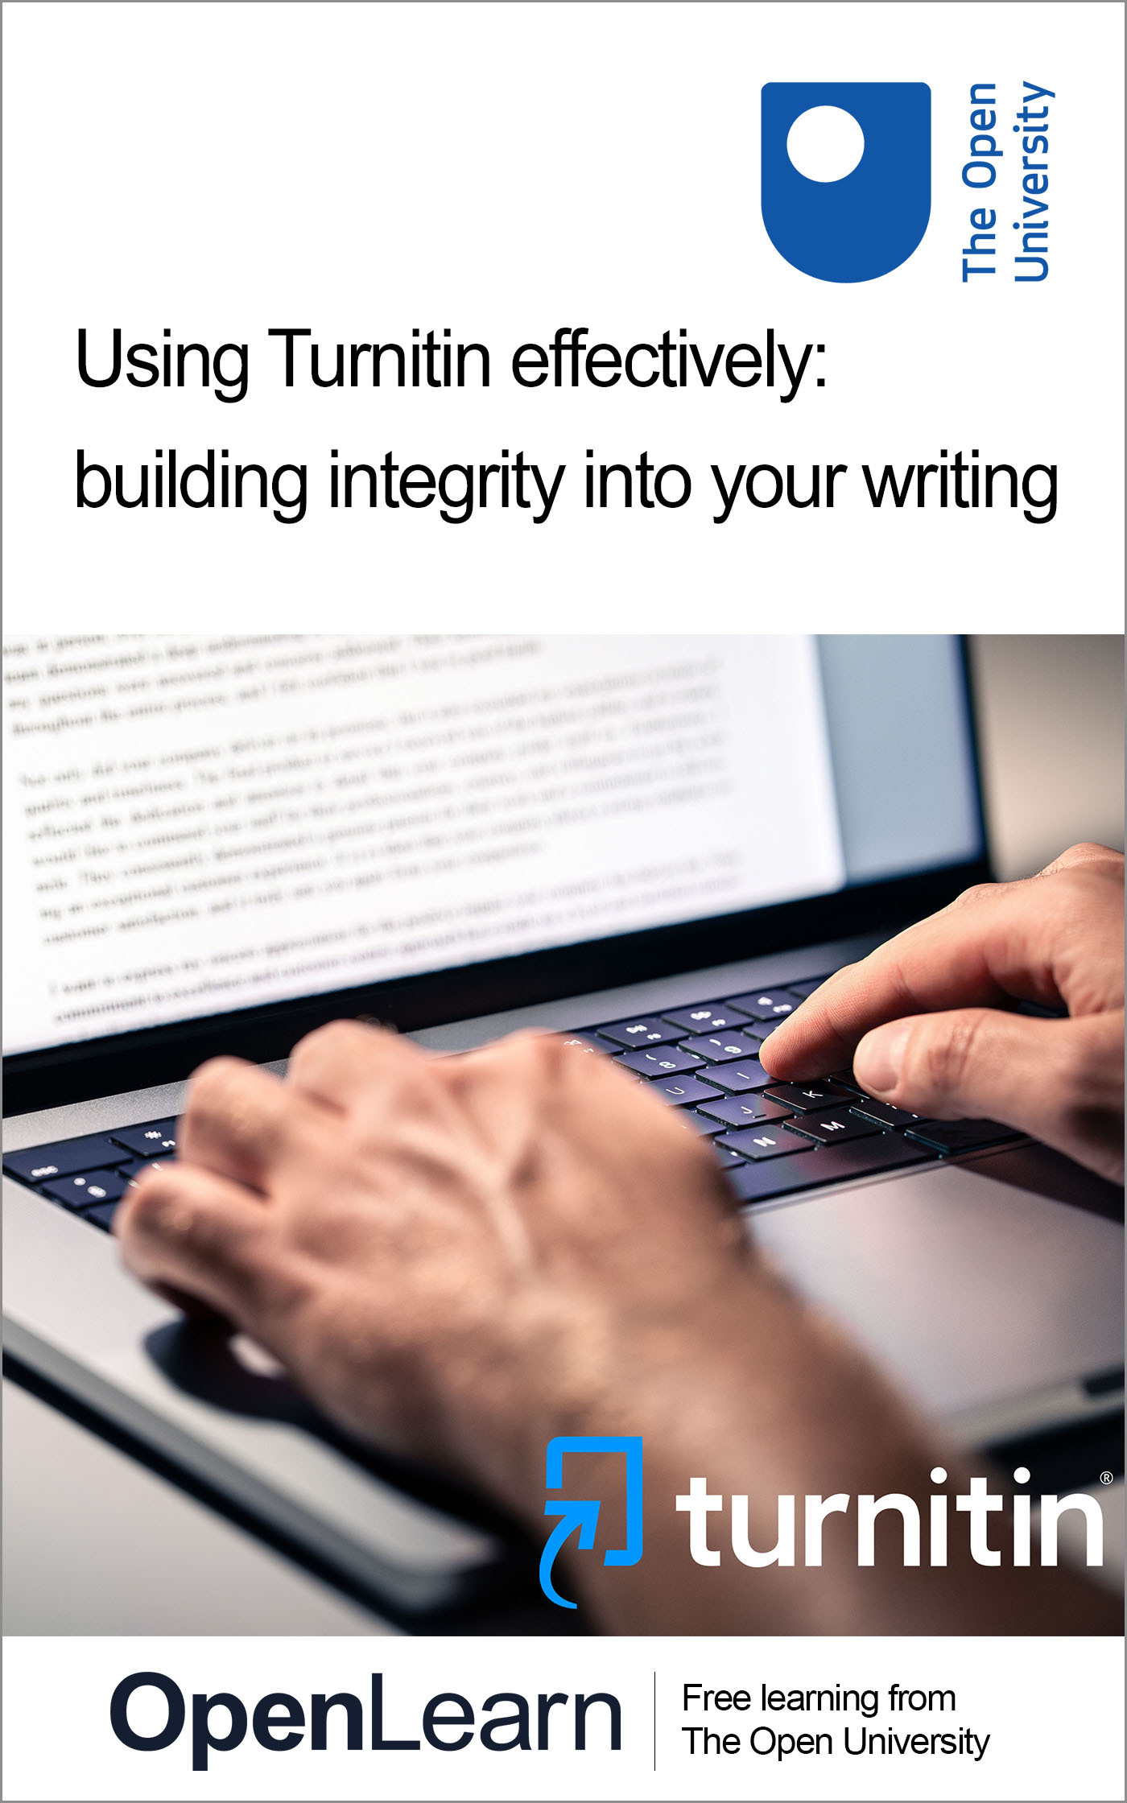

TURN_1

Using Turnitin effectively: building integrity into your writing

About this free course
This free course is an adapted extract from the Open University course .
This version of the content may include video, images and interactive content that may not be optimised for your device.
You can experience this free course as it was originally designed on OpenLearn, the home of free learning from The Open University –
There you’ll also be able to track your progress via your activity record, which you can use to demonstrate your learning.
First published 2025.
Unless otherwise stated, copyright © 2025 The Open University, all rights reserved.
Intellectual property
Unless otherwise stated, this resource is released under the terms of the Creative Commons Licence v4.0 http://creativecommons.org/licenses/by-nc-sa/4.0/deed.en. Within that The Open University interprets this licence in the following way: www.open.edu/openlearn/about-openlearn/frequently-asked-questions-on-openlearn. Copyright and rights falling outside the terms of the Creative Commons Licence are retained or controlled by The Open University. Please read the full text before using any of the content.
We believe the primary barrier to accessing high-quality educational experiences is cost, which is why we aim to publish as much free content as possible under an open licence. If it proves difficult to release content under our preferred Creative Commons licence (e.g. because we can’t afford or gain the clearances or find suitable alternatives), we will still release the materials for free under a personal end-user licence.
This is because the learning experience will always be the same high quality offering and that should always be seen as positive – even if at times the licensing is different to Creative Commons.
When using the content you must attribute us (The Open University) (the OU) and any identified author in accordance with the terms of the Creative Commons Licence.
The Acknowledgements section is used to list, amongst other things, third party (Proprietary), licensed content which is not subject to Creative Commons licensing. Proprietary content must be used (retained) intact and in context to the content at all times.
The Acknowledgements section is also used to bring to your attention any other Special Restrictions which may apply to the content. For example there may be times when the Creative Commons Non-Commercial Sharealike licence does not apply to any of the content even if owned by us (The Open University). In these instances, unless stated otherwise, the content may be used for personal and non-commercial use.
We have also identified as Proprietary other material included in the content which is not subject to Creative Commons Licence. These are OU logos, trading names and may extend to certain photographic and video images and sound recordings and any other material as may be brought to your attention.
Unauthorised use of any of the content may constitute a breach of the terms and conditions and/or intellectual property laws.
We reserve the right to alter, amend or bring to an end any terms and conditions provided here without notice.
All rights falling outside the terms of the Creative Commons licence are retained or controlled by The Open University.
Head of Intellectual Property, The Open University

Contents
- Introduction
- Learning outcomes
- 1 What is Turnitin?
- 2 Turnitin myths
- 3 What does a Turnitin report look like?
- 4 Understanding the similarity report
- 5 A step-by-step guide to Turnitin
- 6 Paraphrasing
- 7 Developing good habits with Turnitin
- 8 Academic conduct versus academic integrity
  - 8.1 Building a culture of integrity
- 9 It’s your education
- Conclusion
- References
- Acknowledgements
- Solutions
- Descriptions

Introduction
Welcome to this short course on using Turnitin formatively. This course is designed for students, particularly those who are new to university study or returning to academic work after a break. It will also be useful for anyone in higher education who wishes to understand how Turnitin can be used to develop good academic practice, strengthen writing skills, and ensure that all assessed work is their own.
This course builds on the OpenLearn course All my own work: exploring academic integrity and the resources in the Good Academic Practice collection, and will help you to take the next step: it focuses specifically on Turnitin and how it can be used to strengthen your writing and your confidence in academic integrity.

Learning outcomes
After studying this course, you should be able to:
- explain what Turnitin is and how it supports academic integrity
- interpret a Turnitin similarity report and identify areas for improvement
- use Turnitin formatively to develop academic writing before final submission
- recognise the value of using Turnitin as a positive and constructive learning tool.

1 What is Turnitin?
Turnitin is a text-matching software tool used by many educational institutions to scan submitted student assessments against a database of internet sources, published works, and previously submitted student papers. It can also be used to help you check your writing before you hand in your assignments.
When you upload your work to the Turnitin draft link on your assessment tab, it creates a report (see Figure 1) that shows where your writing is like books, websites, or other students’ work. This doesn’t mean you’ve done anything wrong – instead, it’s there to help you see if you’ve used your sources properly. Turnitin’s main function is to highlight instances of textual similarity—not to decide whether plagiarism (or misconduct) has occurred.

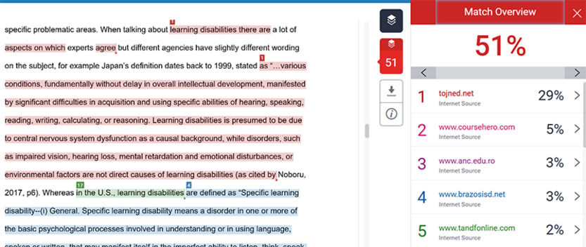
Figure 1 A Turnitin report
View description - Figure 1 A Turnitin report

Using Turnitin formatively allows you to engage with your writing process early and regularly, rather than viewing similarity checks as purely a punishment or as evidence of plagiarism. Submitting drafts for Turnitin gives you access to a similarity report (or originality report) that identifies matched text and sources and can guide you in refining citation, paraphrasing and referencing before final submission, promoting academic writing skill development.
Research also shows that when Turnitin is used as a developmental tool, your perceptions shift: you can use it as a learning tool rather than simply a plagiarism detector (Oldham, 2025). This approach supports the broader benefits of formative assessment — enhancing understanding, scaffolding performance, and empowering you to self-regulate learning (Marks, 2025). By enabling safe revision cycles, you can correct misconceptions, improve academic integrity habits and reduce the possibility of misconduct. The feedback loop created by formative Turnitin use thus fosters academic confidence, stronger writing practices and enables you to have more choice and responsibility for your learning and writing.

2 Turnitin myths
It’s important to clear up some myths about Turnitin:

By looking at the report, you can spot places where you might need to add a reference, change your wording, or improve your paraphrasing. Using Turnitin in this way gives you the chance to practise and make improvements, so your final work is stronger and shows your own voice clearly.
In the next section you will look more closely at a Turnitin report and what it shows you.

3 What does a Turnitin report look like?
When you open your report, you will see a percentage, a list of matched sources with a smaller percentage on the right, and corresponding highlighted matches in the main body of your assessment submission on the left. An example is shown in Figure 2.

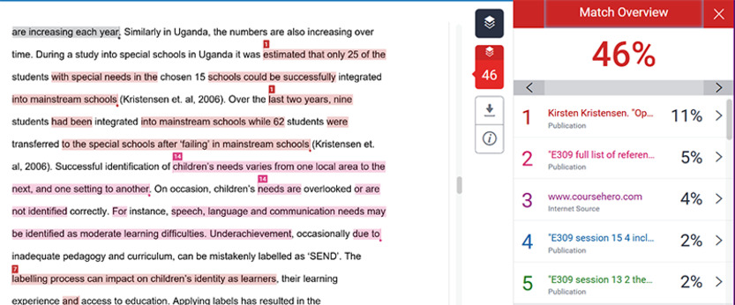
Figure 2 A Turnitin report
View description - Figure 2 A Turnitin report

To access the list of sources that Turnitin has matched to your assessment, you need to click on the number listed in the tools block in the centre of your report.

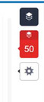
Figure 3 The tools block in the centre of your report
View description - Figure 3 The tools block in the centre of your report

It is important that you explore these buttons and tools so you are familiar with the report. There are additional videos and blogs that might help you on the Turnitin website.
The list of sources matched to your work are hyperlinked, so you can click on each to take you to the website or publication that your work has been matched to.
If the match is to another student, you will not be shown the other students work, but you should still check the text that has been highlighted in your own document.
In Figure 4, you can see three matches to student papers (these will not be shown to you) and one match to a website (#3). If you click on that link, you will be taken to the website where you will see the matching text.

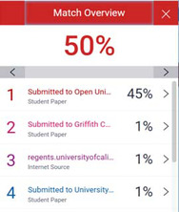
Figure 4 A list of matched sources in a Turnitin report
View description - Figure 4 A list of matched sources in a Turnitin report

All matches should be checked to ensure you have cited, referenced and paraphrased successfully. In the next section you will learn how to understand your similarity report in more detail.

4 Understanding the similarity report
When you upload a draft to Turnitin, it produces a similarity report. This highlights parts of your work that are similar to other sources in its database.

Turnitin will show you where you’ve:
- missed a citation
- forgotten quotation marks
- copied wording accidentally and forgotten to identify it.
What to do: add the missing in-text citation or use quotation marks where needed. Make sure your reference list matches the sources you actually used.
You should be keeping an ongoing list of sources, or if you are using course materials you need to keep a note of the section, unit and week so that you can tell your reader where your source can be located.

Figure 5 shows part of a Turnitin report. In this example, 31% of this students word count has been matched to sources other than this assessment, such as webpages and course materials.
Number 1 is a match to another student's submission, number 2 is a 7% match to course materials and number 3 is a match to a webpage.

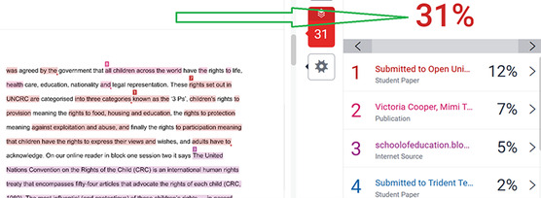
Figure 5 A Turnitin report shows matched sources
View description - Figure 5 A Turnitin report shows matched sources

Remember, the similarity percentage is not a plagiarism score. The percentage score is a simple calculation between the assessment word count and the number of words that have been matched. For example, if the assessment word count is 1000 words and your match is 100 words, it will show on the Turnitin report as 10%. What matters is how you interpret the report. Here, we’ll break down how the report in Figure 5 could be interpreted and solutions you could take.
- Number 1 has been highlighted in red and matches another student’s work that has previously been submitted to Turnitin. The student who is matched also studies with The Open University.
The problem: this section is poorly paraphrased.
The solution: try to use your own words and the three steps for easy paraphrasing (see Section 6 of course).
- Number 2 is matched to the course materials, but it also contains the title of a document that is frequently cited in education, health and other courses at The Open University.
The problem: this section is not quoted and is not paraphrased and so it has been matched to content from the course materials.
The solution: this section should be identified as a direct quotation from the course materials even though the name of the policy document cannot be changed. There should be a citation for this section.
- Number 3 is matched to an internet website which could be referenced and cited correctly. If the website has been acknowledged you won’t need to change anything in your work.
Now have a go at interpreting a Turnitin report yourself in Activity 1.

Activity 1 Interpreting a Turnitin report
Allow approximately 20 minutes

Look at Figures 6 and 7 which, combined, show a similarity report from Turnitin. Review each match and identify which you would need to correct and which are acceptable. What changes would you need to make?

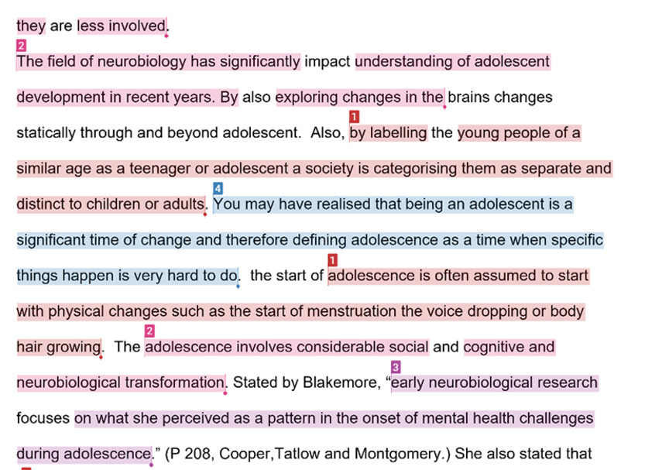
Figure 6 Submitted text to Turnitin
View description - Figure 6 Submitted text to Turnitin

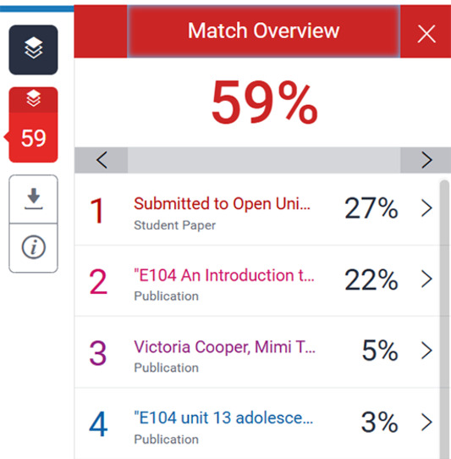
Figure 7 The Match Overview of a similarity report on Turnitin
View description - Figure 7 The Match Overview of a similarity report on Turnitin

Number 1 (highlighted in red): Number 2 (highlighted in pink): Number 3 (highlighted in purple): Number 4 (highlighted in blue):
View discussion - Activity 1 Interpreting a Turnitin report

5 A step-by-step guide to Turnitin
Watch Video 1 which demonstrates how to use your Turnitin report before submitting your work.

Video content is not available in this format.
Video 1
View transcript - Video 1

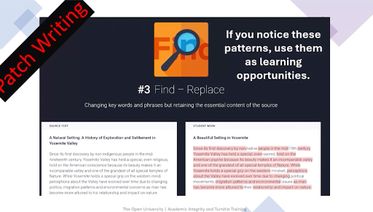
View alternative description - Uncaptioned Figure

When you open your Turnitin report, start by remembering that it is a learning tool, not a judgement or a ‘plagiarism score’. The overall percentage does not tell you whether there is a problem. What matters is understanding where the matches appear, why they are there, and what you may need to revise.
Follow these six steps to help you use Turnitin effectively.
- Submit your draft and collect your report. The link to submit your draft assessment will be made available to you on the Assessment Tab of your module. To submit a draft assessment you need to click on this link and follow the instructions. It will be similar to attaching a document to an email.
- To open your report click on the link or the coloured box near the similarity score.
This will open the Turnitin viewer, where your writing is shown in the main window and the list of matched sources appears on the right-hand side. At this stage, ignore the large percentage. Instead, click through each individual match to see the highlighted sections in your work.

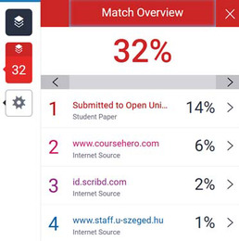
Figure 8 Matched sources appear on the right-hand side
View description - Figure 8 Matched sources appear on the right-hand side

- Check each match by clicking on the hyperlinks on the right-hand side of your report. When you click on the link it will take you to the corresponding original source online.
As you review each match (indicated by each number), ask yourself whether the highlighted wording genuinely belongs to you. Sometimes the match is harmless—for example, it could be your reference list, a template, or a commonly used academic phrase. Other matches, however, may show where you have used someone else’s ideas or wording. If the text is almost identical to the original source and you have not cited it, or if you intended to paraphrase but the structure still mirrors the original closely, you need to revise that section.

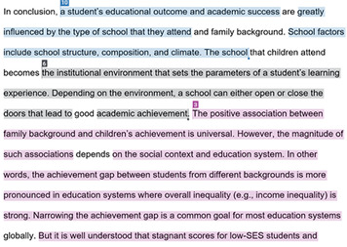
Figure 9 Your writing will be highlighted where matches have occurred
View description - Figure 9 Your writing will be highlighted where matches have occurred

Figure 9 shows an example of where paraphrasing has been ineffective, and citations are missing throughout each coloured section. This section would need to be revised. You do not want to see lots of block highlighting. There should also be more citations because a citation tells your reader where you got your information from and what your source is.
- As you revise your work, think carefully about where you should place citations and references. Every time you use another person’s idea, whether you quote directly or paraphrase, you must include a citation. Quotes need quotation marks and an in-text citation immediately afterwards. Paraphrased ideas should be expressed fully in your own wording and structure, followed by a citation at the end of the sentence or section. If you use data, images or figures, reference them in the caption. At the end of your assignment, make sure your reference list accurately includes every source you cited, formatted consistently and in alphabetical order.
- When Turnitin shows an issue, decide whether you need to quote or paraphrase. If it is a direct quote, keep the exact words, add quotation marks and include a citation with a page number if available. If you intended to paraphrase, close the original source, rewrite the idea in your own words, then compare afterwards to ensure it is genuinely different. Add the appropriate citation and update your reference list.
- Finally, re-read your entire assignment to ensure the writing flows and reflects your own understanding. If your course allows resubmissions, upload a revised draft to Turnitin to check that the problematic matches have been addressed. A good final check is to make sure you can explain every idea in your work without looking at your sources. If something still feels unclear, speak with your tutor—they are there to help you use Turnitin confidently and ethically.

Plagiarism and collusion
Turnitin can also reveal two types of issues: plagiarism and collusion. Plagiarism typically appears when your work contains long passages that match published sources such as journal articles, websites or textbooks, without proper citation or quotation marks. These blocks often indicate patchwriting, copy-and-paste work, or missing references.
Collusion looks different: here the match is usually to a ‘submitted paper’ or another student’s work. Large similarities with another student’s assignment—whether from your course or elsewhere—suggest unauthorised collaboration or sharing of work. Even if the wording has been lightly changed, the structure and sequence often give collusion away.

The next section will look at how to paraphrase effectively in your work.

6 Paraphrasing
Paraphrasing means reading a source, setting it aside, and then rewriting the idea entirely in your own words and structure to show understanding, followed by an appropriate citation.
Good academic writing with accurate citations and referencing takes practice. The better you understand what you are reading, the better you will be at writing about it. It can sometimes help to speak to friends and family who might not know about the subject matter you are learning about because when you try and explain the subject and the content you will be naturally paraphrasing and taking mental notes.
Figure 10 shows the three steps to take for better paraphrasing.

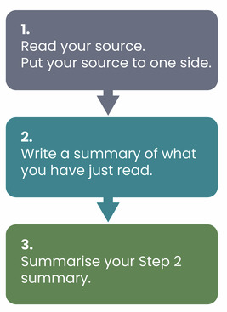
Figure 10 Paraphrasing
View description - Figure 10 Paraphrasing

Activity 2 Rewrite challenge
Allow approximately 5 minutes

Read the sentence below and then rewrite it using your own words.

Original text: ‘Turnitin is widely used by universities to promote academic integrity.’

Provide your answer...
View discussion - Activity 2 Rewrite challenge

7 Developing good habits with Turnitin
Turnitin works best when it’s part of your regular study habits. Submit drafts early, reflect on results, ask for help, and think long term.

Activity 3 Reflection 1
Allow approximately 10 minutes

Write down three things you will do to build good academic habits with Turnitin.

Provide your answer...
View discussion - Activity 3 Reflection 1

8 Academic conduct versus academic integrity
There is a difference between academic integrity and academic conduct. However, you might hear them used interchangeably. Here you will look at the subtle differences between the two.

It is very important that you are honest about your assessments and that the work you submit is your own.
When we talk about student behaviours we mean the activities and actions that you undertake just before you start an assessment and during your assessment. For example, one student shared that when they start an assessment they clear their desk area (action), light a candle (action), and check they have all the stationery they need (action). They then start their assessment by reading through their notes and highlighting sentences and sections they want to use (activity) before taking a fresh page and writing a paraphrased page of notes (activity). They make sure that they include citations throughout their new notes to ensure they know where the ideas came from.

Activity 4 Reflection 2
Allow approximately 10 minutes

List the activities and actions you do just before you start an assessment

Provide your answer...
View discussion - Activity 4 Reflection 2

8.1 Building a culture of integrity
Generative AI tools such as ChatGPT or Bard can support your learning. They can explain concepts or generate practice questions, but they must be used ethically.
Appropriate uses of such tools include: brainstorming, planning and simplifying concepts. Examples of misuse include: submitting AI text as your own, copying without referencing and bypassing learning.
Integrity is not just about avoiding plagiarism. It is about building honest, responsible, and respectful habits. Open University research shows early engagement with Turnitin reduces referrals and improves outcomes (Oldham, 2025).
A culture of integrity is built through choices: time management, careful notetaking, critical thinking, seeking help early, and valuing learning as much as grades.

Activity 5 Integrity pledge
Allow approximately 10 minutes

Write an integrity pledge for yourself using the following as prompts:
- One habit you will commit to.
- One skill you want to improve.
- One reason integrity matters to you.

Provide your answer...

9 It’s your education
Now it’s time to put everything you’ve learnt in this course into practice. So far you have learned what to do with each of the matches that your Turnitin report gives you before you submit your work.
You have seen examples showing you where you would need to apply additional work to make all of your submission acceptable. Ensure you check these carefully and use Cite them Right if you are unsure how to reference correctly.

Activity 6 Submit, analyse, improve
Allow approximately 45 minutes

- Write a short essay draft on a topic of your choosing (500 words)
- Submit your draft to Turnitin
- Review your similarity report
- Reflect:
  - What was your similarity score and how do you feel about it?
  - Which matches are acceptable?
  - Which matches need revision?
  - What changes will you make?

Provide your answer...

Conclusion
This course is just the beginning of a positive relationship between you and the use of Turnitin as you build a culture of integrity around yourself. Turnitin is not there to trip you up or to create fear, it is a very simple tool that can help you to see where you need improvement, before you submit any assessment.
Remember:
- use Turnitin frequently
- ask for help if you need it
- attend as many academic integrity sessions as you can and look for group study skills tutorials to attend
- understand that you are learning and mistakes are part of the learning process. Never stop learning and soon you will feel confident about academic integrity every time you submit your work.
Congratulations on completing this course!

Further resources
Listen to students share their experiences of using Turnitin formatively:

Watch the video at YouTube.com.

References
Marks, L. (2025) ‘How transparent learning practices cultivate student accountability’, Turnitin, 17 April. Available at: https://www.turnitin.com/blog/how-transparent-learning-practices-cultivate-student-accountability (Accessed: 24 March 2026).
Oldham, C. (2025) ‘Reframing Turnitin: from plagiarism detector to formative tool for academic writing and integrity’, European Journal of Open Education and E-learning Studies, 10(3).

Acknowledgements
This free course was written by Chelle Oldham, Cath Smillie and Shona Clark.
Except for third party materials and otherwise stated (see terms and conditions), this content is made available under a Creative Commons Attribution-NonCommercial-ShareAlike 4.0 Licence.
The material acknowledged below is Proprietary and used under licence (not subject to Creative Commons Licence). Grateful acknowledgement is made to the following sources for permission to reproduce material in this free course:
Every effort has been made to contact copyright owners. If any have been inadvertently overlooked, the publishers will be pleased to make the necessary arrangements at the first opportunity.
Course image: Tero Vesalainen/Getty. Logo: Turnitin https://www.turnitin.com
Figures 1-9: text/illustrations generated using Turnitin ©The Open University
Academic conduct versus academic integrity figures: Pixabay
Video 1: ©The Open University
Don't miss out
If reading this text has inspired you to learn more, you may be interested in joining the millions of people who discover our free learning resources and qualifications by visiting The Open University – www.open.edu/openlearn/free-courses.

Solutions

Activity 1 Interpreting a Turnitin report

Discussion
- Number 1 has been highlighted in red and matches another student’s work that has previously been submitted to Turnitin. The student who is matched also studies with The Open University.
The problem: this section is poorly paraphrased course materials that multiple students have submitted.
The solution: try to use your own words and the three steps for easy paraphrasing (see Section 6 of course).
- Number 2 (highlighted in pink) is matched directly to the course materials, but it also contains words and phrases that are not easily paraphrased. This happens with nouns and names.
The problem: this section is not quoted and is not paraphrased and so it has been matched to content from the course materials.
The solution: this section should be identified as a direct quotation from the course materials.
- Number 3 (highlighted in purple) is matched to a chapter within the course materials and the textbook. It is cited and quoted correctly.
- Number 4 (highlighted in blue) is a match to a chapter within the course.
The problem: this match is not quoted and there is not citation present despite it being copied word for word.
The solution: there must be acknowledgement that this is not unique text and therefore a citation is needed in text and a reference at the end of the assessment.
Back to - Activity 1 Interpreting a Turnitin report

Activity 2 Rewrite challenge

Discussion
For example: ‘Turnitin is software that many universities use to help students learn about academic integrity’.
Back to - Activity 2 Rewrite challenge

Activity 3 Reflection 1

Discussion
Examples:
- Submit drafts one week before the deadline.
- Check every highlighted section carefully.
- Keep a record of sources while writing.
Back to - Activity 3 Reflection 1

Activity 4 Reflection 2

Discussion
Positive student behaviours can include:
- Taking ownership of the assessment content and being an original author
- Putting time into planning and managing time before writing a first draft
- Reading and interpreting the assessment brief
- Using Turnitin formatively for drafts
- Engaging with support and tutorials.
Back to - Activity 4 Reflection 2

Descriptions

Figure 1 A Turnitin report
Screenshot showing a Turnitin report. On the left-hand side is part of an essay. Some of the text is highlighted in red, blue and green. Other parts of the text are left unhighlighted. The highlighted areas also have a corresponding number next to them.
Next to the essay in the centre of the screen is a tool bar.
On the right-hand of the screen is the ‘Match Overview’. It displays 51% in bold red then beneath is a list from 1 to 5. Each number is coloured differently and has a url, ‘internet source’ and a percentage next to it.
Back to - Figure 1 A Turnitin report

Figure 2 A Turnitin report
Screenshot showing a Turnitin report. On the left-hand side is part of an essay. Some of the text is highlighted in grey, red and pink. Other parts of the text are left unhighlighted. The highlighted areas also have a corresponding number next to them.
Next to the essay in the centre of the screen is a tool bar.
On the right-hand of the screen is the ‘Match Overview’. It displays 46% in bold red then beneath is a list from 1 to 5. Each number is coloured differently and has a title, either ‘publication’ or ‘internet source’ written underneath, and a percentage next to it.
Back to - Figure 2 A Turnitin report

Figure 3 The tools block in the centre of your report
A website tool bar. The first icon is a layer icon and is blue. The second is also a layer icon, but this is coloured red and has the number 50 underneath. The third icon is a cog.
Back to - Figure 3 The tools block in the centre of your report

Figure 4 A list of matched sources in a Turnitin report
A zoomed in image of the ‘Match Overview’ in a Turnitin report. At the top are the words ‘Match Overview’ and then directly underneath is 50% in bold red. Beneath this percentage is a list from 1 to 4. Number 1 reads 1 Submitted to Open Uni…. Student Paper. 45%. Number 2 reads 2 Submitted to Griffith C…. Student Paper. 1%. Number 3 reads regents.universityofcali…. Internet Source. 1%. Number 4 reads Submitted to University…. Student Paper. 1%.
Back to - Figure 4 A list of matched sources in a Turnitin report

Figure 5 A Turnitin report shows matched sources
Screenshot showing a Turnitin report. On the left-hand side is part of an essay. Some of the text is highlighted in red, blue and green. Other parts of the text are left unhighlighted. The highlighted areas also have a corresponding number next to them.
Next to the essay in the centre of the screen is a tool bar.
On the right-hand of the screen is the ‘Match Overview’. It displays 31% in bold red then beneath is a list from 1 to 5. Each number is coloured differently and has a title, either ‘publication’ or ‘internet source’ or ‘student paper’ written underneath, and a percentage next to it.
A large arrow points from the essay to the 31%.
Back to - Figure 5 A Turnitin report shows matched sources

Figure 6 Submitted text to Turnitin
A screenshot of a passage of text. Large parts of the text are highlighted in red, pink, blue and purple.
The red text is labelled with a ‘1’. The pink text is labelled with a ‘2’. The purple text is labelled with a ‘3’. The blue text is labelled with a ‘4’
Back to - Figure 6 Submitted text to Turnitin

Figure 7 The Match Overview of a similarity report on Turnitin
A zoomed in image of the ‘Match Overview’ in a Turnitin report. At the top are the words ‘Match Overview’ and then directly underneath is 59% in bold red. Beneath this percentage is a list from 1 to 4. Number 1 is in red text and reads ‘1 Submitted to Open Uni…. Student Paper. 27%’. Number 2 is in pink text and reads ‘2 E104 An Introduction t…. Publication. 22%’. Number 3 is in purple text and reads ‘3 Victoria Cooper, Mimi T... Publication. 5%.’ Number 4 is in blue text and reads ‘4 E104 unit 13 adolescen.... Publication. 3%’.
To the left of the ‘Match Overivew’ is a website tool bar. The first icon is a layer icon and is blue. The second icon also shows a layer icon, but this is coloured red and has the number 59 underneath the icon. The third icon is a downloads icon and the fourth icon is an information icon.
Back to - Figure 7 The Match Overview of a similarity report on Turnitin

Uncaptioned Figure
Back to - Uncaptioned Figure

Figure 8 Matched sources appear on the right-hand side
A zoomed in image of the ‘Match Overview’ in a Turnitin report. At the top are the words ‘Match Overview’ and then directly underneath is 32% in bold red. Beneath this percentage is a list from 1 to 4. Number 1 reads 1 Submitted to Open Uni…. Student Paper. 14%. Number 2 reads 2 www.coursehero.com…. Internet Source. 6%. Number 3 reads id.scribd.com…. Internet Source. 2%. Number 4 reads www.staff.u-szeged.hu…. Internet Source. 1%.
To the left of the ‘Match Overivew’ is a website tool bar. The first icon is a layerd icon and is blue. The second icon also shows a layers icon, but this is coloured red and has the number 32 underneath the icon. The third icon is a cog.
Back to - Figure 8 Matched sources appear on the right-hand side

Figure 9 Your writing will be highlighted where matches have occurred
A screenshot of a passage of text. Large parts of the text are highlighted in blue, grey or purple.
Back to - Figure 9 Your writing will be highlighted where matches have occurred

Figure 10 Paraphrasing
A three step flow chart.
Step 1. Read your source. Put your source to one side.
Step 2. Write a summary of what you have just read.
Step 3. Summarise your Step 2 summary.
Back to - Figure 10 Paraphrasing

Video 1

Transcript
SPEAKER:
Welcome to this short guide on how to use your Turnitin Similarity Report to improve your academic writing. When you open your report, you will see several key areas on your screen. At the top, you will find your overall similarity percentage. But don't worry, we will explain in a moment why that number doesn't tell the full story.
On the right hand side, you will see colour-coded matches that show where Turnitin has found text in your work that closely resembles other sources. You can click these matches to view the original sources and understand where the similarity comes from.
Now, let's start with the big myth, the overall percentage. It's easy to focus on this number, but it doesn't measure plagiarism, quality, or integrity. A high percentage doesn't necessarily mean something is wrong, and a low percentage doesn't automatically mean your work is perfect. What matters is where those matches occur and why. Think of the percentage as a summary of all the text Turnitin has found elsewhere. Your task is to interpret that information.
Let's explore how to use your report effectively. Look carefully at the highlighted sections within your work. You are looking for patterns, for example, large blocks of matching text that might suggest you have copied too closely from a source, or paragraphs where a few words have been changed, but the sentence structure is still the same.
These are signs of patchwriting-- when text has been altered slightly rather than properly paraphrased. If you notice these patterns, use them as learning opportunities. Ask yourself, have I fully understood and re-expressed the original idea? Have I included proper citations and quotation marks where needed. Could I rephrase this section in my own words to show deeper understanding? Turnitin helps you see where these issues might occur, so you can improve before submitting your final version.
Take action by paying particular attention to each of the highest matches, and have a look at your script to see if you have, one, included indication that you are using a direct quotation word for word, or you are paraphrasing writing in your own words from a source. An indication might be quotation marks or indented text. Two, you have included a correct citation that leads the reader to a reference. Three, included a reference at the end that matches the citation. Remember, Turnitin is not a test for plagiarism. It is a formative tool designed to help you strengthen your academic writing.
Always use your Turnitin draft submission link if it is available. Review your report carefully, make improvements, and resubmit where possible. The more you engage with your report, the more confident you'll become in paraphrasing, referencing, and expressing your ideas with academic integrity. Turnitin isn't there to catch you out. It's there to help you do better.
Back to - Video 1

