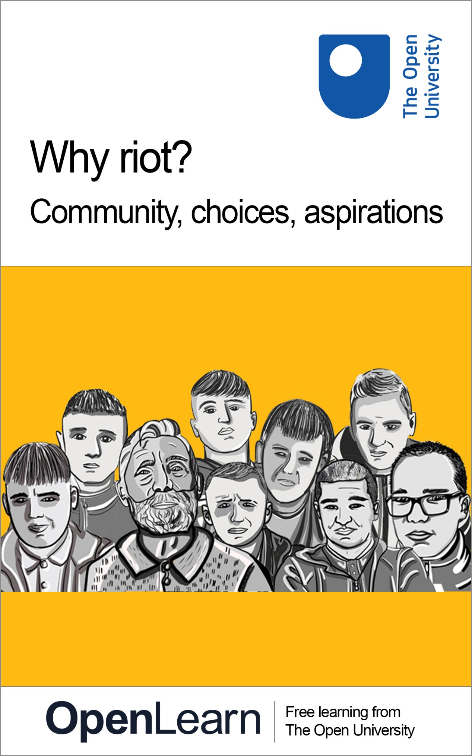

ALT_1

Why riot? Community, choices, aspirations

About this free course
This version of the content may include video, images and interactive content that may not be optimised for your device.
You can experience this free course as it was originally designed on OpenLearn, the home of free learning from The Open University – https://www.open.edu/openlearn/education-development/why-riot-community-choices-aspirations/content-section-overview
There you’ll also be able to track your progress via your activity record, which you can use to demonstrate your learning.
Copyright © 2022 The Open University
Intellectual property
Unless otherwise stated, this resource is released under the terms of the Creative Commons Licence v4.0 http://creativecommons.org/licenses/by-nc-sa/4.0/deed.en_GB. Within that The Open University interprets this licence in the following way: www.open.edu/openlearn/about-openlearn/frequently-asked-questions-on-openlearn. Copyright and rights falling outside the terms of the Creative Commons Licence are retained or controlled by The Open University. Please read the full text before using any of the content.
We believe the primary barrier to accessing high-quality educational experiences is cost, which is why we aim to publish as much free content as possible under an open licence. If it proves difficult to release content under our preferred Creative Commons licence (e.g. because we can’t afford or gain the clearances or find suitable alternatives), we will still release the materials for free under a personal end-user licence.
This is because the learning experience will always be the same high quality offering and that should always be seen as positive – even if at times the licensing is different to Creative Commons.
When using the content you must attribute us (The Open University) (the OU) and any identified author in accordance with the terms of the Creative Commons Licence.
The Acknowledgements section is used to list, amongst other things, third party (Proprietary), licensed content which is not subject to Creative Commons licensing. Proprietary content must be used (retained) intact and in context to the content at all times.
The Acknowledgements section is also used to bring to your attention any other Special Restrictions which may apply to the content. For example there may be times when the Creative Commons Non-Commercial Sharealike licence does not apply to any of the content even if owned by us (The Open University). In these instances, unless stated otherwise, the content may be used for personal and non-commercial use.
We have also identified as Proprietary other material included in the content which is not subject to Creative Commons Licence. These are OU logos, trading names and may extend to certain photographic and video images and sound recordings and any other material as may be brought to your attention.
Unauthorised use of any of the content may constitute a breach of the terms and conditions and/or intellectual property laws.
We reserve the right to alter, amend or bring to an end any terms and conditions provided here without notice.
All rights falling outside the terms of the Creative Commons licence are retained or controlled by The Open University.
Head of Intellectual Property, The Open University

Contents
- Introduction and guidance
  - Introduction and guidance
  - Guidance for facilitators and teachers
  - Sources of support
  - Moving around the course
- Session 1: Community
  - Introduction
  - 1 Welcome to the community
    - 1.1 Who do you think you are?
    - 1.2 How others see you
    - 1.3 Not just hoods and thugs
  - 2 What does community mean to you?
    - 2.1 Community as a place
    - 2.2 Community as a shared history
    - 2.3 Communities of spirit
  - 3 Communities and conflict
    - 3.1 Living at the interface
    - 3.2 Exploring different perspectives
  - 4 Community, your choices and you
  - 5 Summary
- Session 2: Choices
  - Introduction
  - 1 Why do you make the choices you make?
    - 1.1 Community, identity, belonging
    - 1.2 How free are you to choose?
    - 1.3 Breaking the mould
  - 2 Thinking for yourself
    - 2.1 Social media influence and the riots
    - 2.2 Filter bubbles and echo chambers
  - 3 How to spot false or fake news
    - 3.1 Information, misinformation, disinformation
    - 3.2 Separating opinions from facts
  - 4 How to handle hate speech
    - 4.1 ‘March for our lives’
    - 4.2 Changing the conversation
    - 4.3 How does it make you feel?
  - 5 Summary
- Session 3: Aspirations
  - Introduction
  - 1 The future and you
    - 1.1 Exploring possibilities
    - 1.2 Considering the consequences
  - 2 Making decisions
    - 2.1 De Bono’s 6 thinking hats
    - 2.2 How to use the 6 thinking hats
    - 2.3 Pulling it all together
  - 3 Being true to yourself
    - 3.1 How Marcus Rashford used his voice
    - 3.2 Knowing your values
  - 4 The power of collective action
    - 4.1 Becoming wiser
    - 4.2 Making connections
    - 4.3 Becoming a positive changemaker
  - 5 Summary
- Acknowledgements
- Solutions

Introduction and guidance

Introduction and guidance
Why riot? is a collaboration between the Action for Community Transformation Initiative in Belfast (ACT) and The Open University.
This free online course was co-produced over a 12 month period, by The Open University in Ireland’s Time to Think initiative and ACT, in response to the riots that took place in the Shankill and other Loyalist communities in Northern Ireland in the spring of 2021.
Why riot? is based on a face-to-face course and workshops developed by William Mitchell a Loyalist ex-prisoner, former Open University student, and project director of the ACT Initiative in the Shankill. It was made with eight boys taking part in the ACT Initiative and Belfast Boys’ Model School project: Adam, Ashton, Brandon, Dylan, Matty, Ryan, Stephen and William. This online course draws specifically on the experiences of these teenage boys from the Shankill, a Protestant/Unionist/Loyalist area in Belfast City and one of many communities deeply affected by the legacy of violent conflict in and about Northern Ireland. It has however been designed to be a flexible resource that can be adapted to different contexts of social and political division and taught in a range of individual and group settings and to diverse audiences and communities.
This course is divided into 3 sessions:
- Session 1 is about community
- Session 2 is about choices
- Session 3 is about aspirations.
The whole course is approximately 12 hours long. Each of the 3 sessions can be broken down into four 45-minute teaching sections or workshops. This course can be taught in small groups, or you can study it on your own on a computer or smartphone.
By the end of this course, you should be able to:
- consider how external factors shape personal identity and choices
- ask questions and think critically about information
- explore different perspectives
- broaden thoughts about the future and develop a voice to work with others for a positive change.

Guidance for facilitators and teachers
If you are doing this as an individual learner, move on to the next section.
Why riot? Community, choices, aspirations has been designed to support critical thinking skills amongst young people aged 14+ and is for use in community, school, alternative and independent settings. The course is for young people, especially those growing up in contexts of social or political division and who may be at risk of engaging in violence and offers alternative pathways for making their voice heard around issues that concern them.
You are encouraged, as course facilitators and teachers, to explore the full course yourself, in advance of using it with young people to familiarise yourself with the course structure and themes of community, choices and aspirations, and its range of resources including media clips and interactive activities. This will allow you to work creatively and dynamically with this material and adapt it to your context and to identify where questions are explored in more depth at different points in the course.
Preparation

Sign up to the course by clicking on the ‘enrol now’ button, which is on the right-hand column on the course description page, and on the top, middle banner throughout the course. Then complete the course to get to know its structure and range of resources available to you. You will know you are enrolled on the course by seeing the text: ‘You’re enrolled! This course has now been added to your OpenLearn Profile’ on the About this free course box. | 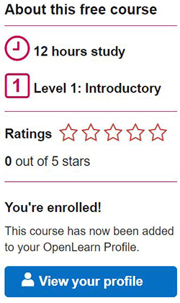  View description - Uncaptioned Figure

- Familiarise yourself with the case study central to this course – namely, the violent disturbances in the streets of Belfast in the summer of 2021 and the experiences of some boys involved in or affected by these disturbances, from the Shankill, a Protestant/Unionist/Loyalist area in Belfast, Northern Ireland.
- Think about the context in which you work, whether this case study resonates, how to use or adapt this case study, or introduce an appropriate case study in your setting alongside how you would structure your teaching/facilitating around this, especially if working with a different kind of group or context.

For the media assets, download an offline (Epub3) version of the course or alternatively, the specific media assets you plan to use onto your laptop/PC, if you want to use these resources in a location with slow or unreliable internet. You can do this by looking for the ‘Download this course’ box, which appears in the left-hand column on the course description page, and then consistently in the right-hand column throughout the course. To download individual assets, there is a download option underneath the specific asset. | View description - Uncaptioned Figure

Where to teach?
The course can be used in any setting you feel works for your group. For example:
- As an online resource to support group work (blended learning), for example in a community centre, youth club or school classroom setting.
- As an offline resource for use in an independent or detached setting where young people meet/spend time. You can do this by looking for the ‘Download this course’ box, which appears in the left-hand column on the course description page, and then consistently in the right-hand column throughout the course.
- As a resource for learners to log in and study themselves at home, whether on a smartphone or computer.
How to teach?
How you teach it is up to you, but below are some suggestions:
- Be creative and dynamic in how you teach this material, drawing on your own ways of teaching.
- Enhance or supplement the course material with your own material, local case studies or other resources where appropriate.
- When teaching in group settings, or when working offline you may choose to explore creative alternatives to a written submission with young people. You could take this approach in particular, for the reflection activity at the end of each session (Community, Choices and Aspirations) to encourage learners to think about the core themes of the session, and what they have learned.
Course activities and completion
This course can be completed in different ways depending on what is appropriate to your setting. For example:
- By an individual learner working independently online (as they would do with a traditional Open University OpenLearn course). To gain an OpenLearn statement of participation, learners register with OpenLearn to create their individual learner’s profile, enrol on the course, and work their way through the course.
- By groups working with a facilitator or a teacher, using a learning profile set up by the facilitator to submit collective/group responses in each of the activities.
- Or a mix of both independent and group working in which the learner participates in group sessions but also completes the course themselves online to gain an individual OpenLearn statement of participation.
Your feedback
This course is currently in a pilot phase, and we are interested in learning how it is being used by educators like you. If you want to share your ideas on how you are using the course, the young people you are working with, or settings you are teaching it in, or if you want to stay in touch about Why riot? course development, we would love to hear from you. Please contact us (the ACT and Open University Why riot? team) at The Open University in Ireland Time to Think email: Ireland-Time-to-Think@open.ac.uk

Sources of support
As you study Why riot? Community, choices, aspirations, please be aware that the course contains a broad range of material relating to the experience of life in local communities in situations of conflict. It also addresses decision making around protesting and rioting and includes some opportunities for personal reflection on choices, identity and values. For some course participants, aspects of the content may be sensitive or ‘triggering’ in nature, with the potential to cause emotional distress, particularly if it resonates with negative personal experiences, or the experiences of others known to you.
If you notice a negative emotional reaction to aspects of the course materials, leading to you feeling low or anxious, you may wish to step away from the materials, to reflect and to think about whether to continue at this time. Although feeling distress can be unpleasant, we are also naturally curious about the experiences of others who may have been in similar situations at some point in their life and continuing with your learning may be beneficial in helping you to develop a better understanding of the situations you were in and of the decisions you took. If you experience an ongoing impact on your sense of wellbeing, you might consider seeking support from a trusted person, or seeking help through counselling, or from your own GP (doctor).
If you are based in the UK and feel you need any professional help to deal with the issues this course discusses, these agencies will be pleased to offer advice. Many of these resources are available not only in England and Wales but also in Scotland and Northern Ireland. There is also a list with additional/specific services for Northern Ireland/Scotland below.

Helplines and online support: England and Wales
Mind – Details of local Minds, other local services, and Mind’s Legal Advice Line.
- 0300 123 3393 (Monday to Friday 9am to 6pm)
- http://mind.org.uk/
- https://sidebyside.mind.org.uk/ A friendly, supportive online community for people experiencing a mental health problem
Samaritans – 24-hour emotional support for anyone struggling to cope.
- 24-hour Freephone helpline: 116 123
- Email: jo@samaritans.org
- https://www.samaritans.org/
Childline – The UK’s free, 24-hour helpline for children and young people (up to age 18).
- https://www.childline.org.uk/
- 24-hour Freephone helpline: 0800 1111 (telephone number will not show up on your phone bill)
Counselling (in person or online)
Counselling can sometimes be accessed by contacting your GP, or you may opt to see a counsellor in private practice. Details of counsellors working in private practice across all areas across the UK can be found here:
British Association for Counselling and Psychotherapy – BACP is a membership body for counsellors and therapists. They provide information on different types of therapy, and you can search for a therapist by area.
- https://www.bacp.co.uk/
- Counselling Directory – connects you with professional counsellors and therapists near you to help you find the help you need.

Northern Ireland
- In Northern Ireland, the main 24 hour telephone support is: https://www.lifelinehelpline.info/
- This is a directory of services in Northern Ireland relating to a wide range of issues: https://www.mindingyourhead.info/
- This website provides phone numbers and information about helplines in Northern Ireland: https://www.helplinesnetworkni.com/
- For people affected by the Troubles/Conflict in Northern Ireland (including rioting): Wave Trauma Centre

Scotland
SAMH (Scottish Association for Mental Health) provide local services in addition to information about mental ill health and signposting to other organisations.
- Phone: 0141 530 1000
- https://www.samh.org.uk/
Breathing Space - Breathing Space is a free and confidential phoneline service for any individual who is experiencing low mood or depression.
- Helpline: 0800 83 85 87

Moving around the course
In the ‘Summary’ at the end of each session, you will find a link to the next session. If at any time you want to return to the start of the course, click on ‘Full course description’. From here you can navigate to any part of the course.
It’s also good practice if you access a link from within a course page, to open it in a new window or tab. That way you can easily return to where you’ve come from without having to use the back button on your browser.
You will probably want to make notes as you go along, so choose your preferred method for this, either writing in a notebook or on your computer or tablet. There are free response box options inside some of the activities. Please note anything you add into these boxes will be saved for you to return to, provided you are signed into OpenLearn and enrolled on the course. But the information saved is only accessible to you and cannot be viewed by anyone else. You can collate and download all of your answers and notes for the course by clicking ‘Download your answers for the documents on this course’, which is on the left-hand column of the course.
The activities have individual timings, this is an approximate, suggested time that the activity might take. If working through the course as a group rather than individually, you might want to consider doubling the suggested timings, to allow for discussions.
Enrolling on the course will track your progress and give you the opportunity to earn your OpenLearn statement of participation. Statements are not accredited by The Open University but they’re a great way to demonstrate your interest in the subject and commitment to your learning and your career, and to provide evidence of continuing professional development. Once you are signed in, you can manage your OpenLearn statement of participation online from My OpenLearn. In addition, you can download and print it.
To gain a statement of participation, you need to read every page of the course, including the introduction and guidance sections. You will be notified by email if you have received a statement of participation but please allow up to 24 hours for this to happen.
You can now go to Session 1.

Session 1: Community

Introduction

‘And I said to my mates. Do you know what you are rioting for?’
Matty (Aged 15)

In the spring of 2021 young people from mainly Protestant/Unionist/Loyalist (PUL) communities across Northern Ireland from Derry/Londonderry to Belfast, took part in street riots. Buses and cars were burned, bricks and stones were thrown at the PSNI and young people from PUL and Catholic/Nationalist/Republican (CNR) communities also clashed. Several young people were arrested, and these events quickly made the international news. The Shankill is where the boys involved in the making of this course, live. Their area is featured in this news report and is where some of the worst rioting took place.

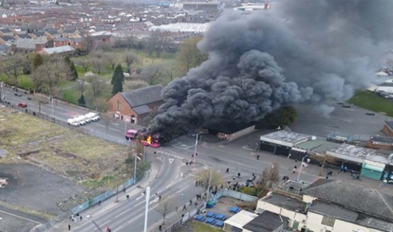
Figure 1: Bus burning in the Shankill, Belfast, April 2021 (Image: Hugh Pollock)
View description - Figure 1: Bus burning in the Shankill, Belfast, April 2021 (Image: Hugh Pollock)

To get started, have a go at Activity 1.

Activity 1: Why do people riot?
15 minutes

Now watch Video 1, which is a BBC News report on the riots in Northern Ireland in 2021. Then write down your thoughts on the following questions.

Video content is not available in this format.
Video 1: Worst violence in Belfast for years as British and Irish leaders call for calm
View transcript - Video 1: Worst violence in Belfast for years as British and Irish leaders call for ...

What are some of the reasons given in the news report for the rioting by young people?

Provide your answer...

Why do you think young people get involved in riots like this?

Provide your answer...
View discussion - Part

Now read Matty and Dylan’s comments on why they think young people from their community rioted. Remember when reading that this is how Matty and Dylan feel, from their perspective, and there will be other views on these issues across the different communities, depending on whose perspective you hear.

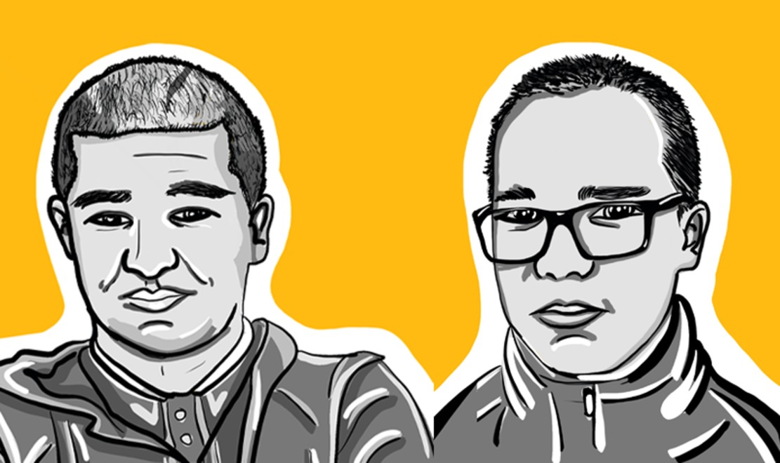
Figure 2: Illustration of Matty (left) and Dylan (right)

Read through Dylan and Matty’s views and then answer the following questions.

Dylan
‘I didn’t think it was good but that was the only way young people could get heard by going out and lifting the bottle so they could. Because it’s not like everyone has this opportunity to speak. Most people just rely on going out of the house and looking for a riot and going and throwing a few bricks and then the trouble starts and then think that’s how to get their voice heard until they are sitting in the back of a wagon [police van] and going down to Musgrave [a city centre police station] and having to ask a few questions. Why were they there? And why were they doing it? Why were they doing it is the question?’

Matty
‘Northern Ireland is being split off from England, Scotland and Wales by an Irish sea border. So, people are feeling angry that they are being separated from other British people if you know what I mean. Another factor in the riots was that the Protestant community [Matty’s community] was sort of treated differently by the PSNI (local police force). That was another sort of reason why young people were letting their frustration out because the police were treating the Loyalist protestant community differently than the nationalist Republican community [a neighbouring community] I wouldn’t use violence, but I can understand why some people are using violence because they are being treated differently and their voice is not being heard. Because before the riots, we peacefully protested … and it just wasn’t working. So, people just thought a way to get their voice heard was violence. I can understand it, I can understand it.’

- What reasons do Matty and Dylan give about why young people might choose to riot in their community?
- How did Matty and Dylan’s reasons compare with your own thoughts?
- Did anything surprise you about what they said?

1. 2. 3.
View discussion - Part

While Matty and Dylan feel young people have grievances you may have noticed that both are also asking young people to take a moment to think more deeply, to question themselves and consider why are they rioting. In this course you will have a chance to explore this and other questions. As you work your way through this course, you will have the opportunity to consider your own thoughts on these issues as well as exploring alternative ways of protesting or making your voice heard, without using violence and putting yourself and others at risk.
By the end of Session 1, you should be able to:
- think about how you see yourself and your identity
- think about how others see you and your community
- explore what community means to you and your identity
- think about how all these factors can shape the options you have and the choices you make.

Protecting your mental health and wellbeing
Please refer to the Sources of support page if you notice a negative emotional reaction to aspects of the course materials. You may wish to step away from the materials, to reflect and to think about whether to continue at this time.

1 Welcome to the community
You heard from Matty and Dylan earlier, so let’s take a moment to meet the rest of the group from ACT Initiative and Boys Model School project, along with William who has worked with The Open University to put this course together for you.

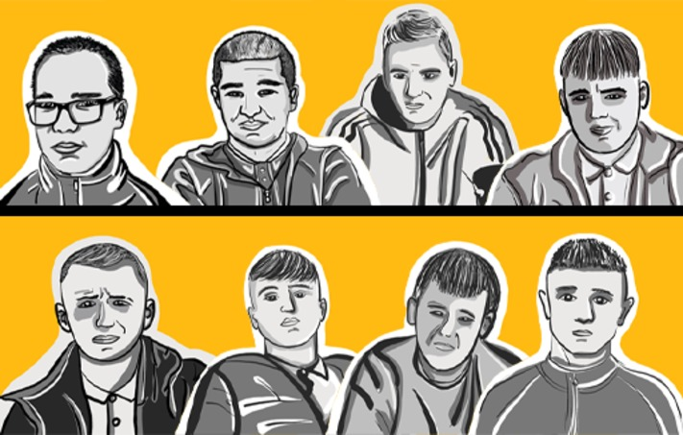
Figure 3: Group illustration from left to right: Dylan, Matty, Brandon, Adam (top row) and Ashton, Ryan, Stephen, William (bottom row).

Dylan, Matty, Brandon, Adam, Ashton, Ryan, Stephen and William are from the Shankill, a Protestant/Unionist/Loyalist (PUL) community in West/North Belfast. The Shankill has become an international tourist destination because of its history of conflict and is often in the news, like when the riots happened in the Spring of 2021. Many people seem to have views about them, because of where they come from. So, the boys have taken part in making this course to share what they have been learning with William, and to tell their own stories.

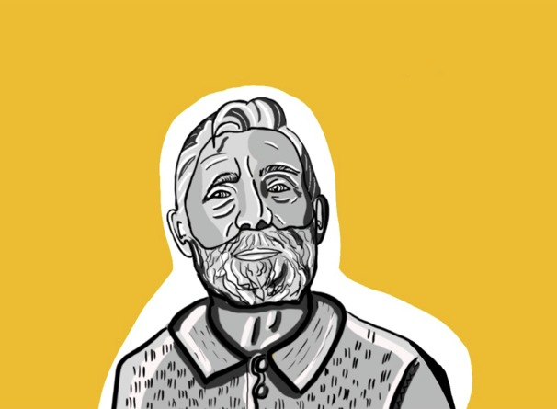
Figure 4: Illustration of William

And this is William. William is the Project Director for the ACT Initiative, a conflict transformation programme based on the Shankill Road. As a young man William was drawn into the conflict in Northern Ireland and a result of that is that he spent almost 13 years in the Maze and Long Kesh prison. His personal background is one of the reasons why he does the work he does today with young people.
For these boys growing up in the Shankill, in Northern Ireland, street disturbances, including clashes with the police and young people from other areas, is not something new. You may also have a history of conflict, violence or street disturbances in your areas and amongst your communities too. One aspect of this course is to explore how external forces can shape your thinking and choices particularly in situations of social conflict. Let’s start by considering a seemingly simple question to help you understand yourself better.

1.1 Who do you think you are?
Take a moment to think about the question: ‘Who am I?’

Figure 5: Who am I?
View description - Figure 5: Who am I?
View description - Figure 5: Who am I?

Let’s look at how you might answer this question.

Activity 2: Who am I?
10 minutes

Write down as many different answers to the question ‘Who am I?’ as quickly as you can in the box below, in whatever order they come to you. Try to write at least 20 different things. There are no right or wrong answers. (Adapted from: Twenty Statements Test by Kuhn and McPartland, 1954)

Table 1: ‘Who am I?’
Who am I?
I am … | For example:  Funny; a good cook; a sister; a brother; loyal; working class; tall …

Now write down your thoughts in answer to the following questions:
- How many of the ways you described yourself were things that connected you to other people or groups?
- How many were things that you value most about yourself personally?
- Did anything surprise you?

Provide your answer...
View discussion - Part

This exercise was based on one created by two social researchers, Manford Kuhn and Thomas Partland, many years ago in 1954, to understand how people see themselves. They spotted that people generally describe themselves in two sorts of ways: how they see their role in the world socially and in the groups they belong to (their social identity); and how they see themselves personally. They also discovered that for most people their social identity and the groups or community they feel they belong to can be particularly important. This is especially the case in contexts of social conflict.

1.2 How others see you
It can be hard sometimes to separate who you think you are personally and your values and beliefs from how other people see you and your community, as you will explore next.

Activity 3: Welcome to the Shankill
15 minutes

Now watch Video 2, a short film with Matty and Dylan about their community, the Shankill.

Video content is not available in this format.
Video 2: Welcome to the Shankill
View transcript - Video 2: Welcome to the Shankill

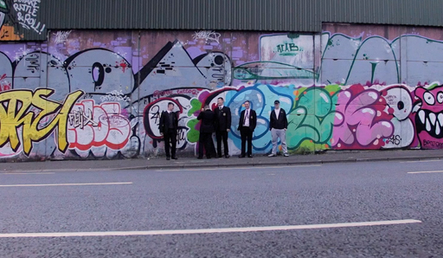

Take a few minutes to write your thoughts in the box below:
- How do Matty and Dylan see themselves and their community?
- How does this compare to how others see them and their community?
- Can you list three things that are important to them personally or they want to change?

Provide your answer...
View discussion - Activity 3: Welcome to the Shankill

1.3 Not just hoods and thugs
One of the issues Matty talks about is how others see boys like him as just ‘hoods and thugs’ because of the recent riots but also because of the history of conflict there. The Shankill is one of many areas deeply affected by the conflict that took place in Northern Ireland. This violence lasted for almost thirty years, from 1969 until 1998 when a political agreement (The Good Friday Agreement) was reached between the main parties involved in the conflict. Like many communities, people in the Shankill experienced terrible violence during the conflict. Families were driven out of their homes, people were shot and even killed or lived in fear of this happening every day. Many young people, from across the different communities, were also drawn into the violence during those times, and some including William, spent many years in prison, for their part in this conflict.
For young people today growing up in the Shankill, as in other areas affected by the conflict, the past often overshadows how both they see themselves and how they and their community are seen, by the media and outsiders.

2 What does community mean to you?
Your community is just one aspect of your identity, but it can be an important one. Community can be a simple way of describing things you value that connect you to other people, or where you feel you belong or what you have grown up in, or the place where you live.

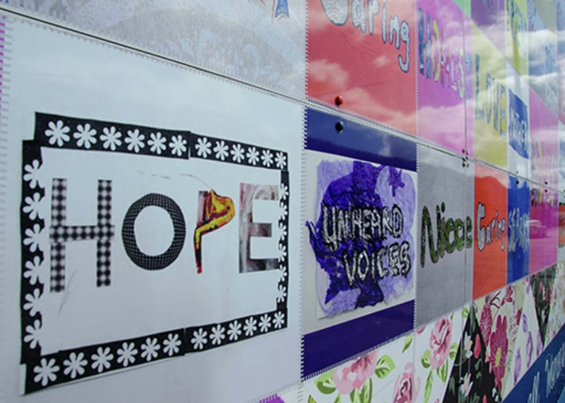
Figure 6: Women’s hope mural
View description - Figure 6: Women’s hope mural

So, let’s start with exploring your local community and what it means to you.

2.1 Community as a place
One way of thinking about your community involves the place where you live and your connections to other people who live there. This could be local neighbourhoods or housing estates and surrounding streets, where people feel bounded by that local area. Matty and Dylan talk about the Shankill as being their community. For example, below is a map of the Shankill. The boundaries of the Shankill area that the boys live in are marked in dark green on this map.

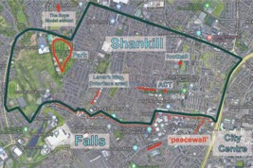
Figure 7: A map of the Shankill area and local community where the boys live
View description - Figure 7: A map of the Shankill area and local community where the boys live

So let’s take a look at how would you describe your local community.

Activity 4: Making a profile of your local community
15 minutes

This activity is to help you create a profile of your local community where you live. Thinking about your local area, list at least three points under each heading in the table below. You can do this activity on your own or in a group. This will be saved (as long as you are signed into OpenLearn and enrolled on this course) so you can return to it later in the course for other activities such as mind-mapping.

Table 2: Making a profile of your local community
Places: the important locations, places or spaces, including boundaries that are important to you and maybe to other young people you know. | People: the different groups of people in this location (the key different groups which live in your community for example in terms of faiths, cultures and/or ethnicities). | Issues: the issues that are currently of concern to you and other young people in the area.
Provide your answer... | Provide your answer... | Provide your answer...
Provide your answer... | Provide your answer... | Provide your answer...
Provide your answer... | Provide your answer... | Provide your answer...
Provide your answer... | Provide your answer... | Provide your answer...
Provide your answer... | Provide your answer... | Provide your answer...

One way of thinking about community then is as a place, where particular people may feel connected, as well as being affected by particular issues in their area.

2.2 Community as a shared history
Community can be something that exists over generations. Residents who have lived in a neighbourhood for a long period of time may share a sense of belonging, solidarity or togetherness. They may pass on this sense of belonging to future generations. One useful way of getting to know your local community is to ask someone you know from an older generation to show you pictures or even take you on a local walking tour or to share their stories of the places or people or events that are meaningful to them. You may discover things that are very different to what you know or have been told about your local community today.
The Shankill community, as you have heard, is often defined by its history as one of a number of communities segregated by religious, political or historical differences, and deeply affected by violence in Northern Ireland. This history, visible through the murals and memorials and the ‘peacewalls’ you saw in the community film, make this one of the top tourists spots in this city. But this is not all that defines this area. There is more to the Shankill than the violence of the conflict here. The Shankill Area Social History Society (S.A.S.H.) for example, documents the stories of its residents going back 70 years or more when this area was famous for its thriving linen mill industry. Local residents also worked in the nearby Harland & Wolff shipyard where the Titanic was built, as well as Mackies – an engineering and rope works factory. They also held street parties and community celebrations, as they do today.

Interactive content is not available in this format.
Figure 8: Slideshow of 5 images from the S.A.S.H. archive
View description - Figure 8: Slideshow of 5 images from the S.A.S.H. archive

Below is an optional activity you can do in your own time.

Activity 5: Talk to an older relative or neighbour
(optional activity)

Please note, to do this activity, you will need to ask your teacher, community worker, parent or guardian for permission. (But don’t worry if you are unable to do this activity, you can skip it.)
Find an older relative or neighbour who lives in your local community to talk to. Your teacher or community worker can help you with this. Make sure your parent or guardian knows this person, and that you are talking to them.
Ask this person what life was like in the area where you live when they were growing up and what the community was like then? For example, what kinds of things did they do with their friends locally and where did they go? What was the area best known for then? What were the issues that mattered to them at your age? How different is this from your own experience of your community? Write your thoughts down in the box below.
- What surprised you most about this conversation?
- How have things changed or stayed the same?
- Did you discover any points of connection with the person you spoke with?
- How has this changed how you think about your local community?

Provide your answer...
View discussion - Activity 5: Talk to an older relative or neighbour

2.3 Communities of spirit
Another way to think about community is as something that you choose to define or even create for yourself, based on what you value most, as William describes next.
Listen to Video 3, where William talks about what community means to him.

Video content is not available in this format.
Video 3: William on community.
View transcript - Video 3: William on community.

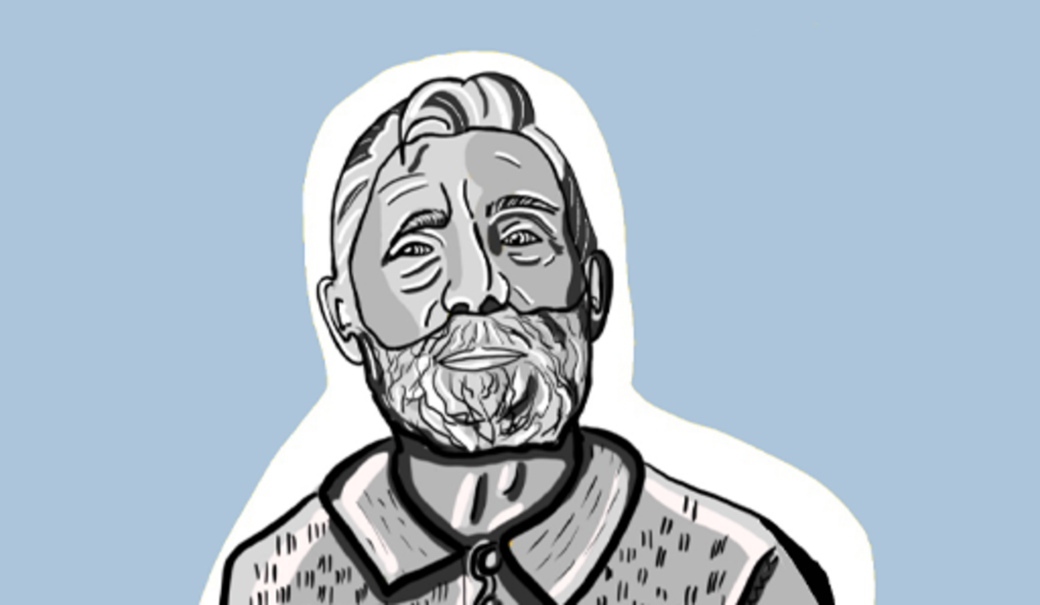

Now answer the following questions in Activity 6.

Activity 6: William’s perspective on community
15 minutes

- How did you feel reading/listening to William’s story of what community means to him?
- Did any of the things he values surprise you?
- Why was having time alone important to him?

Provide your answer...
View discussion - Activity 6: William’s perspective on community

Discovering who you are and what you value, as an individual separate from your environment, the community you grow up in or how others see you, is not an easy thing to do. One skill William learned while in prison and through his education and the advice of others, was how to take the time to pause, to reflect on his experience and to actively explore his own thoughts. When doing self-reflection like this it is useful to note down your thoughts so that you can revisit them again at another time. You can also see if your thinking has changed over time. Self-reflection is something you will find valuable to do throughout this course, so why not try it now.

Activity 7: Time to reflect
10 minutes

Take a few minutes to note down your thoughts on the following.
- What do I value most in my life (write down three things)?
- What does community mean to me?
- What community or communities do I feel I belong to? There may be more than one community you feel you belong to so feel free to list as many as you can and how these overlap for you, if at all.

Provide your answer...

Community is something that is made through relationships, memories and experiences with others, and because of this, as people we can also change our community or its boundaries or even make new communities. In times of social or political conflict however, or if you and your community are feeling under threat, it can be harder to change your idea of community or make new connections with others, as you will explore in the next section.

3 Communities and conflict
The city of Belfast has a long history of periodic outbursts of political and communal conflict, extending back over many generations. The recent disturbances on the Shankill, for example, which you saw in the short BBC film, are just one more recent example of this kind of violence. While there are many different views on the causes of the long conflict in Northern Ireland, one of the outcomes is that over the years cities such as Belfast were divided or segregated by religion, political identity or ethnicity. During the early days of the conflict in 1969 walls were created at areas where segregated communities met – these became known as interface areas.

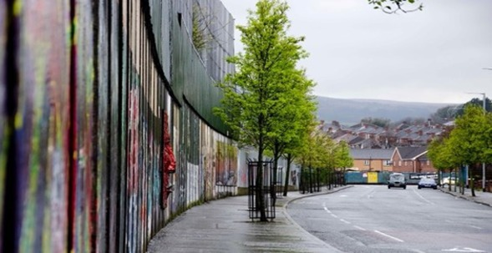
Figure 9: ‘The Peacewall’, Cupar Street, Belfast.
View description - Figure 9: ‘The Peacewall’, Cupar Street, Belfast.

Like many places which have experienced political and communal conflict, Northern Ireland still has a number of these segregated communities today. Some remain separated by walls like the one above (Figure 9) which you also saw in the short film made with Matty and Dylan. This image shows part of the wall that separates the Shankill, a predominantly Protestant/Unionist/Loyalist area, from The Falls, which is a predominantly Catholic/Nationalist/Republican area. Young people from the Shankill have a range of views about the role of the wall here, as you can see in these quotes.

‘The peace wall is there to keep people from fighting. Keep them from killing each other, petrol bombing each other’s homes…. The other side would say the same’
(Boy 1, from the Shankill, aged 15)

‘It’s a burden. It’s a wall that keeps people separate. We shouldn’t have to be separated through a wall’.
(Boy 2, from the Shankill, aged 15)

Activity 8: Community divisions in your area
15 minutes

Note down your thoughts on the following questions about your area.
- Are there any barriers or boundaries between your and other communities in your local area? These don’t need to be physical, they could be streets you don’t walk down, shops you don’t go into for example?
- How does it make you feel when you are in another community’s area?
- How do you think people in those communities might feel when they are in your area?
- What might change how you feel?

Provide your answer...

3.1 Living at the interface
Figure 10 is a map of the wall along the interface between the Falls and the Shankill areas in West Belfast. The red line in Figure 10 indicates the peace wall. It runs from the Shankill and Falls to Springfield Road. There are gates or access points between communities along the wall, including one on Lanark Way where the disturbances you saw earlier happened.

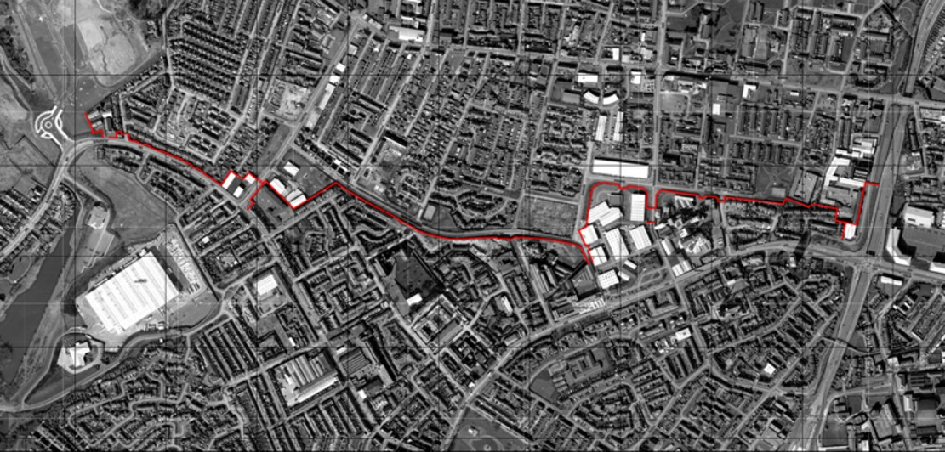
Figure 10: The Falls and the Shankill areas in West Belfast (Source: The Peacewall archive)
View description - Figure 10: The Falls and the Shankill areas in West Belfast (Source: The Peacewall ...
View description - Figure 10: The Falls and the Shankill areas in West Belfast (Source: The Peacewall ...

Within communities who live on either side of these interfaces, such as the Falls and the Shankill communities, there is often a strong sense of community spirit because of the hardships people have lived through. But there is also fear and mistrust of the other community. It can be hard now to break the cycle when you don’t have an opportunity to speak to people on the other side or ‘put yourselves in their shoes’.

3.2 Exploring different perspectives
In Belfast and across Northern Ireland, community groups have been working together to gather people’s memories and stories from different sides of the conflict mostly from the years before the walls were built, as one way to foster connections today. One of these projects in Belfast is called Dúchas. It was set up by people in the Falls community (who live on the other side of the wall to Matty and Dylan in the Shankill) to record experiences of the conflict. Members of the Shankill community are also working with Dúchas to include some of their stories in this community-led archive.

Activity 9: ‘Pieces of the Past’

Part 1: I was born
10 minutes

Listen to these audios (or you can read the transcript) from the oral history project Dúchas, called Pieces of the Past, before answering the questions below. These are just two women’s stories which capture life in these communities from the perspective of Beatrice and Rosemary who were born in the late 1940s. Beatrice was born and grew up in the Shankill and Rosemary was born in the Falls and then moved between Ballymurphy [a mainly CNR area] and Donegall Pass [a mainly PUL area]. In their first stories, Rosemary and Beatrice describe life in these areas in the 1960s, before communities were segregated and the walls were built.

Audio content is not available in this format.
Audio 1: Rosemary: Where I was born
View transcript - Audio 1: Rosemary: Where I was born

Audio content is not available in this format.
Audio 2: Beatrice: Where I was born
View transcript - Audio 2: Beatrice: Where I was born

- Was there anything that surprised you by listening to these women’s stories?
- What similarities and differences did you notice between these women’s experiences growing up?

Provide your answer...
View discussion - Part 1: I was born

Part 2: 1969
10 minutes

In their second stories, Beatrice and Rosemary describe the changes that happened in their communities with the outbreak of violence in 1969.

Audio content is not available in this format.
Audio 3: Rosemary: Experiences of 1969
View transcript - Audio 3: Rosemary: Experiences of 1969

Audio content is not available in this format.
Audio 4: Beatrice: Experiences of 1969
View transcript - Audio 4: Beatrice: Experiences of 1969

- What were some of the changes that happened in their lives as the conflict unfolded in1969?
- Does hearing these two women’s stories raise any questions for you?

Provide your answer...
View discussion - Part 2: 1969

Hearing different perspectives can often raise new questions that you may not have thought of and different ways of looking at things. In times of conflict or times of hardship, however, community can become particularly important to a sense of identity and feelings of togetherness as well as a sense of safety in face of danger. People within these communities may choose to stay together for example, because of violence or the fear of violence from others. But over time this can also lead to barriers forming between communities (physical or otherwise), that are hard to break down and this can fuel more violence and mistrust when tensions rise.
This is one explanation given for the recent riots at the interface areas (locations where two different communities meet) in Belfast and other parts of Northern Ireland. This is something you might have experienced yourself in your communities or amongst groups of young people in your area.

Activity 10: Time to reflect
5 minutes

Take a few minutes to reflect on the following question:
- How might hearing more than one perspective help your understanding of a conflict situation?

Provide your answer...

In situations of conflict community members tend to have a strong sense of their existence in relation to other communities and so their awareness of particular social identities (or group memberships) becomes particularly important or significant. This can lead people to make comparisons with other groups and even feel that there is a sense of competition between groups or communities.
Sometimes it can be helpful to remember that you don’t have to be completely defined by your group membership or community, but rather that you have diverse identities, made up from a wide range of group memberships and your personal qualities.

4 Community, your choices and you
Sometimes, your past can shape how you view the present and how others view you. Where you come from, the context in which you grow up, and how other people see you, can affect your options and the choices you make in all sorts of unexpected ways - some positive and some negative.
As you have seen from the boys’ film about the Shankill, how people see you and your local community can be used to define you and people’s expectations of you. It can also shape how you see yourselves, both positively and negatively. Let’s think about how you might describe what community means to you now.
One way to help you explain what community means to you is to draw a ‘mind map’. This map could include streets or places, people past and present, relationships with friends, family, places to go, things to do, the past and how it affects you and so on, all around the central idea or topic of community.
Mind-mapping was invented by Tony Buzan (1942–2019), an author who has explored ways in which people think and learn. This is a tool to help you open your mind, think more creatively and come up with new ways of looking at things.
You can also watch this short film on doing a mind map.

Video content is not available in this format.
Video 4: William’s explanation of a mind map
View transcript - Video 4: William’s explanation of a mind map

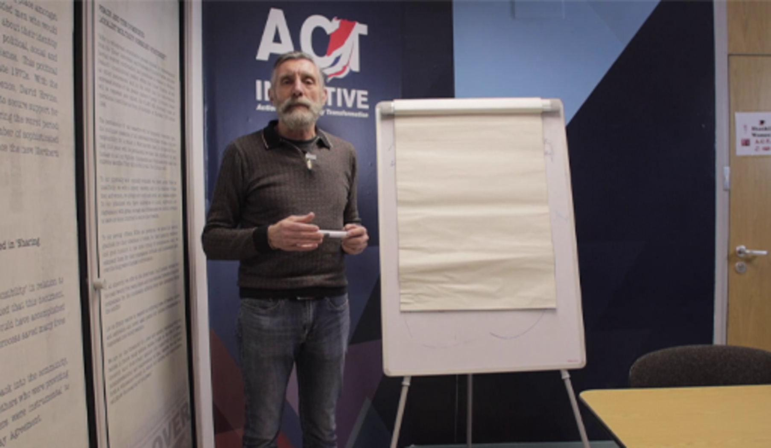

Mind maps are often very personal – they are, after all, maps of your mind. For example, take a look at this short video of William doing his mind map of ‘me’.

Video content is not available in this format.
Video 5: William’s community mind map (please note, this video has no audio)

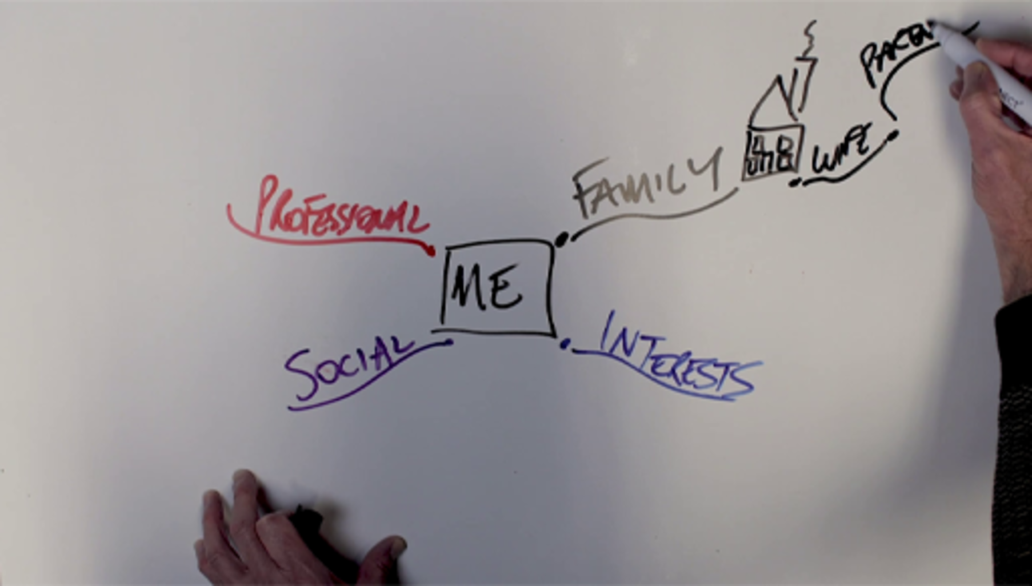

Activity 11: Mapping your community
15 minutes

Now take a blank piece of paper to create a mind map of what community means to you. When you have finished take a picture of it to keep. If you prefer to do a word-based map without colour or pictures, you can use this online mapping tool. Don’t forget to save your map.

Interactive content is not available in this format.
Interactive 1: Mind-mapping

View discussion - Activity 11: Mapping your community

Community, or the sense of belonging you feel with others, can be about where you live, or from having a shared history in a place. It can be about something you cannot see or directly experience yet it is there nevertheless, such as a shared social identity or culture or shared values and can exist over time and across generations. It can also be about how other people see you and other people’s expectations of you based on this.
By mapping what community means to you, you can understand how these different ideas of community might shape your action and choices. By stepping back and reflecting on what community means to you, you can also begin to create your own understanding of community and change the role you play. In Session 2, you will explore some of the reasons why you make the choices you do, develop your skills for thinking critically and develop skills to help you make the right decisions for you.

Activity 12: Time to reflect
10 minutes

Before you finish this session, take a moment to reflect again on the question ‘Who am I?’ which was posed in Section 2. What have you learned about yourself and your place within your community or communities?

Provide your answer...

5 Summary
In this session you have:
- explored why some young people feel rioting is the only way to have their voice heard
- considered what you value most and the issues of concern to you in your community
- considered how other people’s views of you and your community or its past, can shape how you see yourself and the options you have for highlighting the issues you care about
- developed your self-reflection skills
- developed your mind-mapping skills to explore your thoughts and to think more creatively.

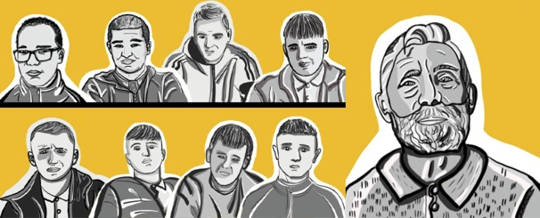
Figure 11: Group illustration from left to right: Dylan, Matty, Brandon, Adam (top row) and Ashton, Ryan, Stephen, William (bottom row). William (Project Director for the ACT Initiative) is on the right of the group.

We hope you liked Session 1 of the course and that it was helpful to you. Session 2 explores choices and decisions, with lots of tips and advice. See you there.

Protecting your mental health and wellbeing
Please refer to the Sources of support page if you notice a negative emotional reaction to aspects of the course materials. You may wish to step away from the materials, to reflect and to think about whether to continue at this time.

Now go to Session 2.

Session 2: Choices

Introduction

‘A thing I have learned is to stop and think for a moment first before (acting). I would stand and think first for a second…what’s the point?’
(Dylan, aged 15)

Welcome to Session 2 of the course Why riot? Community, choices, aspirations. In this session you will explore different factors that might influence the choices you feel you have as young people and the decisions you make, and you will develop your critical thinking skills to help you question information and make up your own mind about the issues that concern you.

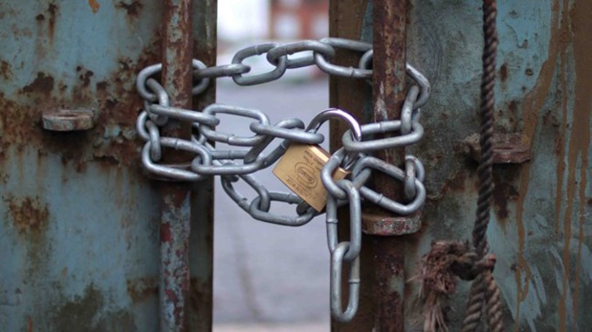
Figure 1: Padlock at the Lanark way interface, Belfast. (Source: © Hugh Pollock, 2021)
View description - Figure 1: Padlock at the Lanark way interface, Belfast. (Source: © Hugh Pollock, ...

By the end of this session, you will be able to:
- understand what might influence your choices
- question online information and fact check
- use social media in positive ways.

Figure 2: Group illustration from left to right: Dylan, Matty, Brandon, Adam (top row) and Ashton, Ryan, Stephen, William (bottom row). William (Project Director for the ACT Initiative) is on the right of the group.

We hope you enjoy Session 2 of our course.

1 Why do you make the choices you make?
People make choices every day. But how much do you think about those choices you are making? What processes (if any) do you go through when you make decisions? And what are some of the factors that might influence these choices?

Figure 3: Why do you make the choices you make?
View description - Figure 3: Why do you make the choices you make?
View description - Figure 3: Why do you make the choices you make?

Let’s go back to the riots that took place across Belfast and other cities in Northern Ireland in the spring of 2021.The riots began in largely Protestant Unionist Loyalist (PUL) areas during a time of political tension. Street violence and clashes took place between PUL youth and the local police force (PSNI) and then at interface areas, between young people from PUL and Catholic/Nationalist/Republican (CNR) communities. A number of people were arrested after these events including teenage boys.
Read these quotes from young people involved in this course, about why young people riot. One quote is from a boy who was involved in the riots and later arrested. The other is from Dylan which you also read in Session 1.

‘There’s loads of kids, like loads of young teens, like myself, they like-- they just want to go out to have fun. Like a riot to them is fun. Like they like fun stuff. I think they got a buzz out of it. Like, see other people, they actually have a point of view of what’s going on. Where most people don’t. They just want to go out and have fun.’
(Young person aged 15)

‘Most people just rely on going out of the house and looking for a riot and going and throwing a few bricks and then the trouble starts and then think that’s how to get their voice heard until they are sitting in the back of a wagon [police van] and going down to Musgrave [a city centre police station] and having to ask a few questions. Why were they there? And why were they doing it? Why were they doing it is the question?’
(Dylan aged 15)

Activity 1: What influences people’s choices?
10 minutes

- What do you think when you read these quotes?
- Do you recognise any of these feelings?
- How much do you think the people in the quotes thought before they acted? Is that true for you too?

Provide your answer...

1.1 Community, identity, belonging
In the first session you explored how important the idea of community is to your sense of who you are, how you see yourself and also to how other people see you. You read and heard from the contributors about the values they have in relation to community and what it is they hold dear. Some of these demonstrate that there are similarities in how people value community but, equally so, some differences. You have also been introduced to the Shankill community, a predominantly Protestant/Unionist/Loyalist (PUL) community in Belfast, which like a lot of communities in Northern Ireland (and also possibly the ones in which you live) is emerging from conflict. And you considered how a history of conflict or violence or division in a community can also affect how outsiders see people from that community. Some of the comments from the young people are still rooted in the history associated with their community and how this may have influenced some of the choices they have made thus far in their lives.
In Session 1 you also developed some new skills to help you think creatively about who you are, what community means to you and how you can find your own sense of identity within this. You might want to take look again at your answers to the question ‘Who am I?’ and your mind map on what community means to you from Session 1.
Having a clear sense of your own identity and values – as opposed to what other people think about you – is the first tool to help you make decisions and choices that are right for you.

1.2 How free are you to choose?
By the age of 15 or 16 you, like many young people, may be starting to make important decisions or choices about your future (sometimes with advice or guidance from parents or guardians) such as, ‘What do I want to do in life’ or ‘Should I stay in education (at school or college)?’ Imagine this is the decision you are about to make now. Do you know what factors might influence your decision?

Figure 4: How free are you to choose?
View description - Figure 4: How free are you to choose?

Activity 2: Should I stay in education ?
15 minutes

Take a look at these two young people Alex and Jo (characters) and the choices they face.
Character A: This is Alex. Alex is 15 and thinking about whether to stay on and study after the age of 16. Some of Alex’s teachers think Alex has academic potential [to go on to college or university] but no one in the family has stayed on in education. Most of Alex’s friends are also not interested in staying on in school. Some are already getting jobs or apprenticeships. Earning money right now would be really helpful to the family as times are tough, but Alex also really likes school and subjects like reading, maths, and drawing, and dreams of being an engineer or designing things. Alex sometimes has self-doubts too about having what it takes to study.
Character B: This is Jo. Jo is 15 and thinking about whether to stay on and study after the age of 16. Jo’s brother is going to university. Jo’s mother is a doctor and everyone in their family expects Jo to become a doctor too. Many of Jo’s friends are planning to stay on in school and go to University, though some are also talking about getting jobs. Jo’s not sure about a career in medicine and often dreams of a more practical job like being a plumber and where you can be your own boss.
For both Alex and Jo, choose one option below to summarise how you see their choice.
- To leave school and find a job that will support them and their family.
- To follow their dreams and stay on in school.
- To take another path. Can you give an example?
What made you choose a, b or c for Alex or Jo? Is there something in your own background or experience that led you to that option?

Provide your answer...
View discussion - Activity 2: Should I stay in education ?

1.3 Breaking the mould
As you have seen, there are many different things that can restrict the choices you have (the options that are available to you) and influence your decisions – what you choose to do. Some are easy to identify. But many are harder to see. People are influenced by what they know and the surroundings social systems and structures they grow up in. For example, the values of the political system you grow up in, whether you live in a wealthy area or an area of high deprivation, an urban or rural area, whether you live in a mixed/diverse/international community or one rooted in its local history. The society we are born into has its own history, tradition and culture as well as economic, political and social factors which shape how we grow up. In turn, these factors can condition or constrain or limit us in what we believe and how we think.

Activity 3: William’s story: Part 1
15 minutes

Now watch this short video in which William who you met earlier, tells his story of how he became involved in the conflict in Northern Ireland as a 15-year-old boy and the decisions he made at that time.

Video content is not available in this format.
Video 1: William’s story: Part 1
View transcript - Video 1: William’s story: Part 1

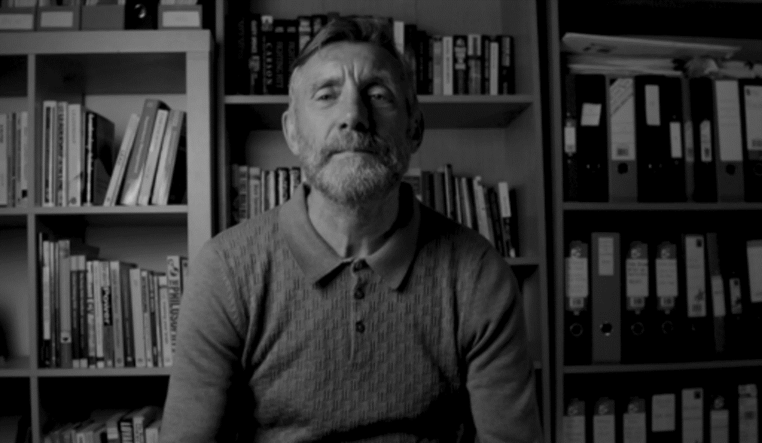

- What questions does his story raise for you?
- What kinds of social issues might have limited William’s choices?
- From hearing his story as a 15-year-old boy what do you imagine his future might have held?

Provide your answer...
View discussion - Activity 3: William’s story: Part 1

The South American educationalist Paulo Freire (1921–1997) described how people’s freedom to be more than what they already know, is conditioned by their social context – or the reality in which they live. But that wasn’t the end of the story for Freire. He was also interested in how change happens. Freire developed a radical approach to education with communities, empowering people to use learning and knowledge to expand their understandings of themselves, their social structures and how to change things.
This use of knowledge is something that William has done in his life. In the next video, William is reflecting on his choices and decisions, while in prison and after he returns to his community from prison. His story begins in the compounds of the Maze and Long Kesh prison in Northern Ireland, where William was imprisoned for 13 years. From here he talks about the choices he made after this release from prison following the paramilitary ceasefires in 1994 and following the Good Friday Agreement in 1998.

Activity 4: William’s story: Part 2
15 minutes

Watch the video and then consider the questions that follow.

Video content is not available in this format.
Video 2: William’s story: Part 2
View transcript - Video 2: William’s story: Part 2

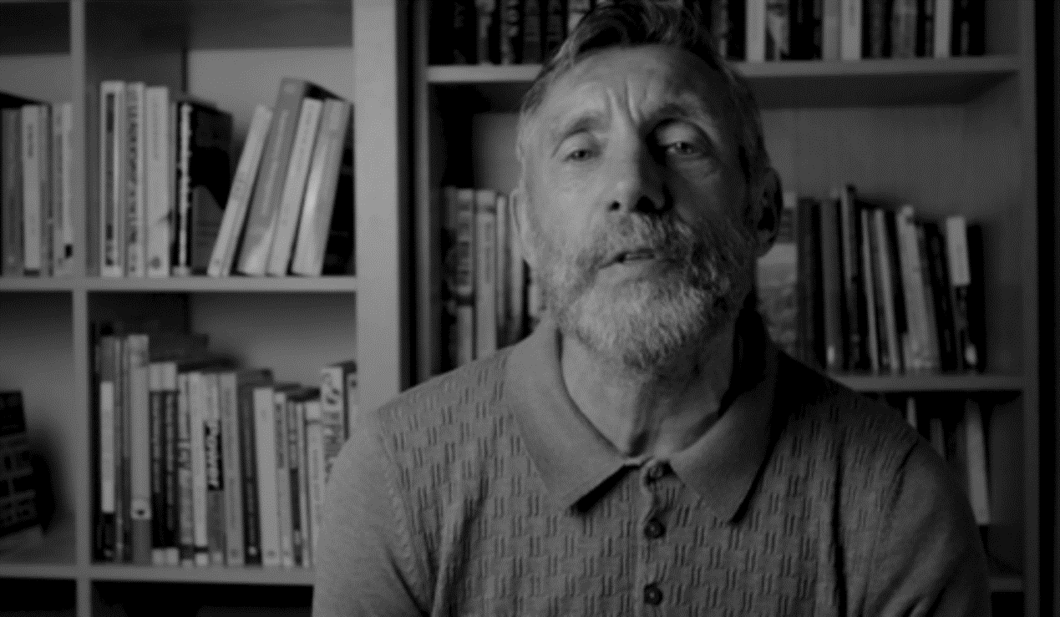

- Is there anything that surprised you about William’s story?
- Can you give some examples of the decisions he made as an adult, after returning to the community?
- What are some of the changes William describes in his ways of thinking about the world?

Provide your answer...
View discussion - Part

William’s story hints at the possibility within all of us to learn to think differently and to use these skills to open alternative options or pathways. As you have seen, when making decisions, people often stick with what they know or is familiar to them. For example, when thinking about work or their future career, people may follow the same pathways as their parents or friends. You too may want to follow what you know already in life, but you can also explore different pathways. To do this you need to ‘use your head’ or thinking skills.
Let’s look at some tools to help you to develop your thinking so that choices you make are your own and not just following the crowd.

2 Thinking for yourself
In today’s digital world you have the potential to connect to other people, places, information and ideas that take you far beyond where you are born or are growing up. You also have access to a wealth of information. But it is not enough just to have knowledge about something or to know stuff. You need to know how to think through all this information in order to make your own decisions and choices.

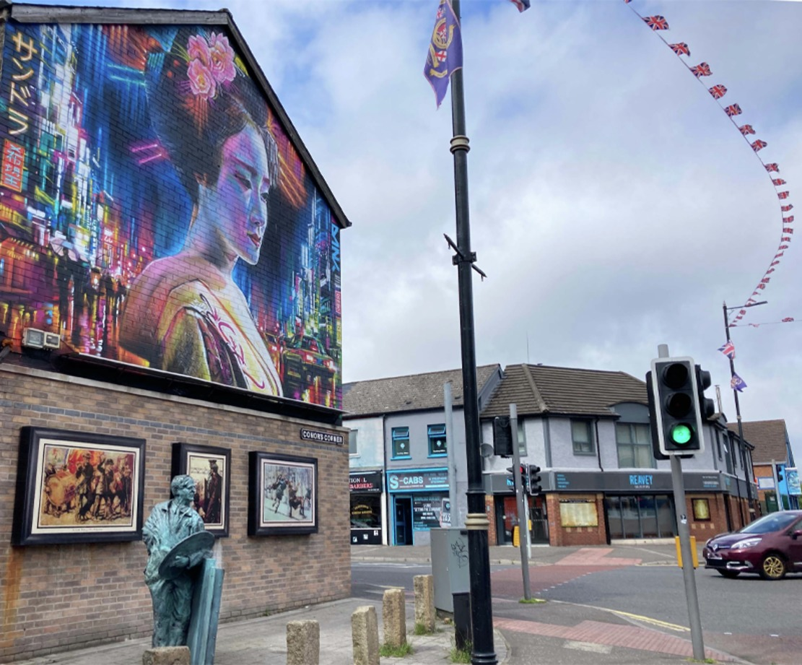
Figure 5: Image of a mural
View description - Figure 5: Image of a mural

The thinker Edward De Bono (1933–2021) claims most forms of education concentrate on knowledge. The educationalist Paulo Freire (1921–1997), who you met earlier, states that education often focusses on delivering existing knowledge rather than encouraging ways of thinking and questioning. This combination can lead to people simply following the same pathways of thought as those around them. What both De Bono and Freire are arguing for is a more conscious process of thinking, in which people think about the different influences they are under, explore different possibilities and make your own decisions and choices.

2.1 Social media influence and the riots
Earlier you were introduced to the riots that took place in PUL areas in Belfast and other cities in Northern Ireland in the Spring of 2021. These riots and street disturbances also spread to interface or boundary areas between Catholic/Nationalist/Republican (CNR) and Protestant/Unionist/Loyalist (PUL) communities, where tensions were already high. In the aftermath of the riots, commentators, community workers, and young people themselves describe social media as playing a significant role. So what information sources were young people relying on when making decisions about whether to join the disturbances and how might this have influenced their choices?
Take a moment to read some of the comments below on social media in the build-up to the Belfast riots in 2021, targeting young people in areas like the Shankill.

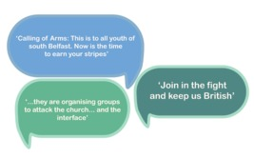
Figure 6: Speech bubbles
View description - Figure 6: Speech bubbles
View description - Figure 6: Speech bubbles

And here are some reflections from the young people involved in this course on what was happening on social media.

Figure 7: Group illustration from left to right: Dylan, Matty, Brandon, Adam (top row) and Ashton, Ryan, Stephen, William (bottom row). William (Project Director for the ACT Initiative) is on the right of the group.

‘People were making all sorts of fake accounts just to get people out. Grown men saying like “Oh we want everyone around here at such a time.” As soon as it happens, everyone just goes out [on the streets]’.
‘the kids are hearing stuff that’s 99% through social media, which isn’t always accurate. And they are led to believe different stories, which doesn’t really represent what this community is about’.
Shankill Community worker

Activity 5: Responding to a call to action
15 minutes

How would you decide what to do if faced with a call to action on social media around an issue facing you or your community?

Provide your answer...

Sometimes in the heat of the moment it can be hard to see clearly what is happening, especially if you are feeling angry or upset. And as the boys also highlighted, sometimes things are not always what they seem. It may be that other people have their own agenda and reasons for wanting you to act in a certain way or to influence your actions.
Thinking critically is a powerful tool you can use to help you question information, weigh up and evaluate the quality of any information and make your own decisions based on this. Let’s start with ways of questioning the information you receive.

2.2 Filter bubbles and echo chambers
People use information every day to make decisions. One of the main sources of information is likely to be social media. Yet, have you ever noticed how the information and social media messages you see online are often personalised to you, from adverts about the brand of trainers you like, to the sports clubs you support, to the political views you or your friends tend to know or already agree with? This is called a filter bubble or an echo chamber (where the same views as your own are echoed back to you).
Filter bubbles narrow the range of information you have access to, which has its benefits if you always buy a particular brand of jeans or trainers, but is not so helpful when trying to understand important issues or if you need to make informed decisions. You may also find it harder to identify false information as you are not exposed to other sources of information or ideas that may challenge you or make you question what you are reading or hearing.

Activity 6: Understanding filter bubbles
20 minutes

Take a few minutes to watch Video 3 before answering the following questions.

Video content is not available in this format.
Video 3: Filter bubbles and fake news
View transcript - Video 3: Filter bubbles and fake news

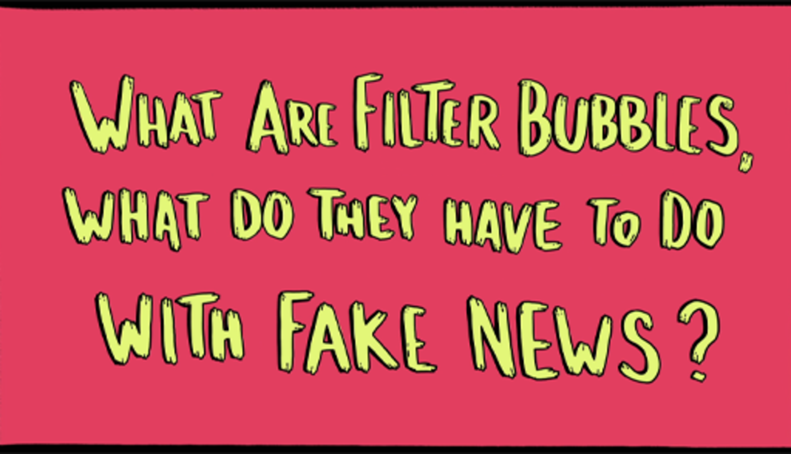

1. You are in a filter bubble when:

Computer algorithms use your online search history and preferences to make assumptions about what you want to heard and filters the information it feeds you.
Computer algorithms use your online search history and preferences to expand the range of ideas and perspectives it feeds you.
View answer - Part

2. Which of the following can happen when you are in a filter bubble?

It isn’t always obvious you are in a filter bubble!
You may only see the opinions of those who think the same way as you.
You may be surprised by or become much less tolerant of other viewpoints.
View answer - Part

3. Fake news is ___________ that is purposefully circulated.

Provide your answer...
View answer - Part

4. List three reasons for why people might circulate fake news.

Provide your answer...
View answer - Part

5. Why do you think misinformation or fake news does well in filter bubbles?

Provide your answer...
View discussion - Part

Figure 8: Fact or fake?
View description - Figure 8: Fact or fake?
View description - Figure 8: Fact or fake?

So, how can you protect yourself from filter bubbles and false or misinformation? In short, you can’t. If you use the internet and social media, computer algorithms will analyse what you say and do online and filter the information you see. This can be helpful for some tasks, but it will also limit what you see and hear. The important thing is for you to be aware that you might be isolated from wider society in your thinking (in a filter bubble), so ask questions about the information you receive and expand the range of information you are exposed to.

3 How to spot false or fake news
Fake news like other forms of disinformation and misinformation is nothing new. It has been used throughout history – you may have studied the use of propaganda in the Second World War (1939–1945) or the Cold War (from the 1950s to 1989) for example. More recently in the war in Ukraine, both mainstream media and social media have become battlegrounds in which propaganda and misinformation are widely used. In the world of social media, misinformation is just more personally targeted whether for fun, to influence you for political reasons or just to make money. This matters because the information you are exposed to often shapes how you see the world, and your understanding of society. It can also influence how you feel and the decisions you make. This is particularly the case in times of high emotion, political tension or conflict. Remember for example, some of the comments by young people and community workers in the Shankill about the false information and fake messages they were targeted with.

3.1 Information, misinformation, disinformation
There are many kinds of false information some of which are outlined below. Click the following labels in Interactive Figure 9 to reveal the answer. When clicking on the top hexagonal shapes, you may need to scroll down slightly to see the information box (that appears below the image) on your screen.

Interactive content is not available in this format.
Figure 9 (interactive): Different types of false information
View description - Figure 9 (interactive): Different types of false information

While you can’t avoid false information, you can read more widely, talk to people outside your circles and read mainstream reputable news sources, to burst your filter bubbles. At the end of this session, you will find lots of resources to explore and quizzes you can try on how to recognise deep fakes, misinformation and propaganda.
You can also use your thinking and questioning skills to help you evaluate the quality of the information and to make good decisions for you. Let’s look at some tips and tricks for doing this.

3.2 Separating opinions from facts
How do you know what information is a fact or just someone’s opinion, or even who is behind the information being posted, or messages that are targeting you and your friends? There are many ways that you can fact check information and claims.

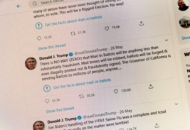
Figure 10: Tweet from former US president Donald Trump, 26 May 26 2020
View description - Figure 10: Tweet from former US president Donald Trump, 26 May 26 2020
View description - Figure 10: Tweet from former US president Donald Trump, 26 May 26 2020

This tweet was posted by former US president Donald Trump on 26 May 2020 and flagged as requiring fact checking by Twitter.
There are lots of polarising issues that become the focus of offline and online debate, conspiracy theories and misinformation campaigns, from highly contested elections to Brexit, climate change and Covid. These are issues that you may be discussing amongst your friends and making decisions about personally or within your community, or that your politicians are making decisions about through national and international policies.
Let’s take the example of this tweet from Donald Trump. There are a few simple ways to check information online and on social media. Think: before you act take a moment to stop and think, is this information correct/real? You can use online searches to look for information around the issue and check facts using websites like Fullfact.org.
Take a look at Figure 11 and ask yourself 5 simple questions: who, what, where, when and why.

Interactive content is not available in this format.
Figure 11 (interactive): TIPS: The Trustworthy information check list
View description - Figure 11 (interactive): TIPS: The Trustworthy information check list

Now have a go at Activity 7.

Activity 7: Fact-checking Trump
20 minutes

Try your skills with former President Donald Trump’s tweet from 26 May 2020.
You can do this on your own or with friends. Take a few minutes to do some online research around the story. Think about the 5 questions as you do to help with your research. Fill in the table below. At the end of this process ask yourself what is your judgement on this tweet? Was it opinion or fact? Is it something people should believe and react to? If you were a Trump supporter how would it have made you feel?

Table 1: Fact-checking Trump
There is NO WAY (ZERO!) that Mail-In Ballots will be anything less than substantially fraudulent. Mail boxes will be robbed, ballots will be forged & even illegally printed out & fraudulently signed. The Governor of California is sending Ballots to millions of people, anyone...— Donald J. Trump (@realDonaldTrump)
Who - Source | Provide your answer...
What – The facts | Provide your answer...
Where | Provide your answer...
When | Provide your answer...
Why / how does it make you feel. | Provide your answer...

View discussion - Activity 7: Fact-checking Trump

Remember, how information makes you feel can be one of the most important factors in any decision you make, but if you use your head and not your heart, you will be in control of the decisions you make and not just following the herd. Why not try using these skills to fact checking stories you have come across on social media in your own life.

4 How to handle hate speech
It can be hard to keep a clear head and make cool decisions when there is so much messaging going on, including offensive language and hate speech on social media whether it’s on chat groups or by sharing videos.

Activity 8: Time to reflect
5 minutes

Reflect on the following questions.
Have you ever said something on social media without thinking? Or when you are angry to hurt someone else? What difference did this make to the situation?

Provide your answer...

Social media is both a source of information and a powerful tool to talk with friends, share ideas, organise events and mobilise others locally or globally, to work together on common issues you care about. It is also a place where people can create false information to manipulate others, use hateful language and be abusive to those they don’t agree. It can sometimes feel like anything can go online, which can make it a dangerous and sometimes very hurtful space. But this is your space too, and you have choices in how you use social media, how you connect with others and how you make change happen.
This is what young people did in Parkland, Florida in 2018, in response to a terrible event that affected them and their communities.

4.1 ‘March for our lives’
In February 2018, 17 students were shot and killed by a fellow student armed with an assault rifle at the Marjory Stoneman Douglas High School in Florida, Parkland (US). This was the latest in a spate of school shootings in America, where gun ownership is legal, and the right to gun ownership is a highly emotive and divisive issue. While the world’s media covered the events as a news story, students at the school began to tell their own stories on social media, sharing their feelings, challenging the views of politicians and commentators, and calling for stricter gun controls. Within days some of these students including Emma Gonzalez and Cameron Kansky used social media to build a campaign called March for Our lives around the issue of gun control. Hundreds and thousands of young people soon joined them, taking to the streets in marches across America as part of a youth led social movement to hold their politicians to account and to demand change.

Figure 12: Emma Gonzalez (centre right) at a March for Our Lives protest, 2018
View description - Figure 12: Emma Gonzalez (centre right) at a March for Our Lives protest, 2018

On 24 March, one of the March for Our Lives founders, 17-year-old Emma Gonzalez made a speech to her political leaders – here are two quotes.

‘Maybe the adults have gotten used to saying ‘it is what it is’, but if us students have learned anything, it’s that if you don’t study, you will fail. And in this case if you actively do nothing, people continually end up dead, so it’s time to start doing something.’
‘The people involved right now, those who were there, those posting, those tweeting, those doing interviews and talking to people, are being listened to for what feels like the very first time on this topic.’

Activity 9: Time to reflect
5 minutes

What do Emma’s statements make you feel about your power as a young person?

Provide your answer...

Over the following months these young people spoke to politicians, ran national anti-violence rallies, became spokespeople for their generation and shifted the debate around gun control in their country. They also learned a lot about how social media could be a negative or positive force. As they took to social media promoting debate and discussion around the issues they cared about, these young people also became the target for hate speech, trolling and misinformation. Those who opposed their views spread negative stories, produced fake profiles and fake images. Twitter provided online verification – a tick symbol – for Emma Gonzalez, Cameron Kasky and the other prominent students activist so people would be able to tell when they were hearing directly from these young people.

Figure 13: Example of the twitter blue tick symbol

Activity 10: Verification and you
15 minutes

- Can you think of any examples where you or young people in your community have been misrepresented on social media?
- What ideas do you have for how to counter this kind of misinformation?

Provide your answer...

Find out more about the March for our Lives campaign here.

4.2 Changing the conversation

‘Social media especially. It’s the worse for it. It’s just slabbering [being provocative or insulting].’
(Boy 1, the Shankill)

‘You get people that put up videos of the riots and all. Say one side would be like aye with tricolours [Irish flag]. And then the other side would be Union Jacks [British Flag]. People like put up videos people of throwing bricks and putting in car windows and all that stuff.’
(Boy 2, the Shankill)

Social media can be a hateful space. This is something the boys in the Shankill talked about a lot. Offensive language can also be really hurtful to experience, and it can be tempting to use this language yourself whether to goad someone you are angry with or in retaliation when there are issues you feel strongly about. So how can you change the conversation?

Activity 11: Using your head on social media
20 minutes

Watch Video 4, with another one of the March for our lives founders Cameron Kansky reflecting on what he has learned in 2021. Take notes as you listen to what he is saying.

Video content is not available in this format.
Video 4: Cameron Kansky’s reflection on the March for our lives
View transcript - Video 4: Cameron Kansky’s reflection on the March for our lives

- What struck you most from listening to Cameron?
- Write down three key lessons Cameron learned?
- Are there any situations you can think of in your lives where you can apply his advice?

(a)
(b)
(c)
View discussion - Activity 11: Using your head on social media

Cameron’s tips for talking to people you disagree with
- Social media exists to supplement but not replace human connection.
- Don’t become part of the problem. (Try instead to be part of the solution.)
- Break down the walls – it’s important to look at people we disagree with as other human beings. Approach everybody like they are part of the same world you are.
- Come from the place you want to learn.
- You learn the most from people who disagree with you.
- Aim to lift someone up, not knock them down. Disagree with the issue not the person.
- Be open to changing your mind.

4.3 How does it make you feel?

‘Just use your head, don’t be rash about it, think it through’.
(Matty, 15)

Questioning and evaluating are powerful skills. You can use these skills to check how trustworthy the information you hear or see is, and to reveal some of the hidden influences that you are exposed to everyday. You can also use these skills to help you change how you relate to others on social media.

Tips: Stop, check, think before you act
Before you act, stop and ask yourself some simple questions:
- Have you checked the information is correct?
- Think – How does this information make you feel?
  - Are you acting with your heart, or with your head?
  - What are the consequences of taking this action for others and for you?
  - Will your actions help to solve the problem at stake?
These tips are adapted from the Fact NI toolkit.

Activity 12: What would you do?
5 minutes

If you got a message like one of these anonymously, what would you do? And which one do you think gives you the most choices? Choose one of the following responses.
- You hear on social media that the police have just arrested a young lad you know. He’s being held in the local police station and he’s in a bad way. What do you do?
- You hear that young people in a neighbouring community have got funding for their youth centre and your community has got nothing. You are angry and frustrated. What do you do?
- Someone has been offensive to you on social media and is saying hateful things about you and your community. What do you do?

Respond straight away, for example by taking to the streets with your mates; or by sending angry or hateful messages.
Stop, check, and think before you act.
Share the message with all your networks so everyone knows the news and what’s happening on the streets.
View answer - Activity 12: What would you do?

In the next session you will explore ways to come up with alternative possibilities, to help you decide what to do in the situations you face.

Activity 13: Time to reflect
10 minutes

Before you finish this session, think again about how you make decisions in difficult situations. What have you learned and what would do differently now that you developed these new skills?

Provide your answer...

5 Summary
You have listened to William and choices he made, and you have heard how social media affected riots. You have learned to question information and disinformation in your own lives, and how filter bubbles can reduce the range of views and opinions you are exposed to or can manipulate how you feel and act. You have learned how to use your head for example to stop, check (verify the information) and think (analyse the information, why it is saying what it is saying and how it makes you feel) before you act on it.
Finally, you have listened to the stories of young people in Parkland Florida and their experiences of using social media, and learned some valuable tips on how to talk constructively on social media and face to face, even with people you don’t agree with.
In Session 3 you will be doing this and looking at ways to use your skills for positive change and to help you make your own decisions for your future.

Protecting your mental health and wellbeing
Please refer to the Sources of support page if you notice a negative emotional reaction to aspects of the course materials. You may wish to step away from the materials, to reflect and to think about whether to continue at this time.

We hope you enjoyed this session. See you in Session 3.

Session 3: Aspirations

Introduction

‘My qualities? Leadership, honesty and respect. I don’t want to be looked upon as a young hood or young thug, because I’m not’.
(William, aged 15)

Welcome to Session 3 in the course Why riot? Community, choices, aspirations. This session focuses on making your future, the future you want it to be. It is about opening new possibilities and choices, finding your voice, and making your own decisions to help you achieve your goals.

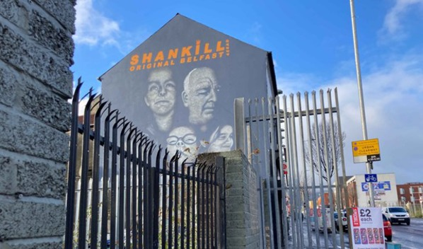
Figure 1: Mural in the Shankill, Belfast, 2021
View description - Figure 1: Mural in the Shankill, Belfast, 2021

By the end of this Session 3, you should be able to:
- think creatively about problems and how to solve them
- use your mind to open new possibilities and choices
- make decisions based on your values
- find your own voice
- explore ways of working with others on shared goals.

Figure 2: Group illustration from left to right: Dylan, Matty, Brandon, Adam (top row) and Ashton, Ryan, Stephen, William (bottom row). William (Project Director for the ACT Initiative) is on the right of the group.

We hope you enjoy this session, which is the final session in our course.

1 The future and you
In previous sessions you listened to the boys talk about the Shankill community they love, and why they thought young people had rioted. You also heard them question if rioting was the best way to get their voice heard. In the aftermath of the riots nothing had changed politically. Some young people had been arrested. Many young people – especially boys – including those not involved in the riots, also found the community looked upon them negatively as troublemakers or young ‘hoods’.
When the boys making this course first met William after the riots, he asked them a number of questions. For example, what did they think was the end game [goal] for young people who took part in the riots and violence; what did they as young people want to say as they all said they wanted a voice; and what were their hopes from taking part in the course with William? In between the banter, the boys had lots of opinions and hopes too for changing how others saw them.

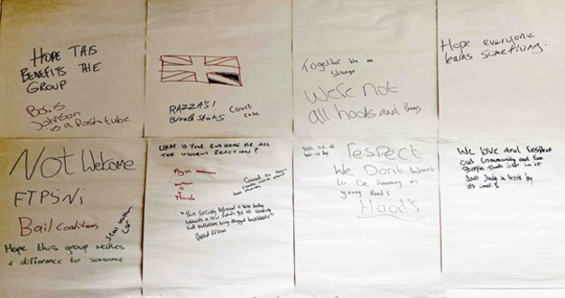
Figure 3: ‘What is the end game?’ William and the boys’ wordstorming whiteboard, May 2021.
View description - Figure 3: ‘What is the end game?’ William and the boys’ wordstorming whiteboard, ...
View description - Figure 3: ‘What is the end game?’ William and the boys’ wordstorming whiteboard, ...

The boys were particularly concerned with how they were seen now in their community. But they were not sure how they could change things. To help them with this William asked them what they wanted for themselves and how they saw themselves in their future. Now let’s join the boys as they revisit these questions and explore their aspirations (what they hope for).

Activity 1: Hopes for the future
10 minutes

Watch Video 1 and then try this activity for yourself.

Video content is not available in this format.
Video 1: Boys’ Aspirations Workshop
View transcript - Video 1: Boys’ Aspirations Workshop

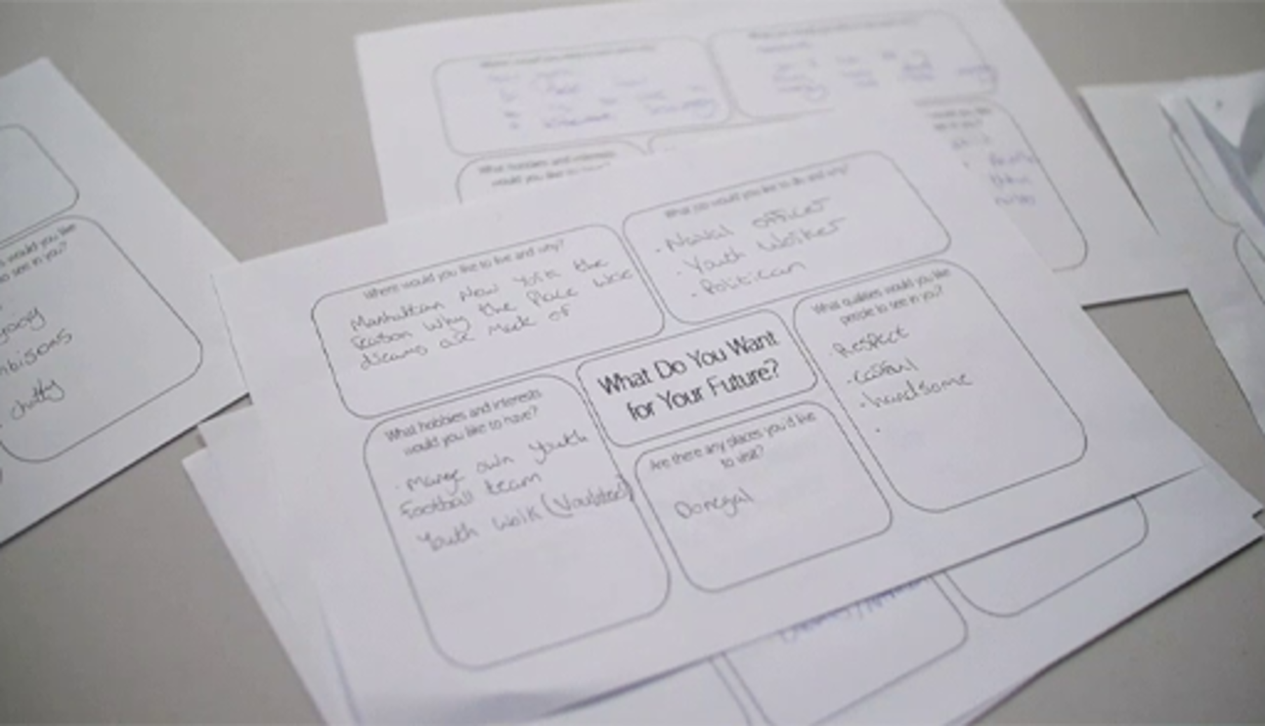

Write down what you want for your future in the boxes below. Let your imagination run free. Think of these as goals or aspirations for your life, that you can work towards. You will be able to save this document to look at or work on again later.

Table 1: What do you want for your future?
Where would you like to live and why? | Provide your answer...
What job would you like to do and why? | Provide your answer...
What are your hobbies and interests? | Provide your answer...
Are there any places you’d like to visit? | Provide your answer...
What qualities would you like people to see in you? | Provide your answer...
Source: Beth Sandhem

View discussion - Activity 1: Hopes for the future

What you want for your future will be personal to you. In this activity you might have said you wanted to continue to live in your local area and bring change to your community. Or you might want to live in another city or country, or travel the world. You might want to go to university or be a street artist or run your own food business. You might want people to see you as someone who is independent minded or kind or trustworthy or courageous. Or you might have struggled to think of things that took you beyond what you already know or see around you or what others expect of you.
It is often easy to identify what you don’t want, but harder to know what you do want or to imagine something different and how to achieve this. This is where you can use your skills of reflection, critical thinking, and your imagination too, to deepen your understanding of your situation and to create different choices. Let’s look at how you can you come up with alternative possibilities, to help you decide what to do in the situations you face.

1.1 Exploring possibilities
One way of thinking outside the box when faced with a choice or a problem is to imagine you are trying to solve a puzzle. A detective, for example, will explore all the different possibilities or explanations and then weigh the best option or most likely explanation, using information as evidence.

Figure 4: Light bulb moment
View description - Figure 4: Light bulb moment
View description - Figure 4: Light bulb moment

Inventors do a similar thing when coming up with solutions. The American inventor and businessman Thomas Edison (1847–1931) tested more than 6,000 different materials in his search for the filament for the light bulb, before arriving at bamboo as the one that worked most effectively. This teaching on thinking has been adapted from some of the thinking techniques developed by Edward De Bono (1933–2021) who you met in Session 2.
Now imagine you were a detective trying to solve the following puzzle…

Figure 5: Exploring possibilities
View description - Figure 5: Exploring possibilities
View description - Figure 5: Exploring possibilities

Take a look at this picture of a dog lying dead. What happened?
There are several possible explanations that can be explored, examined and discounted or not, depending on the facts. For example:
- The dog accidentally fell from the flats above.
- Someone from a rival gang killed the dog for revenge.
- The dog ate rat poison nearby.
- The dog was found dead somewhere else and put here.
- The dog was just old, laid down here and died.
Often in situations where there seems at first to be an obvious explanation, there are many other possibilities that are worth considering, weighing up and deciding if they are valid before closing the case. When faced with a puzzle or problem and it feels like there is only one choice, remember to take a step back and look at it with a cool head. If you look hard enough, you might find there are more choices available than you first thought.
Your ability to imagine different possibilities can help you with understanding a situation and different people’s agendas or motivations and help you come up with different responses or solutions.

1.2 Considering the consequences
Most things that you do will affect other people, so it is important to think about what the reaction of others might be before you act, especially if you are hoping to achieve something with your actions. You always need to consider whether the other people involved in the situation are going to agree with you and whether they are going to help or hinder you. This may depend, for example, on whether they feel listened to or supported by you, or whether they feel scared or threatened by you. To make things more complicated, people are not all the same in how they react. Some people are very organised, some are unpredictable, some have strong views and opinions whilst others prefer to act quietly in the background. And people usually do things for a reason. For example, you may offer to help a friend do their homework, because you want to borrow something from them in return. People may also want you to do things for them, even if they don’t say this directly – remember what you learned in Session 2 about external influences.
You cannot predict how events and actions may turn out, but you can think through the consequences of your actions for you and others, to help you make more effective decisions or to achieve your goals, especially if you want other people’s support or to bring them with you.
Let’s look at this further using the example of 2021 riots in the Shankill area in Northern Ireland.

Activity 2: Exploring the consequences
15 minutes

Read the example below based on the events of riots in the Shankill area in West/North Belfast. You can also rewatch the video from Session 1. As you read, take notes on your thoughts about how the actions of the rioters might affect all those involved.
In April 2021, amidst political tensions over Brexit, social media was buzzing with messages urging young people to get out onto the streets, stand up for their rights and defend their community. Young people came onto the streets and there were clashes between the PSNI [local police force] and local youth. At Lanark Way, which is an interface area (a boundary area between communities), a bus was burned and there were also clashes between PUL and CNR young people and petrol bombs thrown by both sides. The events were covered by local, national and international media and the Shankill and other Loyalist and interface areas became the focus of news reports about violence and rioting and sectarian tensions (tensions between different political and religious communities). Community leaders urged calm. Politicians publicly condemned the attacks. Some also stated their ‘fears of further unrest on the streets of Northern Ireland over the Brexit protocol’. Some young people when interviewed by the media stated that this was about ‘getting our voice heard’.
Now fill in this table on the consequences you have thought about for all those involved.

Table 2: Exploring the consequences
Who are all the people involved? | What are the possible consequences of the riots for each of these actors? How are they affected by the riots?
Young people | Provide your answer...
The PSNI (Police) | Provide your answer...
Local bus driver | Provide your answer...
Politicians | Provide your answer...
Community leaders | Provide your answer...
The national media | Provide your answer...
Unknown people/groups on social media | Provide your answer...
Local residents | Provide your answer...
Other? | Provide your answer...

View discussion - Activity 2: Exploring the consequences

This activity may have helped you to think about your actions too. You can apply this process to any problem or dilemma you face, to help you think through the consequences of your actions.

2 Making decisions
Making decisions can be difficult and complicated. It can be hard to juggle different information, your feelings, the views of others and the limited sets of choices you might feel you are facing. But there are lots of different decision-making tools you can use to help you make the decision that is right for you. When faced with a decision on what course of action to take, you could start by thinking creatively and mapping your thoughts about the problem. Mind maps, which you were introduced to in Session 1, help you to visualise your thoughts and come up with new ideas using words, colours and images. In Session 1, Video 4, William talked about Tony Buzan’s (1942–2019) theory of whole brain thinking and the use of mind maps to open up the creative side of your brain.
In Session 2 you looked at ways of thinking critically about information before taking action, including expanding your sources, asking questions and using fact checking tools. In this session, Session 3, you have already learned about ways to expand the range of possibilities and explanations, by thinking like a detective and using your skills of deduction. And you have used a framework for thinking through the consequences from different perspectives. So how can you pull all these tools together to help you make decisions?

2.1 De Bono’s 6 thinking hats
One powerful thinking tool for making decisions is Edward De Bono’s 6 Thinking Hats technique. You may have come across this already but if not, De Bono (1933–2021) came up with this tool to help people step outside their usual way of thinking or to become more aware of how other people may think about an issue, by playing different roles.

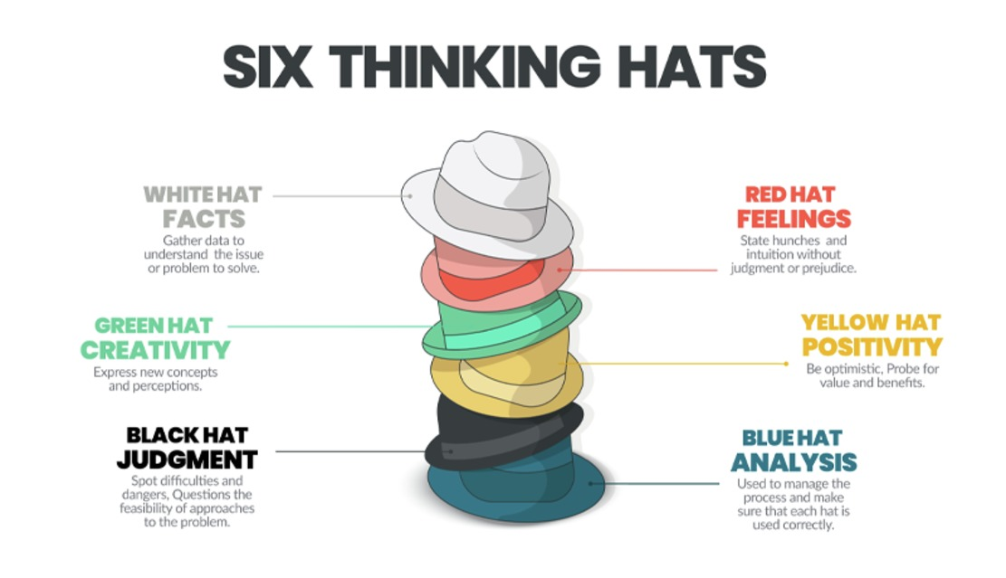
Figure 6: Edward De Bono’s 6 Thinking Hats technique
View description - Figure 6: Edward De Bono’s 6 Thinking Hats technique
View description - Figure 6: Edward De Bono’s 6 Thinking Hats technique

As you can see each hat represents a distinct type of thinking. The following short film will introduce you to De Bono’s technique and how to use it.

Activity 3: Introducing De Bono’s 6 thinking hats
15 minutes
Watch this short film Introduction to De Bonos 6 thinking hats (duration: 2 minutes) before answering the following questions.

1. What does De Bono’s 6 thinking hats technique allow you to do?

Look at a problem from one perspective.
Look at a problem from a number of different perspectives.
Ignore a problem.
View answer - Part

2. What premise or theory is De Bono’s technique based on?

The human brain thinks in a number of distinct ways.
The human brain only looks at things in one way.
These perspectives can be challenged.
View answer - Part

3. What does the yellow hat stand for?

Positive thinking.
Intuition and emotion.
Creativity.
View answer - Part

2.2 How to use the 6 thinking hats
By ‘wearing’ each of the 6 Thinking Hats in turn, you can gain a better understanding of the issues you face – and the best ways forward. Each hat gives you a different perspective for thinking about a problem, and it also helps you to understand how other people might think about the situation too.
When using the 6 hats technique, try using the blue hat first and last. This hat is about thinking about the bigger picture and how you are going to solve it. You can decide the main question you want to answer and the order in which to put on the other hats.

Figure 6 (repeated): Edward De Bono’s 6 Thinking Hats technique
View description - Figure 6 (repeated): Edward De Bono’s 6 Thinking Hats technique
View description - Figure 6 (repeated): Edward De Bono’s 6 Thinking Hats technique

Let’s take the decision on whether or not to use street protests and rioting as a way to get your voice heard.
Blue hat: Wear the blue hat to frame your question. For example: ‘Is rioting the best way for us as young people to get our voice heard?’ ‘What information do I need?’ ‘Whose views do I need to consider?’
For example:
- do you need to consider the facts (white hat)
- what you are feeling (red hat)
- look at potential problems or risks and evaluate (black hat)
- think positively (yellow hat)
- come up with different ideas and solutions (green hat).
If you put the blue hat on again at the end of the exercise, then with this organisational hat on you can pull together all the different perspectives to help you decide what you want to do.
Here are some of the alternative solutions Dylan suggested in his case for what young people could do to get their voice heard, instead of getting involved in the riots.

‘If you want to get your voice heard, go to someone, your local youth group or your mum to try and see if she knows anyone to get your voice heard, you could go to your local politicians or your representatives or if you really wanted you could go down to the Shankill Mirror or into your youth group and say look this here is wrong. This happened and maybe they could help you sort it out before it turns into violence.’

2.3 Pulling it all together
Now it’s time to pull all these skills together. Imagine there is a problem or issue you are concerned about, where you want to take action which leads to a positive outcome. It could be an issue like someone is being bullied or a concern you have about climate change or a lack of sports facilities or the closure of your local youth club. How would you decide the best way of getting your voice heard using De Bono’s 6 hats? You can do this next exercise yourself or with other people.

Activity 4: How would you make your voice heard for positive change?
10 minutes

You can use the issue ‘School Uniforms should be abolished’ or you can choose you own.

Table 3: Making your voice heard
Your issue:  The question: How can you make your voice heard? | [add your chosen issue here]
Blue hat: organisation planning the process | Provide your answer...
Green hat: creative thinking | Provide your answer...
Red hat: gut feelings and instincts | Provide your answer...
Yellow hat: benefits and values | Provide your answer...
Black hat: problems and risk | Provide your answer...
White hat: the facts/ information gathering | Provide your answer...

View discussion - Activity 4: How would you make your voice heard for positive change?

Thinking creatively, like any new skill, is something that you can learn. And the more you practice the better thinker you can become. You can use these thinking skills to solve problems and to help you make decisions, no matter how big or small. You can also use mind maps which you learned about in Session 1. Using your creativity and imagination when thinking about your future will expand the range of choices you have when a solving problem or when working towards the goals you aspire to or to explore new possibilities.

3 Being true to yourself
In Sessions 1 and 2 you looked at how the societies in which you grow up can influence how you see yourself in the world, both positively and negatively, limiting the range of choices available to you. This is particularly the case in societies and communities where there is a history of violence, like Northern Ireland and the Shankill area where the boys you met are growing up and where William works.
You also heard William’s story of growing up in Northern Ireland in the late 1960s and early 1970s, and how he became involved in the conflict as a 15-year-old boy before being imprisoned in the Maze and Long Kesh prison. Reflecting on his actions in part 2 of his story, William described how:

‘As a young man with the limited opportunities that I felt was presented to me, I had a limited imagination. I didn’t aspire to be anything beyond the immediacy of my situation.’

Your choices can also be constrained or limited by the context within which you live, and by the knowledge and information as well as the opportunities you have access to. These factors can influence how others see you, as well as how you see yourself and the choices you make. But they do not need to shape or determine your whole future. As William explained in his story, learning how to think more deeply widened his imagination and gave him more choices and the freedom to create a different future and to take different actions to make change happen.

3.1 How Marcus Rashford used his voice
There are all sorts of ways in which you can break the mould and find your own voice. Your voice will be unique to you, shaped by your values, your community or where you grew up, and your experiences in life. Look at the following example of how the footballer Marcus Rashford, used his voice.

‘As a Black man from a low-income family in Wythenshawe, Manchester, I could have been just another statistic. Instead, due to the selfless actions of my mum, my family, my neighbours, and my coaches, the only stats I’m associated with are goals, appearances and caps. I would be doing myself, my family and my community an injustice if I didn’t stand here today with my voice and my platform and ask you for help’.
(Marcus Rashford, public letter to MPs April 2020)

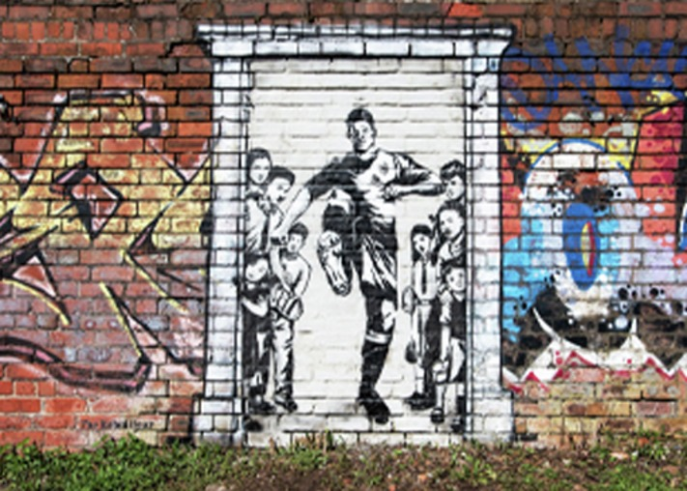
Figure 7: Mural of Marcus Rashford kicking down the door of Number 10 Downing Street to end food-poverty. Old Trafford, Manchester.
View description - Figure 7: Mural of Marcus Rashford kicking down the door of Number 10 Downing Street ...
View description - Figure 7: Mural of Marcus Rashford kicking down the door of Number 10 Downing Street ...

In 2021 at the age of 22, Marcus Rashford was named by Time Magazine as one of Next 100 most influential people to change the world. Marcus is a professional footballer from Manchester in England and an anti-poverty activist. He grew up in South Manchester, on what was once the largest council housing estate in Europe. His mum Melanie, a single parent, worked three jobs to support the family, but still struggled to put food on the table. Marcus and his brothers and sisters, like many others in their community, were often hungry growing up and relied on breakfast clubs and free school meals. This experience shaped his choices, his values and his activism as an adult.

‘Thank you for sticking up for our kids who needed a voice, here on Merseyside and across the country.’
(Everton fans)

In March 2020, during the first COVID-19 lockdown, schools were closed across the UK and in many other countries around the world too. In response Marcus used his twitter account to highlight the food poverty crisis facing families across the UK, many of whom had relied on free school meals. He set up the Child Food Poverty Task Force and raised £20 million pounds for the FareShare charity providing food for foodbanks and meals for struggling families. But Marcus also realised food poverty was a bigger social issue and that it needed a political solution. Drawing on his own experiences of hunger as a child, he wrote a public letter to MPs which he shared on twitter putting public pressure on the British Prime Minister to continue to provide free school meal vouchers to 1.3 million children during the school holidays. Marcus followed up with a campaign to extend the voucher scheme into the winter and won. He continues to campaign for struggling families today. His community has put up murals in his honour. His work has even united rival football communities across the country who value the work he does for all struggling families.

Activity 5: Marcus Rashford’s story
15 minutes

Now watch this short film about Marcus Rashford. Based on what you read and on watching this film, answer the following questions:
- How has Marcus’s personal experience shaped his understanding of food poverty?
- How does he use his voice for communities with similar experiences to his?
- What if anything from his story inspires you to use your own voice?

Provide your answer...
View discussion - Activity 5: Marcus Rashford’s story

Everyone’s voice, including yours, is unique and when you find your voice it will be shaped by your experiences and underpinned by your personal values. Identifying these values is what you will be looking at next.

3.2 Knowing your values
A person’s core values can be thought of as a set of principles that shape their attitudes, behaviour and decision making, influencing their interactions with other people or groups. Core values can relate to personality traits or characteristics, for example being kind, honest or truthful and they can be shaped by life experience, culture and background.
In Session 1 you answered the question ‘Who am I?’ and you may have identified some of your core values through that exercise. You can see what you wrote here.
You may also have your own important principles, such as honesty and integrity, that you do your best to follow. In this section, we will explore how you can become more aware of your core values, thinking about how they can be used to help you to make decisions that affect your life.

Activity 6: Core values
15 minutes

- Read through the list and consider any values that speak to you. If you would rather print this off and circle them, download the list here.
- Add any other core values that you have already identified, that do not appear on this list.
- Look at all the values you have circled (and any you have added) and choose 6 that seem most significant to you. These can be described as your core values.

Table 4: Core values (part 1)
Accountability | Curiosity | Honesty | Parenting | Success
Achievement | Dignity | Hope | Patience | Teamwork
Adaptability | Diversity | Humility | Patriotism | Thrift
Adventure | Environment | Humour | Peace | Time
Altruism | Efficiency | Inclusion | Perseverance | Tradition
Ambition | Equality | Independence | Personal fulfilment | Travel
Authenticity | Ethics | Initiative | Power | Trust
Balance | Excellence | Integrity | Pride | Truth
Beauty | Fairness | Intuition | Recognition | Understanding
Being the best | Faith | Job security | Reliability | Uniqueness
Belonging | Family | Joy | Resourcefulness | Usefulness
Career | Financial stability | Justice | Respect | Vision
Caring | Forgiveness | Kindness | Responsibility | Vulnerability
Collaboration | Freedom | Knowledge | Risk -taking | Wealth
Commitment | Friendship | Leadership | Safety | Well-being
Community | Fun | Learning | Security | Wholeheartedness
Compassion | Future generations | Legacy | Self-discipline | Wisdom
Competence | Generosity | Leisure | Self-expression | Provide your answer...
Confidence | Giving back | Love | Self-respect | Provide your answer...
Connection | Grace | Loyalty | Serenity | Provide your answer...
Contentment | Gratitude | Making a difference | Service | Provide your answer...
Contribution | Growth | Nature | Simplicity | Provide your answer...
Cooperation | Harmony | Openness | Spirituality | Provide your answer...
Courage | Health | Optimism | Sportsmanship | Provide your answer...
Creativity | Home | Order | Stewardship | Provide your answer...

Now in the table below enter your 6 core values across the top. For each core value, try to identify an area where you have practised this core value already in your life and an area where you would like to practise this value in future (see the examples below).

Table 4: Core values (part 2)
Core values | Example: kindness | Value 1 | Value 2 | Value 3 | Value 4 | Value 5 | Value 6
What I have done | Helped a friend fix their bike. | Provide your answer... | Provide your answer... | Provide your answer... | Provide your answer... | Provide your answer... | Provide your answer...
Things I could do | Be kinder to my sister, who I tend to shout at. | Provide your answer... | Provide your answer... | Provide your answer... | Provide your answer... | Provide your answer... | Provide your answer...

Once you are aware of your core values you can think about how certain choices might be in keeping or in conflict with your core values.

Take a look at this example: Alex has listed kindness and friendship as two of her core values. Within her friendship group she becomes aware that Josie has been giving Susan a really hard time, calling her names and excluding her from the group.
Consider Alex’s options below and choose which are compatible with her values and which are in conflict with them?

Option 1: say and do nothing.
Option 2: have a word with Josie and ask her to stop picking on Susan.
Option 3: have a chat with Susan and check if she is OK and how she has been feeling.
View answer - Part

As you think about your future, keep your core values in mind. This will help you in making decisions that feel right for you, rather than doing what others expect of you or making decisions that don’t seem compatible with your values. By being true to your values in how you act, this will also help you achieve your aspirations for how others see you.

4 The power of collective action
The global COVID-19 pandemic which began in 2020 has highlighted the importance and value of local community groups and of people working together to provide self-help and support when times are hard. This has been the case in societies across the world in times of crises or in response to political or social needs. There are likely to be community groups in your area you can be part of to make a difference around the issues that matter to you locally.

Figure 8: COVID-19
View description - Figure 8: COVID-19
View description - Figure 8: COVID-19

As you learned in Session 1 however, your relationship with your community can be complex. Communities can provide a sense of belonging, solidarity and protection and they can also label you or place limitations or expectations upon you. Yet, as you heard in William’s story in Session 2 your role in your community is not fixed. It can change as you change and grow and you can also expand what community or communities you belong to and even forge new communities to help you with your goals.
In William’s case, for example, he used education and self-reflection during his time in prison, to understand the social and political context he had grown up in and to clarify his values and how he wanted to make change happen positively. But he found upon his release that the community he had left as a boy had not changed. As he explained:

‘We were still living separately; we were still worshipping separately; we were still employed separately; we were still housed separately; we were still socialising separately…’

The community he had left was also not welcoming to him because of his past. So he forged new communities based around his interests and values. For example, he moved to a mixed (PUL and CNR) community and educated his children in an integrated school. He nurtured connections with people who shared similar views, including other Loyalists who were involved in community conflict transformation, and later set up a community group to do this kind of work based in the Shankill community.
If you have a clear sense of your core values you will find it easier to find your own voice within your community or communities.

4.1 Becoming wiser
After the riots in the Spring of 2021, some of the young people making this course took part in cross community projects as well as working with William. In the following conversation between three of the boys, they reflect on the riots and how things have changed since then. You will hear them talk about their relationship with young Republicans before the riots and what happened when they spent time with them through a cross community youth project in the summer. Now listen to an audio clip from this conversation.

‘When you mature and you grow up you realize, focus on yourself. Don’t focus on the crowd you’re with. Don’t do the things you’re pressured into doing’.
(Boy 1)

Activity 7: Boys’ conversation on ‘becoming mates’
20 minutes

Audio content is not available in this format.
Audio 1: Boys conversation on ‘Becoming mates’
View transcript - Audio 1: Boys conversation on ‘Becoming mates’

- Is there anything you could relate to in this conversation?
- What do you think the boys mean by ‘becoming wiser’ or ‘more mature’?
- What did this make you think about your own relationships with young people from different communities?

Provide your answer...
View discussion - Activity 7: Boys’ conversation on ‘becoming mates’

As the boys point out, facing difficult situations and political happenings is part of life as young people. It is also something you can learn how to deal with. Becoming more mature involves knowing your own values and focussing on these and not on following the crowd. They also talk about their hopes for this course and that it is something that will open other young people’s minds, show another perspective, and help other young people find their voice and make a difference in their communities.
The boys describe being part of building the future in their communities and they see participating with cross-community groups as part of that process. (In Northern Ireland cross-community usually means people from PUL and CNR groups working together). Importantly, they describe how they connected with other young people who want to talk rather than fight. Finding connections with young people that share your values and working together on common problems can be a powerful way to make change happen.

4.2 Making connections
Remember that you don’t have to be completely defined by your group membership or community, but rather that you have diverse identities, made up from a wide range of group memberships and your personal qualities and core values. In every community there will be groups you can be part of to make a difference around the issues that matter to you locally. And if they don’t exist you can work with your school, your youth group or others to create them.

Activity 8: Identifying community connections
10 minutes

Take a few minutes to think about these questions. If you are in a group, you can discuss this with others.
- Are there any groups in your locality where you can meet other young people from different communities?
- If so, what do they do?
- Are there any groups that give you an opportunity to work on the issues you are concerned about locally as young people?

Provide your answer...
View discussion - Activity 8: Identifying community connections

Thinking about the issues facing you and other young people can help you to make new connections through these common concerns. You might also be able to create new relationships and communities that cross the boundaries of where you live to tackle these issues and challenges from campaigning for a new youth centre or sports facilities to making your voice heard about climate change.

4.3 Becoming a positive changemaker
People find their voices in all sorts of ways to highlight the issues they are concerned about, to fulfil their aspirations and to bring about change. The boys who are making this course have used their experiences to help other young people to think differently, and to change people’s perspectives of them and their community.

Figure 9: Group illustration from left to right: Dylan, Matty, Brandon, Adam (top row) and Ashton, Ryan, Stephen, William (bottom row).

Marcus Rashford uses his experience and voice (and social media) for families and communities across the country living with food poverty. Emma Gonzalez, Cameron Kasky and other Parkland students in their darkest hour used their experience and voices to speak for better gun laws and in doing so built a community of hundreds of thousands of other young people, through their social movement ‘March for our Lives’. So let’s look at what you might be able to do in your communities?

Activity 9: How can you make a positive contribution?
15 minutes

Now take a few minutes to think about all you have learned before reflecting on the following question. You can discuss your reflections with your friends or community worker or others in your class if you are studying this in school.
How can you draw on your experience and your values to make a positive contribution to your community or society?

Provide your answer...
View discussion - Activity 9: How can you make a positive contribution?

People find their voices in all sorts of ways, to highlight the issues they are concerned about, to fulfil their aspirations and to bring about change. Remember, community is not something that is fixed. It is something that is created by people over time and can be remade by people, and this includes you.

Activity 10: Time to reflect
10 minutes

Before you finish, take a look at your hopes and aspirations for your future and the qualities you want others to see in you, from the beginning of this session.
Do you still feel the same? Is there anything you want to add now you have had time to explore, and imagine different possibilities? Think through the consequences and what you might want for yourself.

Provide your answer...

5 Summary
Sometimes you may feel you have to act in a particular way, for example, because that’s how your community is seen or what people expect of you, based on the past. This can have life changing consequences for you and others around you.
In this course you have learned the power of thinking things through before you act. You have explored how community might shape your action and choices and you have considered how you can create your own understanding of community. You have identified your personal values. You explored some of the reasons why you make the choices you do, developed your skills for thinking critically and skills to help you make the right decisions for you. And you have considered the role you want to play in your community or communities and how you can go about doing this.
As you get ready to use your new skills and voice in the world, take a few minutes to listen to this final message from William.

Video content is not available in this format.
Video 2: Final word from William
View transcript - Video 2: Final word from William

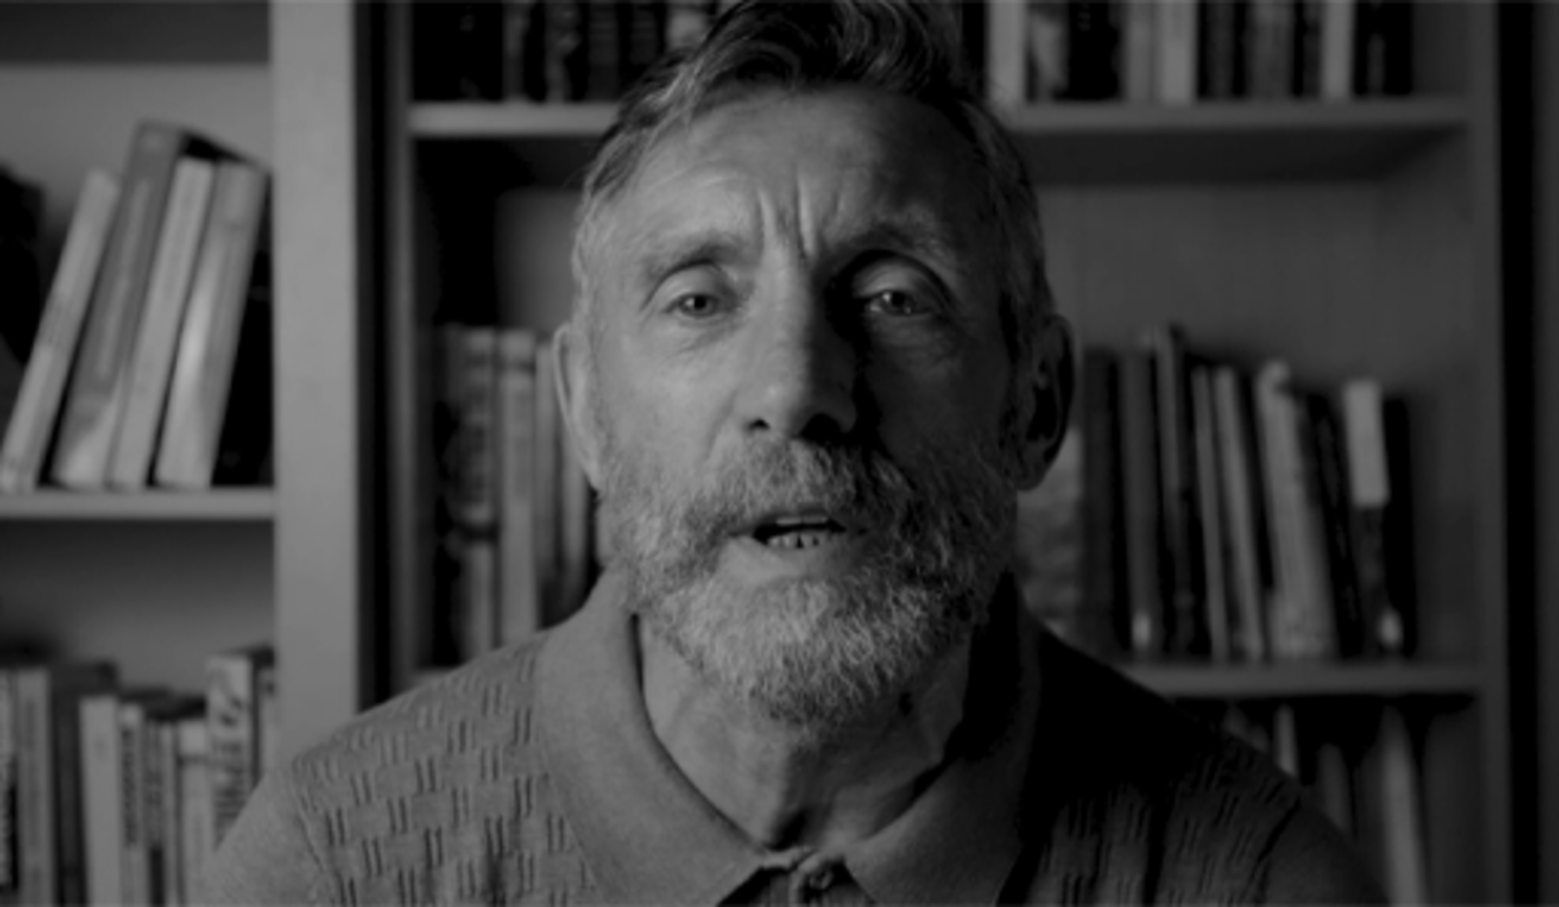

Now you have completed the course, you should be able to:
- consider how external factors shape personal identity and choices
- ask questions and think critically about information
- explore different perspectives
- broaden thoughts about the future and develop a voice to work with others for a positive change.

Figure 2 (repeated): Group illustration from left to right: Dylan, Matty, Brandon, Adam (top row) and Ashton, Ryan, Stephen, William (bottom row). William (Project Director for the ACT Initiative) is on the right of the group.

Thank you for doing our course and for taking the time to think about things that matter to you. We hope you enjoyed it.

Protecting your mental health and wellbeing
Please refer to the Sources of support page if you notice a negative emotional reaction to aspects of the course materials.

Acknowledgements
This free course was written by
Except for third party materials and otherwise stated (see terms and conditions), this content is made available under a Creative Commons Attribution-NonCommercial-ShareAlike 4.0 Licence.
The material acknowledged below is Proprietary and used under licence (not subject to Creative Commons Licence). Grateful acknowledgement is made to the following sources for permission to reproduce material in this free course:
Every effort has been made to contact copyright owners. If any have been inadvertently overlooked, the publishers will be pleased to make the necessary arrangements at the first opportunity.
Don't miss out
If reading this text has inspired you to learn more, you may be interested in joining the millions of people who discover our free learning resources and qualifications by visiting The Open University – www.open.edu/openlearn/free-courses.

Solutions

Activity 1: Why do people riot?

Part

Discussion
Many different reasons were given in this news report. The reporter mentions political issues such as Brexit and sectarian violence and the recent history of the conflict in Northern Ireland. One resident also stated that young people were being influenced by their politicians into taking part in the violence. But how did you get on with thinking about the young people themselves and their reasons for being involved in rioting? That’s what you are going to explore next.
Back to - Part

Part

Discussion
Both Matty and Dylan make clear they would not choose violence themselves, but they can understand it. From Matty’s perspective he feels young people are hearing about political events that affect their community and their concerns about the impact of these events on their community are not being listened to. He also talks about young people in his community feeling they are being treated differently to young people in other communities. (Remember, young people from Catholic/Nationalist/Republican (CNR) communities were also involved in some of this rioting and might have different perspectives on this issue). Both Matty and Dylan say that rioting was one of the few options available to young people in their area and that it was something young people ‘rely on’ to get their voice heard (that it is an established way of acting). But both boys are also asking questions about the choices young people make.
Back to - Part

Activity 2: Who am I?

Part

Discussion
All of you will have different ideas about who you are. You may have described a community or groups you feel you belong to through your connections with other people such as your family, religion, the place where you live, or your culture. You may also have described some of the things you value about yourself personally. For example, that you are a caring person or funny or interesting or good at football or a thinker. In other words, you can be many different things at the same time.
You may also have found it harder to describe your personal values than your values in relation to other people or your community. If so, take a few minutes to note down some more things in Table 1 that you value about who you are personally now. You will be able to view this table again in Session 3.
Back to - Part

Activity 3: Welcome to the Shankill

Discussion
From listening to Matty and Dylan, you might have noticed how the recent conflict in and about Northern Ireland (1969-1998) dominates how other people and the media sees them and their community in the Shankill, and why tourists come to their area. While the past is still part of life in the Shankill today, the things they value most are not related to the conflict. Matty for example talks about football and school. Dylan talks about the people of the Shankill and just the normal things in life. In terms of what they want to change, they talk about the need to have their voices heard, the need for more opportunities and things to do for young people such as sports facilities, and they talk about their hopes for their future and for a better future for their community too.
Back to - Activity 3: Welcome to the Shankill

Activity 5: Talk to an older relative or neighbour

Discussion
While it may seem at first that a community is something that is fixed, a community can and does change over time, and is shaped by historical events and experiences. Think about the conversation you have listened to about the Shankill and how older and younger people view their community. You might find some common experiences like knowing the same streets or shops or a shared understanding of the recent past. But their ideas of what this community means might be very different too – especially if their memories go back to life before a period of conflict or violence. This is something you will explore a little more in Section 3.
Back to - Activity 5: Talk to an older relative or neighbour

Activity 6: William’s perspective on community

Discussion
William talks about what community means to him in different ways and has created his own understanding of community and belonging, which is not simply about where he has grown up or how others might see him. For William community is not all about place. Instead, he describes different kinds of communities he belongs to. He uses the phrase ‘community of spirit’ to describe what he feels with other people such as his family, those he works with on conflict transformation and also with people he spent time with during his long imprisonment. He also values time alone to think and reflect.
Back to - Activity 6: William’s perspective on community

Activity 9: ‘Pieces of the Past’

Part 1: I was born

Discussion
You might have noticed how these two women, Beatrice and Rosemary, have different perspectives and identities, but they also have things in common. They were born into working-class communities in the Falls and Shankill and grew up with Catholic and Protestant neighbours. As teenagers in the early 1960s they shared a love of music and dancing including going to the same dance halls – The Jig and The Plaza. They comment on how as young people they joined in events with their neighbours such as getting dressed up for The 12th of July. But they also describe different experiences, for example with the police.
Back to - Part 1: I was born

Part 2: 1969

Discussion
From 1969 onwards they both describe seeing their own communities close in, and how neighbours and friends moved or were driven out of their homes, and their areas became more and more segregated. As tensions, violence, fear and mistrust between their communities grew, opportunities to meet and talk to each other also broke down.
It’s important to remember these are just two people’s personal stories and memories and other people will have different experiences.
Back to - Part 2: 1969

Activity 11: Mapping your community

Discussion
Everyone’s community mind map will be different. As an example, your understanding of community might have multiple meanings and be both negative and positive – violence, segregation, local alienation as well as peace and global connections and belonging.
Back to - Activity 11: Mapping your community

Activity 2: Should I stay in education ?

Discussion
When making an important decision there are often a range of issues that inform your choices. Some of these you may be able to see very clearly. Others you may not even be aware of until they are in front of you – but can influence the choices you make. For example, you may be concerned about how others see you or you may not know how to achieve your dreams if no one you know has chosen this path to show you the way. Maybe it just feels like you have no choice at all, or that other people have already made decisions about you and for you, based on your background or the community you live in.
Back to - Activity 2: Should I stay in education ?

Activity 3: William’s story: Part 1

Discussion
In your own lives, there are some things you can’t easily change or that are outside of your control, whether personally or in the society in which you live. But there are things that you do have some control over right now, such as how you use your own mind to think about things and how you use this thinking to inform the decisions you make. This can also change how others see you and can help you make a positive contribution the world.
Back to - Activity 3: William’s story: Part 1

Activity 4: William’s story: Part 2

Part

Discussion
You may be surprised that William chose such a different pathway than the one he pursued as a teenager. In his reflections, William gives different examples of decisions he made as an adult, based on his personal values, that contrast with those he made as a young man. He describes choosing to live in a mixed community and to educate his children in in an integrated school [cross community]. He chose to return to education and to work with young people to support them in making different choices. William mentions becoming a more articulate and self-aware person and when talking about his children, and the young people with whom he works, the importance of seeing beyond the world in which you are living or growing up.
Back to - Part

Activity 6: Understanding filter bubbles

Part

Answer
Right:
Computer algorithms use your online search history and preferences to make assumptions about what you want to heard and filters the information it feeds you.
Wrong:
Computer algorithms use your online search history and preferences to expand the range of ideas and perspectives it feeds you.
Back to - Part

Part

Answer
Right:
It isn’t always obvious you are in a filter bubble!
You may only see the opinions of those who think the same way as you.
You may be surprised by or become much less tolerant of other viewpoints.
Wrong:
Back to - Part

Part

Answer
misinformation
Back to - Part

Part

Answer
- For money (for example fake reviews may influence you into buying a product).
- For propaganda (information may be designed to influence you politically).
- For fun (false stories can become viral videos for sharing and entertainment).
Back to - Part

Part

Discussion
In your reflections you might thought about how only reading the views of those who agree with you means you have nothing to compare or check this information against. You may not be exposed to different views which raise question or alarm bells. Something might sound very believable because it uses the same language you do. Or you may think that it must be true because no one else in your circles has stopped to check the information or flagged it as an issue.
Back to - Part

Activity 7: Fact-checking Trump

Discussion

Table 1: Fact-checking Trump (Discussion)
There is NO WAY (ZERO!) that Mail-In Ballots will be anything less than substantially fraudulent. Mail boxes will be robbed, ballots will be forged & even illegally printed out & fraudulently signed. The Governor of California is sending Ballots to millions of people, anyone...— Donald J. Trump (@realDonaldTrump)
Who - Source | This comes from Donald Trump’s personal account.
What – The facts | While Trump makes claims about voter fraud, there is no factual evidence in this statement to back it up. For example no links to external or independent and verifiable sources that confirm what he is saying. The claim that the Governor of California is sending ballots to millions of people has no context. Such as whether this is normal practice i.e people can choose to register for postal votes.
Where | This was posted on Twitter. At the time this message had over 130 thousands likes and 38,000 retweets.
When | It was posted on the 26 May 2020. There was a presidential election taking place in the US in 2020. Trump was standing for the Republican party and Biden for the Democratic party. A search of news reports highlighted that more potential democratic voters were registering to vote using postal votes than republican.
Why / how does it make you feel. | The language is quite emotive. He used words like fraudulent, robbed, illegally signed …

Back to - Activity 7: Fact-checking Trump

Activity 11: Using your head on social media

Discussion
Cameron had lots of useful advice from his experience. Different things he said may have been meaningful to each of you depending on your own situation. Some examples are outlined in the top tips at the end of this section.
Cameron describes both his experience of being the target for hate speech and also some of the consequences of using negative, hateful or derogatory talk whether online or in person. As you heard in Cameron’s film, making other people feel bad is not just disrespectful. It can also be a barrier to solving problems, especially around contested issues where people strongly disagree. If instead you try to see and connect with others as human beings, are open to others’ points of views and to learning from others, you may be able to build create a space for people to talk and for real change to happen.
Back to - Activity 11: Using your head on social media

Activity 12: What would you do?

Answer
Right:
Stop, check, and think before you act.
Wrong:
Respond straight away, for example by taking to the streets with your mates; or by sending angry or hateful messages.
Share the message with all your networks so everyone knows the news and what’s happening on the streets.
Back to - Activity 12: What would you do?

Activity 1: Hopes for the future

Discussion
Depending on how you are feeling and how much thinking you have done so far, this might have been an easy or difficult task. Don’t worry if you struggled to imagine your future. This is something you will be able to revisit at the end of this session as you develop your creative thinking skills and use your imagination to think about different possibilities and futures.
Back to - Activity 1: Hopes for the future

Activity 2: Exploring the consequences

Discussion

Table 2 (completed): Exploring the consequences
Who are all the people involved? | What are the possible consequences of the riots for each of these actors? How are they affected by the riots?
Young people | The riots may result in young people being physically hurt, being expelled from school, being labelled as troublemakers, getting arrested, getting a criminal record, getting into trouble with their parents, losing friends who don’t agree with their actions, going down a path they didn’t intend to.
The PSNI (Police) | The police being physically hurt or heightened tensions between police and local youth.
Local bus driver | The bus driver being physically or emotionally hurt, unable to return to work, losing their job, trauma.
Politicians | Politicians gaining greater prominence, support for their particular political cause, provide leverage for wider politics.
Community leaders | Community leaders being physically hurt, having to deal with increasing community tensions, the loss of trust and/or negative perceptions of their community.
The national media | Members of the media being physically hurt, getting a good news story or good ratings for their media outlet.
Unknown people/groups on social media | Supporting other people’s political or criminal agenda, fuelling their work, fuelling misinformation.
Local residents | Local residents feeling fearful or unsafe, losing their jobs, homes or money because of the damage, fuelling community tensions, bringing the community into disrepute.
Other?

Back to - Activity 2: Exploring the consequences

Activity 3: Introducing De Bono’s 6 thinking hats

Part

Answer
Right:
Look at a problem from a number of different perspectives.
Wrong:
Look at a problem from one perspective.
Ignore a problem.
Back to - Part

Part

Answer
Right:
The human brain thinks in a number of distinct ways.
These perspectives can be challenged.
Wrong:
The human brain only looks at things in one way.
Back to - Part

Part

Answer
Right:
Positive thinking.
Wrong:
Intuition and emotion.
Creativity.
Back to - Part

Activity 4: How would you make your voice heard for positive change?

Discussion
There is not a right or wrong way to do this activity. The aim is that you explore the question through a range of different thinking styles and that you challenge each of these different perspectives too. Hopefully you were able to use some of the new skills you have developed from doing this course when thinking things through from each perspective, before arriving at your decision.
Back to - Activity 4: How would you make your voice heard for positive change?

Activity 5: Marcus Rashford’s story

Discussion
In this short film, Marcus explains why he took the actions he did. He talks about his desire to wake people up to child food poverty. He makes connections to the Covid Pandemic and the response to it at a government and policy level and asks why the same hasn’t happened in tackling child food poverty. Your response to this film and how Marcus Rashford’s story inspires you will be personal to you.
Back to - Activity 5: Marcus Rashford’s story

Activity 6: Core values

Part

Answer
Right:
Option 2: have a word with Josie and ask her to stop picking on Susan.
Option 3: have a chat with Susan and check if she is OK and how she has been feeling.
Wrong:
Option 1: say and do nothing.
Back to - Part

Activity 7: Boys’ conversation on ‘becoming mates’

Discussion
What you took from this conversation will be personal to you. But there are a number of points you could pick up from this conversation. The boys forged new connections by spending time with CNR young people and getting to know them. While in the past they would have been organising fights over social media, the boys describe how they would now be the ones working with the other side to stop fights. Becoming more mature for them in short, means learning how to think for themselves.
Back to - Activity 7: Boys’ conversation on ‘becoming mates’

Activity 8: Identifying community connections

Discussion
There are all sorts of groups, you can be part of. For example, you may have thought about community support groups set up by local people during times of hardship such as the COVID-19 pandemic; football and other sports groups; music and culture groups; youth groups; social history groups with older people or community groups working on history or conflict issues.
Back to - Activity 8: Identifying community connections

Activity 9: How can you make a positive contribution?

Discussion
The contribution you can make either individually or collectively by working with others on common concerns will be personal to you, or the group you are working with, your experiences and values.
Back to - Activity 9: How can you make a positive contribution?

Uncaptioned Figure

Description
About this free course box screenshot. Text on the box: 12 hours study, Level 1: Introductory, Ratings, 0 out of 5 stars, You’re enrolled! This course has now been added to your OpenLearn Profile. View your profile.
Back to - Uncaptioned Figure

Uncaptioned Figure

Description
Download this course box screenshot. Text in box: Download this course for use offline or for other devices: Word Word Mobi Kindle Printable PDF Epub Epub 2 Epub3 Epub 3 Rss RSS Html HTML Scorm SCORM Ouxml OUXML File Imscc IMS CC Ouxmlpackage OUXML Pckg. See more formats.
Back to - Uncaptioned Figure

Figure 1: Bus burning in the Shankill, Belfast, April 2021 (Image: Hugh Pollock)

Description
Arial view of a burning bus on the junction of Lanark way and the Shankill Road in Belfast with PSNI (local police) vehicles blocking the road and small crowds of people watching. © Hugh Pollock
Back to - Figure 1: Bus burning in the Shankill, Belfast, April 2021 (Image: Hugh Pollock)

Figure 5: Who am I?

Description
A graphic of a white brick wall with a question mark on.
Back to - Figure 5: Who am I?

Figure 6: Women’s hope mural

Description
A photograph of a women’s hope mural on the wall.
Back to - Figure 6: Women’s hope mural

Figure 7: A map of the Shankill area and local community where the boys live

Description
A marked up Google maps screenshot highlighting the boundaries of the Shankill area a PUL community in North/West Belfast and key community landmarks for the boys. These include the Belfast Boys’ Model school, Woodvale Park, football pitches, the ACT office, Lanark Way (an interface area where some of the riots took place), the Falls (a CNR area), the ‘peacewall’ and Belfast City Centre, which are all labelled.
Back to - Figure 7: A map of the Shankill area and local community where the boys live

Figure 8: Slideshow of 5 images from the S.A.S.H. archive

Description
Slide 1: black and white photograph of a street party celebrating VJ Day on 15th August 1945, in Vara Drive in the Greater Shankill © S.A.S.H.
Slide 2: black and white photograph of residents in Argyle Street in the Shankill, sending two Sailors off to war circa later 1930s/early1940s © S.A.S.H.
Slide 3: black and white photograph from 1948, of 4 men outside the Harland & Wollf Shipyard in Belfast © S.A.S.H.
Slide 4: black and white photograph of a group of workers - men and women - at Mackie’s engineering factory on Woodvale Road, Belfast, celebrating the Queen, date unknown © S.A.S.H.
Slide 5: black and white photograph of women linen Mill workers, Belfast, date unknown © S.A.S.H.
Back to - Figure 8: Slideshow of 5 images from the S.A.S.H. archive

Figure 9: ‘The Peacewall’, Cupar Street, Belfast.

Description
An image of a tall graffiti covered concrete and wire barrier (peacewall) in Belfast, with a housing estate and a taxi in the distance. © Gabi Kent 2021
Back to - Figure 9: ‘The Peacewall’, Cupar Street, Belfast.

Figure 10: The Falls and the Shankill areas in West Belfast (Source: The Peacewall archive)

Description
A bird’s eye image of the Shankill areas in West Belfast. A red line runs through the middle of the image, showing the wall along the interface between the Falls and the Shankill areas.
Back to - Figure 10: The Falls and the Shankill areas in West Belfast (Source: The Peacewall archive)

Figure 1: Padlock at the Lanark way interface, Belfast. (Source: © Hugh Pollock, 2021)

Description
A photograph of a padlock and chains locking the Lanark way gate at the interface between the Falls from the Shankill. (© Hugh Pollock, 2021)
Back to - Figure 1: Padlock at the Lanark way interface, Belfast. (Source: © Hugh Pollock, 2021)

Figure 3: Why do you make the choices you make?

Description
Photograph of a person’s shoes on the ground with a question mark painted on the floor and arrows going in different directions, outwards.
Back to - Figure 3: Why do you make the choices you make?

Figure 4: How free are you to choose?

Description
An illustration of 5 young people lined up, all with their arms crossed and a hand on their face, deep in thought.
Back to - Figure 4: How free are you to choose?

Figure 5: Image of a mural

Description
A large colourful mural of a woman in a Tokyo street scene, located high on a wall on a street corner in the Shankill, by the artists Dan Kitchener (DANK). © Gabi Kent 2021
Back to - Figure 5: Image of a mural

Figure 6: Speech bubbles

Description
An illustration of 3 speech bubbles. 1) ‘Calling of Arms: This is to all youth of south Belfast. Now is the time to earn your stripes’ 2) ‘Join in the fight and keep us British’ 3) ‘…they are organising groups to attack the church…and the interface’
Back to - Figure 6: Speech bubbles

Figure 8: Fact or fake?

Description
An image of 4 cubes in a line. The first two have an ‘F’ and ‘A’. The second two are being held at an angle. One side shows a ‘K’ and ‘E’, so spelling out ‘FAKE’ and the other side shows ‘C’ and ‘T’, spelling out ‘FACT’.
Back to - Figure 8: Fact or fake?

Figure 9 (interactive): Different types of false information

Description
Misinformation: The sharing of false inaccurate and misleading information in an unintentional way. For example, you might repost a message sent to you that you thought to be true but turned out to be false.
Disinformation: The deliberate sharing of false or inaccurate information with the intention to cause harm, for example by falsely discrediting someone or by stirring up hatred.
Fake news: The intentional falsification and fabrication of news-based information with the purpose to harm and deceive people.
Fake images: Photographs or visual material that has been manipulated to deceive people. You can use tools such as Tineye and Google reverse image to check whether a picture is real or fake.
Deep fakes: A video or photo which has been digitally altered to replace the person in the original video with someone else – often a public figure. Examples of people who have been subject to deep fakes include former US president Barrack Obama and the actor Tom Cruise.
Propaganda: A video or photo which has been digitally altered to replace the person in the original video with someone else – often a public figure. Examples of people who have been subject to deep fakes include former US president Barrack Obama and the actor Tom Cruise.
Back to - Figure 9 (interactive): Different types of false information

Figure 10: Tweet from former US president Donald Trump, 26 May 26 2020

Description
A screenshot of a tweet from Donald Trump, 26 May 26 2020 ‘There is NO WAY (ZERO!) that Mail-In Ballots will be anything less than substantially fraudulent. Mail boxes will be robbed, ballots will be forged & even illegally printed out & fraudulently signed. The Governor of California is sending Ballots to millions of people, anyone…’
Back to - Figure 10: Tweet from former US president Donald Trump, 26 May 26 2020

Figure 11 (interactive): TIPS: The Trustworthy information check list

Description
5 boxes with click-and-reveal information.
Who is the source?
Is it from a named person or organisation? Is it a reliable source you know or trust? Reliable sources usually show more than one side of an argument and provide verifiable evidence. If there is no named source, this should be an alarm bell for you.
Tip: Check the about page or twitter handle or do a search to find out more about the author and any links they have or their agenda. For example, with companies, organisations or political groups or if you can find nothing about them at all that might also be a red flag…
What are the facts?
Is there any evidence to back up what is being said/claimed? Do an online search – looking for different sources - around this story. Are there any other stories to back it up, such as on mainstream news sites? If not, it is likely to be just an opinion.
Tip: Change your twitter feed trends to include the topic so that you get information from other sources to compare. You can also use factcheck websites such as: https://fullfact.org/ or https://factcheckni.org/
Where is this information being shared?
For example. Is it on a social media thread, a news site, lobbying or campaign group site, a public or private site? Ask yourself why they might be posting it?
Tip: Look for the story in other mainstream news websites or twitter feeds too, that don’t share the same agenda. How do they tell the story?
When is it being shared?
The timing can tell you something about the purpose of this information. Is it to discredit or support an event; is it to urge you to act?
Tip: Do a quick search to see what else is going on elsewhere at this time – a conflict, a campaign launch, an election, a new policy?
Why do you think this information is being shared?
Is it asking you to do anything? If so, what and why might that be? How does it make you feel?
Tip: A useful question to ask yourself is: who benefits from your actions?
Back to - Figure 11 (interactive): TIPS: The Trustworthy information check list

Figure 12: Emma Gonzalez (centre right) at a March for Our Lives protest, 2018

Description
A photograph of Emma Gonzalez (centre right) and Tyra Hemans (centre left) student activists from Marjory Stoneman Douglas High School in Parkland, Florida hugging at the end of a March for our lives rally demanding gun control, in Washington, USA, March 24th 2018. © REUTERS/Jonathan Ernst
Back to - Figure 12: Emma Gonzalez (centre right) at a March for Our Lives protest, 2018

Figure 1: Mural in the Shankill, Belfast, 2021

Description
Photograph of a mural in the Shankill, Belfast, 2021 © Gabi Kent 2021
Back to - Figure 1: Mural in the Shankill, Belfast, 2021

Figure 3: ‘What is the end game?’ William and the boys’ wordstorming whiteboard, May 2021.

Description
A photograph of different notes made on paper.
Back to - Figure 3: ‘What is the end game?’ William and the boys’ wordstorming whiteboard, May 2021.

Figure 4: Light bulb moment

Description
A photograph of a light bulb switched on.
Back to - Figure 4: Light bulb moment

Figure 5: Exploring possibilities

Description
An illustration of a dead dog laying on its back and tongue out.
Back to - Figure 5: Exploring possibilities

Figure 6: Edward De Bono’s 6 Thinking Hats technique

Description
An illustration of 6 hats in a pile, from top to bottom, white, red, green, yellow, black and blue. The white hat is labelled ‘WHITE HAT FACTS’ ‘Gather data to understand the issue or problem to solve.’ The red hat is labelled ‘RED HAT FEELINGS’ ‘State hunches and intuition without judgement or prejudice.’ The green hat is labelled ‘GREEN HAT CREATIVITY’ ‘Express new concepts and perceptions.’ The yellow hat is labelled ‘YELLOW HAT POSITIVITY’ ‘Be optimistic, probe for value and benefits.’ The black hat is labelled ‘BLACK HAT JUDGEMENT’ ‘Spot difficulties and dangers. Questions the feasibility of approaches to the problem.’ The blue hat is labelled ‘BLUE HAT ANALYSIS’ ‘Used to manage the process and make sure that each hat is used correctly’.
Back to - Figure 6: Edward De Bono’s 6 Thinking Hats technique

Figure 6 (repeated): Edward De Bono’s 6 Thinking Hats technique

Description
An illustration of 6 hats in a pile, from top to bottom, white, red, green, yellow, black and blue. The white hat is labelled ‘WHITE HAT FACTS’ ‘Gather data to understand the issue or problem to solve.’ The red hat is labelled ‘RED HAT FEELINGS’ ‘State hunches and intuition without judgement or prejudice.’ The green hat is labelled ‘GREEN HAT CREATIVITY’ ‘Express new concepts and perceptions.’ The yellow hat is labelled ‘YELLOW HAT POSITIVITY’ ‘Be optimistic, probe for value and benefits.’ The black hat is labelled ‘BLACK HAT JUDGEMENT’ ‘Spot difficulties and dangers. Questions the feasibility of approaches to the problem.’ The blue hat is labelled ‘BLUE HAT ANALYSIS’ ‘Used to manage the process and make sure that each hat is used correctly’.
Back to - Figure 6 (repeated): Edward De Bono’s 6 Thinking Hats technique

Figure 7: Mural of Marcus Rashford kicking down the door of Number 10 Downing Street to end food-poverty. Old Trafford, Manchester.

Description
A photograph of a Mural of Marcus Rashford kicking down a door. It is painted on a brick wall, alongside other graffiti.
Back to - Figure 7: Mural of Marcus Rashford kicking down the door of Number 10 Downing Street to end food-poverty. Old Trafford, Manchester.

Figure 8: COVID-19

Description
An illustration of the COVID-19 virus.
Back to - Figure 8: COVID-19

Video 1: Worst violence in Belfast for years as British and Irish leaders call for calm

Transcript
REPORTER
Police in Northern Ireland have used water cannon tonight as more petrol bombs and fireworks were thrown on the seventh night of violence on the streets of Belfast. The renewed unrest comes despite a plea for calm from the British and Irish prime ministers, who issued a joint statement this evening.
Police say the clashes between Catholic and Protestant communities last night were some of the worst violence they have seen in recent years. During an emergency session of the Northern Ireland Assembly today, politicians on all sides lined up to condemn the attacks.
Our Ireland correspondent Emma Vardy has the latest.
[SIREN WAILING]
[SHOUTING]
EMMA VARDY
On an already febrile situation, now more fuel on the fire.
[CHEERING]
At one of Belfast’s peace lines, last night the peace was broken.
[EXPLOSION]
In the hands of teenagers, petrol bombs thrown in both directions over the wall.
[CHEERING]
Each evening, these gates are locked to keep the mainly Protestant and Catholic communities apart. Now forced open, rammed by cars, and battered closed by police amidst a running battle between crowds on each side.
JIM KELLY
It’s hard to control mobs of kids. When they see one side doing it, they’re joining in.
EMMA VARDY
Who’s encouraging it?
SPEAKER 1
The loyalist politicians are doing it. Why? Because of they got Brexit in, and it’s not working. It will take months and months to repair the damage community wise, if its ever repaired.
[CHEERING]
EMMA VARDY
As the fighting continued between Belfast’s Shankill and Springfield Road--
[EXPLOSION]
--local priests tried to warn young people of the danger, themselves in harm’s way. The to-and-fro attacks which lasted over an hour have just been interrupted by the arrival of this line of police Land Rovers, who pushed the crowd back from this side of the peace wall. Earlier, on the other side of the wall in the loyalist Shankill Road, a bus was hijacked and set alight.
JONATHAN ROBERTS
The disorder last night was on a scale that we have not seen in recent years in Belfast or further afield. The fact that it was sectarian violence, there was large groups on both sides of the gates at Lanark Way, and again, is something that we have not seen for a number of years.
Back to - Video 1: Worst violence in Belfast for years as British and Irish leaders call for calm

Video 2: Welcome to the Shankill

Transcript
DYLAN
Anything that’s ever been put on the news about the Shankill is about murders or shootings or anything. They never point out the good stuff.
MATTY
We’re very misunderstood, the Loyalist community. Especially the Shankill. People think we’re thugs.
DYLAN
The Shankill’s not what people think it is.
MATTY
They don’t see certain things like this going on, young people like myself doing courses, doing documentaries as a way of getting our voice heard.
[TEXT ON SCREEN]
Welcome to the Shankill
DYLAN
People look at the Shankill and think about shootings and bombings and rioting...
DYLAN
There’s loads of stuff scattered over the Shankill, like memorials and stuff that’s dedicated to buildings that’s been blown up or people that’s been killed.
[TEXT ON SCREEN]
The Shankill is a proudly Protestant Unionist Loyalist area, in West/North Belfast, Northern Ireland.
[TEXT ON SCREEN]
It is one of many communities deeply affected by almost 30 years of violent conflict, between 1969 and 1998.]
[TEXT ON SCREEN]
Today the past still overshadows the present...
DYLAN
If you went to someone over in England or Scotland and said, ‘What do you think about this young lad from the Shankill?’ and showed a picture, they would explain violence, petrol bombs, bricks. Just the bad stuff. It’s just all about violence, people think, so it is. Not going and playing football or going and having a laugh or going to the youth club.
MATTY
I go to a very successful school in the Greater Shankill, in Ballysillan, Boys Model.
I play for a very successful football team from the Shankill, Shankill United. Especially at my age group, under 18. We’re a very successful club, we’ve won numerous trophies around the country, over in England, over in Scotland.
DYLAN
It’s peaceful. People just go about their day-to-day life, shopping, going to the park, going to the swimmers, just doing what normal people do.
MATTY
But it’s regarding young people. There’s not many, there’s not many things to do for young people.
DYLAN
There’s things to do and there’s not that much things to do. There’s a lot for people who want to come and look at the Shankill and look at the past on it.
DYLAN
Definitely. It’s a tourist destination alright like, especially the peace wall.
I live at the peace wall, and thousands of people up and down there every day, and black taxis and buses and all, so there is.
DYLAN
I just think they are mad because it’s a wall. They go to draw their name on it and then drive away again, so they do. But for the people who live here, there’s not much things to do, so there’s not.
MATTY
People want youth clubs etc. to go to, especially young people like myself.
MATTY
If you drive up the Shankill, you see a whole lot of waste ground. There’s about 13 waste grounds that you could easily build houses, youth clubs, football pitches on, because they’re doing it in the Nationalist communities so I don’t understand why they can’t do it in the Loyalist community.
DYLAN
I feel like young people nowadays just don’t really know what to do with themselves because there is nothing to do. If there is something wrong, who do they go to? If there’s anything happening, if there’s fighting or anything, do you ring the police or are they going to come and harass you? Are they going to treat you differently?
MATTY
Before the riots, we peacefully protested. It just wasn’t working.
MATTY
I wouldn’t use violence, but I can understand why someone would use violence if they are being treated differently and their voice isn’t being heard
DYLAN
It’s not like everyone gets this opportunity to speak.
MATTY
I want to study politics at university because I’m already doing politics for GCSE in school.
MATTY
Have a family, raise my family on the Shankill, where I’ve been brought up.
DYLAN
I want to help out in the community, so I do. I want to maybe run a youth club or anything for young people to do to get them out of trouble. Or to just stop people from thinking that it’s only violence.
I would like people to actually see what it’s like to live on a day on the Shankill, so I would. Just to see that it is normal.
MATTY
There’s some people look at the Shankill and just think we’re all wee thugs, we’re all wee hoods, we’re all wee sectarian rioters, but that’s far from the case.
[TEXT ON SCREEN]
This film was made with young people from the Boys’ Model Initiative with ACT project.
Back to - Video 2: Welcome to the Shankill

Video 3: William on community.

Transcript
WILLIAM
Community is something more than a place, and that’s where I want to start about what I value most about community. Because maybe unlike others, I don’t value in the same way where I live in relation to how I fit into that community, and the origin of that probably dates back to my release from prison. Because as a political prisoner for a long period of time, when I came back, I didn’t come back to the community that I was first arrested from. And in that respect, I struggled to fit in to that community.
Subsequently, as I made a life of my own then, I moved from community to community and didn’t put down any roots in any one given community. So, community as a place doesn’t have the same meaning to me that it might do with others. The love of my family, my wife, my siblings, my mother and father, my children, my grandchildren mean the utmost to me as a value, and on occasions when we come together, I can sense that community of spirit within us all.
I value the respect of others. I have a significant amount of responsibility that I believe what I do, working in conflict transformation. And whilst my background would mean that some members of society would be sceptical of me, those that I work with regularly on a day-to-day basis, I value the respect of them.
In the early morning, often before the sun comes up, I value those times on my own. When I’m sitting just with my own thoughts, with a cup of coffee. I value even being out walking in places that are unfamiliar to me. Some people might term that as being lost, but for someone again with my background, I don’t mind occasionally being lost.
The community of interest that I get from the comradeship, from people that I spent long times in prison with outside of my family interest, are the thing that I value most. Because with that, I sense a community of spirit that comes from my experience of being a political prisoner for a long period of time.
Back to - Video 3: William on community.

Audio 1: Rosemary: Where I was born

Transcript
INTERVIEWER
I just want to start by asking you when and where you were born.
ROSEMARY
I was born in rooms above a pub in 1a Elizabeth Street, off, which ran between Albert Street and the Grosvenor Road [off The Falls Road]. (Interviewer: I hadn’t realised that). Nowadays they call them apartments, but we had rooms. It was actually my granny’s rooms that my mother lived with and my mother, my father and our family and my grandmother and her son, and at some stage along the way, her other son Mickey and his wife and child lived there as well.
INTERVIEWER
That was a lot of you.
ROSEMARY
A lot of us in the one room, in the one area now. I was two and a half when we moved to Ballymurphy, so that area I don’t remember. Well that’s where we came from first and we moved to Ballymurphy.
The streets were safe and the streets were great. But when the older boys Seamus and Liam and fellows of their age like, played football in the streets or they had card schools and all, the peelers came gave them a hard time, even in them days. Of course that was in the early 60s when they were teenagers. You used to see fellas caught in the card schools leaving the money on the ground and away flying because the peelers came. And kicking football in the street, the peelers would have come to your door. My da being the way he was used to say, ‘What do you want Mac’? He used to keep them at the door. He would never have let a peeler in through the door. Never would have. Our family never gave my mother any trouble in that sense, but the peelers provoked it.
At that time, Ballymurphy was 60/40. Maybe 70/30, but I think it was 60/40 at the time. We had Protestant neighbours in our street. The Crosbys across the street, I mean they were characters. I would still see people from the Crosby family and ‘Hello’, and we had a UDA, a B Special lived up the street. I didn’t even know what a B Special was, you know what I mean. You know I remember him, this man going out in his uniform and walking, but I didn’t know. Everybody lived together. I don’t remember, I basically had the best of both worlds. Everybody just helped one another, and the neighbours were fantastic, they were just brilliant.
In my teenage years, we had great times. I went to The Jig from a very early age, twelve. People can say what they like about the Jig in Coates Street I absolutely loved it and was there to the day they closed the doors.
In school, everybody used to borrow jumpers and batwing, skirts. Everybody exchanged clothes. That’s how you survived in the dance world, you borrowed everybody else’s clothes. Because there was no way my mummy could have afforded to keep up with the style then, because I was at the age where I was still getting my clothes for Christmas and in July. We all got dressed for July, the 12th of July. Isn’t that amazing? Everybody got dressed for the 12th of July. That was your new clothes and Christmas.
INTERVIEWER
When did you meet your husband to be?
ROSEMARY
I met Terry when I was about fifteen. I would definitely only have been about fifteen and a half. He thought I was older like, I’m sure. I met him outside the Plaza. We used to go up in the lift, with the bouncers and be the first into the dancehall.
We saw all the big bands. Like, we saw Dickey Rock and Joe Dolan and Eileen Reid and the Cadets. It was brilliant. So that’s where I met Terry.
Back to - Audio 1: Rosemary: Where I was born

Audio 2: Beatrice: Where I was born

Transcript
INTERVIEWER
Beatrice, where and when were you born?
BEATRICE
I was born on the Shankill Road, Mountjoy Street.
INTERVIEWER
How many would have been in your family?
BEATRICE
Including my three brothers and one sister, my mother and father, would have made seven.
INTERVIEWER
Was that a two-up, two-down house?
BEATRICE
No, a one-up, one-down. There was only the one bedroom.
INTERVIEWER
I’m sure it was very tight for you’se?
BEATRICE
It was very tight, very poor.
INTERVIEWER
In and around that area, what school would you have attended there?
BEATRICE
I went to Mayo Street School Primary first, and then when I came eleven I went over to Glenwood Intermediate. It was called Glenwood Intermediate on the Shankill Road. I was there until I was fifteen.
INTERVIEWER
And did you leave school then and start work?
BEATRICE
Yes. I left school on a Friday and started work on a Monday up in Ewart’s Weaving Factory, learning the weaving.
INTERVIEWER
During that time, Beatrice, would you have had Catholic friends then? Would you’se all run about together?
BEATRICE
Oh aye, yes, oh aye, certainly. Catholic friends, Catholic friends in work. We used to run about and go to the dances, down to the Jig, the Plaza and the Tudor Hall. And we would have went over to the Kashmir Road, I think it was 15th of August they had their bonfire, and we used to go over there and watch their bonfire and they would have come over to us on the eleventh night to watch our bonfire, the eleventh of July like. We just went about, danced together, got boyfriends and carried on and all that.
INTERVIEWER
So there was never any really bad feelings?
BEATRICE
No, no, there was no talk about politics or Orangemen or nothing like that. You were just talking about your boyfriends, and what clothes you were wearing, and how much money you had. We didn’t even smoke nor drink then. It was just good fun, good clean fun.
INTERVIEWER
So, moving on now, when you actually got a job and you were working and you had your own pocket money, you said you started going out around the dances and stuff like that. I take it you met your husband then?
BEATRICE
No, no, no. I would have went to the Jig that was in Coates Street that was near the Falls Road, the bottom end of the Falls Road. We would have went to the Plaza, you had to dress up and make yourself older looking to go to the Plaza. Then you would have went to the Tudor Hall, like, everybody just all mixed together. The Plaza, the ones from the Markets and all went to that, the other side, the Catholics.
INTERVIEWER
The Catholic side and the Protestant side both got on well together then?
BEATRICE
Yes, uh huh, yes.
INTERVIEWER
Moving on, Beatrice, when you met your husband and got married, where did you live then?
BEATRICE
I was married in 1963 and I lived in Kenmore Street, right at the bottom of Kenmore Street, that was, right at the bottom of Kenmore street, about three hundred yards from Cupar Street which is now the Peace Line. I lived there. My first daughter was born in '64, my second daughter was born in '68, my third daughter was born in 1972. Now the one, the first daughter, Joanne, we used to take her up to the Falls Park and the children from Kenmore Street walked up to the Falls Park; take them out for a wee day and went up to the Falls Park.
INTERVIEWER
And there was never any problems or anything; you could have gone anywhere?
BEATRICE
Anywhere, yes, certainly. Shopped anywhere, went anywhere.
Back to - Audio 2: Beatrice: Where I was born

Audio 3: Rosemary: Experiences of 1969

Transcript
ROSEMARY
Terry and I had got a house in Pine Street in the Donegall Pass a year before we married, and I then worked in Magee’s on the Donegall Road, the famous Magee’s Tailoring. I used to walk down the Donegall Road at night after work and meet with Terry, his brother Robbie would have been there when they would have been ashore, and we would have been decorating the house, and doing it up, stripping it down, quite free and quite happy, not in any way afraid of anything.
INTERVIEWER
You were telling Terry about the woman next door.
ROSEMARY
I said, ‘That woman next door is nuts, Terry’. She said to me, ‘If anything happens, you can knock the wall. Like he’s got something on top of the wardrobe and all’. And Terry looked at me, and I said, ‘She said they would get us down into the Markets and all’. And he was going, ‘Aye, aye, Rosie, don’t be listening to people like her’. Then when the papers were full of the stuff and you know then, like that then the burning, the people started getting burned out in Bombay Street [a predominantly Catholic street] and areas like that there, I said to Terry, ‘Is there any chance that could happen to us down here?’
And it took months for it to develop. It became obvious that we were, we were living in danger, where we were. It became obvious. Clusters of people at night standing at the corner talking, whispering and abuse, you know, all that was going on. So, I said to my mammy about it and she said to me, ‘Don’t be saying to your, daddy. Rosemary, maybe you should come up here and stay with us for a wee while, you know’.
We would have been back and forward to our house down in Pine Street, you know. And it was during the day, but I took it upon myself to go down one day and I thought I was the bees knees with our Sean in his red pram and I pushed him all the way down. And I got down into it and out in the yard, there were all these bottles broke and my back windows were all broke, you know. And all these porter bottles were smashed in the back yard. (Interviewer: your own backyard?) Yes. And the woman next door wasn’t there. I came out and I tried to get her, and she wasn’t there. And this one across the street shouted, ‘Your Fenian neighbour’s not there. She’s away back to the Markets’. And I looked over and I said, ‘Oh my God, what am I going to do here?’ I was really petrified. Then I realised that the doors were all closed and there was a terrible feeling in the area.
INTERVIEWER
Did you feel you were being watched as you left the house?
ROSEMARY
Easy, yeah. The hair on the back of my neck was standing. And I said to Terry, ‘Will we get out? Will we get up back up to Ballymurphy’? He said, ‘Just keep walking’. So, we pushed our Sean’s pram down Pine Street, which ran in an L shape, went like that, like that, that. We lived this way, down, and they were all, kind of, you know... nobody was saying anything to us and nobody was giving us any abuse, but you could have cut the atmosphere with a knife, you know.
Back to - Audio 3: Rosemary: Experiences of 1969

Audio 4: Beatrice: Experiences of 1969

Transcript
INTERVIEWER
Moving on up into around about '69, that would have been sort of a real bad interface area where maybe a lot of the trouble would have kicked off?
BEATRICE
Yes, yeah. Especially around the Kashmir Road [off Springfield Road on the interface between the Falls and the Shankill] around that way. I remember the 13th August, that was 1969. My husband, he came home that night and he said, ‘There’s trouble on the Springfield Road,’ I think they were attacking the police station then, that was the 13th of August. And then the 14th I think it was the factories and all got it, the Falls Road factories and all round that way, and then the trouble just erupted. Then Bombay Street [a predominantly Catholic street], it was attacked. We were told the Catholics were coming down to put us out so my husband got me and my two children then up to Finaghy where mother and father lived, they lived up in Taughmonagh which was a mixed area, and I stayed up there for two days.
And I came back home. And when I came back home I went round to North Howard Street [on the interface between the Shankill and The Falls] because the Catholics were getting put out of their houses, the houses were burning, and I just stood shocked, I was more mesmerised than anything, when I saw the police sitting with their ties open, their shirts open, their ties hanging off them, and they were exhausted. And the wee ferret cars, we called them then, the wee ferret tanks, they were driving about and people were taking their furniture out of their houses and, just, houses on fire.
INTERVIEWER
Was this both Catholics and Protestants?
BEATRICE
Yes, they were both Catholics and Protestants, because they lived beside each other in Cupar Street [where the current wall is]-- next door to each other, before all that happened. Even the Catholics had their union jacks out and their streamers and all up celebrating the twelfth. They’d have joined in dancing and all like that, had all night music and parties for children.
INTERVIEWER
So what about, as I say the Troubles started then, how did you really feel about it then? Did you feel bitter against the Catholic community or any sectarianism towards Catholics? What way did you actually feel about it?
BEATRICE
I felt shocked that it was happening, but I didn’t think it would have lasted as long as what it did. And it wasn’t till one night, we were watching TV, now it was black and white TV we had then, that Father Philbin, I think, Philbin, you called him, he called for the Army to come in. Then I realised it was going to be serious. When the Army started to come in.
INTERVIEWER
What about your own children, your three daughters? Would you have been bringing them up in a way, during the Troubles, against Catholics or letting them make their own decision?
BEATRICE
Oh, I brought them up not to be hating anybody, to try and just to get on with people, make their own decision, you know. There’s bad and good on both sides, no matter what their religion was.
But when they were young, the things they seen, like you know, especially my older daughter in Kenmore Street, you weren’t allowed out to play after a certain time. Then when the Army there, the curfew was on and children weren’t allowed out and then, every night nearly, you just heard bombing and shooting and it just went off every night. And then the strike came on and trying to get food in and trying to make a fire and it was hard going, hard going for the mothers, like, with families. Not so much for the men, for they were out.
Back to - Audio 4: Beatrice: Experiences of 1969

Video 4: William’s explanation of a mind map

Transcript
WILLIAM
We have introduced you within the material to the concept of mind map. And I thought I'd do now just to make it a bit more interactive is give a quick demonstration of the rationale behind mind map. So you all know the origin of it rests with a guy called Tony Buzan (1942–2019), who developed this quite a number of years ago. But I've always found it particularly useful for a number of reasons.
The first is in recall. So we are more inclined to take notes when we're attending lectures and stuff. And now we have to sift through the notes to try and recall what it is we heard from the lecturer or whatever. But the other reason behind it is for quickly generating ideas. And according to Buzan, what we are actually doing when we use mind maps is what he calls whole-brain thinking.
So the notion is if we consider that this is our brain, by large, it's in two sections. We have the right and the left. And what Buzan claims is we're more prone conventionally to use the left side of the brain, which is the linear side whereby what we do is we make lists, we make numbers, we make sequences. And one follows other and so on and so forth.
And when we record notes like that, as I said earlier, we have to sift through them to extract what is more relevant. But according to his thinking, if we use whole-brain thinking, the right shade of the brain is the more creative side. And within this, we're talking about spatial awareness, we're talking about colour, we're talking about imagery, and so on and so forth.
So our idea of using the mind map was to at least try and get you to think of some of these things, like community, aspirations, and choices in a whole-brain approach. So, in other words, to see the big picture. And the way they introduce you to a mind map then is do the most basic one. Do a mind map on yourself. And to lead by example, I'm going to do that now.
Back to - Video 4: William’s explanation of a mind map

Video 1: William’s story: Part 1

Transcript
I was born and reared in an area not far from here. So, although I’m not from the Shankill, I’m from another area of North Belfast. And this is a community that I lived in, very similar to the boys you’ve heard about during this course. And as a boy growing up in the early '60s, it was easy to navigate my way through this community. And by that, what I mean is, born into a Protestant Unionist Loyalist family my mother taught me religiously to be a respectful child, to attend Sunday school, to attend church, to attend all those things that more or less young people at the time took part in
What she inducted me into was a way of life that was about respect, and that was about understanding of others. And I say that because the community I lived in at the time was a mixed community. And in Northern Ireland terms, mixed is usually denoted as Catholic Nationalist Republican, as it’s now known as, and Protestant Unionist Loyalist And in those days, there was quite a lot of work, which was why people moved towards this community
That changed significantly in 1969, because my previous comment of being able to navigate this community easily that became harder because at the time with the outbreak of conflict in 1969, it wasn’t safe if you were in a minority in some of these communities. In actual fact, families were moving to communities where they felt safer because they were in the majority. And in some instances, people were forcibly removed from their communities. And with the development of the area that I lived in, this resulted in the displacement of people from this part of North Belfast. So, Protestants by and large moved outside of the inner-city suburb to the outskirts of North Belfast.
I moved in the early '70s to one of these communities, which was at the time, the second biggest housing project in Western Europe, to an area called Rathcoole.
And at this period of 1972, bear in mind that with the rise in the extremism within the conflict - by that, what I mean is in 1969, less than 30 people had died; but by 1972 almost 500 people were killed in a single year. So, at this time, young men - like the young men you’re hearing on this course, albeit from a different generation - were faced with a number of choices that in some cases, may have been enforced on people, but by and large a lot of young men from both communities made the decision, rightly or wrongly, for some of them for personal or public reasons to become active within the conflict, and I was one of those young men. As a boy at 15, I engaged in the armed conflict from a Loyalist perspective and was active for the next two years until my subsequent incarceration in Long Kesh.
You may be forgiven for questioning me for my reasons for making the choices that I made, but at the time, particularly within Loyalist communities, there was a perception from within the community that these were communities under siege, and young men felt that the conventional response to the armed activity from what at the time was considered indiscriminate Republicanism, was that the only option was to fight fire with fireI was a young boy at the time who had this perception, so my choice I believed at that the time was limited. I wasn’t articulate enough, or au fait enough with the political situation to see beyond the immediacy of the situation I felt that young Loyalists were in, so I took the course, as did hundreds of others, and joined paramilitaries. But of course, as I’ve said, that led to my incarceration in Long Kesh prison camp.
Back to - Video 1: William’s story: Part 1

Video 2: William’s story: Part 2

Transcript
WILLIAM
Within this regime in Long Kesh, a number of things occurred. So, you were encouraged by the older men, particularly to think differently about the circumstances that led to your incarceration in Long Kesh. So, by that, I use the term politicisation because you were being called on to self-reflect. And in that self-reflection, one of the things that you were being directed to was self-directed education. And I welcomed this with both hands, I did some short courses with The Open University, I’m still collaborating with them to this day. And I think on my release then I was a self-directed, more analytical thinking young man.
In returning back to the community, the North Belfast community that I had been arrested from, things hadn’t changed significantly much. We were still living separately; we were still worshipping separately; we were still employed separately; we were still housed separately; we were still socialising separately and so on.
And in actual fact, the Unionist community were not very welcoming of former Loyalist prisoners. And for a number of years, I struggled to reintegrate back in this community.
And at the time also, I had a family of my own. So, I made my own way in life. On being released, I set up home with a woman that I had settled down and married, and I set out not to have my children brought up in the similar circumstances that I had been brought up. So, I moved to a mixed community, I should say - where Catholics and Protestants were encouraged to do all those things that I’ve just mentioned that they didn’t do in other communities. And one of those things was to educate our children together, and I sent two of my children to an integrated school, that was at the first time, the original integrated school in Northern Ireland. And my rationale for doing that, was to widen their horizons. So, I would argue that at the time, being a young man, having the limited choices that I have outlined, recognising that in retrospect, I had a limited imagination. I didn’t aspire to be anything beyond the immediacy of my situation. I didn’t want my own children following the similar path as I followed.I know that the world is a smaller place these days and I aspire beyond the immediacy of Northern Ireland. And I wanted my children to do the same.
So, in 1998 the opportunity was afforded me to play a different role within my community because in the mid '90s we had the development of ex-prisoners projects that emerged following the ceasefires in 1994. I began volunteering with the Ex-Prisoners Interpretive Centre [EPIC] and one of the things I volunteered in doing, was working with young men. And my rationale at the time was I could see in those young men, me 30 years earlier, and what I wanted them to do was deter them from following the path that men like myself had followed previously. And I set out then to be a youth worker by getting a diploma in Informal and Community Education; following that up with a degree in Youth and Community Work and then subsequently in 2011 graduating with a Doctorate of Philosophy.
So, I argue at times that I have a foot in both camp, and what I mean by that is I can argue that I’ve lived the experience of being someone who was immersed in the conflict, but also have sufficiently become a more intelligent, articulate individual to talk about the circumstances of that situation. And this then brings me right up to the present situation. What I’m attempting to do is ask these young men to think about the choices they make in their lives; ask them to think about the pathways they follow; ask them when at times they’re drawn in the negative decisions to consider what the consequences might be on them and others, so that ultimately, they have a wider horizon and a raised opportunity and aspiration to be more than they currently are now.
Back to - Video 2: William’s story: Part 2

Video 3: Filter bubbles and fake news

Transcript
SPEAKER
What are filter bubbles? What do they have to do with fake news? Or Filter Bubbles and Fake News. Language is central to the way we understand the world. It mediates everything from the way we see world events to how we understand the big issues of the day.
But it’s not only newspapers and television programs that shape our understanding of society. Our friends also play a part. We tend to be friends with people who have the same views as us. And this creates an echo chamber effect where we mainly just get to hear opinions that we already agree with.
This issue has become very noticeable in the era of social media. And it’s further reinforced by the way personalisation algorithms on sites like Facebook feed us stories based on what we’ve shown a preference for in the past. These algorithms create what are known as online filter bubbles, which can have the effect of shielding people from opposing viewpoints.
And from the comfort of our filter bubbles, it can come as quite a shock when large groups have very different opinions to our own. But judging by Frank’s experience, these algorithms don’t always work. This is because most people’s friends on Facebook come from a wide range of backgrounds, so there’s always a lot of diversity in our online networks and lots of different opinions.
But people don’t usually want to get into arguments on sites like Facebook. After all, they’re supposedly friends with the people they interact with. When they realise someone’s regularly posting views they disagree with, the tendency is not to engage with them in debate but to quietly unfriend them or block them.
One of the big implications of filter bubbles is the spread of misinformation or fake news. Fake news refers to stories which are purposefully circulated for money for propaganda or just for fun. Fake news can spread very quickly on social media because of its culture of sharing and the fact that there are no editorial checks to slow things down. And if people only get one side of the story and only speak with people who share their views, they’re unlikely to spot or challenge these inaccuracies.
So Frank, what have we learned? The only real way to deal with fake news is to be aware that it happens and to look at more than one source. And just as language mediates the way we see the world, so does technology. It’s crucial to understand how social media can distort the information we receive before we make up our minds.
Back to - Video 3: Filter bubbles and fake news

Video 4: Cameron Kansky’s reflection on the March for our lives

Transcript
CAMERON KASKY
My name is Cameron Kasky. I am 18 years old now. After a horrible tragedy at my school, my friends and I came together to try to change the narrative of school shootings.
Our job is to protect our country. And if our elected officials aren’t doing it, we have to step up. So we came together and started a movement that was very much mobilized by social media. We were tweeting out a lot. We were using our Instagram to connect with other people and show them our messaging in a really accessible way.
We didn’t really plan to do a social media based movement, we planned to do a movement. And we didn’t even think about what it was like a base it into social media because that’s just how we interact with each other. And it was hard.
And over the course of the year, we have been harassed online. I received countless death threats. I received very lewd images in my Instagram direct messages.
We were attacked like adults, but we were not defended by kids. I have personally said things online that I’m sure I’ll look at as an adult and not be very thrilled about. And a lot of us learned a lot about how we interact with each other in social media.
There are a lot of things about the Parkland movement that I think are amazing and a lot of things I regret. But one thing I can tell you that is my point of pride after all of this is that people don’t remember Parkland as the city that was destroyed. People remember Parkland as the city that was strong and brave enough to stand up and say, we are not going to let you get away with another one of these.
The one lesson I wish I had learned before all this started was that the internet, while it’s not real life, is becoming a part of it. It’s all about remembering that the social media exists to supplement personal connections and not replace them. Behind every single account on Twitter, unless they’re a bot, there’s a human being typing. And that person might not realize just who they’re interacting with.
So you feel like it doesn’t mean anything. And you feel like the people who see your comments aren’t affected by it. We are now a part of this large ocean of connection and it’s now our job to be responsible. We need to hold ourselves accountable so somebody else doesn’t do it for us.
I used to look down on people. I put myself on a pedestal. And I encouraged a lot of my friends to do it as well.
I treated people who disagreed with me like they weren’t as good human beings as I was. I did a Town Hall debate at CNN. Emotions were high, and just a week ago, people that I loved were killed. I went up and asked my Senator Marco Rubio, if he would stop taking money from the NRA. Can you tell me right now that you will not accept a single donation from the NRA.
And I wish I had stopped it there, but before that, I compared him to the likeness of the shooter for my school. I became part of the problem. Because I went up there on that debate to make another human being look bad as a human being and not as a politician. Because I wanted to go up there and embarrass him. I wanted to ruin his career.
I did not do that to benefit the conversation. I did not do that to benefit our discourse as human beings. I did that to make another person look bad. I learned a lesson from it.
And I’m thrilled that we went out there and I’m thrilled that we were able to make this conversation such a national topic. But at the end of the day, I’m never going to do something like that again. That’s where we can stop this.
We had counter-protesters at all our events who were the same people who were commenting these awful things in our social media posts. When we broke the wall, when we simply just spoke to them and we became humans interacting with other humans, things changed. I was in Texas this summer, I met a man who came up to me shook my hand and said, I went after you on Twitter a lot this year. I said some nasty things about you on the internet.
But the fact that you’re coming up here to this counter-protest really taught me something because I didn’t know that you kids were interested in approaching this like people. He introduced me to his wife and kids who are all out there protesting us as well, and they said they don’t know if they want to do this again because when we came up and connected with them it changed the way they look at it. That left knee floored. And that’s why it’s so important to look at people who disagree with you like other human beings.
When people disagree with you on political issues, you have to remember that approaching them like this is your enemy it’s not going to do anything for you. You have to approach everybody in bitterly social and political situations like they’re part of the same world that you are. Approach a bitterly partisan topic, but come from a place where you want to learn.
You learn the most from the people who disagree with you. I’m not speaking about any specific issues, but be ready to learn something. Assume that every single person you speak to knows something that you don’t because it’s true. Remember that the best thing you can do as a human being is lift another person up not knock them down.
I think you’re allowed to criticize my messaging without criticizing my character or who I am. These are emotional topics because they affect us. A lot of kids like me and like you believe what we believe because of our upbringing, that’s OK. That’s how we were raised. It’s part of our character.
I used to not understand how someone could disagree with me. But be ready to change people’s hearts. Be ready to change people’s minds. And be open to changing your mind.
Back to - Video 4: Cameron Kansky’s reflection on the March for our lives

Video 1: Boys’ Aspirations Workshop

Transcript
WILLIAM:
I asked you some similar questions three or four months ago around...
SPEAKER 2:
I don’t remember.
WILLIAM:
Yes, you won’t remember, but I’m going to remind you. So, one of the things we did was a workshop around what do you want for the future? Here’s what I’m going to ask you. Do it again quickly before and we’ll, we’ll review it next week. But you’ve all got pens.
SPEAKER 3:
[INAUDIBLE]
WILLIAM:
What might your answers be? Think of a blank canvas. But don’t limit your ambition. Don’t limit what your future ambitions might be. These challenges we face in life shouldn’t stop us getting on in life. So it shouldn’t limit how we think about the future.
SPEAKER 4:
What qualities would you like people to see in you? What do you mean by that?
WILLIAM:
OK, well, what do you want people to think of you’se is being a toe-rag or being, or what do you want? Being a hood, or do you want them to think of you as being honest or respectful? Any of those type of things.
SPEAKER 4:
[INAUDIBLE]
WILLIAM:
You done, yeah Ryan Brandon you’re done?
You’re good?
[Chatter amongst the boys]
WILLIAM:
Okay.
STEPHEN:
I wrote where would you like to live and why? And I said I wouldn’t move because I have mates but have each other, we all have each other’s backs and if anything happens we look out for eachother. For what job you would like to do I said I would like to be a mechanic or an entrepreneur.
GABI:
What kind of entrepreneur?
STEPHEN:
Just like, owning a shop, giving back to the community. My grandmother owns a shop, you see.
WILLIAM:
I put for where I would like to live and why, I put Italy 'cause it’s an amazing place. And I love the food, so I do. And then for the job, I pick the army because it’s been a childhood fantasy and a dream.
STEPHEN:
And for what qualities would people see in you? Honest, outgoing ambitious and chatty, Charlie, I like to say. So what?
WILLIAM:
On the qualities, leadership, honesty, and respect. I don’t want to be looked upon as a young hood or a young thug, because I’m not. That’s it so it is.
Back to - Video 1: Boys’ Aspirations Workshop

Audio 1: Boys conversation on ‘Becoming mates’

Transcript
SPEAKER 1:
There’s difficult situations in every country of the world. Northern Ireland is just a bit different. Every young person is going to experience some sort of political happening going on in their country at some point in their life.
GABI (The Open University):
Do you want be part, then, of building the future here?
SPEAKER 1:
We already are building the future with the groups we do. We do cross community groups. We do groups, this is how we know all these Nationalists from North Belfast. Because we do different cross community groups.
GABI:
Can you tell me a bit about that?
SPEAKER 2:
About a year ago, we wouldn’t have done any of it. We wouldn’t even think about doing a cross community group. But the older you get, the more wiser you get, so you do. So, when I got older, I was just like, all right, what’s the point in doing all this? Aye, what’s the point in not having friends from the other side now? I’ve got loads of friends on the other side now. I’d never think I’d ever have friends from the other side.
SPEAKER 1:
Nah. You’d never like-- see, we used to go to organized fights with Nationalists. And then people we were fighting with-- well, a handful of the Nationalists, we used to go and organize fights over social media with, we wouldn’t to talk to them because they still want to fight. But the one, we run about with like the ones we used to fight, we used to go organize fights. You get it everywhere in Northern Ireland. Anywhere where there’s an interface.
SPEAKER 2:
There was nothing to do. Not a thing to do. We used to go up every day. It was mostly in the summertime, because you were off school. So, from about 12 that day right through to 12 that night, you’d be running up and down. Chasing each other. People would be like, literally, just hitting each other. Just anywhere they went. It was madness.
SPEAKER 3:
Just chasing. And the police used to come.
SPEAKER 2:
You used to-- people loved getting a peeler chase over here for a day. They think it’s fun.
PHILIP (The Open University) :
And peeler chase, what? Just getting chased by the police?
SPEAKER 3:
Aye
SPEAKER 2:
Aye literally. That’s what it is. Just getting chased. And they think it’s fun. I didn’t like getting chased. Like, see, when you get out of breath, no way. I couldn’t deal with it.
SPEAKER 1:
But now we’re all good mates with them. We all do groups. We all go on trips with them. We’re all close to each other.
GABI:
How did that happen?
SPEAKER 1:
I don’t know. Everyone just became more mature, didn’t they? Everyone just thought, what’s the point in this? Why? We actually became mates-- we were the ones who used to try to stop everyone from fighting. The first time we all met each other was when we went on a trip from all different areas around North Belfast. So, you have Shankill, Ligoniel, Shore Road, Tigers Bay, Ardoyne, and New Lodge. The first time we all got to get together and go on a trip and were civilized-- well, not civilized, but sort of mates, if you like. It was probably one of the best days we had over summer.
SPEAKER 2:
Aye. The banana boating was the funniest thing.
SPEAKER 1:
We went banana boating, and it was quality, you want to have seen it.
But this is with people that we never would have thought would have came on the trip with Protestants. And they were the nicest people.
SPEAKER 2:
Aye, the nicest. They were dead on. They were really nice, so they were.
SPEAKER 1:
They were really nice to us. Because me and him were the only Protestants. There were about 13 Nationalists and two Protestants there. Me and him were the only two Protestants, and they treated us like we were one of their own.
SPEAKER 2:
Aye. But we didn’t like any of them during the riots.
SPEAKER 1:
I was, one of my good mates, he wasn’t in the other riots. Neither was I. So, he just stayed away from the riots, know what I mean? That was mainly one of the reasons, the main reason I didn’t go to the riots. I didn’t want to tarnish any of the relationships I had with Nationalists.
SPEAKER 2:
I didn’t have no relationships with any Nationalists back then, so I didn’t. I was running about with the wrong people back then, so I was. Most of them mates back then - well, so-called mates - all they wanted to do was go out and fight every night and do stupid stuff. They still do it. And they’re like 18 now. Still do it.
SPEAKER 3:
They’re all in their late teens and they’re just getting on immaturely.
SPEAKER 1:
That’s all it is-- immatureness. Just immature, just looking for a chase from the police, looking for a fight with Nationalists. It’s just immature. There’s people from the Nationalist side who are like us, who just don’t want to go out and do all that, who just want to be mates. But then there’s people that also want to go out and fight, just like there is on our side. When you mature and you grow up, you realise - focus on yourself, don’t focus on the crowd you’re with. Don’t do the things you’re pressured into doing.
SPEAKER 2:
Oh, I don’t think I’ll ever go to a riot again.
SPEAKER 3:
I’ve never been to a riot.
SPEAKER 2:
Never again would I go to a riot.
SPEAKER 1:
If it ever comes around again, hopefully it’s not in the situation we’re in now. Hopefully there’s a political way of doing it, where politicians over in the mainland all listen to us and understand us.
GABI:
So can you imagine there’s other young people your age who end up reading this course that you’ve taught, that you’re part of making...
SPEAKER 1:
If I could change their perspective on the Shankill, or if I could change the perspective of young Nationalists on young Loyalists, I’d be delighted because
SPEAKER 3:
Aye
SPEAKER 1:
then they won’t look at us as hating them, they will look at us as wanting to make a change in Northern Ireland, wanting to make a change in our own community. If a Nationalist watched that and he decided to go make a change in his community, I’d be delighted because at least someone’s thought something of it and wanted to make a difference.
Back to - Audio 1: Boys conversation on ‘Becoming mates’

Video 2: Final word from William

Transcript
WILLIAM
At some stage in your life, you will be faced with having to make options, having to make choices, having to follow pathways that you may feel forced into, you may feel coerced into, you may feel peer-pressurised into. You may feel it’s your duty. What we’re asking you to think about in this, is that what might be the consequences of this?
So, in doing so, we’re encouraging you to consider that there may be more than one pathway. There’s nothing wrong with thinking about the immediacy of where you live, the people you are involved with, and so forth. But in this shrinking global environment, we’re asking you to think beyond and to raise your aspirations so that you widen your intelligence, your horizons, your articulation, your political thinking, be it what it may to you.
What we hope that you would take away from this course is that not only do you become a more self-reflected individual, but that you consider those options that you’re faced with in life, so’s that subsequently you don’t make decisions that somewhere down the line, you will regret.
Back to - Video 2: Final word from William

Figure 5: Who am I?

Description
A graphic of a white brick wall with a question mark on.
Back to - Figure 5: Who am I?

Figure 10: The Falls and the Shankill areas in West Belfast (Source: The Peacewall archive)

Description
A bird’s eye image of the Shankill areas in West Belfast.
Back to - Figure 10: The Falls and the Shankill areas in West Belfast (Source: The Peacewall archive)

Figure 3: Why do you make the choices you make?

Description
Photograph of shoes on the ground with a question mark painted on the floor and arrows going in different directions.
Back to - Figure 3: Why do you make the choices you make?

Figure 6: Speech bubbles

Description
An illustration of 3 speech bubbles.
Back to - Figure 6: Speech bubbles

Figure 8: Fact or fake?

Description
An image of 4 cubes in a line.
Back to - Figure 8: Fact or fake?

Figure 10: Tweet from former US president Donald Trump, 26 May 26 2020

Description
A screenshot of a tweet from former US president Donald Trump, 26 May 26 2020
Back to - Figure 10: Tweet from former US president Donald Trump, 26 May 26 2020

Figure 3: ‘What is the end game?’ William and the boys’ wordstorming whiteboard, May 2021.

Description
A photograph of different notes made on paper.
Back to - Figure 3: ‘What is the end game?’ William and the boys’ wordstorming whiteboard, May 2021.

Figure 4: Light bulb moment

Description
A photograph of a light bulb switched on.
Back to - Figure 4: Light bulb moment

Figure 5: Exploring possibilities

Description
An illustration of a dead dog laying on its back and tongue out.
Back to - Figure 5: Exploring possibilities

Figure 6: Edward De Bono’s 6 Thinking Hats technique

Description
An illustration of 6 hats in a pile, from top to bottom, white, red, green, yellow, black and blue.
Back to - Figure 6: Edward De Bono’s 6 Thinking Hats technique

Figure 6 (repeated): Edward De Bono’s 6 Thinking Hats technique

Description
An illustration of 6 hats in a pile, from top to bottom, white, red, green, yellow, black and blue.
Back to - Figure 6 (repeated): Edward De Bono’s 6 Thinking Hats technique

Figure 7: Mural of Marcus Rashford kicking down the door of Number 10 Downing Street to end food-poverty. Old Trafford, Manchester.

Description
A photograph of a Mural of Marcus Rashford kicking down a door.
Back to - Figure 7: Mural of Marcus Rashford kicking down the door of Number 10 Downing Street to end food-poverty. Old Trafford, Manchester.

Figure 8: COVID-19

Description
An illustration of the COVID-19 virus.
Back to - Figure 8: COVID-19

