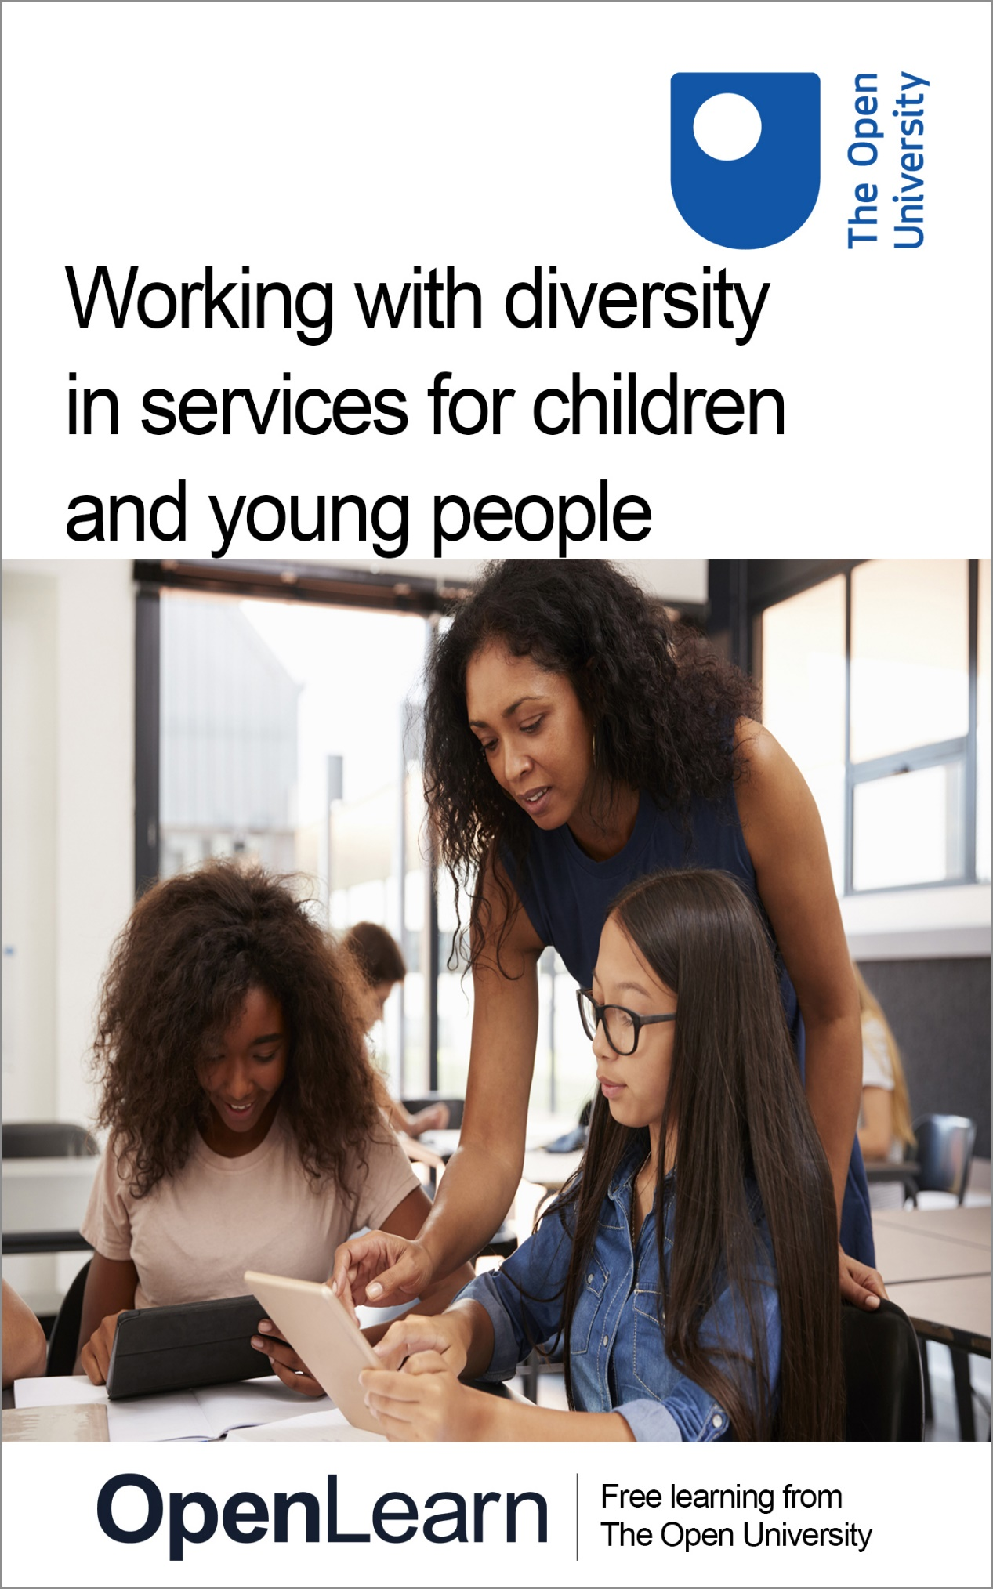

E809_2

Working with diversity in services for children and young people

About this free course
This free course is an adapted extract from the Open University course E809 Frameworks for critical practice with children and young people: www.open.ac.uk/postgraduate/modules/e809 .
This version of the content may include video, images and interactive content that may not be optimised for your device.
You can experience this free course as it was originally designed on OpenLearn, the home of free learning from The Open University –
www.open.edu/openlearn/education-development/working-diversity-services-children-and-young-people/content-section-0
There you’ll also be able to track your progress via your activity record, which you can use to demonstrate your learning.
Copyright © 2021 The Open University
Intellectual property
Unless otherwise stated, this resource is released under the terms of the Creative Commons Licence v4.0 http://creativecommons.org/licenses/by-nc-sa/4.0/deed.en_GB. Within that The Open University interprets this licence in the following way: www.open.edu/openlearn/about-openlearn/frequently-asked-questions-on-openlearn. Copyright and rights falling outside the terms of the Creative Commons Licence are retained or controlled by The Open University. Please read the full text before using any of the content.
We believe the primary barrier to accessing high-quality educational experiences is cost, which is why we aim to publish as much free content as possible under an open licence. If it proves difficult to release content under our preferred Creative Commons licence (e.g. because we can’t afford or gain the clearances or find suitable alternatives), we will still release the materials for free under a personal end-user licence.
This is because the learning experience will always be the same high quality offering and that should always be seen as positive – even if at times the licensing is different to Creative Commons.
When using the content you must attribute us (The Open University) (the OU) and any identified author in accordance with the terms of the Creative Commons Licence.
The Acknowledgements section is used to list, amongst other things, third party (Proprietary), licensed content which is not subject to Creative Commons licensing. Proprietary content must be used (retained) intact and in context to the content at all times.
The Acknowledgements section is also used to bring to your attention any other Special Restrictions which may apply to the content. For example there may be times when the Creative Commons Non-Commercial Sharealike licence does not apply to any of the content even if owned by us (The Open University). In these instances, unless stated otherwise, the content may be used for personal and non-commercial use.
We have also identified as Proprietary other material included in the content which is not subject to Creative Commons Licence. These are OU logos, trading names and may extend to certain photographic and video images and sound recordings and any other material as may be brought to your attention.
Unauthorised use of any of the content may constitute a breach of the terms and conditions and/or intellectual property laws.
We reserve the right to alter, amend or bring to an end any terms and conditions provided here without notice.
All rights falling outside the terms of the Creative Commons licence are retained or controlled by The Open University.
Head of Intellectual Property, The Open University

Contents
- Introduction
- Learning outcomes
- 1 Working effectively with African-Caribbean young women
- 2 Working with minority ethnic young people in Swansea
- 3 Applying intersectionality to practice
- 4 Reflecting on diversity
- Conclusion
- Acknowledgements
- Solutions

Introduction
If you work with children or young people, whether as a professional or in a voluntary or supporting role, then you will be aware that the contexts in which that work takes place are increasingly diverse in many ways. A ‘one-size-fits-all’ approach is no longer appropriate, if indeed it ever was. But working with diversity presents a number of challenges, as well as some undoubted rewards. Practitioners need a good understanding of the diverse identities and experiences of the children and young people they work with and how best to respond to them. In this free course, Working with diversity in services for children and young people, you’ll be exploring the impact of diverse social identities on children’s and young people’s experiences of the services designed for them, and some practical strategies for working effectively with diverse groups and communities.
The course is designed primarily for those working with children or young people, for example in childcare, education, healthcare, social work or youth work settings. However, you will also find it of value if you are planning to work in one of these fields, or if you simply wish to improve your understanding of services for children and young people.
The course is structured around a series of activities which invite you to read an academic text, watch videos of a practice setting and an academic presentation, and reflect on your own experience of working with or supporting children and young people. Since there are no ‘right’ answers to most of the questions in the activities, and because this free course offers a taste of advanced study, in which students are expected to be relatively independent learners, feedback comments have not been included for all the activities.
This OpenLearn course is an adapted extract from the Open University course E809 Frameworks for critical practice with children and young people.

Learning outcomes
After studying this course, you should be able to:
- demonstrate an understanding of some of the ways in which diverse and intersecting social identities structure the lives and experiences of children and young people
- show an awareness of the relevance of theories of diversity and intersectionality for everyday practice with children and young people
- reflect critically on the implications for your own practice of the diverse social identities of the children and young people that you work with or support
- demonstrate an awareness of some practical strategies for working in an inclusive and participatory way with children and young people.

1 Working effectively with African-Caribbean young women

For this activity, you will read ‘Working effectively with African-Caribbean young women: an intersectional approach’, a book chapter by Jenny Douglas who is a Senior Lecturer in Health Promotion at The Open University.
In this chapter Douglas argues that, in order to work effectively with young African-Caribbean women, practitioners ‘must have some understanding of the lives and contexts of young black women’. She maintains that practitioners working with young black women need to understand the complexity of their lives and to resist the dangers of ‘homogenising and essentialising’ them: in other words, seeing them as all the same and reducing them to their ethnic identity. Douglas also argues that an ‘intersectional’ approach is needed to understand young black people’s lives and to work effectively with them.

Activity 1

Read the chapter now and, as you do so, make notes in response to the questions that follow.
Reading 1: Working effectively with African-Caribbean young women: an intersectional approach
1. What were some of the key facts that you learned from the chapter about African-Caribbean families in the UK? What have been some of the main popular misunderstandings about them?

Provide your answer...

2. What does the author suggest has been distinctive about parenting practices within African-Caribbean families?

Provide your answer...

3. What does the author mean by an ‘intersectional approach’, and how can it help to understand the social identities of young black women?

Provide your answer...

4. How might a better understanding of young black women’s lives help to improve practice?

Provide your answer...

2 Working with minority ethnic young people in Swansea
EYST (Ethnic Minorities and Youth Support Team) Wales is an organisation working mainly with black and minority ethnic young people in Swansea, South Wales. The video that you are going to watch for the following activity features a cross-section of EYST’s work and staff and volunteers from the organisation. You will also see an extract from a film made by the organisation about the experiences of young migrants.

Activity 2

Watch the video now and, as you do so, make notes in response to the questions that follow.

Video content is not available in this format.
Video 1: EYST: Identity, gender, ethnicity
View transcript - Video 1: EYST: Identity, gender, ethnicity

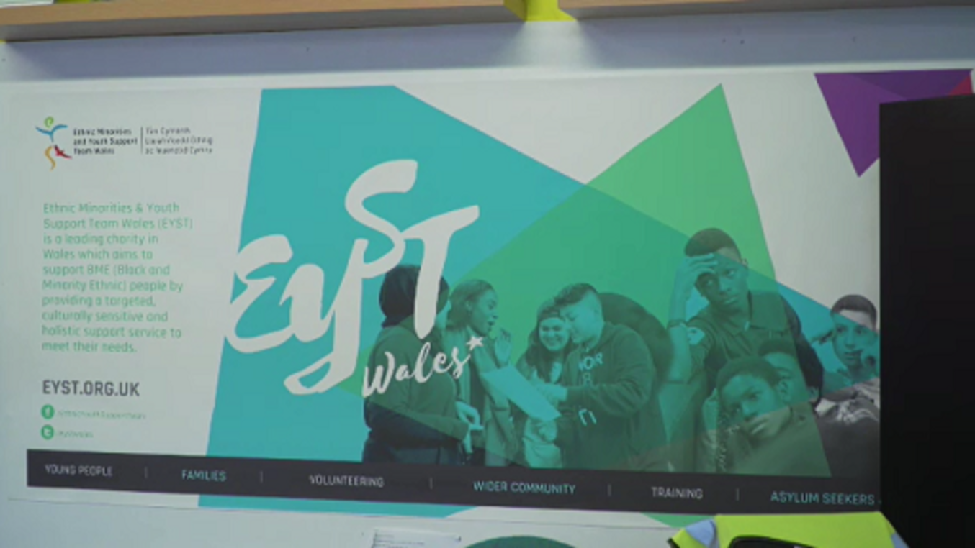

1. Which communities and groups of young people does EYST work with?

Provide your answer...

2. Why is there a need for an organisation specifically aimed at young people from minority ethnic communities?

Provide your answer...

3. What kinds of needs and issues do the young people who come to EYST face, and how does the organisation address them?

Provide your answer...

4. What role does EYST have in relation to mainstream services?

Provide your answer...

5. How does the organisation help young people to develop a strong sense of identity?

Provide your answer...
View discussion - Part

3 Applying intersectionality to practice
In the chapter that you read for Activity 1, Jenny Douglas cites the work of influential theorists of intersectionality such as Kimberlé Crenshaw. But what does intersectionality mean in practice? In the video you are going to watch in the next activity, Kimberlé Crenshaw explains what intersectionality is, why it is important, and how practitioners can apply the theory. Although Crenshaw is addressing those who work in schools, what she says can also be applied to work with children and young people in other contexts.

Activity 3

Watch the video now, and as you do so, make notes in answer to the questions that follow.
Kimberlé Crenshaw: what is intersectionality?
1. Crenshaw states that intersectionality is just a metaphor. What does she say it’s a metaphor for?

Provide your answer...

2. What example does she mention involving school suspensions, and what does she think this example illustrates?

Provide your answer...

3. ‘Identity isn’t simply a self-contained unit. It is a relationship.’ What do you think Crenshaw means by this?

Provide your answer...

4. Crenshaw gives examples of what schools can do to ensure they provide equality for all students, taking into account their intersecting identities. Can you think of an example of something that the practice setting with which you’re most familiar could do?

Provide your answer...

4 Reflecting on diversity
Activity 4 provides time for reflection on your own experiences relating to diversity in relation to children and young people, in a practice setting which you know well. If you don’t have any recent practice experience, you could think about a social setting in which you have interacted with a group of children or young people.

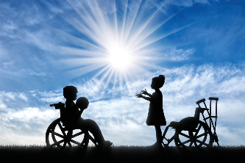

Activity 4

1. Think of a practice setting with which you are familiar. Make a list of the different social identities of the children and/or young people who use that service: for example, the diverse ethnicities, nationalities, religions, genders, sexualities, and abilities/disabilities represented.

Provide your answer...

2. Now select two or three children or young people that you have worked with and list their different social identities (e.g. ‘Faiza is female, Somali, Muslim, has a learning disability … .’).

Provide your answer...

3. Make a brief note of how you think each child or young person’s social identities interact in their experience and what the implications are for practitioners working with them.

Provide your answer...

Conclusion
In this free course, Working with diversity in services for children and young people, you read a book chapter by Jenny Douglas which provided you with an understanding of the experiences and needs of black and minority ethnic young people and an introduction to the concept of intersectionality. The video that you watched about the work of a project for minority ethnic young people in Wales provided some practical examples of working with diversity. The video featuring Kimberlé Crenshaw provided further insight into the meaning of intersectionality and its relevance for everyday practice. Reflecting on the diverse social identities of children and young people that you know and the implications for your own practice will have provided you with insights that will help to make that practice more effective.
This OpenLearn course is an adapted extract from the Open University course E809 Frameworks for critical practice with children and young people.

Acknowledgements
This free course was written by Martin Robb.
Except for third party materials and otherwise stated (see terms and conditions), this content is made available under a Creative Commons Attribution-NonCommercial-ShareAlike 4.0 Licence.
The material acknowledged below is Proprietary and used under licence (not subject to Creative Commons Licence). Grateful acknowledgement is made to the following sources for permission to reproduce material in this free course:

Text
Reading 1: Douglas, J. (2019) ‘Working effectively with African-Caribbean young women: an intersectional approach’. Originally published in Martin Robb, Heather Montgomery and Rachel Thomson (eds) Critical Practice with Children and Young People (pp. 91-107). Re-published with permission of Policy Press (an imprint of Bristol University Press, UK). Policy Press in association with The Open University

Images
Course image: © Monkey Business Images/Dreamstime.com
Section 1 image: © David Prado Perucha/ Shutterstock
Section 4 image: © Prazis Images / Shutterstock

Audio-visual
Video 1: Images: Girl with Welsh flag, Young girl in gold hijab, Woman in karate suit, Girl with hand covering half her face, Young Migrant and Welsh group sitting on fence, Young Migrant and Welsh group in a church, Woman weightlifter, Young Migrant and Welsh girls on a beach, Girl drawing in sand on a beach, Young Migrant and Welsh timeline, 2 girls in field with sheep – EYST. Footage: Coast, Series 3 Cardiff to St Davids – BBC; Young Migrant and Welsh – EYST.
Every effort has been made to contact copyright owners. If any have been inadvertently overlooked, the publishers will be pleased to make the necessary arrangements at the first opportunity.
Don't miss out
If reading this text has inspired you to learn more, you may be interested in joining the millions of people who discover our free learning resources and qualifications by visiting The Open University – www.open.edu/openlearn/free-courses.

Solutions

Activity 2

Part

Discussion
EYST works mainly with young people from the local Asian and Muslim communities. However, the organisation also runs activities aimed specifically at young migrants and refugees from other ethnic and cultural backgrounds.
Staff at EYST argue that there is a need for an organisation specifically aimed at minority ethnic young people, because parents from some communities do not want their children to go to mixed-gender youth clubs and are generally wary of mainstream services, which they do not feel address their cultural or religious needs.
The young people who attend EYST experience a variety of needs, including confidence issues and a lack of support in relation to education and employment. Some of the young people have experienced racism, and the organisation provides them with a safe place to share their experiences and to be safe from discrimination.
The staff see EYST as a bridge connecting young people from minority communities to mainstream services: in the video, we see young people attending a scuba diving class and learning about support services in relation to mental health issues, for example.
The organisation supports young people in developing a strong sense of identity by providing a safe space where they can share their experiences with others from a similar cultural background. However, they also learn about the cultures and beliefs of other communities: the video made by the young people and the exhibition of photographs about being ‘young, migrant and Welsh’ were examples of this.
Back to - Part

Video 1: EYST: Identity, gender, ethnicity

Transcript
[MUSIC PLAYING]
ROCIO CIFUENTES
EYST is an organisation that was set up in 2005 to-- initially to support ethnic minority young people in Swansea. Since then, it's expanded to become an organisation that aims to support ethnic minority people of all ages through a culturally targeted and sensitive service.
In Swansea, the ethnic minority population has always been relatively small, but has increased gradually over the last ten to twenty years, and it's a community which is and was predominantly Muslim and Asian. There were specific cultural sensitivities in those communities, which meant, for example, that parents didn't really want their young people to access gender-mixed youth clubs and so on. And parents also had reservations about youth clubs generally, and misconceptions, and felt that they weren't necessarily meeting their cultural/religious needs of the young people.
So initially, there was a clear need to provide single-sex youth activities for young-- predominantly young Muslim Asian people who lived in Swansea. So that's what we started off doing, providing a safe place for them to attend, somewhere their parents were comfortable and happy for them to attend, but also, really importantly, what we provided were youth workers who were from the same or similar cultural and ethnic backgrounds.
[GROUP OF FRIENDS TALKING]
SHAHAB MIAH
So we do work with a whole wide range of organisations, and they are anyone and everyone who can bring a benefit to the community. So you're talking, just currently, I'm working with the police, the Children's Commissioner's office, we're working with a lot of sporting facilities, anyone and everyone really.
The reason why we opened an organisation like this is because we recognise that because of those barriers, a lot of people from the BAME community-- black and minority ethnic communities-- would not be using mainstream services. So we came in as a link to encourage people to use these services, because they're there for them.
ROCIO CIFUENTES
Amongst the school age population in Swansea, I think around ten percent, or maybe just over ten percent, of the school age population is from a non-white, non-British background. So it's a significant proportion of young people who have a different ethnicity or a different religion, or a different nationality, a different language, a different home life, which makes it more difficult, and they face an extra challenge and barrier to getting on in school and continuing into higher education and into employment and so on.
SAWA HUMAYAN
Swansea is kind of, like, a diverse city, where people are from different countries, and having this community like EYST, where we got a chance to meet in one place, and having all different people from different country get to know about their culture, get to know about their religion, which is so important for us. So having this community, when we sit together and talk to different people, we got a chance to see how people are practising about their religion, about their culture. So we learn lots of things from this community.
SHAHAB MIAH
For some of the young people in our communities, you're talking confidence issues, lack of support in the household with education. So, we're setting up things like homework clubs, a safe place to play. People feel comfortable that when they come to a place, they're not going to be targeted or discriminated, or they're not going to have racism hurled at them.
So, it's this kind of stuff that I'm working on at the moment, but we're also working on trying to get external agencies to come in and talk to young people, explain who they are and how they're there to help as well. So we're sort of connecting organisations and the communities as best as we can.
ALEX WATERS
But my name's Alex. I'm from Swansea Mind. And I do work about mental health.
[MUSIC PLAYING]
So what we're going to do is we're going to talk about the 'bad day' card first of all, OK? So if you can, just say a little bit about how that is like your bad day.
ROCIO CIFUENTES
Other challenges, of course, as we know, is a significant increase in racism and Islamophobia and xenophobia, which is growing across the world, really, unfortunately, and how that really impacts particularly on a young person's sense of identity as they grow up. It's really crucial that we provide a safe space where they can discuss how that feels, where they can share that in a safe space with other people who may be going through a similar experience, so that that can be managed, and they can really figure out their place in the world, because it's a really important part of growing up is figuring out where you belong, who you are, how you fit in, what you contribute, how others see you. So that's what we try and offer.
MAN
Hello.
RECEPTIONIST
Hiya.
MAN
I'm here to see Alia please.
ROCIO CIFUENTES [VOICEOVER]
We also provide services which are targeted at refugees and asylum seekers, because more asylum seekers have come to Wales in the last ten years, fifteen years.
RECEPTIONIST
Yep. No problem.
RUDINA KOKA
In Swansea is, I think, only this organisation that deal with asylum refugees and different BME problem issues. The staff really communicate and try their best to help them, to listen to them, to know really the issue what is going on, and then to deal with issue in very ethical ways, so, like, ethical issues that nobody will know their problem.
SAWA HUMAYAN [VOICEOVER]
The 'Young, Migrant, and Welsh' project was particularly for people who are migrant from different country. We interviewed different people from different country, they talk about their life, that how they are living in Swansea.
WOMAN
I was born in Palestine in 2002.
MAN
I am from Syria, from Aleppo city.
WOMAN
I was born in London, and my mum was born in East Africa in a little island called Zanzibar, and my father was born in the Caribbean in Dominica.
WOMAN
I'm from Iraq, and my family burned in Iraq. I haven't been here for a long time. I just-- I have been here only for three years.
SAWA HUMAYAN [VOICEOVER]
We talked about our culture. We talked about how we are living in Swansea.
WOMAN
We lived there for about eight years.
SAWA HUMAYAN: We kind of, like, put everything together about their culture and about Welsh culture as well, because we didn't find the difference between our culture and Welsh culture. We feel like we are same no matter where we are from. It shows our identity. It shows our religion and how we are living in this country.
WOMAN
I really, really enjoy weightlifting and boxing. Those are my two favourites.
WOMAN
So currently, I'm doing karate. I'm one away from a black belt.
MAN
My favourite thing living in Wales has first been the history. Second then, Welsh rugby team, because I really support them and I like to play rugby, and one of my dream is to be a rugby player with Wales.
RUDINA KOKA
There were lots of young people that we could communicate, do friendship with each other, talk about our experience. There were bits of their lives that, oh, gosh, I've been through the same thing, so we could understand each other. So, this is the main things why is this important, because of the project that they are running, young people can join together, and they can be socialise with. This is the main thing, being together, and improving and developing themselves, and be part of the community, really.
SHAHAB MIAH
Cultural sensitivity is something that is used a lot. We don't want to offend, or you got to be politically correct, and all this kind of stuff. But a lot of times when organisations come to me for advice in terms of, oh, is this OK to do, is this culturally OK? And I will always advise them, have you spoken to the young person? Have you asked them if that's OK? Generally, nobody will mind people asking questions to say, oh, well, we're going to do this this way, is that OK? It's OK to ask. If you don't ask, you don't know.
Back to - Video 1: EYST: Identity, gender, ethnicity

