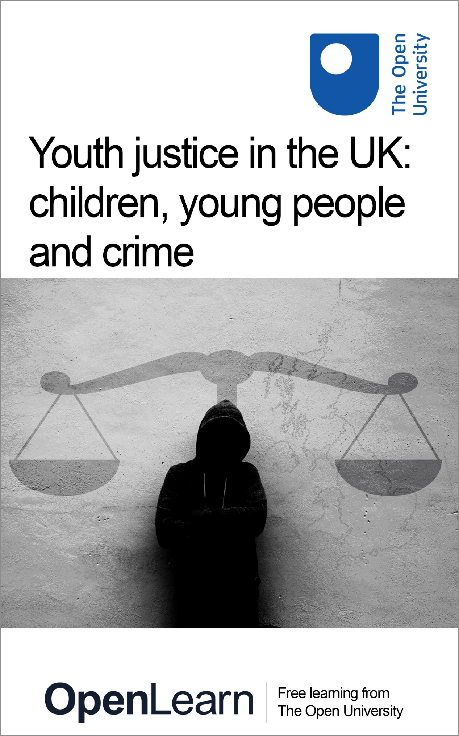

YJ_1

Youth justice in the UK: children, young people and crime

About this free course
This free course is an adapted extract from the Open University course .
This version of the content may include video, images and interactive content that may not be optimised for your device.
You can experience this free course as it was originally designed on OpenLearn, the home of free learning from The Open University –
There you’ll also be able to track your progress via your activity record, which you can use to demonstrate your learning.
Copyright © 2019 The Open University
Intellectual property
Unless otherwise stated, this resource is released under the terms of the Creative Commons Licence v4.0 http://creativecommons.org/licenses/by-nc-sa/4.0/deed.en_GB. Within that The Open University interprets this licence in the following way: www.open.edu/openlearn/about-openlearn/frequently-asked-questions-on-openlearn. Copyright and rights falling outside the terms of the Creative Commons Licence are retained or controlled by The Open University. Please read the full text before using any of the content.
We believe the primary barrier to accessing high-quality educational experiences is cost, which is why we aim to publish as much free content as possible under an open licence. If it proves difficult to release content under our preferred Creative Commons licence (e.g. because we can’t afford or gain the clearances or find suitable alternatives), we will still release the materials for free under a personal end-user licence.
This is because the learning experience will always be the same high quality offering and that should always be seen as positive – even if at times the licensing is different to Creative Commons.
When using the content you must attribute us (The Open University) (the OU) and any identified author in accordance with the terms of the Creative Commons Licence.
The Acknowledgements section is used to list, amongst other things, third party (Proprietary), licensed content which is not subject to Creative Commons licensing. Proprietary content must be used (retained) intact and in context to the content at all times.
The Acknowledgements section is also used to bring to your attention any other Special Restrictions which may apply to the content. For example there may be times when the Creative Commons Non-Commercial Sharealike licence does not apply to any of the content even if owned by us (The Open University). In these instances, unless stated otherwise, the content may be used for personal and non-commercial use.
We have also identified as Proprietary other material included in the content which is not subject to Creative Commons Licence. These are OU logos, trading names and may extend to certain photographic and video images and sound recordings and any other material as may be brought to your attention.
Unauthorised use of any of the content may constitute a breach of the terms and conditions and/or intellectual property laws.
We reserve the right to alter, amend or bring to an end any terms and conditions provided here without notice.
All rights falling outside the terms of the Creative Commons licence are retained or controlled by The Open University.
Head of Intellectual Property, The Open University
978-1-4730-2973-6 (.kdl)
978-1-4730-2974-3 (.epub)

Contents
- Introduction and guidance
  - Introduction and guidance
  - What is a badged course?
    - How to get a badge
- Session 1: Children or criminals?
  - Introduction
  - 1 Child or adult?
  - 2 The age of criminal responsibility
  - 3 What the law says
  - 4 Taking court action
  - 5 A mind to a crime
  - 6 Children talk labels
  - 7 This session’s quiz
  - 8 Summary of Session 1
- Session 2: Youth justice in England and Wales
  - Introduction
  - 1 The Crime and Disorder Act 1998
  - 2 Getting to know the youth justice system
    - 2.1 Unintended consequences
  - 3 Children in prison
  - 4 Wales makes a difference?
  - 5 Getting smaller, getting smarter?
  - 6 Different paths to youth justice
  - 7 This session’s quiz
  - 8 Summary of Session 2
- Session 3: Children’s Hearings in Scotland
  - Introduction
  - 1 An enlightenment idea?
  - 2 Hearing about panels
  - 3 Raising the age
  - 4 Children’s views of Hearings
  - 5 Young people and knife crime: a Scottish approach
  - 6 The language of justice
  - 7 This session’s quiz
  - 8 Summary of Session 3
- Session 4: Restorative conferencing in Northern Ireland
  - Introduction
  - 1 What is restorative justice?
  - 2 From rough justice to restorative justice
  - 3 Restorative conferencing with young people in Northern Ireland
  - 4 Youth custody in Northern Ireland
  - 5 The age of criminal responsibility in Northern Ireland
  - 6 Moving on
  - 7 This session’s quiz
  - 8 Summary of Session 4
- Session 5: It’s different for girls?
  - Introduction
  - 1 Bad girls?
  - 2 It’s different for girls
  - 3 Girls and the gangs
    - 3.1 A case study: Gina
  - 4 Possibilities, alternatives, changes
  - 5 This session’s quiz
  - 6 Summary of Session 5
- Session 6: Race, ethnicity and youth justice
  - Introduction
  - 1 Why race and racism matters
    - 1.1 What about ethnicity?
  - 2 Injustice and youth justice
  - 3 Youth, sub-cultures and resistance
  - 4 New generations, new voices
  - 5 Islamophobia and racism
  - 6 This session’s quiz
  - 7 Summary of Session 6
- Session 7: It’s all about class
  - Introduction
  - 1 Poverty and class disadvantage
  - 2 Ghostbusters on the estate – a case study
  - 3 Class: intersections, contexts and convictions
  - 4 Drugs, knives, county lines and fast lanes
  - 5 Changing the questions?
  - 6 Class acts
  - 7 This session’s quiz
  - 8 Summary of Session 7
- Session 8: Youth justice with integrity
  - Introduction
  - 1 Why social and economic justice?
  - 2 Why comprehensive, universal and socially engaging?
  - 3 Diversion
  - 4 Child-appropriate justice
  - 5 Abolishing youth justice, championing children’s rights
    - 5.1 Children’s rights
  - 6 This session’s quiz
  - 7 Summary of Session 8
  - 8 Course conclusion
  - Tell us what you think
- References
- Acknowledgements
- Solutions

Introduction and guidance

Introduction and guidance
This free badged course, Youth justice in the UK: children, young people and crime, lasts 24 hours and is comprised of eight sessions. You can work through the course at your own pace, so if you have more time one week there is no problem with pushing on to complete a further study session. The eight sessions are linked to ensure a logical flow through the course. They are:
- Children or criminals?
- Youth justice in England and Wales
- Children’s Hearings in Scotland
- Restorative conferencing in Northern Ireland
- It’s different for girls?
- Race, ethnicity and youth justice
- It’s all about class
- Youth justice with integrity
Each session should take you around 3 hours. There are a number of activities throughout the course where you are asked to note down your response. A text box is provided for you to do this, however if you would prefer to record your answers in another way that is fine.
At the end of each session there is also a quiz to help you check your understanding. And, if you want to receive a formal statement of participation, at the end of Sessions 4 and 8 there is a quiz which you need to pass.
After completing this course, you should be able to:
- describe the youth justice systems operating in the UK
- appreciate the significance of different approaches to children’s offending behaviour within the UK
- understand more about children’s experiences of victimisation and crime
- appreciate there are many ways of reducing the harms some children can cause
- appreciate how differences around gender, race, ethnicity and social class operate in youth justice.

Moving around the course
In the ‘Summary’ at the end of each session, you will find a link to the next session. If at any time you want to return to the start of the course, click on ‘Full course description’. From here you can navigate to any part of the course.
It’s also good practice, if you access a link from within a course page (including links to the quizzes), to open it in a new window or tab. That way you can easily return to where you’ve come from without having to use the back button on your browser.
The Open University would really appreciate a few minutes of your time to tell us about yourself and your expectations for the course before you begin, in our optional start-of-course survey. Participation will be completely confidential and we will not pass on your details to others.

What is a badged course?
While studying Youth justice in the UK: children, young people and crime you have the option to work towards gaining a digital badge.
Badged courses are a key part of The Open University’s mission to promote the educational well-being of the community. The courses also provide another way of helping you to progress from informal to formal learning.
Completing a course will require about 24 hours of study time. However, you can study the course at any time and at a pace to suit you.
Badged courses are available on The Open University’s OpenLearn website and do not cost anything to study. They differ from Open University courses because you do not receive support from a tutor, but you do get useful feedback from the interactive quizzes.

What is a badge?
Digital badges are a new way of demonstrating online that you have gained a skill. Colleges and universities are working with employers and other organisations to develop open badges that help learners gain recognition for their skills, and support employers to identify the right candidate for a job.
Badges demonstrate your work and achievement on the course. You can share your achievement with friends, family and employers, and on social media. Badges are a great motivation, helping you to reach the end of the course. Gaining a badge often boosts confidence in the skills and abilities that underpin successful study. So, completing this course could encourage you to think about taking other courses.

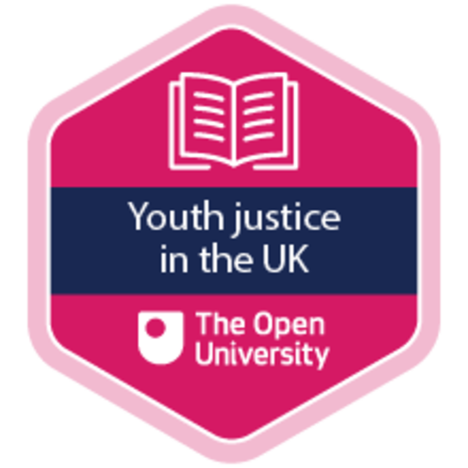

How to get a badge
Getting a badge is straightforward! Here’s what you have to do:
- read each session of the course
- score 50% or more in the two badge quizzes in Session 4 and Session 8
For all the quizzes, you can have three attempts at most of the questions (for true or false type questions you usually only get one attempt). If you get the answer right first time you will get more marks than for a correct answer the second or third time. Therefore, please be aware that for the two badge quizzes it is possible to get all the questions right but not score 50% and be eligible for the badge on that attempt. If one of your answers is incorrect you will often receive helpful feedback and suggestions about how to work out the correct answer.
For the badge quizzes, if you’re not successful in getting 50% the first time, after 24 hours you can attempt the whole quiz, and come back as many times as you like.
We hope that as many people as possible will gain an Open University badge – so you should see getting a badge as an opportunity to reflect on what you have learned rather than as a test.
If you need more guidance on getting a badge and what you can do with it, take a look at the OpenLearn FAQs. When you gain your badge you will receive an email to notify you and you will be able to view and manage all your badges in My OpenLearn within 24 hours of completing the criteria to gain a badge.
Get started with Session 1.

Session 1: Children or criminals?

Introduction
This first session is all about the age of criminal responsibility – the age at which someone can be arrested and charged with a criminal offence. This is important because it says so much about the way society thinks of children. In this session you will consider how the law defines the boundary between being an adult and a child and sets limits on what someone is allowed to do. You will use the internet to listen to people talking about the issues. You will also get to see what children think about the way the criminal law attaches labels to them.
Watch the following video, in which course author Rod Earle from The Open University introduces this session.

Video content is not available in this format.
Session 1 introduction
View transcript - Session 1 introduction

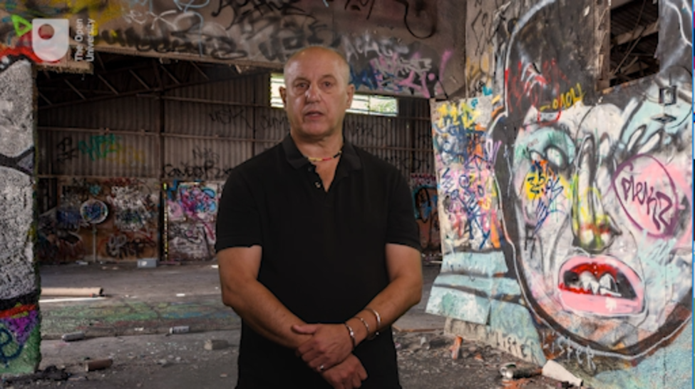

By the end of this session, you should be able to:
- appreciate how the age of criminal responsibility is a key indicator of social responses to children’s behaviour
- understand that there are wide international variations in the age of criminal responsibility.
The Open University would really appreciate you taking a few minutes of your time to tell us about yourself and your expectations of the course. Your input will help to improve the online learning experience. If you would like to help, and if you haven’t done so already, please fill in this optional survey.

1 Child or adult?
Have you ever asked yourself the question ‘when do children stop being children and become adults?’ If not, it doesn’t matter but you cannot learn very much about youth justice without considering this question. It is going to be a focus for your learning in this session. This is because it’s a good way to start understanding many of the issues shaping youth justice practice and youth justice systems in the UK.
What you think about the boundaries that separate children from adults – what makes a child a child and an adult an adult – is very important to the issues you’ll learn about in this course.
Ideas about childhood and adulthood differ from culture to culture and over historical time. These ideas are given particular force and influence when they become law, and changes in law reflect the way the ideas change. For example, in 1969 the law on the ‘age of majority’ – the age at which an individual gains adult status and is granted the right to vote – was changed from 21 to 18 in England and Wales. This did not provoke controversy because it reflected widespread acceptance that by the age of 18 a person had sufficient mental and physical capacity for independent participation in society.

Activity 1 At what age can someone …?
Allow approximately 30 minutes for this activity

Use an internet search tool to find answers to the following questions.
At what age …:
- … can someone legally drive a car in the UK?
- … can a child be left on their own?
- … can someone leave school?
- … can someone vote?
- … can someone marry?
- … can someone stand for election to Parliament?
- … can someone consent to sex?
Add your answers to the box below.

Provide your answer...
View discussion - Activity 1 At what age can someone …?

It may have come as no surprise that there are so many variations in the age at which different activities are considered lawful or become permissible. The boundary between adulthood and childhood is a fuzzy one. However, when it comes to the criminal law the boundaries become sharper, as you will examine in the next section.

2 The age of criminal responsibility
You have already looked at the sometimes blurred boundaries dividing adulthood from childhood. The big question you’ve been building up to is, of course, ‘what is the age of criminal responsibility?’. In other words, at what age can someone be arrested and charged with a crime that will be prosecuted in a criminal court?

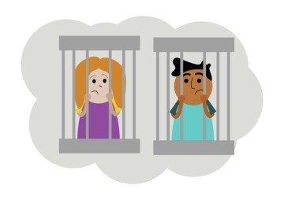
Figure 1 In the future it is possible that prosecuting children in criminal courts may seem as wrong as sending them down coal mines to dig coal.
View description - Figure 1 In the future it is possible that prosecuting children in criminal courts ...

Activity 2 Old enough to know better?
Allow approximately 15 minutes for this activity

Part 1

Try to guess the answer to the following question: What age do you think a young person can be prosecuted in a criminal court in England or Wales for something they may have done wrong? Your answer should be between 5 and 21 years.

Provide your answer...
View discussion - Part 1

Part 2

Interactive content is not available in this format.

View discussion - Part 2

The legal context surrounding children is an important feature of any kind of professional or voluntary practice concerned with their behaviour and wellbeing. That is what you will look at next.

3 What the law says

Figure 2 The traditional image of justice is of a blindfolded woman with a set of scales in one hand and a sword in the other. Justice is blind, as the saying goes, and this means it is only concerned with the nature of the act, not the age of the actor.
View description - Figure 2 The traditional image of justice is of a blindfolded woman with a set of ...

In 1833, a 9 year old boy was sentenced to death for pushing a stick through a cracked window so that he could extract a small bundle of papers from a London print shop. The value of the papers was about two pence but it didn’t stop the court from passing the death sentence (Morris et al., 1980). The law, as it stood then, would see the crime not the child. In this section you’ll explore the limits of that vision and how it has been changed.

Activity 3 Criminal responsibility
Allow approximately 30 minutes for this activity

To find out a bit more about the legal background to the age of criminal responsibility, read this article on the subject by Sue Bandalli (from the Dictionary of Youth Justice).
The Youth Justice System of England and Wales: A short overview
Identify the four relevant Acts of Parliament mentioned in the article and make a note of them. Bandalli refers to a Latin phrase in her discussion. Write it down and what it means in English and ask yourself why it is significant. Record your thoughts as they may be useful when you complete the quiz at the end of this session.

Provide your answer...
View discussion - Activity 3 Criminal responsibility

For many people who study or work in youth justice the provisions in the Children and Young Persons Act 1969 to raise the age of criminal responsibility to 14 represent a high-water mark in efforts to prioritise the welfare of the child, to put their needs before their deeds. However, the provisions were never enacted and in 1998 the New Labour Government confirmed and reinforced that children aged 10 or above were suitable for criminal prosecution.
The age at which it is appropriate to take children to court continues to be a controversial and important topic. It features in the next section.

4 Taking court action
The idea of taking a child to court is controversial not only because the consequences can be so serious, but also because the procedures of the court and the rules of legal practice can be very complicated. The criminal court, as Bandalli mentioned, has to rule on what happened – in Latin, actus reus – and on the intention of the child at the time of the act – in Latin, mens rea. The child will be found guilty or not guilty. The inevitable and unavoidable differences between one child and another as they grow and mature with age means that it can be very difficult to apply these rules fairly. Many other countries take a more cautious approach to putting children through these complicated procedures than do the jurisdictions of the UK. You can find out more about these complicated procedures in the next activity.

Activity 4 Trials of youth
Allow 20 minutes

Listen to this extract from the BBC’s Law in Action radio programme.

Audio content is not available in this format.
Audio 1
View transcript - Audio 1

The presenter Clive Coleman mentions two countries where the age of criminal responsibility is higher than 10. Make a note of them, and the ages they have set, then with the help of a search engine find the ages set in Italy, Norway, Spain and France. You may have noted the reference to Scotland’s age as 8 rather than the current 12. The programme was recorded in 2009 and the change since then indicates how things may be changing in the UK. Looking at the following map, you can see how the age varies across the world.

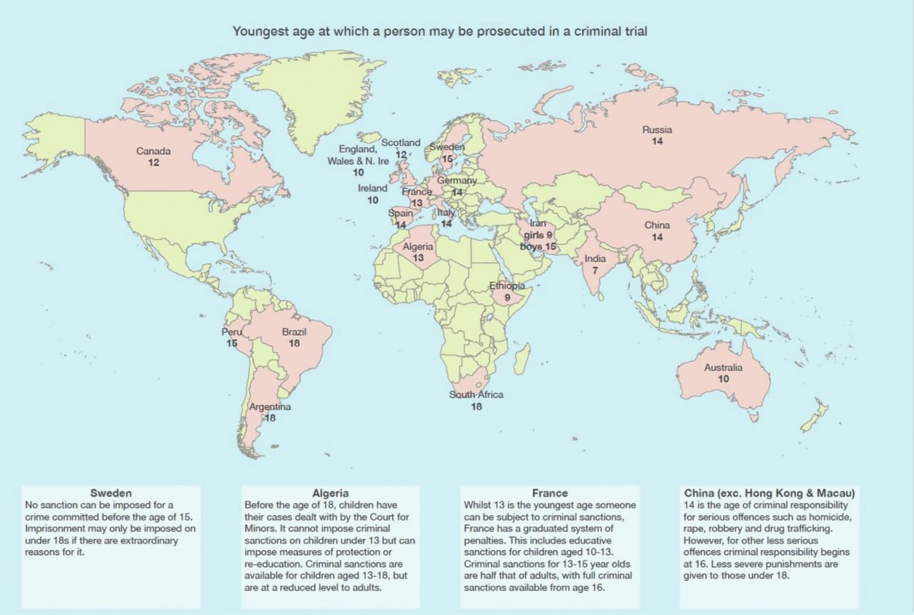
Figure 3 World map showing ages of criminal responsibility.
View description - Figure 3 World map showing ages of criminal responsibility.

In the map you can see the age for some European countries. Use an internet search engine to find the age of criminal responsibility in as many of the other European states as you can and enter them into the table below.

Age 10 years | Age 12 years | Age 13 years | Age 14 years | Age 15 years | Age 16 years | Age 18 years
Countries: | Countries: | Countries: | Countries: | Countries: | Countries: | Countries:

View discussion - Activity 4 Trials of youth

England and Wales appear to be a significant outlier among European jurisdictions in having an exceptionally low age of criminal responsibility. The activity in the next section helps you to consider why being so out of step with the way other countries respond to children’s problematic behaviour should be a matter of concern.

5 A mind to a crime
A key principle in law is concerned with the mental capacity to act in a certain way, knowing it to be against the law. This derives from the Latin term mens rea. This refers to the mental element of a person’s intention to commit a crime, a knowledge that their action or lack of action would result in a crime being committed. You will remember from Activity 3 the concept of doli incapax, Latin for ‘incapable of evil’. This is the principle that determines, in English law, the age of being held responsible for a crime.

Activity 5 Brains and minds
Allow approximately 40 minutes for this activity

Returning to another part of the BBC’s Law in Action programme, now listen to the views of psychologist Dr Eileen Vizard who offers reasons for thinking that raising the age of criminal responsibility is not only sensible, it is urgent and necessary to prevent injustice and to promote children’s wellbeing.

Audio content is not available in this format.
Audio 2
View transcript - Audio 2

Drawing on the points made by Dr Vizard and your own views on child development, make a list of three reasons why physical development should be taken into account by the law.

Provide your answer...
View discussion - Activity 5 Brains and minds

The criminal law tends to see things in black and white – guilty or innocent. This means it can be a dangerous instrument to use in relation to the ambiguities and uncertainties of childhood and children’s behaviour. In the final part of this session there is an opportunity to consider this from another perspective.

6 Children talk labels
So far in this first session you’ve heard quite a lot about children from adults so perhaps it’s time to listen to what children have to say about how being labelled in a criminal court affects them. Watch this video made by children in Wales about their experiences of, and ideas about, getting into trouble with the law. Are the children right to worry about the labels they feel are attached to them? (Please note that the video is quite long at 10 minutes, so you might want to watch it in stages.)

Watch the video at YouTube.com.
Video 1

Labelling is a concept that sociologists are very interested in because different labels have different effects, and some labels can stick and have a lasting impact. There’s an old English proverb that people still use to capture this meaning: ‘give a dog a bad name and you hang him’. It refers to the fact that it can be very difficult to lose a bad reputation. As the children say in the video, people see the label not the person, the offender not the child.

Figure 4 Give a dog a good name …
View description - Figure 4 Give a dog a good name …

Criminal labels change the way people are seen and can stick for life. To be known as a ‘young offender’ can become self-fulfilling. This is an argument made not just by children in Wales or in old English proverbs but also by criminologists like Frank Tannenbaum who said ‘the person becomes the thing he is described as being’ (Tannenbaum, 1938). The work Tannenbaum did nearly one hundred years ago in New York among boys and young men caught up in the criminal justice system suggested that criminal justice interventions tended to produce more crimes and more criminals: ‘the harder they work to reform evil, the greater the evil grows under their hands’. His analysis was that criminal courts make things worse and were best avoided.

7 This session’s quiz
Well done – you have reached the end of Session 1. You can now check what you’ve learned this session by taking the end-of-session quiz.
Session 1 practice quiz
Open the quiz in a new tab or window by holding down Ctrl (or Cmd on a Mac) when you click on the link. Return here when you have finished.

8 Summary of Session 1
In this first session you have considered one issue – the age at which children should be considered criminally responsible – from a variety of perspectives. This first session offers an outline of the arguments you will encounter as you continue through the course. For example, you will later return to the issue of negative labelling raised in the video. You will consider how this might operate in relation to the wider structures of disadvantage and discrimination that children and young people experience – around crime, victimisation and a youth justice system that delivers different outcomes according to whether they are white, male, female or from a black and minority ethnic group.
You’ve also seen how different countries take different approaches to young people’s misbehaviour. The next session offers you a quick guide to the system in England and Wales, currently operating as a single jurisdiction in matters of crime and justice. The third session examines the issues in Scotland, and the fourth, Northern Ireland.
The main learning points of this first session are:
- Establishing the best response to the crimes children may commit is a complicated issue.
- The age of criminal responsibility in all the jurisdictions of the UK are among the lowest in Europe. The trend is upward because it is recognised that criminalising children at a young age can have lasting damaging consequences.
- Contemporary scientific evidence about brain development reinforces the idea that children’s mental capacities are very different from adults.
- Involving children in the operation of the criminal law is rarely straightforward.
- Labelling children as criminal often has counter-productive effects.
- Listening to children’s perspectives is important.
In the next session, you will explore the current youth justice system in England and Wales and learn about the way it is changing.
You can now go to Session 2.

Session 2: Youth justice in England and Wales

Introduction
The children speaking in the video at the end of the last session felt that their involvement with the youth justice system labelled them as criminals. It’s significant the video was made in Wales because although there is a single system for both England and Wales, the two jurisdictions have tended to become increasingly distinct. In this session you will get the chance to look at some of the reasons for this. You will be examining the establishment of the Youth Justice Board (YJB) for England and Wales and how the youth justice system operates. The emergence of distinctive forms of practice and policy in Wales will be the focus of learning towards the end of this session.

Video content is not available in this format.
Session 2 introduction
View transcript - Session 2 introduction

By the end of this session, you should be able to:
- recognise the main features of the youth justice system of England and Wales
- identify the principles and practice guiding the system’s development
- understand the way the system has been changing.

1 The Crime and Disorder Act 1998
In Session 1 you encountered some of the legislation associated with children and young people’s behaviour. The Children and Young Persons Act 1969 was referred to as a highwater mark in efforts to emphasise children’s welfare needs over their offending behaviour. For most of the thirty years that followed it was difficult to identify a single system or set of principles concerned with the troublesome behaviour of children in England and Wales. In Scotland, as you will consider in more detail in the next session, legislation confirmed a child’s welfare as the defining principle of the system of intervention with children in trouble.
It wasn’t until 1998 that a single, comprehensive system was established for England and Wales. The Crime and Disorder Act 1998 aimed to deliver on a key election pledge made by the leader of the Labour Party, Tony Blair, to be ‘tough on crime and tough on the causes of crime’. It established that the aim of the youth justice system was to prevent offending by young people. For the first time a single, dedicated system – the youth justice system – was established across England and Wales. In the next activity you will examine the key features of this system.

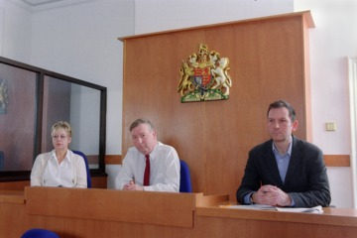
Figure 1 Magistrates in the youth court.
View description - Figure 1 Magistrates in the youth court.

Activity 1 The youth justice system
Allow approximately 30 minutes for this activity

The youth justice system in England and Wales draws together the work of the police, the Crown Prosecution Service (CPS), the Courts and the ‘Secure Estate’ (custodial institutions such as Young Offender Institutions or YOIs) – as well as the work of Youth Offending Teams (YOTs).
Read this summary of the provisions of The Crime and Disorder Act 1998 produced by The Open University for the Foundation Degree for the youth justice system workforce:
The Youth Justice System of England and Wales
Having read the summary, choose two of the tasks listed and use the remaining time to briefly describe in your own words:
- two objectives of the youth justice system in England and Wales
- one of the main responsibilities of youth offending teams (YOTs)

Provide your answer...
View discussion - Activity 1 The youth justice system

From this ‘first look’ at the youth justice system you may have begun to suspect there is more to it than meets the eye. You would be right! In the next activities you can take a closer look.

2 Getting to know the youth justice system

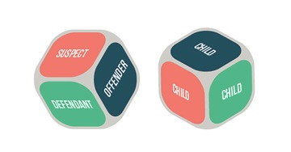
Figure 2 A child first and last.
View description - Figure 2 A child first and last.

The system established in 1998 by the Labour government’s Crime and Disorder Act survives more or less intact in the twenty-first century. Some minor changes were introduced by the Criminal Justice and Immigration Act 2008 and the coalition government formed in 2010 passed the Legal Aid, Sentencing and Punishment of Offenders Act 2012 with some further changes but the main structures established in 1998 remain in place.
To give you some idea of the complexity of the system, the next activity presents you with a process chart to map the possible journeys a child could take if they were to get into trouble with the police.

Activity 2 Going with the flow
Allow approximately 20 minutes for this activity

Take a look at the following flow chart.

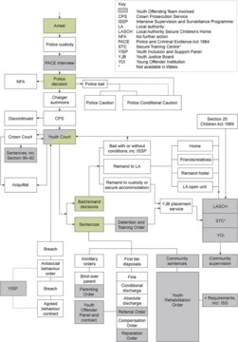
View description - Uncaptioned Figure

A key is provided to the various acronyms on the chart. As you will see the process map starts with an arrest and a number of different journeys through the system can result.
Find on the map: Youth Court, The Detention and Training Order and YOI. Make a few notes about each one. Spend 10 minutes tracing the routes someone might make from arrest to YOI.
Make a record of unfamiliar words, phrases or terminology. Any profession tends to develop and use its own vocabulary but making a note of strange terms now will help you recognise them more easily in future.

Provide your answer...
View discussion - Activity 2 Going with the flow

The establishment of the youth justice system was a significant achievement but the positive changes it was designed to develop have not always been forthcoming. The next section considers why it may not have lived up to expectation.

2.1 Unintended consequences
The Crime and Disorder Act 1998 established a greater degree of coherence to the uneven patchwork of different services and processes that preceded it, but it came at a price. As the system grew, so did the numbers of children and young people being drawn into it.
With most measures of the crimes committed by young people suggesting falling levels of crime, the reasons for this growth in the numbers of young people in the system are complicated and controversial but the results were clear. By 2002 the number of young people in custody had risen to record highs. At 3,200 there were more young people locked up in England and Wales than in any other European State. Some of the reasons for this are explored in the next section.

3 Children in prison

Figure 3 Why are so many children locked up?
View description - Figure 3 Why are so many children locked up?

In Session 1 you will remember reading the words of Frank Tannenbaum warning in 1938 against the tendency of criminal justice interventions to make matters worse rather than better, despite the best of intentions: ‘the harder they work to reform evil, the greater the evil grows under their hands’.
As the numbers of children and young people in custody grew, more and more voices were raised against a youth justice system that was generating such terrible outcomes. One concern was that the expanded youth justice system was both reflecting and exacerbating existing social disadvantages and discrimination experienced by young people from neglected or marginalised parts of society. You consider this argument in the next activity.

Activity 3 Punishing the poor?
Allow approximately 20 minutes for this activity

The Prison Reform Trust is an organisation that collects and analyses information about prison and campaigns for reforms of the system. In 2010 their director Juliet Lyon wrote an article about their work on young people in prison, demanding urgent change.
Read the article from The Guardian here:
Putting children in custody punishes disadvantage
Now use the drop-down menus to complete the following sentences based on the information in the article.

Interactive content is not available in this format.

View discussion - Activity 3 Punishing the poor?

The next section will help you to consider how and why the youth justice system of England and Wales responded to the challenge to reduce the numbers of young people locked up in custodial institutions and changed the way it responds to young people’s offending behaviour.

4 Wales makes a difference?

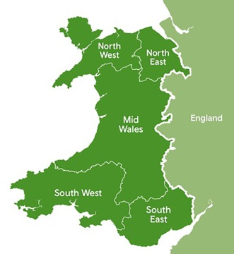
Figure 4 A map of Wales.
View description - Figure 4 A map of Wales.

England and Wales have the same criminal justice system but successive moves towards devolution have widened differences between the two jurisdictions. In Wales all children and young person related services (e.g. Children’s Services, Education, Health and Housing) are devolved to the Welsh Government with the exception of youth justice. The Welsh Government’s formal adoption of the United Nation’s Convention on the Rights of the Child (UNCRC) resulted in the incorporation of the convention into its domestic legislation. In youth justice this has led to practice and policy that emphasises children’s rights and entitlement to various services. It has become known as a ‘children first, offenders second’ approach. This contrasts with the practice and policy enshrined in the Crime and Disorder Act 1998 that emphasises the management of risks – the risk of children offending, the risk they pose to themselves and others, as well as risks of neglect.
The activities in this section help you to appreciate these differences and consider their implications.

Activity 4 The Swansea Bureau
Allow approximately 10 minutes for this activity

Some of the developments in youth justice in Wales have been built on evidence and practice developed in a pioneering project based in Swansea called ‘the Swansea Bureau’.
Read this short account of its work and then answer the questions that follow.
Swansea Bureau - Pre Court Diversion Model

What year was the Swansea Bureau set up in?

2011
2013
2009
1998
View answer - Part

Name the three approaches to children’s offending behaviour underpinning the Bureau’s practice and policy.

children’s rights
restorative justice
needs-led theory
procedural justice
punitive protection
pre-emptive punishment
View answer - Part

What legislation allows for the scheme to be extended to low level offending by children and young people already in the justice system?

Legal Aid, Sentencing and Punishment of Offenders Act 2012
Crime and Disorder Act 1998
Criminal Justice Act 2003
View answer - Part
View discussion - Part

The Crime and Disorder Act 1998 covered England and Wales as if they were one place, but the pace of change and patterns of divergence from the system continue – as you will explore in the next activity.

Activity 5 The Commission on Justice in Wales
Allow approximately 15 minutes for this activity

In 2018 a Commission on Justice in Wales was launched. The Commission examined all aspects of criminal justice, including youth justice. It offered The Welsh Government and other stakeholders in Wales an opportunity to make the case for changes they would like to see in the way criminal justice operates in Wales.
Below is an edited extract of the submission by the Welsh Government that discusses youth justice.
Commission on Justice in Wales: Written evidence submitted by the Welsh Government
Read the extract and when you’ve finished make a note of what the acronyms ACE, ECM and LAC stand for.

Provide your answer...
View discussion - Activity 5 The Commission on Justice in Wales

The impacts of developments in Wales are not confined to Wales. In the next section you will examine how the changes being developed in Wales might have implications for England, and elsewhere.

5 Getting smaller, getting smarter?

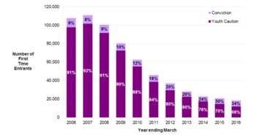
Figure 5 In the year ending March 2016, 31 per cent of First Time Entrants (FTEs) to the Youth Justice System were young people aged 10–14 and the average age of an FTE was 15.2 years.
View description - Figure 5 In the year ending March 2016, 31 per cent of First Time Entrants (FTEs) ...

The youth justice system in England and Wales is getting smaller. Fewer children are being drawn into the system. Most people involved in youth justice seem to think this is a good thing.
Influenced by developments pioneered by practitioners, policy makers and academics in Wales, the language of youth justice is changing. There is less talk of offenders and more talk of children.

Activity 6 Positive Youth Justice: Children First, Offenders Second (CFOS)
Allow approximately 15 minutes on this activity

Read this blog by two academics who have been involved in developing practice in Wales and supporting more widespread use of their CFOS approach.
Children first, offenders second
Use the box below to write a short summary of why they promote CFOS. This will help you to absorb the argument they make and think about its implications.

Provide your answer...
View discussion - Activity 6 Positive Youth Justice: Children First, Offenders Second (CFOS)

6 Different paths to youth justice

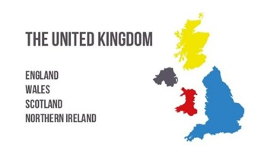
Figure 6 A map of the UK.
View description - Figure 6 A map of the UK.

The trend towards distinctive practice in each of the four jurisdictions that make up the United Kingdom has been accelerating since the end of the twentieth century. In 1998 the Crime and Disorder Act created an ambitious system that funnelled much needed resources into the work people did with children in trouble with the law.
As you saw at the end of Section 2, this came at a price. In that discussion, the price was measured by the unintended consequences of rising numbers of young people in custody. As the system got bigger, so did the number of people drawn into it.
Another part of the price was simply about the money it all cost. It is no coincidence that – after the international financial crisis of 2008, caused by the near-collapse of the banking system, and the subsequent formation of a coalition government in 2010 committed to policies of ‘austerity’ – the youth justice system in England and Wales has shrunk in size dramatically. Other resources and spending on young people have also been reduced in many areas. Economic and political crises can shape policy as much as the fine ideas of energetic practitioners and innovative research by academics.
In England and Wales, new ideas and new priorities have emerged and children, rather than offenders, have come back into the picture. Wales, as a distinct constitutional entity, can justifiably claim to have drawn much of that picture and people are getting more accustomed to there being different approaches to children in trouble with the law. In England and Wales, it’s a story of new ideas and new systems, and possibly further separation of powers. In Scotland, which is the focus of the next session, it is another story altogether.
But before moving on to that story, complete the quiz to help you check your understanding and learning about the issues you’ve covered so far.

7 This session’s quiz
Well done – you have reached the end of Session 2. You can now check what you’ve learned this session by taking the end-of-session quiz.
Session 2 practice quiz
Open the quiz in a new tab or window by holding down Ctrl (or Cmd on a Mac) when you click on the link. Return here when you have finished.

8 Summary of Session 2
In this second session you have explored the origins of the youth justice system in England and Wales. Although this single entity is operational throughout the two jurisdictions, you have explored how different approaches developed in Wales are feeding back into the larger system of England. You will return to this issue in Session 8. Several decades have passed since the system was established and some of its best intentions to provide systematic coherence and national consistency have come at a high price – high levels of incarceration with lots of children and young people in prison. Young people’s offending behaviour and the way society responds to their needs and their deeds are complex issues. Another approach, with an even longer history, is the subject of the next session.
The main learning points of this second session are:
- The youth justice system in England and Wales was established in 1998 by the Crime and Disorder Act.
- A complex system expanded and the numbers of young people drawn into the system grew, resulting in the highest levels of childhood incarceration in Europe.
- More recently, the youth justice system in England and Wales has shrunk and its priorities changed.
- Wales has led some of the changes and has developed distinctive approaches to children’s offending behaviour.
- These approaches are characterised by diversion and an emphasis on the child as a person with particular needs rather than on the label of being an offender.
In the next session, the focus shifts to Scotland and a very different approach.
You can now go to Session 3.

Session 3: Children’s Hearings in Scotland

Introduction
So far you’ve had the opportunity to learn about the youth justice system in England and Wales, and you’ve begun to appreciate the diversity of practice and policy that occurs throughout the UK. Nowhere is this more obvious than in Scotland where the phrase ‘youth justice’ does not even feature in the name of the system. The system in Scotland is dominated by what are known as ‘Children’s Hearings’. What could be more different from the prevailing focus on offenders and punishment that characterises the system established by the Crime and Disorder Act 1998 in England and Wales? The reasons behind this different approach in Scotland are the focus of your learning in this session.

Video content is not available in this format.
Session 3 introduction
View transcript - Session 3 introduction

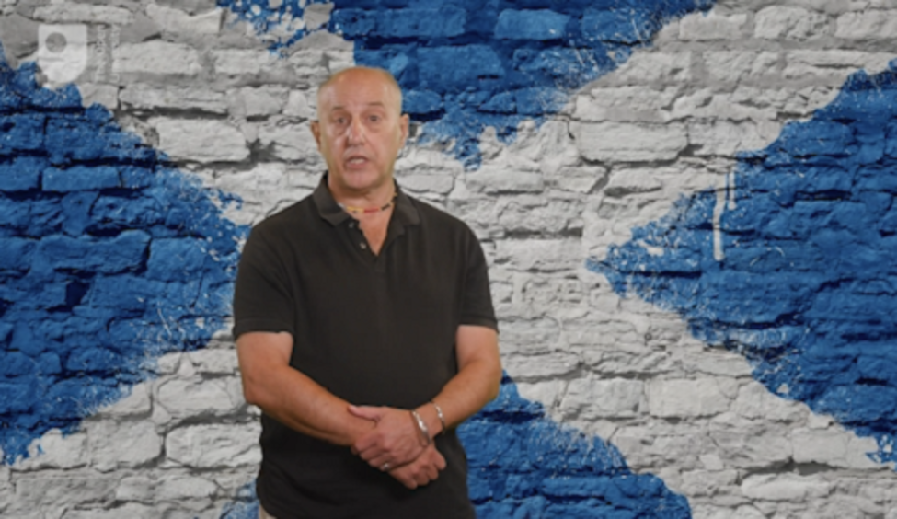

By the end of this session, you should be able to:
- recognise the main features of the Scottish Children’s Hearings system
- identify the significance of the Kilbrandon Commission to the Hearings’ development
- understand the way the system has been changing.

1 An enlightenment idea?

Figure 1 Scotland has a long history of independence.
View description - Figure 1 Scotland has a long history of independence.

According to some historians (Herman, 2002) the Scots are responsible for many of the ideas we associate with the modern world, or ‘modernity’ as academics like to call it. This is no idle boast, and nor is it an expression of some kind of Celtic ethnic chauvinism. The names of Adam Smith, David Hume, James Watt and Robert Burns play very differently on the ear according to whether one is in Edinburgh or London, or are English or Scottish. The books they produced, the ideas and institutions they established, along with other people, are recognised as part of a distinctive Scottish dimension of eighteenth-century history known as ‘The Enlightenment’. Few historians dispute that the incorporation of Scotland under the Act of Union in 1707 marked a crucial turning point in the development of the United Kingdom and the British Empire.
The return of a Scottish parliament in 1998 indicates not only the durability of Scottish claims to be doing things their own way, but the vitality of many of those founding ideas in contemporary Scottish culture. In the next two activities you’ll briefly explore the distinctive history of Scotland’s Children’s Hearings system.

Activity 1 Hearing children in Scotland
Allow approximately 30 minutes for this activity

Read the following explanation of how the Hearings system was established.
Introduction to Scotland’s Children’s Hearings
As you read, highlight any key words or phrases you think are significant. Paste them into the box below. This will help clarify your understanding of the account and consolidate your learning. What do you think of the way they are called Hearings? Write down some of your thoughts about why this word is, or is not, appropriate.

Provide your answer...
View discussion - Activity 1 Hearing children in Scotland

This short outline of the origins of the Hearings system will have given you some idea of the way it works. This is developed further in the activity in the next section.

2 Hearing about panels
The Children’s Hearings system has come a long way since it was established in 1971. You may recall from Session 2 that the Children and Young Persons Act 1969 was referred to as a high-water mark of the child-centred, welfare principles shaping responses to children’s offending behaviour. At about the same time, the Social Work (Scotland) Act 1968 allowed Scotland to take its own path with these principles. They have proved durable, distinctive and effective. The next activity provides an opportunity to find out more about how they work.

Activity 2 The Children’s Hearings system in Scotland
Allow approximately 20 minutes for this activity

Spend 15 minutes exploring the website of the Children’s Hearings Scotland.
Make sure you watch the short film which can be found on this page: About us.
When you have done this, make a note of three things you would tell a friend or colleague about if they had never heard of the Children’s Hearings system.

Provide your answer...
View discussion - Activity 2 The Children’s Hearings system in Scotland

Having explored the Hearings system in these activities you should now have a clearer idea as to how different they are to the system described in Session 2. Scotland has a legal system that is very different to the one that operates in England and Wales. Some aspects of it are closer to the legal systems of continental Europe because, in the eighteenth and nineteenth centuries, political power and influence in Scotland were aligned as closely with its continental neighbours, particularly France, as much as with England. There is no Crown Prosecution Service, for example, in Scotland and it is the ‘Procurator Fiscal Service’ which is the body responsible for the prosecution of crimes. In the next section you’ll return to the issue explored in Session 1 about the age at which a child can be prosecuted for a crime and you’ll explore how Scotland has addressed it.

3 Raising the age

Figure 2 Children or potential criminals?
View description - Figure 2 Children or potential criminals?

In Session 1 you considered how out of step the jurisdictions of the UK appear to be from the rest of Europe and, indeed, much of the world when it comes to the age of criminal responsibility. Until recently, the only jurisdiction in Europe to have a lower age of criminal responsibility than England and Wales was Scotland. This reflects something of the common history and cultural priorities around welfare that took shape in the Children and Young Persons Act 1969 for England and Wales, and for Scotland, the Social Work (Scotland) Act 1968. The proposal in the 1969 Act to raise the age to 14 in England was shelved and then, in 1998, the Crime and Disorder Act formally endorsed the age at 10. In Scotland, for many years the primacy of welfare principles deflected attention from the fact that children as young as 8 years old could be prosecuted.
This is no longer the case and the next activity offers you some context on how and why the age of criminal responsibility in Scotland was raised from 8 to 12 years.

Activity 3 The age of change
Allow approximately 15 minutes for this activity

Read this short BBC article about the proposal to raise the age of criminal responsibility in Scotland. It brings together arguments about raising the age that are gathering support in many countries, and will feature again in the next session of the course. The article indicates that reform of the age would affect only a small number of children. What do you think of this as a line of argument for keeping things as they are? Make some notes in the box below.
At what age should children have a criminal record?

Provide your answer...
View discussion - Activity 3 The age of change

Where do you stand on raising the age? The next activity may help you take a stand on an issue that is likely to be part of the story in youth justice wherever you live in the UK.

Activity 4 Top ten and high five
Allow approximately 10 minutes for this activity

Interactive content is not available in this format.

View discussion - Activity 4 Top ten and high five

In the next section you return to the principle first outlined at the end of Session 1. This is the principle that listening to children’s voices and attending to their experiences should be central to any system of intervention.

4 Children’s views of Hearings

Figure 3 Young people should be in the picture and the process. Their voices matter.
View description - Figure 3 Young people should be in the picture and the process. Their voices matter. ...

As you’ve explored in earlier activities there are good reasons why children should not be treated as adults because their young age automatically implies a lack of maturity. Unfortunately, the same arguments often mean they are not listened to or, when they are, their experiences are dismissed as invalid because they lack the benefits of mature reasoning.
This process of dismissal is sometimes referred to as ‘infantilisation’. It implies that, because children and young people are closer in age to infants, they have no capacity to look after themselves, take meaningful decisions or act for themselves in their own best interests. People who work in children’s health and social care services must work hard to resist infantilisation. This can often involve listening respectfully and patiently. Sometimes this requires training and practice. In the next activity you will listen as children give voice to their experiences of the Hearings system.

Activity 5 The elephants in the room
Allow approximately 10 minutes for this activity

Finding out how children and young people see the world and make sense of their situation can be difficult. Recognising how important this is to the fairness, or otherwise, of the Hearings process the Scottish Government commissioned some workshops with children aged 7–15 from both urban and rural setting, to find out more about their experiences in the hearings system. Listen to an extract of their views and make a note of one or two phrases used by the children.

Video content is not available in this format.
Video 1
View transcript - Video 1

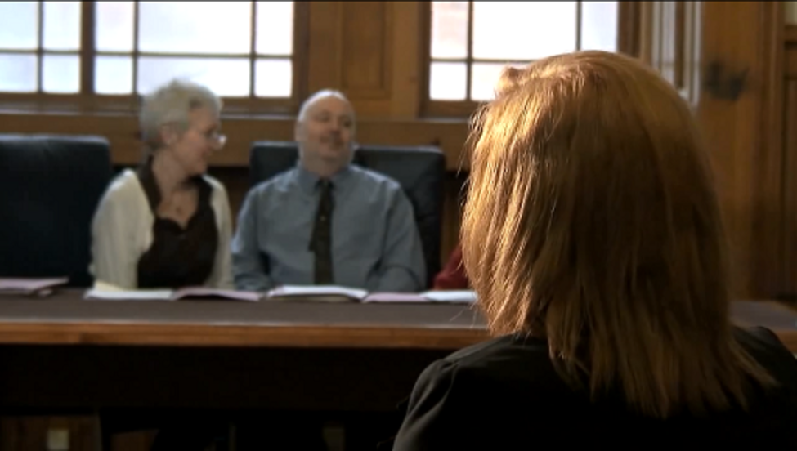

Provide your answer...
View discussion - Activity 5 The elephants in the room

Children’s lives, especially those that come to the attention of the Hearings system, can be full of challenges. Most children are referred to the system on welfare grounds and, even for the minority referred because of offences, securing their welfare is the priority of the Hearings.
Sometimes things don’t work out well and it can be hard to make changes. Some children face particularly difficult circumstances. The next section explores some of these scenarios.

5 Young people and knife crime: a Scottish approach

Figure 4 Knife crime and other forms of violent behaviour have serious social consequences, especially for children.
View description - Figure 4 Knife crime and other forms of violent behaviour have serious social consequences, ...

In 2005, a United Nations report noted that Scotland was the most violent country in the developed world (Younge and Barr, 2017). The World Health Organisation declared it had the second highest murder rate in western Europe (Finland had the highest). In Glasgow alone, there were about seventy killings each year. The reasons for these levels of violence were complex, but one part of the problem was identified in the growing culture of knife carrying among young people in the city. This was also associated with different gangs competing to control the city’s illegal drug markets.
In response, the Scottish Government funded a new multi-agency Violence Reduction Unit (VRU). It adopted a public health approach to knife crime in which the police worked with those in the health, education and social work sectors to address the problem. The results have been dramatic. In 2018, of the 35 children and teenagers who were killed in Britain, none were from Scotland.
In the next activity you can see some of the ways this has been achieved, by adopting the principles of holistic social education that informed the Kilbrandon Commission and the Children’s Hearings system.

Activity 6 Animating and educating to reduce violence
Allow approximately 15 minutes for this activity

Spend five minutes looking at the ‘No knives, better lives’ website so that you are briefly familiarised with its aims.
As an optional activity, look at the complete interactive animation.
Please note that there are some distressing themes and graphic images in this video, as well as some bad language which may cause offence.

View discussion - Activity 6 Animating and educating to reduce violence

Elsewhere in Britain, the issue of violence among young people and the lethal use of knives became urgent and high profile during 2018 and 2019. The Scottish approach of seeking social solutions rather than criminal justice ones is anchored in its civic traditions and philosophies that have been part of Scottish society since the eighteenth century. They form the basis for the Children’s Hearings system.

6 The language of justice
Few people in Scotland would say their system is perfect. You have listened to children saying as much in this session. Equally, few people would deny it is also very different from the systems prevailing in the rest of the UK. This difference is crystallised in its name – Children’s Hearings.
This language is important because it signals the priorities of the system in two simple words that anyone can understand. If you live in England or Wales, or Northern Ireland, where the language of criminal justice and offending has been more dominant over the last 30 to 40 years, it can be a surprise to discover this other language. As you progress through this course, you will see how the language of youth justice is changing. Something old, something new, as the saying goes.
If Scotland has drawn on its old traditions, Northern Ireland has borrowed from afar to integrate restorative justice conferencing systems into the reform of its youth justice system. This is what you turn to in the next session.

7 This session’s quiz
Well done – you have reached the end of Session 3. You can now check what you’ve learned this session by taking the end-of-session quiz.
Session 3 practice quiz
Open the quiz in a new tab or window by holding down Ctrl (or Cmd on a Mac) when you click on the link. Return here when you have finished.

8 Summary of Session 3
Completing this third session has introduced you to a very different way of responding to children’s problematic behaviour. Scotland’s Hearings system was established in the 1970s by placing children’s welfare firmly at the centre of all state intervention. Children are measured by their needs rather than their deeds. It is far from perfect and children in Scotland have voiced their concerns about the way it works. It has proved to be resilient and flexible. Children and young people in Scotland face similar challenges to those in other nations. Violence and crime often go hand in hand but Scotland has demonstrated how alternatives to conventional police-led, criminal justice responses can be effective.
The main learning points of this third session are:
- Scotland’s Children’s Hearings system is a distinctive, and distinctively Scottish, response to children’s problematic behaviour.
- The Children’s Hearings system is designed to convene social support for children whose needs are seen as central to any intervention arising from what they have done.
- The system seeks to renew itself and be responsive to changing circumstances of children and their families.
- Creative and innovative responses to these issues are being developed.
In the next session, you will explore how the particular circumstances of Northern Ireland have led to the development of another distinctive approach to tackling children and young people’s offending behaviour.
You can now go to Session 4.

Session 4: Restorative conferencing in Northern Ireland

Introduction
The partition of Ireland in 1920 led to the establishment of two separate jurisdictions on the island of Ireland. The recent history of youth justice in one of these jurisdictions − Northern Ireland − has been shaped by the violent conflicts that emerged from this partition which created a bitterly contested territory composed of six of the nine counties of the Irish province of Ulster. In 1998 an attempt to resolve the conflict was achieved through the Comhaontú Bhéal Feirste or Belfast (Good Friday) Agreement. This was an international treaty signed by all the major political parties in the province of Northern Ireland, and the British and Irish governments. Part of the agreement included a comprehensive review of the criminal justice system to ensure that it delivered a fair and impartial system of justice that was responsive to community concerns, encouraged community involvement where appropriate, and retained the confidence of all sections of the community (Doherty, 2010).

Figure 1 The peace process in Northern Ireland shapes all its institutions, including those of youth justice.
View description - Figure 1 The peace process in Northern Ireland shapes all its institutions, including ...

In seeking to develop a youth justice system that could secure the support of all communities in Northern Ireland, the Criminal Justice Review Group (CJRG, 2000) looked to a new set of ideas that had been adopted successfully in New Zealand, Australia, post-apartheid South Africa and elsewhere. These ideas about resolving conflict, encouraging dialogue and developing participation are known as ‘restorative justice’. The learning in this session focuses on how restorative justice has been built into the youth justice system of Northern Ireland.

Video content is not available in this format.
Session 4 introduction
View transcript - Session 4 introduction

By the end of this session, you should be able to:
- recognise the main features of youth justice conferencing in Northern Ireland
- identify the significance of ideas about restorative justice to the youth justice system in Northern Ireland
- understand the historical context of the justice system in Northern Ireland.

1 What is restorative justice?

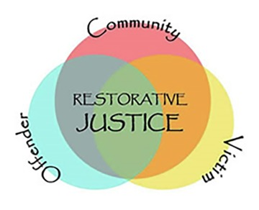
Figure 2 The three key elements of restorative justice.
View description - Figure 2 The three key elements of restorative justice.

The political conflict over the status of Northern Ireland that was addressed by the 1998 Comhaontú Bhéal Feirste or Belfast (Good Friday) Agreement demanded imaginative and radical responses. Criminal justice institutions, such as the police and the court system, were regarded with deep suspicion and young people’s communities were divided by different political loyalties, traditions and national aspirations. When the criminal justice system was reviewed, restorative justice appeared to offer significant potential. In this section you’ll explore the origins of restorative justice and the principles that underpin its practice. Then, in the following sections, you will consider how it has been adapted to the needs of young people in Northern Ireland.

Activity 1 The origins of restorative justice
Allow approximately 15 minutes for this activity

Although it has featured in many new developments in youth justice − from New Zealand to Northern Ireland − restorative justice is anchored in old ideas about resolving conflicts. What distinguishes them from the approach taken in conventional criminal justice is the stress placed on direct dialogue between the people involved, including, where possible, the victim or victims.
Restorative justice has been propelled onto the agendas of governments, schools and communities by a dynamic social movement. This movement is diverse and produces sometimes competing accounts of the origins of restorative justice. You can read one account here. Read this brief history of restorative justice:
Defining restorative
Now make a list of five applications of restorative practice as mentioned in the article.

Provide your answer...
View discussion - Activity 1 The origins of restorative justice

‘Restorative practice’ refers to how restorative justice is actually put into practice in various contexts. Sometimes these settings are established by criminal law and sometimes they are less formal, for example in schools or colleges. They can also be established in local communities to resolve neighbourhood disputes or other forms of community tension. Wherever they are used, restorative practices are guided by certain principles. The next activity looks at some examples of these principles.

Activity 2 The principles of restorative practice
Allow approximately 15 minutes for this activity

Read the following account from the Restorative Justice Council of the principles underpinning restorative practice:
Principles of restorative practice
Now complete the following sentence in your own words:
Understanding the principles underpinning restorative practice is important because…

Provide your answer...
View discussion - Activity 2 The principles of restorative practice

The practice and principles of restorative justice are often described as ‘dialogic’ − they draw on ideas about negotiation between people in conflict, a dialogue that involves direct communication and sometimes compromise. This emphasis on the ‘process’ of the interaction between people is a characteristic of the youth justice system in Northern Ireland. In the next section you will consider why this has become so important.

2 From rough justice to restorative justice

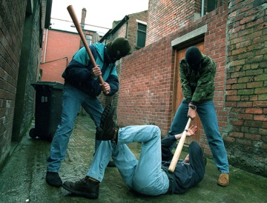
Figure 3 Punishment beatings of young people suspected of crimes administered by paramilitaries were one consequence of the conflict in Northern Ireland.
View description - Figure 3 Punishment beatings of young people suspected of crimes administered by ...

Mistrust in conventional criminal justice and the strength of sectarian divisions in Northern Ireland resulted in the police being regarded as a central part of the problem rather than part of the solution for much of the twentieth century. The attempt to move on and restore confidence in the administration of justice, and the institutions of criminal justice, has involved bringing restorative justice from the fringes of the system to the centre. In this next activity you will listen to a short account of how this has happened.

Activity 3 The introduction of restorative justice in Northern Ireland
Allow approximately 10 minutes for this activity

Listen to this extract from the BBC Radio 4 programme Thinking Allowed where two academics discuss how and why restorative justice came to be used in Northern Ireland.

Audio content is not available in this format.
Audio 1
View transcript - Audio 1

Complete the following sentence:
Restorative justice in Northern Ireland was introduced an alternative to…

Provide your answer...
View discussion - Activity 3 The introduction of restorative justice in Northern Ireland

Now you have looked at the history and principles of restorative justice, and have considered the context of its introduction to Northern Ireland, it’s time to look at how this is applied to the youth justice system. This is the focus of the next section.

3 Restorative conferencing with young people in Northern Ireland
A key feature of restorative justice is that it seeks to include victims in ways that conventional systems of justice do not. In Session 1 you will remember the statue of justice, a blindfolded woman holding a sword and a set of scales. The Court of Law that this figure symbolises is not a major feature of restorative justice − victims rarely appear in court, and their voice is not usually considered to be part of the process.
In restorative justice, the victim is brought into the process wherever possible and suitable. In the next two activities you will watch videos telling you how this is accomplished in Northern Ireland’s youth conferencing system.

Activity 4 Northern Ireland’s Youth Justice Agency
Allow approximately 20 minutes for this activity

The adoption of restorative justice as the central guiding theme of the youth justice system in Northern Ireland is unique within the UK. Read the following short account of restorative practice in Northern Ireland’s Youth Justice Agency.
Then watch the following video.

Video content is not available in this format.
Video 1
View transcript - Video 1

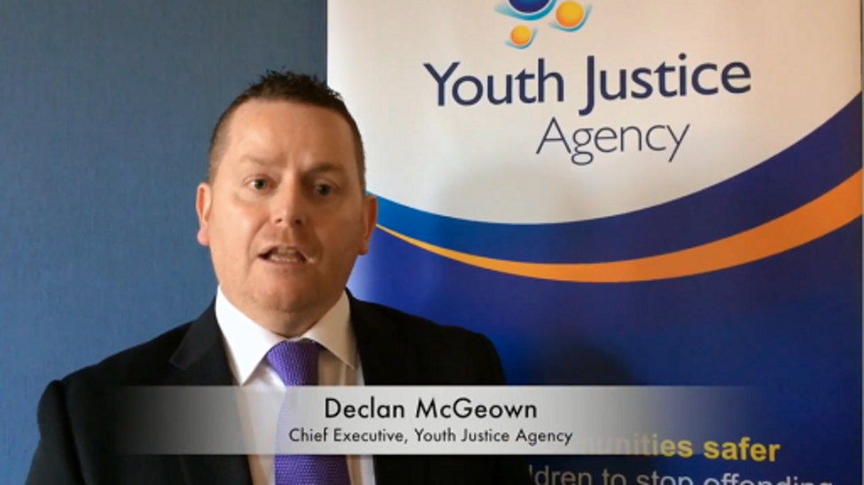

Make a note of two features you regard as positive and one negative. Doing this will help to consolidate your learning and encourage critical reflection, an important academic skill when studying complex social issues.

Provide your answer...
View discussion - Activity 4 Northern Ireland’s Youth Justice Agency

Victims rarely play a prominent role in conventional systems of criminal justice but are central to restorative practice and principles. The next activity offers insights into what can be accomplished.

Activity 5 Facing justice, facing victims
Allow approximately 15 minutes for this activity

In most conventional systems of criminal justice the victim is a peripheral figure, rarely appearing in the process. They are often seen mainly as instruments to secure a conviction rather than a person with complex needs in the process. Restorative justice challenges this approach. Watch the video at the link below, which offers an account of how restorative justice can work for victims of crime by young people in Northern Ireland:
What is restorative justice? The top table
Imagining you have been a victim of a non-violent crime, list three reasons why you might want to participate in a restorative conference, and one reason why not.

Provide your answer...
View discussion - Activity 5 Facing justice, facing victims

The Northern Ireland Youth Justice Agency’s use of restorative justice throughout its interventions has been widely praised for its innovative and ethically principled approach. In the next section you look at how restorative justice can make a difference even at the ‘hard end’ of the youth justice system – the use of custody.

4 Youth custody in Northern Ireland

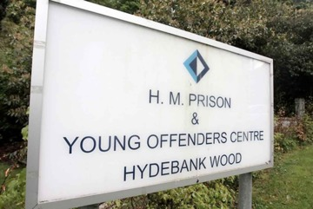
Figure 4 Hydebank Wood young person’s prison.
View description - Figure 4 Hydebank Wood young person’s prison.

Restorative justice seeks resolutions of young people’s offending behaviour in their community and among the people who have been most affected. Sometimes however custodial sentences are imposed where the offending behaviour has been particularly serious or sustained.
As you have learned, listening to the actual voices of children and young people is of paramount importance, and the next activity offers more accounts of children’s experiences of Northern Ireland’s way of doing youth justice.

Activity 6 Young people’s voices from inside
Allow approximately 20 minutes for this activity

As a relatively new process that is attempting to do justice differently, restorative justice practitioners are often involved in developing resources that demonstrate or explain the process. First, watch this video which features two young men, Paul and Kevin, who spent time in and out of custody and the care system in Northern Ireland – the video highlights the connections between the two systems:
The view of young offenders
Now hear from three young people who have spent time in a custodial centre dedicated to meeting children’s needs:
Young people’s experience of the formal youth justice system (watch from 02:46 to the end)
Use the text box to make some reflective notes on what you’ve seen and heard in the videos.

Provide your answer...
View discussion - Activity 6 Young people’s voices from inside

As an alternative way of doing youth justice, restorative justice has made significant progress. Even so, a recurring controversial feature of youth justice systems through the UK is the age at which a young person can be prosecuted. The way this issue is being looked at it in Northern Ireland forms the final set of activities in this session.

5 The age of criminal responsibility in Northern Ireland

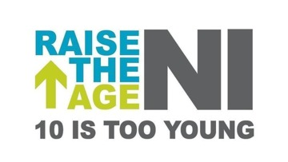
Figure 5 The only way is up!
View description - Figure 5 The only way is up!

In Session 3 you learned about Scotland’s decision to raise the age of criminal responsibility from 8 to 12. In Northern Ireland a review of the youth justice system also recommended raising the age to 12 (Youth Justice Review, 2011). This would bring it more into line with changes in the Republic of Ireland which raised the age of criminal responsibility to 12 in all but the most serious cases, and where pressure is mounting for the adoption of 14 as the most appropriate age. In the next activity you’ll consider arguments for this change in Northern Ireland.

Activity 7 Raising the age
Allow approximately 10 minutes for this activity

Read the short policy briefing produced by NIACRO:
NIACRO policy briefings: the age of criminal responsibility
Five ‘key messages’ are included in the briefing. The fourth considers the impact of a criminal record on a young person. Thinking back to some of the comments made in Session 2 by children in Wales about being seen as criminals, write down one reason this may be important to young people.

Provide your answer...
View discussion - Activity 7 Raising the age

Activity 8 Off the record
Allow approximately 15 minutes for this activity

The Off the Record campaign urges the government of Northern Ireland to allow adults to apply for any minor convictions they received while under the age of 18 to be removed from the records kept by the government. Take a look at the ‘key messages’ from NIACRO’s Off The Record campaign:
NIACRO Policy Briefings: Off The Record
Imagine you want to persuade a friend, neighbour or colleague to support the campaign. Choose one of the five key messages and, in the box below, explain briefly why it might persuade this person to support the campaign.

Provide your answer...
View discussion - Activity 8 Off the record

6 Moving on
The importance of diverting children from any criminal justice process that permanently labels them as criminals is a recurring theme of this course. This is because there is a strong evidence base suggesting that raising the age of criminal responsibility is one of the most effective ways of achieving this diversion. Across and between the four jurisdictions of the UK there is growing recognition of this evidence, and the costs to children, young people and wider society, of ignoring it.

7 This session’s quiz
It’s now time to complete the Session 4 badged quiz. It’s similar to the previous quizzes but this time instead of there being 5 questions there are 15, covering Sessions 1 to 4.
Session 4 compulsory badge quiz
Remember, this quiz counts towards your badge. If you’re not successful the first time, you can attempt the quiz again 24 hours later.
Open the quiz in a new tab or window by holding down Ctrl (or Cmd on a Mac) when you click on the link. Return here when you have finished.

8 Summary of Session 4
In this session you’ve looked at the way children and young people in conflict with the law are treated in Northern Ireland, the last of the four jurisdictions that make up the United Kingdom. Northern Ireland’s relationship to the rest of the United Kingdom changed radically with the Comhaontú Bhéal Feirste or Belfast (Good Friday) Agreement of 1998. The youth justice system has pioneered the use of restorative justice and further changes involving raising the age of criminal responsibility are rising up the agenda.
In the four sessions you’ve looked at so far, you have seen how changes in the status of children with respect to the criminal law are an issue across all four jurisdictions of the UK. Restorative justice approaches also feature in all four jurisdictions, to varying degrees, but in Northern Ireland they occupy the mainstream. They have taken this place because the restructuring of the youth justice system was prompted by wider attempts to heal the injuries of the past and find a peaceful way forward from the conflicts arising after the partition of Ireland in 1920.
What happens to children and young people when they get into trouble often involves ‘conflicts with the law’. By stressing the need to resolve this conflict by involving all parties, including victims wherever possible, restorative justice offers models of practice and ways of thinking that have wide and profound implications – and not just for children and young people in Northern Ireland!
The main learning points of this fourth session are:
- The youth justice system in Northern Ireland is part of a wider reconstruction of Northern Irish society that emerged through the signing of the Comhaontú Bhéal Feirste or Belfast (Good Friday) Agreement in 1998.
- Restorative justice is embedded in the system and central to its working.
- Restorative justice operates through distinctive principles involving dialogue and negotiation.
- The place and voice of victims is important to restorative justice and the way it works in Northern Ireland.
- The Youth Justice Agency of Northern Ireland has developed innovative systems of intervention with children and young people.
Now you have considered the four ‘national’ jurisdictions of the UK in the first half of this course, you will move on in the second half to consider equally important issues around gender, race and social class. In the next session you will explore how girls and young women fare in youth justice, asking if youth justice includes gender justice.
You are now halfway through the course. The Open University would really appreciate your feedback and suggestions for future improvement in our optional end-of-course survey, which you will also have an opportunity to complete at the end of Session 8. Participation will be completely confidential and we will not pass on your details to others.
You can now go to Session 5.

Session 5: It’s different for girls?

Introduction
One of the enduring features of criminal justice systems is that they deal largely with men and men’s offending behaviour. Throughout the world, over 90 per cent of prison populations are composed of men. In the UK, females comprise less than five per cent of young people in custody (YJB, 2019) although they constitute 49 per cent of the general population. This means that most of our knowledge about how to work most effectively with young people to help them stop committing crime comes from work with young men.
Under-representation or over-representation on this scale in many areas of social policy and government provision of services would normally set alarm bells ringing. Is there an issue of unfair or unreasonable discrimination at work? Should there be targets to achieve parity in youth custody so that there are the same numbers of young women in custody as there are young men? Thankfully, no one is suggesting this because most people understand that issues about gender are more complicated than simple symmetry and that equality does not mean treating all people the same.
Understanding the differences between girls’ and young women’s experience of crime and youth justice is the focus of this session. It will examine how girls and young women fare in youth justice systems and procedures where they are often a small minority compared to boys and young men. This session will introduce you to how youth justice systems work with girls and young women.

Video content is not available in this format.
Session 5 introduction
View transcript - Session 5 introduction

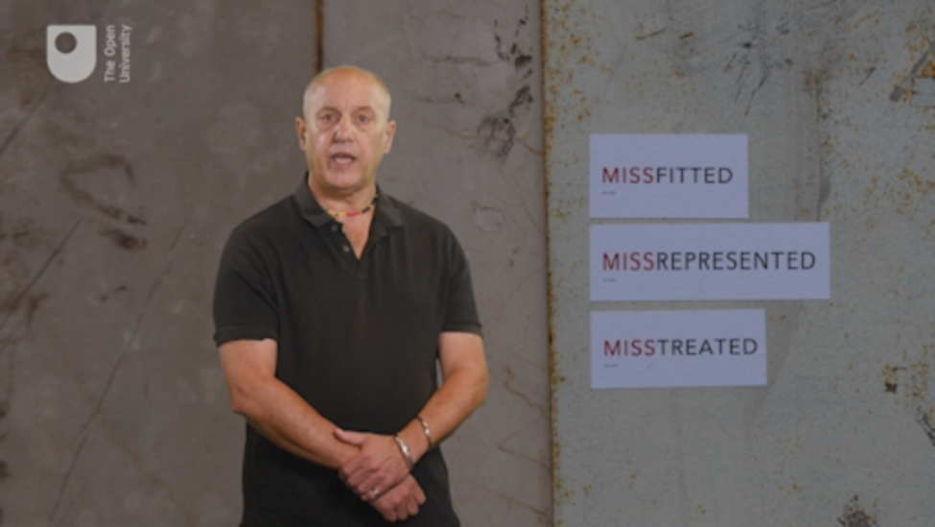

By the end of this session, you should be able to:
- identify ways in which girls’ and young women’s experience of crime and youth justice may be different to that of boys and young men
- recognise when and how these differences are significant and what is being done to address them
- understand how gender stereotypes impact on youth justice practice.

1 Bad girls?

Figure 1 Is the experience different for girls and young women?
View description - Figure 1 Is the experience different for girls and young women?

It is quite widely believed that offending behaviour by girls is getting worse, is more serious and probably more widespread than it was in the past. These beliefs are largely false (Bateman, 2017). It remains the case now, as in the past, that girls and young women commit fewer and less serious crimes than do boys and young men. It is also clear that girls and young women ‘grow out of crime’ more successfully and at a lower age than do young men. Fears that girls’ offending behaviour is getting worse are not supported by research data. The number of young women entering the youth justice system actually fell by 92 per cent in the ten years between 2008 and 2018 – a fall from 32,100 to around 2,600 (YJB, 2019).
The reasons for the popular belief that crime among young people, and particularly crimes committed by girls, has been rising are complex. The beliefs can be fuelled by wider social anxieties and a sense of panic about ‘the state of the country’. The way crime is recorded and reported in newspapers and other media contribute to these worries. For example, between 2003 and 2007 a government sponsored scheme to measure and improve police performance contributed to a belief that crime and offending behaviour by girls and young women was rising steeply. In this period there was a substantial rise in the number of girls entering the youth justice system in England and Wales. This rise in ‘first time entrants’ was more than twice the rate of increase for boys (35 per cent for girls against 16 per cent for boys). It turned out that this ‘unprecedented crime wave among teenage girls’, as it was reported in the media, was more the result of police arresting more girls and young women to meet the government’s targets for police performance than it was about the deterioration in girls’ behaviour (Nacro, 2008; Bateman, 2017). Because of these concerns about a female crime wave the Youth Justice Board commissioned a comprehensive report on girls’ offending behaviour and patterns of interventions. This report offers some insights and evidence about the criminal behaviour of girls and young women. These are the subject of the first activity.

Activity 1 Girls, young women and crime: get some facts
Allow approximately 20 minutes for this activity

Using the Executive Summary of the report (p. 5) below fill in the blanks in the following statements from the drop-down menu.
Girls and offending – patterns, perceptions and interventions

Interactive content is not available in this format.

Interactive content is not available in this format.

Interactive content is not available in this format.

Interactive content is not available in this format.

Interactive content is not available in this format.

Interactive content is not available in this format.

View discussion - Part

Activity 2 Girls in youth justice
Allow approximately 20 minutes for this activity

Using the ‘Summary of findings’ section of this government report on girls in the criminal justice system (p. 7), find the answers to the following questions.

Interactive content is not available in this format.

Interactive content is not available in this format.

View discussion - Part

The next section examines some of the key differences between girls and young women who offend and their male counterparts. Understanding these differences is important if services and interventions are going to respond effectively to their offending behaviour.

2 It’s different for girls

Figure 2
View description - Figure 2

Research suggests that it is possible to identify six distinctive ways in which girls and young women get involved in crime and respond to interventions designed to help them stop:

- The pathways into crime and offending are different for girls and young women compared to young men. It is often focused around close personal relationships and strongly associated with experiences of loss, bereavement, abuse and local authority children’s services.
- Young women’s problematic behaviour is often made worse by criminal justice interventions, and while the same holds for young men, the association is much stronger for girls and young women.
- The capacity of girls and young women to maintain positive relationships is seriously damaged by custodial sentences.
- Vulnerability and mental health difficulties make prison life particularly difficult and damaging for girls and young women. Compared to boys, they are three times more likely to have been victims of sexual abuse and twice as likely to have spent time in local authority care prior to incarceration.
- Girls and young women need an interpersonal focus to make their resettlement after custody effective.
- The obstacles to desistance (stopping offending) for girls and young women are different compared to those for boys and young men.
(Beyond Youth Custody, 2014)

Some differences between young women’s and young men’s offending behaviour are likely to shift over time but the evidence suggests definite patterns in young women’s offending and that they ‘grow out of crime’ quite differently. For example, most girls or young women who get convicted of a crime will only be convicted once. They are almost half as likely to reoffend as boys or young men. Even if they do go on to commit more crimes, their period of offending behaviour is much more likely to be brief (less than a year) than is the case for boys (Newburn, 2017). The general picture is that young women commit less crime, commit less serious crime and are less likely to be ‘recidivists’ (repeat offenders). In addition, if they get a custodial sentence, young women are far more likely to self-harm while in custody than are boys or young men.

Activity 3 What’s the difference?
Allow approximately 10 minutes for this activity

Imagine you have met someone who thinks that girls and boys, young women and young men, are essentially the same – young people – and thus there is no reason to treat them differently. From the list of six distinctive ways in which young women get involved with crime and respond to interventions, produced for youth justice practitioners by Beyond Youth Custody, which two do you think are the most likely to change their mind?
Write them down and give one reason for each choice.

Provide your answer...
View discussion - Activity 3 What’s the difference?

The complex web of social and personal relations that may be exposed by crime and criminal justice interventions are explored in more detail next by looking at real events and a fictional case study.

3 Girls and the gangs

Figure 3
View description - Figure 3

In 2018–19, there were a lot of concerns about knife crime and drug gangs using ‘county lines’ to develop their illegal and violent trading activity beyond the cities where it had previously been located. ‘County lines’ are explored further in Session 7. Those involved, and harmed, in London and elsewhere were mainly young men but girls and young women were certainly not absent from the picture. In April 2018, a 17 year old young woman, Tanesha Melbourne, was shot dead in Tottenham, north London. The bullets that killed her were fired from a car passing the group of young people she was with at the time. She became the ninth teenager to be killed in London in what was to become a violent year for the capital. By the end of 2018, 132 people had died as a result of violent crime.

Activity 4 Nequela’s story
Allow approximately 15 minutes for this activity

Young people involved in gangs are often in the news but their stories rarely get told in full. It is even more unusual that they get to tell their own story in their own words. This activity offers you a chance to hear one young woman’s account of her life.
Before reading this story, write down two reasons why you think a young woman would end up leading a gang. When you’ve read the story, you can compare your reasons with any you find in Nequela’s account.
Read this article written by Natalie Gil about a young woman – Nequela Whittaker – and her journey leading a gang:
Drugs, fights and guns: my life as a female gang leader in London

Provide your answer...
View discussion - Activity 4 Nequela’s story

Notwithstanding accounts such as Nequela’s, it is more common for girls and young women to get involved around the periphery of low-level crime and anti-social behaviour. Interventions by youth justice agencies, sometimes motivated by genuine concerns to protect girls, can often have the reverse effect than the one intended. The fictional case study you will explore next offers some insights into how this can happen.

3.1 A case study: Gina

Figure 4 ‘Gina’ has been sentenced for a first offence.
View description - Figure 4 ‘Gina’ has been sentenced for a first offence.

Consider the following fictional case study.

‘Gina’ is a 15 year old girl who has been sentenced for a first offence. The offence was quite serious and arose from Gina’s involvement in a robbery. Another young woman’s mobile phone was taken from her in the street and passed to Gina by the ‘robbers’ as they quickly disappeared into the neighbourhood streets on mopeds. Gina was seen by a witness to receive the phone as part of a planned and co-ordinated crime.
Gina was arrested and subsequently found guilty of the offence but refused to help the police identify the others involved. As part of her sentence she was required to make reparations ‘to the community’ but has missed several appointments with the organisation delivering community project work. She didn’t like the manager of the project and felt she was being picked on. After some unsuccessful attempts to secure better compliance with the court-ordered reparation work, Gina has been taken back to court by the Youth Offending Team (YOT) because they are obliged by the law to do so if they cannot secure compliance with the order.
The court report prepared by the local YOT worker highlights Gina’s vulnerability in the community where some of her peers suspect she has cooperated with the police or is likely to in the future. Gina fears this all the more if she is seen to be complying with her court order. Her peers and friends in the neighbourhood worry that she is coming under pressure to provide the police with information about some young men who have been arrested in connection with other phone thefts in the area.
With Gina in the youth court again, despite not having committed another offence, the magistrate wants to change the conditions of her sentence by imposing an ‘intensive supervision and surveillance’ requirement (ISS), the most demanding intervention requirement available for young people on community sentences. It is the magistrate’s belief that a more intensive order is necessary due to Gina’s vulnerability, to help protect her from drifting into more troubled relationships in her neighbourhood.
The YOT worker argued in court that this was inappropriate and would increase the chances of Gina breaching her order because her behaviour will be more strictly monitored. The magistrate insists his more intensive order is intended to deliver support to Gina, not to punish her more severely.

Activity 5 Do the right thing
Allow approximately 20 minutes for this activity

Is the magistrate doing the right thing by insisting on the intensive supervision and surveillance order? Use the boxes below to develop the scenario in two directions.

- Yes, the magistrate is doing the right thing because:

Provide your answer...

- No, the magistrate is not doing the right thing because:

Provide your answer...
View discussion - Part

The research evidence reviewed by Bateman and Hazel (2017) and the Prison Reform Trust (2017) points to this kind of scenario happening a lot. Gina, with one crime to her name, could end up being locked up, removed from her friends, family and neighbourhood and pressed into the repetitive cycles of the criminal justice system as an unwanted result of the magistrate’s good intentions. The Lammy Review (2017), which you will learn about more in Session 6, indicates that if Gina has a black or minority ethnic heritage, this is even more likely.

Activity 6 From courts to custody
Allow approximately 15 minutes for this activity

In 2016, the All Party Parliamentary Group on Women in the Penal System produced a report called Inquiry on girls: From courts to custody. Questions relating to the ten ‘key points’ from their report are given below. Select the correct words from the drop-down menus to answer the questions.

Interactive content is not available in this format.

Interactive content is not available in this format.

Interactive content is not available in this format.

Interactive content is not available in this format.

Interactive content is not available in this format.

Interactive content is not available in this format.

Interactive content is not available in this format.

Interactive content is not available in this format.

View discussion - Part

4 Possibilities, alternatives, changes
At the beginning of this session, you learned how few girls and young women are in custody compared to boys and young men. Taken at face value, this might have suggested they get an easier ride in the youth justice system. But evidence is mounting up that this isn’t the case and the opposite might even be more likely.
To tackle this possibility, the Welsh Government launched the ‘Female Offending Blueprint’ in 2019 to develop more joined up and proactive gender-informed policies. In 2012, the Scottish Government’s Commission on Women Offenders announced changes to criminal justice strategy intended to reduce the numbers of young women in custody. It hoped that a gender-informed approach would have positive effects throughout the Hearings system and acknowledged that, for equal and fair treatment to be achieved, change was needed to produce a system designed for women’s needs rather than men’s. A champions group for Vulnerable Girls and Young Women was established to promote and influence cultural change in the Hearings System.
In each of the jurisdictions of the UK, gender specific services are becoming more widely available and deliver fairer and more effective services. They recognise it is different for girls, and that differences are not to be avoided but engaged with.

5 This session’s quiz
Well done – you have reached the end of Session 5. You can now check what you’ve learned this session by taking the end-of-session quiz.
Session 5 practice quiz
Open the quiz in a new tab or window by holding down Ctrl (or Cmd on a Mac) when you click on the link. Return here when you have finished.

6 Summary of Session 5
The fact that girls and young women are a minority in the youth justice system means that their needs and circumstances are sometimes neglected, misunderstood or misinterpreted. Gender stereotypes about girls and young women are increasingly open to challenge. Gender is not a symmetrical relationship between two biological sexes but a hierarchical relationship where men tend to have more power and influence than women. In this session you have explored the ways in which gender shapes the youth justice system, the experiences and prospects of girls and young women. You have explored ways that the system is changing to recognise difference, and this work continues in the next session where questions of race, racism and ethnicity are explored.
The main learning points of this fifth session are:
- There are relatively few girls and young women involved in youth justice systems, compared to boys.
- The characteristics of crime and offending by girls and young women are different to those of boys and young men.
- Youth justice systems need gender specific interventions to respond effectively to girls’ and young women’s needs.
- Stereotypes about girls’ and young women’s involvement in crime and offending behaviour are common.
In the next session you will explore how changes have become necessary for youth justice systems in relation to racism and ethnicity.
You can now go to Session 6.

Session 6: Race, ethnicity and youth justice

Introduction

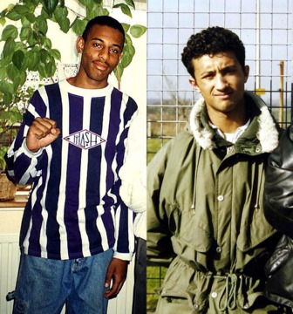
Figure 1 Stephen Lawrence (age 18), murdered by white racists in south London in 1993, and Zahid Mubarek (age 19), murdered in his cell in HMYOI Feltham in 2000 by his white cell-mate, a young man known to be violently racist and with mental health problems.
View description - Figure 1 Stephen Lawrence (age 18), murdered by white racists in south London in ...

The murders of Stephen Lawrence and Zahid Mubarek occurred in very different circumstances – one on a south London street, the other in a west London prison cell – but they have come to symbolise the lethal implications of racism and the need to mobilise against it in youth justice. The fact that they occurred at the end of the last century and start of a new one lays down a challenge to youth justice: can the twenty-first century do better than the twentieth?
The police, courts and prison system are very powerful institutions in society. With powers of arrest, the use of force and detention, they are uniquely able to intervene in your life whether you want them to or not. They also symbolise ideas about justice and fairness, equality and civil rights. If these institutions operate in ways that reproduce, or even amplify, racism, their credibility and legitimacy evaporates. Justice and racism cannot co-exist.
It was only the long, hard campaigning for a public inquiry into the police investigation of Stephen Lawrence’s murder, led by his mother and father, that culminated in the 1999 MacPherson Report and the identification of his murderers. In a historic breakthrough, the report established the significance of ‘institutional racism’ in the police and other institutions of society. Youth justice systems need to combat racism and be demonstrably sensitive to the shifting diversity of contemporary society.
This session begins with a short examination of racism and why racism and race continue to be a feature of life in the UK. This includes a brief discussion of the relevance of ethnicity. You will then go on to examine the legacies of Stephen Lawrence and Zahid Mubarek in youth justice before concluding with a short exploration of the underacknowledged positive contributions of Black, Asian and Minority Ethnic (BAME) young people to communities and cultures in the UK.

Video content is not available in this format.
Session 6 introduction
View transcript - Session 6 introduction

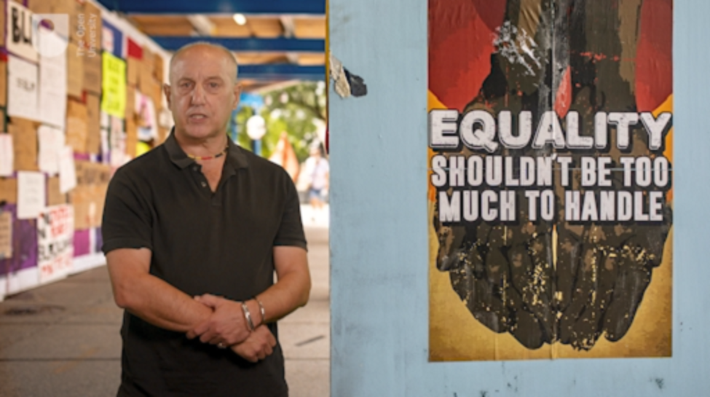

By the end of this session, you should be able to:
- identify ways in which racism, race and ethnicity are significant to youth justice
- understand how and why young people with Black, Asian and Minority Ethnic (BAME) backgrounds may experience crime and justice issues differently from young white people
- recognise when and how these differences are significant and what is being done to address them.

1 Why race and racism matters

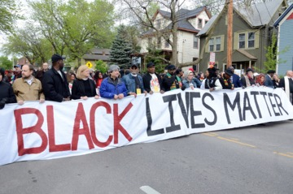
Figure 2 Black Lives Matter is a campaign, originating in the USA, against racism.
View description - Figure 2 Black Lives Matter is a campaign, originating in the USA, against racis ...

What are we talking about when we talk about racism and why does it matter? Racism may seem to be a simple concept that is widely understood to be abhorrent, but it remains a powerful feature of society, shaping everyday experience for white people and people of colour.
Oddly though, it seems to be everywhere and nowhere and, depending on whether you are white or not, you are more likely to believe it is one or the other (Eddo-Lodge, 2018). As Priyamvada Gopal (2019) puts it ‘people believe that not “seeing” race, or being “colour-blind”, is progressive when it is merely evasive’.
The idea that there are several different races has been discredited but the implications of there being only one race, with no racial hierarchy – the human race – have not been dealt with (Neiman, 2019). The political system that placed ‘the white race’ above all other so-called races remains largely intact and race remains a central organising feature of modern society. Although the extremes of European racism and nationalism that thrived as fascism in the middle of the twentieth century was defeated in 1945, the broader political matrix from which it emerged survives (Valluvan, 2019). It shapes educational opportunities for young people, and affects labour markets, housing choices and attitudes to sport. Race influences our ideas about crime, criminals, mental health, madness, music and leisure. And these ideas have consequences. In the UK, according to Anoop Nayak:

Black Caribbean pupils are more than three times more likely to be permanently excluded than the school population as a whole; those who identify as Black or Black British are four times more likely to be stopped by the police than their white counterparts; and in 2016 for young people aged between 16 and 24 years, the White ethnic group had the lowest unemployment rate of 12 per cent, a figure which more than doubles when it comes to youth of Black (25 per cent) and Bangladeshi/Pakistani (28 per cent) backgrounds respectively. What these figures, and many more besides impart, is that while race may be a discredited concept it still structures society.
(Nayak, 2018)

Few people will openly defend racism but many people continue to misunderstand and underestimate it. They see racism as a personal moral failing or misplaced belief in a discredited concept. These perceptions may be part of the story but race and racism are structural features of our society and the world economy, established and entrenched over the last 300–400 years. They are not just failings of an individual character, and race has never relied on science to be believed as real.

1.1 What about ethnicity?

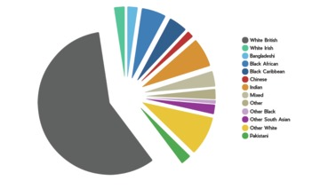
Figure 3 Organisations may collect data on people’s ethnicity to help monitor fairness.
View description - Figure 3 Organisations may collect data on people’s ethnicity to help monitor fa ...

Because race has been discredited as a scientific categorisation of human differences and has such a violent legacy, the terms ‘ethnicity’ and ‘ethnic groups’ have become more widely used. Although ethnicity and race mean different things, they remain tangled together. The key difference is that ethnicity is not a hierarchical concept. It avoids the issues of purity and superiority bound up in the idea and history of race. Ethnicity refers to the collection of cultural, historical, physiological, religious, linguistic, national, regional and local characteristics that bind people into groups who share various features of those characteristics. It is a looser and less rigid concept, and from it comes the related concept of ‘ethnic diversity’.
Everyone has a past and places in the world that shape their life and their prospects. The concept of multiple ethnicities and ethnic diversity is an attempt to come to terms with these inevitable differences in human life but they still remain ‘labels’ that tend to be fixed by the powerful on the less powerful. Because recording ethnic identity is a feature of youth justice practice, this first activity invites you to reflect on these issues.

Activity 1 Ethnicity or race: it’s not black or white
Allow approximately 10 minutes for this activity

How do you describe your ethnicity?

Provide your answer...

Who asks you to describe your ethnicity?

Provide your answer...

What words work in describing ethnicity?

Provide your answer...
View discussion - Part

It is easy to get bogged down in the differences and intricacies of ethnicity and to forget that often it is a power struggle that decides who is doing the counting and categorising, what is counted and what it is counted for. For children and young people, it can be through schools or health services that they become aware of an official ethnic category. For some, it is the police who these young people find recording their ethnicity and insisting on the significance of the words used to describe their sense of belonging or their identity. Since the 1970s the police have used the 6+1 IC (Identity Codes) formula to describe the perceived or apparent ethnicity of suspects or other people they interact with. The 6+1 IC formula comprises the following categories that are not recognised ethnicities but are used as provisional features of identification:
- IC1 White Nordic – north European
- IC2 ‘White south European’
- IC3 ‘Black’ – Sub-Saharan African or African-Caribbean
- IC4 ‘Asian’
- IC5 ‘Oriental’
- IC6 ‘Arabic’
- IC9 Unknown
Now you have spent a bit time and effort exploring these fundamental background issues, it’s time to move into the youth justice system itself.

2 Injustice and youth justice
You will now explore the ways in which race, racism and ethnicity shape young people’s experience of youth justice, crime, policing and punishment. Young people from a Black, Asian and Minority Ethnic (BAME) background constitute a small minority (approximately 14 per cent) of the wider UK population (Lammy, 2017). However, their disproportionate presence in youth justice systems has undermined confidence in the system and increased concerns about the persistence of racism in the UK.

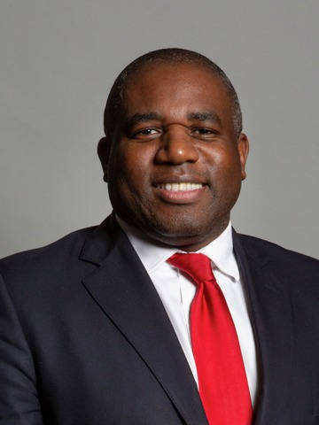
Figure 4 David Lammy, MP for Tottenham in London (at time of writing). His 2017 review of Black, Asian and Minority Ethnic (BAME) representation in the criminal justice system has become a landmark report.
View description - Figure 4 David Lammy, MP for Tottenham in London (at time of writing). His 2017 review ...

In 2017 a Ministry of Justice analysis of youth custody revealed that young black people were nine times more likely to be locked up in England and Wales than young white people. In custody the proportion of young men from BAME backgrounds was approaching 50 per cent and the general reduction of the numbers of children and young people in youth custody was a long way from being equally distributed across ethnic groups.

Activity 2 The Lammy Review
Allow approximately 5 minutes for this activity

Watch this video of David Lammy MP speaking to a Parliamentary Committee on his concerns about race.

Video content is not available in this format.
Video 1
View transcript - Video 1

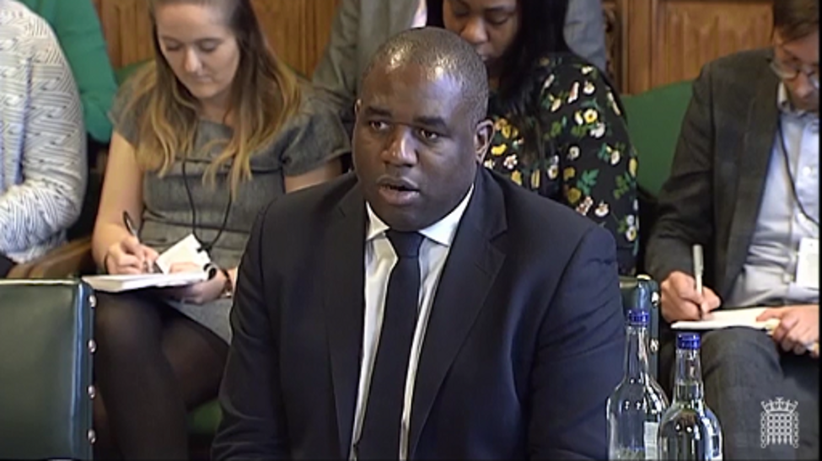

Lammy mentions that there has been activity in response to his review but he is worried that it may not result in better outcomes, and that things have actually got worse.
Make a list of some outcomes you can think of that would suggest to you that things are getting better (for example, ‘fewer BAME young people being sent to prison’).

Provide your answer...
View discussion - Activity 2 The Lammy Review

David Lammy MP was prompted into action by nearly a decade of improving outcomes for white children and young people in youth justice while there was a deterioration in outcomes for BAME children. For example, a general decline in the number of arrests of young people by the police in England and Wales in 2016 was widely welcomed. However, the figures also revealed, of the 88,000 child arrests made in 2016, BAME children accounted for 26 per cent of them (Howard League, 2017). Even more worrying was evidence that more than a third (36 per cent) of children detained overnight in police cells in England were from BAME backgrounds (CRAE, 2017).
The Lammy Review has quickly become the reference point for people researching the effects of race and racism in the youth justice system. The next activity gives you an opportunity to become more familiar with this research.

Activity 3 Arresting figures to make you stop and think
Allow approximately 25 minutes for this activity

Read this 2017 press release from the Howard League for Penal Reform. Then answer the three questions below.
- What principle did the Lammy Review call for once ethnic difference became apparent in criminal justice data?

a) Be firm and fair
b) Explain or reform
c) Non-discrimination
d) Transparency
View answer - Part

- For each of these three police forces, match:
  - the proportion of BAME people within the general population for their area, and
  - the proportion of BAME young people arrested in their area.

Arrests 60%; GP 40%
Arrests 42%; GP 23%
Arrests 41%; GP 30%
Metropolitan police
Bedfordshire
West Midlands Police
View answer - Part

- Which police force failed to provide any ethnicity figures at all?

Cumbria
Norfolk
Thames Valley
View answer - Part
View discussion - Part

The evidence of disproportionality is presented in numbers that are important but do little to reflect the complex realities of life. The experience of unfairness and prejudice for children and young people can have long lasting effects. Each small episode of being made to feel different, less worthy of respect, or of being likely to behave in a certain kind of way because of your ethnicity or by white people’s reactions to you conditioned by racism, can build up over a child’s life. These small injuries or ‘microaggressions’, as they are sometimes called, may amount to confusing feelings as a child tries to make sense of their life and grow into adulthood. This is sometimes a lonely and isolating experience, but it often becomes something more.
As children grow and explore their potential, their common experiences and feelings, peer groups and collective activity become more important to their lives. Pushing boundaries, exploring possibilities and stretching limits can result in troubles with the law and law enforcement. It can involve harmful behaviour, cruelty and worse. All too often for young people from black and minority ethnic backgrounds, when these lead to conflicts with law enforcement, these actions come to define them in the media and wider cultures. The almost automatic assumption within majority white ethnic groups that ‘black means trouble’ is widespread and influential. This is an injustice with far-reaching consequences.

3 Youth, sub-cultures and resistance

Figure 5
View description - Figure 5

Since the end of the Second World War in 1945, youth sub-cultures have been significant features of society in the UK. You can probably think of some. There were Teddy Boys in the 1950s, then Mods, Skinheads, Hippies, Punks and Ravers in the 1960s, 70s, 80s and 90s. Most of these sub-cultures were largely composed of young white people. In the Noughties (2000s), the Grime scene, originating amid London’s black communities but spreading quickly across the UK, became influential. In 2012, the London Olympics opening ceremony featured Dizzee Rascal, a young black man from south London’s Grime scene. Dizzee Rascal’s ‘Sirens’ is an evocative account of his interactions with the police as a younger man. Like many of his predecessors, he has recorded music that tells his story and it is one in which the police, race, racism and resistance have always been a significant feature. His songs are stories but they are based on reality. This continues today, with young black men like Stormzy, Slowthai and Dave making the transition from sub-cultural legend to wider national recognition.
The following activity invites you to find and listen to and consider some of the contributions of youthful black artists to popular culture.

Activity 4 Voices of experience, musical truth
Allow approximately 20 minutes for this activity

Use an internet search engine to find and listen to performances of any or all of the following. Use the artist’s name and song title as a search terms:
- Peter Tosh – Here Comes the Judge
- Smiley culture – Cockney translation
- Linton Kwesi Johnson – Sonny’s lettah
- Benjamin Zephaniah – Dis Policeman Keeps On Kicking Me to Death
- Dave – Black
- Macka B – We’ve had enough
- Dizzee Rascal – Sirens
- KRS1 – Sound of da police
- P Money – Stereotype
If you can think of other songs on a similar theme, write them down here.

Provide your answer...
View discussion - Activity 4 Voices of experience, musical truth

4 New generations, new voices
In the early 1980s, there were relatively few academics from black and minority ethnic backgrounds writing about young people and crime. If you were young and black and in trouble, you were more likely to be written about and studied ‘as a social problem’ by white academics. Paul Gilroy’s (1987) landmark study ‘Ain’t no Black in the Union Jack’ focused on racism and nationalism rather than young people or crime, but it begins with how the issue was raised at the start of the twentieth century by the black American sociologist W.E.B. Du Bois (pronounced so it rhymes with ‘noise’). Du Bois said that wherever he went he encountered white people with a question on their lips:

Between me and the other world there is ever an unasked question: unasked by some through feelings of delicacy; by others through the difficulty of rightly framing it. All, nevertheless, flutter round it. They approach me in a half-hesitant sort of way, eye me curiously or compassionately, and then, instead of saying directly, How does it feel to be a problem? they say, I know an excellent colored man in my town; … or, Do not these Southern outrages make your blood boil? At these I smile, or am interested, or reduce the boiling to a simmer, as the occasion may require. To the real question, How does it feel to be a problem? I answer seldom a word.
(Du Bois, 1903)

Black and minority ethnic academics in the UK like Kehinde Andrews, Claire Alexander, David Olusoga, Coretta Phillips, Monish Bhatia, Anthony Gunter, Yasmin Gunaratnam, Craig Pinkney and Waqas Tufail, to name just a few, are now making sure that Du Bois’s question is both asked and challenged. In the next activity you can see some of it in action.

Activity 5 Speaking youth to justice
Allow approximately 10 minutes for this activity

In this video Craig Pinkney talks about his ideas of using youth work to tackle some of the issues facing young people in the West Midlands.

Video content is not available in this format.
Video 2
View transcript - Video 2

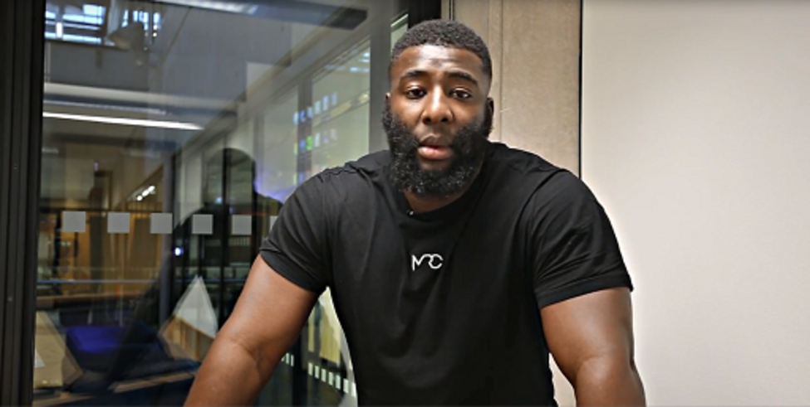

The link referred to at the end of the video is this: ‘On Road’ Youth Work: Inside England’s gun crime capital.
When you’ve watched the video, complete the following sentence:

‘On road’ youth work offers services to young people outside conventional working hours because…
View discussion - Activity 5 Speaking youth to justice

5 Islamophobia and racism
At the beginning of this session you saw that race and racism are both widely condemned but poorly understood. This is because race is now largely dismissed as a fake biological category with no real substance, and without ‘race’, it is sometimes argued, there can be no racism. However, as the US writer Ta-Nehisi Coates (2015) clarifies ‘Race is the child of racism not the father’. The sociological explanation is that race is ‘socially constructed’, a product of our making rather than a scientific category.
However, religion has increasingly come to take the place of biology in that process of construction and justification. Islam and Muslims are the ‘new black’, the new aliens who cannot be part of ‘us’, when ‘us’ means ‘the white majority’ or ‘the civilised world’. The next activity provides an opportunity to look into what has come to be called ‘Islamophobia’ and youth justice.

Activity 6 Islam, racism and young people
Allow approximately 10 minutes for this activity

Read the Foreword (p. 2) to the 2016 report Young Muslims on Trial by Baroness Lola Young. Make some reflective notes on what Baroness Young says about ‘throwaway remarks’ and stereotyping and why these issues might have implications for youth justice.

Provide your answer...
View discussion - Activity 6 Islam, racism and young people

6 This session’s quiz
Well done – you have reached the end of Session 6. You can now check what you’ve learned this session by taking the end-of-session quiz.
Session 6 practice quiz
Open the quiz in a new tab or window by holding down Ctrl (or Cmd on a Mac) when you click on the link. Return here when you have finished.

7 Summary of Session 6
Racism has always involved a complex blend of white cultural arrogance, political opportunism, religious sentiment, violence and brutality. The focus on science providing a justification, or an alibi, for racism has declined since the defeat of fascism in Europe and the full exposure of Nazi atrocities.
Increasingly, religion and nationalism are taking its place as justifications for separation and differences. Children and young people with diverse Muslim backgrounds feel the force of these new forms of racism.
The family of Stephen Lawrence campaigned to expose the racism that crippled the police investigation into his murder, changing forever the way in which relations between policing and black people could be talked about. In 2018, the Zahid Mubarek Trust won the Criminal Justice Alliance Outstanding Organisation award for its work offering advocacy and support to prisoners and their families.
In youth justice there can be no room for complacency that racism is a marginal issue or the business of ethnic minorities. Everyone has an ethnicity, but the relative position in terms of majority and minority, power and influence, are shaped by racism. Racism is a deadly and corrupting force that cannot coexist with any system of justice, least of all youth justice. Anyone and everyone interested in working in youth justice must equip themselves to oppose racism. This session has been designed with that in mind and now you have completed it you should feel more confident in delivering on Baroness Young’s call for urgent, in-depth and nuanced responses to racism.
The main learning points of the sixth session are:
- Racism must be challenged in youth justice and elsewhere.
- To challenge racism effectively it must be understood as a dynamic, changing feature of contemporary society, not a discredited relic of the past.
- Children and young people from Black, Asian and Minority Ethnic backgrounds suffer from being seen as ‘problem’ populations.
- Ethnicity and ethnic monitoring can provide insights into and evidence of racist discrimination and patterns of provision in youth justice.
Although race and ethnicity are recognised as categories that shape experience, processes and outcomes in youth justice, another factor – often less readily recognised but no less impactful – is social class. You will explore this in the next session.
You can now go to Session 7.

Session 7: It’s all about class

Introduction

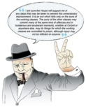
Figure 1 War time prime minister and British national icon Winston Churchill expresses his point of view on the imprisonment of the working classes.
View description - Figure 1 War time prime minister and British national icon Winston Churchill expresses ...

The social class a child is born into, and their parents’ level of education and health, are major determinants of their life chances (Dorling, 2018). Winston Churchill, like many white people of aristocratic background who feel safe in their elevated position in society, was sharply aware of the class structure of society, but less prone to deny its existence and effects than the generations of Conservative MPs that have followed. He enthusiastically defended its hierarchies and was a self-confessed white supremacist (Valluvan, 2019), but his unfiltered insights on the dynamics of the class system in the UK still ring true today at the start of the twenty-first century.
Churchill probably had in mind behaviour influenced by alcohol, perhaps contrasting beer-fuelled behaviour against the antics of a few champagne-drenched university graduates (Rutherford, 2002). These class contrasts remain, though the differences today are as likely to be between crack and cocaine as between beer and champagne. At least two Conservative Party government ministers confessed in 2019 to taking cocaine but have not been prosecuted while youth prisons are full of young men whose behaviour was propelled by crack or heroine dependency, or the rewards of trading in its illicit markets.
In this session, the learning activities focus on how a young person’s class background shapes their experience of crime and criminal justice.

Video content is not available in this format.
Session 7 introduction
View transcript - Session 7 introduction

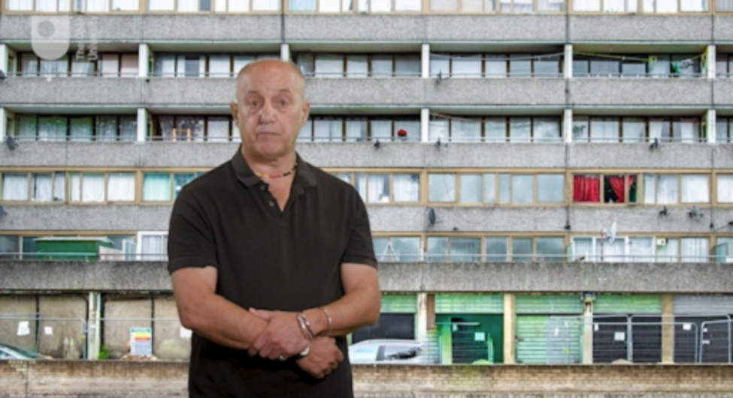

By the end of this session, you should be able to:
- identify ways in which poverty and social class influence young people’s experiences of crime and criminal justice
- recognise how the dynamics of social class operate in the youth justice system and what is being done to address them
- understand how economic inequality impacts on youth justice issues.

1 Poverty and class disadvantage
Poverty and class-based inequality influence a young person’s physical and mental health, their educational prospects and their chances of employment. In the UK, as elsewhere, social classes are separated by inequalities of wealth and income. These, in turn, impact on the likelihood of a child or young person becoming a victim or a perpetrator of crime. Poverty is not a passive, background issue but an aggressive one that actively steers children and young people towards personally limiting and socially destructive outcomes.
In the UK in 2017–18:
- an estimated 14.3 million people lived in poverty
- one in every 100 children were homeless at any one time
- £6 billion was cut from social care
- 5.4 million people earned below the living wage (£9.30 per hour in 2019).
In 2014, 15,000 people died because they couldn’t afford to heat their homes (Cooper and Whyte, 2017).

Figure 2
View description - Figure 2

All too often interventions are focused on the children and young people who are poor, rather than focused on the poverty that generates the need for intervention. The children and young people come to be seen as the problem, not the poverty. Although the intentions of such interventions are usually well-meaning and benign, their effect is to generate and reinforce ideas about working class children and young people as objects of policy, unfortunately requiring help and guidance to help them live within their ‘narrow’ means. They are seen as ‘problems’, deficient in various ways, dependent on financial support, a liability to the economy and a potential threat to the stability of society.
The relentless focus on the behaviour and apparent ‘immorality’ of working class children and young people is a constant feature of British history (Pearson, 1983). They are sometimes referred to as ‘the criminal classes’ but the evidence from criminological research is that all occupational groups, all social classes commit crime. Some argue that ‘most serious crimes … can be located in power, not weakness, in privilege not disadvantage, in wealth not poverty’ (Box, 1983, p. 3).
Children, because they are young and relatively powerless, often bear the brunt of the effects of poverty. Growing up poor means you are more likely to suffer debilitating health conditions. Low birth weight, developmental delay, obesity, mental health difficulties, physical injury, teenage pregnancy, acute respiratory infection, and poor linear growth are pervasive, cumulative in effect and life limiting in outcome. A study by the Youth Justice Trust discovered that 90 per cent of the Youth Offending Team case files on young people in their survey had ‘significant experience of loss or bereavement, or the onset of mental illness or physical disability for a parent’ (YJT, 2003). Since then there has been slowly increasing recognition that young people’s experiences of grief, trauma, loss and distress need to be more widely acknowledged. The next two activities offer you an insight into this.

Activity 1 Adverse childhood experiences (ACEs)
Allow approximately 10 minutes for this activity

Watch the following video which was developed to raise awareness of adverse childhood experiences (ACEs) and their potential to propel children into criminal justice systems.

Video content is not available in this format.
Video 1
View transcript - Video 1

View discussion - Activity 1 Adverse childhood experiences (ACEs)

The next activity provides some further insights into how the trauma-informed approach is taking shape in youth justice.

Activity 2 Trauma-informed youth justice
Allow approximately 25 minutes for this activity

Read the ‘In Brief’ (first two-pages) of the guide to trauma-informed practice in youth justice produced for practitioners by the Youth Justice Board.
Summary of trauma-informed youth justice
When you’ve finished, make a note of two things you feel you’ve learned from reading the summary.

Provide your answer...
View discussion - Activity 2 Trauma-informed youth justice

2 Ghostbusters on the estate – a case study

Figure 3
View description - Figure 3

Read the following case study in which you meet Charlie, a young white boy who has started to engage in criminal activity.

Charlie is 12 years old and a bit below average height. Although he can barely reach the pedals of a car, this hasn’t prevented him developing a reputation on his estate he could do without. Charlie is called ‘the ghost driver’ because older friends and relatives steal cars and he drives them.
Standing in front of the car seat or perched on its edge, Charlie operates the pedals while standing at the steering wheel he can barely see above. He changes gears with a gear shift he can barely reach and is almost invisible to other drivers, hence his nick name. The ghost driver.
Stolen cars are brought into the estate where he lives by older youths and he gets in to drive them around the more traffic-heavy streets of the town centre. His passengers delight in the stares the apparently driverless vehicle attracts from pedestrians and other drivers. Until, eventually, the police are alerted and the chase is on. The more experienced ‘escape driver’ takes over with the intention of getting back safely to the estate where the objective is to abandon the car and disappear before being stopped. In the car, and on the estate, the ‘Ghostbusters’ theme tune is sung loudly and with relish. The estate community seems to warm to the attention and notoriety that develops around Charlie.

Activity 3 What can possibly go wrong …?
Allow approximately 10 minutes for this activity

In the box below, sketch out in words what might go wrong for Charlie if he continues with his current behaviour.

Provide your answer...
View discussion - Activity 3 What can possibly go wrong …?

The next activity extends your consideration of Charlie’s circumstances by asking you to consider how they may vary according to where he lives and which of the youth justice systems of the UK are likely to be involved with him.

Activity 4 Differences and decisions
Allow approximately 20 minutes

Imagine Charlie has been caught, following the intervention of a police patrol car. No one has been injured, but on stopping the car the police quickly establish it is a stolen vehicle. Charlie was not at the wheel. In the boxes below, briefly write out what might happen to Charlie according to where he lives, based on what you have already learned in this course. Choose any two of the four possible jurisdictions – Scotland, England, Wales or Northern Ireland – and don’t forget to state which ones you have chosen in your responses.

Jurisdiction 1: Jurisdiction 2:
View discussion - Activity 4 Differences and decisions

3 Class: intersections, contexts and convictions
Charlie’s life may take a number of different turns. Some of those will be shaped by the interventions from the systems responding to his problematic and harmful behaviour. A case study like this inevitably focuses on an individual, and while Charlie’s future is going to be shaped by his actions, the range of possibilities open to him is powerfully shaped by where he lives, why he lives there and the institutions and services available to him. These social circumstances can easily slip out of view if he is the only object of concern.
Social expectations of gender may have pushed him towards cars and driving, and the peer group he associates with. His ethnicity and race relations in his locality will also have shaped his early life. Charlie’s class background will have helped to determine the school he went to, the food and health services available to him as an infant, the home he was raised in and the horizons in front of him.
The social profile of ‘young offenders’ in each of the four jurisdiction of the UK, and most other industrialised countries, tend to look the same. They are likely to be from low-income households, have low levels of educational attainment and/or be in low paid employment or unemployed. Typically, a young person’s class situation is recognisable from their geographical location in terms of housing, the capacity of their parent/s to provide material support, the type of school they attend (private or state) and the kind of employment or labour market opportunities they are likely to find. Class-based inequalities are deeply entrenched in each and every part of the UK creating structural disadvantages and different opportunities that shape the lived experience of someone like Charlie. Youth justice services tend not to be focused on these determining contexts but on the individuals presented to them by the priorities of criminal justice. As important as these services may be, they fail when they become dislocated from actions, policies and practice promoting social justice.
The remaining activities in this session explore how criminal justice works around agendas that might make problems worse rather than better for young people.

4 Drugs, knives, county lines and fast lanes

Figure 4
View description - Figure 4

The term ‘county lines’ has become familiar to those in youth justice and other professions, as well as to volunteers who work with young people. It refers to the way people involved in dealing illegal drugs, sometimes in organised gangs, expand their operations from the centres of big cities to smaller towns. Dedicated mobile telephone lines may be used to organise a network of longer supply chains that go beyond the conventional city limits of the established dealer.
Delivery and distribution sometimes involve exploiting young people, especially those who are vulnerable and exposed in the care system. These young people may be subject to ‘grooming’ techniques involving cash or other material rewards. ‘Benefits’ in terms of prestige among a peer group and access to particular lifestyles are pushed by the organising groups, who are often older individuals and never operating in the best interests of the child.
As with other types of illicit activity, the county lines phenomenon has developed its own distinctive vocabulary of words and phrases. The next activity introduces you to some of the terminology associated with ‘county lines’.

Activity 5 Know the right words
Allow approximately 10 minutes for this activity

Drag the correct definition to match the terminology associated with ‘county lines’.

This term is used when drug gangs take over the home of a vulnerable person to use their house or flat as the base for their drug operation. The gangs exploit the person’s vulnerabilities using violence and intimidation or some other form of manipulation.
The general term that covers the county lines activity. It refers to anything involved in establishing the county line, such as travelling to the towns or around them and the manufacture or packaging of drugs.
The slang term for the transactions, dealing or distribution of drugs to the town or in the town.
A building or flat used as the base for the county lines operation in a town or city. Drugs may be bought and sold there, manufactured or packaged or distributed to the network of sellers.
Cuckooing
Going county
Trapping
Trap house
View answer - Activity 5 Know the right words
View discussion - Activity 5 Know the right words

Drugs, crime and young people are commonly linked but some of the social relations that connect them are often forged in other places such as Parliament. This is what is explored in the final section of this session.

5 Changing the questions?
Winston Churchill, who featured at the beginning of this session, appears to have taken a fairly relaxed attitude to the dangers of substance abuse, perhaps because he was notorious for indulging heavily himself in excessive drinking. This legal drug taking was culturally approved and acceptable.
Even so, many Parliamentary careers and personal relationships have been undone by alcohol dependency. Research evidence suggests drug abuse (legal and illegal) and violence often go hand in hand, but Churchill’s remarks about tolerance are drawn from the contexts of his own consumption (Jack, 2017).
His own drinking while in the House of Commons, ‘at work’ and elsewhere, was within the law and any adverse social consequences were made manageable, or excused, by the enormous wealth, power and financial resources that surrounded him (Knight, 2008). Churchill knew, however, that the drunken or anti-social behaviour of a young working-class man was more likely to be handled by police intervention, prosecution and probably prison. There is a certain amount of truth in his evaluation that the background (social class) of the perpetrators determined the way they were dealt with, and the consequences. The criminalisation of the activity for one class of person had serious and lasting consequences, while the tolerance and informal sanctions of the other (for people like Churchill) produced less harmful and less lasting consequences.
In the final activity of this session, you will reconsider some of the implications of Winston Churchill’s evaluation by means of a challenging argument around drugs and young people.

Activity 6 Legalise and regulate or criminalise and marginalise?
Allow approximately 20 minutes for this activity

Read this 2019 blog by Keir Irwin-Rogers about his research looking into young people, drugs and crime. Then answer the two questions below.
Illicit drug markets and the exploitation and criminalisation of young people
1. What methods did Dr Irwin-Rogers use to find out about young people and drugs? Select all that apply:

a. police arrest data
b. court records
c. social media platforms
d. interviews and focus groups with young people
e. large scale surveys of the neighbourhood
f. database of photos and videos
View answer - Part

2. Dr Irwin-Rogers suggests a solution could be to:

a. impose harsher sentences for possession and supply
b. create more alternative community sentences that keep people out of prison
c. legalise and regulate drug markets
View answer - Part
View discussion - Part

6 Class acts
Winston Churchill was proud to be a representative of the British class system, and the political party he led (the Conservatives) has resisted many attempts to dismantle it, with varying degrees of success (Wayne, 2018; Williams, 1983).
Poverty is sometimes regarded as natural and inevitable. Christian teaching can be used to make the point – ‘the poor you will always have with you’ is attributed to Jesus (John 12:8; Matthew 26:11) – but child poverty is far from natural and varies across time and between countries, according to different political priorities of government.
Child poverty in the UK has increased dramatically since 2010 because of the imposition of austerity policies, prompted by the global financial crisis. The Institute of Fiscal Studies estimates that, unless these policies change, 37 per cent of children will be living in poverty by 2022 (Ryan, 2019). Youth justice systems will almost inevitably focus on the actions of some of the children and young people who make up this percentage, whatever it turns out to be. Reducing poverty may not be the principal aim of any youth justice system but, if it is not part of a broader strategy of social justice, its prospects for success will be limited.

7 This session’s quiz
Well done – you have reached the end of Session 7. You can now check what you’ve learned this session by taking the end-of-session quiz.
Session 7 practice quiz
Open the quiz in a new tab or window by holding down Ctrl (or Cmd on a Mac) when you click on the link. Return here when you have finished.

8 Summary of Session 7
The previous two sessions looked at the way gender and race are powerful forces shaping young people’s experience of crime and youth justice. Neither operate independently of each other and both are always tangled up with social class. The learning activities in this session have explored how what happens in a young person’s life may be influenced by their parents’ level of income, wealth and education. The range of possibilities available to them, the choices they are likely to make and the future they grow into, are determined by the social structures of society. Each child and young person makes what they can out of those opportunities and choices, but ignoring the differences available to those at the top of this hierarchy and those at the bottom reproduces injustice. Winston Churchill was honest enough to speak clearly about them, as the quote at the beginning of the session indicates. Times have changed since then and a new century is unfolding. The next and final session looks forward to what this might mean for youth justice.
The main learning points of this seventh session are:
- The issue of structural disadvantage and poverty are central to young people’s crime and offending.
- Social class determines the advantages and disadvantages a child is born with.
- Growing up in poverty increases the likelihood of trauma and its consequences being experienced over the life course.
- Structural disadvantage is not the focus of the youth justice system, but many of its consequences are.
In the next and final session, you will consider in more detail the principles that might guide youth justice towards social justice, and you will encounter an even more radical approach to young people and crime.
You can now go to Session 8.

Session 8: Youth justice with integrity

Introduction

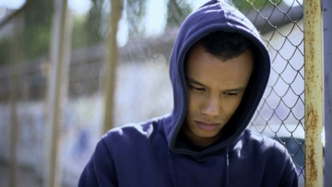
Figure 1
View description - Figure 1

In this final session, you will explore how youth justice in the UK can resist the recurring pressures of ‘toughness’ and remain creative, diverse and principled. You will consider four guiding principles for assessing the integrity of youth justice in an unjust world. These are principles that draw implicitly and explicitly from what you have learned about in earlier sessions of this course.
The four principles are informed by an appreciation of the social dynamics of race, class and gender shaping youth justice and their potential to influence ideas about, and responses to, crime and offending behaviour. The diverse forms of youth justice practice in the UK feed into wider concerns to promote social justice by developing practice and policy based around principles that empower children and defend their rights.
The four principles are:
- Social and economic justice for youth justice
- Comprehensiveness, universality and social engagement
- Diversion
- Child-appropriate justice
You will explore and examine each of these principles in this session.
Establishing the importance of basic and guiding principles is central to youth justice with integrity (Goldson and Muncie, 2008). ‘Integrity’ in this context means forms of policy and practice with young people that observe and uphold principles of fairness and human equality, respect the rights of children and celebrate human diversity.

Video content is not available in this format.
Session 8 introduction
View transcript - Session 8 introduction

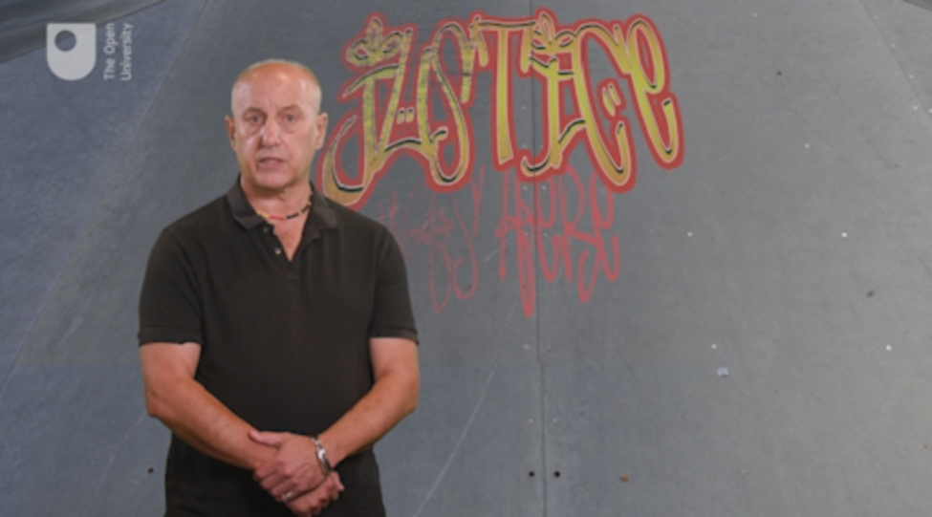

By the end of this session, you should be able to:
- identify ways in which the four principles of youth justice with integrity are relevant in the UK
- recognise how the four principles underpin youth justice in a changing world
- understand the relevance of children’s rights to youth justice
- recognise the limitations of youth justice and the value of diversion.

1 Why social and economic justice?

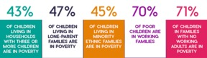
Figure 2 The data tells a story about social class (figures from CPAG, 2018).
View description - Figure 2 The data tells a story about social class (figures from CPAG, 2018).

The first of the four principles you will look at is ‘social and economic justice for youth justice’.
There are youth justice systems in most structures of government and all the countries of Europe have distinctive responses to young people’s offending behaviour. Each of the four jurisdictions of the UK has developed approaches that reflect their history and contemporary ideas about children, crime and punishment.
Many people involved in these systems – the people who work in youth courts, Children’s Hearings panels or Restorative Conferences – would tell you that the children they see most frequently are the children of people who are poor, and who are poor themselves. This is consistent with research evidence that correlates the identification of offending behaviour with high rates of child poverty, social and economic marginality and other forms of social hardship (Muncie, 2014; Yates, 2010). Those children and young people who attract intervention from the police are mostly located in neighbourhoods and communities worn thin by poverty.
Families and children under the pressures of limited domestic space and scarce social or financial resources are often let down by education and other services. Youth justice services that seek to engage positively with children who have committed crimes inevitably find themselves responding to family discord, drug and alcohol problems, school exclusions, physical, mental and emotional health issues, sexual and physical abuse, neglect, isolation, bullying and unemployment. A child or young person’s criminal offending is often the tip of an iceberg that the limited range of resources available to a youth justice team are inadequate to address. In addition, legal principles of proportionate punishment and deterrence rarely sit neatly with a child’s need for care and welfare.
The social and economic circumstances of young people are the focus of the first activity because they are the context for any and all youth justice work.

Activity 1 Lazy, idle snowflakes or hard times for the young?
Allow approximately 20 minutes for this activity

Read this 2019 article by Edward Yates of the University of Sheffield which outlines the economic predicaments faced by young people.
How Britain’s economy has wronged young people for decades
The article refers to ‘three solutions’. Complete the following statements based on the article’s recommendations and analysis:

Interactive content is not available in this format.

View discussion - Activity 1 Lazy, idle snowflakes or hard times for the young?

The first principle guides youth justice practice towards seeing young people not as problems to be solved but as people whose social and economic conditions generate anti-social behaviour. It encourages a focus on these conditions and how they determine the contexts in which young people live and grow to adulthood, and how they might be changed.

2 Why comprehensive, universal and socially engaging?
The second of the four principles that underpin youth justice with integrity is ‘comprehensiveness, universality and social engagement’. Comprehensive, universal and engaging services are based on the belief that people are entitled to decent living standards regardless of the circumstances into which they are born and without the need to undergo assessment.
Services that support young people need to be comprehensive, universal and engaging because the lesson of history throughout the nineteenth and twentieth centuries is that the alternatives – selective and means-tested support – exclude those deemed undeserving or unworthy (Goldson and Muncie, 2008; Muncie, 2014).
Making divisions between the ‘deserving’ and ‘undeserving’ poor has been a recurring feature of government policy toward families living in poverty throughout the nineteenth and twentieth centuries. Deciding who is deserving and who is not requires the establishment of elaborate qualifying and disqualifying criteria and a mechanism for testing those criteria. These become costly, demeaning and divisive. Resentment, conflict and distress are the outcomes (Hopkins Burke, 2016).
Holistic, universal services that meet the needs of all children in society, safeguard their interests and promote the wellbeing of all young people builds social belonging, solidarity and co-dependence. Families and children need good social infrastructure in order to thrive and these should include leisure and recreational facilities for young people, adequate health and education services, decent schools with stimulating, diverse and flexible curricula, proper training and good job opportunities. Resourcing generic youth support around these services is an effective way of preventing the escalation of socially and personally destructive behaviour, such as crime (Montgomery and Robb, 2018).

Activity 2 A promise to be kept, a promise to be made?
Allow approximately 20 minutes for this activity

The National Youth Agency launched a manifesto in 2019 featuring five elements they see as crucial to creating new hope and possibilities for young people.
1. Take a look at the description of the five elements of the manifesto in Figure 3.

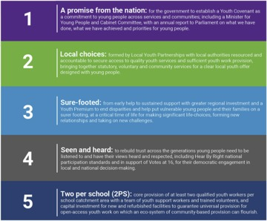
Figure 3 A manifesto for youth from the National Youth Agency.
View description - Figure 3 A manifesto for youth from the National Youth Agency.

2. Now read the more extensive account of Item 1 that explains why ‘a promise from the nation’ is proposed:
High 5 full manifesto

3. Once you have read the account of Item 1, complete the statement and answer the question below according to the proposal outlined in the manifesto.

Interactive content is not available in this format.

Provide your answer...
View discussion - Part

The next principle you will explore is based on the understanding that, despite good intentions, formal youth justice procedures frequently accelerate and intensify problematic behaviour. As a result, diversion from prosecution and criminal justice agencies are to be recommended.

3 Diversion
As the youth justice system grew in size and complexity in England and Wales after the ambitious reforms introduced by the 1998 Crime and Disorder Act, the numbers of young people sucked into the system mushroomed dramatically. The good intentions of delivering more consistent interventions based on research evidence developed into bad outcomes for many children. New custodial institutions had to be built and old ones expanded to hold the growing number of young people in custody.
Research evidence mounted up to show that contact with the criminal justice system was itself ‘criminogenic’ – that is, it created more crime. In contrast, diversionary practices – the third of our four principles underpinning youth justice integrity – that seek to point children and young people away from prosecution have been shown to have radically reduced the size of the youth custody population and the caseloads of youth justice staff. In the decade from 2007–8 to 2016–17 there was an 85 per cent reduction in the numbers of children entering the youth justice system. In the period from 2010–11, when austerity was introduced, to 2017–18 the annual budget of the Youth Justice Board fell by 72 per cent from £452.3 million to £126.6 million (Case and Haines, 2020). It seems that by reducing the machinery of youth justice by diverting children away to other services or declining to prosecute them, can have less harmful outcomes than maintaining a larger youth justice system.
Setting up comprehensive, universal and socially engaging support for children and young people, as proposed in the second principle, reinforces one of the most basic ‘facts of crime’, which is that most people grow out of it if they are given the chance. This isn’t to say offending and harmful behaviour should be ignored but that avoiding prosecution and encouraging social support is likely to be more effective. Lesley McAra’s (2015) study of young people in Edinburgh is one of the most methodologically robust studies of young people’s offending behaviour of recent times. It showed that 96 per cent of the 4,300 young people involved in the study reported committing a criminal offence between the ages of 11 and 24. Crime of one kind or another is normal among young people, but relatively short-lived for most of them. In her study, 56 per cent had desisted by the age of 18, and 90 per cent by the age of 24. Most of these children and young people had no contact with either formal criminal justice or welfare processes. They grew out of crime.

Activity 3 Diversion ahead
Allow 5 minutes

Below is an extract from the National Association of Youth Justice’s ‘Manifesto for Youth Justice’ (NAYJ, 2015). Some of the words have been removed from the statement supporting their proposal about diversion. Complete the sentences using the drop-down options.

Interactive content is not available in this format.

View discussion - Activity 3 Diversion ahead

The argument for diversion is based on evidence that while nearly all children commit some kind of crime at some stage in their young life, most will grow out of it and learn to know better (Goldson and Muncie, 2008; Muncie, 2014; Rutherford, 1987). Diversion does not mean that nothing is done when children behave badly or indulge in destructive and harmful behaviour. Diversion is based on the recognition that criminal justice and the criminal law are blunt and potentially harmful instruments to deal with such behaviour, and that other tools could and should be used. This is the kind of thinking and the kind of practice you look at next.

4 Child-appropriate justice
The fourth principle of youth justice with integrity is that justice should be child-appropriate.
Because the criminal law allocates responsibility to individuals who must be held accountable for their actions, prosecuting children and young people in criminal courts will always involve a degree of ‘adultification’ (Goldson and Muncie, 2008). This assumes a degree of adult independence and maturity which is inappropriate to childhood.
However, it is almost inevitable that there will be some very rare and very serious cases involving children, where some form of intervention by the criminal law is necessary – history has shown that children will sometimes kill or commit dreadful acts of violence. In accordance with the diversionary principle, it is recommended that as few children as possible should be taken down the route of criminal prosecution. If they are prosecuted, and they are convicted of a terrible crime, the intensity and duration of the intervention should be limited to the minimum necessary to offer positive outcomes for the injured parties, victims or their relatives as well as for the child concerned.
People who study youth justice are often invited to compare the tragic cases of James Bulger and Silje Redergåard. James Bulger was two years old when he was killed by two 10 year old boys in Liverpool, England in 1993, and Silje Redergård from Trondheim, Norway was killed in 1994 by two six year olds when she was five years old (James and MacDougall, 2010). The differences between the responses to these cases are illuminating and reveal that other possibilities and other routes through tragedy and violence can be found. You will examine this in the next activity.

Activity 4 Children, serious crime and punishment – or something else
Allow approximately 45 minutes for this activity

Read this article from the Guardian newspaper about what can be learned from the similarities and differences between the two cases. The article includes some upsetting details of the tragedies. If you are concerned these are likely trigger unsettling or unmanageable emotions, you may move to the next activity without reading the article.
When you’ve finished, ask yourself – as Silje’s mother does at the end of the article – which system is better, the Norwegian or the English? Make notes in the box and give your reasons.
The Norway town that forgave and forgot its child killers

Provide your answer...
View discussion - Activity 4 Children, serious crime and punishment – or something else

The four principles that are proposed here to constitute a youth justice system with integrity can also lead to a more radical proposal. You will look at this next, in the final section of this course.

5 Abolishing youth justice, championing children’s rights
The deflation of the youth justice system established in 1998 by the New Labour government in England and Wales has been dramatic and largely unplanned. The contraction of resources has been driven by austerity measures in the economy, and the deflation in the youth justice system has been driven by a collapse of faith in the efficacy of interventions it delivered.
A major review of the youth justice system conducted by Charles Taylor published its report in 2016. It advocates an approach prioritising ‘the child first and the offender second’ (Taylor, 2016, p. 3). The report proposed more diversion and the establishment of Children’s Panels to decide on interventions. It also recommended the establishment of a new form of education-focused secure institution to replace young offender institutions (YOIs). The report received a lukewarm response from a Conservative government disinclined to take radical, complex and potentially controversial steps to restructure the youth justice system while trying to negotiate the UK’s withdrawal from the European Union (Transform Justice, 2016).
The policy paralysis that accompanied the four years leading up to the formal ratification of Brexit in January 2020 has prompted louder calls for the complete abolition of the youth justice system (Case and Haines, 2020). What might this mean or look like? In the next activity you can take a closer look.

Activity 5 Community oriented justice
Allow approximately 15 minutes for this activity

As The Open University celebrated its 50th anniversary in 2019 (see Earle and Mehigan, 2019) some of its senior academics were invited to present lectures that reflected their understanding of and contributions to contemporary issues. Professor Jo Phoenix chose to talk about youth crime and the youth justice system. This has been a focus of her work as a social scientist for over 30 years. In her lecture she reviewed some of the issues that have been explored in this course and ended her presentation with a call for alternatives, daring alternatives developed in the bold tradition of The Open University itself. Established in 1969, The Open University broke with the elitism and exclusivity of the conventional university system and adopted a mission ‘to be open to people, places, methods and ideas’. Listen to the final section of Professor Jo Phoenix’s lecture, the title of which is ‘Youth Crime and Justice: Does Age Matter’ presented in the 50th anniversary year of The Open University.

Video content is not available in this format.
Video 1
View transcript - Video 1

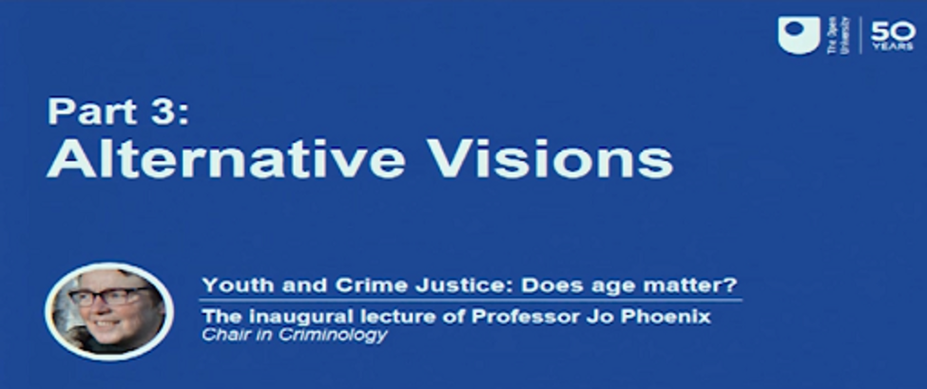

Interactive content is not available in this format.

Interactive content is not available in this format.

View discussion - Part

Radical reduction in the size and reach of the youth justice system may or may not be a continuing feature of the uncertain future of the UK, but one thing is certain for now. There will be a need for a continuing focus on children’s rights to safeguard their well-being in society. For this reason, this course on youth justice will end with a leap out of the territory of the United Kingdom (UK) into the universal concerns of the United Nations (UN). The United Nations is an international forum established at the end of the second world war after the triumph over fascism. It reflected global concern that the implications of racism and narrow nationalistic interests that had tipped into genocide against Jewish people and other ethnic minorities demanded a planetary structure to maintain peace and to promote progress, better living standards and human rights for all the people of the world. The Universal Declaration of Human Rights was drafted in 1948 as the platform of the United Nations. It has become an important reference point for developing support for human rights, and the particular rights of children.

5.1 Children’s rights
One of the first attempts to promote children’s rights in youth justice systems was established in 1985 when the United Nations adopted a set of rules guiding the development of specialist and separate juvenile/youth justice systems in the various nations of the world.
The ‘Beijing Rules’, as they are called, are the United Nations ‘Standard Minimum Rules for the Administration of Juvenile Justice’. These were followed by further agreements about youth and juvenile justice. In 1990 the United Nations ‘Guidelines for the Prevention of Juvenile Delinquency’ (the ‘Riyadh Guidelines’) and the United Nations ‘Rules for the Protection of Juveniles Deprived of their Liberty’ (the ‘JDL Rules’) were all adopted.
At about the same time in 1990 a World Summit on Children, convened by the UN, met in New York. It was the largest gathering of state leaders in history. From that meeting the UN Convention on the Rights of the Child (UNCRC) emerged. Its focus is on children in general rather than youth justice but many of its provisions (Articles) are very relevant to children who find themselves caught up in criminal law and youth justice systems.

Activity 6 UN Convention on the Rights of the Child (UNCRC)
Allow approximately 10 minutes for this activity

Use an internet search engine to find out the answers to the following questions:
- When did the UK ratify the UNCRC?
- Which nations have not yet ratified the UNCRC?

Provide your answer...
View discussion - Activity 6 UN Convention on the Rights of the Child (UNCRC)

6 This session’s quiz
It’s now time to complete the Session 8 badged quiz. It is similar to the previous quizzes but this time, instead of answering 5 questions there will be 15, covering Sessions 5–8.
Session 8 compulsory badge quiz
Remember that the quiz counts towards your badge. If you’re not successful the first time, you can attempt the quiz again in 24 hours.
Open the quiz in a new tab or window by holding down Ctrl (or Cmd on a Mac) when you click the link. Come back here when you are done.

7 Summary of Session 8
In this final session you have explored bold and challenging visions of youth justice. These locate youth justice practice and principles firmly in struggle against social injustice. Following the logic of the four principles of youth justice with integrity can even lead to a utopian vision of the abolition of youth justice as it becomes displaced by wider transformations of local communities. The utopias and manifestos considered in this final session offer anyone interested in helping children live well much to think about. They are consistent with the ideas and visions which led to the establishment of The Open University in 2019 and the universal humanism that propels the United Nation’s concerns for children’s rights.
- Youth justice with integrity involves practice and policy guided by four principles: The four principles are:
  - Social and economic justice for youth justice
  - Comprehensiveness, universality and social engagement
  - Diversion
  - Child-appropriate justice.
- The implications of these principles are that interventions to support positive behaviour take precedence over punishment.
- Doing youth justice with integrity involves recognition of social injustice.
- Children’s rights offer an international framework and perspective to develop child-friendly youth justice.

8 Course conclusion
At the beginning of this course you were asked to think about the question ‘when do children stop being children and become adults?’. There is no single correct or simple answer to this question because the journey between childhood and adulthood is so complex and variable. As a result, and as you have explored through the eight sessions, there is much diversity in practice and principle.
The learning activities you have completed have given you some insights into this diversity and the ways in which the four jurisdictions of the UK respond to children in trouble on that journey toward adulthood. When those troubles are framed by questions of crime and punishment, it is easy to lose sight of the child and focus on the offender. When this happens the part played by wider social forces such as gender, race and class, in a child’s behaviour, circumstances and future prospects are quickly obscured. That is why they have been highlighted in this course.
The arguments over diversion, abolition, the need for punishment and rights to support services will continue, as will struggles against racism, sexism and the social divisions of class. You can join both the arguments and the struggles by continuing to study these issues with The Open University. If you have taken this course about youth justice, you may be interested in working professionally or voluntarily with children and young people who are struggling to live within the law and to thrive. The Open University offers several qualifications relevant to this kind of work. If you are interested in this area, you might like to take a closer look at the following courses:
School of Education, Childhood, Youth and Sport
BA (Hons) Childhood and Youth Studies
BA (Hons) Health and Social Care

Tell us what you think
Now you’ve come to the end of the course, we would appreciate a few minutes of your time to complete this short end-of-course survey (you may have already completed this survey at the end of Session 4). We’d like to find out a bit about your experience of studying the course and what you plan to do next. We will use this information to provide better online experiences for all our learners and to share our findings with others. Participation will be completely confidential and we will not pass on your details to others.

References
Earle, R. (2016) Convict Criminology – Inside and Out. Bristol: Policy Press.
Morris, A., Giller, H., Szwed, E. and Geach, H. (1980) Justice for Children. London: MacMillan.
Tannenbaum, F. (1938) Crime and Community. Boston: Ginn & Company.
Prison Reform Trust (PRT) (2019) Bromley Briefings Prison Factfile Winter 2019. London: Prison Reform Trust.
Youth Justice Board (YJB) (2019) Youth Justice Statistics 2017/18 England and Wales. London: Youth Justice Board.
Herman, A. (2002) How the Scots Invented the Modern World. London: Crown Publications.
Younge, G. and Barr, C. (2017) ‘How Scotland reduced knife deaths among young people’, Guardian, 3 December. Available at https://www.theguardian.com/membership/2017/dec/03/how-scotland-reduced-knife-deaths-among-young-people (Accessed 7 April 2020).
Criminal Justice Review Group (2000) Review of the criminal justice system in Northern Ireland. Belfast: HMSO.
Doherty, K. (2010) ‘The Development of Restorative Justice in Northern Ireland’, in Taylor, W., Earle, R. and Hester, R. (eds) Youth Justice Handbook: Theory, Policy and Practice. Cullompton: Willan.
Youth Justice Review (2011) Review of the Youth Justice System of Northern Ireland. Belfast: HMSO.
Bateman, T. (2017) ‘The State of Youth Justice 2017: An overview of trends and developments, National Association of Youth Justice’. Available at: https://core.ac.uk/download/pdf/130975212.pdf (Accessed 18 March 2020).
Beyond Youth Custody (BYC) (2014) ‘Resettlement of Girls and Young Women: A Practitioner’s Guide’. Available at: http://www.beyondyouthcustody.net/wp-content/uploads/Resettlement-girls-and-young-women-guide.pdf (Accessed 7 March 2020).
Choak, C. (2018) ‘Young Women on Road: Femininities, Race and Gangs in London’, unpublished PhD Thesis, London: University of East London.
Lammy, D. (2017) Lammy Review: Final Report – An independent review into the treatment of, and outcomes for, Black, Asian and Minority Ethnic individuals in the Criminal Justice System. London: Ministry of Justice.
NACRO (2008) Responding to girls in the youth justice system. London. Nacro
Newburn, T. (2017) Criminology, 3rd edn. London: Routledge.
Prison Reform Trust (2017) ‘Why Focus on Reducing Women’s Imprisonment?’ Briefing Paper. London. PRT.
YJB (2009) Girls and offending – patterns, perceptions and interventions. London: YJB. Available at: https://assets.publishing.service.gov.uk/government/uploads/system/uploads/attachment_data/file/354833/yjb-girls-offending.pdf (Accessed 7 March 2020).
YJB (2019) Youth Justice Statistics 2017/18 England and Wales. London: YJB.
Children’s Rights Alliance (CRAE) (2017) ‘CRAE responds to publication of David Lammy review’. Available at: http://www.crae.org.uk/news/crae-responds-to-publication-of-david-lammy-review/ (Accessed 29 October 2020).
Coates, T. (2015) Between the World and Me. Melbourne: The Text Publishing Company.
Du Bois, W.E.B. (1903) Souls of Black Folks. Harmondsworth: Penguin
Eddo-Lodge, R. (2018) Why I’m No Longer Talking To White People About Race. London: Bloomsbury.
Gopal, P. (2019) ‘If we can’t call racism by its name, diversity will remain a meaningless buzzword’, Guardian, 8 October.
Howard League (2017) ‘Howard League publishes ethnicity analysis of child arrests following the Lammy Review. Available at: https://howardleague.org/news/howard-league-publishes-ethnicity-analysis-of-child-arrests-following-the-lammy-review/ (Accessed 14 October 2020).
Lammy, D. (2017) Lammy Review: Final Report – An independent review into the treatment of, and outcomes for, Black, Asian and Minority Ethnic individuals in the Criminal Justice System. London: Ministry of Justice.
Nayak, A. (2018) ‘Children, young people and race’, in H. Montgomery and M. Robb (eds) Children and Young People’s worlds. Bristol: Policy Press.
Neiman, S. (2019) Learning from the Germans: Confronting Race and the Memory of Evil. London: Allen Lane
Valluvan, S. (2019) The clamour of nationalism – Race and nation in twenty-first century Britain. Manchester: Manchester University Press.
Box, S. (1983) Power, Crime and Mystification. London: Tavistock Publications.
Dorling, D. (2018) Peak Inequality: Britain’s Ticking Time Bomb. Bristol: Policy Press.
Ferreira, S. (2017) ‘Portugal’s radical drugs policy is working. Why hasn’t the world copied it?’, Guardian, 5 December. Available at: https://www.theguardian.com/news/2017/dec/05/portugals-radical-drugs-policy-is-working-why-hasnt-the-world-copied-it (Accessed 1 April 2020).
Jack, I. (2017) ‘Parliament’s palace of booze and sex’, Guardian, 9 December. Available at: https://www.theguardian.com/commentisfree/2017/dec/09/parliament-palace-booze-sex-modern-westminster-mps-sober (Accessed 1 April 2020).
Knight, N. (2008) Churchill: The Greatest Briton Unmasked. London: David and Charles.
Pearson, G (1983) Hooligan: A history of respectable fears. Basingstoke: Palgrave.
Rutherford, A. (2002) Growing Out of Crime: The New Era. Winchester: Waterside Press.
Ryan F. (2019) ‘Tories should bear the shame that child poverty in Britain is the new normal’, Guardian, 16 May. Available at: https://www.theguardian.com/commentisfree/2019/may/16/tories-children-poverty-britain-austerity (Accessed 2 April 2020).
Wayne, M. (2018) England’s Discontents: Political Cultures and National Identities. London: Pluto Press.
Williams, R. (1983) Towards 2000. Harmondsworth: Penguin.
Case, S. and Haines, K. (2020) ‘Abolishing Youth Justice Systems: Children First, Offenders Nowhere’, Youth Justice, 27 January.
Earle, R and Mehigan, J. (eds) (2019) Degrees of Freedom: Prison Education at The Open University. Bristol: Policy Press
Goldson, B. and Muncie, J. (eds) (2008) Youth Crime and Justice. London: Sage.
Hopkins Burke, R. (2016) Young People, Crime and Justice. London: Routledge.
James, R. and Macdougall, I. (2010) ‘The Norway town that forgave and forgot its child killers’, 10 March. Available at: https://www.theguardian.com/theguardian/2010/mar/20/norway-town-forgave-child-killers (Accessed 4 October 2020).
Montgomery, H. and Robb, M. (2018) Children and young people’s worlds. Bristol: Policy Press.
Morrison, B (1997) As If. London: Granta.
Muncie, J. (2014) Youth and Crime. London: Sage.
Transform Justice (2016) ‘Reform of Youth Justice – a lost opportunity?’. Available at: www.transformjustice.org.uk/reform-of-youth-justice-a-lost-opportunity/ (Accessed 2 April 2020).
Williams, R. (1983) Towards 2000. Harmondsworth: Penguin.
Warner, M. (1994) ‘Managing Monsters: Six Myths of Our Time, The 1994 Reith Lectures’, London: Vintage. Also available at BBC https://www.bbc.co.uk/programmes/p00gmw3z.

Acknowledgements
This free course was written by Rod Earle.
Except for third party materials and otherwise stated (see terms and conditions), this content is made available under a Creative Commons Attribution-NonCommercial-ShareAlike 4.0 Licence.
The material acknowledged below and within the course is Proprietary and used under licence (not subject to Creative Commons Licence). Grateful acknowledgement is made to the following sources for permission to reproduce material in this free course:

Text

Session 2
Activity 3: Lyon, J. (2010) ‘Putting children in custody punishes disadvantage’, The Guardian, 16 September.
Activity 5: Welsh Government (2018) ‘Commission on Justice in Wales: Written Evidence submitted by the Welsh Government’. Available at: https://gov.wales/sites/default/files/publications/2018- 06/Submission-from-welsh-government-en.pdf Copyright 2018 OGL http://www.nationalarchives.gov.uk/doc/open-government-licence/version/3/

Session 3
Activity 1: Introduction to Scotland’s Children’s Hearings © The Open University

Session 5
2. It’s different for girls: Extract: Beyond Youth Custody (BYC) (2014) ‘Resettlement of Girls and Young Women: A Practitioner’s Guide’. Available at: http://www.beyondyouthcustody.net/wp-content/uploads/Resettlement-girls-and-young-women-guide.pdf

Session 8
Activity 4: Erwin James and Ian MacDougall (2010) The Norway town that forgave and forgot its child killers, The Guardian 20 March 2010.

Images
Course image: © Celiafoto/Shutterstock.com

Session 1
Figure 2: https://pixabay.com/photos/justice-statue-lady-justice-2060093/
Figure 3: Bromley Briefings Prison Factfile Autumn 2018 (page 39) Prison Reform Trust
Figure 4: Photo by Angela Cavina https://www.pexels.com/photo/close-up-photography-of-adult-black-and-white-american-pit-bull-terrier-prone-lying-on-floor-1840427/

Session 2
Figure 1: photofusion pictures https://www.photofusion.org/
Figure 3: PAImages https://www.paimages.co.uk/
Figure 4: Wales.com
Figure 5: Figure ES.1: Trends in First Time Entrants, years ending March 2006 to March page 7 Youth Justice Statistics 2015/16 England and Wales Statistics bulletin Published 26 January 2017 © Crown Copyright https://www.nationalarchives.gov.uk/doc/open-government-licence/version/3/
Figure 6: from https://yalibnan.com/wp-content/uploads/2016/07/UK-devolution-e1468681421349.jpg

Session 3
Figure 1: Steve Allen Travel Photography/Alamy Stock Photo
Figure 2: Highwaystarz-Photography/Getty Images
Figure 3: FatCamera/Getty Images
Figure 4: Lovattpics/Getty Images

Session 4
Figure 1: Bravissimo$/Shutterstock.com
Figure 2: Restorative Justice Logo: https://restorativejustice.org.uk/
Figure 3: Pacemaker Press http://www.pacemakerpressintl.com/
Figure 4: photograph: HM Prison and Young Offender Centre Hydebank Wood
Figure 5: Logo:Raise the Age NI

Session 5
Figure 1: Igor Vershinsky/Getty Images
Figure 2: Murika/Getty Images Plus
Figure 3: MachineHeadz/Getty Images Plus
Figure 4: John Sommer/Getty Images

Session 6
Figure 1: left: Stephen Lawrence: James Boardman Archive/Alamy Stock Photo; right: Zahid Muberak Shutterstock.com
Figure 2: AAraujo/Shutterstock.com
Figure 4: Official portrait of Rt Hon David Lammy MP https://creativecommons.org/licenses/by/3.0/
Figure 5: Marco_Piunti/Getty Images

Session 7
Figure 1: quote by Winston Churchill
Figure 2: Courtesy Public Health Wales from https://www.youtube.com/watch?v=XHgLYI9KZ-A
Figure 4: National Crime Agency https://www.nationalcrimeagency.gov.uk/

Session 8
Figure 1: Motortion/Istockphoto/Getty Images plus collection
Figure 3: Courtesy National Youth Agency https://nya.org.uk

Audio-visual

Session 1
Video 1: Labels: courtesy Media Academy Cardiff http://www.mediaacademycardiff.org/
Audio 1: clip from Law in Action Exploring the Age of Criminal Responsibility https://www.bbc.co.uk/sounds/play/b00l0z36 © BBC (2009)
Audio 2: clip from Law in Action Exploring the Age of Criminal Responsibility https://www.bbc.co.uk/sounds/play/b00l0z36 © BBC

Session 3
Video 1: courtesy: Children’s Parliament www.childrensparliament.org.uk

Session 4
Audio 1: clip: Thinking Allowed BBC R4Restorative Justice in N.I - RG Collingwood 16/9/2009 © BBC 2009
Video 1: courtesy Youth Justice Agency| Department of Justice NI https://www.justice-ni.gov.uk/

Session 6
Video 1: Justice Select Committee hearing 26 March 2019 © Parliament TV. Used under licence
Video 2: On the Road Youth Work - Craig Pinkney (Youth & Policy) © outh and policy https://www.youthandpolicy.org/

Session 7
Video 1: courtesy: Adverse Childhood Experiences (ACEs) Public Health Wales Public Health Network Cymru
ANY PERSONS DEPICTED IN THE STOCK PHOTOGRAPHIC CONTENT ARE MODELS AND THESE IMAGES ARE USED FOR ILLUSTRATIVE PURPOSES ONLY
Every effort has been made to contact copyright owners. If any have been inadvertently overlooked, the publishers will be pleased to make the necessary arrangements at the first opportunity.
Don't miss out
If reading this text has inspired you to learn more, you may be interested in joining the millions of people who discover our free learning resources and qualifications by visiting The Open University – www.open.edu/openlearn/free-courses.

Solutions

Activity 1 At what age can someone …?

Discussion
You will have found that for most of the questions the law prescribes an age at which something becomes permissible. You can only vote in a political election from the age of 18, for example. However, for the referendum over Scottish independence in 2014, 16 and 17 year olds were allowed to vote. If you live in the Crown Dependency of Jersey (one of the Channel Islands) you can vote after your 16th birthday.
You will probably have discovered that there is often more than one answer to what seems like a relatively simple question. For example, you may get married between the ages of 16 and 17 if you secure parental consent in England, Wales and Northern Ireland, otherwise you must be 18. In Scotland you can marry with or without parental consent from 16.
In response to the question about the age a child can be left on their own, the law actually has nothing to say. However, parents can be prosecuted if they leave a child unsupervised ‘in a manner likely to cause unnecessary suffering or injury to health’.
You may have also discovered other interesting differences and distinctions that the law makes, and how these change. For example, the age at which someone can consent to sex is now, at 16, the same for homosexual as well as heterosexual acts.
The ‘age of majority’ referred to above is the formal recognition of full adult status when the law allows someone full legal control of themselves so they are deemed responsible for their actions and decisions.
Back to - Activity 1 At what age can someone …?

Activity 2 Old enough to know better?

Part 1

Discussion
The correct answer is 10 years old.
Back to - Part 1

Part 2

Discussion
You may have been wide of the mark, especially if you chose any of the later teenage years. Or perhaps you guessed correctly or had some prior experience that guided you to the correct age. At 10, the age of criminal responsibility in England and Wales is one of the lowest in the world. As you may also have guessed, there is some variation within the UK, with Scotland opting to raise the age from 8 to 12 in 2019 (you will learn more about this in Session 3). In 2007 the United Nations Committee on the Rights of the Child declared that an age of criminal responsibility below 12 is ‘not acceptable’.
How does this move to raise the age to 12 compare to the range most favoured as revealed in the poll results?
Back to - Part 2

Activity 3 Criminal responsibility

Discussion
The article mentions the Children and Young Persons Act 1963, the Children and Young Persons Act 1969, the Children Act 1989 and the Crime and Disorder Act 1998. Each of these has been very significant in shaping the way the criminal law operates around children’s behaviour. Bandalli mentions that the 1963 Act used the term doli incapax – a Latin phrase meaning ‘incapable of evil’. The law says that under the age of 10 a child’s mental capacity is so different from that of an adult that they must be seen as being ‘incapable of evil’ and cannot be held responsible for their actions. Another way of saying this is that a child does not understand the full moral or social implications of their actions. A child of nine cannot, in law, steal something. It is assumed they cannot know the full consequences and contexts of their action – they are doli incapax.
Back to - Activity 3 Criminal responsibility

Activity 4 Trials of youth

Discussion
Compare your answers to those given in the table below.

Age 10 years | Age 12 years | Age 13 years | Age 14 years | Age 15 years | Age 16 years | Age 18 years
England  Wales | Netherlands  Turkey | France | Austria  Bulgaria  Cyprus  Estonia  Germany  Hungary  Italy  Kosovo  Latvia  Lithuania  Spain | Czech Republic  Denmark  Finland  Greece  Norway  Sweden |  | Belgium  Luxembourg  Romania

Being taken to court is a frightening business for anyone, but especially a child. Nobody really enjoys being judged, and if you recall the image of justice in Figure 2 where the blindfolded woman holds a sword, you realise this feeling is intentional and part of the process. The court has power, and in some cases an awful lot of power. Many other European countries refrain from using the powers of a criminal court until much later in a child’s life. This doesn’t mean that nothing happens when a child in these countries behaves badly or does something wrong or harmful. It means they prefer to use other systems of intervention to respond, establish what happened and decide what to do about it.
Back to - Activity 4 Trials of youth

Activity 5 Brains and minds

Discussion
Everyone accepts that children are in a state of change and development. Throughout adolescence – roughly the period between 12 and 21 – children’s bodies will be growing and taking on more of the physical characteristics commonly associated with adulthood. It is only relatively recently that advances in neuroscience have revealed something similar is occurring, out of sight, between a child’s ears – in their brains. The importance of these medical insights is that they bring the strength of evidence associated with good scientific practice to bear on more abstract philosophical questions about ‘intent’ and ‘responsibility’. For Dr Eileen Vizard it is time for the law to listen to the science and raise the age.
Back to - Activity 5 Brains and minds

Activity 1 The youth justice system

Discussion
The establishment of the youth justice system by the Crime and Disorder Act 1998 was a significant event because it introduced a new way of working – the multi-agency partnerships in youth offending teams (YOTs) – within a new unified, national system across England and Wales. Neither had been tried before. The body tasked with the national co-ordination to make this new approach work was the Youth Justice Board (YJB).
Back to - Activity 1 The youth justice system

Activity 2 Going with the flow

Discussion
As you can now appreciate, the youth justice system is complex and extensive. It is a structure that practitioners become familiar with through training and regular practice. Even so, parts of it are harder to get to know than others. Youth Courts, for example, are not open to the public so as to protect the privacy of young people and their families. Young Offender Institutions can sometimes be remote from the places where the young people in them actually live. The language of court sentences and youth justice procedures can come to dominate young people’s lives, obscuring other features of their lives and circumstances. If you found it difficult to understand the operation of the system, consider what it might be like trying to explain it to a 12 or 13 year old child. Or how they may feel about it themselves.
Back to - Activity 2 Going with the flow

Activity 3 Punishing the poor?

Discussion
Much has changed in youth justice since 2010 and the numbers of young people in custody have fallen from the high point of over 3,000 to fewer than 900 (YJB, 2019). Although Juliet Lyon would be pleased to see this reduction in numbers, it is a reduction that has not been equally experienced by all ethnic groups. The reduction in numbers of young people in custody has been most pronounced among the white population, while young people from minority ethnic groups account for more than 50 per cent of those in custody (PRT, 2019), far beyond their proportion in the general population. These are issues you will return to in Session 6.
Back to - Activity 3 Punishing the poor?

Activity 4 The Swansea Bureau

Part

Answer
Right:
2009
Wrong:
2011
2013
1998
Back to - Part

Part

Answer
Right:
children’s rights
restorative justice
needs-led theory
Wrong:
procedural justice
punitive protection
pre-emptive punishment
Back to - Part

Part

Answer
Right:
Legal Aid, Sentencing and Punishment of Offenders Act 2012
Wrong:
Crime and Disorder Act 1998
Criminal Justice Act 2003
Back to - Part

Discussion
The work of the Swansea Bureau is interesting because it is an example of how a small scale local development had wider significance. By showing how a diversionary approach developed by practitioners working with academics could address children’s needs, they won wider support for making children’s rights more central than children’s offending. The Swansea Bureau linked practice to the Welsh Government’s rights-based ‘Extending Entitlements’ youth policy. Significantly, this meant that rather than simply holding children and their parents to account for their behaviour, local services that had a responsibility to support young people could also be held to account.
Back to - Part

Activity 5 The Commission on Justice in Wales

Discussion
Adverse Childhood Experiences (ACEs) are increasingly recognised as propelling children into social- and self-destructive behaviour. Enhanced Case Management (ECM) builds from the recognition that such behaviours often arise from complex and entrenched difficulties that require a range of agencies and additional resources. Frequently both ACEs and ECM feature in the lives of Looked After Children (LAC). The common denominator in each of these terms is a focus on children as children. Their needs as children takes priority over their deeds as offenders, hence the phrasing that describes the Welsh approach – Children First, Offenders Second. The Commission weighed up the evidence presented to it by all the different stakeholders and the final report, published in October 2019, recommends the devolution of youth justice to Wales and raising the age of criminal responsibility to 12.
Back to - Activity 5 The Commission on Justice in Wales

Activity 6 Positive Youth Justice: Children First, Offenders Second (CFOS)

Discussion
Children First, Offenders Second (CFOS) has come a long way in a relatively short period of time. It has moved from the margins of policy, promoted by two determined academics and an alliance of enthusiastic practitioners, to occupy a central position in youth justice.
Back to - Activity 6 Positive Youth Justice: Children First, Offenders Second (CFOS)

Activity 1 Hearing children in Scotland

Discussion
The system is unusual to anyone familiar with the youth courts of England and Wales. The Scottish Children’s Hearings system works by combining the voluntary input of ordinary or ‘lay’ members of the public with that of professional social workers. A pivotal role is played by the ‘Reporter’, who is a legally trained professional co-ordinating the process and marshalling resources but who otherwise remains outside the decision-making process. The use of the word ‘Hearings’ offers some sense of what is involved in the panel and emphasises a sense of human dialogue rather than legalistic conflict.
Back to - Activity 1 Hearing children in Scotland

Activity 2 The Children’s Hearings system in Scotland

Discussion
What you would tell a friend or colleague might depend somewhat on whether you are from Scotland or not. To most people outside Scotland, the Children’s Hearings system is unfamiliar and people in England and Wales often assume the system for children’s offending behaviour will be the same throughout the UK. The emphasis on social work rather than courts and punishment is notable, as are the words used in the name of the system: ‘Children’ and ‘Hearings’. Another aspect is the stress placed on education and care.
Back to - Activity 2 The Children’s Hearings system in Scotland

Activity 3 The age of change

Discussion
The article presents some helpful and concrete background to the issues you looked at in Session 1, and will return to again. The Scottish Parliament has raised the age to 12 but some people would like to see it raised again. The argument that only a small number of children would actually be affected is one that surfaces sometimes in England, where there are currently no proposals to raise the age. It is undoubtedly difficult and probably impossible to establish exactly the ‘right’ age, but the symbolism is important. The age limit communicates general cultural values and social priorities.
Back to - Activity 3 The age of change

Activity 4 Top ten and high five

Discussion
One of the most interesting features of the move to raise the age of criminal responsibility in Scotland was that it appeared to have the overwhelming support of the public, with one survey reporting 95 per cent support. The arguments listed are far from comprehensive, but the weight of evidence and public sentiment suggests that England and Wales may follow this upward path when it comes to the age at which children can be prosecuted in a criminal court.
Back to - Activity 4 Top ten and high five

Activity 5 The elephants in the room

Discussion
‘They stare at you’ … ‘you feel like a mouse in a mouse trap’ … ‘they’re bigger than you’ … ‘they’re adults’.
Listening to children is not like listening to adults. Their voices are often quieter. When children are asked to speak to a roomful of adults, they may sense they are outnumbered and at a disadvantage. What is obvious to children (the elephant in the room) can be invisible to well-meaning adults. The Scottish Children’s Parliament researchers who helped to make this film recognised this and provided a variety of ways to help the children express themselves, such as by offering them crayons to draw with and other ways to put their views across. People who work with children, or those who conduct research with and about them, learn many different techniques to help them hear children, respect their views and value their experiences. In times of distress and strain around a crime or some other form of harm, this is even more important.
Back to - Activity 5 The elephants in the room

Activity 6 Animating and educating to reduce violence

Discussion
Violence is a complex phenomenon and there is strong research evidence to support the approaches developed in Glasgow. The animation uses graphics and realistic scenarios to offer visitors to the website a way of appreciating how young people may negotiate those complexities. Different consequences emerge through the interactive story sequence. The website suggests a simplistic policing and criminal justice response to knife crime is inadequate, short-sighted and counter-productive.
Back to - Activity 6 Animating and educating to reduce violence

Activity 1 The origins of restorative justice

Discussion
Restorative justice has emerged in and alongside criminal justice systems from America to South Africa and New Zealand. A major consolidation and recognition of the practice began with the family group conferences established in Aoteroa, New Zealand to accommodate Maori concerns about the white (Pākehā) colonial system of criminal justice. As defined by one of its most dynamic proponents, Howard Zehr, restorative justice is ‘a way of looking at criminal justice that emphasizes repairing the harm done to people and relationships rather than only punishing offenders’ (Zehr, 1990).
Back to - Activity 1 The origins of restorative justice

Activity 2 The principles of restorative practice

Discussion
Six principles are identified in the reading and while they may seem relatively straightforward and non-controversial, they can create tensions when applied to systems of criminal justice. For example, the principle of voluntarism sits uneasily with the idea of court sanctions and punishment that are widely applied in conventional youth justice systems in which the court orders participation as a condition of the sentence. The principle of restoration may also be difficult to realise when a child has access to limited resources. Because each individual case will be different, a sound appreciation of the principles underpinning practice is important so that practitioners can be flexible while seeking to maintain the integrity of the process.
Back to - Activity 2 The principles of restorative practice

Activity 3 The introduction of restorative justice in Northern Ireland

Discussion
The move out of the war-like conditions that had harmed so many people in Northern Ireland involved slow and painstaking work. In some communities, justice had become synonymous with violence. There were numerous ‘punishment beatings’ sometimes known colloquially as ‘kneecappings’ because the beatings might involve breaking the legs of the alleged perpetrator. The police and criminal justice agencies were regarded in some places as hostile, or indeed foreign, forces. Restorative justice presented a route out of the entrenched practices of the past and offered alternative possibilities that were taken up and developed by many of those involved in the transition to more peaceful conditions.
Back to - Activity 3 The introduction of restorative justice in Northern Ireland

Activity 4 Northern Ireland’s Youth Justice Agency

Discussion
Putting restorative justice at the heart of the youth justice system in Northern Ireland has involved the establishment of new structures funded by the government of Northern Ireland. The Youth Justice Agency of Northern Ireland recognises that the dialogues and negotiations involved in restorative justice extend its work into many features of community life. This can include schools and other local services that need to become familiar with the principles and practice being developed.
Back to - Activity 4 Northern Ireland’s Youth Justice Agency

Activity 5 Facing justice, facing victims

Discussion
Facilitating dialogue between young people and their victims involves overcoming a number of difficulties. It can be difficult to organise, and it can be personally difficult for everyone who participates. There is strong research evidence to suggest that when victims participate, the effects are powerful and positive for all concerned. The conference sometimes offers victims a real view of the perpetrator and helps them cancel or contextualise their imagined view of them and their motivations. This evidence has helped to secure support for the Youth Justice Agency approach in Northern Ireland.
Back to - Activity 5 Facing justice, facing victims

Activity 6 Young people’s voices from inside

Discussion
The accounts from Kevin and Paul who spent time in Hydebank Wood were far from positive. The Youth Justice Review recommended that young people should not be held in custodial centres close to adults, and dedicated children’s custodial centres should be built. John, Mick and Louise’s accounts are taken from a training video for staff in one of these centres. They may or may not be representative or typical but they do provide some insights into a custodial regime seeking more positive outcomes for children.
Back to - Activity 6 Young people’s voices from inside

Activity 7 Raising the age

Discussion
Children are sensitive to the power of being labelled a criminal. The children who made the video you watched in Session 2 resented how the mistakes they might make could be brought up years in the future in ‘criminal record’ checks. This is a powerful argument for raising the age and is the focus of another campaign you consider in the next activity.
Back to - Activity 7 Raising the age

Activity 8 Off the record

Discussion
Any of the five messages could be persuasive. The fact that a comprehensive review of criminal justice in Northern Ireland (cited in Message 1) proposed that adults should be able to apply for old and minor convictions to be expunged is a powerful argument. It also appeals to the kind of common sense that the mistakes a person makes as a child or as a youth, before they are fully adult, should not be able to define their future.
Back to - Activity 8 Off the record

Activity 1 Girls, young women and crime: get some facts

Part

Discussion
Crime and offending among young women and girls is increasingly recognised as having distinctive patterns that are different from among boys and young men. Girls and young women commit less crime – and less serious crime – than do boys and young men, and offering them the same services or treating them the same as young men seems unfair.
Back to - Part

Activity 2 Girls in youth justice

Part

Discussion
The report’s ‘Summary of findings’ provides insights into important features of youth justice by highlighting how 80 per cent of YOT caseloads involve boys and young men. It also reveals that the risk of becoming a victim of crime is different for girls and young women – sexual exploitation can be a serious risk for some of them. Boys and young men may also be at risk from this kind of harm, but they are also often at more risk of being harmed by violence from other men than are girls and young women, and it is important to recognise these differences.
This kind of detailed, gender specific evidence can lead to more appropriate and more effective support and intervention to reduce crime and victimisation among girls and young women. Without it there is a tendency to allow the majority experience of boys and young men to define services that respond to crime, offending and victimisation. This can leave girls and young women exposed to further harm and neglect.
Back to - Part

Activity 3 What’s the difference?

Discussion
Everyone will have their own opinions on which of the findings are most persuasive. Perhaps it’s not a great surprise to learn that, generally speaking, criminal justice interventions tend to make young women’s behaviour worse. However the fact that pathways into crime are distinctively different tells us something powerful about gender relations, and particularly power in gender relations. This difference persists as women get older with most women in prison being there for convictions in which a male partner is also implicated in various ways (PRT, 2017).
The strong personal attachments mentioned in the first finding may be damaged by custody, but the research also suggests the strong bonds are often compromised by violence and abuse. There is a sense that girls and young women are more vulnerable than boys and young men, and that they are more likely to come to harm from both criminal justice interventions and crime, even when they are perpetrators themselves.
Back to - Activity 3 What’s the difference?

Activity 4 Nequela’s story

Discussion
Nequela is speaking about a life she has left behind and it is undoubtedly unusual for her to have lived a life more commonly associated with young men. Her life in that sense is atypical, and recent research with young women in east London suggests that to think of young women as ‘victims’ of gang activity reproduces stereotypical ideas about women’s passivity. Young women may be involved at various levels of gang criminality and actively negotiate their involvement (Choak, 2018). Nequela’s story reveals a variety of reasons for her involvement, including exposure to serious trauma and extreme violence – the murder of a close friend.
Back to - Activity 4 Nequela’s story

Activity 5 Do the right thing

Part

Discussion
The case study is fictional but based on reality. Magistrates are often motivated by good intentions but the research evidence suggests that drawing young people further into the youth justice system often has unintended consequences. The magistrate may feel that because Gina is a young woman on the periphery of gangs where young men are dominant, she is vulnerable and needs protection. On the other hand, if ‘she’ were a ‘he’ the magistrate might read non-compliance as defiance, or rebellion. These gender stereotypes can have subtle but impactful effects. In both instances, the court outcome might be the same – an intensive supervision and surveillance requirement, but research evidence suggests that young women are offered fewer ‘chances’ than young men and progress more quickly up the sentencing tariff (PRT, 2017).
With tighter supervision, more appointments to keep and less flexible rules about compliance, it is possible that Gina will find a way to complete the court order successfully. Her support worker may strike up a positive relationship with her and help her find constructive friendships and better ways of dealing with peer pressure.
However, if Gina struggles to make the changes quickly, she will find herself back in court for non-compliance. Maybe she will be given another chance. Maybe not. What if there have been some high-profile ugly incidents reported in the local news? Another magistrate may decide an even more serious intervention is needed and, as a last resort, impose a custodial sentence because of what she or he regards as Gina’s wilful refusal to comply with the court order.
Back to - Part

Activity 6 From courts to custody

Part

Discussion
The report’s key points indicate how the youth justice system is failing girls and young women, even when it tries to do its best. It also suggests that it is being slow to respond to evidence and proposals that could make things better for girls and young women.
Back to - Part

Activity 1 Ethnicity or race: it’s not black or white

Part

Discussion
You probably don’t introduce friends or workmates to anyone by describing their ethnicity and the usual reasons for defining your ethnicity are to do with official procedures. One of the most common ways to refer to your ethnicity is to use the UK Government census categories. The 1991 census was the first to record ethnicity and it used nine categories: ‘White’, ‘Black–Caribbean’, ‘Black–African’, ‘Black–Other’, ‘Indian’, ‘Pakistani’, ‘Bangladeshi’, ‘Chinese’ and ‘Any other ethnic group – please describe’. By 2011 this had expanded to eighteen categories. The words used are a telling mixture of nations, colours, regions and countries.
Ethnicity, unlike race, is not meant to be fixed but fluid. This makes recording it a bit more complicated. For instance, in the 1991 census you might have been categorised as ‘White’, but by 2001 will have become ‘White–Irish’.
Back to - Part

Activity 2 The Lammy Review

Discussion
Although fewer BAME young people being sent to prison would probably suggest things were getting better and might be seen as a positive outcome, the question of proportionality is also very important. If there is a general decline in rates of custody (as there has been recently) but the rate of decline is much slower for BAME young people than for other ethnicities, the questions of unfair discrimination would remain just as urgent.
Back to - Activity 2 The Lammy Review

Activity 3 Arresting figures to make you stop and think

Part

Answer
Right:
b) Explain or reform
Wrong:
a) Be firm and fair
c) Non-discrimination
d) Transparency
Back to - Part

Part

Answer
The correct matches are:
Arrests 60%; GP 40%
Metropolitan police
Arrests 42%; GP 23%
Bedfordshire
Arrests 41%; GP 30%
West Midlands Police
Back to - Part

Part

Answer
Right:
Thames Valley
Wrong:
Cumbria
Norfolk
Back to - Part

Discussion
The Lammy Review explains that disproportionality in ethnic data does not necessarily mean that unfair discrimination or poor practice is at work. The report calls for explanations to be provided and, if there are no reasonable or fair explanations for the disparity, for reforms to be enacted.
If the data provided is poorly collected (as in the case of Norfolk and Suffolk) or absent (as in the case of Thames Valley), then it is difficult for a police force to provide a reasonable explanation for its practice. This can lead to suspicion and a lack of trust that it is acting fairly and capable of challenging racist practice.
Back to - Part

Activity 4 Voices of experience, musical truth

Discussion
Music and stylings that originated in the Caribbean islands such as Rocksteady, Ska, Bluebeat, Mento and Calypso crossed the Atlantic with the Windrush generation of migrants to the UK in the 1950s. By fusing aspects of European, American, African and indigenous Caribbean music into new forms, the Windrush migrants started a process that has immeasurably enriched the cultural life of the UK. The tradition of commenting on social and community affairs through music that was a feature of 1940s and 50s Calypso has continued to the present day in the samples you may have discovered in your internet search. These songs tell of young people’s experiences of policing and criminal justice in which race and racism are central rather peripheral.
Back to - Activity 4 Voices of experience, musical truth

Activity 5 Speaking youth to justice

Discussion
Pinkney describes how street-based youth work tends to be confined to day time or early evening work, based in certain centres. In contrast, his ‘on road’ approach attempts to offer services to young people around the times they are most likely to come into conflict with the law or be drawn into illegal and harmful behaviour, which is not always within office hours.
Back to - Activity 5 Speaking youth to justice

Activity 6 Islam, racism and young people

Discussion
Baroness Young summarises some of the report’s findings and concludes that ‘throwaway remarks’ considered innocent and inconsequential by those making them indicate that tokenistic diversity training is inadequate. She insists that ‘something much more nuanced and in-depth is urgently required’. The influence of stereotypes is also raised by Baroness Young, and she links personal practice to institutional process. You may have noticed how these themes are linked to similar ones around gender and sexism in youth justice explored in Session 5.
Back to - Activity 6 Islam, racism and young people

Activity 1 Adverse childhood experiences (ACEs)

Discussion
The video draws from a wide body of evidence about children’s health and wellbeing. It takes a life-course perspective favoured by health professionals and neatly contrasts the possibilities and consequences of different interventions.
Back to - Activity 1 Adverse childhood experiences (ACEs)

Activity 2 Trauma-informed youth justice

Discussion
One of the strongest messages to come over in the briefing is that trauma is cumulative and compounding. The more trauma there is, and the longer it is endured, the worse the outcomes are likely to be.
You might have noted the two possible aspects of the way the effects of trauma can manifest: internal and external. The development of Enhanced Case Management (ECM) is an approach that has been adopted in youth offending teams in Wales because it facilitates a comprehensive multi-agency response to the complexities of trauma.
Back to - Activity 2 Trauma-informed youth justice

Activity 3 What can possibly go wrong …?

Discussion
Charlie is committing a number of serious criminal offences. If caught, he faces prosecution and serious consequences in the form of a sentence that will limit his freedom of movement, possibly with a curfew. He should avoid a custodial sentence if it is his first conviction. It could easily get worse though. The chances of him causing serious injury or a traffic accident are high. He is at serious risk of hurting other people and himself. If this happens, the likelihood of arrest, conviction and custody are high.
Back to - Activity 3 What can possibly go wrong …?

Activity 4 Differences and decisions

Discussion
In England and Wales, there is a possibility that Charlie would be prosecuted. Both jurisdictions have youth courts to handle such cases where a child aged 10 or over can be prosecuted. In each, there may be robust diversionary procedures that might prevent a prosecution and the imposition of a criminal record.
In Northern Ireland, a restorative conference is likely to be convened and a suitable package of support and reparations may be negotiated by the relevant parties involved in what has happened. This might include members of Charlie’s family and other people from the estate. The victim whose car was stolen may also be involved.
In Scotland, a Reporter to the Children’s Hearings system will prepare a report to present to a Hearing involving local social services and members of Charlie’s family.
Back to - Activity 4 Differences and decisions

Activity 5 Know the right words

Answer
The correct matches are:
This term is used when drug gangs take over the home of a vulnerable person to use their house or flat as the base for their drug operation. The gangs exploit the person’s vulnerabilities using violence and intimidation or some other form of manipulation.
Cuckooing
The general term that covers the county lines activity. It refers to anything involved in establishing the county line, such as travelling to the towns or around them and the manufacture or packaging of drugs.
Going county
The slang term for the transactions, dealing or distribution of drugs to the town or in the town.
Trapping
A building or flat used as the base for the county lines operation in a town or city. Drugs may be bought and sold there, manufactured or packaged or distributed to the network of sellers.
Trap house
Back to - Activity 5 Know the right words

Discussion
Dealing drugs and taking drugs has long been recognised to generate its own terminology. In some cases, it is like a secret language, the use of which signals membership or affiliation. More commonly, the connections between underground drug ‘business’ and other forms of popular sub-culture mean the words move quite rapidly into the mainstream.
Back to - Activity 5 Know the right words

Activity 6 Legalise and regulate or criminalise and marginalise?

Part

Answer
Right:
c. social media platforms
d. interviews and focus groups with young people
Wrong:
a. police arrest data
b. court records
e. large scale surveys of the neighbourhood
f. database of photos and videos
Back to - Part

Part

Answer
Right:
c. legalise and regulate drug markets
Wrong:
a. impose harsher sentences for possession and supply
b. create more alternative community sentences that keep people out of prison
Back to - Part

Discussion
Dr Irwin-Rogers’ research suggests that there are positive ways to address the damage that drugs inflict on communities, especially on their younger members. However, his proposals are radically different from those pursued by criminal justice agencies, such as the police and courts. By changing the ways drugs can be bought and sold he suggests the harms they impose can be reduced. Other countries in Europe have adopted these approaches with considerable evidence of success (Ferreira, 2017).
Back to - Part

Activity 1 Lazy, idle snowflakes or hard times for the young?

Discussion
Life has never been easy for young people with few resources. The crimes that young people commit may damage their communities and victimise people already made vulnerable by wider social conditions, but it is only by attending to the repair of those conditions that lasting change for the better can be accomplished. Working for decent pay in jobs that provide some meaning to life rather than just profit for the owner of the business is part of a struggle that stretches back much further than the banking crisis of 2007–8. Real change in the balance of power in the economy is achieved by organisations, such as trade unions.
Back to - Activity 1 Lazy, idle snowflakes or hard times for the young?

Activity 2 A promise to be kept, a promise to be made?

Part

Discussion
As the cultural critic Raymond Williams (1983, p. 8) points out ‘manifestos are among the most unread writing of our time’, which is a pity. Youth services in the UK have been hit hard by the austerity policies of governments since 2010. Young people face difficult times and an uncertain future with little evidence of government attention to their needs. The NYA manifesto sets out a remedy that would be consistent with the second principle that services for young people should be comprehensive, universal and socially engaging. As the urgency of making changes to our systems of provision to young people rises and becomes more obvious, manifestos such as the one produced by the NYA may become more widely read.
Back to - Part

Activity 3 Diversion ahead

Discussion
As you will remember from Session 1, raising the age at which children can be prosecuted for committing a crime would be the single most effective form of diversion. Countries that have raised the age, or already have a higher age, show no signs of negative consequences or a desire to lower the age. The NAYJ recommend in their manifesto ‘a considerable rise in the minimum age of criminal responsibility and immunity from prosecution’. Diversion involves making alternatives to criminal prosecution more widely available.
Back to - Activity 3 Diversion ahead

Activity 4 Children, serious crime and punishment – or something else

Discussion
The Guardian article makes clear that such awful incidents have consequences that cannot be easily overcome. The hurt and the bitterness lives on in the families of both victims.
The article also stresses the differences between the cases, and that each is unique to itself. The murder of James Bulger, the subsequent trial of the children who killed him, and the media coverage have become a significant milestone in English legal history and a troubling cultural landmark. For many it symbolises the flaws of the criminal prosecution of children. For some, at the time, the case appeared to symbolise a terrible and deep-seated anxiety about the state of the country. The children’s murderous actions were seen as somehow ‘typical’ rather than absolutely exceptional (Morrison, 1997; Warner, 1994).
In Norway, another route was taken and other meanings found in the tragedy. It did not reflect a nation’s unease and was treated as a terrible personal tragedy. The children remained beyond the reach of criminal justice and this approach is one preferred by those opposed to adultification and in favour of child-appropriate justice.
Back to - Activity 4 Children, serious crime and punishment – or something else

Activity 5 Community oriented justice

Part

Discussion
The abolition of the youth justice system, or its replacement with community courts addressing a range of social injustices undifferentiated by age, is a radical and utopian vision. Jo Phoenix insists her ideas are not a fully-fledged blueprint for change, but instead represent a very different way of thinking about what the problem is, where solutions can be found and who can make it happen. She closes by suggesting that without these utopian visions there would be no such thing as The Open University – a university open to all, regardless of previous education and schooling. Her ideas are radical by seeking to remove the child, the age-defined individual, from the picture entirely. Open thinking from an open mind, she challenges us to go further, think harder and find real change.
Back to - Part

Activity 6 UN Convention on the Rights of the Child (UNCRC)

Discussion
The UK ratified the UNCRC on 16 December 1991, and it came into effect within the UK from 15 January 1992. The thirtieth anniversary of these two important protections falls in 2021, and 2022 respectively. You may find it helpful to be alert to these anniversaries as they are likely to generate public discussion over the extent of compliance with the UNCRC recommendation that the UK Government should ‘raise the minimum age of criminal responsibility in accordance with acceptable international standards’ (UNCRC, 2016).
The USA remains the only nation to decline ratification of the UNCRC.
Back to - Activity 6 UN Convention on the Rights of the Child (UNCRC)

Figure 1 In the future it is possible that prosecuting children in criminal courts may seem as wrong as sending them down coal mines to dig coal.

Description
This is a cartoon of two children behind bars.
Back to - Figure 1 In the future it is possible that prosecuting children in criminal courts may seem as wrong as sending them down coal mines to dig coal.

Figure 2 The traditional image of justice is of a blindfolded woman with a set of scales in one hand and a sword in the other. Justice is blind, as the saying goes, and this means it is only concerned with the nature of the act, not the age of the actor.

Description
This is a photograph of a gold female figure holding a set of scales in one hand and a sword in the other.
Back to - Figure 2 The traditional image of justice is of a blindfolded woman with a set of scales in one hand and a sword in the other. Justice is blind, as the saying goes, and this means it is only concerned with the nature of the act, not the age of the actor.

Figure 3 World map showing ages of criminal responsibility.

Description
This is a map of the world showing the age of consent in different countries.
Back to - Figure 3 World map showing ages of criminal responsibility.

Figure 4 Give a dog a good name …

Description
This is a photograph of a dog.
Back to - Figure 4 Give a dog a good name …

Figure 1 Magistrates in the youth court.

Description
This is a photograph of three magistrates sitting in a court room.
Back to - Figure 1 Magistrates in the youth court.

Figure 2 A child first and last.

Description
This is an illustration in which there is one dice with the sides labelled as ‘suspect’, ‘offender’ and ‘defendant’ and another dice in which all sides are labelled as ‘child’.
Back to - Figure 2 A child first and last.

Uncaptioned Figure

Description
This is a flowchart showing the various ways a child can move through the youth justice system, starting with Arrest, Police custody, PACE (Police and Criminal Evidence Act 1984) interview) and Police decision. Other key parts of the journey include Youth court, Crown Court and the journey ends include Youth Offender Panel and contract, Reparation order, Youth Rehabilitation Order and Community supervision.
Back to - Uncaptioned Figure

Figure 3 Why are so many children locked up?

Description
This is a photograph of a child in a prison cell.
Back to - Figure 3 Why are so many children locked up?

Figure 4 A map of Wales.

Description
This is a map of Wales with the different regions labelled.
Back to - Figure 4 A map of Wales.

Figure 5 In the year ending March 2016, 31 per cent of First Time Entrants (FTEs) to the Youth Justice System were young people aged 10–14 and the average age of an FTE was 15.2 years.

Description
This is a graph, with ‘Year ending March’ on the X-axis and ‘Number of First Time Entrants’ on the Y-axis.
Back to - Figure 5 In the year ending March 2016, 31 per cent of First Time Entrants (FTEs) to the Youth Justice System were young people aged 10–14 and the average age of an FTE was 15.2 years.

Figure 6 A map of the UK.

Description
This is a map of the UK showing the countries in different colours.
Back to - Figure 6 A map of the UK.

Figure 1 Scotland has a long history of independence.

Description
This shows two Scottish flags.
Back to - Figure 1 Scotland has a long history of independence.

Figure 2 Children or potential criminals?

Description
This is a photograph of five young people standing against a wall.
Back to - Figure 2 Children or potential criminals?

Figure 3 Young people should be in the picture and the process. Their voices matter.

Description
This is a photograph of a group of young people.
Back to - Figure 3 Young people should be in the picture and the process. Their voices matter.

Figure 4 Knife crime and other forms of violent behaviour have serious social consequences, especially for children.

Description
This is a photograph of a selection of knives.
Back to - Figure 4 Knife crime and other forms of violent behaviour have serious social consequences, especially for children.

Figure 1 The peace process in Northern Ireland shapes all its institutions, including those of youth justice.

Description
This shows two hands shaking hands. One is decorated to look like the Irish flag and the other a Union Jack.
Back to - Figure 1 The peace process in Northern Ireland shapes all its institutions, including those of youth justice.

Figure 2 The three key elements of restorative justice.

Description
This shows three overlapping circles. The circles are labelled ‘Community’, ‘Offender’ and ‘Victim’ and the words ‘Restorative justice’ appear in the centre.
Back to - Figure 2 The three key elements of restorative justice.

Figure 3 Punishment beatings of young people suspected of crimes administered by paramilitaries were one consequence of the conflict in Northern Ireland.

Description
This is a photograph of two masked men hitting another man with baseball bats.
Back to - Figure 3 Punishment beatings of young people suspected of crimes administered by paramilitaries were one consequence of the conflict in Northern Ireland.

Figure 4 Hydebank Wood young person’s prison.

Description
This is a sign outside a prison, which says: H.M. Prison & Young Offenders Centre, Hydebank Wood.
Back to - Figure 4 Hydebank Wood young person’s prison.

Figure 5 The only way is up!

Description
This is a graphic. The text reads: Raise the age. NI. 10 is too young.
Back to - Figure 5 The only way is up!

Figure 1 Is the experience different for girls and young women?

Description
This is a photograph of female handcuffed.
Back to - Figure 1 Is the experience different for girls and young women?

Figure 2

Description
This is a photograph of four young women.
Back to - Figure 2

Figure 3

Description
This is a photograph of two girls and a boy.
Back to - Figure 3

Figure 4 ‘Gina’ has been sentenced for a first offence.

Description
This is a photograph of a young woman.
Back to - Figure 4 ‘Gina’ has been sentenced for a first offence.

Figure 1 Stephen Lawrence (age 18), murdered by white racists in south London in 1993, and Zahid Mubarek (age 19), murdered in his cell in HMYOI Feltham in 2000 by his white cell-mate, a young man known to be violently racist and with mental health problems.

Description
This contains two photographs side by side. On the left is a photograph of Stephen Lawrence and on the right is a photograph of Zahid Mubarek.This contains two photographs side by side. On the left is a photograph of Stephen Lawrence and on the right is a photograph of Zahid Mubarek.
Back to - Figure 1 Stephen Lawrence (age 18), murdered by white racists in south London in 1993, and Zahid Mubarek (age 19), murdered in his cell in HMYOI Feltham in 2000 by his white cell-mate, a young man known to be violently racist and with mental health problems.

Figure 2 Black Lives Matter is a campaign, originating in the USA, against racism.

Description
This is a photograph of a group of people holding up a banner which says ‘Black Lives Matter’.
Back to - Figure 2 Black Lives Matter is a campaign, originating in the USA, against racism.

Figure 3 Organisations may collect data on people’s ethnicity to help monitor fairness.

Description
This is a pie chart with a number of categories included: White British; White Irish; Bangladeshi; Black African; Black Caribbean; Chinese; Indian; Mixed; Other; Other Black; Other South Asian; Other White; Pakistani. ‘White British’ has a large portion of the chart.
Back to - Figure 3 Organisations may collect data on people’s ethnicity to help monitor fairness.

Figure 4 David Lammy, MP for Tottenham in London (at time of writing). His 2017 review of Black, Asian and Minority Ethnic (BAME) representation in the criminal justice system has become a landmark report.

Description
This is a photograph of David Lammy.
Back to - Figure 4 David Lammy, MP for Tottenham in London (at time of writing). His 2017 review of Black, Asian and Minority Ethnic (BAME) representation in the criminal justice system has become a landmark report.

Figure 5

Description
This is a photograph of a collection of stickers.
Back to - Figure 5

Figure 1 War time prime minister and British national icon Winston Churchill expresses his point of view on the imprisonment of the working classes.

Description
This is cartoon of Winston Churchill. There is a speech bubble with the following: ‘I am sure the House will support me in any steps that may be taken to prevent this unnecessary imprisonment. It is an evil which falls only on the sons of the working classes. The sons of the other classes may commit many of the same kind of offences and in boisterous and exuberant moments, whether at Oxford or anywhere else, may do things for which the working classes are committed to prison, although injury may not be inflicted on anyone.’
Back to - Figure 1 War time prime minister and British national icon Winston Churchill expresses his point of view on the imprisonment of the working classes.

Figure 2

Description
This is cartoon of a boy.
Back to - Figure 2

Figure 3

Description
This is a cartoon of a young boy driving a car.
Back to - Figure 3

Figure 4

Description
This is a poster showing a teenaged boy with the word ‘victim’ written across him. There is the following text: ‘Dan, 16, has been stabbed and forced to sell drugs miles away from home. Find out more about #CountyLines.’
Back to - Figure 4

Figure 1

Description
This is a photograph of a boy wearing a hoodie.
Back to - Figure 1

Figure 2 The data tells a story about social class (figures from CPAG, 2018).

Description
This is a graphic. It contains the following text in coloured boxes: 43% of children living in households with three or more children are in poverty; 47% of children living in lone-parent families are in poverty; 45% of children living in minority ethnic families are in poverty; 70% of poor children are in working families; 71% of children in families with no working adults are in poverty.
Back to - Figure 2 The data tells a story about social class (figures from CPAG, 2018).

Figure 3 A manifesto for youth from the National Youth Agency.

Description
This is a graphic containing the following text: 1. A promise from the nation for the government to establish a Youth Covenant as a commitment to young people across services and communities; including a Minister for Young People and Cabinet Committee, with an annual report to Parliament on what we have done, what we have achieved and priorities for young people. 2. Local choices: formed by Local Youth Partnerships with local authorities resources and accountable to secure access to quality youth services and sufficient youth work provision, bringing together statutory, voluntary and community services for a clear local youth offer designed with young people. 3. Sure-footed: from early help to sustained support with greater regional investment and a Youth Premium to end disparities and help put vulnerable people and their families on a surer footing, at a critical time of life for making significant life-choices, forming new relationships and taking on new challenges. 4. Seen and heard: to rebuild trust across the generations young people need to be listened to and have their views heard and respected, including Hear By Right national participation standards and in support of Votes at 16, for their democratic engagement in local and national decision-making. 5. Two per school (2PS): core provision of at least two qualified youth workers per school catchment area with a team of youth support workers and trained volunteers, and capital investment for new and refurbished facilities to guarantee universal provision for open-access youth work on which an eco-system of community-based provision can flourish.
Back to - Figure 3 A manifesto for youth from the National Youth Agency.

Session 1 introduction

Transcript
ROD EARLE
Stories about children and young people in crime are rarely far from the news headlines. Whether it's stories about youthful disorder or being involved in distressing incidents with dreadful consequences, what children do and the way society responds affects us deeply. We've all been young once. And some of us probably got into trouble or at least, had friends who did.
I worked in the youth justice in the 1980s and 1990s. And although that seems a long time ago now, it means I've seen how ideas come and go. And how some ideas hang around. On this course, you'll get to grips with these ideas. And understand the way things are always changing in the youth justice, but also, somehow, not changing enough. That's why it's called diversity in principle and practice.
The UK is made up of four jurisdictions-- England, Wales, Scotland, and Northern Ireland. In each of these, there may be subtle or dramatic differences, both in the principles-- that's the basic ideas-- that shape the way children in trouble are dealt with and in what people actually do. In other words, the practice of youth justice.
But before you start looking at these jurisdictions, there's one basic principle I want you to explore-- the legal principle of how children are defined in law. It's a complicated, but fundamental issue. And I think you may find a few things that surprise you.
Later in the course, the focus shifts onto background issues that are also fundamental to youth justice practice. The way that children are treated according to whether they're a girl or a boy, rich or poor. And the way racism and ethnicity influence what happens to you. Research tells us time and time, again, that these are profoundly significant in shaping what happens to a child as they grow up.
There's also quizzes along the way so that you can consolidate your learning. And if you want to, at the end, you can receive a certificate of completion.
I hope you enjoy the learning journey through the diversity of principle and practice in youth justice. And that it includes a few surprises along the way.
Back to - Session 1 introduction

Audio 1

Transcript
CLIVE COLEMAN
Thames Youth Court, East London on a Friday morning. Jermaine, not his real name, has just appeared before the judge. I met him and his mother outside.
JERMAINE’S MOTHER
My son got involved with a couple of youths where we live to rob a pizza guy of his bike and pizza. I just felt disappointed, heartbroken. He’s only 15.
JERMAINE
We didn’t think about it. We didn’t plan it or nothing. Just went for him.
CLIVE COLEMAN
So how’s that going to affect the way you go about thinking about those things in the future? Because it’s dangerous if you’re part of a gang like that.
JERMAINE
Yeah I know. It will affect me badly still. I’m easily like that, that’s why.
CLIVE COLEMAN
It’s going to be your last time?
JERMAINE
Yes, definitely.
CLIVE COLEMAN
With an ever increasing concern about violent crime committed by young people, we’re spending today at Thames Youth Court talking to people like Jermaine and his mum. But we’re also going to be addressing the highly divisive issue of the age of criminal responsibility. In England, Wales and Northern Ireland it’s 10. At 8, Scotland currently has the lowest age of criminal responsibility in Europe, but the government there plans to raise it to 12. So, should the rest of the United Kingdom follow suit, or perhaps raise it even higher? It’s 15 in Portugal, 18 in Belgium. Jermaine’s 15. Should he be on trial?
Back to - Audio 1

Audio 2

Transcript
CLIVE COLEMAN
Do you accept that there are many people who believe that a child aged 10 absolutely does know the difference between right and wrong, and that is, and that should be the test for criminality?
EILEEN VIZARD
To them what I would say is why 10, why not 9, why not 7? Because age 7, children do have some grasp of right and wrong.
CLIVE COLEMAN
And they would say well look 10 is the age we’ve got and from our experience we know that that’s a sensible and reasonable age to know that children do know the difference.
EILEEN VIZARD
I don’t think we know anything of the sort actually. I think we know that children understand the difference between big rights and big wrongs but in terms of defending themselves in the criminal courts, they have no capacity to understand where a guilty or a not guilty plea will take them. They do not have the developmental maturity to participate fairly and fully in their own trial, and there’s abundant evidence to that effect.
CLIVE COLEMAN
Do you accept that’s also an almost impossible sell politically but it’s also a very difficult sell to parents of young children perhaps who have been on the receiving end or even killed by child offenders and also people whose lives frankly are made a misery by young children and their offending.
EILEEN VIZARD
Well I do understand that but I think what we’ve also got to look at is the wider public interest here. The present system isn’t working.
Back to - Audio 2

Session 2 introduction

Transcript
ROD EARLE
In this session, you'll be taking a good close look at the Youth Justice System of England and Wales. We call it the Youth Justice System, but what that actually involves is a complex collection of youth courts at one end and Young Offender Institutions or YOIs at the other. In between, as it were, there are multi-agency Youth Offending Teams or YOTs.
You'll explore what they do and why they do it. You'll also take a look at the changes that are developing in the system and how these emerged in Wales first and have now spread more widely. Towards the end of the session, you'll be invited to consider if Wales and England are still on the single path to youth justice or are becoming more separate.
Back to - Session 2 introduction

Session 3 introduction

Transcript
ROD EARLE
If you live in Scotland, you won't be surprised to learn that Youth Justice goes by another name there. It's called the Children's Hearing System. And I can remember how surprised I was as a youth justice worker in London to discover that there is a completely different system for dealing with youth crime north of the border.
In this session, you'll find out why they have panels, not courts, and a Procurator Fiscal rather than a Crown Prosecution Service. You'll be guided through the Hearing System and learn what it means to children and the people who work in it. You'll also take a look at other youth justice issues such as serious violence among young people, and the way that Scotland has pioneered new ways of dealing with it.
Back to - Session 3 introduction

Video 1

Transcript
CHILD 1: A children's hearing is people who want to make things better for you, who help you with contact, and make a decision at the end of the hearing if you are getting home or if you can have longer contacts and stuff. Lots of other meetings are about you don't really get to go. And that's why it's called a children's hearing because you get to go.
SPEAKER 1: It's to try and make you safe and others safe. They're just trying to do the best for you.
CHILD 2: It's meant to make a difference, and it doesn't make any difference. It just makes everybody worried.
CHILD 3: When the hearing had finished everybody went crying and we all got upset and started crying too, and then we just walked out. I felt sad because they didn't see what was going to happen. They didn't even see if they was going to the judge or not. They just all walked out.
SPEAKER 2: Having a panel, it's really- the child feels quite intimidated as well because they're sitting there basically on spotlight as well. Like it's all about them. So I think they're necessary, but I think we could change the way they do it.
[INAUDIBLE MURMURING]
SPEAKER 3: She's the youngest with three older brothers.
SPEAKER 3: Is that OK?
SPEAKER 4: Yeah.
SPEAKER 3: That makes her.
CHILD 4: I think my first children's hearing was when I was about seven, I think, or eight. It wasn't very nice. I didn't like it. It was just really scary first time. You get a weird feeling in your stomach, and you feel sick. I thought I was going to get taken away.
CHILD 5: I heard about children's hearing by a letter got posted to my house. I felt that it was all right because my social worker told me what would be happening. Who will be there.
CHILD 6: Well, I got a letter in the post and found it lying in my bedroom and opened it. And it said, you are going to a children's hearing.
CHILD 7: I never really got told anything apart from we're all going to see a big building in Glasgow. Felt a bit scared.
CHILD 8: Um, the chairperson, he was kind of in a grumpy mood I think. It was kind of scary when I saw him Kind of like the hulk when he's transforming.
CHILD 9: They didn't look happy to see no one. Um, they looked like they were just wanting the job over and done with. So yeah, you've got to like sit and listen to them more than they listen to you. And they basically tell you what you're doing. They don't ask, they just tell. They make you feel outnumbered in a way. Like they make you feel like you want to cry because they put so many things- just throw them in front of you.
CHILD 10 Well, they stare at you. And then when you say something, that either they think isn't true, or it is true, and they'll just like smile at you. But in a way that- not a nice smile. Like a smile as if we've got you. You feel really down. You feel like actually basically a mouse in a mouse trap because they're bigger than you. They're adults, basically, and you're just a child. And they're deciding your future.
Back to - Video 1

Session 4 introduction

Transcript
ROD EARLE
This is the last of the sessions that looks at the four jurisdictions of the UK. You'll consider how and why Northern Ireland has developed a unique youth justice system that relies heavily on something called restorative justice. Restorative justice features in many areas of youth justice across all four jurisdictions of the UK.
But here you'll discover a lot more about it, and explore the reasons why restorative justice has become so central to youth justice in Northern Ireland. You'll also take a look at moves to increase the age of criminal responsibility in Northern Ireland, following the example of its neighbor to the South, the Republic, and similar initiatives in Scotland.
Back to - Session 4 introduction

Audio 1

Transcript
SPEAKER 1
Now you looked at, in great detail, a huge number of interviews, in both areas, both communities, at community restorative projects in Northern Ireland after the Good Friday peace agreement of 1998. Now you say that this was a time of continued violence on the streets. This you say is actually, is historically replicated, you do tend to get this after signing an agreement such as the peace agreement.
SPEAKER 2
It is. Just because you sign a piece of paper doesn’t mean that everyone in society moves on instantly to a peaceful democratic co-existence, it takes time. So violence tends to linger and also increase.
SPEAKER 1
And what was going on then? People were working out their own methods of justice on the streets?
SPEAKER 2
It was the only way of doing things and was quite well known from around Northern Ireland, knee-capping it was generally called, quite brutal para-militarial punishments, which these restorative projects were an alternative to.
SPEAKER 1
Because I’ve already indicated, at that time the police were not regarded, well particularly in Catholic communities at least were not regarded as having any legitimacy, and the State wasn’t really intervening. So the para-militaries were exercising their own form of justice on the streets.
SPEAKER 2
Yes absolutely. They filled a vacuum in policing you could argue, and also control over their own communities.
SPEAKER 1
Now let me turn to you Heather, is this description of Northern Ireland in 1998 one that you recognise, you recognise the predicament, the situation that exists then.
SPEAKER 3
Absolutely, I think that Anna has portrayed an extraordinary moment in the history of criminal justice in these Irelands and it’s a time from which we can draw many lessons. It’s very important to understand that the punishment beatings and so on that were taking place at that time were occurring because of the absence of the State and of legitimate authority, and it’s certainly, all credit is due to those communities who when offered the alternative of a restorative approach were prepared to take it up.
SPEAKER 1
But I mean how did you go about this? If you look at a particular community, where para-militiaries were exerting their own sort of form of justice, beatings or whatever they were doing, is it that other people and the para-military say look we can’t go on like this. How do notions of restorative justice, how do notions of bringing people together to resolve disputes without this type of para-military power. How does it occur, how does it start up?
SPEAKER 2
Well in Northern Ireland it occurred from the Republican movement itself, and the very people who had been involved in punishment attacks that were the ones who said we need something different, it’s not working.
Back to - Audio 1

Video 1

Transcript
DECLAN MCGEOWN
I'm Declan McGeown, chief executive of the Youth Justice Agency. Restorative practices is at the heart of all that we do. Indeed during restorative justice week, which is an internationally recognised event we're hoping to showcase the great work that we do with our young people who offend, the victims, and the wider community in which they live.
It provides young people with an opportunity to play an active part in the resolution and repair of the harm caused by their actions. But importantly, it also gives victims a much-needed voice that is sometimes absent from the traditional justice process. Communities too can benefit from the reparation work undertaken, which can often help restore broken relationships.
Restorative practice within the Youth Justice Agency also extends beyond the innovative youth conference process. We deliver workshops in schools and children's homes about the benefits in working through problems and issues restoratively. And how this approach delivers long lasting-results. The agency also works restoratively with young people and their families in addressing relationship difficulties, and with communities in supporting reintegration where perhaps relationships have broken down.
As chief executive, I'm immensely proud of the commitment and passion of our staff who firmly believe that through restorative working, we can change behaviours and help young people relate better to each other.
Back to - Video 1

Session 5 introduction

Transcript
ROD EARLE
This is the first of three sessions in which you get a chance to explore how a young person's experience of crime, youth justice, policing, and punishment might vary according to their gender, their ethnicity, or their class background. In this session, you'll consider whether girls and young women get treated differently in youth justice systems that seem to be designed more for boys and young men.
You'll also get to consider your first case study. That's a fictional character designed to help you think about real events and real people. You'll ask questions and seek answers about whether stereotypes about girls and young women result in unfair outcomes for them in youth justice systems.
Back to - Session 5 introduction

Session 6 introduction

Transcript
ROD EARLE
In this session, you'll explore the controversial issue of racism in youth justice. You'll be asked to consider how and why racism is such an important topic. And begin by looking at its fatal consequences in youth justice in the cases of Stephen Lawrence and Zahid Mubarek.
You'll also be looking at ethnicity and explore why this concept is related to race and racism. You'll get the chance to explore some youth subcultures. And consider the positive contributions of young people from black and minority ethnic backgrounds to the diverse multi-cultures of the UK.
At the end of the session, you'll look at how racism's focus on cultural difference gets funneled into hostility towards Muslims. And you'll explore the impact of stereotypes here, too.
Back to - Session 6 introduction

Video 1

Transcript
DAVID LAMMY
-context. The need for the review is illustrated by the fact that things have got worse. The fact that as we sit here this morning, 51% of the youth prison population is from a Black, Asian, or minority ethnic background is something that should concern us all. And is a major, major development when you look at that proportion in the public, as a whole.
And I think it's also the case that the fact that violent crime has risen. We've got 132 homicides in London, the highest in 10 years. And overall, the level of violent crime is the worst it's been since the war. And clearly, many of those victims are from a Black, Asian, and minority ethnic background. Mean that since my review, it would be crazy, frankly, if I suggested that things have not got considerably worse.
Having said that, as you've heard from others, it is right to say that this was commissioned by the government. It was commissioned in a cross-party sense. And it is absolutely the case that I have detected quite a lot of activity within the Ministry of Justice, and indeed, in the agencies that they work with. And particularly I would say in the area of prisons, there has been a lot of activity. Activity should not be confused for outcome, and measurable outcome.
But also, I think it's also right to say that the seriousness and the complexity of this subject means that it would also be churlish to have expected dramatic change just a year on from the government publishing its response to my review.
Back to - Video 1

Video 2

Transcript
CRAIG PINKNEY
My name is Craig Pinkney. I'm a criminologist, urban youth specialist, and lecturer at a local university in Birmingham. In recent times, the West Midlands has experienced a rise in gun crime and gang-related murders.
My article, "On Road Youth Work," essentially, is a theoretical concept that looks at street-based youth work that operates outside traditional hours. Hours of 9 till 5 or 9 till 6, where workers might do centre-based work- that might do detach work or outreach work engaging with young people.
But "On Road Youth Work" looks at what happens outside of those hours, at 9 till 10, at 9 till 12, at 1 till 2 in the morning, when individuals might be engaged in certain types of behaviours will also require help and assistance. That help and assistance- that is not always founded by law enforcement that individuals might need support from a youth worker.
So this particular article focuses on some of the challenges from frontline youth workers that work in the field or work in the community that experience issues of violence and how they respond to those issues and highlighting what are some of the key things that an individual needs to be able to respond effectively to individuals that are going through, engaged in, or trying to desist or get out of that type of behaviour.
So if you'd like to read more about this particular article, click the link below.
Back to - Video 2

Session 7 introduction

Transcript
ROD EARLE
This session begins with the bold statement that it's all about class. You'll discover why youth justice systems seem to deal mostly with children and young people from poor backgrounds and deprived areas of the UK. You'll explore how factors that a child has very little control over, such as the place they were born and their parents' wealth and education, can shape their behaviours and their chances of becoming a criminal.
And you'll engage with another case study to help you understand the way poverty influences the behaviour and life chances of young people. In the news, you may have heard of something called county lines. And you'll explore how it's connected to issues around drugs and young people in this session.
Back to - Session 7 introduction

Video 1

Transcript
TEXT ON SCREEN
This is one person’s story of how adverse childhood experiences affected their life.
NARRATOR
My parents don't understand all the drinking and fighting means I'm scared. I'd like a cuddle, perhaps a bedtime story. But mostly, I'd like them to stop shouting at me. And sometimes they hit me. Feeling scared every day and not feeling loved or wanted will change me for the rest of my life.
Later, I'll have problems at school, problems with alcohol, and I'll get in trouble with the police. What's happening to me right now means I'm more likely to have serious health problems in middle age and die sooner than I should.
TEXT ON SCREEN
Adverse Childhood Experiences are traumatic events that can have negative, lasting effects on health and behaviour.
ACEs including being physically, emotionally or sexually abused as a child and growing up in a house with domestic violence, mental illness, alcohol and drug abuse or criminal problems.
NARRATOR
Doctors say my life is full of adverse childhood experiences or ACEs. But in my world, this means I see my dad hitting my mum. Dad's got a drinking problem, and mum's always crying even with the tablets. I am always being shouted at and hit. After the booze and fags, there's not a lot of money for toys or clothes or even food. I'm getting used to being scared all the time. Now I'm just angry.
Doctors say things are changing inside me. My brain isn't learning how to control my feelings properly. My body can't relax like those kids who don't have ACEs. So my body won't be able to repair itself properly when I get older. Making it more likely I'll get cancer or heart disease as an adult. It hurts when my parents hit me. But the real damage is hidden, and that damage will be with me for life.
TEXT ON SCREEN
Children who have abusive or otherwise stress-filled childhoods are more likely to develop heart disease, diabetes, cancer and other health and social problems throughout their adult life.
How I coped with ACEs as a teenager.
NARRATOR
I drink and smoke. They say I'm out a control but I'm not. It's just my way of coping with my ACEs. I've been in plenty of fights but what's wrong with that. Kids punches don't hurt half as much as when my dad hits me. I beat up a kid last week at school because he looked at me weird. Who cares?
I ended up with more time out at school. Learning is not for me anyway and the teachers don't care anymore than my parents. I don't like the way anyone looks at me except my girl. She's 16 and pregnant just like my mum was with me.
So this is where I've ended up. I've got diabetes and cancer is probably on the way. I know these kill you, but I couldn't do without them. I've never had a proper job, and I've spent time inside. I hit my kids. I hit their mum too until she left so my kids have grown up with ACEs.
And now, my daughter had her first kid. She's 16. The course of my life was set in the wrong direction a long time ago. I know where I'm heading and sadly, I know where my kids are heading too.
This doesn't have to happen. A little help in childhood makes a big difference to where life takes you. When I was a baby, the nurses noticed that my mum wasn't coping, and helped her and explained how important my childhood is to the rest of my life. So with a bit of help, she coped.
The police came around after next door complained about the noise from mum and dad fighting. They asked how I was feeling. I told them I was scared all the time. Mum and dad got help. The shouting got better and the hitting stopped. I even got some bedtime stories. I still had problems at school, but the teacher asked me about what was happening at home. I got help controlling my feelings. It wasn't a lot, but it was enough.
I'm now married with two children. And I've got a job, most of the time. I haven't repeated the same problems with my kids. We got help when being a parent got too much. Our children are ACE free, and that means their kids stand a good chance of growing up ACE free as well.
Almost half the people in England and Wales experience one ACE as a child. And one in 10 of us suffered four or more ACEs. If we stop ACEs, millions of children would not become smokers or binge drinkers. And levels of violence in adults would be cut in half.
Fewer ACEs in childhood also means fewer adults developing diseases like cancer, heart disease, and diabetes in middle age. We all need to be ACE aware. Are you? Doctors, police, nurses, teachers, firefighters, and most importantly parents. The more you know about ACEs, the more you can help stop children growing up with ACEs in their lives. And for those of you who have already suffered ACEs, the more you know, the more you can help yourself, and others who have suffered ACEs cope.
Back to - Video 1

Session 8 introduction

Transcript
ROD EARLE
So this is the final session of the course and it proposes four principles that should be important to anyone interested in youth justice. They're relevant to all four jurisdictions of the UK and apply across questions of gender, race, and class that you've explored in the last three sessions.
The principles have been developed by scholars associated with the Open University in the past. And this session includes a contribution from Professor Jo Phoenix. Professor Phoenix continues the Open University tradition of innovation and imagination by proposing an even more radical response to young people's offending behaviour.
Jo suggests that abolishing the youth justice system is the most promising way of making a real difference to the lives and prospects of young people. For Jo, there's no point in separating anyone's behaviour from the social circumstances that produced it, and thus no justification for individualised responses to challenging behaviour.
Criminalisation is the problem, not the solution, according to Jo. And she proposed this in a lecture she recorded in 2019 to help celebrate the 50th anniversary of the formation of the Open University. "The Open University was a radical experiment," says Jo, "that many thought was just impossible. But by demanding the impossible, the possibilities grew larger. The Open University that built this course and many, many others, was the result of radical thinking, thinking out of the box." And Jo urges us to think in this radical way about youth justice.
I hope you enjoy this final week of the course, and that you found all the sessions worthwhile and interesting. There are always new questions about children and crime coming forward in the news or social issues. Completing this course will help you make better sense of them and will perhaps help you find answers and ask new questions of your own. So thank you and keep studying.
Back to - Session 8 introduction

Video 1

Transcript
JO PHOENIX
Right, let's see how we can get out of this, right? Because I don't know about you. I don't like being depressed. I'm actually quite a cheery person, believe it or not. So how do we escape this endless circularity of age-related justice issues? How can we link social and criminal justice in what we do?
Now, I hope what's come out for you so far is that when we give precedence to considerations of age difference in debate about what to do with young people who are in trouble with the law, we end up in that circularity. It's a necessary thing, because the problematic becomes, how do we stop young people who are breaking the law from becoming adults breaking the law? And yet, even within some of the models that we've outlined earlier, it is possible to imagine a response that emphasises the role of social disadvantage as well as how a variety of social discriminations around class, race, gender, sex, religion, and so on shape the administration of justice.
Now, one way to do this, I want to suggest to you, is something that I'm calling community oriented justice. Community oriented justice sees young people and adults who are suspected or found guilty as part of the community in which they live, rather than merely or only a set of walking risk factors transitioning to a law-abiding adulthood. But before I tell you what community oriented justice is, I want to tell you what it is not.
It is not controlling crime via community policing. It is not controlling crime via community courts, although I'm going to call them community courts in a second, so it's a little bit confusing there. It's not restorative justice, and it's not reparative justice panels. All of these forms of justice require the individual to repair the damage that they have committed to the community. So again, it places the onus back on the individual. Nor are they problem-solving, specialist diversionary courts, which are an alternative to formal adjudication, even though these have been established to deal with complex and profound welfare-related problems.
Now, a community oriented justice has this main assumption, that adults and young people who come to the attention of criminal justice share more in common than separates them. And the emphasis of my suggestion for a community oriented justice needs to be on ameliorating the effects of social injustice. What would this look like?
These are a new form of community courts. These community courts are laypeople, comprised of laypeople, operating within the laws of the land. They are empowered to develop greater understanding and evidence of the criminogenic features of their communities. For those who don't know that term, it means the things that produce crime, such as the overpolicing of Black and ethnic minority young people, the lack of public leisure facilities for young people.
They would need to analyse data and trends, including the identification of areas producing disproportionate numbers of young lawbreakers and the socioeconomic drivers of any of these, of growth in any of these. They would use this understanding to hold local authorities, police constabularies, and through them, central government accountable for their abrogation in their duties to tackle the sources of youthful and adult crime in the area. And they could take part in political discussions at the local authority level about how to resolve some of the problems that young people face, such as youth unemployment, the lack of access to housing, the lack of further education or vocational training without burdening young people with debt.
Now, age here is treated as just one of the many salient factors that courts take account of, along with class, race, sex, and gender, when addressing the criminogenic features of the community. So the focus is the community. It's not the individual. Now, the possibilities are almost limitless. Community courts could order local police constabularies to address the manner in which they overpolice, arrest, and charge particular constituencies of individuals or particular types of people.
They could order local authorities to address the sources of fear and insecurity that drive other groups of young people to carry knives, for instance, or through concerted action to address the economic drivers that make knife and drug crime a rational and reasonable response to often extreme economic precarity. Or local authorities could create more usable, safe, friendly, and free public spaces and leisure facilities for young people. In other words, these things could offer entirely novel experimentation with a totally different way of understanding and addressing the issues inherent in the complexity of young people's transition to adulthood as well as in adult lives.
As I said at the beginning of the lecture, it was all about ideas. It's not about what can be done to reduce lawbreaking of young people or how to reform youth justice. The purpose was simply to open a space to conceive of a form of justice that does not take age differentiation and the idea of young people's transitions to adulthood as the overriding concerns determining our official response.
The lecture was also utterly utopian in its vision for an alternative form of justice. I make no apologies for this, as I believe it is not possible to address issues of social justice without recourse to blue-skies thinking and visions. And let's face it. If we were all tied to imagining only what was realistic and grounded in the realities of the present, I dare say that such a thing as an Open University would not exist.
Back to - Video 1

