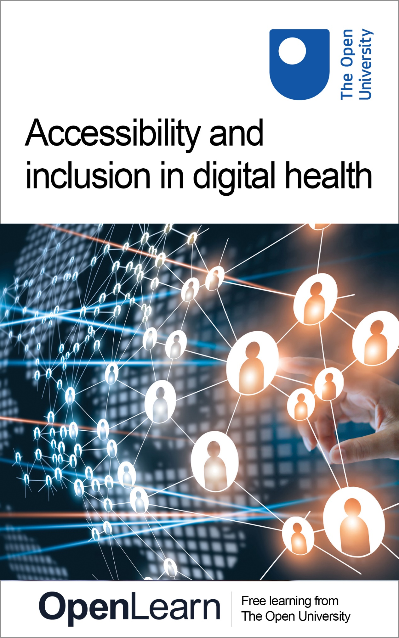

K102_4

Accessibility and inclusion in digital health

About this free course
This free course is an adapted extract from the Open University course K102 Introducing health and social care: www.open.ac.uk/courses/qualifications/details/k102.
This version of the content may include video, images and interactive content that may not be optimised for your device.
You can experience this free course as it was originally designed on OpenLearn, the home of free learning from The Open University –
www.open.edu/openlearn/health-sports-psychology/accessibility-and-inclusion-digital-health/content-section-0
There you’ll also be able to track your progress via your activity record, which you can use to demonstrate your learning.
Copyright © 2021 The Open University
Intellectual property
Unless otherwise stated, this resource is released under the terms of the Creative Commons Licence v4.0 http://creativecommons.org/licenses/by-nc-sa/4.0/deed.en_GB. Within that The Open University interprets this licence in the following way: www.open.edu/openlearn/about-openlearn/frequently-asked-questions-on-openlearn. Copyright and rights falling outside the terms of the Creative Commons Licence are retained or controlled by The Open University. Please read the full text before using any of the content.
We believe the primary barrier to accessing high-quality educational experiences is cost, which is why we aim to publish as much free content as possible under an open licence. If it proves difficult to release content under our preferred Creative Commons licence (e.g. because we can’t afford or gain the clearances or find suitable alternatives), we will still release the materials for free under a personal end-user licence.
This is because the learning experience will always be the same high quality offering and that should always be seen as positive – even if at times the licensing is different to Creative Commons.
When using the content you must attribute us (The Open University) (the OU) and any identified author in accordance with the terms of the Creative Commons Licence.
The Acknowledgements section is used to list, amongst other things, third party (Proprietary), licensed content which is not subject to Creative Commons licensing. Proprietary content must be used (retained) intact and in context to the content at all times.
The Acknowledgements section is also used to bring to your attention any other Special Restrictions which may apply to the content. For example there may be times when the Creative Commons Non-Commercial Sharealike licence does not apply to any of the content even if owned by us (The Open University). In these instances, unless stated otherwise, the content may be used for personal and non-commercial use.
We have also identified as Proprietary other material included in the content which is not subject to Creative Commons Licence. These are OU logos, trading names and may extend to certain photographic and video images and sound recordings and any other material as may be brought to your attention.
Unauthorised use of any of the content may constitute a breach of the terms and conditions and/or intellectual property laws.
We reserve the right to alter, amend or bring to an end any terms and conditions provided here without notice.
All rights falling outside the terms of the Creative Commons licence are retained or controlled by The Open University.
Head of Intellectual Property, The Open University

Contents
- Introduction
- Learning outcomes
- 1 Why create digital citizens?
- 2 Accessing mental health in Wales
- 3 Innovation in health at the beginning of life
- 4 Digital health, children and young people
- 5 Caring robots
- 6 Digital health and the patient/professional relationship
- Conclusion
- References
- Acknowledgements
- Solutions

Introduction
In this free course, Accessibility and inclusion in digital health, you will consider some of the ways that people can access digital health in the UK and how they are able to take more control over their physical and mental health. However, for a number of reasons not everyone has access to digital health technology; for example, affordability, fear of using technology or personal circumstances. This is why the NHS Digital Health organisation in England and the Scottish and Welsh government have also developed initiatives to increase accessibility and to empower people to feel included in decisions about their health and wellbeing. This is explored in the context of a variety of different people from different backgrounds and for different health conditions.
This OpenLearn course is an adapted extract from the Open University course K102 Introducing health and social care.

Learning outcomes
After studying this course, you should be able to:
- explain what is meant by digital health
- identify the contexts in which digital health is used
- evaluate some of the ways in which using digital health can give people greater control over their health.

1 Why create digital citizens?
While digital health technology can mean better access to and control of patients’ information, health and care, more control of patient health and shared care, the people most likely to benefit from digital health are least likely to do so. According to the NHS Digital Report (2019) 11 million people, or almost one-fifth of the population, in the UK lack the skills to engage with digital technology and some don’t use technology at all. NHS Digital suggest that those more likely to be affected include the following people:

- older people
- people in lower income groups
- people without a job
- people in social housing
- people with disabilities
- people with fewer educational qualifications and those who left school prior to 16
- people living in rural areas
- people whose first language is not English.
(NHS Digital, 2019, p. 11)

To address this, NHS Digital published a guide to assist commissioning groups and NHS managers to develop initiatives to enable people who may currently be or feel excluded to become ‘digital citizens’ and to access health care. This is the focus of the next activity.

Activity 1 Digital Ambassadors: creating digital citizens

First, read the article ‘Being a digital ambassador for young carers’, in which Amen Dhesi gives an insight into the value of being a digital ambassador.
Next, go to the Good Things foundation website and use the search function to find and read the following two articles, each of which describes a case study of a Good Things Foundation project designed to help people who lack skills in digital literacy:
- A Place of Welcome
- Disadvantaged in Leeds developing Skills for Tomorrow
As you read the case studies, make notes on the following:
- identify who each project reaches out to help
- what are some of the issues that each project helps address?

View discussion - Activity 1 Digital Ambassadors: creating digital citizens

Digital technology initiatives have clearly had a significant impact upon the lives of people affected by various physical and mental health conditions and social issues as experienced in the case studies.
The focus of the next section explores the potential of digital technology to improve the life of someone experiencing anxiety in Wales.

2 Accessing mental health in Wales
In 2014, the Department of Health made improvement in mental health a key priority. Its first objective was to ensure that mental health had equal priority with that of physical health and its second was to reduce the gap between people with mental health problems and the rest of the population (Department of Health, 2014). Their vision was that everyone who needs it should have access to an intervention, through the ‘Improving Access to Psychological Therapies’ (IAPT) programmes including children and young people. While the Department of Health aimed to reduce waiting times in accessing services, more people were being offered the service and as a result, waiting lists significantly increased. This is a particular issue in Wales, where a significant amount of the population reside in rural areas and at considerable distance from psychological therapeutic services.
In Cardiff, research is currently ongoing to evaluate the potential of digital technology to both reduce waiting times in accessing services and provide people experiencing mental health problems access to much-needed support.

Activity 2 My 24 hour app

Watch the video below, which features Sarah Cosgrove talking about her use of digital technology to help her to obtain support due to Post Traumatic Stress Disorder (PTSD).

Video content is not available in this format.
Video 1 Digital support for PTSD
View transcript - Video 1 Digital support for PTSD

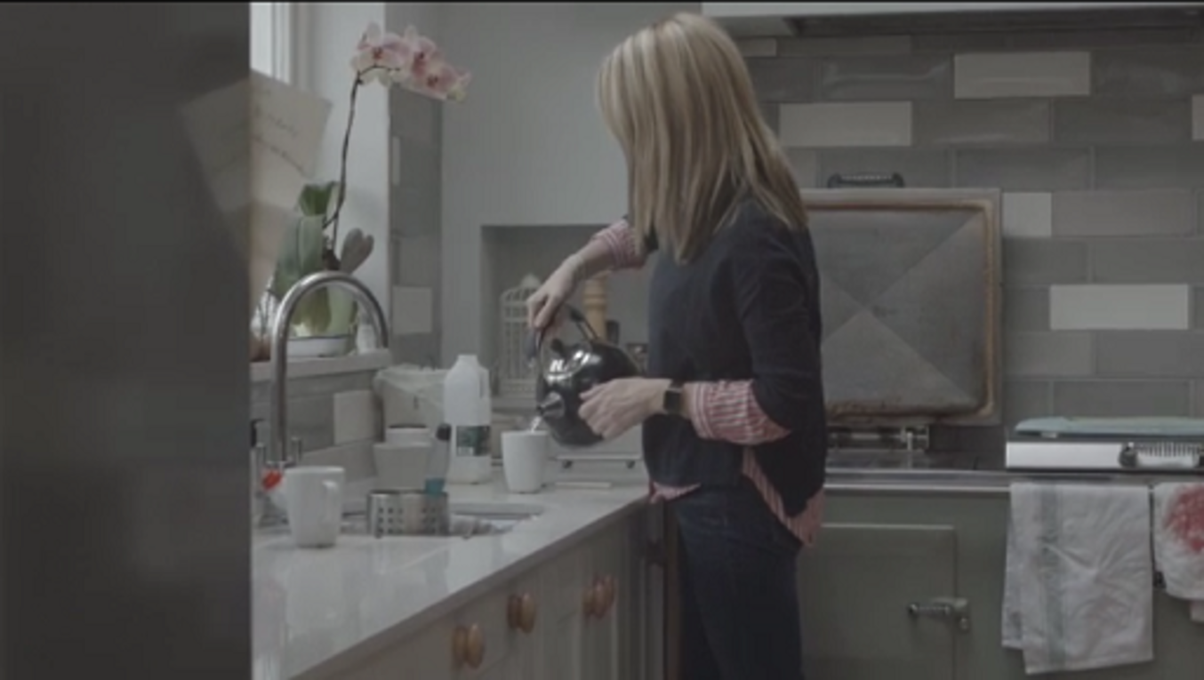

Next, answer the following questions and complete the grid below.
In what ways has the use of digital technology increased Sarah’s confidence, skill and knowledge in managing her symptoms? In what other ways has the use of digital technology led to improvements in care delivery?

Confidence | Provide your answer...
Skills | Provide your answer...
Knowledge | Provide your answer...
Other ways | Provide your answer...

View discussion - Activity 2 My 24 hour app

Digital technology has the power to improve mental health and transform people’s quality of life.
You’ll continue with this theme in the next section, as you explore ways in which digital innovation is being used to enhance the wellbeing of babies in Scotland.

3 Innovation in health at the beginning of life
Around 60,000 babies are born prematurely in the UK every year. This means that 1 in every 13 babies who are born in the UK will be premature, i.e. born before the 37th week of pregnancy (Bliss, n.d.).

There have been many advances in neonatal technology in the last few decades which have saved the lives of premature babies. However, the focus for innovation in the healthcare of babies has been directed primarily towards health professionals and ways of improving the delivery of care. Parents, therefore, have been insufficiently consulted about developing innovation to improve babies’ health. To bring patients into the equation, NHS Fife developed an innovation with the intention of changing this. An interactive virtual platform was developed to enable parents and their families, including children and grandparents, to become much more active in the care of their sick or premature baby while they are on the neonatal intensive care unit (Kimber, 2015).
This innovation is the focus of the next activity.

Activity 3 My Little One

Watch the short video about NHS Fife’s initiative, called My Little One. This will help you to answer the following questions. Provide your answers in the box below.
Please note: due to the nature of the recording, you may find the audio quality to be noticeably poor. If this is the case, use the subtitles and transcript provided.

Video content is not available in this format.
Video 2 NHS Fife’s My Little One
View transcript - Video 2 NHS Fife’s My Little One

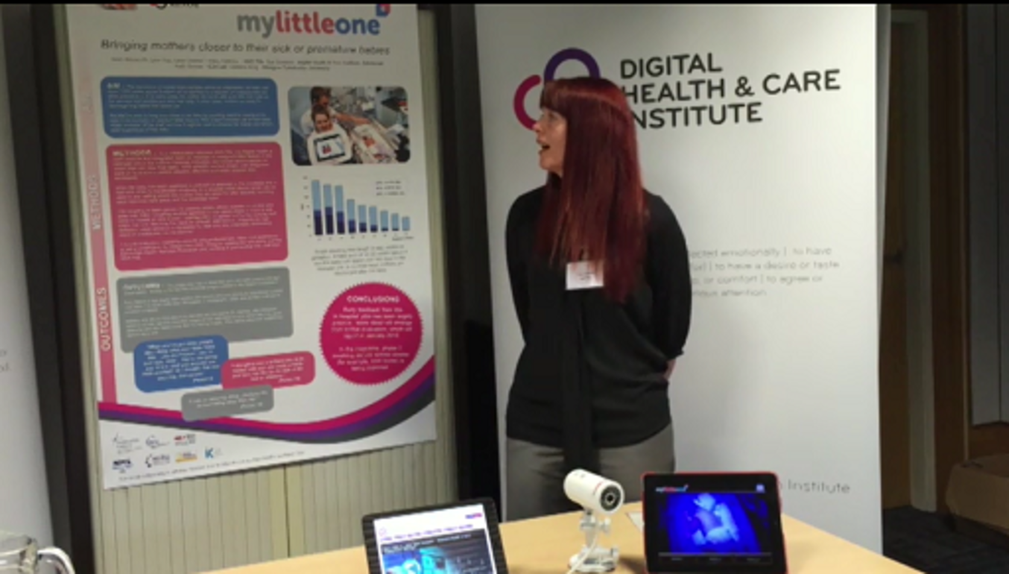

- What is the technology for and how does it work?
- Why is it so important for parents and families?

Provide your answer...
View discussion - Activity 3 My Little One

4 Digital health, children and young people
Just as adults are affected by mental health problems, so too are children. The Cheltenham Holistic Health Centre have identified a number of psychological problems in children which can manifest in a number of ways including, but not limited to:
- anxiety
- depression
- behavioural difficulties
- eating disorders
- anger
- self-harm
- under-performance at school
- difficulties with friends.

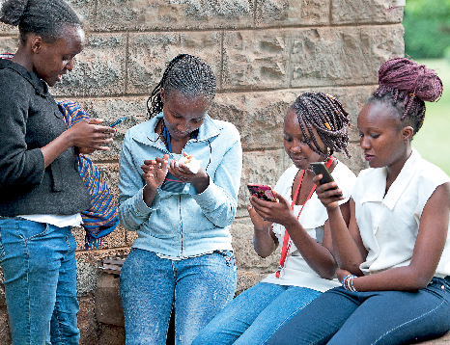

While psychological therapies can provide children and young people with a space to think and talk about their problems, and also to find a variety of ways to cope, access to therapies can be limited (Cheltenham Holistic Health Centre, n.d.). Even if the services are free, they may be time-limited, meaning that only a few sessions are available.
A number of initiatives have been developed with digital technology and children in mind, such as Chat Health. This is an intervention involving a two-way communication system, in which children and young people aged 11 to 16 can ask a nurse questions through SMS text messages. A web-based management application allows teams of school nurses to reply; this is conducted anonymously and confidentially.
Other initiatives have also been developed for use by children such as web-based initiatives to improve health and wellbeing. These initiatives and Chat Health’s digital interventions are the focus of the next activity.

Activity 4 Chat Health, the web and me

Watch the video and, as you do, make notes. This will help you to respond to the questions that follow.

Video content is not available in this format.
Video 3 Chat Health
View transcript - Video 3 Chat Health

- From the perspective of the school nurses, what are the advantages of Chat Health?
- From the perspective of young people, what are the advantages of Chat Health?
- From the perspective of children and young people what are the benefits of web-based innovations to improve health and wellbeing?

Provide your answer...
View discussion - Activity 4 Chat Health, the web and me

Chat Health and similar web-based interventions are able to capture a young audience and harness technology to support children and young people.

If you’re interested in exploring more about children’s mental health and wellbeing, you might be interested in the free OpenLearn course Supporting children’s mental health and wellbeing.

What about other age groups and other forms of digital innovation to deliver support and care? This is the focus of the next section.

5 Caring robots
You will already have considered some of the benefits and challenges associated with implementing digital health care and promoting its wider use. But what about artificial intelligence (AI)? That is, the use of intelligent machines that work and react like humans.

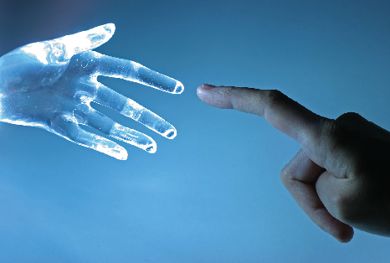

AI is not new. Passport control employs facial recognition techniques, and voice recognition on virtual assistants such as Alexa and Siri are a part of everyday life. Driverless cars and ‘companion robots’ that care for the frail and elderly are currently undergoing trials. Google’s DeepMind has taught machines to read retinal scans with at least as much accuracy as an expert (Galeon, 2016).
While AI is said to bring more relief to many of the pressures the healthcare system faces, can AI ever replace human care? This is the focus of the next activity, in which you will explore the extent to which AI can be ‘culturally competent’, i.e. being sensitive and aware of the needs of different cultures and responding appropriately.

Activity 5 Can artificial intelligence care?

Watch the video by CARESSES, a company that is developing a robot that provides care for the elderly, then answer the questions that follow.

Video content is not available in this format.
Video 4 CARESSES, the Flower that Taught Robots about Culture
View transcript - Video 4 CARESSES, the Flower that Taught Robots about Culture

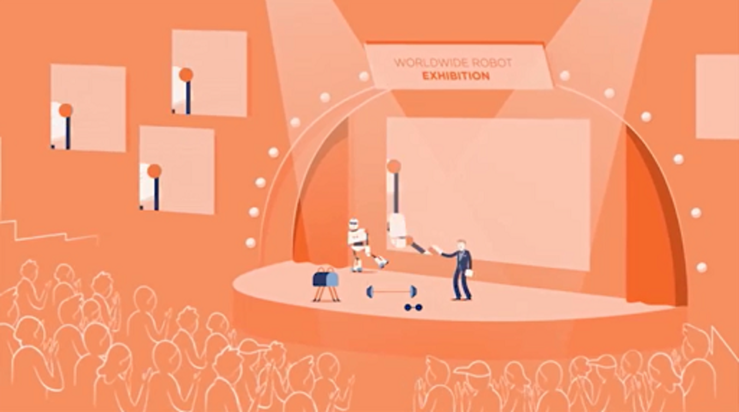

- Would you be prepared to use a robot to help you with a disability? For example, in the case of memory loss the robot would remind you to take your medication and to contact family and friends.
- Do you think robots can truly replace humans in the care of the elderly?

Provide your answer...
View discussion - Activity 5 Can artificial intelligence care?

The next activity asks you to critically evaluate two sides of an argument and also to consider the practical and ethical implications of using AI.

Activity 6 Doing my job

Think about the place of the usefulness of robots to the social care profession. What do you think the implications would be for a professional working in health and social care?

Provide your answer...
View discussion - Activity 6 Doing my job

Activity 7 AI and the patient: safe or safer?

Read pages 11 and 12 from the Academy of Medical Royal Colleges report Artificial Intelligence in Healthcare about Patient Safety. Use this information to complete the table below.
What are the practical and ethical advantages and disadvantages that can arise from using AI in health care for the following factors?

Factors | Advantages | Disadvantages
1. Reliability and safety | Provide your answer... | Provide your answer...
2. Efficiency | Provide your answer... | Provide your answer...
3. Data management, accountability and security | Provide your answer... | Provide your answer...
4. Effect on patient | Provide your answer... | Provide your answer...
5. Effect on health professional | Provide your answer... | Provide your answer...
6. Trust | Provide your answer... | Provide your answer...

View discussion - Activity 7 AI and the patient: safe or safer?

Clearly, there are several ways AI can offer solutions to pressing health concerns, but it also has implications for issues such as security of some highly sensitive and personal information.
In the next section, the focus turns to the way digital innovation is delivered across four nations and the way this has transformed both the relationship between a person and a health professional and its impact on health service delivery.

6 Digital health and the patient/professional relationship
The NHS Five year forward view, published in 2014, had a vision that the NHS should be paperless by 2020. The National Information Board (2014) then developed a framework of action which would see patients being able to use digital technology to manage their health, e.g. booking appointments, checking medical records and communicating with health professionals with the use of the internet, Skype or texts.

Since 2014, implementation of digital health schemes has been driven by local commissioning groups in the form of digital road maps (Honeyman et al., 2016).
At the time of writing (2019) there are a number of innovative digital health schemes in place across England, Wales, Scotland and Northern Ireland. Some of these schemes are targeted at specific sectors of the population and are designed to involve service users being more in control of their health and in accessing services. For example, in Wales ‘Patient Knows Best’ is an online portal which enables patients with diabetes to instantly access their medical records. Patients are able to obtain up-to-date information on treatments, acquire medication from the online portal and access messages from health professionals. This information can be shared securely with different medical teams and carers, and take-up of the service has been good, although not all patients are joining. However, this example is just one of many. It demonstrates both the potential benefits of the service and also the challenge it represents for some patients who may not have access to technology, or even their own email address.
Digital innovation is also deemed to be beneficial to the individual person and professional relationship because it empowers the patient (Meskó et al., 2019). A patient-centred approach is at the heart of many digital interventions, often being designed and developed along with potential recipients. Along with initiatives such as e-health records shared among professional teams and patients, this approach can help decisions to be made jointly, with the individual driving choice and control. However, there are potential barriers to empowering the individual, for example, a lack of knowledge about technology, access to knowledge and resources as well as language skills (Meskó et al., 2019).
This is the focus of the next activity, in which you will explore digital healthcare delivery from Wales and Northern Ireland as well as the way it changes the relationship between an individual and a health professional.

Activity 8 Going digital across the nations

Below are links to two examples of digital health that have helped people to be more in control of their health. Read these examples and make notes, as these will enable you to answer the questions below.

Part 1: Wales

Wales: turn to p. 50 of the PDF and read the case study, ‘Telehealth for frail elderly people in rural North Wales’.

Where is the digital health delivery service located?
Provide your answer...
Who is it intended for?
Provide your answer...
Describe briefly what it is about.
Provide your answer...
What are the benefits and how has the service transformed the relationship between patients and professionals?
Provide your answer...
What, if any, are the challenges faced by the digital health service?
Provide your answer...

View discussion - Part 1: Wales

Part 2: Northern Ireland

Northern Ireland: read the press release.

Who is it intended for?
Provide your answer...
Describe briefly what it is about.
Provide your answer...
How has the service transformed the relationship between patients and professionals?
Provide your answer...
What, if any, are the challenges faced by the digital health service?
Provide your answer...

View discussion - Part 2: Northern Ireland

Conclusion
Since 2014, NHS England’s five year forward view has sought to deliver high quality care by taking advantage of digital technology and innovation. Already, there are services in place that support people of many ages across the four nations. There are also other initiatives at the community level that are aimed at supporting individuals, families and the general public in improving their health and wellbeing.
Technology is being used to integrate services, provide joined-up care and reduce duplication. Digital innovation is also about trying to provide choice and control for the individual and to empower them to take responsibility for their own health and wellbeing. That said, it is necessary use evidence to justify its benefits and limitations and where it is lacking find ways to overcome the issues that are presented. What is clear is that people need to embrace it, and be supported in doing so.
This OpenLearn course is an adapted extract from the Open University course K102 Introducing health and social care.

References
Bliss (no date) Prematurity Statistics in the UK. Available at: https://www.bliss.org.uk/research-campaigns/neonatal-care-statistics/prematurity-statistics-in-the-uk (Accessed: 2 December 2020).
Cheltenham Holistic Health Centre (no date) Psychological therapy for children, adolescents and families. Available at: https://www.chhc.co.uk/therapies/psychological-therapy-for-children-adolescents-and-families/ (Accessed: 2 December 2020).
Department of Health (2014) Access to psychological therapies campaign. Department of Health’s response to the ‘We Still Need to Talk’ campaign about psychological therapies. Available at: https://www.gov.uk/government/news/access-to-psychological-therapies-campaign (Accessed: 2 December 2020).
Galeon, D. (2016) Google’s AI can read your retinas to prevent blindness. Available at: https://futurism.com/neoscope/googles-ai-can-read-your-retinas-to-prevent-blindness (Accessed: 2 December 2020).
Honeyman, M., Dunn, P. and McKenna, H. (2016) A digital NHS? An introduction to the digital agenda and plans for implementation. Available at: https://www.kingsfund.org.uk/publications/digital-nhs (Accessed 2 December 2020).
Kimber, H. (2015) mylittleone wins People’s Choice Award at NHS Scotland event. Bringing mothers closer to their sick or premature babies. Available at: https://www.ic24.org.uk/news/mylittleone-wins-peoples-choice-award-at-nhs-scotland-event/ (Accessed: 1 August 2019).
Macguire D., Evans, H., Honeyman, M. and Omojomolo, D. (2018) Digital change in heath and social care. The King’s Fund. Available at: https://www.kingsfund.org.uk/sites/default/files/2018-06/Digital_change_health_care_Kings_Fund_June_2018.pdf (Accessed: 2 December 2020).
Meskó, B., Radó, N. and Győrffy, Z. (2019) ‘Opinion leader empowered patients about the era of digital health: a qualitative study’, BMJ, 9.
National Information Board (2014) Personalised health and care 2020. Available at: https://www.gov.uk/government/publications/personalised-health-and-care-2020 (Accessed: 2 December 2020).
NHS Digital Health (2019) Digital inclusion guide for health and social care. Available at: https://digital.nhs.uk/about-nhs-digital/our-work/digital-inclusion#download-the-digital-inclusion-guide-for-health-and-social-care (Accessed: 2 December 2020).

Acknowledgements
This free course was written by Lucy Rai.
Except for third party materials and otherwise stated (see terms and conditions), this content is made available under a Creative Commons Attribution-NonCommercial-ShareAlike 4.0 Licence.
The material acknowledged below is Proprietary and used under licence (not subject to Creative Commons Licence). Grateful acknowledgement is made to the following sources for permission to reproduce material in this free course:

Images
Course image/Section 1 figure: © ipopba / istockphoto / Getty Images Plus
Section 3 figure: © jm1366 / iStock / Getty Images Plus
Section 4 figure: © pilesasmiles / iStock Editorial / Getty Images Plus
Section 5 figure: © joruba / iStock / Getty Images Plus
Section 6 figure: © akinbostanci / istockphoto / GettyImages Plus

Audio-visual
Video 2: Used with permission from Digital Health & Care Institute
Video 3: Courtesy of Leicestershire Partnership NHS Trust
Video 4: Used with permission from Prof. Antonio Sgorbissa / CARESSES
Every effort has been made to contact copyright owners. If any have been inadvertently overlooked, the publishers will be pleased to make the necessary arrangements at the first opportunity.
Don't miss out
If reading this text has inspired you to learn more, you may be interested in joining the millions of people who discover our free learning resources and qualifications by visiting The Open University – www.open.edu/openlearn/free-courses.

Solutions

Activity 1 Digital Ambassadors: creating digital citizens

Discussion
A Place of Welcome
This project is in an area of high social deprivation. The project reaches out to the following:
- people who live in social housing
- people with fewer educational qualifications
- people in lower income groups
- people of different ages including older people.
The location of the project is familiar, welcoming and comfortable for many people. It provides opportunities for people to learn new skills from each other in an informal environment. There is access to digital technology and support. This has helped some people maintain social contact with family members. The example is given of a woman being supported to search and find housing association accommodation.
Disadvantaged in Leeds developing Skills for Tomorrow
This project appears to have a broad reach across a multicultural community. It specifically offers help to:
- people with fewer educational qualifications, perhaps because they left education prematurely or because they had negative learning experiences.
- people currently without work or who are seeking employment
- people on low incomes
- disabled people.
The project helps people develop learning, literacy, numeracy and IT skills. It also helps develop confidence and more general life skills. Achievement with basic skills can be a stepping-stone towards developing more complex skills. The project recognises that some people need help overcoming a fear of technology and that people can develop IT skills to find employment.
Back to - Activity 1 Digital Ambassadors: creating digital citizens

Activity 2 My 24 hour app

Discussion
Confidence:
Since using the app, Sarah has grown more confident in applying what she has learned in her everyday life; in particular, about managing her symptoms and realising they are a part of her condition. She also knows that she has a therapist available, and this knowledge gives her confidence that she has backup, should she need it, to manage her condition. Her confidence has increased significantly because now she feels able to socialise and has even got a dog which was a long-term goal for her to aspire towards.
Skills:
The app has taught Sarah a number of strategies in which she can manage her condition such as being able to feel calm. She has also learned to be reflective by writing about what led to her PTSD and going over it again and again until she feels that she is less impacted by the events that led to it.
Knowledge:
The app has assisted Sarah in finding out about her condition and the symptoms associated with it, and this has enabled her to normalise what is going on for a condition that sounds overwhelming at times and prevented Sarah from socialising.
Other ways:
The app has afforded Sarah a great deal of flexibility. She can use the app at any time, day or night, and is reassured that she has access to an intervention that makes her feel safe. Without the app Sarah may not have had timely access to psychological services when she needed it, which could have worsened her condition considerably. The app also gives Sarah more time, as the appointments she has with her therapist in person are not as long as they would normally be, but they still allow Sarah sufficient time to build a good relationship with her therapist which is an important part of therapy.
The researcher in the video also demonstrated the power of the app for people living in rural areas who would not be able to access psychological therapies.
Back to - Activity 2 My 24 hour app

Activity 3 My Little One

Discussion
- Not only are parents more involved in the neonatal unit, but they can also be reassured by having virtual contact with their baby. My Little One brings parents closer to their baby through the use of tablets and smartphones. A webcam is attached to the incubator and a real-time video is transmitted to the device held by the parents.
- This innovation enables parents to have virtual contact with their baby which would otherwise be limited. It is much better than a still photograph as the tablet transmits moving and real-time images of the baby. This is particularly important for mothers who may be recovering from a Caesarean section on the post-natal ward.
Back to - Activity 3 My Little One

Activity 4 Chat Health, the web and me

Discussion
- Chat Health gives nurses flexibility; for example, they are able to respond to texts and help young people deal with issues they would otherwise not get help with. Nurses can go out to other schools to demonstrate its use and promote the app for young people. Participating in supervision also assures that the most appropriate and considered responses are provided to young people. Supervision means they can ensure that the service is delivered to a high quality standard.
- Children and young people are able to address issues they don’t have the confidence to raise in person via the app. They can talk about issues that they find embarrassing. Chat Health assists them in finding ways to cope. Children value the fact that the service is confidential, anonymous and that they don't feel judged as they feel they might in a face-to-face situation.
- For children and young people, interacting with web-based interventions to improve their health and wellbeing was appealing and fun, and it was clear that the children were engaged. For older children (those in their teenage years), becoming involved in the design of the interventions was key. They were enthusiastic, but also consulted as ‘experts of their own experience’, and this gave them the confidence to endorse an intervention. They would have also developed key skills and knowledge in the process of developing the app.
Back to - Activity 4 Chat Health, the web and me

Activity 5 Can artificial intelligence care?

Discussion
While AI can bring about significant benefits and opportunities, there are a number of implications. A central concern raised by the Academy of Royal Colleges Report (2019) is whether AI will make patients safe or safer. This is the focus of the next activity.
Back to - Activity 5 Can artificial intelligence care?

Activity 6 Doing my job

Discussion
You may have thought that it was a good idea to have the involvement of robots as it may help people who are frail to remain in their own home for longer as the robot would be on call to conduct certain tasks. However, you might argue that human contact, affection and compassion cannot be simulated by a robot. Moreover, robots could have implications for people’s jobs and threaten livelihoods. There is also the issue about the extent to which artificial intelligence can ever truly be safe. This is the focus of the next activity.
Back to - Activity 6 Doing my job

Activity 7 AI and the patient: safe or safer?

Discussion
Advantages
Reliability and safety
Unlike humans, machines are designed to keep going; they don’t require sleep which means they can be available to assist any time of the day or night, which is important for anyone needing help. Going digital offers a solution to variation in patient care.
Efficiency
Providing digital consultations enables patients to access services irrespective of where they live. This is especially helpful for people who live in rural areas where services may be more limited. Patients don’t have to rely on a specific appointment which means they access a service at a time which is convenient for them. This type of service is particularly useful for those who may experience communication difficulties.
Data management, accountability and security
Algorithms ensure that the latest guidelines are imported into a system, so that all information contained within it is kept constantly up-to-date. It does not need manual involvement – it is able to update itself, saving the need to use manual labour. This also means that tests and prescriptions are also kept up-to-date.
Effect on patient
Artificial intelligence can improve healthcare access and can save people from having to travel for appointments because they can receive any information and advice wherever they are. It is also important for health professionals as it can identify if a patient may be in danger and alert a health professional to intervene.
Effect on health professional
Providing clinical care in a digital format enables health professionals to deliver health care which is standardised which reduces the potential for any negative impact on a patient’s health and care.
Trust
Can rely on being kept up to date with the latest information and guidelines.
Disadvantages
Reliability and safety
Much of the advice and decisions that doctors make about a patient’s health are based on what they know about the patients. This not only includes information about their medical condition but how this is affected by other factors such as their personal life and behaviour. Knowing this information enables a doctor to tailor the type of treatment and support they can offer which can vary from one individual to the next. Algorithms which tend to standardise systems are unable to do this.
Efficiency
It is difficult to judge how safe any AI can be. If it is not programmed well it can create problems and could be used inappropriately. If it is poorly programmed it is unlikely to be efficient because the data it needs to work well might not be complete, potentially leading to inaccurate advice.
Data management, accountability, and security
Just like any system, AI is vulnerable to abuse and security breaches. There is also the issue of who is accountable if something goes wrong with the software or if information is leaked out. Is it the technology company who designed it? Or is it up to the regulator to ensure everyone is trained in how to use the technology safely and securely? There is no indication about who should be ultimately responsible, which means there is a lack of accountability. There is also the issue about who is in charge. Is it the doctor who has precedence over an AI’s decision?
Effect on patient
While AI will be helpful for some people it could cause harm to others.
Effect on health professional
Health professionals are trained to possess certain clinical skills in order to deliver health and care. Therefore, the information guide and any training in how to use available technology to manage health needs to be good. If it isn’t, this can lead to frustration and a lack of engagement with the technology – even for a technological wizard.
Trust
It could be difficult to trust an AI as they won’t be able to discern between what seems to be good medical advice and the patient’s wishes. This is important because a patient may not follow the advice of an AI that recommends something they find difficult to do or take.
Back to - Activity 7 AI and the patient: safe or safer?

Activity 8 Going digital across the nations

Part 1: Wales

Discussion
Where is the digital health delivery service located?
Betsi Cadwaladr Health Board Area in Wales.
Who is it intended for?
Patients over the age of 85.
Describe briefly what it is about.
Remote healthcare through Skype and online consultations are provided at a local community hospital (rather than a city hospital) in rural North Wales where there is poor public transport. Patients see their doctor by telemedicine clinics at their local community hospital.
What are the benefits and how has the service transformed the relationship between patients and professionals?
It reduces the need to travel for many frail patients. There has been positive feedback, with over 83% of patients stating they would recommend the clinics to family and friends. A digital inclusion officer secured the support of the community to use the service by working in consultation with county councillors, local community groups, the local media, patient champions and representatives. This provided the opportunity to raise awareness of the service but also to dispel any myths or anxieties. It also removed the need to travel which some people find extremely stressful. Individuals can converse with professionals in real time, be reassured and be provided with the right information by the professional to help them make the right choices. This gives the individual access, choice and control about the decisions they make about their health and provides for a much more equal relationship.
What, if any, are the challenges faced by the digital health service?
Some patients may still prefer to see a health professional in person.
Back to - Part 1: Wales

Part 2: Northern Ireland

Discussion
Describe briefly what it is about.
Orion is a shared care record about patients’ diabetes. This means that health professionals can now access more information about the patients and this information is shared between trusts.
How has the service transformed the relationship between patients and professionals?
Patients no longer need to repeat to different health professionals what their symptoms or current state of health are, because this information can now be accessed in a way that enables those professionals to offer more appropriate treatment and advice. This information can now be accessed by different professionals who can provide more appropriate treatment and advice. As a result, this should reduce the risk of the individual becoming frustrated and tired and the professional has the information to hand to be able to provide better advice more efficiently.
What, if any, are the challenges faced by the digital health service?
The shared record might mean more shared information, and the right treatment can be provided, but it doesn’t mean it can promote the right behaviour; for example, lifestyle choices (e.g. exercise, a good diet) to keep diabetes in check.
You may have identified some real benefits to certain members of the population. However, implementing and using digital health is not without its challenges. Implementing new systems requires financial resources and some organisations have struggled to find the funds to implement digital healthcare due to the cost of buying the hardware (Macguire et al., 2018). There are also cultural organisational factors such as a workforce’s willingness to change and engage with new systems when they are already feel stretched (Macguire et al., 2018). Others might be reluctant, fearing that digital health reduces the human face of healthcare because some digital health schemes are conducted remotely. However, the benefits to many people living in rural areas have been improved health and wellbeing because individuals are now able to access services that would otherwise be challenging for them to reach.
Back to - Part 2: Northern Ireland

Video 1 Digital support for PTSD

Transcript
[MUSIC PLAYING]
SARAH COSGROVE
So I met with the team at Cardiff University, and we had to go through a bit of a process to see if I was suitable. So was it one single event that caused my PTSD? Yes, it was. And was I prepared to put the hard yards in and do this work myself, which I was more than prepared to do, because I wanted to stop being a victim and be active in my recovery and get back.
NEIL ROBERTS
So PTSD is a serious mental health disorder that can develop for some people through exposure to very threatening events or traumas. Standard therapy for PTSD would normally involve appointments that last 60 to 90 minutes over around three months. I guess the difference with guided self-help is that a lot of the work that service users would do is self-directed. So we've developed a package that takes them through a number of steps.
SARAH COSGROVE
When I told my family that I would be going on to this trial using an app, they were a bit worried about doing everything remotely with no support. But I was very supported. I would meet regularly with a therapist, either in person or on the telephone. And that would happen at least weekly. But the app was particularly good at illustrating what PTSD can mean in a civilian context. It helped me learn about my PTSD, and it helped me understand that what I was experiencing was totally normal. So things like heightened anxiety, palpitations, getting very hot, perspiring, breathless, all of those things were explored in the app. And so it was great, because I was able to realise that this is normal, and this is what having this condition means.
NEIL ROBERTS
The appointments are briefer, and the focus for the therapist is more on ensuring that the service user is engaged with the programme. It's a different way of working. So normally we would-- I guess relationship building is an important part of the therapy process and trying to help.
SARAH COSGROVE
So there are tips like how to ground yourself. They are basically techniques to bring you into the moment to stop your mind from going back and reliving that traumatic event over and over. One of the major symptoms of my PTSD was anxiety. And the app was really good at giving me ways, techniques to manage my anxiety. And slowly I was able to enjoy socialising again.
I'd also always wanted a dog, and we got a dog. And that was a fantastic thing to do. So the app guides you to a point where you need to come to terms with your trauma. And it takes the form of writing a present-tense, very detailed account of what that trauma was. And then you read it. And you read it over and over and over and over again, until eventually you become desensitised to it. And I think really that was one of the most powerful steps in the app.
And so because I was guided by the therapists, they were meeting me regularly, I felt confident enough to take those steps, that if I was feeling particularly anxious or traumatised again, that I could talk it over with them. The app gets you to write a letter to a friend as if that friend was you. And so you're able to take an external perspective. And I find that hugely helpful, actually. The talking sessions are brilliant. So if you are feeling a bit uncertain or you're having a bit of a wobble, you know that you've got that added reassurance of talking to a real-life human being.
The flexibility of the app is really wonderful, because you have it when you need it. So if I was having a moment, I could just reach into my pocket, get out my phone, and bring it up. But also I didn't have to take loads of time off for medical appointments. I could do the preparatory work from my own home. I could do it when my daughter was in bed. I could do it on the weekends. And so again, it was a really important way to help me get control back, because I was at the heart of that recovery.
NEIL ROBERTS
We don't know at the moment if this is the right intervention for everyone. I think we know clinically that people with more complex presentations, with more severe symptoms will probably need longer interventions and probably also the direct face-to-face nature of standard therapy.
CATRIN LEWIS
The guidelines in the United Kingdom say that we should be using psychological therapy rather than medication. The only problem is that we have very long waiting lists to access psychological therapy. And unfortunately, there are a limited number of therapists that are able to deliver these sorts of interventions, as we know. And technology is evolving. And it's very important for interventions of this sort to keep up with technology and to be able to be used on the latest devices and so forth.
So for example, here in Wales we have individuals that live in rural, remote areas that simply aren't able to access psychological therapies. So these sorts of interventions enable the opportunity for people that wouldn't normally be able to get access to psychological therapies to engage in treatment such as this. But we're still undergoing clinical trials to try and establish enough evidence in order that it can be used routinely at the NHS. But the trial that we have ongoing at the moment is actually a multisite trial. So we're testing it here in Wales, but also in England and in Scotland. And we're hoping that the results will support our ongoing work.
Back to - Video 1 Digital support for PTSD

Video 2 NHS Fife’s My Little One

Transcript
LISA HALLADAY
Hi. I'm Lisa Halladay. I'm an eHealth Delivery Specialist for NHS Fife. This project's called My Little One. I worked with Digital Health and Care Institute and IC24. This product, basically, it brings mothers closer to their sick or premature babies. It is the ability to have a camera on an incubator, which links to an iPad that the mother receives upon the birth of her baby, where they cannot go down to the special care unit and see their baby for themselves.
People interested in this product is anybody who has either delivered a premature baby or one that's in a special care unit. It's something that's very, very simple, but it's very, very beneficial to both parents and families with premature babies. As you can see here, this is what we have. We have an incubator with a camera that sits at the end. And the mother receives an iPad upon the birth of the baby.
The main features is exactly what it is. It's a real-time feed of the baby. There is a slight delay upon the video of around a minute, and this means that there is a capability for the nurse. If they're going to carry out a treatment on the baby or anything, they can flick a switch, and the mum gets a comfort message saying that the video feed has been stopped. But it's a continuous feed of the baby basically.
Nothing is stored. Everything is all secure. It is basically a feed from the camera to the server from the technical perspective and then to [INAUDIBLE]. If I had one message about it. It's brilliant. It's absolutely fantastic. It is something from any health perspective that delivers everything. It delivers care. It's something that's patient centric.
It's just something that's so simple, but yet so efficient. Personally, I think every neonatal unit in Scotland should have that. And we would be more than happy for anybody to come over to Fife and see it. And if you want to get it, either contact myself, Lisa Halladay, or if you want to contact the Digital Health and Care Institute or IC24.
Back to - Video 2 NHS Fife’s My Little One

Video 3 Chat Health

Transcript
STUDENT
It allows us to express ourselves in a way that we can express to our friends. And to know that it's confidential makes me open up to other people besides my other friends.
STUDENT
Sometimes you have things that are so embarrassing that you can't talk about. So if you send a message, then you have-- the nurse already knows what you've going to talk about. And then we can just think of ways to get over that and just help. So it's really useful.
STUDENT
You can feel judged by talking to someone face to face. So I think if you can text them it's like they don't actually know who you are.
JANE DAWSON
Hi, my name's Jane Dawson, and I'm a school nurse for the Brixton team, and I'm a chat health ambassador.
KATIE
Hi, my name's Katie. I'm a school nurse in the Hinckley & Bosworth school nursing team. I've been a chat health ambassador now for the last two years.
JANE DAWSON
I do chat health as part of my daily job, but it doesn't stop my day. I can go in and out of all the schools, come back, respond to text messages, and then go out again.
KATIE
Generally, we get about 15 messages a day from young people asking a variety of questions or asking for a variety of advice.
JANE DAWSON
We're informed when we're going to be a chat health ambassadors. So I plan my day to make sure I'm in the office in some points of the day to respond to the text messages. I also go out to my schools and promote the chat health service so young people know how to access it.
KATIE
Chat health allows us to have a pause in what we're doing so we can have supervision with other staff or think about our responses, which enables us to provide a high standard service and also a standardised service as well.
JANE DAWSON
I love the fact that the young people can access this service, and the feedback is just brilliant. They will text you saying, thank you so much for your support. And it just puts a smile on your face knowing that you've helped someone.
STUDENT
Hello, my name's Serita, and I like this website because it makes me fit and healthy.
STUDENT
I like the website because it will make you fit, and I like the characters.
STUDENT
I like your website because it has funny games in it and fun games in it, and it keeps me fit and healthy.
STUDENT
I like the website because it makes me fit and healthy, and I like the logo as well.
STUDENTS
We love Health For Kids!
STUDENT
Website looks really great, and it really looks like they've taken on our advice, and the videos are a really nice touch.
STUDENT
I think that the quizzes are a really entertaining way to get information across to teens.
STUDENT
Today's website launch has been amazing, and I'm very proud to be a part of this wonderful, exciting launch.
STUDENT
I really think the website is really good. And it can really help teenagers who have problems, and it can really help you out.
STUDENT
It looks like it was really well designed, and it can fit basically every purpose, especially with everything new coming out for it.
STUDENT
You know, being involved in what we have all created as something essential for everyone is to benefit not just us alone. It's to benefit everyone in the UK. So I think that to be good.
STUDENT
Visit health for teens.
[GIGGLING]
Back to - Video 3 Chat Health

Video 4 CARESSES, the Flower that Taught Robots about Culture

Transcript
[MUSIC PLAYING]
[APPLAUSE]
NARRATOR
At around 2020, robots were already very capable. Some were strong. Some were clever. And some were extremely precise. But as powerful as they were, robots were sometimes awkward and didn't really know how to behave with humans in many situations, even the simplest.
That all changed when a group of European and Japanese researchers developed Caresses, a revolutionary artificial intelligence. When it was wired into robots, Caresses added a key feature. The robots learned to adapt to the culture and habits of the people they interacted with. And they never used stereotypes. The technical word for this is cultural competence. So it became easier for robots to be accepted by humans.
With cultural competence, Caresses started a new era in the history of robotics. Soon, robots began to support caregivers, assisting older people in a variety of tasks all over the world. This development was valuable to health systems in many countries and helped them better deal with the needs and preferences of an ageing population. Thanks to their experience in elder care, culturally competent robots also proved useful in education, transportation, and tourism.
If today's robots look much more at ease with humans, seem more perceptive, and ultimately more helpful in a wide range of situations, credit should be given to Caresses-- that little flower over robots' hearts. It didn't make the robot stronger or faster. But it showed how much you can achieve by teaching them to pay attention to people's culture.
[MUSIC PLAYING]
Back to - Video 4 CARESSES, the Flower that Taught Robots about Culture

