M150_3

An introduction to data and information in health and social care

About this free course
This version of the content may include video, images and interactive content that may not be optimised for your device.
You can experience this free course as it was originally designed on OpenLearn, the home of free learning from The Open University –
https://www.open.edu/openlearn/health-sports-psychology/introduction-data-and-information-health-and-social-care/content-section-0?active-tab=description-tab
There you’ll also be able to track your progress via your activity record, which you can use to demonstrate your learning.
Copyright © 2021 The Open University
Intellectual property
Unless otherwise stated, this resource is released under the terms of the Creative Commons Licence v4.0 http://creativecommons.org/licenses/by-nc-sa/4.0/deed.en_GB. Within that The Open University interprets this licence in the following way: www.open.edu/openlearn/about-openlearn/frequently-asked-questions-on-openlearn. Copyright and rights falling outside the terms of the Creative Commons Licence are retained or controlled by The Open University. Please read the full text before using any of the content.
We believe the primary barrier to accessing high-quality educational experiences is cost, which is why we aim to publish as much free content as possible under an open licence. If it proves difficult to release content under our preferred Creative Commons licence (e.g. because we can’t afford or gain the clearances or find suitable alternatives), we will still release the materials for free under a personal end-user licence.
This is because the learning experience will always be the same high quality offering and that should always be seen as positive – even if at times the licensing is different to Creative Commons.
When using the content you must attribute us (The Open University) (the OU) and any identified author in accordance with the terms of the Creative Commons Licence.
The Acknowledgements section is used to list, amongst other things, third party (Proprietary), licensed content which is not subject to Creative Commons licensing. Proprietary content must be used (retained) intact and in context to the content at all times.
The Acknowledgements section is also used to bring to your attention any other Special Restrictions which may apply to the content. For example there may be times when the Creative Commons Non-Commercial Sharealike licence does not apply to any of the content even if owned by us (The Open University). In these instances, unless stated otherwise, the content may be used for personal and non-commercial use.
We have also identified as Proprietary other material included in the content which is not subject to Creative Commons Licence. These are OU logos, trading names and may extend to certain photographic and video images and sound recordings and any other material as may be brought to your attention.
Unauthorised use of any of the content may constitute a breach of the terms and conditions and/or intellectual property laws.
We reserve the right to alter, amend or bring to an end any terms and conditions provided here without notice.
All rights falling outside the terms of the Creative Commons licence are retained or controlled by The Open University.
Head of Intellectual Property, The Open University

Contents
- Introduction
- Learning outcomes
- 1 What this course is about
- 2 Daily life and computers
  - 2.1 A day in the life
  - 2.2 Data and information
  - 2.3 Health and social care providers care records
- 3 Sensing data and turning it into something usable
  - 3.1 Human beings, data, signs and symbols
  - 3.2 Data and information
  - 3.3 What does this have to do with computers?
- 4 Computers as tools for finding
  - 4.1 Where am I and how do I get to …?
  - 4.2 Finding information: the internet
- 5 Genetic databases and disease
  - 5.1 What is DNA?
  - 5.2 The human genome
- 6 COVID-19 and the importance of data and technology as a tool
- 7 Controlling things; selling things
  - 7.1 Controlling things
  - 7.2 Technology and change
  - 7.3 Summary
- Conclusion
- Acknowledgements
- Solutions

Introduction
Computers are used to find, store, process and share data and information. The World Wide Web, more commonly known as the internet, is an example of a vast store of information, which can be searched.
The internet and the web: what’s the difference?
People sometimes confuse the internet and the World Wide Web.
The internet refers to the physical interconnection of large numbers of smaller data communications networks to form a huge, publicly accessible ‘network of networks’. Thus the internet carries electronic mail (email), hosts chat rooms and bulletin boards, enables the transfer of files, and is the physical basis for supporting the World Wide Web.
The web is the collection of linked data stored on the internet which is accessed using a browser.
This material will introduce you to what a web browser is and how to use one. The use of search engines to find information more effectively on the web will also be demonstrated. This course looks at how data is transformed into information and relates the topics of data and information to the computer and its impact on health and social care planning, treatment and decision making. These are of fundamental interest to those participating in the delivery of services and will play an ever-increasing part in patient and client care. One needs only to look at the notion of track and trace for control of COVID-19, and the scope and range of technologies that have been deployed to capture and utilise data.
This OpenLearn course provides a sample of Level 1 study in Computing & IT and Health and Social Care.

Learning outcomes
After studying this course, you should be able to:
- identify some of the instances in a care setting where a computer is, or is likely to be, involved
- describe, in simple terms, the difference between data and information
- give a simple explanation of why computers are important to people working in health and social care in terms of data and information
- explain in simple terms what a computer program is, and why one is necessary
- explain the role of the computer with respect to the data given to it and how this can improve health and social care delivery.

1 What this course is about

You can have data without information, but you cannot have information without data.
Daniel Keys Moran

Computers used to be mysterious boxes that were hidden away in large, secure buildings in major companies and government organisations. The average person came in contact with them only in the form of stories in the press, or printed statements they received from their bank or gas supplier.
All that has changed dramatically over the last few decades. Today, most people experience computers not as remote machines producing bills or directing space flight (though they still do these things), but in two ways:
- as a medium that combines graphics, video, sound and text to impart information and a means of enabling us to carry out our banking, our shopping and make appointments
- as ubiquitous but hardly noticeable means of controlling everything from toasters to air traffic.
Whether or not you realise it, you are not only surrounded by computers, but you have a persona created by the data associated with you. Some of this data you create yourself, consciously. Some is created when you open a bank account, enrol on a course, shop using a loyalty card, use an electronic healthcare record (EHR) and so on.
Your persona consists of all of this data, whether you're aware of it or not. That is what a ‘persona’ is: a ‘picture’ of you created by various collections of data about you, such as your finances, shopping habits, interests.
How much of this persona of yours is public, whether the data it contains is correct, and whether it should be held in the public domain are all things you need to be aware of.
You’ll now think about personas in the health and social care system.

Activity 1 Data collection
Allow about 10 minutes

Mrs Craig is a 76-year-old woman who has fallen at home. Begin thinking about all the people and places Mrs Craig will come into contact with: on her journey from home, within the hospital, to discharge home, to the care of community services. What data will be created about her and by whom, where will it be stored and how, and who will access it for particular reasons?

View discussion - Activity 1 Data collection

You might like to ask yourself at this point: how aware were you, before this page and activity, that so much information about you could exist in the public domain?

2 Daily life and computers
If you take an average day in your life, you may find yourself surrounded by computers, most of which are invisible to you. This section looks at where computers are found in the course of everyday life. It aims to place computers in the context of the things we do in our day-to-day lives. It does this from two points of view: the individual, and the services provided within the health and social care system.

2.1 A day in the life
Here, an individual describes a typical day in their life, as they keep an eye out for computers:

I wake to an alarm. It’s controlled by a small computer in my smartphone that lets me set the time I want to wake up and the sound that will wake me.
I prepare breakfast in a microwave which has a small computer that controls the cooking time and power level.
I take my dog for a walk. She has a microchip (i.e. a very small simple computer) implanted under her skin that will enable her to be traced if she is lost or stolen.
I take my son to his nursery in the car. It has a number of small computers that control the steering, manage the engine, and control the braking system.
My son’s nursery has a computer that children as young as two can use. The nursery keeps its records on a computer and it has a website.
At work, I write using a computer and find information both from the library catalogues and from the internet using my computer. I send and receive emails from colleagues down the corridor as easily as those from across the world.
During my lunch break I stop at the bank. My computer-produced statement has a confusing entry that I want clarified. On the way out I draw cash from another computer (an automated teller machine or ATM).
I phone a friend using my mobile telephone. It’s controlled by a small computer, and my network is able to locate my phone and connect my calls through computer-controlled switching systems.
After picking up my son, I drive to the supermarket. Supermarkets are just one form of business that depends on computers to check stock, order items that are running out and add up sales, among other things. These computers also use my loyalty card to record my preferences, and issue me with vouchers that might entice me to exercise these preferences.
On the way home I pass a police speed camera. If I were exceeding the speed limit, its computer-controlled system would recognise my number plates, identify me as the owner using the DVLA licensing records, and automatically send me a ticket. (Of course, it’s not triggered into action as I pass by!)
Later in the evening my partner and I go to visit a friend who’s in hospital. As we aren’t too sure where the hospital is, we use an in-car navigation system (sat nav) to help us get there using the best route.
At the very end of the day, I take a shower which uses a small computer to control the temperature and pressure to ensure I’m neither frozen nor scalded if someone else in the house turns a tap on or off.
The one thing I’m fairly certain of is that my bed doesn’t (yet) contain a computer.

Activity 2 Information on a ward
Allow about 10 minutes

Imagine you are working on a ward, say as a nurse. What type of information might you need, and how is this shared?

View discussion - Part

What sort of information would a doctor need in the course of their working day?

View discussion - Part

2.2 Data and information
So far in the course, you have seen two words in connection with computers: data and information. Did you see any differences in the way the two terms have been used? Here is one difference.
Data refers to discrete bits of information, such as the price of an item on the shelf of a supermarket, or a patient’s temperature at a moment in time. The word ‘data’ is a plural Latin word, but it is generally used as a singular word in English.
In contrast, information involves linking together two or more items of data to provide an item of knowledge. If someone suddenly said to you, ‘38 °C’, you’d be a bit puzzled. However, being told, ‘The patient’s temperature is 38 °C’, would convey information. In other words, information can be thought of as the answer to a question such as: ‘What is the patient’s temperature?’ So, the words ‘38 °C’ said in connection with nothing would mean little, but stated in answer to the above question would convey information or knowledge.
The distinction made here between data and information may seem fuzzy. One person’s data could be another’s information (as you will see later in this course). But for now, please work with the simple definitions given above.

2.3 Health and social care providers care records
All health and social care providers, from GPs to hospitals, will have a record relating to you as a person. These records are important, confidential and crucial when decisions are made about your health and well-being.
Every time you use a service in health and social care, there will be a record made – this may be on a variety of systems, some paper-based, some electronic. Sometimes they won’t link, which is why you might be asked for the same data again and again.
One of the reasons to use an electronic system for working with patients is for this data to flow to multiple users, in different disciplines, to help the patient’s care, and make this process easier for those involved.
In certain countries, Northern Ireland for example (see Figure 3), you are assigned a unique number – your health and care number – which is unique and individual to you, and means that your identity can be found across the many health and social care systems. In many respects this is like having a loyalty card in a supermarket, as all your purchases are linked to this card and identifying number.

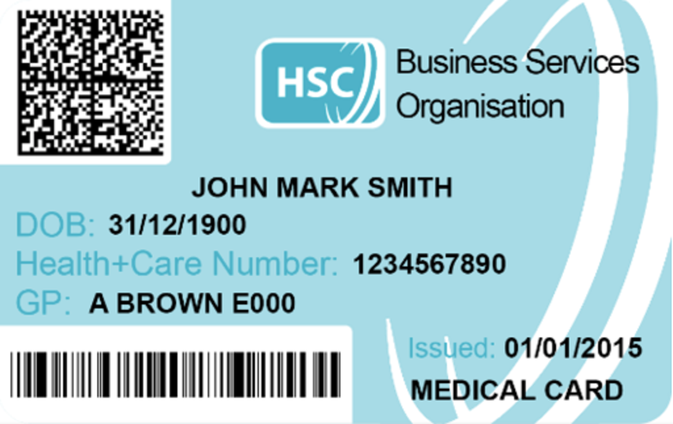
Figure 1 Northern Irish health membership card
View description - Figure 1 Northern Irish health membership card

In this section you will learn about how a hospital might use some of the following information:
- your postcode
- prescription data from GP records.

Activity 3 Postcode use
Allow about 5 minutes

Can you think of a use for the postcode data that you give when admitted to hospital?

View discussion - Activity 3 Postcode use

When you are given a script for a prescription, you might collect this by hand, or an appointment arranged with your GP. They have to take your details from the record they hold. Assuming that this data is correct, it will provide a link to other information that may be used for other purposes, including prevention and public health policy.

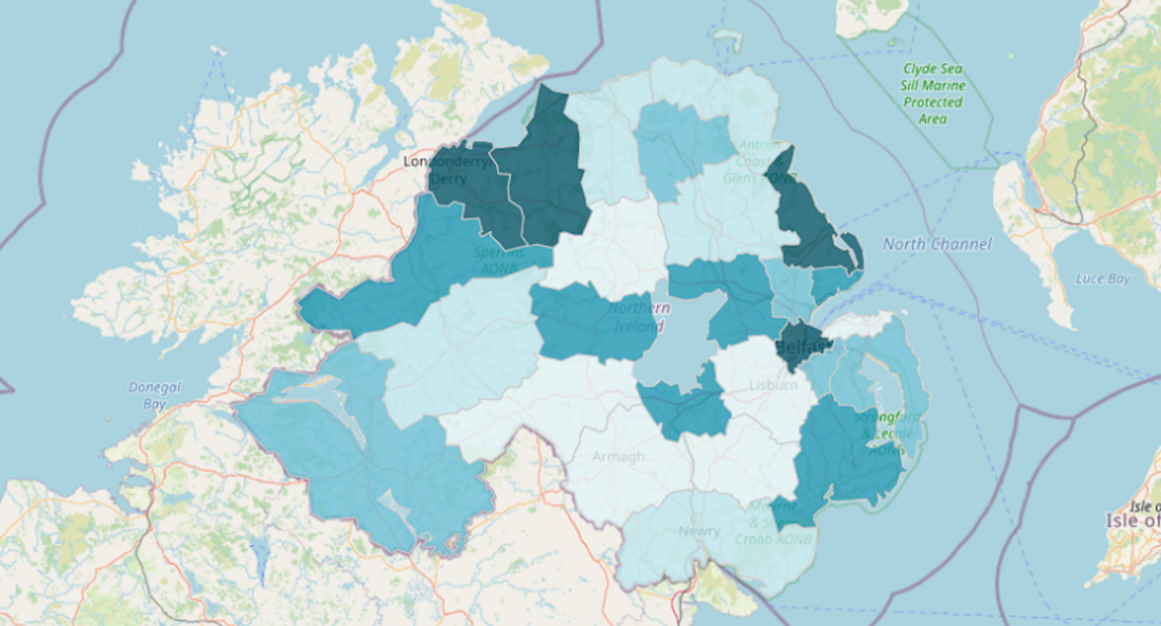
Figure 2 Prescriptions for antidepressant drugs
View description - Figure 2 Prescriptions for antidepressant drugs

3 Sensing data and turning it into something usable
In the previous section you learned something about what data is, where it can be found, and how it can be used. But have you ever thought about how we get data in the first place? As human beings, we are so used to reading, writing, speaking and observing that we rarely think about the true origins of the data we commonly use with such ease. This course won’t take you back to these origins – that would take too long. Rather, you will look at how human beings ‘get’ data and put it into a useful form.
This section aims to:
- provide a more detailed definition of data
- show in simple terms how human beings can turn sensory data into something that can be communicated and reasoned about.
Before computers, it was mainly philosophers who thought about how human sensation (such as sight or hearing) could be turned into an abstract thing like thought (i.e. ideas or reasoning). To do this, most agreed, sensation had somehow to be transformed into an appropriate form. Once it had such a form, it could become the subject of thought, and human beings could reason about it.

Example 1 Temperature
If you touch a surface, one of the things you will sense is its temperature, i.e. whether it is hot, cold or neither. This is a survival mechanism: if a surface is so hot, or so cold, that it will damage your hand, you need to remove it immediately. But between the extremes of damagingly hot or cold there are all sorts of other sensory experiences: uncomfortably hot, comfortably hot, comfortably warm, neutral, comfortably cool, and uncomfortably cold. Even these categories can be further divided.
If we were only able to react instinctively to our sensations of hot and cold, we wouldn’t be able to convey anything about that surface to another person – for instance to warn them that the surface was damagingly hot or cold. So, in the course of our evolution, we have developed the means of transforming sensation into a form that can be thought about and communicated. We have developed words like ‘hot’, ‘cold’, ‘warm’, and ‘cool’. Such words allow us to link one sensation (touch) to another (vision) (e.g. ‘as hot as burning coals’) and use them to convey our thoughts to other human beings who share our language.
But humans have also gone further. Languages have been given written form, which enables us to transmit our sensations and thoughts across time and space, so that someone over four centuries ago could write:

as, the icy fang
And churlish chiding of the winter’s wind,
Which, when it bites and blows upon my body,
Even till I shrink with cold, I smile …
(Shakespeare, As You Like It)

and convey to us now the feeling of coldness.
Also, because science doesn’t deal in words (such as ‘cold’) which are open to different interpretations, we have developed more objective measures of hot and cold, such as the length of a column of mercury in a thermometer. Thermometers can then be used to compare temperatures by dividing the column of mercury into gradations, called degrees Celsius (written °C). (In some countries temperature is measured in degrees Fahrenheit.) So everyone will agree that a particular surface with a temperature of 112 °C is hotter than one of 91 °C, even though both may feel unbearably hot.

The remainder of this section looks at the concept of sensation, and how perceptions of sensation (such as feeling something is warm or seeing colour or hearing sounds) can be represented so that a computer can do something with them.

3.1 Human beings, data, signs and symbols
We live in a sea of sensation: sight, sound, touch, taste, smell and balance (really a sense of our bodies in three-dimensional space). These sensations, and our ability mentally to process, and then react to and communicate them, are vital to our survival. What we perceive with our senses we call the most primitive form of data: perceptual data.
However, as Example 1 showed, human beings don’t just react instinctively; they respond reflectively, using thought. In other words, we seek to name, to classify and finally to understand what we perceive. A reaction like withdrawing your hand from something that is painful to touch is instinctive. Physiologically, such a reaction protects us from harm.
Language, one of the defining characteristics of human beings, is a hugely complex system of meaningful sounds which can be combined and repeated. It enables us not only to name and classify our sensations, but also to communicate them and our thoughts about them to others.
About 30,000 years ago human beings began making ‘useless’ objects: items not strictly necessary for survival. They couldn’t be used as tools, eaten or used to keep warm. They were the beginnings of art. These ‘art’ objects were often marked with regular scratches, rhythmic lines or dots. No one now knows what these marks meant to the people who made them. Yet we believe that they were signs conveying specific meanings to those who made and used them (anything from counts of days between full moons to reminders of important events in the stories told around the communal fire at night).
A sign (or symbol: these terms are considered to have the same meaning in this course) can be defined as something that conveys some information by means other than direct representation. Signs represent something other than themselves: they symbolise something. Signs vary: a beeping sound on a monitor in the intensive care unit (ICU) can indicate a patient’s condition is changing; a flashing sign on the monitor can draw attention to a specific piece of information, for example tachycardia.
In the well-known painting, The Arnolfini Portrait by Jan van Eyck (shown in Figure 3), the inclusion of the dog in the foreground symbolises domestic fidelity, and the convex mirror in the background symbolises the observing eye of God, keeping watch over the couple.

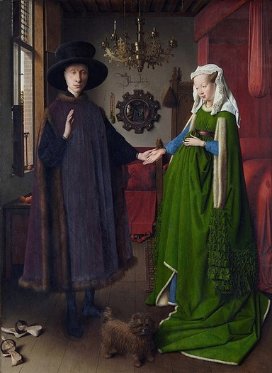
Figure 3 The Arnolfini Portrait by Jan van Eyck (1434) portrays the marriage of Giovanni Arnolfini and Giovanna Cenami, and is rich in Christian symbolism (National Gallery)
View description - Figure 3 The Arnolfini Portrait by Jan van Eyck (1434) portrays the marriage of Giovanni ...

The painting includes many other objects which are symbolic as well as representational, such as the shoes, the single candle in the candelabra, and the positions of the couple’s hands.
Generally, we distinguish signs and symbols from representations by saying that:
- they have a meaning apart from their direct representation
- this meaning is understood by a group of people who agree broadly on what that meaning is.
A flag symbolises a nation or other group, and what is pictured on the flag usually symbolises things important to that group: homeland, language, history or myth. The hands of the couple in Figure 3 symbolise a very ancient custom that the groom ‘asks for the hand’ of his future wife, and the bride ‘gives her hand in marriage’.
Coming back to language, words are also signs. The word ‘blood’ symbolises a particular type of liquid that the body uses to transport oxygen, nutrients, protection and waste products. The word itself is not blood, nor is it a particular person’s blood; it symbolises the substance we think of as a blood. To consider this point, take a look at these images then complete the activity.

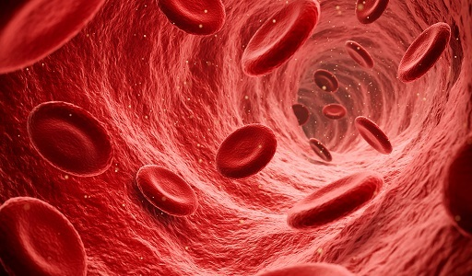
Figure 4 Red blood cells
View description - Figure 4 Red blood cells

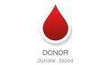
Figure 5 Blood donation icon
View description - Figure 5 Blood donation icon

Activity 4 The symbol of blood
Allow about 5 minutes

Would you call the depiction shown in Figure 4 blood, or does the art symbolise what blood is? In Figure 5, which appears for blood donation, is it a sign in the sense used above? If so, what does it symbolise?

View discussion - Activity 4 The symbol of blood

Signs can come in many forms. There are visual signs (such as road signs, biohazard signs), audible signs (beeps and tones used as attention-getters or warnings, as with medical equipment in ICUs) and tactile signs (such as textured paving stones near a road crossing).

Activity 5 Tactile signs
Allow about 5 minutes

Can you think of any other examples of tactile signs? What might their uses be?

View discussion - Activity 5 Tactile signs

Example 2 An alphabet of touch
Louis Braille, the inventor of the braille system, was only a precocious 10-year-old when he entered Valentin Haüy’s pioneering school for children with a visual impairment in 1819. Haüy – a specialist in decoding manuscripts before he founded the school – had already invented a form of writing for people with a visual impairment using an embossed alphabet. Though a great step forward, Haüy’s system had its drawbacks: it was prone to errors and confusion.
When Braille was 12, Charles Barbier de la Serre, a French army captain, visited the school and described his system of 12 raised dots representing sounds which could be combined to form words. Braille experimented with Barbier’s system and, by the time he was 20, he had simplified it so that each letter of the alphabet could be represented by six raised dots arranged in three rows.
The dots are precisely placed in relation to each other for each character and precisely aligned (sloppily written braille is even harder to read than messy handwriting), and the 63 combinations of dots and positions comprise an alphabet, numerals, the main mathematical signs and a music notation.
Braille is interesting because the basic unit of the sign is, simply, the raised dot, whereas most alphabets compose letters using straight lines, dots, curves and compound marks. Thus braille is very simple and purely abstract (that is, it has no remnants of an iconic system, such as representing the quantity zero by an empty circle). An average braille reader can read about 150 words a minute.
The braille system also freed those with a visual impairment to write for themselves (using a variety of hand- and machine-operated tools). Nowadays computers can produce braille text directly.

In summary, a sign or symbol is a way of representing data. For example, the word ‘blue’ is a sign of a particular colour sensation; a seemingly simple word like ‘cow’ is a sign of a complex thought or idea derived from many sensations; a road sign can represent some condition of the road (e.g. that it narrows ahead) and warn the driver to take care.

Activity 6 What is a sign?
Allow about 5 minutes

Describe in your own words what is meant by a sign or symbol and explain how your personal name is an example.

Provide your answer...
View discussion - Activity 6 What is a sign?

3.2 Data and information
This course is also about information, which in Section 2.2 was distinguished from data. Whereas data is a discrete item, like a price or the name of a product (such as milk), information links two or more items of data to give knowledge: e.g. the patient’s temperature is 38 º C.
To give a simple example, if a person said they were standing at approximately 1 degree 40 minutes and 20 seconds longitude west (written 1°40′20″W), 55 degrees, 4 minutes and 57 seconds latitude north (55°4′57″N), you probably wouldn’t know exactly where it was. You would need to know the meaning of the words ‘latitude’ and ‘longitude’ to understand that the person was referring to a location.
Assume that latitude and longitude and the signs symbolising roads, towns, and so on are data. Longitude measures distance east and west of the Greenwich meridian in (angular) degrees, while latitude measures distance north and south of the Equator in degrees. When they are combined together in a map, they become information, because they answer questions about location. You’d find, for example, that the latitude and longitude mentioned above refer to a place called Ewe Hill in Northumbria, England. On the map, the printed words ‘Ewe Hill’ are the sign of what the place is called.

Example 3 Care planning
Human beings turn data into information through a process of:
- creating signs to represent the data
- agreeing on what the signs symbolise
- linking these signs in a variety of ways to create information
- communicating that information to other people.
The distinction between data and information isn’t always very clear. Is a bus timetable data or is it information?
You might consider that it’s a lot of data, from which you can extract information about when you need to be at a bus stop to catch an appropriate bus.
However, to the person who created the timetable from lots of data about when certain buses arrive at various points along a route, the timetable is information about the system of bus travel in a particular geographical area.
So, whether something is data or information depends partly on the perspective of the user. Data becomes information in users’ minds when it informs them (answers a question, such as how to use a bus to get from A to B at a particular time).

Here is another example.

Example 4 Sign from a stranger
You meet a stranger on a street corner. They move their right hand towards you with their hand extended but relaxed and open, palm held perpendicular to the ground. You perceive the movement. That’s the data.
You now need to interpret that data. Are they going to hit you? Do you need to dodge or duck? Because you may share at least some common culture, you might interpret this movement as a gesture to shake your hand, and not as a blow about to be struck. This would be combining your perception of the movement of their right hand towards you in a particular way with other knowledge you have about cultural signs and their symbolism in order to interpret your perceptual data in a way that tells you not to fear this person's arm movements. This knowledge (that the gesture is not hostile) is information. Alternatively, it could be said that you have used information about cultural norms and gestures in the shared cultural experience to decode the sign made with this gesture. Either interpretation is valid; indeed, both are valid.

You might consider the implications of you and another not sharing some cultural norm. Many cultures have a gesture that is intended to convey to strangers that one party has no hostile intent toward the other. However, what happens if one party (X) to the exchange doesn’t understand the sign intended by the gesture of the other party (Y)? What if there is some additional data or information available (e.g. Y is carrying a weapon)? How then might X react?
You can see from this that information is very important to us as social beings. It is also possible for information to be false, or for a person to have the wrong information, or for information to be ambiguous (subject to multiple interpretations), or for a person to misinterpret information even when it is not ambiguous. One of the themes running through this course concerns whether or not you can always trust data and information to be true, and whether or not data and information which were once true will remain so.

Activity 7 Prescriptions - information or data?
Allow about 10 minutes

Consider a prescription for a medication for a patient. It consists of a form that needs to be complete and followed before the medication is given to the patient.
- 1. Is a prescription information or data according to the definitions given above?

Provide your answer...

- 2. In what ways might a member of the healthcare team find difficulties in interpreting a prescription?

Provide your answer...

View discussion - Part

3.3 What does this have to do with computers?
Human beings invented computers because we have a compelling interest in data. We seek to turn our perceptions of sensations into symbols, and then to store, analyse, process, and turn these symbols into something else: information. Modern computers, with their enormous storage capacity and incredible processing power, are an ideal tool for doing this. They allow us to acquire data, code it in terms of signs, store, retrieve, or combine it with other data. Sophisticated output devices allow us to present the results of all this processing (i.e. information) in ways that were hitherto impossible, too time-consuming, or too expensive.
Long before we developed computers, human beings began developing tools to enhance and extend our perceptions, to help us know better what sort of world we lived in. Telescopes extended our sense of vision by compressing distance for us. We can make temperature sensors to determine the temperature of things so hot or cold (e.g. a kiln or liquid nitrogen, respectively) that we cannot possibly sense these directly without severe harm to ourselves.
Likewise, humans have invented many devices to amplify their muscle power. For example, a hydraulic lift can perform hundreds of times the amount of work that a human or an animal can, thus helping to move patients (hoist). Automobiles and jet aircraft enable us to move at speeds and cover distances that would be impossible if we had to depend on our own legs, or even those of an animal like a horse.

Example 3 Remote sensing
Remote sensing satellites have been examining the earth from space since the 1970s. They do so using not only the spectrum of light visible to our eyes but also infrared and ultraviolet radiation. The pictures built up through their sensing processes are decomposed into symbols which a digital computer can process. These symbols are stored, and then transmitted to an earth station where another computer converts the symbols back into pictures.
If temperature is sensed instead of light, a picture is built up using a technique called false colour, where colours are assigned to values of (in this case) temperature. Commonly, a so-called ‘cold’ dark colour, like black or deep blue, is assigned to areas of relatively low temperature, and a so-called ‘hot’ colour, like orange, to areas of higher temperature, with intermediate temperatures being represented by other colours.
In other examples, remote sensing is sensitive enough to detect disease or pests in crops before they are noticeable from the ground. It has also located upwellings of colder water in the seas and has resulted in the discovery of two hitherto unknown islands in the Arctic.
Figure 6 shows a false-colour image of a huge ice-storm system over eastern Canada on 12 January 1998. It was recorded by a remote sensing satellite orbiting at 800 km altitude. Vegetation is represented in green. Open water is depicted in black. The yellow lines represent political borders between Canada and the USA, and between the provinces of Quebec and Ontario. Clouds, ice and frost all appear in various tones of white to blue-white. It is therefore possible to obtain an impression of the extent of the area covered by heavy freezing rain concentrated in southern Quebec and eastern Ontario.

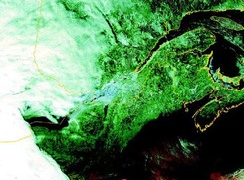
Figure 6 False-colour image of the ice-storm over Canada
View description - Figure 6 False-colour image of the ice-storm over Canada

Computers started as calculating instruments that took as input numbers symbolising things such as distance to a target and the velocity of a missile, and calculated ballistic trajectories to enable artillery troops to fire shells accurately. However, it quickly became obvious that computers could be used for far more than merely ‘number crunching’, because anything that can be symbolised in an appropriate code can be captured in a computer, stored, processed, and then fed back as information.
Using simple devices, computers can mimic our senses and gather data we have no way of dealing with directly. For example, photographs from space probes cannot come back to earth as rolls of film to be developed: they are transmitted back as radio signals which computers can reassemble into pictures. These pictures can be derived from things we cannot see, such as ultraviolet radiation.
The information that computers produce can be used to control devices like mechanical or hydraulic machinery. For example, computers can be ‘put in charge’ of machinery that might be dangerous for humans to operate, or which might move too fast for our nervous systems to control.
Furthermore, computers have vast memories, and they don’t object to storing huge collections of data (e.g. data that is generated when a patient undergoes a CT or MRI scan) that are far beyond the capacity of a single human being. Once such data is stored, we do not need to remember it: rather we can concentrate on remembering what it describes and where it can be found.

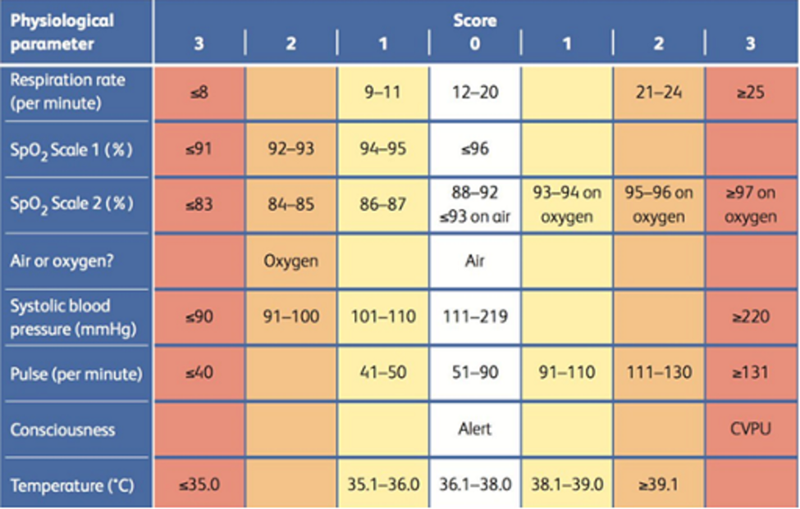
Figure 7 Physiological parameter score chart, intended for use in assessing and responding to acute illness
View description - Figure 7 Physiological parameter score chart, intended for use in assessing and responding ...

Activity 8 The advantages of computers
Allow about 5 minutes

List at least four ways in which computers are important to human activities. Try to think of one or two ways that are not mentioned above.

Provide your answer...
View discussion - Activity 8 The advantages of computers

A computer system is the combination of:
- the computer (with its processor and storage)
- other equipment such as a scanner, monitor screen, keyboard, mouse or printer
- the software programs that make it all work (software programs that are designed to help with some human task are often referred to as applications).

4 Computers as tools for finding
Computers can be used to find things – and the obvious thing they can find is information. The internet is just one example of a vast store of information which can be searched to find what you want using computers (the web consists of linked data which is accessed via the internet using a browser). But computers can also ‘find’ things in the sense of locating them geographically, either by generating maps that can be used for navigation or by locating something or someone with reference to a map.
This section aims to:
- describe how computers can be used in geographical applications (and, in doing so, it discusses maps and shows that maps can have uses beyond mere navigation)
- describe and help you learn how to find information.
As you read on, you should try to determine for yourself:
- what data is involved
- how it might be acquired
- what the computer is doing to this data
- what information is being presented, and for what purpose.
You may find it useful to take notes as you go along.

4.1 Where am I and how do I get to …?
In Section 3, you saw an example that gave a location (Ewe Hill in Northumbria) in terms of latitude and longitude, which are parameters for indicating specific locations on the face of the earth. (The word ‘parameter’ comes from mathematics, and in this course means a property or characteristic – often measurable or quantifiable – of something.) Any point on the earth can be described in terms of latitude and longitude. Indeed, map-makers have used them ever since reasonably accurate means of determining them were developed in the eighteenth century.

Activity 9 Your parameters
Allow about 5 minutes

Can you think of four or five quantifiable and measurable parameters that describe you? If you’re not certain about this, try looking in your wallet or purse at things like your driving licence or other documents.

Provide your answer...
View discussion - Activity 9 Your parameters

4.1.1 Maps
Many people are fascinated by maps, and most find them useful, though not in all situations. A lone driver, without a map-reading navigator, will find it difficult to use a map. More recent in-car navigation systems are designed to help such a driver, or one who is without map-reading skills but is able to follow directions.
This section uses maps to introduce some important terms and concepts. It also examines a navigation system, used both in cars and in hand-held devices, as an example of the application of computer systems to problem solving.
Maps use latitude and longitude to form a two-dimensional grid that covers the curved surface of the earth.
Altitude or depth (based on a notional sea level) can be superimposed on the latitude and longitude grid using lines connecting adjacent points of the same altitude or depth, called contour lines. Contour lines give a map-reader (using a two-dimensional map) an idea of the topography of the area covered by the map.
A map showing only latitude, longitude and contour lines might be of great interest to a geographer. But such a map would be almost useless for, say, a rambler or a driver unless other features, such as roads and villages, were also shown on the map. Examples of two types of map are shown in Figures 8 and 9. Both cover approximately the same area but look very different. They are for a similar purpose (longer distance travel) but serve completely different audiences.

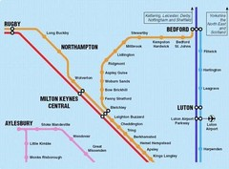
Figure 8 Train line map around Milton Keynes
View description - Figure 8 Train line map around Milton Keynes

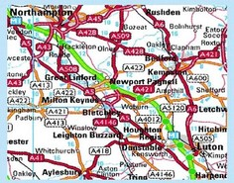
Figure 9 Road map around Milton Keynes
View description - Figure 9 Road map around Milton Keynes

Maps can be made up of separate layers of data. The idea of layering can best be understood if you imagine that each of the following layers is printed on transparent overlays, except the first (the grid) which is printed on opaque paper:
- the underlying grid of latitude and longitude
- contour lines showing altitude
- features such as rivers, roads, buildings and boundaries
- the names of towns, roads, hills, rivers and other notable features of the landscape.
Other types of map may have quite different layers. For example, part of a map showing the incidence of cholera is shown in Figure 10. This was produced by Dr John Snow in 1854, and is a classic example of medical cartography, as it proved that cholera was a water-borne disease.
The layers in this map consist of: (1) the relevant 1854 London streets, (2) the location of 578 deaths from cholera and (3) the position of 13 water pumps. Each location of a death specifies the address of a person who died from cholera. When many such locations are associated with a single address, they are ‘stacked’ in a line away from the street so that the numbers of deaths at an address are more easily visualised. (Using this mapping technique, Dr Snow identified a contaminated pump as the source of the cholera outbreak. By removing the handle of the pump once he’d identified it, Dr Snow averted an epidemic.)

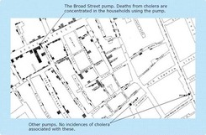
Figure 10 A portion of Dr John Snow’s map of part of London
View description - Figure 10 A portion of Dr John Snow’s map of part of London

Early maps were drawn using counted paces, and local knowledge for place and feature names. However, as the need for greater accuracy grew, geographical data began to be gathered by a painstaking and exacting process of measurement carried out by surveyors. The tools used in the task included chains of an exact length, accurate clocks, sextants and theodolites. Modern mapping still uses some of these, but also relies on aerial photography, on remote sensing from orbiting satellites (described earlier in Example 3) and, increasingly, on the global positioning system (GPS).
This GPS technology can and does have potential use within the healthcare domain. This can include tracking assets such as beds, thus allowing hospitals to know where these may be at any one time (storage, moved to another ward, in a corridor, etc.) to geofencing solutions, that allow families and professionals to set boundaries for clients that send an alert if they stray beyond predefined geographical fences. This is potentially of use when caring for patients with dementia, who may at time wander, with a small wearable device that can be tracked when they cross the threshold set in consultation with them and their relatives. Obviously, issues around surveillance and potential deprivation of liberty may need to be addressed – but the use of technology within an appropriate regulatory framework offers solutions for care unimaginable in the 20th century.

4.1.2 Geographical data
Modern maps are now mostly assembled by computers using very large collections of geographical data, such as latitude, longitude, altitude, roads and towns. Collections of data like this (stored in databases) aim to eliminate the need to duplicate data. The data in databases is described in symbols that the computer can handle, i.e. numbers. Even the names of features are symbolised using numbers.
If someone was trying to tell you the way to a particular street in a town, using only the numbers that a computer uses for geographical data, it would be meaningless to you. Even if you knew the meaning of the individual symbols, there would be too many of them for you to make sense of.
Since maps are constructed from layers of data, it’s possible to leave out some layers in order to achieve a particular purpose, or to substitute other layers to achieve a different purpose. For example, features such as roads, buildings and boundaries can be left out in order to produce a map of interest to certain types of geographer; or population figures can be transformed into appropriate symbols to produce a map of interest to, say, an epidemiologist studying the spread of disease.
Map users like hikers, drivers, pilots and sailors need to have a much more understandable version of geographical data. They might use a map printed on a large sheet of paper, such as one of the Ordnance Survey maps of the UK. However, paper maps have their drawbacks. For example, they require a user to learn how to read them, they don’t show the user where he or she currently is, and they need to be unfolded and refolded.
This highlights a very important theme of this course: fitness-for-purpose. A physical geographer wants certain things from a map (e.g. topographical contour lines) and will probably want to see geographically important features such as soil types. A hydrologist will be more interested in a map that emphasises bodies of water and watersheds. Ramblers want to see footpaths and field boundaries. Drivers want to see roads, junctions and streets in towns.

4.1.3 Global positioning system (GPS)
Your phone is likely to use global positioning system (GPS) software to track your location for maps and other apps. Receivers are also made for aircraft, ships, ground vehicles and as hand-held devices.

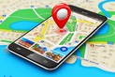
Figure 11 Phone and GPS
View description - Figure 11 Phone and GPS

Examples of applications for GPS are:
- navigation
- surveying, and establishing the shortest distance between two points (a line of sight along the ground is no longer necessary for precise positioning, so greater distances, with features such as hills obscuring the line of sight, can be surveyed much more easily)
- plate tectonic studies (seeing how large areas of the earth’s surface move relative to each other).
The worldwide GPS is funded and controlled by the US Department of Defense (DOD) but its standard positioning service is used by many thousands of civilian users worldwide. More expensive receivers, such as those used in aircraft, are more accurate than the standard service used by most recreational receivers.
The system involves a network of satellites in orbit around the earth, which provide specially coded signals that can be processed in a GPS receiver. Signals from four GPS satellites enable the computer in the receiver to compute the receiver’s position in three physical dimensions (i.e. latitude, longitude and altitude), the receiver’s velocity, and a highly accurate time.

The satellite system for GPS
The GPS satellite system consists of at least 24 satellites in orbit at any one time. The placement of the satellites is such that a user’s ground-based receiver can receive signals from between five and eight satellites from any point on the earth’s surface. Satellite orbits are calculated and controlled from a series of ground stations, one of which (in Colorado in the US) is the master station.

Most leisure users of GPS receivers want to relate position, and perhaps movement, to particular places and features in the landscape. It may be no use to a hiker (trying to get to the next refuge) to come to the foot of a high cliff believing that she’s travelling in the right direction; she needs to know the cliff is in the way of her direct line of travel. This is where the geographical data that goes into making maps comes into its own.
Most GPS systems allow users to superimpose their position information onto a map created from a collection of geographical data that can be loaded into the GPS receiver. As the user moves through an area, the map is constantly updated, keeping the user at the centre of the map. What transforms the data into a map which can be understood (i.e. information) is a small computer contained within the receiver device.
Figure 12 shows an example of a GPS receiver, and how the receiver’s position is ‘placed’ at the centre of the map, indicating the current position and direction of the carrier.

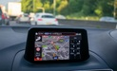
Figure 12 An example of a GPS receiver
View description - Figure 12 An example of a GPS receiver

What happens when a map is wholly inappropriate, e.g. when navigating in the dark, smoke or fog, or if the user has a visual impairment? In such situations oral directions are needed, meaning spoken words to describe both surroundings and the ‘features’ of a journey (left, right, straight ahead, crossroads, junction, and so on). Many navigation devices can give audible directions as an alternative/supplement to a map: ‘Proceed straight ahead for 100 metres before turning left 90 degrees into Porchester Road …’.
Such devices are being further developed as hand-held aids for:
- those with a visual impairment to navigate campuses, shopping malls and buildings
- members of the emergency services who may have to find their way around an unfamiliar building quickly in thick smoke and darkness, or district nurses trying to navigate to a patient, or emergency mountain rescue teams tracking to an individual who is lost.
Since, in the case of buildings, GPS signals don’t work to a small enough scale and don’t penetrate into such structures, they can be supplemented by small local signal beacons or even bar codes on doors and in corridors.
Developments in this area (e.g. Google Maps, and built-in navigation in cars) result in ever more accurate directions to help us navigate.

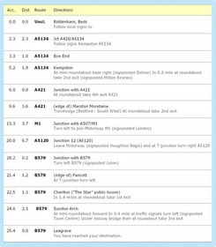
Figure 13 A route between Biddenham and Leagrave in Bedfordshire, obtained from a route-planning service on the web. Taken from http://www.theaa.com.
View description - Figure 13 A route between Biddenham and Leagrave in Bedfordshire, obtained from a ...

Just think of the importance of managing a patient caseload for a health visitor who can plan using satnav, ensuring that the patient will have a reasonable expectation of when they will arrive, and the healthcare professional being able to maximise their effort to meet that caseload need.
Here are some further examples of how a computer system can use the right sort of data to generate useful information in an appropriate way:
- A computer in a microwave oven transforms the pulses of an electronic clock into a time display that shows how long until the cooking is finished.
- A computer in a satellite television control box obtains the signals emitted by a transmitter satellite and converts them into a television picture and sound for the attached television set.
- The computers in a nuclear power station monitor signals produced by pressure sensors and other devices to provide a moment-by-moment summary of the state of the reactor.
- A computer in a car turns the pressure of the driver’s foot on the brake pedal into fine control movements of each wheel’s brake so as to prevent the car from skidding.
- A powerful PC turns signals from a scanner into a representation on the computer’s screen of the item scanned. The PC can then accept commands from the user to modify that image.
It is transformations like these that lie at the heart of this course.

Activity 10 Healthcare data
Allow about 5 minutes

Consider a computer on a ward.
- 1. What kinds of data might it require and where would these originate?

Provide your answer...

- 2. What kinds of information might it present to the healthcare team?

Provide your answer...

View discussion - Part

Activity 11 Data, information and parameters
Allow about 5 minutes

- 1. What is the role of the computer with respect to the data given to it?

Provide your answer...

- 2. How should requirements (such as the need for a user’s attention to be focused on a complex task like driving) affect the presentation of information?

Provide your answer...

- 3. What, in your own words, is the meaning of the term parameter?

Provide your answer...

View discussion - Part

4.2 Finding information: the internet
The web is a vast storehouse of ever-changing, linked information on subjects as diverse as dog breeding, astronomy, tiddlywinks, and coping with bereavement.
Browsers like Chrome, Firefox and Edge are used to access the internet. However, given that the internet contains literally billions of words of text, how do you find information on a particular subject?

4.2.1 Search engines: what are they?
The computer application that facilitates finding things on the web is known as a search engine. This is an application that serves a similar function to an index in a book. Figure 14 shows the home page of the best-known search engine, Google.
For healthcare workers, be that nurses, doctors, or allied health professionals, there are specific databases that have been created to collate and organise healthcare related information. For example, PubMed and CINAHL can be used to look for information about specific topics of interest to a practitioner. These bring together vast repositories of information, from journals, conference proceedings, poster presentations, published theses, to enable users to not only understand the evidence base that currently exists, but also to understand where potential gaps in that evidence currently are.

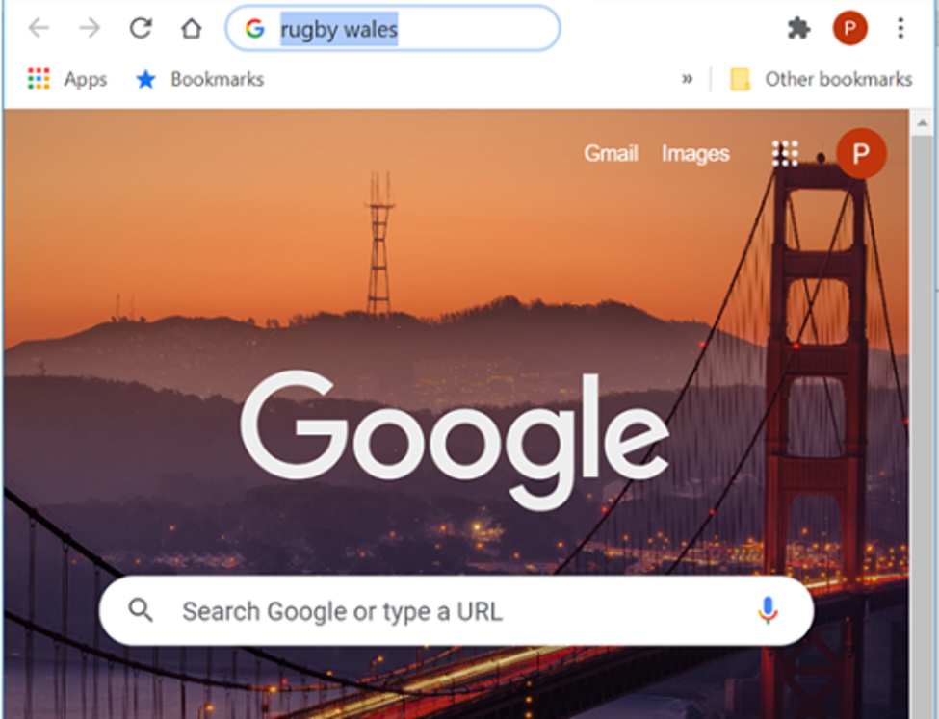
Figure 14 Google home page
View description - Figure 14 Google home page

There is a single box shown in Figure 14 into which keywords (words or terms that identify and distinguish topics from other topics) are typed.
When the button labelled ‘Google Search’ is clicked (or the Return or Enter key is pressed), the search engine finds and returns a list of references to any websites which match all the keywords. Figure 15 shows the results of a search for ‘rugby wales’ (The use of capital letters ‘Rugby Wales’ would produce the same results.) In this case there are more results than will fit on a single screen, and only the first screenful of results is shown.

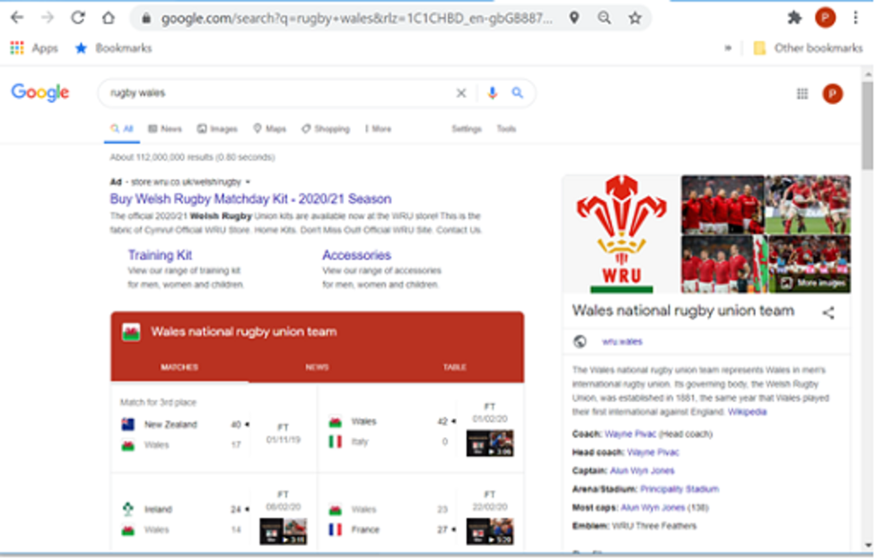
Figure 15 Output from a Google search for ‘rugby wales’
View description - Figure 15 Output from a Google search for ‘rugby wales’

There are a number of references to the game of rugby in Wales, with the first being an advertisement to buy a WRU jersey. Each of the entries in blue is a link which can be clicked on to see more information.

Ego surfing
The internet is full of its own special jargon, abbreviations and acronyms. An example is the term ‘surfing’, which refers to the process of wandering around the internet searching for information. The term ‘ego surfing’ describes the act of looking for information about oneself.

Search engines find results based on keywords, although you may find that performing the same search across several engines returns slightly different results. This is due to the way in which they classify websites, and the relative importance they give to different features. Figure 16 shows two displays, one from Google and one from Bing, using the same keywords: ‘covid 19’. Note the variation in information and how it's presented between both sets of results.

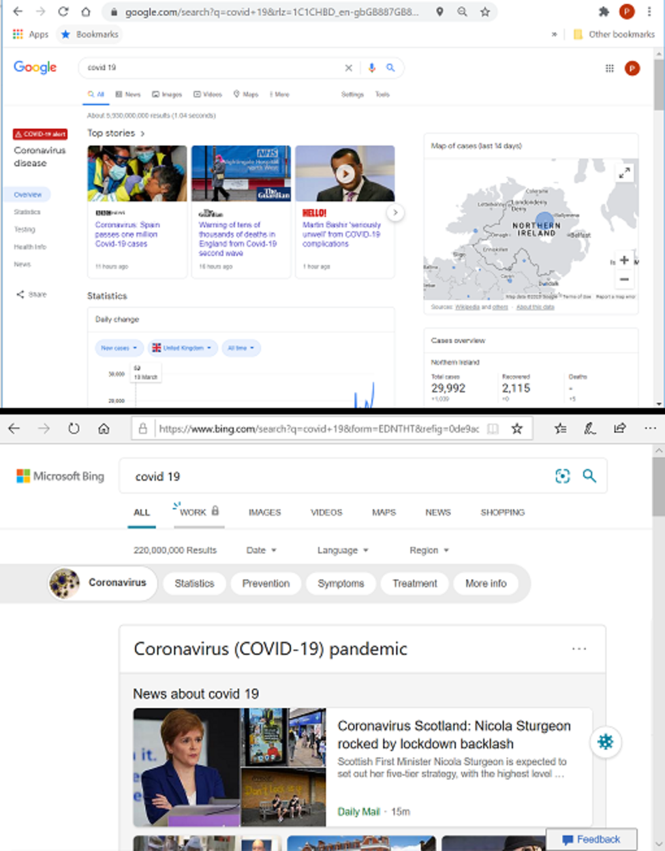
Figure 16 Different search engines: same search, different results
View description - Figure 16 Different search engines: same search, different results

As the web changes constantly, repeating a search a few days later may well produce slightly different results. It is instructive to understand the steps involved when a web search engine is used:
- The keywords are transmitted over the internet to a special computer known as a web server. This web server contains an index to websites. Each website is associated with a series of keywords which can be found in the site’s title, address or contents. The index keywords and the user’s requested keywords are compared by the server.
- The web server then retrieves references to those websites that contain the right keywords and sends details of each reference back to the user’s browser.
- The browser then displays the references for the user.
The data (the keywords) is used to assemble information (the references to websites). Some further ideas on this topic:
- Computers can communicate with each other, and two or more computers can cooperate to provide a service to users.
- A remote computer (the web server) contains data that the user, who could be anywhere in the world, wants to access. This web server computer holds the index used to select those websites relevant to a user’s search.
- Possibly the most important idea is concerned with the sentence in step 2, ‘The web server then retrieves references to those websites that contain the right keywords …’. The computer certainly does this, but how? The answer is that a computer program carries out the actions necessary to do whatever it is that the computer system is designed for (in this case, to search through an index of websites seeking keywords that match the user’s request).
A computer program is essentially a step-by-step set of instructions that tell the computer what to do. In other words, it’s analogous to a cookery recipe. Computer programs are often referred to as software programs, or simply programs. Notice the spelling of the word ‘program’.
Translated into English, the instructions in a computer program (all written in specially designed programming language) might read as follows:
- extract the keywords from the user’s search engine web page
- send the keywords to the web server.
This would happen on the user’s computer (often referred to in this context as a ‘client’). On the web server, the instructions might be:
- extract each keyword from the message sent by the user’s browser over the internet
- search the index for all websites that contain all the keywords.
Computer programs can be range in size, from small programs containing few instructions, or larger, containing hundreds of thousands.
These programs form the basis for how your computer works, and also how your mobile phone works. Apps are programs constructed using code that is optimised for the form factor (design) of the handset. This form factor also allows apps to offer different types of service, Apple Pay for example, or more recently the COVID-19 contact tracing apps which, because of the phone's mobility and ability to communicate, can link geographical proximity information to allow you to be alerted when someone you have been in contact with tests positive.

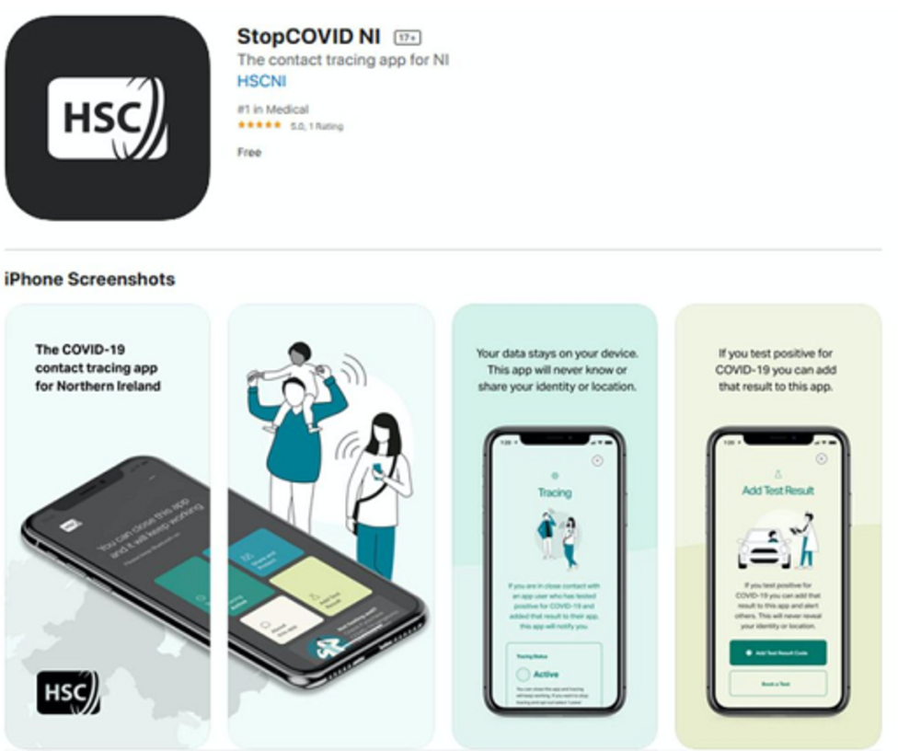
Figure 17 COVID-19 contract tracing app for Northern Ireland
View description - Figure 17 COVID-19 contract tracing app for Northern Ireland

4.2.2 Using the web more effectively
There are a number of information systems on the internet that you can use to examine particular topics in detail. These databases can be accessed directly, or through organisations, who will pay a subscription for access to the information.
University librarians often set up these systems for particular areas of study, although they may be set up by anyone with sufficient expertise in a topic. These databases may be fairly general, such as a gateway site for sciences, or more specific, such as particle physics.
Professional or vocational bodies may also develop databases useful to their members, as may hobby organisations. A well-known gateway for people interested in family history and genealogy is ancestry.co.uk.
These are updated by volunteers or paid staff who add new links relevant to topics of interest, such as births and deaths, marriages, local news and national news sites, and so on.
Sites are searchable, often using the same search engines (e.g. Google) that are available directly through browsers. Because the search engine limits its search to the site’s indexes, this can prove to be a more focused way to search, particularly if the topic is one that is likely, in the wider web, to yield lots of spurious results.
Databases such as CINAHL and PubMed have a gateway which can be accessed by any user to access biomedical literature. PubMed, for example, has more than 30 million citations for biomedical literature, which can include links to full copies of the publication. This is important when assessing evidence for healthcare delivery, as curated, organised and high-quality repositories of information need to be accessible to professionals when considering individual treatment plans, operational systems delivery and healthcare policy at population level.
While healthcare portals are significant and sophisticated there are still issues, not least the pre-eminence of English as the language of publication, the sheer volume of material available, and of course the imbalance towards positive outcome publication in the literature contained in these repositories.
For non-initiates, the technical language can be difficult, and thus limit public involvement in scrutiny and contribution to health and healthcare.
Figure 18 shows the main page of Johns Hopkins Coronavirus Resource Center. Here, information about the virus is presented graphically, with links through to analysis and education about SARS-CoV-2.
Each box or link on the screen is clickable, taking you to specific resources or more in-depth information.

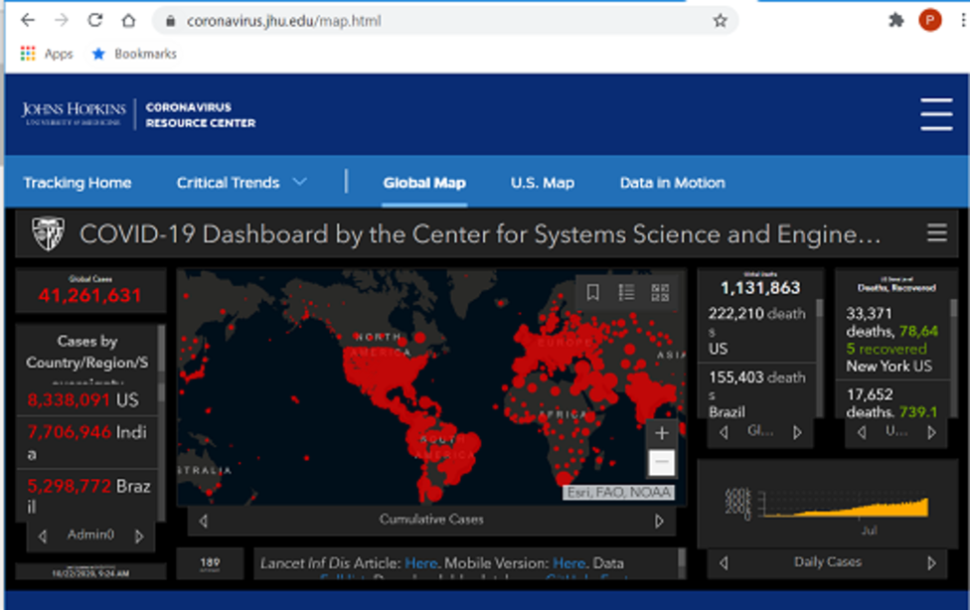
Figure 18 Front page of the Johns Hopkins Coronavirus Resource Center
View description - Figure 18 Front page of the Johns Hopkins Coronavirus Resource Center

4.2.3 Using a search engine more effectively
The search shown in Figure 15 is an example of how to use a search engine in a simple way. However, one of the problems with finding information on the web is that there is so much of it, mostly not relevant to what you want. A search for ‘osteogenic sarcoma’ using the Google search engine yielded about 743000 results or ‘hits’. The first few sites listed will probably contain the information being sought. But what about all the others? Are they all about the disease?
The answer is ‘no’. The search results reference all those sites that mention osteogenic sarcoma, so there will be definitions for the disease, clinical information, research papers, minutes of multidisciplinary meetings, and so on. To get to the right information will take refinement, or as previously mentioned, a specialised site.
If you are just looking for information in a general way, too much information isn’t always a problem. Excessive information becomes more irritating and counterproductive when you are looking for some quite specific information.

Example 4 Myriad
Suppose you’re searching within the topic of breast cancer, and your specific interest is the Myriad testing controversy. If you search on the web by typing in the keywords ‘breast’ and ‘cancer’, the web server will return every website it finds with those two words in it. This results in approximately 525 million hits, so you need to be more specific. Using ‘myriad’, ‘breast’ ‘and legal’ decreases that to about 4 million and the top answers relate to the legal case – much more refined.

There is a skill in being able to narrow down your search to eliminate at least some of the things you aren’t looking for. Each search engine has its own ‘personality’ so to speak, though the basic concepts of making more targeted searches are common to most search engines. Search engine screens will generally have a selectable topic called something like ‘Advanced Search’ or ‘Search Tips’.
One obvious step is to choose your keywords carefully. The more specific the keywords you choose, the more likely you are to get what you want. For example, if you want to find information on antique chairs, typing in just the keyword ‘antique’ will return all websites that use the word antique, and typing in the keyword ‘chair’ by itself will return all websites that use the word chair. But typing in both keywords will only return websites that use both words. Adding ‘British’ to ‘antique’ and ‘chair’ will only return websites that have all three words in them. The more keywords you add, the more targeted will be the websites returned to you.

Activity 12 Refining the Myriad search
Allow about 5 minutes

How could you utilise this skill of incorporating more keywords to help you look for information on the Myriad screening controversy?

View discussion - Activity 12 Refining the Myriad search

Interestingly, if you have misspelled the keyword ‘myriad’ as ‘myrad’, some search engines will not match it to websites containing the term ‘myriad’. Others will respond with the closest word possible. Google, for example, will respond to ‘myrad’ with the message ‘Did you mean myriad?’ together with some websites related to myriad. Remember to check your spelling carefully.
Another useful strategy is to look for phrases rather than individual words. The previous activity mentioned that you might use ‘myriad’ and ‘supreme court’ to look for information on the controversy. This might yield a response that includes anything about the case in the supreme court. However, if you were to enclose both words together in quotation marks – “myriad supreme” – the web server will only return websites that contain the words used specifically in that order.

Activity 13 Search engine quiz
Allow about 10 minutes

- What is a search engine? How does it differ from a browser?
- In carrying out a web search, how many computers (at least) are involved?
- What makes a computer actually do its work?
- In what way is a gateway useful?

Provide your answer...
View discussion - Activity 13 Search engine quiz

5 Genetic databases and disease
Section 2 looked at data and information from two different perspectives: that of the individual and that of health and social care systems. The type of data you have will dictate both why you want to process it using a computer and, to a large extent, how that is done.
This and the next section contain two short case studies whose unifying theme is that the computer and its programs are tools for working with data. The two studies provide an interesting contrast between:
- simple data in large and complex structures (which require large and complex programs to handle them)
- complex data which a complex program helps a non-expert to handle in some interesting, creative, flexible ways.
This section uses a case study to show how simple data (the four bases in DNA) can be combined in different ways to create a huge and complex collection of information.

5.1 What is DNA?
DNA (deoxyribonucleic acid) is frequently in the news for four main reasons.
- DNA can be used in crime detection to eliminate innocent suspects from enquiries or, conversely, to identify with a very high degree of probability the guilty.
- DNA is now used in medicine to detect the possibility that diseases having a genetic origin may occur in an individual. This enables doctors to prescribe preventative treatments.
- It is hoped that discoveries about DNA will yield important new treatments for hitherto intractable diseases and conditions.
- DNA can be used to identify victims of disasters and establish whether people are related.
Figure 19 illustrates the following characteristics of DNA.
- DNA has the shape of an immensely long twisted ladder (the famous double helix) in which each pair of chemical bases in the strand can be thought of as a rung in the ladder.
- It consists of pairs of chemical bases called adenine (A), cystosine (C), guanine (G) and thymine (T).
- The bases (which in Figure 19 are colour-coded) can only be paired according to the rules: A to T, and C to G.
- A ‘rung’ or pair of bases (e.g. A–T) is called a base pair.
- A nucleotide is a base pair plus its attached ‘structural’ molecules (i.e. the sides of the ladder).
- Sequences of base pairs constitute genes, which are the sections of a DNA strand that form discrete units of heredity (such as eye colour).
- A complete DNA strand constitutes a chromosome (a human being has 46 of these, combined into 23 pairs).
- The four letters (A, C, G, and T) representing the DNA bases constitute ‘signs’ symbolising the building blocks of DNA. You can think of a set of signs as a code.

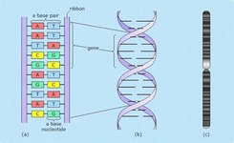
Figure 19 A DNA strand: bases, nucleotides, genes, and chromosomes
View description - Figure 19 A DNA strand: bases, nucleotides, genes, and chromosomes

Activity 14 The English languages
Allow about 5 minutes

The English alphabet is a system of signs that consists of 26 letters, from A to Z. There are rules that govern how letters can form words in English. For example, the combination ‘m-s’ cannot be used to begin a word, but is acceptable within or at the end of a word. This limits the number of English words it is possible to form.
Words, and parts of words, can be combined to make longer words. For example, adding an ‘s’ to ‘dog’ makes ‘dogs’, and preceding ‘mill’ with ‘wind’ gives ‘windmill’. Rules also determine that ‘windmill’ is all right, but ‘millwind’ is not.
- Considering these facts, how many words do you think the English language has?
Now think about things that can be said using the English language, referred to as ‘utterances’. These consist of words strung together according to a set of rules known as grammar.
- How many utterances do you think it’s possible to make in English?

Provide your answer...
View discussion - Activity 14 The English languages

You should now have some idea about how a relatively simple code (signs like the alphabet) can be combined in simple and complex ways to produce an enormous variety of possible ‘products’ (utterances in English).

Activity 15 DNA
Allow about 5 minutes

Think of the DNA bases (A, C, G, and T) as forming a code similar to the alphabet, i.e. four ‘signs’ that can be combined according to rules to form genes. The genes in turn are combined into structures called chromosomes (i.e. DNA strands) of which the human being has 46 (in 23 pairs). Given this structure, a gene is analogous to an English word, a chromosome to a volume of English utterances, and all 23 pairs of chromosomes to the volumes of an encyclopaedia.
- At a guess, how many base pairs, like A–C, do you think the 23 pairs of human chromosomes have?
- What might that answer tell you about how difficult a problem it is to develop a full understanding of the human genetic structure?

Provide your answer...
View discussion - Activity 15 DNA

These two activities demonstrate that having a simple code is no guarantee of a simple system. What can be produced lies not in the simplicity or complexity of the code, but in the possibilities for combinations and the stringing together of small parts to form larger products. In other words, simple elements of data can generate a huge amount of information.

5.2 The human genome
All life is ‘encoded’ chemically in genes. What this means is that the structure of an organism, the organs it possesses, its colouring, and so on are all determined by different genes. A very simple organism may have just a few genes, and a complex one may have tens of thousands. The ‘map’ of an organism’s genes is referred to as its genome. It shows, in essence, which genes give rise to which characteristics or traits of the organism. The word ‘template’ would describe the genome better than ‘map’.
Figure 20 shows the 23 pairs of human chromosomes that constitute the structure of the human genome. These chromosomes contain between 30,000 and 40,000 genes in total. For each human characteristic, such as eye or hair colour, the human genome shows where the genes are that control that characteristic.
Until recently, the idea of mapping the genome of even a simple organism was just that, an idea. The work involved in extracting genetic material, examining it and mapping it to known traits, would be analogous to sitting a dozen people down at typewriters and asking them to write a multi-volume encyclopaedia. It could have been done, but it would have been time consuming (and therefore costly).
Why do it? DNA acts like a computer program. Just as programs instruct a computer to produce certain outputs, DNA instructs the body to develop proteins that make up tissues, cells, antibodies, and so on in a certain way. If there is a defect in a person’s genetic makeup then problems can occur; for example, that person might be more susceptible than average to certain diseases. Mapping the human genome offered some enticing possibilities:
- better understanding of diseases, particularly complex and threatening diseases like cancers
- an understanding of the relationship between different human groups. For example, are we descended from one pair of proto-humans, or did different groups have many different origins?
International effort to map the human genome began in 1995, when it was estimated that the project would require $3 billion and take eight years. But, due to the development of computer-controlled robotic laboratory techniques and improvements in information technology (IT) systems, the Sanger Centre announced in 2000 the first draft of the human genome.

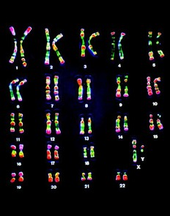
Figure 20 The human chromosomes. An X and Y chromosome is shown as the final pair, meaning that the individual would be a male (females have two X chromosomes)
View description - Figure 20 The human chromosomes. An X and Y chromosome is shown as the final pair, ...

5.2.1 Screening for genetic defects
Now that scientists have mapped the human genome, computers can be used to detect genetic defects.
Screening for genetic diseases existed before the application of computers. Family histories were used, together with a knowledge of inheritance patterns and statistics, to determine the likelihood of a couple having offspring with genetic disorders such as sickle cell anaemia.
Some genetic disorders such as phenylketonuria have had simple chemical detection tests available for some time. Once detected, careful control of diet prevents mental retardation, demonstrating the value of detecting the presence of a genetic disease before any symptoms have appeared.
What the computer adds to the screening process is the power to compare very long genetic sequences (i.e. sequences of base pairs) against the human genome in a way that would be far too time consuming (and therefore expensive) to be carried out by hand. Once a particular gene and type of defect has been identified, it becomes possible to develop a test to find out whether a patient has that genetic defect well before any signs of it appear.
Genetic tests are used for several reasons, including:
- prenatal diagnostic testing
- testing to predict adult-onset disorders such as Huntington’s and Alzheimer’s disease
- forensic and identity testing.

Example 5 Breast cancer and genetics
Breast cancer is one of the most common cancers in women (it occurs in men as well, albeit rarely). The success of treatment following early diagnosis led to a great deal of research in ways of identifying the cancer in the population at large. Some time before the mapping of the human genome, it was already known that between 10 and 15 percent of breast cancers are familial in origin (i.e. groups of related individuals show a greater than average tendency to develop the disease).
Following the mapping of the human genome, it was determined that about one third of familial cancers are attributable to defects in two genes known as BRCA1 and BRCA2. Now there is a genetic test to determine whether or not a woman whose family history includes a high incidence of breast cancer is carrying these defective genes. If she is, her risk of developing breast cancer over her lifetime is between 56 and 85 per cent; and she has a greater than average probability of developing ovarian cancer.
However, there is little point in having a test if there are not corresponding means of providing help. In the case of breast cancer, increased frequency in screening can help detect the cancer at an early stage (and thereby increase the effectiveness of treatment). More controversial is the preventive removal of breast tissues, which imposes a heavy emotional and physical burden without being completely effective. As with so many technological developments, there are costs associated with their use.

It is hoped that using information related to the human genome will lead to ways in which genetic defects can be corrected or their effects lessened.
There are a number of genetic databases that can be accessed over the internet. Using them to detect defects involves searching enormous databases containing genetic sequences which requires huge computational effort.
This case study on DNA has illustrated three main points:
- DNA data is coded in a very simple way (with just four letters of the alphabet)
- such a simple code can still generate complex, multiple structures
- searching such a structure is a time-consuming task.

Activity 16 Simple code, complex problem
Allow about 5 minutes

How can a simple code, such as the DNA bases, become such a complex problem for computing?

Provide your answer...
View discussion - Activity 16 Simple code, complex problem

6 COVID-19 and the importance of data and technology as a tool
The world has changed – certainly in the short term, but possibly in the long term as well. A virus jumping between species, from bat to human, has had a profound global impact. Data, computers, human ingenuity and scientific endeavour allowed the sequencing of the viral genome and the discovery of its structure.

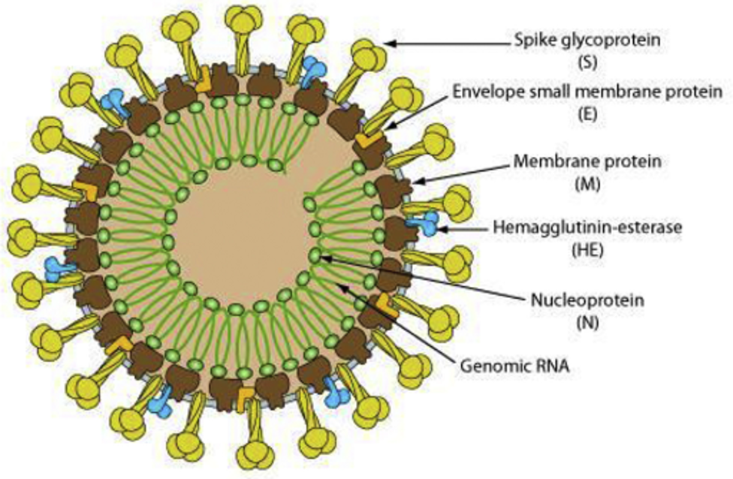
Figure 21 Schematic of a coronavirus
View description - Figure 21 Schematic of a coronavirus

This enabled the anticipation and prediction of behaviour and properties, in order to try and combat the effects of the virus. Collation of data on effect, spread, impact, mortality and morbidity allowed us to evaluate our initial models and refine, facilitating a more targeted response over time. It also allowed us to scrutinise the virus and develop a vaccine as a strategic intervention against it.
What is important to understand is that the collection, collation, interrogation and analysis of high-quality data is a prerequisite in fighting against this disease successfully.
As previously mentioned, Track and Trace systems use the hardware (phone) with the software harmoniously to try and limit the spread of the disease through notification of positive result to individuals and contacts. Obviously the software, testing, permissions, data management and technology must work to achieve efficacy, but the mere ability to do this would impact on the spread eventually.
There are certain contradictions though, if one considers the 1918 Spanish flu pandemic. It spread more slowly, albeit aided by troop returns and movements at the end of the First World War, and ran its course over approximately two years. In those days technology was limited, and even understanding of disease and how to manage public health emergency had no real firm scientific basis. In 2020 the COVID-19 virus spread rapidly, principally through airbridges between countries – thus, technology aided the spread of the virus.
What’s important to conclude in this section is that technology is both a blessing and a curse. In this instance the benefits, such as ease of travel, speed, comfort and cost have benefited the virus, but on the other hand, our ability to examine, track, analyse and manage our public health has benefited us. Technology and the data that drives decision making is only a tool, and of course, a tool is only as good as the one who wields it.

Activity 17 The view from your window
Allow about 5 minutes

If you were asked to develop a coding system that enabled you to store the view from your window in the form of perceptual data in a computer, how do you think it would compare, in terms of complexity, with that of the DNA code?

Provide your answer...
View discussion - Activity 17 The view from your window

7 Controlling things; selling things
As you learned in Section 1, computers can collect, process, store and distribute information. This section shows that they can also be used to:
- control machines and simple mechanisms
- conduct a special kind of commerce: selling on the web.
This section will look more closely at these concepts, using a common example as a case study.

7.1 Controlling things
Think about that common household appliance, your television. For years now, virtually all televisions have been controlled using a microcomputer (chip) of some type. Before that, such control was provided by mechanical systems.
However, because these systems had moving parts they suffered from wear, and tended to break down frequently or require replacement. Also, the nature of mechanical control systems limited how complex they could be. Consequently, they tended to be quite simple, and therefore less ‘automatic’. This functionality developed with use of remote controls.
Things changed as processing power and the internet developed. One need only remember the days before satellite TV and cable, when there were two channels that transmitted for limited hours each day.
Video tape, laser disc and DVD players hooked to a TV increased access to content, but in a physical form factor. Remote controls grew in sophistication, but everything stayed limited to broadcasts and physical media.
Now we have broadband, online content and apps embedded in TVs. Let's explore these in more depth.

7.1.1 The user interface
An interface is a connection, and in this case it’s the means for you to connect and sort function and information from your TV.
While each manufacturer will have differences in design, the functionality is similar, with access to apps for specific content providers. This approach follows on from the interfaces developed for computers, mobile phones and tablets, keeping in mind the form factor it's being designed for.
This form factor drives the interaction: for a mobile almost all screens are now touch-driven, while for TV the handheld remote (and more recently voice control) is ubiquitous.
The interface is designed to be intuitive and functional, so that you can navigate as quickly and easily as possible.

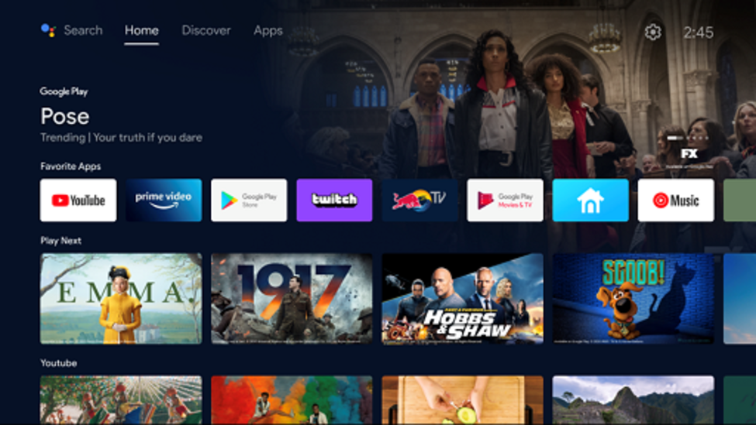
Figure 22 Android TV interface
View description - Figure 22 Android TV interface

Some TVs will list or display content, similarly to apps (that will have their own interfaces). What is evident is that these systems, while distinct and separate, have overarching similarities. The user interface is designed to allow the user to manage the functionality as easily as possible – and for modern TVs that means accessing content when the viewer wants.

7.1.2 Choosing programs and parameters
Within the systems settings on a TV, tailoring for individual taste has become ever more important. This is not only for personal preferences, but also to help users adjust in response to their particular requirements (e.g. colour blindness). Menus (navigated by the remote and/or voice) allow the user to adjust many system settings, such as: colour, sound, connectivity, internet access, Bluetooth and other device access.
These are complex functions at times, but gone are the days of tuning to individual stations and pressing buttons to set and store channels. Automation and system intelligence carry out these functions for the user, allowing the person to concentrate on how they use the technology, and the aesthetics.

Activity 18 A simple interface
Allow about 5 minutes

What kind of interface would you expect on a very simple tablet?

Provide your answer...
View discussion - Activity 18 A simple interface

7.1.3 Ensuring safety
Ensuring that a user can’t blow up the TV is of course essential. The very form and design of the TV, its power systems, circuitry and construction, protect against these risks. System settings will have restrictions, hidden to users, that prevent the software damaging the TV and protecting the user.
On a related note, TVs now often shut down automatically after periods of inactivity (to protect against screen burn), and notify viewers when they've been on for a length of time, suggesting to switch the device off.

Activity 19 Car door locks
Allow about 5 minutes

It is common in modern cars to have central locking. This usually involves pressing a button on a key fob and sending a signal to the car from a short distance which locks or unlocks all doors simultaneously. A button on the control panel may work in a similar way to lock and unlock all the doors from inside.
- Can you identify any safety considerations for the lock-control program in the car’s microcomputer?
- What kind of information might a driver need about the door locks?

Provide your answer...
View discussion - Activity 19 Car door locks

7.1.4 Controlling the machine
The major task of a TV’s microcomputer is to control the actions of the machine in accordance with the user's preferences and wishes, while ensuring that it provides the content to the user in an acceptable form. To do this, the computer is electrically attached to a variety of mechanisms of control, such as light sensors, remote sensors, internet connections, power supply and connectors (both physical and remote – WiFi, Bluetooth).

Activity 20 Computer-controlled devices in the workplace
Allow about 10 minutes

To finish off this topic, consider any computer-controlled devices in your workplace, and any improvements you might suggest, using these questions as prompts:
- What role do computer-controlled devices play in your workplace?
- Is any information collected, processed, stored or distributed?
- What's the user interface like?
- How do you interact with the device?
- Are there built-in safety controls?

Provide your answer...
View discussion - Activity 20 Computer-controlled devices in the workplace

7.2 Technology and change
The internet has fast cemented its position as the place to buy and sell, with a wide variety of core product sites and services available for the exchange of funds when purchasing goods (Amazon, Apple, eBay, Google Pay, PayPal, Boohoo, ASOS to name a few). We are fast becoming a contactless payment society, with phones replacing cards as a means of transaction.
Amazon’s revenue in 2019 was 280.52 billion dollars, which is staggering when you consider the company started in 1994.
Technology has transformed how we interact, trade, relate and manage. 20 years ago social media platforms didn’t exist. Facebook was only formed in 2004, yet they are ubiquitous, with 2.7 billion active users. Other popular platforms now include Instagram, TikTok, Twitter, YouTube. This remote interaction through technology has obviously and overtly impacted on our use and reliance of technology. Think about the discussion of GPS and satellite navigation earlier in the course – where would we be without this kind of technology?
The empty shops in town centres over recent years are evidence not only of economic issues, but also of a move from away from our more traditional means of commerce. Banks, for example, closed a third of their branches between 2015-2020, driven in large part by cost controls and restructuring, but also by the shift to online and app-based banking, as demonstrated by digital banks like Revolut and Starling.
As of 2020 there were 14.02 billion mobile devices in the world. The global distribution of mobile phones is shown in Figure 23:

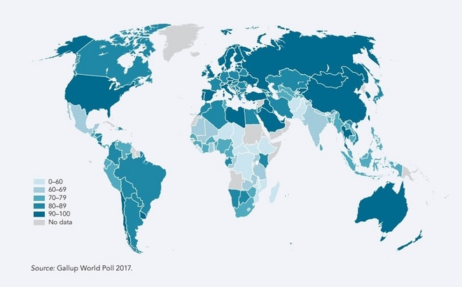
Figure 23 Mobile phone ownership around the world - adults with a mobile phone (%) 2017
View description - Figure 23 Mobile phone ownership around the world - adults with a mobile phone (%) ...

Mobile phones have a multitude of functions, and it’s clear that they have significantly changed many of our behaviours.
They can assist with achieving health goals, with various fitness apps and platforms available (e.g. Strava, MyFitnessPal and Google Fit) that the phone either uses independently or synchronises with wearable technology, such as activity trackers or smart watches. The data can be used not only by an individual, but also collated for use in areas such as public health planning and city planning.
What’s important to understand is the importance of the technology in our everyday lives, and the potential for it to be used to better manage and protect our health.

7.2.1 Using a sales website
A visitor to a sales website is usually able to:
- browse through the details of the goods for sale
- search for a particular product
- check on the availability of goods
- read reviews of the products by other purchasers
- register to receive newsletters which detail new items of interest
- buy products using credit or debit cards, online payment systems (e.g. PayPal), and in some cases, other payment methods such as cheques.
Some sales sites also allow the user to:
- see what items are most popular
- check the status of their order.
A typical indication of what the Amazon website offers can be seen on its home page:

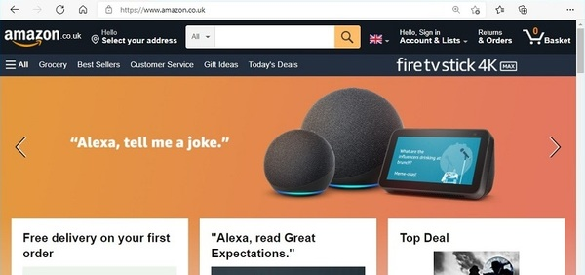
Figure 24 Amazon.co.uk homepage
View description - Figure 24 Amazon.co.uk homepage

Activity 21 Search functions
Allow about 5 minutes

Retail websites offer a variety of search functions for customers.
- Describe what you think are the differences between these types of search.
- Why should there be a variety of ways to search?

Provide your answer...
View discussion - Activity 21 Search functions

7.2.2 Database servers
To be able to search a website like Amazon’s requires not only a web server, but a database server. Like a web server, a database server is a computer that responds to requests from other computers. Its task is to find and extract data from a database.
The internet and database servers form part of a distributed system. This means that separate computers exchange data and information across a network (in this case the internet) to produce results for a user. For example, suppose you use the keyword search to ask for ‘kitchen cleaners’. This request is transferred to the web server, which has an index of products which can be categorised as kitchen cleaners. It then sends these product numbers to the database server, which locates the correct items in the product database and returns information about them (pictures, description and price), via the web server, to the browser.
Compared with the simple data from which the complex DNA database is built, the data processed by the database servers at a company like Amazon is complex (text, graphics, pictures).

Activity 22 Information requirements
Allow about 5 minutes

For a company like Amazon:
- what are its customers’ information requirements?
- what are the company’s information requirements?

View discussion - Activity 22 Information requirements

Let’s see how Amazon’s system addresses some of these requirements in terms of the data they store in their databases. This will include:
- information about customers:
  - names and contact details
  - credit card information
  - the passwords (if any) they use to gain access to the Amazon website
- information about their products for sale:
  - pictures
  - specifications
  - price
  - special offers
- the current stock (inventory) of a particular item
- the position of a product in terms of its popularity
- orders that have been made:
  - when they were made
  - when they were or will be dispatched
  - whether the full order can be satisfied from stock.
What is interesting is that although the data listed above is quite ‘rich’ (i.e. complex), the processing required to extract the data is not very complicated. For example, it takes very little computational effort to extract a customer’s current order. All that is necessary is for the area of the database containing order details to be searched for a match with the customer’s name information or an order number.

7.2.3 Security: are my credit card details safe?
Many people now shop regularly on the web. However, many others don’t because they fear that an unscrupulous person could obtain their credit card details. They also fear that if they provide their names and addresses to a firm on the internet, they will be bombarded with junk mail (or its electronic equivalent, junk email). Some worry that since anyone can put up a website, the seller may be bogus, and no goods will appear after the sale has been completed, or they won’t be as advertised.
Consequently, this raises the important issues of security and trustworthiness. The internet is a remarkably open medium. It does not take too much effort to ‘capture’ the data that flows along communication lines. Someone could theoretically read your credit card details as they are transmitted between your computer and that of the seller. (‘Theoretically’ is used there because techniques exist which enable the data to be transformed into a form which would be virtually impossible to read.)
You can be reasonably confident of buying from a website if it displays one of two things.
- The address shown in the bar at the top of the screen should start with ‘https’ instead of ‘http’. The letter ‘s’ means you are connected to a secure web server using techniques to protect your details from electronic snoopers.
- An icon representing a small padlock/key is present. This also indicates that the web server you are connected to is a secure one.
Another safety precaution is to deal only with web sellers you know are reputable. Consumer organisations often have schemes for accrediting web sellers who are legitimate and secure dealers. Friends and neighbours may also be able to recommend reputable and secure web sellers.

Activity 23 A distributed system
Allow about 5 minutes

Is web selling an example of a distributed system? Explain your reasoning.

Provide your answer...
View discussion - Activity 23 A distributed system

7.3 Summary
This section examined how computers can be used to control machines. It used the household washing machine as a case study and explored how the microcomputer contained in such a machine is programmed to:
- provide an interface for the user to operate the machine
- control the way the machine carries out the operations chosen by the user.
The washing machine case study also illustrated the necessity of building safety features into computer-controlled mechanisms.
Computers are also used to support selling goods and services via the web. A case study of a successful company showed what the information requirements for such a system are, and examined how two or more computers can cooperate as part of a distributed system to satisfy these requirements in a way that is secure.

Conclusion
This course began by exploring some basic issues involving computers:
- the nature of data and information
- why human beings need (and want) computers
- the prevalence of computers in modern life and their use in some instances for healthcare.
The course looked briefly at how a computer-based society affects the average person, who (whether they know it or not) has a persona that consists of data about them held by many diverse organisations.
Much of this course consisted of case studies illustrating the possibilities for computer use. They raised some of the issues posed by computing technologies, such as:
- the distinction between data and information
- what computers can do with data to produce information, and how this might be used to manage COVID-19 as an example
- how computers can be used to work with data and search for it, control machines, and support commercial operations, and how society has changed to incorporate this.
There were are a number of themes running through this course:
- Data requires encoding.
- In order to function, a computer requires data which may be stored in databases.
- Data has to be transmitted from place to place.
- At the heart of a computer system there are one or more programs.
- Many current computer systems are distributed, in that they consist of a number of computers which cooperate and communicate with each other in order to function.
- Information has to be fit for purpose.
- Security and trustworthiness are major concerns with many systems.
- Computer systems also have drawbacks and adverse effects. They also have social, political, legal and ethical implications.
This OpenLearn course provides a sample of Level 1 study in Computing & IT and Health and Social Care.

Acknowledgements
This free course was written by Paul Carlin and Donna Gallagher (Staff Tutors at The Open University), and Claire Buchner (Assistant Director Digital Health & Nursing, DHCNI & Public Health Agency, NI).
It was adapted from a previous version of the course titled An introduction to data and information, which was published in 2012.
Except for third party materials and otherwise stated (see terms and conditions), this content is made available under a Creative Commons Attribution-NonCommercial-ShareAlike 4.0 Licence.
The material acknowledged below is Proprietary and used under licence (not subject to Creative Commons Licence). Grateful acknowledgement is made to the following sources for permission to reproduce material in this free course:
Course image: in-future; Getty Images
Figure 1: taken from: https://covid-19.hscni.net/get-vaccinated/; HSC NI
Figure 2: NISRA / NINIS
Figure 3: The Arnolfini Portrait, Jan van Eyck, oil on oak, 1434. National Gallery, London
Figure 4: ExperienceInteriors; Getty Images
Figure 5: Antonina Prokhorova; Shutterstock.com
Figure 6: Canada Centre for Remote Sensing, Natural Resources Canada
Figure 7: Reproduced from: Royal College of Physicians. National Early Warning Score (NEWS) 2: Standardising the assessment of acute-illness severity in the NHS. Updated report of a working party. London: RCP, 2017.
Figure 8: Map extract produced by FWT and reproduced with the kind permission of the Association of Train Operating Companies
Figure 9: Ordnance Survey map with permission of Ordnance Survey on behalf of The Controller of Her Majesty's Stationery Office, © Crown Copyright
Figure 10: John Snow (1813-1858); OOC
Figure 11: scanrail; Getty Images
Figure 12: KerrysWorld; Shutterstock.com
Figure 13: reproduced by permission of AA; https://www.theaa.com
Figure 14/15/16a: Results from Google.com search
Figure 16b: Results from Bing.com search
Figure 17: taken from: https://apps.apple.com/gb/app/stopcovidni/id1519404160
Figure 18: taken from https://coronavirus.jhu.edu/map.html; JHU.edu Copyright © 2021 by Johns Hopkins University & Medicine
Figure 20: CNRI/Science Photo Library
Figure 21: biowiki.org; https://creativecommons.org/licenses/by/4.0/
Figure 22: Example user interface: https://www.android.com/static/2016/img/tv/hero/tv-hero-mobile@us.jpg
Figure 23: © 2018 International Bank for Reconstruction and Development/The World Bank; cc-by
Figure 24: Results from Amazon.co.uk search
Every effort has been made to contact copyright owners. If any have been inadvertently overlooked, the publishers will be pleased to make the necessary arrangements at the first opportunity.
Don't miss out
If reading this text has inspired you to learn more, you may be interested in joining the millions of people who discover our free learning resources and qualifications by visiting The Open University – www.open.edu/openlearn/free-courses.

Solutions

Activity 1 Data collection

Discussion
A number of people will collect data about Mrs Craig:
- Mrs Craig will have data collected by the ambulance service when they attend to her call at home.
- The A&E department will collect data within their computer system.
- The doctors and nurses will collect information from Mrs Craig on the ward.
- The operating theatre staff will record data on their computer system during her operation to repair her fractured hip.
- The physiotherapist will document more information during rehabilitation.
- The district nurse, occupational therapist and perhaps the social work team will create more records on their systems when Mrs Craig returns home.
- Mrs Craig also has a record with her GP.
All of this data, collected by many people on her journey, will create a huge amount of information about Mrs Craig. Each member of staff will use it in different ways because of the job they do. The data is not often shared.
Back to - Activity 1 Data collection

Activity 2 Information on a ward

Part

Discussion
There is no single answer to this activity, but here are some examples:
Nurses collect data and make decisions based on that data. It could come from the patient, visually, through physical examination, smell and listening, from paper records, through equipment that sends information to systems for analysis, and from other health professionals directly.
This needs to be structured so decisions about treatment or investigations can be made, so it’s not a good idea to write this type of information down on hundreds of scraps of paper.
Think about why it’s better, for example, to use a chart for observations. How is the data structured and prepared for review and decision-making?
For members of the team ordering stock, they may use codes that make it easier to track and control various types of medication. A nurse/doctor may record a diagnosis that is then coded by the coding team for analysis.
Back to - Part

Part

Discussion
Here is an example list of things a doctor might need to know:
- personal information about a patient which enables the doctor to visit that patient
- the patient’s medical records which show previous treatments, any adverse reactions to treatments, and so on
- information about the external bodies that deal with patients, such as the location of the nearest pathology laboratory, and the name of the consultants at the local hospital who treat particular disorders
- information about the latest policies and procedures of the NHS
- recent research findings relevant to a patient’s condition.
The above list shows how daunting information requirements can be. A doctor needs everything from the simple and obvious (the patient’s name and address) to the complex and possibly obscure (the latest research findings on a rare disease).
Back to - Part

Activity 3 Postcode use

Discussion
Your postcode can be used to examine how services might be delivered in your area. What services exist? How many GPs are available? How might services in the futurebest be planned for?
The postcode can give information about prescription use in your area, for example, that can highlight a number of issues that might be relevant to you and your family, such as the use of painkillers, and social deprivation.
While this will not be directly attributed to you, it might influence health information campaigns or resources to highlight and deal with an issue in a specific geographical location.
Back to - Activity 3 Postcode use

Activity 4 The symbol of blood

Discussion
The picture of the blood in Figure 4 is a representation (symbolism) of real blood. Figure 5 is intended to be a sign that symbolises blood in a blood donation drive.
Back to - Activity 4 The symbol of blood

Activity 5 Tactile signs

Discussion
You might have thought of braille, which is intended to be read by those with a visual impairment, using the tips of the fingers.
Even for sighted users, tactile signs can be useful. Where the user must use sight or hearing for other things (operating complex machinery), or where vision or hearing is not possible (in very dark or very noisy environments), the position, shape, size or texture of a tactile sign can ensure that the user knows what it is without having to look at it. Most cars, for example, use position to differentiate between two otherwise similar controls, like the indicator lever and the windscreen wiper lever.
Back to - Activity 5 Tactile signs

Activity 6 What is a sign?

Discussion
You might have said something like this:
A sign is a representation of something, where the representation could be a sound (such as a word) or a drawing or some other more abstract representation. To be a meaningful sign, there must be a group of people who agree on what the sign represents.
Your name is a sign, in that it is not you, but represents you to yourself and to others (e.g. your family, your employers, your community).
Back to - Activity 6 What is a sign?

Activity 7 Prescriptions - information or data?

Part

Discussion
- You might consider the prescription to be information, because it answers the question: how do I make sure I am giving the correct medication to the correct patient at the correct time? The list of individual drugs, dose, time and signature and any separate instructions might be considered as all data.
- There might be many difficulties in interpreting the prescription. The member of the team might assume that the dosage was appropriate if they had no real knowledge of the drug, might not understand that the means of administration might be described in shorthand and unrecognised terms might be used (PO, IV). The prescription could list the drugs in a confusing order if you were not familiar with the format of the script. The form and information contained in the script assume a previous knowledge.
Back to - Part

Activity 8 The advantages of computers

Discussion
You might have a list similar to the following:
- Computers can store large amounts of data.
- They are not bored by what people might consider to be trivia.
- They can be used to control machinery in remote or dangerous situations or where things happen too quickly for human responses.
- They are useful for data analysis.
- They facilitate the transmission of data across vast distances by, for example, putting a picture into a form that can be transmitted, and then reassembling it into a picture at the receiving end.
Back to - Activity 8 The advantages of computers

Activity 9 Your parameters

Discussion
You might have listed things as: your age in years, your height in centimetres, your weight in kilograms, and your birth date. All of these are measurable or quantifiable characteristics of you.
Back to - Activity 9 Your parameters

Activity 10 Healthcare data

Part

Discussion
- The data originates either from a variety of sources, observational (looking at the patient), devices (thermometer, BP machine), data on the computer screen (labs, radiology), paper based records..
- The observation chart might display the patients obs, and perhaps a change. The computer screen might display the patient record. Notes will provide a record over time of the patient’s treatment and response.
Back to - Part

Activity 11 Data, information and parameters

Part

Discussion
- The role of the computer is to transform data into information.
- The presentation of information needs to be fit-for-purpose and, in the example given, presented in a way that lets the user keep their primary focus of attention on the task.
- A parameter is a property or characteristic of something that is measurable or quantifiable.
Back to - Part

Activity 12 Refining the Myriad search

Discussion
You could choose to enter the keywords ‘myriad’ and ‘supreme court’. This will almost certainly eliminate websites about breast cancer genetics. You could add an additional terms such as ‘decision’ or ‘history’.
Back to - Activity 12 Refining the Myriad search

Activity 13 Search engine quiz

Discussion
- A search engine is a computer program that uses keywords to help users locate websites containing information they want.
- At least two are involved: the user’s computer (the client) and the web server.
- A program of instructions, stored in the computer, called a computer program.
- A gateway provides a pre-chosen set of links on the web for a particular topic. Instead of searching the whole of the web for information, a gateway provides a very focused means of getting information that usually has been compiled by an expert.
Back to - Activity 13 Search engine quiz

Activity 14 The English languages

Discussion
- A standard, reputable dictionary will have between 30,000 and 50,000 entries. Even this is only part of the story since most dictionaries do not include slang, dialect words or words that exist for only a very short period of time. Neither do they contain specialised vocabularies that exist in certain professional and trade groups (e.g. among doctors). Thus the likely total vocabulary of English is (at a guess) in excess of 100,000 words.
- The number of utterances possible in English is virtually infinite. This is because, even given the rules of grammar, they can vary in length and word order.
Back to - Activity 14 The English languages

Activity 15 DNA

Discussion
- The longest human chromosome has about 263 million base pairs, the shortest 50 million. For all 23 pairs the total exceeds 3.2 billion (i.e. 3,200,000,000).
- The base pairs in a gene can vary, which is what gives us genetic diversity. So the problem of trying to understand the genetic structure of humans is roughly analogous to trying to read and understand all the sentences in a huge, multi-volume encyclopaedia!
Back to - Activity 15 DNA

Activity 16 Simple code, complex problem

Discussion
Although the code is simple, the bases combine in very complex structures called genes (analogous to words in a language) that can be combined into more complex structures called chromosomes (analogous to a volume of a large encyclopaedia). Searching for a particular genetic defect in the genetic structure of the human being is not a trivial task. Apart from the size of the search, there are likely to be many instances of the same combination of base pairs (just as searching for the word ‘king’ in the collected works of Shakespeare would yield a large number of hits, including some false ones such as ‘lurking’).
Back to - Activity 16 Simple code, complex problem

Activity 17 The view from your window

Discussion
DNA has a very simple code: just four values or letters. A scene such as the view from a window is highly complex. It contains innumerable colours, light and shade, lines and edges, and visual depth, with objects nearby appearing focused and those further away progressively less distinct. So, encoding this for use by a computer would require a complex code.
Back to - Activity 17 The view from your window

Activity 18 A simple interface

Discussion
Since a typical tablet has no keyboard, a touch screen is required. How the screen is then laid out and navigated becomes important, particularly when utilising context-specific gesture control, as is the case with Android and Apple interfaces.
Buttons on the tablets are usually limited to on/off and volume controls. Everything else is contained in the UI (user interface).
Back to - Activity 18 A simple interface

Activity 19 Car door locks

Discussion
- It might be dangerous to allow someone to unlock the doors while the car is in motion. For example, a child might press the button on the control panel, unlocking the doors, then accidentally open the door and fall out. With very small children, it might be dangerous for the child to be able to unlock any door (even when the car is stationary) without the driver knowing. Thus one safety consideration might be to ensure that it is not possible to override child-proof locks accidentally or through carelessness.
- The driver might simply need a light to tell them whether the locks are engaged or not.
Back to - Activity 19 Car door locks

Activity 20 Computer-controlled devices in the workplace

Discussion
Here are some example notes, though yours may vary:
- They manage sensors and actuators to control the actions of mechanical devices such as cars, microwaves and washing machines.
- They provide interfaces that enable the user to control the workings of the machine.
- They control the machine’s actions in response to the user’s choices and the state of the machine.
- They help deliver and manage care for patients, as well as how staff are employed, recruited, developed and allocated on a daily basis.
- A multitude of examples exist, from imaging systems such as X-ray, CT and MRI, to electronic thermometers that wirelessly send information about a patient’s temperature to the patients record.
- Off duty is managed through sophisticated rostering systems, that track working hours, study leave and annual leave, while also assuring the correct skill mix on a ward.
- Portable technology is becoming more relevant to healthcare delivery, with iPads being used to collate information, action investigations and review information with patients being actively involved. This helps to democratise the decision-making process for those who may wish to have a more active role in their own care.
- Aggregated data is used to evaluate and plan systems of care delivery, at population levels, and can also be used to help manage significant health events such as the outbreak of an infectious disease, by allowing those in control to map, plan and predict need and risk.
Back to - Activity 20 Computer-controlled devices in the workplace

Activity 21 Search functions

Discussion
- A keyword search allows the user to type in words, such as ‘clothes storage’, and the search engine will look through the website for products which fit this description.
A product search applies when looking for a specific item. You may know the exact name of the product and type that in. This is often associated with businesses with product catalogues the customer can look through. The product numbers in the catalogue can be used to access a product very quickly. For example, typing in ‘5692’ will display the product designated by that number.
- The types of search serve different customers: those who are interested in a particular type of product (keyword search), and those who have their eyes on an actual product (product search).
Back to - Activity 21 Search functions

Activity 22 Information requirements

Discussion
Your answer will probably differ from this list, but you should have a number of similar points.
- Customers are likely to want to know:
  - the items for sale
  - what items look like
  - details about performance
  - cost
  - other information, such as availability, guarantees, delivery costs, and time of delivery.
- Amazon’s requirements will be much broader and include information relating to:
  - product suppliers
  - wholesale cost
  - availability and delivery arrangements
  - its own storage and distribution system
  - who buys products from Amazon and why
  - what other products such buyers might be interested in
  - where there might be sufficient customers to warrant opening a new shop
  - hiring, training, promoting and retaining staff
  - competitors and what they offer that Amazon does not
  - accounts and finance
  - legal matters such as product and supplier liability, employment law, contract law.
Back to - Activity 22 Information requirements

Activity 23 A distributed system

Discussion
Yes, it is a distributed system. It consists of user PCs, web servers, and database servers, with data and information being transferred between them using networks (in this case the internet).
Back to - Activity 23 A distributed system

Figure 1 Northern Irish health membership card

Description
This image shows an example of a health card, with various pieces of personal information displayed (name, date of birth, health+care number, GP info, and issue date). There’s also a barcode and QR code.
Back to - Figure 1 Northern Irish health membership card

Figure 2 Prescriptions for antidepressant drugs

Description
This is a map diagram, showing how demographic data can be used in public health policy. This example shows Northern Ireland with areas colour coded according to data about antidepressent prescription drugs (the metric being depicted is ‘drug items dispensed per head of registered population’). Colouration varies from pale white to dark blue depending on the area’s numbers.
Back to - Figure 2 Prescriptions for antidepressant drugs

Figure 3 The Arnolfini Portrait by Jan van Eyck (1434) portrays the marriage of Giovanni Arnolfini and Giovanna Cenami, and is rich in Christian symbolism (National Gallery)

Description
This image shows The Arnolfini Portrait by Jan van Eyck, depicting a couple with joined hands. As mentioned in the text, the painting is rich in Christian symbolism.
Back to - Figure 3 The Arnolfini Portrait by Jan van Eyck (1434) portrays the marriage of Giovanni Arnolfini and Giovanna Cenami, and is rich in Christian symbolism (National Gallery)

Figure 4 Red blood cells

Description
An image of red blood cells flowing through the bloodstream.
Back to - Figure 4 Red blood cells

Figure 5 Blood donation icon

Description
This is an icon showing a large droplet of blood with the word ‘Donor’ underneath, and beneath that ‘Donate blood’.
Back to - Figure 5 Blood donation icon

Figure 6 False-colour image of the ice-storm over Canada

Description
This satellite image shows a false-colour image of an ice-storm system over eastern Canada, with colouration as described in the text.
Back to - Figure 6 False-colour image of the ice-storm over Canada

Figure 7 Physiological parameter score chart, intended for use in assessing and responding to acute illness

Description
This chart shows the National Early Warning Score (NEWS) scoring system, which advocates the standardising of assessment and response to acute illness. This is a table with a number of physiological parameters on each row (e.g. respiration rate, systolic blood pressure, temperature), with a spectrum of results listed for each measurement. These parameters are scored along the top of the table – there is a middle baseline score of 0, and 1 to 3 then running in both directions, so that high or low parameters can be scored according to severity. The numbers are highlighted as they increase in severity, with 1 being yellow, 2 being orange and 3 being red.
Back to - Figure 7 Physiological parameter score chart, intended for use in assessing and responding to acute illness

Figure 8 Train line map around Milton Keynes

Description
This map shows the train lines in the South East England area around Milton Keynes. It shows the connections from Milton Keynes Central train station to Rugby and Northampton, and the local stops on the way to London and Bedford. It also shows the nearby routes connecting Bedford to Luton, and the separate line through Aylesbury. This map is deliberately simple, and does not show any exact geographical locations or distances – it could not be used precisely to navigate between these places by road.
Back to - Figure 8 Train line map around Milton Keynes

Figure 9 Road map around Milton Keynes

Description
This map shows the road map in the South East England area around Milton Keynes. It shows the network of roads connecting the local towns with real world accuracy. The roads are all labelled and colour coded by their road type. It could be used to precisely plot a route between two points by road.
Back to - Figure 9 Road map around Milton Keynes

Figure 10 A portion of Dr John Snow’s map of part of London

Description
This is a rudimentary overhead map showing a few London streets, with deaths from cholera plotted on the map. Several addresses along Broad Street can be seen with highly ‘stacked’ cases as explained above. The Broad Street water pump is marked out as the ones used by these addresses. Several other water pumps further from this area are notated as having no associated incidences of cholera.
Back to - Figure 10 A portion of Dr John Snow’s map of part of London

Figure 11 Phone and GPS

Description
This is a stylised image of a phone placed on top of a physical map. The phone is displaying a similar-looking map (in an app), to show that these are essentially two versions of the same information. A stylised GPS icon is hovering over the phone screen, demonstrating this functionality which can be delivered by a device, and not by a traditional printed map.
Back to - Figure 11 Phone and GPS

Figure 12 An example of a GPS receiver

Description
A photo of a satnav on the dashboard of a car. The small arrow icon at the centre of the map indicates the current position and direction of the driver.
Back to - Figure 12 An example of a GPS receiver

Figure 13 A route between Biddenham and Leagrave in Bedfordshire, obtained from a route-planning service on the web. Taken from http://www.theaa.com.

Description
This image shows a detailed set of written directions laid out in steps, as any route planning service will provide. Each step lists the distance travelled so far in the journey, the distance contained in the particular step, the name of the road being taken, and then any specific directions for the given step.
Back to - Figure 13 A route between Biddenham and Leagrave in Bedfordshire, obtained from a route-planning service on the web. Taken from http://www.theaa.com.

Figure 14 Google home page

Description
This is a screenshot from the Google home page, depicting the search bar where you can type in search terms or a website URL.
Back to - Figure 14 Google home page

Figure 15 Output from a Google search for ‘rugby wales’

Description
This is a screenshot showing the results of a Google search for ‘rugby wales’. The first result is a paid advert for the official online shop selling Welsh Rugby Union kits. Underneath that, results for the most recent fixtures can be seen. Down the right hand side, there is an information box automatically being pulled through by Google from the Welsh Rugby Union website. It lists some key information about the WRU, its history and its current leaders.
Back to - Figure 15 Output from a Google search for ‘rugby wales’

Figure 16 Different search engines: same search, different results

Description
This figure compares the same search results (for ‘covid 19’) using two different search engines, Google and Bing. The results differ in several respects. Bing returns 220 million results, while Google returns over 5 billion. Google groups together several news stories at the top of the results, while Bing displays one more prominently, with others beneath. Google then displays some recent covid statistics, along with a map of recent case density in the searcher’s local area. Bing features a variety of clickable related topics (statistics, prevention, symptoms, treatment, more info) at the very top to help the searcher find exactly what they’re looking for. Google has a similar feature down the left hand side of the results.
Back to - Figure 16 Different search engines: same search, different results

Figure 17 COVID-19 contract tracing app for Northern Ireland

Description
This is a screenshot from an app store, showing the listing for the ‘StopCOVID NI’ app. There are several screenshots showing the app interface, and explaining its purpose and how it handles your data.
Back to - Figure 17 COVID-19 contract tracing app for Northern Ireland

Figure 18 Front page of the Johns Hopkins Coronavirus Resource Center

Description
This is a screenshot of the Johns Hopkins Coronavirus Resource Centre website. There's a world map showing some general worldwide statistical information, and numerous information boxes breaking down different coronavirus metrics: by country and region; daily case numbers; and deaths and recoveries.
Back to - Figure 18 Front page of the Johns Hopkins Coronavirus Resource Center

Figure 19 A DNA strand: bases, nucleotides, genes, and chromosomes

Description
Three diagrams of DNA, labelled (a), (b) and (c). Diagram (a) shows a small section of a DNA strand as though it were untwisted, which looks like a ladder with two boxes on each rung. Each box represents a base (A, C, G or T). Each pair of bases forms one nucleotide. Several nucleotides make up a gene. Diagram (b) shows how the strand of DNA in (a) is twisted into the famous double helix. Diagram (c) shows a chromosome formed from one DNA strand.
Back to - Figure 19 A DNA strand: bases, nucleotides, genes, and chromosomes

Figure 20 The human chromosomes. An X and Y chromosome is shown as the final pair, meaning that the individual would be a male (females have two X chromosomes)

Description
This is a diagram showing the 23 pairs of human chromosomes. An X and Y chromosome is shown as the final pair, meaning that the individual would be a male (females have two X chromosomes).
Back to - Figure 20 The human chromosomes. An X and Y chromosome is shown as the final pair, meaning that the individual would be a male (females have two X chromosomes)

Figure 21 Schematic of a coronavirus

Description
This is a diagram showing the schematic of a coronavirus. Numerous components are labelled on the diagram: spike glycoprotein; envelope small membrane protein; membrane protein; hemagglutinin-esterase; nucleoprotein; genomic RNA.
Back to - Figure 21 Schematic of a coronavirus

Figure 22 Android TV interface

Description
This is a screenshot of the home page of an Android TV. There are rows of thumbnail tiles for quick browsing and navigation. The first row lists various installed apps (for services like YouTube, Prime Video, Google Play, Twitch). Then there is a 'Play Next' section with large thumbnails showing films and television programs.
Back to - Figure 22 Android TV interface

Figure 23 Mobile phone ownership around the world - adults with a mobile phone (%) 2017

Description
This diagram shows a world map, colour-coded according to the rates of mobile phone ownership among adults. Each country is coloured in a shade of blue – darker blue shading denotes higher rates of mobile phone ownership. Countries where no data was available are shown in grey.
Back to - Figure 23 Mobile phone ownership around the world - adults with a mobile phone (%) 2017

Figure 24 Amazon.co.uk homepage

Description
This is a screenshot of the amazon.co.uk homepage. A large banner promotes the Alexa virtual assistant. Boxes underneath (only partially visible) showcase a variety of offers and services available on the website.
Back to - Figure 24 Amazon.co.uk homepage

