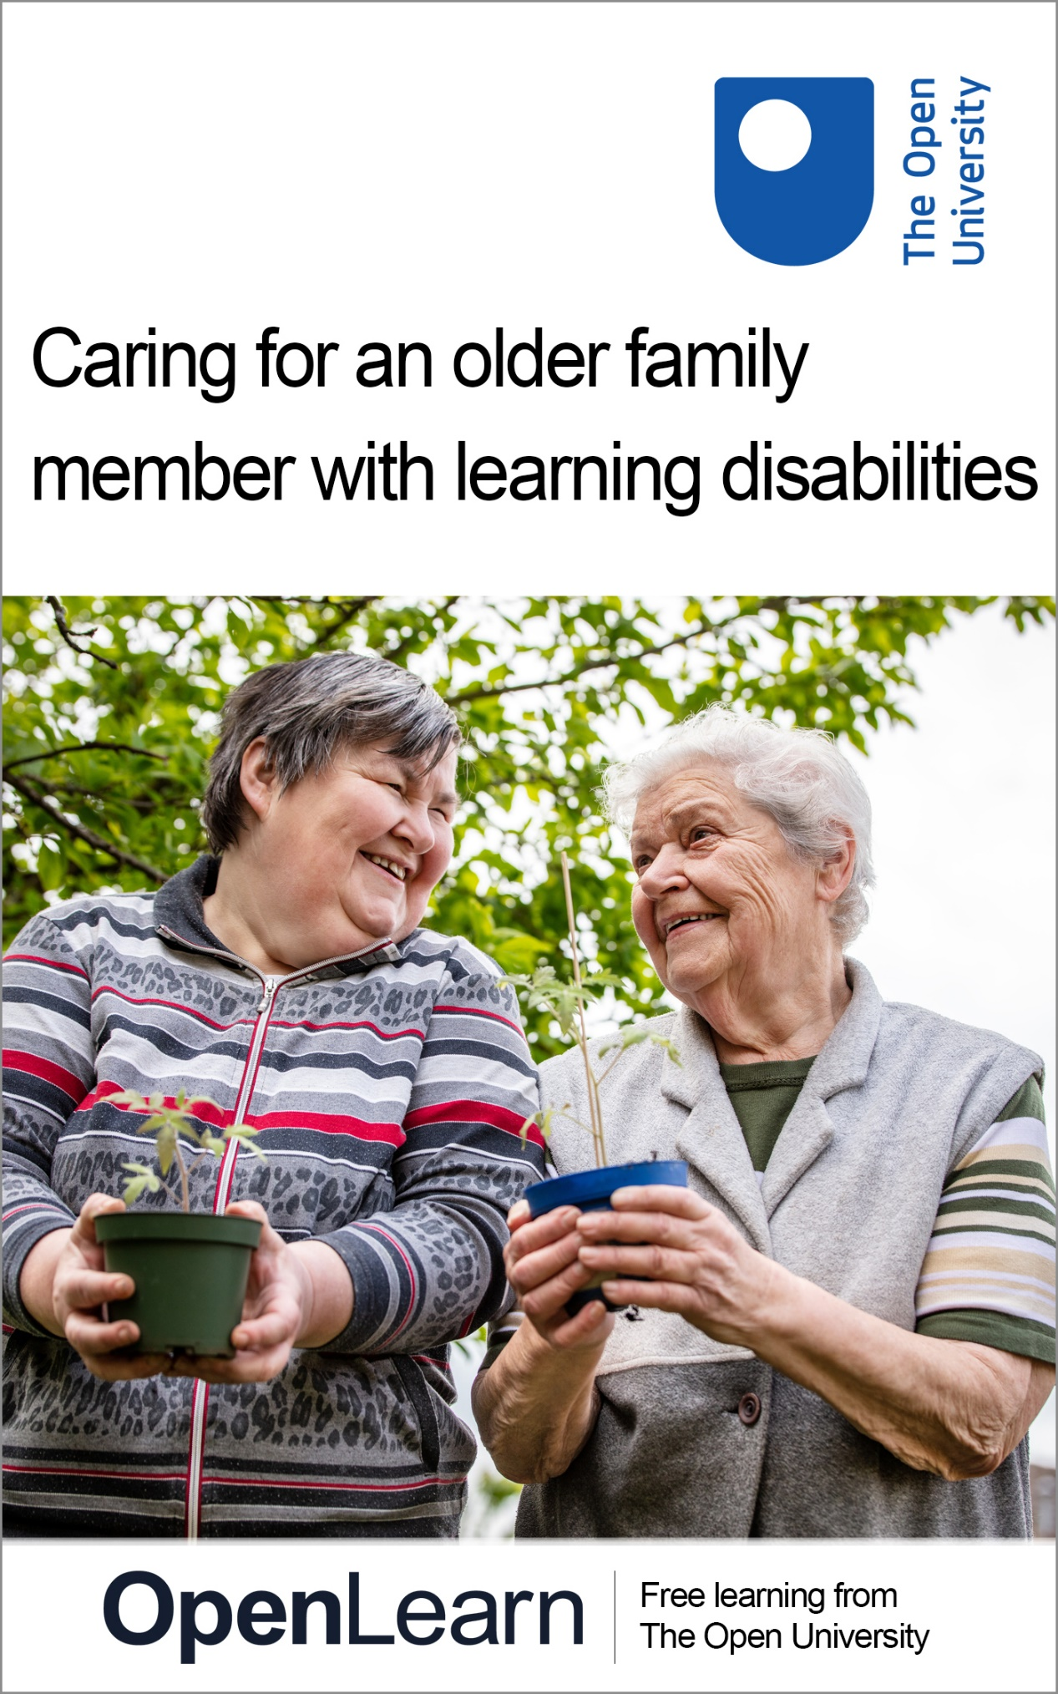

GOPA_1 Caring for an older family member with learning disabilities

Introduction and guidance

About this free course
Find out more about The Open University’s English language courses and qualifications: www.open.ac.uk/courses/english.
This version of the content may include video, images and interactive content that may not be optimised for your device.
You can experience this free course as it was originally designed on OpenLearn, the home of free learning from The Open University –
www.open.edu/openlearn/languages/a-short-introduction-the-english-language/content-section-0
There you’ll also be able to track your progress via your activity record, which you can use to demonstrate your learning.
Copyright © 2023 The Open University
Intellectual property
Unless otherwise stated, this resource is released under the terms of the Creative Commons Licence v4.0 http://creativecommons.org/licenses/by-nc-sa/4.0/deed.en_GB. Within that The Open University interprets this licence in the following way: www.open.edu/openlearn/about-openlearn/frequently-asked-questions-on-openlearn. Copyright and rights falling outside the terms of the Creative Commons Licence are retained or controlled by The Open University. Please read the full text before using any of the content.
We believe the primary barrier to accessing high-quality educational experiences is cost, which is why we aim to publish as much free content as possible under an open licence. If it proves difficult to release content under our preferred Creative Commons licence (e.g. because we can’t afford or gain the clearances or find suitable alternatives), we will still release the materials for free under a personal end-user licence.
This is because the learning experience will always be the same high quality offering and that should always be seen as positive – even if at times the licensing is different to Creative Commons.
When using the content you must attribute us (The Open University) (the OU) and any identified author in accordance with the terms of the Creative Commons Licence.
The Acknowledgements section is used to list, amongst other things, third party (Proprietary), licensed content which is not subject to Creative Commons licensing. Proprietary content must be used (retained) intact and in context to the content at all times.
The Acknowledgements section is also used to bring to your attention any other Special Restrictions which may apply to the content. For example there may be times when the Creative Commons Non-Commercial Sharealike licence does not apply to any of the content even if owned by us (The Open University). In these instances, unless stated otherwise, the content may be used for personal and non-commercial use.
We have also identified as Proprietary other material included in the content which is not subject to Creative Commons Licence. These are OU logos, trading names and may extend to certain photographic and video images and sound recordings and any other material as may be brought to your attention.
Unauthorised use of any of the content may constitute a breach of the terms and conditions and/or intellectual property laws.
We reserve the right to alter, amend or bring to an end any terms and conditions provided here without notice.
All rights falling outside the terms of the Creative Commons licence are retained or controlled by The Open University.
Head of Intellectual Property, The Open University

Contents
- Introduction
- Learning outcomes
- Introduction
  - Taking stock of your own situation
- Session 1: Working with numbers
  - Introduction
  - Learning outcomes
  - 1 Taking stock of your own situation
  - 2 Dealing with large numbers
    - 2.1 Calculations with large numbers
  - 3 Rounding
    - 3.1 Rounding to a degree of accuracy
    - 3.2 Rounding to approximate an answer
  - 4 Multistage calculations
  - 5 Negative numbers
  - 6 Mathematical terms
  - 7 Fractions
    - 7.1 Simplifying fractions
    - 7.2 Writing a quantity of an amount as a fraction
    - 7.3 Fractions of amounts
  - 8 Percentages
    - 8.1 Calculating a percentage of an amount
    - 8.2 Expressing one number as a percentage of another
    - 8.3 Percentage change
  - 9 Fractions, decimals and percentages
    - 9.1 Converting between percentages, decimals and fractions
    - 9.2 Changing a fraction to a percentage
    - 9.3 Changing a fraction to a decimal
  - 10 Ratio
    - 10.1 Simplifying ratios
    - 10.2 Solving ratio problems where the total is given
    - 10.3 Solving ratio problems where the total of one part of the ratio is given
    - 10.4 Solving ratio problems where only the difference in amounts is given
    - 10.5 Other applications of ratio
  - 11 Formulas
    - 11.1 Order of operations
    - 11.2 Formulas in practice
  - 12 Checking your answers
  - 13 Session 1 quiz
  - 14 Session 1 summary
- Session 2: The importance of planning
  - Introduction
  - 1 Introducing Sharon and Becky
  - 2 Thinking about Becky’s future care
  - 3 Some of the realities of planning future care
  - 4 Summary of Session 2
  - 3 Time, timetables and average speed
    - 3.1 Calculating with time and timetables
    - 3.2 Converting units of time
    - 3.3 Average speed
  - 4 Temperature
    - 4.1 Celsius and Fahrenheit formulas
  - 5 Reading scales
    - 5.1 Scale examples
    - 5.2 Scales and measuring instruments
    - 5.3 Using conversion scales
  - 6 Session 2 quiz
  - 7 Session 2 summary
- Session 3: What are you aiming for?
  - Introduction
  - 1 What are you aiming for?
  - 2 What works when planning?
    - 2.1 Think about what matters
    - 2.2 Explore your options
    - 2.3 Know what your local authority should do to help you
  - 3 Summary of Session 3
- Session 4: Thinking the worst … ?
  - Introduction
  - 1 Thinking the worst … ?
  - 2 Be proactive
  - 3 Advocate, advocate!
    - 3.1 Being assertive
    - 3.2 People and organisations who can advocate for you
  - 4 Summary of Session 4
- Session 5: Looking after yourself
  - Introduction
  - 1 Hearing from those who know
  - 2 Summary of Session 5
  - 2 Summary of Session 5
- Session 6: Pulling it all together
  - Introduction
  - 1 The best care possible
  - 2 Summary of Session 6
  - 3 Summary of the course
  - Where next?
- References
- Acknowledgements
- Solutions

Introduction
We are all aware of improvements in the United Kingdom (UK) population’s life expectancy. Less well recognised is that the life expectancy of people with learning disabilities has also improved and over half are now aged over forty-five. The majority of those with learning disabilities live with their parents or a sibling. As people with learning disabilities are living longer, family carers are continuing to care well into their own old age.

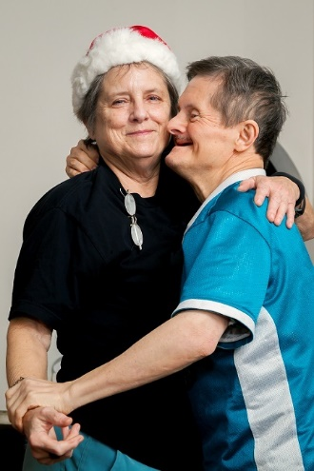
View description - Uncaptioned Figure
View alternative description - Uncaptioned Figure

Do you care for an adult or a sibling with learning disabilities who is middle-aged or older? Is the advice and support you need hard to come by? Do you have concerns and questions about the future care of your family member? Whether you are a parent or a sibling caring for a relative with a learning disability, this free 4-hour course is designed to help you navigate the system as they grow older. It has been developed from a cutting-edge research projectthat explored how to improve the care and support for older people with learning disabilities and behaviours that challenge others, and their families. Hence some of the material will specifically consider the needs of older people with learning disabilities and whose behaviours may at times challenge others.
During the course you will watch extracts of interviews by our researchers with members of our panel of experts. These panel members’ photos and a brief outline of their experiences and expertise are set out below.


View description - Uncaptioned Figure
View alternative description - Uncaptioned Figure

Dawn Wiltshire and Pam Bebbington are both members of My Life My Choice, a self-advocacy organisation for people with learning disabilities. They are supported on the panel by Lisa Davidson.

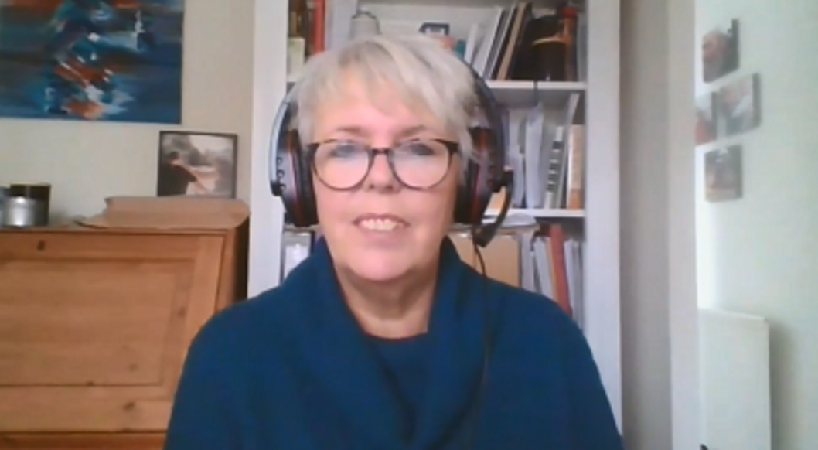
View description - Uncaptioned Figure
View alternative description - Uncaptioned Figure

Gail Hanrahan is a carer and one of the lead family advocates from Oxfordshire Family Support Network.
Interested in taking your learning further? You might find it helpful to explore the Open University’s Health and Social Care courses and qualifications.

Learning outcomes
After studying this course, you should be able to:
- understand the planning required as a family member with learning disabilities grows older
- understand the core principles and skills of advocating effectively for yourself and a family member with learning disabilities as they grow older
- recognise the importance of looking after yourself and other family carers.

Introduction

Taking stock of your own situation
You’ll start by thinking about your own situation.

Activity 1 Your thoughts
Allow about 5 minutes

Take a few minutes to think about some of the issues you and your family may be facing as your family member grows older. If you would like, write these down in your ‘Tips’ notepad which has been created for this course. Anything you write on this notepad is personal to you – no one else can see it. Download the notepad now and save it somewhere so you can access it and add to it throughout the course.
Error! Hyperlink reference not valid.
In case you would rather record your notes that way, text boxes have been added to every activity. Again, your notes will only be visible to you.

Provide your answer...

View discussion - Part

This course will help you navigate the system and work out how to deal with some of the associated challenges of caring for a family member with learning disabilities as they grow older. Based on case studies from our research, the course will do this by exploring planning for the future and some of the skills and resources that are useful to do this. Links to useful sources of information and organisations are provided throughout.
You can work through the course at your own pace and choose which sections and activities you want to do. Although the estimated completion time is four hours, if you are pushed for timedo not feel you have to do all the activities. Sessions 2 and 3 focus on planning. In Session 4 you will look at some of the skills that are useful such as being proactive and advocating for yourself and your family member. Session 5 deals with looking after yourself and provides sources of advice and information. In the final session you will pull your learning together and reflect on the changes you can make to enable you to best support the person you care for and yourself.
In the next session, you will start to think about making plans for the future using a case study from our research.
You can now go to .Error! Hyperlink reference not valid.

Session 1: Working with numbers

Introduction
We are all aware of improvements in the United Kingdom (UK) population’s life expectancy. Less well recognised is that the life expectancy of people with learning disabilities has also improved and over half are now aged over forty-five. The majority of those with learning disabilities live with their parents or a sibling. As people with learning disabilities are living longer, family carers are continuing to care well into their own old age.

View description - Uncaptioned Figure
View alternative description - Uncaptioned Figure

Do you care for an adult or a sibling with learning disabilities who is middle-aged or older? Is the advice and support you need hard to come by? Do you have concerns and questions about the future care of your family member? Whether you are a parent or a sibling caring for a relative with a learning disability, this free 4-hour course is designed to help you navigate the system as they grow older. It has been developed from a cutting-edge research projectthat explored how to improve the care and support for older people with learning disabilities and behaviours that challenge others, and their families. Hence some of the material will specifically consider the needs of older people with learning disabilities and whose behaviours may at times challenge others.
During the course you will watch extracts of interviews by our researchers with members of our panel of experts. These panel members’ photos and a brief outline of their experiences and expertise are set out below.

View description - Uncaptioned Figure
View alternative description - Uncaptioned Figure

Dawn Wiltshire and Pam Bebbington are both members of My Life My Choice, a self-advocacy organisation for people with learning disabilities. They are supported on the panel by Lisa Davidson.

View description - Uncaptioned Figure
View alternative description - Uncaptioned Figure

Gail Hanrahan is a carer and one of the lead family advocates from Oxfordshire Family Support Network.
Interested in taking your learning further? You might find it helpful to explore the Open University’s Health and Social Care courses and qualifications.

Learning outcomes
After studying this course, you should be able to:
- understand the planning required as a family member with learning disabilities grows older
- understand the core principles and skills of advocating effectively for yourself and a family member with learning disabilities as they grow older
- recognise the importance of looking after yourself and other family carers.

1 Taking stock of your own situation
You’ll start by thinking about your own situation.

Activity 1 Your thoughts
Allow about 5 minutes

Take a few minutes to think about some of the issues you and your family may be facing as your family member grows older. If you would like, write these down in your ‘Tips’ notepad which has been created for this course. Anything you write on this notepad is personal to you – no one else can see it. Download the notepad now and save it somewhere so you can access it and add to it throughout the course.
Error! Hyperlink reference not valid.
In case you would rather record your notes that way, text boxes have been added to every activity. Again, your notes will only be visible to you.

Provide your answer...

View discussion - Part

This course will help you navigate the system and work out how to deal with some of the associated challenges of caring for a family member with learning disabilities as they grow older. Based on case studies from our research, the course will do this by exploring planning for the future and some of the skills and resources that are useful to do this. Links to useful sources of information and organisations are provided throughout.
You can work through the course at your own pace and choose which sections and activities you want to do. Although the estimated completion time is four hours, if you are pushed for timedo not feel you have to do all the activities. Sessions 2 and 3 focus on planning. In Session 4 you will look at some of the skills that are useful such as being proactive and advocating for yourself and your family member. Session 5 deals with looking after yourself and provides sources of advice and information. In the final session you will pull your learning together and reflect on the changes you can make to enable you to best support the person you care for and yourself.
In the next session, you will start to think about making plans for the future using a case study from our research.
You can now go to Error! Hyperlink reference not valid..

2 Dealing with large numbers
It is important to be able to carry out calculations with numbers of any size. Large numbers can be written in different ways e.g.

1 200 000 (one million, two hundred thousand) or it can be written as 1.2 million.

Here is another example:

4 250 000 000 (four billion, two hundred and fifty million) is 4.25 billion.

It is often easier to deal with very large numbers when they are written as decimals.
Notice how the decimal is placed after the whole millions or billions.
Hint : A billion is a thousand million.
Using a place value grid can help you to read large numbers as it groups the digits for you, making the whole number easier to read.
Notice how the numbers above are written in this place value grid.

Table 1
Billion | Million |  |  | Thousand
Billions | Hundreds of millions | Tens of millions | Millions | Hundreds of thousands | Tens of thousands | Thousands | Hundreds | Tens | Units
 |  |  | 1 | 2 | 0 | 0 | 0 | 0 | 0
4 | 2 | 5 | 0 | 0 | 0 | 0 | 0 | 0 | 0

Sometimes when dealing with large numbers it is sensible to round them, for example, the Office for National Statistics gives the number of people unemployed in the UK in February 2019 as 1.36 million. The number of people unemployed will not be exactly 1 360 000 but, by rounding the exact value and writing it as 1.36 million, it is easier to understand.

Activity 6: Rounding large numbers

The following table gives the population of countries.
Round each population to the nearest million and write the figure in shortened form, using decimals where needed.

Table 2(a)
Country | Population
UK | 66 959 016
China | 1 420 062 022

View answer - Activity 6: Rounding large numbers

2.1 Calculations with large numbers
The best way to get used to these types of calculations is to go straight into an example.

Example: Calculations with large numbers
Calculate the total population of Malta (0.4 million) and Cyprus (1.2 million).

Method 1
Work in shortened form:
- 1.2 + 0.4 = 1.6 million

Method 2
Write the numbers in full:
- 1 200 000 + 400 000 = 1 600 000 (1.6 million)

Activity 7: Calculations with large numbers

- Calculate the total turnover for Cambria Trading over the first quarter (3 months).

Table 3 Cambria Trading turnover
Month | Profit (£ million)
January | 1.2
February | 0.9
March | 0.85
April | 1.1
May | 1.02
June | 0.87
July | 1.19
August | 0.98
September | 1.05
October | 1.08
November | 1.8
December | 1.65

- Calculate the turnover of the last quarter.
- Calculate the difference in turnover between the first and last quarters.
  - Which month had the largest turnover?
  - Which month had the smallest turnover?
  - What is the difference between the largest and smallest turnovers?

View answer - Activity 7: Calculations with large numbers

Summary
In this section you have learned how to:
- write large numbers in full and shortened forms
- round large numbers
- add and subtract large numbers.

3 Rounding
Why might you want to round numbers? You may wish to estimate the answer to a calculation or to use a guide rather than work out the exact total. Alternatively, you might wish to round an answer to an exact calculation so that it fits a given purpose, for example an answer involving money cannot have more than two digits after the decimal point.


Figure 4 Rounding up and down
View description - Figure 4 Rounding up and down

You will now explore each of these examples in more detail and practise your rounding skills in context.

3.1 Rounding to a degree of accuracy
Watch the short video below to see an example of how to round to 1, 2 and 3 decimal places.

Video content is not available in this format.
View transcript - Uncaptioned interactive content

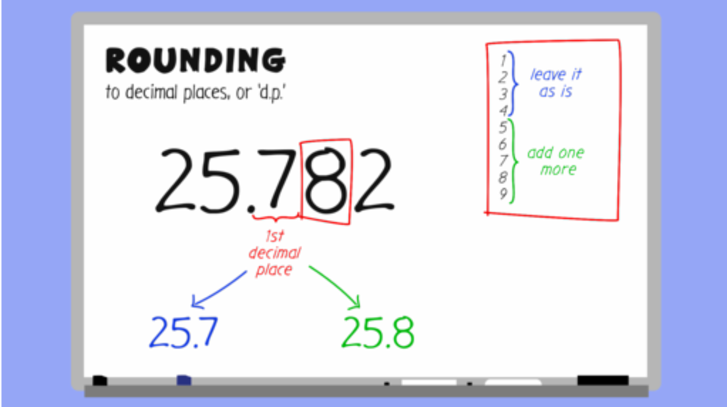

Remember this rounding rhyme to help you:

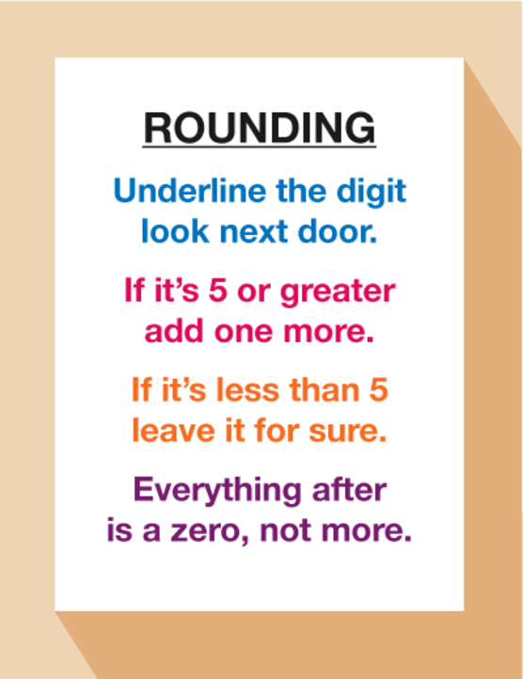
Figure 5 A rounding rhyme
View description - Figure 5 A rounding rhyme

Activity 8: Rounding skills

Practise your rounding skills by completing the below.
- What is 24.638 rounded to one decimal place?
- What is 13.4752 rounded to two decimal places?
- What is 203.5832 rounded to two decimal places?
- What is 345.6794 rounded to three decimal places?
- What is 3.65 rounded to the nearest whole number?
- What is £199.755 to the nearest penny?
- What is £37.865 to the nearest pound?
- What is 61.607 kg to the nearest kg?

View answer - Activity 8: Rounding skills

3.2 Rounding to approximate an answer
You might round in order to approximate an answer. At the coffee shop, you might want to buy a latte for £2.85, a cappuccino for £1.99 and a tea for £0.99. It is natural to round these amounts up to £3, £2 and £1 in order to arrive at an approximate cost of £6 for all three drinks. It is also very useful when checking calculations to make sure that your answer makes sense, especially when working with large numbers and decimals.

Activity 9: Approximation

Calculate the following using a calculator and use estimation to check your answers.
- On 5th March 2019, 190 people matched 5 numbers and won £1650 each. What was the total prize fund?
- Swansea AFC’s home ground is the Liberty Stadium which holds 21 088 fans. Cardiff City FC plays at the Cardiff City Stadium which holds 33 316 fans.
What is the difference in capacity at these grounds?

View answer - Activity 9: Approximation

Summary
In this section you have learned:
- how and when to use rounding to approximate an answer to a calculation
- how to round an answer to a given degree of accuracy – e.g. rounding to two decimal places.

4 Multistage calculations
Often in daily life you will come across problems that require more than one calculation to reach the final answer.

Example: Multistage calculations
Four friends are planning a holiday. The table below shows the costs:

Table 4
Item | Price
Flight (return) | £305 per person
Taxes | £60 per person
Hotel | £500 per room. 2 people per room
Taxi to airport | £45

The friends will be sharing the total cost equally between them. How much do they each pay?

Method
First we use multiplication to find the cost of items that we need more than one of:
- Flights = £305 × 4 = £1220
- Taxes = £60 × 4 = £240
- Hotel = 2 rooms required for 4 people = £500 × 2 = £1000
Now we use addition to add these totals together along with the taxi fare:
- £1220 + £240 + £1000 + £45 = £2505
Finally, we need to use division to find out how much each person pays:
- £2505 ÷ 4 =£626.25 each

Activity 10: Multistage calculations

- Your current mobile phone contract costs you £24.50 per month.
You are considering changing to a new provider. This provider charges £19.80 per month along with an additional, one off connection fee of £30.
How much will you save over the year by switching to the new provider?
- You are going on holiday and you have decided to stay in a cottage in North Wales for 7 nights.
There will be 12 of you staying and the total cost of the cottage you have chosen is £460 per night. If you split the cost equally, how much will each of you pay?

View answer - Activity 10: Multistage calculations

All the examples we have looked at until now have used positive numbers. However, as anyone with an overdraft will know, numbers (or bank balances) are not always positive! Our next section therefore deals with negative numbers.

Summary
In this section you have:
- applied the four operations to solve multistage calculations.

5 Negative numbers
Negative numbers come into play in two main areas of life: money and temperature. Watch the animations below for some examples.

Video content is not available in this format.
View transcript - Uncaptioned interactive content

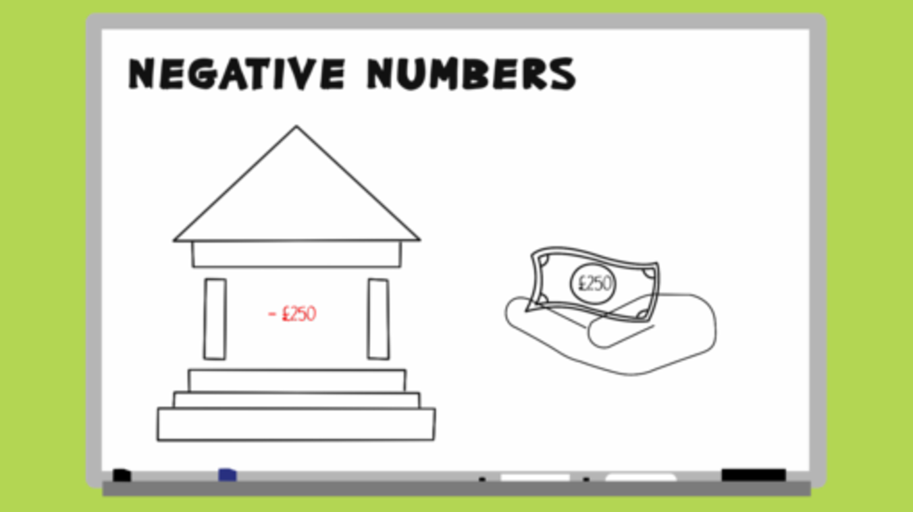

Activity 11: Negative and positive temperature

- The table below shows the temperatures of cities around the world on a given day

Table 5
London | Oslo | New York | Kraków | Delhi
4˚C | −12C | 7˚C | −3˚C | 19˚C

  - Which city was the warmest?
  - Which city was the coldest?
  - What is the difference in temperature between the warmest and coldest cities?

View answer - Part

- Look at this bank statement.

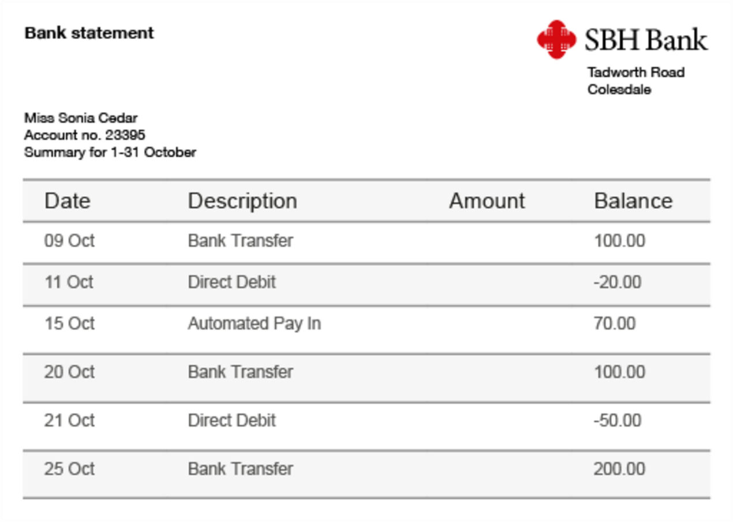
Figure 6 A bank statement
View description - Figure 6 A bank statement

  - On which days was Sonia Cedar overdrawn, and by how much?
  - How much money was withdrawn between 9 and 11 of October?
  - How much was added to the account on 15 October?

View answer - Part

- Look at the table below showing a company’s profits over 6 months.
Hint: a negative profit means that the company made a loss.

Table 6
Month | Profit (£000)
January | 166
February | 182
March | −80
April | 124
May | 98
June | −46
Balance

  - Which month had the greatest profit?
  - Which month has the greatest loss?
  - What was the overall balance for the six months?
Hint: start by calculating the total profits and the total losses.

View answer - Part

Summary
In this section you have:
- learned the two main contexts in which negative numbers arise in everyday life – money (or debt!) and temperature
- practised working with negative numbers in these contexts.

6 Mathematical terms
It is important to know the meaning of the following terms:
- multiples
- lowest common multiple
- factors
- common factors
- prime numbers

Multiples
A multiple of a number can be found by multiplying that number by any whole number e.g. multiples of 2 include 2, 4, 6, 8, 10 etc. (all are in the 2 times table).

Note: To check if a number is a multiple of another, see if it divides exactly into the multiple, e.g. to see if 3 is a multiple of 81 do 81 ÷ 3 = 27. It divides exactly so 81 isa multiple of 3.

Lowest common multiple
In maths, we sometimes need to find the lowest common multiple of numbers.
The lowest common multiple (LCM) is simply the smallest multiple that is common to more than one number.

Example: Lowest common multiple of 3 and 5
Hint: when looking for multiples, it is easiest to start by listing the multiples of the highest number first. This saves you going any further than you need to with the list.
The first few multiples of 5 are:
- 5, 10, 15, 20, 25, 30 etc.
The first few multiples of 3 are:
- 3, 6, 9, 12, 15, 18, 21 etc.
You can see that the lowest number that is a common multiple of 3 and 5 is 15.

Activity 12: Finding the lowest common multiple

Find the lowest common multiple of:
- 6 and 12
- 2 and 7

View answer - Activity 12: Finding the lowest common multiple

Factors, common factors and prime numbers
Factors of a number divide into it exactly. Factors of all numbers include 1 and the number itself. However, most numbers have other factors as well. If you think of all of the numbers that multiply together to make that number, you will find all of the factors of that number.

Example: What are the factors of 8?
8 × 1 = 8
2 × 4 = 8
So the factors of 8 are 1, 2, 4 and 8.

Activity 13: Finding factors

- What are the factors of 54?
- What are the factors of 165?

View answer - Activity 13: Finding factors

A common factor is a factor that goes into more than one number. For example, 4 is a common factor of 8 and 12 because it divides exactly into both numbers.
Prime Numbers
A prime number is a number which only has 2 factors: 1 and itself.
The prime numbers between 1 and 20 are 2, 3, 5, 7, 11, 13, 17 and 19.

Note:
- 1 is not a prime number as it only has one factor.
- 2 is the only even prime number.

You have now learned how to use all four operations, how to work with negative numbers and learned some important mathematical terms. Every other mathematical concept hinges around what you have learned so far; so once you are confident with these, you’ll be a success!

Summary
In this section you have:
- learned some key mathematical terms: multiple, lowest common multiple, factor, common factor and prime number
- identified the lowest common multiple
- identified factors.

7 Fractions
You will be used to seeing fractions in your everyday life, particularly when you are out shopping or scouring the internet for the best deals. It’s really useful to be able to work out how much you’ll pay if an item is on sale or if a supermarket deal really is a good deal!

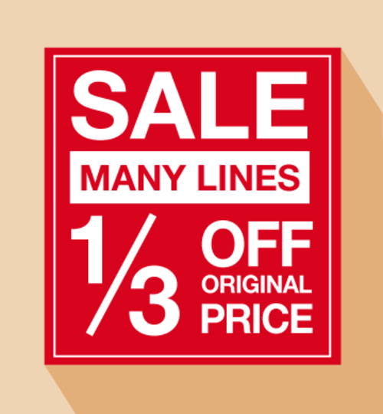
Figure 7 A poster advertising a sale
View description - Figure 7 A poster advertising a sale

There are several different elements to working with fractions. First you will look at simplifying fractions.

7.1 Simplifying fractions
Watch the video below which looks at how to simplify fractions before having a go yourself in Activity 14.

Video content is not available in this format.
View transcript - Uncaptioned interactive content

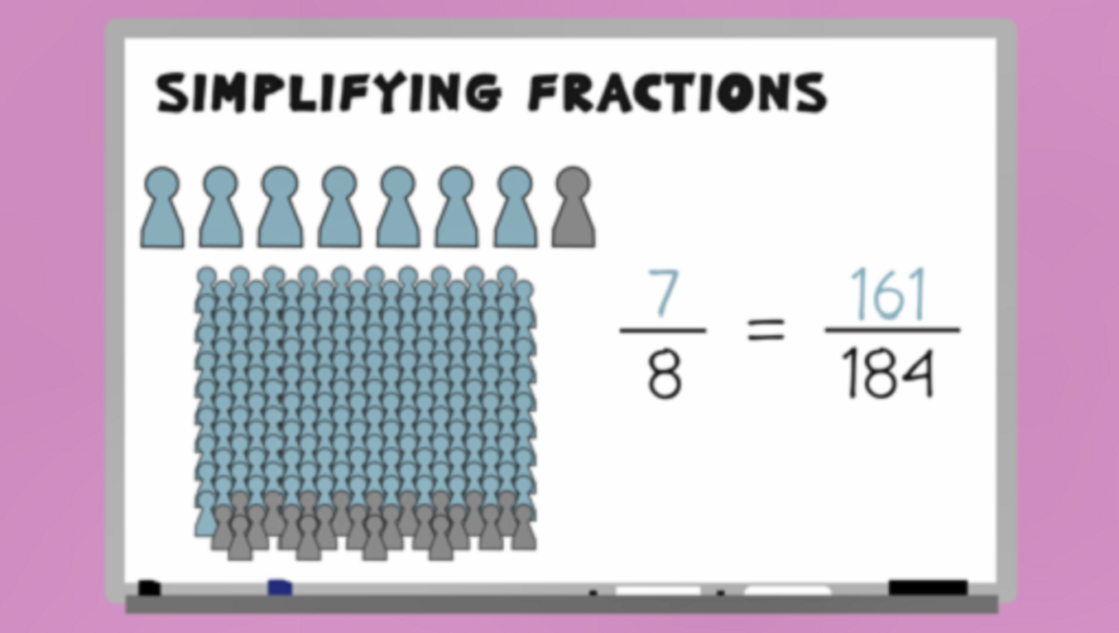

Activity 14: Simplifying fractions

Show the following fractions in simplest form, where possible:

- 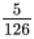

- 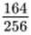

View answer - Activity 14: Simplifying fractions

Next you’ll look at expressing a quantity of an amount as a fraction.

7.2 Writing a quantity of an amount as a fraction
Sometimes you will need to show one amount as a fraction of another. This might sound complicated, but it’s actually very logical. Look at the examples below.

Example 1: Fraction of an amount
In Figure 8, what fraction of Smarties are red?


Figure 8 Smarties in different colours
View description - Figure 8 Smarties in different colours

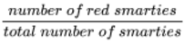 =

To express the fraction of Smarties that are red, you simply need to count the red Smarties (4) and the total number of Smarties (30). Since there are 4 red Smarties out of 30 altogether, the fraction is . It is worth noting here that this could also be written as 4/30.
You may well be asked to give your answer as a fraction in its simplest form, so always check to see if you can simplify your answer. In this case will simplify to .

Example 2: Fraction of an amount
250 g of flour is taken from a 1 kg bag. What fraction is this?
Hint: there are 1000 g in a kg.
To express quantities as fractions, the top and bottom numbers need to be in the same units, so here you need to make sure that you express both the top and bottom values in grams:
- The flour removed is already expressed in grams: 250 g
- The total amount is in kilograms so you need to convert to grams: 1 kg = 1000 g
Now write the amount taken over the total amount to express as a fraction:
- 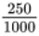 (250 g of flour out of the 1000 g bag has been taken or used)
Then cancel down (or simplify) if possible:
- =
So of the flour has been used.

Activity 15: Expressing one number as a fraction of another

- What fraction of a kilogram is:
  - 100 g
  - 750 g
  - 640 g
  - 20 g

View answer - Part

- What fraction of an hour is:
  - 15 minutes
  - 20 minutes
  - 35 minutes
  - 48 minutes

View answer - Part

- A farmer takes 120 eggs to the local farmer’s market. She has 24 eggs left at the end of the day. What fraction of the eggs are left?

View answer - Part

- A class of students sit a test. 18 pass and 12 fail. What fraction passed the test?

View answer - Part

- Mary bought her car for £12 500. When she goes to trade it in she is offered £8750. What fraction of the original price is this?

View answer - Part

- 30 people entered a raffle. 6 of these people won a prize. What fraction of people did not win a prize? Give your answer as a fraction in its simplest form.

View answer - Part

Sometimes fractions will not cancel down easily. When this happens, you estimate the fraction by rounding the numbers to values that will cancel. Sometimes this means breaking the ‘rules’ of rounding.

Example: Estimating fractions
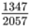 will not cancel.
By rounding 1347 up to 1400 and 2057 to 2100 we can cancel down the fraction to get:
- 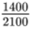 =

Note: Round to numbers that are easy to cancel, but if you round off too much, you will lose the accuracy of your answer.

Now that you can express a quantity as a fraction, estimate and simplify fractions, the next step is to be able to work out fractions of amounts. For example, if you see a jacket that was priced at £80 originally but is in the sale with off, it’s useful to be able to work out how much you will be paying.

7.3 Fractions of amounts
Fractions of amounts can be found by using your division and multiplication skills. To work out a fraction of any amount you first divide your amount by the number on the bottom of the fraction – the denominator. This gives you 1 part.
You then multiply that answer by the number on the top of the fraction – the numerator.
It is worth noting here that if the number on the top of the fraction is 1, multiplying the answer will not change it so there is no need for this step. Take a look at the examples below.

Example: Divide by the denominator

Method
To find of 90 we do 90 ÷ 5 = 18.
Since the number on the top of our fraction is 1, we do not need to multiply 18 by 1 as it will not change the answer.
So of 90 = 18.

Example: Multiply by the numerator

Method
To find of 42 we do 42 ÷ 7 = 6.
This means that of 42 = 6.
Since you want of 42, we then do 6 × 4 = 24.
So of 42 = 24.

Let’s go back to the jacket that used to cost £80 but is now in the sale with off. How do you find out how much it costs? Firstly, you need to find of 80. To calculate this you do:
- £80 ÷ 5 = £16 and then £16 × 2 = £32
This means that you save £32 on the price of the jacket. To find out how much you pay you then need to do £80 − £32 = £48.
You will have practised finding fractions of amounts in Everyday maths 1, but have a go at the following activity to recap this important skill.

Activity 16: Finding fractions of amounts

Work out the following without using a calculator. You may double-check on a calculator if you need to and remember to check your answers against ours.
- You are looking to buy house insurance and want to get the best deal. Put the following offers in order, from cheapest to most expensive, after the discount has been applied.

Table 7
Company A | Company B | Company C
£120 per year | £147 per year | £104 per year
Special offer: off! | Special offer: off! | Special offer: off!

View answer - Part

- A cinema sells 2400 tickets over a weekend. They review their ticket sales and find that of the weekend ticket sales were to adults. How many adult tickets were sold?

View answer - Part

- A college has raised of its £40 000 charity fundraising target. How much money does the college need to raise to meet its target?

View answer - Part

Discounts and special offers are not always advertised using fractions. Sometimes, you will see adverts with 10% off or 15% off. Another common area where we see percentages in everyday life would be when companies apply VAT at 20% to items or when a restaurant adds a 12.5% service charge. The next section looks at what percentages are, and how to calculate them.

Summary
In this section you have:
- learned how to express a quantity of an amount in the form of a fraction
- learned how to, and practised, simplifying fractions
- revised your knowledge on finding fractions of amounts.

8 Percentages
There are different ways of working out percentages of amounts. We will take a look at the most common methods now.


Figure 9 Percentage discounts in a sale
View description - Figure 9 Percentage discounts in a sale

Note: You may use a different method to these ones. You may even use different methods depending on the percentage you are calculating. Do whatever works for you.

8.1 Calculating a percentage of an amount

Method 1
Percentages are just fractions where the number on the bottom of the fraction must be 100. If you wanted to find out 15% of 80 for example, you work out 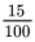 of 80, which you already know how to do!
Working out the percentage of an amount requires a similar method to finding the fraction of an amount. Take a look at the examples below to increase your confidence.

Example 1: Finding 17% of 80

Method
17% of 80 = 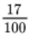 of 80, so here we do:

80 ÷ 100 = 0.8
0.8 × 17 = 13.6

Another way of thinking about this method is that you are dividing by 100 to find 1% first and then you are multiplying by whatever percentage you want to find.
Alternatively, you could multiply the value by the top number first and then divide by 100:

17 × 80 = 1360
1360 ÷ 100 = 13.6

The answer will be the same.

Example 2: Finding 3% of £52.24

Method
3% of 52.24 = 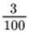 of 52.24, so we do:

52.24 ÷ 100 = 0.5224.
0.5224 × 3 = £1.5672 (£ 1.57 to two d.p.)

Or

52.24 × 3 = 156.72
156.72 ÷ 100 = £1.5672 (£1.57 to two d.p.)

This is a good method if you want to be able to work out every percentage in the same way. It can be used with and without a calculator. Many calculators have a percentage key, but different calculators work in different ways so you need to familiarise yourself with how to use the % button on your calculator.

Method 2
To use this method you only need to be able to work out 10% and 1% of an amount. You can then work out any other percentage from these.
Let’s just recap how to find 10% and 1%.

10%
To find 10% of an amount divide by 10:

10% of £765 = 765 ÷ 10 = £76.50
10% of £34.50 = 34.50 ÷ 10 = £3.45

Hint: remember to move the decimal point one place to the left to divide by 10.

1%
To find 1% of an amount divide by 100:

1% of £765 = 765 ÷ 100 = £7.65
1% of £34.50 = 34.50 ÷ 100 = £0.345 (£0.35 to two d.p.)

Hint: remember to move the decimal point two places to the left to divide by 100.

Once you know how to work out 10% and 1%, you can work out any other percentage.

Example 1: Finding 24% of 60
Find 10% first:

60 ÷ 10 = 6
10% = 6

20% is 2 lots of 10% so:

6 × 2 = 12
20% = 12

Now find 1%:

60 ÷ 100 = 0.6

4% is 4 lots of 1% so:

0.6 × 4 = 2.4
4% = 2.4

Now add the 20% and 4% together:
12 + 2.4 = 14.4

Example 2: Finding 17.5% of £328
17.5% can be broken up into 10% + 5% + 2.5%, so you need to work out each of these percentages and then add them together.
Find 10% first:

328 ÷ 10 = 32.8
10% = 32.8

5% is half of the 10% so:

32.8 ÷ 2 = 16.4
5% = 16.4

2.5% is half of the 5% so:

16.4 ÷ 2 = 8.2
2.5% = 8.2

Now add the 10%, 5% and 2.5% figures together:

32.8 + 16.4 + 8.2 = £57.40

This is a good method to do in stages when you do not have a calculator.

Note: There are some other quick ways of working out certain percentages:

50% – divide the amount by two.
25% – halve and halve again.

These quick facts can be used in combination with method 2 to make calculations, e.g. 60% could be worked out by finding 50%, 10% and then adding the 2 figures together. You just need to look for the easiest way to split up the percentage to make your calculation.

Activity 17: Finding percentages of amounts

Use whichever method/s you prefer to calculate the answers to the following:
- Find:
  - 45% of £125
  - 15% of 455 m
  - 52% of £677
  - 16% of £24.50
  - 2% of 4000 kg
  - 82% of £7.25
  - 37% of £95
- The Cambria Bank pays interest at 3.5%. What is the interest on £3000?
- Sure Insurance offer a 30% No Claims Bonus. How much would be saved on a premium of £345.50?
- Sunshine Travel Agents charge 1.5% commission on foreign exchanges. What is the charge for changing £871?

View answer - Activity 17: Finding percentages of amounts

Just as with fractions you will often need to be able to work out the price of an item after it has been increased or decreased by a given percentage. The process for this is the same as with fractions; you simply work out the percentage of the amount and then add it to, or subtract it from, the original amount.

Activity 18: Percentages increase and decrease

- You earn £500 per month. You get a 5% pay rise.
  - How much does your pay increase by?
  - How much do you now earn per month?

View answer - Part

- You buy a new car for £9500. By the end of the year its value has decreased by 20%.
  - How much has the value of the car decreased by?
  - How much is the car worth now?

View answer - Part

- You invest £800 in a building society account which offers fixed-rate interest at 4% per year.
  - How much interest do you earn in one year?
  - How much do you have in your account at the end of the year?

View answer - Part

- Last year Julie’s car insurance was £356 per annum. This year she will pay 12% less. How much will she pay this year?

View answer - Part

- A zoo membership is advertised for £135 per year. If Tracy pays for the membership in full rather than in monthly installments, she receives a 6% discount. How much will she pay if she pays in full?

View answer - Part

- A museum had approximately 5.87 million visitors last year. Visitor numbers are expected to increase by 4% this year. How many visitors is the museum expecting this year?

View answer - Part

Next you’ll look at how to express one number as a percentage of another.

8.2 Expressing one number as a percentage of another
Sometimes you need to write one number as a percentage of another. You have already practised writing one number as a fraction of another; this just takes it a bit further.

Example 1: What percentage are women?
A class is made up of 21 women and 14 men, what percentage of the class are women?
To work this out, you start by expressing the numbers as a fraction. You then multiply by 100 to express as a percentage.
The formula is:
- 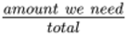 × 100
In this case, 21 out of a total of 35 people are women so the sum we do would be:
- × 100
The fraction line is also a divide line, so if you were doing this on a calculator you would do:
- 21 ÷ 35 × 100 = 60%
How would you work this out without a calculator?
There are different ways you can make the calculation. Two methods are shown below.

Method 1
- 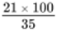
You start by multiplying the top number in the fraction by 100. The bottom number will stay the same:
- 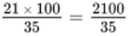
Now you need to cancel the fraction down as much as possible:
- 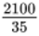 ÷ top and bottom by 5 = 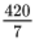, then, ÷ top and bottom by 7 =
Anything over 1 is a whole number so the answer is 60.
So 60% of the class are women.

Note: When using this method, if you cancel as far as possible and you do not end up with an answer over 1, you will need to divide the top number by the bottom number to work out the final answer, e.g. the fraction cannot cancel any further, so:
- 15 ÷ 4 = 3.75

Method 2
The other method involves expressing the fraction as a decimal first and then converting it to a percentage. This means that you multiply by 100 at the very end of the calculation.
A local attraction sold 150 tickets last bank holiday, 102 of which were full price. What percentage of the tickets sold were at the concessionary price?
Work out the number of concessionary tickets sold:
- 150 – 102 = 48
Write the number of concessionary tickets sold as a fraction of the total number sold:
- 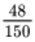
Cancel down your fraction:
- ÷ top and bottom by 6 =
Once you cannot cancel any further, you need to divide the top number by the bottom number to express as a decimal:
- 8 ÷ 25 = 0.32

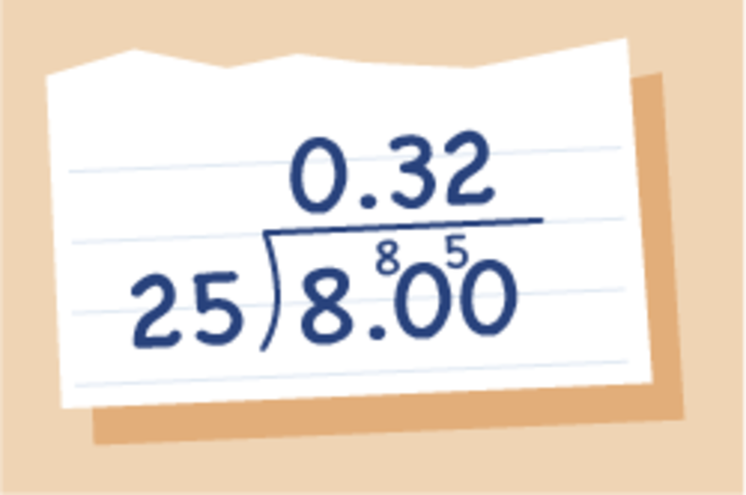
Figure 10 Expressed as a decimal: 8 divided by 25
View description - Figure 10 Expressed as a decimal: 8 divided by 25

Finally, multiply the decimal answer by 100 to express as a percentage:
- 0.32 × 100 = 32%
So 32% of the tickets were sold at the concessionary price.

Activity 19: Expressing one number as a percentage of another

Use whichever method you prefer to calculate the answers to the following. Give answers to two d.p. where appropriate.
Hint: make sure your units are the same first.
- What percentage:
  - of 1 kg is 200 g?
  - of an hour is 48 minutes?
  - of £6 is 30p?

View answer - Part

- Bea swam 50 laps of a 25 m swimming pool in a charity swim. A mile is almost 1600 m. What percentage of a mile did Bea swim?

View answer - Part

- A student gets the following results in the end of year tests:

Table 8
 | Maths | English | Science | Art
Mark achieved | 64 | 14 | 72 | 56
Possible total mark | 80 | 20 | 120 | 70

- Calculate her percentage mark for each subject.

View answer - Part

- Susan is planting her flower beds. She plants 13 yellow flowers, 18 white flowers and 9 red ones. What percentage of her flowers will not be white?

View answer - Part

- A building society charges £84 interest on a loan of £1200 over a year. What percentage interest is this?

View answer - Part

Next you will look at percentage change. This can be useful for working out the percentage profit (or loss) or finding out by what percentage an item has increased or decreased in value.

8.3 Percentage change
Watch the video below on how to calculate percentage change, then complete Activity 20.

Video content is not available in this format.
View transcript - Uncaptioned interactive content

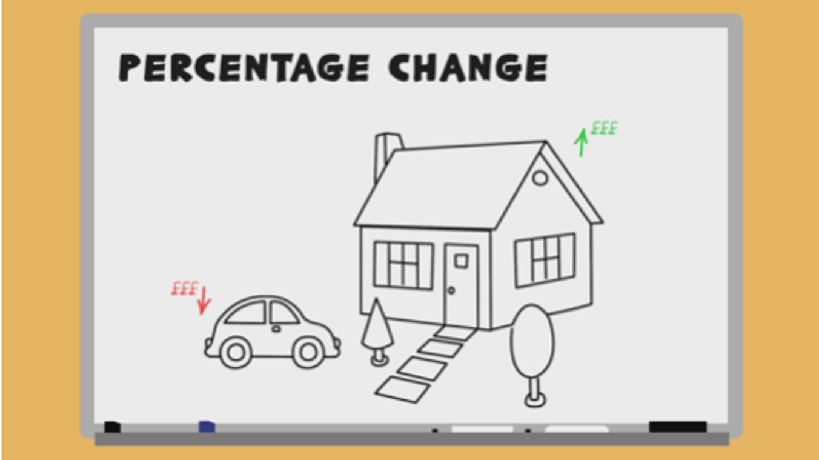

Activity 20: Percentage change formula

Practise using the percentage change formula which you learned about in the video above on the four questions below. Where rounding is required, give your answer to two decimal places.
- Last year your season ticket for the train cost £1300. This year the cost has risen to £1450. What is the percentage increase?

View answer - Part

- You bought your house 10 years ago for £155 000. You are able to sell your house for £180 000. What is the percentage increase the house has made?

View answer - Part

- You purchased your car 3 years ago for £4200. You sell it to a buyer for £3600. What is the percentage decrease of the car?

View answer - Part

- Stuart buys a new car for £24 650. He sells it 1 year later for £20 000. What is the percentage loss?

View answer - Part

Congratulations, you now know everything you need to know about percentages! As you have seen, percentages come up frequently in many different areas of life and having completed this section, you now have the skills to deal with all kinds of situations that involve them.
You saw at the beginning of the section that percentages are really just fractions. Decimals are also closely linked to both fractions and percentages. In the next section you will see just how closely related these three concepts are and also learn how to convert between each of them.

Summary
In this section you have:
- found percentages of amounts
- calculated percentage increase and decrease
- calculated percentage change using a formula
- expressed one number as a percentage of another.

9 Fractions, decimals and percentages
You have already worked with decimals in this course and many times throughout your life. Every time you calculate something to do with money, you are using decimal numbers. You have also learned how to round a number to a given number of decimal places.

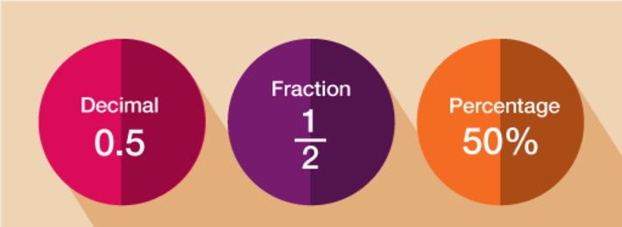
Figure 11 Equivalent decimals, fractions and percentages
View description - Figure 11 Equivalent decimals, fractions and percentages

9.1 Converting between percentages, decimals and fractions
Since fractions, decimals and percentages are all just different ways of representing the same thing, we can convert between them in order to compare. Take a look at the video below to see how to convert fractions, decimals and percentages.

Video content is not available in this format.
View transcript - Uncaptioned interactive content

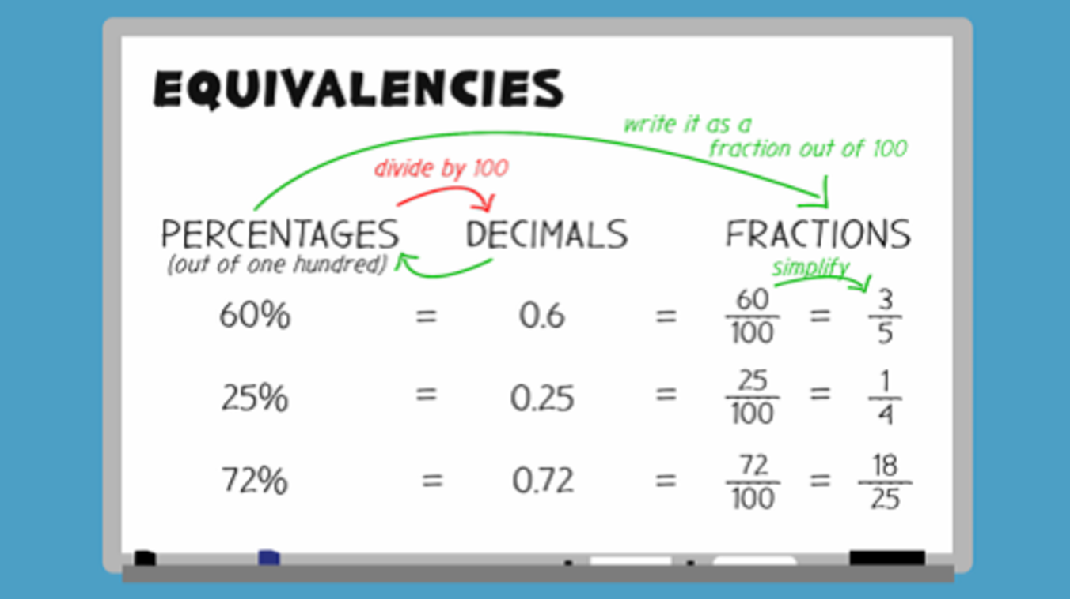

Lets look in more detail at changing a percentage to a fraction.

Example: 50% is 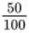
As you can see this percentage is essentially a fraction of 100. However you can simplify it to .
To change a percentage to a fraction, put the percentage over 100 and simplify if possible.
Sometimes we might see a percentage like this: 12.5%.
If we use the method above we get 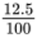 but we can’t have a decimal in a fraction.
To get rid of the decimal in the fraction we must multiply the top and bottom of the fraction, the numerator and denominator, by any number that will give us whole numbers. In this case 10 or 2 both work well (12.5 × 10 = 125 and 12.5 × 2 = 25):

Method 1: × 10
- × top and bottom by 10 = 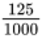 =

Method 2: × 2
- × top and bottom by 2 = 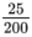 =

Activity 21: Converting between percentages, decimals and fractions

- Express these percentages as decimals:
  - 62%
  - 50%
  - 5%
- Express these decimals as percentages:
  - 0.02
  - 0.2
  - 0.752
  - 0.055
- Express these percentages as fractions:
  - 15%
  - 2.5%
  - 37.5%

View answer - Activity 21: Converting between percentages, decimals and fractions

Now have a go at matching these fractions to decimals and percentages.

Activity 22: Matching fractions, decimals and percentages

Choose the correct fraction for each percentage and decimal.

35% = 0.35 =
40% = 0.4 =
8% = 0.08 =
62.5% = 0.625 =
View answer - Part

Next you’ll look in more detail at how to change a fraction to a percentage.

9.2 Changing a fraction to a percentage
There are two ways you can do this.

Method 1
To change a fraction into a percentage, multiply it by 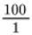 (essentially, you are just multiplying the top number by 100 and the bottom number will stay the same).

Example: Change into a percentage

× = 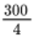
This cancels to = 75%

Note: Remember anything over 1 is a whole number. If you do not end up with a 1 on the bottom, you will have to divide the top number by the bottom one to get your final answer.

Method 2
Divide the top of the fraction by the bottom (to express the fraction as a decimal) and then multiply the answer by 100.

Example: = 3 ÷ 4 = 0.75

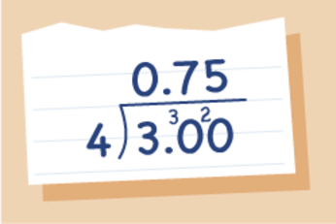
Figure 12 Expressed as a decimal: 3 ÷ 4
View description - Figure 12 Expressed as a decimal: 3 ÷ 4

- 0.75 × 100 = 75%

Activity 22: Changing a fraction to a percentage

- Express these fractions as percentages:

View answer - Activity 22: Changing a fraction to a percentage

Now you’ll look at changing a fraction to a decimal.

9.3 Changing a fraction to a decimal
Again there are two ways to do this, both based on the two methods just shown for changing a fraction to a percentage.

Method 1

Example: Change the fraction into a percentage and divide by 100
× = 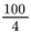 which cancels to = 25%
Now convert to a decimal by dividing by 100:
- 25 ÷ 100 = 0.25

Method 2

Example: Divide the top of the fraction by the bottom
= 1 ÷ 4 = 0.25.

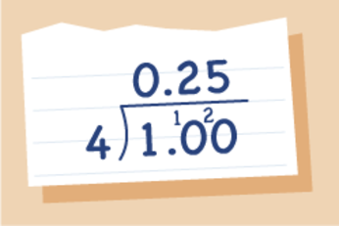
Figure 13 Expressed as a decimal: 1 ÷ 4
View description - Figure 13 Expressed as a decimal: 1 ÷ 4

Activity 23: Changing a fraction to a decimal

Express these fractions as decimals:

View answer - Activity 23: Changing a fraction to a decimal

Fractions and percentages deal with splitting numbers into a given number of equal portions, or parts. When dealing with the next topic, ratio, you will still be splitting quantities into a given number of parts, but when sharing in a ratio, you do not share evenly. This might sound a little complicated but you’ll have been doing it since you were a child.

Summary
In this section you have:
- learned about the relationship between fractions, decimals and percentages and are now able to convert between the three.

10 Ratio
As you can see from Figure 14, ratio is an important part of everyday life.

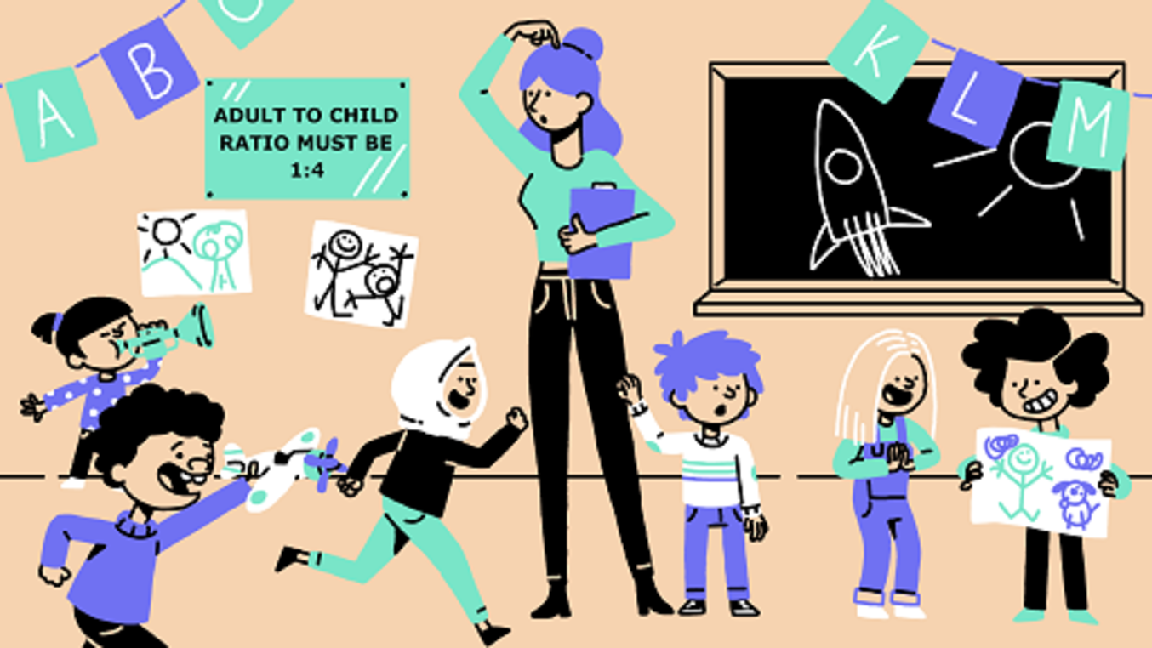
Figure 14 Day-to-day ratio
View description - Figure 14 Day-to-day ratio

It is important to understand how to tell which part of the ratio is which. If for example, you have a group of men and women in the ratio of 5:4, as the men were mentioned first, they are the first part of the ratio.
The order of the ratio is very important. Consider the following:

Julia attends a drama club where 100 members are men and 150 members are women. What is the ratio of women to men at the drama club?

Notice how the information that you need to answer the question is given in the opposite order to that required in the answer. It is very important that you give the parts of the ratio in the correct order.
The ratio of women to men is 150:100
If you were asked for the ratio of men to women it would be 100:150

10.1 Simplifying ratios
Sometimes you need to work out the ratio from the quantities you have.
If we refer back to the example we discussed earlier, we said that the ratio of women to men at the drama club is 150:100. However, you can simplify this ratio by dividing all parts by the same number. This is similar to simplifying fractions, which you have done.
With 150:100, we can divide each side of the ratio by 50 (you could also divide by 10 and then by 5), so the ratio will simplify to 3:2. Therefore, the ratio of women to men at the club is 3:2. Having it written in its simplest form makes it easier to think about and to use for other calculations. For every 2 men you have, there are 3 women.
Let’s look at another example.

Example: Recipes and ratio
Look at this recipe for a mocktail:
Sunset Smoothie
- 50 ml grenadine
- 100 ml orange juice
- 150 ml lemonade
The ratio of the ingredients is:
- grenadine:orange juice:lemonade
- 50 : 100 : 150
To simplify this ratio you can divide all of the numbers by 50 (or by 10 and then 5).
This gives the ratio of grenadine to orange juice to lemonade as 1:2:3.

Activity 24: Simplifying ratios

Simplify the following ratios:
- The ratio of women to men in a class is 15:20.
- The ratio of management to staff in a warehouse is 10:250.
- The ratio of home to away supporters is 24 000 to 8000.
- The ratio of votes in a local election was candidate A 1600, candidate B 800, Candidate C 1200.
- The ratio of fruit in a bag of mixed dried fruit is 150 g currants, 100 g raisins, 200 g sultanas and 50 g mixed peel.

View answer - Activity 24: Simplifying ratios

Ratio questions can be asked in different ways. There are three main ways of asking a ratio question. Take a look at an example of each below and see if you can identify the differences.

Type 1
A recipe for bread says that flour and water must be used in the ratio 5:3. If you wish to make 500 g of bread, how much flour should you use?

Type 2
You are growing tomatoes. The instructions on the tomato feed say ‘Use 1 part feed to 4 parts water’. If you use 600 ml of water, how much tomato feed should you use?

Type 3
Ishmal and Ailia have shared some money in the ratio 3:7. Ailia receives £20 more than Ishmal. How much does Ishmal receive?

In questions of type 1, you are given the total amount that both ingredients must add to, in this example, 500 g. In questions of type 2 however, you are not given the total amount but instead are given the amount of one part of the ratio. In this case you know that the 4 parts of water total 600 ml.
The final type of ratio question does not give us either the total amount or the amount of one part of the ratio. Instead, it gives us just the difference between the first and second part of the ratio. Whilst neither type of ratio question is more complicated than the others, it is useful to know which type you are dealing with as the approach for solving each type of problem is slightly different.

10.2 Solving ratio problems where the total is given
The best way for you to understand how to solve these problems is to look through the worked example in the video below.

Video content is not available in this format.
View transcript - Uncaptioned interactive content

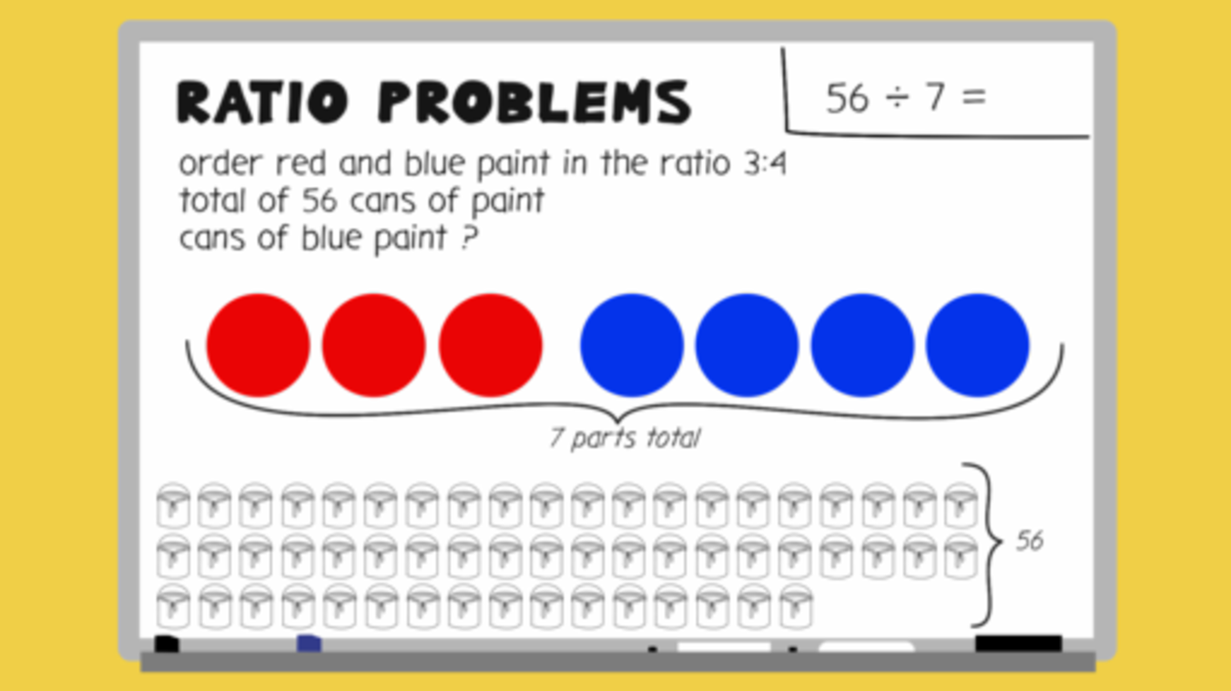

Activity 25: Ratio problems where the total is known

Try solving these ratio problems:
- To make mortar you need to mix soft sand and cement in the ratio 4:1. You need to make a total of 1500 g of mortar.
How much soft sand will you need?

View answer - Part

- To make the mocktail ‘Sea Breeze’ you need to mix cranberry juice and grapefruit juice in the ratio 4:2.
You want to make a total of 2700 ml of mocktail. How much grapefruit juice should you use?

View answer - Part

- The instructions to mix Misty Morning paint are mix 150 ml of azure with 100 ml of light grey and 250 ml of white paint.
How much light grey paint would you need to make 5 litres of Misty Morning?

View answer - Part

- You want to make 14 litres of squash for a children’s party. The concentrate label says mix with water in the ratio of 2:5.
How much concentrate will you use?

View answer - Part

- A man leaves £8400 in his will to be split between 3 charities:
  - Dogs Trust, RNLI and MacMillan Research in the ratio 3:2:1.
How much will each charity receive?

View answer - Part

Next you’ll look at ratio problems where the total of one part of the ratio is known.

10.3 Solving ratio problems where the total of one part of the ratio is given
Take a look at the worked example below:

You are growing tomatoes. The instructions on the tomato feed say:
- Use 1 part feed to 4 parts water
If you use 600 ml of water, how much tomato feed should you use?

These questions make much more sense if you look at them visually:

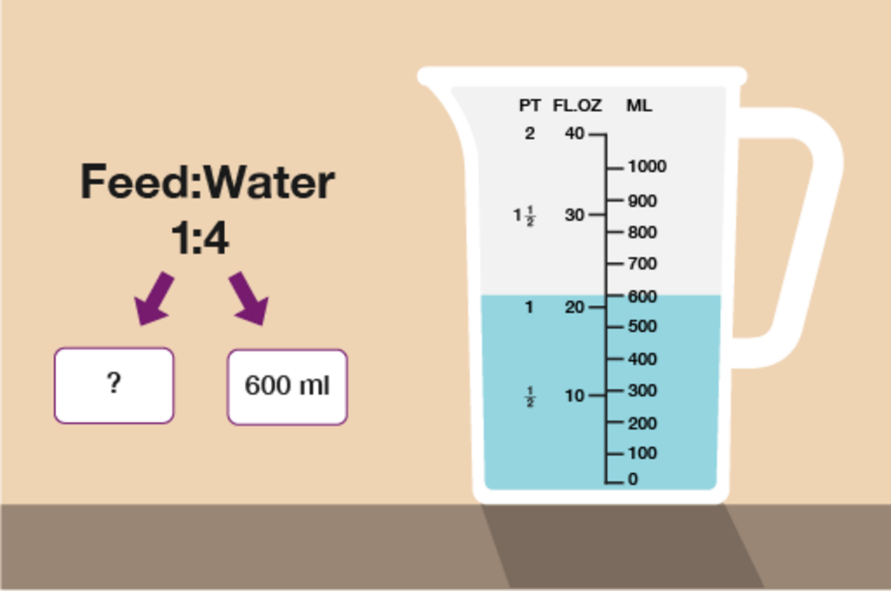
Figure 15 Solving ratio problems to grow tomatoes
View description - Figure 15 Solving ratio problems to grow tomatoes

You can now see clearly that 600 ml of water is worth 4 parts of the ratio. To find one part of the ratio you need to do:
- 600 ml ÷ 4 = 150 ml
Since the feed is only 1 part, feed must be 150 ml. If feed was more than one part you would multiply 150 ml by the number of parts.
Just as with the previous type of question, you need to try to work out the value of 1 part. The value of any other number of parts can be worked out from this.

Activity 26: Ratio problems with one part given

Practise your skills by tackling the ratio problems below:
- A recipe requires flour and butter to be used in the ratio 3:5. The amount of butter used is 700 g.
How much flour will be needed?

View answer - Part

- When looking after children aged between 7 and 10, the ratio of adults to children must be 1:8.
  - For a group of 32 children, how many adults must there be?
  - If there was one more child in the group, how would this affect the number of adults required?

View answer - Part

- A shop mixes bags of muesli using oats, sultanas and nuts in the ratio 6:3:1.
If the amount of sultanas used is 210 g, how heavy will the bag of muesli be?

View answer - Part

Next you’ll look at ratio problems where only the difference in amounts is given.

10.4 Solving ratio problems where only the difference in amounts is given
Earlier in the section you came across the question below. Let’s have a look at how we could solve this.

Example: Solving ratio amounts from the difference
Ishmal and Ailia have shared some money in the ratio 3:7.
Ailia receives £20 more than Ishmal. How much does Ishmal receive?
- Ishmal:Ailia
3:7
You know that the difference between the amount received by Ishmal and the amount received by Ailia is £20. You can also see that Ailia gets 7 parts of the money whereas Ishmal only gets 3.
The difference in parts is therefore 7 − 3 = 4. So 4 parts = £20.
Now this is established, you can work out the value of one part by doing:
- £20 ÷ 4 = £5
As you want to know how much Ishmal received you now do:
- £5 × 3 = £15
As an extra check, you can work out Ailia’s by doing:
- £5 × 7 = £35
This is indeed £20 more than Ishmal.

Activity 27: Ratio problems where difference given

Now try solving this type of problem for yourself.
- The ratio of female to male engineers in a company is 2:9. At the same company, there are 42 more male engineers than females.
How many females work for this company?
- A garden patio uses grey and white slabs in the ratio 3:5. You order 30 fewer grey slabs than white slabs.
How many slabs did you order in total?

View answer - Activity 27: Ratio problems where difference given

Even though there are different ways of asking ratio questions, the aim of any ratio question is to determine the value of one part. Once you know this, the answer is simple to find!
Ratio can also be used in less obvious ways. Imagine you are baking a batch of scones and the recipe makes 12 scones. However, you need to make 18 scones rather than 12. How do you work out how much of each ingredient you need? The final ratio section deals with other applications of ratio.

10.5 Other applications of ratio
A very common and practical use of ratio is when you want to change the proportions of a recipe. All recipes state the number of portions they will make, but this is not always the number that you wish to make.You may wish to make more or less than the actual recipe gives. If you wanted to make 18 scones but only have a recipe that makes 12, how do you know how much of each ingredient to use?
- To make 12 scones
- 400 g self-raising flour
- 1 tablespoon caster sugar
- 80 g butter
- 250 ml milk

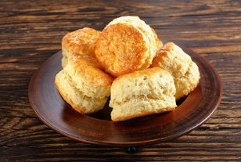
Figure 19 Scones on a plate

As you already know the ingredients to make 12 scones, you need to know how much of each ingredient to make an extra 6 scones. Since 6 is half of 12, if you halve each ingredient, you will have the ingredients for the extra 6 scones. To find the total for 18 scones you need to add together the ingredients for the 12 scones and the 6 scones.

Table 9
12 scones | 6 scones | 18 scones
400 g flour | 400 g ÷ 2 = 200 g flour | 400 g + 200 g = 600 g flour
1 tablespoon caster sugar | 1 ÷ 2 = tablespoon caster sugar | 1 + = 1 tablespoons caster sugar
80 g butter | 80 g ÷ 2 = 40 g butter | 80 g + 40 g = 120 g butter
250 ml milk | 250 ml ÷ 2 = 125 ml milk | 250 ml + 125 ml = 375 ml milk

Have a go at the activity below to check your skills.

Activity 28: Ratio and recipes

- This recipe makes 18 biscuits:
  - 220 g self-raising flour
  - 150 g butter
  - 100 g caster sugar
  - 2 eggs
- How much of each ingredient is needed for 9 biscuits?

View answer - Part

- To make strawberry milkshake you need:
  - 630 ml milk
  - 3 scoops of ice cream
  - 240 g of strawberries
  - The recipe serves 3
- How much of each ingredient is needed for 9 people?

View answer - Part

- Angel Delight recipe:
  - Add 60 g powder to 300 ml cold milk
  - Serves 2 people
- How much of each ingredient is needed to serve 5 people?

View answer - Part

The final practical application of ratio can be very useful when you are out shopping. Supermarkets often try and encourage us to buy in bulk by offering larger ‘value’ packs. But how can you work out if this is actually a good deal? Take a look at the example below.

Example: Ratio and shopping
Which of the boxes below offers the best value for money?

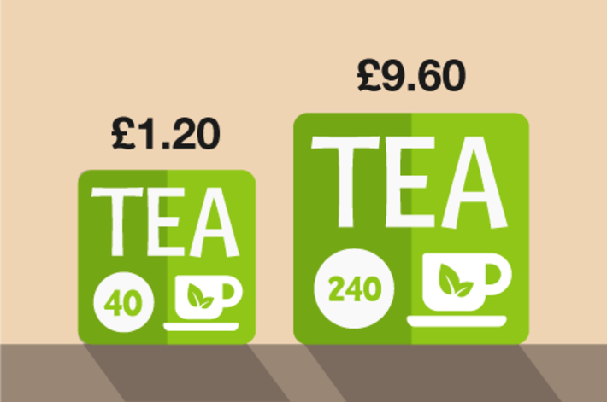
Figure 20 Shopping options: tea
View description - Figure 20 Shopping options: tea

There are various ways of comparing the prices.

Method 1
To work out which is the best value for money we need to find the price of 1 teabag.
If 40 teabags cost £1.20 then to find the cost of 1 teabag you do:

£1.20 ÷ 40 = £0.03, or 3p

If 240 teabags cost £9.60 then to find the cost of 1 teabag you do:

£9.60 ÷ 240 = £0.04, or 4p

The box containing 40 teabags is therefore better value than the larger box.

Method 2
The ratio of teabags is

40 : 240 which you can simplify to 1:6

If we use the price for the small box you can see that 1 part is £1.20
You can then use this value to calculate the price of the large box. At this price, the bigger box would be £1.20 × 6 = £7.20 so we can see that the small box is better value.

Activity 29: Practical applications of ratio

Use whichever method you prefer to work out the best deal in each case.
- Work out which deal is the best value for money.

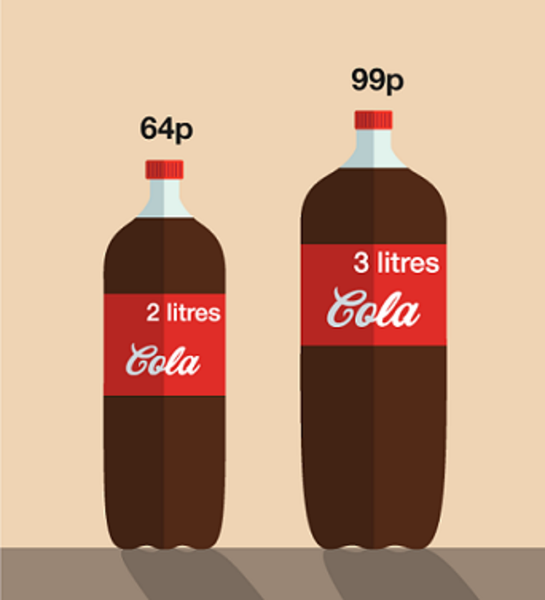
Figure 21 Cola options
View description - Figure 21 Cola options

View answer - Part

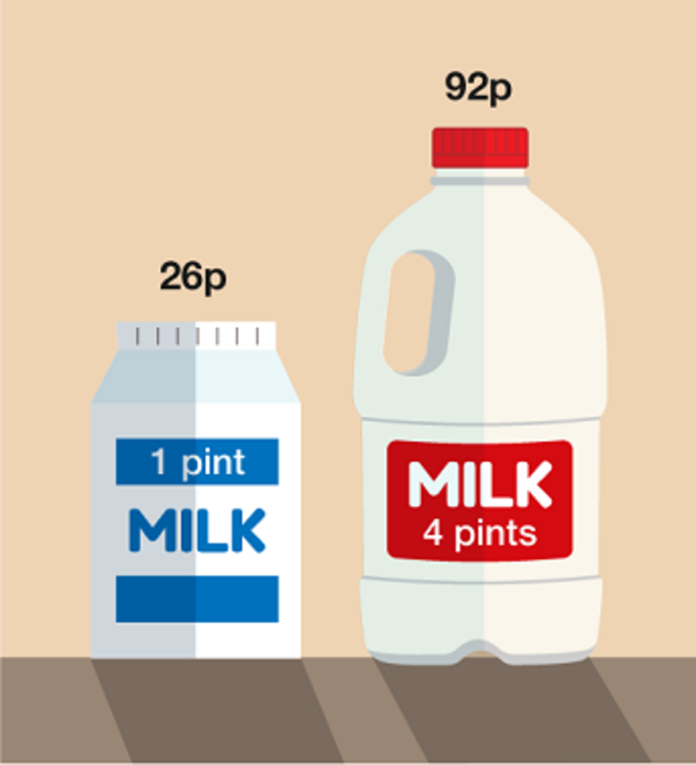
Figure 22 Milk options
View description - Figure 22 Milk options

View answer - Part

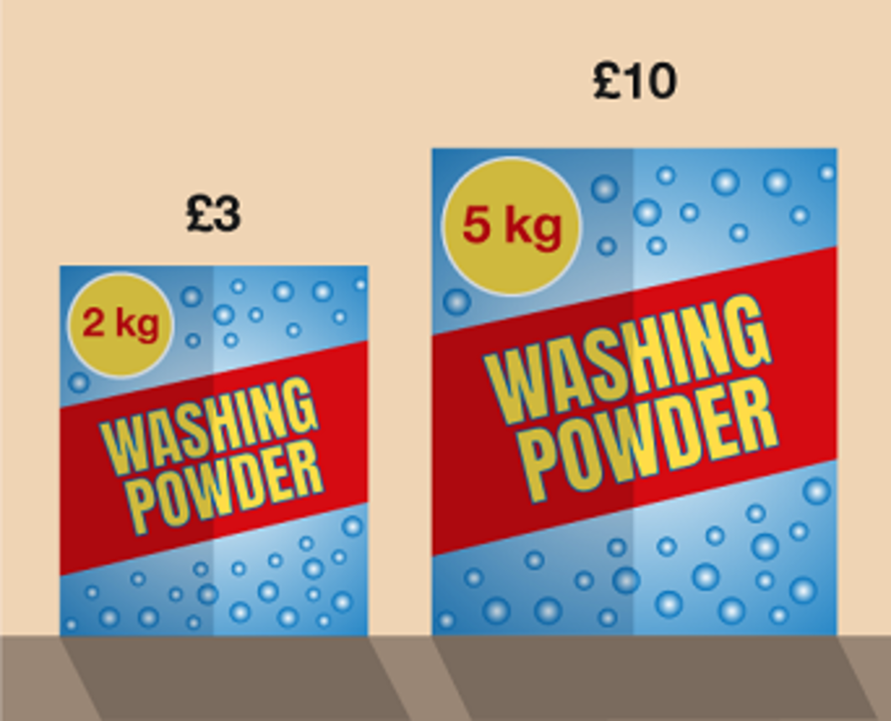
Figure 23 Washing powder options
View description - Figure 23 Washing powder options

View answer - Part

- Two supermarkets sell the same brand of juice. Shop B is offering ‘buy one get second one half price’ for apple juice and ‘buy one get one free’ for orange juice.
For each type of juice which shop is offering the best deal?

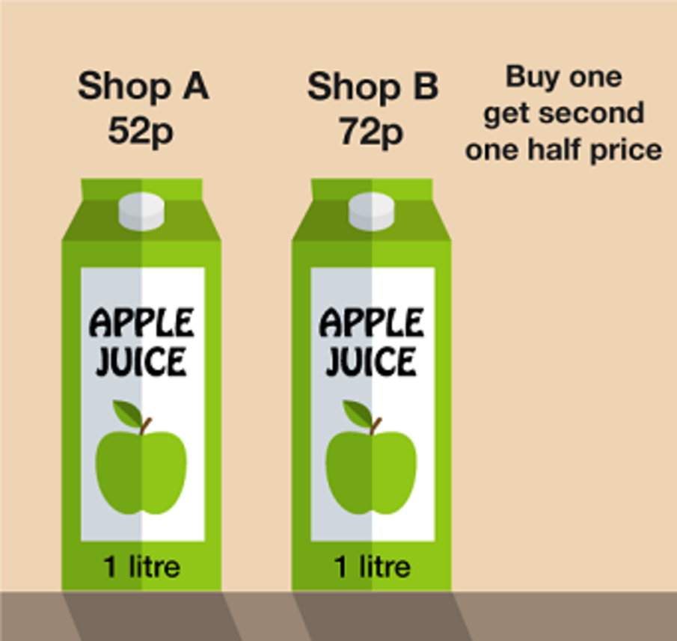
Figure 24 Apple juice options
View description - Figure 24 Apple juice options

View answer - Part

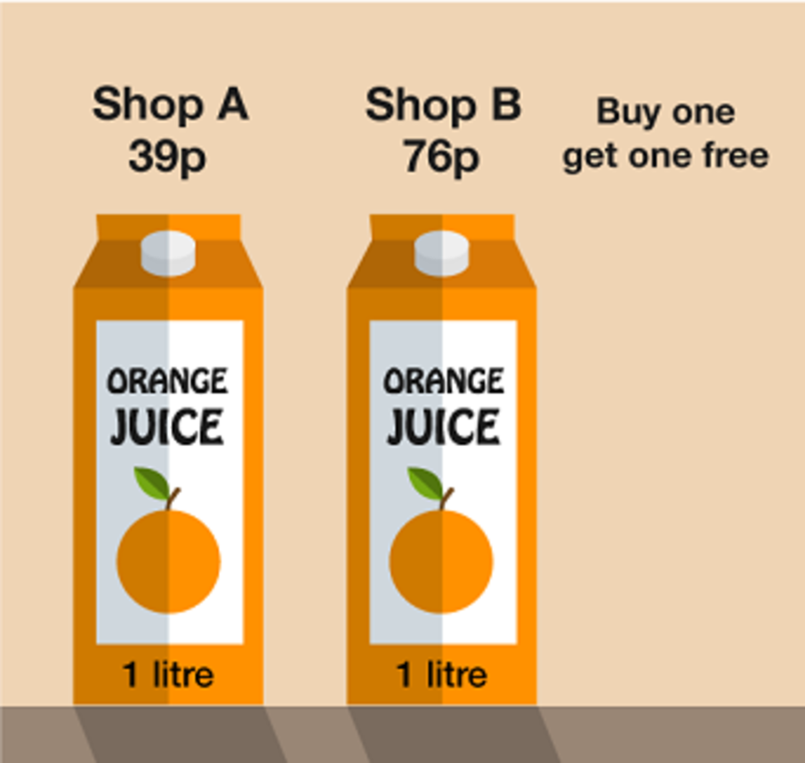
Figure 25 Orange juice options
View description - Figure 25 Orange juice options

View answer - Part

- A supermarket sells bread rolls in 3 different size packs. Which size offers the best value for money?

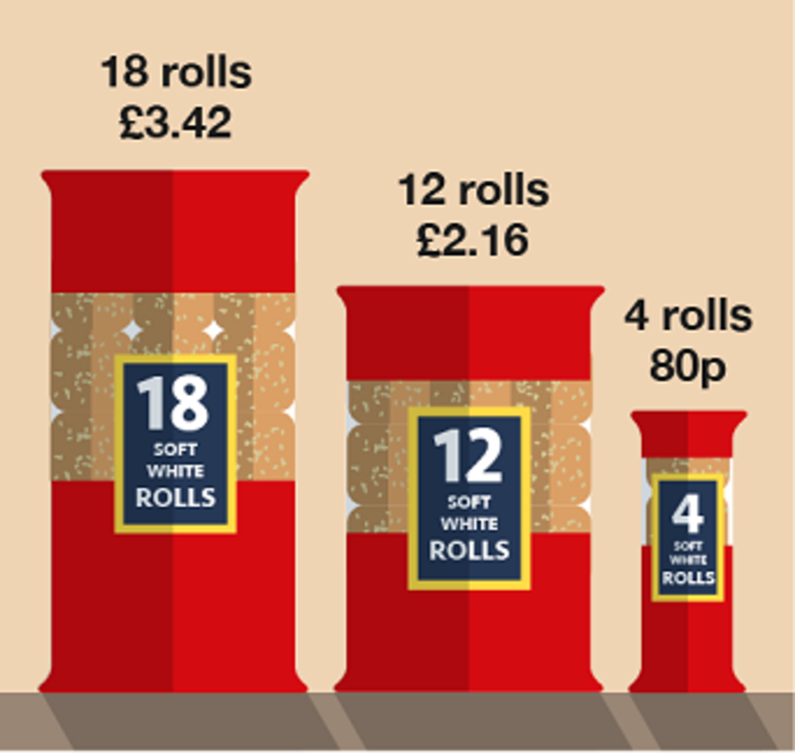
Figure 26 Bread rolls options
View description - Figure 26 Bread rolls options

View answer - Part

You have now completed all elements of the ratio section and hopefully are feeling confident with each topic.
The next section of the course deals with formulas. This might sound daunting but you have actually already used a formula. Remember when you learned about how to work out the percentage change of an item? To do that you used a simple formula and you will now take a closer look at slightly more complex formulas.

Summary
In this section you have:
- learned about the three different types of ratio problems and that the aim of any ratio problem is to find out how much one part is worth
- practised solving each type of ratio problem:
  - where the total amount is given
  - where you are given the total of only one part
  - where only the difference in amounts is given
- learned about other useful applications of ratio, such as changing the proportions of a recipe.

11 Formulas


Figure 27 Formulas
View description - Figure 27 Formulas

Before diving in to this topic, you first need to learn about the order in which you need to carry out addition, subtraction, multiplication and division. Have you ever seen a question like the one below posted on social media?

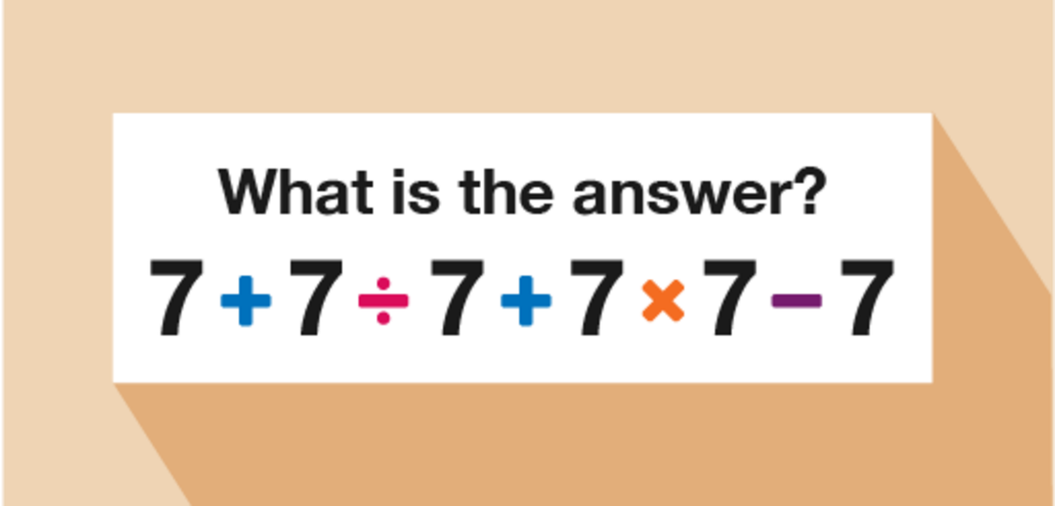
Figure 28 A calculation using the four operations
View description - Figure 28 A calculation using the four operations

There are usually a wide variety of answers given by various people. But how is it possible that such a simple calculation could cause so much confusion? It’s all to do with the order in which you carry out the calculations.
- If you go from left to right:
  - 7 + 7 = 14
  - 14 ÷ 7 = 2
  - 2 + 7 = 9
  - 9 × 7 = 63
  - 63 − 7 = 56
Check this on a calculator and you will see that the correct answer is actually 50. How do you arrive at this answer? You have to use the correct order of operations, sometimes called BIDMAS.

11.1 Order of operations
The order in which you carry out operations can make a big difference to the final answer. When doing any calculation that involves doing more than one operation, you must follow the rules of BIDMAS in order to arrive at the correct answer.

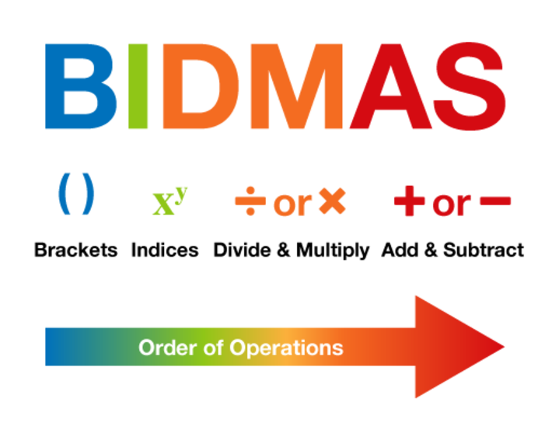
Figure 29 The BIDMAS order of operations
View description - Figure 29 The BIDMAS order of operations

B: Brackets
Any calculation that is in brackets must be done first.
Example:

2 × (3 + 5)
2 × 8 = 16

Note that this could also be written as 2 (3 + 5) because if a number is next to a bracket, it means you need to multiply.
If there is more than 1 operation in the brackets, you must follow the rules of BIDMAS in the brackets.

I: Indices
After any calculations in brackets have been done, you must deal with any calculations involving indices or powers i.e.

3² = 3 × 3
or
4³ = 4 × 4 × 4

Example:

3 × 4²
3 × (4 × 4)
3 × 16 = 48

D: Divide
Next come any division or multiplication calculations. Of these two calculations, you should do them in the order that they appear in the sum from left to right.
Example:

16 − 10 ÷ 5
16 − 2 = 14

M: Multiply
Example:

5 + 6 × 2
5 + 12 = 17

A: Add
Finally, any calculations involving addition or subtraction are done. Again, these should be done in the order that they appear from left to right.

S: Subtract
Example:

24 + 10 − 2
34 − 2 = 32
or
24 + 8 = 32

Activity 30: Using BIDMAS

Now have a go at carrying out the following calculations yourself. Make sure you apply BIDMAS!
- 4 + 3 × 2
- 5 (4 − 1)
- 36 ÷ 3²
- 7 + 15 ÷ 3 − 4

View answer - Activity 30: Using BIDMAS

Now that you have learned the rules of BIDMAS you are ready to apply them when using formulas.

11.2 Formulas in practice
You will already have come across and used formulas in your everyday life. For example, if you are trying to work out the cost of a new carpet you will have used the formula:
- area = length × width
to calculate how much carpet you would need.
Often division in a formula is shown as one number over another, for example:
- 6 ÷ 3 would be shown as
Let’s look at division in a formula:

- 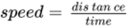
A lorry driver travels 120 miles in 3 hours. What was the average speed during the journey?

Note: As the lorry driver was unlikely to have travelled at a constant speed for 120 miles we say we are calculating the average speed as this will give us the typical overall speed.

- speed = 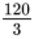
speed = 40 miles per hour
Sometimes we use letters to represent the different elements used in a formula, e.g. the formula above might be shown as:
- s =
where:
  - ‘s’ = speed in mph
  - ‘d’ = distance in miles
  - ‘t’ = time in hours

If you are trying to work out the time to cook a fresh chicken you may have used the formula:

- Time (minutes) = 15 + 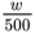 × 25 where ‘w’ is the weight of the chicken in grams.
For example, if you wanted to cook a chicken that weighs 2500 g you would do:
- Time (minutes) = 15 + 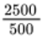 × 25
Remembering to use BIDMAS you would then get:
- Time (minutes) = 15 + 5 × 25
= 15 + 125
= 140 minutes

Let’s look at another worked example before you try some on your own.

Example: Gas bill formula

The owner of a guesthouse receives a gas bill. It has been calculated using the formula:
Cost of gas (£) = 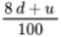

Note: 8d means you do 8 × d.

Where d = number of days and u = number of units used, if she used 3500 units of gas in 90 days, how much is the bill?
In this example, d = 90 and u = 3500 so you do:

Cost of gas (£) = 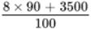

= 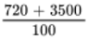

= 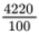

= £42.20

Activity 31: Using formulas

- Fuel consumption in Europe is calculated in litres per 100 kilometres. A formula to approximate converting from miles per gallon to litres per 100 kilometres is:
  - L = 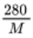
where L = number of litres per 100 kilometres and M = number of miles per gallon.
A car travels 40 miles per gallon. What is this in litres per kilometres?

View answer - Part

- Using the formula I = 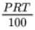 where:
  - I = interest
  - P = principal amount of loan
  - R = interest rate
  - T = time in years
calculate how much interest is due on a loan of £5000 taken over 3 years at an interest rate of 5.5%.

View answer - Part

- The area of a trapezium can be calculated using the formula:
  - A = 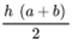

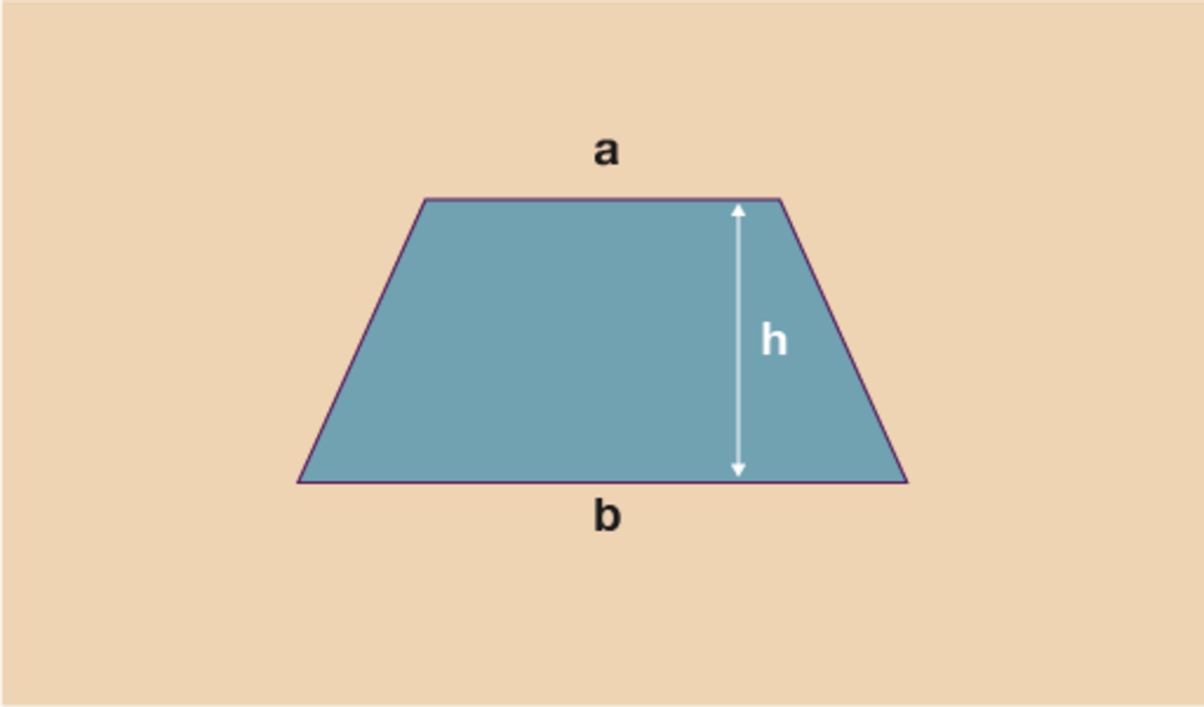
Figure 30 Dimensions of a trapezium
View description - Figure 30 Dimensions of a trapezium

Find the area of trapeziums where:
  - a = 5 cm, b = 9 cm and h = 7 cm
  - a = 35 mm, b = 40 mm and h = 10 cm

View answer - Part

- A company uses the following formula to work out the total cost to the customer of hiring a bouncy castle:
  - T = hc + (0.45d) + 15
where:
T = total
h = number of days hire
c = cost of castle per day
d = delivery distance in miles.

- 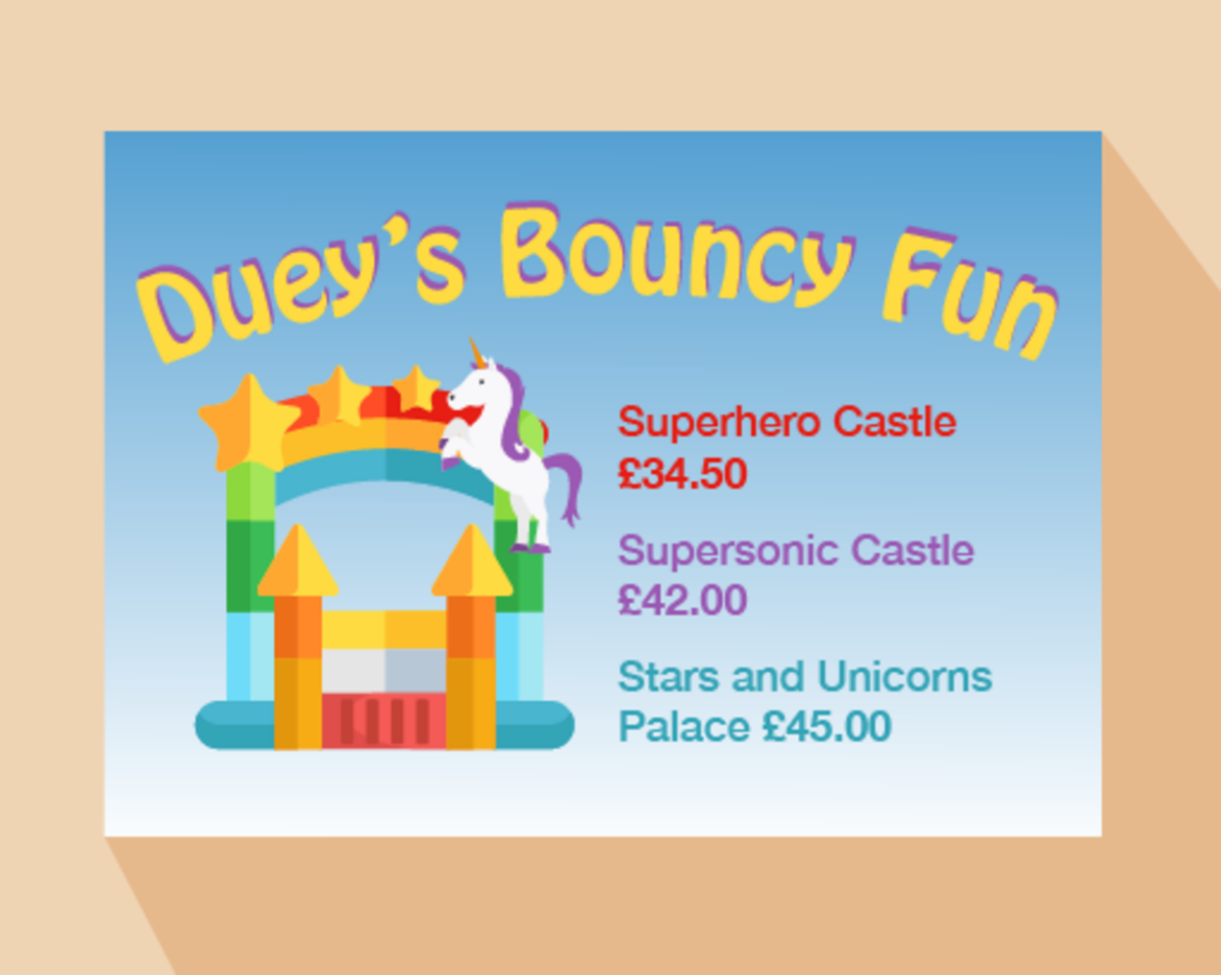
- Figure 31 Dues’s Bouncy Fun – price list
- View description - Figure 31 Dues’s Bouncy Fun – price list

- Stuart lives 12 miles away and would like to hire a Supersonic Castle for 2 days. How much will it cost?

View answer - Part

Now that you have learned all the skills that relate to the number section of this course, there is just one final thing you need to be able to do before you will be ready to complete the end-of-session quiz for numbers.
You are now proficient at carrying out lots of different calculations including working out fractions and percentages of numbers, using ratio in different contexts and using formulas.
It is fantastic that you can now do all these things, but how do you check if an answer is correct? One way you can check would be to approximate an answer to the calculation (as you did in Section 3.2). Another way to check an answer is to use the inverse (opposite) operation.

Summary
In this section you have:
- learned about, and practised using BIDMAS – the order in which operations must be carried out
- seen examples of formulas used in everyday life and practised using formulas to solve a problem.

12 Checking your answers

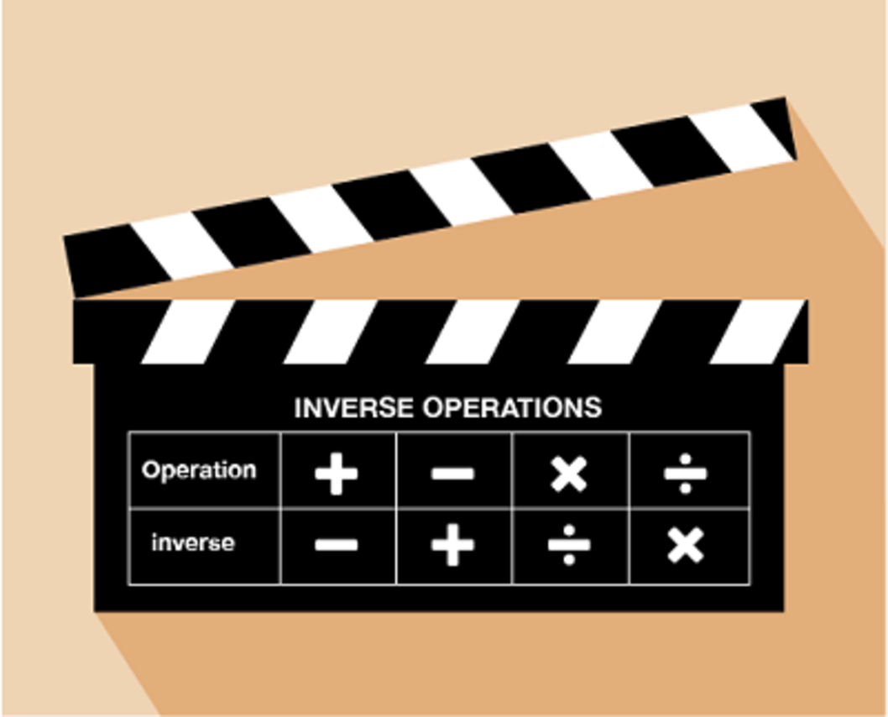
Figure 32 Inverse operations
View description - Figure 32 Inverse operations

An inverse operation is an opposite operation. In a sense, it ‘undoes’ the operation that has just been performed. Let’s look at two simple examples to begin with.

Example: Check your working 1
6 + 10 = 16

Method
Since you have done an addition sum, the inverse operation is subtraction. To check this calculation, you can either do:

16 − 10 = 6
or
16 − 6 = 10

You will notice here that the same 3 numbers (6, 10 and 16) have been used in all the calculations.

Example: Check your working 2
5 × 3 = 15

Method
This time, since you have done a multiplication sum, the inverse operation is division. To check this calculation, you can either do:

15 ÷ 5 = 3
or
15 ÷ 3 = 5

Again, you will notice that the same 3 numbers (3, 5 and 15) have been used in all the calculations.
If you have done a more complicated calculation, involving more than one step, you simply ‘undo’ each step.

Example: Check your working 3
A coat costing £40 has a discount of 15%. How much do you pay?

Method
Firstly, we find out 15% of £40:

40 ÷ 100 × 15 = £6 discount
£40 − £6 = £34 to pay

To check this calculation, firstly you would check the subtraction sum by doing the addition:

£34 + £6 = £40

To check the percentage calculation you then do:

£6 ÷ 15 × 100 = £40
Don’t forget, sometimes it can also be helpful to use estimation to check your answers, particularly when using decimal or large numbers.

You have now completed the number section of the course. Before moving on to the next session, ‘Units of measure’, complete the quiz on the following page to check your knowledge and understanding.

Summary
In this section you have:
- learned that each of the four operations has an inverse operation (its opposite) and that these can be used to check your answers
- seen examples showing how to check answers using the inverse operation.

13 Session 1 quiz
Now it’s time to review your learning in the end-of-session quiz.
Session 1 quiz.
Open the quiz in a new window or tab (by holding ctrl [or cmd on a Mac] when you click the link), then return here when you have done it.
Although the quizzes in this course do not require you to show your working to gain marks, real exams would do so. We therefore encourage you to practise this by using a paper and pen to clearly work out the answers to the questions. This will also help you to make sure you get the right answer.

14 Session 1 summary
You have now completed Session 1, ‘Working with numbers’. If you have identified any areas that you need to work on, please ensure you refer back to this section of the course and retry the activities.
You should now be able to:
- use the four operations to solve problems in context
- understand rounding and look at different ways of doing this
- write large numbers in full and shortened forms
- carry out calculations with large numbers
- carry out multistage calculations
- solve problems involving negative numbers
- define some key mathematical terms (multiple, lowest common multiple, factor, common factor and prime number)
- identify lowest common multiples and factors
- use fractions, decimals and percentages and convert between them
- solve different types of ratio problems
- make substitutions within given formulas to solve problems
- use inverse operations and estimations to check your calculations.
All of the skills above will help you with tasks in everyday life. Whether you are at home or at work, number skills are an essential skill to have.
You are now ready to move on to Session 2, ‘Units of measure’.

Session 2: The importance of planning

Introduction
While families of people with learning disabilities who are ageing may see staying together for as long as possible as a positive choice, it is often because of a lack of acceptable alternatives and many people with learning disabilities want to move into their own home as they get older. This needs careful planning and conversations with the person with learning disabilities, family members and professionals about what the options might be.


View description - Uncaptioned Figure
View alternative description - Uncaptioned Figure

Without future planning, there is a risk that a crisis will precipitate a move to somewhere that is notappropriate ormiles away from the family home and friends.
In this session you will look at a case study from our research involving an older person with learning disabilities and her mother to highlight some of the issues commonly experienced in families around moving to a new home.

1 Introducing Sharon and Becky
In this case study, you will meet Sharon (aged 71) and her daughter Becky (aged 45) who has learning disabilities. Sharon, her husband Bob (aged 75) and Becky live in their family home. You will be returning to this case study later in the course.

Activity 1 Meet Becky
Allow 10 minutes

Read the vignette below to find out more about Becky and her life. Make some notes if you wish, either in you ‘Tips’ notepad (which you may have downloaded in Session 1) or in the text box below.

Becky’s story
Becky lives with her parents who are both in their 70s. She goes to a day centre four times a week, where she has one-on-one support. Becky loves to be outside and in nature. Her favourite activities include watching people, trains, buses and YouTube videos. She likes to carry a shopping bag with her into which she puts things that she likes, for example a basketball, empty burger boxes, drinks cans and crisp packets. Becky likes how they shine and crinkle.
Some of her staff have supported Becky for years and know her very well. Although Becky is good at communicating what she likes and wants, generally staff rely on her body language and facial expressions. Becky does not have any significant health needs at the moment, but she is overweight.
Several ‘hazards’ when supporting Becky have been identified. She does not like changes in her routine, environment and those who care for her. Her anxiety can manifest itself in spitting, kicking, grabbing or stealing until she has become accustomed to such changes. The incidence of behaviours that challenge others also seem to have worsened since Becky started the menopause. There is a risk of harm to herself or a member of staff. Members of the public may respond negatively to her. The service has put in place strategies staff can use to reduce these risks which include taking her away from the situation as quickly as possible when she gets upset. If Becky refuses to move she is given space and allowed to calm down.
Becky’s parents want to plan for her future.

Provide your answer...

2 Thinking about Becky’s future care
You’ll now hear from Becky’s mum (Sharon) talking about Becky’s future and future care.

Activity 2 What next for Becky?
Allow 15 minutes

Now listen to Sharon reflecting on Becky’s future care. As you listen make a note of the points she makes that you think could be useful in your own situation given the concerns you identified in Session 1. You can write these in your ‘Tips’ notepad or in the text box below.

Audio content is not available in this format.
View transcript - Uncaptioned interactive content

Provide your answer...

View discussion - Part

Activity 3 Information and resources to help you plan ahead
Allow 30 minutes

There are some resources that you can use to help you with planning ahead. An example of checklist which will help is: Error! Hyperlink reference not valid.. During our research we worked alongside people with learning disabilities and family members to produce a set of practical ‘planning ahead cards’ to prompt and support conversations with people with learning disabilities who are getting older.
Watch the following video that explains how to use the cards: How to use the planning ahead cards for people with learning disabilities
Now spend a few minutes reviewing the cards:
- Online version
- PDFs for normal printing
- PDFs for professional printing
Finally, make some notes in your ‘Tips’ about how you might use these cards to facilitate your planning ahead. Are there particular cards that you think would be particularly useful?

Provide your answer...

3 Some of the realities of planning future care
This session would not be complete without thinking about those situations where the person with learning difficulties does not want to move out.

Activity 4Understanding and coping with reluctance
Allow 10 minutes

Watch the two short videos below. These are reflections on personal experiences and are also relevant to Becky’s situation. In the first video Gail reflects on her own experiences and in the second Dawn and Pam make some suggestions about what might help during conversations about future care. Make some notes if you wish.

Video content is not available in this format.
View transcript - Uncaptioned interactive content

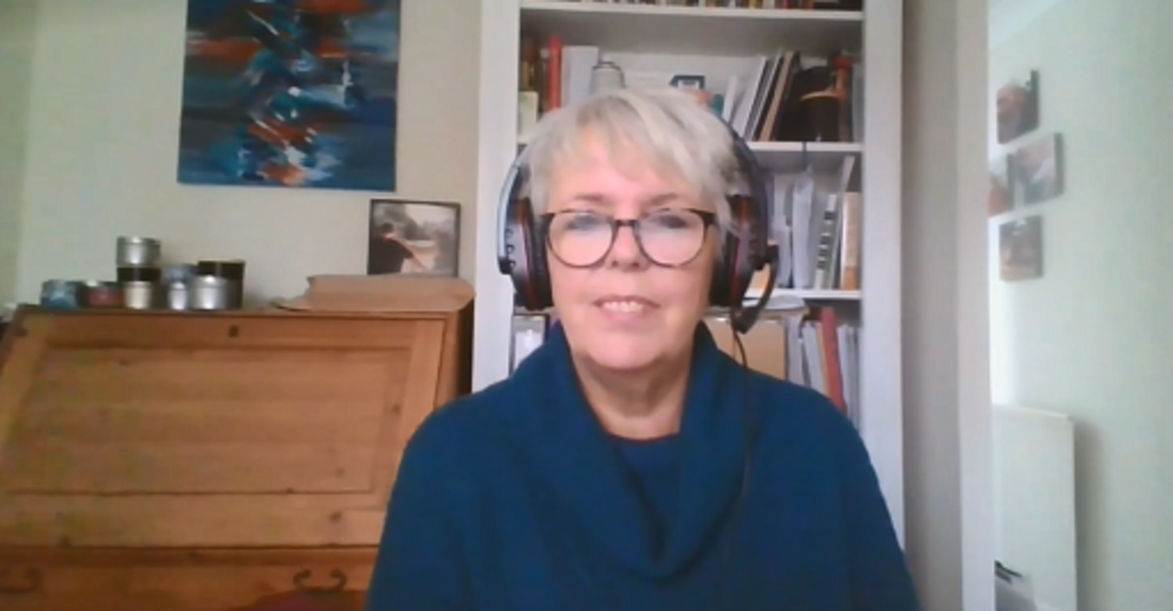

Video content is not available in this format.
View transcript - Uncaptioned interactive content

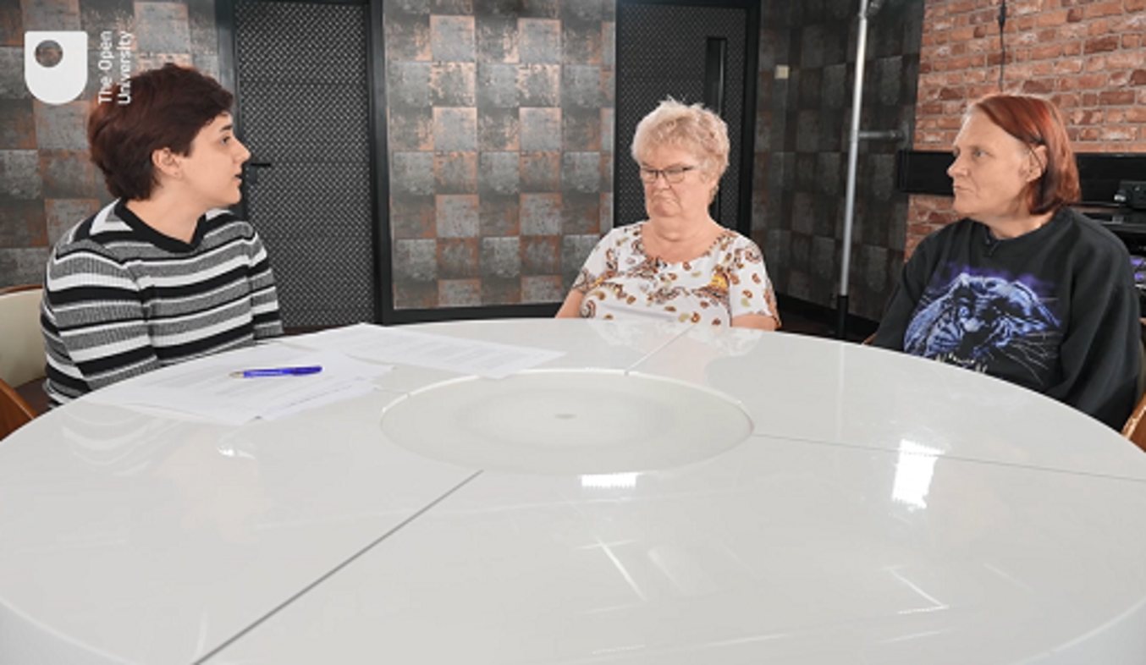

Provide your answer...

View discussion - Part

4 Summary of Session 2
There is a major gap in supporting older family carers to plan for their family member’s future in health and social care. This is reflected in published research (Tilley et al., 2022; Larkin et al., 2023).
The ‘Tips’ you are developing about planning ahead well in advance, having an emergency care plan in place, thinking about options and taking time over your planning will be useful to you.As mentioned above, you can add to them as you work through the rest of the course and after you have completed the course, for example, when you get ideas from information and examples of what has worked for other families.
You can now go to Session 3.

3 Time, timetables and average speed
Calculating with time is often seen as tricky, not surprising really considering how difficult it can be to learn how to tell the time. The reason many people find calculating with time tricky is because, unlike nearly every other mathematical concept, it does not work in 10s. Time works in 60s – 60 seconds in a minute, 60 minutes in an hour. You cannot therefore, simply use your calculator to add on or subtract time.

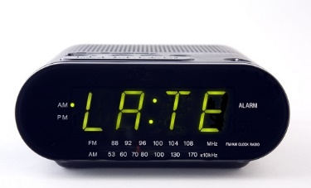
Figure 13 A radio alarm clock

Think about this simple example. If it’s 9:50 and your bus takes 20 minutes to get to work, you cannot work out the time you will arrive by doing 950 + 20 on your calculator. This would give you an answer of 970 or 9:70 – there isn’t such a time!
You will need to calculate with time and use timetables in daily life to complete basic tasks such as: getting to work on time, working out which bus or train to catch, picking your children up from school on time, cooking and so many other daily tasks.

3.1 Calculating with time and timetables
As previously discussed, calculators are not the most useful items when it comes to calculations involving time. A much better option is to use a number line to work out these calculations. Take a look at the examples below.

Example: Cooking
You put a chicken in the oven at 4:45 pm. You know it needs to cook for 1 hour and 25 minutes. What time should you take the chicken out?

Method
Watch the video below to see how the number line method works.

Video content is not available in this format.
View transcript - Uncaptioned interactive content

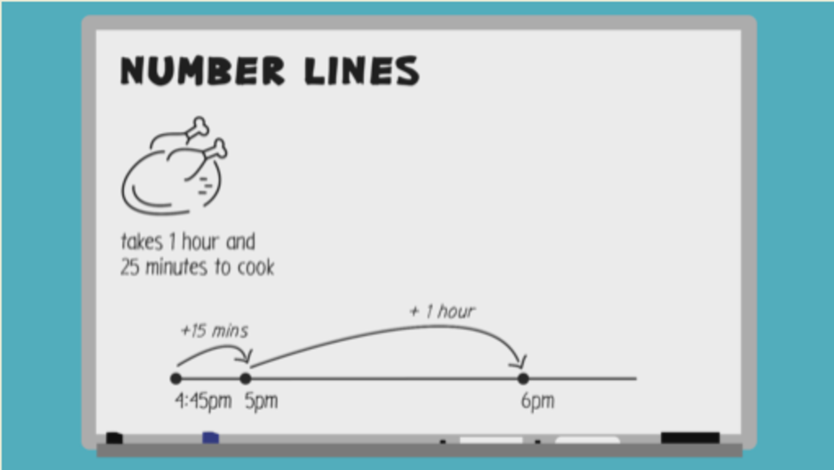

Example: Time sheets
You work for a landscaping company and need to fill out your time sheet for your employer. You began working at 8:30 am and finished the job at 12:10 pm. How long did the job take?

Method

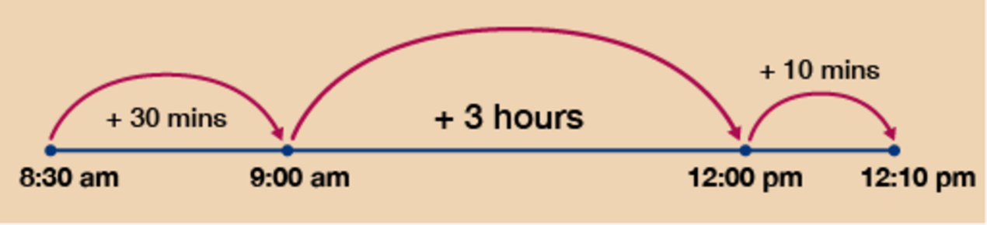
Figure 14 A number line for a time sheet
View description - Figure 14 A number line for a time sheet

Again, for finding the time difference you want to work with easy ‘chunks’ of time. Firstly, you can move from 8:30 am to 9:00 am by adding 30 minutes. It is then simple to get to 12:00 pm by adding on 3 hours.
Finally, you just need another 10 minutes to take you to 12:10 pm. Looking at the total time added you have 3 hours and 40 minutes.

Another aspect of calculating with time comes in the form of timetables. You will be used to using these to work out which departure time you need to meet in order to get to a location on time or how long a journey will take. Once you can calculate with time, using timetables simply requires you to find the correct information before carrying out the calculation. Take a look at the example below.

Example: Timetables
Here is part of a train timetable from Swindon to London.

Table 2(a)
Swindon | 06:10 | 06:27 | 06:41 | 06:58 | 07:01 | 07:17
Didcot | 06:27 | 06:45 | 06:58 | 07:15 | 07:18 | 07:34
Reading | 06:41 | 06:59 | 07:13 | - | 07:33 | -
London | 07:16 | 07:32 | 07:44 | 08:02 | 08:07 | 08:14

- You need to travel from Didcot to London. You need to arrive in London by 8:00 am. What is the latest train you can catch from Didcot to arrive in London for 8:00 am?

Method

Table 2(b)
Swindon | 06:10 | 06:27 | 06:41 | 06:58 | 07:01 | 07:17
Didcot | 06:27 | 06:45 | 06:58 | 07:15 | 07:18 | 07:34
Reading | 06:41 | 06:59 | 07:13 | - | 07:33 | -
London | 07:16 | 07:32 | 07:44 | 08:02 | 08:07 | 08:14

Looking at the arrival times in London, in order to get there for 8:00 am you will need to take the train that arrives in London at 07:44 (highlighted with bold). If you then move up this column of the timetable you can see that this train leaves Didcot at 06:58 (highlighted with italic). This is therefore the train you must catch.
- How long does the 06:58 from Swindon take to travel to London?

Method

Table 2(c)
Swindon | 06:10 | 06:27 | 06:41 | 06:58 | 07:01 | 07:17
Didcot | 06:27 | 06:45 | 06:58 | 07:15 | 07:18 | 07:34
Reading | 06:41 | 06:59 | 07:13 | - | 07:33 | -
London | 07:16 | 07:32 | 07:44 | 08:02 | 08:07 | 08:14

Firstly, find the correct train from Swindon (highlighted with italic). Follow this column of the timetable down until you reach London (highlighted with bold). You then need to find the difference in time between 06:58 and 08:02. Using the number line method from earlier in the section (or any other method you choose).

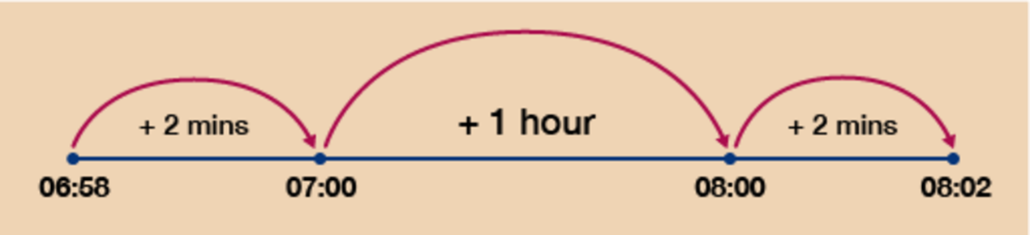
Figure 15 A number line for a timetable
View description - Figure 15 A number line for a timetable

You can then see that this train takes a total of 1 hour and 4 minutes to travel from Swindon to London.
Have a go at the activity below to practise calculating time and using timetables.

Activity 6: Timetables and calculating time

- Kacper is a builder. He leaves home at 8:30 am and drives to the trade centre. He collects his items and loads them into his van. His visit takes 1 hour and 45 minutes. He then drives to work, which takes 50 minutes. What time does he arrive at work?
- You have invited some friends round for dinner and find a recipe for roast lamb. The recipe requires:
  - 25 minutes preparation time
  - 1 hour cooking time
  - 20 minutes resting time
You want to eat with your friends at 7:30 pm. What is the latest time you can start preparing the lamb?
- Here is part of a train timetable from Manchester to Liverpool.

Table 3(a)
Manchester to Liverpool
Manchester | 10:24 | 10:52 | 11:03 | 11:25 | 12:01 | 12:13
Warrington | 10:38 | 11:06 | 11:20 | 11:45 | 12:15 | 12:28
Widnes | 10:58 | 11:26 | 11:42 | 12:03 | 12:34 | 12:49
Liverpool Lime Street | 11:09 | 11:38 | 11:53 | 12:14 | 12:46 | 13:02

- You need to travel from Manchester to Liverpool Lime Street. You need to be in Liverpool by 12:30. Which train should you catch from Manchester and how long will your journey take?

View answer - Activity 6: Timetables and calculating time

You should now be feeling comfortable with calculations involving time and timetables. Before you move on to looking at problems that involve average speed, it is worth taking a brief look at time conversions. Since you are already confident with converting units of measure, this part will just consist of a brief activity so that you can practise converting units of time.

3.2 Converting units of time
You can see from the diagram below that to convert units of time you can use a very similar method to the one you used when converting other units of measure. There is one slight difference when working with time however.

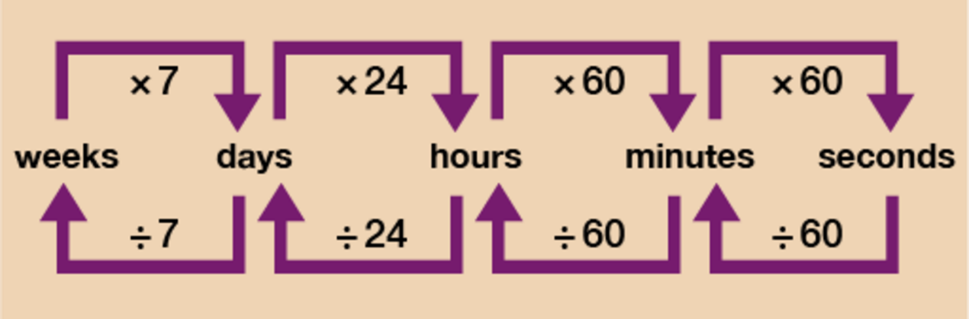
Figure 19 A conversion chart for time
View description - Figure 19 A conversion chart for time

Let’s say you want to work out how long 245 minutes is in hours. The diagram above shows that you should do 245 ÷ 60 = 4.083. This is not a particularly helpful answer since you really want the answer in the format of: ___ hours __ minutes. Due to the fact that time does not work in 10s, you need to do a little more work once arriving at your answer of 4.083.
The answer is obviously 4 hours and an amount of minutes.
4 hours then is 4 × 60 = 240 minutes.
Since you wanted to know how long 245 minutes is you just do 245 – 240 = 5 minutes left over. So 245 minutes is 4 hours and 5 minutes.
It’s a very similar process if you want to go from say minutes to seconds. Let’s take it you want to know how long 5 minutes and 17 seconds is in seconds. 5 minutes would be 5 × 60 = 300 seconds. You then have a further 17 seconds to add on so you do 300 + 17 = 317 seconds.
Have a go at the activity below to make sure you feel confident with converting times.

Activity 7: Converting times

Convert the following times:
- 6 hours and 35 minutes = ___ minutes.
- 85 minutes = ____ hours and ____ minutes.
- 153 seconds = ____ minutes and ___ seconds.
- 46 days = ___ weeks and ____days.
- 3 minutes and 40 seconds = ____ seconds.

View answer - Activity 7: Converting times

Hopefully you found that activity fairly straightforward and are now feeling ready to move on to the next part of the ‘Units of measure’ session – Average speed.

3.3 Average speed
The sign below is commonly seen on motorways but it is not the only time when it is useful to know your average speed.

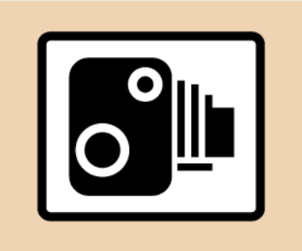
Figure 20 A speed camera sign

Being able to calculate and use average speed can help you to work out how long a journey is likely to take. The method for working out average speed involves using a simple formula.

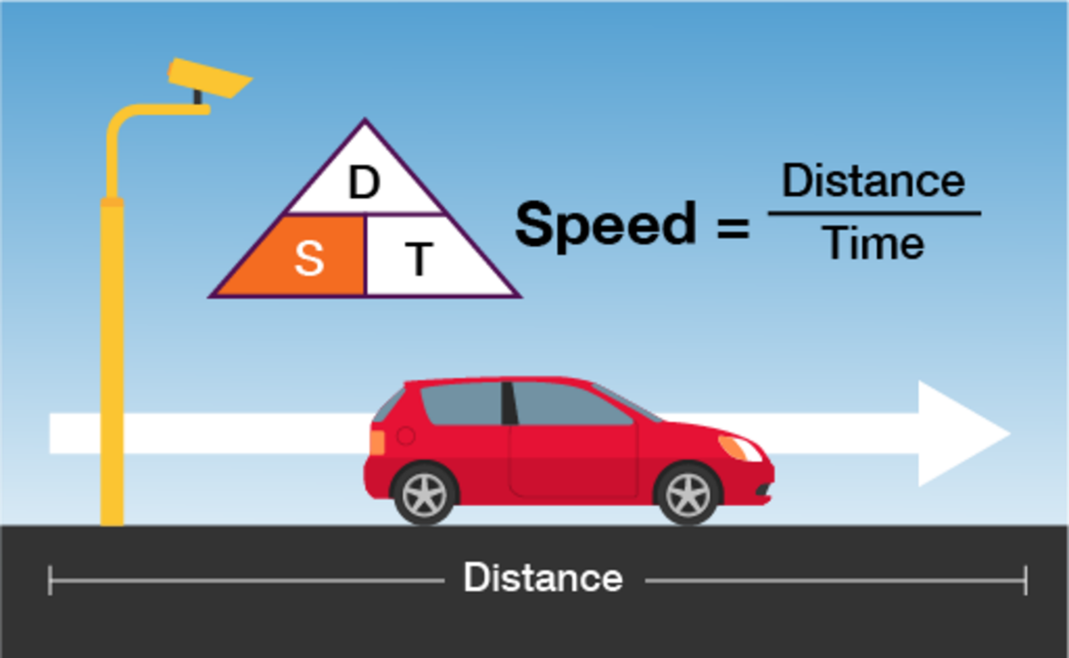
Figure 21 A formula for average speed
View description - Figure 21 A formula for average speed

You can also use this formula to work out the distance travelled when given a time and the average speed, or the time taken for a journey when given the distance and average speed.
The formulas for this are shown in the diagram below. You can see that when given any two of the elements from distance, speed and time, you will be able to work out the third.

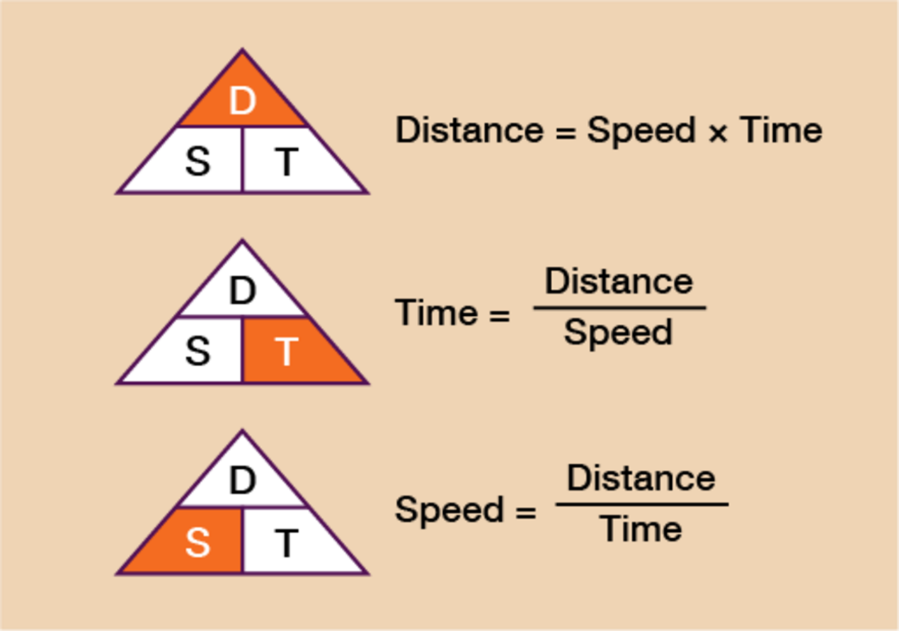
Figure 22 Distance, speed and time formulas
View description - Figure 22 Distance, speed and time formulas

If you can learn this formula triangle, when you want to use it, you write it down and cover up what you want to work out (the segment in orange). This will tell you what calculation you need to do.
Let’s look at an example of each so that you can familiarise yourself with it.

Example: Calculating distance
A car has travelled at an average speed of 52 mph over a journey that lasts 2 and a half hours. What is the total distance travelled?

Method
You can see that to work out the distance you need to do speed × time. In this example then we need to do 52 × 2.5. It is very important to note here that 2 and a half hours must be written as 2.5 (since 0.5 is the decimal equivalent of a half).
You cannot write 2.30 (for 2 hours and 30 mins). If you struggle to work out the decimal part of the number, convert the time into minutes (2 and a half hours = 150 minutes) and then divide by 60 (150 ÷ 60 = 2.5).

52 × 2.5 = 130 miles travelled

Example: Calculating time
A train will travel a distance of 288 miles at an average speed of 64 mph. How long will it take to complete the journey?

Method
You can see from the formula that to calculate time you need to do distance ÷ speed so you do:

288 ÷ 64 = 4.5 hours

Again, note that this is not 4 hours 50 minutes but 4 and a half hours.
If you are unsure of how to convert the decimal part of your answer, simply multiply the answer by 60, which will turn it into minutes and you can then convert from there.
In this case, 4.5 × 60 = 270 minutes. We already know from the answer of 4.5 hours that this is 4 whole hours and so many minutes, so we now need to work out how many minutes the .5 represents:

60 × 4 = 240 minutes
270 − 240 = 30 minutes
So 4.5 hours = 270 minutes = 4 hours, 30 minutes

Example: Calculating speed
A Formula One car covers a distance of 305 km during a race. The time taken to finish the race is 1 hour and 15 minutes. What is the car’s average speed?

Method
The formula tells you that to calculate speed you must do distance ÷ time. Therefore, you do 305 ÷ 1.25 (since 15 minutes is a quarter of an hour and 0.25 is the decimal equivalent of a quarter):

305 ÷ 1.25 = 244 km/h

In a similar way to example 1, if you are unsure of how to work out the decimal part of the time simply write the time (in this case 1 hour and 15 minutes) in minutes, (1 hour 15 minutes = 75 minutes) and then divide by 60:

75 ÷ 60 = 1.25

Now have a go at the following activity to check that you feel confident with finding speed, distance and time. Please do the calculations first without a calculator. You may then double-check on a calculator if needed.

Activity 8: Calculating speed, distance and time

- Filip is driving a bus along a motorway. The speed limit is 70 mph. In 30 minutes, he travels a distance of 36 miles. Does his average speed exceed the speed limit?
- A plane flies from Frankfurt to Hong Kong. The flight time was 10 hours and 45 minutes. The average speed was 185 km/h. What is the distance flown by the plane?
- Malio needs to get to a meeting by 11:00 am. The time now is 9:45 am. The distance to the meeting is 50 miles and he will be travelling at an average speed of 37.5 mph. Will he be on time for the meeting?

View answer - Activity 8: Calculating speed, distance and time

Hopefully you will now be feeling more confident with calculations involving speed, distance and time. You will now move on to temperature conversions.

Summary
In this section you have learned how to:
- use timetables to plan a journey and how to calculate time efficiently
- convert between units of time by using multiplication and division skills
- use the formula for calculating distance, speed and time.

4 Temperature
Temperature can be recorded in either degrees Celsius (°C) or degrees Fahrenheit (°F). In Everyday Maths 1 you used conversion tables to help you to compare temperatures expressed in the different units. You will now look at how to convert between them using formulas.

4.1 Celsius and Fahrenheit formulas
The following formulas can be used to convert between Celsius and Fahrenheit.

To convert Celsius to Fahrenheit use the formula:
- F = C + 32
Method:
  - divide the Celsius figure by 5
  - multiply by 9
  - add 32.
If you prefer, you can multiply the Celsius figure by 9 first and then divide by 5. You will still need to add on 32 at the end.

To convert Fahrenheit to Celsius use the formula:
- C = 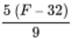
Method:
  - subtract 32 from the Fahrenheit figure
  - multiply by 5
  - divide by 9.

If you need a recap on the rules for using formulas, revisit Session 1 ‘Working with numbers’. We will now look at an example.

Example: Which city is warmer?
I look up the average temperature for New York on a particular day and it is 10°C. I know the average temperature in Swansea on the same day is 55°F. Which city is warmer?
You either need to convert New York’s temperature into °F or the Swansea temperature into °C.
Method 1 – Converting °C to °F
If we look back at the formulas above, the one we need to use to convert from °C to °F is:

F = C + 32

We need to substitute the C with our °C figure of 10°C. We then need to follow the rules of BIDMAS to carry out the calculation in stages, as shown below:

F = × 10 + 32
Divide the celsius figure by 5:
- 10 ÷ 5 = 2
Multiply by 9:
- 2 × 9 = 18
Add 32:
- 18 + 32 = 50°F

You may have done the calculation slightly differently by multiplying the Celsius figure by 9 first and then dividing by 5. The answer will work out the same:

F = × 10 + 32
Multiply by the Celsius figure by 9:
- 10 × 9 = 90
Divide by 5:
- 90 ÷ 5 = 18
Add 32:
- 18 + 32 = 50°F
So which is warmer:
- New York at 10°C (which we now know is 50°F) or Swansea at 55°F?
Swansea is warmer.

Method 2 – Converting °F to °C
The formula for converting from °F to °C:

C =

We need to substitute the F with our °F figure of 55°F. We then need to follow the rules of BIDMAS to carry out the calculation in stages, as shown below:

Take 32 away from the Fahrenheit figure of 55:
- 55 − 32 = 23
Multiply by 5:
- 23 × 5 = 115
Divide by 9:
- 115 ÷ 9 = 12.8°C (rounded to 1 decimal place)

So which is warmer:
- New York at 10°C or Swansea at 55°F (which we now know is 12.8°C)? Swansea is warmer.

Hint: Google has its own unit converter (search for Google Unit Converter) which you can use to convert between various units of measure, including between °C and °F. You could try using it to double-check your answers to the questions below.

Activity 9: Temperature conversions

Work out the answers to the following without using a calculator. You may double-check your answers on a calculator or using the Google unit converter, if needed, and remember to check your answers with ours at the end. Round your answers off to one decimal place where needed.
- Convert the following temperatures into degrees Fahrenheit (°F):
  - 22°C
  - 0°C
  - −6°C

View answer - Part

- Convert the following temperatures into degrees Celsius (°C):
  - 45°F
  - 212°F
  - 5°F

View answer - Part

- I find a recipe which states that my oven needs to be set at a temperature of 400°F. My settings on my oven are in °C. What temperature should I set my oven to?

View answer - Part

- I see Moscow’s temperature is −4°C on a particular day in February, whilst the temperature in Toronto is 19°F. Which place is colder?

View answer - Part

Hopefully you will be feeling more confident when solving problems relating to temperature. The next section will cover reading measurements on scales.

Summary
In this section you have:
- practised converting between degrees Celsius (°C) and degrees Fahrenheit (°F).

5 Reading scales
You may need to read a scale to measure out an amount of liquid, read a measurement on a ruler, weigh out ingredients for a recipe or to take someone’s temperature.
Reading scales can be tricky because every scale is different.
To read a scale correctly, you need to ask yourself:
- What does the scale go up in? What steps or intervals does it use?

Note: The marks on a scale may be referred to as any of the following: intervals, steps, increments or markers. These terms are often used interchangeably.

5.1 Scale examples
Take a look at the following examples.

Example 1: Reading scales

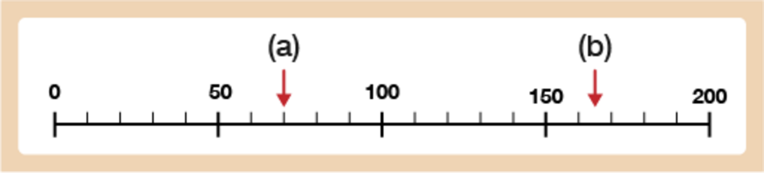
Figure 23 Scale with numbered intervals of 50
View description - Figure 23 Scale with numbered intervals of 50

You can see that this scale is marked up in numbered intervals of 50. However, what does each line in between each numbered interval represent? You can use your judgement to help you to figure out what each small step represents.
Watch this video (https://corbettmaths.com/2013/04/27/reading-scales/) for further information about how to do this.
Alternatively, you can work this out using division. If you count on from 0 to 50 on this scale, there are 5 steps: 50 ÷ 5 = 10, so each step is 10.
- The arrow is pointing to the 2nd mark after 50. As the steps are going up in 10s, the arrow is pointing to 70.
- The arrow is halfway between the 1st and 2nd step after 150. The first step is 160 and the second is 170 so the arrow is pointing to 165.

Example 2: Reading scales
Sometimes you will need to read scales where the reading will be a decimal number.

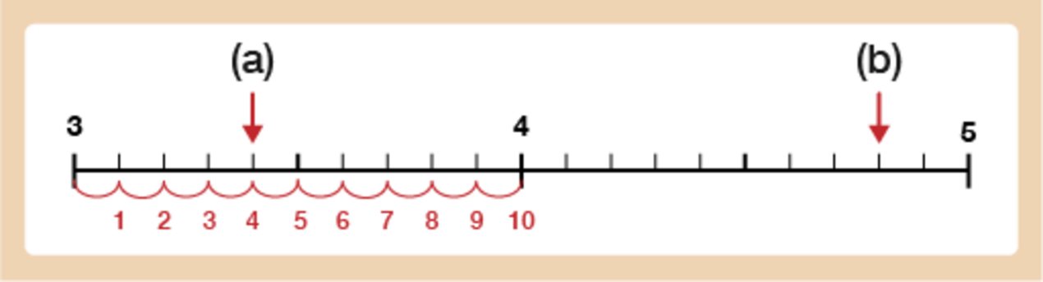
Figure 24 Scale with single numbered intervals going from 3–5
View description - Figure 24 Scale with single numbered intervals going from 3–5

If you look at this scale, it goes up in numbered intervals of 1. From one whole number to the next whole number there are 10 small steps. 1 ÷ 10 = 0.1, so each step is 0.1.
Hint: Have a look at the image to show how to count the number of steps between the numbered markers.
- The arrow is pointing to the fourth step after 3 so the arrow is pointing to 3.4.
- The arrow is pointing to the eighth step after 4, so the arrow is pointing to 4.8.

5.2 Scales and measuring instruments
Now you’ve worked through some examples have a go at the following activities.

Activity 10: Reading scales

- Read the scales below and find the values the arrows are pointing to for (a), (b) and (c).

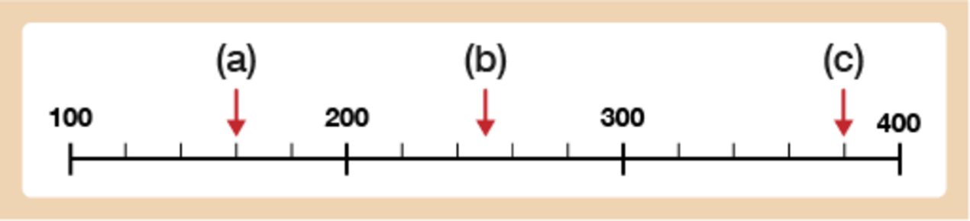
Figure 25 Scale with numbered intervals every hundred going from 100–400
View description - Figure 25 Scale with numbered intervals every hundred going from 100–400

View answer - Part

- Read the values for (a), (b) and (c) on the scales below.

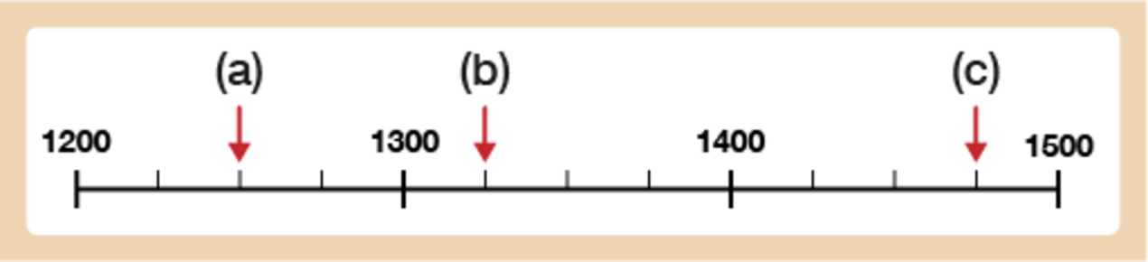
Figure 26 Scale with numbered intervals every hundred going from 1200–1500
View description - Figure 26 Scale with numbered intervals every hundred going from 1200–1500

View answer - Part

- Read the values for (a), (b), (c) and (d) on the scales below.

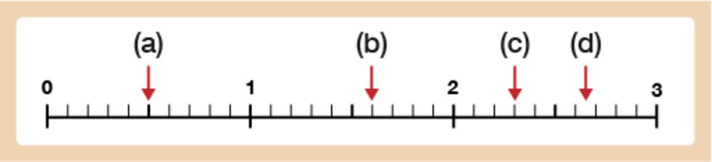
Figure 27 Scale with single number intervals from 0–3
View description - Figure 27 Scale with single number intervals from 0–3

View answer - Part

- Read the values for (a), (b), and (c) on the scales below.

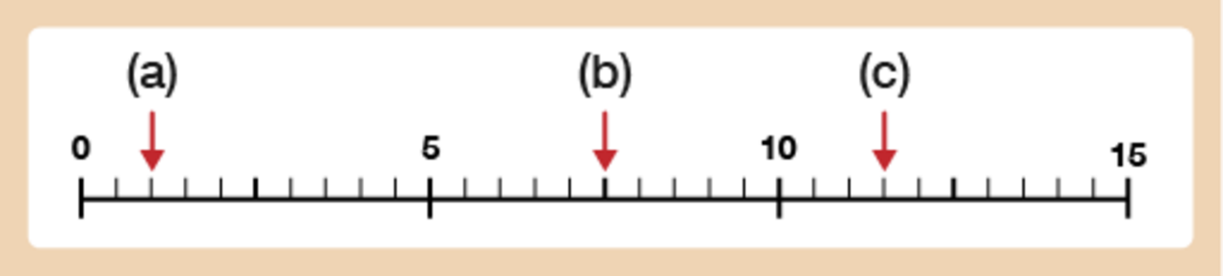
Figure 28 Scale with numbered intervals every 5 going from 0–15
View description - Figure 28 Scale with numbered intervals every 5 going from 0–15

View answer - Part

Now have a go at reading the scales on the different instruments of measure.

Activity 11: Measuring instruments

- How much water is left in the bottle, to the nearest 50 millilitres (ml)?

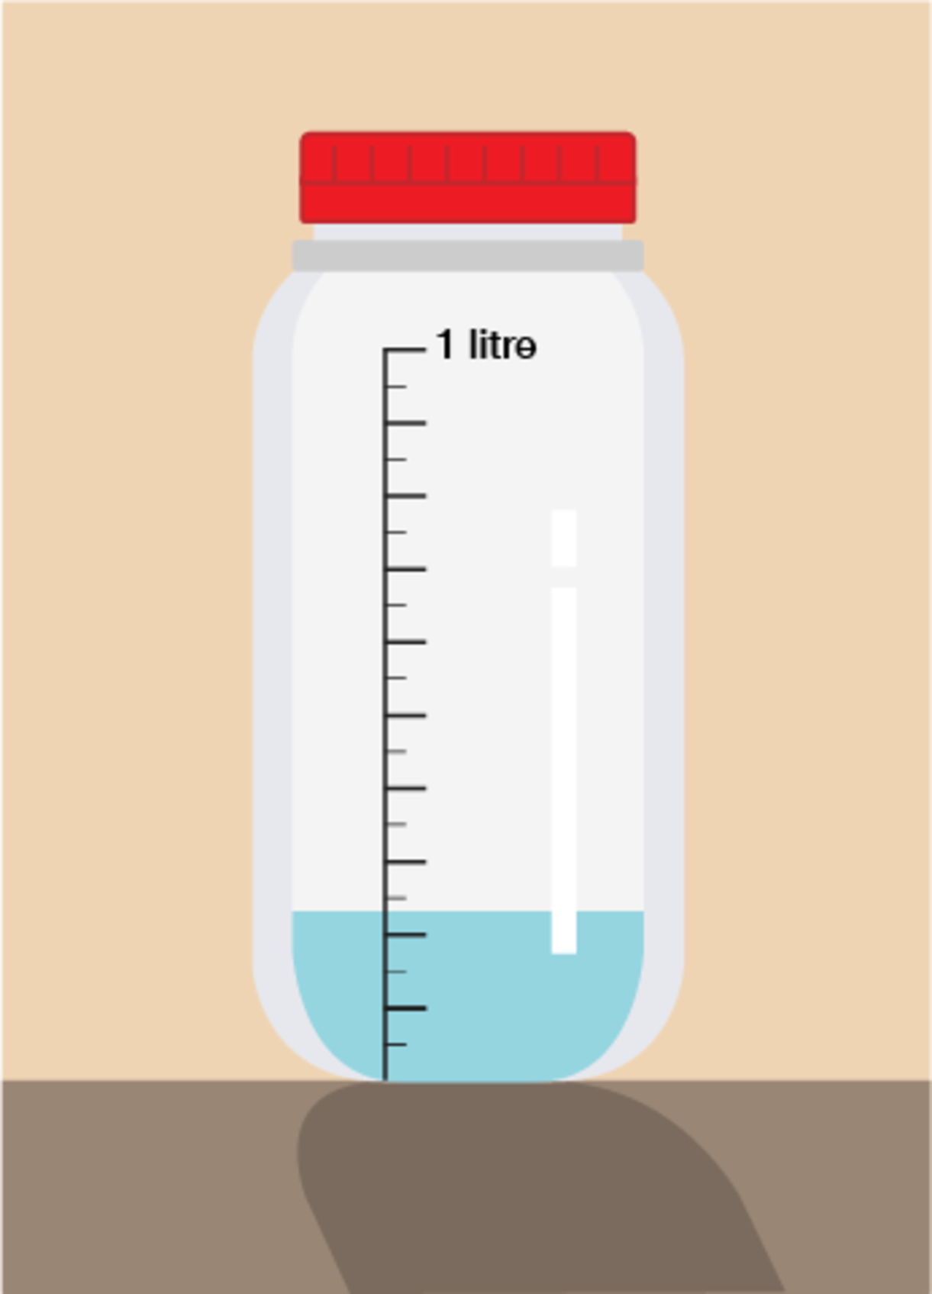
Figure 29 A water bottle with a scale on the side and water inside
View description - Figure 29 A water bottle with a scale on the side and water inside

View answer - Part

- Sara weighs her case using a set of luggage scales. She has a weight limit of 21 kg. How much more can she pack to the nearest 100 grams?

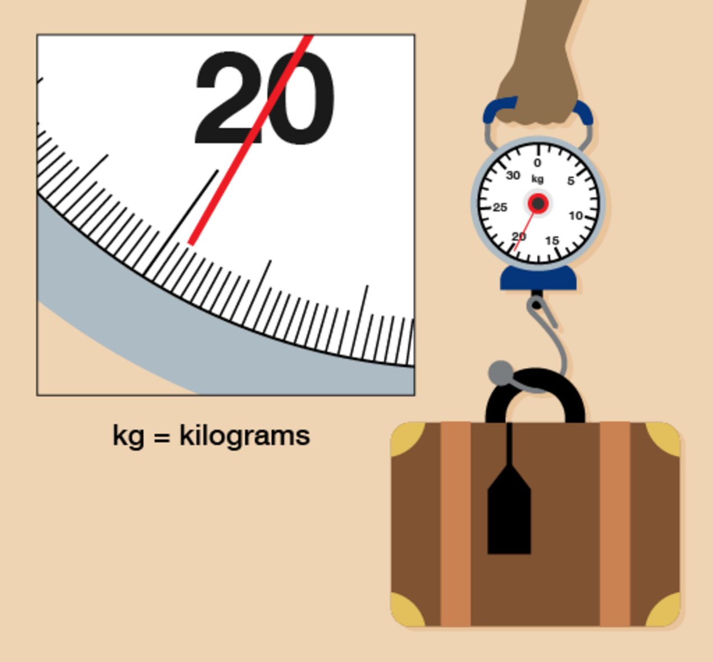
Figure 30 Luggage scales weighing luggage
View description - Figure 30 Luggage scales weighing luggage

View answer - Part

- Simon needs to weigh out 4 kg of potatoes. Looking at the reading on the scale, how many more grams of potatoes does he need to add to make 4 kg?

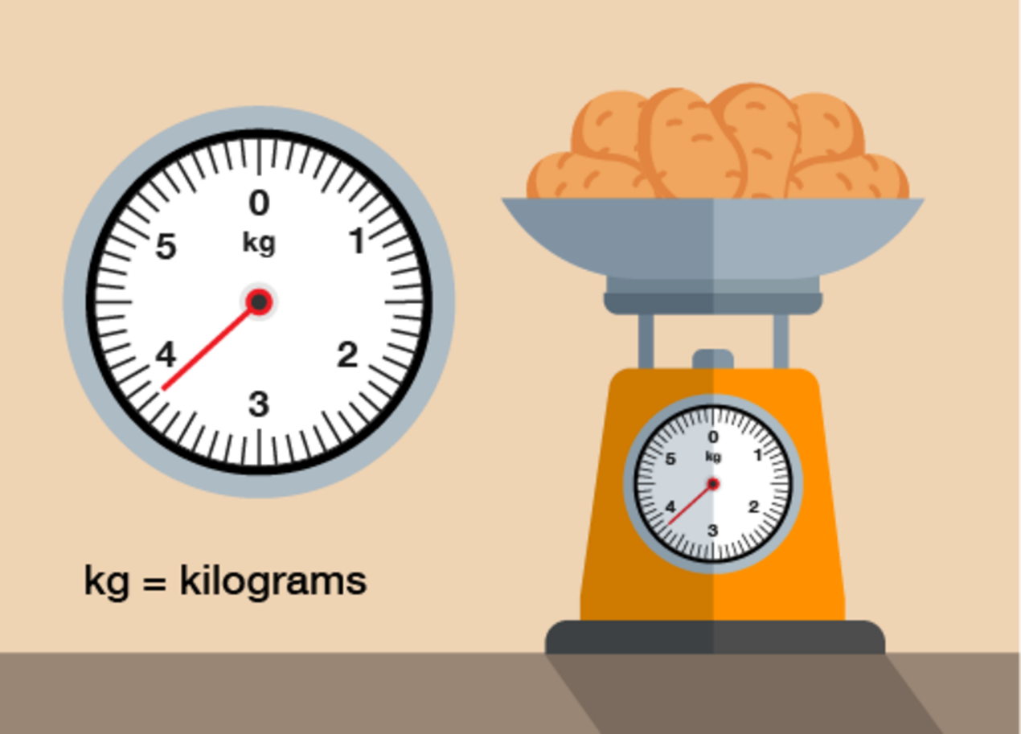
Figure 31 Food scales weighing potatoes
View description - Figure 31 Food scales weighing potatoes

View answer - Part

Hopefully you will be feeling confident at reading scales on measuring devices now which leads you nicely onto the next section which looks at conversion scales.

5.3 Using conversion scales
Earlier on in the session you looked at converting between units of measure in different systems by carrying out calculations.
Many measuring instruments (e.g. thermometers, rulers, measuring jugs) have scales which show two or more different units of measure. This means that there may be times where you can compare the scales on the measuring instrument to make a conversion rather than carry out a calculation.
Look at the following example.

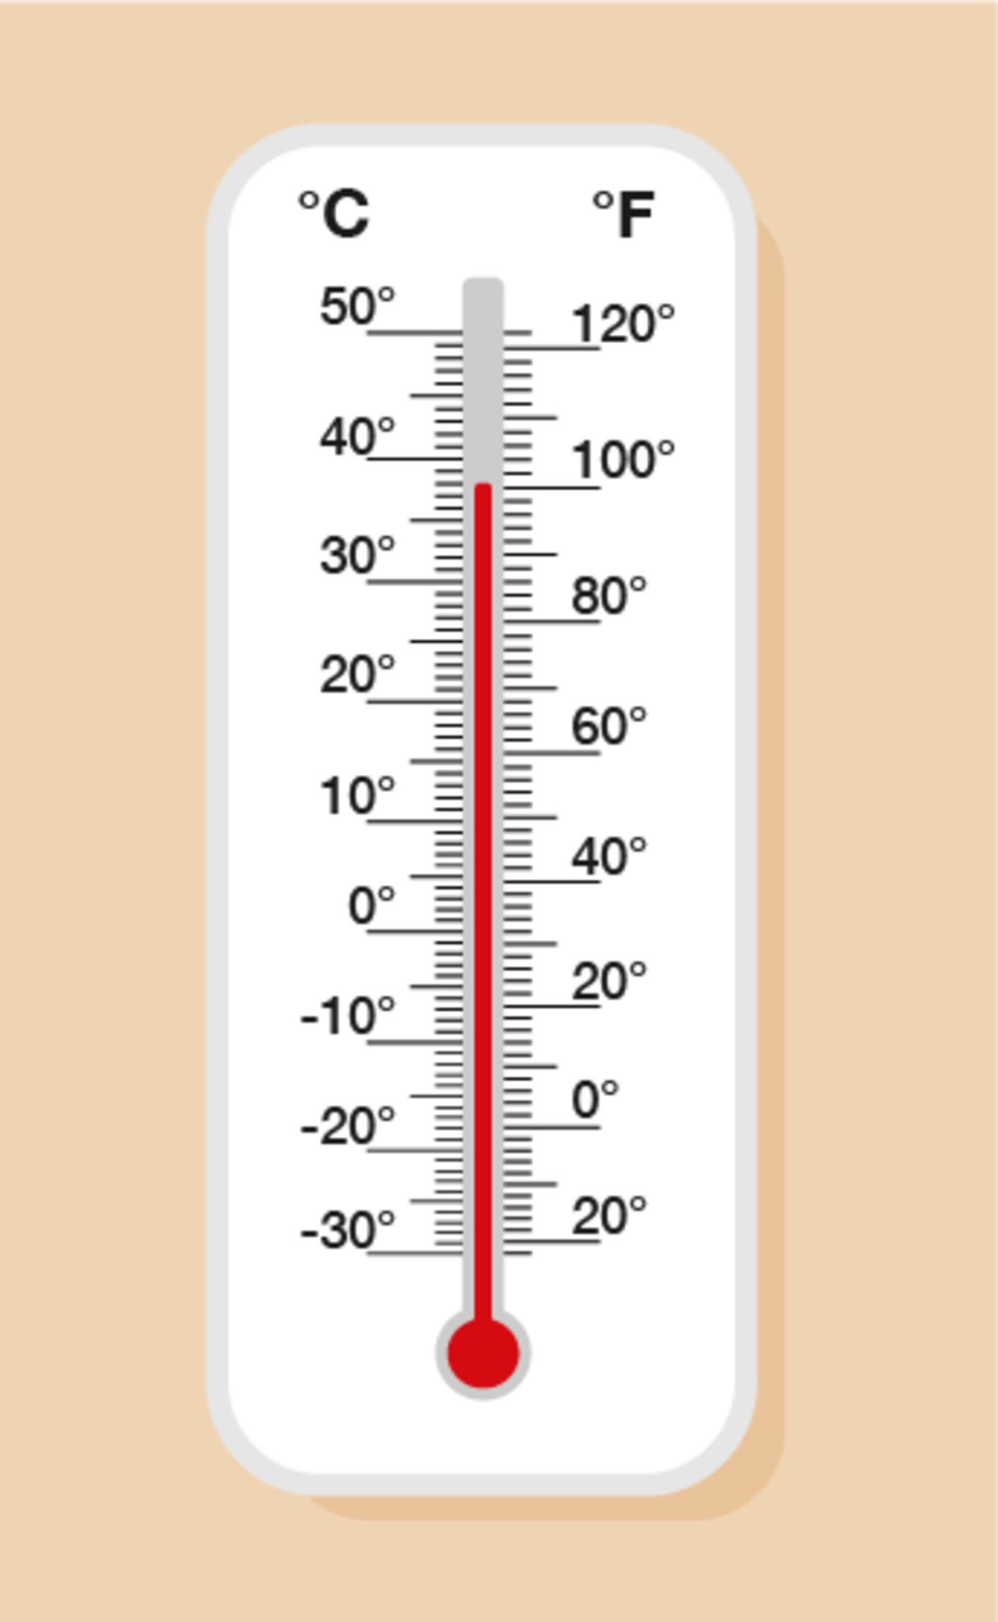
Figure 32 Example – Reading a thermometer
View description - Figure 32 Example – Reading a thermometer

The thermometer above has a scale down the left-hand side which shows degrees Celsius (°C) and a scale on the right-hand side which shows degrees Fahrenheit (°F). This means that you can take a reading on this thermometer in both units of measure, depending on which is needed or which you are more familiar with. It can also help you to look up conversions between units.
You need to be careful with each scale, though – as they are showing different units, they are marked differently and go up in different steps.
On this thermometer, the degrees Celsius scale is going up in steps of 1°C, so the temperature shown is 38°C. If you want to take the reading in degrees Fahrenheit, you can see that it is 100°F (the scale is going up in steps of 2°F). It can be difficult to get a precise comparison between units, but using this thermometer, we can say that 38°C is roughly 100°F.
Now have a go at the following activity.

Activity 12: Using conversion scales

Look at the weighing scales below and answer the questions that follow.

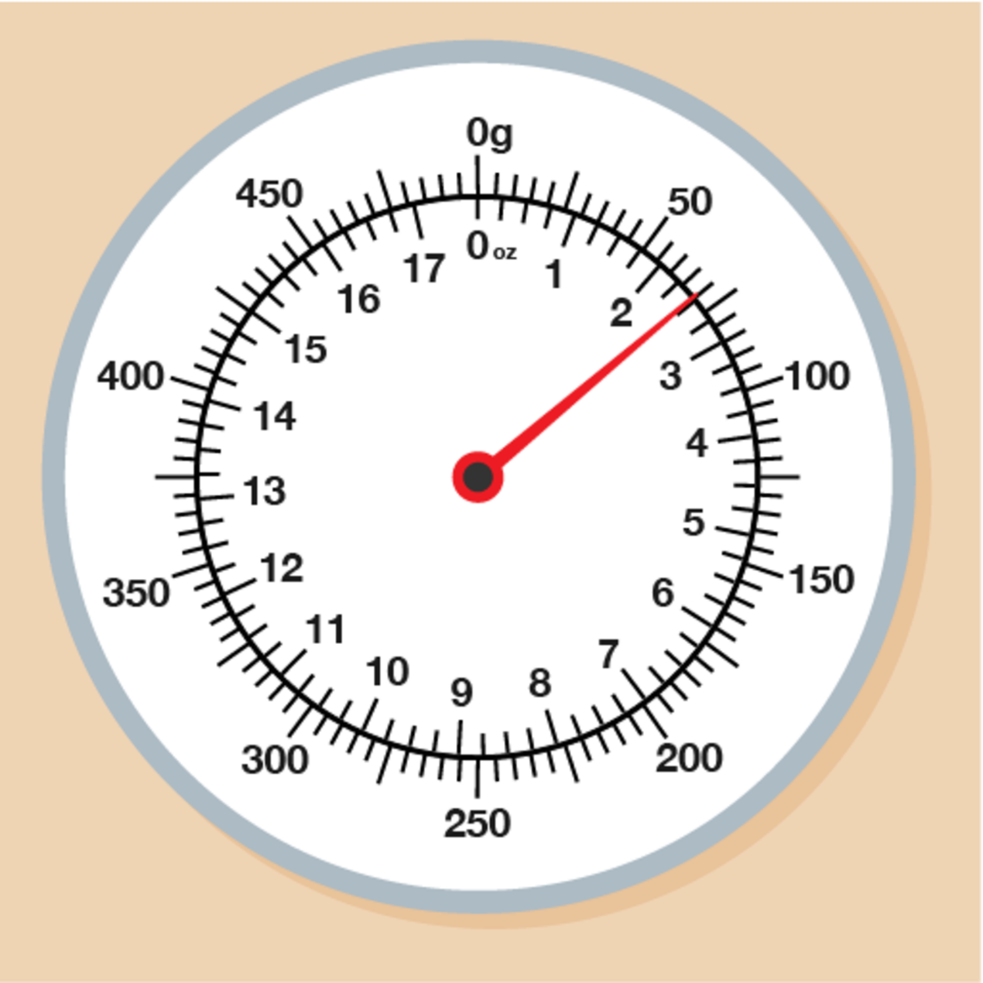
Figure 33 Weighing scales showing two units of measure
View description - Figure 33 Weighing scales showing two units of measure

- What is the reading shown by the arrow in grams?
- How many ounces (oz) is 200 g, to the nearest whole oz?
- Roughly how many grams is 1 oz, to the nearest 10 g?
- I see a recipe which states that I need 6 oz of flour. Roughly, how many grams of flour is this?

View answer - Activity 12: Using conversion scales

You have now learned all you need to know about units of measures! If you feel unsure on any part of this section, feel free to refer back to the examples or activities again to ensure you feel secure in all areas. All that remains of this section is the end of session quiz. Good luck!

Summary
In this section you have learned to read:
- measuring scales using different intervals
- scales on different measuring instruments
- conversion scales.

6 Session 2 quiz
Now it’s time to review your learning in the end-of-session quiz.
Session 2 quiz.
Open the quiz in a new window or tab (by holding ctrl [or cmd on a Mac] when you click the link), then return here when you have done it.

7 Session 2 summary
You have now completed Session 2, ‘Units of measure’. If you have identified any areas that you need to work on, please ensure you refer to this section of the course and retry the activities.
You should now be able to:
- understand that there are different units used for measuring and how to choose the appropriate unit
- convert between measurements in the same system (e.g. grams and kilograms) and those in different systems (e.g. litres and gallons)
- use exchange rates to convert currencies
- work with time and timetables
- work out the average speed of a journey using a formula
- convert temperature measurements between Celsius (°C) and Fahrenheit (°F)
- read scales on measuring equipment.
All of the skills listed above will help you with tasks in everyday life, such as measuring for new furniture or redesigning a room or garden. These are essential skills that will help you progress through your employment and education.
You are now ready to move on to Session 3, ‘Shape and space’.

Session 3: What are you aiming for?

Introduction
When you start to plan anything it’s always good to start with what you see as your end goal. In this case it is working with and supporting your family member to move into a home that is right for them.

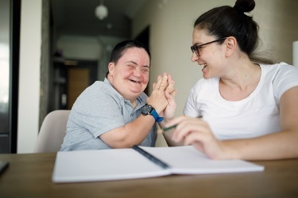
View description - Uncaptioned Figure
View alternative description - Uncaptioned Figure

In this session you will think about how to achieve this well and how forward planning can help you achieve it. As you work through this session don’t forget to continue to add to your ‘Tips’ for coping with the challenges you identified in Session 1.

1 What are you aiming for?
Do you know what ‘success’ would represent? You’ll start with hearing from a carer – Mel.

Activity 1 Mel’s story
Allow 20 minutes

Mel’s brother Sam is 50 and has learning disabilities. Mel has always been very closely involved in Sam’s care and supported her parents as they aged and were no longer able to care for Sam at home. Sam has lived in different types of housing and homes. Read what Mel says about the different places he has lived in. As you read make a note below in the box on the left-hand side what helps to make a good home for Sam. When you have done this think about what a good home would look like for the person that you care for. Jot down your ideas in box on the right-hand side below.

Mel and Sam
Sam is 5 years older than me. We have a very close relationship, we always have. I’ve always thought he’s very special. He really touches the hearts of people when they meet him. He loves watching snooker and darts. But he likes football and rugby and all sorts of things really. He likes to be in a pub with a pint of beer. He used to love gardening a lot – weeding, and just helping out.
Sam lived with Mum and Dad until my Dad died 15 years ago. Because mum couldn’t cope on her own he went to residential home. He lived there for 2 years, but he never settled and kept saying he was bored and wanted to come home.
After that Sam was placed with a family. It was a man and woman who were both working with people with learning disabilities, but they had two young children of their own. And then I don’t think I realised, but Sam had to share a bedroom with another man with learning disabilities which was probably far too crowded for him. And he ended up thumping the lady, and she literally ….was washing his clothes….she just grabbed it all, stuck it in dustbin bags, said ‘Get him out’.
And that’s how he came to go to his first Shared Lives carer, Sheila. She had a spare room and also has a daughter with learning disabilities and let Sam stay initially to see how he got on. Sam was very, very challenging at first. He was very fisty, thumping, and shouting and having outbursts and all sorts of stuff. But anyway, he stayed and they worked with him, and they made just a massive difference to his life. They gave him what he needed more than anything - security and love. And routine. They did once work with a psychologist, because he’s always had issues around the toilet, obsessive going to the toilet all the time. They lived not far away so I had him visit us once a month and my partner and I took him on holiday once a year. And then he normally stayed for about a week at Christmas as well.
And he was with Sheila for 13 years. There were ups and downs, but he had a very good life with them. Anyway when Sheila was 75 and she got some health issues and wasn’t able to do as much with Sam and said she wanted me to look for someone else to take care of him. He‘d started to become a bit quiet too…
We then heard a year ago through Shared Lives that there was a couple who live nearby who were both Shared Lives carers who said they would like to have Sam go live with them and that he can have his own room. So it came as a bit out of the blue but we agreed to try it out for a couple of months. Anyhow they’re a lovely family and we get on very well with them as well. I didn’t want to say too much about things if I’d noticed things with Sam when he lived with Sheila … and we did talk about certain things that we disagreed on slightly ….at times, I think, looking back now, sometimes I wish I’d done more. But now with the new move, I feel I don’t have to perhaps tiptoe round as much. I have talked about things with the new carers, I said right from the beginning, and they’ve listened and they’ve given their opinion. But they’ve said, ‘Yeah, we really want to work together on this’. We’ve seen a huge change in him already, in terms of him being more stimulated, and how he is, he’s a bit more lively in himself. It’s more sociable. Because there was just him and Sheila before, whereas now he’s with a couple, and they have 3 older children but who visit regularly and take him to the football. I still have him to stay once a month and we are planning our usual holiday and Christmas holidays with Sam.
I think if this placement that he’s got now continues in the same vein, then I think he will have all the support to do what he wants to. Health wise, he’s got a good doctor and… again, support from his new carers.

What makes Sam’s new home successful? | What would be the ingredients of a successful home for the person you care for?
Provide your answer... | Provide your answer...

View discussion - Activity 1 Mel’s story

2 What works when planning?
The carers in our research who had realised their goal of finding a good home for their relative gave us many insights into what worked when they were planning. These, together with some examples, are set out in the following sections.

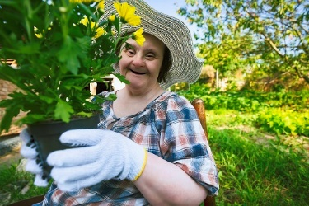
View description - Uncaptioned Figure
View alternative description - Uncaptioned Figure

2.1 Think about what matters
At the core of all discussions that took place during our research was what matters for the person with a learning disability to ensure that they have a good, happy life.

Activity 2 What matters to the person for whom you care
Allow 10 minutes

Watch Dawn and Pam talk about what they value about where they live. Make some notes if you wish.

Video content is not available in this format.
View transcript - Uncaptioned interactive content

Provide your answer...

View discussion - Part

2.2 Explore your options
Where possible, local authorities want people who require care to live in the area in which they live with their families. Gather as much information as you can about what is available locally and visit places with the person you care for before taking any decisions. Test out the different places if you can, for example, by arranging for your relative to have a ‘trial run’ at those you think might be suitable. As you do all this think also about what type of place would not work and why not. This will help when it comes to talking to any professionals about your plans. Sam had ‘Shared Lives accommodation’. This type of accommodation and some examples of other options are set out below.

Shared lives
This involves living with (use of a separate bedroom is guaranteed) a person paid to be a carer in their home. There might be other people with learning disabilities who live there too. While the carer provides the support required, day centre activities are incorporated into many Shared Lives schemes. This is increasingly promoted by local authorities, although it does not necessarily promote the autonomy and independence of the person living with learning disabilities.

Supported living
This is when the person with learning disabilities lives in a flat or house on their own or with housemates and with support workers. The support is through a ‘personalised care package’ which is based on a needs assessment. Most people in supported living rent their home via a tenancy agreement. Some people own or part-own their home. One way to do this is through a shared ownership scheme for people with disabilities called mysafe home.

Residential and nursing care
Care homes provide residential care which includes care (in some cases nursing care too) and support 24/7, food, furniture, a room, bills and activities. Some care homes are just for people with learning disabilities, while others have a mix of people.

Family home
With additional support – such as personal care and assistive technology (see hft virtual smarthouse for ideas on assistive technology to make homes safe) – the person with learning disabilities can continue to live in your home or move to another family member’s home.

2.3 Know what your local authority should do to help you
If you live in the UK, your local authority is your key point of contact so it is important to know what you can expect from this relationship. If you do not live in the UK it’s worth finding out what is the equivalent point of contact.


View description - Uncaptioned Figure
View alternative description - Uncaptioned Figure

Things to remember are:
- The person you care for is entitled to an annual assessment of all their support needs. As their carer you also have a right to separate assessment of your needs which should not assume that you are willing and able to continue to provide the level of care you are currently providing. Contact your local authority to request an assessment.
- When the assessments are carried out show the assessor(s) what things would be like on the worst day; you may have been managing tricky situations for a long time but don’t underplay things if you are struggling. Tell them if you think there is a risk of a crisis. In addition you need to make sure that the assessor considers what the needs of the person for whom you care would be if you were not there.
- When the person you care for is assessed as having a need that your local authority is responsible for, an assessment of income and savings will be carried out. This is to see how much the local authority will contribute towards the care needed.
- Your wellbeing and that of the person for whom you care should be at the heart of all local authority decision making.
- Your local authority should tell you about all options – you should not be offered just one option.
- Do not wait until you are reaching a crisis–local authorities should aim to prevent a crisis and they should be prepared to engage in future planning when you contact them.

3 Summary of Session 3
At this point in the course you will have some ideas about ways you can address issues you identified about planning for a transition to a new home in Session 1. Have another quick read of Sessions 2 and 3 and see if you can pull out any other points for your ‘Tips’notepad.
You can also find information about planning in the following resources:
- Together Matters: resources and information
- mencap: advice and support
Although there are steps you can take to ensure your planning is effective, the reality is that finding the right place can be stressful, time-consuming and feel like an obstacle course. In the next session you will have the opportunity to learn some useful skills to help you.
You can now go Session 4.

Session 4: Thinking the worst … ?

Introduction
As we all know, life and the best laid plans do not always go according to plan! In this sessionyou will have a look at the challenges you may encounter when planning for a new home for the person for whom you are caring and what you can do to address them.

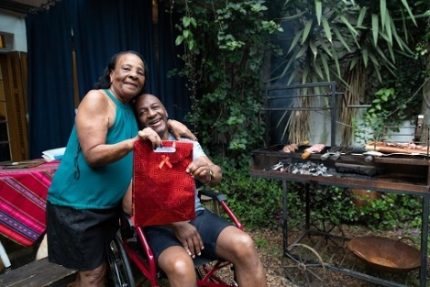
View description - Uncaptioned Figure
View alternative description - Uncaptioned Figure

Keep adding to your ‘Tips’ list for managing the challenges you identified in Session 1 as you work though this session.

1 Thinking the worst … ?
A good place to start when planning is to look at the worst-case scenario and work from there.

Activity 1 What could happen?
Allow 10 minutes

Look at the statements in the table below and think about those that you think might apply to you – add Yes or No to the right-hand column.

Statement | Yes/No
You experience difficulties in talking about the future with your family member and your family. | Provide your answer...
Despite your efforts to reassure your family member, she or he is very worried about moving. | Provide your answer...
You know your family member best but are worried that others will not have the same understanding. | Provide your answer...
You are worried that a change of accommodation will cause more behavioural issues in your family member. | Provide your answer...
You and the person you care for have different views about what might be the best option. | Provide your answer...
Planning takes up a lot of your time. | Provide your answer...
Planning takes a long time. | Provide your answer...
You have already had poor experiences of dealing with your local authority (e.g. there is a lack of support, you have been told that support is only available in emergencies, inconsistency between different social workers) and can see history repeating itself. | Provide your answer...
You need more support to be able to plan for future changes. | Provide your answer...
Even if you found something that works for now, it would be a risk if things could fall apart. | Provide your answer...
Previous move(s) broke down and another one might too. | Provide your answer...
There is change in the services available. | Provide your answer...
There don’t seem to be good options available to your family member in your local area. | Provide your answer...
The financial resources and benefits you can use are not enough both now and in the future. | Provide your answer...
Your health is deteriorating as you continue to age. | Provide your answer...

You may well have ended up with a pretty long list but do not be daunted! There are plenty of things you can do to cope with the challenges that you have identified. You can also feel reassured by the fact that there are sources of help – many of which you may well have been unaware of up until now.
Ways in which you can overcome the challenges and the help available are explored in the rest of this session.

2 Be proactive
Virtually every family we spoke to in our research felt that they had driven any planning for the future. No doubt you will be reaching the conclusion that you need to be proactive– you can’t take it for granted that professionals will take the lead in planning and supporting the person for whom you care.

Activity 2 Becky’s story continued
Allow 10 minutes

Remember Becky and her mother Sharon from Session 2? You heard Sharon talking about getting plans in place for Becky and using Becky’s annual review to initiate plans for her to move into alternative accommodation within two or three years. You will see what action she did take in the continuation of her story below. As you read, make a note of ways in which she is takes the initiative and is proactive. Think about how you could usefully take similar steps in your situation and add these to your ‘Tips’ notepad or the text box below.

What Sharon did
Becky’s previous annual review had been a very informal conversation with her social worker. In fact Sharon had not realised that it was an annual review. Although Sharon understood that this was probably the result of the pressure on social services, after having taken part in our research she contacted social services to request a date from Becky’s social worker specifically for the next annual review. This took several telephone calls before Sharon managed to arrange this. Before the review she arranged a meeting with Becky’s current care provider to discuss their independent supported living options.
During the annual review Sharon emphasised that over the next two or three years she and her husband want to look at suitable places for Becky to live. Becky always seeks assurance about when she is coming home from her weekends of respite care and her behaviour becomes more challenging to others when she faces changes. They feel this long run-in time is necessary to ensure that she settles into her new ‘home’ without the risk of a crisis arising and an emergency placement having to made. She talked about the steps they had taken to explore options for Becky and that they were keen on the independent supported living available through her current day services provider.
Sharon and Rob were concerned with changes they had noticed in Becky since she started going through the menopause – the episodes in which Becky became stressed or upset appeared to be getting more frequent. Although Becky has had annual health checks with her GP, nothing was mentioned about age-related changes, such as the menopause. Sharon used the next annual health check to discuss this and obtained treatment for Becky. It was agreed that this would be regularly reviewed by a practice nurse.

Provide your answer...

View discussion - Part

You can also be proactive around finances. For example, make sure your relative has their own bank account so that their benefits and other payments can be paid into an account which is separate from the family bank account and can be accessed separately. It is worth thinking about getting independent financial advice too. You may want to use an independent financial advisor, and free advice is available from Citizen’s Advice Bureau and Welfare Rights. There are other courses of action you can take too; a good example is when someone indicates they want to leave your family member some money in their will. Encourage them to look into a discretionary trust so that any money inherited does not impact the funding of your adult child’s or sibling’s care. Search for ‘wills and trusts’ on www.mencap.org.uk.
Central to being proactive is doing a fair amount of making sure your opinion and that of the person you care for is properly heard! This is known as advocating – the next topic.

3 Advocate, advocate!
Advocating can take place on different levels in that it can involve you being assertive in conversations and encounters as well as contacting people and organisations to advocate on your behalf.

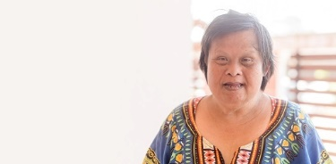
View description - Uncaptioned Figure
View alternative description - Uncaptioned Figure

Before you look at some examples of both it is worth bearing in mind the following. You can’t assume professionals will make the right decisions! Remember that you are an expert in the support of the your relative. You spend longest with the person and have insights and information that professionals will not have. You know their history and achievements, their likes and dislikes, what they enjoy doing, what help they need and what works best for them. You support and care for them when they have a bad day (or night). These insights are important information for social care professionals.

3.1 Being assertive
Family carers of people with learning disabilities have often advocated for their family member from an early age, across childhood and into adulthood. You may feel that being assertive is harder as you get older. Take a few minutes to think about some of the ways in which you can assert yourself.

Activity 3 Making yourself assertive
Allow 10 minutes

Here is Gail, our family carer panel member and advocate for other families, talking about what helps her to be assertive when advocating for her son. Make some notes if you wish.

Video content is not available in this format.
View transcript - Uncaptioned interactive content

Provide your answer...

View discussion - Part

Taking such steps are in turn empowering. Carers UK have produced a very useful guide:Being Heard: a self-advocacy guide for carers. This includes advice on how to communicate well, negotiating, getting better at being assertive and making a complaint. Carers Trust also have a page on their website about advocacy and getting help with complaints.
Here are a few examples of your rights and when you are entitled to be assertive that may also help:
- You are entitled to speak to a social worker and request help with your future planning. Persistence often pays off!
- When you or the person for whom you care has an assessment, make sure the assessor listens – they should listen to the person they are assessing to know what they want and need.
- You can object if you do not feel what your family member has been offered is suitable. You need to have clear reasons why it is not good enough. Be specific. e.g. living in a city is unsuitable as your relative grew up in the countryside and is not used to city life. Find other services that are better and explain why.

3.2 People and organisations who can advocate for you
If advocating for yourself does not seem to be working you can get support. For expert advice see youknow.org.uk or Hft (search for ‘Care act guide’).
These websites have advice about:
- your rights
- being clear about what the problem is and what needs to change
- keeping good records
- ways of resolving disagreements directly with your local authority
- making a formal complaint, for exampleto your local authority’s monitoring officer, the Local Government and Social Care Ombudsman and your MP.Mencap also has advice about this, including a template for letters of complaint (search for ‘challenge decision’ on their website)
- seeking legal aid.
There are certain circumstances where you have a right to have an advocate to speak up for you – it’s worth contacting advocacy organisations in your local area. You can also ask your local authority for details of advocacy services you can access. In addition, carers organisations and centres offer advocacy guides and services.

Activity 4 How can an advocate help me?
Allow 10 minutes

Many people are not sure what advocates actually do. Listen to what Gail has to say about the role of advocates and how they can help you when you are in the process of planning future care for your relative. Make some notes if you wish.

Video content is not available in this format.
View transcript - Uncaptioned interactive content

Provide your answer...

View discussion - Part

4 Summary of Session 4
Hopefully you will have managed to extend your list of ‘Tips’.It might now include what you feel would work for you in terms of opportunities to be proactive, assert your views, and the advice and help that is available when you need to advocate for yourself and for the person for whom you care.
It is understandable that you may well be feeling a little overwhelmed at this point! The next session will focus on you and taking care of yourself.
You can now go to Session 5.

Session 5: Looking after yourself

Introduction
We know that when carers aren’t well supported, their health and wellbeing can suffer (Milne and Larkin, 2023). The additional physical and emotional strain and stress of caring when older, planning for the future care of your relative and advocating can potentially take a toll on your health too. It is therefore important to look after yourself and to know where you can get support to do so.

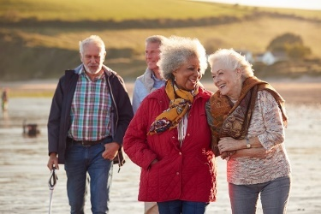
View description - Uncaptioned Figure
View alternative description - Uncaptioned Figure

Keep adding to your list of ‘Tips’ even if looking after yourself was not on your original list of concerns.

1 Hearing from those who know
While generic advice about health and wellbeing is useful, hearing what someone else in a similar situation to you finds works for them can be invaluable.

Activity 1 Advice about looking after yourself
Allow 10 minutes

In this video Gail draws on her own experiences of caring and of working with many family carers of older people with learning disabilities to reflect on what might help carers to look after themselves. Make some notes if you wish.

Video content is not available in this format.
View transcript - Uncaptioned interactive content

Provide your answer...

View discussion - Part

It is important to know resources about self-care that are available to you. Some examples are set out below:
- Nutrition
- Social stimulation
- Cognitive stimulation
- Physical activity for carers
- Physical activity for health and wellbeing in the caring role
- Midlife MOT: wealth, work and wellbeing (especially the wellbeing audit section)

2 Summary of Session 5
Even if you do not feel that all of what Gail has to say about looking after yourself is relevant to you at the moment, it is worth adding points they make to your ‘Tips’ for future reference. It’s also worth making a note of the resources and keeping an eye out for new resources that become available.
You can now go to Session 6.

2 Summary of Session 5
Even if you do not feel that all of what Gail has to say about looking after yourself is relevant to you at the moment, it is worth adding points they make to your ‘Tips’ for future reference. It’s also worth making a note of the resources and keeping an eye out for new resources that become available.
You can now go to Error! Hyperlink reference not valid..

Session 6: Pulling it all together

Introduction
Your list of ‘Tips’ should have grown since the beginning of the course. It should now provide you with plenty of ideas about ways of addressing the issues you and your family may be facing as your family member grows older that you identified at the beginning of the course.

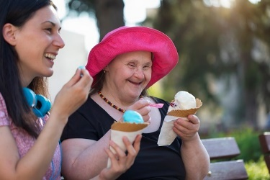
View description - Uncaptioned Figure
View alternative description - Uncaptioned Figure

In this last session you will reflect on changes you can also make to help you manage.

1 The best care possible
We know that you only want the best care for your family member. Spend a few minutes thinking about this using the next activity.

Activity 1 What are the components of excellent care?
Allow 10 minutes

Our research project showed that there were three key elements to providing excellent care to older people with learning disabilities and behaviours that challenge others. Watch this short animation about the Quilt of Excellence. As you watch, think about the following questions:
- What do you and the family member for whom you care see as being the best care?
- What changes will you need to make in your life that will help you cope?
- What changes will you need to make to the life of your family member to help you all cope with planning ahead?

Video content is not available in this format.
View transcript - Uncaptioned interactive content

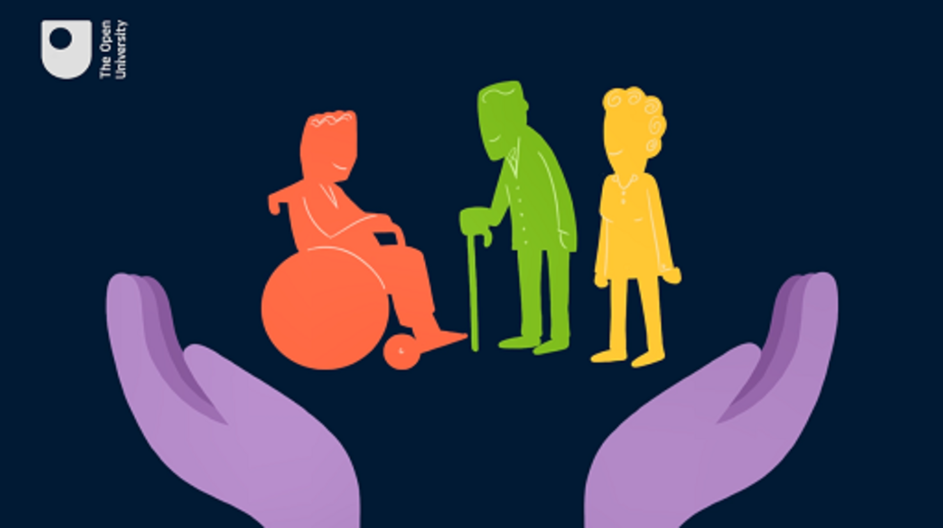

Provide your answer...

View discussion - Part

2 Summary of Session 6
Having reflected on key elements to providing excellent care to older people with learning disabilities and behaviours that challenge others, you may now find it useful to add a ‘Changes’ subheading to your list of ‘Tips’ and revisit your list to pull out any other changes they might suggest to you.
When you have done this, you will have completed your ‘Tips’ notepad and you can add to it as you come across more useful ideas after you have finished this course.

3 Summary of the course
You have covered a lot of ground in this course! The topics relevant to the future care of your family member you have explored have ranged from the planning required as your family member grows older to the core principles and skills of advocating effectively for yourself and your family member with learning disabilities as they grow older and the importance of looking after yourself. You have also had the chance to hear from those who took part in the research underpinning this course, members of our panel of experts and have been provided with different sources of information.
Whether you are a parent caring for a son or daughter who has a learning disability, or you care for a sibling with a learning disability, hopefully you now feel better equipped in terms of the understanding, knowledge information, skills, resources, contacts, sources of help you need to cope and navigate the system as they grow older.
We wish you every success.
Useful resources
The following is a list of the resources which have been used throughout this course:
- Error! Hyperlink reference not valid.
- Planning Ahead cards
  - How to use the cards
- Exploring learning disabilities: supporting belonging
- mysafe home
- hft virtual smarthouse
- Together Matters: resources and information
- mencap: advice and support
- Welfare Rights
- Being Heard: a self-advocacy guide for carers
- youknow.org
- hft
- Local Government and Social Care Ombudsman
For self-care advice:
- Nutrition
- Social stimulation
- Cognitive stimulation
- Physical activity for carers
- Physical activity for health and wellbeing in the caring role
- Midlife MOT: wealth, work and wellbeing (especially the wellbeing audit section)
Organisations such as Carers UK and Carers Trustare other sources of ideas and information.

Where next?
If you’ve enjoyed this course you can find more free resources and courses on OpenLearn.
Interested in taking your learning further? You might find it helpful to explore the Open University’s Health and Social Care courses and qualifications.

References
Larkin, M., Jordan, J., Tilley, E., Vseteckova, J., Ryan, S., Wallace, L. (2023) ‘Transitions-related support for ageing family carers of older people with intellectual disabilities and behaviours that challenge others: a systematic scoping review’. Health and Social Care in the Community (forthcoming)
Tilley, E., Jordan, J., Larkin, M., Vseteckova, J., Ryan, S., Wallace, L. (2022) ‘Transitions for older people with intellectual disabilities and behaviours that challenge others: a rapid scoping review’. Journal of Applied Research in Intellectual Disabilities (JARID)
Milne, A. and Larkin, M. (2023) Family Carers and Caring: What it’s all About, London: Emerald Publishing.

Acknowledgements
This free course was written by Mary Larkin.
Except for third party materials and otherwise stated (see terms and conditions), this content is made available under a Creative Commons Attribution-NonCommercial-ShareAlike 4.0 Licence.
The material acknowledged below is Proprietary and used under licence (not subject to Creative Commons Licence). Grateful acknowledgement is made to the following sources for permission to reproduce material in this free course:

Images
Course image: M.Dörr & M.Frommherz/https://stock.adobe.com/
Introduction images: In The Light Photography/Shutterstock.com; courtesy of Pam Bebbington and Dawn Wiltshire; courtesy of Gail Hanrahan.
Images used are for illustrative purposes only and in no way represent the individuals referred to in the case studies.
Every effort has been made to contact copyright owners. If any have been inadvertently overlooked, the publishers will be pleased to make the necessary arrangements at the first opportunity.
Don't miss out
If reading this text has inspired you to learn more, you may be interested in joining the millions of people who discover our free learning resources and qualifications by visiting The Open University – www.open.edu/openlearn/free-courses.

Solutions

Activity 1 Your thoughts

Part

Discussion
The issues you listed might include struggling with physical or mental health; worrying about your ability to cope; the challenges of dealing with behavioural changes in the person you care for; feeling anxious about what will happen if there is a change in your own circumstances (e.g. if you become ill or when you die); being worried about starting discussions about future care with the person you care for because it might be too difficult to understand and/or might upset them; or struggling with planning for a move to living somewhere else.
Back to - Part

Activity 1 Your thoughts

Part

Discussion
The issues you listed might include struggling with physical or mental health; worrying about your ability to cope; the challenges of dealing with behavioural changes in the person you care for; feeling anxious about what will happen if there is a change in your own circumstances (e.g. if you become ill or when you die); being worried about starting discussions about future care with the person you care for because it might be too difficult to understand and/or might upset them; or struggling with planning for a move to living somewhere else.
Back to - Part

Activity 6: Rounding large numbers

Answer

Table 2(b)
Country | Population | Population rounded | Shortened form
UK | 66 959 016 | 67 000 000 | 67 million
China | 1 420 062 022 | 1 420 000 000 | 1.42 billion

Back to - Activity 6: Rounding large numbers

Activity 7: Calculations with large numbers

Answer
- Profit in 1st quarter 1.2 + 0.9 + 0.85 = £2.95 million
- Profit in last quarter 1.08 + 1.8 + 1.65 = £4.53 million
- The difference is 4.53 − 2.95 = £1.58 million
  - November had the largest turnover at £1.8 million.
  - March had the smallest at £0.85 million.
  - The difference is 1.8 − 0.85 = £0.95 million.
Back to - Activity 7: Calculations with large numbers

Activity 8: Rounding skills

Answer
- 24.6
- 13.48
- 203.58
- 345.679
- 4
- £199.76
- £38
- 62 kg
Back to - Activity 8: Rounding skills

Activity 9: Approximation

Answer
- The actual answer is £313 500 (190 × 1650)
Estimate 200 × 1700.
2 × 17 = 34 so 200 × 1700 = 340 000 so the answer is sensible.
- The actual answer is 12 228 (33 316 − 21 088)
Estimate 33 000 − 21 000 = 12 000 so the answer is sensible.
Back to - Activity 9: Approximation

Activity 10: Multistage calculations

Answer
- First calculate the cost with the current provider
monthly cost × 12
£24.50 × 12 = £294 (current provider)
Second, calculate the cost of the new provider.
To do this you need to calculate the total monthly costs:
  - £19.80 × 12 = £237.60
and then add on the one off connection fee of £30:
  - £237.60 + £30 = £267.60 (new provider)
Finally you can calculate the difference between the two providers:
  - £294 − £267.60 = £26.40 saved
- To do your calculation, you need to work out the cost for 7 nights. Once you have done this, you can divide the total by 12:
  - 460 × 7 = £3220
£3220 ÷ 12 = £268.33 (rounded to two d.p.)
Here we would probably round this amount up to £268.34 per person to make sure the full cost is covered.
Back to - Activity 10: Multistage calculations

Activity 11: Negative and positive temperature

Part

Answer
  - Delhi was the warmest city as it has the highest positive temperature.
  - Oslo was the coldest city as it has the largest negative temperature.
  - The difference between the temperatures in these cities is 31˚C.
From 19˚C down to 0˚C is 19˚C and then you need to go down a further 12˚C to get to −12˚C.
Back to - Part

Part

Answer
  - The minus sign (−) indicates that the customer is overdrawn, i.e. owes money to the bank.
The amount shows how much they owe. So Sonia Cedar was overdrawn on 11 October by £20 and by £50 on 21 October.
  - £120 was withdrawn on 11 October.
The customer had £100 in the account and must have withdrawn another £20 (i.e. £100 + £20 = £120 in total) in order to be £20 overdrawn.
  - The customer owed £20 and is now £70 in credit, so £90 must have been added to the account.
Back to - Part

Part

Answer
  - February had the largest profit with £182 000 (remember to look at the column heading which shows that the figures are in 000s – thousands).
  - March showed the greatest loss at £80 000.
  - To calculate the overall balance you need to first calculate the total profits and the total losses. To calculate the profits you need to do this calculation:
  - 166 + 182 + 124 + 98 = 570
So the profit was £570 000.
Next you need to calculate the total losses; two months showed a loss so you need to add these values:
  - 80 + 46 = 126 so the losses over the six months were £126 000.
Now you can calculate the overall balance by subtracting the losses from the profits:
  - £570 000 − £126 000 = £444 000
This is a positive value so it means the company made an overall profit of £444 000.
Back to - Part

Activity 12: Finding the lowest common multiple

Answer
- The lowest common multiple of 6 and 12 is 12:
Multiples of 12:
12, 24, 36, 48, 60 etc.
Multiples of 6:
6, 12, 18, 24, 30 etc.
You can see from the list that 24 is also a common multiple of 6 and 12, but 12 is the lowest common multiple.
- The lowest common multiple of 2 and 7 is 14:
Multiples of 7:
7, 14, 21, 28, 35, 42 etc.
Multiples of 2:
2, 4, 6, 8, 10, 12, 14 etc.
Back to - Activity 12: Finding the lowest common multiple

Activity 13: Finding factors

Answer
- The factors of 54 are 1, 2, 3, 6, 9, 18, 27 and 54
- The factors of 165 are 1, 3, 5, 11, 15, 33, 55 and 165
Back to - Activity 13: Finding factors

Activity 14: Simplifying fractions

Answer
- =

- =

- =

- =

- can’t be simplified

- =
Back to - Activity 14: Simplifying fractions

Activity 15: Expressing one number as a fraction of another

Part

Answer
- 100 g = 1000 g, so:
  - 100 g 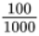 = of a kilogram

  - 750 g 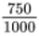 = of a kilogram

  - 640 g 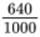 = of a kilogram

  - 20 g = 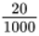 = of a kilogram
Back to - Part

Part

Answer
- 1 hour = 60 minutes so:
  - 15 minutes = = of an hour.

  - 20 minutes = = of an hour.

  - 35 minutes = = of an hour.

  - 48 minutes = = of an hour.
Back to - Part

Part

Answer
- 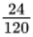 are left. This cancels down to , so of the eggs are left.
Back to - Part

Part

Answer
- Work out the total number of students by adding the number who passed to those who failed 18 + 12 = 30. Now work out the fraction that passed:
  - (18 out of 30 students passed)
Now cancel down:
  - = .
So passed the test.
Back to - Part

Part

Answer
- 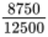 =
Back to - Part

Part

Answer
- As this question wants the number of people who did not win a prize we must first do:
30 − 6 = 24 people did not win a prize.
As a fraction this becomes which simplifies to .
Back to - Part

Activity 16: Finding fractions of amounts

Part

Answer
- Company C is cheapest:
  - of £104 = £104 ÷ 4 = £26 discount
  - £104 − £26 = £78
Company A is second cheapest:
  - of £120 = £120 ÷ 3 = £40 discount
£120 − £40 = £80
Company B is most expensive:
  - of £147 = £147 ÷ 7 × 2 = £42 discount
  - £147 − £42 = £105
Back to - Part

Part

Answer
- 1600 tickets sold to adults:
  - 2400 ÷ 3 = 800 to give
  - 2 × 800 = 1600 to give
Back to - Part

Part

Answer
- £16 000 needed to meet target.
40 000 ÷ 5 = 8000 to give
8000 × 3 = 24 000 to give (the amount raised)
But the question asks how much is needed to meet its target so we need to subtract the amount raised from the target:
  - 40 000 − 24 000 = £16 000
Back to - Part

Activity 17: Finding percentages of amounts

Answer
  - £56.25
  - 68.25 m
  - £352.04
  - £3.92
  - 100 kg
  - £5.945 (£5.95 to 2 d.p.)
  - £35.625 (£35.63 to two d.p.)
- £105
- £103.65
- £13.065 (£13.07 to two d.p.)
Back to - Activity 17: Finding percentages of amounts

Activity 18: Percentages increase and decrease

Part

Answer
  - £25
  - £525 per month.
Back to - Part

Part

Answer
  - The car has decreased by £1900.
  - The car is now worth £7600.
Back to - Part

Part

Answer
  - £32 interest earned.
  - £832 in the account at the end of the year.
Back to - Part

Part

Answer
- She will pay £42.72 less so her insurance will cost £313.28
Back to - Part

Part

Answer
- She will save £8.10 so she will pay £126.90.
Back to - Part

Part

Answer
- 5.87 million = 5 870 000.
4% of 5 870 000 = 234 800
5 870 000 + 234 800 = 6 104 800 people
Back to - Part

Activity 19: Expressing one number as a percentage of another

Part

Answer
  - 1 kg = 1000 g
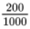 × 100 = 20%
  - 1 hour = 60 minutes
× 100 = 80%
  - £1 = 100 p
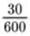 × 100 = 5%
Back to - Part

Part

Answer
- 50 × 25 = 1250 m
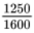 × 100 = 78.13% (to two d.p.)
Back to - Part

Part

Answer
Maths: × 100 = 80%

English: × 100 = 70%

Science: 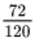 × 100 = 60%

Art: × 100 = 80%
Back to - Part

Part

Answer
- Number not white = 13 + 9 = 22
Total number she is planting = 13 + 18 + 9 = 40
× 100 = 55%
55% of the flowers will not be white.
Back to - Part

Part

Answer
- 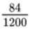 × 100 = 7%
The interest rate is 7%.
Back to - Part

Activity 20: Percentage change formula

Part

Answer
- Difference: £1450 − £1300 = £150
  - Original: £1300
  - Percentage change = 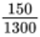 × 100
  - Percentage change = 0.11538... × 100 = 11.54% increase (rounded to two d.p.)
Back to - Part

Part

Answer
- Difference: £180 000 − £155 000 = £25 000
  - Original: £155 000
  - Percentage change = 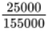 × 100
  - Percentage change = 0.16129... × 100 = 16.13% increase (rounded to two d.p.)
Back to - Part

Part

Answer
- Difference: £4200 − £3600 = £600
  - Original: £4200
  - Percentage change = 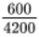 × 100
  - Percentage change = 0.14285... × 100 = 14.29% decrease (rounded to two d.p.)
Back to - Part

Part

Answer
- Difference: £24 650 − £20 000 = £4650
Original: £24 650
Percentage change = 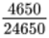 × 100
4650 ÷ 24 650 × 100 = 18.86% loss (rounded to two d.p.)
Back to - Part

Activity 21: Converting between percentages, decimals and fractions

Answer
  - 0.62
  - 0.5
  - 0.05
  - 2%
  - 20%
  - 75.2%
  - 5.5%
  - =

  - 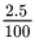 × top and bottom by 10 = 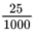 =

  - 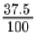 × top and bottom by 10 = 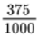 =

You may have multiplied by different numbers to get rid of the decimal in the last two questions. However, your final answers should still be the same as ours.
Back to - Activity 21: Converting between percentages, decimals and fractions

Activity 22: Matching fractions, decimals and percentages

Part

Answer
The correct matches are:
35% = 0.35 =
40% = 0.4 =
8% = 0.08 =
62.5% = 0.625 =
Back to - Part

Activity 22: Changing a fraction to a percentage

Answer
  - 37.5%
  - 90%
  - 80%
Back to - Activity 22: Changing a fraction to a percentage

Activity 23: Changing a fraction to a decimal

Answer
- 0.4
- 0.125
- 0.3
Back to - Activity 23: Changing a fraction to a decimal

Activity 24: Simplifying ratios

Answer
- Women to men is 3:4 (divide both sides by 5).
- Management to staff is 1:25 (divide both sides by 10).
- Home to away supporters is 3:1 (divide both sides by 8000 or by 1000 and then by 8).
- A to B to C is 4:2:3 (divide each part of the ratio by 400 or by 100 and then by 4).
- Currants to raisins to sultanas to mixed peel is 3:2:4:1 (divide by 50 or by 10 and then 5).
Back to - Activity 24: Simplifying ratios

Activity 25: Ratio problems where the total is known

Part

Answer
- Add the parts of the ratio:
  - 4 + 1 = 5
Divide the total amount required by the sum of the parts of the ratio:
  - 1500 g ÷ 5 = 300 g
Since soft sand is 4 parts, we do 300 g × 4 = 1200 g of soft sand.
Check by working out how much cement you need. Cement is 1 part so you would need 300 g:
  - 1200 g + 300 g = 1500 g which is the correct total.
Back to - Part

Part

Answer
- Add the parts of the ratio:
  - 4 + 2 = 6
Divide the total amount required by the sum of the parts of the ratio:
  - 2700 ml ÷ 6 = 450 ml
Since grapefruit juice is 2 parts, we do 450 ml × 2 = 900 ml of grapefruit juice.
Check by working out how much cranberry juice you would use:
  - 4 × 450 = 1800
1800 ml + 900 ml = 2700 ml
You may have simplified the ratio to 2:1 before doing the calculation, but you will see that your answers are the same as ours.
Back to - Part

Part

Answer
- Start by expressing and then simplifying the ratio:
  - 150:100:250 which simplifies to 3:2:5 = 10 parts
  - 5 litres = 5000 ml (converting to ml makes your calculation easier.)
Divide the total amount required by the sum of the parts of the ratio:
  - 5000 ÷ 10 = 500 so 1 part = 500 ml
  - Light grey is 2 parts:
2 × 500 = 1000 ml or 1 litre
Check:
  - azure is 3 parts: 3 × 500 = 1500 ml or 1.5 litres
  - white is 5 parts: 5 × 500 = 2500 ml or 2.5 litres
  - 1000 + 1500 + 2500 = 5000 ml or 5 litres
Back to - Part

Part

Answer
- Add the parts of the ratio:
  - 2 + 5 = 7
Divide the total amount required by the sum of the parts of the ratio:
  - 14 litres ÷ 7 = 2 litres so 1 part = 2 litres
(Note: this calculation was straightforward so there was no need to convert to ml.)
Since the concentrate is 2 parts you will need 2 litres × 2 = 4 litres of concentrate.
Check:
  - Water is 5 parts:
  - 5 × 2 litres = 10 litres
  - 4 + 10 = 14 litres.
Back to - Part

Part

Answer
- Add the parts of the ratio:
  - 3 + 2 + 1 = 6
Divide the total amount required by the sum of the parts of the ratio:
  - £8400 ÷ 6 = 1400
  - – The Dogs Trust receives 3 parts: 3 × £1400 = £4200
  - – The RNLI receives 2 parts: 2 × £1400 = £2800
  - – MacMillan Research receives 1 part so: £1400
  - Check:
4200 + 2800 + 1400 = £8400
Back to - Part

Activity 26: Ratio problems with one part given

Part

Answer
- Flour:Butter

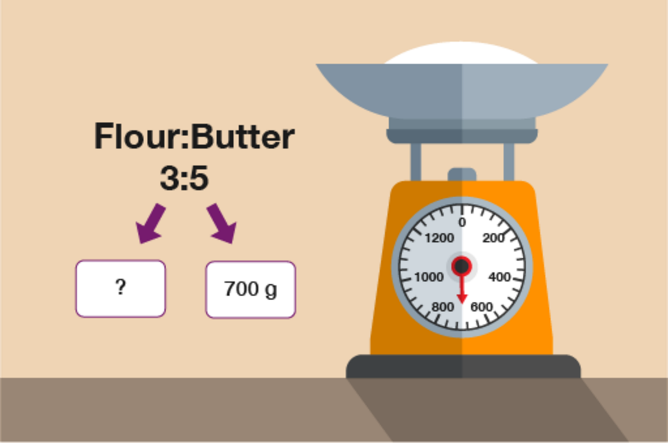
Figure 16 Using ratios in recipes
View description - Figure 16 Using ratios in recipes

To find one part you do 700 g ÷ 5 = 140 g
To find the amount of flour needed you then do 140 g × 3 = 420 g flour.
Back to - Part

Part

Answer
- Adults:Children

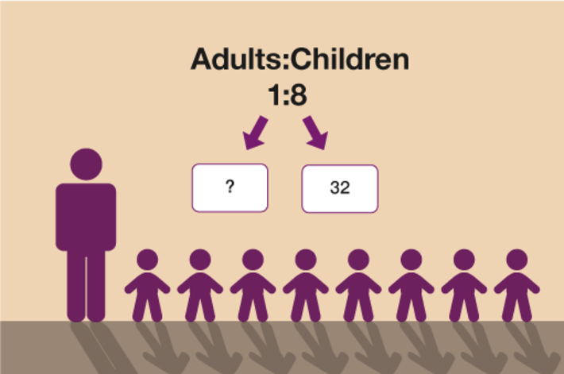
Figure 17 Working out the ratio of adults to children
View description - Figure 17 Working out the ratio of adults to children

To find one part you do 32 ÷ 8 = 4.
Since adults are only 1 part, you need 4 adults.
  - If there were 33 children, one part would be 33 ÷ 8 = 4.125.
Since you cannot have 4.125 adults, you need to round up to 5 adults so you would need one more adult for 33 children.
Back to - Part

Part

Answer
- Oats:Sultanas:Nuts

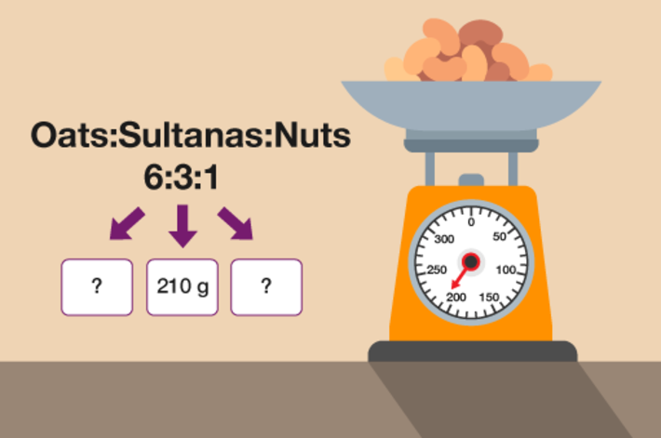
Figure 18 Working out the ratio of oats, sultanas and nuts

Sultanas are 3 parts so to find 1 part you do 210 g ÷ 3 = 70 g.
Oats are 6 parts so 6 × 70 = 420 g.
Nuts are only 1 part so they are 70 g.
The total weight of the bag would be 210 g + 420 g + 70 g = 700 g.
Back to - Part

Activity 27: Ratio problems where difference given

Answer
- The difference in parts between males and females is 9 − 2 = 7 parts.
You know that these 7 parts = 42 people.
To find 1 part you do:
  - 42 ÷ 7 = 6
Now you know that 1 part is worth 6 people, you can find the number of females by doing
  - 6 × 2 = 12 females
Check:
  - The number of males is 6 × 9 = 54.
The difference between 54 and 12 is 42.
- The difference in parts between grey and white is 5 − 3 = 2 parts.
These 2 parts are worth 30. To find 1 part you do:
  - 30 ÷ 2 = 15
To find grey slabs do:
  - 15 × 3 = 45
To find white slabs do:
  - 15 × 5 = 75
Check:
  - The difference between the number of grey and white slabs is 30 (75 − 45).
Now you know both grey and white totals, you can find the total number of slabs by doing:
  - 45 + 75 = 120 slabs in total.
Back to - Activity 27: Ratio problems where difference given

Activity 28: Ratio and recipes

Part

Answer
- Since 9 is half of 18, you need to halve each ingredient to find the amount required to make 9 biscuits.
  - 220g ÷ 2 = 110 g flour
  - 150g ÷ 2 = 75 g butter
  - 100g ÷ 2 = 50 g sugar
  - 2 ÷ 2 = 1 egg
Back to - Part

Part

Answer
- You know the ingredients for 3 but want to know the ingredients for 9. Since 9 is three times as big as 3, you need to multiply each ingredient by 3.
  - 630 ml × 3 = 1890 ml milk
  - 3 × 3 = 9 scoops of ice cream
  - 240 g × 3 = 720 g of strawberries
Back to - Part

Part

Answer
- You could work this out in 2 different ways.
Method 1
You know the ingredients for 2 people. You can find ingredients for 4 people by doubling the ingredients for 2. You then need ingredients for an extra 1 person. Since 1 is half of 2, you can halve the ingredients for 2 people.
  - 60 g + 60 g + 30 g = 150 g powder
  - 300 ml + 300 ml + 150 ml = 750 ml milk
Method 2
You know the ingredients for 2 people so you can find the ingredients for 1 person by halving them. You can then multiply the ingredients for 1 person by 5.
  - 60g ÷ 2 = 30 × 5 = 150 g powder
  - 300ml ÷ 2 = 150 × 5 = 750 ml milk
Back to - Part

Activity 29: Practical applications of ratio

Part

Answer
  - 2 litres cost 64 p, so 1 litre costs 64 p ÷ 2 = 32p.
3 litres cost 99p, so 1 litre costs 99p ÷ 3 = 33p.
Comparing the cost of 1 litre in each case, we see that the 2-litre bottle is the best buy.
Back to - Part

Part

Answer
  - 1 pint costs 26p.
4-pint carton costs 92p, so 1 pint costs 92p ÷ 4 = 23p.
Comparing the cost of 1 pint of milk in each case, we see that the 4-pint carton is the best buy.
Back to - Part

Part

Answer
  - 5 kg costs £10, so 1 kg costs £10 ÷ 5 = £2.
2 kg cost £3, so 1 kg costs £3 ÷ 2 = £1.50.
Comparing the cost of 1 kg of powder in each case, we see that the 2 kg box is the best buy.
Back to - Part

Part

Answer
  - Shop A: 1 litre costs 52p
Shop B: 2 litres cost 72p + 36p = 108p (here we pay 72p for the first litre and 36p for second litre), so 1 litre costs 108p ÷ 2 = 54p.
Comparing the cost of 1 litre of apple juice in each case, we see that Shop A offers the better deal.
Back to - Part

Part

Answer
  - Shop A: 1 litre costs 39p
Shop B: 2 litres cost 76p (we get 1 litre free), so 1 litre costs: 76p ÷ 2 = 38p.
Comparing the cost of 1 litre of orange juice in each case, we see that Shop B offers the better deal.
Back to - Part

Part

Answer
- Calculate the cost of 1 roll in each pack:
  - 80p ÷ 4 = 20p
£2.16 ÷ 12 = £0.18 or 18p
£3.42 ÷ 18 = £0.19 or 19p
- The pack of 12 is best value.
Back to - Part

Activity 30: Using BIDMAS

Answer
- 4 + 6 = 10
- 5 × 3 = 15
- 36 ÷ 9 = 4
- 7 + 5 − 4 = 8
Back to - Activity 30: Using BIDMAS

Activity 31: Using formulas

Part

Answer
  - L = 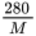and in this case M = 40

  - L = 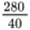

  - L = 7 litres per 100 kilometres
Back to - Part

Part

Answer
- I =
In this case P = £5000, R = 5.5% and T = 3 years.

I = 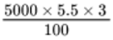

I = 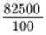

I = 825
So the interest paid would be £825.
Back to - Part

Part

Answer
- A =

  - A = 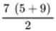

A = 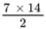

A =

A = 49 cm²

  - In this question you must convert the units so that they are all the same. The units that you select will be the units that your answer will be given in, e.g. if you convert to mm your answer will be in mm² but if you convert to cm your answer will be in cm².

A =

Method 1 – converting to mm
Convert h measurement to mm:
10 × 10 = 100 mm

A = 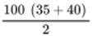

A = 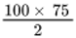

A = 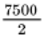

A = 3750 mm²

Method 2 – converting to cm
Convert a and b measurements to cm:
a = 35 ÷ 10 = 3.5 cm
b = 40 ÷ 10 = 4 cm

A = 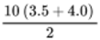

A = 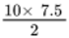

A =

A = 37.5 cm²

Note: it is a good idea to show all the stages of the calculation to help you keep track of your workings.

Back to - Part

Part

Answer
- T = hc + (0.45d) + 15
In this case h = 2, c = £42, and d = 12, so:
T = 2 × 42 + (0.45 × 12) + 15
T = 84 + 5.4 + 15
T = 104.4
The total cost of hire would be £104.40.
Back to - Part

Activity 2 What next for Becky?

Part

Discussion
Your ‘Tips’ list might have included something about the importance of forward planning; Sharon talks about needing to start planning two or three years in advance so Becky can get used to her new home and get to know her staff. She also emphasises the importance of having an emergency care plan which uses the respite care setting with which Becky is already familiar. You may want to add planning for emergencies and the future to your ‘Tips’.
As Sharon and her husband think Becky is wellsupported by her current care provider they hope she can move into a new home supported by them. Exploring options for future care with an existing and trusted provider known to the family who can provide continuity in care is perhaps another ‘Tip’.
Back to - Part

Activity 4Understanding and coping with reluctance

Part

Discussion
Gail talks about some of the reasons why someone may not want to move from the family home to alternative accommodation – some of which are emotionally complex and involve fear. She stresses the importance of starting planning early allowing plenty of time to understand any reluctance and working through concerns sensitively.
Dawn and Pam emphasise listening to family members and suggest using pictures, communication tools as well as involving trusted professionals and friends to help during discussions that take place.
These are all points which are worth building into your ‘Tips’.
Back to - Part

Activity 6: Timetables and calculating time

Answer
- Firstly, work out the total time that Kacper is out for:
  - 1 hour 45 minutes at the trade centre and another 50 minutes driving makes a total of 2 hours and 35 minutes.
Then, using the number line, you have:

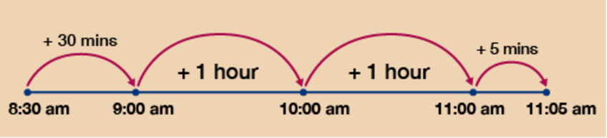
Figure 16 A number line for Question 1
View description - Figure 16 A number line for Question 1

So Kacper arrives at work at 11:05 am.
You could also do the calculation by adding on the 1 hour 45 minutes first:
  - 8:30 am + 1 hour = 9:30 am
  - 9:30 am + 45 minutes = 10:15 am
Finally, you can add on the 50 minutes:
  - 10:15 am + 45 minutes = 11:00 am
Then add on the remaining 5 minutes:
  - 11:00 am + 5 minutes = 11:05 am
- Again, firstly work out the total time required:
  - 25 minutes + 1 hour + 20 minutes = 1 hour 45 minutes in total
This time you need to work backwards on the number line so you begin at 7:30 and work backwards.

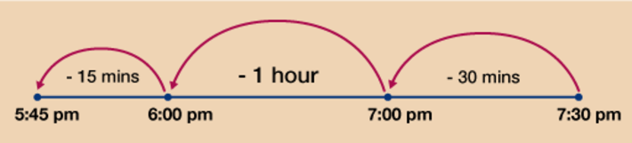
Figure 17 A number line for Question 2
View description - Figure 17 A number line for Question 2

You can now see that you must begin preparing the lamb at 5:45 pm at the latest.
As with the first question, you could have done this question by taking off each stage in the cooking process separately rather than finding the total time first:
  - 7:30 pm − 20 minutes = 7:10 pm
  - 7:10 pm − 1 hour = 6:10 pm
There are 25 minutes left so:
  - 6:10 pm − 10 minutes = 6:00 pm
There are now 15 minutes left so:
  - 6:00 pm − 15 minutes = 5:45 pm
- Looking at the timetable for arrival at Liverpool, you can see that in order to arrive by 12:30 you need to catch the train that arrives at 12:14. This means that you need to catch the 11:25 from Manchester.

Table 3(b)
Manchester to Liverpool
Manchester | 10:24 | 10:52 | 11:03 | 11:25 | 12:01 | 12:13
Warrington | 10:38 | 11:06 | 11:20 | 11:45 | 12:15 | 12:28
Widnes | 10:58 | 11:26 | 11:42 | 12:03 | 12:34 | 12:49
Liverpool Lime Street | 11:09 | 11:38 | 11:53 | 12:14 | 12:46 | 13:02

You therefore need to work out the difference in time between 11:25 (italic) and 12:14 (bold).

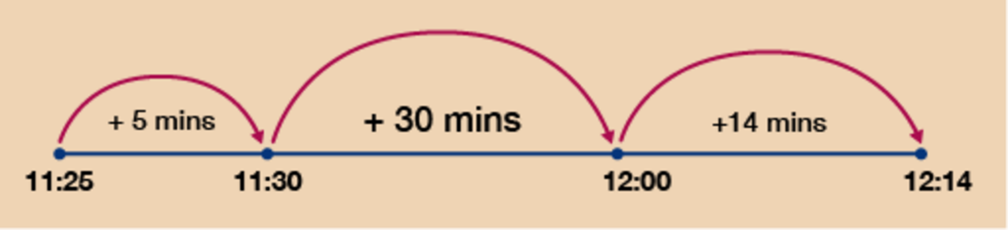
Figure 18 A number line for Question 3
View description - Figure 18 A number line for Question 3

Using the number line again, you can see that this is a total of 5 + 30 + 14 = 49 minutes.
Back to - Activity 6: Timetables and calculating time

Activity 7: Converting times

Answer
- 6 hours = 6 × 60 = 360 minutes
360 minutes + 35 minutes = 395 minutes
- 85 minutes ÷ 60 = 1.417 (rounded to three d.p)
1 hour = 60 minutes.
85 minutes − 60 minutes = 25 minutes remaining
So 85 minutes = 1 hour and 25 minutes
- 153 seconds ÷ 60 = 2.55
2 minutes = 2 × 60 = 120 seconds
153 seconds − 120 seconds = 33 seconds remaining
So 153 seconds = 2 minutes and 33 seconds
- 46 days ÷ 7 = 6.571 (rounded to three d.p)
6 weeks = 6 × 7 = 42 days
46 days − 42 days = 4 days remaining
So 46 days = 6 weeks and 4 days
- 3 minutes = 3 × 60 = 180 seconds
180 seconds + 40 seconds = 220 seconds
Back to - Activity 7: Converting times

Activity 8: Calculating speed, distance and time

Answer
- You need to find the speed so you do: distance ÷ time.
The distance is 36 miles. The time is 30 minutes but you need the time in hours:
  - 30 minutes ÷ 60 = 0.5 hours
Now you do:
  - 36 ÷ 0.5 = 72 mph
Yes, Filip’s average speed did exceed the speed limit.
- You need to find the distance so you do:
  - speed × time
  - 10 hours 45 minutes = 10.75 hours
If you are unsure how to express this in hours, convert 10 hours 45 minutes all into minutes:
  - 10 × 60 = 600 + 45 = 645 minutes
Then divide by 60:
  - 645 ÷ 60 = 10.75 hours
Now to work out the distance do:
  - speed × time = 185 × 10.75 = 1988.75 km from Frankfurt to Hong Kong
- You need to find the time so you do:
  - distance ÷ speed
  - 50 ÷ 37.5 = 1.33 hours (rounded to two d.p)
  - Note: The actual answer is 1.3333333 (the 3 is recurring or never-ending).
To convert this to minutes do:
  - 1.33 × 60 = 79.8 minutes
  - round 79.8 minutes up to 80 minutes
  - 80 minutes = 1 hour and 20 minutes
If the time now is 9:45 am and his meeting is at 11:00 am, then it is only 1 hour, 15 minutes until his meeting, so no, Malio will not make the meeting on time.
Back to - Activity 8: Calculating speed, distance and time

Activity 9: Temperature conversions

Part

Answer
- You need to use the following formula:
F = C + 32
  - F = × 22 + 32
22 ÷ 5 = 4.4
4.4 × 9 = 39.6
39.6 + 32 = 71.6°F

  - F = × 0 + 32
0 ÷ 5 = 0
0 × 9 = 0
0 + 32 = 32°F

  - F = × −6 + 32
−6 ÷ 5 = −1.2
−1.2 × 9 = −10.8
−10.8 + 32 = 21.2°F

Back to - Part

Part

Answer
- You need to use the following formula:
C =

  - C = 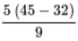
45 − 32 = 13
13 × 5 = 65
65 ÷ 9 = 7.2°C (to one d.p)

  - C = 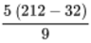
212 − 32 = 180
180 × 5 = 900
900 ÷ 9 = 100°C

  - C = 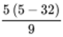
5 − 32 = −27
−27 × 5 = −135
−135 ÷ 9 = −15°C

Back to - Part

Part

Answer
- You need to convert 400°F to °C so use the formula:
C =

C = 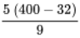

400 − 32 = 368
368 × 5 = 1840
1840 ÷ 9 = 204.4°C (to one d.p).
As you would be unable to set an oven so accurately, you would set the temperature to 200°C.
Back to - Part

Part

Answer
- You either need to convert the Moscow temperature of −4°C to °F, or convert the Toronto temperature of 19°F to °C.
Method 1 – Converting °C to °F
If we look back at the formulas, the one we need to use to convert from °C to °F is:
  - F = C + 32
We need to substitute the C with our °C figure of −4°C. We then need to follow the rules of BIDMAS to carry out the calculation in stages, as shown below:
  - F = × −4 + 32
  - −4 ÷ 5 = −0.8
Multiply by 9:
  - −0.8 × 9 = −7.2
Add 32:
  - −7.2 + 32 = 24.8°F
So which is colder? Moscow at −4°C (which we now know is 24.8°F) or Toronto at 19°F? Toronto is colder.
Method 2 – Converting °F to °C
The formula for converting from °F to °C is:
  - C =
We need to substitute the F with our °F figure of 19°F. We then need to follow the rules of BIDMAS to carry out the calculation in stages, as shown below:
  - C = 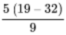
Take 32 away from the Fahrenheit figure of 19:
  - 19 − 32 = −13
Multiply by 5:
  - −13 × 5 = −65
Divide by 9:
  - −65 ÷ 9 = −7.2°C (to one d.p.)
So which is colder: Moscow at −4°C or Toronto at 19°F (which we now know is −7.2°C)? Toronto is colder.
Back to - Part

Activity 10: Reading scales

Part

Answer
- The scale is going up in steps of 20 (the numbered markers are going up in intervals of 100 and there are 5 small steps between each numbered marker: 100 ÷ 5 = 20) so the answers are:
  - 160
  - This is halfway between 240 and 260 so the answer is 250
  - 380
Back to - Part

Part

Answer
  - 1250
  - 1325
  - 1475
Back to - Part

Part

Answer
  - 0.5
  - 1.6
  - 2.3
  - The arrow is pointing to halfway between 2.6 and 2.7 so the reading is 2.65.
Back to - Part

Part

Answer
  - 1.0 (or just 1)
  - 7.5
  - 11.5
Back to - Part

Activity 11: Measuring instruments

Part

Answer
- The bottle holds 1 litre of liquid in total. There are 10 large steps marked on the bottle so each one marks 100 ml (1 litre = 1000 ml and 1000 ÷ 10 = 100).
Halfway between each large step there is a small step so each of these marks off 50 ml.
This means there is 250 ml of water left in the bottle to the nearest 50 ml.
Back to - Part

Part

Answer
- To answer this question you need to remember that 1 kg = 1000 g.
The scale is numbered at every 1 kg interval and there are 10 steps between each numbered interval, so each step marks 0.1 kg (1 ÷ 10 = 0.1). You could also think of each marker being 100 g (0.1 kg = 100 g).
The arrow is almost at 19.8 kg (19 800 g). If Sara has a weight limit of 21 kg then:
21 kg − 19.8 kg = 1.2 kg (21 000 g − 19 800 g = 1200 g)
Sara can pack another 1.2 kg (or 1200 g) worth of luggage.
Back to - Part

Part

Answer
- As with Question 2, you need to remember that 1 kg = 1000 g.
The scale is numbered at every 1 kg interval and there are 10 steps between each numbered marker so each step marks 0.1 kg (1 ÷ 10 = 0.1). You could also think of each step being 100 g (0.1 kg = 100 g).
The arrow is pointing to 3.8 kg (or 3800 g).
If Simon needs 4 kg (4000 g) of potatoes then he needs to weigh out another 200 g.
Back to - Part

Activity 12: Using conversion scales

Answer
Grams (g) are shown on the outside of this scale and ounces (oz) are shown on the inside.
- The arrow is pointing to 70 g (the scale is going up in steps of 5).
- You need to look on the outside of the scale to find 200 g and then look on the inside to see how many whole ounces it is nearest to.
The nearest whole ounce is 7 oz.
- Find 1 oz on the inside of the scale. Now look on the outside to take this reading in grams. The nearest marker is 30 grams (the grams scale goes up in steps of 5) so 1 oz is approximately 30 g.
- Look on the inside of the scale for 6 oz. Then take the equivalent gram reading from the outside of the scale. 6 oz is approximately 170 g.
Back to - Activity 12: Using conversion scales

Activity 1 Mel’s story

Discussion
Mel talks about some of the pros and cons of previous placements and what makes for a good home for Sam. Contributory factors are:
- having the opportunity to ‘test out’ a placement first to see if it works for both parties
- Sam not living far away so Mel can have Sam visit her regularly and take him on holiday
- a good relationship with the carers
- Mel feeling she can have frank conversations with the carers and they listen to her
- carers who can provide stability and who work on behavioural and health issues, seeking help if needed
- Sam has his own space but also has opportunities to socialise.
Hearing from Mel will have helped you to start to formulate your own ideas about what you see as being essential to the sort of future home you are seeking for the person for whom you are caring.
Back to - Activity 1 Mel’s story

Activity 2 What matters to the person for whom you care

Part

Discussion
Dawn and Pam mentioned the importance to them of:
- being in a homely environment
- having the right support
- having privacy
- having their own space
- having opportunities to keep healthy, socialise with their friends, enjoy their pets and to see their family.
Things that the carers in our research also took into consideration were:
- if they want to live in a city, the suburbs or the countryside
- if they want to live on their own or live with others
- if they want to live near family and/or people they know
- if they want to continue to be involved with the family
- are there good transport links?
- will they be near shops?
- are there any accessibility needs?
- will the person be able to stay in their new home as they grow older?
- can they continue to do the things they love?
- can they be involved in the community?
Back to - Part

Activity 2 Becky’s story continued

Part

Discussion
Sharon’s actions highlight the value of making use of any opportunities to take forward plans for the future. This is not easy and we recognise it should not be the responsibility of the family carer to do so.
Some things you can do include approaching providers, asking for meetings and steer annual reviews to focus on realising what is important for your family member and addressing issues that are important in your situation. As you can see, this can include behavioural issues that are causing concern.
Back to - Part

Activity 3 Making yourself assertive

Part

Discussion
Gail suggests finding other parents in the same situation by joining family carers organisations and parents/peer groups in your area. These can give you a forum to share your concerns, learn from others, establish useful connections, and help you to have a collective voice with other parents. She specifically mentions contacting learning disability support services. Other advice she gives is around learning about the law and your legal rights. This could include doing some further learning about health and social care, the law and your rights, for example.
Back to - Part

Activity 4 How can an advocate help me?

Part

Discussion
Gail talks about how specialist advocates in her network can help carers. As you will have seen, having an advocate can be really useful. Here is a list of the sort of things they can do to help you:
- listen to you and your concerns e.g. about services
- put you in touch with other parents
- help you understand choices
- provide you with information
- help you say what you want and don’t want to say
- support you to make your own decisions
- accompany you to assessment and meetings
- help you think about nominating someone who can advocate for your relative if you are no longer able to do this.
Back to - Part

Activity 1 Advice about looking after yourself

Part

Discussion
Gail emphasises knowing what your rights are, having a break from caring, having someone to offload to and giving yourself permission to be selfish. You will probably also already be aware of the importance of eating a healthy balanced diet, getting enough sleep and exercise. Another point you might have picked up is that self-care can be practiced in many ways. Some of the ways might be fairly quick and easy – taking a minute here or there to relax, engaging in a mindfulness activity or exercise, noticing the sounds around you and in taking a short break from the busy world we live in. Choose which works best for you and do not forget to use it!
Back to - Part

Activity 1 What are the components of excellent care?

Part

Discussion
You can see from the Quilt of Excellence animation that really good support for people with learning difficulties and their carers depends on supporting people to live well as they get older (e.g. having a good home and doing the things they really enjoy), supporting people to age well (e.g. helping them to cope with the physical, mental and emotional changes that take place as we age), and creating a caring environment for everyone concerned (e.g. looking after family carers and making sure the person with learning difficulties is in a nurturing environment).
Our research showed that while excellent does exist it is unfortunately far from universal. There is still much to do in terms of improving policy and practice in this area.
Back to - Part

Uncaptioned Figure

Description
An image of two people affectionately hugging one another.
Back to - Uncaptioned Figure

Uncaptioned Figure

Description
An image of two people sitting at a table and smiling.
Back to - Uncaptioned Figure

Uncaptioned Figure

Description
An image of a woman sitting at a desk wearing headphones.
Back to - Uncaptioned Figure

Uncaptioned Figure

Description
An image of two people affectionately hugging one another.
Back to - Uncaptioned Figure

Uncaptioned Figure

Description
An image of two people sitting at a table and smiling.
Back to - Uncaptioned Figure

Uncaptioned Figure

Description
An image of a woman sitting at a desk wearing headphones.
Back to - Uncaptioned Figure

Figure 4 Rounding up and down

Description
Illustration of an up arrow and a down arrow
Back to - Figure 4 Rounding up and down

Figure 5 A rounding rhyme

Description
A rounding rhyme. The text reads: Underline the digit, look next door. If it’s 5 or greater, add one more. If it’s less than 5, leave it for sure. Everything after is a zero, not more.
Back to - Figure 5 A rounding rhyme

Figure 6 A bank statement

Description
A bank statement with four columns: Date, Description, Amount and Balance. There are six lines under the column headings showing money paid in and out. (Date column): 09 Oct, 11 Oct, 15 Oct, 20 Oct, 21 Oct, 25 Oct. (Description column): Bank Transfer, Direct Debit, Automated Pay In, Bank Bank Transfer, Direct Debit, Bank Transfer. The (Amount column) is blank. (Balance column): 100.00, −20.00, 70.00, 100.00, −50.00, 200.00.
Back to - Figure 6 A bank statement

Figure 7 A poster advertising a sale

Description
An illustration of a sale poster reading ‘Sale, many lines 1/3 off original price’.
Back to - Figure 7 A poster advertising a sale

Figure 8 Smarties in different colours

Description
A quantity of Smarties in different colours. 4 are red; 6 are blue; 5 are pink; 3 are green; 6 are yellow; 2 are orange; 4 are purple.
Back to - Figure 8 Smarties in different colours

Figure 9 Percentage discounts in a sale

Description
A series of tags sequentially reading ‘Sale up to 10%, 15%, 20%, 25%, 30%, 40%, 50%’.
Back to - Figure 9 Percentage discounts in a sale

Figure 10 Expressed as a decimal: 8 divided by 25

Description
8.00 ÷ 25 = 0.32. This illustration shows that the sum has been handrawn and there is a small ‘8’ above the first ‘0’ of ‘8.00’ and a small ‘5’ above the second ‘0’of 8.00.
Back to - Figure 10 Expressed as a decimal: 8 divided by 25

Figure 11 Equivalent decimals, fractions and percentages

Description
Illustration showing equivalences: Decimal, 0.5; Fraction, 1/2; Percentage, 50%.
Back to - Figure 11 Equivalent decimals, fractions and percentages

Figure 12 Expressed as a decimal: 3 ÷ 4

Description
3.00 ÷ 4 = 0.75. This illustration shows that the sum has been handrawn and there is a small ‘3’ above the first ‘0’ of ‘3.00’ and a small ‘2’ above the second ‘0’of 3.00.
Back to - Figure 12 Expressed as a decimal: 3 ÷ 4

Figure 13 Expressed as a decimal: 1 ÷ 4

Description
1.00 ÷ 4 = 0.25. This illustration shows that the sum has been handrawn and there is a small ‘1’ above the first ‘0’ of ‘1.00’ and a small ‘2’ above the second ‘0’of 1.00.
Back to - Figure 13 Expressed as a decimal: 1 ÷ 4

Figure 14 Day-to-day ratio

Description
Cartoon of a teacher and several children playing in a school. A sign reads ‘Adult to child ratio must be 1:4’.
Back to - Figure 14 Day-to-day ratio

Figure 15 Solving ratio problems to grow tomatoes

Description
Illustration showing a jug filled up to 600 ml with water. The text reads ‘Feed:Water, 1:4’. An arrow points from the number 4 to ‘600 ml’. Another arrow points from the number 1 to a question mark.
Back to - Figure 15 Solving ratio problems to grow tomatoes

Figure 16 Using ratios in recipes

Description
Illustration showing kitchen weighing scales measuring 700 g. The text reads ‘Flour:Butter, 3:5’. An arrow points from the number 5 to ‘700 g’. Another arrow points from the number 3 to a question mark
Back to - Figure 16 Using ratios in recipes

Figure 17 Working out the ratio of adults to children

Description
Illustration showing an adult and 8 children. The text reads ‘Adults:Children, 1:8’. An arrow points from the number 8 to ‘32’. Another arrow points from the number 1 to a question mark.
Back to - Figure 17 Working out the ratio of adults to children

Figure 20 Shopping options: tea

Description
Illustration of two boxes of teabags. One box contains 40 teabags and costs £1.20. The other box contains 240 teabags and costs £9.60.
Back to - Figure 20 Shopping options: tea

Figure 21 Cola options

Description
Two bottles of cola. One is 2 litres and costs 64 pence. The other is 3 litres and costs 99 pence.
Back to - Figure 21 Cola options

Figure 22 Milk options

Description
Two cartons of milk. One is 1 pint and costs 26 pence. The other is 4 pints and costs 92 pence.
Back to - Figure 22 Milk options

Figure 23 Washing powder options

Description
Two boxes of washing powder. One is 2 kg and costs £3. The other is 5 kg and costs £10.
Back to - Figure 23 Washing powder options

Figure 24 Apple juice options

Description
Two 1 litre cartons of apple juice. The cost in Shop A is 52 pence. The cost in Shop B is 72 pence plus the offer ‘Buy one get second one half price’.
Back to - Figure 24 Apple juice options

Figure 25 Orange juice options

Description
Two 1 litre cartons of orange juice. The cost in Shop A is 39 pence. The cost in Shop B is 76 pence plus the offer ‘Buy one get one free’.
Back to - Figure 25 Orange juice options

Figure 26 Bread rolls options

Description
Three packs of bread rolls: ‘18 rolls £3.42’; 12 rolls £2.16; ‘4 rolls 80p’.
Back to - Figure 26 Bread rolls options

Figure 27 Formulas

Description
Illustration showing examples of formulas.
Back to - Figure 27 Formulas

Figure 28 A calculation using the four operations

Description
Illustration showing the text ‘What is the answer?’ and the sum ‘7 + 7 ÷ 7 + 7 x 7 – 7’.
Back to - Figure 28 A calculation using the four operations

Figure 29 The BIDMAS order of operations

Description
Illustration of the word BIDMAS. ‘B’ stands for Brackets. ‘I’ stands for Indices. ‘DM’ stands for Divide & Multiply. ‘AS’ stands for Add & Subtract. An arrow under the word BIDMAS is labelled ‘Order of Operations’ and points from left to right.
Back to - Figure 29 The BIDMAS order of operations

Figure 30 Dimensions of a trapezium

Description
A trapezium. The length of the top side is labelled ‘a’. The length of the bottom side is labelled ‘b’. The length between the top and bottom sides (height) is labelled ‘h’.
Back to - Figure 30 Dimensions of a trapezium

Figure 31 Dues’s Bouncy Fun – price list

Description
Illustration of an advert for ‘Duey’s Bouncy Fun’ which is displayed at the top. A picture of a bouncy castle is on the left. On the right is the price list: Superhero Castle £34.50; Supersonic Castle £42.00; Stars and Unicorns Palace £45.00.
Back to - Figure 31 Dues’s Bouncy Fun – price list

Figure 32 Inverse operations

Description
A clapper board with the title ‘Inverse Operations’ and showing a two-row table. The first row of the table reads ‘Operation: +, –, x, ÷’. The second row of the table reads ‘Inverse: –, +, ÷, x’.
Back to - Figure 32 Inverse operations

Uncaptioned Figure

Description
An image of two people sitting at a table with a mobile device and some paperwork.
Back to - Uncaptioned Figure

Figure 14 A number line for a time sheet

Description
A number line with times marked from left to right: 8:30am, 9:00am, 12:00pm, 12:10pm. An arrow labelled ‘+ 30 mins’ points from 8:30am, to 9:00am. An arrow labelled ‘+ 3 hours’ points from 9:00am to 12:00pm. An arrow labelled ‘+ 10 mins’ points from 12:00pm to 12:10pm.
Back to - Figure 14 A number line for a time sheet

Figure 15 A number line for a timetable

Description
A number line with times marked from left to right: 06:58, 07:00, 08:00, 08:02. An arrow labelled ‘+ 2 mins’ points from 06:58, to 07:00. An arrow labelled ‘+ 1 hour’ points from 07:00 to 08:00. An arrow labelled ‘+ 2 mins’ points from 08:00 to 08:02.
Back to - Figure 15 A number line for a timetable

Figure 16 A number line for Question 1

Description
A number line with times marked from left to right: 8:30am, 9:00am, 10:00am, 11:00am, 11:05am. An arrow labelled ‘+ 30 mins’ points from 8:30am, to 9:00am. An arrow labelled ‘+ 1 hour’ points from 9:00am to 10:00am. An arrow labelled ‘+ 1 hour’ points from 10:00am to 11:00am An arrow labelled ‘+ 5 mins’ points from 11:00am to 11:05am.
Back to - Figure 16 A number line for Question 1

Figure 17 A number line for Question 2

Description
A number line with times marked from left to right: 5:45pm, 6:00pm, 7:00pm, 7:30pm. An arrow labelled ‘– 30 mins’ points from 7:30pm, to 7:00pm. An arrow labelled ‘‒ 1 hour’ points from 7:00pm to 6:00pm. An arrow labelled ‘‒ 15 mins’ points from 6:00pm to 5:45pm.
Back to - Figure 17 A number line for Question 2

Figure 18 A number line for Question 3

Description
A number line with times marked from left to right: 11:25, 11:30, 12:00, 12:14. An arrow labelled ‘+ 5 mins’ points from 11:25, to 11:30. An arrow labelled ‘+ 30 mins’ points from 11:30 to 12:00. An arrow labelled ‘+ 14 mins’ points from 12:00 to 12:14.
Back to - Figure 18 A number line for Question 3

Figure 19 A conversion chart for time

Description
A conversion chart for time. weeks × 7 for days; days ÷ 7 for weeks days × 24 for hours; hours ÷ 24 for days hours × 60 for minutes; minutes ÷ 60 for hours minutes × 60 for seconds; seconds ÷ 60 for minutes.
Back to - Figure 19 A conversion chart for time

Figure 21 A formula for average speed

Description
Illustration of a car driving for a distance past a speed camera. The text shows the formula ‘Speed equals distance divided by time’.
Back to - Figure 21 A formula for average speed

Figure 22 Distance, speed and time formulas

Description
Illustration of 3 triangles that show the relationship between distance, speed and time. The text reads: ‘Distance equals Speed multiplied by Time’ ‘Time equals Distance divided by Speed’ ‘Speed equals Distance divided by Time’.
Back to - Figure 22 Distance, speed and time formulas

Figure 23 Scale with numbered intervals of 50

Description
There are four markers between each numbered interval on the scale. There are five numbered intervals going from 0–200. ‘(a)’ has an arrow that points to the second marker after ‘50’. ‘(b)’ has an arrow that points in between the first and second marker after ‘150’.
Back to - Figure 23 Scale with numbered intervals of 50

Figure 24 Scale with single numbered intervals going from 3–5

Description
There are nine markers between each numbered interval on the scale and the numbers 1–10 are displayed in red under the scale and count each marker between ‘3’ and ‘4’. There are three numbered intervals going from 3–5. ‘(a)’ has an arrow that points to the fourth marker after ‘3’. ‘(b)’ has an arrow that points to the eighth marker after ‘4’.
Back to - Figure 24 Scale with single numbered intervals going from 3–5

Figure 25 Scale with numbered intervals every hundred going from 100–400

Description
There are four numbered interval on the scale going from 100–400. There are four markers between each numbered interval. ‘(a)’ has an arrow that points to the third marker after ‘100’. ‘(b)’ has an arrow that points between the second and third marker after ‘200’. ‘(c)’ has an arrow that points to the fourth marker after ‘300’.
Back to - Figure 25 Scale with numbered intervals every hundred going from 100–400

Figure 26 Scale with numbered intervals every hundred going from 1200–1500

Description
There are four numbered interval on the scale going from 1200–1500. There are three markers between each numbered interval. ‘(a)’ has an arrow that points to the second marker after ‘1200’. ‘(b)’ has an arrow that points to the first marker after ‘1300’. ‘(c)’ has an arrow that points to the third marker after ‘1500’.
Back to - Figure 26 Scale with numbered intervals every hundred going from 1200–1500

Figure 27 Scale with single number intervals from 0–3

Description
There are four numbered interval on the scale going from 0–3. There are nine markers between each numbered interval. ‘(a)’ has an arrow that points to the fifth marker after ‘0’. ‘(b)’ has an arrow that points to the sixth marker after ‘1’. ‘(c)’ has an arrow that points to the third marker after ‘2’. ‘(d)’ has and arrow that points between the sixth and seventh marker after ‘2’.
Back to - Figure 27 Scale with single number intervals from 0–3

Figure 28 Scale with numbered intervals every 5 going from 0–15

Description
There are four numbered intervals on the scale going from 0–15. There are nine markers between each numbered interval. ‘(a)’ has an arrow that points to the second marker after ‘0’. ‘(b)’ has an arrow that points to the fifth marker after ‘5’. ‘(c)’ has an arrow that points to the third marker after ‘10’.
Back to - Figure 28 Scale with numbered intervals every 5 going from 0–15

Figure 29 A water bottle with a scale on the side and water inside

Description
There are twenty steps on the bottle and ‘1 litre’ on the top marker. There are ten larger, darker markers and a smaller marker in between each large one. The water line is very close to the fifth marker which is a smaller marker.
Back to - Figure 29 A water bottle with a scale on the side and water inside

Figure 30 Luggage scales weighing luggage

Description
The illustration shows a hand holding analogue scales weighing some luggage. There are seven numbered intervals every five on the scales going from 0–30 kg with small markers every 1 kg. A square zooms in on the scales where nine smaller markers are shown between each 1 kg marker. In the zoomed square is a needle that points two smaller markers prior to the numbered interval of 20 kg.
Back to - Figure 30 Luggage scales weighing luggage

Figure 31 Food scales weighing potatoes

Description
Analogue scales are weighing potatoes. A zoomed in version of the scales reading is on the left of the image. There are six numbered intervals, one every kilogram on the scales going from 0–5 kg. There are nine unnumbered markers between each number interval. There is a needle that points two smaller markers prior to the numbered interval of 4 kg.
Back to - Figure 31 Food scales weighing potatoes

Figure 32 Example – Reading a thermometer

Description
A thermometer with ‘°C’ on the top-left and numbered intervals every ten going from ‘−30°’, displayed at the bottom to ‘50°’ at the top. ‘°F’ is on the top-right of the thermometer with numbered intervals every twenty going from ‘20°’displayed at the bottom to ‘120°’ at the top.
Back to - Figure 32 Example – Reading a thermometer

Figure 33 Weighing scales showing two units of measure

Description
A circular analogue weighing scales dial with ‘g’ on the outer circle of the dial in the 12 o’clock position on the dial. ‘oz’ is on the inner circle of the dial at the 12 o’clock position. On the ‘g’ scale (outer) there are numbered interval every fifty going from ‘0g’ to ‘450’. There are nine markers between each numbered interval. On the ‘oz’ (inner) scale there are single numbered intervals going from ‘0 oz’ to ‘17’ at the top with three markers between each numbered interval. The needle points to the fouth marker after ‘50’ on the ‘g’ scale and the second marker after ‘2’ on the ‘oz’ scale.
Back to - Figure 33 Weighing scales showing two units of measure

Uncaptioned Figure

Description
An image of two people high-fiving and smiling.
Back to - Uncaptioned Figure

Uncaptioned Figure

Description
An image of a woman outside in a garden holding a plant.
Back to - Uncaptioned Figure

Uncaptioned Figure

Description
An image of a woman holding a man’s hand supportively.
Back to - Uncaptioned Figure

Uncaptioned Figure

Description
An image of two people outside at a BBQ.
Back to - Uncaptioned Figure

Uncaptioned Figure

Description
An image of a woman smiling.
Back to - Uncaptioned Figure

Uncaptioned Figure

Description
An image of four people enjoying a walk on a beach.
Back to - Uncaptioned Figure

Uncaptioned Figure

Description
An image of two people sitting on a bench eating ice cream.
Back to - Uncaptioned Figure

Uncaptioned interactive content

Transcript
Rounding can be used when you're asked to give an answer to a given degree of accuracy. This is called rounding to decimal places, or d.p. In this video, you'll look at how to round to one, two, and three decimal places.
Take the number 25.782. How would you write this rounded to one decimal place? This is the first decimal place. Rounded to 1 d.p., the number could be either 25.7 or 25.8. Look at the digit next to the number 7. If this number is equal to or greater than 5, add one more. If it's less than 5, leave it. In this case, 8 is greater than 5, so our number rounded to 1 d.p. is 25.8.
Now, let's around a number to two decimal places. A common example of when you would do this in daily life is when dealing with money. If you were at a restaurant and needed to split a bill of £87.95 between three people, you would first calculate the division. £87.95 divided by 3 equals £29.3166667. Clearly, you cannot pay this exact amount. So how much would you pay if the amount per person was rounded to two decimal places?
This is the second decimal place. Look at the number next to it. Is it greater than or equal to 5? 6 is more than 5, so you need to add 1. The amount to pay is £29, 32 pence.
Let's try another example. How would you around the number 35.496 to two decimal places? This is the second decimal place. Look at the number next to it. 6 is greater than 5, so you need to add one more. In this case, the rounded number would be 35.50.
Can you round to three decimal places? Have a go with this number: 412.5762. The number next to the third decimal place is 2, which is less than 5. This means the correctly rounded number is 412.576.
Back to - Uncaptioned interactive content

Uncaptioned interactive content

Transcript
Negative numbers come into play in two main areas of life: money and temperature. If your bank balance is showing as -£250, this means that your balance is £250 below zero. In other words, you owe the bank £250.
Similarly, you'll be used to seeing winter weather forecasts predicting temperatures of -10 degrees Celsius. This means the temperature will be 10 degrees below zero degrees Celsius.
It can be useful to think of a thermometer if you're trying to find the difference between two numbers, where one or both of the numbers are negative. If the temperature is increasing, you go up the thermometer. If the temperature is decreasing, you travel down the thermometer.
For example, you'd like to know the answer to the sum [6 - 10]. Starting at number 6 on a thermometer and travelling down, it's easy to see that subtracting 10 will result in a number less than zero.
What is the answer to the sum [-5 + 12]? This time, we're starting below zero and travelling up the thermometer by 12 places, giving an answer of 7.
Can you work out the answer to the sum [-1 - 8]? In this example, we start below zero and the answer is also below zero: -9. Now try the next activity for more practise with negative numbers.
Back to - Uncaptioned interactive content

Uncaptioned interactive content

Transcript
In this video, you'll look at how to simplify fractions. You'll be used to seeing the results of company surveys given as fractions: '7/8 people say they were satisfied with our customer service'. This is an example of a fraction in its simplest form. It could be that 184 people were surveyed and that 161 of them responded to say they were satisfied. Although they are equivalent fractions, you can see that the fraction '7/8 people' is a lot more user friendly than saying 161/184 people responded to say they were satisfied.
If you're asked to give an answer as a fraction in its simplest form, you firstly find a number that you can divide both parts of the fraction by, and divide it. For example, to simplify the fraction 12/18, you can divide both the top and the bottom number by 2, to give 6/9.
Keep going until you can't find a number that you can divide both parts of the fraction by. The fraction 6/9 can be divided again, this time by 3, to get 2/3. This is now the fraction in its simplest form.
Now let's simplify the fraction 40/120. Remember, find a number that you can divide both parts of the fraction by, and keep going until there is no longer a number that works. So, divide the top and bottom by 10. Divide the top and bottom by 2. Divide the top and bottom by 2. This is the fraction in its simplest form.
Back to - Uncaptioned interactive content

Uncaptioned interactive content

Transcript
You will already be familiar with the concept that if you buy a new car, when you come to sell it, its value is likely to have decreased. On the other hand, if you're lucky, when you buy a house and then wish to sell, you may be able to sell it for more than you bought it for.
The percentage difference between the original price and the sale price is called percentage change. This can be useful for working out the percentage profit, or loss, or finding out by what percentage an item has changed in value. It's important to recognise that percentage change can be either positive, if the price has increased, or negative, if the value of the item has gone down.
To calculate the percentage change, we need to use the simple formula: percentage change equals the difference, divided by the original, multiplied by 100. 'Difference' refers to the difference between the two values. That is, the cost before and after. 'Original' means the original value of the item.
Let's use this formula in an example. A train ticket used to cost £24. The price has gone up to £27.60. How do we find the percentage increase? First, you need to find the difference in cost. The difference = £27.60 - £24, which is £3.60.
Next, divide this difference by the original cost, and then multiply by 100. £3.60 divided by £24, x 100, = 15. The cost of the train ticket has increased by 15%.
Now try another example. You bought a car for £4,500 and you managed to sell it for £3,200. What is the percentage decrease? You should give your answer to two decimal places. The difference is £4,500 - £3,200, which = £1,300. Divide this by the original cost of £4,500. 1,300 divided by 4,500, x 100, equals a 28.89% per cent decrease. Now practise using the percentage change formula in the next activity.
Back to - Uncaptioned interactive content

Uncaptioned interactive content

Transcript
Equivalent fractions, decimals, and percentages are all just different ways of representing the same thing, so you can convert between them to compare. First, let's look at turning percentages into decimals. Take the example of 60%. Remember that a percentage is out of 100. To turn a percentage into its equivalent decimal, you need to divide by 100. 60 divided by 100 = 0.6. So 0.6 is the equivalent decimal of 60%.
What about 25%? Can you work out the equivalent decimal of 25% before the answer is revealed? Remember that 'cent' means 100.
To turn 25% into its equivalent decimal, you need to divide 25 by 100, which = 0.25.
Now let's find the equivalent fraction for the decimals we've calculated. To do this, you need to first turn it into a percentage and write it as a fraction out of 100. Using our previous examples, 0.6 or 60%, can be written as 60 over 100. 0.25, or 25%, can be written as 25 out of 100.
However, these fractions are not written in their simplest form. Remember that to simplify fractions, you need to divide both parts by the same number and keep going until you can't find a number that you can divide both parts by. In their simplest form, 0.6 is written as the fraction 3/5. 0.25 is written as the fraction one quarter, or 1 over 4.
Now looking at the table, you can see how percentages, decimals and fractions relate to each other.
Let's try one more example. Can you work out the equivalent decimal and fraction of 72%? 72 divided by 100 gives the decimal 0.72. To find the equivalent fraction, you need to change it into a percentage and then write it as a fraction out of 100. Then simplify the fraction into its simplest form, 18 out of 25, 18/25.
Back to - Uncaptioned interactive content

Uncaptioned interactive content

Transcript
To understand how to solve ratio problems where the total is given, it's best to look through a worked example.
An art shop is ordering paint. They work out that they need to order red and blue paint in the ratio 3:4. They order a total of 56 cans of paint. How many of those cans are blue paint?
The first step to finding out, is to work out the total number of parts by adding together the parts of the ratio. If there are three parts red and four parts blue, that makes a total of seven parts altogether. Next, you need to work out what one part is worth. To do this, divide the total number of paint cans ordered, by the total number of parts. 56 divided by 7 equals 8. One part is worth eight cans.
Now, you know that one part of paint is 8 cans, you can work out what four parts are worth. 8 x 4 = 32. So the art shop needs to order 32 cans of blue paint.
Can you think of an extra check that you can carry out to confirm your answer? Well as you know what one part of paint is worth, you can also work out how many cans of red paint need to be ordered. 3 parts x 8 cans = 24 cans of red paint.
The total of red paint and blue paint should be 56. So you can check your answer by adding together the number of cans of each. 32 + 24 is indeed 56 cans.
So in summary, the steps for solving a ratio question like this are:
One. Add together the parts of the ratio. 3 + 4 = 7.
Two. Take the total amount given and divide by the sum of the ratio parts. 56 divided by 7 = 8.
Three. Finally, take the answer for step two, 8, and multiply by whichever part of the ratio you're interested in finding. 8 x 4 = 32.
Back to - Uncaptioned interactive content

Uncaptioned interactive content

Transcript
Well I think we have to think about, we’re getting no younger, and what will happen when we can no longer care for her? To sort of start thinking about what can be in place, for if anything, would happen that myself and my husband were unable to care for her just through old age and general practical sides of us not being... maybe as physically able as we were and this kind of thing, that our health deteriorates, then obviously we would need more help with her and probably with a view to finding a placement for her as she gets older... when she has a review is to say, look, we need to get something in place over the next two or three years and to get her you know, hopefully if something happens that she would have already been used to, in you, maybe going somewhere, interacting, you know, that there is some other stability there like with [the centre] that what we would obviously hope is that she could become part of the [the provider], I’d put it in brackets, ‘family’, if you know, that she could be accommodated within their setup, housing and supported living... I think in a way it’s essential because otherwise I think you know, if something happened to us it’s suddenly how the problem falls back on the rest of the family, who have their own independent lives and things, that there is a plan in place, or Becky is settled somewhere, you know, not losing contact with us or anything but that something is there... I’m 71 and [my husband] is 75 (…) I think to a certain extent social services are aware of our age and everything, we have had odd things said about this. But also I think because we have had support with respites and other things that it hadn't become, you know, we’ve been managing (…) I mean I know there is a sort of an emergency care plan, possibly in place, that was done quite a long time ago, that Rebecca would if she needs sudden care, it would be done through the respite service we have, that that would be the first port of call, that she would be treated as an emergency and go to where she normally has respite, you know?
Back to - Uncaptioned interactive content

Uncaptioned interactive content

Transcript
GAIL:
I think it can be really difficult when the person that’s being supported and the family have a different view about what happens next. Maybe Becky wants to stay at home, or maybe somebody that-- your relative doesn’t want to move out of the family home and wants to live with you forever. And that’s normal and to be expected.
You kind of expect if somebody has lived with their family for 45 years, 50 years, the idea of moving out, it’s really scary. And it’s also facing up to all those other things like bereavement and losing a family member, and all of those things that actually none of us really want to think about. But if you have a learning disability, there may be other reasons why that’s difficult to understand or make sense of.
So I think there needs to be really careful steps taken. I think it’s a very delicate situation. I think it’s bringing people along slowly, supporting the person with a learning disability to understand a little bit about why maybe their mum and dad can’t support them like they used to, and that other people move out of their family home when they’re older.
And obviously as a parent, you know your son or daughter best. You know what they will-- their level of understanding will be. For some people, you can have those discussions. For others, it’s much more difficult. My son certainly wouldn’t understand any of that. It would-- so depending on the situation, there would be different things that you could do. I think, take it slowly. That’s why the planning is so important.
Back to - Uncaptioned interactive content

Uncaptioned interactive content

Transcript
LISA: Sometimes, the opinions of the person and the opinions of the family of what’s going to happen-- they might not be the same. So I’m just wondering, how can they support? How can other family carers support when those sort of things happen?
PAM: It should be up to the person what they want, not what everyone else wants.
LISA: Yeah, no-- very, very true. What do you think there, Dawn?
DAWN: Another thing-- if they’re non-verbal, pictures, or words, or--
LISA: Oh. So you’re thinking about how they could have a good conversation with the person to work out what they really want?
DAWN: Yeah, because they’ve got be happy where they’re living, haven’t they?
LISA: They do. They definitely do. And I think it’s really important for everyone’s opinions to be listened to and be thought about. But I think the end decision-- sometimes it has to be like one of those best interest decisions. Obviously, they take into thought of everyone’s opinions, especially that person. So I think it’s important for them to do that. But really have those conversations and get as much information as you can from them. It’s really important there, Dawn.
DAWN: And I think that’s why they should do it earlier because later on in life, they probably won’t have the capacity to say anything.
LISA: Possibly, yeah, especially when we were talking about dementia, Alzheimer’s, and things like that. It can make it really difficult to have those conversations. So do it when you’re young, when you’re healthy, if you can, because sometimes people might not be able to until it’s--
PAM: Plus, it’s not an easy thing to talk about.
DAWN: No, it’s not.
LISA: No, I know.
PAM: Uncomfortable.
LISA: Well, I guess, having those conversations-- what kind of person would you want to have to have those conversations with?
PAM: Family.
DAWN: Yeah, yeah.
LISA: Yeah, for those who are close with you, yeah? And--
DAWN: Doctors.
LISA: Doctors, yeah? And how would you want that doctor to be like?
DAWN: Nice and friendly.
LISA: Nice and friendly, of course.
PAM: And supportive.
DAWN: Supportive, yeah.
LISA: And supportive. And you want them to really know you and also maybe for you to really know them as well because, yeah, as you said-- it’s really awkward to have those conversations, especially when you don’t know the person you’re talking with. Definitely. But I think at the end of the day, you also-- when you have those chats-- you really want them to be on your side, if you know what I mean, to really listen to you and what you want, definitely. Thanks for that, guys.
So also thinking a little bit more about when someone finds it difficult to have conversations, how can families and professionals really talk to them and make those decisions? So you talked a little bit about it, Dawn.
PAM: Be calm.
DAWN: Yeah. And use pictures or, yeah, things that they-- yeah, pictures. Picture bank or--
LISA: Picture bank? So things on the table--
DAWN: Symbols, yeah.
LISA: So there’s lots of communication tools. So there’s talking mats. I know there’s a few things that the Growing Older Planning Ahead Project are creating to help, I think, have some of those conversations-- like picture cards and some questions people can think about. And I think it really-- we also need to think about people’s body language, I think-- don’t you-- when thinking about those things. But talking-- do you think they’d also might need to talk with other people who’s close to that person to really work out what they want or need?
DAWN: Yeah, like their family if they’re still around.
LISA: And who else might they need to talk to? Or who else could they talk to?
DAWN: Social worker?
LISA: Social worker-- I think social workers can be quite close to people, definitely. Who else might be really close to that person and might know what they want?
PAM: The sister or brother, if they’ve got one.
LISA: Yeah? Yeah, really, really close family or friends, as well.
PAM: Yeah, friends. Yeah.
LISA: Yeah, especially when other people might have passed away. And they might have really close support staff members who’ve worked with them for a really long time and really know them that could also help with that. So definitely trying to talk with the person and trying to use different communication tools to talk with them. You’re not able to get all the information you need, you can then talk to all these other people. I think by the sounds of it, talk to the family first. Then, friends. And then, professionals who are really close to them, I think is the thing. And then, you can make a really good decision for that person.
PAM: Yeah.
DAWN: Definitely.
Back to - Uncaptioned interactive content

Uncaptioned interactive content

Transcript
A chicken takes 1 hour and 25 minutes to cook. So, to work out when the chicken will be ready, you can use a number line, which looks like this. The idea behind the number line is that we use small, easy chunks of time to work out the answer. In this example, you know that you need to add 1 hour and 25 minutes onto 4:45 p.m. Here is a number line that starts at 4:45 p.m.
To begin with, add 15 minutes, since this will take us to an easy time of 5:00 p.m. It then makes sense to add an hour on, which takes you to 6:00 p.m. As you've now added 1 hour and 15 minutes, you still need to add another 10 minutes. This takes you to 6:10 p.m., which is when the chicken will be ready. There's no exact science to using the number line for calculations like these. You just add on in chunks of time to make the calculation simpler.
Back to - Uncaptioned interactive content

Uncaptioned interactive content

Transcript
LISA: What kind of things really help make a caring environment for people? So what kind of things help with that?
DAWN: Having the right support.
LISA: Yeah. And you’re happy with that support?
DAWN: Yeah.
LISA: I guess, how they support you, and who supports you.
DAWN: Yeah.
LISA: Definitely, that’s a big one.
PAM: Having your health checks regularly.
LISA: Yeah. So I guess, thinking about--
PAM: That’s very important.
LISA: Think about your health, definitely. Linked to that, there’s also keeping healthy, isn’t it?
PAM: Yeah.
DAWN: Yeah.
LISA: So thinking about what you’re eating.
DAWN: And exercise.
LISA: Exercising too. Definitely. What other things make a caring environment for you guys?
PAM: Making it as homely as possible with pictures and comforts.
LISA: Yeah. And that’s just stuff that you love, really. And having your own space, your privacy. I think, that’s so important. Dawn, can you think of any other things?
DAWN: Yeah. Hanging out with your friends.
LISA: Yeah. And spending that time with other people.
DAWN: Yeah.
LISA: Because I think, you really enjoy that, don’t you?
DAWN: Yeah.
LISA: You have so many friends, Dawn. What kind of things do you do with your friends?
DAWN: We play cards. We play dominoes. We cook for one another.
LISA: That’s really nice. You have those nice chats with people about life, about death.
DAWN: Oh gosh. Yeah.
LISA: And I think, it’s really nice to have those people to support you, I think. And I think, it helps make such a really good, caring environment where it’s also-- you get more out of life, I suppose, when you get to spend time with people you love, and do things that you want to do, too. Cool. Thank you.
Are there any other things you want to--?
PAM: Friends and family are important, just as much as your pets.
LISA: True that. So spending time with them, doing things you want to do with them.
PAM: I have a very supportive family. So I’m quite lucky.
LISA: You all very, very lucky on that front, Pam, definitely. Any other things you can think of?
DAWN: Your animal, your pets. You have to have them around you.
LISA: Especially, with your cats, yeah. Aside from what they did the other day.
DAWN: Well, yeah.
LISA: Any other things you can think of? I think, you got most of it.
PAM: I think, that’s it.
DAWN: Yeah.
Back to - Uncaptioned interactive content

Uncaptioned interactive content

Transcript
GAIL:
There may be other parents in the same situation. There are bound to be other parents. And I think one of the difficulties is families become very, very isolated, even more so as their kids get older, I think. So having those conversations with other parents isn’t always easy. But the carer services may be able to point you to other groups. There may be coffee mornings going on. I think reach out and try and meet other people in a similar situation. It would be my advice right across the board. However old your child is, starting right at the beginning, actually, you need to find your tribe early on and stick with them. But I think carer services-- a local authority have a duty to provide carer services. How that works in different local authority areas will vary, but they would be my first point of contact, I think, at this stage.
Maybe another idea would be to talk to some provider organisations who are currently already providing supported living or shared lives or what other services that are out there to help people live independently. They’re called learning disability support providers as a general term, but there are lots of them around the country. And every local authority will have a list of preferred providers or providers that they use more regularly. It might be worth contacting them to see if they are in touch with any older families who might want to talk to you about what they did. A lot of these providers will have family forums. Maybe ask if you can go along to one of the family forums, have a cup of tea, some cake, chat to some other parents. But that’s a really useful way, I think, of also talking to your peer group who have also gone through the same situation and getting some tips and advice about where to start.
I’d put a bit of a caveat on that, as well, and say, there will be some people who are unhappy with their support. So don’t be put off by other people’s situations. Because the last thing we want is for another older carer to say, oh, don’t do that. It’s terrible. We’re having an awful time.
I mean, that will be happening for some people. But at this stage, the planning and all of that, thinking about it, is the most important bit. The other bit, you can work on later on. So yeah, those two things, I think, would be a really good starting point, and that’s what I would advise people to do. I think what helped me more than anything to advocate for Guy, my son, is that I learned very early on about the law. And knowledge is power. I’ve discovered that quite early on when he was very young in the battles for education, in the battles to get a break. Guy has very complex learning disabilities and needed a lot of support, needs a lot of support.
And so in some ways, for me, it was easier because he was very obviously disabled enough to be able to access some of those services quite early on. But it was still a fight, and it became a fight quite early on in his life. So it was that going from, which happens to a lot of parents, I think, anything for a quiet life sort of person to warrior mother within a few very quick years of him being very young.
So finding out, I did an Open University course. I did an Open University course on social care and the law because I thought, I need to know what they’re being taught. I need to know the law as it relates to my son. And I did that probably when he was about 10. So I started quite early on, and that’s helped me through the years to advocate for him in lots of ways. But the biggest thing by far that anyone can do, that I think is the most powerful and the only thing, apart from knowing your rights, is learn about person-centred planning. And I don't just mean that the term ‘being person centred’, because that’s bandied about like it’s a thing that happens everywhere. But actually really, really learn about what person-centred planning is and what it means to be person centred. And there are courses around that you can do. And that, for me, when Guy was 12, was the turning point.
Because the most powerful thing about it for me was not only did it put him right at the centre of everything that we were thinking about, it helped me to step into his shoes and put myself in his position. It helped very much, when it came to him becoming an adult, to see him as an individual in his own right. But one of the most powerful things is it wasn’t just me as his mum that was saying all of this stuff. So I couldn’t just be labelled as a difficult parent. I’m sure I was quite a few times. But it wasn’t just me saying it.
It was everyone else that was involved in that plan, that knew and loved him and that knew him really well-- his teachers, the staff at the respite centre, his sisters, his grandma, his auntie. Everyone who knew him were agreeing what support he needed and what good life for him would look like. And we did that planning right from the start and have done that throughout his life, so constantly reflecting, going back, checking that how his support is from his perspective.
And some of those things have been quite difficult. I mean, he decided quite recently, before lockdown, that he didn’t particularly want to come and visit me anymore at home, which I found really upsetting. But he was very clearly telling me, actually, Mum, I’m fine. I’m having a lovely time where I am, and I’d much rather be out doing this than coming and sitting in your house. And it’s boring. He couldn’t actually say that, but his body language very clearly was. But I always listen. And I’ve always prided myself on listening to him. So that is for me the key things that you can do. Learn about I can’t honestly reiterate it often enough. Person-centred planning, if it’s done properly with the right people and the right-- can be so powerful and really helps. I suppose they’re the two key things, I would say.
Back to - Uncaptioned interactive content

Uncaptioned interactive content

Transcript
GAIL:
Small groups where possible with cake and coffee or tea is what we found works really best. Bringing them together to break the isolation if we can, but also helping them to have those conversations, again, with their peer group. Providing the information. Sometimes they just need a fact sheet. I did have one family carer that-- well, it was a couple. They asked us to if we could put the Care Act on one page, which no, was the answer to that. A bit difficult.
We managed to get it down to 10 pages, though really, really punchy. These are the things that you need to do. So they want that key information. They want it in very-- don’t overload people with jargon. All these things that have jargon busters. We do it because we feel like we have to, but just don’t use it. Just speak plain English would be my suggestion to anyone writing anything for anyone. Keep it plain language and lose the jargon. So that is key.
Sometimes I think supporting other people-- well, one of the things that we could do is just be with that person sometimes. So when there’s an assessment, we have a small family support service where we can kind of say, well, we’ll send somebody with you. I know that’s not going to be available everywhere, but saying to the family carer that they need-- Just take somebody with you. If you’re having a meeting with someone, don’t go on your own.
Get everything in writing. Back it up. Don’t rely on a phone call for anything. Get them to write it down. And just say, look, your memory is not what it was. Mine certainly isn’t. So get them to write it down and get everything in writing, but back everything up, I think, as well. Again, it’s that knowledge is power stuff. So whatever information that can be provided to any carer. We found doing some of the big events that we’ve done through our elder carers project, we found that younger families came along to that.
So people in their 40s, 50s came along to start thinking ahead. And I think some of the older carers found that intergenerational approach really positive. So they liked being with some of the younger families. So they felt that they’re tired of fighting, so actually having younger parents that could do that around them was really good. So we encourage that in everything that we do.
Back to - Uncaptioned interactive content

Uncaptioned interactive content

Transcript
GAIL:
Make sure that you are getting all the support that you are legally entitled to for your son or daughter, so you can have a proper break. And that is particularly important as you get older, that you can legitimately go back to social care at any time and say we are not getting enough support. We need more.
Just because he goes to day service a couple of days a week or all week even, what happens at the weekend? Are you in your 80s and still doing personal care for somebody or turning them in the night if they are profoundly-- all of those things that might be your-- or just having to be there. I meet parents who have to be there when the bus arrives back or the taxi comes back from day service at 2:30 in the afternoon. And that’s it. They can’t go anywhere for the rest of the day. That takes its toll.
You are legitimately entitled to more help than that if you are older. So make sure, again, the knowing your rights stuff. Know that is the case. And ask for more help. It is not a failure to ask for more help. It is not something-- there is nothing that says you, as a parent, have to do this all on your own. I remember some really good advice from a social worker actually way back who said to me when I said I felt like a failure about caring for my son. You’re not a failure, Gail. No one could do it on their own.
And that is so true, particularly as you get older. I am in awe of some of the older carers that I meet who were still working almost 24/7 supporting their son or daughter. They can’t leave the house, and they’ve done that for 50 years and don’t think they’re entitled to help. So you are entitled to help, so go and ask for it, I think.
And also, I suppose, so it’s your mental health, physical health you need a break, but your mental health, again, it’s back to finding your tribe, finding other parents, finding other people to offload to, to talk to. We all need that. We all need to do that. I need that. I don’t care for my son every day now. But sometimes, you just need to offload. And I think that’s really helpful and have some fun. And if it’s cheese and wine or prosecco or whatever occasionally with a few friends, then that’s the thing that you can do.
Back to - Uncaptioned interactive content

Uncaptioned interactive content

Transcript
NARRATOR
Our research showed that there are three key aspects involved when providing excellent care to older people with learning disabilities and their family carers. Each aspect is made up of its own unique elements. The result is really good support. We talked about how we could show what this support might look like in a visual way. Our team came up with the idea of a patchwork quilt. We call it the quilt of excellence. A patchwork quilt can be added to and changed over time, developing just like our lives do. A patchwork quilt also shows us how lots of smaller elements work together to make the whole. So our quilt of excellence for older people with learning disabilities and their family carers has three main parts, each with many different patches.
The first is about supporting people to live well as they get older. Through our research, we found that living well when people get older means having a good home, being able to get out and about in the fresh air, enjoying nature and being supported to do the things you really love. Enabling people to sustain relationships with their friends, family members, and support workers as they get older is also really important.
The second key element is supporting people to age well. This is about supporting people with the physical, mental, social and emotional changes related to ageing. It's also about planning ahead. This means really thinking about what happens as people age, paying close attention to their health and well-being and any changes they may be experiencing. It's also about ensuring people are in a home that they can grow older in, and supporting people around issues of death, dying and bereavement.
The third aspect of the quilt is about creating a caring environment for everyone. This involves looking after staff, enabling them to be confident and well trained to provide excellent care as people get older. It's also about helping staff to feel happy and well supported in their work. This is also about looking after family carers, supporting them, really listening to them, and keeping them involved in decisions, and being aware of their changing needs as they too get older. And very importantly, it means making sure the person is in a nurturing environment that respects their human rights, enables people to be supported by people that they like, and by people who like them.
When this patchwork of good practice comes together, we get the quilt of excellence, the best ways to support people with learning disabilities and their family carers as they get older.
Back to - Uncaptioned interactive content

Uncaptioned Figure

Alternative description
An image of two people affectionately hugging one another.
Back to - Uncaptioned Figure

Uncaptioned Figure

Alternative description
An image of two people sitting at a table and smiling.
Back to - Uncaptioned Figure

Uncaptioned Figure

Alternative description
An image of a woman sitting at a desk wearing headphones.
Back to - Uncaptioned Figure

Uncaptioned Figure

Alternative description
An image of two people affectionately hugging one another.
Back to - Uncaptioned Figure

Uncaptioned Figure

Alternative description
An image of two people sitting at a table and smiling.
Back to - Uncaptioned Figure

Uncaptioned Figure

Alternative description
An image of a woman sitting at a desk wearing headphones.
Back to - Uncaptioned Figure

Uncaptioned Figure

Alternative description
An image of two people sitting at a table with a mobile device and some paperwork.
Back to - Uncaptioned Figure

Uncaptioned Figure

Alternative description
An image of two people high-fiving and smiling.
Back to - Uncaptioned Figure

Uncaptioned Figure

Alternative description
An image of a woman outside in a garden holding a plant.
Back to - Uncaptioned Figure

Uncaptioned Figure

Alternative description
An image of a woman holding a man’s hand supportively.
Back to - Uncaptioned Figure

Uncaptioned Figure

Alternative description
An image of two people outside at a BBQ.
Back to - Uncaptioned Figure

Uncaptioned Figure

Alternative description
An image of a woman smiling.
Back to - Uncaptioned Figure

Uncaptioned Figure

Alternative description
An image of four people enjoying a walk on a beach.
Back to - Uncaptioned Figure

Uncaptioned Figure

Alternative description
An image of two people sitting on a bench eating ice cream.
Back to - Uncaptioned Figure

