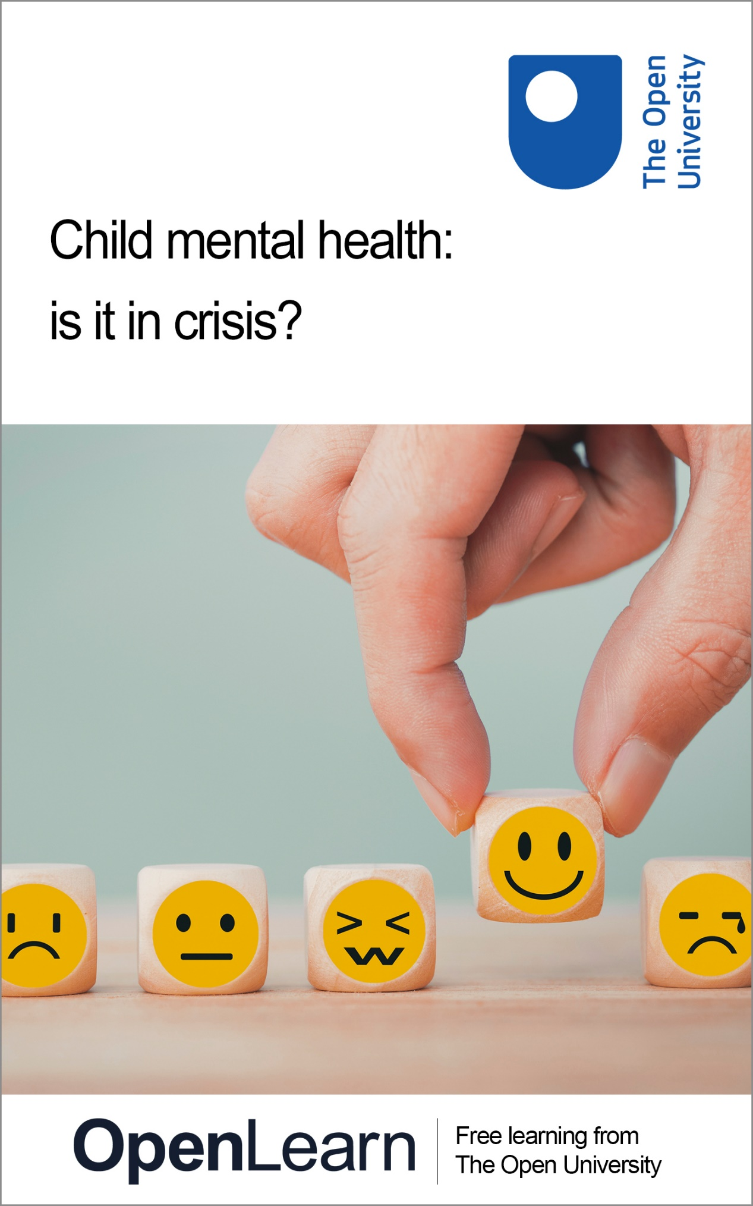

K119_1

Child mental health: is it in crisis?

About this free course
This free course is an adapted extract from the Open University course K119 Wellbeing across the lifecourse: www.open.ac.uk/courses/modules/k119.
This version of the content may include video, images and interactive content that may not be optimised for your device.
You can experience this free course as it was originally designed on OpenLearn, the home of free learning from The Open University –
www.open.edu/openlearn/health-sports-psychology/child-mental-health-it-crisis/content-section-0
There you’ll also be able to track your progress via your activity record, which you can use to demonstrate your learning.
Unless otherwise stated, copyright © 2024 The Open University, all rights reserved.
Intellectual property
Unless otherwise stated, this resource is released under the terms of the Creative Commons Licence v4.0 http://creativecommons.org/licenses/by-nc-sa/4.0/deed.en_GB. Within that The Open University interprets this licence in the following way: www.open.edu/openlearn/about-openlearn/frequently-asked-questions-on-openlearn. Copyright and rights falling outside the terms of the Creative Commons Licence are retained or controlled by The Open University. Please read the full text before using any of the content.
We believe the primary barrier to accessing high-quality educational experiences is cost, which is why we aim to publish as much free content as possible under an open licence. If it proves difficult to release content under our preferred Creative Commons licence (e.g. because we can’t afford or gain the clearances or find suitable alternatives), we will still release the materials for free under a personal end-user licence.
This is because the learning experience will always be the same high quality offering and that should always be seen as positive – even if at times the licensing is different to Creative Commons.
When using the content you must attribute us (The Open University) (the OU) and any identified author in accordance with the terms of the Creative Commons Licence.
The Acknowledgements section is used to list, amongst other things, third party (Proprietary), licensed content which is not subject to Creative Commons licensing. Proprietary content must be used (retained) intact and in context to the content at all times.
The Acknowledgements section is also used to bring to your attention any other Special Restrictions which may apply to the content. For example there may be times when the Creative Commons Non-Commercial Sharealike licence does not apply to any of the content even if owned by us (The Open University). In these instances, unless stated otherwise, the content may be used for personal and non-commercial use.
We have also identified as Proprietary other material included in the content which is not subject to Creative Commons Licence. These are OU logos, trading names and may extend to certain photographic and video images and sound recordings and any other material as may be brought to your attention.
Unauthorised use of any of the content may constitute a breach of the terms and conditions and/or intellectual property laws.
We reserve the right to alter, amend or bring to an end any terms and conditions provided here without notice.
All rights falling outside the terms of the Creative Commons licence are retained or controlled by The Open University.
Head of Intellectual Property, The Open University

Contents
- Introduction
- Learning outcomes
- 1 Is there a crisis?
  - 1.1 What does the evidence suggest?
- 2 ‘My child won’t go to school’
  - 2.1 The case study of Lily
  - 2.2 Lily’s parents seek help
  - 2.4 Supporting Lily and her parents
- Conclusion
- References
- Acknowledgements
- Solutions
- Descriptions

Introduction
Welcome to this free course, Child mental health: is it in crisis?. There is much discussion about the issue of children and young people’s mental health problems in the media in the United Kingdom, and we often hear this issue referred to as a ‘crisis’. But what does the evidence say? Are rates of mental health problems rising? In this course you will explore these important questions as well as delving into a case study of a young person with anxiety who is refusing to go to school, which is based on the real-life experiences of a service user of a child and adolescent mental health service (CAMHS).
This OpenLearn course is an adapted extract from the Open University course K119 Wellbeing across the lifecourse.

Learning outcomes
After studying this course, you should be able to:
- explain what the evidence says about whether child mental health is in crisis in the UK
- apply the ethical concepts of autonomy and paternalism to the example of school refusal
- describe how professionals and others assess children and young people with commonly occurring mental health problems.

1 Is there a crisis?

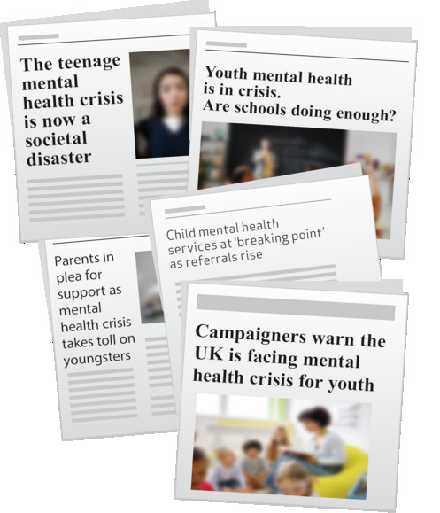
View description - Uncaptioned Figure
View alternative description - Uncaptioned Figure

UK newspapers paint a disturbing picture of children and young people’s mental health, portraying it as an emergency or a crisis, as highlighted by the headlines cited above. There are many factors that are often cited as creating a ‘crisis’. These include the impacts of the COVID-19 pandemic, the harmful effects of social media, children being concerned about global warming or young people worrying about their family’s ability to pay for their household’s necessities, such as food.
Before looking at some data, you will consider your own thoughts about whether the UK is facing a child and adolescent mental health crisis.

Activity 1 Are we facing a crisis?
Allow about 20 minutes

Part 1

Spend less than 5 minutes thinking about what your initial response is to the statement below, if you had to pick from one of the following five options. Note that you will be able to see the results of all those participating in this poll, but no individual will be identified.
We are facing a crisis in terms of the mental health of children and young people in the UK

Interactive content is not available in this format.

Part 2

Reflect on why you selected the response you did. How did you define ‘crisis’ (i.e. what constitutes a crisis)?

Provide your answer...
View discussion - Part 2

1.1 What does the evidence suggest?
‘The Child of the New Century’ study, also known as the Millennium Cohort Study (MCS), includes around 19,000 participants born across England, Scotland, Wales and Northern Ireland in 2000–2. At age 17 years, participants were assessed in terms of key mental health measures, specifically the percentage categorised as experiencing high psychological distress, the percentage who had self-harmed and the percentage who had attempted suicide. The results suggested that rates were similar across England, Scotland, Wales and Northern Ireland for the three outcomes considered (Patalay and Fitzsimons, 2020). Other key findings in terms of the mental health of young people in the UK included:

- The heightened levels of severe mental health difficulties, for instance almost one-quarter (24.1%) of 17-year-olds had self-harmed in the previous 12 months.
- The major sex differences noted, such that 22.1% of females and 10.1% of males experienced high levels of psychological distress.
- The large inequalities, including the compromised mental health of sexual minorities (e.g., lesbian, gay and bisexual youth) and those from lower income households.
(Patalay and Fitzsimons, 2020)

When the results from the MCS were compared to another sizeable population-based study from the UK (the Avon Longitudinal Study of Parents and Children) large increases were noted for key mental health difficulties, specifically depression and self-harm in the decade between 2005 and 2015 (Patalay and Gage, 2019). This adds further weight to the argument that mental health problems are becoming more prevalent among children and young people in the UK.
In addition to the alarm around the levels of mental health problems in children and young people, concern also exists regarding the provision of mental health services. For example, in Scotland the government in their Mental Health Strategy: 2017–2027 (Scottish Government 2017) highlighted increasing access to child and adolescent mental health services (CAMHS), reducing waiting times, and ensuring acceptable and high quality care as areas that needed particular attention. In England, a Care Quality Commission (an independent regulator of health and social care) report estimate that only a quarter of children and young people who require treatment for a mental health problem are able to access this treatment. Children and young people also felt that CAMHS staff did not have enough time to provide the quality of care they would like to (Care Quality Commission, 2017, p. 13).

2 ‘My child won’t go to school’
In the previous section you were presented with data that reinforce a likely increase in the proportion of children and young people experiencing mental health problems across time. Although most children and young people remain well, the notable increases in mental health problems coupled with issues associated with accessing CAMHS are a concern. Referring to the situation as a ‘crisis’ is therefore not really alarmist and may be useful in terms of advocating for further resources to help support the mental health of children and young people.
It is important to address mental health problems in children and young people as early onset problems often persist well into adulthood (Thompson et al., 2021). Common mental health problems for children and young people can span emotional symptoms, conduct or behavioural problems, hyperactivity-inattention and peer relationship problems, or any combination of these. An increasingly prominent issue post COVID-19 is school refusal (a reluctance or refusal of a child or young person to attend school which results in prolonged absences (Berg, 1997)). You will explore this in more detail through the fictional case study of Lily.

2.1 The case study of Lily
The case study of Lily that you look at next is based on a real-life young person who accessed child and adolescent mental health services (CAMHS). All key details have been changed to ensure this young person and their family cannot be identified.

Case study: Lily

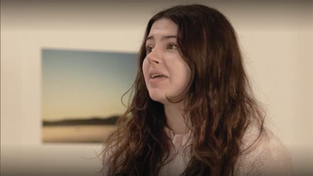
View description - Uncaptioned Figure
View alternative description - Uncaptioned Figure

Lily is 14 years old and lives at home with her mother and father. She is worried that her family, especially her mother (June), will die in a natural disaster, like an earthquake or volcanic eruption – events that are very unlikely in the UK. These are topics her class began studying in geography last term. She has had problems attending school for many weeks now. Lily gets very angry with her parents and has a ‘meltdown’ when they try to force her to go to school and she has been in effect home-schooled for almost a whole term. Lily’s school is insisting on a return-to-school plan and her parents are finding it hard to agree about this.

Activity 2 Lily and returning to school
Allow about 45 minutes

Part 1

Watch the following video of Lily with her parents.

Video content is not available in this format.
View transcript - Uncaptioned interactive content

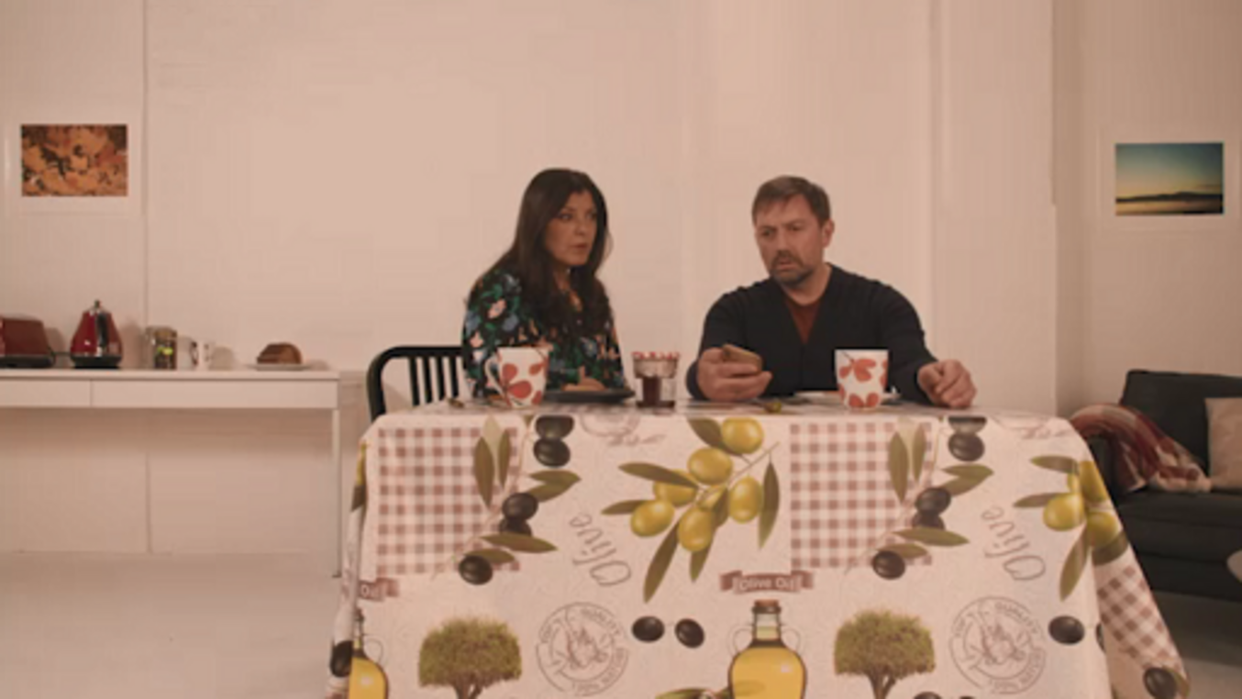

Observing her body language and listening to what she says, note down the ways in which you can tell that Lily is distressed.

Provide your answer...
View discussion - Part 1

Part 2

Spend less than 10 minutes thinking about what your initial response is to the statement below and then pick from one of the five options to indicate whether you agree that forcing Lily back to school is the right course of action.
Lily is experiencing difficulties but should return to school in-person imminently.

Interactive content is not available in this format.

Part 3

The activity below is designed to encourage your ethical reasoning concerning the dilemma of Lily being made to return to school. You will draw on two key concepts (paternalism and autonomy) in completing the activity. These concepts are briefly defined below:
- Paternalism = Decisions are made for someone else, but these need to be in the person’s best interests (e.g. when a parent makes decisions on behalf of a child or young person, because this is for their ‘own good’).
- Autonomy = A person’s (e.g. Lily’s) ability to manage their own matters and make their own important life decisions.
Answer the following questions, in each case deciding whether the statement given is an example of paternalism or autonomy.
1. ‘Lily might not like it, but it’s what the adults think is best for her.’

Paternalism
Autonomy
View answer - Part 3

2. ‘It’s Lily’s life, she should be able to decide what she does.’

Autonomy
Paternalism
View answer - Part

3 ‘It should be Lily’s choice, she says it’s too hard for her at the moment, end of.’

Paternalism
Autonomy
View answer - Part

4. ‘School isn’t optional, Lily needs to go, irrespective of what she says.’

Paternalism
Autonomy
View answer - Part

5. ‘Lily needs to go to school as it’s for her own good.’

Autonomy
Paternalism
View answer - Part

6. ‘No one should be forced to go to school if they don’t want to go.’

Paternalism
Autonomy
View answer - Part

In the next section, the case study of Lily will continue and you will consider the sources of support available.

2.2 Lily’s parents seek help
Read the next part of Lily’s case study.

Case study: Lily
Fortunately, Lily’s parents recognise that they need help, and they take Lily to see her family doctor/general practitioner (GP). During her appointment Lily starts to cry and she discusses her worries. Lily’s doctor asks her to complete a Strengths and Difficulties Questionnaire and notices her very high scores in terms of emotional symptoms. The GP explains that Lily’s issues could be understood by Figure 1.

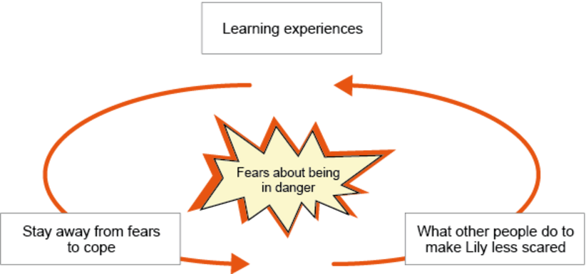
Figure 1 Lily’s fear–avoidance cycle (adapted from Siddaway, Wood and Cartwright-Hatton, 2014)
View description - Figure 1 Lily’s fear–avoidance cycle (adapted from Siddaway, Wood and Cartwright-Hatton, ...
View alternative description - Figure 1 Lily’s fear–avoidance cycle (adapted from Siddaway, Wood and Cartwright-Hatton, ...

In Lily’s case the ‘learning experiences’ revolve around her developing the firm belief that she cannot cope leaving home to attend school, and that school is a risky and unsafe place away from home and her loved ones. Being at home is where she feels she ‘needs’ to be, given her fears of what could happen to her parents (i.e. fears about them being in danger). While staying away from her fears (i.e. school, where she is at a distance from her mother) appears to help her cope or manage, it becomes a cycle whereby her avoidance maintains her anxious feelings. These anxious feelings are then (inadvertently) supported by her parents who unintentionally reinforce her avoidance by presenting in-person school attendance as optional and reducing their demands of her to make her feel less scared. Lily may then come to view herself as someone that cannot cope when outside her home, further reinforcing her anxiety levels.
In the case study above the Strengths and Difficulties Questionnaire (SDQ) was mentioned. You may be unfamiliar with what this. Developed by Professor Robert Goodman, the SDQ is a well-tested assessment of mental health. It moves beyond merely highlighting issues, exploring strengths as well. Additionally, parents and young people report that the SDQ is quick to complete, and that the questions it asks are meaningful, simple and unambiguous (Stasiak et al., 2012). It is designed to assess children and young people aged between 4 and 17 years old and is usually completed by a parent/guardian or teacher. You will the explore the SDQ in more detail in the next activity.

Activity 3 Critiquing the strengths and difficulties questionnaire
Allow about 1 hour

Spend some time familiarising yourself with the questions (also known as items) in the Strengths and Difficulties Questionnaire (SDQ). Then, answer the four questions that follow:

Strengths and Difficulties Questionnaire
For each item, please mark the box for Not True, Somewhat True or Certainly True. It would help us if you answered all items as best you can even if you are not absolutely certain or the item seems daft! Please give your answers on the basis of the child’s behaviour over the last six months or this school year.
Child’s Name .................................................
Male/Female
Date of Birth....................................................

 | Not True | Somewhat True | Certainly true
Considerate of other people’s feelings
Restless, overactive, cannot stay still for long
Often complains of headaches, stomach-aches or sickness
Shares readily with other children (treats, toys, pencils etc.)
Often has temper tantrums or hot tempers
Rather solitary, tends to play alone
Generally obedient, usually does what adults request
Many worries, often seems worried
Helpful if someone is hurt, upset or feeling ill
Constantly fidgeting or squirming
Has at least one good friend
Often fights with other children or bullies them
Often unhappy, down-hearted or tearful
Generally liked by other children
Easily distracted, concentration wanders
Nervous or clingy in new situations, easily loses confidence
Kind to younger children
Often lies or cheats
Picked on or bullied by other children
Often volunteers to help others (parents, teachers, other children)
Thinks things out before acting
Steals from home, school or elsewhere
Gets on better with adults than with other children
Many fears, easily scared
Sees tasks through to the end, good attention span

Date ...........................................................................
Parent/Teacher/Other (please specify:)
Signature ...........................................................................
Thank you very much for your help

Source: © Robert Goodman, 2005
- What are your initial impressions of the assessment?
- Reflect on a time when you were an adolescent (approximately between the ages of 11 and 17 years old) what 3 (or more) items were ‘certainly true’ of you (attempt to pick at least one that is not obviously a ‘positive’ or strength)?
- Was it hard to recall the items that were ‘certainly true’ or was it challenging to think of your difficulties when younger?
- There are 25 items in the SDQ, of which 5 are ‘strengths’. Which do you think are the five strengths-based items?

Provide your answer...
View discussion - Part

2.4 Supporting Lily and her parents
Read the last part of the case study of Lily below.

Case study: Lily
Lily’s GP refers her to CAMHS and when Lily’s parents ask what treatment will include, the GP says it will likely be cognitive behavioural therapy (CBT). CBT is a form of therapy that consists of both behavioural components (i.e. understanding and making strategic changes to behaviours/activities) and cognitive components (i.e. making sense of and shaping/changing thinking patterns/cognitions). The evidence base supports CBT use for child anxiety issues, as it is an effective treatment given its focus on both the cognitive and behavioural aspects of her clinical presentation (National Institute for Health and Care Excellence/NICE, 2013). CBT is frequently employed in CAMHS, including in specific formats such as manualised (specially formulated and structured) versions of treatment (Merry et al., 2020). This approach is then well suited to CAMHS, because for many clinicians working in the field their training in empirically supported treatments takes place after qualifying, either informally on the job or via courses which support a manualised approach (Merry et al., 2020). Note that Lily is fortunate to live in an area where she is seen fairly promptly by her local CAMHS, which is not always the case.

The case study above notes how Lily is supported by her family doctor, but parents also need to consider their own wellbeing. In the next activity you will listen to a parent talk about their experience of supporting her child who refused to go school.

Activity 4 How to cope when your child can’t
Allow about 15 minutes

‘All in the Mind’ is a BBC Radio 4 Open University–BBC co-produced series. Listen to the following audio where a parent (Ursula) and clinician (Roz) talk to the presenter (Claudia Hammond) about how to cope when your child can’t. Note down who is responsible in situations when a child refuses to go to school and the strategies cited that can help parents cope.
Access the audio at the following link and listen from 05:46 (‘And that was something …’) to 09:38 (’... does multi-tasking help you or not help you?’).
How to cope when your child can’t

Provide your answer...
View discussion - Activity 4 How to cope when your child can’t

Conclusion
There has been much discussion about whether there is a crisis in terms of child and adolescent mental health. In this course, you have explored your own opinion on this debate as well as considered relevant data. While most children and young people are well, increasing numbers of them are reporting a probable mental health disorder. Unfortunately, those that require professional help are not necessarily receiving this, due for example to a lack of availability of CAMHS. The course also provided you with the case study of Lily, through which you investigated how a common mental health problem, that of anxiety, can result in the issue of school refusal. You explored ethical issues around forcing young people to return to school, as well as ways that CAMHS can help.
This OpenLearn course is an adapted extract from the Open University course K119 Wellbeing across the lifecourse.

References
Berg, I. (1997) School refusal and truancy. Arch Dic Child, 76,pp. 90–1.
Care Quality Commission (2017) Review of children and young people’s mental health services: Phase one report. Newcastle upon Tyne: Care Quality Commission.
Goodman, R., Meltzer, H. and Bailey, V. (1998) ‘The Strengths and Difficulties Questionnaire: A pilot study on the validity of the self-report version’, European Child and Adolescent Psychiatry, 7(3), pp. 125–30.
Merry, S.N., Hopkins, S., Lucassen, M.F.G., Stasiak, K., Weisz, J.R., Frampton, C.M., Bearman, S.K., Ugueto, A.M., Herren, J., Cribb-Su’a, A. and Kingi-Uluave, D. (2020) ‘Effect of clinician training in the modular approach to therapy for children vs usual care on clinical outcomes and use of empirically supported treatments: A randomized clinical trial’, JAMA Network Open, 3(8), pp. e2011799–e2011799.
National Institute for Health and Care Excellence (2013) Social anxiety disorder: recognition, assessment and treatment: Clinical guideline [CG159]. Available at: https://www.nice.org.uk/guidance/cg159/chapter/Recommendations#interventions-for-children-and-young-people-with-social-anxiety-disorder-2 (Accessed: 11 October 2023).
Patalay, P. and Gage, S.H. (2019) ‘Changes in millennial adolescent mental health and health-related behaviours over 10 years: a population cohort comparison study’, International Journal of Epidemiology, 48, pp. 1650–1664.
Patalay, P. and Fitzsimons, E. (2020) Mental ill-health at age 17 in the UK: Prevalence of and inequalities in psychological distress, self-harm and attempted suicide. London: Centre for Longitudinal Studies.
Scottish Government (2017) Mental Health Strategy: 2017–2027. Edinburgh: Scottish Government.
Siddaway, A.P., Wood, A.M. and Cartwright-Hatton, S. (2014) ‘Involving parents in cognitive-behavioral therapy for child anxiety problems: A case study’, Clinical Case Studies, 13, pp. 322–35.
Stasiak, K., Parkin, A., Seymour, F., Lambie, I., Crengle, S., Pasene-Mizziebo, E. and Merry, S. (2012) ‘Measuring outcome in child and adolescent mental health services: consumers’ views of measures’, Clinical Child Psychology and Psychiatry, 18, pp. 519–35.
Thompson, E.J., Richards, M., Ploubidis, G.B., Fonagy, P. and Patalay, P. (2021) ‘Changes in the adult consequences of adolescent mental ill-health: findings from the 1958 and 1970 British birth cohorts’, Psychological Medicine, pp. 1–10.

Acknowledgements
This free course was written by Phillipa Waterhouse, and is based on OU K119 course materials written by Mathijs Lucassen.
Except for third party materials and otherwise stated (see terms and conditions), this content is made available under a Creative Commons Attribution-NonCommercial-ShareAlike 4.0 Licence.
The material acknowledged below is Proprietary and used under licence (not subject to Creative Commons Licence). Grateful acknowledgement is made to the following sources for permission to reproduce material in this free course:
Images
Course image: © picture / iStock / Getty Images Plus
Section 1 image: Headlines:
- Beal, J. (2022) ‘Child mental health services at “breaking point” as referrals rise’, The Times, 11 April. Available at: https://www.thetimes.co.uk/article/child-mental-health-services-at-breaking-point-nhs-referrals-lockdown-tphkjjzn9 (Accessed: 14 December 2023).
- Buckland, D. (2022) ‘Parents in plea for support as mental health crisis takes toll on youngsters’, Express, 7 August. Available at: https://www.express.co.uk/news/uk/1651678/mental-health-children-parents-services-waiting-times (Accessed: 14 December 2023).
- Independent (2022) ‘Youth mental health is in crisis. Are schools doing enough?’, 17 August. Available at: https://www.independent.co.uk/news/ap-joe-biden-student-mental-health-schools-fairfax-county-b2147263.html (Accessed: 14 December 2023).
- Johnston, L. and McCann, J. (2022) ‘Campaigners warn the UK is facing mental health crisis for youth’, Express, 21 August. Available at: https://www.express.co.uk/life-style/health/1658272/mental-health-crisis-youth-uk-campaigners-warning (Accessed: 14 December 2023).
- Lewis, J. (2022) ‘The teenage mental health crisis is now a societal disaster’, The Telegraph, 12 October. Available at: https://www.telegraph.co.uk/news/2022/10/12/teenage-mental-health-crisis-now-societal-disaster/ (Accessed: 14 December 2023).
Section 2.1 image: © The Open University
Figure 1: Adapted from Siddaway, A.P., Wood, A.M. and Cartwright-Hatton, S. (2014) ‘Involving parents in cognitive-behavioral therapy for child anxiety problems: a case study’, Clinical Case Studies, 13(4), pp. 322–35.
Audio-visual
Activity 3 video: © Hamlett Films/The Open University
Every effort has been made to contact copyright owners. If any have been inadvertently overlooked, the publishers will be pleased to make the necessary arrangements at the first opportunity.
Don't miss out
If reading this text has inspired you to learn more, you may be interested in joining the millions of people who discover our free learning resources and qualifications by visiting The Open University – www.open.edu/openlearn/free-courses.

Solutions

Activity 1 Are we facing a crisis?

Part 2

Discussion
In terms of your reasoning about whether there is a crisis or not, what guided your thinking? Was it that you thought that all young people that need professional help can’t get it or conversely that relevant services for children and young people are currently adequate and meeting the needs of service users? Or is it that you thought the majority (i.e. more than half) of all children and young people have mental health problems or by contrast that the majority are doing well enough? Or, assuming you think there is a crisis, is it that you suspect rates of mental health problems have gone up significantly?
Back to - Part 2

Activity 2 Lily and returning to school

Part 1

Discussion
Lily’s body language suggests she is distressed, based on her clutching a hot water bottle and her pained expressions. She also expresses her distress when stating, ‘You don’t understand, I’m not going. I don’t feel well, I’ve got stomach ache’ and ‘I’m not going to school, I hate it’.
Back to - Part 1

Part 3

Answer
Right:
Paternalism
Wrong:
Autonomy
Back to - Part 3

Part

Answer
Right:
Autonomy
Wrong:
Paternalism
Back to - Part

Part

Answer
Right:
Autonomy
Wrong:
Paternalism
Back to - Part

Part

Answer
Right:
Paternalism
Wrong:
Autonomy
Back to - Part

Part

Answer
Right:
Paternalism
Wrong:
Autonomy
Back to - Part

Part

Answer
Right:
Autonomy
Wrong:
Paternalism
Back to - Part

Activity 3 Critiquing the strengths and difficulties questionnaire

Part

Discussion
Thinking about the items, especially those that focus on issues or difficulties, can be challenging emotionally. Plus, it can be hard to think about how you would have been as a young person retrospectively, after several years have passed. It is also common for people completing self-report questionnaires like the SDQ to comment that it is difficult to decide which response is the most accurate when only three possible responses are available (i.e. ‘not true’, ‘somewhat true’ and ‘certainly true’).
The strengths, known as the prosocial scale in the SDQ (i.e. traits that show an orientation towards the welfare of others), are ‘I try to be nice to other people. I care about their feelings’; ‘I usually share with others (food, games, pens, etc.)’; ‘I am helpful if someone is hurt, upset or feeling ill’; ‘I am kind to younger children’; and ‘I often volunteer to help others (parents, teachers, children) (Goodman, Meltzer and Bailey, 1998). The four other scales are all difficulties (or deficit) focused, and they are the hyperactivity scale, emotional symptoms scale, conduct problems scale and peer problems scale (Goodman, Meltzer and Bailey, 1998).
Back to - Part

Activity 4 How to cope when your child can’t

Discussion
Answers will vary, but Ursula estimated with a child who was 11 at the time (i.e. younger than Lily) that the responsibility for her child going to school wasn’t entirely hers (or that of parents generally). However, the responsibility is spread across the parents (who she estimated are about one-third responsible), the child and their school. Ursula queried whether it was necessary for a child to be happy all the time (i.e. this isn’t realistic) and it was identified that there are ‘no quick fixes’. Instead, parents need to find out what works for them – including the use of appropriate boundaries.
Back to - Activity 4 How to cope when your child can’t

Descriptions

Uncaptioned Figure
Newspaper headlines stating ‘The teenage mental health crisis is now a societal disaster’, ‘Youth mental health is in crisis. Are schools doing enough?’, ‘Child mental health services at “breaking point” as referrals rise’, ‘Parents in plea for support as mental health crisis takes toll on youngsters’ and ‘Campaigners warn the UK is facing mental health crisis for youth’.
Back to - Uncaptioned Figure

Uncaptioned Figure
Newspaper headlines stating ‘The teenage mental health crisis is now a societal disaster’, ‘Youth mental health is in crisis. Are schools doing enough?’, ‘Child mental health services at “breaking point” as referrals rise’, ‘Parents in plea for support as mental health crisis takes toll on youngsters’ and ‘Campaigners warn the UK is facing mental health crisis for youth’.
Back to - Uncaptioned Figure

Uncaptioned Figure
A picture of ‘Lily’, a teenager who, based on her facial expression, appears to be distressed.
Back to - Uncaptioned Figure

Uncaptioned Figure
A picture of ‘Lily’, a teenager who, based on her facial expression, appears to be distressed.
Back to - Uncaptioned Figure

Figure 1 Lily’s fear–avoidance cycle (adapted from Siddaway, Wood and Cartwright-Hatton, 2014)
The figure consists of an overarching theme, depicted in the middle, stated as ‘Fears about being in danger’. These fears are compounded by learning experiences which visually surround the over-arching theme: ‘Stay away from fears to cope’ leads to (as indicted by an arrow) ‘What other people do to make Lily less scared’, which in turn leads again to (as indicated by another arrow) ‘Stay away from fears to cope’ (i.e. there is a cycle of fears).
Back to - Figure 1 Lily’s fear–avoidance cycle (adapted from Siddaway, Wood and Cartwright-Hatton, 2014)

Figure 1 Lily’s fear–avoidance cycle (adapted from Siddaway, Wood and Cartwright-Hatton, 2014)
The figure consists of an overarching theme, depicted in the middle, stated as ‘Fears about being in danger’. These fears are compounded by learning experiences which visually surround the over-arching theme: ‘Stay away from fears to cope’ leads to (as indicted by an arrow) ‘What other people do to make Lily less scared’, which in turn leads again to (as indicated by another arrow) ‘Stay away from fears to cope’ (i.e. there is a cycle of fears).
Back to - Figure 1 Lily’s fear–avoidance cycle (adapted from Siddaway, Wood and Cartwright-Hatton, 2014)

Uncaptioned interactive content

Transcript
[Text on screen: I can’t go to school]
MRS WRIGHT (ON PHONE)
It’s been ten days since Lily made an appearance in school. Her attendance was poor before half-term, but now not turning up at all makes it even more concerning. Do you think she’ll be coming in today?
JUNE
Honestly, Mrs. Wright, we try every day. Every morning’s a battle at our house. She just point blank refuses to budge, and we can’t force her. We can’t drag her into the car.
MRS WRIGHT (ON PHONE)
We’re getting to the point where the school has to take further action. We can’t allow her to continue not attending.
JUNE
We really are doing our best. We’re out of ideas. She gets so upset.
DAVE
And she says she’s got a stomach ache, and she doesn’t look well when she’s like this. I mean, we’ve got an appointment with the GP next week. And she’s been doing her work online. Can she not carry on doing that for now?
MRS WRIGHT (ON PHONE)
Yes, I’ll send her the work, but you must understand we need to work out some return to school plan that means Lily is going to be back in school full time.
DAVE
Yes, OK. That woman. She doesn’t know what it’s like to have to fight with a teenager every morning. Doesn’t she understand we’re trying to do our best?
JUNE
She’s only doing what she has to. Besides, Lily should be going to school. She’s ruining her chances. I just don’t understand what’s wrong with her.
DAVE
Well, I don’t know what all the fuss is about. I used to bunk off school. Didn’t do me too much harm. Look, she just needs a bit of time. She got over it before. It just took a bit of patience.
JUNE
Dave, last time she was six. It was when she changed teachers and I could be in class with her so she could get over it. She’s 14 now.
DAVE
Are you sure that she’s not being bullied? Or maybe she’s got into a situation that she doesn’t know how to cope with or handle? Maybe with a lad or something.
JUNE
I’ve asked and asked her. She swears she’s not. And I asked some of the other mums, and they say nobody said there’s been anything going on. She says we’re all going to die in some sudden disaster if she’s trapped in school. It’s ridiculous. She’s ruining her life.
DAVE
It happens. There are flash floods somewhere every year. It’s global warming. I don’t blame her for worrying.
JUNE
We need to sort this out. She can’t just not go to school.
DAVE
What do you suggest? We can’t bundle a 14-year-old into a car. Oh, Lil! You’re not dressed! The school’s been on to us again. We’ve got to get you there.
LILY
I’m not going.
JUNE
Come on, Lily. We can’t carry on like this. You know you’ve got to go back, and the longer you leave it, the harder it is.
LILY
You don’t understand. I’m not going. I don’t feel well. I’ve got a stomach ache.
JUNE
You’re missing out on your education. You’re ruining your chances. You’re supposed to be choosing your exam subjects in a couple of weeks.
LILY
I’m doing the work online.
JUNE
It’s not the same as being in the class with your teachers. What about your friends?
LILY
They don’t care. I’ve said, I’m not going.
DAVE
Lil, your mum’s just trying to help. We’re worried. Look, when is that doctor’s appointment?
JUNE
Not until next Wednesday. But no one has a stomach ache every school day and not at weekends.
DAVE
Look, that’s not fair, June.
LILY
I have got a stomach ache. I’m not going to school. I hate it!
JUNE
But you’d have to go back eventually. Me and your dad will end up getting into trouble. Can’t you at least try for us?
LILY
I’ve told you, I’m not going. I’m not going. I’m not going! Why can’t you leave me alone? I’m not going to school, and you can’t make me. I hate you!
Back to - Uncaptioned interactive content

