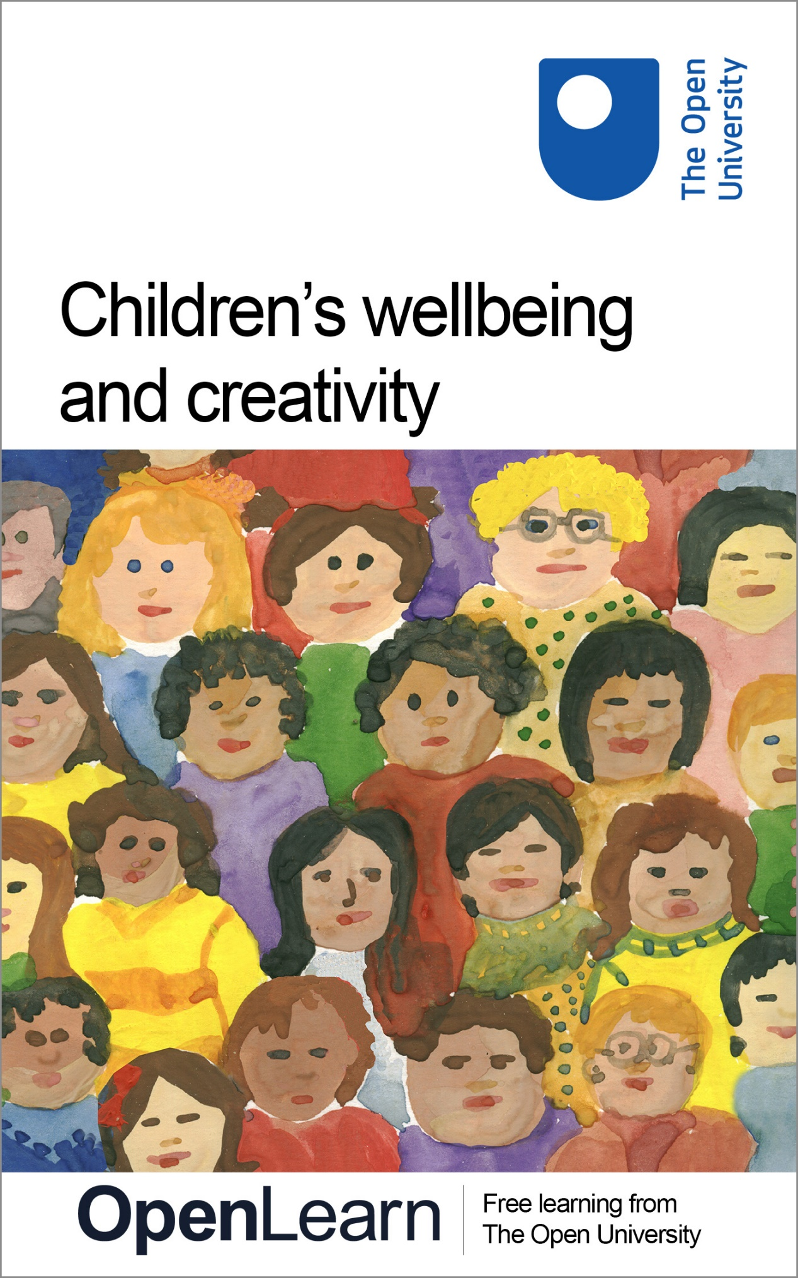

KE207_1

Children’s wellbeing and creativity

About this free course
This free course is an adapted extract from the Open University course KE207 Supporting children and young people’s wellbeing: https://www.open.ac.uk/courses/modules/ke207/.
This version of the content may include video, images and interactive content that may not be optimised for your device.
You can experience this free course as it was originally designed on OpenLearn, the home of free learning from The Open University – https://www.open.edu/openlearn/health-sports-psychology/childrens-wellbeing-and-creativity/content-section-0
There you’ll also be able to track your progress via your activity record, which you can use to demonstrate your learning.
First published 2026.
Unless otherwise stated, copyright © 2026 The Open University, all rights reserved.
Intellectual property
Unless otherwise stated, this resource is released under the terms of the Creative Commons Licence v4.0 http://creativecommons.org/licenses/by-nc-sa/4.0/deed.en. Within that The Open University interprets this licence in the following way: www.open.edu/openlearn/about-openlearn/frequently-asked-questions-on-openlearn. Copyright and rights falling outside the terms of the Creative Commons Licence are retained or controlled by The Open University. Please read the full text before using any of the content.
We believe the primary barrier to accessing high-quality educational experiences is cost, which is why we aim to publish as much free content as possible under an open licence. If it proves difficult to release content under our preferred Creative Commons licence (e.g. because we can’t afford or gain the clearances or find suitable alternatives), we will still release the materials for free under a personal end-user licence.
This is because the learning experience will always be the same high quality offering and that should always be seen as positive – even if at times the licensing is different to Creative Commons.
When using the content you must attribute us (The Open University) (the OU) and any identified author in accordance with the terms of the Creative Commons Licence.
The Acknowledgements section is used to list, amongst other things, third party (Proprietary), licensed content which is not subject to Creative Commons licensing. Proprietary content must be used (retained) intact and in context to the content at all times.
The Acknowledgements section is also used to bring to your attention any other Special Restrictions which may apply to the content. For example there may be times when the Creative Commons Non-Commercial Sharealike licence does not apply to any of the content even if owned by us (The Open University). In these instances, unless stated otherwise, the content may be used for personal and non-commercial use.
We have also identified as Proprietary other material included in the content which is not subject to Creative Commons Licence. These are OU logos, trading names and may extend to certain photographic and video images and sound recordings and any other material as may be brought to your attention.
Unauthorised use of any of the content may constitute a breach of the terms and conditions and/or intellectual property laws.
We reserve the right to alter, amend or bring to an end any terms and conditions provided here without notice.
All rights falling outside the terms of the Creative Commons licence are retained or controlled by The Open University.
Head of Intellectual Property, The Open University

Contents
- Introduction
- Learning outcomes
- 1 What is wellbeing?
- 2 Definitions of wellbeing
- 3 Views about wellbeing
- 4 Creativity and wellbeing
- 5 Dance and wellbeing
- 6 Online gaming
- 7 Arts and crafts
- Conclusion
- References
- Acknowledgements
- Solutions
- Descriptions

Introduction
This short course is designed to introduce you to creativity and its link to children and young people’s wellbeing. It explores children and young people’s engagement with creative activities that contribute to and promote their wellbeing. You will look at a number of ways in which children and young people’s wellbeing can be enhanced and supported through their engagement with convivial, community and creative activities – promoting wellbeing can be fun! You will be introduced to a further couple of models of wellbeing with a view to helping you piece together the concept of wellbeing.
This OpenLearn course is an adapted extract from the Open University course KE207 Supporting children and young people’s wellbeing.

Learning outcomes
After studying this course, you should be able to:
- analyse what is meant by children and young people’s wellbeing
- analyse the relationship between creativity and wellbeing
- evaluate different types of creative activities and how these can help support wellbeing.

1 What is wellbeing?
Wellbeing is a commonly used term which also connects to ideas about feeling well and unwell, feeling happy and feeling sad. This might appear obvious, however, ideas and understandings about wellbeing are not straightforward. Closer inspection reveals wellbeing to be a complex and often contested term.

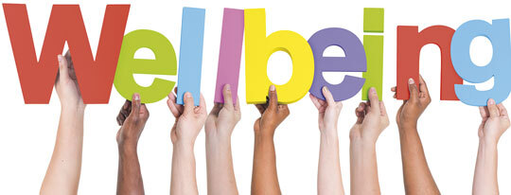
View description - Uncaptioned Figure
View alternative description - Uncaptioned Figure

In this section, you will first reflect on your own understanding of wellbeing before listening to the views of children, young people, practitioners and those with caring responsibilities for children and young people, as well as looking at formal definitions.

Activity 1 What is Wellbeing?
Allow 30 minutes for this activity

Spend some time thinking about what the term ‘wellbeing’ means to you. Don’t overthink this – just go with your initial thoughts and write down five words which define wellbeing.

1)
2)
3)
4)
5)
View feedback - Part

Now spend a few minutes reflecting on your responses. Why do you think you chose these particular words to define wellbeing?

Provide your answer...
View feedback - Part

Discussions about wellbeing have a long history and can be traced back to Ancient Greek philosophy, in particular, the work of Aristotle, who wrote extensively using the term eudaimonia to describe human happiness, contentment and feelings of wellbeing. More contemporary discussions about wellbeing cross over many academic disciplines, spanning philosophy, psychology, sociology and anthropology. The psychologist Ed Diener (1984) proposed a model of subjective wellbeing which described how individuals think about and evaluate their life satisfaction based on positive and negative life experiences. His work reminds us that although genetics may play a role people’s subjective wellbeing can also be influenced by the relationships, environments and activities in which our lives are embedded.

2 Definitions of wellbeing
In the next activity, you will look at different formal definitions of wellbeing.
Take a look at the following definitions of wellbeing that come from various sources.

How we feel, how well were coping with daily life or what feels possible at the moments. Good mental wellbeing doesn’t mean that you’re always happy.
(Mind, 2023)

The state of being comfortable, healthy and happy.
(Oxford English Dictionary)

Wellbeing can be understood as how people feel and how they function, both on a personal and social level, and how they evaluate their lives as a whole.
(New Economics Foundation 2012)

Wellbeing is not just the absence of ill health. It includes the way that people feel about themselves and their lives.
(NHS England 2022)

Activity 2 Definitions of wellbeing
Allow 30 mins for this activity
Having read the definitions, answer the following questions.

1 What are the common themes that cut across these definitions? Make a note of at least two.

Provide your answer...

2 What are the differences between the definitions? Make a note of at least two.

Provide your answer...
View feedback - Part

In the next section, you will listen to children, young people, parents, carers and practitioners from a range of children’s services talk about wellbeing and what this term means to them.

3 Views about wellbeing


View description - Uncaptioned Figure
View alternative description - Uncaptioned Figure

Listen to Audio 1 which covers a range of perspectives on wellbeing. Consider what this term means to them.

Audio content is not available in this format.
Audio 1 Perspectives on wellbeing
View transcript - Audio 1 Perspectives on wellbeing

The audio interviews illustrate the different ways in which wellbeing is understood by different people. You heard parents/ carers and practitioners talk about how wellbeing can be considered as both physical and emotional, and how it also connects to much broader ideas about safety, having fun and being creative as well as feeling included, being respected by others and that you belong. Furthermore, the audio introduces the idea of thriving and reaching ones potential, which is core foundation for a child and young persons wellbeing. A few of the practitioners also talk about how the concept of wellbeing aligns with ideas about happiness and contentment- reflecting how a person feels.
You can see that the concept of wellbeing is highly subjective and changeable and may be influenced by a variety of social, economic, psychological and physical factors.
In the next activity, you will generate your own ideas about these factors which influence a child or young person’s wellbeing

Activity 3 What different factors influence wellbeing?
Allow approximately 45 minutes for this activity.

What different factors do you think influence a child or young person’s wellbeing? Spend some time adding your own ideas to the interactive below. It focuses on four factors which potentially influence a child or young person’s wellbeing (psychological, economic, social and physical factors).

Interactive content is not available in this format.

View feedback - Activity 3 What different factors influence wellbeing?

4 Creativity and wellbeing
In this section, you are invited to explore how involvement in creative activities can directly benefit children and young people’s wellbeing. For example, some creative activities offer opportunities for learning or provide a place or space where identity, interests and passions can develop that may positively influence mental health and self-esteem. There is further potential for practitioners to use creative activities as a vehicle to offer support to children and young people that might positively impact their individual needs, circumstances and wellbeing. For example, considered and clearly planned ideas for learning activities which engage children and young people in discussing lived experiences, personal feelings or current world or societal issues.

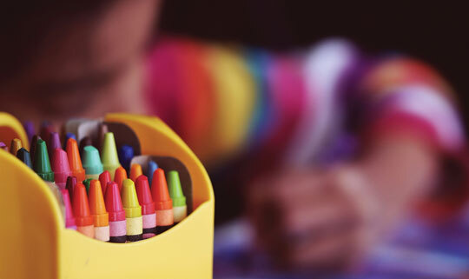
View description - Uncaptioned Figure
View alternative description - Uncaptioned Figure

Although opportunities for creativity can take place at various points in everyday life, it is interesting to see how they can be portrayed and considered in a policy context. One example is the large scoping study (which is a review of current literature) published by the World Health Organization (WHO), which shows the importance of the arts for health and wellbeing for people of all ages (Fancourt and Finn, 2019). Although creativity can be broader than just the arts, this study is useful to consider. First, it signals an increasing interest in policy, practice and research in the broad area of wellbeing. Second, some of the findings can be applied usefully to the demographic group of children and young people. WHO present the results from this scoping study under two broad themes, presented in the table below, which show how the arts can benefit health at different stages of life.

Table 1
Prevention and promotion of mental and physical health | Management and treatment of mental and physical health
Affect the social determinants of health | Help people experiencing mental illness
Support child development | Support care for people with acute conditions
Encourage health-promoting behaviours | Help to support people with neurodevelopmental and neurological disorders
Help to prevent ill health | Support with the management of noncommunicable diseases
Support caregiving | Support end-of-life care
(Fancourt and Finn, 2019, pp. vii–viii)

Broadly, the table illustrates how engagement in the arts might be used at various life stages to benefit the health of individuals. The possible ways for this to take place are outlined at the start of the report.
In relation to health research, engagement with the arts has been proposed as consisting of five broad categories (Fancourt and Finn, 2019, p. 1):
- performing arts (e.g. activities in the genre of music, dance, theatre, singing and film)
- visual arts, design and craft (e.g. crafts, design, painting, photography, sculpture and textiles)
- literature (e.g. writing, reading and attending literary festivals)
- culture (e.g. going to museums, galleries, art exhibitions, concerts, the theatre, community events, cultural festivals and fairs)
- online, digital and electronic arts (e.g. animations, film-making and computer graphics).
These categories provide a good starting point for considering opportunities for children and young people to engage in creative opportunities. Importantly, the WHO’s study notes that positive engagement in creative activities can trigger psychological, physiological, social and/or behavioural responses that can be beneficial to wellbeing. They note the following possible components that may be integral to the link between the arts and wellbeing: aesthetic engagement, involvement of the imagination, sensory activation, evocation of emotion, cognitive stimulation, social interaction, physical activity, engagement with themes of health and interaction with healthcare settings (Fancourt and Finn, 2019, p. 3).
To understand these components better, we are introducing you to three specific examples of creative activities that include the views of children and young people who take part in them.

5 Dance and wellbeing
Dance and drama provide opportunities for children and young people to use their imagination, develop individual skills and work together with peers to create shows, productions or performances. While engagement in dance and drama might be a personal process, with individuals each benefiting from different aspects, there is an evidenced connection between dance and wellbeing. Dr Anna Duberg delivers a powerful TEDx Talk entitled ‘How we can dance our way to better mental health’. She developed Dance for Health, a dance initiative to improve youth mental health and reduce stress through dancing, which is now widely implemented across Sweden as a cost-effective complement to school healthcare and has touched the lives of thousands of young people (TEDx Talks, 2023).

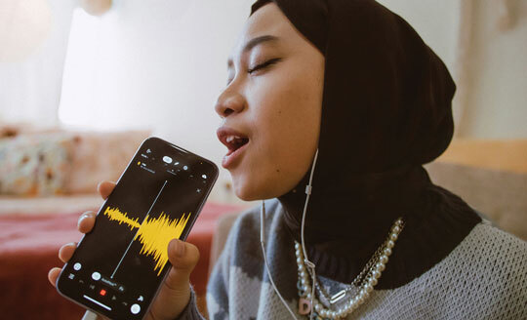
View description - Uncaptioned Figure
View alternative description - Uncaptioned Figure

There is a risk that certain forms of dance can be stereotypically portrayed for particular groups of people. For example, it is only fairly recently that ballet pointe shoes have been created in a range of skin tones (Freed of London, no date), and it tends to be female dancers who dance en pointe. Yet the opportunity to move to music in different ways is something that can be made available to most children and young people. In some cultures, dance is a key part of family and community celebrations. Whereas for others, it might take place in extracurricular activities or leisure time pursuits.
In the next activity, you have the opportunity to hear the experiences of some young people who enjoy and benefit from participating in dance.

Activity 4 Theatre and dance
Allow approximately 30 minutes for this activity.

Watch Video 1 of a young disabled woman, Saida, who has been a participant and now volunteers at Chickenshed in London, a theatre company designed to include everyone.
Then, watch Video 2 which captures reflections by a range of children and young people about why they love to dance.
Use Table 2 below to record any key quotes, that you believe support the view that dance has positive impact on wellbeing.

Video content is not available in this format.
Video 1 I am Saida
View transcript - Video 1 I am Saida

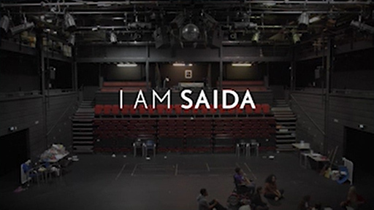

Video content is not available in this format.
Video 2 Why do you love to dance?
View transcript - Video 2 Why do you love to dance?

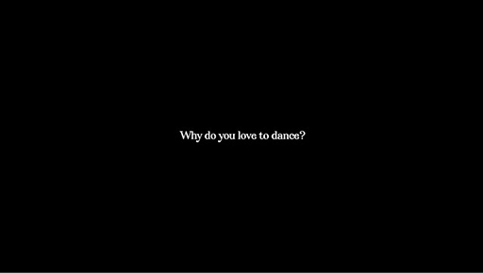

Table 2
Quote | Impact on wellbeing
Example: ‘I was quite a shy person when I was younger. I still kind of am, but I feel like I could never talk. I could never speak in front of 100 people, but I feel like I could dance in front of 100 people. It just makes me so confident.’ | Positive impact on self-confidence, linking to mental health
Provide your answer... | Provide your answer...
Provide your answer... | Provide your answer...
Provide your answer... | Provide your answer...
Provide your answer... | Provide your answer...

View feedback - Activity 4 Theatre and dance

6 Online gaming
For many years, there has been concern about young people’s time spent online, particularly playing video games.

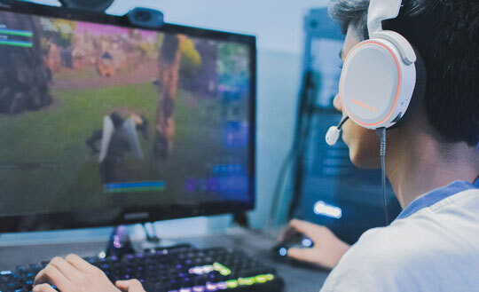
View description - Uncaptioned Figure
View alternative description - Uncaptioned Figure

There is some research evidence that shows violent video games can impact on children’s development (Wei, Liu and Chen, 2022; Erwin and Morton, 2008), but there are many factors that are involved in how children become aggressive, of which only one may be playing violent video games. Many young people take part in online communities or participate in and watch online sports (eSports).
eSports can be defined as:

a form of sports where the primary aspects of the sport are facilitated by electronic systems; the input of players and teams as well as the output of the eSports system are mediated by human-computer interfaces.
(Hamari and Sjöblom, 2017, p. 213)

eSports can involve individuals or teams taking part competitively in online games, or viewers watching a competitive game being played by others online, e.g. the online football game, FIFA. Viewers can watch in person at an event.
The Children’s Commissioner for England’s report (2024) ‘Digital playgrounds: children’s views on video gaming’, children and young people shared their own reflections about playing online games. They report finding playing online games to be fun and good for wellbeing, allowing them to develop digital skills and enabling them to remotely connect with friends.
In the next activity, you will meet a young person who created an idea and a solution to a problem he uncovered with regards to how board games have historically been developed, but which didn’t specifically meet his wishes and needs. He explains his positive experiences of online gaming and how he feels it benefits other young people.

Activity 5 Gaming and safe spaces
Allow approximately 30 minutes for this activity.

Read the blog post ‘Online gaming means autistic people can play in an environment we feel comfortable in and can control’ from the National Autistic Society.
1. What are the different ways in which Barrington’s wellbeing is positively impacted by participating in online gaming?

Provide your answer...

2. What did you learn about the needs of some autistic children and young people and how they may benefit from interacting online?

Provide your answer...

3. What else did you learn from reading this blog post?

Provide your answer...
View feedback - Part

7 Arts and crafts
The beauty of creative arts and activities is the flexible and diverse way in which they can be engaged with. Arts and crafts are often something that children are introduced to at an early age – sticking, gluing and painting in early years settings, often progressing to making cards at school for key celebrations.

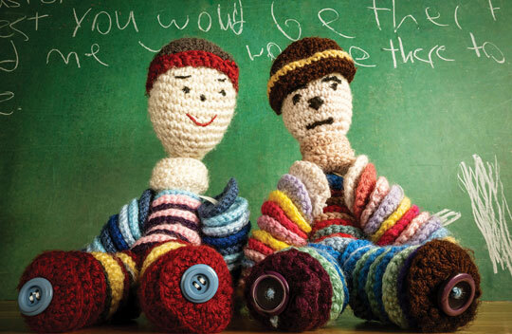
View description - Uncaptioned Figure
View alternative description - Uncaptioned Figure

There can be a satisfaction in creating something anew, or upcycling and recycling items for a different purpose, and often arts and crafts activities can enable this creative process. Craft can be an activity that enables children to share ideas and have a voice, which in its own way can promote their own and others wellbeing. It can be used to vocalise collective ideas and views that demonstrate children and young people’s political activism and concerns about the world around them. The term craftism as explored in the following activity has been coined to represent this type of involvement in arts and crafts.

Activity 6 Craft as activism
Allow approximately 50 minutes for this activity.

This activity explores the idea of using a craft as activism in different ways. Use the text boxes and prompts to record what you learn from watching the two videos and/or reading the article.
Video 3 is a BBC Newsround clip showing students at a boarding school being introduced to the concept of craftivism. You are welcome to watch the whole video, but the key part this activity requires you to watch is from 09:05 minutes in, start at: ‘During this term, some of the girls have been quietly learning a new skill,’ and end at 11:12 minutes; ‘It’s just trying to provoke people to think and look more into the issue.’ Video 3 Craftivism: Our Boarding School: 19. Prom Planners
Alternatively, you can read about the project: Craftivist collective: Introducing our ‘Gentle Protest’ Craftivism on Children’s BBC.
Video 4 is a recording of a project in London with a powerful initiative to re-purpose knives to create community equipment to positively benefit young people.

Video content is not available in this format.
Video 4 Steel Warriors
View transcript - Video 4 Steel Warriors

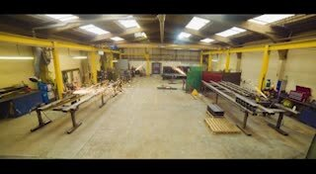

1. What do the students highlight regarding what they have learned about craftivism?

Provide your answer...
View feedback - Part

2. What message are Steel Warriors trying to convey through their actions?

Provide your answer...
View feedback - Part

3. How do you feel having learned about two very different examples of craftivism?

Provide your answer...
View feedback - Part

Conclusion
You have been provided with an insight to wellbeing and a variety of topics, resources and projects linked to creativity which can help promote it indifferent ways. Unlike completing a jigsaw, when often we look for the final piece to complete the picture, the hope is that you will continue piecing together your own understanding of wellbeing.

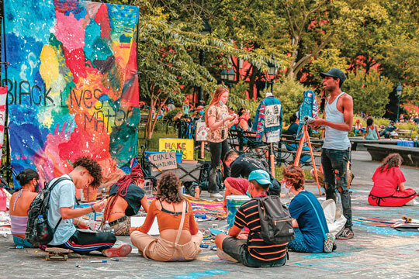
View description - Uncaptioned Figure
View alternative description - Uncaptioned Figure

It is worth remembering that creative activities are a fundamental right as stated in Article 31 of the United Nations Convention on the Rights of the Child (UNCRC):

All children to have rest and leisure, to engage in play and recreational activities appropriate to their age and to participate freely in cultural life and the arts.
(UNICEF, 1990)

A key theme of this course is that as practitioners, we can make a difference to children and young people’s lives. It can be easy to lose sight of this when it is so clear that there are challenges, barriers and inequalities faced by many children and their families. To finish, it is helpful to remember this short story.

A child finds a beach covered in starfish that have washed up on the shoreline and begins to throw them back into the water. A man walking along the beach comments that it is a thankless task because there is no way all the starfish can be saved. The child picks up one starfish, throws it back into the water and notes, ‘Well, I saved that one’. This is a timely reminder that if each of us considers the small actions we can take, together we can make a difference to the experiences and wellbeing of children and young people.
(Straube, 2011)

To conclude, here are the key points to take away from this course.
- There is no one agreed-upon way of understanding wellbeing. There are many different models that can help you think about how to support children and young people’s wellbeing.
- Creative activities can be supportive for children and young people’s wellbeing, and can include crafting, visual arts, digital gaming and more.
- Wellbeing is an important consideration not just for children and young people themselves; it’s also a vital aspect of practice, professional standards for working with children and young people, and for us all.
This OpenLearn course is an adapted extract from the Open University course KE207 Supporting children and young people’s wellbeing.

References
Children’s Commissioner (2024) Digital playgrounds: children’s views on video gaming. Available at: https://assets.childrenscommissioner.gov.uk/wpuploads/2024/01/Report-Digital-playgrounds-Childrens-views-on-gaming.pdf (Accessed: 29 September 2025).
Diener, E. (1984) ‘Subjective well-being’, Psychological Bulletin, 95(3), pp. 542–575.
Erwin, E.J. and Morton, N. (2008) ‘Exposure to media violence and young children with and without disabilities: powerful opportunities for family–professional partnerships’, Early Childhood Education Journal, 36, pp. 105–112
Fancourt, D. and Finn, S. (2019) What is the evidence on the role of the arts in improving health and well-being? A scoping review. World Health Organization (WHO) Health Evidence Network synthesis report 67. Available at: https://www.who.int/europe/publications/i/item/9789289054553 (Accessed: 21 December 2025).
Hamari, J. and Sjöblom, M. (2017) ‘What is eSports and why do people watch it?’, Internet Research, 27(2), pp. 211–223
Mind (2023) How to improve your mental wellbeing. Available at: https://www.mind.org.uk/information-support/tips-for-everyday-living/wellbeing/ (Accessed: 21 December 2025).
New Economics Foundation (2012) Measuring wellbeing: a guide for practitioners. London: New Economics Foundation.
NHS England (2022) Health survey England additional analyses, ethnicity and health, 2011-2019 experimental statistics. Available at: https://digital.nhs.uk/data-and-information/publications/statistical/health-survey-england-additional-analyses/ethnicity-and-health-2011-2019-experimental-statistics/wellbeing-copy (Accessed: 21 December 2025).
Oxford English Dictionary (2024) Well-being. Available at: https://www.oed.com/dictionary/well-being_n?tl=true (Accessed: 21 December 2025).
Straube, P. (2011) The starfish story: one step towards changing the world. Available at: https://eventsforchange.blog/2011/06/05/the-starfish-story-one-step-towards-changing-the-world/ (Accessed: 12 August 2025).
TEDx Talks (2023) How we can dance our way to better mental health. Anna Duberg. TEDxKI. Available at: https://www.youtube.com/watch?v=_0R_0n41y90 (Accessed: 19 January 2026).
Wei, M., Liu, Y. and Chen, S. (2022) ‘Violent video game exposure and problem behaviors among children and adolescents: the mediating role of deviant peer affiliation for gender and grade differences’, International Journal of Environmental Research and Public Health, 19, 15400.

Acknowledgements
This free course was written by Stephen Leverett.
Except for third party materials and otherwise stated (see terms and conditions), this content is made available under a Creative Commons Attribution-NonCommercial-ShareAlike 4.0 Licence.
The material acknowledged below is Proprietary and used under licence (not subject to Creative Commons Licence). Grateful acknowledgement is made to the following sources for permission to reproduce material in this free course:
Course image: Nina Rys / Shutterstock
Section 1 What is wellbeing?: Rawpixelimages / Dreamstime
Section 3 Views about wellbeing: akinbostanci / Getty
Section 4 Creativity and Wellbeing: Photo by Aaron Burden on Unsplash
Section 5 Dance and wellbeing: Photo by BandLab on Unsplash
Section 6 Online gaming: Photo by Priyam Raj on Unsplash
Section 7 Arts and crafts: Photo by Snow White on Unsplash
Conclusion: Photo by Lemon Ruan on Unsplash
Audio 1: Perspectives on wellbeing: The Open University
Video 1: I am Saida | We Are Chickenshed: Chickenshed; https://www.youtube.com/watch?v=UjiIir3ftDA
Video 2: Why do you love to dance?: Jade Lavinia Rumens; https://www.youtube.com/watch?v=RFPATiWEw_Q
Video 4: Steel Warriors: Steel Warriors / https://www.steelwarriors.co.uk/
Every effort has been made to contact copyright owners. If any have been inadvertently overlooked, the publishers will be pleased to make the necessary arrangements at the first opportunity.
Don't miss out
If reading this text has inspired you to learn more, you may be interested in joining the millions of people who discover our free learning resources and qualifications by visiting The Open University – www.open.edu/openlearn/free-courses.

Solutions

Activity 1 What is Wellbeing?

Part

Feedback
There are a number of words you may have chosen to describe wellbeing, including happiness, contentment, healthy, resilient, safe, strong, robust, secure and balanced.
Back to - Part

Part

Feedback
You may have chosen words which describe the physical or mental aspects of wellbeing or how wellbeing connects to feelings of safety and security. Or you may have chosen a whole host of other words not included here to define wellbeing and what this means to you. Wellbeing is a subjective concept and how you describe it reflects your own values and experiences.
Back to - Part

Activity 2 Definitions of wellbeing

Part

Feedback
You may have noted that three of the definitions include a reference to how people feel, emphasising the subjective quality of wellbeing. Although happiness is mentioned in a few of the definitions, so is the cautionary note that wellbeing does not necessarily mean you are happy all the time. It is important to note that wellbeing is fluid and quite changeable and can be thought of as a feeling, or as one definition describes, a state.
A few of the definitions also focus on health, connecting to ideas about how wellbeing encompasses both physical and mental health. One of the definitions also draws out the social aspect of wellbeing, while another focuses on the connection between wellbeing and coping with life.
An important learning point from this activity is that definitions of wellbeing are not straightforward. There are many ways of defining wellbeing and people differ in their ideas. Despite this, there are common themes that run through the definitions suggesting that wellbeing, although not a concrete, definitive concept- does have some shared understandings about its nature. And more generally supporting wellbeing is often held up as a goal by people working with or providing services to children. As you will see later when we focus specifically on supporting children’s wellbeing it is possible to identify many different benefits from participation in creative activities.
Back to - Part

Activity 3 What different factors influence wellbeing?

Feedback
Psychological factors: a child or young person’s sense of self, their identities and their self-esteem can contribute to their wellbeing.
Physiological factors: a child or young person’s health, as well as their abilities and disabilities, can also shape how they feel and their wellbeing.
Social factors: including family and peer relationships, domestic circumstances and local communities can influence a child or young person’s wellbeing.
Economic factors: access to secure housing, amenities and health care, for example, can impact a child or young person’s wellbeing.
Back to - Activity 3 What different factors influence wellbeing?

Activity 4 Theatre and dance

Feedback
Saida and the other young people highlight a wide range of positive experiences as a result of their participation in drama and dance. These range from individual experiences where they feel able to be themselves, whatever their personality, age, gender, sexuality, body shape or ability.
Some of them convey a sense of freedom and enjoyment of both expression and physical movement. For others, they appreciate the opportunity to have fun with friends and support each other, while also learning new skills. The links to wellbeing are multiple and connections can be seen regarding physical and mental health, as well as opportunities for community, care and creativity.
Back to - Activity 4 Theatre and dance

Activity 5 Gaming and safe spaces

Part

Feedback
Children and young people are often encouraged to engage in leisure activities that take place in large groups. However, since the increase in widespread use of the worldwide internet, and particularly since the COVID-19 pandemic, there has been a huge increase in the use of technology, with more adults and children exploring ways of connecting with others online.
Back to - Part

Activity 6 Craft as activism

Part

Feedback
The students at the boarding school share their learning and how their preconceptions of the use of embroidery skills, such as cross-stitch, have been challenged by realising that craftivism can have a quiet but powerful impact. They particularly note that they have learned that activism does not need to be violent, but that important points can quietly be made with the use of crafts, for example, displaying a message or offering a handmade handkerchief with an inspirational quote. Sarah is able to adapt her art form to raise awareness of a variety of issues, for example, the low pay of overseas garment workers.
Back to - Part

Part

Feedback
Steel Warriors have one clear message – to turn steel that might have been used to harm others, into a means of helping others with the provision of new equipment in local communities. While producing fantastic outdoor equipment, their story serves to raise awareness of the dangers of knife crime and publicise alternative opportunities to become strong in healthier, positive ways.
Back to - Part

Part

Feedback
You may have had different reactions to the information shared and hopefully it demonstrates how arts and crafts can combine effectively to create opportunities for activism.
Back to - Part

Descriptions

Uncaptioned Figure
A colour image of several hands holding up letters that spell out the word ‘Wellbeing’.
Back to - Uncaptioned Figure

Uncaptioned Figure
A colour image of several hands holding up letters that spell out the word ‘Wellbeing’.
Back to - Uncaptioned Figure

Uncaptioned Figure
A colour image of a balancing scale supporting two faces; one happy and one sad.
Back to - Uncaptioned Figure

Uncaptioned Figure
A colour image of a balancing scale supporting two faces; one happy and one sad.
Back to - Uncaptioned Figure

Uncaptioned Figure
A colour image focused on a yellow pot containing a range of coloured crayons. A child can be seen drawing in the blurred background.
Back to - Uncaptioned Figure

Uncaptioned Figure
A colour image focused on a yellow pot containing a range of coloured crayons. A child can be seen drawing in the blurred background.
Back to - Uncaptioned Figure

Uncaptioned Figure
A colour image of a young person wearing a black hijab, grey jumper and several necklaces. She has her mouth open and is singing into a mobile phone which is digitally recording the sound.
Back to - Uncaptioned Figure

Uncaptioned Figure
A colour image of a young person wearing a black hijab, grey jumper and several necklaces. She has her mouth open and is singing into a mobile phone which is digitally recording the sound.
Back to - Uncaptioned Figure

Uncaptioned Figure
A colour image of a young person wearing headphones, with their hands on a computer keyboard and a game showing on the computer monitor.
Back to - Uncaptioned Figure

Uncaptioned Figure
A colour image of a young person wearing headphones, with their hands on a computer keyboard and a game showing on the computer monitor.
Back to - Uncaptioned Figure

Uncaptioned Figure
A colour image of two knitted dolls seated on a table side by side.
Back to - Uncaptioned Figure

Uncaptioned Figure
A colour image of two knitted dolls seated on a table side by side.
Back to - Uncaptioned Figure

Uncaptioned Figure
A colour image of a group of young people sitting and standing outdoors. In the background is a large colourful banner painted with the words ‘Black Lives Matter’ on it.
Back to - Uncaptioned Figure

Uncaptioned Figure
A colour image of a group of young people sitting and standing outdoors. In the background is a large colourful banner painted with the words ‘Black Lives Matter’ on it.
Back to - Uncaptioned Figure

Audio 1 Perspectives on wellbeing

Transcript
KEREN:
My name’s Keren Wiley, and my daughter, Runa, she has a rare genetic condition, which means she has profound developmental delay and both cognitive disabilities.
I describe wellbeing as very holistic. It’s from emotional wellbeing to physical wellbeing, to being included, to being safe, respected, to be recognised as an individual and as … as important as everyone else, even if you aren’t able to access things in the typical way. Having the world around you recognising that you deserve just as much as everyone else.
SARAH N:
My name is Sarah Noble, and I’m the Group Support Manager at Plus Forth Valley. I think wellbeing encompasses a whole range of things for both young people and staff. What different people need for their wellbeing is very individualised. So, for some of our young people, what promotes their wellbeing is getting covered from head to in paint and shaving foam and getting really messy. For some other young people, it’s bouncing lots on the trampoline or sitting on the sensory swing. It really is a very, very broad and very varied concept.
BAILEY:
So, my name is Bailey. I am the Play Plus and Plus Youth Coordinator at Plus. Wellbeing is actually how somebody is. So, it’s how they develop, how they feel physically, emotionally, all the kinds of things surrounding their overall health.
SARAH T:
Hi. I’m Sarah. I’m the Family Support Coordinator at Plus. I also have a child in the service called Leo, who’s attended Plus for 12 years and loves it. For me, wellbeing is a combination of lots of different factors. Feeling happy, content, fulfilled, in good health. Someone who is reaching their potential in life or feels that they are reaching their potential.
LOUISE:
I am Louise, and I’m 61 with a technically neurotypical, normal 24-year-old son and a severely disabled 22-year-old with very complex health needs. I would describe wellbeing as feeling at home in the world and one’s own skin and being pleased to be here.
MEG:
My name is Meg. I am the head teacher of a large primary school in London, and we run from nursery through to Year 6. In our school, we define wellbeing as children who are physically and emotionally ready to thrive in school.
Back to - Audio 1 Perspectives on wellbeing

Video 1 I am Saida

Transcript
[Text on screen: I AM SAIDA]
SAIDA AHMED (CHICKENSHED STUDENT)
I remember first hearing about Chickenshed when I was in college. We was going through tonnes and tonnes of unis and theatres, and we came across Chickenshed, thankfully. Everyone on that page looked so happy. I was like, oh, wow, maybe that’s for me.
On my first day at Chickenshed, I remember feeling really anxious but happy at the same time. As soon as I saw everyone, they were so welcoming towards me and I felt kind of overwhelmed. I was like, yeah, I think I found the right place.
Chickenshed does so many things, and I’m so grateful that I get to be a part of all of it. But I especially love working with children. Working with the children’s theatre has opened my eyes to the variety that performing arts has.
I just really like inspiring little kids, especially because their minds are so full of imagination. And when you teach them how to do certain things, they’re really surprised about it. And I like to see the look on their faces.
Over the past two years, I’ve achieved various things which I thought I would never achieve, to be honest. But they really opened my eyes to things I can do, and the only person that’s holding me back is myself. I feel proud to be an ambassador for Chickenshed. I’ve been to schools. It’s good to go in with the kids and teach them how Chickenshed does things.
I remember doing a couple of shows where I got out of my chair and got to stand. And I did get emotional a few times because I never thought I could put myself in a position where I’m out of my chair, because my chair is my comfort blanket to me. So without it, I felt really nervous. But at the same time, I felt really liberated. Like I could be free and just express myself through movement.
I showed myself that there’s really no restrictions if you enjoy what you’re doing. Pretend the audience isn’t there and just pretend you’re flying.
[MUSIC PLAYING]
Chickenshed’s work is very important because it gives people an insight of how to work around people with different abilities. You shouldn’t isolate someone just because they are a certain way. Everyone is just on the same boat. You just got to find what’s special about them.
[Text on screen: We are breaking boundaries. We are Chickenshed. Chickenshed. Theatre changing lives. www.chickenshed.org.uk A Sounds & Pictures production. www.soundsandpictures.net]
[MUSIC PLAYING]
Back to - Video 1 I am Saida

Video 2 Why do you love to dance?

Transcript
SPEAKER 1
Because when I dance, I feel like I’m going to be a dancer when I’m older.
SPEAKER 2
In school, I was kind of told I would get nowhere in life and I would fail because I didn’t pay attention, or it was kind of my fault for my dyslexia.
[Text on screen: Why do you love to dance? By Jade Lavinia]
[MUSIC PLAYING]
SPEAKER 3
I just think it’s a space where I feel free to just explore, be big, take up space. Maybe if it’s in a place where you feel in the world that maybe your voice isn’t heard very much, or you’re not like the top dog, or you’re not socially really gorgeous or really funny or got loads of mates, but then you can just take up as much space as possible and just be big and be seen and be heard.
SPEAKER 4
I was quite a shy person when I was younger. I still kind of am, but I feel like I could never talk. I could never speak in front of a hundred people, but I feel like I could dance in front of a hundred people. It just makes me so confident.
SPEAKER 5
And that’s just a way of expressing myself without using words. I just like exploring how I feel with my body. Do you know what I mean? Pushing myself to do things like commercial, this is the first time. And it was amazing, just feeling different things and stuff like that, you know what I mean?
SPEAKER 6
Because I think dancing is a really good way to entertain my body. And I just want to form really good moves that I could teach to my children in the future.
SPEAKER 7
It’s just helped me communicate along the way. Because I’ve had quite a rough experience through the years. And it’s just helped get my mind together.
[MUSIC PLAYING]
SPEAKER 7
And like, that’s–[GETTING EMOTIONAL]
SPEAKER 8
Because it makes me very happy, and it makes me not bored at home.
SPEAKER 9
Well, I enjoy it because it’s really fun. I get to express myself. And whenever I do it at school, all my friends just say, wow, that’s really good, Caitlin. And then after I’ve finished doing normal street dance, I just start to party and go, yay.
SPEAKER 10
Because I get to join in with my friends. And if they’re nervous, I get to encourage them to join in.
SPEAKER 11
I love the way that my body feels when I get something right. Like, when you’re doing a wave movement, and you feel the movement from your fingertips, and when you’re getting that line just right, I just love the feeling of accomplishment. And also, it’s just fun to move. It’s fun to exercise, all that kind of stuff.
SPEAKER 12
I love to dance because it’s like you can do all different styles. And it takes just away all my worries. And I like doing it a lot because it’s just fun to do. And I love it.
SPEAKER 13
Well, I love to dance because I love feeling the music, feeling the beat. And I just love going along with my dance and street dance.
SPEAKER 14
[NON-ENGLISH SPEECH]
[Text on screen: Well, when I dance I get into the dance role]
Sorry.
SPEAKER 15
That’s OK.
SPEAKER 14
[NON-ENGLISH SPEECH]
[Text on screen: I can forger things that don’t make me very happy and enjoy the dance in the dance studio and how I feel like my whole body is lost and my mood is better. So that’s why I like to dance]
SPEAKER 16
If I’m having a bad day, I can just get rid of the sadness.
SPEAKER 17
I think because when I can be in my own little world and have loads of fun.
SPEAKER 18
Can you do a pose for me? Nice! Well done. High five. Send the next person in. Good job. Off you go.
[Text on screen: Thank you to my students for sharing with me/us. Please like & subscribe]
[MUSIC PLAYING]
Back to - Video 2 Why do you love to dance?

Video 4 Steel Warriors

Transcript
[Text on screen: Knife crime in England and Wales is currently at its highest level on record]
MAN 1
Every day, we’re hearing about another stabbing somewhere. I got stabbed at a young age. I never, ever thought that anything of that magnitude could happen to me. Because as a result of that, I carried a knife for a long period of time myself because I felt like my safety was jeopardised and that was the only way I could protect myself.
The knife culture has evolved and has become a lot more fashionable. People don’t want to be disrespected, and we’ve got a big bullying culture going on. The youngsters are becoming a lot more desensitised to it.
[INSTRUMENTAL MUSIC]
[Text on screen: Around one tonne of seized and surrendered knives are taken off London’s streets every month]
[Text on screen: Steel Warriors]
NARRATOR
Steel Warriors is a UK-based initiative that aims to recycle all the knife steel taken off the streets and turn it into something positive. We wanted to turn this steel into something that gives young people more confidence in their bodies, to walk the streets unarmed.
[INSTRUMENTAL MUSIC]
MAN 2
This is Steel Warriors.
MAN 1
I feel it will give people something to do, be able to train, stay healthy, stay fit, stay strong. That’s physically and mentally, you know. Because they work hand in hand. I believe it’s going to be very positive for people. So you never know what’s going to give people inspiration.
NEWSREADER
Let’s turn to a story of changing attitudes and maybe saving lives, too.
NARRATOR
We installed the first knife steel gym in London’s Tower Hamlets, and the response has been phenomenal. From the young people in the community who are training every day, to the police, local government, knife-crime charities, and influential figures, all have been vocal in their support of Steel Warriors.
[Text on screen: steelwarriors.co.uk]
Back to - Video 4 Steel Warriors

