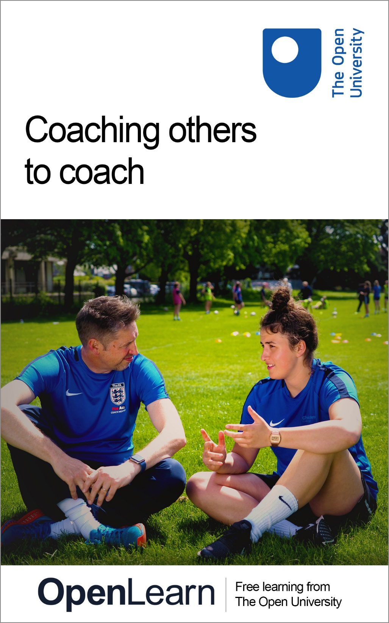

COTC_1 Coaching others to coach

Coaching others to coach

About this free course
You can experience this free course as it was originally designed on OpenLearn, the home of free learning from The Open University – https://www.open.edu/openlearn/health-sports-psychology/coaching-others-coach.
This version of the content may include video, images and interactive content that may not be optimised for your device.
You can experience this free course as it was originally designed on OpenLearn, the home of free learning from The Open University –
https://www.open.edu/openlearn/health-sports-psychology/coaching-others-coach/content-section-overview
There you’ll also be able to track your progress via your activity record, which you can use to demonstrate your learning.
Copyright © 2021 The Open University
Intellectual property
Unless otherwise stated, this resource is released under the terms of the Creative Commons Licence v4.0 http://creativecommons.org/licenses/by-nc-sa/4.0/deed.en_GB. Within that The Open University interprets this licence in the following way: www.open.edu/openlearn/about-openlearn/frequently-asked-questions-on-openlearn. Copyright and rights falling outside the terms of the Creative Commons Licence are retained or controlled by The Open University. Please read the full text before using any of the content.
We believe the primary barrier to accessing high-quality educational experiences is cost, which is why we aim to publish as much free content as possible under an open licence. If it proves difficult to release content under our preferred Creative Commons licence (e.g. because we can’t afford or gain the clearances or find suitable alternatives), we will still release the materials for free under a personal end-user licence.
This is because the learning experience will always be the same high quality offering and that should always be seen as positive – even if at times the licensing is different to Creative Commons.
When using the content you must attribute us (The Open University) (the OU) and any identified author in accordance with the terms of the Creative Commons Licence.
The Acknowledgements section is used to list, amongst other things, third party (Proprietary), licensed content which is not subject to Creative Commons licensing. Proprietary content must be used (retained) intact and in context to the content at all times.
The Acknowledgements section is also used to bring to your attention any other Special Restrictions which may apply to the content. For example there may be times when the Creative Commons Non-Commercial Sharealike licence does not apply to any of the content even if owned by us (The Open University). In these instances, unless stated otherwise, the content may be used for personal and non-commercial use.
We have also identified as Proprietary other material included in the content which is not subject to Creative Commons Licence. These are OU logos, trading names and may extend to certain photographic and video images and sound recordings and any other material as may be brought to your attention.
Unauthorised use of any of the content may constitute a breach of the terms and conditions and/or intellectual property laws.
We reserve the right to alter, amend or bring to an end any terms and conditions provided here without notice.
All rights falling outside the terms of the Creative Commons licence are retained or controlled by The Open University.
Head of Intellectual Property, The Open University
978-1-4730-3173-9 (.kdl)
978-1-4730-3174-6 (.epub)

Contents
- Session 1: What do coach developers do?
  - Introduction
  - 1 Who are coach developers?
    - 1.1 What do coach developers do?
  - 2 Coach developers’ potential to transform practice
  - 3 The mysteries of coaching and a model of behaviour change
  - 4 What makes an effective coach developer?
  - 5 Understanding coach developer expertise
    - 5.1 Exploring expertise further
  - 6 Enhancing your coach developer skills
  - 7 Building your coach developer 101 guide
  - 8 This session’s quiz
  - 9 Summary of Session 1
- Session: 2 How do coaches learn?
  - Introduction
  - 1 Can you remember how you improved as a coach?
  - 2 Looking at learning from a different perspective
  - 3 Theories to explain learning
  - 4 Do coaches filter new ideas when they learn?
  - 5 How do adults learn?
    - 5.1 Applying adult learning principles to your practice
  - 6 Cognitive rigidity: learning often needs unlearning
  - 7 Your chance to contribute: share your ideas
  - 8 Building your coach developer 101 guide
  - 9 This session’s quiz
  - 10 Summary of Session 2
- Session 3: How do you build effective learning relationships?
  - Introduction
  - 1 Coach–coach developer relationships
  - 2 High octane pressure in a motor racing team
  - 3 Learning from the humanist approach
  - 4 First impressions count
  - 5 Planning a first one-to-one meeting
  - 6 Pulling together ideas
  - 7 Learning from teacher–mentor relationships
  - 8 Balancing challenge and support
  - 9 Learning from setbacks
  - 10 Building your coach developer 101 guide
  - 11 This session’s quiz
  - 12 Summary of Session 3
- Session 4: Becoming self-aware of power in your role
  - Introduction
  - 1 Power and social circumstances
  - 2 Power and coach developers
  - 3 Coach developers in control
  - 4 It’s my way!
  - 5 When power is turned upside down
  - 6 The reflexive coach developer
  - 7 Building your coach developer 101 guide
  - 8 This session’s quiz
  - 9 Summary of Session 4
- Session 5: Developing your teaching repertoire and skills
  - Introduction
  - 1 Beyond the assumptions of adult learning
  - 2 Exploring problem-based learning (PBL)
    - 2.1 When would you use PBL?
  - 3 Exploring a flipped learning model
    - 3.1 When would you use flipped learning?
  - 4 Instruction: widely misunderstood?
    - 4.1 Reviewing your current instruction practices
    - 4.2 When would you use instruction?
  - 5 What can we learn from the teaching profession?
  - 6 Your chance to contribute
  - 7 Building your coach developer 101 guide
  - 8 This session’s quiz
  - 9 Summary of Session 5
- Session 6: Asking good questions and listening actively
  - Introduction
  - 1 Why ask questions?
  - 2 Principles for good questions
  - 3 Experiences of using questioning practices
  - 4 Deeper questions: from the inside out
  - 5 From bite-sized to banquet responses
  - 6 Active listening: more than just paying attention
  - 7 Active listening in action
    - 7.1 Better listening
    - 7.2 Active listening summarised
    - 7.3 Use minimal encouragers
  - 8 Building your coach developer 101 guide
  - 9 This session’s quiz
  - 10 Summary of Session 6
- Session 7: Effective observations and feedback
  - Introduction
  - 1 Are teacher observations a waste of time?
  - 2 Analysing coaches: structuring the observation process
  - 3 Systematic observation
  - 4 How should you plan an observation?
  - 5 Discussing feedback and encouraging dialogue
  - 6 Creating a peer-to-peer observation culture
  - 7 Coach observation: pulling it all together
  - 8 Building your coach developer 101 guide
  - 9 This session’s quiz
- Session 8: Refreshing coach development for the digital age
  - Introduction
  - 1 Collaboration, information gathering and learning
  - 2 The role of digital messaging
  - 3 Coach developers as content curators
  - 4 Fostering more mentoring
  - 5 Technology for peer support
  - 6 Forum posting
  - 7 Building your coach developer 101 guide
  - 8 This session’s quiz
  - 9 Summary of Session 8
  - 10 Bringing things together
  - Where next?
  - Tell us what you think
- References
- Acknowledgements
- Solutions

Session 1: What do coach developers do?

Introduction
Welcome to Session 1 of this free course which aims to improve your capability as a coach developer.
It is common to describe the process of learning to become a better coach as a journey, one that is unique to every coach. This journey has many twists, turns and difficulties. This course assumes that as a coach developer you are a ‘skilled helper’ (Egan, 1998); you guide a coach on their way, helping them with a particularly difficult challenge, suggesting an alternative path or a different way of getting them to where they want to go. Your role can add value to their journey by enriching the learning that takes place along the way.

Figure 1 Making sense of the coach developer role
View description - Figure 1 Making sense of the coach developer role

In this, the first of 8 sessions, you will consider the different roles coach developers can undertake and follow the case study of a relationship between a coach and a coach developer that has been transformational. You’ll then examine ideas about what makes an effective coach developer and how the expertise of a coach developer can be described. Finally, you’ll begin to explore the ways your practice as a coach developer can be developed. There are a lot of fascinating things to consider, so it is time to get started.
By the end of this session, you should be able to:
- understand the different roles coach developers undertake and the contexts in which they are undertaken
- describe the process of building relationships in a model of behaviour change
- explain how coaches describe an effective coach developer
- consider how the expertise of a coach developer can be articulated.
The Open University would really appreciate a few minutes of your time to tell us about yourself and your expectations for the course before you begin, in our optional start-of-course survey. Participation will be completely confidential and we will not pass on your details to others.

1 Who are coach developers?
You’ll start by hearing from two coach developers discussing their own experiences.

Figure 2 What roles do coach developers undertake?
View description - Figure 2 What roles do coach developers undertake?

To introduce this section, watch the video with Lucy Moore and Stuart Armstrong where they reflect on aspects they wish they had known more about at the outset of their experience as coach developers.

Video content is not available in this format.
Video 1
View transcript - Video 1

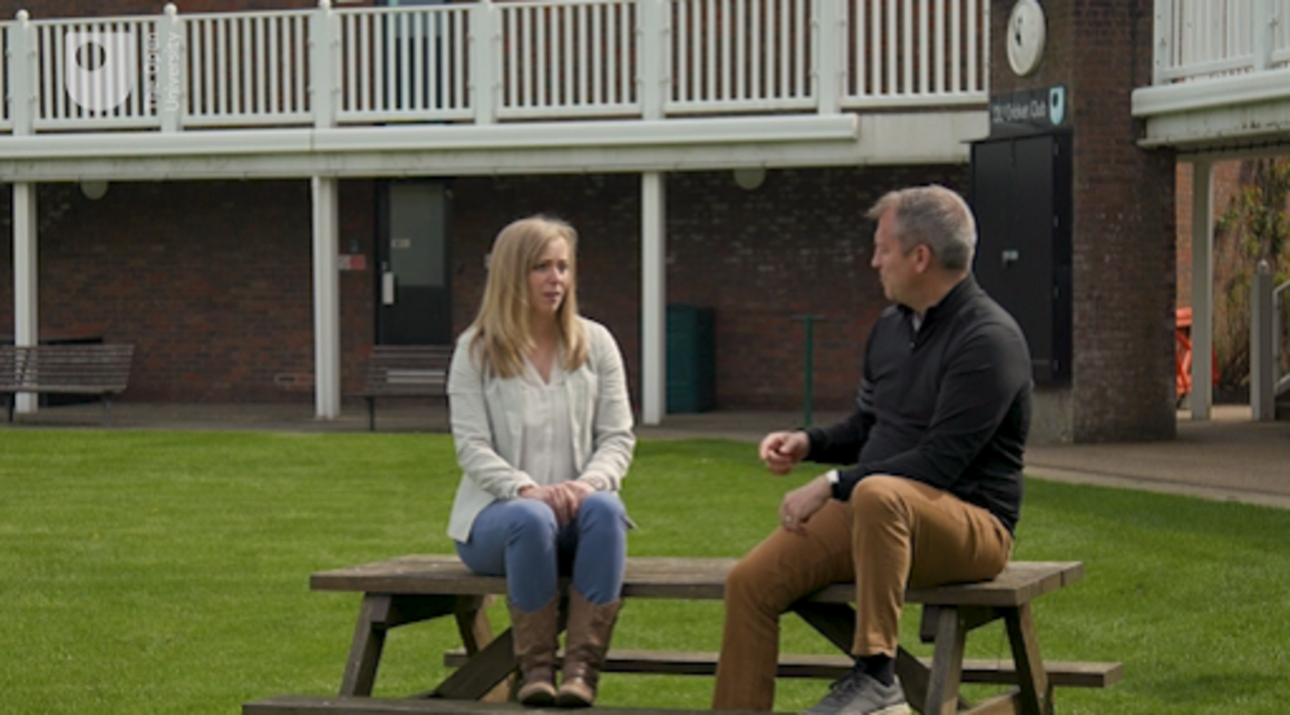

There are three points that can be taken from the discussion:
- Knowing the range of ‘tools’ that coach developers can use to help coaches.
- Not being too eager to ‘step in’ and start giving advice before understanding the needs of the coach and what they want.
- That coach developers don’t have all the answers and instead should be helping coaches to reflect and discover knowledge and ideas for themselves.

1.1 What do coach developers do?
Lucy and Stuart have learned this through their experiences and through the different roles they have undertaken as coach developers. The term ‘coach developer’ can itself be a tricky concept and in the following activity you will meet one of the writers of this course, Alex Twitchen. Alex has been supporting coaches and helping them to learn and develop for twenty years and in this short video he describes how he understands the role of a coach developer.

Activity 1 Who is a coach developer and what do they do?
Allow about 15 minutes

Watch and as you listen to Alex make some notes on the following questions.
- In what different situations or environments does Alex support the development of coaches (e.g. workshops)?
- What four main characteristics does Alex believe it is important to possess if you want to help coaches learn and develop?

Video content is not available in this format.
Video 2
View transcript - Video 2

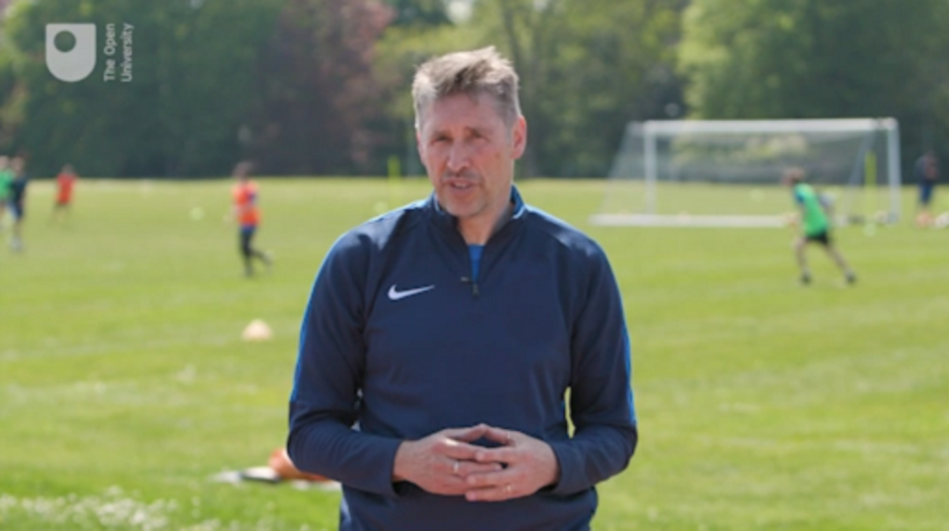

Text boxes are provided in all activities. You can use these to note down your answers to the questions. Once you click Save, your answers will be stored and you can return to them at any point to view or amend your response. Your responses will only be visible to you. However, if you would prefer to make notes using pen and paper or a different format you can.

Provide your answer...

View discussion - Part

Having listened to Alex’s thoughts the term coach developer can be applied to a range of possible roles, which describe the different activities that coach developers undertake. These are:
- Mentoring – supporting and advising a coach who is usually less experienced and knowledgeable in some way.
- Tutoring – teaching small groups of coaches usually through a syllabus provided by an organisation.
- Assessing – evaluating the competence, capability or skill of a coach.
- Facilitating – enabling learning by designing, generating and organising content and activities for coaches to engage in.
- Training – providing instruction to develop specific skills.
- Critical friendship – supporting a coach, usually a colleague, of similar status, experience and expertise.
Each of these roles are based on the intention to provide the support that coaches ask for. These roles are connected through this common intent but require slightly different approaches and methods that need time to have an impact.

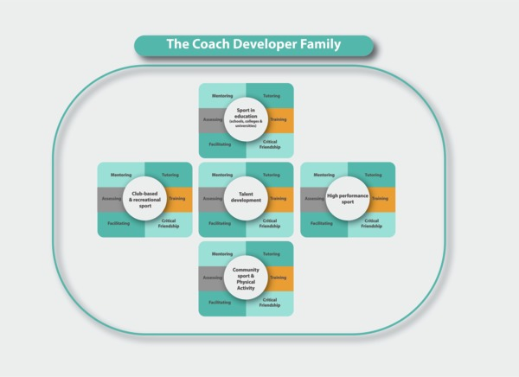
Figure 3 What role do you fulfil as a coach developer? Do you have one role or many, and in what context do you fulfil them?
View description - Figure 3 What role do you fulfil as a coach developer? Do you have one role or many, ...

In Figure 3, you can see how each coach developer role can be situated in one of several different contexts. As a coach developer you might not fulfil every role or feel comfortable operating across all these roles. It is possible you may also fulfil different roles in different contexts or predominantly support coaches within one context.
There is no straightforward definition of a coach developer. It potentially refers to somebody providing focused individual support to coaches, as well as being a broader umbrella term that encompasses the roles undertaken by the ‘coach developer family’ depicted in Figure 3. This course adopts a perspective similar to the ‘professional standard’ developed by the Chartered Institute for the Management of Sport and Physical Activity (CIMSPA) – that a coach developer is essentially a people developer, skilled in providing coaches with an appropriate level of support at the right time – and over time – to better their coaching and therefore improve the experience of the people they coach.

2 Coach developers’ potential to transform practice
In the following activity you will analyse the experiences of Alan Keane, while Head Coach of the England Under-16 Basketball team, when working with his mentor Mark Bennett. Alan and Mark met through a programme delivered by UK Coaching, the UK’s lead agency for developing coaches and coaching.

Figure 4 How can a coach developer put you on a different track to success?
View description - Figure 4 How can a coach developer put you on a different track to success?

During this activity you will see how Mark is fulfilling one of the roles of a coach developer, as shown in Figure 3, since he is mentoring Alan within a Talent Development context.

Activity 2 Alan’s story: moving away from being a ‘playstation coach’
Allow about 25 minutes

Watch the short video below which introduces Alan, and then listen to the audio from the Talent Equation podcast where his story is described in more detail during a conversation with Stuart Armstrong, who you met during the introduction to this course.
As you listen to Alan’s story, analyse how and why Mark had such an impact on Alan’s coaching.

Video content is not available in this format.
Video 3
View transcript - Video 3

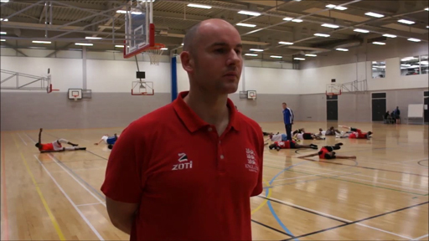

Audio content is not available in this format.
Audio 1 Alan’s account of working with Mark.
View transcript - Audio 1 Alan’s account of working with Mark.

Provide your answer...

View discussion - Part

This is coach development since there is the intent to support Alan, and together Mark and Alan have built a relationship over time. It is also a story about the extent to which a coach developer can transform a coach’s practice. It would be unrealistic, however, to expect that every coach and coach developer relationship can have this scale of impact. Sometimes a coach developer may focus on reinforcing good practice, as opposed to bringing about transformational change.

3 The mysteries of coaching and a model of behaviour change
In this section you will draw more learning from Alan and Mark’s story. First you’ll consider the metaphor of coaching as a mystery, and then coaching as part of a model: a stairway towards behavioural change.
Gregory Treverton (2007) has described the distinction between a puzzle and a mystery. If coaching were a puzzle – like a crossword – Treverton would argue the answers are found by acquiring more information. Coaching is more like the mysteries that Treverton describes – it is more complex, and many of the problems coaches encounter do not always have a right answer or the correct solutions of a puzzle. Mysteries need to be re-framed and seen from a different perspective, so just acquiring more information will not always help.

Figure 5 Mysteries and puzzles in coaching
View description - Figure 5 Mysteries and puzzles in coaching

Mark’s skill as a coach developer illustrates this distinction: he avoids providing Alan with more technical and tactical information or showing him more practices. Instead Mark has sought to re-frame Alan’s method of coaching by offering a different solution, an alternative approach to the one Alan has been using. A temptation for coaches is to believe that coach developers have the right answers to their problems. Instead, some of the skill and expertise of a coach developer comes from understanding their role in helping coaches view problems from a different perspective. It is to make the mysteries of coaching a little less mysterious by re-framing problems and working with coaches to create solutions that improve the experience of the people they coach.
The relationship between Alan and Mark can also be viewed from the perspective of a model used to train negotiators handling a crisis situation (Vecchi et al., 2005). The Behavioural change stairway model (BCSM), represented in Figure 6, claims that five steps can lead to a desirable change in behaviour.

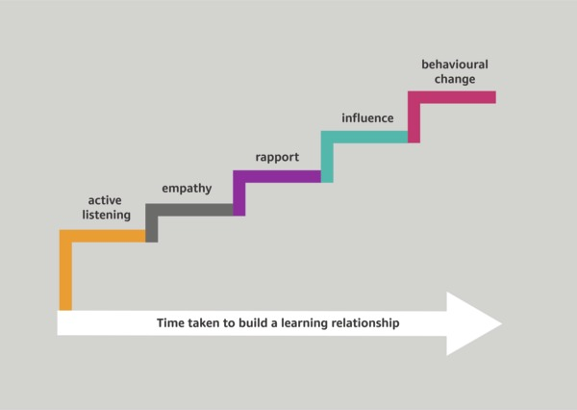
Figure 6 The Behavioural change stairway model
View description - Figure 6 The Behavioural change stairway model

This model suggests that each step is one part of a sequence that builds on another. For example, it is claimed influence cannot be achieved before rapport has been developed; building rapport in turn requires engaging in empathy and active listening. It also takes time to bring about a change in behaviour, as shown by the white arrow, where time is measured relative to the speed of the relationship building process, however quickly or slowly it develops. In Alan’s story you can arguably hear the stairway model in action. The initial phase of building rapport and creating a positive relationship preceded the stage where Mark was able to exert the influence which led Alan to re-think and alter his approach to coaching and the behaviours he used. Such is the importance of rapport that the whole of Session 3 is devoted to building effective learning relationships while active listening is explored more fully in Session 6.
So far in this session you have considered what is meant by the term ‘coach developer’. You have also considered how your role as a coach developer often means enabling coaches to make better sense of what they already know. Now you turn to the question: what makes an effective coach developer?

4 What makes an effective coach developer?

Figure 7 Thinking about what makes an effective coach developer
View description - Figure 7 Thinking about what makes an effective coach developer

The International Coach Developer Framework, developed by the International Council for Coaching Excellence (ICCE), suggests coach developers are:

trained to develop, support and challenge coaches to go on honing and improving their knowledge and skills in order to provide positive and effective sport experiences for all participants.
(International Coach Developer Framework, 2014, p. 8)

The most important person here is the participant – the person being coached. While coach developers should be mindful of meeting the needs of the coaches they support, this should also be framed by the needs of the participants. This three-way relationship is represented in Figure 8. Notice how the participant is at the top and centre. Improving the participant’s experience of being coached should therefore be the focal point in every relationship between a coach and coach developer.

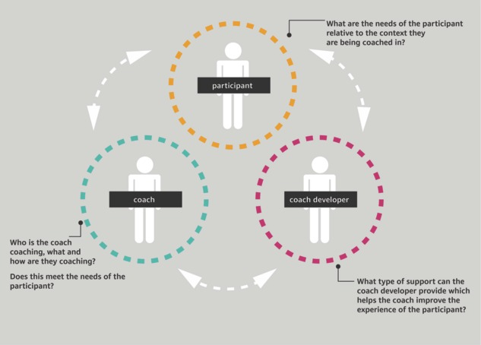
Figure 8 The three-way relationship between participant–coach–coach developer
View description - Figure 8 The three-way relationship between participant–coach–coach developer

Now you understand the importance of this three-way relationship, and some of the key questions coach developers might ask themselves, you can turn to the question of what – from a coach’s point of view – makes an effective coach developer. More precisely, how do coaches describe the knowledge, skills and personal qualities of a coach developer which hone and improve their own knowledge and practice? In the next activity you’ll watch three experienced coaches share their ideas and thoughts about effective coach developers.

Activity 3 What makes an effective coach developer?
Allow about 20 minutes

Watch the video below. What skills, knowledge and personal qualities do the coaches say make someone an effective coach developer?

Video content is not available in this format.
Video 4
View transcript - Video 4

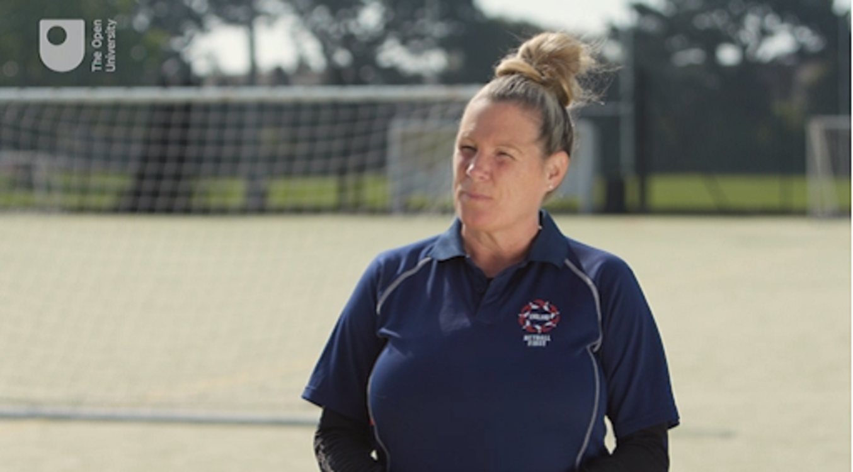

Provide your answer...

View discussion - Part

Effective coach developers have a positive and meaningful impact on a coach’s knowledge, decision-making and practice. Very effective coach developers are also highly skilled and possess considerable expertise which they apply consistently. Acquiring this expertise takes time and experience, alongside the ability to reflect on practice.
In whatever context and role you support coaches, it is important that reflection is built into your work. In the next section you’ll consider how expertise as a coach developer can be described and explained: knowing this gives you a clearer vision of what you might be aiming for in terms of making your own practice more effective.

5 Understanding coach developer expertise
Compared to coaching, there is relatively little research evidence that describes or explains coach developer expertise (Abraham, 2016). In the next two back-to-back activities you’ll consider a possible approach to articulating the expertise of a coach developer.
During these activities there are no claims that an evidence-based explanation of coach developer expertise is being presented. Instead the purpose is to prompt your thinking about what you do, or should do, if you want to develop your own expertise as a coach developer.

Figure 9 How can coach developer expertise be understood?
View description - Figure 9 How can coach developer expertise be understood?

Activity 4 Coach developer expertise 1: Surfacing beliefs?
Allow about 15 minutes

In this activity, you are asked to think about the meaning you attach to the term ‘surfacing beliefs’.
Read the following statement:

‘Surfacing values and beliefs is an important part of coach learning and development.’

- Using your personal interpretation of the statement, how much is this a key part of a coach developer’s expertise?
- With your response to the first question in mind, now consider Figure 10 and the accompanying description which talks about the ‘iceberg principle’. How much attention should a coach developer pay to this element of their expertise?

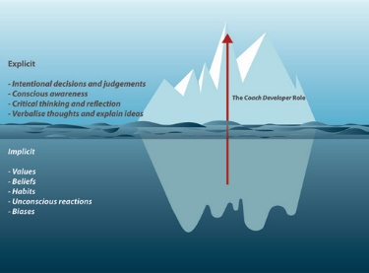
Figure 10 The iceberg principle: coach developers attempt to bring hidden, implicit aspects into the open
View description - Figure 10 The iceberg principle: coach developers attempt to bring hidden, implicit ...

Description of Figure 10
Many aspects that impact on coaching practice and behaviour are implicit. They are taken for granted, they have become habits and stem from ideas, values and beliefs that are not consciously reflected on (e.g. the use of different instructional behaviours is often implicit). Therefore, they are very difficult to change because either coaches are unaware that they hold them, or because they seem so obvious to coaches that they don’t warrant their attention.
The process that coach developers undertake is to make coaches think and reflect about the ideas, values and beliefs they have. It is to make what is implicit explicit: to make what is unconscious, conscious and therefore open to reflection, discussion and change. This is represented in Figure 10.

Provide your answer...

View discussion - Part

5.1 Exploring expertise further
In the following activity you will pursue your thoughts on coach developer expertise further.

Activity 5 Coach developer expertise 2: What insights can be gained from elsewhere?
Allow about 30 minutes

Read this short article (4 minute read time): Exploring coach developer expertise, by Ben Oakley and Alex Twitchen
The purpose of this reading is to act as a further prompt to your thinking about coach developer expertise. To what extent would you agree with the argument and characteristics identified in the article?

Provide your answer...

View discussion - Part

Note: You will have an opportunity in Session 2 to share with others your ideas on the articles and videos you have viewed while working through this material. This will be optional, but hopefully you’ll enjoy taking part if you do choose to.

The last three sections have been full of ideas about what coach developer expertise looks like. The ideas range from the ‘surfacing beliefs’ discussion, to knowing when, how and why tools, techniques and ingredients should be used (in the chef analogy), to ideas relating to expert teachers and authenticity (Hattie, 2003). In the next section you’ll hear two experienced coach developers describe the learning opportunities they have drawn on to develop their own expertise.

6 Enhancing your coach developer skills
This course takes the perspective that becoming a more effective coach developer is an ongoing learning process, and you need tangible forms of support and guidance to help you learn and acquire more expertise.

Figure 11 Developing your own expertise as a coach developer
View description - Figure 11 Developing your own expertise as a coach developer

In the following activity two experienced coach developers provide a personal reflection on their own learning and development.

Activity 6 Developing your coach developer expertise
Allow about 15 minutes

Watch the following video of an interview with two experienced coach developers: Andy Bradshaw, Coaching Manager (Talent and Inclusion) at UK Coaching and coach/mentor with England Hockey, and Jane Lomax, Senior Lecturer in PE and Coaching at the University of Chichester and England Netball tutor. How do they believe they have accumulated the expertise that has helped them become more effective coach developers?

Video content is not available in this format.
Video 5
View transcript - Video 5

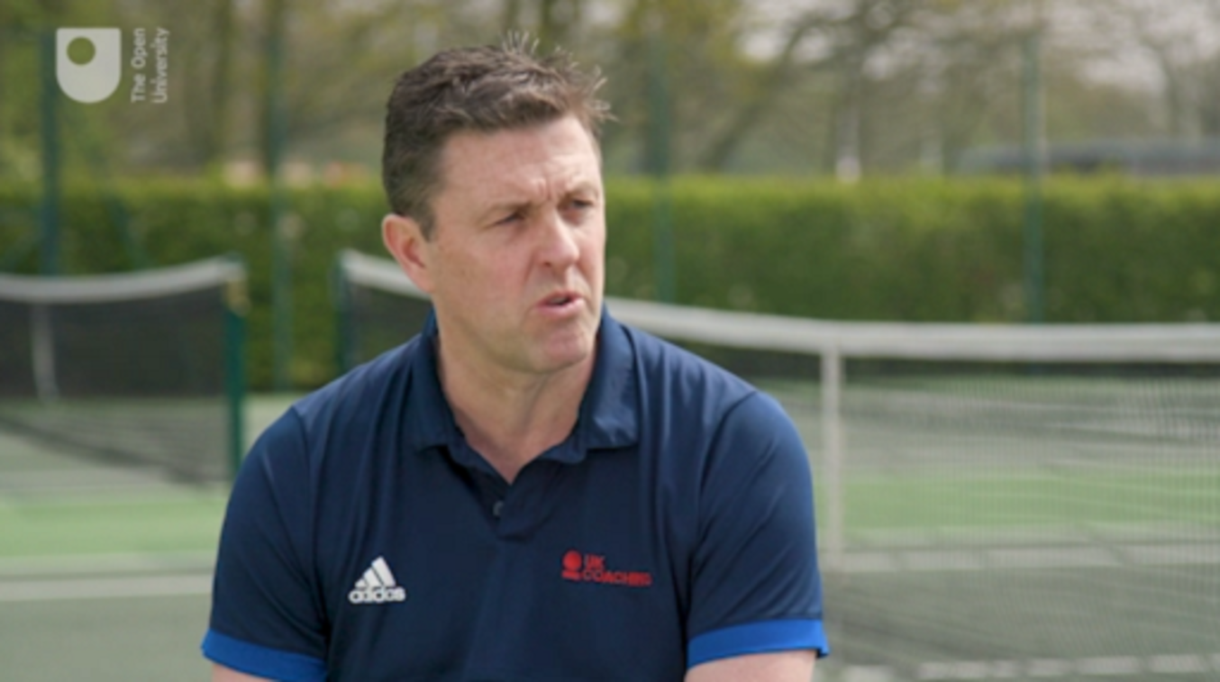

Provide your answer...

View discussion - Part

Like learning to become a better coach, becoming a better coach developer is a journey with its own challenges, difficulties and different paths to follow. This course itself can be part of your journey towards becoming a more effective and expert coach developer.

7 Building your coach developer 101 guide
Already in this first session of the course you have come across five practices and ideas that you can implement in your own work. You will see them summarised in Table 1 below.
At the end of each session, the main expertise practices – between three and five practices for each session – will be summarised and developed into a ‘101 guide’. ‘101’ is a term that is often used to refer to an introductory book or a document that provides an overview of a subject. The intention of the ‘Coach developer 101 guide’ is to provide you with a summary of the coach developer role in a succinct and concise format that can be shared and discussed with your colleagues, particularly others who have already completed this course. The guide is a point of reference about how coach developers should support coaches to learn and improve their practice.
By Session 8, you will have studied thirty-six practices and ideas in total. The complete 101 guide, containing all the practices and ideas, will be available for you to download in Session 8.
Here are the practices and ideas covered in Session 1.

Table 1 Some practices coach developers can use to build expertise in their role
Practices and ideas | Description
1. Sense-making | The role of a coach developer is often to help coaches make better sense of what they already know rather than just providing more information.
2. Surfacing beliefs | The process of raising awareness and making implicitly held beliefs, ideas, values and biases explicit, therefore making them subject to discussion, debate and change.
3. Behavioural change stairway | An illustrative model that describes a process of behaviour change through a sequence of five steps: it takes time.
4. Effective coach developers | People who have a positive and meaningful impact on learning and development which is achieved consistently from coach to coach.
5. Coach developer expertise | The ability to skillfully use a variety of tools, techniques and ingredients to facilitate and enrich learning to improve coaching practice.

8 This session’s quiz
Check what you’ve learned this session by taking the end-of-session quiz.
Session 1 practice quiz
Open the quiz in a new window or tab then come back here when you’ve finished.

9 Summary of Session 1
The main learning points from this session are:
- A coach developer is a people developer who is trained to help and support a coach. This is a process which occurs over time, and coach developers can undertake a range of roles in one or more contexts.
- You followed a case study of a coach and coach developer relationship that was transformational; it significantly influenced and re-shaped the coach’s practice. Not all coach–coach developer relationships have this transformational impact. Sometimes reinforcing good practice is still effective development.
- You heard from three experienced coaches about what they thought makes an effective coach developer. To have a positive and meaningful impact effective coach developers demonstrate a willingness to help people learn, personally connect with coaches, set high standards, command respect and they make coaches think, reflect and question what they know and don’t know.
- The expertise that a coach developer possesses was examined and explained. There is little evidence that conclusively explains the expertise that coach developers possess, but ideas can be drawn from closely allied roles such as teaching.
- You have been introduced to a range of learning opportunities that can be drawn on to improve your own practice as a coach developer. These opportunities are not unlike those that coaches draw on to improve their practice.
- A coach developer 101 guide has been started that will build into a list of 36 practices and ideas that concisely articulate the coach developer role.
In the next session you will explore how coaches learn and the implications for coach developers. At the beginning of this session it was suggested that knowing how people learn is an important body of knowledge for coach developers to possess. Without understanding how people learn your effectiveness as a coach developer may be limited, this will make it more challenging for you to help coaches develop.
You can now go to Session 2

Session: 2 How do coaches learn?

Introduction
At some point in their careers, most coach developers will themselves have been a coach. Some may still be coaching. If this is you, can you remember how you learned to become a better coach? Are there any similarities to the way you are learning to become a better coach developer?

Figure 1 Learning is increasingly thought of as ‘participation’ rather than ‘acquisition’
View description - Figure 1 Learning is increasingly thought of as ‘participation’ rather than ‘acq ...

At the start of this session you’ll hear again from Stuart Armstrong and Lucy Moore when they discuss what learning means to them. You’ll then consider different types of learning opportunities and follow this by exploring how coaches filter new ideas by rejecting some and incorporating others into their practice. These thoughts are complemented by activities in which you learn about the characteristics of adult learning and how they can be used to create purposeful learning environments. Finally, you’ll be asked to consider a provocative idea: learning sometimes requires unlearning the things you already know and do.
You will have an opportunity to interact online with others on the course about their opinions on some of these topics. This is via an optional course forum feature which you will be introduced to at the end of the session.
By the end of this session, you should be able to:
- know how to classify different types of learning experiences
- explain the application of social constructivist theories of learning to coach development
- understand how coaches filter new ideas before potentially implementing some of them into their coaching practice
- describe the principles of adult learning and how they can relate to your practice as a coach developer.

1 Can you remember how you improved as a coach?
We are all constantly learning, but are we conscious of how we learn? As you work through this session reflect not only on the extent to which it examines how coaches learn, but also how it informs your learning as a coach developer.

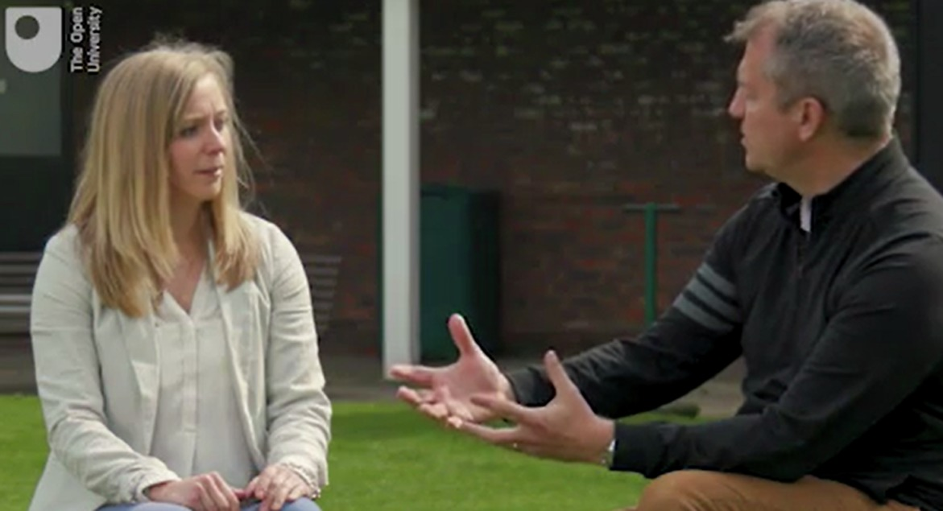
Figure 2 How might learning occur through informal social situations such as this?
View description - Figure 2 How might learning occur through informal social situations such as thi ...

In the following activity you will hear from Stuart Armstrong and Lucy Moore who discuss their ideas about learning and what has influenced their learning and development.

Activity 1 Comparing personal learning stories of becoming a better coach
Allow about 20 minutes

As you watch this conversation between Stuart and Lucy can you describe what learning means to them, and how they describe it? Stuart and Lucy also mention a range of learning experiences – how might you classify or name the different types of learning they refer to?

Video content is not available in this format.
Video 1
View transcript - Video 1

Provide your answer...

View discussion - Part

You have so far heard two views about coach learning but now you explore an entirely different perspective on learning. It comes from a craftsperson in another complicated environment: a master chef working in a professional kitchen.

2 Looking at learning from a different perspective
In the following activity you will learn about one chef’s progression in honing his craft and the different learning opportunities he has drawn on to achieve this.

Figure 3 By looking at something through a different lens you can often see things in different ways
View description - Figure 3 By looking at something through a different lens you can often see things ...

As you follow the story think about how it can apply to the way coaches and coach developers might develop their learning. It is a great story and full of ideas and insights.

Activity 2 Ross Stacey: a craftsman’s road to expertise
Allow about 25 minutes

Read the following article (5 minute read time) about Ross Stacey, a chef at The River Café: The craftsman’s road to expertise: Ross Stacey, a chef’s story
Ross’s story is used by the English Institute of Sport (EIS) to illustrate how people learn in different ways. How do you think the ideas it contains about the following apply to coaches?
- Situated learning
- The apprenticeship
- A craftsman’s journey
- Tribal learning.

Provide your answer...

View discussion - Part

This article illustrates the importance of learning through everyday working relationships and the value of collaboration and the support and guidance provided by others. It emphasises the value of informal learning and the willingness of individuals to take responsibility for their own learning. The quality of relationships between like-minded people seems fundamental and for this reason Session 3 is devoted to understanding social relationships in more detail.
You will now move on to examine some theories of learning.

3 Theories to explain learning
What is the nature of learning? Traditionally, coaching has drawn on cognitive and behavioural theories in which a coach is viewed like a cognitive sponge soaking up knowledge, skills and ideas in an objective, non-personal way. A term that has been used is learning through ‘acquisition’ (Sfard, 1998).

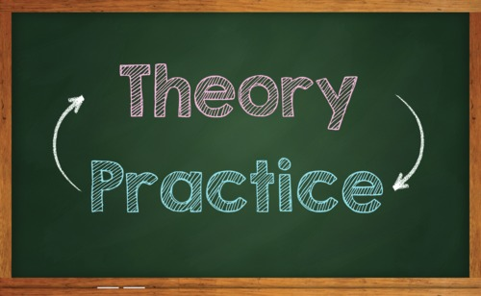
Figure 4 Theory informs practice and practice informs theory
View description - Figure 4 Theory informs practice and practice informs theory

Elements of these theories are useful. However, practice-based learning is focused more on participation rather than acquisition.

Activity 3 Exploring social constructivist theories of learning
Allow about 20 minutes

Using a search engine, look for text or video explanations of a ‘Social Constructivist Theory of Learning’ (use these search terms). Choose two or three of your search results and spend about ten minutes researching these links to ‘get a feel’ for what this theory is about.
If you find material that mentions terms such as ‘construction’, ‘collaboration’, ‘making sense’, ‘culture’, ‘language’ or ‘social’ you will be on the right lines. Think about how your search results relate to coaches and your own learning.

Provide your answer...

View discussion - Part

There are many explanations of learning which fall under the social constructivist term. These are all concerned with how learners build their own mental structures through interaction with their environment, i.e. learning does not occur in a vacuum (Merriam and Caffarella, 1999).
In your work as a coach developer you might recognise that coaches ‘cherry pick’ aspects of their learning to apply to their practice. Since each coach is different, the same learning opportunity is likely to have a different impact on individual coaches (Stodter and Cushion, 2017) due to influences such as:
- the organisational culture within which they coach
- established social norms and conventions
- hierarchy, status and power
- gender and ethnicity
- access to educational opportunities
- personal identity and
- the impressions people try to portray in order to ‘fit in’.
Coach developers need to appreciate all of these broad social influences on coach learning.

4 Do coaches filter new ideas when they learn?
Research by Stodter and Cushion (2017) describes a filtering process through which coaches ‘adopted, adapted and rejected elements of their experiences, leading to uneven learning in apparently similar situations’ (p. 321).

Figure 5 How might coaches filter new ideas in their development journey?
View description - Figure 5 How might coaches filter new ideas in their development journey?

If you begin to appreciate how coaches filter new ideas and knowledge, it could help you design learning experiences which are more likely to be effective.

Activity 4 Exploring Stodter and Cushion’s filtering processes
Allow about 20 minutes

Read the description of Stodter and Cushion’s (2017) filtering processes below and examine its representation in Figure 6. After you have read the description you will be asked to answer two questions.

Filtering processes – a description
Coaches construct and develop their knowledge from learning experiences through two main filter mechanisms and a reflective feedback loop [see Figure 6]:
- A beliefs and attitudes filter: coaches first approach and understand learning experiences through the lens of their existing beliefs, attitudes, knowledge and coaching practice; this influences their perspective and acts as an initial filtering process. Ideas which mismatch their existing beliefs are filtered out and rejected, ideas that match or seem to fit are explored further.
- A context filter: coaches then ask themselves ‘how might this work in my context?’ and sometimes will avoid trying something due to a perception that it may not be relevant to their situation. Ideas that might seem appropriate pass through this filter and coaches experiment and adapt them and test whether they might work or not.
- Reflective cycle: coaches will continue to experiment, adapt and try-out ideas that have not yet been filtered out via a reflective feedback loop. This loop continues until they finally decide to adopt the idea into their practice or reject it. If an idea is accepted it can help to evolve their initial beliefs and attitudes filter.
Another influence was identified - ‘seeing is believing’ - in which new ideas were likely to bypass the first filter if coaches could see someone else using them (i.e. first hand, or via video). The openness of a coach to learning and their development, as well as the degree to which their working environment affords them the opportunity to experiment and adapt new ideas, are also important influences on the operation of the filtering mechanisms.
(Stodter and Cushion, 2017)

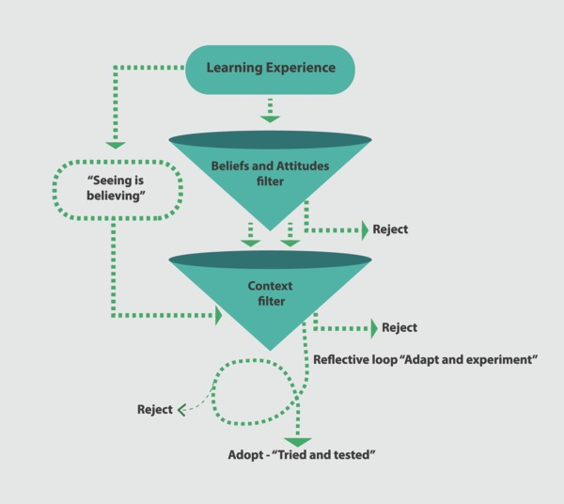
Figure 6 Filtering processes in coach learning (adapted from Stodter and Cushion, 2017)
View description - Figure 6 Filtering processes in coach learning (adapted from Stodter and Cushion, ...

Now answer the following two questions:
- How do these processes and influences connect with coach learning and development?
- What does this framework suggest coach learning experiences should pay particular attention to in order for effective learning to take place?

Provide your answer...

View discussion - Part

The research by Stodter and Cushion highlights the complexity of learning and how specific it can be to each individual coach. Therefore without taking into account the context and individual needs of coaches, any homogeneous and generic learning programme is likely to have limited impact.
In the next section you’ll explore the principles associated with adult learning. These can be used to design more sophisticated learning environments which could potentially dilute some of the filtering processes used by coaches to assess new ideas.

5 How do adults learn?
Coach developers should understand their audience and be familiar with how adults learn. Malcolm Knowles (1990) proposed six principles that explain how adults learn and why their learning might be different to that of children. Knowles popularised the term andragogy, which means the method and practice of teaching adult learners.

Figure 7 Do adults learn in a different manner to children? If so, what is distinct?
View description - Figure 7 Do adults learn in a different manner to children? If so, what is disti ...

In the next two activities you will learn about the six principles associated with andragogy and how these can be applied to the design of learning environments. Then, using these principles, you will be asked to apply these to a workshop for coaches.

Activity 5 Introducing adult learning
Allow about 20 minutes

Watch the following video from the start to 04:51. The six principles of adult learning from Knowles (1990) are explained and then applied to an imaginary workshop. Your task is to make notes on each principle and what you need to do to enhance coach learning.
Video 2: Introduction to Malcolm Knowles’s andragogy theory

Provide your answer...

View discussion - Part

The principles developed by Knowles have been adopted by the International Coach Developer Framework (ICDF) (2014) as recommendations to inform how adults learn best. These recommendations are summarised in the box below.

Box 1 Adult learning recommendations for coach developers (adapted from ICDF, 2014)
Main theme: Adult coaches learn best when motivated by the practical application to their coaching.
Coaches learn best when (words in bold connect to the video in Activity 5):
- They feel the need to know and understand the information.
- Their experience and abilities are recognised and they are helped to reflect on and build on this.
- They are encouraged to take responsibility for their learning and development of self-concept.
- There is an immediate or obvious readiness and reason to learn.
- They have plenty of opportunity to engage in problem-oriented issues and practice in their own context.
- They experience some success and gain feedback that builds their intrinsic motivation and confidence.

You might want to print these recommendations or have them close to you for the activity in the next section where you consider the learning design considerations informing a workshop for coaches.

5.1 Applying adult learning principles to your practice
In the following activity you’ll apply the principles you’ve just learned to an imaginary workshop scenario.

Activity 6 Applying the principles of adult learning
Allow about 20 minutes

In this activity you are going to use these principles to inform decisions involved in designing a 2–3 hour workshop intended to support the learning and development of coaches.
In the table below enter your ideas in the space opposite each of the six principles of adult learning. The workshop will support coaches working with children between 5 and 16 years of age in a large club environment. Most of the coaches will already have an initial coaching qualification. An example of one ‘application to workshop’ response is given below to help you consider how others may be completed.

Adult learning principle | Application to workshop
Need to know – how will you ensure this workshop meets the needs of the coaches and will benefit their coaching? | Identifying the most pressing issues the coaches believe they have will help respond to this principle. Perhaps you will consult or survey their immediate needs when coaching children. You will then need to demonstrate how this helped you determine the focus and content of the workshop.
Experience – how might you draw on the experience and experiences of the coaches? | Provide your answer...
Self-concept – how can you give coaches autonomy and responsibility for their learning? | Provide your answer...
Readiness – will the content be appropriate to the coaches, are they ready for the content? | Provide your answer...
Problem-based – How can you use and draw on the real and everyday issues and challenges the coaches have? | Provide your answer...
Intrinsic motivation – how can you build and design opportunities into the workshop for coaches to experience success and positive feedback? | Provide your answer...

View discussion - Activity 6 Applying the principles of adult learning

In Session 1 the role of a facilitator was identified as one of several roles coach developers can undertake. Facilitators design, generate and organise learning content and activities for coaches. By applying the principles of adult learning you can enhance the effectiveness of the learning environments you create. This might offer coaches more opportunities to discover ideas that match and fit with their beliefs and attitudes filter and work for them in their context. Designing content relevant to their needs is likely to reduce any readiness to reject ideas straight away.
When you come to the part of the course that focuses on teaching (Session 5) you will come across these ideas again as they also form the basis of relevant teaching principles. For the moment read the example in the box below which describes how the principles of adult learning are informing coach learning and development at the Lawn Tennis Association.

Box 2 Applying the principles of adult learning in tennis
Britain’s Lawn Tennis Association has become a hub of adult learning, a concept that Simon Jones, the organisation’s Head of Performance Coach Education has considered at length: ‘Andragogy considers the principles of how adults learn and there are several things that stand out to me that we implement,’ he explains. ‘Adults learn best when they have a say and are involved in what they are learning. They learn best when they are sharing their own experiences with each other … and hearing about other people’s experiences’ (Leaders Performance Institute, 2019).

If you view learning as a form of change or development you will perhaps recognise that people can be resistant to change. Unlearning previous embedded practices can be difficult and this is the challenge you will explore in the following section.

6 Cognitive rigidity: learning often needs unlearning
If new ideas are resisted by coaches, some claim (provocatively, perhaps) that a process of unlearning is required. As one teaching researcher suggests: ‘[practitioners] must learn to treat knowledge as something they construct, test, and explore, rather than as something they absorb and accumulate. They must unlearn much of what they know’ (Cohen, 1991, p. 46).

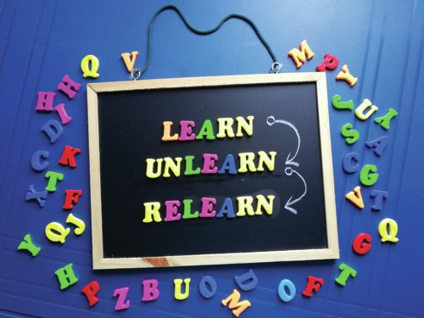
Figure 8 Changing your views on how something is done may require you to discard previous ideas first
View description - Figure 8 Changing your views on how something is done may require you to discard ...

The role of the coach developer is often to support coaches who are resistant to change. Practices become embedded and ritualised making change challenging.

Activity 7 Colleagues talking about unlearning
Allow about 15 minutes

Listen to this clip of colleagues Ross Garner, Owen Fergusson and Dom Price, who work in technology and learning businesses. They all embrace the need for unlearning in their sector. However, what aspects do they identify as problematic? Do these concerns mirror your experience of coaches changing their practice?

Audio content is not available in this format.
Audio 1
View transcript - Audio 1

Provide your answer...

View discussion - Part

Open mindedness is a vital ingredient of successful unlearning. Therefore, coach developers need to establish sound learning relationships and trust with the coaches they work with. Unlearning is a contestable concept and as such you may disagree with the term and what it implies. Therefore, it is timely that you are introduced to the course forum where you have the option to share your thoughts with others about this and other topics on the course.

7 Your chance to contribute: share your ideas
In this session you have considered how learning often involves a social and collaborative process. Sharing and discussing ideas with colleagues is an invaluable part of learning. To support this, you are now invited to go to the course forum pageand make a post to one of the two discussion threads below. If you decide not to, it will not impact on you obtaining your digital badge.

Figure 9 We want to hear your thoughts on what you have learned so far; but it is not a compulsory part of this course
View description - Figure 9 We want to hear your thoughts on what you have learned so far; but it is ...

‘Coaching others to coach’ course forum
- Unlearning discussion thread – to what extent do you agree or disagree that unlearning takes place and is sometimes necessary before learning occurs?
- Coach developer learning discussion thread – how do you believe you have learned to become a better coach developer? Are there any parallels between learning to become a better coach? If so, what are these parallels?

Reading and sharing your thoughts with others will add a further dimension to the learning you can gain from this course. The course forum will normally be moderated throughout the year. However, if your post needs a response from the Open University staff this will normally take two to five days.

8 Building your coach developer 101 guide
The main discussion points from this session that you might share and discuss with colleagues are described in Table 1 below.

Table 1 Some practices coach developers can use to build expertise in their role
Practices and ideas | Description
6. Categorising learning | Learning can be classified into formal, informal and non-formal learning, although it is not always easy to allocate learning situations neatly into one of these categories.
7. Social constructivist theories of learning | A collection of theories that explain how people construct knowledge through their experiences. This is a social, collaborative and active process that takes place within and through relationships between people.
8. Filtering processes | A method that describes how coaches adopt, adapt or reject new forms of knowledge and practice through two filters: a personal filter and a context filter.
9. Adult learning principles | The suggestion that adults learn differently to children (‘andragogy’). Adult learning motivations are distinct and there is a need for the purpose of their learning experiences to be made explicit.
10. Unlearning | It is claimed that to learn you must sometimes unlearn existing knowledge so that it does not impede the potential to learn something new.

9 This session’s quiz
Check what you’ve learned this session by taking the end-of-session quiz.
Session 2 practice quiz
Open the quiz in a new window or tab then come back here when you’ve finished.

10 Summary of Session 2
In this session you have:
- Read about different ways of classifying learning experiences. One of the most common is the distinction between formal, informal and non-formal learning.
- Examined learning from the perspective of a master chef. The story of Ross Stacey offered several insights into how chefs learn their craft that could be applied to coach learning and development.
- Explored how social constructivist theories of learning explain how individuals construct their knowledge through their experiences. These experiences are often shared with others. Learning is a social process that occurs within relationships between people.
- Considered the filters through which coaches assess new ideas and how this influences their adoption, adaptation or rejection of these ideas to their practice. It has been developed by Stodter and Cushion and captures how coaches learn as well as the complexity of the learning process.
- Reviewed the six principles of adult learning developed by Malcolm Knowles (1990). Knowles is associated with popularising the term andragogy to describe the characteristics of adult learning and how this is different to pedagogy (how children learn). Knowing the principles of adult learning can help you design more effective learning environments.
- Reflected on the concept of unlearning. A provocative and arguably contested term that suggests you have to unlearn things you already know and do before you can learn new ideas and change your practice.
While this session focused on how coaches learn you probably recognised there was much which could inform your learning as a coach developer. There are clearly many parallels between the two. Now, in the next session, you’ll focus on developing effective learning relationships.
This focus is valuable since you have just learned that learning is often a social, collaborative and active process that takes place within and through relationships. One of the central questions you will explore is how to initiate and continue to build rapport with the coaches you work with.
You can now go to Session 3.

Session 3: How do you build effective learning relationships?

Introduction
This session is about building relationships that promote learning and development. Watch as Stuart Armstrong explains more.

Video content is not available in this format.
Video 1
View transcript - Video 1

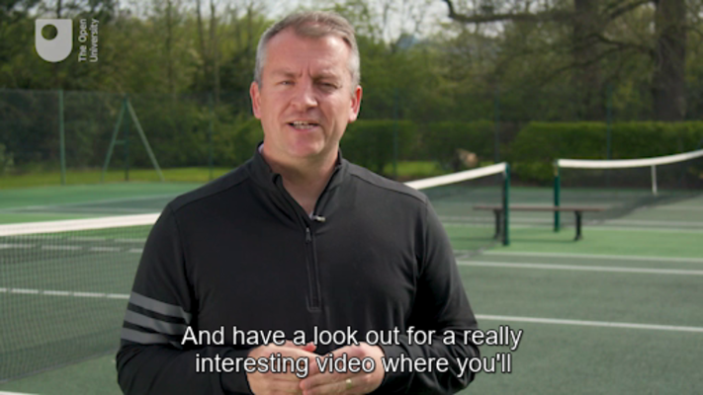

As Stuart explained, in coaching we work with people and this means being able to build trust and rapport with them. In this session you’ll explore different models and perspectives that help you to understand how to nurture effective learning relationships. You will see how understanding the following inform your knowledge about the development of effective learning relationships:
- humanist-based counselling theory
- a lecturer’s attempts to build rapport with over a hundred new students
- the strategies adopted by a coach developer, and
- teacher–mentor relationships in a school.
By the end of this session, you should be able to:
- understand the basis of effective coach–coach developer learning relationships
- know how to initiate and continue to build rapport with coaches
- appreciate how you can strike an appropriate balance between challenging coaches to improve their practice and supporting them through this process
- appreciate the value of learning from mistakes and failure.

1 Coach–coach developer relationships
How can we make sense of the relationship between a coach and coach developer, and does it in any way share similarities to the relationships between coaches and athletes?

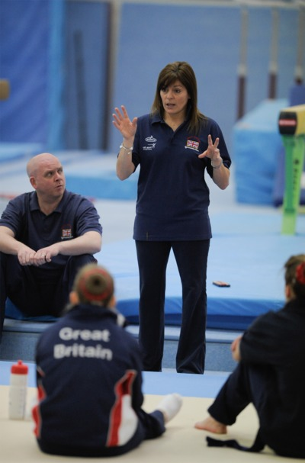
Figure 1 Creating a positive learning relationship through closeness, commitment, complementarity and co-orientation.
View description - Figure 1 Creating a positive learning relationship through closeness, commitment, ...

One answer to this question might come in the form of research identifying four key elements that contribute to a healthy coach–athlete relationship (Jowett, 2005).

Activity 1 Explaining coach–coach developer relationships
Allow about 10 minutes

Think about the relationships you have developed with the coaches you support. How well do the following elements of the coach–athlete relationship model apply to your coach–coach developer relationships?
Closeness– the degree to which two people are connected with expressions of like, trust, respect and appreciation indicating a positive interpersonal relationship.
Commitment– both parties’ desire to maintain their partnership over time.
Complementarity– the extent to which interaction between both is perceived as cooperative e.g. behaviours such as being responsive, at ease and willing.
Co-orientation– the degree to which similarities, including empathetic understanding between both parties, are shared.

Provide your answer...

View discussion - Part

But how can the coach developer build mutual respect and rapport, how can they build closeness?
To begin to answer this question you’ll focus on the behaviours demonstrated in a training and learning situation taking place in a motor racing team.

2 High octane pressure in a motor racing team
In this section you’ll witness an inexperienced pit-crew being trained to improve their performance by team manager Stewart.

Figure 2 Learning to improve performance in a high speed, high pressure environment
View description - Figure 2 Learning to improve performance in a high speed, high pressure environm ...

Stewart gives feedback to a member of the pit-crew about how to assist Chris Hoy (the former Olympic cyclist) in driver changeovers. The team were preparing for the Le Mans 24 hours where driver changeovers occur many times during the race. Hoy – who is wearing a helmet – tactfully tries to give his input.

Activity 2 Observing pit stop training
Allow about 15 minutes

Watch the video and respond to the questions that follow. Be warned that there is some potentially offensive language and behaviour in the video so you should be careful where you watch the video in case it is heard by others.

Video content is not available in this format.
Video 2
View transcript - Video 2

The relationship in this instance between Stewart and the pit-crew is perhaps not dissimilar to situations you might have observed elsewhere. Imagine now that you have been asked to mentor Stewart in his coaching of the team. Putting the gender characteristics of this environment to one side, answer these two questions:
- How would you proceed in trying to build a working relationship with Stewart?
- What background information might you ask Stewart about in your early meetings with him?

Provide your answer...

View discussion - Part

An interesting point in any relationship is how much you can change someone’s behaviour. Transformational change is not easy and requires persistence and time. In the next section you will explore the potential of a humanist approach as the basis for mentoring Stewart.

3 Learning from the humanist approach
Humanist theory suggests that people are their own best experts and therefore best placed to understand their perceptions and decisions (Rogers, 1983). If you were mentoring Stewart in his role as a team manager, your relationship with him would be facilitative and you would use a welcoming and safe environment to promote self-confidence and self-esteem. Stewart would be encouraged to speak freely about his frustrations and feelings of anger without the fear of criticism (Rogers, 1983). This person-centred approach is often what counselling practice draws from.

Figure 3 Understanding humanist theory
View description - Figure 3 Understanding humanist theory

The psychologist Carl Rogers outlined how practitioners can make a relationship a ‘growth-promoting climate’ supported by:
- congruence – the practitioner is genuine and authentic
- empathy – the practitioner feels and demonstrates empathy, and
- unconditional positive regard – the practitioner maintains a positive feeling without reservations, evaluations or judgements.
Counsellors who work in this way often take up to four years to fully understand themselves before they can achieve this growth-promoting climate. Coach developers striving to work in a more person-centred way are unlikely to be able to develop themselves to this extent but it is valuable to think more about how humanist principles might influence their work.

Activity 3 Applying humanist principles to coach developers
Allow about 20 minutes

Look at Figure 4 and explore some of the tensions in applying congruence, unconditional positive regard and empathy to coach learning and development by clicking on each heading. Take time to carefully read through these descriptions: these points are a central part of this session.

Interactive content is not available in this format.
Figure 4 The principles of humanist theory

Provide your answer...

Now, listen to this short audio clip of Lucy Moore and Stuart Armstrong discussing the extent to which the scope of their non-judgemental behaviour towards coaches very much depends on the scenario. There is a useful way in which Stuart describes how he introduces himself and his intentions in his first meeting with those he is supporting.

Audio content is not available in this format.
Audio 1
View transcript - Audio 1

Keep Stuart’s comments about the way he introduces himself in mind during the following sections in which you explore how first impressions matter when meeting others in contrasting situations.

4 First impressions count
The first impressions you portray can have a very important impact on how a relationship develops. How you begin relationships should involve careful thought.

Figure 5 How do you welcome over one hundred learners for the first time?
View description - Figure 5 How do you welcome over one hundred learners for the first time?

You will now explore this further in two activities, the first in a large group educational situation and the second in an individual mentoring context.

Activity 4 Meeting over one hundred new learners at once
Allow about 15 minutes

A first meeting is slightly threatening for both parties since those you meet might have inaccurate perceptions of you and you will be concerned about getting off on the right foot.
What about the challenge of meeting over one hundred new students at once in a lecture situation?
Listen to this audio of course author Ben Oakley and identify five strategies he adopts for this type of situation and notice any links made to person-centred humanist ideas.

Audio content is not available in this format.
Audio 2
View transcript - Audio 2

Provide your answer...

View discussion - Part

This activity demonstrates the importance of planning the initial meeting with building rapport in mind. Beyond group situations how would you go about planning an initial one-to-one meeting? How might the situation and context of this meeting influence your plan?
For example, would it change if you were meeting a beginner coach or a highly experienced, respected and well-known coach in your sport?

5 Planning a first one-to-one meeting
In the following activity you listen to Alex, who you met at the start of Session 1, and hear how he has refined his approach to meeting a new mentee for the first time.

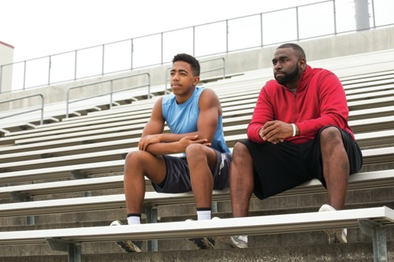
Figure 6 How do you plan your first meeting with a coach?
View description - Figure 6 How do you plan your first meeting with a coach?

Since 2013, Alex has been involved in a mentoring programme which is focused on supporting grassroots voluntary coaches. During this time Alex has worked with over 20 coaches on an individual basis.

Activity 5 Meeting a mentee for the first time
Allow about 10 minutes

In this activity, listen to the approach Alex adopts to the initial meeting with a new mentee.
Was there anything that surprised you with this approach? How well might this approach work with Stewart from the motor-racing team?

Audio content is not available in this format.
Audio 3
View transcript - Audio 3

Provide your answer...

View discussion - Part

If you deliver coaching qualification courses, you will find it valuable to see how Alex adapts his welcome for a course-related learning environment.

Box 1 Alex adapts his welcome strategy to a more formal course-related situation
I make sure I arrive 45 minutes before the start time of the course – you can always guarantee that one of the coaches on the course will arrive very early. Initially I start by playing a video of a football match as a kind of welcoming gesture. As this plays I organise the furniture in the room and put up some posters to make the room look more like a coaching environment. I purposely leave the door open. I do this as I want the coaches to walk through an open door. As the coaches arrive, I greet them and give them a form to complete. This form has four boxes with a question in each box, these questions are:
- What do you want to learn on this course?
- Where and what team are you coaching at present?
- How do you think you are going to learn on this course?
- What is your favourite sporting moment and why?
This serves as an activity that the coaches can complete and share with each other while we wait for everybody to arrive and deal with any initial administrative issues. Once everybody, or almost everybody, has arrived we start by writing each coach’s favourite sporting moment on a ‘post-it’ note and posting them to a wall where I then select one at a time and ask the coach it belongs too for a bit more information about the moment they have chosen. This gives me time to listen to each individual and start to get to know them as well as building the dynamics of the group. It is also a fun and non-threatening activity, no personal information needs to be declared and as a consequence the first activity is purposely designed to underpin the creation of an emotionally safe environment where each individual only has to disclose what they feel comfortable with.

Having planned to make a positive first impression you now consider different aspects that will help to evolve and sustain a learning relationship, particularly those around providing support and challenge.

6 Pulling together ideas
The role of coach developers is to support coaches to improve their practice, but your impact depends on several variables such as your skills, the coach’s openness, their perceptions of the development process and initiating your relationship productively.
You have read about the need to get to know coaches as people and find some shared mutual connections that allow empathy and rapport. In effect, you have explored the first three steps in the Behavioural stairway model (Figure 7) introduced in Session 1.

Figure 7 The behaviour change stairway model
View description - Figure 7 The behaviour change stairway model

Once rapport has been established you can start to exert some influence on the decisions and judgements that coaches make and help them develop their practice. One professional training route where building empathy, rapport and influence is a feature is the training of teachers. You will explore this next.

7 Learning from teacher–mentor relationships
Learning to become a teacher requires a significant amount of school-based practice, supported by an experienced teacher working at the school.

Figure 8 Developing a mentoring relationship
View description - Figure 8 Developing a mentoring relationship

This teacher–mentor relationship is not unlike the role sometimes undertaken by a coach developer. What then can we learn from teacher–mentor relationships?

Activity 6 What do mentors and teachers say about their relationship?
Allow about 15 minutes

Listen to the audio below and note down the potential characteristics of the teacher–mentor relationship. How applicable is this to the coach–coach developer relationship?

Audio content is not available in this format.
Audio 4
View transcript - Audio 4

Provide your answer...

View discussion - Part

The trust that is needed in a new relationship is important when it comes to stretching and challenging a coach. They need to know that they are in safe hands; but what are the elements of establishing trust?

Activity 7 Knight’s components of a trusting coaching relationship
Allow about 15 minutes

James Knight from the University of Kansas researches professional learning and coaching. Watch this video in which he identifies five components of building trust in the context of distance video-based teaching observations.
Which of these components may be more challenging for coach developers to establish?
Video 3: Jim Knight: the 5 components of a trusting coaching relationship. Watch the first video on the page, from 00:00–03:23.

Provide your answer...

View discussion - Part

Trust is therefore particularly important when it comes to balancing the appropriate challenge and support for those you work with. As you can see establishing trust is not straightforward.

8 Balancing challenge and support
Any effective person-centred learning and coach development is based on achieving the right balance between the support which is appropriate to the individual and challenge to progress the coach in their thinking or practice. This balance is represented in Figure 9.

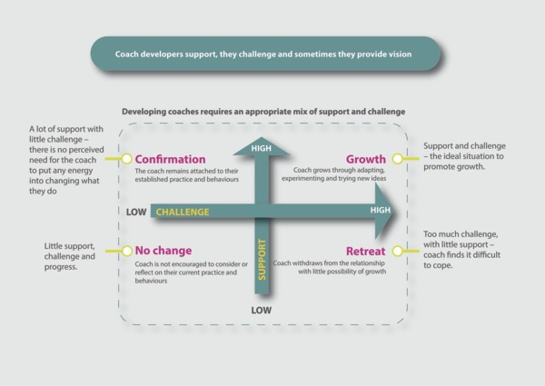
Figure 9 This diagram demonstrates pictorially the balancing dynamics of the coach developer role, between providing both support and challenge to the coach (Source: adapted from Martin, 1996; Daloz, 1986).

It is likely that coaches will need different levels of support and challenge in different situations and contexts. Also, the balance may change over time. Recognising the support or challenge needed in a particular circumstance and being flexible in your approach is a key skill.

Activity 8 Challenge and support
Allow about 10 minutes

Using the model above, think about supporting a coach. What coach developer behaviours in addition to those shown in the figure might be used to challenge and support a coach effectively?
An example is given below:

Challenge-related behaviours | Support-related behaviours
- Ask them to try something different in their next session that stretches them | - Share a session with them as a co-coach letting them take the lead role.
Provide your answer... | Provide your answer...
Provide your answer... | Provide your answer...
Provide your answer... | Provide your answer...
Provide your answer... | Provide your answer...
Provide your answer... | Provide your answer...
Provide your answer... | Provide your answer...

View discussion - Activity 8 Challenge and support

Becoming a better coach is a complex process and sometimes things may not go according to plan, this is when the support part of your role becomes crucial. In this final section you will find out more about learning from mistakes both as a coach developer and as a coach.

9 Learning from setbacks
Learning to become a better coach means being prepared to admit to making mistakes and accepting failure as an inevitable part of coaching. It requires an openness and willingness to discuss things that don’t go to plan and to learn from these experiences. As a coach developer one of the most crucial aspects of your role is to support and guide coaches through the process of learning from failure. This will be helped by the strength and health of the relationship you have with these coaches.

Figure 10 Slipping up and making mistakes is a rich source of learning
View description - Figure 10 Slipping up and making mistakes is a rich source of learning

Failure is not easy – sometimes shame, embarrassment and a fear of ‘losing face’ can be a barrier to accepting that mistakes happen and that something can be learned from them. These feelings may be felt because failure and a fear of mistakes have been socially constructed as a sign of weakness, under-achievement, losing and rejection.

Activity 9 Alex talks about his approach to mistakes
Allow about 15 minutes

In this activity Alex talks about his approach to helping coaches learn from their mistakes. In your experience, do coaches sit down with other people in real life to learn by reflecting on their mistakes, or is this just something that happens in theory?

Audio content is not available in this format.
Audio 5
View transcript - Audio 5

Provide your answer...

View discussion - Part

At the start of this session you saw that shared goals, connection, empathy, trust and attitude towards mistakes all contribute to effective learning relationships. The common coach development thread between all these ideas is the deliberate planning and effort that is needed for these to take effect.

10 Building your coach developer 101 guide
The main discussion points from this session that you might share and discuss with colleagues are described in Table 2 below.

Table 2 Some practices coach developers can use to build expertise in their role
Practices and ideas | Description
11. Using humanist principles | Based on Carl Roger’s humanist approach to relationships it draws on the principles of congruence (being authentic), empathy and unconditional positive regard (being non-judgemental).
12. First impressions and planning the first meeting | Planning the first meeting with a coach is an important process, as it helps start the relationship on a sound footing.
13. Building trust | Trust is an important element of all learning relationships. For learning to take place people have to feel safe, valued and respected; it takes time.
14. Balancing support and challenge | Optimise when and why to challenge coaches and stretch them and know when and why they need support.
15. Learning from mistakes | Mistakes are a rich source of learning. Failure is an essential component of success if perceived in this way.

11 This session’s quiz
Check what you’ve learned this week by taking the end-of-session quiz.
Session 3 practice quiz
Open the quiz in a new window or tab then come back here when you’ve finished.

12 Summary of Session 3
The main learning points from this session are:
- You have examined the similarities between a coach–athlete relationship and a coach–coach developer relationship. You considered the extent to which a coach–coach developer relationship should resemble aspects of closeness, commitment, complementarity and co-orientation.
- The principles of humanist practice to a coach developer role have been outlined, and you have considered how congruence, empathy and unconditional positive regard can create a growth promoting environment.
- Planning the initial meeting with a coach that you will be about to support is crucial – it is a meeting that needs to be carefully thought through.
- Balancing the challenges you deliver to coaches in developing their practice with the support you provide is a skilled process that evolves and changes over time and is specific to each coach you work with.
- Trust and empathy are important components of successful learning relationships – they can be the bedrock on which coaches learn and develop their practice.
- Becoming aware that mistakes are integral to learning – provided they are reflected on and accepted as opportunities to learn and develop. Mistakes only become opportunities to learn if they are perceived in this way.
This session has covered important elements associated with the process of building effective learning relationships. However, one element is missing. All relationships are structured by forms of power, and the coach–coach developer relationship is no exception.
In the next session you begin to explore the influence of power and the consequences this has for your self-awareness as a coach developer.
You can now go to Session 4.

Session 4: Becoming self-aware of power in your role

Introduction
Have you ever experienced an uneasy relationship with a coach you are supporting – perhaps a feeling of coldness or scepticism being expressed towards you? Are you aware of the potential power you have over coaches and how you might, unwittingly, project your ideas onto them?
In this session you’ll develop your self-awareness of how relationships are structured by different forms of power, and how they are infused with opinions, beliefs and perceptions that impact your ability to build rapport and influence change.

Figure 1 How self-aware are you as a coach developer? What is the image you see of yourself in this role?
View description - Figure 1 How self-aware are you as a coach developer? What is the image you see of ...

You will explore these insights using three examples from research:
- a coach being assessed for a coaching qualification
- coaches participating in coaching qualification courses
- coach developers entering a professional football club.
By becoming more knowledgeable about your status, identity and power you will develop your ability to manage the influence you have on other people.
To start this session, watch this short video where Lucy Moore and Alex Twitchen briefly discuss their understanding of power and it how influences their work as coach developers.

Video content is not available in this format.
Video 1
View transcript - Video 1

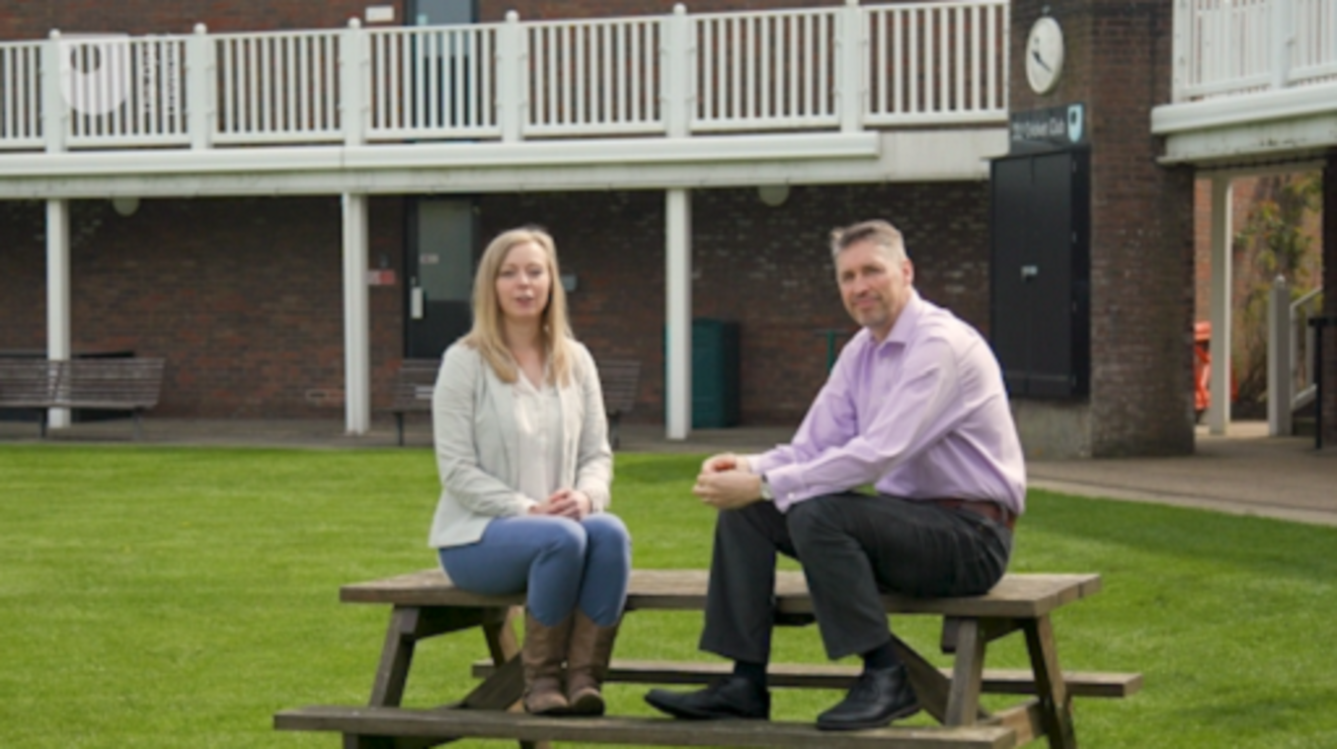

By the end of this session, you should be able to:
- describe the meaning of power in a coach–coach developer relationship
- reflect on case studies illustrating the use of power in coach learning and development relationships
- become more self-aware of your power and identity as a coach developer and where this power stems from.
Throughout this session you will come back to the ideas expressed in Video 1. You’ll start, however, by exploring what is meant by power in social relationships.

1 Power and social circumstances
Power is an intrinsic aspect of all social relationships but often its presence or importance is not understood. A power imbalance of one individual over others can stem from factors such as their position of authority, status, reputation and personality.

Figure 2 Who has more power, and how unbalanced is the distribution of power in a relationship?
View description - Figure 2 Who has more power, and how unbalanced is the distribution of power in a ...

Power is not necessarily bad, but when there is a power imbalance between people the effectiveness of learning can be influenced by the way the possession of power is used.

Activity 1 Power, society and your role
Allow about 10 minutes

Watch this short video which describes power in personal and social relationships. Afterwards, make brief notes on the following question: What creates the power you have as a coach developer?

Video content is not available in this format.
Video 2
View transcript - Video 2

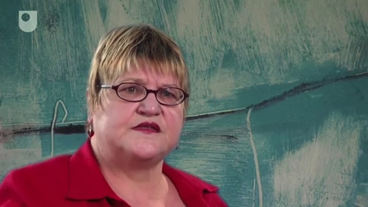

Provide your answer...

View discussion - Part

Power operates at both a societal level as well as within relationships between two people. If you are assessing a coach for a qualification you have a source of power as the assessor; this status and power is connected to the policy for coaches to be professionally certificated and the qualification system that is created to service this policy.
The source and distribution of power can be said to flow from the societal level right down to the interaction between you and any coach you are assessing. This is just one example of how power is created and distributed. In the next activity the idea of power as a relational process specific to the context of a coach–coach developer relationship is examined further.

2 Power and coach developers
In the following activity you will read an article that has been specially written for this course by Ed Cope, Learning design and development manager at the Football Association.
The article offers a rich insight into the type of power that exists between coaches and coach developers. The article also illustrates how coach developers can become more self-aware of the power they possess and in so doing use their power to better support learning and development.

Figure 3 Power is not something that can be turned off or on
View description - Figure 3 Power is not something that can be turned off or on
View description - Figure 3 Power is not something that can be turned off or on

Activity 2 Power: Why it should be shared with rather than exerted on coaches
Allow about 20 minutes

Read the following article (5 minute read time) by Ed Cope, Learning design and development manager at the Football Association. As you read the article respond to these three questions:
- Why is context vital to fully understanding the distribution of power between a coach and coach developer?
- Traditionally, how does the hierarchical structure of the coach–coach developer relationship influence power?
- How can coach developers share power with coaches?

Understanding power in the learning and development process: Insights for coach developers
As a coach developer, you hold a position of power over coaches. Power is the notion of being able to influence the behaviours of others, and materializes in many different ways, including economic, cultural and social. In the context of the coach–coach developer relationship, it is social power that is most applicable. Social power refers to how people use their social position to influence the behaviours of others within a particular context. Context is a vital factor here, as this determines who holds the power and the extent to which they hold it. For example, while a coach developer may have power over a grassroots coach because of the relationship they hold, the same coach developer will hold a different relationship with a coach working in a different context and therefore the power relationship will be different.
Status and esteem – a source of power
Traditionally, the role of a coach developer has been hierarchically positioned above that of a coach. This situation has emerged often because coach developers have transitioned into this role from being experienced coaches who often hold the highest-level coaching qualification and coaching positions relevant to the context they are working in. Because of coach developers’ biographies and the esteem they tend to possess, their ideas and practices go unquestioned by coaches who simply conform through fear of being embarrassed or ostracized if they do not. This is especially the case on formal coaching qualification courses, where coach developers are responsible for making judgements of coach competency.
Historically, it has been common for coach developers to see themselves as the ‘knowledge bearer’ whose role is to pass knowledge down to coaches. The term ‘empty vessels waiting to be filled’ is a term that has been coined by coaching scholars (Cushion et al., 2003) to indicate how coaches are passive recipients of the education they receive. The more coaches are exposed to this approach the more they uncritically accept ideas presented to them. Over time, coaches transitioning into coach developer roles end up promoting the very approach that they were subjected to, and thus the process becomes cyclical and reproduced successively over periods of time. This is particularly problematic as their coach development practice will unlikely ever be as effective as it has the potential to be in terms of positively impacting coach learning and development.
Sharing power with coaches
Clearly a learning culture that does not promote the questioning of ideas and practices, and crucially where these come from, is not conducive for an honest, trusting and effective coach–coach developer relationship. To move this forward, coach developers need to recognize the power they have and adopt strategies that lead to this power being shared with, rather than exerted on, coaches. Such strategies include listening to coaches to understand their learning needs, avoiding making judgements on coaches’ practice before understanding the context in which they work and who it is they work with, and being open-minded to consider alternative ways of responding to problems faced that may not fit with existing experiences.
(Cope, 2019)

Provide your answer...

View discussion - Part

In the sections that follow you explore three examples (Cases A–C) that illustrate further the arguments made in the article. As you will discover, two of the examples represent power and influence being exerted on coaches rather than shared with coaches, while the third represents power being exerted on coach developers.
The examples highlight the complexity of power relations and the extent to which the presence, use and effect of power to influence others shifts and flows from context to context. Power is therefore never produced and reproduced identically across all coach–coach developer relationships.

3 Coach developers in control
The first example of a power imbalance is a stark case and makes uncomfortable reading. In the example, a coach developer exerts power to regulate and control a coach as he assesses the coach for a qualification.

Figure 4 What happens when a coach and coach developer have a different perspective on an aspect of coaching practice?
View description - Figure 4 What happens when a coach and coach developer have a different perspective ...
View description - Figure 4 What happens when a coach and coach developer have a different perspective ...

As you undertake the activity reflect on whether or not you have been confronted with a similar experience in the past.

Activity 3 Case A: Do it like this
Allow about 20 minutes

Case A is drawn from a study of the relationships between mentors and beginner coaches (mentees) in the sport of swimming (Zehntner and McMahon, 2018). Read Case A about the mentor–mentee relationship in the context of a coaching certification process – the mentor is also assessing the coach. The trainee coach has noticed that a swimmer is having problems adopting the right breathing technique. Once you have read Case A, answer the following questions:
- Where is the power the mentor is using coming from?
- What are the consequences of the power being used in this way?

Case A:
As I approach the little girl, my mentor clicks his fingers like a person … in a restaurant … I turn towards him and he points to the same swimmer that I have already noticed. His face is screwed up and looks angry. ‘Fix that’ he says, ‘That needs to be corrected now!’ I nod and smile. I feel like I am in trouble. I quickly scan the parents on the pool deck and they have all heard the interaction between my mentor and I. At this stage I am holding back tears, there are three other coaches on pool deck and everyone’s attention seems to be on me so I just try and hold my emotion in.
I stop the little girl … and talk her through what she is supposed to be doing. My mentor calls out from his chair, ‘You need to hold her head and do it for her!’ I feel panicky again. I do not feel comfortable with manipulation of the little girl’s head. I know that he wants it done like that, but it does not sit right with me. But, I do it anyhow. I don’t want to get into trouble anymore. It all feels incredibly awkward, I want this job, I want to coach, I need to do these hours here otherwise I will have to start over somewhere else. If my mentor refuses to sign off my hours, I won’t get certified.
I gently hold the swimmer’s head .... the boss [mentor] gets up off his chair and strides up behind me. He bends down onto one knee and pushes my hands away. He calls out with unnecessary loudness, ‘that’s not how you do it. Do it like this!’. He grabs the girl’s head aggressively and turns it to the side. I cringe as he does it. I feel a knot in my stomach … This is not how I want to coach but I know I have to do it his way to get though …
(Zehntner and McMahon, 2018)

Provide your answer...

View discussion - Part

Zehntner and McMahon (2018) use concepts developed by Michel Foucault, a social theorist and critic of modern societies, to explain the social effects of power. According to this approach coaches are subtly regulated, disciplined and controlled so that their coaching practices become incorporated into established and dominant ideas about coaching. In Case A, the mentee feels relatively powerless to rebel or resist the power invested in the mentor and so they feel compelled to conform.
In the next section you’ll explore similar ideas but in a different context. You’ll read about the power and influence of individuals tutoring on coaching qualification courses.

4 It’s my way!
You’ll now explore how power relations can be applied to a coaching qualification course. In the activity that follows you’ll read about how individuals tutoring on these courses deploy their knowledge and subtle forms of power over the coaches.

Figure 5 In control and doing it my way
View description - Figure 5 In control and doing it my way
View description - Figure 5 In control and doing it my way

Case B represents another example of power although, as you might conclude, a form of power that is closely related to the example you read about in Case A.

Activity 4 Case B: An open approach to responding to questions?
Allow about 20 minutes

Read the following extract from a study undertaken by Piggot (2012). To what extent do you recognise the tutoring being demonstrated in this extract? Please note, L1, L2 and L3 refer to the qualification levels adopted by the United Kingdom Coaching Certificate (UKCC) framework.

… coach educators … employed a range of techniques to (re)produce knowledge and protect their positions of power. First, authority was established, usually through reference to experience and status. As Hayley explained: ‘… it was the constant reminder of his years of experience and years in the job that was drip-fed into the conversation … [It] served as a reminder that he had the experience; he had the knowledge. Therefore, there was no need to question it.’ (Hayley, Swimming L2)
Such practices served to establish dominant … power relations which were described by coaches as ‘paternalistic’, [we were] ‘treated like children or like players’ (Lyle, Football L2). In order to reinforce these relations, coach educators drew on the technique of ‘deifying knowledge’, rendering unassailable the ideas and practices they were presenting. This practice was characterised by Craig: ‘They constantly referred to ‘when they were working with such and such a player’ and ‘when they were working with such and such a club’ and erm … you feel they were bringing them in because they feel their experience outweighs your own and undermines your own way of coaching’ (Craig, Basketball L3). When coaches attempted to question this knowledge and the associated practices, questions were either bluntly ‘shot down’ or countered with the more subtle response: ‘that’s interesting but …’. This technique characterised a sophisticated attempt to ‘pay lip service to questions’ (Evelyn, Gymnastics L1) whilst simultaneously drawing attention back to the orthodoxy, [e.g.]: ‘they’ll always say ‘that’s a good idea. I really like that but …’ Then they’ll take it back to what they know. So there is that chance to sort of debate, but it’s not real. It’s artificial. It’s for show. There’s still that underlying feeling that their way is still the best way to do it and we accept that because we want to pass the course’. (Lyle, Football L2).
(Piggot, 2012)

Provide your answer...

View discussion - Part

Reflecting on experiences and the ability to read the social situations that unfold is partly what makes a highly skilled coach developer. Being aware of the power you possess, the extent of this power, its source and how you can use your power constructively to support learning and development is vitally important.
As a contrast, in the next section you consider a situation where power has been inverted and the coach developer is in a relatively powerless position.

5 When power is turned upside down
As a coach developer you often enter organisations as the representative of another organisation. In the activity below you will read how a coach developer’s work is compromised by the perceptions of their role and the organisation they represent.

Figure 6 How can you stop forms of power obstructing your role as coach developer?
View description - Figure 6 How can you stop forms of power obstructing your role as coach develope ...

Through the following case study you are continuing to build on your own self-awareness of power relations.

Activity 5 Case C: Placed ‘on the back foot’
Allow about 15 minutes

The following three extracts are taken from interviews that examine the experiences of full-time coach developers, academy managers and coaches within professional football clubs (Cushion et al., 2017).
Read the extracts and then write down your thoughts on the following:
- Can you think of examples where you have also been placed ‘on the back foot’ or met a brick wall as a guest at an organisation: how would you react in this situation?
- Where do the views and opinions of the academy managers (Extracts 1 and 2) and the coach (Extract 3) come from, and why?

Extract 1
Interviewer: How do you see the coach [developer role] within your club?
Academy manager 1: Well, first of all, the word ‘within’ is dangerous, ‘cause he wouldn’t be within! … He would be ‘outside’, supporting us with our qualifications. [They] could not come and start telling anybody what to do. It doesn’t work that way. He’s invited in as our guest, as our support person. I told him that he could come in but he wasn’t going to change anything as we have our own way of doing things and our way is the right way.
Extract 2
Interviewer: Can you describe the impact that the coach [developer] had on your coaching programme?
Academy manager 2: None. No, we’ve asked the coach [developer] when he comes in … to reinforce our coaching programme.
Extract 3
Coach developer: I was told I could come in but wasn’t going to change anything as they (the club) have their own way of doing things and their way is the right way.
Coach: When I first came across the coach [developer] and asked who that is, oh it’s … from the Sports Governing Body, straightaway I was defensive.
(Cushion et al., 2017)

Provide your answer...

View discussion - Part

In this last example the tables have been turned. It is the coach developer on whom power is being exerted. Through the circumstances of this context the coach developers may have to explore and find some quite subtle methods of building relationships that will influence the development of coaching practice.
These three case studies have demonstrated how power relations between a coach and coach developer vary from situation to situation and are in a continued state of flux. They have also underlined the importance as to why coach developers should be self-aware about the degree of power they may have, or might not have, and the influence this can have on learning.
To draw this session to a close you are now introduced to a term that may be new to you: reflexivity.

6 The reflexive coach developer
Being reflexive means looking back on your experiences and understanding the effect you have on other people as well as recognising the reasons why you have this effect.

Figure 7 Looking back at yourself through the lens of your own self-identity – what do you see?
View description - Figure 7 Looking back at yourself through the lens of your own self-identity – what ...

Being reflexive can be an important aspect of expertise for those supporting the learning and development of coaches. Lucy Moore takes up the story:

For me, being reflexive is a process of looking back on your own practices and behaviours to help you better appreciate how and why the coaches you are supporting perceive you in the way they do. It is having a heightened sense of self-awareness and understanding about your role as a coach developer – about understanding why you believe what you believe – and seeing this from the perspective of the coach. I always remember how I felt when I was being observed as a coach and being given feedback. Those experiences now shape my behaviour when I am supporting coaches. The saying goes ‘treat others as you want to be treated’ and I aspire to do so. Being reflexive increases your potential to navigate some of the power relations, opinions, beliefs and perceptions that you may encounter as a coach developer and understand these in more detail.
(Lucy Moore, coach developer)

Reflexivity is therefore more than just being reflective. Instead, it is reaching a point of knowing why you believe what you believe about developing coaches, and projecting this in your behaviours and actions (Warren, 2011). It is about how you construct your self-identity as a coach developer and what this role means to you.
Being reflexive requires having a deep sense of self-awareness and introspection and a willingness to always question yourself and imagine your effect on others through the lens of how you would want to be treated. An important and integral part of this is recognising the distribution of power in your relationships with coaches.

7 Building your coach developer 101 guide
The main discussion points from this session that you might share and discuss with colleagues are described in Table 1 below.

Table 1 Some practices coach developers can use to build expertise in their role
Practices and ideas | Description
16. Power relations | Power is intrinsic in every relationship, but power is not distributed evenly and it stems from many different sources. The distribution of power can shift within relationships over time.
17. Sharing power | Self-aware coach developers share power through listening to coaches’ needs, avoiding making judgements on their practice, being open minded and conscious of the context in which they work.
18. Hierarchy and status | Coach developers are often highly qualified and experienced coaches which reinforces a perceived hierarchy and status. Taking steps to listen and connect to coaches will help collaborative learning.
19. Reflexivity | This is the process of bending back onto yourself, your actions and behaviours to better understand the identity you project to others. This involves being introspective and knowing yourself well.

8 This session’s quiz
Now it’s time to complete the Session 4 badge quiz. It is similar to previous quizzes, but this time instead of answering five questions there will be fifteen.
Session 4 compulsory badge quiz
Remember, this quiz counts towards your badge. If you’re not successful the first time, you can attempt the quiz again in 24 hours.
Open the quiz in a new tab or window then come back here when you’ve finished.

9 Summary of Session 4
The main learning points from this session are:
- Power is a feature of all social relationships. Power can be a force for good or it can be used to constrain, discipline and impose ideas on others. The distribution of power within relationships is uneven and always changing.
- Coach developers possess power through their status and reputation. Being self-aware of this is crucial in developing relationships with coaches and power should be shared with coaches not exerted on them.
- Relationships of power between a coach and coach developer can vary from context to context. No two situations are the same and the distribution of power is constantly in flux as the specific circumstances of a relationship change.
- You have read three examples how power influences the learning and development process. These examples demonstrated the fluidity of power between contexts and reveal where the sources of power can stem from.
- You have been introduced to the idea of reflexivity. Reflexivity is more than being reflective. It is a process of bending back onto yourself the behaviours you use with others, recognising how you would respond to these behaviours if you were the subject of them and knowing why you believe what you believe about developing coaches.
Tutoring courses is one of the potential roles you may undertake as a coach developer. In this role as well as the ability and awareness to build effective learning relationships, and understand the power you potentially possess, you also require good teaching skills. This is the subject of the next session.
You are now halfway through the course. The Open University would really appreciate your feedback and suggestions for future improvement in our optional end-of-course survey, which you will also have an opportunity to complete at the end of Session 8. Participation will be completely confidential and we will not pass on your details to others.
You can now go to .Session 5

Session 5: Developing your teaching repertoire and skills

Introduction
As a coach developer there may be occasions when you undertake some form of teaching. When you deliver a workshop, for example, you draw on teaching skills to explain information and support learning.
Helping coaches to learn through good teaching is a skill that can be continuously improved. In this session, you will explore the idea of developing your repertoire of teaching approaches.

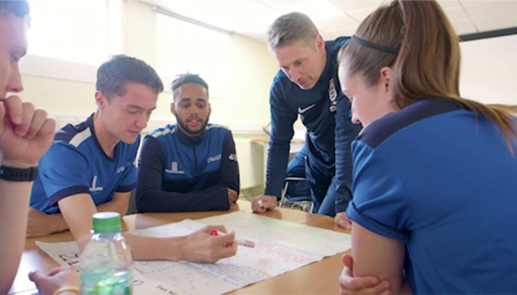
Figure 1 The coach developer when tutoring uses a variety of teaching skills in this role.
View description - Figure 1 The coach developer when tutoring uses a variety of teaching skills in this ...

This session cannot cover all teaching situations. Instead you will look more closely at the following three approaches:
- problem-based learning
- flipped learning
- instruction.
You will focus on these approaches because they cover techniques including facilitation, group work, use of online technologies and instructional behaviours that are used elsewhere in teaching. In subsequent sessions you will also cover teaching-related skills such as questioning (Session 6) and observation (Session 7). The overall purpose is to build a deeper knowledge of teaching and how learning occurs.
By the end of this session, you should be able to:
- appreciate different approaches to teaching that coach developers can draw on
- know the principles of problem-based and flipped learning, and
- use direct instruction more effectively.
You start this session by applying some of the assumptions about adult learning you covered in Session 2.

1 Beyond the assumptions of adult learning
You may remember Knowles’ (1990) ideas about how adults learn from earlier in this course.

Figure 2 Adults need to understand why they are learning and how it applies to their context
View description - Figure 2 Adults need to understand why they are learning and how it applies to their ...
View description - Figure 2 Adults need to understand why they are learning and how it applies to their ...

The end point (in Session 2, Activity 5) arrived at the following six conclusions.
To enhance coach learning and development you need to:
- Clearly explain the purpose of the learning and how it will benefit coaches.
- Draw on the considerable and varied experiences of coaches as a rich resource for learning and recognise prior knowledge in the tone of your delivery.
- Enable coaches to be responsible for their own learning and provide individual autonomy where possible.
- Relate the content you are presenting as being applicable to their world and to current issues and challenges.
- Use problem solving and task-centred approaches where possible.
- Relate learning to personal characteristics such as self-esteem, quality of life and job satisfaction.
This list is useful in comparing your current approach to teaching. Perhaps it makes you consider how you might adjust part of your teaching practice. Two further teaching approaches should also be encouraged according to Knowles et al. (2005), which are:
- Adults should be involved in the planning and organisation of their learning.
- Learning experiences provide the basis for experimentation and making mistakes.
One of Knowles’ (1990) conclusions is that adults learn best when content is presented to them in a problem-centred way (item 5 in the above list); problem-based learning (PBL) is the first teaching approach that you explore in more detail.

2 Exploring problem-based learning (PBL)
Problem-based learning originated as a popular method of teaching in medical schools in the 1960s. The essence of the PBL approach lies in stimulating learning by actively exploring possible solutions to open-ended problems. It is considered a constructivist approach to learning, as learners construct and build their knowledge through the problem-solving process.

Figure 3 Collaboration with others often illustrates the different perspectives we have of a problem
View description - Figure 3 Collaboration with others often illustrates the different perspectives we ...
View description - Figure 3 Collaboration with others often illustrates the different perspectives we ...

Problems that directly address the immediate priorities and challenges facing coaches are also more likely to be motivating than simulated abstract problems that are unrelated to the context the coach is working in.

Activity 1 Exploring problem-based learning in practice
Allow about 20 minutes

Watch the following two videos. The first (Video 1) shows the reflections of a new sport lecturer introduced to PBL, and the second (Video 2) summarises the problem-based learning approach used by Maastricht University across all subjects. As you watch both videos respond to the following questions:
- Explain the role of the teacher in PBL.
- How might PBL be used in your context, perhaps with less regular contact with groups than those at a university?
- How effective do you think PBL is for learning about a coaching problem when, to understand the problem, it requires learning considerable new knowledge?

Video content is not available in this format.
Video 1
View transcript - Video 1

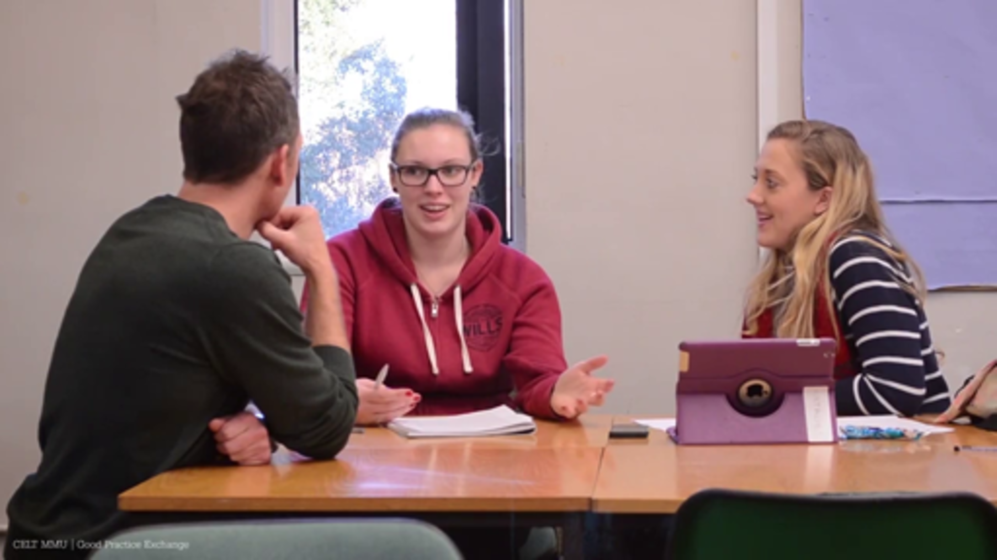

Video content is not available in this format.
Video 2
View transcript - Video 2

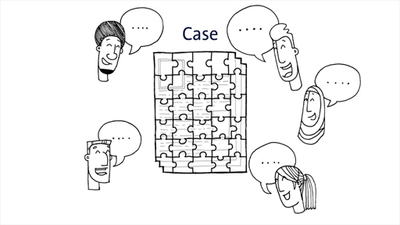

Provide your answer...

View discussion - Part

Having considered these aspects of PBL, you will now look at two examples where this approach to teaching might be used.

2.1 When would you use PBL?
Look at these two examples of problems that coaches might typically confront:
- Your athlete suffers an injury three months before a major competition that limits their ability to train. How do you adjust and adapt the training programme and maintain the athlete’s psychological welfare?
- One of the participants that attends your regular coaching session suddenly becomes disruptive, uncooperative and openly critical of your coaching. What do you do?
These might be appropriate types of problems for coaches to find solutions for, but only if they are relevant to the context of the coaches you are supporting. They also suggest that your coaches need to have reasonable levels of prior experience and knowledge. They need to have time to explore the options and have the skills to collaborate in groups to address the problem. They need to be motivated to explore an issue and ideally you need to maintain some contact with them (in person or online) while they are problem solving.
The next approach you discover more about is called flipped learning. It has a similarity to PBL in allowing people to explore topics on their own terms and with teachers again acting as facilitators.

3 Exploring a flipped learning model
The approach to the start of this section is very different – you go straight into an activity. The reason will soon become apparent.

Activity 2 Preparing for the section ahead: flipped learning
Allow about 10 minutes

Using the terms ‘flipped learning’ or ‘flipped classroom’ in an internet search engine, research what flipped learning means. You may even find a video of flipped learning being used in practice, even if it is outside of a sport context.

Provide your answer...

View discussion - Part

In the following activity you will extend your understanding further.

Activity 3 Rethinking space and time: how it applies to coaching practice
Allow about 20 minutes

Watch Video 3 which is about rethinking space and time using the flipped learning model. Then watch Video 4 in which Mark Upton (formerly of the English Institute of Sport) explains how he used flipped learning in his coaching practice at a professional club.
Answer these two questions:
- What space and time is being changed?
- What does Upton claim are the benefits of using flipped learning?

Video content is not available in this format.
Video 3
View transcript - Video 3

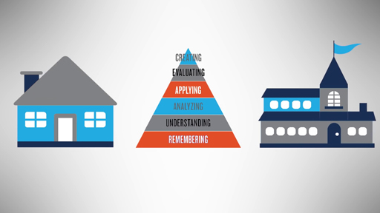

Video 4: The ‘flipped classroom’ and sports coaching. Watch from the start up to 06:23.

Provide your answer...

View discussion - Part

There is evidence to support the effectiveness of flipped learning. For example, Reddan et al. (2016) have reported on the successful use of flipped learning with a group of sports coaching students. The students preferred the flipped classroom method and teachers found that they could engage with their students more individually.

3.1 When would you use flipped learning?
Devising well thought through, structured activities that engage learners before you meet them is the essence of the flipped approach.

Figure 4 Flipped learning refers to how structured tasks are often undertaken before face-to-face teaching
View description - Figure 4 Flipped learning refers to how structured tasks are often undertaken before ...

You are most likely to use this approach if you have resources you can direct learners to; this might free up time in face-to-face contact. In a sense, this very course – if used as a pre-requisite for those attending coach developer training – could act as a form of flipped learning since everyone should arrive with similar baseline knowledge.
Both PBL and flipped learning have been termed active teaching approaches as opposed to passive i.e. learners do something rather than just sit and listen. In the next section you’ll consider the extent to which the marginalisation of so-called passive teaching approaches, like instruction, could be unjustified.

4 Instruction: widely misunderstood?

Instruction is widely misinterpreted … [Paul Kirchner] believes most teachers see it as ‘drill and skill, authoritarian, isolated fact accumulation, one size fits all’ when it is nothing of the sort.
(Times Educational Supplement, 2018)

All coach developers instruct to some extent. Yet instruction in teaching and sport is often maligned and its important role in learning can be marginalised. Perhaps this is because, as Gustafson (2019) claims, theories of learning – such as social constructivism (from Session 2) – have also been mis-appropriated as a theory of teaching. This has resulted in traditional instruction being perceived as authoritarian and old-fashioned while progressive teaching methods, characterised by minimal teacher input, have become more dominant.

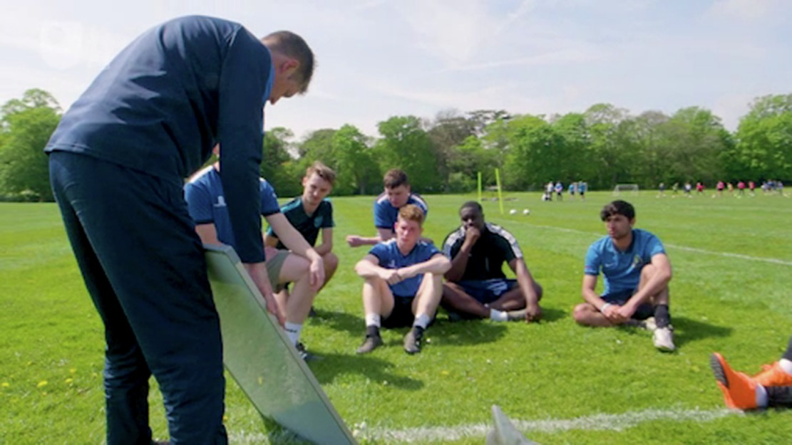
Figure 5 In what circumstances is instruction an effective approach to teaching?
View description - Figure 5 In what circumstances is instruction an effective approach to teaching?
View description - Figure 5 In what circumstances is instruction an effective approach to teaching?

If done well using some basic principles, evidence shows that instruction is very effective (Stockard et al., 2018). Some of the principles of ‘direct instruction’ – as it is formally known by researchers – include ensuring that:
- learners have the prerequisite knowledge to learn something
- there is a clear explanation of what is expected of learners and what you want them to do
- you model the process, show learners how it is done, and try to talk through why you did it.
A more complete explanation of these and other principles follows in the next section.

4.1 Reviewing your current instruction practices
In the following activity you will explore some instruction principles that are based on the work of Neelen and Kirchner (2015) and compare them to your existing practice.

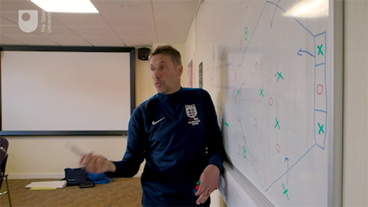
Figure 6 Knowing when to instruct coaches, and how to do this well, is a skill that all coach developers use on occasions
View description - Figure 6 Knowing when to instruct coaches, and how to do this well, is a skill that ...
View description - Figure 6 Knowing when to instruct coaches, and how to do this well, is a skill that ...

Activity 4 Instructional principles all teachers should know
Allow about 25 minutes

Look at the ten instructional principles in Figure 7, some of which may mirror your own current practices. Work through each principle in turn and reflect on examples from your own coach developer role where you already use all or part of the principle.
How might you implement it more fully in your context? When reflecting, think about both workshop knowledge delivery situations (i.e. class-based ‘instruction’) and practical coaching practice.
Ten instructional principles

Provide your answer...

View discussion - Part

4.2 When would you use instruction?
You are most likely to use this careful structured progression when coaches have limited knowledge of something and therefore you are breaking relatively new ground. It is often used to introduce new conceptual ideas or theories to a group.
Instruction as a teaching approach positions you in the role of guiding coaches through a series of sequenced steps while checking for understanding and giving them chances to show success.
It is also important that an over reliance on PowerPoint presentations is avoided.
In the following section you’ll move on to consider professional development within teaching and the potential insights you can apply to coach learning and development.

5 What can we learn from the teaching profession?
If you view coach learning and development as sharing some aspects of pedagogy (teaching children) the teaching profession might offer further insights into improving your practice.

Figure 7 The professional development of teachers may offer insights for coach learning and development.
View description - Figure 7 The professional development of teachers may offer insights for coach learning ...
View description - Figure 7 The professional development of teachers may offer insights for coach learning ...

To begin to understand what you can learn from the teaching profession the following five ideas are a way of summarising contemporary teaching research. They are drawn from a fascinating book Urban Myths about Learning and Education (De Bruyckere et al., 2015). The book’s authors, who are recognised researchers in this field, recommend:
- Keep the end in mind – Identify the key information you want coaches to remember at the end of a session and formulate an appropriate question that provides focus (a bit like our question for this and other sections).
- Concrete examples and a narrative – Avoid ideas that are abstract and out of context, use storytelling. Can you work the essence of your learning into a good narrative story?
- Variety and surprise – Give your learners diversity to sustain their attention. Aim to do something different every 15 minutes e.g. an image, a story or something else that is different.
- Enough breaks – Ensure you build in enough breaks for people to process information.
- Effective feedback – Such is the importance of this topic that it is addressed in more detail in Session 7.

A shared coach developer vocabulary?
Like coaching, learning to teach is an ongoing process influenced by continuing professional development (CPD). Doug Lemov, an author and teacher developer, has observations about running CPD sessions for teachers that are potentially useful for coach development.
He suggests that the use of commonly named teaching practice behaviours that enhance shared understanding and discussion is valuable, i.e. a shared vocabulary.
Since the coach developer role is relatively new compared to other professions the shared vocabulary may emerge over time as learning and development practices become more established. This course aims to contribute to this process of a more widely shared vocabulary by the creation of the coach developer 101 guide.
Also of note in this audio clip was an appreciation that much of the learning takes place after any formal session, as new ideas reverberate around informal environments. This is, provided coaches’ ‘filters’ do not result in new ideas being discarded straight away (Session 2).

Final thoughts
For many, including Lemov, teaching and coaching have elements of a craft; craftspeople adapt tools to their own style to the needs of the environment they are in.
The outcome of this session may be that you can begin to answer some challenging questions about
- which active learning methods
- in what kind of circumstances
- lead to more effective learning for which coaches
- are these methods genuinely better than traditional methods?
If you want to explore further evidence about this complex question we recommend you consult the list of references, in particular De Bruyckere et al. (2015) and Neelen and Kirschner (2015).

6 Your chance to contribute
Since you were last invited to post to the course forum you have explored a lot of material (relationships, power and teaching) and you probably have some valuable thoughts about these ideas and your coach developer role. You are reminded that a posting is not a requirement in order to obtain a digital badge.

Figure 8 Posting to the forum.
View description - Figure 8 Posting to the forum.

By posting to the course forum you will help ensure that the wider coach developer community voice is heard. Any consensus evident on this forum will be communicated to Sport England, UK Coaching, CIMSPA and other appropriate organisations to help further meet the needs of coach developers.

Activity 5 Forum posting
Allow about 20 minutes or more

Go to the course forum page and create a posting articulating your thoughts on one or both of the discussion threads below.
Your teaching repertoire
- How has your exploration of teaching in this session contributed to your understanding or connected with your existing coach developer practice?
Earlier sessions (relationships or power)
- How have aspects of Sessions 3 and 4 (see below) contributed to your understanding or connected with your coach developer role?
  - In Session 3 you focused on learning relationships
  - In Session 4 you focused on power and self-awareness.

View discussion - Activity 5 Forum posting

7 Building your coach developer 101 guide
The main discussion points from this session that you can share and discuss with colleagues are described in Table 1 below.

Table 1 Practices coach developers can draw on to build expertise in their role
Practices and ideas | Description
20. Problem-based learning (PBL) | An approach to learning that dissects an authentic ‘problem’. Connects well to adult learning since it uses real world coaching issues and supports learners’ motivations. The teacher becomes a facilitator.
21. Flipped learning | Learners research a topic and bring the information to a session. Flipped learning engages people in tasks earlier in the learning process and passes to them some responsibility for their own learning.
22. Instruction | A widely misunderstood teaching skill. Used well ‘direct instruction’ is an effective means of supporting learning, particularly when learning new content.
23. Shared vocabulary | The process of helping coach developers acquire and construct a shared vocabulary of terms related to learning and development.

8 This session’s quiz
Check what you’ve learned this session by taking the end-of-session quiz.
Session 5 practice quiz
Open the quiz in a new window or tab then come back here when you’ve finished.

9 Summary of Session 5
The main learning points from this session are:
- The method of problem-based learning (PBL) has been outlined and an explanation of how it might be used to support coach learning and development considered.
- You have examined the method of flipped learning – an approach whereby learners are asked to prepare beforehand and so come ready to explore content in more detail. As with the PBL, the role of the teacher is to guide and facilitate learning.
- Instruction is often misunderstood – it is still a valuable teaching method if undertaken well by following some key principles. These key principles were outlined in this session.
- Explored five ideas which summarise research into teaching:
  - keep the end in mind
  - use concrete examples and a narrative
  - use variety and surprise
  - provide enough breaks
  - effective feedback.
- Your repertoire of teaching approaches can be continuously developed and expanded. Selecting when each approach might be most effectively deployed is a real skill and part of the craft of being a coach developer.
In the next session you continue to think about how you support learning through the type of questions you ask. It is a real skill to frame good questions, to listen attentively and not provide the answers too quickly.
You can now go to Session 6.

Session 6: Asking good questions and listening actively

Introduction
In this session you will explore why questions are a valuable tool for coach developers and what principles can be applied to help you think about asking good questions. A lot of these ideas stem from a humanistic person-centred approach (e.g. counselling) which was introduced to you in Session 3. An equally important aspect is listening actively – this is more than just paying attention since it involves really understanding how you encourage genuine two-way dialogue.

Figure 1 Do coach developer’s asks questions to help coaches illuminate their own practice and encourage new insight?
View description - Figure 1 Do coach developer’s asks questions to help coaches illuminate their own ...

To ask great questions you have to know your stuff; I don’t mean technical and tactical but curiosity, framing good questions and looking at something with a critical eye. The coach developer needs to be asking questions not providing answers.
(Michael Poulton, Coach education and development consultant)

Good questions and active listening are all part of collecting information about coaching practice and understanding the reasoning and intention behind the behaviours demonstrated by coaches, as well as the judgements and decisions they make. Being skilled in asking good questions and listening well enables you to access their core beliefs as well as prompting reflection and dialogue.
By the end of this session, you should be able to:
- ask a range of effective questions to support learning and development and appreciate some questioning traps
- understand the importance of listening actively and hear what coaches are saying to you
- ask deeper questions about coaching purpose using a model of why, how and what.

1 Why ask questions?
Those who support coaches are often encouraged to use questioning as part of their approach (e.g. Kidman, 2005). Research also suggests that those who are coached this way – through questioning rather than just ‘being told’ – display greater performance gains and take more responsibility for and awareness of their learning (e.g. Chambers and Vickers, 2006).

Figure 2 It is unlikely you have come to questioning as a newcomer, you are probably on this track already but what is the purpose of questioning?
View description - Figure 2 It is unlikely you have come to questioning as a newcomer, you are probably ...
View description - Figure 2 It is unlikely you have come to questioning as a newcomer, you are probably ...

There are at least two dimensions to asking good questions. First of all, what type of question should you pose and secondly, how should you frame and ask the question? Combining these two aspects influences how a coach ‘hears’ your questions and responds to them. In the first activity you are going to watch two different people use questions in different environments to see how questions can be used to very different effect.

Activity 1 The use of questioning to support learning
Allow about 40 minutes

Watch the two short videos below which show how questioning is used to encourage reflection on practice. It’s possible that the presence of cameras influences the exchanges, as well as any differences there may be in ways of working between higher education (Video 1) and referee training (Video 2). However, despite this the contrast between approaches is fascinating.
While watching, make brief notes on the following questions:
- Which word is used most frequently to open questions – for example, ‘how’ or ‘what’? Are any other words used?
- Of the conversations in the videos, roughly how much of the time is taken up by the coach developer talking, and how much by the trainee? For example, in Video 1 you might estimate that the coach talks twenty per cent of the time, and the coach developer eighty per cent.
- How are the questions delivered, and in what manner are they posed?

Video content is not available in this format.
Video 1 (Higher Education). This clip features Thomas Legge (Senior Lecturer) at Hartbury University.
View transcript - Video 1 (Higher Education). This clip features Thomas Legge (Senior Lecturer) at ...

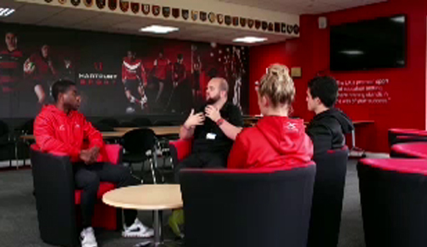

Video content is not available in this format.
Video 2 (referee training). This is a different style clip, an Australian training film; it features a rugby referee receiving mentoring support.
View transcript - Video 2 (referee training). This is a different style clip, an Australian training ...

Provide your answer...

View discussion - Part

Now that you have seen examples of the ways in which questioning might be used in diverse environments, you will next consider some overarching principles to follow for good questioning.

2 Principles for good questions
There are numerous checklists, books and online resources devoted to effective questioning. In the next few sections, you will explore some of the main principles that will help you in your work.

Figure 3 What is a principle? A proposition or ground rule that serves as the foundation of your coach development behaviours
View description - Figure 3 What is a principle? A proposition or ground rule that serves as the foundation ...

You may be familiar with two types of questions: open and closed. Open questions are generally short and begin with ‘what’ or ‘how’ or occasionally ‘when’ or ‘who’. They are very neutral and content free and they leave the answer open for the coach to interpret and answer as they see fit. These questions can optimise deeper exploration of coaching practice. Closed questions are occasionally useful to end part of the conversation or to check something out. They typically provoke a very closed response, usually comprising a ‘yes’ or ‘no’ answer. Closed questions are described as a form of conversational punctuation. Examples of closed questions are:
- Are you clear now about your action?
- Have we spent enough time on this subject?
Asking open and closed questions appropriately is a form of good practice, but there are some questioning ‘traps’ that you want to avoid. These are outlined in the next activity.

Activity 2 Questioning traps to avoid
Allow about 10 minutes

Listen to Audio 1. List those practices that are described as potential ‘traps’.

Audio content is not available in this format.
Audio 1
View transcript - Audio 1

Provide your answer...

View discussion - Part

To summarise the ideas covered so far, you have explored open, closed, multiple and leading questions, and finally questions beginning with ‘why’. Before you move on, watch Video 3 in which leading athletics coach Toni Minichiello (coach of Olympic gold medallist Jessica Ennis-Hill) reflects, with sophisticated self-awareness, on his own questioning style.

Video content is not available in this format.
Video 3
View transcript - Video 3

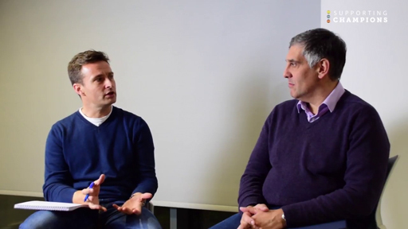

Notice how Toni admits to being ‘conscious of what I say’ and his comments on how to use video playback silently to get ‘richer answers’ before any questions are asked.
In this section you have explored several guiding principles. In the next section you will enhance these further.

3 Experiences of using questioning practices
Questioning should help to create a dialogue – it should be conversational, but it is a skill just like many other interpersonal practices.

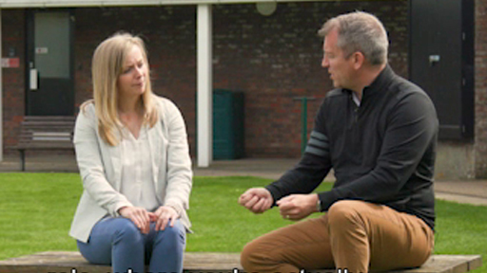
Figure 4 Lucy Moore and Stuart Armstrong share their experiences of questioning practices.
View description - Figure 4 Lucy Moore and Stuart Armstrong share their experiences of questioning ...
View description - Figure 4 Lucy Moore and Stuart Armstrong share their experiences of questioning ...

In the following activity you will discover further nuances that may help you ask better questions.

Activity 3 Lucy Moore and Stuart Armstrong discuss their experiences
Allow about 20 minutes

Listen to Audio 2. In this audio Lucy Moore and Stuart Armstrong reflect on their own experiences to discuss the balance between persistence in asking questions in order to raise a coach’s awareness and being more direct in proposing or suggesting something. They call this more direct approach ‘tell’ questions. What advice do they suggest in using ‘tell’ questions and when might it be appropriate to use this question type?

Audio content is not available in this format.
Audio 2
View transcript - Audio 2

Provide your answer...

View discussion - Part

You have head here how even two experienced coach developers are constantly reflecting on their own questioning practices and working towards improving their approach. Questioning is also an area that is researched. Cope et al.’s (2016) interesting conversational analysis in coaching suggests, amongst other findings, that when using questions you need to allow enough time for people to think and not being afraid of silence. This research is summarised more fully in an article by Oakley and Twitchen (2019): ‘How to ask better questions in developing others’.
So far, the types of question you have focused on have addressed what coaches do. But there are also deeper questions and conversations to be had that start to explore the beliefs and values that coaches hold.

4 Deeper questions: from the inside out
This section is, for many, a central part of developing coaches. In Session 1 you explored how part of the process of coach learning and development is to help make implicit values and beliefs explicit, and therefore open to reflection and discussion. Deeper questions, delving closer to a coach’s core beliefs, can help surface these.

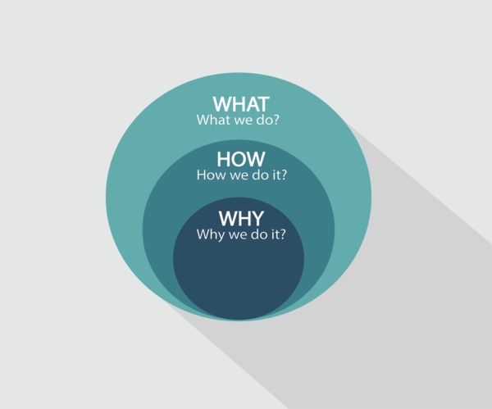
Figure 5 Deeper questions about purpose and beliefs can help surface a coach’s core ideas which they may not have articulated before.
View description - Figure 5 Deeper questions about purpose and beliefs can help surface a coach’s core ...

Simon Sinek is a leadership and management author. He argues that, to be effective, some of the important questions organisations and people should be asking centre around purpose and beliefs. For coach developers this would mean asking questions such as: What is the purpose of your coaching? What are you trying to achieve? What are your coaching beliefs? What do you believe is meant by good coaching practice and why do you believe this? In the next activity you will pursue these ideas further.

Activity 4 Simon Sinek and understanding ‘why’
Allow about 15 minutes

In Video 4, Sinek explains his ideas with reference to Apple, the digital business. While watching think about how this might transfer to coaches explaining and understanding their coaching practice.

Video content is not available in this format.
Video 4
View transcript - Video 4

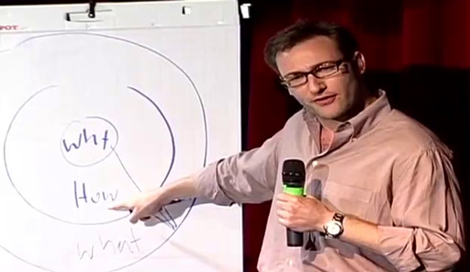

Provide your answer...

View discussion - Part

This style of deeper questioning requires a trusting and open relationship since it will take time for people to reveal their inner motivations. It is not easy. You can’t just jump in with this type of questioning. The following activity shows some of the bite-sized responses you may encounter and how more might be drawn out of such initial responses.

Activity 5 Coaches explain their approach
Allow about 20 minutes

When coaches talk about what drives them and what is important to them, it is most accurately described as their ‘coaching ideology’. Yet the literature often calls this their ‘coaching philosophy’ (Lyle and Cushion, 2016). This latter term is an extremely ambiguous which is why it has not been used so far in this course. However, in Video 5 you will see how three coaches – Sara, Helen and Brett – attempt to respond to a ‘What is your coaching philosophy?’ question.
How would you summarise each coach’s stated approach to coaching? What further questions would you like to ask them?

Video content is not available in this format.
Video 5

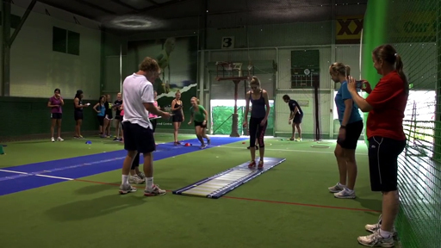

Provide your answer...

View discussion - Part

By exploring, through the effective use of questions, what coaches state as their core guiding principles and then revisiting these ambitions in subsequent session observations, you may be able to gradually build a richer picture. The skill for coach developers is to see how far a coach’s stated principles are put into action within their coaching practices and behaviours.

5 From bite-sized to banquet responses
Paddy Upton is an international cricket coach from South Africa. He is now a coach developer. In the following activity Paddy begins to explain why he looks at coaching in the way he does. It is far more fully developed than the bite-sized responses you saw earlier.

Figure 6 Probing into why coaches view coaching in the way they do can help to reveal their ideology
View description - Figure 6 Probing into why coaches view coaching in the way they do can help to reveal ...

Activity 6 Paddy Upton: Why I look at things the way I do
Allow about 15 minutes

Watch this short video. How do you think Upton’s stated purpose is reflected in his behaviour when developing coaches?

Video content is not available in this format.
Video 6
View transcript - Video 6

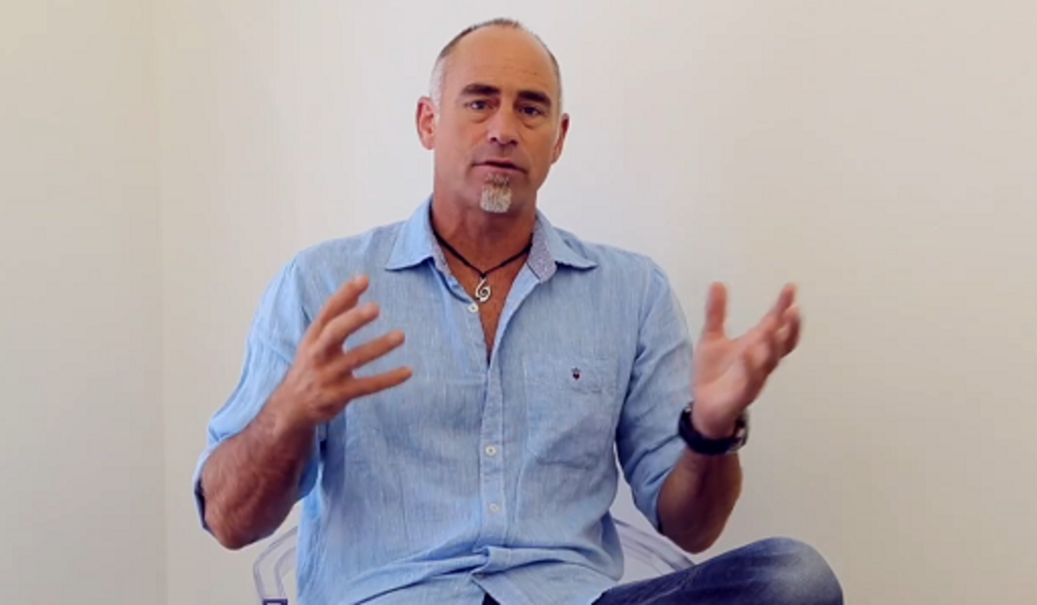

Provide your answer...

View discussion - Part

It is unlikely that those coaches you work with have devoted the time, like Upton, to assemble their thoughts. In Sinek and Upton you have examples of full, articulate and charismatic responses. Whatever replies from questions you receive from coaches, your active listening behaviour provides important cues and encouragement for the speaker to say more and make sense of their ideology and associated actions.
You will look at this next.

6 Active listening: more than just paying attention
It is all very well asking powerful questions, but you also need to actively listen to the responses. Active listening is far more than just paying attention.

Figure 7 Careful, attentive focus helps decode messages and non-verbal clues
View description - Figure 7 Careful, attentive focus helps decode messages and non-verbal clues
View description - Figure 7 Careful, attentive focus helps decode messages and non-verbal clues

In Video 7 you’ll see psychologist Dr Julia Yates explain why listening is the most important coaching skill of all.

Video content is not available in this format.
Video 7
View transcript - Video 7

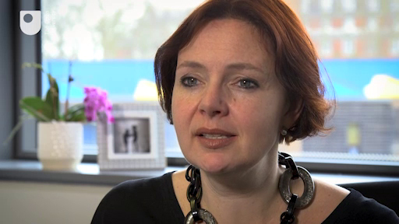

In this section and the next, you will explore active listening through several examples – first, you will investigate an example of poor active listening and then an example of excellent listening in action.

Activity 7 What makes someone a poor listener?
Allow about 10 minutes

Watch this example of a listener who is working in a career-mentoring role. Pay attention to what it is that characterises him as being so poor at listening. Consider his listening behaviour in the context of these terms: ‘self’, ‘interpretation’ and ‘opinion’.
Then think about your own experiences of when you have not been listened to properly: what goes through your mind in such instances?

Video content is not available in this format.
Video 8
View transcript - Video 8

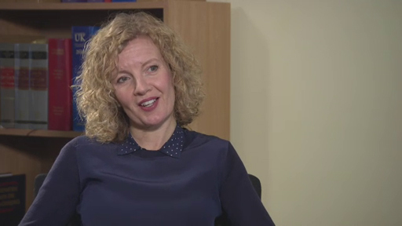

Provide your answer...

View discussion - Part

You will see a better experience of the same scenario with a more self-aware coach in the next section.

7 Active listening in action
There are three parts to this final section. The three steps that you take in developing a fuller understanding of active listening in action are:
- Better listening – In the previous section, you saw an example of a poor listener who was working in a career-mentoring role. Now you will see a transformation when active listening skills are applied
- Active listening summarised – Next you view a figure which contains a fuller description of the three main aspects of active listening: attentive body language, following skills and reflecting skills.
- Use minimal encouragers – In this final section you read about the small verbal and physical signals that help smooth the flow of conversation.
Collectively these sections are likely to raise your awareness of how you can more genuinely hear what others are communicating.

7.1 Better listening
Here you revisit the career mentoring discussion. Now in Video 9 you will see how the situation has a completely different complexion once the mentor applies his active listening skills. Now, the listener reflects back what he has heard and allows the other person to determine where the conversation goes.
The listener also checks for understanding which will reinforce not only that the person is being listened to, but also provide them with reassurance that what they are saying is worth listening to by others. A little bit of active listening goes a long way to completely changing the interaction.
Watch the video now.

Video content is not available in this format.
Video 9
View transcript - Video 9

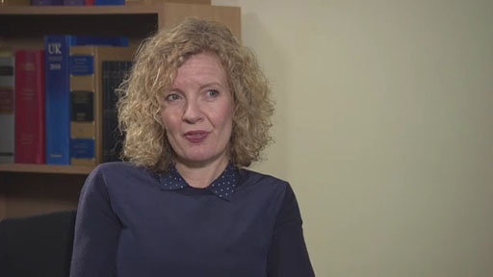

Coaching interactions like this, in which there is a genuine attempt to listen to and support, are the basis for authentic coach developer relationships.

7.2 Active listening summarised
A summary of the key aspects of active listening appears in Figure 8 below. Click on each heading to reveal the summaries.
Following skills – (giving the speaker space to tell their story in their own way)
- Interested ‘door openers’
- Minimal verbal encouragement
- Infrequent, timely and considered questions
- Alternative silences
Reflecting skills – (Restating the feeling and/or content with understanding and acceptance)
- Paraphrase (check periodically that you’ve understood)
- Reflect back feelings and content
- Summarise the major issues

Interactive content is not available in this format.
Figure 8 A summary of the three main elements of active listening
View description - Figure 8 A summary of the three main elements of active listening

7.3 Use minimal encouragers
Imagine you are speaking but the people you are talking to remain completely blank and stand there stock still. You are getting no feedback from the others in the conversation that they are listening to you and understanding your message.
Words and sounds such as ‘mm’, ‘yeah’ or ‘OK’ play a vital role in active listening. These words and sounds signal for the talker to continue. Verbal signals and head gestures show comprehension and agreement, and they are known as minimal encouragers. One key tip is: nod more, it really gives encouragement.
Providing your coaches with small verbal and physical signals to feel more comfortable helps to smooth the flow of the conversation, and it is also part of the process of building trust and rapport. The trouble is we often forget to do it.

8 Building your coach developer 101 guide
The main discussion points from this session that you might share and discuss with colleagues are described in Table 1 below.

Table 1 Some proven practices coach developers can contribute towards asking good questions and listening actively
Practices and ideas | Description
24. Questioning traps | Multiple questions and leading questions are both traps that contribute towards ineffective practice. Inappropriate use of ‘why’ questions can make coaches defensive.
25. Why, how, what questions | Use clear and open ‘why’, ‘how’ and ‘what’ questions that require deeper thinking. Allow coaches time to answer and let their answers dictate the flow of the conversation.
26. Coaching ideology | Asking questions ‘inside-out’ addresses ideas and beliefs about coaching. This type of questioning opens dialogue about the purpose of coaching and why coaches view coaching in the way they do.
27. Active listening | Use small verbal and physical gestures during dialogue to convey that you are taking a real interest in what coaches are saying. For some coach developers: listen more, talk less.

9 This session’s quiz
Check what you’ve learned this session by taking the end-of-session quiz.
Session 6 practice quiz
Open the quiz in a new window or tab then come back here when you’ve finished.

10 Summary of Session 6
The main learning points from this session are:
- Questioning provides a useful tool for coach developers in encouraging the coaches they support to take more responsibility for and awareness of their learning. Good questioning also enables the core beliefs, values and ideas of coaches to be surfaced and raised to a level of conscious thought.
- Good questioning practice involves use of questions that begin with ‘what’, ’how’, ‘who’ or ‘where’, and allow time for a person to respond including not being afraid of silence.
- Questioning traps include use of multiple or leading questions (the advice is disguised) or ‘why’ type questions. These traps are best avoided for effective learning to take place.
- Active listening is an essential skill which is viewed as having three main aspects: attentive body language, following skills and reflecting skills. Listening actively really helps you to fully understand the coach and what they are saying or telling you.
- Minimal encouragers, small verbal and physical signals play an important role in smoothing the flow of conversation.
Questioning is often used when you carry out coaching observations. Yet effective observation and feedback are far from straightforward – should you use a checklist? How do you frame your feedback? These are two dilemmas explored in the next session which will make you think about how you currently watch and support coach’s practice.
You can now go toSession 7.

Session 7: Effective observations and feedback

Introduction
Observing coaches and providing effective feedback is an important part of learning and for this reason it is a necessary skill for coach developers to master. Yet it is far from straightforward, and in this session you’ll examine why it takes time to refine and implement well.

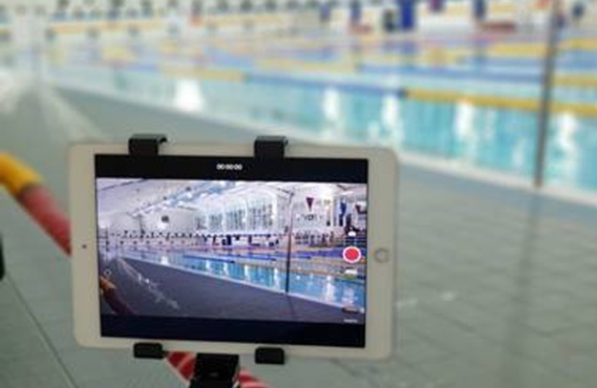
Figure 1 Does what you see depend on your focus?
View description - Figure 1 Does what you see depend on your focus?

Early in this session you will watch the same video of a coaching session twice, but each time you will use a different observational approach to analyse the coach and compare your thoughts. Observation is only part of coaching others; effective feedback is also a key component and you’ll explore how feedback is best provided, what feedback you should provide, and why feedback is really effective when it leads to a meaningful conversation.
Your observation and feedback practices largely depend on your coach developer role. Observation can range from the formal – in which you are required to observe and provide feedback against set criteria – to far less formalised peer-to-peer approaches. There is evidence to suggest that the latter is far more conducive to learning than the former (Williams and Reddy, 2016). Consequently, the value of creating a peer-to-peer observation and feedback culture is examined in the latter part of this session.
By the end of this session, you should be able to:
- reflect on and compare your current observation practices to a range of approaches and case studies
- identify how feedback can be discussed and framed to support learning and development
- consider the benefits of peer-to-peer observation and feedback in a coaching context.
In the first section, you will read an article that makes an interesting argument about observing others.

1 Are teacher observations a waste of time?
Education writer and speaker David Didau has questioned how observations of classroom practice contribute to learning and development. In the following activity you’ll use his blog as a prompt to think about the purpose of observing coaches.

Figure 2 When we observe what are we seeing?
View description - Figure 2 When we observe what are we seeing?

As you will see from the title, the blog raises an interesting issue about where our focus should be when observing practice.

Activity 1 Are teacher observations a waste of time?
Allow about 15 minutes

Read the following short blog (3 minute read time) from David Didau:
Are teacher observations a waste of time?
While reading the blog, identify any questions you think it raises about observing coaches. You might want to substitute the words ‘coach’ and ‘participant’ for ‘teacher’ and ‘student’ in the blog.

Provide your answer...

View discussion - Part

2 Analysing coaches: structuring the observation process
Using a form with pre-populated categories or criteria is a common tool used in observational situations to help structure and collect information. But how does using an observation form assist you in your evaluation of coaches and your subsequent feedback to them?

Figure 3 If something sits between your eyes and their focus of attention does it influence what you see?
View description - Figure 3 If something sits between your eyes and their focus of attention does it ...
View description - Figure 3 If something sits between your eyes and their focus of attention does it ...

In the next activity, you will assess how the difference between using and not using an observation form can determine your observation and judgement. It is rather an unusual video example since it uses a coaching session in a sport many people have attempted: the sport of snooker. The fly-on-the-wall video shows a snooker coach working with a player. As such, you are observing only a tiny fragment of the coach’s practice, so it will be difficult to draw definitive conclusions.

Activity 2 Observation: just watching and listening
Allow about 30 minutes

Snooker is a sport that perhaps does not come readily to mind from a coaching perspective. In this video you will watch an experienced snooker coach working with a player on their stance and cueing action.
- Watch the video and answer the questions below – assume that this is not an observation for a coaching qualification, but instead the type of observation you might undertake in a mentoring role:
  - How did you record your observations, what did you notice and how did you decide what to watch and why?
  - Are there any questions you would like to ask the coach after the session has finished?

Video content is not available in this format.
Video 1
View transcript - Video 1

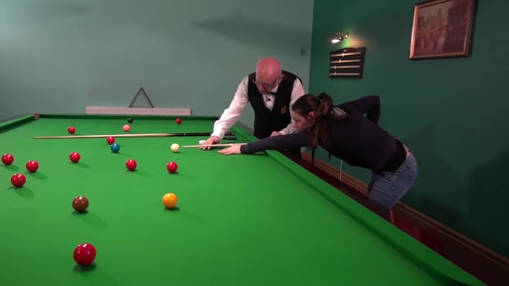

Provide your answer...

- Now watch the video again but this time use this 11-point observation form to assist you while you are observing the coach in action. This observation form is a shortened version of those that might be typically used to observe coaches.
Using the observation form to help, reflect on how you observed anything different between the two occasions: with and without the form. The following prompts may be useful:
  - Did your observational focus change because of the categories on the observation form?
  - Did you prefer just watching the video without the form, perhaps making your own notes, or did you prefer having the form present?
  - How might your feedback to the coach have changed based on using or not using the observation form?
  - On both occasions did you have sufficient information to undertake an effective observation? Did you know the decisions the coach had taken in planning the practices? Do you know their beliefs about what coaching means to them and how this is informing their behaviours? Did you know enough about the coaching relationship between the coach and the player?

Provide your answer...

View discussion - Part

Using a coach observation form to highlight areas of strength and opportunities for learning and development is widespread. However, the extent to which the method is significantly better than just observing a coach and allowing your eyes to see without the categories and influence of a form is debatable. Perhaps without a form it gives you more opportunity to notice more and direct your sight on what the participants are doing rather than the coach, a point identical to the one raised by Didau in Activity 1.
Using and reflecting on different approaches to observing coaches is an integral part of the process of becoming more proficient in watching coaching practice. It is also important to inform the observation process by asking the coach about their ideas and beliefs about coaching and practice design. What you observe is the product of a coach’s decision-making process which is then contributing towards their behaviours. For this reason, undertaking observation might best be started once you have developed your relationship with the coach and understood their approach to coaching in more detail.
Observing coaches can be a subjective process that embodies your own ideas, beliefs and ideas about coaching practice. In the next section you see how use of systematic observation tools can potentially overcome some of this subjective bias and potentially produce a more informed view of a coach’s practice and their behaviours.

3 Systematic observation
Systematic observation, if undertaken rigorously, is a more methodical form of observation that measures coach behaviour through a standardised and consistent approach. It is often used in research to provide numerical evidence (often percentages) for the analysis of coaching behaviours.

Figure 4 The systematic observation of coach behaviours requires a rigorous, methodical and consistent approach
View description - Figure 4 The systematic observation of coach behaviours requires a rigorous, methodical ...
View description - Figure 4 The systematic observation of coach behaviours requires a rigorous, methodical ...

One of the most popular methods is the Arizona State University Observation Instrument (ASUOI) developed by Lacy and Darst (1984). This has fourteen categories that describe different coaching behaviours. For example, here are two coach behaviour categories from the ASUOI:
- Questioning: Any question to athletes concerning strategies or techniques
- Praise: Verbal or non-verbal compliments, statements or signs of acceptance.
Imagine using this with the snooker coach (Video 1), noting the number of instances when the coach asked questions or gave praise. Another approach is to time how long a coach is using these behaviours for. The final output for such analysis is a profile of the proportions of different behaviours being used by the coach under observation.
In the following activity you hear academic Chris Cushion discussing systematic observation.

Activity 3 Systematic observation: how aware are coaches of their behaviour?
Allow about 15 minutes

In Video 2 Chris Cushion is presenting at the Gaelic Athletic Association (GAA, Ireland) coach development conference. Turn your attention to the bullet point on ‘Interventions’ which is what Cushion is addressing as the video begins.
Answer this question: how aware are coaches of their coaching behaviours? For example, a coach might claim, ‘I use a bit of questioning but a lot more silence’. This could be tested with systematic observation – so if the coach demonstrates questioning behaviours = <5% of the time and silence = 10–20%, then this coach would be accurate and aware of their own behaviour.

Video content is not available in this format.
Video 2
View transcript - Video 2

Provide your answer...

View discussion - Part

Observation instruments such as the ASUOI, while primarily a research tool, can also be used by coach developers to support development. Their use will give you a different type of information – not necessarily better information – but just as an observation form guides your observation and what you are looking for, so too does a numerically based instrument. Systematic observation can, however, provide the basis for a good conversation starter and it can be hard to argue against the reality of the data produced. But again, its success depends on the rigour and accuracy of the initial observation and collection of data – this has to be systematic and rigorous.
Perhaps one of the most important considerations in any observation process is setting up and planning the observation and this is what you turn to next.

4 How should you plan an observation?
In the next activity you will explore how one coach developer plans her approach to observation. As you undertake the activity reflect on why planning an observation is important.

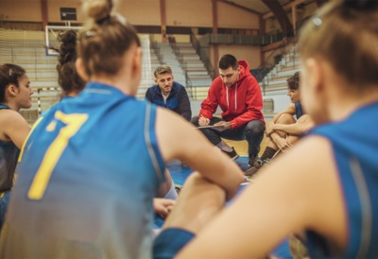
Figure 5 Planning an observation: a vital ingredient in the observation process
View description - Figure 5 Planning an observation: a vital ingredient in the observation process
View description - Figure 5 Planning an observation: a vital ingredient in the observation process

Activity 4 Planning and observation
Allow about 20 minutes

Watch the following video of a basketball coach and make notes on the following:
- What do you consider was effective about the actions taken by the coach developer?
- How would you improve the planning of this process including any interaction in the days before the session?

Video content is not available in this format.
Video 3
View transcript - Video 3

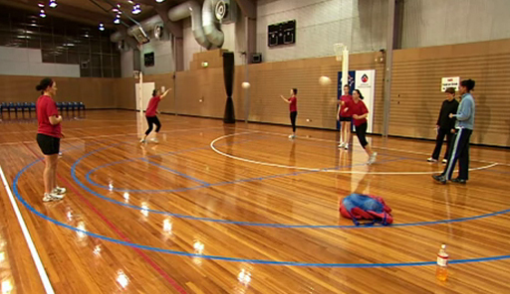

Provide your answer...

View discussion - Part

A successful observation that supports learning and development requires preparation. In addition to finding out what a coach would like feedback on it is also worth agreeing the parameters of the observation and how this will inform your feedback – this enables you to focus your observational gaze.

5 Discussing feedback and encouraging dialogue
The Chartered Institute of Personnel and Development, in their 2016 report Could do better: assessing what works in performance management, suggests it is not the content of feedback that is important in determining its effectiveness, but how people respond to it. In the next activity you’ll analyse the feedback provided to a judo coach and assess its effectiveness.

Figure 6 After an observation do you provide feedback or have a conversation with the coach?
View description - Figure 6 After an observation do you provide feedback or have a conversation with ...
View description - Figure 6 After an observation do you provide feedback or have a conversation with ...

The video features Mike, a judo coach, working in a school environment and this may have an influence on the structure and organisation of the feedback provided by Rob, the coach developer.

Activity 5 Discussing feedback to allow constructive dialogue
Allow about 20 minutes

Watch Video 4. How well do you believe the feedback has been approached? Is this how you would like to receive feedback if you were the coach? Would you respond positively to the feedback and does the video reveal anything about the relationship between the two people involved and the context in which the feedback is being undertaken?

Video content is not available in this format.
Video 4
View transcript - Video 4

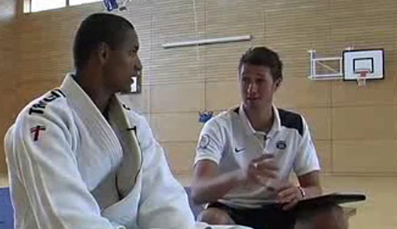

Provide your answer...

View discussion - Part

Aguilar (2013) writing about coaching in educational settings accepts that discussing feedback is an art that takes time to learn. People can be sensitive about receiving feedback on their performance, but she offers several suggestions you may find useful:
- Know the person. Make an effort to know who you are giving feedback to and how you should adapt your feedback accordingly.
- Ground feedback in observational data (for example, ‘you used the word ‘great’ on twelve occasions’; ‘you asked four questions in total’). Ensure you can support your feedback with examples from your observation.
- Keep critical feedback to one or two key points. Focus on the immediate priorities. Try not to overload the coach with multiple areas in which they need to improve.
- Ask for permission. Precede your comments with phrases such as ‘can I share a couple of things with you’, or ‘would it be OK if I suggest this’. This helps to demonstrate that your feedback is coming from a place of care and a desire to help the coach develop.
- Find the phrasing. Think about the language you use to convey your feedback and how the coach will hear you. Remember it is how feedback is received that influences its effectiveness, so you want a coach to hear you positively.
- Invite reflection. Invite the coach to offer their reflection and thoughts. Watch their body language carefully as this can convey how they have responded to your feedback.
The timing of when to provide feedback is also worth considering. Straight after a game or session the coach may be on an emotional high and perhaps this is not always the optimum time for detailed feedback. Instead, if appropriate, leave the coach with a couple of questions to ponder and then arrange to speak over the coming days when they have had a chance to reflect and you to will have thought through your feedback. This might help the coach be more receptive to your comments and open the possibility for a more productive dialogue.
Finally, when do you start to provide feedback to a coach? Aguilar’s first point ‘Know the person’ would suggest that providing feedback to a coach is best begun only when a relationship is established and when you have built an understanding of – and with – the coach. Perhaps you would start to observe but not provide any feedback – any observation does not necessarily require feedback, but you should explain this to the coach so they understand why you are watching them but not intending to provide any subsequent comment. Maybe your first observation could involve watching and focusing on the participants being coached to learn and understand more about them. Again, explain this to the coach and your reasoning for this. These points are reinforced in the next activity where you see how a culture shift towards peer-to-peer observation was developed in education. Could this work effectively in coaching?

6 Creating a peer-to-peer observation culture
When you observe others, how useful is it towards developing your own understanding of coaching? Similarly, if you are only occasionally observing a particular coach are you then seeing their normal behaviour or are you witnessing a special performance put on for your benefit? Both these questions raise issues about the value of the observational process and how it could be improved to become a better learning experience for everyone.

Figure 7 The power of your peers can be vital in making more sense of what you already know
View description - Figure 7 The power of your peers can be vital in making more sense of what you already ...

In the next activity you’ll learn about the potential value of peer-to-peer learning, especially when it is implemented sensitively and developed gradually as the trust between peers grows.

Activity 6 Peer-to-peer observation
Allow about 20 minutes

Watch the following video from the Australian Institute for Teaching and School Leadership. Ask yourself, do the topics raised in this video have implications for the practice of observing and providing feedback to coaches?

Video content is not available in this format.
Video 5
View transcript - Video 5

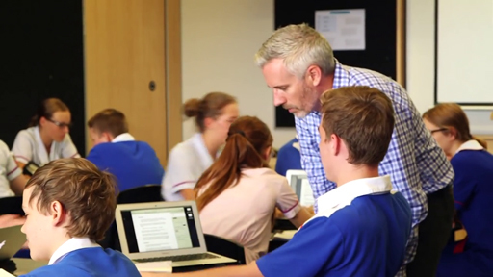

Provide your answer...

View discussion - Part

Anecdotal evidence from the practice of some of the biggest companies in the world (e.g. Adobe, Deloitte and Accenture) indicates how they are moving away from formal annual appraisal processes in favour of more regular, informal developmental conversations between staff. This is increasingly being known as Peer-Assisted Learning (PAL).
Sports coaching can perhaps learn from this and recognise and encourage more peer-to-peer learning conversations between individuals.

7 Coach observation: pulling it all together
To help summarise this session there are two important final activities for you to complete that pull together your thoughts and ideas on observation and feedback.

Figure 8 Dave Keelty: When does observation take a narrow or broad focus?
View description - Figure 8 Dave Keelty: When does observation take a narrow or broad focus?
View description - Figure 8 Dave Keelty: When does observation take a narrow or broad focus?

Activity 7 Pulling together your thoughts and ideas on coach observation
Allow about 40 minutes

Part 1

Read this extract from a blog post (5 minute read time) by Dave Keelty. Keelty is a coach developer and mentor, having worked with organisations including New Zealand (NZ) Rugby, NZ Football, and Leinster Rugby and Hockey. The extract addresses many of the issues and ideas that you have considered in this session.
How might you now develop your approach to observing and giving feedback to coaches in light of any new insights you have gained?
Is coach observation worth pursuing?

Provide your answer...
View discussion - Part 1

Part 2

Listen to the discussion between Andy Bradshaw and Alex Twitchen. How do the issues and points they discuss further develop your ideas and understanding about observing and providing feedback to coaches?

Audio content is not available in this format.
Audio 1
View transcript - Audio 1

Provide your answer...

View discussion - Part

8 Building your coach developer 101 guide
The main discussion points from this session that you might share and discuss with colleagues are described in Table 1 below.

Table 1 Some practices coach developers can use to build expertise in their role
Practices and ideas | Description
28. Observational focus | Your observational gaze can be influenced by the presence or otherwise of observational criteria or a checklist that influences what is and what is not seen.
29. Systematic observation | A method, if used methodically and rigorously, that can provide detailed and often numerical data about the behaviours and actions of coaches.
30. Planning for observation | Observational visits need to be well planned and organised beforehand to be optimised.
31. Discussing feedback | Acting on feedback is influenced not by content but how the coach receives it. Carefully thinking through language and how it is discussed helps encourage coaches to be receptive.
32. Peer-to-peer feedback | Feedback between colleagues is a mutually beneficial learning process that should be encouraged as a continuous aspect of learning and development.

9 This session’s quiz
Check what you’ve learned this session by taking the end-of-session quiz.
Session 7 practice quiz
Open the quiz in a new window or tab then come back here when you’ve finished.

Session 8: Refreshing coach development for the digital age

Introduction
This session explores how coach learning and development may need to adjust as technology, society and coaching evolve in a digital age.

Figure 1 How far will digital devices become integrated into learning? Will they become as widely used as starting blocks are now, following their debut in 1948 Olympic Games?
View description - Figure 1 How far will digital devices become integrated into learning? Will they ...
View description - Figure 1 How far will digital devices become integrated into learning? Will they ...

Technology will be the big one and there’s a lot of unknowns in that respect and possibly something we’ve got to invest more time in, trying to predict and future-proof our approach to both coach development and player development with the advent of different technological advancements.
(Edd Vahid, Assistant Academy Manager, Southampton FC, Leaders Performance Institute, 2019)

Coaching practice is now influenced by digital devices whether they be used for filming, collaborating or communicating. But coach learning and development has also been transformed with coaches having a wealth of expertise and information available in a few clicks. Watch as Stuart Armstrong explains further.

Video content is not available in this format.
Video 1
View transcript - Video 1

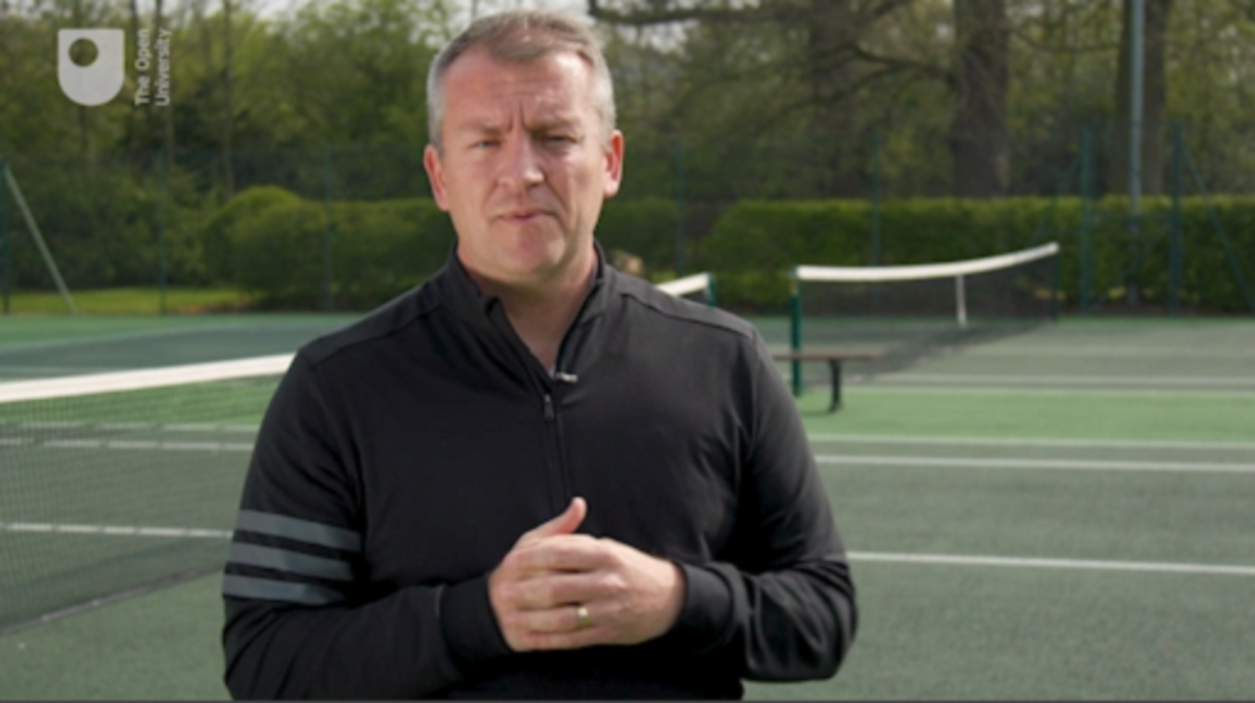

As this course comes to a close you will explore the future potential of digital technology – some of which is a little controversial.
By the end of this session, you should be able to:
- demonstrate a heightened awareness of the potential impact of digital technologies on coach learning and development
- consider and reflect on the concept of coach developers as ‘digital content curators’
- explore cases of coach learning and development informed through the use of social media.

1 Collaboration, information gathering and learning
The use of social media and digital devices arguably changes how coaching knowledge is created and shared.

Figure 2 If the digital age impacts athletes and coaching, what are the implications for coach learning and development?
View description - Figure 2 If the digital age impacts athletes and coaching, what are the implications ...

An example of how coaching is changing comes from Steven Trigg (Head Performance Swimming Coach, University of Stirling). He suggests: ‘The role of the coach is changing, it’s not to be the holder of information but to encourage them [athletes] to go and get it’ (English Institute of Sport, 2018). He describes how technology is enhancing learning with an example of race footage being sent to smart phones within 5 minutes of a race finishing; athletes then review the race and give coaches feedback on what they’ve felt and seen. They also make considerable use of WhatsApp.
If the role of the coach is changing due to technology what else can we learn from digital companies such as Netflix and Amazon?

Activity 1 Learner analytics: implications for coach learning and development
Allow about 15 minutes

Each year the Institute of Educational Technology (IET) at the Open University reports on trends in learning. The reading below describes the emergence of learner analytics as a trend in 2018. Learner analytics is the collection of digital data which can be used to profile and understand individual learner preferences to subsequently identify learning opportunities that might help them.
Read the text below and think of coaches in your sport who may have different learning needs. Using the reading as a prompt consider what tool you might ask a software developer to produce for the purpose of collecting data to inform coach learning. The resulting solution would ideally recommend appropriate learning opportunities for each individual coach. Imagine what features and possibilities this might entail.

What ideas can learner-led analytics take from Netflix or Amazon?
Learner-led analytics is the use of data to help learners learn. The trend for learner-led analytics signifies a shift away from just assessing what learners have learnt to focusing more on helping them to identify their own goals and ambitions and supporting them through their learning.
A practitioner’s view comes from Nigel Paine, change-focused leader and learning expert: analytics will change learning.... ‘We are in a data driven revolution. If you have the data and bring it together, you have a massively important picture of the learner…. It’s about individualising the whole learning process … the ultimate aim is to get learners to take charge of their own learning better – to facilitate that and enable them.
It’s like Netflix – as I log onto the interface, what it gives me is totally unique. It’s the same with learning – the personalisation of learning through algorithms. For an individual it means: what works for me and my needs and for my [role]. He suggests an example of being nudged or recommended – do you want to watch this Ted talk? Read this new blog? It’s not very complicated and Amazon have been doing it for years.’
We are still at the early stages of learning analytics which use learners’ preferences, ambition and past learning to recommend learning that is more personalised. That’s the way that learning is going – targeted, personalised learning that meets the needs of learners and the organisation they work for.
(IET, 2018, pp. 12–13)

Provide your answer...

View discussion - Part

Perhaps when it comes to assembling appropriate learning opportunities there is also a role for coach developers in sifting through, recommending, curating and pointing to the most useful online content. Perhaps a combination of learner analytics and the human influence of a coach developer is an interesting way forward?
You have begun to see how digital technology might offer some opportunities to enhance coach learning and development. Your focus in the next series of activities is how the digital age influences sharing, collaboration and building new knowledge. You will explore a range of digitally related coach learning and development possibilities including:
- digital messaging
- curating online content
- remote mentoring
- peer-to-peer support through an internet-based application.

2 The role of digital messaging
If communication, relationships and dialogue are an integral part of coach development then how does digital messaging, such as use of WhatsApp or other social media platforms, contribute if at all?

Figure 3 Digital messaging is often informal and outside of the control of organisations, but how can it be used to support coach learning and development?
View description - Figure 3 Digital messaging is often informal and outside of the control of organisations, ...
View description - Figure 3 Digital messaging is often informal and outside of the control of organisations, ...

The following activity shows how the messaging platform WhatsApp is being used and asks for your opinion of its purpose and usefulness.

Activity 2 Coach learning and development via WhatsApp
Allow about 10 minutes

Three different examples of messaging via WhatsApp in closed coaching groups are illustrated below. For each example review the conversation and think about:
- the purpose and value of this communication
- the extent to which you consider this plays a part in coach learning and development.

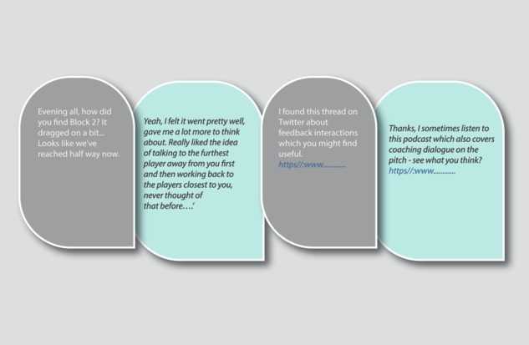
Figure 4 Example 1: A group of developing coaches on a learning programme have formed their own WhatsApp group separate from the coach developer.
View description - Figure 4 Example 1: A group of developing coaches on a learning programme have formed ...

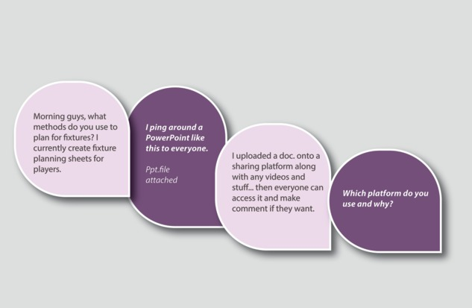
Figure 5 Example 2: This is the same group in which one member of the group asks a specific coaching-related question. Again, the coach developer is not present.
View description - Figure 5 Example 2: This is the same group in which one member of the group asks ...

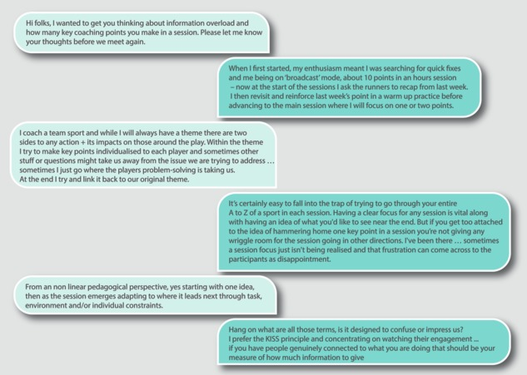
Figure 6 Example 3: This is a different WhatsApp group in which a coach developer stimulates the group to think about a particular issue and encourages them to share different perspectives.
View description - Figure 6 Example 3: This is a different WhatsApp group in which a coach developer ...

Provide your answer...

View discussion - Part

All three examples show the potential of digital messaging to promote learning and development, but it would be wrong to overplay its significance. One of the above examples showed online resources being shared. A challenge for coach developers is to get others to recognise that online material can hinder as much as help due to the limited validity of some ‘expert’ opinions. Coach developers may increasingly need to help recommend reliable content to those they work with. You will look at this next.

3 Coach developers as content curators
In Session 5 you were asked to search the internet to find out about flipped learning. The information you found may, or may not, have come from reliable sources. How would you know?

Figure 7 How easily can you collect appropriate material and recommend it to others?
View description - Figure 7 How easily can you collect appropriate material and recommend it to oth ...

With more and more resources now available online, the question is – will the internet change the nature of coach learning and development? And should coach developers curate (i.e. filter, collect and use) online content for their coaches?
You will begin to answer these questions by exploring perspectives from education.

Activity 3 Should education change due to the internet?
Allow about 20 minutes

Watch this TED talk from Elizabeth Boese a higher education teacher. She suggests education should change in recognition of the fact that in her words ‘the internet is the textbook’. When she talks of ‘just in time learning’ for her students think about:
- How would this apply to coaches?
- What changes, if any, are appropriate for coach learning and development in light of the internet as a potential source of knowledge?

Video content is not available in this format.
Video 2
View transcript - Video 2

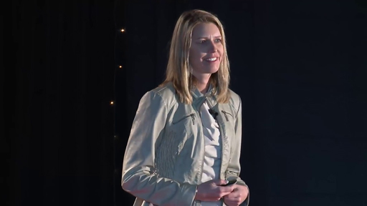

Provide your answer...

View discussion - Part

Perhaps some coach developers or organisation in the future may need to coalesce, bring together and curate content to support coach learning and development. Notice ‘some’, not all coach developers. Curation, therefore, becomes a kind of continual stewardship of research, and coaching practice along with recognising others’ material; it requires a self-regulating critical dialogue of what might be recommended to other coaches.

4 Fostering more mentoring
Mentoring is recognised as an important role undertaken by coach developers. It can have a positive and significant impact on learning and development. How then might more mentoring opportunities and support be achieved in the digital age?

Figure 8 People working together to support each other: but does it have to be face to face?
View description - Figure 8 People working together to support each other: but does it have to be face ...
View description - Figure 8 People working together to support each other: but does it have to be face ...

To answer this question here you see what is already happening in Triathlon. It shows what might be possible.

Activity 4 Seeing is believing: remote mentoring in action
Allow about 15 minutes

Watch this video of Sorrel, a triathlon coach, who opted to be remotely mentored, yet never met Toby, the person mentoring her, face to face. This appears to be an unstructured and relatively low-tech solution to mentoring.

Video content is not available in this format.
Video 3
View transcript - Video 3

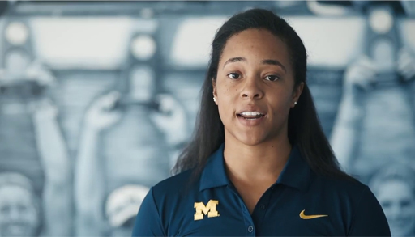

After watching, answer this question: How might any additional structure or use of technologies (beyond phones) enhance mentoring in your context?

Provide your answer...

View discussion - Part

Next, you are asked to respond to a more hi-tech peer-support idea for transforming coach learning and development that draws on experiences in the education sector.

5 Technology for peer support
As Session 7 illustrated peer-support, or peer-assisted learning, is being recognised as an increasingly important aspect of learning and development. In this section you’ll explore how technology can assist this form of learning.

Figure 9 People working together to support each other: but does it have to be face to face?
View description - Figure 9 People working together to support each other: but does it have to be face ...
View description - Figure 9 People working together to support each other: but does it have to be face ...

In the video from Session 3 (Activity 7 – researcher) James Knight spoke about trust in learning relationships. Knight works with an online video sharing platform called IRIS Connect. The videos in the following activity are from the same organisation and provide stimulus material for possibly extending and enhancing coach learning and development in the digital age.

Activity 5 Should video sharing and peer-support be more widely used?
Allow about 25 minutes

This activity involves working with two separate videos from IRIS Connect. The organisation and their technology grew out of a 2007 University of Sussex research project. The company expanded to the USA in 2015.
Watch this short animation explaining the rationale for their work.

Video content is not available in this format.
Video 4
View transcript - Video 4

Now watch a second short video which outlines the possibilities of the sharing platform

Video content is not available in this format.
Video 5
View transcript - Video 5

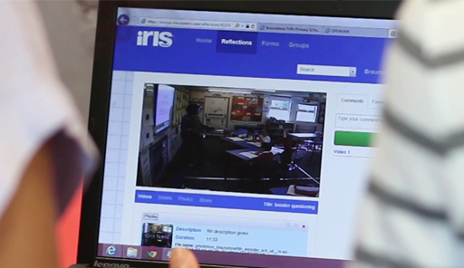

- Note down the phrases which summarise the ten-point rationale for IRIS Connect’s learning approach (tip: their rational is similar to your exploration of developments in the digital age). For example, the first three phrases they use are:
  - personalised learning opportunities
  - [new] ideas for change
  - putting ideas into practice.
- With sufficient investment and training to what extent could this idea be adapted to the future development of coaches? Notice how you may well apply a filtering process, similar to your beliefs filter and your context filter.

Provide your answer...

View discussion - Part

You are invited to contribute your thoughts on the possibilities this technology presents to a forum posting in the following section.

6 Forum posting
This final activity invites you to respond to the ideas you have read and heard about in this session and elsewhere in the course in order that the wider coach developer community voice is heard.

Figure 10 Making your voice heard
View description - Figure 10 Making your voice heard

Any consensus evident on this forum will be communicated to Sport England, UK Coaching, CIMSPA and other appropriate organisations to help meet the needs of coach developers. You are reminded that a posting is not a requirement in order to obtain a digital badge.

Activity 6 Your chance to contribute and share ideas
Allow about 20 minutes or more

Go to the course forum page and create a posting articulating your thoughts on one or both of the discussion threads below.
The digital age
Which aspect(s) of facilitating coach learning and development in the digital age do you feel show promise? Which should not be pursued?
You are commenting on the topics you have learned in this session. Here is a reminder of what you have explored:
- using digital messaging
- curating online content
- fostering more mentoring
- video sharing and peer support (e.g. IRIS Connect)
The course as a whole
What is your feedback on your experience of this course? Is there anything that needs more or less attention and is there anything that was not covered? As a reminder here are key words from the titles of each session:
- coach developer role
- coach learning
- learning relationships
- power and self-awareness
- teaching repertoire
- questioning
- observing practice
- the digital age

View discussion - Activity 6 Your chance to contribute and share ideas

In the next section you will read the final part of the coach developer 101 guide. The guide is now complete with 36 practices you can use, share, discuss and draw on to develop your expertise and capability as a coach developer.

7 Building your coach developer 101 guide
The main discussion points you might share and discuss with colleagues are described in Table 1 below.

Table 1 Practices coach developers can draw on to build expertise in their role.
Practices and ideas | Description
33. Technology facilities | The use of digital devices and technologies such as social media can facilitate learning, communication and collaboration between coaches and coach developers.
34. Personalised learning | Creating a more personal approach to learning via digital technologies can make it more individual and suited to a coach’s particular context and help avoid new ideas being filtered out.
35. Digital content curation | This is the process of curating learning resources by drawing on existing information available through the internet. But care is needed to make sense of this information and ensure its validity.
36. Remote mentoring | An opportunity provided by digital communications to remotely mentor coaches at scale with the possibility of sharing videos and documents.

The complete guide can be downloaded as a PDF: Coach developer 101 guide.

8 This session’s quiz
Now it’s time to complete the Session 8 badge quiz. It is similar to previous quizzes, but this time instead of answering five questions there will be fifteen.
Session 8 compulsory badge quiz
d
Remember, this quiz counts towards your badge. If you’re not successful the first time, you can attempt the quiz again in 24 hours.
Open the quiz in a new tab or window then come back here when you’ve finished.

9 Summary of Session 8
The main learning points from this session are:
- Digital technologies may facilitate learning and development through increased opportunities for sharing, collaboration, information gathering and support, but this does not automatically happen; the tone and environment need to be appropriate.
- Communication examples between coaches and coach developers which use a social media platform suggest postings can contribute to reflection, resource sharing, problem solving and sustaining engagement particularly in between face-to-face gatherings.
- Coach developers may become ‘content curators’ pulling together and making sense of information gathered from the internet. This involves a form stewardship by coach developers as they filter and refine content that is evidence based, reliable and proven.
- Technology may be able to support the development of coaches remotely via online mentoring and the opportunities offered by video sharing and peer-to-peer contributions.
- A combination of these digital opportunities may well be able to increase personalised learning for coaches and help make learning and development more suited to individual needs.

10 Bringing things together
Congratulations and well done for reaching this point. You will by now have formed your own thoughts about this course and how it has possibly influenced your role as a coach developer. However, the following four questions are stated explicitly as a means of comparing what you think you have learned to what the course intended you to learn. The four questions are:
- Do you better appreciate the skills, knowledge and personal qualities that you have which inform your ability to support learning and development as a coach developer in whatever role or roles you fulfil?
- Has the course made you think about some of the implicit ideas, beliefs and values that influence your behaviour and actions as a coach developer (i.e. aspects that you may not have thought about before)?
- Did the course make you reflect on what you believe good and effective coach learning and development practice means and why you believe it is good practice?
- Is there anything you might change, adapt, adjust or experiment with in your coach developer role?
These questions represent the intentions behind the content and activities you have followed. Above all though, if you are a bit more confident and better able to support the coaches you work with, and if they in turn provide a better experience to the participants and performers they coach, then the aim of this course will have been achieved.
One final thought …
Coach learning and development is changing in the UK. The Coaching Plan for England and the new approach to learning being adopted by UK Coaching (Transforming Learning, Transforming Lives) signify a shift towards a more person-centred focus. Coaches will be encouraged to take more responsibility for their learning and share, collaborate and connect with others to help them reflect and become more confident in their practice. How will this influence and change the role of coach developers? Perhaps it will mean that coach developers will have to become increasingly flexible and agile enough to more effectively support coaches with different needs in different contexts through different roles. Being attuned to the needs of each individual coach will be critical – as you reflect back on this course you might appreciate how this has been an integral aspect to what you should have learned.

Where next?
If you’ve enjoyed this course you can find more free resources and courses on OpenLearn. You might be specifically interested in two other badged courses, Exploring sport coaching and psychology and Communication and working relationships in sport and fitness. There is also a page of sport and fitness courses on OpenLearn.
New to University study? You may be interested in our courses on health and wellbeing. You might be particularly interested in our BSc (hons) Sport, fitness and coaching.
Making the decision to study can be a big step and The Open University has over 40 years of experience supporting its students through their chosen learning paths. You can find out more about studying with us by visiting our online prospectus.

Tell us what you think
Now you’ve come to the end of the course, we would appreciate a few minutes of your time to complete this short end-of-course survey (you may have already completed this survey at the end of Session 4).

References
Abraham, A. (2016) ‘Task analysis of coach developers: applications to the FA Youth Coach Educator role’, in Allison, W., Abraham, A. and Cale, A. (eds) Advances in Coach Education and Development: From Research to Practice, London, Routledge.
Egan, G. (1998) The Skilled Helper: A Problem-Management Approach to Helping, London, International Thomson Publishing Europe.
International Coach Developer Framework (Version 1.1) (2014) International Council for Coaching Excellence.
Treverton, G. (2007) ‘Risks and riddles’, Smithsonian Magazine, June [Online]. Available at https://www.smithsonianmag.com/history/risks-and-riddles-154744750/ (Accessed 31 March 2019).
Vecchi, G., Van Hasselt, V. and Romano, S. (2005) ‘Crises (hostage) negotiation: current strategies and issues in high-risk conflict resolution’, Aggression and Violent Behavior, vol. 10, pp. 531–51.
Cohen, D. (1991) ‘Revolution in one classroom (or, then again, was it?)’, American Educator: The Professional Journal of the American Federation of Teachers, vol. 15, no. 2, pp. 44–8.
Coombs, P. and Ahmed, M. (1974) Attacking Rural Poverty: How Nonformal Education Can Help, Baltimore, Johns Hopkins University Press.
Farrow, D., Baker, J. and MacMahon, C. (2008) Developing Sport Expertise. Researchers and Coaches put Theory into Practice, London, Routledge.
International Coach Developer Framework (2014) International Council for Coaching Excellence (ICCE) [Online]. Available at https://www.icce.ws/_assets/files/documents/PC_ICDF_Booklet_Amended%20Sept%2014.pdf (Accessed 31 March 2019).
Knowles, M. (1990) The Adult Learner: A Neglected Species, Houston, Texas, Gulf Publishing.
Lave, J. and Wenger, E. (1991) Situated Learning: Legitimate Peripheral Participation, Cambridge, Cambridge University Press.
Leaders Performance Institute (2019) ‘Coaching the coaches. Coach education and development: The state of play across elite sport’ [Online]. Available at https://leadersinsport.com/category/performance/ (Accessed 20 April 2019.
Lyle, J. and Cushion, C. (2017) Sport Coaching Concepts, 2nd edn, London, Routledge.
Merriam, S. and Caffarella, R. (1999) Learning in Adulthood: A Comprehensive Guide, 2nd edn, San Francisco, Jossey-Bass.
Rushmer, R. and Davies, H. T. O. (2004) ‘Unlearning in health care’, BMJ Quality & Safety, vol. 13, Supplement 2, ii10–ii15.
Sfard, A. (1998) ‘On two metaphors for learning and the dangers of choosing just one’, Educational Researcher, vol. 27, no. 2, pp. 4–13.
Stodter, A. and Cushion, C. J. (2017) ‘What works in coach learning, how, and for whom? A grounded process of soccer coaches’ professional learning’, Qualitative Research in Sport, Exercise and Health, vol. 9, no. 3, pp. 321–38.
Daloz, L. (1986) Effective Teaching and Mentoring, San Francisco, Jossey-Bass.
Jowett, S. (2005) ‘On repairing and enhancing the coach–athlete relationship’, in Jowett, S. and Jones, M. (eds) The Psychology of Coaching, Leicester, The British Psychological Society, pp. 14–26.
Martin, S. (1996) ‘Support and challenge: conflicting or complementary aspects of mentoring novice teachers?’, Teachers and Teaching, vol. 2, no. 1, pp. 41–56.
Nelson, L., Cushion, C. J., Potrac, P. and Groom, R. (2014) ‘Carl Rogers, learning and educational practice: critical considerations and applications in sports coaching’, Sport, Education and Society, vol. 19, no. 5, pp. 513–31.
Rogers, C. R. (1983) Freedom to Learn for the 80s, Columbus, OH, Charles E. Merrill.
Cushion, C., Armour, K. and Jones, R. (2003) ‘Coach education and continuing professional development: experience and learning to coach’, Quest, vol. 55, no. 3, pp. 215–30.
Cushion, C., Griffiths, M. and Armour, K. (2017) ‘Professional coach educators in-situ: a social analysis of practice’, Sport, Education and Society, vol. 24, no. 5, pp. 533–46.
Piggot, D. (2012) ‘Coaches’ reflections of formal coach education; a critical sociological investigation’, Sport, Education and Society, vol. 17, no. 4, pp. 535–54.
Warren, J. (2011) ‘Reflexive teaching: toward critical autoethnographic practices of/in/on pedagogy’, Critical Studies–Critical Methodologies, vol. 11, no. 2, pp. 139–44.
Zehntner, C. and McMahon, J. (2018) ‘Power and knowledge in a coach mentoring program’, Sports Coaching Review, vol. 7, pp. 62–82.
De Bruyckere, P., Kirschner, P. and Hulshof, C. (2015) Urban Myths about Learning and Education, London, Elsevier.
Gustafson, J. (2019) ‘Deconstructing constructivism: a widely misunderstood and misapplied theory of learning’ [Online]. Available at https://mrgmpls.wordpress.com/2019/01/08/deconstructing-constructivism-a-widely-misunderstood-and-misapplied-theory-of-learning/ (Accessed 21 February 2019).
Knowles, M. (1990) The Adult Learner: A Neglected Species, Houston, Texas, Gulf Publishing.
Knowles, M., Holton, E. and Swanson, R. (2005) The Adult Learner, 6th edn, London, Elsevier.
Leslie, I. (2015) ‘The revolution that could change the way your child is taught’, Guardian, 11 March [Online]. Available at https://www.theguardian.com/education/2015/mar/11/revolution-changing-way-your-child-taught (Accessed 4 January 2019).
Neelen, M. and Kirchner, P. (2015) ‘Research-based principles of instruction applied to workplace learning’, 18 August [Blog]. Available at https://3starlearningexperiences.wordpress.com/2015/08/18/research-based-principles-of-instruction-applied-to-workplace-learning/ (Accessed 11 November 2018).
Reddan, G., McNally, B. and Chipperfield, J. (2016) ‘Flipping the classroom in an undergraduate sports coaching course’, International Journal of Sports Science & Coaching, vol. 11, no. 2, pp. 270–8.
Stockard, J., Wood, T. W., Coughlin, C. and Rasplica Khoury, C. (2018) ‘The effectiveness of direct instruction curricula: a meta-analysis of a half century of research’, Review of Educational Research, vol. 88, no. 4, pp. 479–507.
Times Educational Supplement (TES) (2018) ‘Why you have got direct instruction wrong’, 23 May [Online]. Available at https://www.tes.com/news/why-you-have-got-direct-instruction-wrong (Accessed 31 March 2019).
Aguilar, E. (2013) The Art of Coaching: Effective Strategies for School Transformation, San Francisco, Jossey-Bass.
Lacy, A. and Darst, P. (1984) ‘Evolution of a systematic observation system: The ASU coaching observation instrument’, Journal of Teaching in Physical Education, vol. 3, no. 3, pp. 59–66.
Williams, B. and Reddy, P. (2016) ‘Does peer-assisted learning improve academic performance? A scoping review’, Nurse Education Today, vol. 42, pp. 23–9.
English Institute of Sport (2018) ‘Supporting the #Next generation: opportunities’ (video), Talent Shorts, Performance Pathway Learning Hub [Online]. Available from https://pphub.eis2win.co.uk/assets/sections/talent-shorts (Accessed 24 June 2019).

Acknowledgements
This free course was written by Alex Twitchen and Ben Oakley. It was first published in July 2019.
The Open University would like to acknowledge and thank the following people for their help and generous assistance with the writing of this course: Ed Cope (The Football Association), Steve McQuaid (ActionProvoked), Andy Bradshaw (UK Coaching), Jay Roper (UK Sport), staff and students at the University of Chichester, and Stuart Armstrong, Lucy Moore and Sion Kitson (Sport England).

Session 1

Images
Figure 1: Dusit; Shutterstock.com
Figure 2: faithie; Shutterstock.com
Figure 4: subin pumsom; Shutterstock.com
Figure 5: Mopic; Shutterstock.com
Figure 7: Marish; Shutterstock.com
Figure 9: wavebreakmedia; Shutterstock.com
Figure 11: wavebreakmedia;Shutterstock.com

Audio-visual
Video 3: courtesy of: Mark S Bennett MBE; PDScoach.com
Audio 1: Alan Keane and Stuart Armstrong; The Talent Equation

Session 2

Images
Figures 1 and 9: Rawpixel.com; Shutterstock.com
Figure 3: cla78; Shutterstock.com
Figure 4: Rei Imagine; Shutterstock.com
Figure 5: vfpictures; Shutterstock.com
Figure 7: Rawpixel; Shutterstock.com
Figure 8: mypokcik ; Shutterstock.com

Audio-visual
Audio 1: GoodPractice; www.goodpractice.com

Session 3

Images
Figure 1: Alan Edwards/Alamy Stock Photo
Figure 2: Thor Jorgen Udvang; Shutterstock.com
Figure 3: BlurryMe; Shutterstock.com
Figure 5: Matej Kastelic;Shutterstock.com
Figure 6: digitalskillet ; Shutterstock.com
Figure 8: fizkes ; Shutterstock.com
Figure 10: Michele Paccione;Shutterstock.com

Audio-visual
Activity 2: Video 2: Chris Hoy: 200 mph at Le Mans 29 0ct 2016 © BBC
Activity 3: Audio 1: Lucy Moore and Stuart Armstrong; The Talent Equation
Activity 7: Video 3: IRIS Connect

Session 4

Text
Activity 3: case A: taken from: Power and knowledge in a coach mentoring program, (2018): Chris Zehntner & Jenny McMahon, Sports Coaching Review
Activity 4: case B: taken from ‘Coaches’ reflections of formal coach education; a critical sociological investigation’ (2012) Piggot, D., Sport, Education and Society, vol. 17, no. 4, pp. 535–54.

Images
Figure 1: Peter Hermes Furian;Shutterstock.com
Figure 2: nicomenijes; Getty Images
Figure 3: Olivier Le Moal; Shutterstock.com
Figure 4: Erica Smit; Shutterstock.com
Figure 5: Axel Alvarez; Shutterstock.com
Figure 6: Lightspring; Shutterstock.com
Figure 7: Triff; Shutterstock.com

Session 5

Images
Figure 2: kali9; Getty Images
Figure 3: Flamingo Images; Shutterstock.com
Figure 4: Africa Studio; Shutterstock.com
Figure 7: Jarretera; Shutterstock.com

Audio-visual
Activity 1: Video 1: courtesy of Manchester Metropolitan University
Activity 1: Video 2: courtesy of Maastricht University
Activity 3: Video 3: Edutopia Technologies
Activity 3: Video 3: Edutopia Technologies

Session 6

Images
Figure 1: docstockmedia; Shutterstock.com
Figure 2: igorstevanovic ;Shutterstock.com
Figure 3: ESB Professional; Shutterstock.com
Figure 6: EtiAmmos; Shutterstock.com
Figure 7: pathdoc; Shutterstock.com

Audio-visual
Activity 1: Video 2: Australian Sports Commission; https://creativecommons.org/licenses/by-nc-nd/3.0/au/deed.en
Activity 2: Video 3: Supporting Champions; https://www.supportingchampions.co.uk/
Activity 3: Audio 2: Lucy Moore and Stuart Armstrong; The Talent Equation
Activity 4: Video 4: TED Talks; https://creativecommons.org/licenses/by-nc-nd/4.0/
Activity 5: Video 5: Griffith University
Activity 6: Video 6: Paddy Upton

Session 7

Text
Is coach observation worth pursuing? David Keelty; https://medium.com/@CoachngUnleashd

Images
Figure 1: courtesy of Jenny Coady
Figure 2: Monkey Business Images; Shutterstock.com
Figure 3: Africa Studio; Shutterstock.com
Figure 4: Titov Nikolai; Shutterstock.com
Figure 5: South_agency; Getty Images
Figure 6: Rawpixel.com; Shutterstock.com
Figure 7: Sangoiri; Shutterstock.com
Figure 8: David Keelty

Audio-visual
Activity 2: Video 1: Barry Stark Snooker Coach
Activity 3: Video 2: research conducted by Loughborough University; Professor C. Cushion
Activity 4: Video 3: Australian Sports Commission; https://creativecommons.org/licenses/by-nc-nd/3.0/au/deed.en
Activity 5: Video 4: Youth Sport Trust, 2010
Activity 6: Video 5: Australian Institute for Teaching and School Leadership (aitsl)
Activity 6: Audio 1: can’t find in the Portal?

Session 8

Images
Figure 1: OSTILL is Franck Camhi ;Shutterstock.com
Figure 2: Pixsooz;Shutterstock.com
Figure 3: Golden Sikorka; Shutterstock.com
Figure 7: metamorworks; Shutterstock.com
Figure 8: kikovic; Shutterstock.com
Figure 9: tuntekron petsajun; Shutterstock.com
Figure 10: Rawpixel.com: Shutterstock.com

Audio-visual
Activity 3: Video 2: TED Talks; https://creativecommons.org/licenses/by-nc-nd/4.0/
Activity 4: Video 3: British Triathlon; www.britishtriathlon.org
Activity 5: Videos 4 and 5: IRIS Connect
Except for third party materials and otherwise stated (see terms and conditions), this content is made available under a Creative Commons Attribution-NonCommercial-ShareAlike 4.0 Licence.
The material acknowledged below is Proprietary and used under licence (not subject to Creative Commons Licence). Grateful acknowledgement is made to the following sources for permission to reproduce material in this free course:
Every effort has been made to contact copyright owners. If any have been inadvertently overlooked, the publishers will be pleased to make the necessary arrangements at the first opportunity.
Don't miss out
If reading this text has inspired you to learn more, you may be interested in joining the millions of people who discover our free learning resources and qualifications by visiting The Open University – www.open.edu/openlearn/free-courses.

Solutions

Activity 1 Who is a coach developer and what do they do?

Part

Discussion
- Alex indicates that the role of a coach developer can embrace different situations and environments, for example working with a group of coaches on a course or helping an individual coach. In both situations he is supporting learning and development.
- Regardless of the situation Alex believes that the following characteristics are important:
  - knowing how people learn
  - understanding the people involved and how to build effective relationships with them
  - having a sense of humility and understanding that it’s about the coach and not about him, and
  - a good level of self-awareness.
Alex also mentions he is conscious that coaches require different forms of support, and this can vary according to their level of experience and the people they coach. Supporting a coach should be specific to their context and their own circumstances and this requires flexibility and adaptability on the part of coach developers.
Back to - Part

Activity 2 Alan’s story: moving away from being a ‘playstation coach’

Part

Discussion
Mark’s impact on Alan can be summarised as follows:
- Alan has a good sense of what he wanted from a mentor and he saw this in Mark.
- Mark’s ability to build a positive relationship with Alan over time became increasingly founded on mutual trust and respect.
- Alan was willing to take risks, and Mark was able to utilise this willingness to facilitate learning.
- Mark was able to show and illustrate a different and alternative approach. For example, Mark focused on demonstrating a different way of working with the players as opposed to just providing more technical and tactical information.
- Transforming Alan’s coaching practice stems from Mark’s ability to influence. It is not easy for a coach to have their current practice challenged. It can, as Alan discovered, be uncomfortable and perseverance is required.
Back to - Part

Activity 3 What makes an effective coach developer?

Part

Discussion
The coaches featured in the video refer to a range of qualities they thought effective coach developers should possess. They thought effective coach developers should:
- Show a willingness to help coaches learn and develop and invest time into this process.
- Demonstrate empathy and listen to the coach and understand the context and environment they work in.
- Stretch and challenge a coach’s thinking and their practice.
- Create a positive learning environment where information and knowledge can be shared and discussed without fear.
- Help a coach improve the experience of the participants they are coaching.
Back to - Part

Activity 4 Coach developer expertise 1: Surfacing beliefs?

Part

Discussion
- Some coaches may find change harder if they don’t begin to understand why they use the behaviours they do and how their deeply held ideas, values and beliefs shape this. So, for those working as coach developers it is important to help make coaches more self-aware about their beliefs and where these beliefs might come from.
- In whatever specific role you undertake as a coach developer, guiding coaches to become more self-aware takes real expertise. Being able to support and challenge coaches might be called a soft skill, but it is hard to do well. This is why surfacing values and beliefs is a key component of a coach developer’s role and a significant marker of expertise.
Back to - Part

Activity 5 Coach developer expertise 2: What insights can be gained from elsewhere?

Part

Discussion
In the absence of systematic studies of expertise among coach developers the article suggests a possible way of recognising and discussing expertise. You may have agreed or disagreed with some of the ideas in the article but learning from what expertise looks like amongst teachers has some merit, while an approach that focuses on professional judgement and decision-making is also useful. Figure 1 in the article, defining what authenticity might mean as a coach developer, is a further stimulus for your thinking.
Back to - Part

Activity 6 Developing your coach developer expertise

Part

Discussion
Andy and Jane identify a range of learning opportunities from which they have benefited. These opportunities include:
- Learning by working alongside more experienced colleagues, making sense of their practice and bouncing ideas off them.
- Finding the time and space to critically reflect on their practice and learning from what works and what didn’t and why.
- Being curious and drawing on research and evidence to support and develop their practice and understanding why they are doing what they are doing.
- Having a trusted group of colleagues who can challenge their thinking and a supportive network within their own governing body.
Back to - Part

Activity 1 Comparing personal learning stories of becoming a better coach

Part

Discussion
Learning is a ubiquitous term. Learning is also complex, personal and continuous, and it can also be hard work. Stuart and Lucy believe learning is about:
- Developing knowledge and skills that lead to a change in an individual’s behaviour which may mean underlying ideas, beliefs and decision-making skills are altered and reconstructed.
- Working with other people; learning is social, and it is about sharing and exploring ideas together and drawing on people’s different viewpoints and perspectives.
- Learning occurs in context and through reflecting on practice – in coaching, learning tends to be a practical process where new ideas and knowledge are tried and assessed, mistakes are made and learned from, and insights from others are adapted and modified to a coach’s own environment.
There are many ways of describing coach learning but one of the most common is the distinction between formal, informal and non-formal categories of learning (Coombs and Ahmed, 1974). These are explained below in the context of comments made by Stuart and Lucy.
Formal learning: these are structured programmes of learning generally with a form of assessment attached to them and designed around a prescribed syllabus. Lucy highlighted how she valued the benefit of her coaching qualifications and training. Most National Governing Body (NGB) coaching qualification courses represent this type of learning experience.
Informal learning: a self-directed process whereby coaches acquire skills and knowledge from experience and the educative influences and resources in their own environment. Discussing issues with other coaches and colleagues, watching others coach, reading books and articles and the use of online resources, podcasts and videos would fall under this category. Stuart explains how this is a very important part of his own learning.
Non-formal learning: this is any organised educational activity outside a formal programme, so this course, a workshop, a conference or a form of continuing professional development (CPD) represent the types of activities categorised under this label. Lucy links this with the value she has gained from her formal qualifications and talks about attending conferences and workshops to see and hear from people she might not seek out herself.
It is not always easy to neatly classify every learning experience into these categories and, as Lucy and Stuart indicate, coaches will combine and connect several different forms of learning to develop their practice.
Back to - Part

Activity 2 Ross Stacey: a craftsman’s road to expertise

Part

Discussion
Possible links from the article to the role of a coach developer – for each of the four learning situations – include:
- Situated learning – there is no doubt coaches learn a great deal from their own coaching environment, and coach developers can enhance this type of learning through skilful guidance, particularly by supporting coaches to critically reflect on their practice.
- The apprenticeship – this seems a recognised path for trainee chefs. Coaches would benefit from a type of ‘apprentice–master’ relationship but such role models are not always available within their own environment. Creating programmes where coach developers can undertake a similar role is possible.
- A craftsman’s journey – the best and most expert coaches have learned their craft by engaging in as many varied learning experiences as possible and travelling around to experience ideas to help them develop. Perhaps coach developers should open coaches’ eyes to alternative ways of doing things by stimulating them to try new approaches or learn from other sports and from environments other than their own.
- Tribal learning – the term ‘community of practice’ (Lave and Wenger, 1991) is often used in coaching and increasingly there are attempts to create social learning among the coaching community. A tight-knit team in a kitchen can be a powerful learning resource. Coach developers need to stimulate a similar open environment; it is not always easy when working with people, status and hierarchies, but it is achievable with a focus on improvement.
Back to - Part

Activity 3 Exploring social constructivist theories of learning

Part

Discussion
Social constructivist theories argue that people learn by constructing knowledge through their experiences. This often involves actively participating in making sense of information to construct their knowledge about:
- the environment around them
- their relationships with people
- their own sense of self-identity
- their values and ideas which influence their behaviour and actions.
This is a continuous process informed by reflecting on, layering and interweaving new experiences and information onto their existing thoughts and knowledge, potentially transforming their behaviour. As a coach developer you should understand that social constructivist theories attempt to explain learning as a predominantly active, social and collaborative process.
Back to - Part

Activity 4 Exploring Stodter and Cushion’s filtering processes

Part

Discussion
- When coaches see new ideas being used in a similar context to their own they are more likely to take an interest in them. This demonstrates how new ideas reinforced by favourable peer discussion might be adopted or adapted. In this way a coach’s practice repertoire may be influenced by their colleagues, yet a coach’s openness to change will also be shaped by any resistance from their colleagues and the culture of the environment they work in.
- Coach learning and development should pay attention to the two filters, a coach’s belief system and their coaching context, for new knowledge to be constructed. This means that ‘individualised, contextually and practically relevant learning opportunities are most valuable’ (Lyle and Cushion, 2017, p. 314). For this reason, having rich individual dialogue with coaches whereby you can start to surface their underlying beliefs gives you a chance to question assumptions and start to influence their belief systems (as discussed in Session 1).
Back to - Part

Activity 5 Introducing adult learning

Part

Discussion
You can see that, to enhance learning and development in coaches, you need to:
- Clearly explain the purpose of the learning and how it will benefit coaches.
- Draw on the considerable and varied experiences of coaches as a rich resource for learning and recognise prior knowledge in the tone of your delivery.
- Enable coaches to be responsible for their own learning and provide individual autonomy where possible.
- Relate the content you are presenting as being applicable to their world and to current issues and challenges.
- Use problem solving and task-centred approaches where possible.
- Build intrinsic motivation by providing positive and constructive feedback that enhances self-esteem.
Back to - Part

Activity 6 Applying the principles of adult learning

Discussion
The following completed table is not intended to be an exhaustive application of adult learning principles to your environment. Instead it is intended to help you compare your own thoughts to other possibilities.

Adult learning principle | Application to workshop
Need to know – how will you ensure this workshop meets the needs of the coaches and will benefit their coaching? | Identifying the most pressing issues the coaches believe they have will help respond to this principle. Perhaps you will consult or survey their immediate needs when coaching children. You will then need to demonstrate how this helped you determine the focus and content of the workshop.
Experience – how might you draw on the experience and experiences of the coaches? | You will need to devise activities that capture and recognise the different levels of coaching experience in the room and perhaps celebrate this diversity. One option is for you to match people and make groups based on those with more experience working alongside those with less experience. Consider the pros and cons of grouping coaches by the age group they coach or across age groups. Ultimately, how will all the experience present be best shared and used in the learning experience?
Self-concept – how can you give coaches autonomy and responsibility for their learning? | Two ways in which you can design opportunities for coaches to take responsibility for their learning might include:  i) ask them to find information before the workshop or come prepared with some problems, examples and questions they want to explore  ii) offer a choice of activities to pursue and work on activities most connected to their needs
Readiness - will the content be appropriate to the coaches, are they ready for the content? | This principle is about the level of complexity coaches are able to tackle. You need to establish beforehand or early in the workshop their readiness for the content and allow some flexibility. Is the content appropriate for their level of experience and expertise is a critical question. Providing some additional reading or online links to those that want to pursue ideas further may be appropriate.
Problem-based - How can you use and draw on the real and everyday issues and challenges the coaches have? | This links to ‘self concept’ (above) since if they provide existing challenges and problems before the workshop you are more likely to capture their attention. Prior preparation of some typical problems before the workshop based on your own experience may help. These can be made relevant to coaches’ context filter if you explore how any solutions would be adapted to their own situation.
Intrinsic motivation - how can you build and design opportunities into the workshop for coaches to experience success and positive feedback? | Ideally early activities will be designed to allow success and constructive feedback. Think about how to support their motivation with stimulating examples that allow them to discover new insights. This would be supported by feedback that encourages further self-exploration of a topic.

Back to - Activity 6 Applying the principles of adult learning

Activity 7 Colleagues talking about unlearning

Part

Discussion
The problems the colleagues identified as problematic were:
- particularly later in their careers people can become more fixed in their ideas, and dropping long-held ideas can be hard
- adopting new ideas often challenges people’s core beliefs
- many people focus on past practice as opposed to what their practice can become in the future
- the mindset someone holds is important including a curiosity about practice (i.e. the mystery of practice)
- people need to be willing to fail as part of any unlearning.
In terms of your experience of coaches changing their practice the technology sector is ever changing while sport and coaching is slow to change and is conservative (Farrow et al., 2008). Perhaps this is because many coaches have developed ideas, beliefs and habits as players and bring these with them into their coaching. Rushmer and Davies (2004) highlight that the barriers to change include habit, security, fear of the unknown, stereotypes and lack of awareness of the need to change. Do these concerns mirror your experience of coaches changing their practice?
Back to - Part

Activity 1 Explaining coach–coach developer relationships

Part

Discussion
Ideally, all these would be evident between a coach and coach developer, and they align with some of the ideas in Session 1 about ‘Exploring coach developer expertise?’. However, in your role perhaps circumstances get in the way of these relationships. For instance, you might be:
- a stranger or guest coming in from outside the coach’s environment
- responsible for formally assessing the coach, or sometimes perceived by the coach as judging them in some way
- limited by a fixed period of time in which you can support the coach, and/or
- influenced by the transactional nature of your role when you are remunerated for your work as a coach developer.
These all impact the relationship between a coach and coach developer. Hopefully complementarity is evident since the coach should want to learn and the coach developer should want the coach to learn; there are shared goals about the experience.
Back to - Part

Activity 2 Observing pit stop training

Part

Discussion
- You could try and establish what he hopes you can achieve together and discuss any shared goals. You may deliberately demonstrate empathetic understanding of his challenges in developing the pit-crew to help establish connection. You may perhaps look for some common ground in terms of either the sport, family or other interests and you might feel it is appropriate to disclose a bit of information about yourself that may contribute to building rapport.
- It would be valuable to know how he got into the sport and the route to his current role. Perhaps some exploration of how he thinks people learn would be useful since his comment ‘I don’t want to hear excuses, I want to see people pushed’ suggests he has a particular approach. It might also be useful to explore his perception about the ‘culture’ of the sport and how this potentially influences his approach. Ideally this should all be undertaken in a non-judgemental way.
Back to - Part

Activity 4 Meeting over one hundred new learners at once

Part

Discussion
In his strategies Ben ensures the following:
- He greets people at the door – this provides a welcoming atmosphere and sets an example of the environment he wants to create.
- He is authentic in his communication – both in his opening remarks and also while talking to people at the door he speaks genuinely from the heart in a way that is congruent and person-centred. Smiling warmly also helps.
- He discloses biographical information to support his relationship with the group – he talks about trying to show empathy (i.e. person-centred) with those in the audience although there is a balance as to how much of this is appropriate.
- He demonstrates that he values the learners and what they can offer.
- He asks easy safe questions and in so doing talks about his distinct aims connected with:
  - his familiarity with the audience
  - encouraging participation
  - showing that the audience is varied, and
  - acknowledging there are people with common experiences.
Back to - Part

Activity 5 Meeting a mentee for the first time

Part

Discussion
This might seem a very calculating way of initiating the relationship – Alex plans to act out what the sociologist Erving Goffman would describe as a performance, that is managing impressions and influencing the relationship building process.
This approach may well work with Stewart and is similar to that suggested in Activity 2. You may now think that to really engage with Stewart constructively requires initiating the relationship away from the race track and away from the heat of competition.
Back to - Part

Activity 6 What do mentors and teachers say about their relationship?

Part

Discussion
The issue of establishing trust is key. In a school there is an established formal relationship between the experienced practising teacher as a mentor and the student teacher. Perhaps in coaching the difference in experience might not be so obvious and a coach developer will often be visiting the practice environment of the coach rather than the other way around in a school.
Back to - Part

Activity 7 Knight’s components of a trusting coaching relationship

Part

Discussion
Of the five factors Knight describes, three are arguably personality traits which you might need to outwardly demonstrate i.e. character (honesty), warmth and benevolence (helpfulness).
However, reliability and competence are more akin to skills. You need to be organised and efficient to be reliable while your competence as a developer perhaps comes with experience and confidence in your role. However, the very fact that you are studying this course suggests you are active in reinforcing your competence.
Back to - Part

Activity 8 Challenge and support

Discussion
Table 1 shows some examples of possible coach developer behaviours. Your response may well have differed depending on your working context. It is important to think about this balance between challenge and support throughout your work and to try and make it appropriate to each individual’s needs: not an easy task.

Table 1 Examples of coach developer behaviours aimed at challenging or supporting a coach
Challenge-related behaviours | Support-related behaviours
- Ask them to try something different in their next session that stretches them | - Share a session with them as a co-coach letting them take the lead role
- Invite them to explain a new idea they are using with another group (athletes or coaches) | - Show care by contacting them outside your normal scheduled time e.g. ‘Do you want to talk anything through before the weekend?’
- Ask their permission to observe their session with video and/or an observation tool (see Session 7) | - Pass on any resources you think may help them with an issue they are facing
- Set them a goal of using feedback with athletes in four different ways | - Invite them to watch a colleague with you
- Extend an invitation to let them watch you coach and ask for their feedback | - Receive feedback from them on your own coaching and ask them to explain how it may have benefited them?

Back to - Activity 8 Challenge and support

Activity 9 Alex talks about his approach to mistakes

Part

Discussion
Alex claims that learning from mistakes is a vital part of becoming a better coach and a better coach developer. Sharing reflections on mistakes and failure may well be productive in a strong, healthy relationship that is supportive and co-operative.
Sometimes the rhetoric around how you should deal with setbacks can seem rather theoretical but one thing is certain, failure is part of success. Often, working through setbacks while in a close, committed and complementary relationship can make the relationship stronger.
Back to - Part

Activity 1 Power, society and your role

Part

Discussion
Until you are made aware of it you are unlikely to think about where the source of power as well as imbalances in power, stem from. Certainly, by being labelled a coach developer, tutor, assessor, mentor, trainer or similar, imbues you with some authority, as does your history and reputation in your sport.
By the end of this session you will be able to appreciate where your power stems from more fully.
Back to - Part

Activity 2 Power: Why it should be shared with rather than exerted on coaches

Part

Discussion
- As you saw in the first activity of Session 1, the relationship between a coach and a coach developer varies according to the context of the relationship. This can mean the power relationship between a highly experienced coach developer and a novice beginner coach will be very different to the degree of power the same coach developer will have over a highly experienced and well qualified coach.
- Coach developers tend to be experienced and highly qualified coaches in their own right. Where this occurs it creates a hierarchical structure in which the distribution of power can be unequal and coaches feel relatively powerless to challenge or question the practice of the coach developer.
- Coach developers can become more aware of the power they have – this is the purpose of this session – and through this greater degree of self-awareness they can learn to share rather exert power on coaches. The article provides some practical suggestions on how this can be achieved and these are worth noting.
Back to - Part

Activity 3 Case A: Do it like this

Part

Discussion
- The power that is being exerted by the mentor over the mentee coach stems from two sources. First, we assume the mentor is a more experienced and more highly qualified coach appointed by the sport’s governing body. Second, power also stems from the context: the mentor’s dual role of mentor and assessor is accompanied by the power to pass or fail the coach.
- The consequences create a discordant relationship that does not appear to be conducive to learning and development. The direct action of the mentor illustrates how the mentor has a different way of approaching the coaching of the swimming technique, and he forcibly imposes his solution. The mentee reluctantly submits to the power of the mentor and doesn’t challenge the mentor. He accepts this is how it must be in order to achieve his certification.
Back to - Part

Activity 4 Case B: An open approach to responding to questions?

Part

Discussion
Case B reveals subtle yet powerful techniques that can be used unwittingly by coach developers to reinforce and reproduce certain forms of behaviour and practice. When tutoring a course you have an immediate potential power imbalance which can influence what and how coaches learn. If you are not self-aware the use of this authority can have unintentional consequences.
This power is often a constituent part of the relationship between the person delivering and those being taught. An expert coach developer should reflect and recognise the nature of the power relationship and how they can use their knowledge and that of participants to positively effect learning. Effective questioning is such an important part of a coach developer’s work that Session 6 is devoted to this topic.
Back to - Part

Activity 5 Case C: Placed ‘on the back foot’

Part

Discussion
- Case C demonstrates how the coach developer’s work is always constructed within, and shaped by, the beliefs, perceptions and opinions of individuals. Academy managers 1 and 2 are setting boundaries that impact on the support the coach developer can provide. The coach developer has been told he is not going to change anything: it is challenging to build a relationship to improve coaching practice when people are not open in the first place. The coach in Extract 3 reveals how a perception of the coach developer’s organisation immediately puts the coach on the defensive.
Responding to these types of situations is hard and can be demotivating but honesty, authenticity and a willingness to try to develop rapport are sound starting points. In these examples any coach learning and development that takes place involves the interplay of power between the coach developer, the academy managers and the coaches.
- Perhaps these views and opinions – and how they shape the distribution and balance of power between people – are either:
  - a fear of what somebody from an outside organisation might bring with them
  - a perception of the organisation the coach developers are employed by, and/or
  - a conviction that their club’s coaching programme doesn’t need to change or be challenged.
In these circumstances any potential to influence coaching practice becomes a complex and dynamic social process of accommodation, negotiation and compromise.
Back to - Part

Activity 1 Exploring problem-based learning in practice

Part

Discussion
- The role of the teacher using PBL is to direct and facilitate a deeper, more critical understanding of the problem. Rarely does the teacher provide information – they are conducting the learning experience and helping students to learn through their own resources, curiosity and analysis. This is arguably more about facilitation skills than teachers conveying information.
- It is impossible to know if PBL would work in your environment unless you try it. Also, the coaching problem you focus on needs careful framing; it is a skill to teach this way and it is likely to need some practice through trial and error. Ideally PBL needs enough time for coaches to go away and research further into a problem so the amount of contact you have with a group and their existing knowledge may shape how you implement PBL.
- The videos do not directly explain how much prior knowledge is needed for PBL. However, if you are thinking of exploring a very complex problem you might question if coaches already have sufficient background knowledge to make sense of, and pick apart, the problem. De Bruyckere et al. (2015) present evidence that PBL is appropriate when applying existing knowledge to new problems; it is not an effective approach for acquiring new knowledge.
Back to - Part

Activity 2 Preparing for the section ahead: flipped learning

Part

Discussion
Flipped learning is all about learners doing meaningful preparation, just like you have in already researching the topic of this section. By flipping a traditional approach to teaching you have already acquired an understanding of the ideas you are going to consider further.
When you flip the classroom and coaches and teachers meet face-to-face, the focus can be organised around discussing, clarifying, extending and applying the material the learners have engaged with prior to the session.
Back to - Part

Activity 3 Rethinking space and time: how it applies to coaching practice

Part

Discussion
- The ‘space’ relates to the classroom space and how it is organised, while ‘time’ refers to the face-to-face time when you meet with your learners.
- Upton claims in Video 4 that flipped learning is more learner-centred than in a traditional teaching model as learners discuss and make sense of the content between themselves in a more engaged way. It was claimed from Upton’s piece of research that learners’ recall of tactical concepts was negligible after ‘sage on the stage’ learning. He referred to teachers using flipped learning as more of a ‘guide on the side’ i.e. not being the centre of attention or knowledge.
Back to - Part

Activity 4 Instructional principles all teachers should know

Part

Discussion
This activity highlights the importance of some teaching methods you may not have been aware of previously. For example, the importance of – ideally – daily, weekly and monthly reviews with learners is emphasised in the principles. Evidence shows that finding time for this type of dialogue is valuable; allowing a group or individuals to reflect back on their learning and articulate it is a powerful glue to learning. For example, daily reviews would be a particularly useful method on a coaching qualification course taking place over a number of days.
Peer-to-peer learning is also a useful technique cited both in the ‘daily review’ and ‘ask questions’ principles. In coaching you often use demonstrations to ‘provide models’; this principle (no. 4) emphasises the use of worked examples along with talking through how something is done. The role of ‘guidance’ and ‘providing scaffolds’ (i.e. creating a supporting structure around material) for progress towards ‘independent practice’ is a familiar part of coaching.
Back to - Part

Activity 5 Forum posting

Discussion
There are very limited opportunities for the voice of UK-wide coach developers to be heard so this forum represents a valuable place for you to air the needs and opinions of coach developers. In particular, it will be interesting to capture your views and suggestions on the topics of teaching, relationships and power, for example what further training would be useful.
The two discussion threads also represent very important feedback mechanisms to improve this course so that it can becomes a key part of new – or existing – coach developers’ support and enhancement.
Back to - Activity 5 Forum posting

Activity 1 The use of questioning to support learning

Part

Discussion
Here are some observations about the two videos, addressing the three questions.
Video 1 (Higher Education) – Legge uses ‘what’ as the most frequent word to open his questions, and he talks for about forty per cent of the time. He maintains a positive stance towards individuals throughout and his use of ‘I’m proud you have done that’ was a particularly powerful use of words.
Video 2 (referee training) – the person mentoring the referee uses a full range of question-starting words: ‘did you’, ‘what’, ‘when’, ‘how’, ‘tell me’, ‘why’. He only talks for about twenty per cent of the time. He makes evaluations of the referee’s practice from which advice and guidance are given, perhaps in a fairly authoritarian manner, for example ‘I want you to …’.
These two examples demonstrate how questions can be asked in different ways using different words as a starting point. The questions also invite a response, they invite reflection which the coach developer can respond to and create a dialogue. This dialogue can build and develop, initially it can be welcoming before moving on to addressing areas for improvement.
Back to - Part

Activity 2 Questioning traps to avoid

Part

Discussion
Questioning traps to avoid include:
Multiple questions: These tend to confuse. Imagine if someone were to ask you:

‘So, what’s the issue – I mean do you have one? Is it a wholly fitness-based thing or one of those psychological balance issues? I mean, what do you think? Is this important?’.

Which question would you answer?
Leading questions: These tend to be questions which suggest there is a right or wrong answer. Some people refer to these questions as advice in disguise – they pose as questions but really they are all about what the coach developer thinks is the right answer.
Examples of leading questions include:
- Don’t you think it would be a good idea to use a clearer voice? (The intent of the question is: ‘I think you should speak more clearly’)
- Have you thought about option X? (The intent of the question is: ‘I think you should think about option X’)
Questions beginning with ‘why’: This may strike you as strange – we use ‘why’ naturally in all kinds of situations. However, in a coaching conversation using the question ‘why’ can be interpreted negatively in meaning the coach needs to explain themselves: it can make the coach defensive. A good practical tip here is to create a why question without using ‘why’. So, ‘what was your thinking there?’ or ‘what were your intentions?’ rather than ‘why did you make that decision?’. Maybe you can appreciate the subtle but significant difference between these examples.
Back to - Part

Activity 3 Lucy Moore and Stuart Armstrong discuss their experiences

Part

Discussion
Lucy reveals that she thinks she ought to use ‘tell’ questions more often while Stuart suggests he is trying to move away from his tendency to ‘tell’ in coach learning and development. This is largely based on their different personalities. They both suggest ‘tell’ can be used as a direct question such as ‘have you thought of using ….’ and that they only use it when it is obvious that a person has limited self-awareness and a protracted questioning approach is drifting without focus. They describe it as inviting someone to consider an idea. Being candid and giving facts that a coach may not be able to see (e.g. the proportion of time a coach talks in a session) is another way of using ‘tell’. This can generate a meaningful conversation rather than ‘a questioning pantomime’ of a respondent trying to guess the answer that someone is looking for. A final tip that emerged from Lucy’s story of a her telling a coach to try something different in their half time team talk was her reflection that she had not adequately explained why trying something new might be useful to the coach and their participants.
Back to - Part

Activity 4 Simon Sinek and understanding ‘why’

Part

Discussion
In coach learning and development, you are trying to help coaches understand and articulate their purpose and the influences that make them act in the way they do. You are trying to tease out why they believe what they believe and how this informs their decisions and behaviours and underpins how they coach and what they coach. Probing and asking these kinds of question may well help coaches become more self-aware. In addition, if you start to communicate in Sinek’s terms ‘from the inside out’ you may be able to influence changes in behaviour with the coaches you work with.
Back to - Part

Activity 5 Coaches explain their approach

Part

Discussion
Sara – Sara mainly refers to ‘athlete engagement’ and the ‘efficiency and quality’ of training. Further questions might investigate what she means by engagement and how she knows the extent to which an athlete is engaged. Further exploratory questions might progress on to focus on observations of her coaching practice compared to her intentions of ‘efficiency and quality’.
Helen – Helen describes creating enthusiasm and encouraging an active lifestyle habit among young people. She also stated developing confidence and self-esteem as further aims. Additional questions might be: ‘Tell us how you think your approach has changed over time?’ and ‘How do PE sessions influence lifelong habits?’, or similar.
Brett – Brett makes three points: athlete enjoyment, allowing an athlete to choose their level of attainment, and the coach as role model. Subsequent questions might probe how he uses goal setting with athletes and any beliefs about how athlete enjoyment factors vary between different age groups.
Back to - Part

Activity 6 Paddy Upton: Why I look at things the way I do

Part

Discussion
Upton talks passionately about people and individuals. It is likely that he attempts to connect to coaches showing care and concern for their unique circumstances. It is also likely that he finds an appropriate way to use external expertise, science and statistics that is relevant to an individual’s needs rather than treating a team as a homogeneous group with identical characteristics.
Back to - Part

Activity 7 What makes someone a poor listener?

Part

Discussion
The listener who is working in a career-mentoring role refers to his own agenda and gives the impression the conversation is partly about his own ego. He also offers interpretation of what the other person is saying and promptly offers his own opinion in a way that has little regard for person-centred (humanist) mentoring and the feelings of the other person.
The thoughts and feelings you might experience when you are not being listened to properly could include:
- frustration
- a dent in your confidence
- a decrease in any respect you hold for the other person
- perhaps a need to re-state any ideas you were expressing.
An alternative approach, as in this video, is to maintain a polite silence.
Back to - Part

Activity 1 Are teacher observations a waste of time?

Part

Discussion
Didau raises three questions that are of interest in relation to observing coaches. These are:
- Should you be observing what the coach is doing or should your focus be on watching their participants and the learning that is taking place?
- When observing a coach how prone are you to making judgements about their behaviour through your own ideas about what constitutes good practice? Your ideas might not be shared by the coach being observed.
- Being observed can be a stressful and intimidating process and people often feel uncomfortable being watched. To what extent does the process inhibit how receptive coaches might be to any learning opportunity it provides?
These important questions demonstrate how there is more to observational practice than you might think. You now move on to explore three different approaches to observing coaching practice and examine the difference between these approaches. The first approach is observing without the aid of a criteria or checksheet, the second is with a list of criteria and the third is through a process of systematic observation. Understanding these different approaches to observation will help you select the best approach for the role you undertake as a coach developer, albeit that in some situations your choice of approach may be determined for you.
Back to - Part

Activity 2 Observation: just watching and listening

Part

Discussion
- Without using a form it is likely that you still structured your observation by making decisions about what to focus on and why. Perhaps these decisions were sub-conscious and perhaps you based your observation on what you expected to see or want you wanted to see and your ideas and beliefs about ‘good coaching practice’.
- Finding out why the coach has organised practice in the way they have, and knowing the underlying decisions is important. Without that knowledge it may be hard to undertake an effective observation. Shaping what you observe is about understanding the coach and their decision making as well as what you actually see.
- It is likely that you might have used the observation form in a different way to other coach developers. Perhaps you used the categories as ‘prompts’ that informed your observation, whereas others may have used the categories more literally. Each coach developer may use an observation form in different ways to support their observation and this can be often be linked to their experience and the context of the observation. If, for example, it was an assessment the categories may have been used more rigidly and directed the gaze of the coach developer more intensely towards the behaviours represented by the categories.
- Any feedback that you might give the coach will be influenced by how you have watched and observed the coach. If you watched without the presence of the form your feedback may be quite different to what you might provide had you used the form.
Back to - Part

Activity 3 Systematic observation: how aware are coaches of their behaviour?

Part

Discussion
Cushion explains how systematic observation if done well can be useful for establishing a baseline of coaching behaviours, yet he explains that eight out of ten coaches are not aware of the proportions of their behaviours in sessions. Coaches ‘talk the talk’ about what they do but are not accurate in describing it; he recommends asking athletes or using systematic observation as a far more reliable measure of what happens in sessions.
Back to - Part

Activity 4 Planning and observation

Part

Discussion
- The coach developer greets the coach and reflects on the feedback provided from a previous session. The conversation then turns towards the current session and the coach developer invites the coach to highlight what aspects of her coaching she would like feedback on – this is a really strong feature of good practice. This dialogue, however, seems to have occurred just before the session began; it can often be difficult to have a constructive conversation at this point.
- Perhaps it would be better to interact a day or two before the session. This would provide more time to discuss the observation and it will give the coach developer a better chance to plan the collection of appropriate information. For example, in the video the coach was asking for input on the extent to which she herself provided feedback to individual participants. Knowing this in advance the coach developer could have prepared an observation form that collects this information, perhaps supplemented with some form of unobtrusive video capture. A list of the players showing tally marks against each time feedback was provided to each player would be illuminating, perhaps with notes of the nature of feedback given on the form.
We don’t know from the video the nature of the relationship between the coach and coach developer. How long has the coach been supported by the coach developer, and do they have a relationship whereby the coach developer is familiar with the coach’s beliefs and ideas? If not, might this kind of conversation feature as part of the preparation for the visit?
Back to - Part

Activity 5 Discussing feedback to allow constructive dialogue

Part

Discussion
The feedback is taking place in a calm environment and the body language and tone of Rob, the coach developer, appears helpful and sincere. The conversation starts on a positive note as Rob invites Mike, the coach, to reflect on the session by asking some prompting questions.
Before Rob provides his main feedback, he explains what he is doing and opens it by reinforcing some positive points. Mike is then provided with two things he might consider towards furthering his development. The feedback is framed positively, and Rob creates a constructive dialogue.
Back to - Part

Activity 6 Peer-to-peer observation

Part

Discussion
This school slowly created the peer-to-peer observation scheme, initially without feedback, to ensure that it was not perceived as a threat. Applying this to coaches could be useful if it were explained that watching other coaches, without feedback, is an important opportunity for everyone to learn. Extending this to a mutually beneficial exchange of ideas, good practice, problem solving and extending knowledge through a peer feedback process could be exciting. This would work best between coaches who work together regularly, and those who know each other well – could they be encouraged to become each other’s coach developer. If so, this might be a form of critical friendship that was identified as one of the roles featured in the Coach Developer Family (Session 1, Figure 3).
Back to - Part

Activity 7 Pulling together your thoughts and ideas on coach observation

Part 1

Discussion
The article draws out several themes from this session which may influence your practice. These are:
- The focus of an observer can be steered by how their observation is being directed by the presence of an observation tool or not.
- As Keelty says, behaviours are often prematurely judged through the observer’s own ideas and bias about good or bad coaching.
- It is important to understand what the coach is trying to achieve, why and how. Knowing the intention of the coach is critical and you need to be careful about entering ‘advice mode’ before you fully understand the coach’s aims for any session.
- Narrowing or expanding your observational focus can depend on the nature of the relationship you have with a coach as opposed to their relative expertise and experience.
Dave Keely’s blog can site can be found here: https://medium.com/@CoachngUnleashd
Back to - Part 1

Part

Discussion
The discussion between Andy and Alex highlights several further aspects of the observation and feedback process. These are:
- The timing of the observation – when is the right time to start observing a coach and what benefit will the coach gain from the observation.
- You want to observe a coach as close to reality as possible and not see a performance just for your benefit.
- Plan an observation with the coach and emphasise the supportive nature of the process.
- Instead of feedback aim to have a conversation and dialogue with the coach – a shared conversation which is rich and meaningful. This is perhaps challenging to achieve in some contexts such as a coaching qualification course, but not impossible.
There have been several ideas discussed in this session and perhaps the overall message is that observation and feedback practices can be developed with experience. The process of observing and providing feedback via rich and shared conversations is also dependent on the context and role you are fulfilling as a coach developer. If, for example, you are tutoring a coaching qualification course you are more constrained when compared to supporting an individual coach in a mentoring role. Nevertheless, the key principles and considerations still apply, they are just implemented differently.
Back to - Part

Activity 1 Learner analytics: implications for coach learning and development

Part

Discussion
The possibilities are endless but there are perhaps two components to consider in any software application or online tool that might be developed from learner analytics. First, in order for learning recommendations to be made data would need to be collected. This might mean coaches completing a questionnaire from which a profile of their preferences can be constructed. Alternatively, and as with Amazon and Netflix, the online search activity of coaches might be captured and used to identify patterns in their choices and behaviours. In both cases algorithms can be developed to make subsequent recommendations.
A second aspect is the learning opportunities it might refer individuals to. In addition to video and blogs a ‘recommendations for you’ list could also include research articles, webinars, interviews with other coaches, podcasts and national governing body resources, including courses.
In both instances the ability to collect data, analyse this data and produce individual recommendations is a powerful tool that is only beginning to influence learning and development.
The Institute of Educational Technology (IET) 2018 report on trends in learning is available free from The Open University website.
Back to - Part

Activity 2 Coach learning and development via WhatsApp

Part

Discussion
Comments are made on each example.
- Example 1: In this case there is a small bit of reflection and then the dialogue turns to sharing online resources. Arguably this helps to create a type of shared learning community among the group. This might be called peer-to-peer coach development; the coach developer is not present, but it perhaps supports their learning and exposure to new resources.
- Example 2: In this case one proactive coach wants to check how their fixture planning compares with others in the group. Again peer-to-peer learning is evident as information is exchanged as different solutions to an issue are shared. The coaches’ perspectives of possible tools to use is certainly being broadened; this might stimulate further discussion when the group meets in the future. It is debatable whether any behaviour has been changed as a result, other than awareness of an alternative approach to solving an issue.
- Example 3: In this example a range of opinions are articulated with the different contexts and learning of each person in their varied sports sometimes making the online conversation discordant. Perhaps when common purpose, shared goals and coaching context are present this would be easier. There is also an example, toward the end, of one member starting to be slightly offensive to another. Perhaps if this type of group had clear ground rules and was set up with clear expectations it could have an impact on coach learning and development.
Back to - Part

Activity 3 Should education change due to the internet?

Part

Discussion
- It would be false to assume that the internet can easily act as a coaching textbook. Many new ideas can be gleaned from skilled used of the internet such as ideas for sessions, training plans and valuable discussions among coaches. However, there is a ‘but’. You construct knowledge by making sense of new ideas with reference to your existing mental models; coaches require some underpinning knowledge to help interpret new information. If you want a fuller explanation of this perspective Neelan and Kirshner’s (2017) evidence informed article is useful: Why Google® can’t replace individual human knowledge.
- You may find the following perspective useful in considering any changes needed in coach learning and development. Bhatt (2015), writing about education generally offers a view which you may recognise from your own use of Google. Some expert coach developers and indeed coaches are ‘digital content curators’. People use these types of sophisticated practices to search, sift, critically evaluate, collect and use online content.
- Many coaches’ online practices are about harnessing an abundance of information from a multitude of sources. Curation in this sense is about how learners use existing content to produce new content through engaging in problem-solving and inquiry (Bhatt, 2015). This can include taking sources from other areas and exploring how they might be applied within coach learning and development. In fact, this course is an example of a form of online curation of existing video and text content.
Back to - Part

Activity 4 Seeing is believing: remote mentoring in action

Part

Discussion
It could be argued that this open, flexible approach to mentoring fosters individualised learning since Sorrel’s needs determine the focus of her interactions. Her increased confidence is certainly likely to impact on her practice. However, if such mentoring were also used to structure, for example, coaches interpretation of common learning experiences (i.e. workshops, online resources), it might provide further valuable reflective conversations. Using more sophisticated technology such as Skype or conferencing software with video functionality may increase possibilities but this may come at a financial cost.
Back to - Part

Activity 5 Should video sharing and peer-support be more widely used?

Part

Discussion
- A very similar argument is presented compared to the one that you explored in Sections 2 and 3 earlier. For example, the following phrases were used:
  - the fit of [new] ideas
  - help people make sustained change
  - observing others
  - working with a coach
  - collaboration/sharing practice
  - closed door culture
  - collective (peer to peer) knowledge.
- In your evaluation of this new idea would you be more willing to adjust your underlying beliefs and attitudes if you could see video sharing and peer support in action in your coaching context. With new ways of working perceptual barriers exist in terms of practicalities, costs and wishing to maintain face-to-face interactions. However, if other people focused professions such as teaching are adapting perhaps coach developers should at least investigate the opportunity further.
Back to - Part

Activity 6 Your chance to contribute and share ideas

Discussion
This forum represents a valuable place for you to express your opinion and, if they can be identified, the needs of coach developers. It will be interesting to capture your views and suggestions regarding the future potential of digital technologies. Is this an area where coach developers might require further training and support?
The two discussion threads also represent very important feedback mechanisms to improve this course so that potentially it can become part of any new or existing support to coach developers.
Back to - Activity 6 Your chance to contribute and share ideas

Figure 1 Making sense of the coach developer role

Description
A blackboard with eight chalk circles in themselves forming a circle. One circle is being drawn by a hand. Each circle has an arrow pointing to the centre in which sits a red chalk circle.
Back to - Figure 1 Making sense of the coach developer role

Figure 2 What roles do coach developers undertake?

Description
Three outline figures of people on a grey background, one of whom is holding a trophy aloft, having come first in a competition.
Back to - Figure 2 What roles do coach developers undertake?

Figure 3 What role do you fulfil as a coach developer? Do you have one role or many, and in what context do you fulfil them?

Description
An image with five blocks divided into six sectors. Each sector relates to one of the roles undertaken by a coach developer. The five contexts are High Performance Sport, Talent Development, Sport in Education, Community Sport and Physical Activity and Club and Recreational sport. This image describes the coach developer family.
Back to - Figure 3 What role do you fulfil as a coach developer? Do you have one role or many, and in what context do you fulfil them?

Figure 4 How can a coach developer put you on a different track to success?

Description
An empty running track, with the sun setting in the distance.
Back to - Figure 4 How can a coach developer put you on a different track to success?

Figure 5 Mysteries and puzzles in coaching

Description
A large maze, in the shape of a human head facing right. A person stands at the doorway about to step into the maze.
Back to - Figure 5 Mysteries and puzzles in coaching

Figure 6 The Behavioural change stairway model

Description
An image of a stairway that has five steps that start with active listening as the bottom step progressing upwards with empathy next, then rapport, then influence and finally behaviour change. A white arrow runs along the bottom of the stairway indicating how it takes time to climb all the stairs.
Back to - Figure 6 The Behavioural change stairway model

Figure 7 Thinking about what makes an effective coach developer

Description
Four cartoon heads with blank speech bubbles above them.
Back to - Figure 7 Thinking about what makes an effective coach developer

Figure 8 The three-way relationship between participant–coach–coach developer

Description
An image that has three figures representing a coach, coach developer and participant. Arrows connect all three to signify a close relationship between them. By each figure there is a text box. The words in these boxes are: Coach: Who is the coach coaching, what and how are they coaching. Does this meet the need of the participant? Coach Developer: What type of support can the coach developer provide which helps the coach improve the experience of the participant? Participant: What are the needs of the participant relative to the context they are being coached in?
Back to - Figure 8 The three-way relationship between participant–coach–coach developer

Figure 9 How can coach developer expertise be understood?

Description
A coach studies his clipboard notes, standing next to a swimming pool.
Back to - Figure 9 How can coach developer expertise be understood?

Figure 10 The iceberg principle: coach developers attempt to bring hidden, implicit aspects into the open

Description
This is an illustration of an iceberg. Above the water are the explicit aspects: intentional decisions and judgements; conscious awareness; critical thinking and reflection; verbalise thoughts and explain ideas. Under the water are the implicit aspects: values; beliefs; habits; unconscious reactions; biases.
Back to - Figure 10 The iceberg principle: coach developers attempt to bring hidden, implicit aspects into the open

Figure 11 Developing your own expertise as a coach developer

Description
A coach in discussion with four players next to a badminton net.
Back to - Figure 11 Developing your own expertise as a coach developer

Figure 1 Learning is increasingly thought of as ‘participation’ rather than ‘acquisition’

Description
People gathered around a laptop watching players in a table tennis match.
Back to - Figure 1 Learning is increasingly thought of as ‘participation’ rather than ‘acquisition’

Figure 2 How might learning occur through informal social situations such as this?

Description
Lucy Moore and Stuart Armstrong seated on a bench, in discussion.
Back to - Figure 2 How might learning occur through informal social situations such as this?

Figure 3 By looking at something through a different lens you can often see things in different ways

Description
Looking through the lenses of a pair of glasses. Through the lenses you can see built-up areas with tall buildings, in focus. The background is the same image of a built-up area, but out of focus.
Back to - Figure 3 By looking at something through a different lens you can often see things in different ways

Figure 4 Theory informs practice and practice informs theory

Description
The words ‘theory’ and ‘practice’ on a blackboard. Arrows link the two words to the left and the right.
Back to - Figure 4 Theory informs practice and practice informs theory

Figure 5 How might coaches filter new ideas in their development journey?

Description
A close up of a metal sieve.
Back to - Figure 5 How might coaches filter new ideas in their development journey?

Figure 6 Filtering processes in coach learning (adapted from Stodter and Cushion, 2017)

Description
An image that has two filter like shapes and a series of arrows. The first filter is labelled as a beliefs and attitude filter, an arrow coming out to the side of the filter shows learning experiences which are rejected. An arrow leading into the next filter shows learning experiences that will be considered further. The next filter is labelled as a context filter. An arrow coming out from the side indicates ideas that coaches don’t feel will work in their context. Another arrow points downwards towards a loop where coaches continue to experiment and adapt ideas before adopting them or rejecting them. Another arrow bypassing the first filter shows how coaches might initially accept ideas if they see others using them.
Back to - Figure 6 Filtering processes in coach learning (adapted from Stodter and Cushion, 2017)

Figure 7 Do adults learn in a different manner to children? If so, what is distinct?

Description
People leaning against a wall, smiling and reading books.
Back to - Figure 7 Do adults learn in a different manner to children? If so, what is distinct?

Figure 8 Changing your views on how something is done may require you to discard previous ideas first

Description
The words ‘learn’, ‘unlearn’ and ‘relearn’ are formed on a blackboard by magnetic letters. There are arrows linking the words.
Back to - Figure 8 Changing your views on how something is done may require you to discard previous ideas first

Figure 9 We want to hear your thoughts on what you have learned so far; but it is not a compulsory part of this course

Description
Looking at a table from above, a number of hands are pointing to the words ‘forum’ and ‘discussion’. The table shows images of cartoon speech bubbles, cogs and a checklist.
Back to - Figure 9 We want to hear your thoughts on what you have learned so far; but it is not a compulsory part of this course

Figure 1 Creating a positive learning relationship through closeness, commitment, complementarity and co-orientation.

Description
A coach stands while addressing three people in a gymnasium.
Back to - Figure 1 Creating a positive learning relationship through closeness, commitment, complementarity and co-orientation.

Figure 2 Learning to improve performance in a high speed, high pressure environment

Description
Engineers in yellow hi-vis jackets change the tyres of a motor racing car in a pit lane during a race.
Back to - Figure 2 Learning to improve performance in a high speed, high pressure environment

Figure 3 Understanding humanist theory

Description
One person with a clipboard listens while another person talks during a counselling session.
Back to - Figure 3 Understanding humanist theory

Figure 5 How do you welcome over one hundred learners for the first time?

Description
Looking at the rear view of someone standing at a lecture podium, the audience out of focus behind them.
Back to - Figure 5 How do you welcome over one hundred learners for the first time?

Figure 6 How do you plan your first meeting with a coach?

Description
Two men in athletic clothing seated on a long metal bench in an empty stadium.
Back to - Figure 6 How do you plan your first meeting with a coach?

Figure 7 The behaviour change stairway model

Description
This shows a number of steps with associated words. From bottom to top these are: active listening, empathy, rapport, influence and behavioural change.
Back to - Figure 7 The behaviour change stairway model

Figure 8 Developing a mentoring relationship

Description
A female wearing headphones sits at her laptop for an online discussion with a man who is smiling.
Back to - Figure 8 Developing a mentoring relationship

Figure 10 Slipping up and making mistakes is a rich source of learning

Description
A drawing of a person’s foot, poised and about to step on a banana skin.
Back to - Figure 10 Slipping up and making mistakes is a rich source of learning

Figure 1 How self-aware are you as a coach developer? What is the image you see of yourself in this role?

Description
A drawing of two people looking into a mirror. The faces that look back at them have no facial features, just question marks.
Back to - Figure 1 How self-aware are you as a coach developer? What is the image you see of yourself in this role?

Figure 2 Who has more power, and how unbalanced is the distribution of power in a relationship?

Description
A white ball with a white plank balanced on top. The left side of the plank is weighted down with colourful boxes, while the boxes on the right side must be lighter as this side is lifted.
Back to - Figure 2 Who has more power, and how unbalanced is the distribution of power in a relationship?

Figure 3 Power is not something that can be turned off or on

Description
Against a dark background, a finger is about to press an on/off power button.
Back to - Figure 3 Power is not something that can be turned off or on

Figure 4 What happens when a coach and coach developer have a different perspective on an aspect of coaching practice?

Description
A coach assists a young girl in a swimming pool as she is learning to swim.
Back to - Figure 4 What happens when a coach and coach developer have a different perspective on an aspect of coaching practice?

Figure 5 In control and doing it my way

Description
A man in a blue shirt, one of his fingers pointing upwards, shouts into a loud hailer.
Back to - Figure 5 In control and doing it my way

Figure 6 How can you stop forms of power obstructing your role as coach developer?

Description
A drawing of a person whose path along a road is blocked by a tall brick wall. The person, with their hands on their hips, is looking upwards to the top of the wall and a race track with the word ‘Start’ across it.
Back to - Figure 6 How can you stop forms of power obstructing your role as coach developer?

Figure 7 Looking back at yourself through the lens of your own self-identity – what do you see?

Description
A photograph of a camera lens, the background presented in soft focus.
Back to - Figure 7 Looking back at yourself through the lens of your own self-identity – what do you see?

Figure 1 The coach developer when tutoring uses a variety of teaching skills in this role.

Description
A coach (standing) discusses tactics with three players (seated). One of the players holds a pen and is pointing to a large sheet of paper on the table.
Back to - Figure 1 The coach developer when tutoring uses a variety of teaching skills in this role.

Figure 2 Adults need to understand why they are learning and how it applies to their context

Description
A group of smiling women in gym gear are dancing, their arms raised.
Back to - Figure 2 Adults need to understand why they are learning and how it applies to their context

Figure 3 Collaboration with others often illustrates the different perspectives we have of a problem

Description
People in business attire place colourful sticky notes on a glass wall.
Back to - Figure 3 Collaboration with others often illustrates the different perspectives we have of a problem

Figure 4 Flipped learning refers to how structured tasks are often undertaken before face-to-face teaching

Description
An image of desks, chairs, bookcase and curtains in a classroom – they have all been turned 180 degrees so it looks as if they are all fixed to the ceiling and upside down. A sign saying ‘flipped classroom’ hangs the right way up on the wall.
Back to - Figure 4 Flipped learning refers to how structured tasks are often undertaken before face-to-face teaching

Figure 5 In what circumstances is instruction an effective approach to teaching?

Description
A coach is giving instructions to a group of players.
Back to - Figure 5 In what circumstances is instruction an effective approach to teaching?

Figure 6 Knowing when to instruct coaches, and how to do this well, is a skill that all coach developers use on occasions

Description
This is a photograph of a coach at a whiteboard.
Back to - Figure 6 Knowing when to instruct coaches, and how to do this well, is a skill that all coach developers use on occasions

Figure 7 The professional development of teachers may offer insights for coach learning and development.

Description
A closeup of a book on a table – ‘Teach like a champion’ by Doug Lemov.
Back to - Figure 7 The professional development of teachers may offer insights for coach learning and development.

Figure 8 Posting to the forum.

Description
Looking at a table from above, a number of hands are pointing to the words ‘forum’ and ‘discussion’. The table shows images of cartoon speech bubbles, cogs and a checklist.
Back to - Figure 8 Posting to the forum.

Figure 1 Do coach developer’s asks questions to help coaches illuminate their own practice and encourage new insight?

Description
A hand is drawing some white chalk steps on a blackboard. At the bottom of the steps (on the left) there is an orange question mark. At the top of the steps (on the right), there is a lightbulb which is giving light. An arrow, pointing towards the lightbulb, links the two.
Back to - Figure 1 Do coach developer’s asks questions to help coaches illuminate their own practice and encourage new insight?

Figure 2 It is unlikely you have come to questioning as a newcomer, you are probably on this track already but what is the purpose of questioning?

Description
The single lane of a bright orange running track has the word ‘ready?’ written on it in white.
Back to - Figure 2 It is unlikely you have come to questioning as a newcomer, you are probably on this track already but what is the purpose of questioning?

Figure 3 What is a principle? A proposition or ground rule that serves as the foundation of your coach development behaviours

Description
A wooden arrow with the word ‘principles’ on it is nailed to a stick and points to the right. Behind it, you can see a road, mountains and a blue sky.
Back to - Figure 3 What is a principle? A proposition or ground rule that serves as the foundation of your coach development behaviours

Figure 4 Lucy Moore and Stuart Armstrong share their experiences of questioning practices.

Description
Lucy Moore and Stuart Armstrong are seated on a bench, in discussion.
Back to - Figure 4 Lucy Moore and Stuart Armstrong share their experiences of questioning practices.

Figure 5 Deeper questions about purpose and beliefs can help surface a coach’s core ideas which they may not have articulated before.

Description
This shows three circles. In the centre circle are the words ‘Why we do it?’. In the next circle is ‘How we do it?’ and in the outer circle are the words ‘What we do?’.
Back to - Figure 5 Deeper questions about purpose and beliefs can help surface a coach’s core ideas which they may not have articulated before.

Figure 6 Probing into why coaches view coaching in the way they do can help to reveal their ideology

Description
A close up of metal cogs, each displaying a different word: coaching, support, potential, knowledge, advice, goal, skill and education.
Back to - Figure 6 Probing into why coaches view coaching in the way they do can help to reveal their ideology

Figure 7 Careful, attentive focus helps decode messages and non-verbal clues

Description
A man cups his ear as a stream of white letters flow in.
Back to - Figure 7 Careful, attentive focus helps decode messages and non-verbal clues

Figure 8 A summary of the three main elements of active listening

Description
On the first tab, titled ‘Attentive body language’ is the following text: ‘Postures and gestures showing involvement and engagement. Appropriate body movement. Appropriate facial expressions. Appropriate eye contact. Non-distracting environment’. On the second tab, titled ‘Following skills’ is the following text: ‘(Giving the speaker space to tell their story in their own way.) Interested ‘door openers’. Minimal verbal encouragement. Infrequent, timely and considered questions. Alternative silences.’ In the third tab, titled ‘Reflecting skills’, is the following text: ‘(Restating the feeling and/or content with understand and acceptance.) Paraphrase (check periodically that you’ve understood). Reflect back feelings and content. Summarise the major issues’.
Back to - Figure 8 A summary of the three main elements of active listening

Figure 1 Does what you see depend on your focus?

Description
A tablet resting on a stand displays an image of a swimming pool set up in lanes. The swimming pool is out of focus behind the display screen of the tablet.
Back to - Figure 1 Does what you see depend on your focus?

Figure 2 When we observe what are we seeing?

Description
Looking at a classroom of adult learners from the rear, the teacher stands at the front of the class, pointing to a whiteboard.
Back to - Figure 2 When we observe what are we seeing?

Figure 3 If something sits between your eyes and their focus of attention does it influence what you see?

Description
A person in close proximity faces the camera, looking through binoculars.
Back to - Figure 3 If something sits between your eyes and their focus of attention does it influence what you see?

Figure 4 The systematic observation of coach behaviours requires a rigorous, methodical and consistent approach

Description
A drawing of a clipboard with checklist, a pen and a stopwatch.
Back to - Figure 4 The systematic observation of coach behaviours requires a rigorous, methodical and consistent approach

Figure 5 Planning an observation: a vital ingredient in the observation process

Description
This is a photograph of a coaching session.
Back to - Figure 5 Planning an observation: a vital ingredient in the observation process

Figure 6 After an observation do you provide feedback or have a conversation with the coach?

Description
A coach discusses tactics with a basketball player.
Back to - Figure 6 After an observation do you provide feedback or have a conversation with the coach?

Figure 7 The power of your peers can be vital in making more sense of what you already know

Description
A drawing of a girl and a boy, facing each other and their profiles in solid black. A yellow string which is scrambled in the brain of the boy feeds through to the girl where it is neatly coiled.
Back to - Figure 7 The power of your peers can be vital in making more sense of what you already know

Figure 8 Dave Keelty: When does observation take a narrow or broad focus?

Description
An image of Dave Keelty. He has light brown and combed hair, a smiling face with beard and is wearing a checked shirt. He is standing on the green grass of a sports pitch.
Back to - Figure 8 Dave Keelty: When does observation take a narrow or broad focus?

Figure 1 How far will digital devices become integrated into learning? Will they become as widely used as starting blocks are now, following their debut in 1948 Olympic Games?

Description
A sprinter in a yellow shirt is poised on his starting blocks ready to race.
Back to - Figure 1 How far will digital devices become integrated into learning? Will they become as widely used as starting blocks are now, following their debut in 1948 Olympic Games?

Figure 2 If the digital age impacts athletes and coaching, what are the implications for coach learning and development?

Description
A cartoon drawing of hands using technology – laptops, tablets and phones. Blank speech bubbles appear above each set of hands.
Back to - Figure 2 If the digital age impacts athletes and coaching, what are the implications for coach learning and development?

Figure 3 Digital messaging is often informal and outside of the control of organisations, but how can it be used to support coach learning and development?

Description
A drawing of a mobile phone displaying messages from a group chat of three people.
Back to - Figure 3 Digital messaging is often informal and outside of the control of organisations, but how can it be used to support coach learning and development?

Figure 4 Example 1: A group of developing coaches on a learning programme have formed their own WhatsApp group separate from the coach developer.

Description
This is a series of speech bubbles. The text in the first bubble is ‘Evening all, how did you find Block 2? It dragged on a bit... Looks like we’ve reached half way now’. The text in the second bubble is ‘Yeah, I felt it went pretty well, gave me a lot more to think about. Really liked the idea of talking to the furthest player away from you first and then working back to the players closest to you, never thought of that before’. The text in the third bubble is ‘I found this thread on Twitter about feedback interactions which you might find useful’. In the final bubble is the text ‘Thanks, I sometimes listen to this podcast which also covers coaching dialogue on the pitch - see what you think’.
Back to - Figure 4 Example 1: A group of developing coaches on a learning programme have formed their own WhatsApp group separate from the coach developer.

Figure 5 Example 2: This is the same group in which one member of the group asks a specific coaching-related question. Again, the coach developer is not present.

Description
This is a series of speech bubbles. The text in the first bubble is ‘Morning guys, what methods do you use to plan for fixtures? I currently create fixture planning sheets for players’. The text in the second bubble is ‘I ping around a PowerPoint like this to everyone’. The text in the third bubble is ‘I uploaded a doc onto a sharing platform along with any videos and stuff... then everyone can access it and make comment if they want’. In the final bubble is the text ‘What platform do you use and why?’.
Back to - Figure 5 Example 2: This is the same group in which one member of the group asks a specific coaching-related question. Again, the coach developer is not present.

Figure 6 Example 3: This is a different WhatsApp group in which a coach developer stimulates the group to think about a particular issue and encourages them to share different perspectives.

Description
This is a series of speech bubbles. The text in the first bubble is ‘Hi folks, I wanted to get you thinking about information overload and how many key coaching points you make in a session. Please let me know your thoughts before we meet again’. The text in the second bubble is ‘When I first started my enthusiasm meant I was searching for quick fixes and me being on ‘broadcast mode’, about 10 points in an hours session - now at the start of the sessions I ask the runners to recap from last week. I then revisit and reinforce last week’s point in a warm up practice before advancing to the main session where I will focus on one or two points’. The text in the third bubble is ‘I coach a team sport and while I will always have a theme there are two sides to any action and its impacts on those around the play. Within the theme I try to make key points individualised to each player and sometimes other stuff or questions might take us away from the issue we are trying to address... sometimes I just go where the players problem-solving is taking us. At the end I try and link it back to our original theme’. In the fourth bubble is the text ‘It’s certainly easy to fall into the trap of trying to go through your entire A to Z of a sport in each session. Having a clear focus for any session is vital along with having an idea of what you’d like to see near the end. But if you get too attached to the idea of hammering home one key point in a session you’re not giving any wriggle room for the session going in other directions. I’ve been there... sometimes a session focus just isn’t being realised and that frustration can come across to the participants as a disappointment. The text in the next bubble is ‘From a non linear pedagogical perspective, yes starting with one idea, then as the session emerges adapting to where it leads next through task, environment and/or individual constraints’. In the final bubble is the text ‘Hang on what are all those terms, is it designed to confuse or impress us? I prefer the KISS principle and concentrating on watching their engagement... If you have people genuinely connected to what you are doing that should be your measure of how much information to give’.
Back to - Figure 6 Example 3: This is a different WhatsApp group in which a coach developer stimulates the group to think about a particular issue and encourages them to share different perspectives.

Figure 7 How easily can you collect appropriate material and recommend it to others?

Description
A young woman in business attire watches a wall of hologram images. The floor comprises metal slats and the room is a deep blue in colour.
Back to - Figure 7 How easily can you collect appropriate material and recommend it to others?

Figure 8 People working together to support each other: but does it have to be face to face?

Description
This shows a number of colourful trainers.
Back to - Figure 8 People working together to support each other: but does it have to be face to face?

Figure 9 People working together to support each other: but does it have to be face to face?

Description
A silver webcam against a white background is facing directly towards the camera.
Back to - Figure 9 People working together to support each other: but does it have to be face to face?

Figure 10 Making your voice heard

Description
Looking at a table from above, a number of hands are pointing to the words ‘forum’ and ‘discussion’. The table shows images of cartoon speech bubbles, cogs and a checklist.
Back to - Figure 10 Making your voice heard

Video 1

Transcript
STUART ARMSTRONG: If you were to have your time again, being a coach of coaches in all the different roles that you've been in, what would be the sort of things that you wish you'd knew beforehand that would have perhaps helped you on that journey?
LUCY MOORE: How can I be helpful? How can I help somebody to be better at what they want to do and understanding what can I do, what tools can I offer them, what do I have for me to use, what should I be watching for, what should I be talking to them about? Just understanding how to build that relationship with somebody who I've maybe never met before. Those kind of tools that will help me to help them. That would be really invaluable.
STUART ARMSTRONG: When somebody is on a learning journey, I've often found that, sometimes, the mistakes I've made in the past have been I've been wanting to step in a bit too early and offer some thoughts and advice, and they're not always ready for that. So the one thing I wish I'd learned beforehand was to establish the relationship first and understand what it is that they're looking for before then beginning any process of helping them on a kind of learning journey even though you might feel that there's something really obvious that they need to know. Stepping back and allowing them to almost invite that information, that would be a key thing for me that if I was to have my time again I'd want to do a lot better, and I want to learn about.
LUCY MOORE: Yeah, I think, because ultimately we're helping them to understand their practise and themselves. So, actually, it's not necessarily about you having all the answers and information and imparting that on them. Actually, it's about helping them to reflect better or understand what they've done and, and that's really powerful.
Back to - Video 1

Video 2

Transcript
ALEX TWITCHEN
As a coach developer, I see myself as somebody who wants to help coaches learn and get better. That's my intention. And it takes time. It doesn't happen overnight.
And as best you can, you have to get to know the people that you're working with. I think to be a coach developer, you should be adaptable and capable of working with coaches in different situations. There will be times when I might be working with a group of coaches on a course or a workshop. And then on other occasions, I'll be helping a coach individually, perhaps watching them coach or discussing something with them.
I also spend time helping my colleagues and assist them in any way that I can. To me, that's still developing coaches. And it might mean we just share a coffee and have a good chat.
I'm also conscious that the type of support a coach wants can vary according to their experience and the people they coach. Working with an inexperienced coach in a grassroots or community environment can be very different to supporting an experienced coach working with talented young players. And the type of support I have to provide will change accordingly.
There are some aspects that remain the same-- knowing how people learn, understanding how to build good relationships, that it's about them and not me, and knowing myself are important. Being a coach developer can be a really satisfying role. But you're always learning and looking for opportunities to improve yourself and provide even better support to the coaches that you're working with.
Back to - Video 2

Video 3

Transcript
ALAN KEANE
I've been very lucky to work with Mark Bennett and the PDS coaching system for the past 18 months now. Even though I've only had Mark maybe work with me about six to 10 days, I feel it's been revolutionary in terms of my coaching development. I've been coaching basketball 10 years now, and I can truly say that the past 18 months have been life-changing in terms of how I deliver as a coach.
And for me, I think it's been a bit of a game-changer in terms of how I'm coaching my players now as opposed to how I used to do it. And I can clearly see the benefits it's having with the players. For me as a coach, it's more enjoyable, it's less stressful, and it's more rewarding for both the players and myself to see the players taking ownership of the session.
Back to - Video 3

Audio 1 Alan’s account of working with Mark.

Transcript
SPEAKER
Well, I was first introduced to them through-- I was part of the ASPIRE course with Sports Coach UK. I was lucky to be one of the 15 people on that course, which was like an 18 month course. I'm not sure if you know much about it. Sure. Just in a nutshell, it's like an 18 month course where we come together maybe once every six weeks or so. And we have two days' workshops, where we would do a lot of-- all the focus would be on anything involved in coaching that's not technical/tactical.
So it's understanding the biological age, just understanding the relative age effect. It's understanding the rocky road of talent. We had some guest speakers in there, like Dr. Richard Bailey and a lot of other people, who were extremely interesting. I personally learned loads from that. And I really, really loved every moment we were together for that course.
But through that course, we had a speed dating session, which was very interesting. I've never been on a speed dating session before. And our speed dating session was to find a mentor for this 18-month period. So what we had to do was we'd move around the room. We'd have five minutes where we'd talk to each mentor. There was about 15 or 20 mentors.
Mark Bennett happened to be one of them. I never heard of him up to this point. But when I sat down with him, the first question I asked him was can you explain to me how you worked with your previous mentee? And he said to me, well, it didn't work out really well, he said, because we agreed a plan, and my mentee wasn't living up to his end of the bargain. OK. We gave some support. He went again. And I just cut him loose, because he wasn't doing as he agreed to do.
And in that moment, I thought, this is exactly who I need, because my schedule's so busy, as everybody is, that I will probably keep putting stuff off. And I need somebody, basically, who's going to keep me in check or challenge me to be better and be quite straightforward with that.
So I kind of gravitated to Mark. And as it turned out, I think I was the only one that selected him, because I could see a guy that wasn't going to you know wrap me up in cotton wool and kind of say, yeah, it's OK. He was going to hold me accountable for what we agreed. And I really liked that side of Mark.
So I chose him as my mentor. And then from there, we just built our relationship. He came into my school. We had our first meeting to just get to know each other. He came with me through the national team that summer with under 16s. It was about four or five years ago Now and he turned up to the first practise session. And me trying to impress him, I guess at the time, when I look back on it right now, I produced him a session plan for a two-hour practise. And the session plan was three pages long.
He had one look at it, and he just put it down on the table. And he said, right, and completely changed the subject. And that kind of rocked me a little bit. I didn't know what to make of it.
And as you know Mark quite well, Mark can be very emotionless when he wants to be. He doesn't show you a lot of emotion. He's very good at a poker face, let's say. So he watched the practise. We had a conversation after. And as you know with Mark, he doesn't really give you anything straightforward. He kind of gets you to take it get it out of yourself.
So he was asking me a lot of questions about it to review the practise and do a hot review, as you know, in the moment straight after practise. And everything I said to him was completely wasn't going to help the conversation move forward in terms of how I wanted. I wanted to talk about technical/tactical. Mark was talking about, well, how do you know what they've learned, what you've tried to teach them? Did you have any moments where you asked them to recall what you did? How are you going to start the next practise?
So forth and so on-- so later on in that camp, probably next day or so, he asked me to he said to me, how vulnerable are you are you willing to be? And I said, well, I feel like I'm on Big Brother at the moment. You've got a GoPro camera on me. There's another camera over there. Your questioning me 25 questions a minute. So I said, look, how much more vulnerable do I have to be because I feel like I've gone through all extremes?
So he asked me, he said, would you mind if I take the practise tomorrow? And I've known Mark-- as well as I know him at that stage, I knew that basketball wasn't his specialty. I knew it wasn't a sport he played or coached or had much to do with. He'd mentored some coaches in the States for sure. I knew that. And my assistant coaches were saying to me, Alan, this is crazy.
We've got the European championships next week. You can't allow this guy to come in and take a practise session, because we don't have-- we can't waste that time. So I just bit the bullet. And I said, you know what, Mark? I'm going to go for this. I didn't know what to expect. He brought the players together. He basically asked them what did they feel they need to focus-- what's urgent? What's top of the critical list that they need to be better at in terms of preparing for the Euros next week?
They gave him a couple of technical/tactical stuff. He said, OK, now, I want you to pick one. They picked one. Now, I want you to define what's acceptable, unacceptable, but what's exceptional in these moments? OK? So they listed two or three things. He said, OK, well, how long can you stay in this? So if that's what exceptional looks like, and this is what acceptable looks like, how long? What's the time frame you can stay in an acceptable actions striving for exceptional?
They gave him some crazy-- they gave him a number like seven, eight, 10 minutes. And he said, are you sure? So they said, yeah, we can. So they gave like three technical points, like fast break with spacing, all five guys boxing out on the release of his shot, this type of basketball type stuff.
So he set the clock. They played. He gave them like three lives. OK? You get it wrong once, boom, twice, three. Once it's the third, you've got to stop, that's it. We stopped the clock. They lasted 32 seconds. So he brought them back in. He said, OK, let's recalibrate this. Let's start again.
Now that you really assessed yourself in these moments-- because they thought that this would be very achievable. So they said eight minutes, nine minutes, some were saying 15 minutes, because it was very simple, basic stuff, but simple, basic stuff that would change the game completely if we're consistent with it.
As it turns out, we got it down to like a minute 30, so we failed it like three or four times. Then they got the time down to a minute 30. When they achieved the target of a minute 30, the celebration, the atmosphere and the energy in the gym was electric. I had not achieved that in the past two days in any of my practises. In comes a guy who knows very little about basketball in comparison to myself in terms of technical/tactical.
I give him the reins of the practise session. I stand back. My assistant coaches think we're crazy. I can see the expression on their faces saying, this is just a waste of time. What are you doing? And that practise session that Mark took, I'm not ashamed to say, was better than any practise I took over those three days.
So that was my first introduction, really, with hands on with Mark. And from that moment forward, he won me over completely. And all he got them to do, really, Stuart, was to kind of change the focus from we've got to do these seven, eight things to OK, what can I do now in this moment to be the best I can be? So he got them, really, to focus on their behaviour in a moment.
And secondly, we could talk a little bit about it after. I know Mark spoke to you about it last week or two weeks ago, the rule of three, where the coach steps away and the players are self-sufficient. And when they're struggling, another teammate recognises it, and they step in, and they help. So actually, the engagement in that practise that morning was higher than it's ever been. The communication-- I spent the whole year going, guys, we have to talk. A quiet gym is a loser's gym. You're not communicating. You're not communicating, really having a go at guys for not talking.
Looking back at it now, they probably didn't know what to say, because I hadn't given the guidelines of what effective communication was and what that looks like. In comes Mark, and all of a sudden, the gym is louder than it's ever been. The engagement's better than it's ever been. Guys are talking more than they've talked. And the technical execution was better than it's ever been in those two or three areas that they selected.
Just one more thing that comes to mind, actually-- and it was on that same weekend. We had a four day camp. And part of the four day camp was we were to play Holland twice. And the other thing that comes to mind-- one of my targets was managing my emotional state. The other target was to check learning of players, which we can talk a little bit about after. We did a project in my school, which was really interesting in terms of that.
But to go back to the Holland game, he said to me before the game, he said, OK, well, now, I want you to become more vulnerable again. You've done great up to this point. And at this point, I was all over the place. I was like, geez, I was really beginning to doubt myself as a coach, because I was like OK, the old traditional guy in the sidelines shouting, telling everybody where to go, what to do, the PlayStation coach, if you want to say-- he took me away from that, and I felt like I couldn't do that while he was there. And I felt almost paralysed a little bit.
So he said to me before the first game, he said, I want you to agree to something. You don't have to. It's completely up to you. But he says, I don't want you to say anything to the players during the game except for one thing. And he said, you can choose how you want to phrase it, but he said, it can be, talk to me, reflect, review, what are your thoughts? He said, choose one of those.
And I said, OK, well, I'll choose talk to me. So the game, we start the game. Everything's fine. We call a time out. As you know in basketball, there's a lot of time outs. Each team has-- so there's four time outs in the first half. There'll be up to six in the second half if both teams use all the time outs.
And in that time out, you have one minute to bring the players together, talk to them. So I called a time out in the first quarter. Mark's sitting on the bench beside me. I've got a GoPro on my chest. All this was crazy for me. I didn't know what was going on.
And he elbows me in the side, and he said, remember what we agreed. So the players come over, sit down on the bench. Now, at this stage, we've had seven or eight warmup games anyway. So they're used to my style of coaching. So I crouch down in front of the players, complete silence. And I took a deep breath, and I say, OK, guys, talk to me. And the players, all the players, all 12 them, looked at me as if to say, with a confused look on their face, as if to say, what are you on about?
They were waiting for me to give them 100 different things like I had been previously. OK, you're not doing this. Why are you not doing this? You're not getting back. You're not switching on screens. All this technical/tactical jargon. And they were expecting that. The only thing I said was, talk to me.
So 45 seconds went by, which felt like an hour, and there was absolute silence. Nobody said anything. I'm sitting there feeling like I'm looking like a fool. The players are looking at me confused. The referee comes over and says, time up. Everybody back in.
Players go back on the court. I go back to my seat. My assistant coach is going to me, this is crazy. This is nuts. We've got the Euros next week. What are you doing? And Mark's on my other shoulder going, don't worry. Just be patient. Be patient. When the next time out, do the same thing again. So we get to it. Holland called a time out five, six, seven minutes later.
So here I go, take a deep breath, thinking, oh, god, this is going to be awkward again. So I crouched down in front. I said, OK, guys, talk to me. And there was silence again for about 10 or 15 seconds, Stuart. And then the quietest player, the player who hasn't said anything all summer, comes up with the best comment that any coach could've made in a game. He made an observation about a tactical thing that Holland were doing. And he came up with a solution for what we could do to counter attack that.
Now, when he said that, I looked at my assistant coach. We kind of looked at each other as if to say, we didn't see that. But that's what he said and saw. So I said, OK, guys, if that's what you say, is everybody else in agreement with that? Yeah, we'll switch these screens. OK. Great. You guys are fine with that? Great. Let's do that.
And it changed the face of the game. And again, that was another light bulb moment, that OK, I'm beginning to trust Mark more now, because I see the value in the stuff he's asking me to do. It might take time. It's not going to be something we can really change the face of the game in a weekend or one camp. But I left that camp driving home, and I had so many thoughts going through my head about things he had asked me to do and situations he put me in which were completely out of my comfort zone.
But as time goes on, that has become my comfort zone right now, to question the players more, to kind step back and ask them to do-- actually, the biggest challenges I ever had probably in the past three years is my assistant coaches, trying to get them to buy into that philosophy.
Back to - Audio 1 Alan’s account of working with Mark.

Video 4

Transcript
COACH 1
An effective coach developer, I would say, would be someone that listens to me and helps me be myself as a coach, someone that helps me coach, what to coach and how to coach, and how to coach the person that I'm coaching, and someone who is empathetic.
COACH 2
So some of the most effective coach developers I've worked with manage to really stretch me and challenge me and give me a new thought process, an ability to reflect in a different manner. But at the same time, they've always understood the context and the environment I'm working in, and being really fair and honest, as well.
COACH 3
An effective coach developer is someone who gives up their time and you have an ongoing relationship with them. So someone who I can pick up the phone to, drop an email to them if I have a query or if they want to challenge my thinking. Because ultimately, that helps me improve my day-to-day work.
COACH 2
Fundamentally, I'm there as a coach to benefit my players and make sure my players grow and excel to their best capabilities. And without the assistance or the help and the development with a coach developer, I don't think I'd be in a position to make sure that they can grow as much as possible.
COACH 1
And it has to be someone that builds a relationship with you over time and someone that you feel can help you all the time and into the future.
COACH 2
Some of the most effective coach developers that I've worked with in my time, I've really felt that they've invested time in me personally and my development and my growth. And they've been, first and foremost, just really good teachers. And they've been able to create positive environments in which I can share knowledge and share information without fear.
Back to - Video 4

Video 5

Transcript
ANDY BRADSHAW
The way I've learned over a number of years has been working with more experienced coach developers, making sense of their practise, applying it my own, and trying things.
JANE LOMAX
One of the most powerful influences on that is working alongside other coach developers, people who've been doing it longer than me, and bouncing ideas with them, and having a look at how they use those adult learning principles to tease out the learning from the coaches. I find that very informative and really helpful.
ANDY BRADSHAW
It's been crucial in my learning to find the time and the space to reflect effectively and critically on what I do, and how I do it, and how I can improve.
JANE LOMAX
Well, I'm quite a sort of thinker. And when I finish trying something, whether that was in teaching, coaching myself, or whether in coach development, I will always think about it afterwards. And sometimes, some of the things that you try work really well, and sometimes you try the same idea on someone else, and it doesn't work nearly so well. So those car journeys on the way home are particularly busy in my head because I spend a lot of time thinking about how could I make it better.
ANDY BRADSHAW
The process of looking at current research and trying to make sense of that in my mind to try to understand why I'm doing what I'm doing and possibly why I'm not doing other things is crucially important. So an example from the last six months would be exploring the think aloud process, so that is as simple as a coach or a coach developer verbalising their decision making process. And that is something that can really bring to life coaching practise and Coach development practise. And I found it as useful for me as a coach developer as it is for coaches.
JANE LOMAX
Well, I have a great support network. Most of my coaching and coach development work happens in England Netball. We have a regular basis of courses that we all go to and meet, and that exchange of ideas with other people working in the same sport and trying to develop coaches within an England Netball ethos of what we're after is a very rich source. Some of those are compulsory, and some I would volunteer to go on anyway because I always find that exchange is really important for consistency across the sport as well.
ANDY BRADSHAW
Curiosity is a big part of the learning process for me. Finding out different sources of information, maybe from different sectors, different sports, and applying that learning into my own practise.
Building a network of trusted colleagues and peers has been a really important part of my development, and I think it's important just to think of the depth of reflection and some challenge as well, so not always surrounding myself with people that agree with me. Finding that challenge point and reflecting on it effectively.
Back to - Video 5

Video 1

Transcript
LUCY MOORE
We talk a lot about learning, but I just wondered what you think that word means.
STUART ARMSTRONG
Learning. It's interesting, isn't it, particularly in a sports context? I think, traditionally, when people talk about learning, often they're talking about-- or they'll think about-- like being in school, and memorization of facts, and being able to sort of process those, and to go through a particular process in order to be able to come with an actual answer. One of the problems, I suppose, in our world, in sport, is that we're learning a physical dimension as well. So there isn't always an answer that's easy. So, for me, learning in sport is about experience, and there's a bit about how we can utilise our experience, reflect on our experience, and then utilise that to maybe act in different ways going forward. What about you?
LUCY MOORE
Yeah, totally. I think it's a really, really personal process. And like you say, it's not just about knowledge and information. It's also about skills. So I think it is really, really individual. How do you like learning as a coach?
STUART ARMSTRONG
Now, that's interesting, as a coach. I think I learn best with others. I definitely like to read. I like to study. I like to find out new information and new knowledge and try and apply it, but what I've found is that the actual application of my learning is much better when I'm doing it with others. So I've got that opportunity to be able to get there almost like immediate feedback because there's times when I think I know I've got something, I go and do something, but I'm not 100% certain, and having somebody else's viewpoint is so much better for me in terms of either giving me the oh, you might have missed this, the gaps, or showing me perhaps the areas where I could have done it better.
LUCY MOORE
It sounds like you're quite driven to learn by yourself, but that in practise stuff's really important for you.
STUART ARMSTRONG
Definitely, the practical element.
LUCY MOORE
Yeah. I think, for me, I would completely resonate with that, but also I can't undervalue the qualifications and more formal opportunities that I've had, so going through more structured workshops, and training, and attending conferences just to hear information and ideas from people I wouldn't perhaps seek out on my own.
STUART ARMSTRONG
So, in that context then, in order to then make it real for you and actually make a difference to how you act as a coach, how have you been able to make that translation happen?
LUCY MOORE
So I guess that comes with a huge amount of self-reflection and thinking, and then, as you say, when you get into practise, bouncing off ideas of other people and letting them come and ask me questions about what I've learned and whether I'm actually showing what I think I'm showing.
STUART ARMSTRONG
Now you say that, I think that's probably the same for me as well. I definitely think some of the formal stuff I'm using as a reference point and using that as a place where I can refer back to the things that I'm then trying to do, but I still feel that, for me, the most powerful experiences have usually been I'm either working with another coach, and I get to see them in action, and kind of bounce ideas off them. I definitely feel, for me, that it's in the environment where I'm definitely learning the most.
Back to - Video 1

Audio 1

Transcript
MAN
I think there's a tricky balancing act that Dom is unlearning, because I think one of the ways that you grow and develop through-- particularly in the later stages of your career. When you're at an early stage of your career, you're kind of picking up the core nuts and bolts of how you get to somewhere. It's almost that there's a base level of stuff that you have to get and do.
But over time, those ossify. And just because those are the things that got you to a successful point in your career, you kind of hold onto them like holy treasures. And it's incredibly difficult to drop them. And it's one of the things-- again, to come back to software developers, one of the things that I see great software developers doing is once they have established that there is a newer, better technology out there to be able to achieve things, they will drop something that they have spent many years developing expertise in to go and learn the new thing. And it takes an awful lot of confidence in your own ability to be able to do that.
I'm intensely curious. And I genuinely-- I think over time, one of the things that I've done, and again, this is a personal thing similar to what Dom has outlined, I am more than willing to change my mind at the drop of a hat if I find a convincing argument to the contrary of what I am currently holding as a belief, and I deliberately seek those out.
And actually, one of my-- when we come to what I unlearned this week, because there's a couple of articles where I think they exemplify that to a certain extent. But I think you need to be willing to change, try out new things, willing that you're not always going to succeed. But at least give new approaches a go.
MAN
Occasionally, one-on-one time with people. Because if you look at unlearning, it's normally going to the core of one of your beliefs and you need to let go of it. And I wouldn't just kind of mention this. At some point, you need to have that reflective moment and go, I'm going to drop that now.
But the weird thing is, that thing you're dropping has probably paid you a really good dividend. It's probably been a good servant for you for a number of years. But when you change your lens from the past and look to the future, you're pretty confident it's not going to be a servant in the future. So you make a conscious decision to drop it before it fails. And that does require some good faith. It requires some confidence.
I think generally, you talk about curiosity. People with the growth mindset tend to get this more than people with a fixed mindset, where you're just happy just doing. But I think it's a little bit more than just the growth mindset. It's that real curiosity to go and do something new, but not do more. It's I want to do something new, So I have to stop something to give myself the cognitive capacity to do it, and be willing to fail. And it's not easy.
Back to - Audio 1

Video 1

Transcript
STUART ARMSTRONG
In coaching we're working with people. And whenever we're working with people, one of the things that we really need to be able to do is to build relationships and to build trust and rapport. Those things are really important if we're going to create a really great connection and then help those individuals with providing a learning experience that's going to help them on a journey of change.
Now, in this section, we're really going to explore that and look at the different techniques that we can use to help people to build trust and build rapport, particularly when we're in that role of supporting coaches and helping coaches.
And have a look out for a really interesting video where you'll see a motor racing pit crew practicing their changeovers in the pits. Now, it's really interesting to look at the relationships and observe what you see. Now, it features Chris Hoy, the Olympic cycling champion, having a go at motor racing, moving away from cycling. So it's really interesting to see all the different dynamics.
Back to - Video 1

Video 2

Transcript
NARRATOR
With Chris now able to drive pain free, Stuart's next job is to speed up the driver change drill for Le Mans.
STEWART
OK, we need to practise it now. It's like basically the Orecas is 19 seconds. That just took a minute and 10. Three driver changes in the time you take to do one. So basically, we might as well pack the fucking car up and go home.
NARRATOR
Stuart decides to show the team how it should be done.
MAN
Go.
STEWART
You do your belt, son. That's my first time in about a year.
MAN
Yeah, but you didn't fasten the belt up.
STEWART
I don't give a fuck. They do that.
MAN
They can't.
STEWART
They have to. Because that's what all the pros do. So don't argue, just do as you're told, and you'll learn.
CHRIS
If you say it to people, they're going to get stressed.
STEWART
I don't want to hear excuses. I want to see them push. It's easier to go, I can't do it. If you can't do it son, I'll just hits you harder until you do it and it works.
CHRIS
Stuart cares so much about it. That's why he gets frustrated.
STEWART
Right, for me that bottom strap is actually quite tight.
CHRIS
He's not just angry for the sake of it. He's a lovely bloke. But the frustration brings out the anger in him.
Back to - Video 2

Audio 1

Transcript
LUCY MOORE
To be non-judgemental, and to watch truly nonjudgmentally is really, really hard. I'm not saying I can do it.
STUART ARMSTRONG
Can you do that?
LUCY MOORE
I don't know if you can.
INTERVIEWER
I'm not sure you can. Well, I certainly find it very-- because isn't it part of the job? Essentially, to get oh-- go ahead. Then, what does it depend on?
LUCY MOORE
So I would say it depends on why you're there. Who are you in that scenario, what are you doing there? Am I more senior, am I there to help you advance your practise to the best that you can be? Am I there to pass judgement on what you're actually doing?
Am I assessing you to something? Is why are you there? I might have a different opinion to you, which could spark some thinking for you. But does my opinion take precedence?
STUART ARMSTRONG
That's one of the things I think about coach development is really difficult, is how rarely have I been given clarity, either by the deploying agency, or by the other person, around what my role is. So I find myself clarifying that role to the individual, before we start. So I would have a kind of pre-nearly always, wherever possible.
For somebody to have their first sort of formal coach development, and watch them and observe them coach, is a pretty scary thing. And so for that interview, I always, always sort of try and pre-clarify what I'm going to be there for. And also get a sense of what they would like.
And it is definitely, too-- usually what I would say is look. Certainly do not think of me as somebody who is senior, somebody who is here to, in any way, assess or critique. My job is to help you make sense of what's going on in your coaching, and to perhaps, sometimes, make you aware of things that you might not be aware of.
That then can help you with your learning journey. So I'm just another coach, I'm another pair of eyes. And we can have a conversation afterwards, and I will share with you what I observe. And you can use what I observe as much as you want to, or not. Because I want to kind of disarm them a little bit, as much as possible. And usually, I find that's helpful.
Back to - Audio 1

Audio 2

Transcript
BEN OAKLEY
When I'm meeting a large group of new students, I make sure I greet people at the door. I'm trying to create a welcoming atmosphere, setting an enthusiastic tone that, together, we've got an interesting time coming up. I want people to connect with each other and the team running the sessions, so I figure I need to model a good example of this from the start.
I try to be authentic in my communication. I try to be myself, saying occasional words like, "welcome, do come in," to people at the door and looking people in the eye. And I also attempt to smile a lot. I say attempt, since I've seen pictures of me at work, and sometimes I look very severe and grumpy. So I'm still working at being more approachable.
Then I have a little routine. I deliberately share personal information to help establish connection and some empathy with the audience. I say something like, "A few decades ago, I was just sat where you are. I was initially very nervous, but gradually, I realised I enjoyed the challenge of coaching." I give some personal experiences of my coaching influences and journey and my family. However, I'm careful not to go OTT. I just think it helps build rapport if people know a little bit about you.
I talk about one of the most powerful learning resources being the people in the room, the range of experiences they have when combined and used in discussions. I'm trying to show that I value their ideas and varied experiences in different sports.
I then ask a series of easy, non-threatening questions to show my familiarity and empathy with the audience. They're mainly demographic questions, like, "How many of you have about two or three years of coaching experience, or more than that, or less?" Another one might be, "Find someone near to you who you don't know, and chat about what the greatest influence on their coaching has been."
What I aim to do is sow three seeds in their mind. First, that their responses are an expected part of our sessions. Second, that each person can see that there are others like me in the room. Finally, I want the group to see the diversity of different backgrounds and interests in the audience.
Back to - Audio 2

Audio 3

Transcript
MENTOR
My approach starts by arranging to meet the new mentee in a relaxed and quiet space, deliberately away from their coaching environment. And I'll ask them to prepare for this meeting by thinking about their expectations of the programme and why they've become involved. When we meet, I very consciously wear casual, everyday clothes, and not the branded kit supplied by the governing body.
After the initial welcoming conversation and small talk, I'll ask for their ideas and expectations, such as what do they hope to achieve and what would success look like to them. In a way, I'm exploring what kind of outcome they would like to achieve. I don't take any notes, I just sit and listen and give them all my attention, and probably gently probe with a few questions.
I might then take my turn, and briefly explain the programme and provide an overview of my role and my background, without being too elaborate. For example, I sometimes avoid mentioning that I work in a university, since this can create a certain impression for some people. I then steer the conversation away from the mentoring programme and ask them more general questions about their coaching, their job or career, maybe about their children, family, and other interests, because very often, the coach I'm mentoring is a parent whose son or daughter either plays on the team or another team at the club. My purpose is to try and find out about them as a person first and a coach second.
Interspersed with bits for general conversation, I try to understand why they coach, their values, and what they believe their role and purpose as a coach is, and how they want to develop. I also try to find a connection in this conversation through which I can share my experiences with them. For example, we might share experiences such as communicating and working with parents. This helps me to build some empathy and connect with them on a personal level. Before I head home, I make some notes and start to assess where and how this relationship might progress.
Back to - Audio 3

Audio 4

Transcript
INTERVIEWER
We interviewed people who have recently been through the mentoring experience and asked them to describe the mentor role.
SUBJECT 1
It's quite a complex role. There's a pastoral element in kind of the concern and the support that you need to offer to the student teacher. And learning to teach for many people can be very stressful and quite traumatic. But essentially, it's being there to provide the training that they need in schools.
SUBJECT 2
They need to have quite a lot of different skills. They clearly have to be efficient and have to be able to organise experiences, so that students in school can make progress, because there are successful plans laid for them that they can work with and can learn. But they also have to be very good at working with people. They have to be very good at working with students.
They need to be welcoming. They need to be warm. They need to be accepting of people. And they certainly need to give students the feeling that students can make mistakes, that they won't be done for them, that they'll be helped to make progress. But students really need to have great trust in their mentors. And I think that's really a very important quality that really can't be ignored.
INTERVIEWER
So students need to trust their mentors. But what do students themselves think? What's a good mentor to them? I put this question to Daniel Park.
DANIEL PARK
Someone who's prepared to give you the space that you need to get used to being a teacher is to give good feedback. I respond well to positive criticism rather than negative criticism. And to be encouraged is always very helpful.
INTERVIEWER
Daniel Park. Certainly, a mentor has to be well-organised to do the job in the first place. But personal qualities, like approachability, objectivity, and listening skills, were also mentioned by most of our student teachers. In fact, they found them more important than anything else.
SUBJECT 1
I think first and foremost they need to be very approachable. They need to be there for you and to make you feel that you can go to them with any problems, any help, whenever you need it. You really want to feel that they're happy to give you their time whenever you need it.
I think, also, they need to be objective. I think it's very easy for people to sit at the back of a classroom and have too many of their own thoughts about the way they teach and put those onto the way they think you should teach. And I don't really think that's the right way of doing it. They should sit there as impartial as they can, not make a judgement with respect to how they do it, but purely look at how you do it and talk about your skills and what you're good at and not good at. They need to be objective.
SUBJECT 3
I think it's very important for them to be able to listen. They need to be able to hear what a student teacher needs to know what their problems are, what their difficulties are. Especially as many mentors are quite experienced teachers, they've perhaps lost touch a bit with what it's like to be a new teacher.
SUBJECT 4
My mentor was looking after me and one other person. And we were very different. And I think he had to adapt himself to both of our needs, really. So I already thought that was the most important thing. You need to be very good at listening as well, because sometimes it's just like going to a counsellor-- you end up pouring your heart out about things that went wrong. So sometimes, in fact, that's all you need, is someone to listen to you rather than tell you what you did wrong, because you're usually fairly aware of it.
Back to - Audio 4

Audio 5

Transcript
ALEX TWITCHEN
I suspect there is often a feeling amongst coaches that I will provide them with the answers to their problems, as though I have the solutions that will magically make everything better for them. I have to explain that I don't have all the answers. I can't tell them what to do in every situation.
My job is to help them find the best solutions to their problems. And a really important part of this involves learning from the mistakes they make. All the mistakes they think they make. As somebody who develops coaches my responsibility is to help them make better sense of things, which didn't work, that didn't go quite as expected, or maybe, had a different impact or effect than originally planned. Reflecting on these instances, provoking curiosity as to why things happened the way they did is crucial.
As I explained to the coaches I work with, mistakes and failures are not a roadblock in their progress, but instead, a very good way of speeding up the journey. I make sure I reveal the mistakes I have made and the mistakes I continue to make, both as a coach and a coach developer, and how I've learned to accept that I learn just as much from these situations than I do from what I might consider a success.
I found this has also given me the courage to be more innovative, bolder, and experimental in my own coaching and not be afraid of playing safe and sticking to what I know works.
Back to - Audio 5

Video 1

Transcript
LUCY MOORE:
This session is all about self-awareness and understanding the power that you might have over a coach during a coach development intervention. So, for me, power is all about how you might influence that coach's behaviour during an interaction.
ALEX TWITCHEN:
Yeah, and I think those two key points, one that power is always relational. So what I mean by that is that in any relationship it's not a case that nobody is powerless. It's about the distribution of power. Who has relatively more power over the other person? And the second point I would make is that that changes from situation to situation and context to context, so power is always in flux. It's always dynamic. I could have a set amount of power over you in one situation, but in another situation, that relationship of power is completely different.
LUCY MOORE:
Yeah, that makes sense. As you talk, Alex, it makes me think of when I was being assessed for my coaching qualification and just thinking about how knowing that there was a coach developer there made me behave in a certain way because I wanted to show them what they wanted to see. Because, ultimately, they were in charge of whether I passed or failed.
ALEX TWITCHEN:
I think that's a really good example of a situation where there is a power relationship between you and the person who's assessing you. And I wonder if the person that's assessing you really consciously reflects or understands the amount of power that they have in that particular situation and how they use that power and the influence they have over whether you pass or fail the particular course, and what that might mean.
LUCY MOORE:
Yes, so genuinely, I think it's a really fascinating area for us to explore and to start to think about how our power over coaches might manifest in a coach development intervention.
ALEX TWITCHEN:
That's right. And in this session, you're going to explore three different examples of the way that power has been used in coach learning and development, and they're all kind of different in a way.
Back to - Video 1

Video 2

Transcript
PERSON 1
Power relations are everywhere. So every time we interact with somebody else, power relations are apparent in the interactions. It doesn't mean that the people interacting are conscious of those power relations, but they are evident if you analyse the interactions. And so power relations are also evident at a broader social level, societal level, so that one can think about everybody being positioned within society in relation to power. And those relations are shifting.
PERSON 2
Power permeates everything. It permeates everything that we do. I think it permeates every relationship we have with somebody else. There are these complex networks of power going on. And also that the power is not necessarily a good thing or a bad thing. There's nothing inherently good or bad in power, it's what you do with it and what the effect of exercising power is.
Back to - Video 2

Video 1

Transcript
DAVID WRIGHT
I'm David Wright. I'm a lecturer in motor control and sport psychology here at MMU. Sort of arrived at MMU last September, and Damian said this was the style of teaching that we were going to go for. I didn't know a huge amount about what problem-based learning was at that particular moment in time, so it took me a while to sort of get my head around how it worked, sort of sat at the back of a few of Damian's sessions and kind of watched what he was doing, how he was interacting with the students.
It was definitely a bit of an eye opener. Like I said, it was something I didn't really know too much about what problem-based learning was. As a relatively new lecturer, definitely, I had the view that it was my role to be the information provider. And of course, with problem-based learning, that's not the case. It's much more the emphasis on the students finding out the information for themselves.
So every time you sort of speak to the students, you ask them a question. They give you an answer, and then they immediately want to know, is that right or is it wrong? And that's not what we want to be getting across. We want them to be working out for themselves whether it's right or wrong. So trying to develop that effective questioning style to guide them to where they needed to get to without specifically telling them was something I found a little bit of a challenge. It definitely took me a good couple of months' practise before I got comfortable doing it.
I think it's definitely a beneficial way for the students to learn. In problem-based learning, the emphasis is much more on them going to find out the information that they need. And I think that process of actually finding the information for themselves rather than just being told it is very beneficial. Because, in addition to learning about the content, they're getting quite a lot of other valuable skills. You know, how to find the research that they need, how to interpret it, that kind of thing, as well as the content of the-- the specific motor control content that we're focusing on.
WOMAN
you for watching this good practise exchange film. You can find lots more teaching ideas and resources on our website.
Back to - Video 1

Video 2

Transcript
NARRATOR
Welcome to Maastricht University. Are you ready? Wait a minute. That's what you were expecting, but that's not how we do it. Small tutorial groups. That's better.
Maastricht University is known for problem-based learning, PBL. We solve complex problems ourselves using real-life cases. Each group has 12 to 15 students, and we divide the different tasks between ourselves.
Dozing in lecture halls is not an option. We all participate actively in the discussion. One student leads the discussion, ensuring that it stays on track. To make sure we don't forget anything, the secretary takes notes of what we say. The other students, too, play an active part. Together, we ensure that the group process runs as smoothly as possible.
So what does a tutor do? He or she is specially trained to monitor the whole process, making sure we don't miss anything. But we often make good progress by ourselves, and so the tutor stays in the background. Let's go back to the case.
A case is a problem from everyday professional practise. This may be a scientific problem. We each receive a text describing the case, and we read it carefully.
If the case is complicated, we'll need strategy and teamwork to solve the problem. The tutorials provide a safe environment where we learn to communicate effectively, discuss, and cooperate with one another. We start by examining the case.
Through active brainstorming, we try to get a picture of the puzzle and its individual pieces. We're often amazed at how much we already know. The next step is to cluster the pieces of information.
Theories are separated from experience, causes from consequences. In this way, we get a good idea of the structure of the problem. Finally, for each category, we search for the missing pieces of the puzzle.
Based on what we need to find out, we formulate learning goals. These are concrete questions that help us to identify the required information. The tutorial's over. It's time to go and do some research.
Working independently and using the research skills we've learned, we each look for answers to the learning goals set during the tutorial. In some courses, you may have to go to the university library and find the resources you need. In other courses, these are provided.
After a few days, we meet again. In this session, we each present our findings. Based on what we've found out, we try to arrive at a solution. Usually this goes fine, but sometimes it can be hard to bring all the information together, as not everyone has come up with the same findings.
Fortunately, the tutor is there to help us reach a consensus. The knowledge and experience of the tutor come in handy. We repeat this process in every tutorial. Of course, we also have lectures, but their role varies between different courses and programmes.
Problem-based learning is a good match for very motivated and dedicated students. With PBL, we learn more than just facts. We learn to conduct our own research, to think, and work in a solution-focused way. We learn to collaborate with others and deal with feedback. And we're always actively involved in the tutorials.
In this way, we remember more, not least because the tutorials always alternate with practicals and skills-training sessions. The skills vary per programme, from analysing statistical data to pleading a court case or examining a patient. Once more, we work in teams.
This experience will come in handy in our future careers. We learn to understand and respect other people's points of view. And our students come from all over the world. This makes our learning environment highly international, dynamic, and innovative. Problem-based learning at Maastricht University, giving you a solid foundation for your career.
Back to - Video 2

Video 3

Transcript
[MUSIC PLAYING]
JON BERGMANN
The flipped class requires us to fundamentally rethink two important aspects of education-- space and time.
AARON SAMS
So let's talk a little bit about space. If you think about the way classrooms have been set up traditionally, they had a chalkboard in the front of a classroom. Then those chalkboards became whiteboards. And then those whiteboards became overhead projectors, which then turned into LCD projectors that we hung on the ceiling.
But really, the classroom in all of those situations is a presentation station. It's not a centre of learning. When we rethink the space of the classroom, we're reorienting how the classroom is used, where the front of the classroom is or where the front of the classroom isn't.
JON BERGMANN
All you have to really do is rethink where you're going to put tables and chairs. But then that begs a very interesting question. Now what do you do with the extra time you're going to have in a flipped classroom with the kids?
AARON SAMS
The short answer is we don't know what the best use of your face-to-face class time is. But what we want to encourage you to do is to think about ways you can get your students engaged in some of the higher-order thinking, the higher tiers of Bloom's Taxonomy, the analysis and application and evaluation and creation components, all within the context of the content that they've already learned before they come to class in better ways with an expert in the room-- a content-area expert and a learning expert. And that expert is you.
JON BERGMANN
This probably sounds familiar-- Project-Based Learning, PBL; Universal Design for Learning; inquiry learning. And These learning pedagogies fit greatly in a flipped learning environment.
AARON SAMS
In short, a flipped classroom is a way for teachers to transition into the role of facilitator, becoming that guide on the side. We really see the flipped classroom as a transitional tool for educators to move away from being the centre of attention in the classroom and move that attention onto students and onto the learning that's happening in those classrooms.
[MUSIC PLAYING]
[APPLAUSE]
Back to - Video 3

Video 1 (Higher Education). This clip features Thomas Legge (Senior Lecturer) at Hartbury University.

Transcript
COACH
How did you feel when you asked a question midway through-- what could we do? What could we challenge? And nobody responded. What was going on then for you?
JACK
I think-- well, the first initial thought I was thinking, did I word it right?
COACH
Good point. Yes.
JACK
Was my English correct? And then the second thought process was, was I using too much jargon or language that for individuals who don't take part in rugby throughout the week or throughout the year? Was it clear enough for them? Was it peeled back enough for everyone? And then I also thought if I can inject a few words or ignite a few thoughts, that may be a question or an answer would come out of that.
COACH
And that's the one thing to wrap up. I'm really proud you've done that, in that a lot of coaches immediately blame the athlete or the learner. Why aren't they getting this? Why are they struggling? Why aren't I getting feedback or buy-in? But I think it's really important that we reflect and think about, did I phrase that question to the level? That's a real honest reflection that thinking about yourself in practise and how you influence the athletes is a real honest conclusion to that.
[MUSIC PLAYING]
All right, guys. Good coaching sessions. I enjoyed that practical. I'd like to start off-- Isabel, what did you think? What did you take from your performance today?
ISABEL
I'm really happy with the way that the performance went today for me individually and from the students I was coaching. And it was nice to receive the feedback from the group that I did and to see that my personality was coming across within the coaching and that I was relaxed.
COACH
I'm actually pleased for that. I think I couldn't agree more. Considering our theme was looking at the best version of self, and how often in practise we present the best version of self, I guess for you, Jack, does anything stand out for you? Or what are your reflections on your best vision of self in practise?
JACK
The best version of myself would be to implement in key stages my personality and the ability to-- my humour, or my-- just the way I am, my personal traits. But also, for me, the biggest for that session was little one percenters that made a massive difference TO me-- either trying to look the part, which I thought-- especially with coaching a group of mates, I think it's really important from the get-go that you show that professionalism-- that you show that front as well as also relating back to who you truly are. And I thought that was the biggest thing for me. I thought I tried my best to try and be who I am and give it a go.
COACH
So I guess looking back on your practise, to what extent do you think you presented the best version of self?
STUDENT
Well, before the whole session started, I was joking around with the lads because they're all my mates. But then I think it's not serious. It was professional. I was being professional. And I felt like I was doing it just because I wanted them to improve, not because I felt like this is a job. The teacher's watching. I just wanted them to improve. So everything that they did wrong-- and that was one of the reasons why, as soon as I seen them do something wrong, I jumped straight into the session and give them little one pointers. I also, before the session, made my mind up that I wouldn't explain too much. I wouldn't say too much. The only thing that I'd do is give coaching points and coaching tips because I'm aware they can all play football. So I don't want to, like, overload them with information that they probably already know because that's when students start looking other places and losing their attention.
COACH
I think the nice thing is all that joins up. Coaching 101 says you shouldn't jump in every time. Let people experiment. But you know the standards these guys can play at. I think that was a very real pragmatic session. But the nice thing for me is that you are aware of the aspects of your personality that can be injected into practise and that you touchpoint nicely there-- and I think Jack mentioned it-- the idea of front and impressions. We know from Goffman's research-- the presentation of self. I think just a bare minimum, as long as the coach is thinking about it and how they are portraying the best version of self in the moment, I think that that's only a positive moving forward.
[MUSIC PLAYING]
Back to - Video 1 (Higher Education). This clip features Thomas Legge (Senior Lecturer) at Hartbury University.

Video 2 (referee training). This is a different style clip, an Australian training film; it features a rugby referee receiving mentoring support.

Transcript
NARRATOR
This video shows how a mentor can provide feedback to assist the mentee to improve their performance.
The mentor should build rapport at the start of a feedback session to set the mentee at ease.
MENTOR
Tell me, Jerry. Did you enjoy the game tonight?
JERRY
Yeah, it was a lot of fun, actually. Yeah. Good game. I know we didn't have a capacity crowd out there. But they still made a lot of noise. It was a bit of a battle for us to hear each other, actually. And the fact it was close made it really enjoyable too.
MENTOR
Now mate, what do you think you did really well tonight?
JERRY
Well, pretty comfortable with most of it. I think, our decision-making was close to spot-on. And we got a good speed in the rocks, so I was happy with that.
Yeah. I mean, I guess there were just a couple of instances where it was a bit on-sided with things that happened in the play of the ball. I guess that can happen in any game-- you get on-sided.
NARRATOR
The mentor should use questions to encourage the mentee to self-reflect.
MENTOR
So Jerry, where do you see the areas for improvement?
JERRY
Well, if we had picked up those few little things around the play of the ball, it would have been the icing on the cake. It would have felt as if we really nailed it. So I guess to pick up those things would be the bit of a goal for next time.
MENTOR
So the last time we met you really wanted to work on your focus and vocab at the play of the ball. How do you think that went today?
NARRATOR
The mentor can provide advice to help the mentee improve their performance.
JERRY
Yeah. Well, you can see there the Dragons player puts their hand there and knocks the ball out. That should have been a penalty.
The thing was, the touch judge was calling to me for a penalty. And the same time the pocket referee was saying it was a lost ball. So it just came through as garbled to me.
MENTOR
I know the communication might have been garbled. But really, you're the central referee. You're the control guy. And you really should have seen it.
So tell me about your position.
JERRY
Yeah. Well, I hadn't looked at positioning that much. But when you look on there, I'm probably only one or two metres wide of the play of the ball. And I'm kind of trying to peer around to get a clear view. And I just didn't get a clear view from there.
MENTOR
So if you had your time over again, what would you do? How would you change things?
JERRY
Well, I guess looking at it now, put myself a few metres wider, maybe actually turn my body so I'm looking back in at the play of the ball.
NARRATOR
There may be times when the mentor and mentee disagree, and the mentor needs to diffuse conflict.
MENTOR
Yeah. I want to talk about the communication, because it really looked as if the Newcastle skipper was running the show.
JERRY
Oh, I don't know about that. I mean, it's just a straight out penalty. And sure, he questions it. But I give him a response, and we move on.
MENTOR
Why do you think he took that liberty with you and came at you the way that he did?
JERRY
Yeah. Look. I'm probably not that confident, because I haven't seen what's actually gone on. And maybe that invites him to question me.
I don't think he's seen what's happened either. But the fact I haven't gives him escape to come in and ask me a question.
MENTOR
Let me show you some of these great advantages--
NARRATOR
Establishing an action plan will provide the mentee with a way forward to improve their performance.
MENTOR
Well, Jerry, just to wrap up, I thought you contributed really well to a terrific game of football. I thought some of the advantages that you played were wonderful. Overall, I've never seen you look fitter or better.
JERRY
Well, yeah. I was pretty happy with it, overall. I think we got the big things right. So I was happy with that. And we left it to the players to determine the result. And we won a talking point at the end. So yeah. It was good.
I think it's just that fine tuning, the positioning around the play of the ball, working on getting in that tight rack and creating an angle so we've got vision in there.
MENTOR
Yeah. I think in relation to that I want you to have a talk to Bill before the next training session Thursday and work on developing a couple of drills that you can practise and make sure you get used to the new angles that you'll be running.
JERRY
Yeah. I've noticed a couple of guys in the squad are actually really good at it in around that area. So I might get their DVD and just have a look at where they go to in that scenario. And I'm sure if we get some guys running some sets into the drive line and I practise getting into position at the tight rack and get comfortable in that position, should be something I can carry forward next week.
NARRATOR
When providing feedback, mentors should build rapport with the mentee. Mentors use open questions and active listening skills to encourage mentees to self-reflect. Mentors provide advice and suggestions for improvement. If mentees get upset by negative feedback, mentors diffuse the conflict. The development of an action plan will assist the mentee in the future.
Back to - Video 2 (referee training). This is a different style clip, an Australian training film; it features a rugby referee receiving mentoring support.

Audio 1

Transcript
Questioning is a key coaching skill. Good questioning helps the client to think and to reflect. Poor questioning has the opposite effect, and weak questioning will necessarily produce weak coaching.
Some examples of poor practice in questioning would include the asking of multiple questions, the effect of which is to confuse the client. Or the coach may ask leading questions, which in essence are a version of advice, sometimes referred to as advice in disguise. Some people may be surprised to learn that the question why is a poor question in coaching. The reason being that why tends to provoke a defensive response in the client, and also takes them back into the past, where in coaching we’re really trying to take them to thinking about the future.
So, really, good practice in coaching questioning is about asking a mixture of open and closed questions. The majority of coaching questions need to be open, and an open question is one which is generally very short and normally begins with a what or a how, whereas closed questions provide closure to a particular section of coaching and provide punctuation to the session.
In the video examples on questioning, there’s an example of bad questioning and an example of good questioning.
Back to - Audio 1

Video 3

Transcript
SUBJECT
So you're framing the question appropriately for that individual. I suffered a lot with leading questions-- a lot. A friend of mine who was teacher trained just happened to be visiting one of the coaching sessions. And he was like, that's a leading question. And I was like, what? And he was like, yes.
INTERVIEWER
You were asking a--
SUBJECT
Yeah. And I was like-- and he just kept saying it. So it's like this nagging--
INTERVIEWER
Give us an example. Come on.
SUBJECT
That was better, wasn't it?
INTERVIEWER
Right.
SUBJECT
Bet that felt better. And it's like, leading question. Leading question. And after about three or four minutes of this, I just wanted to punch Kev in the face, like shut up. You're free to visit. Just drink your coffee and watch. And it's like, yeah. Actually, it is.
INTERVIEWER
Did you-- It is a leading
SUBJECT
Question.
INTERVIEWER
Did you ask him, you've got some observations to make, haven't you?
SUBJECT
It's kind of-- because really, what it was trying to do was, within the question, was be encouraging at the same time. That's better, isn't it? Which is my semblance of, well done! That's good! And it was kind of-- so now I'm a little more conscious about what I say. There was another thing I did with a psychologist was use video cameras, iPhones, iPads, and all paraphernalia. But part of it was that you'd get a richer answer. So somebody runs down a runway, long jumps. In this instance, you take the video film. And then actually shut up. Don't say anything. Just go over with the-- have a look at that. And then once they've seen it, you then go, now tell me what you thought. Whereas normally, somebody runs down and-- because you're instantly trying to do something. How was that? What does that-- how does that feel? What's that like? Was that better? But from the psychology model, for them to feel it internally, then witness it on film, then when you ask the question, they'd give you back a much richer answer. But again, it depends on the level of the youngsters and stuff. If I'm honest, most people, when they watch video of themselves, critique themselves negatively. They're always looking for the thing they did wrong. I didn't do that very well. Yeah, but we weren't working on that. We were working on this. Yeah, but that wasn't good. I should've done that more. I should have done that. And it's frustrating, but I sometimes wonder if they do that because of my communication style earlier. And that it's-- coaching, a lot of the time, is correcting, correcting, correcting. So you always tend to focus on what went wrong more than you do what went well. So it's--
Back to - Video 3

Audio 2

Transcript
LUCY
When I deliver coach development courses, people say, oh, what's the deal with questions? It's like, questions are great. But they have to be natural, and they have to come from a curious place unless you want it to be a tell question. So for an example, I had a coach. And I talked about questions. And I don't think I'd explained it very well. And he rang me up, and he said, I tried that question thing that you said, Lucy at the weekend, and it didn't work I didn't say anything. And I said, all right. That's interesting. What did you ask? And he said, well, I went over to them, and I said, do you think that is good enough?
[LAUGHTER]
And I thought, he's not done anything wrong. That's-- I've told him to open his halftime talk with a question. That is what he did. That is-- he's followed that instruction directly. So questions can be aggressive. Questions can be tell. It's all interwoven. I think because of my tendency to lean towards questions, I can fall into being too empathetic and trying to guide that person somewhere. And if I really genuinely want to be candid, I have to drip in a bit of tell.
STUART
So I suppose-- this is something I've reflected on for myself, actually, as coach developer because I was slightly-- I've got a tendency to tell, definitely. And my big development area-- my big work on has been kind of moving away from that and kind of providing that space, designing the space to allow people to explore and develop, providing using questions as a means-- essentially as a means to draw attention, raise awareness of something, and then and then invite information through that question. But I've found that there's been times when I just can't get there with somebody. That just can't get through. And I usually put it down to a failure of myself to be able to ask the right questions, or ask the questions in the right way. But what you're saying is, actually, sometimes, it just isn't possible to keep going. And actually, keeping going would be worse. So that's where you might have to then go, what about that? Even that's a question. But you might be more directive.
LUCY
Yeah.
STUART
It could be couched as a question. But-- or you could say, you could do this. It's still a question. I'm trying to think about how good--
LUCY
Yeah.
STUART
But you can basically propose something, or you can suggest something, as opposed-- interestingly, I always try and phrase it that way rather than just say, do this.
LUCY
Yeah.
STUART
But either way, it's still framed as a question. But the point is that what we're trying to do is to invite somebody to consider something.
LUCY
YES.
STUART
Now, that's-- is that what you're talking about? That sort of-- it's more didactic in the sense of you are giving somebody something rather than just allow them to sort of arrive at something. But not it's not an instruction, necessarily.
LUCY
Yes. So you wouldn't give them a solution. So if I said to you, Stew, you talk too much.
STUART
It wouldn't be the first time.
LUCY
Stop talking. And I have a certain response. If I said to you, at the beginning of the session, you said you wanted to hear what the athletes thought, you spoke for 26 of the 30 minutes. That's a statement of fact. I'm telling you something but encouraging you to have a reflection. And I'm sure that's not the best example that could be out there, but it's something I'm trying to be braver at because previously, I would have attacked that conversation perhaps with-- so how do you think it went? Did you hear much from them? What questions did you ask? And we would go round and round. And if you had no self-awareness of how much you spoke, actually, we could get to a more meaningful discussion quicker if I'd just given you that piece of information that I had in my head rather than falling into that question pantomime of trying to get you to guess what's in my head because that's not a real conversation. That's fake. That's questioning for question's sake. You're not genuinely curious, whereas--
STUART
Is that disingenuous? It's somewhere between disingenuous and ruinous empathy, isn't it?
LUCY
So on that depends on your motivation. So am I doing that to protect myself because I don't want you to hate me because I've been horrid to you? For is that me worrying about you losing all of your self-confidence and self esteem because I've said something to you that's hard? So it's-- where does my motivation lie as the person who's having that conversation?
STUART
OK. That's interesting. Yeah. I mean, so just-- let me just follow into that example that you use. There's two examples you've just given us. And I'd like to go further into them because I think they're interesting stories, and I think they can pull out a little bit of what we talked about. So in the case of earlier, when you said, I asked that question, and it didn't work. And so you've got this individual who's basically gone to halftime, and said, do you think that was good enough? I dread to think what they would have said previously.
LUCY
Well, I don't think they were--
STUART
That wasn't good enough.
LUCY
They weren't invited to speak at halftime. It we would be-- they were presented with information about what had happened. He wanted to encourage some reflection, and some ownership, and some drive, and some motivation and then tried to do that with a question. It came from a good place, but it wasn't-- it still wasn't a curious question. It was a question, but it wasn't a curious question because he didn't really want them to tell him. He wasn't genuinely interested in whether they thought it was good enough.
STUART
He wanted get a message across.
LUCY
He wanted to say that wasn't good enough. And he wanted to spark something in them to do something.
STUART
And he had the exact opposite response.
LUCY
Well, they just had silence. So I couldn't tell you how they performed afterwards. I feel like they won the game, but I think-- I don't know whether that had any bearing on anything whatsoever.
STUART
What did you then-- what did you say in that scenario with that individual who basically said that? What was your response when they said it didn't work?
LUCY
So that's where I was saying, having a conversation about, what were you trying to get from it, which is how I know that he was trying to put something under them and spark--
STUART
What the intent was.
LUCY
Yeah. Why? Why did you ask that question? Because my instruction to him was very direct. Let's try it. Just try it. Go on. Try it this time. Try it next week. Try it. Open with a question. See what happens. They will talk to you. Because he was saying they never-- this new approach doesn't work because they never speak. Just try it. Just try it. And that's was a shortcoming of my explanation as to why you'd ask a question. I just told him to ask question. That is what he did. Yeah.
STUART
So he didn't have the why.
LUCY
He didn't know why he was asking a question.
STUART
So that's your reflection there.
LUCY
Because he didn't-- he felt like he was asking that question and was expecting a reply but didn't really know why a question would have got more conversation than a statement.
Back to - Audio 2

Video 4

Transcript
SINEK
And it's probably the world's simplest idea. I call it the golden circle. Why, how, what, this little idea explains why some organisations and some leaders are able to inspire where others aren't. Let me define the terms really quickly.
Every single person, every single organisation on the planet knows what they do 100%. Some know how they do it, whether you call it your differentiating value proposition or your proprietary process or your USP. But very, very few people or organisations know why they do what they do. And by why, I don't mean to make a profit. That's a result. It's always a result.
By why, I mean, what's your purpose? What's your cause? What's your belief? Why does your organisation exist? Why do you get out of bed in the morning? And why should anyone care?
Well, as a result, the way we think, the way we act, the way we communicate is from the outside in. It's obvious. We go from the clearest thing to the fuzziest thing. But the inspired leaders and the inspired organisations, regardless of their size, regardless of their industry, all think, act, and communicate from the inside out. Let me give you an example.
I use Apple because they're easy to understand and everybody gets it. If Apple were like everyone else, a marketing message from them might sound like this. We make great computers. They're beautifully designed, simple to use, and user friendly. Want to buy one?
And that's how most of us communicate. That's how most marketing is done. That's how most sales are done. And that's how most of us communicate interpersonally. We say what we do. We say how we're different or how we're better. And we expect some sort of behaviour, a purchase, a vote, something like that.
Here's our new law firm. We have the best lawyers with the biggest clients. We always perform for our clients that do business with us. Here's our new car. It gets great gas mileage. It has leather seats. Buy our car. But it's uninspiring.
Here's how Apple actually communicates. Everything we do, we believe in challenging the status quo. We believe in thinking differently. The way we challenge the status quo is by making our products beautifully designed, simple to use, and user friendly. We just happen to make great computers. Want to buy one?
Totally different, right? You're ready to buy a computer from me. All I did was reverse the order of the information. What it proves to us is that people don't buy what you do. People buy why you do it. People don't buy what you do. They buy why you do it.
Back to - Video 4

Video 6

Transcript
PADDY UPTON
So I'll set you up for a few hours this morning just sharing some of my experiences and some of my ideas that I've gained over the last 12, 15 years working as a mental conditioning coach, a coach in various professional sports and businesses.
Why am I actually sitting here sharing this? This story really goes back to the 1990s when I spent four years from 1994 to 1998 as the fitness trainer with the South African cricket team, under Bob Woolmer and Hansie Cronje. And I was in my mid 20s then. I had pretty much anything someone in their mid 20s or a young man could want. I had money. I had freedom, three, four months a year holiday, travel the world, staying in 5-star hotels, meeting girls, having free meals at every restaurant I went into with the superstar cricketers, meeting Nelson Mandela, the Queen.
But I touched-- and it was an emptiness within me, even though everything on the outside really worked and was great. And when I touched that, I looked at the individual players and I thought I could sense in quite a few of them a similar emptiness on a personal level.
And on a professional level, I looked around at this team under Bob Woolmer, who was probably the most innovative and forward thinking coach in the world at the time, and I honestly believed that as a team we could be doing so much better. But I didn't know what that missing piece was within me personally. And I didn't know what was missing with a national team that I felt if we had that we could be a whole lot better.
And really when I resigned in 1998 and put a backpack on my back and went wandering around Southeast Asia for six months living on US dollars a day budget, I started to come across some of the answers or the beginning to the answers that I was searching for-- like what's that something missing?
And if I fast forward to a few years later, studying a second master's degree in business coaching-- and I got exposed to what some of the best leaders were doing to bring the best out in individuals and in teams and create these great cultures where people's natural motivation just flowed and it brought the best out in people. And that's really where the lights went on for me. It was like that real personal caring, people's first, people centred approach to high performance in business and sport in a time where sport science, and measuring people, and measuring people's behaviours, and video people, and statistics, and all these experts coming into tell us what to do, and how to do it, and how to do it better, and things just got better, and better, and more, and more, scientific, and less, and less, personal.
And that's really what started me on this journey to start include and encompass all of those things that are required in the professional era of stats, and data, and clever strategy, and expert inputs that we need in sports and business. But that's become too commonplace. In fact, it seems to have overtaken so much of our lives.
Back to - Video 6

Video 7

Transcript
JULIA YATES
There are a wide range of skills that a good coach needs to foster, but if I was to pick one of those skills that I think really lies at the heart of coaching, it would be the skill of listening. And listening does lots of different things. One thing that listening does is it helps to develop the rapport and the relationship. And we know from the evidence about coaching, and about all sorts of other therapies, that the key to successful coaching outcomes lies in the quality of the relationship. And listening is at the heart of the relationships, so it's absolutely vital for developing the trust and the rapport that the individual needs.
The other particular value in listening is that it allows clients to clarify their thoughts. Thoughts usually, that are sort of running around our heads, are quite foggy, quite fuzzy, and not very well formed. And it's only in the process of articulating them, putting them into words, that we actually can crystallise what it is that we think. So if somebody is sitting and listening to us, that gives us the space to get our foggy, amorphous thoughts out of our minds and into a nice, clear, crystallised form.
Back to - Video 7

Video 8

Transcript
FEMALE SPEAKER
So as we previously discussed, I'm at a crossroads now in my career, and I can go in one of two directions. I could stick to what I'm doing now, the project management, or I could do something different, which is to start managing people more and perhaps get to the point where I have my own team. Which I think sounds like something I might be interested in actually.
MALE SPEAKER
It's tough though, to be in a crossroads. I mean, I remember myself, when I was at a career crossroads - it's probably 20 years ago now - but it really took me ages to work out what I was going to do. And I thought about things like, you know, am I going to go down the people management route or just the project management route? And in the end, I made a really clear decision actually that I was going to go down the project management route.
FEMALE SPEAKER
Right. Did you?
MALE SPEAKER
I did. Yeah. Yeah.
FEMALE SPEAKER
Oh, OK. Yeah, it is a bit confusing thinking - because I know what I'm doing now, and I'm familiar with it, and I'm good at that. Is it worth running the risk of taking on something really challenging, which in the long run could end up being good.
MALE SPEAKER
It sounds to me as if you're a little bit lost and confused here? And that's what I'm getting from you.
FEMALE SPEAKER
Right. Really?
MALE SPEAKER
I mean, is this something which is a pattern in your life?
FEMALE SPEAKER
Um, I hadn't thought of that before.
MALE SPEAKER
Well, I'm definitely getting a sensation of you being a bit blocked here, you know, a bit lost. That's how it's coming across to me.
FEMALE SPEAKER
Oh, oh, gosh. OK.
MALE SPEAKER
So I think, you know, you need to get a bit clearer in your thinking, actually.
FEMALE SPEAKER
Right. I need to get clearer. And I thought I was getting quite clear. I was...
MALE SPEAKER
You're talking about going people management for a professional route?
FEMALE SPEAKER
Yes. OK. And perhaps that's not such a good idea for me.
MALE SPEAKER
Personally, I don't think that's a great idea.
FEMALE SPEAKER
Right.
MALE SPEAKER
People are very difficult to manage.
FEMALE SPEAKER
I guess I don't really have the qualifications either.
MALE SPEAKER
Well, that's right. It sounds like you might be deluding yourself actually a little bit.
FEMALE SPEAKER
It's a bit of a dilemma to be honest. I do find myself a bit worried about making the wrong choice.
MALE SPEAKER
Yes. And lost, worried, confused. You know, this isn't sounding like you're in a good head space, is it really?
FEMALE SPEAKER
Oh, right. Perhaps not.
MALE SPEAKER
So I've got a few ideas anyway as to how you could sort this through.
FEMALE SPEAKER
OK. What do you think I should do?
MALE SPEAKER
Well, I think it's about getting really focused thinking to begin with. And, you know, if you take my advice, you would really abandon the people management route. I'm not sure it's suited for you.
FEMALE SPEAKER
OK.
MALE SPEAKER
That's what I think.
FEMALE SPEAKER
Right.
Back to - Video 8

Video 9

Transcript
FEMALE SPEAKER
So as we discussed previously, I'm at a career crossroads now, and I really need to think about what direction to go in. I can stay where I am now and just progress in that area of project management, or I can start to do something quite different, actually, which is to lead the people of a team, and eventually have my own team. Which is something that I find myself being more interested in lately.
MALE SPEAKER
OK, so it sounds like you've done quite a bit of thinking on this, and you've got a bit of clarity about the options. And it sounds at this stage as if you're beginning to favour the people management option.
FEMALE SPEAKER
I think I am. I do favour that, and I find it exciting, the thought of a new challenge. I do know, though, that I don't have the requisite qualifications. And also I am a bit worried that my manager might think that, I don't know, I've got delusions of grandeur or something by thinking I can have my own team already.
MALE SPEAKER
So if I can just check my understanding of that, it sounds on the one hand that you have that excitement and that you're relishing a bit of challenge.
FEMALE SPEAKER
Yes, yes.
MALE SPEAKER
But I think I also heard maybe an assumption that you might be making that says something like, maybe I'm not sufficiently qualified for this stage.
FEMALE SPEAKER
That's right. Yes, yes, I think you're right. Am I being too ambitious? Will my manager think that I am - I don't know, deluding myself that I'm capable of this? I do think that I am good with people, though, and I have managed projects with people on them. And I have enjoyed it, and I have had good feedback.
MALE SPEAKER
Hm, so you're questioning yourself a bit about this...
FEMALE SPEAKER
Yes.
MALE SPEAKER
...by the sound of it. And you're also concerned a little about what your manager in particular might be thinking about you.
FEMALE SPEAKER
Yes.
MALE SPEAKER
But I keep hearing your enthusiasm. In fact, I can hear it in your voice, actually.
FEMALE SPEAKER
Really?
MALE SPEAKER
I can hear your enthusiasm for people and managing people.
FEMALE SPEAKER
Yes, I am. In my heart, I know that that is what I want to do.
MALE SPEAKER
In your heart?
FEMALE SPEAKER
Yes, I do want to do that. And I've been thinking about it for some time, and I've kept putting it off. But it's interesting you say that I look enthusiastic, because I do genuinely feel very keen to do that.
MALE SPEAKER
Yeah. Your voice had more energy and your face had more animation when you were talking about it. It came through.
FEMALE SPEAKER
Yes, yes. I just need to figure out what the next steps are, really, and to feel more confident that it's not a silly thing to pursue.
MALE SPEAKER
OK, so bottom line here, in terms of what we seem to be talking about, is be confident you're making the right decision for yourself, and then thinking through what the plan is to go to there.
FEMALE SPEAKER
Absolutely. That is what I need to do, and not to worry so much about what other people think about that decision.
MALE SPEAKER
OK. So as part of our conversation, I guess, is about thinking about how you could be confident, and not worry about what other people think.
FEMALE SPEAKER
I think that's exactly it.
MALE SPEAKER
OK.
FEMALE SPEAKER
Hm.
Back to - Video 9

Video 1

Transcript
[THUNK]
[CLACK]
INSTRUCTOR
Good. Now, can I just stop you there? Don't you find that tape there rubs on your bridge, yeah?
SELENA
Yeah, it does.
INSTRUCTOR
Right. Well, we'll correct that in a moment, OK?
SELENA
OK, thank you.
[THUNK]
[CLACK]
INSTRUCTOR
Good. The basic idea is there. It's coming along nicely. Takes time, doesn't it?
SELENA
Mm, it does. Definitely.
INSTRUCTOR
Right, just stop there at the cueball now. Just stop at the cueball. Just stay still for me. Right. Now one of the things that's happening initially with your stance is that if you turn your head towards me now, you're leaning backwards.
You know, if I look at the angle of this rear leg-- stay there. If I look at this angle of this rear leg now, yeah. We're tending to slope backwards. So what I like to see is the weight going forward a little bit onto the table. So if you just think of moving your feet back and lean into the shot just marginally. Away you go. That's better, yeah?
SELENA
Yeah.
INSTRUCTOR
You get what I mean? Now you're more stable. The weight's going forward, rather than backward. Right. I just want to have a look at your overall position again, Selena. So if you can-- I want to just take a measurement of where that tapers there. Because I think you've moved it away from the mark I put on, haven't you?
SELENA
I think it should be further up there.
INSTRUCTOR
Yeah. Right, just get down as though you're going to pop the blue. I want to have look at that stance. Pretty good there, Selena. Not bad at all. That's a good bridge, although the heel of the hand is off the table which can encourage the hand to rock. So if you can get the hand-- that's better. Good girl.
Now just turn the hand to the right a little bit. Just turn-- no, turn the whole hand like that. Oh, marginally. Only a little. And that gives you a nice V. And when this belly here gets in the way, just turn the hand to the right and it's out the way, OK? All right, stay there.
Let's have a look at that measurement. Right well, we're 12 and a 1/4 inches to the knuckle, which is-- to be honest-- a little excessive, all right? So I'm going to move that-- with your permission, of course.
SELENA
Yeah, yeah. That's fine. Yeah, yeah, yeah.
INSTRUCTOR
So I'm going to make that, I think, 10 and 1/2 inches. Now I'm going to take this tape off because I just told you, I don't like that. Don't do things like that.
[LAUGHING]
SELENA
That's why I've got you as my coach. That's why.
INSTRUCTOR
Oh, dear.
[CHUCKLES]
Got to have a bit of fun while we learn, you know?
SELENA
Oh, yeah. Definitely.
INSTRUCTOR
Right. So just get down again now. And we're going to use that mark for where your bridge goes, all right?
SELENA
Yep.
INSTRUCTOR
So cue to the ball. Move your hand forward. That is it. Now you'll feel as though you're a little bit cramped up because you've been used to it being here. And now I've moved you a good inch and 1/2 forward, yeah?
SELENA
Yeah. So just stay there. Don't move. Little kink in that arm. Now that's good at the front. Let's have a look here. Now you keep looking forward for me, Selena. Good girl. Now let this hand come forward just a fraction. All right, keep looking forward.
Now that's a much better position. Now this distance here between your hand and your body, that's going to transfer to the front. You all right?
INSTRUCTOR
SELENA
Mm-hmm.
INSTRUCTOR
So come forward there. No, don't move your bridge arm. So go there. And now that has become your follow-through, OK? Very, very important. So the mark that I've put on here, you've still retained that, haven't you?
SELENA
Looks like.
INSTRUCTOR
Yeah. And that's quite good. But with you altering that position, you've invalidated the value of this, you know? Right. So let me just have your cue for a second. Now if you come round there. Right. So your hand is on that mark, the front of the hand. And you're on this mark here. Now we get down and we can play the shot from there.
Now if this cue ball happens to be here, when you're on that mark still, we can't get on that mark. So we have to move forward where we need to put it to play the shot. Make a judgement of how far you've gone forward of this mark, all right? And then move this hand forward the same amount.
SELENA
Oh, OK.
INSTRUCTOR
So what we're looking at is there is the relationship between the two hands-- right-- when we're playing a normal shot. If we have to move that hand, we move this one the same. So the relationship between the two hands is fairly constant. Do you get-- it's very important, you know?
So with your permission, I'm going to put that mark on a little bit more pronounced, all right?
SELENA
OK, yeah. That's great.
INSTRUCTOR
Because when you're rubbing along it like that, you're going to rub it.
SELENA
Oh, yeah. Definitely.
INSTRUCTOR
So what I've got here is a permanent marker. If you want it off at any time--
SELENA
Nah, that's all right.
INSTRUCTOR
--all you need is a little bit of nail varnish remover, and it's gone. I'll be fine.
SELENA
At least it's theirs, not going away again.
INSTRUCTOR
So we'll put this on a little bit more pronounced than what it was for you, all right?
SELENA
Yeah. Thank you.
INSTRUCTOR
OK, that's fine. So now, front of the hand, and your knuckle of your bridge hand.
SELENA
Yeah, I can see it better as well.
INSTRUCTOR
Yeah, that's right. All right, let's see how we go. Down you go. That's lovely. I like that. Good. Stay there. Good, good. Let this hand come forward onto your mark, remember. Good. Now do your preparation and play the shot.
[THUNK]
[CLANK]
Good girl. All right, not bad at all.
Back to - Video 1

Video 2

Transcript
CHRIS CUSHION
As you see, we can use the data as feedback. So we can give the coaches information back, we can reinforce the type of behaviours that we want, and we can make recommendations for practise. That's a really useful device, starting with what coaches do. So this research has been going on, as I say, since the '70s in coaching. And there are some implications from it. And I'll just quickly skip over those.
Number one, the most important thing that we find again and again and again, everyone talks a great game. But when we actually observe them, we find low self-awareness. So if we get 10 coaches in a room and ask them to explain their behaviour to us, only two of them will get it right. Eight of them will get it wrong. So 80% of coaches probably don't understand their own coaching behaviour, and it's a pretty consistent finding when we start looking at objective measures of coaching behaviour. Interestingly, if we ask the athletes the data switches, so if we get 10 athletes and ask them to describe their coach's behaviour, eight of them get it right and only two of them get it wrong.
So if I want to know about you as a coach, yeah, I ain't talking to you, I'm going to go and talk to your athletes, because they will give me a better and more accurate description of what you do as a coach than you will. OK, so that's quite important. So that self-awareness is really interesting and important. It happens again and again and again. There's a huge consistency in the data. So just an example here-- I use a lot of questioning, so I tend to spend about a week with a coach if they're full time, maybe a bit longer to get that baseline analysis. One coach in particular, tell me about your coaching. Oh, yeah, I used to be really directed, but now I use a lot of questioning. A great quote-- I use a lot of questioning. At the end of the week, his questioning behaviour was 3.4% of his overall profile. So 96% point something of his behaviour wasn't questioning. So that, to me, isn't I use a lot of questioning. That's something else. That's something else.
Back to - Video 2

Video 3

Transcript
JILL
[INAUDIBLE] how are you going?
COACH
Well, thank you, Jill.
JILL
Now, last time we spoke, you asked me to focus my observations on your feedback. What in particular would you like me to be looking out for in this session?
COACH
I would like you to look at the feedback that I give to the individual athlete but also to the group.
JILL
And how are you thinking of approaching your feedback in this session?
COACH
Well, I want my feedback to prompt change in the athlete. So it mustn't just be general to the group, but each person must take something out of it.
JILL
And how do you plan to do that?
COACH
The skills for the session will allow me to move between the players, so I should be able to give individual feedback as well as to the group.
JILL
All right, sounds good. Now, I'm going to position myself close to you so I can hear and watch you.
COACH
OK.
JILL
Let me know if I get in your way.
COACH
No problem, thank you.
Back to - Video 3

Video 4

Transcript
NARRATOR
After Rob watches Mike coach, watch how he skillfully teases out the points for development.
ROB
OK, Mike, great session. Looked like you enjoyed teaching it. What would you say went well in today's session?
MIKE
I think that the girl has got the moves. And they learned [NON-ENGLISH], some Japanese terminology. They have done good work today. And they have improved from the last session.
ROB
Yep. So what were your objectives for the session? And at the end, would you say that those objectives were achieved?
MIKE
We have tried to work on the [NON-ENGLISH], first of all, and tried to jog, make them try to understand the moves in different position. And we have tried to do some contests also. They have to turn their partners, try to use one of the three techniques we have sought to do.
ROB
I'll just go through my observations.
MIKE
OK.
ROB
And then I'll relate my observations into our coach assessment sheet. And then we'll go through that very briefly.
So lots of things I observed. Right? Start on the really positive stuff. I thought all the demonstration was excellent. Very clear what you're setting out to do. And you have Darren there, which is useful.
MIKE
Yeah.
ROB
I thought you got through a lot of content. They managed to do a hold and two throws, which was excellent. And I think that the opportunity for them to contest against each other is brilliant, because actually they get an opportunity to grapple and have a go at things. And they clearly really enjoy that.
The structure, like I said last time, is excellent.
MIKE
OK.
ROB
And you're giving them lots of good information. Bits that I would pick up on are the reinforcement of the information you're giving them.
MIKE
Yeah?
ROB
Do you think when they left they knew what the holds were that you'd shown them, in terms of what the Japanese word was?
MIKE
Yeah.
ROB
Do you think they'd have remembered?
MIKE
They will remember.
ROB
Did you ask them about it at the end?
MIKE
Yeah. I asked--
ROB
So that sort of level are things that we need to develop. So your interaction with the girls. Because they've got all the tools there.
MIKE
Yeah?
ROB
And what you need to do is you need to make sure that the learning is taking place by asking yourself. So things like, can you remember the name of this hold that I've told you at the start?
MIKE
Ah. Yeah. Yeah. Yeah.
ROB
What three things have we done in today's lesson, particularly when you get to that end bit.
MIKE
But at the beginning I have told them what we are going to do.
ROB
Yeah. You did.
MIKE
But that's just a session. And then some bit before--
ROB
You're nervous on camera. I know. But you did it at the start.
MIKE
At the start. Yeah.
ROB
But then make sure you go back to it. There was a bit in which you did do some questioning. And that was really positive. They need to develop that understanding of why they're doing something so that you're showing them. They're doing it. But then there's the difference between why they're doing it.
So you're saying you may be in a judo exchange, and this will come up. And you need to hold them down this way because of this. You know what I mean?
MIKE
OK. Yeah.
ROB
So what I would have liked to have seen, and I was waiting for you to do it. I was hoping that you'd say, right, link your throw with the hold.
MIKE
Ah. Yeah. Yeah. Yeah.
ROB
So they could have done that at the end.
MIKE
Yeah.
ROB
So you had all that progressed.
MIKE
Yeah. I have just missed.
ROB
Yeah. Cause then that would have been representative of a judo exchange. You know?
MIKE
Yeah. I have just missed that bit. And we have done the [NON-ENGLISH]. And we have done the standing technique. They have slap. And I've just missed this bit.
ROB
Yeah.
MIKE
Yeah.
ROB
And you know what I said at the start. That Japanese terminology thing, they can go away with that. It's great. Because it's something that I wouldn't know. And coming to this, I would want to be reminded what it was over and over again.
Now, in terms of the bits which I specifically talked about from last session, which was your behaviour management and your control of the group, I thought at the beginning it was slow in regard to I thought it was quite similar to the way it was before, using the voice at the same level. But then you changed midway through, and you started being a bit louder.
MIKE
Louder. Yeah.
ROB
A bit louder. And a lot clearer. And I think that was a lot better with the girls.
MIKE
OK.
ROB
Between when we did the first observation and now, what sort of things have you tried to do to sort of--
MIKE
I have tried to take more control in the group. They were more quiet. I see it was better now than before, I think.
ROB
Yes. That's what I'm saying here.
MIKE
And I have tried to put the standing technique. We have done standing, I think, last time.
ROB
OK. Cause they did learn loads today.
MIKE
Yeah. They did loads.
ROB
But make sure you go away knowing that they have done that.
MIKE
Yeah. I will try next time. Because I have done a quite good session. I have the warm up, the techniques, the fight, and then try to do stretching after. So I think it was a complete session.
ROB
All the general teaching traits I gave you excellent for. The preparation and the progression through the lesson I gave you excellent for. The presentation, I gave you good. OK. I still need you to work on the use of the names.
MIKE
The first names. Yeah.
ROB
Yep. And also a little bit on differentiating the practise. So if you can see two girls that are really good at activity, you maybe move them on a bit quicker.
And the behaviour management stuff was much better. In terms of your clarity and your direction, I still think you need to set out your own rules so they know that when you're speaking, they're not to speak. And if they do speak when you're talking, you make sure you re-establish the rules from that.
OK? So those are the only two things really.
MIKE
OK.
ROB
Other than that, it was very good. Well done.
MIKE
Thank you, Rob.
Back to - Video 4

Video 5

Transcript
[MUSIC PLAYING]
GEOFFREY NEWTON
Schools for many years have had the silo effect, where a teacher goes to a class and teaches a class, and any practises or any innovations or anything that happens within that classroom kind of stays there. So an observation programme broadens the ability for other teachers to see what practises are in various subjects and different teachers, different modes of delivery.
JASON SHARLAND
We looked at this huge pool of talent that we've got in the school and why are we never looking at what we do? Why are we never observing our peers? Why aren't we capitalising on the strengths that we've got? And so we decided that we should look into peer observation. So we launched our peer-to-peer programme.
STEPHANIE MUNDAY-LAKE
People volunteered to be involved, and then they would approach people to kind of come and visit you in your classroom.
JASON SHARLAND
When we launched our peer-to-peer programme, we were really conscious of the fact that teachers had not had other teachers in their rooms for most of their careers, except when they were being formally evaluated. So we were really conscious that we wanted to go slowly, slowly, slowly.
We wanted to build the culture so that our observations wouldn't be threatening, that the process of reflection would be something that people were really on board with. So we definitely kept the brakes on in terms of-- initially we just said no feedback, no feedback at all. This is about your reflection. And some people sort of want to jump in. It's like, no, please, at the start. We're going to take this slowly. Let's just get used to the thing of having other people coming into our classrooms.
GEOFFREY NEWTON
I think in terms of the effects of peer-to-peer or classroom observation programme, the first thing I'd say is that it's made teaching and learning more collegial. So we have a very flat structure at the school, and we have a strong culture of support. And one of the things that I think has come out of that is that teachers have taken on board the observations or have been observed as a teacher as a professional responsibility, rather than somebody checking up on them. And that, I think, has been, from the beginning, a very clear message that we've tried to give everyone.
CRAIG MERRITT
Our next step for observation at the school is just expanding it to make sure that we do have all staff involved. And at the moment, it's been on a voluntary basis. And we've taken over 80% of the staff of being involved in that.
GEOFFREY NEWTON
Teachers make the biggest difference in the student's learning. That's pretty obvious. And if we can improve every single teacher by observation, which is a main thing, and by research, which is a secondary thing, and by further study, which is the third thing, then I think we'll have a very powerful teaching programme, I suppose, teaching and learning programme and a very powerful group of teachers.
Back to - Video 5

Audio 1

Transcript
ALEX TWITCHEN
Andy, from your experience as a seasoned coach developer, what are your thoughts around the process to observing and providing feedback to coaches?
ANDY BRADSHAW
I think one thing that's really important is the timing of any observation, so building the relationship with the coach, starting to understand where they are on their journey, what their needs might be. I think at times, it can be a little too easy to think, I'll just jump in and watch the coach. So actually, really thinking about that timing question and then starting to think about if and when we feel that an observation is going to be useful and going to be relevant and maybe uncover some interesting points.
And that might be raising a coach's self-awareness of what they're doing, using the observation as a feedback tool. There's the question to ask around actually how am I going to observe. Am i just going to go and watch the coach see that environment, see how they operate with other coaches, and what that environment looks like? So again, a bit of a broader context of where the coach works.
It might then be that you can be more specific at times. So it might be an element of filming the coach. You might do something on an audio recording so where you actually get the coach to maybe verbalise what they're doing, maybe just record the audio of the words, again, just as an analysis tool.
Actually thinking around, well, what's the purpose of this? I think that's really crucial for the coach to have in their mind. And that's a conversation that you'd have with the coach and quite an open and honest conversation. I think one thing to be very mindful of is how intimidating a coaching observation might be. And there's this certainly from a cultural and traditional point of view, people might be quite intimidated by someone coming to watch them and think that that is going to be judgmental, is going to be something that is going to pick out all the things that they're doing wrong. So that lead into any observation is crucial.
ALEX TWITCHEN
It's the planning, isn't it?
ANDY BRADSHAW
It is.
ALEX TWITCHEN
It's so important to actually plan and observation with a coach, because you've got go get their buy-in. They've got to be invested in the process and understand the process and how this is there to help them develop and improve. It's not a judgement on them.
ANDY BRADSHAW
No. And what you are looking for is to try and get as close to what natural coaching performance might be. And that is an issue. When we do coach, then often than not, we are putting on a performance. But you want it to be as close to reality as possible. And that might take some time. So more often than not, the coaches on first reflection if they see themselves on video, they'll be reflecting on, I didn't realise I looked like that or sounded like that or walked or stood like that.
And what you're looking to try and do potentially with an ongoing series of observations and feedback is to get beyond that to some of the key bits-- why they were doing things in a particular way, why they maybe spoke to a particular player or group of players in the way that they did.
So that planning is crucial. And I think it's just vital. It's planning done with the coach not to the coach, that they see the purpose of it. It's a supportive process, so not a judgmental. One it's part of their ongoing journey. And for the most part with coaches, it's a crucial, crucial intervention to build that self-awareness.
ALEX TWITCHEN
And everything you said that is really interesting from the perspective of observing and providing feedback to a coach on a typical coaching certification course where we might just see them deliver a 15 minute, 20 minute, half an hour practise. And I sometimes wonder in that particular situation whether we're actually really observing and assessing their coaching, because how can we in that kind of environment? For me, it's more about, well, we're observing and assessing their technical understanding of their sport, because everything you said about the importance of planning and getting the coach's buy-in into an observation and really making a supportive process is very, very difficult to achieve on your typical coaching course that you might do with your governing body. What are your thoughts about that?
ANDY BRADSHAW
What you'll tend to get is you'll get a snapshot of coaching. And what you're looking for is you're looking for more of the entire film, the entire movie, the, well, actually what does that coaching look like. And that is always something once you come to having the conversation about any observation or footage that's been taken or video that's been viewed that you get the fuller context. It's a start point for a conversation. It's some data which will enable you to have a really hopeful rich and meaningful conversation.
But it's not the only thing. And I think that's mindful for the coach developer just to ask some really good questions. Why did you do this in a particular way that you did? Not it being a threatening I want to find out exactly why, but actually just give me the context. And if things had gone differently, what other things had you considered maybe? How might you have changed this plan or this approach depending on what you saw in front of you? So the skill of the coach developer or the coach educator is just to find out the bigger picture.
ALEX TWITCHEN
And it's really interesting that I sometimes think that we don't give feedback to coaches. What we try and have is a shared conversation, a dialogue with the coach, that it's about as much as their input into the process as much as my input to the process. So I've often wondered whether actually feedback isn't the right term. It's about having a conversation. It's having a dialogue. And like you say, it's understanding their intention-- why did they do that, what were they hoping to achieve, what was their kind of thought process before that-- and building up that kind of rich dialogue, which I think when coaches get a lot from.
ANDY BRADSHAW
And as you have explored in other bits of this course, it's not about the coach developer coming in and providing the answers, it's about finding or helping the coach to find out those answers themselves. And it might be a little bit of staring and guiding. But it's a collaborative journey, not a directive one.
ALEX TWITCHEN
Andy, it's perfect. Thank you very much.
Back to - Audio 1

Video 1

Transcript
MAN
Oh, sorry. I was just on a WhatsApp there with a group of coaches who I've been working. I'm mentoring them, and we're having a really good discussion about their practise from last night and a few challenges they needed to face. This is what we're going to talk about in this next session, technology. Digital technology is changing the way we live our lives. It's also changing the way we can stay in contact with each other, and that's fantastic for coaches. Coaches are using technology on a daily basis to help them work with athletes, and coach developers can do so too.
But we've got to be careful about how we use it because the danger is that we can replace the interaction and the relationships that we need to build. We don't want to do that. We want to use technology to add to the experience for the coach. So in this session, that's what we're going to be exploring.
Back to - Video 1

Video 2

Transcript
[MUSIC PLAYING]
[APPLAUSE]
ELIZABETH BOESE
My goal in life was to not become my mother. Now, my mum was a grade school teacher. So I got a degree in computer science. And after a couple of years, somehow I found myself in the role of teaching. And I thought to myself, oh, no. Am I becoming my mother?
Now, my mum was really passionate about always improving the educational process every year. She cared so much about her kids. And by "her kids," I mean not just my brother and me. And now that I've been teaching computer science for over 10 years, I realise I thought I had figured it all out. I had all the right ways on how to help students learn best, my kids I cared about.
And I figured it all out. And I had this formula. And it worked. But then my students started to challenge me. And they would ask, why should we learn it when we can just google it? I was horrified. How can they think this? Why can't they just learn what they're supposed to learn? Why aren't they following my formula?
And then I started to think about this. And when I have a problem to solve, I don't go read a whole book on the topic. I just find the information that I need to solve that problem. And this is called a just-in-time learning model.
So why do we expect students to learn through the just-in-case model, learning everything upfront in the hopes that they're going to need it and actually remember it later? Why not let students follow the just-in-time learning model? It's much more motivational. It's how we all do it. And it prepares them better for the workforce.
And honestly, we don't have much of a choice but to change. It's the students who are getting us to realise this. And they're saying it very loudly. Most people just complain about how difficult and frustrating it is to work with millennials. And that's because their generation does not fit our mould of what we expect.
We are still doing things the old way, the way things worked before the internet. Maybe it's our attitude that needs adjusting. We need to change. It's their future. And change is long overdue. The internet has killed education as we currently know it. I believe it's time we fully adopt the just-in-time learning model. This is how the world works today. And this is what students are doing anyway.
And so what exactly is the just-in-time learning model? This is when students no longer read the full background on a topic. Instead, they find just the information they need to answer a question or solve a problem. This gives them a focal point for their reading and answers that critical motivation question, the why. Why learn this? And now they have a reason. It's because to answer this question or solve this problem.
So there are four parts to this just-in-time learning model. The first is realising that the textbook is dead. Now, I'm saying that as a textbook author. Students no longer sequentially read through a 400-page book. My students don't even buy the book anymore.
So I asked my software engineering class how many of them had read the chapter. Now, this is a $35 book. And you can find a version of it online on the internet for free. And in a class of about 80 students, none of them raised their hand.
This is the "just google it" era. That's what students are doing. But that brings us with thousands and thousands of search results. And not everything you read on the internet is true. So how do you know? If we no longer use a textbook and we rely on the internet for our learning, how do you know if what you're reading is accurate?
The best example of this problem is work that was done in communications. And it's been widely misquoted in websites and in published books about communication. In Mehrabian's work, what he found was that 7% of communication is through the words that you say. 38% is through the tone of your voice. And 55% is through the body language.
But if you read the paper more closely, you find that this is only applicable when talking about attitudes and feelings. Yet tonnes of business books have cited this incorrectly that it's for all communication, like business meetings, phone calls, emails.
So this leads to one of the other problems we get when we rely on "just google it" for our information. We lose context. And context of information is becoming just as important as the information itself. This is the second part of our just-in-time learning model. We need to help students learn how to vet the information they find.
Now, we can do that by having them go through multiple websites and looking for the most reputable ones. This also includes reading the comments on articles and blog posts to find out if there were any errors in that post and different ideas on that solution. The nice side effect about vetting the information is that you really get to know and learn that material by seeing it presented in multiple different ways.
Now, this is important because I always demonstrate to my class what happens when they rely on just my lecture for the topic and they don't read anything about it. So here is how much there is to know about a topic. Here's how much the book usually covers.
Here's how much I can really cover in a lecture. And this is how much you tend to retain from a lecture. So understanding the context of information is just as important as finding the information. And vetting the information helps you really learn it.
The third part of the just-in-time learning model is supporting creative student ideas. Students become so much more invested and engaged when they're working on their own unique, creative ideas.
An example of this is when I taught a non-major's introduction to programming course. And there are two student project examples up on the slides. The first was a Jeopardy game. And I still use this in my classes today as a great and fun way to review the material. The second is a fully functional two-player board game that runs on the internet.
My students would typically report working well over 100 hours on their projects, well beyond anything I'd ever ask or require. They were so engaged in making their idea work. And seniors who were computer science majors were jealous of what these freshmen non-majors produced.
And this leads us to the fourth and final part of the just-in-time learning model, the role of the teacher. We are no longer lecturers, imparting our wise knowledge about a topic. That's the internet's job-- to be the disseminater of information. Our role now is that of tutors, guides, facilitators, helping students learn and learn how to learn.
Now, if we include all four of these just-in-time learning model into education, there's no longer the concept of cheating. Think about it. If students are working on their own unique problems, they're allowed to just google it, and we encourage collaboration, then how can students, quote, "cheat"?
If we educators and parents are helping students learn how to solve problems, think critically, make really good decisions, and communicate effectively, then we have succeeded. That's real education. And we can do that by embracing the internet and including the just-in-time learning model.
Now, my mum was really passionate about improving the educational process every year. And I am just as passionate about that as well. And I am proud to have become just like my mother. Because by improving the educational process with the just-in-time learning, my students no longer come up and ask, why should we learn it when we can just google it? Because now, by googling it, they are learning it. Thank you.
[APPLAUSE]
[MUSIC PLAYING]
Back to - Video 2

Video 3

Transcript
SORREL
Following on from my level three course, I had a little bit of uncertainty as to what I wanted to do next and where I'm going to go with that direction. So I'd heard about the mentoring course with British Triathlon and thought I might as well ask somebody if they would help me out.
British Triathlon gave me two people to choose from. I rang them both and had a conversation with them both. One person, we got on fine and they answered all my questions and could give me some help for certain things. And then the other person I spoke to had a little bit more background of where I think I wanted to go. And we ended up chatting for an hour and a half. So I decided that we got on. And there was a bit of chemistry there. We had a good conversation. So I decided to go there.
No, it worked out better than I expected it to be.
A lot more confident as a coach, understanding that I do know more than I think I do. So I've been able to put that into practise with my club and coaching privately.
It's made me a lot more confident as a person, being able to talk to somebody about what I want to do, where I want to go, where I want to take my coaching career. It's given me a lot more passion and a lot more drive to go and achieve the things that I want to go and achieve.
We talk on the phone, and then WhatsApp and email each other with questions in between the times when we talk.
Whatever I want to talk about, really. Most of the time, we talk about things that I've done, things that I can go and do, what I've achieved, things to go and explore. And then Toby gives me suggestions as to what I might want to look at next or challenges me on my assumptions or why I might not want to go and do something.
No, I have no idea what Toby looks like.
Definitely an increase in my own confidence. I've also got more out of it in terms of I know where I want to go and what I want to do, and also somebody who I can ask questions of where they don't judge my answer me and they're there with me helping me make those decisions.
About 2% maybe. The rest of the time is talking about me, developments, softer skills, and how I can develop as a person as well as a coach.
You absolutely should do it. And if it doesn't work out, you can stop. But if you don't start, you'll never know.
Having somebody to talk to, who is on my side, who asks me challenging questions. But I know there's no hidden agenda. They're just asking me challenging questions. Whatever my answer is, there's no judgement. And there are no consequences. And it's nice to have somebody who can act as that sounding board for me.
SUBJECT 2
I think for me mentoring is about sharing my experience and helping to guide other people. So it's about giving back to coaches. And coaches have helped me in my career. And I want to help other coaches.
Back to - Video 3

Video 4

Transcript
[MUSIC PLAYING]
MAN
The central aim of any teacher, parent, and education system is to provide the best opportunities for our young people. Every child is different and requires engaging, personalised learning. Teachers are key to enabling this. To do the best they can for their students, teachers need high-quality, personalised learning opportunities, too. But sadly, most professional development as we know it is broken. The education system spends millions providing training, which can expertly deliver ideas for change. But very few of these ideas actually get put into practise. Why? Because these ideas don't immediately fit with the reality of our classrooms. So how can we help teachers make sustainable change? Having time to think about their lessons can help, as can observing other teachers and working with a coach. Only these collaborative classroom-based activities can effectively fit ideas into practise. But there's a problem. Tight timetabling, restrictive budgets, and closed-door cultures can make sharing practise difficult. And teachers often remain isolated in their classrooms. Schools need to break down these barriers to release the collective knowledge and experience of teachers so we can build professional capital and improve outcomes for everyone in a school, a region, a country. Only by helping teachers collaborate can we all play our part in improving outcomes for all of our young people.
Back to - Video 4

Video 5

Transcript
[MUSIC PLAYING]
WOMAN
Our professional learning platform goes beyond simple video recording, giving you access to everything research shows is needed to improve teaching and learning. Simply log into your own private account to access theory and research. See teaching techniques and strategies and action. Reflect and analyse your practise. Give and receive coaching and feedback. Share securely with your peers, wherever they are. And contribute what you've learned back into the community at the click of a button. Iris connect is your secure space to discover, develop, and share.
Back to - Video 5

Figure 3 Power is not something that can be turned off or on

Description
Against a dark background, a finger is about to press an on/off power button.
Back to - Figure 3 Power is not something that can be turned off or on

Figure 4 What happens when a coach and coach developer have a different perspective on an aspect of coaching practice?

Description
A coach assists a young girl in a swimming pool as she is learning to swim.
Back to - Figure 4 What happens when a coach and coach developer have a different perspective on an aspect of coaching practice?

Figure 5 In control and doing it my way

Description
A man in a blue shirt, one of his fingers pointing upwards, shouts into a loud hailer.
Back to - Figure 5 In control and doing it my way

Figure 2 Adults need to understand why they are learning and how it applies to their context

Description
A group of smiling women in gym gear are dancing, their arms raised.
Back to - Figure 2 Adults need to understand why they are learning and how it applies to their context

Figure 3 Collaboration with others often illustrates the different perspectives we have of a problem

Description
People in business attire place colourful sticky notes on a glass wall.
Back to - Figure 3 Collaboration with others often illustrates the different perspectives we have of a problem

Figure 5 In what circumstances is instruction an effective approach to teaching?

Description
A coach is giving instructions to a group of players.
Back to - Figure 5 In what circumstances is instruction an effective approach to teaching?

Figure 6 Knowing when to instruct coaches, and how to do this well, is a skill that all coach developers use on occasions

Description
A photograph of a coach at a whiteboard.
Back to - Figure 6 Knowing when to instruct coaches, and how to do this well, is a skill that all coach developers use on occasions

Figure 7 The professional development of teachers may offer insights for coach learning and development.

Description
A closeup of a book on a table – ‘Teach like a champion’ by Doug Lemov.
Back to - Figure 7 The professional development of teachers may offer insights for coach learning and development.

Figure 2 It is unlikely you have come to questioning as a newcomer, you are probably on this track already but what is the purpose of questioning?

Description
The single lane of a bright orange running track has the word ‘ready?’ written on it in white.
Back to - Figure 2 It is unlikely you have come to questioning as a newcomer, you are probably on this track already but what is the purpose of questioning?

Figure 4 Lucy Moore and Stuart Armstrong share their experiences of questioning practices.

Description
Lucy Moore and Stuart Armstrong are seated on a bench, in discussion.
Back to - Figure 4 Lucy Moore and Stuart Armstrong share their experiences of questioning practices.

Figure 7 Careful, attentive focus helps decode messages and non-verbal clues

Description
A man cups his ear as a stream of white letters flow in.
Back to - Figure 7 Careful, attentive focus helps decode messages and non-verbal clues

Figure 3 If something sits between your eyes and their focus of attention does it influence what you see?

Description
A person in close proximity faces the camera, looking through binoculars.
Back to - Figure 3 If something sits between your eyes and their focus of attention does it influence what you see?

Figure 4 The systematic observation of coach behaviours requires a rigorous, methodical and consistent approach

Description
A drawing of a clipboard with checklist, a pen and a stopwatch.
Back to - Figure 4 The systematic observation of coach behaviours requires a rigorous, methodical and consistent approach

Figure 5 Planning an observation: a vital ingredient in the observation process

Description
A photograph of a coaching session.
Back to - Figure 5 Planning an observation: a vital ingredient in the observation process

Figure 6 After an observation do you provide feedback or have a conversation with the coach?

Description
A coach discusses tactics with a basketball player.
Back to - Figure 6 After an observation do you provide feedback or have a conversation with the coach?

Figure 8 Dave Keelty: When does observation take a narrow or broad focus?

Description
An image of Dave Keelty.
Back to - Figure 8 Dave Keelty: When does observation take a narrow or broad focus?

Figure 1 How far will digital devices become integrated into learning? Will they become as widely used as starting blocks are now, following their debut in 1948 Olympic Games?

Description
A sprinter in a yellow shirt is poised on his starting blocks ready to race.
Back to - Figure 1 How far will digital devices become integrated into learning? Will they become as widely used as starting blocks are now, following their debut in 1948 Olympic Games?

Figure 3 Digital messaging is often informal and outside of the control of organisations, but how can it be used to support coach learning and development?

Description
A drawing of a mobile phone displaying messages from a group chat of three people.
Back to - Figure 3 Digital messaging is often informal and outside of the control of organisations, but how can it be used to support coach learning and development?

Figure 8 People working together to support each other: but does it have to be face to face?

Description
A number of colourful trainers.
Back to - Figure 8 People working together to support each other: but does it have to be face to face?

Figure 9 People working together to support each other: but does it have to be face to face?

Description
A silver webcam against a white background is facing directly towards the camera.
Back to - Figure 9 People working together to support each other: but does it have to be face to face?

