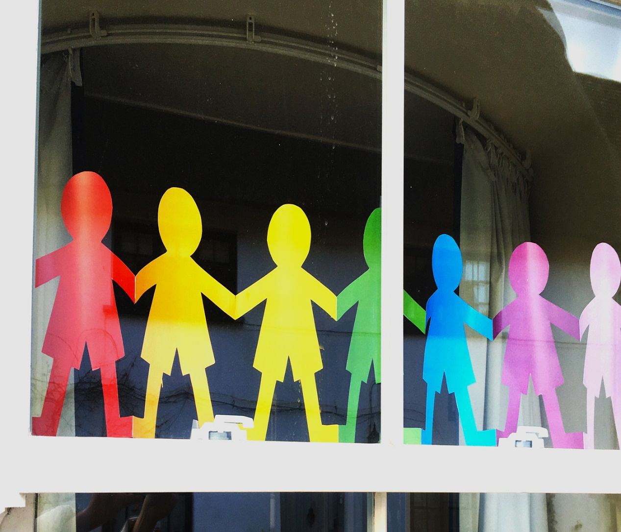

ALT_1

Coping in isolation: Time to Think

About this free course
This free course is an adapted extract from the Open University course .
This version of the content may include video, images and interactive content that may not be optimised for your device.
You can experience this free course as it was originally designed on OpenLearn, the home of free learning from The Open University –
There you’ll also be able to track your progress via your activity record, which you can use to demonstrate your learning.
Copyright © 2019 The Open University
Intellectual property
Unless otherwise stated, this resource is released under the terms of the Creative Commons Licence v4.0 http://creativecommons.org/licenses/by-nc-sa/4.0/deed.en_GB. Within that The Open University interprets this licence in the following way: www.open.edu/openlearn/about-openlearn/frequently-asked-questions-on-openlearn. Copyright and rights falling outside the terms of the Creative Commons Licence are retained or controlled by The Open University. Please read the full text before using any of the content.
We believe the primary barrier to accessing high-quality educational experiences is cost, which is why we aim to publish as much free content as possible under an open licence. If it proves difficult to release content under our preferred Creative Commons licence (e.g. because we can’t afford or gain the clearances or find suitable alternatives), we will still release the materials for free under a personal end-user licence.
This is because the learning experience will always be the same high quality offering and that should always be seen as positive – even if at times the licensing is different to Creative Commons.
When using the content you must attribute us (The Open University) (the OU) and any identified author in accordance with the terms of the Creative Commons Licence.
The Acknowledgements section is used to list, amongst other things, third party (Proprietary), licensed content which is not subject to Creative Commons licensing. Proprietary content must be used (retained) intact and in context to the content at all times.
The Acknowledgements section is also used to bring to your attention any other Special Restrictions which may apply to the content. For example there may be times when the Creative Commons Non-Commercial Sharealike licence does not apply to any of the content even if owned by us (The Open University). In these instances, unless stated otherwise, the content may be used for personal and non-commercial use.
We have also identified as Proprietary other material included in the content which is not subject to Creative Commons Licence. These are OU logos, trading names and may extend to certain photographic and video images and sound recordings and any other material as may be brought to your attention.
Unauthorised use of any of the content may constitute a breach of the terms and conditions and/or intellectual property laws.
We reserve the right to alter, amend or bring to an end any terms and conditions provided here without notice.
All rights falling outside the terms of the Creative Commons licence are retained or controlled by The Open University.
Head of Intellectual Property, The Open University

Contents
- Introduction and overview
  - Introduction and overview
  - 1 Moving around the course
- Session 1: Getting used to lockdown
  - Introduction
  - 1 Learning from the past: coping with confinement through education
  - 2 Going into lockdown
  - 3 Adjusting to the ‘new normal’
  - 4 Summary of Session 1
- Session 2: Life in a ‘new normal’
  - Introduction
  - 1 The confines of space and time
    - 1.1 Transition and change
  - 2 Strategies for managing time and space
  - 3 Separated but connected
  - 4 Summary of Session 2
- Session 3: Our minds are always free
  - Introduction
  - 1 Living with loss in all its forms
    - 1.1 Helping the passage of time
  - 2 Structure and freedom
  - 3 Time to Think: learning from the past
  - 4 Reflection
  - 5 Summary of the course and learning outcomes
  - Further resources
- References
- Acknowledgements
- Solutions

Introduction and overview

Introduction and overview
As millions worldwide face prolonged periods of social isolation or confinement, what can we learn from those who have experienced isolation in the past? One such group are the men and women who were imprisoned during the conflict in and about Northern Ireland. Some lived in small political groups in huts in prison compounds. Others spent months or years in their individual cells, while engaged in political protests. Many used this time to develop new skills and help build a more peaceful society. In this free course, explore these experiences and if/how they can help you through these difficult times.
This free course explores resources from the Open University's Time to Think project. Time to Think is an oral history archive and ongoing collaboration for teaching, research, impact and knowledge exchange between The Open University (Open University in Ireland, the Faculty of Arts and Social Sciences (FASS) and Open University Library) and people who participated in the Time to Think archive. This includes Loyalist and Republican ex-prisoners, OU tutors and office staff and prison staff and governors.
After studying this course, you should be able to:
- develop existing and new skills for coping with isolation and confinement
- understand the role education can play in surviving adversity
- develop skills for self-reflection and self-empowerment to use in a range of other contexts
- reflect on and learn from the stories of those imprisoned during the conflict in and about Northern Ireland.

1 Moving around the course
In the ‘Summary’ at the end of each session, you will find a link to the next session. If at any time you want to return to the start of the course, click on ‘Full course description’. From here you can navigate to any part of the course.
It’s also good practice, if you access a link from within a course page, to open it in a new window or tab. That way you can easily return to where you’ve come from without having to use the back button on your browser.
You can now go to Session 1.

Session 1: Getting used to lockdown

Introduction
Coronavirus, or COVID-19, has become our ‘new normal’. Since January 2020, people worldwide have faced long periods in enforced social isolation or confinement, with no certainty of when it will end.

Figure 1 The Coronavirus pandemic of 2020 has led to enforced self-isolation.
View description - Figure 1 The Coronavirus pandemic of 2020 has led to enforced self-isolation.

Take a moment to watch this short BBC film which outlines some of the social distancing measures introduced by the United Kingdom (UK) Government in March 2020, in response to COVID-19. The restrictions you experience will vary depending on which country you live in, where in that country you live, your occupation, your age, your health, your income and other aspects of your personal situation. You may find yourself somewhere on the spectrum from denial to acceptance of these new restrictions, the loss of freedom and control over your life, and to the uncertainty this brings. Living in this new normal, you may wonder how others adjusted to enforced isolation and confinement in the past and what solace they may offer.
In this short course, you will hear the thoughts of Michael, an Irish Republican, and David, a Loyalist, who were imprisoned as a result of the conflict in and about Northern Ireland. In this context, the term Loyalist refers to those who want Northern Ireland to remain a part of the United Kingdom. Historically, Loyalists supported the use of physical force where necessary to defend the union of Great Britain and Northern Ireland. The term Republican refers to those who seek to end the partition of Ireland and who wish to bring about the reunification of the island of Ireland. Republicans have also historically supported the use of physical force where necessary to achieve this.
Between them, David and Michael spent 28 years in confinement or isolation in the Maze and Long Kesh prison in Northern Ireland. David and Michael are co-producing this course with The Open University (OU). They are also contributors to The Open University’s Time to Think archive. This is a digital oral history archive documenting the educational life journeys of those involved in Open University education in British and Irish prisons during the years of conflict (1972–2000).
As you progress in this course, you will be guided through the transition from freedom to lockdown or confinement. You will be introduced to strategies and structures for using your time and invited to explore, adventure and escape through your mind. You will discover ways to reframe this situation and become agents of positive change in your own lives and the lives of others.
You will also be able to listen to the stories of other men and women who spent years in British and Irish prisons during the conflict, and how they coped by using their minds and skills they developed primarily through informal and/or formal education.
But first, take a moment to reflect on your current situation. What resources do you have that can assist you in adjusting to the ‘new normal’ of life under COVID-19?

Activity 1 Reflection on how you are adjusting to the new normal

In the box below note down your thoughts on the following (no more than 150 words).
- How do you feel about the new restrictions you are facing?
- Can you think of any parallels with other times in your life where you spent a period of time alone, or with limited contact with others, that required personal adjustments?
- Were there any skills you developed then that might assist you with coping today?

Provide your answer...
View discussion - Activity 1 Reflection on how you are adjusting to the new normal

1 Learning from the past: coping with confinement through education

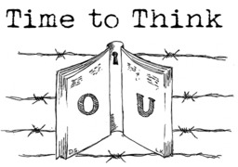
Figure 2 Time to Think
View description - Figure 2 Time to Think

You may find parallels between your experiences of isolation and the experiences of individuals and groups of people who have lived through other forms of forced confinement and isolation.
In 2010, The Open University (OU) began collecting the oral histories of Loyalist and Republican OU students in British and Irish prisons during the years of conflict, 1972–2000. The OU also collected the stories of OU tutors and office staff, prison education staff and prison governors, reflecting on their educational journeys with The Open University during this time. You can explore The Open University Ireland archive, which is called Time to Think at the following link: Time to Think archive.
Next, you will watch a short film, made for the Time to Think archive launch in 2019, about how people used education to help them cope with confinement and isolation. Take some notes as you go along about what ideas it sparks for you.

Activity 2 Time to think

Now watch the film Time to Think.

Video content is not available in this format.
Video 1: Time to Think

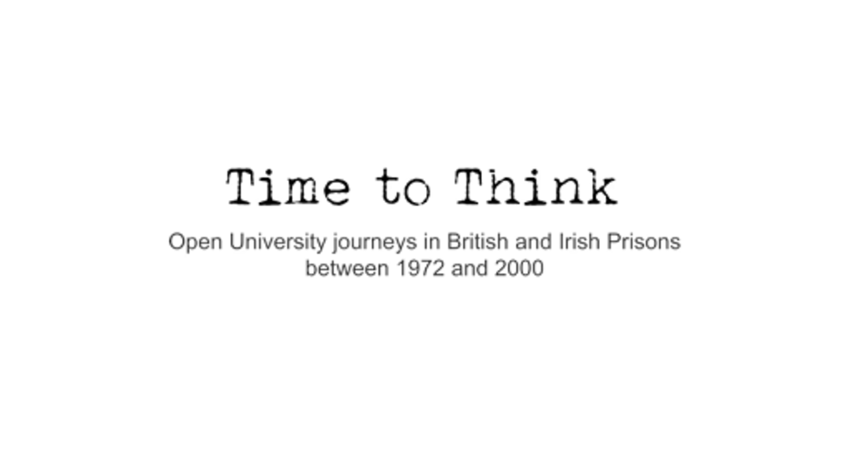

Video 1 transcript (Word document)
Answer the following questions:
- What struck you most about these stories?
- Can you make any connections between these experiences and your own experiences of confinement?
- What could you do with your own time to think?

Provide your answer...

2 Going into lockdown
One of the issues in the COVID-19 pandemic of 2020 is that there is no determinate end to isolation. This is very different from coping with change for a fixed period of time. Imagine for example, if you have to leave your home for 3 or 4 weeks due to emergency repairs, because of damage, a fire or a flood. You can count the days to getting back to normality. But for many of us living through this global pandemic, there is no end date in sight. So how can you cope with this kind of uncertainty?
For people like David and Michael, who faced indeterminate prison sentences as a result of the conflict, learning how to cope with uncertainty was essential. Take a moment to read their reflections on how they felt in those early days of confinement.

Reflection 1: David

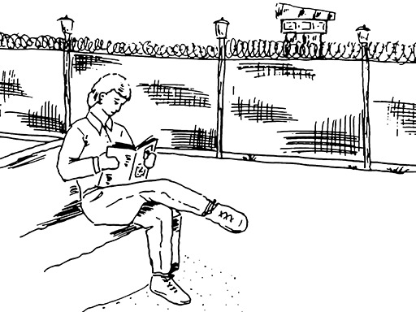
Figure 3 David in the Compounds
View description - Figure 3 David in the Compounds

My name is David. I am a Loyalist ex-prisoner. I was born in Belfast in Northern Ireland and entered prison in the late 1970s when I was aged 19. After a time on remand in Crumlin Road Gaol I served over 12 years as a special category [de facto prisoner of war status] prisoner in Long Kesh [The Maze and Long Kesh prison] where I gained an Honours Degree in Psychology with The Open University.
I remember the feeling at the beginning of an indeterminate sentence. There was no release date. The years just stretched off into the distance. No one else to talk to. No one knew. Staying here until the troubles are over. 20 years? Maybe more. A slow knot of worry starting to rise in the stomach. But there are many like me. If they can survive, so can I.
But how do you measure off time. By day, week or year? There was no point in looking to the future. A forlorn hope. Pointless. Focus on the here and now. What can I do now to get this day over and let tomorrow worry about itself? It was like slowly going out to sea. I could see the land behind me, freedom, my world, a normal life. But the boat kept going out. Further and further until I could see no land. Just the endless expanse of ocean. Featureless, with no idea of when I would see land again.
‘Settle yourself’, the old hands would say. Get busy. The more you do the quicker time goes. When will this be over? I don’t know. But some day it will be over. I will prepare for that time.

Reflection 2: Michael

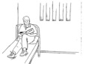
Figure 4 Michael in the H Block
View description - Figure 4 Michael in the H Block

My name is Michael and I am a Republican ex-prisoner from Belfast in the North of Ireland. I was sentenced to life imprisonment in 1979 and after a time on remand in Crumlin Road Gaol, I spent 16 years in the H Blocks, Long Kesh Prison. For the last 9 years of imprisonment I was an Open University student, gaining a degree and diploma in adult education. I was also heavily involved in the informal Republican education system in prison. It was in my head that should I ever be released, that I would like to teach in adult education. That is exactly what I got to do.
I was 28 years old, married and employed as a social worker and facing an indeterminate prison sentence. My wife was a teacher and we had two young sons. I did not have the language for it then but unquestionably I was traumatised by the whole experience of arrest, interrogation, charging and imprisonment. I had been thrust into a new world and, with my package of responsibilities I had to maintain what control I could under the circumstances. I could not go home – a natural want. Nor could I influence the ‘high level’ rules of the place I was in. But I could survive if I followed the ‘low level’ rules of the other prisoners, who like me were all more or less new to this situation but with a little more experience of it.
I had been a political activist for most of my adult life – marginal civil rights participant, community activist in my area when the conflict began- basically a person who could read situations quite well. I was determined to hold onto that mindset of activism as much as possible in prison. I developed my own mechanisms for coping, learned some from my fellow prisoners and in general terms lived for and in the day I was.

Next you will listen to an audio conversation between David and Michael recorded remotely in April 2020. In this conversation, they discuss their experiences of going into confinement in the past and reflect on living under the restrictions imposed by COVID-19. They describe what if felt like physically and emotionally when first held on remand in Crumlin Road Gaol, Belfast in the 1970s. They also talk about some of the more challenging aspects of those first few days as they waited to find out what their future held.

Activity 3 Facing isolation for the first time

Now listen to the audio recording with David and Michael.
Please note that the conversation was recorded online.

Interactive content is not available in this format.
Audio 1: Facing isolation for the first time

Audio 1 transcript (Word document)
- Having listened to this conversation, do you notice any similarities with how you are feeling now or felt when you first went into social isolation or lockdown?
- How has your life changed since lockdown?
- What adjustments have you made, if any, to cope with your changed living situation?

Provide your answer...

3 Adjusting to the ‘new normal’

Figure 5 The road ahead …
View description - Figure 5 The road ahead …

Over time you, along with millions of people around the world, will have learned new ways of coping with the challenges of social isolation and social distancing imposed in response to the COVID-19 pandemic. These may include adjusting to living in close quarters with others, losing privacy, and living under new rules. Some of these rules are externally imposed by the state or government of the country you live in. Others are created by you or those you live with, in order to keep you safe or to make co-habiting under current restrictions more manageable.
You will now listen to a second audio. In this conversation between Michael and David, they reflect on some on ways in which adapted to cope with those first few days in isolation.

Activity 4 Adjusting to isolation and confinement

Interactive content is not available in this format.
Audio 2: Adjusting to isolation and confinement

Audio 2 transcript (Word document)
Take a moment to reflect on some of the ways in which you are adapting to make your new living situation easier for you and/or for those who live with you. Have you experienced any examples of support from others or provided support yourself?

Provide your answer...
View discussion - Activity 4 Adjusting to isolation and confinement

You may have already surprised yourself with the resources you have both individually and as a family, household or community. You may also find the following advice helpful as you continue to adjust to this new normal and the uncertainty it brings.
Some thoughts to keep hold of:
- It’s okay to feel scared.
- Remember that many other people are also going through this.
- Find ways to stay connected with friends or your local community or to make new friends.
- Take one day at a time.
- Remember your sense of humour.
- Remember your own skills and resources
- Above all- understand why you are doing this and why it matters – this is not just for you, this is for the general good.
Now listen to the final audio in this session. Here David and Michael reflect back on their time ‘inside’ and offer some final words of advice, having emerged the other side of this experience.

Interactive content is not available in this format.
Audio 3: No end in sight

Audio 3 transcript (Word document)

4 Summary of Session 1
That is the end of Session 1. During this session you have:
- reflected on the existing skills and resources you have for coping with change
- listened to the experiences of others who faced lockdown in the past and the advice they can offer
- considered different ways of adjusting to this ‘new normal’
- learned about the educational experiences of Open University students in British and Irish prisons during the years in conflict.
In Session 2 you will hear more from David and Michael on learning to live in a ‘new normal’. Drawing on their experiences, you will explore practical ways in which you can begin to structure and manage your time and space to regain some control over your life.

Protecting your mental health and wellbeing
Many of us will experience slight increases in anxiety in situations like the COVID-19 pandemic, or we may feel that mood is a bit lower than usual. Both may be considered to be normal reactions to the dramatic change in circumstances, brought about by COVID-19 and the lockdown. However, if you experience a significant increase in your levels of anxiety, or if you notice that your mood feels much lower than usual, you should take action to safeguard your mental health. Consider these points of contact:
- Your GP. Most GPs are currently offering telephone or online appointments, so you can talk to your GP without going to the surgery. They can provide information about possible medication and about counselling.
- A counsellor. Many counselling agencies and private practitioners are currently offering online and telephone support. You can use a Google search to help find counsellors in your area.
- A telephone helpline. If life feels like a struggle, or if you are experiencing suicidal thoughts, it can be good to talk to someone and helplines can offer valuable support.
UK information:
https://www.nhs.uk/conditions/stress-anxiety-depression/
https://www.nidirect.gov.uk/articles/lifeline-freephone-helpline
UK helplines:
https://www.samaritans.org/
https://www.lifelinehelpline.info/

You can now go to Session 2.

Session 2: Life in a ‘new normal’

Introduction

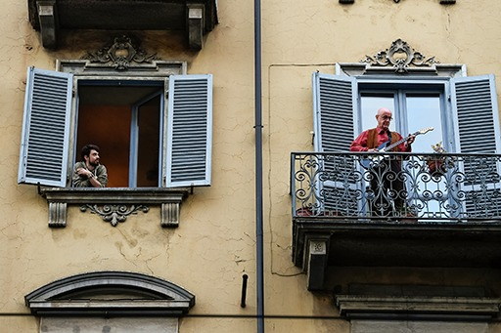
Figure 1 Man plays guitar while his neighbour watches during COVID-19 Pandemic, Turin, Italy 2020
View description - Figure 1 Man plays guitar while his neighbour watches during COVID-19 Pandemic, Turin, ...

In this second session of the course, you will consider the impact of both time and space on your experience of confinement during the 2020 COVID-19 pandemic and explore ways of gaining some control and agency over your situation.
Where you live and the space you live in will significantly shape your experience of social distancing and isolation and your ways of coping during the pandemic. Some of you may be living on your own. Others may live in shared accommodation, with extended family, friends or even strangers in institutions or other group settings. You may be in a city, in a high-rise building or a flat with little or no outdoor space. Or you may be in a village or the countryside with a garden or even some land and the additional freedoms this offers. Wherever you live, and however long you are in isolation, there are inventive ways to make the most of the space you are in and the time you have.
Course co-producers and Open University graduates, Michael, a Republican ex-prisoner and David, a Loyalist ex-prisoner, draw on their past experiences of confinement to suggest strategies for living with this ‘new normal’. These include discovering your hidden strengths, structuring your time and connecting with others.
The following short film, recorded in March 2020, shows some of the ways in which people in Italy responded to confinement under COVID-19, through music and song.
Watch the film at the following link: BBC film.

Activity 1 Reflecting on the value of community

Take a moment to reflect on your own situation.
- Has any act of community solidarity inspired you recently? This could be something you have taken part in, or something you saw or heard others do.
- Did that action change how you felt or feel or about your sense of social isolation and, if so, in what ways?

Provide your answer...

By the end of this session, you should be able to:
- consider ways of reframing how you think about isolation and confinement
- reflect on the ways of regaining some control and agency
- explore practical ways in which you can begin to structure and use your time
- consider different ways in which you can stay connected while apart
- know more about the experiences of Loyalist and Republican Open University students in the Maze and Long Kesh prison during the years of conflict in Northern Ireland.

1 The confines of space and time

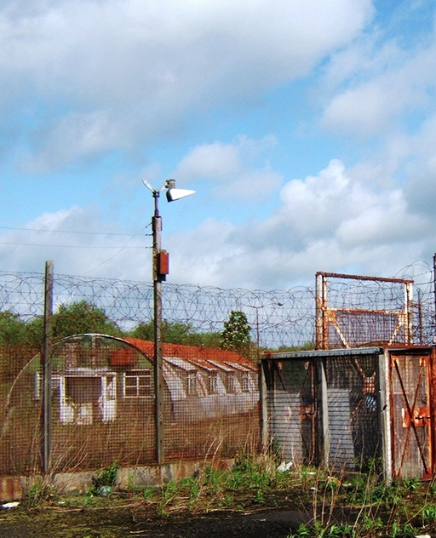
Figure 2 Exterior of a compound, The Maze and Long Kesh prison.
View description - Figure 2 Exterior of a compound, The Maze and Long Kesh prison.

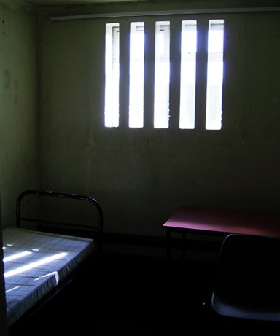
Figure 3 Interior of H Block cell
View description - Figure 3 Interior of H Block cell

During the thirty years of conflict in and about Northern Ireland (1969–2000), most people arrested under Emergency Powers were held on remand in Crumlin Road Gaol in Belfast while they awaited sentencing, as you heard from Michael and David in Session 1. Loyalists and Republicans who were given indeterminate sentences experienced a range of living conditions in prison. In the Maze and Long Kesh Prison for example, some men lived in political groups in what were known as Compounds or Cages. These were old British army Nissen huts (left over after the Second World War), each containing up to 30 men and separated by fencing and razor wire from other huts in the prison. After 1976 others lived in individual cells in what were known as the H Blocks, given this name because each block was constructed in the shape of the letter H. In the following audio recording of a conversation between Michael and David, they discuss their experience of these different living conditions – David in the Compounds or Cages and Michael in the H Blocks. Now listen to the following audio conversation, taking some notes as you go along:

Interactive content is not available in this format.
Audio 1: Life in the Compounds and H Blocks of Maze and Long Kesh

Audio 1 transcript (Word document)

Activity 2

Having listened to the audio, answer the following questions:
- What struck you most about this discussion?
- What similarities or differences do you notice with your own experience of confinement?

View discussion - Activity 2

1.1 Transition and change
All of us are likely to go through a period of transition as we come to terms with this’ new normal’. For David, whose OU honours degree was in Psychology, transition and change theories (Kübler-Ross, 1969 and Hopson and Adams, 1975) proved useful as a way of thinking about the different stages he went through during his confinement. Transition theory offers a psychological framework for understanding human response to bereavement, grief and other profound life changes.

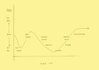
Figure 4 ‘Transition phases’, adapted by David Smyth (2020) from Kübler-Ross, 1969 and Hopson and Adams, 1975, p. 13)
View description - Figure 4 ‘Transition phases’, adapted by David Smyth (2020) from Kübler-Ross, 1969 ...

David used transition theory and the different phases in this diagram, to make sense of his own experiences in the following way:
- Shock /disbelief: My arrest and imprisonment were sudden and unexpected. I experienced trauma and shock as I realised I was being held in a very volatile and severe environment.
- Denial/initial adjusting: After a short period, I entered a ‘honeymoon’ period or one of denial. I got used to the new routines and adapted quickly to what was needed. However, as time went on and there was no foreseeable end to this stage of life.
- Uncertainty/Depression: I entered a downward spiral as I came to realise, I was here for a long time. I felt like there was no preparing for tomorrow. No planning ahead. I had to just take each day as it came.
- Reconciling: At some point there is a bottoming out or turning point where you ‘let go of the old’. For me, this was my trial, where I was found guilty. While unhappy, I could now settle into a new way of life. New routines of my making included undertaking an Open University degree and A levels, art and craft work and physical training.
- Recovery: After a short while I realised, I was making positive inroads into my life situation; regaining confidence and control, learning new ways and a ‘new normal’.

Activity 3 Reflecting on your journey

- Looking at the adapted ‘Transition phases’ graph (Figure 4), where do you see yourself at the moment in this process?
- How might you move yourself to the next stage?
- Thinking about your inner resources, how can you use these current skills or some of the tips and guidance in this course, to help with this process?

2 Strategies for managing time and space

Figure 5 The passing of time
View description - Figure 5 The passing of time

I think of the mystery of times passage. There are minutes and hours which have no end: the eternity of the instant. There are many empty hours … endless days; and weeks which pass without leaving the least memory behind them, as if they had never been.
(Victor Serge, 1931)

These words by the Russian revolutionary, Victor Serge (1890–1947) may strike a chord with some of you. Serge spent many years in solitary confinement for his political beliefs. This quote was chosen by David from a book he read during his own imprisonment, to explain the ‘elasticity of time’ he experienced. Dealing with this elasticity of time is also one of the challenges of life under COVID-19 restrictions. Days and weeks may feel like they merge into one. Managing this time along with the pressures of life in new or confined spaces, alone or with others may require new strategies.
In the following reflections, Michael and David describe how they responded to their new lives in the Maze and Long Kesh prison. David had Special Category Status (SCS) which was given to those charged with political offences under British Emergency Powers from 1972, until it was withdrawn by the British Government in 1976 leading to political protests. Michael reflects on his experiences in complete lockdown in the H Blocks, during Irish Republican protests to regain political status after 1976. David also reflects on his experience of solitary confinement while in the Compounds. Each found different ways to reframe their situation, discovered hidden strengths and learned new ways of making the situation work for them.
Now read their reflections.

Reflection by Michael: Thinking communally not individually

Figure 6 Michael in the H Block
View description - Figure 6 Michael in the H Block

During the conflict not all people imprisoned succeeded in coping, or in coping all of the time. But many did cope, and many did for most of the time. So, Republican prisoners were not mentally a homogenous group. Just like all in society today. Much of the coping depended on themselves and the package of their individuality but the latter was also somewhat dependent on other support mechanisms such as their multiple belief systems – micro in that their girlfriends, wives/ families supported them, that God would assist, macro in that the Republican Movement was there to support them, that the struggle would soon be finished and the’ Brits’ would be ‘out’, that they would eventually escape and so on. I know many men who fitted into many of these categories. But eventually the initial thinking had to change, and men had to begin thinking differently. This will be the same today – as attitudes change with the receipt of new knowledge and general acceptance sets in. Some did not in the past and found imprisonment very difficult.
Mindset was vital and for me and many others this meant focussing on the political rather than the personal and on finding opportunities to take back some form of agency and control. Prisoners sentenced under British Government Emergency Powers and given indeterminate sentences were different than ordinary prisoners. We had normally been in jail for at least one year prior to sentence so were used to prison and routines etc. We had either had grown stronger or weaker as result of that year. We were certainly not the same people as who had come into jail a year earlier. We may have been in prison alone, but we were part of a community.
Several weeks now into that lockdown, many of us were changing our approaches in order to adapt to the new ways. Some of us, for example, joined the blanket protest [a 5 year protest for rights and recognition as political prisoners]. We knew the deprivations ahead – solitary confinement, no sanitary conditions, no visits or contact with friends, families and very bad relationships with those in control/power. This led to a oneness of goal, a set mindset, similar strong ideological grounding (based on a political understanding of our situation). We recognised the long- term costs/benefits of our decisions, potential outcomes and decided on a course of action.
The same can be seen today. At first people may be primarily focussed on their own situation including for their immediate families – more ‘self-centred’ perhaps. They may not see themselves as part of the wider community or society, with broader responsibilities. They may want to go out with friends, ignore recommendations to wash your hands. Over time, as it becomes clear to people that by working collectively, we are stronger, the development of a broader social loyalty may begin to kick in (instead of being imposed). This should allow that unit to feel part of the broader positive activity.

Reflection by David: Solitary is what you make it

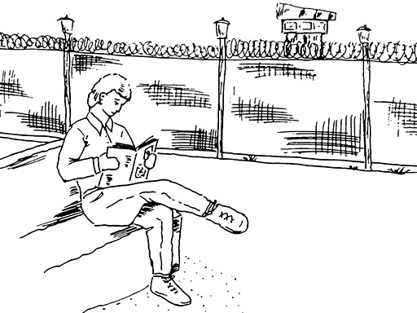
Figure 7 David in the Compounds
View description - Figure 7 David in the Compounds

It was towards the end of my time that I ended up on ‘the boards’ [slang for concrete/wooden plinth lying on the floor in place of a bed/mattress] or in solitary confinement. The cell measured 10 feet by 6. No TV, no radio, no books. Nothing. In the morning the screws [slang for prison officers] came and took out the mattress leaving a concrete plinth. There was no chair. The day was divided up by mealtimes. Of course, we had no watch, clock, etc to mark out time. Maybe that was a good thing. By sheer luck I had tried yoga in the compound and liked it. Now was a good time to practise. I don’t know how but I have an ability to lie on any surface and go to sleep. So, I was able to lie on the plinth and drift off. Escape. Sleep was important as it meant escape for a while. It also marked the passing of a day. We were allowed one hour per day exercise. Again, it split the day up...
Mental arithmetic was a good companion. I worked out how many times I would walk round the cell to do 10 miles. I imagined I was walking from Belfast to Bangor. Took a while but got there. Could I recall all the states of America? All the football teams in the football league? Of course, I would try and go over the material I was studying at that time for the OU [Open University]. Given that I was doing Psychology and indeed Criminology, which included prisons, this helped immensely. I had read of so many other accounts by prisoners that this helped me. Jack Henry Abbot’s In the Belly of the Beast made this stay look like a souped up Butlins holiday [British seaside holiday camp].
Other supports were; that I was not on my own and that others had suffered this a lot more than me. And a good motivator for me was bloodymindness. I wasn’t going to give in. I was not going to be beaten by the system. I was so happy to receive a visit from a Presbyterian minister. He insisted I sit with him in another cell which had no heat. I still recall the blissful coolness. He even visited my parents to assure them. My biggest worry was my parents. They had no experience of me being punished in prison. I worried that they were worrying. Which they were. On the very next visit my mum was frantic to see me.
My second and third times on solitary were easier. You can get used to many things. I enjoyed the chance of some down time. Peace and quiet. That’s good if your personality is that way inclined. I suspect others do not take social isolation so easily. Social isolation, like prison time, is what you make of it. The more you do, the quicker it goes.

In the following audio conversation recorded in April 2020, David and Michael discuss the practical structures and strategies they found useful for managing life in their ‘new normal’, many of which may be relevant to today. Now listen to this audio:

Interactive content is not available in this format.
Audio 2: Strategies for living in the ‘new normal’

Audio 2 transcript (Word document)

Activity 4 What are your strategies for managing your time and space?

Having read Michael’s and David’s reflections and listened to their conversation, answer the following questions:
- What struck you most about the ways in which they responded to their difference experiences?
- What strategies have you put in place to manage your time?
- What new ideas for managing time and space, if any, has this sparked for you?

View discussion - Activity 4 What are your strategies for managing your time and space?

3 Separated but connected

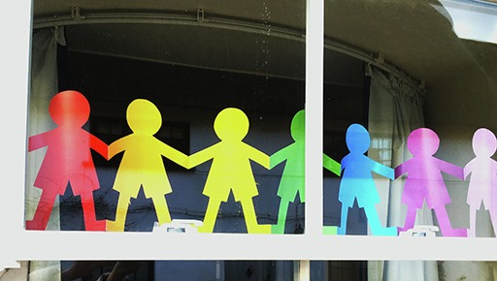
Figure 8 Rainbow symbol in a window during the COVID-19 pandemic.
View description - Figure 8 Rainbow symbol in a window during the COVID-19 pandemic.

One striking difference you may notice between the past experiences of David and Michael and those of us socially isolating under the 2020 pandemic, is the degree of isolation they faced and the limited access they had to the outside world. This degree of access we have to the outside world can make a significant difference to our sense of social isolation as do opportunities for social interaction.
During the COVID-19 pandemic, people have a range of options and choices for communicating and staying connected, for example, through the internet, social media, video and audio apps. Not everyone, however, has the same levels of internet access or the skills to use these tools. Yet a range of innovative ways of communicating are emerging in countries around the world, such as displaying rainbows or hearts as symbols of hope or the use of red, amber, green cards in windows to indicate who is in need of help.
Shortly you will listen to the final audio conversation in this session. Here David and Michael discuss some of the different ways they found to communicate with others, despite their isolation. They also discuss the powerful personal impact of actions by others then and now, which help to keep us all connected and know that while isolated, we are not alone.

Interactive content is not available in this format.
Audio 3: Separate but connected

Audio 3 transcript (Word document)

Activity 5 Staying connected

Take a moment to imagine that during the pandemic, the internet has been down for a week. Or because of your age or circumstances, you do not have the skills, means or opportunity to access the internet or a smartphone. You might like to have a conversation over the phone with someone who doesn’t use the internet or social media, to help you with this activity. Now note down your answers to the following questions.
- How might people connect with you in ways which do not rely on the internet? Try to list 2 or 3 suggestions.
- Is there anything you can do now to connect with people who may be isolated in your wider community?

Provide your answer...
View discussion - Activity 5 Staying connected

Throughout this session you have explored different strategies for adjusting to isolation and confinement, managing the ‘elasticity of time’ and staying connected. You have also had an opportunity to reflect on the resources you have individually or as a family, household or community.
As you near the end of this session, here are some thoughts to keep hold of:
- Remember that change is challenging and you need time to adjust your mindset.
- Find ways to be proactive and take some control over your situation, no matter how limited.
- Create new routines to break up and manage your time.
- Keep your mind active – crosswords, learning a language, study, problem-solving.
- Build in some time for self-reflection to take stock.
- Note the victories – this could be hearing good news stories or making new contacts.
- Try to avoid the negative such as rolling news reports or ill-informed / irresponsible social media posts.
- Find creative ways for communicating with others who may be isolated in your community or elsewhere.
- Do something kind or useful for someone else. Making others happier will make you feel happier too!

4 Summary of Session 2
In this session you have heard some thoughts from Michael and David on managing life in lockdown, based on their own experiences serving indeterminate sentences in the Maze and Long Kesh prison. You have also:
- considered ways of reframing how you think about isolation and confinement
- reflected on ways of regaining some control and agency
- explored practical ways in which you can begin to structure and use your time
- considered different ways in which you can stay connected while apart
- learned more about the experiences of Loyalist and Republican Open University students in the Maze and Long Kesh prison during the years of conflict.
In the next Session, you will explore creative ways of escaping confinement and finding solace during isolation in these difficult times.

Protecting your mental health and wellbeing
Many of us will experience slight increases in anxiety in situations like the COVID-19 pandemic, or we may feel that mood is a bit lower than usual. Both may be considered to be normal reactions to the dramatic change in circumstances, brought about by COVID-19 and the lockdown. However, if you experience a significant increase in your levels of anxiety, or if you notice that your mood feels much lower than usual, you should take action to safeguard your mental health. Consider these points of contact:
- Your GP. Most GPs are currently offering telephone or online appointments, so you can talk to your GP without going to the surgery. They can provide information about possible medication and about counselling.
- A counsellor. Many counselling agencies and private practitioners are currently offering online and telephone support. You can use a Google search to help find counsellors in your area.
- A telephone helpline. If life feels like a struggle, or if you are experiencing suicidal thoughts, it can be good to talk to someone and helplines can offer valuable support.
UK information:
https://www.nhs.uk/conditions/stress-anxiety-depression/
https://www.nidirect.gov.uk/articles/lifeline-freephone-helpline
UK helplines:
https://www.samaritans.org/
https://www.lifelinehelpline.info/

You can now go to Session 3.

Session 3: Our minds are always free

Introduction

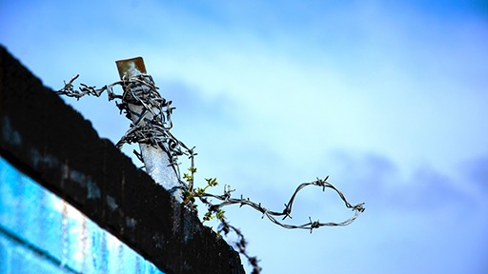
Figure 1 Wire against a blue sky, Belfast, County Antrim.
View description - Figure 1 Wire against a blue sky, Belfast, County Antrim.

In this final session of the course you will explore new opportunities for using your mind and imagination during times of social isolation and confinement. During this session, course co-producers and Open University graduates, Michael, a Republican ex-prisoner and David, a Loyalist ex-prisoner, draw on their past experiences of confinement to suggest strategies for finding peace of mind and embarking on new discoveries. You will also hear stories from Open University students in the Time to Think archive, who used education for solace and escape while in prison during the years of conflict.
A recurring theme throughout this session is the power of human resilience in times of adversity, our abilities to problem solve, and the importance of hope in driving us forward. The poem ‘Don’t quit’, written in 1921 by the British born American poet Edgar Guest (1881–1959), has inspired and motivated many people through difficult times. It also featured in a short film by the BBC released in April 2020 during the COVID-19 pandemic. In this film the poem is read by the British actor Idris Elba. Now take a moment to watch the short film: Bringing us closer.
You can also read a full version of Guest’s poem.

Activity 1 Reflecting on what inspires or motivates you

Note down your reflections, in response to the following questions, in the box below.
- What was your reaction to this short film? Is there a line in the poem that speaks to you in your situation?
- What have you found most surprising, hopeful or inspirational during the COVID-19 Pandemic?
- List one thing, no matter how small, that has helped you through this or other difficult times.

Provide your answer...

1 Living with loss in all its forms

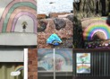
Figure 2 Image of rainbow symbols.
View description - Figure 2 Image of rainbow symbols.

In the dark reality of COVID-19 with its high human cost, finding inspiration, mutual support and creative communal solutions is more important than ever. One of the most painful losses many people have experienced is losing a loved one during lockdown, whether as a result of the COVID-19 pandemic, or due to other causes. When in social isolation, for example, it may not be possible to spend time with a loved one who is dying. Under new restrictions it may not be possible to mourn or mark their death in accordance with traditional religious or belief systems in ways that a family or community wishes.
Yet under COVID-19, alternative rituals have also emerged as people find new ways to bear witness to the lives and deaths of those they have known. In some communities neighbours and friends pay their respects from afar, standing on their doorsteps as the funeral car passes, rather than walking behind the hearse and attending the funeral service. Letters and cards have replaced actually being there, hugging and shaking hands with the bereaved ones. Communal prayer services are conducted on video conferencing apps such as Zoom in which hundreds of people can take part to provide love and support. In other cases, memorials are live-streamed on private YouTube channels. Promises are made to celebrate the lives of loved ones at an unspecified future date.
In 2020, more generally, our social way of life has changed significantly. Personal freedom, for example, can often be taken for granted, particularly by those living in Western democracies. For a significant period of time, losing the freedom to choose what you do, where you go, with whom you spend time and with whom you don’t, can be challenging. Friendships or relationships may shift and your horizons may feel narrower due to the confines of the physical space you are in. Coping with loss in all its forms and finding new ways of being and of doing things, is both a challenge and an opportunity for all of us during the COVID-19 pandemic.

Activity 2 Reflecting on change and renewal

Note down your responses to the following questions:
- Take a moment to reflect on some of the rituals that you notice have changed or been lost, during the pandemic.
- Can you think of either any alternative rituals or a new ways of doing things to cope with this loss that have emerged?

Provide your answer...

1.1 Helping the passage of time
One of the ways of coping in times of adversity such as these, is through activities which not only pass the time, but help to expand the limitations of the space you are in. You can also develop skills for use in the future, when the constraints are lifted, and where new ideas and abilities are needed. In the following reflections, David and Michael outline some of the ways they maintained their physical and mental wellbeing while in isolation and confinement.

Reflection: David

Figure 3 David in the Compounds
View description - Figure 3 David in the Compounds

Different people can take different views on coping with the loss of freedom, depending on their outlook. There is denial. Pretend It isn’t happening. There is diversion. Just keep doing something else. There is clinging to hope. Something will turn up. And there is rationalisation. I am in this position because…There is coping by knowing you are in a group going through the same experience. I see parallels on a social level with today.
For me, reading was very important. Some of us set up our own book club. We would buy jointly then share the books. Reading was a means of escaping the immediate situation. I recall on different occasions of reading a book through from start to finish in one go. One such book was Hugh Trevor Roper’s, The last days of Hitler – an amazing story and well written. In hospital one time I had The Crossman Diaries and The Gulag Archipelago by Aleksandr Solzhenitsyn which passed many hours.
Then I had the Open University material. I’m not sure how my interest in Psychology developed but it was interesting and could be related to my situation of imprisonment. Even more useful and tangible was the Social Sciences course on the justice system. It dealt with police, law, courts and prison. The OU was a means to structure time. It was learning and it was challenging and constructive. Many hours were used up in typing (I learned to type in prison) various essays. There were experiments. I once taught fish to learn the difference between colours and shapes!
There was always an ongoing battle between myself and the prison authority but especially the security department. I had a lot of problems getting books into prison. Quite often I had to lodge a written submission to the governor. This was mostly turned down on security grounds which could not be challenged or explained. I finally decided that I had nothing to lose and made a written request for the book Pole Vaulting for Amateurs. I didn’t even get a reply to that one! Books on hypnosis were strictly forbidden.
Another aspect to my day to day routine was artwork. There was a huge resource of talent in the cage [Compound]. I learned to paint on glass which became my preferred art mode. I also dyed leather, completed pencil drawings, dabbled with oil and water colours and painted large scale murals on the walls of the hut.

Reflection: Michael

Figure 4 Michael in the H Block
View description - Figure 4 Michael in the H Block

When in prison, we lived according to a routine, which mostly was of our own invention. For example, get up early and get a few hours reading/studying done – breakfast, exercise, some social interactions, food, back to reading or OU essay/note reading in prep for essay. Most Open University courses allowed for a lot of ‘supplementary’ reading which could always be incorporated into formal work. I found it amazing that even reading fiction could assist in getting essays done. I found that in studying Arts, psychology and particularly Social sciences – almost anything in the world became relevant to the courses I was doing.
I was initially reluctant to do the ‘Arts’ course, but basically I had no option. So I went for it. From literally nowhere I got insights I never had – not only into how to interpret things – but how to view the world from slightly differing view points. Doing other courses under Social Sciences had opened my eyes but this Arts course brought things home to me. I see that as something like Woody Allen’s comments about having read the book Animal Farm. He said he enjoyed it – ‘it was all about pigs’. Well I suppose that if we take away the exaggeration, that could have been me as a younger man taking things at a face value instead of looking to see if there is hidden meaning – even in jokes. It is obvious when you think about ‘sarcasm’ or ‘irony’ – how do they really work if you don’t know that the meaning is not really in the words used? When I read Umberto Eco’s book The Name of the Rose I then read up on the author Eco and found out about semiotics/semiology – the interpretation of signs/hidden signs or signals which are all around us. Fascinating learning there for me. Studying the Arts also led me onto dabbling in artwork – painting, developing my calligraphy writing abilities – all as a result of my developed interest in these things I used to have no interest in.
Of course, in tandem with me as a student escaping through my mind, as a political prisoner my thoughts were also on real escape. Today is very different for us all in that the confinement is for our benefit and I see the ‘isolation’ as a positive – full of opportunity to try new things. I have already pretty much got new daily routines – though I have to consciously think and remember them – but I am coping OK given that I am fortunate enough to have a mobile phone, computer and TV – many do not.
Not everyone has the desire to broaden their outlooks on the world by reading, studying or whatever, but most people do interact with matters other than the humdrum of their own lifestyles. They watch TV, shop, read etc. So I would suggest to people –be open to alternatives – try learning something new. You might be would be amazed at what you will find and where it will take you.

In the following conversation, Michael and David discuss the creative ways in which they passed time, found peace of mind and ways to escape, while in lockdown in the 1970s and 1980s.
Now listen to Audio 1.

Interactive content is not available in this format.
Audio 1: Your mind is always free

Audio 1 transcript (Word document)

Activity 3 Using your mind for solace and escape

Having listened to the audio, try to answer the following questions:
- What most sparked your interest in this discussion between David and Michael?
- Was there anything that surprised you?
- Were there any ideas that were relevant to your situation today?

Provide your answer...
View discussion - Activity 3 Using your mind for solace and escape

Another point mentioned in the discussion above was the role of time management. This will now be explored in more detail in the next section.

2 Structure and freedom

When you are on the dance floor, there is nothing to do but dance.
(Umberto Eco)

The quote above was selected by Michael, as one way of thinking about and responding to situations which may be beyond our control. It is from the 2004 book The Mysterious Flame of Queen Loana, by Umberto Eco – an author Michael discovered while studying Arts with The Open University. When faced with loss and the challenge this brings, most people can and do find a way to adapt and survive. Part of this involves accepting the things you can’t do anything about and focussing on the things you can.
Throughout this course Michael and David have discussed the value of structuring your time and building your own routine to regain control over some aspects of your life, and with this find some freedom. In the Maze and Long Kesh prison during the years of conflict, prison life was strictly controlled by the internal prison authorities and external British Government policies. Yet, within the Compounds or Cages and the H Blocks, there were always ways and opportunities to regain some degree of freedom.
One way was to divide up the day into morning, afternoon and evening. In the sketch below, David outlines a typical weekly schedule he used to structure his time while in the Loyalist Compound, Compound 21 (C21) of the Maze and Long Kesh prison.

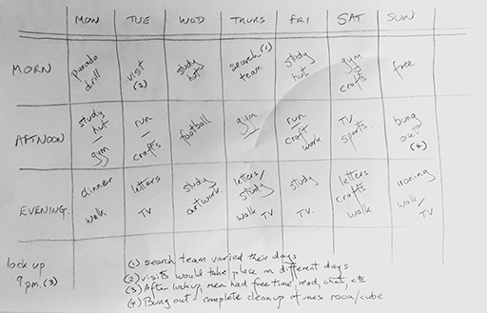
Figure 5 Weekly schedule circa 1982 by David Smyth
View description - Figure 5 Weekly schedule circa 1982 by David Smyth

Michael also highlights the value of creating a routine, especially within the extreme restrictions of his imprisonment in the H Blocks of the Maze and Long Kesh during the years of political protests from 1976 to 1981. One aspect of his routine included a communal event to look forward to at the end of the day such as shared storytelling through the cell doors (or the creative retelling of books people had once read), as you heard in Audio 1.
Below is a list of tips from David and Michael, for activities which helped their mental and physical wellbeing during long periods of confinement. Some were mentioned in Audio 1 above. Others are highlighted elsewhere in this course. Take a moment to read the list of activities below.
Mind
- Challenge yourself and broaden your horizons.
- Learn a new skill: a language, knitting, painting, gardening.
- With a new language, practice your skills by speaking it out loud.
- Undertake new routines/schedules.
- Take journeys in your mind to keep your memory sharp. Going to the seaside for a summer day as a child. Walking around the streets or areas you lived. Try to picture all the different shops, the houses, the street names.
- Go through a favourite book or film and trying to recall the different scenes.
- Set your own quizzes. Name all the states in USA. Name all counties in Ireland. Think of all the football teams in England. How many animals can you name that start with letter b, c, etc.
- Try meditation or mindfulness.
- Consider a short course or other forms of education.
Body
- Include physical activity in your daily routine.
- Take the opportunity to exercise outside if restrictions allow.
- Exercise indoors, you can use whatever you have around you to exercise to the best of your ability – lifting cans of food as weights, walk up and down the stairs, sits ups in the living room, lifting cans of food as weights.
- Set yourself distance goals to achieve, even if you are in a confined space.
- Try Yoga, Pilates or Taiichi.
- Do daily stretches.
One striking difference for those of us in lockdown during the COVID-19 pandemic in 2020, is the range of social and cultural resources available online. For those who have internet access there is a treasure trove for discovery and exploration, from the confines of your home. During the COVID-19 pandemic, many cultural and learning events are free. So why not try something new?
For example, a short internet search (at the time of writing) shows that you can hear an intimate performance by up and coming musicians direct from their home, take part in shared storytelling or listen to compelling true stories by others. You can listen to sounds from cities around the world and contribute your own, travel to the seven wonders of the world or visit a library in another country. You can read Tolstoy’s War and Peace with others in an online book club or set up your own virtual book club. You can travel into space with the Apollo13 mission. You can learn a new language or enrol in a new course whether in the Arts to Social Sciences, Maths or Astronomy, Health or Wellbeing to develop your mind and hone your questioning and critical thinking skills. (You can check out links to these and other free resources in the Further resources section at the end of this session.)
For those without internet access, there are many activities (mental and physical) you can do with a little imagination, books, pens and paper, including all of the activities outlined by David and Michael in the tips above. (You can check out links to these and other free resources in the Further resources section at the end of this session.)

Activity 4 Creating a new routine

Take a moment to think about your current routine, if you have one.
- How different is this from your old routine/what changes have you had to make?
- Now, either use the table below, or click on the link below that which will take you to an empty table, or use the table to create a new routine.
- Is there anything missing from your routine, from the list above that you would like to add?

Week | Monday | Tuesday | Wednesday | Thursday | Friday | Saturday | Sunday
Morning | Provide your answer... | Provide your answer... | Provide your answer... | Provide your answer... | Provide your answer... | Provide your answer... | Provide your answer...
Afternoon | Provide your answer... | Provide your answer... | Provide your answer... | Provide your answer... | Provide your answer... | Provide your answer... | Provide your answer...
Evening | Provide your answer... | Provide your answer... | Provide your answer... | Provide your answer... | Provide your answer... | Provide your answer... | Provide your answer...
Notes | Provide your answer... | Provide your answer... | Provide your answer... | Provide your answer... | Provide your answer... | Provide your answer... | Provide your answer...

A new routine: table (You might find it useful to print this.)

3 Time to Think: learning from the past

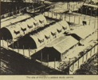
Figure 6 Image of the Compounds, 1972.
View description - Figure 6 Image of the Compounds, 1972.

The Open University’s Time to Think archive captures people’s educational journeys with The Open University in prisons during the years of conflict (1972–2000). Stories were captured over a ten-year period and include contributions from OU tutors and office staff, prison education staff, prison governors and some of the thousands of Republicans, and Loyalists imprisoned as a result of their role in the conflict.
A number of these Open University students played a role in the unfolding peace process during imprisonment and upon release. Some went on to become teachers, academics, architects or artists. Others became community or political leaders including district or city councillors, Members of the European Parliament (MEPs) and Members of the Legislative Assembly (MLAs) in the Northern Ireland Assembly [the devolved legislature for Northern Ireland].
You might like to listen to the following 8 clips from the Time to Think archive. Each reveals different ways in which people have expanded their horizons despite the physical confines they inhabited. (Each clip is only between 40 seconds to 1 minute long.)

Eddie Kinner

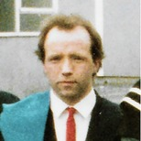
Figure 7 Eddie Kinner
View description - Figure 7 Eddie Kinner

Eddie gained an Open University degree in Mathematics in the Loyalist Compounds [the Maze and Long Kesh Prison] in the 1980s. He was later one part of the Loyalist negotiating team for the Good Friday Agreement.

Interactive content is not available in this format.

Audio transcript (Word document)

Harry Donaghy

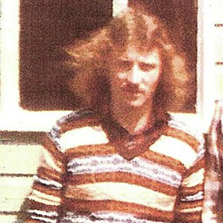
Figure 8 Harry Donaghy
View description - Figure 8 Harry Donaghy

Harry studied for O and A levels in the Official IRA Compounds [the Maze and Long Kesh Prison] in the 1970’s. After his release he studied in the Soviet Union, graduating from the Lenin Institute in Moscow in 1989. Harry works in the community sector on peacebuilding by facilitating new conversations about the construction of modern British and Irish identities.

Interactive content is not available in this format.

Audio transcript (Word document)

Jackie McMullan

Figure 9 Jackie McMullan
View description - Figure 9 Jackie McMullan

Jackie gained a Social Sciences degree in the Republican wings of the H Blocks [the Maze and Long Kesh Prison] in the 1980s. He was later Special Advisor for the Minister of Education at the Assembly in Stormont. Jackie works in the community sector.

Interactive content is not available in this format.

Audio transcript (Word document)

Robert Campbell

Figure 10 Robert Campbell
View description - Figure 10 Robert Campbell

Robert gained an Open University degree in Mathematics in the Loyalist wings of the H Blocks [the Maze and Long Kesh Prison] in the 1990s. Later he gained a Master’s degree in Numerical Analysis from the University of London. Robert works with Loyalist ex-prisoners in education and peacebuilding.

Interactive content is not available in this format.

Audio transcript (Word document)

William Mitchell

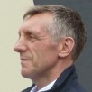
Figure 11 William Mitchell
View description - Figure 11 William Mitchell

William studied short courses with The Open University while in the Loyalist Compounds [the Maze and Long Kesh Prison] in the 1970s. On release he gained a degree in Youth and Community Work from the University of Ulster and later, a PhD in Philosophy. William is Project Director for the Action for Community Transformation initiative, a conflict transformation process for Loyalists

Interactive content is not available in this format.

Audio transcript (Word document)

Martina Anderson

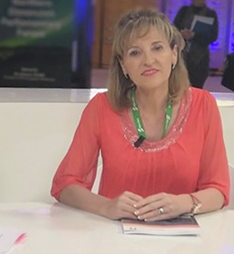
Figure 12 Martina Anderson
View description - Figure 12 Martina Anderson

Martina studied for a Social Sciences degree with The Open University in Durham Gaol and Maghaberry Prison, graduating in 1997. She was first elected as a Sinn Féin member of the Legislative Assembly (MLA) in 2007, and later as a Member of the European Parliament (MEP) from 2012 to 2020. Martina is a Sinn Féin MLA.

Interactive content is not available in this format.

Audio transcript (Word document)

Michael Atcheson

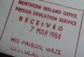
Figure 13 Michael Atcheson
View description - Figure 13 Michael Atcheson

Michael studied Arts with The Open University in the Loyalist wings of the H Blocks [the Maze and Long Kesh Prison] in the 1980s. Later he worked in the community sector and graduated with a degree in Community Development. Michael is retired.

Interactive content is not available in this format.

Audio transcript (Word document)

Carál Ní Chuilín

Figure 14 Carál Ní Chuilín
View description - Figure 14 Carál Ní Chuilín

Carál studied Social Sciences with The Open University in Maghaberry Prison in the 1990s and gained a Masters in Management from Queen’s University upon her release. She was first elected as a Sinn Féin Member of the Legislative Assembly (MLA) in 2007 and from 2011 to 2016 was Minister for the Department for Culture, Arts and Leisure. Carál is a Sinn Féin MLA.

Interactive content is not available in this format.

Audio transcript (Word document)

Activity 5 Learning from the past

Having listened to these clips, now write down your thoughts on the following questions.
- Did any of these stories echo with your own ways of using your mind?
- Are there ways in which you could apply any of these examples to your own situation?
- What about writing down or recording your own stories of ways you have found to come through this situation?

Provide your answer...

4 Reflection

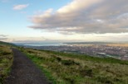
Figure 15 Landscape and Belfast city in the distance, County Antrim 2020
View description - Figure 15 Landscape and Belfast city in the distance, County Antrim 2020

You may find it useful to take some quiet time to reflect on what you are living through, your resources and sources of strength and on all that you have learned already from this experience. In this conversation between David and Michael they offer some final reflections of their own on parallels between their past experience of confinement and the COVID-19 lockdown in 2020. Now listen to Audio 2:

Interactive content is not available in this format.

Audio 2 transcript (Word document)

Activity 6 Reflecting on what you have learned/what you know now

Having listened to David and Michael, take some time to think about your own experiences. What advice would you like to share with others? You might find the following questions useful to help frame your thoughts.
- What have you learned from this experience about yourself?
- What have you learned about your resources individually and/or as part of a wider community?
- If you were to pass on tips to other people in the future facing a similar situation to the one you are in today, what tips would you give them?
Use the box below to capture your thoughts.

Provide your answer...

As this course comes to an end, David and Michael have drawn together some tips and suggestions on ways of moving forward from across all three sessions. You may find these helpful now and in the future.

David: Moving forward
We did not see this situation coming. It has been brutal for some people. It is at times surreal. But it has affected us all. Know that we will get over this. It will be easier for some than others. For some life is fast and packed. We have to come back to a day by day living. Slow down. See what is important. Will there be hardship. Yes. And worry. Yes. But life will go on. Maybe in a different shape and with changes, but we will adapt as we have done in the past. My main words of advice are:
- Do not panic. There is help and support out there for you. Help others – we all need to help each other.
- The more we stick by the social distancing rules the quicker we will get through this time period.
- In the future we will come out stronger and appreciate many things that we had taken for granted.

Michael: Moving forward
I am struck once again by how quickly we can get used to new ways of doing things. We did so in the past and we do so today from funerals and ritual to how we communicate, these are all changing. But we adapt and we get used to new ways. So, we must hold on to this. We can do this. We can adapt. We don’t know all the in’s and out’s but we can do it and do it differently. Look at our strengths. The rest we will fall into place as we find ways around these horrendous times. My main points are:
- Take the ‘negatives’ and turn them into a plus. For example, think about the pandemic situation not as ‘lockdown’ or ‘isolation’ – but as ‘protection from the virus’, or ‘for my own good’. Look for positive new reports on the numbers of people recovering, not those entering hospitals.
- Give yourself positive encouragement. Do this out loud, especially if you are in isolation on your own, but even when just thinking on your own about things - use positive language and say it out loud, so you ACTUALLY HEAR YOURSELF. For example, ‘This is for my own good’ or ‘I am doing well’/‘I am doing my best’.
- Use your time to try some new ways to get through the period we are in and try to find positive things you can do for yourself or other people. All this will help get through this situation and come out the other end stronger.

5 Summary of the course and learning outcomes
In Session 3, the final session of this course, you have heard from David and Michael and from other Open University students in the Time to Think archive about ways of using ideas and education to find peace of mind and to expand your horizons beyond the limitations of your confinement. You have considered strategies and tools for structuring your time and for developing new skills. You have also reflected on your resources, abilities and strengths and how they can help you cope in this pandemic.
By completing this course, you have:
- developed existing and new skills for coping with isolation and confinement today
- developed your skills for self-reflection and self-empowerment to use in a range of other contexts
- developed your understanding of the role education can play in surviving adversity
- gained new insights from the stories of those imprisoned as a result of the conflict in and about Northern Ireland.
If you wish to explore some of the ideas and resource mentioned in the course, take a look at the Further resources section.

Protecting your mental health and wellbeing
Many of us will experience slight increases in anxiety in situations like the COVID-19 pandemic, or we may feel that mood is a bit lower than usual. Both may be considered to be normal reactions to the dramatic change in circumstances, brought about by COVID-19 and the lockdown. However, if you experience a significant increase in your levels of anxiety, or if you notice that your mood feels much lower than usual, you should take action to safeguard your mental health. Consider these points of contact:
- Your GP. Most GPs are currently offering telephone or online appointments, so you can talk to your GP without going to the surgery. They can provide information about possible medication and about counselling.
- A counsellor. Many counselling agencies and private practitioners are currently offering online and telephone support. You can use a Google search to help find counsellors in your area.
- A telephone helpline. If life feels like a struggle, or if you are experiencing suicidal thoughts, it can be good to talk to someone and helplines can offer valuable support.
UK information:
https://www.nhs.uk/conditions/stress-anxiety-depression/
https://www.nidirect.gov.uk/articles/lifeline-freephone-helpline
UK helplines:
https://www.samaritans.org/
https://www.lifelinehelpline.info/

Further resources
Time to Think archive
Arts and Culture events overview
- Lockdown culture
Theatre
- Hottest front-room seats: the best theatre and dance to watch online
- Get your theatre fix in isolation
Museums and art galleries
- 10 of the world’s best virtual museum and art gallery tours
- Virtual museum tours
- Coronavirus: pass the time in self-isolation with virtual museum tours
- The top online museum and art tours
- Andy Warhol: Take a virtual tour around the Tate Modern exhibition
- Best virtual travel experiences
Science: Star gazing and space travel
- Try these astronomy activities to keep you busy during the coronavirus outbreak
- Apollo 13 in real time
Travel and exploration
- Best virtual tours, museums and national parks around the world
- 10 virtual tours of the world’s most famous landmarks
Health and wellbeing
- Free online mindfulness courses
- Try yoga
- Coronavirus: How residents cope with life under lockdown in Wuhan
- Write a diary, take action: Hubei residents on fighting coronavirus anxiety
Music and sounds
- Listing of the best live stream gigs
- Concerts: Intimate online video performances by musicians around the world
- Tiny desk (home) concerts
Books, storytelling, talks and comedy:
- Virtual Libraries, Northern Ireland
- Social distancing book clubs
- betweentwobooks on Instagram
- The moth story library
- tenx9.com/
- ted.com/talks
- The Social Distancing Festival: Live stream directory
Openlearn courses with the Open University
Full list of free OpenLearn courses
Northern Ireland
Prisons Memory Archive
Public Record Office of Northern Ireland (PRONI)
Conflict and Politics in Northern Ireland (CAIN)
Further learning with The Open University
Having completed this course you might be inspired to embark on a degree or Postgraduate course with The Open University. Try exploring the Arts and humanities or Social Sciences prospectuses.
For new students, degree courses that might be of interest include:
- DD102 Introducing the social sciences
- A111 Discovering the arts and humanities
- DD105 Introduction to criminology
- T879 Conflict and development

References
Getting through together
Coronavirus: how residents cope with life under lockdown in Wuhan
Write a diary, take action: Hubei residents on fighting coronavirus anxiety
Models of adjustment: OpenLearn course, The meaning of home.
Useful links on the conflict in and about Northern Ireland:
Time to Think
Prisons Memory Archive
Public Record Office of Northern Ireland (PRONI)
Conflict and Politics in Northern Ireland (CAIN)
Hopson, B. and Adams, J. (1976) ‘Towards an understanding of transition: defining some boundaries of transition dynamics’, in Adams, J., Hayes, H. and Hopson, B. (eds) Transition: Understanding and Managing Personal Change, London: Martin Robertson.
Kübler-Ross, E. (1969) On Death and Dying, London: Routledge.
Serge, V. (1931) Men in Prison, Reprint: London, Writers and Readers Publishing Cooperative, 1977.
Getting through together
Coronavirus: how residents cope with life under lockdown in Wuhan
Write a diary, take action: Hubei residents on fighting coronavirus anxiety
Models of adjustment: OpenLearn course, The meaning of home.
Useful links on the conflict in and about Northern Ireland:
Time to Think
Prisons Memory Archive
Public Record Office of Northern Ireland (PRONI)
Conflict and Politics in Northern Ireland (CAIN)

Acknowledgements

Images Session 1
Figure 1: © HT-Pix/Shutterstock.com
Figure 2: Courtesy of David Smyth © The Open University’s Time to Think Digital Archive www.open.ac.uk/library/timetothink
Figure 3: Courtesy of David Smyth © The Open University’s Time to Think Digital Archive www.open.ac.uk/library/timetothink
Figure 4: Courtesy of David Smyth © The Open University’s Time to Think Digital Archive www.open.ac.uk/library/timetothink
Figure 5: © Krzysztof Nahlik/iStockphoto.com

Audio-visual Session 1
Video 1: © The Open University and its licensors. From the OU’s Time to Think Digital Archive www.open.ac.uk/library/timetothink
Audios 1, 2, 3: © The Open University and its licensors. From the OU’s Time to Think Digital Archive www.open.ac.uk/library/timetothink

Images Session 2
Figure 1: © Nicolò Campo/Getty Images
Figure 2: Courtesy of Rab Kerr © The Open University’s Time to Think Digital Archive www.open.ac.uk/library/timetothink
Figure 3: Courtesy of Loran Fairmichael © The Open University’s Time to Think Digital Archive www.open.ac.uk/library/timetothink
Figure 4: Courtesy of David Smyth; Adapted from Kübler-Ross, E. (1969) On Death and Dying, London: Routledge; and Hopson, B. and Adams, J. (1976) ‘Towards an understanding of transition: defining some boundaries of transition dynamics’, in Adams, J., Hayes, H. and Hopson, B. (eds) Transition: Understanding and Managing Personal Change, London: Martin Robertson.
Figure 5: © bernie_photo/iStockphoto.com
Figure 6: Courtesy of David Smyth © The Open University’s Time to Think Digital Archive www.open.ac.uk/library/timetothink
Figure 7: Courtesy of David Smyth © The Open University’s Time to Think Digital Archive www.open.ac.uk/library/timetothink
Figure 8: Gabi Kent; https://creativecommons.org/licenses/by-nc/3.0

Audio-visual Session 2
Audios 1, 2, 3: © The Open University and its licensors. From the OU’s Time to Think Digital Archive www.open.ac.uk/library/timetothink

Images Session 3
Figure 1: Gabi Kent; https://creativecommons.org/licenses/by-nc-nd/4.0/
Figure 2: Gabi Kent; https://creativecommons.org/licenses/by-nc-nd/4.0/
Figure 3: courtesy of David Smyth © The Open University’s Time to Think Digital Archive www.open.ac.uk/library/timetothink
Figure 4: courtesy of David Smyth © The Open University’s Time to Think Digital Archive www.open.ac.uk/library/timetothink
Figure 5: courtesy of David Smyth © The Open University’s Time to Think Digital Archive www.open.ac.uk/library/timetothink
Figure 6: © unknown
Figure 7: courtesy of Eddie Kinner © The Open University’s Time to Think Digital Archive www.open.ac.uk/library/timetothink
Figure 8: courtesy of Harry Donaghy © The Open University’s Time to Think Digital Archive www.open.ac.uk/library/timetothink
Figure 9: courtesy of Jackie McMullan © The Open University’s Time to Think Digital Archive www.open.ac.uk/library/timetothink
Figure 10: Gabi Kent. © The Open University’s Time to Think Digital Archive www.open.ac.uk/library/timetothink
Figure 11: courtesy of William Mitchell © The Open University’s Time to Think Digital Archive www.open.ac.uk/library/timetothink
Figure 12: courtesy of Martina Anderson © The Open University’s Time to Think Digital Archive www.open.ac.uk/library/timetothink
Figure 14: Irish Eye/Alamy Stock Photo
Figure 15: John O’neill/EyeEm;

Audio-visual Session 3
Audios 1 and 2: © The Open University and its Licensors. From the OU’s Time to Think Digital Archive www.open.ac.uk/library/timetothink
Section 3 audios: © The Open University and its Licensors. From the OU’s Time to Think Digital Archive www.open.ac.uk/library/timetothink
This free course was written by Gabi Kent and co-produced by Michael, an Open University graduate and Republican ex-prisoner, David, an Open University graduate and Loyalist ex-prisoner, Gabi Kent, Jenny Meegan, Philip O’Sullivan, Colette Hughes and Ruth Cammies from The Open University’s Time to Think project. The critical reader was Stephen Robinson, Lecturer and Staff Tutor, School of Psychology, Faculty of Arts and Social Sciences.
Time to Think is an oral history archive and ongoing collaboration for teaching, research, impact and knowledge exchange between The Open University (Open University in Ireland, the Faculty of Arts and Social Sciences (FASS) and Open University Library) and people who participated in the Time to Think archive. This includes Loyalist and Republican ex-prisoners, OU tutors and office staff and prison staff and governors.
This course was first published in April 2020.
THE FOLLOWING COURSE, IN PART OR IN ITS ENTIRETY, IS NOT AVAILABLE UNDER A CREATIVE COMMONS LICENCE AND IS ONLY AVAILABLE FOR USE IN OPENLEARN.
FOR THE AVOIDANCE OF DOUBT, ALL ASSETS USED IN THE FOLLOWING COURSE MUST BE USED IN THE COURSE CONTEXT AT ALL TIMES. NO OTHER USE IS PERMITTED WITHOUT THE PRIOR WRITTEN APPROVAL OF THE OPEN UNIVERSITY ARCHIVIST university-archive@open.ac.uk
Grateful acknowledgement is made to the following sources for permission to reproduce material in this free course:
Course image: Gabi Kent; https://creativecommons.org/licenses/by-nc/3.0
Every effort has been made to contact copyright owners. If any have been inadvertently overlooked, the publishers will be pleased to make the necessary arrangements at the first opportunity.
Don't miss out
If reading this text has inspired you to learn more, you may be interested in joining the millions of people who discover our free learning resources and qualifications by visiting The Open University – www.open.edu/openlearn/free-courses.

Solutions

Activity 1 Reflection on how you are adjusting to the new normal

Discussion
You may have thought about your feelings when you had the flu, the measles or where you kept away from others or spent time alone in hospital; how you felt when you first moved away from home, emigrated, or started at a new school, or job or going to university or retirement.
For you and many others, life under the new restrictions of COVID-19 may feel like a strange or even frightening situation. It also presents all sort of challenges and opportunities. You may be facing different rules, new ways of living whether alone or with others, restrictions on your movement, a decrease in personal space, new modes of social interaction or new power relationships. You may have discovered your own ways of coping, some negative and some positive. You will have a chance to reflect on your answer at the end of this course and to add some new skills and ideas to help you through these challenging times.
Back to - Activity 1 Reflection on how you are adjusting to the new normal

Activity 4 Adjusting to isolation and confinement

Discussion
Everyone’s ways of adapting will be different. You may have considered some of the following adjustments.
- Changing old routines and creating new ones
- Taking on slightly different roles
- Making an extra effort to be kind to people
- Making space for and give way to others before they need to ask
Back to - Activity 4 Adjusting to isolation and confinement

Activity 2

Discussion
How you respond to your new situation is likely to be shaped by your life experience and your world view. Like all of us, you will all have different attitudes, backgrounds and experiences – good and bad – and in times of duress, you may find these come to the surface. Some of you may already have experiences of dealing with adversity or extreme situations. For others this may be an entirely new experience. One of the challenges with a novel situation like the COVID-19 pandemic, is finding ways of making sense of the profound changes you are living through.
Back to - Activity 2

Activity 4 What are your strategies for managing your time and space?

Discussion
You will already have many of your own strategies for coping. You may have found ways of connecting to and being part of the wider community while in isolation and the strength this brings. Whatever you do, creating structures and routines to manage your time and ‘expand’ the space you are in, will be invaluable.
Back to - Activity 4 What are your strategies for managing your time and space?

Activity 5 Staying connected

Discussion
You might have considered a variety of ways of communicating safely, without the use of social media such as: using colour coding in windows, adapting the use of semaphore to your location, Morse code to communicate between houses using torches, collective storytelling from balconies, communal clapping, singing or more traditional mechanisms such as letter writing or landline phone calls. Some of these may provide opportunities for younger people to communicate with older relatives, neighbours or friends about what they did in the past and learning new skills.
Back to - Activity 5 Staying connected

Activity 3 Using your mind for solace and escape

Discussion
You may have been interested in how David and Michael continued to develop themselves personally and politically during their imprisonment and how they expanded their horizons through their imagination and ideas. They also highlighted:
- the value of shared storytelling
- the power of a good book to take you elsewhere
- the importance of a longer-term project to pass the time, to provide a sense of purpose and develop new skills.
In David and Michael’s case, who both faced many years in prison, this involved undertaking a degree with The Open University. But any level of formal education from a short course to a full degree can be beneficial.
Back to - Activity 3 Using your mind for solace and escape

Figure 1 The Coronavirus pandemic of 2020 has led to enforced self-isolation.

Description
This is a graphic showing a group of white figures on the left and one single red figure on the right.
Back to - Figure 1 The Coronavirus pandemic of 2020 has led to enforced self-isolation.

Figure 2 Time to Think

Description
This is an illustration of a book with ‘OU’ written on it, against some barbed wire. The words ‘Time to Think’ appear at the top of the image.
Back to - Figure 2 Time to Think

Figure 3 David in the Compounds

Description
This is an illustration of a man in a prison compound, sitting on a bench reading a book.
Back to - Figure 3 David in the Compounds

Figure 4 Michael in the H Block

Description
This is an illustration of a man reading in his prison cell.
Back to - Figure 4 Michael in the H Block

Figure 5 The road ahead …

Description
This is a photograph of an empty road.
Back to - Figure 5 The road ahead …

Figure 1 Man plays guitar while his neighbour watches during COVID-19 Pandemic, Turin, Italy 2020

Description
This is a photograph of a man standing on a balcony, playing the guitar. His neighbour looks on.
Back to - Figure 1 Man plays guitar while his neighbour watches during COVID-19 Pandemic, Turin, Italy 2020

Figure 2 Exterior of a compound, The Maze and Long Kesh prison.

Description
This is an image of a Nissen hut in the compounds at the Maze and Long Kesh prison
Back to - Figure 2 Exterior of a compound, The Maze and Long Kesh prison.

Figure 3 Interior of H Block cell

Description
This is a photograph of the interior of a cell in the H Blocks showing a window and a bed.
Back to - Figure 3 Interior of H Block cell

Figure 4 ‘Transition phases’, adapted by David Smyth (2020) from Kübler-Ross, 1969 and Hopson and Adams, 1975, p. 13)

Description
This is a graph showing a process of transition over time from shock to recovery
Back to - Figure 4 ‘Transition phases’, adapted by David Smyth (2020) from Kübler-Ross, 1969 and Hopson and Adams, 1975, p. 13)

Figure 5 The passing of time

Description
This is a photograph of an hourglass.
Back to - Figure 5 The passing of time

Figure 6 Michael in the H Block

Description
This is an illustration of a man reading in his prison cell
Back to - Figure 6 Michael in the H Block

Figure 7 David in the Compounds

Description
This is an illustration of a man in a prison compound, sitting on a bench reading a book
Back to - Figure 7 David in the Compounds

Figure 8 Rainbow symbol in a window during the COVID-19 pandemic.

Description
This is a photograph of a chain of paper figures, in the different colours of the rainbow.
Back to - Figure 8 Rainbow symbol in a window during the COVID-19 pandemic.

Figure 1 Wire against a blue sky, Belfast, County Antrim.

Description
This is a photograph of a section of fence with barbed wire attached. There is blue sky in the background.
Back to - Figure 1 Wire against a blue sky, Belfast, County Antrim.

Figure 2 Image of rainbow symbols.

Description
This is a montage of images featuring rainbows
Back to - Figure 2 Image of rainbow symbols.

Figure 3 David in the Compounds

Description
This is an illustration of a man in a prison compound, sitting on a bench reading a book
Back to - Figure 3 David in the Compounds

Figure 4 Michael in the H Block

Description
This is an illustration of a man reading in his prison cell
Back to - Figure 4 Michael in the H Block

Figure 5 Weekly schedule circa 1982 by David Smyth

Description
This is a handwritten weekly schedule. Each day is broken up into morning, afternoon and evening, with lock up at 9pm. It contains activities such as ‘study hut’, ‘visit’, ‘letters’ and ‘walk’.
Back to - Figure 5 Weekly schedule circa 1982 by David Smyth

Figure 6 Image of the Compounds, 1972.

Description
This is a photograph of the Compounds at Maze and Long Kesh Prison, 1972.
Back to - Figure 6 Image of the Compounds, 1972.

Figure 7 Eddie Kinner

Description
A photograph of Eddie Kinner.
Back to - Figure 7 Eddie Kinner

Figure 8 Harry Donaghy

Description
A photograph of Harry Donaghy
Back to - Figure 8 Harry Donaghy

Figure 9 Jackie McMullan

Description
A photograph of Jackie McMullan
Back to - Figure 9 Jackie McMullan

Figure 10 Robert Campbell

Description
A photograph of Robert Campbell
Back to - Figure 10 Robert Campbell

Figure 11 William Mitchell

Description
A photograph of William Mitchell
Back to - Figure 11 William Mitchell

Figure 12 Martina Anderson

Description
A photograph of Martina Anderson
Back to - Figure 12 Martina Anderson

Figure 13 Michael Atcheson

Description
A stamp from a prison saying ‘Received 7 March 1984’.
Back to - Figure 13 Michael Atcheson

Figure 14 Carál Ní Chuilín

Description
A photograph of Carál Ní Chuilín
Back to - Figure 14 Carál Ní Chuilín

Figure 15 Landscape and Belfast city in the distance, County Antrim 2020

Description
This is a photograph of a country path, with a city in the background.
Back to - Figure 15 Landscape and Belfast city in the distance, County Antrim 2020

