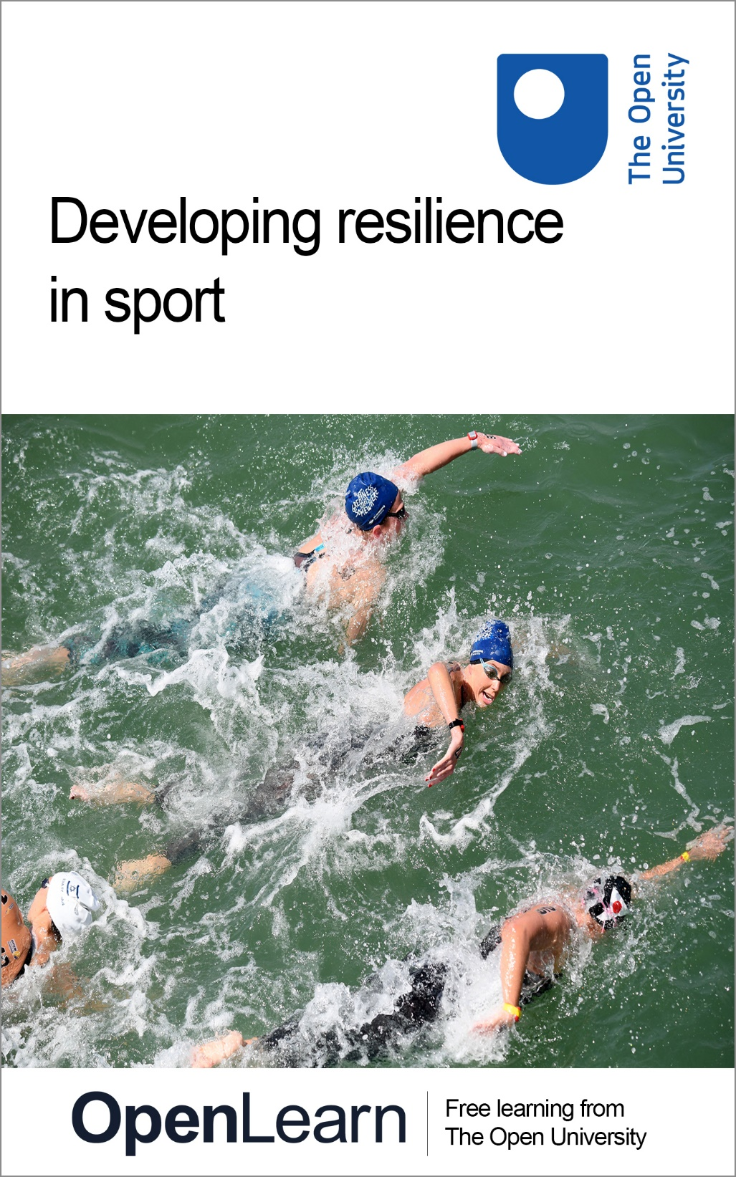

E312_1

Developing resilience in sport

About this free course
This free course is an adapted extract from the Open University course E312 Athletic development: a psychological perspective: www.open.ac.uk/courses/modules/e312 .
This version of the content may include video, images and interactive content that may not be optimised for your device.
You can experience this free course as it was originally designed on OpenLearn, the home of free learning from The Open University –
www.open.edu/openlearn/health-sports-psychology/developing-resilience-sport/content-section-overview
There you’ll also be able to track your progress via your activity record, which you can use to demonstrate your learning.
Copyright © 2022 The Open University
Intellectual property
Unless otherwise stated, this resource is released under the terms of the Creative Commons Licence v4.0 http://creativecommons.org/licenses/by-nc-sa/4.0/deed.en_GB. Within that The Open University interprets this licence in the following way: www.open.edu/openlearn/about-openlearn/frequently-asked-questions-on-openlearn. Copyright and rights falling outside the terms of the Creative Commons Licence are retained or controlled by The Open University. Please read the full text before using any of the content.
We believe the primary barrier to accessing high-quality educational experiences is cost, which is why we aim to publish as much free content as possible under an open licence. If it proves difficult to release content under our preferred Creative Commons licence (e.g. because we can’t afford or gain the clearances or find suitable alternatives), we will still release the materials for free under a personal end-user licence.
This is because the learning experience will always be the same high quality offering and that should always be seen as positive – even if at times the licensing is different to Creative Commons.
When using the content you must attribute us (The Open University) (the OU) and any identified author in accordance with the terms of the Creative Commons Licence.
The Acknowledgements section is used to list, amongst other things, third party (Proprietary), licensed content which is not subject to Creative Commons licensing. Proprietary content must be used (retained) intact and in context to the content at all times.
The Acknowledgements section is also used to bring to your attention any other Special Restrictions which may apply to the content. For example there may be times when the Creative Commons Non-Commercial Sharealike licence does not apply to any of the content even if owned by us (The Open University). In these instances, unless stated otherwise, the content may be used for personal and non-commercial use.
We have also identified as Proprietary other material included in the content which is not subject to Creative Commons Licence. These are OU logos, trading names and may extend to certain photographic and video images and sound recordings and any other material as may be brought to your attention.
Unauthorised use of any of the content may constitute a breach of the terms and conditions and/or intellectual property laws.
We reserve the right to alter, amend or bring to an end any terms and conditions provided here without notice.
All rights falling outside the terms of the Creative Commons licence are retained or controlled by The Open University.
Head of Intellectual Property, The Open University

Contents
- Introduction
  - Introduction
- Session 1: Understanding resilience
  - Introduction
  - 1 Defining resilience
  - 2 Resilience in action: resilient athletes
  - 3 Resilience in action: resilient coaches
  - 4 Investigating team resilience
  - 5 Resilience at the extremes of sporting performance
  - 6 Resilience in the early stages of the athletic development journey
  - 7 Summary of Session 1
- Session 2: Developing resilience
  - Introduction
  - 1 Building resilience: getting it right
  - 2 The role of the environment
  - 3 Approaches to building athlete and coach resilience
  - 4 Building team resilience
  - 5 Developing resilience for the athletic development journey
  - 6 Summary of Session 2
  - Where next?
- References
- Acknowledgements
- Solutions

Introduction

Introduction
This free course, Developing resilience in sport, explores how the concept of resilience can support athletes on their athletic development journey. Resilience can act as a buffer to protect against the challenges that might be faced by athletes.
The course is divided into two sessions:
- In Session 1 you’ll investigate the concept of resilience, identify the characteristics of resilience and explore resilience in differing social contexts. Throughout, you will consider why resilience is an important psychological skill for athletic development.
- In Session 2 you’ll examine how we might build resilience, looking at the role of the environment, reviewing several interventions and considering how best to support both athletes and coaches to develop resilience.
Within both sessions you’ll be directed to a number of fascinating resources, including research articles to support your learning. While you will see that the majority of the research into resilience in sport has been completed in elite sport, you will reflect that it is a concept that impacts across all levels of sport, in different athletic contexts.
By the end of this course, you should be able to:
- describe the features of resilience in both individual and team contexts and understand why it is important for athletic development
- critically discuss the role of the environment in the development of resilience
- examine how to build resilience in a range of sport settings and apply this knowledge to real world scenarios.

Moving around the course
In the ‘Summary’ at the end of each session, you will find a link to the next one. If at any time you want to return to the start of the course, click on ‘Full course description’. From here you can navigate to any part of the course.
It’s also good practice, if you access a link from within a course page, to open it in a new window or tab. That way you can easily return to where you’ve come from without having to use the back button on your browser.
This OpenLearn course is an adapted extract from the Open University course E312 Athletic development: a psychological perspective.
You can now go to Session 1.

Session 1: Understanding resilience

Introduction

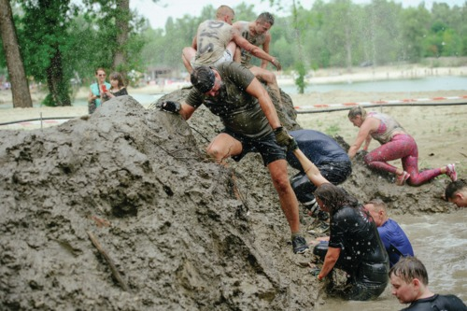
View description - Uncaptioned Figure
View description - Uncaptioned Figure

A Japanese proverb ‘Fall seven times, stand up eight’ effectively captures the essence of psychological resilience. We know that athletes will face highs and lows and will constantly withstand a wide range of pressures to attain and sustain high performance (Howells and Fletcher, 2016; Sarkar and Fletcher, 2013). This is not only the case for elite athletes and could also be the case for you in your own sport and exercise pursuits, or if you support the performance of others. Indeed, understanding resilience is vital for those involved in an athlete’s journey ‘as it may be fundamental in facilitating ongoing success and positive mental wellbeing’ (Howells, 2022, p. 203).
Before you explore what research tells us about resilience, look at an introduction to resilience more broadly in Activity 1.

Activity 1 Reflecting on your own resilience
Allow approximately 10 minutes

First, watch the video ‘Introduction to resilience’ and identify the key points raised.

Video content is not available in this format.
Introduction to resilience
View transcript - Introduction to resilience

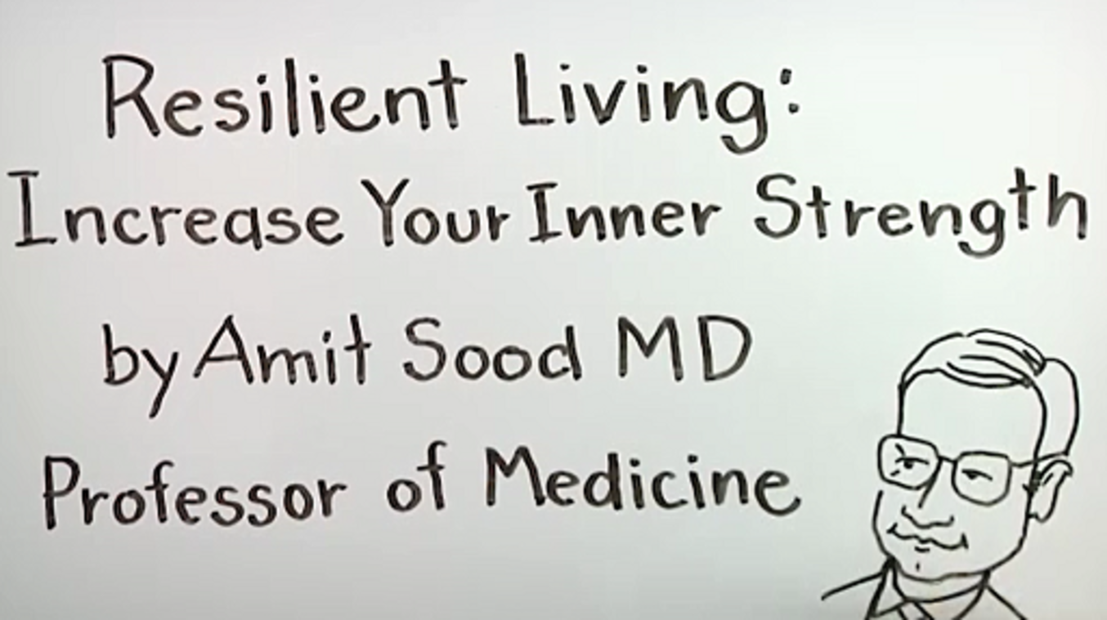

Having viewed the content, reflect on when and how you, or someone you know, have shown resilience.
Note your thoughts in the box below.

Provide your answer...
View discussion - Activity 1 Reflecting on your own resilience

It is important to emphasise that resilience is a psychological skill that can be learned, and that we can all demonstrate resilient qualities and behaviours. This is critical when we consider that resilience can aid us in our everyday life.
Before you can think about how we might build resilience in Session 2, you must first fully understand what resilience is, and what being resilient might look like.

1 Defining resilience

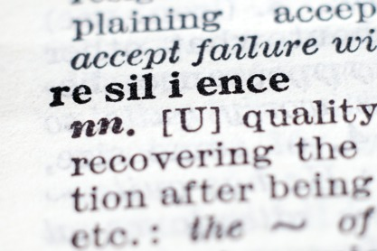
View description - Uncaptioned Figure
View description - Uncaptioned Figure

In a seminal paper on resilience in human development, Masten (2001, p. 235) argues that resilience comes from ‘the everyday magic of ordinary, normative human resources’ and not from rare or special qualities, suggesting that it is attainable for all of us. Originating from the Latin phrase to rebound or recoil (Masten, Gewirtz and Sapienza, 2013), the term ‘resilience’ has had many definitions proposed over the years (Sisto et al., 2019).
Despite the use of multiple terms to describe resilience, there is consensus among researchers that resilience is best understood when examined in a particular context as models of resilience developed in other domains, such as business, might not be transferable, for example to sport (Wagstaff et al., 2017).

In simple terms, resilience is ‘the ability to use personal qualities to withstand pressure’ (Fletcher and Sarkar, 2016, p. 136).

In the sporting context, resilience relates to an athlete’s ability to manage daily stressors, where stressor is defined as ‘the environmental demands (i.e., stimuli) encountered by an individual’ (Fletcher, Hanton and Mellalieu, 2006, p. 359) and could include training and competition.
Evidence suggests that resilience is one of the key psychological characteristics for athletic success (Rees et al., 2016). In Activity 2 you will investigate resilience in a sporting context in more detail.

Activity 2 But what does it all mean? Making sense of resilience
Allow approximately 60 minutes

Read the reading at the link below, which is a section of a chapter called ‘Developing resilience on the athlete’s journey’ (Howells, 2022).
Reading: What is resilience?
Then complete the following tasks:
1. What are the two fundamental components of resilience agreed by researchers?

Provide your answer...
View discussion - Part

2. Match the correct definition to the terms: ‘robust’ and ‘rebound’ resilience.

Refers to resilience providing protection to an athlete which supports wellbeing and performance levels when under pressure.
Refers to the bounce-back qualities that are reflected in the minimal impact that adversity has on an athlete’s wellbeing and/or performance.
Robust
Rebound
View answer - Part

3. From your reading, complete interactive Figure 1 below. Click on the image or ‘View interactive version’ to access it.

Interactive content is not available in this format.
Figure 1 A grounded theory of psychological resilience and optimal sport performance (Fletcher and Sarkar, 2012, p. 672).
View description - Figure 1 A grounded theory of psychological resilience and optimal sport performance ...

4. Why are these five psychological factors (Figure 1), evident in the elite athletes who were interviewed in Fletcher and Sarkar’s (2012) research, important for withstanding the pressure of performance?

Provide your answer...
View discussion - Part

As you have seen in Activity 2, researchers suggest that resilience isn’t a trait (Galli and Vealey, 2008) but it is thought that athletes high in resilience possess certain psychological characteristics, such as confidence, that ‘protect’ them and enable them to withstand the potential negative effect of stressors (Fletcher and Sarkar, 2012).
It is also worth noting that these protective factors (referred to as psychological factors in Figure 1) are often referred to as the third component of resilience, to add to adversity (or stressor) and positive adaptation as you will see as you move through the course.
Now you have started to explore resilience as a concept, you’ll now look at what a resilient athlete and a resilient coach might look like.

2 Resilience in action: resilient athletes
So far, you have looked at research relating to elite athletes, but the findings can be applied to other contexts, as you will see in Activity 3.

Activity 3 Resilient athletes
Allow approximately 30 minutes

First, watch the video ‘The Merthyr mermaid’ which follows Cath Pendleton completing some incredible feats, arguably demonstrating high levels of resilience.

Video content is not available in this format.
The Merthyr mermaid
View transcript - The Merthyr mermaid

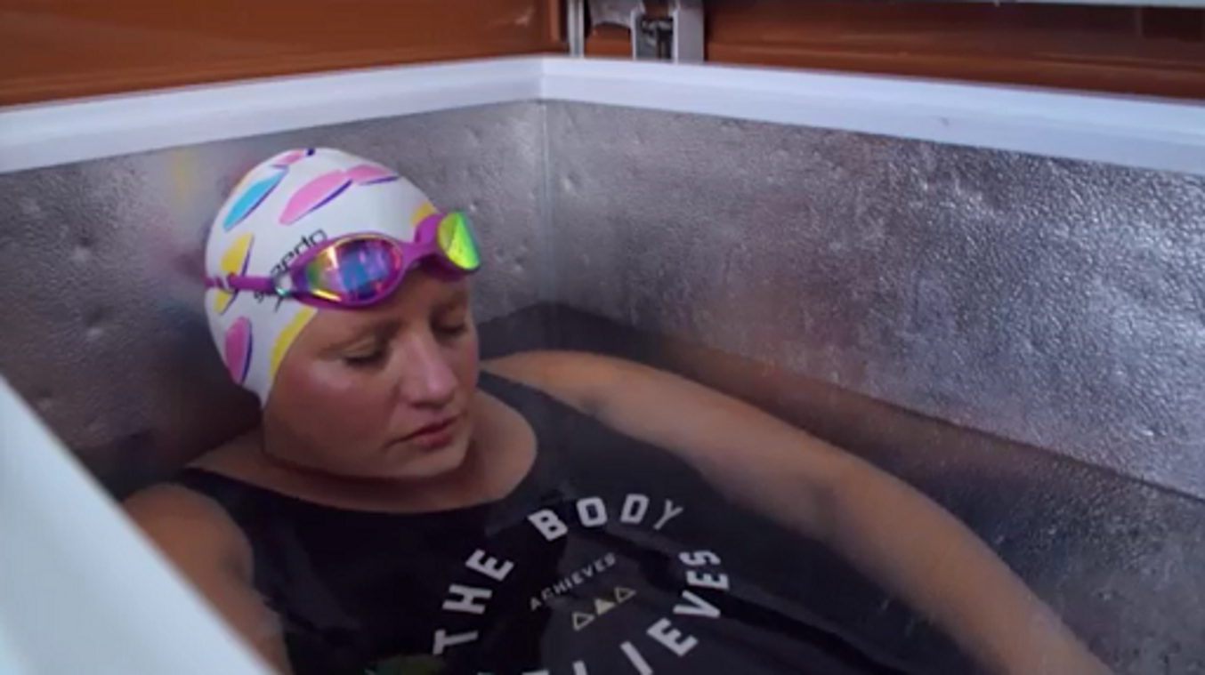

Then consider the following:
- Identify an individual athlete, that you know personally or from elite sport, that has demonstrated resilience.
- Why have you chosen this example – can you draw on your developing knowledge of resilience to justify your choice?

Provide your answer...
View discussion - Activity 3 Resilient athletes

Athletes are not the only performers in the sporting context, and coaches need to be able to draw on their own resilience to positively evaluate the ‘plethora of stressors’ (Olusoga et al., 2012, p. 230) that they could experience, including preparing for events and managing their own wellbeing (Sarkar and Hilton, 2020). Olusoga et al. (2012) examined factors that coaches perceived as enabling them to coach in stressful environments and identified eleven psychological attributes including focus, confidence, commitment, and support; similar to the five psychological factors highlighted by Fletcher and Sarkar (2012) in their research on athlete resilience.

3 Resilience in action: resilient coaches
You should now be able to build a picture up of what a resilient individual in sport might look like. In Activity 4 you’ll look further at what a resilient coach might look like by hearing from one of the leading academics in this field and his co-researcher.

Activity 4 Exploring coach resilience
Allow approximately 30 minutes

First, watch ‘Coach resilience (Part 1)’, which introduces research by Sarkar and Hilton (2020) exploring resilience in swimming coaches.

Video content is not available in this format.
Coach resilience (Part 1)
View transcript - Coach resilience (Part 1)

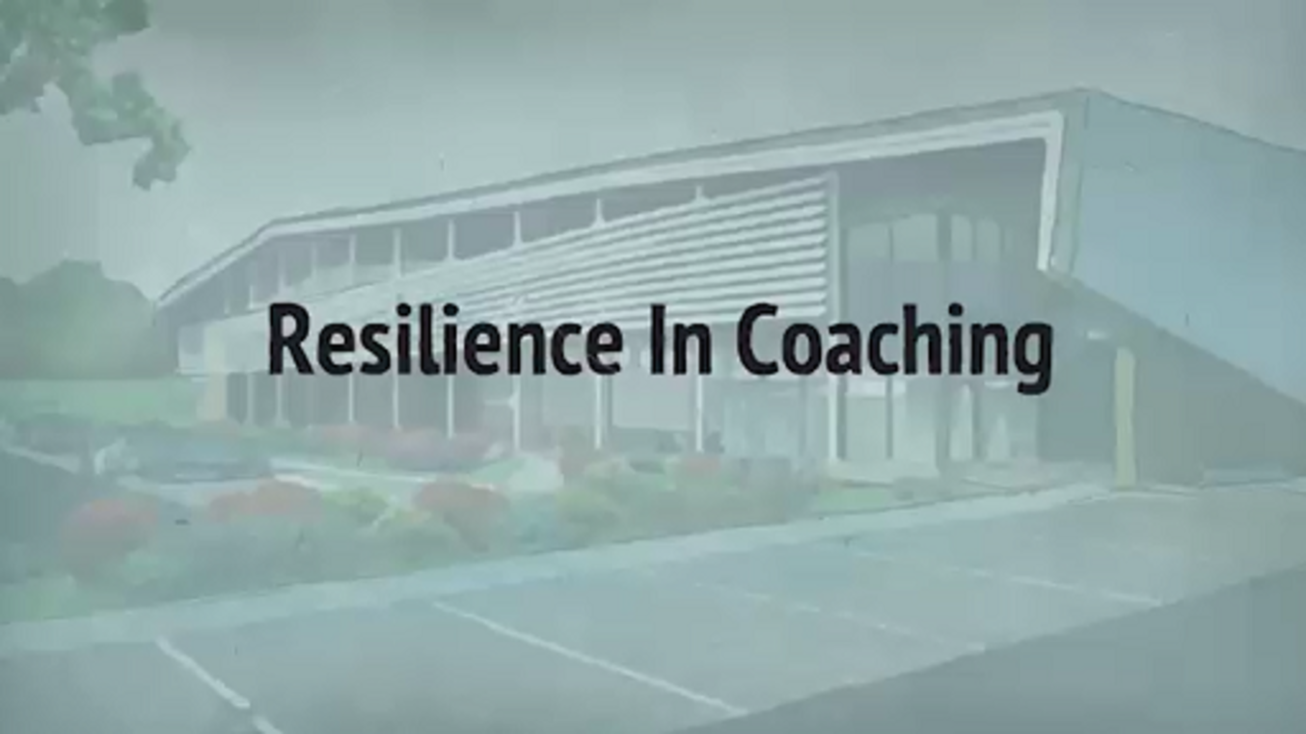

Now, having watched the video, answer the following questions:
- What was the aim of the research and why did the researchers feel that coach resilience was an important area to study?
- What were the key findings of the research?
- The research examined ‘super-elite’ Olympic medal-winning coaches. Do you think any of the stressors or protective factors identified in the findings could be applied to non-elite coaches?
- Can you recognise some of the features described in yourself (if you are a coach or teacher) or in coaches that you know?

Provide your answer...
View discussion - Activity 4 Exploring coach resilience

So far you have considered what a resilient athlete and coach might look like, but would these features apply to a team situation? You will explore team resilience in the next section.

4 Investigating team resilience

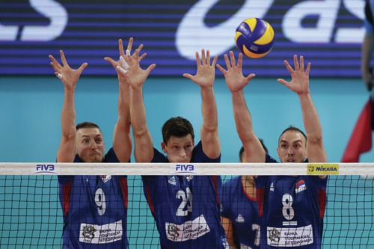
View description - Uncaptioned Figure
View description - Uncaptioned Figure

Whether from your own experience as an athlete, or from watching a sports team that you follow, the highs and lows of team sport cannot be ignored. For athletes and coaches to be able to face these challenges and positively adapt is not an easy task. West, Patera and Carsten (2009, p. 254) argue that team resilience could be of importance for teams to ‘repair and rebound’ from experiencing these stressful situations.
In Activity 5 you will examine team resilience in more depth, in addition to hearing again from Dr Mustafa Sarkar on the differences between individual and team resilience.

Activity 5 Investigating team resilience
Allow approximately 45 minutes

There are two parts to this activity.
First, read the reading at the link below, which is part of an article called ‘Recent developments in team resilience research in elite sport’ (Morgan, Fletcher and Sarkar, 2017):
Reading: Recent developments in team resilience research in elite sport
Identify the key features of team resilience that are discussed.

Provide your answer...
View discussion - Part

Then listen to the following audio recording, ‘Developing resilience in sport’, in which resilience researcher Dr Mustafa Sarkar explains what team resilience comprises.

Audio content is not available in this format.
Developing resilience in sport
View transcript - Developing resilience in sport

Finally, make a note of how team resilience differs from individual resilience.

Provide your answer...
View discussion - Part

So far, you have seen differences between individual and team resilience. In the audio, Dr Sarkar acknowledged that while there were some nuances in team resilience across sports, there were some key similarities. In the next section, you will look at how resilience applies to the extremes of sporting performance.

5 Resilience at the extremes of sporting performance

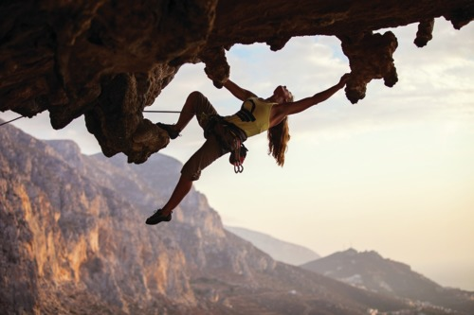
View description - Uncaptioned Figure
View description - Uncaptioned Figure

‘Resilience’ as a term is perhaps more widely used in environments where the human body is tested to its limits, such as performing in extreme temperatures (e.g., the desert ultramarathon, Marathon de Sablé), and attempting solo challenges where isolation can play a significant role (Leach, 2016). MacIntyre et al. (2019, p. 3) argue that the interaction with nature that occurs in extreme sports ‘offers an opportunity to explore how stress, psychological resources, coping and psychological growth interact’.
To explore this further, in the next activity you will read a short article written by a researcher who is investigating resilience in extreme sports.

Activity 6 Investigating the cluster effect
Allow approximately 45 minutes

First, read Dave Harrison’s (2020) blog post where he discusses resilience in extreme environments.
Next, having read Harrison’s post, answer the following:
- Identify what a cluster effect is and why it is of interest when studying resilience.
- Why is a challenge mindset important and how can it be developed in an extreme environment?

Provide your answer...
View discussion - Activity 6 Investigating the cluster effect

You will explore the challenge mindset concept further in Session 2, where you look at how we might develop resilience. Before you do this, the final section in this session considers another point raised by Harrison (2020), that our past experiences can help us to respond positively to the given demands of a situation.

6 Resilience in the early stages of the athletic development journey

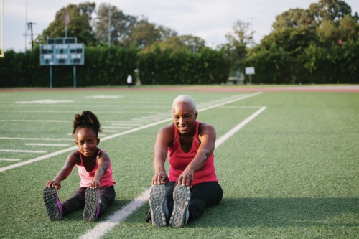
View description - Uncaptioned Figure
View description - Uncaptioned Figure

If we consider Harrison’s (2020) article and apply it to early experiences on the athletic development journey, it could be argued that positive experiences in school sport and physical education (PE) are more likely to result from young people adopting a challenge mindset and having the ability to ‘buffer’ the potential negative effects of stressors that they might encounter.
Research to examine potential stressors experienced by young people in PE was conducted by Tudor, Sarkar and Spray (2019), to explain patterns of motivation and engagement in the subject. Stressors for the students were identified as:
- the social environment, including interactions between peers
- the physical and organisational environment, including the changing facilities
- the performance environment, including situations where physical appearance and physical competencies were exposed.
Having gained an understanding of the stressors experienced in PE, Tudor, Sarkar and Spray moved their focus to exploring the protective factors that alter the student response to the identified stressors associated with PE participation – investigating student resilience in the PE context. This resulted in a second article being published, which you will see being applied to a case study in Activity 7.

Activity 7 Examining resilience in PE
Allow approximately 30 minutes

First, read this summary of the research by Tudor, Sarkar and Spray (2020):

Research summary
Tudor, K., Sarkar, M. and Spray, C.M. (2020) ‘Resilience in physical education: A qualitative exploration of protective factors’, European Physical Education Review, 26(1), pp. 284–302.
Aim: to explore protective factors that alter secondary school students’ responses to common stressors associated with PE participation.
Method: Interviews and focus groups (group interviews) were conducted with six teachers and 54 students. Transcripts were analysed using thematic analysis.
Findings: The study identified individual assets and environmental factors that may buffer the impact of stressors on positive adaptation.
- Individual assets identified as potential protective factors comprised of cognitive factors (e.g., perceived competence), personality trait (e.g., extraversion) and behavioural factors (e.g., approaching challenge).
- Environmental resources that influenced the impact of the stressors experienced comprised of peers (e.g., being with friends), teachers (e.g., reinforcing resilient behaviour) and parental factors (e.g., reinforcing the value of PE).
Conclusion: The study identified and explored unique protective factors that teachers may target to facilitate resilience in the PE context.

Secondly, read this short case study about Efia, and consider how the research findings were able to support her in her role.

Case study: Efia (PE teacher)
Efia is a newly qualified PE teacher and has just started a new position in a large secondary school. Like you, she was introduced to the topic of resilience in her studies and she is keen to continue to learn how she can integrate this knowledge and understanding into her practice. She has read the research article and is going to try to implement a number of the practitioner implications that are suggested by the researchers.
Specifically, Efia is going to ensure that she can cater for the needs of all of her students by using differentiation, manage the use of competition appropriately and consider techniques that can improve student engagement following a poor performance. She will try and encourage students to embrace challenge and offer a choice of activity where possible. Building strong relationships with students is a key buffer to stressors encountered, and Efia will focus on an equal relationship with all students, regardless of their levels of motivation and behaviour.

Finally, if you are a coach or work with children in a different setting reflect on how this might be applied to your own role. If this does not apply to you, think back to your own PE experiences and how the changes that Efia intends to make might have created a different environment for your PE experience.

Provide your answer...
View discussion - Activity 7 Examining resilience in PE

7 Summary of Session 1
This session has introduced you to the concept of resilience through an examination of a number of research studies of resilience in different sporting contexts.
The main learning points of this session include the following:
- Resilience is a skill that can be developed, although there are factors that can influence an individual’s ability to be resilient.
- Resilience consists of three components: adversity (stressor), protective factors and positive adaptation.
- Team resilience differs from individual resilience in that it involves relationships and requires a difference set of qualities including group structure, importance of collective confidence, deep emotional bonds, and social identity.
- A cluster effect is when there is an accumulation, or grouping, of stressors, rather than experiencing just one which can impact on our ability to be resilient.
- Students can experience a number of stressors in the PE environment. Research informs us that there are strategies that PE teachers can implement to buffer against these to facilitate the development of resilience.
You can now go to Session 2.

Session 2: Developing resilience

Introduction

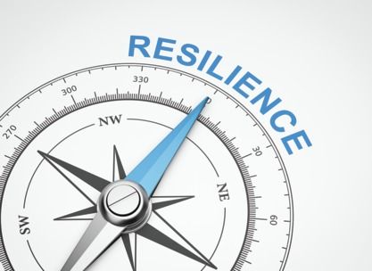
View description - Uncaptioned Figure
View description - Uncaptioned Figure

The aim of this session is to develop a deeper understanding of resilience and for you to consider how to build resilience in sport settings. How can an athlete or coach develop these skills, and how can we be proactive to support athletes, and coaches, to prepare for any challenges that they might face along their athletic journey?
To address these questions within this session you will reflect on the optimum conditions in which resilience can be developed. You will also examine the role of the environment (e.g., organisation or team) that surrounds the athletes as they develop resilience, including how coaches can facilitate the development of these skills. Finally, you’ll look at what a programme to develop resilience might look like for athletes and coaches, alongside evidence-informed considerations required when implementing such interventions.

1 Building resilience: getting it right
Before you consider how we might develop resilience, both in ourselves and in others, it is important to have an understanding of the features of a specific sport environment. While a focus on developing an individual’s ability to withstand pressure might seem a logical step when working with athletes, it is important to create environments in which people can thrive both as a person and a performer (Sarkar, 2018).
Indeed, if an athlete found themselves in a toxic organisational culture or a power imbalance in the coach-athlete relationship, we would not want to focus on building resilience in the athlete to enable them to ‘cope’. Instead we would need to consider the wider issues. In Activity 1 you will read another reading from Howells (2022) and apply the content to a case study organisation to help you further understand how best to prepare for building resilience.

Activity 1 Preparing to build resilience
Allow approximately 60 minutes

First, read the reading at the link below, which is a section of a chapter called ‘Developing resilience on the athlete’s journey’ (Howells, 2022).
Reading: Building resilience
Next, watch the video ‘Athlete wellbeing and engagement’ from the Australian Institute of Sport (AIS).

Video content is not available in this format.
Athlete wellbeing and engagement
View transcript - Athlete wellbeing and engagement

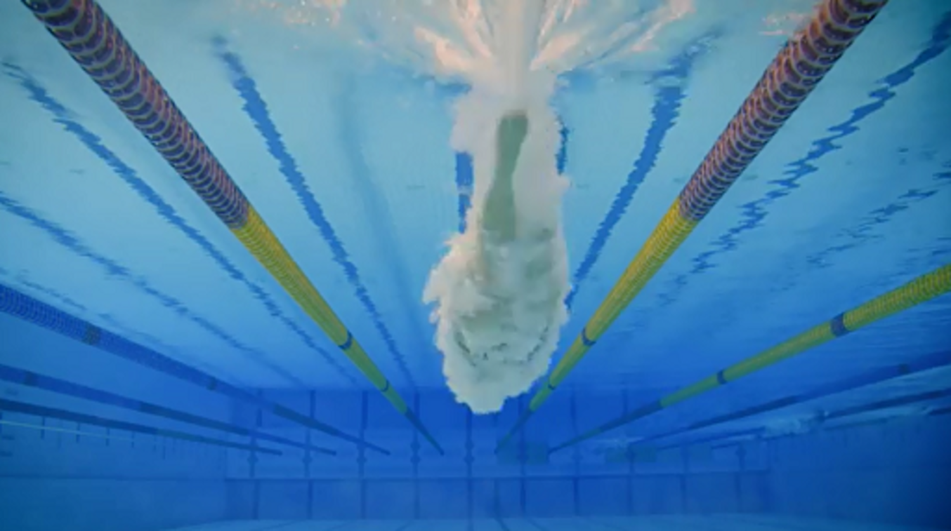

Finally, consider the second question posed by Howells (2022, p. 205): What is the motivation for building resilience? Do you feel that the AIS address the issues raised that would enable them to embark on a programme to develop resilience?

Provide your answer...
View discussion - Activity 1 Preparing to build resilience

In this section you have started to consider the environmental conditions that would best facilitate the development of resilience. As touched on in Session 1, the environment itself can create a number of stressors for the athlete, coach and team, so getting this element ‘right’ is crucial and is the focus of the next section.

2 The role of the environment

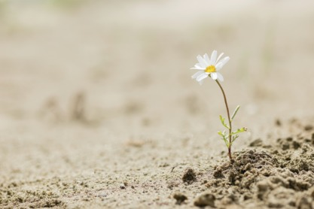
View description - Uncaptioned Figure
View description - Uncaptioned Figure

To help us to understand the role of the environment when considering the development of resilience, Sarkar (2019) uses the analogy of a flower. If a flower is not blooming, we do not look to the flower for a reason but, instead, we focus on its environment; we examine the volume of water, the quality of the soil, and the amount of sunlight available.
In Activity 1, you reflected on the environment created by the AIS to support its elite athletes. This approach has also been committed to by UK Sport who seek to create the ‘right environment, providing equal levels of support and challenge while also being extra vigilant in caring about the well-being of athletes’ (Nicholl, 2017).
The notion of challenge and support is highlighted in the UK Sport statement. You will look in more detail at these concepts in Activity 2.

Activity 2 What is the ‘right’ environment for building resilience?
Allow approximately 45 minutes

First, read the short article ‘Developing resilience in elite sport: the role of the environment’ (Sarkar, 2018) which introduces mental fortitude training. Central to this is the role of the environment in developing resilience and the challenge-support matrix.
Now, based on the reading, complete interactive Figure 1.

Interactive content is not available in this format.
Figure 1 A challenge–support matrix for developing resilience (Fletcher and Sarkar, 2016).
View description - Figure 1 A challenge–support matrix for developing resilience (Fletcher and Sarkar, ...

Research indicates that a facilitative environment for the development of resilience can be achieved through offering high levels of challenge and support. Fletcher (2020) highlighted that the nature, and level, of challenges faced by an individual, both athlete and coach, will change over time. As such, the associated support for each challenge must accommodate this. For example, more support might be required in the final stages before a major competition or following an injury.
Having established the importance of creating a facilitative environment, you’ll now turn your focus to the development of resilience in individuals, from both an athlete and a coach perspective.

3 Approaches to building athlete and coach resilience

Mental resilience is not something that all participants and coaches automatically have and this should be developed with the same consideration that physical resilience is built.
(Grey-Thompson, 2017, p. 23)

This quote is taken from a UK government independent report by Baroness Grey-Thompson looking into the issues surrounding the Duty of Care that sports have towards their participants. The review examined aspects of elite sport ranging from personal safety and injury, to mental health issues, and the support provided to those involved. What is interesting here is the equal value given to both physical and mental resilience and the reference to both sport participants and coaches.
As a result of the growing awareness of the importance of building resilience in sport, there are increasing numbers of resources being published to support the development of resilience in athletes, such as the Resilience Building Toolkit from UK Coaching. A second example is presented in Figure 2, with an infographic developed for a coach audience to offer tips for building resilience.

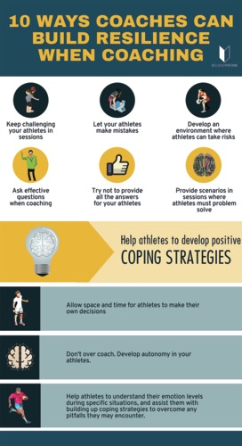
Figure 2 An infographic aimed to support coaches to develop resilience in their athletes (BelievePerform, 2020).
View description - Figure 2 An infographic aimed to support coaches to develop resilience in their athletes ...
View description - Figure 2 An infographic aimed to support coaches to develop resilience in their athletes ...

While such resources are a positive step, researchers call for other considerations to be made when planning interventions, for example, the timing of an intervention to develop resilience is critical and both robust and rebound resilience should be considered (Fletcher and Sarkar, 2016). Furthermore, an intervention should be grounded in theoretical and conceptual advances (Fletcher and Sarkar, 2012).
In Activity 2, you were introduced to mental fortitude training (Fletcher and Sarkar, 2016) to support the development of resilience. Howells (2022) discusses two further interventions: planned disruptions and rational-emotive behaviour therapy (REBT), which you look at next.

Activity 3 Investigating resilience interventions
Allow approximately 45 minutes

First read the reading at the following link, which is a section of a chapter called ‘Developing resilience on the athlete’s journey’ (Howells, 2022).
Reading: Planned disruptions and REBT
Then complete the ‘Key features’ column in the table below to summarise each intervention appropriately.

Table 1 Planned disruptions and REBT
 | Aim | Key features
Planned disruptions | Involves the exposure of athletes to specific training activities that increase/change demands placed on them. | Provide your answer...
REBT | Works on the assumption that many of the problems faced by an athlete can be caused by irrational thinking. | Provide your answer...

View discussion - Part

Watch the video ‘Coach resilience (Part 2)’, which revisits the research from Sarkar and Hilton (2020). In the video, the protective factors (identified by the coaches in the research) are discussed along with practical implications from the research findings in terms of building coach resilience.

Video content is not available in this format.
Coach resilience (Part 2)
View transcript - Coach resilience (Part 2)

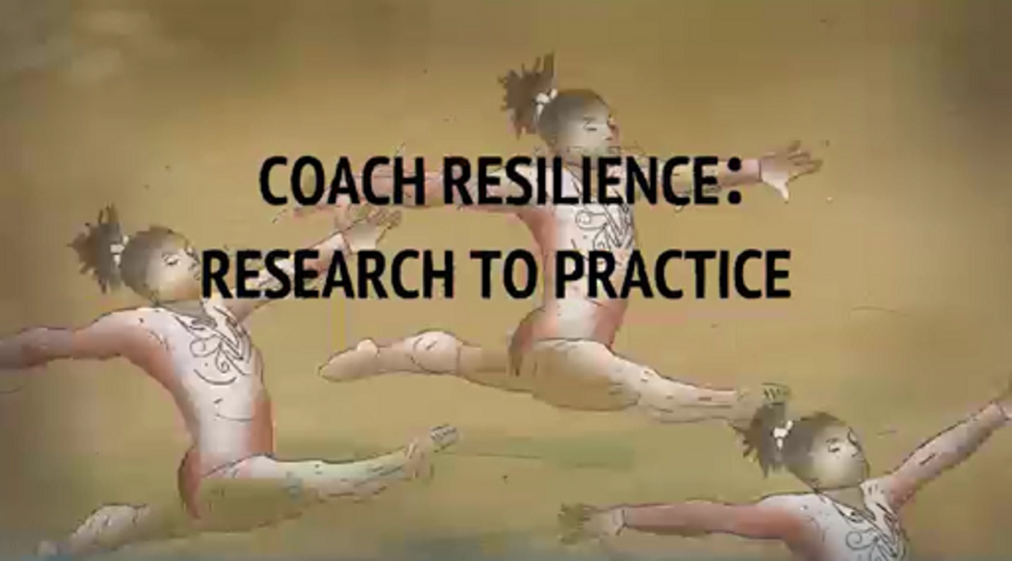

Now, having watched the video, answer the following questions:
- How might the research findings help a coach, to support them to build their own resilience?
- How could the practical implications of the research inform the organisation that the coach works for to support the development of their own resilience and other coaches’ resilience?

Provide your answer...
View discussion - Part

It is clear that education is a core element in the development of resilience to support impactful interventions, and here you have considered how a coach might support the facilitation of an individual athlete, alongside the development of their own skillset.
In Session 1, you examined the difference between individual and team resilience. It is important, then, for the coach to consider each separately when looking to develop resilience. You will investigate developing team resilience in the next section.

4 Building team resilience

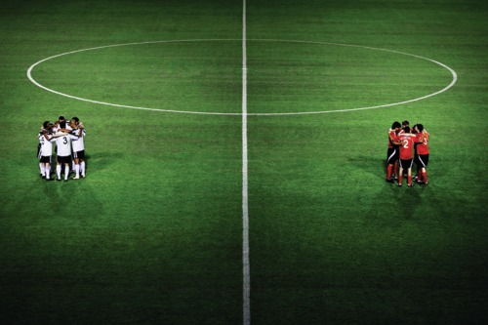
View description - Uncaptioned Figure
View description - Uncaptioned Figure

It benefits both coaches and sport psychologists to understand how teams should collectively perform when under pressure and in the face of setbacks (Morgan, Fletcher and Sarkar, 2017). You read in Session 1 that team resilience is a shared experience and, as such, research suggests that a programme aimed to build resilience in teams should open by involving team members in conversations about their own team’s resilience (Morgan, Fletcher and Sarkar, 2013). This might also involve using measures such as the Characteristics of Resilience in Sports Teams (CREST) questionnaire (Decroos et al., 2017; the questionnaire is in the appendix of the article).
In Activity 4, you will hear further input from Dr Mustafa Sarkar on building team resilience and examine research that followed a rugby union team throughout a season (an example of longitudinal research design) to study how they were able to promote the development of their resilience.

Activity 4 Working with teams to build resilience
Allow approximately 60 minutes

First, listen to the second extract from the podcast that you first accessed in Session 1. In this part of the audio, Dr Mustafa Sarkar outlines the importance of leadership in building team resilience.

Audio content is not available in this format.
The importance of team resilience
View transcript - The importance of team resilience

Next, having listened to the audio, note down your understanding of ‘shared leadership’ and reflect on the findings of resilience across a variety of sports.

Provide your answer...
View discussion - Part

Now read the reading at the following link, which is a section from an article called ‘Developing team resilience: a season-long study of psychosocial enablers and strategies in a high-level sports team’ (Morgan, Fletcher and Sarkar, 2019). It explores the enablers and strategies that promote the development of team resilience.
Reading: Developing team resilience
Finally, drawing from the key points raised in both the podcast and the article, consider how you might apply these to one of the following:
- your own team, or one that you work with or follow, or
- the relay coach that works with the women’s Team GBR 4 x 100m squad.

Provide your answer...
View discussion - Part

Looking more broadly than the team, research findings from Fasey et al. (2021) indicate that organisations such as schools, clubs and governing bodies approaching the development of resilience can look to their own structures, in addition to focusing on the creation of an environment that balances appropriate challenge and support for athletes and coaches, as has been discussed in this session.
You’ll now turn your attention to how the development of resilience can be supported as an athlete navigates through their athletic development journey.

5 Developing resilience for the athletic development journey

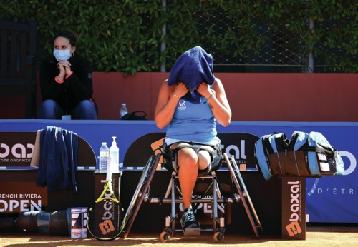
View description - Uncaptioned Figure
View description - Uncaptioned Figure

As highlighted by Tudor, Sarkar and Spray (2020) in Session 1, the supported development of resilience could start in childhood, for example in the school PE setting. Although it is important to highlight that our resilience levels will fluctuate over time and, indeed, often be specific for particular aspects of our lives, it could be of benefit to consider the development of resilience in the early stages of an athlete’s life.
Arguably, an athlete’s family are an influential factor in creating opportunities to develop resilience. Watch the video ‘Building children’s resilience’ which is an example of a resource aimed at offering parental guidance on children’s resilience.

Video content is not available in this format.
Building children’s resilience
View transcript - Building children’s resilience

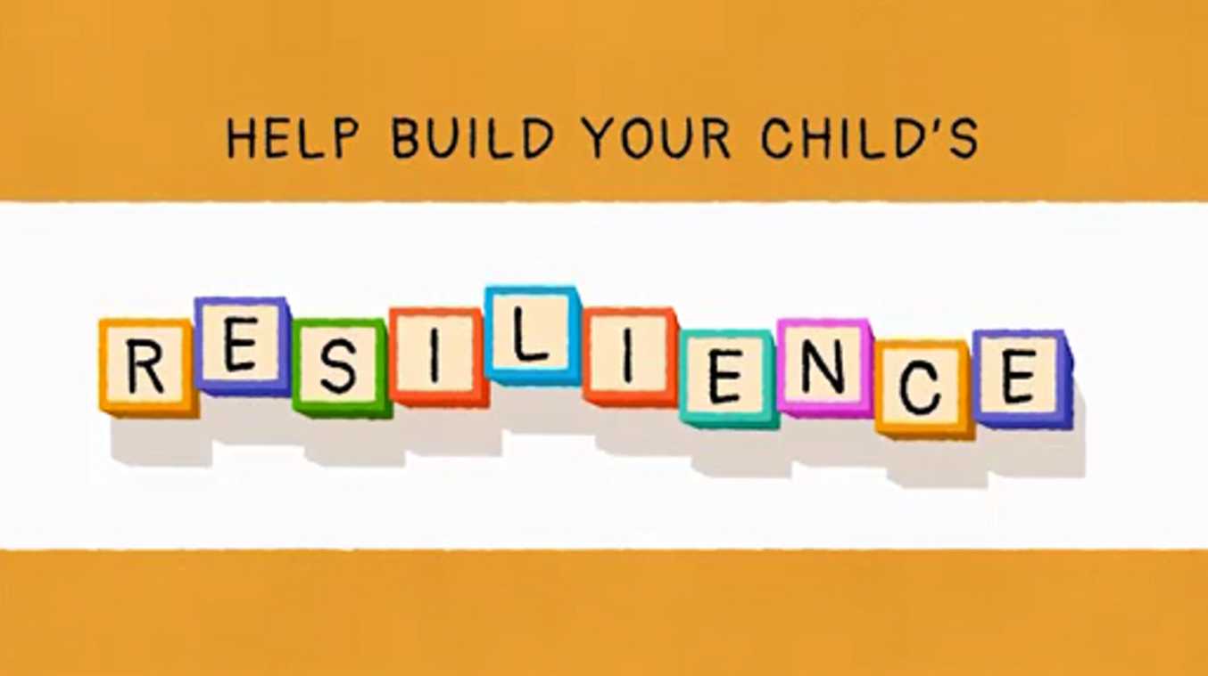

As highlighted in the video, participating in physical activity and exercise can facilitate the development of resilience. In their research examining young gymnasts and their coaches, White and Bennie (2015) found that resilience can be cultivated through participation in sport. The research, focusing on athlete and coach perceptions on the development of resilience in community-level gymnastics, highlighted that gymnastics participation resulted in the development of life skills, self-efficacy and self-esteem, in addition to resilience. Where much of the research into resilience in sport has focused on elite sport, this community-level research allows us to see the benefits of sport participation more widely.
We could conclude, therefore, that particularly with young athletes, the development of resilience can be facilitated by participation in sport and physical activity, but as you have seen this should be within an effective environment. Such experiences could support the young athlete as they continue on their athletic development journey.
In the last activity of this course, you are encouraged to reflect on your learning.

Activity 5 Reflecting on your own learning
Allow approximately 30 minutes

At this point, take some time to reflect on the topics covered in this course by considering:
- your thoughts on resilience as a mechanism for supporting athletes and coaches on their athletic development journey
- any planned action that you have as a consequence of your learning, from your perspective as a coach, a parent with sporting children, as an athlete yourself or within your life more widely.

Provide your answer...
View discussion - Activity 5 Reflecting on your own learning

6 Summary of Session 2
In this session you have explored how to support the development of resilience in athletes and coaches. With reference to research, you have examined the optimum conditions or the facilitation of resilience and considered a number of interventions to build resilience.
Some of the key learning points of this session are:
- It is important to consider the purpose of implementing a programme to develop resilience.
- The role of the environment is a key factor for the development of resilience. An environment that offers a high level of challenge and support is identified as being most facilitative.
- Mental fortitude training, planned disruptions and Rational-Emotive Behaviour Therapy (REBT) are examples of interventions for building resilience.
- The development of team resilience differs from building resilience in individual athletes and coaches.
- Supporting the development of resilience in young athletes can aid them as they navigate the athletic development journey. This support can come from education settings and sports clubs.
Congratulations on finishing this free course on resilience in sport.
This OpenLearn course is an adapted extract from the Open University course E312 Athletic development: a psychological perspective.

Where next?
If you’ve enjoyed this course you can find more free resources and courses on OpenLearn.
You might be specifically interested in these free badged courses:
- Communication and working relationships in sport and fitness
- Exploring sport coaching and psychology
- Learning from sport burnout and overtraining
- Coaching others to coach
- The athlete’s journey: transitions through sport
- Exploring the psychological aspects of sport injury
There is also a page of sport and fitness courses on OpenLearn.
You might also be interested in registering for this course’s related OU course E312 Athletic development: a psychological perspective, which is part of our BSc (hons) Sport, fitness and coaching.

References
Fletcher, D., Hanton, S. and Mellalieu, S.D. (2006) ‘An organizational stress review: conceptual and theoretical issues in competitive sport’ in Hanton, S. and Mellalieu, S.D. (eds) Literature reviews in sport psychology, Hauppauge, NY: Nova Science, pp. 321–73.
Fletcher, D. and Sarkar, M. (2012) ‘A grounded theory of psychological resilience in Olympic champions’, Psychology of Sport and Exercise, 13, pp. 669–678.
Fletcher, D. and Sarkar, M. (2016) ‘Mental fortitude training: An evidence-based approach to developing psychological resilience for sustained success’, Journal of Sport Psychology in Action, 7, pp. 135–157.
Galli, N. and Vealey, R.S. (2008) ‘“Bouncing back” from adversity: Athletes’ experiences of resilience’, The Sport Psychologist, 22, pp. 316–335.
Harrison, D. (2020) ‘The importance of psychological resilience in extreme environments’, OU Sport Blog. Available at: http://www.open.ac.uk/blogs/OU-Sport/?p=2480 (Accessed: 17 September 2021).
Howells, K. and Fletcher, D. (2016) ‘Adversarial growth in Olympic swimmers: Constructive reality or illusory self-deception?’, Journal of Sport & Exercise Psychology, 38, pp. 173–186.
Howells, K. (2022) ‘Developing resilience on the athlete’s journey’, in Heaney, C., Kentzer, N. and Oakley, B. (eds) Athletic Development: A Psychological Perspective. London: Routledge, pp. 202–213.
Leach, J. (2016) ‘Psychological factors in exceptional, extreme and torturous environments’, Extreme Physiology & Medicine, 5(1), pp. 1–15.
MacIntyre, T.E., Walkin, A.M., Beckmann, J., Calogiuri, G., Gritzka, S., Oliver, G., Donnelly, A.A. and Warrington, G. (2019) ‘An exploratory study of extreme sport athletes’ nature interactions: From well-being to pro-environmental behavior’, Frontiers in Psychology, 10, p. 1233.
Masten, A.S., Gewirtz, A.H. and Sapienza, J.K. (2013) ‘Resilience in development: The importance of early childhood’, in Tremblay, R.E., Boivin, M., Peters De. V.R. (eds) Encyclopedia on Early Childhood Development. Available at: http://www.child-encyclopedia.com/resilience/according-experts/resilience-development-importance-early-childhood (Accessed: 17 September 2021).
Masten, A.S. (2001) ‘Ordinary magic: Resilience processes in development’, American Psychologist, 56(3), pp. 227–238.
Morgan, P.B., Fletcher, D. and Sarkar, M. (2013) ‘Defining and characterizing team resilience in elite sport’, Psychology of Sport and Exercise, 14(4), pp. 549–559.
Morgan, P.B.C., Fletcher, D. and Sarkar, M. (2017) ‘Recent developments in team resilience research in elite sport’, Current Opinion in Psychology, 16, pp. 159–164.
Olusoga, P., Maynard, I., Hays, K. and Butt, J. (2012) ‘Coaching under pressure: A study of Olympic coaches’, Journal of Sports Sciences, 30(3), pp. 229–239.
Rees, T., Hardy, L., Güllich, A., Abernethy, B., Côté, J., Woodman, T., Montgomery, H., Laing, S. and Warr, C. (2016) ‘The great British medalists project: a review of current knowledge on the development of the world’s best sporting talent’. Sports medicine, 46(8), pp. 1041–1058.
Sarkar, M. and Fletcher, D. (2013) ‘Psychological resilience: A review and critique of definitions, concepts, and theory’, European Psychologist, 18(1), pp. 12–23.
Sarkar, M., and Hilton, N. K. (2020) ‘Psychological resilience in Olympic medal–winning coaches: A longitudinal qualitative study’, International Sport Coaching Journal, 7(2), pp. 209–219.
Sisto, A., Vicinanza, F., Campanozzi, L.L., Ricci, G., Tartaglini, D. and Tambone, V. (2019) ‘Towards a transversal definition of psychological resilience: A literature review’, Medicina, 55(11), p. 745.
Tudor, K., Sarkar, M. and Spray, C.M. (2019) ‘Exploring common stressors in physical education: A qualitative study’, European Physical Education Review, 25(3), pp. 675–690.
Tudor, K., Sarkar, M. and Spray, C.M. (2020) ‘Resilience in physical education: A qualitative exploration of protective factors’, European Physical Education Review, 26(1), pp. 284–302.
Wagstaff, C.R.D., Sarkar, M., Davidson, C.L. and Fletcher, D. (2017) ‘Resilience in sport: A critical review of psychological processes, sociocultural influences, and organizational dynamics’, in Wagstaff, C.R.D. (ed.) The organizational psychology of sport: Key issues and practical applications. London: Routledge, pp.120–149.
West, B.J., Patera, J.L. and Carsten, M.K. (2009) ‘Team level positivity: Investigating positive psychological capacities and team level outcomes’, Journal of Organizational Behavior, 30, pp. 249–267.
BelievePerform (2020) 10 ways coaches can build resilience when coaching. Available at: https://believeperform.com/product/10-ways-coaches-can-build-resilience-when-coaching/ (Accessed: 17 September 2021).
Brown, D.J., Sarkar, M. and Howells, K. (2020) ‘Growth, resilience and thriving: A jangle fallacy?’, in Wadey, R., Day, M. and Howells, K. (eds) Growth following adversity in sport. London: Routledge, pp. 59–72.
Decroos, S., Lines, R.L., Morgan, P.B., Fletcher, D., Sarkar, M., Fransen, K., Boen, F. and Van de Broek, G. (2017) ‘Development and validation of the characteristics of resilience in sports teams inventory’, Sport, Exercise, and Performance Psychology, 6(2), pp. 158–178.
Fasey, K.J., Sarkar, M., Wagstaff, C.R. and Johnston, J. (2021) ‘Defining and characterizing organizational resilience in elite sport’, Psychology of Sport and Exercise, 52, p. 101834.
Fletcher, D. and Sarkar, M. (2012) ‘A grounded theory of psychological resilience in Olympic champions’, Psychology of Sport and Exercise, 13, pp. 669–678.
Fletcher, D. and Sarkar, M. (2016) ‘Mental fortitude training: An evidence-based approach to developing psychological resilience for sustained success’, Journal of Sport Psychology in Action, 7, pp. 135–157.
Fletcher, D. (2020) ‘How should we create environments that promote psychological resilience?’ [Webinar]. PQ (Lboro) Ltd. 9 December 2020.
Grey-Thompson, T. (2017) Duty of Care in Sport Review. Available at: https://assets.publishing.service.gov.uk/government/uploads/system/uploads/attachment_data/file/610130/Duty_of_Care_Review_-_April_2017__2.pdf (Accessed: 17 September 2021).
Howells, K. (2022) ‘Developing resilience on the athlete’s journey’, in Heaney, C., Kentzer, N. and Oakley, B. (eds) Athletic Development: A Psychological Perspective. London: Routledge, pp. 202–213.
Morgan, P.B.C., Fletcher, D. and Sarkar, M. (2013) ‘Defining and characterizing team resilience in elite sport’, Psychology of Sport and Exercise, 14(4), pp. 549–559.
Morgan, P.B.C., Fletcher, D. and Sarkar, M. (2017) ‘Recent developments in team resilience research in elite sport’, Current Opinion in Psychology, 16, pp. 159–164.
Morgan, P.B.C., Fletcher, D. and Sarkar, M. (2019) ‘Developing team resilience: A season-long study of psychosocial enablers and strategies in a high-level sports team’, Psychology of Sport and Exercise, 45, pp. 101543.
Nicholl, L. (2017) Better culture creates a stronger system. Available at: https://www.uksport.gov.uk/news/2017/10/24/uk-sport-statement-on-culture (Accessed: 17 September 2021).
Sarkar, M. (2018) ‘Developing resilience in elite sport: The role of the environment’, The Sport and Exercise Scientist, 55, pp. 20–21.
Sarkar, M. (2019) How to create psychological resilience [podcast]. 1 July. Available at: https://athletedevelopmentproject.com/2020/01/ep-72-mustafa-sarkar-how-to-create-psychological-resilience/ (Accessed: 17 September 2021).
Sarkar, M. and Hilton, N. K. (2020) ‘Psychological resilience in Olympic medal–winning coaches: A longitudinal qualitative study’, International Sport Coaching Journal, 7(2), pp. 209–219.
Tudor, K., Sarkar, M. and Spray, C.M. (2020) ‘Resilience in physical education: A qualitative exploration of protective factors’, European Physical Education Review, 26(1), pp. 284–302.
White, R.L. and Bennie, A. (2015) ‘Resilience in youth sport: A qualitative investigation of gymnastics coach and athlete perceptions’, International Journal of Sports Science & Coaching, 10(2–3), pp. 379–394.

Acknowledgements
This free course was written by Nichola Kentzer.
Except for third party materials and otherwise stated (see terms and conditions), this content is made available under a Creative Commons Attribution-NonCommercial-ShareAlike 4.0 Licence.
The material acknowledged below is Proprietary and used under licence (not subject to Creative Commons Licence). Grateful acknowledgement is made to the following sources for permission to reproduce material in this free course:

Text
Session 1
‘What is resilience?’ reading: © The Open University
‘Recent developments in team resilience’ reading: ‘Recent developments in team resilience research in elite sport’, Current Opinion in Psychology, Elsevier
Session 2
‘Building resilience’ reading: © The Open University.
‘Planned disruptions and REBT’ reading: © The Open University.
‘Developing team resilience’ reading: Morgan, P.B.C., Fletcher, D. & Sarkar, M. (2019). ‘Developing team resilience: A season-long study of psychosocial enablers and strategies in a high-level sports team’. Psychology of Sport and Exercise. Elsevier

Images
Introduction
Course image: © Delly Carr/Getty Images
Session 1
Introduction image: © Ruslan Sitarchuk/Dreamstime.com
Section 1 image: © Vitezslav Vylicil/shutterstock.com
Figure 1: Adapted from Fletcher, A., and Sarker, M. (2012) ‘A grounded theory of psychological resilience in Olympic champions’ Vol 13, Issue 5. Psychology of Sport Exercise. 2012 Elsevier
Section 4 image: © Belish/Shutterstock
Section 5 image: photobac/123RF
Section 6 image: © Shestock/Getty
Session 2
Introduction image: © mrgao/iStock
Section 2 image: © AlessandroZocc/iStock
Figure 1: adapted from Fletcher and Sarker 2016
Figure 2: © BelievePerform
Section 4 image: © Patrik Giardino/Getty
Section 5 image: © FRANCK FIFE/Contributor/Getty

Audio-visual
Session 1
‘Introduction to resilience’ video: Courtesy of Resilient Option, www.stressfree.com
‘The Merthyr mermaid’ video: © BBC
‘Coach resilience (Part 1)’ video: © The Open University. Female swimmer in pool: WK-Production/Creatas Video+/Getty Images Plus
‘Developing resilience in sport’ audio: Courtesy of BelievePerform.com
Every effort has been made to contact copyright owners. If any have been inadvertently overlooked, the publishers will be pleased to make the necessary arrangements at the first opportunity.
Session 2
‘Athlete wellbeing and engagement’ video: Swimming Australia, https://creativecommons.org/licenses/by-nc-nd/3.0/au/deed.en
‘Coach resilience (Part 2)’ video: © The Open University.
‘The importance of team resilience’ audio: Courtesy of Believeperform.com
‘Building children’s resilience’ video: used with the permission of Home-Start Central Bedfordshire.
Every effort has been made to contact copyright owners. If any have been inadvertently overlooked, the publishers will be pleased to make the necessary arrangements at the first opportunity.
Every effort has been made to contact copyright owners. If any have been inadvertently overlooked, the publishers will be pleased to make the necessary arrangements at the first opportunity.
Don't miss out
If reading this text has inspired you to learn more, you may be interested in joining the millions of people who discover our free learning resources and qualifications by visiting The Open University – www.open.edu/openlearn/free-courses.

Solutions

Activity 1 Reflecting on your own resilience

Discussion
You might have noted down that resilience is an inner strength that helps us to withstand and bounce back from adversity, allowing us to ‘get the most mileage from our brain’. You might have reflected on one or more times in your life when you have shown resilience.
As noted on the video – our genes, all aspects of our lives, and the experiences that we have, influence our ability to be resilient.
Back to - Activity 1 Reflecting on your own resilience

Activity 2 But what does it all mean? Making sense of resilience

Part

Discussion
The two fundamental components of resilience are:
- adversity (perceived negative experience)
- positive adaptation.
Back to - Part

Part

Answer
The correct matches are:
Refers to resilience providing protection to an athlete which supports wellbeing and performance levels when under pressure.
Robust
Refers to the bounce-back qualities that are reflected in the minimal impact that adversity has on an athlete’s wellbeing and/or performance.
Rebound
Back to - Part

Part

Discussion
Fletcher and Sarkar (2012) argued that these factors could protect athletes from the potential negative effects of stressors by using positive evaluations, or challenge appraisals, and meta-cognitions (the evaluation of their own thoughts). Figure 1 is helpful to see the relationship between the five factors and challenge appraisal and meta-cognition.
Back to - Part

Activity 3 Resilient athletes

Discussion
You may have found it hard to come up with just one example, as it could be argued that there are a number of athletes that have demonstrated resilience along their journey. Your justification might have considered robust or rebound resilience or you might have reflected on how the athlete demonstrated one or more of the five psychological (protective) factors that were highlighted by Fletcher and Sarkar (2012), and was able to overcome significant challenges.
Back to - Activity 3 Resilient athletes

Activity 4 Exploring coach resilience

Discussion
- Dr Sarkar highlighted that coaches are performers in their own right and they will face numerous stresses and pressures in their own coaching career. As such, it was argued that it was important to understand coach resilience from two angles: how coaches can enhance their own resilience and how can they develop resilience in their athletes.
- There were three main findings identified in the research:
  - four themes of stressors experienced by the coaches
  - six themes of protective factors (the psychological qualities that protected coaches against the potential negative effects of these stressors)
  - factors that coaches used to develop resilience in athletes.
- You may have reflected that several of the stressors and/or protective factors could be applied to non-elite coaches. For example, of the stressors identified, you may have considered that coach wellbeing would apply to any level of coach and that there would be an element of managing an organisation, albeit perhaps on a different scale. For example, a coach might have assistants and volunteers working with them that they manage.
In terms of the protective factors, non-elite coaches could take a progressive approach, try to maintain a work–life balance and have a focus on motivation and effective decision-making. However, a non-elite coach might not always have access to a coach support network nor function in a secure work environment.
- You may have reflected on a number of the research findings, including any potential stressors that you might face in your role or perhaps some protective factors (psychological qualities) that you recognise in coaches that you have observed. For example, you may have reflected that coaches/teachers you work with have a real love for their role, with clear enjoyment – evidence of intrinsic motivation (part of durable motivation).
Back to - Activity 4 Exploring coach resilience

Activity 5 Investigating team resilience

Part

Discussion
Having read the reading, you might have noted down that there is ‘some consensus about the protective nature of team resilience from the potentially harmful effects of stressors’ (Morgan, Fletcher and Sarkar, 2017, p. 159). Furthermore, the authors highlight that team resilience is a dynamic process and is a shared or collective phenomenon, comprising both psychological and social elements (psychosocial).
You might have summarised the findings from the two research articles discussed; one that collected primary data through the use of focus groups and one that analysed written narratives of athletes from autobiographies.
Back to - Part

Part

Discussion
From the audio recording, you might have noted that, unlike individual resilience, team resilience involves relationships and requires a difference set of qualities including group structure, importance of collective confidence, deep emotional bonds and social identity.
Back to - Part

Activity 6 Investigating the cluster effect

Discussion
- A cluster effect occurs when an individual experiences an accumulation or grouping of stressors, rather than experiencing just one. In the blog, Harrison refers to dealing with wet kit while mountain climbing, with no time to address this before the next day’s travel begins. If we are to fully support the development of resilience in extreme sport athletes, we need to understand how they experience stressors, and if groups of stressors can have an accumulative effect, it is crucial that this is considered when preparing the athletes for their events and challenges.
- It is important to develop a challenge mindset as it allows an individual to see situations as a challenge and not as a threat. It is important that this mindset is adopted and then maintained within an extreme environment to buffer against the potential negative impact of a cluster effect of stressors. Increasing an individual’s experience can allow them to slowly build up exposure to stressors and reduce the potential negative effect of stressors.
Back to - Activity 6 Investigating the cluster effect

Activity 7 Examining resilience in PE

Discussion
One of the key takeaway messages from the research examined in this activity, is that PE teachers – and therefore arguably coaches – can play a significant role in facilitating the development of resilience. This will be explored further in Session 2.
Back to - Activity 7 Examining resilience in PE

Activity 1 Preparing to build resilience

Discussion
Howells (2022) highlights three issues that should be addressed before embarking on an approach to building resilience.
- Fletcher and Sarkar (2016) argue that any programme to build resilience should be part of a wider holistic programme to support the development of well-adjusted performers. You might have identified that the AIS strongly promote such an approach with reference made to the five aspects of athlete wellbeing and engagement, including mental health and personal development.
- There should be considerations of the reasons for proposing an intervention to build resilience. For the AIS, it could be argued that the purpose of introducing an intervention to develop resilience could be both to enhance performance (personal development) and to protect the athlete from potential negative impact of stressors (mental health).
- A decision to introduce a resilience programme should be made while being mindful of the dynamics of an organisation, such as how open it might be to sport psychology. You might have considered that with the AIS promoting a holistic development programme, that the AIS would be ‘open’ to sport psychology support.
It is important to note that the term ‘thrive’ was referred to by one of the athletes in the video. To make the distinction between the two terms, Brown, Sarkar and Howells (2020) posit that resilience does not lead to thriving but can result in its maintenance. Furthermore, the authors offer that if an athlete is thriving (i.e., fully functioning) they are better able to demonstrate resilience if they experience stressors.
Back to - Activity 1 Preparing to build resilience

Activity 3 Investigating resilience interventions

Part

Discussion

Table 1 Planned disruptions and REBT
 | Aim | Key features
Planned disruptions | Involves the exposure of athletes to specific training activities that increase/change demands placed on them. | Research has identified a number of types including competition simulation.  Involves encouraging the athletes to reflect on their responses to build self-awareness.
REBT | Works on the assumption that many of the problems faced by an athlete can be caused by irrational thinking. | Uses the ABC(DE) framework.  Does not dispute that stressors/adversity exists but works to change the athlete’s perception by replacing their beliefs.

Back to - Part

Part

Discussion
- You might have noted that Dr Sarkar emphasises the importance of a coach understanding their own protective factors. The coach could reflect on the six protective factors discussed and consider their own strengths in these areas and identify where they might need to develop further. For example, they might perceive that they has a sound coach support network and has durable motivation but might acknowledge that they could improve their work-life balance.
- The research highlighted that an organisation could support coaches in developing resilience. It identified education and support regarding the stressors that might be experienced and the protective factors that could buffer against these factors. For example, organisations such as English Athletics could provide coach education on resilience that a coach could access to help them become more aware of the possible stressors in their role and how they could develop skills to protect themselves from the potential negative effects of these stressors. There could be workshops and resources to help them to develop leadership and management skills, as well as mechanisms to support their wellbeing.
Back to - Part

Activity 4 Working with teams to build resilience

Part

Discussion
In the second extract from the podcast, Dr Sarkar highlights the importance of sharing leadership throughout the team in order to support the development of resilience. He uses the example of the World Cup winning Rugby Union coach, Clive Woodward, who stressed the need for an exceptional leader among a group of great leaders. Dr Sarkar noted that by having a leadership group there are more people to be accountable when setbacks occur, to share the responsibilities of the outcome of the performance.
As highlighted in the podcast, although there are consistencies between the resilience found in teams across a variety of sports, there will be some contextual differences.
Back to - Part

Part

Discussion
If you chose to apply the key points from the resources to your own examples, there are likely to be some variations.
If you chose to apply the key points from the podcast to the relay coach, you might have reflected that they might face a potential challenge of having a leadership group in such a small team but that as each sprinter had responsibility for each leg of the relay, you could argue that there was a natural sharing of responsibilities. This is supported by the findings of Morgan, Fletcher and Sarkar (2019) who call for the development of a team regulatory system founded on this ownership and responsibility. The relay coach should also emphasise the importance of cultivating team identity (e.g. all athletes wear team kit) and create a selfless culture, as opposed to a blame culture. The coach should pose challenges to the team during training but maintain the importance of enjoyment, and a positive outlook when faced with adversity.
Back to - Part

Activity 5 Reflecting on your own learning

Discussion
Hopefully you have reflected not only on how your learning from this course could be applied to your own sporting practices and interests, but also enabled you to reflect on your own levels of resilience. Having this increased self-awareness can support you to be mindful of the environments in which you function, both in sport and more widely in your life. For example, do you have appropriate challenge and support?
Back to - Activity 5 Reflecting on your own learning

Uncaptioned Figure

Description
Image of men and women helping each other to climb over a mud barrier in a challenge race
Back to - Uncaptioned Figure

Uncaptioned Figure

Description
Image of the word resilience in a dictionary
Back to - Uncaptioned Figure

Figure 1 A grounded theory of psychological resilience and optimal sport performance (Fletcher and Sarkar, 2012, p. 672).

Description
The figure displays the concept that a facilitative response to a stressor can result in optimal sport performance. The facilitative response is dependent on the challenge appraisal and metacognitions of the stressor, which is influenced by five psychological factors: positive personality, motivation, confidence, perceived social support and focus.
Back to - Figure 1 A grounded theory of psychological resilience and optimal sport performance (Fletcher and Sarkar, 2012, p. 672).

Uncaptioned Figure

Description
Image of three male volleyball players blocking a shot at the net
Back to - Uncaptioned Figure

Uncaptioned Figure

Description
Image of a female rock climber scaling an overhang in a mountain location
Back to - Uncaptioned Figure

Uncaptioned Figure

Description
Image of young girl and her grandmother stretching on a sports pitch
Back to - Uncaptioned Figure

Uncaptioned Figure

Description
Image of compass with needle pointing towards the word resilience
Back to - Uncaptioned Figure

Uncaptioned Figure

Description
Image of a single daisy growing on sandy soil
Back to - Uncaptioned Figure

Figure 1 A challenge–support matrix for developing resilience (Fletcher and Sarkar, 2016).

Description
The figure shows the four quadrants of the challenge support matrix for developing resilience. The top left quadrant represents an unrelenting environment where there is high challenge and low support. The bottom left quadrant is a stagnant environment where both challenge and support are low. The bottom right quadrant is a comfortable environment where the challenge is low but the support is high. The top right quadrant represents a facilitative environment for the development of resilience where both challenge and support is high.
Back to - Figure 1 A challenge–support matrix for developing resilience (Fletcher and Sarkar, 2016).

Figure 2 An infographic aimed to support coaches to develop resilience in their athletes (BelievePerform, 2020).

Description
The figure shows an infographic providing ways in which coaches can build resilience when coaching. 1. Keep challenging your athletes in sessions. 2. Let your athletes make mistakes. 3. Develop an environment where athletes can take risks. 4. Ask effective questions when coaching. 5. Try not to provide the answers for your athletes. 6. Provide scenarios in sessions where athletes must problem solve. 7. Help athletes to develop positive coping strategies. 8. Allow space and time for athletes to make their own decisions. 9. Don’t over coach. Develop autonomy in your athletes. 10. Help athletes to understand their emotion levels during specific situations, and assist them with building up coping strategies to overcome any pitfalls they may encounter.
Back to - Figure 2 An infographic aimed to support coaches to develop resilience in their athletes (BelievePerform, 2020).

Uncaptioned Figure

Description
Image of two football teams in two huddles on each side of the halfway line of a football pitch
Back to - Uncaptioned Figure

Uncaptioned Figure

Description
Image of female wheelchair athlete on courtside during a break in play with towel over her head
Back to - Uncaptioned Figure

Introduction to resilience

Transcript
NARRATOR: Since the early 1900s, many scientists opine that some phenomena don't follow a straight line. With no pressure, no challenge, life gets to be boring. We wander into distractions, find ourselves snoring.
Excessive load and pressure, however, isn't what I desire. They hurt my back and morale and douse the creative fire.
I need challenge, I need pressure that is just about right so I don't get bored and jaded, nor weary or too tight.
With 50 user IDs to remember, a question my mind asks, how do I deal with daily deadlines? Little control, countless undone tasks.
Each day is a struggle. I'm barely getting by. I risk burnout and illness, even an early goodbye.
Prioritise, simplify, delegate, better manage your day. To lower my stress, that is certainly one way.
Is there anything else I can do since little is left to snip? Can't I bolster my strength so nothing I need to clip?
I indeed have another option to lift my every experience. That option is to smartly choose a life of resilience.
[MUSIC PLAYING]
Resilience trains my brain. Resilience helps my intention to enhance my creativity, positivity and attention.
With resilience, I bounce back faster, better heal my pain. I'm happier, more productive, get more mileage from my brain.
Friends, resilience is your inner strength that helps you withstand and bounce back from adversity, as well as prevent and grow from life's hardships.
Your happiness and resilience depends on three key factors. Number one your genes, number two, your life situation, and number three, the choices you make. While you can't pick your genes and have limited control over your life situations, you can choose your thoughts, words, and actions that help you be more resilient.
Self-awareness, authentic presence, a can-do attitude, gratitude, compassion, acceptance, nurturing relationships, finding deeper meaning, and a spiritual anchor. These are the nine pillars that support your resilience.
For more information about resilient living, check out stressfree.org.
Back to - Introduction to resilience

The Merthyr mermaid

Transcript
CATH PENDLETON:
I’m Cath Pendleton. And believe it or not, I’m going to swim a mile in the coldest place on Earth, Antarctica. Most people would die of hypothermia after 15 minutes in these waters. I’d be in there for at least 35.
WOMAN
Some people do yoga to sort of get to their moment and have their happy place and sort of reset and calm down. And for her, hers is just going in the water.
CATH PENDLETON
I got completely hooked. I was swimming four or five times a week.
WOMAN
She just sort of turned around one day and was like, you know what? I’m going to book in for the Channel. And next thing you know, within a year, she’d already swum the Channel.
CATH PENDLETON
And then things got even more crazy. I was selected to represent Great Britain in the World Ice Swimming Championships in Russia and came away with third in my age group.
WOMAN
We were like, you’ve done so well. And she was like, oh, yeah. But it’s the next thing I’ve got to do now.
CATH PENDLETON
I’d been told about this incredible challenge for ice swimmers, to swim one mile in each of the seven continents.
MAN 1
Very few people in the world have the ability to go to those limits. You’d have to be the fastest swimmer. You have to be rock-solid in your training.
CATH PENDLETON
And then yeah, the freezer journey began.
Yeah.
I was thinking, if I can’t just sit in this freezer, then I’m going to really struggle. Although I felt I could do it, there was always that element of doubt.
After six days at sea, we had arrived. If the swim was to go ahead here, we would be the first people in the world to swim a mile this far south.
I just knew if I don’t sit still and relax, I’m not going to pass my medical. And then all of a sudden, it was like, OK, you’ve passed.
So it was like, you’re going first. I was like, OK. That’s fine. And then the tide came and off we went. And then it was like, go.
MAN 2
[SPEAKING SPANISH]

CATH PENDLETON
So I’m swimming away. And I’d taken on a little bit of water. And I was coughing. And I was thinking, I really need to stop and cough this water out.
But I thought, if I stop, they’ll think I’m in danger. And they’ll stop me. So I’m like, just cough underwater. Get a grip, Cath. Just swim.
I knew I could do it. But every swim is different. Some days, it’s just not your day.
Every time I did sight the boat, it just still seemed so far away. But each time I see people clapping.
MAN 1
Come on, Cath.
CATH PENDLETON
There’s just something in my brain that says, don’t give up. Keep going. Eventually, they were like, you can stop. I was like, yeah.
[CHEERING]
I’ve trained really, really hard. I’ve pushed my body to the limits. And you know what? To be the first, to be able to say you’ve done anything first in the world is just absolutely awesome.
Back to - The Merthyr mermaid

Coach resilience (Part 1)

Transcript
NATHAN HILTON:
I'm Nathan Hilton. I'm the Director of Coaching at Nova Centurion in Nottingham. And I've been involved in research around psychological resilience at Nottingham Trent University. Focus on your work off the walls on that 200. The 50s, what we're going to do, we're going to go faster 15, 20, 25.
My MS was around the theme of psychological resilience in elite swimming coaches. And I was fortunate enough to work with Mustafa Sarkar during collecting the data and developing the paper that we worked on together. Maybe after each set, just change your lane, so they all get a chance. So maybe–
MUSTAFA SARKAR:
I'm Dr. Mustafa Sarkar. I'm an Associate Professor of Sport and Performance Psychology at Nottingham Trent University. My main area of research looks at the psychology of sporting excellence. And in particular, I'm interested in individual, team and organisational resilience in elite sport and the application of resilience to other high-performance domains, such as business.
NATHAN HILTON:
And they can see what they're doing, and then they're going off on the next rep.
MUSTAFA SARKAR:
Resilience is important to study in sport because it helps us to understand why some individuals are able to withstand the pressures of competitive sport and attain peak performances, whereas others succumb to the demands and underperform.
[TEXT ON SCREEN
Research Focus]
A lot of the research has typically focused on resilience in athletes. But there's been very, very little research looking at resilience in coaches. And we identified, or we know, that coaches are performers in their own right. They are helping athletes on a daily basis, on a weekly basis to perform at their best. And coaches themselves face numerous stressors and pressures in their own coaching career.
[TEXT ON SCREEN
Research Methods]
NATHAN HILTON
There was five coaches, four males and one female. And they all had won Olympic medals, so it was quite an elite, well, we termed it super-elite, cohort of people.
MUSTAFA SARKAR
In this study, we utilised two interviews over a period of time in line with the longitudinal approach, which suggests that resilience can change over a period of time. The majority of research on resilience actually just are single interviews at one particular time point. So we extended on this by doing two interviews over two periods of time across the course of a swimming season.
We conducted one interview in September 2016 which was just post the Rio Olympics. And we also conducted one interview in April 2017, which was just before the World Championship Selection Trials. So that allowed us to understand those changes and stressors, but also the changes in protective factors that coaches use to help manage some of those stressors.
[TEXT ON SCREEN
Research Findings]
In terms of the results, there were three main categories that we identified. Firstly, we identified the stressors, the coach stressors that were experienced. We also identified six protective factors, which were the psychological qualities that protected coaches from the potential negative effects of those stressors. And we also identified various factors that coaches use to develop resilience in athletes as well.
NATHAN HILTON
Within the findings around the coach stressors, there was four higher order themes. The first one was managing the Olympic environment. And that really described either the coaches having maybe failed at an Olympic games in terms either as an athlete or a coach or on Olympic trials, but then also the stressors associated with working within that environment when they're at those competitions.
The second area was preparation for major events. And that really was around describing things that potentially could go wrong. So as an example, somebody may get ill the year before the Olympic games, not swim that well at the major meet that year, but actually could rebound and come back really well at the Olympics.
The third one was coach personal wellbeing. And that's pretty self-explanatory. It was a stressor for the coach is that being able to find the balance between maintaining their work life, but also balance around their physical and mental wellbeing.
And then the last higher order theme was directing an organisation. And that really described how the coaches work to manage the environment that they were operating within at any given time whether that be in a club setting or national centre or working for the governing body.
MUSTAFA SARKAR
One aspect of the study was to identify the protective factor that coaches utilise. And protective factors refer to the psychological qualities that enabled coaches to withstand the pressures that they experienced. So in terms of the six protective factors, the first one was progressive coaching. The second protective factor referred to the coaching support network.
The third protective factor was about maintaining a work–life balance. The fourth protective factor was about creating a secure working environment. The fifth protective factor was about maintaining durable motivation. And then finally the sixth protective factor was about effective decision making.
NATHAN HILTON
One of the things that we identified within the paper was that coaches probably needed some education around those topic areas, so they're actually able to manage those stressors and put things within day to day practice that are going to protect them and be able to withstand those stressors.
So I think for my mind, really, it's quite interesting that there's things that you are able to do that are actually going to help you and probably prolong your coaching career or practitioner career, however you want to look at it. You could look at it in the context of whatever domain you work in, there's things that you can do within your day to day life or your day to day practice that you are able to withstand those stressors and become probably more effective at what you do.
Back to - Coach resilience (Part 1)

Developing resilience in sport

Transcript
DR MUSTAFA SARKAR
I think one of the key messages occur the difference really between individual and team resilience – two things really. I think firstly the key with team resilience that’s not really majorly applicable to individual resilience is the importance of relationships.
Relationships are crucial for team resilience, whether that’s kind of things like leadership and communication but also things around kind of forming a really good social identity within the team. So I think relationships are really, really important.
And then secondly, one of the key messages, really, that we’ve kind of come across is that just because you’ve got a set of resilient individuals, that doesn’t necessarily guarantee a resilient team.
And kind of the example I often give with that – I know, kind of, at the time of this podcast, I think the World Cup draw has been made with England. Often the example I give with that example of individual resilience doesn’t necessarily guarantee team resilience is the England kind of football team – a bunch of individuals who are great individually, some of whom have kind of participated, you know, competed at, you know, highest levels in champions league and other kind of competitions but, again, collectively when they’re getting together as a team, they find it very, very difficult to perform as a team under that kind of pressurised situation.
So I think that’s the other– as well as the importance of relationships. Just because you have got a set of individuals who are resilient, that doesn’t necessarily guarantee team resilience. And the reason for that is because we’ve found in some of the research that we’ve done is that there are a distinct set of qualities that are important for team resilience that are different from the qualities required for individual resilience. Things like group structure, things like the importance of kind of collective confidence or collective efficacy and, as I mentioned, the importance kind of deep emotional bonds and a strong sense of social identity.
Back to - Developing resilience in sport

Athlete wellbeing and engagement

Transcript
TYSON BULL:
The Athlete Wellbeing and Engagement Programme is a world-leading initiative
MONIQUE MURPHY:
As an elite athlete, it is important to have a culture and environment to learn, thrive, and the ability to engage and contribute to the wider community. Athlete Wellbeing and Engagement is supported across five critical areas.
[TEXT ON SCREEN:
Athlete Wellbeing & Engagement. Mental health; career & education; personal development; conduct & professionalism; engagement]
Mental health. Giving current and former athletes, along with coaches and high-performance staff access to the best practise mental health information and education, as well as individualised psychology services. Career and education.
TYSON BULL:
Providing advice face-to-face or online learning related to education, career mapping, professional development, and work experience.
MONIQUE MURPHY:
Personal development. Focused on empowering elite athletes to grow in their life and sporting career by building self-knowledge, and applying values-based decision making. Conduct and professionalism.
TYSON BULL:
Supporting athletes’ strategic leadership by providing advice on managing duty of care and well-being issues, including ethical decision making, and the development of policies and procedures within the high-performance environment.
MONIQUE MURPHY:
Engagement. Enabling us to become positive role models, inspiring communities by connecting with grassroots sport, and national charities.
TYSON BULL:
Finding the right balance between the requirements of an elite sport, competition, and activities outside of training leads to a high-performance athlete leading a meaningful life.
MONIQUE MURPHY:
The holistic wellbeing approach created in this initiative forms a healthy, balanced lifestyle to support performance outcomes and podium success.
[TEXT ON SCREEN:
AIS. To find out more visit www.ais.gov.au]
Back to - Athlete wellbeing and engagement

Coach resilience (Part 2)

Transcript
NARRATOR
Resilience in athletes has become the subject of discussion in the field of sport over recent years. But less discussed is the subject of resilience in coaches. Mustafa Sarkar and Nathan Hilton's research with Olympic medal winning swimming coaches looked at some of the factors and psychological qualities that can protect coaches from the potential negative effects of stressors.
The design of the study enabled researchers to understand how a number of protective factors could buffer the coaches from pressure and stressors. They identified six protective factors.
DR MUSTAFA SARKAR (Associate Professor in Sport and Performance Psychology, Nottingham Trent University):
In terms of the protective factors, the first protective factor was progressive coaching. And this referred to coaches' ability to evaluate stresses and pressures in a positive fashion. And specifically around some of their positive personality characteristics around being proactive, being quite conscientious, and also being quite optimistic in nature.
NARRATOR
As well as the ability to evaluate the stresses, the coaches discussed building support networks around themselves.
DR MUSTAFA SARKAR
Coaches talks about having other coaches within their support network, and using those coaches as mentors in terms of their own personal and professional development. Coaches also talked about the importance of family and friends in terms of being able to provide that sense of perspective.
And I guess in relation to social support and coaches' support in particular, it was a combination of what we might call perceived support, so the perception that support is available to them. But also the idea that the receipt of support in terms of coaches believing that they were actually getting the social support.
So in relation to that particular protective factor, it was a combination of a variety of people within their social support network that provided that role of the perception of support, but also the receipt of support as well.
NARRATOR
Having a good support network was valued by the coaches, but there was also an emphasis on their own ability to create a balanced approach to their coaching role, and to maintain a work–life balance.
DR MUSTAFA SARKAR
In terms of the third protective factor, this referred to work–life balance. And this is where coaches talked about the importance of having a balance between their day to day coaching, kind of, practises, but also being to be able to do things outside of the work context in terms of outside interests and activities.
And coaches were very clear to articulate the fact that balance suggests that it a kind of a 50-50 split, whereas it was more about creating a harmony between work and life. And that harmony didn't necessarily need to be a 50-50 split, but just making sure that coaching wasn't everything that they were doing and that they were able to maintain a sense of perspective and being able to have an outlook and detach outside of work by doing other types of activities, such as volunteering.
NARRATOR
Connected to the coach managing their own work–life balance was the reported importance of their working environment.
DR MUSTAFA SARKAR
The fourth protective factor refers to coaches talking about the importance of a secure working environment. And this was about creating a daily work environment that enabled coaches to perform under pressure and also attain success at the highest level. In particular, it was about confidence in the role. It was also about managing some of the insecurities of that work environment and controlling some of that self-doubt.
But also as coaches, being able to direct the working environment in terms of directing how the organisation and how that particular club could operate in terms of that work environment.
NARRATOR
Coaching at an Olympic games brings prestige, and winning at Olympic level is the goal of many coaches. However, the research highlighted the importance of balancing the motivation of this type of success with an enjoyment of the role.
DR MUSTAFA SARKAR
So the fifth protective factor referred to as durable motivation. And durable motivation refers to coaches' ability to sustain motivation over a period of time. And coaches talked about the importance and blend between intrinsic motivation and extrinsic motivation.
Intrinsic motivation referring to coaches being motivated for enjoyment, for value, for learning purposes. And extrinsic motivation referring to coaches talking about being motivated to win Olympic medals, for prestige purposes, for example. And coaches articulated that for motivation to be sustained over a period of time, there needs to be a balance between both intrinsic and extrinsic motives.
They also suggested that if coaches were just purely extrinsically motivated, for example, just wanting to be in the job purely for extrinsic reasons such as winning Olympic medals then their resilience levels would be impacted if they didn't also have some of those intrinsic motives to kind of combine with them.
NARRATOR
Reflection and evaluation are an important part of a coach's tool kit. The research found that effective use of these tools could be used to support the coaches in their role.
DR MUSTAFA SARKAR
The sixth protective factor refers to effective decision-making. And this is where coaches talked about the importance of self-analysing, reflecting, and making effective decisions under pressure. Coaches also talked in relation to this protective factor. Coaches talked about the importance of experience and learning. Taking the time to actually understand the decisions that they were making. Taking the time to understand what went right, what didn't go so well, and then being able to reflect on that to make better decisions in the future.
NARRATOR
These six protective factors can play a role in protecting a coach from the potential negative effects of stressors that they experience. But how could this information be used to inform coaching practise?
DR MUSTAFA SARKAR
I think in terms of the practical implications in relation to the protective factors, I think it's probably twofold. Firstly, in relation to coach education. It's about being firstly aware of the protective factors that coaches already have and what they need to do to improve some of these protective factors.
But also secondly, I think it's important to understand which particular protective factors match best with the particular stressors they might be experiencing. So as an example, one of the pressures that coaches talked about in this study was coach wellbeing. Now are there certain protective factors? For example, the coaches support network, that might be a better protective factor to mitigate some of the coach personal wellbeing versus, for example, having a secure work environment and effective decision-making which might be better for the stress that was identified in terms of directing a sport organisation.
So I think it's really important that coaches and coach education talk about and think about the match between protective factors and stresses. At the organisational level, so I think that's, for me, at the coach education level. I think national governing bodies and organisations also need to think about from a protective factors point of view about how they can help coaches, both in terms of support network.
Is there a system in place, for example, that coaches can benefit from mentors? And I think that can be done at the organisational level. I think as well, creating that secure working environment. There's only so much coaches can do in relation to managing sometimes what's considered to be quite unsecure working environments.
So working with organisations to create better and more secure working environments, because that will obviously impact that durable motivation. But also working with coaches at the organisational level to help them better their decision-making. So I think from a practical implications point of view, I think there are certain things that can be done at coach education level, but also there are certain things that needs to be done at the organisational level as well.
Back to - Coach resilience (Part 2)

The importance of team resilience

Transcript
DR MUSTAFA SARKAR
I guess, going back to your question around developing team resilience, some of the things that we’ve looked at is leadership, and leadership traditionally has been looking at just one individual that whether that’s the captain or the manager, providing a sense of vision or inspiration and charisma. But what we found, team resilience is the importance of sharing that leadership throughout the team.
So in particular, one of the research studies that we did was looking at the England 2003 England World Cup winning team, and Clive Woodward talked about the importance of a team to have an exceptional leader in a group of great leaders. So you need to have that figure-head, you need to have a captain or a coach who is going to provide that vision particularly when setbacks have happened but, at the same time, you need to be able to share that responsibility. So, for example, things like having a good leadership group so that when things go wrong people are more accountable and more people in the team are accountable and responsible for the team’s performance or the team’s outcome.
INTERVIEWER
And it’s interesting hearing about the relationships and that sense of connectedness and how important it is, and stepping up amongst leaders and it’s fascinating to see. In terms of sports, is there, you know, developing team resilience, are there different, you know, you mentioned sort of different qualities, does that vary across sport, then?
DR MUSTAFA SARKAR
Yeah, so, well, there is obviously going to be some contextual differences. In the study that we did, looking at kind of these resilient qualities, or these resilient characteristics, we looked at a variety of sports in elite sports, so professional Olympic sports, and the qualities we found seemed to be consistent across the variety of sports, so I am sure, as with all these things, there are probably going to be some contextual differences but, at the same time, we did identify a number of qualities that seem to be common across quite a few elite sport teams.
Back to - The importance of team resilience

Building children’s resilience

Transcript
[TEXT ON SCREEN:
Help build your child’s resilience]
NARRATOR:
There are a number of things that can help build your child’s resilience. Allow children to push their boundaries by taking healthy risks, like learning a new skill. Empower children to fix their problems and ask for support when they experience difficulty. Show them that you believe that they can cope.
Embrace them make mistakes and show them how your mistakes have helped you learn. Lead by example.
Support children in understanding and regulating their emotions while respecting where they are emotionally and not rushing them. We can teach them that emotions pass and are temporary. Identify and help label emotions, showing them how to manage it.
Show them how to reframe negative thoughts into positive ones. Encourage creativity through play, as this builds problem-solving skills, which in turn helps increase resilience.
Encourage exercise, as the neurochemicals released to help the brain to be more resilient to stress. Show our children unconditional love.
For more ideas to help your child with anxieties, follow the link in the description.
[TEXT ON SCREEN:
HomeStart Central Bedfordshire. Thanks to: BBC Children in Need and Erin May, MSc MBACP Children’s Therapist]
Back to - Building children’s resilience

Uncaptioned Figure

Description
Image of men and women helping each other to climb over a mud barrier in a challenge race
Back to - Uncaptioned Figure

Uncaptioned Figure

Description
Image of the word resilience in a dictionary
Back to - Uncaptioned Figure

Uncaptioned Figure

Description
Image of three male volleyball players blocking a shot at the net
Back to - Uncaptioned Figure

Uncaptioned Figure

Description
Image of a female rock climber scaling an overhang in a mountain location
Back to - Uncaptioned Figure

Uncaptioned Figure

Description
Image of young girl and her grandmother stretching on a sports pitch
Back to - Uncaptioned Figure

Uncaptioned Figure

Description
Image of compass with needle pointing towards the word resilience
Back to - Uncaptioned Figure

Uncaptioned Figure

Description
Image of a single daisy growing on sandy soil
Back to - Uncaptioned Figure

Figure 2 An infographic aimed to support coaches to develop resilience in their athletes (BelievePerform, 2020).

Description
The figure shows an infographic providing ways in which coaches can build resilience when coaching. 1. Keep challenging your athletes in sessions. 2. Let your athletes make mistakes. 3. Develop an environment where athletes can take risks. 4. Ask effective questions when coaching. 5. Try not to provide the answers for your athletes. 6. Provide scenarios in sessions where athletes must problem solve. 7. Help athletes to develop positive coping strategies. 8. Allow space and time for athletes to make their own decisions. 9. Don’t over coach. Develop autonomy in your athletes. 10. Help athletes to understand their emotion levels during specific situations, and assist them with building up coping strategies to overcome any pitfalls they may encounter.
Back to - Figure 2 An infographic aimed to support coaches to develop resilience in their athletes (BelievePerform, 2020).

Uncaptioned Figure

Description
Image of two football teams in two huddles on each side of the halfway line of a football pitch
Back to - Uncaptioned Figure

Uncaptioned Figure

Description
Image of female wheelchair athlete on courtside during a break in play with towel over her head
Back to - Uncaptioned Figure

