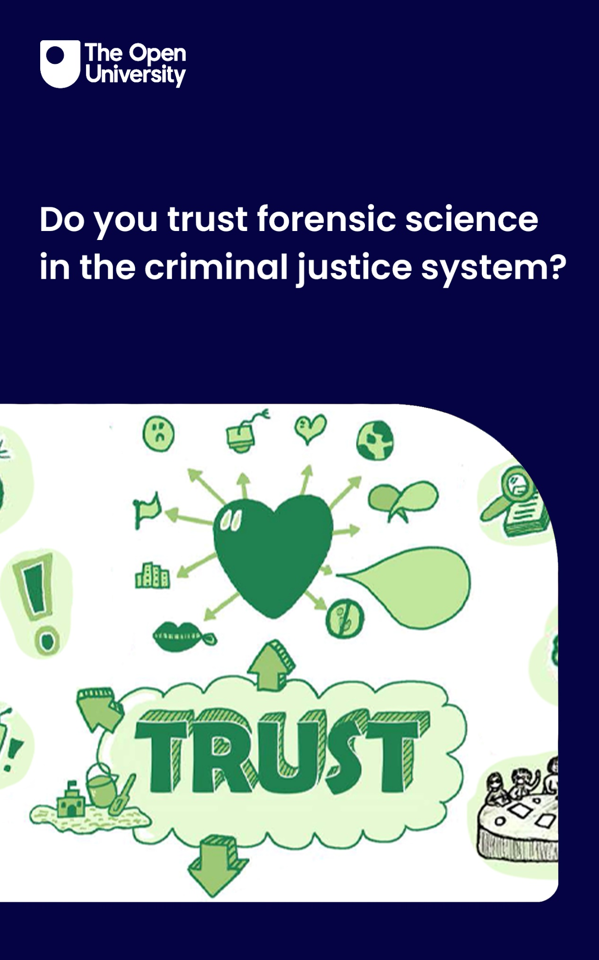

FPY_1

Do you trust forensic science in the criminal justice system?

About this free course
This free course is written by the UKRI ES/Y010639/1 team.
This version of the content may include video, images and interactive content that may not be optimised for your device.
You can experience this free course as it was originally designed on OpenLearn, the home of free learning from The Open University – https://www.open.edu/openlearn/health-sports-psychology/do-you-trust-forensic-science-the-criminal-justice-system/content-section-overview
There you’ll also be able to track your progress via your activity record, which you can use to demonstrate your learning.
First published 2026.
Unless otherwise stated, copyright © 2026 The Open University, all rights reserved.
Intellectual property
Unless otherwise stated, this resource is released under the terms of the Creative Commons Licence v4.0 http://creativecommons.org/licenses/by-nc-sa/4.0/deed.en. Within that The Open University interprets this licence in the following way: www.open.edu/openlearn/about-openlearn/frequently-asked-questions-on-openlearn. Copyright and rights falling outside the terms of the Creative Commons Licence are retained or controlled by The Open University. Please read the full text before using any of the content.
We believe the primary barrier to accessing high-quality educational experiences is cost, which is why we aim to publish as much free content as possible under an open licence. If it proves difficult to release content under our preferred Creative Commons licence (e.g. because we can’t afford or gain the clearances or find suitable alternatives), we will still release the materials for free under a personal end-user licence.
This is because the learning experience will always be the same high quality offering and that should always be seen as positive – even if at times the licensing is different to Creative Commons.
When using the content you must attribute us (The Open University) (the OU) and any identified author in accordance with the terms of the Creative Commons Licence.
The Acknowledgements section is used to list, amongst other things, third party (Proprietary), licensed content which is not subject to Creative Commons licensing. Proprietary content must be used (retained) intact and in context to the content at all times.
The Acknowledgements section is also used to bring to your attention any other Special Restrictions which may apply to the content. For example there may be times when the Creative Commons Non-Commercial Sharealike licence does not apply to any of the content even if owned by us (The Open University). In these instances, unless stated otherwise, the content may be used for personal and non-commercial use.
We have also identified as Proprietary other material included in the content which is not subject to Creative Commons Licence. These are OU logos, trading names and may extend to certain photographic and video images and sound recordings and any other material as may be brought to your attention.
Unauthorised use of any of the content may constitute a breach of the terms and conditions and/or intellectual property laws.
We reserve the right to alter, amend or bring to an end any terms and conditions provided here without notice.
All rights falling outside the terms of the Creative Commons licence are retained or controlled by The Open University.
Head of Intellectual Property, The Open University

Contents
- Week 1 Trusting forensic science
  - Introduction
  - Learning outcomes
  - 1 What is forensic science?
  - 2 Using forensic science at the crime scene
  - 3 Forensic science evidence processes
  - 4 What is trust?
  - Conclusion
- Week 2 The forensic analysis process
  - Introduction
  - Learning outcomes
  - 1 Crime scene to court
    - 1.1 Eyewitness account
    - 1.2 Forensic Biologist account
  - 2 DNA: Forensic Scientist
    - 2.1 The DNA profile
  - 3 Digital Forensic Scientist
    - 3.1 Trust generation
  - Conclusion
- Week 3 Forensic science in the courtroom
  - Introduction
  - Learning outcomes
  - 1 Crown Court at Leicester Castle Business School
  - 2 Some typical questions for DNA evidence
  - 3 Likelihood ratio calculations
  - 4 What if there’s doubt?
  - Conclusion
- Week 4: Public trust and forensic science
  - Introduction
  - Learning outcomes
  - 1 What do you think?
  - 2 Understanding trust in forensic science
  - 3 Research findings
  - 4 Why do these perceptions matter?
  - 5 What other factors affect distrust?
  - 6 Recommendations from the research
  - References
  - Acknowledgements
- Glossary
- Solutions
- Descriptions

Week 1 Trusting forensic science

Introduction
Do you trust how forensic science evidence is used in criminal investigations? Do you want to learn about how and in what circumstances police, crime scene investigators and the court would use DNA and mobile phones in a case? This four-week course takes you through a fictional crime, from crime scene to courtroom. You’ll see how the evidence is collected, analysed and presented in court. Along the way, you’ll learn about trusting the science and the scientists, with a focus on how marginalised community members experience forensic science evidence. You’ll learn about eyewitness, victim and defendant rights when forensic science is part of the criminal investigation.
Join us on this four-week journey as we follow Dave’s case from the crime scene to the court and learn more about how forensic science is used, trusted and questioned along the way.
Listen to the crime that was committed against our victim, Dave Miller. This fictional case will be used to illustrate how forensic science evidence might be used in the criminal justice system. Click on the image to play the audio, or read the transcript.

Crime: The scenario

Audio content is not available in this format.
Audio 1: The scenario
View transcript - Audio 1: The scenario

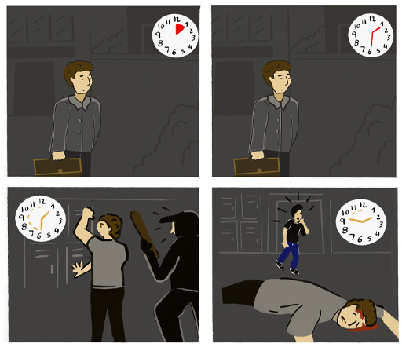

Learning outcomes
After studying this week, you should be able to:
- have an understanding of the principles of forensic science
- explore the forensic science process
- discuss concepts of trust
- consider the relationship between trust in forensic science and the criminal justice system.

1 What is forensic science?
Forensic science is often described as the science that is used to resolve a legal dispute. It might be better, and more officially, thought of as a case-based endeavour that brings a scientific and research-based approach to studying traces of a past activity, such as the presence of a person and their actions. This is undertaken through many steps, including detecting, recognising, and recovering trace materials, comparing them with other traces that are recovered, interpreting and evaluating what they mean in relation to the crime and communicating the meaning of the traces to the police, the courts and possibly the public.
The Sydney declaration (Roux et al, 2022) provides seven principles underpinning forensic science. These help in the practice, research and education of forensic science. This is important because practitioners need to be learning what and how to do their jobs and the public need to know that the scientists have the training and expertise to be trusted. The principles are, put simply:
- What people or criminals do and where they do it can leave traces which can be followed up in an investigation.
- Scientists collecting evidence at a crime scene need to have specialist training and need to treat crime scene work as a true science.
- Each case is different, but forensic scientists will apply their scientific knowledge to each case systematically to draw their conclusions.
- Forensic scientists need to consider what happens in the commission of a crime, and the possible time lag between the activity and the trace evidence being discovered and analysed.
- It is often hard to state forensic science findings with absolute certainty so forensic scientists have to be prepared to work with some uncertainty.
- Forensic science can contribute to many aspects of criminal justice including investigating and providing evidence to help prove innocence, or guilt.
- Forensic science work only has meaning when it is viewed in the context of the specific investigation or crime. You cannot necessarily lift findings from one case and apply them to another. Each case has its own unique features.
The purpose of the Sydney declaration is to emphasise the importance of forensic science and the scientist from the beginning of the investigation – at the crime scene all the way through to its end in the courtroom.

2 Using forensic science at the crime scene
Forensic science could be crucial in the investigation of this crime. It can provide objective, scientific analysis of evidence associated with alleged activity and support justice outcomes for Dave, the accused, and ultimately for everyone. In this crime, if DNA and fingermark evidence (called traces) are recovered from the weapon it might potentially identify Dave’s attacker. Digital evidence might be used to locate the person who has Dave’s phone, laptop or tablet. However, these traces may also wrongly suggest individuals not associated with the attack if those individual’s DNA or fingermarks are on the weapon or if the cell tower data isn’t precise enough.

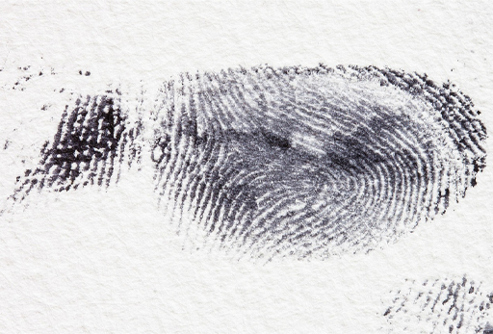
View description - Uncaptioned Figure
View alternative description - Uncaptioned Figure

One of the key issues in forensic science is that the simple presence of traces of evidence may identify an individual or an object but will not necessarily determine how those traces got to the place from where they were recovered. Similarly, the absence of traces such as fingermarks or DNA does not necessarily rule out the involvement of an individual (as they could have been wearing gloves, for example).

3 Forensic science evidence processes
In the UK there are three separate criminal justice systems (CJS). There is one in Northern Ireland and one in Scotland and they are devolved responsibilities of the respective governments. The third system is for England and Wales, and Dave’s attack occurred in England. Although investigative practices may differ across the three jurisdictions, forensic science and scientists play a critical role in helping investigators conduct effective investigations in all three jurisdictions. Here’s how it typically unfolds.
Teams of forensic scientists such as crime scene investigators (CSIs) will collect physical traces from a crime scene that may become evidence. In Dave’s case, this could mean gathering DNA samples and fingermarks from the locker room and retrieving CCTV footage from the gym’s cameras. Forensic science involves the observation, documentation, collection, analysis, and scientific interpretation of evidence during the course of an investigation (Shen & Vieira, 2016).
CSIs document the scene thoroughly: photographing the area, recording what was recovered, and from where. They follow strict protocols to prevent cross-contamination and ensure evidence remains admissible in court.

Audio content is not available in this format.
Audio 2: Crime Scene Investigator (CSI)
View transcript - Audio 2: Crime Scene Investigator (CSI)

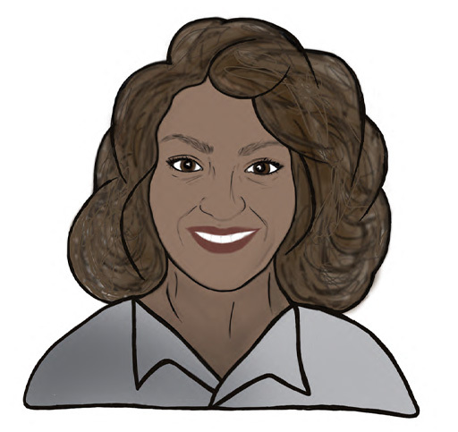

Items recovered from the crime scene will then be submitted to a forensic science laboratory, where they are logged. This chain of custody from the crime scene to the lab continues so that every item is tracked from the crime scene to courtroom. Ensuring that evidence is admissible in court requires that none of the objects collected are tampered with and that procedures follow due diligence (Yeboah-Ofori & Brown, 2020). Once the items are logged and stored, scientists decide which items to analyse and how.
Results from the items in the investigation can be checked against national databases. This is done by running DNA profiles through the National DNA Database (NDNAD), and fingermarks through the National Fingerprint Database (IDENT1), to identify matches with known offenders or links to other crime scenes. The UK’s NDNAD, set up in 1995, is one of the longest established and largest forensic DNA databases internationally. This can sometimes help to identify people who might be of interest in the investigation. In 2022/23, the overall DNA match rate from a crime scene profile to the NDNAD was 64%, demonstrating its continuing value as a tool in policing investigations (Home Office, 2023). Digital forensic experts may also examine phones, computers, or other devices for relevant data.
Forensic scientists and digital experts produce written reports of their findings, which are shared with investigators, prosecutors, and legal defence teams. They may also be called to give evidence in court, where they are required to remain neutral. Their role is to explain the science, not to support either side.

Audio content is not available in this format.
Audio 3: Digital Forensic expert
View transcript - Audio 3: Digital Forensic expert

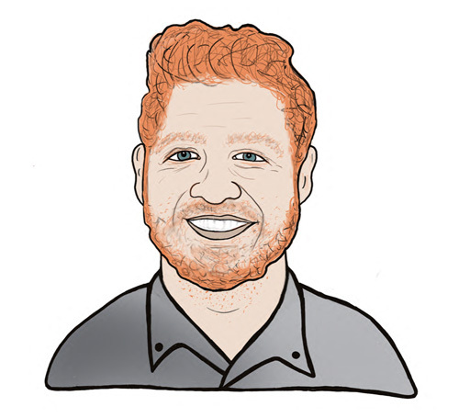

It is important to note that forensic evidence rarely tells the whole story. A fingermark might place someone at a location but says nothing about why they were there or what they intended. Research has shown that the context in which fingerprint examination takes place can significantly affect expert judgement (Dror et al., 2006). Equally, digital evidence can be manipulated; material can be planted on a device, and tampered digital evidence may jeopardise its correct interpretation (Hargreaves & Patterson, 2012). The context always matters when interpreting evidence. In Dave’s case, the attacker might have used gloves and left the tablet for someone else to take, keeping only the laptop.

4 What is trust?
In the CJS, forensic science often carries a special kind of authority. When jurors hear that DNA or digital (e.g. mobile phone) evidence might link someone to a crime, the evidence can seem powerful. Behind this influence lies a fundamental concept, that of trust.
At every step of the crime scene to courtroom process, we need to consider whether those involved – victims, the accused, eyewitnesses, and the jury – have trust in the justice system. Do they trust the police, the forensic science experts, digital evidence experts, legal practitioners, and the legal processes represented by the court? Before we get to this, we should establish what trust is.

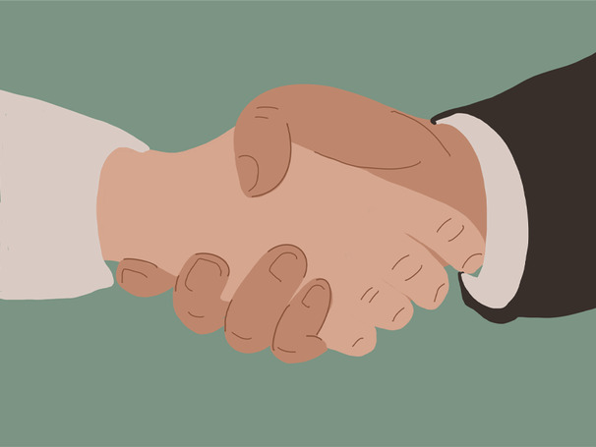
View description - Uncaptioned Figure
View alternative description - Uncaptioned Figure

Simply put, trust means believing what someone is telling you because you think they are being honest (Mayer et al, 1995). In forensic science, trust is important on several levels. First, we need to trust that forensic evidence is properly collected and stored. Second, it means that there is trust that scientific methods are properly used to analyse the evidence and that those methods are reliable and applied without bias. Third, there should be trust in the institutions, and this includes the police, laboratories, and the legal system.
Since it was first used, forensic science was seen as a ground-breaking tool for aiding the investigation of crime, and its evidence had been viewed as objective and nearly infallible. Crime shows on TV reinforced this by presenting forensic results as clear-cut and definitive. However, academic research over the past few decades has shown that forensic evidence is not necessarily the failsafe it was thought to be (Chin & Ibaviosa, 2022; Rosenblum et al, 2024). In fact, there have been a few instances where forensic science evidence was wrongly interpreted, and this has led to a crisis of credibility in forensic science. Government, policymakers, and academics have acknowledged that forensic science is not trusted as it once was and that the public have lost confidence in it (UK House of Lords, 2019).
Trust also depends on context. If evidence is ambiguous, we might see it as supporting our opinion even if it does not. For example, just because the gym manager’s fingerprint was on Dave’s locker, meaning it was found at the crime scene, does not make him guilty. The manager’s fingerprint might be there for many reasons, e.g. he used that locker earlier in the day, he noticed some dirt on it and wiped it with his hand. We should not use that information to lay the guilt on the manager even if we think he is the suspect.
Research shows that when something is unclear, we are more likely to see it as supporting what we already believe, this can be devasting for a suspect if the evidence is not clear but we think someone is guilty (Kassin et al, 2013). It might happen with forensic experts as well; they might not intentionally act in bad faith but their decisions reflect broader findings from psychological research showing that human decision-making is susceptible to bias (Mingboyeva, 2026).
Research has been carried out to try and make the criminal justice system fairer, or more trustworthy. As a result of this research various procedures have been brought in that try to help everyone make better decisions. One example of this is called sequential unmasking. In this procedure a forensic examiner analyses evidence BEFORE they see information that might bias their judgement. In Dave’s case, sequential unmasking could help ensure that the forensic scientist analyses the crime scene evidence (e.g. fingermarks or DNA) independently, then learns information about the suspect. This reduces the risk that the forensic examiner interprets ambiguous evidence in a biased way, for example that points too strongly to one suspect, such as the gym manager, over another.
Communication is another crucial element of trust. Forensic experts often present their conclusions in court, but research suggests that jurors may misunderstand the meaning of forensic statistics or the certainty of an expert’s opinion. Overstating the strength of evidence, for example by implying that a result uniquely identifies a suspect, can unintentionally exaggerate what the science actually supports (Rosenblum et al., 2024).
Seen in this light, trust in forensic science is not simply about believing experts. It is about creating systems that deserve confidence. Reliable methods, transparent procedures, and honest communication about uncertainty all contribute to evidence that the public can reasonably trust.
Forensic science has enormous potential to help uncover the truth in criminal investigations. But its power depends on something less visible than microscopes or databases: the careful construction of trust.

Conclusion
In the UK, forensic experts are meant to be independent (Crown Prosecution Service, 2024). Their duty is to the court, not to whoever hires them, which helps build confidence that the evidence they give is fair and unbiased. But trust in forensic science is not as simple as it sounds.

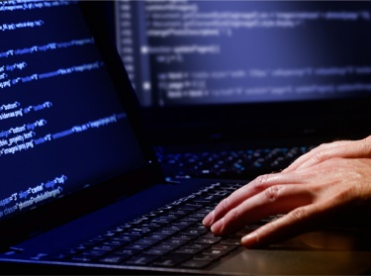
View description - Uncaptioned Figure
View alternative description - Uncaptioned Figure

Over the past couple of decades, researchers and policymakers have raised concerns about how reliable some forensic techniques really are, and whether the system itself has the funding, structure, and expertise it needs (see Jhalani et al.’s 2025 paper for an overview).
Public expectations also play a big part. You might have heard of the ‘CSI effect’ or the idea that TV shows like CSI make forensic science look fast, foolproof and incredibly precise. In reality, it is often slower, more complex and less certain, which can lead to misplaced confidence (Chin & Ibaviosa, 2022).
Healthy trust, or believing in forensic science and simultaneously scrutinising it, is key to ensuring justice is both done and seen to be done.
In this week, you were introduced to Dave and the crime committed against him. You learned what forensic science is, what trust is, and how people may or may not trust forensic science evidence as it is used in the CJS.
In the next session, the crime against Dave will unfold and you will hear directly from the police, forensic scientists, and others about how they work with forensic science in criminal cases.
Now go to Week 2.

Week 2 The forensic analysis process

Introduction
In order to learn more about the forensic analysis process you will return to the case of Dave which you learned about last week. You will consider the crime scene, the police investigation, and the forensic laboratory as settings where forensic evidence is identified, collected, documented, recorded, recovered, analysed, evaluated, and reported.
You will also consider whether or not Dave should trust the forensic evidence in his case. This means seeing if Dave can have confidence in how potential evidence has been identified, collected, and recorded from the scene. It also means seeing if Dave should feel confident about how potential evidence is analysed and how the data from these tests are evaluated and reported by different experts as part of the investigation.
Next week we will consider the process that happens in the court.
If you need a recap, take another look at The scenario in the Week 1 Introduction.

Learning outcomes
At the end of the week, you should be able to:
- understand how forensic science evidence is collected and used
- better understand when to trust forensic science evidence at the crime scene and in the laboratory
- differentiate between trusting the police investigator, victim, eyewitness, and the scientist.

1 Crime scene to court
Look at the crime scene to courtroom process diagram. Click on the tiles labelled with the different roles to find out what each person does.

Crime to courtroom diagram
View description - Crime to courtroom diagram

Activity 1 Considering other perspectives
10 minutes

Now, considering this process above, listen to an account of what happened.

Audio content is not available in this format.
Audio 1: Narrator
View transcript - Audio 1: Narrator

Now listen to Dave’s experience.

Audio content is not available in this format.
Audio 2: Dave
View transcript - Audio 2: Dave

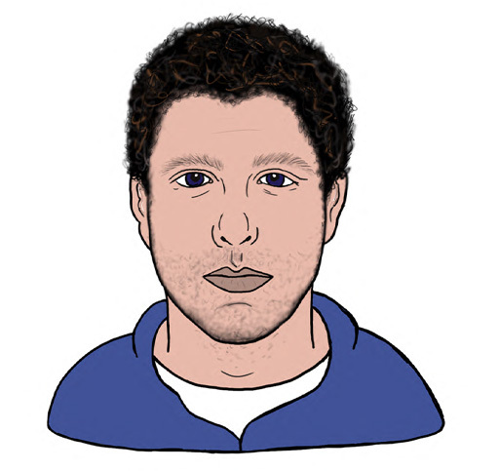

If you were Dave, what would you think about the police?

I’d trust them
I wouldn’t trust them
I don’t know
View answer - Activity 1 Considering other perspectives

Research shows that public trust in the police has been declining (Cotter, 2015). Recent surveys indicate confidence fell from 58% in 2019 to 49% in 2022 (YouGov, 2019; 2022). Dave’s feelings about the police might be representative of the general public’s view. It can be difficult to distinguish between trust in the police and trust in forensic science evidence, since the two are often connected. For marginalised communities, such as ethnic minorities or those with prior negative experiences of law enforcement, this distinction can be even more blurred — people may trust the science but distrust the system delivering it (Trust interviews, 2025).

1.1 Eyewitness account
An eyewitness has come forward; she was walking past the gym entrance and has provided evidence on what she saw. Below is what the witness says:

Audio content is not available in this format.
Audio 3: Eyewitness
View transcript - Audio 3: Eyewitness

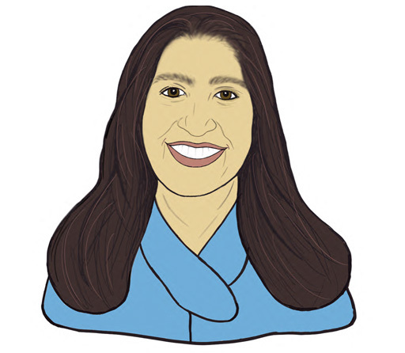

Activity 2 Trust
5 minutes

Do you think the eyewitness should be trusted?

yes
no
I don’t know
View answer - Activity 2 Trust
View discussion - Activity 2 Trust

Now listen to the Crime Scene Investigator (CSI):

Audio content is not available in this format.
Audio 4: Crime Scene Investigator (CSI)
View transcript - Audio 4: Crime Scene Investigator (CSI)

Activity 3 Crime Scene Investigator focus
5 minutes

Investigating the scene: If you were the police investigator in Dave’s case, what would you ask the Crime Scene Investigator (CSI) to look for at the crime scene (the gym locker room) to help identify a culprit or assist in determining whether a crime had been committed?

Provide your answer...
View discussion - Activity 3 Crime Scene Investigator focus

1.2 Forensic Biologist account
The CSI identified and recovered the baseball bat at the crime scene. Pictures of the blood spatter at the scene were taken for later analysis and evaluation by a blood pattern analyst. The main items of evidence in this case involve potential DNA from blood and the baseball bat, fingerprints, digital evidence and any subsequent items that may be recovered, such as Dave’s clothing which will be documented, recovered, packaged, and submitted to the laboratory.

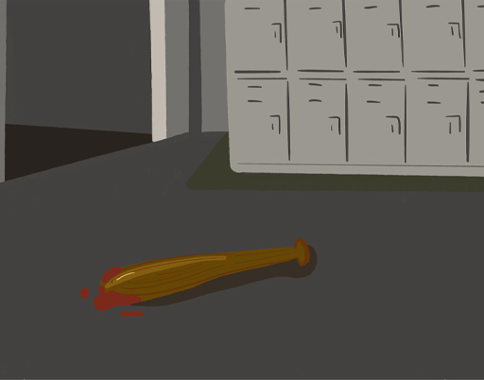
View description - Uncaptioned Figure
View alternative description - Uncaptioned Figure

Here you can see what a forensic science laboratory looks like, this is where a forensic scientist might examine items of potential evidential value in detail.

Video content is not available in this format.
Video 1: De Montfort University forensic science laboratory (recording by Emma Johnston)
View transcript - Video 1: De Montfort University forensic science laboratory (recording by Emma J ...

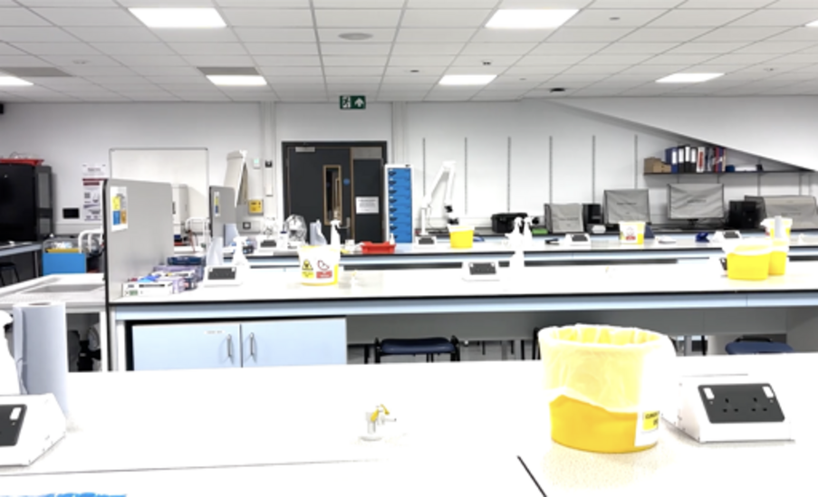

Now that you’ve seen the laboratory, listen to what the forensic biologist says about Dave’s case.

Audio content is not available in this format.
Audio 5: Forensic Biologist
View transcript - Audio 5: Forensic Biologist

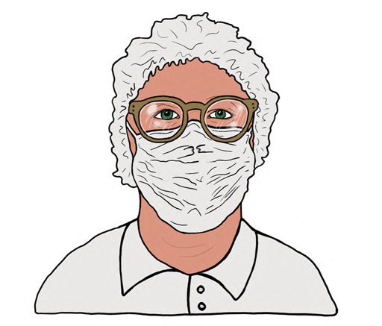

2 DNA: Forensic Scientist
Forensic scientists specialise in different areas, using scientific methods to analyse traces recovered from crime scenes and items recovered from victims and suspects. They interpret the data produced from their analysis and evaluate their findings within the context of the specific case.

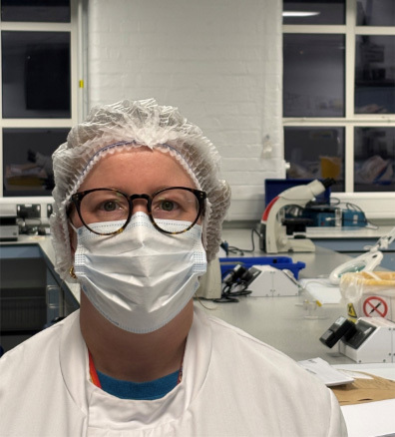
View description - Uncaptioned Figure
View alternative description - Uncaptioned Figure

In this case, a Forensic Biologist (DNA), Fingerprint Expert, and a Digital Forensic Expert would likely be involved. We will go through the DNA and digital expert roles.
Forensic Biologists examine biological traces like blood, other body fluids, hair, and DNA swabs. They receive traces recovered from the crime scene, and they document these items in detail, often including diagrams and photographs. They may conduct tests, typically by swabbing to see whether a body fluid is present on the item and then collect a sample of it. If a DNA profile is needed from the collected samples, a number of lab processes are carried out:
- DNA is extracted from the cells.
- Copies of the DNA are made through a process called Polymerase Chain Reaction (PCR).
- DNA fragments are separated and visualised to produce a DNA profile.
- A DNA profile from a crime scene can then be compared to the profile of a victim or suspect to see if they are the same or different.
- Unknown DNA profiles may be loaded onto the National DNA Database to search for matches.
- Results of such analyses can be provided in a statement and presented in court. This is done by a likelihood ratio which will be discussed in Week 3.

2.1 The DNA profile
In Dave’s case, the Forensic Biologist would examine the baseball bat and any clothing recovered from the victim / suspect, testing any red / brown staining for potential blood. A Blood Pattern Analyst may be able to interpret the distribution of staining on the baseball bat and in the locker room to reconstruct how the blood may have come to be where it was found. A sample of the blood on the baseball bat would be analysed for DNA. DNA analysis could also be performed on samples from the baseball bat handle.
Research has shown that it is possible for a person to handle an item and leave very little / no DNA behind, or for a person’s DNA to be transferred to an item / surface without direct contact – a process known as secondary or tertiary transfer (DNA Judicial Primer, 2025; van Oorschot et al., 2019).
A DNA profile generated from the swab taken of the blood on the baseball bat and from the baseball bat handle would be compared with a reference DNA profile from Dave. This is done so that the police know to rule out Dave’s DNA when they are looking for a suspect.
In our case, the DNA profile obtained from the swab of the blood on the baseball bat was indistinguishable from Dave’s DNA profile. This would be reported as ‘the DNA profile matched the DNA profile from the victim Dave’.
The DNA profile obtained from the swab of the handle of the baseball bat did not match Dave’s DNA profile and was unidentified. This DNA profile was then compared against DNA profiles held on the UK National DNA Database; however no match was returned. The interpretation of these results will be covered in Week 3.

3 Digital Forensic Scientist
Digital devices such as computers and mobile phones are typically seized by non-expert police officers. Typically, they are seized from individuals, during property searches, and from scenes of crime. Seizing officers should follow procedures for the recovery of digital devices that helps to maintain the integrity of data held on those devices, while also considering device security features that can make them challenging to analyse later.

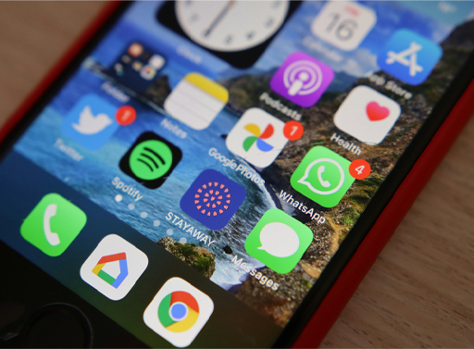
View description - Uncaptioned Figure
View alternative description - Uncaptioned Figure

Digital forensic experts recover and analyse data stored on digital devices that have been seized, to identify salient evidence that could be used to progress an investigation and be presented and tested in court. Where possible, experts will make an exact copy of a device, analysing the copy to preserve the state of the original device. Data extracted from devices can include digital artefacts such as documents, emails, texts, instant messages, images, and internet history. Digital forensic experts are trained to use specialised software to help them identify digital evidence. They use techniques such as:
- Keyword searches to find information containing specific words and terms. In Dave’s case, this might involve anyone else who was a gym member. Dave might have been in contact to let them know he’d be at the gym late. They could think he’d be an easier target as there weren’t other people around to witness the attack and theft.
- File filtering to isolate files that match certain criteria (e.g. over a certain size, of a certain type such as a video).
- Timeline analysis that helps in the identification of files and other digital artefacts that have been created, modified, or accessed during specific periods of time.

Audio content is not available in this format.
Audio 6: Digital Forensic expert
View transcript - Audio 6: Digital Forensic expert

3.1 Trust generation

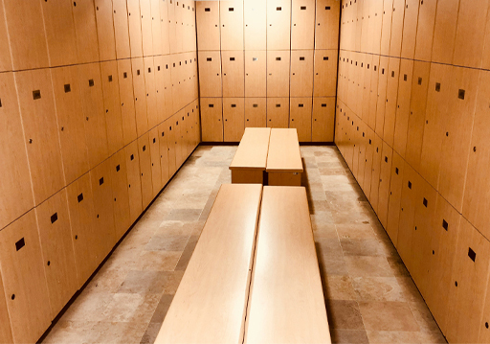
View description - Uncaptioned Figure
View alternative description - Uncaptioned Figure

This activity looks at trust generation in the crime scene and laboratory practices.

Activity 4 Trust in the forensic process
10 minutes

Do you trust the forensic analysis process in Dave’s case so far?

yes
no
I don’t know
View answer - Activity 4 Trust in the forensic process

The mishaps could occur at different points in the forensic process from the crime scene to the laboratory. This could be in any of the following:
- contamination
- expert misconduct
- bias of experts
- inaccurate analysis
- unqualified examiners and analysts
- unvalidated techniques
- other

- Learn more about this here:
- In the USA, research shows that although members of the public believe forensic science remains a key part of criminal investigation, they perceive a high risk of error ‘about half of the time at each stage’ of the forensic process. This makes the public sceptical about the accuracy of some forensic science techniques (Kaplan, et al., 2020). Generally, errors in forensic science can be caused by practitioner, analytical, or systemic failures and may contribute to wrongful convictions. These mistakes are therefore drivers of distrust.
To help mitigate this, oversight and regulatory measures have been established in many jurisdictions, such as the Forensic Science Regulator in England and Wales and the Organisation of Scientific Area Committees (OSAC) for Forensic Science in the USA. These bodies aim to ensure and improve the quality and reliability of forensic evidence provision, such as by establishing quality standards, ensuring accreditation of forensic science service providers (FSPs), competency of practitioners and investigating and sanctioning FSPs for failures and practices that do not meet required standards.

Conclusion
This week you learned more about the different experts involved in the investigation of a potential criminal case.
In England and Wales, the police oversee the investigation, which can vary between being straightforward or being very complex. The Senior Investigating Officer (SIO) has oversight of a case and may lead discussions about what items recovered from the scene are prioritised for scientific analysis. In Scotland the investigation is overseen by the Crown Office, Procurator Fiscal Service (COPFS) and a lawyer called a Procurator Fiscal, who all work together with the SIO in making decisions.
Next week we’ll see how the forensic evidence is used in the courtroom.
Go to Week 3.

Week 3 Forensic science in the courtroom

Introduction
This week we focus on the courtroom. The forensic evidence in Dave’s case has been provided to the prosecution’s legal team by the police and the forensic scientists. A suspect (Mike) has been identified using the DNA and digital evidence that you learned about in Week 2. We will now visit the court to see how the evidence is presented. Most importantly, we will consider whether Dave can and should trust the forensic evidence as it is presented in the courtroom.
If you need a recap, take another look at The scenario in the Week 1 Introduction.

Learning outcomes
At the end of the session, you should be able to:
- explain how DNA and digital evidence are presented in court
- think of questions that lawyers or judges might ask about DNA and digital evidence in court
- spot and reflect on limitations that can affect how reliable forensic evidence seems in court.

1 Crown Court at Leicester Castle Business School
Watch this short video and explanation of the layout of a courtroom. In case you need a recap, remember the Crime to courtroom diagram in Week 2.

Video content is not available in this format.
Video 1: Layout of a courtroom
View transcript - Video 1: Layout of a courtroom

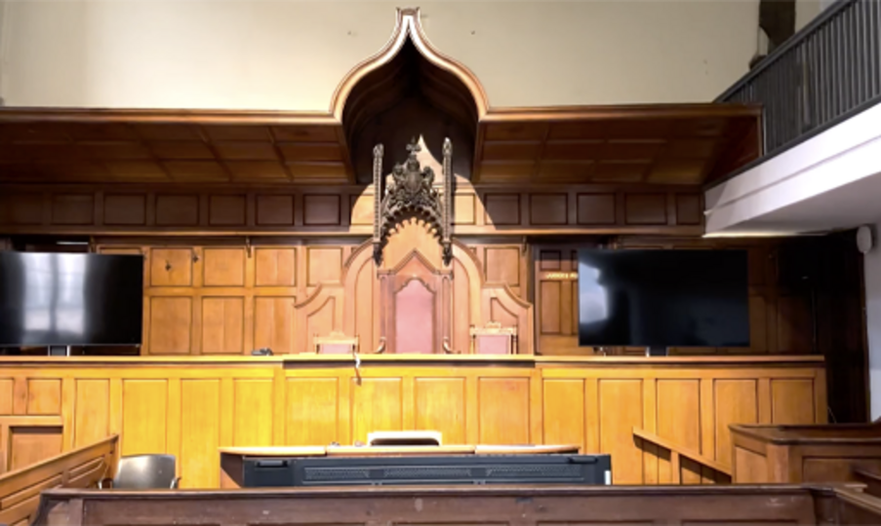

This is the sort of courtroom in which Dave’s case would be heard. Click on the image to listen to the audio or read the transcript.

Audio content is not available in this format.
Audio 1: The courtroom
View transcript - Audio 1: The courtroom

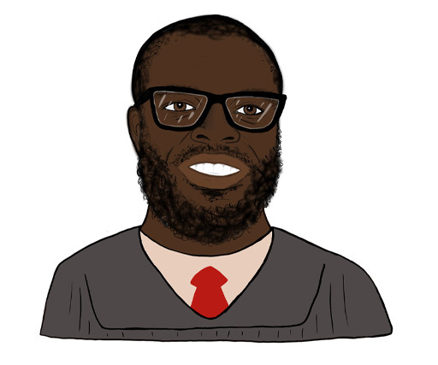

Dave’s case goes through the typical process which is that the expert witnesses are called by the prosecution (Leonetti, 2024), though experts could be called by the defence or the court itself. The experts present DNA and digital forensic evidence to inform the court rather than to provide evidence for the side (defence or prosecution team) that hired them. The expert’s main duty is to help the court by interpreting the scientific findings and evaluating these findings by offering opinions as to their meaning within the case context. The opinions will be presented in the form of a written report, oral testimony, or both, by the forensic scientist who undertook the analysis and authored the report.

Activity 1 Remaining impartial
5 minutes

How easy or difficult do you think it would be for the expert witness to remain impartial in court and not be influenced by the defence or prosecution team that hired them in court?

easy
neither easy nor difficult
difficult
View answer - Activity 1 Remaining impartial

The prosecution will begin questioning the expert during what is known as examination in chief. Afterwards, the defence will have the same opportunity to ask the expert further questions based on their evidence and answers during examination in chief, during what is known as cross-examination. These questions oppose each other as they are used to address the prosecution or defence arguments to show guilt or innocence. During testimony, experts must respond directly to the questions asked and remain impartial. Further, they must communicate their scientific findings, staying within the bounds of their expertise. The evidence must be relevant and help the court answer specific questions about the case. The trustworthiness of the expert and their evidence, whether in written form or spoken testimony, should follow guidance from the International Organization for Standardization which advises on best practice on how to report forensic science evidence (ISO 21043 Part 5). The expert’s evidence will depend on:
- accuracy
- scientific underpinning and robustness of their analysis
- clarity, including explaining complex scientific techniques in lay person’s terms
- transparency
- completeness
- lack of ambiguity
- impartiality
- suitability for its intended purpose.

2 Some typical questions for DNA evidence
Acting as a lawyer in this case, consider questions that you would ask the DNA expert in court. You need to be able to justify why these should be asked.

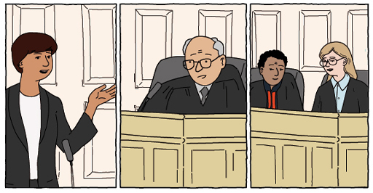
View description - Uncaptioned Figure
View alternative description - Uncaptioned Figure

The following are some questions that may be asked of the DNA expert by both the prosecution and defence lawyers. We would explore whether the expert can or cannot provide opinions to address them. These are:
- Is there DNA on the bat? Is the DNA present from a single source or multiple sources, and how could multiple sources be accounted for?
- Whose DNA is on the bat, and how sure are you of that result?
- What activities could result in a person’s DNA being transferred to the bat?
You might think that a question such as ‘is the person whose DNA is on the bat the perpetrator of the crime?’ might be asked, but that is what is known as an ‘offence level question’. An offence level question is one that the prosecution and defence teams need to make arguments for and against, and ultimately the jury would weigh the evidence to make a decision. Scientists would and should not answer offence level questions like that.
It is likely that the digital forensic expert in the case would be questioned in a similar way, though about digital evidence.
The trustworthiness of both the scientific tests and the expert’s interpretation of the scientific results will depend on how clearly the expert explains what the evidence means within the case context, what the limitations of the evidence are, and how this is communicated (more on this in Week 4).
To answer the question about certainty of whose DNA is on the bat, the DNA expert would report the results of a statistical calculation which evaluates how likely it is that the DNA found on the bat belongs to the suspect (Mike), compared to how likely it is to belong to someone else in the ‘world’ who is unrelated to the suspect. This calculation is called a likelihood ratio. In trying to communicate this information to the court, the expert might say something like:

‘Analysis of the DNA recovered from the bat gave a full DNA profile that matched that of the suspect. If the DNA evidence did not come from the suspect, then the DNA profile must match by chance. It is estimated that the chance of obtaining these matching profiles if the evidence came from a random person unrelated to the suspect is in the order of 1 in a billion (where a billion is a thousand million).’

Research has shown that, since the introduction of the use of likelihood ratio calculations in the late 1980s, both legal practitioners and juries have found it difficult to understand, and this difficulty remains to this day (Morrison et al., 2025).

3 Likelihood ratio calculations
In simple terms, the expert is communicating that:
- DNA that matches the suspect’s (Mike) DNA is on the bat.
- The chances of this DNA profile being obtained from someone other than the suspect are very small.
- On the basis of (1) and (2), it is more likely that Mike’s DNA is on the bat than someone else’s DNA.
However, these interpretations do not mean that Mike actually handled the bat, or, as will be of utmost interest to the court, whether he hit the victim with the bat. So, while the likelihood ratio of the DNA evidence may answer the first and second question (is there DNA on the bat?), and (who’s DNA is that most likely to be?), it cannot reliably answer the third question (how Mike’s DNA came to be on the bat). How Mike’s DNA came to be on the bat is an activity-level question. The activity-level question is the one the jury will need to decide by weighing the evidence provided and determining whether they think Mike is the person who committed the alleged crime.
During the cross-examination, the defence lawyer may contest the answers to all questions but the answer to the third question should be one of particular interest to both lawyers and the court. Research has shown that it is possible for a person to handle an item and leave very little to no DNA behind, or for a person’s DNA to be transferred to an item or surface without direct contact. This is a process known as secondary or tertiary transfer (DNA Judicial Primer; 2025, van Oorschot et al, 2019).
A good line for challenging the activity-level question might be from where (location) on the bat the DNA was recovered, and how and when the DNA got there. For example, if Mike used the bat to hit the victim, then it would be expected that the victim’s DNA may be transferred, remain on, and be recovered from the blood-stained area, and Mike’s DNA could be transferred and remain on the bat handle to be recovered. The expert could consider how likely (probable) it is that Mike’s DNA was transferred to the handle of the bat through direct contact or via a different transfer mechanism and then persisted on the bat handle.
Likelihood in Dave’s case
But remember from Week 2 that Mike stated that he was a member of the gym, frequented the locker room, but had nothing to do with the alleged attack. If he handled the bat at any time, innocently, his DNA could have been left on the handle. It could also be transferred to the bat from the locker room environment, without direct contact (secondary or tertiary transfer), although this may be less likely.
Both of these are equally likely; however, the likelihood of transfer and persistence might be different, and is based on what is known about the persistence of DNA on baseball bat handles and what impacts that (time since handling, pressure, humidity, environmental conditions, etc.).
The biggest task for the expert in providing any opinion towards question three will be to consider the likelihood of finding Mike’s DNA as a result of holding the bat to hit the victim, as opposed to the same likelihood of Mike’s DNA on the bat for other reasons that are unrelated to the alleged crime. The expert has to determine these likelihoods (probabilities) before they can offer an opinion regarding the likelihood of obtaining the DNA as a result of a particular activity. However, this has not been possible in our case. Therefore, question three is outside the ability and expertise of the expert, and all that the expert can reliably provide, at this point in the case, is an opinion about the likelihood of finding Mike’s DNA on the bat.
Forensic experts might be able to assess how the DNA evidence was transferred to the bat, how long it has remained on it, and how it was recovered from the bat. However, this is complex and remains an area of debate in forensic science (Hunt, 2025; Stacey et al., 2025). Even when experts can provide this information, they cannot say what actually happened. For example, if Mike’s DNA is found on the bat, they cannot determine whether it got there before, during, or after the alleged incident.
Like all forensic evidence, the expert’s role is to support understanding, not decide the case. The final decision rests with the court, which considers all the evidence together, including the presence of DNA, to determine what is most likely and whether Mike is guilty or not guilty.

4 What if there’s doubt?
Can the suspects commission their own expert witness?

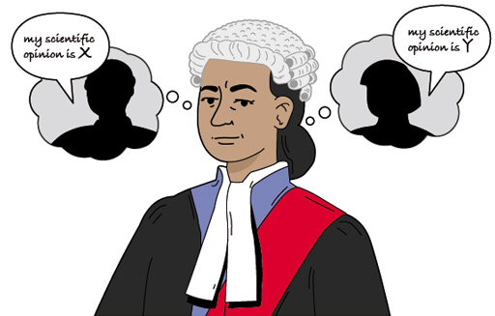
View description - Uncaptioned Figure
View alternative description - Uncaptioned Figure

Yes. The law governing expert evidence in England and Wales (known as the Criminal Procedure Rules, Part 19, and Practice Directions, Part 7) allows the suspect to commission their own expert witness, such as via state-funded legal aid. The defence expert can review the forensic science data from the tests undertaken and the interpretation and evaluation provided by the prosecution’s expert or carry out additional tests.
There are similar provisions for the use of defence experts in Scotland and in Northern Ireland.

- Did you know about the possibility of commissioning a defence scientist through legal-aid?
yes
no
- There is no correct answer but if you clicked ‘no’, you can find out more about legal-aid here.

The Criminal Procedure Rules and Practice Directions also permit Pre-hearing Discussion between the experts. This is where both the defence and prosecution experts meet, before the case trial in court, to identify areas of agreement and disagreement on the forensic evidence. A joint report is then written by both experts summarising these points, which would be presented during the court trial. This, in addition to effective cross-examination, helps the jury, who ultimately decide how much weight to give the expert evidence, to see where the experts align and where they differ. These procedures are designed to protect the court from conflicting opinions and misinterpretations.
Yet, in practice, limitations of both the legal system and forensic science can play out in the courtroom and impact how trustworthy the evidence appears. If an expert makes mistakes, through biased interpretation, poor communication, lack of clarity, exaggerating or decreasing the strength of the evidence, or struggling to explain complex numerical values and probabilities in plain language, the credibility of the evidence may suffer. Similarly, if the jury is disengaged or overwhelmed by the expert evidence, if lawyers fail to ask the right questions, or the judge erroneously allows inaccurate evidence to be admitted, all of this will ultimately impact the reliable use and trust of the forensic evidence. This might contribute to the wrongful conviction of an innocent person, and research shows the contribution of inaccurate forensic science to such miscarriages of justice (Morgan, 2023). This could hurt Dave’s case if it goes to trial.

Conclusion
Forensic evidence doesn’t speak for itself. How it is identified, collected, documented, recorded, recovered, analysed, evaluated, and reported all effect whether it is ultimately trusted.
In the CJS, forensic scientists work within an adversarial setting. This means they may be instructed by the prosecution, the defence, or sometimes both. Regardless of who instructs them, their role is to act as independent experts, using science to analyse evidence and explain what it means in the context of a case.
However, the pathway to that analysis matters. Decisions made in an investigation, such as which items are sent for testing, what questions are asked, and which lines of inquiry are pursued, can shape the scientific work that follows. These choices may subtly influence how evidence is interpreted.
Because of this, forensic scientists and expert witnesses have a crucial responsibility: they must remain objective, transparent, and independent, ensuring the integrity of their evidence at all times (Roberts, 2009).
Trust in forensic evidence is not only about the science itself. It also depends on how well that science is analysed, evaluated, and reported in court.
This week we looked at the courtroom. The police and the forensic scientists shared Dave’s case with the prosecution’s legal team and a suspect, Mike, was identified using DNA and digital evidence.
Next week we’ll see what research underpins this work. For example, we’ll look at how different groups of people trust and distrust forensic science and their impact on criminal investigations and outcomes.
Now go to Week 4.

Week 4: Public trust and forensic science

Introduction
This week, the research carried out by the team who authored this course will be presented. Specifically, we will examine how different groups of people, including those who have and have not interacted with the Criminal Justice System (CJS), such as victims or suspects, trust or distrust forensic science. We will also look at the drivers of trust and distrust and their impact on criminal investigations and outcomes.
If you need a recap, take another look at The scenario in the Week 1 Introduction.

Learning outcomes
By the end of this week, you will be able to:
- examine how people view trust and distrust in forensic science, and what impact these views have
- explore the research around what increases trust and distrust in forensic science
- reflect on potential changes to address public distrust in forensic science.

1 What do you think?

Activity 1 Is there enough evidence?
10 minutes

You’ve now seen all of the evidence in Dave’s case. This includes:
- DNA recovered from blood on the baseball bat and from Dave’s clothing,
- fingerprints from the baseball bat,
- digital files from Dave’s devices (recovered on the suspect Mike),
- the eyewitness statement and
- Rob’s (the cleaner who found Dave) statement.
The digital devices could have had evidence about who Dave was in contact with, e.g. letting someone know he’d be at the gym or have recordings Dave might have taken at the gym of his exercise routine. The traces that were gathered during the investigation from the bat and clothing underwent examination in the laboratory and would have been presented in a report by a forensic science expert. You now need to consider all of the evidence in order to attempt to deliver justice for this case.
- Based on what you have read, do you think there is enough evidence to take the case to trial?
- If it did go to trial and you were sitting on the jury, based on the evidence, would you acquit or convict?

Provide your answer...
View answer - Activity 1 Is there enough evidence?

2 Understanding trust in forensic science
In Week 1, we learned that trust is transactional. Specifically, within the CJS, trust is known to be shaped by people’s experiences and interactions with institutions and procedures. Whether people will trust or distrust depends on whether they believe these institutions are/will be fulfilling their roles properly and fairly, in line with the overall purpose of the CJS (Bradford et al., 2008). Trust can be interpersonal (between individuals) or institutional (confidence in systems and structures). It is therefore a subjective experience that differs between (groups of) individuals.

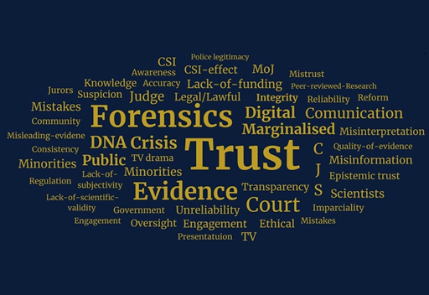
View description - Uncaptioned Figure
View alternative description - Uncaptioned Figure

3 Research findings
From 2024–2026, a team of experts including forensic scientists, criminologists, and psychologists set out to tackle a deceptively simple question: what does it really mean to trust forensic science evidence?
The team, who are the authors of this course, focused on two types of evidence, DNA and digital data recovered from mobile phones, to examine if trust varies depending on who you are, your experiences, and your role in relation to the justice system. And they found that it does, somewhat.

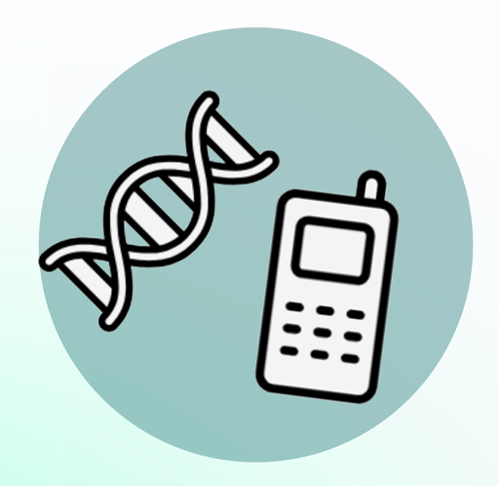  View description - Uncaptioned Figure  View alternative description - Uncaptioned Figure | Results of interviews with criminal justice stakeholders (forensic scientists, police officers, lawyers, magistrates, and civil servants) found that they  - believe the public generally trusts forensic science but that trust weakens when it is associated with policing or government institutions  - believe that poor communication and limited transparency about how forensic science is used in the CJS may negatively affect public perceptions.

The general public (people across England and Wales) participated in an online survey and reported they
- trust forensic science and scientists, but are sceptical of the police and government that use forensic science
- were either ‘familiar’ or ‘very familiar’ with the term ‘forensic science’, with most learning about it from TV and popular media. 97% of a 300 person sample reported this
- have greater trust in private forensic laboratories than in police laboratories, reflecting lower trust in policing
- are unsure about their rights and what actions to take when asked to provide DNA or digital data that may be used as evidence.

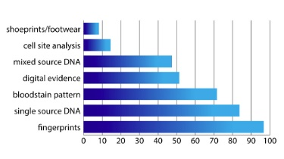
Kapageorgiadou et al., (in preparation)
Familiarity with types of forensic science evidence (Scale 0–100%)
View description - Familiarity with types of forensic science evidence (Scale 0–100%)
View alternative description - Familiarity with types of forensic science evidence (Scale 0–100%)

Members of seldom heard communities (young people (16–17-year-olds), immigrants, people who are homeless, ethnic minorities, in recovery for addiction, those who have been convicted of crimes, who have suffered domestic abuse, or have low levels of literacy) reported
- variable and often lower levels of trust than the general public. These are shaped by general distrust of authorities and barriers to accessing clear, reliable information, e.g. what evidence must be provided, what happens to their DNA or phone if they agree to give it as evidence
- the lowest levels of confidence in the police, lawyers, how evidence is interpretated, and fairness in court procedures compared to other populations
- low levels of trust in both public versus private laboratories
- barriers to understanding rights about what forensic evidence ‘must’ vs ‘could’ be turned over to investigation teams
- greater reliance on community networks than police for advice and information
- a desire for clear, in-person guidance, particularly around what evidence must be provided and individuals’ rights
- commonly learning about forensic science through TV documentaries (preferred over fictional portrayals), but uncertainty about their accuracy.
The chart shows that people from marginalised subgroups differentially trust in how police use DNA and digital evidence and differential trust in public and private labs. People are not confident about what evidence they are required to handover for a police investigation.

Perceptions of forensic science evidence (Scale 0–10). Focus groups with marginalised communities (2024).
Dempsey et al., (in preparation)
View description - Perceptions of forensic science evidence (Scale 0–10). Focus groups with marginalised ...

4 Why do these perceptions matter?
Our research findings show that trust influences people’s willingness to collaborate with police investigations, meaning that they might not come forward with evidence critical to resolving the case. For instance, they may have a video of a crime on their mobile phone but are unwilling to give it to the police for fear the police would find incriminating information about them unrelated to the crime. This lack of sharing potentially relevant evidence can severely impact case investigations and outcomes (Kaplan-Damary et al, 2025; Ingemarsson et al., 2024).

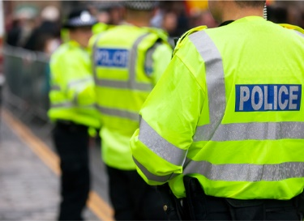
View description - Uncaptioned Figure
View alternative description - Uncaptioned Figure

Some people, and especially those from communities that are rarely heard, don’t fully understand how the CJS works. At the same time, they are often more affected by it, sometimes as victims of crime. For those who do have experience with the system, their understanding often comes from past contact. Unfortunately, this experience can lead to distrust, especially if they felt they were treated unfairly or that the system was biased against them.
Many people said they want to help the police, for instance by sharing evidence, because they believe it’s the right thing to do. But, they worry about how this might affect their relationships within their community and fear they could be seen as betraying their own.
When people were shown a video of someone sharing footage of a crime with police to help an investigation, 87% (out of approximately 250 people) agreed this was the right thing to do. However, when asked if they would allow police to access their phone directly, most were uncomfortable with this. They preferred to keep control and share photos or videos themselves, e.g. by email.
This helps explain the wider issue of criminal cases not having enough evidence. Across England and Wales, the number of cases leading to a criminal charge has fallen. Between 2016 and 2023, charging someone for a crime dropped significantly (from 11.1% to 4.6% for crimes involving a victim), though there was a small increase in charging rates in 2024.
A key challenge to charging someone with a crime are ‘evidential difficulties’. This means there is not enough solid evidence even if a suspect is known. It could be due to lack of sufficient physical evidence or because victims or witnesses are unwilling to support the case.

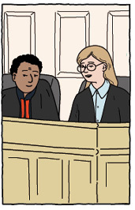
View description - Uncaptioned Figure
View alternative description - Uncaptioned Figure

5 What other factors affect distrust?
There are a number of factors that might influence trust or distrust of forensic science for example,
- Forensic evidence could be present in a case, but the prosecutorial service (the CPS in England and Wales or Crown Office in Scotland) thinks that the evidence presented by the prosecution is not sufficient to meet the threshold of charging and/or admissibility in court.
- There could be concerns about the impartiality of scientists working in laboratories.
- There might be inadequate funding for police to undertake sufficient forensic science analysis.
- The cost of compliance with regulation could cause forensic laboratories to be dismissive about accreditation.
Our research (Kapageorgiadou et al., 2024) identified that these were some of the structural or systemic factors that were perceived as contributing to distrust in the delivery and communication of forensic science (as opposed to the science itself). Some of these factors are beyond the direct control of forensic scientists or professionals.

Activity 2 Factors that affect trust and distrust
10 minutes

When listening to someone speak about scientific evidence, does the delivery influence your trust or distrust of forensic science? Listen to the audio clips from forensic scientists providing explanations about DNA. Consider how trustworthy, understandable, honest, educated, confident, intelligent, and professional each speaker sounds.

Audio content is not available in this format.
Audio 1
View transcript - Audio 1

Audio content is not available in this format.
Audio 2
View transcript - Audio 2

What did you notice about the voices that you listened to? What can you say about where those speakers are from and what their backgrounds are?

Provide your answer...
View answer - Activity 2 Factors that affect trust and distrust

If you want to learn more about how accent influences how people are judged (specifically in the courtroom), you can explore the Morning Live Court Room Accents video from the Morning Live Archive Page.

6 Recommendations from the research
Our recommendations for improving public trust in forensic science are grounded in the evidence of a strong link between public trust and the willingness of individuals to share information and materials of forensic relevance with investigative authorities. While diverse backgrounds and criminal justice interactions and experiences pose different barriers to trust and cooperating with investigators, several issues consistently emerge across both the general public and members of seldom-heard communities. Key among these is a limited understanding of what authorities will do with the information provided and the purposes for which it will be used. Addressing these concerns through tailored education that reflects the circumstances and realities of the communities involved presents a clear opportunity to strengthen trust and enhance public cooperation with forensic and investigative processes.
To achieve this, we recommend the following:

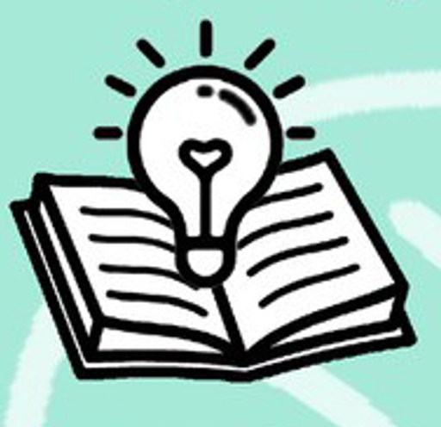  View description - Uncaptioned Figure  View alternative description - Uncaptioned Figure | - Develop a coordinated suite of public-facing educational resources to improve understanding of forensic science within the CJS. This should include a Massive Open Online Course (MOOC), resources to support forensic science education in schools, and guidance to promote accurate portrayals of forensic science in the media. Engagement with initiatives such as this OpenLearn course represents an important step towards this goal.  - Ensure that information about forensic science is accessible, inclusive, and responsive to diverse audiences. Research emphasises the importance of variety in both delivery format (e.g. infographics, video, audio content, interactive tools) and location (e.g. libraries, community centres, and online platforms), recognising that a ‘one-size-fits-all’ approach is ineffective. Education should begin early (e.g. in schools) but also be available at the point of need through community networks or accessible reading materials.  - Provide clear, transparent information about legal rights and data use when individuals are asked to provide physical samples, mobile devices, or other personal information. This includes explaining how and why data will be used, who will have access to it, and how long it will be retained. Crucially, it also includes the right that other than suspects, people do not have to hand over forensic science evidence to an investigation.  - Ensure professional development across the CJS workforce, e.g. to police and legal professionals, provides an understanding of forensic science, its appropriate use, and its limitations. This should also include greater awareness of the experiences and perspectives of seldom-heard communities, to support more informed, equitable, and trust-building practices.

In this week you have seen some research findings and how they relate to different perceptions of trust in forensic science. We have also explored some of the drivers of trust and distrust and the impact they can have in the CJS. Next time you’re reading about a crime where there is forensic evidence, think about why you do or don’t trust it.
This downloadable document has handy references on how forensic science evidence is used in a criminal investigation and trial.
Crime to court booklet
In this course we explored the role and importance of trust and distrust in forensic science evidence in a criminal investigation. The course took you from the crime scene to the court, examining how police and CSIs collected, analysed, and used the evidence in Dave’s fictional case. It also looked more broadly at when it can and cannot be used in an investigation.
Research on trust in forensic science evidence was provided. Data was shared from three groups: the public, people who work in the CJS, and those whose opinions are seldom heard. Recommendations for increasing trust – where appropriate – was provided along with better understandings as to why the forensic science might not be trusted.
We hope you enjoyed the course.

References
Chin, J. M. & Ibaviosa, C. M. (2022) ‘Beyond CSI: calibrating public beliefs about the reliability of forensic science through openness and transparency’, Science and Justice, 62(3), pp. 216–224.
Crown Prosecution Service (2024) Expert Evidence. Available at: https://www.cps.gov.uk/legal-guidance/expert-evidence
Dror, I. E., Peron, A., Hind, S., & Charlton, D. (2006) ‘When emotions get the better of us: The effect of contextual top-down processing on matching fingerprints’, Forensic Science International, 11(1), pp. 310–313.
Hargreaves, C., & Patterson, J. (2012) ‘An automated timeline reconstruction approach for digital forensic investigations’, Digital Investigation, 9, S69–S79.
Home Office (2023) Forensic information databases annual report 2022–2023.
House of Lords (2019) Forensic science and the criminal justice system: A blueprint for change. Available at: https://publications.parliament.uk/pa/ld201719/ldselect/ldsctech/333/333.pdf
Jhalani, S., Morgan, R. M., Shooter, A., Cassella, J. & Pintér, J. (2025) ‘The development of Forensic Science in the criminal justice system of England and Wales (2000–2024): A systematic review’, Forensic Science International: Synergy, 11, 100641, ISSN 2589-871X. DOI: https://doi.org/10.1016/j.fsisyn.2025.100641.
Kassin, S. M., Dror, I. E., & Kukucka, J. (2013) ‘The forensic confirmation bias: Problems, perspectives, and proposed solutions’, Journal of Applied Research in Memory and Cognition, 2(1), pp. 42–52.
Mayer, R. C., Davis, J. H., & Schoorman, D. (1995) ‘An integrative model of organizational trust’, Academy of Management Review, 20, pp. 709–734.
McCarthy Wilcox, A., & NicDaeid, N. (2018) ‘Jurors’ perceptions of forensic science expert witnesses: Experience, qualifications, testimony style and credibility’, Forensic Science International, 291, pp. 100–108.
Mingboyeva, M. (2026) ‘Cognitive biases and their impact on decision-making under uncertainty’, International Multidisciplinary Science Conference, 1(5), pp. 25–30. DOI: https://doi.org/10.5281/zenodo.20043464
Peña, M. M., Stoiloff, S., Sparacino, M., & Schreiber Compo, N. (2024) ‘The effects of cognitive bias, examiner expertise, and stimulus material on forensic evidence analysis’, Journal of Forensic Sciences.
Quigley-McBride, A., & Blackall, T. L. (2025) ‘On the continuum of foundational validity: Lessons from eyewitness science for latent fingerprint examination’, Behavioral Sciences.
Redgrave, H., & Rolfe, M. (2023) Rebuilding trust and delivering safer communities: A plan for reforming UK policing. Tony Blair Institute for Global Change. Available at: https://institute.global/insights/public-services/rebuilding-trust-and-delivering-safer-communities-plan-for-reforming-uk-policing
Rosenblum, M., Chin, E. T., Ogburn, E. L., et al. (2024) ‘Misuse of statistical method results in highly biased interpretation of forensic evidence’, Law, Probability and Risk.
Roux, C., Bucht, R., Crispino, F., De Forest, P., Lennard, C., Margot, P., Miranda, M. D., NicDaeid, N., Ribaux, O., Ross, A., & Willis, S. (2022) The Sydney declaration: Revisiting the essence of forensic science through its fundamental principles. Forensic Science International, 332, 111182. DOI: https://doi.org/10.1016/j.forsciint.2022.111182
Schneider, J., Wolf, J., & Freiling, F. (2020) ‘Tampering with digital evidence is hard: The case of main memory images’, Forensic Science International: Digital Investigation, 33, 300924. DOI: https://doi.org/10.1016/j.fsidi.2020.300924
Shen, M., & Vieira, D. N. (2016) ‘Forensic science: Defending justice’, Forensic Science Research, 1(1), pp. 1–2.
Simpson, R., & Pappas, L. N. (2024) ‘Public perceptions of courts and cooperation with police’, Crime Science, 13(9). DOI: https://doi.org/10.1186/s40163-024-00207-9
Yeboah-Ofori, A., & Brown, A. D. (2020) ‘Digital forensics investigation jurisprudence: Issues of admissibility of digital evidence’, Journal of Forensic, Legal & Investigative Sciences, 6(1), pp. 1–8.
DNA Judicial primer 2nd edition: https://royalsociety.org/-/media/about-us/programmes/science-and-law/royal-society-forensic-dna-analysis-primer-second-edition.pdf
Cotter, A. (2015) Public confidence in Canadian institutions. Statistics: Canada.
Innocence Project https://innocenceproject.org/our-work/
Kaplan, J., Ling S. & Cuellar, M. (2020) ‘Public beliefs about the accuracy and importance of forensic evidence in the United States’, Science & Justice, 60(3), pp. 263–272. DOI: https://doi.org/10.1016/j.scijus.2020.01.001
Trust project (2025) Trust interviews, 2025.
Trust project (2025) Trust general survey, 2025.
van Oorschot, R. A. H., Szkuta B., Meakin, G. E., Kokshoorn B. & Goray M. (2019) ‘DNA transfer in forensic science: A review’, Forensic Science International: Genetics, 38, pp. 140–166, ISSN 1872–4973. DOI: https://doi.org/10.1016/j.fsigen.2018.10.014.
YouGov (2019) Daily Questions: 25/1/2019.
YouGov (2022) Daily Questions: 2/11/2022.
DNA Judicial primer 2nd edition. Available at: https://royalsociety.org/-/media/about-us/programmes/science-and-law/royal-society-forensic-dna-analysis-primer-second-edition.pdf
Gov.uk (2020) Criminal Procedure Rules 2025 and Criminal Practice Directions 2023 Available at: https://www.gov.uk/guidance/rules-and-practice-directions-2020 (Accessed: 28 January 2026).
Hunt, T. R. (2025) ‘Activity Level Testimony in U.S. Courts: A Legal Problem’ (April 20, 2025). 74 Kan. L. Rev. 1 (2025), Available at: SSRN: https://ssrn.com/abstract=5233773 or http://dx.doi.org/10.2139/ssrn.5233773
ISO 21043-5:2025 Forensic sciences – Part 5: Reporting Available at: https://www.iso.org/standard/73896.html (Accessed: 28 January 2026).
Kukucka, J., Kassin, S.M., Zapf, P.A., & Dror, I.E. (2017) ‘Cognitive Bias and Blindness: A Global Survey of Forensic Science Examiners’, Journal of Applied Research in Memory and Cognition 6(4), pp. 452–459. DOI: https://doi.org/10.1016/j.jarmac.2017.09.001.
Leonetti, C. (2024) ‘Ensuring the reliability of evidence in the New Zealand criminal courts: The admissibility of forensic science’, Common Law World Review, 53(4), pp. 197–222. DOI: https://doi.org/10.1177/14737795241237799 (Original work published 2024)
Morgan, J. (2023) ‘Wrongful convictions and claims of false or misleading forensic evidence’, Journal of Forensic Sciences, 68(3), pp. 908–961. DOI: https://doi.org/10.1111/1556-4029.15233
Morrison, G.S., Bali, A.S., Martire, K.A., Grady, R.H., & Thompson, W.C. (2025) ‘What is the best way to present likelihood ratios? A review of past research and recommendations for future research’, Science & Justice, 65(6), DOI: https://doi.org/10.1016/j.scijus.2025.101342.
Roberts, P. (2009) The science of proof: Forensic science evidence in English criminal trials, pp. 446–485. In Fraser, J., & Williams, R. (Eds.) Handbook of Forensic Science (1st ed.). Willan. DOI: https://doi.org/10.4324/9781843927327
Stacey, J., Opperman, S., Curran, J. M. & Harbison, S. A. (2025) ‘Current state and barriers to global adoption of forensic evaluative reporting of findings given activity-level propositions’, Science & Justice [online]. p. 101336.
van Oorschot, R.A.H., Szkuta B., Meakin, G.E., Kokshoorn B., Goray M., (2019) ‘DNA transfer in forensic science: A review’, Forensic Science International: Genetics, Volume 38, pp. 140–166, ISSN 1872-4973. DOI: https://doi.org/10.1016/j.fsigen.2018.10.014.
Bradford, B., Jackson, J., Hough, M., & Farrall, S. (2008) ‘Trust and Confidence in Criminal Justice: A Review of the British Research Literature’, in Jokinen, A., Ruuskanen, E., Yordanova, M., Markov, D. Ilcheva, M. (eds.), Review of Need: Indicators of Public Confidence in Criminal Justice. DOI: http://dx.doi.org/10.2139/ssrn.1303567
Dempsey, C., Kapageorgiadou, V., Johnston, E., Nsiah Amoako, E., Maclennan, M., Hughes, V., Nic Daeid, N., Flowe, H., & Frumkin, L. (in preparation). Perceptions of forensic science evidence. Focus groups with marginalised communities (data collected 2024).
Hughes, V., Kapageorgiadou, V., Dempsey, C., Johnston, E., Nsiah Amoako, E., Maclennan, M., Nic Daeid, N., Flowe, H., & Frumkin, L. (in preparation). Linguistic bias in reporting of forensic science evidence.
Ingemarsson, J., Birath, M. & Kävrestad, J. (2025) ‘Factors influencing Swedish citizens’ willingness to provide their mobile phones to forensic examination’, International Journal of Information Security 24(42). DOI: https://doi.org/10.1007/s10207-024-00955-4
Kapageorgiadou, V., Dempsey, C., Johnston, E., Nsiah Amoako, E., Maclennan, M., Hughes, V., Nic Daeid, N., Flowe, H., & Frumkin, L. (in preparation). Survey with the UK public (data collected 2024).
Kapageorgiadou, V., Zhang, M., Johnston, E., Nsiah Amoako, E., Maclennan, M., Hughes, V., Nic Daeid, N., Flowe, H., & Frumkin, L. (2024) Trust in Forensic Science Evidence: Project Launch Event Report.
Kaplan-Damary, N., Jonathan-Zamir, T., Perry, G., & Itskovich, E. (2025) ‘Public views of forensic science: An intersection of science and policing?’, Forensic Science International: Synergy 11(100640). DOI: https://doi.org/10.1016/j.fsisyn.2025.100640
The Code for Crown Prosecutors (2018). Available at: https://www.cps.gov.uk/publication/code-crown-prosecutors (Accessed: 26 January 2026).

Acknowledgements
This free course was written by Lara Frumkin, Violeta Kapageorgiadou, Emma Johnston, Emmanuel Nsiah Amoako, Niamh Nic Daeid, Vincent Hughes, Maria Maclennan, Heather Flowe and Clair Dempsey.
This work was supported by UKRI grant reference number ES/Y010639/1.
Except for third party materials and otherwise stated (see terms and conditions), this content is made available under a Creative Commons Attribution-NonCommercial-ShareAlike 4.0 Licence.
The material acknowledged below is Proprietary and used under licence (not subject to Creative Commons Licence). Grateful acknowledgement is made to the following sources for permission to reproduce material in this free course:
UKRI ES/Y010639/1 Trust in forensic science evidence in the criminal justice system: The experience of marginalised groups.
Text
Week 4
Crime to court booklet: Lara Frumkin, The Open University with other University partners as illustrated in booklet.
Images
Course image: courtesy: Maria Maclennan.
Week 1
Fingerprint image: stux/Pixabay.
Hands typing coding into a laptop: scyther5/Getty Images.
Week 2
Crime to courtroom diagram: adapted from crime to court process: a booklet by Lara Frumkin, in collaboration with other universities.
A forensic biologist: courtesy: Emma Johnston.
Smart phone with multiple applications on the screen. Photograph Filipe Alves in Unsplash. Third party Apps logos/trademarks as illustrated.
A changing room: Raúl Lazcano lazcanini/Unsplash.
All images on audios: courtesy: Maria Maclennan.
Week 3
Image on audio: courtesy: Maria Maclennan.
Week 4
Illustration of a DNA double helix and mobile phone: courtesy Maria Maclennan.
Police: BrianAJackson/GettyImages.
Lightbulb coming out of a book: courtesy: © Maria Maclennan.
Video
Week 2
Video 1: De Montfort University forensic science laboratory: courtesy: Emma Johnston.
Week 3
Video 1: Layout of a courtroom: courtesy: Emma Johnston.
Every effort has been made to contact copyright owners. If any have been inadvertently overlooked, the publishers will be pleased to make the necessary arrangements at the first opportunity.
Don’t miss out
If reading this text has inspired you to learn more, you may be interested in joining the millions of people who discover our free learning resources and qualifications by visiting The Open University – www.open.edu/openlearn/free-courses.

Glossary
Activity-level question
What specifics actions were done by the suspect, e.g. hitting the victim with a bat, stealing from him, etc.
Adversarial Criminal Justice System
A legal system where two sides present their cases to a neutral judge or jury, who determine pass judgement.
Analytical
There is an error in the science, e.g. machine calibration error leads to incorrect chemical analysis of forensic evidence.
Cell tower data
Data collected from cellular towers to identity where a phone was at a particular time.
Cognition research
Studying how people perceive, learn, remember, think, reason, and understand.
DNA
DNA can be from one person or multiple. DNA of people who were never in a room could be recovered because of transfer and persistence of DNA on items carried into the room. DNA can also be airborne.
DNA profiles
These are used to compare a suspect’s DNA to DNA evidence collected at the crime scene to determine if they are the same. This means that the suspect was at the scene, or the suspect’s DNA evidence was transferred to the scene.
Fingermark
Fingermarks come from an individual who’s identity is not known. Fingerprints come from an individual who’s identity is known and as such can be attributed to them.
IoT devices
Internet of Things (IoT) These are objects using the internet to connect and exchange information.
Offence level question
For example, whether a crime is murder vs manslaughter.
Practitioner
The science is sound but the scientist’s judgement introduces error, e.g. a suspect has confessed and the scientist finds fingerprint evidence that matches the suspect even though it is ambiguous.
Systemic failures
There is a problem in the way the system handles the evidence, e.g., evidence is contaminated by other evidence from another crime scene due to inadequate lab procedures.
Traces
Remnants of a crime such as DNA. Fingerprints, semen, text messages.

Solutions

Activity 1 Considering other perspectives

Answer
Right:
I’d trust them
I wouldn’t trust them
I don’t know
Wrong:
Back to - Activity 1 Considering other perspectives

Activity 2 Trust

Answer
Right:
no
Wrong:
yes
I don’t know
Back to - Activity 2 Trust

Discussion
Eyewitnesses can be useful but they can also wrongly identify people. Since its formation in 1992, the USA Innocence Project has overturned numerous wrongful convictions, many based on faulty eyewitness testimony later disproved by DNA evidence. DNA and other forensic science evidence can be more reliable than eyewitness evidence.
Back to - Activity 2 Trust

Activity 3 Crime Scene Investigator focus

Discussion
The CSI focuses on identifying, collecting, documenting, and recording traces that could be related to the alleged offence. These traces may be physical (weapons, fibres, hairs, footwear mark, fingerprints, DNA, etc.) or digital (phones, computers, routers, IoT devices, access logs, etc.). The CSI must collect all relevant evidential items that can progress the investigation. In this scenario the CSI might swab items for DNA, such as the bat, locker, door handles, and bags – recognising that many people use items daily, and their DNA could be present on surfaces for innocent reasons. Digital evidence, such as electronic gym access and mobile phone activity, could help reconstruct movements and link individuals to the scene.
Back to - Activity 3 Crime Scene Investigator focus

Activity 4 Trust in the forensic process

Answer
Right:
yes
Wrong:
no
I don’t know
Forensic evidence has been historically trusted even though there have been some high profile mishaps resulting in some decrease in trust.
Back to - Activity 4 Trust in the forensic process

Activity 1 Remaining impartial

Answer
Right:
difficult
Wrong:
easy
neither easy nor difficult
Research shows that forensic experts are not immune to bias. Yet, it is rare that they would acknowledge their own biases or they may even fancifully think that they can overcome them with their willpower (Kukucka, et al., 2017). This is changing as biases in thinking is gaining more attention though it is questionable whether simply reminding experts of their duty to be objective and impartial might be enough to address expert biases.
Back to - Activity 1 Remaining impartial

Activity 1 Is there enough evidence?

Answer
In reality, there was not sufficient evidence to meet the CPS threshold for the prosecution to further the case, so the case was dropped. This means it didn’t go to trial and that was because after the forensic scientists completed their analyses, there was not evidence matching Mike’s DNA to anything at the crime scene. He had Dave’s devices but this does not show that he was involved in the attack.
Prosecutors must be satisfied that there is sufficient evidence to provide a realistic chance of conviction against each suspect on each charge. They must consider what the defence case may be, and how it is likely to affect the prospect of a conviction. A case which does not pass the evidential stage must not proceed, no matter how serious or sensitive it may be. This means that no one was convicted. Reflect on how this makes you feel. This illustrates a real challenge faced by the justice system.
Back to - Activity 1 Is there enough evidence?

Activity 2 Factors that affect trust and distrust

Answer
When we listen to voices, we make all sorts of explicit and implicit judgements about them. These judgements directly influence the extent to which we trust both the individuals themselves and what they are saying. In a large-scale linguistic study in the context of forensic science evidence, we found that people rate ‘posh’ speakers of received pronunciation highly in terms of status traits such as intelligence, professionalism, and level of education, compared with speakers from Yorkshire. Yorkshire speakers were, however, rated more highly in terms of solidarity traits such as trustworthiness, honesty, and understandability. We would expect the same pattern with other regional accents.
Female speakers were rated more highly than male speakers for those same solidarity traits.
These findings highlight the importance of thinking about how forensic science evidence is communicated, not only in terms of what is said, but also how it is said and by whom. Our data (Hughes et al, in preparation) show that there are often competing factors: people may judge ‘posh’ speakers as being more professional, but less trustworthy, while speakers with regional accents may be judged as being more trustworthy, but less professional.
Back to - Activity 2 Factors that affect trust and distrust

Descriptions

Uncaptioned Figure
Image of a fingerprint
Back to - Uncaptioned Figure

Uncaptioned Figure
Image of a fingerprint
Back to - Uncaptioned Figure

Uncaptioned Figure
An illustration of a hand shaking another hand.
Back to - Uncaptioned Figure

Uncaptioned Figure
An illustration of a hand shaking another hand.
Back to - Uncaptioned Figure

Uncaptioned Figure
Photograph of hands typing coding into a laptop.
Back to - Uncaptioned Figure

Uncaptioned Figure
Photograph of hands typing coding into a laptop.
Back to - Uncaptioned Figure

Crime to courtroom diagram
This diagram is a flowchart illustrating the process of a criminal investigation, from an incident to the courtroom.
The diagram is organised into a sequence of connected steps. In the Police Investigation section:
Incident occurs: An incident occurs when a possible crime or emergency takes place.
Crime reported or discovered: A crime is reported by the public or detected by the police.
Police Investigation: The police are typically the first authority to engage. They secure the scene, gather initial information, and begin the investigation, for instance, by collecting digital evidence.
Request Crime Scene Investigators (CSI): The responding officer or the Senior Investigating Officer assesses the scene and, if forensic evidence might help (e.g. fingerprints, DNA), they request the attendance of CSIs.
Collection of evidence: They carefully search for and recover physical evidence such as weapons, ensuring it is properly packaged and labelled.
This is connected to the forensic investigation section and then court. In the forensic investigation section:
Secure and assess the scene: CSIs secure the area to prevent contamination and assess what type of evidence may be present. They document the scene with photographs and notes before collecting anything.
Collect the Evidence: The CSIs carefully search for and recover physical evidence, such as fingerprints, DNA, fibres, and weapons, and ensure it is properly packaged and labelled.
Send Evidence to the Lab: Once collected, evidence is sent to the forensic laboratory for detailed scientific analysis, following strict chain-of-custody procedures.
Report CSI Findings: CSIs record their observations in a formal report, describing how and where each item was found and any relevant scene details.
The Forensic Lab Analyses the Evidence: Forensic scientists test the evidence using scientific methods to identify substances, analyse DNA, compare fingerprints, and interpret results.
The Lab Reports Finding: The lab shares its results with investigating officers to support the case. Forensic experts may also present and explain their findings in court as impartial witnesses.
Forensic Science Regulator: The Forensic Science Regulator ensures that all forensic work used in the criminal justice system meets high scientific and quality standards. They set guidelines, issues a Code of Practice, and checks that police forces, laboratories, and practitioners follow proper procedures. https://www.gov.uk/government/organisations/forensic-science-regulator
Back to - Crime to courtroom diagram

Uncaptioned Figure
Illustration of a baseball bat covered in blood on the floor of a gym locker room.
Back to - Uncaptioned Figure

Uncaptioned Figure
Illustration of a baseball bat covered in blood on the floor of a gym locker room.
Back to - Uncaptioned Figure

Uncaptioned Figure
Photograph of a forensic biologist wearing a protective face mask and hair net.
Back to - Uncaptioned Figure

Uncaptioned Figure
Photograph of a forensic biologist wearing a protective face mask and hair net.
Back to - Uncaptioned Figure

Uncaptioned Figure
Image of a smart phone with multiple applications on the screen.
Back to - Uncaptioned Figure

Uncaptioned Figure
Image of a smart phone with multiple applications on the screen.
Back to - Uncaptioned Figure

Uncaptioned Figure
Image of a narrow changing room with rows of lockers on all sides.
Back to - Uncaptioned Figure

Uncaptioned Figure
Image of a narrow changing room with rows of lockers on all sides.
Back to - Uncaptioned Figure

Uncaptioned Figure
An illustration image depicting a scene in a courtroom. There is a lawyer addressing a judge and other court officials.
Back to - Uncaptioned Figure

Uncaptioned Figure
An illustration image depicting a scene in a courtroom. There is a lawyer addressing a judge and other court officials.
Back to - Uncaptioned Figure

Uncaptioned Figure
An illustration of a court judge with two speech bubbles on either side of their head. On one side there is the text: my scientific opinion is X. On the other side the text: my scientific opinion is Y.
Back to - Uncaptioned Figure

Uncaptioned Figure
An illustration of a court judge with two speech bubbles on either side of their head. On one side there is the text: my scientific opinion is X. On the other side the text: my scientific opinion is Y.
Back to - Uncaptioned Figure

Uncaptioned Figure
Word cloud image
Back to - Uncaptioned Figure

Uncaptioned Figure
Word cloud image, including: Police legitimacy, CSI Awareness, CSI-effect, MoJ, Mistrust, Research, Knowledge, Accuracy, Lack-of-funding, Peer-reviewed, Jurors, Suspicion, Judge, Legal/Lawful, Integrity, Reliability, Reform, Mistakes, Community, Forensics, Digital Comunication, Misleading evidence, DNA Crisis, Marginalised, Misinterpretation, Consistency, Minorities, Public, TV drama, Trust, Quality-of-evidence, Misinformation, JEpistemic trust, Lack-of-Minorities, Regulation, subjectivity, Evidence, Transparency, scientists, validity, Government, Unreliability, court, Imparciality, Engagement, Oversight, Engagement, Ethical Mistakes, Presentation, TV.
Back to - Uncaptioned Figure

Uncaptioned Figure
Illustration of a DNA double helix and mobile phone.
Back to - Uncaptioned Figure

Uncaptioned Figure
Illustration of a DNA double helix and mobile phone.
Back to - Uncaptioned Figure

Familiarity with types of forensic science evidence (Scale 0–100%)
A horizontal bar chart showing the relative frequency or importance of different forensic evidence types.
Back to - Familiarity with types of forensic science evidence (Scale 0–100%)

Familiarity with types of forensic science evidence (Scale 0–100%)
A horizontal bar chart showing the relative familiarity of different forensic evidence types from a survey of the UK public on a scale from 0 to 100.
- Fingerprints: ~95
- Single source DNA: ~85
- Bloodstain pattern: ~72
- Digital evidence: ~52
- Mixed source DNA: ~48
- Cell site analysis: ~15
- Shoeprints/footwear: ~9
Back to - Familiarity with types of forensic science evidence (Scale 0–100%)

Perceptions of forensic science evidence (Scale 0–10). Focus groups with marginalised communities (2024).
Perceptions of forensic science evidence (Scale 0–10)
A bar chart with six horizontal bars of varying lengths and colours that represent mean scores demonstrating perceptions of forensic science evidence. Each bar has a numerical value at the end, ranging from 3.5 to 7.4.
- 5.1 Trust police investigations
- 6.6 Trust DNA analysis
- 5.2 Trust phone evidence analysis
- 4.4 Trust police digital forensic analysis
- 7.4 Trust private company forensic analysis
- 4.5 Confidence in rights (DNA)
- 3.5 Confidence in rights (phone data)
Back to - Perceptions of forensic science evidence (Scale 0–10). Focus groups with marginalised communities (2024).

Uncaptioned Figure
Photograph of three police officers wearing high visibility jackets standing behind crown barriers.
Back to - Uncaptioned Figure

Uncaptioned Figure
Photograph of three police officers wearing high visibility jackets standing behind crown barriers.
Back to - Uncaptioned Figure

Uncaptioned Figure
Illustration of two members of a jury, seated at the bench in a courtroom setting.
Back to - Uncaptioned Figure

Uncaptioned Figure
Illustration of two members of a jury, seated at the bench in a courtroom setting.
Back to - Uncaptioned Figure

Uncaptioned Figure
Illustration of a lightbulb coming out of a book.
Back to - Uncaptioned Figure

Uncaptioned Figure
Illustration of a lightbulb coming out of a book.
Back to - Uncaptioned Figure

Audio 1: The scenario

Transcript
Narrator:
Dave Miller works twilight shifts regularly and often finishes work between midnight to 1am. He goes to this 24-hour gym after his shifts. On Tuesday Dave had finished his work-out around 1:30am and was at his locker when he was attacked and robbed. His attacker had a face covering and hat with dark, baggy clothing. He hit Dave from behind with a heavy object, several times. Dave was found unconscious and bleeding by a member of the cleaning team. He said he felt like he’d been hit by a bat-like object and didn’t see the person’s features.
Dave is 5’10 and the attacker appeared to be shorter than him. Dave’s laptop, tablet, and phone were stolen. His car keys were in his pocket and weren’t taken. He wasn’t sure if the attacker was wearing gloves. The weapon wasn’t found.
It’s a very busy gym, and the CCTV outside the gym entrance isn’t good quality. There is no CCTV in the locker rooms. Male gym members have reported thefts. Every member has to swipe through the barriers to gain entrance.
There has been a spate of thefts at the gym. Stolen items include: mobile phones, headphones, tennis rackets, tablets, watches and a bracelet. The gym security has analysed the data of people swiping into the gym and have narrowed the list down to five suspects – one being the gym manager, another the cleaner who called the ambulance for Dave and three other gym members.
Forensic science evidence found during the investigation can help identity the perpetrator.
Back to - Audio 1: The scenario

Audio 2: Crime Scene Investigator (CSI)

Transcript
CSI
The crime scene investigator will identify, document, recover and package items (traces) from a crime scene, victim or suspect which may ultimately have evidential value. Their role is critical and needs to bring a scientific underpinning to the decisions they make at the scene around the items selected for recovery.
Back to - Audio 2: Crime Scene Investigator (CSI)

Audio 3: Digital Forensic expert

Transcript
Digital Forensic expert
The forensic scientist documents, records and analyses the recovered traces/items to generate information and, potentially, scientific evidence. They provide expert opinion as to the meaning of the scientific evidence given competing hypotheses based on the case circumstances.
Back to - Audio 3: Digital Forensic expert

Audio 1: Narrator

Transcript
Narrator
The victim, Dave, was found unconscious in the locker room by Rob, a member of the cleaning team. The police arrived to secure and preserve the scene, gather materials of potential evidence, follow all lines of enquiry, and coordinate between Dave, the forensic scientists, and the eyewitness. Dave was taken to the hospital. Rob reported to the police that he found a baseball bat hidden in a locker near where Dave was found.
Back to - Audio 1: Narrator

Audio 2: Dave

Transcript
Dave
I don’t remember much. One minute I was getting stuff from my locker to head home, then Rob was kneeling above me. I was taken to the hospital and the doctor said I had a mild concussion and could go home. Rob and the hospital were great, but the police felt a bit pushy – they kept asking me to remember things I couldn’t. I know they are doing their job, but it feels like they’re pressuring me to give them information I just don’t have.
Back to - Audio 2: Dave

Audio 3: Eyewitness

Transcript
Eyewitness
I was walking past the gym entrance at 1:45am. I’m sure that was the time because I had just come from the off license and my receipt was time stamped at 1:40am. I saw a guy running out of the gym with what looked like a large bag, but it didn’t look heavy. He looked athletic, had dark hair, and moving quickly so I think he couldn’t have been over 35 years old. I was about 30 metres away and it was dark but I saw him clearly. I described him to the police but they seemed sceptical of my description.
Back to - Audio 3: Eyewitness

Audio 4: Crime Scene Investigator (CSI)

Transcript
CSI
Crime Scene Investigators (CSIs) are requested to attend the gym scene by the responding police officer to search for and recover items which may be relevant to the alleged assault and might generate forensic evidence relating to the alleged offence. Other CSIs may also later be asked to examine any additional scenes and recover other potentially relevant items such as the bag the witness saw or clothing from a potential suspect.
Back to - Audio 4: Crime Scene Investigator (CSI)

Video 1: De Montfort University forensic science laboratory (recording by Emma Johnston)

Transcript
Emma Johnston
Welcome to the forensic science lab.
So this is the sort of environment where evidence from a case like Dave’s would be examined.
So we think about evidence going through a crime scene to lab to court process.
And forensic scientists would be examining evidence like from Dave’s case in a laboratory like this.
So they’d receive the evidence from crime scene examiners and be examining it here.
They’d received the evidence in tamper evident bags like this one here.
They’d be wearing their PPE, so gloves, face masks and so on.
And they’d be taking precautions to make sure that evidence from the victim and any potential suspects were kept separate.
Back to - Video 1: De Montfort University forensic science laboratory (recording by Emma Johnston)

Audio 5: Forensic Biologist

Transcript
Forensic Biologist
In Dave’s case, the Forensic Biologist would examine the baseball bat and any clothing recovered from the victim or suspect, testing any red/ brown staining for potential blood. A Blood Pattern Analyst may be able to interpret the distribution of staining on the baseball bat and in the locker room to reconstruct how the blood may have come to be where it was found. A sample of blood on the baseball bat would be analysed for DNA. DNA analysis could also be performed on samples from the baseball bat handle.
Back to - Audio 5: Forensic Biologist

Audio 6: Digital Forensic expert

Transcript
Digital Forensic expert
In Dave’s case, a Digital Forensics expert located the stolen devices through GPS, and this led police to arrest a suspect. When taken into custody, the suspect (Mike) stated that he was a member of the gym, frequented the locker room, but had nothing to do with the alleged attack.
Back to - Audio 6: Digital Forensic expert

Video 1: Layout of a courtroom

Transcript
Emma Johnston
Welcome to the courtroom.
This is where, if you think about that crime scene to court process, forensic evidence could end up being presented.
So in front of you, that’s where the judge would sit in a case like this.
Over to the left here, we’ve got the jury box.
On this side, there’s the witness box.
And that’s where any sort of forensic scientist would present evidence or say perhaps police officers, crime scene investigators, other kinds of expert witnesses or eyewitnesses as well.
Next to that, we’ve got a press box.
And here in front of me, this is the dock where the defendant would stand.
And then just where I am here, we’ve got a public gallery.
Back to - Video 1: Layout of a courtroom

Audio 1: The courtroom

Transcript
Speaker
In our case, the court would want to reach a final judgement of whether the suspect (Mike) is guilty or innocent of the alleged crime. To be able to achieve this, the court will be interested to know the involvement of the suspect in the crime.
During the trial, the burden of proof rests with the prosecution who must, based on relevant evidence gathered in this case, including eyewitnesses, professional witnesses (such as the police) and expert witnesses (such as the forensic scientists), prove beyond all reasonable doubt that the suspect committed the crime alleged.
Conversely, the defence’s role is to cast doubt on the prosecution’s allegation and argue that the suspect is innocent and did not commit the alleged crime. The forensic science evidence (DNA and digital evidence) in this case will be crucial in understanding the involvement (or not) of the suspect in this case.
Expert witnesses, in this case forensic scientists with expertise in the areas of DNA and digital evidence, can explain how these pieces of evidence relate to the case.
Back to - Audio 1: The courtroom

Audio 1

Transcript
SPEAKER
DNA is the genetic material found in most living organisms, including humans. The pattern and arrangement of nucleotide bases in DNA are unique to each individual and are preserved in the chromosomes, which can be passed on to the organism’s offspring. Humans have 23 pairs of chromosomes, totalling 46. Each person inherits 23 chromosomes from each parent, which means that some unique characteristics can be shared between parents and offspring. DNA is therefore unique in identifying individuals and family lineage.
Back to - Audio 1

Audio 2

Transcript
SPEAKER
DNA can be found in biological samples such as blood, saliva, hair, semen, and skin cells left at crime scenes or parties to a crime. These samples are collected using cotton swabs. To avoid contamination and DNA damage, the samples are collected following careful steps, including wearing gloves and using appropriate packaging. Additionally, each sample is labelled with detailed information about its origin and is kept at an appropriate temperature to prevent degradation. This process ensures that the DNA evidence remains intact for analysis in the laboratory.
Back to - Audio 2

