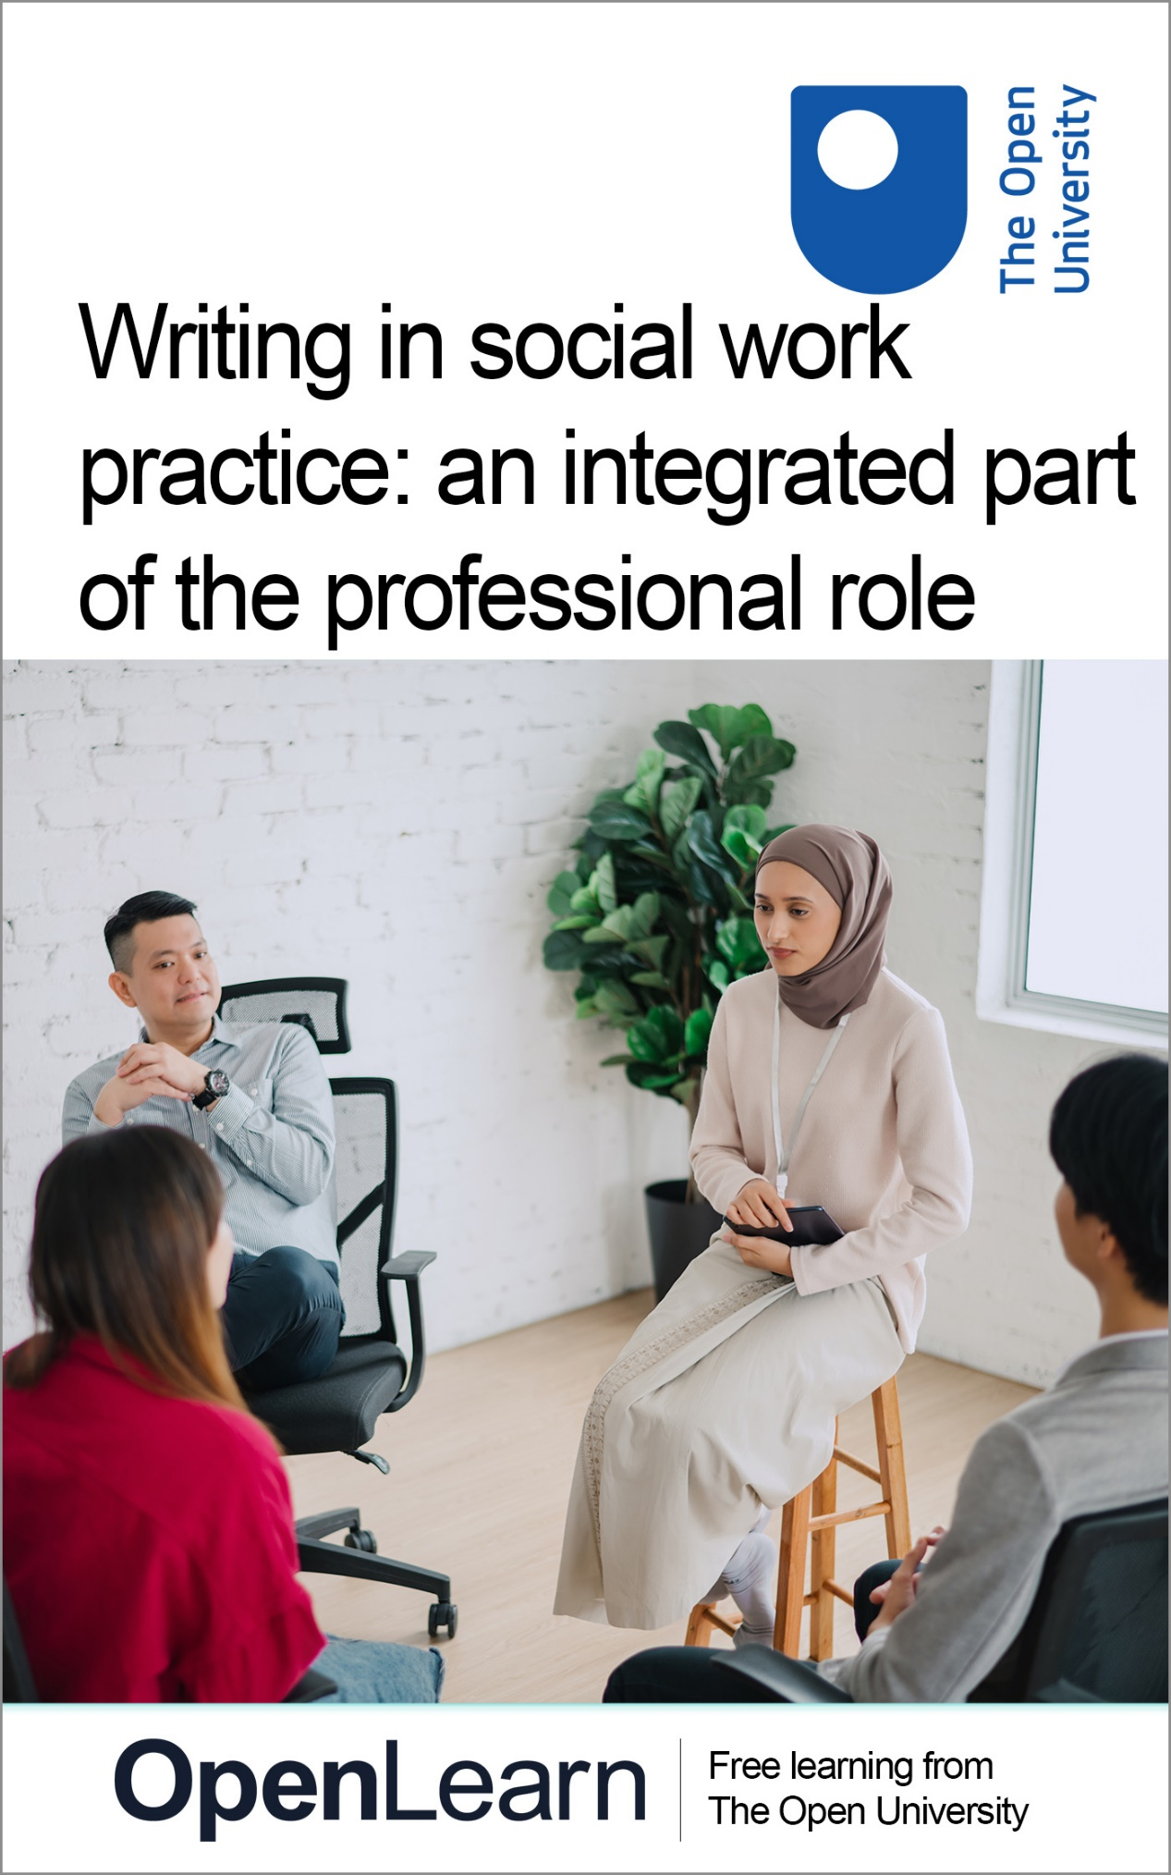

k246_1

Effective writing in professional social work practice

About this free course
This OpenLearn course is an adapted extract from the Open University Social Work courses.
This version of the content may include video, images and interactive content that may not be optimised for your device.
You can experience this free course as it was originally designed on OpenLearn, the home of free learning from The Open University – https://www.open.edu/openlearn/health-sports-psychology/effective-writing-professional-social-work-practice/content-section-0
There you’ll also be able to track your progress via your activity record, which you can use to demonstrate your learning.
First published 2025.
Unless otherwise stated, copyright © 2025 The Open University, all rights reserved.
Intellectual property
Unless otherwise stated, this resource is released under the terms of the Creative Commons Licence v4.0 http://creativecommons.org/licenses/by-nc-sa/4.0/deed.en. Within that The Open University interprets this licence in the following way: www.open.edu/openlearn/about-openlearn/frequently-asked-questions-on-openlearn. Copyright and rights falling outside the terms of the Creative Commons Licence are retained or controlled by The Open University. Please read the full text before using any of the content.
We believe the primary barrier to accessing high-quality educational experiences is cost, which is why we aim to publish as much free content as possible under an open licence. If it proves difficult to release content under our preferred Creative Commons licence (e.g. because we can’t afford or gain the clearances or find suitable alternatives), we will still release the materials for free under a personal end-user licence.
This is because the learning experience will always be the same high quality offering and that should always be seen as positive – even if at times the licensing is different to Creative Commons.
When using the content you must attribute us (The Open University) (the OU) and any identified author in accordance with the terms of the Creative Commons Licence.
The Acknowledgements section is used to list, amongst other things, third party (Proprietary), licensed content which is not subject to Creative Commons licensing. Proprietary content must be used (retained) intact and in context to the content at all times.
The Acknowledgements section is also used to bring to your attention any other Special Restrictions which may apply to the content. For example there may be times when the Creative Commons Non-Commercial Sharealike licence does not apply to any of the content even if owned by us (The Open University). In these instances, unless stated otherwise, the content may be used for personal and non-commercial use.
We have also identified as Proprietary other material included in the content which is not subject to Creative Commons Licence. These are OU logos, trading names and may extend to certain photographic and video images and sound recordings and any other material as may be brought to your attention.
Unauthorised use of any of the content may constitute a breach of the terms and conditions and/or intellectual property laws.
We reserve the right to alter, amend or bring to an end any terms and conditions provided here without notice.
All rights falling outside the terms of the Creative Commons licence are retained or controlled by The Open University.
Head of Intellectual Property, The Open University

Contents
- Introduction
- Learning outcomes
- 1 Writing in social work
  - 1.1 Thinking about writing
  - 1.2 Experiences of writing
  - 1.3 Approaching writing
- 2 The functions of writing
  - 2.1 Documents in social work practice
  - 2.2 Recognising the differences
  - 2.3 Using CAPS with social work documents
- 3 Writing style
  - 3.1 Language in social work writing
  - 3.2 Professional language?
  - 3.3 Description and analysis
  - 3.4 The importance of description
  - 3.5 The importance of analysis
  - 3.6 Artificial intelligence and social work writing
- 4 Writing about yourself and others
  - 4.1 Contributors to social work writing
  - 4.2 Identifying the voices in the social work documents
  - 4.3 Who is social work writing for?
  - 4.4 Reflection
- Conclusion
- References
- Additional resources
- Acknowledgements
- Solutions
- Descriptions

Introduction
This course introduces you to professional writing which is an integral aspect of social work practice. Social workers need to consider how their writing forms part of their communication and record keeping. Ensuring people who are being written about are at the centre of writing about their lives is a key guiding principle. Learning writing and critical analysis skills is a core part of professional development across the social work career.


Figure 1
View description - Figure 1
View alternative description - Figure 1

The course is organised in four sections about professional writing for social workers:
- Writing in social work
- The functions of writing
- Writing style
- Writing about yourself and others
Professional writing is an important part of social work practice. Social workers spend a significant proportion of their time doing a broad spectrum of written tasks. This part of social work is often presented as a burden outweighing other activities but it is actually a crucial way that social workers communicate, negotiate, present, articulate recommendations and demonstrate their values in action. The four sections will explore the nature of social work writing, some key issues to think about and draw from extensive research to highlight the skills that are involved. The course is relevant for social workers who are already qualified and those who are students. Ideas from the course may also be helpful to other health and social care practitioners who want to learn about writing in their practice.
This OpenLearn course is an adapted extract from the Open University Social Work courses.

Learning outcomes
By the end of this course, you should be able to:
- describe different types of social work writing
- understand the importance of professional writing as part of practice
- explain why writing is central to the lives of people being written about
- demonstrate description and analysis skills in writing.

1 Writing in social work
Social workers spend more than half of their time writing (Lillis et al 2020) so learning to write effectively for practice is a very important element of professional development across the career. This course focuses on developing your understanding of professional writing in social work and the ways in which you can become an effective writer.


Figure 2
View description - Figure 2
View alternative description - Figure 2

In this section you will:
- learn about the WiSP Research project and
- listen to Vicki, a qualified social worker, talking about her experiences of learning to write as a social worker
- look at differences between writing activities.

1.1 Thinking about writing
As you progress through your career as a social worker you will have had to write different types of things. Lucy Rai developed a way to think about the purpose and focus of social work writing. The mnemonic CAPS, stands for Context, Audience, Purpose and Self (Rai, 2020). In summary, CAPS can help you focus on what you are writing, why you are writing and who the audience(s) are (Rai, 2020). You will develop your understanding and use of CAPS later in this course.
Professional writing, the writing undertaken in daily practice, is part of the core business of social work. Much of the content of this course is drawn from research undertaken at The Open University. The Writing in Social Work Practice (WiSP) project gathered and analysed examples of social work texts and documented the experiences of social workers’ writing in children’s services, mental health services and adult services teams. You can find more details about the research project using the links at the end of this course. The project also involved social work students, social work managers and service users. Figure 3 below details the data that was collected for this research study.

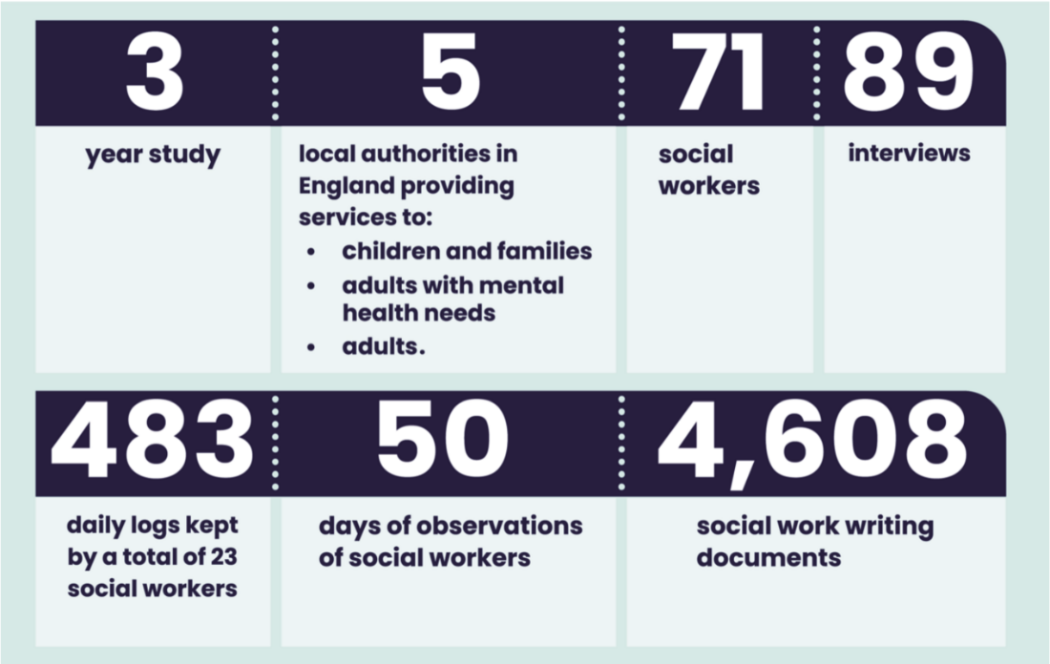
Figure 3 The Writing in Social Work Practice (WiSP) Research Project
View description - Figure 3 The Writing in Social Work Practice (WiSP) Research Project
View alternative description - Figure 3 The Writing in Social Work Practice (WiSP) Research Project

The Open University social work team worked with a group of people who have experience of using social work services to develop resources based on the research which would inform students, practitioners, managers and policy makers. The following statement sets out the mission for writing in social work:

Everything about social work writing should reflect the views, voices and experiences of the people who are being written about. Writing should be respectful, and respect peoples’ differences including any protected characteristics, preferences, interests and identities. Written products should be usable and understandable by all relevant stakeholders that need to access it. ‘Nothing about us without us’ is applicable to all aspects of social work writing.
WiSP information booklet produced in partnership with social work service users (Open University, 2023)

1.2 Experiences of writing
The findings of the WiSP project raise awareness of the importance of social work documents and some of the challenges that are faced by social workers in producing them. In the following activity you will hear from Vicki, an experienced social worker, talking about her own learning journey as she developed her professional writing skills.

Activity 1 Reflecting on writing as a social worker

Listen to Vicki, a social worker in the field of children and families social work. Here she reflects on how her writing has changed and discusses how to write in an accessible way. Don’t worry if you do not fully understand everything in this audio, you will return to it at the end of this section and revisit some of the concepts that Vicki talks about.
Make some notes on the questions that follow:

Audio content is not available in this format.
Audio 1: Reflecting on professional language
View transcript - Audio 1: Reflecting on professional language

- What does Vicki say about her writing when she was a newly qualified social worker?
- Why might social work records be important to children as they grow older?
- Vicki discusses writing in an accessible way. What features does she describe as part of this?
- What does she say about using professional language?
- What changes has Vicki noticed in the way some professionals write?

Provide your answer...
View answer - Activity 1 Reflecting on writing as a social worker

1.3 Approaching writing
It is important to approach each new writing task by thinking carefully about what you are being asked to write and the function of this. You may find similarities between how you should approach some types of writing that you might be familiar with, such as ‘essays’ or ‘reflective writing’ but in any task you will need to read guidance carefully and understand the purpose.
Many of the writing skills that social workers develop as a student can be transferred to practice writing. Rai and Lillis (2012) interviewed final year social work students who suggested that they had been able to transfer their learning, even if it was difficult to pinpoint where or how. The following two quotes are from two of the students who participated in this study:

I’m really sure that having to sit down and agonise over those essays has helped me but I can’t identify or pinpoint exactly where. But it has to have helped me because I do all sorts of reports for work and although it’s nowhere near like writing an essay I think the fact that you have to focus on a certain point and draw out the significance of it helps you somewhere.
(Rai and Lillis, 2012 p. 359)

Definitely adaption is key, and I think from the variety of the writing skills throughout the three year programme. If there’s something I’ve taken from it is having that variety of writing skills and being able to, to use that in practice.
(Rai and Lillis, 2012 p. 359)

These quotes from students suggest that they found that their academic assignments helped them learn to write as social workers, but that the learning needed to be transferred as there were still important differences. Some of the ways in which the learning needed to be transferred were not very clear to them.

Activity 2 Differences between writing activities

What do you think are the main differences between writing as a student and writing as a social worker, again using CAPS? Make a few notes about what these differences are before exploring the summary box that follows.

Table 1 Academic writing compared with social work writing
 | Student writing | Social work writing
Context | Provide your answer... | Provide your answer...
Audience | Provide your answer... | Provide your answer...
Purpose | Provide your answer... | Provide your answer...
Self | Provide your answer... | Provide your answer...

View answer - Activity 2 Differences between writing activities

Student social workers are still learning with support and guidance and so do not have the full responsibilities expected of a qualified social worker. However, they are still accountable for their writing within a student role. Consequently, an important element of your learning will be how to write the documents required within your own practice setting. The service users you work with (such as children and families, adults with mental health needs or older people) and also the setting will all impact on the kinds of documents you will write and how you are expected to write them. In the following section you will learn more about the different functions of social work writing.

2 The functions of writing
It is important to be clear about the different functions of professional writing in social work practice. The WiSP research highlighted how many kinds of things social workers were writing in their everyday work. This section explores the diversity of professional written documents are how they are a fundamental aspect of social work practice.


Figure 4 Writing for study and work
View description - Figure 4 Writing for study and work
View alternative description - Figure 4 Writing for study and work

In this section you will:
- learn about the different functions of social work writing
- identify the differences between document types
- practice applying CAPS to social work documents.

2.1 Documents in social work practice
Social work services are delivered to a wide range of people and in many different settings, such as in the community, in hospitals, day and residential services. Within these services, social work writing has multiple functions, including undertaking assessments and reviews of risk and need, contributing to financial assessments and providing services to support service users, their families and carers. This wide range of activity is also reflected in the diversity of documents that social workers produce as part of their daily work. The WiSP research project identified eleven different functions of writing:

Table 2 The functions of writing
Function | Description
Administration | Preparatory, interim or short texts, often as part of/before larger activity, or one offs
Applications for services, equipment, support checks and referrals | Document often on a template to provide services/equipment or specific actions
Assessments | Document often on a template to check or evidence eligibility or risk, usually in preparation for allowing or preventing service provision or moving onto a next stage in a process
Case recording | Ongoing logging of case activity, usually stored centrally on an authority-based IT system
Communication with others | Documents that set out formal arrangements, often with sanctions if not adhered to
Diagrams/drawings/mapping | Texts that illustrate a process or relationships, often accompanying other documentation
Documents when working with clients | Documents often completed whilst with clients, often to aid interaction/inform decisions
Meeting-related paperwork | Texts written in preparation for, during and to document meetings
Reports | Documents often on a template, with the purpose to evaluate, summarize, and/or state next actions to be done, after an event or process of engagement
Training/supervision documentation | Texts aimed at arranging, delivering, evaluating and undertaking training and supervision activities

Activity 3 Mapping the functions of writing

Look at the clusters of different kinds of writing that social workers do. Map these against the 11 key functions listed in the left hand column of the Table. Select the relevant examples from the drop down menu.

Interactive content is not available in this format.

View answer - Activity 3 Mapping the functions of writing

There are also many areas of guidance on different written documents produced by organisations, local areas and national policy which support social workers in their practice. We have included some links in the Additional Resources section of this course, but it is important to check on what your local expectations are in any practice setting.

2.2 Recognising the differences
Table 3 illustrates the many different functions of writing in social work, but the research team identified just four kinds of document which were the most commonly used across all service user groups. These four document types are:

Table 4 Four most common document types
Document type | Purpose
Case notes | The day to day record of all interactions and decisions made in relation to a specific person receiving a service. These are normally created on a digital system and need to be completed within specific timeframes
Assessment reports | Reports written by the social worker but often compiling information from many sources, including the service user. Assessment Reports also contain a recommendation.
Emails | Digital communication between the social worker and anyone else involved, including the service user and anyone involved in providing a service to them.
Handwritten notes | These can take many forms including notes taken during or shortly after a conversation or meeting, rough drafts of other forms of official documents such as Assessment Reports, writing or even diagrams and drawings, used during face to face meetings with service users.

You will come across many different types of texts that you have to write as part of your daily work which are essential. Of course exactly what you will have to write will depend on your particular area of social work. But there are three key types of writing that social workers carry out across all areas of practice: case notes, assessment reports and emails.

Activity 4 Identifying text types

Look at the brief extracts taken from social workers’ writing. Which of the three key types of writing do they come from, case notes, assessment reports or emails? Select the relevant option from the drop down menu. As you do this consider your reasons for making your decisions, thinking about the content, the language and purpose of each text.

Interactive content is not available in this format.

2.3 Using CAPS with social work documents
You have considered how to use CAPS to think about the Context, Audience, Purpose and Self in some written tasks, and now you will consider it in relation to document types.

Activity 5 Applying CAPS to social work documents

The following activity asks you to apply CAPS to what you have learnt about the three key social work documents of case notes, assessments and emails. For each one make some notes on how you think CAPS would apply to each if you were writing these documents.

Table 5
 | Case note | Assessment report | Emails
Context | Provide your answer... | Provide your answer... | Provide your answer...
Audience | Provide your answer... | Provide your answer... | Provide your answer...
Purpose | Provide your answer... | Provide your answer... | Provide your answer...
Self | Provide your answer... | Provide your answer... | Provide your answer...

View answer - Activity 5 Applying CAPS to social work documents

In the next section you will explore how the style of writing in different social work documents might vary.

3 Writing style

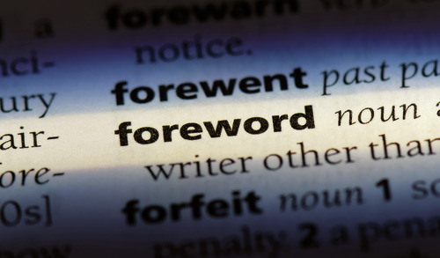
Figure 5
View description - Figure 5
View alternative description - Figure 5

Writing is part of your professional practice as a social worker and recognising what style is appropriate is a key skill. In this section you will explore how language, description and analysis are core components of effective social work writing.
In this section you will:
- look at the language used in three main document types
- match different writing styles with specific examples
- learn about description and analysis how to identify them in social work documents
- reflect on how to use description effectively in your writing
- explore how analysis is used in social work writing.

3.1 Language in social work writing
The language, or way in which you write, is likely to vary depending on whether you are writing a case note, an assessment report or an email. This can be related to the level of formality but also whether you are mainly describing events or using your professional judgement to provide analysis or make a recommendation. The next activity asks you to think again about different types of documents and the language that might be used in them.

Activity 6 Thinking about language in social work documents

Complete the following table, again thinking about the text types of Case Notes, Assessment Reports and Emails. For each one, think about the language that you would use. You can think about the following questions:
- How formal informal would the language be?
- Would the document be written in a template using prescribed section headings?
- Would you be including mainly description?
- Would you include analysis?
- Would you include a recommendation?

Table 6
 | Case Note | Assessment Report | Email
Formal or informal language? | Provide your answer... | Provide your answer... | Provide your answer...
Needs a template? | Provide your answer... | Provide your answer... | Provide your answer...
Include description? | Provide your answer... | Provide your answer... | Provide your answer...
Include analysis? | Provide your answer... | Provide your answer... | Provide your answer...
Include recommendations? | Provide your answer... | Provide your answer... | Provide your answer...

View answer - Activity 6 Thinking about language in social work documents

Considering these questions helps to recognise what and how you write in your social work practice. The following sections explore this further, including types of writing and understanding in more detail the difference between description and analysis.

3.2 Professional language?
In the previous activity you saw how social workers need to use different language for different kinds of document. These differences in style of writing include not only the level of formality / informality and balance between description and analysis, but also decisions about the kinds of words you use, whether to include abbreviations and whether the document can be written as notes (with bullet points for example) or must include full sentences.
To illustrate this, complete the following activity and match the language styles to the examples.

Activity 7 Formal or informal?

Read the short extracts from genuine social work documents. Using the drop down menu, select which language type you think corresponds to the extract. Some extracts are listed more than once and therefore are examples of more than one language type. These are the language types included in this activity
- Formal language
- Informal language
- Professional language
- Full sentence
- Notes
- Abbreviations / acronyms

Interactive content is not available in this format.

View answer - Activity 7 Formal or informal?

Having looked at these examples, do you think that some aspects of style are more appropriate for some texts and not others? Are there aspects of style that you personally feel strongly about and if so what are these?

3.3 Description and analysis
Two of the most important elements of social work writing are description and analysis. Both are equally significant, but it is very important to recognise the difference between them and when each is required.
In simple terms, when writing a description, the social worker is providing factual information. This could be information that has been directly observed by the social worker or has been provided to them directly by someone else. Here are some examples:
Description:
- Rhiannon is 4 years old
- Anup informed me that she has lived alone at the same address for 18 months
- Mr McFadden has 1 visit a day from the home care service
- Dr Khan informed me by email that Tyrone has not had his MMR vaccination or been seen by anyone at the practice since he was 6 months old.
- Blake’s parents met with me on the 17th July 2024 and stated that they no longer wanted their contact with Blake to be supervised.
Defining description and analysis can be difficult, a brief definition of each is included here.
Description in social work writing is reporting the details of what has happened. Descriptions provide details of a situation, a person, a context, an emotional state, a physical need.
Analysis is evaluating and selecting the most important aspects of information and communicating these in a way that can be understood by different kinds of readers.
Here are some examples of analytical writing – or writing that demonstrates analysis – to illustrate how it differs from descriptive writing.
Analysis:
- Based on reports from the educational psychologist, Rhiannon’s teacher and my observations, her language seems to be significantly delayed. This may have a medical cause, but her mother’s depression and social isolation may also be factors.
- Mr McFadden’s weight loss and confusion indicate that he would benefit from a second home care visit to make sure that he is eating at least one full meal a day.
- The information provided by Dr Khan suggests that Tyrone’s physical health needs may not be met. Without the normal checks it is not known whether he is meeting his developmental targets and he is at risk due to the missed vaccinations.
- My professional judgement is that Blake would be at risk if his contact with his parents was unsupervised. This is based on observations of the contact provided by the family support worker who reported that they have missed or been late on 4 occasions out of 7 and that they do not interact with Blake or respond to him, even when he attempts to engage them in play.
The final example of analysis contains a ‘professional judgement’. In other words, the social worker is expressing a view or judgement based on their professional analysis of a situation.
Professional judgement is central to effective social work writing. Key aspects of professional judgement in writing are the use of both description and analysis. The descriptive details that you include constitute the evidence for any analysis you offer, which will ultimately lead to specific outcomes: for example, the provision of a particular service, support package, a particular placement for a child or adult. Whilst writing relevant description may seem to be a relatively straightforward task, in practice it is more complicated and can take some time to learn to do well.
The difference between description and analysis is not always obvious when you are reading or writing a document. However, it is important to develop the ability to look at documents critically, even when you are the writer, and identify whether description or analysis is being used. The following activity provides some more practice in recognising description.

Activity 8 Identifying description

Look at the brief extract from a mental capacity assessment form below. Highlight what you consider to be description (using yellow) and what you consider to be analysis (highlight green). Click on the different yellow and green pen button options to change the colour.

Interactive content is not available in this format.
View description - Uncaptioned interactive content

3.4 The importance of description
Description is generally needed to support professional judgements. A key challenge social workers face is how much description to include.

Activity 9 Why is description important?
Watch the video where Theresa (the coordinator and lead researcher of the WiSP project) and Lisa (an experienced social worker) are discussing the importance of careful description in social work writing. As you watch, make brief notes using the questions below.

Video content is not available in this format.
Video 1: What is description?
View transcript - Video 1: What is description?

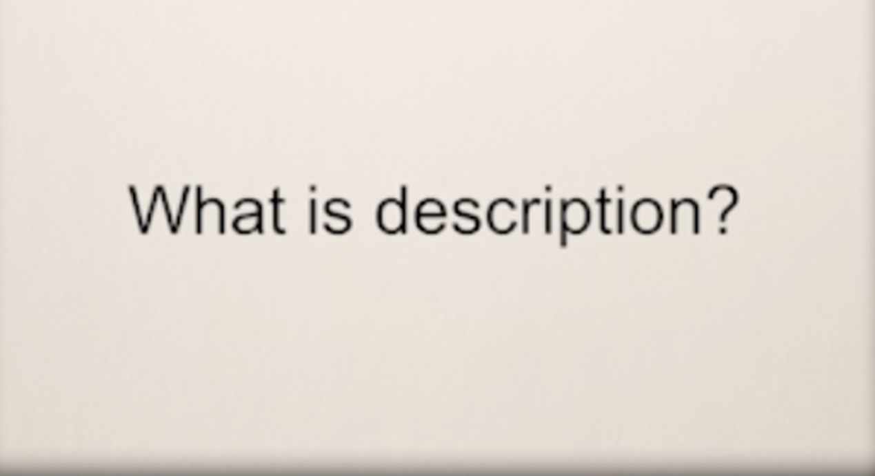

What kinds of description are there?

Provide your answer...
View answer - Part

How is description used in making decisions?

Provide your answer...
View answer - Part

What other tips does Lisa give about description and what to avoid?

Provide your answer...
View answer - Part

3.5 The importance of analysis
Writing analysis can seem daunting to social workers irrespective of their experience but you can learn good skills in this from the early stages of your career. It requires you to not only collate factual information but also to use your knowledge and experience. The job of the writer is to select and present the factual information, apply their professional expertise based on knowledge and experience. In the following activity you will hear from Theresa and Lisa again. They explain how description is used alongside ‘claims’ and ‘judgements’.

Activity 10 Identifying analysis

Watch the video of Theresa and Lisa talking about analysis on social work writing. Lisa says that analysis is ‘threaded throughout all aspects of work’. As you watch the video make brief notes on how analysis is evident at the level of words and at the level of claims, or professional judgements that are reached.

Video content is not available in this format.
Video 2: What is analysis?
View transcript - Video 2: What is analysis?

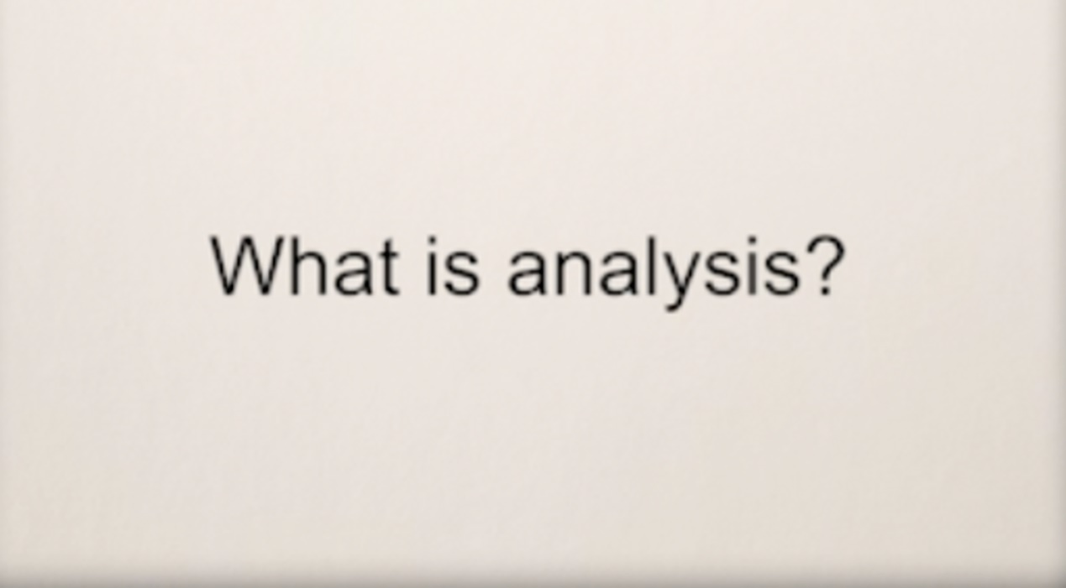

Provide your answer...
View answer - Part

Claims

View answer - Part

Re-watch the video of Theresa and Lisa talking about analysis and making claims in writing. Claims are a key part of expressing professional judgement. Note down the key points that Theresa and Lisa make about how claims should be written.

Provide your answer...
View answer - Part

For a more in-depth exploration of analysis you can find details in the Additional Resources section of this course.

3.6 Artificial intelligence and social work writing
Many social workers and organisations have been thinking about using technology and artificial intelligence (AI) to reduce the time it takes to produce written documents. This remains an evolving area of social work. In this course we have already explored the importance of the language used, and the focus required to ensure that professional judgements are communicated clearly and carefully.
AI has ‘emerged as a transformative and disruptive force with potential to reshape social work practice’ (Haider et al., 2025 p. 5) but there are some major ethical and professional issues to consider. Generative AI is being adopted by social workers and organisations to reduce what is perceived as administrative burden. Given the importance of language and nuance in the words we use in social work writing we need to consider the reliability of AI systems and tools. While arguments for the use of AI propose that this enables social workers to focus more fully on relationship-based practice we have explored within this course that social work writing is not a separate activity and it is through written communication and documents that social workers practice.
Haider et al., (2026) summarise some of issues that are vital for social work to consider:
- AI not yet reliable in predicting risk and making decisions
- Nuance and context
- Accountability, transparency and defensible-decision making
- Bias and inequality perpetuated by AI systems and tools
- Sensitivity, security of data and ethics
Social workers still need to use critical analysis within their tasks and formulate records. Social workers still need to engage with the ethical foundations of the profession and careful consideration of the legacy of the written record for people being written about. Developing skills in writing and critical analysis are therefore crucial to learn within the social work career alongside the use of any technology being used.
This section has focused on the details of social work writing in order to think about language at the level of the sentence and even individual words. As you spend more time in practice as a student social worker, try to notice the language that is used. Practice identifying where description, analysis and professional judgements are used within the documents you read and be aware of your own language as you write.
The final part of this section on social work writing will focus on you as the writer and on your readers, and how an awareness of both reader and writer has on writing.

4 Writing about yourself and others


Figure 6 Writing about others
View description - Figure 6 Writing about others
View alternative description - Figure 6 Writing about others

In this section you will:
- consider who contributes to creating social work documents
- learn to identify the different voices within a document and how to use different points of view when writing
- learn about how to write a report ‘to the child’
- reflect on applying learning to your practice.

4.1 Contributors to social work writing
Writing is primarily a form of communication, it conveys meaning from the writer to the reader. This process can be particularly complex when more than one person is contributing to a document and also when there are multiple readers, some of whom may be unknown or even reading the document in the future.

Activity 11 Who contributes to social work writing?

Look at the figure below and identify who are the potential contributors as well as readers of social work documents. You may be able to think of more people to add based on your experience.

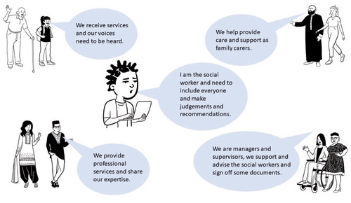
Figure 7 Who contributes to social work writing?
View description - Figure 7 Who contributes to social work writing?
View alternative description - Figure 7 Who contributes to social work writing?

View answer - Activity 11 Who contributes to social work writing?

4.2 Identifying the voices in the social work documents
The WiSP project explored the different ways in which people contribute to social work documents. When writing an assessment report, for example, it is important that the views and wishes of the service user are represented clearly. Sometimes there are also family members and carers who provide information or whose views need to be included. Assessment reports often need to include information from a range of other professionals who may provide factual information or expert opinions.
The task of the social worker is therefore not only describing and providing analysis based on their own observations and professional judgement, but drawing together and synthesising information and opinion from several sources. The way in which all of these ‘voices’ are represented is important so that the reader understands the source of the information or opinion. It is not uncommon for a report to include an opinion that the social worker does not agree with, but it is nonetheless important to include.

Activity 12 Who said

Read the following extract from an assessment report and identify the source of the information or judgement. Use the highlighting tool to identify which content is from. Click on the different yellow, pink and blue pen button options to change the colour.
- The social workers (blue)
- Santosh the service user (Yellow)
- Rachel the community nurse (Pink)

Interactive content is not available in this format.
View description - Uncaptioned interactive content

This activity illustrates that weaving several voices together can be tricky. As a social worker you may also need to use different voices depending on your role and how you refer to yourself. The choices that you make about language can alter the way in which readers understand who’s views are being expressed and the authority or expertise of the views.
The following illustrates some the different voices used:

Table 8
Point of view | Example | Comment
First person | I observed, I believe, I offered | The writer is taking clear personal ownership of what is being said
Passive voice | It was observed, it is believed, it was offered | Distances the writer personally from the statement and can also imply that the statement is commonly accepted as a fact.
Second person | You observed, you believe, you offered | Directed at a specific person, not normally used in formal / professional documents
Third person (impersonal) | The social worker observed, the authority believes, Social services offered | The person is less visible individually and the opinion or information is located in the organisation or role that they hold.
Third person (specific speaker) | Dr Jones observed, Dr Jones believes, Dr Jones offered | Identifies the person expressing the view who is not the writer.
Use of quotations | Mrs O’Rourke said she was ‘at the end of her tether’ | The use of speech marks indicates who expressed the opinion / provided the information. It also distances the writer from the content

Activity 13 Identifying the voice

Look at the examples from written texts and use the drop down feature to select the correct categories.

Interactive content is not available in this format.

View answer - Activity 13 Identifying the voice

4.3 Who is social work writing for?
There are many ways in which the choice of language may differ depending on who is the main intended reader. The examples here differentiate writing to an authority or organisation compared with to an individual person, in this case a person using the social work service. The specific ways in which a social worker might write should also take account of factors such as the age, mental capacity, first language and specific communication needs of the reader.
In the following activity you will hear from Gillian, an experienced social worker in a role in England of Independent Reviewing Officer (IRO).

Activity 14 Writing to the child

Watch the following video in which Gillian talks about how she thinks reports and case notes about children should be written. As you watch, note down how reports can be explicitly addressed to a child and what Gillian sees as the benefits of doing this

Video content is not available in this format.
Video 3: What is your current role?
View transcript - Video 3: What is your current role?

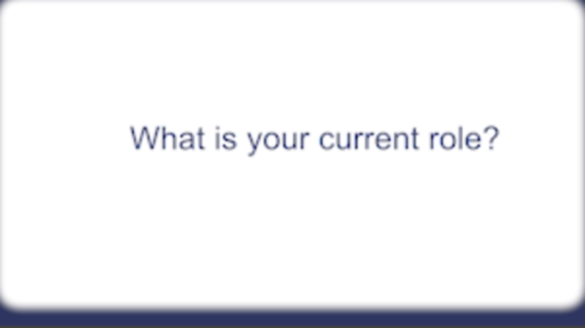

Provide your answer...
View answer - Activity 14 Writing to the child

4.4 Reflection
Writing is an integral part of your practice and the documents you write and contribute to can make a big difference to the lives of the people you support. It is through writing that you enact social work. While this section has not specifically addressed social work values, just as in any other aspect of practice, your writing should be based on the core values of social work. The written word is very powerful, and although many people, including service users, may contribute to documents, it will very often be the social worker who has the powerful position of deciding what information to include, what conclusions to draw and recommendations to make. Learning to write professional social work documents is a skill you will continue to develop throughout your career.

Activity 15 Reflecting on your own writing journey

In the final activity, listen again to Vicki talking about her learning journey. This time as you listen, identify three areas of your own writing that you will focus on in your practice.

Audio content is not available in this format.
Audio 1 (repeated): Reflecting on professional language
View transcript - Audio 1 (repeated): Reflecting on professional language

Provide your answer...
View answer - Activity 15 Reflecting on your own writing journey

Conclusion
In this course you explored how to write professional social work documents in practice. It has included some approaches that you can use to consider the purpose and audience of your practice writing. As you heard from Vicki, learning to be an effective social work writer takes time. You will develop your skills throughout your practice learning as a student social worker and beyond into qualified practice.
The WiSP project reminds us of the tremendous power of writing as part of social work practice, at the heart of which is a person for whom what you write will undoubtedly impact their lives. We also highlight how important critical analysis is within writing and the necessity to consider this and other ethical issues when using any AI systems or tools. Earlier in the course we highlighted the voices of service users and carers to which we now return:

‘Everything about social work writing should reflect the view, voices and experiences of the people who are being written about ... written products should be usable and understandable by all relevant stakeholders that need to access it.’
(The Open University, 2023)

This OpenLearn course is an adapted extract from the Open University Social Work courses.

References
Haider, S., Ferguson, G., Flynn, A., Giraud and Vseteckova, J. (2026) ‘Emerging use of AI in social work education and practice: A rapid evidence assessment of the literature’, Social Work England, Sheffield, [Online]. Available at: https://www.socialworkengland.org.uk/about/publications/the-emerging-use-of-artificial-intelligence-ai-in-social-work/ (Accessed: 26 Jan 2026).
Lillis, T., Leedham, M. and Twiner, A. (2020) ‘Time, the Written Record, and Professional Practice: The Case of Contemporary Social Work’, Written Communication, 37(4) pp. 431–486, DOI: https://doi.org/10.1177/0741088320938804 https://oro.open.ac.uk/70776/
Lillis, T. and Leedham, M. (2024) Who is the ‘I’? An exploration of social work professional written discourse and implications for social work education, Social Work Education, DOI: 10.1080/02615479.2024.2314608
Lillis, T. (2023) ‘Professional written voice “in flux”: the case of social work’, Applied Linguistics Review, 14(3), pp. 615–641. [Online]. Available at: https://doi-org.libezproxy.open.ac.uk/10.1515/applirev-2021-0055
Rai, L. and Lillis, T. (2012). ‘“Getting it Write” in social work: exploring the value of writing in academia to writing for professional practice’, Teaching in Higher Education, 18(4) pp. 352–364, DOI: https://doi.org/10.1080/13562517.2012.719157
Rai, L. (2020) Writing skills for social workers in Parker, J. (Ed) Introducing Social Work SAGE.
The Open University (2023) WiSP information booklet produced with social work service users.

Additional resources
The WiSPeR website contains a wide range of resources aimed to support social workers, including those studying at university. You can explore the topics to continue to develop your knowledge and skills.
Writing Analysis in Social Care is an interactive learning resource which is freely available for any workers in the social work and social care field and relevant to all UK nations.
A summary of research into social workers’ writing is the focus of Rai, L., Ferguson, G. and Giddings, L. (2025) ‘Writing as social Work: thematic review of the literature’, The British Journal of Social Work, 55(1), pp. 25–44. Available at: https://doi.org/10.1093/bjsw/bcae124
BASW have produced Generative AI & Social Work Practice Guidance, which is available to members on their website.
The TACT Fostering website has a section on ‘Language that cares’, which includes a glossary compiled by children and young people of alternative phrases that they prefer social workers to use.
Your nation’s professional standards and codes of practice can also be reviewed for their expectations about writing. There are also specific policies and guidance documents which are relevant in different areas of practice. Some examples are listed below:
The Promise Progress Framework (COSLA, The Scottish Government and The Promise Scotland, 2024) is downloadable from their website, this is linked with the major Scottish policy and guidance following the Independent Care Review in 2017.
Keeping the promise (The Promise Scotland, 2025) contains links to the reports from Scotland’s Independent Care Review, 2017.
For students based in Wales, a section (00:49:34 onwards) of the Student Connect Webinar on ‘Recording and report writing in social work’ deals with writing specifically in accordance with the Social Services and Well-being (Wales) Act 2014.
The Scottish Government has information on developing chronologies as part of their Getting it Right for Every Child (GIRFEC) guidance.
Iriss, the Institute for Research and Innovation in Social Services, has published the useful report Chronologies in Adult Support and Protection: moving from current to best.
The Centre for Excellence for Children’s Care and Protection (CELCIS) has produced guidance on Developing Practice for Care Records in Scotland.
The Social Care Institute for Excellence (SCIE) has a useful resource about social work recording.
Research in Practice has a practice tool for completing social work chronologies on their website.
Social Care Wales has created Friend not Foe: make recording personal and accessible, which is a guide to supporting meaningful, outcome-focused recording in social care.
The Healthcare Library of Northern Ireland has published a supplement on record keeping and note-taking.
Social worker Rebekah Pierre’s Open Letter to the Social Worker Who Wrote My Case Files was published by BASW as part of National Care Leavers Week 2022. (Please note that this resource has a Trigger Warning because it contains extracts of case notes some may find upsetting, with reference to child sexual exploitation and domestic abuse.)

Acknowledgements
This free course was written by Dr Gillian Ferguson and Dr Lucy Rai.
The WiSP research project was funded by the Economic and Social Research Council ES/M008703/1 and The Open University, UK.
This course is based on extensive ESRC funded research into social work writing (WiSP), undertaken by Professor Theresa Lillis (Principal Investigator), Dr Alison Twiner and Dr Maria Leedham and a web based resource for social care professionals designed by Professor Theresa Lillis and Dr Lucy Rai working with members of the former WiSP Advisory Committee (full details can be found here). Many of the activities within this course are drawn from the original research project and web based resources and further developed in collaboration with social work practitioners, academics and people with lived experiences of social work services lead by Dr Lucy Rai. We thank all the original researchers, the former WiSP Advisory Committee, social work users and social work practitioners. You can find out more about the research at https://www.writinginsocialwork.com/.
Except for third party materials and otherwise stated (see terms and conditions), this content is made available under a Creative Commons Attribution-NonCommercial-ShareAlike 4.0 Licence.
The material acknowledged below is Proprietary and used under licence (not subject to Creative Commons Licence). Grateful acknowledgement is made to the following sources for permission to reproduce material in this free course:
Images
Course image: Chong Kee Siong / Getty
Figure 1: South_agency / Getty
Figure 2: Strelok / 123rf
Figure 3: WiSPeR Findings document / The Open University
Figure 4: Vadymvdrobot / 123rf
Figure 5: Piotrkt / 123rf
Figure 6: Valerii Honcharuk / Dreamstime
Figure 7: The Open University
Audio
Audio 1: © 2024 WISP
Video
Video 1: The Open University
Video 2: The Open University
Video 3: The Open University
Every effort has been made to contact copyright owners. If any have been inadvertently overlooked, the publishers will be pleased to make the necessary arrangements at the first opportunity.
Don’t miss out
If reading this text has inspired you to learn more, you may be interested in joining the millions of people who discover our free learning resources and qualifications by visiting The Open University – www.open.edu/openlearn/free-courses.

Solutions

Activity 1 Reflecting on writing as a social worker

Answer
- Vicki says that when she was newly qualified she was less confident about writing ‘in a clear and straightforward way’ and she tended to use longer, more complicated language to compensate for her relative inexperience. She says she now feels that she did not generally consider the reaction of the child or parent in her writing.
- Children may use their social work records to make sense of early childhood experiences. It’s therefore important to write in a way that the child can understand, either now or when they’re older.
- Vicki suggests the following:
  - Avoid judgmental language e.g., manipulative, needy
  - Explain what things mean for the child
  - Avoid over-complicated sentence structure, for example use of the passive (e.g., the child was placed in foster care by the Local Authority (passive), the Local Authority placed the child in foster care (active).
- She always explains acronyms at first use (acronyms are words made from initial letters e.g., LAC for looked after child).
- Vicki says she has noticed an increase in child-friendly writing e.g., Independent Reviewing Officers writing meeting minutes as a letter addressed to the child and a judge writing to children to explain their decisions.
Back to - Activity 1 Reflecting on writing as a social worker

Activity 2 Differences between writing activities

Answer

Table 1 Academic writing compared with social work writing (completed)
 | Student writing | Social work writing
Context | You are writing within a university in order to be assessed on a specific module. | You are writing within your role and on behalf of your employer. The documents you write may have a statutory function and the outcome can have a life changing impact on the people using the service.
Audience | You tutor or script marker. | Multiple and very diverse audiences. These may be known or unknown at the time of writing, but some may only read the document in the future.
Purpose | Assessment of your learning and feedback to help you develop your learning. | Multiple purposes including recording actions and decisions, detailing assessment, expressing professional judgements and recommendations, communication with service users and other professionals.
Self | You are a student, learning both about your subject and how to write. | You are a qualified professional with legal and ethical responsibilities to your employer and to the public.

Back to - Activity 2 Differences between writing activities

Activity 3 Mapping the functions of writing

Answer

Table 3
Functions of writing | Examples
Administration
Preparatory, interim or short texts, often as part of/before larger activity, or one offs | to do lists; online diary entry; annual leave requests
Applications for services, equipment, support checks and referrals
Document often on a template to provide services/equipment or specific actions | housing application; third sector support check; referral for emergency home based respite care
Assessments
Document often on a template to check or evidence eligibility or risk, usually in preparation for allowing or preventing service provision or moving onto a next stage in a process | assessment of needs and outcomes; parenting assessment; risk profile
Communication with others
Sharing/requesting information, via different technologies and media | emails, instant messaging, letters
Contracts/contractual information
Documents that set out formal arrangements, often with sanctions if not adhered to | contact agreements; contract monitoring form
Case recording
Ongoing logging of case activity, usually stored centrally on an authority-based IT system | case notes; contact log; statutory visit record
Diagrams/drawings/mapping
Texts that illustrate a process or relationships, often accompanying other documentation | chronology; genogram
Documents when working with clients
Documents often completed whilst with clients, often to aid interaction/inform decisions | social stories; worksheets; flip charts in person-centred review
Meeting-related paperwork
Texts written in preparation for, during and to document meetings | agenda; minutes; list of people attending
Reports
Documents often on a template, with the purpose to evaluate, summarise, and/or state next actions to be done, after an event or process of engagement | pathway plan; AMHP report; best interest statement
Training/supervision documentation
Texts aimed a arranging, delivering, evaluating and undertaking training and supervision activities | report on a student; portfolio; supervision record

Back to - Activity 3 Mapping the functions of writing

Activity 5 Applying CAPS to social work documents

Answer

Table 5 (completed)
 | Case note | Assessment report | Emails
Context | Case notes are intended to be daily, contemporaneous records (kept in real time) and are agency requirements | Often statutory requirements or completed following agency policy. The can be one off or reviews or previous assessments. | Diverse contexts depending on the purpose, but an important part of multi-agency working.
Audience | No explicitly stated audience/reader (except where emails are copied in as case note). Other social workers and the local authority are the implied readers. | Often not explicitly stated and varies according to specific type of assessment- service user (e.g. assessment of need), courts, local authority. | Named individuals.
Purpose | To record actions, events, interactions and correspondence relating to a specific individual. | To present an evidence based evaluation of the needs of and risks to specific individuals which constitute an argument for specific services and care. | To communicate with social worker colleagues, other professionals, clients and other involved parties about actions, requests, concerns.
Self | As the writer you are often the person responsible for the case | You could be the main author, bringing together contributions from other people, or a contributor if you are not the main case workers | Communication from you in your specific role. This may vary depending on who the email is to

Back to - Activity 5 Applying CAPS to social work documents

Activity 6 Thinking about language in social work documents

Answer
You might have thought that it would depend who the recipient of an email was, your relationship with the person and/ or their role. You may have thought that all or most professional documents should be quite formal. It is always important to think about the specific document and purpose in your practice area of social work, and if you are required, or if it is useful, to use a template. It is also essential to think about the language of the person you are writing about or to. What might be the issues if most communication is in English? You might be working with someone whose first language is not English. If you are working in Wales you will also be working with the active offer which will also be central to written texts. Adapting to the specific needs of individual people you are working with will also extend to considering how writing is clear for people who have Dyslexia. Considering individual audiences will therefore remain key. It is essential to reflect on these issues when you are undertaking your practice learning. We have collated our notes across these questions for each document type in the table below.

Table 6 (completed)
 | Case Note | Assessment Report | Email
Language | Describing language e.g. reporting what has happened, is happening (James has reoffended)  Analytic language e.g. the social worker’s professional judgement  (Sarah lacks insight into her needs and any risks faced). | Describing language e.g. reporting what has happened, is happening James has reoffended  Analytic language  e.g. the social worker’s professional judgement  (Sarah lacks insight into her needs and any risks faced).  Recommendations for actions/services  Often structured by templated headings (e.g. health, education, nutrition, capacity.) | Greetings  Requesting and giving information about people, meetings, services  Thanking/acknowledging actions carried out

Back to - Activity 6 Thinking about language in social work documents

Activity 7 Formal or informal?

Answer

Table 7
Example | Style
The chronology indicates that there is a pattern of domestic violence and concerns around alcohol use. | Formal language
Hello, hope all well with you. | Informal language
When Mary is low in mood she lacks motivation to complete daily tasks. | Formal language
A pattern of domestic violence. | Professional language
The chronology indicates that there is a pattern of domestic violence and concerns around alcohol use. | Full sentence
Explained mum needs to check baby skin. | Notes
Lacks motivation. | Professional language
T/C to father. | Abbreviations/acronyms
When Mary is low in mood she lacks motivation to complete daily tasks. | Full sentence

Back to - Activity 7 Formal or informal?

Activity 9 Why is description important?

Part

Answer
There are many kinds but in the video they discuss describing places, people and their states, what’s happened, who’s involved, how someone’s feeling, what the social worker has done.
Back to - Part

Part

Answer
It is used to inform others about a situation and to provide evidence for any recommendations made.
Back to - Part

Part

Answer
Here are some points that Lisa makes:
- Use professional judgement.
- Describe anything that is directly relevant to the specific situation- description of a place for example, may be relevant to some situations and not in others.
- Think about what a reader (a manger, a panel member, a service user) may need to know.
- Avoid vague description.
- Too much description may detract (or distract readers) from the analysis.
Back to - Part

Activity 10 Identifying analysis

Part

Answer
Words… Many words we use involve analysis or evaluation. Examples discussed were:
- abusive
- negative and
- appropriate
- positive
Back to - Part

Part

Answer
Claims… are statements which indicate a professional view or conclusion about a particular situation. A claim follows on from careful description which counts as evidence for the claim being made. An example discussed was:
Without Alice’s support David cannot return safely home
[claim] following on from
David becomes agitated if his wife Alice leaves the room
…
David attempts to leave the premises unsupported
…[descriptions]
Back to - Part

Part

Answer
Here are some points they discuss:
- Any claim needs to be based on evidence and much evidence in writing is expressed as relevant and careful description.
- Claims do not need to be overstated or exaggerated in writing in order to be convincing – using hedging language such as ‘appears settled...seem to be in line with’ may be more appropriate.
- Claims need to be carefully worded and in line with any description offered. If insufficient, irrelevant or vague description (evidence) is included in the written text, any claims made will not be convincing and may affect the outcomes of any report, such as services and resources.
Back to - Part

Activity 11 Who contributes to social work writing?

Answer
- Social workers (in your own team and other teams)
- Line managers
- Other professionals such as doctors, health visitors, care workers, residential workers, benefit advisors, police, teachers, psychologists, occupational therapists
- Service users
- Family and carers
Back to - Activity 11 Who contributes to social work writing?

Activity 13 Identifying the voice

Answer
Activity feedback

Table 9
Example | Voice
I would strongly recommend that the children are placed on child protection plans | Written in first person singular
Jane disclosed that her Mother sexually abused her between the ages of 6 and 10 | Written in third person
It was agreed there should be an adjournment. | Written in the passive voice
Her son gave her ‘a dirty look’. | Use of quotations

The words and phrasing may also be different depending on who the writing is primarily addressed to as in the following two examples:

Table 10
Statement | Reader
The aim is to support John in transitioning in to his new flat, by providing support to him in managing his daily routine and preparing meals. | Addressed to an authority (implied)
I have attempted to contact you by telephone but got your answer phone. | Addressed to service user

Back to - Activity 13 Identifying the voice

Activity 14 Writing to the child

Answer
Here are some points that stand out from Gillian’s comments:
- The main point is that reports (indeed all writing about a child) should be written in a way which explicitly addresses the child. An example would be to write ‘you’ in place of the child’s name.
- Gillian likens this kind of writing to a ‘conversation’ with a child which means that it is important to explain what is happening and why in ways that a child will understand.
- Gillian talks about choosing the words used carefully, avoiding professional language that a child may not understand. She suggests using words such as referring to ‘mummy and daddy’ and describing the reason and outcome of a meeting instead of referring to it as a ‘child protection plan’.
- Gillian makes the point that writing directly to the child is part of the core values of child-centred social work.
Perhaps a general point that Gillian is making is that just because particular ways of writing have become common in professional practice, these do not need to remain the same, if there are good reasons for writing in different or new ways these should be tried out.
Back to - Activity 14 Writing to the child

Activity 15 Reflecting on your own writing journey

Answer
What you have identified in this activity will be unique to you. Here is an example of someone else’s three areas of their writing practice that they will focus on:
- Notice and change when I am using overly complicated language.
- Write in a child-centred style in documents.
- Use a more active tense instead of relying on long sentences that are in the passive tense.
Back to - Activity 15 Reflecting on your own writing journey

Descriptions

Figure 1
Photograph showing a young woman studying in home environment.
Back to - Figure 1

Figure 1
Photograph showing a young woman studying in home environment.
Back to - Figure 1

Figure 2
A photograph of a messy desk.
Back to - Figure 2

Figure 2
A photograph of a messy desk with a laptop, mobile phone, writing paper, mouse, screwed up paper, pot of pens and a coffee cup and a cold drink.
Back to - Figure 2

Figure 3 The Writing in Social Work Practice (WiSP) Research Project
A visual diagram of eight boxes split into two rows.
Back to - Figure 3 The Writing in Social Work Practice (WiSP) Research Project

Figure 3 The Writing in Social Work Practice (WiSP) Research Project
Eight boxes split into two rows, each containing a number and a description. On the top row, the first box contains three year study, the second box contains 5 local authorities in England providing services to children and families, adults with mental health needs, adults. The third box reads 7 social workers, the fourth reads 89 interviews. On the second row the first box reads 483 daily logs kept by a total of 23 social workers. The second box reads 50 days of observations of social workers. The final box reads 4,608 social work writing documents.
Back to - Figure 3 The Writing in Social Work Practice (WiSP) Research Project

Figure 4 Writing for study and work
A photograph of a student working at a desk at night.
Back to - Figure 4 Writing for study and work

Figure 4 Writing for study and work
A photograph of a student working at a desk at night. They are writing with a pen and paper, sitting in front of a monitor, keyboard, mobile phone and some papers.
Back to - Figure 4 Writing for study and work

Figure 5
An image of a page in a dictionary.
Back to - Figure 5

Figure 5
An image of a page in a dictionary with the words ‘forward, noun, writer other than’ are highlighted, also visible on the page is the word ‘forewent, past’.
Back to - Figure 5

Uncaptioned interactive content
Description:
- Imran has been asking about his wife, Susan.
- Imran’s wife and main carer, Susan stated that she no longer feels able to care for Imran at home.
Analysis:
- It is my opinion that Imran requires 24 hour support to maintain his safety as he lacks insight into both his needs and any risks.
Back to - Uncaptioned interactive content

Figure 6 Writing about others
A photograph of a social worker sitting next to a child.
Back to - Figure 6 Writing about others

Figure 6 Writing about others
A photograph of a social worker sitting next to a child showing them some writing. The child is holding a glass of water and looks tense.
Back to - Figure 6 Writing about others

Figure 7 Who contributes to social work writing?
A diagram illustrating the various people involved as both potential contributors and readers of social work documents.
Back to - Figure 7 Who contributes to social work writing?

Figure 7 Who contributes to social work writing?
A diagram illustrating the various people involved as both potential contributors and readers of social work documents. The diagram is organised with a central figure of a social worker, surrounded by four other figures, each with a text bubble explaining their role.
- Central Figure (Social Worker): ‘I am the social worker and need to include everyone and make judgements and recommendations’.
- Top Left Figure (Service Users): ‘We receive services and our voices need to be heard’.
- Top Right Figure (Family Carers): ‘We help provide care and support as family carers’.
- Bottom Left Figures (Professionals): ‘We provide professional services and share our expertise’.
- Bottom Right Figures (Managers/Supervisors): ‘We are managers and supervisors, we support and advise the social workers and sign off some documents’.
Back to - Figure 7 Who contributes to social work writing?

Uncaptioned interactive content
The social workers:
- This is a particular concern as the only washing facilities on the ground floor is the kitchen sink.
- In my last visit, which was on a Friday, there were still more than 6 ready meals in the fridge, some of which were out of date. When I asked Santosh about his meals and washing he became agitated and upset.
Santosh the service user:
- Santosh says that he is able to wash and bath himself and does not need any personal care in this area. He is also happy with his brother delivering ready meals each Saturday, which he says he is able to heat in the microwave.
Rachel the community nurse:
- Rachel Dodd (health visitor) who has been visiting to dress Santosh’s ulcer has expressed concern about Santosh’s ability to keep himself clean due to his limited mobility.
- Rachel also reported that Santosh’s weight has continued to fall so she is concerned that he is not eating well.
Back to - Uncaptioned interactive content

Audio 1: Reflecting on professional language

Transcript
VICKY
My name’s Vicky.
I’ve been a qualified social worker for six years.
I’ve recently left frontline child protection practice and I’m still in a social work role, working with children and I’m going to talk a little bit about my experience of writing in social work.
So one thing that I have realised is that when I was less experienced, when I was newly qualified, I was much less confident writing in a clear and straightforward way, and I think I sometimes used big words, overly complicated language to try to over compensate for my inexperience and to try and make me feel what I perceived to be professional and to come across in a certain way.
Umm I remember when I was very first qualified writing a Court report and I used the word ‘cervix’ in the report which I found in a thesaurus, I was quite proud of that, I thought it might impress my manager, maybe the judge, but at that point I barely understood what that word meant myself and I didn’t really give any thought to whether or not the parents or the child would understand what I was trying to say. Whereas now when I write I’m keeping the child at the centre of my mind, so I’m trying to write in a way which that child could either understand now if they’re old enough or for them to be able to understand in the future and children when they are older often use their social work records to make sense of what happened to them earlier in life so I’m keeping that in mind and I’m trying to write in a way which will help a child to do that if they come back to read their records at a later date.
It’s also really important writing an accessible way because that means it’s going to be more easily understood by their parents that I’m trying to work with. And when I work with children and parents I’m trying to work with them not do things to them or for them and I think the language that I use and the way that I write is a really important way to try to achieve that.
So writing accessibly for me is about several things. It’s about the words I choose. For example, I always try to avoid judgemental language. Umm there’s certain words that I wouldn’t use, I don’t think they’re helpful in either building relationships with children and parents now or for children and parents to read in the future. For example, I wouldn’t use the words ‘manipulative’ to describe a parent or the word ‘needy’ to describe a child. I don’t think any of us would like to be described in those ways and I always try to write in way which is explaining what things mean for that child which I don’t think those words help to achieve.
I also try to avoid choosing over complicated sentence structure, and something which I’ve become aware of recently is that the passive tense is much more difficult for people with a lower literacy level to understand, so it’s something that I’m consciously trying to do to avoid writing in the passive tense.
Although there are many audiences for social work writing so I’m not just writing for the child now or in the future I also might be writing for my manager or for other professionals or maybe for a judge, all of those professionals are able to understand something written in straightforward way, whereas if I’m writing in a complicated way for someone else for another professional it doesn’t work both ways, it’s not that the family would necessarily be able to understand what I was trying to say. And in my experience writing in a really, much more clear way and straightforward way is well received in any event by professionals.
Something else I try to do when time allows and it doesn’t always allow but is to try writing using an easy read format which is about distilling a much longer report down into the key points and that’s used and can be particularly helpful for parents with a learning difficulty or disability and again that’s something I found that’s been really well received.
Obviously sometimes it’s necessary to use professional language so maybe when I’m talking about a particular professional role or service or referring to a particular social work theories. However, I would always try to put this in some context and try to make this as accessible as possible. For example, I wouldn’t use acronyms without first explaining what that referred to.
I’ve seen in the time that I’ve been a social worker writing in a more child friendly way is increasing across the field. So independent review officers I’ve seen now widely writing their meeting Minutes as letters directly addressed to the child and even in some cases I’ve come across judges writing to children to explain the decisions that they’ve made.
Back to - Audio 1: Reflecting on professional language

Video 1: What is description?

Transcript
THERESA LILLIS
Hello, Lisa. Well, thanks for joining me today. From the many conversations that we’ve had about writing in social work and from the many different types of texts that I’ve looked at from social work, it’s clear that description is absolutely crucial. Could you say something about what description is in social work writing and why it’s so important?
LISA LEWIS
I think that description is a way of trying to capture information in social work writing. You can be talking about people, places, and events. And it’s really important when doing that the information is specific and detailed. The other thing is it can be really important in terms of evidence when it comes to decision making for children and families and any other aspect of social work.
THERESA LILLIS
So description is absolutely crucial to everything that you’re doing.
LISA LEWIS
Absolutely.
THERESA LILLIS
I think it would be useful if we look at some brief examples. So example one is from a single assessment and says the home environment is clean.
LISA LEWIS
So that would be an example of describing places.
THERESA LILLIS
Example two is from a case note and says his father told him to leave and get his belongings.
LISA LEWIS
So that’s describing what happened.
THERESA LILLIS
Example three is from a case note again. They’ve both been seen with bruising and marks.
LISA LEWIS
So that’s describing people in their states.
THERESA LILLIS
Example four is from a court report and says he is presently seeing his probation officer.
LISA LEWIS
And that would be describing who’s involved.
THERESA LILLIS
Example 5 is from a single assessment. She says she feels safe.
LISA LEWIS
So that’s describing how someone’s feeling.
THERESA LILLIS
The last example here, example 6, which is also from a case note says I contacted the school who have reported numerous incidents, some requiring physical intervention.
LISA LEWIS
So that’s describing what the social worker has done in a situation.
THERESA LILLIS
So there’s lots of different kinds of description. Are these descriptions here typical, do you think?
LISA LEWIS
I think it’s important to remember that social workers are going to be using a combination of these descriptions in the writing that they do.
THERESA LILLIS
So let’s have a look at an example where perhaps some of these are brought together. This is from a case note. This is an example seven. Peter has been given a 24-week sentence. Jane, his mother, feels he needs intensive residential rehab but does not believe he would volunteer for this. She’s wondering whether there is any means of compelling him in his best interests. I assessed Peter under the Mental Health Act this week, and he’s not detainable.
LISA LEWIS
Well, there’s a number of things going on here. We can clearly see description of what happened, a description of what someone feels or thinks about the situation, and a description of what the social worker did. So in this case, it’s a specific assessment, which led to the social worker having a particular conclusion.
THERESA LILLIS
Thank you, Lisa. I think people can underestimate how difficult good description is in social work for a number of reasons. One obvious one is that it’s impossible for anybody to describe every single detail about something that’s going on. And secondly, even if you could, you would never have the time to write all that description. So how do you go about deciding what kinds of things to describe in everyday social work?
LISA LEWIS
Well, I think it’s important that you use your professional judgement in all aspects of the work you do to really think about the specific information that needs to go into a report. So that’s really contextual in terms of the case and the report you’re writing. So earlier, we talked about an example in a single assessment of a clean home environment. And I think, in that example, if say it was a child neglect case, that would be really important to highlight in that particular case-- in that particular example.
THERESA LILLIS
So everything has to be contextually specific and relevant to that case to be able to decide what detail should go in.
LISA LEWIS
I agree.
THERESA LILLIS
I think it would be useful to look at an example here. So if we look at example eight, this is from an enablement assessment. And it says, when Mary is low in mood, she lacks motivation to complete daily tasks. Mary will struggle to get out of bed and have motivation to prepare meals.
Mary has recently moved into her own flat, and she’s just started living on her own. Therefore, she’s still needing to develop skills surrounding cooking meals and developing this as part of a routine. So wonder what things are going on here then in the description.
LISA LEWIS
So again, we can see a number of things happening here. There’s a description of the actual situation. But there’s also a description of a situation that sometimes arises, alongside an analysis and a judgement about the consequence for Mary’s day-to-day living. So careful description is really important because it influences the decisions that are made about people’s lives.
THERESA LILLIS
Thank you, Lisa. So Lisa, we know that description is crucial. But we also know that it’s not necessarily straightforward. It’s not necessarily straightforward to write good or meaningful description. What are the challenges for writing good description from your experience?
LISA LEWIS
Well, I think what’s really important is that description has to have a purpose and be meaningful to you as the author but also to the audience of the report so, for example, managers, panel members, and anyone else that might be reading it. Service users are really important as well. And I think the other thing that comes up quite a lot is that description can be too vague. And it’s really important to try and steer away from that.
THERESA LILLIS
I think it would be good to look at some examples of vague description. So let’s have a look at example nine. Her parents are sentimental.
LISA LEWIS
So I guess I’d be asking, what does this mean, and why is it important to mention?
THERESA LILLIS
Example 10, he was behaving in a risky way. What would you think about that?
LISA LEWIS
I’d ask what is meant by risky. Is he being risky to himself or to others, for example?
THERESA LILLIS
Example 11 – a different example really – the family had Christmas dinner with all the trimmings.
LISA LEWIS
So why is that important to mention? And what is meant by trimmings? That sounds quite vague to me.
THERESA LILLIS
So some of those descriptions could be included, but they would need more description or analysis to make those meaningful in a report.
LISA LEWIS
I agree. Absolutely.
THERESA LILLIS
I mean, another issue that comes up with description is how much description is enough. And that seems to be really difficult. I don’t know whether that’s an issue that you find is something that comes up a lot.
LISA LEWIS
I think, quite often, social workers can include too much description. And that sometimes takes away from the analysis in a report.
THERESA LILLIS
Let’s have a look at an example here. This is example 12. And this is from a prospective adopters report. And it says Hilary has vivid memories of playing out all the time with her brother and children of the village, enjoying day spent running through the fields with the air on her face and sometimes falling asleep in the warm grass.
LISA LEWIS
So it’s not that there’s anything particularly wrong here. But it’s about thinking about what descriptions are important to help the reader make a final decision. And I think, in this case, there is some detail that could be cut out. Enjoying days spent running through the fields with the air on her face and sometimes falling asleep in the warm grass, and the point about enjoying can just be added to the main sentence.
THERESA LILLIS
Thank you, Lisa. So social workers often talk about having their own style in writing. And this seems to be quite important because it seems to suggest that people can have a sense of ownership over the writing that they’re doing. But from your experience, are there any particular trouble spots or issues around style?
LISA LEWIS
I think one of the things that can happen in terms of description is that, sometimes, people can focus too much on it. And the language that is used can be quite flowery. And that can be really, really problematic for the reader in various different social work reports.
THERESA LILLIS
Are there any examples of this kind of flowery language in any of the texts that we’ve looked at today?
LISA LEWIS
I think if we were to look back at example 12 again, so the air on her face, the warm grass would be an example of flowery language.
THERESA LILLIS
Why do you think a social worker might include that kind of flowery language or description?
LISA LEWIS
I think, from my experience, social workers quite often want to focus on bringing an applicant or a service user to life in their reports. And they might get a bit too carried away with that as a focus rather than coming back to the ultimate aim of the report, which is the decision making. That can be really quite tricky.
THERESA LILLIS
And so why does language like that detract from the report? What is it that readers such as managers and panel members are critical of?
LISA LEWIS
I think what can happen is that, if somebody, whoever it is reading the report, sees that there’s too much description, too much flowery language, it might detract from the rest of the report. So they might lose trust in the author. And therefore, the meaning later down the report might become less important.
THERESA LILLIS
So it actually affects negatively, the reader’s impression of the social worker’s expertise or judgement?
LISA LEWIS
Yeah. I think so. I think, it basically removes the trust in the author.
THERESA LILLIS
Thank you, Lisa.
Back to - Video 1: What is description?

Video 2: What is analysis?

Transcript
THERESA LILLIS
Hello, Lisa. Thank you for joining me. We’re talking about and thinking about analysis. And clearly, analysis is absolutely crucial to everything that social workers are doing in their day to day practise. Can you say something about the kind of analysis that social workers do?
LISA LEWIS
Yeah. I think analysis is absolutely crucial to the work that social workers do. And it’s threaded throughout all aspects of the work, whether you’re working with children and families, the elderly, working with people with mental health problems and assessing them for services that they might require. And I think what can be challenging is that social workers will do this instinctively every day and talk it. But sometimes when it comes to writing it, people can find that really challenging.
THERESA LILLIS
I think from all the different texts I’ve seen, there’s different kinds of analysis going on in writing. I think it would be useful to look at some examples at the level of words. So example one says, ‘Her previous relationship had been abusive’.
LISA LEWIS
OK, so the fact that the social worker has chosen to use the word ‘abusive’ demonstrates her ability to analyse. The fact that this particular word has been chosen demonstrates a negative analysis of the relationship in question.
THERESA LILLIS
Example two, ‘She was dressed appropriately and appeared well’.
LISA LEWIS
This is more of a positive aspect in terms of the assessment from the social worker.
THERESA LILLIS
And example three, ‘She struggles to motivate herself’.
LISA LEWIS
That signals the challenges that somebody is facing.
THERESA LILLIS
So even at the level of the single words that social workers are using, they reflect the analysis that’s going on.
LISA LEWIS
Yeah. I agree. Yeah.
THERESA LILLIS
And of course, analysis is going on not just at the level of words but at larger statements and claims, I think, which are really important. If we look at example four, we can see how claims are explicitly linked to and based on descriptive evidence.
So example four, ‘David becomes agitated if his wife Alice leaves the room, and David goes in search of her. As such, David cannot remain safely on his own in his apartment, even for short periods. David also attempts to leave his premises unsupported to return to town. And therefore, he requires close monitoring to maintain his safety. Without Alice’s support, David cannot safely return home. And therefore, it’s my opinion that he requires 24 hour residential to meet his needs and maintain his safety’. Can you say something about what’s going on in that description and analysis there?
LISA LEWIS
So there are a number of things happening here. Firstly, we can see the description of the specific person and the situation. Secondly, we can see the claims made by the social worker based on the evidence. And thirdly, we can see a judgement by the social worker about what is needed. So the consequences are clearly based on the description and analysis.
THERESA LILLIS
Thank you, Lisa. So we’ve been looking at analysis and in example four, we saw explicit analysis. And of course, it’s the case that some forms or documents have sections called ‘Analysis’. So I think it be useful to have a look at an example of one of these sections.
So example 5 is from a child’s plan. And the social worker is required to write analysis. And you have that there in the heading, analysis, are we achieving good outcomes.
And it says, ‘Hannah appears settled within her foster placement and is having her needs met. She has appropriate contact sessions with important family members, which seem to be in line with her current needs and wishes and feelings. Hannah continues to struggle with her emotions and will be offered further support through the school doctor and court psychologist.’
LISA LEWIS
OK, so all of the comments here are analytical. She is making claims about whether the child is settled, whether she has appropriate contact with family members, and about her overall emotional state and well-being.
THERESA LILLIS
Yes, and I think what’s important to note here is that this is analysis, and the social worker is clearly reaching conclusions. But she’s not being categorical. We can see that she’s hedging some of her comments. She’s using ‘appears’, ‘seems to be’. So she’s being quite cautious. And presumably, we don’t know, because we don’t have the documentation, that’s because that’s what the evidence allows her to say.
I think it would be useful if we looked at a contrasting example. So if we look at example 6, and this is from a single assessment, it says, ‘The chronology indicates that there is a pattern of domestic violence and concerns around alcohol use. The risks include the children witnessing domestic disputes, which would harm the children’s emotional well-being and place them at risk of physical harm, especially if the violence and aggression took place in front of them. The children are vulnerable and need to have a home that is safe where the adults are not stressed and where their carers can prioritise their needs at all times’.
LISA LEWIS
OK, so here there is no hedging at all. But the use of words such as ‘include’ and ‘indicates’ are categorical statements used by the social worker. And I think we assume here that these statements will be evidenced elsewhere in the report. However, if they haven’t been evidenced, then there will be a problem.
THERESA LILLIS
So that’s a really important point about evidence. Let’s have a look at example 7. This is from a prospective adopters report. And it’s in a section entitled ‘Analysis’. We’ve been looking at these specific analysis sections.
And it says, ‘Carolyn’s childhood was stable and consistent, with adults providing care and warmth. And she will draw on this experience in her role as a parent’.
LISA LEWIS
OK, so if we were to take this extract just in isolation, we aren’t able to tell if the social worker’s analysis is based on evidence. However, for this specific example, we have been able to read the full report. And we know there’s evidence missing. Specifically, there’s an example from this applicant’s childhood that should have been included in the final analysis.
THERESA LILLIS
Let’s have a look at how the analysis might be revised to include that specific incident. So ‘Carolyn’s childhood was for the most part stable and consistent, with adults providing care and warmth. And she will draw on this experience in her role as a parent. The one specific incident which shocked her as a teenager was when her mother hit her for staying out late. Carolyn reflected that whilst this was not a way she would parent, she saw this as a one-off incident within an overall relationship of warmth and trust’. To what extent do you think inserting those comments changes the analysis?
LISA LEWIS
I think by adding that additional nuance of information you are creating a more robust rapport overall, which is a lot better.
THERESA LILLIS
Thank you very much, Lisa.
Back to - Video 2: What is analysis?

Video 3: What is your current role?

Transcript
GILLIAN LUCAS
My current role is an independent reviewing officer, also known as an IRO. I started off in social work in child looked after team, and I progressed to reviewing officer.
Central to the work of an IRO is writing up the review minutes. And currently, in Islington, we’re writing them to the child rather than as a professional report. And so, that involves breaking down information and making sure that there is no professional language within that report, and it’s a conversation between you and the child. And that will involve explaining what different plans and assessments are.
So an example would be to explain what a child protection plan is. My description might include professionals, which are doctors, teachers, social workers. We’re worried about you. So they wanted to help mummy, daddy to look after you properly. Mummy and daddy had to agree to take you to nursery on time, make sure you were collected on time. And just talk to the child, so that conversation is clear and the child understands what might have led to them becoming looked after.
I think it’s really important to direct reviews and reports to the child because one of the social work values is to keep all work child focused, all decision making child focused. And if you’re writing a report or a review directly to that child, all of your thoughts and your thinking is child focused.
It can be really difficult to write directly to a child because you need to avoid using jargon and professional language and actually think about what you’re saying. You need to pitch it at the right level to the child’s age and understanding. So initially, it takes longer to write reports.
But as you get into the flow and start thinking of the child in front of you and you’re having a direct conversation rather than writing a report about the child, then the flow gets easier and easier. I think it’s a nicer way to write to a child. It keeps language sensitive. And it will show the child that we do genuinely care about them.
The benefits of writing directly to a child in this way is that the tone and the pitch of the writing is much warmer. The language used is far more sensitive. And it will also show the child when they do come back as an adult and they’re reading their reports that you did genuinely care about them.
You did want them to know why decisions were being made. You were making that explicitly clear in a very sensitive manner. I also know parents have read the reports, and they prefer it. They feel that they’re written in a nice, softer tone and actually written in a way that shows that you care.
Writing in a child-directed way could happen across the board in terms of social workers writing and other professionals writing. So, for example, there’s no reason why case notes can’t be written in a child-directed way. Child protection reports could be, the social work review reports. Some social workers in Islington are writing their reports to children. Court reports could be written in this way. I just don’t understand why we’re not all trained to start writing all of our work to the child to keep all our minds and our work child focused.
Back to - Video 3: What is your current role?

Audio 1 (repeated): Reflecting on professional language

Transcript
VICKY
My name’s Vicky.
I’ve been a qualified social worker for six years.
I’ve recently left frontline child protection practice and I’m still in a social work role, working with children and I’m going to talk a little bit about my experience of writing in social work.
So one thing that I have realised is that when I was less experienced, when I was newly qualified, I was much less confident writing in a clear and straightforward way, and I think I sometimes used big words, overly complicated language to try to over compensate for my inexperience and to try and make me feel what I perceived to be professional and to come across in a certain way.
Umm I remember when I was very first qualified writing a Court report and I used the word ‘cervix’ in the report which I found in a thesaurus, I was quite proud of that, I thought it might impress my manager, maybe the judge, but at that point I barely understood what that word meant myself and I didn’t really give any thought to whether or not the parents or the child would understand what I was trying to say. Whereas now when I write I’m keeping the child at the centre of my mind, so I’m trying to write in a way which that child could either understand now if they’re old enough or for them to be able to understand in the future and children when they are older often use their social work records to make sense of what happened to them earlier in life so I’m keeping that in mind and I’m trying to write in a way which will help a child to do that if they come back to read their records at a later date.
It’s also really important writing an accessible way because that means it’s going to be more easily understood by their parents that I’m trying to work with. And when I work with children and parents I’m trying to work with them not do things to them or for them and I think the language that I use and the way that I write is a really important way to try to achieve that.
So writing accessibly for me is about several things. It’s about the words I choose. For example, I always try to avoid judgemental language. Umm there’s certain words that I wouldn’t use, I don’t think they’re helpful in either building relationships with children and parents now or for children and parents to read in the future. For example, I wouldn’t use the words ‘manipulative’ to describe a parent or the word ‘needy’ to describe a child. I don’t think any of us would like to be described in those ways and I always try to write in way which is explaining what things mean for that child which I don’t think those words help to achieve.
I also try to avoid choosing over complicated sentence structure, and something which I’ve become aware of recently is that the passive tense is much more difficult for people with a lower literacy level to understand, so it’s something that I’m consciously trying to do to avoid writing in the passive tense.
Although there are many audiences for social work writing so I’m not just writing for the child now or in the future I also might be writing for my manager or for other professionals or maybe for a judge, all of those professionals are able to understand something written in straightforward way, whereas if I’m writing in a complicated way for someone else for another professional it doesn’t work both ways, it’s not that the family would necessarily be able to understand what I was trying to say. And in my experience writing in a really, much more clear way and straightforward way is well received in any event by professionals.
Something else I try to do when time allows and it doesn’t always allow but is to try writing using an easy read format which is about distilling a much longer report down into the key points and that’s used and can be particularly helpful for parents with a learning difficulty or disability and again that’s something I found that’s been really well received.
Obviously sometimes it’s necessary to use professional language so maybe when I’m talking about a particular professional role or service or referring to a particular social work theories. However, I would always try to put this in some context and try to make this as accessible as possible. For example, I wouldn’t use acronyms without first explaining what that referred to.
I’ve seen in the time that I’ve been a social worker writing in a more child friendly way is increasing across the field. So independent review officers I’ve seen now widely writing their meeting Minutes as letters directly addressed to the child and even in some cases I’ve come across judges writing to children to explain the decisions that they’ve made.
Back to - Audio 1 (repeated): Reflecting on professional language

