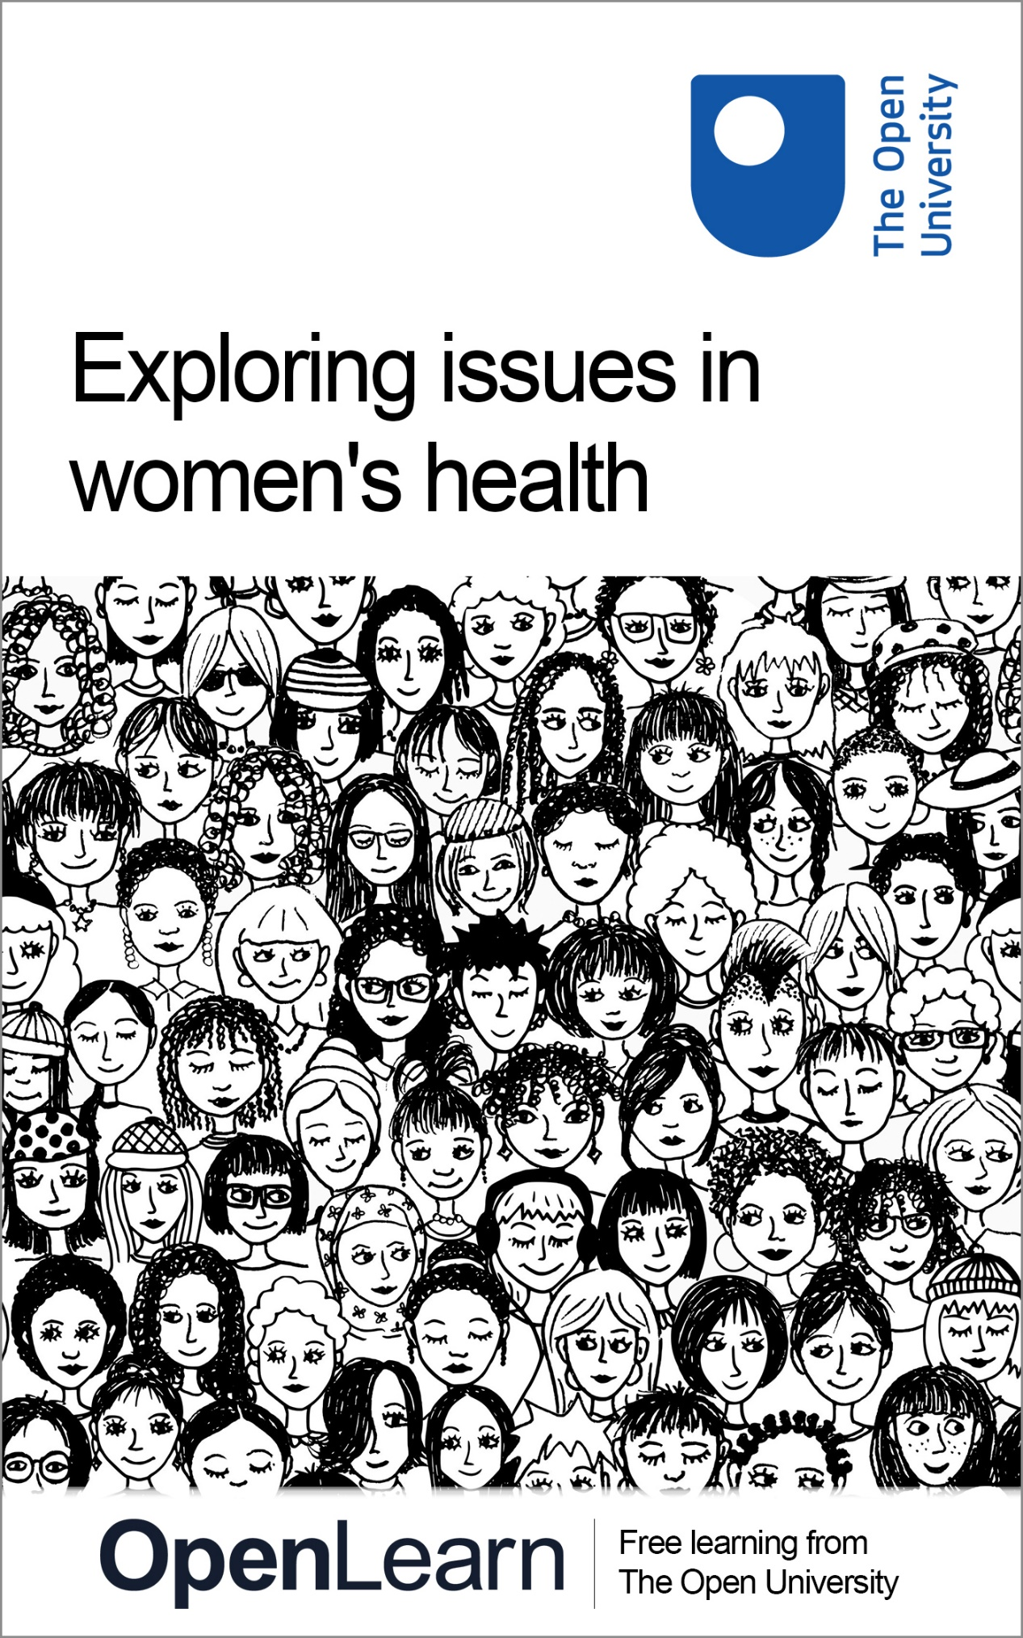

K219_1

Exploring issues in women's health

About this free course
This free course is an adapted extract from the Open University course K219 Critical issues in health and wellbeing: www.open.ac.uk/courses/modules/k219.
This version of the content may include video, images and interactive content that may not be optimised for your device.
You can experience this free course as it was originally designed on OpenLearn, the home of free learning from The Open University –
www.open.edu/openlearn/health-sports-psychology/exploring-issues-womens-health/content-section-0
There you’ll also be able to track your progress via your activity record, which you can use to demonstrate your learning.
Copyright © 2019 The Open University
Intellectual property
Unless otherwise stated, this resource is released under the terms of the Creative Commons Licence v4.0 http://creativecommons.org/licenses/by-nc-sa/4.0/deed.en_GB. Within that The Open University interprets this licence in the following way: www.open.edu/openlearn/about-openlearn/frequently-asked-questions-on-openlearn. Copyright and rights falling outside the terms of the Creative Commons Licence are retained or controlled by The Open University. Please read the full text before using any of the content.
We believe the primary barrier to accessing high-quality educational experiences is cost, which is why we aim to publish as much free content as possible under an open licence. If it proves difficult to release content under our preferred Creative Commons licence (e.g. because we can’t afford or gain the clearances or find suitable alternatives), we will still release the materials for free under a personal end-user licence.
This is because the learning experience will always be the same high quality offering and that should always be seen as positive – even if at times the licensing is different to Creative Commons.
When using the content you must attribute us (The Open University) (the OU) and any identified author in accordance with the terms of the Creative Commons Licence.
The Acknowledgements section is used to list, amongst other things, third party (Proprietary), licensed content which is not subject to Creative Commons licensing. Proprietary content must be used (retained) intact and in context to the content at all times.
The Acknowledgements section is also used to bring to your attention any other Special Restrictions which may apply to the content. For example there may be times when the Creative Commons Non-Commercial Sharealike licence does not apply to any of the content even if owned by us (The Open University). In these instances, unless stated otherwise, the content may be used for personal and non-commercial use.
We have also identified as Proprietary other material included in the content which is not subject to Creative Commons Licence. These are OU logos, trading names and may extend to certain photographic and video images and sound recordings and any other material as may be brought to your attention.
Unauthorised use of any of the content may constitute a breach of the terms and conditions and/or intellectual property laws.
We reserve the right to alter, amend or bring to an end any terms and conditions provided here without notice.
All rights falling outside the terms of the Creative Commons licence are retained or controlled by The Open University.
Head of Intellectual Property, The Open University

Contents
- Introduction
- Learning outcomes
- 1 Thinking about women’s health today
- 2 Exploring the social model
  - 2.1 Why do we need a social model?
  - 2.2 Understanding the social model of health
  - 2.3 Lay perspectives matter
- 3 Social change for health and wellbeing?
  - 3.1 Movements in women’s health
- Conclusion
- References
- Acknowledgements
- Solutions

Introduction
This free course, Exploring issues in women’s health, introduces social model approaches to health and wellbeing, which takes as their starting point not the scientific context of the body, but the social context in which women live. The focus is on women and the impact of social and cultural factors on women’s health.
This OpenLearn course is an adapted extract from the Open University course K219 Critical issues in health and wellbeing.

Learning outcomes
After studying this course, you should be able to:
- understand the impact of social and cultural contexts on women
- describe how the women’s movement has influenced the health and social care sector
- identify pertinent health issues in the field of women’s health.

1 Thinking about women’s health today
Before you start, you’ll watch a video featuring OU academics, Dr Sara MacKian and Dr Sharon Mallon, as well as OU employees discussing issues in relation to women’s health.

Activity 1 Issues in women’s health

Watch the video and as you’re watching consider your response to the question ‘If you could click your fingers and solve a problem to improve women’s health’ what problem would you solve?

Video content is not available in this format.
Video 1
View transcript - Video 1

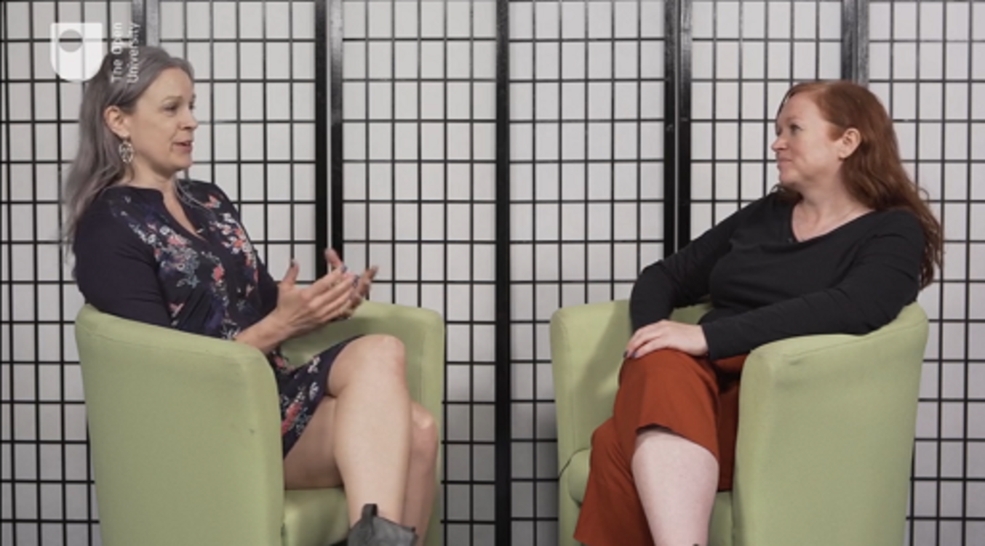

Provide your answer...
View discussion - Activity 1 Issues in women’s health

2 Exploring the social model

Being a man or a woman has a significant impact on health, as a result of both biological and gender-related differences. The health of women and girls is of particular concern because, in many societies, they are disadvantaged by discrimination rooted in sociocultural factors.
(World Health Organization, 2019)

It is clearly important to focus on women’s health and to address the sociocultural issues that prevent women from attaining the best possible level of health. Additionally, as you will know, women lead complex lives and, if they become unwell, some will have aspirations that go beyond what a ‘biomedical fix’ can offer. But what might an alternative model of health look like? You will begin to explore this by considering challenges to health and wellbeing that are beyond the reach of biomedicine. In this section, you will consider how lay knowledge – that of women who are not medical or healthcare professionals – takes a more central, and even vital, role in the social model.

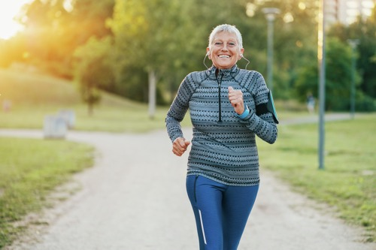
Figure 1 Health: this is important for women across the lifespan.
View description - Figure 1 Health: this is important for women across the lifespan.

2.1 Why do we need a social model?
In Engel’s seminal work, the biomedical model was defined as assuming ‘…disease to be fully accounted for by deviation from the norm of measurable biological (somatic) variables. It leaves no room within its framework for social, psychological, and behavioral dimensions of illness’ (1977, p. 196). But this model clearly needs to be expanded to encompass a broader, more holistic approach to treatment and care. Although holism considers ‘the complete woman’ by looking, for example, for social and emotional explanations for their disease and symptoms (Henderson, 2014), the social model of health takes a different perspective. The social model explains health and wellbeing through the social context. Rather than starting with a woman in a particular state of health or disease, the main focus is on how living conditions and social factors affect health and wellbeing.
Looking at Dahlgren and Whitehead’s diagram (Figure 2), you could think of holism as starting with ‘Age, sex and constitutional factors’ and working outwards. By contrast, the social model would focus first on general socioeconomic, cultural and environmental conditions before working its way through the layers to eventually consider a woman’s constitutional factors.

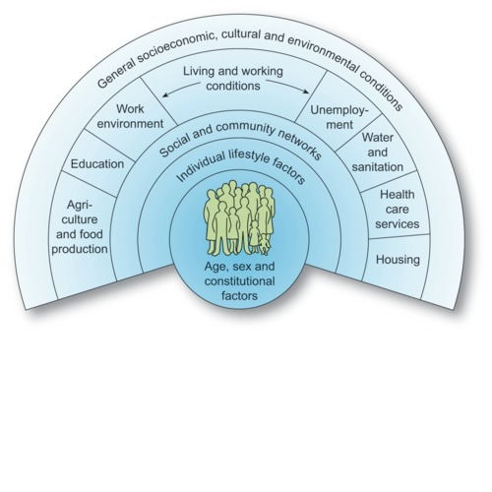
Figure 2 The determinants of health (Dahlgren and Whitehead, 1993, in Dahlgren and Whitehead, 2007).

Women frequently have limited control over the many sociocultural factors that affect their health and wellbeing. Therefore, the social model of health lends itself to campaigns arguing for social justice and better working and living conditions. In addition, the biomedical model isn’t always able to account for how sociocultural factors can interact with the diagnosis it is – or isn’t – able to provide, or how this can impact on a woman’s sense of wellbeing.

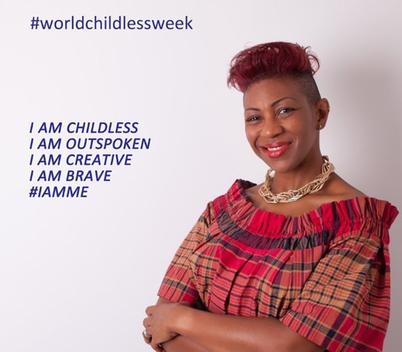
Figure 3 Yvonne John.
View description - Figure 3 Yvonne John.

For example, Yvonne John is an author who has documented the experiences of childless women. In the following activity you will hear her speak about her own experiences around childlessness.

Activity 2 Wellbeing beyond the reach of biomedicine
Allow about 30 minutes

Part 1

Listen to Yvonne John talking on BBC Woman’s Hour about her experiences of childlessness.

Audio content is not available in this format.
Audio 1
View transcript - Audio 1

Part 2

Now answer the following questions.
- What role did biomedicine play when Yvonne and her husband were trying to conceive, and how was biomedicine unable to help her?

Provide your answer...
View discussion - Part 2

- What challenges to Yvonne’s health and wellbeing did she face following the medical diagnosis? What was the impact of social and/or cultural expectations on her wellbeing?

Provide your answer...
View discussion - Part

Part 3

- What did help Yvonne?

Provide your answer...
View discussion - Part 3

- Taking a social model perspective, what might you want to better understand in order to improve the health and wellbeing of Yvonne and other women in a similar situation?

Provide your answer...
View discussion - Part

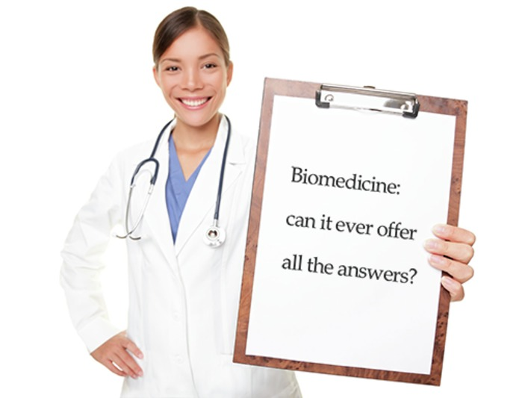
Figure 4 Biomedicine: does it offer all the answers?

The social model of health attempts to integrate social structures and women’s bodily existence in the world. It goes beyond the body to address the social, economic and environmental determinants of health. As you have learned, female reproductive health is one example where the social model offers a useful perspective. The biomedical model would consider reproductive health in relation to the body and reproductive roles, whereas the social model starts from the perspective of the social, cultural and economic, as well as equality issues. You will read more about the social model of health next.

2.2 Understanding the social model of health
The social model of health is so broad that it can be difficult to get a sense of it as a whole, but at the heart of it is a woman’s social context. As you have already touched on, a woman’s social context can bring a wide range of factors to bear on her health and wellbeing.
Yuill and colleagues (2010) have highlighted six features of the social model of health which help to provide an overview of what this model or approach encapsulates.
These six features or factors are:
- An individual’s health is enabled or inhibited by their social context.
People commonly believe that lifestyle factors such as diet and exercise are simply about personal choices, whereas the social model explains that people’s behaviours are shaped by their social context.
- The body is simultaneously social, psychological and biological.
The biological aspects of bodies cannot be separated from social, psychological, cultural and individual processes. Identity is a good example of showing how social and cultural expectations blend with people’s psychology to shape how people present their bodies to others.
- Health is cultural
All cultures have developed their own norms for understanding illness and expressing its impact. Some South Asians can express mental distress by referring to physical pain in their bodies, whereas inhabitants of a community in North East Scotland were habitually stoical when facing illness and tended not to complain or draw attention to their problems.
- Biomedicine and medical science is something – but not everything.
Social scientists can tend to present an inaccurate ‘caricature’ of biomedicine. Although many criticisms are valid, one should not disregard the many strengths of biomedicine.
- Health is political.
Different political ideologies can lead to very different healthcare systems. For example, the free-market ideology of the United States has led to predominantly privatised healthcare provision.
- Other voices matter.
In terms of making sense of and experiencing health as well as ill-health, the social model acknowledges that other voices matter. Knowledge and perspectives must go beyond the biomedical approach.
In the next activity you will match these six features with illustrative examples.

Activity 3 The social model of health
Allow about 15 minutes

Part 1

Drag and drop the correct illustrative example for each of the six factors about the social model of health as summarised by Yuill et al. (2010).

Social class and a woman’s context shapes her life, it affects access to material resources and the amount of control women have over their lives.
It is both through and with a woman’s body that her self-identity is enacted and performed, for instance in the styling of her hair and selection of clothes.
Football sub-culture means that players frequently mask pain in order to keep their place in the squad.
Sometimes social scientists can present biomedicine in such a way that no medical practitioner/doctor would ever recognise the medical model that they are said to be delivering.
Many people in the United Kingdom feel passionately about the importance of the state-run, public sector delivered format of the National Health Service/NHS (i.e. the NHS is political).
Many people with a long-term or chronic illness feel that maintaining and creating an understanding of their situation provides a sense of self and identity that is just as important (if not more so) than medical discourses about their condition.
An individual’s health is enabled or inherited by their social context.
The body is simultaneously social, psychological and biological.
Health is cultural.
Biomedicine and medical science is something, but not everything.
Health is political.
Other voices matter.
View answer - Part 1

As you work through this free course, you will be encouraged to continue to think about the range of voices that can be brought to bear on our understandings of health and wellbeing.

2.3 Lay perspectives matter
It is important that professionals consider a woman’s understanding of their health when responding to her health issues. The biomedical approach has traditionally viewed lay perspectives as inferior, driven by personal opinion, and they often deviate from the scientific and technical knowledge of experts. Traditionally therefore, under a biomedical approach, the voices of female patients, their carers and other non-experts are viewed as less important than professional voices, knowledge and expertise.
By contrast, the social model of health suggests that a good understanding of lay knowledge can usefully inform expert knowledge. Rather than reinforce the distinctions between these forms of knowledge, academics following the social model argue that understanding how people construct and interpret health and wellbeing is vital to maintaining and supporting health (Yuill et al., 2010).
Women construct and interpret their own health and wellbeing based on all aspects of their personal identity and background. Psychiatrist Dr Micol Ascoli believes that being able to work with people’s own cultural interpretations of mental illness is crucial to supporting their recovery. She spoke to broadcaster and psychologist Claudia Hammond, about her work at Newham Centre for Mental Health in London. In the next activity, you will consider Dr Ascoli’s approach to her work and hear from one of her patients, Angela.

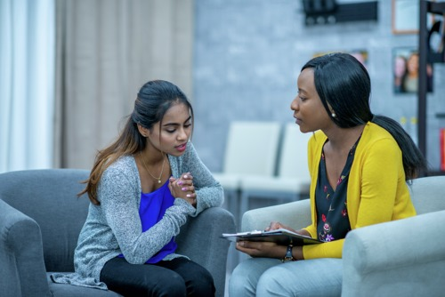
Figure 5 A therapy session
View description - Figure 5 A therapy session

Activity 4 Working with lay perspectives of illness

Part 1

Listen to the following audio, which is an extract from the radio programme Mental health: mad or sad.

Audio content is not available in this format.
Audio 2
View transcript - Audio 2

Part 2

What lay perspectives on bipolar disorder are discussed in the audio? How did the speakers report the lay perspectives as being helpful? Add your findings below.

Lay perspectives described by: |  | How this knowledge can help:
Angela | Provide your answer... | Provide your answer...
Dr Ascoli | Provide your answer... | Provide your answer...

View discussion - Part 2

Part 3

Think about a condition – a disease or disorder – that you or perhaps someone close to you has. What are your own beliefs about the causes of this condition? Are there any aspects of your background that helped to shape these beliefs?
Reflect on the two questions and then write a brief response below.

Provide your answer...

Whatever a woman’s beliefs about health are, it is likely they will have been shaped by many factors that are specific to that woman and may not always reflect wider assumptions held by society more broadly, or indeed fit with the biomedical model. This, however, does not diminish their potential value for understanding health and wellbeing because they will affect health behaviours, personal resilience and the ability to achieve health goals. Furthermore, sometimes the experiences and views of a particular group can have a profound and powerful effect on the views of wider society and alter the professional knowledge base as a result.
In the next section, you will consider the impact of social and cultural contexts on health and wellbeing by exploring issues of particular salience in terms of women’s health.

3 Social change for health and wellbeing?

There is no such thing as a single-issue struggle because we do not live single-issue lives.
(Lorde, 2007, p. 138)

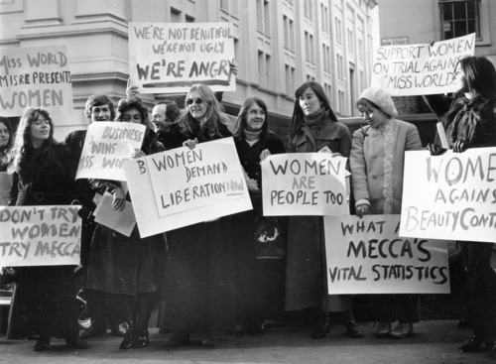
View description - Uncaptioned Figure

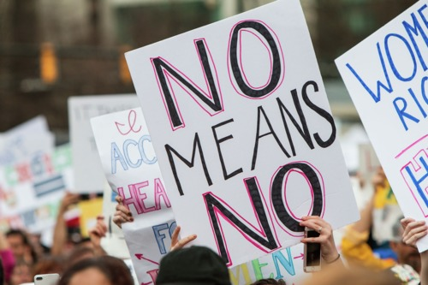
Figure 6 Women’s rights protests spanning the decades.
View description - Figure 6 Women’s rights protests spanning the decades.

The social model highlights how important it is to recognise that health is intricately related to the society in which people live. The model also allows for the influence of culture on how illness is understood, treated and avoided. It follows that social policy can have a fundamental impact on women’s health and wellbeing. But more than that, social policies affect access to healthcare services, as well as the type of services that are available. For example how legislation varies across the United Kingdom, meaning that Northern Ireland is one of only two regions in Europe where abortion effectively remains illegal (Malta being the other) (Galway and Mallon, 2018). (See the article Abortion ban in Northern Ireland likely to worsen mental health crisis.)
Some social and cultural practices and beliefs can undermine the resilience and aspirations of women in a way that has very little to do with the underlying biomedical issue they may be facing. All of this can negatively influence an individual’s sense of wellbeing and recovery in ways that are equal in impact to the physiological or mechanical fix that might come through a biomedical intervention. This section addresses the impact of social and cultural context on health and wellbeing by exploring selected pertinent issues in women’s health.

3.1 Movements in women’s health

Women need not always keep their mouths shut and their wombs open.
(Emma Goldman, 1916, see Anderson, 1970, p. 62)

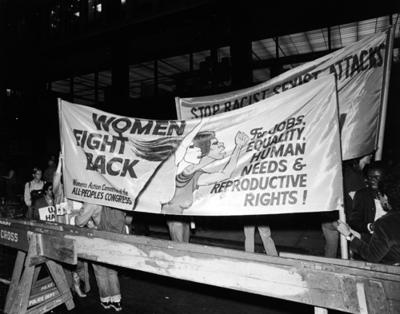
View description - Uncaptioned Figure

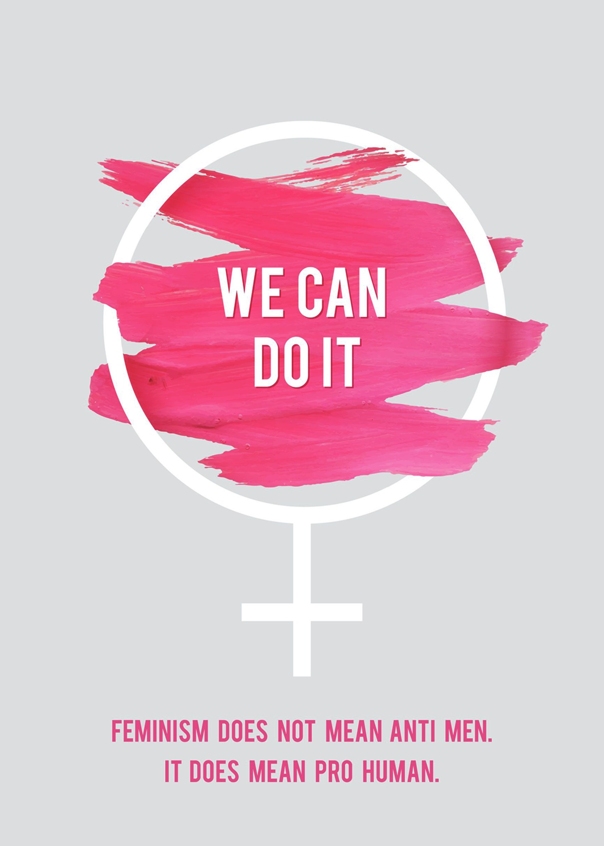
Figure 7 Women protesting about reproductive rights: past and present.
View description - Figure 7 Women protesting about reproductive rights: past and present.

Social movements have a history of challenging the dominance of biomedicine and developing their own focus on health issues. An important impact of the work of social movements relates to how they have liberated what people already instinctively know about health and illness and legitimised this lay knowledge as a counter to biomedical opinions and priorities.
For example, one of the ways in which the women’s health movement has attempted to gain more control for women over their bodies and their health is by sharing experiences and information about health matters among women. The Boston Women’s Health Book Collective, which began in 1969, has been influential in this area. The work of the women in Boston influenced the development of women’s healthcare worldwide. Many of the early aims of the women’s health movement were to challenge doctors’ control over reproductive technology and to claim women’s right to control their own bodies and develop self-help groups and feminist education (Doyal and Elston, 1986).
Although these concerns still exist, many women’s organisations now focus on disadvantaged groups. The Women’s Health and Equality Consortium, for example, has championed the needs of homeless women, migrant women, women with dementia, older women, and girls and young women in health policy. The consortium links these groups with issues such as economic disadvantage, caring roles and gender-based violence (WHEC, 2011), claiming that ‘Women are the main “shock absorbers” of poverty of households’ (p. 1).
Research can also disadvantage women if it does not accurately represent them. Alice Dan, a researcher who has been writing about women’s health since the 1970s, suggested that women’s experiences are ‘distorted in the research’ and that ‘Women’s lives exist in the gaps between the traditional disciplines’ (Dan, 2013, p. 164). Menstruation and menopause are significant examples of issues tightly bound with the social context, and which can fall between disciplines. Journalist Allison Pearson shared her experience of menopause for the BBC’s Woman’s Hour. In the next activity, you will hear her account and you will consider how a social model of health could help to change things for the better. You will also read about period poverty, and how this is being addressed in Scotland.

Activity 5 ‘Women’s issues’
Allow about 45 minutes

Watch the following video in which the menopause is discussed. Then complete the activity.

Video content is not available in this format.
Video 2
View transcript - Video 2

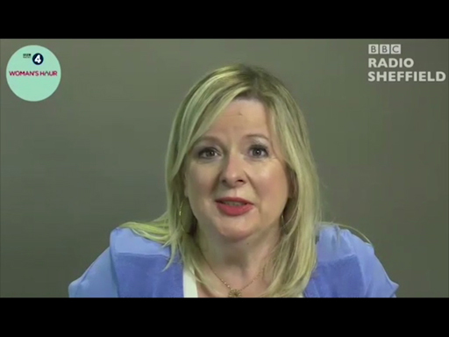

Bearing in mind the concerns identified by the women’s health movement and the ‘gaps between disciplines’ highlighted by Alice Pearson above, identify issues raised in the video and propose solutions to them from the perspective of the social model, adding your notes to the table below. Don’t worry about the practicalities – that is for the policymakers. Simply get your ideas down. This is good practice for developing your skills in academic argument, because to complete the table below you will need to match ‘evidence’ (or, in this case, the issues raised in personal accounts) with a ‘claim’ of some sort (in this case, your proposed solution, e.g. ‘Health professionals need better education on the menopause’).

Rank | Issue | Proposed social model solutions
Provide your answer... | Provide your answer... | Provide your answer...
Provide your answer... | Provide your answer... | Provide your answer...
Provide your answer... | Provide your answer... | Provide your answer...
Provide your answer... | Provide your answer... | Provide your answer...
Provide your answer... | Provide your answer... | Provide your answer...
Provide your answer... | Provide your answer... | Provide your answer...

View discussion - Part

Part 3

The personal account presented in the video is a good illustration of a women’s health issue. However, if you really wanted to make a case for social change, you would clearly need more, and stronger, evidence, to represent the extent of the issue (how many people are affected, and the depth of the personal impact) and perhaps some economic statistics. The article below provides some of these details in relation to period poverty. Read the article and then answer the questions that follow: Ending period poverty: Scotland’s plan for free menstrual products shatters taboos and leads a global movement.

- What is the estimated average a woman in the United Kingdom will spend on period products in a lifetime?

£890
£4,800
£13,200
£27,300
View answer - Part
View discussion - Part

- What are the cited consequences of period poverty for girls and women? Select all that apply.

Using only pads.
Using products like socks and toilet paper.
Using a product for too long.
Using only tampons.
View answer - Part
View discussion - Part

- How does advertising maintain the taboo around periods? Select all that apply.

They do not portray the pain or the physical discomfort of periods.
They only promote their own products.
They do not provide pricing details.
They conceal realities by using blue liquid instead of blood.
View answer - Part
View discussion - Part

Evidence, including statistics, can be powerful means by which to encourage social change. However, women have skillfully adopted other means by which to raise awareness about the challenges they face. For instance, Rayka Zehtabchi directed an Oscar winning short documentary about women in India fighting the stigma surrounding menstruation. Her 2018 documentary was entitled ‘Period. End of Sentence’.
If you are interested in topics related to women’s health, why not follow some women’s organisations on Twitter, for example:
- Wellbeing of Women
- WomensResourceCentre
- Women and Equalities
If you don’t have a Twitter account, you could explore their Twitter feeds instead by clicking on the links provided above.
Over time, the women’s health movement became rather fragmented as differences based on race and ethnicity, class, sexuality, gender identity and age emerged. A recent report has highlighted, for example, the health inequalities faced by black and ethnic minority women in the UK, and their particular vulnerability to cuts to public services (Hall et al., 2017). Despite this fragmentation, women’s voices are stronger and more diverse than ever. In essence, women’s movements have helped to assert the need for ‘lay’ knowledge to be taken seriously when considering responses to health-related issues.

Conclusion
Focusing on the subject of women’s health is important, as this subject is frequently neglected when discussions occur on the topic of wellbeing more generally. This free course, Exploring issues in women’s health, has provided an introduction to social model approaches to health and wellbeing as this applies to women, using examples including period poverty and the biomedicalisation of menopause to illustrate key points. The social model approach takes as its starting point not the scientific context of a woman’s body, but the social milieu in which she lives.
If you have previously studied courses related to health and wellbeing, you will have already started to explore questions related to the various perspectives in the field; however, this is something you will think about in more depth if you study further at The Open University.
This OpenLearn course is an adapted extract from the Open University course K219 Critical issues in health and wellbeing.

References
Anderson, M. (1970) The Little Review Anthology, New York, Horizon Press.
Dahlgren, G. and Whitehead, M. (2007) European Strategies for Tackling Social Inequities in Health: Levelling Up Part 2, Copenhagen, WHO Regional office for Europe [Online]. Available at http://www.euro.who.int/__data/assets/pdf_file/0018/103824/E89384.pdf (Accessed 5 June 2019).
Dan, A. J. (2013) ‘Emancipatory research: then and now’, Sex Roles, vol. 68, no. 1, pp. 163–7.
Doyal, L. and Elston, M. A. (1986) ‘Women, health and medicine’, in Beechy, V. and Whitelegg, E. (eds) Women in Britain Today, Milton Keynes, Open University Press, pp. 173–208.
Engel, G. L. (1977) ‘The need for a new medical model: a challenge for biomedicine’, Science, vol. 196, no. 4286, pp. 129–36.
Galway, K. and Mallson, S. (2018) ‘Abortion ban in Northern Ireland likely to worsen mental health crisis’ in The Conversation [Online]. Available at https://theconversation.com/abortion-ban-in-northern-ireland-likely-to-worsen-mental-health-crisis-98420 (Accessed 5 June 2019).
Hall, S-M., McIntosh, K., Neitzert, E., Pottinger, L., Sandhu, K., Stephenson, M.-A., Reed, H. and Taylor, L. (2017) Intersecting Inequalities: The Impact of Austerity on Black and Minority Ethnic Women in the UK [Online]. Available at https://www.intersecting-inequalities.com/copy-of-report (Accessed 5 June 2019).
Henderson, R. (2014) Holistic Medicine [Online]. Available at https://patient.info/doctor/holistic-medicine (Accessed 5 June 2019).
Lorde, A. (2007) ‘Learning from the 60s’, in Sister Outsider: Essays and Speeches by Audre Lorde, Berkeley, CA, Crossing Press.
Plan International (2017) ‘1 in 10 girls have been unable to afford sanitary wear, study finds’ [Online]. Available at https://plan-uk.org/media-centre/1-in-10-girls-have-been-unable-to-afford-sanitary-wear-survey-finds (Accessed 5 June 2019).
Women’s Health and Equality Consortium (WHEC) (2011) Why Women’s Health? [Online]. Available at https://forwarduk.org.uk/599/ (Accessed 9 July 2018).
World Health Organization (WHO). (2019) ‘Women’s Health’, WHO [Online]. Available at https://www.who.int/topics/womens_health/en/ (Accessed 14 March 2019).
Yuill, C., Crinson, I. and Duncan, E. (2010) ‘The social model of health’, in SAGE Key Concepts Series: Key Concepts in Health Studies, London, Sage UK.
Zipp, S., Røstvik, C.M. and Purcell, C. (2018) ‘Ending period poverty: Scotland’s plan for free menstrual products shatters taboos and leads a global movement’ in The Conversation [Online]. Available at https://theconversation.com/ending-period-poverty-scotlands-plan-for-free-menstrual-products-shatters-taboos-and-leads-a-global-movement-103138 (Accessed 15 March 2019).

Acknowledgements
This free course was developed by Mathijs Lucassen based on material written by Anthea Wilson and Sara MacKian. It was first published in June 2019.
Except for third party materials and otherwise stated (see terms and conditions), this content is made available under a Creative Commons Attribution-NonCommercial-ShareAlike 4.0 Licence.
The material acknowledged below is Proprietary and used under licence (not subject to Creative Commons Licence). Grateful acknowledgement is made to the following sources for permission to reproduce material in this free course:

Images
Course image: © franzidraws / www.123rf.com
Figure 1: © pixelfit / iStock / Getty Images
Figure 2: Dahlgren, G. and Whitehead, M. (1991) Policies and Strategies to Promote Social Equity in Health, Stockholm, Sweden, Institute for Futures Studies.
Figure 3: courtesy of Yvonne John.
Figure 4: © maridav / www.123rf.com
Figure 5: © FatCamera / iStock / Getty Images
Figure 6: © W. Breeze / Stringer / Getty Images; © Russell Ensley / www.123rf.com
Figure 7: © Getty Images / Stringer; © laracold / www.123rf.com

Audio-visual
Audio 1: © BBC
Audio 2: © BBC
Video 2: © BBC
Every effort has been made to contact copyright owners. If any have been inadvertently overlooked, the publishers will be pleased to make the necessary arrangements at the first opportunity.
Don't miss out
If reading this text has inspired you to learn more, you may be interested in joining the millions of people who discover our free learning resources and qualifications by visiting The Open University – www.open.edu/openlearn/free-courses.

Solutions

Activity 1 Issues in women’s health

Discussion
In the video several ‘click your fingers’ examples are provided in relation to women’s health, for instance:
- If men were magically given periods, they would experience the pain and disruption that these cause and the world is likely to change quite radically for the better as a result.
- In terms of mental health, addressing toxic diet culture and unrealistic expectations in terms of body image would make a major difference to the mental wellbeing of women.
- Appreciating women for who they are, by no longer objectifying them and focusing on how women look – this would be extremely beneficial.
- Improving access to abortion (especially in Northern Ireland) and addressing the stigma attached to abortion.
- Providing affordable treatment options for women who cannot get pregnant.
In the video there are other key messages. For example, Sara and Sharon highlight that women’s bodies are often controlled by others, especially in relation to reproduction. There can also be a medicalisation of nature processes, such as menopause, which is frequently pathologised in an inappropriate way, given that it is a normal biological process. There is a need for a wider understanding of women’s health and issues, because keeping these ‘hidden’ or ‘unspeakable’ is clearly problematic.
Back to - Activity 1 Issues in women’s health

Activity 2 Wellbeing beyond the reach of biomedicine

Part 2

Discussion
Yvonne received ‘infertility investigations’ that concluded she was unable to conceive. There was no particular cause found, which meant that there was no detectable ‘defect’ to treat medically.
Back to - Part 2

Part

Discussion
Yvonne experienced many challenges, starting with the difficulties of talking to her family when she was experiencing shock and grief. She was grieving when there was no visible loss. She also talked a lot about how being diagnosed with unexplained infertility challenged the beliefs and cultural expectations of her and her family, and this further had an impact on her wellbeing, in particular:
- There was an expectation that there should be a way of fixing her infertility (perhaps referencing a biomedical approach).
- Yvonne experienced shame in not being able to live up to the expectation that she would one day become a mother. Being from an immigrant family increased the pressure of this expectation. Perhaps the pressure of having to be positive about the situation was the worst element.
- The diagnosis interfered with her sense of identity and belonging.
- She experienced religious challenges, particularly surrounding expectations of turning to God.
Back to - Part

Part 3

Discussion
Things that helped were simple human gestures, such as ‘being allowed to be sad’, receiving a hug and ‘being accepted for being sad’.
Back to - Part 3

Part

Discussion
If taking a social model perspective, you might want to understand why immigrant families feel the pressures they do. You might also want to look at the place of women in society regarding their reproductive roles and expectations.
Back to - Part

Activity 3 The social model of health

Part 1

Answer
The correct matches are:
Social class and a woman’s context shapes her life, it affects access to material resources and the amount of control women have over their lives.
An individual’s health is enabled or inherited by their social context.
It is both through and with a woman’s body that her self-identity is enacted and performed, for instance in the styling of her hair and selection of clothes.
The body is simultaneously social, psychological and biological.
Football sub-culture means that players frequently mask pain in order to keep their place in the squad.
Health is cultural.
Sometimes social scientists can present biomedicine in such a way that no medical practitioner/doctor would ever recognise the medical model that they are said to be delivering.
Biomedicine and medical science is something, but not everything.
Many people in the United Kingdom feel passionately about the importance of the state-run, public sector delivered format of the National Health Service/NHS (i.e. the NHS is political).
Health is political.
Many people with a long-term or chronic illness feel that maintaining and creating an understanding of their situation provides a sense of self and identity that is just as important (if not more so) than medical discourses about their condition.
Other voices matter.
Back to - Part 1

Activity 4 Working with lay perspectives of illness

Part 2

Discussion
You may have found it refreshing to hear a medical practitioner so deeply engaged with lay perspectives. Below are some notes in response to the questions.

Lay perspectives described by: |  | How this knowledge can help:
Angela | She talked about her upbringing and religious background, particularly with regards to her believing in ‘the spirit’.  She believes that her bipolar disorder is a gift from God.  Medication is also a ‘gift’. | She is able to make sense of manic and depressive episodes by linking to passages in the Bible.  The way she views medication helps it to fit with her belief system.
Dr Ascoli | A patient’s desired outcomes from medical treatment can be quite different from the medical outcomes that the doctors normally work towards.  Some groups can have different cultural constructs that cause professionals confusion. For example, some ethnic minorities may refer to ’brothers and sisters’ in a completely different sense to that normally applied in Western societies. | Recognising that medical models are also culturally determined, and that taking lay views of health seriously helps patients.  Better communication between healthcare professionals and service users can broaden understanding and ‘fill the gap’.

Back to - Part 2

Activity 5 ‘Women’s issues’

Part

Discussion
Below is an example of a completed table.

Issue | Proposed social model solutions
Menopause is the butt of jokes. | Menopause needs more recognition and understanding in society generally, and especially in the workplace. Education in schools and workplaces would help. People need access to better information – in workplaces, on the internet, as well as in health centres.
Men’s blood is acceptable in films, whereas women’s blood is thought to be ‘disgusting’.
A woman can experience discriminaton in the workplace because of menopausal symptoms.
Women are commonly misdiagnosed with depression rather than as going through the menopause. | Health professionals need better education about the menopause.

Back to - Part

Part

Answer
Right:
£4,800
Wrong:
£890
£13,200
£27,300
Back to - Part

Discussion
For households on low incomes, this kind of expense will be a heavy burden. For instance, even in a high income country like the United Kingdom, a survey of 1,000 girls and young women (14 to 21 years old) found one in ten were not able to afford period products (Plan International, 2017).
Back to - Part

Part

Answer
Right:
Using products like socks and toilet paper.
Using a product for too long.
Wrong:
Using only pads.
Using only tampons.
Back to - Part

Discussion
Missing physical education lessons and dropping out of sport due to their period for adolescents could be a consequence, but this is also tied up with period stigma.
Back to - Part

Part

Answer
Right:
They do not portray the pain or the physical discomfort of periods.
They conceal realities by using blue liquid instead of blood.
Wrong:
They only promote their own products.
They do not provide pricing details.
Back to - Part

Discussion
Advertisers make the natural processes around menstruation appear pathological (e.g. by having blue liquid masquerade as blood). They also avoid mention of the pain and discomfort associated with periods.
Back to - Part

Figure 1 Health: this is important for women across the lifespan.

Description
This is a photograph of a mature woman jogging.
Back to - Figure 1 Health: this is important for women across the lifespan.

Figure 3 Yvonne John.

Description
This is a photograph of Yvonne John. Next to her are the words: I am childless. I am outspoken. I am creative. I am brave. I am me.
Back to - Figure 3 Yvonne John.

Figure 5 A therapy session

Description
This is a photograph of a woman in a therapy session.
Back to - Figure 5 A therapy session

Uncaptioned Figure

Description
This is a black-and-white photograph of a women’s rights protest.
Back to - Uncaptioned Figure

Figure 6 Women’s rights protests spanning the decades.

Description
This is a colour photograph of a women’s rights protest with a close-up of a sign saying ‘No means no’.
Back to - Figure 6 Women’s rights protests spanning the decades.

Uncaptioned Figure

Description
This is a black-and-white photograph of a sign at a women’s rights protest reading ‘Women fight back: for quality, human needs and reproductive rights.
Back to - Uncaptioned Figure

Figure 7 Women protesting about reproductive rights: past and present.

Description
This is a poster reading ‘We can do it: feminism does not mean anti men. It does men pro human’.
Back to - Figure 7 Women protesting about reproductive rights: past and present.

Video 1

Transcript
[MUSIC PLAYING]
WOMAN 1
Women's bodies are always controlled, and they're the ones that are controlled with reproduction. So the pill is the female pill.
WOMAN 2
We still don't have a male pill.
WOMAN 1
We still don't have a male pill. And if we did, would we trust them to take it? That's the kind of argument. So let's trust the women to do it because we know the women are reliable, kind of thing. And because we embody the child as the child grows, then naturally, we're the one who then carries it around all the time after it's been born. And so I think it has all kinds of knockon effects for just putting women in a particular place.
MAN 1
Yeah, if there's only a reliable male contraceptive pill, I think- yeah, I think men would take the pill. Because they want to have sex without pregnancy, I think.
WOMAN
I actually think that's terrifying. I think having the pill, even though it's not a great option, sometimes, I think it's one of the areas where women feel they have some kind of control over their body. So if that wasn't an option for women, I think that's a real kind of scary power shift.
WOMAN 2
I think about the menopause. I've been reading about that recently. And this natural process that happens to women has been medicalized for decades now. It's been the subject of much attention from pharmaceutical companies, because they can make a lot of money out of hormone replacement. So you get things like, our ovaries are failing, and things are in decline. And actually, it's just a normal biological process. It does have some symptoms for some women that are very unpleasant. But this idea that it's unnatural and needs to be controlled, is something that's very powerful.
WOMAN 1
And again, personally, I'm experiencing leading up to the menopause at the moment. So I'm going through this. And it's something that, even though it's kind of like now we can medicalize it, we can treat it, we can, as you say, treat this natural event, actually, what would be more helpful is to have wider understanding about the impact of it.
WOMAN
We don't really want to talk about periods. That's why period adverts or sanitary towel adverts have-
WOMAN 1
Blue water.
WOMAN 2
-blue blood, not real blood. And there's this sense that it's this hidden, scary thing, I think, still. I was listening to Women's Hour, and they were talking about gushing. And I had never heard that being talked about in a kind of public forum. And there is this idea that women's health is unspeakable and kind of hidden and shameful still. There's still aspects, Although we're much more open in many ways, there are still particular aspects of women's bodies that we don't talk about. And I think the problem that I have is then that doctors have so much power over us, that they have the specialist knowledge about our bodies, and we don't actually even understand our own bodies very well. Because it's not taught to us very well. And our hormonal cycles are a source of great knowledge, if you understand them. But if you don't, they're just something very scary and something that can be held up against you by a man. Well, you're behaving like that because your hormones are crazy today. Your real emotions very much dismissed. So if you could click your fingers and solve something today for women and women's health, what would it be?
WOMAN 1
Do you know, I think one of the best solutions to- it's all to do with the patriarchal society that we live in, isn't it?
WOMAN 2
Mm-hmm.
WOMAN 1
And I think one of the best solutions would be just to somehow magically give all men periods, as well. And then they would experience it. They'd experience the pain. They'd experience the disruption. They'd experience not being able to wear certain clothes or go to certain places or not being able to leave the house if they're gushing. The world might change quite radically.
WOMAN 2
I was watching Fleabag recently, and she talks about how women's bodies are sites of pain from very early on. And I think we should celebrate the fact that we're kind of free from bleeding every month. And actually free from male sexual attention might not be such a bad thing.
WOMAN
I think if it was men that had periods instead of women, I think for one, it would be seen as less of a sign of fertility and more of a sign of power. And it would be used in competition with other men and a way to compare themselves, as opposed to other women, as well.
MAN 1
There would be a leave for the men, like say, four-day leave for your period. And that wouldn't be part of your sick leave. It would just be leave for that purpose.
MAN
I reckon if men had periods, particularly around them being young adolescents, it will be kind of a rite of passage, a bit like the bar mitzvah. It will be like the equivalent of you becoming a man. And it'll be something that would be, I think, among the youth, something that you might be actually quite proud of and you'll talk about a lot. And it will be really celebrated. They'll be parallels between, oh, it's the blood coming out of you, and like war, and really kind of masculine, traditional ideas of violence and power from the past. So I think if men had periods, it would be kind of moving towards that way of thinking.
WOMAN
If I could click my fingers and solve something today for women's health, I think it would definitely be mental health, in relation to body image and diet culture. I think there is a lot to be said for that. And I think if that could be improved, I think that would change people's lives.
MAN 1
Just in the media, less objectifying women as a whole, and just appreciate who they are beyond how they look.
WOMAN
If I could click my fingers and solve one thing to do with women's health today, I would basically change the access to abortions. I think at the moment, we have to speak to two doctors. There's a big social stigma around it. It should be as easily accessible as, say, the morning-after pill.
MAN
If I could click my fingers and solve something with women's health, I would make more affordable options for couples that couldn't get pregnant.
WOMAN 2
I think for me, it's still about reproductive control, and being from Northern Ireland, the fact that women in Northern Island still do not have the right to access abortion. Even for cases extreme that are about foetal abnormalities that mean the child will not survive, you still have to travel to England or Scotland to achieve that. So I think we still have a long way to go. And the control that is exerted over women's bodies is something we need to fight against.
Back to - Video 1

Audio 1

Transcript
SPEAKER 1: I had been trying for three years naturally with my husband, and within that time, we had infertility investigations. And at the end of that, my consult sat with me and told me I had unexplained infertility.
SPEAKER 2: How difficult was it for you to tell your story within your family?
SPEAKER 1: It was really hard. It was-- I think when you are in so much pain and so much grief, you don't understand it yourself, anyways. It's really hard to find the words to describe it. And what I found is then trying to tell my family, because I couldn't explain it for myself, it was really hard to tell them. And when I did try and tell them, they all wanted to fix it. No one wants to see you hurt and in pain. They just automatically wanted to give you all that you know. That you shouldn't feel that way, it's OK, just keep praying about it. It's God's will. You know, I had so many things that really were unhelpful. So it was just a really difficult time for me.
SPEAKER 2: And what about friends?
SPEAKER 1: Friends were the same. Again, no one wants to see you be hurt so they just want to comfort you and give you things like, you know, well, you've got a good job, have one of my children, it's all OK. And no one really allows you to be that sad about it.
SPEAKER 2: You used the word grieving. Why?
SPEAKER 1: Because it is a sadness. It's this place where you don't understand and no one understands why because you haven't lost anything, but we have lost the dream of being mothers. It's something we had-- a lot of women from childhood, we were brought up hearing, when you become a mum, you'll understand. I remember my parents telling me all the things that I did that I'll get back when I was going to be a mother.
So I always knew I was supposed to be a mum, and all of a sudden I was in this place where it wasn't going to happen. Wasn't going to happen, and I didn't know what that meant for me or my marriage, and I didn't know who I was anymore. Where did I belong?
SPEAKER 2: We heard women talking about this last week. Why is it a taboo subject, particularly among women of colour? I know you have two aunts who don't have children.
SPEAKER 1: That's right, yeah. What I found, and it's something I've experienced myself, but I talked to my black friends about it just to see what their experience were around motherhood and the whole notion of becoming a mum, and one of the things that was very common with all our experiences was the shame. So being first generation British, it was the pride that our parents had when they'd come to this country, the racism they went through, the things that they stood up for to afford us this privilege to be in England, to be educated in England, to have lives and good jobs, because they fought a lot for that.
So to come here and show any weakness, or shame, or negativity in any way wasn't an option. So it was always about hiding all of that and not talking about it. And also I found religion was another big thing. So it was all about pray and turning to God, and I also felt like if we did talk about it, it was like we didn't trust God because instead of talking to someone about it, we should be on our knees praying and believing and trusting in God. And in the absence of that, it almost means-- feels like you don't trust God or you don't believe in him. When actually, for me, that isn't true, but that was the experience I had from it.
SPEAKER 2: What kind of things, in the period that you've gone through, have you found helpful and comforting from other people?
SPEAKER 1: Was being allowed to be sad. Somebody saying to me, oh, my gosh, that sounds really difficult, was one of the best things I ever heard. And getting a hug, as well. It's being allowed to be sad and being accepted for being sad. You know, even things like when I can't go to my friend's birthday-- my goddaughter's birthday party because actually it's so painful to be amongst parents and young children. And for her to say, you know what? I really understand. It's OK, let's have time on our own and spend that together instead.
SPEAKER 2: And just one more question. Interestingly that childfree has been the sort of expected-- accepted expression for women who don't have children. You use childless. Why?
SPEAKER 1: Because childfree is by choice. So we use childless by circumstance to explain that, actually, it wasn't our choice not to have children.
Back to - Audio 1

Audio 2

Transcript
SPEAKER 1: My dad's a pastor and I come from a Pentecostal background, so it's a lot of clapping, singing, shouting. We really believe in the spirit. It's very hard for a lot of the West to understand.
I see my bipolar definitely as a gift from God. Now, in the manic phase, you're entering into what I would call a spiritual dimension when I then read passages in the Bible. I'm like, wow, that means I've entered into a spiritual dimension. So I owe quite a lot of my religious beliefs to my manic experiences. And similar to my depression, I get some kind of healing because if I can identify people in my faith that have gone through my experiences, then I use those same strategies for myself.
SPEAKER 2: The art of cultural psychiatry is precisely to explore these different views, to get to an area of agreement and I think this work starts from the awareness that your own explanatory model is just as culturally determined as the patient's one.
The Western training can be very reassuring. You've got an international specification of mental disease. You've got the bulk of evidence that certain treatments work on symptoms, et cetera, et cetera. It took me a few years to realise that sometimes the outcome I look for are not the outcomes the patients look for. I look for symptom relief, discharge, improvement in functioning, quality of life.
But quality of life means different things to different people. Some patients tell me I'm quite happy to come to the hospital three times a year if this means that I can enjoy a satisfactory sexual life and a good set of activities, and be free from side effects from medications. People will talk about their culture, their belief, if they feel you are interested and if they feel they can do it safely without being stigmatised or without this resulting in a longer admission or high doses of medication.
SPEAKER 1: Whenever I talk to a mental health professional, they normally get involved when I have had the manic experience. They would pick me up from various places. They would say, how did you get there? And then I would say to them, I was flown there on the wings of the cloud. Literally, that's how my spiritual experience takes me. So they would say, my wings of the cloud, delusion. In a lot of the cases, I was sectioned.
SPEAKER 2: People from ethnic minorities are not always happy about the degree to which they perceive the problems are understood by mental health professionals. Things are to be improved, there's no doubt about it. There are huge variations in what is considered normal and abnormal in different cultures. A patient who tells you, I've got 150 brothers and sisters, what does he mean? Maybe it's just the family system whereas cousins of first, second, and third degree are considered in cold as brothers.
Tolerating a degree of uncertainty of meanings is quite hard and sometimes painful, I think, for us.
SPEAKER 3: So if someone is sitting in front of you in practise, what do you do that's different?
SPEAKER 2: You start with asking simple question, how do you call this problem? What does it do to you? What have you tried before? What's causing it, in your view, and then a lot of meanings come out of it. And then you try to accommodate into the care plan the things that the patient would want to do about it, with the common goal of the patient's getting better and feeling better.
For example, I did allow patients to have leave and go to a traditional healer or to a spiritual healer.
SPEAKER 3: If I were to come to you and say, what I'm having is a spiritual experience, but what you want to do is to treat it with medication, there's always going to be this divide, isn't there?
SPEAKER 2: Not necessarily. There are ways to fill the gap. For example, you can talk the medication through and show how it can make people stronger against, for example, spiritual intrusions or possessions. And also, I think we have to consider that in a globalised world, explanatory models are also sometimes multiple. It's not like you either believe in spirits or you believe in mental illness. Sometimes you believe in both.
SPEAKER 1: The reason why I take medication, even though I believe the spirit is the primary force, is because when I am manic, it's a gift that I believe is given to me.
Back to - Audio 2

Video 2

Transcript
ALLISON PEARSON
All I had in my mind was that sort of joke version of the menopause, the sort of Les Dawson, you know, my mother-in-law, she's got hot flushes kind of thing. I was taken aback by how crazy I felt, absolutely out of control. Most of movies and popular entertainment is men's blood. And that's OK, gory violence, heads being blown off, that's all completely standard. But women's blood, which is not violent, is supposed to be disgusting. So I thought I'll tackle it head on. I will become the Quentin Tarantino of the menopause. I really wish I'd known what was happening to me so I could have discussed it with my children, instead of thinking I was like some kind old souped up Lady Macbeth. I became very frightened of things, like going on an escalator. I literally couldn't go out of the house. Eventually went to see a gynaecologist. And he said so many women come in here having been given antidepressants, and he said they're not depressed. It's their hormones leaving their body. And he gave them HRT and almost immediately they felt better. And honestly, I was so grateful to have that oestrogen. We know that puberty is a tumultuous time and that teenagers are likely to be very tricky. And maybe it's just knowing that menopause is a very tricky time and my mum's are likely to be difficult as well. Some women deal with it fine. But a lot of people have a lot of trouble. So I think there should be more understanding in the workplace about it. I spoke to a senior police woman, actually, who's retired from the force, because she said she'd had such a terrible menopause. And she felt she'd been extremely discriminated against, because she wasn't functioning very well for a year or 18 months.
Back to - Video 2

