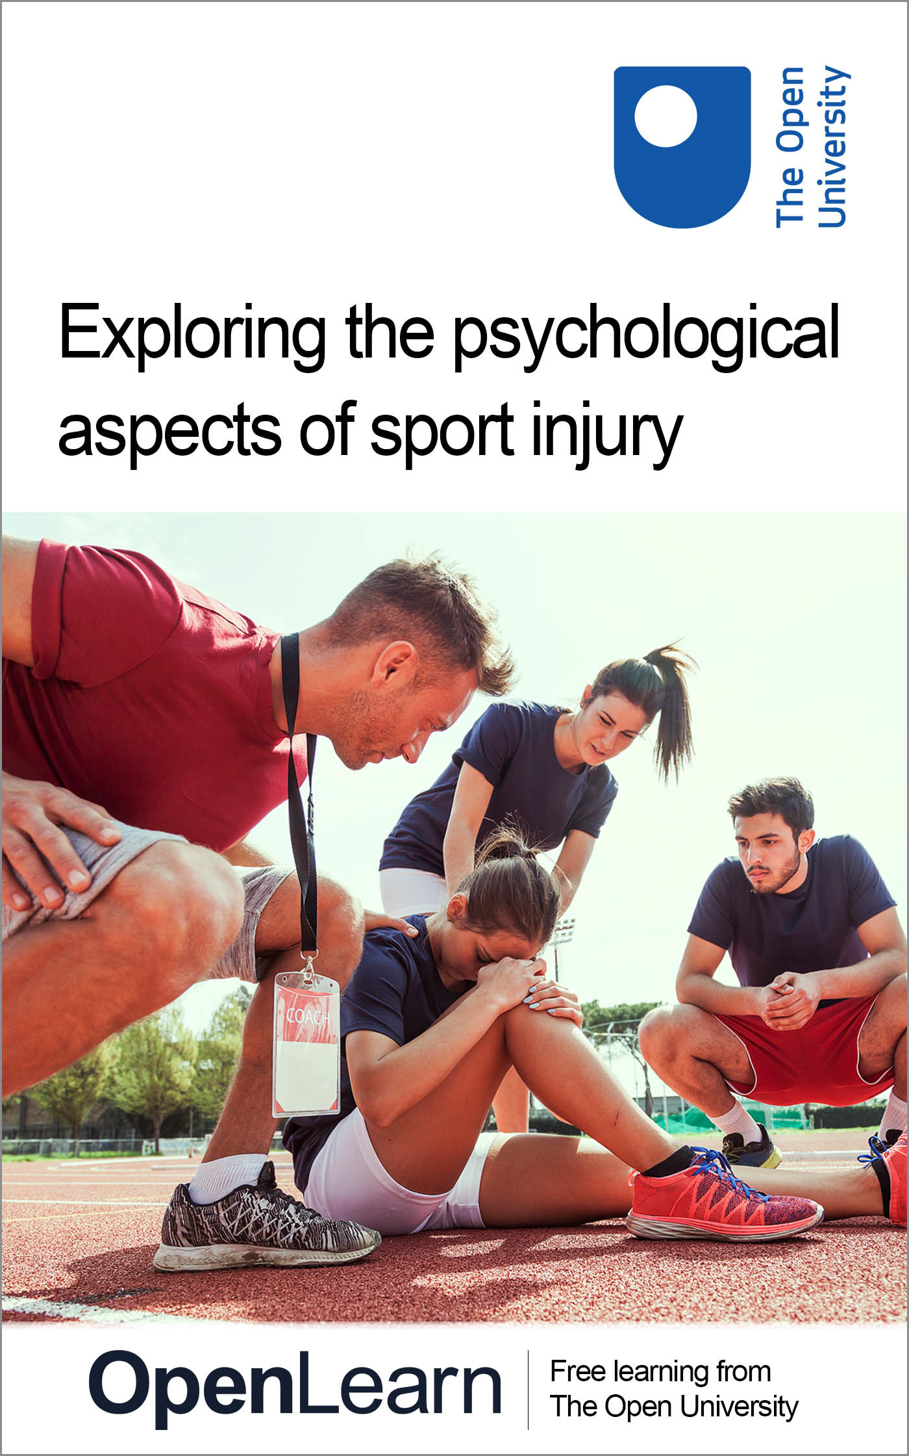

E235_2

Exploring the psychological aspects of sport injury
About this free course
This free course is an adapted extract from the Open University course.
This version of the content may include video, images and interactive content that may not be optimised for your device.
You can experience this free course as it was originally designed on OpenLearn, the home of free learning from The Open University – Exploring the psychological aspects of sport injury: https://www.open.edu/openlearn/health-sports-psychology/exploring-the-psychological-aspects-sport-injury/content-section-0
There you’ll also be able to track your progress via your activity record, which you can use to demonstrate your learning.
Copyright © 2019 The Open University
Intellectual property
Unless otherwise stated, this resource is released under the terms of the Creative Commons Licence v4.0 http://creativecommons.org/licenses/by-nc-sa/4.0/deed.en_GB. Within that The Open University interprets this licence in the following way: www.open.edu/openlearn/about-openlearn/frequently-asked-questions-on-openlearn. Copyright and rights falling outside the terms of the Creative Commons Licence are retained or controlled by The Open University. Please read the full text before using any of the content.
We believe the primary barrier to accessing high-quality educational experiences is cost, which is why we aim to publish as much free content as possible under an open licence. If it proves difficult to release content under our preferred Creative Commons licence (e.g. because we can’t afford or gain the clearances or find suitable alternatives), we will still release the materials for free under a personal end-user licence.
This is because the learning experience will always be the same high quality offering and that should always be seen as positive – even if at times the licensing is different to Creative Commons.
When using the content you must attribute us (The Open University) (the OU) and any identified author in accordance with the terms of the Creative Commons Licence.
The Acknowledgements section is used to list, amongst other things, third party (Proprietary), licensed content which is not subject to Creative Commons licensing. Proprietary content must be used (retained) intact and in context to the content at all times.
The Acknowledgements section is also used to bring to your attention any other Special Restrictions which may apply to the content. For example there may be times when the Creative Commons Non-Commercial Sharealike licence does not apply to any of the content even if owned by us (The Open University). In these instances, unless stated otherwise, the content may be used for personal and non-commercial use.
We have also identified as Proprietary other material included in the content which is not subject to Creative Commons Licence. These are OU logos, trading names and may extend to certain photographic and video images and sound recordings and any other material as may be brought to your attention.
Unauthorised use of any of the content may constitute a breach of the terms and conditions and/or intellectual property laws.
We reserve the right to alter, amend or bring to an end any terms and conditions provided here without notice.
All rights falling outside the terms of the Creative Commons licence are retained or controlled by The Open University.
Head of Intellectual Property, The Open University

Contents
- Introduction and guidance
  - Introduction and guidance
    - What is a badged course?
    - How to get a badge
- Session 1: Sport injury and psychology – what’s the link?
  - Introduction
  - 1 What is sport injury?
    - 1.1 Sport injury case studies
  - 2 Injury and psychology
  - 3 Experiences of sport injury
    - 3.1 The two aspects of sport injury psychology
  - 4 This session’s quiz
  - 5 Summary of Session 1
- Session 2: A holistic approach to sport injury
  - Introduction
  - 1 Sport injury: a biopsychosocial approach
  - 2 The team around the injured person
    - 2.1 The multidisciplinary support team
  - 3 Professional boundaries in sport and exercise psychology
  - 4 This session’s quiz
  - 5 Summary of Session 2
- Session 3: Can psychological factors increase the risk of injury?
  - Introduction
    - 1 Causes of sport injury
    - 2 Which psychological factors increase injury risk?
  - 3 How can stress increase the risk of injury?
    - 3.1 Other proposed stress-injury mechanisms
  - 4 How can personality increase the risk of injury?
  - 5 This session’s quiz
  - 6 Summary of Session 3
- Session 4: Psychological interventions to prevent sport injury
  - Introduction
  - 1 Why would psychological interventions work?
  - 2 What psychological interventions?
  - 3 Are psychological interventions effective?
  - 4 This session’s quiz
  - 5 Summary
- Session 5: Psychological responses to sport injury
  - Introduction
  - 1 How does sport injury make people feel?
    - 1.1 Lois and Travis: coping with sport injury
  - 2 Predicting how individuals will respond to sport injury
  - 3 Applying models of psychological response to sport injury
  - 4 This session’s quiz
  - 5 Summary of Session 5
- Session 6: What impact does psychology have on recovery?
  - Introduction
  - 1 Psychology, coping and outcomes
    - 1.1 Lois’s experience
    - 1.2 Travis’s experience
  - 2 Do reactions to injury change over time?
  - 3 Sport injury-related growth
  - 4 This session’s quiz
  - 5 Summary of Session 6
- Session 7: How can imagery, self-talk and relaxation help injury rehabilitation?
  - Introduction
  - 1 The benefits of sport psychology intervention
  - 2 Imagery in sport injury rehabilitation
  - 3 Self-talk and sport injury rehabilitation
    - 3.1 Self-talk in practice
  - 4 Relaxation techniques and sport injury rehabilitation
    - 4.1 Relaxation in practice
  - 5 This session’s quiz
  - 6 Summary of Session 7
- Session 8: How can goal setting and social support help injury rehabilitation?
  - Introduction
  - 1 Coping with sport injury
  - 2 Goal setting and sport injury rehabilitation
    - 2.1 Effective goal setting
  - 3 Social support in sport injury rehabilitation
    - 3.1 Social support in practice
  - 4 Reflection: What can you do to support an injured person?
  - 5 This session’s quiz
  - 6 Summary
  - Where next?
  - Tell us what you think
- References
- Further reading
- Acknowledgements
- Solutions

Introduction and guidance

Introduction and guidance
This free badged course, Exploring the psychological aspects of sport injury, lasts 24 hours, with 8 ‘sessions’. You can work through the course at your own pace, so if you have more time one week there is no problem with pushing on to complete a further study session. The eight sessions are linked to ensure a logical flow through the course. They are:
- Sport injury and psychology – what’s the link?
- A holistic approach to sport injury
- Can psychological factors increase the risk of injury?
- Psychological interventions to prevent sport injury
- Psychological responses to sport injury
- What impact does psychology have on recovery?
- How can imagery, self-talk and relaxation help injury rehabilitation?
- How can goal-setting and social support help?
This course will develop your confidence and skills for online study, whether this is to explore sport and exercise topics or part of your preparation for other study.
You’ll begin in the first two sessions with a general overview of the psychological aspects of sport injury, drawing on your own experiences and those from case study examples, before moving onto a more detailed analysis of the two keys areas of the topic:
- Pre-injury factors: psychological factors that may increase the risk of sport injury (Sessions 3 and 4)
- Post-injury factors: psychological responses to sport injury and their potential impact (Sessions 5-8)
As part of this you will explore psychological techniques that can be used to help minimise the risk of developing a sport injury and help an individual to cope with sport injury once it has occurred.
Case studies and audio-visual examples are used to help explain concepts and you’ll get plenty of opportunities to demonstrate your new understanding and practise your study skills.
Part of this practice will be the interactive quizzes, of which Sessions 4 and 8 will provide you with an opportunity to earn a badge to demonstrate your new skills. You can read more on how to study the course and about badges in the next sections.
After completing this course, you should be able to:
- identify the psychological factors that may lead to a sport injury
- recognise the role sport and exercise psychology intervention can play in the prevention of injury
- evaluate psychological responses to sport injury
- identify psychological interventions that can aid rehabilitation from injury.

Moving around the course
In the ‘Summary’ at the end of each session, you will find a link to the next session. If at any time you want to return to the start of the course, click on ‘Full course description’. From here you can navigate to any part of the course.
It’s also good practice, if you access a link from within a course page (including links to the quizzes), to open it in a new window or tab. That way you can easily return to where you’ve come from without having to use the back button on your browser.
The Open University would really appreciate a few minutes of your time to tell us about yourself and your expectations for the course before you begin, in our optional start-of-course survey. Participation will be completely confidential and we will not pass on your details to others.

What is a badged course?
While studying Exploring the psychological aspects of sport injury you have the option to work towards gaining a digital badge.
Badged courses are a key part of The Open University’s mission to promote the educational well-being of the community. The courses also provide another way of helping you to progress from informal to formal learning.
Completing a course will require about 24 hours of study time. However, you can study the course at any time and at a pace to suit you.
Badged courses are available on The Open University’s OpenLearn website and do not cost anything to study. They differ from Open University courses because you do not receive support from a tutor, but you do get useful feedback from the interactive quizzes.

What is a badge?
Digital badges are a new way of demonstrating online that you have gained a skill. Colleges and universities are working with employers and other organisations to develop open badges that help learners gain recognition for their skills, and support employers to identify the right candidate for a job.
Badges demonstrate your work and achievement on the course. You can share your achievement with friends, family and employers, and on social media. Badges are a great motivation, helping you to reach the end of the course. Gaining a badge often boosts confidence in the skills and abilities that underpin successful study. So, completing this course could encourage you to think about taking other courses.



How to get a badge
Getting a badge is straightforward! Here’s what you have to do:
- read each session of the course
- score 50% or more in the two badge quizzes in Session 4 and Session 8
For all the quizzes, you can have three attempts at most of the questions (for true or false type questions you usually only get one attempt). If you get the answer right first time you will get more marks than for a correct answer the second or third time. Therefore, please be aware that for the two badge quizzes it is possible to get all the questions right but not score 50% and be eligible for the badge on that attempt. If one of your answers is incorrect you will often receive helpful feedback and suggestions about how to work out the correct answer.
For the badge quizzes, if you’re not successful in getting 50% the first time, after 24 hours you can attempt the whole quiz, and come back as many times as you like.
We hope that as many people as possible will gain an Open University badge – so you should see getting a badge as an opportunity to reflect on what you have learned rather than as a test.
If you need more guidance on getting a badge and what you can do with it, take a look at the OpenLearn FAQs. When you gain your badge you will receive an email to notify you and you will be able to view and manage all your badges in My OpenLearn within 24 hours of completing the criteria to gain a badge.

Session 1: Sport injury and psychology – what’s the link?

Introduction

Being injured and missing the whole athletics season was devastating. I’d worked so hard and then I had nothing to show for it. I missed training, I missed my training group, and most importantly I missed being an athlete. I felt empty.
(Lois, sprinter)

I was under a lot stress at work before I got injured and I’m sure that was a contributing factor to the injury happening. I also found being injured and not being able to go to the gym so frustrating. It made me very unhappy and my family and friends became really worried about me.
(Travis, exercise participant)

Have you ever had a sport injury? If so, you are not alone. Injury is a relatively common occurrence among sport and exercise participants (Peterson and Renstrom, 2016). It is difficult to obtain accurate information about the exact rates of injury occurrence but an NHS report suggested that 2.3% of unplanned Accident and Emergency attendances (388,515 visits) in England were as a result of sport injuries (NHS, 2012). Obviously, this figure does not take into account the vast number of injuries that do not require emergency hospital treatment and so the actual figure will be much greater. A study of the Great Britain 2014 Winter Olympic Team revealed that 39% of the 56-member team experienced an injury during the 2014 Winter Olympics – an extremely high proportion over the 18-day period (Palmer-Green and Elliott, 2015).


Figure 1 Sport injuries are fairly common
View description - Figure 1 Sport injuries are fairly common

Traditionally, the study of sport injury has focused on the physical aspects of injury. More recently, however, the psychological aspects of sport injury have also been recognised. As the quotes from Lois and Travis indicate the psychological aspects of injury can be a significant part of the injury process and return to sport/activity. In this session we will give a brief overview of the role of psychological factors in sport injury, before exploring these in more detail in later sessions.
By the end of this session, you should be able to:
- understand how psychology relates to sport injury
- recognise that psychological factors can impact at two key points: pre-injury and post-injury.
The Open University would really appreciate a few minutes of your time to tell us about yourself and your expectations for the course before you begin, in our optional start-of-course survey. Participation will be completely confidential and we will not pass on your details to others.

1 What is sport injury?
Before you begin to investigate the psychological aspects, let’s first explore more about sport injury. As its name suggests a sport injury refers to an injury that is sustained during – or as a result of – sport or physical activity. It is important to note that throughout the course we use the term ‘sport injury’ to refer to injuries sustained in both sport and exercise settings. There are various types of sport injury, which can broadly be split into ‘acute’ and ‘chronic’ injuries. The next activity explains what these are.

Activity 1 Types of sport injury
Allow about 15 minutes

Watch Video 1 below and then read the ‘Introduction’ section of the article Sports Injuries to explore some of the causes and types of sport injury. (You can open the link in a new tab by holding down Ctrl [or Cmd on a Mac] when you click the link.)

Watch the video at YouTube.com.
Video 1
View transcript - Video 1

Now match each of the terms below with the appropriate definition.

Acute injury
Chronic injury
An individual suffers a broken leg as a result of a tackle during a football match
An individual suffers a stress fracture after increasing their mileage
View answer - Activity 1 Types of sport injury
View discussion - Activity 1 Types of sport injury

1.1 Sport injury case studies
If you’ve ever experienced an injury yourself or been close to somebody who has (e.g. an athlete that you coach or an exercise participant that you train), you will appreciate what it is like to be injured. You will have the opportunity to draw on any such experiences as you progress through the course. Additionally, as you explore the psychological aspects of injury you will be examining the experiences of two case studies – Lois and Travis – who are introduced below. You will learn more about Lois and Travis as you progress through the course.

Case study: Introducing Lois (sprinter)
Lois is a 27-year-old sprinter who competes in the 200m and 400m. After a successful season last year in which she ran personal bests (PBs) in both of her events Lois was looking forward to having another successful season this year.
The first part of her winter training went really well, and Lois was feeling stronger than ever before and very positive about the season ahead. However, after Christmas she started to experience pain in her left Achilles tendon and eventually ruptured it. She has been told that she will miss the whole of the athletics season.


Figure 2 Lois (sprinter)
View description - Figure 2 Lois (sprinter)

Case study: Introducing Travis (exercise participant)
Travis is a 35-year-old exercise participant. He goes to the gym every day and takes his training very seriously. He enjoys the buzz he gets from exercising as well as the aesthetic and physical benefits he derives from exercise. He does not like to miss exercise sessions and has a very structured exercise regime.
Travis sustained a rotator cuff injury (shoulder) during a weight training session. He has been told that he will be unable to go to the gym for a few weeks to do any upper body training and will need to reduce his exercise intensity for a while when he does return.

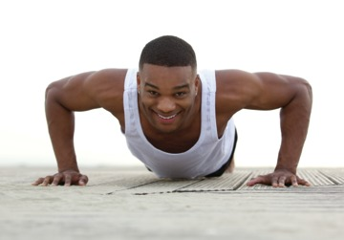
Figure 3 Travis (exercise participant)
View description - Figure 3 Travis (exercise participant)

Now that you’ve met Lois and Travis let’s move on to explore how injury and psychology are linked.

2 Injury and psychology
So why are we interested in the psychological aspects of injury? Intuitively we tend to think of sport injury as a physical experience, but sport injury also has various psychological aspects. Before you start to investigate the research and theory around the psychological aspects of sport injury, you’ll first examine your own thoughts on the potential links.

Activity 2 Early thoughts – psychological aspects of injury
Allow about 10 minutes

If you have suffered from a sport injury in the past, think about some of the thoughts, feelings and behaviours you experienced before you were injured (antecedents) and after you were injured (responses). Make a list of these psychological aspects of your injury experience in the table below.
Text boxes are provided in all activities. You can use these to note down your answers to the questions. Once you click Save, your answers will be stored and you can return to them at any point to view or amend your response. Your responses will only be visible to you. However, if you would prefer to make notes using pen and paper or a different format you can. We have added one or two examples to help you.
If you haven’t experienced a sport injury yourself, instead try to think of someone you know who has been injured (e.g. an athlete you coach, an exercise participant, friend, partner or famous sportsperson). Reflect on how they behaved around the time they were injured and how they said their injury made them feel at the time.

Table 1 Thoughts feelings and behaviours
Before injury (antecedents) | After injury (responses)
E.g. Anxiety  Provide your answer... | E.g. Anger  Provide your answer...

View discussion - Activity 2 Early thoughts – psychological aspects of injury

Having looked at your own experiences of sport injury, you will now move on to look at the experiences of the two case study examples, Lois and Travis.

3 Experiences of sport injury
While sport injury can have a significant psychological impact on both sport and exercise participants, their experiences may be slightly different. Therefore, throughout this course you will be drawing on examples from both sport and exercise. You will begin by exploring the experiences of one of the case studies, Travis.

Activity 3 Travis’s injury experience
Allow about 10 minutes

In Section 1, you were introduced to our exercise case study Travis. Read the box below describing Travis’s experience of injury and then answer the question below.
What psychological factors has Travis experienced related to his injury?

Case study: Travis’s exercise injury – psychological factors
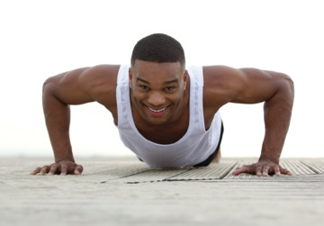
I’d been quite stressed at work before I sustained my injury as I’m in the process of bidding for a very large contract. Normally coming to the gym is my way of relieving stress but I couldn’t switch off – I just kept thinking about the contract while I was in the weights room on the day I was injured.
After getting injured I wasn’t allowed to train properly for a few weeks which meant I didn’t have my normal stress release and it made me feel frustrated and angry. I had all this anger about being injured and nowhere to direct it. I ended up taking it out on my family – my husband Trevor took the brunt of it. There were times when I was just so frustrated that I couldn’t go to the gym that I just wanted to cry.
(Travis, exercise participant)

View discussion - Activity 3 Travis’s injury experience

You can see in the activity you have just completed that injury has had a significant psychological impact on Travis as a recreational exerciser. In the next activity you will explore the devastating impact that an injury had on former Olympic heptathlon champion Jessica Ennis-Hill.

Activity 4 Jessica Ennis-Hill’s injury experience
Allow about 20 minutes

Watch Video 2 below in which you see former heptathlete Jessica Ennis-Hill sustain an injury just before the 2008 Olympics. Complete the following tasks:
- As you watch the video, examine Jessica’s psychological reaction to the news.
- How might Travis’s experiences (Activity 3) as an exercise participant differ from those of a sports participant such as Jessica Ennis-Hill?

Watch the video at YouTube.com.
Video 2
View transcript - Video 2

View discussion - Activity 4 Jessica Ennis-Hill’s injury experience

3.1 The two aspects of sport injury psychology
The activities you have completed within this session so far have highlighted that the psychological aspects of sport injury can be split into two broad categories:
- psychological factors that may increase an athlete’s risk of developing an injury (psychological antecedents of injury, or pre-injury), and
- psychological reactions to sport injury and their impact (post-injury).

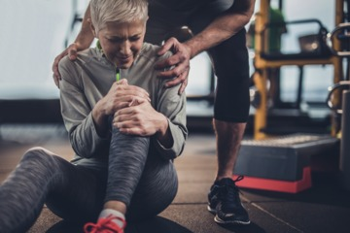
Figure 4 Psychological factors are important both pre- and post-injury.
View description - Figure 4 Psychological factors are important both pre- and post-injury.

The psychological antecedents of injury and the interventions that can be put in place to reduce the risk of injury will be examined in detail in Sessions 3 and 4, while psychological reactions to injury and the interventions that can be used to reduce negative reactions to injury are discussed in Sessions 5–8.

4 This session’s quiz
Check what you’ve learned this session by taking the end-of-session quiz.
Session 1 practice quiz
Open the quiz in a new tab or window (by holding down Ctrl [or Cmd on a Mac] when you click the link) then come back here when you’ve finished.

5 Summary of Session 1
This session has provided a brief introduction to the psychological aspects of sport injury, which we will develop in the sessions that follow. It has demonstrated that while injury is commonly thought of as a physiological experience, the psychological aspects of injury are highly important.
The main learning points from this first session are:
- Sport injury is a fairly common occurrence in sport and exercise settings.
- Sport injury has a psychological component as well as a physiological component.
- The psychological aspects of sport injury can broadly be split into two categories:
  - Psychological factors that may increase an athlete’s risk of developing an injury
  - Psychological reactions to sport injury.
In the next session, you will examine the team around the injured person and explore the importance of a holistic and multidisciplinary approach to their support.

Session 2: A holistic approach to sport injury

Introduction
As you explored in the previous session, sport injury is not an exclusively physical experience – it also has a psychological component and psychological factors can influence both injury risk and injury outcomes. Similarly, sport injury doesn’t just affect the injured person – there are several people around them that can also be affected. These might be professionals in charge of supporting the individual or they may be family, friends or team mates.

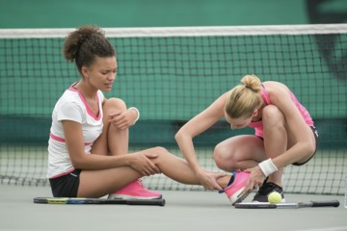
Figure 1 The people around the injured athlete are important
View description - Figure 1 The people around the injured athlete are important

In this session you will explore the team around the injured person and how they can work together to prevent injury and/or ensure that the individual progresses smoothly through their injury experience. In doing this, you will explore the biopsychosocial approach to sport injury and consider the roles of those around the injured athlete or exercise participant.
By the end of this session, you should be able to:
- understand the biopsychosocial approach to sport injury
- recognise the importance of multidisciplinary teams in supporting the injured person
- be aware of professional boundaries in providing sport psychology support.

1 Sport injury: a biopsychosocial approach
As understanding of the psychological aspects of sport injury has grown there has been a move in sports medicine towards the adoption of a biopsychosocial approach to treating and preventing sport injury. As its name indicates the biopsychosocial approach suggests that when dealing with sport injury the complex interaction between biological, psychological and social factors should be considered (Walker and Heaney, 2013).
This approach differs from the more traditional biomedical model which only recognises the influences of biological factors (Brewer and Redmond, 2017; Green, Jackson and Klaber Moffett, 2008). It has been suggested that the adoption of a biopsychosocial approach by sports medicine professionals can have a positive impact on the injured person through increases in factors such as patient satisfaction, empowerment and pain management (Heaney, Green, Rostron and Walker, 2012).

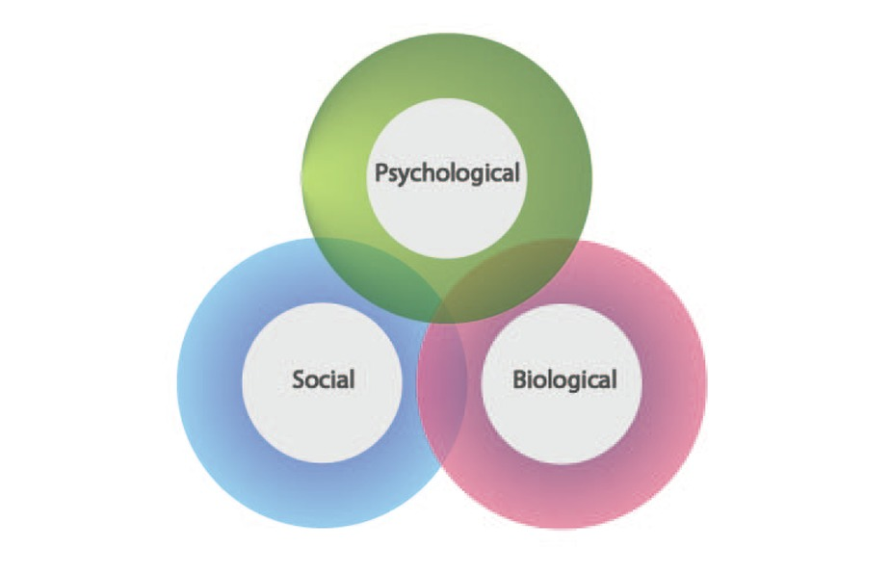
Figure 2 A biopsychosocial approach involves the interaction of biological, psychological and sociological factors

In line with the two psychological aspects of sport injury identified in Session 1 – psychological antecedents to injury and psychological responses to injury – Brewer and Redmond (2017) suggest that the biopsychosocial approach has two key implications on our understanding of sport injury:
- Injury occurrence is influenced by interactions between biological, psychological and social factors, and
- Injury can impact a person physically, psychologically and socially.
You will explore this further in the next activity.

Activity 1 Sport injury and the biopsychosocial approach
Allow about 10 minutes

Make a list of some of the biological, psychological and social factors that you think might influence sport injury. These can be factors that influence either before an injury has occurred (factors that might make a sport injury more or less likely) or after an injury has occurred. Some examples have been added to help you.

Biological | Psychological | Social
E.g. Diet  Provide your answer... | E.g. Stress  Provide your answer... | E.g. Peer pressure  Provide your answer...

View discussion - Activity 1 Sport injury and the biopsychosocial approach

2 The team around the injured person
The biopsychosocial approach suggests that those around the injured athlete or exercise participant need to consider the impact of biological, psychological and social factors on the individual, but who exactly are these people? When someone suffers from a sport injury there are potentially a myriad of people who can support and influence the injured person. In the next activity you will try to identify who some of these people are.

Activity 2 The people around the injured athlete/exercise participant
Allow about 15 minutes

- Make a list of all the people you think might be involved in supporting an injured athlete or an exercise participant in some way. These can be people in formal or informal roles. Try to think beyond just sports medicine professionals.
If you have experienced an injury yourself or are familiar with someone who has experienced an injury, you may find it useful to reflect on who supported you (or them) during the injury. Or you might identify who didn’t support you that you think should have.
- Pick three of the people in your list and try to describe the type of support they provide to the injured person.

1.
2.

View discussion - Part

The activity you’ve just completed shows how different people can provide support to the injured person. Next you’ll explore this further as you examine the multidisciplinary support team.

2.1 The multidisciplinary support team
As you identified in Activity 2 there are potentially a wide range of people that can support the injured athlete/exercise participant. In an ideal world these people should work together to support the injured person in what is known as a multidisciplinary support team. Such a team may be more accessible to some than others. For example, a competitive athlete is perhaps more likely to have access to various professionals such as psychologists, physiologists, nutritionists and biomechanists, than an exercise participant would – particularly if they are part of a professional sports club or an elite athlete in a National Lottery funded sport.
It has been suggested that these multidisciplinary teams help injured athletes/exercise participants to access services that will enhance their rehabilitation from injury and facilitate a holistic treatment plan that uses a biopsychosocial approach (Clement and Arvinen-Barrow, 2013).

Activity 3 How do multidisciplinary teams work successfully?
Allow about 20 minutes

Read about the treatment that Lois is having for her injury and answer the questions that follow.

Case study: Lois’s multidisciplinary team
Lois is having her Achilles tendon injury treated at a sports medicine clinic that is using a multidisciplinary team to support her. At the clinic she is working with a physiotherapist, a sports massage therapist, a sport and exercise psychologist, and a nutritionist. She is also receiving informal support outside the clinic from both her boyfriend Dave and her coach.

- What are the benefits of Lois having this multidisciplinary support team?
- What might be some of the challenges of having a support team of this size and how can these be overcome?
- Think about any current or future role you hold in sport and fitness (e.g. coach, instructor, athlete or sports therapist) and consider what your specific role would be as part of a multidisciplinary team supporting someone with an injury?

Provide your answer...

View discussion - Part

Figure 4 below illustrates all of the different relationships and communications that might need to be managed within a multidisciplinary team.

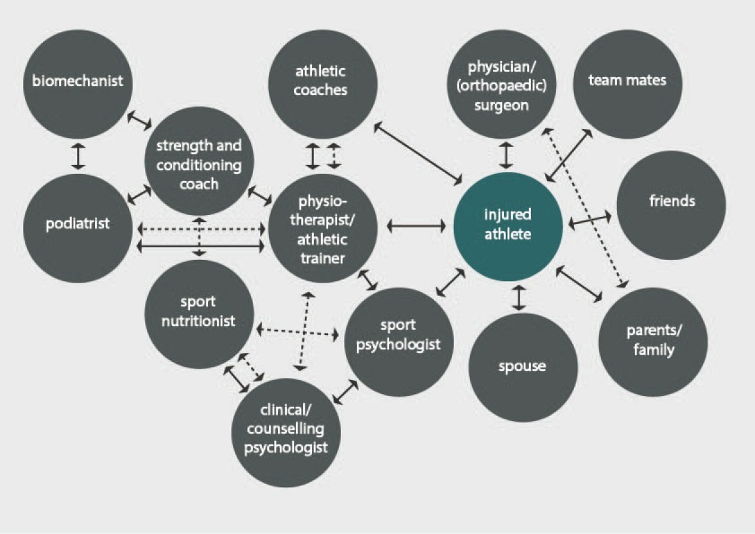
Figure 4 Communication channels within a multidisciplinary team (Clement and Arvinen-Barrow, 2013)

With such a wide range of people potentially supporting the injured person it is important that everyone is aware of their professional boundaries, which is what you will explore next.

3 Professional boundaries in sport and exercise psychology
In this course you are specifically interested in examining the psychological aspects of sport injury. Therefore, as you explore the roles that different people take on within a multidisciplinary support team it is important that you address the question of whose role it is to provide sport and exercise psychology support to the injured person. This may seem a simple question at first, but as you start to examine the case study with Travis’s experience you will see that it is not quite as straightforward as it first appears.

Activity 4 Whose role is it to provide sport and exercise psychology support?
Allow about 20 minutes

In this activity you will meet Lydia, a physiotherapist, who is helping Travis with his treatment, and Wilma, Lois’s coach.

1. Read the paragraph below about Travis and decide how his physiotherapist Lydia should proceed.

Case study: The role of Travis’s physiotherapist
Travis is currently undergoing treatment for his rotator cuff injury with a local physiotherapist, Lydia. Lydia has recently read a paper about the psychological aspects of injury and is concerned that Travis isn’t coping with his injury very well. She feels that he would benefit from using some sport and exercise psychology interventions such as imagery and relaxation techniques.
Other than Lydia and his personal trainer, Travis isn’t being supported by any other professionals. The clinic Lydia works at doesn’t employ a sport and exercise psychologist and Lydia is unsure whether she should talk to Travis about how he’s feeling and recommend some psychological techniques for him to try.


Figure 5 Travis’s physiotherapist, Lydia
View description - Figure 5 Travis’s physiotherapist, Lydia

Provide your answer...

2. If you hold a role in sport and fitness (e.g. coach or instructor) think about how you would deal with an injured athlete/exercise participant who you feel is not coping very well with sport injury and would benefit from sport and exercise psychology support. What do you think your role would be in the process? How would you support the injured person? What would you do?
If you don’t hold such a role, try to imagine what Lois’s coach Wilma would do.

Provide your answer...

View discussion - Part

4 This session’s quiz
Check what you’ve learned this week by taking the end-of-session quiz.
Session 2 practice quiz
Open the quiz in a new tab or window (by holding down Ctrl [or Cmd on a Mac] when you click the link) then come back here when you’ve finished.

5 Summary of Session 2
This session has explored a holistic approach to preventing and treating sport injury. In doing that you have examined the biopsychosocial approach, multidisciplinary support teams, and professional boundaries.
The main learning points from this session are:
- The biopsychosocial approach suggests that when dealing with sport injury you should consider the interaction between biological, psychological and social factors.
- Several people can be involved in supporting the injured athlete including the physiotherapist, coach, instructor, sports therapist, partner, family, friends and team mates.
- Ideally an injured person should be supported by a multidisciplinary team.
- Whilst it is important for all those involved in supporting the injured person to have an awareness of sport and exercise psychology, it is important that they are aware of their professional boundaries.
In the next session, you will explore the psychological factors that may increase an individual’s risk of developing a sport injury.

Session 3: Can psychological factors increase the risk of injury?

Introduction
In the previous sessions you have identified that the psychological aspects of sport injury can be split into two components:
- Psychological factors that can increase the risk of developing an injury, and
- Psychological reactions to injury.
In the next two sessions you will focus on psychological factors that can increase the risk of developing a sport injury. In this session you will look at what these factors are and how they can increase the risk of injury, and in Session 4 you will look at how the risk of injury from these factors can be reduced. The following video explains more, featuring Caroline Heaney who is the author of this course.

Video content is not available in this format.
Video 1
View transcript - Video 1

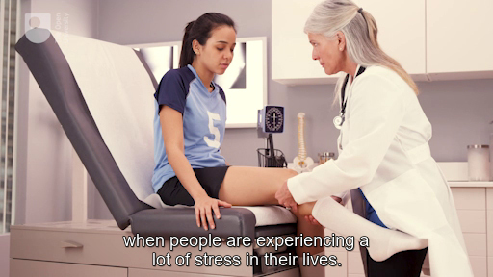

By the end of this session, you should be able to:
- understand how psychological factors might predispose an athlete to injury
- explore the link between stress and injury
- explore the link between personality and injury.

1 Causes of sport injury
Sport injuries can be caused by a wide variety of factors. These factors can be grouped into four main areas: physical, environmental, socio-cultural and psychological (Wiese-Bjornstal and Shaffer, 1999) as illustrated in Figure 1.

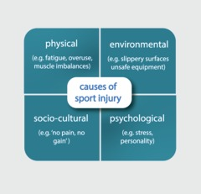
Figure 1 Causes of sport injury (Wiese-Bjornstal and Shaffer, 1999)

Physical and environmental factors are perhaps more obviously associated with injury, but the links between socio-cultural and psychological factors and injury are less obvious. Socio-cultural factors relate to the culture and attitudes that are often adopted within sport that could encourage the development of a sport injury. Some examples of the attitudes that could increase the risk of injury include: the belief that pain tolerance demonstrates strength and toughness, an acceptance that pain and injury are part of sport (‘no pain, no gain’), and an unwillingness to seek medical treatment for fear of appearing weak (Wiese-Bjornstal and Shaffer, 1999).
Meeuwise et al. (2007) suggest that the risk factors for developing an injury can be split into intrinsic risk factors and extrinsic risk factors:
- Intrinsic risk factors are those that are internal or personal to the individual and can include physical variables (such as age, strength, flexibility, and previous injury) and psychological variables (such as self-concept and personality) (Brewer and Redmond, 2017).
- Extrinsic risk factors are those external to the individual and can include sport-related variables (such as type of sport, rules, opponent/team mate behaviour), equipment and weather conditions (Brewer and Redmond, 2017).
Next you’ll look at psychological factors in more detail.

2 Which psychological factors increase injury risk?
In the previous section you identified that there are various factors that can increase the risk of developing a sport injury, including psychological factors. In this section you will begin to explore what these psychological factors are and how they can potentially increase the risk of injury. There are two main psychological factors that have been identified as potential antecedents of sport injury – stress and personality. These both feature in a key model in this field – the Stress and Injury model (Williams and Andersen, 1998).
The Stress and Injury model (Figure 2) can be used to explain how psychological factors increase the risk of sport injury. When exposed to a potentially stressful situation the individual’s stress response will dictate whether or not an injury occurs. This stress response is influenced by three key things – personality, history of stressors and coping resources – and can be mediated through the use of interventions.

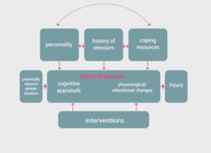
Figure 2 The Stress and Injury model (Williams and Andersen, 1998)

The next activity will help you to understand the model and its application.

Activity 1 Applying the Stress and Injury model
Allow about 35 minutes

Watch Video 2 in which Lesley Podlog, a key researcher in the psychological aspects of sport injury, describes the components of the Stress and Injury model.

Video content is not available in this format.
Video 2
View transcript - Video 2

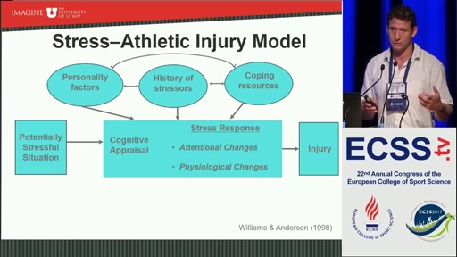

Now read the next instalment of Travis’s case study in the box below and try to apply the model to Travis. Alternatively, you may prefer to apply the model to yourself or someone you know who has experienced sport injury.

Case study: Applying the Stress and Injury model to Travis’s injury
In the weeks leading up to his injury Travis had been under a lot of pressure at work as he had been promoted into a new role and was in charge of bidding for a new contract for his company. This led him to feel very stressed and he didn’t feel that he was coping very well with the stress of his new job role. Travis has always found it difficult to cope with high pressure situations. He has been finding it hard to switch off from work and was consequently feeling very tense. He had been experiencing muscle tension in his shoulders and had been short tempered at home in the days leading up to his injury.
He came to the gym following an argument with his husband Trevor on the day that he sustained his rotator cuff injury during a heavy weight lifting session. When talking to his physiotherapist Lydia, he said that he had been quite distracted thinking about both the argument and the contract he was bidding on at work (the main source of his work-related stress). He felt that this caused him to use poor technique when lifting the bar which may have led to the injury.

View discussion - Activity 1 Applying the Stress and Injury model

Having explored the Stress and Injury model, you’ll now examine some of the mechanisms to explain how stress can lead to injury.

3 How can stress increase the risk of injury?
You have seen that stress can be a significant predictor of sport injury, but how exactly can stress lead to a sport injury?
In this section you will explore some of the mechanisms proposed to explain this relationship. The core of the Stress and Injury model (Figure 3) that you explored in the previous section indicates that physiological/attentional responses are responsible. More specifically, three key mechanisms were proposed by Andersen and Williams (1988) in the original version of the model:
- distraction
- attention narrowing, and
- muscle tension.
These are explained in the table below.

Table 1 Mechanisms of how stress can increase the risk of injury
Distraction | Attention narrowing | Muscle tension
‘I was so preoccupied by the argument I’d had with my husband before I went to the gym that I just wasn’t concentrating on lifting properly.’ (Travis) | ‘I was so stressed that I wasn’t focusing on what was going on around me and I just didn’t see the tackle coming.’ (Nala, rugby player) | ‘I was so stressed that I had a lot of tightness and tension around my shoulders when I walked into the gym that day.’ (Travis)
This mechanism suggests that when people are stressed they fail to pay attention to vital cues (e.g. the position of other players) in the sport or fitness environment around them. This can lead to injury when a missed cue leads to an event such as a mis-step (Brewer and Redmond, 2017). | Stress can lead to narrowing of the peripheral field of vision. This means that individuals may miss vital cues in their periphery which can increase the risk of injury (e.g. an incoming tackle) (Andersen and Williams, 1988). | It is suggested that stress can lead to the somatic (i.e. physiological) response of muscle tension which interferes with flexibility, co-ordination and fluidity of movement thus increasing the risk of injury (Brewer and Redmond, 2017). This inefficient movement may also lead to greater perceptions of fatigue which could also increase the risk of injury.

The next activity explores these mechanisms and the links between stress and injury.

Activity 2 Stress and injury: a sports therapist’s story
Allow about 30 minutes

Watch Video 3 below in which Dale Forsdyke discusses his experiences of working with injured sport and exercise participants as a sports therapist. Dale has worked as a sports therapist for over 10 years, predominantly working in football. He currently works Head of Science and Medicine at York City Tier 1 Regional Talent Club. In addition to his role as a sports therapist Dale also works as a university lecturer.
As you watch the video, answer the following questions.
- Dale discusses how stress can be a risk factor for developing a sport injury. What are some of the sources of stress experienced by the players he works with?
- How can the stress experienced by athletes lead to an injury?
- What strategies does Dale put in place to try and reduce the risk of injury in the players he works with?

Video content is not available in this format.
Video 3
View transcript - Video 3

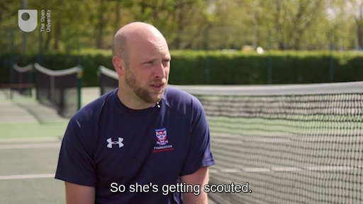

Provide your answer...

View discussion - Part

In Video 3 Dale suggested that there are other mechanisms beyond distraction, attention narrowing and muscle tension that may explain how stress can lead to injury. Some of these are explored next.

3.1 Other proposed stress-injury mechanisms
In addition to distraction, attention narrowing and muscle tension, other mechanisms have also been proposed to explain how stress can lead to sport injury, including: immunosuppression, disrupted tissue repair, sleep disturbance and altered self-care (Petrie and Perna, 2004). These are summarised in Table 2 below.
As you will see, some of these factors are linked to each other as well as to the mechanisms of distraction, attention narrowing and muscle tension discussed earlier. For example, sleep disturbance may lead to distraction. It is important to recognise that in practice it might be multiple mechanisms acting together that lead to the development of a sport injury.

Table 2 Other stress-injury mechanisms (adapted from Brewer and Redmond, 2017, pp. 35–36)
Immuno-suppression | Disrupted tissue repair | Sleep disturbance | Altered self-care
Chronic (long-term) stress has been linked to suppression (reduced functioning) of the immune system which can increase injury risk. | Stress can increase the secretion of the hormone cortisol which can inhibit processes involved in healing muscle and other body tissues. | Stress can interfere with the quality and duration of sleep. This can lead to factors that might cause an injury such as reduced reaction time, increased aggression, reduced concentration, distraction, or impaired decision- making. | Stress can cause an individual to take less care of themselves. As a result, they may fail to engage in activities that help prevent injury such as healthy eating, hydration or adequate warm-up.

In Section 2 of this session it was suggested that there are two main psychological factors that increase the risk of injury – stress and personality. Having looked at stress, next you’ll look at the links between personality and injury.

4 How can personality increase the risk of injury?
Most research exploring the effect of psychological factors on injury risk has examined the relationship between stress and injury. However, much research has also been undertaken examining the link between personality and injury.


Figure 3 Personality can influence our risk of injury
View description - Figure 3 Personality can influence our risk of injury

As you saw in Section 2, personality is also a component of the Stress and Injury model (Figure 2) where it is suggested that personality factors (e.g. competitive trait anxiety) can be a moderator of the stress response, influencing for example how likely someone is to perceive (cognitively appraise) a situation as stressful. These personality characteristics can be split into:
- positive personality traits – traits that allow the individual to perceive a situation as challenging rather than threatening, thus resulting in a lower stress response and lower risk of injury, and
- negative personality traits – traits that lead an individual to perceive a situation as threatening, thus resulting in a higher stress response and higher risk of injury (Appaneal and Habif, 2013).
A wide range of personality characteristics have been investigated as being linked to sport injury risk. In their review of forty-five research studies, Appaneal and Habif (2013) identified more than twenty personality characteristics but suggest that three have received the most attention – anxiety, locus of control and mental/emotional states. You will explore these in the next activity.

Activity 3 Personality characteristics and sport injury
Allow about 20 minutes

Read the extract from Appaneal and Habif (2013) below which explores the three personality characteristics that have received the most research attention, and then answer the questions that follow.
Psychological antecedents to sport injury (Appaneal and Habif 2013)
- What is competitive trait anxiety and how does it link to sport injury? Why do you think this might be?
- What is ‘locus of control’ and how strong is its relationship with sport injury?
- What is the relationship between mood and injury risk?

Provide your answer...
View discussion - Part

5 This session’s quiz
Check what you’ve learned this session by taking the end-of-session quiz.
Session 3 practice quiz
Open the quiz in a new tab or window (by holding down Ctrl [or Cmd on a Mac] when you click the link) then come back here when you’ve finished.

6 Summary of Session 3
In this session you have explored some of the psychological factors that may increase an individual’s risk of developing a sport injury.
The main learning points from this session are:
- Injuries can be caused by physical, environmental, socio-cultural and psychological factors.
- Stress and personality are the two main psychological factors that have been investigated.
- The Stress and Injury model (Williams and Andersen, 1998) explains the links between stress, personality and injury.
- Stress can potentially increase the risk of injury by various mechanisms such as distraction, attention narrowing, muscle tension, immunosuppression and sleep disturbance.
- Personality factors such as competitive trait anxiety and negative mood may increase the risk of injury.
In the next session, you will examine some of the psychological interventions that could be used to reduce the risk of developing a sport injury.

Session 4: Psychological interventions to prevent sport injury

Introduction

I really feel that the strategies my sport psychologist taught me will help me to cope better with the stresses of being a competitive athlete.
(Lois, sprinter)

As you saw in the previous session, psychological factors such as stress can increase an individual’s risk of developing a sport injury. In this session you will consider whether interventions that address these psychological factors can reduce the risk of sport injury. In this course we are using the term ‘psychological interventions’ to describe the psychological techniques and strategies that an individual can use.

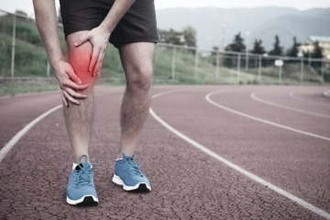
Figure 1 Interventions for injury
View description - Figure 1 Interventions for injury

You will be looking at psychological interventions again in Sessions 7 and 8 when we explore their use in the treatment of injury, but this session is focused purely on their use in the prevention of injury.
By the end of this session, you should be able to:
- explore some of the psychological interventions that may help to reduce the risk of sport injury
- consider the effectiveness of psychological interventions to reduce injury risk.

1 Why would psychological interventions work?
You begin your investigation of psychological interventions to prevent or reduce the risk of sport injury by reflecting back on what you have learned so far and considering how and why psychological interventions might work.

Activity 1 Psychological interventions to reduce the risk of injury
Allow about 15 minutes

Think back to Session 3 of this course and the psychological factors that may increase the risk of injury (e.g. stress and personality). Then identify how psychological interventions could potentially address these factors and reduce the risk of injury.

Provide your answer...

View discussion - Part

2 What psychological interventions?
A wide range of psychological interventions has been used to reduce the risk of injury (Brewer and Redmond, 2017), including those summarised in interactive Figure 2 below.

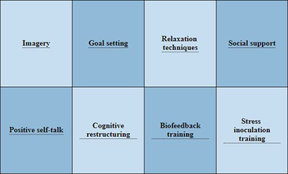

Interactive content is not available in this format.
Interactive Figure 2 Psychological interventions to reduce the risk of injury
View description - Interactive Figure 2 Psychological interventions to reduce the risk of injury

The exact techniques that a sport and exercise psychologist would recommend would depend on the individual’s needs as Amir demonstrates in the quote below.

I would always recommend psychological interventions on an individual basis. What’s right for one person isn’t necessarily right for the next person. I like to find out about the individual and conduct a kind of needs analysis first. When prescribing stress management strategies, I often try to match the type of symptoms with the intervention. For example, if the individual is experiencing somatic or physical symptoms such as muscle tension then I might prescribe a physically based intervention like controlled breathing. Likewise, if the individual is experiencing cognitive or psychological symptoms like negative thoughts, I might prescribe a more cognitive intervention like functional self-talk. Often though it’s not as simple as that and people experience a combination of symptoms.
(Amir, sport and exercise psychologist)


Figure 3 Amir, sport and exercise psychologist
View description - Figure 3 Amir, sport and exercise psychologist

You will learn more about some of the psychological interventions that could potentially be used to reduce the risk of sport injury as you progress through this session. As discussed in Session 2 it is important to remind you about professional boundaries and that some psychological interventions should only be prescribed by an HCPC-registered sport and exercise psychologist (in the UK).

3 Are psychological interventions effective?
Various studies have indicated that psychological interventions are effective in reducing the risk of sport injury. For example:
- In their systematic review of psychological interventions to reduce sport injury Gledhill et al. (2018) reviewed thirteen papers and found that 93% reported a reduction in injury rates. These studies predominantly involved stress management related interventions and used the Stress and Injury model as a framework.
- Similarly, a meta-analysis (a study which statistically combines the results from multiple research studies) of fifteen studies by Tranaeus et al. (2015) concluded that psychological interventions have a large effect on injury reduction.
- A further meta-analysis by Ivarsson et al. (2017) revealed decreased rates of injury in the treatment groups (those who used interventions) compared to the control groups (those who didn’t use interventions) in the seven injury prevention studies they examined.
In the next activity you will explore one particular study in more detail by reading the box below.

Box 1 Research: The effectiveness of a stress management intervention
Purpose:
To measure the effectiveness of a three-month stress management programme designed to reduce the incidence of sport injury.
Participants:
63 male youth football players aged 17–19 years from four Spanish national youth league teams. 35 of these participated in a stress management programme (intervention group) and 28 did not (control group).
Stress management programme intervention:
The stress management programme was designed to teach the players to cope with stress. It required the players to attend a weekly one-hour session for three months and included the following modules:
- linking thoughts and emotions
- progressive muscle relaxation, breathing, imagery, passive and differential muscle relaxation
- self-instructional and attention-focus training
- stress inoculation training
It was based on a method called Stress Inoculation Therapy (SIT) which aims to teach people about stress and how to manage it. SIT aims to progressively expose the individual to stressful situations, gradually ‘inoculating’ the events that might trigger a stress response in order to increase the participant’s ‘resistance’ to stress.
Findings:
The average number of sport injuries experienced per month was recorded before and after the stress management programme intervention. Before the intervention the number of injuries was similar for the intervention and control groups, but following the stress management programme the intervention group experienced significantly fewer injuries than the control group.
(Olmedilla-Zafra et al., 2017)

Activity 2 An injury prevention programme
Allow about 45 minutes

Read Box 1 which outlines a study undertaken by Olmedilla-Zafra et al. (2017) examining the effectiveness of a stress management intervention on injury prevention in football (soccer) players. Then complete the following tasks:
- Visit the Athletes Connected – Skills and Strategies webpage and find out more about one of the following techniques included in the stress management programme:
  - Progressive muscle relaxation (also known as muscle relaxation)
  - Breathing strategies
  - Imagery (also known as visualisation).
- Reflect on whether you think our case study Travis, who was experiencing a lot of stress before his injury (see Activity 1 of Session 3), would have benefited from using a stress management package such as this and why.

Provide your answer...
View discussion - Part

You will look at psychological interventions in more depth in Sessions 7 and 8 when you explore their use in rehabilitation from sport injury.

4 This session’s quiz
Now it’s time to complete the Session 4 badge quiz. It is similar to previous quizzes, but this time instead of answering five questions there will be fifteen.
Session 4 compulsory badge quiz
Remember, this quiz counts towards your badge. If you’re not successful the first time, you can attempt the quiz again in 24 hours.
Open the quiz in a new tab or window (by holding down Ctrl [or Cmd on a Mac] when you click the link) then come back here when you’ve finished.

5 Summary
Congratulations – you have reached the halfway point of the course.
In this session you have explored some of the psychological interventions that can be used to prevent or reduce the risk of sport injury.
The main learning points from this session are:
- As stress is considered to be a potential cause of sport injury, any intervention aimed at reducing stress (or the individual’s response to it) could potentially reduce injury risk.
- A wide range of interventions have been used including imagery, positive self-talk and relaxation techniques.
- There is strong research evidence to support the role of psychological interventions reducing injury risk.
You have now looked at some of the psychological factors that may increase the risk of developing a sport injury as well as the interventions that may reduce the risk. In the next session, you will move on to explore psychological responses to an injury once it has occurred.
You are now halfway through the course. The Open University would really appreciate your feedback and suggestions for future improvement in our optional end-of-course survey, which you will also have an opportunity to complete at the end of Session 8. Participation will be completely confidential and we will not pass on your details to others.

Session 5: Psychological responses to sport injury

Introduction

I went through so many emotions after getting injured – anger, frustration, upset, disappointment … too many to name! It just felt like my whole world had ended.
(Lois, sprinter)

In this session you’ll be looking at psychological responses to an injury after it has occurred – from immediately after injury, right up until the individual returns to full fitness and returns to sport or exercise. You briefly touched on this in Session 1, but in the next few sessions you will investigate psychological responses more deeply.
As the quote from Lois demonstrates, sport injury can lead to various psychological responses. In this session you will explore the common psychological responses to injury and the frameworks used to explain them. The video below, featuring Caroline Heaney who is the author of this course, explains more.

Video content is not available in this format.
Video 1
View transcript - Video 1

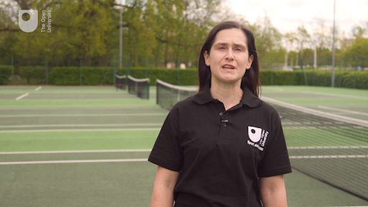

By the end of this session, you should be able to:
- understand the range of negative psychological responses to sport injury
- be able to critically analyse models of psychological reaction to injury.

1 How does sport injury make people feel?
If you have ever experienced a sport injury, you will have first-hand experience of how having an injury can make people feel. Being involved in sport can become a significant part of people’s lives. In fact, some people have a very strong athletic identity, where their personal identity is strongly attached to being a sportsperson (Brewer et al., 1993). When an injury occurs, and sports participation is consequently either restricted or stopped, that identity can be lost which can lead to several psychological reactions.
England footballer Danny Rose described feeling very angry and experiencing depression after a knee injury that occurred in 2017 which took him away from playing for eight months.

I was getting very angry, very easily. I didn’t want to go into football, I didn’t want to do my rehab, I was snapping when I got home; friends were asking me to do things and I wouldn’t want to go out, and I would come home and go straight to bed.
(Danny Rose in Kelner, 2018)

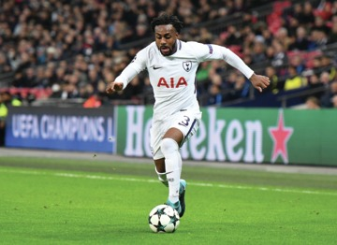
Figure 1 Danny Rose (footballer)
View description - Figure 1 Danny Rose (footballer)

Activity 1 What are common psychological reactions to injury?
Allow about 20 minutes

Watch the video below in which 2016 Olympic hockey gold medallist Helen Richardson-Walsh discusses the psychological impact of the various injuries she has experienced during her career. As you watch the video, answer these questions:
- What are some of the psychological responses Helen has experienced in response to sport injury?
- What other negative psychological responses might a sport injury elicit?

Video content is not available in this format.
Video 2
View transcript - Video 2

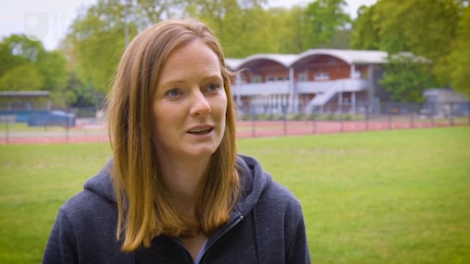

Provide your answer...

View discussion - Part

While we are focusing on negative psychological reactions here – as most athletes will view injury as a negative unwanted experience – it is important to note that some may view the onset of an injury as positive. For example, an injury could be viewed as an excuse for poor performance or a break from intensive training.
It is important to consider psychological responses to injury as they are considered to have an important influence on the rehabilitation process, and most people are likely to have some kind of psychological reaction to being injured. In the next section, you will explore the reactions of our two case studies Lois and Travis.

1.1 Lois and Travis: coping with sport injury
In this section you will explore how our case studies Lois and Travis cope with sport injury.

Case study: Lois’s reaction to her sport injury
Lois is a very dedicated athlete and devotes a lot of time to athletics. She trains every day and most of her friends and her boyfriend are fellow athletes. Before her Achilles tendon injury, her training had been going really well and she was expecting to have another good season in the summer and lower her personal best times.
Following her injury, Lois was told by her physiotherapist that she would have to miss the entire athletics season. Lois experienced several negative psychological reactions. She also didn’t want to hear her friends talking about training sessions or watch them train and compete.

Case study: Travis’s reaction to his sport injury
As someone who goes to the gym every day and enjoys the buzz he gets from doing so, Travis is struggling with being told he can’t exercise in the way he wants to for the next few weeks. He normally uses his trips to the gym as a way to de-stress and unwind, but that has been taken away from him temporarily and he doesn’t like it.
Travis is desperate to get back to his normal gym routine and just wants his shoulder injury to get better as soon as possible. He thinks it is unfair that he has sustained the injury, particularly when he sees other people exercising. He also worries about how strong he will be when he returns to the gym and whether the injury will come back.

Activity 2 Analysing the case study experiences
Allow about 20 minutes

- Make a list of some of the feelings you think Lois and Travis might have experienced in response to their injuries. Think about the feelings they may have had immediately after injury as well as after having been injured for several weeks or months.
- Make a list of the factors that might affect how someone such as Lois or Travis feels in response to the timing of an injury.

Provide your answer...

View discussion - Part

Now that you have identified some of the psychological responses to injury that might occur, next you’ll move on to explore some models used to explain responses to injury.

2 Predicting how individuals will respond to sport injury
For those supporting Lois and Travis through their injuries – such as the coach Wilma, personal trainer Melissa and physiotherapists – it would be useful to have an understanding of how an individual might respond to injury and why. This may help them to plan and support Lois and Travis better.


Figure 2 Responses to sport injury
View description - Figure 2 Responses to sport injury

This is where models of psychological response to injury are beneficial. They provide a framework to aid our understanding of how individuals respond to injury and the impact this might have. There are two groups of model that you will explore in this course:
- grief response models, and
- cognitive appraisal models.
You will look at one example of a grief response model (Kübler-Ross, 1969) and two examples of cognitive appraisal models (Brewer, 1994; Wiese-Bjornstal et al., 1998).

Activity 3 Models of psychological response to sport injury
Allow about 25 minutes

Watch the video below which introduces three models of psychological response to sport injury and then answer the following questions.
Note: The models shown in the video have been produced as images below – they will be useful for you to look at while you watch the video and you will also refer to these in the next activity:

Video content is not available in this format.
Video 3
View transcript - Video 3

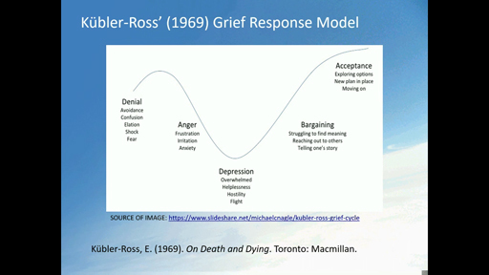

Now answer the following questions:
- What are grief response models?
- What are cognitive appraisal models and how do they differ from grief response models?
- What are the differences and similarities between the two cognitive appraisal models examined in the video?

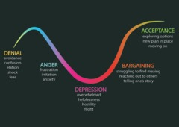
Figure 3 Kübler-Ross’s (1969) Grief response model

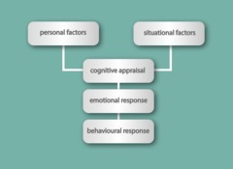
Figure 4 Brewer’s (1994) Cognitive appraisal model

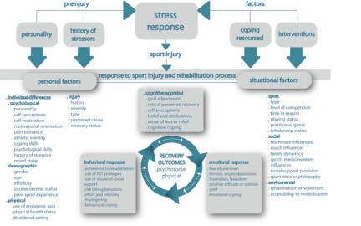
Figure 5 Wiese-Bjornstal et al.’s (1998) Integrated model of psychological response to sport injury

Provide your answer...

View discussion - Part

Next you’ll apply these models to the case studies.

3 Applying models of psychological response to sport injury
In the previous section you were introduced to three models of psychological response to sport injury:
- Kübler-Ross’s (1969) Grief response model
- Brewer’s (1994) Cognitive appraisal model
- Wiese-Bjornstal et al.’s (1998) Integrated model of psychological response to sport injury
In the next activity you will apply these models to our case study Lois.

Activity 4 Applying the models
Allow about 30 minutes

Read the information in the box below and then try to apply each of the three models to Lois, thinking about how each might explain her response to injury. As you do this, think about the strengths and limitations of each model and decide which model you think is most valuable.

Figure 3 (repeated) Kübler-Ross’s (1969) Grief response model

Figure 4 (repeated) Brewer’s (1994) Cognitive appraisal model

Figure 5 (repeated) Wiese-Bjornstal et al.’s (1998) Integrated model of psychological response to sport injury

Case study: Lois’s longer-term response to her sport injury
When Lois first became injured, she was extremely upset and angry as she felt that her world had fallen apart. Her whole life was centred on athletics and her goal of being a successful athlete. She was angry because she felt that the injury was taking her dreams away from her. Initially, she refused to accept the diagnosis and was adamant that she would return to training and competition long before her physiotherapist suggested.
Gradually, she has grown to accept that the injury will cause her to miss a long period of training and competition. She finds this very frustrating and feels jealous when she hears other athletes talking about training sessions or competitions they have undertaken. She is trying to focus her attention on her rehabilitation programme, but she is feeling very demotivated and down as she finds her rehabilitation programme very boring in comparison to athletics training. Consequently, her adherence to her rehabilitation sessions has not been very good.
Lois is also starting to experience doubts about her ability to recover from the injury and to regain her pre-injury form when she does return. She is looking forward to eventually returning to training but is worried about re-injuring herself and sometimes experiences flashbacks of when the injury occurred.

Provide your answer...

View discussion - Part

The models you have explored indicate that our psychological responses to a sport injury can shape our behavioural response (e.g. our adherence to rehabilitation sessions) and our recovery outcomes (e.g. how the injury heals). You will explore this more in the next session.

4 This session’s quiz
Check what you’ve learned this session by taking the end-of-session quiz.
Session 5 practice quiz
Open the quiz in a new tab or window (by holding down Ctrl [or Cmd on a Mac] when you click the link) then come back here when you’ve finished.

5 Summary of Session 5
In this session you have explored some of the psychological reactions that may be experienced by someone who sustains a sport injury.
The main learning points from this session are:
- Common reactions to sport injury include anger, frustration, fear, isolation, anxiety and low self-esteem.
- Grief response models view a sport injury as a form of loss and suggest that all injured people will progress through the same progressive stages of grief in response to the injury.
- Cognitive appraisal models suggest that reactions to a sport injury will depend on the individual’s cognitive appraisal of it and consequently accounts for individual differences between how people react to injury.
- The Integrated model of psychological response to sport injury is a comprehensive model that is commonly used to explore response to injury.
In the next session, you will examine the impact that these psychological responses to sport injury have on injury rehabilitation and recovery.

Session 6: What impact does psychology have on recovery?

Introduction
In the previous session you explored some of the models that explain psychological responses to sport injury. These models show that how an individual reacts to their injury can have an impact on their behaviour and consequently their rehabilitation outcomes. In this session you will examine the impact of psychological reactions on the rehabilitation process in more detail. You will begin by re-visiting our case studies Lois and Travis.

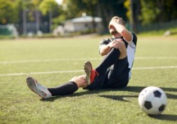
Figure 1 Psychological responses can have an impact on sport injury rehabilitation

By the end of this session, you should be able to:
- examine the impact of psychological factors on the rehabilitation process and rehabilitation outcomes, and
- explore sport injury-related growth.

1 Psychology, coping and outcomes
The cognitive appraisal models you examined in Session 5 show a clear link between emotional responses to injury and behavioural responses (e.g. adherence/non-adherence). Research shows that these responses influence rehabilitation outcomes (Brewer and Redmond, 2017). Sport injury rehabilitation outcomes can be defined as ‘outcome measures of success’ – these include readiness to return to sport, treatment satisfaction and rate of recovery (Brewer and Redmond, 2017).
Research has been conducted to explore the impact of psychological responses to sport injury. A systematic review of the literature (Forsdyke et al., 2016) which examined twenty-five research studies concluded that various psychological factors are associated with a range of rehabilitation outcomes. For example, negative mood was found to be associated with negative rehabilitation outcomes.

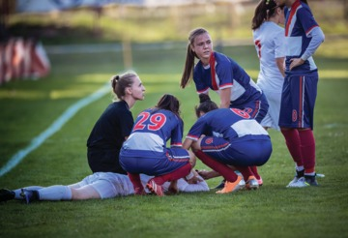
Figure 2 Psychological factors and rehabilitation outcomes
View description - Figure 2 Psychological factors and rehabilitation outcomes

The ‘coping style’ the individual adopts in response to injury can also have an impact on rehabilitation outcomes. Udry (1997) identified four types of coping:
- Instrumental coping – attempting to reduce the source of stress through activities such as finding out more about the injury or listening to the advice of the physiotherapist (sometimes referred to as ‘problem-focused coping’).
- Negative emotion coping – preoccupation with the emotional consequences of a stressor such as feeling anxious or worrying about an injury (sometimes known as ‘emotion-focused coping’).
- Distraction coping – thinking about or engaging in other activities to avoid thinking about the injury (sometimes referred to as ‘avoidance coping’).
- Palliative coping – engaging in ‘self-help’ activities aimed at providing a soothing effect or reducing the unpleasantness of an injury, such as getting more sleep.
Unsurprisingly, instrumental coping is associated with more positive behavioural responses (e.g. better rehabilitation adherence) and rehabilitation outcomes (Udry, 1997).
To help you further examine the links between psychological factors and rehabilitation outcomes, you will now re-visit our case studies Lois and Travis to see how their reactions affect their recoveries.

1.1 Lois’s experience
As you have seen, Lois has struggled to come to terms with being injured. In the activity that follows you will explore how this might impact on her rehabilitation.

Activity 1 Lois’s reaction to injury
Allow about 15 minutes

Read about how Lois is coping with her injury in the box below. Then reflect on how her responses to her injury are impacting on her recovery and rehabilitation.

Case study: Lois’s reactions and rehabilitation
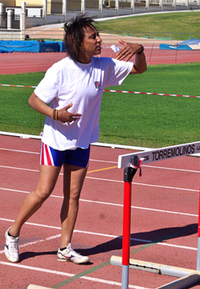
Following her injury Lois has been feeling quite down. She is struggling with not being able to train and compete and is missing being part of her training group. Her coach Wilma has noticed that she has been withdrawn and quiet and not her usual bubbly self. Lois has told Wilma that, as well as being frustrated about not being able to run, she feels socially isolated as most of her friends are athletes.
Wilma has also learned that Lois has not been attending all of her rehabilitation sessions at the sports medicine clinic. In the last few weeks she has only been to fifty per cent of her scheduled sessions. The physiotherapist has noted that she doesn’t seem very motivated in these sessions and isn’t working as hard as she could. Additionally, Lois has not been engaging in her daily rehabilitation exercises at home. The physiotherapist has referred her for a session with the sport psychologist at the clinic to try and get her back on track.
When Wilma asked Lois about the rehabilitation sessions, she seemed very depressed and her response was ‘what’s the point? – my career is probably over anyway’. This does not match with the physiotherapist’s diagnosis, who believes she can make a full recovery.

Provide your answer...

View discussion - Part

But what about Travis? How is he coping?

1.2 Travis’s experience
Like Lois, Travis has also found the experience of being injured difficult but he has reacted in a very different way, as you will see in the activity below.

Activity 2 Travis’s responses to injury
Allow about 25 minutes

1. Read how Travis is coping with his injury in the box below and contrast Travis’s responses and their impact with those of Lois in the previous section.

Case study: Travis’s reactions and rehabilitation
Travis is really missing the buzz of going to the gym every day and can’t wait to get back to full fitness and resume his normal fitness regime. He has experienced feelings of sadness, anger and frustration about being injured, but is now determined that he is going recover as quickly as possible. He is in denial about the extent of his injury and believes that he will recover much quicker than his physiotherapist Lydia has suggested.
Travis turns up on time for every rehabilitation session and works hard in every session, but Lydia is concerned that he is pushing too hard and ignoring her advice to slow down. She believes that he is doing his rehabilitation exercises at home more frequently and at a higher intensity than she has prescribed. She recently saw him leaving a circuit training class even though he has agreed that he will take two weeks off from the class. She is concerned that if he doesn’t take her advice, he will aggravate his shoulder injury and consequently delay his recovery even further.

Provide your answer...

2. Watch Video 1 below about American wrestler Adam Coon and reflect on the similarities between Adam’s and Travis’s responses to injury. How might their responses impact on injury recovery?

Video content is not available in this format.
Video 1
View transcript - Video 1

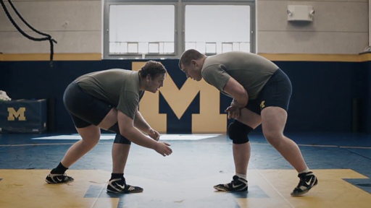

Provide your answer...

View discussion - Part

Now you’ve identified how psychological responses can impact on injury rehabilitation, next you’ll explore how these responses change over time.

2 Do reactions to injury change over time?
Time may be a great healer, but is that true of sport injuries? Do psychological reactions to injury change over time?
Grief response models suggest that they do but, as you have seen, grief response models have limitations. It is intuitive to believe that over time an individual may feel differently about their injury and indeed this does seem to be the case. For example, Forsdyke et al. (2016) found in several of the studies they reviewed that as rehabilitation progressed closer towards the point where individuals returned to sport, they began to develop a more positive mood. However, Forsdyke et al. (2016) also found that performance related anxiety often increased as individuals prepared to return to sport following injury.
Similarly, Ardern et al. (2013), in their review of eleven studies, found that while emotions generally become more positive as rehabilitation and recovery progress, fear is a prominent emotion when an individual returns to sport. Emotions can fluctuate and therefore as an individual progresses through their sport injury journey they will likely experience highs and lows and fluctuating psychological states.
Next you will explore how Lois’s feelings about her injury have changed over time.

Activity 3 Impact of psychological factors: over time
Allow about 15 minutes

Read the information about Lois’s progress in the box below and then answer the following questions.
- How have Lois’s responses to her injury changed over time (since Session 6, Activity 1)?
- What impact have these changes had on her behaviours and rehabilitation outcomes?

Case study: Lois’s rehabilitation progress
Since having a session with her sport psychologist Amir, Lois has started to feel a bit more motivated. Amir has helped her to put things in perspective and to focus on developing a more positive attitude towards her recovery. Lois has begun to accept the injury and has become more determined. As a consequence, her adherence to rehabilitation sessions has drastically improved and she is starting to see some progress. This is making her feel more optimistic about her recovery.
Amir has taught Lois some techniques she can use to help her manage her emotions and to get through difficult times. To address her feelings of isolation from her training group, Lois now does her rehabilitation exercises at the track while they are training. She is also helping Wilma to coach some of the younger athletes.

Provide your answer...

View discussion - Part

You will explore some of the psychological techniques that Amir has taught Lois in Sessions 7 and 8.

3 Sport injury-related growth
Before concluding this session, it is important to note that sport injury can lead to positive as well as negative experiences. You have learned that responses to injury can be positive rather than negative – for example, where an injury is interpreted as providing a break from intensive training or as an excuse for poor performance. Individuals who have positive responses may not want to recover quickly and consequently may not engage with rehabilitation activities and are sometimes termed ‘malingering athletes’ (Brewer and Redmond, 2017).
Positive experiences can, however, also be derived by individuals who interpret injury as negative. This can be termed ‘sport injury-related growth’ and can be defined as ‘perceived changes that propel injured athletes to a higher level of functioning than that which existed before their injury’ (Roy-Davis et al., 2017, p. 36).
Research has consistently demonstrated that positives (growth) can be derived from the negative experience of sport injury (Salim and Wadey, 2018). In a study by Wadey et al. (2013) eight coaches were interviewed about the growth they perceived injured athletes to experience. Four categories of growth were identified:
- Personal growth – development of beliefs, attitudes, knowledge, priorities, outlook and general qualities
- Psychological growth – development of sporting qualities and coping skills
- Social growth – development of social support
- Physical growth – development in strength and conditioning.
You will explore these categories of growth further in the next activity.

Activity 4 Positive consequences
Allow about 30 minutes

Those who have experienced sport injury often find that being injured can lead to several negative psychological reactions. However, despite this, it is also possible for these individuals to derive positive benefits (growth) from their injuries. In this activity you will explore some of these potential benefits.
Watch Video 2 below in which former heptathlete Jessica Ennis-Hill discusses some of the positive consequences she derived from being injured. As you watch the video:
- Categorise each of the positive consequences she mentions under one of the categories of sport injury-related growth identified by Wadey et al. (2013):
  - personal growth
  - psychological growth
  - social growth
  - physical growth.
- Identify any further examples of positive benefits that injured athletes (including Lois and Travis) may experience that would fit under these four categories.

Video content is not available in this format.
View transcript - Uncaptioned interactive content

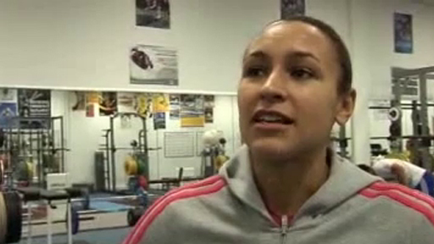
Video 2

Category | Examples
Personal growth | Provide your answer...
Psychological growth | Provide your answer...
Social growth | Provide your answer...
Physical growth | Provide your answer...

View discussion - Activity 4 Positive consequences

In Sessions 7 and 8 you will examine some of the psychological techniques that can be used to help individuals deal more positively with sport injury.

4 This session’s quiz
Check what you’ve learned this session by taking the end-of-session quiz.
Session 6 practice quiz
Open the quiz in a new tab or window (by holding down Ctrl [or Cmd on a Mac] when you click the link) then come back here when you’ve finished.

5 Summary of Session 6
In this session you have explored the impact of psychological factors on recovery and rehabilitation from sport injury and the return to sport following injury.
The main learning points from this session are:
- Emotional responses to injury (e.g. anger) can influence behavioural responses (e.g. non-adherence) which can impact on rehabilitation outcomes (e.g. slower recovery rate).
- Psychological reactions to injury can change over time.
- Although generally an unwanted experience, sport injury can lead to positive consequences such as personal, psychological, social or physical growth.
Now that you have examined the impact of psychological factors on recovery from sport injury you will next explore some of the psychological interventions that can be used during rehabilitation.

Session 7: How can imagery, self-talk and relaxation help injury rehabilitation?

Introduction
Sport injury can lead to several psychological responses that can have a negative impact on rehabilitation. So it seems logical that psychological interventions aimed at helping individuals to cope more effectively with injury will have a positive impact.

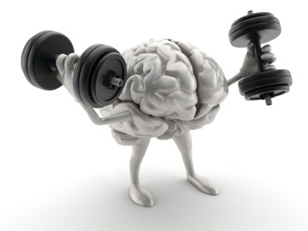
Figure 1 Psychological intervention can help people cope with sport injury
View description - Figure 1 Psychological intervention can help people cope with sport injury

As a reminder, in this course we are using the term ‘psychological interventions’ to describe the psychological techniques and strategies an individual can use. The terms ‘intervention’, ‘technique’ and ‘strategy’ are therefore used interchangeably.
You will be exploring five key techniques that have been shown to aid sport injury rehabilitation:
- imagery
- self-talk
- relaxation
- goal setting, and
- social support.
In this session you will look at imagery, self-talk and relaxation. You will look at goal setting and social support in Session 8. As you are looking at psychological interventions it is important to remember that such interventions should normally only be prescribed by a registered sport and exercise psychologist. That is not to say that understanding these interventions is not relevant to you – it is still useful to recognise their value and application so that you are able to support an injured person to get the help they need. Additionally, some of the techniques you will explore (particularly those in Session 8) can be implemented at a basic level by someone who is not a sport and exercise psychologist.
By the end of this session, you should be able to:
- understand how imagery, functional self-talk and relaxation techniques can all enhance injury rehabilitation,
- explain the benefits of psychological intervention in sport.

1 The benefits of sport psychology intervention
Using psychological interventions for people with a sport injury can lead to several benefits, such as:
- increased adherence to rehabilitation programmes
- more positive attitude towards recovery
- increased motivation
- pain management
- enhanced coping skills
- reduced stress, anxiety and depression, and
- enhanced healing.
(Petitpas and Danish, 1995; Heil and Fine, 1999; Wiese-Bjornstal and Shaffer, 1999; Williams and Scherzer, 2006)
In the next activity you will explore Helen Richardson-Walsh’s experience of using psychological interventions while injured.

Activity 1 Using psychological techniques in sport injury
Allow about 30 minutes

- Watch the video below of 2016 Olympic hockey champion Helen Richardson-Walsh. What are some of the psychological strategies she used to aid her recovery from injury?
- Reflect on any role you have in supporting individuals with sport injury (e.g. coach, instructor, team mate, partner). Which aspects of your work could be considered to be psychological strategies or techniques? If you don’t hold such a role think about how you have been supported when you’ve been injured or how you might like to be supported if you were injured.

Video content is not available in this format.
Video 1 Helen Richardson-Walsh
View transcript - Video 1 Helen Richardson-Walsh

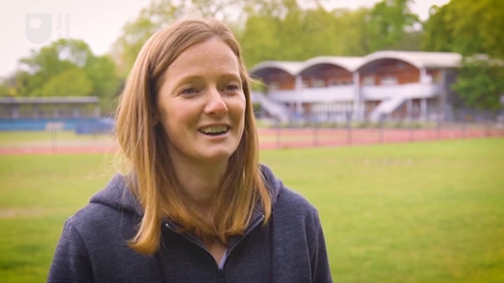

Provide your answer...

View discussion - Part

In the activity you have just completed Helen Richardson-Walsh describes how she used imagery while she was injured. In the next section you will explore imagery in more detail.

2 Imagery in sport injury rehabilitation
In sport you often see athletes appearing to run through a performance in their mind before executing it (for example, a high jumper before a jump). This is an example of imagery.

Figure 2 Imagery can aid sport injury rehabilitation
View description - Figure 2 Imagery can aid sport injury rehabilitation

Imagery can be defined as the process of ‘using one’s senses to re-create or create an experience in the mind’ (Vealey and Forlenza, 2015, p. 240). Imagery can be a useful technique for individuals to use during sport injury rehabilitation. It can be used in many different ways, including those outlined in Figure 3.

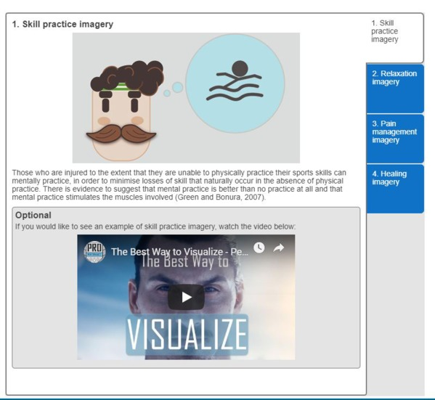

Interactive content is not available in this format.
Interactive Figure 3 Imagery in sport injury rehabilitation
View description - Interactive Figure 3 Imagery in sport injury rehabilitation

Activity 2 Using imagery to help Lois and Travis
Allow about 25 minutes

Select one of our two case studies below (Lois or Travis) and read up on their progress. Make a list of how they could use imagery during their recovery from injury.

Case study: Lois
Lois has gone to see her sport psychologist Amir. They have been discussing how difficult she finds it to cope with the pain of the treatment that she is having on her Achilles tendon during physiotherapy sessions.
Lois has asked Amir if he can recommend any techniques to help her as the pain is so intense that it’s causing her to tense up which makes it much harder for the physiotherapist to work on the injured area.

Case study: Travis
Travis has been experiencing a lot of stress and anxiety due to his injury. Normally he would use exercise as a way of dealing with stress, but the injury is preventing him from exercising as he would like. He therefore needs to find an alternative way to relax and unwind.

Provide your answer...

View discussion - Part

Next you move on to look at how self-talk can aid recovery from sport injury.

3 Self-talk and sport injury rehabilitation
Self-talk, as its name suggests, refers to the things people say to themselves. Self-talk can be internal (i.e. internal thoughts) or external (i.e. vocal). The things we say to ourselves are thought to be influential on our attitude, behaviour and performance.
At a basic level it is suggested that negative self-talk is more likely to lead to a negative attitude or outcome and positive self-talk is more likely to lead to a positive attitude or outcome. However, it may actually be more appropriate to refer to ‘functional’ and ‘dysfunctional’ self-talk rather than ‘positive’ and ‘negative’ self-talk as it appears some individuals may find negative self-talk motivational (Walker and Hudson, 2013).

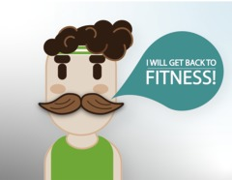
Figure 4 Getting back into fitness

When an injury occurs, it can cause negative or dysfunctional self-talk. So the deliberate use of positive self-talk – and the ability to stop negative or dysfunctional self-talk – are considered valuable in helping to develop a more positive attitude towards sport injury rehabilitation. Those who are injured should therefore be encouraged to use positive self-talk.
Here are a few examples of how you can use positive self-talk during injury rehabilitation:
- Whenever an individual has a negative thought (for example, ‘I’m never going to get back to fitness’) encourage them to say the word ‘stop!’ firmly to themselves and immediately replace that thought with a positive one (for example, ‘I will get back to fitness’).
- Encourage injured athletes or participants to repeat a positive phrase or statement to themselves when they are undertaking difficult or painful rehabilitation exercises (for example, ‘I can do this!’). This same positive phrase could perhaps be written down and placed in a prominent place.
- You could ‘ban’ the individual from making negatively framed comments about their injury to other people (for example, phrases like ‘My rehabilitation is going really badly!’).
- Encourage the injured person to make a list of all the negative thoughts they have been having and write a counteracting positive statement for each.

3.1 Self-talk in practice
According to Hardy (2006) there are two main types of self-talk:
- instructional (or cognitive) self-talk – this tells or reminds people what to do (e.g. ‘relax’), and
- motivational self-talk – this encourages people in some way (e.g. ‘I can do this’).
It is suggested that instructional self-talk is effective in enhancing or directing attention, while motivational self-talk is effective in increasing confidence and motivation and regulating effort. Below are some examples of motivational and instructional self-talk used by our case studies Lois and Travis:

When the physio is about to do some painful treatment on my Achilles, I take a deep breath and say the word ‘relax’ to myself.
(Lois – instructional self-talk)

Every morning now I wake up and say ‘I will get back to fitness’ to myself.
(Travis – motivational self-talk)

When I’m coaching at the track I look at the other athletes running fast and think ‘I will be back running with them soon’.
(Lois – motivational self-talk)

Activity 3 Self-talk: have a go!
Allow about 30 minutes
This activity is divided into two parts. For the first part you are going to watch a video showing how someone has learned to use self-talk. In the second part you are going to complete a self-talk exercise.

- Watch the video below in which swimmer Kally Fayhee discusses how she uses a self-talk strategy of identifying and reframing negative thoughts. What are the stages of strategy she describes?

Video content is not available in this format.
Video 2
View transcript - Video 2

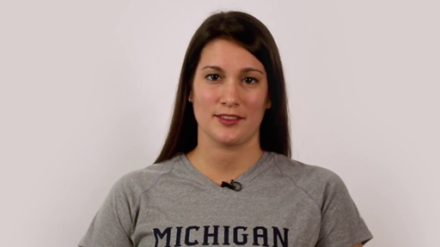

Provide your answer...

View discussion - Part

- Think of a time when you have said negative things to yourself (for example, when you have been lacking confidence about a particular task, or when you have been injured). Write down some of the negative statements you have said to yourself in the first column of the table below, then write down a counteracting positive statement that you could have said to yourself instead.

Negative self-talk | Positive self-talk
Provide your answer... | Provide your answer...
Provide your answer... | Provide your answer...
Provide your answer... | Provide your answer...

View discussion - Part

4 Relaxation techniques and sport injury rehabilitation
Individuals can experience stress and anxiety when they sustain a sport injury. This stress and anxiety can have a negative impact on motivation, adherence and rehabilitation outcomes. So, any technique that can reduce stress and anxiety may have a positive impact on the rehabilitation process.

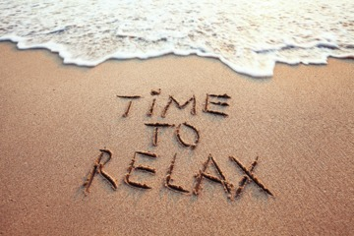
Figure 5 Relaxation can aid sport injury rehabilitation
View description - Figure 5 Relaxation can aid sport injury rehabilitation

Relaxation techniques can help to ease the stress and anxiety that may be a consequence of injury. They can also help to relieve tension in the injured area, which may allow a therapist to treat the injury more effectively.
You will now explore a range of relaxation techniques. All these techniques have the potential to induce what is known as a ‘relaxation response’. The relaxation response is characterised by physiological responses that include decreased heart rate, respiration rate, oxygen consumption and muscle activation, and increased alpha brainwaves (Cox, 2007).

4.1 Relaxation in practice
There are a wide range of relaxation techniques that can be used by injured sport and exercise participants. Four examples are given in Figure 6 below and you will have the opportunity to try one of these yourself in Activity 4.

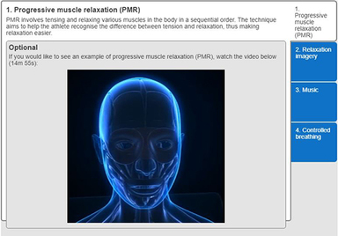

Interactive content is not available in this format.
Interactive Figure 6 Relaxation techniques in sport injury rehabilitation
View description - Interactive Figure 6 Relaxation techniques in sport injury rehabilitation

Activity 4 Relaxation: have a go!
Allow about 45 minutes

Select one of the relaxation techniques from Figure 6 and then watch the associated video and undertake the technique. Evaluate how effective you found the technique by answering the following questions:
- How did the technique make you feel? Was it effective in making you feel relaxed?
- How easy or difficult did you find it to undertake the task?
- Do you think you would use this technique to help you relax? If so, in what circumstances would you use it?
- Do you think it would be a useful technique for an injured athlete or exercise participant? Why?

Provide your answer...

View discussion - Part

All of these techniques have received research support for use in the treatment of sport injury, but there has been some wider debate about the effectiveness of PMR. A systematic review (Pelka et al., 2016) concluded that PMR was ineffective in enhancing performance. It should be noted, however, that this review was specifically investigating the direct effect of PMR on measures of sports performance (e.g. tennis strokes, reaction time, muscle strength, aerobic performance), while the benefits of PMR in relation to sport injury are likely to be more indirect. For example, PMR has been shown to improve sleep which could indirectly reduce injury risk (e.g. improved recovery from training, reduced stress and anxiety) (McCloughan et al., 2016).

5 This session’s quiz
Check what you’ve learned this session by taking the end-of-session quiz.
Session 7 practice quiz
Open the quiz in a new tab or window (by holding down Ctrl [or Cmd on a Mac] when you click the link) then come back here when you’ve finished.

6 Summary of Session 7
In this session you have explored how imagery, self-talk and relaxation techniques can be used during rehabilitation from sport injury.
The main learning points from this session are:
- Sport psychology intervention during sport injury rehabilitation can lead to several positive outcomes including increased adherence, more positive attitude, enhanced pain management and enhanced healing.
- Imagery can be used in several different ways to benefit sport injury rehabilitation, for example skill practice, relaxation, pain management and healing imagery.
- Both instructional and motivational self-talk can be used to enhance sport injury rehabilitation.
- Relaxation techniques such as PMR, relaxation imagery, controlled breathing and music can be used to help injured athletes and exercise participants to combat the stress and anxiety that can be a consequence of injury.
Having explored imagery, self-talk and relaxation, in the next session you will look at two more interventions that can be used during sport injury rehabilitation – goal setting and social support.

Session 8: How can goal setting and social support help injury rehabilitation?

Introduction
In the previous session you examined how imagery, positive self-talk and relaxation strategies can be used to help people cope more effectively with sport injury. In this session you will explore two further intervention strategies – goal setting and social support. In Activity 1 of Session 7, Olympic Gold Medallist Helen Richardson-Walsh identified both of these as key strategies that she found useful to help her cope with sport injury.

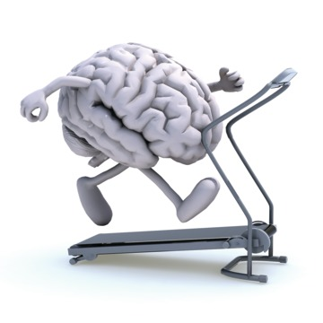
Figure 1 Goal setting and social support are techniques that can help injured athletes
View description - Figure 1 Goal setting and social support are techniques that can help injured at ...

By the end of this session, you should be able to:
- understand how social support and goal setting can both enhance sport injury rehabilitation, and
- identify different strategies for coping with sport injury.

1 Coping with sport injury
Sport injury rehabilitation can be negatively influenced by psychological factors. Consequently, putting in place interventions to help people cope with injury can enhance the rehabilitation process. In the next activity you will explore athlete experiences of coping with injury.

Activity 1 How sports stars cope with injury
Allow about 15 minutes

Watch the video below which is a news item discussing how athletes cope with injury. As you watch, make a note of the factors and strategies the athletes say helped them to cope with injury.

Watch the video at YouTube.com.
Video 1
View transcript - Video 1

Provide your answer...

View discussion - Part

2 Goal setting and sport injury rehabilitation
Goal setting is a psychological technique that most people involved in sport and exercise are well versed in. Effective goal setting is a key part of sport injury rehabilitation and is considered to be a highly effective technique (Arvinen-Barrow and Hemmings, 2013). Sport and exercise participants are used to working towards targets and so often need such targets within their rehabilitation programmes. There is a wide variety of goals that might be set for those recovering from sport injury and some of these are summarised in Figure 2.

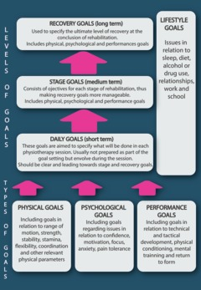
Figure 2 Types of goal for sport injury rehabilitation (Arvinen-Barrow and Hemmings, 2013, p. 60)

Setting goals can help focus the individual’s attention, keep them motivated and increase their adherence, but how do you know that your goal setting is effective? You will look at what constitutes effective goal setting next.

2.1 Effective goal setting
Obviously, the goals you set need to be appropriate – goals that are unrealistic can have a negative impact on motivation. In the next activity you will examine some principles of effective goal setting.

Activity 2 Goal setting in practice
Allow about 15 minutes

Watch the video below which looks at goal setting in sport and then answer the questions that follow.
https://www.youtube.com/watch?v=MeChdwU-53E
Video transcript
- Look at the following examples of goals set by our case study Lois. Decide whether each of Lois’s goals (a, b and c) is a process, performance or outcome goal:
  - Goal: to return to the track by September
  - Goal: to increase my personal best on calf raises
  - Goal: to focus on staying high on my toes as I run.
- What is SMARTER? Using SMARTER, try to improve the wording of the goal below, set for our case study Travis:
Goal: to improve fitness.
- Why do you think it is important to set both short-term and long-term goals?

Provide your answer...

View discussion - Part

Injury rehabilitation can be unpredictable – this can sometimes make goal setting a difficult task, and at times goals won’t be achieved. In these situations, it is important that you try to frame positively in order to maximise the individual’s motivation and positive attitude towards rehabilitation. Therefore, it is recommended that where necessary you focus on the degree of goal attainment rather than absolute attainment. For example, if an individual hasn’t fully achieved a goal you might emphasise the progress made towards it instead – focusing on the improvement from last time rather than the failure to achieve the target.
Next you’ll look at the role of social support in sport injury rehabilitation.

3 Social support in sport injury rehabilitation
Social support can be defined as ‘an exchange of resources between two individuals perceived by the provider or the recipient to be intended to enhance the well-being of the recipient’ (Corbillon et al., 2008, p. 94). Social support can be provided by different people around the injured athlete such as the coach, team mates, physiotherapist, sports therapist, friends or family.
At first glance, social support may not seem like a psychological technique, but its potential impact on an injured athlete is extremely powerful. It can mediate some of the psychological stresses of being injured. Being able to talk to someone about how being injured is making you feel is an important therapy for an athlete or exercise participant. If you have regular and close contact with an injured person you can be a key source of social support. Simply by talking and listening to the injured person you can make them feel better and more positive.
When talking to an injured athlete, ask them about the emotional and psychological aspects of their injury as well as the standard physical aspects. This will help the athlete to come to terms with their feelings. Using effective counselling skills such as active listening in your interactions with injured athletes may help improve your social support skills. Active listening can be thought of as listening with a purpose in a way that makes the speaker feel listened to. Other counselling skills that may improve interactions with injured athletes and exercise participants include being empathetic, non-judgemental and genuine (a ‘person-centred approach’). These are summarised in Figure 3.

Interactive content is not available in this format.
Interactive Figure 3 The person-centred approach

You can also help to encourage social support from sources other than yourself. Some of the negative consequences of injury such as loss of identity and loneliness occur because contact is lost with team mates and coaches when an athlete is injured.
In Section 6 you saw that Lois was experiencing these feelings. Her support team addressed this by scheduling her rehabilitation sessions alongside team training sessions to encourage her to maintain contact and social support from her coach and team mates.
Lois’s story has parallels with the athlete in the video below, Arielle Sanders (rower), who initially felt very isolated following injury. She then received social support from a support group (Athletes Connected) and through remaining involved with her team mates when she could no longer compete.

Video content is not available in this format.
Video 3
View transcript - Video 3

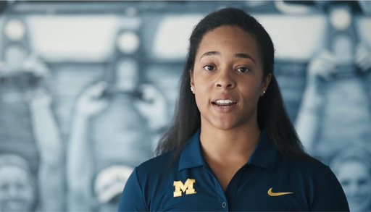

You’ve seen that social support is important, but what does good social support look like? You’ll explore this next.

3.1 Social support in practice
Forsdyke et al. (2016) identified that having trust in the rehabilitation provider, feeling wanted by others and satisfaction with social support were associated with positive rehabilitation outcomes. Social support is considered to be a multidimensional construct with different categories of social support possible, including (Arvinen-Barrow and Pack, 2013):
- emotional
- technical
- informational
- tangible, and
- motivational support.
Table 1 defines these different categories of social support.

Interactive content is not available in this format.
Interactive Table 1 Different categories of social support (adapted from Arvinen-Barrow and Pack, 2013, pp. 122–3)
View description - Interactive Table 1 Different categories of social support (adapted from Arvinen-Barrow ...

Activity 3 Social support in practice
Allow about 15 minutes

Our case studies Travis and Lois have been asked to identify three key sources of social support they have drawn upon during their rehabilitation (see below). Select either Lois or Travis and then for each person they have identified consider what type of social support each person might provide.

Table 2: Case studies: social support
Lois (sprinter)

View description - Uncaptioned Figure

Coach (Wilma) | Provide your answer...
Sport psychologist (Amir) | Provide your answer...
Boyfriend (Dave) | Provide your answer...
Travis (exercise participant)

View description - Uncaptioned Figure

Husband (Trevor) | Provide your answer...
Physiotherapist (Lydia) | Provide your answer...
Personal trainer (Melissa) | Provide your answer...

View discussion - Activity 3 Social support in practice

The sources of social support discussed in Activity 3 focus on individual relationships, but it is important to note that group sources of social support can also be highly effective. The video below describes one such example – a sport injury support group.

Watch the video at YouTube.com.
Video 4
View transcript - Video 4

Having looked at how all these different interventions can help recovery from sport injury next you’ll reflect on what this means to you.

4 Reflection: What can you do to support an injured person?
As you near the end of this course, this section provides an opportunity to reflect on what you have learned about the psychological aspects of injury, and what you can do to support an injured person.

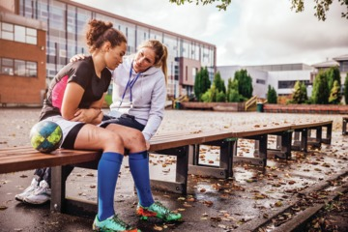
Figure 4 You can play an important role in supporting an injured athlete
View description - Figure 4 You can play an important role in supporting an injured athlete

Activity 4 Self-reflection
Allow about 15 minutes

Using the following questions as prompts, reflect on how what you have learned on this course will affect your future practice:
- will your interactions with any injured athletes or exercise participants change as a result of studying this course? If so, in what way?
- what actions might you now take to help prevent sport injury?
- what actions might you take to help individuals going through sport injury rehabilitation?
- what are the key lessons you have learned about the psychological aspects of sport injury?

Provide your answer...

View discussion - Part

5 This session’s quiz
Congratulations on almost reaching the end of the course.
Now it’s time to complete the Session 8 badged quiz. It is similar to the quiz that you took at the end of Session 4, with 15 questions in total.
Session 8 compulsory badge quiz
Open the quiz in a new tab or window (by holding down Ctrl [or Cmd on a Mac] when you click the link) then come back here when you’ve finished.

6 Summary
In this session you have explored how goal setting and social support can be used during rehabilitation from sport injury.
The main learning points from this session are:
- Psychological interventions can help people to cope with the challenges of sport injury.
- Goal setting is an effective tool in sport injury rehabilitation.
- There are three types of goal: outcome, performance and process goals.
- Effective goal setting should adhere to the SMARTER principles and should include both short-term and long-term goals.
- Social support can be provided by a wide range of people around an injured athlete.
- Five broad categories of social support have been identified: emotional, technical, informational, tangible and motivational support.

Where next?
If you’ve enjoyed this course you can find more free resources and courses on OpenLearn.
You might be specifically interested in these badged courses:
- Communication and working relationships in sport and fitness
- Exploring sport coaching and psychology
- Learning from sport burnout and overtraining
- Coaching others to coach
There is also a page of sport and fitness courses on OpenLearn.
New to University study? You may be interested in our courses on Health and Wellbeing. You might be particularly interested in our BSc (hons) Sport, fitness and coaching.
Making the decision to study can be a big step and The Open University has over 40 years of experience supporting its students through their chosen learning paths. You can find out more about studying with us by visiting our online prospectus.

Tell us what you think
Now you’ve come to the end of the course, we would appreciate a few minutes of your time to complete this short end-of-course survey (you may have already completed this survey at the end of Session 4).

References
NHS (2012) Provisional Monthly Hospital Episode Statistics for Admitted Patient Care, Outpatients and Accident and Emergency Data – April 2011 to February 2012 [Online]. Available at https://digital.nhs.uk/data-and-information/publications/statistical/hospital-episode-statistics-for-admitted-patient-care-outpatient-and-accident-and-emergency-data/provisional-monthly-hospital-episode-statistics-for-admitted-patient-care-outpatients-and-accident-and-emergency-data-april-2011-to-february-2012 (Accessed 15 October 2018).
Palmer-Green, D. and Elliott, N. (2015) ‘Sports injury and illness epidemiology: Great Britain Olympic team surveillance during the Sochi 2014 winter Olympic games’, British Journal of Sports Medicine, vol. 49, pp. 25–9.
Peterson, L. and Renstrom, P. A. F. H. (2016) Sports Injuries: Prevention, Treatment and Rehabilitation, 4th edn, London, CRC Press.
Brewer, B. W. and Redmond, C. J. (2017) Psychology of Sport Injury, Leeds, Human Kinetics.
Clement, D. and Arvinen-Barrow, M. (2013) ‘Sport medicine team influences in psychological rehabilitation – A multidisciplinary approach’, in Arvinen-Barrow, M. and Walker, N. (eds) The Psychology of Sport Injury and Rehabilitation, London, Routledge, pp. 156–170.
Green, A. J., Jackson, D. A. and Klaber Moffett, J. A. (2008) ‘An observational study of physiotherapists’ use of cognitive-behavioural principles in the management of patients with back pain and neck pain’, Physiotherapy, vol. 94, no. 4, pp. 306–13.
Heaney, C. (2006) ‘Recommendations for successfully integrating sport psychology into athletic therapy’, Athletic Therapy Today, vol. 11, pp. 60–2.
Heaney, C. A., Green, A. J. K., Rostron, C. L. and Walker, N. C. (2012) ‘A qualitative and quantitative investigation of the psychology content of UK physical therapy education programs’, Journal of Physical Therapy Education, vol. 26, no. 3, pp. 48–56.
Heaney, C. A., Walker, N. C., Green, A. and Rostron, C. L. (2015) ‘Sport psychology education for sport injury rehabilitation professionals: A systematic review.’, Physical Therapy in Sport, vol. 16, pp. 72–9.
Walker, N. and Heaney, C. (2013) ‘Psychological responses to injury: a review and critique of psychological response to injury models’, in Arvinen-Barrow, M. and Walker, N. (eds) The Psychology of Sport Injury and Rehabilitation, London, Routledge, pp. 23–39.
Andersen, M. B. and Williams, J. M. (1988) ‘A Model of Stress and Athletic Injury: Prediction and Prevention’, Journal of Sport and Exercise Psychology, vol. 10, no. 3, pp. 294–306.
Appaneal, R. N. and Habif, S. (2013) ‘Psychological antecedents to sport injury’, in Arvinen-Barrow, M. and Walker, N. C. (eds) The Psychology of Sport Injury and Rehabilitation, London, Routledge, pp. 6–22.
Brewer, B. W. and Redmond, C. J. (2017) Psychology of Sport Injury, Leeds, Human Kinetics.
Meeuwise, W. H., Tyreman, H., Hagel, B. and Emery, C. (2007) ‘A dynamic model of etiology in sport injury: the recursive nature of risk and causation’, Clinical Journal of Sport Medicine, vol. 17, no. 3, pp. 215–9.
Petrie, T. A. and Perna, F. M. (2004) ‘Psychology of injury: theory, research and practice’, in Morris, T. and Summers, J. (eds) Sport Psychology: Theory, Applications and Issues, Chichester, Wiley, pp. 547–71.
Wiese-Bjornstal, D. M. and Shaffer, S. M. (1999) ‘Psychosocial dimensions of sport injury’, in Ray, R. and Wiese-Bjornstal, D. M. (eds) Counseling in Sports Medicine, Leeds, Human Kinetics, pp. 23–40.
Williams, J. M. and Andersen, M. B. (1998) ‘Psychosocial antecedents of sport injury: review and critique of the stress and injury model’, Journal of Applied Sport Psychology, vol. 10, no. 1, pp. 5–25.
Andersen, M. B. and Williams, J. M. (1988) ‘A Model of Stress and Athletic Injury: Prediction and Prevention’, Journal of Sport and Exercise Psychology, vol. 10, no. 3, pp. 294–306.
Brewer, B. W. and Redmond, C. J. (2017) Psychology of Sport Injury, Leeds, Human Kinetics.
Corbillon, F., Crossman, J. and Jamieson, J. (2008) ‘Injured Athletes’ Perceptions of the Social Support Provided by Their Coaches and Teammates During Rehabilitation’, Journal of Sport Behavior, vol. 31, no. 2, pp. 93–107.
Gledhill, A., Forsdyke, D. and Murray, E. (2018) ‘Psychological interventions used to reduce sports injuries: a systematic review of real-world effectiveness’, British Journal of Sports Medicine, vol. 52, no. 15, pp. 967-71.
Gould, D. (2015) ‘Goal setting for peak performance’, in Williams, J. M. and Krane, V. (eds) Applied Sport Psychology – Personal Growth to Peak Performance, 7th edn, London, McGraw Hill, pp. 188–206.
Hanton, S., Mellalieu, S. and Williams, J. M. (2015) ‘Understanding and managing stress in sport’, in Williams, J. M. and Krane, V. (eds) Applied Sport Psychology – Personal Growth to Peak Performance, 7th edn, London, McGraw Hill, pp. 207–37.
Ivarsson, A., Johnson, U., Andersen, M. B., Tranaeus, U., Stenling, A. and Lindwall, M. (2017) ‘Psychosocial factors and sport injuries: meta-analyses for prediction and prevention’, Sports Medicine, vol. 47, no. 2, pp. 353–65.
McCloughan, L. J., Hanrahan, S., Anderson, R. and Halson, S. R. (2016) ‘Psychological recovery: Progressive muscle relaxation (PMR), anxiety, and sleep in dancers’, Performance Enhancement & Health, vol. 4, pp. 12–7.
Olmedilla-Zafra, A., Rubio, V. J., Ortega, E. and Garcia-Mas, A. (2017) ‘Effectiveness of a stress management pilot program aimed at reducing the incidence of sports injuries in young football (soccer) players’, Physical Therapy in Sport, vol. 24, pp. 53–9.
Pelka, M., Heidari, J., Ferrauti, A., Meyer, T., Pfeiffer, M. and Kellmann, M. (2016) ‘Relaxation techniques in sports: a systematic review on acute effects on performance’, Performance Enhancement & Health, vol. 5, pp. 47–59.
Tranaeus, U., Ivarsson, A. and Johnson, U. (2015) ‘Evaluation of the effects of psychological prevention interventions on sport injuries: A meta-analysis’, Science & Sports, Elsevier Masson, vol. 30, no. 6, pp. 305–13.
Vealey, R. S. and Forlenza, S. T. (2015) ‘Understanding and using imagery in sport’, in Williams, J. M. and Krane, V. (eds) Applied Sport Psychology – Personal Growth to Peak Performance, 7th edn, New York, McGraw Hill, pp. 240–73.
Williams, J. M. and Andersen, M. B. (1998) ‘Psychosocial antecedents of sport injury: review and critique of the stress and injury model’, Journal of Applied Sport Psychology, vol. 10, no. 1, pp. 5–25.
Williams, J. M., Zinsser, N. and Bunker, L. (2015) ‘Cognitive techniques for building confidence and enhancing performance’, in Williams, J. M. and Krane, V. (eds) Applied Sport Psychology – Personal Growth to Peak Performance, 7th edn, London, McGraw Hill, pp. 274–303.
Brewer, B. W. (1994) ‘Review and critique of models of psychological adjustment to athletic injury’, Journal of Applied Sport Psychology, vol. 6, no. 1, pp. 87–100.
Brewer, B. W., Van Raalte, J. L. and Linder, D. E. (1993) ‘Athletic identity: Hercules’ muscles or Achilles heel?’, International Journal of Sport Psychology, Italy, Edizioni Luigi Pozzi, vol. 24, no. 2, pp. 237–54.
Brewer, B. W. and Redmond, C. J. (2017) Psychology of Sport Injury, Leeds, Human Kinetics.
Evans, L. and Hardy, L. (1995) ‘Sport injury and grief responses: a review’, Journal of Sport and Exercise Psychology, vol. 17, no. 3, pp. 227–45.
Kelner, M. (2018) ‘Danny Rose opens up about depression after tragedy and tough year at Spurs’, Guardian, 6 June [Online]. Available at https://amp.theguardian.com/football/2018/jun/06/danny-rose-tells-family-not-travel-world-cup-player-racism-fears-abuse-england-football-team?CMP=share_btn_tw&__twitter_impression=true (Accessed 10 August 2018).
Kübler-Ross, E. (1969) On Death and Dying, Toronto, Macmillan.
Walker, N., Thatcher, J. and Lavallee, D. (2007) ‘Psychological responses to injury in competitive sport: a critical review’, The Journal of Royal Society for the Promotion of Health, vol. 127, no. 4, pp. 174–80.
Wiese-Bjornstal, D. M., Smith, A. M., Shaffer, S. M. and Morrey, M. A. (1998) ‘An integrated model of response to sport injury: psychological and sociological dynamics’, Journal of Applied Sport Psychology, vol. 10, no. 1, pp. 46–69.
Ardern, C. L., Taylor, N. F., Feller, J. A. and Webster, K. E. (2013) ‘A systematic review of the psychological factors associated with returning to sport following injury’, British Journal of Sports Medicine, vol. 47, no. 17, pp. 1120–6.
Brewer, B. W. and Redmond, C. J. (2017) Psychology of Sport Injury, Leeds, Human Kinetics.
Forsdyke, D., Smith, A., Jones, M. and Gledhill, A. (2016) ‘Psychosocial factors associated with outcomes of sports injury rehabilitation in competitive athletes: a mixed studies systematic review’, British Journal of Sports Medicine, vol. 50, no. 9, pp. 537–44.
Roy-Davis, K., Wadey, R. and Evans, L. (2017) ‘A grounded theory of sport injury-related growth’, Sport, Exercise and Performance Psychology, vol. 6, no. 1, pp. 35–52.
Salim, J. and Wadey, R. (2018) ‘Can Emotional Disclosure Promote Sport Injury-Related Growth?’, Journal of Applied Sport Psychology, vol. 30, no. 4, pp. 367–87.
Udry, E. (1997) ‘Coping and social support among injured athletes following surgery’, Journal of Sport and Exercise Psychology, vol. 19, no. 1, pp. 71–90.
Wadey, R., Clark, S., Podlog, L. and McCullough, D. (2013) ‘Coaches’ perceptions of athletes’ stress-related growth following sport injury’, Psychology of Sport and Exercise, vol. 14, no. 2, pp. 125–35.
Cox, R. H. (2007) Sport Psychology Concepts and Applications, London, McGraw-Hill.
Green, L. B. and Bonura, K. B. (2007) ‘The use of imagery in the rehabilitation of injured athletes’, in Pargman, D. (ed) Psychological Bases of Sport Injuries, 3rd edn, Morgantown, Fitness Information Technology, pp. 131–47.
Hardy, J. (2006) ‘Speaking clearly: a critical review of the self-talk literature’, Psychology of Sport and Exercise, vol. 7, no. 1, pp. 81–97.
Heil, J. and Fine, P. G. (1999) ‘Pain in sport: A biopsychological perspective’, in Pargman, D. (ed) Psychological Bases of Sport Injuries, 2nd edn, Morgantown, Fitness Information Technology, pp. 13–28.
McCloughan, L. J., Hanrahan, S., Anderson, R. and Halson, S. R. (2016) ‘Psychological recovery: Progressive muscle relaxation (PMR), anxiety, and sleep in dancers’, Performance Enhancement & Health, vol. 4, pp. 12–7.
Pelka, M., Heidari, J., Ferrauti, A., Meyer, T., Pfeiffer, M. and Kellmann, M. (2016) ‘Relaxation techniques in sports: a systematic review on acute effects on performance’, Performance Enhancement & Health, vol. 5, pp. 47–59.
Petitpas, A. and Danish, S. J. (1995) ‘Caring for injured athletes’, in Murphy, S. M. (ed) Sport Psychology Interventions, Leeds, Human Kinetics, pp. 255–81.
Vealey, R. S. and Forlenza, S. T. (2015) ‘Understanding and using imagery in sport’, in Williams, J. M. and Krane, V. (eds) Applied Sport Psychology – Personal Growth to Peak Performance, 7th edn, New York, McGraw Hill, pp. 240–73.
Walker, N. and Hudson, J. (2013) ‘Self-talk in sport injury rehabilitation’, in Arvinen-Barrow, M. and Walker, N. (eds) The Psychology of Sport Injury and Rehabilitation, London, Routledge, pp. 103–16.
Wiese-Bjornstal, D. M. and Shaffer, S. M. (1999) ‘Psychosocial dimensions of sport injury’, in Ray, R. and Wiese-Bjornstal, D. M. (eds) Counseling in Sports Medicine, Leeds, Human Kinetics, pp. 23–40.
Williams, J. M. and Scherzer, C. B. (2006) ‘Injury risk and rehabilitation: Psychological considerations’, in Williams, J. M. (ed) Applied Sport Psychology – Personal Growth to Peak Performance, London, McGraw-Hill, pp. 565–94.
Arvinen-Barrow, M. and Hemmings, B. (2013) ‘Goal setting in sport and rehabilitation’, in Arvinen-Barrow, M. and Walker, N. (eds) The Psychology of Sport Injury and Rehabilitation, London, Routledge, pp. 56–70.
Arvinen-Barrow, M. and Pack, S. (2013) ‘Social support in sport injury rehabilitation’, in Arvinen-Barrow, M. and Walker, N. (eds) The Psychology of Sport Injury and Rehabilitation, London, Routledge, pp. 117–31.
Corbillon, F., Crossman, J. and Jamieson, J. (2008) ‘Injured Athletes’ Perceptions of the Social Support Provided by Their Coaches and Teammates During Rehabilitation’, Journal of Sport Behavior, vol. 31, no. 2, pp. 93–107.
Forsdyke, D., Smith, A., Jones, M. and Gledhill, A. (2016) ‘Psychosocial factors associated with outcomes of sports injury rehabilitation in competitive athletes: a mixed studies systematic review’, British Journal of Sports Medicine, vol. 50, no. 9, pp. 537–44.
Newman, N. D. and Weiss, W. M. (2018) ‘Relationship between demographic variables and collegiate athletes’ perceptions of social support from head coaches’, International Journal of Sports Science & Coaching, vol. 13, no. 3, pp. 343–8.

Further reading
The FA (2015) Developing the 5 Cs in training: Top Tips for Coaches [Online], London, The FA. Available at http://www.cpunited.co.uk/wp-content/uploads/2015/03/17.-5-Cs-Psychology-for-Coaches.pdf (Accessed 22 May 2019).

Acknowledgements
This free course was written by Caroline Heaney. It was first published in August 2019.
Except for third party materials and otherwise stated (see terms and conditions), this content is made available under a Creative Commons Attribution-NonCommercial-ShareAlike 4.0 Licence.
The material acknowledged below is Proprietary and used under licence (not subject to Creative Commons Licence). Grateful acknowledgement is made to the following sources for permission to reproduce material in this free course:
Course image: marino bocelli; Shutterstock

Week 1
Figure 1: lassedesignen; Shutterstock
Figure 2: nd3000; Getty Images
Figure 3: m-imagephotography; Getty Images
Figure 4: Serbia; Getty Images

Week 2
Figure 1: ALPA PROD; Shutterstock
Figure 5: PeopleImages; Getty Images

Week 3
Figure 3: eclipse_images; Getty Images
Activity 3: Appaneal, R. N., & Habif, S. (2013). Psychological antecedents to sport injury. In M. Arvinen-Barrow & N. C. Walker (Eds.), The Psychology of Sport Injury and Rehabilitation(pp. 6–22). London: Routledge.
Video 2: European College of Sports Science, ECSS

Week 4
Figure 1: tommaso79; Getty Images
Figure 3: FilippoBacci; Getty Images

Week 5
Figure 1: CosminIftode; Shutterstock
Figure 2: turgaygundogdu ;Shutterstock
Video 3: courtesy of Dr. Caroline Heaney

Week 6
Figure 1: Syda Productions; Shutterstock
Figure 2: skynesher; Getty Images
Activity 1: Image: courtesy of Dr. Caroline Heaney
Video 1: courtesy of Athletes Connected; University of Michigan
Video 2: © BBC

Week 7
Figure 1: adventtr; Getty Images
Figure 2 (repeated from Session 1): lassedesignen; Shutterstock
Interactive Figure 3: video: ProPerformance.Guru
Figure 5: anyaberkut; Getty Images
Interactive Figure 6: Progressive Muscle Relaxation video: Connelly M, Bickel J, Wingert T, Galemore C. The Headache Action Plan Project for Youth (HAPPY): school nurses as facilitators of system change in pediatric migraine care. NASN Sch Nurse 2018;33(1):40-47. Example of Relaxation Imagery video: Inner Space, Covent Garden, www.innerspace.org.uk. Example of Controlled Breathing video: Therapist Aid
Video 2: courtesy of Athletes Connected, University of Michigan

Week 8
Figure 1: fberti: Getty Images
Figure 4: SolStock; Getty Images
Video 3: courtesy of Athletes Connected, University of Michigan
Every effort has been made to contact copyright owners. If any have been inadvertently overlooked, the publishers will be pleased to make the necessary arrangements at the first opportunity.
Don't miss out
If reading this text has inspired you to learn more, you may be interested in joining the millions of people who discover our free learning resources and qualifications by visiting The Open University – www.open.edu/openlearn/free-courses.

Solutions

Activity 1 Types of sport injury

Answer
The correct matches are:
Acute injury
An individual suffers a broken leg as a result of a tackle during a football match
Chronic injury
An individual suffers a stress fracture after increasing their mileage
Back to - Activity 1 Types of sport injury

Discussion
There are several sport injuries that can be experienced by a sport or exercise participant, but they can all be classified as either acute or chronic. An acute injury is one that develops as a result of a sudden impact, whilst a chronic injury develops over time. Both acute and chronic injuries can be linked with psychological factors as we will explore in this session and throughout this course.
Back to - Activity 1 Types of sport injury

Activity 2 Early thoughts – psychological aspects of injury

Discussion
Reflecting on your own experiences (or those around you) is often a good place to start when identifying the links between injury and psychology. There are no right or wrong answers to this question as everyone’s experience of injury is slightly different, so below are just a few examples of aspects you may have identified.
- Before injury: People tend to find it more difficult to identify the psychological aspects that are present before an injury than those that occur after injury. You may have thought about high levels of stress or feelings of fear or anxiety you were experiencing before an injury occurred – these may have increased your risk of being injured through changes in focus or technique.
- After injury: You may have thought about particular feelings that you (or the person you chose) experienced in response to being injured such as anger or frustration, or you might have thought about particular behaviours you exhibited such as poor adherence to your rehabilitation programme.
Back to - Activity 2 Early thoughts – psychological aspects of injury

Activity 3 Travis’s injury experience

Discussion
Psychological factors are evident in Travis’s case study both before and after injury. Before injury he seemed to be experiencing high levels of stress which may have affected his performance in the gym and possibly contributed to his injury. Following the injury, he describes feelings of anger and frustration about not being able to exercise. If not addressed, these feelings could impact on his recovery from injury.
Back to - Activity 3 Travis’s injury experience

Activity 4 Jessica Ennis-Hill’s injury experience

Discussion
- In the video we see Jessica struggling with an ankle injury which causes her to pull out of a competition ten weeks before the Olympics. It later emerges that this injury is a stress fracture that will cause her to miss the Olympics where she was a medal contender. She describes a very emotional reaction where she wanted to cry and explained that the timing of the injury, so close to the Olympics, intensified her response.
- It is evident from Travis’s and Jessica’s examples that injuries can have a significant psychological impact on both sport and exercise participants of any level. However, there may be differences in the experiences of exercise participants and sports participants due to the effect of competitions. For example, you saw that Jessica’s reaction was more pronounced because it was so close to the Olympics and her injury meant that she might not be able to compete. An exercise participant wouldn’t have this factor. This demonstrates how psychological reactions to injury can be influenced by factors such as timing. You will examine some of the factors that can influence reactions to injury in more depth in Sessions 5 and 6.
Back to - Activity 4 Jessica Ennis-Hill’s injury experience

Activity 1 Sport injury and the biopsychosocial approach

Discussion
There are various factors that you might have identified under each of the three headings. Biological factors might include things such as diet, hydration or illness. For example, being dehydrated or having a cold may make you more prone to injury. Psychological factors might include those you identified in Activities 2–4 in Session 1 such as stress, fear or anxiety, which could contribute to the development of an injury or influence your response to injury. Social factors could include things like peer pressure or social support. For example, peer pressure from team mates could encourage an individual to engage in ‘risky’ behaviour that might lead to a sport injury.
The important thing to remember about the biopsychosocial approach is that it is not looking at these factors in isolation, but in a holistic way. It suggests that sport injury can be influenced by the interaction of biological, psychological and social factors.
Back to - Activity 1 Sport injury and the biopsychosocial approach

Activity 2 The people around the injured athlete/exercise participant

Part

Discussion
- There are a wide range of people who can support the injured athlete. The most obvious of these are sports medicine professionals such as physiotherapists, sports therapists and surgeons. Clement and Arvinen-Barrow (2013) call these people the ‘primary rehabilitation team’ (Figure 3). In addition to these people there are various other individuals who might support the injured person in different ways who can be termed the ‘secondary rehabilitation team’ (Clement and Arvinen-Barrow, 2013). The people that make up this secondary team will vary from individual to individual, but can include professionals such as coaches, instructors and sport psychologists, and people in non-professional roles such as family members, team mates and friends. Figure 3 gives more examples of people who might fit into this category.

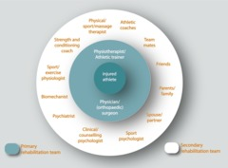
Figure 3 Who supports the injured athlete/exercise participant? (Clement and Arvinen-Barrow, 2013)

- We asked our case study Lois to describe the support she gets from three of the people on her list and this is what she said:

Case study: Lois’s support
Three key people on my list are my physio, my sport psychologist and my boyfriend, Dave. My physio gives the kind of traditional sport injury support in that she treats the physical aspect of my injury, but she also motivates me to get through the rehab sessions which can sometimes be quite painful.
My sport psychologist, Amir, helps with the more emotional side of the injury and he also talks to my physio so that they can support me together which is really useful. Finally, my boyfriend is probably one of my biggest sources of support as he’s with me every day and sees my highs and lows and knows what to say to pick me up when I’m feeling down.
(Lois, sprinter)

Back to - Part

Activity 3 How do multidisciplinary teams work successfully?

Part

Discussion
- The main benefit of Lois having a multidisciplinary support team is that it allows for her injury to be treated in a holistic way considering various aspects that might be contributing to the development and recovery of the injury. This facilitates a biopsychosocial approach which considers more than just the physical aspects of injury.
- The biggest potential challenge is communication. It is important that a multidisciplinary team works effectively together and communicates well. Failure to do this could result in the injured person receiving conflicting messages and cause confusion. Competing demands from the different people involved also need to be managed. For Lois’s support team to work effectively they should have clearly defined roles and boundaries within the team and ensure that channels of communication are open (e.g. regular team meetings).
- Reflecting on your potential role in a multidisciplinary team is really useful in developing a holistic or biopsychosocial approach to sport injury. A key area to think about is your professional boundaries – i.e. what are you and what aren’t you qualified to do? In the next section we will explore this more in relation to sport psychology support.
Back to - Part

Activity 4 Whose role is it to provide sport and exercise psychology support?

Part

Discussion
- Sport and exercise psychology support should be provided by a qualified sport and exercise psychologist. In the UK only those registered with the Health and Care Professions Council (HCPC) are legally allowed to use the title ‘sport and exercise psychologist’. You can check whether a sport and exercise psychologist is registered through the ‘check the register’ section of the HCPC website. That doesn’t mean that other people such as coaches, instructors and sports therapists can’t integrate an awareness of sport and exercise psychology into their practice, however.
Lydia’s dilemma indicates the difficulties that some practitioners face in identifying where the professional boundaries lie with regard to sport and exercise psychology. Lydia has rightly identified that sport and exercise psychology support is an important part of the injured person’s rehabilitation programme and in line with the biopsychosocial approach she is taking a holistic approach to treating Travis. She is, however, not qualified to prescribe psychological strategies to aid his rehabilitation and should avoid doing so. She should refer him to a sport and exercise psychologist to do that.
As a physiotherapist working in sport it would be beneficial for her to develop links with a local sport and exercise psychologist (Heaney et al., 2015). Whilst Lydia is not qualified to deliver sport and exercise psychology support to Travis she can still deliver what Heaney (2006) terms ‘frontline’ psychological support, which could involve social support e.g. listening to Travis talk about how the injury is making him feel.
- Here’s what Lois’s coach Wilma had to say:

Case study: The perspective of Lois’s coach Wilma
When Lois first got injured I could see that she was struggling to cope. She was saying lots of negative things about her future in athletics and I could see that becoming a barrier to her recovery. I saw my role as trying to be positive about the injury and to motivate her. I felt it was really important for her to talk to a sport psychologist, so I encouraged her to do so because I’m not an expert in that area.

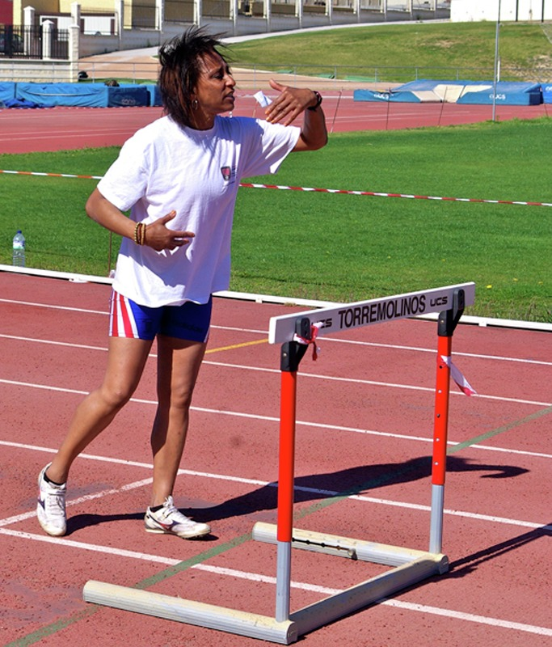
Figure 6 Lois’s coach, Wilma
View description - Figure 6 Lois’s coach, Wilma

I was really pleased that the sport psychologist wanted to talk to me because then we could work together to support her – I was able to reinforce the things he was doing with her and vice versa. I think I learned as much from him as Lois did! I have a really close relationship with Lois as I’ve coached her for seven years and she looks to me for support and guidance, so my job is to listen to her and offer her support and to let her know that I still value her. To keep her motivated I get her to come to the track to do her rehab exercises at the same time that the rest of my group train – that way she still feels part of the group. I also encourage my other athletes to talk to her about how she’s feeling since some of them have been through injuries before so understand what she’s going through.
(Wilma, Lois’s coach)

Wilma’s comments emphasise the important role that coaches and others play in providing social support to the injured person, something you will explore later in the course.
Back to - Part

Activity 1 Applying the Stress and Injury model

Discussion
If you apply the Stress and Injury model to Travis’s case study, you can see that Travis’s new job and being in charge of bidding for a new contract at work is a potentially stressful situation that Travis has cognitively appraised as being stressful. This appraisal has caused attentional changes (Travis was distracted when lifting weights as a result of thinking about the argument and the contract) and physiological changes (muscle tension in his shoulders) that could have led to his injury.
As the model shows, Travis’s cognitive appraisal and stress response has been influenced by personality factors (it seems that Travis is prone to finding it difficult to cope with high pressure situations), history of stressors (e.g. the change in job, argument with his husband) and a perceived lack of coping resources (he doesn’t feel he was coping well with the stress of his new job). The model suggests that interventions (strategies or techniques to help him manage stress) may have reduced his risk of developing an injury. As Travis didn’t use any such interventions the injury was more likely to occur. You will explore interventions to help reduce injury in Session 4.
Back to - Activity 1 Applying the Stress and Injury model

Activity 2 Stress and injury: a sports therapist’s story

Part

Discussion
- Dale mentions that the cause of injury is often multifactorial, which means that they can be caused by a multitude of factors, and psychological factors such as having a lot of stress is one of those factors. Stress can come from inside or outside of sport. As the players he works with are quite young exam stress is one of the main sources of stress experienced outside of sport. Examples of sources of stress within sport that Dale mentions include concerns around selection and exiting the programme (transition into the next phase of their football career).
- Dale discusses seeing examples of all three mechanisms you looked at in Table 1 – distraction, attention narrowing and muscle tension. He also mentions other mechanism such as sleep disturbance which you will look at in the next section.
- Dale discusses three strategies that they put in place to minimise the risk of injury at his club:
  - Routine monitoring of players – they monitor the players’ stress levels at the beginning and end of each session to help identify when a player is under stress and more susceptible to injury.
  - Psychological skills training – the players are taught psychological skills to help them cope with stress. Dale refers to the Football Association’s (FAs) 5 Cs framework which highlights 5 important skills players need to develop – confidence, control, commitment, concentration and communication. You can find out more about this model here. You will look at psychological skills training in more detail in Sessions 4, 7 and 8.
  - Preparing athletes for return to sport – the staff work to ensure that players are mentally ready to return to sport (e.g. confident, low anxiety level) as this can reduce the risk of re-injury.
Back to - Part

Activity 3 Personality characteristics and sport injury

Part

Discussion
- Competitive trait anxiety is where an individual has a tendency to perceive competitive situations (e.g. sport competition) as threatening and respond with stress and anxiety. Unsurprisingly, the research suggests that those with higher levels are at greater risk of injury, but why is that the case? If you are anxious about competition you are likely to have a stronger stress response and increase your risk of injury. Additionally, as outlined in the extract, factors such as poor sleep and nutrition as a result of anxiety may inhibit sport performance and lead to an injury.
- ‘Locus of control’ is the individual’s perception of who or what is responsible for what happens to them (internal or external factors). It is hypothesised that those with a higher internal locus of control (i.e. someone who believes that they, rather than external forces, are responsible for outcomes they experience) were more likely to suffer an injury. However, the evidence for this is limited with only two out of the nine studies Appaneal and Habif (2013) reviewed supporting this.
- People who exhibit negative mood states such as anger appear more likely to develop a sport injury. Perhaps being angry leads to changes in behaviour (e.g. going in for hard tackles) that increase the risk of injury.
Back to - Part

Activity 1 Psychological interventions to reduce the risk of injury

Part

Discussion
As you saw in Session 3, those with greater levels of stress are at higher risk of developing a sport injury. Therefore, it is intuitive to think that stress management strategies aimed at helping the individual to control their stress levels would reduce their risk of injury. Research evidence supports this (Gledhill, Forsdyke and Murray, 2018) as you will examine later in this session. The Stress and Injury model (Williams and Andersen, 1998) (Figure 2 of Session 3) identifies ‘coping resources’ as mediating the stress response. Coping resources can be defined as ‘behaviours and social networks that help the individual deal with the problems, joys, disappointments and stresses of life’ (Andersen and Williams, 1988, p. 302).
Stress management strategies can therefore be thought of as a coping resource. Such strategies can work by either:
- changing the perception of an event (i.e. not perceiving an event as stressful), or
- by buffering the effects of a stressful event (i.e. minimising the symptoms of stress).
You will examine a range of stress management strategies in the next section.
As distraction and attention narrowing are two proposed mechanisms for how stress can lead to an injury you may also have thought that psychological techniques aimed at improving concentration could be beneficial. Concentration training may improve the individual’s focus and prevent them from being distracted and missing important cues.
There is debate around whether personality traits (characteristics) can be changed, but stress management strategies may also help to reduce the characteristics such as anxiety and anger that you looked at in Session 3.
Back to - Part

Activity 2 An injury prevention programme

Part

Discussion
- Progressive muscle relaxation (PMR), breathing techniques and imagery are all examples of techniques that have been used to increase relaxation and reduce stress. The Athletes Connected page will have shown you some practical examples of your chosen technique.
All of these techniques have received research support for use in the prevention of sport injury, but there has been some wider debate about the effectiveness of PMR. This is because a systematic review (Pelka et al., 2016) concluded that PMR was ineffective in enhancing performance. It should be noted, however, that this review was specifically investigating the direct effect of PMR on measures of sports performance (e.g. tennis strokes, reaction time, muscle strength, aerobic performance), while the benefits of PMR in relation to sport injury are likely to be more indirect. For example, PMR has been shown to improve sleep, which could indirectly reduce injury risk (e.g. improved recovery from training, reduced stress/anxiety) (McCloughan et al., 2016). Additionally, as you have just seen, studies such as Olmedilla-Zafra et al. (2017) have found support for PMR in sport injury prevention.
- The study undertaken by Olmedilla-Zafra et al. (2017) shows that the stress management programme was effective in reducing the incidence of sport injury in youth footballers. As you saw in Activity 1 (Session 3) Travis was experiencing a large amount of stress before his injury. It is possible that, had he had access to a stress management programme like this, he may not have become injured. To help prevent future injuries it would be beneficial for him to learn stress management strategies such as those in the study.
Back to - Part

Activity 1 What are common psychological reactions to injury?

Part

Discussion
- Helen describes various psychological responses to sport injury. These include feelings of isolation, fear, anxiety and hopelessness. She also discusses feeling a loss of identity when not being able to play hockey, which links to the concept of athletic identity discussed at the beginning of this section. As a full-time hockey player, Helen might be expected to have a strong athletic identity and to see a large part of her identity as a hockey player.
- Common negative psychological responses to injury include:
  - loss of identity
  - anger
  - fear
  - depression
  - reduced motivation
  - grief
  - loneliness
  - stress
  - anxiety
  - low self-esteem, and
  - confusion.
Back to - Part

Activity 2 Analysing the case study experiences

Part

Discussion
- How someone responds to an injury is likely to be personal and affected by a range of different factors. However, as you have seen, common reactions include anger, frustration, anxiety, low self-confidence, low self-esteem and loneliness, and it seems that Lois and Travis are both experiencing some of these. Additionally, they both seem to have feelings of jealously towards those around them. Travis is also demonstrating a fear of reinjury which is relatively common.
- An individual’s response to being injured may be affected by several factors, such as:
  - the timing of the injury e.g. in relation to the competitive year, the athlete’s career or an important competition. For an example, an injury in the off-season may be perceived to be less of a problem than an injury in the competitive season
  - the individual’s previous experiences. An individual may have experienced a similar injury and recovered quickly
  - the perceived severity of the injury. An individual will be less concerned about an injury if they don’t consider it to be particularly serious
  - the reaction of other people to the injury. The individual’s reaction may be guided by significant others, such as the coach, instructor or physiotherapist
  - athletic identity. An athlete who has a strong athletic identity is more likely to experience negative reactions than someone low in athletic identity.
Back to - Part

Activity 3 Models of psychological response to sport injury

Part

Discussion
- Grief response models assume that injury constitutes a form of loss to the individual and thus the onset of a grieving process. They suggest that an individual will respond to injury in the same way in which people respond to other significant losses, such as the death of a loved one (Brewer, 1994; Evans and Hardy, 1995). This involves progressing through a series of sequential stages. The number of stages varies from model to model, but in Kübler-Ross’s (1969) Grief response model – which has been most commonly applied in the sport injury psychology literature (Walker et al., 2007) – there are five stages.
- In contrast to grief response models, cognitive appraisal models take individual differences into account. They do not assume that everyone will react in the same way to injury. Instead they suggest that how an individual interprets or appraises the injury (cognitive appraisal) will determine their psychological reactions. This allows two people to exhibit entirely different psychological responses to the same injury. Therefore, it is the perception of an injury that affects psychological responses, rather than the injury itself.
- Both cognitive appraisal models suggest that how an individual interprets or appraises their injury is influenced by two key variables – personal and situational variables – and that cognitive appraisal influences emotional and behavioural responses to injury. The main difference between the models is that the Integrated model of psychological response to sport injury (Wiese-Bjornstal et al., 1998) is a more comprehensive model – this model also incorporates psychological factors that increase the risk of injury. The Integrated model has been widely applied within the sport injury psychology literature (Brewer and Redmond, 2017).
Back to - Part

Activity 4 Applying the models

Part

Discussion
As you examine Lois’s case study, you can probably see some evidence of all five stages of Kübler-Ross’s (1969) model, although the stages do not necessarily occur in the specified order (for example, anger seems to come before denial). The main limitation of grief response models is their rigidity: they assume that every person is the same and that consequently all people will react to sport injury in the same stereotypical way. In practice this is not the case – Lois may react in a completely different way to her injury than another athlete with the same injury. Due to these limitations, cognitive appraisal models have come to be more widely accepted as models of psychological reaction to injury than grief response models as they allow for individual differences.
The two cognitive appraisal models demonstrate that Lois’s poor adherence is likely to be a consequence of her individual cognitive appraisal of the injury and her subsequent emotional responses (e.g. frustration, jealousy, boredom). It is important to note that the appraisal of an injury is not static, and neither are its consequences. Appraisals are likely to change as the injury progresses and possible setbacks are experienced. This is demonstrated in Lois’s reactions to her injury which progressively changed over time.
You will find that Wiese-Bjornstal et al.’s (1998) Integrated model is a far more extensive model which considers a wealth of personal and situational factors that can influence cognitive appraisal and consequent recovery outcomes. Unlike the other models you have explored in this session, this model also incorporates (at the top) psychological factors that increase the risk of injury. It is therefore a comprehensive model that incorporates both psychological factors that may increase the risk of injury and psychological reactions to injury.
Back to - Part

Activity 1 Lois’s reaction to injury

Part

Discussion
It appears that Lois’s low mood is negatively impacting on her adherence to her rehabilitation programme which in turn will slow her recovery from the injury. Because Lois is feeling down, she doesn’t have the motivation to work hard on her rehabilitation. As the cognitive appraisal models show, Lois’s cognitive appraisal of the injury is resulting in a negative emotional response and an inappropriate behavioural response (poor adherence). This in turn is having a negative impact on her recovery outcomes (slowed recovery).
Back to - Part

Activity 2 Travis’s responses to injury

Part

Discussion
Travis appears to have the opposite problem to Lois – over adherence. While Lois has lost her motivation, Travis is highly motivated, but to his detriment because he is trying to do too much too soon.
This is very similar to the wrestler Adam Coon in the video who slowed his recovery by working too hard. If you relate this to cognitive appraisal models, you could say that Travis’s cognitive appraisal of his injury (‘it’s not that bad’) is resulting in an inappropriate behavioural response (over adherence). This in turn is having a potentially negative impact on his recovery outcomes (re-injury and slowed recovery).
Back to - Part

Activity 3 Impact of psychological factors: over time

Part

Discussion
Lois appears to have moved from a negative mindset to a more positive one. She was previously feeling quite down (Activity 1). The session with the sport psychologist has boosted her motivation and increased her adherence to her rehabilitation sessions, which will in turn have a positive impact on her rehabilitation outcomes.
Back to - Part

Activity 4 Positive consequences

Discussion
The video starts with Jessica Ennis-Hill stating that she believes injury made her stronger and concludes with her saying that her performance improved as a result of injury. This demonstrates that she experienced sport injury-related growth.
Some of the comments she made in the clip have been integrated into the table below, along with some examples of quotes from Travis and Lois that also fit under the four categories of sport injury-related growth identified by Wadey et al. (2013). You may have come up with several other examples of your own.

Category | Examples
Personal growth | - … it just gave me a bit of time to, you know, step back from the sport and really think about what I’d achieved so far, and also what I wanted to achieve from my career. (Jessica Ennis-Hill)  - I now know that I can overcome injury. (Travis)  - Being unable to train just made me appreciate how important athletics is to me and how much I love it. (Lois)  - The break gave me a chance to develop my identity outside of my sport. (Lois)
Psychological growth | - … coming back this year just made me even more hungry for a medal. (Jessica Ennis-Hill)  - My motivation to train has increased dramatically. (Travis)  - My imagery skills have developed. (Lois)  - I feel mentally stronger than ever before. (Travis)
Social growth | - My relationship with my coach has got even stronger as a result of being injured. (Lois)  - As a consequence of being injured I’ve developed a stronger network of people to support me. (Travis)
Physical growth | - … also gave me time to just take a step back and let my body freshen up and just take a rest … (Jessica Ennis-Hill)  - I feel like my fitness has actually improved through being injured (Travis)  - Being injured has given me the opportunity to really develop my upper body strength (Lois)

Back to - Activity 4 Positive consequences

Activity 1 Using psychological techniques in sport injury

Part

Discussion
- Helen describes three key strategies that she used, all of which are discussed in either this session or in Session 8. First, she used goal setting to help her focus. Second, she visualised herself achieving her goal of becoming Olympic champion (imagery), and finally she used a blog as a way of sharing and articulating her experience and connecting to other people (social support).
- You might find that you tend to use a lot of psychology in your day-to-day practice without even realising it. Sometimes this use of psychology is explicit (for example, recommending the use of psychological techniques or referring someone to a sport and exercise psychologist), and sometimes it is less explicit (for example, the way in which you choose to speak to an individual about their injury).
Back to - Part

Activity 2 Using imagery to help Lois and Travis

Part

Discussion
All four examples of imagery in Figure 3 could be effective for both Lois and Travis. Pain management imagery would be particularly appropriate for Lois, while relaxation imagery would be particularly useful for Travis. Here are their thoughts on using these techniques:

I tried using the pain management imagery Amir suggested during my physiotherapy session today. I used it right at the point where the physio was really digging her fingers into my tendon which is when I normally tense up or flinch. I was amazed how well it worked – I coped with the pain so much better and the physio was able to do more work on it than normal.
(Lois)

I’ve started doing relaxation imagery every evening. At first it felt a bit weird but now I’m getting used to it and it’s really working. When I get in from work, I’m often feeling stressed and need to unwind, so now I lie down and take myself to my relaxing place in my mind and it calms me.
(Travis)

Back to - Part

Activity 3 Self-talk: have a go!

Part

Discussion
- In the video Kally Fayhee describes three main stages:
  - paying attention to her thoughts (self-awareness)
  - slowing down and thinking about what she would say to a friend (rationalising), and
  - reframing her thought into a positive one (identify and reframe).
Back to - Part

Part

Discussion
- It’s a useful exercise to think about when you yourself might be using negative self-talk and to consider the impact those negative thoughts have on you. Being able to counteract negative statements with positive statements is a useful tool. Try using this technique next time you catch yourself saying negative things to yourself. Injury is a time when negative thoughts can be common and therefore this can be a useful strategy to counteract them.
Back to - Part

Activity 4 Relaxation: have a go!

Part

Discussion
It is useful to try a technique in order to fully understand its effectiveness and potential application for those with a sport injury. You may find that some relaxation techniques are more effective for you than others.
As with all techniques, individuals will have a preference for particular relaxation techniques over others. The most appropriate relaxation technique will also depend on the situation. For example, if you only have a very short period of time to relax, a short breathing technique will likely be more appropriate than a full PMR routine. In comparison to the other techniques – which are cognitive in nature – PMR has a physical (or somatic) component which might make it particularly suitable for individuals who are experiencing muscle tension.
Back to - Part

Activity 1 How sports stars cope with injury

Part

Discussion
The video provides more evidence of how difficult it can be for a sports performer to cope with injury and the importance of psychological intervention. The athletes in the video point towards the importance of the two interventions you are going to explore in this session. For example, Kyle Brown (rugby player) talks about the need to set realistic rehabilitation goals, and JP Duminy (cricketer) talks about the role of social support when stating the importance of receiving ‘support of family, friends and team mates’.
Back to - Part

Activity 2 Goal setting in practice

Part

Discussion
- Lois’s goals can be categorised as follows:
  - outcome goal,
  - performance goal,
  - process goal.
- SMARTER is an acronym which reminds us of key goal setting principles (specific, measurable, attainable, relevant, timely, evaluated and rewarded). You may already be familiar with it or the shorter SMART version, or you may be familiar with a slightly different version.
Travis’s goal doesn’t adhere to the SMARTER principles. For example, it is not very specific – what aspect of fitness? The goal would be improved by adding a more specific component of fitness such as strength. You could get even more specific by stating which muscle groups or exercises. To make the goal measurable you could add the target weight or repetitions. The target weight or repetitions would need to be realistic (attainable) and the exercises would need to be relevant to Travis’s rehabilitation.
The goal could also be enhanced by setting a realistic timeframe for its achievement (timely). The goal should be evaluated so that progress can be seen and a reward for achievement may motivate Travis. An adjusted goal might read something like:
Goal: to improve upper body strength on the bench press exercise to 60kg in six weeks.
- Ultimately the key goal for most athletes is a return to sports performance at pre-injury levels. However, for some athletes this ultimate goal can seem too distant. which is why it is important to set both short-term and long-term goals. A long-term goal to return to sport needs to be supported by a series of short-term goals that lead to this ultimate goal. These can be thought of as stepping stones towards the ultimate goal, each of which gives the athlete something to focus on that is tangible. These shorter-term goals can be broken down into smaller and smaller sub-goals.
Back to - Part

Activity 3 Social support in practice

Discussion
Interestingly, both Lois and Travis have identified a mixture of personal and professional relationships. Different people can provide a range of different types of social support, but you might expect a partner (here, Dave or Trevor) to particularly provide emotional, tangible and motivational support. You might have thought that a coach or trainer would particularly provide technical, informational and motivational support. However, with an established coach–athlete relationship such as that between Lois and Wilma, there would likely be emotional support too.
Coaches are considered to be an important source of social support during sport injury (Newman and Weiss, 2018). A sport psychologist would likely predominantly provide emotional, tangible, informational and motivational support. A physiotherapist would be expected to predominantly provide technical, informational and motivational support, but a good physiotherapist would also provide emotional support.
Back to - Activity 3 Social support in practice

Activity 4 Self-reflection

Part

Discussion
Reflecting like this is a useful way to consider how what you have learned in this course can be applied to your everyday life. Hopefully, the course has led you to consider the psychological aspects of injury rather than just the physical aspects of injury.
You may have reflected on how you can integrate more sport psychology into your practice in your professional role (e.g. coach, instructor, sports therapist), or you may have thought about the need to include a sport psychologist into your professional network.
Back to - Part

Figure 1 Sport injuries are fairly common

Description
An image of a woman standing with her side against a dark wall with crutches.
Back to - Figure 1 Sport injuries are fairly common

Figure 2 Lois (sprinter)

Description
A female athlete, Lois, is poised ready to sprint at the starting line of an athletic race track. Her hands are in position against the starting line, she is on her toes and her head is tilted upwards, looking down the track, towards the camera. The sun is shining.
Back to - Figure 2 Lois (sprinter)

Figure 3 Travis (exercise participant)

Description
A man in a white gym vest is doing push ups on a wooden deck. As he presses up, he is looking up towards the camera, smiling. This is Travis who is an exercise participant.
Back to - Figure 3 Travis (exercise participant)

Figure 4 Psychological factors are important both pre- and post-injury.

Description
A photograph of an injured woman sitting on the floor in a gym, clutching her knee in pain. A man standing behind her comforts her.
Back to - Figure 4 Psychological factors are important both pre- and post-injury.

Figure 1 The people around the injured athlete are important

Description
An injured woman sits on a tennis court, her racket by her side, as the other player tends to her ankle.
Back to - Figure 1 The people around the injured athlete are important

Figure 5 Travis’s physiotherapist, Lydia

Description
A woman in a light and airy room perches on a couch covered in towels. She is wearing a light blue top, dark trousers and is studying a tablet held out in front of her. This is Travis’s physiotherapist, Lydia.
Back to - Figure 5 Travis’s physiotherapist, Lydia

Figure 6 Lois’s coach, Wilma

Description
Lois’s coach, Wilma Description: A woman in athletic gear stands on a racetrack in front of a hurdle. She looks as if she is discussing tactics with someone out of shot of the photograph. This is Wilma, Lois’s coach.
Back to - Figure 6 Lois’s coach, Wilma

Figure 3 Personality can influence our risk of injury

Description
A woman wearing boxing gloves works out with a punch bag.
Back to - Figure 3 Personality can influence our risk of injury

Figure 1 Interventions for injury

Description
A photograph of the lower half of a man standing on a racetrack. He has injured his knee, which he is clasping and which is glowing red.
Back to - Figure 1 Interventions for injury

Interactive Figure 2 Psychological interventions to reduce the risk of injury

Description

Imagery  Imagery can be defined as the process of ‘using one’s senses to re-create or create an experience in the mind’ (Vealey and Forlenza, 2015, p. 240). | Goal setting  Goal setting refers to the process of setting goals and a goal can be defined as the object of a person’s effort which involves attaining a specific standard of proficiency in a task (Gould, 2015). | Relaxation techniques  Relaxation techniques are interventions that aim to reduce physiological arousal and anxiety symptoms (Hanton, et al., 2015). | Social support  Social support can be defined as ‘an exchange of resources between two individuals perceived by the provider or the recipient to be intended to enhance the well-being of the recipient’ (Corbillon et al., 2008, p. 94).
Positive self-talk  As its name suggests self-talk refers to the thing people say to themselves (their internal dialogue) and can occur out loud or in your head (Williams et al., 2015). | Cognitive restructuring  Cognitive restructuring refers to the reinterpretation of symptoms from a negative (debilitative) to positive (facilitative) (Hanton et al., 2015). | Biofeedback training  Biofeedback is where people receive information about one or more of their physiological processes (e.g. muscle activity, heart rate, skin activity) to encourage greater self-awareness and control (Brewer and Redmond, 2017). | Stress inoculation training  Stress inoculation training involves using a variety of techniques (imagery, self-talk and relaxation) together to progressively rehearse exposing the individual to increasingly stressful situations whilst practicing relaxation to gradually desensitise or ‘inoculate’ the individual to the stressful situation (Hanton et al., 2015).
Figure 2 Psychological interventions to reduce the risk of injury

Back to - Interactive Figure 2 Psychological interventions to reduce the risk of injury

Figure 3 Amir, sport and exercise psychologist

Description
Amir, a sport and exercise psychologist, stands facing the camera wearing a green tee shirt with arms folded and smiling.
Back to - Figure 3 Amir, sport and exercise psychologist

Figure 1 Danny Rose (footballer)

Description
A photograph of a male footballer on the pitch wearing a white strip. The footballer is looking down at the ball as he dribbles it forward at speed, the crowd in soft focus behind him.
Back to - Figure 1 Danny Rose (footballer)

Figure 2 Responses to sport injury

Description
From the bottom quarter of the picture, a man looks upwards to a blackboard on which is drawn a large think bubble. This large think bubble is connected to the man’s head by small bubbles.
Back to - Figure 2 Responses to sport injury

Figure 2 Psychological factors and rehabilitation outcomes

Description
A group of female football players are gathered around an injured player who is lying on the pitch.
Back to - Figure 2 Psychological factors and rehabilitation outcomes

Figure 1 Psychological intervention can help people cope with sport injury

Description
An image of a cartoon human brain with arms lifting a pair of black dumb-bells.
Back to - Figure 1 Psychological intervention can help people cope with sport injury

Figure 2 Imagery can aid sport injury rehabilitation

Description
A female in everyday clothes is standing with crutches in a dingy room. She is in profile, facing to the right. On the wall behind her is her shadow, which shows her running. The implication is that she is remembering with regret her time before she was injured.
Back to - Figure 2 Imagery can aid sport injury rehabilitation

Interactive Figure 3 Imagery in sport injury rehabilitation

Description

Skill practice imagery  Those who are injured to the extent that they are unable to physically practice their sports skills can mentally practice, in order to minimise losses of skill that naturally occur in the absence of physical practice. There is evidence to suggest that mental practice is better than no practice at all and that mental practice stimulates the muscles involved (Green and Bonura, 2007).  If you would like to see an example (optional), visit: https://www.youtube.com/watch?v=hjCrnwbkx-A | Relaxation imagery  Stress and anxiety are common responses to sport injury, but imagery is an effective way to combat them. Imagery of being in a relaxing place (for example, lying on a beach) can be used as a stress management or anxiety control technique.  To see an example, visit: https://www.youtube.com/watch?v=ar_W4jSzOlM
Pain management imagery  Individuals can be encouraged to undertake imagery to distract them from the pain of treatment. For example, imagery of placing an ice pack on an injured area may help with pain management.  To see an example, visit: https://www.youtube.com/watch?v=BgOKKjgqqMc | Healing imagery  There is some evidence to suggest that imagining injured tissues healing can actually speed up the healing process. An individual might, for example, imagine healing blood cells being delivered to the injured area or tissues re-aligning. This might involve anatomically correct imagery or representative imagery (e.g. imagining an army of soldiers rebuilding your injured tendon).  To see an example, visit: https://www.youtube.com/watch?v=up3VtMUv8hE
Figure 3 Imagery in sport injury rehabilitation

Back to - Interactive Figure 3 Imagery in sport injury rehabilitation

Figure 5 Relaxation can aid sport injury rehabilitation

Description
A photograph of a gentle wave washing up on the sand. On the sand is written the words ‘time to relax’.
Back to - Figure 5 Relaxation can aid sport injury rehabilitation

Interactive Figure 6 Relaxation techniques in sport injury rehabilitation

Description

Progressive muscle relaxation (PMR)  PMR involves tensing and relaxing various muscles in the body in a sequential order. The technique aims to help the athlete recognise the difference between tension and relaxation, thus making relaxation easier. | Relaxation imagery  As you saw previously, imagery of being in a relaxing place (e.g. lying on a beach) can also be effective in producing a relaxation response.
Music  Music has a great capacity to induce a relaxation response and therefore playing music in your treatment room could be beneficial.  If you use music, it is worth discussing music preferences with the individual as what is relaxing for one person may not be for another! There are many commercially available relaxation CDs and music downloads. | Controlled breathing  Our breathing rate is generally increased when we are stressed or anxious. Controlling and slowing down our breathing normally triggers a relaxation response.  Therefore, breathing exercises can help us to relax and control anxiety. There are lots of different breathing exercises including:  - rhythmic breathing (e.g. breathing in for a count of four and breathing out for a count of four) and  - ratio breathing (e.g. breathing in for a count of four and breathing out for a count of eight).

Back to - Interactive Figure 6 Relaxation techniques in sport injury rehabilitation

Figure 1 Goal setting and social support are techniques that can help injured athletes

Description
A cartoon human brain running on a treadmill.
Back to - Figure 1 Goal setting and social support are techniques that can help injured athletes

Interactive Table 1 Different categories of social support (adapted from Arvinen-Barrow and Pack, 2013, pp. 122–3)

Description

Table 1 Different categories of social support (adapted from Arvinen-Barrow and Pack, 2013, pp. 122–3)
Categories of social support | Sub-types | Definition
Emotional | Esteem support | Enacting behaviours that bolster an individual’s self confidence, sense of competence or self-esteem, perhaps through provision of positive feedback or by demonstrating belief in the individual’s ability to cope with injury.
 | Listening | Actively listening to the individual whilst refraining from giving advice or making judgement. This should involve sharing both positive (e.g. joys of rehabilitation success) and negative (e.g. setback frustrations) thoughts and feelings associated with rehabilitation.
 | Emotional support | Providing an individual with impartial assistance during emotionally difficult times and demonstrating acceptance, empathy and encouragement should they experience setbacks, thus facilitating a sense of comfort and security.
 | Emotional challenge | Challenging the individual to do their utmost to overcome obstacles to goal-achievement, and structuring support so as to facilitate motivation toward rehabilitation.
 | Shared social reality | Acting as a ‘reality touchstone’ by verifying an individual’s perception of the current situation and social context, thus potentially providing a sense of ‘normalisation’.
Technical | Technical appreciation | Demonstrating an acknowledgement of an individual’s achievements, or reinforcing effort and intensity during a rehabilitation session.
 | Technical challenge | Encouraging individuals to achieve more, to be excited about their work and progress, and to seek new ways in which they might rehabilitate.
Informational | Personal assistance | Providing advice, guidance and assistance in the form of time, skill, knowledge and expertise targeted directly at problem-solving or feedback relating to rehabilitation.
Tangible | Material assistance | Providing tangible assistance such as the provision of transport to rehabilitation, assistance with general household duties, and financial support thus directly facilitating an individual’s chances of goal achievement.
 | Technical challenge | Encouraging individuals to achieve more, to be excited about their work and progress, and to seek new ways in which they might rehabilitate.
Motivational | Motivational | Encouraging individuals to overcome, or give into, various barriers during the rehabilitation process.

Back to - Interactive Table 1 Different categories of social support (adapted from Arvinen-Barrow and Pack, 2013, pp. 122–3)

Uncaptioned Figure

Description
A female athlete, Lois, is poised ready to sprint at the starting line of an athletic race track. Her hands are in position against the starting line, she is on her toes and her head is tilted upwards, looking down the track, towards the camera. The sun is shining.
Back to - Uncaptioned Figure

Uncaptioned Figure

Description
A man in a white gym vest is doing push ups on a wooden deck. As he presses up, he is looking up towards the camera, smiling. This is Travis who is an exercise participant.
Back to - Uncaptioned Figure

Figure 4 You can play an important role in supporting an injured athlete

Description
Two female footballers sit on a long wooden bench. One footballer has her arm around the other as if to comfort her. Behind them is a large glass windowed building and a grey sky. The football sits on the bench beside them.
Back to - Figure 4 You can play an important role in supporting an injured athlete

Video 1

Transcript
Dr. Jordan Metzl
So, there are two kinds of injuries in sports medicine the acute traumatic injuries that's when somebody runs and trips and falls on their hand or their head those injuries sometimes just happen in competition the much more common injury is called an overuse injury that happens when something starts to hurt over time a great example is like shin splints if you're getting pain if it's changing the way you move if it changes your mechanic of how you land how you run how you walk you have to get that checked out before it becomes much more problematic.
Dr. David Wang
The big factor is usually training you know once they once you've gotten to the Olympics you put in the time and you know you're there for a few weeks and you know they're we tend to see more acute injuries the overuse injuries usually develop kind of right around now as you're building up and finishing your preparations because really it's the amount of activity that you do that leads to the overuse injuries and really it's the training where you see the most load through the body they're working out in the gym every day playing practicing every day
Dr. Brett Toresdahl
Overuse injuries is a broad category which can affect joints tendons muscles it's something that is essentially volume related so how much an activity somebody is doing how often how intense and it's often directly related to how much rest they also have so making sure that there's ample time for athlete's to rest and recover can avoid those injuries.
Dr. Jordan Metzl
Common overuse injuries are things like Achilles tendonitis. The Achilles tendon gets sore and it starts to get inflamed over time shin splints which can turn into a stress fracture and the shin or in the hip and runners in the Entertainer to the cartilage underneath the kneecap we treat those injuries by figuring out first of all what the injury is so we'll do things like get an x-ray and sometimes get an MRI and then figure out why the injury is happening is it because their muscles are too tight or because their feet are pronating a rolling in or because there's running stride is too long we try and fix the reason why it's happening once we figured out the cause.
Back to - Video 1

Video 2

Transcript
TONY:
Bar Kelly Sotherton, really, everybody's here, but I think Jess can hold her own amongst those people.
[BANG]
[CHEERING]
NARRATOR:
In the 100-metre hurdle, she gets off to a good start, finishing second overall.
ANNOUNCER:
--Jessica Ennis.
NARRATOR:
In her weakest event, the shot put, she has a chance to see if her training has been working. If she manages to throw more than 13 metres, it would mean that an Olympic medal could become a reality.
Tony:
Well, that went well. Three throws beyond her personal best.
JESS ENNIS
I knew that I could throw the 13, but I didn't think I'd throw 13.50, so ah! I'm happy.
NARRATOR:
It's a fantastic result for Jess and keeps her near the top of the leaderboard. The high jump is one of Jess's strongest events and where she expects to pick up a lot of points.
[CLAPPING]
[SIGHING]
TONY:
Let's stay up. And let's run it, come on.
[APPLAUSE]
NARRATOR:
But it's not going to plan. Jess is feeling some pain in her ankle. To try and help her continue, the physios treat her ankle straight away, while the competition carries on.
JESS ENNIS:
I just didn't have the spring and the take-off, like I normally do in the high jump. Every time I put my foot down, it was just sore.
[CLAPPING]
JESS ENNIS:
I tried to run again. It just-- it was so sore.
TONY:
Jess, Jess, Jess, Jess, leave it. Leave it. Leave it. Leave it. Leave it. Step back from it.
JESS ENNIS:
I stopped and went off and got some more treatment.
TONY:
She'll be fine, she'll be fine. She'll be fine.
NARRATOR:
The final event of the day is the 200 metres, which would put her painful ankle under a lot of pressure.
[MUSIC PLAYING]
[BANG]
JESS ENNIS:
I couldn't really feel the pain, but it just didn't feel like my natural running pattern. It felt like-- coming up the homestretch, it felt like I was going backwards. I crossed the line, and I just-- literally, I couldn't walk properly on it. I was thinking, this is really bad.
[APPLAUSE]
PHYSIO:
So just walk slowly and as natural as you can.
NARRATOR:
It's clear to Jess she won't be able to finish the competition.
TONY:
If we go in there, we'll do it in the changing rooms. Can we do it in the changing rooms?
NARRATOR:
Tony calls an emergency press conference. Until they know exactly what's wrong, he wants to play down his concerns.
TONY:
The reason for withdrawal is there is a little bit of joint, ankle-- a bit of soreness, really. And I think with only 75 days left until the Olympics, we've probably seen enough, in terms of her competition ability. And I think the common sense thing is to back off.
REPORTER
You have no fear? Just fine? And you have no fears? Jessica won't be in--
TONY:
No.
REPORTER:
--Beijing
Tony:
No. Sorry, your question was, I've no fear that she'll be in Beijing?
REPORTER:
[INAUDIBLE]
TONY:
No, none whatsoever. None whatsoever
[MUSIC PLAYING]
JESS ENNIS:
I just felt like this, and I was crying. It was just-- it was awful. I didn't know what was going on. I just wanted to get the scan and find out what was happening.
TRAINER:
Nobody's coming. They're not coming. Can you feel it?
PHYSIO:
You don't put any of the weight on the minimally. You're just using--
NARRATOR:
With 10 weeks until the Olympics, learning to use crutches was not the kind of training Jess was hoping for.
JESS ENNIS:
I was just really overwhelmed with the whole situation and the fact that I was going to have to pull out. I trained so hard through the winter. I just felt like, oh, I've done all this work for nothing.
[MUSIC PLAYING]
JESS ENNIS:
I probably expected them to say something like I bruised a bone because there's a lot of bones in your ankle and foot, and it wasn't that bad.
NARRATOR:
Anything more serious would mean that she'd lose too much training time, leaving her way behind the rest of the field.
[SCANNER WHIRRING]
NARRATOR:
Jess has been dreaming of competing at the Olympics since she was 12. For the last year and a half, she's been training six days a week, knowing that she had a chance of getting to the Olympic podium.
[KNOCKING]
[DOOR CREAKS OPEN]
DOCTOR:
I think we're going to do this one.
CAMERAMAN:
Do you want me to leave?
DOCTOR:
Yeah.
CAMERAMAN:
OK. OK.
JESS ENNIS:
Thanks.
NARRATOR:
The scans have revealed Jess's worst nightmare.
JESS ENNIS:
There and then, I was told that I've got three stress fractures and that you won't be going to the games. I couldn't believe it. I just felt really numb. So I was just-- I didn't know what to say. I just cried. It was horrible.
Any other time, it would have been disappointing in Britain. But because it's the Olympics, so close to the Olympics, it just intensifies everything and makes it 10 times worse.
[MUSIC PLAYING]
Back to - Video 2

Video 1

Transcript
CAROLINE HEANEY:
Sport injury can have a massive impact. And, of course, it would be better if injuries didn't happen at all. So that's what we turn our attention to now in this next part of the course, injury prevention. Over the next two sessions, you'll be looking at how psychological factors can increase the risk of sports injury and how psychological strategies can be put in place to help minimise injury. We often find that injuries occur at times when people are experiencing a lot of stress in their lives. And the links between stress and sport injury is something that you're going to be looking at a lot as you progress through this course.
Back to - Video 1

Video 2

Transcript
LESLEY PODLOG
So looking at the model, the first thing that Williams and Andersen suggests occurs is that the athlete enters into a potentially stressful athletic situation. So this can be an important competition. It could be a demanding training session. It could be a physical test of strength or endurance. But the key is that the situation is only potentially stressful. Why?
One of the things that George mentioned at the end of his talk is this idea of perception. The key to the model is how athletes appraise or interpret the meaning of the situations that they enter into. So as individuals, when we enter into a competition or really any situation, one of the things that we do is we make an assessment of the demands of the situation. So the athlete assesses what's being required of me in this particular situation.
They also make an assessment of what are their abilities, their resources, or capabilities for meeting the demands of the situation. If they believe that they have the capabilities to meet the demands, they're likely to interpret this situation as a challenge, one that they can successfully meet and do well at.
On the other hand, if they perceive the situation, if they believe that the demands are greater than their ability to meet those demands, they're more likely to appraise the situation as threatening. In this case, it's suggested that athletes experience what Williams and Andersen call the stress response.
The stress response is characterised by two key features. There is an attentional component, and there's a physical component. From an attentional standpoint, it's suggested that a couple things happen to athletes under stress conditions.
First of all, the athlete has a greater inability to detect cues in the peripheral environment. So they become less sensitive to cues in the periphery, and they experience what we call tunnel vision or a narrowing of the peripheral vision. So for instance-- the football player who's really stressed might only be able to see straight ahead, and they fail to see that defender who's coming in for the slide tackle. And under these conditions, the athlete is more susceptible to getting hurt.
From an attentional standpoint, there are other consequences from stress. Another consequence is that individuals tend to become distracted. So they have task-irrelevant types of thoughts.
So maybe the athlete is thinking oh, why did I miss that last pass? Or my coach is not particularly impressed with how I'm performing right now. In other words, they're not absorbed in the task at hand. So under these conditions when the athlete is not fully immersed in the process of what they're doing, when they're distracted, they're also more susceptible to getting hurt.
From a physical standpoint, it's also been suggested that there are also a number of changes that occur during stress. So for instance, heart rate may increase. Timing and coordination may be impaired. And one of the factors that George mentioned-- fatigue may also be related to or is suggested to be related to increased likelihood of injury.
So there's a few other factors that I just want to briefly mention in the model before highlighting the empirical work that's tested it. It's also contended that three categories of factors-- one's personality so the traits that make up the individual or how they typically respond from one situation to the next.
Their history of stress, and the here, there's two main categories. One are major negative life events so significant changes in the person's life, things like moving to a new country, or getting a new job, or relationship issues. But also more chronic daily hassles or even uplifting events can be challenging for an individual to deal with.
So these history of stresses combined with how athletes cope, how they manage situations, how they deal with stress and challenges, along with their personality all come to bear on how they appraise discrete situations. So again, these factors are suggested to either increase or decrease the likelihood that athletes interpret the situation as threatening, and the subsequent stress response and injury likelihood.
Just finally, in the model, it's also suggested that psychological skill interventions-- things like the ability to try and breathe, or regulate one's heart rate, or somatic tension; giving athletes skills to help them think about how they talk to themselves, or how they interpret situations. Mindfulness techniques that help the athlete to be more attentive in the moment and absorbed in what they're doing can mitigate or reduce the stress response and the subsequent likelihood of injury.
Back to - Video 2

Video 3

Transcript
DALE FORSDYKE
Sports therapist is an important part of the multidisciplinary sports medicine and performance team. They have particular skill sets in terms of injury prevention, the assessment and treatment of sports injuries, and then finally, culminate in with the reconditioning and exercise prescription to ensure that athletes return to sport in a safe, informed, and timely manner.
I think the first thing to mention is that the cause of injury is multifactorial. And there are many internal and external factors that interlink to cause someone to get injured. Psychological factors are just one type of internal risk factor. And certainly, stress and the stress that an athlete is exposed to is one of those factors. Now that stress can come from the sport itself, such as the relationship with the coach, the pressure on fixtures, the pressure on selection, or it can be just as importantly, they're away from sports stress as well.
So for the athletes I work with times of high stress include exams, exit in the programme, selection for international tournament's as well. There are also other psychological factors that might make an athlete more predisposed or have a heightened stress response, such as their personality. Certain personality traits may have higher stress response compared with others, perfectionism, for example, and also coping skills.
So if an athlete is relatively young, such as the athletes I work with, that won't necessarily have the right amount of coping skills or the sufficient coping skills to be able to deal with those stressors, both sport related and non-sport related stressors. We do see spikes in our injury rates during times of high levels of stress. So if I explore some of the reasons why that might be the case, so we've got players who may train or compete, and they may become distracted. So they can't concentrate. They make poor decisions. They're technical, so their skill execution is worse. They may have a narrowed attentional focus, so they miss external cues.
We've also got the increase in muscle tension itself, which really impacts upon the athlete's movement quality so the coordination, the fluidity of the movement itself, the loss of range of motion can all kind of come together to make them more susceptible to injury. And we can add into that in terms of their overall recovery rate. We know that stress will impair their sleep quality and sleep quantity, which is a period where the athletes are going to be recovering the most. And it may also impair their tissue repair as well and tissue adaptations.
Something we haven't really necessarily talked about is illness, which is another leading form of time loss in sport. And we know that stress can suppress immune system, which might make them more susceptible to illness, which again, from managing in a sport's team is difficult because, again, it means your athletes are less available than you want them to be.
We address psychosocial factors in three main ways. Number one is the routine monitoring of players. So on arrival, we look at their wellness to see how they've recovered and their preparedness to train that day with sleep and stress forming one of those questions. And then after training, we want to look at the cognitive load that the players had. So they score out of 10 how cognitively challenging that is, so we get an idea of their accumulated psychological stress.
The second way relates to using the FA's 5C framework to give them some greater psychological skills training and, ultimately, more coping skills to deal with areas or occasions of high levels of stress. The third way is using our return to sport criteria. So we want to return players to sport where they are confident with low levels of anxiety, which ultimately might mean that they're at less risk of re-injury
So one example of a player I've worked with that comes to light is an international player who's having a major kind of stressful occurrence in her life at the moment. She's exiting our programme into senior women's football. So she's getting scouted. She's going for trials. There's that big question mark and uncertainty. She's at school. She's got her mock exams. She's got her GCSE exams. And the third is because she's an international level player obviously getting selected for the next international camp or major international tournament is of big concern to her.
Now of recent, she's had a number of injuries, non-contact injuries. And what we've done with that is we've sat down with her, and we've just done some goal setting to start figuring out, well, what are the major causes of her stress. We've put things in timelines. She's been given some breathing techniques to do. And she's also been given some imagery for when she goes to these trials in order to reduce that stress.
Back to - Video 3

Video 1

Transcript
CAROLINE HEANEY
I know from firsthand experience and from working with injured athletes that having a sport injury can have a huge psychological impact. Having already looked at the psychological factors that can increase the risk of sports injury, you're now focused on psychological responses to sport injury. On this journey, you'll hear all about athlete's experiences and the psychological strategies they use to help them cope with sport injury and to learn and grow from the experience.
Back to - Video 1

Video 2

Transcript
HELEN RICHARDSON-WALSH
As a full-time hockey player, I've experienced, unfortunately many injuries-- lots of little niggles, a few muscle tears. But I've also, unfortunately, experienced some quite big injuries that kept me out of the game for some time. When I was around 21, 22, I had an ankle injury which needed three operations, and I was out the game for two years.
More recently, I had double back surgery within the space of a year. That was hard to take. I missed a World Cup, which was very difficult. And it took a lot of hard work and some mental resilience to get me back to the sport that I love.
When I experienced those injuries, I had, obviously, the physical effects but also had to deal with the psychological effects. And there were many. Trust me. I found one of the things I did straight away was kind of isolate myself from the group, which I found really weird because I was someone who was very sociable. And I suddenly found I didn't want to be around the people that were doing what I wanted to do. I guess I was a little bit jealous of that and so took myself away.
I had a fair bit of embarrassment because I didn't get selected for a tournament, and I'd always been selected for a tournament. And there was kind of fear and anxiety that I couldn't get back to the sport that I played and had a dream of becoming an Olympic champion. That was a massive goal for me, and this injury was getting in my way.
Kind of encompassing that was a loss of identity as well. I really saw myself as a hockey player. And when I was injured, I struggled to mentally get around that, because was I a hockey player anymore because I couldn't actually physically play it? Plus the whole thing of not being able to do the thing that all my friends are doing because that's my social group. So there were so many mental aspects that I had to deal with when I was injured.
There was always a kind of progression with how I went through to get back on the pitch. Initially, when I was told that I was-- had the pain and told that I had to have surgery-- it was actually quite a fearful time. Surgery on your back, in particular with me, is quite scary. And so I was scared. It's not a nice thing to have to go through. But once I had the surgery and the surgeon comes in and says everything's fine, it was all about setting a plan. And that really helped me. I love plans, and once I was on that I kind of got the confidence to be able to go forward.
But unfortunately, the plan never works out. Always something comes up. And I always tell people now when they're going through injuries expect stuff to go wrong. And having that expectation is actually quite helpful, because I got to the point where because it's not going right, you kind of feel hopeless. You're thinking is this going to work out? You go through those different transitions, but once I was getting closer to the pitch that obviously helps.
But when you get back onto the pitch, then you're not as good as you were. And that's something really difficult to deal with. You're not as fit. Your skills aren't quite as good. And so you go through another difficult time. And then it's about setting your own expectations about how long things are going to take and how quickly you can get back to where you were.
Back to - Video 2

Video 3

Transcript
CAROLINE HEANEY
In this video, we're going to explore some of the models have been used to explain psychological responses to sport injury. The first group of models we're going to look at are grief response models, which is sometimes called stage models. Grief response models assume that an athlete will react to an injury in a similar way to which an individual might respond to a significant loss, such as the death of a loved one. This suggests the injury constitutes a form of loss to the individual.
Kubler-Ross's 1969 grief response model, which was originally developed to explain responses to terminal illness, has been commonly used in early psychology of sport injury research. The model is comprised of five stages, denial, anger, depression, bargaining, and acceptance. She suggested that following injury all athletes regress through each of the five stages in order.
Whilst these models are intuitively appealing, they do have limitations. The main limitation is their rigidity. They assume that every athlete is the same and that consequently all athletes respond to injury in the same stereotypical way. In practise, this is simply not the case. Different people respond to injury in different ways. For example, one person may be totally devastated by an injury whilst another person with the same injury who has been underperforming may see the injury as an escape from or an excuse from that poor performance. Such an athlete is unlikely to demonstrate, for example, a period of depression. Because they may actually be quite happy about being injured.
Due to these limitations, cognitive appraisal models have come to be more widely accepted as models of psychological response to sport injury. In contrast to grief response models, cognitive appraisal models take individual differences into account. They do not assume that all athletes respond in the same way to injury. Instead, they suggest how an individual appraises the injury will dictate their psychological responses. It is therefore the perception of an injury that affects psychological responses rather than the injury itself.
Brewer's 1994 cognitive appraisal model shown on screen now suggests how an individual appraises their injury, their cognitive appraisal, is influenced by two variables, personal factors and situational factors. Personal factors include things such as personality, age, and previous experiences of injury. Situational factors include things like the stage of the competitive year and social influences, such as the coach or teammates' reaction to an injury.
The model suggests how an individual appraises their injury, their cognitive appraisal, dictates that psychological or emotional response to the injury. The model further proposes that these emotional responses will affect the individual's behaviour in relation to the injury, for example whether or not they will adhere to their injury rehabilitation programme.
Brewer's model is a fairly simplistic cognitive appraisal model. In contrast, the integrated model of psychological response to sports injury is a more comprehensive model that has been widely adopted in sport injury psychology research. The model was developed specifically for sport injury. And unlike, the other models it incorporates psychological factors that can increase the risk of injury as well as psychological responses to injury.
Like Brewer's model, the integrated model suggests that cognitive appraisal is dictated by personal and situational factors and provides a wealth of examples of each. This cognitive appraisal then impacts on the athlete's emotional and behavioural responses and recovery outcomes.
So how are these models relevant to people involved in sporting injuries or [? exercise participants? ?] They are useful in helping us to understand how and why individuals might respond in a particular way following sports injury, which might help us to identify appropriate interventions to prevent or minimise psychological difficulties. Additionally, we can look at the models and identify factors within our control that can have a positive influence on injured person's recovery such as social support.
I hope you have found this video useful. Thanks for watching.
Back to - Video 3

Video 1

Transcript
[MUSIC PLAYING]
ADAM COON
Wrestling has been a huge part of my life since I was four years old, rarely taking a break. When I was told that I would need surgery to repair my shoulder and it would be a long recovery, I was upset and very nervous.
Since starting college, I have been having shoulder issues. In the past, I would rehab it with the help of my athletic trainer until the pain would subside. This became a cycle. As the cycle continued, I thought I had a new normal-- rehab, get better, rehab, get better, until the rehab wasn't working.
In 2016, I had a great opportunity to make the Olympic team. I fell just short by placing second. I was, however, afforded the opportunity to go as a workout partner. I jumped right back into training with the goal being the best workout partner that I could be.
My shoulder, however, started acting up. I got an MRI. I found out that I had torn my labrum and would need surgery. Not only was I out for the Olympics, but I would also have to redshirt this whole next year.
I sat at home in pain, watching the Olympics on the TV. I was constantly reminded that I couldn't wrestle or workout with the team. Being on the side was difficult, feeling like I couldn't help my teammates, or that I was falling behind in the sport that had been a part of my life for as long as I could remember. I just wanted to get back on the mat, wrestling, doing what I loved.
Being told to take it slow added to the frustration. When I was allowed to run, I sprinted. When I was allowed to lift, I lowered the bars. When I was allowed to drill, I went as hard as possible. Rather than taking it slow and letting my body heal, I rushed into everything and ended up having to take unnecessary days off due to my impatience.
Taking it easy made me feel like I was taking the easy way out. It took me a while to accept that I was injured and that I was not currently able to do the things that I could before. Once I could accept the process, it got easier.
I am now one year past my surgery, and I feel great. Once I took the process slow and listened to my body, understanding what it could and couldn't handle, things got easier. I learned I only need to worry about myself and not compare myself to others. Watching your teammates, seeing changes, it's hard not to question or compare to how they are doing. Learning to focus on myself, my recovery, and my career helped me embrace the temporary lifestyle of my injury and allowed me to become more rejuvenated and energised. My excitement is back fully, and I cannot wait to get back in the competition.
KATLYN HAYCOCK
You're not just an athlete.
MIKE FAVRE
Asking for help is a sign of strength.
WARDE MANUEL
You perform best when you're physically and mentally healthy.
Back to - Video 1

Uncaptioned interactive content

Transcript
JESS ENNIS
I think it definitely made me stronger. I think that it just gave me a bit of time to step back from the sport and really think about what I'd achieved so far and also what I wanted to achieve from my career. So it just gave me time to think about that and also gave me time to just take a step back and let my body freshen up and just take a rest.
So I think that really helped just to open my perspective, really, and thinking about this year just made me even more hungry for a medal and to achieve a championship. So I think without having an injury like that, I think I would have probably done well this year, but I don't know if I would have done this well, to be honest. So I think it helped me a lot.
Back to - Uncaptioned interactive content

Video 1 Helen Richardson-Walsh

Transcript
Helen
I almost think that experiencing an injury can actually make you stronger mentally. Because when I went through my first injury, I actually learned quite a lot about myself as a person and as a hockey player.
Before my injury, I probably wasn't the best trainer. But through my injury, because you can't skip anything, you have to do your exercises, you have to do A, B, and C that your physio tells you, it makes you really focused and able to set goals. I found goal-setting really helpful. And it helped me, not only through my injury, but also later on, throughout my whole career.
So I definitely became a stronger athlete and hockey player from being injured. And that was certainly from a mental aspect as well.
I would always visualise myself on top of that Olympic podium. When you're going through really hard training sessions and really boring, dull training sessions-- because rehab is just the dullest training ever-- it really helped me to have that very strong focus on why I was doing what I was doing.
Another thing I used for my back surgery was I wrote a blog. Because of my past injuries, I knew that I was going to isolate myself. I knew that's what I did as a person. And so I decided to write a blog to make myself speak to people. I put it online. And the amount of support I got from people that I didn't know. The hockey family was incredible.
But also another thing that I was hoping I would get from it was the support of my teammates. Which I knew they would anyway, but for them to support you, I knew I needed to give something. And with me opening up and talking about what I was going through in quite a candid fashion, it helped that dialogue between the two parties, and it really helped me in my recovery.
My advice to anybody who is injured and going through an injury would be to be kind to yourself. You will experience emotions that you possibly have never experienced before, and you don't want to experience. And you may feel, as a person, that you're changing or it's not who you are. But just be kind to yourself, because that's the injury talking in a way.
I think it's so easy to say, be positive, and it will be OK. But you're going through a difficult time. And that's important to accept. It's a difficult time. It will be tough. And there will be challenges along the way. I don't think it will be a smooth ride. But if you accept that and almost expect that in a way, then I think when those challenges come, it's a lot easier to deal with.
I think when you're in the injury, it's sometimes really difficult to think, I know this could be a positive outcome. But once you do get through it and you do get back into the sport that you love, then it really can have a positive effect. And you can come out much stronger, physically and mentally, and knowing yourself a lot better as well.
Back to - Video 1 Helen Richardson-Walsh

Video 2

Transcript
[MUSIC PLAYING]
KALLY FAYHEE
I frequently felt overwhelmed with all of the thoughts racing through my head, and I didn't know how to sort through them. As a starting point, my counsellor asked me to simply pay attention to my thoughts. I have to be honest, at first it seemed a bit silly. But when I truly looked at all of the thoughts racing through my head, I realised most were negative, but not based on fact. These self-defeating thoughts were triggered by external pressures, usually occurring after a practise, during a test, or before a race.
Once I had identified when these thoughts occurred, I was able to start anticipating and then managing them. One thing that was helpful was to slow down and think about what I would say to a friend in each situation. If my friend were having these thoughts, what would I say to her? How would I view her? Would I be as hard on her as I was on myself?
[MUSIC PLAYING]
Identifying and reframing negative thoughts by putting myself in a friend's shoes gave me permission to not be so hard on myself. It allowed me to step out of the current of self-defeating thoughts. The longer you try, the easier it becomes to give yourself the permission to have positive, encouraging thoughts.
[MUSIC PLAYING]
Back to - Video 2

Video 1

Transcript
ALICIA PILLAY:
Injuries in sport are all part of the game. We take a closer look at how recovering from an injury is more than just getting back your fitness.
CLINTON GAHWILER:
Becoming injured when sport plays a huge role in your life, for example, in the case of a professional athlete or sportsman or woman, can be very traumatic, often because their entire identity has gotten caught up in me, the rugby player, the cricket player, the athlete, whatever it might be.
JP DUMINY:
It's pretty tough at times to recover from the trauma of the injury, first of all, I think not understanding or knowing how long you have or for how long you're out of the game for.
KYLE BROWN:
It's always tough knowing that you've got six months ahead of you not playing anything. You're not being part of anything that happens on the pitch. And that's going to determine how much involvement you can have with the team. And if you're going to be upset and you're going to be depressed the whole time, you're probably not going to be wanted too much on the team. So one of the biggest fights is to be positive, have a good outlook.
CLINTON GAHWILER:
I think the one thing that's really important for any professional or serious athlete is just to keep some perspective. And part of what that means is to recognise that over the length of an entire successful career, it's highly unlikely that one isn't ever going to be injured or sick or whatever. But almost one's response to how one deals with the setbacks is almost more important than the actual setback itself.
KYLE BROWN:
For me, the biggest thing for me was just to be realistic. The doctors told me six months. And that's minimum. I'm not going to be running in three weeks after I get the cast off or anything like that. You have to be realistic. And you've got to set these small goals and try to attain those. And if it doesn't happen, slight disappointment and move on. So it has been quite a mental battle. But it's been really good, really challenging. And hopefully I think I've grown a bit.
JP DUMINY:
I think I've been pretty blessed in having people around me in the physios and the trainers. And obviously the support of your family and friends and teammates, I think that has been the crucial part. Spending a Christmas at home is not quite the thing that happens for a cricketer. So I've enjoyed those sort of occasions. And just the whole processes has been good from a mental point of view and focusing on things that you wouldn't have if you're on tour and with the team and so on.
ALICIA PILLAY:
Working closely with physios, trainers, and psychologists who specialise in sport is key to the recovery process, not forgetting a good support structure from friends, family, and teammates will also help in the recovery process.
SPEAKER 6:
Eye Witnesses News, in touch, in tune, and independent. For the latest, log onto ewn.co.za, or ewn.mobi.
Back to - Video 1

Video 3

Transcript
[MUSIC PLAYING]
ARIELLE SANDERS
When I started at the University of Michigan, I had no idea I would have the opportunity to walk onto the rowing team. I immediately fell in love with the sport and the team. Every aspect of my life revolved around the team, and I didn't want it any other way.
During the fall of my junior year, everything changed. I became injured and had to medically redshirt for the rest of the season. I was devastated. What was I supposed to do without rowing? Being away from my teammates, unable to practise or compete, made me sick to my stomach. Negative thoughts ran through my mind.
I spent most of that year crying, feeling sorry for myself. I went from everything in my day to day revolving around rowing and my teammates to isolating myself to numb the pain. I felt like a failure. I was scared and embarrassed to ask for help.
This same year, Athletes Connected was created. I started attending Athletes Connected meetings. These meetings helped me realise that I shouldn't suffer in silence. I began to open up to my coaches and close friends. Learning how to communicate my feelings during these meetings was important for my mental health while being injured. With the injury rehabbed, I came back in the fall of the next year ecstatic to be back training with my favourite team.
Within the first week of practise, I was injured again. I was devastated. Through that year, I worked with my athletic trainer, and I was able to come back at the end of the season. But I did not contribute in the way I wanted. Fast forward to the beginning of my fifth year, I was still suffering from lingering injuries. My coaches and I decided that it was time to medically retire.
I had recently been elected as one of the captains by my teammates, and I felt that by seeking medical retirement, I was giving up and letting my team down. But in reality, it was the opposite. I was met with unwavering support. My coach asked me if I wanted to still be captain and take on a new role as a student coach. It took me a long time to accept that my rowing career was over. But I had a new place to put my passion for the team and rowing.
Athletes Connected and our athletic counsellors helped me realise that my sport does not define me. Even though I was not contributing to the team physically, I could still contribute by being a great leader and a great teammate. Although my journey was a roller coaster of ups and downs and different than I could have ever imagined, I am forever grateful for the experience. Michigan and Michigan rowing has changed my life for the better.
STEVE CONNELLY
We are one community.
CAROLINE MANDEL
You perform best when you're physically and mentally healthy.
JEVON MOORE
Asking for help is a sign of strength.
Back to - Video 3

Video 4

Transcript
DR. NORAH SIMPSON:
There is a critical need to be able to provide additional support services to injured athletes research evidence suggests that injured athletes experience higher levels of distress and may have difficulty coping following an injury, but we don't really know the best way to help these athletes during their recovery. So our clinical services and our funding that was provided by the NCAA has allowed us to study a new pilot clinical service we've developed at Stanford and to really look to see how effective is the programme and how we're being able to meet student needs.
The clinical service we developed is an injured athlete recovery support group, and it is run by my collaborator on this grant Dr. Lisa Post. And each group meets eight weeks in a row. Each meeting has a particular topic that we focus on for the first part of the group.
It may be increasing effective communication, reducing stress, increasing social support, and so there is some education and some skills that we teach the athletes. And then the second half of the group is a facilitated discussion where the athletes can bring in things that they've been dealing with on that particular week, and there is both a group support component and also we like to draw in some of the skills that we're teaching the students.
Some athletes are newly injured and are really grappling with the beginning part of the recovery process and some athletes are farther along in the process and may be thinking more about what it means to potentially be medically retiring from the sport. There is a collective identity of struggling with injury as a collegiate athlete, but there are a range of points in that process where injured athletes may, may benefit from this type of service.
I think the thing that I'm most proud of is some of the responses that we've had from students after participating in the group. We've had comments like this is the first place on campus that I've really felt that somebody's understood my injury and the impact that it's had on me. And that really speaks to me regarding the impact of that group and us being able to be able to help these student athletes in their recovery process.Our goal in the long term is to have this be a permanent service that's available to Stanford athletes. And as we formalise the programme, we'll be able to make this support programme perhaps be something that's available to other campuses who may be interested in sharing in this resource as well.
Back to - Video 4

