

JAMOVI_1

Getting started with Jamovi

About this free course
This version of the content may include video, images and interactive content that may not be optimised for your device.
You can experience this free course as it was originally designed on OpenLearn, the home of free learning from The Open University – https://www.open.edu/openlearn/health-sports-psychology/getting-started-jamovi/content-section-0
There you’ll also be able to track your progress via your activity record, which you can use to demonstrate your learning.
First published 2026.
Unless otherwise stated, copyright © 2026 The Open University, all rights reserved.
Intellectual property
Unless otherwise stated, this resource is released under the terms of the Creative Commons Licence v4.0 http://creativecommons.org/licenses/by-nc-sa/4.0/deed.en. Within that The Open University interprets this licence in the following way: www.open.edu/openlearn/about-openlearn/frequently-asked-questions-on-openlearn. Copyright and rights falling outside the terms of the Creative Commons Licence are retained or controlled by The Open University. Please read the full text before using any of the content.
We believe the primary barrier to accessing high-quality educational experiences is cost, which is why we aim to publish as much free content as possible under an open licence. If it proves difficult to release content under our preferred Creative Commons licence (e.g. because we can’t afford or gain the clearances or find suitable alternatives), we will still release the materials for free under a personal end-user licence.
This is because the learning experience will always be the same high quality offering and that should always be seen as positive – even if at times the licensing is different to Creative Commons.
When using the content you must attribute us (The Open University) (the OU) and any identified author in accordance with the terms of the Creative Commons Licence.
The Acknowledgements section is used to list, amongst other things, third party (Proprietary), licensed content which is not subject to Creative Commons licensing. Proprietary content must be used (retained) intact and in context to the content at all times.
The Acknowledgements section is also used to bring to your attention any other Special Restrictions which may apply to the content. For example there may be times when the Creative Commons Non-Commercial Sharealike licence does not apply to any of the content even if owned by us (The Open University). In these instances, unless stated otherwise, the content may be used for personal and non-commercial use.
We have also identified as Proprietary other material included in the content which is not subject to Creative Commons Licence. These are OU logos, trading names and may extend to certain photographic and video images and sound recordings and any other material as may be brought to your attention.
Unauthorised use of any of the content may constitute a breach of the terms and conditions and/or intellectual property laws.
We reserve the right to alter, amend or bring to an end any terms and conditions provided here without notice.
All rights falling outside the terms of the Creative Commons licence are retained or controlled by The Open University.
Head of Intellectual Property, The Open University

Contents
- Introduction
- Learning outcomes
- 1 The Jamovi tutorials
- 2 How to start Jamovi
- 3 Using the menus
- 4 Adding variables
- 5 Obtaining Descriptive Statistics
- 6 Correlation
- 7 Scatterplots
- 8 Independent t-tests
- 9 Repeated measures t-tests
- Conclusion
- Acknowledgements

Introduction
The aim of this OpenLearn course is to provide a step-by-step introduction to some of the most commonly used statistics in the social sciences, alongside one piece of software that is increasingly being used to carry out these analyses: Jamovi. This course is designed for students, researchers, tutors, and professionals who are new to both statistics and statistical software.
For many learners, statistics can feel intimidating… either because they have had little previous experience with data analysis, or because they are concerned about the maths involved. These interactive tutorials are designed to help you become familiar with the basic statistical techniques commonly used in research, while building your confidence and reducing any anxieties you may have about studying statistics.
The good news is that, in modern social science research, very little statistical analysis is carried out by hand. Instead, statistical software performs most of the calculations for us. In this course, we use Jamovi: a free, open-source, and user-friendly statistical software package designed to make data analysis more accessible and intuitive.
In recent years, Jamovi has become more and more popular across the social sciences, health sciences, and education sectors due to its zero-cost model, transparency, accessibility, and ease of use. Unlike some traditional statistical software packages, Jamovi can be used across a wide range of devices and operating systems, including Chromebooks and tablets, and it offers improved accessibility features such as compatibility with screen readers. As a result, it is particularly well suited to teaching and learning environments.
While statistical software can reduce the amount of manual calculation required, learning how to use a new programme can sometimes feel like an additional challenge. These tutorials have therefore been developed to guide you through Jamovi step by step, helping you learn both the fundamentals of the software and the statistical concepts behind the analyses. You do not need any prior experience with statistics or Jamovi to complete this course.
Throughout the course, you will take part in a series of practical activities and tutorials. These will introduce you to the basics of navigating Jamovi, managing and exploring data, carrying out descriptive and inferential statistical analyses, and interpreting your results. By the end of the course, you will have developed the confidence to apply statistical techniques to real-world data using Jamovi.
This course is intended for a wide audience. It may be particularly useful for:
- students beginning a research methods or statistics module
- tutors supporting students in quantitative methods
- researchers interested in switching to open-source statistical tools
- professionals seeking accessible and cost-effective data analysis software.
The course also supports the growing move towards open-source statistical software within higher education. As institutions increasingly transition from proprietary software packages to accessible open-source alternatives, Jamovi provides an effective and pedagogically suitable platform for teaching and learning statistics.
Other statistical software packages are also available for carrying out quantitative research and data analysis. The Open University does not endorse any particular software package, and the links below are provided simply to illustrate some of the alternatives available. (When clicking on links, open them in a new tab or window so that you can refer back to the course when you are ready.)
- IBM SPSS Statistics
- The R Project for Statistical Computing
- SAS Statistical Software
- Minitab Statistical Software

Learning outcomes
After studying this course, you should be able to:
- understand how to open, navigate, and use the main features and menus within Jamovi
- enter, organise, and manage different types of data within the software
- produce and interpret basic descriptive statistics and scatterplots to summarise and explore datasets
- carry out and interpret a range of inferential statistical analyses, including correlations and t-tests, to investigate research hypotheses.

1 The Jamovi tutorials
This online tutorial is designed to help you become familiar with the statistical software package Jamovi and learn the basics of quantitative data analysis. To complete the course, you should work through the activities in the order presented.
Each activity includes demonstrations, explanations, and opportunities for you to practise using Jamovi yourself. Some activities may include short questions or prompts to encourage you to reflect on what you have learned, while others will guide you through key features and statistical procedures within the software.
Most tutorials in this course are provided as video demonstrations. You can engage with the videos in whichever way best supports your learning. For example, you may wish to:
- watch the video and follow along in Jamovi at the same time; or
- watch the video first and then reproduce the steps independently afterwards using Jamovi.
Where data files are needed, these will be provided within the activity so that you can practise the analyses demonstrated in the videos.
All course materials are accessed online, but you are encouraged to download and install Jamovi so that you can practise the techniques demonstrated throughout the course. Jamovi is a free, open-source software and is available across multiple operating systems and devices.
The activities are designed to help you become familiar with the software and develop confidence carrying out basic statistical analyses using Jamovi. Each activity should take approximately 20 minutes to complete, and are summarised below:

Activity 1: Getting started with Jamovi | This activity is recommended if you have little or no experience using Jamovi or statistical software. It introduces the Jamovi interface and explains how to open and navigate the programme.
Activity 2: Exploring the Jamovi menus | This activity provides an overview of the main menu options and analysis tools available in Jamovi. It is designed to help you feel more comfortable and confident using the software.
Activity 3: Adding variables in Jamovi | In most statistical analyses, you will first need to enter, import, or manage data within the software. This activity introduces variables, data entry, and basic data management in Jamovi.
Activity 4: Obtaining descriptive statistics | One of the first steps in data analysis is understanding what your data looks like and being able to summarise it clearly. This activity shows you how to produce and interpret basic descriptive statistics in Jamovi.
Activity 5: Correlation | Correlation is one of the simpler and most commonly used statistical techniques. In this activity, you will learn how to carry out and interpret a correlation analysis in Jamovi.
Activity 6: Scatterplots | Scatterplots are a simple and useful way of visually exploring the relationship between two variables. In this activity, you will learn how to produce and interpret a scatterplot in Jamovi.
Activity 7: Independent samples t-tests | This activity introduces the independent samples t-test. This test is used when comparing two separate groups of participants, for example when examining differences between an experimental group and a control group.
Activity 8: Repeated measures t-tests | This activity introduces the repeated measures t-tests. This test is used to compare scores from the same group of participants in two different conditions. For example, the same people might complete a task before and after an intervention, or under two different sets of conditions. It can also be used when participants are matched in pairs, such as in studies involving twins or matched samples.

2 How to start Jamovi
Before carrying out statistical analyses in Jamovi, it is important to become familiar with the software and learn some of the basic skills needed to work with data. In this activity, you will begin developing confidence using Jamovi by learning how to install the software, open it on your device, and navigate the programme.

Activity 1: Getting started with Jamovi
Allow 20 minutes

The materials in this activity provide a practical introduction to Jamovi and are designed to help you become comfortable using the software before moving on to more advanced topics later in the course.
If you have not yet installed Jamovi, you should begin by working through the installation guide below. The guide includes step-by-step instructions for both Windows and Mac devices, including advice for users who may have restricted permissions on their computer. Remember to open the link in a new tab or window so you can refer back to the course as you go through the document.
Please note, if the images in the activities or tutorials look slightly different from what you see on your screen, or the version numbers do not match, don’t worry. Jamovi is updated from time to time, so its appearance may change a little. The key steps should still be the same.
File: Installing Jamovi
Once Jamovi has been installed, you can then work through the second handout, which explains how to locate and open the software on either a Windows or Mac device. It also provides information about Jamovi Cloud for learners who are unable to install the software locally.
File: Getting started with Jamovi
As you work through these materials, we recommend that you open Jamovi on your own device and follow along with the instructions in real time. Alternatively, you may prefer to read through the guides first and then practise the steps independently afterwards.
Once you have successfully installed and opened Jamovi, you will be ready to begin exploring the software and working with data in the next activities.

3 Using the menus
This activity builds on the previous one by encouraging you to explore the menus available in Jamovi. It guides you through each of the main menu options, providing a brief overview of their purpose and the different tasks they allow you to carry out.

Activity 2: Exploring the Jamovi menus
Allow 20 minutes

By becoming more familiar with the layout and features of the software, we hope you will feel more confident and less anxious about using Jamovi in your own work.

Video content is not available in this format.
Video 1: Overview of menus in Jamovi
View transcript - Video 1: Overview of menus in Jamovi

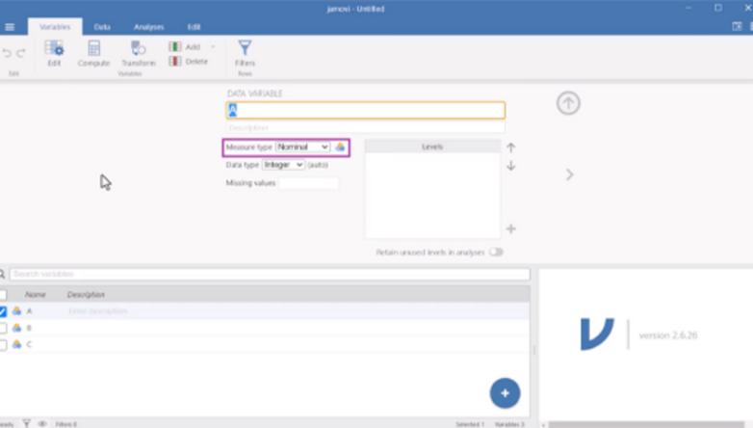

File: Overview of menus in Jamovi

4 Adding variables
Before carrying out statistical analyses in Jamovi, you first need to understand how to organise and enter data correctly. In this activity, you will learn how to create variables, define different types of data, and enter information into a dataset using Jamovi.
You may want to watch the video and follow along in Jamovi at the same time; or watch the video first and then reproduce the steps yourself afterwards.

Activity 3: Adding variables in Jamovi
Allow 20 minutes

The video in this activity uses a simple fictional research example based on the concept of social facilitation: the idea that people may perform differently when they are being observed by others. In this example, participants are asked to complete a simple word-generation task either in the presence of an audience or while alone. The activity demonstrates how this information can be organised within Jamovi by creating variables for the experimental condition, participant performance, and basic demographic information.
As you watch the video, you will be guided through the process of:
- defining variables in Jamovi
- selecting appropriate measure types and data types
- creating categories (or ‘levels’) for categorical variables
- entering participant data into the spreadsheet
- saving your completed dataset.
You may wish to watch the video first to become familiar with the process before attempting it yourself. Alternatively, you can open Jamovi and follow along step by step as the video progresses. Practising the steps yourself is strongly recommended, as becoming confident with data entry and variable creation is an essential foundation for later statistical analyses.
By the end of this activity, you should feel more confident creating your own datasets and entering data into Jamovi.

Video content is not available in this format.
Video 2: Adding variables
View transcript - Video 2: Adding variables

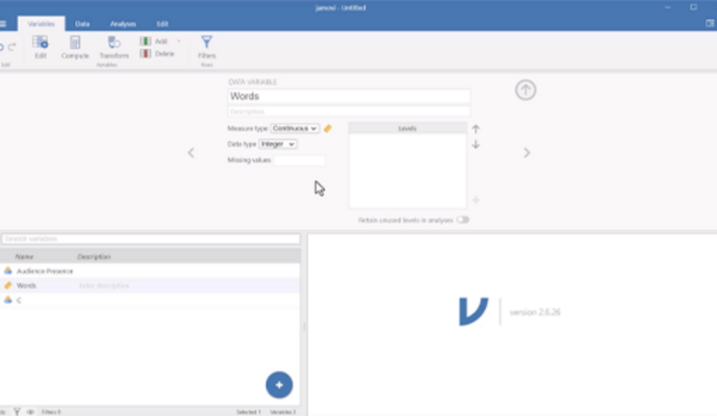

You can download a PDF copy of this tutorial here: Adding variables into Jamovi
Now you have seen how to create variables and enter data into Jamovi, you can practise these skills yourself using the additional dataset provided in PDF format below. Remember to open the link in a new tab or window so you can refer back to the course as you go through the document.
File: Entering data into Jamovi exercise
This practice activity will give you the opportunity to create your own variables and enter participant data into Jamovi independently, helping to reinforce the steps demonstrated in the video.

5 Obtaining Descriptive Statistics
Before carrying out more advanced statistical analyses, it is important to understand how to explore and summarise your data. In this activity, you will learn how to produce descriptive statistics in Jamovi and how these statistics can help you identify patterns within a dataset.

Activity 4: Obtaining descriptive statistics
Allow 20 minutes

The video uses a fictional research example loosely based on the evaluation of a schools linking programme designed to encourage positive contact between pupils from different communities. The example dataset includes demographic information, measures of enjoyment, and questionnaire scores relating to respect for others before and after participation in the programme.
As you work through the activity, you will learn how to:
- identify different types of variables in a dataset
- produce descriptive statistics in Jamovi
- interpret common descriptive statistics such as the mean, median, standard deviation, and range
- explore how data can be summarised for different groups of participants.
The video will guide you through the process of selecting variables, generating descriptive statistics using the Descriptives menu in Jamovi, and interpreting the output produced by the software.

Video content is not available in this format.
Video 3: Descriptive statistics
View transcript - Video 3: Descriptive statistics

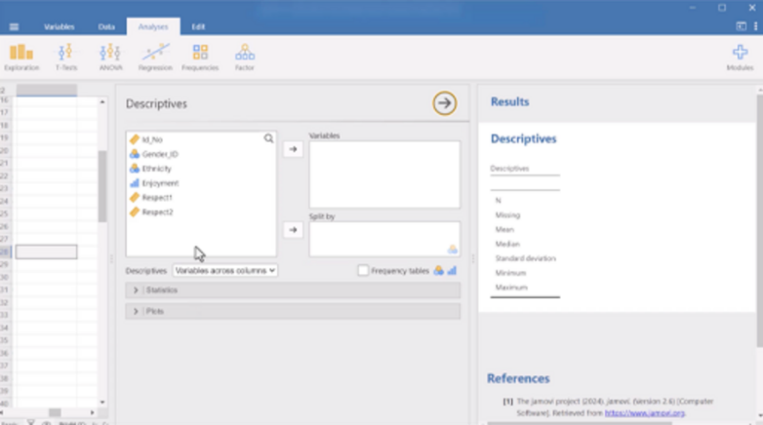

File: Descriptive statistics
Now you have seen how to produce descriptive statistics in Jamovi, you can practise these skills yourself using the example dataset provided alongside this activity. Try reproducing the descriptive statistics shown in the video and explore some of the additional options available within the Descriptives menu. You can download a PDF version of this tutorial, and the dataset used in it below:
File: Descriptive statistics
File: Descriptive statistics dataset
Practising these techniques yourself will help you become more confident both in using Jamovi and in understanding how descriptive statistics help researchers summarise and interpret data.

6 Correlation
In previous activities, you learned how to enter data into Jamovi and produce descriptive statistics to help summarise and explore a dataset. In this activity, you will move on to one of the most commonly used inferential statistical techniques in the social sciences: correlation.
In research, inferential statistical tests are often used to test hypotheses. A hypothesis is a prediction about what researchers expect to find in their data based on theory, previous evidence, or observation. For example, a researcher may predict that higher stress levels will be associated with poorer sleep quality; that increased age may be related to poorer memory; or that increased exercise will be linked to higher wellbeing.
Correlation analyses are used when researchers want to investigate whether two variables are related to one another. They examine whether changes in one variable are associated with changes in another. Relationships may be positive (both variables increase together) or negative (as one variable increases, the other decreases).

Activity 5: Correlation
Allow 20 minutes

The video uses a fictional research example investigating the relationship between mood and serotonin levels. In the example, participants complete a standardised questionnaire measuring depression, while serotonin levels are assessed using blood samples. The aim is to investigate whether lower serotonin levels are associated with higher levels of depressed mood. Specifically, the hypothesis predicts that ‘there is a negative correlation between serotonin and depression score’.
As you work through the activity, you will learn how to:
- run a correlation analysis in Jamovi
- select variables for analysis
- interpret the direction and strength of a correlation
- understand statistical significance within the correlation output
- report and interpret correlation results appropriately.
The video will guide you through the process of carrying out a Pearson correlation using the Correlation Matrix option in Jamovi, as well as explaining how to interpret the output produced by the software.

Video content is not available in this format.
Video 4: Correlation
View transcript - Video 4: Correlation

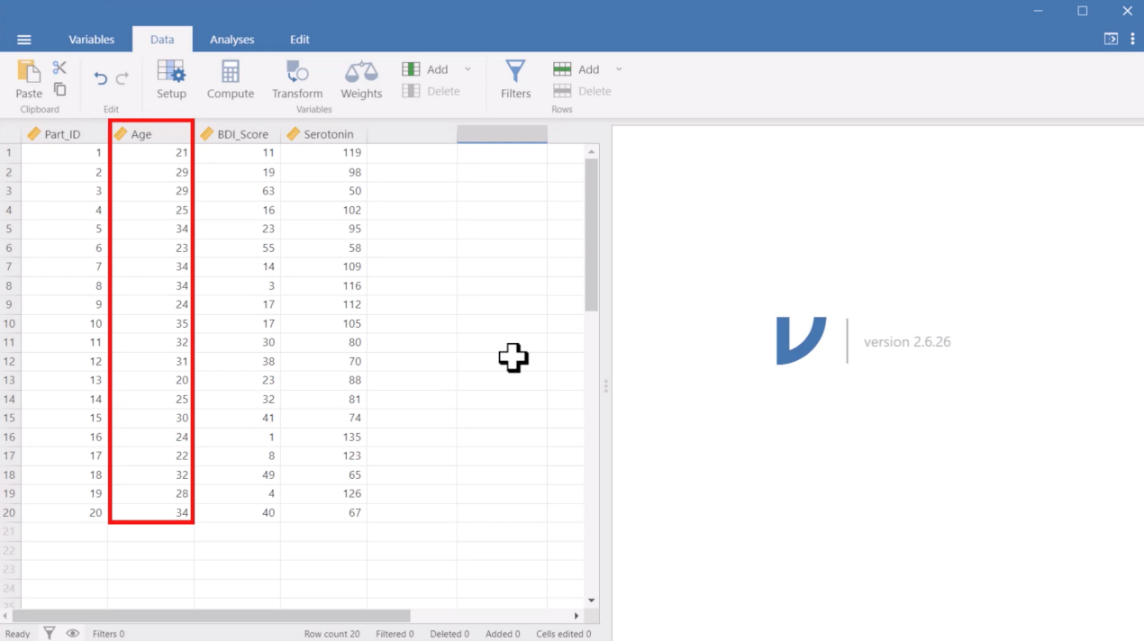

File: Correlation

Now you have seen how to carry out a correlation analysis in Jamovi, you can practise these skills yourself using the example dataset activity which you can download below and open using the File menu in Jamovi. Try reproducing the same analysis and explore what happens when you include additional variables in the correlation matrix. You can download a PDF version of this tutorial, and the dataset used in it below:
File: Correlation tutorial
File: Correlation dataset
Practising these techniques yourself will help you become more confident both in using Jamovi and in understanding how correlations can be used to investigate relationships between variables in research.

7 Scatterplots
In the previous section, you learned how to carry out a correlation analysis using Jamovi. In this activity, you will take this a step further by learning how to visualise the relationship between two variables using a scatterplot.

Activity 6: Scatterplots
Allow 20 minutes

The video uses the same example as Activity 5, where we explored the relationship between mood and serotonin levels. This time, you will use the same data to produce one of the most common types of graph used to examine relationships between variables in social science research: a scatterplot.
In the previous activity, the correlation analysis showed a negative relationship between mood and serotonin levels. This means that as scores on one variable increase, scores on the other tend to decrease. But what does this relationship actually look like in the data?
A scatterplot allows us to see this. Each point on the graph represents a pair of scores, showing us how values on the two variables relate to one another. Looking at the overall pattern of points can help us identify both the direction and strength of a relationship.
The video will guide you through how to produce a scatterplot in Jamovi and explain how to interpret what you see.

Video content is not available in this format.
Video 5: Scatterplot
View transcript - Video 5: Scatterplot

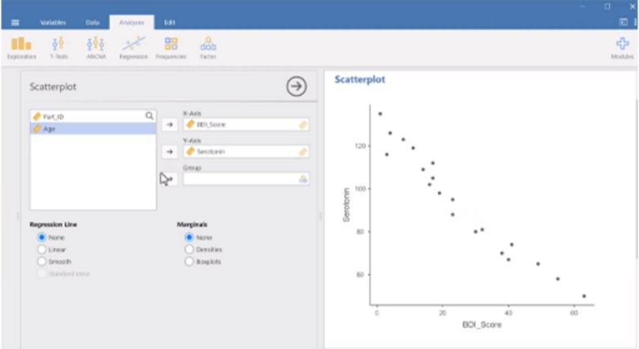

Please note: later versions of Jamovi may look slightly different. You can find the options you need to produce a regression line under the ‘General Options’ menu.
Now that you have seen how to carry out a correlation analysis and produce a scatterplot in Jamovi, try these skills yourself using the example dataset provided alongside the previous activity.
You can download a PDF version of this tutorial, and the dataset used in it below:
File: Scatterplot tutorial
File: Correlation dataset
Start by reproducing the analysis shown in the video. You can then explore the data further by including additional variables in the correlation matrix and looking at their scatterplots. What patterns can you identify? Are the relationships positive or negative? Do some relationships appear stronger than others?
Practising these techniques will help you become more confident using Jamovi and, importantly, help you understand how numerical correlations and scatterplots work together to tell us about relationships between variables in research.

8 Independent t-tests
In previous activities, you learned how to enter data into Jamovi, explore datasets using descriptive statistics, and investigate relationships between variables using correlations. In this activity, you will learn how to carry out an independent samples t-test in Jamovi.
Like correlations, t-tests are used to test research hypotheses. A hypothesis is a prediction about what researchers expect to happen in a study. In experimental research, hypotheses often predict that there will be a difference between groups or conditions.
While correlations investigate relationships between variables, t-tests investigate differences between groups or conditions. For example, researchers may wish to compare whether one group scores higher or lower than another, or whether participants perform differently before and after an intervention.
An independent samples t-test is used when researchers want to compare the average scores of two separate groups or conditions. This type of test is commonly used in experiments and other studies where different participants take part in each condition.

Activity 7: Independent samples t-tests
Allow 20 minutes

The video uses a fictional research example based on a study investigating how people respond when witnessing a conflict between two individuals. Participants are shown one of two versions of a video depicting an argument and are then asked to rate how willing they would be to intervene. The study explores whether participants respond differently depending on whether they believe the individuals are strangers or in a relationship.
As you work through the activity, you will learn how to:
- identify the independent and dependent variables in an independent groups design
- run an independent samples t-test in Jamovi
- check assumptions such as homogeneity of variance
- interpret descriptive and inferential statistics from the output
- report and interpret the results of an independent samples t-test appropriately.
The video will guide you through selecting variables for analysis, choosing the correct t-test options, and interpreting the output produced by Jamovi, including means, standard deviations, t-values, p-values, and effect sizes.

Video content is not available in this format.
Video 6: Independent t-test
View transcript - Video 6: Independent t-test

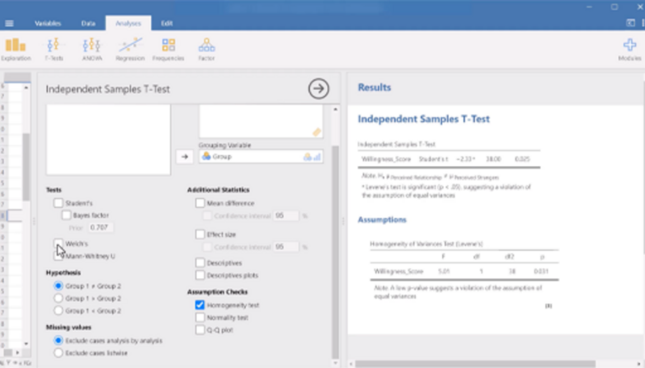

File: Independent t-test
Now you have seen how to carry out an independent samples t-test in Jamovi, you can practise these skills yourself using the example dataset provided alongside this activity. Try reproducing the same analysis and explore how changing different options within the t-test menu affects the output. You can download a PDF version of this tutorial, and the dataset used in it below:
File: Independent t-test tutorial
File: Independent t-test dataset

9 Repeated measures t-tests
In this activity, you will learn how to carry out a repeated measures t-test in Jamovi. Unlike the independent samples t-test, which compares scores for two separate groups of participants, a repeated measures t-test is used when the same participants provide data in both experimental conditions.

Activity 8: Repeated measures t-tests
Allow 20 minutes

The video uses a fictional research example inspired by studies examining the so-called ‘Hungry Judges’ effect – the idea that hunger may influence decision-making. In this example, participants rate the severity of fictional crimes before and after a lunch break, allowing researchers to investigate whether sentencing decisions differ depending on hunger levels.
As you work through the activity, you will learn how to:
- recognise when a repeated measures design is being used
- understand how repeated measures datasets are organised in Jamovi
- run a paired samples t-test in Jamovi
- interpret descriptive and inferential statistics from the output
- report and interpret repeated measures t-test findings appropriately.
The video explains how repeated measures data differs from independent groups data, demonstrates how to select paired variables for analysis, and guides you through interpreting the resulting output, including the means, standard deviations, t-values, degrees of freedom, and significance values produced by Jamovi.

Video content is not available in this format.
Video 7: Repeated measures t-test
View transcript - Video 7: Repeated measures t-test

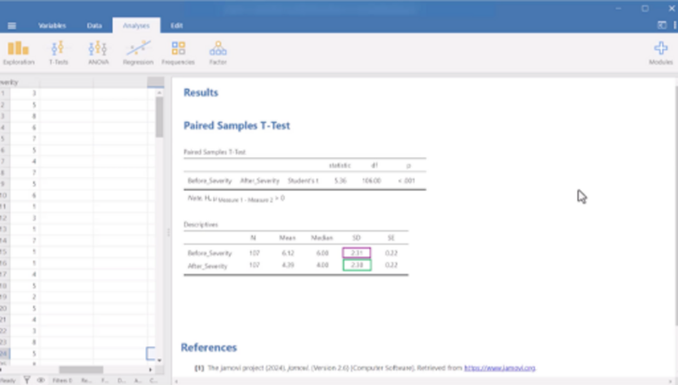

File: Repeated measures t-test
Now you have seen how to carry out a repeated measures t-test in Jamovi, you can practise these skills yourself using the example dataset provided alongside this activity. Try reproducing the same analysis and explore how the output changes when different options are selected.
You can download a PDF version of this tutorial, and the dataset used in it below:
File: Repeated measures t-test tutorial
File: Paired t-test dataset

Conclusion
In this course, you have been introduced to Jamovi and the foundations of quantitative data analysis. Through a series of guided activities and practical examples, you have learned how to install and navigate the software, create and manage datasets, produce descriptive statistics, and carry out a range of commonly used statistical analyses.
You should now feel more confident:
- opening and navigating Jamovi
- defining variables and entering data correctly
- exploring and summarising datasets using descriptive statistics
- investigating relationships between variables using correlations and scatterplots
- comparing groups and conditions using independent and repeated measures t-tests.
Alongside learning how to use Jamovi itself, you have also developed an understanding of how statistical analyses are applied within real research scenarios in the social sciences and psychology. Importantly, you have had opportunities to practise interpreting statistical output and thinking about what the results mean in the context of research questions and hypotheses.
Learning statistics and statistical software can feel challenging at first, but confidence develops through practice and experimentation. One of the advantages of Jamovi is that it provides an accessible and user-friendly environment in which to explore data and learn statistical techniques without needing to carry out complex calculations by hand.
We encourage you to continue practising the skills introduced throughout this course by revisiting the datasets, exploring additional options within the software, and applying these techniques to your own research questions and assignments.
By completing this course, you have taken an important first step towards developing practical data analysis skills using open-source statistical software.
Explore more on OpenLearn:
- Critically exploring psychology
- Making sense of ourselves
- Investigating psychology
If you enjoyed this course, you might be interested in exploring the following Open University courses:
- D120: Encountering psychology in context
- D810: Critically exploring psychology 1
- D811: Critically exploring psychology 2
- DE200: Investigating psychology 2
- DE300: Investigating psychology 3
- BSc (Honours) Psychology
- MSc in Psychology (Conversion)

Acknowledgements
This free course is an adapted extract from the courses DE200 and D810. Whilst this course features Jamovi, other statistical software packages are also available for carrying out quantitative research and data analysis. The Open University does not endorse nor recommend any particular software package.
Except for third party materials and otherwise stated (see terms and conditions), this content is made available under a Creative Commons Attribution-NonCommercial-ShareAlike 4.0 Licence.
The material acknowledged below is Proprietary and used under licence (not subject to Creative Commons Licence). Grateful acknowledgement is made to the following sources for permission to reproduce material in this free course:
Image
Course image: izusek/Getty Images
Videos
Videos 1–7: © The Open University (2026) created using Jamovi free software package.
Text
Accompanying files/tutorials to the videos: © The Open University (2026) created using Jamovi free software package.
Every effort has been made to contact copyright owners. If any have been inadvertently overlooked, the publishers will be pleased to make the necessary arrangements at the first opportunity.
Don't miss out
If reading this text has inspired you to learn more, you may be interested in joining the millions of people who discover our free learning resources and qualifications by visiting The Open University – www.open.edu/openlearn/free-courses.

Video 1: Overview of menus in Jamovi

Transcript
SPEAKER
Overview of menus in jamovi. This tutorial aims to provide you with an overview of the menus in jamovi and to explain their function. This will be helpful for you when you need to use jamovi for your own work.
jamovi has several menu options located at the top of the screen, as with any other computer program. This tutorial will go through them one by one. To follow is a summary of the key menus and their functions.
Firstly, the File menu. The first icon in our toolbar is three horizontal lines, which represents the File menu. If you click on this icon, you will see these options available to you. The menu allows you to start a New data set, Open a data set, Special Import files to combine multiple data sets, Save or Save As any of your work, Export results or data to PDF, HTML, or other formats.
The Variables menu. The second menu in our toolbar is the Variables menu. Here you can manage and customize the variables in your data set. The Variables menu is essential for ensuring that each variable is correctly formatted before running any analysis, as the type and structure of a variable determine which statistical tests are appropriate.
Under Variables, you will have an icon named Edit. By clicking here, you can name your variables, add variable descriptions, edit the variable measure type, edit the data type, define missing values, and add levels to variables, if you have ordinal or nominal data.
Under the Variable menu, you can also Compute variables, which allows you to create a new variable based on a formula or expression using existing variables in your data set. It's similar to using a formula in Excel. This is useful when you want to perform calculations, such as combining variables, calculating a total score, or computing averages.
For example, if you have test scores from three quizzes labeled Quiz1, Quiz2, and Quiz3, you can use the Compute variable function to create a new variable called TotalScore by adding them together, that is, total score equals Quiz1 plus Quiz2 plus Quiz3.

Transform variables allows you to automatically recode or modify values in a variable based on rules you set. This is useful when you want to group, label, or simplify data for analysis without changing the original variable. For example, let's say you have a variable called score with numbers from 0 to 100. You want to turn this into a new variable that group scores into letter grades, such as A, B, C, et cetera.
Using Transform, you can create rules such as, if the score is greater than or equal to 85, then grade equals A. If the score is greater or equal to 70 and less than 85, then grade equals B. If score is greater than or equal to 50 and less than 70, then grade equals C. If the score is less than 50, then grade equals F.
jamovi will then create a new transformed variable, e.g., called Grade that automatically applies these rules to every row of data.
Data menu. The third menu in our toolbar is titled Data. When you click on this menu, your jamovi window will appear with a spreadsheet style layout. The data menu in jamovi provides tools for managing and preparing your data sets before running analysis. Each row represents a case or participant. And each column represents a variable, such as age, gender, or test score.
On the data spreadsheet, you can input your data, edit data, and understand your data at a glance. You can click into cells, scroll through data, and make quick changes just like you would in a typical spreadsheet.
In the example below, you can see what the spreadsheet would look like once we have some data. Each row represents one student. And in this example, we have 16 rows of data, which means we have data on 16 students. Each column represents each score for either Quiz1, Quiz2, or Quiz3, and the student's total score when the scores for each quiz have been combined.
Like the Variables menu, you can also add new variables, rename, or delete existing variables, and filter the data to include or exclude certain cases in your analysis. You can also compute and transform variables.
Overall, the Data menu helps ensure your data is properly structured and ready for accurate statistical testing.
Analyses menu. In jamovi, the fourth menu is our Analyses menu, which is where you can access all the statistical tests needed for data analysis. It is grouped into six categories. Exploration allows you to generate descriptive statistics, frequency tables, and exploratory data analysis, for example, the mean, median, and standard deviation for selected variables useful for getting a quick overview of your data.
The T-Tests option is used to compare the means of conditions to see if there are statistically significant differences between them. It includes three main types-- Independent Samples T-Test for comparing two different groups, such as males versus females; Paired Samples T-Test for comparing the same group at two different times, for example, pre-test and post-test; and the One Sample T-Test for comparing a sample mean to a known value.
The ANOVA option is used to compare the means of three or more conditions to determine if there are statistically significant differences between them. It includes options such as One-Way ANOVA for analyzing one independent variable with three or more levels, ANOVA for analysis with more than one between groups independent variable; Repeated Measures ANOVA for comparing the same group under three or more different conditions or times.
The Regression option is used to explore and model relationships between continuous variables. It includes options such as Correlation Matrix for assessing relationships between two or more continuous variables, and Linear Regression for modeling how predictor variables study time, age, or income influence an outcome variable, such as exam scores.
Frequencies. This option is used for any analysis where the dependent variable or outcome of interest is categorical. For example, if you wanted to test whether one subjects, for example English, science, or maths is significantly more popular among school students, you could use the N Outcomes Chi squared Goodness of fit option.
Factor. This option contains more complex analysis for finding patterns in data and validating survey scales. The various options all provide different ways of exploring whether a large number of data points can be grouped together into fewer concepts or components.
For example, if you have a survey with 10 questions about learning, the Factor menu can help you find out if some questions are really about motivation and others are about interest. Your studies will include further tutorials which will show you what these options mean and when and how to use them.
Edit menu. Our fifth and last menu in jamovi is the Edit menu. The Edit menu in jamovi works a lot like the Edit menu in a text editor. It includes basic editing functions such as cut, copy, and paste, which allows you to move or duplicate data or analysis, just like copying and pasting text.
Undo and redo, which goes backwards or forwards if you make a change you want to reverse. Text edit, bold italics, underline, or strike text, as well as editing the text color. Paragraph to add bullet points or number points and align or indent text.
Insert formula to add and format mathematical expressions or calculations in your notes or outputs. Styles to help you format the text in your output or notes to make them clearer and more organized. This includes adding headings, inserting code block, which formats text to computer code, and add links.
These tools are not for analysis, but they can help you edit and manage your data and output more easily, just like when you're editing a document. Remember, practice makes perfect.
Now that you're a bit more familiar with the jamovi menus, you might want to take some time to explore the menu lists and their options in your own time. This will help increase your familiarity and confidence with navigation and using jamovi, and reduce any worries you may have about learning to use new statistical software and tests.
Remember, practice makes perfect. Why not try adding some data and see what you can do with the different menu options. You don't need to worry about breaking jamovi. The worst case scenario is that you produce some meaningless analysis, but that's just part of learning how it works.

Back to - Video 1: Overview of menus in Jamovi

Video 2: Adding variables

Transcript
SPEAKER
Adding variables into jamovi. This tutorial will show you how to create variables and add data into jamovi. Using a simple example, let's imagine that we want to investigate the phenomenon of social facilitation. Our simple hypothesis might be that participants perform better on a simple task when in the presence of others.
To test this hypothesis, we could create two experimental groups. Group 1, audience present, participants perform a task while being watched by an audience. Group 2, audience absent, different participants perform the same task alone.
We could call this variable audience presence, and it will be our independent variable. We would then need to measure participants performance in some way. For this example, let's consider a simple task that involves participants being asked to write down as many words as possible that begin with the letter F in 60 seconds. The number of words generated would therefore be the dependent variable. The two groups performance could then be directly compared.
Defining variables. First, let's open jamovi. Before we add our data, we need to tell jamovi what information we collected, so we need to define our variables. To do this, you need to click on variables, which is the first menu on the toolbar at the top of your window.
Jamovi automatically provides three variables titled A, B, and C, under variable view. To edit these variables, you can either double click on a variable or select a variable and click the Edit button as shown.
Alternatively, to add a new data variable, you can click on the Add button at the top and select Insert to insert a data variable between the current variables, or Append to insert a data variable at the end. Double clicking a variable, clicking Edit, or adding a new variable will all reveal the data variable box.
Defining our independent variable as audience presence. The first thing we need to do is set up a variable to indicate whether an audience was present or absent. In the variable view, select the first variable currently called A and click Edit.
The variable is currently called A but we want to replace this with something meaningful. The name you choose will appear at the top of the corresponding data columns in the data view sheet. As such, you don't want to give your variables long names as this makes them difficult to read.
For this example, we will call the variable audience presents. Under the title box, we have the option to include a description. This can be helpful if you have a large number of similar variables, but for this example, we will leave it blank.
Next, we have measure type. The measure column allows us to tell jamovi what type of variable we are entering data for. You would select continuous if you are entering interval or ratio data, that is, where the difference between scores on the scale is meaningful and standardized, and intervals across the scale are equal.
Ordinal, if you have a categorical variable where the order of the categories matter. Or nominal, if you have a categorical variable where the order of categories does not matter. In our example, we need to select the nominal option as we are looking at a categorical variable, which is audience present versus audience absence without obvious ordering.
Next, we have data type. Here you can change the type of data that is associated with the variable. We have three options, integer. Integer variables in jamovi are designed for values that can only be whole numbers. This contrasts with decimal variables, which can include decimal points and fractions.
For example, IDs such as the student ID number or ordinal scales where numbers represent ordered categories. For example, 1 for strongly disagree, 2 for disagree, and so on. Decimal represents numerical data with decimal points, indicating the presence of a fractional part. It's used for values that are not whole numbers.
Text variables are often used to represent categories or labels, such as names, locations, or descriptions. For example, a variable might hold the name of different cities or the different responses to a survey question. For our variable audience, we could select text as our data type. This allows us to write present or absent to represent each of our conditions when inputting our data.
After you've done this, your data variable window should look the same as shown. Now, we need to tell jamovi what our conditions are for this variable. You can see a box titled levels and a plus sign to the bottom right hand side. Click on the plus sign.
This will bring up a box asking us to enter level value. This is where we input each of our conditions. To represent our condition where the task is being completed with an audience present, we want to type present and click OK.
Then click on the plus sign again to enter our second condition. This time we want to represent the condition where the task is being completed without an audience present. So we will type absent and click OK.
Defining a dependent variable, words. Once we've entered the information for our first variable, we can enter in the details for our other variables. Let's move on to our dependent variable, which is the number of words each participant wrote down in 60 seconds.
Either double click on variable B or select variable B and click the Edit button as shown. For the title, we could put words. Under Measure Type, we would click on Continuous as the difference between scores on the scale is meaningful and standardized, and intervals across the scale are equal.
For data type, we would select integer as participant scores will be whole numbers. We do not need to add any levels for this variable as it is not categorical. When you've done this, your dependent variable words should look like this.
Defining demographic variables. When carrying out research, it's also important to collect demographic information about your participants, especially age and sex. These variables also need to be defined so we can enter the data into our data sheet.
Let's edit the C variable and title it sex. The measure type would be nominal as sex is categorical. For data type, we can select Text again. So we can input our sex data as words, e.g. male or female.
We could define our categories in this variable by clicking the plus sign to the bottom right hand side of the box titled levels. We would enter male for our first category. Then click the plus sign again to enter female. When you've done this, your sex variable should look like this.
Finally, let's define age. Insert a new variable and title it age. The measure type for age would be continuous. For data type, we will select Integer as we usually collect age in whole years, for example, 23 rather than 23.4. Your age variable should look like this.
Entering data. Once you've added all four variables, this is how your variable window should look. Now we can start entering in our actual data. To do this, click on Data, which is the second menu on your toolbar at the top of your window. This will take you to the data spreadsheet.
Notice how the headers of the columns have now changed to display the variable names. They should now read audience presence, words, sex, and age. When entering data into jamovi, it is important to follow the simple rule of thumb, each row represents an individual participant, observation, or case.
When you enter data, the number of rows should be the same as the number of participants you have. If you find yourself entering data from the same participant on more than one row, or entering data from many participants on only one row, the chances are you are entering it incorrectly. In this case, you need to enter the data in the following way.
Enter in present or absence in the audience column to represent whether the participant completed the task with an audience or without. The numbers entered into the words column are the number of words participants wrote down. Enter male or female into the sex column.
The number entered into the age column, the participant age in years. Have a go at entering the data into your own spreadsheet. Once you are done, it should look like this.
You have now finished entering your first set of data. Once you've finished creating your data file, you need to save it. To do this, click on the File menu, which is three horizontal lines at the top of the left hand side of your window. Then select the Save option or Save As and name your file in the usual way.
Now you have completed the first three tutorials, Getting Started, Menus, and Adding Variables, why not explore the program further yourself? Try adding some data and seeing what you can do with the different menu options. You don't need to worry about breaking jamovi. The worst case scenario is that you produce some meaningless output, but that's just part of learning how it works.

Back to - Video 2: Adding variables

Video 3: Descriptive statistics

Transcript
SPEAKER
Descriptive statistics. Using a simple data set, this tutorial will show you how to produce descriptive statistics using Jamovi. The data in this example is loosely based on the evaluation of the Schools Linking Network. As the name suggests, this project links schools in different communities to put the contact hypothesis into practice. The contact hypothesis suggests that by increasing contacts between people from diverse backgrounds, prejudice can be reduced and positive attitudes towards out-groups can be fostered.
This is what the data looks like in Jamovi, and this can be found in the file below. Each column represents a different variable, and each row contains the data from one participant. The different columns display the following data-- ID number-- this refers to the ID number assigned to the participants. We use these numbers as identifiers instead of participant names, as this allows us to collect data whilst keeping the participants anonymous. As anonymity is ethically important in psychology research, this is generally considered good practice.
Gender ID-- this column contains categorical, nominal information about participant's gender identity. Ethnicity-- this column contains information about participant's ethnicity. Like gender identity, this is a categorical or nominal variable as participants belong to different groups or categories. Enjoyment-- this variable measures pupils enjoyment of meeting new people through the Linking School Network on a scale of 1 to 5d where 1 equals did not enjoy at all, and 5 equals really enjoyed. As this is a single scale with five ordered categories to choose from, it's an ordinal variable.
Respect1-- the Linking School Network aims to reduce prejudice between different groups. To assess this, a questionnaire that measures participants respect for the rights of others was given to students both before and after their participation in the program. This variable represents their respect for others before the intervention. As this is measured using a standardized questionnaire, this is a continuous variable. Respect2-- following Respect1, this variable represents participants respect for others after the intervention. It uses the same questionnaire and is calculated in the same way as Respect1. Again, this is a continuous variable.
Getting descriptive statistics in Jamovi. Now you've had a chance to explore what the different variables are. You need a way to inspect and summarize the data so you can get a better idea of any patterns that may exist within it. You can do this by looking at descriptive statistics for the data. To obtain the descriptive statistics, you need to click on Analyses, select Exploration, and click Descriptives.
This will bring up the Descriptives dialog box. It has the names of your variables in the pane on the left-hand side, and empty panes on the right-hand side, labeled Variables and Split by. When producing descriptive statistics, you only want to do so for continuous and ordinal variables. It doesn't make sense to ask Jamovi to produce means and standard deviations for nominal data.
Continuous variables are represented by a ruler symbol, ordinal variables by a bar chart, and categorical variables by the three circles. Always remember to check that these are set correctly before beginning any analyses. See previous tutorials for details.
To tell Jamovi which variables you want descriptive statistics for, you need to move the variables from the box on the left-hand side to the boxes on the right. This process is quite common for many of the analyzes you will undertake using Jamovi. First, select the Enjoyment variable in the left-hand box and click on the arrow to move it to the right-hand box titled Variables. Then select the Respect1 variable in the left-hand box and click on the arrow to move it to the right-hand box titled Variables.
Next, select Respect2 variable in the left-hand box, and click on the arrow to move it to the right-hand box titled Variables. Once you've done this, it should look like this. If you wanted to produce separate statistics for different groups of participants, you would add the appropriate grouping variable to the Split by box. For example, if you moved Gender_ID into the Split by box, Jamovi would calculate separate enjoyment and respect scores for each gender identity. For the purposes of this tutorial though, just leave this box empty.
Next, click on the arrow next to Statistics to expand the options available. Once you've expanded this box, you will see the descriptive statistics that Jamovi selects by default. For the purpose of this tutorial, let's add the range to our descriptive statistics. To do this, select the box to the left of this option so the box becomes ticked. Once this has all been done, the output will update on the right-hand side of the window.
The output. The descriptive statistics table displays all the information you've requested. Variable names are listed at the top-- Enjoyment, Respect1, Respect2-- with the descriptives listed in the left-hand column. These descriptive statistics represent the following-- N stands for the number of participants. This column simply tells you how many participants you have data for each variable. We have 50 participants in our data set, so our N equals 50 for each variable.
Missing-- this tells us if we have any data missing from our data set. In this case, missing equals 0. So we know we do not have any data missing. Mean-- the mean column shows the mathematical average for each of the variables. This is the sum of the scores divided by the number of scores, or the N. Median-- the median represents the middle number or data point in the data set, if the data was arranged from the lowest value data point to the highest value data point.
Standard deviation-- this column displays the standard deviation for each variable. This refers to the spread of the scores around the mean, and represents how much variation you have in the data. The larger the values relative to the means, the more disperse the scores are. Range-- this column measures the spread of the scores obtained. Essentially, the range is the difference between the highest and the lowest value. Minimum-- this refers to the lower end of the range, and the minimum column is the lowest score of the variable in each row. Maximum-- this refers to the upper end of the range, and the maximum column is the highest score of the variable in each row.
When carrying out research that has continuous data, you should always report the means and standard deviations of your variables, as each statistic provides a useful summary to help make sense of the data. They are usually reported to two decimal places. In this case, looking at the table, you could say on average, pupils seem to enjoy the Linking Schools Project with a mean enjoyment score of 3.74 standard deviation 1.14. In addition, participants respect scores before taking part in the project appeared lower, with a mean of 71.10 and a standard deviation of 13.60. Then afterwards-- where the mean was 79.44 and the standard deviation was 11.70.
Now you have been shown how to enter data and produce descriptive statistics. Why don't you try creating your own set and calculating the means, standard deviations, and other descriptive statistics? Or download the data file used in this tutorial and see if you can produce the same output yourself. Why not explore these options and see what output you can produce? Practicing using Jamovi yourself will help you increase your confidence with using the program and analyzing statistics. So we really do recommend that you take advantage of any opportunities for practice that are available.
Back to - Video 3: Descriptive statistics

Video 4: Correlation

Transcript
SPEAKER
Correlation-- in the following tutorial, you will be shown how to carry out a simple correlation analysis. Correlations tell us about the relationship between pairs of variables-- for example, height and weight or age and memory performance.
We're going to do a worked example. This example is based on a fictional study investigating the relationship between mood and serotonin levels. As some drugs that are given to people to treat depression work by stimulating serotonin pathways, we might expect to see a relationship between depression scores and serotonin levels in the blood. Specifically, we might predict that people with lower levels of serotonin have higher levels of depression.
To test the relationship between mood and serotonin levels, we first need a way of measuring these two things. We could give participants a standardized test to reliably measure their depression levels. In this example, we could use the Beck Depression Inventory, which involves filling out a short questionnaire about their feelings and depressive symptoms. This is then numerically scored. Serotonin level could be measured by taking blood from each participant and assessing the level of the neurotransmitter detected in the samples.
This is what the data looks like in jamovi, and this can be found in the file below. The different columns display the following data. Part_ID refers to the ID number assigned to the participant. We use these numbers as identifiers instead of participant names, as this allows us to collect data while keeping the participants anonymous. This is good practice in psychology, especially when collecting potentially sensitive data, such as that about mental health. Age is usually recorded to allow the researcher to rule out age as a possible confounding variable.
BDI_Score is our first variable of interest, depression score. This is measured by the Beck Depression Inventory and is scored between 0 and 63. Higher scores indicate higher levels of depressed mood.
Serotonin is our second variable of interest. In this case, levels of the neurotransmitter in participants' blood samples were measured in nanograms per mil.
Running the correlation-- to start the analysis, click on Analyses. Select Regression, and click Correlation Matrix. This brings up the Correlation Matrix dialog box. Here, we can see all our variables from the data file displayed in the box on the left.
To tell jamovi what we want to analyze, we need to move our variables to the box on the right. First, select BDI_Score in the left-hand box, and click on the arrow to move it to the right-hand box. Then select Serotonin in the left-hand box, and click on the arrow to move it to the right-hand box, the same box that BDI_Score has moved to. Now you will see both variables in the right-hand box, as shown.
We next want to make sure that we have ticked certain things in the boxes below, to make sure they are included in our output. Under correlation coefficients, we need to make sure Pearson is selected. Normally, jamovi selects Pearson as the default. As you can see, we have the option to select Spearman or Kendall's tau-b. For the purposes of the example, we want to use Pearson.
Under Additional Options, we want to select Report significance, Flag significant correlations, N sample size. What we select under hypothesis depends on our predictions about the outcome. If we were unsure whether the relationship between our variables is likely to be positive-- that is, as one variable increases, so does the other-- or negative-- as one variable increases, the other decreases-- we would choose correlated. If we had good scientific reason to expect the relationship to be positive-- as one variable increases, so does the other-- we would select correlated positively. If we had good scientific reasons to expect the relationship to be negative-- as one variable increases, the other decreases-- we would select correlated negatively.
We stated above that we expect serotonin levels to fall as depression increases, i.e. a negative correlation. So we should select correlated negatively. Once you've done this, your Correlation Matrix dialog box should mirror the image shown. The output will then update on the right-hand side based on our selection.
The output-- so what does the output show you? The correlation table only has two variables in it, so it's not too hard to read in this example, but sometimes you might be investigating the relationship between several variables all at once. If that were the case, you would have multiple variables in your table. Regardless of the number of variables you have in this table, the way you read it is always the same.
In our example, you can see we have variables displayed on the left-hand side of the table and across the top. The part of the table that contains numbers is the section that we want to focus on. This is highlighted in the red box in the image shown.
These correlation statistics tell us three things. Firstly, the direction of the correlation between the variables, Pearson's r. Secondly, the strength of the correlation between the variables is Pearson's r. And finally, whether this correlation is significant or not from the p-value.
The Pearson's r is used to determine the strength and the direction of the correlation. We can tell the direction of the relationship between the variables from the Pearson correlation line. If the Pearson's coefficient r is positive, this means that as the value of one variable goes up, the value of the other variable also increases. In contrast, if the relationship is negative, this means that as the value of one variable goes up, the value of the other variable goes down. As you can see, our Pearson's r is minus 0.97. This indicates a negative relationship between our two variables.
The strength can also be read from the Pearson correlation line. Ignoring the direction of this value-- that is, whether it's positive or negative-- the Pearson's coefficient, or r, tells you the strength of the relationship. 0.8 or above is very strong. 0.5 or above is strong. 0.3 or above is medium. Less than 0.3 is weak. Looking at our Pearson's r, which is minus 0.97, we can see that there is a very strong negative relationship between our two variables, as Pearson's r is larger than 0.8.
The p-value tells us whether or not this relationship is significant. In psychology, we tend to accept values of less than p equals 0.05 as significant. As you can see, our p-value is less than 0.001, indicating that the negative correlation between depression score and serotonin level is significant. As such, we can confirm that our hypothesis, which predicted that there will be a negative correlation between depression scores and serotonin level, is supported and correct.
You will also notice at the bottom of the table, jamovi has noted that a hypothesis is one tailed. This means that we have tested a directional prediction. That is that the relationship between BDI score and serotonin will be negative, and the p-value reflects that.
Quick quiz-- question one, what does the correlation table show? Is it A, there is no significant correlation between depression score and serotonin level; B, that depression score and serotonin level are highly positively correlated; C, that depression score and serotonin level are highly negatively correlated; or D, the correlation between depression score and serotonin level is an example of a perfect correlation?
The answer is C. There is a correlation between depression score and serotonin level, which you can tell by looking at the Pearson's r, or the Pearson correlation coefficient. So A is incorrect. Looking at the value of the coefficient, it is neither positive-- so B is incorrect-- nor a perfect correlation, which is either 1.0 or minus 1.0 So D is incorrect. The two variables are highly negatively correlated.
Question two, do the results in the table support the hypothesis that there will be a significant negative correlation between depression score and serotonin level? Answer A, yes; B, no; or C, they neither support nor refute this claim?
Null-hypothesis significance testing uses a rule to decide whether you should accept or reject the null hypothesis, H0, in favor of the research hypothesis, H1. To determine this, the p-value needs to be less than 0.05. As this is the case here, as p is less than 0.001, the answer is A. The negative correlation between depression score and serotonin level is significant, so you can reject the null hypothesis, that there is no relationship between the variables, in favor of your research hypothesis.
Writing up the results-- when writing up your results, you need to report the strength, direction, and significance of the correlation, along with the correct statistics, and give a meaningful interpretation of your findings. A Pearson's correlation is reported using the small letter r, followed by the degrees of freedom, df, in parentheses. So in this case, we may say something like, the results showed a very strong significant negative relationship between depression score and serotonin level. r bracket 18, close bracket, equals minus 0.97. p is less than 0.001, one-tailed test. As serotonin scores increased, the participants' depression scores decreased.
This brings us to the end of the tutorial. Why not download the data set used in this tutorial and see if you can produce the same output on your own? You could also try adding age into the correlational analysis to see what you find.
Back to - Video 4: Correlation

Video 5: Scatterplot

Transcript
SPEAKER
Scatter plot. In this tutorial, you will be shown how to visualize your data in the form of a scatter plot using Jamovi. Scatter plots, also known as scatter graphs, make it easier to see the relationship between two variables. In a scatter plot, one variable is assigned to the horizontal axis or the x-axis, and the other to the vertical axis, the y-axis.
The example here is based on a fictional study investigating the relationship between mood and serotonin levels. As some drugs that are given to people to treat depression work by stimulating serotonin pathways, you might expect to see a relationship between depression scores and serotonin levels in the blood.
This relationship is explored further in the correlation tutorial, where you can also learn more about measures used in the study. This is what the data looks like in Jamovi. The data set you see here contains the following data from left to right. The participant ID numbers, their age in years participants depression scores as measured by the Beck Depression Inventory, or the BDI, their serotonin levels.
Producing a scatter plot in Jamovi. To produce a scatter plot, click on exploration and select scatter plot. This brings up the scatter plot dialog box. Here, we can see all our variables from the data file displayed in the box on the left. In this example, we want our depression variable, BDI score, on the x-axis.
So we select BDI score and move it to the x-axis box by clicking on the arrow. Next, we want our y-axis to show serotonin levels. So we select serotonin and move this variable to the y-axis box by clicking on the arrow. Once you've done this, your selection should mirror the screen and your output will update with a scatter plot.
The output, scatter plots give you some sense of the relationship between two variables. But a collection of dots can be quite difficult to understand at quick glance without some sort of visual guide. To show the relationship more clearly, you can insert a line of best fit. To add a line of best fit, select Linear under regression line.
This is a line through the data points that best represents the relationship between those data points. You should always add a line of best fit to a scatterplot to make the direction of the relationship easier to identify. Once you've selected linear, the scatterplot will update in your output and will look like the image shown.
So what does the scatterplot actually show us? The text on the left-hand side is your y-axis label and is labeled serotonin. The text at the bottom is your x-axis label and is labeled BDI score. The numbers beside each of these axes represent serotonin levels and BDI scores, respectively. Each dot on the graph represents a single participant. Each participant has a BDI score and a serotonin score, and these are used by Jamovi to plot them on the graph.
The line drawn between the points is the line of best fit. Here, you can see that it looks a bit displaying a negative correlation because it slopes down from the top left to the bottom right. This means that as the BDI values on the x-axis go up, the serotonin values on the y-axis are going down. If this graph showed a positive correlation, then the line would slope upwards from the left towards the right.
The higher participants serotonin levels, the closer to the top of the graph their data point appears. The higher their BDI score, the further to the right their data point appears. For example, a participant with a high serotonin level but a low BDI score will appear high up and to the left of the graph. Conversely, participants with low serotonin scores but high BDI scores appear at the bottom right of the graph.
Back to - Video 5: Scatterplot

Video 6: Independent t-test

Transcript
SPEAKER
Independent t-test. The t-test assesses whether the means of two groups or conditions are statistically different from one another. These are reasonably powerful tests used on data that is parametric and normally distributed. T-tests are useful for analyzing simple experiments or when making simple comparisons between levels of your independent variable.
The two most common variants of the t-test are the independent t-test, which is used when you have two separate groups of individuals or cases in a between participants design, for example male versus female experimental versus control group. The repeated measures t-test, also known as the paired samples or related t-test, is used when participants provide data for each level or condition of the independent variable within participant's design, for example, before and after an intervention.
For this tutorial, we will focus on the independent t-test. There is another tutorial for the repeated measures t-test. The reason for separating them is that the data files are set up differently, and they produce different types of output. The following example demonstrates what happens after you have created the data file. See the earlier tutorial on adding variables to see how to create your own file.
Doing an independent t-test in Jamovi. This tutorial will walk you through how to run and interpret an independent t-test. The example is based on a study by Schottland and Straw, 1976, who were interested in how the perceived relationship between a couple fighting may affect the likelihood of someone intervening.
To test this, participants were split into two groups and asked to watch a video of two people fighting. The videos were identical except for one crucial line. One group sees the victim shouting, "leave me alone, I don't know you," while the other group sees her saying, "leave me alone. I should never have married you." Participants were then asked to rate how willing they would be to intervene on a scale of 1 to 5.
This is what the data looks like in Jamovi, and this can be found in the file below. For an independent t-test, the data file should have at least two columns, one for the independent variable and one for the dependent variable. Each column represents a different variable, and each row contains the data from one participant.
The different columns display the following data. The ID_No variable refers to the ID number assigned to each participant. We use numbers as identifiers instead of participant names as this allows us to collect data whilst keeping the participants anonymous. This is good practice in psychology, especially when collecting potentially sensitive data.
The variable group tells you which experimental condition participants are in. This is our independent variable. In this example, participants were split into two groups, 1, perceived relationship, 2, perceived strangers. Willingness score is a self-report rating of how willing participants would be to intervene in the fight they witnessed. This is our dependent variable.
In our example, the score is rated using a 5 point Likert scale ranging from strongly disagree to strongly agree, with strongly agree indicating the likelihood of intervention. As mentioned at the beginning of this tutorial, the independent t-test compares the scores of two groups on a certain variable. In this case, we want to compare the willingness scores of the two experimental groups.
Running the independent t-test. To start the independent t-test analysis, click on analysis, select t-tests, and click independent samples t-test. This brings up the independent samples t-test dialog box. Here, we can see all our variables from the data file displayed in the box on the left. To tell Jamovi what we want to analyze, we need to move our variables to the correct boxes on the right.
First, select the willingness score in the left hand box and click on the arrow to move it to the right hand box titled Dependent Variables. Then select the group variable in the left hand box and click on the arrow to move it to the right hand box titled Grouping Variables. Before running the t-test, we will want to check homogeneity using the Levene's test.
To do this, go to Assumption Checks, and select Homogeneity Test. The output on the right-hand side will update depending on which boxes we select. The second table in the output window, titled "Assumptions" shows us the result of Levene's test for equality of variances. This test is significant because the p value is 0.031, which is less than 0.05, meaning that equal variances cannot be assumed.
Because of this, when we run the independent t-test, we should use Welch's correction for unequal variances. To run Welch's t-test, unselect students under tests and select Welch's. Then make sure that under Additional Statistics, you've selected mean difference, effect size, and descriptives. Lastly, we need to go to the hypothesis section and specify whether we have a two tailed, non-directional or one tailed directional hypothesis.
If your hypothesis is that there will be a difference between the groups but you do not specify which group you expect to have higher scores than the other, then your hypothesis is two tailed as either group scoring significantly higher than the other would support your hypothesis. That is, the difference can be in two directions.
For a two tailed hypothesis, you would choose group 1 will not be equal to group 2. If your hypothesis is that there will be a particular difference between the groups, for example, that those who perceive the couple as strangers would be more likely to intervene, then your hypothesis is one tailed, as only significantly higher scores from that one group over the other group would support your hypothesis.
For a one tailed hypothesis, you need to select one of the options specifying the direction of your prediction. Group 1 will have higher scores than group 2, or group 1 will have lower scores than group 2. In the current example, our hypothesis is that the perceived relationship between the people fighting will have an effect on participants willingness to intervene.
As there is no specific direction to this hypothesis, this is two-tailed. Therefore, we select the box that group 1 will not be equal to group 2. Once this has all been done, your selection should mirror the image shown, and the output will update on the right-hand side of the window. The output, so what does the output show you? Let's look at the tables one at a time.
Firstly, group descriptives. We're going to look at the third and final box in our output first as it provides us with descriptive statistics for the groups. It is always useful to inspect this box before you look at anything else as it allows you to gain an initial insight into the pattern of your data. In this table, you can see that the mean willingness score for participants in the perceived relationship condition is 1.60 and 2.35 in the perceived strangers condition.
In addition, you can see from the standard deviations that the variation in the data that is the spread of the scores is a little wider for the strangers group with an SD of 1.23 than the relationship group with an SD of 0.75. It is standard practice to report these descriptive statistics when reporting your results.
So by looking at the means, you can see that on average, participants who thought the fighting couple were in a relationship with one another were less likely to be willing to intervene than those who thought the couple were strangers. But how should you interpret the difference between the means? To find out whether this observed difference between the scores is statistically significant, you next need to look at the first table in the output titled Independent Samples T-Test.
The first table in our output gives us our t-test statistics. We will go through all of the columns and statistics that you need to understand and to write up your independent samples t-test. Statistic, t-statistic, this is the value of t-test statistic that Jamovi has calculated. The t-value may be negative or positive depending on our groups.
In this case, it is negative because one group, the perceived relationship group, had a lower mean than our other group, the perceived strangers group. If our perceived relationship group had a higher mean than our perceived stranger group, than the t-value would be positive but would still have the same numeric value of 2.33. Whilst you should report whether the value is positive or negative, the important thing here is the size or magnitude of t. The larger the value of t, the smaller the probability that the results occurred by chance.
DF, Degrees of Freedom. You will come across degrees of freedom in most statistical tests. It is a value we use to represent the size of the sample or samples used in the statistical test, and it needs to be reported. The way that degrees of freedom are calculated varies for different statistical tests, but they must be calculated correctly before a test result can be checked for significance.
Don't worry too much about this as Jamovi automatically calculates the value for you. But it might be useful to note that with independent t-tests, the degrees of freedom, DF, is always close to the total number of participants. P, significance, the significance columns give us the significance value or p value for our test. If the value is smaller than 0.05, then the result is statistically significant. If it is larger, it's statistically non-significant, and we reject our hypothesis in favor of the null hypothesis, which is that there is no difference between the two groups.
Effect size, Cohen's d. To measure effect size for the independent t-test, we generally use Cohen's d. This is calculated by taking the difference between the group means and dividing it by the average standard deviation of the groups. The magnitude of the effect size can tell you how much of an effect your experimental manipulation has had.
Cohen, 1988, suggested that values of 0.8 or greater can be seen as large effect size. Values of 0.5 to 0.79 are medium effect sizes. And values of 0.2 to 0.49 are small effect sizes. Values smaller than 0.2 are very small. When reporting Cohen's d, ignore whether the value is positive or negative and simply report the number itself after the t-statistic. In this case, d is equal to 0.074.
Writing up your t-test results. When writing up the results of your t-test, you need to report whether the test was significant following this formula, t, bracket, df, equals t value, comma, p equals p value, comma, d equals Cohen's d value. Here you insert the relevant numbers from the table into the formula.
For this example, we have found that the t-test is significant as the p value is less than 0.05. This is reported as t, bracket, 31.58, close bracket, equals minus 2.33, comma, p equals 0.026, comma, d equals 0.074. Alternatively, Cohen's d can be commented on separately. So t, bracket, 31.58, close bracket, equals minus 2.33, comma, p equals 0.026, full stop. There was a medium effect size, bracket d equals 0.074, closed bracket.
Putting it all together, when interpreting and writing up your findings need to use information from the different tables provided in your output and finish by clearly interpreting your results. For example, step 1, describe the pattern of your data using the means and standard deviations. In this case, you could say something like, results showed participants who saw a relationship between the couple had lower willingness scores, bracket, m 1.60, SD equals 0.75, close bracket. Then those who did not, bracket, m equals 2.35, SD equals 1.23, close bracket.
Step two, use both words and numbers to formally report whether this difference is significant, and comment on the effect size. An independent t-test found this pattern to be significant, t, bracket, 31.58, close bracket, equals minus 2.33, comma, b is less than 0.05. There was a medium effect size, bracket, d equals 0.074, close bracket.
Step three, finally, you need to put this information together to interpret and summarize what you found in terms of your hypothesis. This should be written in plain English. For example, "Together this suggests the perceived relationship between the victim and perpetrator affects participants willingness to intervene, supporting our hypothesis." What next? Now, you've learned how to carry out an independent t-test using Jamovi. Why not try downloading the data file from this tutorial to see if you can produce the same output on your own? Remember, practice makes perfect.
Back to - Video 6: Independent t-test

Video 7: Repeated measures t-test

Transcript
SPEAKER
Repeated measures t-test. The t-test assesses whether the mean scores from two experimental conditions are statistically different from one another. A repeated measure t-test, also known by other names, such as the paired samples or related t-test, is what you should use in situations when your design is within participants.
In a within-participants design, participants contribute data for the dependent variable in all of the experimental conditions. If you have a study design where different participants take part in your different experimental conditions, then you have a between-participants design. In this case, you would need to use the independent t-test. There is a separate tutorial for this type of test.
The following example demonstrates what happens after you have created the data file. See the tutorial on adding variables for more information on how to create your own file. Doing a repeated measures t-test in Jamovi. This tutorial will walk you through how to run and interpret a repeated measures t-test in Jamovi. In this tutorial, we will examine fictional data based on a study by Muncurlkin et al. in 2021 that was inspired by the Hungry Judges effect.
This is the finding that hunger can influence judges sentencing decisions, with studies showing that judges may be more lenient when sentencing after a meal break and more severe before a meal break. To test this effect, the researchers arranged a day of testing in which participants were given 10 vignettes, or short descriptions, which depicted fictional crimes committed by a fictional individual.
For each vignette, participants scored how severe a sentence they would give to that crime if they were judged from 1, least severe, to 10, most severe. Crucially, participants saw five of the vignettes in the morning before a lunch break and five of the vignettes after a lunch break. The seriousness of the crimes depicted in the vignettes before and after lunch would need to be matched, and the order they were presented should be counterbalanced to prevent any order effects occurring.
As we are interested in the effect that a lunch break might have on sentencing severity, the lunch break is our independent variable. It has two conditions, before the break and after the break. As participants see all the vignettes delivered both before and after lunch, this is a within-participants, also known as a paired samples or repeated measures design. As the variable we are measuring is the severity of the sentence the participants give to the crimes described in the vignettes, our dependent variable is sentence severity.
This is measured by taking the mathematical average or mean of the severity scores for the five vignettes given before and after the lunch break. In this example, higher scores indicate more severe judgments. This is what the data looks like in Jamovi, and this can be found in the file below. The different columns display the following data. Participant ID, this refers to the ID number assigned to the participants.
We use these numbers as identifiers instead of participant names, as this allows us to keep participants' data together whilst also keeping the participants anonymous. This is good practice in psychology, especially when collecting potentially sensitive data. Before severity. This column contains the mean severity scores for the five different vignettes seen before lunch, e.g. if a participant scored the five vignettes before lunch as 2, 2, 4, 4, 3, then the score shown for that participant in this column would be the mean of that data, which is 3. These are the DV scores for the first experimental condition.
After severity. This column contains the mean severity scores for the five different vignettes seen after lunch. These are the DV scores for the second experimental condition. Have you spotted the difference between this data file and the one we used for the independent t-test? While the data file for an independent t-test contains a specific column that defines and codes the conditions of the independent variable, this is not the case for a repeated measures t-test.
Instead, within-participants IV is encoded by the columns representing the two conditions under which the dependent variable was measured. In this case, before severity and after severity. Using this approach ensures that all the data from a single participant is in just one row in the data file. Running the repeated measures t-test in Jamovi. To start the repeated measures t-test analysis, click on analyses, select t-tests, and clicked paired samples t-test.
This brings up the paired samples t-test dialog box. Here we can see all our variables from the data file displayed in the box on the left. To tell Jamovi what we want to analyze, we need to move our two variables that represent DV to the correct box on the right. First, select before severity in the left hand box and click on the arrow to move it to the right hand box titled paired variables.
Then select after severity in the left hand box and click on the arrow to move it to the right hand box titled paired variables. In the paired variables box, which you can see here, both conditions of your experiment now create one pair. Pair one. In other words, they provide a pair of data points for Jamovi to compare. Hence the paired samples terminology used by Jamovi to describe a repeated measures design.
If you wanted to conduct more than one t-test at this point, you could insert more pairs of conditions into this box. Before running the t-test in Jamovi, go to the hypothesis section and make sure that you confirm whether you have a two-tailed non-directional, or one tailed directional hypothesis. If your hypothesis is that there will be a difference between the conditions, but you do not specify which conditions you expect to have higher scores, then your hypothesis is two-tailed as either condition resulting in significantly higher scores than the other would support your hypothesis.
If this is the case, you would select the box measure 1 is not equal to measure 2. If your hypothesis is that there will be a particular difference between the conditions, for example, that participants would be more severe in sentencing before lunch than after, then your hypothesis is one-tailed, as only significantly higher scores from that condition over the other would support your hypothesis.
For a one-tailed hypothesis, you need to predict one of the options shown specifying the direction of your prediction. Measure 1 will have higher scores than measure 2, or measure 1 will have lower scores than measure 2. In the current example, our hypothesis is that sentences will be more severe before lunch. This is a one-tailed hypothesis, as we have predicted that scores will be higher before lunch, which is measure 1 than after lunch, measure 2. We therefore select the option, measure 1 is greater than measure 2.
Before running the t-test, we also want to make sure that we've selected descriptives. Once all this has been done, your selection should mirror the image shown and the output will update on the right hand side of the window. The output. So what does the output show you? Let's look at the tables one at a time.
Group descriptives. We're going to look at the second and final box in our output first as it provides us with descriptive statistics for our two conditions. It is always useful to inspect this box before you look at anything else, as it allows you to gain insight into the pattern of your data. We are mainly interested in the mean and the standard deviation here.
We can see from the two means that the participants made more severe sentencing decisions before the lunch break, where the mean was 6.12, than after the lunch break, where the mean was 4.39. We can also see from the standard deviations, before severity, standard deviation was 2.31. After severity, standard deviation was 2.30. That the scores in both conditions are similarly dispersed. Note the value under N refers to the number of participants in each condition.
Don't forget, though, that the same participants take part in both conditions. So in this case, we had 107 participants participate in both conditions. How should you interpret the difference between the means? To find out whether this observed difference between the scores is statistically significant, we next need to look at the first table in the output titled paired samples t-test.
The first table in the output gives us our t-test statistics. We will go through all the columns and statistics that you will need to understand and write up your paired samples t-test output. Statistic, t-test statistic. This is the T value calculated by the repeated measures t-test. This is an important statistic that you will need to report when writing up your findings.
It is an expression of the difference between the scores in your two experimental conditions. The larger the value of T, the more pronounced the difference between the conditions and the smaller the probability that this difference occurred by chance. df, degrees of freedom. This is an important statistic that needs to be reported, as its value directly impacts the significance of the T-statistic.
In a repeated measures t-test, the value of df will be one less than the number of participants in the study. In this case, there are 107 participants, so the degrees of freedom or df is 106. p, significance. The significance columns give us a significance value or p-value for our test. If the value is smaller than 0.05, then the result is statistically significant. If it is larger so statistically non-significant, then we reject our hypothesis in favor of the null hypothesis, which that there is no difference between the two groups.
Writing up your t-test results. When writing up the results of your t-test, you need to report whether the test was significant following this formula. t bracket degrees of freedom or df close bracket equals t value comma p equals p value. You insert the relevant numbers from our table into the formula. For this example, we have found that the t-test is significant as the p-value is less than 0.05. This is reported as t bracket 106 Close bracket equals 5.36 comma p is less than 0.001.
Putting it all together. When interpreting and writing up your findings, you need to use information from both the descriptive and inferential statistics in your output. It doesn't matter which order you report these two types of statistics, but always finish by interpreting your results meaningfully. Step one, describe the pattern of your data using the means and standard deviations from the first output table.
In this case, could say something like, results showed participants made harsher sentencing decisions before lunch, bracket M 6.12, SD equals 2.31 close bracket than after lunch bracket M equals 4.39, SD equals 2.30 close bracket. Step two, report the test you used if it was one-tailed or two-tailed, and whether or not the finding was significant. For example, a one-tailed repeated measures t-test found this difference to be significant, t bracket 106 close bracket equals 5.36 comma p is less than 0.001.
Step three, finally, you need to put this information together to interpret and summarize what you found in terms of your hypothesis. This should be written in plain English. For example, this finding supported our hypothesis that sentencing severity would be affected by hunger. So what next? Now you've learned how to carry out a repeated measures t-test using Jamovi, why not try downloading the data file and see if you can produce the same output on your own?

Back to - Video 7: Repeated measures t-test

