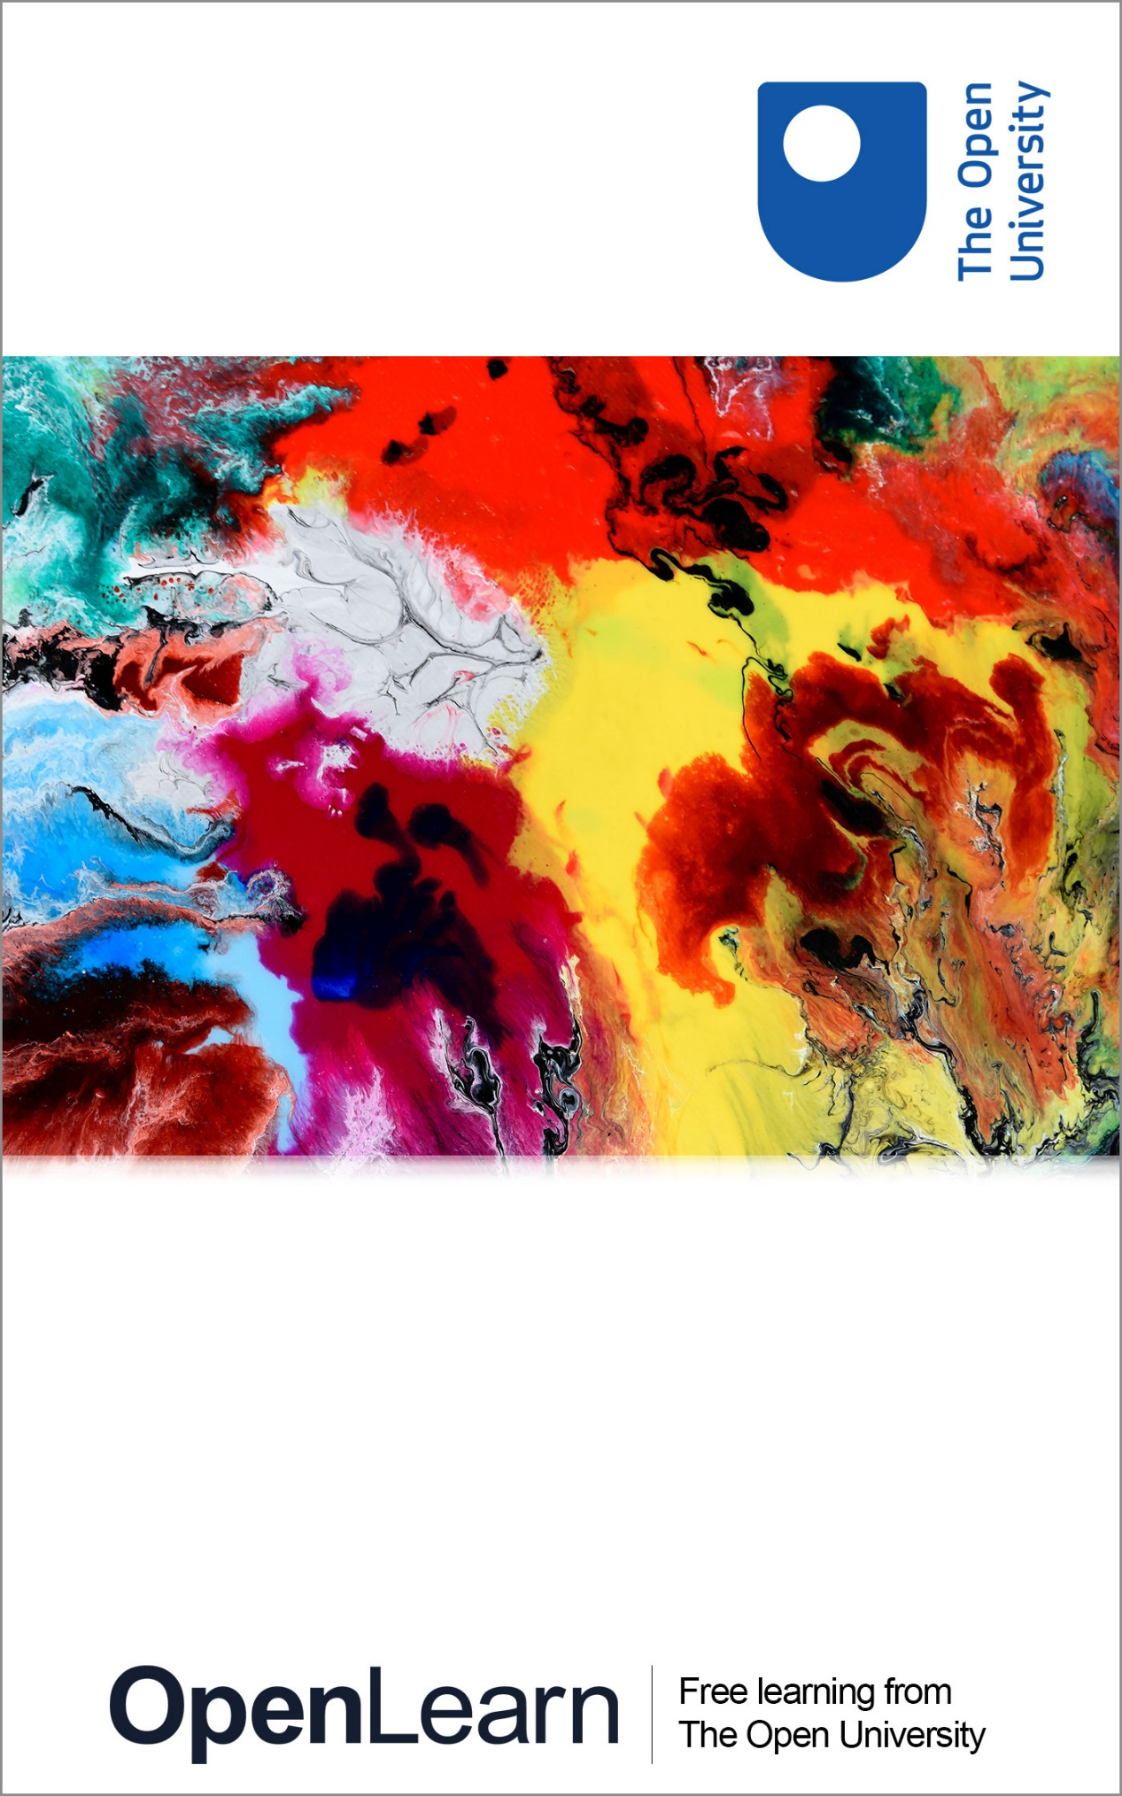

K212_1

Healthy living and choice (title tbc)

About this free course
This free course is an adapted extract from the Open University course .
This version of the content may include video, images and interactive content that may not be optimised for your device.
You can experience this free course as it was originally designed on OpenLearn, the home of free learning from The Open University –
There you’ll also be able to track your progress via your activity record, which you can use to demonstrate your learning.
First published 2026.
Unless otherwise stated, copyright © 2026 The Open University, all rights reserved.
Intellectual property
Unless otherwise stated, this resource is released under the terms of the Creative Commons Licence v4.0 http://creativecommons.org/licenses/by-nc-sa/4.0/deed.en. Within that The Open University interprets this licence in the following way: www.open.edu/openlearn/about-openlearn/frequently-asked-questions-on-openlearn. Copyright and rights falling outside the terms of the Creative Commons Licence are retained or controlled by The Open University. Please read the full text before using any of the content.
We believe the primary barrier to accessing high-quality educational experiences is cost, which is why we aim to publish as much free content as possible under an open licence. If it proves difficult to release content under our preferred Creative Commons licence (e.g. because we can’t afford or gain the clearances or find suitable alternatives), we will still release the materials for free under a personal end-user licence.
This is because the learning experience will always be the same high quality offering and that should always be seen as positive – even if at times the licensing is different to Creative Commons.
When using the content you must attribute us (The Open University) (the OU) and any identified author in accordance with the terms of the Creative Commons Licence.
The Acknowledgements section is used to list, amongst other things, third party (Proprietary), licensed content which is not subject to Creative Commons licensing. Proprietary content must be used (retained) intact and in context to the content at all times.
The Acknowledgements section is also used to bring to your attention any other Special Restrictions which may apply to the content. For example there may be times when the Creative Commons Non-Commercial Sharealike licence does not apply to any of the content even if owned by us (The Open University). In these instances, unless stated otherwise, the content may be used for personal and non-commercial use.
We have also identified as Proprietary other material included in the content which is not subject to Creative Commons Licence. These are OU logos, trading names and may extend to certain photographic and video images and sound recordings and any other material as may be brought to your attention.
Unauthorised use of any of the content may constitute a breach of the terms and conditions and/or intellectual property laws.
We reserve the right to alter, amend or bring to an end any terms and conditions provided here without notice.
All rights falling outside the terms of the Creative Commons licence are retained or controlled by The Open University.
Head of Intellectual Property, The Open University

Contents
- Introduction
- Learning outcomes
- 1 Quantitative research and the body mass index
  - 1.1 Understanding lifestyles
  - 1.2 ‘Lifestylism’
  - 1.2 Quantitative research
  - 1.3 Benefits of the body mass index
  - 1.4 Weaknesses of the body mass index
  - 1.5 Section summary
- 2 Qualitative research and obesity
  - 2.1 Lifestyles in context
  - 2.2 Qualitative research
  - 2.3 Is obesity the responsibility of the individual concerned?
  - 2.4 Section summary
- 3 Changing health-related behaviours; the case of obesity
  - 3.1 Changing health-related behaviours
  - 3.2 The scale of obesity as an issue
  - 3.3 What do the statistics mean?
  - 3.4 Improving understanding about what we eat
  - 3.5 Encouraging behavioural change
- 4 Quiz
- Conclusion
- References
- Acknowledgements
- Glossary
- Solutions
- Descriptions

Introduction

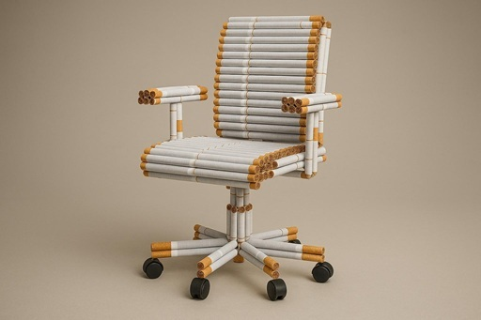
Figure 1 How do we make lifestyle choices?
View description - Figure 1 How do we make lifestyle choices?

[Editor: remaining queries / to do list:]
[Editor: course title to be finalised (FYI the old version of this course was called Exploring health: is your lifestyle really to blame?)]
[Editor: course image to be picked (banner image that sits on front of course, and thumbnail size at the top of every page, currently has a placeholder in situ)]
[Editor: some short bits of text to be added to section opening pages (I've suggested a possible solution for Section 3, see comment on that page)]
[Editor: Section 1.2 – Figure 3 – to be added? or removed?]
[Editor: Section 2.1 – section at bottom to be kept where it is, or moved to separate page?]
[Editor: Section 3.4 – see query about editing the learning guide reference out]
[Editor: full reference info to be added. I've collated the short refs to get that started (see References page)]
[Editor: glossary – couldn’t find a definition for ‘structural’ on the module site, can one be provided?]
[Editor: see Acknowledgements page – course credit to be added! can be as detailed as appropriate to credit everyone who’s worked on this course]
People make choices, but not in circumstances of their own choosing. That is to say, we all do make health choices, like choosing what we eat. But the circumstances of such choices aren’t always entirely under our control. For example, we don’t pick what a supermarket sells to us, we don’t necessarily understand what goes into the way a brand or a product is advertised. What is ‘healthy’ also changes over time. In the 1950s and 1960s, for instance, white bread was often advertised as ‘healthy’ – that is less true now, compared to seeded loaves. These are the kind of choices that we might already know something about. But what about all the broader circumstances we don’t know anything about, but which might nevertheless affect our health?
So, are the factors influencing our health and wellbeing social or structural, or can they be exclusively attributed to individual differences in terms of lifestyle? For instance, in high-income countries, many people live physically inactive lifestyles, and this can have a negative impact on a person’s health as it is associated with obesity. By considering the impact of social, cultural, political and economic factors that influence obesity in adulthood, you will investigate whether a focus on lifestyles and a person’s behaviours is sufficient to explain contemporary health and wellbeing concerns. You will also learn about two broad approaches used to generate evidence in the field of health: quantitative and qualitative research.
This OpenLearn course is an adapted extract from the Open University course K212 Critical ideas in wellbeing and public health. You can find out more about Open University courses and qualifications, tuition fees and funding options by visiting our online prospectus.

Learning outcomes
After studying this course, you should be able to:
- describe what the term ‘lifestylism’ means
- demonstrate a basic understanding of what quantitative research involves
- discuss the body mass index, what it measures, its benefits and weaknesses
- understand how ‘structural’ factors can influence health
- demonstrate a basic understanding of qualitative research
- outline the basics of obesity.

1 Quantitative research and the body mass index

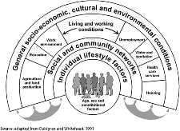
Figure 2 The social determinants of health (adapted from Dahlgren and Whitehead, 1991, cited in Dahlgren and Whitehead, 2021)
View description - Figure 2 The social determinants of health (adapted from Dahlgren and Whitehead, ...

[Editor: can some brief text be added here to introduce the section?]

1.1 Understanding lifestyles
What is meant by the term ‘lifestyle’?
The Oxford English Dictionary defines it as:

A style or way of living (associated with an individual person, a society, etc.); esp. the characteristic manner in which a person lives (or chooses to live) his or her life.
(OED, 2023a)

In this definition, the whole notion of ‘lifestyle’ is bound up with an individual’s choices and habits. The concept of lifestyles as choice can become problematic when considering the boundaries around what is innate and what is something a person selects for themselves – in other words, what is a choice and what is something a person has very little (or no) conscious control over. Very few people will have the ‘ideal healthy lifestyle’. Instead, most have aspects of their lifestyle that are healthy and others that are less healthy. The next activity asks you to consider certain lifestyle factors to help you make sense of key aspects of your own behaviours related to health and wellbeing.

Activity 1 Describing your own lifestyle
Allow about 30 minutes

Part 1
Looking at the list of behaviours below, click the button that best describes how frequently you carry out that behaviour.
(If it helps, think about their applicability over the last month.)

Interactive content is not available in this format.

View discussion - Part

Part 2
Pick one of the lifestyle factors from Part 1 that you find easy to maintain as part of your lifestyle. Summarise why you find it easy in the box below.
(For example, if you are currently a non-smoker and find this easy to maintain, why is this?)

Provide your answer...
View discussion - Part

Pick one of the lifestyle factors from Part 1 that you find challenging to change, and summarise why that is.
(For example, if you spend a lot of time being sedentary and sitting for long periods, why is it challenging to be more active?)

Provide your answer...
View discussion - Part

1.2 ‘Lifestylism’
The term ‘lifestyle’ is often associated with health-related behaviours, like those you considered in Activity 1. A substantial amount of the total current burden of disease (i.e., the number of years of life lost to disease and the number of years lived with disability as a result of disease) is attributable to unhealthy behaviours such as smoking, alcohol misuse, poor diet and a lack of physical exercise (Jagannathan et al., 2019; Dai et al., 2020; Timmis et al., 2022).
The term ‘lifestylism’ was coined by Petr Skrabanek (1994) and implies that most diseases are caused by the unhealthy behaviour of individuals, such that it is people’s lifestyles that affect their health, and indeed their life expectancy. This link between behaviour and disease has been much emphasised by health professionals.
Learning about lifestyles and wellbeing requires some ‘way of knowing’. In other words, some evidence is needed to ‘make sense’ of the challenge of adult obesity, to take one example. Such evidence can be acquired through both quantitative and qualitative research methods. In the next section, you will begin to explore how quantitative evidence is used to understand what obesity is and how it is linked to unhealthy lifestyles, before moving on to qualitative approaches later in the course.

1.2 Quantitative research


[Editor: Figure 3 (image to be picked/added? no problem to cut the figure entirely though if that’s easier)]

Quantitative research reflects the philosophical stance of ‘positivism’. Those who ascribe to this position believe a topic of research can be described, recorded and studied numerically in a scientific manner. In simple terms, they believe that it is possible to quantify and therefore measure, in a research context, most aspects of life. For instance:
- Basic descriptive statistics can often be used to describe a population by comparing different age ranges or genders. For example, the Office for National Statistics (ONS) reported that in the UK in 2022, 12.9 per cent of people aged 18 years and over smoked cigarettes. The highest proportion of smokers in 2022 was in Wales (14.1 per cent) and the lowest was in England (12.7 per cent); Northern Ireland and Scotland reported 14 per cent and 13.9 per cent respectively (ONS, 2023).
- Correlational analysis explores relationships between factors or variables. For instance, there is a correlation between neighbourhood socioeconomic environment and obesity. Living in an area of higher deprivation (as measured by the deprivation index score) is an indicator of higher risk of obesity in children as young as 18 months (Conrey et al., 2022).
- Experimental research can be used to measure the effect of an intervention. That is to say, it can show the difference, if any, that a specific change has made. As an example, Naima Covassin et al. (2022) showed that if you deprive someone of sleep, then this heightens the risk of obesity.
Quantitative research involves using methods such as questionnaires or collecting numerical data in a repeated and controlled way. Geoff Payne and Judy Payne (2011) conclude that almost all forms of quantitative research share certain features:
- describing and/or accounting for phenomena
- breaking down or separating behaviour into variables or factors that can be measured
- containing statistical results that are analysed in a structured way.
In the next section, you’ll look at a type of quantitative research that uses statistical data to analyse overweight and obesity across a population.

1.3 Benefits of the body mass index

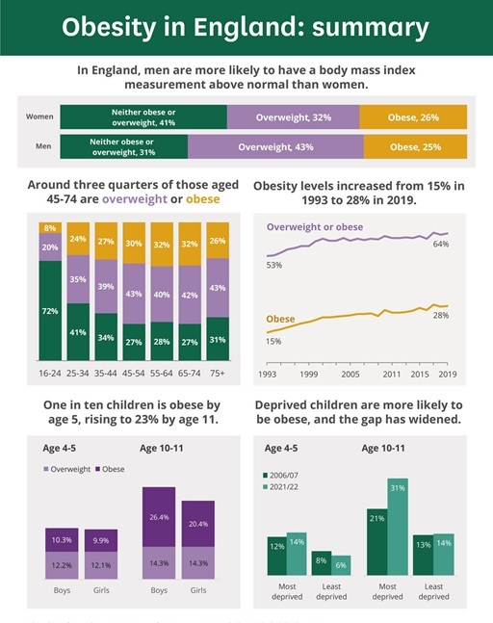
Figure 4 Obesity in England (Baker, 2023)
View description - Figure 4 Obesity in England (Baker, 2023)

Quantitative research is particularly useful for studying whole populations and identifying general trends and relationships because it makes use of statistical data. The results of large-scale, quantitative studies are frequently summarised in documents like government-commissioned reports or academic journal articles, but these documents are not particularly accessible or easy to interpret. For this reason, agencies such as Public Health England (disbanded in 2021, partly incorporated into the Office for Health Improvement and Disparities) sum up key findings using infographics, as seen in [Editor: Figure 4] – although these too can be inaccessible to some.
Body mass index (BMI) is a widely used measure for working out if a person’s weight is ‘healthy’. BMI is calculated by dividing an adult’s weight in kilograms by their height in metres squared. As such, BMI can be used to calculate and compare weights of groups of people relative to their heights. The weight categories for interpreting BMI for adults are shown in Table 1.

Table 1 Weight categories for BMI (NHS, 2023)
Weight category | BMI
Underweight | <18.5 kg/m²
Healthy weight range | 18.5–24.9 kg/m²
Overweight | 25–29.9 kg/m²
Obese | 30–39.9 kg/m²
Severely obese | >40 kg/m²
(Note that the symbol < means ‘less than’ and > means ‘more than’.)

However, BMI has its critics, and you will look at some of the drawbacks of this statistical method next.

1.4 Weaknesses of the body mass index
BMI is just a measure of weight relative to height, and as such is very much an imperfect health metric. For example, a very muscular person may weigh more because muscle is denser than fat. As a result, they may have a higher BMI than someone who has less muscle but is the same height.
A person’s high BMI shouldn’t necessarily be cause for concern, so much as an unhealthy diet and lack of physical activity, as these factors are the leading causes of the major non-communicable diseases, such as diabetes and cardiovascular disease (World Health Organization, 2023). Researchers have also questioned the validity of BMI as a representative health measure:

Primarily derived from data obtained on Anglo-Saxon populations, the generalizability and applicability of the BMI and its cut-off points to other populations has been questioned and its sensitivity as a measure of excess fat queried.
(Eknoyan, 2008, p. 48)

The next activity asks you to categorise three adults based on their BMI (health and social care professionals are often required to interpret and use pre-existing data). You’ll also think more about why BMI on its own can say very little about a person’s overall health.

Activity 2 BMI categories explored
Allow about 15 minutes

Use the BMI chart in [Editor: Figure 5] to identify the category into which each of the three people listed below fit (i.e. ‘underweight’, ‘healthy weight range’, ‘overweight’, ‘obese’ or ‘severely obese’).
Here is the key to the colour coding in the chart:
underweight = green
healthy weight = blue
overweight = white
obese = orange
severely obese = purple
If you would like to access a larger version, click on ‘Maximise’ beneath the image. There is also an accessible version available as a Word file.

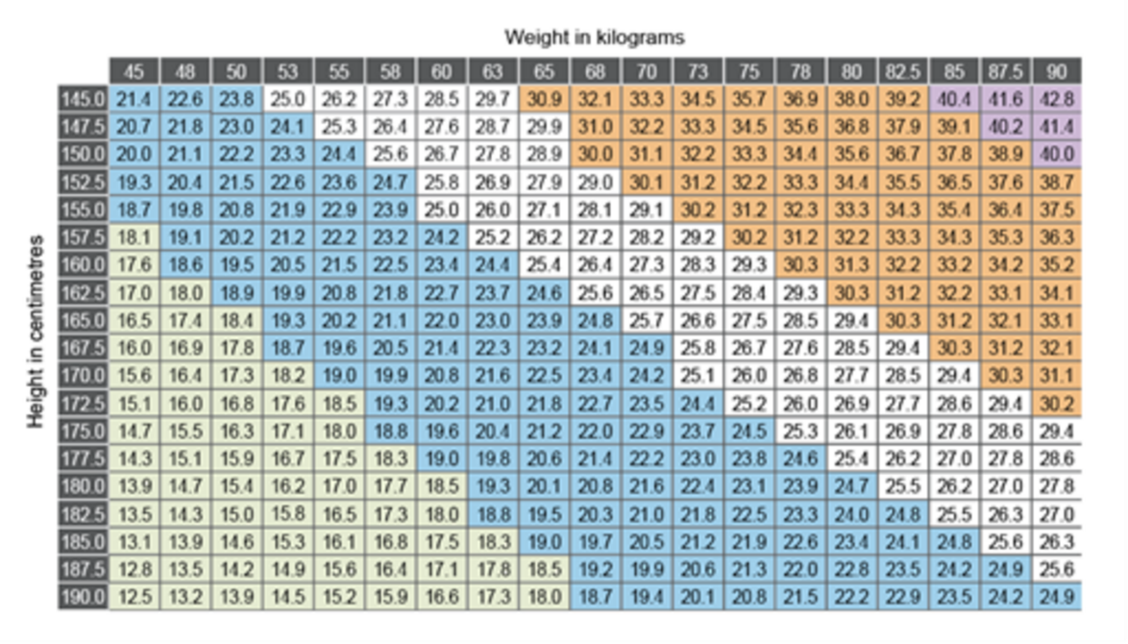
Figure 5 BMI chart [Editor: (add thumbnail / large version)]

Table 2 BMI data
Name | Height (cm) | Weight (kg)
Kaya | 166 | 85
Bradley | 158 | 86
Amber | 171 | 90

Kaya:

underweight: <18.5 kg/m²
healthy weight range: 18.5–25 kg/m²
overweight: 25–30 kg/m²
obese: 30–40 kg/m²
morbidly obese or severely obese: >40 kg/m²
View answer - Part

Bradley:

underweight: <18.5 kg/m²
healthy weight range: 18.5–25 kg/m²
overweight: 25–30 kg/m²
obese: 30–40 kg/m²
morbidly obese or severely obese: >40 kg/m²
View answer - Part

Amber:

underweight: <18.5 kg/m²
healthy weight range: 18.5–25 kg/m²
overweight: 25–30 kg/m²
obese: 30–40 kg/m²
morbidly obese or severely obese: >40 kg/m²
View answer - Part

What can you conclude about the health of Kaya, Bradley and Amber as a result of determining their BMI?

Provide your answer...
View discussion - Part

1.5 Section summary
So far in this course, you’ve critically considered the term ‘lifestyle’. You started by looking at yourself. Then you moved on to consider quantitative methods for understanding our lifestyles and wellbeing. This didn’t go into too much detail, only giving a flavour of what quantitative methods can tell us. In public health, the main application for quantitative research is that it can tell us about whole populations. For example, it could tell us about the public health of all pregnant women, or general statistics about obesity. Then you looked at the BMI as a measurement, finding that it has weaknesses. If you are an athlete, for example, it might not be a particularly good measure for overall health; at the same time, it is a rough tool that can be useful for analysing a whole population.

2 Qualitative research and obesity
[Editor: text to be added here]

2.1 Lifestyles in context

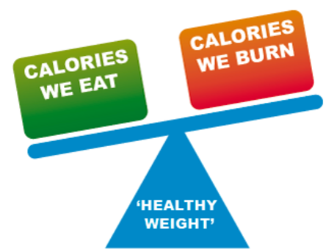
Figure 6 There is more to maintaining a healthy weight than just burning more calories than we eat
View description - Figure 6 There is more to maintaining a healthy weight than just burning more calories ...

The Oxford English Dictionary defines obesity as:

The condition of being extremely fat or overweight; stoutness, corpulence.
(OED, 2023b)

Obesity is frequently seen as a consequence of poor lifestyle choices – the underlying explanatory argument being that it is concerned with individual responsibility. But it is also about how our environment works, invisibly, to support obesity. There is more to obesity than an imbalance between the energy going into a person’s body compared to energy that it expends. Yet this was a view which informed government thinking over many years (Department of Health, 2011).
The Black Report on Inequalities in Health (Department of Health and Social Security, 1980) has been described as a seminal document in debates about health. This report judged material and structural factors (such as income, housing and employment) to be the main contributors to health inequalities. In her review of The Black Report, Professor Dame Margaret Whitehead (1987) concluded that material and structural factors severely limit a person’s choice of lifestyle. In other words, living and working conditions impose severe restrictions on an individual’s ability to choose a healthy lifestyle.
Subsequently published reports such as The Acheson Report (Acheson, 1998) and, more recently, The Marmot Review (Marmot et al., 2010) and Health Equity in England: The Marmot Review 10 years on (Marmot et al., 2020) support this perspective and highlight the importance of social, cultural, political and economic elements, which are at times labelled ‘structural’ factors. Based on this, it has been suggested that an individual’s efforts to change their lifestyle will frequently fail unless the foundations for such changes are established through economic and social supports.
In the next activity, you’ll read an article that challenges the use of individual lifestyle choices as a means to reduce obesity. Martin Cohen argues instead that obesity is an issue that should be tackled at a societal level.

Activity 3 Obesity as a societal issue
Allow about 50 minutes

Read ‘It’s poverty, not individual choice, that is driving extraordinary obesity levels’ (Cohen, 2018), then answer the questions below.

1. According to the article, what is obesity a product of?

Provide your answer...
View discussion - Part

2. According to the article, who is usually treated as being responsible for obesity?

Provide your answer...
View discussion - Part

3. According to the article, how supportive is the food industry of public health initiatives?

Provide your answer...
View discussion - Part

[Editor: new page or keep this segment here?]

The social determinants of health
Social problems such as insecure and erratic employment, inadequate education, stress, depression and a lack of social cohesion all contribute to obesity. According to Cohen, the answer is collective action and tackling the issues which allow ‘obesity germs’ to ‘breed’.
Research evidence suggests that people’s ability to change or choose a lifestyle depends upon a range of social and environmental factors. This evidence takes the form of both quantitative and qualitative research. You have already seen how quantitative research is key in terms of exploring aspects of a health issue such as obesity, whereby obesity can be determined using a statistical measure like BMI. In the next section, you will explore the role of qualitative evidence in furthering our understanding of health issues.

2.2 Qualitative research

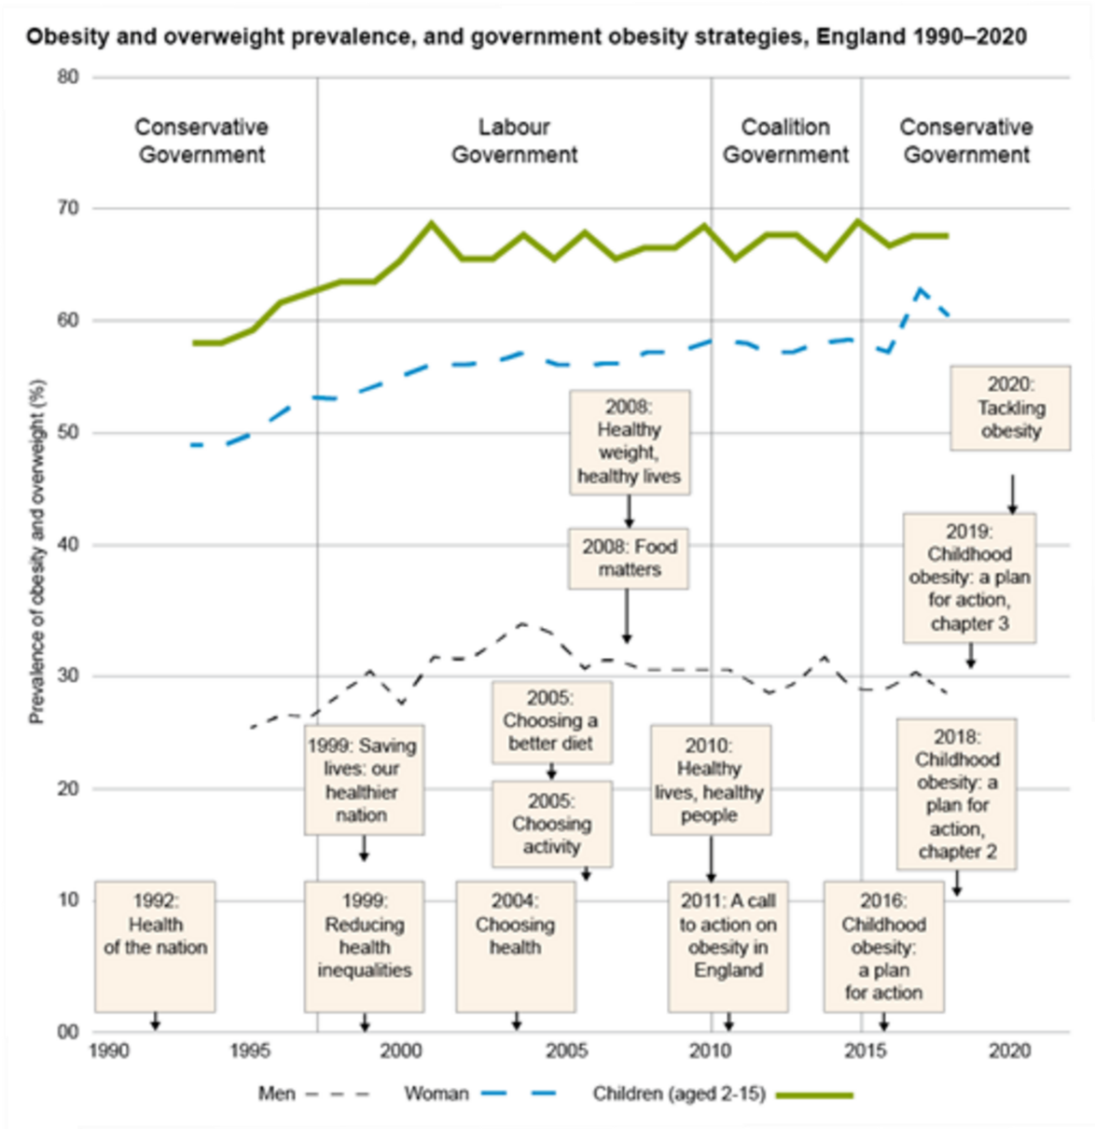
Figure 7 Government strategies on obesity in relation to the prevalence of obesity and overweight in England from 1990 to 2020 (Theis and White, 2021, p. 129)
View description - Figure 7 Government strategies on obesity in relation to the prevalence of obesity ...

The graph in [Editor: Figure 7] depicts quantitative data showing the growing prevalence of obesity and overweight in England, as well as the anti-obesity reports and interventions that have been undertaken by governments since the 1990s. As the graph illustrates, obesity has remained a salient issue because of the health risks associated with it and the various government initiatives developed. This suggests that obesity is a complex challenge, and one that is likely to remain an issue for the foreseeable future. Qualitative research can assist us in the endeavour to more fully understand obesity as an issue.
How people experience their health is highly subjective. For example, how does a person quantify their experience of pain? Or how does someone verify that they are in ‘poor health’? Because of the subjective nature of health and wellbeing generally, and obesity specifically, research methods need to delve into the meaning and reasons behind why a person struggles to lead a healthy lifestyle. It is not that quantitative research is better than qualitative research, it is just that qualitative research answers different types of questions (Busetto, Wick and Gumbinger, 2020).
Qualitative research tends to be associated with smaller-scale studies that involve fewer participants than quantitative studies, and it aims to provide a full and more holistic understanding of research participants’ views and actions. In qualitative research, words are the unit of analysis, rather than numbers. The following are examples of methods used to gather qualitative evidence or data:
- Participant observation involves the researcher systematically describing events and behaviours in the setting of their chosen study. For instance, in fieldwork conducted in a South Australian community that has experienced significant socioeconomic disadvantage, researchers detailed how the ‘problem of fat’ is countered from the experience of the people targeted by obesity interventions (Zivkovic et al., 2018).
- In-depth individual interviews can attempt to explore the world from the perspective of the people studied. In Scotland, 62 members of Men’s Sheds were interviewed ‘to investigate the impacts of Shed activity on the health improvement behaviours and attitudes of Shed users’ (Kelly et al., 2021).
- Focus groups are interviews with a group of people who are asked to explore their views on a topic. For example, in Wales, the capacity and capability of schools to contribute to mental wellbeing has recently been open to question. A study involving focus groups found that ‘existing pressures on schools may impact implementation of a WSA [whole school approach], with school staff already time poor and many staff experiencing their own mental well-being challenges’ (Brown et al., 2023, p. 241).
- Analysis of documents or texts involves the researcher studying in detail selected written texts on a subject. For example, Dolly Theis and Martin White’s (2021) discussion of public health strategies and policies involved document analysis of 689 policies in England between 1992 and 2020.

2.3 Is obesity the responsibility of the individual concerned?
Interventions or solutions for the problem of obesity are not straightforward. Furthermore, obesity is usually treated as the responsibility of individuals or families, not as a social issue. This is problematic, as social, cultural, political and economic factors are major contributors to obesity. Put simply, the challenge of adult obesity cannot be explained as being entirely ‘the individual’s fault’.
You have considered the social, cultural, political and economic factors that are thought to have an impact on adult obesity. This section has encouraged you to think about such factors in relation to a person’s lifestyle, to aid in understanding how they impact upon an individual’s health and wellbeing.
Next, you will consider how change can be made at the policy level to tackle obesity.

2.4 Section summary
You have learnt that the social context is important in determining possible health choices. You have also learnt about qualitative methods of analysing and understanding what is happening. These are preconditions for understanding how we can change health behaviour for the better – something that will be considered in the next section.

3 Changing health-related behaviours; the case of obesity
[Editor: some section intro text to be added here (we could just port the 3.1 content over, and renumber the pages)]

3.1 Changing health-related behaviours

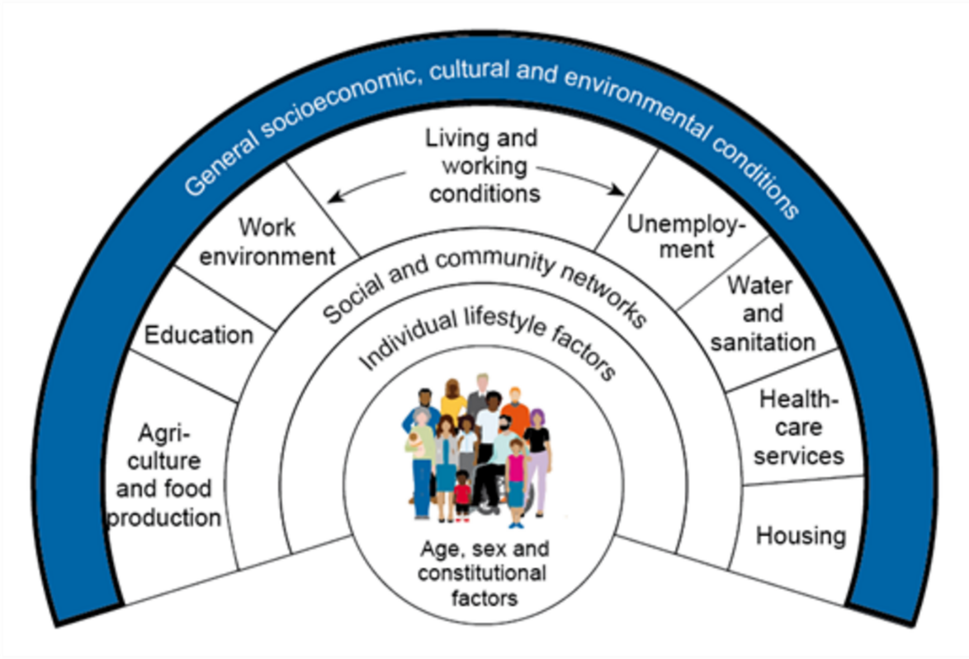
Figure 8 The social determinants of health (Dahlgren and Whitehead, 1991, cited in Dahlgren and Whitehead, 2021)
View description - Figure 8 The social determinants of health (Dahlgren and Whitehead, 1991, cited in ...

You will explore some of the organisations and individuals that have been given the responsibility of tackling the rising levels of obesity in our society. In [Editor: Figure 8], the diagram created by Göran Dahlgren and Margaret Whitehead, the layer labelled ‘General socioeconomic, cultural and environmental conditions’ has been highlighted to show that this will be the focus of this section.

3.2 The scale of obesity as an issue
Obesity has remained an ongoing focus for the UK government (Department of Health, 2012), and it was revisited in a 2020 policy paper called Tackling obesity: empowering adults and children to live healthier lives (Department of Health and Social Care, 2020). The next activity invites you to explore the scale of the obesity problem in the UK.

Activity 4 Obesity: the statistics
Allow about 90 minutes

Read this extract from ‘Obesity statistics’ (Baker, 2023) and note down answers to the following questions.

1. What are the percentages of adults who are overweight and obese in each of the four nations of the UK?

Provide your answer...
View discussion - Part

2. What is the underlying trend in obesity in England?

Provide your answer...
View discussion - Part

Next, you will go beyond the obesity statistics to analyse their meaning, and then consider the strategies that are being pursued to address this issue.

3.3 What do the statistics mean?

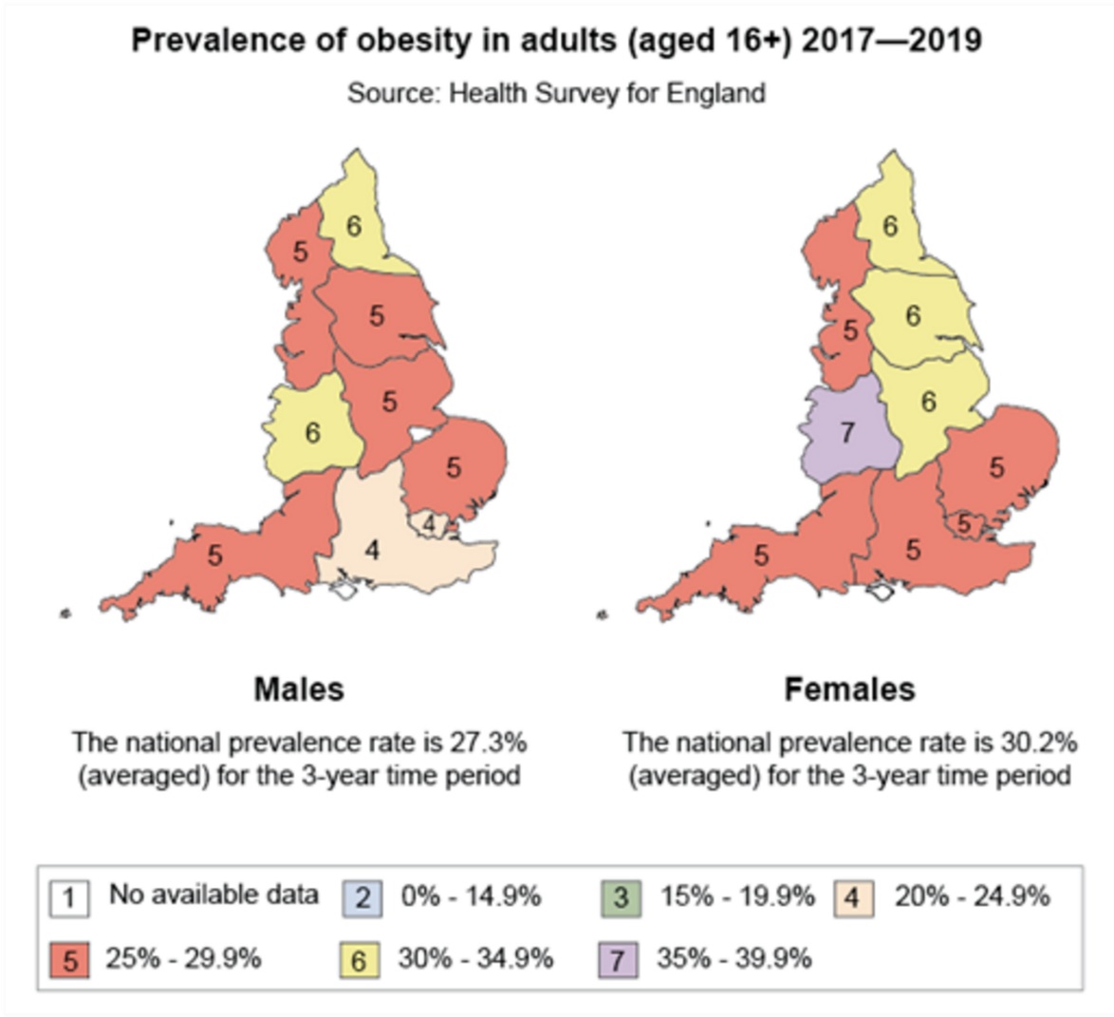
Figure 9 The prevalence of obesity in adults across England (Hancock, 2021)
View description - Figure 9 The prevalence of obesity in adults across England (Hancock, 2021)

As you saw in Activity 4, the broad picture is that over 60 per cent of people in each of the four nations of the UK report that they are overweight or obese, if BMI is the measure used. Of these, not less than a quarter, and in some places nearly a third of people say they are obese. Consider for a moment what this means:
- Objective measures can establish that over 60 percent of people are obese or overweight.
- ‘Not less than a quarter’ think, subjectively, that they are not.
This means there is a gap of understanding between the 25% of people who are obese or overweight and know it, and the 60% people who are obese or overweight but think they are not.
And as you can see from [Editor: Figure 9], according to the UK Health Security Agency, there is a greater problem with obesity in the north of England compared with the south, and a greater number of females categorised as obese in the north of England as well (Hancock, 2021). And although there is variation in different parts of the north or south, it is clear that people living in areas with more income deprivation are more likely to have a range of health conditions, including overweight and obesity (Baker, 2019). The link between deprivation and obesity affects all age groups too, including children, who are more than twice as likely to be obese if they live in the most deprived areas compared with their peers living in the richest areas (Department of Health and Social Care, 2020).
And yet, calls to action on this tend to repeat a focus on individual choice rather than what is given to us:

Governments have adopted less interventionist policy approaches … policies have relied on a design that makes high demands on individual agency, meaning that they rely on individuals to make behavior changes rather than shaping external influences such as the environment or economy and are thus less likely to be effective or reduce health inequities. …
To increase the likelihood of policies being implemented, governments should accompany policy proposals with … a clearly identified responsible agent, evaluation plan, and time frame; and to increase … effectiveness and equability, governments should increasingly focus obesity strategies on ‘low agency’ population intervention[s].
(Theis and White, 2021, pp. 163–164).

In the next activity, you’ll read a report that is not only about what individuals can do to improve their health and reduce their weight, but also what government could do.

Content warning
Please be aware that the next activity discusses COVID-19. If you are concerned this might adversely affect your mental health or wellbeing, you might prefer to skip this activity or engage with it lightly.

Activity 5 What has been done to tackle obesity?
Allow about 60 minutes

Read sections 1 to 3 (‘Introduction’, ‘COVID-19 and obesity’ and ‘A call to action’) in ‘Tackling obesity: empowering adults and children to live healthier lives’ (Department of Health and Social Care, 2020) and then answer the following questions.

1. Is there a link between deprivation and obesity?

Provide your answer...
View discussion - Part

2. According to the policy paper, does the risk from having COVID-19 increase as body mass increases?

Provide your answer...
View discussion - Part

3. What does the report say the government will do to address overweight and obesity in the population?

Provide your answer...
View discussion - Part

Having established the scale of the obesity problem and its costs to society, it is often argued that governments, and even society as a whole, have a responsibility to try to address the issue. If people live in an obesogenic environment, then while it will be necessary to concentrate attention on individual consumers, it is also the case that entrenched interests in society that profit from highly processed foods must be addressed. Next, you will look at how a lack of understanding about what we eat contributes to obesity.

3.4 Improving understanding about what we eat

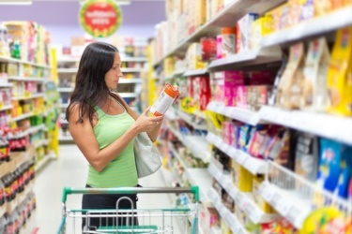
Figure 10 How do we monitor what we eat?
View description - Figure 10 How do we monitor what we eat?

As mentioned previously, obesity is in part the result of consuming more than the body needs. This can be because of unhealthy food choices, such as eating food and consuming drinks high in energy, fat and/or sugar, as well as drinking too much alcohol. But in order to reach and maintain a healthy weight, most people need some assistance to bring about positive behavioural changes. In part, this requires education, so government, industry and individuals need to work together to tackle the issue of obesity.
People can find it difficult to estimate how much they have eaten. Education is therefore central in ensuring people eat well and adopt healthier lifestyles. But what strategies need to be deployed to ensure that people are sufficiently educated? You will explore factors related to diet, nutrition and education, and some of the policies focused on this later in this learning guide. [Editor: < would need to remove this sentence entirely to edit out the reference to LG... but does this paragraph then stand alone well enough without it? or can anything more be added here? ]
Some people think that industry has little to do with obesity, but the food industry has been increasing portion sizes substantially over many years. As our exposure to larger portions has become more and more common, these sizes have come to be seen as appropriate, with consumption then increasing (Marteau et al., 2015; Robinson et al., 2023).
Understanding what we eat is one issue. Another is generating the right kind of behavioural change – and that is what you will look at next as this course comes to a close.

3.5 Encouraging behavioural change

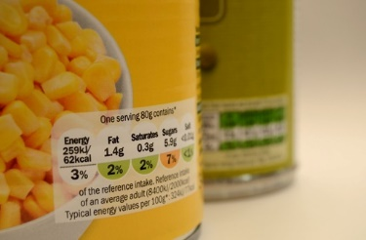
Figure 11 How do we encourage change?
View description - Figure 11 How do we encourage change?

Several strategies have been put forward by the UK government to encourage health-related behavioural changes, and some of these include placing restrictions on industry as follows.
- Promoting healthy eating: regulations governing food-based standards for school lunches (introduced in 2006) ban economy burgers from school lunches, deep-fried products such as chips are limited to twice a week, and chocolate, crisps and sweetened fizzy drinks can no longer be part of school lunches (Department of Health, 2012). However, since these regulations were introduced, childhood obesity has continued to increase.
- Clear nutrition labelling: in the UK, 80 per cent of pre-packaged food carries nutritional information on the front of the packaging. Placing this nutrition information in a prominent place is key to consumers using it in order to make healthier choices (Department of Health and Social Care, 2020).
- Restrictions on food advertising: the government is restricting access to television advertising for ‘unhealthy’ eating choices, which can only be shown beyond the 9pm watershed (Department of Health and Social Care, 2022).
In addition to these government-endorsed strategies, what else can be done to influence behaviour and encourage behavioural change? Behaviour is seen as comprising the interaction of two systems. On the one hand a ‘reflective system’, which emphasises our values, and on the other an ‘automatic system’, where we are not aware of the impulses behind our behaviour (Marteau, n.d.; House of Lords, 2011, pp. 16–17).
One method of changing behaviour is called ‘nudge theory’ (Thaler and Sunstein, 2009). Annaliese Arno and Steve Thomas (2016) consider nudge theory to be a collection of methods, deemed to be ‘nudges’, that have the potential for low-cost and broad application to guide healthier lifestyle choices. Examples include nutrition information being added to menus in a restaurant so that diners can establish how many calories are in a meal (nudging them towards healthier options) and increasing the availability of healthier options in supermarkets (nudging consumers towards selecting healthy food options).

4 Quiz
[Editor: some text here along the lines: ‘here’s an end-of-course quiz to reinforce your learning on the topics covered throughout the course’]

1. Lifestylism

Pick the correct answer from the options below.
The term ‘lifestylism’, created by Petr Skrabanek (1994), implies which of the following?

Most diseases are caused by the unhealthy behaviour of individuals, such that it is people’s lifestyles that affect their health and, indeed, their life expectancy.
Most diseases are caused by biological entities of one kind of another, not because of anything that a person does, and could affect their life expectancy.
Most diseases are caused by the healthy behaviour of individuals, and happen in spite of their lifestyle.
View answer - 1. Lifestylism

2. Quantitative Research

Pick the correct answer from the options below.

Quantitative research reflects the philosophical stance of ‘positivism’. Those who ascribe to this position believe a topic of research can be described, recorded and studied numerically in a scientific manner. In simple terms, they believe that it is possible to quantify and therefore measure, in a research context, most aspects of life.
Quantitative research reflects the philosophical stance of ‘negativism’. Those who ascribe to this position believe a topic of research can be described, recorded and studied using words. In simple terms, they believe that it is possible to deal scientifically with the words that people speak in everyday terms.
Quantitative research reflects the philosophical stance of ‘integrationism’. Those who ascribe to this position believe a topic of research can be described, recorded and studied numerically or using the words that people speak. In simple terms, they believe that it is possible to quantify and therefore measure the words that people speak, or use numbers to represent what people say.
View answer - 2. Quantitative Research

3. The body mass index

Pick the correct answer from the options below.

Body mass index (BMI) is a widely used measure for working out if a person’s weight is ‘healthy’. BMI is calculated by dividing an adult’s weight in kilograms by their height in metres squared. As such, BMI can be used to calculate and compare weights of groups of people relative to their heights.
Body mass index (BMI) is a widely used measure for working out if a person’s weight is ‘unhealthy’. BMI is calculated by multiplying an adult’s weight in kilograms by their waist size in metres cubed. As such, BMI can be used to calculate and compare weights of groups of people relative to their heights.
Body mass index (BMI) is a widely used measure for working out if a person’s weight is ‘healthy’. BMI is calculated by adding an adult’s weight in kilograms to their height. As such, BMI can be used to calculate and compare weights of groups of people relative to their heights.
View answer - 3. The body mass index

4. Obesity

The Black Report on Inequalities in Health (Department of Health and Social Security, 1980) has been described as a seminal document in debates about health. This report judged material and structural factors (such as income, housing and employment) to be the main contributors to health inequalities. In her review of The Black Report, Professor Dame Margaret Whitehead (1987) concluded that material and structural factors severely limit a person’s choice of lifestyle. In other words, living and working conditions impose severe restrictions on an individual’s ability to choose a healthy lifestyle.
Read these two analyses, then indicate beneath which is true.

(a) Subsequently published reports such as The Acheson Report (Acheson, 1998) and, more recently, The Marmot Review (Marmot et al., 2010) and Health Equity in England: The Marmot Review 10 years on (Marmot et al., 2020) support this perspective and highlight the importance of social, cultural, political and economic elements, which are at times labelled ‘structural’ factors. Based on this, it has been suggested that an individual’s efforts to change their lifestyle will frequently fail unless the foundations for such changes are established through economic and social supports.
(b) Subsequently published reports such as The Acheson Report (Acheson, 1998) and, more recently, The Marmot Review (Marmot et al., 2010) and Health Equity in England: The Marmot Review 10 years on (Marmot et al., 2020) do not support this perspective and suggest that the social, cultural, political and economic elements, which are at times labelled ‘structural’ factors, are unimportant factors in public health. Based on this, it has been suggested that an individual’s efforts to change their lifestyle will succeed unless the economic and social factors are disregarded.

(a) is true
(b) is true
View answer - Part

5. Qualitative research

Pick the correct answer from the options below.

Qualitative research tends to be associated with smaller-scale studies that involve fewer participants than quantitative studies, and it aims to provide a full and more holistic understanding of research participants’ views and actions. In qualitative research, words rather than numbers are the unit of analysis.
Qualitative research tends to be associated with large-scale studies that involve many more participants than quantitative studies, and it aims to provide a narrow and limited of research participants’ views and actions. In qualitative research, numbers rather than words are the unit of analysis.
Qualitative research tends to be associated with smaller-scale or larger studies that can involve any amount of people. It aims to provide a full understanding of research participants’ views and actions, but can also provide a narrow understanding. In qualitative research, words or numbers are the unit of analysis.
View answer - 5. Qualitative research

6. Obesity statistics

Drag and drop the numbers to fill in the statistics below (drawn from the work of Baker, 2023).

View discussion - 6. Obesity statistics

Conclusion
In this course you have considered how, in relation to our health choices, we do make choices – but not in circumstances of our own choosing. Yes, we can make choices about what we eat, but we are at least influenced (knowing or unknowingly) by other factors. Therefore, it isn’t just us who are responsible for addressing our own obesity; it’s something for the food industry to engage with as well. You have considered two ways of investigating these matters: quantitative and qualitative methods. (You have not gone into either in great depth in this short course, but hopefully it has opened up an interest to study this topic further.) These research methods are not opposed to each other, rather they ask different types of questions.
Providing people with adequate knowledge about what they eat, in addition to ensuring that government, industry and individuals work together, will assist in encouraging healthy behavioural change. Strategies are already in place, and theories of behavioural change are utilised, but it is likely that greater efforts will be required to ensure the upward trend in obesity is reversed.
This free OpenLearn course is an adapted extract from the Open University course K212 Critical ideas in wellbeing and public health.

References
Acheson, D. (1998) Independent inquiry into inequalities in health report. London: The Stationery Office. Available at: https://assets.publishing.service.gov.uk/government/uploads/system/uploads/attachment_data/file/265503/ih.pdf (Accessed: 3 September 2026).
Arno, A. and Thomas, S. (2016) ‘The efficacy of nudge theory strategies in influencing adult dietary behaviour: a systematic review and meta-analysis’, BMC Public Health, 16, article number 676. Available at: https://bmcpublichealth.biomedcentral.com/articles/10.1186/s12889-016-3272-x (Accessed: 3 September 2026).
Baker, C. (2019) Health inequalities: income deprivation and north/south divides. (House of Commons Library: Insight). Available at: https://commonslibrary.parliament.uk/health-inequalities-income-deprivation-and-north-south-divides (Accessed: 3 September 2026).
Baker, C. (2023) House of Commons Library - obesity statistics. London: UK Parliament. Available at: https://researchbriefings.files.parliament.uk/documents/SN03336/SN03336.pdf (Accessed: 16 February 2024).
Brown, R. et al. (2023) ‘A qualitative exploration of stakeholder perspectives on the implementation of a whole school approach to mental health and emotional well-being in Wales’, Health Education Research, 38(3), pp. 241–253. Available at: https://doi.org/10.1093/her/cyad002
Busetto, L., Wick, W. and Gumbinger, C. (2020) ‘How to use and assess qualitative research methods’, Neurological Research and Practice, 2, article number 14. Available at: https://doi.org/10.1186/s42466-020-00059-z
Cohen, M. (2018) ‘It’s poverty, not individual choice, that is driving extraordinary obesity levels’, The Conversation, 19 February. Available at: https://theconversation.com/its-poverty-not-individual-choice-that-is-driving-extraordinary-obesity-levels-91447 (Accessed: 3 September 2026).
Conrey, S.C. et al. (2022) ‘Neighbourhood socio-economic environment predicts adiposity and obesity risk in children under two’, Pediatric Obesity, 17(12), article number e12964. Available at: https://doi.org/10.1111/ijpo.12964
Covassin, N. et al. (2022) ‘Effects of experimental sleep restriction on energy intake, energy expenditure, and visceral obesity’, Journal of the American College of Cardiology, 79(13), pp. 1254–1265. Available at: https://doi.org/10.1016/j.jacc.2022.01.038
[Editor: Dahlgren and Whitehead, 1991], cited in Dahlgren and Whitehead (2021)
Dahlgren, G. and Whitehead, M. (2021) ‘The Dahlgren–Whitehead model of health determinants: 30 years on and still chasing rainbows’, Public Health, 199, pp. 20–24. Available at: https://doi.org/10.1016/j.puhe.2021.08.009
Dai, H. et al. (2020) ‘The global burden of disease attributable to high body mass index in 195 countries and territories, 1990–2017: an analysis of the Global Burden of Disease Study’, PLOS Medicine, 17(7), article number e1003198. Available at: https://doi.org/10.1371/journal.pmed.1003198
Department of Health (2011) Healthy lives, healthy people: a call to action on obesity in England. Available at: https://assets.publishing.service.gov.uk/government/uploads/system/uploads/attachment_data/file/213720/dh_130487.pdf (Accessed: 3 September 2026).
Department of Health (2012) An update on the government’s approach to tackling obesity. London: National Audit Office. Available at: https://www.nao.org.uk/wp-content/uploads/2012/07/tackling_obesity_update.pdf (Accessed: 3 September 2026).
Department of Health and Social Care (2020) Tackling obesity: empowering adults and children to live healthier lives. Available at: https://www.gov.uk/government/publications/tackling-obesity-government-strategy/tackling-obesity-empowering-adults-and-children-to-live-healthier-lives (Accessed: 3 September 2026).
Department of Health and Social Care (2022) Health and Care Bill: advertising of less healthy food and drink. Available at: https://www.gov.uk/government/publications/health-and-care-bill-factsheets/health-and-care-bill-advertising-of-less-healthy-food-and-drink (Accessed: 3 September 2026).
Department of Health and Social Security (1980) Inequalities in health: report of a working group chaired by Sir Douglas Black. London: Department of Health and Social Security.
Eknoyan, G. (2008) ‘Adolphe Quetelet (1796–1874) – the average man and indices of obesity’, Nephrology, Dialysis, Transplantation, 23(1), pp. 47–51. Available at: https://doi.org/10.1093/ndt/gfm517
Hancock, C. (2021) ‘Patterns and trends in excess weight among adults in England’, UK Health Security Agency blog, 4 March. Available at: https://ukhsa.blog.gov.uk/2021/03/04/patterns-and-trends-in-excess-weight-among-adults-in-england (Accessed: 3 September 2026).
House of Lords (2011) Behaviour change: Science and Technology Select Committee, second report of Session 2010–12. (HL Paper 179). London: The Stationery Office. Available at: https://publications.parliament.uk/pa/ld201012/ldselect/ldsctech/179/179.pdf (Accessed: 3 September 2026).
Jagannathan, R. et al. (2019) ‘Global updates on cardiovascular disease mortality trends and attribution of traditional risk factors’, Current Diabetes Reports, 19(44). Available at: https://doi.org/10.1007/s11892-019-1161-2
Kelly, D. et al. (2021) ‘Men’s sheds as an alternative healthcare route? A qualitative study of the impact of Men’s sheds on user’s health improvement behaviours’, BMC Public Health, 21, article number 553. Available at: https://doi.org/10.1186/s12889-021-10585-3
Marmot, M. et al. (2010) Fair society, healthy lives: the Marmot Review. Strategic review of health inequalities in England post-2010. London: The Marmot Review. Available at: https://www.parliament.uk/documents/fair-society-healthy-lives-full-report.pdf (Accessed: 3 September 2026).
Marmot, M. et al. (2020) Health equity in England: the Marmot Review 10 years on. London: Institute of Health Equity. Available at: https://www.health.org.uk/publications/reports/the-marmot-review-10-years-on (Accessed: 3 September 2026).
Marteau, T.M. et al. (2015) ‘Downsizing: policy options to reduce portion sizes to help tackle obesity’, BMJ, 351, article number h5863. Available at: https://doi.org/10.1136/bmj.h5863
[Editor: Marteau (n.d.), quoted in Parliament]
NHS (2023) Overweight and obesity in adults. Available at: https://www.nhs.uk/conditions/overweight-and-obesity (Accessed: 3 September 2026).
OED (2023a) Definition of ‘lifestyle’. Available at: https://www.oed.com/dictionary/lifestyle_n (Accessed: 3 September 2026).
OED (2023b) Definition of ‘obesity’. Available at: https://www.oed.com/dictionary/obesity_n (Accessed: 3 September 2026).
Office for National Statistics (ONS) (2023) Adult smoking habits in the UK: 2022. Available at: https://www.ons.gov.uk/peoplepopulationandcommunity/healthandsocialcare/healthandlifeexpectancies/bulletins/adultsmokinghabitsingreatbritain/2022 (Accessed: 3 September 2026).
Payne, G. and Payne, J. (2011) ‘Quantitative methods’, in G. Payne and J. Payne, Key concepts in social research. London: SAGE Publications. Available at: https://doi.org/10.4135/9781849209397.n38
Robinson, E. et al. (2023) ‘Downsizing food: a systematic review and meta-analysis examining the effect of reducing served food portion sizes on daily energy intake and body weight’, British Journal of Nutrition, 129(5), pp. 888–903. Available at: https://doi.org/10.1017/S0007114522000903
Skrabanek, P. (1994) The death of humane medicine and the rise of coercive healthism. Bury St Edmunds: The Social Affairs Unit.
Thaler, R.H. and Sunstein, C.R. (2009) Nudge: improving decisions about health, wealth and happiness. London: Penguin Books.
Theis, D.R.Z. and White, M. (2021) ‘Is obesity policy in England fit for purpose? Analysis of government strategies and policies 1992–2020’, The Millbank Quarterly, 99(1), pp. 126–170. Available at: https://doi.org/10.1111/1468-0009.12498
Timmis, A. et al. (2022) ‘European Society of Cardiology: cardiovascular disease statistics 2021’, European Heart Journal, 43(8), pp. 716–799. Available at: https://doi.org/10.1093/eurheartj/ehab892
UK Chief Medical Officers (2019) UK Chief Medical Officers’ physical activity guidelines. Available at: https://www.gov.uk/government/publications/physical-activity-guidelines-uk-chief-medical-officers-report (Accessed: 3 September 2026).
Whitehead, M. (1987) The health divide: inequalities in health in the 1980s. London: Health Education Council.
Zivkovic, T. et al. (2018) ‘Fat as productive: enactments of fat in an Australian suburb’, Medical Anthropology, 37(5), pp. 373–386. Available at: https://www-tandfonline-com.libezproxy.open.ac.uk/doi/abs/10.1080/01459740.2018.1423563 (Accessed: 3 September 2026).

Acknowledgements
This free course was written by [Editor: to be added]
Figures
Videos
Except for third party materials and otherwise stated (see terms and conditions), this content is made available under a Creative Commons Attribution-NonCommercial-ShareAlike 4.0 Licence.
The material acknowledged below is Proprietary and used under licence (not subject to Creative Commons Licence). Grateful acknowledgement is made to the following sources for permission to reproduce material in this free course:
Every effort has been made to contact copyright owners. If any have been inadvertently overlooked, the publishers will be pleased to make the necessary arrangements at the first opportunity.
Don’t miss out
If reading this text has inspired you to learn more, you may be interested in joining the millions of people who discover our free learning resources and qualifications by visiting The Open University – www.open.edu/openlearn/free-courses.

Glossary
Body mass index (BMI)
A measure of nutrition that takes the ratio of an individual’s weight in relation to height. BMI is calculated as weight in kilograms divided by height in metres squared.
Correlation
The measure of association between two variables calculated using the correlation coefficient, which is a statistical way of measuring the strength of the relationship between two variables.
Deprivation
A general lack of resources and opportunities in a community.
Health and wellbeing
Takes into account the whole person. In this sense, health includes physical, mental and social wellbeing.
Health inequalities
Avoidable inequalities in health status. In much of the literature the terms ‘health inequity’ and ‘health inequality’ are used interchangeably.
Holistic
In a medical context, an approach that sees the whole person and not just the disease. It recognises that there are a lot of factors involved in health and illness and that physical, mental, emotional, spiritual and environmental aspects need to be taken into account in care and treatment.
Life expectancy
The average number of additional years a person could expect to live if mortality at each age remained constant for the rest of their life.
Non-communicable diseases
Disease that cannot be passed from one person to another.
Obesity
According to the NHS, adults with a BMI of over 30 can be categorised as obese.
Obesogenic
Causing obesity.
Population
A research population is generally a large collection of individuals or objects that is the main focus of a scientific query. This could be all UK residents (census), but it might be all students currently at UK universities, the population of a town or any other defined group.
Qualitative
A research approach used when the aim is to gain an understanding of people’s feelings, opinions and motivations. Qualitative research gives insight into a problem or issues. Qualitative data collection methods include focus groups, interviews and observation/participant observation. The sample size is typically small and very carefully selected so as to address the research question in the best possible way.
Quantitative
Research that involves the collection and analysis of numerical data that can be interrogated through statistical methods.
Statistics
The science of learning from data.
Structural
[Editor: to be added]
Values
A set of important beliefs or ideals shared by members of a culture or profession about what is good or bad and desirable or undesirable. Values have major influence on our personal and professional behaviours and often serve us as broad guidelines in our professional responses.
Variables
In research, any factor that can change and that can be measured.

Solutions

Activity 1 Describing your own lifestyle

Part

Discussion
The eight behaviours you have considered are not an exhaustive list, but represent some of the key factors thought to be relevant to a healthy lifestyle. For instance:

Each week, adults should accumulate at least 150 minutes (2 1/2 hours) of moderate intensity activity (such as brisk walking or cycling); or 75 minutes of vigorous intensity activity (such as running); or even shorter durations of very vigorous intensity activity (such as sprinting or stair climbing); or a combination of moderate, vigorous and very vigorous intensity activity.
(UK Chief Medical Officers, 2019, p. 10)

Back to - Part

Part

Discussion
Here’s an example response:

We have a dog, so I get out walking every day and also use parks and green spaces often. I wonder if I would find this as easy if we didn’t have the dog. I imagine I’d find it harder to motivate myself to get out in the cold and wet weather.

Back to - Part

Part

Discussion
You may find some lifestyle factors easy to change, while others are more difficult.
Here’s an example response:

I sit for long periods every day due to my job. This worries me and I would like to be more active but with work and a young family I don’t find it easy to build exercise into my day. Often the only physical exercise I get is walking the children to school.

Back to - Part

Activity 2 BMI categories explored

Part

Answer
Right:
obese: 30–40 kg/m²
Wrong:
underweight: <18.5 kg/m²
healthy weight range: 18.5–25 kg/m²
overweight: 25–30 kg/m²
morbidly obese or severely obese: >40 kg/m²
Back to - Part

Part

Answer
Right:
obese: 30–40 kg/m²
Wrong:
underweight: <18.5 kg/m²
healthy weight range: 18.5–25 kg/m²
overweight: 25–30 kg/m²
morbidly obese or severely obese: >40 kg/m²
Back to - Part

Part

Answer
Right:
obese: 30–40 kg/m²
Wrong:
underweight: <18.5 kg/m²
healthy weight range: 18.5–25 kg/m²
overweight: 25–30 kg/m²
morbidly obese or severely obese: >40 kg/m²
Back to - Part

Part

Discussion
Each of these people fall into the obese category. Kaya and Amber each have a BMI around 31 kg/m², while Bradley has a BMI around 34 kg/m². Based purely on their BMIs, you might assume that they are in poor health, but this would not be accurate – each person would have been on peak form at this weight in order to compete in the 2016 Rio Olympic Games:
- Kaya Salman represented Turkey in athletics.
- Bradley Tandy represented South Africa in swimming.
- Amber Campbell represented the USA in athletics.
Very little can actually be determined about their health based on their BMIs. One would assume, by virtue of being Olympians, that they are in very good health. As such, it is fair to say that BMI is not an especially valid measure of health. But it is often used as a proxy measure, or in other words, as a ‘rough tool’ to determine whether a person is overweight or obese.
Back to - Part

Activity 3 Obesity as a societal issue

Part

Discussion
Cohen argues that despite a medicalisation of the issue, obesity is ultimately a product of social inequality, and it requires a collective response.
Back to - Part

Part

Discussion
The author writes that obesity is usually cast as the responsibility of individuals or families, and not as a social problem like low educational achievement.
Back to - Part

Part

Discussion
At the end of the article, the author suggests that the food industry has resisted public health initiatives. This is presumably because of the impact on profits.
Back to - Part

Activity 4 Obesity: the statistics

Part

Discussion
England: ‘In the 2021 survey, 25.9% of adults in England were obese and a further 37.9% were overweight, making a total of 63.8% who were either overweight or obese’ (p. 5).
Scotland: ‘69% of men and 65% of women in Scotland were overweight or obese in 2021’ (p. 17).
Wales: ‘In 2021/22, 26% of women and 23% of men reported being obese (BMI over 30). 67% of men were overweight or obese, compared with 58% of women’ (p. 18).
Northern Ireland: ‘In 2019/20, 27% of adults in Northern Ireland were obese, with a further 38% overweight. 71% of men were overweight or obese, compared with 60% of women’ (p. 19).
Back to - Part

Part

Discussion
There was a clear increase in the proportion of overweight or obese adults between 1993 and 2001. Since then, there have only been small changes, although the proportion has risen slightly over the past decade (p. 6).
Back to - Part

Activity 5 What has been done to tackle obesity?

Part

Discussion
The report states in section 1 that ‘Obesity prevalence is highest amongst the most deprived groups in society. Children in the most deprived parts of the country are more than twice as likely to be obese as their peers living in the richest areas’. So, if you live in poor circumstances, there is a likelihood that you will be obese or overweight. The report goes on to state that this lowers life expectancy through an increased likelihood of disease.
Back to - Part

Part

Discussion
Although there are problems with using BMI as a statistic because it does not accommodate some people, in general the answer is that the risk of serious illness or death from having COVID-19 does increase as BMI increases. The report states in section 2 that ‘new evidence in the UK and internationally, indicates that being overweight or living with obesity is associated with an increased risk of hospitalisation, severe symptoms, advanced levels of treatment such as mechanical ventilation or admission to Intensive Care Units and death from COVID-19. These risks increase progressively as an individual’s body mass index (BMI) increases’. Note that these statistics are from 2020, prior to the widespread vaccination of the UK population.
Back to - Part

Part

Discussion
In 2020, the following policy suggestions were made in the report:
- introducing a new campaign – a call to action for everyone who is overweight to take steps to move towards a healthier weight, with evidence-based tools and apps with advice on how to lose weight and keep it off
- working to expand weight management services available through the NHS, so more people get the support they need to lose weight
- publishing a four-nation public consultation to gather views and evidence on our current ‘traffic light’ label to help people make healthy food choices
- introducing legislation to require large out-of-home food businesses, including restaurants, cafes and takeaways with more than 250 employees, to add calorie labels to the food they sell
- consulting on our intention to make companies provide calorie labelling on alcohol
- legislating to end the promotion of foods high in fat, sugar or salt (HFSS) by restricting volume promotions such as ‘buy one get one free’, and the placement of these foods in prominent locations intended to encourage purchasing, both online and in physical stores in England
- banning the advertising of HFSS products being shown on TV and online before 9pm, and holding a short consultation as soon as possible on how we introduce a total HFSS advertising restriction online.
Back to - Part

1. Lifestylism

Answer
Right:
Most diseases are caused by the unhealthy behaviour of individuals, such that it is people’s lifestyles that affect their health and, indeed, their life expectancy.
Wrong:
Most diseases are caused by biological entities of one kind of another, not because of anything that a person does, and could affect their life expectancy.
Most diseases are caused by the healthy behaviour of individuals, and happen in spite of their lifestyle.
Back to - 1. Lifestylism

2. Quantitative Research

Answer
Right:
Quantitative research reflects the philosophical stance of ‘positivism’. Those who ascribe to this position believe a topic of research can be described, recorded and studied numerically in a scientific manner. In simple terms, they believe that it is possible to quantify and therefore measure, in a research context, most aspects of life.
Wrong:
Quantitative research reflects the philosophical stance of ‘negativism’. Those who ascribe to this position believe a topic of research can be described, recorded and studied using words. In simple terms, they believe that it is possible to deal scientifically with the words that people speak in everyday terms.
Quantitative research reflects the philosophical stance of ‘integrationism’. Those who ascribe to this position believe a topic of research can be described, recorded and studied numerically or using the words that people speak. In simple terms, they believe that it is possible to quantify and therefore measure the words that people speak, or use numbers to represent what people say.
Back to - 2. Quantitative Research

3. The body mass index

Answer
Right:
Body mass index (BMI) is a widely used measure for working out if a person’s weight is ‘healthy’. BMI is calculated by dividing an adult’s weight in kilograms by their height in metres squared. As such, BMI can be used to calculate and compare weights of groups of people relative to their heights.
Wrong:
Body mass index (BMI) is a widely used measure for working out if a person’s weight is ‘unhealthy’. BMI is calculated by multiplying an adult’s weight in kilograms by their waist size in metres cubed. As such, BMI can be used to calculate and compare weights of groups of people relative to their heights.
Body mass index (BMI) is a widely used measure for working out if a person’s weight is ‘healthy’. BMI is calculated by adding an adult’s weight in kilograms to their height. As such, BMI can be used to calculate and compare weights of groups of people relative to their heights.
Back to - 3. The body mass index

4. Obesity

Part

Answer
Right:
(a) is true
Wrong:
(b) is true
Back to - Part

5. Qualitative research

Answer
Right:
Qualitative research tends to be associated with smaller-scale studies that involve fewer participants than quantitative studies, and it aims to provide a full and more holistic understanding of research participants’ views and actions. In qualitative research, words rather than numbers are the unit of analysis.
Wrong:
Qualitative research tends to be associated with large-scale studies that involve many more participants than quantitative studies, and it aims to provide a narrow and limited of research participants’ views and actions. In qualitative research, numbers rather than words are the unit of analysis.
Qualitative research tends to be associated with smaller-scale or larger studies that can involve any amount of people. It aims to provide a full understanding of research participants’ views and actions, but can also provide a narrow understanding. In qualitative research, words or numbers are the unit of analysis.
Back to - 5. Qualitative research

6. Obesity statistics

Discussion
Here are the statistics as sourced from Baker (2023):
England: ‘In the 2021 survey, 25.9% of adults in England were obese and a further 37.9% were overweight, making a total of 63.8% who were either overweight or obese’ (p. 5).
Scotland: ‘69% of men and 65% of women in Scotland were overweight or obese in 2021’ (p. 17).
Wales: ‘In 2021/22, 26% of women and 23% of men reported being obese (BMI over 30). 67% of men were overweight or obese, compared with 58% of women’ (p. 18).
Northern Ireland: ‘In 2019/20, 27% of adults in Northern Ireland were obese, with a further 38% overweight. 71% of men were overweight or obese, compared with 60% of women’ (p. 19).
Back to - 6. Obesity statistics

Descriptions

Figure 1 How do we make lifestyle choices?
Image of an office chair which is constructed of cigarettes.
Back to - Figure 1 How do we make lifestyle choices?

Figure 2 The social determinants of health (adapted from Dahlgren and Whitehead, 1991, cited in Dahlgren and Whitehead, 2021)
A drawing that overall is semi-circular in shape with a single circular image in the centre. From this central image are four emanating layers, each containing slightly larger rainbow-shaped areas. The second, third and fifth layers each contain one continuous section. The fourth layer is divided into eight sections. The central image is an abstract representation of a range of people. Under this are the words ‘Age, sex and constitutional factors’. In the next rainbow-shaped layer are the words ‘Individual lifestyle factors’. The third layer contains the words ‘Social and community networks’. Working from a clockwise direction, the fourth layer lists living and working conditions that are relevant to people’s lives: ‘Agriculture and food production’, ‘Education’, ‘Work environment’, ‘Living and working conditions’, ‘Unemployment’, ‘Water and sanitation’, ‘Healthcare services’ and ‘Housing’. In the final rainbow-shaped layer are the words ‘General socioeconomic, cultural and environmental conditions’.
Back to - Figure 2 The social determinants of health (adapted from Dahlgren and Whitehead, 1991, cited in Dahlgren and Whitehead, 2021)

Figure 4 Obesity in England (Baker, 2023)
An infographic displaying results for adults in various weight categories, highlighting that most adults in England are either overweight or obese. At the top of panel is text that reads: ‘In England, men are more likely to have a body mass index measurement above normal than women.’ Underneath this text is a bar chart showing data categorised by ‘women’ and ‘men’. For women, 41 per cent are neither obese nor overweight, 32 per cent are overweight and 26 per cent are obese. For men, 31 per cent are neither obese nor overweight, 43 per cent are overweight and 25 per cent are obese. Panel two has text at the top which reads: ‘Around three quarters of those ages 45–74 are overweight or obese’. Underneath this a bar chart shows the following data: Among those aged 16–24, 72 per cent are neither obese nor overweight, 20 per cent are overweight and 8 per cent are obese. Among those aged 25–34, 41 per cent are neither obese nor overweight, 35 per cent are overweight and 24 per cent are obese. Among those aged 35–44, 34 per cent are neither obese nor overweight, 39 per cent are overweight and 27 per cent are obese. Among those aged 45–54, 27 per cent are neither obese nor overweight, 43 per cent are overweight and 30 per cent are obese. Among those aged 55–64, 28 per cent are neither obese nor overweight, 40 per cent are overweight and 32 per cent are obese. Among those aged 65–74, 27 per cent are neither obese nor overweight, 42 per cent are overweight and 26 per cent are obese. Among those aged 75+, 31 per cent are neither obese nor overweight, 43 per cent are overweight and 26 per cent are obese. Panel three has the heading ‘Obesity levels increased from 15 per cent in 1993 to 28 per cent in 2019’ above a line graph showing that the percentage of people who were overweight or obese rose from 53 per cent in 1993 to 64 per cent in 2019 and that the percentage of people who were obese rose from 15 per cent in 1993 to 28 per cent in 2019. Panel four has the heading ‘One in ten children is obese by age 5, rising to 23 per cent by age 11.’ A bar chart shows that at age 4–5, 10.3 per cent of boys are obese and 12.2 per cent are overweight. For girls at the same age, 9.9 per cent are obese and 12.1 per cent are overweight. For boys aged 10–11, 26.4 per cent are obese and 14.3 per cent are overweight. For girls aged 10–11, 20.4 per cent are obese and 14.3 per cent are overweight. Panel five has the heading ‘Deprived children are more likely to be obese, and the gap has widened.’ Underneath, a bar chart shows the following data: For children aged 4–5 in the most deprived areas, obesity was 12 per cent in 2006/07 and 14 per cent in 2021/22. In the least deprived areas, obesity was 8 per cent in 2006/07 and 6 per cent in 2021/22. For children aged 10–11 in the most deprived areas, obesity was 21 per cent in 2006/07 and 31 per cent in 2021/22. In the least deprived areas, obesity was 13 per cent in 2006/07 and 14 per cent in 2021/22.
Back to - Figure 4 Obesity in England (Baker, 2023)

Figure 6 There is more to maintaining a healthy weight than just burning more calories than we eat
The image shows balancing scales with the words ‘healthy weight’ written on it. There are two boxes representing weights on the scales. On the left-hand side of the scales is a green box that contains the words ‘calories we eat’; on the right-hand side is a red box with the words ‘calories we burn’. The scales are tipping towards the green box.
Back to - Figure 6 There is more to maintaining a healthy weight than just burning more calories than we eat

Figure 7 Government strategies on obesity in relation to the prevalence of obesity and overweight in England from 1990 to 2020 (Theis and White, 2021, p. 129)
A graph titled ‘Obesity and overweight prevalence, and government obesity strategies, England 1990–2020’. The x-axis shows years going up in 5-year increments from 1990 to 2020. The y-axis is labelled ‘Prevalence of obesity and overweight (%)’ and it goes up in intervals of ten from zero to 80. The graph shows three sets of statistics, for men, women and children aged 2–15. These three sets of statistics are plotted on the graph. Each line runs upwards from left to right. The line for men lies the lowest, starting at about 25 per cent, peaking in around 2004 and ending on about 27 per cent. The line for women starts at just under 50 per cent and peaks around 2017, ending at about 60 per cent. The line for children starts at around 57 per cent and ends at around 67 per cent, with peaks and troughs in between. Marked on the graph are the changes of government: a Conservative government 1990 to 1997, a Labour government 1997 to 2010, a coalition government 2010 to 2015 and a Conservative government from 2015 onwards. Also marked on the graph are the obesity strategies brought in by different governments. They are as follows: 1992: Health of the nation, 1999: Saving lives: our healthier nation, 1999: Reducing health inequalities, 2004: Choosing health, 2005: Choosing activity, 2005: Choosing a better diet, 2008: Food matters, 2008: Healthy weight, healthy lives, 2010: Healthy lives, healthy people, 2011: A call to action on obesity in England, 2016: Childhood obesity: a plan for action, 2018: Childhood obesity: a plan for action, chapter 2, 2019: Childhood obesity: a plan for action, chapter 3, 2020: Tackling obesity.
Back to - Figure 7 Government strategies on obesity in relation to the prevalence of obesity and overweight in England from 1990 to 2020 (Theis and White, 2021, p. 129)

Figure 8 The social determinants of health (Dahlgren and Whitehead, 1991, cited in Dahlgren and Whitehead, 2021)
A blue-and-white drawing, semi-circular in its overall shape, with a single circular image in the centre. Moving out from this central image, there are four emanating layers, each containing slightly larger rainbow-shaped areas. The first, second and fourth of these layers each contain one continuous section, and the third layer is divided into eight sections. In the central image there’s a circle, which contains an abstract representation of a range of people. Under this are the words ‘Age, sex and constitutional factors’. In the next rainbow-shaped layer are the words ‘Individual lifestyle factors’. The second layer contains the words ‘Social and community networks’. Working from a clockwise direction, the third layer lists living and working conditions that are relevant to people’s lives: ‘Agriculture and food production’; ‘Education’; ‘Work environment’; ‘Living and working conditions’; ‘Unemployment’; ‘Water and sanitation’; ‘Healthcare services’; and ‘Housing’. In the final rainbow-shaped layer are the words ‘General socioeconomic, cultural and environmental conditions’. This layer is coloured blue.
Back to - Figure 8 The social determinants of health (Dahlgren and Whitehead, 1991, cited in Dahlgren and Whitehead, 2021)

Figure 9 The prevalence of obesity in adults across England (Hancock, 2021)
Diagram showing two maps of England placed side-by-side with the title ‘Prevalence of obesity in adults (aged 16+) 2017–2019, Source: Health Survey for England’. The map on the left is labelled ‘Males’ and shows ‘The national prevalence rate [of obesity in males] is 27.3 per cent (averaged) for the 3-year time period’. The map on the right is labelled ‘Females’ and shows ‘The national prevalence rate is 30.2 per cent (averaged) for the 3-year time period’. The key underneath the maps is numbered and colour-coded to show different ranges of percentages of adults who are obese, as follows: 1. white: no available data; 2. pale blue: 0 to 14.9 per cent; 3. green: 15 to 19.9 per cent; 4. pale orange: 20 to 24.9 per cent; 5. red: 25 to 29.9 per cent; 6. yellow: 30 to 34.9 per cent; 7. purple: 35 to 39.9 per cent. On the map representing obesity in males, all areas of the country are labelled ‘5’ apart from the South East, which is labelled ‘4’ and the West Midlands and North East, which are labelled ‘6’. On the map representing obesity in females, the east side of England, apart from the south, is labelled ‘6’ and the West Midlands is labelled ‘7’. Everywhere else is labelled ‘5’.
Back to - Figure 9 The prevalence of obesity in adults across England (Hancock, 2021)

Figure 10 How do we monitor what we eat?
A photograph of a person in a supermarket examining the label of a food item.
Back to - Figure 10 How do we monitor what we eat?

Figure 11 How do we encourage change?
A photograph of a nutrition label on a tin of sweetcorn.
Back to - Figure 11 How do we encourage change?

