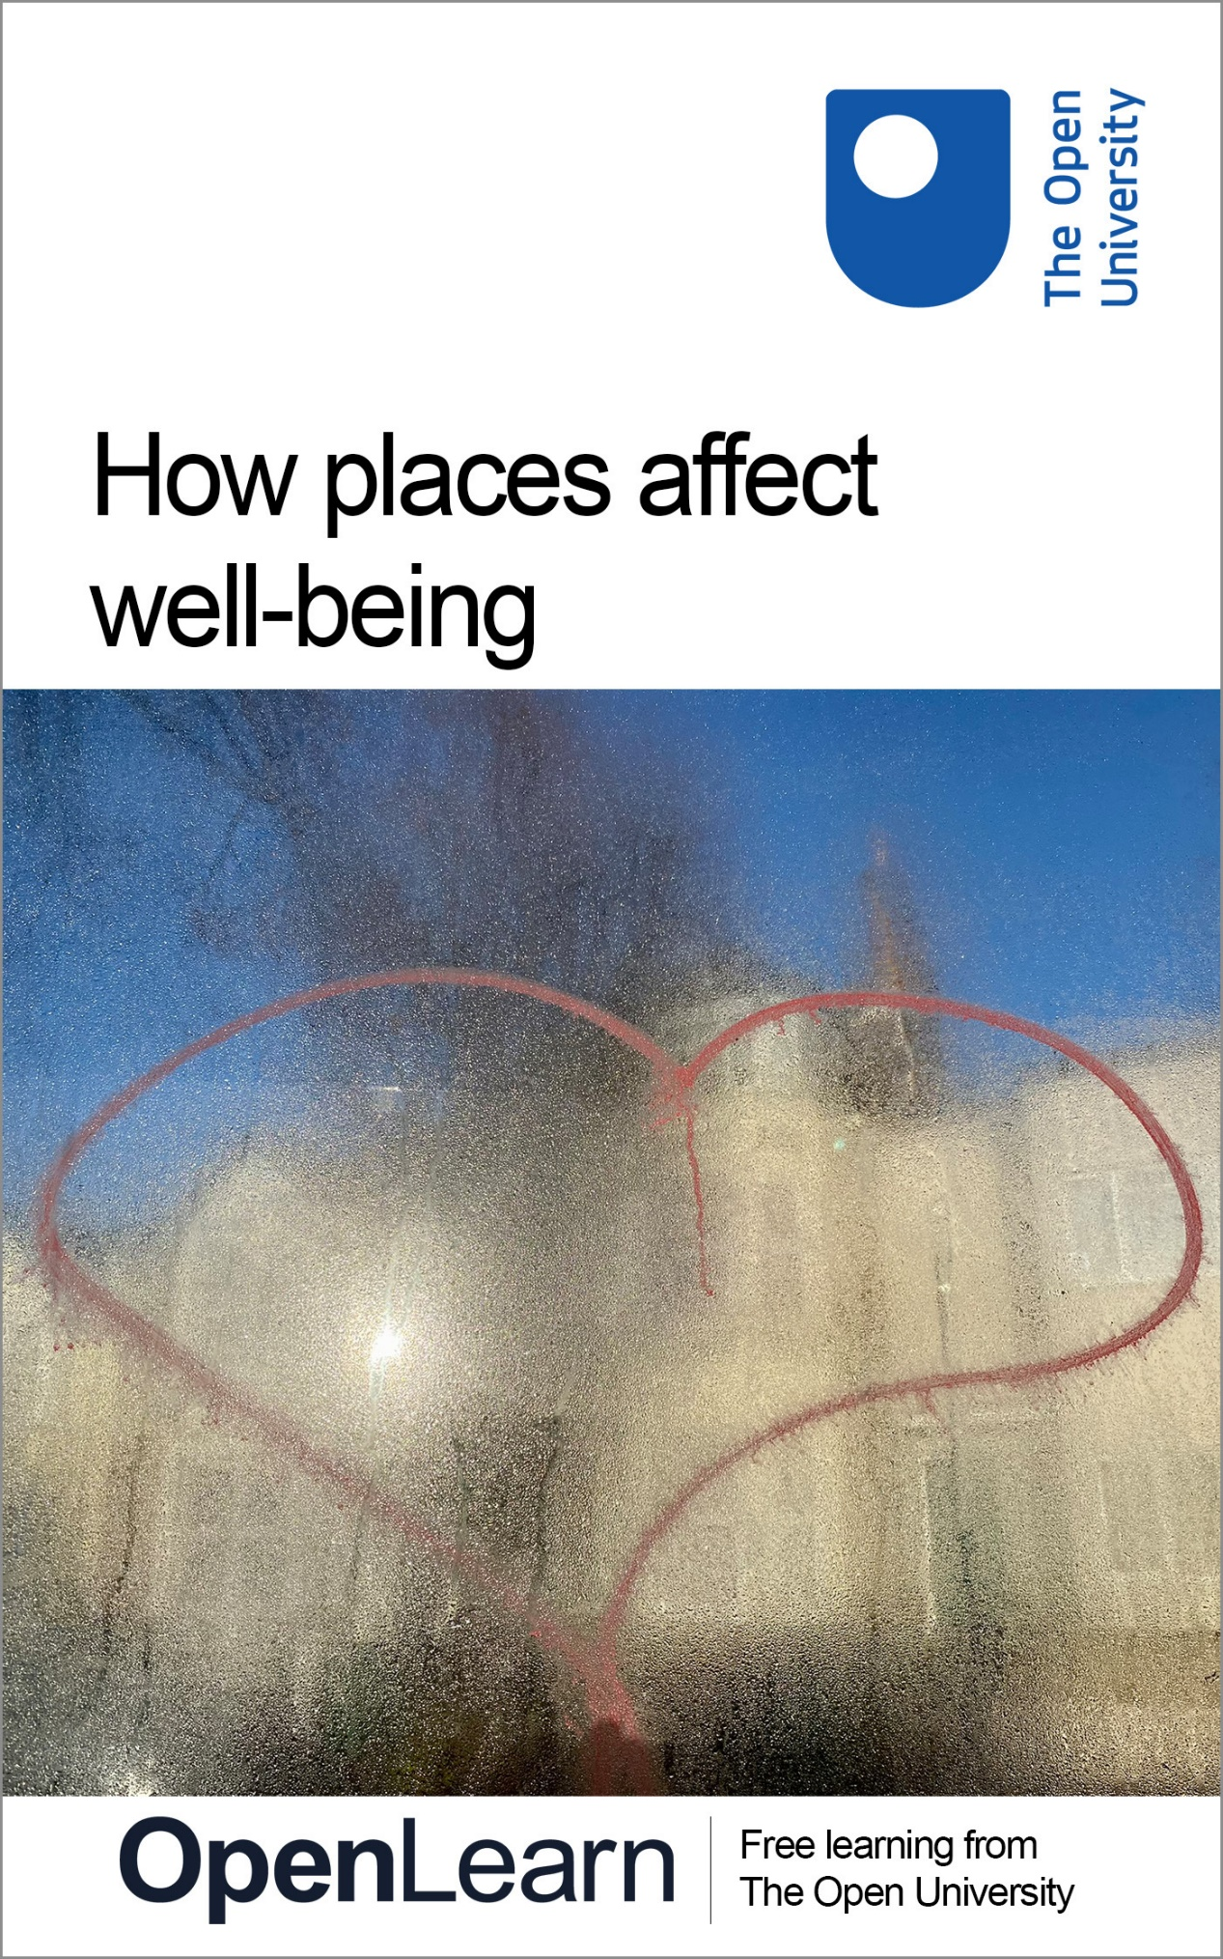

WELL_1

How places affect well-being

About this free course
.
This version of the content may include video, images and interactive content that may not be optimised for your device.
You can experience this free course as it was originally designed on OpenLearn, the home of free learning from The Open University –https://www.open.edu/openlearn/course/view.php?id=34664
There you’ll also be able to track your progress via your activity record, which you can use to demonstrate your learning.
First published 2026.
Unless otherwise stated, copyright © 2026 The Open University, all rights reserved.
Intellectual property
Unless otherwise stated, this resource is released under the terms of the Creative Commons Licence v4.0 http://creativecommons.org/licenses/by-nc-sa/4.0/deed.en. Within that The Open University interprets this licence in the following way: www.open.edu/openlearn/about-openlearn/frequently-asked-questions-on-openlearn. Copyright and rights falling outside the terms of the Creative Commons Licence are retained or controlled by The Open University. Please read the full text before using any of the content.
We believe the primary barrier to accessing high-quality educational experiences is cost, which is why we aim to publish as much free content as possible under an open licence. If it proves difficult to release content under our preferred Creative Commons licence (e.g. because we can’t afford or gain the clearances or find suitable alternatives), we will still release the materials for free under a personal end-user licence.
This is because the learning experience will always be the same high quality offering and that should always be seen as positive – even if at times the licensing is different to Creative Commons.
When using the content you must attribute us (The Open University) (the OU) and any identified author in accordance with the terms of the Creative Commons Licence.
The Acknowledgements section is used to list, amongst other things, third party (Proprietary), licensed content which is not subject to Creative Commons licensing. Proprietary content must be used (retained) intact and in context to the content at all times.
The Acknowledgements section is also used to bring to your attention any other Special Restrictions which may apply to the content. For example there may be times when the Creative Commons Non-Commercial Sharealike licence does not apply to any of the content even if owned by us (The Open University). In these instances, unless stated otherwise, the content may be used for personal and non-commercial use.
We have also identified as Proprietary other material included in the content which is not subject to Creative Commons Licence. These are OU logos, trading names and may extend to certain photographic and video images and sound recordings and any other material as may be brought to your attention.
Unauthorised use of any of the content may constitute a breach of the terms and conditions and/or intellectual property laws.
We reserve the right to alter, amend or bring to an end any terms and conditions provided here without notice.
All rights falling outside the terms of the Creative Commons licence are retained or controlled by The Open University.
Head of Intellectual Property, The Open University

Contents
- Introduction
- Learning outcomes
- 1 What kinds of places are better or worse for well-being?
  - 1.1 Neighbourhoods
  - 1.2 Buildings, housing and design features
- 2 How do places affect people’s well-being?
  - 2.1 Emotion and cognition in nature
  - 2.2 Relationships, connections and community
  - 2.3 Status, value and power
- 3 Designing happier places
- Conclusion
- References
- Acknowledgements
- Solutions
- Descriptions

Introduction
Welcome to this short course looking at the relationship between places and well-being. Before you get stuck into the research in this area, start with the first activity.

Activity 1: Emotion mapping
20 minutes
Emotion mapping is a technique used in both therapy and research to understand how people relate to the places they live in. Have a go at producing an emotion map yourself following the instructions below.

1. Draw a simple map of your home.

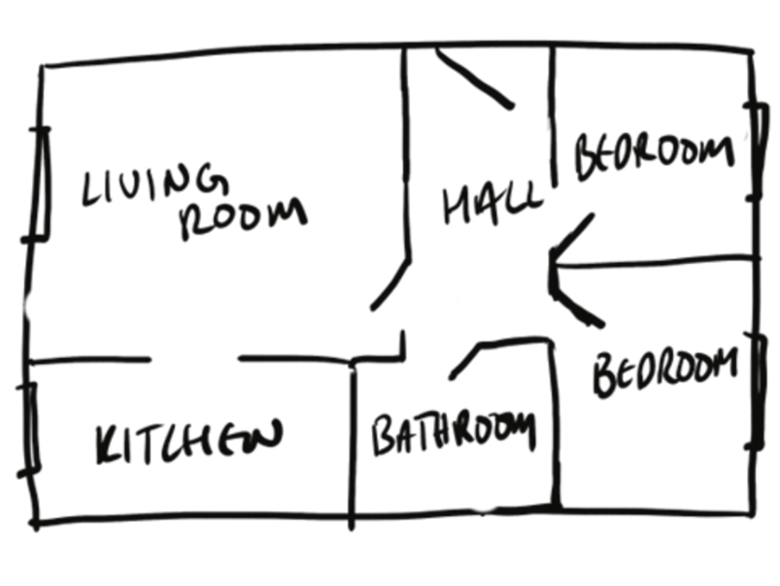
View description - Uncaptioned Figure
View alternative description - Uncaptioned Figure

2. Now think through a typical week in your home. Pick up to three emotions represented by the emoticons below, representing laughter, happiness, indifference, sadness, upset, grumpiness/anger, and love/affection. Now draw these emoticons on your map, in the places where you remember feeling the emotions you have chosen.


View description - Uncaptioned Figure
View alternative description - Uncaptioned Figure

3. Now look at where you’ve placed your emoticons. Are there any patterns? What might this tell you about how the way that people feel is influenced by their environment?

View discussion - Part

In this course you will learn about some of the evidence from psychology and other areas of research that has tried to understand the relationship between places and how people feel.

Learning outcomes
After studying this course, you should be able to:
- describe features of buildings that have been shown to impact people’s well-being
- describe features of cities and neighbourhoods that have been shown to impact people’s well-being
- outline some psychological mechanisms thought to be important in linking people’s environments and their experiences of well-being
- outline some of the considerations for designing and planning places to enhance people’s well-being.

1 What kinds of places are better or worse for well-being?
The kind of place a person lives in has been found to influence their well-being.
In this first section of the course, you will first learn about some of the research on how the neighbourhood someone lives in affects their mental health. After this, you will learn about research that has looked at how the details of buildings can impact well-being.

1.1 Neighbourhoods
Some of the earliest research indicating that the neighbourhood someone lives in can influence their mental health was done in Chicago, US in the 1930s. Like a lot of the evidence about what kinds of effects places have on people, this research looked at people’s experiences of mental health problems, rather than more positive experiences of well-being. This is a general bias in psychological research, which tends to focus on negative experiences.
Faris and Dunham (1939) mapped the incidence of schizophrenia, a serious mental health condition, across the city of Chicago. They found that these people diagnosed with schizophrenia were concentrated in some areas of the city. Complete the activity below to explore their work in more detail.

Activity 2: Schizophrenia in the city
15 minutes

Below is the original Faris and Dunham map of Chicago. Where are the most incidents of schizophrenia? What kinds of areas do you think these might be?

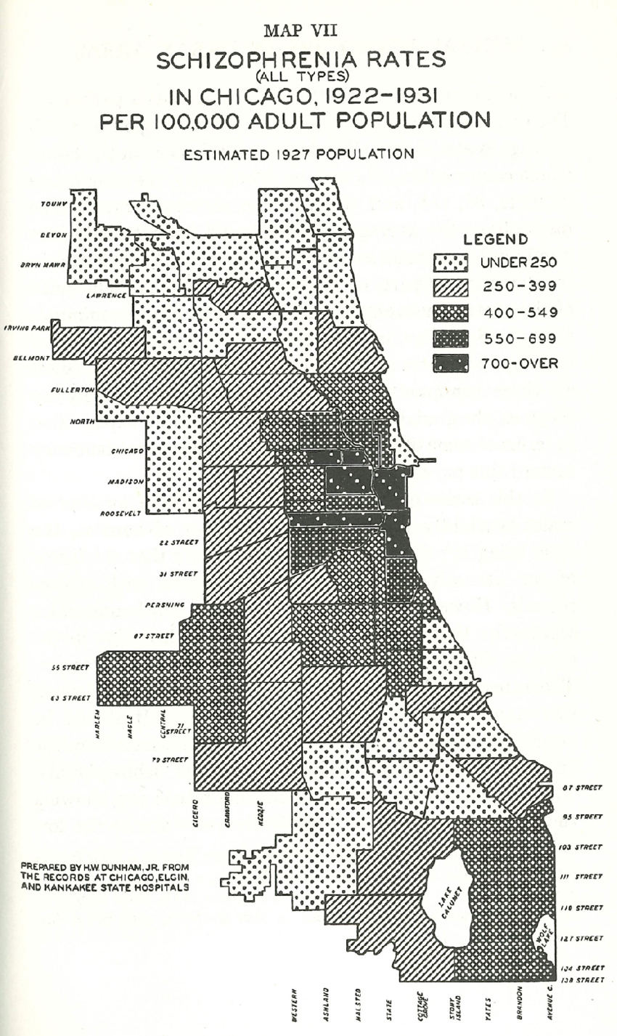
View description - Uncaptioned Figure
View alternative description - Uncaptioned Figure

View discussion - Activity 2: Schizophrenia in the city

There are a few possible explanations for this pattern. You may be thinking that poverty is an obvious explanation for mental health issues being more centred in the inner city. It is well known that there is a ‘social gradient’ in mental health diagnoses, meaning that people who are poorer are more likely to experience mental health difficulties. Poorer people are also more concentrated in inner-city areas. A limitation of this explanation, however, is that there is also a lot of poverty in rural areas, but the same level of poverty in a rural area does not seem to translate into the same risk for schizophrenia.
Another explanation could be that people who are diagnosed with schizophrenia might become poor due to their difficulties, and might end up in poorer urban areas, elevating the numbers. This is known as the ‘social drift’ hypothesis. People with serious mental health problems certainly do face difficulties with employment and are poorer on average.
There is, however, also evidence that the conditions of the neighbourhood itself play a role, independently of these personal factors. A Danish study that tracked people from birth found that being born in an urban inner-city area increased a person’s chance of developing schizophrenia in adulthood by 2.4 times, compared to being born in a rural area (Mortenson et al., 1999). This figure of between two and two and a half times more likely to develop schizophrenia is pretty much consistent across all studies that have looked at the relationship between urban areas and serious mental health issues (Pignon et al., 2023).
In the later sections of this course, you will explore some of the ways that researchers think that places impact mental health – both negatively, as seen in this example, and positively. First, you can learn in the next section about some more specific features of buildings and design that have been found to influence how people feel when living in their homes.

1.2 Buildings, housing and design features
There is also evidence that the design of buildings can influence people’s well-being. Complete the activity below to learn more about this area of research.

Activity 3: Buildings and well-being
25 minutes
Below are some comparisons of architectural features that have been shown to impact well-being or mental health. For each pair, see if you can pick which is better for well-being and think about why this might be:

Pair 1: Open deck versus closed corridor

Look at the following images and think about which layout you think would be better for well-being, and why. Try not to be influenced by which you think looks better or is more to your taste. Think about where the doors are placed and the fact that one is indoors and the other is outdoors.

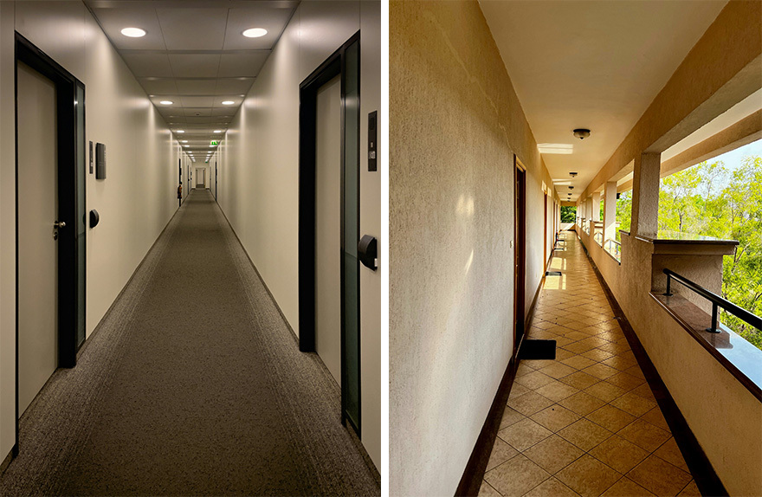
View description - Uncaptioned Figure
View alternative description - Uncaptioned Figure

View answer - Pair 1: Open deck versus closed corridor

Pair 2: lower floor versus upper floor

Living in which of these flats do you think would be better for well-being?

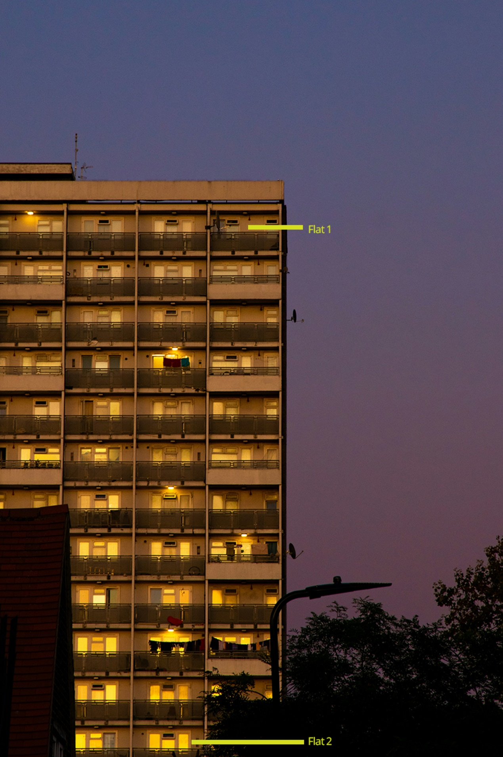
View description - Uncaptioned Figure
View alternative description - Uncaptioned Figure

View answer - Pair 2: lower floor versus upper floor

Pair 3: intrusive noise versus calmer noise

Imagine that the two sounds played here are the main experience of noise inside someone’s home. How do you think these would affect a person’s well-being?

Audio content is not available in this format.
Audio 1: A busy street in Milan with sirens
View transcript - Audio 1: A busy street in Milan with sirens

Audio content is not available in this format.
Audio 2: Sounds from a busy street from an open window in Florence
View transcript - Audio 2: Sounds from a busy street from an open window in Florence

View answer - Pair 3: intrusive noise versus calmer noise

Pair 4: nature views versus no nature views

Which window view do you think would be better for well-being?

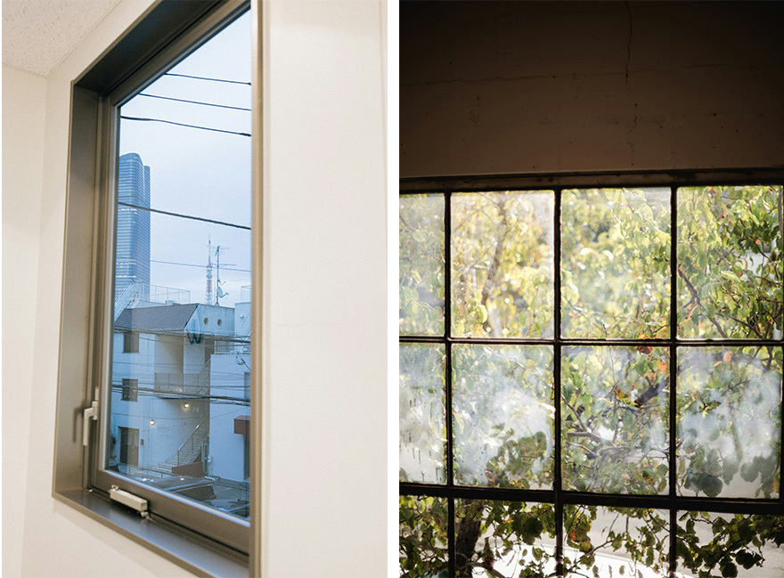
View description - Uncaptioned Figure
View alternative description - Uncaptioned Figure

View answer - Pair 4: nature views versus no nature views

In this section you have learned about some of the features of the built environment that have been found to influence well-being. In the next section, you will learn more about why these features have these impacts.

2 How do places affect people’s well-being?
So far in this course you have learned about some of the evidence that places – from neighbourhoods to buildings – play a role in people’s mental health and well-being. In this section, you will learn about some of the key mechanisms that researchers think are responsible for this relationship.

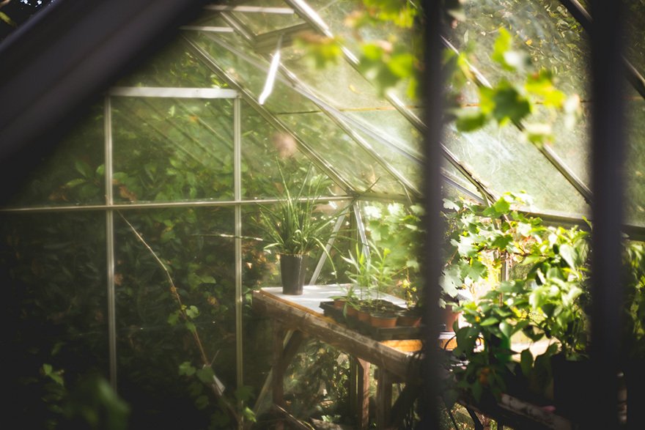
View description - Uncaptioned Figure
View alternative description - Uncaptioned Figure

2.1 Emotion and cognition in nature

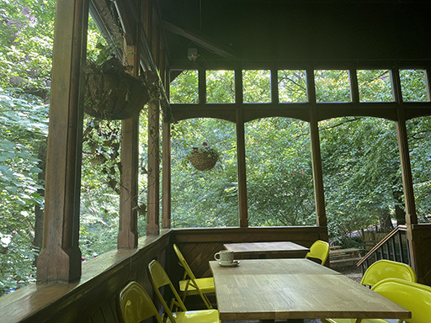
View description - Uncaptioned Figure
View alternative description - Uncaptioned Figure

In Activity 3, you learned about the evidence that views of nature seem to have a positive impact on people’s well-being. There are different theories as to why this might be.
Some researchers have focused on the emotional experience of nature. People have been found to experience feelings of ‘awe’ in natural environments, meaning a feeling of wonder and reverence in the face of something greater than themselves (Van Cappellen & Rime, 2013). Feelings of awe have been found to be particularly strong when people are absorbed or captivated by a natural scene. Awe involves a sense of being connected to the wider world and has a function of taking the person outside of themselves, known as experiencing a ‘small self’ (Bai et al., 2017). Feeling connected is a vital part of well-being, while a ‘small self’ seems to help shift people’s attention away from their individual concerns and towards other people. Focusing and ruminating on problems is well-established to be something that can prolong and deepen experiences of both anxiety and depression (Nolen-Hoeksema, 2000).
Another major area of research has looked at the impact that nature can have on the way that people think, known as ‘cognition.’ The aspect of thinking of most interest here is attention. Attention means a state of conscious focus. If you think about paying attention to something you might be listening hard, or reading something in a concentrated way, or following a particular event or story in the news. Something that you are not paying attention to, on the other hand, is still happening but it is outside of your awareness.
Psychologists who study attention tend to think of this both as a skill and a resource. People can train themselves to be able to sustain attention for longer, for instance through mindfulness training. There is also evidence that people’s capacity for attention can be worn out or drained by overuse, as well as restored by rest. This is where nature comes in. The earliest research in this area, by Kaplan and Kaplan (1989) compared how well people’s attention was restored by looking either built environment or natural scenes. They found that after viewing natural scenes, people performed better on tests measuring attention than the city scenes. In the following activity you will learn about a study that looked at these processes in everyday life.

Activity 4: Coping with difficult life events
15 minutes
In a study from the early 2000s, Frances Kuo worked with women living in a social housing estate (‘a project’) in Chicago, US. In this estate, residents were housed in tower blocks, pictured below. Some of the blocks had no trees surrounding them (pictured on the left) and some blocks were surrounded by trees (pictured on the right).
This provided a comparison between women whose everyday views from their home included nature, and those who did not. This is known as a ‘natural experiment’ – when something in the world provides a comparison between two groups who are otherwise similar.

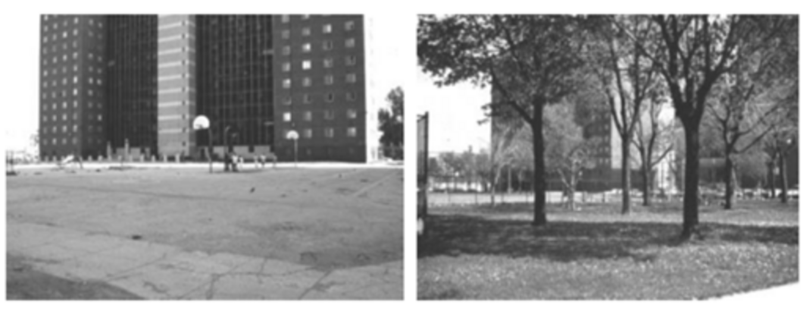
View description - Uncaptioned Figure
View alternative description - Uncaptioned Figure

1. Kuo compared women living in these blocks on measures of attention and memory. From what you know of the research in this area, who would you predict performed better on these tests?

Provide your answer...
View answer - Part

2. In the study, women were asked about the difficulties they faced in their everyday life. This could include money problems, relationship difficulties, parenting issues, and other everyday stresses and strains.
The women had similar levels of difficult life events, but the women with a view of trees rated these events as less important and less long-lasting than the women with no view of trees.
How could you explain this difference, using the concepts you’ve learned about in this course?

Provide your answer...
View answer - Part

In the next section you will learn about the role of relationships in people’s experience of places and environments.

2.2 Relationships, connections and community


View description - Uncaptioned Figure
View alternative description - Uncaptioned Figure

An important mechanism proposed for the relationship between places and well-being is that places that better facilitate strong relationships, connection and community lead to better well-being. Some of the research you learned about in the previous section implicitly highlighted this, for instance that designs which enable people to talk to their neighbours more easily seem to be better for mental health.
One way that researchers have tried to understand the relationship between relationships and well-being is by looking at what kinds of environments lead people to be lonelier. Loneliness is feeling that a person’s relationships are not sufficient to meet their needs. There is not an objective measure of loneliness, a certain number of relationships or type of connections that mean that a person is or is not lonely. The quality of relationships is more important than quantity. Some people can feel lonely despite having many friends while others can be content in relative solitude.
The relationship between places and loneliness is similarly subjective and variable. When reviewing all the published studies that looked at relationships between the built environment and loneliness published in the twenty-first century, Bower and colleagues (2023) found that there was no one kind of place that could prevent loneliness in everyone. There were, however, lots of ways in which built environments influenced loneliness and the quality of people’s relationships. One example was that people living in smaller apartments were found to be lonelier, a relationship explained by the fact that smaller homes made it harder to host friends and family. On a larger scale, having access to better amenities and transport was found to be positive for loneliness, due to the fact that people were able to access activities and facilities out of the home more easily.
One conclusion it would be possible to draw from this research is that it’s crucial to build places that enable people to interact as much as possible with those around them. It’s not quite this simple, however, as there are also some negative impacts of contact with others. Early work in this area was carried out by Altman (1975), who suggested that people feel crowded when their sense of personal space and territory is violated, and that this is made worse if they feel watched by others. He suggested that people respond to feeling crowded by withdrawing, and if this is not possible, they can become distressed. These needs change and shift, meaning that the design of housing also needs to be flexible and allow for people to both find privacy and be sociable.
You may have noticed that the research above is not solely about the architectural features of the buildings. Also involved is how people live in the buildings, and the level of control they have over the space. These physical, social and psychological components of the experience of living in a particular place all inter-relate and interact with each other in complicated ways.
It is clear from these examples that the relationship between the environment and people’s experience is hard to pin down. One concept that is often used to understand the relationship between the physical environment and psychological experience is ‘affordance’. This is a concept from the psychologist Eleanor Gibson, writing in the 1960s and 1970s. ‘Afford’ means ‘make possible’ and it can be helpful to think about the relationship between the built or physical environment and people’s lives. Complete Activity 5 to learn more about this idea.

Activity 5: Affordances of water
15 minutes

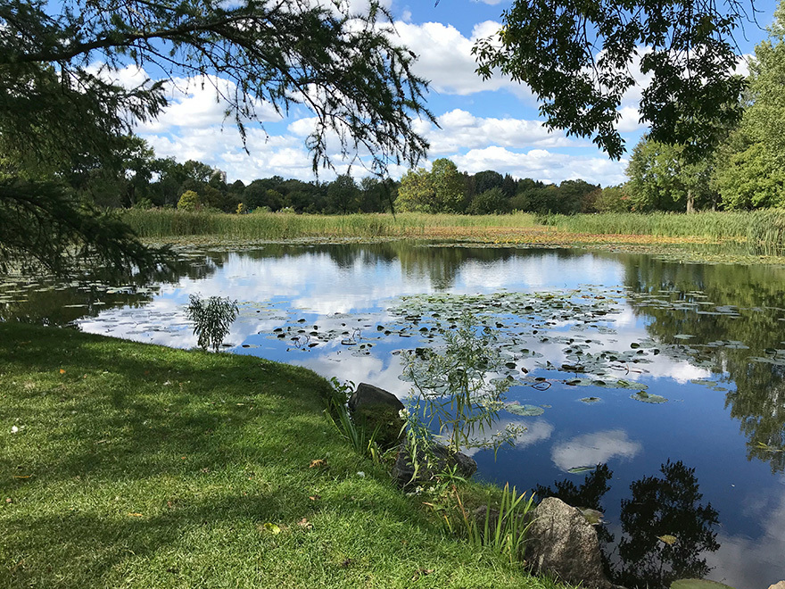
View description - Uncaptioned Figure
View alternative description - Uncaptioned Figure

Think of a body of water such as the one above. Now list all the possible ways that a person could interact with this water. What kinds of activities could they do? How might they feel or react to the water?

Provide your answer...
View discussion - Activity 5: Affordances of water

As well as the kinds of relationships that places can afford for the residents, there is also evidence that the meaning attributed to places and the people who live in them plays a role in well-being. You will learn about this in the next section.

2.3 Status, value and power

View description - Uncaptioned interactive content

Pictured here are two housing estates in London made up of multi-story towers, built in a similar architectural style, known as brutalism. The Barbican Centre, on Slide 1, is an expensive and highly desirable place to live. Many residents are attracted to live there specifically because of its architecture. On Slide 2 is the Aylesbury Estate in South London, which has been repeatedly used by politicians as a prime example of failed urban planning. (It is worth noting that many residents of the Aylesbury Estate strongly object to this characterisation!)
While these two places have similar physical properties, they are assigned a very different social meaning. The Barbican is a high-status place which is often seen as also increasing the status of the people who live there. People who live in housing estates like the Aylesbury, on the other hand, are often stigmatised, looked down upon, and seen as a problem to be solved (Smith, 2025). This example demonstrates that it is never enough to look only at the physical features of a place. These issues of status, value and social meaning are also crucially important in understanding how places affect people.
One marker of how valued a place is could be the amount of care that is taken in its upkeep and in keeping the people who live there safe. Places with high levels of visible crime and vandalism have indeed been found to be worse for people’s mental health (Ross, Mirowsky & Pribesh, 2001). Another indicator of social status and power is how easily a person is able to influence decisions about the place where they live. The sociologist Anne Rogers did indeed find that people who feel like they have less say over their neighbourhood also have worse mental health. If a place has problems but people feel more able to fix them, this is perhaps less of an issue for well-being.
Comparison and a feeling of where someone is in society seem to also play a role. One study in South Africa found that between two communities of comparable levels of deprivation there were higher levels of dissatisfaction and distress in the community that was located on a hill overlooking a rich neighbourhood as opposed to the other area surrounded by neighbourhoods of similar wealth (Rogers & Pilgrim, 2003). This example also shows that value and status are always relative. Another example of this pattern is that people in more unequal countries in general have worse mental health than people who live in a country where people’s incomes are closer together (Wilkinson & Pickett, 2010). The dynamics shaping how people feel about the places they live, whether they feel valued, heard or excluded, are therefore complex and in flux, but always important to consider.

3 Designing happier places
In this course you have learned about some of the ways in which people might be impacted by the places they live in. How could these be used to help build and create happier places?
In this section you will think about some different aspects of places and how they might be designed or organised to maximise people’s wellbeing. First, complete Activity 6 to start to think through these ideas.

Activity 6: Places that work for people
15 minutes

Look at the example below and see if you can think of a way to design a place to help the problem.
Rosie is an older person living in sheltered housing in a moderate sized town. She has family living between two and three hours away who visit regularly but don’t get to see her that often.
Rosie has reasonable mobility but struggles with standing up for long.

Provide your answer...
View discussion - Activity 6: Places that work for people

In Activity 6, you explored how to think about making places that function well for people’s everyday lives. Another strand of research in this area has focussed on making places that are relaxing and restorative, including in cities. Complete Activity 7 to explore this idea further.

Activity 7: Creating restorative cities
15 minutes

Earlier in the course you learned about the ways that urban environments are known to be a risk for mental health. Most people in the work live in cities, so the answer to this problem can’t be to get everyone to move to a rural location! Some researchers and designers have instead tried to build in more relaxing elements in city environments.
Watch the following short video from ‘Project DeStress’ led by Dr. Sarah Payne from the University of Surrey. This video is an example from a virtual reality public space that can be modified to see how different aspects of the space affect how people feel. As you watch the video make notes of:
- Which versions of the space you find more and less relaxing.
- What aspects or elements of the space you think most contribute to feelings of relaxation or restoration?

Video content is not available in this format.
Video 1: Environment simulator – Project DeStress
View transcript - Video 1: Environment simulator – Project DeStress

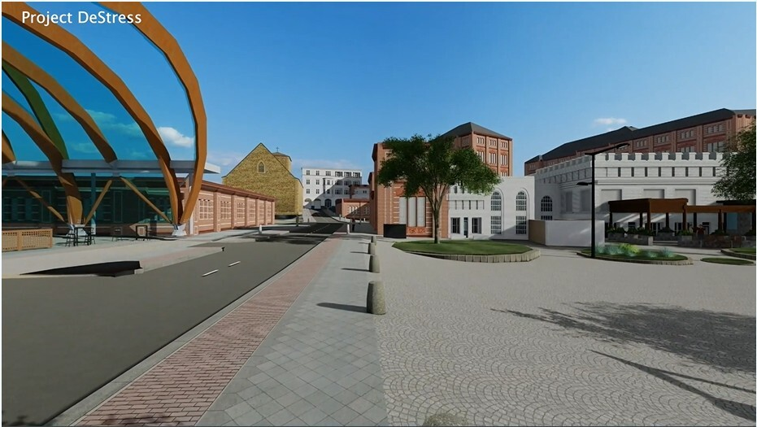

Provide your answer...
View answer - Activity 7: Creating restorative cities

Conclusion
The research on places and well-being is still in development. It is clear that the kinds of places that people build and live in play a significant role in how people feel. This includes details of buildings and public spaces, natural views and sounds, as well as the ways that people are treated, valued and able to meaningfully shape their environments.
If you enjoyed this course, you might want to explore the following Open University courses:
- D110: Exploring psychological worlds: thinking, feeling, doing
- K119: Wellbeing across the lifecourse
- T24: Certificate of Higher Education in Children and Families

References
Altman, I. (1975) The Environment and Social Behavior. Brooks / Cole Publishing Co.
Bai, Y., Maruskin, L. A., Chen, S. et al. (2017) ‘Awe, the diminished self, and collective engagement: Universals and cultural variations in the small self’, Journal of Personality and Social Psychology, 113(2), p. 185.
Bower, M., Buckle, C., Rugel, E., Donohoe-Bales, A., McGrath, L., Gournay, K., ... & Teesson, M. (2023). ‘Trapped’,‘anxious’ and ‘traumatised’: COVID-19 intensified the impact of housing inequality on Australians’ mental health. International Journal of Housing Policy, 23(2), 260-291.
Bower, M., Kent, J., Patulny, R., Green, O., McGrath, L., Teesson, L., ... & Rugel, E. (2023). The impact of the built environment on loneliness: A systematic review and narrative synthesis. Health & place, 79, 102962.
Evans, G. W., Wells, N. M., Moch, A. (2003). Housing and mental health: A review of the evidence and a methodological and conceptual critique, Journal of Social Issues, 59 (3), 475 – 500.
Faris, R. E. L., & Dunham, H. W. (1939). Mental disorders in urban areas: an ecological study of schizophrenia and other psychoses. Univ. Chicago Press.
Freeman, H. L., (2008). ‘Housing and mental health’. In H. L. Freeman, S. Stansfield (Eds.), The impact of the environment on psychiatric disorder. London: Routledge.
Gabb, J. (2008). Mapping Intimacy in Families. In: Researching Intimacy in Families. Palgrave Macmillan Studies in Family and Intimate Life. Palgrave Macmillan, London. https://doi.org/10.1057/9780230227668_5
Kaplan, R., Kaplan, S. (1989). The experience of nature: A psychological perspective. New York: Cambridge.
Kuo, F. E. (2001). Coping with poverty: impacts of environment and attention in the inner city, Environment and Behaviour, 33 (5), 5 – 34.
Montgomery, C. (2013). Happy city: Transforming our lives through urban design. Penguin UK.
Mortensen, P. B., Pederson, C. B., Westergaard, T., Wohlfahrt, J., Ewald, H., Mors, O., Andersen, P. K., Melbye, M. (1999). Effects of family history and place and season of birth on the risk of schizophrenia, New England Journal of Medicine, 340 (8), 603 – 608.
Nolen-Hoeksema, S. (2000) ‘Rumination and depression’, Journal of Abnormal Psychology, 109(3), pp. 504–511.
Payne, S. R. (2013). The production of a perceived restorativeness soundscape scale. Applied acoustics, 74(2), 255-263.
Pignon, B., Szöke, A., Ku, B. et al. (2023) ‘Urbanicity and psychotic disorders’, Dialogues in Clinical Neuroscience, 25(1), pp. 122–138.
Ross, S., Mirowsky, J., Pribesh, S. (2001). Powerlessness and the amplification of threat: neighborhood disadvantage, disorder, and mistrust, American Sociological Review, 66 (4), 568–591.
Smith, H. (2025) Up in the Air: A History of High Rise Britain. Verso Books.
Sturm, U., Tuggener, S., Damyanovic, D., & KAIl, E. (2019). Gender sensitivity in neighbourhood planning: The example of case studies from Vienna and Zurich. In Gendered approaches to spatial development in Europe (pp. 124-156). Routledge
Ulrich, R. S. (1984). View through a window may influence recovery from surgery, Science, 224, 420–421.
Van Cappellen, P. and Rimé, B. (2013) ‘Positive emotions and self-transcendence’, Current Directions in Psychological Science, 22(1), pp. 41–45.
Van den Berg, M. et al. (2016) ‘Green space and stress buffering’, Social Science & Medicine, 166, pp. 1–9.
Weich, S. et al. (2002) ‘Mental health and built environment’, British Journal of Psychiatry, 180, pp. 428–433.
Wilkinson, R., & Pickett, K. (2010) The spirit level: Why equality is better for everyone. Penguin, UK.

Acknowledgements
This free course was written by Laura McGrath.
Except for third party materials and otherwise stated (see terms and conditions), this content is made available under a Creative Commons Attribution-NonCommercial-ShareAlike 4.0 Licence.
The material acknowledged below and/or referenced in course is Proprietary and used under licence (not subject to Creative Commons Licence). Grateful acknowledgement is made to the following sources for permission to reproduce material in this free course:
Images
Course image: Graffiti at a bus stop: courtesy Laura McGrath
Emotions Emojis
A map showing the geographical distribution of schizophrenia rates across Chicago neighbourhoods between 1922 and 1931 in Faris, R. E. L., & Dunham, H. W. (1939) Mental disorders in urban areas: an ecological study of schizophrenia and other psychoses. Univ. Chicago Press.
Two different corridors, side by side: left: Bernd Dittrich on Unsplash; right: Open Deck Prabal Kumar / Unsplash
High rise block of flats: Ben Allan / Unsplash
Two window views, side by side: left: Tsuyoshi Kozu / Unsplash; right: Jason Leung / Unsplash
Garden glass house full of plants: Thomas Verbruggen / Unsplash
An outdoor space surrounded by nature: courtesy: Laura McGrath
Two photographs, side by side: Attrition Has Left Some Buildings Surrounded Almost Entirely by Concrete and Asphalt and Others With Pockets of Green, Figure 1 from -2001-Coping-with-Poverty-.pdf
Multiple hands coming together: Zacqueline Baldwin / Unsplash
Green grass field near a lake Goulet Isabelle on / Unsplash
Barbican Towers: Riodamascus https://commons.wikimedia.org/wiki/Category:Barbican_Estate#/media/File:Barbican_towers.jpg https://creativecommons.org/licenses/by-sa/3.0/
Aylesbury Estate viewed from Chiltern: Mkimemia https://commons.wikimedia.org/wiki/File:Aylesbury_Estate_View.jpg
Audio / Video
Audio 1: A busy street in Milan with sirens: https://freesound.org/people/achats57/sounds/348350 Creative Commons Zero
Audio 2: Sounds from a busy street from an open window in Florence: https://freesound.org/people/tonycarlisle/sounds/592926 / https://creativecommons.org/licenses/by/4.0
Video 1: Environment simulator – Project DeStress: https://destress.surrey.ac.uk/environment-simulator-holding/ courtesy: Sarah Payne
Every effort has been made to contact copyright owners. If any have been inadvertently overlooked, the publishers will be pleased to make the necessary arrangements at the first opportunity.
Don’t miss out
If reading this text has inspired you to learn more, you may be interested in joining the millions of people who discover our free learning resources and qualifications by visiting The Open University – www.open.edu/openlearn/free-courses.

Solutions

Activity 1: Emotion mapping

Part

Discussion
In the original study this task is based upon, the sociologist Jacqui Gabb asked families to complete this task over the course of a week. She found that the families reported different emotions happening in different parts of the house.
Arguments, for instance, were particularly likely to happen in the doorway of teenager’s bedrooms. Both arguments and strong positive emotions happened in the kitchen and shared living spaces. You can probably think of some reasons why this might be. A teenager’s bedroom is an important territory for them and the doorway is a border between the shared space of the home and the teenager’s own territory. Living rooms and kitchens are more communal spaces, whereas bedrooms might have more experiences of contentment and calm, but fewer joyful or fun experiences.
What this kind of exercise demonstrates is the way in which people’s emotions and psychological experiences are located. The way that people feel is not only driven by their internal thoughts and feelings, but also is made possible, shaped and limited by the environments that people live in.
Back to - Part

Activity 2: Schizophrenia in the city

Discussion
Faris and Dunham identified that people diagnosed with schizophrenia were most likely to live in the central areas of the city, and that incidence decreased in the outer suburbs. This pattern has been found in many other places across the world in subsequent studies. In 2012, researchers looked at all the available data from studies looking at urban areas and schizophrenia incidence together, in a type of study called a ‘meta-analysis’. They found that when all the data was combined together, the risk for developing schizophrenia was 2.37 times higher in the most urban environments compared to the most rural environments.
Back to - Activity 2: Schizophrenia in the city

Activity 3: Buildings and well-being

Pair 1: Open deck versus closed corridor

Answer
You might have thought that the ‘open deck’ set up has some advantages as it has a direct view of the outdoors and more natural light in the corridor. There are benefits of being able to see nature from your home, which you will learn about in a later section. The left-hand corridor arrangement, however, has surprising well-being benefits. Weich and colleagues (2002) found that people living on closed corridors knew their neighbours better and had better mental health overall, than people living in flats with an open deck. Generally, housing that makes it easier to interact with neighbours is associated with lower levels of loneliness.
Back to - Pair 1: Open deck versus closed corridor

Pair 2: lower floor versus upper floor

Answer
You may have thought here about how living on a higher floor could give a better view and sense of space. Or you may have thought about the ease of getting in and out of the flat, especially if lifts are not reliable. For parents with young children, it has been consistently found that this latter issue is more important. Freeman (2008) found that women with young children who lived on higher floors in multi-occupancy buildings had worse mental health than those on the lower floors. They explain this pattern in terms of isolation and access to facilities. Being higher up a building makes it harder to get out to the playground or socialise. Some urban planners have tried to address these issues. In Vienna, for example, many apartment blocks have been built with small play areas that are observable from inside the flats.
Back to - Pair 2: lower floor versus upper floor

Pair 3: intrusive noise versus calmer noise

Answer
You probably thought here that the quieter noise would be better for well-being, and the research supports that view. A study carried out in Australia found that intrusive noise at home increased people’s experiences of both anxiety and depression, having the biggest effect of any housing feature. Natural light, on the other hand, was found to affect people’s levels of depression and loneliness (Bower et al., 2021). There is also some evidence that quality of housing also plays a role in people’s well-being, such as living in a home that is well repaired, or has mould (Beemer et al., 2021).
There is not, however, a completely straightforward relationship between the quality, size or tenure (whether people rent or own their home) of a person’s home and their well-being. This is because people’s relationship to their homes is complicated and depends on lots of other factors in the person’s life. People spend different amounts of time at home and use home space in a wide variety of ways. Bower et al. (2021) for instance found that in the COVID-19 pandemic people talked about how they had suddenly noticed lots of issues with their homes that they usually did not notice. Living in a noisy flat, for instance, is a different experience if a person spends most of their time out of the house at work, socialising, at the gym, or elsewhere.
Control is also thought to be an important factor in how much people are impacted by the features of their homes (Evans et al., 2003). This could perhaps explain why noise can have such as an effect on mental health and well-being. The definition of ‘noise’ is an unwanted or unpleasant sound; it is inherently an experience of being out of control of the auditory environment.
Back to - Pair 3: intrusive noise versus calmer noise

Pair 4: nature views versus no nature views

Answer
There is quite a lot of evidence that access to – or even views of – nature can play an important role in people’s well-being. Globally, it’s been found that people living in places with more green space (e.g. parks) have better mental health. People who spend more time in their local green spaces have also been found to report better mental health and ‘vitality’ (feeling well and vigorous) than people who used the green spaces less (van den Berg et al., 2016). As with the neighbourhood findings above, however, there are a few possible explanations for these relationships. Firstly, richer areas of cities tend to also be greener, so these studies could be picking up the social gradient in mental health. Secondly, it could be that people who are healthier and happier are more likely to have the energy to be active and use their green spaces, so it’s not clear that green space causes an increase in well-being from these studies.
Other studies have tried to pinpoint these relationships more precisely. In a classic study, Ulrich and colleagues (1984) compared the recovery rates of hospital patients in the US who had a view of nature from their window with those who did not. They found that patients with a nature view had shorter hospital stays and required fewer painkillers than those who had a view of a brick wall. This is better evidence, because in other ways the patients were very similar, so the study isolated the impact of the view of nature. You will learn a bit more about the research on nature and well-being in Section 2.
Back to - Pair 4: nature views versus no nature views

Activity 4: Coping with difficult life events

Part

Answer
The women who could see trees performed better on these tests. This finding seems to support the idea that views of nature, even limited, can help to restore cognitive capacities including attention.
Back to - Part

Part

Answer
This finding implies that while both groups of women had the same level of difficult life events, as women navigating living in poverty, these issues seemed to weigh less heavily on women who had a view of nature in their daily view. Kuo explains this finding as showing that nature can restore attention, leaving more cognitive capacity to deal with ongoing life issues and cope with them more easily. You may have also thought about the emotional impacts of nature discussed above – particularly the way that nature is thought to produce feelings of a ‘small self’ where a person might ruminate less on their individual concerns. This pattern seems to track with women rating their problems as less important when they were able to view trees.
Back to - Part

Activity 5: Affordances of water

Discussion
You may have listed the following activities: swim, wash, drink, or potentially even drown. All of these are valid answers and notice how different they are. These are all activities that the presence of a body of water makes possible (or affords) for a person who encounters the water.
Let us take the example of a person washing in the water. Notice that there is nothing inherent in the water or the person that makes the outcome of washing inevitable. The way the person uses the water is what matters. At the same time, the ability of the person to wash is dependent on the water existing and being in this place. The final outcome – person washing – is dependent on both the person and the environment, it happens because of the way that these two come together in a particular place and for a particular purpose. This sense of contingency is what the concept of affordance captures.
This is why it is a useful idea for understanding the relationship between people and their environments. There is nothing inevitable about how a person will feel or think when they are in a particular place. Building environments in particular ways, however, can make some experiences more likely, easier to have – more possible – than other kinds of built environments. Having a shared landing space in a building, for example, makes it easier and more likely that someone will bump into their neighbours and over time build up a relationship with them. This in turn can mean that they feel less lonely and more connected. The landing space affords more interaction than a long corridor where people do not stop in the same place. It does not guarantee this outcome, however, and the evidence seems to suggest that no architectural feature can guarantee a psychological outcome.
Back to - Activity 5: Affordances of water

Activity 6: Places that work for people

Discussion
You might have thought here about aspects of where Rosie lives that could help her to get around easily and access people and activities out of the home. You also might have thought about what might help her to get around with reduced mobility and feel sage. Some possibilities include:
- Good quality transport connecting to amenities.
- Walkable pavements.
- Benches.
- Good quality street lighting.
There is a significant interest in town planning and architecture in designing and building places that better support people’s well-being. Some of the most common issues raised in this field are walkability, access, and safety. Places that are more walkable and have lots of amenities within easy reach are thought to have lots of additional benefits. If people are out walking around their local area, using local services and feeling safe, then they will also see the same people regularly, and build up feelings of familiarity and trust with others (Montgomery, 2013). Similarly, good quality transport networks have lots of additional benefits meaning that people are able to access facilities, maintain relationships and sustain employment. There is no magic solution, but places that help to facilitate, rather than limit people’s lives, relationships and activities seem to offer the key to good well-being.
Back to - Activity 6: Places that work for people

Activity 7: Creating restorative cities

Answer
You may have noticed the variations in sound – natural sounds, sounds of traffic, and people. You may also have noticed the variations in the amount of greenery present. You have already explored the ways in which views of nature can help well-being, and the ways that sounds in the home can be stressful. In public places, natural sounds, especially birdsong, have been found to be more relaxing than mechanical sounds such as traffic (Payne, 2013). City environments that incorporate natural views and sounds, and include some respite from traffic noise, may therefore be an important tool in creating happier places.
Back to - Activity 7: Creating restorative cities

Descriptions

Uncaptioned Figure
Drawing of a floorplan of a house.
Back to - Uncaptioned Figure

Uncaptioned Figure
Drawing of a floorplan of a house.
Back to - Uncaptioned Figure

Uncaptioned Figure
Emotions from left to right: laughter, happy, indifference, sadness, upset, grumpiness or anger, and love/affection.
Back to - Uncaptioned Figure

Uncaptioned Figure
Emotions from left to right: laughter, happy, indifference, sadness, upset, grumpiness or anger, and love/affection.
Back to - Uncaptioned Figure

Uncaptioned Figure
A map showing the geographical distribution of schizophrenia rates across Chicago neighbourhoods between 1922 and 1931.
Back to - Uncaptioned Figure

Uncaptioned Figure
A map showing the geographical distribution of schizophrenia rates across Chicago neighbourhoods between 1922 and 1931. It maps the rate of schizophrenia cases per 100,000 adult population based on 1927 population estimates.
The map displays Chicago divided into various neighbourhood sectors. The map uses five distinct patterns to indicate the rate of incidents:
- under 250 (lowest rate)
- 250–399
- 400–549
- 550–699
- 700–over (highest rate)
The highest rates (700–over and 550–699) are clustered in a small, concentrated area directly in the centre-east of the city, along the Lake Michigan shoreline (near the Loop and Madison Street).
As you move outward from this central core toward the northern, southern, and western outskirts, the rates consistently drop. The outermost suburbs and edges of the city are dominated by the under 250 and 250–399 patterns. High concentrations (400–549 and above) also extend slightly westward along major corridors like Chicago Avenue and Roosevelt Road, but remain largely centralised.
Back to - Uncaptioned Figure

Uncaptioned Figure
Images of two different corridors.
Back to - Uncaptioned Figure

Uncaptioned Figure
Images of two different corridors, side by side. The left-hand image has no natural light and is a long, grey hallway. The right-hand image is open, and looks outside to trees and greenery.
Back to - Uncaptioned Figure

Uncaptioned Figure
Image of a high rise block of flats.
Back to - Uncaptioned Figure

Uncaptioned Figure
Image of a high rise block of flats with the top flat (on the corner of the 11th floor) labelled flat 1 and the bottom flat (on the corner of the ground floor) labelled flat 2.
Back to - Uncaptioned Figure

Uncaptioned Figure
Images of two window views.
Back to - Uncaptioned Figure

Uncaptioned Figure
Images of two window views, side by side. The left-hand window has buildings in view, the right-hand window has greenery in view.
Back to - Uncaptioned Figure

Uncaptioned Figure
Image of a garden glass house full of plants.
Back to - Uncaptioned Figure

Uncaptioned Figure
Image of a garden glass house full of plants.
Back to - Uncaptioned Figure

Uncaptioned Figure
A photograph of an outdoor space surrounded by nature.
Back to - Uncaptioned Figure

Uncaptioned Figure
A photograph of an outdoor space surrounded by nature.
Back to - Uncaptioned Figure

Uncaptioned Figure
Two photographs of high-rise buildings, one has trees planted in front.
Back to - Uncaptioned Figure

Uncaptioned Figure
Two photographs, side by side. The left-hand image has a high-rise building, block of flats in front of an open space. The right-hand image has a similar building but with lots of trees planted in front.
Back to - Uncaptioned Figure

Uncaptioned Figure
Photograph of multiple hands together.
Back to - Uncaptioned Figure

Uncaptioned Figure
Photograph of multiple hands coming together in the centre to form a circle / star shape.
Back to - Uncaptioned Figure

Uncaptioned Figure
Photograph of a green grass field.
Back to - Uncaptioned Figure

Uncaptioned Figure
Photograph of a lake, with green grass around it, under a blue sky, during the daytime.
Back to - Uncaptioned Figure

Uncaptioned interactive content
Slide 1: Photograph of the Barbican Estate in London. Slide 2: Photograph of Aylesbury Estate in South East London.
Back to - Uncaptioned interactive content

Audio 1: A busy street in Milan with sirens

Transcript
Please note this audio contains the sounds from a busy street in Milan with sirens, there is no spoken audio.
Back to - Audio 1: A busy street in Milan with sirens

Audio 2: Sounds from a busy street from an open window in Florence

Transcript
Please note this audio contains the sounds from a busy street from an open window in Florence, there is no spoken audio.
Back to - Audio 2: Sounds from a busy street from an open window in Florence

Video 1: Environment simulator – Project DeStress

Transcript
Please note this video contains a walk-through of an environment simulator depicting an urban square. The video transitions between three scenarios, ranging from low, medium and high levels of traffic, vegetation and people. There is no spoken audio.
Back to - Video 1: Environment simulator – Project DeStress

