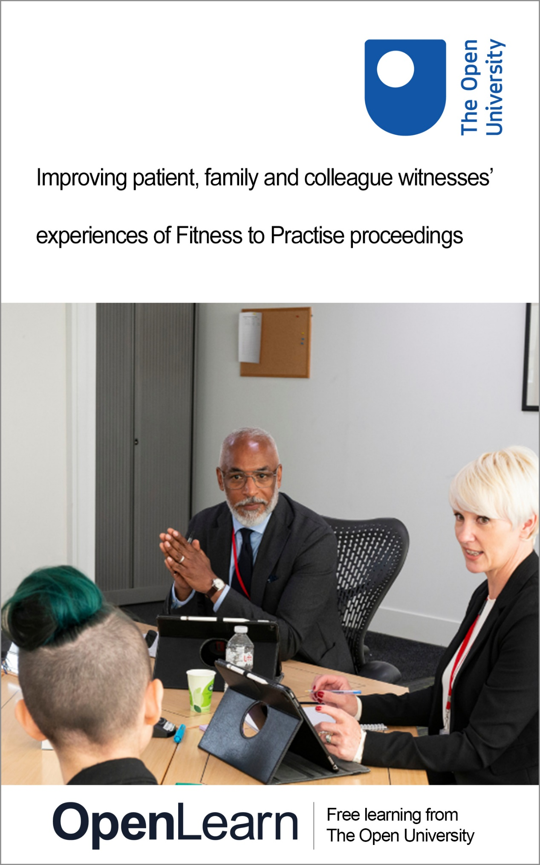

WTH_1

Improving patient, family and colleague witnesses’ experiences of Fitness to Practise proceedings

About this free course
This free course is an adapted extract from the Open University course .
This version of the content may include video, images and interactive content that may not be optimised for your device.
You can experience this free course as it was originally designed on OpenLearn, the home of free learning from The Open University –
There you’ll also be able to track your progress via your activity record, which you can use to demonstrate your learning.
First published 2024.
Unless otherwise stated, copyright © 2024 The Open University, all rights reserved.
Intellectual property
Unless otherwise stated, this resource is released under the terms of the Creative Commons Licence v4.0 http://creativecommons.org/licenses/by-nc-sa/4.0/deed.en_GB. Within that The Open University interprets this licence in the following way: www.open.edu/openlearn/about-openlearn/frequently-asked-questions-on-openlearn. Copyright and rights falling outside the terms of the Creative Commons Licence are retained or controlled by The Open University. Please read the full text before using any of the content.
We believe the primary barrier to accessing high-quality educational experiences is cost, which is why we aim to publish as much free content as possible under an open licence. If it proves difficult to release content under our preferred Creative Commons licence (e.g. because we can’t afford or gain the clearances or find suitable alternatives), we will still release the materials for free under a personal end-user licence.
This is because the learning experience will always be the same high quality offering and that should always be seen as positive – even if at times the licensing is different to Creative Commons.
When using the content you must attribute us (The Open University) (the OU) and any identified author in accordance with the terms of the Creative Commons Licence.
The Acknowledgements section is used to list, amongst other things, third party (Proprietary), licensed content which is not subject to Creative Commons licensing. Proprietary content must be used (retained) intact and in context to the content at all times.
The Acknowledgements section is also used to bring to your attention any other Special Restrictions which may apply to the content. For example there may be times when the Creative Commons Non-Commercial Sharealike licence does not apply to any of the content even if owned by us (The Open University). In these instances, unless stated otherwise, the content may be used for personal and non-commercial use.
We have also identified as Proprietary other material included in the content which is not subject to Creative Commons Licence. These are OU logos, trading names and may extend to certain photographic and video images and sound recordings and any other material as may be brought to your attention.
Unauthorised use of any of the content may constitute a breach of the terms and conditions and/or intellectual property laws.
We reserve the right to alter, amend or bring to an end any terms and conditions provided here without notice.
All rights falling outside the terms of the Creative Commons licence are retained or controlled by The Open University.
Head of Intellectual Property, The Open University

Contents
- Introduction
  - Introduction
  - Learning outcomes
  - Our project: Witness to Harm, Holding to Account
  - About this course
    - Before you start …
- Session 1: Raising a concern
  - Introduction
  - 1 Why do people raise a concern?
  - 2 Why don’t people raise a concern, and why does this matter?
  - 3 Summary of Session 1
- Session 2: How do people experience the process of raising a concern?
  - Introduction
  - 1 What information is available about raising a concern?
    - 1.1 Types and format of information
    - 1.2 Length and amount of information
    - 1.3 Readability
  - 2 How easy is it to raise a concern?
    - 2.1 Usability: what we found
  - 3 Summary of Session 2
- Session 3: How do people experience the Fitness to Practise process after raising a concern?
  - Introduction
  - 1 After raising a concern
    - 1.1 Experiences of people during screening and investigation
  - 2 Between raising a concern and the hearing
    - 2.1 Practicalities
  - 3 Summary of Session 3
- Session 4: How do people experience the Fitness to Practise hearing?
  - Introduction
  - 1 Vulnerability
  - 2 Experiences of giving evidence and cross-examination
  - 3 The outcome
  - 4 Summary of Session 4
- Session 5: Research recommendations
  - Introduction
  - 1 Recommendations to regulators and the government
  - 2 At the hearing
  - 3 Summary of Session 5
  - Course conclusion: thinking about Fitness to Practise
  - Additional resources
  - References
  - Acknowledgements
- Glossary
- Solutions
- Descriptions

Introduction

Introduction

integrity – transparency – respect – fairness – teamwork
To protect the public by delivering highly effective oversight of regulation and registration.
(Professional Standards Authority, 2024)

Regulators play a vital role in protecting members of the public and health and social care workers.
The UK has 13 health and social care regulators and 29 registers that require people on the register to meet certain behaviours and skills (in 2024).
These regulators register people with the qualifications and experience to work in their profession. Fitness to Practise is a process where people can refer concerns to regulators about people on their register. Regulators aim to maintain public confidence in the profession and contribute to patient safety by ensuring professional standards are upheld (Professional Standards Authority, 2023).
Most regulators rely on people and organisations to raise concerns about a registered person. Concerns may include misconduct, lack of competence, criminal convictions, illegal activity (e.g., fraud, deception, sexual harassment and abuse) and health conditions.
They will investigate if the regulator finds enough evidence that the concern is serious. An investigation involves members of the public with relevant information about the concern(s) giving a statement. If there is evidence that the concerns are serious enough, they are sent to a Fitness to Practise panel, where the member(s) of the public may have to give evidence in a hearing.

Learning outcomes
After studying this course, you should be able to:
- understand the role of professional regulators
- understand why people do or do not raise a concern about registrants of professional regulators
- understand the types of information available to people who are interested in raising a concern with a regulator
- explore the experiences of people who raise a concern with a regulator and those whose case is closed before a Fitness to Practise hearing
- explore the experiences of people who are required to be witnesses at a Fitness to Practise hearing
- describe the ways in which regulators can improve the Fitness to Practise process based on research findings.

Our project: Witness to Harm, Holding to Account
Improving patient, family and colleague witnesses’ experiences of Fitness to Practise proceedings: a mixed methods study



Our research aimed to understand the experience of people being a witness in the Fitness to Practise process. We focused on cases where the witness or their family member has died or believes that someone seriously harmed them. We examined:
- the impact of being involved in Fitness to Practise investigations and hearings on the person, family and colleague witnesses
- what support they receive from the regulator, and what support they would like.
For people who have experienced harm, it can be profoundly distressing or re-traumatising to have to remember and describe traumatic events. However, the person’s account raising concerns is often crucial to the Fitness to Practise process.
We completed a research project with input from members of the public, regulators, professionals, employers, lawyers and the public. The project aim was to find out about public experiences of the Fitness to Practise process and what regulators can do to improve it.



This study/project was funded by the NIHR HS&DR programme (NIHR131322). The views expressed are those of the author(s) and not necessarily those of the NIHR or the Department of Health and Social Care.

About this course
This course is for members of the public, health and social care professionals, Fitness to Practise panel members, regulators’ panel members, employers, unions/professional bodies and Fitness to Practise lawyers.
If you complete this course, it will provide insight and understanding about how members of the public experience the Fitness to Practise process and how best to support people.
The course is split into five sessions, which include optional activities. The sessions are:
- Raising a concern
- How do people experience the process of raising a concern?
- How do people experience the Fitness to Practise process after raising a concern?
- How do people experience the Fitness to Practise hearing?
- Research recommendations
The course contains quotations taken from real cases and therefore may contain some errors in grammar.

Before you start …
We would like to know a little about why you accessed this course to understand the relevance of the content for different people. Please answer the following questions.
What best describes you?

Interactive content is not available in this format.

What best describes the reason you want to use this course?

Interactive content is not available in this format.

Do you plan on completing the whole course or a selection of sessions of interest to you?

Interactive content is not available in this format.

How would you rate your current knowledge of Fitness to Practise processes and how people experience these?

Interactive content is not available in this format.

You can now go to Session 1.

Session 1: Raising a concern

Introduction
In this session, you will learn why some people raise concerns to regulators. You will also understand why some people do not report their concerns to regulators.


View description - Uncaptioned Figure
View alternative description - Uncaptioned Figure

1 Why do people raise a concern?
Protecting the public is the primary goal of health and social care regulators. By doing so, they aim to maintain public trust. It is one of the criteria used to determine if a registrant – who registers with a regulatory body – no longer poses a risk to the public. Our findings show that people who use services raise concerns about practitioners to guarantee that the lesson is learned and that practitioners do not repeat the mistakes that endanger the public. Along with this, Fitness to Practise procedures that are supportive and responsive to the needs of the public boost public trust in health and social care institutions.
The role of health and social care regulators is to protect the public by ensuring those on the register are competent and upholding the profession’s standards. To accomplish this, regulators must provide accessible and readable information, so that the public understands how to report a concern. It should also include how they will be supported throughout the Fitness to Practise process. Our findings suggest that when content relevant to Fitness to Practise is easily understandable by most adults, people feel more comfortable raising concerns and going through the procedure.
We found that raising concerns and going through the Fitness to Practice procedure caused significant further trauma for some people, which should be largely avoidable. Trauma-informed practice, which refers to services based on the knowledge that trauma can harm people and their ability to build trustworthy connections with social and healthcare providers, is possible. This type of approach would give referrers the assistance they need, freeing regulators to fulfill their primary duty of safeguarding the public while concurrently advancing and maintaining their safety and wellbeing.
People were motivated to go through the Fitness to Practise process to stop anyone else from going through what they did. One participant stated: ‘I did not want another individual to go through the same distress and trauma that I suffered.’ Similarly, another participant highlighted:

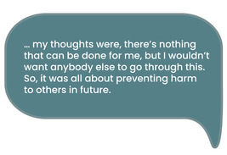
View description - Uncaptioned Figure
View alternative description - Uncaptioned Figure

Some participants felt Fitness to Practise is about enabling practitioners to reflect on their conduct and change their practice.
Some participants described being unsatisfied with the outcome of their referral, but they wanted to ensure that people are aware of their concerns. According to an interview participant:

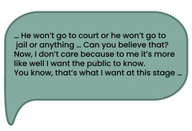
View description - Uncaptioned Figure
View alternative description - Uncaptioned Figure

Hopefully this has given you an insight into why some people raise concerns to regulators. This discussion was centered on the general population rather than health and social care professionals. So, the question is, can professionals report concerns to regulators?
The answer is that yes, they can, and indeed they are required to since practitioners’ values include protecting people’s safety and wellbeing while providing quality services. Although it can be difficult for them, we found that practitioners do raise concerns about their fellow colleagues.
Although whistleblowing procedures are put in place to protect practitioners who raise concerns about their colleagues, in our research we found that some practitioners still found it difficult due to power differential and the working culture. Whistleblowing is in the public interest because it legally protects people to raise concerns that affect the public or workers in an organisation. Raising concerns through appropriate routes is seen as important in protecting the public and people working in health and social care (General Medical Council, 2014; General Dental Council, 2015).
According to a junior doctor in training who was concerned about the conduct of a senior colleague:

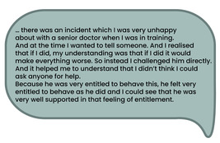
View description - Uncaptioned Figure
View alternative description - Uncaptioned Figure

The same practitioner also highlighted reasons they thought misconduct and malpractice existed in their workplace:

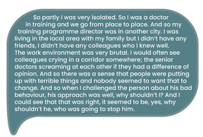
View description - Uncaptioned Figure
View alternative description - Uncaptioned Figure

Furthermore, when a practitioner raises a concern about their colleagues, they do not always receive support from their employer. One research participant commented:

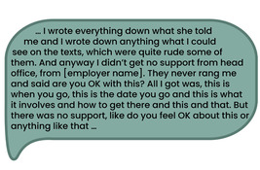
View description - Uncaptioned Figure
View alternative description - Uncaptioned Figure

2 Why don’t people raise a concern, and why does this matter?
So far, you’ve learned about some of the reasons the public expresses concern to regulators. You will now read our findings on why some people are unwilling to report concerns and the repercussions of not raising issues with health and social care regulators.


View description - Uncaptioned Figure
View alternative description - Uncaptioned Figure

Activity: reflection point
Allow 10 minutes

Watch the animation below and decide whether you agree with the reasons people gave for raising or not raising a concern.
If you’d like to, make some notes in the text box below. Your notes will only be visible to you.

Video content is not available in this format.
View transcript - Uncaptioned interactive content

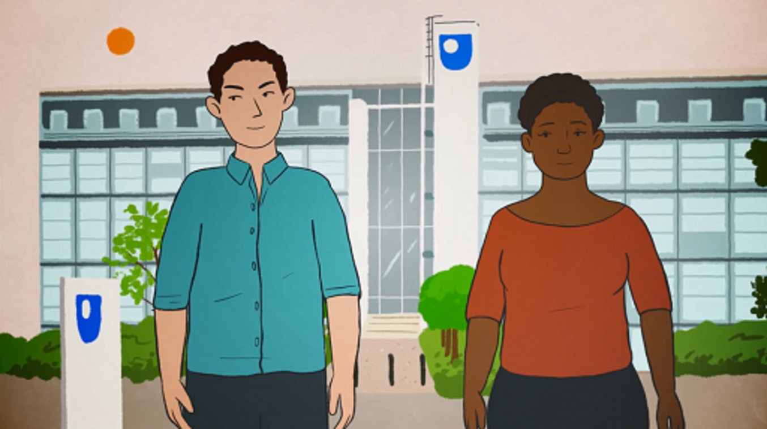

Provide your answer...
View discussion - Activity: reflection point

When some people wish to lodge concerns with regulators, the complex process deters them, and they may feel it’s a challenge when they are already distressed by practitioners’ conduct. One thing for sure is that to make people comfortable raising concerns, information needs to be easily available and accessible.
Given that the majority of UK citizens look for information online and that the majority of information is available there, research participants believed that how information is presented online is critical; too much information can overwhelm individuals, and too little will not provide them with enough information to make informed decisions.

Activity: reflection point
Allow 5 minutes

Reflect on the following question and make some notes in the text box below:
- If you needed to raise a concern with a regulator and found that there is a limit on the number of words you can write or that you cannot upload existing documents, would you still fill out the form and submit it? Note down the reasons why you responded in this way.

Provide your answer...
View discussion - Activity: reflection point

We also found that some people do not want to speak up about issues that are difficult to prove due to the poor practice, itself having an isolating effect:

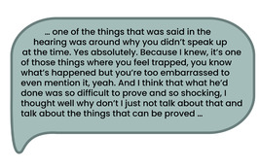
View description - Uncaptioned Figure
View alternative description - Uncaptioned Figure

3 Summary of Session 1
This session has provided an overview of why people raise a concern. It has shown that there are a lot of reasons why people raise concerns. Also, they find it difficult to raise concerns that include colleague practitioners. One point is clear: raising a concern is important because it is a mechanism for changing health and social care practice.

Activity: reflection point

Think about what you have learned in this session and how it has changed your knowledge of Fitness to Practise processes.
In completing this session, to what extent do you agree with this statement: ‘My knowledge of the reasons people raise concerns has improved’?

Interactive content is not available in this format.

How will you use the knowledge learned in this session? Make some notes in the text book below.

Provide your answer...

You can now go to Session 2.

Session 2: How do people experience the process of raising a concern?

Introduction
Regulators emphasise the importance of people receiving services to be able to raise concerns about a professional’s practise. This is to ensure the quality and safety of care (General Medical Council, 2014, 2019; General Dental Council, 2015). It is generally agreed that complaints and concerns are important for identifying flaws and allowing lessons to be learned.
Research before ours about raising a concern to a regulator focuses primarily on registrants’ legal and ethical duty to report colleagues. This can be through whistleblowing (to ensure the quality and safety of care) (General Dental Council, 2015; Biggar et al., 2020). Whistleblowing is in the public interest because it legally protects people to raise concerns that affect the public or workers in an organisation. Raising concerns through appropriate routes is seen as important in protecting the public and people working in health and social care to ensure the quality and safety of care (General Medical Council, 2014; General Dental Council, 2015). Our research looked at how and why the public raise concerns and their experiences of the process.
It is important that people who want to raise a concern have access to information and can do this easily (General Medical Council, 2019). This session will talk about our research in the content of public-facing websites and documents of UK regulators. There is an assessment of how easy it is to raise a concern using regulator websites. It also includes what information was available when a person wishes to raise a concern with a regulator.

1 What information is available about raising a concern?
Information about raising a concern is usually available on regulator websites. Our participants had mixed feelings about how useful this information was.
A General Osteopathic Council Patient Witness said:

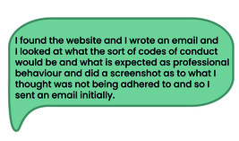
View description - Uncaptioned Figure
View alternative description - Uncaptioned Figure

However, our research participants found that they were not always aware of who to raise their concerns with.
A Nursing and Midwifery Council Public Witness – Family Member said:

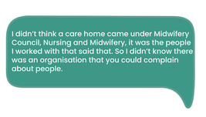
View description - Uncaptioned Figure
View alternative description - Uncaptioned Figure

We looked at the documents available and what information was included in them including different formats.

1.1 Types and format of information
We know that people use websites to source information, either on webpages or in downloadable documents, but these are not always very accessible:

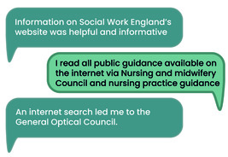
View description - Uncaptioned Figure
View alternative description - Uncaptioned Figure

A General Optical Council Patient Witness also said:

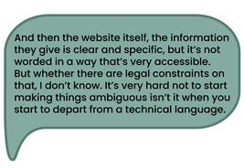
View description - Uncaptioned Figure
View alternative description - Uncaptioned Figure

But people also valued speaking to an actual person:

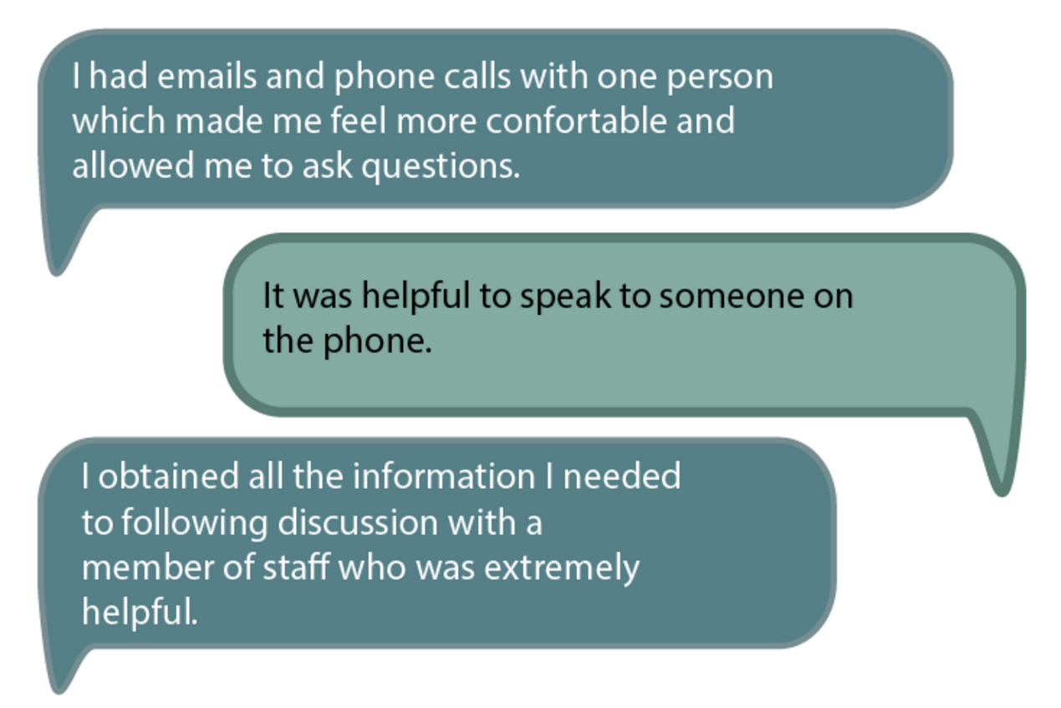
View description - Uncaptioned Figure
View alternative description - Uncaptioned Figure

Most information provided was in written form, but every person in our focus groups expressed that they would like the information in different formats such as simple flowcharts, images and videos along with documents to download based on individual preference. One participant said:

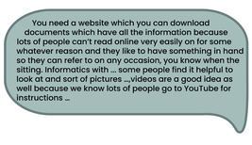
View description - Uncaptioned Figure
View alternative description - Uncaptioned Figure

Videos were seen as desirable to people in our focus groups:

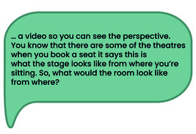
View description - Uncaptioned Figure
View alternative description - Uncaptioned Figure

Although it is possible to pause and revisit videos, best practice for the delivery of information through videos suggests that they should be no longer than six minutes, and where videos go beyond this, they should be segmented (Brame, 2016). Some regulators had videos much longer than this. To comply with UK Government standards (2022) videos should also offer captions or a transcript for accessibility purposes.

1.2 Length and amount of information


View description - Uncaptioned Figure
View alternative description - Uncaptioned Figure

Although people liked details about what would happen and why (e.g. how long the process will take and what will happen after raising a concern) to set expectations, long documents with lots of detailed information about the Fitness to Practise process were not always helpful. For example, very detailed information about being a witness and cross-examination may not be relevant at the point of raising a concern and more simple summaries of what will happen after raising a concern are more appropriate, i.e. the right information at the right time.
Contents pages in long documents and those that linked to specific pages in the document were useful to people as were bulleted lists that summarised detailed or complex information. An example from the Northern Ireland Social Care Council can be seen in Figure 1.

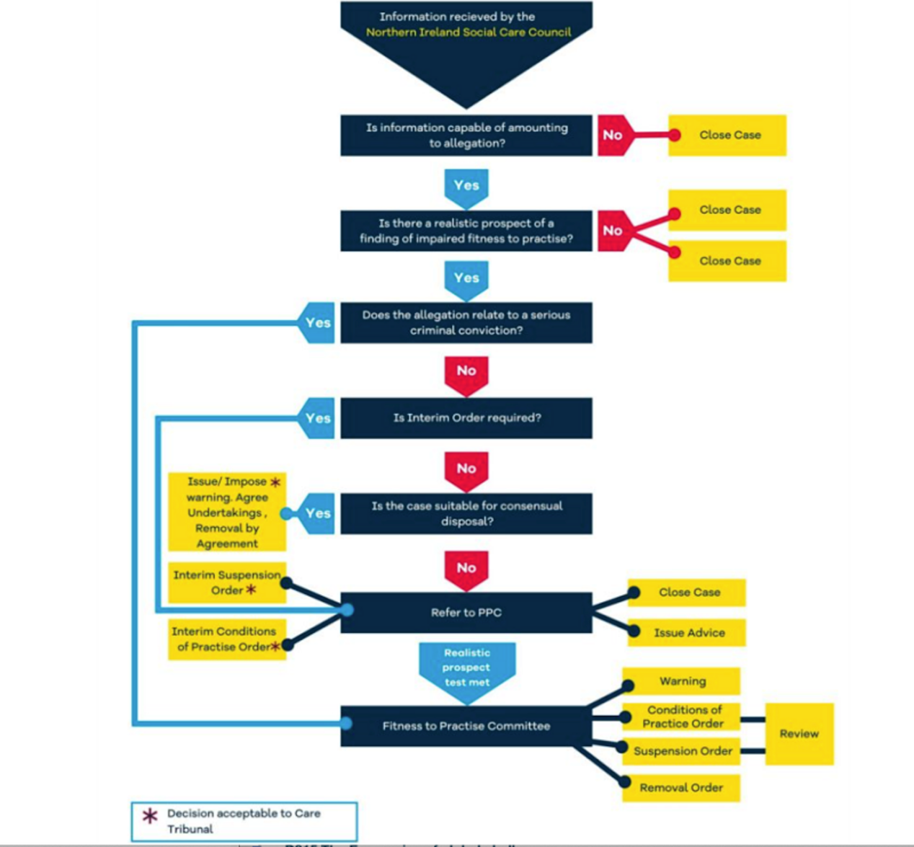
Figure 1 A flowchart example (Note: PCC is Preliminary Proceedings Committee which is part of the investigation process).
View description - Figure 1 A flowchart example (Note: PCC is Preliminary Proceedings Committee which ...
View alternative description - Figure 1 A flowchart example (Note: PCC is Preliminary Proceedings Committee which ...

1.3 Readability


View description - Uncaptioned Figure
View alternative description - Uncaptioned Figure

Readability refers to the quality of information and how easy it is to read and understand. In one study, up to 43% of written health information is often too complex for adults in the UK to understand (Rowlands et al., 2015). The average reading age of adults in the UK is typical of a child of nine years old (National Literacy Trust, 2023).
Members of the public are the largest group of people who raise concerns about registrants to a regulator, so the information available for people considering raising a concern with a regulator must be easy enough to be read by the UK average reading age.
It is also important to note that people who have raised a concern have been through trauma. So even if they have previously had a high reading age, it can impact their ability to understand and retain information.
Some regulators provided ‘easy read’ documents which use pictures and simple language to provide information and are primarily intended for people with learning difficulties.
What did we find out about the readability of regulator information?
We reviewed the information provided by regulators using different measures of readability. These measures are explained in Figure 2. Click on the plus signs to read the explanations.

Figure 2

Acceptable readability is a score of 80+. We found that none of the regulator documents met this 80+ standard. Three met 60+ which is a reading age of 14–15 years old. Eight met 50+ which is readable by 16–17 year olds. Readability scores are generally inconsistent across regulators. Easy read documents (there were 8 in total) ranged from scores of 59–88. One easy read document was deemed to be a score of 80+, the remaining seven did not meet this score. This suggests that ‘easy read’ documents may not be sufficiently easy to read for the intended audience.
Recommendations
Based on our findings we suggested the following:
- Keep the readability score to 60+ wherever possible (note: this may not always be possible for documents that include direct quotations, e.g. from research participants or where complex topics are covered).
- Mainly use one (them, a, the) to two-syllable words (pic-nic, tic-ket, un-less), except those polysyllable words in common use such as ‘es-ca-la-tor’.
- Avoid passive voice. Focus on the person or object that acts, not the person that experiences the action or object. For example,‘he praised them’ rather than ‘they were praised’.
- Avoid long sentences of more than 25 words.
- Use minimal medical and legal jargon and, where used, give a glossary or explanation.
- Always be consistent with the language and terms, e.g. use one term, not several (complaint, referral, concern, notification).
- Bullet points are better than detailed text to summarise information.
- Check spelling, punctuation and grammar.
- Avoid symbols and quotation marks.
- Only use comparisons between one thing and another (analogies) if they are familiar, and culturally and religiously appropriate.

2 How easy is it to raise a concern?
Our research participants had mixed experiences. Some found it difficult to raise a concern. A General Optical Council (GOC) patient witness said the following:

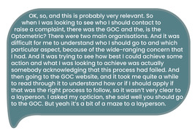
View description - Uncaptioned Figure
View alternative description - Uncaptioned Figure

Others found the process to be straightforward. However, this seemed to depend on the individual and the regulator. As most people used regulator websites to raise a concern, we also looked at how easy it was to use these.

2.1 Usability: what we found
Website usability is ‘... an essential indicator of user-friendliness of a website which can be evaluated by observing users when using the website’s features and user interfaces. Good usability design focuses on user-centric design, which focuses primarily on users’ experience rather than the actual procedure’ (Ramotion, 2024).
Website usability involves the design of websites so that they are simple enough for people to achieve their tasks quickly and easily (Singhuja and Surajith, 2009). It includes being able to find your way around a website to locate the information you need and know what to do next with minimal effort (Nah and Davis, 2002). As users of websites tend to have a specific goal or aim in mind, the usability of websites is important. People may leave a website if they struggle to obtain the information required even if the website contains the information needed (McKinney et al., 2002).
Eleven academics and members of the research team (including a member of the public with lived experience of raising a concern) evaluated the usability of the websites. They approached regulator websites as a member of the public who wanted to raise a concern to the point of submitting a concern (but not submitting it). We asked our usability testers to explain their experiences with this process.

Activity: the usability of websites when raising a concern
Allow 15 minutes

Watch the following animation about how usable the regulator websites were based on our participants’ experiences. Make some notes in the text box below about what you might like if you were trying to raise a concern. Your notes will only be visible to you.

Video content is not available in this format.
View transcript - Uncaptioned interactive content

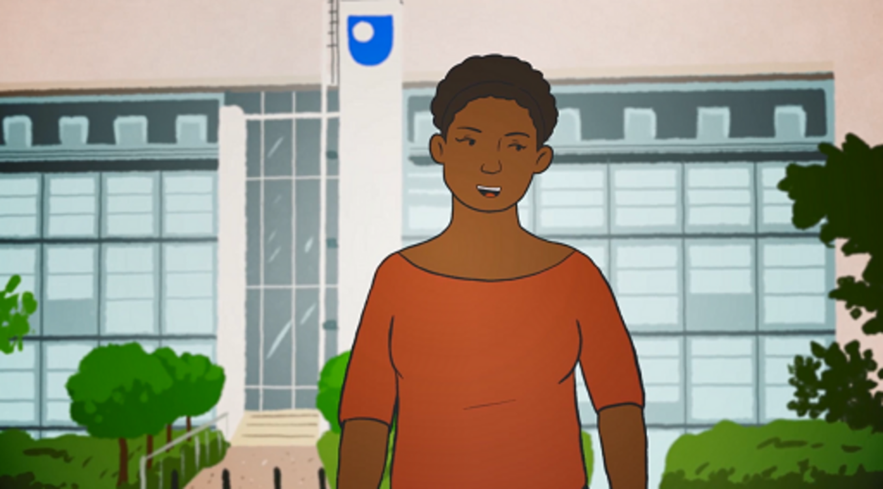

Provide your answer...
View discussion - Activity: the usability of websites when raising a concern

3 Summary of Session 2
In this session, you explored our findings about information provided when raising a concern and also how people experience the process of raising a concern from a usability perspective.

Activity: reflection point

‘The right information, in the right format, at the right time.’
You might want to take some time to reflect on what you learned in Session 2. Perhaps consider:
- What information would you want to have if you were raising a concern about a professional?
- What type and format of information is helpful and in what format?
- What would you want to know if you were considering/are considering raising a concern about a registrant?
In completing this session, to what extent do you agree with this statement: ‘My knowledge of people’s experiences of readability and finding information has improved’?

Interactive content is not available in this format.

How will you use the knowledge learned in this session? Make some notes in the text box below.

Provide your answer...

You can now go to Session 3.

Session 3: How do people experience the Fitness to Practise process after raising a concern?

Introduction


View description - Uncaptioned Figure
View alternative description - Uncaptioned Figure

When a concern has been raised the regulator takes several actions. They read the details of the concern. They may decide to take it forward but they may decide that there is not enough evidence or that the concerns are not serious enough. They may decide that they are not the best organisation to deal with the concern (e.g. a concern to another organisation may be more appropriate, such as the service provider or commissioner) and not proceed any further with the concern until it has been investigated by an employer. Once investigated, the regulator may also decide that the concern is not serious enough or there is not enough evidence to proceed to a public hearing, or if it is serious enough it may go to a full public hearing with a panel. If there is a concern about the safety of other people or the concern is very serious, the registrant may be suspended until further investigations have taken place.
The process can take months or years and is stressful for members of the public and registered professionals involved. There is a lot of time and effort involved for witnesses (e.g. finding and providing evidence, attending a hearing) and other people involved. This session is about how members of the public who have raised a concern about a professional to a health or social care regulator experience the process before a hearing, and their views of what could be improved.

1 After raising a concern
After a concern is raised the regulator will review the information and any evidence submitted and may decide to investigate further. This is known as screening and investigation. This is where the regulator may ask for a statement from the person raising the concern, and any other people involved. The statement gives people the opportunity to provide the facts (as they see them) about the concern. A statement can be provided verbally or in writing and includes facts and information about the event that led to the concern. It may take place by email, in writing or sometimes in person with a point of contact with the regulator, sometimes called a ‘case worker’ or similar. This may also be formalised as a witness statement in discussion with a lawyer from the regulator.
As our research shows, people differ in how they experience this aspect of the Fitness to Practise process or people have different experiences of the process and find the process affects them in different ways.

1.1 Experiences of people during screening and investigation
People found that the Fitness to Practise process was quite distressing and repetitive, having to repeat their story over and over again:

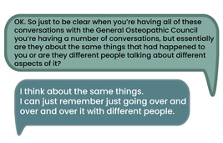
View description - Uncaptioned Figure
View alternative description - Uncaptioned Figure

When there were changes in staffing at the regulator this also had a negative impact on people’s experiences:

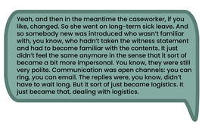
View description - Uncaptioned Figure
View alternative description - Uncaptioned Figure

What happens during screening and investigation?
During screening and investigation, regulators may ask themselves certain types of questions to help make a decision. For example, Nursing and Midwifery Council (2023a) may ask:
- Do we have a written concern about a nurse, midwife or nursing associate on our register?
- Is there evidence of a serious concern that could require us to take regulatory action to protect the public?
- Is there clear evidence to show that the nurse, midwife or nursing associate is currently fit to practise?
They will also verify facts, explore whether there is enough supporting evidence, consider anonymous concerns, context, and seriousness about the concern that has been raised (Nursing and Midwifery Council, 2023b).
Click on the plus signs to read the examples.

Experiences of people whose cases were closed
Many cases were closed before proceeding to a hearing and these people had their own individual experiences.
We surveyed 62 people whose case was closed prior to a hearing. Only 6 said they had a single point of regulator contact to help them after raising a concern:

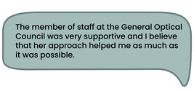
View description - Uncaptioned Figure
View alternative description - Uncaptioned Figure

Others felt it was unclear who they could contact about the case.
People whose case was closed before proceeding to hearing were often disappointed and frustrated:

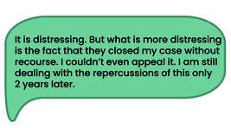
View description - Uncaptioned Figure
View alternative description - Uncaptioned Figure

However, people felt it was important to raise a concern for the purposes of public good, despite finding the retelling distressing:

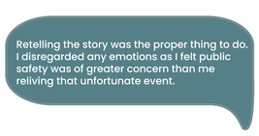
View description - Uncaptioned Figure
View alternative description - Uncaptioned Figure

Support after raising a concern
Many reported that they got most of their support from their friends and families (who were also the people who helped them at the time of the event):

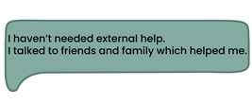
View description - Uncaptioned Figure
View alternative description - Uncaptioned Figure

Some regulators offer access to an independent counselling service (Victim Support) but our participants often reported that this was not helpful and they have preferred advice independent of the regulator on how to progress their concern:

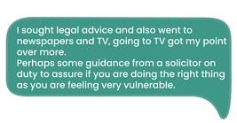
View description - Uncaptioned Figure
View alternative description - Uncaptioned Figure

This tells us that support from the regulator (a consistent, single point of contact), independent advice, and personal networks are crucial to help people at all stages of the Fitness to Practise process. Family and friends are often important in challenging times of life. However, they may also suffer emotional stress and witnesses may not involve them for fear of this.
There are independent support services (outside of the regulator) available, and many regulators provide information about how to access these. Figure 1 shows some examples of services that are available across the UK and those specific to different nations.
Click on the ‘i’ on each flag to read the resources available in each part of the UK.

Figure 1

In our research, participants did not mention using the independent support organisations in Figure 1, so it is unclear how useful this signposting to such organisations may be. People often sought support from their social networks or services independent of the regulator.

2 Between raising a concern and the hearing
There are a range of things to think about before and during a Fitness to Practise hearing, from simple practicalities like claiming expenses or travelling to a face-to-face hearing, and preparing a witness statement, to giving evidence as a witness and being questioned by both ‘parties’ in the case, namely the registrant’s representative and the regulator.
The regulator may draft a witness statement with the person who has raised a concern. They may check the details of this statement and it is then used as evidence as part of the Fitness to Practise hearing.

2.1 Practicalities


View description - Uncaptioned Figure
View alternative description - Uncaptioned Figure

Several regulators are based in London, although others are situated elsewhere in the United Kingdom.
Attending a hearing as a witness may mean travelling to the regulator’s head office and being available to be called to be cross-examined about the witness statement. Hearings usually run from 9am to 5pm which means witnesses have to travel to the regulator’s hearing centre and stay nearby while they are waiting to give evidence. This might mean staying overnight the day before the hearing to get there on time. Committees (or hearing panels) usually aim to hear from public witnesses in one day, but it is possible that they are asked to return the next day which might mean staying another night or returning the next day. If witnesses have to give evidence over more than one day or over a lunch break they remain under oath/affirmation and are not allowed to discuss the case with anyone else. Witnesses are given somewhere to wait in the regulator’s office. Regulators will usually cover travel expenses and overnight accommodation, but people will need to liaise with the regulator about claiming expenses and organising travel and accommodation.
Virtual hearings
Most hearings are now conducted online via software such as Microsoft Teams. Several regulators provided written information and instructions about how this will work and what the witness will need to do. However, for people who do not use this type of software or technology regularly, it can be a challenge. Even people who are confident in using this type of software can come across technical issues. For example, a regulator may want them to attend anonymously and some actions and settings need to be changed on the software to allow people to do this.

Activity: reflection point
Allow 10 minutes

Our focus group members felt that videos of the hearing room were useful in helping them understand what it would be like to attend a face-to-face hearing. Our research participants also felt that seeing the hearing room before anyone else was there helped to reassure them.
Watch the following video and consider whether you feel this is something you would want to prepare you for being a witness. The Medical Professional Tribunal Service (MPTS) manages Fitness to Practise cases where a concern has been raised about a doctor.
If you’d like to, make some notes in the text box below. Your notes will only be visible to you.
Video: A tour of the MPTS hearing centre

Provide your answer...
View discussion - Activity: reflection point

Several regulators have virtual tours, videos or images of the hearing room. You are normally able to bring someone with you for support and they may be able to attend the hearing with you but not take part. You are not allowed to observe a hearing before you give evidence but can attend as member of the public afterwards, if the hearing is in public but any costs associated with this are not normally paid by the regulator.
Witness ‘work’


View description - Uncaptioned Figure
View alternative description - Uncaptioned Figure

People (or their family members) who have raised concerns have often experienced poor treatment by health or social care professionals. Our research found that being a witness and reliving the bad experiences is not only stressful but involves a significant amount of unpaid work. Before a hearing it’s likely they raised the concern and have made statements. This includes recalling of the details of events and taking time to gather information required from them (such as letters or records) as part of the investigation. This work is often not recognised by those involved in the process. This work carries costs and consequences such as time, effort, energy and stress.

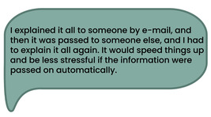
View description - Uncaptioned Figure
View alternative description - Uncaptioned Figure

It also takes time for people to prepare for a hearing, reading through/remembering the facts in a witness statement to prepare for being questioned on this evidence. Some people had experience of travelling to a hearing, waiting, then not being called and being asked to attend on new dates. This can create more work for witnesses (e.g. financial, time away from work, organising childcare).

3 Summary of Session 3
This session has provided an overview of the experiences of people after they have raised a concern and in preparation for a hearing. It has shown that there is a lot of work involved and that there are practicalities that need to be considered if the case does proceed to hearing and what information/support people need/want from when they first make a concern and across the Fitness to Practise process.

Activity: reflection point

Think about what you have learned in this session and how it has changed your knowledge of Fitness to Practise processes.
In completing this session, to what extent do you agree with this statement: ‘My knowledge of what happens after raising a concern has improved’?

Interactive content is not available in this format.

How will you use the knowledge learned in this session? Make some notes in the textbox below.

Provide your answer...

You can now go to Session 4.

Session 4: How do people experience the Fitness to Practise hearing?

Introduction
Our research shows that attending a hearing as a witness can be stressful regardless of how well someone is prepared beforehand. The hearing is a very formal process, and witnesses are expected to follow the direction of the person who chairs the hearing in relation to when they are allowed to enter the hearing room, where they sit, and when they speak. Figure 1 shows an example hearing room at the General Dental Council (GDC) and chair 5 is where a witness would sit. If you click on Figure 1 you will be able to see where other people sit and who they are. The Chair of the panel will introduce who people are but will not normally name patients and a witness may be called ‘patient A’ for example or ‘witness A’.
Click on the plus signs next to each numbered chair to read who sits where.

There is usually a hearings officer or clerk to help and advise you. The panel will be seated in a formal arrangement. The registrant may or may not be present. Legal representatives (barristers or solicitors) will be present. People usually wear smart clothing.
Witnesses are not usually allowed to have their own notes or devices with them and are expected to speak only when asked a question. Witnesses are required to swear an oath (confirming that they will tell the truth); they can do this on a holy book of their choice or read out an affirmation to confirm that they will tell the truth. This is important because the purpose of regulators is to protect the public, but it is also easier for a witness to tell the truth about the facts in their witness statement. This session explores the experiences of attending a hearing and being questioned as a public witness.

1 Vulnerability
Regulators are affected by a range of different legislation in the United Kingdom, particularly those relating to equality and diversity such as the Human Rights Act (1998) and Equality Act (2010) along with other guidance, such as the Professional Standards Authority Standards of Good Regulation (2020).
Vulnerability is a well-know term in health and social care, such as safeguarding of children and young people. It is often focused on individual traits or circumstances, such as someone with a learning disability. This means the term vulnerable can sometimes mean people are stigmatised rather than supported appropriately.
The term vulnerable is relevant to witnesses’ part of the Fitness to Practise process. The process is challenging as the person may have experienced trauma, being cross-examined is challenging and, therefore, this could mean the person is vulnerable. As such, regulators should consider this as part of the preparation of witnesses.

Activity: reflection point
Allow 15 minutes

Watch the following animation explaining some of the findings from our research about why support offered by regulators is often not enough to support those who are vulnerable. This part of the project used policy documents from social care and social work regulators to see how they identified and supported those who were seen to be vulnerable. Before you begin, reflect on what you think makes someone vulnerable.
If you’d like to, make some notes in the text box below. Your notes will only be visible to you.

Video content is not available in this format.
View transcript - Uncaptioned interactive content

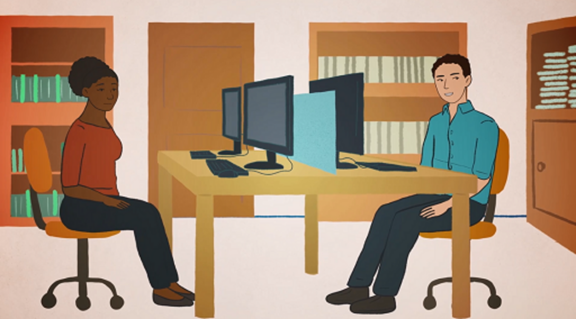

Provide your answer...
View discussion - Activity: reflection point

You will now explore the lived experiences of people who have given evidence in a Fitness to Practise hearing.

2 Experiences of giving evidence and cross-examination
Cross-examination is ‘a legal term used to describe the process of asking questions to witnesses. Cross-examination can be challenging for witnesses but please remember it is a necessary process to ensure a fair hearing’ (Nursing and Midwifery Council, 2021, p. 13). Cross-examination can go on for several hours and it involves both the legal representative of the regulator (case presenter) and the registrant’s legal representative, asking questions about the witness statement. The panel and the panel’s legal adviser may also ask questions. Questions can be repeated and re-phrased and may result in versions of events proposed that are different to the ones the witness first presented in their statement. Witnesses may also be asked how well they remember what happened and why they believe this to be true. This can be made more difficult by the passage of time, perhaps several years since the events took place.
Being cross-examined can be a challenging process, and the person may feel anxious about it. We found that often it was a surprise to the public witness how challenging it was. They felt that the quality of their evidence was questioned, and so too was their memory, truthfulness and integrity as a witness. Fitness to Practise hearings can often take place many months or years after concerns have been raised. The professional’s legal representative can ask questions that make the witness seem unreliable, for example questioning how well they remember events.

Activity: reflection point
Allow 15 minutes

Watch the following animation and take a few minutes to think about why cross-examination might be stressful. Make some notes in the text box below.

Video content is not available in this format.
View transcript - Uncaptioned interactive content

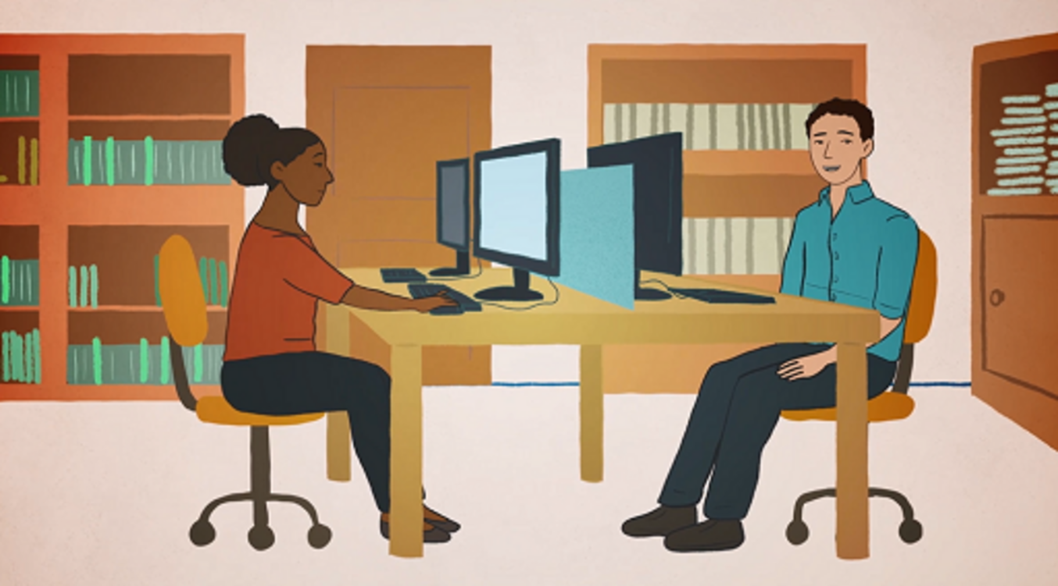

Provide your answer...
View discussion - Activity: reflection point

Cross-examination is also challenging because there are often tensions between the perspectives of panel members, witnesses and registrants.
Perspectives include:

The panel
We are the Fitness to Practise panel. Our focus is on protecting the public, establishing if a registrant’s Fitness to Practise is impaired and taking action accordingly. The focus is on the registrants’ actions. Harm is potentially an indicator of misconduct, and can be linked to sanctions.

The witness
I am the witness, my experience encompasses my history of events leading to the hearing (and process of giving information to investigation and hearing). My focus is on the impact of events.

The registrant
I am the registrant, here to defend my case and evidence I am fit to practise.

To prepare for the hearing people may want to know how questions will be asked and the types of things witnesses can ask for to assist them during the cross-examination process. And although regulators do provide information, it is not necessarily being used by witnesses. We found that the General Dental Council (2022) provides some key things to remember about being questioned as a witness (Box 1) and what a witness can do. The panel and legal adviser can control the questioning, and step in if they think it is inappropriate. A witness can also ask them if the question is appropriate and if they must answer it or, if they feel they need one, a break from cross-examination.

Box 1 What the GDC (2022) advise witnesses in their guidance for witnesses
When answering questions, please:
- take your time
- speak clearly and slowly so everyone can hear your evidence and a recording can be made
- ask for a break if you need one.
Other important things to remember when giving evidence:
- Listen carefully to the questions and make sure you understand them before giving your answer.
- If you don’t understand the question, say ‘I don’t understand. Can you ask me that again in a different way?’ If you still don’t understand, it is okay to say ‘I am sorry, but I still don’t understand’.
- If someone asks you two or three questions together, you can ask them to repeat the questions one at a time.
- Don’t try to answer a question if you don’t know the answer or you cannot remember.
- If you’re asked the same question again, this does not mean your first answer was wrong. Just answer the question again.

3 The outcome


View description - Uncaptioned Figure
View alternative description - Uncaptioned Figure

Some people who have given evidence may wish to stay for the remainder of the hearing. And while this may create more ‘work’ (e.g. financial or the need to extend childcare), many people want to see the rest of the hearing.
Once the hearing is complete and a decision about the outcome is made (known as determination), we found there was little support available for people to understand the outcome. It was also unclear to them about steps they can take with the regulator or other bodies, or how to obtain independent advice or emotional support. Regulators provide information about the following:
- Claiming expenses (how to do so).
- Outcome decisions (the different decisions the panel can make). For example, taking the professional off the register, preventing them from practicing, conditions on what they can do for a period of time or no action.
- Registrant appeals (that the registrant can appeal the decision of the panel).
- How to give feedback about the experience.
Our focus group participants felt that they would want the outcome provided in writing and regulators do provide this:

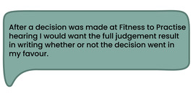
View description - Uncaptioned Figure
View alternative description - Uncaptioned Figure

And, we know from Parliamentary and Health Service Ombudsman (2020) who focus on healthcare complaints that it is important that information/communication to witnesses is tailored to individual needs so that they can understand the outcome and what this means. Many felt that this was not the case. A public witness said:

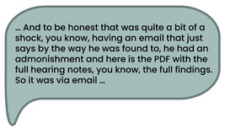
View description - Uncaptioned Figure
View alternative description - Uncaptioned Figure

Some regulators provide outcomes in lengthy documents (sometimes over 50 pages long) and use language difficult for members of the public to understand. It is important that communications with members of the public are suited to their individual needs and that they have support to understand what the outcome means.

4 Summary of Session 4
This session has provided an overview of what it is like to be a witness and the challenges that come with it. It has also considered what happens after the hearing and how people experience the final ‘outcome’.

Activity: reflection point

Think about what you have learned in this session.
In completing this session, to what extent do you agree with this statement: ‘My knowledge of the experiences of witnesses at a fitness to practice hearing has improved’?

Interactive content is not available in this format.

How will you use the knowledge learned in this session? Make some notes in the text box below.

Provide your answer...

You can now go to Session 5.

Session 5: Research recommendations

Introduction


View description - Uncaptioned Figure
View alternative description - Uncaptioned Figure

In the last four sessions, you learned about the findings of the ‘witness to harm’ project. Now you will look at recommendations based on the project’s findings. Several proposals are suggested for both regulators and the government.
In this session, you will identify the recommendations made to the government and regulators about the involvement of independent advocacy services.

1 Recommendations to regulators and the government
This section allows you to think about what you would recommend to regulators and the government in order to improve experiences of people who raise concerns.

Activity: reflection point
Allow 10 minutes

Based on your understanding of the findings from Sessions 1 to 4 what recommendations would you propose to the government? Also, what should regulators do to provide independent support to public referrers?
If you did not complete Sessions 1 to 4 you may want to think about what you would expect from a regulator if you wanted to raise a concern.
If you’d like to, make some notes in the text box below. Your notes will only be visible to you.

Provide your answer...
View discussion - Activity: reflection point

We are also suggesting that employers and health and social care regulators should review and extend informational, wellbeing and emotional support offered to members of the public, registrants and colleague witnesses involved in Fitness to Practise processes. In addition to this, based on our findings, we recommend that regulators recognise the public’s key role when they raise concerns in the Fitness to Practise process. Also, they need to understand how Fitness to Practise processes can be experienced by the public, their motivations for raising a concern in the first place, the impact of the unfamiliarity of these processes, and the work and personal costs involved for the public. They should recognise the harm caused by unintentionally disrespectful or overtly legalistic communications. We make these recommendations to all regulators of the UK’s health and social care workforce.


View description - Uncaptioned Figure
View alternative description - Uncaptioned Figure

Activity: reflection point
Allow 5 minutes

Consider what recommendations you would make to regulators on information provision. Make some notes in the text box below.

Provide your answer...
View discussion - Activity: reflection point

Communication is critical in supporting public referrers. We strongly believe that instead of one-way communication based on transmission of information regulators should focus on a two-way dialogue to allow public referrers to feel valued and heard in the Fitness to Practise process. There are several ways they may accomplish this, and in the following activity you will learn how regulators might strengthen their communication with public referrers.

Activity: reflection point
Allow 10 minutes

Watch the following animation.

Video content is not available in this format.
View transcript - Uncaptioned interactive content

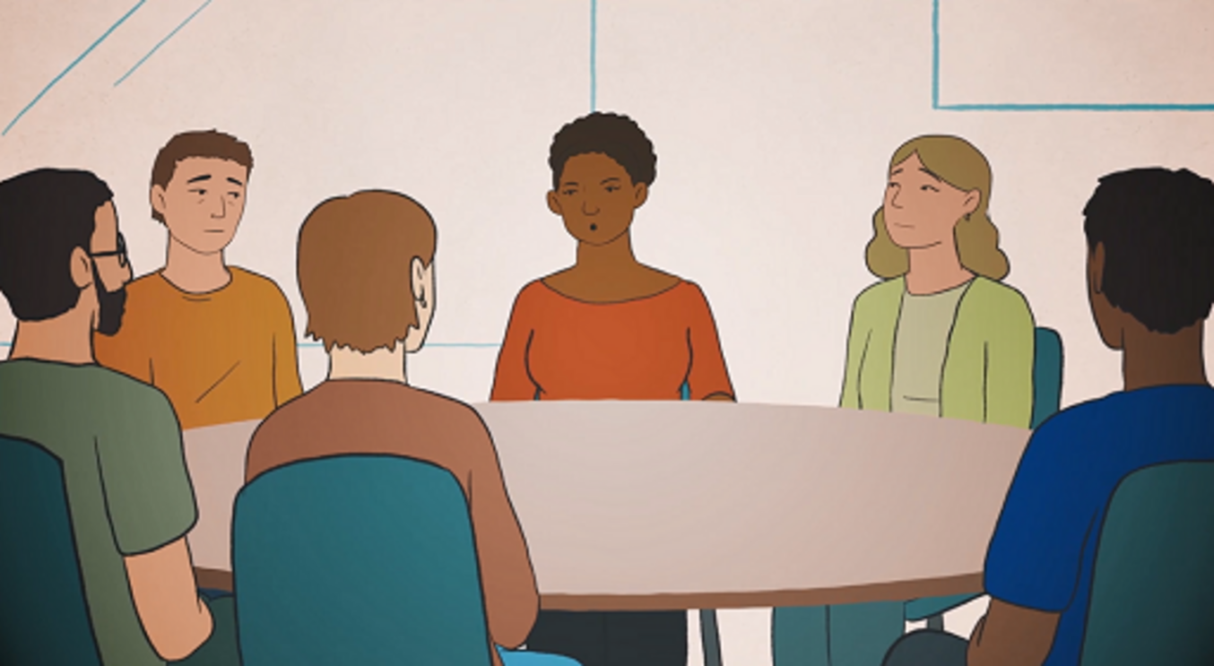

All of these statements are recommendations based on our research findings. Reflect on these recommendations and consider whether you feel they would support improve Fitness to Practise. Write your response in the box next to the statement.

Statement | Agree/Not sure/Disagree?
Clearly explaining the function and purpose of the process, and for each case explain why aspects of a case might not be included, or a referral may be closed. | Provide your answer...
Actively listening to and, as far as possible, addressing people’s concerns about the process. | Provide your answer...
Recording a statement of their concerns and the impact of these concerns available to regulator staff throughout the case. | Provide your answer...
Keep people affected by the case regularly updated on progress. In the event of unavoidable delays explain as clearly as possible why this has happened and what will happen next. | Provide your answer...
Establish the means of communication, amount of information and timings of communications with the public who raised concerns and others affected by the case and make this available to regulator staff throughout the case. | Provide your answer...
Decisions should be communicated by appropriate staff members who are able to answer questions. | Provide your answer...
Review terminology and provide staff training in respectful and empathetic engagement and communication. | Provide your answer...

View discussion - Activity: reflection point

2 At the hearing
Now you are going to focus on the hearing part of the Fitness to Practise process. The process of cross-examination can generate additional harm for witnesses. Regulators should support witnesses to understand the nature of being a public witness and cross-examination, including clearly explaining the hearing; what actions they can take when giving evidence such as asking for breaks, and for questions to be rephrased.
Panel members and legal advisers should be trained to use their role to prevent or intervene in inappropriate or distressing cross-examination.
Regulators need to support witnesses to observe the proceedings after they have given evidence if they want to. Finally, online hearings should ensure that all attendees have their correct and/or anonymised name and role on display.
Also, where appropriate, and in conjunction with the public witness, regulators should consider whether alternative or modified approaches to cross-examination may be appropriate and possible within existing Fitness to Practise processes. More broadly, they need to consider whether alternatives to Fitness to Practise processes can be sought out and evaluated with reference to, among other matters, ensuring that the voices of harmed witnesses are heard.

3 Summary of Session 5
This session has provided an overview of the recommendations proposed based on the findings of this research.

Activity: reflection point

You might want to take some time to reflect on what you learned in this and other topics you might have accessed.
In completing this topic, has your knowledge of Fitness to Practise processes and/or how people experience them improved?

Interactive content is not available in this format.

How will you use the knowledge learned in this session? Make some notes in the text box below.

Provide your answer...

Course conclusion: thinking about Fitness to Practise


View description - Uncaptioned Figure
View alternative description - Uncaptioned Figure

This resource has explored the findings from the research project ‘Witness to Harm, Holding to account’. It discussed the experiences of people who have been part of the Fitness to Practise process, raising a concern about registered professionals. Session 1 introduced you to the Fitness to Practise process and explored the reasons why someone would want to raise a concern about a professional. Session 2 explored the ways to raise a concern and how easy (or not) it is to do this. Sessions 3 and 4 explained the experiences of people who have raised a concern and what it is like to be a witness at a hearing. Finally, we presented the recommendations from our research findings which explain how the experience of the Fitness to Practise process could be improved for members of the public or people who are witnesses at a hearing.
Our recommendations include:
- compassion and integrity in dealing with concerns
- greater clarity regarding where, when and how to report concerns
- greater inclusion in the Fitness to Practise process
- greater use of experts who understand or specialise in particular issues
- information, preparation and other increased support
- reduction in the duration of the process
- regulators to make themselves more visible to the public, ‘to promote themselves and their role’.

Activity: reflection point

Now you have completed this course, think about what you have learned.
How would you rate your knowledge of Fitness to Practise processes and how people experience these?

Interactive content is not available in this format.

Did this course improve your knowledge of Fitness to Practise processes and how people experience these?

Interactive content is not available in this format.

How will you use the knowledge learned in this course? Make some notes in the text box below.

Provide your answer...

This study/project is funded by the NIHR HS&DR programme (NIHR131322). The views expressed are those of the author(s) and not necessarily those of the NIHR or the Department of Health and Social Care.

Additional resources
Here are some further resources that outline the findings from our project.
In this resource, we hear from Berry Rose (SWE), Dinah Godfree (PSA), Emma Willis (NMC), Paul Cummins (GPhC), David Dolan (GMC), Jessie Cunnett (The Point of Care Foundation and public advisor to the team), from our team Professor Rosalind Searle, and Richard West, a public member of the team with lived experience of involvement in fitness to practise proceedings.
Here is a is a blog for the Professional Standards Authority: ‘More compassion is needed in complaints handling’.
You can read more about our two dissemination events in London and Dundee.
You might be interested in viewing the following posters:
- How easy to read are social care and social work regulators’ Fitness to Practise web resources?
- Assessing the usability and accessibility of regulator websites for members of the public wishing to raise a concern
- A content analysis of UK social care regulator information for public witnesses in a fitness to practise heading
- A content analysis of professional regulator information for public witnesses in a fitness to practise hearing
- How easy is it to report concern about a doctor, nurse or someone giving you care? Does it help to have Easy Read leaflets? What we found …
- Witness to Harm-holding to account: Survey of harmed public referrers whose case closed prior to a hearing
- Employer support to witnesses: Professional regulatory (fitness to practise) proceedings
- How easy to read are regulators’ Fitness to Practice web resources?
Hear some witness experiences.
Read our research briefing document.
There are two animations for people involved in social care. The first is for service users of social care, which explains what fitness to practise is and what they can do to raise a concern with a regulator. The second is for social care and social work registrants, similarly, explaining what fitness to practise is and why it is important for registrants to understand it along with how and why to raise a concern with a regulator.

Video content is not available in this format.
View transcript - Uncaptioned interactive content

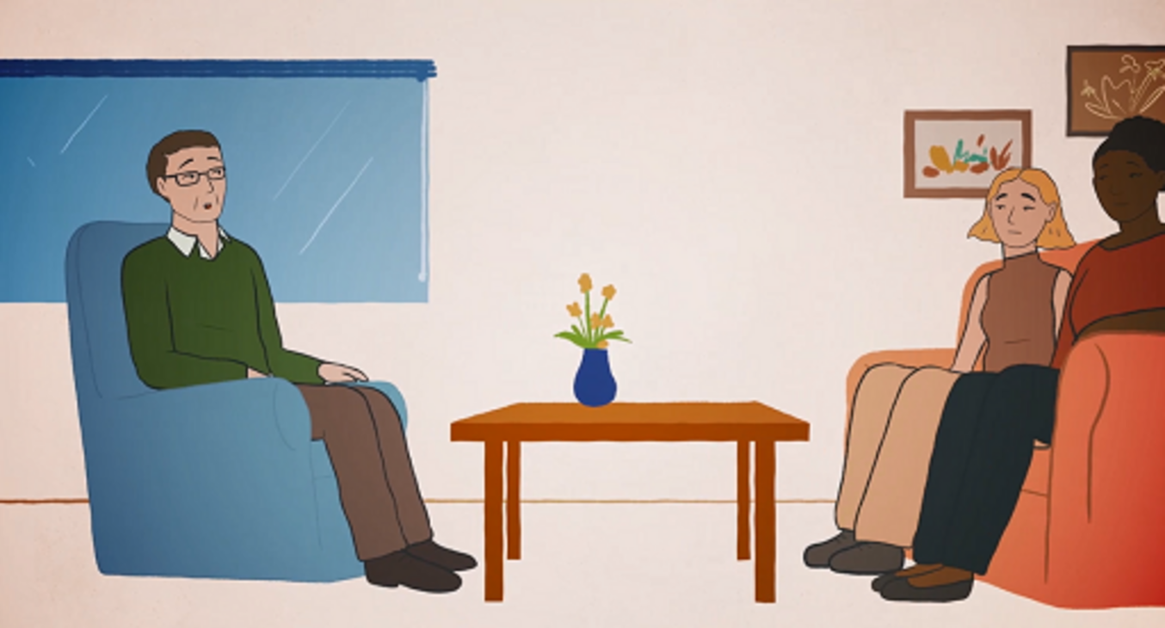

Video content is not available in this format.
View transcript - Uncaptioned interactive content

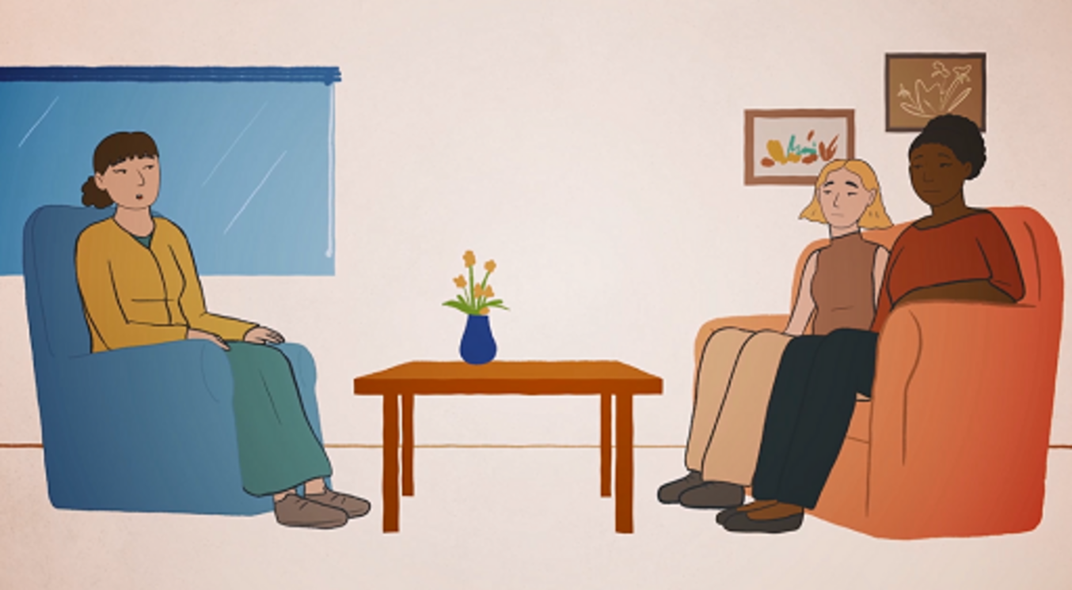

References
International Association of Medical Regulatory Authorities (2023) ‘Membership listing’. Available at: https://www.iamra.com/membership-listing (Accessed: 9 February 2024).
International Council of Nurses (2023) ‘Who we are’. Available at: https://www.icn.ch/who-we-are (Accessed: 9 February 2024).
Professional Standards Authority (2024) ‘Strategic Objectives’. Available at: https://www.professionalstandards.org.uk/about-us/strategic-objectives (Accessed: 12 March 2024).
Professional Standards Authority (2023) ‘What is Fitness to Practise?’ Available at: https://www.professionalstandards.org.uk/news-and-blog/blog/detail/blog/2022/07/14/what-is-fitness-to-practise (Accessed: 9 February 2024).
General Dental Council (2015) GDC ‘“Raising Concerns” Research Final Research Report’. Available at: https://www.gdc-uk.org/docs/default-source/research/gdc-raising-concerns-research-report-final.pdf?sfvrsn=3a613f46_2 (Accessed: 5 March 2024).
General Medical Council (2014) ‘Exploring the experience of public and patient complainants who have been through the GMC’s Fitness to Practise procedures’. London.
Biggar, S. and Lobigs, L.M. (2020) ‘How can we make health regulation more humane? A quality improvement approach to understanding complainant and practitioner experiences’, Journal of Medical Regulation, 106(1), pp. 7–15.
Brame, C. (2016) ‘Effective educational videos: principles and guidelines for maximising student learning from video content’, CBE Life Sciences Education, 15(4).
Care Quality Commission (2014) ‘Complaints Matter’. CQC, UK.
Dictionary.com (n.d.) ‘concern’. Available at: https://www.dictionary.com/browse/concern (Accessed: 24 January 2024).
General Dental Council (2015) ‘GDC “Raising Concerns” Research Final Research Report’. Available at: https://www.gdc-uk.org/docs/default-source/research/gdc-raising-concerns-research-report-final.pdf?sfvrsn=3a613f46_2 (Accessed: 5 March 2024).
General Medical Council (2014) ‘Exploring the experience of public and patient complainants who have been through the GMC’s Fitness to Practise procedures’. London.
General Medical Council (2019) ‘Why do many public concerns that would be better directed to another organisation come to the GMC? Full Report’. London.
McKinney, V., Yoon, K. and Zahedi, F. M. (2002) ‘The Measurement of Webcustomer Satisfaction: An Exception and Disconfirmation Approach’, Information Systems Research, 13(3), pp. 296–315.
Nah, F. F. and Davis, S. (2002) ‘HCI Research Issues in E-commerce’, Journal of Electronic Commerce Research, 3(3), pp. 98–113.
National Literacy Trust (2023) ‘Literacy’. Available at: https://literacytrust.org.uk/parents-and-families/adult-literacy/ (Accessed: 24 January 2024).
NHS Resolution (2020) ‘CG12 Complaints Policy’. Available at: https://resolution.nhs.uk/wp-content/uploads/2020/01/CG12-Complaints-Policy.pdf (Accessed: 23 January 2024).
Parliamentary and Health Service Ombudsman (2023) ‘NHS Complaint Standards 2021–22 pilot evaluation report’. Complaint Standards NHS, Parliamentary and Health Service Ombudsman, UK.
Parliamentary and Health Service Ombudsman (2014) ‘Report. My expectations for raising concerns and complaints’. Parliamentary and Health Service Ombudsman, UK.
Ramotion (2024) ‘Website usability 101: Definition, Principles and Methods’. Available at: https://www.ramotion.com/blog/website-usability/#:~:text=Website%20usability%20is%20an%20essential,rather%20than%20the%20actual%20procedure (Accessed: 12 March 2024).
Rowlands, G., Protheroe, J., Winkley, J., Richardson, M., Seed, P.T., Rudd, R. (2015) ‘A mismatch between population health literacy and the complexity of health information: an observational study’, 65(635), e379–e386.
Sindhuja, P. N. and Surajith, G. D. (2009) ‘Impact of the Factors Influencing Website Usability on User Satisfaction’, IUP Journal of Management Research, 9(12), pp. 54–66.
Surrey Council (2023) ‘Reading Level for Web Pages’ Available at: https://www.surreycc.gov.uk/website/writing-guide/reading-levels-for-web-pages#:~:text=Most%20pages%2C%20even%20ones%20with,they%20can%20do%20it%20well (Accessed: 24 January 2024).
UK Government (2022) ‘Guidance and tools for digital accessibility’. Available at: https://www.gov.uk/guidance/guidance-and-tools-for-digital-accessibility (Accessed: 24 January 2024).
Nursing and Midwifery Council (2021) ‘Being a witness: taking part in a hearing’. Available at: https://www.nmc.org.uk/globalassets/sitedocuments/Fitness to Practise_information/witness_hearings.pdf (Accessed: 25 January 2024).
Nursing and Midwifery Council (2023a) ‘The three questions we ask when making screening decisions’. Available at: https://www.nmc.org.uk/ftp-library/screening/our-overall-approach/the-three-questions-we-ask-when-making-screening-decisions/#:~:text=We%20use%20a%20screening%20process,the%20Fitness%20to%20Practise%20Committee (Accessed: 14 March 2024).
Nursing and Midwifery Council (2023b) ‘Is there evidence of a serious concern that could require us to take regulatory action to protect the public’. Available at: https://www.nmc.org.uk/ftp-library/screening/our-overall-approach/the-three-questions-we-ask-when-making-screening-decisions/is-there-evidence-of-a-serious-concern/ (Accessed: 14 March 2024).
Fricker, M. (2007) Epistemic injustice: Power and the Ethics of knowing. Oxford, Oxford University.
General Dental Council (2022) ‘Giving evidence at a dental hearing’. Available at: https://www.dentalhearings.org/attending-a-hearing/witnesses/giving-evidence (Accessed: 9 February 2024).
Nursing and Midwifery Council (2021) ‘Being a witness: taking part in a hearing’. Available at: https://www.nmc.org.uk/globalassets/sitedocuments/Fitness to Practise_information/witness_hearings.pdf (Accessed: 25 January 2024).
Parliamentary and Health Service Ombudsman (2020) ‘Making complaints count: Supporting complaints handling in the NHS and UK Government Departments’. Available at: https://www.ombudsman.org.uk/sites/default/files/%28HC%20390%29%20-%20Making%20Complaints%20Count-%20Supporting%20complaints%20handling%20in%20the%20NHS%20and%20UK%20Government%20Departments.pdf (Accessed: 12 December 2023).
Department of Health (2009) ‘Tackling concerns locally-Report of the Working Group’. NHS Medical Directorate. Available at: https://data.parliament.uk/DepositedPapers/Files/DEP2009-1072/DEP2009-1072.pdf (Accessed: 25 March 2024).

Acknowledgements
Authoring of content for this course was led by Gemma Ryan-Blackwell with support of the Witness to Harm research team. Sessions 1 and 5 were primarily authored by Dr Sharif Haider. The Introduction, Sessions 2–4 and the conclusion were authored by Dr Gemma Ryan-Blackwell. We would also like to acknowledge the valuable contributions of our research participants, our project advisors and members of steering groups who contributed to the project.
Except for third party materials and otherwise stated (see terms and conditions), this content is made available under a Creative Commons Attribution-NonCommercial-ShareAlike 4.0 Licence.
The material acknowledged below is Proprietary and used under licence (not subject to Creative Commons Licence). Grateful acknowledgement is made to the following sources for permission to reproduce material in this free course:
Introduction
Images
Course image: Medical Practitioners Tribunal Service https://www.mpts-uk.org/
Logos: Used with permission: Manchester Metropolitan University; University of Leicester; University of Glasgow; The University of Edinburgh, Edinburgh Law School; NIHR National Institute for Care and Health Research.
Session 1
Images
Introduction image: Tero Vesalainen/Shutterstock.com
Section 2 image: Thinglass/Shutterstock
Audio-visual
Section 2 animation: © The Open University (2024)
Session 2
Images
Section 1.2 image: Zdenek Sasek/Getty Images
Figure 1: https://niscc.info/fitness-to-practise/ NI Social Care Council https://niscc.info/
Section 1.3 image: Amir Ali/Getty Images
Audio-visual
Section 2.1 animation: © The Open University (2024)
Session 3
Images
Introduction image: Nastassia Samal/Getty Images
Figure 1: Northern Ireland flag representation /Photograph DavidRockDesign/Pixabay; Scotland Flag/image: OpenClipart-Vectors/Pixabay; England Flag: image Pixabay; Wales Flag image: Clker-Free-Vector-Images/Pixabay
Section 2,1 images: bloodua/Getty Images; fdmsd8yea/Getty Images
Session 4
Images
Introduction image: Dental Professionals Hearings Service https://www.dentalhearings.org/attending-a-hearing/witnesses/attending-a-hearing https://www.dentalhearings.org/
Section 3 image: Jinda Noipho/Getty Images
Audio-visual
Section 1 animation: © The Open University (2024)
Section 2 animation: © The Open University (2024)
Session 5
Images
Introduction image: FHPhoto/shutterstock.com
Section 1 image: Courtesy Medical Practitioners Tribunal Service https://www.mpts-uk.org/
Course conclusion image: Laurence Dutton/Getty Images
Audio-visual
Section 1 animation: © The Open University (2024)
Additional resources animations: © The Open University (2024)
Every effort has been made to contact copyright owners. If any have been inadvertently overlooked, the publishers will be pleased to make the necessary arrangements at the first opportunity.
Don't miss out
If reading this text has inspired you to learn more, you may be interested in joining the millions of people who discover our free learning resources and qualifications by visiting The Open University – www.open.edu/openlearn/free-courses.

Glossary
integrity
the quality of being honest and having strong moral principles
policy
a course of action adopted or proposed by an organisation or individual

Solutions

Activity: reflection point

Discussion
This study revealed a number of reasons why people are willing to and reluctant to express concerns; some people believe that raising a concern will have no impact. Some people try to handle their concerns locally with the organisation rather than filing a formal concern with regulators under the Fitness to Practise procedure, as there are several ways people can raise a concern.
Back to - Activity: reflection point

Activity: reflection point

Discussion
We discovered that restrictions like this could discourage people from voicing concerns. Similarly, they become irritated and lose interest if they are given difficult and jargonistic material. We identified that most of the online information linked to the Fitness to Practice of 13 regulators is inaccessible to those with limited literacy skills. If the public does not express concerns to regulators, changing poor practice in health and social care will be impossible.
Back to - Activity: reflection point

Activity: the usability of websites when raising a concern

Discussion
You will have seen from the animation that although there was some agreement between participants, there were some differences in opinion and only two websites scored highly enough to be ‘usable’. Some people liked screening questions to help direct them to the right place to raise a concern whereas others did not. This suggests that individual needs and preferences vary and even people who are confident with complex information found some of the websites and forms difficult to work with.
Back to - Activity: the usability of websites when raising a concern

Activity: reflection point

Discussion
Along with videos of the hearing room, our research participants also wanted to know about the practical aspects of attending a hearing. Some of these are outlined in Figure 2. Our analysis of regulator documents also found that regulators commonly provided this information.

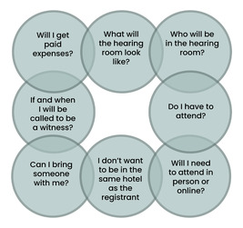
Figure 2 Practical questions ahead of a hearing.
View description - Figure 2 Practical questions ahead of a hearing.
View alternative description - Figure 2 Practical questions ahead of a hearing.

Back to - Activity: reflection point

Activity: reflection point

Discussion
You might have been surprised to hear about the different types of vulnerability and that there are a range of reasons why a witness at a Fitness to Practise hearing could be seen as vulnerable despite not having a disability, for example.
Back to - Activity: reflection point

Activity: reflection point

Discussion
You probably noted a range of reasons for why cross-examination can be challenging. Our research team found, through observations of hearings, that not being believed or having your character questioned is a form of moral injustice and is also evidenced outside of this research (Fricker, 2007). It is a distressing experience to be misrepresented and challenged in the hearing. It might be proposed during cross-examination that you are not remembering events correctly or that your understanding of what happened is mistaken. This can feel very unfair.

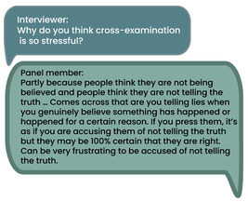
View description - Uncaptioned Figure
View alternative description - Uncaptioned Figure

Back to - Activity: reflection point

Activity: reflection point

Discussion
You will most likely agree that additional support is needed for members of the public and professionals wishing to raise a concern. This should include confidential advice and clearer signposting for those considering raising a concern; support in articulating the concern, advocacy support; and support as the concern is progressed, including for witnesses at Fitness to Practise hearings. This key recommendation is also part of Tackling Support Locally (Department of Health, 2009, p. 50). Similarly, we argue that regulators and employers should signpost public referrers to sources of independent advocacy and advice across the various processes including inquests, civil proceedings, NHS complaints, social services complaints and criminal cases.
Based on our research findings we feel that all these recommendations should support to improve the Fitness to Practise process for all. The following video provides some regulator comments about our findings and recommendations.
Watch Film 1 at the following link: Improving patient, family and colleague witnesses’ experiences of Fitness to Practise proceedings: A mixed methods study
Back to - Activity: reflection point

Activity: reflection point

Discussion
We identified four recommendations to provide information effectively:
- Support members of the public to understand Fitness to Practise processes and decision-making steps, answer their questions and keep them regularly updated.
- Provide clearer public-facing information co-produced with members of the public about the steps that can be taken to support people in raising concerns and to provide evidence as a witness throughout the process and at a hearing.
- Public-facing information should be designed to be understood by the the large majority of the UK adult population by:
  - being compliant with UK government accessibility requirements
  - being worded to be easily understood by those with limited literacy and support for people to understand more complex topics
  - being available in different formats including audio and video
  - covering each of the main stages of Fitness to Practise and the support available.
- Regulators should consider providing a liaison function to employers, where this does not already exist, to improve the selection and management of cases and to identify issues which may fall on the employer to support the witnesses.
Back to - Activity: reflection point

Activity: reflection point

Discussion
Based on our research findings we feel that all these recommendations should support to improve the Fitness to Practise process for all.
Back to - Activity: reflection point

Descriptions

Uncaptioned Figure
A checklist with a green happy face, white neutral face and unhappy red face along side a pen
Back to - Uncaptioned Figure

Uncaptioned Figure
A checklist with a green happy face, white neutral face and unhappy red face along side a pen
Back to - Uncaptioned Figure

Uncaptioned Figure
The quote reads: ‘...my thoughts were, there’s nothing that can be done for me, but I wouldn’t want anyone else to go through this. So, it was all about preventing harm to others in future.’
Back to - Uncaptioned Figure

Uncaptioned Figure
The quote reads: ‘...my thoughts were, there’s nothing that can be done for me, but I wouldn’t want anyone else to go through this. So, it was all about preventing harm to others in future.’
Back to - Uncaptioned Figure

Uncaptioned Figure
The quote reads: ‘… He won’t go to court or he won’t go to jail or anything … Can you believe that? Now, I don’t care because to me it’s more like well I want the public to know. You know, that’s what I want at this stage …’
Back to - Uncaptioned Figure

Uncaptioned Figure
The quote reads: ‘… He won’t go to court or he won’t go to jail or anything … Can you believe that? Now, I don’t care because to me it’s more like well I want the public to know. You know, that’s what I want at this stage …’
Back to - Uncaptioned Figure

Uncaptioned Figure
The text reads: ‘… there was an incident which I was very unhappy about with a senior doctor when I was in training. And at the time I wanted to tell someone. And I realised that if I did, my undertanding was that if I did it would make everything worse. So instead I challenged him directly. And it helped me to understand that I didn’t think I could ask anyone for help. Because he was very entitled to behave like this, he felt very entitled to behave as he did and I could see that he was very well supported in that feeling of entitlement.’
Back to - Uncaptioned Figure

Uncaptioned Figure
The text reads: ‘… there was an incident which I was very unhappy about with a senior doctor when I was in training. And at the time I wanted to tell someone. And I realised that if I did, my undertanding was that if I did it would make everything worse. So instead I challenged him directly. And it helped me to understand that I didn’t think I could ask anyone for help. Because he was very entitled to behave like this, he felt very entitled to behave as he did and I could see that he was very well supported in that feeling of entitlement.’
Back to - Uncaptioned Figure

Uncaptioned Figure
The quote reads: ‘So partly I was very isolated. So I was a doctor in training and we go from place to place. And so my training programme director was in another city. I was living in the local area with my family but I didn’t have any friends, I didn’t have any colleagues who I knew well. The work environment was very brutal. I would often see colleagues crying in a corridor somewhere; the senior doctors screaming at each other if they had a difference of opinion. And so there was a sense that people were putting up with terrible things and nobody seemed to want that to change. And so when I challenged the person about his bad behaviour, his approach was well, why shouldn’t I? And I could see that that was right, it seemed to be, yes, why shouldn’t he, who was going to stop him.’
Back to - Uncaptioned Figure

Uncaptioned Figure
The quote reads: ‘So partly I was very isolated. So I was a doctor in training and we go from place to place. And so my training programme director was in another city. I was living in the local area with my family but I didn’t have any friends, I didn’t have any colleagues who I knew well. The work environment was very brutal. I would often see colleagues crying in a corridor somewhere; the senior doctors screaming at each other if they had a difference of opinion. And so there was a sense that people were putting up with terrible things and nobody seemed to want that to change. And so when I challenged the person about his bad behaviour, his approach was well, why shouldn’t I? And I could see that that was right, it seemed to be, yes, why shouldn’t he, who was going to stop him.’
Back to - Uncaptioned Figure

Uncaptioned Figure
The quote reads: ‘… I wrote everything down what she told me and I wrote down anything what I could see on the texts, which were quite rude some of them. And anywayI didn’t get no support from head office, from [employer name]. They never rang me and said are you OK with this? All I got was, this is when you go, this is the date you go and this is what it involves and how to get there and this and that. But there was no support, like do you feel OK about this or anything like that …’
Back to - Uncaptioned Figure

Uncaptioned Figure
The quote reads: ‘… I wrote everything down what she told me and I wrote down anything what I could see on the texts, which were quite rude some of them. And anywayI didn’t get no support from head office, from [employer name]. They never rang me and said are you OK with this? All I got was, this is when you go, this is the date you go and this is what it involves and how to get there and this and that. But there was no support, like do you feel OK about this or anything like that …’
Back to - Uncaptioned Figure

Uncaptioned Figure
A sign saying ‘stop doing what doesn’t work’
Back to - Uncaptioned Figure

Uncaptioned Figure
A sign saying ‘stop doing what doesn’t work’
Back to - Uncaptioned Figure

Uncaptioned Figure
The quote reads: ‘… one of the things that was said in the hearing was around why you didn’t speak up at the time. Yes absolutely. Because I knew, it’s one of those things where you feel trapped, you know what’s happened but you’re too embarrassed to even mention it, yeah. And I think that what he’d done was so difficult to prove and so shocking, I thought well why don’t I just not talk about that and talk about the things that can be proved …’
Back to - Uncaptioned Figure

Uncaptioned Figure
The quote reads: ‘… one of the things that was said in the hearing was around why you didn’t speak up at the time. Yes absolutely. Because I knew, it’s one of those things where you feel trapped, you know what’s happened but you’re too embarrassed to even mention it, yeah. And I think that what he’d done was so difficult to prove and so shocking, I thought well why don’t I just not talk about that and talk about the things that can be proved …’
Back to - Uncaptioned Figure

Uncaptioned Figure
The quote reads: ‘I found the website and I wrote an email and I looked at what the sort of codes of conduct would be and what is expected as professional behaviour and did a screenshot as to what I thought was not being adhered to and so I sent an email initially.’
Back to - Uncaptioned Figure

Uncaptioned Figure
The quote reads: ‘I found the website and I wrote an email and I looked at what the sort of codes of conduct would be and what is expected as professional behaviour and did a screenshot as to what I thought was not being adhered to and so I sent an email initially.’
Back to - Uncaptioned Figure

Uncaptioned Figure
The quote reads: ‘I didn’t think a care home came under Midwifery Council, Nursing and Midwifery, it was the people I worked with that said that. So I didn’t know there was an organisation that you could complain about people.’
Back to - Uncaptioned Figure

Uncaptioned Figure
The quote reads: ‘I didn’t think a care home came under Midwifery Council, Nursing and Midwifery, it was the people I worked with that said that. So I didn’t know there was an organisation that you could complain about people.’
Back to - Uncaptioned Figure

Uncaptioned Figure
The first quote reads: ‘Information on Social Work England’s website was helpful and informative.’ The second quote reads: ‘I read all public guidance available on the internet via Nursing and midwifery Council and nursing practice guidance.’ The third quote reads: ‘An internet search led me to the General Optical Council.’
Back to - Uncaptioned Figure

Uncaptioned Figure
The first quote reads: ‘Information on Social Work England’s website was helpful and informative.’ The second quote reads: ‘I read all public guidance available on the internet via Nursing and midwifery Council and nursing practice guidance.’ The third quote reads: ‘An internet search led me to the General Optical Council.’
Back to - Uncaptioned Figure

Uncaptioned Figure
The quote reads: ‘And then the website itself, the information they give is clear and specific, but it’s not worded in a way that’s very accessible. But whether there are legal constraints on that, I don’t know. It’s very hard not to start making things ambiguous isn’t it when you start to depart from a technical language.’
Back to - Uncaptioned Figure

Uncaptioned Figure
The quote reads: ‘And then the website itself, the information they give is clear and specific, but it’s not worded in a way that’s very accessible. But whether there are legal constraints on that, I don’t know. It’s very hard not to start making things ambiguous isn’t it when you start to depart from a technical language.’
Back to - Uncaptioned Figure

Uncaptioned Figure
The first quote reads: ‘I had emails and phone calls with one person which made me feel more comfortable and allowed me to ask questions.’ The second quote reads: ‘It was helpful to speak to someone on the phone.’ The third quote reads: ‘I obtained all the information I needed to following discussion with a member of staff who was extremely helpful.’
Back to - Uncaptioned Figure

Uncaptioned Figure
The first quote reads: ‘I had emails and phone calls with one person which made me feel more comfortable and allowed me to ask questions.’ The second quote reads: ‘It was helpful to speak to someone on the phone.’ The third quote reads: ‘I obtained all the information I needed to following discussion with a member of staff who was extremely helpful.’
Back to - Uncaptioned Figure

Uncaptioned Figure
The quote reads: ‘You need a website which you can download documents which have all the information because lots of people can't read online very easily on for some whatever reason and they like to have something in hand so they can refer to on any occasion, you know when the sitting. Informatics with … some people find it helpful to look at and sort of pictures …, videos are a good idea as well because we lots of people go to YouTube for instructions …’
Back to - Uncaptioned Figure

Uncaptioned Figure
The quote reads: ‘You need a website which you can download documents which have all the information because lots of people can't read online very easily on for some whatever reason and they like to have something in hand so they can refer to on any occasion, you know when the sitting. Informatics with … some people find it helpful to look at and sort of pictures …, videos are a good idea as well because we lots of people go to YouTube for instructions …’
Back to - Uncaptioned Figure

Uncaptioned Figure
The quote reads: ‘… a video so you can see the perspective. You know that there are some of the theatres when you book a seat it says this is what the stage looks like from where you’re sitting. So, what would the room look like from where?’
Back to - Uncaptioned Figure

Uncaptioned Figure
The quote reads: ‘… a video so you can see the perspective. You know that there are some of the theatres when you book a seat it says this is what the stage looks like from where you’re sitting. So, what would the room look like from where?’
Back to - Uncaptioned Figure

Uncaptioned Figure
A stick figure of a person overwhelmed with information
Back to - Uncaptioned Figure

Uncaptioned Figure
A stick figure of a person overwhelmed with information
Back to - Uncaptioned Figure

Figure 1 A flowchart example (Note: PCC is Preliminary Proceedings Committee which is part of the investigation process).
A step-by-step guide of the fitness to practise process after a referral is made. From Northern Ireland Social Care Council.
Back to - Figure 1 A flowchart example (Note: PCC is Preliminary Proceedings Committee which is part of the investigation process).

Figure 1 A flowchart example (Note: PCC is Preliminary Proceedings Committee which is part of the investigation process).
A step-by-step guide of the fitness to practise process after a referral is made. From Northern Ireland Social Care Council.
Back to - Figure 1 A flowchart example (Note: PCC is Preliminary Proceedings Committee which is part of the investigation process).

Uncaptioned Figure
A magnifying glass containing a tick, examining a piece of paper
Back to - Uncaptioned Figure

Uncaptioned Figure
A magnifying glass containing a tick, examining a piece of paper
Back to - Uncaptioned Figure

Uncaptioned Figure
The quote reads: ‘OK, so, and this is probably very relevant. So when I was looking to see who I should contact to raise a complaint, there was the GOC and the, is the Optometric? There were two main organisations. And it was difficult for me to understand who I should go to and which particular aspect, because of the wide-ranging concern that I had. And it was trying to see how best I could achieve some action and what I was looking to achieve was actually somebody acknowledging that this process had failed. And then going to the GOC website, and it took me quite a while to read through it to understand how or if I should apply if that was the right process to follow, so it wasn’t very clear to a layperson. I asked my optician, she said well you should go to the GOC. But yeah it’s a bit of a maze to a layperson.’
Back to - Uncaptioned Figure

Uncaptioned Figure
The quote reads: ‘OK, so, and this is probably very relevant. So when I was looking to see who I should contact to raise a complaint, there was the GOC and the, is the Optometric? There were two main organisations. And it was difficult for me to understand who I should go to and which particular aspect, because of the wide-ranging concern that I had. And it was trying to see how best I could achieve some action and what I was looking to achieve was actually somebody acknowledging that this process had failed. And then going to the GOC website, and it took me quite a while to read through it to understand how or if I should apply if that was the right process to follow, so it wasn’t very clear to a layperson. I asked my optician, she said well you should go to the GOC. But yeah it’s a bit of a maze to a layperson.’
Back to - Uncaptioned Figure

Uncaptioned Figure
A magnifying glass with the words ‘code of conduct’ in the glass
Back to - Uncaptioned Figure

Uncaptioned Figure
A magnifying glass with the words ‘code of conduct’ in the glass
Back to - Uncaptioned Figure

Uncaptioned Figure
The first quote reads: ‘OK. So just to be clear when you’re having all of these conversations with the General Osteopathic Council you’re having a number of conversations, but essentially are they about the same things that had happened to you or are they different people talking about different aspects of it?’ The second quote reads: ‘I think about the same things. I can just remember just going over and over and over it with different people.’
Back to - Uncaptioned Figure

Uncaptioned Figure
The first quote reads: ‘OK. So just to be clear when you’re having all of these conversations with the General Osteopathic Council you’re having a number of conversations, but essentially are they about the same things that had happened to you or are they different people talking about different aspects of it?’ The second quote reads: ‘I think about the same things. I can just remember just going over and over and over it with different people.’
Back to - Uncaptioned Figure

Uncaptioned Figure
The quote reads: ‘Yeah, and then in the meantime the caseworker, if you like, changed. So she went on long-term sick leave. And so somebody new was introduced who wasn’t familiar with, you know, who hadn’t taken the witness statement and had to become familiar with the contents. It just didn’t feel the same anymore in the sense that it sort of became a bit more impersonal. You know, there were still very polite. Communication was open channels: you can ring, you can email. The replies were, you know, didn’t have to wait long. But it sort of just became logistics. It just became that, dealing with logistics.’
Back to - Uncaptioned Figure

Uncaptioned Figure
The quote reads: ‘Yeah, and then in the meantime the caseworker, if you like, changed. So she went on long-term sick leave. And so somebody new was introduced who wasn’t familiar with, you know, who hadn’t taken the witness statement and had to become familiar with the contents. It just didn’t feel the same anymore in the sense that it sort of became a bit more impersonal. You know, there were still very polite. Communication was open channels: you can ring, you can email. The replies were, you know, didn’t have to wait long. But it sort of just became logistics. It just became that, dealing with logistics.’
Back to - Uncaptioned Figure

Uncaptioned Figure
The quote reads: ‘The member of staff at the General Optical Council was very supportive and I believe that her approach helped me as much as it was possible.’
Back to - Uncaptioned Figure

Uncaptioned Figure
The quote reads: ‘The member of staff at the General Optical Council was very supportive and I believe that her approach helped me as much as it was possible.’
Back to - Uncaptioned Figure

Uncaptioned Figure
The quote reads: ‘It is distressing. But what is more distressing is the fact that they closed my case without recourse. I couldn’t even appeal it. I am still dealing with the repercussions of this only 2 years later.’
Back to - Uncaptioned Figure

Uncaptioned Figure
The quote reads: ‘It is distressing. But what is more distressing is the fact that they closed my case without recourse. I couldn’t even appeal it. I am still dealing with the repercussions of this only 2 years later.’
Back to - Uncaptioned Figure

Uncaptioned Figure
The quote reads: ‘Retelling the story was the proper thing to do. I disregarded any emotions as I felt public safety was of greater concern than me reliving that unfortunate event.’
Back to - Uncaptioned Figure

Uncaptioned Figure
The quote reads: ‘Retelling the story was the proper thing to do. I disregarded any emotions as I felt public safety was of greater concern than me reliving that unfortunate event.’
Back to - Uncaptioned Figure

Uncaptioned Figure
The quote reads: ‘I haven’t needed external help. I talked to friends and family which helped me.’
Back to - Uncaptioned Figure

Uncaptioned Figure
The quote reads: ‘I haven’t needed external help. I talked to friends and family which helped me.’
Back to - Uncaptioned Figure

Uncaptioned Figure
The quote reads: ‘I sought legal advice and also went to newspapers and TV, going to TV got my point over more. Perhaps some guidance from a solicitor on duty to assure if you are doing the right thing as you are feeling very vulnerable.’
Back to - Uncaptioned Figure

Uncaptioned Figure
The quote reads: ‘I sought legal advice and also went to newspapers and TV, going to TV got my point over more. Perhaps some guidance from a solicitor on duty to assure if you are doing the right thing as you are feeling very vulnerable.’
Back to - Uncaptioned Figure

Uncaptioned Figure
An image of a red London bus
Back to - Uncaptioned Figure

Uncaptioned Figure
An image of a red London bus
Back to - Uncaptioned Figure

Figure 2 Practical questions ahead of a hearing.
A number of overlapping circles containing the following questions: Will I get paid expenses? What will the hearing room looks like? Who will be in the hearing room? If and when will I be called to be a witness? Do I have to attend? Can I bring someone with me? I don’t want to be in the same hotel as the registrant. Will I need to attend in person or online?
Back to - Figure 2 Practical questions ahead of a hearing.

Figure 2 Practical questions ahead of a hearing.
A number of overlapping circles containing the following questions: Will I get paid expenses? What will the hearing room looks like? Who will be in the hearing room? If and when will I be called to be a witness? Do I have to attend? Can I bring someone with me? I don’t want to be in the same hotel as the registrant. Will I need to attend in person or online?
Back to - Figure 2 Practical questions ahead of a hearing.

Uncaptioned Figure
An image of a person carrying a large bag on their shoulders
Back to - Uncaptioned Figure

Uncaptioned Figure
An image of a person carrying a large bag on their shoulders
Back to - Uncaptioned Figure

Uncaptioned Figure
The quote reads: ‘I explained it all to comeone by e-mail, and then it was passed to someone else, and I had to explain it all again. It would speed things up and be less stressful if the information were passed on automatically.’
Back to - Uncaptioned Figure

Uncaptioned Figure
The quote reads: ‘I explained it all to comeone by e-mail, and then it was passed to someone else, and I had to explain it all again. It would speed things up and be less stressful if the information were passed on automatically.’
Back to - Uncaptioned Figure

Uncaptioned Figure
The first quote reads: ‘Interviewer: Why do you think cross-examination is so stressful?’ The second quote reads: ‘Panel member: Partly because people think they are not being believed and people think they are not telling the truth … Comes across that you are telling lies when you genuinely believe something has happened or happened for a certain reason. If you press them, it’s as if you are accusing them of not telling the truth but they may have been 100% certain that they are right. Can be very frustrating to be accused of not telling the truth.’
Back to - Uncaptioned Figure

Uncaptioned Figure
The first quote reads: ‘Interviewer: Why do you think cross-examination is so stressful?’ The second quote reads: ‘Panel member: Partly because people think they are not being believed and people think they are not telling the truth … Comes across that you are telling lies when you genuinely believe something has happened or happened for a certain reason. If you press them, it’s as if you are accusing them of not telling the truth but they may have been 100% certain that they are right. Can be very frustrating to be accused of not telling the truth.’
Back to - Uncaptioned Figure

Uncaptioned Figure
A hand putting a final piece into a jigsaw puzzle
Back to - Uncaptioned Figure

Uncaptioned Figure
A hand putting a final piece into a jigsaw puzzle
Back to - Uncaptioned Figure

Uncaptioned Figure
The quote reads: ‘After a decision was made at Fitness to Practise heading I would want the full judgement result in writing whether or not the decision went in my favour.’
Back to - Uncaptioned Figure

Uncaptioned Figure
The quote reads: ‘After a decision was made at Fitness to Practise heading I would want the full judgement result in writing whether or not the decision went in my favour.’
Back to - Uncaptioned Figure

Uncaptioned Figure
The quote reads: ‘… And to be honest that was quite a bit of a shock, you know, having an email that just says by the way he was found to, he had an admonishment and here is the PDF with the full hearing notes, you know, the full findings. So it was via email …’
Back to - Uncaptioned Figure

Uncaptioned Figure
The quote reads: ‘… And to be honest that was quite a bit of a shock, you know, having an email that just says by the way he was found to, he had an admonishment and here is the PDF with the full hearing notes, you know, the full findings. So it was via email …’
Back to - Uncaptioned Figure

Uncaptioned Figure
A sign saying ‘Recommendations’
Back to - Uncaptioned Figure

Uncaptioned Figure
A sign saying ‘Recommendations’
Back to - Uncaptioned Figure

Uncaptioned Figure
Three members of a panel/committee listening to a witness.
Back to - Uncaptioned Figure

Uncaptioned Figure
Three members of a panel/committee listening to a witness.
Back to - Uncaptioned Figure

Uncaptioned Figure
A man wearing glasses who looks like he is thinking
Back to - Uncaptioned Figure

Uncaptioned Figure
A man wearing glasses who looks like he is thinking
Back to - Uncaptioned Figure

Uncaptioned interactive content

Transcript
SPEAKER 1: From social workers to nurses to child protection officers, health and social care workers play a vital role in care, protection, and advocacy for a wide range of communities.
SPEAKER 2: But in these positions, there will be occasions when professionals fail to meet the standards expected of them.
SPEAKER 1: In such cases, members of the public may raise concerns about them, which will lead to a fitness to practice investigation and hearing.
SPEAKER 2: The Open University lead a team with four other universities who conducted in-depth research to understand the experiences of people who raised these concerns.
SPEAKER 1: One of the key areas they investigated was the reasons people do and don’t express concerns to regulators.
SPEAKER 2: So let’s get a sense of what they discovered. First of all, why do people raise concerns?
SPEAKER 3: I wanted to make sure no one would go through the same distress and trauma as I did from my treatment. I wanted the public to know so, hopefully, it will never happen again.
SPEAKER 4: I wanted to face the person who did this to me. It’s not like I wanted revenge or to ruin their career. I wanted them to reflect, to really think about what they’d done.
SPEAKER 2: So, to recap, some of the key reasons people raised concerns included raising awareness of issues to prevent them happening again--
SPEAKER 1: --and to make the person involved reflect on what they had done and why it was wrong.
SPEAKER 2: So, why don’t people raise concerns? What’s stopping them from even beginning the witness to harm process?
SPEAKER 5: I didn’t know where to go. I did look, but it was just really hard. I don’t think enough people know about the General Dental Council or any of the other regulators. They’re just not visible. They need to advertise more.
SPEAKER 6: I felt trapped. I was too embarrassed to even mention it. It was something so shocking and difficult to prove that it felt easier to keep quiet. I’d also heard that complaining about a GP could make it difficult to find another one. That was a real worry.
SPEAKER 2: So, to recap, one of the key reasons people didn’t raise concerns was the process was just too difficult. It was hard to find where to report a problem. And even if you did, the process was arduous, with many pages to read and zero assistance.
SPEAKER 1: People also felt they couldn’t speak up because the issues were difficult to prove. They found that the misconduct itself had an isolating effect.
SPEAKER 2: Some people also feared the negative consequences involved in raising a concern-- difficulty finding a new dentist, for instance.
[DRAMATIC MUSIC]
Back to - Uncaptioned interactive content

Uncaptioned interactive content

Transcript
SPEAKER 1: The usability of health and social care regulators websites is one of the first hurdles people face when raising a concern. For this reason, a team of researchers led by The Open University conducted research into people’s experiences navigating the sites to raise a concern about a professional. So let’s get a sense of people’s experiences, firstly, with finding information on the websites.
SPEAKER 2: First of all, with the main tab, it uses the term Fitness to Practise, which is just difficult to understand. It would be better to use the word concern or complaint. On the plus side, I did find the jargon busters and glossaries useful. The site should always include them.
SPEAKER 3: It would be good to have a navigation panel on the side showing where we’re up to and what’s available. The pages should be short and simple and in a logical order.
SPEAKER 4: It’s best when the links open in a new tab. Otherwise, I get worried I’m going to lose the original page. In general, there shouldn’t be too many links as all the information and places to go can be really overwhelming.
SPEAKER 1: OK, let’s take a closer look at the reporting process. First of all, what are people’s experiences of finding the form?
SPEAKER 2: If you’re going to have a concerns landing page, you should have a link to the form right there. So we don’t have to click through several pages of screening questions to get to it.
SPEAKER 4: Screening questions can be useful to make sure our concerns are raised with the right organisation. But they can be obstructive if we already know we’re in the right place.
SPEAKER 3: There should be multiple ways to raise a concern, email, downloadable document, telephone and online, and there should be the option to raise a concern anonymously. Only a few sites allow this.
SPEAKER 2: We should be able to see a list of what information we will need to have to hand before starting the form and to get a sense of how long it might take.
SPEAKER 4: It would also be helpful to have simple information about what will happen once a concern is raised, so we know what to expect.
SPEAKER 1: Finally, what were people’s experiences using the form itself?
SPEAKER 2: Mandatory fields on the reporting forms are actually quite obstructive. We might not have information like the registrant’s name or the registration number to hand.
SPEAKER 3: It’s helpful to have prompts saying what type of information we should put in each box and to be able to upload documents to avoid having to retell unpleasant stories and also to provide evidence like medical records.
SPEAKER 4: Forms should be short and simple with a progress bar so we know how far through we are. It’s better not to have word limits on our answers, so we can provide as much detail as we need to. It would be good if we could save our progress too, so we can take breaks.
Back to - Uncaptioned interactive content

Uncaptioned interactive content

Transcript
SPEAKER 1: In this part of the project, researchers on our team at the University of Edinburgh examined written texts of different regulators of social work and social care professionals.
SPEAKER 2: The regulators were Social Work England, the Scottish Social Services Council, Social Care Wales, and the Northern Ireland Social Care Council.
SPEAKER 1: We were interested in how regulators’ policies defined witness vulnerability in fitness to practise processes.
[MUSIC PLAYING]
TEXT ON SCREEN: Why is witness vulnerability relevant to regulators?
SPEAKER 2: The way the term vulnerability is used is important in the social care sector. Some argue the term has a stigmatising and othering effect when we apply it to people.
SPEAKER 1: Some researchers say there are different types of vulnerability.
SPEAKER 2: Inherent vulnerability refers to things like age, disability or gender.
SPEAKER 1: Situational vulnerability is about the context and structures we live in.
SPEAKER 2: And then there are pathogenic sources of vulnerability. This refers to how trying to address one form of vulnerability actually makes things worse, like treating all people with various disabilities the same, for instance.
TEXT ON SCREEN: So what did you do in your research?
SPEAKER 1: We looked at the parts of the regulators, laws, and policies that related to witness vulnerability to see how they might impact people’s experiences.
SPEAKER 2: We also performed six workshops with the regulators and groups, including people with lived and learned experiences of fitness to practise proceedings.
TEXT ON SCREEN: What were your main findings?
SPEAKER 1: We discovered what we call a regulatory thicket. Law and policy provisions around witness vulnerability are complicated and differ between the many different regulators. When it comes to defining vulnerability, regulators were too focused on inherent vulnerabilities, things like age or disability.
SPEAKER 2: Little attention was paid to situational vulnerability or pathogenic sources of vulnerability.
SPEAKER 1: So how structures and environments cause vulnerabilities and how attempts to address vulnerabilities can make things worse.
SPEAKER 2: We found whole groups were described as being vulnerable, despite their own views on this.
SPEAKER 1: At the same time, vulnerability was constructed too narrowly. The trauma associated with, say, giving evidence around the death of a relative wouldn’t fit into the regulator’s narrow descriptions.
TEXT ON SCREEN: So what needs to happen to make this better for people?
SPEAKER 1: We call for a change in how witness vulnerability is constructed in regulators’ legal and policy documents.
SPEAKER 2: They need to look at the bigger picture and recognise the diverse lived experiences of witnesses, including service users, their families, colleagues, and the wider public. Regulators’ provisions should account for the vulnerabilities produced by poor experiences in the fitness to practise process itself.
SPEAKER 1: Regulators should stop lumping diverse groups together. And instead discuss the individual support they need.
SPEAKER 2: They should work with people with lived and learned experiences to make their provisions more supportive.
SPEAKER 1: This will not only improve the fitness to practise process, but help avoid future harm.
Back to - Uncaptioned interactive content

Uncaptioned interactive content

Transcript
SPEAKER 1: After raising a concern to a regulator about a healthcare or social worker, witnesses give evidence in a fitness to practise hearing. The research team conducted a series of interviews with these witnesses to further understand their experiences. These are direct quotes, although their identities have been changed.
SPEAKER 2: It was a tough time. I think I was still emotionally fragile from what happened and dealing with everything. And then again, like I said, having to speak about it in a public space. Obviously, my worst nightmare anyway, that I had to talk about something so personal and traumatic. It was a lot.
When I got to the hearing, I was a bundle of nerves. But when I was there, I was really put at ease with the caseworker and being led into the room beforehand. So I could understand where I’d be sitting, who would be speaking to me, who else would be in the room, if there was going to be a recording. And that really helped.
SPEAKER 3: It was intimidating, but you have to be strong, and then try to remember things because I didn’t realise I had a memory loss caused by it. They went, how do you know you’ve got memory loss? So they were asking me questions, and I said, I can’t remember. We spent ages on some areas.
I can remember things, what happened, but certain things I can’t remember because my memory is gone. And I thought I was abused. They should be more wary. They weren’t aware of it, so it needed more hard work for me. And the way they were talking as well, these solicitors, I put it to you, hang on a minute. I’m not in court here.
And then so much paperwork as well. So they’re all confused as well. You’ve got a page, you’ve got bundles in here, and then you go to page 699. You’ve got to try and find it. And then it’s that one there, and then you have to go to that page. So it’s a bit confusing.
SPEAKER 4: I think they gave me-- they sort of explained how it worked. But what I think would have been most useful if someone had attempted to prepare me for what the cross examination might be like. So yeah, we then had another two weeks in [BLEEP] that we had to out for ourselves.
But I’ve got a cousin who lives on the edge of [BLEEP]. So we stayed in his spare room. And my parents basically moved in and looked after my three children for those two weeks. But it was a nightmare logistically, and the girls weren’t happy that we were vanishing.
So it’s-- I think it’s hard not having a representative because you can’t talk back and argue back for yourself. So it felt like the barrister could say whatever he wanted and try and like tear me apart and make out like I was a bad mum, and that I didn’t care about my children and that I was too busy to go and do what the midwife said, and that I wasn’t listening, but I wasn’t allowed to say no or to give any evidence about myself that proves that I do always take health care professionals’ advice. Because it wasn’t about me. It was about the midwife’s fitness to practise.
Back to - Uncaptioned interactive content

Uncaptioned interactive content

Transcript
SPEAKER 1: We have called this meeting to hear more about your experiences as witnesses in the fitness to practise process and to present our recommendations for how fitness to practise can be improved based on the findings in our research.
SPEAKER 2: For me, I was really scared to talk about it all publicly. I was worried I could lose my licence. But the whole thing was being treated as a box-ticking exercise. They need to show more compassion. These issues really affect people.
SPEAKER 1: Yes, in general, we recommend regulators show much more compassion and integrity when dealing with these complaints. There was a lack of humanity, which really needs addressing.
SPEAKER 3: It was really difficult to work out where to begin. There are all these regulatory bodies I had to sift through, and the website wasn’t worded accessibly.
SPEAKER 1: This is a common problem. There needs to be greater clarity about where, when, and how to report concerns.
SPEAKER 4: I thought I’d get regular updates about the case, but I heard nothing. Meanwhile, they were writing reports that were just wrong, totally wrong, and I wasn’t privy to any of it.
SPEAKER 1: We recommend greater inclusion for witnesses in the fitness to practise process to avoid this common experience. There needs to be improved access to information about the investigation and preparation before hearings too. We also recommend offering independent advocates who can work with individuals to guide and support them through the process.
SPEAKER 5: The amount of time it took them to deal with the case was really frustrating. They were waiting for the professional that raised the concern about to send them information. It took a year to receive it, and I’d kind of given up by then.
SPEAKER 1: Thank you all for providing your vital insights into your experiences as witnesses in the fitness to practise process. Your comments and our own research has brought to us a number of recommendations. These are just some of them.
Firstly, there needs to be more compassion, integrity, and humanity when dealing with complaints, minimising the number of times people need to retell their distressing story. There needs to be greater clarity around where, when, and how to report concerns. The fitness to practise process needs to be more inclusive with better access to information, preparation, and other sources of support. We recommend offering independent advocates who can work with individuals to guide and support them across the process.
People want others to know about the lasting impact of the harm they have experienced from the professional. People need more realistic preparation for what to expect when cross-examined in a hearing and what they and the panel chair can do to make it less adversarial. People should be offered support after the hearing to understand the outcome and how to get support. Panel members and lawyers should be trained in cross-examination to minimise distress and harm.
Back to - Uncaptioned interactive content

Uncaptioned interactive content

Transcript
SPEAKER 1: As a service user, I want to know how to raise a concern about a social work and care professional. How do I start? How difficult will it be? And who will investigate my concern?
SPEAKER 2: The process is called fitness to practise. Your concern will be investigated by a social work and social care regulator. Professionals have to register with regulators to practise their profession. It is a legal requirement.
SPEAKER 1: How many regulators are there?
SPEAKER 3: There are four social work and social care regulators in the UK. They are Scottish Social Services Council, Social Work England, Social Care Wales, and Northern Ireland Social Care Council.
SPEAKER 2: There are also nine health care regulators. You can find out who regulates the health care professionals on the Professional Standards Authority website.
SPEAKER 1: What can regulators investigate?
SPEAKER 3: There are many reasons regulators will investigate professionals, including misconduct, lack of competence, criminal convictions, and health conditions that affect service user safety.
SPEAKER 2: Also dishonesty, fraud, abuse of trust, violence, and sexual misconduct.
SPEAKER 3: There are many more examples.
SPEAKER 1: And what can’t regulators investigate?
SPEAKER 3: Regulators can’t deal with complaints about the level of service an organisation provides.
SPEAKER 2: They can’t get involved in matters which should be decided by a court, and they can’t provide legal advice.
SPEAKER 3: Again, there are many more examples. You can find out more on their websites.
SPEAKER 1: OK. So if I want to raise a concern about a professional, where do I start?
SPEAKER 2: You can go through their employer’s complaints process. This might be through their website or phone line.
SPEAKER 1: What if I want to raise a concern with a regulator?
SPEAKER 3: You can raise concerns using the regulator’s website or telephone support line.
SPEAKER 2: You can get help raising a concern from a social care worker, advocacy service, or citizens advice.
SPEAKER 1: And what happens once I raise a concern?
SPEAKER 3: They will confirm if they are legally able to take up the concern.
SPEAKER 2: Then the investigation can take some time, even years.
SPEAKER 3: The investigation is to decide if there is sufficient evidence to proceed. If there isn’t, the process stops there.
SPEAKER 2: If there is, the next stage would be the fitness to practise hearing to investigate if the professional in question is fit to practise in the future.
SPEAKER 3: You may need to provide a witness statement in writing or in person.
SPEAKER 2: In person, the professional’s lawyer will ask you about your witness statement, challenging your views on what happened.
SPEAKER 3: It can be hard work and upsetting, but it’s vital people raise concerns to ensure safety and quality of care.
SPEAKER 2: If the case is proven, the professional may have limits put on their practice or be taken off the register altogether, struck off, preventing them from practising again.
SPEAKER 3: Raising concerns like this and giving evidence in fitness to practise hearings is an important way to stop the same thing happening again to ensure all care users can trust their care providers.
Back to - Uncaptioned interactive content

Uncaptioned interactive content

Transcript
SPEAKER 1: As a social care professional, I’ve heard about fitness to practise, but I want to know how it’s relevant to me.
SPEAKER 2: Fitness to practise refers to the health, character, and competence of a professional to practise.
SPEAKER 3: As a social care professional, you will be a member with one of the social care regulators.
SPEAKER 2: They keep patients safe by ensuring professional standards are upheld and that their members are fit to practise.
SPEAKER 3: There are four social work and social care statutory regulators in the UK, they are-- Scottish Social Services Council, Social Work England, Social Care Wales, and Northern Ireland Social Care Council.
SPEAKER 2: There are also 9 health care regulators in the UK regulated by the Professional Standards Authority.
SPEAKER 1: What can regulators investigate?
SPEAKER 3: A range of concerns, from misconduct to lack of competence, to criminal convictions, and health conditions that might affect user safety.
SPEAKER 2: And many more.
SPEAKER 1: And what can’t regulators investigate?
SPEAKER 2: Regulators will tell you what they cannot regulate on their websites.
SPEAKER 3: For instance, they can’t deal with complaints about the level of service an organisation provides.
SPEAKER 2: They can’t get involved in matters which should be decided by a court. And they can’t provide legal advice.
SPEAKER 3: You’ll find many more examples on their websites.
SPEAKER 1: What are my responsibilities regarding fitness to practise as a social care professional?
SPEAKER 2: To practise as a social care professional, it’s a legal requirement that you register with them. Though each regulator is different, they all require that professionals promote professional standards and report concerns about other professionals or your own practice.
SPEAKER 3: This might include reporting harm, exploitation, inappropriate, unsafe, or discriminatory practices. It may include informing service users and families of their right to complain and providing them with relevant support.
SPEAKER 2: Plus cooperating with any investigations into your own fitness to practise.
SPEAKER 3: You can find out more on your regulator’s website.
SPEAKER 1: OK. How do I, or a service user, raise a concern about their social care?
SPEAKER 2: You can do this yourself or support the service user or their family to do so.
SPEAKER 3: You can raise your concern through both your employer, and regulator’s website, or telephone support line.
SPEAKER 1: What happens if I raise a concern?
SPEAKER 3: There will be an investigation by a regulator which can take a long time, even years.
SPEAKER 2: If the investigation finds sufficient evidence to proceed, there will be a fitness to practise hearing.
SPEAKER 3: The aim of the hearing is for the regulator to find out whether the professional fell seriously below the standards expected of them.
SPEAKER 2: You may need to provide a witness statement in writing or in person.
SPEAKER 3: The professional’s lawyer or union representative will ask you about your witness statement, challenging your views on what happened.
SPEAKER 2: You may need to provide evidence, including records of care or what you observed.
SPEAKER 3: This can be hard work and even upsetting for service users who may feel they’ve been harmed. But it’s vital people raise concerns to ensure safety and quality of care.
SPEAKER 2: If the case is proven, the professional may have limits put on their practice, or be taken off the register altogether, struck off, preventing them from practising again.
SPEAKER 3: Raising concerns and giving evidence in fitness to practise hearings helps to ensure the professional doesn’t do the same thing again.
SPEAKER 2: This ensures all care users can trust their care professionals.
Back to - Uncaptioned interactive content

