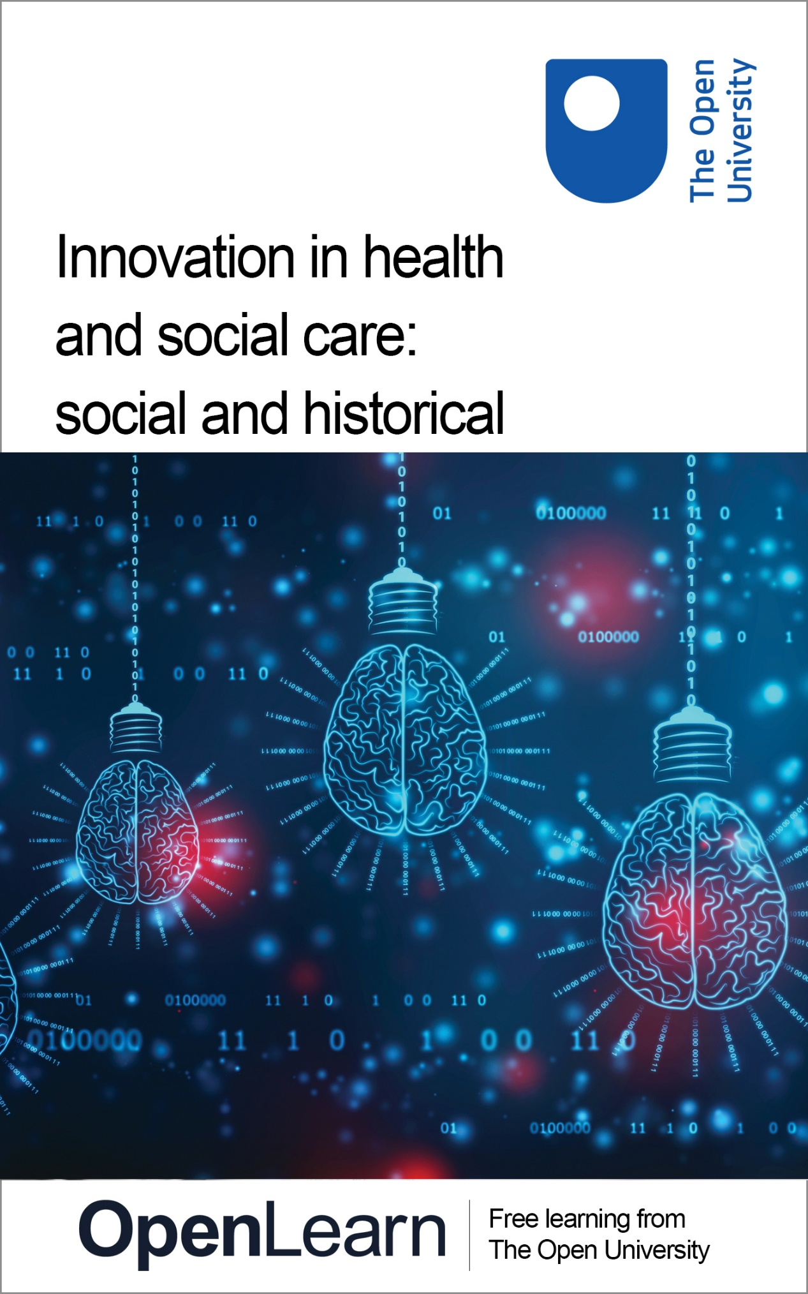

K102_1

Innovation in health and social care: social and historical

About this free course
This free course is an adapted extract from the Open University course K102 Introducing health and social care: www.open.ac.uk/courses/qualifications/details/k102.
This version of the content may include video, images and interactive content that may not be optimised for your device.
You can experience this free course as it was originally designed on OpenLearn, the home of free learning from The Open University –
www.open.edu/openlearn/health-sports-psychology/innovation-health-and-social-care-social-and-historical/content-section-0
There you’ll also be able to track your progress via your activity record, which you can use to demonstrate your learning.
Copyright © 2021 The Open University
Intellectual property
Unless otherwise stated, this resource is released under the terms of the Creative Commons Licence v4.0 http://creativecommons.org/licenses/by-nc-sa/4.0/deed.en_GB. Within that The Open University interprets this licence in the following way: www.open.edu/openlearn/about-openlearn/frequently-asked-questions-on-openlearn. Copyright and rights falling outside the terms of the Creative Commons Licence are retained or controlled by The Open University. Please read the full text before using any of the content.
We believe the primary barrier to accessing high-quality educational experiences is cost, which is why we aim to publish as much free content as possible under an open licence. If it proves difficult to release content under our preferred Creative Commons licence (e.g. because we can’t afford or gain the clearances or find suitable alternatives), we will still release the materials for free under a personal end-user licence.
This is because the learning experience will always be the same high quality offering and that should always be seen as positive – even if at times the licensing is different to Creative Commons.
When using the content you must attribute us (The Open University) (the OU) and any identified author in accordance with the terms of the Creative Commons Licence.
The Acknowledgements section is used to list, amongst other things, third party (Proprietary), licensed content which is not subject to Creative Commons licensing. Proprietary content must be used (retained) intact and in context to the content at all times.
The Acknowledgements section is also used to bring to your attention any other Special Restrictions which may apply to the content. For example there may be times when the Creative Commons Non-Commercial Sharealike licence does not apply to any of the content even if owned by us (The Open University). In these instances, unless stated otherwise, the content may be used for personal and non-commercial use.
We have also identified as Proprietary other material included in the content which is not subject to Creative Commons Licence. These are OU logos, trading names and may extend to certain photographic and video images and sound recordings and any other material as may be brought to your attention.
Unauthorised use of any of the content may constitute a breach of the terms and conditions and/or intellectual property laws.
We reserve the right to alter, amend or bring to an end any terms and conditions provided here without notice.
All rights falling outside the terms of the Creative Commons licence are retained or controlled by The Open University.
Head of Intellectual Property, The Open University

Contents
- Introduction
- Learning outcomes
- 1 Early innovation
  - 1.1 Prosthetics: function and identity
- 2 Innovations discovered by Scottish medics
- 3 Innovation and discovery in healthcare
  - 3.1 Discoveries that changed the world of health
- 4 A history of innovation in the NHS
- 5 Is innovation a good thing?
- Conclusion
- References
- Acknowledgements
- Solutions

Introduction
In this free course on digital technologies and innovations in health and social care you will explore the types of innovations that are available and the impact this has on the individuals using them. This will provide you with insight into the potential advantages and disadvantages involved.
Technology has fundamentally changed the way we live. The internet has opened up new ways in which we can gain access to information and services. As recently as the late 1990s, certain information and services were only available during office hours. Now, we can access that same information any time, day or night, without leaving our homes. This has also changed the way we shop, pay bills, the way the way we travel, and also the way we communicate (Digital Health and Care Scotland, 2018). The internet has also provided us with more choice and control. Advances in technology including mobiles, smartphones and robotics are just a few examples that can change how we manage our health and interact with the health service.
As you can see, digital technology and innovations have the potential to change not only how we manage our health but also the way health and social care is delivered by a workforce who will need to be more technologically skilled than ever before.
While there has been significant development in innovations to improve health and wellbeing, there is a long history of human endeavour to innovate to improve lives.
This is the focus of the next section which explores the evolution of innovation in health and social care in relation to prosthetics to improve the lives of amputees.
This OpenLearn course is an adapted extract from the Open University course K102 Introducing health and social care.

Learning outcomes
After studying this course, you should be able to:
- identify the types of innovations available in health and social care
- explain the impact that innovation has on the lives of users of health and social care services
- recognise the advantages and disadvantages of using digital technologies in health and social care.

1 Early innovation
In the past decade there has been a serious drive to innovate, such as through the use of digital technology in the health and social care sector to improve the health and wellbeing for many people. For example, within social care this has meant implementing digital inclusion officers to work alongside health professionals to ensure people who reside in rural areas can access services. In the health sector, innovation is exemplified by prosthetics designed to replace amputated or missing limbs. The Paralympic Games is not just a major sporting event, it’s also a showcase for sophisticated innovation in this area. Since 1976, athletes at the Games have competed to set record-breaking achievements in terms of agility and speed. Yet innovation isn’t new – humans have for a long time sought ways to improve their health and wellbeing.

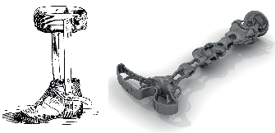

1.1 Prosthetics: function and identity
To appreciate how far innovation has come, it is important to explore early attempts to improve lives around the world. Looking at prosthetics is one way of exploring innovation in a health context, from its primitive beginnings with the fixed-position foot to the present day’s highly sophisticated contemporary designs like the computerised leg (Norton, 2007).
Prosthetics aren’t just about physical functioning. They can provide a way for people to participate in activities that would otherwise be difficult, helping to maintain aspects of the person’s identity.
Innovation in this field can be found as far back as the Ancient Egyptians. A 3,000-year-old mummy with a prosthetic wooden big toe with attachment straps, named the Cario Toe, was an extraordinary find. Not only was the prosthesis designed for comfort, but the toe could even flex (MacDonald, 2017). The Egyptian toe prosthesis was important, because it was developed to retain not only functionality but also identity, as wearing sandals was a significant part of the cultural life of an Egyptian.
Even before this though, ancient discoveries of replacement body parts are discussed in the classical literature of many cultures. For example, the mythical Greek Pelops had an ivory shoulder, animal teeth used to replace human teeth feature prominently among Etruscan archaeological finds, and Herodotus wrote about a Persian seer who in 424 BC evaded execution by amputating his own foot and using a wooden filler to escape to the next town 30 miles away (Norton, 2007).
Custom-built prosthetics made from wood, metal and leather and controlled by cables and gears have been found in France and Switzerland dating from the late fifteenth century. Some cable-controlled hands were so sophisticated they could hold a fork. The designs of these objects were used to develop prosthetics after each of the World Wars (MacDonald, 2017).
Veterans from the Second World War were dissatisfied with what they felt was the lack of sophistication of devices, which prompted governments to team up with product developers to invest in improving the function of prosthetic devices. This led to the development of modern prostheses. Contemporary designs are now made of plastic, aluminium and, with the use of computer chips, are much more personalised, enabling amputees to enjoy greater quality of life (Norton, 2007).
Present-day scientists are now working on prosthetics which can be controlled by the brain. Ultimately, it could mean that losing a limb can be a temporary loss because due to increasing sophistication, personal identity can be retained as far as is possible, thereby enabling people to live life to the fullest with either a prosthesis or, one day, a regrown limb. Scientists are also making advances in the field of reversing the loss of other functioning parts such as eyesight through stem cell therapy.
The focus of the next section explores advancements in innovation in Scotland.

2 Innovations discovered by Scottish medics
You will now continue on the theme of historic innovation in this section where the focus turns to discoveries which transformed the way we experience health care today, particularly the discoveries of two Scottish medics, Sir James Young Simpson and Ian Donald.

In 1847, Sir James Young Simpson pioneered surgical anaesthesia. As an obstetrician he was concerned by the pain of childbirth and sought ways to alleviate it, so he travelled to London and met with Robert Lister, a surgeon, who pointed out the use of ether as an anaesthetic in an operation. In 1799 Sir Humphry Davy had used nitrous oxide, otherwise known as laughing gas, for this purpose.
Simpson was appointed as physician to Queen Victoria while she visited Scotland in 1847, and it was on that trip that Simpson and Lister decided to experiment with chloroform. After inhaling chloroform one evening they found that they felt cheerful and in good humour. However, they collapsed and didn’t gain consciousness until the following morning. Simpson knew as soon as he woke up that he had found something that could be used as an anaesthetic.
More recently, in 1955, a Scottish physician, Ian Donald, observed ultrasound being used in the shipyards of Glasgow and pioneered its use in diagnostic medicine (Digital Health and Care Institute, 2018). Other important developments were to follow, such as the use of superglue, which was originally used to stop soldiers from bleeding to death during the Vietnam War.
Many other innovations have been discovered by accident: possibly the most famous is by Alexander Fleming, who discovered penicillin, and later won a Nobel Prize for his research into it. This is the focus of the first activity.

Activity 1 Accidental discovery

Watch the following video about the discovery of Penicillin, then answer the questions in the box below.

Video content is not available in this format.
Video 1 Alexander Fleming and the accidental mould juice
View transcript - Video 1 Alexander Fleming and the accidental mould juice

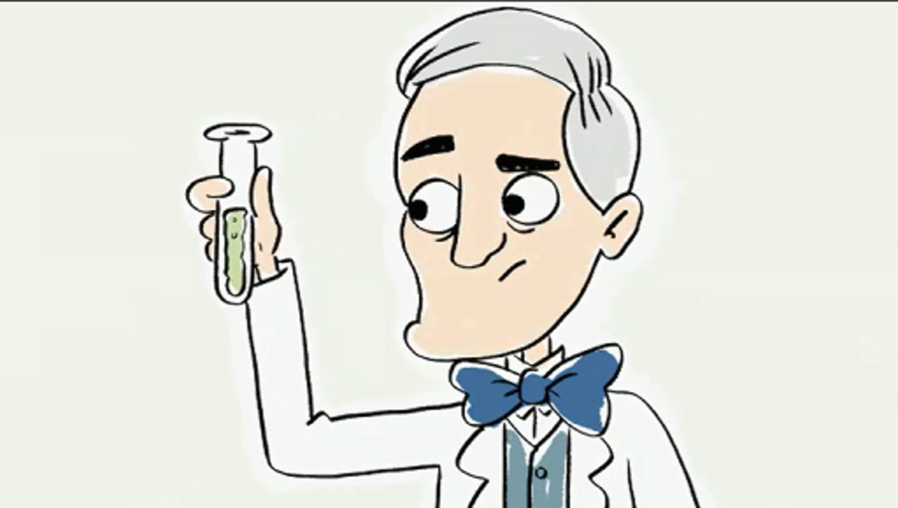

- Why is Alexander Fleming’s discovery described as accidental?
- Why was it timely that Alexander Fleming discovered penicilin?
- How effective was it?
- What are the limitations of the medicine?

Provide your answer...
View discussion - Activity 1 Accidental discovery

If you want to learn more about resistance to antibiotics, visit the free OpenLearn course Understanding antibiotic resistance.

Clearly, the nineteenth and twentieth centuries were a time of great invention and innovation, to which Scotland contributed significantly. There have been many innovations that have led to significant improvements in the lives of the population.
The focus of the next section is on exploring other advancements in healthcare.

3 Innovation and discovery in healthcare
As with other fields of innovation, scientists have also made important discoveries in healthcare. Today, procedures such as keyhole surgery are available, which has replaced more invasive surgery, and we now have cures for illnesses that were previously incurable. Technology has also contributed significantly to ensuring that medicine is more effective than ever.

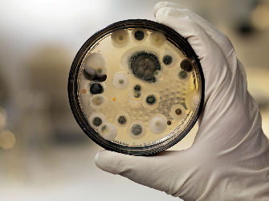

At the time of writing (2020) three new vaccinations for COVID-19 are in the process of being formally approved following trials which have been completed at unprecedented speed. The urgency for a vaccination in this context created the unusual actions of pharmaceutical companies, in the face of government pressure, insisting that trial protocols are fully complied with to ensure maximum public confidence in the safety of their products (Avorn and Kesselheim, 2020).

3.1 Discoveries that changed the world of health
Some of the discoveries that are critical to our health are taken for granted today. One such development is the thermometer, originally based on the principle that a liquid’s density changes with its temperature (Noyes, 1936). Although the mercury thermometer is currently being phased out in favour of digital thermometers due to mercury’s toxicity, its use has been critical to detecting fevers which need treatment.
Another important innovation is X-ray technology. Without this, it would be extremely difficult to make a correct diagnosis for some medical conditions. Discovered by Wilhelm Röntgen, a German physicist, who was studying electric currents passing through gas at low pressure, he observed that in a darkened room, the ray tube covered with barium platinocyanide created a fluorescent effect. Despite winning a Nobel Prize for his innovation, he was mocked by an American journalist for trying to photograph something that was deemed invisible (Kaye, 1934).
The discovery of X-rays led to the search to access even more areas of the body which, in turn, led to the invention of the CT scanner by Dr Godfrey Hounsfield and Allan Macleod Cormack. Both Hounsfield and Cormack were unaware of each other’s work, so they both received a Nobel Prize in 1979 for an invention they had discovered independently of one another.
The CT scanner was able to reveal multiple layers within multiple X-ray images. This technology later enabled Dr Raymond Damadian to be able to determine the difference between cancerous and normal cells using nuclear magnetic resonance, a method known as an MRI (Dawson, 2013).
These are just some of the innovations that have helped to transform millions of lives. The next activity gives you an opportunity to find and explore other great discoveries that have pioneered and transformed the health of many people.

Activity 2 Discovering innovations

Search the internet for four innovations that have transformed healthcare and the way that healthcare is delivered. Make notes about what you found and write your findings in the box below. Write down who discovered it, what the innovation was, and how it has been used.

Provide your answer...
View discussion - Activity 2 Discovering innovations

Now that you have identified other important breakthroughs that have transformed health care, the focus of the next section is on innovations specific to the National Health Service (NHS) in the UK.

4 A history of innovation in the NHS
Innovation can be incremental, that is to say it builds on existing ideas or practice, or it can be revolutionary and ground-breaking, but ultimately its widespread use has led to millions of lives being saved (Gerry and Wyatt, 2011). The next activity invites you to explore a timeline of innovation within the NHS in the United Kingdom and to identify key changes that led to the improvements in the healthcare of the nation.

Activity 3 A journey of innovation through time

Watch the following video about innovations in health care.
Please note: this video dates from 2009 and, due to its age, has noticeably poorer picture quality than videos uploaded today.

Watch the video at YouTube.com.
Video 2 A history of health innovation
View transcript - Video 2 A history of health innovation

Next, use the drag and drop activity underneath to match seven innovations with the year of their discoveries.

1867
1896
1948
1953
1989
2000
2007
Carbolic acid used to sterilise surgical equipment
Almoth Wright invents anti-typhoid vaccine
NHS formed by Aneurin Bevan to provide free medical treatment for all the population
Franklin, Watson and Crick discover DNA is a double helix
Umbilical cord blood is harnessed to repair damage caused by chemotherapy
The Sanger Centre produces the human genome
Imperial College grows a heart valve from stem cells
View answer - Part

Finally, in the text box that follows, identify five ways in which the UK population’s health has improved.

Provide your answer...
View discussion - Part

So far, this section has focused on pioneering discovery in healthcare. In the next section, attention is given to change and innovation and whether it is always a good thing.

5 Is innovation a good thing?
Engaging potential recipients of digital innovation in health and social care is an important part of developing new ways of supporting people. This is the central ethos of services which provide integrated health and social care. For example, Recovery Colleges integrate with many services to provide the optimum care for people experiencing mental health issues. During recovery, recipients of this care are considered as ‘experts by experience’ and recruited to co-design and deliver future services. While such services have been highly beneficial for many, innovation can also come with a high degree of uncertainty.

Indeed, since many innovations in health and social care are now being implemented and many more are planned, it is difficult to ascertain whether the innovation will either be an improvement or be effective in meeting the health and social care needs of the population.
There are several examples of innovations which have been considered beneficial for the whole population, yet remain highly controversial. For example, in 1905, Alfred Binet, a psychologist, and Théodore Simon, his research assistant, developed a series of tests known as the Binet-Simon scale to ascertain children’s intelligence. The main aim of the test was to differentiate between children considered ‘normal’ compared with those labelled as ‘retarded’ and to separate the two, with the latter being housed in institutions. This was considered to be beneficial for society (Gabriel and Simon, 2016); however, Canadian researchers McGowan and Westley (2015) argue that Binet was influenced by genetics and pedagogy.
Herbert Goddard adapted the Binet-Simon scale for use in American schools and, later, Stanford University Professor Lewis Terman, a fan of eugenics, adapted the scale to measure adult intelligence. As a consequence, several US states introduced compulsory sterilisation to prohibit ‘undesirable’ or ‘feeble minded’ people from reproducing (McGowan and Westley, 2015). While medical technology had made sterilisation safe, to contemporary ethicists it was unethical practice. However, at the time Terman and others believed they were doing the best for society.
What is considered a problem and what is considered a solution changes over time. Contemporary approaches to supporting children with learning disabilities value independence, inclusion and wellbeing (Gabriel and Simon, 2016). The focus of the next activity gives you an opportunity to explore some examples of a health or social care innovation.

Activity 4 Innovation: beneficial or controversial?

Search the internet for examples of innovation in health or social care. You might like to search in a particular area of practice that interests you or in your community. Write a short paragraph describing the innovation and include the URL (web address) for the example you have chosen. Add to your paragraph one thing you find interesting about the example you have chosen.

Provide your answer...
View discussion - Activity 4 Innovation: beneficial or controversial?

While some innovation is considered beneficial and even essential, it can also cause harm if misused. Innovation can also be disruptive, disintegrating old systems in favour of the new. This can potentially mean the end of someone’s role, an institution or a service model. Innovation creates both winners and losers – it can improve the lives of many, but it can also exclude groups and communities and undermine institutions that have previously been highly valued.

Conclusion
Innovation in health and social care aims to provide solutions to problems in order to benefit society. However, historical examples demonstrate that theories about what is good or what doesn’t work changes over time. For example, 20 years from now it’s possible that we might view some of the health and social innovations that are implemented today as either damaging or ineffective.
Innovation can be highly valuable for some people but highly problematic for others. For example, the internet has been highly innovative for millions of people and is being harnessed to transform the health and wellbeing of many, but at the same time, it has also generated new forms of criminality and social anxiety.
It is important, therefore, to be careful when claiming that all innovation is good. The beneficial impact of health and social care innovation needs to be backed up by robust research evidence to avoid both inefficiency and repeating the mistakes of the past.
This OpenLearn course is an adapted extract from the Open University course K102 Introducing health and social care.

References
Avorn, J. and Kessleheim, M.D. (2020) Up is down - pharmaceutical industry caution vs federal acceleration of COVID-19 vaccine approval. Available at: https://www.nejm.org/doi/full/10.1056/NEJMp2029479 (Accessed: 2 December 2020).
Dawson, M.J. (2013) Paul Lauterbur and the invention of MRI. Cambridge, MA: MIT Press.
Digital Health and Care Scotland (2018) Scotland’s digital health and care strategy: enabling, connecting and empowering. Edinburgh: The Scottish Government.
Digital Health and Care Institute (no date) A history of innovation. Available at: https://www.dhi-scotland.com/about-dhi/what-is-digital-health-and-care/a-history-of-innovation/ (Accessed: 16 July 2019) .
Gabriel, M. and Simon, J. (2016) When social innovation goes bad. Available at: https://www.pioneerspost.com/news-views/20160714/when-social-innovation-goes-bad (Accessed 2: December 2020).
Gerry, P. and Wyatt, S. (2011) NHS Chief Executive’s review of innovation in the NHS summary of responses to the call for evidence and ideas. Available at: https://youngfoundation.org/wp-content/uploads/2012/10/Review-of-Innovation-in-the-NHS-December-2011.pdf (Accessed: 2 December 2020).
Kaye, G. (1934) ‘Wilhelm Conrad Röntgen: and the early history of the Roentgen Rays’, Nature, 133, pp. 511–513.
MacDonald, J. (2017) A brief history of prosthetic limbs. Available at: https://daily.jstor.org/a-brief-history-of-prosthetic-limbs/ (Accessed: 2 December 2020).
McGowan, K. and Westley, F. (2015) New frontiers in social innovation research. London: Palgrave Macmillan.
Norton, K,M. (2007) ‘A brief history of prosthetics’, inMotion, 17(7), pp. 11–13.
Noyes, B. (1936) ‘The history of the thermometer and the sphygmomanometer’, Bulletin of the Medical Library Association, 24(3), pp. 155–165.

Acknowledgements
This free course was written by Lucy Rai.
Except for third party materials and otherwise stated (see terms and conditions), this content is made available under a Creative Commons Attribution-NonCommercial-ShareAlike 4.0 Licence.
The material acknowledged below is Proprietary and used under licence (not subject to Creative Commons Licence). Grateful acknowledgement is made to the following sources for permission to reproduce material in this free course:

Images
Course image: © Blackboard373/Dreamstime.com
Section 1 figure (left): © ilbusca / iStock / Getty Images Plus
Section 1 figure (right): © Waldemarus / iStock / Getty Images Plus
Section 2 figure: © Oleksii Liskonih / istock / Getty Images Plus
Section 3 figure: © AndreasReh / Getty Images
Section 4 figure: © bagi1998 / iStock / Getty Images
Section 5 figure: © alashi / Getty Images

Audio-visual
Video 1: © The Open University
Every effort has been made to contact copyright owners. If any have been inadvertently overlooked, the publishers will be pleased to make the necessary arrangements at the first opportunity.
Don't miss out
If reading this text has inspired you to learn more, you may be interested in joining the millions of people who discover our free learning resources and qualifications by visiting The Open University – www.open.edu/openlearn/free-courses.

Solutions

Activity 1 Accidental discovery

Discussion
- Fleming was described as someone who was untidy in nature so when he returned to his lab after some time away, he discovered a petri dish with culture in it that had been left behind. He noted that some of the bacteria had been killed off.
- Fleming’s discovery was extremely timely since he saw first-hand how soldiers in the battlefields of the First World War were being treated for their wounds with the use of antiseptic. Many soldiers died as a result.
- With the invention of penicillin, millions of lives were saved. Penicillin was also critical to treating the wounds of Second World War soldiers.
- While penicillin has gone on to save millions of lives, its overuse has led to certain bacteria becoming resistant to it, which has led to superbugs such as MRSA which are immune to penicilin.
Back to - Activity 1 Accidental discovery

Activity 2 Discovering innovations

Discussion
Here are some suggestions.
- Stethoscope: The French physician René Laennec invented the stethoscope. The earliest version was made of wood and shaped like a trumpet tube to amplify sound. He found that doctors would listen to a patient’s heartbeat by placing their ear on the chest of the patient. The problem was, however, that if there was considerable insulation between the heart and the chest (e.g. fat) then this way of determining a patient’s heartbeat was ineffective. The idea of using an instrument to amplify sound remains in use today.
- Cardiac defibrillator: Invented by Claude Beck, who first used the device to defibrillate a boy’s heart during surgery in 1947, defibrillators save millions of lives each year. It works by sending a high energy shock to the heart to enable it to return to a normal rhythm. It is especially useful for someone who is experiencing cardiac arrest.
- The hypodermic needle: The hypodermic needle is a significant innovation enabling blood and poisons to be removed and insulin and anaesthesia to be inserted. While the Romans and Greeks used needles, the practice wasn’t always safe. It wasn’t until a nineteenth-century surgeon, Alexander Wood, combined the syringe with a needle to inject morphine to a patient that it became much safer to use. Now needles are much stronger, thinner, more sterile and even come pre-filled to enable people to self-inject, for example, to treat diabetes. This makes it much more efficient for health professionals and patients.
- Artificial pacemaker: Two Australian scientists, Mark C. Lidwill and Edgar H. Booth, developed the cardiac pacemaker in 1926. The original device was portable and consisted of two poles, one of which was connected to a salt solution-soaked skin pad, while the other pole was attached to a needle that was inserted into a patient’s heart chamber. With this device, they were able to revive a stillborn baby. Contemporary designs are now more sophisticated, enabling a patient to use one for up to 20 years.
Back to - Activity 2 Discovering innovations

Activity 3 A journey of innovation through time

Part

Answer
The correct matches are:
1867
Carbolic acid used to sterilise surgical equipment
1896
Almoth Wright invents anti-typhoid vaccine
1948
NHS formed by Aneurin Bevan to provide free medical treatment for all the population
1953
Franklin, Watson and Crick discover DNA is a double helix
1989
Umbilical cord blood is harnessed to repair damage caused by chemotherapy
2000
The Sanger Centre produces the human genome
2007
Imperial College grows a heart valve from stem cells
Back to - Part

Part

Discussion
Was there anything that surprised you in the video? You may have been slightly alarmed that hip operations were once considered so rare that the artificial hips had to be returned after a patient’s death. This may have caused some distress to families given that a deceased relative would have had to be operated on to remove the replacement. Now of course though, hip replacements are common.
Back to - Part

Activity 4 Innovation: beneficial or controversial?

Discussion
Here is an example: The use of insulin shock therapy to treat schizophrenia and drug addiction seems highly controversial. The therapy was developed by Polish researcher Manfred Sankel in 1933 and was used until as recently as the 1950s. It involved injecting the patient with large doses of insulin which caused convulsions and resulted in the patient being in a coma for up to 100 minutes. The procedure ended by giving the patient a glucose saline solution intravenously through the stomach.
There were complications with the treatment since epileptic seizures occurred during the early stages of the procedure prior to the onset of a coma. However, seizures occurring during a coma are more dangerous as this requires the treatment to be withdrawn with immediate effect. The consequences are such that the patient either takes longer to recover or experiences severe shock, or both.
The therapy is considered controversial because there is no robust evidence to indicate that it was efficient or that it worked. Insulin therapy did have a higher success rate among patients who had been ill for less than two years as this is when a spontaneous recovery could occur anyway. However, at the time there was no other treatment available to administer to schizophrenic patients and this was therefore seen as something which could be beneficial. It remains a controversial treatment because it could lead to irreversible coma and, in severe cases, anoxia (this is a condition where the body is not getting enough oxygen, resulting in the patient writhing about and in vascular shock). Milder cases were typified by temporary paralysis of some limbs and confusion. Some patients were in a state of unconsciousness for days following the treatment.
Back to - Activity 4 Innovation: beneficial or controversial?

Video 1 Alexander Fleming and the accidental mould juice

Transcript
NARRATOR
Having been brought up on a farm in Scotland, scientist Alexander Fleming wasn't afraid of getting his hands dirty, examining nasty bacteria like Staphylococcus aureus, which, in humans, as well as horses, can cause death, as well as vomiting and boils.
[CREAKING]
One day in 1928, Fleming came back from his holidays. He found some cultures of the Staphylococcus aureus bacteria which he'd meant to throw away. It had died.
[CHURCH BELL]
But instead of throwing them away, he stopped to think, what might have caused some of his sample to die and the rest to live? After a lot of time and effort in his lab, Fleming worked out that some of his sample had been contaminated by a particular fungus, which he then managed to grow himself.
As an ex-soldier in World War I, he'd seen hundreds of soldiers die due to bacterial infection. And he figured that if the fungus could kill bacteria on his bench, it might also kill bacteria in wounded soldiers. And he was right.
Having renamed his mould juice "penicillin"--
[BRASS FANFARE]
--it was ready for public consumption, in time for the next war, on D-Day.
Penicillin has saved the lives of millions of people and horses.
[NEIGHS]
But due to overuse, some bacteria are becoming resistant and methicillin-resistant Staphylococcus aureus is now widespread among humans, known by its more popular name, MRSA.
Back to - Video 1 Alexander Fleming and the accidental mould juice

Video 2 A history of health innovation

Transcript
ON SCREEN: “a history of healthcare innovation”
ON SCREEN: “1867: carbolic acid used to sterilise surgical instruments”
ON SCREEN: “1896: Almoth Wright invents anti-typhoid vaccine”
NARRATOR
--a huge history of major inventions.
ON SCREEN: “1928: Alexander Fleming discovers penicillin”
Miracle out of mould when a brilliant doctor, Professor Alexander Fleming, discovered that it produces the drug known as penicillin.
ON SCREEN: “1948: NHS is founded, unveiled by Aneurin “Nye” Bevan”
We have a tremendous heritage.
--then proposes a comprehensive health service, securing medical treatment of all kinds for all citizens.
ON SCREEN: “1953: Watson and Crick discover DNA is a double helix”
ON SCREEN: “1956: Colin Murdoch invents disposable syringes”
--as we celebrate the 60th anniversary of the NHS, I could highlight at least two or three major discoveries every decade.
ON SCREEN: “1965: Frank Pantridge invents portable defibrillator”
ON SCREEN: “1973: Godfrey Houndsfield invents CAT scanner”
ON SCREEN: “1989: umbilical-cord blood used to repair damage from chemotherapy”
ON SCREEN: “2000: The Sanger Centre produces a draft of the human genome”
ON SCREEN: “2003: Peter Mansfield wins Nobel Prize for the MRI scanner”
ON SCREEN: “2007: Imperial College grow a heart valve from stem cells”
ON SCREEN: “2009: Innovation for a healthier future”
ON SCREEN: “2020: miniaturised haemo dialysis equipment in universal use?”
ON SCREEN: “2030: reversal of brain pathology for dementia?”
MAN
There are many innovations. Innovations in wellbeing. How do we prevent patients getting ill? Innovations in diagnosis. Innovations in treatments. Robotics is one good example. We're moving into what we call surgery without incisions in the future.
ON SCREEN: “2040: cure for obesity?”
ON SCREEN: “In 1948 a cataract operation immobilised a patient for a week. Now it’s over in 20 minutes and most go home the same day.”
MAN
British inventors are very creative in terms of making or inventing the technology. The vision sees through how do we actually turn technology into improved clinical practice.
ON SCREEN: “In 1958, hip operations were so rare patients had to return them post-mortem.”
ON SCREEN: “The first UK heart transplant patient survived 46 days.”
MAN
This is a piece of equipment that allows us to rehearse a surgical mission prior to doing it.
ON SCREEN: “Transplants are now routine and at least two dozen could be done in the same period.”
MAN
We performed the first patient procedure rehearsal carotid artery stenting last week.
ON SCREEN: “The world waited until 1978 for the first test tube baby.”
MAN
The future is about improving outcomes, minimising patient risk by simulation in a way that has been demonstrated in the airline industry.
ON SCREEN: “6000 test tube babies are now born here annually.”
MAN
Innovation isn't just about kit and drugs. It's about looking at the whole health care pathway. How do we tailor care around the needs of the patients? That's innovation.
ON SCREEN: “The breast screening programme introduced in 1988 now saves the lives of 1400 women a year.”
WOMAN
I was really excited about the opportunity to come to work in a paediatric short stay unit because it was a new way of developing patient care and new streamlined approach for patients.
ON SCREEN: “No-one now waiting more than 18 weeks for referrals to treatment.”
ON SCREEN: “9000 fewer deaths from cancer.”
MAN
Birmingham Own Health provides telephone-based care to people with long term conditions.
WOMAN
We build up a relationship with our members by making regular contact with them over the telephone. It's the first type within the UK of care management over the telephone.
Children, when they are here, and their families, will not just be passive recipients of care. When they leave and go home they go home as expert patients who are able much better to look after their own condition, know where to seek help, and therefore much less dependent on hospital care in the future.
ON SCREEN: “One of the highest percentages of women being screened for cervical cancer worldwide.”
MAN
Innovation isn't just for the doctors and nurses. Innovation is for everyone who works in the health care system. There are pockets of excellence that we should all be very proud of. How do we really diffuse that innovation? How do we copy it from one area and transplant it into another area? We need the front line staff, the 1.3 million people who work in the NHS, to have access to that evidence base.
ON SCREEN: “33,000 fewer deaths from cardiovascular in people under 75 in 2007 compared with 1997.”
MAN
It's innovation in management. How do we stop doing things that there isn't the evidence base supporting them? Innovation should be very much part of our culture.
MAN
Be imaginative, be brave, be bold, be prepared to take a risk, and you'll get the rewards.
Back to - Video 2 A history of health innovation

