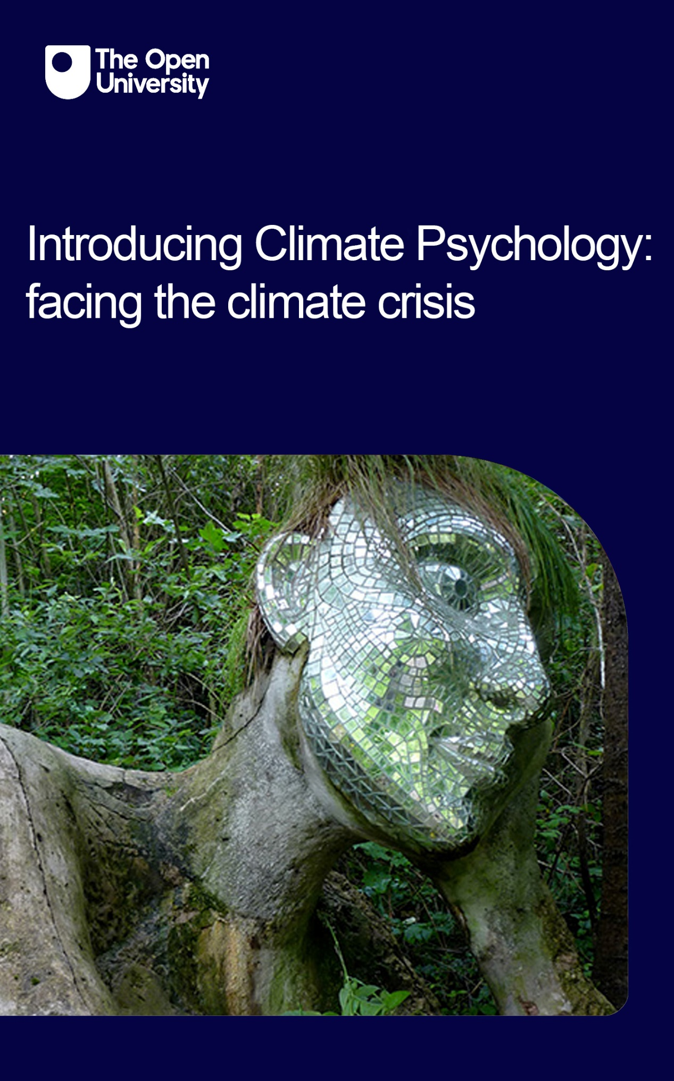

CLPSY_1

Introducing Climate Psychology: facing the climate crisis

About this free course
This free course is an adapted extract from the Open University course .
This version of the content may include video, images and interactive content that may not be optimised for your device.
You can experience this free course as it was originally designed on OpenLearn, the home of free learning from The Open University –
There you’ll also be able to track your progress via your activity record, which you can use to demonstrate your learning.
First published 2023.
Unless otherwise stated, copyright © 2023 The Open University, all rights reserved.
Intellectual property
Unless otherwise stated, this resource is released under the terms of the Creative Commons Licence v4.0 http://creativecommons.org/licenses/by-nc-sa/4.0/deed.en_GB. Within that The Open University interprets this licence in the following way: www.open.edu/openlearn/about-openlearn/frequently-asked-questions-on-openlearn. Copyright and rights falling outside the terms of the Creative Commons Licence are retained or controlled by The Open University. Please read the full text before using any of the content.
We believe the primary barrier to accessing high-quality educational experiences is cost, which is why we aim to publish as much free content as possible under an open licence. If it proves difficult to release content under our preferred Creative Commons licence (e.g. because we can’t afford or gain the clearances or find suitable alternatives), we will still release the materials for free under a personal end-user licence.
This is because the learning experience will always be the same high quality offering and that should always be seen as positive – even if at times the licensing is different to Creative Commons.
When using the content you must attribute us (The Open University) (the OU) and any identified author in accordance with the terms of the Creative Commons Licence.
The Acknowledgements section is used to list, amongst other things, third party (Proprietary), licensed content which is not subject to Creative Commons licensing. Proprietary content must be used (retained) intact and in context to the content at all times.
The Acknowledgements section is also used to bring to your attention any other Special Restrictions which may apply to the content. For example there may be times when the Creative Commons Non-Commercial Sharealike licence does not apply to any of the content even if owned by us (The Open University). In these instances, unless stated otherwise, the content may be used for personal and non-commercial use.
We have also identified as Proprietary other material included in the content which is not subject to Creative Commons Licence. These are OU logos, trading names and may extend to certain photographic and video images and sound recordings and any other material as may be brought to your attention.
Unauthorised use of any of the content may constitute a breach of the terms and conditions and/or intellectual property laws.
We reserve the right to alter, amend or bring to an end any terms and conditions provided here without notice.
All rights falling outside the terms of the Creative Commons licence are retained or controlled by The Open University.
Head of Intellectual Property, The Open University

Contents
- Introduction and guidance
- Week 1: The climate and ecological crisis and how we got hereReferences
- Introduction
- 1 Facing it
- 2 Anthropocene and growth
  - 2.1 The Great Acceleration
- 3 Modern humans’ relation to the Earth
  - 3.1 Ecopsychology
  - 3.2 Consumerism
- 4 Individual behaviour change and beyond
  - 4.1 Responsibilisation
- 5 Trouble with the COPs
- 6 Summary of Week 1
- Week 2: Engaging with the climate and ecological crisis: indifference, distress and beyond
- Introduction
- 1 Facing difficult truths
- 2 A depth psychological perspective
- 3 A human story of real-world feelings
- 4 Eco-anxiety
  - 4.1 Solastalgia
- 5 Climate distress as a healthy response to reality
- 6 Doomism
- 7 Summary of Week 2
- Week 3: Engaging with the climate and ecological crisis: denialism and other challenges
- Introduction
- 1 Business as usual?
- 2 Types of denial
- 3 Organised climate change denial: a brief history and its main strategies
  - 3.1 What are the main strategies used by organised climate change deniers?
- 4 Individual responsibility
- 5 Greenwashing
- 6 Technology
- 7 A problem too difficult to conceive: climate change as a ‘hyperobject’
- 8 Summary of Week 3
- Week 4: Living with the climate and ecological crisis
- Introduction
- 1 Emotional engagement
- 2 Taking action
  - 2.1 Danger of burnout
  - 2.2 Self-care
- 3 Summary of Week 4
- 4 Course summary
- References
- Acknowledgements
- Solutions
- Descriptions

Introduction and guidance
Climate Psychology is defined by the Climate Psychology Alliance as:

… a new way of understanding our collective paralysis in the face of worsening climate change… It is concerned with the emotions, and the social and mental processes that have contributed to the ecological and climate crisis and our responses and processes of adaptation to it.
(Climate Psychology Alliance, 2023)

As a new and emerging psychological discipline, Climate Psychology draws on several schools of thought and practice such as psychotherapeutic approaches, psychosocial studies, philosophy, systems thinking and ecopsychology. It explores our anxieties and defences associated with the climate and ecological crisis, considers forms of support and aims to help individuals and communities cope and adapt. In essence it aims to provide a psychosocial understanding by exploring the ‘interactions between the personal and the political, the psychological and the social’ (Andrews and Hoggett, 2021, p. 157).
The course is divided into 4 weeks of study and each week should take around 3 hours. However, you can study the course at your own pace. The four weeks are:
- The climate and ecological crisis and how we got here
- Engaging with the climate and ecological climate: indifference, distress and beyond
- Engaging with the climate and ecological crisis: denialism and other challenges
- Living with the climate and ecological crisis
After studying this course, you should be able to:
- understand why the climate and ecological crisis has developed
- recognise the emotional and behavioural responses to the climate and ecological crisis
- identify the individual and cultural defences that prevent engagement with the crisis
- develop a personal action plan to enable the ability to cope with and adapt to the crisis.

Moving around the course
In the ‘Summary’ at the end of each week, you will find a link to the next week. If at any time you want to return to the start of the course, click on ‘Full course description’. From here you can navigate to any part of the course.
It’s also good practice, if you access a link from within a course page (including links to the quizzes), to open it in a new window or tab. That way you can easily return to where you’ve come from without having to use the back button on your browser.
You can now go to Week 1..

Week 1: The climate and ecological crisis and how we got hereReferences

Introduction
This week, the scene is set for the emerging area called Climate Psychology. Climate Psychology, according to the Handbook available at the Climate Psychology Alliance (CPA) website is ‘a new way of understanding our collective paralysis in the face of worsening climate change’ (Climate Psychology Alliance, 2023).
In this course you’ll learn how difficult it is for people to face the reality of climate change and what style of communication is needed to reach people. Activities are designed to help go beyond a dry intellectual knowledge of climate breakdown to enable some familiarity with the psychological challenges of recognising it as a serious threat to humans and millions of other species.
The climate and ecological crisis is situated historically in three ways: deep (geological) time, the more recent history of modernity, and the ‘Great Acceleration’ period since the 1950s, when the principle of infinite growth collides with the finite resources of planet Earth. Climate Psychology asks what it is about how humans live on the planet and what needs to change; it critically examines the emphasis on individual behaviour change. It widens horizons from the global north (those countries characterised by high economic and industrial development) to look at recent international agreements that recognise ‘loss and damage’ in nations of the global south (those countries characterised by low economic and industrial development).
In this week you will:
- reflect on how it feels to face the climate and ecological crisis
- consider the crisis within three time periods
- learn about our modern relationship with nature and an ecopsychological perspective
- learn about the role of consumerism
- critique the role of the international conference that works for agreement on addressing the climate crisis
- consider the issue of social justice.

1 Facing it
What does it feel like to face the reality of the climate and ecological crisis? This is a core question for Climate Psychology, for if we don’t know the answer to it, how can we rely on human action to make the changes that humanity urgently needs to make?
On 19 July 2022, the temperature in the UK surpassed 40 degrees Celsius (104 degrees Fahrenheit) for the first time. Up until then, the UK was a country relatively little affected by climate change. This is how the weather presenter Ben Rich spoke about it when interviewed by The Guardian reporter Sam Wollaston:

… I went to work for my shift. The station was really hot, the train was really hot, and I remember having this moment. I got a bit emotional about it, to be honest. I thought: this is huge. And if it can happen once, why can’t it happen again?
(Rich, 2023)

In his training as a meteorologist, Rich had learned that 40 degrees C in the UK was ‘nigh on impossible because there are all sorts of factors that should stop that from happening, not least the fact that we are surrounded by ocean. It should be too moist for temperatures to get that high’.
At work, as the temperature rose, ‘There were stories of wildfires in east London and other places, the train network went down, there were reports of runways melting at some airports. All this was happening at the same time’.

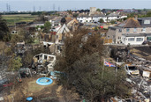
Figure 1 The aftermath of the wildfires in London, July 2022.
View description - Figure 1 The aftermath of the wildfires in London, July 2022.
View alternative description - Figure 1 The aftermath of the wildfires in London, July 2022.

Wollaston comments that knowing and understanding what’s going on is one thing, but a whole new level of awareness comes from actually experiencing something. ‘I think the human condition is that to really get your head around a problem you have to be able to see it and feel it’, Ben Rich says. ‘That was a real watershed moment, when the climate crisis was clearly happening to us, there and then. It felt to me that was a marker that something had fundamentally shifted in what the weather is capable of – and in our climatology.’
The emphasis on actually experiencing climate change, seeing it and feeling it as well as knowing about it, has been important in the last fifty years. Scientists have been establishing the facts of climate change for that long but it often takes an immediate experience like a record high temperature and wildfires in London for the reality to click. The reality made Ben Rich emotional but he doesn’t feel comfortable about that (‘I got a bit emotional about it to be honest’).
Laura Tobin, another weather presenter, talked of watching the temperature forecasts with incredulity and dread on that same morning,

Then when I sat down and chatted to my producer, I had tears in my eyes. Something I had thought would be a reality in the future was a reality that day. We shouldn’t be reaching these temperatures – it would be impossible to without climate change.
(Tobin, 2023)

As a weather presenter it was hard to know how to present the increased frequency of extreme weather events (record temperatures, rainfall, drought and wildfires): ‘It got to a point where it’s like: another record? We won’t do this one because we did a record the other day.’ Here we see how the requirement to make news ‘new’, to interest the audience, can play into how climate change is communicated.
Laura Tobin spoke of another factor that affected her personal experience of deeply realising about the seriousness of climate change, one that affects many people: she had a baby.

I had already seen how things had changed between my mum’s generation and mine; now it was about how it was going to change for her. Having a daughter has definitely made me want to talk about [climate change] more. Before, it was: this could happen in so many years. Now it’s going to happen in her lifetime; it’s already happening. When you put a value and a feeling on that timescale it makes it more real.
(Tobin, 2023)

Her comment shows up another common feature: that for years people got the impression that climate change was not going to happen in their lifetime, and this was a way of shelving it. Becoming a parent extends this timeline. Not only will it happen in her daughter’s lifetime, but ‘it’s already happening’.
Recording a programme from the melting glaciers of Northern Norway, Laura Tobin found herself crying on camera.

I didn’t mean to. I didn’t want it to be about me crying; I wanted it to be about the science. But I just saw the reality of it and it moved me. I realised that we – everybody – is responsible for that change. Seeing the reality compared to seeing and knowing the science was different. That was the moment for me when I was like: I want my daughter to come back and see this.
(Tobin, 2023)

Note also how she contrasted being emotional with talking about the science, as if they were in opposition. Scientists have been especially beset by the requirement to be unemotional, as if objectivity required being emotion free. Arguably the dry and dusty style of scientific – including many psychological – articles has made it harder to communicate climate change successfully. What do we mean by successfully? We mean communication in a way that makes it feel real and as momentous as it is, so that it moves people – emotionally – to engage in some way, rather than avoid, that reality.
You may well recognise many features of these reactions to climate change in your own feelings. Climate Psychology emphasises how difficult it is for people to fully recognise the extent of the threat that climate change poses. And this difficulty has been mirrored in the language and politics and media information that has been available to us.

Activity 1 When climate change can hit you
Allow about 10 minutes

Can you locate a time when you felt the reality of climate change more deeply than before? Write down a description of how you felt and describe what was going on at the time.

Provide your answer...

2 Anthropocene and growth
You’ll now take a step back to look at the Earth’s history and humanity’s recent history, for it is in these wider contexts that people can situate and grasp what is happening.
The Anthropocene is a label recently given to a new period in the Earth’s history. The root ‘anthropo-’ means human and refers to ‘the period of humans’. The Anthropocene label highlights just how profoundly humans have impacted on planet Earth’s geology and ecosystems.
Geology is the scientific discipline that categorises the history of planet Earth into periods, eras and epochs, mostly preceding the human species. The most recent epoch is the Holocene, a mere 11,000 years (a blip in deep geological time), in which climate stability and relatively hospitable weather enabled a prolific biosphere, within which human civilization could emerge. The Anthropocene classification is the work of a consensus of international geologists who, in 2013, claimed that the Earth was entering a new period defined by the fact that human activity now dominates the functioning of Earth systems and that the extent of these activities has thrown Holocene climate stability out of balance (Ellis, 2018).
Figure 2 shows the Anthropocene relative to the whole of geological time.

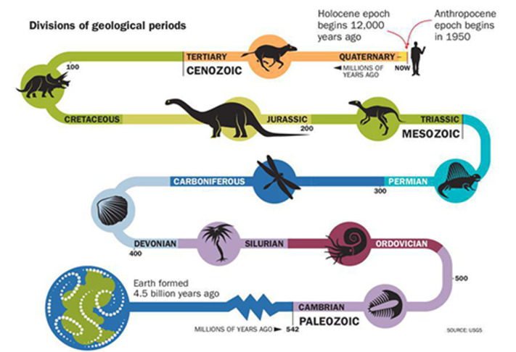
Figure 2 A summary of our planet’s geological periods.
View description - Figure 2 A summary of our planet’s geological periods.
View alternative description - Figure 2 A summary of our planet’s geological periods.

The disruption of the Holocene and the emergence of the Anthropocene refers to the fact that atmospheric carbon dioxide is (as far as can be established retrospectively) at its highest level in 15 million years, with consequences, long predicted, that are already disastrous and could lead to human extinction. On the Anthropocene timeline this level was recorded in 2014.
Figure 3 shows the Keeling Curve. This curve is represented by a graph which shows the concentration of carbon dioxide in the planet’s atmosphere. Measurements to produce this graph have been collected continuously at the Mauna Loa Observatory in Hawaii from 1958 until now. Despite carbon dioxide (CO₂) concentrations varying seasonally (hence why you see alternating minor ups and downs in the line), overall, the levels of carbon dioxide are continuously increasing.

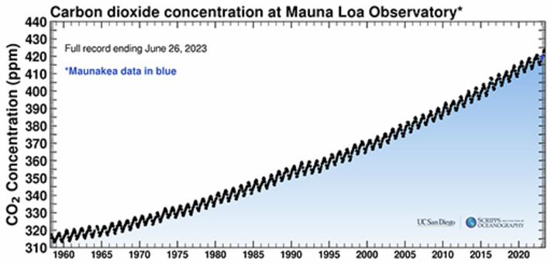
Figure 3 The Keeling Curve.
View description - Figure 3 The Keeling Curve.
View alternative description - Figure 3 The Keeling Curve.

However, a high level of CO₂ emissions is only the most notorious of many threats, all ‘anthropogenic’ (that is, all the effects the result of human activity). In addition, we are facing multiple species extinction, desertification, ice melt leading to sea level rise, deforestation, poisoning of soil and polluting of rivers and oceans. This is why we give the crisis its full name, not just ‘climate crisis’ but ‘climate and ecological crisis’.

2.1 The Great Acceleration
The starting point of the Anthropocene can be located in the industrial revolution, starting in eighteenth-century Europe. More commonly, though, the Anthropocene is defined as beginning with the ‘Great Acceleration’, a period from 1950 that saw steep growth in many human activities which together make up the global socio-economic system.

Activity 2 The Great Acceleration
Allow about 10 minutes

Look at Figure 4, which is an example of the ‘Great Acceleration’ in human activity since the 1750s.
First, try to make sense of the trajectories of the lines in each box – what do they show about human activity? Is human activity increasing or decreasing in each domain over time? Does it develop slowly, or does it increase rapidly after a while? When did these increases start?
Second, compare this graph to the Keeling Curve (Figure 3 – in the previous section) which shows the continuous rise of carbon in the Earth’s atmosphere. Do you see any patterns? They all show an exponential growth pattern – a slow rate of increase at the bottom, followed by such a steep, rapid rise that the line goes up almost vertically.

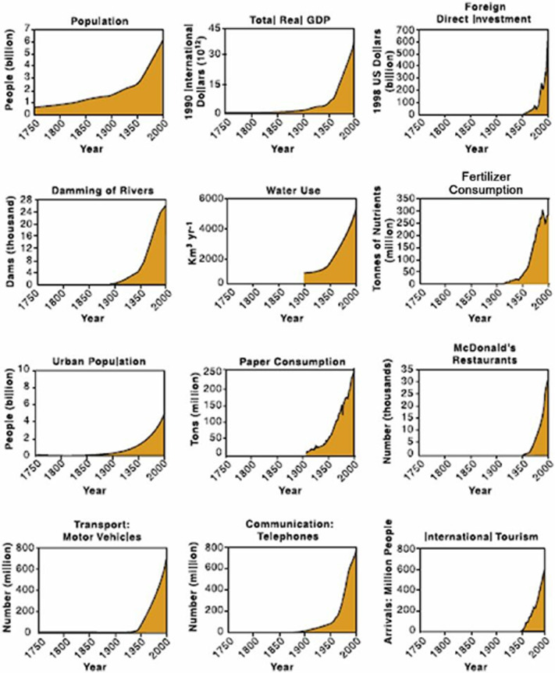
Figure 4 The Great Acceleration refers to increasing rates of human activity since the Industrial Revolution.
View description - Figure 4 The Great Acceleration refers to increasing rates of human activity since ...
View alternative description - Figure 4 The Great Acceleration refers to increasing rates of human activity since ...

Provide your answer...

Much more could be said about these features of global growth in human activity and their interactions with the planetary biosphere. The predicament can be summarised as ‘you cannot have infinite growth on a finite planet’.
During the ‘Great Acceleration’, all the indices of growth – as represented by the graphs you have been looking at – are due to two factors: global human population growth and levels of resource consumption of those populations. The Earth Overshoot Day website reminds us about the relation of resource consumption to what the Earth can provide on a sustainable basis. This is called ‘ecological overshoot’. Humanity is using nature 1.8 times faster than our planet’s biocapacity can regenerate.
The massive increase in human population from 2.5 billion in 1950 to an expected 8 in 2023 undoubtedly puts pressure on the planet’s biocapacity. However, the Earth Overshoot Day website also shows how nations’ consumption habits are vastly different. Whereas the USA uses up over 5 earths, many nations of the global South – India, Pakistan, Rwanda, Uganda for example – use up less than 1, in Somalia’s case only a half. However, we need to look more closely at oversimplification about the global north’s ecological footprint.
For example, so-called developing countries are fast catching up in terms of the volume of greenhouse gases produced. In China the footprint per capita is growing fast, partly because the people espouse Western lifestyles, which have long been seen as ‘progress’. For example, with rising income, people in China are eating more meat than they used to.
Just as consequential, perhaps, the patterns of consumption in the so-called developed countries (the ones we are calling the global north) are very uneven and getting more so. For example, an Oxfam report found that the world’s richest 1% own two-thirds of new wealth amassed since the start of the COVID-19 pandemic in 2020. By the end of 2021, that amounted to $26 trillion. The other 11 trillion went to the remaining 99% of the world’s population. According to Oxfam, these concentrations of wealth lead to weaker economic growth, corrupted politics and media, corroded democracy and political polarisation. When it comes to the climate and ecological crisis, a billionaire emits twice as much carbon and is twice as likely to invest in polluting industries, compared to an average investor (Elliott, 2023).

3 Modern humans’ relation to the Earth

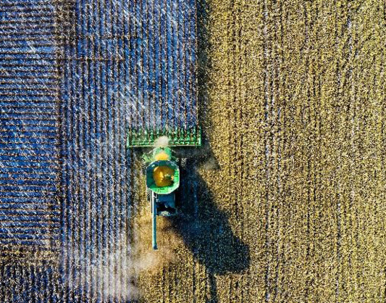
View description - Uncaptioned Figure
View alternative description - Uncaptioned Figure

Introducing a psychology in understanding the climate and ecological crisis, and why it matters, poses two questions about humans’ relation to planet Earth, the only home we have.
- What is it about how humans have been living on the planet that has caused this massive impact?
- What could change our relation to the planet to alleviate the deadly and catastrophic anthropogenic effects?

3.1 Ecopsychology
Ecopsychology is ‘an inquiry into our human relationship with the rest of nature’ (Rust, 2020, p. 51). It is not a unified discipline, however. It is a complex web of several different disciplines and areas of study such as deep ecology, transpersonal psychology, indigenous traditions, wilderness studies and philosophy, to name some. A central tenet of ecopsychology is the exploration of the reciprocal human–nature relationship and in particular the human mind as it relates to nature. Rust (2020) describes it as ‘the study (logos) of the soul (psyche) in its natural home (ecos)’ (p. 51).
Ecopsychologists claim that ecological and psychological health are mutually dependent (Roszak, Gomes and Kanner, 1995); the psychological wellbeing of humans and the ecological health of the planet are dependent on an intimate human-nature relationship. In other words, the more disconnected we become from nature, the more our psychological health suffers and the more planetary destruction ensues. The practice of ecopsychology seeks to heal this disconnection and restore the earth. Roszak (1995) proposes that life on Earth and the human mind have evolved together within physical, biological, mental and cultural systems and that our ecological unconscious has been repressed through industrialisation. The role of ecopsychology then is to ‘awaken the inherent sense of environmental reciprocity that lies within the ecological unconscious’ (Roszak, 1992 p. 320).
The idea that we have an ‘ecological self’ was first proposed by the Norwegian environmental philosopher and founder of the deep ecology movement, Arne Naess. He used it to refer to an experience of self which is expansive, relational, wider and deeper than the ego and identifies with all of life not just other humans. He says, ‘One experiences oneself to be a genuine part of all life’ (Naess, 1989, p. 174) and ‘We may be said to be in, of, and for Nature from our very beginning’ (Naess, 1995, p. 14). The ecological self is not a fixed thing to be discovered or a static idea but an opening up to experiencing oneself authentically in relationship and embedded within our environmental context, specifically the natural and non-human world.

Activity 3 Relationship to your chosen familiar outdoor space
Allow about 15 minutes

This activity borrows from a published article by Susan Bodnar and colleagues in the USA, entitled ‘The environment as an object relationship’ (Bodnar et al., 2023). Participants in the research were asked to do the following task, which you should also try out.
Take five minutes to ‘free-write’ on the subject of your relationship to a familiar place (make it an outdoor place, from the past or present). A free-write means writing spontaneously with minimum hesitation or revision.
Now reflect on the following three questions:
- Describe your relationship to this ecosystem or place.
- What other relationship in your life is most similar to the one you have to the ecosystem you described?
- How would you feel if this place no longer existed?

Provide your answer...
View discussion - Activity 3 Relationship to your chosen familiar outdoor space

Humans can live in a sustainable relationship with the natural earth; some still do.
Robin Wall Kimmerer, an ethno-botanist of American-Indian descent, explains how it works in her culture in her widely-read book Braiding Sweetgrass:

In the indigenous worldview, a landscape is understood to be whole and generous enough to be able to sustain its partners. It engages land not as a machine but as a community of respected non-human persons to whom we humans have a responsibility. […] Restoring land without restoring relationship is an empty exercise. It is relationship that will endure and relationship that will sustain the restored land.
(Wall Kimmerer, 2020, p. 338)

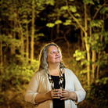
Figure 5 Robin Wall Kimmerer.
View description - Figure 5 Robin Wall Kimmerer.
View alternative description - Figure 5 Robin Wall Kimmerer.

During the Modern period of history (which began in Europe about 500 years ago), technological innovation, urbanisation, science and globalisation were the hallmarks of modernity in a period that is characterised as ‘enlightenment’, as the growth of rationality and – above all – as ‘progress’. However, in recognising climate and ecological collapse, people are beginning to realise what was lost during this momentous period of human history. Modern humans’ relation to nature changed dramatically; we lost our sense of belonging to nature.
The worldview described in the quote from Robin Wall Kimmerer, above, is preserved among indigenous peoples but widely lost among those living a Modern lifestyle in the global north. Modern people learned to see nature as separate and humanity as superior. The Christian bible taught this:

And God said, Let us make man in our image, after our likeness: and let them have dominion over the fish of the sea, and over the fowl of the air, and over the cattle, and over all the earth, and over every creeping thing that creepeth upon the earth.
(Genesis 1:26)

‘Man’ was to have dominion and that has indeed come to pass, especially with the help of science and technology. The mechanistic, reductionist and rationalist thinking during the Enlightenment in Europe further contributed to the hyper-separation between humans and the natural world.
René Descartes (1596–1650), an influential early figure in modern philosophy and science, split mind from matter and saw animals as ‘mere mechanical automata’ lacking the ability to reason and respond in complex ways. Key thinkers of the time such as Newton, Bacon and Galileo all held to the view that reason and rationality were the key to understanding the world and ourselves, developing a scientific method based on principles of observation, induction, cause and effect. Nature became an object to be studied in a detached manner. Rather than an holistic way of approaching nature, traditional scientific thinking breaks it down to constituent parts, each studied separately and independent from the whole. As scientific specialisms have developed, our current understanding has become increasingly reductionist; experts treat nature as abstracted data and aim for a relationship of objectivity, detachment and neutrality.
Rather than feeling a part of a living world of plants, rocks, animals and water, Modern humans turned them into resources, there for human exploitation. Gradually, human relations to the natural world have been monetised; that is, treated in terms of their financial value. You shall see, later this week, an example of how indigenous people’s experience is now powering young climate activists’ demands (Ayisha Saddiqa, who you will meet later, has a powerful line: ‘colonisers go to war with nature and call it a business opportunity’).
Ecopsychology rejects the hyper-separation of humans as exceptional and the value of nature being based on its usefulness to humans. Instead, it sees humans as embedded within, and dependent upon, our natural world.

3.2 Consumerism
Especially since the 1950s, consumerism – the driving force of capitalist growth – has invented a never-ending stream of new needs and desires in order to grow profits. We are all susceptible to the pleasures of consumption.

Activity 4 Consumerism
Allow about 5 minutes

When did you last buy something that you didn’t need? Think up your own examples. How avoidable are they?

Provide your answer...
View discussion - Activity 4 Consumerism

At the UN biodiversity conference held in Montreal in December 2022, the UN secretary general, António Guterres, opened the summit with a stark warning:

Without nature, we are nothing. Nature is our life-support system, and yet humanity seems hellbent on destruction. With our bottomless appetite for unchecked and unequal economic growth, humanity has become a weapon of mass extinction.

4 Individual behaviour change and beyond
If Modernity has shaped this ‘bottomless appetite’, how can the selves of contemporary humans change so as to limit those appetites to what the planet can afford? And isn’t clean water, unpolluted air and safe food more important than marketised inessential consumer products?
This line of thinking might look as if it leads to the view that it is individuals who must change their consumer behaviour if climate breakdown is to be averted, as we are often told to do. There is a strand of Climate Psychology thinking that focuses on ways to encourage individuals’ behaviour change. Paradoxically, this is not the message that we are emphasising in this account of Climate Psychology. This might seem counterintuitive, even shocking: how else can we save the planet when the threat is anthropogenic? There is an important distinction to be made in where the emphasis is placed when it comes to how consumer behaviour needs to be altered.
Have you ever been plagued by a feeling that, however hard you try – recycling the varieties of plastic, putting less water in the kettle, and so on – you aren’t making, and can’t make, a drop of difference to carbon emissions? You might come across statistics that reinforce this feeling. For example in July 2017, a headline read ‘New report shows just 100 companies are source of over 70% of emissions’ (CDP, 2017).

Activity 5 Feelings about climate change
Allow about 5 minutes

When you ask yourself what can you do to support action against climate change, what feelings accompany your thinking? Write down everything that comes to mind, without pausing to consider or censor.

Provide your answer...
View discussion - Activity 5 Feelings about climate change

4.1 Responsibilisation
Arguably, the history of psychology, as a discipline, has contributed to what is called ‘responsibilisation’, that is, the expectation that individuals become responsible for activities that previously would have been the responsibility of the state. When applied to greenhouse gas emissions, this means that instead of it being the responsibility of corporations and governments to change their activities and policies, individual behaviour is targeted. In the UK, a House of Lords Committee report (October 2022) was entitled In our Hands: Behaviour change for climate and environmental goals. In its summary, the report says ‘we have identified that 32% of emissions reductions up to 2035 require decision by individuals and households …’. But if, for example, we resolve not to fly and then read of numerous aeroplanes flying empty to preserve airlines’ slots at airports, we may well feel frustration and despair at corporate and government policies that enable such destructive and dysfunctional waste.
Fossil fuel companies have an interest in promoting the emphasis on individual behaviour change: it makes it easier to continue business as usual and protects their profits. For example, guess who created the first carbon footprint calculator? British Petroleum, one of the largest oil companies in the world. If this seems surprising (why would a fossil fuel company want us to be concerned about high carbon footprints?), the answer requires a look at the discipline of psychology.
Psychology is a relatively new discipline, emerging from being a branch of philosophy in the late nineteenth century. Traditionally it has been defined as ‘the science of the individual’ and has influenced (and been influenced by) the idea that the human individual is master of his world; he is a rational agent, autonomous, separate from the rest. For traditional psychology, then, the idea that the responsibility lies with individuals to change their consumer behaviour has largely been unquestioned.
You might notice that the words ‘master’ and ‘he’ were used in the previous paragraph. This is because it was white European men that developed the roots of traditional psychology. This is beginning to change, with recognition of the powerful shaping interests from external forces, such as shareholder interests, fossil fuel lobbying and disinformation, as well as the habits that shape people’s lives (Adams, 2021).
This course takes into account the social drivers of consumption, notably the structures and technologies, language and culture that incite people, for example to want what they don’t need. These interact with the psychological processes that inhibit and facilitate change, which in their turn affect the social factors. Climate Psychology in this treatment is psycho-social, which means it looks at the relation between the social structures and how they shape and are shaped by people. Such an account enables the conclusion that it is not either/or individual or social change that needs to happen, but that both are necessary and that there are continuous interactions between them.

5 Trouble with the COPs
You’ll now focus on the other end of the spectrum from individual behaviour change to look at the actions of the international organisations that should be guiding the world’s responses to the climate and ecological crisis. There are two international United Nations conferences that run annually in parallel. These are called ‘COPs’ (Conferences of the Parties). In 2022 the ecological COP, COP15 (the ‘Convention on Biological Diversity’), was hosted by Canada and chaired by China. It adopted four goals, the key one being to protect 30% of Earth’s lands, oceans, coastal areas and inland waters. The better-known conferences are the COPs on climate change that focus on reducing carbon emissions, with goals like ‘net zero by 2030’ (or 2050 for the laggards) and the goal of no more than 1.5C degree rise in average temperature beyond which more catastrophic weather events will be triggered.
COP27, in 2022, was hosted for the first time by a nation of the global South (Egypt). It enlarged the ‘net zero’ focus with a historic shift that recognised the ‘loss and damage’ caused to vulnerable nations that played only a tiny part in carbon emissions. For the first time, a loss and damage policy was agreed which acknowledges that the people and countries least responsible for climate change are being affected first and most severely. The agreement was reached not long after devastating floods that affected one third of Pakistan, a vast area. Yet Pakistan, historically, is responsible for less than 1% of global greenhouse gas emissions. Millions lost homes, livestock, livelihoods and their futures. The effects will last for decades and the costs of repair are way beyond the financial means of Pakistan.
This example, and an equivalent one which is the long-term drought in the horn of Africa, galvanised the wealthy nations at COP27, but it would not have happened unless the vulnerable countries themselves had organised and formed a powerful interest group to press their case.

Activity 6 Climate justice
Allow about 15 minutes

Here is Ayisha Siddiqa, a young Pakistani woman, at COP27, talking about the reason for her climate work, the fossil fuel industry’s malign influence on the COPs and how support for the most vulnerable communities is a way of protecting the planet.
Symone D. Sanders talks climate justice with Ayisha Siddiqa
- What was the most important thing you learned from this video?
- What do you think is relevant for Climate Psychology here? Consider her motivation for involvement (family history); her consequent identification with vulnerable communities; the root of the principle of climate justice in her experience of colonial injustice.

Provide your answer...
View discussion - Activity 6 Climate justice

It followed that her climate activism centred on fossil fuel polluters, founding an organisation called ‘Polluters Out’, which, among other things, lobbies for a conflict-of-interest policy for the COPs. Listen to her explaining this in the following video:

Video content is not available in this format.
View transcript - Uncaptioned interactive content

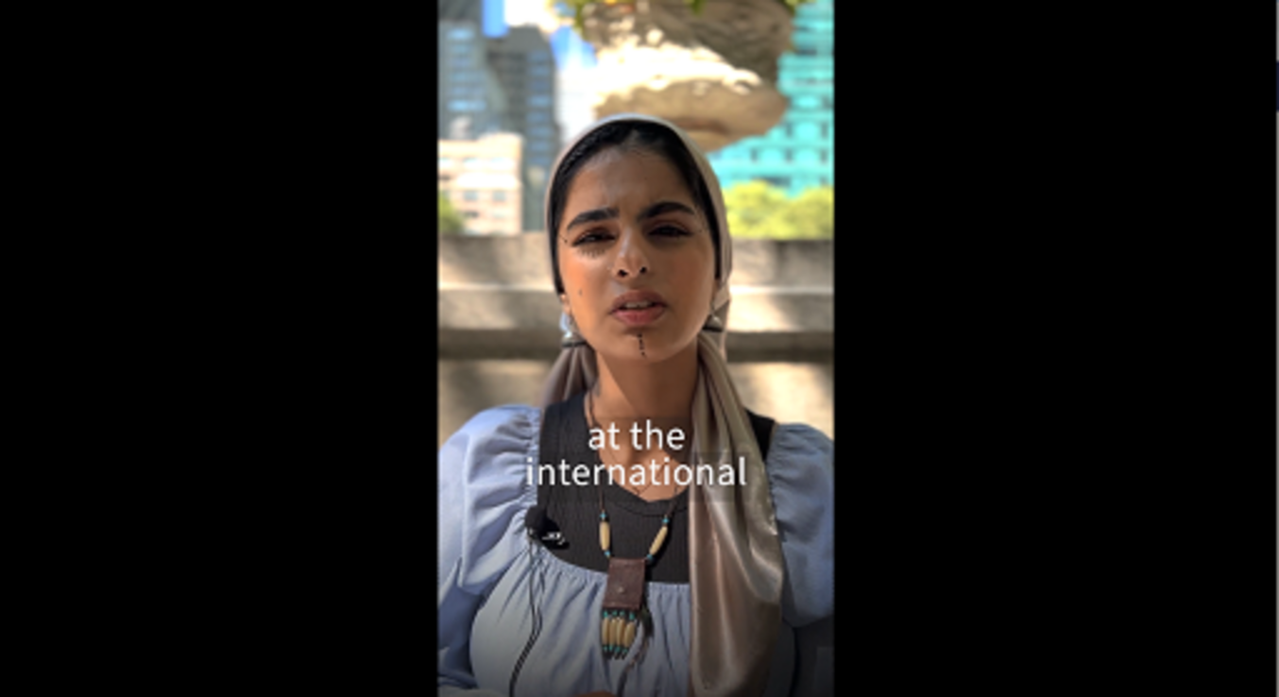

Pakistan was part of India when India was still a British colony (until 1947). The wealth of that vast and abundant country, appropriated by Britain, had fuelled the industrial revolution in the UK and made fortunes for the white colonisers (for example, find out about the history of the East India Company online). A similar story can be told throughout Asia and Africa and across the global south. These centuries-long colonial relations form the history of Pakistani people’s suffering with the exploitation of their natural resources, war and industrial pollution. Now they are the basis for their claims for reparations both more generally and in the form of loss and damage for climate-caused destruction.

Activity 7 The Earth has a memory?
Allow about 15 minutes

Here is Ayisha Siddiqa again harnessing her anger about this history to deliver a powerful poetic message to COP27 about climate justice and the desecration of nature.

Video content is not available in this format.
View transcript - Uncaptioned interactive content

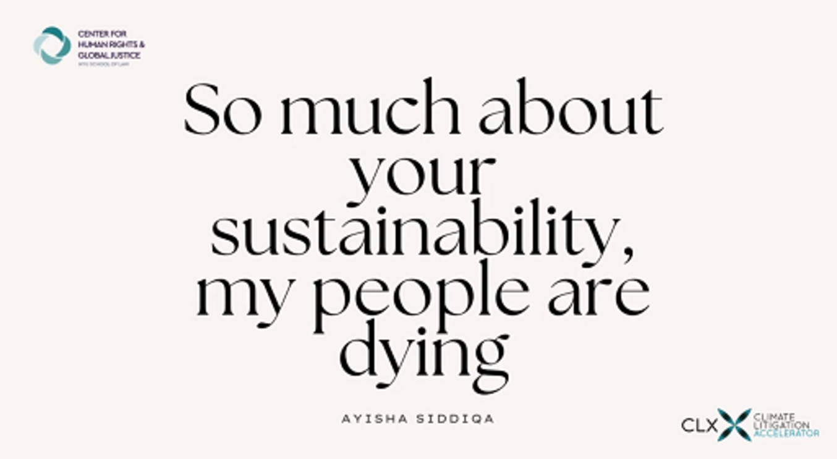

In this video, Ayisha Siddiqa offers us a different idea of nature and the Earth from the Modern, separated one. She says ‘… the Earth has a memory and all of her beloveds that she keeps tucked in her landscapes have birthed guardians, they are sitting among me’.
Reflect on the following questions:
- What would a Climate Psychology look like that could live in concert with the idea that the Earth has a memory?
- What relation to this Earth is she feeling when she says that the guardians ‘are sitting among me’? (Think back to the section on ecopsychology.)
- What is the core of the critical time in history that she wants the audience to tell the rest of the world?
- Did you feel that Ayisha Siddiqa was addressing you and if so, as what? And how did it make you feel?

Provide your answer...

6 Summary of Week 1
In this first week of the course, you have been introduced to the climate and ecological crisis through three time perspectives. You then learned about a psychological approach to explore how difficult it is to face this unprecedented threat. You looked at the history of Modern humans’ relation to the Earth through an ecopsychological and non-Western lens and contrasted this with the way that consumerism, the driving force of capitalism, has shaped Modern human behaviour. You were introduced to the tendency of politics and traditional psychology to ‘individualise’ and ‘responsibilise’ individual behaviour change when change needs urgently to happen at every level. Finally, you were introduced to a global and climate justice perspective with the example of a young Pakistani-heritage climate activist.
Next week you will begin by asking why people and society still seem not to be facing unprecedented risk of climate change.
You can now go to Week 2..

Week 2: Engaging with the climate and ecological crisis: indifference, distress and beyond

Introduction
This week you will begin by asking why people and society still seem not to be facing the unprecedented risk of climate change. You will explore the world of feelings that underpin thought through terms like eco-anxiety and eco-distress and find out about research into young people’s feelings. You will learn to distinguish these from approaches that would treat them as a weakness of individual psychology rather than recognising them as a healthy – if upsetting – response to the reality of the climate threat. You are offered the opportunity to use a scale to reflect on how distressed you are. The story of doomism is told, whose political origins in the misinformation activities of fossil fuel interests demonstrates the bigger social pressures that can woo us all into avoiding the difficult truths about climate and ecological destruction.
This week you will:
- learn about the psychological difficulties of facing the climate and ecological crisis
- be introduced to a depth psychology approach to Climate Psychology
- hear a personal perspective of living with climate change
- learn about eco-anxiety and climate distress as a healthy response
- learn about doomism.

1 Facing difficult truths

… our collective equanimity in the face of the unprecedented risk posed by climate change is perhaps the greatest mystery of our age.
(Hoggett, 2019, p. 3)

This was written in 2019 by Paul Hoggett in his introduction to one of the early texts Climate Psychology: On Indifference to Disaster. He goes on to say that Climate Psychology can throw some light on this mystery. He also explains how traditional psychological models – ones that assume humans are rational decision-makers based on evidence – are not complex enough to reflect real life situations. This assumption is also too individualised, which is to say that it doesn’t pay enough attention to the external conditions (past, present and even future) that influence our thoughts and actions. Traditional models therefore don’t get us very far in understanding why, faced with a mountain of evidence of climate and ecological destruction, the serious steps necessary to halt or even sufficiently mitigate climate and ecological collapse are not happening. There are numerous explanations for this evasion and inaction, which will be explored in further detail below.

Activity 1 Facing a difficult truth
Allow about 5 minutes

First, pause and reflect on how difficult that last assertion is to properly digest: faced with a mountain of evidence of climate and ecological destruction, the serious steps necessary to halt or even sufficiently mitigate climate and ecological collapse are not happening.
To ask you to reflect on this is to give you first-hand experience in the difficulties we all face in really knowing what that means – for us and for the world. We can read it – you just have, twice. But what happened in your thought processes? What feelings did they evoke? Asking about feeling is not a separate question from asking about your thought processes. Conventional models of psychology have treated thinking and feeling as if they are separate psychological activities. Perhaps you can locate where in your body you were experiencing the effects of that sentence (traditional models have separated mind and body too, yet it is all one inner world). Using this guidance, try the same process again.
Read the following and ask yourself the same question. This time the statement comes from a more prominent source, David Attenborough. Speaking at the security council of the United Nations in 2023, he called climate change ‘the biggest threat to security that modern humans have ever faced’. He said, ‘If we continue on our current path, we will face the collapse of everything that gives us our security, … food production, access to fresh water, habitable ambient temperature and ocean food chains’.
Use these questions as prompts to help you reflect on your response to the statement:
- What thoughts did you have?
- Did any images come to mind?
- What feelings did you experience. Can you name them or are they difficult to name?
- What sensations did you feel in your body?

Provide your answer...

2 A depth psychological perspective
Humans’ apparent inability to act on what climate science has been saying for over fifty years suggests we cannot rely on rational thought processes while ignoring feelings. Depth psychology teaches us that when thoughts are too painful or frightening or immense to think about, we fail to process them. In Paul Hoggett’s introduction to Climate Psychology: On Indifference to Disaster, he suggests we need to include the complexity and mystery of what it is to be human:

… the raw passions that often dominate our thoughts and behaviours; the internal conflicts and competing voices that characterize our internal lives and give colour to our different senses of self; the effect of powerful outside forces on the way in which we think and feel about ourselves.
Viewed from this perspective it is possible to see how attempts to defend ourselves against the feelings aroused by worsening climate change are mediated by deep-seated assumptions about ourselves and society. For example, a powerful sense of entitlement may help us to shrug off guilt and shame about our lifestyles, or a touching faith in progress can mitigate anxiety and induce complacency. Typically, we will feel torn between different impulses, to face and avoid reality, between guilt and cynicism, between what is convenient for us and what is necessary for the common good.
(Hoggett, 2019, p. 8)

How does that description tally with your own experience, of yourself and of those around you? Is it reassuring? Irritating? Perhaps confusing?
Hoggett goes on to mention some of the effects of these conflictual and uncomfortable feelings on how we respond to the threat of climate change:

Climate change and environmental destruction threatens us with powerful feelings – loss, guilt, anxiety, shame and despair – that are difficult to bear and mobilise defences such as denial and distortion which can undermine our capacity to get to grips with the issue. Climate Psychology seeks to understand how this plays out both in our individual lives and in society and culture.
(Hoggett, 2019, p. 8)

The psychological defences that are mobilised when faced with difficult truths (which you’ll learn more about in Week 3) can’t really be extricated from the feelings themselves. However, here, you can first find out more about the powerful feelings that we cannot afford to avoid.

Activity 2 Painful feelings about difficult truths
Allow about 10 minutes

Loss, guilt, anxiety, shame and despair. Do you recognise any or all of these five feelings from your own experience (they are quite likely to come as a bundle)? Would you like to add any more to the list? (Please do so. Clue: look for Figure 1 in Section 4 to find a different list.) What about sadness? Grief? Can you remember a situation when you felt a particular feeling, or a bundle of feelings? Write it down in a short paragraph.
If you can think of another occasion that triggered such feelings about climate and ecological destruction, write those down too. Climate Psychology explores these feelings further, based on the practical consideration that if humanity does not recognise them, how they are intertwined with our thoughts and how they influence our actions, we will be less able to get engaged in the climate and ecological crisis.

Provide your answer...

3 A human story of real-world feelings
Climate Psychology tries not to get stuck in rationalistic or individualised accounts, for the reasons explored previously. So it often prefers to use approaches that produce real-world stories, for example by interviewing people in many varied positions and letting them tell their stories, with context, in an unstructured way. A Climate Psychology conference in 2022 invited a young South African woman to talk about her experience of water shortages. Although the conference was being organised in the UK, it expanded its perspectives by inviting speakers and discussants from many continents and of different ages and cultures. Shelot Masithi spoke about what water meant to her as she was growing up, gradually experiencing shortage of drinking water and actual thirst from drought. After the conference, she wrote a piece for the Climate Psychology Alliance monthly Digest. You can find that longer version of her story on the CPA website.

When I was growing up, I had the privilege of playing in the mountains and rivers and waterfalls. In different villages, growing up, I witnessed nature in its glorious form.
One of these villages is where my great-grandmother and my grandmother lived. It had the most beautiful stream carrying water from the mountain to the village and farms, turning into one of the main rivers in my home region. That is where I learned to swim. It is so sad that when I go back to this village today, my heart breaks to see that river barely flowing. Five years ago, it dried up completely and although the rains helped it back a little, it's still barely flowing.
(Climate Psychology Alliance, 2022)

Activity 3 Water shortage
Allow about 5 minutes

Now listen to a clip from Shelot’s keynote speech and answer the questions that follow.

Video content is not available in this format.
View transcript - Uncaptioned interactive content



- What common assumptions did Shelot make about the water shortages and climate change?
- What was required for her to make the link between climate change and her reality?

Provide your answer...
View discussion - Activity 3 Water shortage

4 Eco-anxiety
You can probably see traces of what is called ‘eco-anxiety’ in Shelot Masithi’s story. It is increasingly common and the term has now even entered the popular media, but what does it mean? There have been various definitions given:
- ‘a chronic fear of environmental doom’ (Clayton et al. for the American Psychological Association press conference, 2017, p. 68)
- ‘dread associated with negative environmental information more generally’ (Clayton, 2020, p. 2)
- ‘heightened psychological (mental, emotional, somatic) distress in response to the climate emergency’ (Bednarek, 2019).
The Climate Psychology Alliance Handbook has definitions and discussions of key terms. Figure 1 shows a screenshot of the page on eco-anxiety.

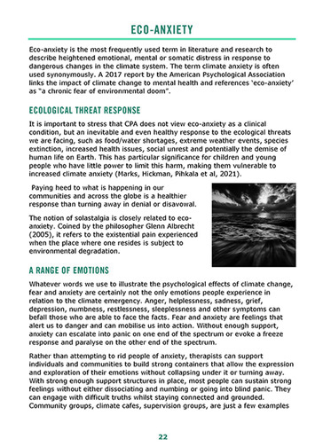
Figure 1 A definition of eco-anxiety.
View description - Figure 1 A definition of eco-anxiety.
View alternative description - Figure 1 A definition of eco-anxiety.

A piece of research across many continents that asked for young people’s responses about climate change found how widespread eco-anxiety is and how it is closely linked with people’s perceptions that people in power are not doing enough and are not trustworthy on the issue of climate and ecological threats. It is referenced above, on the page of the CPA handbook defining eco-anxiety. The same team, Elizabeth Marks, Caroline Hickman, Panu Pikhala and Elouise Mayall, then gave evidence to the UK government, drawing on their research and professional expertise. In their summary they said:

Concern about climate change and environmental issues is highly prevalent across the UK (and worldwide) and increasingly associated with a range of painful eco-emotions, functional impairment, disturbing thoughts and feeling betrayed by governments who are failing to act. (…) Although painful, these emotions are realistic responses to the realities of today’s world. Depending on how we work with emotions, they have the potential to be either significant catalysts for change, or barriers leading to disengagement, avoidance, or paralysis.
(Marks et al., 2022, p. 4)

You can find the full statement here: Submission to The House of Lords Environment and Climate Change. Committee inquiry into behaviour change in the context of climate change and the environment: A psycho-social perspective

4.1 Solastalgia
The term solastalgia is, as mentioned before, closely related to eco-anxiety. It comes from the Latin word ‘solacium’ (comfort) and the Greek word ‘algos’ (pain) and is used to indicate a specific type of distress caused by the climate crisis. Namely the pain that people experience when beloved aspects of their environment are damaged by the changing climate, for example the loss or suffering of animal or plant species, a home destroyed by fire, wind or water, the felling or die-back of local trees. Shelot Masithi’s references to the mountains, waterfalls, streams and rivers of her childhood are an example of solastalgia. The term applies to pain from losses that have already occurred, and also from losses that people fear will happen in the future. The first feeds into the second. One strength of this term is that, through its emphasis on grief from real losses, solastalgia clarifies that eco-anxiety and related distress are closely linked to real-world happenings.

Activity 4 A range of emotions
Allow about 10 minutes

If you haven’t already, read the summary of the House of Lords submission and the CPA’s information on eco-anxiety.

Concern about climate change and environmental issues is highly prevalent across the UK (and worldwide) and increasingly associated with a range of painful eco-emotions, functional impairment, disturbing thoughts and feeling betrayed by governments who are failing to act. (…) Although painful, these emotions are realistic responses to the realities of today’s world. Depending on how we work with emotions, they have the potential to be either significant catalysts for change, or barriers leading to disengagement, avoidance, or paralysis.
(Marks et al., 2022, p. 4)

Make a list of all the different feelings and emotions that could be associated with the climate crisis. Do you think eco-anxiety is useful term? What are your preferred terms to describe anxious feelings about climate and ecological destruction?

View description - Uncaptioned Figure
View alternative description - Uncaptioned Figure

5 Climate distress as a healthy response to reality
There is growing and widespread agreement that eco-distress is a healthy response to the reality of the climate crisis as expressed in the statement to the House of Lords: ‘Although painful, these emotions are realistic responses to the realities of today’s world’. Within the wider politics of climate change, the point that eco-anxiety is not a clinical condition is important to make because psychology – notably Clinical Psychology with its links to Psychiatry – has a tendency to label conditions as pathologies of individuals without recognition of the wider social reality: ‘you are worried about climate change, there must be something wrong with you, let’s help make you feel less distressed by prescribing this medication’. While antidepressants, for example, may dull the feelings, they disconnect the person experiencing them from the real source of their worries – the fact that not enough is being done to avert a climate and ecological catastrophe.
This vignette, somewhat oversimplified, nonetheless points to some embedded psychological assumptions: life problems are typically seen by Psychology as a malfunction of the individual that should be treated. Professional psychologists are trained to evaluate the symptoms and provide a corresponding diagnosis (e.g., anxiety, depression, post-traumatic stress disorder). Diagnoses are guided by classifications and typologies that psychologists have constructed and developed over many decades, guided by psychologists’ cultural and social values. (They are contained in a huge American tome called the Diagnostic and Statistical Manual, or DSM, which is a core reference book for Psychiatry and Clinical Psychology.) For example, homosexuality used to be perceived as a psychological disease until relatively recently when it was removed from these classification systems. This is because societal values changed, and not because Psychology discovered new knowledge about human nature that went against its previous findings.
Psychiatry is a branch of medicine and Psychology tends to medicalise psychological issues. In the way that medicine can identify problems in people’s bodies and prescribe particular medication to fix them, psychology has taken a similar approach to psychological issues – they could be treated with medicine and individual therapy. However, as we have seen, psychological problems are more complex, the consequence not only of their current situations but of problematic experiences that may reach back into previous generations and have shaped a person’s development.
Based on her clinical practice, psychotherapist Caroline Hickman has tried to categorise eco-anxiety by developing a simple scale (Hickman, 2020). However, she cautions about using it too rigidly or in an overly clinical medicalised way. This is a shortened version of her scale.

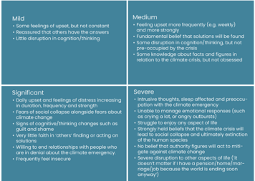

Mild
- Some feelings of upset, but not constant
- Reassured that others have the answers
- Little disruption in cognition/thinking
Medium
- Feeling upset more frequently (e.g. weekly) and more strongly
- Fundamental belief that solutions will be found
- Some disruption in cognition/thinking, but not pre-occupied by the crisis
- Some knowledge about facts and figures in relation to the climate crisis, but not obsessed
Significant
- Daily upset and feelings of distress increasing in duration, frequency and strength
- Fears of social collapse alongside fears about climate change
- Signs of cognitive/thinking changes such as guilt and shame
- Very little faith in ‘others’ finding or acting on solutions
- Willing to end relationships with people who are in denial about the climate emergency
- Frequently feel insecure
Severe
- Intrusive thoughts, sleep affected and preoccupation with the climate emergency
- Unable to manage emotional responses (such as crying a lot, or angry outbursts)
- Struggle to enjoy any aspect of life
- Strongly held beliefs that the climate crisis will lead to social collapse and ultimately extinction of the human species
- No belief that authority figures will act to mitigate against climate change
- Severe disruption to other aspects of life (‘it doesn’t matter if I have a pension/home/marriage/job because the world is ending soon anyway’)

Activity 5 How distressed are you?

After reading through Hickman’s scale descriptions above, consider the following questions:
- Can you locate yourself on the scale?
- Has your position on the scale changed or does it oscillate?
- Does your position on the scale depend on other factors?
- Do you think it is helpful to think of eco-distress as being on a scale?
- How helpful did you find the above categories in recognising your own relation to eco-anxiety?

Provide your answer...
View discussion - Activity 5 How distressed are you?

6 Doomism
Michael Mann, Professor of Atmospheric sciences at Penn State University in the USA, is a world-renowned climate scientist with a high media profile as a result of his preparedness to be a climate advocate. In 2019, as the denial of climate change was increasingly exposed, he came under personal attack for his so-called ‘doomism’. Doomism in this context does not just refer to those who are predicting that the world is doomed as a result of the climate threat; it is more specific. In this case, Michael Mann was accused of taking the view that it was too late to turn around runaway climate change and that therefore action was pointless. This was not Michael Mann’s position, rather that construction of his position was an attempt to discredit him. He was saying that action was urgent and that the world had ten years (and this was 2019) to make the necessary reductions in carbon emissions to avert the worst climate impacts.
It is an example of the way climate science is politicised. It was clear to Mann that the attacks were coming from fossil fuel lobbying groups. Since then, with climate change now indisputable, he points out that fossil fuel interests have changed their tactics (Mann, 2021).
Michael Mann rejected doomism as much as he criticised denialism. The accusation against him that set up one against the other is an example of how political culture and media trades in ‘either/or’ thinking (as if you can’t be critical of both doomism and denialism) in order to incite extreme views. This is relevant for Climate Psychology, which is trying to hold on to the reality while that is being distorted by such false binaries. It is pointing out that difficult truths are hard to face. In addition to binary positions operating at the level of individual minds, here we see the same principle operating at the level of political culture and involving huge organisational global groupings like climate science and fossil fuel corporate interests.

7 Summary of Week 2
This week began by asking how come so little is happening to mitigate runaway climate changes and ended with an example of fossil fuel interests’ attempts to brand realistic, evidence-based thinking about climate change as ‘doomism’. This acts as a reminder of the wider societal pressures encouraging us not to face difficult truths. Nonetheless, the feelings based on recognising the dangerous reality come through and we have explored these under the headings of eco-anxiety, eco-distress and similar terms.
In Week 3, you will focus on how these difficult feelings can be defended against as well as confronted and what supports help us to face reality.
You can now go to Week 3..

Week 3: Engaging with the climate and ecological crisis: denialism and other challenges

Introduction
This week will focus on the many manifestations of climate denial, individual and social, and the way these interact. Climate Psychology explains the splitting of thoughts and feelings in the way that climate disavowal can work. You will see how these are mirrored at the level of wider society. You will also look into social interactions, greenwashing and the role of technology in encouraging us to act as if nothing catastrophic will happen; that action is sufficient, that technology can solve everything. A central theme in the discussion is to question the way responsibility to change behaviour is put on individual consumers. The idea of climate change as a ‘hyperobject’ is introduced as an approach that does not draw on depth psychology to explain the difficulty of getting to grips with climate change.
This week you will:
- understand why there has not been a concerted attempt to tackle greenhouse gas emissions
- learn about the concept of unconscious defences such as denial and their use by fossil fuel interests
- revisit the idea of individual responsibility
- learn about the practice of greenwashing
- find out how technological solutions play into our defences
- learn about the idea of climate change as a hyperobject.

1 Business as usual?
Climate Psychology Alliance’s (CPA) strap line is ‘facing difficult truths’ and this reflected the situation in the first years of the twenty-first century when there seemed to be a massive failure to face the difficult truth of climate change. Al Gore, previously US vice president, made a renowned and influential film in 2006, called An Inconvenient Truth. CPA’s emphasis has been on the importance of understanding how and why it was that there was not an attempt, at every level, to reverse greenhouse gas emissions.
Bruno Latour, a prominent French intellectual, has argued that ‘we can understand nothing about the politics of the last fifty years if we do not put the question of climate change and its denial front and center’ (Latour, 2018, p. 2). The denial of climate change has operated at many simultaneous levels, all mutually influencing each other. We call this psycho-social: psychological and social interacting (here the ‘social’ includes the political, economic, technological, corporate and cultural). This is a key reason why Climate Psychology goes well beyond documenting the psychological defence mechanisms that work to achieve denial at the individual level.
We can start with the recognition, central to a dynamic depth psychology, that when a thought or an experience is too painful or difficult to bear, it is likely to be met with a protective defence mechanism which involves getting rid of it. This enables us to carry on as if the thought wasn’t there; carrying on with business as usual. It is then necessary to expand our understanding to the social dynamics. Large, global culture has been carrying on pretty much as usual, despite knowing about climate change, for the last fifty or more years.
According to Bruno Latour, the agreement about the climate that was reached in Paris in December 2015 (COP21) was hugely important, but not for the reasons usually recognised:

What counts as a measure of the event’s real impact is not what the delegates decided; it is not even whether or not the agreement is carried out (the climate change deniers will do their utmost to eviscerate it); no, the crucial fact is that, on that December day all the signatory countries, even as they were applauding the success of the improbable agreement, realized with alarm that, if they all went ahead according to the terms of their respective modernization plans, there would be no planet compatible with their hopes for development. They would need several planets; they have only one.
(Latour, 2018, p. 5)

The record since 2015 suggests that, one way or another, governments and organisations at every level have continued to carry on as if COP21 need not interrupt business as usual.

2 Types of denial
‘Every denial is based upon fear of truth’, so begins Paul Hoggett in Climate Psychology: A Matter of Life and Death (Hoggett, 2022, p. 18). He goes on to point out that with the contemporary flood of mass and social media, we can no longer avoid knowing about worsening climate change. The basic defence mechanism might then kick in: we can split off thoughts about climate change from feelings. ‘This results in a special kind of “knowing”; one drained of meaning, so that what we are left with is a set of lifeless thoughts about climate change which fail to trouble us’ (p. 18). It is called disavowal, sometimes ‘soft denial’. The term soft denial is used more generally in political discussion of climate denial, whereas ‘disavowal’ comes from psychoanalysis, where it is used to explore the psychological mechanisms involved. How can we know and not know something at the same time? Again, to explain this requires a depth psychology, because the idea of a rational knower/actor without inner conflict cannot account for this phenomenon. Splitting off refers to the psychological mechanism that enables disavowal.

Activity 1 Splitting off
Allow about 10 minutes

Part 1

Paul Hoggett offers the following example. When you have read this, think about a situation where you acted in a similar split-off fashion. Note, we all have to do this from time to time, just to get by in a world that inevitably compromises attempts to live zero carbon lives.

The interviewee recalled sitting at Heathrow airport about to catch a flight somewhere, when his wife remarked that ‘a 747 taking off generates more damage to the environment than a family car driven for a year’. He commented ‘and I remember noting the fact with interest, although not at any point changing my view about where we should go on 747s’.
(Hoggett, 2022, p. 18)

Note down your example in the box below.

Provide your answer...

Part 2

In the pages following this example, Paul Hoggett goes on to document many different shades and mechanisms of denial, all based on avoiding thinking truthfully:
- diffusion of responsibility (e.g. ‘others that produce more pollution than me are the problem’)
- suspension of curiosity (e.g. not wanting to find out the relevant information about climate change)
- splitting/compartmentalisation, one of the mechanisms to achieve the example above (e.g. climate change will affect ‘them’ not ‘us’)
- wishful thinking (e.g. scientists/technology/God will solve it)
- doubt (e.g. ‘we need more research and evidence’)
- knowing is not believing (e.g. ‘surely it can’t be that bad’)
- distancing/detachment (e.g. ‘I can’t do anything about it’, ‘it’s not an immediate threat, we still have lots of time’, or taking an intellectual problem-solving approach)
- routinisation (e.g. immersing oneself in routine day-to-day tasks or avoiding thinking too far into the future)
It is not hard to see how the demands of everyday life preoccupy most people to such an extent that thinking about climate change becomes fleeting.
Which, if any, of these mechanisms of denial can you apply to your example from Part 1?

Provide your answer...

Paul Hoggett points out that ‘the life of the mind and the life of society bear an uncanny resemblance … all of us have learnt how not to think too much, how to make peace with unacceptable situations’ (Hoggett, 2022, p. 17). What we notice, pay attention to and speak about in different contexts is socially constructed through rules. We learn how to behave tactfully and politely in our communities. In his book, The Elephant in the Room, Eviatar Zerubavel illustrates the way in which certain subjects are avoided or even considered taboo. These internalised social rules provide us with social defences against anxiety – they make it easier for us to ignore certain topics in order to avoid feeling pain, fear or shame (Zerubavel, 2006).

Activity 2 Talking about climate change
Allow about 5 minutes

Can you think of social situations where you brought up the topic of climate change? How did others respond? Was there a meaningful conversation or were you met with an uncomfortable reaction?

Provide your answer...

In the previous sections you learned about how ordinary people might attempt to avoid thinking about the painful truth of climate change as a means of protecting themselves. However, there is also another, more insidious type of denialism which will be explored next. It refers to strategic attempts by particular social actors to promote climate change denialism in order to protect their vested financial interests.

3 Organised climate change denial: a brief history and its main strategies
The fossil fuel industry has been aware about the warming and damaging effects of increasing carbon dioxide emissions for the Earth’s climate since the 1950s. For example, internal documents and models by ExxonMobil’s own scientists projected human-led global warming with dramatic effects by the year 2050, similar to data by governments and other scientific groups. However, the company’s public communication strategy was to promote doubt and uncertainty (Supran et al., 2023).
The main fear of both government and industry was that measures to prevent climate change would place limits on the free market and economic regulations would harm the fossil fuel industries (Jacques, 2006). This led them to create what has been termed the ‘denial machine’ – an organised attempt to limit public support for policies related to preventing climate change by sowing the seeds of doubt, uncertainty and eventually, denialism (Begley, 2007). Key parties involved in organised climate change denialism are the fossil fuel industries, resource corporations (e.g. mining, forestry), foundations, thinktanks, politicians, and media that mainly belong on the right-wing political spectrum (Dunlap and McCright, 2011).

3.1 What are the main strategies used by organised climate change deniers?
Various strategies and arguments are used to persuade the public either that climate change is not happening, or that it is not serious enough to warrant immediate action (McCright and Dunlap, 2010; Oreskes and Conway, 2010). One such example is the use of fake experts or contrarian scientists. Fake experts appear to be authoritative based on supposed expertise, when in reality they might have none. Contrarian scientists are real scientists who use their credentials to challenge the scientific consensus – in reality, they might have vested interests that make them promote certain positions (e.g., financial interests). Fake experts and contrarian scientists can provide relief to anxiety caused by the knowledge of climate change, ensuring people don’t engage deeply with that knowledge.
Denialists create a distorted version of the scientific consensus on climate change, by ignoring the wealth of evidence that points to the problem’s existence and instead focusing on isolated, often flawed studies, presenting them as opposite yet equally valid to the scientific consensus. This is called selectivity or ‘cherry-picking’ and can create the impression that climate change-denialist positions are backed by scientific evidence. Denialists also sometimes set impossible expectations on what types of scientific evidence count. For example, they often demand data that go back millions of years, which scientists might not be able to provide.
Even when data are provided, denialists can change criteria and demand alternative evidence (also called ‘moving the goalposts’). This is an attempt to discredit science in the eyes of the public, remove the sense of urgency and facilitate disavowal. Finally, another common strategy is the deployment of conspiracy theories. Many climate change-related conspiracy theories posit that climate change is a global conspiracy orchestrated by governments and scientists around the world in order to control people and limit independent thinking. Although such assertions do not reflect reality (it would be impossible for thousands of scientists across thousands of institutions and different disciplines to conspire and promote falsehoods), the idea that ‘climate change is a hoax’ can relieve people of stress related to climate change.
Overall, organised climate change denialism is effective because it can provide a certain part of the public with the tools through which they can operate self-deception and do not have to worry about climate change. The next section will move away from strategic climate denialism in order to discuss some problematic elements in how (especially Western) societies try to deal with climate change. These include an overemphasis on individual responsibility for behavior change (as you saw in Week 2) and on consumers making ‘green’ choices, as well as an undue trust in technology.

4 Individual responsibility
As previously discussed, ordinary people can operate disavowal because there are those – in positions of power – in whose interests it is to share material of self-deception, even while knowing that they are spreading lies. In his book The New Climate War (2021), Michael Mann makes a distinction between those parts of the media that have knowingly promoted climate change denial (he cites the Rupert Murdoch empire for example) and those well-intentioned media outlets who unwittingly reproduce the dominant framing of the culture, for example, focusing on the responsibility of individuals for changing their consumer behaviour.
The fossil fuel lobbies’ change of tactic, Michael Mann notes, has heightened the emphasis on individual behaviour change. They have funded and conducted a marketing campaign with this orientation to deflect the blame away from fossil fuel companies. This is a kind of denial because they know full well that changes at the level of individual consumption (however useful and necessary) will not achieve the massive reductions in climate emissions without deep systemic change. For that, governments must refuse the influence of fossil fuel interests.

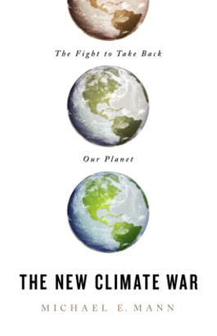
Figure 1 Michael Mann’s The New Climate War.
View description - Figure 1 Michael Mann’s The New Climate War.
View alternative description - Figure 1 Michael Mann’s The New Climate War.

The tactic of ‘individual responsibilisation’ – putting blame and responsibility on the shoulders of individual consumers – works particularly well. It does so for at least two reasons. First is that consumer habits will have to change, so it is not a wholly unrealistic ask. But the psycho-social point is for consumers to be offered different choices as a result of change happening at corporate and policy levels – be this in food consumption, travel, fashion or family size. For example, trains could be made cheaper than planes for many journeys; many foods, if handled differently, need not come in plastic packaging; products destructive to the ecosystem (neonicotinoids, PFAS) could be banned.
The second reason is that the culture of modern society is already so individualised that it seems like the natural thing to require individuals to change (Margaret Thatcher, British prime minister in the 1970s, was notorious for claiming that there was ‘no such thing as society’). As individuals shaped by this culture, we are more liable to take on the associated guilt of not doing enough to go green while often not considering that the primary responsibility lies at higher levels.

5 Greenwashing
Greenwashing is a phenomenon closely associated with the extreme focus on individual responsibility for tackling climate change. Companies have capitalised on the necessity to reduce greenhouse emissions and prevent climate collapse in an attempt to maximise their goals. They do this through marketing their products as environmentally friendly or not environmentally harmful. Combined with the emphasis on individual responsibility, greenwashing can encourage people to believe that they are having a stronger positive environmental effect on the planet as customers than they might do in reality. This is an example of cultural disavowal – seducing us into a belief that our individual purchasing choices are the answer to the climate crisis. At the same time, larger scale policies that could place limits on how different companies, industries and governments operate are not put into practice. Companies can still benefit from large profits while the Earth’s resources are still being depleted, natural habitats are destroyed, and the global south continues to suffer from the consumerism of the global north.
Watch the following humorous short video (from Make My Money Matter) that makes fun of greenwashing.

Video content is not available in this format.
View transcript - Uncaptioned interactive content



Often, the choice of which product or service to buy is more complex than its advertising would lead us to believe. If we take the example of buying an electric car rather than a petrol one, we need to consider the impact of that choice over the whole lifetime of the car in order to fully understand the environmental impact. Production, maintenance and charging of electric car batteries still results in high CO₂ emissions, particularly in countries where a large proportion of electricity is generated from the burning of fossil fuels. We also need to consider more than just CO₂ emissions. Producing batteries requires the mining of lithium, cobalt and manganese. These processes require huge amounts of water and result in toxic waste contaminating water systems. The burden of this is felt by areas in the global south such as Democratic Republic of the Congo where mines are hazardous to health and safety, and child labour is often used.
Car manufacturers that spend millions on advertising do not give us these facts. Instead, they use images and messages to convey a simple choice – buy an electric car and do your bit for the environment. This is not to say that we should not switch to electric vehicles, but we should be aware of relevant facts. It would be better if governments invested in public transport infrastructure and our social and economic systems were adapted such that we needed fewer cars. This would not suit the interests of the car manufacturers however. It is very difficult to be an ethical consumer because we have been shaped and are enmeshed in our Modern consumerist culture.

Activity 5 Greenwashing
Allow about 10 minutes

Watch the following video clip from London Live regarding greenwashing.
Greenwashing and how to spot it
Find a product in your home that you have purchased recently because you believed it was a green product. What made you buy that particular product? Have a look at the packaging and labelling. Are there any signs of greenwashing? If you were influenced by the product’s advertising, how did this seem to be achieved?

Provide your answer...
View discussion - Activity 5 Greenwashing

6 Technology
How technology is framed within our culture is another problematic aspect of how modern societies deal with climate change. The idea that technology is humankind’s crowning achievement is central to modernity; that it is what distinguishes us from other animals, that nothing is too difficult for technology to solve – including climate change. This has led to fractious debates as to whether it is wise or plausible to rely on still untested technologies such as carbon capture. Because technology is etched deeply into modern life, there is an infinite number of ways technology can help us. The problem is where it is grasped as a solution in such a way that it disavows the actual threat. For example, in a 2023 policy paper discussed in The Guardian (Harvey and Ambrose, 2023), the British government – challenged on the poor progress towards its net zero promises – relied heavily on carbon capture technologies that scientists said were unrealisable in the timescale required.
It is hard to unpick the truth from warring claims about what actions will suffice to avert climate disaster. The psychology involved helps us to understand how defence mechanisms, such as wishful thinking, doubt or distancing, can serve to steer us away from facing difficult truths. This could be an example of wishful thinking (from the earlier list of defences), perhaps also having the soothing effect of distancing or detachment. Facing difficult truths requires some psychological bravery to face the anguish of knowing what is happening to our awesome planet. From the above, we can also see that it requires scepticism, involving a dose of mistrust of corporate messaging, and the time to pay attention to everyday actions.

7 A problem too difficult to conceive: climate change as a ‘hyperobject’
Climate Psychology has put the understanding of defences in a central position. However, there is a further understanding of why it is difficult to grasp the reality of climate change. Timothy Morton, a philosopher and Professor of English, discusses climate change through a different lens, that of a ‘hyperobject’. This idea emphasises the impossible-to-grasp nature of climate change. Hyperobjects are massively extended in time and space, which makes them historically beyond the range of human cognition. Morton says that hyperobjects ‘massively outscale us’ (2013, p. 12). Yet, paradoxically, the idea of global warming as a whole cannot be accessed at a cognitive distance, rather it is ‘right here in my social and experiential space’ (Morton, 2013, p. 27). It sticks to everything – the plastic food wrapping, the car journeys, heating the house, a hot day, using the microwave, the smell of bacon, waste disposal. The hyperobject is not what is immediately in front of us because its local direct manifestations are not the hyperobject itself (for example, it is raining heavily – again – but this is not climate change that I feel directly).

Activity 6 Where does climate change pop up in your everyday activities?
Allow about 5 minutes

Morton gives examples such as heating the house, a person’s relation to plastic food wrapping, and turning on the ignition of a petrol-run car. Everything we do in our everyday lives is touched by climate change.
Make a short list of the everyday activities that prompt you to consider climate change in its whole manifestation (as a ‘hyperobject’).

Provide your answer...

8 Summary of Week 3
This week, you took a psycho-social perspective on denial in its many manifestations. This meant looking beyond individual defence mechanisms that work through splitting off to recognise the many pressures there are on us to not think realistically about the climate and ecological crisis. These range from social pressures to organised climate denial. Also discussed was the way that corporate interests use tactics of individual responsibilisation, greenwashing, and the idealisation of the power of technology to solve all problems. The week ended with the idea of the hyperobject, to help appreciate just how psychologically elusive the idea of climate and ecological crisis really is.
In the face of all these pressures, and what can feel like unrelenting bad news, next week will focus on how we can manage to live with the climate and ecological crisis and what psycho-social resources can help the realistic distress that people feel.
You can now go to Week 4.

Week 4: Living with the climate and ecological crisis

Introduction
In this final week you will learn about some ways in which we can engage and live with the reality of the climate and ecological crisis. You will be invited to develop an action plan that reflects your own personal situation, resources and goals.
This week you will:
- learn about the importance of emotional engagement with the climate and ecological crisis
- learn about the value of taking action
- become aware of the risk of burnout for activists
- find out what might be involved in self-care
- develop your own personal action plan for living with the climate and ecological crisis.
Figure 1 is a simplified model suggesting that in order to live with the reality of the climate crisis, three broad elements need to be present and in balance. Too much emotional engagement can lead to overwhelming eco-distress; too much action can lead to burnout, and although we cannot overdo self-care, if we disengage, this could tip into unhelpful disavowal.
You will look at each of these elements in turn.

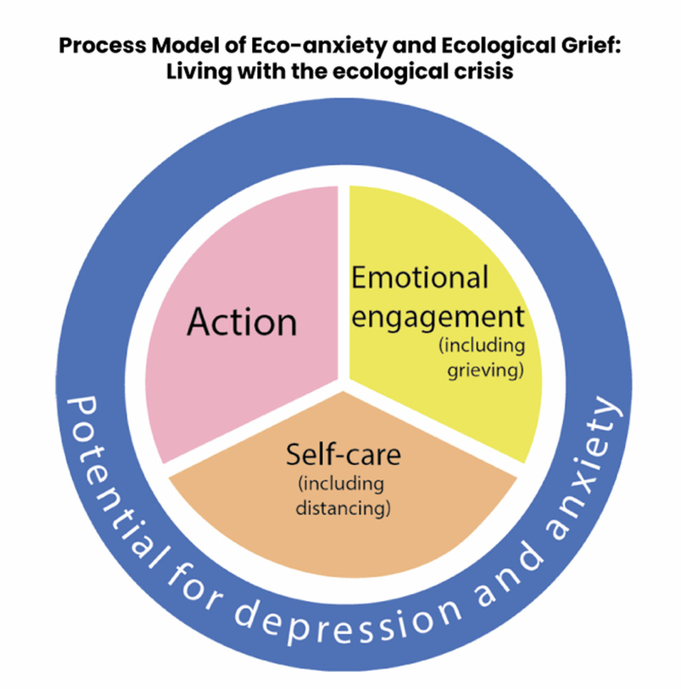
Figure 1 Three elements of living with the Climate and Ecological Crisis.
View description - Figure 1 Three elements of living with the Climate and Ecological Crisis.
View alternative description - Figure 1 Three elements of living with the Climate and Ecological Crisis.

1 Emotional engagement
As you learned in Week 2 there are a variety of emotional responses to the climate and ecological crisis. You may experience anxiety, depression, anger, guilt or a numbing of emotional response. Part of living with the crisis will involve acknowledging and engaging with these emotions and processing them in such a way that they are not overwhelming but, at the same time, enable you to act in ways which are part of mitigating the crisis.
One useful concept that helps us to manage potentially overwhelming emotions is to think about our individual window of tolerance (Siegel, 1999).

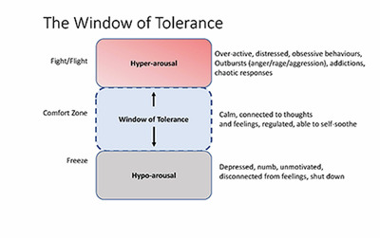
Figure 2 The window of tolerance.
View description - Figure 2 The window of tolerance.
View alternative description - Figure 2 The window of tolerance.

The idea is that we each have a window of tolerance when it comes to distress. This is the amount of stress that we can tolerate and still stay present and connected to our thoughts and feelings. We all have a threshold. When we experience more stress than we can tolerate, we go to the edges of our window. On the one hand, this can mean we become hyper-aroused, commonly known as the fight/flight response. This can present as anxiety or anger, we can become impulsive or drawn into obsessive, even addictive behaviours like drinking too much alcohol, compulsive shopping or over-working.
On the other hand, we may become hypo-aroused with the so-called freeze response. We can feel numb, disconnected, depressed and flat.
Each time we are exposed to new reports or documentaries about the climate crisis, when we think about the impact of what is happening, we can feel shock. As the reality dawns on us, it can push us out of our window of tolerance. We may lose the ability to stay present and resilient and engaged with the situation.
In order to stay within our window of tolerance we need to notice what’s happening within ourselves. Are we feeling anxious or irritable? Or are we feeling flat or even numb? We can then do things which are calming and soothing to bring us back within our window of tolerance.

Activity 1 Soothing and calming
Allow about 5 minutes

Make a list of the kinds of things that you find soothing and calming when you are distressed (hyper-aroused). What activities help to enliven you if you feel flat or disconnected (hypo-aroused)? What support do you need?

Provide your answer...

Another model which can be helpful comes from grief theory. Worden (2015) suggests that processing grief associated with loss involves working through psychological ‘tasks’ which we can either face into or avoid. These tasks are:
- Accepting the loss
- Working through the painful emotions
- Adjusting to the new reality
- Reinvesting emotional energy
These tasks are not linear or ever really completed. They are always there and we find ourselves returning to them repeatedly.

Activity 2 Tasks of grief
Allow about 5 minutes

Watch the video of psychotherapist Rosemary Randall discussing Worden’s grief model in relation to the climate and ecological crisis.

Video content is not available in this format.
View transcript - Uncaptioned interactive content

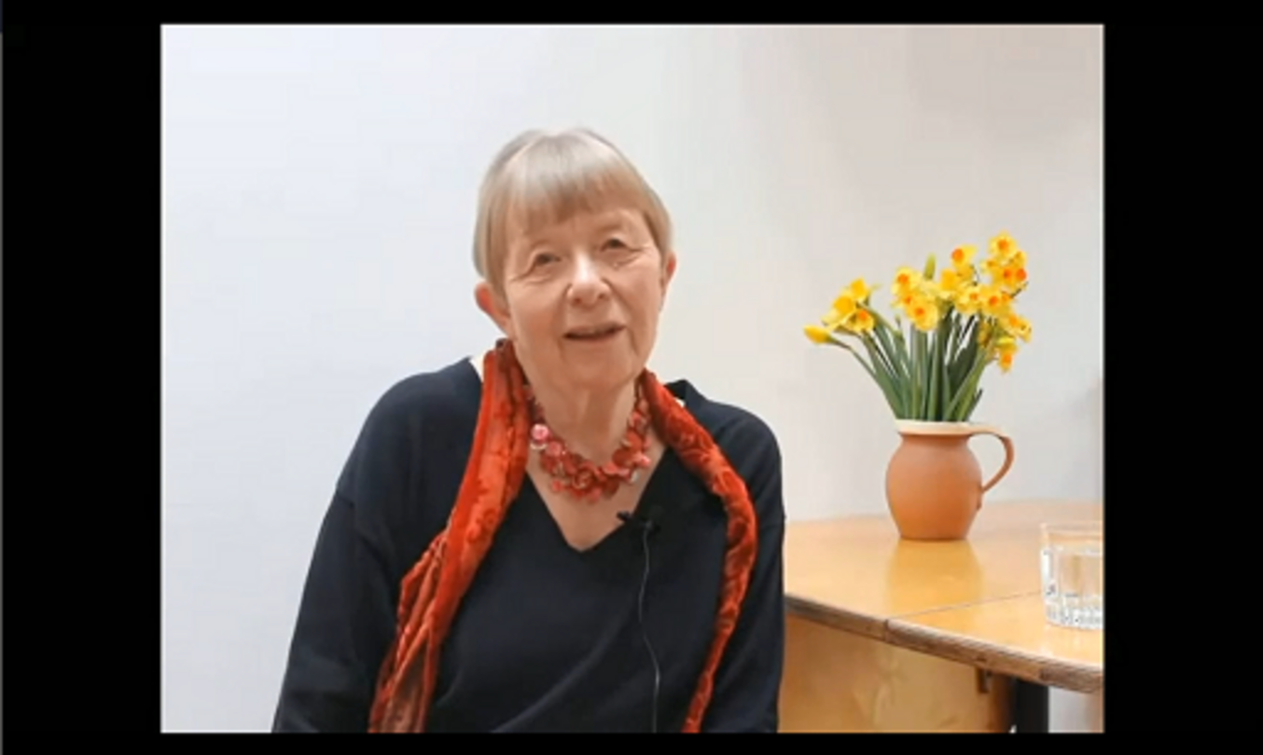

- Do you recognise these tasks in your own attempts at thinking realistically about the crisis?
- Which tasks have you found most difficult?
- What would you find helpful when approaching these tasks?

Provide your answer...
View discussion - Activity 2 Tasks of grief

2 Taking action
In Worden’s model taking action is part of tasks 3 and 4 – re-adjusting to the reality and re-investing emotional energy. You will need to ask yourself, what does it mean now that I know this? This readjustment happens over an extended period, and may require several different types of adjustment; internal, external, spiritual, practical and emotional. We may make changes to our behaviours, friendship groups and so on. This can present us with a conflict. We may feel scared of change. We may not want to change. There is often a struggle to let go of the old to allow the new.
Worry and anxiety about the climate and ecological emergency has been identified as a positive motivation for engaging in activism (Ojala et al., 2021) and – reciprocally – activism has been suggested as a way to cope with feelings of eco-distress as well as adapting and adjusting to a new way of living (Clayton, 2020; Lawrance et al., 2022). Studies in various parts of the world have shown that taking some kind of action to mitigate the climate crisis can help with feelings of eco-distress.
Many of these studies have focussed on children and young people because eco-distress is particularly common in this group (Hickman et al. 2021).
This quote from a young climate activist sums up how activism has helped her:

I’m involved in activism because it gives you a real sense of power, it feels like you are actually doing something that will help. It’s so easy to feel powerless and overwhelmed by the many problems the world is facing and activism is a kind of a relief for that.
(in Godden et al., 2021)

This sense of relief in taking action is an important factor in managing eco-anxiety. Taking action can help us to adapt to living with the climate crisis, to adjust to a new world reality, and in so doing improve our sense of wellbeing. Taking action is a form of problem solving and helps with feelings of powerlessness by connecting us to our agency. In turn, this can lead to a sense of purpose or meaning, improving life satisfaction (Ojala, 2012) and increasing hopefulness (Macy and Johnstone, 2012). These positive emotions can help us to bear the distress we may feel when we think about the climate crisis. Social support and relationships gained through engaging in activism can build emotional resilience and can be a protective factor against low wellbeing (Ojala et al., 2021).
It is important that we do not confuse ‘taking action’ with ‘activism’ though. Taking action need not necessarily mean joining activist movements such as Extinction Rebellion or becoming involved in large-scale protests.
It has been shown that engaging in individual pro-environmental behaviours, such as cycling rather than driving or buying fewer clothes, can benefit mental wellbeing while at the same time benefitting the environment (Lawrance et al., 2022). Although small actions matter, we know that on their own they will not solve the problem. Corporations and governments have more power to make the big changes necessary to limit the climate and ecological crisis. For this reason, it has been argued that citizen activism is the most effective way of bringing about change through pressure on governments and organisations (Ockwell et al., 2009).
Think about the big social changes in history, such as how women got the right to vote, gay marriage became legal and South African apartheid ended. It was ordinary people who decided the world had to be different and they used their voices through citizen activism to press for change. However, the slogan ‘the personal is political’ points towards an expanded idea of what citizen action involves. Fighting inaction on the climate and ecological crisis and social injustices requires the individual to take responsibility for their own behaviour. As you learned in Week 1, it is not either/or individual or social change that needs to happen, but that both are necessary and that there are continuous interactions between them.

Activity 3 Activism and protests
Allow about 5 minutes

Watch the video clip of an Extinction Rebellion protestor and answer the question below.

Video content is not available in this format.
View transcript - Uncaptioned interactive content

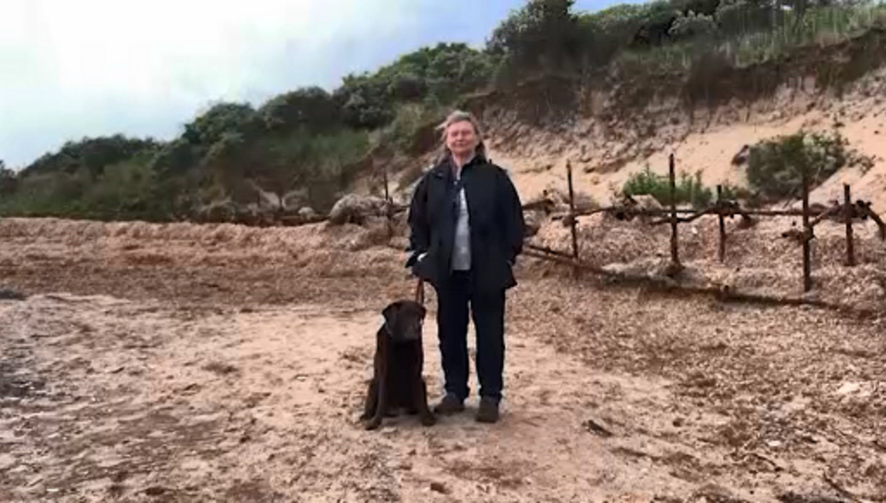

There are many positive reasons to become engaged in action of some kind, but what potential difficulties might arise for people who become engaged with more overt activism and protests about the climate crisis?

Provide your answer...

There are words of caution about seeing action merely as a cure for eco-distress (Hickman, 2020). By seeing activism as a means of alleviating distress it reinforces the notion of eco-distress as a pathology to be cured – remember the discussion about this in Week 2. It also risks disillusionment and disappointment if the action lacks positive outcomes, and may worsen mental wellbeing for people who are severely distressed (Clayton, 2020).
Those who are severely distressed by climate anxiety and cannot control or rid themselves from anxious and negative thoughts may need help to gain some distance from the topic. For example, by reducing their attention to media coverage, focusing on more immediate issues, and finding alternative sources of activity and meaning.

2.1 Danger of burnout
The risk of activist burnout is well documented (Hoggett and Randall, 2018; Brown and Pickerill, 2009; Lawson, 2021), but what is it and what are the psycho-social factors that can lead to it?
Mental Health UK (2023) defines burnout as ‘a state of physical and emotional exhaustion’ and lists the common signs of burnout as:
- feeling tired or drained most of the time
- feeling helpless, trapped and/or defeated
- feeling detached/alone in the world
- having a cynical/negative outlook
- self-doubt
- procrastinating and taking longer to get things done
- feeling overwhelmed.
So why does activism carry this risk? Brown and Pickerill (2009) suggest that there is a socially constructed ‘perfect standard’ for being an activist which is unrealistic. They describe an ‘activist identity’ that encompasses values of total commitment to the cause and personal sacrifice. There can even sometimes be a culture of competition between activists in a group – who is the ‘best’ activist. Buying into this identity can lead to physical, emotional and even financial strains that eventually lead to burnout.
Hoggett and Randall (2018) describe a possible activist journey:
- Epiphany – the person realises the seriousness of the problem.
- Immersion – the person becomes heavily involved in activism and spends a great deal of time reading and thinking about the issue.
- Crisis (burnout) – the person experiences the urgency of the climate crisis and at the same time feels over-worked, over-whelmed, disillusioned or disempowered.
- Resolution – the person finds a balance between their activism and normal life, finds a sense of proportion that works for them. They also find intermittent distance from the knowledge of the climate crisis so that there is a reduction in the pre-occupation with information.

Activity 4 Climate activist journey
Allow about 5 minutes

In relation to climate grief, psychotherapist Sally Gillespie gives a personal example of her own journey of coping with the climate crisis and finding a balance. Read the following extract and reflect on Sally’s words.

These days I am no longer stalked by apocalyptic imaginings or dreams in ways that I once was, although I am even more concerned about climate disruption and its consequences. I have learned to accept that I cannot be sure of any scenario ahead, although I do anticipate immense change. This acceptance enables me to hold a conscious resolve to stay open to the world as it is, beautiful and wounded, while doing what I can to contribute to ecological restoration, climate action and cultural change. While grief and anxiety ebbs and wanes in me, so too does hope and inspiration, grounded in the resilience and creativity of the natural world, including human nature.
(Gillespie, 2020, p. 37)

What do you notice in Sally’s description about how her feelings have evolved regarding the climate crisis?

Provide your answer...
View discussion - Activity 4 Climate activist journey

Taking the time to reflect on how you are feeling when you engaged in activism is a vital part of avoiding burnout. You can then ensure that you engage in self-care.

2.2 Self-care
Taking care of yourself physically, emotionally and spiritually is an important part of living with the climate crisis. Restorative practices such as meditation, yoga, getting enough sleep, taking holidays and time off, and spending time with family and friends are all important activities to build into your life.

Communities of care
Activist Charlie Hertzog Young says the most important support we need once we awaken to the reality of the climate crisis is to find communities of care (Gen Dread, 2023). These could be close family and friends, neighbourhoods, formal and informal support groups and networks of like-minded people. Through his own personal experience he argues that being part of communities of care helps with climate-related mental health issues:

what appears over and over again as a foundation for collective wellbeing and resilience is a dense, mutually supportive web of relationships – just like any thriving ecosystem.
(Gen Dread, 2023)

Distancing
Sometimes, you will need respite from engaging with the reality of the climate crisis and the difficult emotions it can evoke. This kind of distancing, when done consciously, is different from the more unconscious states of denial you learned about in Week 3.
Spending time in nature
We know that this can be a great stress reliever. If you don’t have access to natural environments outside, what can you do to bring nature indoors – plants, flowers, pictures? Even watching documentaries for instance can help us to feel connected. Remember the window of tolerance and the importance of soothing to keep us present, connected and resilient. You learned about ecopsychology in Week 1; strengthening our connection with the natural world is part of addressing the hyper-separation that ecopsychologists believe has led to the climate crisis.
Think about what you love about your life.
It may not seem directly related, but you need to calm your mind before ideas about how to make a difference can come to you. This involves developing what psychologists call ‘meaning-focused coping’ (Ojala, 2016), which can include everything from thinking about what you appreciate in your work or family or the natural world around you, to enjoying weekly walks with a friend. It is important to continue to enjoy these things, engaging in activities that are meaningful, finding new activities that are enjoyable, or finding new relationships. It is about grounding ourselves in the present. Remember, being grounded in the present helps us stay in our window of tolerance, while also keeping an eye on the future and discovering what matters most to us. We can make space for joy and happiness.

Activity 5 Personal action plan
Allow about 30 minutes

Having come to the end of this course, you are invited to make your own personal action plan to help you to live with the climate crisis. Think about the three interlocking circles to help you to do this:

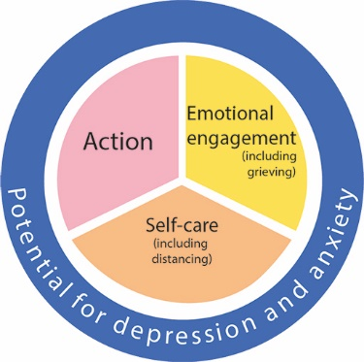
View description - Uncaptioned Figure
View alternative description - Uncaptioned Figure

Emotional engagement
- How will you make time to reflect on your feelings?
- Who can you talk with about your feelings?
Action
- What can you do to make changes to live in a more environmentally sustainable way?
- What community actions can you take?
- What political actions can you take?
Self-care
- What practices will help you to stay well physically, emotionally and spiritually?
- What warning signs do you need to be aware of that may signal you need to distance yourself for a while?

Provide your answer...

So how do we engage with climate change and ecological destruction? The penultimate paragraph of the book Climate Psychology: A Matter of Life and Death lays out a range of responses:

Do we engage by keeping our head firmly in the ground? Or leap to forms of action that, manic in nature, are likely to burn us out and piss others off? Are we overwhelmed by a visceral fear of imminent catastrophe? Do we hold stubbornly to a touching faith in the capacity of business, science and government to find the solutions? Do we reckon that we’re all doomed and decide to disappear into a spiritual retreat? Do we conclude that if the ship is going down then we may as well party? These are all different forms of engagement with the issue.
(Hollway et al., 2022, p. 129)

3 Summary of Week 4
This week you were introduced to ways in which Climate Psychology can help us to cope, adapt and build resilience in the face of our predicament by recognising the need for a balance between engaging with our emotions, taking action and self-care. You were invited to develop your own personal action plan for living with the climate and ecological crisis. Individual actions alone will be insufficient to change the course of the crisis but that might be all that is available to us.

4 Course summary
This course began by looking historically at how and why we find ourselves in a climate and ecological crisis. You learned about the Anthropocene, the Great Acceleration and the development of the Western culture of consumerism and separation from nature. You were introduced to ecopsychology and the contrasting view of our embeddedness in nature that is shared by indigenous cultures. You then explored the emotional impact of facing the reality of the climate crisis and learned about the individual and social defences we use to avoid difficult emotions. You learned to look psycho-socially and politically at greenwashing, denialism and doomism. The final week was about finding ways to live meaningfully and responsibly with the reality of the climate and ecological crisis.
You are left with the concluding paragraph from the book Climate Psychology: A Matter of Life and Death by Hollway et al. (2022):

We hope this book represents a particular ethic of engagement with climate change. First, find the courage to face the difficult truths it presents to us. Second, stay with the trouble that this creates for us. Third, engender frameworks of care that enable us to do this together. If we can do this, if we can develop this kind of culture in the networks, organisations and movements to which we belong, then our love for this world can only grow stronger, and if we get the love right then everything else follows. Finding our love for the world is not a substitute for searching out solutions; the pressure remains (‘but what are we going to DO’). Nonetheless, to find and retain our love for the world – our care, compassion – is a crucial foundation for whatever actions follow.
(Hollway et al., 2022, p. 129)

References
Adams, M. (2021) ‘Critical psychologies and climate change’. Current Opinion in Psychology, 42, pp. 13–18. Available at: https://www.sciencedirect.com/science/article/abs/pii/S2352250X21000087?via%3Dihub (Accessed: 27 July 2023).
Bodnar, S., Aljovin, P., O’Neill, P., Alavi, S., Gamoran, J., Liaqat, A., Bitensky, D., Bi, H., Grella, E., Kiefer, M., Morenberg, L., O’Leary, C., Yadav, P. and Wasret, A. (2023) ‘The environment as an object relationship: a two-part study’, Ecopsychology, 15(2), pp. 110–15.
Climate Psychology Alliance (2023) Climate Psychology Handbook. Available at: https://www.climatepsychologyalliance.org/index.php/component/content/article/climate-psychology-handbook?catid=15&Itemid=101 (Accessed: 25 May 2023).
CDP (2017) New Report Shows just 100 Companies are Source of over 70% of Emissions. Available at: https://www.cdp.net/en/articles/media/new-report-shows-just-100-companies-are-source-of-over-70-of-emissions (Accessed: 25 May 2023).
Elliott, L. (2023) ‘Call for new taxes on super-rich after 1% pocket two-thirds of all new wealth’, The Guardian, 16 January. Available at: https://www.theguardian.com/inequality/2023/jan/16/oxfam-calls-for-new-taxes-on-super-rich-pocket-dollar-26tn-start-of-pandemic-davos? (Accessed: 25 May 2023).
Ellis, E. (2018) The Anthropocene: A Very Short Introduction. Oxford: Oxford University Press.
Naess, A. (1989) Ecology, Community and Lifestyle: Outline of an Ecosophy. Cambridge: Cambridge University Press.
Naess, A. (1995) ‘Self-realization: an ecological approach to being in the world’, in A. Drengson and Y. Inoue (eds) The Deep Ecology Movement: An Introductory Anthology. Berkeley, California: North Atlantic Books, pp. 13–30.
Rich, B. (2023) ‘Outlook? Terrifying: TV weather presenters on the hell and horror of the climate crisis’, The Guardian, 18 January. Available at: https://www.theguardian.com/environment/2023/jan/18/outlook-terrifying-tv-weather-presenters-on-the-hell-and-horror-of-the-climate-crisis. (Accessed: 25 May 2023).
Roszak, T. (1992) The Voice of the Earth. NY: Simon and Schuster.
Roszak, T. (1995) ‘Where Psyche Meets Gaia’ in T. Roszak, M.E. Gomez and A.D. Kanner (eds) Ecopsychology: Restoring the Earth, Healing the Mind. San Francisco: Sierra Club Books, pp.1–17.
Roszak, T., Gomes, M.E. and Kanner, A.D. (eds) (1995) Ecopsychology: Restoring the Earth, Healing the Mind. San Francisco: Sierra Club Books.
Rust, M-J. (2020) Towards an Ecopsychotherapy. London: Confer Books.
Steffen, W., Sanderson, A., Tyson, P., Jäger, J., Matson, P., Moore, B., Oldfield, F., Richardson, K., Schellnhuber, J., Turner, B.L. and Wasson, R.(2004) Global Change and the Earth System: A Planet Under Pressure. Available at: http://www.igbp.net/download/18.1b8ae20512db692f2a680007761/1376383137895/IGBP_ExecSummary_eng.pdf (Accessed: 25 May 2023).
Tobin, L. (2023) ‘Outlook? Terrifying: TV weather presenters on the hell and horror of the climate crisis’, The Guardian. Available at: https://www.theguardian.com/environment/2023/jan/18/outlook-terrifying-tv-weather-presenters-on-the-hell-and-horror-of-the-climate-crisis (Accessed: 25 May 2023).
Wall Kimmerer, R. (2020) Braiding Sweetgrass: Indigenous Wisdom Scientific Knowledge and the Teachings of Plants. London: Penguin Books.
Bednarek, S. (2019) ‘Is there a therapy for climate-change anxiety?’, Therapy Today, 30(5), pp. 36–8.
Clayton, S. (2020) ‘Climate anxiety: psychological responses to climate change’, Journal of Anxiety Disorders, 74, p. 102263. Available at: https://www.sciencedirect.com/science/article/abs/pii/S0887618520300773?via%3Dihub (Accessed: 25 May 2023).
Clayton Whitmore-Williams, S., Manning, C., Krygsman, K. and Speiser, M. (2017) Mental Health and Our Changing Climate: Impacts, Implications, and Guidance. American Psychological Association, and ecoAmerica. Available at: https://www.apa.org/news/press/releases/2017/03/mental-health-climate.pdf (Accessed: 25 May 2023).
Climate Psychology Alliance (2022) ‘Climate crisis digest’. Available at: https://www.climatepsychologyalliance.org/index.php/component/content/article/climate-crisis-digest?catid=15&Itemid=101 (Accessed 25 May 2023).
Hickman, C. (2020) ‘We need to (find a way to) talk about … eco-anxiety’, Journal of Social Work Practice, 34(4), pp. 411–24. Available at: https://www.tandfonline.com/doi/full/10.1080/02650533.2020.1844166 (Accessed: 25 May 2023).
Hoggett, P. (2019) ‘Introduction’, in P. Hoggett (ed.) Climate Psychology: On Indifference to Disaster. Palgrave Macmillan, pp. 1–19.
Mann, M.E. (2021) The New Climate Wars: The Fight to Take Back our Planet. Public Affairs.
Marks, E., Pihkala, P., Mayall, E. and Hickman, C. (2022) Submission to the House of Lords Environment and Climate Change Committee Inquiry into Behaviour Change in the Context of Climate Change and the Environment: A Psychosocial Perspective. Available at: https://committees.parliament.uk/writtenevidence/41622/pdf/ (Accessed: 5 July 2023).
Begley, S. (2007) ‘The truth about denial’, Newsweek, 150, 13 August, pp. 20–9.
Dunlap, R.E. and McCright, A.M. (2011) ‘Organized climate change denial’, in J.S. Dryzek, R.B. Norgaard and D. Schlosberg (eds) The Oxford Handbook of Climate Change and Society, 1, pp. 144–60. New York: Oxford University Press.
Harvey, F. and Ambrose, J. (2023) ‘UK government gambles on carbon capture and storage tech despite scientists’ doubts’, The Guardian, 30 March. Available at: https://www.theguardian.com/environment/2023/mar/30/government-gambles-on-carbon-capture-and-storage-tech-despite-scientists-doubts (Accessed: 25 May 2023).
Hoggett, P. (2022) ‘Climate change: from denialism to nihilism’, in W. Hollway; P. Hoggett; C. Robertson and S. Weintrobe (eds) Climate Psychology: A Matter of Life and Death. Bicester: Phoenix publishing house.
Jacques, P. (2006) ‘The rearguard of modernity: environmental skepticism as a struggle of citizenship’, Global Environmental Politics, 6, pp. 76–101.
Latour, B. (2018) Down to Earth: Politics in the New Climatic Regime. Cambridge: Polity Press.
McCright, A.M. and Dunlap, R.E. (2010) ‘Anti-reflexivity: the American conservative movement’s success in undermining climate change science and policy’, Theory, Culture, and Society, 27, pp. 100–103.
Morton, T. (2013) Hyperobjects: Philosophy and Ecology after the End of the World. Minneapolis: University of Minnesota Press.
Oreskes, N. and Conway, E.M. (2010) Merchants of Doubt. New York: Bloomsbury.
Supran, G., Rahmstorf, S. and Oreskes, N. (2023) ‘Assessing ExxonMobil’s global warming projections’, Science, 379 (6628).
Zerubavel, E. (2006) The Elephant in the Room: Silence and Denial in Everyday Life. Oxford: Oxford University Press.
Brown, G. and Pickerill, J. (2009) ‘Editorial: activism and emotional sustainability’, Activism and Emotional Sustainability, 2(1), pp. 1–3. Available at: https://doi.org/10.1016/j.emospa.2009.05.005https://www.sciencedirect.com/science/article/abs/pii/S1755458609000346?via%3Dihub. (Accessed: 25 May 2023).
Clayton, S. (2020) ‘Climate anxiety: psychological responses to climate change’, Journal of Anxiety Disorders, 74, p. 102263. Available at: https://doi.org/10.1016/j.janxdis.2020.102263https://www.sciencedirect.com/science/article/abs/pii/S0887618520300773?via%3Dihub (Accessed: 25 May 2023).
Gen Dread (2023) ‘Post-traumatic growth after touching death: a conversation with climate activist Charlie Hertzog Young’, Gen dread, 25 May. Available at: https://gendread.substack.com/p/post-traumatic-growth-after-touching?utm_source=substack&utm_medium=email (Accessed: 1 June 2023).
Gillespie, S. (2020) Climate Crisis and Consciousness: Re-imagining Our World and Ourselves. Abingdon, Oxon: Routledge.
Godden, N.J., Farrant, B.M., Yallup Farrant, J., Heyink, E., Carot Collins, E., Burgemeister, B., Tabeshfar, M., Barrow, J., West, M., Kieft, J., Rothwell, M., Leviston, Z., Bailey, S., Blaise, M. and Cooper, T. (2021), Climate change, activism, and supporting the mental health of children and young people: perspectives from Western Australia,. Journal of Paediatric Child Health, 57 (11), pp. 1759–1764. Available at: https://doi.org/10.1111/jpc.15649https://onlinelibrary.wiley.com/doi/10.1111/jpc.15649 (Accessed: 25 May 2023).
Hickman, C. (2020) ‘We need to (find a way to) talk about … eco-anxiety’, Journal of Social Work Practice, 34(4), pp. 411–24. Available at: https://doi.org/10.1080/02650533.2020.1844166https://www.tandfonline.com/doi/full/10.1080/02650533.2020.1844166. (Accessed: 25 May 2023).
Hickman, C., Marks, E., Pihkala, P., Clayton, S., Lewandowski, R., Mayall, L., Wray, B.; Mellor, C. and van Susteren, L. (2021) ‘Climate anxiety in children and young people and their beliefs about government responses to climate change: a global survey’, The Lancet Planetary Health, 5(12), pp. e863–e873. Available at: https://doi.org/10.1016/S2542-5196(21)00278-3https://www.thelancet.com/journals/lanplh/article/PIIS2542-5196(21)00278-3/fulltext. (Accessed: 25 May 2023).
Hoggett, P. and Randall, R. (2018) ‘Engaging with climate change: comparing the cultures of science and activism’, Environmental Values, 27(3), pp. 223–43.
Hollway, W., Hoggett, P., Robertson, C. and Weintrobe, S. (2022) Climate Psychology: A Matter of Life and Death. Bicester: Phoenix Publishing House.
Lawrance, E.L., Thompson, R., Newberry Le Vay, J., Page, L. and Jennings, N. (2022) ‘The impact of climate change on mental health and emotional wellbeing: a narrative review of current evidence, and its implications’, International Review of Psychiatry, 34(5), pp. 443–98. Available at: https://doi.org/10.1080/09540261.2022.2128725https://www.tandfonline.com/doi/full/10.1080/09540261.2022.2128725. (Accessed: 25 May 2023).
Macy, J. and Johnston, C. (2012) Active Hope: How to Face the Mess we’re in Without Going Crazy. California: New World Library.
Mental Health UK (2023) Burnout. Available at: https://mentalhealth-uk.org/burnout/ (Accessed: 25 May 2023).
Ockwell, D., Whitmarsh, L. and O’Neill, S. (2009) ‘Reorienting climate change communication for effective mitigation: forcing people to be green or fostering grass-roots engagement?’, Science Communication, 30(3), pp. 305–27. Available at: https://doi.org/10.1177/1075547008328969https://journals.sagepub.com/doi/10.1177/1075547008328969. (Accessed: 25 May 2023).
Lawson, A. (2021) The Entangled Activist. London: Perspectiva Press.
Ojala, M. (2012) ‘How do children cope with global climate change? Coping strategies, engagement, and well-being’, Journal of Environmental Psychology, 32(3), pp. 225–33. Available at: https://doi.org/10.1016/j.jenvp.2012.02.004https://www.sciencedirect.com/science/article/abs/pii/S0272494412000138?via%3Dihub (Accessed: 25 May 2023).
Ojala, M. (2016) ‘Facing anxiety in climate change education: from therapeutic practice to hopeful transgressive learning’,. Canadian Journal of Environmental Education, 21, pp. 41–56.
Ojala, M., Cunsolo, A., Ogunbode, C.A. and Middleton, J. (2021) ‘Anxiety, worry, and grief in a time of environmental and climate crisis: a narrative review’, Annual Review of Environment and Resources, 46(1), pp. 35–58. Available at: https://doi.org/10.1146/annurev-environ-012220-022716https://www.annualreviews.org/doi/10.1146/annurev-environ-012220-022716 (Accessed: 25 May 2023).
Pihkala, P. (2022) ‘The process of eco-anxiety and ecological grief: a narrative review and a new proposal’, Sustainability, 14(24), p. 16628.
Siegel, D. (1999) The Developing Mind. New York: Guilford Press.
Worden, J.W. (2015) ‘Theoretical perspectives on loss and grief’, in T. Attig and Stillion, J.M. (eds.) Death, Dying, and Bereavement: Contemporary Perspectives, Institutions, and Practices. Springer Publishing Company: New York.

Acknowledgements
This free course was written by Trudi Macagnino, Wendy Hollway and Evangelos Ntontis.
With thanks to Climate Psychology Alliance for use of material from their website.
Except for third party materials and otherwise stated (see terms and conditions), this content is made available under a Creative Commons Attribution-NonCommercial-ShareAlike 4.0 Licence.
The material acknowledged below and within the course is Proprietary and used under licence (not subject to Creative Commons Licence). Grateful acknowledgement is made to the following sources for permission to reproduce material in this free course:
Images
Figure 1: Leon Neal/Staff/Getty Images
Figure 2: USGS USGS.gov
Figure 3: Scripps Institution of Oceanography at UC San Diego http://creativecommons.org/licenses/by/4.0/
Figure 4: in Steffen, W., Sanderson, A., Tyson, P., Jäger, J., Matson, P., Moore, B., Oldfield, F., Richardson, K., Schellnhuber, J., Turner, B.L. and Wasson, R.(2004) Global Change and the Earth System: A Planet Under Pressure. Available at: http://www.igbp.net/download/18.1b8ae20512db692f2a680007761/1376383137895/IGBP_ExecSummary_eng.pdf
Section 3 image: Tom Fisk/Pexels
Figure 5: Photograph: Matt Roth
Figure 1: (also Activity 4): A definition of eco-anxiety. In Handbook of Climate Psychology (p. 22) , Psychology Alliance https://www.climatepsychologyalliance.org/images/files/handbookofclimatepsychology.pdf https://www.climatepsychologyalliance.org/
Section 5 image: Hickman Scale: adapted by The Open University based on: Hickman, C. (2020) ‘We need to (find a way to) talk about … eco-anxiety’, Journal of Social Work Practice, 34(4), pp. 411–24. https://www.tandfonline.com/doi/full/10.1080/02650533.2020.1844166
Figure 1: Book Cover: The New Climate War (2021): The Fight to Take Back Our Planet. Author Michael E. Mann. Publisher: Public Affairs, 2021
Figure 1: adapted from Figure 4 Living with the Ecological Crisis in Pihkala, P. (2022) ‘The Process of Eco-Anxiety and Ecological Grief: A Narrative Review and a New Proposal’, Sustainability, 14(24), p. 16628. doi:10.3390/su142416628. Copyright: © 2022 by the author. Licensee MDPI, Basel, Switzerland. An open access article distributed under the terms and conditions of the Creative Commons Attribution (CC BY) license https://creativecommons.org/licenses/by/4.0/
Figure 2 The window of tolerance: courtesy: Trudi Macagnino
Video
Video: Ayisha Siddiqa at COP27 Polluters Out Video: courtesy: GlobalWitness https://www.youtube.com/shorts/6n3mBaeJN80YouTube
Video The earth has a memory: ‘So much about your sustainability, my people are dying’ by Ayisha Siddiqa. Poem inspired by Palestinian poets Rafif Ziadah and Noor Hindi. Courtesy of the Center for Human Rights and Global Justice at New York University School of Law https://www.law.nyu.edu/centers/chrgj-center-for-human-rights-global-justice
Video: from Make My Money Matter: courtesy: Make My Money Matter https://makemymoneymatter.co.uk/
Video: Rosemary Randall discussing Worden’s grief model https://www.youtube.com/watch?v=dHIEwsFBvSA Courtesy: Rosemary Randall
Video: clip from: Open University video: Global Challenge 1: Climate Crisis with thanks to third party content licensors
Don't miss out
If reading this text has inspired you to learn more, you may be interested in joining the millions of people who discover our free learning resources and qualifications by visiting The Open University – www.open.edu/openlearn/free-courses.
Every effort has been made to contact copyright owners. If any have been inadvertently overlooked, the publishers will be pleased to make the necessary arrangements at the first opportunity.
Don’t miss out
If reading this text has inspired you to learn more, you may be interested in joining the millions of people who discover our free learning resources and qualifications by visiting The Open University – www.open.edu/openlearn/free-courses.

Solutions

Activity 3 Relationship to your chosen familiar outdoor space

Discussion
In summary, the research concluded that relationships to the physical environment share important features with human relationships with people who are significant in our psychological development – family and close friends.
Their conclusion makes us re-think human psychology along eco-psychological lines: ‘No matter where we are from, a private ecosystem lives within us much like a family’ (Bodnar et al., 2023 p. 117).
Back to - Activity 3 Relationship to your chosen familiar outdoor space

Activity 4 Consumerism

Discussion
We are all products of a consumerist society and many would be averse to, for example, having to eat only seasonal and local foods. In this way, the lavish consumer provisions on offer have shaped our tastes, indeed, not only our tastes but the shape and motivations of our selves. The point for Climate Psychology is that capitalist economics and consumer culture have fashioned the psychology of individuals during the Modern period.
Back to - Activity 4 Consumerism

Activity 5 Feelings about climate change

Discussion
In subsequent weeks, you might find that the feelings in your list are mirrored in some of the topics that Climate Psychology is covering to help understand the variety of emotions that the climate and ecological crisis faces people with.
Back to - Activity 5 Feelings about climate change

Activity 6 Climate justice

Discussion
In this video, Ayisha Siddiqa explains her personal reason for becoming a climate activist:

I became involved in climate work, not because I wanted to protect the environment, which I think is an absolutely necessary cause. I became involved because the fossil fuel industries have initiated wars in the country that I come from and killed, looted and completely destroyed environments for the reason of gaining control over vital resources like oil.

Back to - Activity 6 Climate justice

Activity 3 Water shortage

Discussion
Shelot Masithi, like the majority of people around the world, did not initially make sense of her experience in terms of climate change. Perhaps this is changing, but until recently there was no available language, few media outlets, that talked of climate change. This is how realising the link with climate change happened for Shelot:

One day it happened that our geography teacher was teaching about climate change. However, I still didn't think that our water scarcity was due to climate change because he spoke of it as a crisis that's going to happen in the far distant future. But I started reading about it. As I read on, I realised that climate change is a real issue, but I was thinking about it happening in other places. I overlooked what was going on in my community.

Back to - Activity 3 Water shortage

Activity 5 How distressed are you?

Discussion
As well as the risk of medicalising what could be considered a reasonable response to the climate crisis, another problem with trying to categorise eco-anxiety is that we all tend to oscillate between varying degrees of distress. Sometimes we may not think about the climate and ecological crisis very much at all. At other times, it can dominate our thoughts, conversations and even our night-time dreams. Our level of distress is mediated by many factors, social and psychological.
Back to - Activity 5 How distressed are you?

Activity 5 Greenwashing

Discussion
In addition to the usual emphasis on warning individuals about surreptitious influences on their consumer choices, the clip also describes action at a corporate level. London has huge purchasing power and therefore can have a big influence on corporations’ actions to go genuinely green.
Back to - Activity 5 Greenwashing

Activity 2 Tasks of grief

Discussion
One of the things that Rosemary stresses is the importance of getting support from others. It is important to have people to talk to who take those concerns seriously and make you feel it is OK to talk about it. It is not helpful, for instance, to try to argue with someone who is strongly defended and perhaps in a state of denial. If that someone happens to be a family member or friend it can be particularly difficult and it may be preferable to avoid the subject rather than try to convince them of the reality of the climate crisis. The other person may cling to their view even more strongly to avoid the shame and embarrassment of being wrong.
Although Worden’s tasks-based model focuses on grief, it is important to acknowledge, talk about, and understand whatever emotions may be present. Being open about them means you will be better able to work through them.
Finding groups in your own community is especially valuable, because practical local solutions can arise that help with feelings of powerlessness and hopelessness. For example, working on improving green spaces together, or campaigning for bike lanes to reduce the number of cars being driven. Being part of a group can help to reduce distress. It gives a sense of togetherness and belonging and creates social bonds which help us to feel supported as we manage our feelings.
Back to - Activity 2 Tasks of grief

Activity 4 Climate activist journey

Discussion
Sally’s words describe how, through a long process involving adjustment and adaptation, she has reached a phase where her eco-anxiety and grief is not so overwhelming. She no longer has disturbing dreams and seems to have reached a place of acceptance. She can accept uncertainty and the inevitable changes that will happen. She is able to accept both her responsibility and the limits of what she can personally achieve. She can experience beauty, hope and empowerment even though grief and anxiety come and go. One of the most striking elements of Sally’s account is the transformation she has experienced in her thinking, social values and way of living.
Back to - Activity 4 Climate activist journey

Descriptions

Figure 1 The aftermath of the wildfires in London, July 2022.
A photograph showing an aerial view of a destroyed residential area, following a fire.
Back to - Figure 1 The aftermath of the wildfires in London, July 2022.

Figure 1 The aftermath of the wildfires in London, July 2022.
A photograph showing an aerial view of a destroyed residential area, following a fire.
Back to - Figure 1 The aftermath of the wildfires in London, July 2022.

Figure 2 A summary of our planet’s geological periods.
A graphic showing the different geological periods following the formation of the Earth: Paleozoic; Ordovician; Silurian; Devonian; Carboniferous; Permian; Triassic; Jurassic; Cretaceous; Cenozoic; Quaternary.
Back to - Figure 2 A summary of our planet’s geological periods.

Figure 2 A summary of our planet’s geological periods.
A graphic showing the different geological periods following the formation of the Earth: Paleozoic; Ordovician; Silurian; Devonian; Carboniferous; Permian; Triassic; Jurassic; Cretaceous; Cenozoic; Quaternary.
Back to - Figure 2 A summary of our planet’s geological periods.

Figure 3 The Keeling Curve.
A graph showing how CO2 levels have increased over time.
Back to - Figure 3 The Keeling Curve.

Figure 3 The Keeling Curve.
A graph showing how CO2 levels have increased over time.
Back to - Figure 3 The Keeling Curve.

Figure 4 The Great Acceleration refers to increasing rates of human activity since the Industrial Revolution.
A set of graphs showing levels of various human activity over time, such as population, water use and paper consumption.
Back to - Figure 4 The Great Acceleration refers to increasing rates of human activity since the Industrial Revolution.

Figure 4 The Great Acceleration refers to increasing rates of human activity since the Industrial Revolution.
A set of graphs showing levels of various human activity over time, such as population, water use and paper consumption.
Back to - Figure 4 The Great Acceleration refers to increasing rates of human activity since the Industrial Revolution.

Uncaptioned Figure
An overhead photograph of a combine harvester.
Back to - Uncaptioned Figure

Uncaptioned Figure
An overhead photograph of a combine harvester.
Back to - Uncaptioned Figure

Figure 5 Robin Wall Kimmerer.
A photograph of Robin Wall Kimmerer.
Back to - Figure 5 Robin Wall Kimmerer.

Figure 5 Robin Wall Kimmerer.
A photograph of Robin Wall Kimmerer.
Back to - Figure 5 Robin Wall Kimmerer.

Figure 1 A definition of eco-anxiety.
The text in the image reads: Eco-anxiety is the most frequently used term in literature and research to describe heightened emotional, mental or somatic distress in response to dangerous changes in the climate system. The term climate anxiety is often used synonymously. A 2017 report by the American Psychological Association links the impact of climate change to mental health and references ‘eco-anxiety’ as a ‘chronic fear of environmental doom’. It is important to stress that CPA does not view eco-anxiety as a clinical condition, but an inevitable and even healthy response to the ecological threats we are facing, such as food/water shortages, extreme weather events, species extinction, increased health issues, social unrest and potentially the demise of human life on Earth. This has particular significance for children and young people who have little power to limit this harm, making the vulnerable to increased climate anxiety. Paying heed to what is happening in our communities and across the globe is a healthier response than turning away in denial or disavowal. The notion of solastalgia is closely related to eco-anxiety. Coined by the philosopher Glenn Albrecht, it refers to the existential pain experienced where one resides is subject to environmental degradation. Whatever words we use to illustrate the psychological effects of climate change, fear and anxiety are certainly not the only emotions people experience in relation to the climate emergency. Anger, helplessness, sadness, grief, depression, numbness, restlessness, sleeplessness and other symptoms can befall those who are able to face the facts. Fear and anxiety are feelings that alert us to danger and can mobilise us into action. Without enough support, anxiety can escalate into panic on one end of the spectrum or evoke a freeze response and paralyse on the other end of the spectrum. Rather than attempting to rid people of anxiety, therapists can support individuals and communities to build strong containers that allow the expression and exploration of their emotions without collapsing under it or turning away. With strong enough support structures in place, most people can sustain strong feelings without either dissociating and numbing or going into blind panic. They can engage with difficult truths while staying connected and grounded. Community groups, climate cafes, supervision groups, are just a few examples.
Back to - Figure 1 A definition of eco-anxiety.

Figure 1 A definition of eco-anxiety.
The text in the image reads: Eco-anxiety is the most frequently used term in literature and research to describe heightened emotional, mental or somatic distress in response to dangerous changes in the climate system. The term climate anxiety is often used synonymously. A 2017 report by the American Psychological Association links the impact of climate change to mental health and references ‘eco-anxiety’ as a ‘chronic fear of environmental doom’. It is important to stress that CPA does not view eco-anxiety as a clinical condition, but an inevitable and even healthy response to the ecological threats we are facing, such as food/water shortages, extreme weather events, species extinction, increased health issues, social unrest and potentially the demise of human life on Earth. This has particular significance for children and young people who have little power to limit this harm, making the vulnerable to increased climate anxiety. Paying heed to what is happening in our communities and across the globe is a healthier response than turning away in denial or disavowal. The notion of solastalgia is closely related to eco-anxiety. Coined by the philosopher Glenn Albrecht, it refers to the existential pain experienced where one resides is subject to environmental degradation. Whatever words we use to illustrate the psychological effects of climate change, fear and anxiety are certainly not the only emotions people experience in relation to the climate emergency. Anger, helplessness, sadness, grief, depression, numbness, restlessness, sleeplessness and other symptoms can befall those who are able to face the facts. Fear and anxiety are feelings that alert us to danger and can mobilise us into action. Without enough support, anxiety can escalate into panic on one end of the spectrum or evoke a freeze response and paralyse on the other end of the spectrum. Rather than attempting to rid people of anxiety, therapists can support individuals and communities to build strong containers that allow the expression and exploration of their emotions without collapsing under it or turning away. With strong enough support structures in place, most people can sustain strong feelings without either dissociating and numbing or going into blind panic. They can engage with difficult truths while staying connected and grounded. Community groups, climate cafes, supervision groups, are just a few examples.
Back to - Figure 1 A definition of eco-anxiety.

Uncaptioned Figure
The text in the image reads: Eco-anxiety is the most frequently used term in literature and research to describe heightened emotional, mental or somatic distress in response to dangerous changes in the climate system. The term climate anxiety is often used synonymously. A 2017 report by the American Psychological Association links the impact of climate change to mental health and references ‘eco-anxiety’ as a ‘chronic fear of environmental doom’. It is important to stress that CPA does not view eco-anxiety as a clinical condition, but an inevitable and even healthy response to the ecological threats we are facing, such as food/water shortages, extreme weather events, species extinction, increased health issues, social unrest and potentially the demise of human life on Earth. This has particular significance for children and young people who have little power to limit this harm, making the vulnerable to increased climate anxiety. Paying heed to what is happening in our communities and across the globe is a healthier response than turning away in denial or disavowal. The notion of solastalgia is closely related to eco-anxiety. Coined by the philosopher Glenn Albrecht, it refers to the existential pain experienced where one resides is subject to environmental degradation. Whatever words we use to illustrate the psychological effects of climate change, fear and anxiety are certainly not the only emotions people experience in relation to the climate emergency. Anger, helplessness, sadness, grief, depression, numbness, restlessness, sleeplessness and other symptoms can befall those who are able to face the facts. Fear and anxiety are feelings that alert us to danger and can mobilise us into action. Without enough support, anxiety can escalate into panic on one end of the spectrum or evoke a freeze response and paralyse on the other end of the spectrum. Rather than attempting to rid people of anxiety, therapists can support individuals and communities to build strong containers that allow the expression and exploration of their emotions without collapsing under it or turning away. With strong enough support structures in place, most people can sustain strong feelings without either dissociating and numbing or going into blind panic. They can engage with difficult truths while staying connected and grounded. Community groups, climate cafes, supervision groups, are just a few examples.
Back to - Uncaptioned Figure

Uncaptioned Figure
The text in the image reads: Eco-anxiety is the most frequently used term in literature and research to describe heightened emotional, mental or somatic distress in response to dangerous changes in the climate system. The term climate anxiety is often used synonymously. A 2017 report by the American Psychological Association links the impact of climate change to mental health and references ‘eco-anxiety’ as a ‘chronic fear of environmental doom’. It is important to stress that CPA does not view eco-anxiety as a clinical condition, but an inevitable and even healthy response to the ecological threats we are facing, such as food/water shortages, extreme weather events, species extinction, increased health issues, social unrest and potentially the demise of human life on Earth. This has particular significance for children and young people who have little power to limit this harm, making the vulnerable to increased climate anxiety. Paying heed to what is happening in our communities and across the globe is a healthier response than turning away in denial or disavowal. The notion of solastalgia is closely related to eco-anxiety. Coined by the philosopher Glenn Albrecht, it refers to the existential pain experienced where one resides is subject to environmental degradation. Whatever words we use to illustrate the psychological effects of climate change, fear and anxiety are certainly not the only emotions people experience in relation to the climate emergency. Anger, helplessness, sadness, grief, depression, numbness, restlessness, sleeplessness and other symptoms can befall those who are able to face the facts. Fear and anxiety are feelings that alert us to danger and can mobilise us into action. Without enough support, anxiety can escalate into panic on one end of the spectrum or evoke a freeze response and paralyse on the other end of the spectrum. Rather than attempting to rid people of anxiety, therapists can support individuals and communities to build strong containers that allow the expression and exploration of their emotions without collapsing under it or turning away. With strong enough support structures in place, most people can sustain strong feelings without either dissociating and numbing or going into blind panic. They can engage with difficult truths while staying connected and grounded. Community groups, climate cafes, supervision groups, are just a few examples.
Back to - Uncaptioned Figure

Figure 1 Michael Mann’s The New Climate War.
A photograph of the front cover of The New Climate War.
Back to - Figure 1 Michael Mann’s The New Climate War.

Figure 1 Michael Mann’s The New Climate War.
A photograph of the front cover of The New Climate War.
Back to - Figure 1 Michael Mann’s The New Climate War.

Figure 1 Three elements of living with the Climate and Ecological Crisis.
A pie-chart with three items: action; emotional engagement (including grieving); self-care (including distancing).
Back to - Figure 1 Three elements of living with the Climate and Ecological Crisis.

Figure 1 Three elements of living with the Climate and Ecological Crisis.
A pie-chart with three items: action; emotional engagement (including grieving); self-care (including distancing).
Back to - Figure 1 Three elements of living with the Climate and Ecological Crisis.

Figure 2 The window of tolerance.
There are three boxes. At the top is Hyper-arousal (or fight/flight): over-active, distressed, obsessive behaviours, outbursts (anger/rage/aggression, addictions, chaotic responses. The next is Window of Tolderance (or comfort zone): calm, connected to thoughts and feelings, regulated, able to self-sooth. The last is Hypo-arousal (or freeze): depressed, numb, unmotivated, disconnected from feelings, shut down.
Back to - Figure 2 The window of tolerance.

Figure 2 The window of tolerance.
There are three boxes. At the top is Hyper-arousal (or fight/flight): over-active, distressed, obsessive behaviours, outbursts (anger/rage/aggression, addictions, chaotic responses. The next is Window of Tolderance (or comfort zone): calm, connected to thoughts and feelings, regulated, able to self-sooth. The last is Hypo-arousal (or freeze): depressed, numb, unmotivated, disconnected from feelings, shut down.
Back to - Figure 2 The window of tolerance.

Uncaptioned Figure
A pie-chart with three items: action; emotional engagement (including grieving); self-care (including distancing).
Back to - Uncaptioned Figure

Uncaptioned Figure
A pie-chart with three items: action; emotional engagement (including grieving); self-care (including distancing).
Back to - Uncaptioned Figure

Uncaptioned interactive content

Transcript
AYISHA SIDDIQUA
We need to establish a conflict of interest policy at the international level with COP. It does not make sense that the very people who have caused the climate crisis, i.e. the fossil fuel companies, are also then sponsoring the COPs, are then editing the legislation that comes out of these conferences, to then say that they are solving the climate crisis.
Most people don’t realise this, but Paris Climate Agreement, which is supposed to be one of the most progressive agreements, which has some binding aspects, does not even have the words oil or gas in any of the thousands of pages. And that is directly due to the lobbying of the fossil fuel industry and the governments who allow that lobbying. So we need a conflict of interest policy at the minimum. But also, we need loss and damage finance for communities that have been affected by natural disasters and we need transparency.
Back to - Uncaptioned interactive content

Uncaptioned interactive content

Transcript
AYISHA SIDDIQA
It’s called, ‘So much about your sustainability, my people are dying’. Colonisers go to war with nature and call it a business opportunity. I tell you that even our dead have drowned in their graves. And you ask me to be polite. You ask me not to blame or shame and remember the colour of my skin, the sound of my tongue, and my place in your world.
You tell me to give you a little bit more benefit of the doubt, to angle my face in front of the camera and give you the perfect soundbite of hope and forgiveness. You take and take until we’ve birthed our babies into the same water as our dead. And even then, you gather like vultures and feed on our helplessness. In your charity, you make profit. I tell you that there has been a massacre and the land will never be the same. The soil will never grow the same. The hum of mosquitoes has changed the colour of the sky. And the sickness of your greed will haunt you in every single lifetime.
And you tell me about a new UN proposition, some politician’s lie that you keep cradling between your mouth and your ear. The bridges you will make after the bombs. Ayisha, you’ve got to be a little more practical. Ayisha, smile so they know you are not dangerous. And still 100 dead, 200 dead, 1,500 dead. And no negotiation, no negotiation, no negotiation will bring them back to life.
I want the world leaders to know that the Earth has a memory. And all of her beloveds that she keeps tucked in her landscapes have birthed guardians . They are sitting among me. You will have to answer to her children, and their children, and your children. And one day, it will be your home, your family, your land. I pray and I hope you make the right choice.
If there is one thing for those of you in the room that I want you to deliver to the rest of the world, it is that you cannot negotiate with nature. There will come a time where no amount of dollars will be able to make up for what is lost and what is broken. We are in a critical time in history. And we don’t have much left. Thank you.
Back to - Uncaptioned interactive content

Uncaptioned interactive content

Transcript
SHELOT MASITHI
Back then, in the years spanning from 2012 and up until 2017, we experienced severe water shortages.
I was always frustrated whenever I left my house and to school and from school to home because I was always worried about water. What if tomorrow there won’t be water? Do we have enough buckets to conserve water for ourselves when there’s no water? And it happened that we ended up experiencing a water shortage in 2016 for a month.
The water buckets that we had were not enough. And the water we reserved or we conserved for crisis like that ran out mid month. And the month dragged. We did not have enough money to buy water from those who had boreholes. It was really frustrating. I remember one day, in the morning when I was ready for school, I stood in the middle of my room and started thinking, should I take a bucket to school so that from school, when I come back from school, I can fetch water either from school or from the river to home?
My previous school had boreholes. So like it was that kind of a school that never ran out of water, like just abundant water. I also thought, if I take a bucket to school so that I fetch water on my way home, my classmates and other kids might bully me for that.
I didn’t think for a moment that they could also be experiencing-- they could also be frustrated or anxious or scared for not having water. I didn’t take the bucket. I just stormed out of my room and went to school. It was one of the most frustrating months in my school-- in my grade-school years because I couldn’t even study properly because I was constantly thinking about water. And I didn’t even know much about what other villages are going through or what other countries are going through when it comes to water and climate change.
Back to - Uncaptioned interactive content

Uncaptioned interactive content

Transcript
ROSE LESLIE
When was the last time you actually posted about me?
KIT HARINGTON
Come on. You know that’s professional suicide.
ROSE LESLIE
Yeah, but you’re constantly posting about the millions that you’re giving to green energy--
KIT HARINGTON
What do you want me to do? Post about the billions I give you every year?
ROSE LESLIE
He’ll tell everyone now that he loves renewables and then he turns around to me and tells me that he loves me. Well, which is it?
KIT HARINGTON
Well, obviously, it’s you. It’s always been you.
TEXT ON SCREEN: Our banks are in a hidden relationship with oil companies. It’s fuelling climate change. In the last 12 months, Barclays, HSBC, Santander, Lloyds and Natwest have given $37 billion to the fossil fuel industry.
Back to - Uncaptioned interactive content

Uncaptioned interactive content

Transcript
ROSEMARY RANDALL
And the first of the tasks that he talks about is the need to accept the reality of the loss. And this is the one which a lot of people stumble at because if you don’t really face the loss, where you go to is that form of denial that psychotherapists call disavowal, where you just hold it in a box in your mind, and you don’t visit it very often, unless somebody forces you to.
The second stage which Worden talks about, is to work through the painful emotions, the really awful things which you feel, the fear, the sorrow, the grief. And you have a great need to talk but only at the moments when it feels right to you. And you’re in tremendous need of those around you, coming around you in a kind of circle of support and being able to tolerate the fact that sometimes you’re angry. Sometimes you’re sad. Sometimes you want to talk about this. Sometimes you don’t. And this is very important. And this is a stage where the support of those around you is crucial.
The third task which Worden describes is that of adjusting to the new reality, of actually saying, OK, so what is my life going to be like now that Dad is dead? What is my life going to be like now that I know that climate change means that I can’t take those holidays I always used to take? Well, it means that I’ve really got to take political actions that don’t come easily to me, or that I’ve got to become part of a campaign, and I hate going to meetings. What’s my identity now?
If you don’t grapple with this task, Worden describes people, in a sense, turning away from life, becoming bitter, and becoming very withdrawn. And this is the point where I think we sometimes see people becoming very depressed. And we see this in relation to climate change-- people feeling hopeless, feeling that they can’t do anything about it, feeling despairing, shutting off.
And finally, Worden talks about the capacity to reinvest emotional energy. This is the last task he talks about. And this, I think, in relation to climate change, is the point at which you start to feel comfortable with the actions that you want to take about climate change whatever they are, whatever it is that you have decided that you’re going to do, this is the point where you maybe know that you’re not going to be the saviour. You’re not necessarily going to be the hero. But you’re going to be able to make a life for yourself with this new reality.
Back to - Uncaptioned interactive content

Uncaptioned interactive content

Transcript
PENNY LANE
I’m Penny, and I’m a part of Extinction Rebellion Lincolnshire. I became very concerned about the messages that were coming out of reports and newspapers about the state of the environment, telling us quite clearly that we have five years to make a difference. It’s that urgent. They’re calling it code red. Most governments, including ours, are leisurely strolling along, saying 2050 is their target. Well, that’s 30 years too late. We’re all at risk. We’ve got island states that are disappearing. We’ve got cities sinking. We’ve got thousands of people displaced. We’ve got wars already that are about resources. Civilisation is deeply threatened by the way things are happening. Extinction Rebellion has taken its lessons from suffragettes, Martin Luther King, the Indian rebellions with Gandhi and so on. And it’s clear that if you do peaceful civil disobedience, you actually are quite powerful.
SPEAKER
Extinction Rebellion is an environmental movement. There’s three main principles and demands. The first is to act now. The second is to tell the truth. And the third is to be beyond politics and move forward to how do we create true democracies.
PENNY LANE
If I was going to rebellion, I would have planned what I was going to do. I would have a group of people I was going to know well, I’m going to do it with. We will use messaging apps. We know where we’re going to meet. We’ve got anything that we need planned, how we're going to get it there. It works like clockwork because we’ve rehearsed it. There are things that we could do. There are things we could do to adjust. And that’s what motivates us. And that’s what gives us the strength to be arrested again and again and to do the difficult things that we do. It’s not easy being locked on. It’s not easy being glued to things. It’s pretty scary. But the thing is that I think it would be criminal not to do it. If there was a chance that I could make a difference, then I’m going to take it.
Back to - Uncaptioned interactive content

