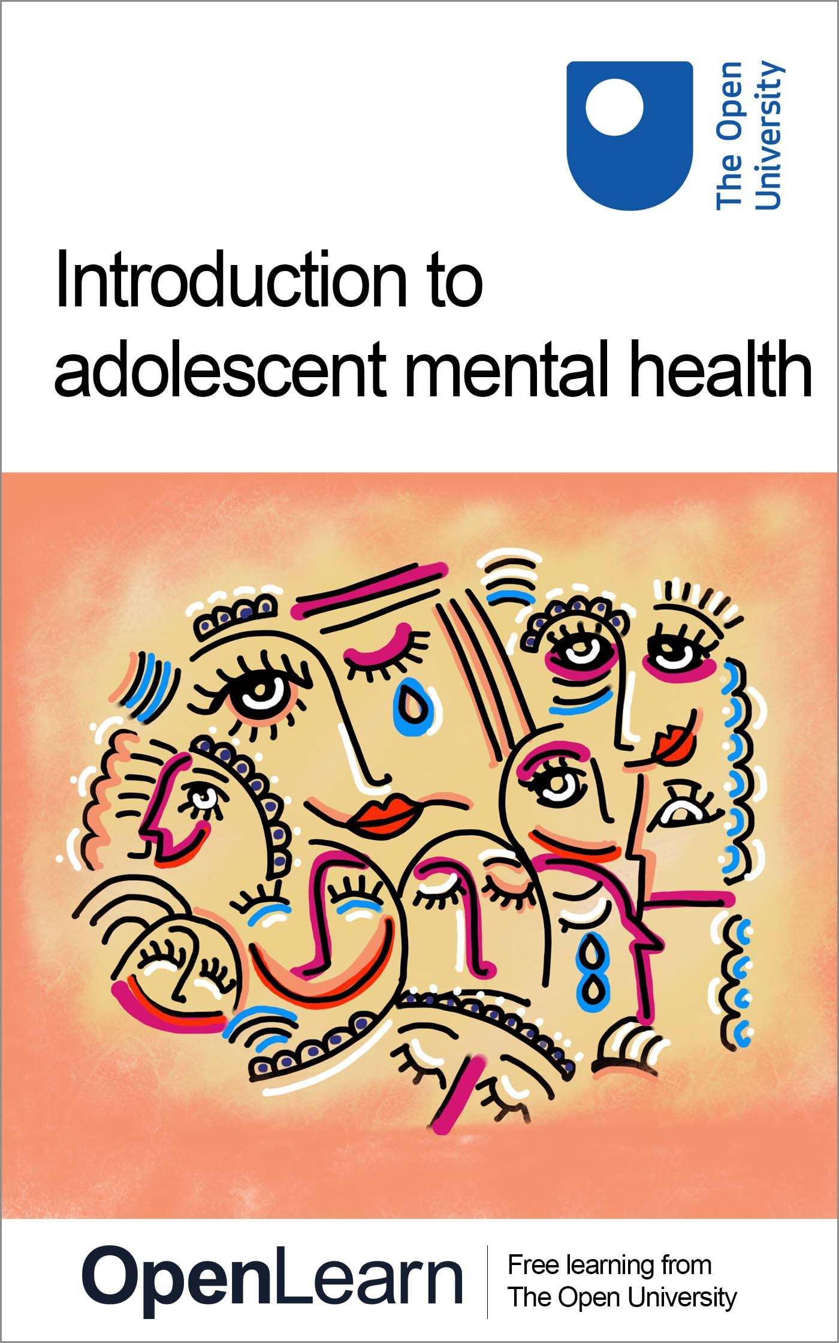

ALT_1

Introduction to adolescent mental health

About this free course
This free course is an adapted extract from the Open University course .
This version of the content may include video, images and interactive content that may not be optimised for your device.
You can experience this free course as it was originally designed on OpenLearn, the home of free learning from The Open University –
There you’ll also be able to track your progress via your activity record, which you can use to demonstrate your learning.
Copyright © 2021 The Open University
Intellectual property
Unless otherwise stated, this resource is released under the terms of the Creative Commons Licence v4.0 http://creativecommons.org/licenses/by-nc-sa/4.0/deed.en_GB. Within that The Open University interprets this licence in the following way: www.open.edu/openlearn/about-openlearn/frequently-asked-questions-on-openlearn. Copyright and rights falling outside the terms of the Creative Commons Licence are retained or controlled by The Open University. Please read the full text before using any of the content.
We believe the primary barrier to accessing high-quality educational experiences is cost, which is why we aim to publish as much free content as possible under an open licence. If it proves difficult to release content under our preferred Creative Commons licence (e.g. because we can’t afford or gain the clearances or find suitable alternatives), we will still release the materials for free under a personal end-user licence.
This is because the learning experience will always be the same high quality offering and that should always be seen as positive – even if at times the licensing is different to Creative Commons.
When using the content you must attribute us (The Open University) (the OU) and any identified author in accordance with the terms of the Creative Commons Licence.
The Acknowledgements section is used to list, amongst other things, third party (Proprietary), licensed content which is not subject to Creative Commons licensing. Proprietary content must be used (retained) intact and in context to the content at all times.
The Acknowledgements section is also used to bring to your attention any other Special Restrictions which may apply to the content. For example there may be times when the Creative Commons Non-Commercial Sharealike licence does not apply to any of the content even if owned by us (The Open University). In these instances, unless stated otherwise, the content may be used for personal and non-commercial use.
We have also identified as Proprietary other material included in the content which is not subject to Creative Commons Licence. These are OU logos, trading names and may extend to certain photographic and video images and sound recordings and any other material as may be brought to your attention.
Unauthorised use of any of the content may constitute a breach of the terms and conditions and/or intellectual property laws.
We reserve the right to alter, amend or bring to an end any terms and conditions provided here without notice.
All rights falling outside the terms of the Creative Commons licence are retained or controlled by The Open University.
Head of Intellectual Property, The Open University

Contents
- Introduction and guidance
  - Introduction and guidance
  - Introduction and guidance
    - What is a badged course?
    - How to get a badge
- Session 1: ‘A crisis in context’
  - Introduction
  - Learning outcomes
  - 1 Adolescent mental health in context
    - 1.1 The trends
    - 1.2 Trends by age group and sex
  - 2 What do we mean by ‘health’ and ‘mental health’?
    - 2.1 The impact of mental health
  - 3 How has the concept of mental health evolved?
    - 3.1 Identity, language and stigma
    - 3.2 #oktosay
  - 4 Mental health policy
  - 5 This session’s quiz
  - 6 Summary of Session 1
- Session 2: Understanding adolescence
  - Introduction
  - Learning outcomes
  - 1 Introducing adolescence
    - 1.1 A time of rapid change
    - 1.2 Body changes
    - 1.3 Social changes
    - 1.4 Adolescence and emotion
    - 1.5 Challenges of adolescence
  - 2 The adolescent brain
    - 2.1 Peer pressure and risk taking
  - 3 The social world of adolescence
    - 3.1 Bullying
    - 3.2 Loneliness
  - 4 What’s ‘normal’ and ‘abnormal’?
    - 4.1 Recognising a problem
  - 5 This session’s quiz
  - 6 Summary of Session 2
- Session 3: Different dimensions of adolescent mental health
  - Introduction
  - Learning outcomes
  - 1 When does mental health become ill-health?
  - 2 Anxiety
  - 3 Depression
  - 4 Eating disorders
    - 4.1 Early intervention
  - 5 Self harm
    - 5.1 Breaking the self-harm cycle
  - 6 Suicide
  - 7 This session’s quiz
  - 8 Summary of Session 3
- Session 4: Recognising mental health problems
  - Introduction
  - Learning outcomes
  - 1 Diagnosis and sense-making
    - 1.1 The case of George
    - 1.2 Determinants of health
  - 2 Professional approaches
    - 2.1 Comparing medical approaches
    - 2.2 Potential sources of conflict
  - 3 The role of social media
    - 3.1 Young people and social media
    - 3.2 Images of perfection?
  - 4 Common misconceptions about adolescent mental health
  - 5 This session’s quiz
  - 6 Summary of Session 4
- Session 5: Understanding resilience in adolescence
  - Introduction
  - Learning outcomes
  - 1 Why is resilience important?
    - 1.1 Defining resilience
  - 2 Adversity
    - 2.1 Disruptive behaviour in adversity
  - 3 Born or made resilient?
    - 3.1 The brain, neuroplasticity and resilience
    - 3.2 Fostering resilience
  - 4 Resilience in schools
  - 5 This session’s quiz
  - 6 Summary of Session 5
- Session 6: Supporting young people
  - Introduction
  - Learning outcomes
  - 1 Parenting and supporting
  - 2 Talking and listening
    - 2.1 Active listening
    - 2.2 Question types
    - 2.3 Conversation starters
  - 3 Food, exercise and sleep
    - 3.1 Food and mental health
    - 3.2 Exercise and mental health
    - 3.3 Sleep and mental health
  - 4 This session’s quiz
  - 5 Summary of Session 6
- Session 7: Identifying sources of support
  - Introduction
  - Learning outcomes
  - 1 Family, friends and other adults
    - 1.1 Fostering supportive networks
    - 1.2 Managing barriers
    - 1.3 Managing responses to mental health disclosures
  - 2 Social media
    - 2.1 Taking control
    - 2.2 Understanding the impact of social media on a young person’s identity
  - 3 Charities
    - 3.1 Helplines
    - 3.2 Online forums
    - 3.3 Mental health apps
  - 4 This session’s quiz
  - 5 Summary of Session 7
- Session 8: Seeking expert support and accessing services
  - Introduction
  - Learning outcomes
  - 1 Responding to concerning behaviours
    - 1.1 Mental health at school
    - 1.2 Self-harm
  - 2 Talking therapies
    - 2.1 Cognitive Behavioural Therapy
    - 2.2 The importance of professional help
  - 3 Medical interventions
    - 3.1 Selective Serotonin Reuptake Inhibitors
  - 4 Making referrals
  - 5 Seeking guidance
  - 6 This session’s quiz
  - 7 Review the journey
  - Where next?
  - Tell us what you think
- Glossary
- References
- Further reading
- Acknowledgements
- Solutions

Introduction and guidance

Introduction and guidance

Introduction and guidance
This free badged course, Introduction to adolescent mental health, lasts 24 hours, with 8 ‘sessions’. You can work through the course at your own pace, so if you have more time one week there is no problem with pushing on to complete a further study session. The eight sessions are linked to ensure a logical flow through the course. They are:
- Session 1: ‘A crisis in context’
- Session 2: Understanding adolescence
- Session 3: Different dimensions of adolescent mental health
- Session 4: Recognising mental health problems
- Session 5: Understanding resilience in adolescence
- Session 6: Supporting young people
- Session 7: Identifying sources of support
- Session 8: Seeking expert support and accessing services
This course will cover understanding mental health, specifically adolescent mental health. It will explore how to recognise mental health issues, including anxiety and depression. You should also gain an understanding of resilience, as well as learning how to support young people to develop greater resilience and self-reliant behaviours. You should also be able to identify support networks for young people.
There will be numerous opportunities to check your learning. This includes interactive quizzes, of which Sessions 4 and 8 will provide you with an opportunity to earn a badge to demonstrate your new skills. You can read more on how to study the course and about badges in the next sections.

Learning outcomes
After completing this course, you will be able to:
- understand the complexity and multifaceted nature of adolescent mental health
- appreciate the variety of strategies that can be employed to support young people
- recognise resilience as a quality and skill that can be learned and developed
- identify resilience markers that can be supported and nurtured
- identity the range of services and contexts through which young people can access support and guidance.

Moving around the course
In the ‘Summary’ at the end of each session, you will find a link to the next session. If at any time you want to return to the start of the course, click on ‘Full course description’. From here you can navigate to any part of the course.
It’s also good practice, if you access a link from within a course page (including links to the quizzes), to open it in a new window or tab. That way you can easily return to where you’ve come from without having to use the back button on your browser.
There are text boxes within the activities for you to make notes where it would be helpful. This saves for you to refer back to, and only you can access these notes, noone else is able to see them. Alternatively, you are welcome to make notes offline instead, for example in a notebook.
The Open University would really appreciate a few minutes of your time to tell us about yourself and your expectations for the course before you begin, in our optional start-of-course survey. Participation will be completely confidential and we will not pass on your details to others.

What is a badged course?
While studying Introduction to adolescent mental health you have the option to work towards gaining a digital badge.
Badged courses are a key part of The Open University’s mission to promote the educational wellbeing of the community. The courses also provide another way of helping you to progress from informal to formal learning.
Completing a course will require about 24 hours of study time. However, you can study the course at any time and at a pace to suit you.
Badged courses are available on The Open University’s OpenLearn website and do not cost anything to study. They differ from Open University courses because you do not receive support from a tutor, but you do get useful feedback from the interactive quizzes.

What is a badge?
Digital badges are a new way of demonstrating online that you have gained a skill. Colleges and universities are working with employers and other organisations to develop open badges that help learners gain recognition for their skills, and support employers to identify the right candidate for a job.
Badges demonstrate your work and achievement on the course. You can share your achievement with friends, family and employers, and on social media. Badges are a great motivation, helping you to reach the end of the course. Gaining a badge often boosts confidence in the skills and abilities that underpin successful study. So, completing this course could encourage you to think about taking other courses.

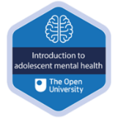
View description - Uncaptioned Figure

How to get a badge
Getting a badge is straightforward! Here’s what you have to do:
- read each session of the course
- score 50% or more in the two badge quizzes in Session 4 and Session 8.
For all the quizzes, you can have three attempts at most of the questions (for true or false type questions you usually only get one attempt). If you get the answer right first time you will get more marks than for a correct answer the second or third time. Therefore, please be aware that for the two badge quizzes it is possible to get all the questions right but not score 50% and be eligible for the badge on that attempt. If one of your answers is incorrect you will often receive helpful feedback and suggestions about how to work out the correct answer.
For the badge quizzes, if you’re not successful in getting 50% the first time, after 24 hours you can attempt the whole quiz, and come back as many times as you like.
We hope that as many people as possible will gain an Open University badge – so you should see getting a badge as an opportunity to reflect on what you have learned rather than as a test.
If you need more guidance on getting a badge and what you can do with it, take a look at the OpenLearn FAQs. When you gain your badge you will receive an email to notify you and you will be able to view and manage all your badges in My OpenLearn within 24 hours of completing the criteria to gain a badge.
Get started with Session 1.

Session 1: ‘A crisis in context’

Introduction
It is possible that you are taking this course because you are worried about a young person close to you, or because you are concerned by adolescent mental health issues in general. What do you already understand about adolescent mental health? Are communities actually facing a mental health crisis, or is this a crisis that is being blown up in the media? To get started on this topic, listen to Audio 1 in which a parent talks about their experience of trying to understand what is happening in the life of their adolescent child.

Audio content is not available in this format.
Audio 1: Parent experiences
View transcript - Audio 1: Parent experiences

Mental health problems can manifest in different ways and generally speaking becomes problematic when it interferes with some aspect of everyday life, including; the ability to learn, to feel, express and manage a range of positive and negative emotions, the ability to form and maintain good relationships with others and to manage change and uncertainty (Mental Health Foundation, 2020).
In the opening audio you heard a parent describe some of the difficulties that her child experienced leading up to a diagnosis of OCD and the value of treatment in providing much needed support. Of course, individual experiences will differ and will reflect the mental health challenges that a young person is facing. The most common mental health problems diagnosed for young people globally include anxiety and depression, often termed emotional disorders, with an increase in self harming behaviours and rates of suicide amongst young adults.

Figure 1
View description - Figure 1
View description - Figure 1

The language used to discuss mental health issues varies and different definitions exist including; mental health, mental health problems and mental illness. These terms are still hotly contested and as you read you will discover a little more about how they shape perspectives and experiences. As the course proceeds you may find that your opinion on what mental ill health is shifts or that how you understand emotional distress in adolescents gains depth.
In this first session, you will consider some statistics showing the extent of mental health issues in young people in the UK, and read about what people actually mean when they talk about ‘mental health’. Terminology and attitudes about mental health have changed dramatically over recent decades, as have the policies and practices designed to help people who experience these issues and those who support them.
The Open University would really appreciate a few minutes of your time to tell us about yourself and your expectations for the course before you begin, in our optional start-of-course survey. Participation will be completely confidential and we will not pass on your details to others.

Learning outcomes
By the end of this session, you should be able to:
- describe the scale of adolescent mental health issues
- recognise that mental health is part of the umbrella concept of health
- describe how people’s understandings about mental health have changed over time
- outline the UK mental health policy developments that affect families.

1 Adolescent mental health in context
Statistics can be baffling if they are presented without their full context as understanding this can help us understand what the numbers mean. To get you thinking about context, carry out the first activity now.

Activity 1: The size of the issue
Allow about 20 minutes

Step 1: If you had to guess how many children were experiencing mental health issues at any one time, which one of these figures would you choose? Click a percentage figure and read the comment. There is a long description button below the figure if this is easier to learn from.

Interactive content is not available in this format.
Interactive Figure 2: Mental health of Children and young people in England (2017)
View description - Interactive Figure 2: Mental health of Children and young people in England (201 ...

View discussion - Part

Step 2: Did any of the information surprise you or raise questions for you? Jot down a note to yourself to record your first thoughts about the size of mental health disorders. (Please note, the text response boxes are completely anonymous and only accessible by you. They can be saved for you to refer back to at another time.)

Provide your answer...
View discussion - Part

Clearly, Interactive Figure 2 shows that something is happening between the ages of 2 and 19, as the rates of mental disorder increase but what might be behind this increase? Our best evidence suggests that it is likely to be the result of a complex, dynamic mixture of physical and social development occurring within particular settings. This course examines what happens roughly between the ages of 10 and 19. This period of time in a young person’s life is sometimes called adolescence.
The statistics you just looked at showed the situation in 2017. Did you perhaps ask yourself, ‘is that better or worse than previous years?’, and ‘What’s the situation now’? You’ll consider these types of time-related trends next.

1.1 The trends
Media headlines frequently announce the existence of a global mental health crisis and that mental health issues in adolescence are on the rise. Is the mental health of young people really poorer than it was, say 20 years ago? Until the 2017 survey, presented in the first activity, data on under-fives and 16 to 19-year-olds was not collected, so trends over time are only available for the age range 5-15 years. In the next activity, you’ll look at the graph in Figure 3, which shows data from surveys of the mental health of 5 to 15-year-olds in England carried out in 1999, 2004, and 2017.

Activity 2: Examining the trends
Allow about 10 minutes

The dark blue line, showing the average between boys and girls, indicates that in 2017 11.2% of 5 to 15-year-olds reported at least one mental health ‘disorder’.

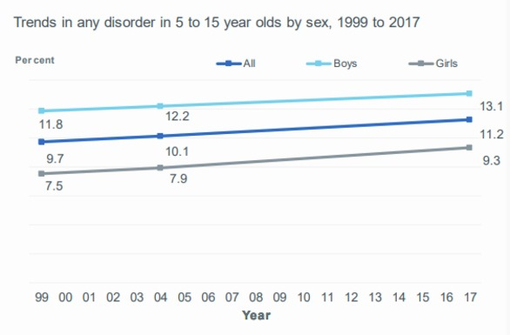
Figure 3: Trends in any mental health disorder in 5 to 15 year olds by sex, 1999 to 2017.
View description - Figure 3: Trends in any mental health disorder in 5 to 15 year olds by sex, 1999 ...
View description - Figure 3: Trends in any mental health disorder in 5 to 15 year olds by sex, 1999 ...

In the first activity, you saw that 12.8% 5 to 19-year-olds had at least one mental health ‘disorder’ in 2017.
Can you see why the percentages are different?

View discussion - Activity 2: Examining the trends

The graph you’ve just looked at shows a steady increase in mental disorders since 1999. There is a marked difference between boys and girls, with a noticeably higher percentage of boys experiencing a mental disorder compared with girls. Looking at this graph, you may conclude that we should be more concerned about boys than about girls. However, these figures, which pool all ages, are hiding some interesting detail!

1.2 Trends by age group and sex
In the next activity, you’ll look at the two graphs in Figure 4 separating the 2017 data into smaller age groups.

Activity 3: Examining sex differences
Allow about 10 minutes

According to the figures in these graphs in Figure 4, in 5 to 10-year-olds, almost twice as many boys as girls have a mental disorder and in 17 to 19-year-olds the reverse is true. In fact, more than twice as many girls as boys disclose a mental disorder in the 17–19 age group.

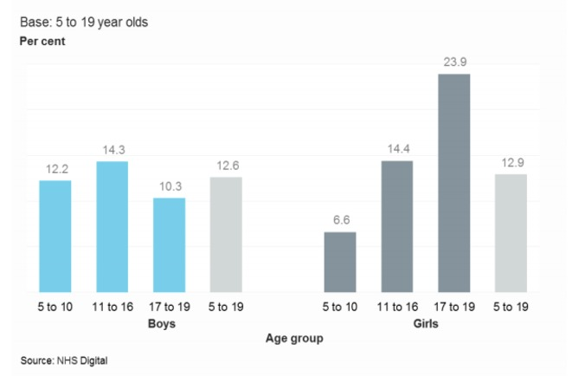
Figure 4: Percentage of any disorder by age and sex, NHS 2017.
View description - Figure 4: Percentage of any disorder by age and sex, NHS 2017.
View description - Figure 4: Percentage of any disorder by age and sex, NHS 2017.

Can you think of any reasons why this might be the case? Jot down a few notes to yourself for future reference.

Provide your answer...
View discussion - Activity 3: Examining sex differences

During the course, you will unpack the knowledge underlying these figures and explore what is happening both physically and socially during adolescence that might help us to understand these differences. Before that, it’s worth going ‘back to basics’ to consider what ‘mental health’ actually is.

2 What do we mean by ‘health’ and ‘mental health’?
Can you be healthy without good mental health? Ever since 1946, the World Health Organization’s original definition of health has been upheld:

‘Health is a state of complete physical, mental and social well-being and not merely the absence of disease or infirmity’.

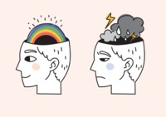
Figure 5
View description - Figure 5
View description - Figure 5

You’ll see that it takes a very wide view of health that includes the mental and social. Certainly, if your mental health were poor you would feel unwell, or at least lack a sense of wellbeing. Many healthcare professionals and researchers argue, however, that the perfect state of health and wellbeing described above is unattainable. Taking this argument further, perhaps it is even harmful for our mental health to suggest that we should somehow aim for this unachievable goal.
Physical and mental health are interdependent, so for example, people who are living with a long-term chronic health condition such as type 1 diabetes or cystic fibrosis may experience challenges to their mental health. Conversely, people who are experiencing mental illness may take less care of their physical health or engage in behaviours that exacerbate their mental health difficulties. Either way, individuals who are unwell will experience a combination of symptoms and challenges that are likely to be physical, mental and social.

2.1 The impact of mental health
As previously indicated a mental health problem can show itself in different ways and usually interferes with some aspect of everyday living. The Mental Health Foundation says:

Good mental health is characterised by a person’s ability to fulﬁl a number of key functions and activities, including:
- the ability to learn
- the ability to feel, express and manage a range of positive and negative emotions
- the ability to form and maintain good relationships with others
- the ability to cope with and manage change and uncertainty.
(Mental Health Foundation, 2020)

Now work your way through Activity 4.

Activity 4: The impact of mental health problems
Allow about 15 minutes

Think of a young person you know, who you think may have a mental health problem, or you are generally concerned about. If you can’t think of anyone, consider a fictional character, or someone older that you know.

Figure 6: Young people who have suffered with their own mental health.
View description - Figure 6: Young people who have suffered with their own mental health.
View description - Figure 6: Young people who have suffered with their own mental health.

Once you have someone in mind, think about whether they may be struggling with any of these ‘key functions and activities’:

The ability to learn
The ability to feel, express and manage a range of positive and negative emotions
The ability to form and maintain good relationships with others
The ability to cope with and manage change and uncertainty
View answer - Part
View discussion - Part

Now watch this short clip in which John Goss, a counsellor who works with the youth counselling service YIS, describes what he experiences with young people who come to see him. Make a note of the two ways in which he describes how they might present with issues.

Video content is not available in this format.
Video 1: John Goss and experiences with young people.
View transcript - Video 1: John Goss and experiences with young people.

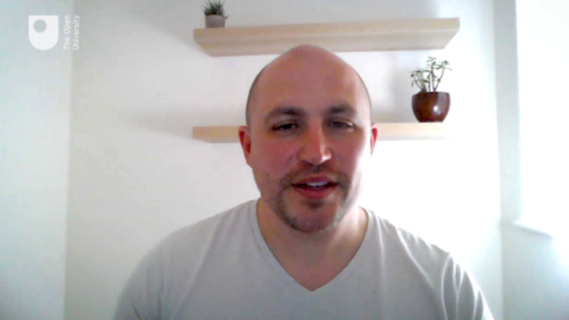

Provide your answer...
View discussion - Part

3 How has the concept of mental health evolved?
The history of ideas about mental health is not, as many people expect, a straightforward journey of progression where things steadily improve, and we understand more about how to treat mental illness. Ideas about the nature, causes and best ways of treating or responding to mental health problems have changed signiﬁcantly over time, inﬂuenced by a variety of factors, including the social and cultural context.

Activity 5: What causes mental health problems in adolescence?
Allow about 10 minutes

What do you think causes mental health problems in young people? Spend a few minutes jotting down your thoughts below.

Provide your answer...

Now, go to the poll and select a possible cause that is closest to the one you have written.

Interactive content is not available in this format.

View discussion - Part

In the psychology camp, Sigmund Freud (1856–1939) pioneered psychodynamics, a theory about how the mind works based on the idea that mental illness resulted from unresolved unconscious issues arising in childhood. Treatment involved encouraging the patient to talk about past events.

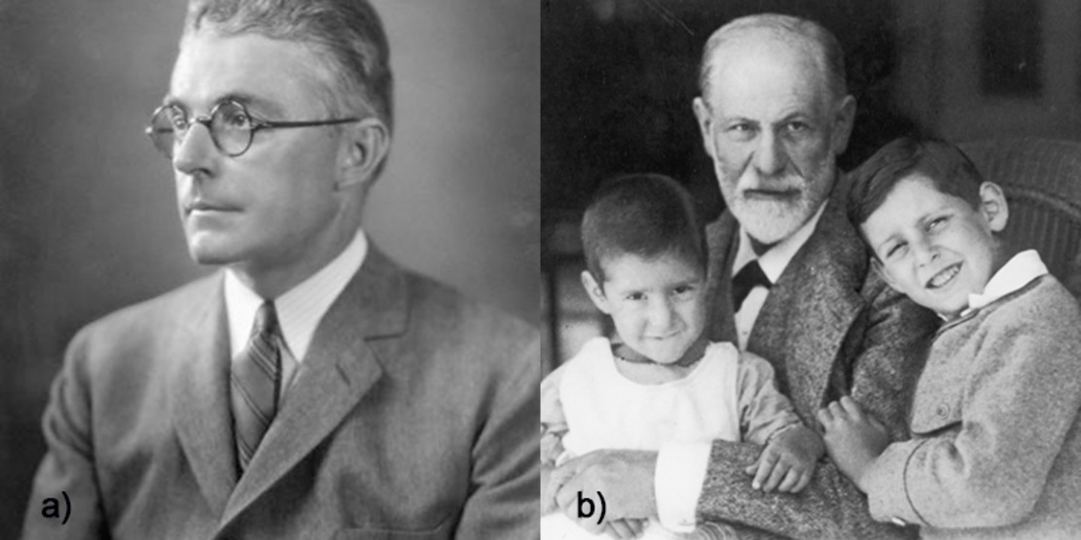
Figure 7: a) John Watson and b) Sigmund Freud
View description - Figure 7: a) John Watson and b) Sigmund Freud
View description - Figure 7: a) John Watson and b) Sigmund Freud

By contrast, the behaviourist viewpoint (initiated by John Watson (1878–1958)) assumed that people became ‘conditioned’ to display certain maladaptive behaviours. The proposed solution was further conditioning by applying rewards and punishments to encourage the desired behaviour, partly supported by the well-known dog experiments conducted by the Russian physiologist Ivan Pavlov (1849–1936). In these experiments it was discovered that the dogs could be ‘conditioned’ to salivate even when food was not present by other stimuli that were associated with the food such as the ringing of a bell.
The modern bio-medical perspective views mental health problems from an illness perspective, identifying inherited genes, hormonal changes and alterations in how the brain works as underlying a range of ‘mental illnesses’. Treatment involves medicines that act on the way the brain works, as well as lifestyle advice based on knowledge of the links between brain health and body health. Immense efforts continue in research laboratories to understand and treat the possible biological foundations of mental health problems. Modern psychological perspectives assume that people can be supported to think differently about challenges to their mental health and learn to manage them with or without the support of medicines.

Figure 8
View description - Figure 8
View description - Figure 8

You will learn more about the modern approaches in sessions 4 and 8, but next, you consider some of the cultural aspects of mental health.

3.1 Identity, language and stigma
Having a mental health problem, and the language used to describe it, can have a profound impact on how a person sees themselves: their sense of identity. This point was reinforced by Ron Coleman:

In the early 1980s I was diagnosed as schizophrenic. By 1990, that was changed to chronic schizophrenic and in 1993 I gave up being a schizophrenic and decided to be Ron Coleman. Giving up being a schizophrenic is not an easy thing to do for it means taking back responsibility for yourself, it means you can no longer blame your illness for your actions. It means there is no disease to hide behind, no more running back to hospital every time things get a bit rough, but more important than any of these things it means that you stop being a victim of your experience and start being the owner of your experience.
(Cited by Laurance, 2003, p. 137)

Social perspectives used to understand mental health tend to be wary of attaching labels to people. To some extent, there is a view that everyone has at least some problems with their mental health at some point in their life. Under the social approach, factors such as poverty, unemployment, inequalities, oppression, divorce and living in a deprived area are seen to lead to ‘stress’ and ‘distress’, which are reactions to difficult circumstances rather than being illnesses (U’ren, 2011; Smail, 2005).
However you think about the characteristics of mental health problems, in cultures around the world it can be difficult to shake off the stigma that surrounds it.

Figure 9: Some people continue to be treated harshly for mental health issues.
View description - Figure 9: Some people continue to be treated harshly for mental health issues.
View description - Figure 9: Some people continue to be treated harshly for mental health issues.

The idea of stigma was first described by the American social psychologist Erving Goffman (1963), as the cause of a ‘spoiled identity’. Here Goffman is describing how individuals are often seen as different in some way, by virtue of how they look, act or behave and the impact that this can have upon how they feel and value themselves. Research exploring stigma includes careful analysis of groups of individuals who are excluded, rejected, blamed and devalued in some way (Scrambler, 2009).
In the next activity, you’ll watch a video of some young people talking about their experience of mental health stigma.

Activity 6: Stigma
Allow about 20 minutes

Watch the video of a group of young people talking about their mental health and when they first started experiencing difficulties during adolescence. How do the young people describe the stigma they have experienced? Stop and start the video as much as you like.
Write down a list of bullet points which reflect the stigmatising experiences these young people describe. You can write these as a list of words or phrases.

Video content is not available in this format.
Video 2: Mental health in our own words
View transcript - Video 2: Mental health in our own words

Provide your answer...
View discussion - Activity 6: Stigma

3.2 #oktosay
Stigma poses a significant obstacle to tackling mental health, partly because it makes people reluctant to talk about their problems. Encouraging people to open up about their problems is now the focus of many high profile media campaigns. Many celebrities, including the UK royal family, are spearheading initiatives such as ‘#oktosay’ in social media to get people to talk about their mental health. In the next video, you’ll see the musician Stormzy talking about his mental health.

Activity 7: Talking about mental health
Allow about 20 minutes

Watch the interview with Stormzy below and consider what effect it has on you. Does it make you feel more likely to talk about mental health?

Video content is not available in this format.
Video 3: Interview with Stormzy
View transcript - Video 3: Interview with Stormzy

As you watch, think too about the relationships between mental health and
- access to opportunities to talk
- support networks
- trying to appear strong and able to cope.

Provide your answer...
View discussion - Activity 7: Talking about mental health

4 Mental health policy
The UK government, along with many others around the world, accepts that childhood experiences can have a ‘lasting impact’ on mental health through to adulthood, and that more needs to be done to support children and young people who are experiencing mental health problems (CQC, 2017). The figures you looked at in the first section relating to the apparent rise of mental disorders in young people are concerning, but they only recognise children and young people who have been diagnosed with a ‘mental disorder’. The problem is wider than these statistics, however, because there are many more families who are concerned about the mental health of their young people and many young people choose not to disclose or share their experiences. They aren’t reflected in the statistics because they may never have sought help or perhaps do not want to admit their concerns. Ideally, the aim would be to intervene sufficiently early to prevent, as far as possible, mental disorders from developing.
The Care Quality Commission (CQC) in the UK recognises that for too long people have had to fit in around a fragmented system rather than accessing services designed around their needs. Designing services around individual needs is commonly referred to as person-centred care. As well as becoming centred on the needs of children and young people, services need much better coordination so that it is clear what is available and how to access it. In 2018, the CQC recommended:
- joint action across government to make children and young people’s mental health a national priority
- a clear ‘local offer’ of the care and support available to children and young people
- that everyone who works, volunteers or cares for children and young people should be trained to encourage good mental health and offer basic mental health support
- inspectors should look at what schools are doing to support children and young people’s mental health (adapted from CQC 2019)
These grand aims would result in huge benefits for adolescent mental health. There is a clear element of prevention here too, in the ambition to train people to ‘encourage good mental health’ and offer basic support. Restricted availability of public resources, however, poses a significant difficulty in delivering these recommendations. Not only is it costly to train families, staff and volunteers to staff services adequately, but changing practices also requires a change in culture, which depends on good leadership. Some of the necessary leadership comes from charities, and the charity MIND is actively pushing for change.

Activity 8: MIND
Allow about 15 minutes

Visit the MIND website and pick out about three of the policy areas to explore. Scan each of the three or so pages you land on and jot down a short summary of the work MIND is doing.
MIND website (Remember to open this page in a new window or tab, so you can refer back to OpenLearn and make some notes.)
Then, think about the impact of organisations such as MIND in influencing policy. How important do you think it is for an organisation like MIND to be actively engaged in putting forward a citizen’s viewpoint?

Provide your answer...
View discussion - Activity 8: MIND

5 This session’s quiz
Check what you’ve learned this session by taking the end-of-session quiz.
Session 1 practice quiz
Open the quiz in a new window or tab then come back here when you’ve finished.

6 Summary of Session 1
The main learning points of this first session are:
- The percentage of adolescents experiencing mental health problems has risen steadily since 1999, as surveys carried out in England have shown. There are differences between boys and girls in the ages at which problems develop.
- Mental health comes under the umbrella of overall health, and cannot easily be separated from physical health. Mental health problems can interfere with a person’s daily activity and ability to function.
- Treatment of mental health problems has been based historically on a range of beliefs about what is causing the problem, from religion and superstition, to psychology and medical explanations. Although it is now widely accepted that one of the first solutions to preventing or supporting a mental health problem is to talk about it, stigma often prevents people opening up about their problems.
- The ambition of policymakers is to revolutionise mental health care and to make it designed around the needs of citizens and to help promote good mental health.
In the next session, you will explore adolescence. What is adolescence, and what is normal behaviour during this transitional stage of development? Some of the mysteries of the adolescent brain will be revealed, and you will come to understand that this is a special and important time in a person’s development.
Now move on to Session 2.

Session 2: Understanding adolescence

Introduction
Welcome to the second session of Introduction to adolescent mental health, in which you will learn about the stage of development known as adolescence. You will also have the opportunity to draw upon many of the insights you gained in Session 1 about mental health and its complexities. To get started, watch a short video in which two young women – Martha and Josie – talk about what it was like to be an adolescent.

Video content is not available in this format.
Video 1: Reflecting on adolescence
View transcript - Video 1: Reflecting on adolescence

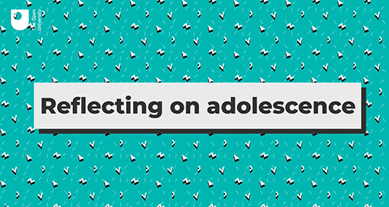

In this second session, you will learn how ‘adolescence’ is defined and why it is a time of development in a person’s life that brings its own set of challenges. You’ll gain some understanding of young people’s experiences, as well as what is going on in their brains at the same time. It isn’t always clear what is ‘normal’ when it comes to adolescent behaviour and mental health, indeed the very idea of what is normal can be questioned. This session will conclude by trying to shed some light on the idea of normality as it applies to adolescence.

Learning outcomes
By the end of this session, you should be able to:
- describe important aspects of development during adolescence
- explain how changes in the adolescent brain make adolescence a unique period of development
- outline the range of social challenges to mental health that may be experienced during adolescence
- discuss the idea of ‘normal’ and ‘abnormal’ adolescent behaviour.

1 Introducing adolescence
Often associated with the teenage years, adolescence is a transitional stage of development, both physically and emotionally.

Figure 1
View description - Figure 1
View description - Figure 1

Marked as a period of development from being a child to becoming a young adult, adolescence is described by many theorists as a time of ‘storm and stress’, often associated with particular behaviours, such as moodiness and irritability. But are these accurate depictions of adolescence? The first activity will help you to consider your own thoughts about adolescent characteristics.

Activity 1: Storm and stress
Allow about 20 minutes

Step 1: What thoughts, emotions and behaviours do you associate with adolescence? Choose your top four from the list. Please note, there are no right or wrong answers. To open up the discussion for this step, once you have selected your choices continue to click all the other options and select ‘Check Your Answer’.

Moodiness
Impulsiveness
Risky behaviour
Sensitive to peer pressure
Argumentative
Loneliness
Staying up late
Embarrassment
Thrill seeking
Boredom
Importance of friendships
Enjoying sport participation
View answer - Part
View discussion - Part

Step 2: Now, watch this video of a comedy sketch depicting ‘Kevin’s thirteenth birthday’ from the BBC series ‘Kevin and Perry’ starring Harry Enfield.

Watch the video at YouTube.com.
Video 2: Kevin’s thirteenth birthday (The Open University is not responsible for external content.)

Note down anything that reminds you of becoming a teenager!

Provide your answer...
View discussion - Part

The idea that adolescence is a time of crisis (or ‘storm and stress’) goes back to Psychologist G. Stanley Hall (1904) who described it in very unflattering terms, claiming that, ‘[the period of adolescence] is strewn with wreckage of body, mind, and morals. There is not only arrest, but perversion, at every stage, and hoodlumism, juvenile crime, and secret vice’ (Hall, 1904, p. xiv). Hall believed that young people were in the grip of powerful biological changes that they could not control.

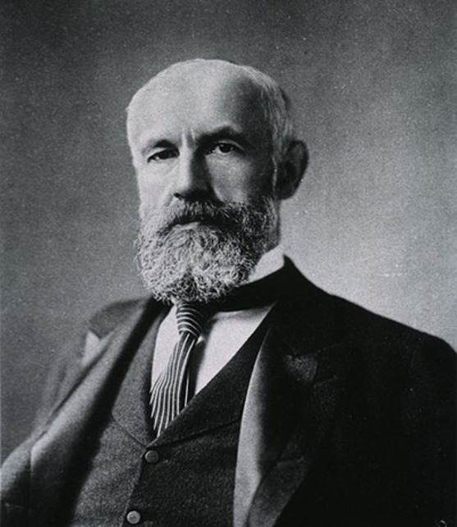
Figure 2: Stanley Hall
View description - Figure 2: Stanley Hall
View description - Figure 2: Stanley Hall

Although he acknowledged that adolescence could be a time of creativity, and crucial to the later development of personality, he also saw it as a time of instability, extremes and contradictions. For example, he saw that young people:
- wished for solitude and seclusion, but also longed to become embedded in friendships and romantic relationships, which took on an overwhelming importance in their lives
- were liable to be full of energy and creativity, but also to descend into gloom and despair
- were capable of idealism and sensitivity, and yet could be extremely cruel and callous
- yearned for idols and for people to look up to and yet rejected ideas of authority and the status quo.
Attitudes have changed since Hall’s time. Adolescence is not necessarily a time of storm and stress. Along with the term ‘crisis’, these troublesome-sounding concepts may be unhelpful because they perpetuate the idea that adolescence is a problem. Many adolescents do not experience conflicts or crises, and move easily from childhood to adulthood. Nevertheless, Hall’s theories of the characteristics of young people have remained highly influential and have coloured subsequent research.

1.1 A time of rapid change
When does a child become an adolescent, and when does adolescence end? These may sound like simple questions, but the answers are not simple. Here are a few definitions of the timing of adolescence. Click on each box to see the explanation. There is a long description button below the figure if this is easier to learn from.

Interactive content is not available in this format.
Interactive Figure 3: Definitions of the timing of adolescence
View description - Interactive Figure 3: Definitions of the timing of adolescence

There are many ways of viewing adolescence, and at its core it represents a time of rapid development initiated by hormonal changes. Next, you consider some of the detail.

1.2 Body changes
In adolescence, young people are going through significant physical changes brought on by puberty. They are growing taller, developing secondary sexual characteristics, and their bodies may well be changing in ways that they cannot recognise or that they actively dislike. They are becoming sexual, responding to members of the opposite sex in different ways, or becoming attracted to members of their own sex. The body is a primary site of identity and clearly these physical changes will have a great impact on who they are, on whether they see themselves as a child, on whether they understand themselves as sexual or sexually attractive, and on how they behave with this knowledge.
In girls, changes include breast development, menstrual periods, widening hips and growth of pubic hair. In boys, the testicles, scrotum and penis enlarge, facial and pubic hair grows, their voices deepen and they experience ‘wet dreams’ (Wiley and Corey, 2018). Changes in body composition during development mean that girls accumulate relatively more body fat while boys develop relatively greater muscle mass (Abreu and Kaiser, 2016). Figure 4 summarises the main features of puberty:

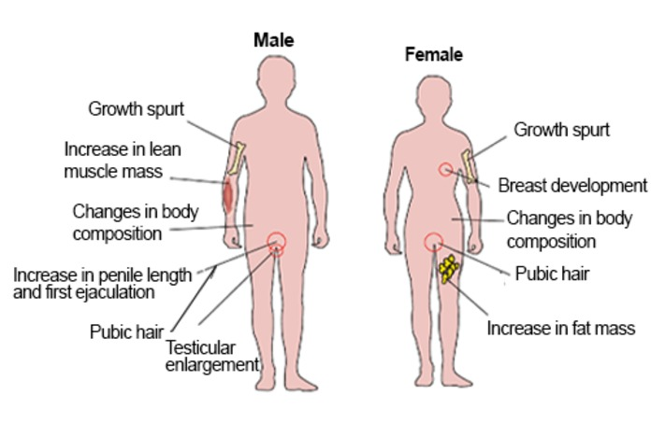
Figure 4: Physical changes and secondary sexual characteristics that appear during puberty.
View description - Figure 4: Physical changes and secondary sexual characteristics that appear during ...
View description - Figure 4: Physical changes and secondary sexual characteristics that appear during ...

Activity 2: What body changes mean to young people
Allow about 10 minutes

Spend a few minutes thinking about the implications of changes during puberty for young people. You might have vivid memories of your own experiences.

View discussion - Activity 2: What body changes mean to young people

1.3 Social changes
In the opening video, Martha and Josie talk about adolescence as a time of great change and often confusion. Whilst they describe many of these changes as challenging, particularly the pressures that many friendships bring, they also reflect on adolescence as a period of excitement marked by increasing responsibilities and new experiences. During adolescence, social spheres are expanding, often coinciding with a move to larger schools and a greater range of options for leisure activities or paid work. There is a tendency to move away from reliance on adult role models (e.g. their parents and caregivers, teachers and mentors) towards an increased emphasis on striving for autonomy, individuality and self-reliance. Friendships rise in level of importance for many and young people rely more on the opinions of friendship groups for approval rather than parents and other caregivers. This need for peer group approval can however, enforce risky behaviours such as drinking alcohol or smoking cannabis (Kehily and Pattman 2006).
The centrality of friendships lasts throughout adolescence but falls off by late adolescence when the importance of belonging to a crowd or a particular group is replaced by the need to become part of a more intimate relationship. In the next activity, you’ll think about elements of adolescent relationships.

1.4 Adolescence and emotion
At the onset of puberty, there are clear changes occurring in the brain on a young person’s journey towards emotional maturity. As you will see in the next section, adolescence is a time of great change in brain development, with implications for how young people recognise and regulate their own emotions (Yurgelun-Todd, 2007). These changes also appear to bring about an increased risk of problematic behaviours and emotions (Steinberg, 2005).

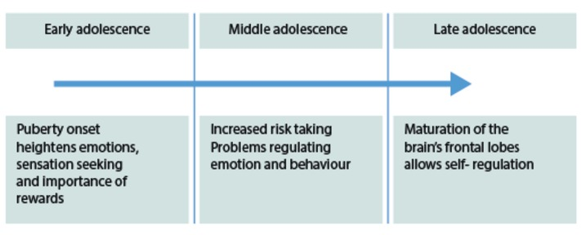
Figure 5: Typical trajectory for adolescent emotional development, adapted from Steinberg (2005)
View description - Figure 5: Typical trajectory for adolescent emotional development, adapted from Steinberg ...
View description - Figure 5: Typical trajectory for adolescent emotional development, adapted from Steinberg ...

You may remember that young people are beginning to distance themselves from their parents and caregivers. This means that adolescents may find themselves relying on their own slightly ‘wobbly’ emotion regulation capacities at a time when they are facing new social challenges.

1.5 Challenges of adolescence
In early adolescence there tends to be a heightening of emotions where young people often seek thrills and challenges (Steinberg, 2005). There is some evidence that adolescents experience greater extremes of high and low emotion (Larson et al., 1980) and that average daily mood becomes more negative between the ages of 9 and 14 (Larson and Lampman-Petraitis ,1989). Perhaps some of the stereotypes about adolescence actually contain a grain of truth!

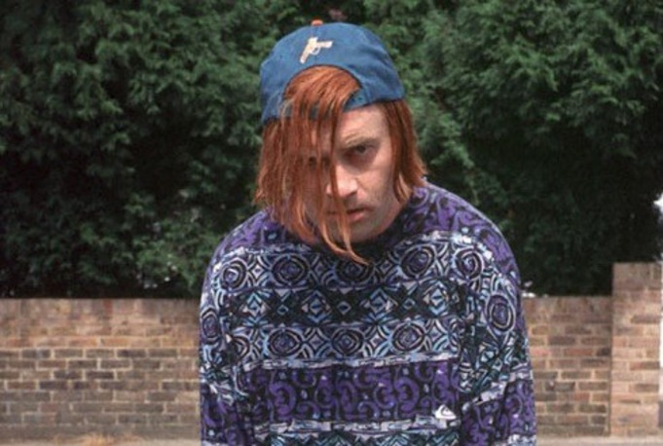
Figure 6: Kevin the teenager
View description - Figure 6: Kevin the teenager
View description - Figure 6: Kevin the teenager

It has also been found that having a boyfriend or girlfriend is particularly associated with wide mood swings (Larson et al., 1996) and it has been argued that this is one of the major sources of stress and emotional pain for many adolescents (Larson et al., 1999). For young people who do not identify as heterosexual (‘straight’), the emotional challenges may be even greater. The next activity asks you to consider a range of adolescent challenges.

Activity 3: Adolescent challenges
Allow about 15 minutes

Watch the video again (from the Session 2 Introduction).

Video content is not available in this format.
Video 1 (repeated): Reflecting on adolescence
View transcript - Video 1 (repeated): Reflecting on adolescence

What do you think are the most important challenges that the young person is facing? Jot down a few notes next to each of these:

physical | Provide your answer...
emotional | Provide your answer...
social | Provide your answer...

View discussion - Activity 3: Adolescent challenges

2 The adolescent brain
Understanding more about adolescent brain development can help you to understand how to support a young person’s mental health. Neuroscience is the scientific study of the nervous system. According to neuroscientists, adolescence constitutes a period of significant transformation in the brain. Neuroscience has advanced considerably since the late 1980s when new imaging techniques such as those you may have already heard of including CT scans and MRI scans, have allowed detailed images to be made of living brains. These images have allowed scientists to understand more about how brains function and develop.
The brain is the ‘control centre’ of the entire nervous system, which comprises nerve cells that transmit messages within the brain as well as between different areas of the brain and the rest of the body. In different parts of the brain, signals from the body are translated into perceptions, feelings, thoughts and actions.
You may be aware that various areas of the brain perform different functions. For example, the occipital lobe at the back of the brain (see diagram below) is responsible for converting the nerve signals originating in the eye into images that you can perceive as ‘sight’. The two areas of the brain that have received the most attention from neuroscientists studying adolescence are:
- the prefrontal cortex
- the limbic system.
Study Figure 7 to familiarise yourself with the locations and broad functions of the prefrontal cortex and the limbic system before moving on to the next activity.

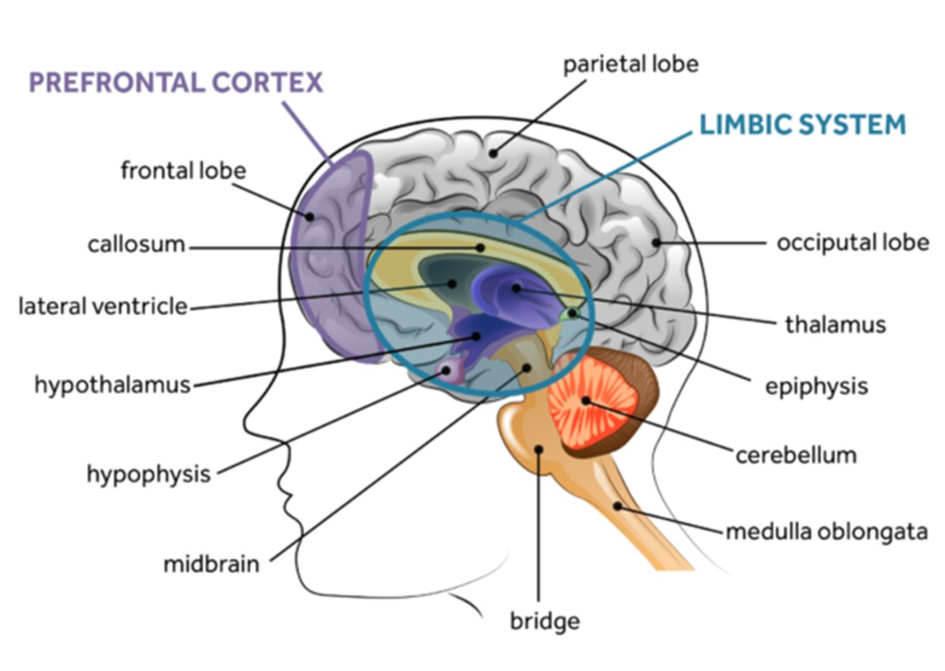
Figure 7
View description - Figure 7
View description - Figure 7

Activity 4: Brain changes during adolescence
Allow about 40 minutes

Step 1: Watch the first 4 minutes of the TED Talk [to 4.04], in which Sarah-Jayne Blakemore describes some of the changes occurring in the brain during adolescence. Jot down three (or more) pieces of information that you find interesting.
Sarah-Jayne Blakemore’s TED talk: The mysterious workings of the adolescent brain

Provide your answer...
View discussion - Part

Step 2: Watch the TED talk from the 4.04 minute point to 8.30. in which Sarah-Jayne Blakemore explains how functional MRI scans have shed light on social functions of the brain. She also describes an experiment. Before you move to the next step, make predictions of the outcomes of the experiment. Select one each from the two pairs of statements. Note that in psychology experiments ‘conditions’ are situations that participants are subjected to.

Both adults and adolescents found the task more difficult with the ‘director’ than with the ‘rules only’ condition.
Only adolescents found the task more difficult with the ‘director’ than with the ‘rules only’ condition.
View answer - Part

and

The ability to take someone else’s perspective in order to guide their behaviour is well developed in early adolescence.
The ability to take someone else’s perspective in order to guide their behaviour is still developing in mid to late adolescence.
View answer - Part

Step 3: Watch the TED talk from 8.30 to 11.39 to discover the outcomes of the experiment. Then, consider for a moment how many aspects of adolescent behaviour could be a reflection of normal brain development.

View discussion - Part

Step 4: Watch the TED talk from 11.39 to 14 minutes (to the end) and consider the following questions:
- What does Sarah-Jayne Blakemore say about how adolescents process emotion?
- What benefits could there be in having an ‘adolescent brain’?
Make notes here:

Provide your answer...
View discussion - Part

Linking adolescent behaviour with brain development can help people accept adolescence and some of the behaviours that are displayed then as a normal process rather than see it as abnormal or deviant. Risk-taking and peer pressure are two characteristics that are strongly associated with adolescence, and you’ll consider these further next.

2.1 Peer pressure and risk taking
You have already learned about an experiment, in which two different ‘conditions’ (the ‘director’ and ‘rules only’) were tested with different age groups.

Figure 8: Adolescents may take more risks when with peers
View description - Figure 8: Adolescents may take more risks when with peers
View description - Figure 8: Adolescents may take more risks when with peers

Psychologists Gardner and Steinberg (2005) conducted an experiment to explore age differences in risk taking. They asked their participants to play a computerised driving game in which they were able to take risks (e.g. driving through an amber or red light) in the pursuit of accruing points, with the aim of getting as many points as possible. They split participants into three age groups (13-16, 18-22, 24+) and assigned them randomly to one of two conditions – playing alone or in the company of two age-matched peers.
Their findings (see figure below) demonstrated that risk taking was greatest in adolescents in the company of their peers, followed by adolescents who were alone. Young adults took greater risks when with their peers, although this was of a lower magnitude, and adults took fewest risks both when alone and with peers.

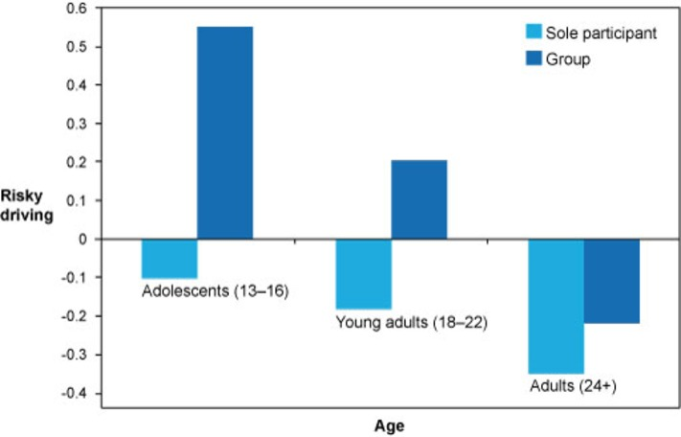
Figure 9: Interaction between age of participant (adolescent, young adult, adult) and individual v. group performance on a computerised game of risky decision making (Gardner and Steinberg, 2005)
View description - Figure 9: Interaction between age of participant (adolescent, young adult, adult) ...
View description - Figure 9: Interaction between age of participant (adolescent, young adult, adult) ...

This study appears to demonstrate that peers have an important role in adolescent risk-taking, and supports the assertion that peers become of greater significance during adolescence. This is, of course, a laboratory-based study and how this relates to actual real-world processes is unclear.
It is still not well understood how an individual’s experiences and behaviours may influence their brain development, or what the implications of certain experiences or learning opportunities in the adolescent period are for the subsequent adult brain. This area of brain development is known as ‘experience-dependent plasticity’ (Dow-Edwards et al., 2019, p. 2). ‘Plasticity’ refers to the ability of the brain to adapt its structure and function in response to accumulated experience and behaviours. A classic example of plasticity is learning to play a musical instrument, in which the nerve pathways involved in controlling movements, reading music and listening to the sounds produced, are reinforced with practice (Herholz, 2012).
Research focusing on the effect of alcohol or drugs on the developing adolescent brain has revealed that these substances can interfere with normal brain development (Dow-Edwards et al., 2019; Spear, 2018). It may be encouraging to know that there are signs that young people are beginning to reject social pressures to drink alcohol (Larm et al., 2018; Vieno et al., 2018). In the next section, you’ll consider some of the other challenges of social pressures.

3 The social world of adolescence
The social world of adolescents is central to their health and wellbeing. It can make young people feel vulnerable as well as provide opportunities for support. In this section, you will consider vulnerability in more detail.

Figure 10
View description - Figure 10
View description - Figure 10

In the opening activity, you will reflect on the social context of adolescence, the pressures it places on young people, and how they might respond.

Activity 5: Identifying sources of pressure
Allow about 10 minutes

Step 1: First, jot down the first thing that comes to mind about adolescent social pressures, e.g. the pressures to meet expectations of other people in their social world of family, friends, peers, communities.

Provide your answer...
View answer - Part

Step 2: Watch this video and make a note of some the factors that are mentioned by John Goss.

Video content is not available in this format.
Video 3: John Goss on sources of pressure
View transcript - Video 3: John Goss on sources of pressure

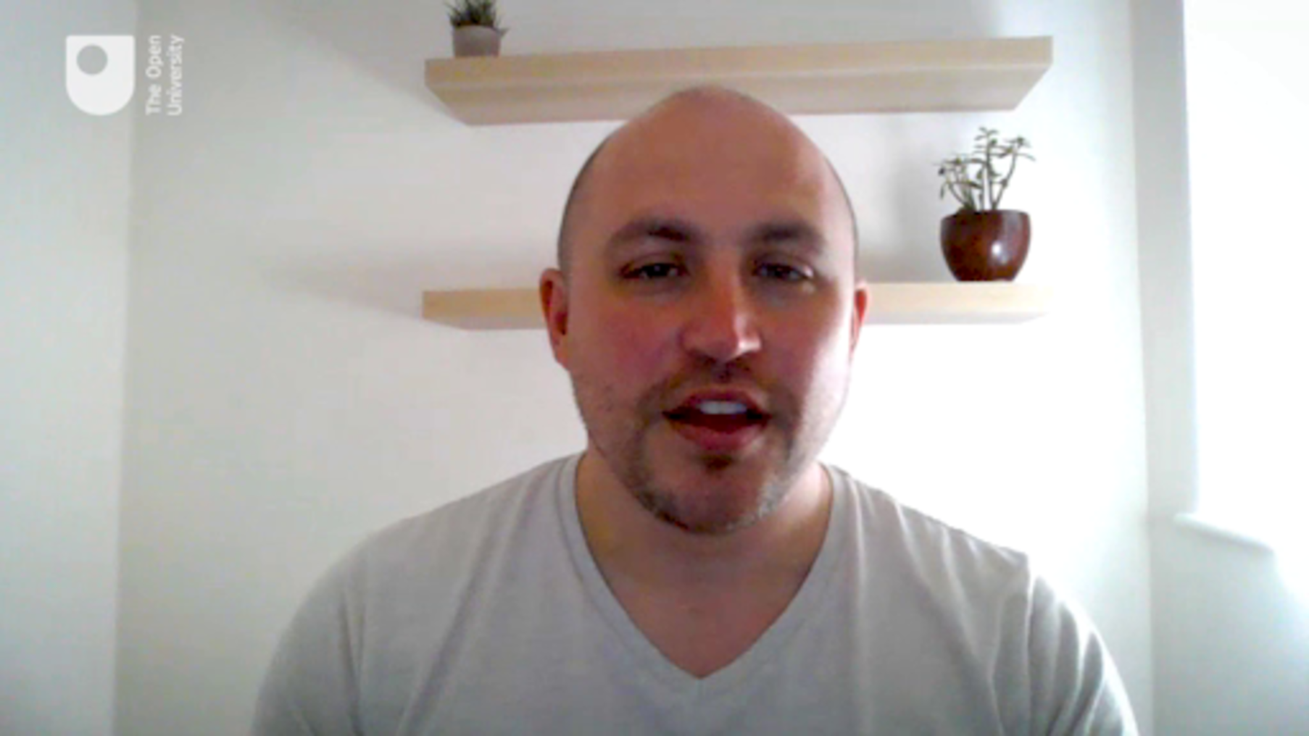

Provide your answer...
View discussion - Part

Step 3: Read the list and think about a young person you know. How many of these pressures do you think they may be experiencing? Tick the three most important ones to you. There are no right or wrong answers here. To open up the discussion for this step, once you have selected your choices continue to click all the other options and select ‘Check Your Answer’.

Managing friendships
Family relationships
Romantic relationships
Exam pressures
Health concerns about self or others
Lack of clear career motivations/ambitions
View answer - Part
View discussion - Part

Some social situations can be difficult and challenging. You’ll consider the challenges of bullying and loneliness next.

3.1 Bullying
Bullying is an extreme form of social pressure.

Figure 11
View description - Figure 11
View description - Figure 11

According to Bullying UK (2019), bullying can be defined as: ‘repeated behaviour which is intended to hurt someone either emotionally or physically, and is often aimed at certain people because of their race, religion, gender or sexual orientation or any other aspect such as appearance or disability.’
If you have any experience of bullying, you will appreciate that bullying can be subtle, cumulative, and not easy to describe to someone. The bullies themselves may be struggling to handle their own situation. In the next activity, you will watch a video created by young people who have experienced bullying.

Activity 6: Anti-bullying campaign
Allow about 10 minutes

Watch this anti-bullying campaign video and make a note of the main message you take from it.

Watch the video at YouTube.com.
Video 4: Winners of Anti bullying campaign video - Virus by PQA Torbay (The Open University is not responsible for external content.)

Provide your answer...
View discussion - Activity 6: Anti-bullying campaign

Bullying is a common experience. A large Canadian study on the extent of bullying in young people found that 58% of girls and 68% boys had experienced some form of bullying during a year (Salmon et al., 2018). Types of bullying included physical threats or injuries, ridicule, saying something bad about their race or culture or sexual orientation or their appearance, and applying pressure in social media. Cyberbullying can be particularly difficult to escape as it can spread rapidly through social media (Hill et al., 2017)
Bullying can be particularly hurtful in the context of adolescence where peer relationships are so pivotal. Loneliness can also inflict pain in adolescence, and you’ll explore this next.

3.2 Loneliness
Adolescents are driven to form friendship groups, from which they gain a sense of belonging and in which they can form their own sense of identity. Feeling ‘left out’ for any reason can lead to loneliness. Loneliness research is an important area for improving understanding of how to help young people who are experiencing loneliness. According to UK (England) statistics, about 10% of 16 to 24-year-olds report feeling lonely ‘often/always’ and 23% report feeling lonely ‘some of the time’, which is significantly greater than people in older age groups (ONS, 2018). Comparable figures are not available for those under 16.
Research carried out during the COVID pandemic indicates how many children and young people find social isolation exceptionally difficult and challenging to their mental health and may add to many worries they have about their own health and the health of their loved ones.
You can read more about the impact of the COVID pandemic here (remember to open these links in a new tab or window, so you can return to the course when you are finished):
- Teenagers’ mental health under severe pressure as pandemic continues - new research
- Pandemic takes toll on young’s mental health, says report
- The impact of COVID-19 on linguists and their mental health
- Grief and COVID-19: Mourning what we know, who we miss and the way we say goodbye
- Five ways in which COVID-19 has impacted on progress in global health
- Coping in isolation: Time to Think
- How can Adult Carers get the best support during Covid-19 pandemic and beyond?
- How does COVID-19 affect cancer treatment?
Later in this course you will also have the opportunity to hear about young people’s experiences during lockdown and the impact of COVID on adolescent mental health.
Loneliness researcher Gerine Lodder has given a TED talk on adolescent loneliness. To get a sense of a young person’s experience of loneliness, work with the video in the next activity.

Activity 7: the experience of loneliness
Allow about 20 minutes

Step 1: Watch Video 4 from the beginning to the 3.30 minute point. What are first the two misconceptions about loneliness Gerine Lodder describes?

Video content is not available in this format.
Video 5: What you don’t know about adolescent loneliness | Gerine Lodder | TEDxGroningen
View transcript - Video 5: What you don’t know about adolescent loneliness | Gerine Lodder | TEDxG ...

Provide your answer...
View discussion - Part

Step 2: Continue watching Video 4 to 4.32 minutes. Notice what Gerine Lodder says about the effects of loneliness on a young person’s health.

View discussion - Part

Step 3: Continue watching Video 4 to the end. Write down the third misconception and the ‘real’ explanation:

Provide your answer...
View discussion - Part

Later in this course you will focus on the different strategies and approaches that can be used to support a young person who is experiencing mental health difficulties perhaps in relation to feelings of loneliness and bullying.
You have covered a lot of ground so far, thinking about the characteristics of adolescence. In the next section, you’ll consider the implications of all this in relation to how people might set the limits on what is ‘normal’.

4 What’s ‘normal’ and ‘abnormal’?
Adolescence is often viewed very negatively, with young people seen as out-of-control, irresponsible, threatening, lazy, discontented, sexually obsessed, naive and difficult to deal with. A young person is often seen as a troublemaker or as a nuisance who must ‘grow up’. They are sometimes discriminated against in a way that would be unthinkable for other sections of the population – banned from shopping centres, for example, not because they have been proved to be troublemakers but because of the assumption that they will cause difficulties. This sense of social exclusion is another challenge that young people have to face, and the dislike of young people that is sometimes expressed indiscriminately in the media also contributes to adolescents’ identity, albeit in a negative way. It is important to note that concerns about the behaviour of young people is not new. For example, in the 1960’s there was a lot concern about the behaviour of members of the youth subcultures the ‘mod and rockers’, such that Stanley Cohen (1972) described it as a ‘moral panic’ in being a sensationalist and over the top reaction. In the 1990’s there was a similar panic about EMO pop bands which were thought to encourage young people to undertake acts of self harm.
Earlier in the course, you found that many young people today seem to be experiencing an increase in mental health problems. What is certainly clear is that there has been an increasing concern in the media and elsewhere about young people’s mental health, resulting in a range of reports and initiatives. Take a look at these headlines:

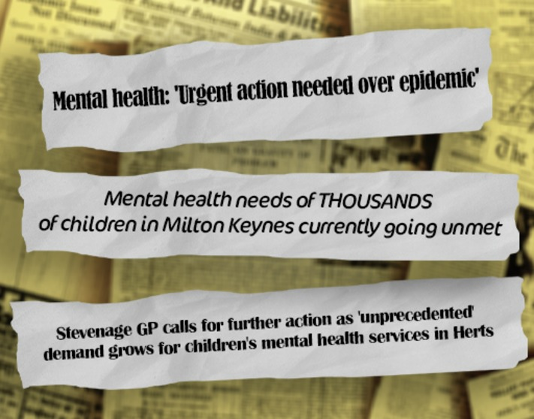
Figure 12: News headlines
View description - Figure 12: News headlines
View description - Figure 12: News headlines

It can be difficult to know when a young person needs help, and what kind of help they might need. In the next activity, you will engage with an interactive case study to see how well you are able to recognise a problem and assist a young person.

4.1 Recognising a problem
For this activity, it’s not about getting it right - it’s about exploring different ways of understanding young people and the different approaches that can be used to support them.

Activity 8: Helping Lily and Ethan
Allow about 20 minutes

Go to the opening page of the interactive case studies, and select either Lily or Ethan. Work through the whole activity with one of them.

Click here to explore the activity. Remember to open the link in a new window or tab so you can refer back to the course when you are ready.
View description - Click here to explore the activity. Remember to open the link in a new window or ...
View description - Click here to explore the activity. Remember to open the link in a new window or ...

View discussion - Activity 8: Helping Lily and Ethan

Are you any closer to deciding what a ‘normal’ adolescent looks like? Changes in the brain, which are independent of cultural judgements about adolescence, indicate that you can expect swings in emotion, a greater tendency to take risks, and immature decision-making abilities as the norm. You might expect more arguments as adolescents test their social boundaries. When young people reach a point where they become unable to function in a way that promotes their longer-term health and wellbeing, you may have cause for concern. Some of this ability to cope with difficulties will be discussed in Session 5, which is about resilience.
Mental health difficulties, similarly, become a cause for concern when the young person is struggling to cope. The diagram below, produced by the UK Centre for Mental Health, shows a spectrum in which there may be no clear dividing line between the transitions from trouble-free mental health, a situation where a young person is coping well with challenges, to points where they struggle or become unwell. As you continue through this course, you’ll refer to this spectrum periodically.

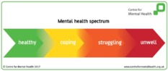
Figure 13: Mental health spectrum
View description - Figure 13: Mental health spectrum
View description - Figure 13: Mental health spectrum

5 This session’s quiz
Check what you’ve learned this session by taking the end-of-session quiz.
Session 2 practice quiz
Open the quiz in a new window or tab then come back here when you’ve finished.

6 Summary of Session 2
The main learning points of this session are:
- The long-standing idea that adolescence is a time of crisis (or ‘storm and stress’) is partially supported by more recent research although it is also evident that the influences on adolescent are complex and cannot be reduced to such a generalisation. Adolescents are living through changes in their bodies, their social world and the ways in which their emotions guide their behaviours.
- Brain changes during adolescence, which have been discovered by the use of MRI and fMRI imaging, affect the way adolescents make decisions and learn. During this time of transition, young people may engage in risk-taking and become more receptive to peer pressure. Brain plasticity means that this is a good time for learning as well as susceptibility to the effects of alcohol and drugs.
- Sources of difficulty in the adolescent’s social world include bullying and loneliness, which are heightened by the drive to feel a sense of belonging to friendship groups.
- There is no clear dividing line between ‘normal’ and ‘abnormal’. Encouraging young people to talk about what is happening in their lives can help them to cope and make healthy decisions.
Now go to Session 3.

Session 3: Different dimensions of adolescent mental health

Introduction
Mental health becomes a problem when it interferes with daily life.

Figure 1
View description - Figure 1
View description - Figure 1

Although individuals vary, there are certain signs and behaviours that can signal that a young person is struggling with their mental health and in this session you’ll learn about some of them. Mental health depends on social, emotional and psychological wellbeing. The causes of mental health problems are often a combination of biology (how the brain and body work, especially in response to stress), psychological traits (e.g. personality type), the social environment (life experience), and sometimes certain chemical substances (such as alcohol or marijuana). A tendency to develop mental health problems can run in families, although the reasons for this are complicated and may include inequalities and poverty that run between generations. There is still a great deal of debate among researchers about how these factors interact. However, most experts now agree that there is rarely a single cause.
To get started on understanding some of the different dimensions that can affect mental health, watch the video, which features a group of young people describing their own experiences of mental health problems.

Video content is not available in this format.
Video 1: Mental health in our own words
View transcript - Video 1: Mental health in our own words

This session will introduce you to four sets of common mental health problems, starting with anxiety and depression. Anxiety and depression are commonly used terms, and you will get below the surface to discover what they mean. Anxiety and depression can sometimes develop into other behaviours such as eating disorders and self-harm. On your journey through this session, you may encounter material that can be unsettling, although we hope that the knowledge and understanding you gain will help you to become a more effective supporter of young people who are struggling with their mental health. If you are affected by any of the course material please refer to our support notes at the end of this session.

Learning outcomes
By the end of this session, you should be able to:
- describe some of the characteristics of a range of mental health problems
- recognise the potentially unhelpful behaviours that can arise with mental health problems
- identify measures that enable you to help young people who are experiencing mental health problems.
Some conditions are not covered here, for example, bi-polar disorder, Obsessive Compulsive Disorder and schizophrenia, including auditory hallucinations and substance abuse. You can find links to information about these conditions in the Error! Hyperlink reference not valid..

1 When does mental health become ill-health?
According to the World Health Organization, ‘Mental disorders comprise a broad range of problems, with different symptoms. However, they are generally characterized by some combination of abnormal thoughts, emotions, behaviour and relationships with others’ (WHO, n.d.).
There may be no clear dividing line between a situation where a young person is coping well with challenges, to a point where they struggle or become mentally unwell. As you can tell from the video you watched in the session introduction, problems with mental health can unfold gradually to a point where the young person and the people around them realise they have a serious problem. In the next activity, you’ll revisit the video and consider where to place these young people on the mental health spectrum.
You first saw this spectrum in Session 2. At the green ‘healthy’ end, there would be no particular cause for concern, except to ensure that the young person has the support and skills necessary to deal with everyday life. In the yellow ‘coping’ zone, the young person may be experiencing difficulties and need extra help to prevent any problems developing further. In the orange ‘struggling’ zone, the problems may become more visible and it is possible a diagnosis of a mental health problem will be made. An ‘unwell’ young person who has a very serious problem may need highly specialised help.

Activity 1: A spectrum of mental health
Allow about 20 minutes

Think about the mental health spectrum in Figure 2 and consider each of the case studies below of young people who are experiencing emotional challenges. As their stories progress, think about where they would be on the spectrum.

Figure 2: Mental health spectrum (repeated from Session 2.)
View description - Figure 2: Mental health spectrum (repeated from Session 2.)
View description - Figure 2: Mental health spectrum (repeated from Session 2.)

Case 1: Jack
Jack had surgery and found it really difficult to play sport and go out with his friends, he found it really hard to cope with this. He became really sad and spoke to a teacher at school who tells him he needs to pick himself up and get on with it. But then as he continued to struggle to get to sleep, he then started to find it hard to get up in the morning and struggled to concentrate in lessons. He finally got help when he refused to go to class.

Case 2: Suzie
Suzie is shy and got bullied at school as a result. This really affected her self esteem and confidence. It also started her worrying when speaking in groups. This kicked off anxiety and she found it hard to enter particular classrooms where she knew the bullies were – she started missing these classes.

Case 3: Bob
Bob started questioning their gender identity from the age of 15. This became a big problem when they shared it with a friend who then broke their confidence and now the whole of her class know. They started to self harm and found they woke up in the middle of the night and could not get back to sleep. Their swim teacher noticed the marks on their arm were bleeding and reports it to her mum.

View discussion - Activity 1: A spectrum of mental health

Although mental health problems can sometimes make people feel trapped in cycles of unhelpful thoughts, feelings and behaviours, it is important to realise that with the right help solutions can be found. Going forward in this course, you’ll come across many examples of how family and friends as well as professionals can help young people.
Everyone has set-backs that can make them feel low, sad or anxious. However, we often know when all is not as it should be, and the next section considers when anxiety becomes a problem.

2 Anxiety
Anxiety is a normal response to situations that may threaten wellbeing. Signs of anxiety usually include feelings of being frightened, worried, nervous or panicky, and these feelings can be useful if you need to respond to a threatening situation.

Figure 3: An illustration of depression
View description - Figure 3: An illustration of depression
View description - Figure 3: An illustration of depression

It is perfectly normal to feel anxious before an exam, the results of which can determine future opportunities. It is also normal to feel anxious in an encounter with a growling dog, which could pose a threat to your physical safety. Many of us will empathise with the feelings of anxiety that can be heightened during a viral pandemic that also pose real threats.
If anxiety persists, young people may have difficulties sleeping, eating and being able to concentrate. When anxiety becomes a more generalised feeling that interferes with everyday life over a lengthy period, it is no longer a useful feeling and it can become a mental health problem. In the next activity, you’ll read about Kim who is having a problem with anxiety.

Activity 2: Kim’s anxiety
Allow about 10 minutes

Read the case of Kim, who is experiencing problems with anxiety. Then, jot down some notes in response to the following questions:
- Which aspects of Kim’s experience might lead you to believe she is ‘struggling’ rather than ‘coping’ with anxiety?
- Are there any aspects of her experience you might consider ‘normal’?
- What makes it difficult to decide?

Kim, who is 15, feels stressed and exhausted all of the time, sleeps badly, and has frequent headaches. She worries persistently about her schoolwork. Each morning on a school day, she gets a ‘nervous tummy’ and sometimes she stays off school because of this. The problem started a couple of years ago when her parents were having terrible rows, at which point she felt incapacitated with anxiety. Since then, her parents have split up and she now lives with her grandparents.

Provide your answer...
View discussion - Activity 2: Kim’s anxiety

Feelings of anxiety may follow life events and certain trigger experiences. For many, although not all young people, learning how to regulate and manage their feelings can be helpful. Session 6 will introduce ways of helping young people.

3 Depression
Depression, thought of as a problem with low mood, is generally a feeling of sadness accompanied by a sense of hopelessness, emptiness, and the loss of interest in things one used to enjoy.

Figure 4: Depression
View description - Figure 4: Depression
View description - Figure 4: Depression

Young people who are depressed are more likely to be irritable or show aggression than adults with depression. They may also refuse school, perform progressively less well in education, and isolate themselves from family and friends (Roberts, 2013). Young people with depression often find it difficult to sleep, or perhaps feel sleepy or tired for large parts of the day. They may express feelings of worthlessness or guilt, and find it difficult to concentrate. You may also notice changes in their appetite.

Activity 3: Elliott’s depression
Allow about 10 minutes

Read this case of Elliott, who is experiencing depression:

Elliot, who is 16, has had difficulty sleeping in the past few months and is frequently tired. He has been spending more time alone and, despite complaining of boredom, has little energy or desire to go out with his friends. His parents have noticed that he has been much more irritable than normal and that he doesn’t seem to be doing much homework these days. When asked about these changes, he says he feels worthless and that nobody likes him.

- Which aspects of Elliott’s experience might lead you to believe he is ‘struggling’ rather than ‘coping’ with his low mood?
- Are there any aspects of his experience you might consider ‘normal’?
- What makes it difficult to decide?

Provide your answer...
View discussion - Activity 3: Elliott’s depression

Many of the signs of anxiety and depression can look similar, and it will help to talk to a young person you are concerned about. You’ll explore ways of encouraging a young person to talk in Session 6. The next section explores eating disorders, which can sometimes arise when a young person is depressed or anxious.

4 Eating disorders
Eating disorders most commonly start in the mid-teens and can become serious illnesses.
In economically advanced countries, it is estimated that the proportion of adolescents and young adults experiencing eating disorders is approximately 3% (30 in a thousand) females and 0.1% (one in a thousand) males. It is easy to underestimate the amount, however, because not everyone seeks help and it can be difficult to conduct surveys that are truly representative of a community (AYPH, 2019).

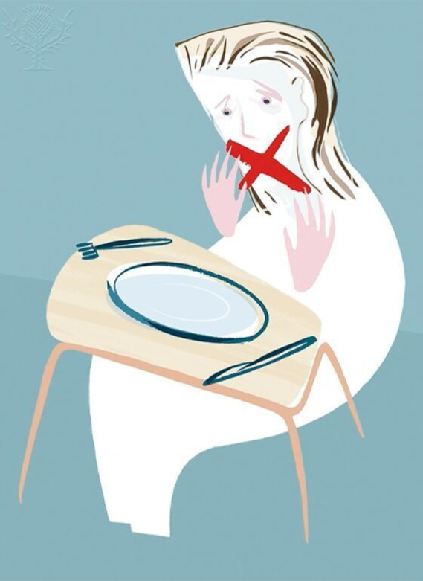
Figure 5: Eating disorder
View description - Figure 5: Eating disorder
View description - Figure 5: Eating disorder

According to the National Institute for Health and Care Excellence (NICE), an eating disorder is when you have an unhealthy relationship with food which can take over your life and make you ill. It might involve eating too much or too little, or becoming obsessed with controlling your weight (NICE, 2017, p. 2).
Eating disorders can be a way of coping and/or expressing emotional distress. Causes of eating disorders are varied and are thought to include:
- low self-esteem, depression or anxiety
- family history of eating disorder and inherited genes
- relationship difficulties, peer pressure to be thin or bullying (Bould et al., 2017).
A young person with anorexia nervosa, for example, becomes preoccupied with weight and body shape and tries to lose weight by restricting food intake, exercising, inducing vomiting or using laxatives. Limiting food intake can be a way of feeling in control and coping with life but the young person can also feel as though the illness controls them. It is common to deny weight loss, have an extreme fear of gaining weight and resist offers of help.
In the next activity, you’ll hear about three types of eating disorder.

Activity 4: Dealing with an eating disorder
Allow about 10 minutes

Watch this video, a cartoon-style explanation of different eating disorders.

Video content is not available in this format.
Video 2: Different eating disorders
View transcript - Video 2: Different eating disorders

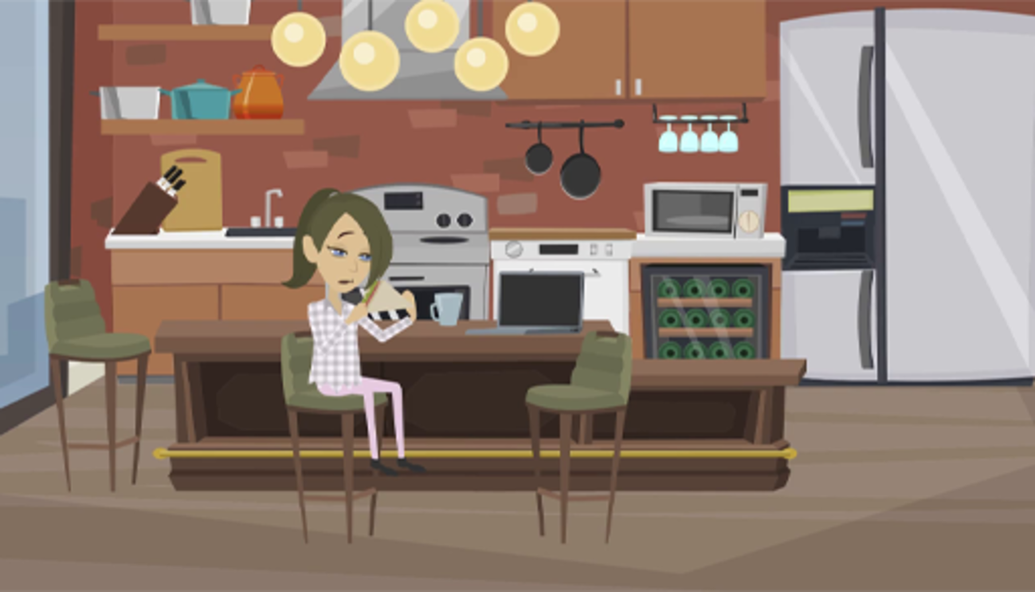

Pick out three common themes relevant to all the types of eating disorder mentioned in the video: Anorexia nervosa, Bulimia nervosa, and Binge eating disorder.

Provide your answer...
View discussion - Activity 4: Dealing with an eating disorder

4.1 Early intervention
Early intervention in the case of an eating disorder makes a substantial difference in reducing the ongoing distress and improving outcomes. In Figure 6, you’ll see figures from a survey conducted by the UK charity BeatED in 2017, which shows that it took on average 69 weeks before recognising a young person had an eating disorder and it took a further 39 weeks before the young person sought medical help.

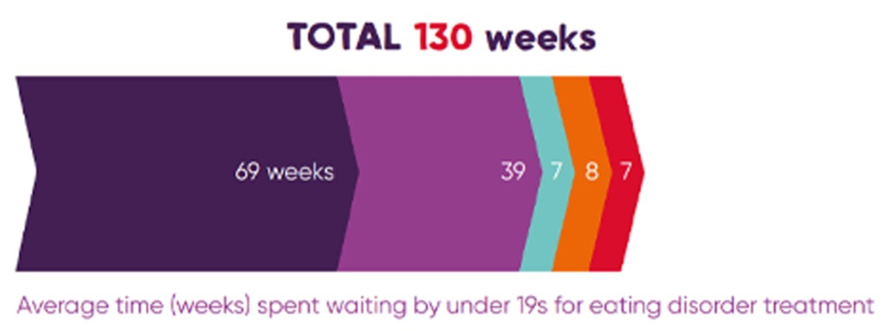
Figure 6: The average time (weeks) spent waiting by under 19s for eating disorder treatment.
View description - Figure 6: The average time (weeks) spent waiting by under 19s for eating disorder ...
View description - Figure 6: The average time (weeks) spent waiting by under 19s for eating disorder ...

Reasons for the initial delays vary. The next activity helps you to consider some of these.

Activity 5: Reasons for a delay in seeking help for an eating disorder
Allow about 10 minutes

Which of the following could be reasons for the delay in a young person recognising they have an eating disorder and seeking medical help? Tick any you think may apply.

Perceived stigma of mental health problems
Family tensions making communication difficult
Not realising the problem is serious
Not knowing what to say or how to say it
The young person is good at hiding their problem
Lack of information about eating disorders
Denial of the problem
Most people are already well informed and know how to deal with an eating disorder
View answer - Activity 5: Reasons for a delay in seeking help for an eating disorder
View discussion - Activity 5: Reasons for a delay in seeking help for an eating disorder

Eating disorders can create tensions and guilt in families and parents may find it difficult to help effectively (Eklund and Salzmann-Erikson, 2016). An interesting study of South Asians living in the UK found that they:
- worried about the stigma associated with mental health
- thought eating disorders could be easily fixed
- worried about privacy and confidentiality within their communities
- warned that these issues were not confined to this ethnic minority.
(Wales et al., 2017).
There is also some evidence that 16-25-year-old males do not recognise an eating disorder in themselves because they consider it a female problem (Räisänen and Hunt, 2014) and that this is a stereotype entrenched in the media (Maclean et al., 2015).
Early identification is important in all mental health problems and it can sometimes prevent the development of unhealthy behaviours such as self-harm, which you will consider next.

5 Self harm
Similar to eating disorders, self-harm is an expression of emotional distress. People who self-harm tend to use it as a coping strategy for handling intense feelings such as anger, distress, fear, worry, depression or low self-esteem (SelfharmUK, 2020a and b). Have a look at the statement from the Royal College of Psychiatrists:

Self-harm happens when you hurt or harm yourself. You may:
- take too many tablets – an overdose
- cut yourself
- burn yourself
- bang your head or throw yourself against something hard
- punch yourself
- stick things in your body
- swallow things.
It can feel to other people that these things are done calmly and deliberately – almost cynically. […]Some of us harm ourselves in less obvious, but still serious ways. We may behave in ways that suggest we don’t care whether we live or die – we may take drugs recklessly, have unsafe sex, or binge drink. Some people simply starve themselves.
Royal College of Psychiatrists (2016)

Activity 6: Reactions to self-harm information
Allow about 10 minutes

Read the statement from the Royal College of Psychiatrists again and note your immediate responses, selecting from the list below. Use the text box to record any further thoughts or reflections you may have. Please note, there are no right or wrong answers.

Difficult to fully grasp.
It must be attention seeking behaviour.
I know someone who has done this.
Perhaps they don’t feel the pain like others do.
I wouldn’t know how to help someone with this problem.
Provide your answer...
View answer - Activity 6: Reactions to self-harm information
View discussion - Activity 6: Reactions to self-harm information

According to the charity Young Minds, self-harm affects up to 1 in 5 young people. An analysis of medical records has indicated that instances of self-harm are rising (Morgan et al., 2017). Self-harm is mainly done in private and is often hidden, and it is a very sensitive topic, so the reliability of data about young people who self-harm has to be considered carefully. For example, has there been a genuine increase in self-harm over the past few decades, or merely more reporting, help seeking and acknowledgement of the issue?
The charity YoungMinds has written a summary of warning signs for self-harm:

There are many signs you can look out for which indicate a young person is in distress and may be harming themselves, or at risk of self-harm, the most obvious being physical injuries in which:
- you observe marks on more than one occasion
- they appear too neat or ordered to be accidental
- the marks do not appear consistent with how the young person says they were sustained.
Other warning signs include:
- secrecy or disappearing at times of high emotion
- long or baggy clothing covering arms or legs even in warm weather
- increasing isolation or unwillingness to engage
- avoiding changing in front of others (may avoid PE, shopping, sleepovers)
- absence or lateness
- general low mood or irritability
- negative self-talk – feeling worthless, hopeless or aimless.
‘At first we thought he was just accident prone, it was easy to miss, he always had an explanation as to how he’d got hurt.’
(Source: Young Minds, 2020, p.3)

You will see some similarities with other mental health problems such as eating disorders, and it is important to realise that the accumulation of signs should raise warning signals.

5.1 Breaking the self-harm cycle
Self-harm is an expression of emotional distress, or of relief of unbearable tension and a sign that something is seriously wrong – it can also be an attempt to communicate internal distress and a need for help. For these reasons, and because of the physical damage people may inflict on themselves, witnessing self-harm in someone you care for or about can be distressing. It can also be puzzling, trying to understand what drives a person to hurt themselves in these ways. If, however, a young person is brave enough to seek help in relation to these behaviours, this should be considered an act that has taken courage and needs a sensitive response.

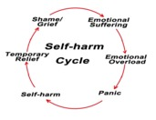
Figure 7: The self-harm cycle
View description - Figure 7: The self-harm cycle
View description - Figure 7: The self-harm cycle

There are no clear-cut explanations about why people begin to self-harm. Reasons that have been put forward include a reaction to specific difficult or unpleasant experiences, and a way of dealing with something that is happening now or that happened in the past. Other common reasons suggested are:
- bullying
- difficulty at school
- sexual, physical or emotional abuse
- failure of relationships (Smith, 2013, p. 5).
Given the highly individual nature of this type of act, it is important not to make too many assumptions. The next activity will help you to consider these issues further.

Activity 7: Understanding the self-harm cycle
Allow about 15 minutes

Watch the video ‘Understanding and breaking the self-harm cycle’ presented by Child and adolescent mental health expert Pooky Knightsmith.

Video content is not available in this format.
Video 3: ‘Understanding and breaking the self-harm cycle’ presented by Child and adolescent mental health expert Pooky Knightsmith.
View transcript - Video 3: ‘Understanding and breaking the self-harm cycle’ presented by Child and ...

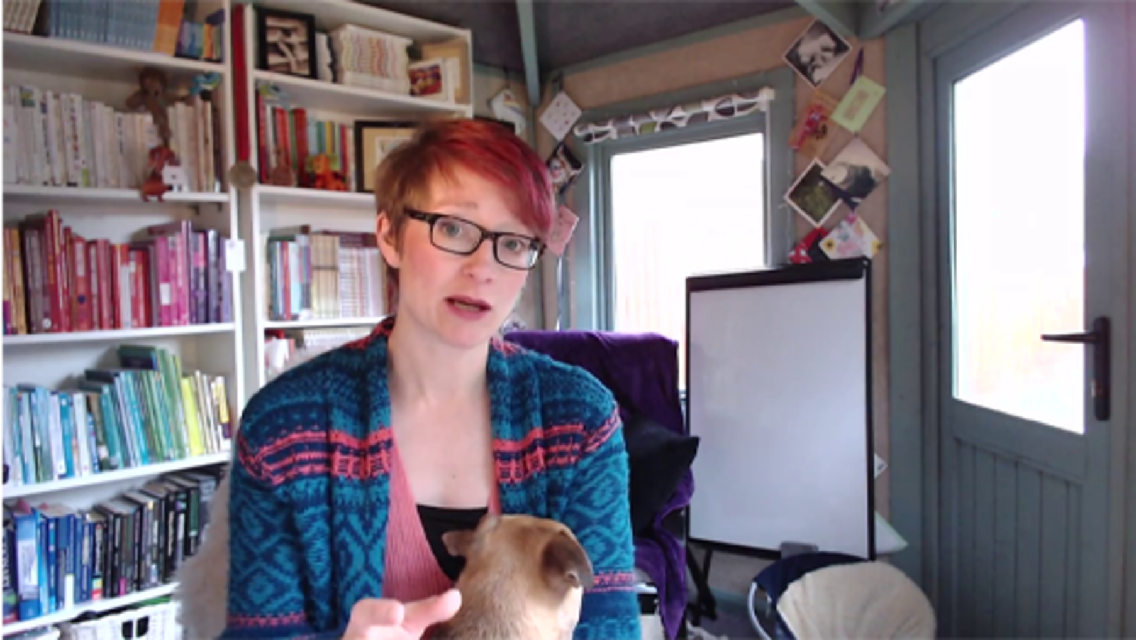

If you know someone who is self-harming, make a note of one or two things you might be able to do to begin breaking the cycle.

Provide your answer...
View discussion - Activity 7: Understanding the self-harm cycle

Sadly, young people who self-harm are more likely than average to contemplate suicide. The next section will deal briefly with this difficult topic.

6 Suicide
Young people face many challenges growing up. You will have already noted that adolescence represents a period of considerable physiological and psychological change, which brings with it new opportunities and experiences. This can be both daunting and exciting and yet as the Mental Health Foundation (2003) stress, for some young people these emotional challenges can be too much to bear.
Suicide is rare at any age and is often undertaken as a last resort in response to emotions, problems and challenging circumstances that overwhelm an individual. It is particularly associated with feelings of hopelessness that things will never get better and a feeling of a lack of control over the future.
The latest available UK figures (at the time of writing) show that in the age group 10-14, the suicide rate is 0.4 per 100,000 and in the 15-19 age group it is 6.7 per 100,000. The highest suicide rates occur in the age group 45-49 (18.1 per 100,000). Suicide is considerably more common in males than in females (ONS, 2019).
If you have studied the course up to this point, you’ll already have some understanding of the emotional challenges for adolescents. In particular, young people may struggle with self-esteem issues and self-doubt. As with all mental health problems, the key to helping is to start a conversation. The infographic in Figure 8 summarises how to help using the WAIT acronym shared by the Mental Health Foundation:

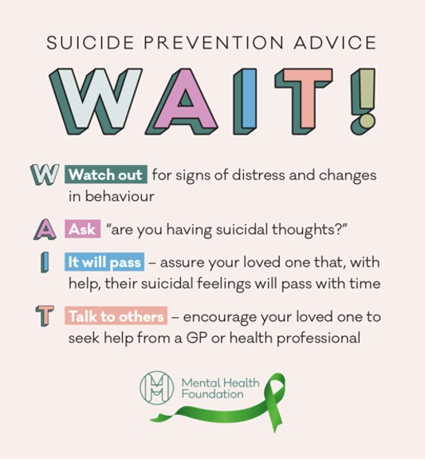
Figure 8: Suicide prevention advice
View description - Figure 8: Suicide prevention advice
View description - Figure 8: Suicide prevention advice

An important message to take from this advice is that directly asking a young person about whether they are having suicidal thoughts will not increase the likelihood of suicide. Contrary to the fears of many, asking about suicide ‘can start a potentially life-saving conversation’ (Mental Health Foundation, 2020). Talking to a young person and encouraging them to share their concerns is vital and will enable you as a parent, carer or practitioner working with young people to seek specialist guidance and support.

If you are concerned about a young person who is showing signs of distress, disclosing their thoughts about suicide or eliciting changes in their behaviour there are avenues of support available to you. If a young person shares suicidal thoughts or feelings with you, it is important that you take them seriously and seek guidance about how to best support the young person and to protect them from undertaking actions which may cause their death. It may be helpful to talk to their carers or parents. Or if you are their parent or guardian talking to the GP about these disclosures will help you to plan what you need to do. Other immediate sources of help include:

- Samaritans offer a 24-hours a day, 7 days a week support service. Call them FREE on 116 123. You can also email jo@samaritans.org
- Papyrus is a dedicated service for people up to the age of 35 who are worried about how they are feeling or anyone concerned about a young person. You can call the HOPElineUK number on 0800 068 4141, text 07786 209697 or email pat@papyrus-uk.org
- NHS Choices: 24-hour national helpline providing health advice and information. Call them free on 111.

7 This session’s quiz
Check what you’ve learned this session by taking the end-of-session quiz.
Session 3 practice quiz
Open the quiz in a new window or tab then come back here when you’ve finished.

8 Summary of Session 3
The main learning points of this session are:
- A helpful way of thinking about mental health is that it exists on a ‘spectrum’ representing anything from healthy functioning through ‘coping’ and ‘struggling’ to becoming ‘unwell’. People can move along this spectrum in both directions.
- Anxiety and depression are emotional responses to life’s challenges, in which a young person begins to find it increasingly difficult to cope and may be struggling. Listening and encouraging the young person to talk about their difficulties is an important first step in helping.
- Eating disorders and self-harm can become habitual ways of coping with emotional distress. Recognising these problems at an early stage can mean the young person receives professional help sooner. Parents, teachers and other caregivers can all play a role in breaking the cycle of harm.
- There is risk of suicide in young people who are struggling with their mental health, and the WAIT! Suicide prevention advice can help you to intervene if you are concerned about someone.
Finally, listen to Tanya Byron summing up some of the issues you have considered in this and the previous sessions.

Audio content is not available in this format.
Audio 1: Interview with Professor Tanya Byron
View transcript - Audio 1: Interview with Professor Tanya Byron

Now go to Session 4.

Session 4: Recognising mental health problems

Introduction
As indicated in session 1, the way in which we talk about mental health varies from person to person. In general, particularly when it has a major impact on their ability to function, a person who is feeling ‘extremely sad’ or ‘very worried’ may be diagnosed with a mental health condition, for example, ‘depression’ or ‘anxiety’. However, in other cases, such feelings may be viewed as understandable reactions to events that will pass with time. A person who seeks to make sense of their mental health problems may come to understand it in the context of their life experience, while a health professional may be looking for evidence of speciﬁc ‘symptoms’ to see if a psychiatric diagnosis is appropriate.

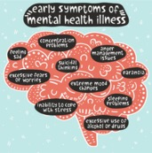
Figure 1: Early symptoms of mental health illness
View description - Figure 1: Early symptoms of mental health illness
View description - Figure 1: Early symptoms of mental health illness

Behind the scenes, some mental health practitioners are continually seeking the right balance between making mental health a medical problem, or seeing it as a continuum along a line of ‘healthy’ to ‘unhealthy’ adaptations to life’s stresses. In this session, you will explore the different ways in which mental health is viewed.
To get started, listen to Tanya Byron again, this time talking about different professional approaches to recognising mental health problems. She uses a number of technical terms, but don’t worry too much about this now, as you’ll explore these in Activity 1.

Audio content is not available in this format.
Audio 1: Interview with Professor Tanya Byron
View transcript - Audio 1: Interview with Professor Tanya Byron

Learning outcomes
By the end of the session, you should be able to:
- recognise the range of professionals who are able to help an adolescent with mental health problems
- outline the perspectives that professionals draw on to diagnose a mental health problem
- explain the role of social media in shaping perceptions of mental health
- debunk some common misconceptions about mental health.

1 Diagnosis and sense-making
The causes of mental illness are disputed, complex and are underpinned by differing theoretical perspectives – which are also referred to as models.

Figure 2
View description - Figure 2
View description - Figure 2

What this means is that there are different types of explanation:

Table 1: The different perspectives
A social perspective | focuses on the environment and the different roles that people play. It also considers adverse experiences, negative life events and childhood adversity, such as exposure to violent behaviour, poverty, abuse, bereavement, parental divorce or separation, parental illnesses and/or non-supportive school or family environments
A psychological perspective | emphasises the role of thought and emotional processes and individual cognitive development in how a person will interpret their negative life events and how this may possibly affect their behaviour
A biomedical perspective | looks at brain structure and function, and is likely to see mental health problems/illnesses in relation to how the brain works and is influenced by hormones and an individual’s genes, with other issues merely operating as triggers

In reality, none of these three perspectives alone can provide all the answers to what causes mental health problems in adolescence. They are often combined in what is called a bio-psycho-social model which recognises the importance of considering biological, social and psychological factors when attempting to understand and treat a young person’s mental health. The National Institute for Clinical Excellence (NICE) is a government run organisation whose guidelines suggest that when healthcare professionals are assessing children and young people, they should routinely record social, educational and family situations. This includes the quality of interpersonal relationships (both between the person and other family members and with their friends and peers), thus acknowledging that family issues need to be taken into consideration.
Next, you’ll return to Tanya Byron’s interview offering her perspective on assessing a young person’s mental health as a clinical psychologist. In the activity, you’ll ‘unpack’ the extract of Tanya Byron’s interview with Professor John Oates.

Activity 1: Unpacking the terminology
Allow about 20 minutes

Step 1: Below is the transcript for the interview extract. Read through it and hover over the highlighted technical words to access the glossary definition for each.

Tanya Byron: Well in a sense when I’m working with my colleagues, when I’m working with my teams, and we are assessing a young person, we tend to think in sort of blocks of theory, and in a sense through careful assessment, both qualitative assessment with the young person, with their family, often with schools and teachers. And sometimes with their friends. I mean if the young person, for example, is very depressed, or unable to communicate, friends are often a very useful resource of information. We are literally sort of kicking down different hypotheses that we may have about why this young person is presenting in crisis. So, to begin with we might wonder whether there are some neuro-developmental issues, is there something actually at a brain level that is making life increasingly challenging through this complex time? We obviously want to know what is going on at home, is there a specific amount of stress, risk factors, whether it is abuse or domestic violence, or just discord, marital breakdown and discord in the home that is contributing to this young person’s difficulties. Some young people may show very context-specific difficulties. So if I’m meeting young people where they are generally doing okay, but struggle really specifically at school, and are getting a lot of negative feedback, beginning to feel like they have failed, maybe becoming the person that they are being told they are, so it becomes a self-fulfilling prophecy, they stop thinking, they stop learning, they misbehave. We might then want to explore specific learning difficulties, you know, finding young people with very good IQs, but actually with learning difficulties, whether they are to do with sensory integration, or to do with dyslexia, or dyspraxia. Whatever we are looking at, it would help us explain why this young person, understandably struggles in that particular learning context.
John Oates: So that sounds pretty wide in the sorts of theoretical orientations you are drawing on, but are there specific therapeutic approaches that you take, or would you say you really have to match that to the case?
Tanya Byron: We do have to match therapeutic approaches to the case, which is why the most effective way of working with a young person, because of the system that they bring with them, is within a multi-disciplinary team. So, even though I would lead the team, I would rely on the expertise of my colleagues, who come from different skillsets, to be able to contribute to the assessment. And then sometimes themselves do further specific assessment, for example educational assessment, or neuro-developmental assessment. Sometimes you know much more sort of specific – we might have to scan some young people’s brains, erm, or even more psychotherapeutic colleagues, who might want to work with families and understand the family narrative. So it is quite complex, and in a sense as a consultant my role is to sort of navigate that, and to … what we do as clinical psychologists is we create what we call a formulation. In a sense we are creating an evidence-based narrative to the presenting difficulties. And actually just explaining to a young person, and their family what we think might be behind what is going on for them can be a very empowering experience, because once you understand a problem, to some degree you are almost in a much better position to try and solve it. So, yes, it is about navigating the complexities, sticking with an evidence-based model, and evidence based therapeutic approaches. And always working collaboratively with the young person, because obviously they need to be very much central to the treatment, they need to take ownership of it. It is their life, and so they also need to inform us and help us understand where we might not be quite hitting it in the right place for them. Communication is vital really.

View discussion - Part

Step 2: Have another look at the three theoretical perspectives in the table. Which perspective do you think Tanya Byron is drawing on most in this interview extract?

Social
Psychological
Biomedical
View answer - Part
View discussion - Part

1.1 The case of George
Various people can become involved in trying to make sense of any particular individual’s mental health problems, including:
- the mentally distressed adolescent themselves
- their friends, family members and others who interact with them socially
- mental health and other professionals who have developed and use various theories, therapies and forms of treatment and support to explain and respond to an adolescent’s mental health problems.
In practice, all these different parties will have a view on what is happening and why, and what ought to happen next when an adolescent is (or appears to be) distressed. In some cases, these different views can contribute to a range of support options that complement each other. On the other hand, there can be times when these different views can lead to contradictory ideas about what the young person needs. For instance, does someone who is feeling anxious much of the time need counselling or medication? Or do they need help to change a situation at school or at home, which might be causing their anxiety? In the next activity, you’ll consider the case of George.

Activity 2: Understanding George
Allow about 15 minutes

Read the case of George.

George
George has just celebrated his 14th birthday. He invited a few friends to come go-karting over the weekend, and his mother Liz was relieved that it had all gone well, because she was aware he hadn’t seemed happy at school lately.
On the following Monday, however, George is reluctant to get up for school. This is nothing new, but it’s all the more disappointing after the promising weekend. Liz coaxes him out of bed as usual, which is a long-drawn-out process, and helps him and his younger sister to get ready at the same time as getting herself ready for work. In the end, she gets angry with him as the frustration and weariness set in. She instantly feels bad about that and decides she must have a proper talk with him when they get home in the evening.
That evening, she prepares a meal she knows both children really like. She calls them both to the table, but George refuses to join them. His sister Jenny tries to help persuade him, to no avail. Liz doesn’t want any more battles so she leaves George’s meal on the table and eats with Jenny. She wishes she had a partner who could back her up at times like this, but she is divorced from the children’s father and has met someone new who she is still getting to know.
Liz feels her frustration growing again and wonders if this is the right time to have a ‘proper talk’ with George. Eventually, she decides she is more worried than angry and goes up to George’s room. She gives him a hug and sits on the bed with him. She asks him what is wrong. After some time, George confides that when he sits in the classroom he feels on edge, shaky, and his knees tremble. He sees other children are misbehaving and when the teachers get angry it makes him shake more.
He also tells her that he feels other children are picking on him in the corridors, but can’t tell her exactly what they are saying or doing. Liz is concerned that he is so stressed by it all that he can’t talk about it. She is also worried that he does not have a secure group of friends who could support him. It also transpires that George is lying awake at night and is getting very little sleep.
The next day, Liz takes time out of work to speak to the deputy head at George’s school. He tells her that George is working well and looks happy at school, although is sometimes distracted in the classroom. He reassures her that they have strict policy on behaviour, and that they take all concerns seriously. It’s not the first time Liz has gone to the school with her concerns, and she feels that they aren’t being taken seriously. Sometimes, she can’t get George to go to school at all, and she is really worried that he could be falling behind.
George becomes increasingly reluctant to leave the house over the following weeks, and Liz makes an appointment with their GP. George says very little during the appointment, and he appears withdrawn. The doctor suggests that George may be experiencing moderate depression and anxiety, and offers to make a referral to CAMHS (Child and Adolescent Mental Health Service). He also suggests that George might need to take antidepressants, but in the first instance recommends that George make an appointment to see the school nurse to talk things through.
Liz goes home with George and feels emotionally adrift. She believes she has let George down in some way and can’t see a way forward. She feels an immense sense of guilt and thinks back to a few years ago when she needed to take antidepressants during her marriage breakdown. She considers that perhaps her own struggles with depression have rubbed off on George somehow. Having only moved to the area recently, she doesn’t have any close friends nearby to really confide in, and her attempts at doing so with new acquaintances haven’t led to any real sense of support.
Based on what you know about anxiety and depression and adolescence, what do you think might be causing George’s problems? Select as many as you like from the list below:

A brain abnormality
Adolescent brain development making George more emotionally sensitive
No sense of belonging to a peer group
Family break-up
He doesn’t like Mum’s new partner
Liz’s history of depression
He’s jealous of his sister
He is naturally reserved
A cascade of issues arising from poor sleep
Issues at school
Friendship issues
View answer - Activity 2: Understanding George
View discussion - Activity 2: Understanding George

Theoretical models can help to organise thinking around what can seem a very complex picture, as you’ll see next.

1.2 Determinants of health
A young person’s social context can bring a wide range of factors to bear on their health and wellbeing. One of the most useful models for representing these factors is this one by Dahlgren and Whitehead (1993; cited in Dahlgren and Whitehead, 2007) in the figure below.
Dahlgren and Whitehead’s model has been widely used by academics and practitioners to guide their thinking about health.

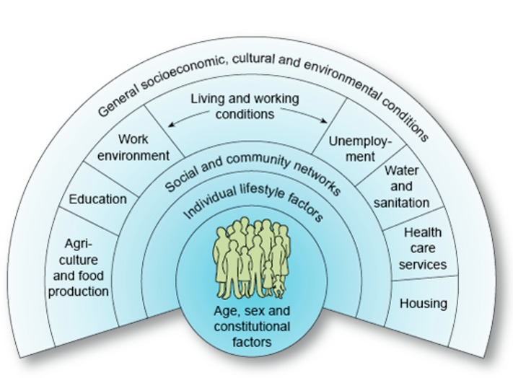
Figure 3: The determinants of health (Dahlgren and Whitehead, 1993; in Dahlgren and Whitehead, 2007)
View description - Figure 3: The determinants of health (Dahlgren and Whitehead, 1993; in Dahlgren and ...
View description - Figure 3: The determinants of health (Dahlgren and Whitehead, 1993; in Dahlgren and ...

Dahlgren and Whitehead’s model depict layers of influence on health. This model maps the relationship between the individual, their environment and health. Individuals are at the centre. Surrounding them are influences on health that can be modified. The first layer represents individual behaviour and lifestyle that can potentially enhance or damage health, for example the choice to smoke or not. The next layer refers to wider social and community influences, which can either provide mutual support or lack of support. The third layer represents structural factors, including housing, working conditions, access to services and provision of essential facilities.
The ‘age, sex and constitutional factors’ in this model apply to both the biomedical and the psychological perspectives, although each will focus on different ‘constitutional factors’. Individual lifestyle factors are also critical to the biomedical and psychological perspectives since diet, exercise and sleep, for example, can directly affect mental health, and mental health can affect lifestyle.

Activity 3: George’s social determinants
Allow about 10 minutes

Study the diagram in Figure 3 and think for a moment about how they might apply to George.

View discussion - Activity 3: George’s social determinants

A variety of professionals draw, to varying degrees, on this wide range of factors to make sense of a young person’s mental health. You’ll learn more about this next.

2 Professional approaches
There can be a surprising range of professions and practitioners involved in helping young people with mental health problems. The next activity will get you thinking about what you already know.

Figure 4
View description - Figure 4
View description - Figure 4

Listen to this interview of a parent talking about their child’s mental health and the different professionals that can provide a supporting role.

Audio content is not available in this format.
Audio 2: Providing a supportive role.
View transcript - Audio 2: Providing a supportive role.

Activity 4: A range of professions
Allow about 10 minutes

How many types of practitioner (or professions) work in the mental health field? Have a look at the list here and tick one that you feel most confident about. This is a polling tool, which will feed your inputs into a larger picture of all the learners engaged in this course.

Interactive content is not available in this format.

Reflect on the following: which was the first type of practitioner or profession that came to mind, and why do you think they were the first one that you thought of?

View discussion - Activity 4: A range of professions

Have a look at Figure 5 below for a summary of the professions and teams that can be involved.

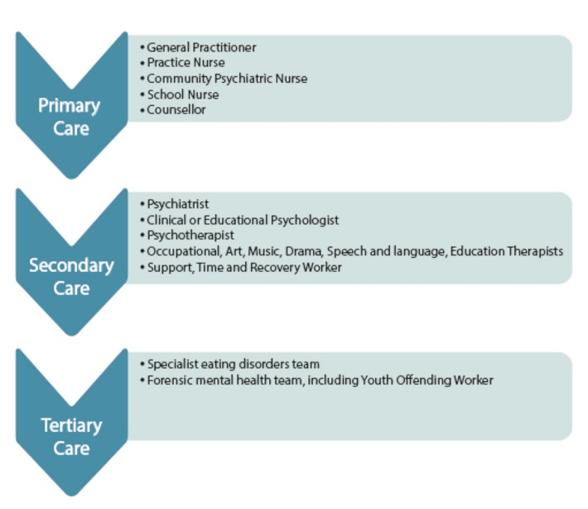
Figure 5: A treatment hierarchy of professions and services.
View description - Figure 5: A treatment hierarchy of professions and services.
View description - Figure 5: A treatment hierarchy of professions and services.

Primary care is usually the first point of contact for people when they become unwell, for instance, when they experience symptoms that are of concern to themselves or others. Primary care is also usually the ‘gateway’ to receiving more specialised care.
Secondary care is for someone who has received primary care and is referred to the next level of care. These services are usually consultant-led (with a psychiatrist as the clinical lead) and include mainstream out-patient services like Child and Adolescent Mental Health Services (CAMHS), as well as in-patient psychiatric units.
Tertiary care is for someone who requires a highly specialised team of professionals. This may involve someone being treated by an eating disorders team (e.g. in an in-patient unit for people with severe eating disorders) or in a forensic mental health facility (i.e. in a facility treating offenders who have severe and enduring mental health problems). You will recall a parent describing the route through which her daughter was able to receive the support she needed for her mental health in Audio 2. This included a GP consultation followed by therapeutic counselling.

2.1 Comparing medical approaches
Psychiatry is a branch of medicine that deals with mental health. Doctors such as general practitioners and psychiatrists draw on models of illness to assess a patient and provide a diagnosis. The biomedical model forms the basis of modern medical practice, although there are few doctors nowadays who would not also draw on social and psychological explanations of mental ill health.
Biomedicine explains health in relation to biology. It attaches importance to learning about body structure (anatomy) and systems (physiology) and understanding mechanisms like the circulation of blood, hormone functions and the workings of the brain. This view offers a particular and distinctive way of ‘seeing’ and understanding health in relation to the body. Certain tests establish what is wrong and medicines are given as a cure or to alleviate symptoms, or surgery repairs or replaces defective body parts.

Figure 6: The Brain – Cerebral cortex viewed under the microscope.
View description - Figure 6: The Brain – Cerebral cortex viewed under the microscope.
View description - Figure 6: The Brain – Cerebral cortex viewed under the microscope.

The biomedical model tends to focus attention on the individual, not groups of people or the health of society more generally. Under this model, health services are geared mainly towards sick people and high value is placed on specialised medical services. Doctors and other qualified experts act as gatekeepers to services. The main function of a health service is remedial or curative, aimed at getting people back to productive lives.
In the next activity you’ll consider two contrasting medical approaches.

Activity 5: Different viewpoints
Allow about 20 minutes

Step 1: First, think back to George’s appointment with the GP. What aspects of the consultation would suggest that the GP was taking a biomedical viewpoint? Do you think it’s important that George has the opportunity to express how he feels?

Provide your answer...
View discussion - Part

Step 2: Next, watch this short video of a child and adolescent psychiatrist talking about her work.

Video content is not available in this format.
Video 1: Mental health in children and young people, Dr Su Sukumaran
View transcript - Video 1: Mental health in children and young people, Dr Su Sukumaran

What aspects of her description of her work suggests she is taking a broader view of the problems adolescents present with?

Provide your answer...
View discussion - Part

Symptoms may overlap between diagnoses or may not meet the criteria for a particular ‘disorder’, but still require treatment. You may have noticed that George’s GP thought he had a combination of anxiety and depression. Taking these issues as well as the views of patient groups into consideration, there has been a move over recent years, and particularly within the UK, towards a more tailored approach to diagnosis and management of mental health that takes the lead from and actively involves the patient (Gask et al., 2009).
With the emergence of biological psychiatry and modern advances in brain and behavioural sciences, most mental illnesses are increasingly presumed to have a neurobiological basis, even if that basis is, as yet, poorly understood.

2.2 Potential sources of conflict
Multidisciplinary teams, which comprise a range of different professions, can be effective because they combine a range of skills and perspectives to help a young person. Although they aim to work together for the benefit of the young person they are helping, there can potentially be conflict between professions, partly because they might be taking different perspectives on diagnosis and treatment. Family members may also feel in conflict with healthcare professionals if they have strong personal views on the use of medication or talking therapies, or labelling their children with a stigmatising diagnosis.
Clinical Psychologist Lucy Johnstone argues that a medical diagnosis ‘turns “people with problems” into “patients with illnesses”’ and that this can be damaging because the medical meaning essentially displaces the person’s own understanding of their situation and their sense of self (Johnstone, 2018, p. 31). Moreover, she continues, psychiatric diagnoses commonly lead to a sense of stigma and shame ‘by locating the difficulties within the person’ (p. 35) rather than their social environment and life story.
The psychologist’s alternative to a medical diagnosis lies in the ‘psychological formulation’. According to Johnstone (2018, p. 39), ‘it is the difference between the message “you have a medical illness with primarily biological causes” and “your problems are an understandable emotional response to your life circumstances.”’ In creating a psychological formulation, the service user and the practitioner combine their knowledge and skills and together reach a ‘best guess’, or hypothesis, about the roots of the problem and agree a way to move forward.
The next activity will allow you to compare and contrast the perspectives of a psychiatrist and a clinical psychologist as they explain their professional allegiances and discuss how they would help a young woman called Mandy.

Activity 6: A psychiatrist and a psychologist
Allow about 20 minutes

Watch the two videos of a psychiatrist Dr Elizabeth Venables and a psychologist Dr Marion Bates talking about their work. What are the similarities and differences? Can you identify any potential source of conflict?

Video content is not available in this format.
Video 2: Dr Elizabeth Venables
View transcript - Video 2: Dr Elizabeth Venables

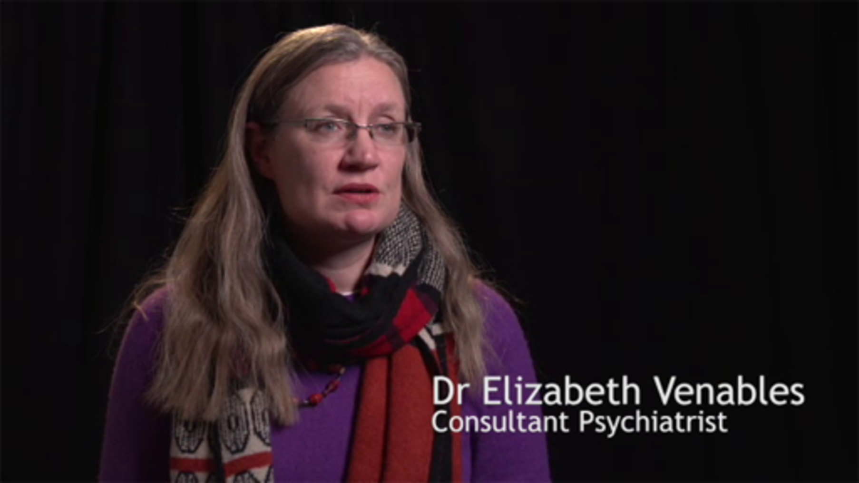

Video content is not available in this format.
Video 3: Dr Marian Bates
View transcript - Video 3: Dr Marian Bates

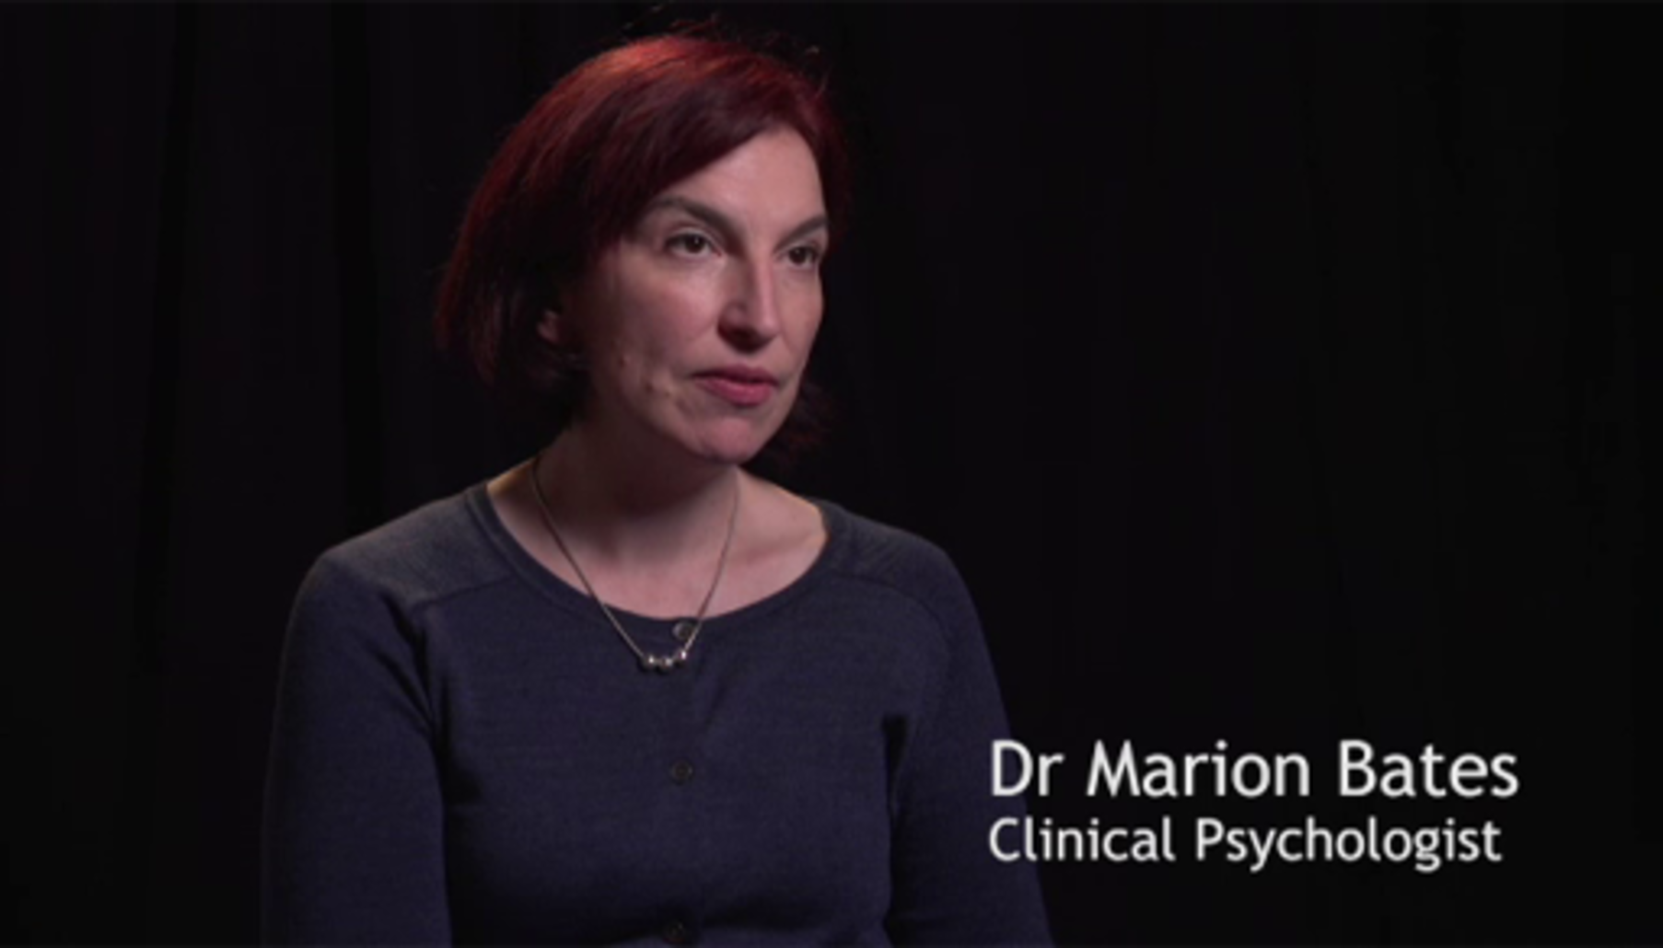

Table 2: Similarities and differences
Similarities | Provide your answer...
Differences | Provide your answer...

View discussion - Activity 6: A psychiatrist and a psychologist

Next, you’ll consider the role of social media in shaping perceptions of mental health.

3 The role of social media
Social media is a big part of the lives of many of us now, but social media has become a part of a young person’s social world to an extent that was unthought of when Dahgren and Whitehead created their model (introduced in Section 1.2) containing the social determinants of health.

Figure 3: (repeated from Section 1.2) The determinants of health (Dahlgren and Whitehead, 1993; in Dahlgren and Whitehead, 2007)
View description - Figure 3: (repeated from Section 1.2) The determinants of health (Dahlgren and Whitehead, ...
View description - Figure 3: (repeated from Section 1.2) The determinants of health (Dahlgren and Whitehead, ...

The reference to ‘Communites’ mentioned in the diagram would now extend to media ‘friends’ and ‘followers’ as well as online discussion forums.
Research continues to explore the impact of social media on mental health. While social media is often discussed in negative terms, the relationship young people have with social media is quite complex. In the next activity you will listen to an interview where two young people, Martha and Josie reflect on their own social media use and discuss its impacts.

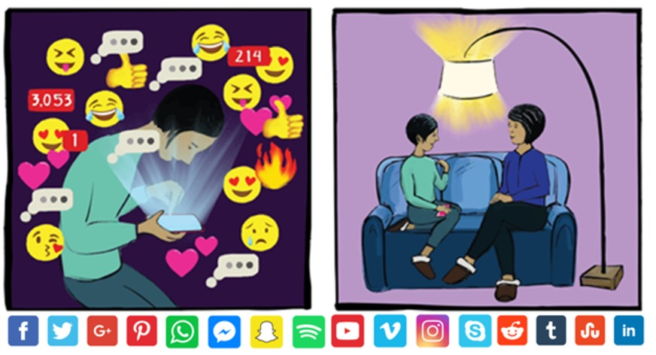
Figure 7: Different types of social media
View description - Figure 7: Different types of social media
View description - Figure 7: Different types of social media

3.1 Young people and social media
Listen to the following interview with Martha and Josie talking about the impact of social media and ideas of perfection.

Activity 7: Ideas of perfection

What are the key messages presented here? Write down a few bullet points.

Audio content is not available in this format.
Audio 3: Ideas of perfection
View transcript - Audio 3: Ideas of perfection

Provide your answer...
View discussion - Activity 7: Ideas of perfection

Unlike local communities, social media contacts can be invisible to parents and other caregivers and it can be difficult to know anything about what a young person is seeing and with whom they are interacting. This can be a source of concern for many parents.
Social media can, however, become a source of support for many young people who are struggling with their mental health, and this will be discussed in Session 7. In the next section, you’ll focus on the role online communities can play in shaping the way people regard their mental health, sometimes in a harmful and unhealthy way.

3.2 Images of perfection?
Young people can spend a great deal of time engaging with social media in very different ways. From social media platforms, messaging and communication applications, online television or radio and online games, young people share images, communicate, learn and play using these different media.

Activity 8: Body shaming
Allow 40 mins

Watch Video 4 of a young person Chessie King who is a YouTuber interested in online digital media and particularly body images. As you watch, make notes which address the following questions:
- How are young people influenced by the reactions of others via social media?
- How might cyber bullying impact upon a young person’s mental health?

Video content is not available in this format.
Video 4: Cybersmile and Chessie King Body Positivity Campaign
View transcript - Video 4: Cybersmile and Chessie King Body Positivity Campaign

Provide your answer...
View discussion - Activity 8: Body shaming

4 Common misconceptions about adolescent mental health
In the general population, views about what mental health problems are and what causes them are likely to have come from personal experiences or ‘common sense’ understandings picked up from other people or the media. Such views may not be particularly influenced by academic research and writing, nor are they necessarily informed by professional interests in the topic.

Activity 9: Reflecting on common misconceptions
Allow about 10 minutes

Read through the misconceptions about mental health below and then reflect on this.

Interactive content is not available in this format.
Interactive Figure 8: Misconceptions about mental health. There is a long description button below if this is easier to learn from.
View description - Interactive Figure 8: Misconceptions about mental health. There is a long description ...

Interactive content is not available in this format.
Interactive Figure 9: Misconceptions about mental health
View description - Interactive Figure 9: Misconceptions about mental health

Reflect on the issues raised above.
- What are your own thoughts and views on some of the information and misinformation disseminated in the media?

Provide your answer...
View discussion - Activity 9: Reflecting on common misconceptions

5 This session’s quiz
Now it’s time to complete the Session 4 badge quiz. It is similar to previous quizzes, but this time instead of answering five questions there will be fifteen.
Session 4 compulsory badge quiz
Remember, this quiz counts towards your badge. If you’re not successful the first time, you can attempt the quiz again in 24 hours.
Open the quiz in a new tab or window then come back here when you’ve finished.

6 Summary of Session 4
The main learning points of this session are:
- Social, psychological and biomedical perspectives can help practitioners to make sense of mental health problems. Determinants of mental health extend from aspects of the person that cannot be changed through to their behaviours, social networks, and wider characteristics of the communities where they live.
- Professionals who work in the mental health field can take contrasting approaches to their work, and this can create the potential for conflict. Mostly, however, they are keen to combine their skills productively to help the young person.
- Social media form a significant aspect of the friendship networks and wider communities for many young people. Social media can sometimes distort how young people view themselves through contagion and social comparisons using images and misinformation.
You are now halfway through the course. The Open University would really appreciate your feedback and suggestions for future improvement in our optional end-of-course survey, which you will also have an opportunity to complete at the end of Session 8. Participation will be completely confidential and we will not pass on your details to others.
Now to go Session 5.

Session 5: Understanding resilience in adolescence

Introduction
Although the term resilience is now widely used in media reports and discussions about mental health, ongoing debates continue to examine what the term really means.

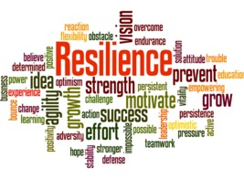
Figure 1
View description - Figure 1
View description - Figure 1

The term is often used to describe an individual’s capacity to endure stressful conditions and to bounce back from challenging situations and circumstances. Some academics, psychologists and psychiatrists have spent their careers trying to understand resilience, and they continue to debate its essence. Whilst they may differ in their definitions of what resilience means, they share a commitment to its value, especially in relation to supporting robust mental health. In this session, you will explore these debates around the meaning of resilience and how resilience can be nurtured in young people.
One thing there is some agreement about is that resilience, much like a muscle or a set of skills, can be learnt and developed, but it takes practice. First, you will hear from some young people who have shown resilience through coping with adversity. As you work through the session, you’ll refer back to this from time to time.
This video provides insights into young people’s views about resilience and what it means to them.

Video content is not available in this format.
Video 1: What Does Resilience Mean To Young People? | YoungMinds
View transcript - Video 1: What Does Resilience Mean To Young People? | YoungMinds

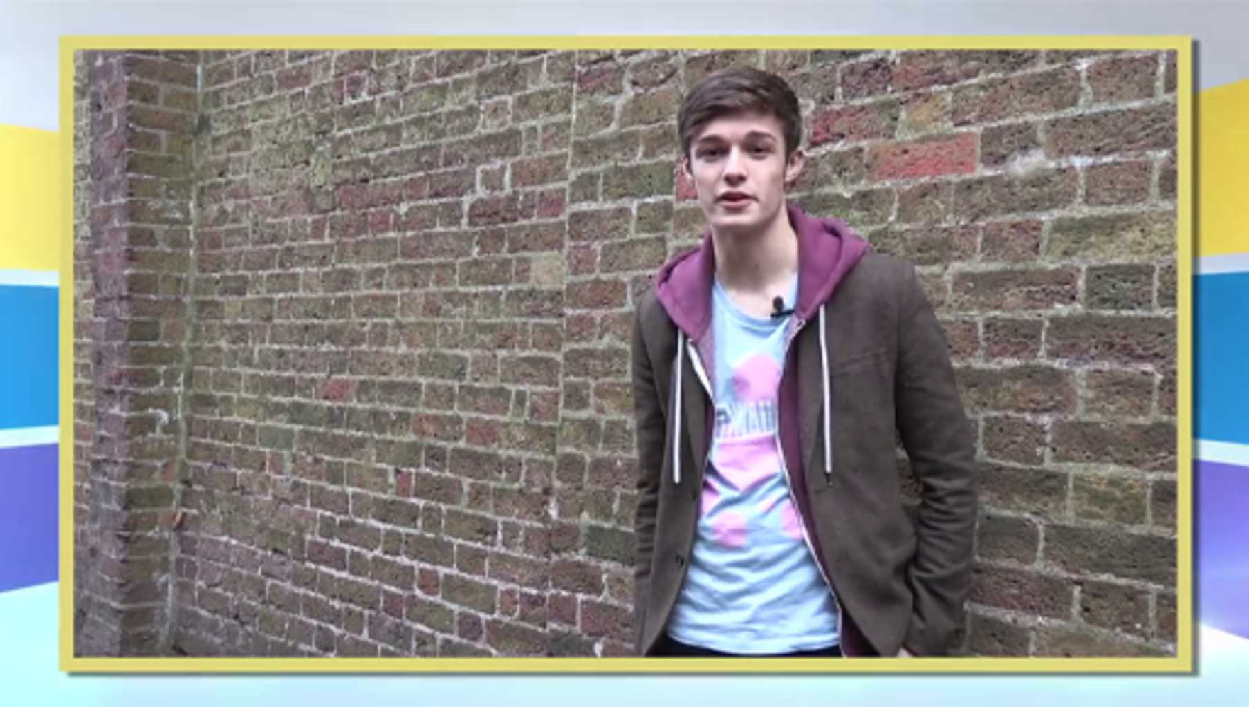

Learning outcomes
By the end of the session, you should be able to:
- define resilience and describe its features
- identify and engage with the debates around resilience
- outline what schools, families and certain communities can do to promote resilience in adolescents
- discuss the features of adversity that can require a young person to be resilient.

1 Why is resilience important?
A growing body of research suggests that learning the skills to cope with everyday challenges during childhood and adolescence can reduce the likelihood of developing stress-related illnesses such as depression and addiction in later life (Cooper, Montgomery and Sheehy, 2018).

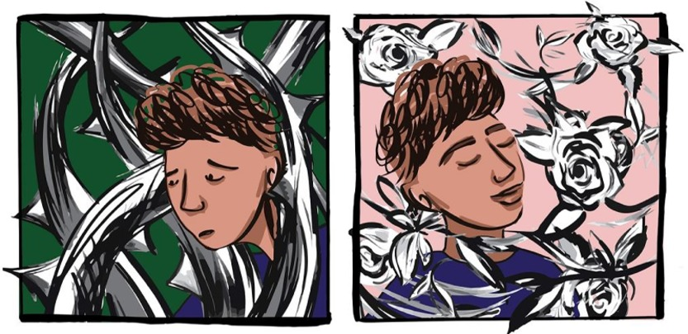
Figure 2
View description - Figure 2
View description - Figure 2

Developing resilient behaviours to endure and adapt to stressful life experiences are clearly important life skills. Yet there are clear differences in how young people react to stressful situations. This leads many parents and practitioners to question why some young people appear more able to bounce back from life’s challenges and show fewer signs of anxiety than other young people. Even young people raised within the same family can demonstrate startling differences in how they react to and cope with stressful events. In the first activity, you will reflect on these issues.

Activity 1: Reflecting on resilience
Allow about 10 minutes

Spend a few minutes thinking back to a time when a young person that you know needed to respond to challenging circumstances. Do you think the young person demonstrated resilience? What was it about their response that made you think that? Jot down your thoughts here:

Provide your answer...
View discussion - Activity 1: Reflecting on resilience

Now that you have started thinking about what resilience might look like, you’ll study definitions of resilience next.

1.1 Defining resilience
As you saw in the introductory video each of the young people described resilience in a different way. This reflects the academic perspective of this concept in that there are no standard definitions of resilience. While there have been attempts to quantify and measure it, most studies look at the concept qualitatively – as one group of researchers argued, ‘Rather like beauty, resilience may be said to lie in the eye of the beholder.’(Gilligan et al.,2014, p.1.).
Existing definitions of resilience have similar components, which involve doing well ‘against the odds’, coping, and recovering (Rutter, 1985; Stein, 2005).
- Psychologist Ann Masten and colleagues (1990) define resilience as the process of, capacity for, or outcome of successful adaptation despite challenging or threatening circumstances.
- Social researcher Robbie Gilligan (2000) defines it as a set of personal qualities that helps a person to withstand many of the negative effects of adversity.
- The British Psychological Society (2019, p. 2) defines resilience as ‘reduced vulnerability to environmental risk, the overcoming of stress or adversity, or a relatively good outcome despite risk experiences.’
The next activity will help you to untangle some of the technical language in these definitions.

Activity 2: Highlighting key terms
Allow about 10 minutes

Re-read the three definitions given above and then have a go at highlighting some terms below.

Interactive content is not available in this format.

View discussion - Activity 2: Highlighting key terms

When deciding if a young person is showing resilience, be aware that what might appear to be coping or resilient behaviour may be nothing of the sort. A young person developing anorexia might appear to be coping well if they are handing in their homework on time at school and seemingly getting on well with friends. As social workers Brigid Daniel and her colleagues note, ‘some young people who appear to be resilient may in fact be internalising their symptoms’ and while they may appear to cope in the short term are actually suffering greatly (Daniel, Wassell and Gilligan, 2010, p 70). When practitioners refer to ‘internalising symptoms’, they mean that a person may be developing anxiety or depression and becoming withdrawn, rather than giving out more open signs of distress such as aggression or impulsiveness, or dramatically falling behind at school. It is therefore important to consider all aspects of a young person’s behaviour when reflecting upon whether they might be struggling with something.
By now, you have probably realised that the concept of resilience is far from clear cut. But how far would you consider that resilience is embedded in an individual? The next activity asks you to decide.

Activity 3: Your views on resilience
Allow about 10 minutes

Study the quote in Figure 3 from the National Scientific Centre on the Developing Child and consider what you think it means. Do you agree with it? Vote whether you agree or disagree, using the poll below.

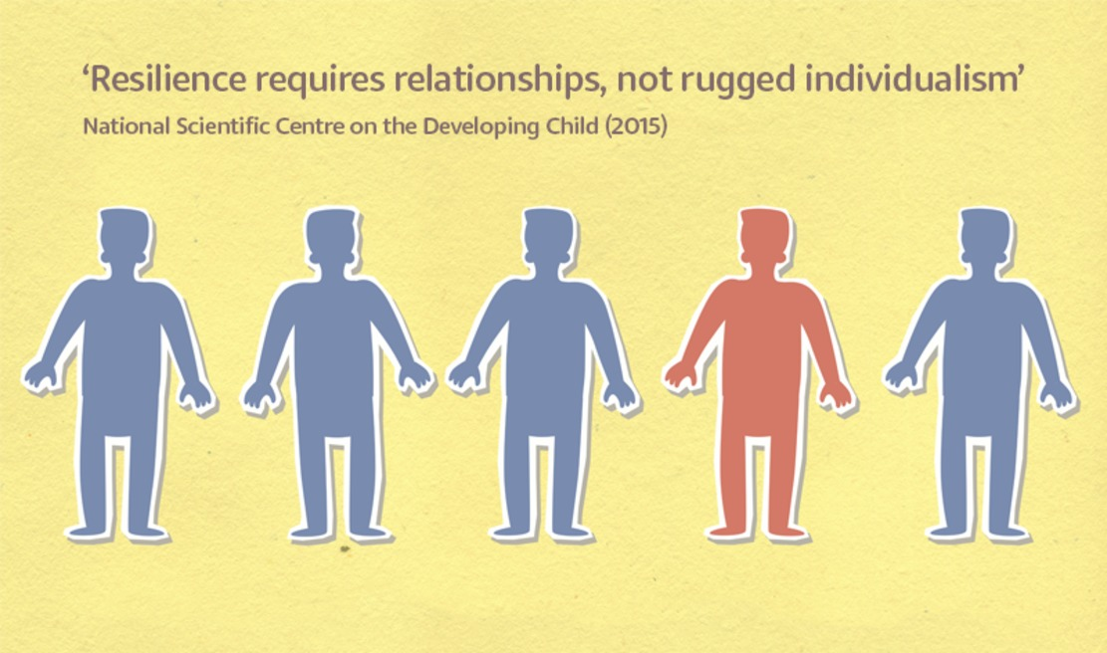
Figure 3
View description - Figure 3
View description - Figure 3

Interactive content is not available in this format.

The National Scientific Centre declaration drew upon academic research showing that one important reason why young people can overcome adversity is having one stable and committed caregiver or adult. It is suggested these relationships provide scaffolding that helps to buffer the effects of the adversity and help young people to adapt to changing circumstances.
Before looking further at resilience, it will help to consider next what people understand by the term ‘adversity’.

2 Adversity
Adversity is commonly defined as ‘a difficult or unlucky situation or event’ (Cambridge Dictionary, 2020). In the world of resilience research, however, adversity is expressed more strongly, as traumatic and potentially harmful events or situations. Among children and young people, resilience shows itself most markedly in being able to cope with adverse situations such as living with drug-using or alcohol-dependent parents, severe traumas such as abuse, or the death of a close relative or friend that results in the loss of security and support.
Parental divorce and a long-standing illness in a parent or caregiver are unfortunately relatively common sources of adversity. You may remember in session 2 one of the young men we interviewed mentioned his parents separating as a source of distress. According to the UK Office for National Statistics (2015), in 2014, lone parents with dependent children accounted for 25% of all families that have dependent children in them. Additionally, researchers Payler, Cooper and Bennett (2020), estimated that parent or caregiver illness could affect approximately 20% of young people aged 11-17. These situations can bring additional burdens and caring responsibilities for these young people.
Adversity can also stem from the wider socioeconomic environment, for example, neighbourhood violence, terror or war, natural disasters, pandemics and poverty (Masten and Barnes, 2018). Multiple negative life events and adverse circumstances often expressed as ACEs (Adverse Childhood Experiences) are currently a focus of concern due to their effect on wellbeing and on future health, and a growing body of research is examining how experiences during childhood and adolescence can affect health later in life (Hughes et al., 2017).

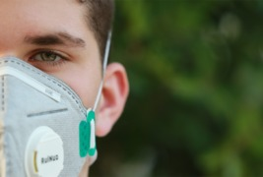
Figure 4
View description - Figure 4
View description - Figure 4

The recent COVID-19 pandemic has introduced adversity into the lives of many young people. Sources of difficulty have included health and money concerns, abrupt changes in daily routines with school closures and families confined to their homes, and a contraction of the usual support networks (Casebourne, 2020). However, research is also showing that there have been some positives. In the next activity, you’ll hear some young people talking about their experience of life during the pandemic.

Activity 4: COVID and resilience
Allow about 15 minutes

Listen to Josie and Martha.

Audio content is not available in this format.
Audio 1: Josie and Martha on the effect of COVID-19.
View transcript - Audio 1: Josie and Martha on the effect of COVID-19.

As you listen make notes on how the young women reflect on what they feel is the potential impact of COVID on young people’s mental health.

Provide your answer...

Now watch Bartholemew, Ed and Louie who also reflect on the impact of the pandemic. Make notes on their views.

Video content is not available in this format.
Video 2: Reflections
View transcript - Video 2: Reflections

Provide your answer...

When you have listened to both clips, think about the different ways in which the young people demonstrate resilience.

Provide your answer...
View discussion - Part

There are two slightly paradoxical ways of looking at the relationship between resilience and adversity. One way is to accept that people develop resilience through successfully coping with challenges. Another way is to recognise that people can be rendered less resilient through adverse experience and circumstances that have made them more vulnerable. Young people who are rendered more vulnerable through adversity are more likely to experience anxiety or depression, exhibit behaviours which many may define as ‘disruptive’ and, in some cases, turn to substance use (Hughes et al.,2017, Oldehinkel and Ormel, 2015). Later on, you will explore how these two scenarios can happen.
In the next section, you’ll consider an example of disruptive behaviour, which can be a sign of living with adversity.

2.1 Disruptive behaviour in adversity
Adversity can refer to a variety of different life experiences and can impact children and young people in different ways.

Figure 5
View description - Figure 5
View description - Figure 5

Living with a family health crisis is one example of adversity which can be a very lonely, isolating and exceptionally stressful experience for young people. The next activity introduces you to Amy, whose mother developed multiple sclerosis when Amy was 10-years-old. Looking back as a 20-year-old, Amy felt that her unmet need for support had resulted in her behaving in ways that others judged as disruptive behaviour. She found the caring responsibilities, school, and the uncertainty surrounding her mother’s ill health very challenging, and she left school to be home educated at 13 years old.
(Bennett, Cooper and Payler, 2017).

Activity 5: Amy
Allow about 20 minutes

Step 1: Read the extracts below which are taken from a research interview with 20-year-old Amy. Can you think of any reasons why she felt unable to cope with the adversity of living with her Mother’s illness?

‘They [school] didn’t ever try getting help for me. Mum and dad tried, like when I was in primary, I had a counsellor, but I didn’t really understand it then either, so I didn’t get why I was being take into a room on my own for an hour to talk about my problems.’ (p. 34)
‘I was labelled a problem child. I was sent out of lessons, I was made to sit in the head teacher’s office and stuff like that. Mum and dad had to come in quite regularly for meetings and stuff but no-one could quite pinpoint what was causing it and stuff. When we look back now, coz obviously it was the time that mum was being diagnosed as well, they don’t think I knew how to cope with what was going on, didn’t know how to process it…then it just got a whole lot worse in secondary school.’ (p. 38)
‘I had I don’t know how many years of feeling no-one cares. Not caring, pushing you to the side, labelling you as something you’re really not, that kind of thing.’ (p. 41)

Provide your answer...
View discussion - Part

Step 2: Eventually, Amy received help from HOPE, a UK charity that provides a variety of support programmes for children and young people living with a loved one who is seriously ill. Volunteers and youth management staff working for HOPE are also young people who have experience of a family health crisis. This is what Amy said about the experience:
‘It was quite useful. People just talked about their ways of coping with stress and anxiety and that. Which is quite good because it’s kind of like talking to strangers but although its people you’ve never met before you trust them because they’re part of Hope, so you know, that was a quite interesting thing to be part of.’ (p. 45)
Why do you think she felt able to trust the ‘strangers’ in the HOPE community?

Provide your answer...
View discussion - Part

Mental health practitioners need to determine how a young person’s social environment may be affecting their health, while being aware of how this might interact with physical and mental developmental changes in adolescence. As you will appreciate, exploring the social environment can be very complex and covers sensitive territory, not least because parents and other caregivers may blame themselves when their child faces challenges to their mental health, and can feel threatened by perceived stigma of other people towards their children.
According to a recent review of the research on the effect of multiple adverse childhood experiences on health (Hughes et al., 2017), adverse childhood experiences (ACEs) are most strongly associated with sexual risk-taking, mental ill health, self-harm, problematic alcohol or drug use and violent behaviour later on in the child’s life. These are associations, meaning that although there is a link between ACEs and subsequent poor mental and physical health, this is not to say that ACEs will cause poor health in later life and it is important to note that there is no clear evidence of a cause and effect relationship. Poor health is not an inevitable outcome of ACEs. Supporting resilience in young people who experience adversity can be the key to preventing the harmful consequences of adversity.
Next, you’ll consider what makes young people resilient.

3 Born or made resilient?
Not all children and young people will be affected by the effects of adversity, which begs the question: what are the protective factors, and what enables some young people to be resilient? The common assumption is that resilience arises from dynamic interactions between genetic predisposition and a person’s life experience. From the mid-20th century, academics, psychologists and psychiatrists have been studying resilience in young people, identifying innate protective factors, for example optimism and creativity, combined with external protective factors, chiefly the support they receive from those who care for them (Richardson, 2002). Neuroscience has opened a window on what happens in the brain in adversity and in the development of resilience. You’ll look at this next.

3.1 The brain, neuroplasticity and resilience
Scientists have developed some understanding about what happens in the brain when people are exposed to stressful situations, and about how the adolescent brain differs from the adult brain. Combining this scientific knowledge can help deepen understanding about resilience in young people and demonstrate how good social support can influence changes in the brain via neuroplasticity.
In session 2, you found that in adolescence the prefrontal cortex is undergoing significant change. This area of the brain is used for the ‘executive functions’ of planning, inhibiting inappropriate behaviour, understanding other people and social awareness. During adolescence, the prefrontal cortex is being re-shaped and ‘pruned’. At the same time the limbic system, which is responsible for emotion, is exceptionally active (Blakemore, 2019). Combined, these changes can make young people particularly sensitive to adversity because the prefrontal cortex becomes temporarily less able to interpret and moderate the emotional responses of the limbic system.
The brain pruning and reshaping described above are aspects of neuroplasticity that significantly (but not exclusively) take place during adolescence. In addition, the nerve pathways formed during early childhood and adolescence show neuroplasticity by changing in response to an individual’s experiences in life (Schauss et al., 2019). Brain activity is highly influenced by social interactions and the wider social environment, whether for better or worse. There is some evidence that adverse experiences can impair development of the prefrontal cortex in young people (Hunter, Gray and McEwen, 2018). On the positive side, neuroscience suggests that supportive social interaction can lead to beneficial brain adaptations and enable a young person to learn resilient behaviours.
Figure 6 demonstrates how potential negative outcomes for a young person can be ‘tipped’ into positive outcomes by the protective factors of ‘warm supportive parenting’, ‘coping skills’, a ‘stable environment’ and ‘positive experiences’. Remember that negative outcomes from adverse experiences are not inevitable.

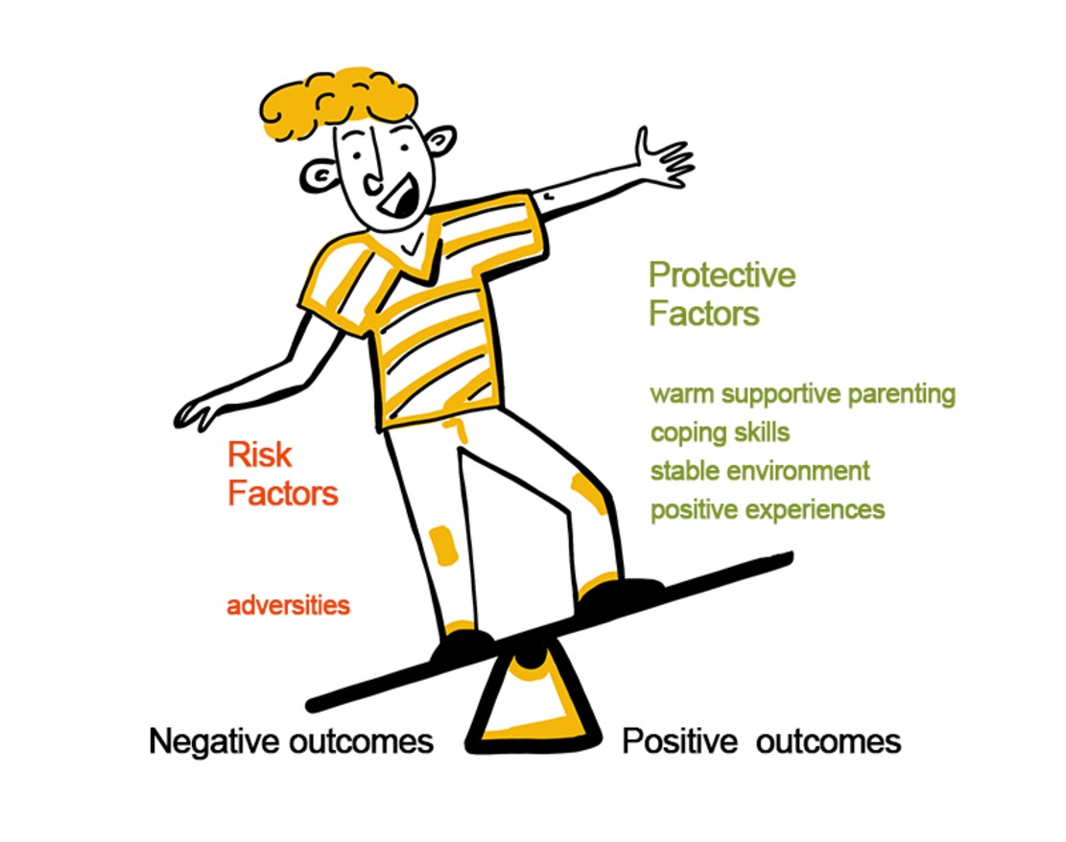
Figure 6
View description - Figure 6
View description - Figure 6

Whatever the social environment, anyone caring for a young person will realise that young people bring their own personal characteristics to any situation. Some individual differences can be attributed to their inherited genes. There is clearly an interaction between ‘nature’, which is genetically determined, and ‘nurture’, which encompasses experience. In the next activity, you’ll learn about a simple but effective analogy for thinking about how interaction between a young person’s genes and the environment can affect the brain.

Activity 6: The resilience seesaw
Allow about 15 minutes

Watch the brief video explaining the dynamic relationship between the developing brain, a person’s genes, and the environment. What is the role of genes, the environment and learning in this process? Write your notes in the table provided.

Watch the video at YouTube.com.
Video 3: InBrief: The Science of Resilience (The Open University is not responsible for external content.)

Table 1: Notes on genes and the environment
Genes | Environment | Learning (i.e. brain changes)
Provide your answer... | Provide your answer... | Provide your answer...

View answer - Activity 6: The resilience seesaw

Research in genetics can help to explain some differences between young people,indicating that a young person’s sensitivity to environmental challenges has genetic origins. For example, Boyce and Ellis (2005) suggested that genetic makeup predisposes how sensitive young people are to the stresses they experience during childhood. Albert et al. (2015) reported a specific gene variant among children who appear highly sensitive to their environments and are particularly vulnerable to stress. These genes are linked to chemical receptors in the brain, which in combination with family stress can lead to social and emotional problems later in life.
Studies in neuroscience and genetics strengthen our understanding of the links between the brain, resilience and mental health. However, there is much more research to be done before we can fully explain how these effects interact and neuroscientists are keen to acknowledge the important part played by experiences and influences within the environment. The next section explores further how resilience can be fostered in young people who may have become vulnerable through adversity.

3.2 Fostering resilience
In recent years, the dominant approach to the promotion of young people’s mental and emotional wellbeing has been to seek ways of developing resilience and promoting the protective factors that might reduce young people’s vulnerability to mental health problems. An example of how these factors are applied in policy can be seen in the work of sociologist Simone Fullagar who examined policy responses to the high rates of suicide among young people in rural areas of Australia. Fullagar reported that policy focused on identifying risk factors such as previous suicide attempts, mental health problems and social isolation, and on promoting protective factors such as social connectedness, problem-solving skills, and readily available mental health services was valuable in supporting young people (Fullagar, 2005, p. 32).
The family therapist and professor of social work Michael Ungar and colleagues (2013) argues that it is important to not just focus on the child or young person and how they can be supported to develop resilience but also on how society can be changed to nurture and foster resilience and remove challenges and barriers that make some children and young people more vulnerable to adversity.
In the next activity, you’ll focus on protective factors and consider whether you could apply this knowledge to a young person you know.

Activity 7: The seven Cs of resilience
Allow about 20 minutes

Watch this video – you’ll probably need to watch more than once – and work through steps 1 and 2 below.

Video content is not available in this format.
Video 4: The Seven Cs of Resilience: Dr. Ken Ginsburg introduces his Seven Cs of Resilience: Confidence, Competence, Connection, Character, Contribution, Coping, and Control. Content provided courtesy of the Center for Parent and Teen Communication, Children’s Hospital of Philadelphia. © 2018 The Children’s Hospital of Philadelphia
View transcript - Video 4: The Seven Cs of Resilience: Dr. Ken Ginsburg introduces his Seven Cs of ...

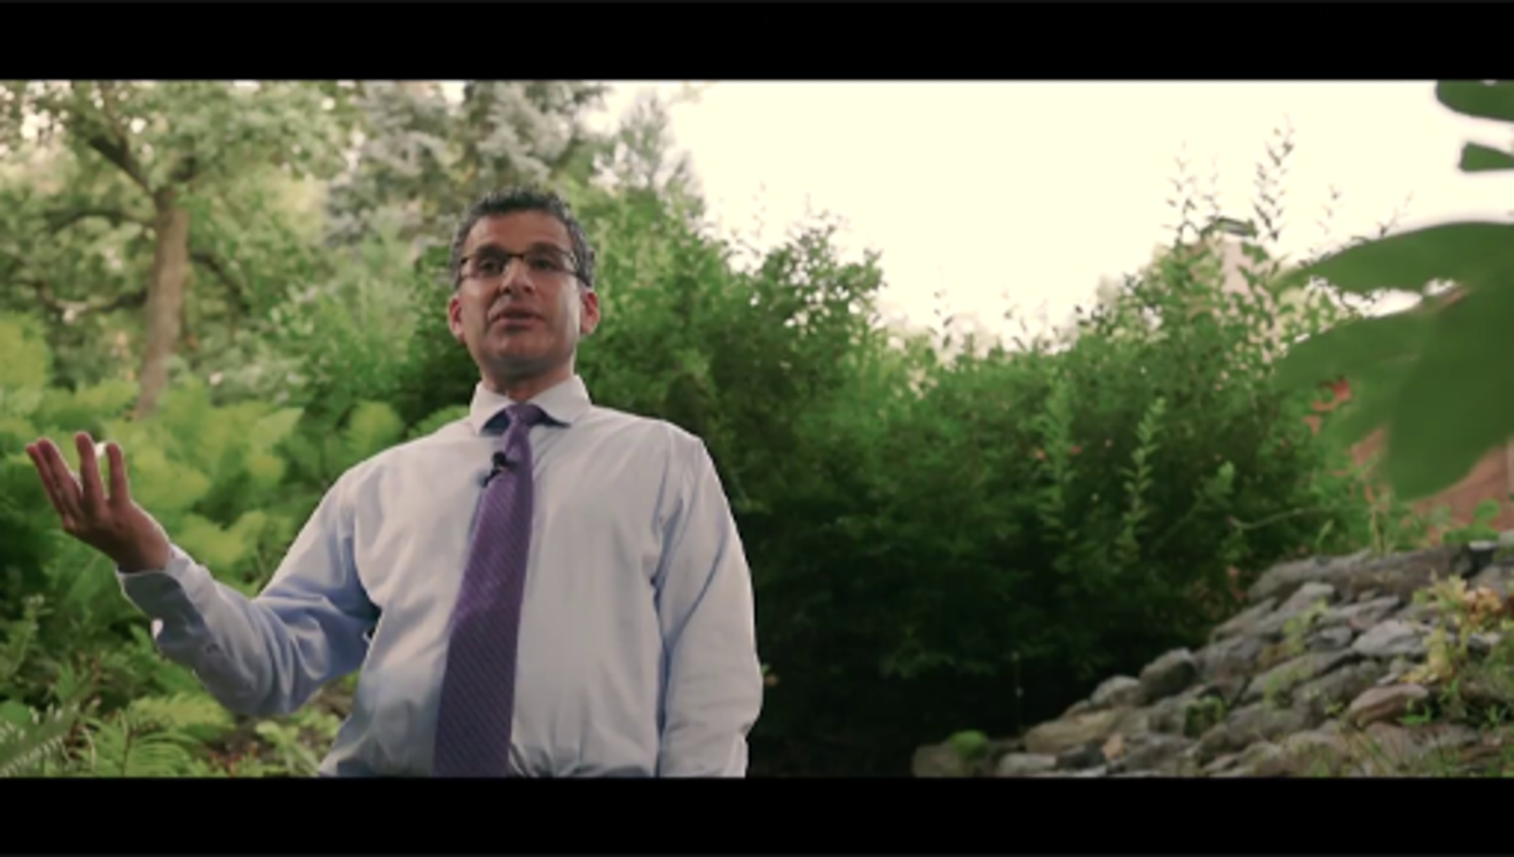

Step 1: Pick out three or more ways in which you could apply these protective factors with a young person you know.

Provide your answer...

Step 2: Using the polling tool, vote for your favourite of the seven Cs, not just because it speaks most to you, but because it shows where you could develop your own competence as a parent or caregiving adult.

Interactive content is not available in this format.

View answer - Part

Next you consider how resilience can be fostered in schools.

4 Resilience in schools
Schools are increasingly seen as major players in creating resilient young people. This was the subject of a detailed report in England, ‘Local action on health inequalities: Building children and young people’s resilience in schools’ (Public Health England, 2014), which explored the different ways that schools could contribute.

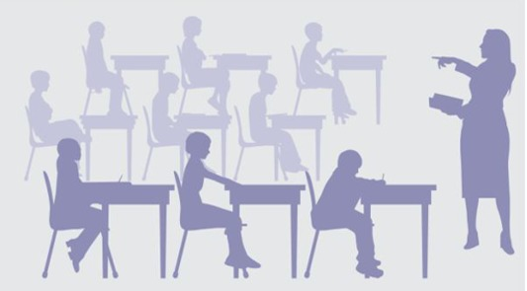
Figure 7
View description - Figure 7
View description - Figure 7

The report considered three levels of resilience support:
Individual:
- improving achievements
- supporting transitions
- promoting healthy behaviours
Interpersonal:
- parents and carers
- teachers and other staff
- friends
School and community
- using a ‘whole school’ aproach
- the scool as a community hub.
Note that this report deliberately did not separate out young people’s mental health from their physical health but considered that resilience relates to the whole of a young person’s wellbeing.
The next activity shows you how a secondary school in Brighton has supported its pupils to develop their resilience.

Activity 8: The academic resilience approach
Allow about 15 minutes

Step 1: Watch Video 5.

Video content is not available in this format.
Video 5: The academic resilience approach – integrating approaches to building resilience across a whole school community
View transcript - Video 5: The academic resilience approach – integrating approaches to building resilience ...

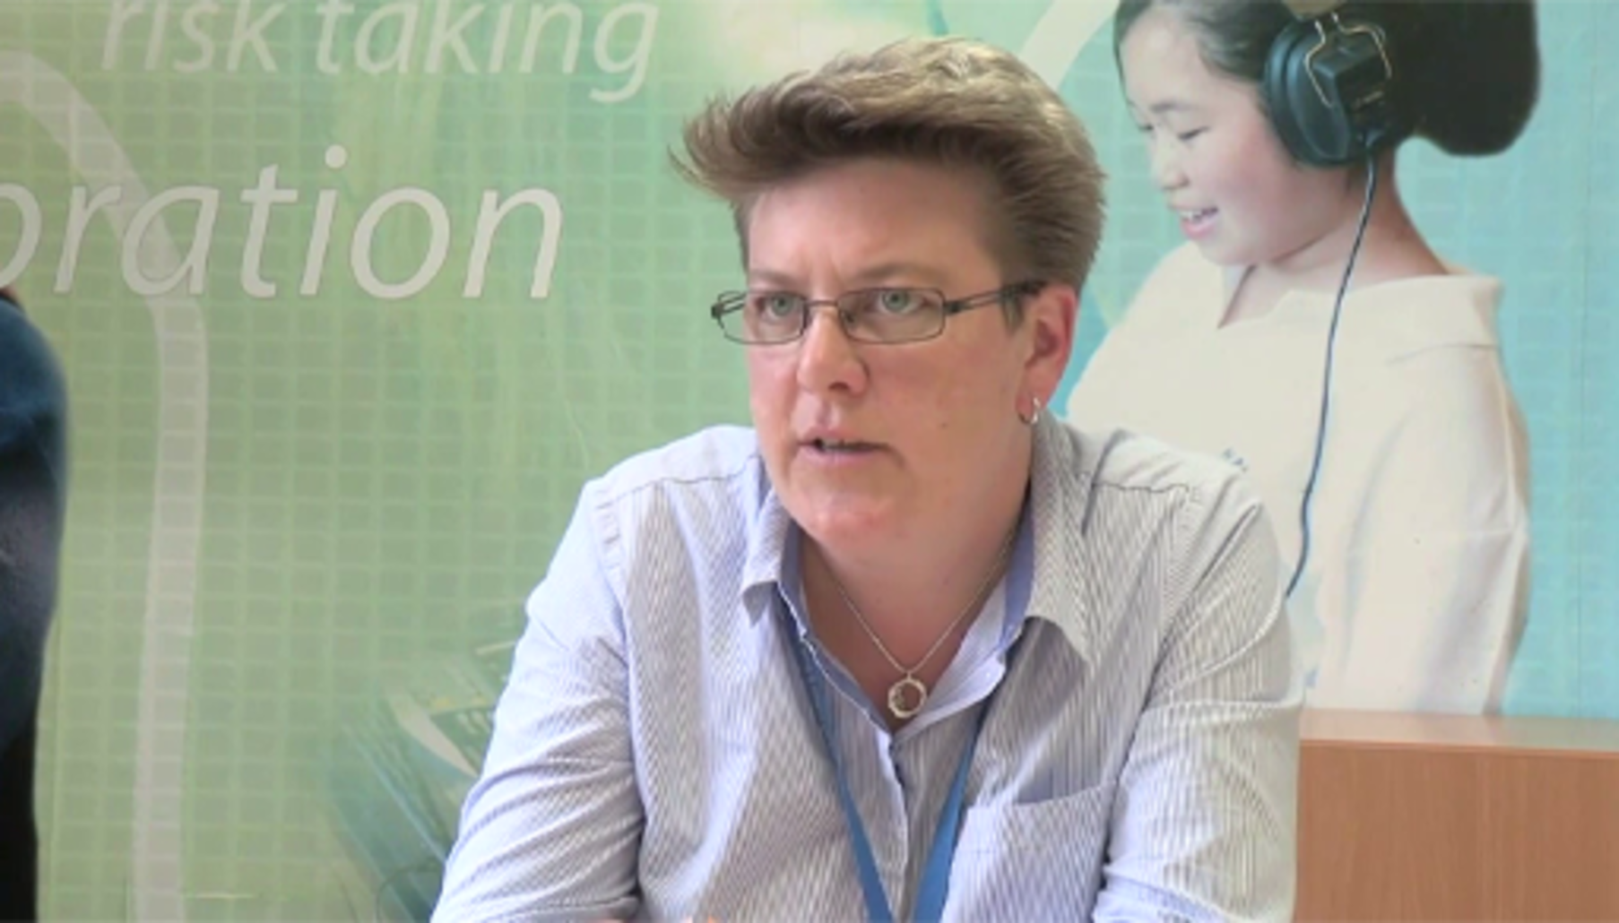

Step 2: Now match the examples of resilience support with one of the levels mentioned in the Public Health England report: ‘individual’, ‘interpersonal’ or ‘School and community’.

Interactive content is not available in this format.

View answer - Part

Even the most resilient young person can become overwhelmed by the effects of poverty and health challenges, and even the most optimistic adolescent can be deeply affected by an acrimonious parental divorce. Cooper and Rixon (2017) argue that resilience is not static, and there are positive (‘protective’) and negative (‘adverse’) factors that can enhance or undermine it. Many young people do show great resilience in the face of difficulty but this should not be used as an excuse to blame those who do not cope with stress or adversity or to believe that if only they had the ‘right’ psychological or genetic qualities they could cope as well as their resilient peers.

5 This session’s quiz
Check what you’ve learned this session by taking the end-of-session quiz.
Session 5 practice quiz
Open the quiz in a new window or tab then come back here when you’ve finished.

6 Summary of Session 5
The main learning points of this session are:
- Resilience can be defined in a variety of ways, although at its heart is a sense of doing well ‘against the odds’, coping, and recovering. Resilience is important in helping young people to cope with difficult life challenges or more serious threats to their wellbeing and learning how to be resilient is a key life skill.
- Adversity can create a resilient response, but it can also render a young person more vulnerable to the knocks in life. Multiple sources of adversity can overwhelm a young person’s resilience resources and sometime adversity can lead to disruptive behaviours.
- Brain and neuroscience studies have identified how the brain adapts in response to experience. Different parts of the brain, especially those that are involved in stress responses, are changed by both adversity and environmental protective factors. Genetic make-up, although it may predispose a person to greater or lower resilience, does not mean they cannot adapt and become more resilient.
- Schools have an important role to play in fostering the resilience of young people.
Now to go Session 6.

Session 6: Supporting young people

Introduction

Figure 1
View description - Figure 1
View description - Figure 1

Supporting young people who are experiencing mental health issues can be challenging for both parents and practitioners. In this session, you will learn about some of the strategies that could make a real difference to any young person you are concerned about. You will draw on knowledge about what can help young people manage their mental health, as well as some insights gained from neuroscience.
To get started, watch this video in which young people who have experienced mental health problems discuss what has helped them.

Video content is not available in this format.
Video 1: Another Way: Young people talk mental health
View transcript - Video 1: Another Way: Young people talk mental health

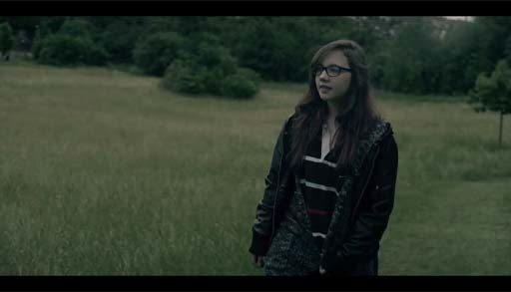

Returning to the mental health spectrum introduced in Sessions 2 and 3, you might consider that in an ideal world everyone would be sailing along in the ‘healthy’ green zone, with perhaps the occasional dip into the yellow ‘coping’ zone when life becomes challenging. To think about interventions for mental health problems in a simplistic way, the aim is to help young people who are ‘struggling’ or ‘unwell’ to move to the ‘healthy’ or ‘coping’ end of the spectrum.

Figure 2: Mental health spectrum (repeated from Session 2.)
View description - Figure 2: Mental health spectrum (repeated from Session 2.)
View description - Figure 2: Mental health spectrum (repeated from Session 2.)

This session will begin by asking you to consider how you and others in your community can intervene and support a young person by listening actively and promoting helpful strategies.

Learning outcomes
By the end of the session, you should be able to:
- explore ways of being a supportive influence to a young person experiencing mental health problems
- improve your active listening skills in helping a young person
- support a young person to manage their own mental health.

1 Parenting and supporting
Practitioners, researchers and policymakers globally are aware of the position of parents, and of other caregivers such as teachers, who often act as a ‘first responder’ to the mental health needs of adolescents.

Figure 3
View description - Figure 3
View description - Figure 3

When faced with a young person who is experiencing mental health problems, however, as a parent or practitioner it is easy to feel isolated and unsure of yourself and at times overwhelmed by the situation. You might at times worry that your efforts are having no impact or may be even doing more harm than good. It is important to acknowledge that anyone who works with or cares for a young person can potentially play an important role in identifying mental health problems at an early stage. Intervening early can help to improve the health and wellbeing of the young person, as well as those who care about him or her.

Activity 1: Parent and caregiver concerns
Allow about 30 minutes. This activity is in 2 parts.

Step 1: Listen to an interview with a parent talking about their concerns about their child’s mental health and reflect on the different feelings and emotions that a parent might experience.

Audio content is not available in this format.
Audio 1: Feeling helpless
View transcript - Audio 1: Feeling helpless

View discussion - Part

Step 2: Now read some of the concerns and frustrations parents and caregivers of young people often express regarding their attempts at supporting a young person. Take the role of a trusted friend and consider what you could say in response to each of these statements that would help to ease the concerns and frustrations. Once you have thought of what to say, click to reveal a comment.
I feel that I am responsible for solving their low mood.

View discussion - Part

It’s hard to stay patient and calm when they don’t want to communicate.

View discussion - Part

They can’t seem to shake off the negative thoughts whatever I do or say.

View discussion - Part

I don’t want to hassle them with too many questions and become a source of annoyance.

View discussion - Part

What if they reject my advice and it pushes them away further?

View discussion - Part

I’m frustrated by their lack of motivation to try anything I suggest.

View discussion - Part

It is a constant worry and I can feel helpless.

View discussion - Part

This activity required you to exercise empathy, putting yourself in the other person’s position and trying to understand what they were experiencing. You may have had similar concerns yourself, and if so, perhaps you found some reassurance from the comments provided here. Coming up with a helpful response can sometimes take practice and will differ with each individual.
A research team in Australia took an innovative approach to researching mental health. They asked parents about their concerns regarding the mental health of their adolescent children, and then also surveyed the adolescents about their perceptions of the issues causing concerns (Cairns et al., 2019). The parents most frequently reported being concerned about drug use, depression, friendships and peer pressure, anxiety, school and study stress, and bullying. Although the young people responding to the survey echoed these matters, they also identified ‘sex, sexuality, and gender identity’ as concerns – ‘topics that parents reported feeling the least confident talking to their children about’ (Cairns et al. 2019, p.65). By the end of this course, you should be able to tackle sensitive topics such as these with more confidence.
Before you move on to learning about active listening, have a look next at some advice on talking with your child and particularly the importance of checking in with them and approaching a difficult conversation.

2 Talking and listening
If you are worried out your child or a child you work with, it is important that you set aside some time where you can check in with them and get a sense of how they feel and perhaps how they are managing their lives at that time.

Activity 2: Checking in
Allow about 10 minutes

Watch Video 2 in which counsellor John Goss discusses how you can check in with your child or a child you are working with or know well.

Video content is not available in this format.
Video 2: John Goss: Checking in
View transcript - Video 2: John Goss: Checking in

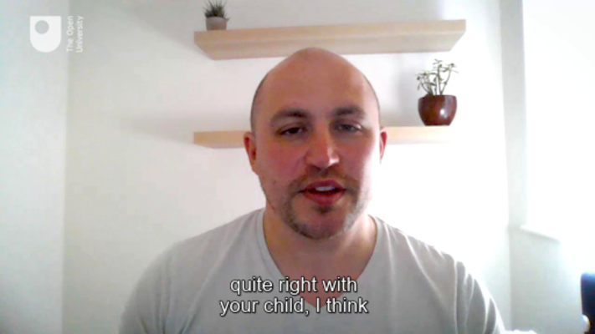

As you watch this clip, jot down a few notes on the key suggestions from John.

Provide your answer...
View discussion - Activity 2: Checking in

An important first step in understanding how your child or a young person you are working with is feeling is to stop and listen to them. This might sound fairly obvious as we all talk and listen throughout our day and yet listening is quite a complex skill. How can you become a better listener? Perhaps you already think you are really good at listening but need to extend your skills to help a young person who is struggling.

2.1 Active listening
Active listening became a professional skill largely thanks to the American psychologist Carl Rogers (1902–1987), who developed a ‘person-centred approach’ to therapy. This approach involved focusing closely on the speaker, not only listening to their words but also to the expression of their voice and other aspects of body language. It also involved portraying warmth and care, helping the speaker feel safe to share unsettling thoughts and feelings (Barrett-Lennard, 1999). Counsellors often undertake many hours of training to achieve this type of skill. However, it is important to note that on a basic level, a lay person can learn to offer warmth, support, guidance and structure to help someone find solutions.
In the next activity you will reflect on the importance of listening to young people who are experiencing distress.

Activity 3: Just listen
Allow about 20 minutes

Watch Video 3 where Pooky talks about different strategies to talk with and listen to your child. As you watch make notes on the four key messages.

Video content is not available in this format.
Video 3: 4 ideas for supporting a child with anxiety
View transcript - Video 3: 4 ideas for supporting a child with anxiety

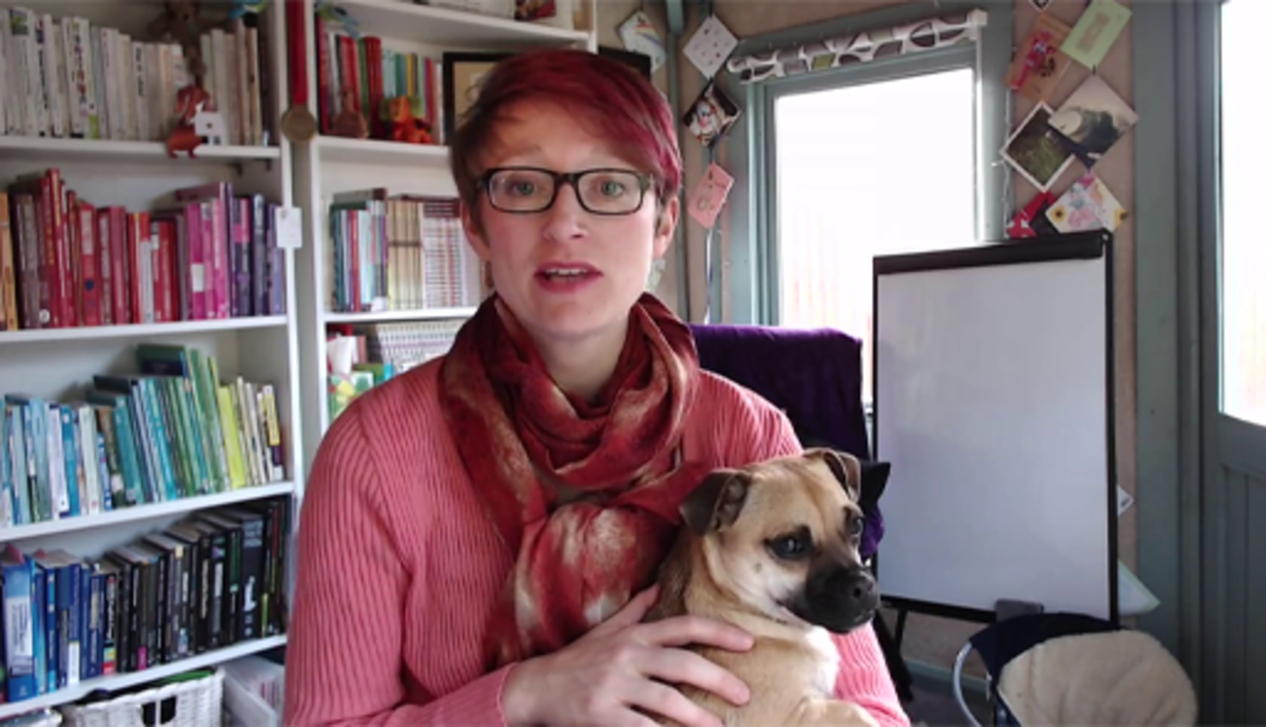

1.
2.
3.
4.

View discussion - Activity 3: Just listen

Active listening is a technique that shows the young person you are giving them your attention and are doing your best to understand what they are telling you. It can encourage young people to talk because it shows that they are being understood and that the information they are sharing is being listened to and acknowledged.

2.2 Question types
Another way of encouraging people to talk and showing you are interested as Pooky suggests is by asking ‘open questions’ rather than ‘closed questions’. An open question invites a free choice of answer, whereas a closed question tends to elicit a ‘yes’ or ‘no’ answer. Compare the two questions below:
- Did you play football today at school?
- How did you find school today?
It would be easy to say ‘yes’ or ‘no’ to the first, whereas the second question could open up a range of different answers.
There are also times when a carefully worded observational statement can encourage a young person to confide in you: ‘I’ve noticed you haven’t been catching up with many of your friends, seems like things are difficult at the moment’ (Stem4, n.d., p.1)
Quite often, the challenge is to know what to say next, and how much time you should give if there is a period of silence. Epic Friends, a website that guides young people to support one another, makes the following suggestions for good listening:
- Giving people the space to talk, by not interrupting.
- Don’t immediately dash in with reassurance and solutions.
- Acknowledge what the person is saying, by simply stating what you think you have heard, e.g. ‘it sounds like you don’t know what to do’.
- Notice how you are feeling as you listen, and whether your emotional responses are stopping you from listening properly. (Epic Friends, n.d.)
As a parent or caregiver, it can be easy to feel defensive or guilty when a young person who is close to you shares dark or troubling thoughts. It’s quite normal for parents to feel responsible and to find it difficult to disentangle their desire to ‘solve a problem’ or their fears about being part of the problem, from the process of allowing a young person find their own solution. Bringing your own background anxieties into the conversation can limit your ability to listen openly. Removing your self-defence filters and focusing back to the young person next to you can help them immensely.
It can be easier for therapists than parents to handle a young person’s difficult thoughts and emotions because they are not personally involved in the young person’s life. In Session 8, you’ll learn more about how trained therapists can help. In the next activity you’ll consider how you might approach a difficult conversation and be an ‘anchor’; for your own child or a young person you are working with.

Activity 4: ‘Be a child’s anchor’
Allow about 30 minutes

Watch Video 4, in which two workers from the YoungMinds Parents Helpline share tips for approaching difficult conversations. Then, work through steps a,b and c below.

Video content is not available in this format.
Video 4: Difficult Conversations - Roundup | YoungMinds Parents Lounge
View transcript - Video 4: Difficult Conversations - Roundup | YoungMinds Parents Lounge

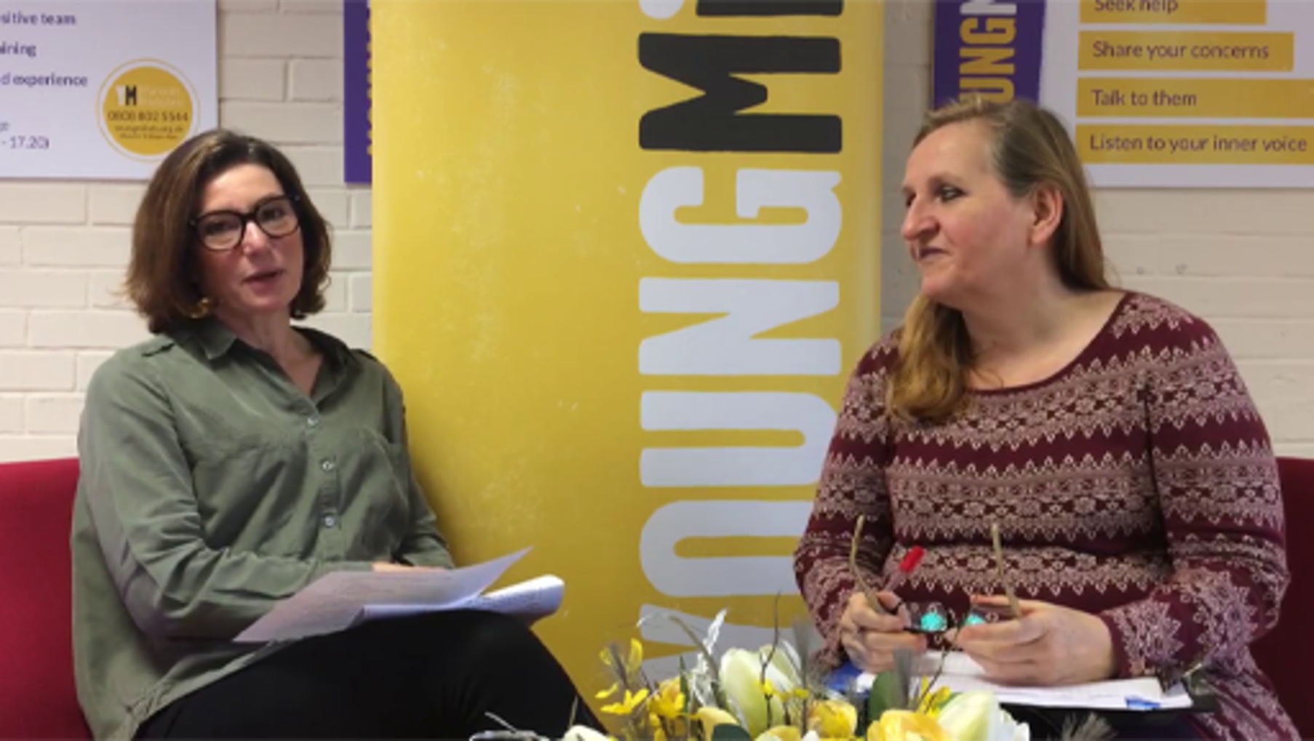

a. Identify one suggestion from the presenters that helps to put your mind at rest, and make a note of it here:

Provide your answer...

b. Identify the five ‘top tips’ and summarise them below.

Provide your answer...
View discussion - Part

c. Make a note of one phrase that you will find particularly useful.

Provide your answer...
View discussion - Part

2.3 Conversation starters
YoungMinds remind us that parents and caregivers know best when their child is not ready to talk, or not in the right mood. In these situations, it is important that young people know they can re-start the conversation when they are ready. In addition to conversation starters, ‘encouragers’ can help a young person who is finding it difficult to open up. Conversation starters suggested by YoungMinds (2020) include:

Interactive content is not available in this format.
Interactive Figure 4: Conversation starters (YoungMinds, 2020)
View description - Interactive Figure 4: Conversation starters (YoungMinds, 2020)

This next activity takes you beyond simply listening towards techniques that can help you to offer practical solutions for your own child or a child you are working with to learn techniques in self-soothing or calming.

Activity 5: Supporting young people to manage their emotions
Allow about 30 minutes
Supporting young people to manage their own emotions and learning self-care and perhaps self-soothing techniques is an important life skill.

Step 1: Watch Video 3 again, and listen to Pooky talk about some of the tips for supporting a child’s anxiety and to develop their own self-soothing techniques.

Video content is not available in this format.
Video 3: (repeated) 4 ideas for supporting a child with anxiety
View transcript - Video 3: (repeated) 4 ideas for supporting a child with anxiety

1.
2.
3.
4.

View discussion - Part

Step 2: Make yourself a list of soothing and calming techniques you might suggest to a young person you know.
How else can you support the emotional health of a young person? Select from this list, or add your own ideas:

Encourage supportive friendships
Encourage them to see the positives, despite their difficulties
Encourage self-compassion, not blaming themselves or feeling selfish about self-care
Provide your answer...
View answer - Part

Next, you’ll learn about ways for you and the young people you care about to maintain their mental health by focusing on diet, exercise, and sleep.

3 Food, exercise and sleep
Health and wellbeing are dependent on diet, exercise and sleep, and these three aspects of lifestyle are linked to mental health. Enjoying a family meal, getting out in the fresh air or playing a team sport, and having a good night’s sleep could give immediate benefits to a young person’s mood. Longer term, healthy living habits promote healthy growth and development of body and brain. This section addresses the questions ‘How do healthy lifestyle habits support mental health?’ and ‘How can you encourage a healthier lifestyle without making things worse?’
As you work through this section, you will notice that much of the evidence for the mental health benefits of these lifestyle factors is nevertheless tentative. It is often not possible to determine whether adopting healthy lifestyles can improve mental health, or whether researchers are just observing that the two are linked for other reasons. This section will guide you carefully through the scientific evidence and mental health practices that link lifestyle with mental health.

3.1 Food and mental health
Adolescents may develop anxieties around eating and body weight, as you saw in Session 3. If you can become well-informed about the characteristics of a balanced diet and understand that no single food source is a panacea for any particular problem, you can put yourself in a stronger position to help.
The UK National Health Service (NHS, 2018) highlights that in adolescence there is a particular need for certain vitamins and minerals:
- Iron (especially in girls)
- Calcium (Particularly for bone and teeth development)
- Vitamin D (to aid absorption of calcium into the body)
The NHS also emphasises the importance of eating breakfast, a range of fruits and vegetables (‘5 a day’) and cutting down on snacks that are high in fat, sugar or salt. A balanced diet is considered to comprise (NHS 2018b):
- at least 5 portions of a variety of fruit and vegetables every day
- meals based on higher fibre starchy foods like potatoes, bread, rice or pasta
- some dairy or dairy alternatives (such as soya drinks)
- some beans, pulses, fish, eggs, meat and other protein
- unsaturated oils and spreads, eaten in small amounts
- plenty of fluids (at least 6 to 8 glasses a day)
Eating well can help to maintain physical health (which is good for the physical brain, of course), and there is mounting evidence that a balanced diet can support good mental health too (Adan et al., 2019). The missing piece is to do with being able to explain the science with certainty, and to predict with confidence how a change of eating habits will affect mental health. Consider the links between food and mood described in the next activity.

Activity 6: Food and mood
Allow about 20 minutes

1. Watch this video produced by Mind the mental health charity.

Video content is not available in this format.
Video 5: How to manage your mood with food | 8 tips
View transcript - Video 5: How to manage your mood with food | 8 tips

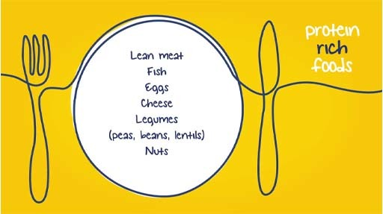

Notice how they are careful to make links with established knowledge about physical health. Can you pick out one ingredient of a diet that comes over strongly for its effect on mood? Make a note below.

Provide your answer...
View discussion - Part

If you are interested in this area and what to find out more take a look at the recent research by Felice Jacka (2019) who has extensively researched the links between food and mood. Her research indicates that an unhealthy diet of processed food can impact young people’s mental health which may result from changes in bodily systems such as the immune system, hippocampus in the brain, the stress-response system and the gut. You can also listen to her talk about her research here: The Ground-Breaking Science of Food & Mood with Prof. Felice Jacka | Stronger Minds on Acast
What could you do to encourage a young person you care about to eat a balanced diet and regular meals? Think about what might be preventing them from eating well. Is it pickiness, or peer pressure, or newfound independence allowing them to explore sweet, salty and fatty food perhaps?
Choose from this list of things that might help, and tick any you think you could achieve or attempt:

Being a role model of good eating habits.
Talking in a positive way about healthy eating.
Involving the young person in meal planning.
Involving the young person in food shopping.
Involving the young person in meal preparation.
Stocking up on healthy snacks.
Involving the young person’s friends or siblings.
View answer - Part
View discussion - Part

3.2 Exercise and mental health
Exercise benefits everyone but most people struggle to integrate sufficient physical activity into their lives.

Figure 5
View description - Figure 5
View description - Figure 5

For young people, the World Health Organization recommends ‘at least an average of 60 minutes per day of moderate-to vigorous-intensity, mostly aerobic, physical activity, across the week’. (WHO 2020a, p. 25)’. The evidence for the physical benefits of exercise is well established, and the evidence for psychological benefits is mounting. In the next activity you will consider some of the research in this area.

Activity 7: Can 10 minutes exercise a day can improve mental health
Allow about 15 minutes

Listen (or watch) Video 6 where Dr Rangan Chatterjee talks to Dr Brendon Stubbs. Try not to get too bogged down in detailed descriptions of research approaches here. Whilst they are important, it’s perhaps more important to consider what the key messages here are in terms of the amount of exercise and how this can impact mental health. As you listen make a note of three key messages which you feel are important.

Video content is not available in this format.
Video 6: How 10 Minutes Of Exercise A Day Can Change Your Brain: Dr Brendon Stubbs | Bitesize
View transcript - Video 6: How 10 Minutes Of Exercise A Day Can Change Your Brain: Dr Brendon Stubbs ...

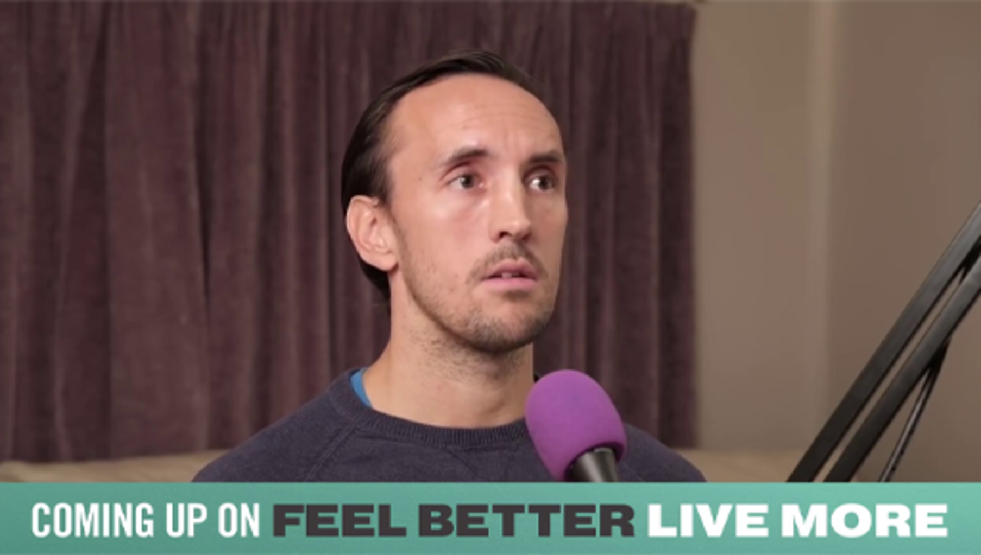

Provide your answer...
View discussion - Activity 7: Can 10 minutes exercise a day can improve mental health

WHO (2020b) has claimed that there is ‘Strong evidence’ that ‘physical activity reduces the risk of experiencing depression’ (p. 39) and can help to treat existing depression. WHO also warns about the health risks of excessive sedentary behaviour, which can occur, for example, when recreational activities are screen-based rather than physical.
The latest figures suggest that very few young people are achieving the WHO recommended levels of physical activity (Guthold et al., 2020). The figure below, which shows the prevalence of insufficient physical activity among school-going adolescents, reveals that globally more than 80% of girls did not achieve the recommended level in 2016, and that boys were only slightly better. There is no clear pattern between rich and poor countries. The trend shows a slight improvement for boys between 2001 and 2016, and hardly any change for girls.

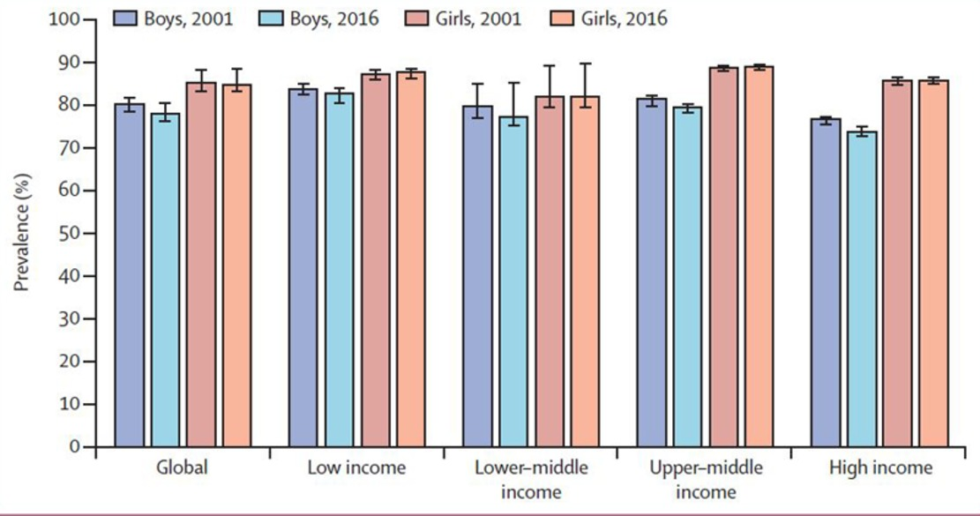
Figure 6: Prevalence of insufficient physical activity among school-going adolescents aged 11–17 years, globally and by World Bank income group, 2001 and 2016 (Guthold et al., 2020)
View description - Figure 6: Prevalence of insufficient physical activity among school-going adolescents ...
View description - Figure 6: Prevalence of insufficient physical activity among school-going adolescents ...

Research on the relationship between physical activity and mental health usually raises further questions. For example, are team sports better for mental health than exercising alone? A recent European survey study (McMahon et al., 2017, p. 120) found that ‘Lowest levels of anxiety and depression and highest level of well-being were found among those participating in team sports’. However, the researchers could not say whether the social aspects of team sport improved mental health and wellbeing, or whether the young people with mental health problems were less likely to engage in team sports.
The amount of exercise required for mental health might not be quite as great as that for maintaining physical health. Indeed, The UK National Institute for Health and Care Excellence (NICE, n.d.) recommends ‘45 minutes to 1 hour per session, up to three times a week’ for an adolescent who has a diagnosis of depression. As more research results become available, people’s understanding of the relationship between mental health and physical activity will become more sophisticated. Increasing one’s levels of physical activity can benefit some individuals more than others, and it is definitely something worth persevering with, in efforts to boost mood.

Research note
It is difficult to make definite claims about whether physical activity actually prevents mental health problems, because most studies are ‘cross-sectional’. A cross-sectional study takes a snapshot at a particular time, by conducting a survey, for example. Surveys can determine how many people who engage in a certain amount of physical activity are experiencing mental health problems (providing a correlation), but they cannot tell whether the activity is preventing mental health problems from developing. Longitudinal studies, which measure changes over time, can help to fill these knowledge gaps, although the causes of mental health problems are so complex it can be difficult to identify the effects of a single factor. Randomised controlled trials are able to measure the effects of a single factor through careful design and the use of sophisticated statistical methods. These are the most difficult to set up, but provide the most conclusive results.
(Howlett et al., 2021).

One of the ways in which exercise is thought to be beneficial is by improving sleep quality (Brand et al., 2017). Daytime exercise is beneficial, whereas vigorous exercise late in the evening can interfere with sleep. Next, you’ll explore the impact of sleep on mental health, as well as ways of helping a young person to sleep better.

3.3 Sleep and mental health
You’ve probably had times when you were unable to sleep and as a result felt tired, grumpy and were unable to concentrate well. Sleep can be particularly important during adolescence. Sleep disruption can exacerbate depression (Baum et al., 2014), and it is widely accepted that good sleep is essential for good mental health. Many young people may report feeling excessively tired when experiencing mental health problems and many parents or caregivers may notice that their child is sleeping a lot or experiencing disrupted sleep.
Before learning more about this, consider how much sleep a young person needs.

Activity 8: Sleep needs in adolescence
Allow about 10 minutes

How much sleep do adolescents need?

4-5 hours
6-7 hours
8-9 hours
10 hours or more
View answer - Activity 8: Sleep needs in adolescence
View discussion - Activity 8: Sleep needs in adolescence

There are some important considerations regarding sleep in adolescence. One is that sleep seems to have an effect on the development of the brain structure in adolescents. It is also understood that restricted or interrupted sleep can affect learning and memory as well as the processing of emotions (Short et al., 2013, Tarokh et al., 2016). There is little doubt that good quality sleep restores the brain, and that the adolescent brain is undergoing significant structural changes. Scientists still have much to learn about the relationship between sleep and the adolescent brain, and this remains an active area of enquiry.
During adolescence, the internal body clock shifts so that a young person tends to go to sleep later at night and wake later in the morning. This shift in body clock tends to disadvantage young people, who find it difficult to wake for school and get to sleep at a good time in the evenings (Crowley et al., 2006).
External factors, such as light, also influence the body clock. Neuroscientists have found that light at the blue end of the spectrum enhances alertness, whereas red light can reduce alertness. Exposure to natural light during the day, which has high levels of blue light, can enhance healthy sleep patterns in young people, and reducing blue light before bedtime can help a young person get to sleep (Studer et al., 2019). There is growing concern over screen use in the bedroom as screens typically emit blue light.
The evidence for the benefits of good sleep is persuasive, so what can you do as a parent or caregiver? The next activity helps to answer this question.

Activity 9: Promoting sleep
Allow about 15 minutes

Decide which of these actions you could take to promote sleep in a young person.
Encourage avoidance of:

strenuous physical exercise in the hour leading to bedtime
using a smartphone, tablet or PC in the hour leading to bedtime
watching TV in the hour leading to bedtime
drinking caffeine, particularly in the 4 hours before bed
View answer - Part

Things to encourage:

reading a book at bedtime
listening to relaxing music
having a bath
change bedroom lightbulbs to ones with a warmer light
write down any worries that are interfering with sleep
aim for at least 60 minutes’ exercise during the day
get outdoors as much as possible while it is light
a good bedtime routine
View answer - Part

Other measures to consider:

thicker curtains or a blackout blind in the bedroom
using an app to support good ‘sleep hygiene’ (the good habits that facilitate sleep)
View answer - Part

4 This session’s quiz
Check what you’ve learned this session by taking the end-of-session quiz.
Session 6 practice quiz
Open the quiz in a new window or tab then come back here when you’ve finished.

5 Summary of Session 6
The main learning points of this session are:
- Active listening provides opportunities to engage with young people and provide time and space for them to share their feelings. This involves stopping what you are doing, listening without interrupting and trying not to judge a young person or trying to fix them.
- Rather than trying to solve a young person’s distress it is important that they learn and are supported in developing life skills in self-soothing and the ability to calm themselves.
- A healthy lifestyle, including a healthy diet, regular exercise and plenty of sleep supports young people’s mental health.
Now to go Session 7.

Session 7: Identifying sources of support

Introduction
A great source of distress for young people who experience mental health problems are feelings of isolation. You will recall in Session 6 that the parents of the young people who were experiencing mental health problems reported that they also withdrew from families and friends. Isolation is often compounded by a sense of stigma. Support networks can be invaluable in assisting young people and their families. It can help them to manage any stigma they may feel in relation to their mental health and help them to feel connected with others who understand the challenges. It can also help them find sources of support. Internet technology has made it possible for people to link with others in the privacy of their homes, and the opportunities to do this continue to develop and have showed some positive results. This has been particularly the case during the COVID-19 pandemic when options to meet in person were limited. In the next video, you’ll see counsellor John Goss talking about the various types of support that in their experience young people have access to. Watch now to get a sense of the range of support.

Video content is not available in this format.
Video 1: John Goss: Various types of support
View transcript - Video 1: John Goss: Various types of support

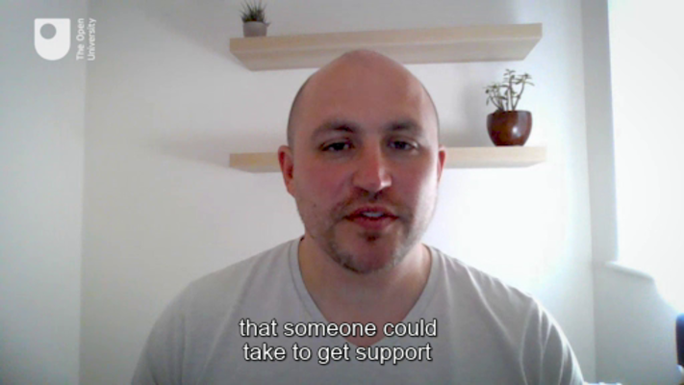

In the video, John talks about the GP and talking therapy with a counsellor, as being two of the main formal support systems that a young person can access. You will learn more about these types of support in this session. However, as John pointed out, it is also important to sometimes engage directly with the young person and/or the people around them to find out what types of things could best support them.
In this session, you will begin by exploring how a secure network of family and friends can help to support a young person. At the beginning of the video, John also talked about the power of support groups in relation to providing spaces for the young person to share their experiences. Some of these can be in person, but as you will discover nowadays many are held online or via social media. When well-managed, these can be a good source of support and this session contains some valuable information on how young people can be encouraged and supported to use social media for the benefit of their mental health. We will also explore how it can impact negatively and how this can be managed. You will then consider what the charities MIND and YoungMinds can offer to young people with mental health problems.

Learning outcomes
By the end of the session, you should be able to:
- describe how a support network can benefit a young person experiencing mental health problems
- advise a young person on the best way of using social media for support
- explore a range of self-help resources and decide whether they will be helpful.

1 Family, friends and other adults
Addressing mental health issues is far from a passive process on the part of the young person concerned. Professional support strategies rely on the young person being able to engage actively in the process, as so much of it is about developing relationships with the self and others. As you will see in the case of cognitive behavioural therapy (CBT), which you will look at in Session 8, young people can improve their mental health by challenging and adjusting the ways they think about events and their emotional responses to their experiences.
Dr Ken Ginsberg, specialist in adolescent medicine, advocates supporting young people to develop the skills they need to develop competence in life. You heard him in Session 5 talking about the ‘Seven Cs of Resilience’. You’ll hear more from him in the next activity.

Activity 1: Nurturing and supporting in adolescence
Allow about 20 minutes

In Session 5 you were introduced to the Seven Cs of Resilience, by Dr. Ken Ginsburg. In the video it was clear that resilience is not one clear definable thing but something that is more complex and influenced by a range of factors, both internal and external to the young person. The topic of Session 7 is about identifying sources of support, so this time we want you to watch the video again, this time focusing this time on ways in which those around the young person can contribute to their resilience.
Complete the table below as you listen to the video again, this time making a note of all the things that those around a young person can help to support a young person’s sense of resilience.

Video content is not available in this format.
Video 2 (repeated from Session 5): The Seven Cs of Resilience: Dr. Ken Ginsburg introduces his Seven Cs of Resilience: Confidence, Competence, Connection, Character, Contribution, Coping, and Control. Content provided courtesy of the Center for Parent and Teen Communication, Children's Hospital of Philadelphia. © 2018 The Children’s Hospital of Philadelphia
View transcript - Video 2 (repeated from Session 5): The Seven Cs of Resilience: Dr. Ken Ginsburg introduces ...

Table 1: Seven Cs of Resilience
1. Confidence | Provide your answer...
2. Competence | Provide your answer...
3. Connection | Provide your answer...
4. Character | Provide your answer...
5. Contribution | Provide your answer...
6. Coping | Provide your answer...
7. Control | Provide your answer...

View discussion - Activity 1: Nurturing and supporting in adolescence

1.1 Fostering supportive networks
The value of a supportive social and family network should not be underestimated. In Session 5, you found that having a supportive social network is a key feature of resilience. A strong social network also instils a sense of belonging, which can promote wellbeing. Psychologist Nathaniel Lambert and colleagues (Lambert et al., 2013, p.1425) identified that ‘Having a sense of belonging is to have a relationship with people, or a group of people, that brings about a secure feeling of fitting in.’ Therefore, when considering a person’s social network it will also be useful to think about the quality of the relationships.
Research has shown that parents, best friends, peers, relatives, siblings, teachers and other practitioners and members of the community can all be a source of secure relationships for a young person (Buckley et al., 2012). Look at the diagram in Activity 2, which gives an illustration of a close social network for a young person.
Working out who is part of a young person’s social network can be a first step towards helping the young person to access support from trusted sources. The next activity will help you to map out the social network of a young person you know, and invite you to do the same for yourself.

Activity 2: Social support networks
Allow about 30 minutes

Spend a few minutes thinking about the people in the life of a young person you know well. It could be a family member, friend, neighbour, or someone you know from education or sports activities. It might be a young person you know about through another adult.
Fill in the social network for this young person the best you can. Then, consider which of these relationships might be the strongest for providing a sense of belonging or trust. You might find it helpful to think back to Ken Ginsberg’s advice about how to support an adolescent with their competence in organisational, communication, self-advocacy skills, and to understand how to handle peer pressure.

Interactive content is not available in this format.
Interactive Figure 1: Mind mapping
View description - Interactive Figure 1: Mind mapping

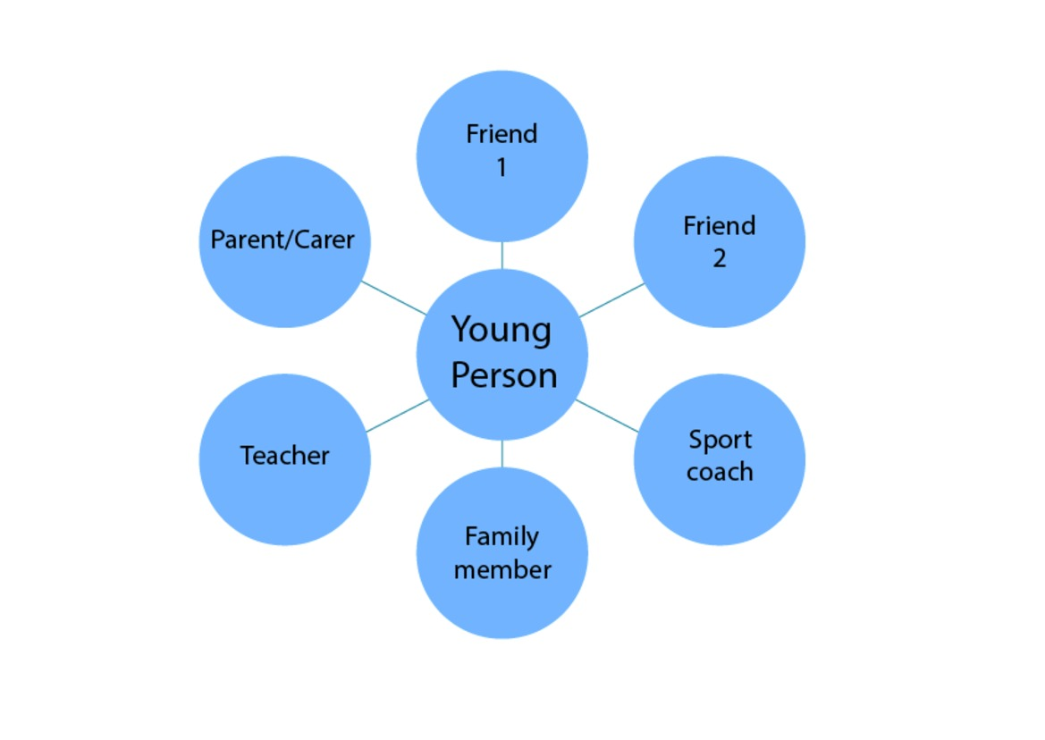

Why not do the same for yourself? Being in a position to support others means that you also need a good social network for your own wellbeing. Consider who might be able to provide good quality support to you. It may be that there are a few individuals who provide slightly different aspects of the support you need.

View discussion - Activity 2: Social support networks

1.2 Managing barriers
In Activities 1 and 2 of this session you have seen how social networks can nurture and strengthen a young person’s emotional health. Research has shown that participating in school-based extra-curricular activities can help to reinforce existing friendships and help new friendships to form (Schaefer et al., 2011). However, it is also important to note that socialising may be a trigger for some young people who feel socially anxious and/or depressed (Martin and Atkinson, 2020). ‘Withdrawal’ from social networks and family can characterise many mental health issues and exacerbates feelings of social isolation, and can also heighten stigma. Therefore, in thinking about a young person’s social network and the influence it has on a young person’s wellbeing, you might consider whether you can suggest ways it can be strengthened or supported. You may also wish to include reviewing any disruptive influences that you think there may be on the young person or improving your confidence in responding to distress. We turn to ways to do this in the next section.
Is it also important to note that a young person may not always want to confide in close family or friends, especially if they are concerned about stigma or worried that they will upset the relationship. It is important to understand barriers to accessing support and this is something we explore in the next activity.

Activity 3: Barriers to accessing informal social support
Allow about 10 minutes

Listen to the young men we interviewed discuss how they perceive their friends might feel about reaching out for support in relation to mental health. Pay particular attention to any tensions they report in relation to how mental health is thought about by them and their peers.

Video content is not available in this format.
Video 3: Barriers to support
View transcript - Video 3: Barriers to support

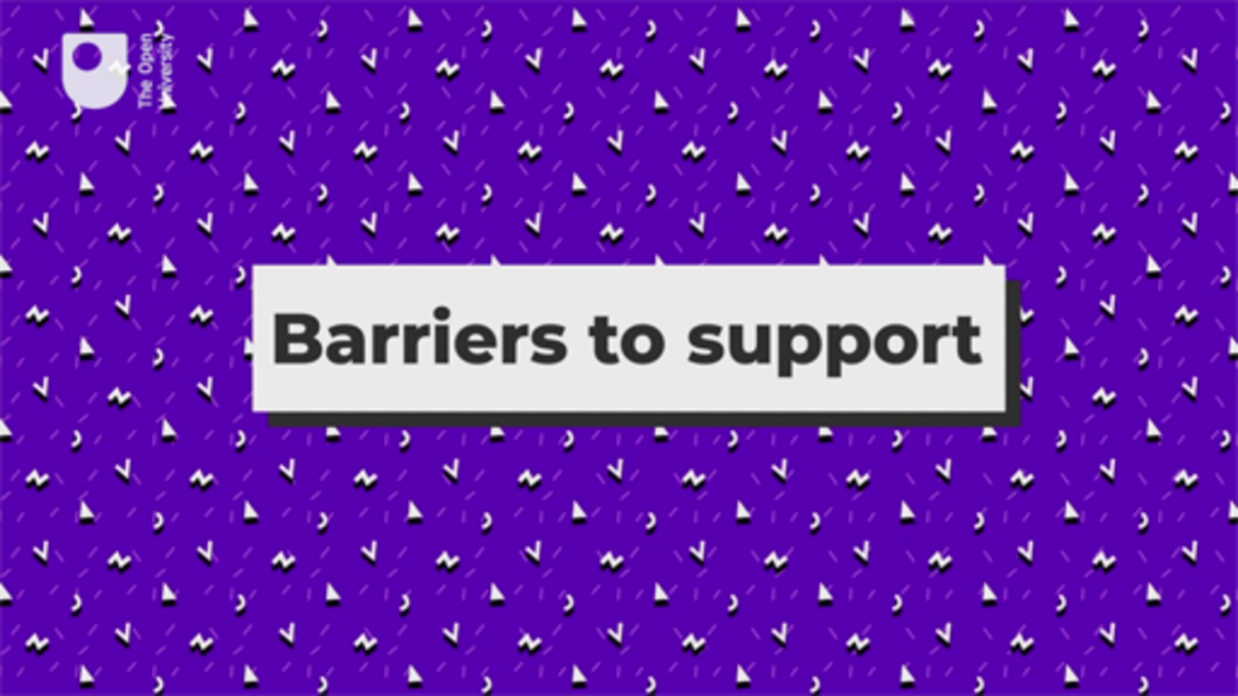

Provide your answer...
View answer - Activity 3: Barriers to accessing informal social support

As the clip you just listened to highlights, there is still a great deal of work to be done to get young men to open up about their emotions. Embarrassment seems to be a key barrier to talking about mental health, but there are things that we can do to support young people to enable them to discuss these issues.
Although a personal network is essential in many ways to support wellbeing and/or recovery from a mental health problem, it is important to acknowledge that supporting someone with mental health issues can be a challenge to us. This is something you’ll explore in the next section.

1.3 Managing responses to mental health disclosures
When a parent or carer is supporting a young person who has confided in them about issues with their mental health and emotional difficulties it can feel overwhelming.

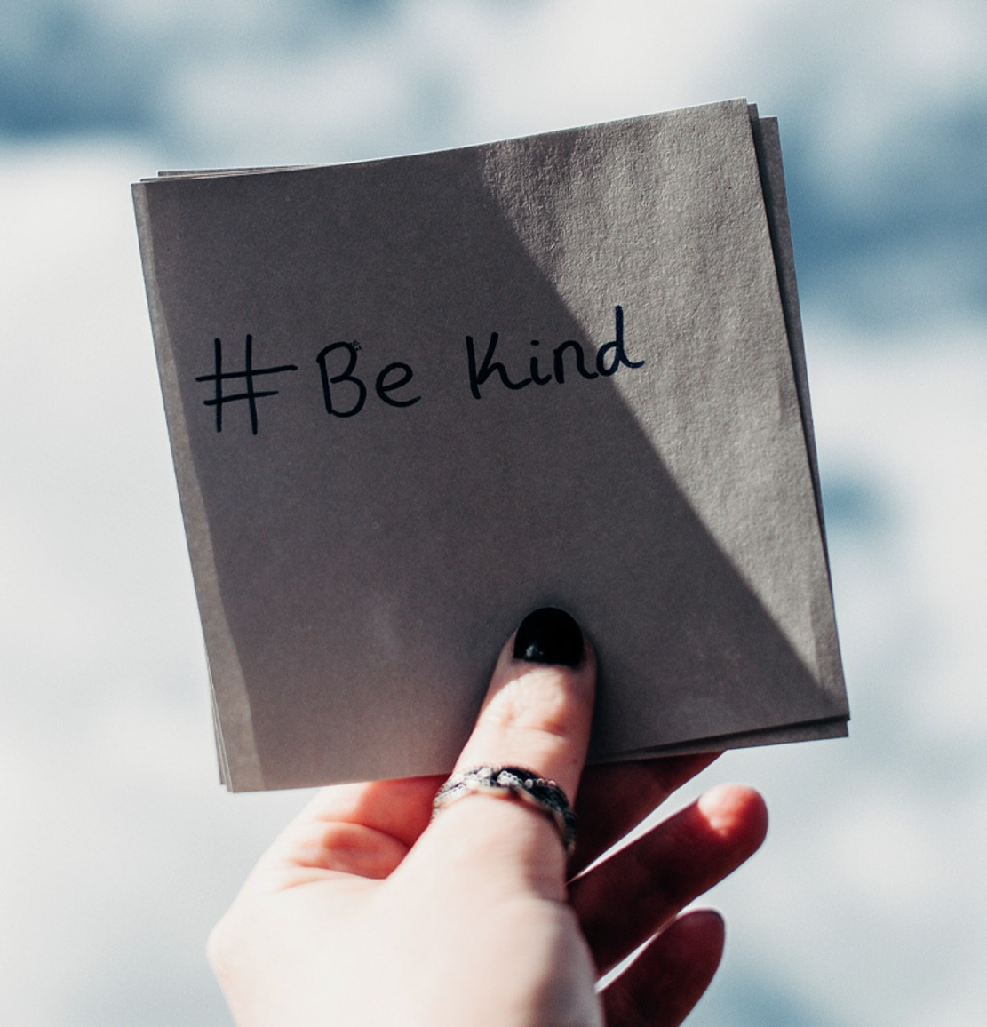
Figure 2: #be kind
View description - Figure 2: #be kind
View description - Figure 2: #be kind

Research shows us that self-care and a network of support for carers is vital in ensuring that when parents, caregivers and educators feel out of their depth, they have support for themselves. However, not everyone knows how to respond when they are told about mental health issues.

Activity 4: Experiencing different supportive responses
Allow about 10 minutes

Listen to this audio from one of the parents we interviewed as she talks about how people reacted when she shared the news that her daughter was experiencing mental health issues. Note the positive and negative aspects and reflect upon how this might impact your behaviour in future if you were told that a friend or colleague was supporting someone with mental health issues.

Audio content is not available in this format.
Audio 1: Support for parents
View transcript - Audio 1: Support for parents

Provide your answer...
View answer - Activity 4: Experiencing different supportive responses

Being exposed to the various responses different individuals may express in response to disclosures about mental health can be challenging. However, often at least part of the problem is that often there is a lack of understanding about mental health distress. You may even find that as a parent, caregiver or educator you are taken out of your comfort zone and challenged beyond your own limits of understanding about these issues. This is why education about mental health distress and how to manage it is so important.
In response to these challenges and in an attempt to improve support and reduce stigma, bespoke training courses have been set up for those who wish to find out more about how they can support and help young people. For example, the training company Mind Matters have developed an adapted version of the popular Mental Health First Aid course to ensure the content is more specific to young persons’ mental health.
Other examples include that offered by Papyrus, a charitable organisation working to prevent young suicide which offers three different types of training for schools and colleges ranging from short courses that can be completed in an afternoon that give a brief overview of the main topics, to more intensive two day courses that build up skills.
While these courses are more formal and therefore have costs associated with them, there are also many other free courses on OpenLearn and FutureLearn that deal with particular areas of concern that you may want to know more about. If you wish to find out more you can simply enter relevant search terms into the search engines both online portals provide.
Some of the parents we spoke to thought it may also be useful for parents and supporters to have counselling themselves. This can provide a safe space to talk over the feelings experienced when supporting someone who has mental health difficulties.

2 Social media
Social media gets a lot of bad press about its negative impact on young people (as well as adults). Research indicates that social media is implicated in increasing adolescent depression (Brunborg and Burdzovic, 2019; Raudsepp, 2019) especially in girls (Kelly et al., 2019). It also provides a platform for narcissistic self-promotion and aggression (Stockdale and Coyne, 2020) and acts as a mediator of body image concerns (Marengo et al., 2018). By contrast, however, there is also evidence that social media can provide a supportive environment for young people to make connections and receive mutual support (Radovic et al., 2017).

Figure 3
View description - Figure 3
View description - Figure 3

In the UK, it is becoming compulsory to include online safety in school curricula (Department for Education, 2019; Welsh Government, 2019; CCEA, 2020; Scottish Government, 2017). Many young people are well briefed on online safety, although this doesn’t mean, of course, that they will take all the precautions they have been taught. In the next activity, you will find out about how a young person you know engages in social media and the impact this may have on their mental health. In this section, we will explore these issues by listening to audio and watching video from our interviews with young men and women.

Activity 5: Assessing the Impact of Social Media Use
Allow about 30 minutes
In this activity, you will explore the varying impacts of social media on young people by watching a series of clips from our interviews with young men in which they are asked to talk about the impact this has had on their lives.

Watch Video 4 and make a note of the concerns the young men describe.

Video content is not available in this format.
Video 4: Trends in how social media impacts mental health
View transcript - Video 4: Trends in how social media impacts mental health

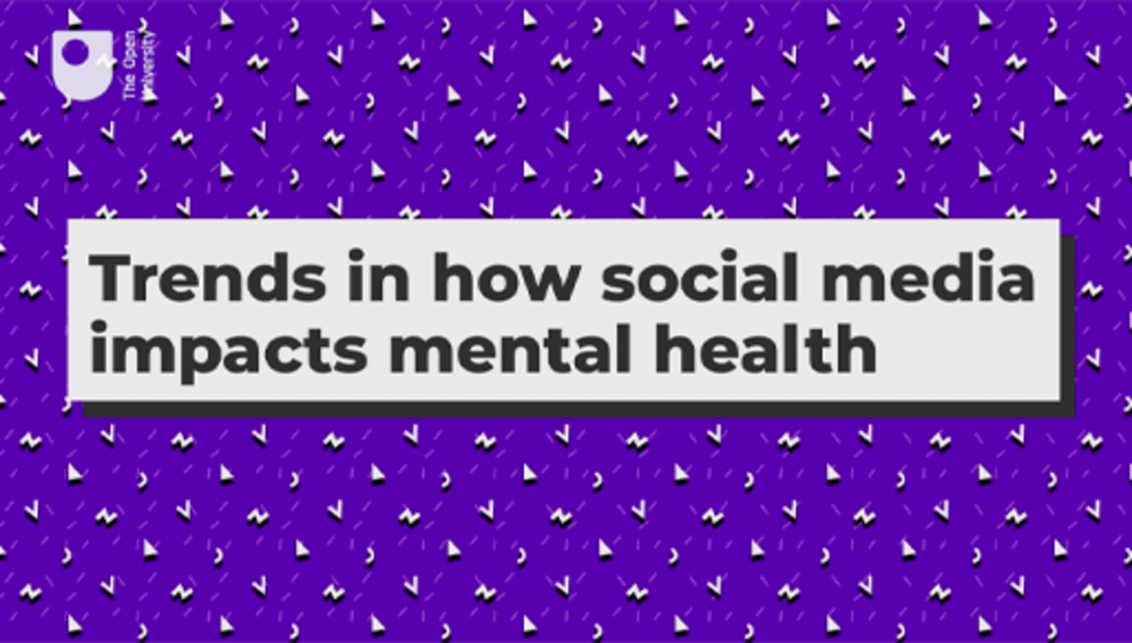

Provide your answer...
View discussion - Part

Now watch Video 5 and note how the young men talk about their behaviour in relation to social media and how they manage the impact of social media on their wellbeing. Note also why they think social media is harmful.

Video content is not available in this format.
Video 5: Helpful ways of limiting the negative impact of social media
View transcript - Video 5: Helpful ways of limiting the negative impact of social media

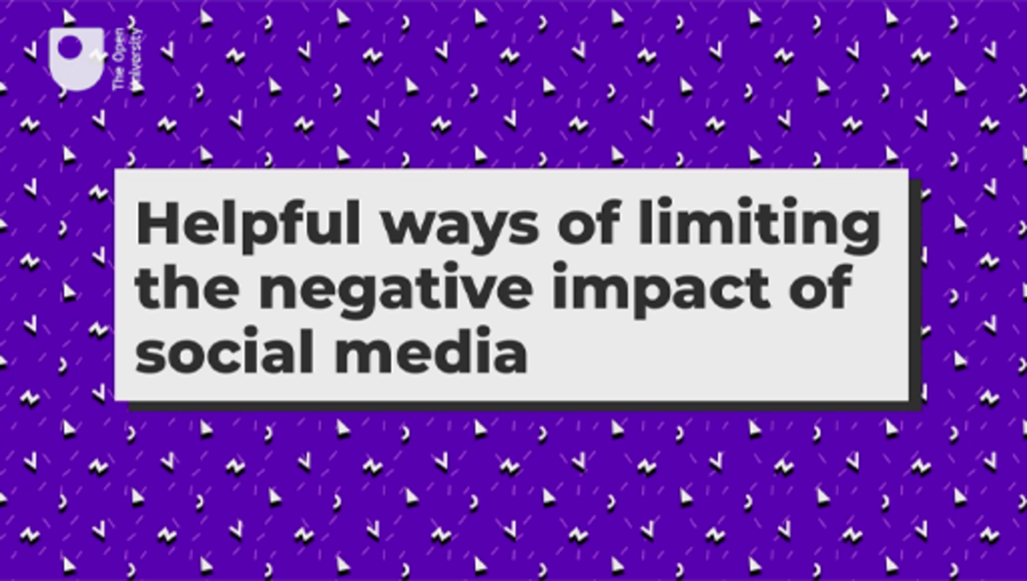

Provide your answer...
View discussion - Part

The young women we interviewed also talked about the impact of social media on them.
Listen to Audio 2 and then make a note of the ways they thought that social media may have impacted upon them and how this has changed over their adolescence.

Audio content is not available in this format.
Audio 2: The change of impacts of social media through adolescence
View transcript - Audio 2: The change of impacts of social media through adolescence

Provide your answer...
View discussion - Part

2.1 Taking control
Researchers and charities are increasingly working to explore how to guide young people to manage their relationship with social media so that it has more of a beneficial impact on their wellbeing. In the next activity, you will explore some of the simple techniques they have developed.

Activity 6: Controlling a social media feed
Allow about 20 minutes

Regardless of your personal opinions of social media and the role it is playing in the lives of the young people you work with, it is important to realise that young people are best supported by helping them to make good personal choices about social media for themselves, especially as many adolescents have individual access to mobile phones and computers. In the previous activity, you heard the young men describe how they limited their use of social media to manage the impact it had on their mental health. Watch Video 6 in which young people describe how they altered their behaviour to have a more positive time when using social media.

Video content is not available in this format.
Video 6: #OwnYourFeed for a more positive time online
View transcript - Video 6: #OwnYourFeed for a more positive time online

As you watch make notes summarising the following three key pieces of advice:
- ‘Cleaning your feed’
- ‘Find your crowd’
- ‘Say hey’

Provide your answer...
View answer - Activity 6: Controlling a social media feed

It can be hard to talk to young people about these things in a way that captures their attention, so it may help to ask the young person to watch the video themselves. However, campaigns like this which are driven by and informed by young people are an illustration of how many of them are increasingly aware of the impact of social media on their mental health.
Another way to help young people engage with their own social media use is to access the reminders that tell them how long they’ve been using an app or to set their own limits. For example, on Facebook, go to Your time on Facebook > Set daily reminder. They can then set their own ideal daily usage.
Being able to limit time spent on social media can also help to prevent sleep disruption. There is now a body of research that indicates ‘young people who spend more time using social media (especially at bedtime) and those who feel more emotionally connected to platforms’ report later bedtimes, take longer to get to sleep, sleep less and have poorer sleep quality (Scott et al,. 2019, p. 539). You learned about the link between sleep and adolescent mental health in Session 6. Fortunately, there are ways to mitigate sleep disruption or to use phones to help promote sleep. For example, most phones now have night time modes to ensure that blue lights emission is reduced. In addition, meditation apps have stories that can help young people wind down and get to sleep.

2.2 Understanding the impact of social media on a young person’s identity
New research can help us to understand the complex ways in which young people engage with the online world as part of their everyday lives. For example, the internet and social media use can serve as a means of self-interpretation, allowing young people to conduct ongoing ‘identity work’. These digital technologies can make it possible for us to create ‘multiple selves’ or ‘multiple identities’ allowing young people to transform themselves. In addition, it can allow young people to connect with other people who are like them.

Activity 7: Understanding the impact of the internet on identity

The young people who are growing up today where born into a world were the internet and social media already existed. In their book on the subject, John Palfrey and Urs Gasser described them as being ‘Born Digital’ and suggested this had a fundamental impact on how their identity was formed. One of the key messages from the book is that it is not always possible for those of us who grew up in a time pre the internet or social media to fully connect with the integrated nature of the digital identities that many young people have these days. But it is important for us to recognise that, as with most things in life, there are both positive and negative consequences.
Watch this video which illustrates well the complex relationship some young people have with social media.

Watch the video at YouTube.com.
Video 7: Social Media, Social Life: Teens Reveal Their Experiences (The Open University is not responsible for external content.)

As you will see from the word cloud (Figure 4), individual reflections on social media and the ways in which young people use it can vary from our own. From this video and from the extracts of interviews with young men it is clear that we should be careful about buying into the notion that all social media is bad for young people. Instead, we need to move towards an understanding of how and why young people engage with various social media networks.

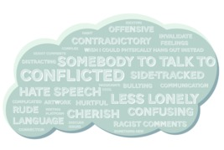
Figure 4
View description - Figure 4
View description - Figure 4

3 Charities
What happens if a young person does not feel able to confide in close friends and family? Charities provide a range of important services for supporting mental health in young people. Their websites are often the first place people go for information.

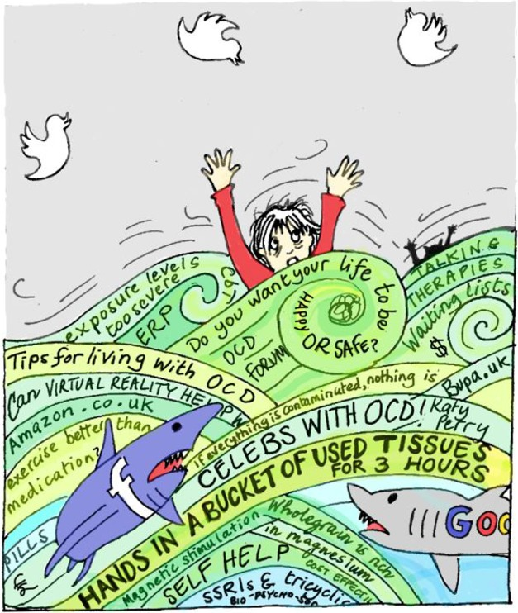
Figure 5
View description - Figure 5
View description - Figure 5

Charities such as Mind and YoungMinds provide support networks for young people. Mind, for example, has linked up with the Anna Freud National Centre for Children and Families, which has a network of centres across the UK that provide support for young people. Mind, itself, has a network of ‘Local Minds’ based in certain localities, and which are able to provide local support. Similarly, YoungMinds acts as an information hub, bringing together a range of organisations that can help young people.
In this section, you’ll find out about some of the help charities provide directly to young people.

3.1 Helplines
COVID-19 has severely restricted people’s ability to engage in face-to-face support. However, as many young people now commonly use social media platforms to communicate with their peers, it is possible to harness these skills to encourage them to engage with other sources of support. There are now lots of ways for young people to reach out for support using technology. In the next activity, you will consider some of them.

Activity 8: Exploring sources of support through technology
Allow about 15 minutes

Think about a young person you know and if you can, ask them about the different kinds of support they have accessed so far. Tick the one you feel is the most useful or important. There are no right or wrong answers here. Your response will feed into a poll so that you’ll be able to see which kinds of support young people most commonly access amongst learners of this course.

Interactive content is not available in this format.

View answer - Activity 8: Exploring sources of support through technology

Whatever your attitudes towards online sources of support, it is now hard to ignore the potential value of the peer support and a feeling of connectedness it offers. Given that young people are enthusiastic users of mobile apps, there is growing interest in developing digital methods of connecting young people to sources of help from both peers and professionals (Bohleber et al., 2016). Easton and colleagues (2017) have discussed the distinction between improvements from a medical perspective of mental health in contrast to ‘social connectedness, personal empowerment, and quality of life’. Fortuna and colleagues (2019) see online peer support as potentially complementary to medical interventions.
There is still much to learn about the value of online networks, but it is important to realise the wide variation in the nature of online support and if a young person is finding it helpful, that may be the most important consideration.

3.2 Online forums
One of the most important aspects of online supportive resources is that they are frequently accessible at very short notice and are often accessible 24-hours a day. This can be an important aspect as it allows young people to reach out whenever they are struggling and when they might think it is not appropriate to reach out to more formal sources of support.
Self-help for adolescents can be supported online via websites and mobile apps. Many charities now provide support directly to adolescents via their websites. For example, YoungMinds and Childline provide advice on a range of issues from bullying to explaining mental health conditions, to asking for help.

Activity 9: Finding help online
Allow about 30 minutes

In this activity, you are encouraged to work through some of the supportive resources that are available online, both for you and for the young person you may be concerned about. Below we have a provided a list of resources.
Spend the next thirty minutes exploring each of them and make a note of those which you think you may want to revisit at another time. Remember to open these links in a new window so you can return to the course when you are ready. (To open a link in a new window or tab, right-click on the link and select ‘Open in new window/tab’. Or, to open in a new tab, hold the Ctrl key as you select the link.)
- YoungMinds
- The mix
- Kidscape
- Anna Freud
- Mind
- Papyrus
You may have noticed while you were reading these websites that they contain a lot of information. It is also important to notice that some of these charities also run some helplines that can provide, in many cases, instant access to a counsellor or trained volunteer. Here are some of the most commonly used that we have come across.
- Hopeline UK – ​call 0800 068 41 41​ ​if you are having suicidal thoughts
- – Childline message boards 0800 1111 (always open, website includes online counselling)
- Kooth - free, safe and anonymous online support for young people. Monday-Friday Noon-10pm and Saturday/Sunday 6-10pm
- Mermaids – 0808 801 0400 – supporting transgender youth, their families and professionals working with them. (Mon-Fri 9am-9pm)
- The Samaritans – 116 123 / jo@samaritans.org (always open)
- Shout – text SHOUT to 85258. 24/7 free text service for anyone in crisis anytime, anywhere.
- YoungMinds Crisis Messenger – text YM to 8525 for free. 24/7 crisis support.
- YoungMinds Parents Helpline – 0808 802 5544 (Mon-Fri from 9:30-4pm).

Provide your answer...

In the next section you will explore how apps can provide a form of therapeutic support and treatment.

3.3 Mental health apps
As our understanding of social media has increased, so has the development of apps that help us to monitor and improve our mental health. This area is an ever-expanding part of technology with new apps being developed all the time. These apps cover a range of topics, from those that help to monitor moods swings to those that teach mindfulness-based cognitive behavioural therapy (CBT).
Recently, there has been a move towards apps that have been developed with young people, so that their needs are central to the design and content. Research now suggests there is significant potential to improve the lives of young people who are experiencing depression via technology-based app based interventions. As the area changes so rapidly it is difficult to recommend any that will remain relevant in the future. Here we have listed some of the key ones that you may chose to explore in your own time. There will be others that you come across that you may also find useful.

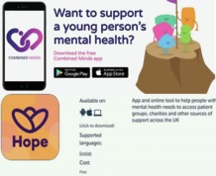
Figure 6: Different types of mental health apps
View description - Figure 6: Different types of mental health apps
View description - Figure 6: Different types of mental health apps

- Hub of hope: An app and online tool to help people with mental health needs to access patient groups, charities and other sources of support across the UK.
- Combined minds: For parents and friends who want to support a young person’s mental health.
- Mental health podcast list
Because apps are constantly changing and the evidence used to develop them is changing, it is hard for us to recommend any for specific use here. However, the NHS has an apps library list aswell as resources here, where they list those that have passed the NHS approval process.
It is also important to remember that for some young people it can provide an alternative form of support, for others it might address their need for support between their face-to-face appointments.

4 This session’s quiz
Check what you’ve learned this session by taking the end-of-session quiz.
Session 7 practice quiz
Open the quiz in a new window or tab then come back here when you’ve finished.

5 Summary of Session 7
In this session you have explored how you can go about both support young people yourself and in supportive networks of other adults and peers. You have also examined how you can find sources of help so that they can engage in self-care. You have heard some young people discuss the impact that social media can have on their mental health and how they have found ways to manage this impact. Finally, you have examined range of online support organisations and mental health apps that exist that can provide both information on mental health and direct contact to helping professionals. Well done, you have now almost completed this course and are ready to turn to the final session.
Now to go Session 8.

Session 8: Seeking expert support and accessing services

Introduction
Congratulations on reaching the final session of the course! You will have learned a great deal since starting to study this course and you will appreciate how complex mental health issues are, as well as the many challenges involved in supporting a young person. This session goes a little deeper in exploring these many challenges and considers the steps involved in gaining additional help. The session will introduce you to a range of professional interventions that are potentially available should you and the young person decide these might be necessary. It will also explore the referral processes that can help you to gain access to these services. By way of introduction to these topics, listen to the following audio in which a parent explains how they came to view getting help for her daughter.

Audio content is not available in this format.
Audio 1: Getting help
View transcript - Audio 1: Getting help

In this clip, the parent clearly describes how telling someone to ‘pull themselves together’, or thinking that they might grow out of the emotional issues they are experiencing may not always be the case. Parents often blame themselves for how their child is feeling but as this mum describes, it is important that parents recognise that help is available and can make a big difference to how ther child feels. At the heart of seeking help, it can be important to get a receptive conversation going with your young person as this may prevent the issue developing into something that is more difficult to deal with. But as this mum also points out, this is something you may need professional help to do.
In this session, you will begin by exploring the referral routes available to parents and practitioners working with young people. You will then consider different treatments for young people with mental health problems, before learning more about how talking therapies can help with a range of issues. Practitioners draw on a range of different strategies to help a young person, and you’ll learn more about these too.

Learning outcomes
By the end of the session, you should be able to:
- describe the referral processes for a young person experiencing mental health problems to access professional support
- identify a range of treatments and support for a young person experiencing mental health problems
- discuss the benefits and challenges associated with professional interventions.

1 Responding to concerning behaviours
It can be hard to know what to do and how best to react to a young person who is displaying worrying behaviour. Given the breadth of issues that can be presented that might relate to emotional distress, it can be hard to provide advice on each situation, and if you are worried it is best that you find someone you trust to talk to.
Self-harm is one of the behaviours that a young person who is experiencing mental distress may display and it is one that can be particularly worrying for those around the young person. In Session 7, we also heard the young men talk about how they felt this behaviour may be influenced by trends on social media. While this can be difficult to explore, it clearly causes a lot of concern for many carers, parents and educators. In this session, we will use it as an example of how to respond to a young person you are worried about.
Parents who notice changes in their child’s behaviour may be the first to realise the need for professional help. The typical way most people begin the formal process of accessing professional help for a young person is to make an appointment with a GP. If you are involved in doing this, it might be helpful when making the appointment to ask if any of the doctors or practice nurses have a special interest in mental health.
It is easy to feel the time pressure in a 10-minute GP appointment and the more prepared you are, the better. To prepare for an appointment with the GP to discuss a young person’s mental health, it will help to make some notes on any questions you’d like to ask or anything you especially want to tell the doctor. You might even ask the young person to keep a diary of the challenges they are dealing with.

Activity 1: Preparing for a GP appointment
Allow about 20 minutes

When people visit a GP it can be hard to remember what they wanted to say. This can be particularly the case when dealing with a sensitive subject such as mental health. It can be hard to find the right words to describe what is creating the feeling of concern. One of the key ways in which you can make the most out of a visit to the GP is to prepare for the visit in advance.
These are some of the questions the doctor may want to ask you about the young person’s problems:

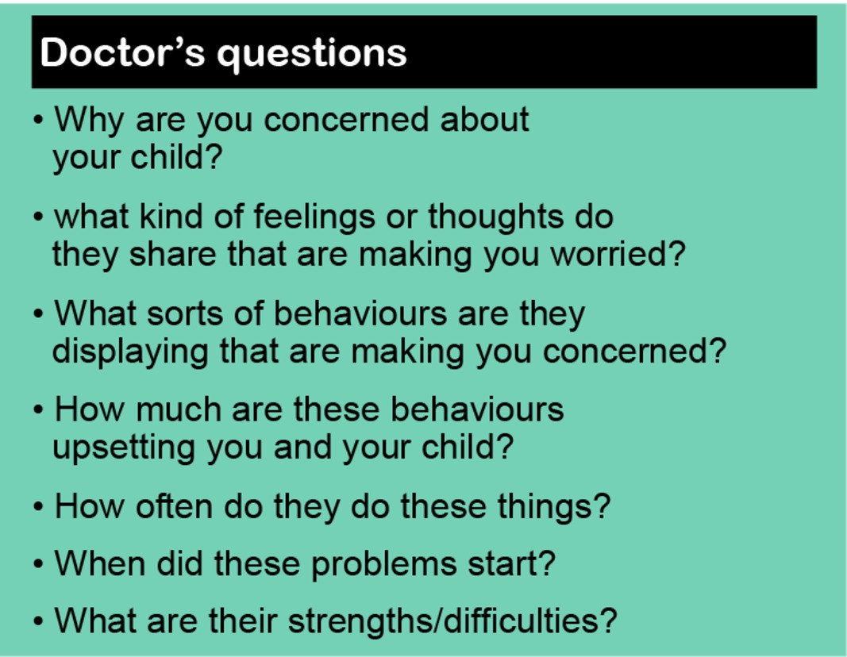
Figure 1: What are their strengths/difficulties? (Source:MindEd for families)
View description - Figure 1: What are their strengths/difficulties? (Source:MindEd for families)
View description - Figure 1: What are their strengths/difficulties? (Source:MindEd for families)

Now visit the following website: Talking to your GP about mental health. Make a note of the key things they say can help you to prepare for a GP appointment in which you, or someone you care for wishes to discuss mental health.

Provide your answer...
View answer - Activity 1: Preparing for a GP appointment

In the video, Mind also suggest that you might want to bring someone with you. This can be particularly important when we are supporting a young person. However, it is also important to note that it is possible for young people to attend the GP alone, and this may be one way of encouraging the young person to seek help. Especially if they are reluctant to share what is going on for them.
GPs and some specialist nurses are able to make a referral to a counsellor employed in the community, or to more specialist services, depending on need. If the young person you are caring for is not referred to specialist services, or is added to a long waiting list, there are still other things that you can do to help support them. You will consider these later in this session.

1.1 Mental health at school
The flow chart in Activity 2 has been developed by researchers at the University of Oxford (Charlie Waller Memorial Trust, 2018). It is aimed at school staff, so if you are a parent or carer you may want to approach this activity in the spirit of understanding the practices underpinning disclosure of self-harm. The essence of this response process can also be applied to other mental health concerns.

Activity 2: Developing a response to mental health concerns at school
Allow about 20 minutes

Spend a few minutes reading through the process and if you are based in a school, consider whether there are any ways you could develop your knowledge and skills at work.

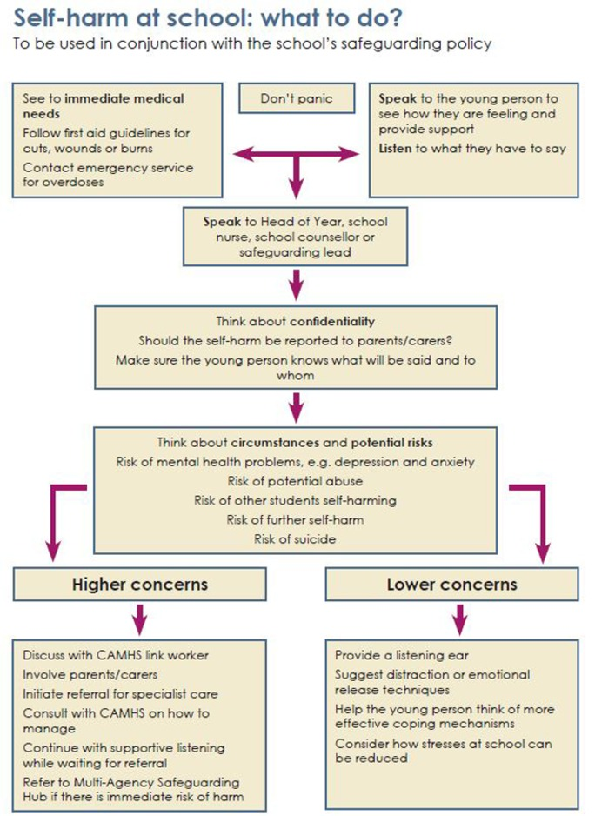
Figure 2
View description - Figure 2
View description - Figure 2

Consider which of the actions in this chart could apply to you as a parent or in your professional role where relevant. Are there any gaps in your knowledge and skills for taking these actions? Make notes below on ways in which you think you are prepared or could prepare yourself to handle a self-harm situation.

Actions | Self-development possibilities
See to immediate medical needs | Provide your answer...
Speak to the young person and listen to what they have to say | Provide your answer...
Speak to the head of year, school nurse, school counsellor or safeguarding lead | Provide your answer...
Think about confidentiality | Provide your answer...
Think about circumstances and potential risks | Provide your answer...
Address ‘lower concerns’ | Provide your answer...
Address ‘higher concerns’ | Provide your answer...

View discussion - Activity 2: Developing a response to mental health concerns at school

While a flow chart is useful in providing a clear checklist of the actions that might be useful when a young person reveals they have been self-harming or displaying other behaviours of concern, it can be hard in the moment to know how to respond as one human to another. You will consider this in the next activity.

1.2 Self-harm
In this activity we ask you to put yourself in the position of the practitioner who is listening to a young person who is revealing they have been self-harming. The young person has shown you the scars and starts to cry.

Activity 3: Responding to self-harm
Allow about 30 minutes

1. Think carefully about what your initial response would be, what emotions do you think would drive your reaction? Would it be fear, compassion, disgust?
Note your reflections here.

Provide your answer...
View discussion - Part

2. Now, watch the video and make a note of the main messages that are suggested for guiding a professional response to this type of disclosure. Consider the skills and characteristics a practitioner would need to demonstrate in order to support the young person effectively.

Watch the video at YouTube.com.
Video 1: No Harm Done film for professionals (The Open University is not responsible for external content.)

View discussion - Part

2 Talking therapies
Mental health campaigns such as ‘#oktotalk’, ‘#Take20’ and ‘#TimeToTalk day’ reinforce the idea that talking about mental health is a positive step in accessing help and improving wellbeing. You will also recall one of the parents introduced in Session 4, talked about how therapy proved exceptionally helpful for her daughter in dealing with depression and anxiety. As the name might suggest, ‘talking therapies’ harness the healing power of talking and being listened to, helping someone to improve their mental health. They usually involve a trained therapist who can help the young person to manage and respond to their feelings of distress. Importantly, talking therapies also offer young people strategies for changing the way they think about their feelings and their responses to events. This can help them to develop good practices for the future and help them to learn vital life skills. It is possible to access NHS psychological therapies service directly (IAPT) without a referral from a GP.
Talking therapies take many forms and the key thing to note is that some talking therapies may suit some type of problem and individual more than others. The experience of talking therapies is highly personal and it can take time to find the most helpful approach. The main talking therapy recommended for adolescents is Cognitive Behavioural Therapy, or CBT. CBT is accepted as an effective first-line treatment in adolescent mental health (Halder and Mohato, 2019).

2.1 Cognitive Behavioural Therapy
Talking therapies, especially CBT (Cognitive Behavioural Therapy), can be useful in a range of mental health problems, for example depression, anxiety, post-traumatic stress, panic disorder, obsessive-compulsive disorder and body dysmorphic disorder. You will recall one of the parents talking about her daughters mental health in Session 1 and how she benefited from CBT. Although CBT is usually conducted face-to-face on a one-to-one basis, it is increasingly offered online, usually as an adjunct to appointments with a therapist, and has been found successful (van der Zanden et al., 2012; Spence et al., 2011).
The idea behind CBT is that a young person is helped to examine and to challenge the way they think as well as what they do. Thoughts, emotions, physical symptoms and actions (behaviour) interact in all directions. Briefly familiarise yourself with the diagram below and then move on to the activity.

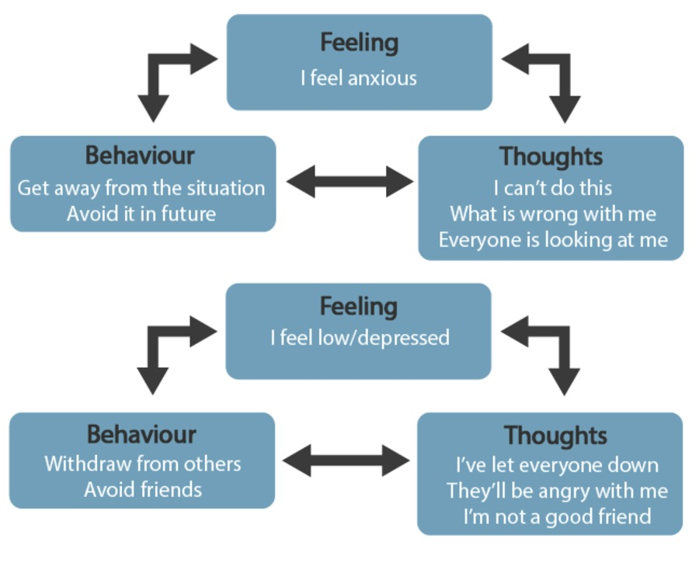
Figure 3: What is CBT?
View description - Figure 3: What is CBT?
View description - Figure 3: What is CBT?

Activity 4: Making sense of CBT
Allow about 15 minutes

Imagine that a young person you are caring for or supporting has been referred for CBT. They don’t think talking will help and complain that they don’t want to ‘lie on a couch discussing their dreams’. Watch this video and make a note of some of the things you can say to help address their concerns and convince them to give therapy a go.

Video content is not available in this format.
Video 2: What is CBT? | Making Sense of Cognitive Behavioural Therapy
View transcript - Video 2: What is CBT? | Making Sense of Cognitive Behavioural Therapy

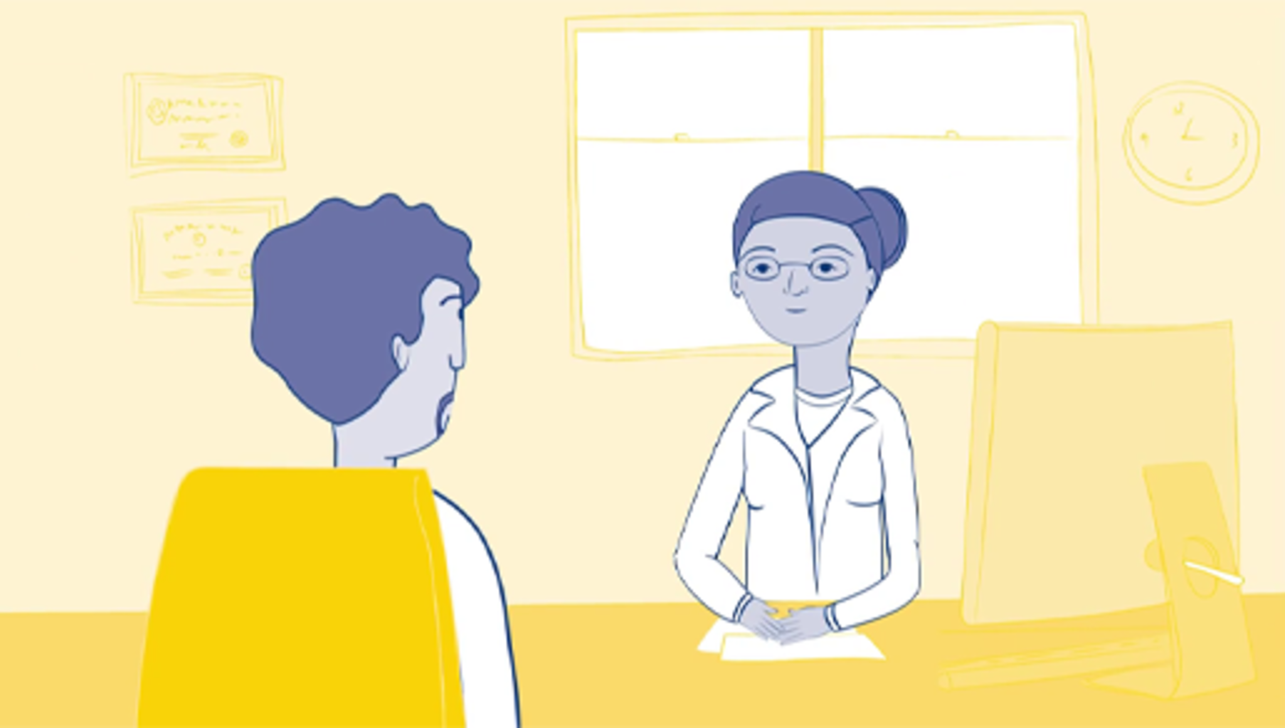

Provide your answer...
View discussion - Activity 4: Making sense of CBT

2.2 The importance of professional help
The following activity will take you through an example of how seeking professional help can really improve some people’s mental health.

Activity 5: Understanding the importance of professional help

In the first clip John Goss, a professional counsellor talks about the issues he listens to when a young person comes to see him.

Video content is not available in this format.
Video 3: John Goss and the issues young people face.
View transcript - Video 3: John Goss and the issues young people face.

Now listen to the following audio and make a note of the things that this mum found to be important about her families work with a professional therapist.

Audio content is not available in this format.
Audio 2
View transcript - Audio 2

Provide your answer...
View answer - Activity 5: Understanding the importance of professional help

A therapist will find ways of intercepting and challenging the relationships between thoughts, feelings and behaviours so that different thought patterns are created and reinforced. By encouraging reinterpretation of a young person’s responses to certain triggers, the practitioner can help to break the cycle of unhelpful responses. If CBT doesn’t work, there are other types of therapy available such as person-centred counselling. You can find out more about these different types of therapy via the NHS website.
Sometimes other forms of treatment are needed. You will learn more about medical interventions in the next section.

3 Medical interventions
The first line of treatment offered nowadays will in many cases involve ‘talking therapies’. However, in some cases medical interventions may be offered for mental health problems. These typically comprise different types of medication such as anti-anxiety medication and anti-depressants. The next activity asks you to consider what you already know about antidepressants for young people.

Activity 6: Understanding the role of anti-depressants
Allow about 10 minutes
Below is a list of statements relating to antidepressants. For each statement, decide whether it is true or false.

The herbal remedy St John’s Wort is a useful alternative to medical drugs for young people.

True
False
View answer - Part

GPs can only prescribe antidepressants to young people under the age of 18 years following assessment and diagnosis by a child and adolescent psychiatrist.

True
False
View answer - Part

Fluoxetine is not a good drug for young people with depression.

True
False
View answer - Part

The use of antidepressant drugs has been linked with suicidal thoughts and behaviour.

True
False
View answer - Part

3.1 Selective Serotonin Reuptake Inhibitors
You may have heard the acronym SSRI, which stands for Selective Serotonin Reuptake Inhibitor. Fluoxetine is a type of SSRI, and it works by raising the levels of serotonin in the brain. According to the NHS (2018):

Serotonin is a neurotransmitter (a messenger chemical that carries signals between nerve cells in the brain). It’s thought to have a good influence on mood, emotion and sleep.
After carrying a message, serotonin is usually reabsorbed by the nerve cells (known as ‘reuptake’). SSRIs work by blocking (‘inhibiting’) reuptake, meaning more serotonin is available to pass further messages between nearby nerve cells.
It would be too simplistic to say that depression and related mental health conditions are caused by low serotonin levels, but a rise in serotonin levels can improve symptoms and make people more responsive to other types of treatment, such as CBT.
source: NHS overview - Selective serotonin reuptake inhibitors (SSRIs)

You can see that the use of SSRIs is firmly based in the biomedical approach introduced in Session 4, drawing on knowledge of neuroscience and finding a drug that has the potential to ‘fix’ a problem in the body. The NHS information extract also pointed out that the situation is not as simple as saying low serotonin is a cause of mental health problems. Mental health is the product of a complex interaction of biological, psychological and social influences, and serotonin is one small part of a big jigsaw.
In most areas of health, and particularly mental health, it is rare to identify a single ‘cause’ of illness. It is important to appreciate this complexity and not to jump to conclusions about the source of a problem, nor what should be done to help. Anti-depressants can be a big taboo and you will learn more about their benefits in the next activity.

Activity 7: Hannah’s mental health story
Allow about 20 minutes

It is important to know when anti-depressants may be useful for some young people. Watch this video and consider the reasons that Hannah describes that underpinned her decision to take anti-depressants.

Video content is not available in this format.
Video 4: Hannah’s Mental Health Story
View transcript - Video 4: Hannah’s Mental Health Story

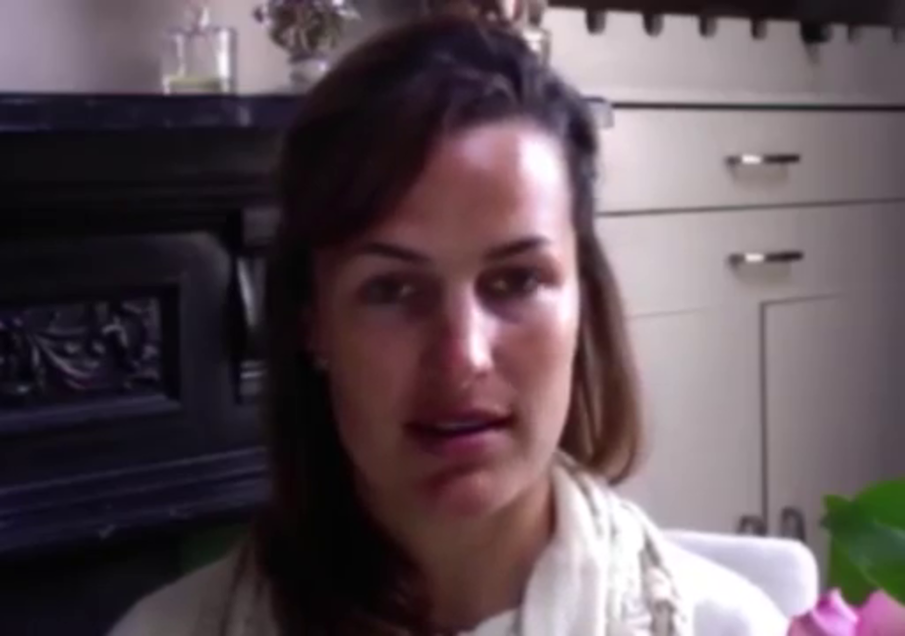

Provide your answer...
View discussion - Activity 7: Hannah’s mental health story

4 Making referrals
If you have been working with children for some time, or if you are familiar with mental health services for adults, you may have heard the word CAHMS used in relation to service provision. In most areas of the UK, Child and adolescent mental health services (CAMHS) are commissioned to work with children and young people up to the age of 18 who are experiencing emotional or mental health problems. It is not possible for a young person or their parents to self-refer, and there are a number of reasons for this. One of the main being that professionals working in primary care and schools, such as GPs, school doctors and nurses, educational psychologists, special educational needs coordinators and social workers are often best placed to provide initial help. They tend to be based in the young person’s community and can draw on their professional networks to organise support around the needs of the young person and their family. CAMHS take over when the practitioners with more generalist skills identify the need for specialist care, e.g. prescribing medication, advanced therapy skills and specialist skills aligned to particular mental health issues. These practitioners based in local communities are essentially the ‘gatekeepers’ for the more specialist CAMHS.
CAMHS is typically represented by a tier structure. Tier 1 represents ‘universal’ services with a remit to promote good mental health. Tier 2 represents more targeted services that can support young people with the less severe problems. Tier 3 is the beginning of the specialist services that deal with more severe needs, usually on an outpatient arrangement. Tier 4 is highly specialist and often involves a hospital stay (ACAMH, 2020). Click through the tabs to read an explanation of each of the tiers.

Interactive content is not available in this format.
Interactive Figure 4: The CAMHS four tier structure
View description - Interactive Figure 4: The CAMHS four tier structure

Revisiting the ‘mental health spectrum’ introduced in Session 2 and considered again in Session 6, a young person would need to be ‘struggling’ and moving into the ‘unwell’ zone for a referral to specialist services.

Figure 5: Mental health spectrum (repeated from Session 2.)
View description - Figure 5: Mental health spectrum (repeated from Session 2.)
View description - Figure 5: Mental health spectrum (repeated from Session 2.)

To put things into perspective, look at this infographic developed by the Centre for Mental Health (2017). Based on 1996 research, the figures will not be quite up to date. They do, however, provide a sense of proportion, based on a population of 1000 children and young people, about the levels of support likely to be needed at any one time.

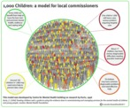
Figure 6: 1,000 children: a model for local commissioners
View description - Figure 6: 1,000 children: a model for local commissioners
View description - Figure 6: 1,000 children: a model for local commissioners

As this infographic highlights, at any one time, out of 1000 children and young people:
- about 150 have a high risk of poor mental health and may need extra help to prevent later problems;
- a further 70 will have a common diagnosable problem for which they need effective help;
- 17 will have a serious problem needing specialist treatment;
- one will have a very serious condition that requires hospital care.
It also illustrates the complexity of mental health and the importance of exploring the referral process in order to receive the most appropriate support and treatment. You will explore this next.

5 Seeking guidance
GPs have to be selective in their referrals to mental health services. At the time of writing, pressures on CAMHS are high in the UK and GPs have been finding that more than half their referrals to CAMHS are rejected. For those whose referral is accepted, it is not uncommon to wait between 3 and 12 months for a CAMHS appointment (Bostock, 2020). Young people who are referred for eating disorders and psychosis are usually given priority (ACAMH, 2020).

Activity 8: What can you do if you are on a waiting list for specialist support?
Allow about 10 minutes

While you are waiting for professional help it can be hard to know what to do. Our interview with counsellor John Goss revealed some things that he thought you could do to support yourself or someone you care for. Make some notes as you watch Video 5.

Video content is not available in this format.
Video 5: Waiting for professional help
View transcript - Video 5: Waiting for professional help

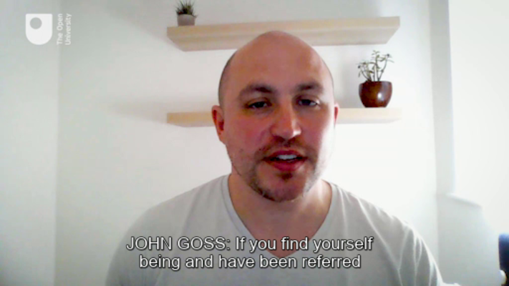

Provide your answer...
View discussion - Activity 8: What can you do if you are on a waiting list for specialist support?

If you find there is a long waiting time on the NHS you may wish to seek alternative sources of help, for example charities sometimes offer advice that can be accessed straight away. If you have funds available to pay for counselling, it is also possible to access private therapy. Many people don’t know where to start in finding counselling for themselves or someone else. Many people find the best way to find a therapist or counsellor is through word of mouth. For example, if you know someone who has already accessed private therapy you might wish to ask them for a recommendation.
Given the sensitive nature of the counsellor relationship, it is important to ensure that the person you reach out to is appropriately qualified. To assist in this the various professional counselling bodies have set up directories of their members that can be accessed via their websites. Examples include those linked to below:
- British Association for Counselling and Psychotherapy (bacp)
- UK Council for Psychotherapy
- NCS | Counsellor Directory

6 This session’s quiz
Now it’s time to complete the Session 8 badge quiz. It is similar to previous quizzes, but this time instead of answering five questions there will be fifteen.
Session 8 compulsory badge quiz
Remember, this quiz counts towards your badge. If you’re not successful the first time, you can attempt the quiz again in 24 hours.
Open the quiz in a new tab or window then come back here when you’ve finished.

7 Review the journey
You have now reached the end of this course. We have covered a lot of ground over the past eight sessions and are aware that it is impossible to cover everything that you might need to know in order to provide support to a young person who is experiencing mental health issues. Our intention here has been to give you a sound introduction to these issues and to help you develop tools which can help you gain the confidence to support young people and to recognise where you can go to find further help.
In the words of one young person experiencing OCD: ‘It’s a battle everyday and during its worst every single thing that I have done took decision making fighting between voices in my head and my own. It can take hold and feel like you can’t control yourself. It’s confusing because it’s not a rational thing. It’s a very difficult thing to describe and I do believe it’s different for everyone – like everyone’s brains. Something I think it’s useful for people to understand is that everyone has struggles and people’s mental health is different and to try and be less judgemental of anyone with mental health as everyone’s behaviour stems from a place of reason. And mainly to support people you don’t have to be perfect you just have to be kind and willing to try your best. We all learn as we go and no one is perfect so if someone is supporting someone with mental health in particular OCD it’s ok to not be perfect – being kind to yourself so you can understand others too.’
As our final activity we want to remind all those who support young people of exactly what young people think about mental health support and what would work for them. With this in mind watch this video, produced in conjunction with young people.

Video content is not available in this format.
Video 6: Three steps to improve mental health support for young people

This video supports many of the messages from across this course, it notes pressures on young people to succeed and issues relating to social media. In relation to the help they wanted, it was reported that they wanted authentic communication that does not infantilize them, tell them it is just a phase, and which does not overly generalise about their experiences. They want personalised care, with more care choices and different types of care offered in a variety of settings. However, as the video also suggests they are aware that waiting times are an issue.
Education and communication remain central to changing our approach to mental health challenges. Throughout this course you have been introduced to a lot of ideas about mental health and how to support a young person who may be struggling with their emotions. The most important thing you can take away from this course is to listen emphatically to the young people you are caring for. Therefore we believe it is fitting to end this course with a clip from one of the young men we interviewed which reminds us of all the things that young people are coping with as they transition this difficult but exciting time of life.

Video content is not available in this format.
Video 7: Gets real very quickly
View transcript - Video 7: Gets real very quickly

Where next?
If you’ve enjoyed this course you can find more free resources and courses on OpenLearn.
You might be specifically interested in these courses:
- Young people’s wellbeing
- Challenging ideas in mental health
- Supporting children’s mental health and wellbeing
Or explore the full catalogue of health, sports and psychology courses.
New to University study? You may be interested in our courses on health and wellbeing.
Making the decision to study can be a big step and The Open University has over 40 years of experience supporting its students through their chosen learning paths. You can find out more about studying with us by visiting our online prospectus.

Tell us what you think
Now you’ve come to the end of the course, we would appreciate a few minutes of your time to complete this short end-of-course survey (you may have already completed this survey at the end of Session 4).

Glossary
Adolescence
Adolescence is a transitional stage of physical and psychological development that generally occurs during the period from puberty to adulthood. Adolescence is commonly associated with the teenage years.
Behaviourist viewpoint
Behaviourism describes a psychological approach to understanding human behaviour and other animals. It assumes that behaviour is either a reflex provoked by particular stimuli within the environment or as a consequence of that individual’s history, including their upbringing and learning within their environment.
Bio-medical perspective
Biomedicine and the biomedical approach is a branch of medical science that draws upon biology to explain and understand health and ill health.
Psychological perspective
Also termed the psychological model of mental illness focuses on how the mind works and the effect of this on a young person’s thoughts, feelings, and subsequent behaviour.
Cystic fibrosis
Cystic fibrosis is an inherited health condition that causes mucus to build up in the lungs and digestive system.
Emotional disorders
Describes the difficulties experienced with mood and emotions such as feelings of anxiety or depression.
Mental disorders
Mental disorders are generally characterised by a combination of abnormal thoughts, perceptions, emotions, behaviour and relationships with other people. Mental disorders are varied and include depression and anxiety as well as conditions such as schizophrenia, OCD and psychoses.
OCD
Obsessive compulsive disorder (OCD) is a common mental health condition where a person has obsessive thoughts and compulsive behaviours.
Psychodynamics
Describes an approach to psychology that emphasises systematic study of the psychological forces that underlie human behaviour, feelings, and emotions and how they might relate to early experience.
Social perspective
Also termed the social model of mental illness focuses on the social environment and the roles people play and views mental illness as being a consequence of how young people are viewed and treated in society, rather than determined by biology.
Stigma
Stigma is a term used to describe the disapproval of, or discrimination against, an individual or group of individuals based on their appearance or behaviour that distinguishes them from other members of a society.
Adolescence
Adolescence is a transitional stage of physical and psychological development that generally occurs during the period from puberty to adulthood. Adolescence is commonly associated with the teenage years.
CT scans
CT (computerised tomography) scans use X-rays to form images inside the body.
MRI scans
MRI (magnetic resonance imaging) uses magnetic fields and radiofrequency pulses to produce detailed pictures of organs and internal body structures.
Psychologist G. Stanley Hall
G. Stanley Hall was a leading American psychologist with an expertise in child development and had a particular interest in adolescence.
Resilience
Rather than being fixed during the early years of life, neuroplasticity describes the brains capacity to adapt in response to environmental influences.
Storm and stress
Storm and stress is a phrase used by G. Stanley Hall to describe the turbulence of adolescent development.
Antidepressants
Medication prescribed by a medical practitioner. Often used to treat depression and anxiety.
Behavioural sciences
Behavioural sciences explore how animals and humans think and behave. It involves the systematic analysis and investigation of human and animal behaviour through observation and controlled scientific experimentation.
Biological psychiatry
Biological psychiatry is an approach to psychiatry that seeks to understand mental illness in terms of the biological function of the nervous system.
Biomedicine
Biomedicine is a branch of medical science that draws upon biology to explain and understand health and ill health.
Dyslexia
A common learning difficulty that can cause problems with reading, writing and spelling.
Dyspraxia
A developmental disorder of the brain in childhood causing difficulty in activities requiring coordination and movement.
Evidence-based model
A model based on evidence.
Evidence-based narrative
Defined as stories with an identifiable beginning, middle, and end that provide information about circumstances, individuals, and conflict; raise unanswered questions or unresolved conflict; and provide solutions. They provide a way of communicating clinical assessments.
Formulation
A particular expression of an idea, thought, or theory.
Hypotheses
A supposition or proposed explanation made on the basis of limited evidence as a starting point for further investigation.
IQ
An intelligence quotient (IQ) is a total score derived from a set of standardized tests or subtests designed to assess human intelligence.
Learning difficulties
A difficulty with learning. Examples might include attention deficit hyperactivity disorder, dyspraxia and autism for instance.
Multi-disciplinary team
Professionals and practitioners form a number of different disciplines such as health, psychology and social care for instance.
Neuro-developmental
Development of the nervous system, including the brain and neurological responses.
Psychotherapeutic colleagues
Psychotherapy is a type of therapeutic approach used by psychologists.
Qualitative
Relating to the measurement of something based on its qualities rather than its quantity. In psychological research terms, qualitative assessment relies on unstructured and non-numerical data such as those derived through observations, field notes and interviews.
Sensory integration
How our brain receives and processes sensory information so that we can do the things we need to do in our everyday life.
Theory
A supposition or a system of ideas intended to explain something.
Therapeutic approaches
Therapeutic approaches refer to the different approaches taken by psychologists for example in treating particular conditions.
adversity
A difficult and challenging situation.
resilience
Rather than being fixed during the early years of life, neuroplasticity describes the brains capacity to adapt in response to environmental influences.

References
Care Quality Commission (2017) Review of children and young people’s mental health services. Phase One supporting documentation: Summary of recent policy and literature [Online]. Available at https://www.cqc.org.uk/sites/default/files/20171027_cypmhphase1_literaturereview.pdf (Accessed 21 December 2021).
Care Quality Commission (2019) Are we listening? A review of children and young people’s mental health services [Online]. Available at https://www.cqc.org.uk/publications/themed-work/are-we-listening-review-children-young-peoples-mental-health-services (Accessed 21 December 2021).
Choudhry, F. R., Mani, V., Ming, L. C., et al. (2016) ‘Beliefs and perception about mental health issues: a meta-synthesis’, Neuropsychiatric disease and treatment, vol 12, no. 2807–2818.
Goffman, E. (1963) Stigma: notes on the management of spoiled identity, New York, Simon and Schuster.
Haslam-Ormerod, S. (2019) ‘“Snowflake millennial” label is inaccurate and reverses progress to destigmatise mental health’, The Conversation [Online], no. January 11. Available at Error! Hyperlink reference not valid. (Accessed 21 December 2021).
Jutras, M. (2017) ‘Historical perspectives on the theories, diagnosis, and treatment of mental illness’, BC Medical Journal, vol 59, no. 2, pp. 86–88.
Laurance, J. (2003) Pure Madness: How Fear Drives the Mental Health System, London, Routledge.
Mental Health Foundation (2020) What is Good Mental Health? [Online]. Available at https://www.mentalhealth.org.uk/your-mental-health/about-mental-health/what-good-mental-health (Accessed 21 December 2021).
NHS Digital (2018) Mental Health of Children and Young People in England, 2017 [Online]. Available at https://digital.nhs.uk/data-and-information/publications/statistical/mental-health-of-children-and-young-people-in-england/2017/2017 (Accessed 21 December 2021).
Sadler, K., Vizard, T., Ford, T., et al. (2108) Mental Health of Children and Young People in England, 2017: Trends and characteristics [Online] Available at https://files.digital.nhs.uk/A0/273EE3/MHCYP%202017%20Trends%20Characteristics.pdf (Accessed 21 December 2021).
Scambler, G. (2009) ‘Health-related stigma’, Sociology of Health & Illness, vol 31, no. 3, pp. 441–455.
Smail, D. (2005) Power, Interest and Psychology, Ross-on-Wye, PCCS Books.
U’ren, R. (2011) Social Perspective: the Missing Element in Mental Health Practice, Toronto, University of Toronto Press.
Abreu, A. P. and Kaiser, U. B. (2016) ‘Pubertal development and regulation’, The Lancet Diabetes & Endocrinology, vol 4, no. 3, pp. 254–264.
Blakemore, S.-J. (2019) Inventing ourselves: The secret life of the teenage brain, London, Black Swan.
Bullying UK (2019) What is bullying? [Online]. Family Lives. Available at https://www.bullying.co.uk/general-advice/what-is-bullying/ (Accessed 21 December 2021).
Cohen, Stanley (1972) Folk Devils and Moral Panics: The Creation of the Mods and Rockers, London Routledge.
Dow-Edwards, D., MacMaster, F. P., Peterson, B. S., et al. (2019) ‘Experience during adolescence shapes brain development: From synapses and networks to normal and pathological behavior’, Neurotoxicology and Teratology, vol 76, no. 106834.
Erikson, E.H. (1968) Identity: Youth and crisis, New York, Norton.
Foulkes, L. and Blakemore, S.-J. (2018) ‘Studying individual differences in human adolescent brain development’, Nature Neuroscience, vol 21, no. 315.
Gardner, M. and Steinberg, L. (2005) ‘Peer Influence on Risk Taking, Risk Preference, and Risky Decision Making in Adolescence and Adulthood: An Experimental Study’, Developmental Psychology, vol 41, no. 4, pp. 625–635.
Herholz, Sibylle C. and Zatorre, Robert J. (2012) ‘Musical Training as a Framework for Brain Plasticity: Behavior, Function, and Structure’, Neuron, vol 76, no. 3, pp. 486–502.
Hill, R. M., Mellick, W., Temple, J. R., et al. (2017) ‘The role of bullying in depressive symptoms from adolescence to emerging adulthood: A growth mixture model’, Journal of Affective Disorders, vol 207, no. 1–8.
Kehily, M. J. and Pattman, R. (2006) ‘Middle-Class Struggle? Identity-Work and Leisure among Sixth Formers in the United Kingdom’, British Journal of Sociology of Education, vol 27, no. 1, pp. 37–52.
Larm, P., Livingston, M., Svensson, J., et al. (2018) ‘The increased trend of non-drinking in adolescence: The role of parental monitoring and attitudes toward offspring drinking’, Drug & Alcohol Review, vol 37, no. S34–S41.
NHS (2018) Stages of puberty: what happens to boys and girls [Online]. Available at https://www.nhs.uk/live-well/sexual-health/stages-of-puberty-what-happens-to-boys-and-girls/ (Accessed 21 December 2021).
Office for National Statistics (2018) Loneliness - What characteristics and circumstances are associated with feeling lonely? Analysis of characteristics and circumstances associated with loneliness in England using the Community Life Survey, 2016 to 2017 [Online]. Available at https://www.ons.gov.uk/peoplepopulationandcommunity/wellbeing/articles/lonelinesswhatcharacteristicsandcircumstancesareassociatedwithfeelinglonely/2018-04-10 (Accessed 21 December 2021).
Salmon, S., Turner, S., Taillieu, T., et al. (2018) ‘Bullying victimization experiences among middle and high school adolescents: Traditional bullying, discriminatory harassment, and cybervictimization’, Journal of Adolescence, vol 63, no. 29–40.
Spear, L. P. (2018) ‘Effects of adolescent alcohol consumption on the brain and behaviour’, Nature Reviews Neuroscience, vol 19, no. 197+.
Vieno, A., Altoè, G., Kuntsche, E., et al. (2018) ‘Do public expenditures on health and families relate to alcohol abstaining in adolescents? Multilevel study of adolescents in 24 countries’, Drug & Alcohol Review, vol 37, no. S120–S128.
Wiley, D. C. & Cory, A. C. (2013) Adolescent growth and development. In Encyclopedia of school health (pp. 22-23). Thousand Oaks, CA: SAGE Publications, Inc. doi: 10.4135/9781452276250.n10
World Health Organization (n. d.) Achieving universal health coverage for the world’s 1.2 billion adolescents [Online]. Available at https://www.who.int/maternal_child_adolescent/adolescence/universal-health-coverage/en/ (Accessed 5 February 2020).
Association for Young People’s Health (2019) ‘CHAPTER 7: Wellbeing and mental health’ AYPH Key Data on Young People 2019.
BeatED (2017) Delaying for years, denied for months: The health, emotional and financial impact on sufferers, families and the NHS of delaying treatment for eating disorders in England [Online]. Available at https://www.beateatingdisorders.org.uk/uploads/documents/2017/11/delaying-for-years-denied-for-months.pdf (Accessed 21 December 2021).
Bould, H., Newbegin, C., Stewart, A., et al. (2017) ‘Eating disorders in children and young people’, BMJ, vol 359, no. j5245.
Eklund, R. and Salzmann-Erikson, M. (2016) ‘An integrative review of the literature on how eating disorders among adolescents affect the family as a system – complex structures and relational processes’, Mental Health Review Journal, vol 21, no. 3, pp. 213-230.
MacLean, A., Sweeting, H., Walker, L., et al. (2015) ‘“It’s not healthy and it’s decidedly not masculine”: a media analysis of UK newspaper representations of eating disorders in males’, BMJ Open, vol 5, no. 5, p. e007468.
Mental Health Foundation (2020) Suicide Prevention: WAIT [Online]. Available at https://www.mentalhealth.org.uk/publications/suicide-prevention-wait (Accessed 17 March 2020).
Morgan, C., Webb, R. T., Carr, M. J., et al. (2017) ‘Incidence, clinical management, and mortality risk following self harm among children and adolescents: cohort study in primary care’, BMJ, vol 359, no. j4351.
National Institute for Health and Care Excellence (NICE) (2014) Anxiety Disorders [Online]. Available at http://www.nice.org.uk/guidance/qs53/resources/new-nicequality-standard-aims-to-improve-recognition-assessment-and-availability-oftreatments-for-anxiety-disorders (Accessed 12 February 2020).
National Institute for Health and Care Excellence (2017) Eating disorders: recognition and treatment [Online]. Available at https://www.nice.org.uk/guidance/ng69/resources/eating-disorders-recognition-and-treatment-pdf-5803729964485 (Accessed 21 December 2021).
Office for National Statistics (2019) Suicides in the UK: 2018 registrations [Online]. Available at https://www.ons.gov.uk/peoplepopulationandcommunity/birthsdeathsandmarriages/deaths/bulletins/suicidesintheunitedkingdom/2018registrations#suicide-patterns-by-age (Accessed 21 December 2021).
Räisänen, U. and Hunt, K. (2014) ‘The role of gendered constructions of eating disorders in delayed help-seeking in men: a qualitative interview study’, BMJ Open, vol 4, no. 4, pp. e004342.
Roberts, J. (2013) ‘Low mood and depression in adolescence: clinical update’, The British journal of general practice : the journal of the Royal College of General Practitioners, vol 63, no. 610, pp. 273–274.
Royal College of Psychiatrists (2016) Self harm [Online]. Available at https://www.rcpsych.ac.uk/mental-health/problems-disorders/self-harm (Accessed 21 December 2021).
SelfharmUK (2020a) Can you grow out of self-harm? [Online]. Available at https://www.selfharm.co.uk/blog/can-you-grow-out-of-self-harm (Accessed 21 December 2021).
SelfharmUK (2020b) What is self-harm? [Online]. Available at https://www.selfharm.co.uk/get-information/the-facts/what-is-self-harm (Accessed 21 December 2021).
Smith, J. (2013) Understanding Self-harm, London, Mind.
Wales, J., Brewin, N., Raghavan, R., et al. (2017) ‘Exploring barriers to South Asian help-seeking for eating disorders’, The Mental Health Review, vol 22, no. 1, pp. 40–50.
World Health Organization (n.d.) Mental disorders [Online]. Available at https://www.who.int/mental_health/management/en/ (Accessed 21 December 2021).
YoungMinds (2020) No Harm Done: Recognising and responding to self-harm [Online]. Available at https://youngminds.org.uk/resources/school-resources/responding-to-self-harm-guide/ (Accessed 21 December 2021).
American Psychiatric Association (2013) Diagnostic and Statistical Manual of Mental Disorders – Fifth Edition DSM-5, Arlington VA; American Psychiatric Association, p.20.
Dowrick, C. and Frances, A. (2013) ‘Medicalising unhappiness: new classification of depression risks more patients being put on drug treatment from which they will not benefit’, BMJ : British Medical Journal, vol 347, no. f7140.
Gask, L., Lester, H., Kendrick, T. and Peveler, R. (2009) ‘What is primary care mental health?’ Chapter 1, in Gask, L., Lester, H., Kendrick, T. and Peveler, R. (eds), Primary Care Mental Health, London: RCPsych Publications, pp. 3–15.
Johnstone, L. (2018) ‘Psychological Formulation as an Alternative to Psychiatric Diagnosis’, Journal of Humanistic Psychology, vol 58, no. 1, pp. 30–46.
Marmot, M., Allen, J., Boyce, T., et al. (2020) ‘Health equity in England: The Marmot Review 10 years on’, [Online] Available at https://www.health.org.uk/sites/default/files/upload/publications/2020/Health%20Equity%20in%20England_The%20Marmot%20Review%2010%20Years%20On_full%20report.pdf (Accessed 21 December 2021).
Tyrer, P. (2014) ‘A comparison of DSM and ICD classifications of mental disorder’, Advances in Psychiatric Treatment, vol. 20, no. 4, pp. 280–85.
YoungMinds (2020) Who’s Who [Online]. Available at https://youngminds.org.uk/find-help/your-guide-to-support/whos-who/ (Accessed 30 March 2020).
Albert, D., Belsky, D. W., Max Crowley, D., Latendresse, S. J., Aliev, F., Riley, B. and Sun, C., Dick, D. M. and Dodge, K. A. (2015) Can Genetics Predict Response to Complex Behavioral Interventions? Evidence from a Genetic Analysis of the Fast Track Randomized Control Trial, in Journal of Policy Analysis and Management, Volume 34, Issue 3, pp. 497–518.
Bennett, Stephanie; Cooper, Victoria and Payler, Jane (2017) The need for support: Young people living through a family health crisis. Hope support services, UK [Online]. Available at http://oro.open.ac.uk/56167/1/Hope%20launch%20report%20%20FINAL.pdf (Accessed 21 December 2021)
Blakemore, S.-J. (2019) Inventing ourselves: The secret life of the teenage brain, London, Black Swan.
Boyce, W. Thomas. and Ellis, Bruce. J. (2005) ‘Biological sensitivity to context: I. An evolutionary–developmental theory of the origins and functions of stress reactivity’, Development and Psychopathology, Cambridge University Press, 17(2), pp. 271–301.
Cambridge Dictionary (2020) adversity [Online]. Cambridge University Press. Available at https://dictionary.cambridge.org/dictionary/english/adversity (Accessed 21 December 2021).
Casebourne, J. (2020) ‘Coronavirus and early intervention: Confronting a new world for families, children and vital services’. Blog, 25 March, [Online]. Available at https://www.eif.org.uk/blog/coronavirus-and-early-intervention-confronting-a-new-world-for-families-children-and-vital-services (Accessed 21 December 2021).
Cooper, V. Montgomery, H. and Sheehy, K. (2018) Parenting the First Twelve Years: What the Evidence Tells Us. New Orleans: Pelican.
Cooper, V. L. and Rixon, A. (2017) Wellbeing, in V. L. Cooper and A. Rixon (ed) Making a difference: Working with children and young people, Milton Keynes: Open University Press.
Daniel, B., Wassell, S. and Gilligan, R. (2010) Child Development for Child Care and Protection Workers, London, Jessica Kingsley Publishers.
Dutcher, J. M. and Creswell, J. D. (2018) ‘The role of brain reward pathways in stress resilience and health’, Neuroscience and Biobehavioral Reviews, vol 95, no. 559–567.
Fullagar, S. (2005) ‘The paradox of promoting help-seeking: a critical analysis of risk, rurality and youth suicide’, International Journal of Critical Psychology, vol. 14, pp. 31–51.
Gilligan, R. (2000) ‘Adversity, resilience and young people: the protective value of positive school and spare time experiences’, Children and Society, 14(1), pp. 37–47.
Gilligan, R., De Castro, E, Vanistendael, S. and Warburton, J. (2014). Learning from Children Exposed to Sexual Abuse and Sexual Exploitation: synthesis report of the Bamboo Project study on child resilience, Geneva, Oak Foundation.
Hughes, K., Bellis, M. A., Hardcastle, K. A., et al. (2017) ‘The effect of multiple adverse childhood experiences on health: a systematic review and meta-analysis’, The Lancet Public Health, 2(8), pp. e356–e366
Hunter, R. G., Gray, J. D. and McEwen, B. S. (2018) ‘The Neuroscience of Resilience’, Journal of the Society for Social Work and Research, 9(2), pp. 305–339.
Masten, A. S., Best, K.M. and Garmezy, N. (1990) ‘Resilience and development: contributions from the study of children who overcome diversity’, Development and Psychopathology, vol. 2, pp. 425–44.
Masten, A. S. (2015). Ordinary magic: Resilience in development. New York. Guilford Publications
Masten, A. S. and Barnes, A. J. (2018) ‘Resilience in Children: Developmental Perspectives’, Children (Basel, Switzerland), 5(7), pp. 98.
Oldehinkel, A. J. and Ormel, J. (2015) ‘A longitudinal perspective on childhood adversities and onset risk of various psychiatric disorders’, European Child & Adolescent Psychiatry, 24(6), pp. 641–650.
Payler, J., Cooper, V. and Bennett, S. (2020) ‘Children and young people living through a serious family illness: structural, interpersonal and personal perspectives’, Children & Society, 34(1), pp. 62–77.
Public Health England (2014) Local Action on Health Inequalities: Building Children and Young People’s Resilience in Schools [Online]. Available at https://www.gov.uk/ government/ uploads/ system/ uploads/ attachment_data/ file/ 355766/ Review2_Resilience_in_schools_health_inequalities.pdf (Accessed 21 December 2021).
Richardson, G. E. (2002) ‘The metatheory of resilience and resiliency’, Journal of clinical psychology, 58(3), pp. 307–321. doi: 10.1002/jclp.10020.
Rutter, M. (1985) ‘Resilience in the face of adversity: protective factors and resistance to psychiatric disorder’, British Journal of Psychiatry, vol. 147, pp. 598–611
Stein, M. (2005) Resilience and Young People Leaving Care: Overcoming the Odds. New York, Joseph Rowntree Foundation.
Ungar, M. Ghazinour, M. and Richter, J. (2013) Annual Research Review: What is resilience within the social ecology of human development, in Journal of Child Psychology and Psychiatry, 54(4), pp. 348–366.
Adan, R. A. H., Van Der Beek, E. M., Buitelaar, J. K., Cryan, J. F., Hebebrand, J., Higgs, S., Schellekens, H. & Dickson, S. L. (2019) ‘Nutritional psychiatry: Towards improving mental health by what you eat’, European Neuropsychopharmacology, 29, 1321–1332. https://doi.org/10.1016/j.euroneuro.2019.10.011.
Barrett-Lennard, G. T. (1999) Carl Rogers’ Helping System : Journey & Substance, London, Sage Publications.
Baum, K. T., Desai, A., Field, J., et al. (2014) ‘Sleep restriction worsens mood and emotion regulation in adolescents’, Journal of Child Psychology & Psychiatry, vol 55, no. 2, pp. 180–190.
Brand, S., Kalak, N., Gerber, M., et al. (2017) ‘During early to mid adolescence, moderate to vigorous physical activity is associated with restoring sleep, psychological functioning, mental toughness and male gender’, Journal of Sports Sciences, vol 35, no. 5, pp. 426–434.
Cairns, K., Potter, S., Nicholas, M., et al. (2019) ‘Development of ReachOut Parents: a multi-component online program targeting parents to improve youth mental health outcomes’, Advances in Mental Health, vol 17, no. 1, pp. 55–71.
Carter, T., Guo, B., Turner, D., et al. (2015) ‘Preferred intensity exercise for adolescents receiving treatment for depression: a pragmatic randomised controlled trial’, BMC Psychiatry, vol 15, no. 1, pp. 247.
Crowley, Stephanie J, Acebo, Christine, & Carskadon, Mary A. (2006) ‘Sleep, circadian rhythms, and delayed phase in adolescence’, Sleep Medicine, vol. 8 no.6, pp. 602-612.
Epic Friends (n.d.) Listening [Online]. Available at http://epicfriends.co.uk/listening (Accessed 21 December 2021).
Gindidis, S., Stewart, S. and Roodenburg, J. (2019) ‘A systematic scoping review of adolescent mental health treatment using mobile apps’, Advances in Mental Health, vol 17, no. 2, pp. 161–177.
Guthold, R., Stevens, G. A., Riley, L. M. and Bull, F. C. (2020) ‘Global trends in insufficient physical activity among adolescents: a pooled analysis of 298 population-based surveys with 1.6 million participants’, The Lancet Child & Adolescent Health, 4(1), pp. 23–35.
Hagell, A. (2016) The connections between young people’s mental health and sport participation: Scoping the evidence [Online]. Association for Young People’s Health. Available at http://www.youngpeopleshealth.org.uk/wp-content/uploads/2016/11/AYPH-health-and-sport-review-Nov-2016.pdf (Accessed 21 December 2021).
Hanley, T., Prescott, J. and Gomez, K. U. (2019) ‘A systematic review exploring how young people use online forums for support around mental health issues’, Journal of Mental Health, 28(5), pp. 566–576.
Howlett, N., Bottoms, L., Chater, A. et al. (2021) ‘A randomised controlled trial of energetic activity for depression in young people (READY): a multi-site feasibility trial protocol’, Pilot Feasibility Stud 7(6) https://doi.org/10.1186/s40814-020-00734-7
Liu, L. and Zhu, G. (2018) ‘Gut–Brain Axis and Mood Disorder’, Front. Psychiatry, vol. 9, p 223. doi: 10.3389/fpsyt.2018.00223
Marshall, J. M., Dunstan, D. A. and Bartik, W. (2019) ‘Clinical or gimmickal: The use and effectiveness of mobile mental health apps for treating anxiety and depression’, Australian & New Zealand Journal of Psychiatry, vol 54, no. 1, pp. 20–28.
McMahon, E. M., Corcoran, P., O’Regan, G., et al. (2017) ‘Physical activity in European adolescents and associations with anxiety, depression and well-being’, European Child & Adolescent Psychiatry, 26(1), pp. 111–122.
NHS (2018a) Healthy eating for teens [Online]. Available at https://www.nhs.uk/live-well/eat-well/healthy-eating-for-teens/ (Accessed 21 December 2021).
NHS (2018b) Eat Well [Online]. Available at https://www.nhs.uk/live-well/eat-well/ (Accessed 21 December 2021)
NHS (2017) Sleep tips for teenagers [Online]. Available at https://www.nhs.uk/live-well/sleep-and-tiredness/sleep-tips-for-teenagers/?tabname=sleep-tips (Accessed 21 December 2021).
NICE (n.d.) Depression: Description of condition [Online]. National Institute for Health and Care Excellence. Available at https://bnfc.nice.org.uk/treatment-summary/depression.html (Accessed 21 December 2021).
Reicher, T. C. F., Veitz, S., Bühler, M. et al. (2020), ‘Wide awake at bedtime? Effects of caffeine on sleep and circadian timing in male adolescents – A randomized crossover trial’, Biochemical Pharmacology, 114283.
Richards, G. & Smith, A. (2015) ‘Caffeine consumption and self-assessed stress, anxiety, and depression in secondary school children’, Journal of Psychopharmacology, 29, 1236–1247.
Stavrakakis, N., Roest, A. M., Verhulst, F., et al. (2013) ‘Physical activity and onset of depression in adolescents: A prospective study in the general population cohort TRAILS’, Journal of Psychiatric Research, vol 47, no. 10, pp. 1304–1308.
Short, Michelle A, Gradisar, Michael, Lack, Leon C, & Wright, Helen R. (2013). ‘The impact of sleep on adolescent depressed mood, alertness and academic performance’, Journal of Adolescence, Vol 36, no. 6, pp. 1025–1033.
stem4 (n.d.) Talking to your teenager [Online]. Available at https://4123n13bqnypihxzs1aprwwe-wpengine.netdna-ssl.com/wp-content/uploads/2019/09/stem4-Talking-to-your-teenager-about-depression-v2.pdf (Accessed 21 December 2021).
Studer, Petra, Brucker, Judith M, Haag, Cornelia, Van Doren, Jessica, Moll, Gunther H, Heinrich, Hartmut, & Kratz, Oliver (2019), ‘Effects of blue- and red-enriched light on attention and sleep in typically developing adolescents’, Physiology & Behavior, Vol 199, pp. 11–19.
Tarokh, L., Saletin, J. M. and Carskadon, M. A. (2016) ‘Sleep in adolescence: Physiology, cognition and mental health’, Neuroscience and biobehavioral reviews, vol 70, pp. 182–188.
Wilson, Valerie (2011), ‘Non-diabetic hypoglycaemia: causes and pathophysiology’, Nursing Standard, 25(46), p. 35. Gale Academic OneFile, link.gale.com/apps/doc/A263879014/AONE?u=tou&sid=AONE&xid=b6d942ce (Accessed 21 December 2021)
World Health Organization (2020a) WHO guidelines on physical activity and sedentary behaviour [Online]. Available at https://www.who.int/publications/i/item/9789240015128 (Accessed 21 December 2021)
World Health Organization (2020b) WHO Guidelines on physical activity and sedentary behaviour: web annex evidence profiles [Online]. Available at https://www.who.int/publications/i/item/9789240015111 (Accessed 21 December 2021)
YoungMinds (2020) Starting the conversation [Online]. Available at https://youngminds.org.uk/starting-a-conversation-with-your-child/starting-the-conversation/ (Accessed 21 December 2021).
Ali, K., Farrer, L., Gulliver, A., et al. (2015) ‘Online Peer-to-Peer Support for Young People With Mental Health Problems: A Systematic Review’, JMIR mental health, vol 2, no. 2, pp. e19.
Baum, K. T., Desai, A., Field, J., et al. (2014) ‘Sleep restriction worsens mood and emotion regulation in adolescents’, Journal of Child Psychology & Psychiatry, vol 55, no. 2, pp. 180–190.
Bohleber, L., Crameri, A., Eich-Stierli, B., et al. (2016) ‘Can We Foster a Culture of Peer Support and Promote Mental Health in Adolescence Using a Web-Based App? A Control Group Study’, JMIR mental health, vol 3, no. 3, pp. e45–e45.
Brunborg, G. S. and Burdzovic Andreas, J. (2019) ‘Increase in time spent on social media is associated with modest increase in depression, conduct problems, and episodic heavy drinking’, Journal of Adolescence, vol 74, no. 201–209.
Buckley, L., Chapman, R. L., Sheehan, M., et al. (2012) ‘Keeping friends safe: a prospective study examining early adolescent’s confidence and support networks’, Educational Studies, vol 38, no. 4, pp. 373–381.
Council for the Curriculum Examinations & Assessment (2020) eSafety [Online]. Available at https://ccea.org.uk/help/esafety (Accessed 21 December 2021).
Department for Education (2019) Teaching online safety in school [Online]. Available at https://www.gov.uk/government/publications/teaching-online-safety-in-schools (Accessed 21 December 2021).
Easton, K., Diggle, J., Ruethi-Davis, M., et al. (2017) ‘Qualitative Exploration of the Potential for Adverse Events When Using an Online Peer Support Network for Mental Health: Cross-Sectional Survey’, JMIR mental health, vol 4, no. 4, pp. e49–e49.
Fortuna, K. L., Brooks, J. M., Umucu, E., et al. (2019) ‘Peer Support: a Human Factor to Enhance Engagement in Digital Health Behavior Change Interventions’, Journal of Technology in Behavioral Science, vol 4, no. 2, pp. 152–161.
Kelly, Y., Zilanawala, A., Booker, C., et al. (2019) ‘Social Media Use and Adolescent Mental Health: Findings From the UK Millennium Cohort Study’, EClinicalMedicine, vol 6, no. 59–68.
Lambert, N. M., Stillman, T. F., Hicks, J. A., et al. (2013) ‘To Belong Is to Matter: Sense of Belonging Enhances Meaning in Life’, Personality and Social Psychology Bulletin, vol 39, no. 11, pp. 1418–1427.
Marengo, D., Longobardi, C., Fabris, M. A., et al. (2018) ‘Highly-visual social media and internalizing symptoms in adolescence: The mediating role of body image concerns’, Computers in Human Behavior, vol 82, no. 63–69.
Radovic, A., Gmelin, T., Stein, B. D., et al. (2017) ‘Depressed adolescents’ positive and negative use of social media’, Journal of Adolescence, vol 55, no. 5–15.
Raudsepp, L. (2019) ‘Brief report: Problematic social media use and sleep disturbances are longitudinally associated with depressive symptoms in adolescents’, Journal of Adolescence, vol 76, no. 197–201.
Schaefer, D. R., Simpkins, S. D., Vest, A. E., et al. (2011) ‘The contribution of extracurricular activities to adolescent friendships: New insights through social network analysis’, Developmental Psychology, vol 47, no. 4, pp. 1141–1152.
Scott, H., Biello, S. M. and Woods, H. C. (2019) ‘Identifying drivers for bedtime social media use despite sleep costs: The adolescent perspective’, Sleep Health, vol 5, no. 6, pp. 539–545.
Scottish Government (2017) Internet safety for children and young people: national action plan [Online]. Available at https://www.gov.scot/publications/national-action-plan-internet-safety-children-young-people/pages/8/ (Accessed 21 December 2021).
Stockdale, L. A. and Coyne, S. M. (2020) ‘Bored and online: Reasons for using social media, problematic social networking site use, and behavioral outcomes across the transition from adolescence to emerging adulthood’, Journal of Adolescence, vol 79, no. 173–183.
del Valle, J. F., Bravo, A. and López, M. (2010) ‘Parents and peers as providers of support in adolescents’ social network: a developmental perspective’, Journal of Community Psychology, vol 38, no. 1, pp. 16–27.
Welsh Government (2019) An online safety action plan for children and young people in Wales [Online]. Available at https://gov.wales/online-safety-action-plan-children-and-young-people (Accessed 21 December 2021).
The Association for Child and Adolescent Mental Health (2020) CAMHS (Child and Adolescent Mental Health Services) [Online]. Available at https://www.acamh.org/topic/camhs/ (Accessed 21 December 2021).
Bostock, N. (2020) ‘More than half of GP referrals to CAMHS services rejected, poll reveals’, GP Online [Online]. Available at https://www.gponline.com/half-gp-referrals-camhs-services-rejected-poll-reveals/article/1669818 (Accessed 21 December 2021).
The Charlie Waller Memorial Trust (2018) ‘Young people who self-harm: A Guide for School Staff’
Centre for Mental Health (2017) 1,000 Children: a model for local commissioners [Online]. Available at https://www.centreformentalhealth.org.uk/mental-health-among-children-and-young-people (Accessed 21 December 2021).
Halder, S., & Mahato, A. K. (2019) ‘Cognitive Behavior Therapy for Children and Adolescents: Challenges and Gaps in Practice’, Indian journal of psychological medicine, Vol 41, No.3, pp. 279–283.
Spence, S. H., Donovan, C. L., March, S., et al. (2011) ‘A Randomized Controlled Trial of Online Versus Clinic-Based CBT for Adolescent Anxiety’, Journal of Consulting and Clinical Psychology, vol 79, no. 5, pp. 629–642.
van der Zanden, R., Kramer, J., Gerrits, R., et al. (2012) ‘Effectiveness of an online group course for depression in adolescents and young adults: a randomized trial’, Journal of medical Internet research, vol 14, no. 3, pp. e86–e86.

Further reading
Blakemore, S.-J. (2019) Inventing ourselves: The secret life of the teenage brain, London, Black Swan.
Beat eating disorders: Delaying for years, denied for months
Fight Flight Freeze – Anxiety Explained For Teens
Knightsmith, P. (2018) Can I Tell You About Self-Harm? A Guide for Friends, Family and Professionals, London, Jessica Kingsley.
Pooky Knightsmith: Understanding self-harm and finding safer alternatives
Mental Health Foundation (2003) Suicide among children and young people, Updates VOLUME 4 ISSUE 15
Mental Health Foundation (2020) Talking to your children about scary world news
Body Dysmorphic Disorder BDD (International OCD Foundation) https://youtu.be/zH5Qn65J_JQ
Who You See in the Mirror ft. Bethan Leadley | Voice Box | Childline
PAPYRUS is the UK national charity dedicated to the prevention of young suicide.
Voice Collective
Voice Collective: Support for parents and carers
How Parents and Carers Can Support Children and Young People Who Hear Voices
How Can Teachers Support Children and Young People Who Hear Voices?
Understanding voices: Young people and hearing voices
Children Who Hear Voices: Dr Sarah Parry talking about the Young Voices Study featured on BBC
Making sense of mental health problems - OpenLearn - Open University - K314_1
Find out what all the roles are in Child and Adolescent Mental Health Services (CAMHS) and in an inpatient care unit, and what they do. Young Minds: Your guide to support.
Association for Young People’s Health (2016): A public health approach to promoting young people’s resilience: A guide to resources for policy makers, commissioners, and service planners and providers
stem4 (Supporting teenage mental health): Resilience
Local action on health inequalities: Building children and young people’s resilience in schools
Young Minds: Childhood adversity, substance misuse and young people’s mental health
Centre for Mental Health: Briefing 54 Trauma, challenging behaviour and restrictive interventions in schools
Emotionally Healthy Schools: Resilience
YoungMinds parental survival guide
How can you become a better listener? Epic friends is for young people to help their friends and offers some insights.
NHS guidance: Talking to your teenager
Healthy eating for teens
Food and mood: Food Fact Sheet (From BDA, The Association of UK Dieticians)
For information and guidance: MindEd For Families
Articles about sleep and insomnia
NHS sleep app
Evidently Cochrane: Young minds matter
Youth Mental health first aid training
Papyrus: Training in Education

Acknowledgements
This free course was written by Victoria Cooper, Sharon Mallon and Anthea Wilson and was published December 2021. We would also to thank Jennifer Colloby, Steven Harrison and Karen Horsley for their key contributions and critical reading of this course. We would like to thank the parents, young people and professionals who shared their experiences with us.Their willingness to share sensitive and highly personal accounts of having or supporting those with mental health challenges adds greatly to this course and we will hope will benefit all those who find themselves in similar situation.
Except for third party materials and otherwise stated (see terms and conditions), this content is made available under a Creative Commons Attribution-NonCommercial-ShareAlike 4.0 Licence.
The material acknowledged below (and within the course) is Proprietary and used under licence (not subject to Creative Commons Licence). Grateful acknowledgement is made to the following sources for permission to reproduce material in this free course:
Course badge: ©The Open University
Course image: ©The Open University
Every effort has been made to contact copyright owners. If any have been inadvertently overlooked, the publishers will be pleased to make the necessary arrangements at the first opportunity.
Don’t miss out
If reading this text has inspired you to learn more, you may be interested in joining the millions of people who discover our free learning resources and qualifications by visiting The Open University – www.open.edu/openlearn/free-courses.

Week 1
Figures
Figure 1: AJ PHOTO/SCIENCE PHOTO LIBRARY
Figure 3: adapted from Copyright © 2018 Health and Social Care Information Centre. Open government Licence http://www.nationalarchives.gov.uk/doc/open-government-licence/version/3/
Figure 4: Copyright © 2018 Health and Social Care Information Centre https://files.digital.nhs.uk/A0/273EE3/MHCYP%202017%20Trends%20Characteristics.pdf http://www.nationalarchives.gov.uk/doc/open-government-licence/version/3/
Figure 5: By woocat/Shutterstock.com
Figure 6: Top: Left: Zayn Malik: Jared Milgrim/Alamy Images; middle Jesy Nelson: Featureflash Photo Agency/shutterstock.com; right Billie Eilish DFree/Shutterstock.com; Bottom: Left: Marcus Rashford: Vlad1988/Shutterstock.com; middle: Emma Raducanu: Roger Parker/Alamy Stock Photo; right: Zoe Sugg: Anton_Ivanov/Shutterstock.com.
Figure 7: (a) Prakruthi Prasad https://commons.wikimedia.org/wiki/File:John-B-Watson.jpg; (b) Mary Evans Picture Library/SIGMUND FREUD COPYRIGHTS
Figure 8: Will & Deni McIntyre/Photo Researchers/Universal Images Group
Figure 9: Paula Bronstein/Getty Images News/Getty Images/Universal Images Group
Audio/Video
Video 2: In our own words: courtesy: Courtesy: Mind https://www.mind.org.uk/ https://www.youtube.com/watch?v=_y97VF5UJcc
Video 3: clip of Stormzy talking about depression on C4: Getty Images

Week 2
Figures
Figure 1: GoodStudio/Shutterstock.com
Figure 2: Frederick Gutekunst (1831–1917) Blue pencil.svg wikidata:Q1452890 https://commons.wikimedia.org/w/index.php?curid=1292633
Figure 4: from: Abreu, A. P. and Kaiser, U. B.(2016) ‘Pubertal development and regulation’, The Lancet Diabetes & Endocrinology, vol 4, no. 3, pp. 254-264.)
Figure 6: Kevin the Teenager (from BBC comedy) Tiger Aspect Production/ ©BBC
Figure 7: adapted ©Viktoria Kabanova|Alamy Images
Figure 8: Purestock/Alamy Stock Photo
Figure 9: adapted from Gardner, M. and Steinberg, L. (2005) ‘Peer influence on risk taking, risk preference, and risky decision making in adolescence and adulthood: an experimental study’, Developmental Psychology, vol. 41, no. 4, pp. 625–35.
Figure 10: ©John Birdsall/Alamy Stock Photo
Figure 11: ANDY HARMER/SCIENCE PHOTO LIBRARY/Universal Images Group
Figure 13: ©Centre for Mental Health https://www.centreformentalhealth.org.uk/mental-health-among-children-and-young-people
Audio/Video
Video 1: Reflecting on Adolescence: Martha and Josie: © The Open University
Video 5: Gerine Lodder | TEDxGroningen TEDx Talks https://creativecommons.org/licenses/by-nc-nd/4.0/
Video: Activity 8 created by The Open University using Elucidate software under licence

Week 3
Figures
Figure 1: CRISTINA PEDRAZZINI/SCIENCE PHOTO LIBRARY/Universal Images Group
Figure 2: ©Centre for Mental Health 2017 https://www.centreformentalhealth.org.uk/mental-health-among-children-and-young-people
Figure 3: LOUISE WILLIAMS/SCIENCE PHOTO LIBRARY/Universal Images Group
Figure 4: PAUL BROWN/SCIENCE PHOTO LIBRARY/Universal Images Group
Figure 5: PAUL BROWN/SCIENCE PHOTO LIBRARY/Universal Images Group
Figure 6: courtesy: beateatingdisorders.org.uk https://www.beateatingdisorders.org.uk/uploads/documents/2017/11/delaying-for-years-denied-for-months.pdf)
Figure 7: arka38/Shutterstock.com
Figure 8: Courtesy: Mental Health Foundation https://www.mentalhealth.org.uk/publications/suicide-prevention-wait
Audio/Video
Video 1: In our own words: Courtesy Mind Home | Mind, the mental health charity - help for mental health problems
Video 2: Dealing with an eating disorder: courtesy: NorthWest Boroughs Healthcare NHS Foundation Trust
Video 3: Understanding and breaking the self-harm cycle courtesy: Dr Pooky Knightsmith www.pookyknightsmith.com

Week 4
Figures
Figure 1: Maria Iglovikova/Shutterstock.com
Figure 2: Olivier Le Moal/Shutterstock.com
Figure 3: adapted from the determinants of health (Dahlgren and Whitehead, 1993; in Dahlgren and Whitehead, 2007)
Figure 4: wutzkohphoto/Shutterstock.com
Figure 5: ©The Open University – for full list only
Figure 6: De Agostini Picture Library\Universal Images Group
Figure 7: courtesy: artwork by ©Wilhelmina Peragine
Figure 8 and Figure 9 (interactive) ©The Open University
Audio/Video
Video 1: Mental health in children and young people, Dr Su Sukumaran courtesy The London Psychiatry Centre http://www.psychiatrycentre.co.uk/
Video 4: courtesy: 'The Cybersmile Foundation' https://www.cybersmile.orghttps://www.youtube.com/watch?v=Csxszvx3oX8

Week 5
Figures
Figure 1: serato/Shutterstock.com
Figure 2: artwork: Courtesy ©WILHELMINA PERAGINE
Figure 3: Monstera/Pexels
Figure 4: OrnaW / 682 images/https://pixabay.com/photos/corona-coronavirus-mask-protection-4970836/
Figure 5: John Birdsall https://www.johnbirdsall.co.uk/
Figure 6: adapted by The Open University https://www.parentingforbrain.com/resilience/
Figure 7: from:Local action on health inequalities: Building children and young people’s resilience in schools PHE publications gateway number: 2014334September 2014© Crown copyright 2014. Open Government Licence (nationalarchives.gov.uk)
Audio/Video
Video 1: What Does Resilience Mean To Young People? courtesy: YoungMinds https://www.youngminds.org.uk/
Video 2: Reflections: ©The Open University
Video 4: The Seven Cs of Resilience: Dr. Ken Ginsburg
Content provided courtesy of the Center for Parent and Teen Communication, Children's Hospital of Philadelphia. © 2018 The Children’s Hospital of Philadelphia. All rights reserved.
Video 5: Courtesy: Young Minds https://www.youngminds.org.uk/ from https://www.youtube.com/watch?app=desktop&v=Dfl9uX6MCzY&feature=youtu.be

Week 6
Figures
Figure 1: Rawpixel.com/Shutterstock.com
Figure 2: Centre for Mental Health 2017 https://www.centreformentalhealth.org.uk/ https://www.centreformentalhealth.org.uk/mental-health-among-children-and-young-people
Figure 3: IAN HOOTON/SCIENCE PHOTO LIBRARY
Figure 4: interactive (text adapted from): CAMH service tiers (icptoolkit.org)
Figure 5: John Birdsall John Birdsall (john-birdsall.com)
Figure 6: from: Figure 1: Prevalence of insufficient physical activity among school-going adolescents aged 11–17 years, globally and by World Bank income group, 2001 and 2016 The Lancet Child & Adolescent Health
Figure 7: KindPNG https://www.kindpng.com/
Audio/Video
Video 1: Another Way: Young people talk mental health: Courtesy Youth Access and Eye Opening Films (Producer)
Video 3: 4 ideas for supporting a child with anxiety. Courtesy Pooky Knightsmith Mental Health https://www.youtube.com/watch?v=VbMUMFxjv40 https://creativecommons.org/licenses/by/4.0/
Video 4: Difficult Conversations - Roundup | YoungMinds Parents Lounge Courtesy: Young Minds https://www.youngminds.org.uk/ https://youtu.be/nrXBaSOd6F8
Video 5: How to manage your mood with food | 8 tips: Courtesy: Mind - the mental health charity https://www.mind.org.uk/
Video 6: How 10 Minutes Of Exercise A Day Can Change Your Brain: Dr Brendon Stubbs | Bitesize This excerpt is taken from Episode 97 of the Feel Better Live More podcast hosted by Dr Rangan Chatterjee. https://drchatterjee.com/how-exercise-changes-your-brain-and-reduces-your-risk-of-depression/ https://drchatterjee.com/blog/category/podcast/

Week 7
Figures
Figure 2: Lisa/ https://www.pexels.com/photo/person-holding-note-with-be-kind-text-3972931/
Figure 3: Rawpixel/Getty Images
Figure 5: (c) Kay Morley https://www.evidentlycochrane.net/picturing-mental-health/visuals-blog-sea-of-google-illustration-by-karen-morley/ https://creativecommons.org/licenses/by-nd/4.0/
Figure 6: Different types of mental health apps with Logos: Google Play and Apple App Store
Audio/Video
Video 2: The Seven Cs of Resilience: Dr. Ken Ginsburg introduces his Seven Cs of Resilience: Confidence, Competence, Connection, Character, Contribution, Coping, and Control. Content provided courtesy of the Center for Parent and Teen Communication, Children's Hospital of Philadelphia. © 2018 The Children’s Hospital of Philadelphia
Video 3: Barriers to support © The Open University
Video 4: Trends in how social media impacts mental health © The Open University
Video 5: Helpful ways of limiting the negative impact of social media © The Open University
Video 6: #OwnYourFeed for a more positive time online courtesy: Young Minds www.youngminds.org.uk

Week 8
Figures
Figure 1: adapted from: https://mindedforfamilies.org.uk/Content/who_can_help_us/#/id/5e30a7a17c501d4bd0554a83 MindEd For Families
Figure 2: from: Young people who self-harm A Guide for School Staff (p15) b5791d_b3807e6a2cd643ed8b29456602afcc01.pdf (wixstatic.com) Developed by Researchers from The University of Oxford © University of Oxford
Figure 3: adapted from SilverCloud & Blended Online CBT SilverCloud & Blended Online CBT – Mid & North Powys Mind (mnpmind.org.uk)
Figure 4: adapted from The CAMHS four tier structure adapted from https://www.icptoolkit.org/child_and_adolescent_pathways/about_icps/camh_service_tiers.aspx © Healthcare Improvement Scotland 2012.
Figure 5: Centre for Mental Health 2017 https://www.centreformentalhealth.org.uk/
Figure 6: Centre for Mental Health 2017 https://www.centreformentalhealth.org.uk/
Audio/Video
Video 2: Video 2: What is CBT? | Making Sense of Cognitive Behavioural Therapy Courtesy: © Mind Home | Mind, the mental health charity - help for mental health problems
Video 4: Hannah’s Mental Health Story Courtesy: ©Mind https://www.mind.org.uk/ https://www.youtube.com/watch?v=gn0F36WvLA8
Video 6: What kind of mental health support do young people want? Healthwatch. https://www.healthwatch.co.uk/ Open Government Licence (nationalarchives.gov.uk) https://www.youtube.com/watch?v=SOxKM1yimpo
Video 7: Gets very real very quickly © The Open University

Solutions

Activity 1: The size of the issue

Part

Discussion
As you will discover, all these figures are correct in some way, but it depends on the age of the child and what we mean when we say ‘mental disorder’ as well as where and when we are counting these issues. For example, all the figures presented here come from a large survey of the mental health of children and young people in England, which was carried out in 2017. A survey of a different country in another year is likely to produce different figures.
It is also helpful to know how the figures were obtained, for example, whether it was a large survey or a handful of interviews.
Back to - Part

Part

Discussion
Figures such as Interactive Figure 2, that summarise a large amount of data, can often raise questions of detail and meanings. In the figure it refers to emotional disorders and mental disorders. You might have wondered whether or not an ‘emotional disorder’ is classified as a ‘mental disorder’, or whether it is a separate thing (it does, in fact, come under the umbrella of mental disorder). You may also have asked whether a ‘mental disorder’ is a severe form of mental illness or whether it covers things such as mild depression and anxiety. Use of the term ’disorder’ itself is disputed in some circles. The terms mental health problems and mental illness are used throughout this course and as you progress you’ll gain many insights into the subject of terminology that is used to describe mental health problems and issues.
Back to - Part

Activity 2: Examining the trends

Discussion
The trends graph is based on 5 to 15-year-olds and the figure in Activity 1 was based on 5 to 19-year-olds, a wider age group. We know that 17 to 19-year-olds had the highest incidence of mental disorder (16.9%) so when added to the statistics for 5 to 15-year-olds, they will raise the overall average. It’s important when looking at trends over time that the data sources are consistent. In this case, the NHS Digital team needed to pick out the 5 to 15-year-olds from the 2017 data to make the comparison with the previous surveys.
Back to - Activity 2: Examining the trends

Activity 3: Examining sex differences

Discussion
You may have thought about differences in the ways boys and girls develop physically and mentally over childhood and adolescence, and that the social pressures on girls may be more intense than for boys as they get older. Perhaps you can think of some young people you know with mental health issues that you have personal theories about.
Back to - Activity 3: Examining sex differences

Activity 4: The impact of mental health problems

Part

Answer
Right:
The ability to learn
The ability to feel, express and manage a range of positive and negative emotions
The ability to form and maintain good relationships with others
The ability to cope with and manage change and uncertainty
Wrong:
Back to - Part

Discussion
Did you tick one or more of them? It is important to note that a person who is struggling in any of these areas does not necessarily have a mental health problem. These kinds of difficulty are warning signs though, and you will find out more about warning signs in Session 2.
Back to - Part

Part

Discussion
John mentioned that young people who present with depression can start to withdraw from friends and are less motivated. Some young people experience compulsions to behave in particular ways that are driven by anxiety. You will recall in the opening interview where a parent describes how they initially become concerned about their child when they withdraw from their friends and socialising and then began to show signs of compulsive behaviours.
Back to - Part

Activity 5: What causes mental health problems in adolescence?

Part

Discussion
A review of research worldwide conducted after 2010 (Choudhry, 2016) found that people’s beliefs about the causes of mental health problems fell into three broad categories:
- Stress from social pressures and life events
- Supernatural and spiritual reasons
- Biomedical, including genetics (anything to do with how the body works)
The media have popularised the idea of young people being ‘snowflakes’, dubbed ‘emotionally weak and lacking resilience’ although academic Shelley Haslam-Ormerod (2019) claims this is unfair and insulting ‘because it encourages stigma and evokes hatred’.
Before the 20th century, people commonly believed that mental illness was caused by supernatural forces. Correspondingly, treatment, often involving physical restraint, was based on religious or superstitious reasoning (Jutras, 2017). Since then, debates about the role of biological versus psychological factors in causing mental illness have dominated, as you will see next.
Back to - Part

Activity 6: Stigma

Discussion
Your notes might have gone something like this, although there are several ways you might have interpreted these brief accounts.
- Feeling alone.
- Feeling like people don’t really understand you.
- Feeling isolated.
- Wanting to be treated as a ‘normal’ person.
- People not realising you are ill or that you are unwell.
- People expecting you to look and act in certain ways because of your mental health.
- Being called names like ‘schitzo’.
Name calling, feeling alone, singled out and devalued in some way are just some of the ways in which these young people talk about their experiences of being viewed as different and the stigma related to their mental health difficulties.
Social scientists spend a lot of time interpreting accounts of people’s experiences. Gathering a range of personal experiences can help to build and test theories. Here, you have been applying theory – a definition of stigma – to some real-life accounts.
Back to - Activity 6: Stigma

Activity 7: Talking about mental health

Discussion
You may feel a certain degree of empathy for Stormzy who talks about his experiences of depression which were compounded by the pressures he felt to appear strong and able to cope with the new challenges that accompanied his musical career.
As you work through this course, you’ll learn more about how people can be supported to talk about their problems and therefore understand the issues better.
Talking about mental health can often be demanding because people may not have the words they need at their fingertips. One gets the sense that Stormzy has become more comfortable in sharing his experiences through his music and using his experiences to encourage others to talk.
As you saw earlier, language can be hurtful and affect a person’s sense of identity. Language plays a big part in shaping people’s experiences. Language is also shaped by certain cultural perspectives. As a result, what different people mean by the words they use may differ, as Johnstone, a clinical psychologist, argued:

How quiet do you have to be before you can be called withdrawn? How angry is aggressive? How sudden is impulsive? How unusual is delusional? How excited is manic? How miserable is depressed? The answers to all these questions are to be found not in some special measuring skill imparted during psychiatric training, but in the psychiatrists’ and lay people’s shared beliefs about how ‘normal’ people should behave.
(Johnstone, 2000, p. 219)

This takes you to a short introduction to mental health policy.
Back to - Activity 7: Talking about mental health

Activity 8: MIND

Discussion
Three examples here are:
- The page about ‘Mental Health Act Review’ shows how MIND ensured that patients’ perspectives were forefront in the review, by facilitating people to feed in directly to the process.
- The page about ‘Talking therapies’ explains how MIND are part of a coalition calling for the maintenance and development of talking therapies on the NHS.
- The page about ‘Our work in Parliament’ explains how MIND is making sure that MPs are well informed about mental health issues and briefs them on important factors in preparation for parliamentary debates.
Thinking about the role of charities such as MIND, it’s clear they act on behalf of people who need support and ensure that their needs and perspectives are kept high on the government agenda. It would be very difficult for individuals to lobby government in this way, and individual service providers may not see the whole picture of what people need.
There is considerable political momentum building for improving the mental health of young people. Much of the success will depend on everyone who has contact with young people, not least their parents and teachers, having the skills to support them appropriately.
Back to - Activity 8: MIND

Activity 1: Storm and stress

Part

Answer
Right:
Moodiness
Impulsiveness
Risky behaviour
Sensitive to peer pressure
Argumentative
Loneliness
Staying up late
Embarrassment
Thrill seeking
Boredom
Importance of friendships
Enjoying sport participation
Wrong:
Back to - Part

Discussion
You probably found it hard to choose just four, but you may have found it helpful to base your choices on someone you know, or even your teenage self. Everything on the list can be attributed to adolescents generally, although not every adolescent would necessarily experience all these things. You can probably think of some adults who fit these descriptions too. People commonly assume that adolescence is a particularly difficult emotional time, and even a time of crisis.
Back to - Part

Part

Discussion
You probably found many moments of amusement and familiarity! One particularly noteworthy moment is when Dad says, ‘he’s losing the power of rational thought’.
Back to - Part

Activity 2: What body changes mean to young people

Discussion
You may have thought about young people becoming self-conscious about the visible changes. Girls might begin to experience harassment in public places (‘wolf whistles’ for example). Boys may feel peer pressure over penis size or their voice dropping. You might have memories of your first bra or your first facial shave (depending on your sex). There will be a whole range of implications, and they can be quite individual.
Back to - Activity 2: What body changes mean to young people

Activity 3: Adolescent challenges

Discussion
Martha and Josie reflect on their own experiences during adolescence as a challenging time, characterised by intense emotional experiences, physical changes, enhanced responsibilities, increasing demands in education and learning and pressures amongst peer groups to look and behave in particular ways. They also reflect on adolescence as a period that brings new and exciting opportunities to socialise and be more independent.
Some of the most enlightening research of recent years has come from neuroscience and neuropsychology. You’ll explore many of these themes next, through a ‘neuroscience lens’.
Back to - Activity 3: Adolescent challenges

Activity 4: Brain changes during adolescence

Part

Discussion
Did you get any of these?
- MRI scans have helped to show that brain development continues well beyond the first few years of life, contrary to what people previously believed
- The brain continues to develop into our 20s and 30s.
- The prefrontal cortex is proportionately bigger in humans than any other species
- The prefrontal cortex is important for planning, inhibiting inappropriate behaviour, understanding other people, and self-awareness.
- Grey matter volume peaks in early adolescence (around 12) and then declines.
- Grey matter reduction is known as ‘pruning’, removing the ‘weaker branches’ and fine-tuning the brain.
The grey matter is where the ‘thinking’ occurs in the prefrontal cortex, and the white matter carries messages between different parts of the brain.
Back to - Part

Part

Answer
Right:
Both adults and adolescents found the task more difficult with the ‘director’ than with the ‘rules only’ condition.
Wrong:
Only adolescents found the task more difficult with the ‘director’ than with the ‘rules only’ condition.
Back to - Part

Part

Answer
Right:
The ability to take someone else’s perspective in order to guide their behaviour is still developing in mid to late adolescence.
Wrong:
The ability to take someone else’s perspective in order to guide their behaviour is well developed in early adolescence.
Back to - Part

Part

Discussion
The outcomes of the experiment showed that:
- Both adults and adolescents found the task more difficult with the ‘director’ than with the ‘rules only’ condition.
- The ability to take someone else’s perspective in order to guide their behaviour is still developing in mid to late adolescence.
Hold your initial thoughts about the link between adolescent behaviour and their brains as you move to the next step.
Back to - Part

Part

Discussion
In adolescence the limbic system, which is involved in emotion reward processing, becomes hyper-sensitive to the rewarding feeling of risk-taking. At the same time, the prefrontal cortex, whose role is to control impulsive behaviour, is still under development. This may explain the thrill-seeking behaviour of adolescents. In their drive to become more independent from parents and impress their friends, they can also succumb to peer pressure to take more risks.
Brain research has implications for people who work with children and young people because it shows that the brain is particularly adaptable and adolescence is an excellent time for learning.
Back to - Part

Activity 5: Identifying sources of pressure

Part

Answer
Did you base your answer on your own experience or someone you know? It can be easier to tune into your own feelings than to understand someone else’s world. Those the course team brought to mind were social media pressures, conflicts with parents and concerns about educational performance.
Back to - Part

Part

Discussion
Below are some sources of the social pressures young people experience. You may also have picked up some of these from the video at the beginning of this session.
- Managing friendships
- Family relationships
- Romantic relationships
- Exam pressures
- Health concerns about self or others
- Lack of clear career motivations/ambitions
- Bullying
- Fitting in with social groups
- Social media
- Caring for others
- Loneliness or social isolation
Back to - Part

Part

Answer
Right:
Managing friendships
Family relationships
Romantic relationships
Exam pressures
Health concerns about self or others
Lack of clear career motivations/ambitions
Wrong:
Back to - Part

Discussion
It is worth bearing in mind that even if a young person seems to be sailing through life and coping well, there’s a good chance they will still be experiencing a significant number of social pressures. A young person who is clearly having difficulties is more likely to need some support to manage them, and you will find out more about this in Session 6.
Back to - Part

Activity 6: Anti-bullying campaign

Discussion
The video expresses some of the ways in which a person can feel the effects of bullying, e.g. blame, manipulation, insecurity. It also makes clear points about the links between bullying and mental health (of both the victim and the bully).
Back to - Activity 6: Anti-bullying campaign

Activity 7: the experience of loneliness

Part

Discussion
The two misconceptions are:
- Loneliness is only a problem in older people
- Loneliness is just a normal part of growing up
It is important to realise that feelings of loneliness are to some extent normal – as part of a normal range of emotions – yet chronic loneliness can be debilitating and problematic.
Back to - Part

Part

Discussion
Loneliness affects young people’s mental health, causing depression and lower self esteem. It can also affect physical health and wider success in society. We should pay attention to our children’s social health, because it has an impact on everything else.
Back to - Part

Part

Discussion
The third misconception is that young people are only lonely because they are on their phones all the time. The ‘real’ answer is that they are lonely because they have no access to peers, may lack the social skills, may feel captured inside their own heads, in the way they perceive their social world. Fortunately, encouraging young people to talk about their relationships can help.
Back to - Part

Activity 8: Helping Lily and Ethan

Discussion
Did you identify the issues Lily or Ethan were dealing with? If you have time, you might want to repeat the activity with the other case.
Back to - Activity 8: Helping Lily and Ethan

Activity 1: A spectrum of mental health

Discussion
The spectrum can be a useful tool for understanding the varying nature of mental health. Although mental health problems are very particular and personal to the individual, their experience also takes place within the context of wider social and environmental inﬂuences. As you can see from these case studies, each of the young people moved through a range of emotions, and that recognising the difference and the point at which it was interfering with their life was crucial and reflected when the adults around them recognised there was a need for a solution.
Back to - Activity 1: A spectrum of mental health

Activity 2: Kim’s anxiety

Discussion
- Signs that Kim is ‘struggling’ include her exhaustion, headaches, taking time off school with minor symptoms. Her worries about school work, which could be normal for many, sound as though they are becoming a problem that she cannot resolve alone.
- Kim’s ‘nervous tummy’ is a common experience for many people, young and old when feeling excited or challenged by a situation. Perhaps in her anxious state she is interpreting it as a bad thing rather than recognising its power simply to signal that she is facing a challenge.
- Everyone faces anxious situations, and problematic anxiety develops over time, so the whole picture is important when deciding whether anxiety is a problem.
Back to - Activity 2: Kim’s anxiety

Activity 3: Elliott’s depression

Discussion
- Signs that Elliott is ‘struggling’ include his tiredness and poor sleep over several months. Also, he seems to have stopped socialising. Expressing his worthlessness and low self-esteem is a clear sign he is struggling.
- Elliott’s irritability and lack of homework might be explained by something that happened at school that is upsetting him, which could be thought of as a ‘normal’ response.
- It can be difficult to decide, partly because it is common for adolescents to feel tired in the mornings if they are adjusting to the changes in their body clock, and Elliott’s irritability might be taken to be normal teenage behaviour, but it could also be part of his depression. As with Kim’s case, the key to identifying a struggling young person would be to notice a combination of factors over a length of time.
Back to - Activity 3: Elliott’s depression

Activity 4: Dealing with an eating disorder

Discussion
Here are three themes that can be picked out:
- Obsession with body shape and food intake.
- A sense of control or lack of control over eating.
- Being secretive about eating.
You may also have noticed the warning signs to look out for, such as noticeable weight loss, feeling tired and cold, eating very fast or very slowly, frequently going to the bathroom after eating, and excessive exercising.
Back to - Activity 4: Dealing with an eating disorder

Activity 5: Reasons for a delay in seeking help for an eating disorder

Answer
Right:
Perceived stigma of mental health problems
Family tensions making communication difficult
Not realising the problem is serious
Not knowing what to say or how to say it
The young person is good at hiding their problem
Lack of information about eating disorders
Denial of the problem
Wrong:
Most people are already well informed and know how to deal with an eating disorder
Back to - Activity 5: Reasons for a delay in seeking help for an eating disorder

Discussion
Did you realise that they could all apply except for ‘Most people are already well informed and know how to deal with an eating disorder ‘?
Back to - Activity 5: Reasons for a delay in seeking help for an eating disorder

Activity 6: Reactions to self-harm information

Answer
Right:
Difficult to fully grasp.
It must be attention seeking behaviour.
I know someone who has done this.
Perhaps they don’t feel the pain like others do.
I wouldn’t know how to help someone with this problem.
Wrong:
Back to - Activity 6: Reactions to self-harm information

Discussion
Some people have described self-harm as a way to express something that is hard to put into words; to reduce overwhelming emotions or thoughts; a means of escaping traumatic memories; a way to communicate to other people that you are experiencing severe distress; and/or to have a sense of being in control. As you will see in the next activity, the physical pain is real and self-harm is rarely a deliberate ‘attention-seeking’ act.
Back to - Activity 6: Reactions to self-harm information

Activity 7: Understanding the self-harm cycle

Discussion
Understanding how a young person can get stuck in the self-harm cycle is a good starting point. Act as early as possible, remembering that talking about the problem is a good thing. Also, exploring ‘healthy’ coping strategies as alternatives to self-harm may be helpful. You may have picked up early in the video that telling someone to stop can be unproductive in the absence of effective coping strategies to replace the self-harm. It is also important to reassure a young person that they can step out of this cycle of self-harm and even though they may revert to these behaviours during difficult times, with help and support they can find healthy coping strategies.
If you are interested in more detail about how to help, see the further reading section.
Back to - Activity 7: Understanding the self-harm cycle

Activity 1: Unpacking the terminology

Part

Discussion
Professionals who work in a particular field of practice develop a specific vocabulary that can sometimes make communication difficult between people with different types of life experience or expertise. It is important not to feel intimidated when faced with specialist language you are not familiar with, and perfectly acceptable to ask for further explanation in a conversation with a specialist. Professor John Oates is a specialist academic and would have been familiar with the language. You are provided with a glossary here but in other circumstances, a good dictionary is invaluable, especially if you are sent a letter or read something that is full of terms you don’t understand! It is also important to note that healthcare professionals base their practice on the best evidence. By contrast, the ‘myths’ perpetuated on social media and in everyday life are based on very little evidence.
Back to - Part

Part

Answer
Right:
Social
Wrong:
Psychological
Biomedical
Back to - Part

Discussion
Tanya is predominantly talking about a social perspective here.
Back to - Part

Activity 2: Understanding George

Answer
Right:
A brain abnormality
Adolescent brain development making George more emotionally sensitive
No sense of belonging to a peer group
Family break-up
He doesn’t like Mum’s new partner
Liz’s history of depression
He’s jealous of his sister
He is naturally reserved
A cascade of issues arising from poor sleep
Issues at school
Friendship issues
Wrong:
Back to - Activity 2: Understanding George

Discussion
To an extent, it is sensible to not rule out anything from the list if you wanted to work out how to help George. You may have wondered what would constitute a ‘brain abnormality’, given that scientists are still working out what is normal in adolescence, and that people exist on a diverse spectrum of personalities and capabilities. Medical treatment with antidepressants is an attempt to adjust the chemical balance at brain synapses to improve mood, assuming that there is an abnormality to correct. As you found in Session 2, adolescence is a time of greater emotional sensitivity, so this could partly explain George’s situation. And you’ll see in Session 6 how important sleep is for young people. There are several social reasons why George might be unable to cope, especially if he does not have a strong network of friends. Issues at home and disruption of family relationships can also contribute. His mother’s depression could indicate an inherited tendency to depression.
Back to - Activity 2: Understanding George

Activity 3: George’s social determinants

Discussion
The wider range of factors related to the community and the person’s wider social, cultural and economic environment primarily make up the social determinants of health. In George’s case, many of the social factors, including his family situation, would fit in to the ‘social and community networks’ part of the model. If you were helping George, you might also consider what is happening in his education setting and whether the healthcare services were able to respond to his needs. Considering the socioeconomic conditions, if George lived in a relatively deprived community he would be more at risk of ill health than if he lived in a relatively affluent community (Marmot et al., 2020). Unfortunately, it is unlikely that an individual practitioner can change a young person’s socioeconomic circumstances.
Back to - Activity 3: George’s social determinants

Activity 4: A range of professions

Discussion
Your response to this activity will depend very much on your own experiences. Did anything surprise you in the poll results? How did your responses compare to those of your fellow learners?
Back to - Activity 4: A range of professions

Activity 5: Different viewpoints

Part

Discussion
We noticed aspects that indicated the service was geared towards George as the ‘sick person’. He offered a medical diagnosis, and the treatment recommendations were aimed at George as an individual – either medication or seeing the nurse at school. It appeared that George may not have been able to access the Child and Adolescent Mental Health Service (CAMHS) without going via his GP, and this placed his GP in the position of gatekeeper who could either grant or deny access to this specialist service.
George was also very quiet, and this is important when considering how George understands his health and what sort of support he feels might help. It builds upon an ‘expert’ model of the GP knowing, diagnosing and prescribing. It seems that both George and his mum were probably still far from having the chance to talk.
Back to - Part

Part

Discussion
Dr Sukumaran explained that she explores the whole family situation and what is happening at school, as well as encouraging the young person to talk. You may have realised that this thorough exploration of a situation takes much more time than is available in a GP consultation, and this could explain why she is able to take a much wider view.
Back to - Part

Activity 6: A psychiatrist and a psychologist

Discussion
Comparing and contrasting are useful analytical skills that are commonly used in academic and professional life.

Table 2 (completed): Similarities and differences
Similarities | They both have to be registered with a professional body or council.  They are both interested in finding out about the person’s life story and the therapeutic benefits of talking.  Both recognise the biological, psychological and social aspects of mental health.
Differences | The psychiatrist is medically trained and can prescribe medication and in fact medication appears to be central to her work. By contrast, the psychologist does not prescribe medication.  The psychiatrist aims to arrive at a diagnosis, whereas the psychologist avoids making a diagnosis and works with the client’s own language for describing and understanding their problem.  There seemed to be the potential for conflict over whether or not a diagnosis was needed.

Back to - Activity 6: A psychiatrist and a psychologist

Activity 7: Ideas of perfection

Discussion
Martha and Josie discuss how social media has the capacity to present unrealistic ideas about people’s lives and to perhaps encourage other young people to adhere to ideas of perfection. They both criticise the impact that social media influencers can have upon young people in presenting only the positive highlights and an image of their life which isn’t necessary real or healthy.
Back to - Activity 7: Ideas of perfection

Activity 8: Body shaming

Discussion
This video highlights the many pressures that social media can exert and here it is presented in relation to body image and the pressure to look a certain way. Many young people experience body shaming and report being the victims of online trolling.
Online trolling is a name used to describe persistent and often seemingly random comments made in an online community to provoke emotion and reaction. Research indicates how online trolls often intend to seek attention by causing upset and distress in others, whilst hiding behind their screens.
Back to - Activity 8: Body shaming

Activity 9: Reflecting on common misconceptions

Discussion
It’s more than a simple matter of awareness or of public perception. Different perspectives and insight gained through personal as well as professional experiences are important to understanding mental illness, and those who are affected by, and living with mental health conditions. The way we perceive an issue, in what light we view a particular topic, greatly influences our thoughts and behaviours, and how we relate to, understand or come to terms with our own and other people’s experiences. We can see things from positive, negative or neutral viewpoints. Mental ill health is clearly an emotive, deeply personal and sensitive discussion area. A better understanding of the issues, the scientific and clinical backdrop to headline news, a closer examination of the evidence (which is often controversial), and informed debates around key issues, will help to dispel misconceptions and misunderstanding, and eliminate stigma.
Back to - Activity 9: Reflecting on common misconceptions

Activity 1: Reflecting on resilience

Discussion
If you thought their response was resilient, perhaps you noticed how the young person seemed to come through relatively unscathed, bounced-back quickly or perhaps appeared wiser in some way. If the response was not resilient, perhaps you noticed them struggling over a long period or not adjusting well to new circumstances. These are just a few suggestions, and there are many other observations you could have made.
Back to - Activity 1: Reflecting on resilience

Activity 2: Highlighting key terms

Discussion
Definition statements are usually focused and condensed pieces of text. You may have wanted to highlight a large number of the terms.
This activity is designed to help you notice some of the variations between the definitions. Is resilience ‘successful adaptation’ as stated in statement 1 or is it ‘withstanding the negative effects of adversity’ as suggested by statement 2? (You’ll explore meanings of adversity in the next section).
In the first statement the word ‘adaptation’ gives a sense of learning and changing in response to experiences. While in the second statement the word ‘withstand’ portrays more of a focus on survival. In the third statement ‘reduced vulnerability’ appears to recognise resilience as a protective factor, and the word ‘overcoming’ draws our attention to the challenges and having a good outcome.
You can also discern a contrast between the idea of resilience being a process (statement 1) as well as being a quality in a person.
Back to - Activity 2: Highlighting key terms

Activity 4: COVID and resilience

Part

Discussion
While Josie and Martha talk about the potential impact of COVID on young people’s mental health in relation to not being able to see as many friends and having to self-isolate they also discuss what they consider to be some of the positive effects of the pandemic which encouraged them to have some ‘breathing space’ and reflect on what is important in their life and particularly the value of ‘slowing down’.
Similarly, the young men discuss how they ‘enjoyed’ aspects of the pandemic which they felt enabled them to learn how to ‘enjoy life’ in different ways and to appreciate the value of friendships in keeping them sane.
You may have noted how the young people demonstrated the capacity to adapt to a challenging life circumstance.
Back to - Part

Activity 5: Amy

Part

Discussion
It appears that although some of the people around Amy tried to find ways to help her, they didn’t seem to understand what her needs actually were. It seems Amy was also struggling to verbalise and comprehend her own emotions and she did not have the support to develop coping skills and strategies.
Back to - Part

Part

Discussion
Perhaps Amy felt an affinity towards these young people who had experienced similar challenges. They had all attended HOPE because of a health crisis that had happened to them. As suggested earlier in this session, resilience can emerge from relationships. ‘Feeling understood’ can be therapeutic in itself.
Back to - Part

Activity 6: The resilience seesaw

Answer
Here’s an example of notes on the video:

Table 1 (completed): Notes on genes and the environment
Genes | Environment | Learning (i.e. brain changes)
- Genes shape where the fulcrum is positioned at the start, i.e. whether or not a child has a inbuilt tendency to be more or less resilient  - Genes turn up or turn down the effects of chemicals in the brain and body circuits governing the response to stress. It can be thought of as a fine-tuning of the stress response. | - Life experience can also influence the position of the fulcrum  - Positive experiences within the community  - Responsive relationships and skilled caregivers  - Witnessing violence  - Poverty  - Education | - Management of stress  - Problem solving skills  - Regulation of behaviour  - Ability to plan

Back to - Activity 6: The resilience seesaw

Activity 7: The seven Cs of resilience

Part

Answer
Resilient responses to all kinds of challenge can be of immense benefit to the young person and those close to them. Resilience in young people is achievable through everyday-sounding requirements such as:

‘a healthy human brain in good working order; close relationships with competent caring adults; committed families; effective schools and communities; opportunities to succeed; and beliefs in the self, nurtured by positive interactions with the world’ (Masten 2015, p.8).

Although it is difficult to imagine such all-round perfection, it can be comforting to know that resilience is not a mysterious quality that either people have or don’t have; resilience can be nurtured.
Back to - Part

Activity 8: The academic resilience approach

Part

Answer
The skills of sorting activities into a category can offer a useful way of making sense of situations and applying logical thinking. It is often the case when considering human behaviour, however, that some things can overlap categories. The student leadership programme, for example, probably fits most closely with the ‘individual’ category, but you could easily argue that is it supporting interpersonal relationships. Ideally, you’d want to include it in both categories.
The school featured in the video clearly had robust systems in place to foster resilience. If you would like to see the whole video for further study, use this link.
Back to - Part

Activity 1: Parent and caregiver concerns

Part

Discussion
Parents and caregivers with a child who is experiencing difficulties with their mental health often report feeling helpless and at a loss as to know how to reach out and help their child, particularly as they may become withdrawn and appear disinclined to talk about things. Parents and caretakers may blame themselves for their child’s distress and feel a strong urge to try and ‘fix’ their problems for them. While this is quite a natural response, in this activity you will examine different ways of responding.
Back to - Part

Part

Discussion
As a parent or ‘responsible adult’, it is easy to think you have to ‘fix’ things for young people. Although it is true you can play a key supportive role, your main aim will be to enable the young person to work things out for themselves as far as is possible and safe. This allows them to develop their life coping skills and will help them to develop for the future.
Back to - Part

Part

Discussion
It’s very hard to remain calm and just be patient with your child when they ignore you or just refuse to talk things through but then talking about feelings can be really hard, especially when young. Giving your child some time to think things through but knowing that you are there for them and here to listen to them when they are ready to talk is so important.
Back to - Part

Part

Discussion
As parents or caregivers its tempting sometimes try and ‘fix’ our children’s problems. This is very a very natural response. Whilst it is so important to listen to your child, support them and be there for them, you cannot fix them. Effective support comes from providing a safe space for them to find their own ways of coping and managing how they feel.
Back to - Part

Part

Discussion
Just listen to your child when they come home from school or back from time spent with friends and perhaps have found something difficult or challenging in their day. Don’t interrupt and try and solve their difficulties – just listen. It’s hard but makes you appreciate how often it feels more about you as a parent or caregiver and how you feel in response to their difficulties. Often young people need to just articulate and move on. As parents and caregivers we want to solve, but often it’s more helpful to just listen.
Back to - Part

Part

Discussion
It’s important that young people develop self-reliance and the capacity to solve their own problems, where possible. Whilst this might not align with your own views and feelings as a parent or caregiver it will empower them to take some responsibility for their own health and wellbeing.
Back to - Part

Part

Discussion
Feeling lethargic and demotivated is a core feature of many mental health problems and so try not to feel too frustrated when your child is not motivated by your suggestions. Try to remain patient, which isn’t always easy, and allow them time and space to explore different ideas which in time may motivate them to make some changes.
Back to - Part

Part

Discussion
It is only natural to worry about your child and feel helpless when you cannot solve their problems for them. If you can remain calm and strong and help them to explore and find the help they need, this will provide important support for them. It also projects an important message to them that you trust them and appreciate that they do have strengths and skills which they can develop for themselves.
Back to - Part

Activity 2: Checking in

Discussion
John suggests that it can be helpful for you to show an interest in some of the things that your child is involved in as a way of establishing a common ground for further conversations and perhaps conversations which are difficult. He also thinks it is important to be open with them in telling them that you have noticed something has changed in how they are behaving.
Back to - Activity 2: Checking in

Activity 3: Just listen

Discussion

1. Just listen. Do not fill in the gaps or try and fix things. Try and remain calm.
2. Do not be afraid of silence.
3. Prompt young people to talk. Ask questions and use their words when you summarise and reflect back to them.
4. Agree some next steps.

Back to - Activity 3: Just listen

Activity 4: ‘Be a child’s anchor’

Part

Discussion
Here are five tips mentioned in the video:
- Engage first in a ‘general’ conversation rather than diving in about an issue.
- Be honest that something is difficult and that you also find it difficult.
- Always validate the other person’s feelings, which means accepting that the emotions they are feeling are real to them.
- Reassure them with love, support, hope, offering the message that you are there for them.
- It’s not always about providing solutions instantly.
Back to - Part

Part

Discussion
Here’s an example: ‘I know this is difficult to talk about…’ Read on to discover suggestions for conversation starters.
Back to - Part

Activity 5: Supporting young people to manage their emotions

Part

Discussion

1. Listen – stop and listen physical, emotional.
2. Begin to encourage them to question the thoughts and feelings – is it true? Accurate? Question the validity.
3. Practical approach – what are the triggers? Person, place, activity? Can we avoid them? E.g. someone who is a bad influence. Other things can’t be avoided and may need to be confronted.
4. Work with them to find ways to soothe and calm. During a time of calm. E.g. breathing techniques, writing, singing, listening to music, drawing, colouring. Put triggers and solutions together.

Back to - Part

Part

Answer
Right:
Encourage supportive friendships
Encourage them to see the positives, despite their difficulties
Encourage self-compassion, not blaming themselves or feeling selfish about self-care
Wrong:
Back to - Part

Activity 6: Food and mood

Part

Discussion
A fall in the level of blood glucose can affect mood, although aside from certain medical conditions, the body is able to maintain blood glucose within normal limits in most cases (Wilson, 2011). There are other factors associated with eating, such as the uplift in mood by satisfying hunger pangs and the pleasure and rewards of eating something you enjoy.
Evidence is building of a link between the gut microbiome (the trillions of bacteria that exist in your gut) and mood, although scientific understanding of this is still in its infancy. Scientists are beginning to describe the ‘gut-brain axis’ as multiple channels of communication between the two. Most of the evidence so far comes from animal research, and this is an exciting field of inquiry for human health (Liu and Zhu, 2018).
Although the link between caffeine and mood was made strongly in the video, the evidence so far is of a link between the two rather than caffeine intake actually causing anxiety or depression (Andrews and Smith, 2015). Children and young people are considered to be more sensitive to the effects of caffeine than adults, so it is certainly sensible to monitor caffeine consumption. Caffeine is a mental stimulant, and it is correct to imply that it might disturb sleep. A recent randomised controlled trial, which explored the effects of caffeine on sleep in adolescents, found that caffeine could be particularly harmful in young people in its capacity to interfere with sleep patterns (Reichart et al., 2020).
Back to - Part

Part

Answer
Right:
Being a role model of good eating habits.
Talking in a positive way about healthy eating.
Involving the young person in meal planning.
Involving the young person in food shopping.
Involving the young person in meal preparation.
Stocking up on healthy snacks.
Involving the young person’s friends or siblings.
Wrong:
Back to - Part

Discussion
If you feel enthusiastic about any of the options, you could start practising some of these options in your daily life.
Back to - Part

Activity 7: Can 10 minutes exercise a day can improve mental health

Discussion
There are many important messages presented in this podcast and you may have been surprised that it takes as little as ten minutes a day of gentle exercise and moving to have an impact on mental health. These changes can be quite significant, as Dr Rangan Chatterjee and Dr Brendon Stubbs describe, including neuroplasticity and changes to brain activity and function. Furthermore, they discuss how these changes can take place in a relatively short period of time. This can provide important information for young people who are experiencing mental health problems who may feel lethargic and find the thought of intensive exercise daunting and hard to become motivated for.
Back to - Activity 7: Can 10 minutes exercise a day can improve mental health

Activity 8: Sleep needs in adolescence

Answer
Right:
8-9 hours
Wrong:
4-5 hours
6-7 hours
10 hours or more
Back to - Activity 8: Sleep needs in adolescence

Discussion
According to the National Sleep Council, adolescents need around 8–9 hours of sleep. Compare this with other age groups in the figure. The minimum for adults is 7 hours, and you might want to review your own sleep patterns with this in mind.

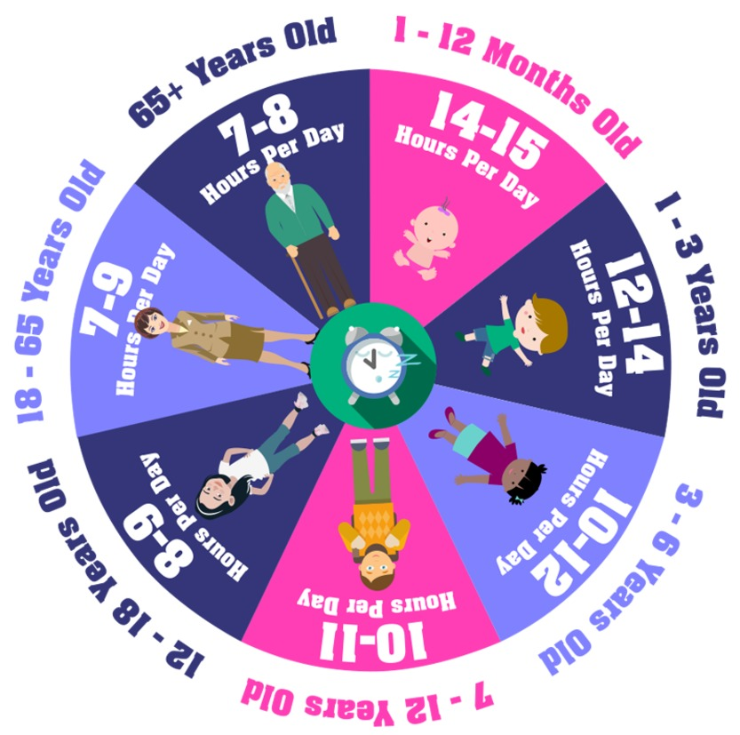
Figure 7
View description - Figure 7
View description - Figure 7

Back to - Activity 8: Sleep needs in adolescence

Activity 9: Promoting sleep

Part

Answer
Right:
strenuous physical exercise in the hour leading to bedtime
using a smartphone, tablet or PC in the hour leading to bedtime
watching TV in the hour leading to bedtime
drinking caffeine, particularly in the 4 hours before bed
Wrong:
Back to - Part

Part

Answer
Right:
reading a book at bedtime
listening to relaxing music
having a bath
change bedroom lightbulbs to ones with a warmer light
write down any worries that are interfering with sleep
aim for at least 60 minutes’ exercise during the day
get outdoors as much as possible while it is light
a good bedtime routine
Wrong:
Back to - Part

Part

Answer
Right:
thicker curtains or a blackout blind in the bedroom
using an app to support good ‘sleep hygiene’ (the good habits that facilitate sleep)
Wrong:
Back to - Part

Activity 1: Nurturing and supporting in adolescence

Discussion

Table 1 (completed): Seven Cs of Resilience
1. Confidence | Those around a young person can help by building their self esteem. While also ensuring not to overly place pressure on them to perform.
2. Competence | Those around the young person can notice what skills they have and comment positively on those already in place and further influence the development of new skills.
3. Connection | Having circles of adults who ‘see’ them, and who are reliable can help young people connect. It also gives them security to meet challenges that arise.
4. Character | Those around the young person can help to provide boundaries for them and connections with family.
5. Contribution | Helping young people know that they matter but also knowing that they can reach out to others for a helping hand is a clear part of contribution. But it’s important to know that this is done ‘in kind’ and that there is no pity that comes with it.
7. Coping | Telling young people what not to do by shaming them doesn’t work, so those around the young person need to work with them to help them learn better ways to cope by modelling this behaviour.
8. Control | Young people begin to have a sense of control within their homes and watch how those around us teach us be in the world. Those around them can also teach them responsibility.

Back to - Activity 1: Nurturing and supporting in adolescence

Activity 2: Social support networks

Discussion
There are no right and wrong answers to this activity as each individual’s personal circumstances are different. It is likely that some of the relationships you have identified include people the young person knows really well and may be emotionally close to, such as family members or friends, while other relationships, though important, are with people whom they are not emotionally close to, such as fellow students, members of a social group or team members. It is important to note that emotional closeness in relationships of course depends upon the quality of the relationship they share with network members. What the activity highlights is that each person is part of a network of relationships of different kinds and varying degrees of importance.
Note that networks may change over time; they grow, shrink and shift. As a person moves through adolescence, their peers may become more important than their close relatives. School transitions and changing family dynamics can be disruptive and adapting to these changes should be seen as a natural part of development.
Back to - Activity 2: Social support networks

Activity 3: Barriers to accessing informal social support

Answer
They start by talking about how some of the young men they know would be embarrassed to talk about their mental health because of the need to keep up a bravado. They also discussed the importance of mental health campaigns that help to reduce stigma. However, this was a source of disagreement among the young men as they reported varied opinions about whether this awareness can also create additional embarrassment. This disagreement is a further example of how individuals react and perceive information on mental health differently. Furthermore, it shows the importance of not making assumptions about how young people react to these campaigns.
Back to - Activity 3: Barriers to accessing informal social support

Activity 4: Experiencing different supportive responses

Answer
This parent describes how regular contact and offers of support were vital to her. However, she also experienced unhelpful responses which dismissed the seriousness of what her daughter was experiencing. Overall, background support and direction were of the greatest help to her.
Back to - Activity 4: Experiencing different supportive responses

Activity 5: Assessing the Impact of Social Media Use

Part

Discussion
The young men described definitive trends in self harm that they became aware of from social media. The young people are aware of these trends and note them among their peers. They describe concern about whether social media glamourised the issue and are clear in saying that they think this behaviour may have been affected by social media, particularly the way that it was possible to share this information online.
While concerns about social media and self-harm are common, it is also important to note that the young men showed considerable awareness of the negative consequences of social media and in another clip went on to discuss how they had developed some strategies to manage this.
Back to - Part

Part

Discussion
You may be surprised at how knowledgeable and reflective the young men were on some matters related to social media. They raised some concerns, but it is important to note that they were also aware of the importance of boundaries in forming a healthy relationship with social media and those actions which were less helpful. Interestingly, the young men compare the impact of social media on their mental health as being worse than drugs or alcohol, using the word ‘addiction’ to describe their assessment of the ways in which they engage with it. In response to this is it clear that they make distinctive efforts to control their engagement with it.
Back to - Part

Part

Discussion
Just like the young men, these young women were animated and engaged when asked to reflect upon the impact social media has had on them. However, they talked about social media as being an integral part of their life such that it was not always possible to be aware of the side effects it is having on your mental health. They also described being so consumed by it that it is hard to detach from. The girls mention the rush and sensations of getting likes and followers on Instagram. However, they also mentioned a particular trend that went on on Facebook when they were younger that they did not see as problematic at the time, but which they have come to reflect upon as being damaging for self esteem.
Throughout all of these clips the young men and women have demonstrated considerable reflection in their engagement with social media. But they also highlight that this is struggle. The final example of something that the young girls were once comfortable engaging with on social media, but which over time they now see as potentially damaging highlights the importance of having supervision and continual conversations with young people. Engagement with social media may almost be inevitable for today’s generation, but it is important to support them as they develop their relationship with social media over time.
Back to - Part

Activity 6: Controlling a social media feed

Answer
This video illustrates three simple steps to helping a young person manage their social media and the impact it has on their emotional health. The key here is the message of ‘cleaning your feed’ and at its core is the idea that young people should consider how each post makes them feel and to mute or unfollow those that do not keep them interested or happy. The second step is to use social media to find like-minded people who share their interests. The final step is to use social media to connect with people, to reach out and say hey.
Back to - Activity 6: Controlling a social media feed

Activity 8: Exploring sources of support through technology

Answer
How did your answer compare to those of your fellow learners? Perhaps you were surprised at how acceptable these forms of support are now. Or perhaps you are well versed with these alternatives to online services. Studies now show that people are increasingly accepting electronic communication to help with their mental health distress. This is particularly the case with the onset of COVID-19 which has pushed the issue further, forcing many organisations online and improving the ways in which they are used.
Back to - Activity 8: Exploring sources of support through technology

Activity 1: Preparing for a GP appointment

Answer
From the website, we noted that it was important to prepare. Write down what you want to say. Find words that help explain how you are feeling, or print out something that captures what is going on for you. It is also possible to ask for a longer double appointment.
Back to - Activity 1: Preparing for a GP appointment

Activity 2: Developing a response to mental health concerns at school

Discussion
In dealing with the physical injuries, you may need to seek help from a trained professional, or if you are acting as an educator you should be able refer to a first aider in your workplace.
Speaking to the young person, it will be important to draw on some active listening skills. Remember that you worked on these in Session 6.
It may be necessary to urgently identify other professionals you could make contact with.
Confidentiality is clearly important to many young people but it is important to know that for educators, your school will have policies about how you should handle sensitive information and were responsibilities lie in regard to safeguarding.
The circumstances and potential risks can be wide ranging, and these serious judgements need to be made in discussion with others.
Back to - Activity 2: Developing a response to mental health concerns at school

Activity 3: Responding to self-harm

Part

Discussion
It is understandable to feel uncertain about how you might respond. It could be that you immediately go into a panic mode, thinking of an emergency level response. There is a burden of responsibility associated with being made aware of the extreme distress of a young person. However, it is important to remember that if such a disclosure is made that the primary response should be to think carefully about how to connect with the young person, who is clearly revealing emotions of distress. Provide a safe space for that person to discuss what is going on for them before then developing a plan with them about how to get additional support.
Back to - Part

Part

Discussion
Skills you might have identified include:
- observation skills
  - Through noticing injuries or behaviour changes, a parent or practitioner may become aware of a problem and ask the young person or their child if they would like to talk.
- listening skills
  - The young person should be the sole focus of attention.
- relationship building skills
  - While a parent can build upon an established relationship, a practitioner needs to build trust, whilst not making unrealistic promises about confidentiality.
- teamworking skills
  - A young person may feel comfortable talking to one particular practitioner and may need help from many people, including family, peers and other practitioners.
- skills around protecting the parent and/or practitioner’s own wellbeing.
  - This work can be challenging, so it is important to be supported and to seek support or take up training opportunities where needed. It is important not to keep any uncomfortable feelings about any disclosures to yourself.
Characteristics for both parents and practitioners that might be helpful include:
- being supportive and accepting
- being non-judgemental
- being calm.
Although it is not mentioned in the video, helping young people find practical alternatives to self-harm, such as making a self-soothe box (a collection of things that will soothe or distract) could also be a useful option. You will recall Dr Pooky Knightsmith in Session 6 talking about the importance of self-soothing.
Back to - Part

Activity 4: Making sense of CBT

Discussion
It’s about helping a person to manage their mental health challenges while staying in the present, and teaching coping skills. It can help the young person understand how their negative thoughts are affecting the way they feel and act. If CBT turns out to be unhelpful, there is no shame in asking to try alternative approaches.
A key skill for CBT practitioners is active listening. You will remember addressing skills in listening in Session 6. You may have noticed in the video that the therapist’s questions follow closely from the patient’s descriptions of his feelings, gently prompting exploration of his beliefs. CBT therapists need to listen carefully and attentively so that they can ‘tune in’ effectively to the patient.
Back to - Activity 4: Making sense of CBT

Activity 5: Understanding the importance of professional help

Answer
John stresses that within the counselling room it is possible for young people to describe things that they may be hiding from others as they attempt to ‘look fine’ on the surface. This mum initially describes the importance of one the techniques they were taught to use with their daughter as part of the CBT, this was called ‘worry time’ and it was a period of time fenced off from the rest of the day in which they would discuss with their daughter any ongoing concerns she had. But she also highlights how crucial the therapist was in highlighting the progress steps that she was making, and how this was taking her through to recovery. It was this progress that helped the family see what the therapist described as the ‘green shoots’ and how things were improving.
Back to - Activity 5: Understanding the importance of professional help

Activity 6: Understanding the role of anti-depressants

Part

Answer
Right:
False
Wrong:
True
False: The National Institute for Health and Care Excellence (NICE) warns against using St John’s wort for the treatment of depression in children and young people.
Back to - Part

Part

Answer
Right:
True
Wrong:
False
True: see the NICE guidelines.
Back to - Part

Part

Answer
Right:
False
Wrong:
True
False: Fluoxetine is often the first line of treatment when drugs are deemed necessary.
Back to - Part

Part

Answer
Right:
True
Wrong:
False
True: The risk of suicide is greatest in the early stages of treatment. This may be due to the fact that the drugs need to be taken for a few weeks before they become effective in treating depression (which is itself associated with an increased risk of suicidal behaviour). Firm explanations are still being sought. Source: Gov.uk
Back to - Part

Activity 7: Hannah’s mental health story

Discussion
Hannah talks a lot in her video, initially about all the efforts she made to improve her mental health. She described getting exercise, sleep and eating right as helpful and her engagement with professionals who provided talking therapy. But she also points out that this had a limited impact and that eventually she became aware that therapy wasn’t enough – she came to accept that she needed anti-depressants. It was a huge step for her to take them and she felt it was taboo to say she needed to take them. She shares the story because she wants people to know that it has changed how she feels about how she wakes up in the morning. In summary her message is that if you have tried everything else and if your mood is not getting better, then medication might provide some additional help.
Back to - Activity 7: Hannah’s mental health story

Activity 8: What can you do if you are on a waiting list for specialist support?

Discussion
John describes simple activities as being effective in providing self-care. For example, walking, reading or writing a diary can be a positive way of challenging thoughts. These are simple but positive ways of supporting the young person, but they also provide a way to prepare for therapy when it does commence.
Back to - Activity 8: What can you do if you are on a waiting list for specialist support?

Figure 1

Description
Sad 12 year-old young person sitting on their bed.
Back to - Figure 1

Interactive Figure 2: Mental health of Children and young people in England (2017)

Description
The interactive figure shows five circles that each contain some information. 5.5% - In England in 2017, 5.5% of 2 to 4 year old children experienced a mental disorder. 8.1% - In England in 2017, 8.1% of 5 to 19 year olds experienced emotional disorders. 12.8% - In England, one in eight (12.8%) 5 to 19 year olds had at least one mental disorder when assessed in 2017. 16.9% - In England in 2017, 16.9% of 17 to 19 year olds experienced a mental disorder. Source: NHS Digital (2017) Mental Health of Children and Young people in England Available at: https://digital.nhs.uk/data-and-information/publications/statistical/mental-health-of-children-and-young-people-in-england/2017/2017
Back to - Interactive Figure 2: Mental health of Children and young people in England (2017)

Figure 3: Trends in any mental health disorder in 5 to 15 year olds by sex, 1999 to 2017.

Description
Digram showing the trends in any disorder. All three lines, one representing all, one representing girls and one representing boys all have a steady incline. The ‘boys’ line starts at 11.8% in 1999 and gets to 12.2% by 2004, reaching 13.1% by 2017. The ‘all’ line begins at 9.7% in 1999, reaches 10.1% in 2004 and gets to 11.2% by 2017. The ‘girls’ line starts at 7.5% and is at 7.9% in 2004. It then reaches 9.3% by 2017.
Back to - Figure 3: Trends in any mental health disorder in 5 to 15 year olds by sex, 1999 to 2017.

Figure 4: Percentage of any disorder by age and sex, NHS 2017.

Description
Two bar charts showing the age groups and sex of those with a reported disorder. On the left-hand side, the bar chart looks at boys. The age category 5 to 10 reports 12.2%, 11 to 16 14.3%, 17 to 19 10.3% and ages 5 to 19 12.6%. The right-hand graph looks at girls, and in the 5 to 10 category it reports 6.6%, 11 to 16 14.4%, 17 to 19 23.9% and 5 to 19 12.9%.
Back to - Figure 4: Percentage of any disorder by age and sex, NHS 2017.

Figure 5

Description
An illustration of two people’s heads. One has a rainbow coming out of the top and this persons face is happy, and the other one has thunderstorms coming out of the top and their face is sad.
Back to - Figure 5

Figure 6: Young people who have suffered with their own mental health.

Description
Six photographs, from left to right: Zayn Malik, Jesy Nelson, Billie Eilish, Marcus Rashford, Emma Raducanu and Zoella/Zoe Sugg.
Back to - Figure 6: Young people who have suffered with their own mental health.

Figure 7: a) John Watson and b) Sigmund Freud

Description
a) is a photograph of John Watson and b) is a photograph of Sigmund Freud, sat with his two grandsons.
Back to - Figure 7: a) John Watson and b) Sigmund Freud

Figure 8

Description
A person lying on a couch in a counselling session. Photographed in silhouette.
Back to - Figure 8

Figure 9: Some people continue to be treated harshly for mental health issues.

Description
A photograph of a young man chained to a poll.
Back to - Figure 9: Some people continue to be treated harshly for mental health issues.

Figure 1

Description
A colourful illustration of different young people in a line.
Back to - Figure 1

Figure 2: Stanley Hall

Description
Photograph of Stanley Hall.
Back to - Figure 2: Stanley Hall

Interactive Figure 3: Definitions of the timing of adolescence

Description
The interactive figure shows four boxes with click to reveal information:
Ages 10 to 19: revealed: The World Health Organization (n.d.) counts 10 to 19 year-olds as adolescents. It estimates that there are 1.2 billion adolescents word-wide. ]
Ages 12 to 18: revealed: Developmental psychologist Erik Erikson (1963) described eight stages of human development, which were based on social development and sense of identity. During the ages of ‘adolescence’- 12 to 18 – people work out who they are in relation to others, especially with their friends, in the world beyond the family.]
The period of puberty: revealed: The timespan during which a child’s body begins and completes the process of development into an adult body. Puberty normally begins between the ages of 8 and 14 and lasts about 4 years (NHS, 2018).]
Ages 11 to 25: revealed: Psychologists and neuroscientists are gathering evidence that social, emotional and brain development continue well into a person’s twenties (Wiley and Corey, 2018; Blakemore, 2019).
Back to - Interactive Figure 3: Definitions of the timing of adolescence

Figure 4: Physical changes and secondary sexual characteristics that appear during puberty.

Description
Illustration of the male and female bodies. For the male on the left-hand side, there are the following labels: growth spurt, increase in lean muscle mass, changes in body composition, increase in penile length and first ejaculation, pubic hair and tesicular enlargement. For the female, there are the following labels: growth spurt, breast development, changes in body composition, pubic hair/monarche and increase in fat mass.
Back to - Figure 4: Physical changes and secondary sexual characteristics that appear during puberty.

Figure 5: Typical trajectory for adolescent emotional development, adapted from Steinberg (2005)

Description
Diagram showing the trajectory for early adolescence through to late adolescence. From the left-hand side, there is the text: Early adolescence Puberty onset heightens emotions, sensation seeking and importance of rewards. Then there is the text next to this one with: Middle adolescence Increased risk taking Problems regulating emotion and behaviour. And then on the right-hand side there is the text: Late adolescence Maturation of the brain’s frontal lobes allows self-regulation. There is an arrow running through all three, coming from the left and pointing to the right.
Back to - Figure 5: Typical trajectory for adolescent emotional development, adapted from Steinberg (2005)

Figure 6: Kevin the teenager

Description
Photograph of the fictional character Kevin.
Back to - Figure 6: Kevin the teenager

Figure 7

Description
A diagram of the brain, labelled. On the left-hand side, there are the following labels, prefrontal cortex, frontal lobe, callosum, lateral ventricle, hypothalamus, hypophysis, midbrain. On the right-hand side there are the following labels, parietal lobe, limbic system, occiputal lobe, thalamus, epiphysis, cerebellum, medulla oblongata and bridge.
Back to - Figure 7

Figure 8: Adolescents may take more risks when with peers

Description
A photograph of a person jumping off a cliff into the sea.
Back to - Figure 8: Adolescents may take more risks when with peers

Figure 9: Interaction between age of participant (adolescent, young adult, adult) and individual v. group performance on a computerised game of risky decision making (Gardner and Steinberg, 2005)

Description
A bar chart representing risky driving for adolescents (13-16 years), young adults (18-22) and adults (24+). The graph shows that adolescents are far more likely to participate in risky decision making when in groups compared to being solo. For young adults, the chance of risky decision making was fairly equal between solo and in groups. For adults, they were actually more likely to be risky when solo.
Back to - Figure 9: Interaction between age of participant (adolescent, young adult, adult) and individual v. group performance on a computerised game of risky decision making (Gardner and Steinberg, 2005)

Figure 10

Description
Group of young people laughing and waving hands
Back to - Figure 10

Figure 11

Description
A photograph of a school child being bullied by another school child.
Back to - Figure 11

Figure 12: News headlines

Description
An image of three news headlines:
Mental health: ‘Urgent action needed over epidemic’.
Mental health needs of THOUSANDS of children in Milton Keynes currently going unmet.
Stevenage GP calls for further action as ‘unprecedented’ demand grows for children’s mental health services in Herts.
Back to - Figure 12: News headlines

Click here to explore the activity. Remember to open the link in a new window or tab so you can refer back to the course when you are ready.

Description
A screenshot of the activity.
Back to - Click here to explore the activity. Remember to open the link in a new window or tab so you can refer back to the course when you are ready.

Figure 13: Mental health spectrum

Description
A diagram of an arrow, on the left it is green with the word ‘healthy’, then it changes to yellow with the word ‘coping’. Then it moves to red with the word ‘struggling’, then it moves to a dark red, with the word ‘unwell’.
Back to - Figure 13: Mental health spectrum

Figure 1

Description
Depressed or sad young person sitting on the floor with head resting on knees and arms wrapped around legs.
Back to - Figure 1

Figure 2: Mental health spectrum (repeated from Session 2.)

Description
A diagram of an arrow, on the left it is green with the word ‘healthy’, then it changes to yellow with the word ‘coping’. Then it moves to red with the word ‘struggling’, then it moves to a dark red, with the word ‘unwell’.
Back to - Figure 2: Mental health spectrum (repeated from Session 2.)

Figure 3: An illustration of depression

Description
A piece of artwork with seven different faces depicting different facial expressions. The idea is to illustrate depression.
Back to - Figure 3: An illustration of depression

Figure 4: Depression

Description
A piece of artwork of a person in a chair with a cloud over their head. The artwork is intended to illustrate depression.
Back to - Figure 4: Depression

Figure 5: Eating disorder

Description
A piece of artwork of a person at a dining table with a cross over their mouth. The artwork is illustrating an eating disorder.
Back to - Figure 5: Eating disorder

Figure 6: The average time (weeks) spent waiting by under 19s for eating disorder treatment.

Description
An image of an arrow going from left to right, titled TOTAL 130 weeks. The majority of the arrow is is dark purple, and labelled 69 weeks. There is another large, lighter purple section, labelled 39 weeks. Then there are three, much thinner sections, blue, labelled 7, orange, labelled 8 and red, labelled 7.
Back to - Figure 6: The average time (weeks) spent waiting by under 19s for eating disorder treatment.

Figure 7: The self-harm cycle

Description
A cycle starting with emotional suffering with arrows linking to emotional overload, panic, self-harm, temporary relief and shame/grief.
Back to - Figure 7: The self-harm cycle

Figure 8: Suicide prevention advice

Description
The graphic has the following text:
Suicide prevention advice WAIT!
W: Watch out for signs of distress and changes in behaviour.
A: Ask ‘are you having suicidal thoughts?’
I: It will pass – assure your loved one that, with help, their suicidal feelings will pass with time.
T: Talk to others – encourage your loved one to seek help from a GP or health professional.
Mental Health Foundation
Back to - Figure 8: Suicide prevention advice

Figure 1: Early symptoms of mental health illness

Description
The graphic is of a brain, and at the top of the brain the text: early symptoms of mental illness
In the brain there are the following labels: feeling sad, concentration problems, anger management issues, paranoia, suicidal thinking, excessive fears or worries, extreme mood changes, sleeping problems, inability to cope with stress, excessive use of alcohol or drugs.
Back to - Figure 1: Early symptoms of mental health illness

Figure 2

Description
A photograph of a filing system with the following labels: mental health, psychiatry, disorders, bipolar, depression, anxiety, schizophrenia.
Back to - Figure 2

Figure 3: The determinants of health (Dahlgren and Whitehead, 1993; in Dahlgren and Whitehead, 2007)

Description
A diagram with age, sex and constitutional factors at the centre with different determinants surrounding it. These are (from the centre, outwards): Individual lifestyle factors, social and community networks, agriculture and food production, education, work environment, living and working conditions, unemployment, water and sanitation, healthcare services, housing. The outer row is labelled: General socioeconomic, cultural and environmental conditions.
Back to - Figure 3: The determinants of health (Dahlgren and Whitehead, 1993; in Dahlgren and Whitehead, 2007)

Figure 4

Description
A photograph of two people talking, one person is holding a computer tablet.
Back to - Figure 4

Figure 5: A treatment hierarchy of professions and services.

Description
A diagram of three rows:
Primary care: General Practitioner, Practice Nurse, Community Psychiatric Nurse, School Nurse, Counsellor.
Secondary care: Psychiatrist, Clinical or Educational Psychologist, Psychotherapist, Occupational, Art, Music, Drama, Speech and language, Education Therapists, Support, Time and Recovery Worker.
Tertiary care: Specialist eating disorders team, Forensic mental health team, including Youth Offending Worker.
Back to - Figure 5: A treatment hierarchy of professions and services.

Figure 6: The Brain – Cerebral cortex viewed under the microscope.

Description
An image of the cerebral cortex viewed under the microscope.
Back to - Figure 6: The Brain – Cerebral cortex viewed under the microscope.

Figure 3: (repeated from Section 1.2) The determinants of health (Dahlgren and Whitehead, 1993; in Dahlgren and Whitehead, 2007)

Description
A diagram with age, sex and constitutional factors at the centre with different determinants surrounding it. These are (from the centre, outwards): Individual lifestyle factors, social and community networks, agriculture and food production, education, work environment, living and working conditions, unemployment, water and sanitation, healthcare services, housing. The outer row is labelled: General socioeconomic, cultural and environmental conditions.
Back to - Figure 3: (repeated from Section 1.2) The determinants of health (Dahlgren and Whitehead, 1993; in Dahlgren and Whitehead, 2007)

Figure 7: Different types of social media

Description
An illustration of two images, on the left is a person surrounded by emojis and message icons coming from their phone. On the right is an image of two people talking on a sofa with a bright lamp above them. Along the bottom are lots of different social media logos, including Facebook, Twitter, Google+, Pinterest, WhatsApp, Facebook Messenger, Snapchat, Spotify, YouTube, Vimeo, Instagram, Skype and LinkedIn.
Back to - Figure 7: Different types of social media

Interactive Figure 8: Misconceptions about mental health. There is a long description button below if this is easier to learn from.

Description
This interactive figure shows information about misconceptions about mental health:
1. Mental illness is not a ‘real’ illness.
FALSE. Mental ill health is not simply the regular ups and downs of life. It creates distress, which does not simply go away by itself, but can be managed through effective interventions. While some people who experience mental illness may act in ways that are unexpected or appear different to others, these cannot be generalised. It can sometimes be challenging to relate to the symptoms and personal experiences of people living with a mental health condition, if one has not experienced these for themselves, but this does not mean that their condition is somehow not real.
2. People with mental illness are typically violent, unpredictable and dangerous.
FALSE. Having a mental health condition does not make a person more likely to be violent or dangerous. The causes of violence are complicated, and mental illness is not by itself a predictor of violence. Few violent acts can be attributed to individuals living with a serious mental illness, people with mental health problems are statistically more likely to bring harm to themselves than to harm someone else. The false perception, popularised in the media that people with mental illness are typically violent, unpredictable and dangerous, is amongst the most damaging of stereotypes
3. People who experience mental illness are unable to work or study.
FALSE. Depending on the severity of their condition, living with mental illness does not necessarily mean that a person is incapable of seeking or maintaining employment or studying. They may require additional support or suitable working arrangements. Those with more serious conditions may face some barriers as a result of discrimination.
4. Mental illness is a result of ‘bad parenting’.
FALSE. Mental health problems are complicated conditions that arise from a combination of genetics, biological, social, environmental, life experiences, and other influences and not simply a consequence of parenting. Around half of all lifetime cases of mental illness begin before the age of 14. Parents and family members have a major role in support and recovery.
5. There is no such thing as mental illness in adolescence; it’s just puberty and signs of ‘teenage awkwardness’.
FALSE. Errant, ‘challenging’ or withdrawn behaviour, and sudden changes in mood at school or at home during adolescence are often seen as a sign that a young person is simply ‘acting out’ their frustration at struggling academically or socially. Adolescence is a period of significant physical and emotional change, brain development in particular. It is important to distinguish mental ill health from ‘transitional’ teenage behaviour, moving towards adulthood. Up to half of all mental health conditions show first signs before the age of 14. However, it is estimated that up to 20% of those diagnosed do not receive the treatment and support they need.
Back to - Interactive Figure 8: Misconceptions about mental health. There is a long description button below if this is easier to learn from.

Interactive Figure 9: Misconceptions about mental health

Description
This interactive figure shows information about misconceptions about mental health:
6. There is no recovery from mental illness − once you have a diagnosis, it’s all downhill from there.
FALSE. Mental illness is not always a chronic, lifelong condition. People who experience mental illness can recover and lead fulfilling lives, learning to manage symptoms with support and appropriate treatments. Many people living with mental health conditions are able to live, work, learn and participate fully as active and productive members of communities. When treated appropriately and early, some people can recover with no further episodes of ill health. For others, ill health may recur throughout their life, and will require longer-term management to help people live full and fulfilling lives..
7. Mental illness is the sign of a ‘weak character’ − people with depression are just ‘lazy’.
FALSE. Mental ill health, whatever the cause, is not a character flaw or personal weakness. People with mental ill health are not ‘lazy’, ‘weak’ or able to ‘snap out of it’. The stereotype of a clinically depressed person as being lazy, or simply lacking motivation shows a lack of understanding of the condition. Multiple factors contribute towards mental illness, including life experiences, trauma, family history, physical illness or biological factors. It is not entirely clear why some people are more ‘resilient’ to developing mental illness than others after, for example, witnessing a traumatic event, being a victim of a crime, or longer-term exposure to traumatic experiences, such as abuse.
8. Prevention doesn’t work − it’s impossible to prevent mental illnesses.
FALSE. If risk factors are known (e.g. exposure to a specific trauma or known biological or environmental stimuli which can trigger mental health problems), then strategies aimed at preventing these would affect mental, emotional and behavioural outcomes in children and adolescents, as well as adults. Similarly we can all learn to read our own triggers and take actions to support self-care.
9. People with depression are just ‘sad’ − they need cheering up.
FALSE. There is a misconception that people who are clinically depressed can simply will away their mood, shake it off, pull themselves together and cheer up. Treatments such as cognitive therapy combined with medication can help address the symptoms of depression.
Back to - Interactive Figure 9: Misconceptions about mental health

Figure 1

Description
A word cloud of lots of different words, with the main ones being resilience, strength, motivate, agility and vision.
Back to - Figure 1

Figure 2

Description
Two illustrations of a childs face, side by side. On the left, the child looks sad and their head is bounded by spiky thorns. On the right, they appear happier, surrounded by roses.
Back to - Figure 2

Figure 3

Description
An image of 5 identical outlines of people, in a line. The fourth person is red and the other four people are in blue. There is a quote at the top: ‘Resilience requires relationships, not rugged individualism’. National Scientific Centre on the Developing Child (2015).
Back to - Figure 3

Figure 4

Description
A photograph of a person wearing a medical face mask.
Back to - Figure 4

Figure 5

Description
A photograph of a person sat on the floor with their knees up and their head in their hands.
Back to - Figure 5

Figure 6

Description
An illustration of a child on a seesaw. On the left there are negative outcomes: risk factors, adversities. On the right, there are positive outcomes: protective factors, warm supportive parenting, coping skills, stable environment, positive experiences.
Back to - Figure 6

Figure 7

Description
An illustration of reflections/shadows of people sat at desks in a classroom formation. There is a person standing at the front of them, teaching.
Back to - Figure 7

Figure 1

Description
A photograph of multiple hands paired up and forming a circle.
Back to - Figure 1

Figure 2: Mental health spectrum (repeated from Session 2.)

Description
A diagram of an arrow, on the left it is green with the word ‘healthy’, then it changes to yellow with the word ‘coping’. Then it moves to red with the word ‘struggling’, then it moves to a dark red, with the word ‘unwell’.
Back to - Figure 2: Mental health spectrum (repeated from Session 2.)

Figure 3

Description
A photograph of a persons face with their eyes closed lying on a bed, they are facing away from another person in the background who is holding their hand and looking at them.
Back to - Figure 3

Interactive Figure 4: Conversation starters (YoungMinds, 2020)

Description
Interactive figure 4 is a rectangular box containing text within it. The text changes when each of four colour-coded tabs at the top of the rectangle are clicked. Thus the first tab heading is ‘General’, below which is the following text:
- How are you feeling?
- What do you want to talk about?
- What was the best and worst bit of your day?
- If you could start today again, what would you do differently?
- What did you do today that you are most proud of?
- What was the best and worst bit of your day?
The second tab heading is ‘Serious’, below which is the following text:
- What was the biggest problem you had today?
- Do you want to talk about what’s going on?
- How can I support you through [issue]?
- Is there anything that you need from me? Space, time to talk, time to do something fun...?
- What was the biggest problem you had today?
The third heading is ‘Fun’, below which is the following text:
- What’s your favourite song at the moment? Would I like it?
- If you were any animal which one would you be?
- If your life was a movie which one would it be?
- What’s your favourite thing about school and why?
- If an alien had landed in your class today, what would you have been embarrassed for them to see?
The fourth and final heading is ‘Encouragers’, below which is this text:
- I love you, nothing can ever change that
- You can talk to me, I’m here for you
- If you need to talk to someone else, that’s okay too
- If you talk to me about what is worrying you, I can do my best to help
- Even if I don’t understand, know that I want to
- We’re going to get through this together
Back to - Interactive Figure 4: Conversation starters (YoungMinds, 2020)

Figure 5

Description
A photograph of young people playing hockey.
Back to - Figure 5

Figure 6: Prevalence of insufficient physical activity among school-going adolescents aged 11–17 years, globally and by World Bank income group, 2001 and 2016 (Guthold et al., 2020)

Description
A bar chart showing the prevalence percentage of insufficient physical activity through different years and genders, comparing global, low, lower-middle, upper-middle and high incomes.
Back to - Figure 6: Prevalence of insufficient physical activity among school-going adolescents aged 11–17 years, globally and by World Bank income group, 2001 and 2016 (Guthold et al., 2020)

Figure 7

Description
An illustration of a circle with different segments displaying different age categories and how much sleep is recommended:
- For 1–12 months old, 14–15 hours per day.
- For 1–3 years old, 12–14 hours per day.
- For 3–6 years old, 10–12 hours per day.
- For 7–12 years old, 10–11 hours per day.
- For 12–18 years old, 8–9 hours per day.
- For 18–65 years old, 7–9 hours per day.
- For 65+ years old, 7–8 hours per day.
Back to - Figure 7

Interactive Figure 1: Mind mapping

Description
An interactive clickable figure. One circle in the centre, labelled young person. Then clockwise, the following labels coming from the centre: parent/carer, friend 1, friend 2, sport coach, family member and teacher.
Back to - Interactive Figure 1: Mind mapping

Figure 2: #be kind

Description
An image of a hand holding up a piece of paper that has the writing ‘#be kind’
Back to - Figure 2: #be kind

Figure 3

Description
A photograph of a person at a desk typing on a laptop.
Back to - Figure 3

Figure 4

Description
An illustration of a word cloud with the following words confusing, complicated, contradictory, conflicted, communication, less lonely, somebody to talk to, wish I could physically hang out instead, distracting, side-tracked, hate speech, racist comments, sexist comments, bullying, rude language, offensive, hurtful, invalidate feelings, cherish connection, artwork, writing platform, discuss issues, passionate, cool, habit, something new, exciting, complex.
Back to - Figure 4

Figure 5

Description
An illustration of a person in the sea drowning with lots of different words surrounding them, such as ‘tips for living with OCD’, ‘Do you want your life to be happy OR safe?’, ‘talking therapies’, ‘waiting lists’, ‘can virtual reality help’, ‘exercise better than medication?’ ‘pills’, ‘hands in bucket of used tissues for 3 hours’, ‘self help cost effective’, ‘celebs with OCD’, ‘Amazon.co.uk’, and ‘exposure levels too severe’. There are three birds above and two sharks in the water. One shark has the Facebook logo and the other shark has the Google logo.
Back to - Figure 5

Figure 6: Different types of mental health apps

Description
Screenshots of the Combined minds and Hope apps.
Back to - Figure 6: Different types of mental health apps

Figure 1: What are their strengths/difficulties? (Source:MindEd for families)

Description
Bulleted list of Doctor’s questions:
- Why are you concerned about your child?
- What kind of feelings, thoughts do they share that are making you worried?
- What sorts of behaviours are they displaying that are making you concerned?
- How much are these behaviours upsetting you and your child?
- How often do they do these things?
- When did these problems start?
Back to - Figure 1: What are their strengths/difficulties? (Source:MindEd for families)

Figure 2

Description
A flow chart describing the options for a person self-harming at school.
Title: Self-harm at school: what to do? To be used in conjunction with the school’s safeguarding policy.
Three boxes at the top. In the middle: Don’t panic. Left: See to immediate medical needs. Follow first aid guidelines for cuts, wounds or burns. Contact emergency service for overdoses. Right: Speak to the young person to see how they are feeling and provide support. Listen to what they have to say.
Then there is an arrow going down to another box: Speak to head of year, school nurse, school counsellor or safeguarding lead.
Then there is an arrow going down to another box: Think about confidentiality. Should the self-harm be reported to parents/carers? Make sure the young person knows what will be said and to whom.
Then there is an arrow going down to another box: Think about circumstances and potential risks. Risk of mental health problems e.g., depression and anxiety. Risk of potential abuse. Risk of other students self-harming. Risk of further self-harm. Risk of suicide.
Then from this box there are two options.
On the left there is the Higher concerns box: Discuss with CAMHS link worker. Involve parents/carers. Initiate referral for specialist care. Consult with CAMHS on how to manage. Continue with supportive listening while waiting for referral. Refer to Multi-Agency safeguarding Hub if there is immediate risk of harm.
On the right there is the Lower concerns box: Provide a listening ear. Suggest distraction or emotional release techniques. Help the young person think of more effective coping mechanisms. Consider how stresses at school can be reduced.
Back to - Figure 2

Figure 3: What is CBT?

Description
An illustration of a flow chart with questions that lead to other options. At the top, the box states ‘Feeling’ ‘I feel anxious’. There are then two options. On the right, the option is ‘Thoughts’ ‘I can’t do this’ ‘What is wrong with me’, ‘Everyone is looking at me’. On the left, the box has ‘Behaviour’, ‘Get away from the situation’, ‘Avoid it in future’. Below this is another, seperate box that has ‘feeling’ ‘I feel low/depressed’. There are then two options. On the right, a box with ‘Thoughts’, ‘I’ve let everyone down’, ‘They’ll be angry with me’, ‘I’m not a good friend’. On the left is a box with ‘behaviour’ ‘Withdraw from others’, ‘Avoid friends’. The two sets of three boxes all have arrows interlinking to one another within the set of three.
Back to - Figure 3: What is CBT?

Interactive Figure 4: The CAMHS four tier structure

Description
A rectangular box with four clickable tabs, explaining the four tiers of CAMHS:
Tier 1: Universal services, such as primary care, including general medical practice, school nursing, health visiting and schools. Tier one services aim to promote mental well-being.
Tier 2: More targeted services, such as youth offending teams, primary mental health workers, and school and youth counselling (including social care and education). This includes support for children with less severe mental health problems.
Tier 3: Specialist community CAMHS. These are multi-disciplinary teams of child and adolescent mental health professionals providing a range of interventions, including teams with specific remits, such as CAMHS learning disability teams; community forensic CAMHS; adolescent substance misuse teams; crisis/home treatment teams preventing admission to hospital; liaison teams providing CAMHS input to children and young people in acute care settings.
Tier 4: Highly specialist services, such as day and inpatient services. Very specialised outpatient services, and, increasingly, services such as crisis/home treatment services which provide an alternative to admission. These are generally services for a small number of children and young prople who are deemed to be at greatest risk of rapidly declining mental health, or from serious self-harm, who need a period of intensive input.
Back to - Interactive Figure 4: The CAMHS four tier structure

Figure 5: Mental health spectrum (repeated from Session 2.)

Description
A diagram of an arrow, on the left it is green with the word ‘healthy’, then it changes to yellow with the word ‘coping’. Then it moves to red with the word ‘struggling’, then it moves to a dark red, with the word ‘unwell’.
Back to - Figure 5: Mental health spectrum (repeated from Session 2.)

Figure 6: 1,000 children: a model for local commissioners

Description
An illustration demonstrating statistics for 1,000 children: a model for local commissioners. In the centre is a circle full of outlines of people. There are five circles coming from the middle and surrounding the main image. From the top left, going clockwise: ‘Every child can benefit from help to have the best start and promote mental health, resilience an coping skills.’ ‘One child in 1,000 will have a very serious problem requiring hospital care.’ ‘About 17 children may have serious diagnosable difficulties needing specialist treatment.’ ‘70 children may have common diagnosable problems and need effective help.’ ‘Around 150 children in 1,000 may need extra help to prevent later crises.’ At the bottom of this, there is the following text: This model was developed by Centre for Mental Health building on research by Kurtz, 1996. Kurtz, K. (1996) Treating children well: a guide to using the evidence base in commissioning and managing services for the mental health of children and young people. London: Mental Health Foundation. © Centre for Mental Health 2017
Back to - Figure 6: 1,000 children: a model for local commissioners

Audio 1: Parent experiences

Transcript
SPEAKER
It was probably brewing, if you like, for quite some time, possibly even over years. But when we noticed something was really wrong, we were on holiday actually and my daughter was doing lots of twirling, turning round and round, and was quite anxious and worried. And maybe some things sort of fell into place, and we thought, well, maybe things aren’t really quite right.
This was in the summer. And then when she went back to, she was in senior school then. One of her friends had passed away from cancer. So, as you can imagine, it was really, really difficult. Yeah. It was almost like a volcanic eruption, then lots of different, more noticeable things were happening that gave us worries. And also she herself had said that she was struggling and not really feeling right.
So it was fairly rapid after that we got in touch with the GP. But I don’t think we’ve really put it all together until it was very obvious. In fact, actually, the topic of OCD came up in her psychology classes. She’d chosen her options by then, and she did actually say to the teacher, I think I’ve got this. And unfortunately, she was ignored. And we didn’t have any information coming back from the school.
We very much do things as a family, and we did talk about it altogether, my husband and my daughter, and we agreed to go to the GP because we knew her. She was very anxious. And the thing of how we’ve got through it really is together as a family. It’s a fine line, isn’t there, between natural parts of sort of growing up. But she was twirling and tapping her foot on things and behaviours that we also knew could potentially mark her out.
My daughter was very quickly referred to the children and adolescent mental health service locally. It wasn’t too long before we were offered an assessment. It was very apparent by that stage things had escalated with the OCD quite dramatically. And at that point, she was assessed as having severe anxiety and OCD and needing to be quite quickly seen by a psychologist.
There was a concern over her life at one point, although I didn’t think that she would harm herself, we couldn’t discount and take a chance on the possibility, and she became very unwell very rapidly. So we were fortunate, in a sense, that she was seen very quickly by the adolescent mental health service.
To my mind, the OCD is not the child. It was never my daughter. My narrative of her and who she is was my daughter, a person in herself, and a dancer, and a performer. And it was the only thing she went out of the house to do. She had a year of CBT, so cognitive behavioral therapy, and with a fantastic, two psychologists, actually. One moved on. She had most of the time with her, and then she had a new person who did the CBT with her. She got on very well. She was worried about the transition, but she managed it fine.
There was a lot. So there was a year, over a year of treatment from, she had medical intervention, which I really didn’t want, but I did accept it. They were delighted with how she came through that. And I’m not sure they really expected it. We didn’t know what to expect. We were just trying to live day by day with a lot of her being very, very upset, very anxious. There’d be a day where she stood knotting and unknotting a necklace literally for hours on end. There was a long road in between the getting better, but I think the professional help was essential to her getting better.
Back to - Audio 1: Parent experiences

Video 1: John Goss and experiences with young people.

Transcript
John Goss
Well, some things might seem fine. Quite often when people come to me, they may talk about how they’re really feeling. So an example of that could be something like depression. The person who presents with depression may have started to withdraw themselves, for example.
They may have started to shrink away from their friendship groups. They may feel that their motivation is waning a little bit. You may notice that they’re not so keen to get up in the morning. Not so keen to attend school, do social events, or go out with their friends.
Another example could be something like compulsions. Some people may feel that they have to count particular things or follow a particular routine or do something that makes them feel a bit more comfortable that they wouldn’t normally do. That may be how they tie their shoelaces or how they arrange something. How they arrange their schoolbooks or how they present their room. Sometimes that can be a comforting thing for them as a way of managing their own anxiety.
Back to - Video 1: John Goss and experiences with young people.

Video 2: Mental health in our own words

Transcript
[MUSIC PLAYING]
SPEAKER 1
My mental health problem means that I go through many highs and lows which I struggle to control.
SPEAKER 2
Sometimes I just want to hide away.
SPEAKER 3
I feel that I have to make everyone else happy. And every day is a struggle, but I just remind myself that I'm strong.
SPEAKER 4
My mental health problem means that sometimes the world can be a very scary, very dangerous, and very dark place.
SPEAKER 5
Everyday tasks can become the most mammoth missions that seem like you'll never going to be able to do them.
SPEAKER 6
My mental health problem means but life is hard.
SPEAKER 7
The hardest thing about having a mental health problem is people not realizing that there's something wrong with you and that you can be really ill, even if you look absolutely fine. I think especially having an eating disorder, people assume that you're going to look a certain way or be a certain size or shape, or they imagined certain stereotypes that aren't necessarily true.
SPEAKER 8
Like the social, and in my case like the cultural stigma associated with it.
SPEAKER 1
If I'm having a bad day, no matter how small it is, it feels like the whole world is crashing in on me and things just keep getting worse.
SPEAKER 3
Just trying to get the people around me to understand what I'm going through when they haven't gone through something like me is probably the hardest thing.
SPEAKER 9
Social situations in particular can be really difficult. I sometimes can't commit to what we'd call, sort of normal everyday activities.
SPEAKER 10
The word, "schizo," I think it has a lot of stigma attached to it. I really don't like it.
[MUSIC PLAYING]
SPEAKER 9
What really reassured me was knowing that there are so many other people out there who have got the same diagnosis as me, and that I'm not alone.
SPEAKER 7
Having my two rescue dogs, and to look after and to take care of because I know that they need me around and they're always happy to see me. So no matter how bad my day is or how awful everything seems to be, I know that they need me and they always make me smile.
SPEAKER 11
Having such a great network of friends, family, and people who are out there who can help.
SPEAKER 3
I'd look at how far I've come and everything that I'd gone through, and realize that I am still standing.
SPEAKER 12
It really helps me when my friends treat me the way they did six years ago before this all started. I was that happy laid back person and that's the person that I want to be and aspire to be again.
SPEAKER 5
It really helps me when people just treat me normally.
SPEAKER 6
I'd like people to treat me like you would your own mother I guess, that's-- yeah, I think that's a good way to treat people.
SPEAKER 1
I don't want people to tiptoe around me.
SPEAKER 13
I would like people to treat me like any other normal person. But also just to be a bit more sensitive around me, not to be stigmatized, depression and everything and telling me to cheer up and everything.
SPEAKER 4
I wish I'd known how much I was going to grow and learn as I grew up and grow older. I wish I'd known how much therapy was going to help me, and how much I was going to gain from that. And I wish I'd known that it was possible to meet people who would love me for all of me, including my mental illness.
SPEAKER 2
But I didn't have to feel so alone, and that there was a lot of support out there.
SPEAKER 10
There were people out there and organizations that can help me.
SPEAKER 5
I don't regret having mental health problems because it has made me who I am today.
SPEAKER 12
I wish I known just how supportive people can be once you tell them what you're going through.
SPEAKER 11
People are accepting. They're not going to walk down the street and cry, "you mental case." They're not going to, you know, not going to do anything like that. Everyone's incredibly understanding. And if they're not, [BEEP] them.
SPEAKER 8
So the best piece of advice I'd have to give would be just getting over that initial fear of coming out to people about your condition because once you talk about it, it really does help.
SPEAKER 4
The best piece of advice I ever got was to just focus on today. Because you can't change what's happened in the past, and there's honestly no real way of predicting what's going to happen in the future.
SPEAKER 13
I know it's hard, but be yourself and be brave, and you will recover.
SPEAKER 9
Take each day as it comes. And even if that's too much, break it right down to just five minutes at a time. I find that really helps.
SPEAKER 12
Just ask for help, just-- so make that step and ask anybody, you know, and they will be supportive for you.
SPEAKER 2
Everybody has scars. Some people have them in the mind, and some people have them on legs, like I do.
SPEAKER 6
Just personally, be yourself, that's simple enough. And while it might be a little bit cliché, I guess it's true.
SPEAKER 11
It's OK to be mental, and that most people are just not in the same way as you, but there are ways to get help.
SPEAKER 7
Even if you think that things can't get better, you tried so many times and you kind of-- you're fed up and you've had enough of trying, things really can and you can get better, and you can recover. So don't give up on yourself.
[MUSIC PLAYING]

Back to - Video 2: Mental health in our own words

Video 3: Interview with Stormzy

Transcript
STORMZY
Had a little moment where I had to deal with things within myself. And being this 23-year-old guy from South London who no longer lives with his mum anymore-- I don't live in my old area anymore-- and I've had this blessing of having a musical career and of seeing the world and performing, and people listening to my music. And then dealing with all the side effects of that, as well as life at home and family and all of these things. And for once, it was like a whirlwind.
INTERVIEWER
So one of the lines on the new album talks about you dealing with depression. Can you talk about what you were going through then?
STORMZY
Basically, I'm not going to lie. For a long time, I didn't really understand the whole-- the depression. I didn't get it. It's easy to dismiss.
I always saw myself as this strong person who just deals with life. I get on with it. And something gets me low, I picked myself back up. That happens, we march on. That's always been my philosophy.
And then when I went through what I went through, it was like, wow. I felt stuck. You know? I felt stuck. Like, actually, I'm not this strong person now I thought I-- I am. Now I know I am.
That was a world that was so alien to me. I just used to think you just get up, you march on. Because to the world, I still want to be strong Mike. I want to be strong--
INTERVIEWER
So what convinced you to talk about it?
STORMZY
If there's anyone out there going for it, I think for them to see that I went through it would help.
Back to - Video 3: Interview with Stormzy

Video 1: Reflecting on adolescence

Transcript
SPEAKER 1
Well, I remember being at school and I’d say it was quite a confusing time, a lot of pressure.
SPEAKER 2
Yeah, I definitely remember the transition from going from sec school to like A-levels. I moved from one school to another, so I definitely remember having to join in to like new social group and like new different groups and try and like say 10. So I definitely remember that transition.
SPEAKER 1
Yeah, and I just feel like everyone was hormonal, it was really cliquey. And it was like the pressure to conform to what everyone else is doing because if you’re doing something different then you’re outcast or bullied, picked on, like you had to keep up with the latest fashion trends. Yeah and also, it’s a time where you’re so self-conscious. You’re coming into like an adult, everything’s changing, the way you look your body changes, you don’t really know yourself. I was trying to figure everything out. But we’ve blocked like six for now.
SPEAKER 2
Yeah, yes a challenging time.
SPEAKER 1
Yeah, when we were doing our A-levels we’ve just blocked completely out because it was so bad and we felt rubbish.
SPEAKER 2
I think-- and the main reason for that was probably just like exams at the same time as when you’re in a stage where you’re just trying to like impress people and be friends with everyone. And then you’ve got this massive pressure of exams that you never really felt like before, like obviously we had GCSEs but A-levels meant so much more and everyone kept saying these actually count GCSEs don’t count, and then it affects your whole life because you don’t get your A-levels and you can’t get into being the best you want to go to. So I think that was definitely an added pressure.
SPEAKER 1
So like I remember, when I passed my driving test and driving by myself for the first time, that was a great feeling. The first time we went to town together--
SPEAKER 2
Yeah.
SPEAKER 1
or like going out drinking for the first time it was never exciting.
SPEAKER 2
Yeah, and I think obviously we did have the pressures but I think a lot of the positives came from just having more freedom and being trusted and establishing that balance of what you could and couldn’t do was quite fun. By testing the water a bit, and seeing how far you could push it and how much responsibility you could be given. And I think the more trust you got and the more you know that things didn’t go wrong, the more freedom you were given and it was an exciting time definitely. And I think as well like friendship groups are still forming in a way like you’re still trying to find out who’s similar to you, and then obviously as you get older that narrows down but I feel like adolescence is quite a good time when you spread your wings and just meet lots of different people.
Back to - Video 1: Reflecting on adolescence

Video 1 (repeated): Reflecting on adolescence

Transcript
SPEAKER 1
Well, I remember being at school and I’d say it was quite a confusing time, a lot of pressure.
SPEAKER 2
Yeah, I definitely remember the transition from going from sec school to like A-levels. I moved from one school to another, so I definitely remember having to join in to like new social group and like new different groups and try and like say 10. So I definitely remember that transition.
SPEAKER 1
Yeah, and I just feel like everyone was hormonal, it was really cliquey. And it was like the pressure to conform to what everyone else is doing because if you’re doing something different then you’re outcast or bullied, picked on, like you had to keep up with the latest fashion trends. Yeah and also, it’s a time where you’re so self-conscious. You’re coming into like an adult, everything’s changing, the way you look your body changes, you don’t really know yourself. I was trying to figure everything out. But we’ve blocked like six for now.
SPEAKER 2
Yeah, yes a challenging time.
SPEAKER 1
Yeah, when we were doing our A-levels we’ve just blocked completely out because it was so bad and we felt rubbish.
SPEAKER 2
I think-- and the main reason for that was probably just like exams at the same time as when you’re in a stage where you’re just trying to like impress people and be friends with everyone. And then you’ve got this massive pressure of exams that you never really felt like before, like obviously we had GCSEs but A-levels meant so much more and everyone kept saying these actually count GCSEs don’t count, and then it affects your whole life because you don’t get your A-levels and you can’t get into being the best you want to go to. So I think that was definitely an added pressure.
SPEAKER 1
So like I remember, when I passed my driving test and driving by myself for the first time, that was a great feeling. The first time we went to town together--
SPEAKER 2
Yeah.
SPEAKER 1
or like going out drinking for the first time it was never exciting.
SPEAKER 2
Yeah, and I think obviously we did have the pressures but I think a lot of the positives came from just having more freedom and being trusted and establishing that balance of what you could and couldn’t do was quite fun. By testing the water a bit, and seeing how far you could push it and how much responsibility you could be given. And I think the more trust you got and the more you know that things didn’t go wrong, the more freedom you were given and it was an exciting time definitely. And I think as well like friendship groups are still forming in a way like you’re still trying to find out who’s similar to you, and then obviously as you get older that narrows down but I feel like adolescence is quite a good time when you spread your wings and just meet lots of different people.
Back to - Video 1 (repeated): Reflecting on adolescence

Video 3: John Goss on sources of pressure

Transcript
John Goss
In my role as a counsellor, I see various challenges that adolescents face today. I would say there are things like sexuality and gender identity and growing up in family, family relationships, relationships with their peers. Quite often schooling is a big issue. And social media in various ways quite often comes into play in a counselling session.
In terms of challenges around school, I think adolescents face various challenges around education. Sometimes that’s around choosing subjects, choosing the direction they want to go in. I think that’s probably one of the first challenges that comes to mind.
Adolescents also face some quite big challenges among their own peer groups as well. Sometimes social media comes into play here to some degree. Sometimes that’s how they get along with their friends’ challenges around various or family-related issues.
There’s various social challenges when growing up, especially in school and college and education. For some people, that’s sometimes things around expectations of what they would like to achieve. Sometimes balancing that out with expectations that the family would like them to achieve. So that, in particular, can be a particular challenge.
Another sense its peer pressure. And forming social groups can also be another factor. For some people, that’s about forming friendships and finding their identity within a particular friendship group. And for others, it’s sometimes around feeling pressured into doing things they might not want to do or maybe feeling that they don’t fit in.
Back to - Video 3: John Goss on sources of pressure

Video 5: What you don’t know about adolescent loneliness | Gerine Lodder | TEDxGroningen

Transcript
[MUSIC PLAYING]
GERINE LODDER
I see a table with some of the girls in my class. I go over, grab a chair, sit down. They don't really seem to see me, they're talking about some teacher having fun, but they're not looking at me. Then I think of something to say and they're laughing and I'm in the conversation, this is good. But it feels fake, it feels like I have to try too hard. And I know that no matter how hard I try, I will never fit in truly, I will never belong with them as much as they belong together. But who cares, I'm in now, so it's good, it's good. And I don't know how long it will take because at some point they will realize how weird I am and they will not want to hang out with me anymore.
This feeling, the feeling of loneliness, the feeling that you lack something in your social life, quality or quantity, is something we all. Maybe also remember it from high school or maybe from a different period in your life, in a relationship when you start a new job. Or maybe even when you came in here today, when you saw people talking together and you had to butt into one of these conversations and you just didn't know how, that's awkward.
Well, I'm a researcher and my research is focused on loneliness. Now, before I tell you more about my research, I first want to tell you about three misconceptions you might have about loneliness. Misconception number 1, this is what loneliness looks like. Well, actually it can be, but this intuitive picture we all have that we're not lonely throughout our entire lives and then at some point loneliness skyrockets, this is not what we see. What we really see is that loneliness levels are more or less equal throughout our entire lifespan.
And then there's two peaks, one peak in the elderly and one peak in adolescence. So I think we should spend some of the time and effort we currently use for the elderly for adolescents, for kids between 12 and 25 because if we can give them the tools to deal with these feelings of loneliness now we might be able to help them throughout their entire lifespan.
Misconception number 2, loneliness is just a normal part of growing up. Well, actually that's not really a misconception because it's actually true. Loneliness is like hunger, you can see loneliness as an equal to hunger. If you're hungry this is your body telling you you need to eat. And it's good that we have this signal because you need food to survive. Well, similarly loneliness is a signal from your body telling you you need to connect, and just like we cannot survive without food we cannot survive without others, human beings are built to be with others.
So being able to feel hunger is good, starvation is not good. Being able to feel lonely is good, chronic loneliness is not good. And we estimate that about 3% of our youth feel lonely chronically, so they don't just feel lonely temporarily as a signal to make them move on, they feel lonely for months, years, or even their entire lives. And this is truly bad because it relates to very many negative outcomes.
We have mental health outcomes, lower depression, self-esteem. We have physical health outcomes, lower sleep quality, heightened stress responses, and in the long term the consequences of loneliness are comparable to those of obesity in terms of early death. And we have consequences for how we fare in society- school grades, dropping out of school delinquency.
So mental health, physical health, how we fare in society, actually those are the three things we find crucial in our kids growing up, and loneliness affects all of them. And that makes sense because loneliness touches our core. And if a core is affected, the whole system is affected. So really we should pay attention to the social health of our youth.
Misconception number 3, kids are only lonely because they're on their phones all the time, because they're on social media. Well, if that's true, then we should have seen an enormous increase in loneliness in the last 10 to 15 years, and we don't really see that. So it can't be that loneliness is a sole cause of loneliness in young people or that social media are the sole cause of loneliness in young people, but what can be is that some kids use social media in a way that's not healthy for them so that the same mechanisms that cause loneliness offline also play a role online.
Now, my research is aimed at these causes for loneliness offline and I've seen that there is not a single cause. There's very many different causes for loneliness, but it boil down to three main reasons. Main reason number 1 or category number 1, some kids are lonely because they truly don't have access to their peers, they don't have access to peers or to social support from their peers. So kids who are bullied, kids who are sick so they can reach other, kids who are socially excluded, those are kids who can feel lonely because they can't reach their peers.
You also need quite good social skills to fit in basically. So if you lack those social skills, ranging from basic conversation skills to very complex skills such as adapting to subtle social norms in your environment, if you lack those skills it's very difficult to form and maintain satisfactory relations.
And then there are some kids who feel lonely because they're captured in their own head, they view themselves negatively and their social environment negatively. They think their friendships have low quality whereas their friends don't really think so. They are more negative about their classmates than others are. So it's in the way they perceive their social world. So we have social environment, social skills, and how we perceive the environment.
You can imagine that these are such different types of causes for loneliness that we also need very different solutions, they're not a one size fits all solution for loneliness. Luckily we do have staff out there that can help, we have excellent social skills trainers, excellent psychologists. So there is help out there. The thing is, we need to get the right kids to the right place. And that's quite difficult because from the outside we can't really see what's going on.
Loneliness is a subjective feeling, some of these mechanisms are also inside your head. So what we need to do is talk to these kids, talk to them, ask them about their loneliness and ask more about the cause for their loneliness because then we can get them to the right place. And believe me I know it's difficult to talk about loneliness. I started this talk by telling you about how I was lonely in high school, and that's difficult for me. I know it makes no sense. I'm 32 years old, this was a long time ago. It's actually my job to research loneliness and still I feel afraid that you might judge me if I tell you that I was lonely. So if that is difficult for me, if for me that's connected to shame, how is that for someone who's 15 right now.
If we contribute to remaining this taboo, to keep loneliness a taboo, then we can't expect our kids to come to us with their problems. So we need to talk about it and also we need to ask them about their loneliness. It should be as normal to ask about loneliness as it is to ask about school grades and mental health. So don't just ask him, how are you doing but specifically ask them how are you doing with your friends? Do you sometimes feel that others have more to do than you? Do you sometimes wish you had more people to talk to? If we ask those questions, we can get behind loneliness in our kids.
So let me ask you right now, who of you know someone between the ages of 1 and 25? Raise your hand if you know someone. Oh, Wow, that's almost everyone. But that's wonderful, that's really great because I encourage you, please talk to those kids because you can make a difference in these kids' lives. Thank you.
[APPLAUSE]
Back to - Video 5: What you don’t know about adolescent loneliness | Gerine Lodder | TEDxGroningen

Video 1: Mental health in our own words

Transcript
SPEAKER 1
I was about 16 when I was diagnosed with depression. My doctors think that it stemmed from my parents divorced and struggling with school really.
SPEAKER 2
It all started when my father died when I was at high school.
SPEAKER 3
It all started in University during my final year.
SPEAKER 4
It all started when I was 16 I came out of a relationship I was in at the time I started purging and self-harming.
SPEAKER 5
I first realized I had a mental health problem when I was 15. I was cutting myself every day and crying all the time.
SPEAKER 6
Soon after the attack happened I started to feel throes of anxiety, panic attacks started creeping in.
SPEAKER 7
I first realized that I had a problem when I really wanted to stop all the things I was doing, but I just couldn't seem to stop no matter how badly I wanted to.
SPEAKER 8
I was suffering from hallucinations, which at the time were really scary because I didn't know what was reality and what was my imagination.
SPEAKER 4
At my worst I felt like I was absolutely worthless alienating and destructive with no help of recovery.
SPEAKER 9
I felt like I had this black cloud hanging constantly over my head and it's just a feeling that stays with you and you can't seem to get away from it at all and you feel completely alone.
SPEAKER 10
I felt like this was going to be it forever.
SPEAKER 8
I felt I say, I'd never reach any of my ambitions or my goals.
SPEAKER 11
I felt like I was in my own bubble hearing muffled voices of people around me.
SPEAKER 3
When I had my first mental break, proper mental breakdown and I decided to run away from home.
Back to - Video 1: Mental health in our own words

Video 2: Different eating disorders

Transcript
SPEAKER
Eating disorders can develop for a number of complex reasons. People have an eating disorder when they have a difficult relationship with food and their bodies, which has a significant negative impact on their lives. It can involve eating too much or too little. And often becoming obsessed with weight and body shape, causing intense distress. But there are treatments that can help, and you can recover from an eating disorder.
People of all genders, ages, ethnicities, sexualities, and populations can develop an eating disorder. There are different types of eating disorders. The most common eating disorders are anorexia nervosa, when you try to keep your weight as low as possible, by not eating enough food and sometimes exercising too much.
Bulimia nervosa, when you sometimes lose control and eat a lot of food in a very short amount of time. And then try and get rid of the food by purging, such as making yourself sick, using laxatives, restricting what you eat or doing too much exercise. Binge eating disorder, when you regularly lose control of your eating. Eat large portions of food all at once, until you feel uncomfortably full and are often then guilty or upset.
It can often be very difficult to identify that one of our friend has developed an eating disorder. Warning signs to look out for include, dramatic weight loss, being secretive about how much and when they’ve eaten, or how much they weigh. Eating a lot of food very fast, going to the bathroom a lot after eating, often returning looking flushed. Excessively or obsessively exercising, avoiding eating with others, cutting food into small pieces or eating very slowly.
And wearing loose or baggy clothes, to hide their weight loss. Physical signs can include feeling cold, tired, or dizzy. Problems with digestion, weights being very high or very low compared to others of a similar age and height, and problems with menstrual cycle. It can be difficult to know what to do, if you’re concerned that someone you know has an eating disorder.
People with an eating disorder often keep their difficulties a secret. Sometimes not realizing that there is a problem, or feeling too embarrassed to seek help. Let them know you’re worried about them, and encourage them to see their GP. You could offer to go along with them. Remember, you can recover from an eating disorder, but it may take time and recovery will be different for everyone.
Back to - Video 2: Different eating disorders

Video 3: ‘Understanding and breaking the self-harm cycle’ presented by Child and adolescent mental health expert Pooky Knightsmith.

Transcript
POOKY KNIGHTSMITH
Hi, this is Pooky and Buddy. And we are here to talk a little bit more about self-harm today. So a question I get asked really commonly is, why do people continue self-harming once they’ve started? And what is it that makes it so difficult to stop?
So if you watched my first video about self-harm, you’ll have noted that I said one of the things we shouldn’t say to someone if they disclose to us that they’re self-harming is stop. It’s difficult to stop, and sometimes if we ask someone to stop and they try to do it, it can mean that those behaviors escalate. Essentially, we can’t stop until we are ready and until we’re able to replace the unhealthy coping behaviors with healthy coping behaviors.
Now, to understand this a little bit more and to think about how we might be able to help someone to stop in time, I’m going to talk to you about the self-harm cycle. It’s relatively simple. And I hope that with a little bit of video magicry, I’m trying to learn, I’ll be able to add this as some sort of split screen or maybe it will be something up here. I don’t know.
We start off with big feelings, and they might be to do with an event, they might be to do with an experience, they might just be difficult thoughts and feelings that we don’t quite know how to manage. Now, they vary massively and will change from person to person, but what these big difficult feelings have in common, this person doesn’t know how to cope with them. So they’ve got big feelings and they can’t cope.
And so because they can’t cope, they look for a way of managing. And for whatever reason, they turn to self-harm. The first instance can happen for a variety of reasons.
Sometimes it can be an accident, and actually that person just finds, actually, that made me feel a lot better. Sometimes it might be that they have learnt from friends or the media that this is a potential method of making them feel better. It might be that they’ve just run out of ideas. It might be they just stumble across it. There’s lots and lots of different reasons why people might do it for the first time.
But importantly, for those who continue, they feel that after this instance or during this instance of self-harm, just for a little while, they have some relief, things feel a little bit better. That can be for a variety of reasons. Now, it might be that the emotional turmoil that they’re in, the really difficult things that they’re managing in their head, that they are not thinking about those just for a moment because all they can think about is the pain.
So like when you stub your toe, all you can think about is your stubbed toe and that’s horrible. But if the alternative is that you are thinking about the abuse you’re experiencing otherwise, maybe the stubbed toe option feels like quite a nice change. Someone once described it to me as the ultimate form of painful mindfulness. You’re literally just thinking about that pain in that moment.
Other reasons why it might bring relief. Some people talk about themselves as being a big balloon bursting with these feelings, and that self-harm is almost like a valve allowing some of those feelings to let go. Other people find that it makes them feel better because they have feelings of self-loathing and hatred, and they feel they deserve to be punished and the self-harm brings that.
There are lots and lots of different reasons why people find self-harm to be helpful in the moment. And the important thing to note is that this is always transient. But we’ll look at the specific reasons in another video and how we would work with those specific reasons. But we need to understand them when we’re trying to help a young person stop because if we don’t understand why they’re self-harming, what they get from it, it’s very difficult for us to help them look for alternative healthy coping mechanisms.
Anyhow, so they have harmed themselves, and however briefly, they have felt some sense of relief and things have felt just a little bit better. However, there are difficult feelings that then go with that, feelings of guilt, feelings of shame, feelings of high emotion. Why have I done this to myself? What would other people think if they knew? Why can’t I manage? Everyone else seems to be able to. I’m so stupid.
And the thing with this is that these sorts of young people or sorts of people who tend to self-harm often have really low self-esteem in the first instance. They may well be struggling with things like anxiety or depression as well. And so these feelings then also feed in.
So we’ve got more big feelings to add to the original big feelings, and we’ve not dealt with whatever the problem was in the first instance. We just did something momentary to take it away. So we’re back at the beginning of our cycle, but perhaps in a slightly worse position.
So what do we do? Well, we don’t have any other ways of coping and we can’t cope, so we return to the self-harm because even though only momentarily, it did make us feel better. So we find ourselves going round and round this cycle.
Now, how we help break the cycle, the first way is to get involved really early on. So the sooner that a young person discloses that they’re self-harming-- so if you’re a young person and you’re self-harming, please try and find the words to tell someone. The sooner we try and break the cycle the better because what happens, remember these feelings of guilt and shame, they begin to go away after a while. The more and more and more you go around this cycle, the more normal it feels and the more that you can justify that behavior in your mind.
The soonest you start talking to someone about it, then you start to realize, actually, these behaviors aren’t OK. And if we can try and use the guilt, the shame, the difficult feelings that come after the self-harm as a leverage to try and break the cycle, then that’s really, really helpful. The other thing that we can do is to have a look in our cycle at the unhealthy coping.
So we’re using self harm of many different types. What healthy coping strategies could we replace there? We’d be thinking really carefully about that.
And that will depend on what relief that’s bringing. So we need to also think, why? What’s the motivation for the self-harm? What’s the relief this it’s bringing?
But hopefully, just understanding the cycle a little bit will help you see why people get stuck in this cycle and which bits of it we need to really attack if we’re going to try and break it. But the key thing, number one thing is to try and break it as early as possible. But if you are watching this and either you know someone who’s been self-harming for a long time, or you are someone who’s been self-harming for a long time, it’s never ever too late to try and start breaking that cycle.
And the other thing is, if you do manage to stop for a while and then you have a slip or a blip, it doesn’t mean you have to go straight back down that cycle and spiral of self-harm. We can break back out again. But it’s much easier if you do it with people around you who you trust.
Good luck. And please leave a comment if you found this helpful. And don’t forget to subscribe. Subscribe, yeah, that’s it. Please subscribe. Thank you.
Back to - Video 3: ‘Understanding and breaking the self-harm cycle’ presented by Child and adolescent mental health expert Pooky Knightsmith.

Audio 1: Interview with Professor Tanya Byron

Transcript
TANYA BYRON
Hello I’m professor Tanya Byron, I’m erm a clinical psychologist and I specialise in working with children and young people.
JOHN OATES
What sort of difficulties do children and young people come to you with?
TANYA BYRON
feeding, erm, even issues with toilet training. Behavioural issues to do with emotional self-regulation, tantrums, all the way up to erm older kids who start to show difficulties in schools. So, we are seeing learning difficulties as well as behavioural difficulties. And then as you move into adolescence, all the kind of issues associated with the emerging adults, if you like. And a lot of the transitional issues erm, that, erm, you know, by the age of 14, 50% of mental health problems
TANYA BYRON
will have shown themselves, so much more serious mental health issues will be kind of popping up then. So, depression, anxiety, and associated behaviours, self-harms, suicidal thoughts, suicidal attempts, those kinds of things.
JOHN OATES
So do you think there is something special about that period when these things start to emerge around that age?
TANYA BYRON
It is incredibly important that we really understand the changes that go on at a brain level, as well as at a hormonal level, and a social level
TANYA BYRON
or the adolescent. Adolescence is a critical time of development, and we really don’t pay it the right kind of attention. We see teenagers as rather annoying adults in waiting. But actually they are not children, they are not adults, they are adolescents. And that period of development has a very, very important and unique purpose. We see such extraordinary changes, particularly in the frontal cortex, changes that have
TANYA BYRON
Such an impact on erm moving forward in one’s life, to do with issues relating to individuation. Becoming one’s own person. And if there is an underlying inherited predisposition towards mental health difficulties, specific risk factors in life, or huge stresses that are impactful at that time of life, which is a stressful time of life. All of those put together, that is when we see a great upsurge in mental health difficulties first presenting.
JOHN OATES
What you have just been saying, you have really been talking about a lot that is going on inside the young person. But you have sort of alluded a little bit to external factors. Do you think it is best seen as something systemic that happens around this period?
TANYA BYRON
If we look at a systemic model, what we are talking about is … the best way I describe it when I am teaching is just a series of sort of concentric circles. So you have the individual in the middle, and then you draw a circle around and sort of really symbolise their sort of
TANYA BYRON
their sort of family that kind of envelopes them, and determines their development, their nurture and so on. And then around that you have their, sort of, educational system, and their peer groups, and then the wider society. So there are so many impacts on children as they emerge and transition into adolescence. Plus the hormonal changes, erm, what puberty brings on in terms of physical changes, early sexual development, sexual exploration, peer identity, which is an incredibly important
TANYA BYRON
part of adolescence, and of course around the sort of mid-adolescent time, huge amounts of academic pressure around public exams. So it is a time sort of fraught with opportunity and experience, but also with a lot of stress, and young people who are vulnerable, either because there is mental illness in the family that they may have inherited, or that they are experiencing, or other family issues. Or they may have neuro-developmental problems.
TANYA BYRON
Erm, these young people through this transitional time, will really, really struggle.
Back to - Audio 1: Interview with Professor Tanya Byron

Audio 1: Interview with Professor Tanya Byron

Transcript
TANYA BYRON
Well in a sense when I’m working with my colleagues, when I’m working with my teams, and we are assessing a young person, we tend to think in sort of blocks of theory, and in a sense through careful assessment, both
TANYA BYRON
qualitative assessment with the young person, with their family, often with schools and teachers. And sometimes with their friends. I mean if the young person, for example, is very depressed, or unable to communicate, friends are often a very useful resource of information. We are literally sort of kicking down different hypotheses that we may have about why this young person is presenting in crisis. So, to begin with we might wonder whether there are some neuro-developmental issues, is there something actually at
TANYA BYRON
a brain level that is making life increasingly challenging through this complex time? We obviously want to know what is going on at home, is there a specific amount of stress, risk factors, erm, whether it is abuse or domestic violence, or just discord, marital breakdown and discord in the home that is contributing to this young person’s difficulties. Some young people may show very context-specific difficulties.
TANYA BYRON
So if I’m meeting young people where they are generally doing okay, but struggle really specifically at school, and are getting a lot of negative feedback, beginning to feel like they have failed, maybe becoming the person that they are being told they are, so it becomes a self-fulfilling prophecy, they stop thinking, they stop learning, they misbehave. We might then want to explore specific learning difficulties, you know, finding young people with very good IQs, but actually with learning difficulties, whether they are to do with
TANYA BYRON
sensory integration, or to do with dyslexia, or dyspraxia. Whatever we are looking at, it would help us explain why this young person, understandably struggles in that particular learning context.
JOHN OATES
So that sounds pretty wide in the sorts of theoretical orientations you are drawing on, but are there specific therapeutic approaches that you take, or would you say you really have to match that to the case?
TANYA BYRON
We do have to match therapeutic approaches to the case, which is why the most effective way of working with a young person, because of the system that they bring with them, is within a multi-disciplinary team. So, even though I would lead the team, I would rely on the expertise of my colleagues, who come from different skillsets, to be able to contribute to the assessment. And then sometimes themselves do further specific assessment, for example educational assessment, or neuro-developmental assessment. Sometimes you know much more sort of specific -
TANYA BYRON
we might have to scan some young people’s brains, erm, or even more psychotherapeutic colleagues, who might want to work with families and understand the family narrative. So it is quite complex, and in a sense as a consultant my role is to sort of navigate that, and to … what we do as clinical psychologists is we create what we call a formulation. In a sense we are creating an evidence based narrative to the presenting difficulties. And actually just explaining to a young person, and their family
TANYA BYRON
what we think might be behind what is going on for them can be a very empowering experience, because once you understand a problem, to some degree you are almost in a much better position to try and solve it. So, yes, it is about navigating the complexities, sticking with an evidence based model, and evidence based therapeutic approaches. And erm, always working collaboratively with the young person, because obviously they need to be very much central to the treatment
TANYA BYRON
erm, they need to take ownership of it. It is their life, and so they also need to inform us and help us understand where we might not be quite hitting it in the right place for them. Communication is vital really.
Back to - Audio 1: Interview with Professor Tanya Byron

Audio 2: Providing a supportive role.

Transcript
SPEAKER 1
Our daughter went off to university. And that’s where it absolutely came to a head and her whole world unraveled. She would frequently ring in the middle of the night, so we’d get phone calls 2:00 and 3:00 in the morning. She would ring at any time in the day, panic stricken, couldn’t cope.
We would go up. We went quite frequently. And she didn’t look well. She was almost hiding in her student room unless she had to come out for a particular reason.
And I think, when I look back on it, what breaks my heart is she tried so hard. She really tried hard to make it work. But at that point, the illness had taken over.
We contacted the Hall of Residence of the college that she was in. And they arranged for her to see the university counsellors. And the university counsellor encouraged her to see the university GP. And she got an appointment with the university GP who, it’s going to make me feel quite emotional, who to this day, I think, saved her life because she diagnosed that she was suffering from anxiety and depression.
She put her on medication. I think she realised at that time she could not continue to study at University. She needed to come home. We brought her home and started the very long and painful progress of her getting better.
I think the GP enabled her to understand she was just suffering from poor mental health with a diagnosis of depression. Not feeling unhappy and depressed, actually depression. And that went together with anxiety.
It was the work that happened between the clinical psychologist and our daughter that started to build the blocks and she started to get her life back on track. And we will be indebted to this clinical psychologist forever, as I’m sure our daughter is too. I will freely admit, I would come home on occasion and wonder what I would find, particularly when I came home on one evening, and we’re talking now over the winter period so it was dark outside, no lights on in the house. I can remember I didn’t even put the car away. I just jumped out of the car and ran in. And she’d just been unable to get out of bed all day.
And it didn’t happen overnight. She saw the clinical psychologist, in the initial stages twice a week. And then it tailed off eventually to once a week. But it took three months for progress to be made.
And I can remember spending the whole weekend in tears thinking, would she ever get better? And the following weekend, she turned me, to the blue, and said, “I feel different.” And I said, “What do you mean?” She said, “I feel different. I don’t feel like I’ve been feeling for the past two or three years.”
And that was the corner that was turned. But it doesn’t happen overnight. You want it to happen quickly. These things cannot happen quickly. It’s slow.
It’s still, I would argue, it might even still be a work in progress. But suddenly, that corner was turned. And I think as a family, we knew that we weren’t there, but we were back on a straight road.
Back to - Audio 2: Providing a supportive role.

Video 1: Mental health in children and young people, Dr Su Sukumaran

Transcript
[MUSIC PLAYING]
DR SU SUKUMARAN
I would say probably about one in five to one in ten children in the population experience mental health difficulties. Mostly people come with concerns about their behaviour or their emotional state, or they’re not performing well at school. And we always talk with the family as a whole, parent and child together, and then with the young person on their own.
We have the training and experience of working in a very holistic way, so we look at the child and their development and their health. We also ask about the family. What’s happening in the family? Stressful events that might be making the child unhappy.
What’s happening in school? How are they getting on? Talking to all those people and connecting up all those bits of information to get a complete picture.
And sometimes it may be that the actual diagnosis isn’t entirely clear, but you’ve identified problems. You could start work with those. It’s very satisfying. And, of course, working with children means you’re potentially making a difference to somebody very young, which could then affect their whole life trajectory.
And you’re making a difference to a family, not just that child. But you’re helping parents to understand the child or do something differently from what they have been doing. This is something that happens in families.
It happens in young people, but there are things you can do to help and make it better. And so that validates the parents, and to be giving some advice to teachers on what they could do to support this child who’s very anxious. What can they do to help her, for example?
Back to - Video 1: Mental health in children and young people, Dr Su Sukumaran

Video 2: Dr Elizabeth Venables

Transcript
Dr Elizabeth Venables
My registration board is called the General Medical Council. It’s often abbreviated to the GMC. And it’s very important because as a doctor you’re doing things which hopefully do good, but can also do harm if they’re not done properly. So it says what the minimum standards are that we are expected to meet and make sure that doctors are scrutinised. And if they don’t meet those minimum standards they can’t continue to practise.
Psychiatrists help service users or patients, I suppose, as we call them, with mental health issues in a number of different ways. The way that is specific to psychiatrists is that they can treat with medication, which involves also making a diagnosis or a list of differential diagnoses. But as well as prescribing, we also as part of our training learn various sorts of talking therapies. And so we would use those both in how we treat patients, but also how we understand how patients develop mental illnesses. And so that would also come into our day-to-day work.
And we work within a multidisciplinary team. And we often have a fairly central role in terms of overseeing how the different professions work together and leading teams in that way. With Mandy, the sorts of interventions I would be thinking of are, well, broadly classed as biological, psychological and social interventions. But the things that I would be thinking of in terms of, say, the things I can do specifically are, medication is central, I suppose. It’s not exclusive, but it’s very important.
So I would be doing a full assessment of Mandy, and that’s basically finding out about someone’s life history and also finding about their family and getting them to describe in as much detail as possible what the problems are that have arisen. And that in itself can be therapeutic because if you tell someone your life story and explain the things that have been making them suffer that can make a person feel better in itself.
But from that account, what I would be doing is trying to arrive at a list of different diagnoses that might apply to that person and I’d be thinking about the treatments that you’d be using for each of those. And those would include medication. They would also include different therapies and also thinking about how I could use the input of my colleagues who provide other specific inputs.
Back to - Video 2: Dr Elizabeth Venables

Video 3: Dr Marian Bates

Transcript
Dr Marian Bates
I’m a clinical psychologist. Some service users may refer to me as a psychologist or as their therapist or sometimes the psychotherapist. I’m chartered with the British Psychological Society. I’m also a practitioner psychologist registered with the Health Care Professions Council.
It’s very important to be registered with both of those bodies. One of them, the British Psychological Society, is a professional body, and the Health Care Professions Council registers a whole range of Health Care Professionals, including psychologists. And it’s important because there are certain protected titles that some types of psychologists can use. And service users need to know that they can trust the therapists they’re seeing, and also that they would have a body to complain to if something goes wrong.
Working in a community mental health team, we all work together, valuing each other’s roles. Psychologists would predominantly look at a formulation of a client from this holistic biopsychosocial model. We’re also in a way different because we see ourselves as scientist-practitioners. So everything that we do is grounded in evidence that has been done across the world, looking at different therapies and different models of working with people.
We’re different from our medical colleagues because we don’t have a medical training, and we cannot prescribe medication. And we would veer away from using medication as a way to work with people’s difficulties. But we are not against medication per se, sometimes it can work in conjunction with therapy.
Somebody like Mandy may be experiencing a first episode of psychosis. She’s experiencing voices. And I would, as a psychologist, steer away from giving her a label or a diagnosis. So I may not even use the word psychosis. I would use the words that Mandy brings to the sessions to really understand and explore what’s going on for her. So what’s happened now she’s come into therapy? Why is it that now things seem to have gone bad for her? And I would be wanting to explore her past with the aim to get a formulation, so really a story of her life.
So thinking about when she was a child, some of the difficulties she may have had, she learned coping strategies to get by. And these are developed into deeply rooted behavioral patterns, really, that, as a grown up, are no longer really working for her. So I’d be looking to identify those patterns and work out exits from those patterns so that she can develop more adaptive ways of behaving and thinking so that she can move forward with her life.
Back to - Video 3: Dr Marian Bates

Audio 3: Ideas of perfection

Transcript
SPEAKER 1
Instagram portrays all your highlights. So when you compare yourself to other people on Instagram, it’s like you’re comparing yourself to someone else’s highlight reel.
SPEAKER 2
Yeah.
SPEAKER 1
So then it’s this constant-- I feel like today in society, everyone is trying to reach perfection, which just isn’t even a thing. Who says what’s perfect? It is unachievable.
SPEAKER 2
Yeah, and I think especially very recently, probably in the last three years, there’s been this idea of influencers. And I think that has just been very damaging because that’s again enforced this whole idea that you have to portray the best image of yourself and influence people. That is what people get paid to do at the end of the day. Is be an influencer.
And kids these days are saying they want to be an influencer. What does that actually mean? That literally means creating the best image of yourself and portraying on social media. That’s so unhealthy.
SPEAKER 1
And it’s just not real. It’s not someone’s life. It’s small snippets. You’ve got 24 hours in a day. It’s just the smallest snippets of the best bet. And it portrays this image that just isn’t actually real.
Back to - Audio 3: Ideas of perfection

Video 4: Cybersmile and Chessie King Body Positivity Campaign

Transcript
It's my body and it has taken me years to embrace it, but I'm finally proud to show it off in my underwear.
[MUSIC PLAYING]

Night, sleep well. Night, sleep-- night, sleep well. Night, sleep well. Night, night, night, night, night, night, night, night.
Back to - Video 4: Cybersmile and Chessie King Body Positivity Campaign

Video 1: What Does Resilience Mean To Young People? | YoungMinds

Transcript
[MUSIC PLAYING]

SPEAKER 1
To me, resilience is the power to come back up. So if you're a bit a clay-- I mean, I know you're not a bit a clay. Oh my goodness.
SPEAKER 2
I think resilience is the ability to bounce back and knowing what to do in the future when it happens again.
SPEAKER 3
It's your way of dealing with something and managing to say to yourself, I've done this, I face this but I'm not going to face it again. It's your way of combating something and the way that you're going to deal with it in future.
SPEAKER 4
For me, emotional resilience is to be able to cope with life issues but also succeed at the same time.
SPEAKER 1
To me resilient--
SPEAKER 5
Emotional resilience is developing ways of coping with different and difficult situations.
SPEAKER 1
So for instance you're a piece of mud and somebody squishing it.
SPEAKER 6
Yes, so sort of building up a toolbox of ways to cope with them.
SPEAKER 7
Resilience means being able to cope normally when this thing is going on and still succeeding.
SPEAKER 1
My god [LAUGHING]
SPEAKER 2
I think it's important to build up your resilience because you'll have a better communication skills with all the people around the world, and also you have more confidence in the future.
SPEAKER 3
Resilience is important because it's the way that you're going to deal with a situation.
SPEAKER 1
To me, resilience-- Oh
SPEAKER 3
It means that you don't have to face the same thing again and it means that your mental strength is just a lot better than it has been previously.
SPEAKER 8
Resilient is important because it gives the know-how to come across problems in your later life and it give you the know how in everything.
SPEAKER 1
Sorry.
SPEAKER 5
Resilience is important because it can help people deal with new situations and it can help people as they're growing up throughout their lives.
SPEAKER 9
It allows you to be yourself, in a way, that gives it a confident to strive.
SPEAKER 1
Oh, I'm not saying it properly
- You are.
SPEAKER 1
I've just remembered what to say. Right, I've got it.
SPEAKER 10
Emotional resilience is important because it allows people to adapt and to change their life so they can cope with anything that they're faced with.
SPEAKER 1
To me, resilience is the power to come back up. So like a bit of mud, you squish it and it gets really sad and squished and flat. So you're upset, you're crying your eyes out and then somebody comes along, a.k.a. head start, and they help you to come back up and be a thick piece of mud again.
- Very good.
- That's brilliant.
- I liked it.
- Very good.
Back to - Video 1: What Does Resilience Mean To Young People? | YoungMinds

Audio 1: Josie and Martha on the effect of COVID-19.

Transcript
SPEAKER 1
I think mentally there’s going to be quite a lot of long-lasting effects of coronavirus, because I think people have just got in that hard things that they may have not before in terms of social situations been ingrained into us that we can’t be with more than what I don’t even-- six people. That I think can have quite long lasting effects because I think people might start feeling quite self-conscious in social groups and things like that and if you’ve already got those vulnerabilities, then I think this would just completely like exaggerate them.
So I think it’s quite a case by case basis how much people will be affected by coronavirus and obviously there’s so many other factors at play which is just so individual. But I think as a whole I think what we will come out of that. But I do think that’s going to be a lot of mental health issues that will last a while coming from this for sure.
SPEAKER 2
And I think it makes you realise having all these lock-downs but you don’t actually have to do all the things you did before.
SPEAKER 1
Yeah, that’s probably a positive.
SPEAKER 2
Yeah.
SPEAKER 1
Yeah.
SPEAKER 2
Like people are so busy and it gave people a chance to slow down and actually think and have some breathing space and it makes you reflect and think actually I don’t want to live my life being busy 24/7. I want take time for myself which could actually help people’s mental health in the long run because taking your time for yourself is really important.
SPEAKER 1
Yeah, I definitely think that’s positive because I don’t know how I’d have done the third year trying to maintain that busy social life that I enjoy whilst also trying to--
SPEAKER 2
Get a degree.
SPEAKER 1
get a degree and do that as well. So yeah, I feel like there are a few positives.
Back to - Audio 1: Josie and Martha on the effect of COVID-19.

Video 2: Reflections

Transcript

SPEAKER 1
I thought that we all handled COVID reasonably well. We seemed to keep ourselves busy.
SPEAKER 2
Yeah, I'm not going to lie. I felt pretty all right.
SPEAKER 1
Yeah. I almost enjoyed it, I'd say.
SPEAKER 3
Yeah.
SPEAKER 2
Yeah. Made the most out of it.
SPEAKER 1
Yeah.
SPEAKER 2
I mean, that's because you had to bend the rules.
SPEAKER 1
Yeah, true. I was very bad for that right from the [INAUDIBLE]. I was going out and meeting mates. But that helped keep me sane. But also at the same time, I don't really miss everything being open. Such that a lot of people are already just saying, get me back in the club. Whereas, I feel like I've grown to enjoy myself without having to do that ever.
SPEAKER 3
We are so mature.
SPEAKER 1
Yeah.
[LAUGHTER]
SPEAKER 2
They're laughing. No, that's true because, obviously my parents weren't children or anything. So it's not really like I didn't feel bad about going out.
Obviously, if my mom was going to see my grandma, that I wouldn't go out for a bit or I will get a test. But the parents were actually [INAUDIBLE] actually had underlying health conditions. My friend, he couldn't go out for, like, I don't know, how many months, say, nine, 10 months.
Even when lockdown-- restrictions were loosened back in, I think, it was last summer, he still wasn't allowed to go out because his dad was too high risk. So yeah, basically he was pretty upset. And I said well, I say he's progressed.
SPEAKER 3
Not in a good place.
SPEAKER 2
Yeah. Because we were able to go out and see friends. And you didn't have the fun experiences they had with your friends in a different way. Like, whether it's playing football in the park or something rather than going to the park, you still have fun doing that.
There's just different ways to have fun and doesn't need to always be going out and partying. But [INAUDIBLE] was just speaking to your friends. I think speaking to each other like relaxes you, I guess.
So I feel like it's better to have asked if any of us feel like stress about anything that we saw. We just like chat. We're not-- I didn't feel had our issues that much.
SPEAKER 1
I think we can tell when each other is stressed.
SPEAKER 3
Yeah.
SPEAKER 2
Yeah. Like even yesterday, you said to me yesterday, why are you stressed out? I had a call with one of the managers from work for the first time. And I didn't want him to have a bad impression of me. I was just getting really stressed about it. And I'm a bit worried by it, and then, yeah.
Back to - Video 2: Reflections

Video 4: The Seven Cs of Resilience: Dr. Ken Ginsburg introduces his Seven Cs of Resilience: Confidence, Competence, Connection, Character, Contribution, Coping, and Control. Content provided courtesy of the Center for Parent and Teen Communication, Children’s Hospital of Philadelphia. © 2018 The Children’s Hospital of Philadelphia

Transcript
[BIRDS CHIRPING]
KENNETH GINSBURG
Competence is about the ability to handle situations effectively. It's not something that is this vague can-do spirit. It's actually rooted in reality and experience.
It's about having the skills. And we can build those skills in our children. First, it's about noticing and building on the skills that they already have. But it's also understanding that they haven't yet had the life experiences or the opportunities to develop other skills. And that we can prepare them for life when we help them to build those skills.
So what do they look like? Organizational skills. If you don't have organizational skills, you're not going to succeed academically now or in the workplace in the future. Communication skills. If you don't have communication skills, you're not going to find your spouse ultimately. And you're not going be able to get a job.
You have to be able to say to someone, I'm the right person for the job. Self-advocacy skills. Skills to be able to stand up and do what you know is right, even if the people around you are telling you otherwise.
Which brings me to peer negotiation skills. We worry about peer pressure. We don't need to, not if we prepare our kids to know how to recognize and respond to peer pressure.
Just as important as our building our kids skills is us not tearing down the skills and competencies they already have. Too often adults treat young people as if they're incapable. In a top-down fashion, we correct them, we overprotect them, and we tell them what to do.
A classic example is the way we lecture kids. We understand the consequences that might happen from a given action. And what do we do? We tell them in rapid-fire. And we tell them all the things that can go wrong. And then end with some dire consequence.
They can't hear us. It's not the way their brains think. So they get that we don't think they're capable. They get that we're angry and frightened. But they don't know why.
When we learn to talk to kids differently and honor the intelligence that they do have, by breaking subjects down so that they can figure things out one step at a time, another step, another step so that they get it, got it, own it, then we honor the intelligence that they have. And they feel capable and they feel competent.
When you're thinking about competence in your kids, so often, we forget how to prepare our kids. Preparation is protection. Hovering and over-protection is not a way to build your child's competency.
Think about what message over protection sends. When you step into often and you say things like let me help with that, what's the message? The message is I don't think you're capable of doing this on your own. It's not a good way to build our kids competencies.
So think about this. Do you let your child make her own mistakes or develop the skills to right herself? Do you try to protect her from every fall or help her understand that falling down is the only way you learn how to get up stronger? Truly, fear of failure is the greatest way to stem competence building.
What you want is for your child to understand where they excel. You want them to find their islands of competencies. I call these spikes. Ultimately, when we're successful, it's going to be because we figured out how to contribute to the world. What is our spike? What are we great at?
The only way we're going to figure that out is to know where you're not great at. And that's going to be a lot of trial and error to get there. So, literally, we have to learn to celebrate our children's unevenness so that their spikes show.
And you have to ask yourself, are you scared of failure? Do you model for your child that when you fall down, you get up stronger? Does your child know that you're uneven?
Every one of your kids is different. Every one of them is developing a different skill set. Every one of them has the opportunity to sharpen their unique spike. And what happens so often when we're incredibly well-meaning is to compare one child to the other. And when we do that, we undermine kids' ability to feel good about themselves.
Another way of understanding the importance of unevenness and actually why we should celebrate unevenness and why it leads ultimately to success for our adolescents is to actually look within their brains and understand what's happening. There's a process called pruning that's happening. So what happens is during adolescence, it's not that you grow extra brain cells.
What happens during adolescence is that your brain cells become more efficient. They become more efficient in two ways. One is the body lays down what's called myelin, it's called myelination. And what this is insulation in the brain that makes all the signals travel more efficiently and faster.
The other thing that's happening is brain cells are connecting with each other and forming these very important connections. And the brain cells that don't need to be a part of that connection get cut away. That's called pruning.
Adolescent development is about pruning. It is about taking away that which you don't need precisely so that which is your strongest self rises. So when your child during adolescence is beginning to cut away certain activities so they can concentrate on something else.
So when your child is beginning to realize that they're not as good at one subject and want to devote more time to another subject, don't think of that as quitting, don't think of that as failure. Think of that as pruning. Pruning to develop the strongest shoots.
And it mimics or copies exactly what is happening in the adolescent brain. You know it's competencies that build confidence and that ultimately develop in us the skill sets that are going to allow us to flourish in great times and to withstand the challenging times.
Back to - Video 4: The Seven Cs of Resilience: Dr. Ken Ginsburg introduces his Seven Cs of Resilience: Confidence, Competence, Connection, Character, Contribution, Coping, and Control. Content provided courtesy of the Center for Parent and Teen Communication, Children’s Hospital of Philadelphia. © 2018 The Children’s Hospital of Philadelphia

Video 5: The academic resilience approach – integrating approaches to building resilience across a whole school community

Transcript
CLAIRE SIMPSON
I've been Head of Year now for three years. I started with Year 7 and they're now Year 9.
We started very much with a resilience program that was almost quite explicit in Year 7, in the transition from primary to secondary. So the point now where it really is part of the vocabulary of students. We ask them, what's the R word? And they will say resilience. It's not so explicit now, but it is all part of our culture.
Tutors have been using various activities, but also in terms of the one to one mentoring, progress conversations that they have with students about how they're doing in their work, that element of resilience is always there in the background.
The students are going through so many changes. Over the three years I've known them, they're now turning into adults and young people. They're growing. And it's something we are coming back to more, funnily enough, and reminding them a little bit, sometimes, that as they change, this is where the resilience really comes in.
JIM ROBERTS
It's about a common language. And it's about a whole staff culture. And a lot of our support staff already have very positive relationships with the young people and are doing exactly the things that help support and build young person's resilience anyway. But what it did was, it confirmed to them, in their minds, what they were doing is right, and important, and offer real value.
And I think, coming out of that session, a lot of them felt very, very pleased. They were very upbeat. They felt good about themselves because they could see, actually, they were having a very positive impact on the young people they were supporting. And it add value to that person's life.
And so, a young person going into the canteen is speaking to one of the people over the counter, and they're asking about how they're doing. And there's some relationships there already, in terms of knowing them, and they feel comfortable about asking how they got on at the weekend at football. Or finding out what they're doing over the holidays.
And rather than staff feeling as though they can't have that sort of conversation with young people, actually, it gave them the green light to say, yes I can, actually. And it is important, and it is of value.
SPEAKER 1
And schools encouraged it. And the senior leadership team are saying, do it. This is what we want to see you doing. I think that's really important.
JIM ROBERTS
I mean, we have 90 support staff, if you include site staff, librarians, TAs, [INAUDIBLE] of year, a whole variety of people there who can have a significant influence on how young people feel about coming to school.
CLAIRE SIMPSON
And with the student leadership programs that we've got, we've got a complete range of students that take part. You've got your able students, who perhaps might want to do a little bit more prefect type role, or governance type role-- so student governance, student counselors.
We've got students who are house captains and want to get involved in trying to sort of coordinate different events, and sort of be team leaders. We've got peer mentors who want to work one to one with people. We've got reading mentors that go and help at primary, but also with Year 9 work with Year 7 students. And it's a complete range of different students that will do this. And there are opportunities for all to get involved.
Year 9 have just been going through the options process. It's a really big year for them, another transition point for them. And having gone through transition with them before, building in the resilience work, it's been interesting going through the options process as they move to Key Stage 4.
And the aspiration that the students have, the way that they conduct themselves in terms of reflection. One of the activities we've been asking them to do is working on learning journals. They're not marked, they're not necessarily looked at, but they're a personal journal for that student. And they were asked to sort of present elements of that journal at the options interview.
And you can really see how students have developed their resilience, their aspiration. And so many of them, through the interview process, had an idea of where they wanted to go and what they wanted to do, even if it wasn't specific. They did have aspirations to go onto further education, or which job it was, or which area of work they wanted to do.
They had some confidence about them and they could present really well. And, I think, a lot of people were really pleased and surprised, actually, at how well they'd come on since them starting in Year 7.
JIM ROBERTS
So for me, it's been about building a resilient culture and all staff embracing that and being part of a young person's life. And that doesn't matter whether it's at the top of the pyramid, with some of our students with complex, highly complex needs, and the short stay school-- what that they do there in fostering relationships. Or the rest of the school, in terms of driving achievement and supporting young people in all sorts of different ways that I know you've seen today.
CLAIRE SIMPSON
We're rapidly improving school, and we've been through lots and lots of changes over the last couple of years. Having that resilience framework in place has really sort of helped, not just support students-- I think it's actually helped support all of us to manage change. It is probably there already, but the framework kind of just identifies that.
And moving forward, I'm really looking forward to being with my year group, taking them through to GCSEs. They feel like they are much stronger now. We know there's changes in the exams, and they feel like they can cope with that a little bit better. They are a resilient bunch of teenagers, and it's great to see.
SPEAKER 1
We've heard about some of the things that the school's done around, sort of, under the umbrella of resilience, if you like. And it's all very lovely, but tell me about how it links to attainment in school.
JIM ROBERTS
So in terms of students making progress and achieving, the school's gone from 20% to 5/8 [INAUDIBLE] in English Maths to 65%. And I know this is not just about the work on the resilience, but it's definitely a factor that has played a massive part in helping create the culture and ethos within the school, where every child feels they can achieve, and every member of staff feels that every child can achieve and reach their full potential.
Back to - Video 5: The academic resilience approach – integrating approaches to building resilience across a whole school community

Video 1: Another Way: Young people talk mental health

Transcript

RHIANNON
I had no where to go to. I was completely isolated. I just thought I was a complete freak. I thought I was a nutcase.
CATHERINE
I remember sitting in a classroom with my parents, my learning mentor, and my head of year being like you know he needs to get help. I remember them calling up my doctor being like she needs to get an emergency appointment. And then they were like well, we don't really have any spaces. So that was straight to A&E for me.
SPEAKER 3
Everything that I said to them they came back to me and said that it wasn't true, you know. I find it very difficult to open up and having someone say OK no, you're lying. That was a big shock.
[MUSIC PLAYING]
JAYME
In a clinical setting it can really be difficult to try and connect with the people, to connect with the professionals.
GRACE
When I was in services nobody ever asked me what I wanted or asked me if I felt able to do any of the things they were prescribing to me. It was very prescriptive.
FRANKIE
There's definitely a lot of stigma around being a young person as well because there's the assumption that when you're a young person you don't have anything to say.
CATHERINE
Being under the age of 18 you feel like you have a lot less rights. People are telling you what to do and it feels like you're so out of control.
VINCENT
Organizations such as CAMS don't start early enough. They wait for you to fall to the bottom.
GRACE
I first got some counseling from off the record when I was about 13, 14. And then I developed an eating disorder. Then I got involved with off the record again through volunteering on the mentality project.
SPEAKER 4
So does anybody have anything they'd like to start with?
GRACE
And now I run the mentality project. Off the record we have counseling or CBT specifically for young people who may be having more severe problems. But then we offer a whole range of other things.
FRANKIE
I've always loved climbing so I would climb every single tree I would find and it's also nice for problem-solving how am I going to do this climb? What moves should I do? Where will I go next?
GRACE
We have less of a medical approach to mental health so we're self-referral, which means young people don't need a doctor or a GP or a teacher or a social worker to refer them. We take referrals direct from young people.
SPEAKER 6
The majority of people who use like slurs and things like that don't do it vindictively it's just ignorance. Mostly ignorance comes from a lack of understanding, a lack of compassion and you fight that--
FRANKIE
It's just the fact that the people there are just so lovely. Having a really lovely person makes the absolute major difference.
RHIANNON
It makes people come out of their shells. Like I've seen so many people who didn't talk, didn't do anything. And then you get to know them and they have all these talents and they have so much to offer the world. They always ask, well, what you're knitting. I'm like it's just for me. It doesn't have to be perfect. It doesn't have to be pretty. Something to keep my hands busy, something to so not with.
GRACE
We try to encourage this proactive culture of everyone doing something to look after their mental health just like you do your physical health.
VINCENT
No one knows your mental health better than you. The professionals around you are just there to help you rather than to force you to do anything. Cycling helps reduce my anxiety. It made me focus on my physical side rather than mental side.
JAYME
My Warhammer modeling hobby, it's like reading a good book where you just sort of shut off the outside world and you get into that zone and you focus on it and it really helps you to relax. The main services that I use are Freedom Youth, their social support network group for LGBTQ plus young people and for 11 to 25. It's really important that those services are there for when people need them.
FRANKIE
Young people could finally get a voice and to be heard of what we want from services and be included in decision making and things like that.
CATHERINE
I still struggle OCD and anxiety still. They take up a lot of my mind but I'm living a happier life and I can do more of what I enjoy.
GRACE
In fact, this is a membership organization that has lots of different services like subscribing to it and there are always services that see mental health and young people's being in a similar way to off the record. And they try to get organizations such as Off the Record in every area.
RHIANNON
These places are not just important they are lifesaving. Like there shouldn't be a debate about it. They should be everywhere. Every young person should have the equal opportunity to go to these places. They shouldn't have to miss out because of their post code or where they live. It's just vital. It's essential.
Back to - Video 1: Another Way: Young people talk mental health

Audio 1: Feeling helpless

Transcript
SPEAKER
As a parent, you would take it away and have it yourself in a heartbeat. And not to be able to make things OK for your child is the hardest thing, it’s the worst part. So for me, it felt like my daughter was in the middle of quicksand. And I could see her sinking, but I just was on the side. I couldn’t reach her, I couldn’t do anything. And at first, that was almost like that sense of helplessness to be able to do anything.
But there was a point in the depths of it where it almost felt like she didn’t want the help she was so entrenched in the OCD. Being perfectly honest, I just really wished it wasn’t happening to her and us. It was shocking really. I must be honest to say, there were times where I was beside myself with anxiety and worry about her, but also trying to hold on very closely to the person that I knew or I know.
Back to - Audio 1: Feeling helpless

Video 2: John Goss: Checking in

Transcript
JOHN GOSS
If you feel that something’s not quite right with your child, I think it’s really important to try and check in with them. Perhaps just take an interest in how their day is, how their school or college is going, just take an interest in something they’re doing. If that’s a sport or a hobby that they’re doing, then maybe that’s a really good starting point.
I think it’s also really important to be open with them. So if there’s something that you feel may have changed or be a bit different, feel free to perhaps gently bring that into conversation and try and open that up with them. And certainly allow them to feel that they can open up to you, and start to discuss what might be going on for them.
Back to - Video 2: John Goss: Checking in

Video 3: 4 ideas for supporting a child with anxiety

Transcript
POOKY
Hello. It’s Pooky and Buddy, of course, as always. Now today’s video is a quick one. And it’s for parents or teachers who are worried about a child who’s struggling with anxiety. It’s in response to a query from someone who asked, what are some simple things that I can do because I’m concerned about my child and I don’t know how to help? So I’m going to just share four really basic ideas. We’ll expand on these and explore more in other videos, but hopefully this will give you a start of a 10.
So the first thing and I say this about everything all the time. The first thing is to listen. Just stop and listen. Let the child, let the young person talk to you. Allow them to explore their story. Allow them to tell you how they’re feeling, when and why, how this feels physically, how this feels emotionally, what are the kind of things that are triggering It. Just let them get it out. Let them explore it. And just, yeah, give them a little bit of your time.
This isn’t a time for you to try and problem solve or try and fix it. It’s just a time for them to get it out and for you both to begin to understand the problem a little bit better. Secondly, you want to begin to encourage your child, a young person you’re working with to question the thoughts and feelings that they’re experiencing. So commonly, when we experience anxiety, there may be a reason for it, but it might not be a valid reason, if that makes sense.
So we begin to question these thoughts and these feelings as they come into our mind and they kind of drive our emotional and physical state. And we say, is this feeling true? Is it accurate? Is the way-- the thing I’m worrying about likely to happen? As these thoughts, as these feelings come into their mind, they begin to question the validity of them. The next thing you want to do is to take a really practical approach.
And again, listening to them as they talk through maybe a typical day and try and work out within that day what are the trigger points, when are the moments that things that start to go wrong, which are the moments that cause anxiety or panic to happen. When we can begin to isolate that it’s with-- when you with a certain person, you were in a certain place, it’s in the lead up to a certain activity, then we can begin to understand whether these are things that we can do something about, whether we need to be addressing our feelings about them, whether we might avoid them.
Although, we have to be careful because sometimes avoiding stuff can make it look kind of loom larger in our mind and we don’t address the crux of the issue, but some things we might want to avoid it. Might be that a certain person is a really bad influence on us or our child, and so we might suggest maybe spending less time with that person. So having to think about what are the triggers and what might we be able to do about them.
Even just understanding what those triggers are can really give a bit of a sense of empowerment, and boost our self-esteem, and confidence somehow. And that is a real kind of help when we are trying to, yeah, boost our confidence and reduce our anxiety. Finally, and this is a slightly more long-term approach, you can work with the child to think about things that they can do that help them to feel soothed and calm.
Now we can’t do this at the point in which anxiety is raging because we can’t do anything at that point. We are incapable of thinking of anything other than fight, flight, freeze. What we need to do is during a time of calm, when we’re having a nice time together have a think about what things make me feel good? What are some simple things that I can do that might help me feel calmer during times of anxiety?
These might be things like, you might explore breathing techniques, some people like to write, or to draw, or to sing, or to listen to music. It really doesn’t matter. It’s absolutely up to you and your child and what works for them. But the important thing is to practice these things, to have a go at them when you’re feeling OK and calm. So then, you can put them into place at moments when either you’re beginning to feel anxious or you’re worried that your minds are going back a step thinking about our triggers, then we can begin to then put those two things together.
So for example, we might have identified that I always feel anxious on a Wednesday afternoon because I know I’ve got games coming up. So I might have discovered that I can make myself feel calm by doing coloring and listening to my favorite Ed Sheeran album. And so I might decide that every Wednesday lunchtime I’m going to do some coloring and listening to my favorite album in order to help me feel prepared and less anxious ahead of the thing that I’m anxious about that afternoon.
So you see how it kind of begins to tie together. Whistle-stop tour again, I hope it’s a few helpful ideas. I will happily expand, share more ideas in another video. Let me know what you want, always happy to respond, and also still very, very new to this. Please like. Please comment. And please subscribe. I’m still working on the whole pointy finger thing. Please subscribe.
Back to - Video 3: 4 ideas for supporting a child with anxiety

Video 4: Difficult Conversations - Roundup | YoungMinds Parents Lounge

Transcript
JO
Hello, I’m Jo. I’m head of parents services at Young Minds.
SARAH
I’m Sarah. I’m on the help line volunteers and part of the training consultancy team.
JO
And we’re talking today about having difficult conversations with your children. YoungMinds is about to launch our Take20 campaign, and that is about parents finding the time once a week to take 20 minutes to do an activity with your child or young person in order to open up conversations about mental health and emotional well-being. So Sarah, why is it difficult for parents to talk to their children about mental health?
SARAH
I think very often parents will feel it’s a reflection of them on their parenting if their young person is struggling. Very often parents haven’t had experience of talking about their own mental health and therefore it’s not a comfortable conversation to have. I think sometimes parents fear that by talking about it, they might make it worse. But actually it’s really, really important that we do talk to our young people. A problem shared really is a problem halved. Perhaps together you can work a way forward and look for a solution, let your young person know that you’re on their side. So it’s actually really important.
JO
Does the age of a child make a critical difference in how you should approach talking to them?
SARAH
Well, it will do. I think all advice has to be age appropriate. I think certain rules apply to all such as validating a young person’s feelings, whether they’re 5 or 15, it’s really important to acknowledge what they’re feeling is real for them. Their fear or their anxiety is absolutely real for them even if you don’t share it. But there are more difficult issues that come very often with teenagers for example.
JO
Well, it’s good to say, so teenagers who often don’t want to engage, are really uncommunicative, should parents keep trying? What’s the best way to approach talking to a teenager?
SARAH
Well, they absolutely should keep trying. I think the door has to always be open. I think your young person needs to know that. I think it’s about trying to find strategy that will work with that young person, not all teenagers are the same. Some parents try a sort of eye contact approach. So it might be whilst walking along because you tend to walk side by side with somebody or in the car when there is no eye contact but you’ve got that 20 minutes on the football run or whatever it is. So trying different strategies. If they rarely want to have a conversation, you could try writing to them, send him an email or text sending them resources.
JO
And we talk about early intervention. And actually, no matter what you do as a parent, you might not avert problems happening because we know that all sorts of things trigger mental health. So by no means, is this going to be the cure all for everything. But why is it important to lay those foundations of good communication?
SARAH
I think for everybody sake, so that the young person feels supported. If they don’t feel supported and surrounded with love at home, it’s not going to help them with whatever else they’re facing. So I think it’s really, really important that home can be--
JO
And they’re more likely to come back to you when they need it. I think often you have to spell it out to a child, don’t do that, especially as they become more independent. You actually have to tell them and give them those opportunities so that they actually do really know you’re there.
SARAH
Yes, and don’t assume they do know something just because you’re thinking. It it’s OK to say I can see you’re not in the mood to talk, but I am always here whenever you are. Or if you ever feel there isn’t a solution, sometimes adults can come up with solutions that you might not have thought about. So really spell it out to them.
JO
We’ve got 5 top tips for parents. Do you want to crack on a few of those?
SARAH
Yes. I would say number one is you can always have a general conversation approach to acknowledge what’s going on without it being directly at them. So it might just be very generally about, I know you’re 10 and 11 or whatever school year they’re in, is really stressful. I can see that it must feel like a wall of work. So you can keep the conversations very, very general without firing questions at them.
I think number two is to be very, very honest. Be honest. I know this is difficult to talk about. Sometimes I feel like this. It’s OK to say things, but be honest about it as well because the more honest you are, the more honest they will be in return. Number 3, I would say always validate their feelings, whatever it is they’re feeling. Don’t brush it aside by saying you don’t need to worry about that. They are worrying about it. It’s really important that you say, yeah, I can see that’s really, really difficult for you. I can see that you’re struggling with that. It makes a huge difference to validate somebody’s feelings.
Number four. Reassure them with love, support, hope, you are there for them, you love them, you’re on their side, you can work through this together, and whatever else happens, you’re with them in this. And number five, it’s not always about providing a solution instantly. And again, you can be honest about that. I can’t solve this overnight, but I am with you. We can look at all the problems and all the pathways together. But it’s not necessarily about coming up with a solution.
JO
Great. Thank you so much. So the campaign Take20, there’s going to be a lot of information on our website. There are four key messages with that, we talked about them today. Be your child’s anchor. There is so much comfort and stability and reassurance in routine. Be part of the solution. Be involved in your child’s life. Go and ask questions, go and talk to your GP. Don’t be fobbed off that easily.
Act on warning signs. You know your child best. You’re your child’s expert. If there’s been either a sudden or a dramatic or a slow change, things have changed and they aren’t getting better, do something about it. Talk to somebody and actually take care of yourself. It’s really important as a parent that you are strong and that you are able to provide the care that you need to look after your child. Thank you, Sarah. Thank you.

Back to - Video 4: Difficult Conversations - Roundup | YoungMinds Parents Lounge

Video 3: (repeated) 4 ideas for supporting a child with anxiety

Transcript
POOKY
Hello. It’s Pooky and Buddy, of course, as always. Now today’s video is a quick one. And it’s for parents or teachers who are worried about a child who’s struggling with anxiety. It’s in response to a query from someone who asked, what are some simple things that I can do because I’m concerned about my child and I don’t know how to help? So I’m going to just share four really basic ideas. We’ll expand on these and explore more in other videos, but hopefully this will give you a start of a 10.
So the first thing and I say this about everything all the time. The first thing is to listen. Just stop and listen. Let the child, let the young person talk to you. Allow them to explore their story. Allow them to tell you how they’re feeling, when and why, how this feels physically, how this feels emotionally, what are the kind of things that are triggering It. Just let them get it out. Let them explore it. And just, yeah, give them a little bit of your time.
This isn’t a time for you to try and problem solve or try and fix it. It’s just a time for them to get it out and for you both to begin to understand the problem a little bit better. Secondly, you want to begin to encourage your child, a young person you’re working with to question the thoughts and feelings that they’re experiencing. So commonly, when we experience anxiety, there may be a reason for it, but it might not be a valid reason, if that makes sense.
So we begin to question these thoughts and these feelings as they come into our mind and they kind of drive our emotional and physical state. And we say, is this feeling true? Is it accurate? Is the way-- the thing I’m worrying about likely to happen? As these thoughts, as these feelings come into their mind, they begin to question the validity of them. The next thing you want to do is to take a really practical approach.
And again, listening to them as they talk through maybe a typical day and try and work out within that day what are the trigger points, when are the moments that things that start to go wrong, which are the moments that cause anxiety or panic to happen. When we can begin to isolate that it’s with-- when you with a certain person, you were in a certain place, it’s in the lead up to a certain activity, then we can begin to understand whether these are things that we can do something about, whether we need to be addressing our feelings about them, whether we might avoid them.
Although, we have to be careful because sometimes avoiding stuff can make it look kind of loom larger in our mind and we don’t address the crux of the issue, but some things we might want to avoid it. Might be that a certain person is a really bad influence on us or our child, and so we might suggest maybe spending less time with that person. So having to think about what are the triggers and what might we be able to do about them.
Even just understanding what those triggers are can really give a bit of a sense of empowerment, and boost our self-esteem, and confidence somehow. And that is a real kind of help when we are trying to, yeah, boost our confidence and reduce our anxiety. Finally, and this is a slightly more long-term approach, you can work with the child to think about things that they can do that help them to feel soothed and calm.
Now we can’t do this at the point in which anxiety is raging because we can’t do anything at that point. We are incapable of thinking of anything other than fight, flight, freeze. What we need to do is during a time of calm, when we’re having a nice time together have a think about what things make me feel good? What are some simple things that I can do that might help me feel calmer during times of anxiety?
These might be things like, you might explore breathing techniques, some people like to write, or to draw, or to sing, or to listen to music. It really doesn’t matter. It’s absolutely up to you and your child and what works for them. But the important thing is to practice these things, to have a go at them when you’re feeling OK and calm. So then, you can put them into place at moments when either you’re beginning to feel anxious or you’re worried that your minds are going back a step thinking about our triggers, then we can begin to then put those two things together.
So for example, we might have identified that I always feel anxious on a Wednesday afternoon because I know I’ve got games coming up. So I might have discovered that I can make myself feel calm by doing coloring and listening to my favorite Ed Sheeran album. And so I might decide that every Wednesday lunchtime I’m going to do some coloring and listening to my favorite album in order to help me feel prepared and less anxious ahead of the thing that I’m anxious about that afternoon.
So you see how it kind of begins to tie together. Whistle-stop tour again, I hope it’s a few helpful ideas. I will happily expand, share more ideas in another video. Let me know what you want, always happy to respond, and also still very, very new to this. Please like. Please comment. And please subscribe. I’m still working on the whole pointy finger thing. Please subscribe.
Back to - Video 3: (repeated) 4 ideas for supporting a child with anxiety

Video 5: How to manage your mood with food | 8 tips

Transcript
- Food and mood. Eight ways to get you thinking about how your food affects your mood. One, eat regularly. If your blood sugar drops, it can make you feel tired, irritable or depressed. Eating regularly will keep your sugar levels steady. Try food that releases energy slowly like food high in proteins such as nuts and seeds, oats and whole grains.
Two, make sure you’re getting the right fats. Your brain needs fatty oils such as omega 3 and 6 to keep it working well. So rather than avoiding all fats, it’s important to eat the right ones. Try eating foods high in the good fats like oily fish, chicken, nuts like walnuts and almonds, olive and sunflower oils, sunflower or pumpkin seeds, avocados or milk, yogurt, cheese, and eggs.
Three, increase your protein. Protein has amino acids in it. These make up the chemicals your brain needs to regulate your thoughts and feelings. It also helps control your blood sugar levels. So try eating protein-rich foods, lean meat, fish, eggs, cheese, legumes like peas, beans, and lentils, nuts and seeds.
Four, drink more. If you’re not hydrated enough you, might find it difficult to concentrate or think clearly. You might also start to feel constipated, which puts no one in a good mood. Water is great. But why not try drinking herbal or green tea or diluted fruit juice?
Five, eat a rainbow of fruit and vegetables. Vegetables and fruit contain a lot of the minerals, vitamins, and fiber we need to keep us physically and mentally healthy. Eating a variety of different colors every day means you’ll get a good range of nutrients.
Six, cut down on the caffeine. Having too much caffeine can make you feel anxious and depressed, disturb your sleep, especially if you’re having it last thing at night or give you withdrawal symptoms when you stop suddenly. Caffeine is in things like coffee, tea, chocolate, Cola, and energy drinks. You might feel better if you stop drinking caffeine completely. but just cutting down will help too.
Seven, pay attention to your gut. Your gut and your brain use similar chemicals. So keeping your gut healthy can help to keep your brain healthy too. Healthy gut foods include fiber-rich foods like fruits, vegetables, and whole grains, and live yogurts which contain probiotics. Remember that it might take time for your gut to get used to a new eating pattern, so make changes slowly.
Eight, are you intolerant? Sometimes people have food intolerances, which can affect both your mental and physical health. If you’re worried you might be intolerant, you could contact a professional dietitian or nutritionist. Remember that any changes you make might take time for your body and your mind to get used to. So if you’re changing to a new eating pattern, it might take a while for you to start feeling the benefits.

Back to - Video 5: How to manage your mood with food | 8 tips

Video 6: How 10 Minutes Of Exercise A Day Can Change Your Brain: Dr Brendon Stubbs | Bitesize

Transcript
DR. BRENDON STUBBS
Just 10 minutes today of light activity can get meaningful changes in the emotional processing areas of your brain.
DR. CHATTERJEE
Have we understood enough that excise is just as powerful for our mental health as it is for our physical health?
DR. BRENDON STUBBS
I think now we’re at the point where we can say, without reservation, that moving around in your daily life is beneficial for your mental well-being and your mental health just as much as it is your physical health. You’re right. And the focus generally in society and in medicine has been about how does it improve our physical health. And an often an individual or societal level, it was if I move around and exercise more, how does it make me look, how does it make me feel or fit into my clothes.
But really we’re trying to frame the conversation to be quite different around saying, how does physical activity and exercise make you feel? Does it make you feel good? And that’s very much the focus of the research, what we’re doing. And we can say really, really strongly that when you look at big populations of people moving around in your daily life and different types of exercise can really help build up resilience, reduce the risk of developing adverse mental well-being and even mental health conditions also.
DR. CHATTERJEE
We know that moving makes us feel good.
DR. BRENDON STUBBS
Yeah.
DR. CHATTERJEE
But I think what you’ve done so well is move it beyond that sort of human intuition. It’s what actually get some hard science on this.
DR. BRENDON STUBBS
So I think there’s a few key research papers which provide good data. One is which we published in the American Journal of Psychiatry in 2018. It was led by Professor Felipe Schuch, who’s a professor of physical activity in Brazil. And essentially we did something really, really simple, is we wanted to look at everything that had ever been published on how active people are in their daily lives, and the risk or odds of developing depression in the future.
And we followed those 260,000 people who were freed from depression or any adverse mental health or well-being at baseline, followed them for an average of 7 and 1/2 years. And we found that people who were most active compared to the least active were around 15% less likely to develop depression in the future. But the most potent effect was when people were meeting recommended government guidelines of say, 30 minutes, five times a week, or 150 minutes over the course of a week and has around a 30% reduced risk or odds of developing depression in the future. So a longitudinally--
DR. CHATTERJEE
30%?
DR. BRENDON STUBBS
30% reduced risk or odds in the future. So we’ve been able to say-- we’re following people free from depression at baseline and following them over time. So we’ve prospectively or over time shown there is a direction in the relationship between being more active and reduced risk or rise of depression in the future.
DR. CHATTERJEE
So that’s predictive in the sense that someone’s listening to this now and goes, OK, what does that mean for me? If they currently do not have a mental health diagnoses and they’re feeling pretty good-- they’re feeling OK. But let’s say they’re worried about the growing rates of mental health problems, or they have a family member, let’s say. What that particular paper is suggesting for them is that if they meet those government guidelines of activity, they are 30% less likely to develop depression at some point in the future.
DR. BRENDON STUBBS
Yes, that is essentially the message.
DR. CHATTERJEE
The way we look at nutrition and lifestyle and things like exercise, it’s never really been deemed real medicine. And therefore it’s almost as if we have to-- the onus is on us to prove to a much higher degree that this basic stuff can really work. Do you know what I mean?
DR. BRENDON STUBBS
I do.
DR. CHATTERJEE
It’s really frustrating because it’s so powerful.
DR. BRENDON STUBBS
So powerful. And it’s just-- the evidence now is accumulating in such mass, which is just wonderful because we have the credibility to say, this can to help prevent adverse mental health but also be used as a real viable treatment for people who are presenting with depression as well. And perhaps one of the examples I use when I work with people is where we’re saying you don’t have to wait 12 or 16 weeks to feel the benefits. There was a really nice randomised controlled trial done in Japan.
And one of the areas which is implicated as being reduced in people with depression and other cognitive disorders is the area of the brain called the hippocampus, which is really important to consolidate our memories from short to long term and processing of emotions. So this is often reduced in mental health conditions. And what they did in this study in Japan was something really, really simple. They randomised people, so again, gold standard evidence to sit still in a functional magnetic resonance imaging scanner, or to sit down in a functional magnetic resonance imaging scanner and cycle very, very lightly on the spot. And they looked at people’s brains live, which an fMRI enables you to do.
And what they showed in this randomised controlled trial is just 10 minutes of light, very, very, very light activity, the equivalent to just gentle walking could result in meaningful changes in electrical activity happening within the hippocampus and also other emotional processing areas of the brain. So just 10 minutes today of light activity can get meaningful changes in the emotional processing areas of your brain.
DR. CHATTERJEE
And the volume of the hippocampus as well, I think on one study I saw.
DR. BRENDON STUBBS
Yeah, so we’ve also done studies as well where we’ve looked at changes in the volume. And obviously that’s really exciting because neuroplasticity or changing the structure of the brain is really important and changed in many mental health care conditions. And we’ve shown that with aerobic exercise over a 12-week period, you can get changes in the volume of the hippocampus--
DR. CHATTERJEE
I mean, this is--
DR. BRENDON STUBBS
--after 12 weeks.
DR. CHATTERJEE
This is mind-blowing information because ultimately what we’re saying is that moving regularly can change the size of a very important part of your brain, the memory center, in many ways, the hippocampus. You can change in size by regularly being active. And it’s about-- for me, it’s about how do you reframe the conversation around movement and exercise. So it’s not about your appearance and your weight. It’s so much more varied than that.
There’s so much more exciting things to talk about than that. It changes the structure of your brain, your nerve cells, we’re not even mention BDNF today, your brain-derived neurotrophic factor. This hormone that goes up when you exercise, which helps to create new nerve cells, so a new nerve connections. And it’s like this is exciting stuff that we have access to if we move more. It’s just remarkable how small things when done consistently add up very, very quickly. It’s not about a one-hour spinning class three times a week. If you can do that, go for your life. But if you can’t, don’t let that put you off.
DR. BRENDON STUBBS
Exactly. And today, you, I, anybody can get meaningful changes in the electrical activity in the brain fertilise, you mentioned BDNF, just from moving around more today. And we’ve shown that in randomised controlled trials as well. You can increase BDNF. We can change our brain connectivity and actions today.
DR. CHATTERJEE
Do we know, for example, if for particular conditions or problems that is aerobic training better, is strength training better, is interval training better, or are we not quite there yet with the research?
DR. BRENDON STUBBS
My personal opinion is find something you enjoy, you find pleasurable, and then stick to it, whether it’s aerobic resistance, dancing, whatever, that should be what you go to. What does the actual evidence say? So the evidence says that within the context of perhaps we start off in depression is that both aerobic and resistance training are very good and beneficial for people’s mental health.
There’s also evidence in anxiety symptoms and anxiety disorders as well, including PTSD. The aerobic and resistance training is positive for people and as an emerging evidence base around other sort of mind body interventions such as yoga, saying it can improve people’s depressive and anxiety symptoms also. So I don’t think we can say that one is superior to the other. I think we’re very much moving towards what an individual prefers, finding what they enjoy. And there’s evidence growing for each of them. Today, the evidence base is largely focused in aerobic training because that’s where most of the research and research funding has gone. And by aerobic mean by moving around, in any way where you get your heart rate up.
DR. CHATTERJEE
So that could even be walking?
DR. BRENDON STUBBS
That could be a brisk walking. And we tend to categorise physical activity or exercise in intensities. So low intensity could be just moving around the house or very gently walking. Moderate intensity activity could be where you’re briskly walking and you’re perhaps finding a bit difficult to talk when you’re walking around and panting for your breath. And then hard or vigorous physical activity is when you’re really panting and struggling to maintain a conversation such as a vigorous game of squash or sprinting. But all of those have beneficial impacts for our physical and our mental health.
But to date, the focus in guidelines generally has all been about how much can we do of moderate and vigorous physical activity. And we’ve completely neglected the importance and also the enjoyment of light activity. And as emerging evidence, we’ve got a paper coming out in Lancet Psychiatry soon looking at adolescents, showing that to protect against depressive symptoms in adolescence, that it’s actually light physical activities such as moving around and perhaps light playing which can protect against mental health symptoms in the future. And it doesn’t have to be this really hard fast sport exercise.
Fundamentally, physical activity is any bodily movement where you’re moving and you’re expending energy. So dancing, moving, cycling, walking to make a cup of tea, all of this can help to make you feel better.
DR. CHATTERJEE
Yeah, for sure. I always like to finish the podcast with some tips for people. So I wonder if you’ve got your top tips to inspire the listeners to get moving.
DR. BRENDON STUBBS
If you look at psychological or any behavioral literature, people who maintain behaviors, whatever behavior may be, do it and enjoy it. So find something you enjoy and stick at it. And continue to challenge yourself and change as you go along. And just rest assured that just a couple of minutes a day of movement can increase your feelings of happiness within your mental health and make meaningful changes within your brain as well.
DR. CHATTERJEE
We really hope you enjoyed that conversation. Please do think about one thing that you can take and apply into your life. Inspiration is not enough. You need to take action. If you did enjoy that, please do press Subscribe, hit that notification bell. And why not check out this conversation that I picked out that acts as the perfect follow up.
Back to - Video 6: How 10 Minutes Of Exercise A Day Can Change Your Brain: Dr Brendon Stubbs | Bitesize

Video 1: John Goss: Various types of support

Transcript
John Goss
There’s various approaches that someone could take to get support for their mental health. For example, they might like to talk to their GP, who then might be able to signpost them to particular support groups or potentially counseling and some sort of talking therapy. Support groups could be really beneficial for someone who would like to share their experience and feel that they’re in an experience with someone that has been through something quite similar.
So the benefit of a support group can be quite empowering in the sense that those people in the group have also been through a similar experience. And the idea would be to share your experience and also hear other people’s experience. That can be very powerful for some people, making them feel less isolated. But they’re not the only person in that sort of situation.
The other possibility is a talking therapy with a counselor. If an adolescent decided to seek counseling, they can expect to be paired with someone, generally on a one-to-one basis, who will be there to listen to them. This will be a space for them to talk about their fears, perhaps their anxieties, or their concerns. That in itself can be incredibly powerful. And the counselor’s role, then, is to listen to that person, to help understand that person, and for that person to understand themselves as well.
So the counselor may do that by asking things like open questions, like, how are they feeling. They may also help set a direction for them and give them some things to think about using reflection. So they may, for example, reassure them to some degree that what they’re going through now has an end goal to it. They may give them tasks to do in between. So that could be things like building confidence, making friendships, and other particular challenges. The real thing about counseling is that that person can expect to be listened to in a non-judgmental way that will feel incredibly powerful to them.
Let’s look at depression, for example. If someone comes to counseling with depression, having that safe space and confidential space to explore what’s going on for them can be incredibly powerful. If you’re particularly concerned about your child, a good starting point might be someone that knows them already. So that could be someone at the school, in particular a teacher or someone they get on well with at school. Or you may choose to go to your GP, as well, who may then be able to refer them to a talking therapy. If you’ve spoken to them already and they also feel that they would like help or some sort of support, then maybe it’ll be more appropriate to approach a counselor in that instance.
Back to - Video 1: John Goss: Various types of support

Video 2 (repeated from Session 5): The Seven Cs of Resilience: Dr. Ken Ginsburg introduces his Seven Cs of Resilience: Confidence, Competence, Connection, Character, Contribution, Coping, and Control. Content provided courtesy of the Center for Parent and Teen Communication, Children's Hospital of Philadelphia. © 2018 The Children’s Hospital of Philadelphia

Transcript
[BIRDS CHIRPING]
KENNETH GINSBURG
Competence is about the ability to handle situations effectively. It’s not something that is this vague can-do spirit. It’s actually rooted in reality and experience.
It’s about having the skills. And we can build those skills in our children. First, it’s about noticing and building on the skills that they already have. But it’s also understanding that they haven’t yet had the life experiences or the opportunities to develop other skills. And that we can prepare them for life when we help them to build those skills.
So what do they look like? Organizational skills. If you don’t have organisational skills, you’re not going to succeed academically now or in the workplace in the future. Communication skills. If you don’t have communication skills, you’re not going to find your spouse ultimately. And you’re not going be able to get a job.
You have to be able to say to someone, I’m the right person for the job. Self-advocacy skills. Skills to be able to stand up and do what you know is right, even if the people around you are telling you otherwise.
Which brings me to peer negotiation skills. We worry about peer pressure. We don’t need to, not if we prepare our kids to know how to recognise and respond to peer pressure.
Just as important as our building our kids skills is us not tearing down the skills and competencies they already have. Too often adults treat young people as if they’re incapable. In a top-down fashion, we correct them, we overprotect them, and we tell them what to do.
A classic example is the way we lecture kids. We understand the consequences that might happen from a given action. And what do we do? We tell them in rapid-fire. And we tell them all the things that can go wrong. And then end with some dire consequence.
They can’t hear us. It’s not the way their brains think. So they get that we don’t think they’re capable. They get that we’re angry and frightened. But they don’t know why.
When we learn to talk to kids differently and honor the intelligence that they do have, by breaking subjects down so that they can figure things out one step at a time, another step, another step so that they get it, got it, own it, then we honor the intelligence that they have. And they feel capable and they feel competent.
When you’re thinking about competence in your kids, so often, we forget how to prepare our kids. Preparation is protection. Hovering and over-protection is not a way to build your child’s competency.
Think about what message over protection sends. When you step into often and you say things like let me help with that, what’s the message? The message is I don’t think you’re capable of doing this on your own. It’s not a good way to build our kids competencies.
So think about this. Do you let your child make her own mistakes or develop the skills to right herself? Do you try to protect her from every fall or help her understand that falling down is the only way you learn how to get up stronger? Truly, fear of failure is the greatest way to stem competence building.
What you want is for your child to understand where they excel. You want them to find their islands of competencies. I call these spikes. Ultimately, when we’re successful, it’s going to be because we figured out how to contribute to the world. What is our spike? What are we great at?
The only way we’re going to figure that out is to know where you’re not great at. And that’s going to be a lot of trial and error to get there. So, literally, we have to learn to celebrate our children’s unevenness so that their spikes show.
And you have to ask yourself, are you scared of failure? Do you model for your child that when you fall down, you get up stronger? Does your child know that you’re uneven?
Every one of your kids is different. Every one of them is developing a different skill set. Every one of them has the opportunity to sharpen their unique spike. And what happens so often when we’re incredibly well-meaning is to compare one child to the other. And when we do that, we undermine kids’ ability to feel good about themselves.
Another way of understanding the importance of unevenness and actually why we should celebrate unevenness and why it leads ultimately to success for our adolescents is to actually look within their brains and understand what’s happening. There’s a process called pruning that’s happening. So what happens is during adolescence, it’s not that you grow extra brain cells.
What happens during adolescence is that your brain cells become more efficient. They become more efficient in two ways. One is the body lays down what’s called myelin, it’s called myelination. And what this is insulation in the brain that makes all the signals travel more efficiently and faster.
The other thing that’s happening is brain cells are connecting with each other and forming these very important connections. And the brain cells that don’t need to be a part of that connection get cut away. That’s called pruning.
Adolescent development is about pruning. It is about taking away that which you don’t need precisely so that which is your strongest self rises. So when your child during adolescence is beginning to cut away certain activities so they can concentrate on something else.
So when your child is beginning to realise that they’re not as good at one subject and want to devote more time to another subject, don’t think of that as quitting, don’t think of that as failure. Think of that as pruning. Pruning to develop the strongest shoots.
And it mimics or copies exactly what is happening in the adolescent brain. You know it’s competencies that build confidence and that ultimately develop in us the skill sets that are going to allow us to flourish in great times and to withstand the challenging times.
Back to - Video 2 (repeated from Session 5): The Seven Cs of Resilience: Dr. Ken Ginsburg introduces his Seven Cs of Resilience: Confidence, Competence, Connection, Character, Contribution, Coping, and Control. Content provided courtesy of the Center for Parent and Teen Communication, Children's Hospital of Philadelphia. © 2018 The Children’s Hospital of Philadelphia

Video 3: Barriers to support

Transcript
SPEAKER 1
But, yeah, I would say I have a lot of friends that would not say anything. They’d be too embarrassed. They think it ruins their--
SPEAKER 2
Most of them have bravado.
SPEAKER 1
Yeah, exactly. And-- so, yeah, because they’d be embarrassed if I-- because people would talk about-- I never talked about that thing.
SPEAKER 2
I’ve definitely got friends that would-- yeah.
SPEAKER 1
People don’t want to talk mental health issues.
SPEAKER 2
Yeah, would never, even if they were feeling really shit about themselves, would never dream of actually saying something about it, which is a shame, really. But--
SPEAKER 1
Yeah, some people just need to find that one person that they could speak to about it.
SPEAKER 2
I think it-- even in the last 12 to 18 months, it has started getting better. Because awareness around men’s mental health is becoming quite popular in mainstream media. And I think a shift is beginning. And it is going in the right direction. But it is definitely still a bit of an issue.
SPEAKER 1
I don’t know, though. I feel like the whole talk about it almost creates a bigger stigma.
SPEAKER 3
Yeah, I think so as well.
SPEAKER 1
I don’t know. The fact that everyone has been like, let’s talk about it. Let’s talk about it. Yeah, that’s good. And I understand why you’re saying that. But it also-- I feel like it would make it more almost embarrassing to have mental health issues.
Because now everyone knows what they are. And it’s understood people would perceive you worse. Not worse, but as in, if you compare to how I would perceive someone before, I wouldn’t really think much of it. Because I didn’t know much about it. But now because that’s spoke about so much, I would think more of it.
Back to - Video 3: Barriers to support

Audio 1: Support for parents

Transcript
SPEAKER
I had one friend who, when she found out, sent me a text that sort of said, "I’m here for you night and day." And I’ve never forgotten that, and I will never ever. I will always be grateful.
And other friends as well-- a colleague particularly at work rang me every single week, and her opening words were, "How is she?" And I will never, ever forget that either. And if there’s any way I can repay people-- but you find people do react differently. Another very good friend of mine said, "Well, I daren’t tell my husband, because he’ll just laugh at something like that." People don’t see it, I think, as an illness.
If you can bring yourself to be open about it, the support and directions you can get from other people probably were of the greatest help. Some way down the line, I just crumbled. Maybe I’d internalised it all, and it was time to get it back out, get rid of the-- try to come to terms with the feeling of guilt that I had failed as a parent in the very early stages of what she was going through.
Back to - Audio 1: Support for parents

Video 4: Trends in how social media impacts mental health

Transcript
SPEAKER 1
I can speak from personal experience, not with my own mental health issues but with my school. There was a very definitive trend that came around. And I think I was in year nine, where a couple of people started to actually self-harm. And then--
SPEAKER 2
Became trendy [INAUDIBLE]
SPEAKER 1
--and then before I knew it, me and my friends actually counted, there was near close to 25 people in a year of 120 who were openly self-harming. So there was probably even more people that were doing it behind closed doors and not saying something. So I think 100% more so than. But if I speak to my dad or my mom like-- it was unheard of in their generation for people to do that. And if they did do it, no one would know about it whereas now it is, as Larry said it is-- it was almost like a fashion. Wasn’t it?
SPEAKER 2
It was weird because on social media people were like, I don’t know--
[INTERPOSING VOICE]
Yeah. They would put the pictures of their cuts online and like.
SPEAKER 3
They’d always be supporting each other as well. But then-- well, not always. But they would. And then people would join in like a bandwagon.
[INTERPOSING VOICES]
Yeah. It was always on social media, stuff like that.
SPEAKER 1
Yeah.
SPEAKER 2
Yeah.
SPEAKER 3
But they wouldn’t do it in person.
SPEAKER 1
Yeah.
SPEAKER 2
Around this time.
SPEAKER 3
I feel like social media has definitely affected it.
Back to - Video 4: Trends in how social media impacts mental health

Video 5: Helpful ways of limiting the negative impact of social media

Transcript
SPEAKER 1
You don’t get too wrapped up in things like social media. Because I think it’s quite addictive. For some people certainly, Yeah. I think that has a massive effect on them maybe. Am not sure if drugs and alcohol and things like that would have an effect. I don’t know it too much. But obviously, no parent wants their kids to get involved in that too much as well. I feel like those sort of things would have a big effect on them. I’d say, Yeah. Stay away from them. as--
SPEAKER 2
I would say surgery is probably the worst.
SPEAKER 1
--I think surgery is the worse. Yeah.
SPEAKER 3
I don’t know.
SPEAKER 1
Especially for our generation because it’s a new thing. And it’s not well-- There has been research now. But especially when we’re younger like in year seven, everyone get Instagram and stuff like that and it’s like they’re basically-- there still popping [INAUDIBLE], really.
SPEAKER 2
Yeah.
SPEAKER 1
Or recently actually we--
SPEAKER 2
Yeah. We actually-- we have-- what do we--
SPEAKER 1
--we had a little detox from Instagram recently.
SPEAKER 2
Yeah.
SPEAKER 3
Yeah.
SPEAKER 1
Yeah.
SPEAKER 2
Am learning from time to time.
[INTERPOSING VOICES]
SPEAKER 3
We all came-- came off Instagram.
SPEAKER 2
And you go back on to see what my girlfriend posted.
SPEAKER 3
Yeah.
SPEAKER 1
[LAUGHTER]
SPEAKER 2
He says [INAUDIBLE]
SPEAKER 3
Yeah, pretty much. Don’t have Facebook anymore. I’d say actually, for like-- in comparison where a lot of people our age will ask for you.
SPEAKER 2
Not that bad.
[INTERPOSING VOICES]
SPEAKER 3
Yeah.
SPEAKER 2
We’re pretty bad. But we’re not that bad.
SPEAKER 3
Yeah, in comparison to others.
SPEAKER 2
Comparison to someone probably of your age or like [INAUDIBLE] the average time we would still be whereby the average. But I reckon if you took the average of our age--
SPEAKER 3
Of our age, we are much better.
SPEAKER 2
Yeah. Our record would be probably below the average.
SPEAKER 3
Yeah. Yeah--
SPEAKER 1
I think people thriving off Other people-- other people’s of them. So they’ll say something and they’ll want these other people-- they want other people to say, Oh, you look really nice in that. And they thrive off it and it becomes addictive for them that they get a day off or something and they post and get like. Try to think very natural at all.
SPEAKER 2
It’s sort of like comes back to that comparison thing again. But if you compare yourself to these people in social media who obviously only share their good moments but when you’re looking at you don’t think, Oh, like-- this is just one good snippet of his life but like-- And also a lot of the time people will post things like pretending they’re having loads of fun when they’re really not. Am like, I’m not going to lie. If you’re having a much fun, you’re not going to be sitting there like filming everything.
SPEAKER 1
Exactly.
SPEAKER 2
But that’s what you take a step back from it and look at it that way. But I mean, when I was younger, I used to always be like, well, this person is cool or this person is like. You say, Oh. I like what he’s wearing or I like whatever. It is comparisons. And it was like, I don’t know, I think he is comparing myself to other people. And if you feel inferior to others then. That’s probably where the mental health issues come from.
Back to - Video 5: Helpful ways of limiting the negative impact of social media

Audio 2: The change of impacts of social media through adolescence

Transcript
SPEAKER 1
Our generation definitely saw that social media just blow up and become such a big thing. And I think we’re actually quite aware now of the side effects and--
SPEAKER 2
The negatives.
SPEAKER 1
The negatives. Everyone is very aware of that. At the same time, we’re so consumed by social media now. And we’re so involved in it. It’s extremely hard to detach yourself from that. And although you think things aren’t affecting you in terms of social media, I can guarantee they definitely are.
SPEAKER 2
Yeah.
SPEAKER 1
So I feel like even just things like Instagram, for example. And we were just so-- we still are about how many likes you have and things like that. Definitely.
SPEAKER 2
Yeah, with Instagram, it’s sometimes like a personal portfolio where you’re selling yourself. And so you can get so caught up on likes, followers, and really, it means nothing. But subconsciously, you probably do think about and are affected by it.
SPEAKER 1
Yeah.
SPEAKER 2
So that probably has a massive effect on people’s mental health. So there was a phase-- it must have been when you were like year 9--
SPEAKER 1
Or even younger.
SPEAKER 2
Oh, yeah. Maybe. You’re right. Where it was like on Facebook, you make a post saying hot or not? And whoever liked it then made a video, and you’d rate the person out of 10 and see if they’re hot or not.
Or there was also a thing called like for lines. So you’d like it and then they’d be like, oh, blah blah. Oh, I think you’re really nice. And then I’d say [INAUDIBLE].
SPEAKER 1
Or it’s like LPC, which was looks, personality, and closeness. So you’d rate that out of 10. So even from-- were young when this was going about. I never saw anything wrong with that. And everyone did it.
SPEAKER 2
It was just normal.
SPEAKER 1
It’s so sad because sometimes you get really low rating and that sticks of you. And then--
SPEAKER 2
You’d never do that now.
SPEAKER 1
Never. But then maybe they do. I don’t know. We do. We definitely do, and that’s horrible. But I feel like as social media’s got bigger, so has the awareness of almost mental health at the same time. It’s made mental health work worse. So it’s like this paradox between the two. So do you think people are more aware of it? Like, things like that would never happen now?
Back to - Audio 2: The change of impacts of social media through adolescence

Video 6: #OwnYourFeed for a more positive time online

Transcript
[MUSIC PLAYING]
SPEAKER 1
How you experience social media can affect your mood.
SPEAKER 2
If it constantly seeing something makes you angry or stressed.
SPEAKER 3
Jealous.
SPEAKER 4
Or frustrated.
SPEAKER 5
It can build up and start having a negative impact on your life.
SPEAKER 6
But there are things you can do to own your feed and have a more positive time online.
SPEAKER 7
And we’ve got three steps to get you started.
SPEAKER 8
The first step to owning your feed is cleaning your feed.
SPEAKER 9
A good way to clean your feed is ask yourself how each post makes you feel.
SPEAKER 6
Does it make you angry? Maybe you should meet that person for a bit or unfollow.
SPEAKER 7
Does it make you bored? Maybe it’s not worth your time.
SPEAKER 9
Happy or inspired? Keep it coming.
SPEAKER 2
Remember, it’s your feed. It’s up to you who you follow.
SPEAKER 3
The second step to owning your feed is to use social media.
SPEAKER 6
To find like-minded people who share your passions.
SPEAKER 1
No matter what you’re into or what you’re going through, there are people out there that feel the same way that you do.
SPEAKER 7
You’re not weird.
SPEAKER 5
You’re not a freak.
SPEAKER 8
And you’re certainly not alone.
SPEAKER 5
You can use social media to figure out who you are, what makes you tick and get help with the stuff you’re dealing with. The third step to owning your feed is to make sure you’re not just watching, you’re part of it.
SPEAKER 7
And it can make you feel so much better to get involved.
SPEAKER 1
Why not DM someone you haven’t seen for a while and ask how they are?
SPEAKER 8
Or tag a friend in something that makes you smile.
SPEAKER 2
Or just leave a positive comment to cheer somebody up.
SPEAKER 4
You never know it might make a difference to someone to show them that you’re there.
SPEAKER 1
Take these three steps to take control of your feed and have a more positive time online.
SPEAKER 8
Start owning your feed now.
SPEAKER 5
You’ve got this.
SPEAKER 6
Let’s do it.
[MUSIC PLAYING]
Back to - Video 6: #OwnYourFeed for a more positive time online

Audio 1: Getting help

Transcript
SPEAKER
The change in personality, or the anger, or the withdrawal. And it’s all those things. And I’ve read so much about it now. And the worst thing you can say is, pull yourself together. You can’t pull yourself together. You have an illness that needs treating.
And you need people hopefully, around you, who can support and understand it. And my husband and I can look back still with guilt that we didn’t see it in the very, very early stages. We just thought, oh, she’ll grow out of it, or she’ll stop doing it.
Whereas, I could say to somebody now, that can be the early stages of it. And if you can somehow get a receptive conversation, a two way conversation going, and you can find a means of sorting it at that point, it may prevent it developing into anything that is more difficult to deal with, and has far more serious implications.
The chances are as a parent you’re not blame. So you do blame yourself entirely. But the chances are you probably weren’t. If you can hold on to that, that can help. It’s just something that happens physiologically, or magically to a person. And you probably didn’t cause it. It just is one of those things.
If you can read what you can now find out there, talk about it, you will find people who have been through it themselves, or with somebody else. And you can learn from them, and find the start of the journey that you have to take. And it is a journey. And it’s not a quick fix. It’s a journey. And so you’ve got to stay strong for quite a period of time.
Back to - Audio 1: Getting help

Video 2: What is CBT? | Making Sense of Cognitive Behavioural Therapy

Transcript
Making sense of CBT. A guide to what CBT is and how you can decide whether it’s best for you.
If you’re living with a mental health problem, it can be hard to know which way to turn or what to do to feel better. You might go to your GP, and one of the first things they might offer is CBT, which stands for cognitive behavioral therapy. It combines cognitive therapy, examining the things you think, and behavioral therapy, examining the things you do.
The word therapy might make you think of laying on a couch talking to a man with spectacles and a beard about your childhood while he analyzes your dreams, but CBT is actually a very practical type of talking therapy, which focuses on goals and focuses mostly on the present day and things that are affecting you in your life now.
The theory behind CBT is that the way we think about situations can affect the way we feel and behave. It does this by dealing with how your thoughts affect your feelings and behaviors, and teaches you coping skills for dealing with different problems.
For example, you might make a simple mistake like, say, burning the dinner. This might make you think bad things and it might make you feel worthless and inadequate, which could lead you to do things like withdrawing, snapping at your family, or trying to avoid things which you think might go wrong.
Or perhaps you’ve been invited out for drinks with some friends and you start thinking negative things. This might make you feel anxious and scared, which might make you do something like saying no to the invite, avoiding your friends completely, or using drink and drugs to cope with the situation.
Over time, whether it’s years, weeks, or months, this cycle of thoughts, feelings, and behaviors may have happened so many times it’s become like a habit. You start avoiding situations more and more or automatically blame yourself if something goes wrong. And the more you do these things, the worse it can get.
A CBT therapist will help you break this cycle and figure out what sorts of negative feelings, thoughts, and behaviors might be contributing to the problems you’re experiencing. They will help you deal with your negative thinking and help you change your behavior, both of which will lead to an improvement in your mood. CBT can be helpful for people with nearly every diagnosis you can think of, and can be delivered through one on one sessions, in groups, self-help books, online, or through a CD-ROM.
That doesn’t mean that CBT works for everyone though. Some people struggle with it because they find it just too hard to talk about their feelings. CBT is usually quite a short term treatment. And so you may find that your problems are too complex to deal with in the time. It can also be quite hard work. Your therapist will probably set you homework, and you have to really practice the skills they teach you to see a difference in how you’re feeling.
If you don’t think CBT is the right treatment for you, you should be able to talk to your GP about what alternatives there are. The Mind website also has lots of information about the different treatments that are available for a wide range of mental health problems. And Mind’s infoline can also talk to you about what you might find helpful.
Back to - Video 2: What is CBT? | Making Sense of Cognitive Behavioural Therapy

Video 3: John Goss and the issues young people face.

Transcript
JOHN
So people can be affected by various issues in different ways. And for some people the things can be quite a knock to their self-esteem. I think adolescence it’s a challenging time anyway. So it’s not unusual for things like self-confidence to be mentioned or come into the counseling room. Sometimes other issues such as body image or feeling that they have to be-- meet certain expectations can also be a particular challenge for some people.
Many young people may look fine on the surface, but quite often when they come to me, we often see issues like anxiety. People are worried. Worry is another big issue for some people. Sometimes compulsions are coming into play. So underneath the surface there could be various things going on. Depression may also be another factor. So while things may look fine when someone comes to me, there may be various issues or challenges that they are facing, that they start to reveal, and start to feel that they can talk about.
Back to - Video 3: John Goss and the issues young people face.

Audio 2

Transcript
SPEAKER 1
Having the support from professionals and a toolbox of-- you know, using more worry time, for example-- when she was coming through the treatment, to have a dedicated worry time of the day, and sit and listen to the worries. And they tried to coach [INAUDIBLE] keep that worry time fenced off from the rest of the time.
What she was crucial at was helping us see what she described as the green shoots of progress. And we became entrenched in it as well, and couldn’t see that these little baby steps that she was taking-- going out with a friend, going out for a walk, the progress steps that she was making-- how they were bringing her through to recovery.
So that was really important, that we were able to see that. But working with a professional was important.
Back to - Audio 2

Video 4: Hannah’s Mental Health Story

Transcript
HANNAH
Hi, I’m Hannah Shucksmith, and this is my mental health selfie for Mind. I have struggled with depression for quite some time, and most of it I’ve got through on my own. I am good at doing the right thing when I don’t feel right. I’m good at taking the exercise I need. I’m good at responding to my body. I’m good at eating well. I’m fortunate that I’ve got great friends and I’m good at getting around them.
But that wasn’t enough, and I got to the point where I needed more help. And acknowledging that was really quite scary for me. So going to therapy felt OK because it was still me taking control, me having the initiative. It felt like I was doing everything in my power to make the situation better.
But when therapy wasn’t enough and I was still really struggling, I had to accept that I needed these-- antidepressants. It felt like a huge step to start taking them and a big taboo to say I needed something-- a little tablet-- to make me feel OK every day.
Why am I sharing this as my mental health selfie? Because I honestly believe it’s these that have changed my life for the better. I’ve been on them since last May, so almost a year now. And OK, I have to swallow my pride every morning with the pill, but I feel good about being alive. I feel excited about waking up.
I wake up and I look forward to the day. If the sun’s shining, I want to get outside. And that’s not how I felt a year ago before I took the medication. If the sun was shining, it was like a painful sting on the fact that I was feeling so bad and yet the day was so beautiful.
I wouldn’t be here without these, and I’m sharing this because I know a lot of people feel like I did, that it’s a big step to go onto antidepressants. And I want to really encourage you that if you’ve tried other things and you’re not getting better, please do be kind to yourself. You don’t have to be better on your own. You can be better with help, and some of that help looks like tablets.
I had a skiing accident. I’ve just had an operation. I’m on crutches at the moment. I can only get around on crutches because my knee is in agony. And no one is looking at me thinking, gosh, she’s using crutches, she’s really failed at life.
In the same way no one is really making that judgment that I’ve failed because I’m on antidepressants, but I was making it of myself. But actually, I’ve succeeded because I’ve got over my pride and I am doing the thing that helps me. Now, if you’ve enjoyed this, please do your own mental health selfie for Mind and look up #MentalHealthSelfie on YouTube to follow others.
Back to - Video 4: Hannah’s Mental Health Story

Video 5: Waiting for professional help

Transcript
JOHN
If you find yourself being and have been referred and there is a waiting list or a period of waiting time until you can be seen, there’s various things that you can do to look after yourself. The first thing is try and connect with things that you enjoy doing. So that could be something quite simple like going out for regular walks, enjoying nature. If there’s somewhere in particular nearby that you like being, that’s something firstly that can be really positive.
Other things can be things such as reading or generally doing something else you enjoy doing. I quite often suggest people write a diary of some sort. That can be a really positive way of identifying particular thoughts or challenges that someone might be having. These two things are really simple but could be really effective as a start if you’re waiting and, often, a really positive way of reflecting on how you’re feeling. And when you go into some sort of therapy or support, they can also be a really good toolkit to helping your therapist help you.
Back to - Video 5: Waiting for professional help

Video 7: Gets real very quickly

Transcript
SPEAKER 1
For me, it all gets very real very quickly. And obviously I always knew that like at some point you actually you’re not like just a kid anymore. You’re a member of society. But it does come around quick. All of those kind of things are worrying about getting a job and what you’re going to do romantically with your relationship and like where you’re going to live and all that stuff comes around real fast.
SPEAKER 2
I think it’s very overwhelming.
SPEAKER 1
Yeah. I say there’s more of a stressful time than any other.
SPEAKER 2
Yeah, because you feel like it counts the most. You feel like now it’s you’ve got to decide about the rest of your life.
SPEAKER 3
I agree. I feel like because my brother did, he didn’t have a life he can do. If he can, I know I can do it.
SPEAKER 1
Yeah.
Back to - Video 7: Gets real very quickly

Uncaptioned Figure

Description
Digital badge for Introduction to adolescent mental health.
Back to - Uncaptioned Figure

Figure 1

Description
Sad 12 year-old young person sitting on their bed.
Back to - Figure 1

Figure 3: Trends in any mental health disorder in 5 to 15 year olds by sex, 1999 to 2017.

Description
Digram showing the trends in any mental health disorder. All three lines, one representing all, one representing girls and one representing boys all have a steady incline.
Back to - Figure 3: Trends in any mental health disorder in 5 to 15 year olds by sex, 1999 to 2017.

Figure 4: Percentage of any disorder by age and sex, NHS 2017.

Description
Two bar charts showing the age groups and sex of those with a reported disorder.
Back to - Figure 4: Percentage of any disorder by age and sex, NHS 2017.

Figure 5

Description
An illustration of two people’s heads. One has a rainbow coming out of the top and this persons face is happy, and the other one has thunderstorms coming out of the top and their face is sad.
Back to - Figure 5

Figure 6: Young people who have suffered with their own mental health.

Description
Six photographs, from left to right: Zayn Malik, Jesy Nelson, Billie Eilish, Marcus Rashford, Emma Raducanu and Zoella/Zoe Sugg.
Back to - Figure 6: Young people who have suffered with their own mental health.

Figure 7: a) John Watson and b) Sigmund Freud

Description
a) is a photograph of John Watson and b) is a photograph of Sigmund Freud, sat with his two grandsons.
Back to - Figure 7: a) John Watson and b) Sigmund Freud

Figure 8

Description
A person lying on a couch in a counselling session. Photographed in silhouette.
Back to - Figure 8

Figure 9: Some people continue to be treated harshly for mental health issues.

Description
A photograph of a young man chained to a poll.
Back to - Figure 9: Some people continue to be treated harshly for mental health issues.

Figure 1

Description
A colourful illustration of different young people in a line.
Back to - Figure 1

Figure 2: Stanley Hall

Description
Photograph of Stanley Hall.
Back to - Figure 2: Stanley Hall

Figure 4: Physical changes and secondary sexual characteristics that appear during puberty.

Description
Illustration of the male and female bodies.
Back to - Figure 4: Physical changes and secondary sexual characteristics that appear during puberty.

Figure 5: Typical trajectory for adolescent emotional development, adapted from Steinberg (2005)

Description
Diagram showing the trajectory for early adolescence through to late adolescence.
Back to - Figure 5: Typical trajectory for adolescent emotional development, adapted from Steinberg (2005)

Figure 6: Kevin the teenager

Description
Photograph of the fictional character Kevin.
Back to - Figure 6: Kevin the teenager

Figure 7

Description
A diagram of the brain, labelled.
Back to - Figure 7

Figure 8: Adolescents may take more risks when with peers

Description
A photograph of a person jumping off a cliff into the sea.
Back to - Figure 8: Adolescents may take more risks when with peers

Figure 9: Interaction between age of participant (adolescent, young adult, adult) and individual v. group performance on a computerised game of risky decision making (Gardner and Steinberg, 2005)

Description
A bar chart representing risky driving for adolescents (13-16 years), young adults (18-22) and adults (24+).
Back to - Figure 9: Interaction between age of participant (adolescent, young adult, adult) and individual v. group performance on a computerised game of risky decision making (Gardner and Steinberg, 2005)

Figure 10

Description
Group of young people laughing and waving hands
Back to - Figure 10

Figure 11

Description
A photograph of a school child being bullied by another school child.
Back to - Figure 11

Figure 12: News headlines

Description
An image of three news headlines.
Back to - Figure 12: News headlines

Click here to explore the activity. Remember to open the link in a new window or tab so you can refer back to the course when you are ready.

Description
A screenshot of the activity.
Back to - Click here to explore the activity. Remember to open the link in a new window or tab so you can refer back to the course when you are ready.

Figure 13: Mental health spectrum

Description
A diagram of an arrow, on the left it is green with the word ‘healthy’, then it changes to yellow with the word ‘coping’. Then it moves to red with the word ‘struggling’, then it moves to a dark red, with the word ‘unwell’.
Back to - Figure 13: Mental health spectrum

Figure 1

Description
Depressed or sad young person sitting on the floor with head resting on knees and arms wrapped around legs.
Back to - Figure 1

Figure 2: Mental health spectrum (repeated from Session 2.)

Description
A diagram of an arrow, on the left it is green with the word ‘healthy’, then it changes to yellow with the word ‘coping’. Then it moves to red with the word ‘struggling’, then it moves to a dark red, with the word ‘unwell’.
Back to - Figure 2: Mental health spectrum (repeated from Session 2.)

Figure 3: An illustration of depression

Description
A piece of artwork with seven different faces depicting different facial expressions. The idea is to illustrate depression.
Back to - Figure 3: An illustration of depression

Figure 4: Depression

Description
A piece of artwork of a person in a chair with a cloud over their head. The artwork is intended to illustrate depression.
Back to - Figure 4: Depression

Figure 5: Eating disorder

Description
A piece of artwork of a person at a dining table with a cross over their mouth. The artwork is illustrating an eating disorder.
Back to - Figure 5: Eating disorder

Figure 6: The average time (weeks) spent waiting by under 19s for eating disorder treatment.

Description
An image of an arrow going from left to right, titled TOTAL 130 weeks. The majority of the arrow is is dark purple, and labelled 69 weeks. There is another large, lighter purple section, labelled 39 weeks. Then there are three, much thinner sections, blue, labelled 7, orange, labelled 8 and red, labelled 7.
Back to - Figure 6: The average time (weeks) spent waiting by under 19s for eating disorder treatment.

Figure 7: The self-harm cycle

Description
A cycle starting with emotional suffering with arrows linking to emotional overload, panic, self-harm, temporary relief and shame/grief.
Back to - Figure 7: The self-harm cycle

Figure 8: Suicide prevention advice

Description
A graphic from the Mental Health Foundation about suicide prevention.
Back to - Figure 8: Suicide prevention advice

Figure 1: Early symptoms of mental health illness

Description
An illustration of early symptoms of mental illness.
Back to - Figure 1: Early symptoms of mental health illness

Figure 2

Description
A photograph of a filing system with the following labels: mental health, psychiatry, disorders, bipolar, depression, anxiety, schizophrenia.
Back to - Figure 2

Figure 3: The determinants of health (Dahlgren and Whitehead, 1993; in Dahlgren and Whitehead, 2007)

Description
A diagram with age, sex and constitutional factors at the centre with different determinants surrounding it.
Back to - Figure 3: The determinants of health (Dahlgren and Whitehead, 1993; in Dahlgren and Whitehead, 2007)

Figure 4

Description
A photograph of two people talking, one person is holding a computer tablet.
Back to - Figure 4

Figure 5: A treatment hierarchy of professions and services.

Description
A diagram of three rows: primary care, secondary care and tertiary care.
Back to - Figure 5: A treatment hierarchy of professions and services.

Figure 6: The Brain – Cerebral cortex viewed under the microscope.

Description
An image of the cerebral cortex viewed under the microscope.
Back to - Figure 6: The Brain – Cerebral cortex viewed under the microscope.

Figure 3: (repeated from Section 1.2) The determinants of health (Dahlgren and Whitehead, 1993; in Dahlgren and Whitehead, 2007)

Description
A diagram with age, sex and constitutional factors at the centre with different determinants surrounding it.
Back to - Figure 3: (repeated from Section 1.2) The determinants of health (Dahlgren and Whitehead, 1993; in Dahlgren and Whitehead, 2007)

Figure 7: Different types of social media

Description
An illustration of two images, on the left is a person surrounded by emoji and message icons coming from their phone. On the right is an image of two people talking on a sofa. Along the bottom are lots of different social media logos.
Back to - Figure 7: Different types of social media

Figure 1

Description
A word cloud of lots of different words, with the main ones being resilience, strength, motivate, agility and vision.
Back to - Figure 1

Figure 2

Description
Two illustrations of a childs face, side by side. On the left, the child looks sad and their head is bounded by spiky thorns. On the right, they appear happier, surrounded by roses.
Back to - Figure 2

Figure 3

Description
‘Resilience requires relationships, not rugged individualism’. National Scientific Centre on the Developing Child (2015).
Back to - Figure 3

Figure 4

Description
A photograph of a person wearing a medical face mask.
Back to - Figure 4

Figure 5

Description
A photograph of a person sat on the floor with their knees up and their head in their hands.
Back to - Figure 5

Figure 6

Description
An illustration of a child on a seesaw balancing between negative and positive outcomes.
Back to - Figure 6

Figure 7

Description
An illustration of reflections/shadows of people sat at desks in a classroom formation. There is a person standing at the front of them, teaching.
Back to - Figure 7

Figure 1

Description
A photograph of multiple hands paired up and forming a circle.
Back to - Figure 1

Figure 2: Mental health spectrum (repeated from Session 2.)

Description
A diagram of an arrow, on the left it is green with the word ‘healthy’, then it changes to yellow with the word ‘coping’. Then it moves to red with the word ‘struggling’, then it moves to a dark red, with the word ‘unwell’.
Back to - Figure 2: Mental health spectrum (repeated from Session 2.)

Figure 3

Description
A photograph of a persons face with their eyes closed lying on a bed, they are facing away from another person in the background who is holding their hand and looking at them.
Back to - Figure 3

Figure 5

Description
A photograph of young people playing hockey.
Back to - Figure 5

Figure 6: Prevalence of insufficient physical activity among school-going adolescents aged 11–17 years, globally and by World Bank income group, 2001 and 2016 (Guthold et al., 2020)

Description
A bar chart showing the prevalence percentage of insufficient physical activity through different years and genders, comparing global, low, lower-middle, upper-middle and high incomes.
Back to - Figure 6: Prevalence of insufficient physical activity among school-going adolescents aged 11–17 years, globally and by World Bank income group, 2001 and 2016 (Guthold et al., 2020)

Figure 7

Description
An illustration of a circle with different segments displaying different age categories and how much sleep is recommended.
Back to - Figure 7

Figure 2: #be kind

Description
An image of a hand holding up a piece of paper that has the writing ‘#be kind’
Back to - Figure 2: #be kind

Figure 3

Description
A photograph of a person at a desk typing on a laptop.
Back to - Figure 3

Figure 4

Description
An illustration of a word cloud with the words such as confusing, complicated, conflicted, communication, less lonely, racist comments, sexist comments, bullying, rude language, somebody to talk to.
Back to - Figure 4

Figure 5

Description
An illustration of a person in the sea drowning with lots of different words surrounding them, such as ‘tips for living with OCD’ and ‘exposure levels too severe’.
Back to - Figure 5

Figure 6: Different types of mental health apps

Description
Screenshots of the Combined minds and Hope apps.
Back to - Figure 6: Different types of mental health apps

Figure 1: What are their strengths/difficulties? (Source:MindEd for families)

Description
Bulleted list of Doctor’s questions.
Back to - Figure 1: What are their strengths/difficulties? (Source:MindEd for families)

Figure 2

Description
A flow chart describing the options for a person self-harming at school.
Back to - Figure 2

Figure 3: What is CBT?

Description
An illustration of a flow chart with questions that lead to other options.
Back to - Figure 3: What is CBT?

Figure 5: Mental health spectrum (repeated from Session 2.)

Description
A diagram of an arrow, on the left it is green with the word ‘healthy’, then it changes to yellow with the word ‘coping’. Then it moves to red with the word ‘struggling’, then it moves to a dark red, with the word ‘unwell’.
Back to - Figure 5: Mental health spectrum (repeated from Session 2.)

Figure 6: 1,000 children: a model for local commissioners

Description
An illustration demonstrating statistics for 1,000 children: a model for local commissioners.
Back to - Figure 6: 1,000 children: a model for local commissioners

