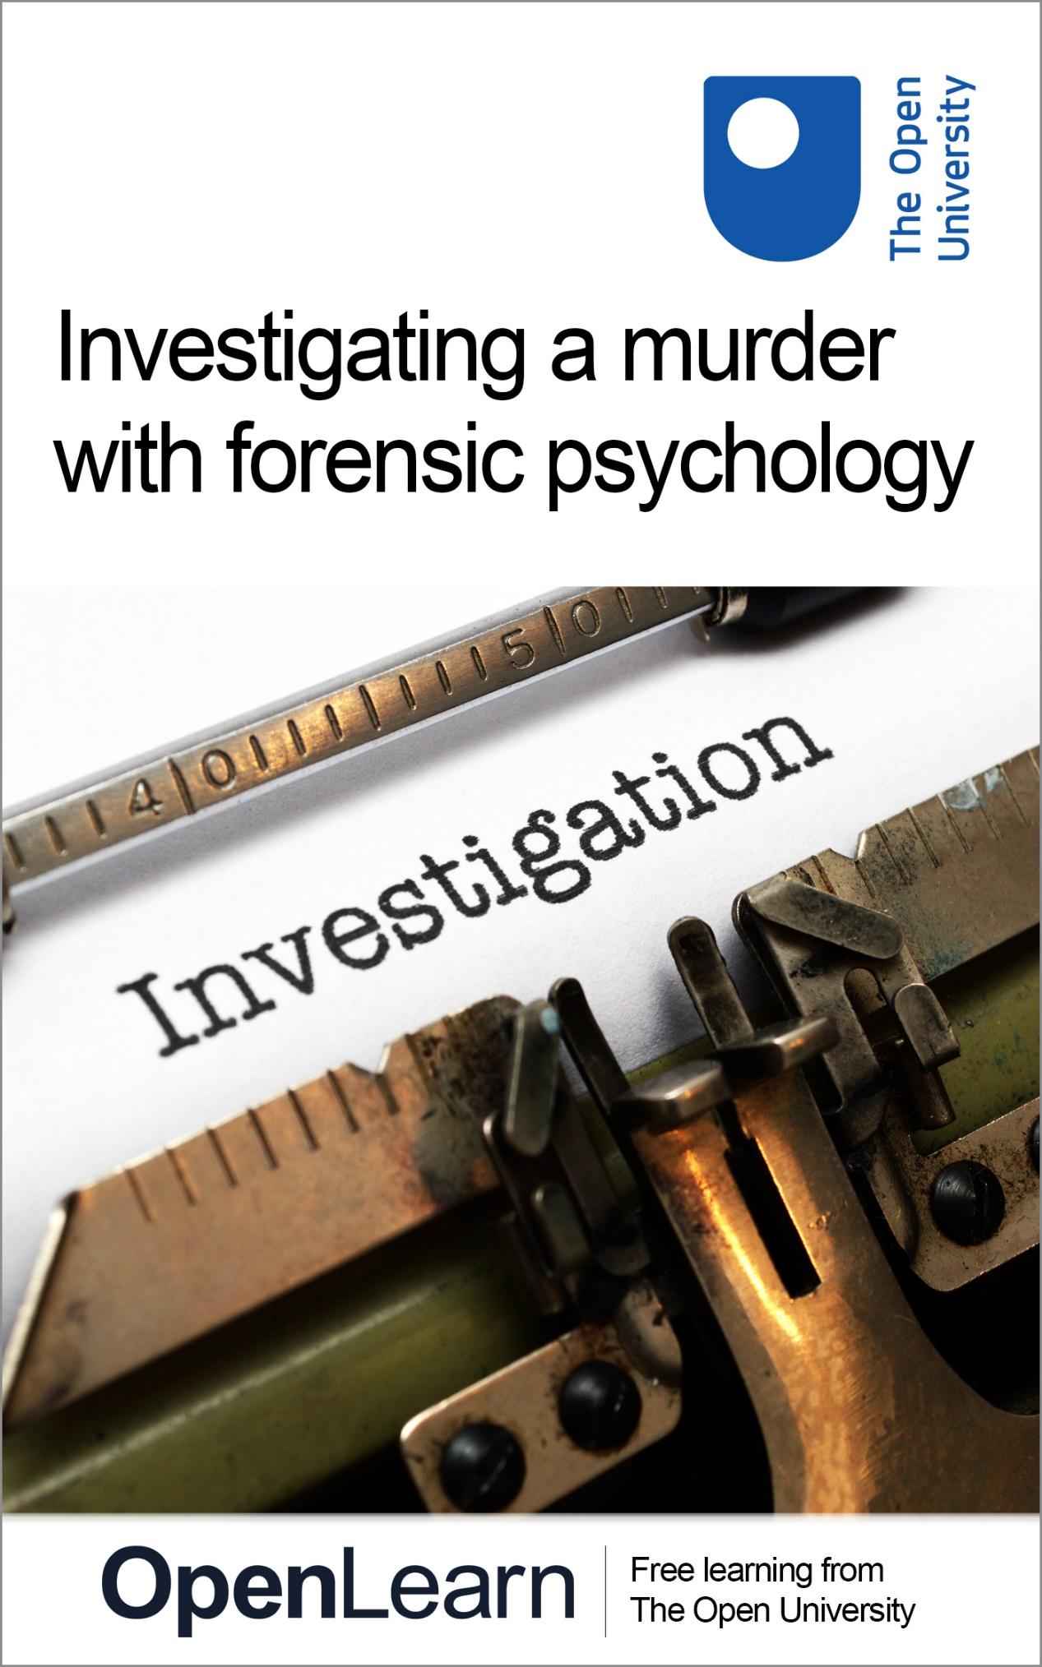

FPSY_2

Investigating a murder with forensic psychology

About this free course
This free course is an adapted extract from the Open University course .
This version of the content may include video, images and interactive content that may not be optimised for your device.
You can experience this free course as it was originally designed on OpenLearn, the home of free learning from The Open University –
There you’ll also be able to track your progress via your activity record, which you can use to demonstrate your learning.
Unless otherwise stated, copyright © 2023 The Open University, all rights reserved.
Intellectual property
Unless otherwise stated, this resource is released under the terms of the Creative Commons Licence v4.0 http://creativecommons.org/licenses/by-nc-sa/4.0/deed.en_GB. Within that The Open University interprets this licence in the following way: www.open.edu/openlearn/about-openlearn/frequently-asked-questions-on-openlearn. Copyright and rights falling outside the terms of the Creative Commons Licence are retained or controlled by The Open University. Please read the full text before using any of the content.
We believe the primary barrier to accessing high-quality educational experiences is cost, which is why we aim to publish as much free content as possible under an open licence. If it proves difficult to release content under our preferred Creative Commons licence (e.g. because we can’t afford or gain the clearances or find suitable alternatives), we will still release the materials for free under a personal end-user licence.
This is because the learning experience will always be the same high quality offering and that should always be seen as positive – even if at times the licensing is different to Creative Commons.
When using the content you must attribute us (The Open University) (the OU) and any identified author in accordance with the terms of the Creative Commons Licence.
The Acknowledgements section is used to list, amongst other things, third party (Proprietary), licensed content which is not subject to Creative Commons licensing. Proprietary content must be used (retained) intact and in context to the content at all times.
The Acknowledgements section is also used to bring to your attention any other Special Restrictions which may apply to the content. For example there may be times when the Creative Commons Non-Commercial Sharealike licence does not apply to any of the content even if owned by us (The Open University). In these instances, unless stated otherwise, the content may be used for personal and non-commercial use.
We have also identified as Proprietary other material included in the content which is not subject to Creative Commons Licence. These are OU logos, trading names and may extend to certain photographic and video images and sound recordings and any other material as may be brought to your attention.
Unauthorised use of any of the content may constitute a breach of the terms and conditions and/or intellectual property laws.
We reserve the right to alter, amend or bring to an end any terms and conditions provided here without notice.
All rights falling outside the terms of the Creative Commons licence are retained or controlled by The Open University.
Head of Intellectual Property, The Open University

Contents
- Week 1: Introduction to the case
  - Introduction
  - 1 Psychology and investigations
    - 1.1 Meet the psychological team
    - 1.2 Fictional detectives
  - 2Police briefing and timeline
    - 2.1 Senior Investigating Officer – police briefing
    - 2.2 Using timelines in investigations
    - 2.3 Creating and using your own timeline
  - 3 The initial witness interview
    - 3.1 Introducing the police team
    - 3.2 DS Sund interviews Neale Anderson
    - 3.3 Evaluation of DS Sund’s interview
    - 3.4 Observations about DS Sund and the witness
    - 3.5 Credibility of the witness
  - 4 Detecting deception
    - 4.1 Psychological theory and research on detecting deception
    - 4.2 Applying detecting deception research
  - 5 New witness statements
  - 6 Summary of Week 1
- Week 2: Police suspect interviews
  - Introduction
  - 1 Types of interview
    - 1.1 The introduction of PACE in England and Wales
    - 1.2 The PEACE model
    - 1.3 The legal caution
  - 2 Planning topics for Neale’s interview
  - 3 How to talk to suspects in police interviews
  - 4 The importance of rapport
    - 4.1 Rapport – an introduction to the interpersonal circle
    - 4.2 Diagnosis of behaviour using the interpersonal circle
    - 4.3 How rapport is applied in criminal investigations
    - 4.4 Adaptive and maladaptive variants of the interpersonal circle
    - 4.5 Rapport principles
  - 5 DI Bullet interviews Neale
    - 5.1 Suspect interview by DI Bullet: Part 1
    - 5.2 Rating DI Bullet’s interview skills
    - 5.3 Expert analysis of the interview so far from
  - 6 Summary of Week 2
- Week 3: How reliable are confessions in criminal investigations?
  - Introduction
  - 1 Suspect interview by DI Bullet: Part 2
    - 1.1 Perceptions of guilt
    - 1.2 Considering questioning techniques
    - 1.3 Evaluating questioning techniques
  - 2 Interrogation, suggestibility and false confessions
    - 2.1 A look at real criminal cases: The Innocence Project
    - 2.2 The psychology of false confessions
    - 2.3 Interrogative suggestibility
    - 2.4 Suggestibility and the Reid technique
  - 3 Evaluating DI Bullet’s suspect interview
    - 3.1 Evaluating Part 2 of DI Bullet’s suspect interview
    - 3.2 The psychological team’s evaluation
    - 3.3 Is Neale’s interview confession true or false?
    - 3.4 Reporting back to the SIO
    - 3.5 The expert view on the confession
  - 4 New evidence and new suspects
    - 4.1 Important new evidence
    - 4.2 Three additional suspects
    - 4.3 Route of enquiry
    - 4.4 Biases
    - 4.5 Biases in an investigation
  - 5 Summary of Week 3
- Week 4: Solving the case
  - Introduction
  - 1 Dealing with the new suspect
    - 1.1 Evidence and testing the truthfulness of a suspects account
    - 1.2 Return to the timeline
    - 1.3 Planning what to disclose
    - 1.4 The psychological team’s thoughts on what to disclose
  - 2 Interviewing the new suspect
    - 2.1 Planning for rapport with Mick Brough
    - 2.2 Interviewer rapport strategies
    - 2.3 DS Sund’s interview of Mick Brough
    - 2.4 DS Sund interviews Mick Brough
    - 2.5 Noting discrepancies on the timeline
  - 3 Assessment of the suspect interview and case closure
    - 3.1 Your assessment of the suspect Mick Brough
    - 3.2 An assessment of Mick Brough as a suspect
    - 3.3 SIO and the two detectives debrief the case
  - 4 Conclusion of the case
  - 5 Course summary
  - Where next?
  - References
  - Acknowledgements
  - Glossary
- Solutions

Week 1: Introduction to the case

Introduction
Welcome to Investigating a murder with forensic psychology. In this free course, you will take the role of a detective investigating a murder. Alongside two fictional detectives, you will work with the Senior Investigating Officer to solve a complex criminal case. You will explore the way that suspects are dealt with during a police investigation and examine whether and how psychology can help the police with investigating such crimes.
Because the course involves a murder (albeit a fictional one), the topic under question is of course sensitive and you should take time to consider whether or not the content is likely to affect you personally. If you enjoy crime dramas or documentaries about policing then the course is likely to suit you, but if you find the idea of following a murder investigation upsetting, it might not be the right course for you.
We must also warn you that in some of the videos you may see the characters in the case study use swear words. This is to stay true to the characters in the scenario (and the pressures they find themselves under) but also because learning points are made throughout the course about dealing with verbal aggression and anger.

1 Psychology and investigations
In the course you will encounter a number of important psychological skills, such as how to develop rapport with people in difficult situations, how to plan interviews effectively, how to assess the credibility of what people tell you and how everyday human thought processes can lead to biased decision making.
You may have joined this course because you have studied our previous Forensic psychology course, which focused on eyewitnesses. This current course has a different focus – it looks at suspects of crime, and different psychological content – but you may recognise the investigation team. DS Sund and DI Bullet are both still involved in this course, for example.
The course is specifically designed to focus on psychology rather than the intricacies of the policing system, recognising that our learners will be based in a range of jurisdictions with different legal processes. As a result, while the fictional case is based in England, the course is not intended to be an accurate portrayal of all legal processes and rules within England and Wales.

1.1 Meet the psychological team
This course was written by two academic psychologists, Zoë Walkington and Graham Pike, who you will meet in the video below and listen to them explain how the course will work and what to expect as a learner. They will appear at various points in later weeks to provide further information and discuss the psychology of the investigation.

Video content is not available in this format.
View transcript - Uncaptioned interactive content

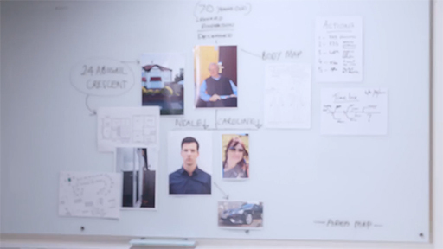

1.2 Fictional detectives
It is very likely that you will have experience of policing and criminal investigations through reading or watching crime fiction, and this experience is likely to lead to expectations about what happens in an investigation. Do you think these expectations might affect how you approach the current case? To start, think about who your favourite detectives are. They might come from novels, drama series or films.
Zoë’s favourite detective is DCI Gene Hunt, the maverick and politically incorrect detective from the show Life on Mars played by Philip Glenister. This is partly because of the humour that is to be gained from Gene Hunt’s 1970s brutal policing methods being juxtaposed against more modern expectations of policing. It is also because, like many fictional detectives, Hunt is depicted as intuitive and instinctive, and it is enjoyable to believe that these are important traits in real detectives. In fact, as you will discover in this course, being curious, open minded and resilient are probably much more important traits.

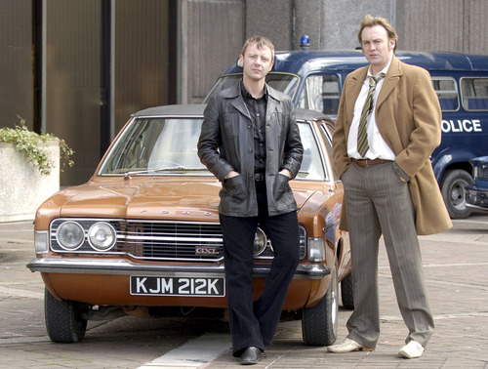
View description - Uncaptioned Figure
View alternative description - Uncaptioned Figure

Graham’s favourite detective is Inspector Sara Lund from the Danish drama series The Killing (‘Forbrydelsen’), played by the immensely talented Sofie Gråbøl and famous for wearing Nordic wool jumpers. Lund is dedicated and relentless in pursuit of her case, and although she has a clear disdain for policing politics and will not let them get in her way, she is psychologically astute and careful to follow the evidence, using techniques that do not distort it. She is not so careful with her personal life, where her emotional distance and prioritisation of her work cause problems in her relationships. The combination of repression and passion make her a fascinating character, and her obsession with the investigation is an irresistible force that carries the viewer along.

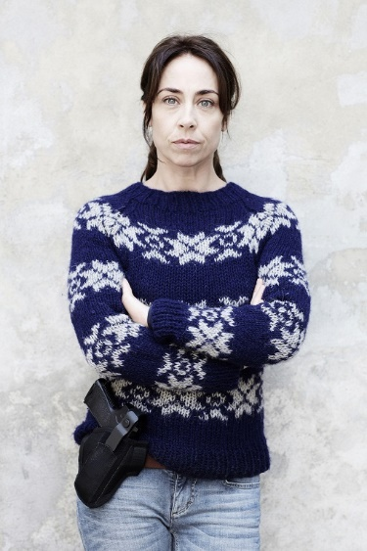
View description - Uncaptioned Figure
View alternative description - Uncaptioned Figure

As you find out more about DI Bullet and DS Sund, the detectives in this course, you may begin to see the influence of Zoë and Graham’s favourite detectives in how their characters were developed.
Think of who your own favourite detectives are and do pay attention to how they have shaped your expectations of how police investigations are conducted and also what the ‘right’ way of doing things might be. Whether you are a Gene Hunt, anything goes if it gets a result, or favour a more play-by-the-rules approach like Sara Lund, may well affect how you perceive the crime and investigation as it unfolds.
In the activity that follows you will think further about how your expectations might be influenced by media depictions of policing.

Activity 1

Do you think that what you might want from a police detective will differ depending on how you are involved in the investigation? To explore this question further, have a go at the two polls below.

Interactive content is not available in this format.

Interactive content is not available in this format.

Did you choose different detectives depending on whether you were the victim or suspect? If so, reflect on what it was about the detectives that made you choose them given the scenario.

2Police briefing and timeline

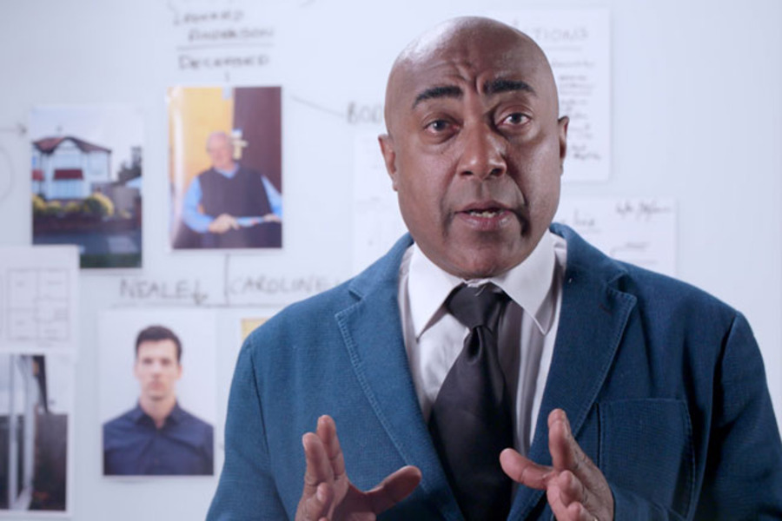
View description - Uncaptioned Figure
View alternative description - Uncaptioned Figure

Many fictional depictions of investigations include a scene, often near the start, where the lead detective briefs their colleagues on the initial details of the case. Not only is this a very useful narrative tool for providing the audience with a useful summary but also something that is a routine part of real police investigations. You will keep to this convention by starting our investigation with a briefing. In this section, you’ll start by meeting the Senior Investigating Officer (or SIO) who will introduce you to the case.
Timelines, in which all of the evidence and information obtained is mapped out to show the order, and timing, in which events occurred are routinely used by the police in a real investigation. Following the briefing from the SIO you will learn about the importance of using timelines in criminal cases and also get to create your own.

2.1 Senior Investigating Officer – police briefing
In this video you will meet Lyndon Harris, the SIO for the investigation, who will provide you with a police briefing on what is known so far about the death of the victim Leonard Anderson.
Make notes on the information, as you would if you were a detective being briefed on the crime. These will be useful to you later in an activity where you start to create a timeline of events.

Video content is not available in this format.
View transcript - Uncaptioned interactive content

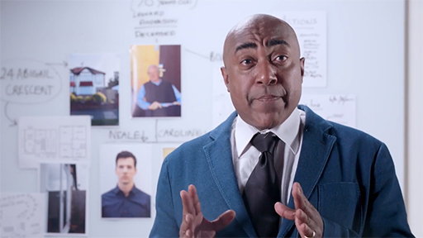

2.2 Using timelines in investigations
The timeline of events is an important tool that police use in an investigation. It allows the officers to establish when key events related to the crime happened.

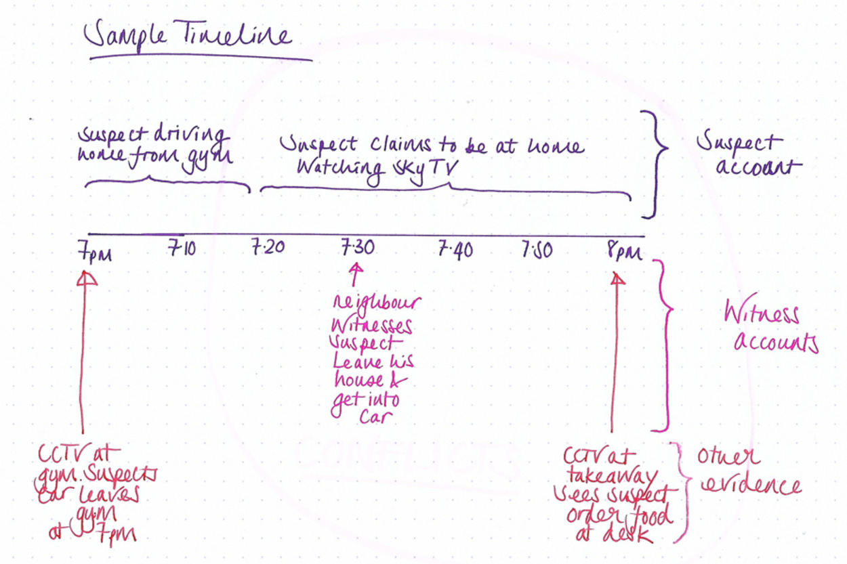
View description - Uncaptioned Figure
View alternative description - Uncaptioned Figure

A timeline will include both physical and digital evidence (such as CCTV footage, payment receipts and phone calls, for example) as well as evidence from the people that might have been involved in the crime (including suspect and witness accounts). It is a simple way for investigators to keep track of the information that is known about the criminal event in a way that allows them to develop lines of enquiry, and also enables the investigation team to notice where there are discrepancies in the accounts of what happened.
A timeline will start at a certain date and time that is relevant to the offence and will stop at a certain date and time. The timeline will run from the left-hand side of the page with the first significant time, through to the right-hand side of the page with the final time. It will record all the information about what happened during that period and will be organised by the source of that information. Sometimes colour will be used to organise the source of the information to make the timeline simpler to interpret (for example all the witness statement information might be in pink, all the suspect information in purple and all the other evidence in red).

2.3 Creating and using your own timeline
Now you will start to create your own timeline for the criminal incident you heard about in Section 2.1. Exactly how you create your timeline is up to you. You can create it physically on a large sheet of paper or digitally using programs like Visio, PowerPoint or Word. You can be creative, and make it visually interesting by using lots of different colours, or you can keep it very simple.

Activity 2

Once you have decided on a method for creating your timeline, you should start by plotting the information you obtained from the video police briefing by SIO Lyndon Harris. This will start to form a visual representation of the information that is currently available to you.
Bear in mind when creating your timeline that at this moment you only have a VERY basic backbone of information, and there will be additional details and further evidence to add as you progress through the course, so leave plenty of space.
The SIO has recommended that your timeline should start from 5pm on Sunday 9 February 2020 (on the left-hand side) and run through until midday on Tuesday 11 February 2020 (on the right-hand side). If you are drawing this timeline on paper, it is recommended that you use it in landscape orientation, which will allow you to make the best use of the space.

You will return to your timeline several times during the course, so please keep it safe, whether it is a digital document or a sheet of paper. Over time, you may start to be able to identify discrepancies by using the information on your timeline. For example, a suspect in the investigation may claim to have been in one place, while several witnesses claim to have seen them in another, or there may be discrepancies with digital information and what people are telling officers in interview. The ability to identify these discrepancies quickly is one of the reasons timelines are so useful.

3 The initial witness interview

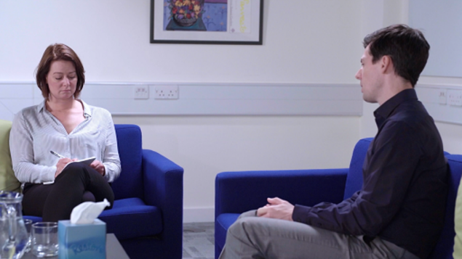
View description - Uncaptioned Figure
View alternative description - Uncaptioned Figure

Shortly you will get the chance to see the first interview that is conducted as part of the investigation, which is a ‘witness interview’ and conducted in quite a different way to those you will see later in the course that are ‘suspect interviews’. While watching the witness interview you will observe the approach and technique used by the detective and use this to evaluate the interview and to decide whether or not you think the witness is credible.

3.1 Introducing the police team
The investigation that you will follow involves you working with a team of investigating officers. You have already met SIO Lyndon Harris in the police briefing. As the Senior Investigating Officer, Lyndon is responsible for the senior-level decisionmaking in the case, and the rest of the team will report to him.
The other officers in the case are Detective Sergeant(DS) Lara Sund and Detective Inspector(DI) Jake Bullet. In UK Police Forces ranks are structured as Constable, Sergeant, Inspector, Chief Inspector through to Chief Constable (who leads the force).
DI Jake Bullet

View description - Uncaptioned Figure
View alternative description - Uncaptioned Figure

DI Jake Bullet represents the ‘old school’ of policing. He thinks of himself as a highly intuitive police officer who works from gut feel rather than an evidence base. He tends to be domineering in personality, preferring talking to listening. He is highly motivated and enthusiastic, although he is not always a fan of more modern and more ethical policing standards.
DS Lara Sund

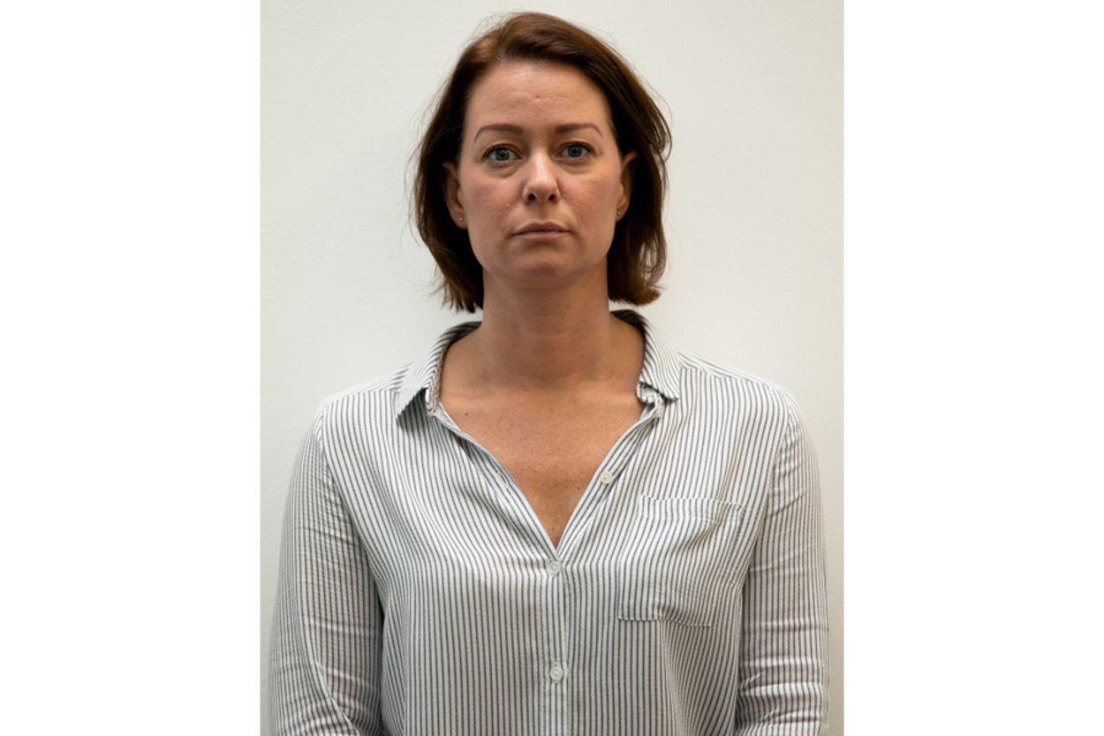
View description - Uncaptioned Figure
View alternative description - Uncaptioned Figure

DS Lara Sund is much more receptive than her counterpart to the idea of evidence-based policing. Evidence-based policing is the use of approaches to policing that rely on a proven evidence base, rather than following a particular hunch regardless of the supporting evidence. Lara is open minded and curious in her outlook and is happy to listen and learn in her approach to her job. In the next section, you will get to see an interview where Lara demonstrates some of these qualities.
Because this is a fictional case, Lara and Jake will undertake a range of duties that real detectives would not actually do. For example, conducting both witness and suspect interviews (in real life detectives are trained as specialists in one or the other).
Of course, there is a much wider team of police officers involved in the investigation alongside this core team, such as the officers who attend at the scene, the Crime Scenes staff and the staff from the forensic science service, all of whom have a role to play.
There are other ways in which some of our material may differ from real life. For example, because we want you to really concentrate on the psychological communication between particular individuals in this investigation, we haven’t included solicitors and second interviewers in our interviews. More often than not in real police suspect interviews, there are four people in the room: the lead interviewer, the co-interviewer, the suspect and their solicitor. This has been simplified in each interview, so that you will only see interviews with lead interviewers, and with no solicitors present.

3.2 DS Sund interviews Neale Anderson
As you learned in the SIO briefing, Neale Anderson, the son of victim Leonard Anderson, is being interviewed by DS Sund as a significant witness.
As you will be aware, because Neale was the first person to attend the scene, his account is particularly important, and he may have useful observations that could provide clues to solving the murder. However, the nature of the situation he found himself in (which was obviously very stressful) may also have interfered with his ability to easily recall the events of the day.
Part of the purpose of this interview is for Sund to allow Neale the best possible opportunity to remember as much as he can about the day in question. By doing this, she will generate as many leads as possible that might be useful to the investigation.
During the following activity, you should watch this interview carefully, paying close attention to the behaviour of both the interviewer and the interviewee. By ‘behaviour’ we don’t just mean the non-verbal communication of the interactants, we also mean paying attention to the content of what they both say.

Activity 3

While watching the video, you should attend to, and make notes about, how DS Sund questions Neale. It might be helpful to consider the following questions:
- Does she seem open minded towards him or does she appear accusatory?
- Does she allow him the opportunity to remember by offering him different ways of accessing his memories of the day?
As you observe the interview also think about the credibility of the witness. Does his account appear credible and true? Are there any signs you can spot that he might not be telling the truth about what happened that day?
Note down any other observations you have about the interaction. Everything that you observe may turn out to be relevant and could prove important as the case develops.

Video content is not available in this format.
View transcript - Uncaptioned interactive content

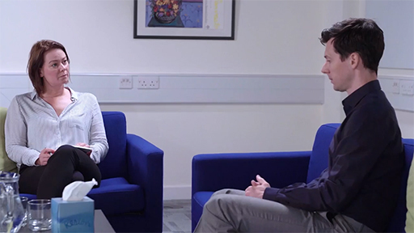

3.3 Evaluation of DS Sund’s interview

View description - Uncaptioned Figure
View alternative description - Uncaptioned Figure

Now that you’ve had a chance to watch the interview between DS Sund and Neale, and to make notes about their interaction, you probably have an opinion about how both behaved. Complete the activity below. You will then look at some of the things that struck Zoë and Graham, as psychological experts, as interesting in the next section.

Activity 4

Gather your notes from the interview together and write a brief summary of your thoughts on how the interview was conducted. As a way of structuring this you may want to focus the points you make on the following questions:
- How does DS Sund behave towards the interviewee?
- What do you think of Neale’s behaviour towards DS Sund?

3.4 Observations about DS Sund and the witness

View description - Uncaptioned Figure
View alternative description - Uncaptioned Figure

The following are observations from Zoë and Graham about the interview.
Observations regarding Sund
There are a number of positive ways in which DS Sund behaves towards Neale, the witness. She sets up the interview by asking him to report in as much detail as he can, and she asks him to imagine himself back at the scene. She hands him control over what he talks about, making clear that he is in charge of where the conversation will go, by saying ‘I will try not to interrupt you, or ask you further questions’. All these things are likely to help increase the amount of information he can remember, and increase the amount of information he will therefore report.
In addition, she is empathic to his situation: ‘I understand this might be difficult for you, Neale. Just take your time. And if you need a break at any point, please just ask.’ Also throughout the interview, while she does interrupt him once, to clarify an important point, she generally lets him talk.
Observations regarding Neale
Neale appears to want to speak to the officers and to help them, he is willing to speak. There were some things that appeared to be unusual about his testimony, although it is important to remember he does state that things were a bit of a blur.
For example:
- He spoke about his father as if he were still alive
- He thought his father may be unwell but flagged down the police rather than calling an ambulance
- He said he did not know his father had a mobile phone
- He did not have keys to his father’s house despite living locally

3.5 Credibility of the witness
Think back to the video you watched in Section 2.2 and consider the points you may have recorded in your notes and that were made in the previous sections about the interview and the behaviour of the witness. Overall, taking into account his apparent willingness to cooperate and also any oddities in his account, do you think he is credible (essentially telling the truth) or not credible (and that what he says is suspicious)?

Activity 5

Use the poll below to indicate your evaluation of Neale.

Interactive content is not available in this format.

4 Detecting deception

View description - Uncaptioned Figure
View alternative description - Uncaptioned Figure

An area that has attracted a lot of research interest within psychology is whether or not it is possible to tell when someone is telling the truth or lying.
This psychological research area has obvious application to the criminal justice system because if we were able to accurately tell if someone is lying, or telling the truth, it would be very helpful and save a great deal of time and money!
In this section you will have a go at detecting deception using a lie-detection scenario which has frequently been used, over the years, in psychological research.

Activity 6

Through the link below you will explore an interactive in which you will use your skills of observation to assess whether or not someone is lying or telling the truth about the theft of £10. Each of the people you see interviewed were left alone in a room with a bag with £10 inside and each had the opportunity to steal the money. Each person will deny taking the money, but some of them actually have the money in their pocket as they are making that denial – so they are lying.
Complete the interactive to see if you can identify the liars and truth tellers: Detecting deception (open the link in a new tab or window so you can easily navigate your way back to the course).
When you have finished the task, return here and look at the questions below.
- Was your estimate of how easy it is to spot when someone’s lying to you accurate?
- Did you find the task easy or difficult?
- What cues did you use?

4.1 Psychological theory and research on detecting deception

View description - Uncaptioned Figure
View alternative description - Uncaptioned Figure

It would be very beneficial if there were ways in which we were able to detect deception within the criminal justice system. However, as you have learned in the detecting deception task you have just carried out, decades of psychological research suggests that when using our skills of observation, we are at around chance level at detecting deception. This means that we would perform just as well on deciding after each clip if the person is lying or telling the truth by tossing a coin! Also, importantly for our investigation, the research suggests that even in professional groups such as police officers, people are still at chance level when trying to detect deceit (Vrij and Mann, 2001).
We also learned in the deception task that people’s confidence and accuracy regarding their decisions about deception do not correlate (Vrij and Mann, 2001). This may be particularly problematic in the area of criminal justice, where people such as police officers may appear confident that they know someone is lying, but the research evidence shows that confidence doesn’t mean that they are actually accurate in the lie-detection decisions they make.
The psychological research suggests that when given a lie-detection task, most lay people tend to be better at detecting truths than lies – this is often referred to as a ‘truth bias’ (Levine, Park and McCornack, 1999). This human tendency to assume people are telling the truth makes sense a lot of the time. It would be pretty exhausting to always assume in our everyday interactions that someone might be lying to us, and so as a form of decision rule it probably saves us a lot of processing effort to hold a systematic bias that we are being told the truth.
Interestingly though, research has found that professional lie detectors (e.g. law enforcement officers or judges, for example) do not tend to hold this bias towards assuming people are telling the truth. Instead, they hold a lie bias (Bond and De Paulo, 2006) which, it has been suggested, may be caused by a generalised suspicion resulting from their professions (Masip et al., 2005).
In the next activity you can consider how your own responses might relate to these research findings.

Activity 7

By looking at your own results from the detecting deception activity you can work out whether or not you a) displayed a truth bias and 2) were better at judging lies or truths.
- From your results, how many out of the eight did you think were telling the truth (regardless of whether or not you were correct)?
If you thought that more than half were telling the truth then you displayed a truth bias.
- How many of the liars did you get correct (Person A, B, G and H) compared with the truth tellers (Person C, D, E and F)?
If you correctly spotted more of the truth tellers than the liars then you were better at detecting truths then lies – though note that simply by making more ‘truth’ decisions than ‘lie’ decisions’ (in other words displaying a truth bias) you will appear to be more accurate with truths than lies.

4.2 Applying detecting deception research
You might already have realised that there are problems with applying an activity such as the detecting deception activity to a policing setting such as the investigation that you are following. These problems include the fact that the consequences to the people lying or telling the truth in the activity we created were quite minor. In psychological research, this is referred to as involving ‘low-stake’ lies. First, the people were only involved in the theft of a small sum of money. Additionally, in the scenario we presented you with, if they convinced the interviewer they weren’t lying when they were, they won a small reward, but the incentives for truth tellers were non-existent and there were no negative consequences for those people who lied and were caught by the interviewer. Obviously, it would have been unethical to impose any real punishment on the participants in this task.
This is very different to the situation facing Neale in the investigation you are following. If he is caught lying, the criminal justice implications would be incredibly serious and so these types of lies would be referred to as ‘high-stake’ lies. For example, if Neale has lied to the police – even if he isn’t involved in any way in this crime – he could be convicted of a public justice offence such as perverting the course of justice.
Some psychologists would argue that while cues to deception might be seen in high-stake lies, they might not be seen where the lies are much lower stake. That said, in 2011, Vrij and Mann carried out an interesting study to test this idea. They showed police officers clips of ‘pleaders’ (i.e. people who appeared on TV to plead with the public about the whereabouts of their missing relatives but who were subsequently found to have killed them). Surely these completely realistic high-stake lies would be detected? Unfortunately, not – they found an accuracy rate of just 50%.
Research on detecting deception has identified an important flaw in how many people try to spot lies, which is that they tend to rely on cues to deception that are not diagnostically useful. For example, they may focus on nonverbal behaviours such as eye gaze, which do not actually correlate with deceptive behaviour (Vrij and Mann, 2001).
Interestingly, though, research has shown that the person carrying out the interview is perhaps less well equipped to observe when someone is lying than someone who is just observing, just as you are able to when following this investigation. As the interviewer, DS Sund is mentally very busy during the interview. She will be trying to think about the questions she needs to ask as well as concentrating on what Neale is saying, meaning that she is under what psychologists would call ‘high cognitive load’. In their research, Buller, Strzyzewski and Hunsaker (1991) found that observers perform better than interviewers in lie-detection tasks, probably because they are less mentally busy.
There are areas of lie-detection research that have shown some promise. For example, Shaw et al. (2013) found that asking someone to recall something out of its normal temporal order (in other words the order in which things actually happened) meant that liars tended to provide less detail than truth tellers. This is likely to be because liars rehearse events in normal temporal order and unexpected questions from interviewers such as, ‘What happened just before that?’ mean that liars have to inhibit what really happened as well as retrieve imagined data. Having to do all that at the same time requires a high cognitive load meaning the person is only able to provide short answers with limited detail. Therefore, asking unexpected questions is one possible way to differentiate truths from lies.
In summary, there is a lot of evidence to suggest that people are not that effective at detecting deception from their observations of either verbal or nonverbal behaviour. It also doesn’t seem to make a difference if they are a police officer or not. For this reason police officers need to find evidence regarding whether or not people are lying, rather than just rely on their sense that someone might be.

5 New witness statements

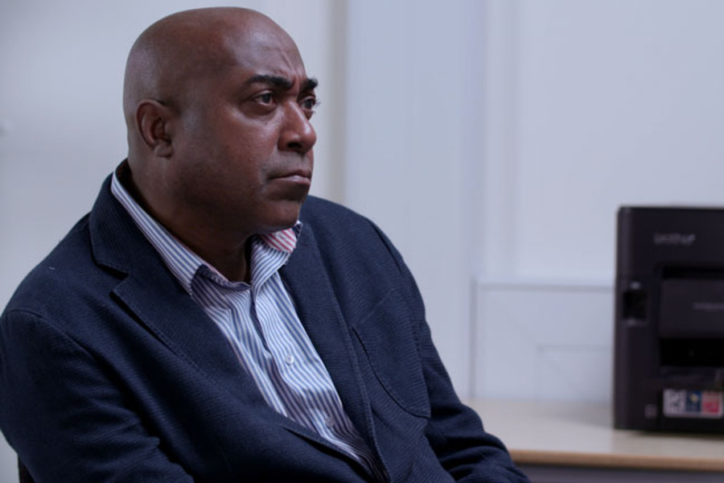
View description - Uncaptioned Figure
View alternative description - Uncaptioned Figure

SIO Harris has now received two new witness statements that have been gathered as part of the ongoing investigation. These comprise a statement from one of the officers who attended at the scene (Sandra Ashton, whom Neale flagged down in the street) and a statement from Coral Gledhill, who lives next door to Leonard Anderson, the victim. You should read both statements with care, paying attention to all of the details. Make note of any detail that you think is relevant to the case, and also bear in mind that after reading these statements you will be asked to update your investigation timeline.
Witness statement: Coral Gledhill
Witness statement: Sandra Ashton
As you learned earlier, it is important in investigations that new information is added to the investigative timeline. In the following activity you will update the timeline you have already created.

Activity 8

Go back to the timeline that you created earlier and add to it any other information that you have picked up from these witness statements. You can add general notes on what each person was doing between particular times to help you get a sense of what was going on when the body was discovered. While many of these general notes might not seem a great deal of investigative use, they will help familiarise you with the case in all its detail. You may also want to read through the witness statements again.

6 Summary of Week 1
In this video, the two detectives, Sund and Bullet, brief SIO Lyndon Harris on their progress on the case so far.

Video content is not available in this format.
View transcript - Uncaptioned interactive content

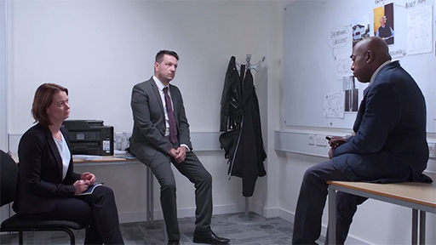

Next week you will pick up the case after SIO Lyndon Harris has had time to deliberate on the evidence provided by his detective team and to decide what actions to take to progress the case.
You can now go to Week 2.

Week 2: Police suspect interviews

Introduction

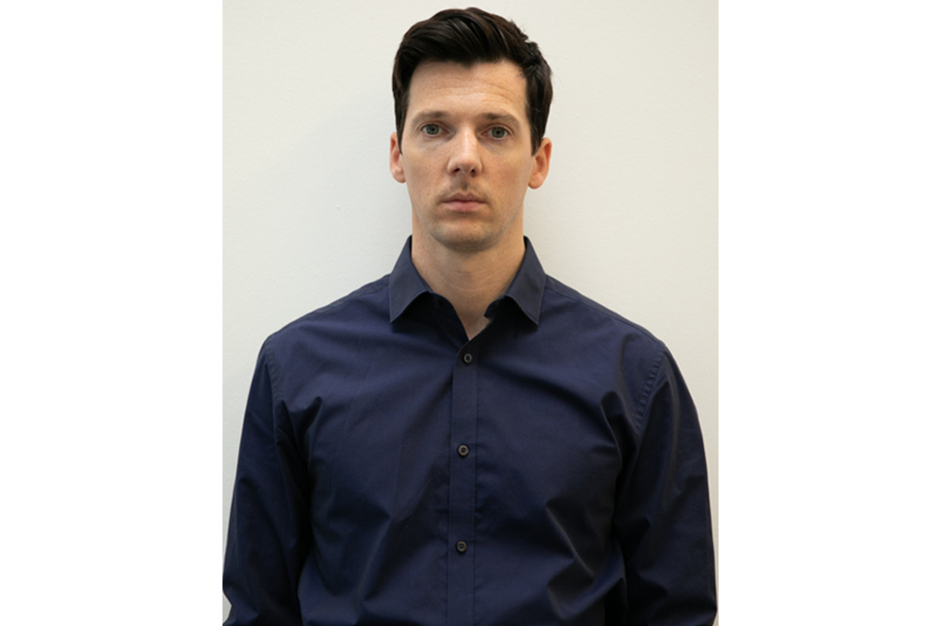
View description - Uncaptioned Figure
View alternative description - Uncaptioned Figure

Welcome to Week 2! In this week, as the case develops and gets a little more complex, you will start to learn about the psychology of how the police interview people suspected of committing criminal acts. You will see that this differs from how they interview witnesses. You will learn a little about the history of how police suspect interviews have been carried out and will learn about the contributions psychology has made to police practice in this area
Following the briefing that you saw at the end of last week SIO Harris has decided that Neale should be arrested, so this week you will be planning and preparing for Neale’s interview as a suspect.
While last week Neale was interviewed as a witness, his status how now changed. A change of status from witness to suspect or from suspect to witness can happen in investigations, as it can become apparent that someone who initially is suspected of committing the crime is in fact a witness and vice versa. This change of status means some changes for the interviews. For example, someone being interviewed as a suspect has to be given the standard legal caution.
In your journey through this week, you will not only think carefully about the topics you might want to cover in the interview with Neale, but will also learn a little about the interpersonal dynamics of police suspect interviews.

1 Types of interview

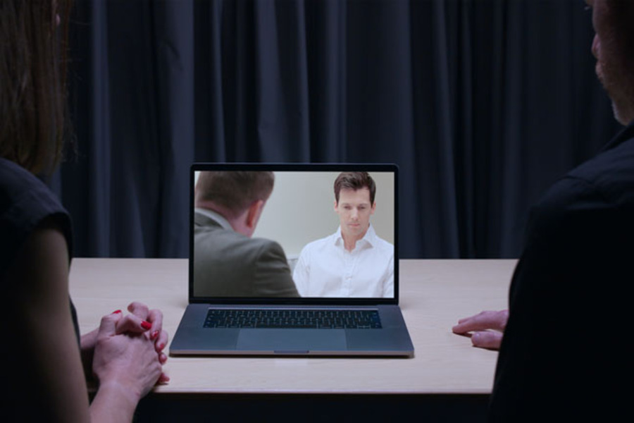
View description - Uncaptioned Figure
View alternative description - Uncaptioned Figure

While there have been a lot of technological advances in the area of criminal justice, there is still a huge role for interviewing in establishing ‘what happened’ in criminal offences.
Crimes are often solved by gathering information from several human sources, as well as using forensic evidence, CCTV and other sources of evidence. Suspect interviews allow a useful and flexible way of obtaining information that enables the police to establish whether or not someone is likely to have been involved with a crime.
In a police interview, information must be obtained professionally in ways that can be used in court, otherwise the investigation will potentially be compromised. Good quality investigative interviews allow investigators to gather relevant material which can either support the prosecution or ensure that an innocent person is not tried for a crime that they did not commit (College of Policing, 2023). The need to adhere to evidence obtained in legally permissible ways is part of the reason why police suspect interviews are such a challenge to carry out, and there are many regulations that the police must abide by to ensure that the evidence can be used, and is obtained both ethically and fairly. Of course, in different legal systems, the rules differ regarding what is acceptable for the evidence to be used in court. For example, the legal rules of how interviews must be carried out are quite different in the UK and in the USA.
Because the investigation we are following regarding the murder of Leonard Anderson is in England, we will continue using the legal systems of England and Wales for this investigation. However, you should bear in mind that if you are a learner studying this course in a different jurisdiction, different rules might apply.

1.1 The introduction of PACE in England and Wales
Before 1984, in England and Wales, interviews were governed by ‘Judges’ Rules’, in which an account of what was discussed in the interview was given from the memory of the interviewing officer. Interviews were not tape recorded and so no ‘true’ record of them existed. From a psychological viewpoint, this approach would (in the present day) be perceived as problematic. First, of course, this would allow officers to lie about what the conversation included if they wanted to do so. However, even for officers trying to do a good and honest job (which would be the majority of them) this system can introduce a lot of errors. Errors are likely to be particularly problematic as interviewers are under high cognitive load (i.e. they are extremely mentally busy) because they not only have to think of their next question, they also have to pay attention to the information the suspect is giving them. If they also had to commit all of the conversation to memory, it is very likely that selective recall consistent with their main theory about what happened would take place.
The Police and Criminal Evidence Act (introduced in 1984), known by the acronym PACE, is legislation that was brought in to regulate and monitor interviewing in England and Wales and to protect the rights of suspects. It introduced the right for all suspects to have a legal advisor present, and phased in the compulsory audio recording of all suspect interviews.
The recording of police suspect interviews also allowed for a much greater proliferation of research into this area by psychologists, which in turn led to an awareness that some of the practices taking place in interviews were less than ideal. In the early 1990s, the national Association of Chief Police Officers and the Home Office (the government ministry responsible for security matters) working with experienced detectives utilised some of the psychological literature on this topic to develop what is called the PEACE approach – which had at its heart the desire to obtain as much information as possible from witnesses or suspects (Bull, 2013).
The PEACE model is based on the idea that successful interviews don’t just come about as a result of investigative genius on behalf of the interviewer, but rather are built and managed in a way that is consistent and logical. It is also based on the idea that such important conversations should be planned for in advance, as well as evaluated at the end.

1.2 The PEACE model
- Planning and preparation – which includes the pre-interview preparations.
- Engage and explain – which refers to all the relevant introductions, how to get the interview started and explain the rights and ground rules regarding the interview.
- Account, clarify and challenge – which refers to obtaining the suspect’s version of ‘what happened’, clarifying any elements of this and if required challenging this account (if for example it is found to be inconsistent with other evidence).
- Closure – which refers to closing the interview in a professional manner so the suspect, solicitor and all parties are clear about the close of the interview and what will happen next.
- Evaluation – which refers to looking at what the interview achieved and how it fits into the investigation as a whole, as well as the interview practitioner reflecting on their own performance and learning (perhaps obtaining feedback from peers or managers).
While you won’t be able to follow all aspects of this model in the course, you will notice how various activities you will undertake relate back to this model. Shortly you will plan an interview with Neale, i.e. you will be working on the P part of the PEACE model. The activity will be to make a plan of how you would approach interviewing Neale if you were the interviewing officer, or were working on the team with Sund and Bullet. However, first we will briefly introduce the idea of the legal caution, which must be given to all suspects at the start of their interview.

1.3 The legal caution
As mentioned earlier, a key difference between interviewing Neale as a suspect and as a witness is that for the suspect interview, Neale needs to be given the legal caution. This is because his answers must be capable of being admissible evidence. The legal caution is: ‘You do not have to say anything. But it may harm your defence if you do not mention when questioned something which you later rely on in court. Anything you do say may be given in evidence.’

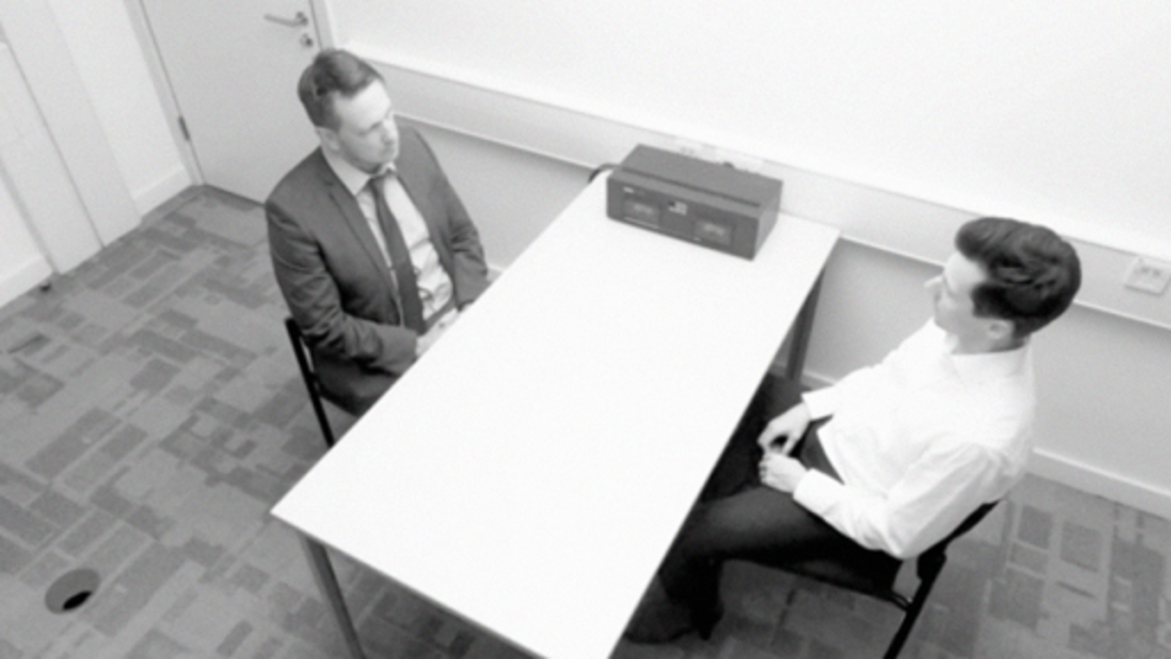
View description - Uncaptioned Figure
View alternative description - Uncaptioned Figure

2 Planning topics for Neale’s interview

View description - Uncaptioned Figure
View alternative description - Uncaptioned Figure

The planning and preparation part of the PEACE model (among other things) involves making a written plan of the interview, including important topics and potential questions.
In the following activity you will start to make your own plan for the interview of Neale.

Activity 1

Imagine that you will be working with Sund and Bullet, helping them to prepare for the interview.
Topics
Think about the different topics you might want to explore with Neale. Your timeline might give you useful information to go on here. You will notice that in the PEACE model, the A stands for ‘Account, clarify and challenge’ and bearing in mind that you are planning for the first suspect interview, you will want to concentrate more on the ‘account’ aspects (rather than the clarify and challenge aspects which might come later on in the interview if they are considered relevant). You will need to decide which you feel are the topics you would like to question Neale about. Asking for the account essentially means getting the suspect to give their account of what they were doing, and their involvement (or lack of involvement) in the crime in question.
Questions
Within each topic, think about the most important questions that you want to ask. Don’t worry about how you will phrase these questions as you will move on to this shortly. At this stage concentrate on the content of the question.
HINT: by topic, we mean a broad area of interest, for example one topic might be Neale’s previous relationship with his father, and three questions within that topic might be:
- How would Neale describe his relationship with his father?
- How close was the relationship between Neale and his father?
- Would he describe the relationship as problematic?
Make a plan of the topics and questions you might like to cover. Make a record of your plan either digitally or just note it on a piece of paper.

3 How to talk to suspects in police interviews

View description - Uncaptioned Figure
View alternative description - Uncaptioned Figure

Of course, when asking questions in police interviews, there is a lot more to consider than what topics to cover. It’s helpful to think about the whole interview as a complex and important social interaction, during which the other person will be constantly evaluating whether or not they want to keep talking.
It is probably also helpful to think about police suspect interviews as an example of a difficult conversation. While most of us will never find ourselves in a police suspect interview (as either suspect or interviewer) many of us will find ourselves having some difficult conversations during the course of our lives. Therefore, thinking about the conversations we have had in our own lives can help us get a better feel for how those same principles might apply in a police suspect interview.
Of course, a police suspect interview has a lot of rules and regulations that everyday interactions don’t have, but it is very important to remember that interviews are still (from an interpersonal and psychological viewpoint) very human conversations. One of the reasons for encouraging you to consider police suspect interviews in this way is that a lot of our everyday impressions about them come from drama series, which often give quite a false impression of how police suspect interviews are carried out. As a result, focusing on examples from your own experience might be useful.
Police suspect interviews are referred to as ‘difficult conversations’ because very often the suspect will not want to be there, but for legal reasons has to be. Regardless of their innocence or guilt of the offence in question, the suspect is likely to find the conversation stressful and may not want to talk to the officers. The officers themselves are likely to be under pressure too. You can probably imagine the pressure you might feel to deliver results should your interview topic plan be accepted by SIO Harris as the one to be used. So suspect interviews can be difficult and stressful for all participants to varying degrees.
How to approach talking with people in these situations (and indeed in lots of other situations) is very important. Research into police interviewer styles carried out in 2002 by Holmberg and Christianson was illuminating. They carried out a very neat study in which they asked men in prisons, who had been convicted either of murder or sexual offences, about the police interviews that had led to their conviction. The questionnaires asked the men to remember these interviews and how they felt the police officers interviewing them had treated them. They also asked them whether or not they admitted or denied the crimes in those interviews.
The researchers found that there seemed to be two main interview styles – one of which was where officers appeared impatient, aggressive and brusque (the dominant style). This style tended to be associated with suspects denying the crime. In the other style, the officers were more helpful and accommodating and showed more empathy (the humanity style) and this was associated with more admissions of guilt. This research goes against what is often shown in television drama series and is a good example of why not to take what you see in these shows too seriously.

4 The importance of rapport
You’ll now move on to explore one of the most important aspects of effective investigative interviewing. This concerns the ability of police officers to build rapport with suspects. Rapport can be tricky to define. Berniero and Gillis (2001, p. 69) provide quite a formal definition: ‘A positive and productive affect between people that facilitates mutuality of attention and harmony’. Alison and Alison (2020, p. 5) refer to it as being when ‘… two people connect or “click” … In other words, rapport occurs when two people “get” each other’.
Rapport is a form of interpersonal behaviour, and you will also learn about a way of representing interpersonal behaviour that is called the interpersonal circle, or to give it its more technical name, the interpersonal circumplex (a circumplex is basically a graph that uses a circular representation).
Circumplex models are often found within psychology because they enable a simple visual circular representation of complex statistical relationships between a lot of different variables. In a circumplex model, variables that are similar are visually represented as being close together, with opposing characteristics displayed at opposite points on the circle. Such circular depictions sound quite complicated when described in the abstract, but as you will discover, are quite simple to grasp when you look at a particular example.

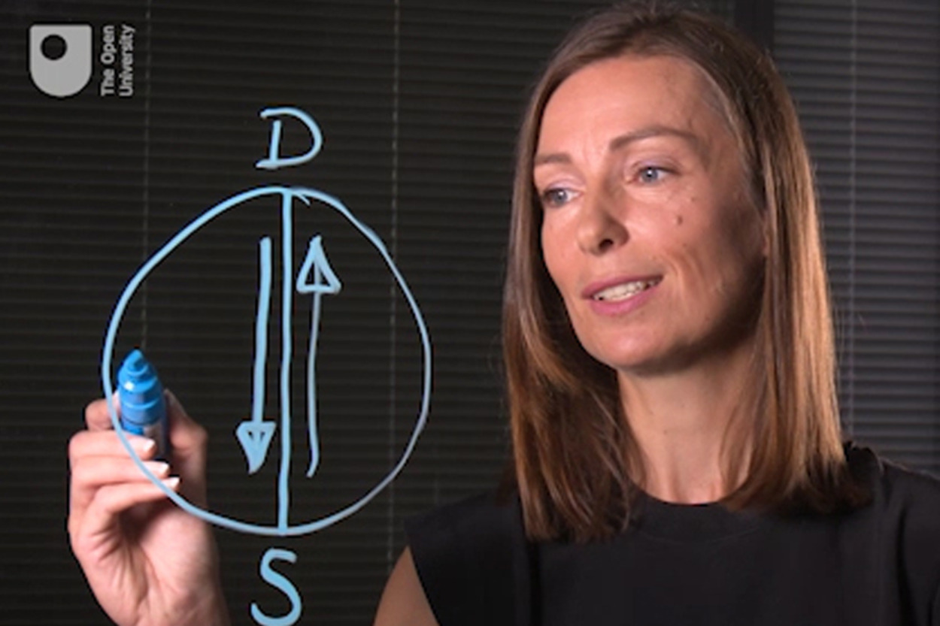
View description - Uncaptioned Figure
View alternative description - Uncaptioned Figure

4.1 Rapport – an introduction to the interpersonal circle
Building on the research conducted by Holmberg and Christianson (2002), other psychologists have developed the notion that similar principles might be important in building a rapport with, and relating to, other people. The interpersonal circle is an example of one such development and has a long history in psychology. In the 1950s, Tim Leary (1957) developed this model as a way to visually represent the interactions between people.
In the video, Zoë Walkington introduces you to the principles of the model.

Video content is not available in this format.
View transcript - Uncaptioned interactive content

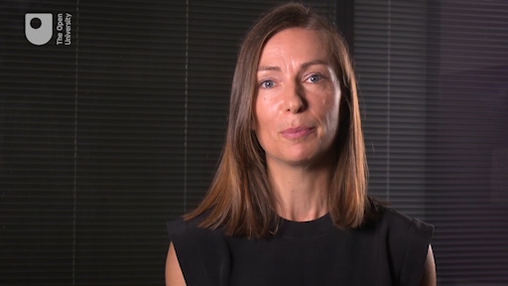

4.2 Diagnosis of behaviour using the interpersonal circle
Watch the following video. In the activity that follows you will be asked to plot the interaction using the interpersonal circle that you have just learned about.

Video content is not available in this format.
View transcript - Uncaptioned interactive content

Activity 2

Have a go at trying to ‘diagnose’ the behaviour you observed in the video, using the interpersonal circle. Where you would place the man who is challenging you in a car park about your poor parking technique?
Think about his behaviour along the two axes you learned about – is he dominant or submissive, and is he hostile or cooperative? Also remember to consider the intensity of the behaviour, with more intense behaviour being towards the edge of the circle, and more neutral behaviour towards the centre.
Using the following plotting tool, plot where you would position the person in the video on the interpersonal circle. Hover over the circle and then click where you think is the correct position. You can then either save your answer or reset and have another go. It is fine for you to rewatch the video as many times as you would like.

Interactive content is not available in this format.

It is worth reflecting on how the behaviour of the man towards you made you feel as you watched. Did it make you feel like you wanted to dominate the conversation or go quiet? Did you feel hostile or did you want to be highly cooperative with the man, wanting to befriend him?

4.3 How rapport is applied in criminal investigations

View description - Uncaptioned Figure
View alternative description - Uncaptioned Figure

You have learned about the fundamental principles underpinning the interpersonal interactions that we have with one another.
You have probably already reflected on what this model might tell you about some of your own conversations in your own relationships. However, the model becomes much more useful in application to policing (and possibly your own conversations too) when we add in a bit more complexity. Alison et al. (2013) researched the use of the model in policing contexts and (along with other researchers such as Birtchnell, 2014) developed the basic model of the interpersonal circle to take into account the fact that there are both ‘adaptive’ and ‘maladaptive’ versions of behaviour. In 2013 Alison et al. developed their model of rapport based on coding many hours of police suspect interviews. They developed the two ‘adaptive’ and ‘maladaptive’ circles which you will learn about in the next section.

4.4 Adaptive and maladaptive variants of the interpersonal circle
In the video, Zoë Walkington introduces the adaptive and maladaptive versions of the interpersonal circle.

Video content is not available in this format.
View transcript - Uncaptioned interactive content

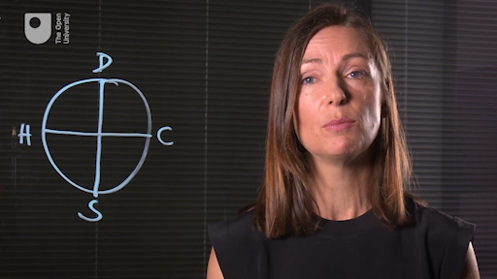

Having now learned about the adaptive and maladaptive versions of the interpersonal circle, you should have also learned to recognise behaviour from both of these types. You should bear in mind throughout, though, that the interpersonal circle isn’t a ‘technique’ to be deployed on someone else, nor is it something you can use to manipulate others. It very much characterises how interactions feel holistically.
Next, you will move on to think about applying these principles to the investigation of Neale.

4.5 Rapport principles
In the next activity you should start to develop your ideas about how you might approach the interview with Neale based on the principles of rapport you have learned about.

Activity 3

To help you with this activity, here are the adaptive and maladaptive interpersonal circles taken from Alison et al.’s (2013) ORBIT model (Observing Rapport Based Interpersonal Techniques). You should use these to help you start to make a plan for the interpersonal interaction with Neale.

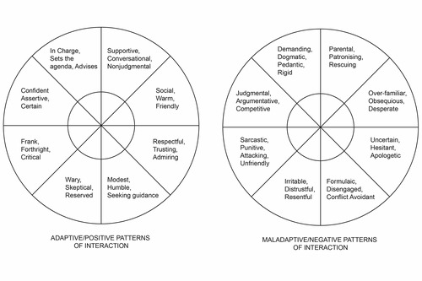
View description - Uncaptioned Figure
View alternative description - Uncaptioned Figure

To structure your thoughts you might want to consider the following questions:
- Where do you expect Neale to be on the interpersonal circle?
HINT: you already have some good intelligence on this, because you have had the benefit of seeing his witness interview – but you need to factor in the impact that being arrested might have on him.
- Where do you think the interviewer might need to be on the interpersonal circle?
- Do you think Neale needs adaptive or maladaptive wheel behaviour from the interviewer and does he need dominance or submission and hostility or cooperation?

As you develop your ideas, remember that this type of planning conversation might comprise part of the ‘P’ mnemonic for planning in the PEACE model. If you make a note of your ideas, you will be able to reflect on your own plans, and compare them to the approach of DI Bullet who carries out Neale’s interview.
According to Alison et al. (2013) the principles of the interpersonal circumplex and also some principles borrowed from counselling psychology (specifically motivational interviewing) suggest that adaptability is also a very important interview skill. Sometimes things need to change as interviewers may need to adapt to how individuals behave, but it is good to devote time to thinking about likely opening interactions with suspects in preparing for interviews, while being open minded that adapting is always an important skill.

5 DI Bullet interviews Neale

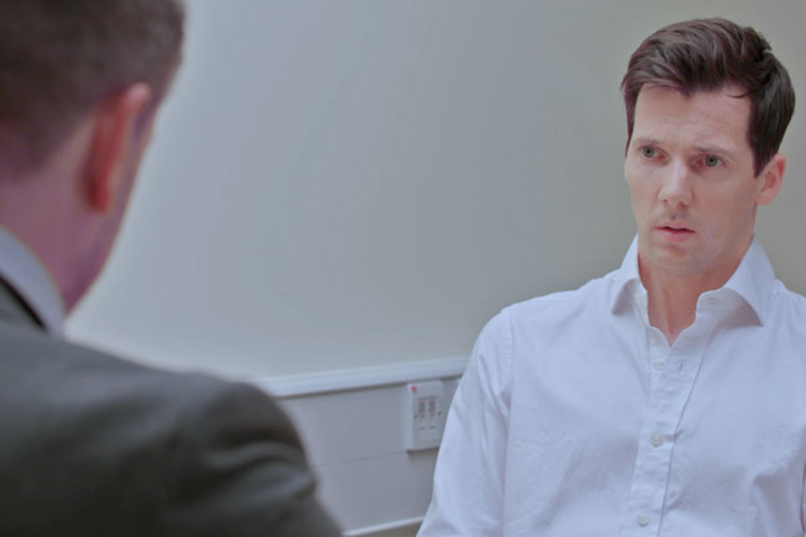
View description - Uncaptioned Figure
View alternative description - Uncaptioned Figure

Having made your own interview plans, you will next observe the interview of Neale from the current investigation.
The interview is going to be conducted by DI Bullet. As you observe the interview, imagine yourself in the role of a psychologist who has been asked to downstream the interview (i.e. to watch it on video as it takes place in another room) and to provide feedback on the interview practice that you observe in the interviewer, given what you have learned.
For the purposes of this task, focus on the psychological aspects of the interaction (you may notice things about the policing agenda too and it is fine to note those down). Have the principles of the interpersonal circumplex at the forefront of your mind as you observe (perhaps even have the PDF open as you observe the interview).
The interview you watch will be split into two halves. After you watch part one, you will complete an activity where you are asked to ‘plot’ where you think the interviewer is on the adaptive and maladaptive circles. You therefore might want to make some notes to support these plots when you observe the interview – and note if there are particular examples of adaptive or maladaptive behaviour that seem important to you.
As you watch, you will also be able to carefully attend to the behaviour of Neale, the suspect.

5.1 Suspect interview by DI Bullet: Part 1
In the video, DI Bullet interviews the suspect Neale Anderson.
Remember as you watch to focus on the psychological aspects of the interaction. In the activity that follows you will be asked some questions that draw on the observations you have made.

Video content is not available in this format.
View transcript - Uncaptioned interactive content

5.2 Rating DI Bullet’s interview skills

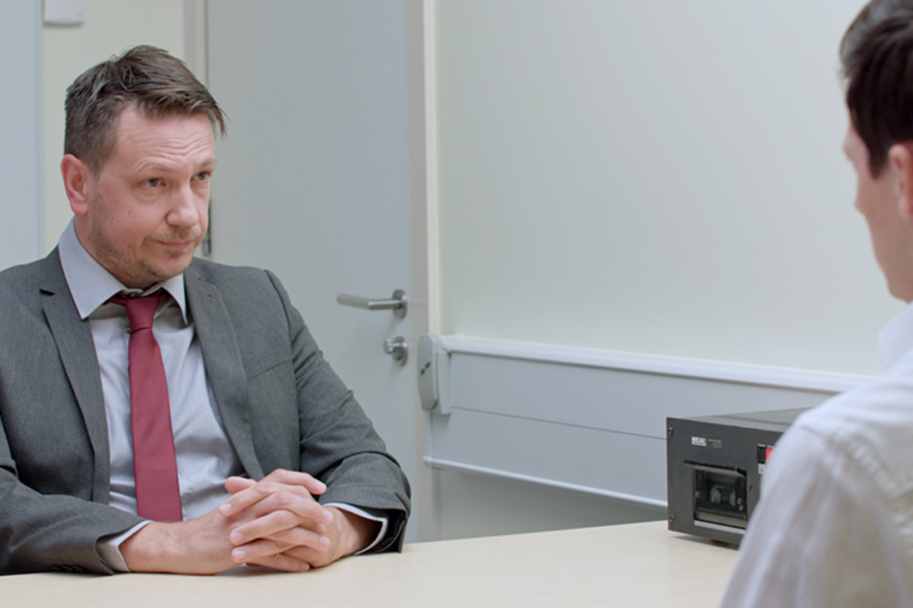
View description - Uncaptioned Figure
View alternative description - Uncaptioned Figure

In the following activity, you’ll think about DI Bullet’s interviewing technique.

Activity 4

Having watched the interview consider the following questions.
- How did this section of the interview ‘feel’ from a psychological perspective? Did it feel like an adaptive interview characterised by positive and adaptive behaviour from Bullet or a maladaptive interview characterised by negative behaviour from him?
- According to the interpersonal circumplex, is Bullet dominant or submissive? And is he hostile or cooperative?
- Looking at the police agenda, do you get the impression that DI Bullet is sticking to the ‘Account’ phase of PEACE?
- Moving the focus to the suspect, what do you notice about his behaviour – is it adaptive or maladaptive?
Note down your answers to the above questions. Summarise your answers and add any other observations you have about Bullet’s interview style and rapport.

5.3 Expert analysis of the interview so far from
In the next video, Zoë Walkington analyses the performance of the interviewing officer according to the principles of the interpersonal circle. You might like to compare your own analysis and notes from the interview to the some of the points she raises.

Video content is not available in this format.
View transcript - Uncaptioned interactive content

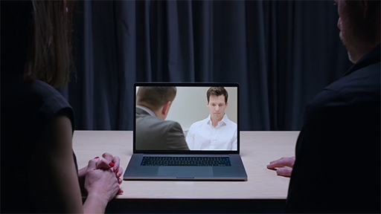

6 Summary of Week 2
This week you have learned about the principles of interpersonal behaviour in difficult conversations such as police suspect interviews. You have also started to think about planning and preparing for interviews.
Considering what you have learned about the principles of rapport this week you might already be starting to formulate some expectations about what the second part of the interview by DI Bullet might look like! You will return to observe part 2 of the interview next week.
You can now go to Week 3.

Week 3: How reliable are confessions in criminal investigations?

Introduction

View description - Uncaptioned Figure
View alternative description - Uncaptioned Figure

Welcome to Week 3! You’ll jump straight back into the investigation.
Last week you observed the first part of the suspect interview with Neale and this week will open with you returning to that interview. You will re-join the interview several hours later. Of course, Neale will not have been interviewed continuously throughout this time as there are rules and regulations about allowing breaks for interviewees. You will re-join the interview at the ‘Challenge’ stage (from the PEACE mnemonic) where Bullet is challenging Neale’s account with other evidence that he has obtained.
Remember that the detective team and case are entirely fictional, and this course is not attempting to replicate a police investigation exactly as it would be conducted by a real police force. It is fair to say that the interview being conducted by DI Bullet would be considered bad practice by the police in the UK.
What you think of it and how it would be seen in other jurisdictions are questions you will return to later in the week.

1 Suspect interview by DI Bullet: Part 2
Now you will watch the second part of the suspect interview of Neale Anderson by DI Bullet.
As you watch, make any notes that you want to. These will help inform a report you will make this week to SIO Harris regarding the ongoing investigation.

Video content is not available in this format.
View transcript - Uncaptioned interactive content

1.1 Perceptions of guilt
As you saw, at the end of the interview Neale confessed to killing his father. Did this surprise you or had you always had a suspicion that Neale was guilty?
Before you begin to look at the interviewing techniques that were employed by DI Bullet in more depth, use the poll below to indicate whether, in light of this confession, you believe Neale is guilty or not guilty.

Interactive content is not available in this format.

1.2 Considering questioning techniques

View description - Uncaptioned Figure
View alternative description - Uncaptioned Figure

Although DI Bullet’s interview would be considered bad practice according to UK guidelines, police from different jurisdictions may well view the interview as a relatively mild and effective approach, and certainly the techniques used are quite subtle and passive compared with those we often see in fictional investigations. For one thing, DI Bullet did not use actual, or even the threat of physical aggression, both of which are often used by fictional detectives.

Activity 1

Think back to films and drama series you’ve seen and books you’ve read that have featured a fictional officer questioning a suspect that has led to a confession. Note down the techniques you’ve noticed and consider whether:
- you think this method has been used in a real suspect interview (in any jurisdiction)
- there is evidence from research that it is a reliable technique.
Consider which techniques you think are reliable, and remember that you are not being asked to judge what is currently the practice in England and Wales (or in any other particular jurisdiction), but whether the technique has ever been used in any jurisdiction.
You will take a closer look at some possible techniques in the next section.

1.3 Evaluating questioning techniques
How many techniques did you come up with?
Below is a list of example techniques selected from crime dramas, along with information about whether the technique has been used in a real case and whether it is considered to be reliable based on evidence obtained from research.

Technique | Used in a real case? | Is it reliable?
Polygraph (lie detector) | Yes | No
Threatening suspect physically | Yes | No
Physically harming the suspect | Yes | No
Pretending a photocopier is a lie detector | Yes | No
Sleep deprivation | Yes | No
Falsely claiming there is forensic evidence | Yes | No
Falsely claiming a witness has identified the suspect | Yes | No
Falsely claiming an informant has provided evidence | Yes | No
Offering a lesser charge in exchange for a confession | Yes | No

You will have seen a clear pattern emerge: that a lot of techniques have been used to intimidate or trick suspects, but there is no evidence that they get reliable results. Research in this area suggests that although such techniques may increase the chances that the suspect will make a confession, they predominantly increase dramatically the chances that this confession will be false! This is one reason UK police do not ‘interrogate’ suspects, nor use false claims and other tricks, but instead interview them fairly.
DI Bullet did not employ any of the techniques from the list above in his interview, so does that mean the resulting confession must be true?

2 Interrogation, suggestibility and false confessions

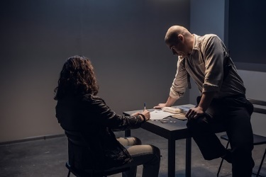
View description - Uncaptioned Figure
View alternative description - Uncaptioned Figure

In many fictional portrayals of criminal investigations, the confession represents the finale of the story, and is used to reveal who the perpetrator was and demonstrate the prowess of the detective. The idea is that confessions are proof of guilt and can, therefore, be used as a narrative device to conclude a story definitively.
But are confessions always ‘true’ in reality? In this section you’ll start by exploring confessions obtained in real cases before looking at the psychology of why someone might confess.

2.1 A look at real criminal cases: The Innocence Project
To answer the question of whether confessions are always ‘true’ in reality, you will look at the work of The Innocence Project, an organisation that (among other things) represents people who believe they were wrongfully convicted, usually by using post-conviction DNA testing. At the time of writing, the Project has assisted in the exoneration of 375 people in the USA. These wrongfully convicted people had served an average of 14 years in prison and 21 had been on death row.
As well as helping to free the innocent (and convict the guilty), the work of The Innocence Project has also been very helpful in determining the factors that tend to lead to a miscarriage of justice. This is achieved by determining which elements the investigations had in common. West and Meterko (2015) analysed cases from the first 25 years of The Innocence Project and found that the most common factor by far was that of mistaken eyewitness identification, which was a feature present in 72% of the 325 cases examined. You may be surprised that the second-most common factor, present in 47% of cases, was the misapplication of forensic science. The third most prevalent contributing factor was that of false confessions, which featured in 27% of the cases.

Activity 2

The Innocence Project website contains details of very moving, and very revealing, cases of miscarriages of justice. The site allows you to explore cases containing specific contributing causes. Visit the site and explore cases that involved false confessions:
- Access The Innocence Project website
- Click on ‘The Cases’ at the top right of the window
- Click on ‘Filter’
- Click on ‘Contributing Causes of Conviction’
- Select the cause(s) you are interested in
- From the search results, explore at least three cases.

One case you may have looked at is that of Damon Thibodeaux, who spent 15 years on death row, in solitary confinement, before being exonerated. Damon was convicted of the murder and aggravated rape of 14-year-old Crystal Champagne (a distant cousin). His confession followed 9 hours of interrogation, in which he was told by law enforcement officers that he had failed a polygraph. The same officers told him they would seek the death penalty unless he confessed (which they did anyway).
As well as the interrogative techniques that led to the confession, this case demonstrates just how important a confession is in an investigation and trial. The confession led to Damon being convicted despite there being no forensic evidence linking him to the crime and even despite there being key differences between his (false) account and the evidence recovered.

2.2 The psychology of false confessions

View description - Uncaptioned Figure
View alternative description - Uncaptioned Figure

You may have noticed that many of the exonerations involving a false confession that are described on The Innocence Project’s website involve cases from a number of years ago. Indeed, most predate the standard use of DNA testing and were obviously from the US.
Following several high-profile miscarriages of justice in the UK in the past, legal rules and regulations were introduced to protect suspects in the UK. These included the use of interview techniques that avoid coercing a suspect and, critically, that all interviews are recorded. Hopefully these measures have helped to reduce the incidence of false confessions. However, the psychology of false confessions remains a fascinating area of study that we would like you to further explore.
Psychologists interested in this area (e.g. Gudjonsson, 2003) tend to draw a distinction between two different types of confession that can arise as a result of the interview process. These are ‘coerced-compliant’ and ‘coerced-internalised’ and you may have found examples of both in the examples from The Innocence Project.
- Coerced-compliant confessions refer to confessions made when the suspect knows that they have not done what they are accused of, but they confess to escape the immediate situation of the interrogation.
- Coerced-internalised confessions differ in that the suspect comes to believe that they may have actually committed the act, for example, believing that maybe they blacked out during the relevant time period due to drinking too much.
There is also a third type of false confession called a voluntary false confession. Unlike the false confessions described above, voluntary false confessions don’t arise due to interview pressure. They describe a scenario where someone voluntarily claims to have committed a crime when they have not. This might involve handing themselves in at a police station claiming to be the culprit after they have seen a particular crime on the news. While this sounds unlikely, it is surprisingly common. For example, when the baby of famous aviator Charles Lindbergh was kidnapped in 1932 from his home in New Jersey, US, there were around 200 confessions. You’ll look at these voluntary false confessions in more detail later in the course.

2.3 Interrogative suggestibility

View description - Uncaptioned Figure
View alternative description - Uncaptioned Figure

Of the three types of false confession, the ‘coerced-internalised’ is perhaps the most psychologically interesting as it does not involve an innocent suspect making a conscious decision to confess, but instead that they are coerced into actually believing they committed a crime.
One way of looking at this phenomenon is through the concept of ‘suggestibility’. The pioneering psychological research on false confessions was led by the work of Gisli Gudjonsson, who refuted the existing belief that only suspects with learning disabilities or other mental health issues were vulnerable to suggestion. Instead, Gudjonsson demonstrated that potentially anyone might falsely confess due to factors such as the psychological drive to comply and particularly through being prone to ‘interrogative suggestibility’. That is, how affected by leading questions a suspect is and how much they alter their responses when pressure is applied. Gudjonsson developed a ‘suggestibility scale’ to measure how prone someone might be to interrogative suggestion, and it has been used within the criminal justice systems of many jurisdictions.

2.4 Suggestibility and the Reid technique
One particular method of suspect interrogation, known as the Reid technique, which has been widely used in the US, has been criticised by many researchers for involving coercive techniques very likely to lead to false confessions (e.g. Walsh, O’Callaghan and Milne, 2016). This is particularly the case in more vulnerable suspects through mechanisms such as suggestibility, as well as causing less vulnerable suspects to shut down and stop answering questions. It is, perhaps, fair to add that the company that provides training in the Reid technique states that this criticism mischaracterises the methods involved, and that false confessions arise from officers misapplying their training and using approaches that are not part of the technique.
The Reid technique comprises a three-stage process. Stage 1 is a ‘factual analysis’ involving information on the crime and on the suspect, designed to estimate probable guilt. Stage 2 is based on a relatively short ‘behaviour analysis interview’ to determine the truthfulness of the suspect (by asking ‘behaviour-provoking’ questions and whether to proceed with stage 3, which is a full interrogation. The interrogation that comprises stage 3 involves nine steps. Below is a brief summary of these nine steps based on Connecticut General Assembly (no date):
- The positive confrontation. The investigator tells the suspect that the evidence demonstrates the person’s guilt.
- Theme development. The investigator then presents a moral justification, or ‘theme’, for the offence in a sympathetic manner.
- Handling denials. The investigator should discourage the suspect from making any denials, as this can make it harder for them to tell the truth later. Innocent suspects will not move past step 3.
- Overcoming objections. The investigator should accept objections that the suspect is innocent as if truthful and use the objection to develop a ‘theme’.
- Procurement and retention of suspect’s attention. The investigator should make the suspect focus on the ‘theme’ rather than on potential punishment.
- Handling the suspect’s passive mood. The investigator should continue to display a sympathetic manner and intensify the ‘theme’ and psychological justification of the act.
- Presenting an alternative question. The investigator should encourage the suspect to choose the more sympathetic explanation offered by the ‘theme’ over an alternative, less justifiable rationale.
- Having the suspect orally relate various details of the offence. When the suspect admits guilt by choosing the explanation offered in the ‘theme’, the investigator should reinforce this by asking for an overview of the events.
- Converting an oral confession to a written confession. The investigator converts the oral overview, and thereby confession, into a written confession.
As stated previously, the Reid technique has been heavily and widely criticised by psychological researchers because rather than using interviewing elements designed to elicit accurate evidence, it is instead aimed at pressuring the suspect into confessing, and so is very likely to lead to a false confession. If you would like to find out more about the Reid technique and its potential to lead to false confessions, you might like to read the article by Starr (2013), ‘Do police interrogation techniques produce false confessions?’, written by a journalist who went on the training course to learn how to use this technique.

3 Evaluating DI Bullet’s suspect interview

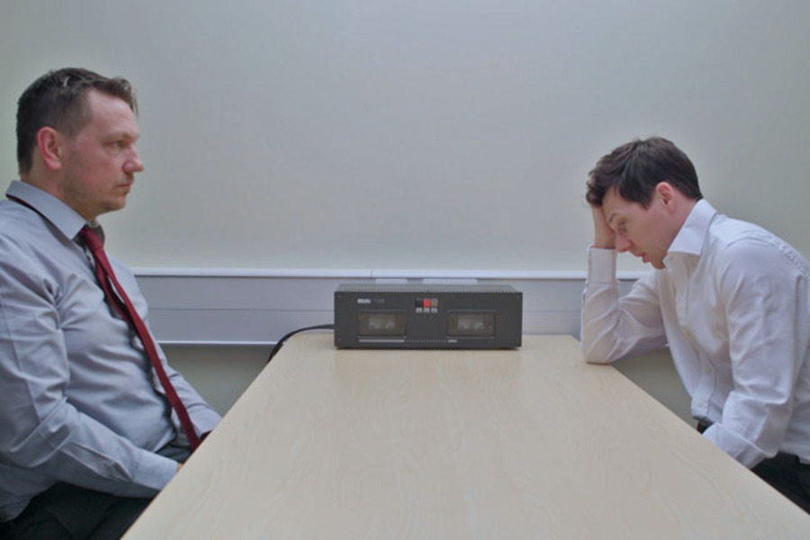
View description - Uncaptioned Figure
View alternative description - Uncaptioned Figure

Did reading about interrogative suggestibility and false confessions make you think differently about the interview conducted by DI Bullet?
As mentioned earlier, DI Bullet did not use any of the more coercive techniques we often see in crime fiction (such as those involving physical aggression).
However, his interview did involve quite a few elements that are not part of standard suspect interviewing practice and that would be considered very poor practice in the UK. Moreover, some of these techniques involve the same type of coercion that the Reid technique has been criticised for.

3.1 Evaluating Part 2 of DI Bullet’s suspect interview

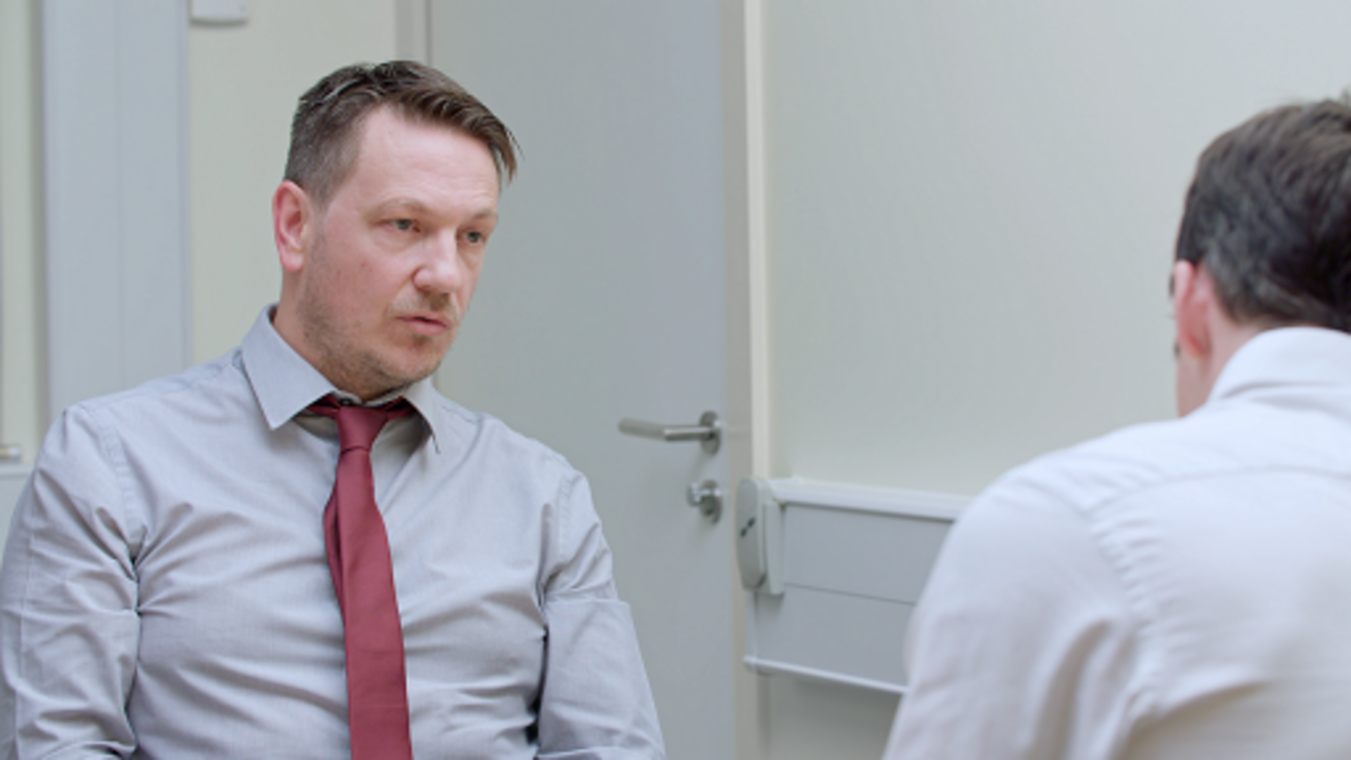
View description - Uncaptioned Figure
View alternative description - Uncaptioned Figure

Research has found that, broadly speaking, interrogation techniques can often be classified as either:
- ‘minimisation’, where the investigator appears supportive and attempts to downplay the seriousness of the offence, or
- ‘maximisation’, where the investigator employs ‘scare tactics’ to emphasise the seriousness of the offence.
Both minimisation and maximisation have been shown to lead to false confessions.

Activity 3

Now you have read about false confessions and the role of suggestibility and tactics such as minimisation and maximisation, re-watch DI Bullet’s interview with Neale that you first watched in Section 1, but this time try to evaluate it in order to determine what techniques he may have used that could have coerced the suspect.
Make a note of any technique you think may be seen as problematic. You will look further at these in the next section.

3.2 The psychological team’s evaluation

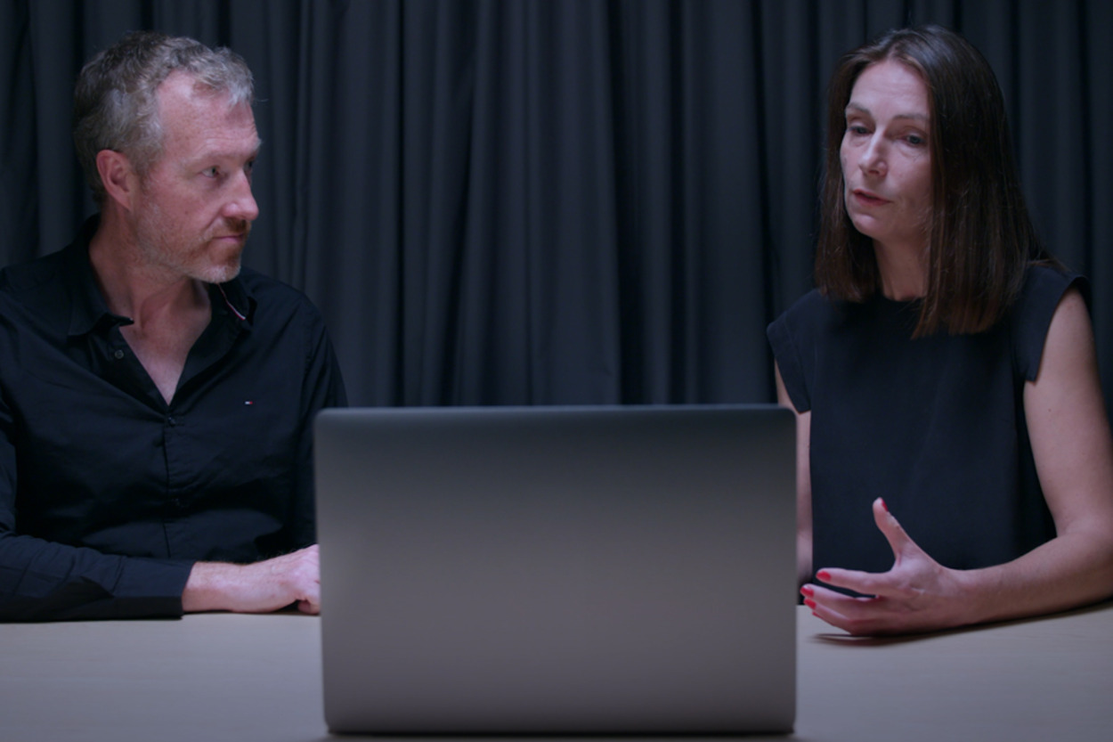
View description - Uncaptioned Figure
View alternative description - Uncaptioned Figure

Zoë and Graham who, given their expertise, are also acting as the psychological team in the investigation, identified the following techniques as problematic:
- The interview took place over a long time, leading to the suspect becoming exhausted.
- DI Bullet kept up a barrage of accusations of guilt.
- DI Bullet concentrated on apparent ‘guilty knowledge’ of the suspect (i.e. that Neale knew his father had been stabbed) and did not explore other evidence.
- DI Bullet claimed he was understanding of why Neale may have committed the act.
- DI Bullet suggested to the suspect a timeline of what took place.
- DI Bullet suggested a motive/rationale (blacking out from being drunk) for why Neale committed the act.
How did your evaluation compare with this?

3.3 Is Neale’s interview confession true or false?

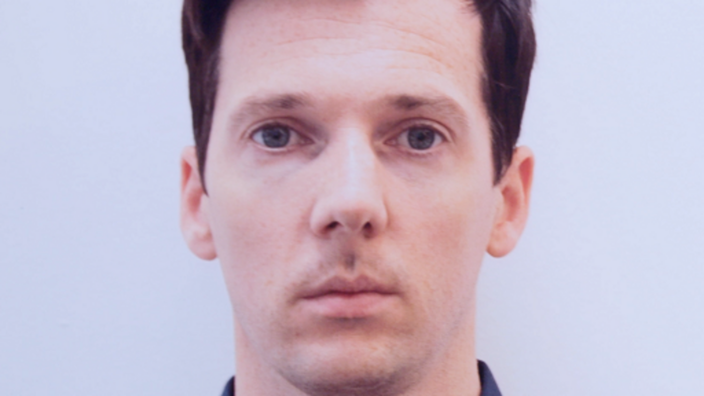
View description - Uncaptioned Figure
View alternative description - Uncaptioned Figure

You have now explored the psychology of false confessions and read about them in relation to real cases. You have also evaluated these techniques used in the interview with Neale. Given this new knowledge, use the following poll to indicate whether you think Neale is guilty or not.

Interactive content is not available in this format.

3.4 Reporting back to the SIO

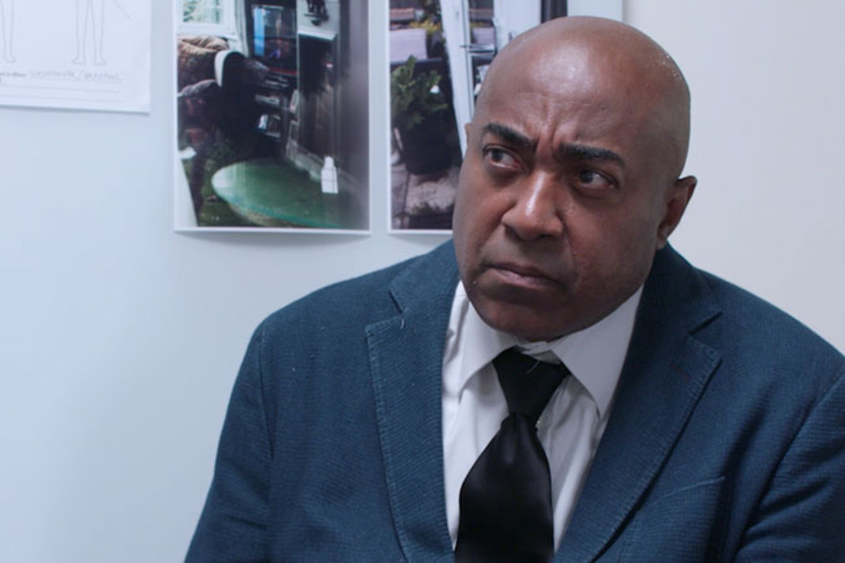
View description - Uncaptioned Figure
View alternative description - Uncaptioned Figure

Did you change your mind as to whether Neale was guilty or not? Hopefully, even if you thought he was not guilty previously, reading about miscarriages of justice and false confessions in the real world, and also the psychological theory and research seeking to explain why these happen, will have given you new insights into how the behaviour of an officer can affect what the suspect says.
Being aware of good interviewing practice and identifying where an officer may have influenced a suspect is an important part of police investigations. You will now get a chance to use your expertise in the psychology of suspect interviewing as you prepare to report back to the SIO.

Activity 4

Based on your thoughts about the validity of Neale’s confession, prepare a final list of psychological issues to present to SIO Harris outlining your view regarding Neale’s confession.
While creating this list, imagine yourself in the role of a psychological expert who has been asked to comment on the psychological issues that have arisen in the interviews of Neale by Bullet.

Once you have created your own list of psychological issues you think arise in the suspect interviews of Neale by Bullet, move on to the next section where you’ll watch Zoë and Graham discuss their view of the psychological issues in the case.

3.5 The expert view on the confession
Watch the video, where Zoë and Graham discuss the issues with the confession of Neale Anderson.

Video content is not available in this format.
View transcript - Uncaptioned interactive content

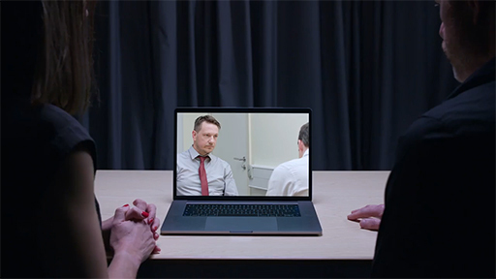

How close were you to the ‘expert’ view on the interview of Neale? Were there things you noticed that they didn’t? Or things they noticed that you hadn’t included in your report to the SIO?

4 New evidence and new suspects

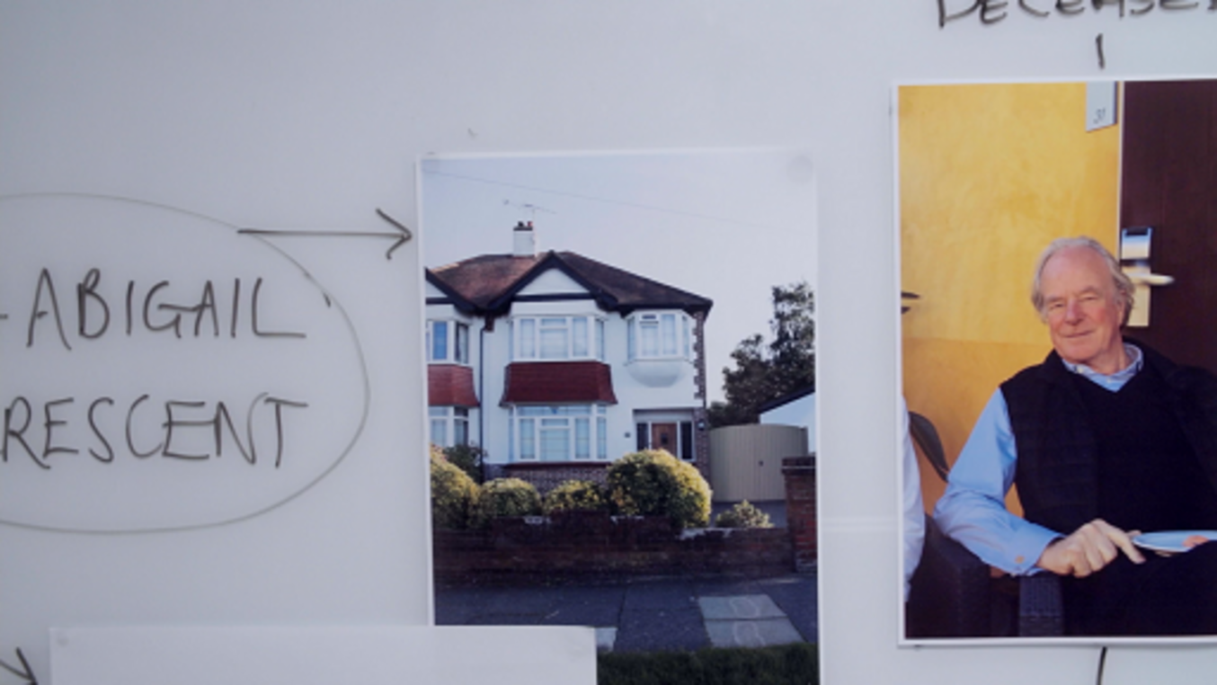
View description - Uncaptioned Figure
View alternative description - Uncaptioned Figure

If the current investigation finished with Neale’s confession to DI Bullet then the whole case would hinge on whether Neale’s confession was legitimate or whether it was coerced by DI Bullet. It is easy to see that this could lead to a conviction given the weight that courts and juries seem to put on confessions.
Thankfully, DI Bullet is not the only detective investigating this case and the wider policing team have been hard at work locating new evidence from which additional suspects begin to emerge.
In this section, you’ll learn about these new areas of enquiry.

4.1 Important new evidence

View description - Uncaptioned Figure
View alternative description - Uncaptioned Figure

SIO Harris has had some important evidence come in from the wider investigation team.
One of the detectives was tasked with trying to contact Dav Spandler, the colleague of Neale’s whom Neale claimed to be with on Sunday night. Dav has now made contact from Delhi via his mobile phone. Dav was unavailable for the past few days as he was on an adventure holiday, trekking in the remote countryside, and was outside of cellular contact. He has now been able to confirm that Neale was with him on Sunday night. Not only that, Dav has concealed CCTV at his property which he believes will have captured Neale’s exact time of arrival and departure at the house on the Sunday in question. Detectives are following this up, but Dav’s recollection is that Neale was with him from approximately 6 pm to 11.30 pm.
Having had confirmation that Neale Anderson has a verified alibi, Sund and Bullet have now established that there are three further persons of interest to the investigation, who have arisen as a result of door-to-door enquiries in the neighbourhood.
Next, you’ll find out about these new persons of interest.

4.2 Three additional suspects

View description - Uncaptioned Figure
View alternative description - Uncaptioned Figure

The broader investigation has identified three additional suspects. Due to the initial focus on Neale Anderson, only preliminary information about these people has been gathered so far.

Person 1: Costi Spiliopoulis, 47 years old and of Greek origin
- Costi is known to be very actively involved in supporting his community, being a voluntary leader at a local day care centre for youths with head injuries.
- He is the owner of a tree surgery business called Treegreen Landscape Services.
- A neighbour reported that a white, flat-backed van had been seen in the area of Leonard’s house around 10 February and in the week prior to that date. Two youngish lads with hoodies were seen leafleting the neighbourhood for Treegreen Landscapes, but some neighbours reported that the lads looked to be eyeing up properties on the road and had, on some occasions, parked up but not dropped leaflets. Calling the number on the leaflets put the police in touch with Costi Spiliopoulis who confirmed he is the business owner.
- In an initial statement, on the evening of the murder, Costi claimed to have been picking up medical supplies for the day care centre from a hospital in a neighbouring town, but could not provide details of anyone who witnessed him doing this.
- Costi was happy to provide a volunteer buccal sample (a method of obtaining DNA using a swab of the inside of the cheek).

Person 2: Mick Brough, 35 years old and of British origin
- Neighbours report that Mick’s visits to Leonard are to offer support with tasks he is finding harder to manage given his deteriorating health. When entering Leonard’s house he often takes in groceries in bags from ASDA.
- Mick’s work comprises casual labour – working cash in hand as a builder’s labourer for a variety of different builders in the local area.
- Mick has been seen visiting Leonard in the fortnight running up to the murder (dates uncertain). He is the brother of Leonard’s ‘girlfriend’ Anita, who is 32 and often goes by the name ‘Nita’.
- Mick drives an Audi A5.
- Mick has previously served time in prison but in the last 5 years has not come to the attention of the police.
- In an initial statement, Mick claims to have been at home watching TV at the time of the murder. He states that Anita can confirm this as she was also there.

Person 3: Dorek Bosko ‘Polski’, 25 years old and of Polish origin
- Dorek was not happy to provide a volunteer buccal sample. He does not have official immigration status in the UK and claimed he does not want his DNA to be recorded in case it affects his application for citizenship.
- Dorek describes himself as a local odd-job man. He works cash in hand and has an advert in the Post Office window, as well as adverts online via Facebook for his services. He came over from Poland five years ago.
- A neighbour witnessed Dorek going into Leonard’s house with a tool kit and a Henry hoover on 8 February 2020. The neighbour reports that Dorek had been to the property several times in the week preceding that date, although cannot remember the exact times and days of most of the visits. Dorek appeared to be working there. The neighbour remembers seeing Dorek on 8 February as he drives a distinctive small orange van, which had partially blocked his own drive on the Saturday morning. The neighbour approached Dorek on Saturday morning as he left Leonard’s house to complain about the van blocking his drive, and Dorek had not made eye contact, but had said ‘Go fuck yourself’, and had spat on the floor.
- The neighbour knows Dorek’s name as they both drink in the same local pub on a Friday evening. The neighbour reports that Dorek is a heavy drinker, and always drinks alone. He regularly plays the slot machine in the pub.
- In an initial statement, Dorek admits to having been at the house on 8 February but claims that was his last visit. He also denies having sworn and spat at the neighbour. At the time of the murder he was at his usual local pub, but did not speak to anyone there other than the bar staff.
You have now had a chance to read the existing information about the new suspects.

Interactive content is not available in this format.

4.3 Route of enquiry
The police decide to investigate each of the three suspects further.

Activity 5

Below, a number of possible routes of enquiry for each suspect have been listed. Your job is to decide how to begin investigating each of the suspects by selecting the evidence you think should be explored first.
Costi
- Search flat-backed van for forensic evidence.
- Look at CCTV evidence from the neighbouring town when Costi claims to have been there.
- Interview people from the day care centre about Costi’s general character.
- Show images of Costi to local residents to see if anyone can identify him.
Mick
- Search Mick’s tools for a possible murder weapon.
- Show images of Mick to local residents to see if anyone saw him at the time of the crime.
- Interview Anita to see if she confirms that Mick was at home at the time of the murder.
- Search Mick’s Audi A5 for forensic evidence.
Dorek
- Search Dorek’s tools for a possible murder weapon.
- Contact Europol and the Polish police for any previous convictions or intelligence on Dorek.
- Search Dorek’s van for forensic evidence.
- Interview the bar staff and regulars at Dorek’s local pub to see if anyone remembers him being there at the time of the murder.
For each suspect make a note about which piece of evidence should be explored first.

4.4 Biases

View description - Uncaptioned Figure
View alternative description - Uncaptioned Figure

It can be attractive to think of ourselves as objective decision makers, weighing the pros and cons of any given situation and making a decision based on the evidence available. However, a very large amount of research has demonstrated that any decision we make, including which applicant to hire or whether a suspect is guilty, is prone to bias. In other words, decisions are affected by who we are, the opinions and values we hold and our previous experiences, and this bias can happen without our knowing and even if we do our best to try to prevent it.
Known as unconscious, or implicit, bias, the stereotypes and general opinions we hold about a subsection of the population can strongly affect any decision we make about an individual person. This means that someone’s ethnicity, sex, sexual identity and age will affect how we perceive that person and in turn affect any decision we make about them.
Other forms of bias arise from the way in which we tend to process information. This includes confirmation bias (Nickerson, 1998), which is the tendency people have to focus on information that is likely to confirm their existing views on a topic. In a police investigation, confirmation bias can mean that officers may concentrate on evidence of guilt when investigating a likely suspect and downplay, or ignore altogether, evidence and routes of enquiry that would establish that suspect’s innocence.
Decisions can even be biased by the order in which information is presented, with the first information encountered acting as an ‘anchor’ (Tversky and Kahneman, 1974). This effect, known as anchoring, means that the first thing revealed about someone may gain more significance than subsequent information.

4.5 Biases in an investigation
It is clear that there is the potential for bias to have a significant impact on a criminal investigation. As was said previously, confirmation bias may mean detectives focus on evidence of guilt and obviously unconscious bias could mean they are disproportionately likely to see people from certain sectors of society as being guilty.
You have been participating in the investigation but do you think you have demonstrated any bias?

Activity 6

Think back to the last two tasks you completed, in which you first said which suspect you thought was most likely to be guilty and then what evidence should be the initial focus in investigating each suspect. Do you think any of your decisions may have been biased?
Before reading the text below, see if you can spot an bias in your decisions and thinking. Did you show any confirmation bias, for example, or were your decisions affected by anchoring?
In describing each suspect, a possible anchoring effect was introduced by beginning the description with a positive piece of information for Costi and Mick but began with something negative for Dorek. Anchoring suggests that this could have led to you forming a more negative opinion of Dorek.
The list of possible routes of enquiry for each suspect contained one element that would establish that person’s innocence (such as confirming their alibi) and other elements aimed at establishing their guilt (such as a neighbour having seen them on the day of the crime). Confirmation bias would suggest that you may have chosen to focus on potential evidence of guilt for the person you thought most likely to be guilty and on potential evidence of innocence for the other two suspects. Did the initial step for the enquiry differ according to whether you thought the suspect was likely to be guilty or innocent? If it did, you may well have been affected by confirmation bias.

5 Summary of Week 3

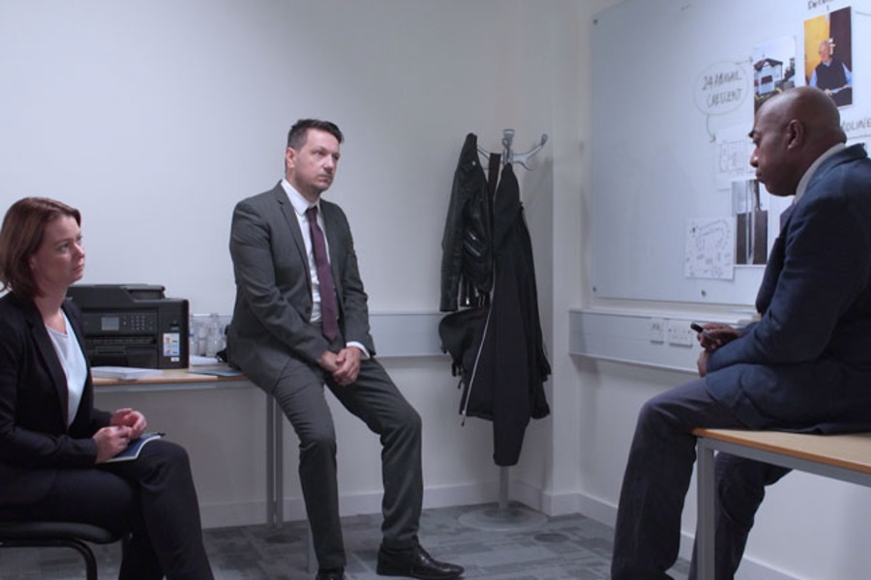
View description - Uncaptioned Figure
View alternative description - Uncaptioned Figure

This week you have seen that the confession of a suspect is not the definitive, ‘truthful’ end to a criminal investigation that we are used to seeing in fiction. Instead, confessions can be false for a number of reasons and innocent suspects can even be coerced into believing they committed a crime. Moreover, the way a suspect is interviewed, including the demeanour of the investigator and the techniques they employ, can profoundly increase the chances that a suspect will falsely confess.
You have also learned that bias means we are not the objective decision makers we like to think of ourselves as, and these biases can lead to criminal investigations focusing on and pursuing innocent suspects.
Returning to our fictional investigation, on Monday 17 February 2020 DI Bullet and DS Sund receive new evidence that causes them to make Mick Brough their prime suspect, and to prepare to arrest him.
To find out what this evidence is, and how our intrepid detectives handle it, move on to Week 4, where you will also have a chance to deploy your own investigative skills by briefing the SIO and preparing your own interview plan.
You can now go to Week 4.

Week 4: Solving the case

Introduction

View description - Uncaptioned Figure
View alternative description - Uncaptioned Figure

Welcome to Week 4! There have been some developments in the case and some information to catch up on.
The suspect, Mick Brough, has been arrested and you, alongside the investigating detectives, now need to prepare for this interview.
You are probably interested to know what led to the arrest of Mick over and above the other suspects. The officers who made enquiries regarding whether or not Mick had been seen in the local area discovered some interesting information. They found that Mick and his sister Nita had both been spotted visiting Leonard in the last fortnight, and one local resident has now confirmed that they saw them at the property on Sunday night. Additionally, the investigation team found other relevant information that led to both Mick and his sister Nita being arrested.
There are several pieces of evidence (presented here in no particular order) that the investigation team have now discovered that led to the arrest of Mick (and also his sister Nita, who was Leonard’s ‘girlfriend’).
- A local resident from Abigail Crescent saw both Mick and Nita visit Leonard at what they estimate to be between 7 pm and 7.15 pm on the evening of Sunday 9 February 2020.
- A forensic science report from Richard Peters regarding the body of Leonard Anderson confirms the following findings:
  - Bodily fluid (in the form of spittle) was recovered from the left-hand side of the face of the deceased. This spittle was tested and matches a buccal swab taken from Mick Brough.
  - The amount of fluid recovered was significant and was consistent with a substantial amount of spittle being deliberately projected onto the face of the deceased in a ‘spitting’ pattern. It is not consistent with the expected transfer of spittle which may happen from conversing with an individual at close quarters.
- Leonard was last seen alive at the bowling club on Sunday morning and CCTV has now been obtained which shows him leaving the bar at 11.58 am.
- An automatic number plate recognition (ANPR) camera picked up an Audi A5 registered to Mick Brough entering Abigail Crescent at 7.10 pm on Sunday evening, and passing by again (in the opposite direction) at 8.07 pm.
- Both Nita and Mick’s fingerprints have been recovered from inside the property.

1 Dealing with the new suspect

View description - Uncaptioned Figure
View alternative description - Uncaptioned Figure

Part of what makes investigative work so interesting is the need for flexibility and adaptation as new information and evidence arises. Given that we now have two new potential suspects in the case, the rest of this week will get you to focus on how best to take the investigation forward.
First you will need to think about how best to proceed given several pieces of new evidence. This includes what information you should and shouldn’t share with the suspects during the interviews.
You will also add to your timeline.

1.1 Evidence and testing the truthfulness of a suspects account
In a suspect interview, decisions about what evidence should be disclosed to the suspect are quite important for a number of reasons. The suspect must understand what they are suspected of, and why they are suspected of it, but there are reasons why police may elect not to disclose all of the evidence that they hold.
There are three main reasons for this:
- First, the suspect needs to be able to provide their own account based on their own memory of the event. Like in a witness interview, it is important not to potentially ‘contaminate’ someone’s recollection of what happened by first presenting them with what someone else said.
- Second, allowing the suspect to provide their own account first adds weight to this account if it is found to be consistent with other evidence.
- The final reason is that it is very important to be able to test the truthfulness of a suspect’s account. This relates to something you learned about in Week 3 – the voluntary false confession. You may remember that the voluntary false confession is the type of false confession that does not arise as a result of investigative pressure. In this type of confession someone falsely, and voluntarily, claims to have committed a crime they haven’t committed. The police need to be able to screen out such false claims, and one of the ways they can do this is through the strategic use of evidence. This will be explained further later.
When a serious crime like a murder takes place, there might be some evidence which is not disclosed to the media or witnesses, that only the suspect (along with the police) will be aware of. Take, for example, Leonard’s death. We know (because we are part of the investigation team) that Leonard was stabbed, but that would not be common knowledge. Let us assume that there has been no press coverage of the murder to date. Therefore, if someone hands themselves in at Chadborough Police Station claiming to have strangled Leonard on the Monday afternoon, we immediately know that they are not the right suspect. We know this because the information the person has provided conflicts with the other evidence we hold. We know the approximate time of death and the method of murder are both incorrect.
In suspect interviewing, investigators go through a process where they decide what information can be immediately disclosed to the suspect, and which bits of information might need to be held back.

1.2 Return to the timeline

View description - Uncaptioned Figure
View alternative description - Uncaptioned Figure

In the following activity you’ll return to your timeline for the crime.

Activity 1

Go to your timeline and add the additional information you have just learned, as this is the first set of evidence you have that relates closely to the time of death.
Look over your timeline and consider whether all the evidence sits consistently together.

1.3 Planning what to disclose

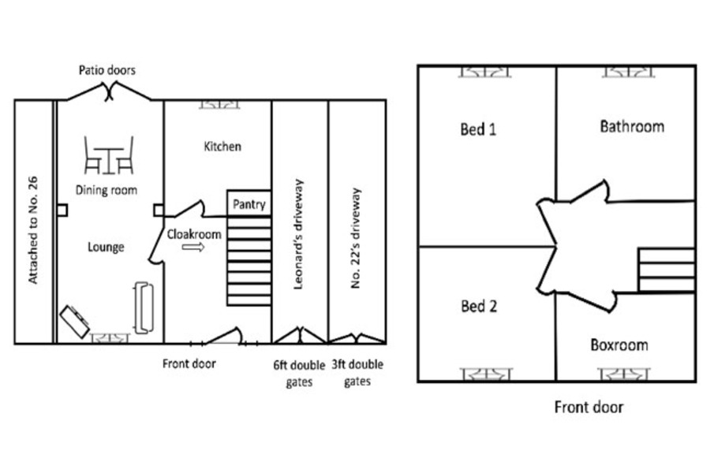
View description - Uncaptioned Figure
View alternative description - Uncaptioned Figure

In the following activity you will start to make a plan about the information that you hold and the order in which you might chose to disclose it.

Activity 2

As you have learned already you need to be clear with the suspect about why they are under arrest, but still allow the truthfulness of their account to be tested. Which of the pieces of evidence that you hold about Mick might you select to disclose initially? These are presented below (in no particular order) and you should make a note of which you would disclose initially and why.
- When the body was found.
- Where the body was found (address).
- The last time Leonard was seen alive.
- The estimated time of death.
- The cause of death (i.e. the stab wound to the neck).
- The ANPR matches of the suspect’s car near the victim’s address in the relevant time period.
- The fact that the victim’s hands were tied with string.
- The spit recovered from the cheek of the deceased (and the DNA match to the suspect).
- The neighbour’s identification of Mick and his sister at the scene during the relevant time period.
- The fingerprints of Mick and Nita at the scene.

1.4 The psychological team’s thoughts on what to disclose

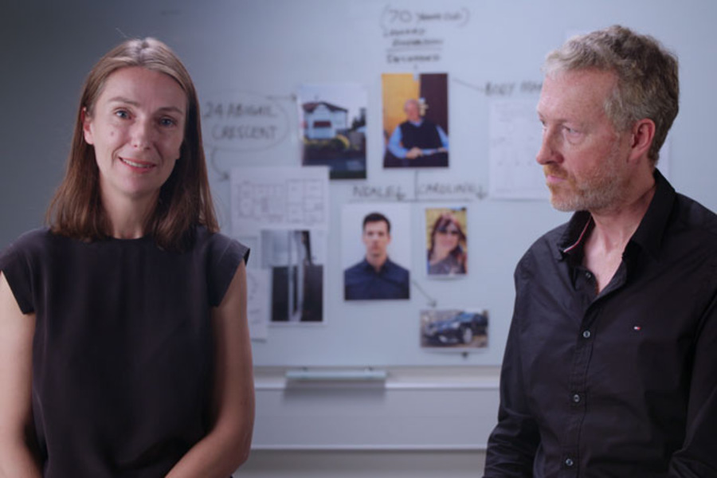
View description - Uncaptioned Figure
View alternative description - Uncaptioned Figure

Zoë and Graham, as the psychological experts, would probably initially disclose the neighbour’s statement, which puts the suspect at the scene, and also the corroborating evidence that their car passed by at 7.10 pm. This is because although eye-witness testimony can be unreliable, the two pieces of evidence together support one another.
They wouldn’t choose to disclose the forensic evidence initially because they would want to obtain the suspect’s uncontaminated account of what happened that evening first. They would, however, want the suspect to understand that they had been placed at the scene, and that is why they had been arrested.
You will return to this topic later on when you observe the suspect interview of Mick Brough. Before that, you will consider the psychological aspects of dealing with this suspect who is quite different to the first suspect you encountered.

2 Interviewing the new suspect

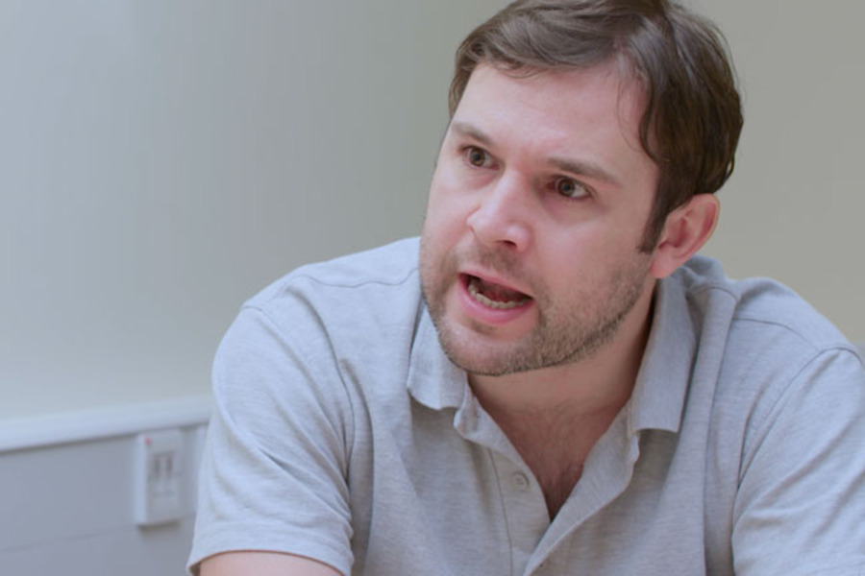
View description - Uncaptioned Figure
View alternative description - Uncaptioned Figure

Having worked on some ideas about disclosure of the evidence you’ll now consider how to plan for the more interpersonal aspects of interviewing the new suspect. You’ll return to the concept of building rapport as part of the interview process. Earlier in the course you made a plan for Neale’s interview. Of course, our new suspect Mick might need a different approach!
You’ll then watch DS Sund’s interview with the new suspect.

2.1 Planning for rapport with Mick Brough
You already have some information about Mick, which you got in Week 3.
For ease, this information is repeated here:
- Neighbours report that Mick’s visits to Leonard are to offer support with tasks he is finding harder to manage given his deteriorating health. When entering Leonard’s house he often takes in groceries in bags from ASDA.
- Mick’s work comprises casual labour – working cash in hand as a builder’s labourer for a variety of different builders in the local area.
- Mick has been seen visiting Leonard in the fortnight running up to the murder (dates uncertain). He is the brother of Leonard’s ‘girlfriend’ Anita, who is 32 and often goes by the name ‘Nita’.
- Mick drives an Audi A5.
- Mick has previously served time in prison but in the last 5 years has not come to the attention of the police.
- In an initial statement, Mick claims to have been at home watching TV at the time of the murder. He states that Anita can confirm this as she was also there.
So, you know that Mick has been regularly visiting Leonard and supporting him in ill health. You know that he is the brother of Nita who was Leonard’s much younger ‘girlfriend’. You know that he has prior convictions. The investigation team have looked further into these convictions and can provide the following information about them:
- At approximately 18 years old – Actual Bodily Harm. Fight outside a nightclub. Male victim jostles Mick in the club and Mick doesn’t like it. He follows the victim out of the club and pushes a broken bottle into his face, causing the victim to require hospitalisation and stitches. Sentenced to 9 months in Thorn Cross Young Offender Institution (behaviour while in Thorn Cross was fine).
- At approximately 22 years old – Actual Bodily Harm. Attack takes place at a bus stop. Mick plus two associates are walking past a bus stop. Victim (19 years) is waiting for bus alone, listening to CD Walkman. Mick punches victim in face repeatedly and steals the Walkman. Victim hospitalised with broken jaw. Sentenced to 6 months in Category C prison.
- At approximately 29 years old – Grievous Bodily Harm. Mick walks into a small hardware shop. He arms himself with a Stanley knife while the shop proprietor talks with a customer who then leaves. Mick approaches the shop proprietor, reaches over the counter and slashes at the proprietor’s face before stealing the contents of the till and running to a waiting getaway car. Victim is hospitalised requiring stitches to his face and minor plastic surgery reconstruction. Sentenced to 4 years in Category B prison. During time served, obtains three governor’s reports for assaults on other prisoners and one for assault on a member of staff in the education block.
You are also fortunate in that the Custody Sergeant who has brought Mick into custody has some informal comments on his behaviour so far. He has said ‘Mr Brough appears extremely agitated. He is argumentative, keeps shouting down the hallway that he is pissed off, and I’m afraid he is using a lot of bad language. I feel a bit sorry for the interview team.’
From the information above you are probably already forming an opinion of where the suspect might be on the interpersonal wheel, and you might already have a pit in your stomach at the idea of facing him in an interview!
Before the next activity, look again at the adaptive and maladaptive interpersonal circles taken from Alison et al.’s (2013) ORBIT model (Observing Rapport Based Interpersonal Techniques) that you used earlier. Plot where you think Mick will be on the interpersonal circumplex.

2.2 Interviewer rapport strategies
In the following activity you’ll think further about rapport.

Activity 3

Given what you have learned about the interpersonal circles so far, and the principles of rapport, select which one of the following you think is the best piece of psychological advice for the interviewer who will speak with Mick.

The interviewer needs to go in hard on Mick – show him who is boss. I would recommend shouting back at Mick if he shouts, and giving as good as you get if he swears.
The interviewer needs to be careful not to get drawn into maladaptive behaviour. The predictions of Mick’s behaviour suggest that because he will behave maladaptively, that will tempt the interviewer into also behaving maladaptively. The interviewer needs to stay on the adaptive wheel (even though this might be difficult!).
The interviewer should try to be really friendly with Mick. Maybe crack some jokes about the football or find another way to befriend him. Call him ‘mate’ regularly, laugh loudly at his jokes, fake an interest in his hobbies and so on.
View answer - Activity 3

2.3 DS Sund’s interview of Mick Brough

View description - Uncaptioned Figure
View alternative description - Uncaptioned Figure

Next, you will now observe the interview of Mick Brough. SIO Harris has asked DS Sund to carry out the interview.
As you watch the interview, you should think about what you have learned across all of the earlier weeks of this course. You will probably notice that you can relate aspects of the interview to:
- establishing the suspect’s credibility (Week 1)
- establishing rapport, even in difficult circumstances (Week 2)
- the potential for coercive interview practices (Week 3).
You will also, of course, pick up on which aspects of the evidence DS Sund chooses to disclose initially and what she holds back, and be able to observe how that works out (Week 4).
You’ll watch extracts from the interview first to emphasise different aspects. The first extract you watch will be from the account phase of the interview. However, you will notice that in the second part of the interview, DS Sund starts to move on to challenging some of the aspects of the account where there are discrepancies between what Mick says and some of the other evidence. You will notice that this second part of the interview happens a few hours later, when the suspect and Sund will have both had breaks, to allow them to rest and gather themselves for the next part of the interview.
In order for you to be able to observe the most relevant (and interesting!) parts of the interview, we have omitted some other parts. For example, DS Sund would have offered Mick legal advice and explained his right to have a solicitor in the room and explained the other procedures at the outset of the interview.

2.4 DS Sund interviews Mick Brough
In this video, you will observe DS Sund interviewing Mick Brough.
You should watch the interview and make some notes of your observations. Be ready for questions about what you observed in the next section. You may wish to have your timeline in front of you as you observe the interview, to note any discrepancies that might arise.

Video content is not available in this format.
View transcript - Uncaptioned interactive content

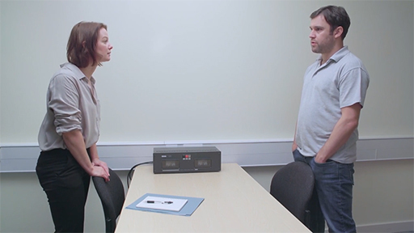

2.5 Noting discrepancies on the timeline
As you observed the interview, you may have noticed a few discrepancies between what Mick was saying happened and the other evidence. If you haven’t already, make sure you have noted these on your timeline.
- In Week 3 (regarding the new potential suspects in the case), you may remember that according to his initial statement, taken at the time, Brough claimed to have been at home watching TV during the time period of the offence.
- In the interview, it would be difficult for Mick to maintain that claim because he has been sighted at the scene, and his car has been picked up close to the scene, both at the relevant time points.
- However, in the interview we see that Mick claims not to have left his car, which is inconsistent with the account of the witness who saw him walk up the drive of 24 Abigail Crescent.
- He also claims to have been there for a shorter time period, saying he left at 7.30 pm, which is inconsistent with the ANPR record, which shows the car leave at 8.07 pm.
- Additionally, Mick claims not to have been at the property in three years, and this conflicts with the forensic evidence – in particular the spit found on the face of the murder victim.
There are, therefore, a number of conflicts between the other evidence and the story that Mick is trying to present that can be seen when you attend to the timeline of events.

3 Assessment of the suspect interview and case closure

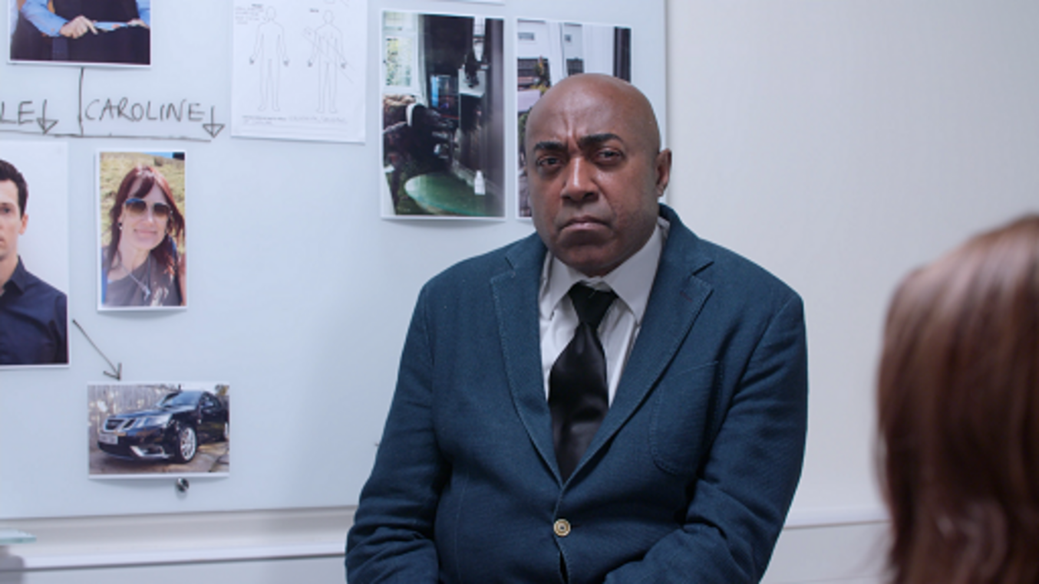
View description - Uncaptioned Figure
View alternative description - Uncaptioned Figure

Having observed the interview with DS Sund and Mick Brough you’ll now make an important decision: do you think Mick Brough is involved in the case?
You’ll also see the investigation team discuss their final thoughts on the case.

3.1 Your assessment of the suspect Mick Brough

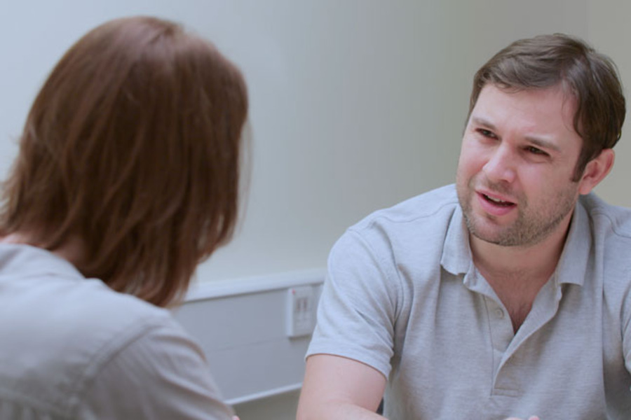
View description - Uncaptioned Figure
View alternative description - Uncaptioned Figure

In the following activity you will be asked your opinion on the case so far.

Activity 4

Take part in the following poll.

Interactive content is not available in this format.

3.2 An assessment of Mick Brough as a suspect

View description - Uncaptioned Figure
View alternative description - Uncaptioned Figure

Now you’ve had a chance to make your own assessment of Mick as a suspect, read the expert opinion.

Suspect credibility
As discussed, in the interview you will have observed a lot of different accounts of what happened from Mick, and these are hard to reconcile unless Mick is lying at various points. In the account he provided prior to the interview, Mick claimed to be at home watching TV. In the interview while he initially claims not to know who Leonard is, he later claims that he dropped his sister off at Leonard’s property but did not enter the property himself. It is obvious to an observer that Mick is not likely to be telling the truth in some of what he is saying to the police as the accounts are inconsistent.
As well as that, there are inconsistencies with both versions of Mick’s account and the other evidence. There are reasons therefore to doubt the truthfulness of Mick’s account. Note that these judgements about deception are not based on body language or any other form of nonverbal communication (as you have learned that these cues are often unreliable), they are made based on discrepancies in the claims being made.

Rapport
Mick is not an easy suspect to interview. He is dominant, hostile and displays maladaptive behaviour, especially at the start of the interview. He refuses to sit down, swears a lot, shouts and is very difficult to manage.
Despite this, DS Sund does an excellent job. In particular she does not match Mick’s maladaptive hostile behaviour. When Mick says ‘Suit yourself, why am I here?’, which is very hostile, she is calm and explains in a frank and forthright way the reasons for his arrest. She is on the adaptive, rather than the maladaptive, circle. Likewise, she is similarly frank about the relationship Leonard was in with Mick’s sister. She does not shy away from covering that, even though Mick might not approve of the relationship.
DS Sund does not try to catch the suspect out when he reveals that he is lying. For example, when he initially claims not to know Leonard but then later says he dropped Nita off there, she doesn’t allow herself the ‘Aha, so you do know who he is’ moment that it might be tempting to have. Instead, she allows him to give the account. Sund does not get drawn into maladaptive arguments, instead she is predominantly in a positive version of the hostile and slightly submissive space, by being frank and forthright. This is a good place for her to be with this suspect.

Coercive practices
There is no evidence of coercive practice on Sund’s part. She doesn’t lie, her behaviour could not be considered oppressive, and she seeks to neither maximise nor minimise the offence. She doesn’t suggest an account to the suspect, she seeks an account from him.

Use of evidence
In the interview you will notice that Sund disclosed the following initially:
- the time of discovery of Leonard’s body
- the last time that Leonard was seen alive
- the fact that a witness claims to have seen Nita and Mick at around 7.00 pm on Sunday
- the ANPR record of Mick’s car passing by the road at 7.10 pm.
This meant that in the interview Mick was able to be located in the relevant time period and at the relevant location (remember that his initial statement said that he was at home watching TV). However, it also meant that there were elements of the evidence that could be used to either support the suspect’s case if he was innocent, or test the truthfulness of his account.

3.3 SIO and the two detectives debrief the case
Watch SIO Harris and the two detectives discuss the conclusion to the case.

Video content is not available in this format.
View transcript - Uncaptioned interactive content

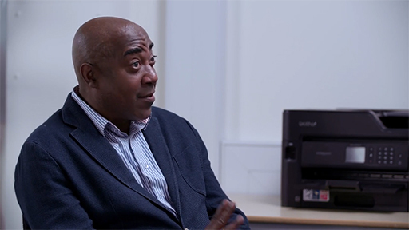

4 Conclusion of the case

View description - Uncaptioned Figure
View alternative description - Uncaptioned Figure

Well done! You have followed a murder investigation to its conclusion and learned how psychology can be applied to many stages of the investigative process. You have learned about the experiences of suspects in the criminal justice system and learned a little about how psychological processes can apply to the experiences of both the investigation team and the suspects.
You may remember that you were asked at the very start of the course to look out for some mistakes in the investigation, and to note them down. There were some mistakes in the investigation as these can, and do, happen, and we wanted to make the case one where a realistic amount of error was included. One of the main mistakes that was made early on in the investigation was made by the junior officers who attended the scene at Leonard’s house. This was the mistake of informing Neale about the injuries to his deceased father.
This is a problem in terms of disclosure, as it should have been information that was withheld in order to be able to test the truthfulness of someone’s account. As you saw in this investigation, DI Bullet became rather obsessed with how Neale could possibly know that information (even though in fact he was told it by the police!).
Another mistake made at the point of the discovery of the body was that the officers at the scene did not check the access points to the property themselves, before breaking the front door down. If they had done so, they would have discovered that the patio doors were open at the back and could have entered the property that way.
You can rest assured that Mick Brough is now serving a 25-year prison service for his part in the murder. DS Sund is currently enjoying a well-earned holiday in Devon, SIO Harris is now heading up a new murder inquiry involving organised crime gangs, and DI Bullet? Well, he is spending a few weeks back at police training school!
Did the case resolve in the way you expected at the start of the course?

5 Course summary
During this investigation you have learned about the application of psychology to the criminal justice system.
Specifically, you have covered the assessment of credibility and the detection of deception in human communication; the importance of honest and authentic rapport and respectful communication and the possibility of creating false confessions through police interviewing and you have applied all of this to a real case.
Well done! We hope that you have enjoyed the experience.

Where next?

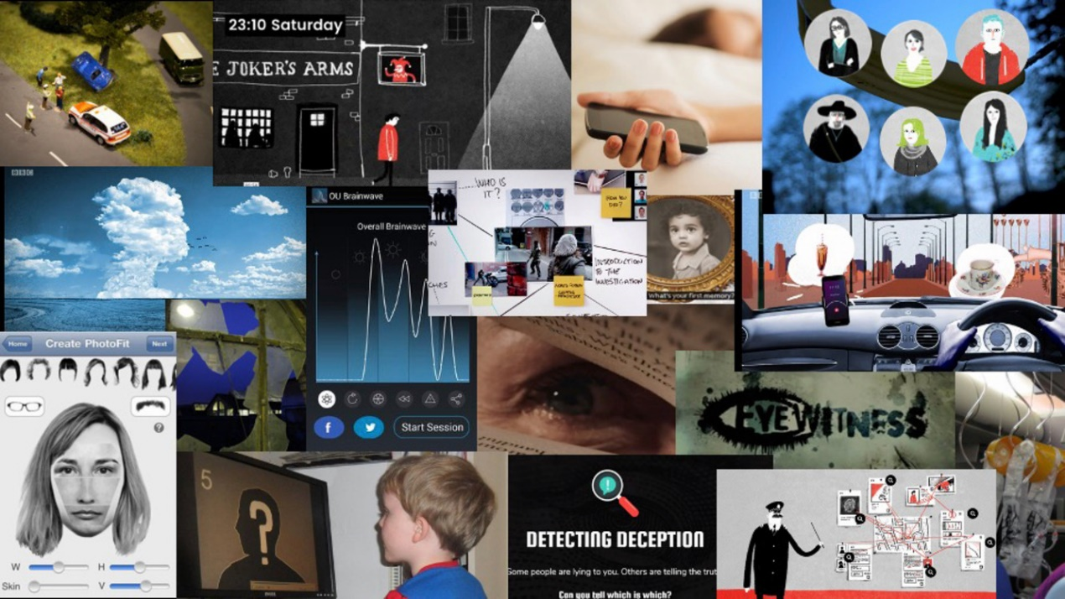

If you have enjoyed this course and are interested in further learning opportunities, explore the links below.

Short courses
There are other free courses from The Open University that might interest you, specifically:
- Forensic psychology: This course explores psychology applied to the criminal justice system too, but it is more focused on the witness experience, rather than the suspect experience.

Qualifications
If you have enjoyed this course, and wish to study more formally with The Open University then the following qualifications might be of interest. The Open University has both an undergraduate degree and a masters qualification which cover material relevant to forensic psychology.
- Undergraduate forensic psychology
- Masters in forensic psychological studies

Book
Since this course was first developed, Emily and Laurence Alison (2020) have written a book called Rapport: The Four Ways to Read People, which talks about their research into rapport in a very accessible way. It is published by Penguin.

Podcast
You might be interested in listening to an episode of the podcast Bad People, which features one of the authors of this course, Zoë Walkington, talking about the changes to the legal system of England and Wales (including PACE and PEACE) that arose as a result of miscarriages of justice. It features the case of Maxwell Confait, which was central to changes made in the criminal justice system.
- Bad People Blue Lips: Does good cop / bad cop actually work?

References
Bond, C. F., Jr. and DePaulo, B. M. (2006) ‘Accuracy of deception judgments’, Personality and Social Psychology Review, 10(3), pp. 214–34.
Buller, D. B., Strzyzewski, K. D. and Hunsaker. F. G. (1991) ‘1. Interpersonal deception’ ‘11: The inferiority of conversational participants as deception detectors’, Communication Monographs, 58, pp. 25–40.
Levine, T. R., Park, H. S. and McCornack, S. A. (1999) ‘Accuracy in detecting truths and lies: documenting the “veracity effect”’, Communication Monographs, 66, pp. 125–44.
Masip, J., Alonso, H., Garrido, E. and Antón, C. (2005) ‘Generalised communicative suspicion (GCS) among police officers: Accounting for the investigator bias effect’, Journal of Applied Social Psychology, 35(5), pp. 1046–1066.
Shaw, D. J., Vrij, A., Leal, S., Mann, S., Hillman, J., Granhag, P. A. and Fisher, R. P. (2013) ‘Expect the unexpected? Variations in question type elicit cues to deception in interviewer contexts’, Applied Cognitive Psychology, 27, pp. 336–43.
Vrij, A. and Mann, S. (2001) ‘Who killed my relative? Police officers’ ability to detect real-life high-stake lies’, Psychology, Crime and Law, 7, pp. 119–32.
Alison, E. and Alison, L. (2020) Rapport: The Four Ways to Read People, Random House.
Alison, L., Alison, E., Noone, G., Elntib, S. and Christiansen, P. (2013) ‘Why tough tactics fail and rapport gets results: Observing rapport-based interpersonal techniques (ORBIT) to generate useful information from terrorists’, Psychology, Public Policy, and Law, 19, pp. 411–31.
Bernieri F. and Gillis J. (2001) ‘Judging rapport: employing Brunswik’s lens model to study interpersonal insensitivity’, in Hall, J. A. and Bernieri, F. J. (eds) Interpersonal Sensitivity: Theory and Measurement. Lawrence Erlbaum, New Jersey, pp 67–88.
Birtchnell, J. (2014) ‘The interpersonal circle and the interpersonal octagon: A confluence of ideas’, Clinical Psychology & Psychotherapy, 21, pp. 62–72.
Bull, R. (2013) ‘What is believed or actually known about characteristics that may contribute to being a good/effective interviewer’, Investigative Interviewing Research and Practice, 5(2), pp. 128–43.
College of Policing (2023) ‘Investigative interviewing’, College of Policing Authorised Professional Practice. Available at: https://www.college.police.uk/app/investigation/investigative-interviewing (Accessed: 27 July 2023).
Holmberg, U. and Christianson, S. A. (2002) ‘Murderers’ and sexual offenders’ experiences of police interviews and their inclination to admit or deny crimes‘, Behavioral Sciences and the Law, 20(1–2), pp. 31–45.
Leary, T. (1957) Interpersonal Diagnosis of Personality. New York: Ronald.
Connecticut General Assembly (no date) Interrogation Techniques. Available at: https://www.cga.ct.gov/2014/rpt/2014-R-0071.htm (Accessed: 16 August 2023).
Gudjonsson, G. (2003) The Psychology of Interrogations and Confessions: A Handbook, New York: John Wiley and Sons.
Nickerson, R. S. (1998) ‘Confirmation bias: A ubiquitous phenomenon in many guises’, Review of General Psychology, 2, pp. 175–220.
Starr, D. (2013) ‘Do police interrogation techniques produce false confessions?’, The New Yorker. Available at: https://www.newyorker.com/magazine/2013/12/09/the-interview-7 (Accessed: 16 August 2023).
Tversky, A. and Kahneman, D. (1974) ‘Judgement under uncertainty: heuristics and biases’, Science, 185, pp. 1124–1131.
Walsh, D., O’Callaghan, S. and Milne, R. (2016) ‘Questioning the interrogational practices of US law-enforcement officers: Legal and psychological perspectives’, in Kapardis, A. and Farrington, D. P. (eds) The Psychology of Crime Policing and Courts, London: Routledge.
West, E. and Meterko, V. (2015) ‘Innocence project: DNA exonerations, 1989–2014: review of data and findings from the first 25 years‘, Albany Law Review, 79(3), pp. 717–95.
Alison, E. and Alison, L. (2020) Rapport: The Four Ways to Read People, Penguin.
Alison, L., Alison, E., Noone, G., Elntib, S. and Christiansen, P. (2013) ‘Why tough tactics fail and rapport gets results: Observing rapport-based interpersonal techniques (ORBIT) to generate useful information from terrorists’, Psychology, Public Policy, and Law, 19, pp. 411–31.

Acknowledgements
This free course was written by Zoë Walkington and Graham Pike. It was first published on FutureLearn in 2020 and updated for use on OpenLearn in October 2023.
Except for third party materials and otherwise stated (see terms and conditions), this content is made available under a Creative Commons Attribution-NonCommercial-ShareAlike 4.0 Licence.
The material acknowledged below is Proprietary and used under licence (not subject to Creative Commons Licence). Grateful acknowledgement is made to the following sources for permission to reproduce material in this free course:
Images
Course Image: alexskopje / iStock / Getty Images Plus
Week 1
Section 1.2 image: Philip Glenister, Life on Mars: Mark Campbell. Used under license from Shutterstock.com
Section 1.2 image: Sofie Gråbøl, The Killing: WENN Rights Ltd / Alamy Stock Photo
Section 4 image: standret/ iStock / Getty Images Plus
Section 4.1 image: Jacob Wackerhausen; Getty Images
Week 2
Section 2 image: LaylaBird/ iStock / Getty Images Plus
4.5 image: adapted from Alison, L., Alison, E., Noone, G., Elntib, S., and Christiansen, P. (2013) ‘Why tough tactics fail and rapport gets results: Observing rapport-based interpersonal techniques (ORBIT) to generate useful information from terrorists’, Psychology, Public Policy, and Law, 19, pp. 411–31. http://dx.doi.org/10.1037/a0034564.
Week 3
Section 1.2 image: Philip Glenister, Life on Mars: Mark Campbell. Used under license from Shutterstock.com
Section 2 image: fpphotobank; Getty Images
Section 2.2 image: Pichsakul Promrungsee/ 123 Royalty Free
Section 2.3 image: mrdoomits/iStock / Getty Images Plus
Section 4.1 image: digicomphoto/ iStock / Getty Images Plus
Section 4.2 image: chaofann/ iStock / Getty Images Plus
Section 4.4 image: Iryna Drozd; Getty Images
All other assets © The Open University
Every effort has been made to contact copyright owners. If any have been inadvertently overlooked, the publishers will be pleased to make the necessary arrangements at the first opportunity.
Don't miss out
If reading this text has inspired you to learn more, you may be interested in joining the millions of people who discover our free learning resources and qualifications by visiting The Open University – www.open.edu/openlearn/free-courses.

Glossary
adaptive
Positive ways of relating to others. Behaviours leading to positive interpersonal communication.
maladaptive
Negative or inappropriate ways of relating to others. Behaviours leading to a damaging effect on communication.

Solutions

Activity 3

Answer
Right:
The interviewer needs to be careful not to get drawn into maladaptive behaviour. The predictions of Mick’s behaviour suggest that because he will behave maladaptively, that will tempt the interviewer into also behaving maladaptively. The interviewer needs to stay on the adaptive wheel (even though this might be difficult!).
Wrong:
The interviewer needs to go in hard on Mick – show him who is boss. I would recommend shouting back at Mick if he shouts, and giving as good as you get if he swears.
The interviewer should try to be really friendly with Mick. Maybe crack some jokes about the football or find another way to befriend him. Call him ‘mate’ regularly, laugh loudly at his jokes, fake an interest in his hobbies and so on.
Back to - Activity 3

Uncaptioned Figure

Description
A photograph of Gene Hunt and Sam Tyler from the television programme Life on Mars.
Back to - Uncaptioned Figure

Uncaptioned Figure

Description
A photograph of Sara Lund from the television programme The Killing.
Back to - Uncaptioned Figure

Uncaptioned Figure

Description
A photograph of SIO Harris, with a busy white board behind him.
Back to - Uncaptioned Figure

Uncaptioned Figure

Description
A hand-drawn timeline. There is a line along the middle which goes from 7pm on the left side to 8pm on the right side with the time at ten minute intervals marked out at regular points along the line (7.10pm, 7.20pm etc). Above the line the suspect’s account is shown, with what the suspect claimed to be doing between certain times marked against the time points. Below the line information from witness accounts and other evidence is marked at relevant time points, allowing the discrepancies between different sources of information to be seen.
Back to - Uncaptioned Figure

Uncaptioned Figure

Description
A photograph of DS Sund interviewing Neale Anderson.
Back to - Uncaptioned Figure

Uncaptioned Figure

Description
A photograph of DI Bullet.
Back to - Uncaptioned Figure

Uncaptioned Figure

Description
A photograph of DS Sund.
Back to - Uncaptioned Figure

Uncaptioned Figure

Description
A close up a person’s hands holding an open notebook.
Back to - Uncaptioned Figure

Uncaptioned Figure

Description
A photograph of DS Sund interviewing Neale Anderson.
Back to - Uncaptioned Figure

Uncaptioned Figure

Description
A photograph of a person taking a lie detector test.
Back to - Uncaptioned Figure

Uncaptioned Figure

Description
A photograph of a person looking through a large magnifying glass.
Back to - Uncaptioned Figure

Uncaptioned Figure

Description
A photograph of SIO Harris sitting on a chair.
Back to - Uncaptioned Figure

Uncaptioned Figure

Description
A photograph of Neale Anderson.
Back to - Uncaptioned Figure

Uncaptioned Figure

Description
A photograph of an interview between DI Bullet and Neale Anderson being watched from a laptop.
Back to - Uncaptioned Figure

Uncaptioned Figure

Description
A photograph of DI Bullet interviewing Neale Anderson.
Back to - Uncaptioned Figure

Uncaptioned Figure

Description
A photograph of someone looking at a collection of post-it notes.
Back to - Uncaptioned Figure

Uncaptioned Figure

Description
A photograph of DI Bullet and DS Sund in conversation.
Back to - Uncaptioned Figure

Uncaptioned Figure

Description
A photograph of Zoe Walkington drawing a diagram. The diagram is a circle with a line intersecting the circle from top to bottom. The top of the circle is labelled D (standing for dominance) and the bottom of the circle is labelled S (standing for submission). There is one arrow from the bottom of the circle pointing upwards (from submission to dominance) and another from the top of the circle pointing downwards (from dominance to submission).
Back to - Uncaptioned Figure

Uncaptioned Figure

Description
A photograph of DS Sund.
Back to - Uncaptioned Figure

Uncaptioned Figure

Description
There are two circles, each split into segments. The first circle is labelled ‘Adaptive/positive patterns of interaction. Within the segments are the following labels: ‘In charge, sets the agenda, advises’; ‘Supportive, conversational, nonjudgmental’; ‘Social, warm, friendly’; ‘Respectful, trusting, admiring’; Modest, humble, seeking guidance’; ‘Wary, skeptical, reserved’; ‘Frank, forthright, critical’; ‘Confident, assertive, certain’. The second circle is labelled ‘Maladaptive/negative patterns of interaction’. Within the segments are the following labels: ‘Demanding, dogmatic, pedantic, rigid’; ‘Parental, patronising, rescuing’; ‘Over-familiar, obsequious, desperate’; ‘Uncertain, hesitant, apologetic’; ‘Formulaic, disengaged, conflict avoidant’; ‘Irritable, distrustful, resentful’; ‘Sarcastic, punitive, attacking, unfriendly’; ‘Judgmental, argumentative, competitive’.
Back to - Uncaptioned Figure

Uncaptioned Figure

Description
A photograph of DI Bullet interviewing Neale Anderson.
Back to - Uncaptioned Figure

Uncaptioned Figure

Description
A photograph of DI Bullet interviewing Neale Anderson.
Back to - Uncaptioned Figure

Uncaptioned Figure

Description
A photograph of SIO Harris in front of a busy white board.
Back to - Uncaptioned Figure

Uncaptioned Figure

Description
A photograph of Gene Hunt and Sam Tyler from the television programme Life on Mars.
Back to - Uncaptioned Figure

Uncaptioned Figure

Description
A woman sits at a desk in a darkened interview room. A man sits on the table in front of her. They are both looking at a document she is signing.
Back to - Uncaptioned Figure

Uncaptioned Figure

Description
A photograph of someone being forced to write a confession.
Back to - Uncaptioned Figure

Uncaptioned Figure

Description
A photograph of a door with ‘Interview Room. Enter’ on it.
Back to - Uncaptioned Figure

Uncaptioned Figure

Description
A photograph of DI Bullet interviewing Neale Anderson.
Back to - Uncaptioned Figure

Uncaptioned Figure

Description
A photograph of DI Bullet interviewing Neale Anderson.
Back to - Uncaptioned Figure

Uncaptioned Figure

Description
A photograph of Zoe Walkington and Graham Pike in discussion.
Back to - Uncaptioned Figure

Uncaptioned Figure

Description
A photograph of Neale Anderson.
Back to - Uncaptioned Figure

Uncaptioned Figure

Description
A photograph of SIO Harris.
Back to - Uncaptioned Figure

Uncaptioned Figure

Description
A photograph of part of the police whiteboard, including a photograph of Leonard and Anderson and a photograph of his house.
Back to - Uncaptioned Figure

Uncaptioned Figure

Description
A photograph of a magnifying glass resting on a piece of paper headed ‘Evidence’.
Back to - Uncaptioned Figure

Uncaptioned Figure

Description
A photograph of three doors, each with a question mark on it.
Back to - Uncaptioned Figure

Uncaptioned Figure

Description
Picture of a magnifying glass over the word ‘bias’.
Back to - Uncaptioned Figure

Uncaptioned Figure

Description
A photograph of SIO Harris, DS Sund and DI Bullet.
Back to - Uncaptioned Figure

Uncaptioned Figure

Description
A photograph of Leonard Anderson’s house.
Back to - Uncaptioned Figure

Uncaptioned Figure

Description
A photograph of Mick Brough.
Back to - Uncaptioned Figure

Uncaptioned Figure

Description
An example timeline.
Back to - Uncaptioned Figure

Uncaptioned Figure

Description
A floor plan of Leonard Anderson’s house. On the left-hand side of the diagram we see the house is attached to number 26. On the left-hand side of the diagram there is a lounge through dining room with a window at the front and patio doors to the rear. Next to that room, at the front of the property, is the front door leading to a square hallway and the stairs, and behind that room at the rear of the property is the kitchen. The front door to the property leads into the hallway room. Outside next to the house there are 6 foot double gates behind which is Leonard’s driveway. Immediately next to Leonard’s driveway is the driveway to number 22. Upstairs at the front of the house there is a box room and bedroom 2, both of which have a window each facing forward. To the rear of the property is bedroom 1 and the bathroom. All of the upstairs rooms are accessed off a small hallway/landing.
Back to - Uncaptioned Figure

Uncaptioned Figure

Description
A photograph of Zoe Walkington and Graham Pike.
Back to - Uncaptioned Figure

Uncaptioned Figure

Description
A photograph of Mick Brough.
Back to - Uncaptioned Figure

Uncaptioned Figure

Description
A photograph of DS Sund interviewing Mick Brough.
Back to - Uncaptioned Figure

Uncaptioned Figure

Description
A photograph of SIO Harris.
Back to - Uncaptioned Figure

Uncaptioned Figure

Description
A photograph of DS Sund interviewing Mick Brough.
Back to - Uncaptioned Figure

Uncaptioned Figure

Description
A photograph of Zoe Walkington and Graham Pike.
Back to - Uncaptioned Figure

Uncaptioned Figure

Description
A photograph of SIO Harris.
Back to - Uncaptioned Figure

Uncaptioned interactive content

Transcript
ZOË WALKINGTON:
Hello, my name is Doctor Zoë Walkington, and I work at the School of Psychology and Counselling here at The Open University. For many years now, I have worked with police detectives on the psychology of police suspect interviews. And this is a fascinating area, and one of the reasons I wanted to develop this course was to introduce learners to the psychology of police investigations and specifically, to spark your interest in how psychology can apply to the criminal justice system.
GRAHAM PIKE:
Hello, I’m Professor Graham Pike, and I also work at the School of Psychology and Counselling here at The Open University. Like Zoë, for many years now, I’ve been working with the police, though I tend to work in a domain of witnesses rather than suspects. Indeed, several years ago, I made a course very similar to the current one that followed a police investigation where the focus was on obtaining evidence from witnesses.
ZOË WALKINGTON:
You are going to be taking part in a murder investigation. We have developed a fictional murder investigation that you will follow week-by-week. Now whilst the case is based in England, it’s not our intention to be entirely legally accurate to the legal system of England and Wales. Instead, we want you to focus on the key psychological concepts.
GRAHAM PIKE:
During the course you’re going to experience what it’s like to be a police officer trying to interview a suspect. You’ll also get to think about what the experience might be like for the suspect themselves. All the way through, you’ll be learning about the potential role of psychology in these legal processes.
ZOË WALKINGTON:
You will be part of a team of investigating officers. The female detective is D.S. Sund, And you’ll see her conduct some of the interviews.
GRAHAM PIKE:
The male detective is called D.I. Bullet, and he will also be joining the interview team. Both Sund and Bullet are being managed by the senior investigating officer, or SIO who’s Lyndon Harris. The senior investigating officer leads on all major criminal investigations and has to make strategic and important decisions about the wider investigation, such as when to make arrests. Of course, there are many other officers involved in the investigation alongside this core team. For example, there are the officers who attended the scene, the crime scene staff, and staff in the forensic science services, all of whom have an important role to play.
ZOË WALKINGTON:
We wanted this case to be as realistic as possible. In the real world, in investigations, mistakes get made. And so we’ve included some mistakes in this investigation. So if you notice, as you go along the course, perhaps some things that the officers do that cause problems for later on in the investigation, make a note of them. We’ll revisit those at the end of the course.
GRAHAM PIKE:
We very much hope you enjoy the course. Very shortly, you’ll meet the SIO, who’s going to give you your initial police briefing that’s going to kick off the case. [SUSPENSEFUL MUSIC]
Back to - Uncaptioned interactive content

Uncaptioned interactive content

Transcript
SIO HARRIS:
Good morning. And welcome to this briefing on the recent murder carried out in Chadborough. Now my name is Lyndon Harris. I work for Falldershire Police Force. I am the senior investigating officer on this case. Now during this briefing, I’m going to talk you through everything we know so far about this incident. And obviously, we are in a rapidly evolving situation. And we will receive further information as we go through the investigation. You must take notes in whatever way you see fit about this case, because you are part of the investigating team. And it’s important that you are aware of all the case details that follow. The deceased is Leonard Anderson.
His body was discovered at 10:30 AM, Tuesday the 11 February, 2020. I will tell you a bit about his background and then I’ll move on to talk to you about how the body was discovered. Leonard Anderson is 70 years old. He’s retired. He was formerly in the army. Leonard lives in a semi-detached three-bedroom house in a suburban area of Chadborough. He lives alone. He was previously married but his wife, Eve passed away at 61 from cancer. He has a social life, which is largely centred around the bowling club which is in walking distance from his house. He is independent and generally travels on local buses and trains, no problem.
He has two children, Caroline, 45, who lives in Australia where she’s a teacher. And he has a son, Neale, 40, who lives in Chadborough, the same town as our victim. Now, Leonard’s health has not been too great. His health complaints are centred around angina, and other heart problems. The discovery of the body was in slightly unusual circumstances. The first we became aware of something having happened is when our officer, Sandra Ashton, was flagged down whilst returning to the police station after another call out. She was flagged down by Neale Anderson the son of the victim Neale Anderson is a 40-year-old Business Development Manager for a small management consultancy. The company is co-owned by 3 directors of whom Neale is one.
Neale drives an executive saloon car. He has a long-term partner who he lives with, Jane Gardner. Neale Anderson flagged down officer
Ashton approximately 10:20 AM. And he said he had turned up for a prearranged meeting with his father at his father’s house. On arrival for the meeting at the house, his dad appeared not to be in. There was no answer at the property. He was concerned as his father was very reliable. He also noticed that the upstairs blinds were still closed, which at 10:20 AM was very unusual. He said he tried to gain access to the house but was unable to and asked officer Ashton to accompany him to the house, which she did. Onto the body then. As you will see in this body map, the deceased had a puncture wound to the right hand side of the neck, 4 centimetres deep, 0.4 centimetres wide, with bruising around the wound. Now it’s believed that this is consistent with a stab wound from a screwdriver, bradawl, or similar tool.
Estimates placed a time of death approximately between 7:00 and 10:00 PM on Sunday the 9 February, 2020, which is the Sunday prior to the body being discovered on the Tuesday. Currently, our officer Sandra Ashton is preparing and submitting a statement about how the body was discovered. Likewise, Neale Anderson is a significant witness and he will be interviewed. There is a scheduled witness interview coming up, which will be handled by DS Sund, who is part of our investigation team. At this present time, no weapon has been located. We have no suspects in mind. And scenes of crime officers are searching the premises. I’d like you to please make notes of what I’ve told you so far. And be prepared and ready for further updates.
Back to - Uncaptioned interactive content

Uncaptioned interactive content

Transcript
DS SUND:
Neale, having explained to you about the interview that we are doing here today, I’m keen to move on to asking you to explain to me, in as much detail as you can, about what happened on the day that you discovered your father. I appreciate this might be difficult for you, Neale, as you’ve lost your father in extremely distressing circumstances. But it is really important to the investigation that we are able to understand as much as we can about the lead up to the discovery. So please, just take your time, and try to imagine yourself back on the day you made the discovery, which was Tuesday, wasn’t it? Tell me everything you can remember, even if you don’t think it is relevant to the case, because all information can potentially be useful. I will try not to interrupt you, or ask you further questions. I’m after your account of what you remember. So please take your time, and just tell me what you remember.
NEALE:
OK. I’ll do my best. I’m sorry if I forget things or get things wrong. Everything is still a bit of a blur.
DS SUND:
That’s OK. Yeah, I understand this might be difficult for you, Neale. Just take your time. And if you need a break at any point, please just ask. Perhaps if it helps to ease you in, you could start with why you were meeting your dad that day.
NEALE:
Yes. Yes, of course. Really, I just want to help as much as I can. No problem. Yeah, so we were meeting that day for a special reason. I work full time, so I wouldn’t normally be meeting my dad on a Tuesday morning, but it was a special day for our family. It would have been my mum’s birthday, had she still been alive. And we always go together on her birthday, to visit her. We go to the crematorium and visit the headstone. She died from cancer a few years back. Dad likes it if I go with him. It might sound a bit morbid to you, I don’t know. But it doesn’t feel like that.
We look forward to it, to be honest. Dad’s really funny. He always reminds me, loads of times, in the run up to the day, as if I’m going to forget. So yeah, I was feeling happy, and looking forward to seeing dad, really. We’re very close. There was one thing bothering me though. Not a big thing, like. But now that I think back, I can remember. I tried to phone dad a few times in the run up to the day. Just on the Monday, just to confirm exact timings and firm things up a bit. But I hadn’t managed to catch him at home. To be honest, dad’s really sociable. He’s always out and about, or down at the bowling club. But it was unusual to not catch him at home when I’d tried a few times on the same day.
I don’t think I’d even really noticed this consciously until I was literally phoning as I was leaving the office to go and meet him, and he didn’t answer. And that struck me as odd, because it was only half an hour from when we were supposed to be meeting at 10:00. Anyway, I arrived at the house slightly early.
I was supposed to be there at 10:00, but I left in plenty of time because I didn’t want dad to fret. I didn’t want to upset him by being late, and the traffic between my office and his house can be a bit unpredictable. I must have got there about ten to, I think. And what I did notice as soon as I arrived was that dad’s blinds were closed upstairs. And that made me feel anxious, and struck me as odd straight away, because dad was in the army. He’s an early riser, and he’s very organised. Appearances matter to him, you know? There’s no way he would’ve left his blinds closed once he’d got up. It just wouldn’t happen.
My first thought was that maybe he was poorly. I guess that’s maybe everybody’s first thought with elderly relatives, isn’t it? So yeah, I thought maybe the flu or something like that.
DS SUND:
OK, so you pulled onto the drive, you notice the blinds.
NEALE:
Yeah, that’s right. And then, of course, I knocked at the door straight away, but there was no answer. I wasn’t quite sure what to do. I must have knocked at the door over 10 times. I remember shouting through the letterbox to try and shout up to him.
I remember seeing there was post on the hallway mat. I even remember checking the diary on my phone and starting to doubt myself, thinking that maybe I’d got the wrong date. My mind was all over the place. I remember phoning the house phone and hearing it ring inside while I was stood outside. Dad’s got a phone next to his bed, as well as the one in the hallway, you see. But nothing. I was starting to get desperate, and that’s when I started peering through the lounge windows. And that’s when dad’s next door neighbour Coral spotted me and came over.
She was so kind. She said that she’d seen me having trouble getting access to the house, and that if I was having trouble getting in, that I could use her drive to get access around the back. She also said, had I tried dad’s mobile? Which I hadn’t. I didn’t even know that he had a mobile, so I was a bit surprised by that. I mean, I kind of knew that he had a mobile, but I didn’t think he ever had it switched on. Anyway, I tried the number that she’d given me, and as I thought, it was switched off. But I did take her up on her offer of using her drive to get around the back.
That way, I only had to hop over the fence. But I wouldn’t have done that without her permission. Dad’s got patio doors around the back, and I checked them to see if by chance they were unlocked, which they weren’t. But I did notice that dad’s TV was on though, and I’m absolutely certain that dad never watched TV in the daytime, only at the night time. I will admit by this point I was in a panic, and I got in my car and I left dad’s. And as I drove I thought, I have to contact the police. And strangely, I drove past a police car that was stuck in traffic. So I parked up and flagged them down.
DS SUND:
I’m interested to know why you decided you thought you needed the police, Neale.
NEALE:
What do you mean?
DS SUND:
It’s just that you mentioned that you wondered if your dad might have been unwell. Yet you said you thought you needed the police?
NEALE:
Oh, well yeah. Just the police or an ambulance, just someone, you know? In case I needed to break dad’s door down.
DS SUND:
OK. So anyway, you flagged down the officer.
NEALE:
Yes. Yeah, yeah. So the patrol car– I was expecting it to be a man, but it was being driven by a woman who seemed really young. But she was very calm and very helpful, though. I explained to her what had happened, and she said that she would follow me to dad’s and try and help. I was so grateful to her. She then explained that she would really offer assistance. I am really grateful to her. And I might have thought that she looked young and inexperienced, but she was absolutely brilliant. Anyway, when we got to the house, the other police car was already there. I can’t remember his name, either. The other officer bloke. But he was really good too.
We stood outside the house, and I explained what had happened, and they asked if there was any other doors or windows open to the property. And I said there certainly wasn’t, as I’d already checked. I then stood back, and they broke dad’s door down.
And I can remember feeling really outside myself at that point, thinking, here I am, standing, watching dad’s front doors being smashed in.
INTERVIEWER:
I’m sorry to interrupt your flow here, Neale. I just, I wanted to ask you about keys.
NEALE:
What about them?
INTERVIEWER:
About spare keys. You mentioned that you and your dad were very close, but I take it your dad hadn’t given you a key to his
NEALE:
Oh, God no. No. Dad’s very funny about his security. There’s no way he would give anyone a spare key, not even his girlfriend. Or even me, and we’re very close.
INTERVIEWER:
Girlfriend?
NEALE:
Oh, yes. Well, that’s another story. But anyway–
INTERVIEWER:
Yes, sorry. I didn’t mean to derail your train of thought. You were watching your dad’s front door being smashed in.
NEALE:
Yeah. I can’t really remember much about that part, apart from feeling a bit sick. And just wanting to know that my dad was all right. I wasn’t allowed in the house, as it might be a crime scene. And so I had to wait outside with the male police officer. And it felt like it took ages. I remember the worst part was hearing the radio call for the ambulance. And that’s when I knew that something was very much awry. I realised that I was parked on the drive, and the car would need to be moved for the ambulance. But the male police officer offered to do it for me. I must have been looking a bit shaky, I don’t know.
Anyway, by the time he came back, the lady constable had come down to the door, and she explained that she’d found dad, and the prognosis wasn’t good.
I asked what was wrong, and she said there was a lot of blood on his shirt collar.
I felt horrified by that.
I just didn’t know who would want to hurt my dad in that way, you know? My dad’s a quiet man, a nice man.
Anyway, by that point, the ambulance had arrived and PC Jones was allocated to take me to the hospital. On the way, we didn’t chat much. Just small talk, really.
At the hospital, a detective from the CID told me that someone would be in touch to arrange this interview. I said that I was more than happy to cooperate, and that was it, really.
INTERVIEWER:
Thank you, Neale. You’ve given us a lot of information there, and it will be really useful. I’m just going to drill down on one or two things now, just to get a little bit more detail. Is that all right?
NEALE:
Yes.
INTERVIEWER:
You mentioned that you checked the back doors and the windows to your dad’s house. When did you do that?
NEALE:
Well, that morning. I went around the back, the neighbour gave me access to it. It was when I couldn’t get dad to answer the door. He’s got patio doors at the back that are locked. I knew they would be, and they were.
INTERVIEWER:
You knew they would be?
NEALE:
Well, yeah. Like I said, dad’s very concerned with his security.
Back to - Uncaptioned interactive content

Uncaptioned interactive content

Transcript
DS SUND:
We need to give you an update, sir, as a number of things have come to light in the last day or so that cast this case in a slightly different light than we first thought.
SIO HARRIS:
OK. I’m listening. Who’s going to start?
DI BULLET:
I will. First thing is, sir, a couple of things have come up in the initial statements that made us uneasy. In his witness interview, which I know you’ve been briefed on already, Neale claims that he tried the doors at the back of the house and they were locked, but there are already a couple of problems with that account. Firstly, the neighbour cannot remember witnessing him do this. And in a statement, she specifically said she didn’t see him do this. Perhaps more importantly, though, the Scenes of Crimes officer’s report is now in and that says that the patio doors were found to be unlocked.
DS SUND:
To make things worse, sir, on that point. As you know, the door at the front was smashed in by the attending police.
SIO HARRIS:
Yes, I thought it was.
DS SUND:
To be honest, sir, I think this was a mistake made by the relatively junior constables that attended the scene in the first place. They didn’t physically check the doors themselves, just took Neale’s word for it.
SIO HARRIS:
OK. Not ideal, but these things happen.
DS SUND:
In addition to the crime scene related detail, the neighbour also reported a bit of unease about Neale’s behaviour at the scene. She said she got the strange feeling that Neale was reluctant to go inside the house, almost having the sense that he didn’t really want to go around the back of the property.
DI BULLET:
Yes, sir. The officer who was waiting with him outside said he seemed very agitated.
SIO HARRIS:
Well, OK, Bullet but that kind of agitation might be expected if he thought his dad had come to harm.
DI BULLET:
I guess.
DS SUND:
We’ve had other intel in too, sir, related to that address. Six months ago on a Saturday night, the neighbour at 26, Pippa, rang in to report a domestic disturbance and raised voices coming from the house. She was unsure if the disturbance might have raised to a physical fight.
The divisional car arrived at 22:42 hours. Present at the scene where both Neale Anderson and Leonard Anderson, but the scene was calm and both were cooperative. No offence was disclosed and Neale took the officer’s advice to leave.
SIO HARRIS:
OK. Anything else?
DI BULLET:
Yes, sir. We have checked Neale’s PNC and he has an affray from six years previously. He pleaded and was found guilty, receiving a six month sentence, suspended for 12 months, and a 600 pound fine. SIO HARRIS: Any details?
DI BULLET:
Looks like a scuffle in a pub, sir.
SIO HARRIS:
What’s your view on the witness interview?
DS SUND:
I was happy with him, to be honest. I mean, it’s hard to tell, isn’t it, sir? After all, he was being interviewed the day after the loss of his father. He seemed a bit buttoned-down, but I mean, that could be shock or anything. DI BULLET: I wasn’t happy with him, sir. I downstreamed the interview and thought he wasn’t being straight with us.
SIO HARRIS:
What makes you say that, Bullet?
DI BULLET:
Gut feel, sir.
SIO HARRIS:
Gut feel? We need more than gut feel to go on.
DI BULLET:
Yes but, sir, there’s something else. We also know that he has plans for a business trip in the near future. It’s overseas to Germany.
SIO HARRIS:
OK. Right. I’m going to have to make a fairly assertive decision here. This, in summary, is what I think we’re dealing with, and I’m going to check with you to make sure I’ve understood correctly the following points. First, Neale informed us that the patio doors were locked, and yet SOCO officers established that they were unlocked and there was no break in continuity from the comment Neale made to the officer to SOCO officers discovering the opposite had occurred. Second, Neale has a prior conviction for affray. Third, there was a domestic disturbance reported by a neighbour involving Neale and Leonard.
And finally– and this is the one that makes me feel an arrest might be considered necessary here– Neale has plans for foreign travel coming up imminently. Anything else?
DI BULLET:
No, sir.
DS SUND:
No, sir.
SIO HARRIS:
OK. Look, I’ve got to go to another meeting right now, but I’ll be back after it and I’ll let you know whether we should move to an arrest or not.
Back to - Uncaptioned interactive content

Uncaptioned interactive content

Transcript
ZOE WALKINGTON:
The interpersonal circumplex is a really old idea. It was developed in the 1950s by Tim Leary. And it’s basically just a way of visibly representing the interactions that take place between people, all sorts of different people, whether it be doctors and their patients, whether it be police and suspects. It’s even been used with primates to characterise their interactions as well. And it’s based on a simple circular structure. And that is intersected by two different axes. The first axis runs from dominance to submission. And the important thing about this axis is whatever you give, you invite the opposite response. So say I’m being dominant in conversation in a lecture theatre, for example.
I’m giving a lecture, and it’s to a crowded room. Me talking all the time and dominating the conversation invites submission from the people listening. Likewise, if I’m having a conversation with someone and it’s like pulling teeth– they don’t seem to want to talk to me or make eye contact with me– they’re in a submissive position. And what that makes us want to do is to actually be dominant in response. So we start to fill the silences. So whatever you give on this axis, you get the opposite back. Now, the second axis runs across the way from hostility through to cooperation. And importantly, it works in a different way.
So what you find with this axis is hostility invites hostility, and cooperation invites cooperation. So it works slightly differently. So whatever you give, you get the same in return. And we can probably all relate to this from our own personal relationships. You come downstairs, and you’re a bit grumpy in the morning with a family member. And they’re grumpy in return because you get hostility inviting hostility. Likewise, when someone is really kind to you, it’s incredibly hard not to be cooperative back to them. Now, we can use this to plot interactions. So for example, we would plot neutral behaviour towards the centre of the circle, but more intense behaviour towards the edges of the circle.
So say someone was being intensely cooperative, we’d mark them around here. But we can also use the principles of a circle to plan behaviours. So say, for example, I want my dinner making this evening. And I would need the person to be cooperative and slightly submissive in order to achieve that. So we’ll mark them there. How would I get them to do it? Well, we know that to get cooperation you need to give cooperation. So we know I would need to be on this side of the circle. But we also know that to get submission we need to be dominant. So I would be plotted somewhere around here.
I would need to plan to be slightly dominant and cooperative in my approach to put the other person around here. Now, what’s really interesting about the circle is people don’t unpredictably move from one area to another. They move around the circle in quite predictable ways. And, also, the circle in many ways characterises what naturally happens, our natural reactions. But we can control those reactions. Now, I’m going to be adding some more complexity to this model later on in the course. But this gives you the underlying principles.
Back to - Uncaptioned interactive content

Uncaptioned interactive content

Transcript
SPEAKER:
Right. You. Is that your car? Hey? This is supposed to be parking for everyone, but you didn’t give a monkey’s, do you? Hey? You’re supposed to park within the lines. You’re nowhere near. Hey? You selfish, arrogant prat. Well, I think you need to get on and get it moved. What are you going to do?
Back to - Uncaptioned interactive content

Uncaptioned interactive content

Transcript
ZOE WALKINGTON:
Remember our original circle? Now you might be forgiven for thinking that some of the behaviours in some areas are always bad and some of them are always good. For example, is hostile behaviour always bad? And is cooperative behaviour always good? Well, it’s not actually that simple because there are some times when we need to confront someone, for example. And we can actually do that positively. Now research that’s been done by Birchnell and then developed by researchers over at Liverpool University, including Laurence Alison, has found that actually, there are two versions of the wheel, one of which is adaptive and one of which is maladaptive. And so there are positive and negative variants of the same sort of behaviour.
And they’ve added a little bit more complexity to the wheel as well, to show that there are different areas that you can move around and different behaviours to be found in these areas. So take, for example, cooperation. You could find that adaptively, someone being cooperative would seem really social, warm, and friendly. And that’s a really positive version of it. But there could be a negative version of it. And that could include being over-friendly, obsequious. And that’s when you can see the maladaptive version of the same sort of behaviour going on. In this diagram, which is from Alison’s research, you will see the adaptive and maladaptive variants of the wheel.
And you will see how the behaviours map onto that same underpinning structure of hostility to cooperation and dominance to submission. But you’ll see that the behaviours are identified as being either adaptive or maladaptive versions.
Remember the guy that we met in the car park earlier who was angry? We can see that his behaviour was on the maladaptive wheel. He was hostile and he was dominant. And we could see that he was judgmental. He was argumentative and competitive. But is it possible that he could have still been on the same place in the circle but expressed that adaptively on the adaptive wheel? Well, it is, because he could have done that by being certain, by being confident, and by being assertive.
SPEAKER:
Excuse me, is this your car? Yeah, I’m not happy about the way you’ve parked it. It’s stopped me from being able to park my car. And what I’ve had to do is I’ve had to go to the paid car park. So I’d really appreciate you moving it. I know it might not have been your fault. You might have had to park it like that because of someone previous. But what are you going to do?
ZOE WALKINGTON:
The most important thing for you to take away from learning about the adaptive and maladaptive variants of the wheel is that we know that any behaviour on the maladaptive variant of the wheel is catastrophic for rapport and building relationships with other people. We know that as soon as you demonstrate any sort of maladaptive behaviour, wherever it might be, it reduces how much someone wants to talk to us. And it reduces their levels of cooperation. So getting rid of this is absolutely critical. And to develop rapport, you always need to be on the adaptive version of the wheel.
Back to - Uncaptioned interactive content

Uncaptioned interactive content

Transcript
DI BULLET:
My name is Detective Inspector Jake Bullet.
And the time is 10:00 AM on the morning of Friday the 14th of February, 2020. Can you state your name, please, for the tape?
NEALE ANDERSON:
Yes. It’s Neale Anderson.
DI BULLET:
Neale, you are here today because you’ve been arrested on suspicion of murdering your father Leonard Anderson. I’m now going to give you the caution. And that is that you do not have to say anything. But it may harm your defence if you do not mention, when questioned, something which you later rely on in court. Anything you do say may be given in evidence. To explain that more in layman’s terms, you do not have to speak to us today. But if you do speak to us, we can use what you say as evidence in court.
Also, if you chose to use your right to remain silent and fail to mention something that you later rely on in court, then they might draw an adverse inference. Do you know what an adverse inference is?
NEALE ANDERSON:
A what?
DI BULLET:
An adverse inference?
NEALE ANDERSON:
No, I don’t.
DI BULLET:
It means if you don’t– can you look at me, please?
NEALE ANDERSON:
What?
DI BULLET:
Well, you keep looking down. Can you look me in the eye?
That’s better. So as I was saying, it means if you don’t talk to us now, and then you mentioned something you could have mentioned now later on in court, people might think, why is he only telling us that now? He could have told the police that, right? Did you get that?
NEALE ANDERSON:
I think so.
DI BULLET:
I need to know you understand it, Neale. So can you explain it back to me?
NEALE ANDERSON:
Sorry, you want me to explain the caution to you?
DI BULLET:
No, not the caution, no. The adverse inference bit.
NEALE ANDERSON:
Oh, the– if I speak later, but not now, then people might wonder why I didn’t speak now.
DI BULLET:
That’s right. And you’re entitled to a legal representative. Do you want one?
NEALE ANDERSON:
Do you mean a lawyer?
DI BULLET:
Yes.
NEALE ANDERSON:
Well, no, I don’t think I need one. I didn’t do anything wrong. So I don’t need one.
DI BULLET:
This interview will be recorded. At the end of the interview, I will explain to you what will happen to the tapes, OK?
I said OK.
NEALE ANDERSON:
Yes.
DI BULLET:
Are you OK? You look a bit flat.
NEALE ANDERSON:
Well, I don’t really understand why I’m here.
DI BULLET:
Well, as I’ve said once already, Neale, we think that you killed your father. So–
NEALE ANDERSON:
What?
DI BULLET:
Sorry, I mean you’ve been arrested on suspicion that you might have killed him.
NEALE ANDERSON:
But– look, I don’t understand. What is making you think that?
DI BULLET:
Well, there are a few reasons. But I’ll ask the questions here. This is my interview, not yours. I’m the police officer. You are the suspect. So I get to ask the questions and not you.
NEALE ANDERSON:
But you must have some evidence to have arrested me.
DI BULLET:
We do.
NEALE ANDERSON:
Well, what is it?
DI BULLET:
What is what?
NEALE ANDERSON:
What is the evidence? Why am I sat here being treated like a suspect when earlier on in the week, you were interviewing me as a witness? Or at least, I thought you were.
DI BULLET:
Yes, we were. We were then. But then other stuff has come up.
NEALE ANDERSON:
What is that supposed to mean?
DI BULLET:
Don’t you worry about that.
NEALE ANDERSON:
Well, I think I’ve got a right to be worried. You are telling me I’m accused of killing my father. For fuck sake.
DI BULLET:
If you keep swearing, this interview will be terminated. And we’ll have to hold you for longer for the next interview.
NEALE ANDERSON:
Jesus.
DI BULLET:
Right. So did you kill your father?
NEALE ANDERSON:
No.
DI BULLET:
Well, do you know who did then?
NEALE ANDERSON:
No.
DI BULLET:
I’m going to have to ask you to moderate your tone, Mr Anderson. There is no need to get het up.
NEALE ANDERSON:
I am not het up. Just try putting yourself in my shoes. I’m just bereaved. And now I find myself accused of killing my father. Imagine how that must make me feel.
DI BULLET:
Well, it’s not a position I’d ever find myself in, frankly.
Let’s move on. I want to talk to you about the French doors. What’s your knowledge of the French doors?
NEALE ANDERSON:
What are you talking about?
DI BULLET:
The French doors at your dad’s place.
You told us that they were locked.
NEALE ANDERSON:
They were. I tried them.
DI BULLET:
It turns out that was a lie.
NEALE ANDERSON:
What are you talking about? Are you accusing me of lying? Is that what this is all about? Is that why I’ve been arrested?
DI BULLET:
We have had scenes of crimes officers out at your dad’s house doing a search. And they say–
NEALE ANDERSON:
Yeah, I should hope you have had.
DI BULLET:
Yeah, they told us the doors were open.
NEALE ANDERSON:
Open?
DI BULLET:
Well, no, not open, but not locked.
NEALE ANDERSON:
Well, when did they go around and check?
DI BULLET:
I’m not sure. Well, I am. But I don’t have the exact time with me at the moment. Anyway, that isn’t the point. The point is, your neighbour– sorry, your dad’s neighbour, Coral, says you didn’t check them either.
NEALE ANDERSON:
Coral? Why are you speaking to her?
DI BULLET:
We talk to everyone. She says she never saw you try the doors.
NEALE ANDERSON:
This is ridiculous. Maybe she was looking away at that point. Maybe she was looking at her phone or something. Is that what this is all about, my word versus hers?
DI BULLET:
No. I have to say, Mr Anderson, I’m finding your attitude very unhelpful.
NEALE ANDERSON:
Well, you aren’t giving me proper information. I just want to know why I am here, so I can try and explain whatever it is that is leading you to think I might be a killer. Look, I just want to help so that you can move on and find the person that stabbed my dad.
DI BULLET:
Stabbed?
NEALE ANDERSON:
Yes.
DI BULLET:
That’s interesting.
NEALE ANDERSON:
What is that supposed to mean?
DI BULLET:
How do you know he was stabbed? Who told you that?
NEALE ANDERSON:
Well, no one specifically. But the constable at the scene said that there was blood from a neck wound on his collar. So I just assumed that–
DI BULLET:
Well, don’t assume.
NEALE ANDERSON:
Yeah, well, that’s what you seem to be doing.
Back to - Uncaptioned interactive content

Uncaptioned interactive content

Transcript
NEALE ANDERSON:
But you must have some evidence to have arrested me.
DI BULLET:
We do.
NEALE ANDERSON:
Well, what is it?
DI BULLET:
What is what?
NEALE ANDERSON:
What is the evidence? Why am I sat here being treated like a suspect when earlier on in the week, you were interviewing me as a witness, or at least I thought you were.
DI BULLET:
Yes, we were. We were then but then other stuff has come up.
NEALE ANDERSON:
Well, what is that supposed to mean?
DI BULLET:
Don’t you worry about that.
NEALE ANDERSON:
Well, I think I’ve got a right to be worried! You’re telling me I’m accused of killing my father. For fuck’s sake!
GRAHAM PIKE:
So we’ve been watching DI Bullet. What do you he think of his interview?
ZOË WALKINGTON:
Oh, this is not a good example of how to interview a police suspect at all. I would be deeply unhappy with it. The main problem is that the overall tone of the interview was very maladaptive and we know that maladaptive behaviour is problematic for rapport. If we go back to the original interpersonal circumplex, we can see– according to those two axes– the main place that Bullet was positioned was somewhere around the dominant and hostile position. So if we go first to those dominant behaviours, we saw examples of them being quite demanding of the suspect, so saying things like, I’ll ask the questions, this is my interview, not yours. And also saying things like, can you look at me?
So, instructional demands. We also saw examples of rigidity. So, if you don’t stop swearing, I’m going to have to terminate the interview. And as well as that, we saw examples of parental and patronising behaviour, so talking down to the suspect. Things like, I’m going to have to ask you to moderate your tone. All of those things are problematic for rapport. We also notice that DI Bullet seems to go a little bit away from the PEACE model of conversation management. He starts to challenge the suspect about his account before he actually asks his suspect for his account and that’s a bit of a problem too.
Now in terms of the hostile behaviours, we see those in the section of the interview where he starts to challenge the account about the patio doors. He makes a really terrible comment, which is, turns out that was a lie, to the suspect. And that comment is both argumentative and judgmental. So that’s a problem too. From the point of view of our suspect, Neale, he’s exactly where we’d expect him to be, given the dominance of Bullet. He’s in a submissive position and we can see that that submission is also maladaptive, in that he is irritable and distrustful. And so, that predictable pattern has indeed emerged in this interview.
So all of these things combined make me think that this is an interview which is really– I’m deeply unhappy with it, basically.
GRAHAM PIKE:
So if he continues like this, what do you think’s going to happen?
ZOË WALKINGTON:
I think it’s reasonably likely if he carries on in this vein that the suspect will just shut down and stop talking to him.
DI BULLET:
I have to say, Mr Anderson I’m finding your attitude very unhelpful.
Back to - Uncaptioned interactive content

Uncaptioned interactive content

Transcript
DI BULLET:
Do you lie in any other areas of your life Neale? Oh, stopped talking now, have you? Now the going’s got a bit tough, eh?
NEALE ANDERSON:
No.
DI BULLET:
Oh, I see. Not completely silent, just monosyllabic. Oh, back to silent.
Sometimes you don’t need a suspect to speak, their non-verbals speak for them.
NEALE ANDERSON:
What is that supposed to mean?
DI BULLET:
Nothing, mate. Nothing. Just saying. Now, Neale, I probably don’t need to tell you this; you seem bright enough. But you are in quite a lot of trouble here. I want to help you. I really do. I mean, you seem like a nice enough bloke. I mean, if circumstances were different. I do want to help but to help you, I need to get inside your head a bit more–
NEALE ANDERSON:
For God’s sake.
DI BULLET:
There’s all this evidence, you see? And I know it’s hard for you. I know it is. No one likes admitting they don’t get along with their old man, do they? I mean, it’s like a cultural norm, isn’t it? We’re meant to rub along with family just fine, aren’t we? And for me, Neale there are too many things you don’t seem to be able to explain. There’s the locked doors that weren’t locked, there’s your other strange behaviour at the scene, leaving your dad’s house without being sure where you were heading, not being sure if you needed an ambulance or the police. Isn’t that right? There’s the fact that you knew he was stabbed, Neale.
You knew he was stabbed and how could you possibly know that if it wasn’t you that killed him?
NEALE ANDERSON:
Because your officers told me, for fuck’s sake.
DI BULLET:
But it’s right, isn’t it? That there are very few people who could possibly know that. Isn’t it, Neale? Isn’t it?
NEALE ANDERSON:
Yes. No. God knows. I don’t even know what you’re asking me anymore. I’m so tired.
DI BULLET:
I think we’re all tired. And this fight with your dad– I mean, argument, a few months earlier. It isn’t normal, is it?
NEALE ANDERSON:
Really. I’m so tired, can we just finish?
DI BULLET:
But we are so nearly there, Neale. I just need you to be honest. Just say what happened. Because until you do, you will feel tired because what you have done is weighing you down. You are dragging it around and all the lies and the trying to remember what you have said. Well, it’s all just so tiring, isn’t it? I see you’re nodding there, Neale. Can you just say yes for the tape?
NEALE ANDERSON:
Yes. Can we just finish?
DI BULLET:
We can. Of course we can. I just want to help you. I really do. I mean, we’ve got to know each other now, haven’t we? Over the last few hours? I can see you’re a decent man. A really decent man. Quite a laugh, in fact, at times. And the only thing I can think is that– I mean, families they are just so difficult, aren’t they? And sometimes when tempers fray over, things can turn violent in an instant, can’t they? And it doesn’t necessarily make someone a bad person though, does it? I mean, if that happens to them. And all I can think is maybe you did do it. I know you don’t remember doing it, of course.
Like you say, you think you were around at a colleague’s on Sunday night but we can’t get hold of them, can we? What with them being in India. But maybe you just think that, Neale, because that is what you have told yourself. And you’ve come to believe it as if it were true.
Yeah? And I can’t blame you for that. But it could be the case, couldn’t it? That maybe that night you had a drink, which I know you can’t do, can you? Not have just one drink, that is. Because that’s something you can’t do. Is it, Neale? Not just the one, it’s always several, isn’t it? And it’s caused you problems in the past, hasn’t it? So maybe in fact, that’s why you don’t remember because you had had a drink.
But maybe you crept in around the back through those doors and maybe you did do it and crept right back out again that same Sunday evening. I mean, do you think that’s possible?
NEALE ANDERSON:
(VOCALISES) Well I didn’t have–
DI BULLET:
And there’s no one else we can think of, is there? No one else that might have something against your dad.
NEALE ANDERSON:
No.
DI BULLET:
So we have to see that. Like you said earlier, Neale, you have had these blackouts before, haven’t you? Like the time in the pub, the affray? You said it was all a blur, didn’t you?
So it’s possible, isn’t it? That you did do it. But like as happened in the past, you can’t remember it and why would you? Who would even want to remember that type of event?
NEALE ANDERSON:
Possible. I guess.
DI BULLET:
And there’s no one else. And you say it’s possible it was you.
NEALE ANDERSON:
Only possible.
DI BULLET:
Only possible, yes. But also let’s look at the wider picture here. No one else wants to hurt your dad, did they? I mean, you’ve said that, haven’t you?
NEALE ANDERSON:
Yeah. I mean– not that I can think of.
DI BULLET:
So maybe you did do it, Neale. Maybe your own mind is protecting you from the truth. Maybe you aren’t even lying to me.
Maybe you just don’t know you did it. Might that be right?
NEALE ANDERSON:
It might. I mean, I can see why you would think that.
DI BULLET:
And we will keep trying with your colleague in India.
NEALE ANDERSON:
Maybe you’re right.
DI BULLET:
We are right. I think, Neale.
NEALE ANDERSON:
Yeah.
Maybe you are.
Back to - Uncaptioned interactive content

Uncaptioned interactive content

Transcript
[VIDEO PLAYBACK]
- Maybe you’re right. - We are right. I think, Neale.
Yeah.
And maybe you’re– [END PLAYBACK]
ZOË WALKINGTON:
So, Graham, what did you think of that second part of that interview? As someone who’s worked in the area of miscarriages of justice in the past, I’m fascinated to know what you thought of that confession.
GRAHAM PIKE:
I thought it was very problematic. There were so many problems with it, I don’t even know where to start.
ZOË WALKINGTON:
Yeah. Well, I certainly noticed quite a few dodgy areas with regard to the rapport. But I’m interested, what did you find problematic?
GRAHAM PIKE:
Well, look, in my view, I think it’s very likely indeed this was actually a false confession. In particular, there were many alarm bells in this second half of the interview that relate to some of the problems involved in the Reid technique. For example, early on in the interview, the suspect is showing visible signs of nerves. And Bullet clearly indicates that he interprets those as actually being signs of anxiety, presumably relating to guilt. However, if I were in Neale’s shoes, I’d be feeling considerable anxiety here, not because I’m guilty, but because I’m being interviewed about the murder of my father.
ZOË WALKINGTON:
Yeah.
[VIDEO PLAYBACK]
- Sometimes you don’t need a suspect to speak. Their non-verbal speak for them. - What is that supposed to mean? - Nothing, mate, nothing. Just saying. [END PLAYBACK]
ZOË WALKINGTON:
So Bullet had a very clear theory about the non-verbal behaviour that he was seeing. He sees that as evidence as guilt. And what we’re saying is psychologists say there’s loads of other reasons why he could be demonstrating that behaviour.
GRAHAM PIKE:
Yes, there are. Bullet is also showing signs here of what psychologists call maximisation and minimization techniques.
ZOË WALKINGTON:
OK. So what would be an example of maximisation?
GRAHAM PIKE:
Well, actually thinking about it, the maximisation was a bit more subtle than the minimization here. But one example would be when Bullet makes a comment such as, “You’re in quite a lot of trouble here.”
ZOË WALKINGTON:
Yeah. And what about minimization then?
GRAHAM PIKE:
The minimization is a fundamental problem with this interview, in my opinion. Moreover, it’s clear that Bullet has a particular investigative theory about what happened, which is that Neale has killed his dad following a family altercation and fallout. But the point is he explicitly puts this theory to Neale.
ZOË WALKINGTON:
Yeah, quite literally suggests it to him.
GRAHAM PIKE:
And that’s right. He’s minimising when he does it. For example, when he makes comments such as, “Things can turn violent in an instant, can’t they? But that doesn’t necessarily make someone a bad person.” [VIDEO PLAYBACK] - And sometimes when tempers fray over things, things can turn violent in an instant, can’t they? And it doesn’t necessarily make someone a bad person, though, does it, I mean, if that happens to them? [END PLAYBACK]
ZOË WALKINGTON:
OK. So it’s not looking great so far. Was there anything else you noticed?
GRAHAM PIKE:
There’s one significant problem, which is that Bullet does most of the talking, which is something we’ve covered previously, but it’s worth reiterating. In fact, not only does Bullet do most of the talking, there are points where he’s putting words into Neale’s mouth. Bullet has a theory about what happened, and he’s continually suggesting that theory to Neale.
ZOË WALKINGTON:
Yeah, I completely agree. And I think to the extent to which Bullet is leading the suspect to give a particular version of events means that, to be perfectly honest, he’d be quite lucky to keep his job after this.
GRAHAM PIKE:
I think he would. So what about the rapport then? [VIDEO PLAYBACK] - Like the time in the pub, the affray, you said it was all a blur, didn’t you?
So it’s possible, isn’t it, that you did do it? [END PLAYBACK]
GRAHAM PIKE:
I’m guessing he didn’t exactly cover himself in glory there either?
ZOË WALKINGTON:
No. In the first part of it, he was still in that dominant and hostile space, which we know is problematic for rapport. But then he switches his tack, and he becomes this over-friendly, obsequious character, almost trying to pal up with the suspect. And that is problematic, too, because that’s maladaptive cooperative behaviour. So I guess to bring those two things together, the reason that the rapport’s problematic is that there is an oppressive feel from that dominant and hostile behaviour in the lead up to the confession, but also that this kind of overly cooperative behaviour could be interpreted as being coercive. I didn’t enjoy watching that at all.
GRAHAM PIKE:
No, no neither did I.
[VIDEO PLAYBACK]
- No one else wants to hurt your dad, did they? I mean you’ve said, haven’t you? - Yeah. I mean, not that I can think of. [END PLAYBACK]
GRAHAM PIKE:
So as a psychologist, when you see an interview such as this one, is there anything you can do about it?
ZOË WALKINGTON:
Yeah. So for me, this is a huge training issue. I mean, we’ve just sat and talked through a number of problem behaviours that we’ve identified psychologically. And I’m quite sure if you got a lawyer in here, they would also notice some problems with regard to the legal side of things. But these things can be addressed with training. At the very least, I think Bullet would need some training interventions.
GRAHAM PIKE:
And maybe that training should include something on psychological knowledge.
ZOË WALKINGTON:
Oh, without doubt. But also, there’s psychology in how we communicate these sorts of difficult messages to an interviewer like Bullet. You’ve got to think about the fact that we’ve just sat here and basically said exactly what we think of the interview. We wouldn’t want to put it to Bullet in those terms. And we need to think about the psychology of how those messages were communicated in order to improve his performance next time.
GRAHAM PIKE:
Oh, it sounds like it’s a delicate balance.
ZOË WALKINGTON:
It certainly is.
Back to - Uncaptioned interactive content

Uncaptioned interactive content

Transcript
DETECTIVE SERGEANT SUND:
Hello, Mick, my name is Detective Sergeant Sund. We are in an interview suite in Falldershire police force, and the date and time is 10:00 AM on Monday, the 17th of February. Would you like to take a seat and for the benefit of the tape–
MICK BROUGH:
No, I don’t fucking well like to take a seat.
DETECTIVE SERGEANT SUND:
OK that is your choice, Mick. For the benefit of the tape could you state your name and date of birth please.
MICK BROUGH:
Mick Brough, six of the fifth ‘86.
DETECTIVE SERGEANT SUND:
Thank you, Mick. I’m just going to take a seat myself.
MICK BROUGH:
Suit yourself, why am I here?
DETECTIVE SERGEANT SUND:
Mick, you have been arrested on suspicion of the murder of Leonard Anderson.
MICK BROUGH:
Who the fuck is that?
DETECTIVE SERGEANT SUND:
Leonard Anderson. Leonard was an elderly man who lived on Abigail Crescent. Mick, I need to explain the caution to you, and then I will go on to explain to you the reasons for your arrest. I need to caution you.
MICK BROUGH:
I already know all that.
DETECTIVE SERGEANT SUND:
Sorry?
MICK BROUGH:
The caution, I already know all about that.
DETECTIVE SERGEANT SUND:
OK, Mick, I’m just going to run it by you anyway to check your understanding. The caution is you do not have to say anything, but it may harm your defence if you do not mention when questioned something which you later rely on in court. Anything you do say may be given in evidence. What that means, Mick, is you do not have to speak to us today. But if you do speak to us we can use what you say as evidence in court. If you chose to use your right to remain silent, which is your right, then you absolutely do not have to speak to us.
But that said, if you fail to mention something which you later rely on in court, then the court might draw an adverse inference. By which I mean they might question why you didn’t mention it to me today.
MICK BROUGH:
Like I said, I already know all that. Why am I here?
DETECTIVE SERGEANT SUND:
Mick, you are here for the following reasons. Leonard Anderson was found deceased on the morning of Tuesday, the 11th of February.
MICK BROUGH:
Who found him?
DETECTIVE SERGEANT SUND:
The police found him deceased in his house. The estimated time of death is on the evening of Sunday, the 9th of February. Sometime between 7:00 and 10:00 PM. Additionally, Mick, the last time Leonard was seen out and about was on the Sunday morning, when he went for a pint with some friends at the bowling club. Importantly, on the evening of that same day, a local resident has provided a statement saying that they saw yourself and your sister Nita go into the property at around 7:00 PM.
MICK BROUGH:
Saw me? They saw me? How the fuck did they know it was me, eh? How the fuck does some local resident at the old dead bloke know me? Who am I to them, eh?
DETECTIVE SERGEANT SUND:
Their report says that they recognised your sister Nita, who we understand was in a relationship with Leonard. So it was–
MICK BROUGH:
Relationship?
DETECTIVE SERGEANT SUND:
–a regular visitor.
MICK BROUGH:
I don’t fucking think so. He’s old enough to be her dad.
DETECTIVE SERGEANT SUND:
It is our understanding, Mick, from speaking to people close with Leonard that they were in a relationship.
MICK BROUGH:
Oh, so that’s how you’ve obtained your evidence, is it? Speaking to people close to Leonard.
DETECTIVE SERGEANT SUND:
We also have an ANPR record match of your number plate passing Leonard’s road at 7:10 on Sunday evening. I need to tell you, Mick, that both yourself and your sister Nita have been arrested.
MICK BROUGH:
Nita’s been arrested?
DETECTIVE SERGEANT SUND:
That’s right. She is being held at a different police station and will be questioned too.
MICK BROUGH:
Oh for fuck’s sake. All because of some fucking neighbour, which neighbour was it?
DETECTIVE SERGEANT SUND:
As you’ll be aware, Mick, I can’t tell you that. Mick, I know this is quite a lot of information to take in but it is really important that you understand why you were here. As you can imagine, in a case like this, there are a lot of people from all different departments of the police working on different aspects of the investigation. But my role today is to speak to you and obtain your account.
MICK BROUGH:
What’s Nita said?
DETECTIVE SERGEANT SUND:
I don’t know that, Mick. Nita’s being interviewed at the same time as you but in a different location. Now, my manager here will coordinate across the different interview locations, but just to be clear, Mick, I will not be able to tell you what Nita has said. In fact, I am unlikely to find out myself. My job is to speak to you and not to worry about what Nita has said. I should stress to you, Mick, that you don’t even have to speak to me. It’s absolutely your right not to. But equally we are really curious to understand in what way you may or may not be involved in this situation. And our conversation today is a good time to discuss that. So that we can do the best thing by Leonard and investigate properly the circumstances of his death.
MICK BROUGH:
Go on, then. What’s your question?
DETECTIVE SERGEANT SUND:
I’m keen to establish, Mick, why you were driving down Leonard’s road at 7:10 on Sunday evening?
MICK BROUGH:
I was dropping Nita off.
DETECTIVE SERGEANT SUND:
Dropping her off?
MICK BROUGH:
Yeah, Leonard’s like– she can’t drive so I have to ferry her about the place.
DETECTIVE SERGEANT SUND:
OK and do you know what she was going to Leonard’s for that night?
MICK BROUGH:
I don’t know. To help him out with something.
DETECTIVE SERGEANT SUND:
Help him out?
MICK BROUGH:
Yeah with IT or something. He’s a bit shit with technology.
DETECTIVE SERGEANT SUND:
Yes it can be a problem I guess for the older generation. I’m not always brilliant at it myself. So you dropped her around. What did you do then?
MICK BROUGH:
I just waited outside. Sat in the car.
DETECTIVE SERGEANT SUND:
OK. I’m curious as to why, Mick. Why did you wait outside?
MICK BROUGH:
Because I couldn’t be arsed with the IT lesson.
DETECTIVE SERGEANT SUND:
OK so what did you do instead?
MICK BROUGH:
Well, I just waited. Had the radio on. Messing around with my phone. Usual things, you know.
DETECTIVE SERGEANT SUND:
And how long did you wait?
MICK BROUGH:
Not long, she was in and out really. 20 minutes, something like that.
DETECTIVE SERGEANT SUND:
OK so Nita came back to the car outside, did she?
MICK BROUGH:
Yeah after 20 minutes she came back to the car. Well what I’m saying 20 minutes. It might be less.
DETECTIVE SERGEANT SUND:
OK so take me forward from that point, Mick. Nita gets in the car.
MICK BROUGH:
Yeah she gets in the car. She says let’s go. We drive home.
DETECTIVE SERGEANT SUND:
OK so that means you should pass the camera again at around 7.30 PM, right?
MICK BROUGH:
What camera?
DETECTIVE SERGEANT SUND:
Oh, sorry. The ANPR camera that captured your number plane on the way into the road.
MICK BROUGH:
No, no because I drove in a different way.
DETECTIVE SERGEANT SUND:
Well, it is a cul-de-sac isn’t it, Mick? Where Leonard lives?
MICK BROUGH:
Yeah. Yeah, I guess it would have seen me leaving around then. There or thereabouts.
DETECTIVE SERGEANT SUND:
Just a thought, Mick, where had you come from? I mean what had you been doing before you dropped Nita around to Leonard’s?
MICK BROUGH:
Before?
DETECTIVE SERGEANT SUND:
Yeah. Do you know where you were driving there from, or what you had been doing earlier that evening?
MICK BROUGH:
No.
DETECTIVE SERGEANT SUND:
So have you ever been inside Leonard’s house, Mick? I know you mentioned that Nita used to go around regularly. Have you ever accompanied her in?
MICK BROUGH:
Maybe.
DETECTIVE SERGEANT SUND:
You’re saying that as if you’re unsure, Mick.
MICK BROUGH:
Well, if I’ve been in it. It would have been like, ages ago.
DETECTIVE SERGEANT SUND:
Ages?
MICK BROUGH:
Yeah, like years.
DETECTIVE SERGEANT SUND:
OK so if you’re unsure if you’ve been in or not, could you just cast your mind back a moment, Mick, and just think about whether or not you know what the layout of Leonard’s house is? Do you think you’ve ever seen his kitchen, for example. Just it might be a way to help you remember if you’ve been in or not, maybe.
MICK BROUGH:
Well I think I know what the inside is like so I must have been in. The kitchen’s sort of right at the back so yeah I must have been in. But like I said, years ago.
DETECTIVE SERGEANT SUND:
Years ago?
MICK BROUGH:
Yeah, when he first started to see Nita to check him over like.
DETECTIVE SERGEANT SUND:
Oh. Yeah, check out who it is your sister is seeing.
MICK BROUGH:
Well, sort of.
DETECTIVE SERGEANT SUND:
And when would that be, Mick? When did Nita start to get to know him? When you might have popped round?
MICK BROUGH:
Three years, something like that.
DETECTIVE SERGEANT SUND:
OK so what I’m hearing is that you think you have been inside Leonard’s house previously, but if you have been in, it hasn’t been for around three years or thereabouts. Is that correct? Have I got that right? I don’t want to put words in your mouth. I want to be clear on exactly what you have said so correct me if I have any of that wrong.
MICK BROUGH:
No that’s right.
DETECTIVE SERGEANT SUND:
Because I’m curious to explore a couple of things, Mick. Things where there is a difference between what you were telling me and what has been established elsewhere. So you mentioned that you waited outside for 20 minutes and left at 7.30pm. Yet your car isn’t seen leaving the cul-de-sac until 8:07 PM.
MICK BROUGH:
I might have got it wrong. I said, that didn’t I? I said I might have got it wrong.
DETECTIVE SERGEANT SUND:
Yeah it’s possible. But I’m also curious about the fact that you are saying that you stayed in the car. Yet the neighbours account says that they saw you both, to be clear that’s both yourself and your sister Nita, walk up the drive to the house.
MICK BROUGH:
Fuck’s sake. Who is this neighbour? Maybe they don’t see too well. I was in the car.
DETECTIVE SERGEANT SUND:
OK and so you seem pretty sure about that, Mick. The fact that you stayed in the car.
MICK BROUGH:
Well I know I did. I was listening to the radio. And I didn’t see any people hanging around making notes on who was in the street at that time either.
DETECTIVE SERGEANT SUND:
Obviously on the one hand, Mick, I’ve got you saying that you stayed in the car and that you can remember listening to the radio. On the other hand, we have this neighbour here saying that they saw you go up the drive. And I’m just really curious to understand how both of those things can be right.
MICK BROUGH:
Well both can’t be right. This neighbour whoever they are is a bullshitter.
DETECTIVE SERGEANT SUND:
I really want you to think about this, Mick, it’s important.
MICK BROUGH:
No, it’s not important. It’s bullshit, unimportant bullshit.
DETECTIVE SERGEANT SUND:
Mick, you mentioned earlier that you haven’t been in the property for around three years. But the forensic reports we have states that there is forensic evidence to link you to Inside the property.
MICK BROUGH:
Well that proves it then doesn’t it? It is bullshit. Maybe it’s Nita’s forensic evidence. We are related, you know.
DETECTIVE SERGEANT SUND:
Mick, both yours and Nita’s fingerprints were found inside the property.
MICK BROUGH:
Well I’ve said that haven’t I. I’ve been in there, just a long time ago.
DETECTIVE SERGEANT SUND:
I have a forensic science report here, Mick from Richard Peters of the Forensic Science Service. Now, he conducted the analysis of items taken from the scene and also of samples taken from the deceased’s body. He mentions a number of items that were examined, but the most important were– exhibit DS6, green string with blood-staining taken from the floor of the box room at epigram Crescent, number 24. Now, that string was tested, Mick, and the blood-staining on this string was tested, and it matches that of the decedent.
MICK BROUGH:
So what? We know someone killed him, didn’t we? You saying they killed him with string?
DETECTIVE SERGEANT SUND:
Well, the report by Richard Peters also goes on to state the following. I was asked to examine the body of Leonard Anderson, deceased in order to obtain any forensically relevant information from the body. His findings go on to say that bodily fluid in the form of spittle was recovered from the left hand side of the face of the deceased. This spittle was tested and matches a buccal swab taken from Mick Brough. Now, I’m curious to understand how that can be the case, Mick, if like you say, you hadn’t been in the property for three years.
MICK BROUGH:
No comment.
Back to - Uncaptioned interactive content

Uncaptioned interactive content

Transcript
SIO HARRIS:
Well done there, Sund. He wasn’t the easiest to interview. But I hear you kept your cool.
DS SUND:
Thanks, sir. Now I felt like I wanted to fight at first. But as per your advice and the advice of the interview advisor, I really worked hard to avoid any arguments. I didn’t want things to escalate.
SIO HARRIS:
Yeah, but you was firm too. You didn’t let him wriggle away with anything. A lesser officer might have felt intimidated. This guy was a seasoned violent offender. But you didn’t let that bother you.
DI BULLET:
We’ve been in the game long enough, sir.
SIO HARRIS:
So are we confident we’ve got our man?
DS SUND:
Yes, sir.
DI BULLET:
Yes, sir. The forensic evidence regarding the spittle was pretty damning.
SIO HARRIS:
What about that then? What did he say about it?
DS SUND:
Well, when we first introduced it, he went into no comment. But I kept progressing with questions.
DI BULLET:
To be fair, you did well there, Sund. You got him talking again, didn’t you?
DS SUND:
I did eventually, yeah. It took a bit of patience. Later on in the interview, he tried to claim that the spit might have been on Leonard’s face because they’d argued earlier on in the street.
DI BULLET:
But that wasn’t consistent with the forensics, sir. The report from Peters was very clear on that. I’ve got it here. The amount of fluid recovered was significant and was consistent with a substantial amount of spittle being deliberately projected onto the face of the deceased in a spitting pattern. It is not consistent with the expected transfer of spittle, which may happen from conversing with an individual at close quarters.
SIO HARRIS:
So it sounds like the victim was spat on whilst he was laying there dying.
DI BULLET:
If someone spits in your face, your first instinct tends to be to wipe it off. We suspect, therefore, the suspect spat on his face when he was already incapacitated.
SIO HARRIS:
It makes sense. What about the sister?
DI BULLET:
Less involved, it would seem. Looks like she was maybe just there so that the old fella would open the door to let them in. She claims to have wandered back to the car as soon as Leonard let Mick in. Said in her interview that Mick had been taking them in some groceries. But she needed to make a phone call from the car to her work. So she didn’t hang around.
SIO HARRIS:
I see. Thoughts on that.
DS SUND:
Hard to say. The phone records do show the phone call. And it was to a work colleague. But from the phone work, whether she was in the house or in the car, it’s hard to pinpoint. Obviously, the house had lots of her prints in it.
DI BULLET:
Yes. But she’s round there pretty regular. So again, hard one to say.
DS SUND:
The phone call did, however, span a significant time period of the time in question. By that, I mean the time between the two ANPR hits of the car arriving and leaving. So it seems unlikely the call was made from inside the house.
SIO HARRIS:
So one last question. Why?
DS SUND:
The usual, sir.
DI BULLET:
Cash. Leonard have been saving up for a trip to Australia to visit his daughter. He thought it might be his last chance either for him to visit her or for her and her family to come over and visit him. Nita worked occasional shifts at the bar at the bowling club, alongside her other job, and somehow got wind of the fact that Leonard had savings and befriended him.
SIO HARRIS:
And Nita told Mick?
DS SUND:
Unfortunately, she did. Mick has a violent background. And he isn’t afraid to part people, even the elderly, from their hard saved cash. It seems the victim’s wrists were tied together. And he was probably being threatened before he died. There wasn’t cash in the property.
But we did find his cash card on the table. So we wonder if Mick was trying to get him to give him the pin.
DI BULLET:
That’s our theory. Of course, we will never absolutely know what went on and why, but money.
SIO HARRIS:
Which is often the motive.
DS SUND:
Indeed. But the old fellow was no pushover. Being from an army background, we don’t reckon he will have given in easily.
SIO HARRIS:
So the charge for Mick is murder.
DS SUND:
That’s right, guv.
SIO HARRIS:
Well done, team. Good job.
Back to - Uncaptioned interactive content

Uncaptioned Figure

Alternative description
A photograph of Gene Hunt and Sam Tyler from the television programme Life on Mars.
Back to - Uncaptioned Figure

Uncaptioned Figure

Alternative description
A photograph of Sara Lund from the television programme The Killing.
Back to - Uncaptioned Figure

Uncaptioned Figure

Alternative description
A photograph SIO Harris, with a busy white board behind him.
Back to - Uncaptioned Figure

Uncaptioned Figure

Alternative description
A hand-drawn timeline. There is a line along the middle which goes from 7pm on the left side to 8pm on the right side with the time at ten minute intervals marked out at regular points along the line (7.10pm, 7.20pm etc). Above the line the suspect’s account is shown, with what the suspect claimed to be doing between certain times marked against the time points. Below the line information from witness accounts and other evidence is marked at relevant time points, allowing the discrepancies between different sources of information to be seen.
Back to - Uncaptioned Figure

Uncaptioned Figure

Alternative description
A photograph of DS Sund interviewing Neale Anderson.
Back to - Uncaptioned Figure

Uncaptioned Figure

Alternative description
A photograph of DI Bullet.
Back to - Uncaptioned Figure

Uncaptioned Figure

Alternative description
A photograph of DS Sund.
Back to - Uncaptioned Figure

Uncaptioned Figure

Alternative description
A close up a person’s hands holding an open notebook.
Back to - Uncaptioned Figure

Uncaptioned Figure

Alternative description
A photograph of DS Sund interviewing Neale Anderson.
Back to - Uncaptioned Figure

Uncaptioned Figure

Alternative description
A photograph of a person taking a lie detector test.
Back to - Uncaptioned Figure

Uncaptioned Figure

Alternative description
A photograph of a person looking through a large magnifying glass.
Back to - Uncaptioned Figure

Uncaptioned Figure

Alternative description
A photograph of SIO Harris sitting on a chair.
Back to - Uncaptioned Figure

Uncaptioned Figure

Alternative description
A photograph of Neale Anderson.
Back to - Uncaptioned Figure

Uncaptioned Figure

Alternative description
A photograph of an interview between DI Bullet and Neale Anderson being watched from a laptop.
Back to - Uncaptioned Figure

Uncaptioned Figure

Alternative description
A photograph of DI Bullet interviewing Neale Anderson.
Back to - Uncaptioned Figure

Uncaptioned Figure

Alternative description
A photograph of someone looking at a collection of post-it notes.
Back to - Uncaptioned Figure

Uncaptioned Figure

Alternative description
A photograph of DI Bullet and DS Sund in conversation.
Back to - Uncaptioned Figure

Uncaptioned Figure

Alternative description
A photograph of Zoe Walkington drawing a diagram. The diagram is a circle with a line intersecting the circle from top to bottom. The top of the circle is labelled D (standing for dominance) and the bottom of the circle is labelled S (standing for submission). There is one arrow from the bottom of the circle pointing upwards (from submission to dominance) and another from the top of the circle pointing downwards (from dominance to submission).
Back to - Uncaptioned Figure

Uncaptioned Figure

Alternative description
A photograph of DS Sund.
Back to - Uncaptioned Figure

Uncaptioned Figure

Alternative description
There are two circles, each split into segments. The first circle is labelled ‘Adaptive/positive patterns of interaction. Within the segments are the following labels: ‘In charge, sets the agenda, advises’; ‘Supportive, conversational, nonjudgmental’; ‘Social, warm, friendly’; ‘Respectful, trusting, admiring’; Modest, humble, seeking guidance’; ‘Wary, skeptical, reserved’; ‘Frank, forthright, critical’; ‘Confident, assertive, certain’. The second circle is labelled ‘Maladaptive/negative patterns of interaction’. Within the segments are the following labels: ‘Demanding, dogmatic, pedantic, rigid’; ‘Parental, patronising, rescuing’; ‘Over-familiar, obsequious, desperate’; ‘Uncertain, hesitant, apologetic’; ‘Formulaic, disengaged, conflict avoidant’; ‘Irritable, distrustful, resentful’; ‘Sarcastic, punitive, attacking, unfriendly’; ‘Judgmental, argumentative, competitive’.
Back to - Uncaptioned Figure

Uncaptioned Figure

Alternative description
A photograph of DI Bullet interviewing Neale Anderson.
Back to - Uncaptioned Figure

Uncaptioned Figure

Alternative description
A photograph of DI Bullet interviewing Neale Anderson.
Back to - Uncaptioned Figure

Uncaptioned Figure

Alternative description
A photograph of SIO Harris in front of a busy white board.
Back to - Uncaptioned Figure

Uncaptioned Figure

Alternative description
A photograph of Gene Hunt and Sam Tyler from the television programme Life on Mars.
Back to - Uncaptioned Figure

Uncaptioned Figure

Alternative description
A woman sits at a desk in a darkened interview room. A man sits on the table in front of her. They are both looking at a document she is signing.
Back to - Uncaptioned Figure

Uncaptioned Figure

Alternative description
A photograph of someone being forced to write a confession.
Back to - Uncaptioned Figure

Uncaptioned Figure

Alternative description
A photograph of a door with ‘Interview Room. Enter’ on it.
Back to - Uncaptioned Figure

Uncaptioned Figure

Alternative description
A photograph of DI Bullet interviewing Neale Anderson.
Back to - Uncaptioned Figure

Uncaptioned Figure

Alternative description
A photograph of DI Bullet interviewing Neale Anderson.
Back to - Uncaptioned Figure

Uncaptioned Figure

Alternative description
A photograph of Zoe Walkington and Graham Pike in discussion.
Back to - Uncaptioned Figure

Uncaptioned Figure

Alternative description
A photograph of Neale Anderson.
Back to - Uncaptioned Figure

Uncaptioned Figure

Alternative description
A photograph of SIO Harris.
Back to - Uncaptioned Figure

Uncaptioned Figure

Alternative description
A photograph of part of the police whiteboard, including a photograph of Leonard and Anderson and a photograph of his house.
Back to - Uncaptioned Figure

Uncaptioned Figure

Alternative description
A photograph of a magnifying glass resting on a piece of paper headed ‘Evidence’.
Back to - Uncaptioned Figure

Uncaptioned Figure

Alternative description
A photograph of three doors, each with a question mark on it.
Back to - Uncaptioned Figure

Uncaptioned Figure

Alternative description
Picture of a magnifying glass over the word ‘bias’.
Back to - Uncaptioned Figure

Uncaptioned Figure

Alternative description
A photograph of SIO Harris, DS Sund and DI Bullet.
Back to - Uncaptioned Figure

Uncaptioned Figure

Alternative description
A photograph of Leonard Anderson’s house.
Back to - Uncaptioned Figure

Uncaptioned Figure

Alternative description
A photograph of Mick Brough.
Back to - Uncaptioned Figure

Uncaptioned Figure

Alternative description
An example timeline.
Back to - Uncaptioned Figure

Uncaptioned Figure

Alternative description
A floor plan of Leonard Anderson’s house. On the left-hand side of the diagram we see the house is attached to number 26. On the left-hand side of the diagram there is a lounge through dining room with a window at the front and patio doors to the rear. Next to that room, at the front of the property, is the front door leading to a square hallway and the stairs, and behind that room at the rear of the property is the kitchen. The front door to the property leads into the hallway room. Outside next to the house there are 6 foot double gates behind which is Leonard’s driveway. Immediately next to Leonard’s driveway is the driveway to number 22. Upstairs at the front of the house there is a box room and bedroom 2, both of which have a window each facing forward. To the rear of the property is bedroom 1 and the bathroom. All of the upstairs rooms are accessed off a small hallway/landing.
Back to - Uncaptioned Figure

Uncaptioned Figure

Alternative description
A photograph of Zoe Walkington and Graham Pike.
Back to - Uncaptioned Figure

Uncaptioned Figure

Alternative description
A photograph of Mick Brough.
Back to - Uncaptioned Figure

Uncaptioned Figure

Alternative description
A photograph of DS Sund interviewing Mick Brough.
Back to - Uncaptioned Figure

Uncaptioned Figure

Alternative description
A photograph of SIO Harris.
Back to - Uncaptioned Figure

Uncaptioned Figure

Alternative description
A photograph of DS Sund interviewing Mick Brough.
Back to - Uncaptioned Figure

Uncaptioned Figure

Alternative description
A photograph of Zoe Walkington and Graham Pike.
Back to - Uncaptioned Figure

Uncaptioned Figure

Alternative description
A photograph of SIO Harris.
Back to - Uncaptioned Figure

