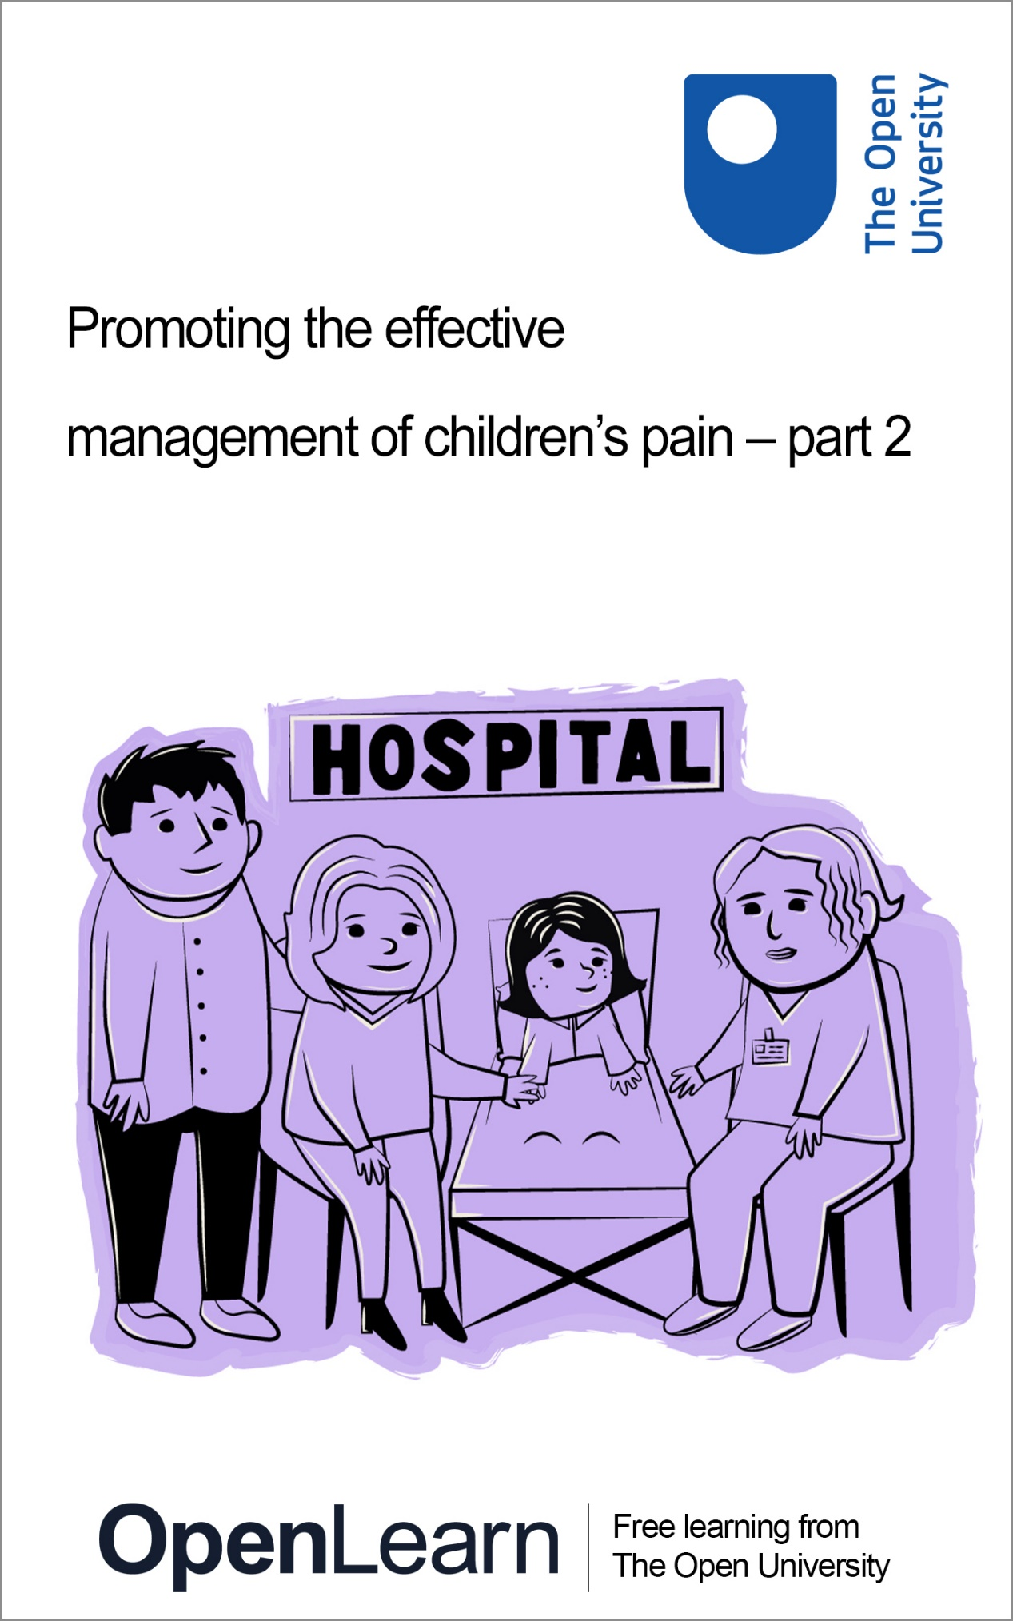

PAIN_2

Promoting the effective management of children’s pain – part 2

About this free course
This free course is an adapted extract from the Open University course .
This version of the content may include video, images and interactive content that may not be optimised for your device.
You can experience this free course as it was originally designed on OpenLearn, the home of free learning from The Open University –
There you’ll also be able to track your progress via your activity record, which you can use to demonstrate your learning.
First published 2024.
Unless otherwise stated, copyright © 2024 The Open University, all rights reserved.
Intellectual property
Unless otherwise stated, this resource is released under the terms of the Creative Commons Licence v4.0 http://creativecommons.org/licenses/by-nc-sa/4.0/deed.en. Within that The Open University interprets this licence in the following way: www.open.edu/openlearn/about-openlearn/frequently-asked-questions-on-openlearn. Copyright and rights falling outside the terms of the Creative Commons Licence are retained or controlled by The Open University. Please read the full text before using any of the content.
We believe the primary barrier to accessing high-quality educational experiences is cost, which is why we aim to publish as much free content as possible under an open licence. If it proves difficult to release content under our preferred Creative Commons licence (e.g. because we can’t afford or gain the clearances or find suitable alternatives), we will still release the materials for free under a personal end-user licence.
This is because the learning experience will always be the same high quality offering and that should always be seen as positive – even if at times the licensing is different to Creative Commons.
When using the content you must attribute us (The Open University) (the OU) and any identified author in accordance with the terms of the Creative Commons Licence.
The Acknowledgements section is used to list, amongst other things, third party (Proprietary), licensed content which is not subject to Creative Commons licensing. Proprietary content must be used (retained) intact and in context to the content at all times.
The Acknowledgements section is also used to bring to your attention any other Special Restrictions which may apply to the content. For example there may be times when the Creative Commons Non-Commercial Sharealike licence does not apply to any of the content even if owned by us (The Open University). In these instances, unless stated otherwise, the content may be used for personal and non-commercial use.
We have also identified as Proprietary other material included in the content which is not subject to Creative Commons Licence. These are OU logos, trading names and may extend to certain photographic and video images and sound recordings and any other material as may be brought to your attention.
Unauthorised use of any of the content may constitute a breach of the terms and conditions and/or intellectual property laws.
We reserve the right to alter, amend or bring to an end any terms and conditions provided here without notice.
All rights falling outside the terms of the Creative Commons licence are retained or controlled by The Open University.
Head of Intellectual Property, The Open University

Contents
- Introduction
- Learning outcomes
- 1 Parent/carer experiences of their child in pain
- 2 Helping parents/carers to feel empowered
- 3 Poor communication
  - 3.1 Overcoming busyness
  - 3.2 Improving the communication between parents/carers and nurses
- 4 Bringing everyone’s views together
- 5 End-of-course quiz
- 6 Conclusion
- References
- Acknowledgements
- Solutions
- Descriptions

Introduction
Welcome to this free OpenLearn course: Promoting the effective management of children’s pain – part 2.
This course is designed primarily for anyone with an interest in effectively managing acute pain experienced by children and young people in hospital up to the age of 18 years.
This is the second of two OpenLearn courses focusing on the effective management of children’s pain. If you haven’t already engaged with the first course or would like to refresh your memory, a link to it is here: Promoting the effective management of children’s pain. The focus of the first course was on why pain matters and how a pain management framework can be used to deliver the effective management of children’s pain. However, studying this is not compulsory or necessary for studying this second course as Promoting the effective management of children’s pain – part 2 is standalone and can be studied in isolation if you prefer.
The focus of this course, Promoting the effective management of children’s pain – part 2, is on how to empower parents/carers to be actively involved in the effective management of their child’s pain in hospital and will be broken up into four main sections:
- Parent/carer experiences of their child in pain
- Helping parents/carers to feel empowered
- Poor communication
  - Overcoming the busy nurse
  - Improving the communication between parents/carers and nurses
- Bringing everyone’s views together.
Each section is designed to take about one hour of study. It is best to tackle them in order, but you can of course, go back and look again over aspects that you would like to revisit for any reason.
You will probably want to make notes as you go along, so choose your preferred method for this, either writing in a notebook or on your computer or tablet. There will also be free response box options inside the activities. Please note anything you add into these boxes will be saved for you to return to, provided you are signed into OpenLearn and enrolled on the course. The information saved is only accessible to you and cannot be viewed by anyone else.
At the end of Section 4 you will find a quiz that will challenge you to answer questions on all the materials you have been studying.
This free course provides a sample of the Open University qualification, BSc (Honours) Nursing (Children and Young People).
Enjoy your course!

Learning outcomes
After studying this course, you should be able to:
- appreciate the lived experiences of parents/carers who have a child in hospital and be confident about what to say to parents/carers facing a similar situation
- recognise nurses’ views on and their rationale for how they deliver pain care
- recognise parents’/carers’, children and young peoples’ views on how to improve the pain management of children in hospital
- understand nurses’ views on how to improve the pain management of children and young people in hospital.

1 Parent/carer experiences of their child in pain
The focus in the first OpenLearn course, Promoting the effective management of children’s pain, was on the four elements that make up the framework for the delivery of effective pain management to children in hospital (Figure 1). Watch Animation 1 which summarises the key points for each section of the framework.

Video content is not available in this format.
Animation 1
View transcript - Animation 1

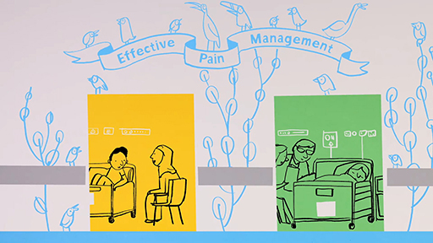
View alternative description - Uncaptioned Figure

This course will predominantly focus on how parents/carers can be empowered to be involved in the management of their child’s pain whilst in hospital. You will look at the findings of two studies. The first study focuses on parents/carers’ views of how they can engage more with nurses and healthcare professionals when their child is in hospital and experiencing pain (Simons and Plowright Pepper, 2024), and the second involves cognitive interviews with nurses, parents and children and young people (Simons et al., 2024). The course will also include findings from other published work focussing on the management of children’s pain in hospital.

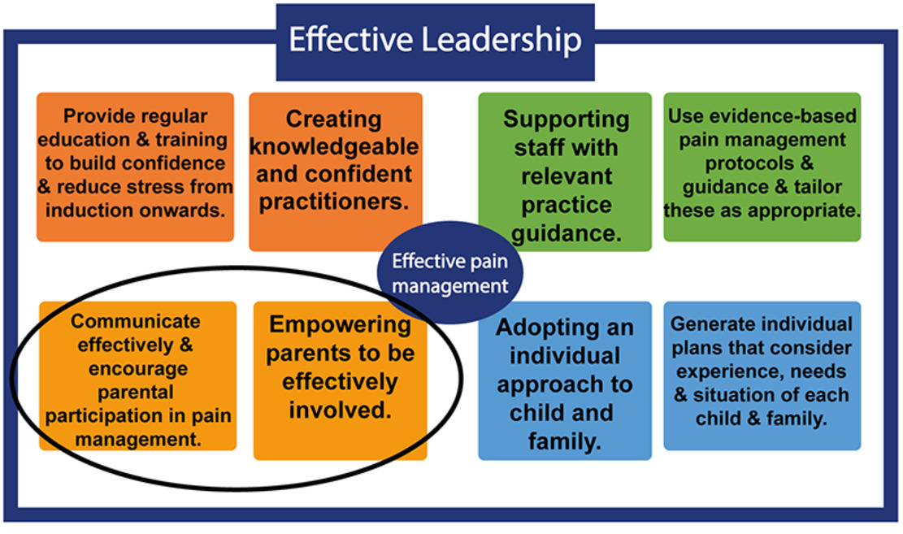
Figure 1 Framework for delivering effective pain management (Simons et al., 2020)
View description - Figure 1 Framework for delivering effective pain management (Simons et al., 2020 ...

Hospital experiences often involve pain, with up to 80% of hospitalised children having at least one painful procedure every 24 hours, with a mean of 6.3 painful procedures per day (Kammerer et al., 2022). Understandably, for parents/carers with children in hospital, the experience is often stressful and difficult. Eccleston et al. (2021), in the first ever Child and Adolescent UK Health Commission on children’s pain, calls for parents/carers to be involved in decisions relating to pain management in their infants and children, so that their views and values are considered.
Parent participants in Simons and Plowright Pepper’s study (2024) described hospitalisation as ‘stressful, bewildering, quite frustrating’ and that often ‘parents can feel quite lost’. When compounding this with their child also being in pain, parents described feeling helpless, intimidated, nervous, worried, not in control, anxious and guilty.
One study participant said: ‘You feel you’re letting down your child if they are in pain’, whilst another said they ‘feel a bit hopeless’ (Simons and Plowright Pepper, 2024).
Many parents also experience feelings of guilt when their child is in pain with one saying: ‘A lot of the parents think that they’ve signed the consent and sent their children to theatre and now their child is in pain, so it’s their fault and they blame themselves for the children being in so much pain.’ Parents reported feeling that they should be part of the team caring for their child in hospital and that providing pain relief was one of the ‘basics’ parents should be able to offer (Simons and Plowright Pepper, 2024).
Empowering parents/carers to be effectively involved in the management of their children’s pain can help to alleviate some of these feelings of guilt, as well as minimise the child’s pain. In the following sections you will look at some of the things that are currently helping and hindering this from happening, before turning to look at how nurses and parents/carers can work together.

2 Helping parents/carers to feel empowered
A number of studies focussing on the prevalence of children’s pain in hospital suggest that a key factor likely to be contributing to this high prevalence is a lack of parental involvement in the management of their child’s pain. Yang et al. (2022) conducted a randomised controlled trial (RCT) with 413 children aged 1–7 years and their parents and found that when parents participated in a Parent Participation Programme intervention, pain scores were significantly lower in the intervention group than in the control group. Jenkins et al. (2019) evaluated the impact of nurse and parent training using a pre-post design and found that when nurses and parents work together, they help reduce children’s pain postoperatively. Despite this, parents have been found to be reluctant to report post-surgical pain, which can result in children experiencing unnecessary pain (Bakir et al., 2023).
To help alleviate this reluctance and feel more at ease, parents reported that they appreciate nurses who spend time with their child and get to know them, listen to their child and them as a parent, and believe them rather than seeing them as unnecessarily anxious (Simons et al., 2024). A recent study by Bakir et al. (2022) revealed that parents reported needing open communication with nurses where they are listened to and have the right to voice their concerns. This helps the child feel seen and the parent be involved in their child’s pain care.


Figure 2 Open communication between parents/carers and nurses is important
View description - Figure 2 Open communication between parents/carers and nurses is important

For parents/carers, knowing a nurse’s name is helpful, as is having a nurse checking in with them regularly and asking about their child’s pain, as often parents/carers are hesitant to bother nurses or doctors for fear of interrupting or disturbing them (Simons and Plowright Pepper, 2024). Some parents/carers like to be given options like a pain scale rating from 0–10, when being asked about their child’s pain.
Being told what to expect regarding pain and understanding when their child is due medication for pain, also helps parents/carers feel more in control. Having nurses explain that they are there to help parents/carers and encourage them to approach them if they need help is reassuring for parents/carers.
Good communication between parents/carers and nurses is one of the primary factors in empowering parents/carers to be effectively involved in the management of their child’s pain. This is because children are more likely to tell their parents/carers than a nurse that they are in pain, meaning parents/carers play a crucial role in communicating this to nurses who are then able to act and relieve the pain. However, in a study by Vasey et al. (2019), parents, children and nurses explained that it is often poor communication that occurs, which creates obstacles to the effective management of a child’s pain.
You will look at this in more detail in the next section after you have completed Activity 1.

Activity 1 Parents/carers and pain
This activity should take approximately 10 minutes

Watch the short animation and make a note of two things you think would help a parent/carer become more involved in managing their child’s pain in hospital where you work.
Is there anything you could do to build the confidence of parents/carers who hesitate to approach a nurse when their child is in pain?

Video content is not available in this format.
Animation 2
View transcript - Animation 2

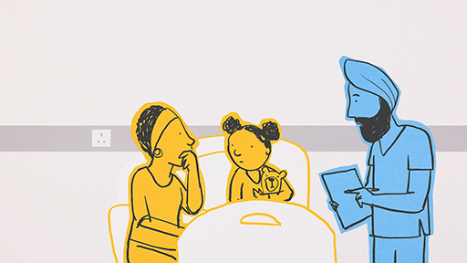
View alternative description - Uncaptioned Figure

Provide your answer...
View comment - Activity 1 Parents/carers and pain

3 Poor communication
A child’s admission to hospital is often a scary and daunting prospect. However, Simons et al. (2024) revealed that some nurses sometimes forget to explain to a child and parent how hospital works. This can add to the feelings of anxiety.
For more than 20 years, it has been recognised that poor communication between nurses and parents contributes to children experiencing unnecessary pain (Simons et al., 2001; Simons and Roberson, 2002). Poor parent–nurse communication has also been reported as the main reason for dissatisfaction related to postoperative pain management among parents (Valizadeh et al., 2016; Nascimento et al., 2010).
Kampouroglou et al. (2020) explored the issue of parental health literacy and noted that where parents have low levels of health literacy they experienced higher levels of parental anxiety. Therefore, a lack of understanding on the parents’/carers’ part around how hospitals work can be stress inducing and can mean parents/carers are unaware that they need to alert a nurse to their child’s pain.

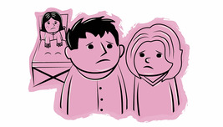
Figure 3 A child’s admission to hospital is often a scary and daunting experience
View description - Figure 3 A child’s admission to hospital is often a scary and daunting experienc ...

As a result of a parent/carer not immediately approaching a nurse when their child is in pain, pain levels can escalate. Not only does this lead to the child experiencing unnecessary pain, but by the time a parent/carer approaches a nurse about their child’s pain they may be tense, anxious and frustrated about waiting for help. Unfortunately, nurses who have been busy elsewhere won’t be aware of this build-up.
Moreover, differences in how different parents/carers and nurses respond to a given situation can make ensuring effective communication difficult. For example, one nurse taking part in the Simons et al. study (2024) commented: ‘Some parents just don’t want to speak. Some parents don’t want to bother us. Some parents on the other side want to shout at us.’
Nurses also provide care in different ways depending on their individual practice and personality (Simons et al., 2024) as suggested by the following quotes:

‘I do genuinely think it’s just nurse specific – how they approach the situations.’

‘I know all nurses know what they should be doing, but some people don’t necessarily say the same things.’

‘I genuinely think it’s a lack of communication culture.’

So, parents/carers can experience different levels of engagement and care, depending on which nurse is looking after their child.

Activity 2 Parent–nurse communication
This activity should take approximately 10 minutes

1. Choose one thing discussed in this section that hindered a parent/carer approaching a nurse for help and identify one key change a nurse could make to help empower parents/carers to seek help when their child is in pain.

Provide your answer...
View comment - Part

2. Identify one key change a parent/carer could make to get help when their child is in pain.

Provide your answer...
View comment - Part

You will now look at one of the primary challenges parents/carers face when trying to communicate with a nurse about their child’s pain: nurse busyness.

3.1 Overcoming busyness
For parents/carers of children in hospital, the busyness of a nurse often acts as a deterrent to approaching them, even when their child is in pain (Simons et al., 2024):

‘You see how busy nurses are and you think of all the other children that they’re trying to look after’.

One parent summed up the busy nurse with the following:

‘You can tell when a nurse is overstretched. She doesn’t smile, she becomes unapproachable. She just wants to come in, give the medication and be out again. She doesn’t want to have chit-chat, she doesn’t want to do that because she’s almost constantly chasing her tail or trying to catch up. And if I notice that this is what’s happening it makes me a little bit reluctant to ask for what my young person may need.’
(Simons et al., 2024)

Kammerer et al. (2022) found that families feel that they must advocate for better pain care for children in hospital, but often feel too intimidated to do so, or worry that their concerns will be dismissed by healthcare professionals.
Families want healthcare professionals to proactively manage their children’s pain. However, Choueiry et al. (2024), who interviewed 11 nurses on parent–nurse relationships, found that when nurses have heavy workloads they tend to rely on parents for pain care of their children. Simons et al. (2024) also found that nurses reported similar frustrations, acknowledging that while they recognise that it is not always easy to approach a nurse, when the ward gets busy they rely on parents/carers coming to tell them if their child is in pain:

‘I always find if quite frustrating because I think we are busy, but that’s because we expect the parents to tell us if there’s any issues….., it’s not their problem if we’re busy, there’ll always be time made for stuff, or there’ll be delegation that we can do in order to make time if we’re not able to provide, to feel like we’re there… I feel bad for them that they feel like we’re too busy to spend time with them, whereas that’s often not the case’.

This reliance on parents/carers, compounded by a reluctance on the part of parents/carers to approach a nurse, may explain why some children’s pain is not effectively managed. Nurses agree that when a parent/carer isn’t confident in approaching a nurse they can hesitate or delay getting help when their child is in pain. This can lead to the parent/carer becoming anxious, which can then lead to a tense encounter with a nurse.


Figure 4 When nurses are busy they can seem unapproachable to parents/carers
View description - Figure 4 When nurses are busy they can seem unapproachable to parents/carers

There appears to be a lack of connection or relationship between parents/carers and nurses. The importance of building relationships with parents/carers is highlighted in a study by Andersson et al. (2022) who carried out a quantitative cross-sectional study of 69 hospitalised children aged 6–18 years, and found that half of the children/adolescents experienced moderate to severe pain. Of those children who experienced pain, six did not tell staff about their pain and five told their parents instead, meaning their likelihood of receiving pain relief was considerably reduced.

Activity 3 The busy nurse
This activity should take approximately 10 minutes

With current staffing levels of children’s wards as they are, nurses are busy for most of their shift. This puts parents/carers off approaching them for help when their child is in pain. In spite of their busyness, nurses report wanting parents/carers to approach them.
This situation contributes to children experiencing unnecessary pain.
- What change in ward practice would make a difference for the nurse?
- What in your view would make a difference on the part of the parent/carer?

Provide your answer...
View discussion - Activity 3 The busy nurse

3.2 Improving the communication between parents/carers and nurses
The inclusion of parents/carers in the care of their child has now been endorsed by the World Health Organisation, who on their Patient Safety Day 2023 recognised the ‘crucial role patients, families and caregivers play in the safety of health care. Evidence shows that when patients are treated as partners in their care, significant gains are made in safety, patient satisfaction and health outcomes’ (Paisley, 2023).
Like parents/carers, nurses recognise that communication is central to managing a child’s pain in hospital, and that the nurse has a role to be proactive in encouraging parents/carers to be involved. To aid this and empower parents/carers, a parent’s/carer’s judgement should be given the benefit of the doubt and parents/carers should let the nurse know when their child is in pain.
However, in the study by Simons et al. (2024), parents recounted negative experiences such as having their concerns dismissed, not being listened to when their child was in pain or being told their child was not due any more medication. They also reported their child being in pain when the nurses gave the lower dose of analgesia, or when nurses avoided giving morphine when it was prescribed.

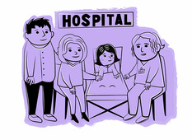
Figure 5 Nurse should encourage parents/carers to be involved in their child’s pain management
View description - Figure 5 Nurse should encourage parents/carers to be involved in their child’s pain ...

Simons et al. (2024) also found that nurses were aware of comments made to parents by professionals that were unhelpful, such as ‘There’s nothing we can give him’ and recognised that such responses can seem defeatist and negative. Offering alternative pain relief through nonpharmacological methods, such as distraction, could help the child to feel more comfortable, although some nurses suggested that ‘there’s numerous drugs that you can give’ and using an ‘escalation policy’ when a child is in pain could help the situation. Policies such as this allow nurses to work flexibly to attempt to relieve a child’s pain in a more holistic way.
Nurses as well as parents made a number of suggestions about ways to communicate key information to parents/carers, such as posters to explain about pain (Simons et al., 2024). Posters allow parents/carers to gain a helpful insight into pain and its management, which could help them feel more confident. You can view an example of a poster here.
Nurses also suggested that parents/carers could feel more empowered if they understood how hospitals worked, what the normal routines are and who to approach to get help when a child is in pain.

4 Bringing everyone’s views together
In this final section of the course, you will focus on bringing the views of nurses and parents/carers together and create actions for each to take to help build trust and improve the management of a child’s pain whilst in hospital.

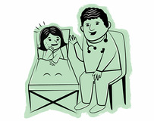
Figure 6 Reducing a child’s level of pain is the target for everyone
View description - Figure 6 Reducing a child’s level of pain is the target for everyone

Based on parent and nurse feedback (Simons et al., 2024; Simons and Plowright Pepper, 2024) the following are suggested as actions to take:

Nurses should:
- start the day by giving the parent/carer their name
- identify pain management at the start of a shift as a priority
- provide parents/carers with information about how their child’s pain will be managed
- give information to parents/carers gradually to help them take it in
- assess the child’s pain level regularly.

Parents/carers should:
- approach any nurse for help when their child is in pain and not necessarily their child’s assigned nurse who may be unavailable
- build up a relationship with the nurse looking after their child, go to the nurse at any time if they have a concern and not wait if their child is in pain
- ask questions and know that they ‘are not being a nuisance’ and ‘there are no silly questions’
- trust the nurses and doctors to help when their child has pain.
For parents/carers, parent/carer empowerment is strongly dependent on the relationship the parent/carer has with the nurse. Having parents/carers and nurses work together as a team is in the best interests of the child in pain.

Activity 4 PAIN mnemonic
This activity should take approximately 10 minutes

Watch this short animation for nurses and answer the following questions:
- How useful is the PAIN mnemonic for nurses to help improve the management of children’s pain in hospital?
- If you were given responsibility for sharing it with parents/carers, what method would you use and why?
- What difference would each of the four sections of the mnemonic (PAIN) make to parents/carers?

Video content is not available in this format.
Animation 3
View transcript - Animation 3

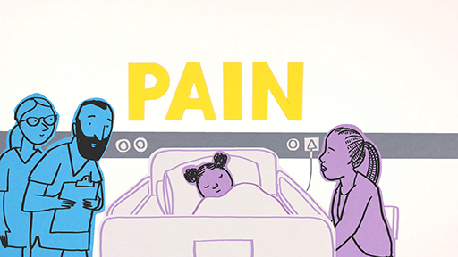
View alternative description - Uncaptioned Figure

Provide your answer...
View discussion - Activity 4 PAIN mnemonic

5 End-of-course quiz
Now that you are coming to the end of the course, test your knowledge with this short quiz.
End-of-course quiz.
Open the quiz in a new window or tab then come back here when you’ve finished.

6 Conclusion
You’ve come to the end of the course – well done. The course explored the experiences of parents/carers when their child is in hospital, as well as the views of nurses on how they interact with parents/carers and manage children’s pain. Both parents/carers and nurses have provided insight into some of the challenges of managing children’s pain, but have also made suggestions as to how to improve the communication between each other to improve the management of children’s pain in hospital.

References
Andersson, V., Bergman, S., Henoch, I., Simonsson, H. and Ahlberg, K. (2022) ‘Pain and pain management in children and adolescents receiving hospital care: a cross-sectional study from Sweden’, BMC Pediatrics, 22(1), pp. 252.
Bakir, E., Briggs, M., Mackintosh-Franklin C., Marshall, M. and Achaliwie, F. (2023) ‘Communication, information, involvement and decision making: A systematic scoping review of child–parent-nurse relationships during postoperative pain management’, Journal of Clinical Nursing, 32(15–16), pp. 4337–4361. DOI: 10.1111/jocn.16655.
Choueiry, J., Chartrand, J.,Harrison, D. and Don, A. (2024) Pain care for children with cognitive impairment: A parent-nurse partnership, Journal of Pediatric Nursing. 77: e139-e149, ISSN 0882-5963, https://doi.org/10.1016/j.pedn.2024.04.002.
Eccleston, C., Fisher, E., Howard R.F., Slater, R., Forgeron, P., Palermo, T.M., Birnie, K.A., Anderson, B.J., Chambers, C.T., Crombez, G., Ljungman, G., Jordan, I., Jordan, Z., Roberts, C., Schechter, N., Sieberg, C.B., Tibboel, D., Walker, S.M., Wilkinson, D. and Wood, C. (2021) ‘Delivering transformative action in paediatric pain: A Lancet Child & Adolescent Health Commission’, The Lancet. Child & Adolescent Health, 5(1), pp. 47–87. DOI: 10.1016/S2352-4642(20)30277-7.
Jenkins, B.N., Fortier, M.A., Stevenson, R., Makhlouf, M., Lim P., Converse R. and Kain Z.N. (2019) ‘Changing healthcare provider and parent behaviors in the pediatric post‐anesthesia‐care‐unit to reduce child pain: Nurse and parent training in postoperative stress’, Paediatric anaesthesia, 29, pp. 730–737.
Jordan, A., Carter, B. and Vasileiou, K. (2021) ‘“Pain talk”: A triadic collaboration in which nurses promote opportunities for engaging children and their parents about managing children’s pain’, Paediatric and neonatal pain, 3(3), pp. 123–133. Available at: https://doi.org/10.1002/pne2.12061.
Kammerer, E., Eszczuk, J., Caldwell, K., Dunn, J., Appelman-Eszczuk, S., Dunn, J., MacNeil, M. and Ali, S. (2022) ‘A Qualitative Study of the Pain Experiences of Children and Their Parents at a Canadian Children’s Hospital’, Children, 9(12), pp. 1796. Available at: https://doi.org/10.3390/children9121796.
Kampouroglou, G., Velonaki, V-S., Pavlopoulou, I., Drakou, E., Kosmopoulos, M., Kouvas, N., Tsagkaris, S., Fildissis, G., Nikas, K. and Tsoumakas, K. (2020) ‘Parental anxiety in pediatric surgery consultations: the role of health literacy and need for information’, Journal of Pediatric Surgery, 55(4), pp. 590–596.
Nascimento, L. C., Strabelli, B. S., de Almeida, F. C., Rossato, L. M., Leite, A. M. and de Lima, R. A. (2010) ‘Mothers’ view on late postoperative pain management by the nursing team in children after cardiac surgery’, Revista Latino-Americana de Enfermagem, 18(4), pp. 709–715. Available at: https://doi.org/10.1590/s0104-11692010000400008.
Paisley, A. (2023) ‘WHO World Patient Safety Day 2023: Engaging Patients for Patient Safety’, The Royal College of Surgeons of Edinburgh, 1 September. Available at: https://www.rcsed.ac.uk/news-public-affairs/the-rcsed-blog/2023/september/who-world-patient-safety-day-2023-engaging-patients-for-patient-safety (Accessed: 3 September 2024).
Simons, J., Franck, L. and Roberson, E. (2001) ‘Parent involvement in children’s pain care: Views of parents and nurses’, Journal of Advanced Nursing, 36(4), pp. 591–599. Available at: https://doi. org/10.1046/j.1365-2648.2001.02012.
Simons, J. and Roberson, E. (2002) ‘Poor communication and knowledge deficits: Obstacles to effective management of children’s postoperative pain’, Journal of Advanced Nursing, 40(1), pp. 78–86. Available at: https://doi. org/10.1046/j.1365-2648.2002.02342.
Simons, J., Carter, B. and Craske, J. (2020) ‘Developing a framework to support the delivery of effective pain management for children: an exploratory qualitative study’, Pain Research and Management, 2020(1). Available at: https://doi.org/10.1155/2020/5476425.
Simons J. and Plowright Pepper C. (2024) ‘Parent involvement in the management of their child’s pain in hospital: parents’ views’. Unpublished.
Simons, J., Craske, J. and Plowright Pepper C. (2024) ‘Improving nursing care delivery of pain management to children through engagement with nurses, parents and children’. Unpublished.
Valizadeh, F., Ahmadi, F. and Zarea, K. (2016) ‘Neglect of postoperative pain management in children: a qualitative study based on the experiences of parents’, Journal of Pediatric Nursing, 31, pp. 439–448.
Vasey, J., Smith, J., Kirshbaum, M.N. and Chirema, K. (2019) ‘Tokenism or true partnership: Parental involvement in a child’s acute pain care’, Journal of Clinical Nursing, 28, pp. 9–10.
Yang J-X., Yao, W-Y., Zhang, F., Jiang, W-T., Gu, Y. and Xu, H-Z. (2022) ‘The effectiveness of a parent participation in postoperative pain management programs for children in a urology ward: A randomized controlled trial’, Journal of Nursing Scholarship, 54(5), pp. 554–561.

Acknowledgements
This free course was written by Professor Joan Simons.
Except for third party materials and otherwise stated (see terms and conditions), this content is made available under a Creative Commons Attribution-NonCommercial-ShareAlike 4.0 Licence.
The material acknowledged below is Proprietary and used under licence (not subject to Creative Commons Licence). Grateful acknowledgement is made to the following sources for permission to reproduce material in this free course:

Figures
Figure 1: Framework for delivering effective pain management: in Simons, J., Carter, B. and Craske, J. ‘Developing a Framework to Support the Delivery of Effective Pain Management for Children: An Exploratory Qualitative Study’, Pain Research and Management Article ID 5476425. Available at: https://doi.org/10.1155/2020/5476425. https://creativecommons.org/licenses/by/4.0/

Posters
How you can help your child if they are in pain in hospital: Royal College of Nursing, The Open University, Edge Hill University, Alder Hey Children's Hospital

Animations
Animation 1: A Framework For Children’s Pain: https://www.youtube.com/watch?v=9r3XMKcFERk made in collaboration with The Open University, Edgehill University and Alder Hey Children’s NHS Foundation Trust
Animation 2: Involving parents in managing child’s pain: https://youtu.be/7Ef-mmU856Amade in collaboration with The Open University, Edgehill University, Alder Key Children’s NHS Foundation Trust and WellChild
Animation 3: Children’s Pain (Nurses): https://www.youtube.com/watch?v=bhjl70odwpo made in collaboration with The Open University, Edgehill University, Alder Key Children’s NHS Foundation Trust and The General Nursing Council for England and Wales Trust
Every effort has been made to contact copyright owners. If any have been inadvertently overlooked, the publishers will be pleased to make the necessary arrangements at the first opportunity.
Don’t miss out
If reading this text has inspired you to learn more, you may be interested in joining the millions of people who discover our free learning resources and qualifications by visiting The Open University – www.open.edu/openlearn/free-courses.

Solutions

Activity 1 Parents/carers and pain

Comment
Nurses should:
- Encourage rapport building with parents/carers as this helps them feel that they can approach their nurse when needed.
- Explain to parents/carers it is helpful for them to let their nurse know if their child is in pain and that this will allow them to keep their child comfortable.
Back to - Activity 1 Parents/carers and pain

Activity 2 Parent–nurse communication

Part

Comment
Parents/carers whose child is in pain often hesitate before finding a nurse, which can mean their child’s pain escalates. If parents/carers are confident in approaching their nurse, such a delay can be avoided.
Nurses who encourage parents/carers to find them if their child is in pain, and check in regularly with parents/carers, are more likely to be seen as approachable by parents/carers, empowering them to seek help when needed if their child is in pain.
Back to - Part

Part

Comment
A study by Jordan et al. (2021) identified ‘pain talk’ as a process which involves nurses talking to children and parents about pain and creating engagement opportunities for children and parents. This was perceived by participants to be essential in ensuring that both the child and the parent were central to discussions and decisions made in relation to the child’s experience of pain.
Back to - Part

Activity 3 The busy nurse

Discussion
Nurses have reported that because recording pain scores is not part of auditing like recording fluid balance, it is sometimes not given the same priority. If pain score records were given a higher priority and visibility it is likely that, despite being busy, nurses would make pain assessment a higher priority.
Providing parents/carers with information such as how hospitals work, how pain is managed in hospital and when their child’s analgesia is due, can give parents the confidence to approach a busy nurse.
Back to - Activity 3 The busy nurse

Activity 4 PAIN mnemonic

Discussion
Many studies have found a longstanding problem in how nurses and parents/carers communicate in relation to children’s pain. By consciously working together to communicate better, by nurses being proactive in their communication about pain, and by parents/carers feeling more confident in approaching a nurse when their child is in pain, there is a greater likelihood of preventing children in hospital experiencing unnecessary pain.
Back to - Activity 4 PAIN mnemonic

Descriptions

Uncaptioned Figure
Back to - Uncaptioned Figure

Figure 1 Framework for delivering effective pain management (Simons et al., 2020)
A diagram with Effective leadership titled at the top.
In the centre, there is the label: Effective pain management, and there are four sections surrounding the centre.
From the top right, there are two boxes:
- Supporting staff with relevant practice guidance.
- Use evidence-based pain management protocols & guidance & tailor these as appropriate.
Then below this, bottom right, there are two boxes:
- Adopting an individual approach to child and family.
- Generate individual plans that consider experience, needs & situation of each child & family.
To the left of this, bottom left, there are two boxes. These are encircled:
- Empowering parents to be effectively involved.
- Communicate effectively & encourage parental participation in pain management.
Above this, top left, there are two boxes:
- Provide regular education & training to build confidence & reduce stress from induction onwards.
- Creating knowledgeable and confident practitioners.
Back to - Figure 1 Framework for delivering effective pain management (Simons et al., 2020)

Figure 2 Open communication between parents/carers and nurses is important
A sketch of three people, one is wearing a name tag. All three people are smiling.
Back to - Figure 2 Open communication between parents/carers and nurses is important

Uncaptioned Figure
Back to - Uncaptioned Figure

Figure 3 A child’s admission to hospital is often a scary and daunting experience
Two parents/carers standing in the foreground looking sad/stressed. Behind them is a girl sat in bed.
Back to - Figure 3 A child’s admission to hospital is often a scary and daunting experience

Figure 4 When nurses are busy they can seem unapproachable to parents/carers
A healthcare professional looking sad/stressed.
Back to - Figure 4 When nurses are busy they can seem unapproachable to parents/carers

Figure 5 Nurse should encourage parents/carers to be involved in their child’s pain management
Two adults and a healthcare professional sitting/standing by a bed with a young girl in it. All are smiling.
Back to - Figure 5 Nurse should encourage parents/carers to be involved in their child’s pain management

Figure 6 Reducing a child’s level of pain is the target for everyone
A healthcare professional sitting and smiling next to a bed with a young girl in it who is also smiling
Back to - Figure 6 Reducing a child’s level of pain is the target for everyone

Uncaptioned Figure
Back to - Uncaptioned Figure

Animation 1

Transcript
SPEAKER:
When children are in hospital, managing any pain they experience is essential. But it’s not always done effectively. Many parents leaving hospital report that their child experienced a lot of pain during their stay, but they also feel positive about the care they received, which means something isn’t working.
Following extensive research with pain specialists across the UK and internationally, we’ve developed a framework for delivering effective pain management for children. There are four components. The first is creating knowledgeable, confident practitioners. Many nurses can feel nervous about giving too much pain medicine. And when nurses are not feeling confident, they may administer less than what’s been prescribed to be on the safe side.
The second element is the support given to those staff. Making sure they have access to relevant protocols ensures that they rely less on their own judgment and more on proven best practice. Pain protocols with well-evidenced guidelines for predictable scenarios are usually created by dedicated teams after a lot of hard work. But when the whole hospital implements them, they are shown to make effective pain management easier to achieve.
Thirdly, nurses need to involve parents and treat them as partners. After all, they have unique expertise when it comes to their child. But parents are often reluctant to point out that their child’s pain is not going away, so they need to be encouraged to speak up. Practitioners want to help, but if they don’t know a child is in pain, they can’t do anything about it.
Lastly, it’s important to take an individual approach to both the child and their family. Talking and listening to each child and finding out about their experience, understanding fears, likes, and dislikes makes it more likely that their pain can be managed effectively.
To be effective, all four components need to happen with everyone at all levels playing their part. If all practitioners start using this framework together, it can contribute to managing children’s pain a lot more effectively.
Back to - Animation 1

Animation 2

Transcript
SPEAKER:
Many children will need to stay in hospital at some point in their lives. For most, the experience won’t have a lasting impact. But for some, it can be an anxious time. One reason for this can be unrelieved pain. We’re working with parents, doctors, and nurses to improve this.
When a child in hospital has pain, a few things usually need to happen for it to be managed effectively. The child needs to tell someone they have pain. That could be their nurse or doctor, parent, or carer. If the nurse or doctor isn’t aware of the child’s pain, the parent may need to tell them about it.
Sometimes, parents don’t feel comfortable asking a nurse or doctor for pain medication. Parents told us that in this situation, they feel nervous or worried about asking for help. They worried about seeming too demanding. And some said you need to be confident to approach the nurses and doctors.
Others said they felt lost in hospital, and worried they would look foolish if they didn’t understand their child’s treatment. And when their child was in pain, they hesitated to bother nurses and doctors as they are so busy.
But we also spoke to parents who approached the nurse or doctor caring for their child and received the help they needed to manage their pain. These parents described being told by nurses and doctors, you can’t bother us too much. And if you need anything, just come and get us.
This meant they could approach the nurse or doctor who then helped with their child’s pain. We also spoke to nurses and doctors about encouraging parents to ask for help. They told us they want to work with parents to manage their child’s pain. If they haven’t picked up on it, they want parents to tell them.
They said parents know their own child best and how they deal with pain. If you are in hospital with your child and they are in pain, remember the nurse or doctor wants to make your child comfortable. They need to know about it so they can help.
If you’re not sure what to say to the nurse or doctor, you could start with some of the following: I don’t think my child’s pain medicine is working properly. I think my child is still uncomfortable. I don’t know why they are getting pain. I want to help my child to cope, but don’t know how. I don’t understand how the medicine is supposed to work.
By working together, nurses, doctors, and parents can reduce the number of children who experience pain during a hospital stay.
[MUSIC PLAYING]
[TEXT ON SCREEN: So remember... You know your child better than anyone and can be their voice. No question is a silly question and it’s important to ask if you don’t understand. The nurses ad doctors are there to help and want to make your child as comfortable as possible.]
Back to - Animation 2

Animation 3

Transcript
[MUSIC PLAYING]
SPEAKER:
When a child is in pain, the relationship between parents and nurses is really important. We’re working with nurses, parents, children, and young people to understand how we can better manage children’s pain in hospital.
Some parents told us they are reluctant to bother a busy nurse, which can lead to lots of waiting. If a parent is unable to get help and their child’s pain escalates, it can leave them feeling helpless and like they’re letting them down. Parents say that waiting for a nurse is stressful, and they try different ways to help their child.
Nurses empathise with parents and want to help. They tell parents, "It doesn’t matter if we’re busy. Come and find us. Just grab us." But despite these messages, parents assume nurses are busy elsewhere and remain concerned about adding to their workload. Getting a child pain relief is always top priority for a parent, but nurses are juggling multiple care priorities. Nurses told us they never want to leave a child in pain, but if they don’t know, other things that need recording, like fluid balance, can be given higher priority.
Pain is invisible. And some nurses told us that they used their own judgment. And if a child looked OK, they didn’t ask them about their pain. A child in pain, a busy nurse, and an anxious parent can lead to frustration, misunderstanding, and terse exchanges. So how can we communicate better to minimise this?
Nurses and parents said that feeling confident and empowered were key. For nurses, this confidence allows them to be flexible and use different strategies to help with the child’s pain. Parents told us these things gave them confidence: being reminded to seek help from a nurse, nurse is listening to them and their child and showing they understood, the use of pain scores, having information about pain relief medication, and pain relieving strategies.
Nurses can support parents to feel empowered by keeping these questions in mind. Does the parent know what to expect regarding pain? Does the parent know when to expect analgesia next? Has the nurse introduced themselves to the parent and child or young person? Does the parent know where to find a nurse when they need one? By working together and communicating better, we can reduce the number of children who experience pain in hospital.
[MUSIC PLAYING]
[TEXT ON SCREEN: Pain. Analgesia. Introduction. Needing help.]
Back to - Animation 3

