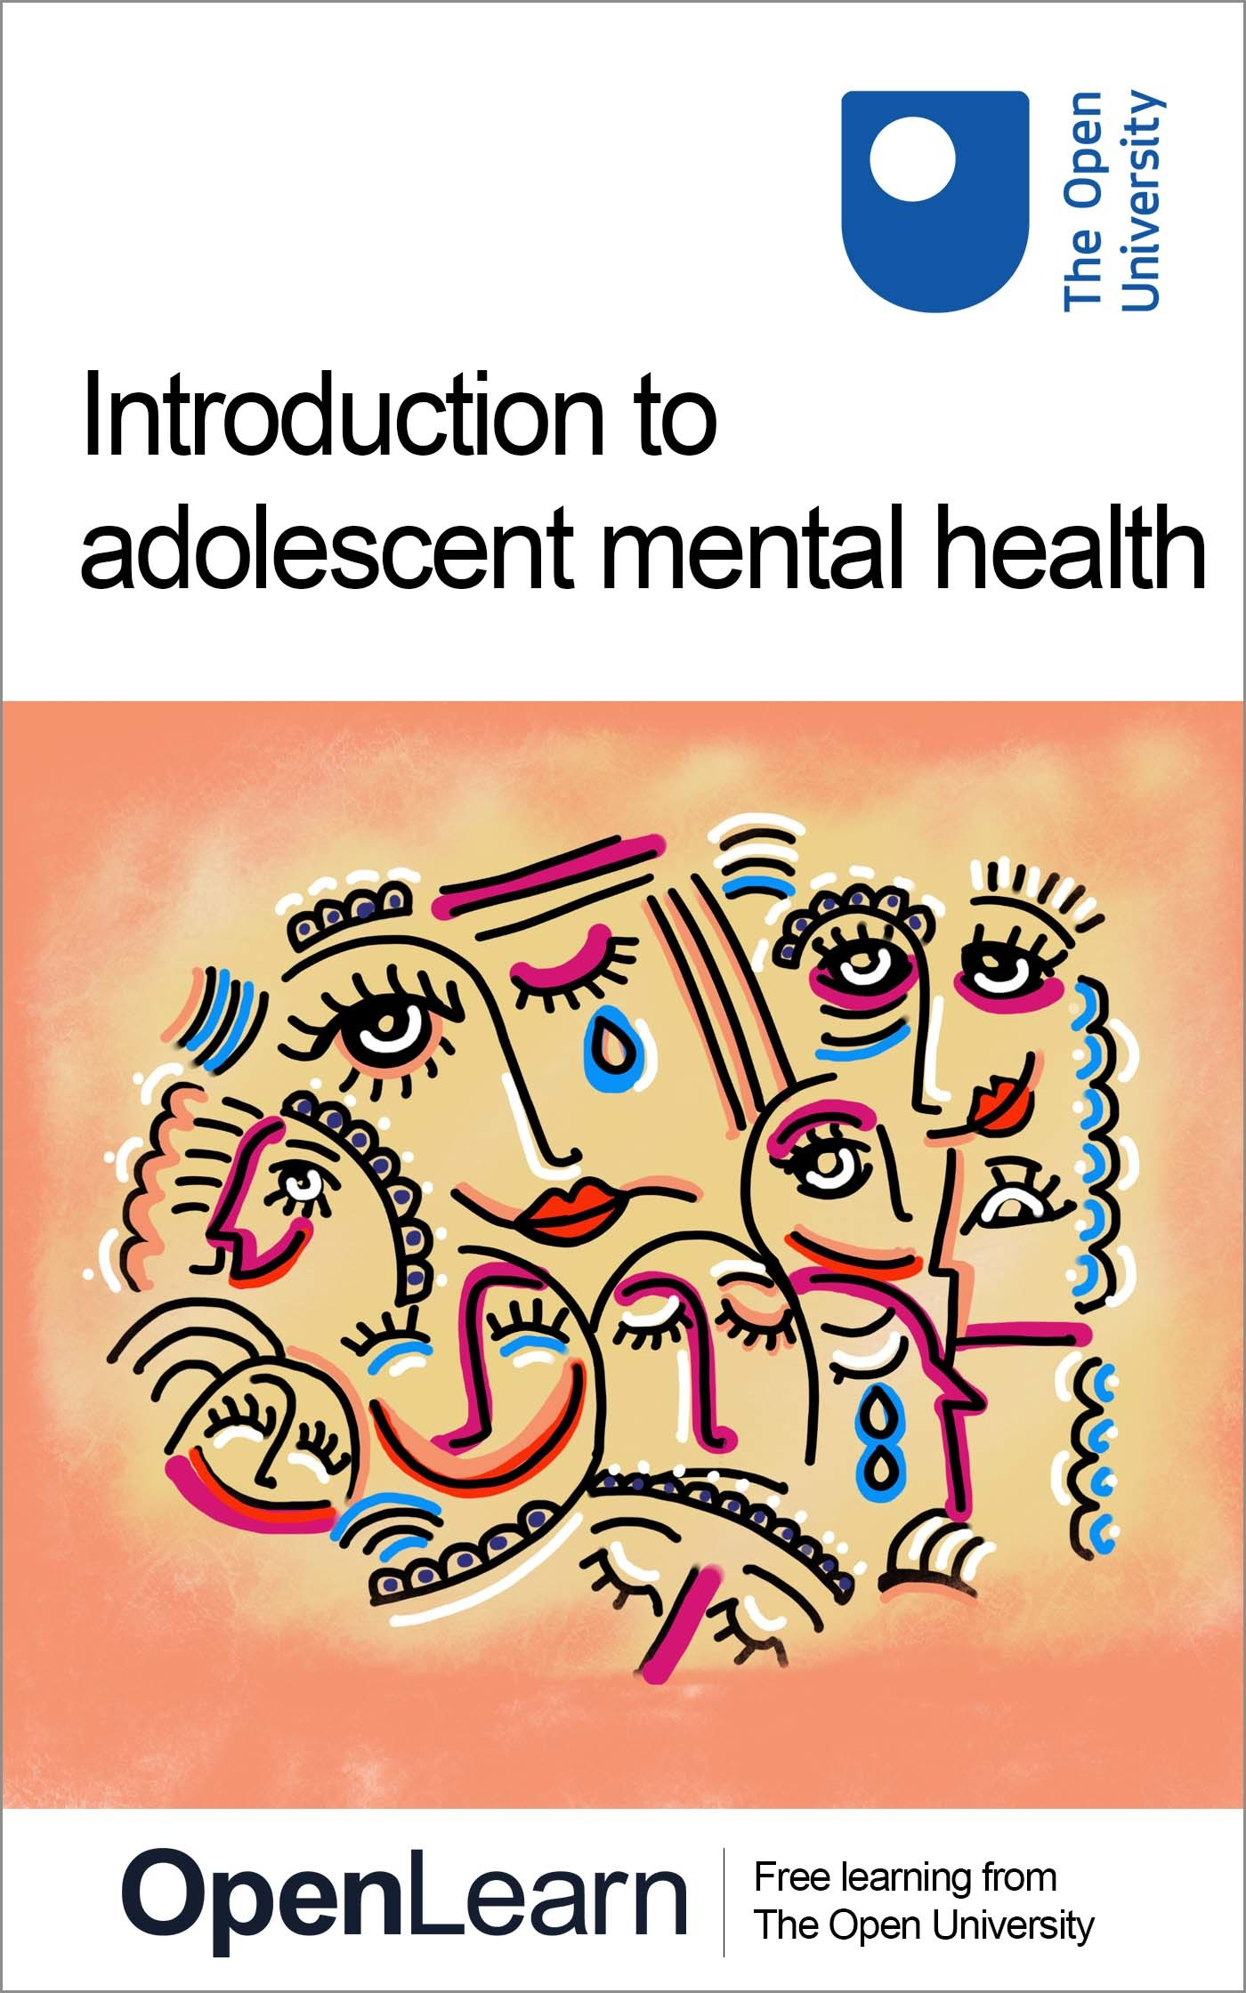

PAIN_1

Promoting the effective management of children’s pain

About this free course
This free course provides a sample of the Open University qualification, BSc (Honours) Nursing (Children and Young People).
https://www.open.ac.uk/courses/nursing-healthcare/degrees/bsc-nursing-children-young-people-r39-cyp
This version of the content may include video, images and interactive content that may not be optimised for your device.
You can experience this free course as it was originally designed on OpenLearn, the home of free learning from The Open University:
https://www.open.edu/openlearn/health-sports-psychology/promoting-the-effective-management-childrens-pain/content-section-0.
There you’ll also be able to track your progress via your activity record, which you can use to demonstrate your learning.
Copyright © 2022 The Open University
Intellectual property
Unless otherwise stated, this resource is released under the terms of the Creative Commons Licence v4.0 http://creativecommons.org/licenses/by-nc-sa/4.0/deed.en_GB. Within that The Open University interprets this licence in the following way: www.open.edu/openlearn/about-openlearn/frequently-asked-questions-on-openlearn. Copyright and rights falling outside the terms of the Creative Commons Licence are retained or controlled by The Open University. Please read the full text before using any of the content.
We believe the primary barrier to accessing high-quality educational experiences is cost, which is why we aim to publish as much free content as possible under an open licence. If it proves difficult to release content under our preferred Creative Commons licence (e.g. because we can’t afford or gain the clearances or find suitable alternatives), we will still release the materials for free under a personal end-user licence.
This is because the learning experience will always be the same high quality offering and that should always be seen as positive – even if at times the licensing is different to Creative Commons.
When using the content you must attribute us (The Open University) (the OU) and any identified author in accordance with the terms of the Creative Commons Licence.
The Acknowledgements section is used to list, amongst other things, third party (Proprietary), licensed content which is not subject to Creative Commons licensing. Proprietary content must be used (retained) intact and in context to the content at all times.
The Acknowledgements section is also used to bring to your attention any other Special Restrictions which may apply to the content. For example there may be times when the Creative Commons Non-Commercial Sharealike licence does not apply to any of the content even if owned by us (The Open University). In these instances, unless stated otherwise, the content may be used for personal and non-commercial use.
We have also identified as Proprietary other material included in the content which is not subject to Creative Commons Licence. These are OU logos, trading names and may extend to certain photographic and video images and sound recordings and any other material as may be brought to your attention.
Unauthorised use of any of the content may constitute a breach of the terms and conditions and/or intellectual property laws.
We reserve the right to alter, amend or bring to an end any terms and conditions provided here without notice.
All rights falling outside the terms of the Creative Commons licence are retained or controlled by The Open University.
Head of Intellectual Property, The Open University

Contents
- Introduction
- Learning outcomes
- 1 Why pain matters
  - 1.1 Way forward
  - 1.2 A pain management framework
- 2 Creating knowledgeable and confident practitioners
  - 2.1 The stress of managing children’s pain
  - 2.2 Alleviating stress for practitioners
  - 2.3 Supporting staff
- 3 Adopting an individual approach
  - 3.1 Parent leaflet
- 4 Empowering parents
  - 4.1 Practitioners views
- 5 End-of-course quiz
- Conclusion
- References
- Acknowledgements
- Solutions

Introduction
Welcome to this free OpenLearn course: Promoting the effective management of children’s pain.
It is designed primarily for anyone with an interest in effectively managing acute pain experienced by children in hospital.
The course is structured in four sections:
- why pain matters
- creating knowledgeable and confident practitioners and supporting staff to access and use relevant practice guidance
- adopting an individual approach to child and family
- empowering parents to be effectively involved in the management of their child’s pain.
Each section is designed to take about one hour of study. It is best to tackle them in order, but you can of course, go back and look again over aspects that you would like to revisit for any reason.
You will probably want to make notes as you go along, so choose your preferred method for this, either writing in a notebook or on your computer or tablet. There will also be free response box options inside the activities. Please note anything you add into these boxes will be saved for you to return to, provided you are signed into openlearn and enrolled on the course. But the information saved is only accessible to you and cannot be viewed by anyone else.
At the end of Section 4 you will find a quiz that will challenge you to answer questions on all the materials you have been studying.
This free course provides a sample of the Open University qualification, BSc (Honours) Nursing (Children and Young People).
Enjoy your course!

Learning outcomes
After studying this course, you should be able to:
- understand the value of creating knowledgeable and confident practitioners
- gain an insight of the need for health care professionals to be supported with relevant practice guidance on pain management
- understand the value of adopting an individual approach to a child and their family
- see the benefit of empowering parents to be effectively involved in the management of their child’s pain.

1 Why pain matters
In this section, which comprises of one hour of study, the history and development of a framework on the effective management of children’s pain will be outlined.
To begin with let us explore why pain matters. Every year in England there are two million hospital admissions of children (Linhares et al 2012). Of these hospital admissions the prevalence of pain is high, ranging from 59% to 94% (Kozlowski et al 2014; Linhares et al 2012) and of that number between 27% and 40% of them experience moderate to severe pain (Groenewald et al 2012). Jenkins et al (2019) who explored how to reduce the experience of pain in the immediate postoperative period, states that child postoperative pain is a significant problem in need of attention. A study of children’s own self report of pain in hospital found that 87% of children reported pain, with 63% reporting a score of greater than 5 (Vejzovic et al 2020). (Based on a rating of 1–10, with 10 being extreme pain and 1 being no pain at all.)
The persistence of high pain rates can have long lasting negative consequences. Poor pain experiences during childhood may also contribute to adverse pain behaviour to subsequent pain events and to development of chronic pain in later life (Twycross, Dowden, & Bruce, 2009).
Attempts have been made to explain the persistence of the high rate of pain experienced by children; Twycross and Finlay (2013) suggest pain management can be opportunistic, simplistic and frequently interrupted. The outcomes of these findings are that children in hospital still experience unnecessary pain.

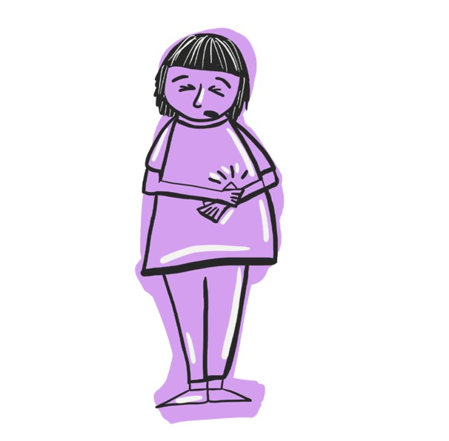
Figure 1: Why pain matters
View description - Figure 1: Why pain matters
View description - Figure 1: Why pain matters

Every child experiences pain. But pain is too often silenced and appropriate relief not given frequently enough. So what has been done to improve the management of children’s pain?
Although the figures above are surprisingly high there has been a significant amount of work carried out in an attempt to reduce the prevalence of pain. Some examples are two well-evidenced guidelines developed by the Royal College of Nursing (2009) and the Association of Paediatric Anaesthetists (2012) developed to guide how pain management should be delivered to children in hospital in the UK. Despite these well-developed guidelines children’s pain prevalence remains high.
Good communication, effective information sharing and clarity about roles can all positively influence the effectiveness of pain management as well as health care practitioners (HCPs) taking a proactive stance on the relief of children’s pain.
However, nurses may not take as active a role as they could do in managing children’s pain, seeing it as the parents and child’s responsibility to inform them when they are experiencing pain (Twycross 2013).

1.1 Way forward
Having looked at the size of the problem and some of the contributory factors of ineffective pain management, let’s look at some ways forward. A study by Vasey et al (2019) which included parents (n=41), children (n=30) and nurses (n=11) found that the involvement of parents can improve the child’s pain experience, as well as reduce parental anxiety and increase parents’ satisfaction in care. Nurses in the study had good intentions to involve parents in pain management, but in practice did not always do so. This finding is supported by other studies that found even when parents attempt to be involved and advocate for their child’s pain care, a lack of communication and information provision and poor negotiation of roles can result in missed opportunities for nurses to work in partnership with parents (Vasey et al 2019; Carter et al 2017; 2016).
In a recent publication Chabot and Ferlanda (2020) who reviewed 10 studies on children’s pain found nurses need to provide parents with more information such as analgesia use. Parents are keen to be involved in their child’s pain management and have been found to use pain relief strategies when nurses share them (Chng et al 2015; Lim et al 2012). However, when their child is in pain parents either hesitate or delay in asking for help from nurses (Valizadeh 2016) but to date there is little evidence of nurses proactively engaging parents in managing their children’s pain whilst in hospital. There is no apparent explanation for this lack of engagement in the literature. Although a study by Twycross (2013) found that nurses may not take as active a role as they could do in managing children’s pain, seeing it as the parents and child’s responsibility to inform them when they are experiencing pain.

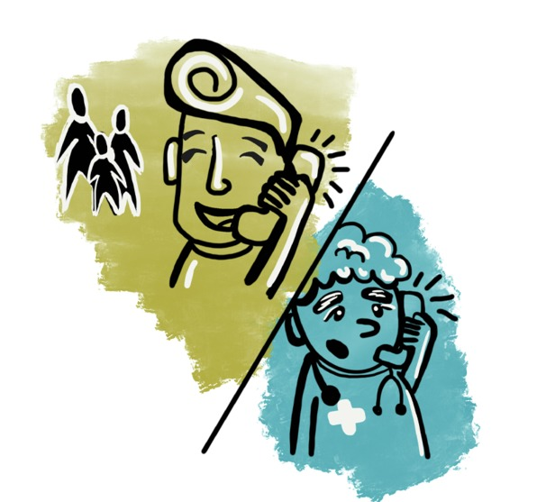
Figure 2: A way forward
View description - Figure 2: A way forward
View description - Figure 2: A way forward

One obstacle for some parents, in approaching a nurse, is the belief that they are too busy already, or that they know their child is in pain and there is nothing that can be done about it. Parents may not know how to ask for more pain relief, and may need some support and guidance, even encouragement, to do so
The need for better communication and information to enable parents to effectively participate in managing their child’s post-operative pain, have been identified by Zhu et al (2018) as necessary to involve parents in the management of their child’s pain. Where parents (and children) are given information on pain management, studies have shown that this results in satisfaction with care (Twycross and Finlay 2013).

1.2 A pain management framework
An international study by Simons (2015) of 28 practitioners in the UK, Sweden and Australia explored innovations in pain management practice. The findings identified five key elements that contributed to the delivery of effective pain management to children in hospital, these being:
- distributed pain management with vision
- effective pain management with less stress
- pain management delivered with confidence
- individual approach to child and parent
- raising parents’ expectations of effective pain management.
Having identified these key elements for the delivery of effective pain management, a further study by Simons et al (2020) explored their relevance and practical application with UK based pain practitioners (n=43). The result of this multistage work is a central focus of this short course.
The 43 practitioners included Band 5 nurses, Advanced Nurse Practitioners (ANP), pain nurses and pain consultants working in the NHS. The findings demonstrated that the following elements were considered to be important: delivering pain management with confidence, supporting colleagues with protocols and guidance, adopting an individual approach to a child and family, and empowering parents to be involved in pain management.
These elements form the basis of a framework for children’s pain management, as illustrated in Figure 3. Each quadrant in Figure 3 is linked with the next but not necessarily a prerequisite of the subsequent quadrant. The four sections contribute to the effective management of children’s pain in hospital. You will explore the framework in more detail in Section 2 and 3 of this course.

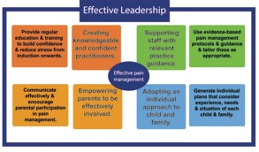
Figure 3: Framework for delivering effective pain management
View description - Figure 3: Framework for delivering effective pain management
View description - Figure 3: Framework for delivering effective pain management

Having stated earlier that there are guidelines that have been well researched and carefully developed it is important to ask: How can the framework above bring about change? The framework has a number of interconnected elements that focus on supporting health care staﬀ, helping them become conﬁdent, adopting an individual approach to children and families, and empowering parents to become more actively involved in their child’s pain management All of these processes are dependent on eﬀective leadership and robust education.
You may ask what difference will the framework make? It is intended to make children’s experience of pain in hospital better, and it is therefore aligned with The Lancet Child and Adolescent Health Commission (Ecclestone et al 2020) on delivering transformative action in paediatric pain, which has four transformative goals: Make pain matter; make pain understood; make pain visible; make pain better. Addressing these goals ‘will improve the lives of children and adolescents with pain and their families’ (Ecclestone et al 2020:1).

2 Creating knowledgeable and confident practitioners
In this section you will explore the first two sections of the framework; creating knowledgeable and confident practitioners and supporting staff to access and use relevant practice guidelines.

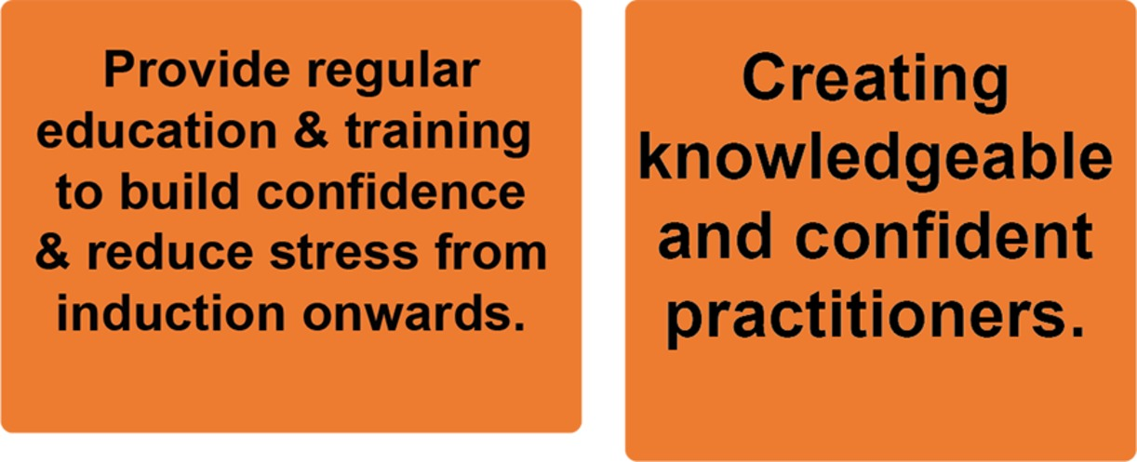
Figure 4: Section 1 of the Framework: Creating knowledgeable and confident practitioners
View description - Figure 4: Section 1 of the Framework: Creating knowledgeable and confident pract ...

Experiencing pain can be stressful, especially as a child, and this is compounded if the pain is not relieved and the child doesn’t know or understand the reasons for the pain persisting. One of the key elements of effective pain management was that when pain was managed well, stress was reduced.
The first element of the pain framework focuses on the reduction of stress and the need for health care practitioners to be knowledgeable and confident in managing children’s pain.

2.1 The stress of managing children’s pain
Managing children’s pain can be stressful for children, parents and practitioners. In a study with 43 HCPs the following was reported. Click through the boxes and read the findings. Alternatively, click ‘toggle plain view’ or ‘long description’ for a more accessible version.

Interactive content is not available in this format.
Figure 5 (interactive): Pain relief or caring for a child in pain
View description - Figure 5 (interactive): Pain relief or caring for a child in pain

2.2 Alleviating stress for practitioners
Having identified that pain management could involve stress, practitioners also identified aspects of practice that could help alleviate stress with the intention of increasing practitioners’ confidence. This finding fits well with previous work on the positive impact confidence has on pain management, with confident nurses giving more analgesia to children in pain. Figures 6 and 7 shows some findings. Click through the circles and read the findings. Alternatively, click ‘toggle plain view’ or ‘long description’ for a more accessible version.

Interactive content is not available in this format.
Figure 6 (interactive): Confidence
View description - Figure 6 (interactive): Confidence

Interactive content is not available in this format.
Figure 7 (interactive): Building confidence
View description - Figure 7 (interactive): Building confidence

2.3 Supporting staff
The second section of the framework focuses on supporting staff with relevant guidance and protocols and builds on the first section by aiming to reduce stress and increase confidence. Managing children’s pain can be complex and HCPs need support to be able to do so effectively.
There was also the suggestion that improving access to protocols, dosing guidance, as well as training at induction would help to reduce stress. Protocols are well researched, and quality assured evidenced based guidance on specific aspects of care, one example being a protocol for the management of pain post tonsillectomy.
The ANPs noted that support was available to help with the stress of pain management: ‘support of the pain team, alongside protocols and procedures, result in less stress and an increase in confidence’.
Practitioners have recognised the complexity of pain and in particular certain painful situations that have been challenging. Examples are the pain post tonsillectomy, or acute sickle cell crisis. Both situations have had numerous studies undertaken to devise a regime in response the acute pain experience (Gostian et al 2020; Persino et al 2017) and academics have undertaken systematic reviews to identify the best approach to deliver effective pain management. Hospital trusts have clinical procedure guidelines that are used in-house to interpret and apply such guidance locally.

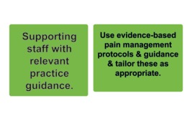
Figure 8: Section 2 of the Framework: Supporting staff with relevant practice guidance
View description - Figure 8: Section 2 of the Framework: Supporting staff with relevant practice gu ...

Some participants called for additional in-service education on children’s pain, as seen in the findings from other research (Alotaibi et al 2019).
Stress could also be reduced if effective interventions were available for every individual child and being able to: ‘provide the right answers or the best answers that you can, or the best care and practice and alter things to reduce that stress’.

Activity 1: Effective pain management
10 minutes

Watch this short video that explains the framework. Whilst you are watching it, you will see that there are four areas all of which link together to provide effective pain management.
While watching the video, consider the following questions and make some notes in the text box. These notes can only be accessed by you and you can refer back to these at any time (as long as you have enrolled on the course and have saved your response).
Do you agree with the elements of the pain framework?
What would need to happen where you work for all elements to be present in the management of children’s pain?

Video content is not available in this format.
Video 1: Paediatric pain Wellchild
View transcript - Video 1: Paediatric pain Wellchild

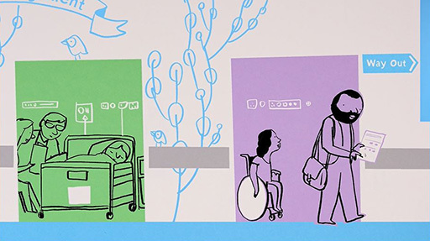

Provide your answer...

3 Adopting an individual approach
To deliver effective pain management to a child there is a need to recognise their individuality, which in turn warrants an individual approach to addressing how to relieve their pain. Many studies have focussed on this approach. Tailored or individualised pain management for children needs to encompass tailored analgesic medication (Lundeberg 2015) as well as non-pharmacological approaches, and managing anxiety and pain (Gai et al 2020; Fortier and Kain 2015).

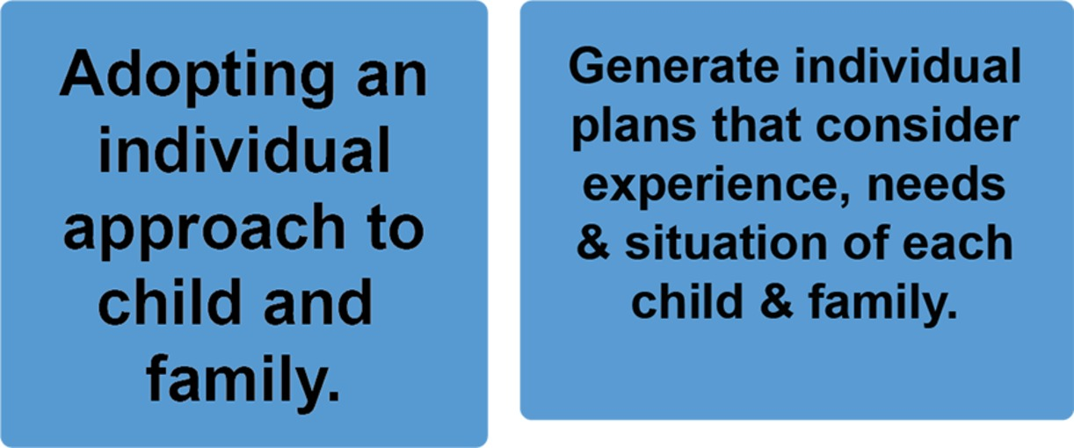
Figure 9: Section 3 of the Framework: Adopting an individual approach to child and family
View description - Figure 9: Section 3 of the Framework: Adopting an individual approach to child and ...

When asked about taking individual approach to a child and family in relation to managing a child’s pain HCPs reported that: ‘everyone’s different, every family is different and every social circumstance is different’.
Most practitioners agreed that an individual approach was an important aspect of managing children’s pain, acknowledging that: ‘it should be paramount in all aspects of care, but certainly within pain management’.
You will remember that in section two we covered the need to provide guidance and protocols to support effective pain management. But as one size doesn’t fit all, such an approach could be deemed to be the opposite of managing a child’s pain through an individualised approach. However, practitioners who were asked about individualised care were clear that this should not be the case.
It was reported that even when working with a protocol, ‘tailoring it to that child or family’ was important, meaning that flexibility was important: ‘We won’t rigidly stick with a regime just because that’s the regime that we do for X. So, I think we’re quite flexible.’
This level of flexibility being reported here may come with experience, as these responses came from pain specialist practitioners.
A pain nurse stated the following: ‘we have a plan there. But within the plan there could be plan A, B and C depending on the individual child’.
Participants talked of the importance of both ‘involving them (child and family) in the conversations at the bedside’ and treating the ‘family as a whole, making sure that they have plenty of information so that they know what to expect’.

3.1 Parent leaflet
An obvious place to start in providing evidence-based care to a child and family is with the child’s parent, by enquiring from them how their child has dealt with pain in the past and using that information to manage a child’s pain.

Figure 10: Parent leaflet
View description - Figure 10: Parent leaflet
View description - Figure 10: Parent leaflet

We designed a leaflet to be used by parents if their child is in pain in hospital after surgery. The leaflet has space for a parent to record how their child usually responds to pain, what words they use for pain, as well as what usually helps when their child is in pain.
It also explains to parents what health care professionals find helpful to know about their child and how they respond to pain, therefore providing parents with insight as to how to link what they know about their child, with what health care professionals need to know, to help to provide individualised care.
The second page of the leaflet goes on to ask a parent to record how much pain their child is experiencing, and how satisfied they are with the pain care.
You can access the parent leaflet here: Helping your child with pain.

Activity 2: Parent leaflet
15 minutes

Read the parent leaflet: Helping your child with pain and answer the following questions in the text box below.
- What are the key messages being conveyed to parents?
- How would you introduce the leaflet to a parent to explain its purpose and encourage them to use it?
- List statements you would make?
- What use could you make of this leaflet in practice?

Provide your answer...

4 Empowering parents
The fourth section of the framework focuses on empowering parents to be effectively involved in the management of their child’s pain by encouraging their participation.

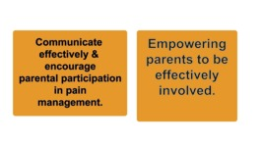
Figure 11: Section 4 of the Framework: Empowering parents to be effectively involved
View description - Figure 11: Section 4 of the Framework: Empowering parents to be effectively involved ...

Earlier we learned that parents want to be involved in helping to alleviate their child’s pain, but are not sure how to go about it. Twenty years ago parents who were asked if they were involved in their child’s pain care said they heard what was discussed about their child’s pain management, suggesting that their involvement was passive (Simons et al 2001). However, more recently it was reported that when parents’ expectations were raised, pain management practice on the part of nurses improved (Simons 2015).

Activity 3: Parents expectations
15 minutes

How would you explain this finding?
How do you think the raising of parents expectations had a positive impact on nurses pain management practice?
Make a note of what you think the explanation could be.

Provide your answer...
View answer - Activity 3: Parents expectations

A lack of communication, information provision and poor negotiation of roles can result in missed opportunities for nurses to work in partnership with parents (Vasey et al 2019).
Sometimes information provision can be inconsistent, resulting in parents having sufficient information about some aspects (e.g., the surgical procedure) but not others (e.g., pain medication) (Gai et al 2020). Although some participants were cautious about raising parents’ expectations, most talked of this as a key element to effective pain management. The skill lies in how practitioners engage and communicate with parents and the information they share with them.
One obstacle for some parents in approaching a nurse is the belief that the nurse is too busy already, or that they know their child is in pain and there is nothing that can be done about it. Also, parents may not know how to ask for more pain relief, and may need some support and guidance, even encouragement, to do so.
Preparation and information giving to parents were identified as key components. As with other studies (Zhu et al 2018), we identified the need for better communication and information to enable parents to effectively participate in managing their child’s post-operative pain.
Where parents (and children) are given information on pain management, studies have shown that this results in satisfaction with care (Twycross and Finley 2013) and parents have been found to be satisfied with their child’s care, even when they report that their child experienced pain. (Twycross and Finley 2013). This seeming contradiction has been explained by parents having low expectations of their child’s pain being managed well, and therefore reporting that they were satisfied with the care, even though their child had pain.
Clearly, empowerment can only really be achieved with consistent and high-quality information that supports parents’ expectations of good care and gives them the confidence to complain about poor pain management (Twycross 2013: Sutters et al 2007). Paradoxically, research has found that strategies to improve pain management and encouraging greater engagement from parents can result in more complaints from parents (Simons 2015); this may be the outcome of parents being more informed, confident and having higher expectations of what can be achieved.
Empowering parents makes considerable sense, as they are their child’s most consistent caregivers, and therefore an obvious source of personalized knowledge to assist in identifying and implementing strategies to optimize better pain care (Bettle et al 2018). However, it is important to recognise when a parent or carer can’t or wont advocate on the part of a child. The onus then is on the nurse to proactively evaluate that child’s pain regularly.

4.1 Practitioners views
In our study to develop the pain framework we asked practitioners how they felt about raising parents expectations of pain management.
Some practitioners were sympathetic stating parents’ expectations ‘may not be voiced, may not be asked’, suggesting that there is first a need to ‘understand’ parents’ expectations. Some practitioners however, expressed reservations about the possibility of setting unrealistic parental expectations, such as reducing pain to zero, that would then be difficult to meet.

Figure 12: Practitioners views
View description - Figure 12: Practitioners views
View description - Figure 12: Practitioners views

Nonetheless, most thought that sharing realistic expectations was helpful, explaining that ‘use of (a) pain pathway helps with parents’ expectations of how their child’s pain will be managed’.
Participants felts parents’ expectations varied between ‘think[ing] their child will be in pain, and they think it’s normal’, and ‘expect their child won’t have any pain or shouldn’t have any pain’. So, although ‘we can’t get rid of all pain at all times’ there should be a commitment to ‘try and sort it out’.
Practitioners reflected that ‘parents’ understanding (of pain) should be checked, not assumed’, and noted that a ‘lack of assertiveness on the part of parents leads to frustration and perhaps avoidable poor pain management’, although parents should not be blamed for this. Parents’ expectations could be raised and managed through pain plans and outlining ‘how pain will be dealt with [and] be realistic and honest with parents’ and ‘educating them that pain management is not just about the drugs’.
Practitioners suggested ways of raising expectations including education and communication, giving parents ‘permission’ to ask about pain and stressing the need for nurses to talk to parents, for example: ‘pre-operative information for parents is seen as important to start the cycle of effective pain management. This can reduce the potential for stress and clarify expectations – which would lead to a good start to the admission’.
Other ways of raising expectations included signs or ‘posters or something in the parents’ room’ to prompt parents to ‘contact the pain team if you feel your child’s pain isn’t as well controlled’.
A consistent approach was deemed important in meeting or raising expectations although it was agreed that this was often dependent on the ‘individual nurses on the floor on that particular day unfortunately’. A pain consultant reported: ‘We can never over-deliver on pain management’ – suggesting the onus is the responsibility of the clinicians, rather than the parents with regards to setting the standard of care.
You can see from these responses that many practitioners are supportive of including parents in the management of their child’s pain. However, there seems to be recognition of the need for a shift in health care practitioners interactions with parents that actively encourages parents to become more involved in the management of their child’s pain in hospital.
Having covered all four sections of the pain management framework, you are now coming to the end of the course.

Activity 4: Six-minute briefing
15 minutes

Before you take the quiz, you might like to review your learning in the Children’s Pain Management Framework six-minute briefing. You can use the text box below to make notes of key points. Click on the link to access the leaflet which will provide an overview of the Pain Framework.
Six Minute Briefing: Children’s Pain Management Framework

Provide your answer...

5 End-of-course quiz
Check what you’ve learned in this course by taking the End-of-course quiz.
Open the quiz in a new window or tab then come back here when you’ve finished.

Conclusion
You have come to the end of this short course – well done.
You have learned about the various aspects of the pain management framework that has been developed over a number of years involving the views of over 60 practitioners and has been shaped by the experiences of children and parents following surgery. The result is a holistic body of work that now needs to be used to engage with best practice and facilitate and deliver effective pain management for children.
So with your new knowledge of the framework, consider what one thing would need to change where you are currently working, or have worked, to enable the key elements of the framework to be delivered. What role could you play in that change and who would support you to deliver it?

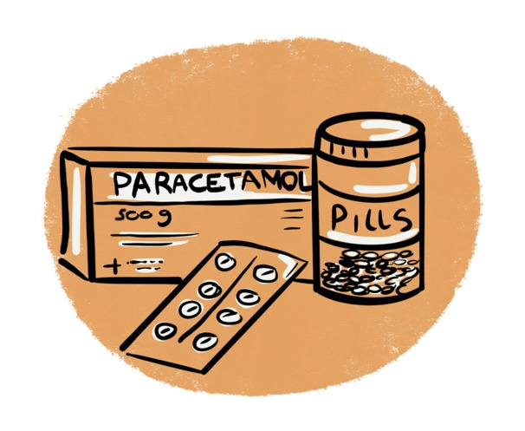
Figure 13: Conclusion
View description - Figure 13: Conclusion
View description - Figure 13: Conclusion

If you are interested in extending your knowledge on OpenLearn you might want to explore some of the following courses, which are free:
- Supporting children’s mental health and wellbeing
- Children’s perspectives on play
- Supporting children’s development
- Understanding children: Babies being heard
- Listening to young children: supporting transition
- Understanding research with children and young people
- Supporting children and young people’s wellbeing
This free course provides a sample of the Open University qualification, BSc (Honours) Nursing (Children and Young People).

References
Alotaibi, K., Higgins, I. and Chan, S. (2019) ‘Nurses’ knowledge and attitude toward pediatric pain management: a cross-sectional study,’ Pain Management Nursing, 20(2), pp. 118–125.
Association of Paediatric Anaesthetists (2012) ‘Good practice in postoperative and procedural pain management’, Pediatric Anesthesia, 22(1), pp. 1–79.
Bettle, A., Latimer, M., Fernandez, C. and Hughes, J. (2018) ‘Supporting parents’ pain care involvement with their children with acute lymphoblastic leukemia: a qualitative interpretive description,’ Journal of Pediatric Oncology Nursing, 35(1), pp. 43–55.
Chabot B. and Ferlanda C. E. (2020) ‘Inpatient postoperative undesirable side effects of analgesics management: a pediatric patients and parental perspective’, Pain Reports, 5(5) p. 845. Available at: https://doi.org/10.1097/PR9.0000000000000845.
Carter, B., Arnott, J., Simons, J. and Bray, L. (2017) ‘Developing a sense of knowing and acquiring the skills to manage pain in children with profound cognitive impairments: mothers’ perspectives,’ Pain Research and Management. Article ID 2514920.
Carter, B., Simons, J., Bray, L. and Arnott, J. (2016) ‘Navigating uncertainty: health professionals’ knowledge, skill, and confidence in assessing and managing pain in children with profound cognitive impairment,’ Pain Research and Management. Article ID 8617182.
Chng H. Y., Mackey, S., Wee Liam, J. L., Zhu, L. and Fong Cheng, K. K. (2015) ‘Parents’ knowledge, attitudes, use of pain relief methods and satisfaction related to their children’s postoperative pain management: a descriptive correlational study’, Journal of Clinical Nursing, 24, pp. 1630–1642. Available at: https://doi.org/10.1111/jocn.12764.
Eccleston, C., Fisher, E., Howard, R. F., Slater R., Forgeron P. et al. (2020) ‘Delivering transformative action in paediatric pain: a Lancet Child and Adolescent Health Commission’, The Lancet Child and Adolescent Health Commission, 5(1), pp.47–87. Available at: https://doi.org/10.1016/S2352-4642(20)30277-7.
Fortier, M. A. and Kain, Z. N. (2015) ‘Treating perioperative anxiety and pain in children: a tailored and innovative approach’, Pediatric Anesthesia, 25(1), pp. 27–35.
Gai, N., Naser, B., Hanley, J., Peliowski, A., . Hayes, J. and Aoyama, K. (2020) ‘A practical guide to acute pain management in children,’ Journal of Anesthesia, 34(3), pp. 421–433.
Gostian, A-O., Loeser, J., Tholen, C., Heindl, L. M., Balk, M. and Gostian, M. (2020) ‘Postoperative pain after tonsillectomy – the value of standardized analgesic treatment protocols’, Auris Nasus Larynx, 47(6), pp.1009–1017. Available at: https://doi.org/10.1016/j.anl.2020.05.011.
Groenewald, C. B., Rabbitts, J. A., Schroeder, D. R. and Harrison, T. E. (2012) ‘Prevalence of moderate-severe pain in hospitalized children’, Pediatric Anesthesia, 22(7), pp. 661–668.
Jenkins, B. N., Fortier, M. A., Stevenson, R., Makhlouf, M., Lim, P., Converse, R. and Kain, Z. N. (2019) ‘Changing healthcare provider and parent behaviors in the pediatric post‐anesthesia‐care‐unit to reduce child pain: Nurse and parent training in postoperative stress’, Pediatric anesthesia, 29(7) pp. 730–737. Available at: https://doi.org/10.1111/pan.13649.
Kozlowski, K. L., Kost-Byerly, S., Colantuoni E. et al. (2014) ‘Pain prevalence, intensity, assessment and management in a hospitalized pediatric population,’ Pain Management Nursing, 15(1), pp. 22–35.
Krishnamurti, L., Smith-Packard, S., Gupta, A., Campbell, A., Gunawardena, S. and Saladino, R. (2014) ‘Impact of individualized pain plan on the emergency management of children with sickle cell disease,’ Pediatric Blood & Cancer, 61(10), pp. 1747–1753.
Lim, S. H., Mackey, S. Wee Liam, J. L. and He H. (2012) ‘An exploration of Singaporean parental experiences in managing school-aged children’s postoperative pain: a descriptive qualitative approach’, Journal of Clinical Nursing, 21, pp. 860–869. Available at: https://doi.org/10.1111/j.1365-2702.2011.03911.x.
Linhares, M. B. M., Doca, F. N. P., Martinez F. E. et al. (2012) ‘Pediatric pain: prevalence, assessment, and management in a teaching hospital,’ Brazilian Journal of Medical and Biological Research, 45(12), pp. 1287–1294.
Lundeberg, S. (2015) ‘Pain in children—are we accomplishing the optimal pain treatment?’ Pediatric Anesthesia, 25(1), pp. 83–92.
MacDougall, T., Cunningham, S., . Whitney, L. and Sawhney, M. (2020) ‘Improving pediatric experience of pain during vaccinations: a quality improvement project,’ International Journal of Health Care Quality Assurance, 32(6), pp. 1034–1040.
Persino, P. R., Saleh, L. and Walner, D. L. (2017) ‘Pain control following tonsillectomy in children: A survey of patients’, International Journal of Pediatric Otorhinolaryngology,103, pp. 76–79, ISSN 0165-5876. Available at: https://doi.org/10.1016/j.ijporl.2017.10.016.
Royal College of Nursing (2009) Clinical Practice Guideline: The Recognition and Assessment of Acute Pain in Children, Royal College of Nursing, London, UK.
Simons, J. (2015) ‘A proposed model of the effective management of children’s pain,’ Pain Management Nursing, 16(4), pp. 570–578.
Simons, J., Carter, B. and Craske, J. (2020) ‘Developing a Framework to Support the Delivery of Effective Pain Management for Children: An Exploratory Qualitative Study’, Pain Research and Management Article ID 5476425. Available at: https://doi.org/10.1155/2020/5476425.
Simons, J., Franck, L. S. and Roberson, E. (2001) ‘Parent Involvement in Children’s Pain Care: Views of Parents and Nurses’, Journal of Advanced Nursing, 36(4), pp. 591–599.
Sutters, K. A., Savedra, M. C., Miaskowski C. et al. (2007) ‘Children’s expectations of pain, perceptions of analgesic efficacy, and experiences with nonpharmacologic pain management strategies at home following tonsillectomy,’ Journal for Specialists in Pediatric Nursing, 12(3), pp. 139–148.
Treadgold, R., Boon, D., Squires, P., Courtman, S. and Endacott, R. (2019) ‘Implementation of paediatric pain care-bundle across South-West England clinical network of emergency departments and minor injury units: a before and after study,’ International Emergency Nursing, 43, pp. 56–60.
Twycross, A. and Finley, G. A. (2013) ‘Children’s and parents’ perceptions of postoperative pain management: a mixed methods study,’ Journal of Clinical Nursing, 22(21-22) pp. 3095–3108.
Twycross, A. (2013) ‘Nurses’ views about the barriers and facilitators to effective management of pediatric pain,’ Pain Management Nursing, 14(4), pp. e164–e172.
Twycross, A., Dowden, S., and Bruce, L. (Eds.) (2009) Managing pain in children: A clinical guide. Ames, IA: Wiley-Blackwell.
Valizadeh, F., Ahmadi, F. and Zarea, K. (2016) ‘Neglect of Postoperative Pain Management in Children: A Qualitative Study Based on the Experiences of Parents’, Journal of Pediatric Nursing, 31, pp. 439–448.
Vasey, J., Smith J., Kirshbaum, M. N. and Chirema, K. (2019) ‘Tokenism or true partnership: parental involvement in a child’s acute pain care,’ Journal of Clinical Nursing, 28(9-10), pp. 1491–1505.
Vejzovic, V., Bozic, J., Panova, G., Babajic, M. and Bramhagen, A-C. (2020) ‘Children still experience pain during hospital stay: a cross-sectional study from four countries in Europe’, BMC pediatrics, 20(1), pp. 39–39. Available at: https://doi.org/10.1186/s12887-020-1937-1.
Zhu, L., Chan, W-C, S., Liam, J. L.W. et al. (2018)‘Effects of postoperative pain management educational interventions on the outcomes of parents and their children who underwent an inpatient elective surgery: a randomized controlled trial’, Journal of Advanced Nursing, 74(7), pp. 1517–1530.

Acknowledgements
This free course was written by Prof Joan Simons PFHEA and was published 2022.
The 2020 study that features in this course was undertaken by Prof Joan Simons (The Open University), Prof Bernie Carter (Edge Hill University) and Jennie Craske (PhD, Alder Hey Children’s NHS Foundation Trust) and is reported in this article:
Simons, J., Carter, B. and Craske, J. (2020) ‘Developing a Framework to Support the Delivery of Effective Pain Management for Children: An Exploratory Qualitative Study’, Pain Research and Management Volume 2020, Article ID 5476425, 8 pages https://doi.org/10.1155/2020/5476425
Except for third party materials and otherwise stated (see terms and conditions), this content is made available under a Creative Commons Attribution-NonCommercial-ShareAlike 4.0 Licence.
The material acknowledged below (and within the course) is Proprietary and used under licence (not subject to Creative Commons Licence). Grateful acknowledgement is made to the following sources for permission to reproduce material in this free course:
Files
Helping your child with pain: OU Wellbeing, Education and Language Studies/ The Open University/ Alder Hey Childrens hospital Alder Hey Children's Hospital | Alder Hey in the Park /WellChild National UK Charity for Seriously Ill Children | WellChild
6 minute briefing: OU Wellbeing, Education and Language Studies/ The Open University/ Alder Hey Childrens hospital Alder Hey Children's Hospital | Alder Hey in the Park /WellChild National UK Charity for Seriously Ill Children | WellChild
Figures
Figure 3: Framework for delivering effective pain management: Copyright © 2020 Joan Simons et al. Alder Hey Children's NHS Foundation Trust, Liverpool, UK https://www.hindawi.com/journals/prm/2020/5476425/ From an open access article distributed under the Creative Commons Attribution License, which permits unrestricted use, distribution, and reproduction in any medium, provided the original work is properly cited.
Figure 4: Section 1 of the Framework: Creating knowledgeable and confident practitioners: Copyright © 2020 Joan Simons et al. Alder Hey Children's NHS Foundation Trust, Liverpool, UK https://www.hindawi.com/journals/prm/2020/5476425/ From an open access article distributed under the Creative Commons Attribution License, which permits unrestricted use, distribution, and reproduction in any medium, provided the original work is properly cited.
Figure 8: Figure 8: Section 2 of the Framework: Supporting staff with relevant practice guidance: Copyright © 2020 Joan Simons et al. Alder Hey Children's NHS Foundation Trust, Liverpool, UK https://www.hindawi.com/journals/prm/2020/5476425/ From an open access article distributed under the Creative Commons Attribution License, which permits unrestricted use, distribution, and reproduction in any medium, provided the original work is properly cited.
Figure 9: Section 3 of the Framework: Copyright © 2020 Joan Simons et al. Alder Hey Children's NHS Foundation Trust, Liverpool, UK https://www.hindawi.com/journals/prm/2020/5476425/ From an open access article distributed under the Creative Commons Attribution License, which permits unrestricted use, distribution, and reproduction in any medium, provided the original work is properly cited.
Figure 11: Section 4 of the Framework: Empowering parents to be effectively involved: Copyright © 2020 Joan Simons et al. Alder Hey Children's NHS Foundation Trust, Liverpool, UK https://www.hindawi.com/journals/prm/2020/5476425/ From an open access article distributed under the Creative Commons Attribution License, which permits unrestricted use, distribution, and reproduction in any medium, provided the original work is properly cited.
Video
Video 1: Paediatric pain Wellchild: OU Wellbeing, Education and Language Studies/ The Open University/ Alder Hey Childrens hospital Alder Hey Children's Hospital | Alder Hey in the Park /WellChild National UK Charity for Seriously Ill Children | WellChild
Don’t miss out
If reading this text has inspired you to learn more, you may be interested in joining the millions of people who discover our free learning resources and qualifications by visiting The Open University – www.open.edu/openlearn/free-courses.

Solutions

Activity 3: Parents expectations

Answer
This finding came from interviews with health care practitioners in Sweden who found that when parents became more confident in approaching the nurses when their child was experiencing pain, nurses responded by being more responsive to parents and this change in practice improved the management of children’s pain.
The pain leaflet you have just looked at attempts to facilitate parents feeling more confident to approach nurses when their child is experiencing pain.
Sharing information with parents as well as valuing their knowledge of their child and communicating in an equal partnership can establish parents’ and nurses’ expectations of parent involvement in the management of their child’s pain.
Back to - Activity 3: Parents expectations

Figure 1: Why pain matters

Description
An illustration of a child holding their stomach, seemingly in pain.
Back to - Figure 1: Why pain matters

Figure 2: A way forward

Description
An illustration of a person having a phone conversation with a medical practitioner.
Back to - Figure 2: A way forward

Figure 3: Framework for delivering effective pain management

Description
A diagram with Effective leadership titled at the top.
In the centre, there is the label: Effective pain management, and there are four sections surrounding the centre.
From the top right, there are two boxes:
- Supporting staff with relevant practice guidance.
- Use evidence-based pain management protocols & guidance & tailor these as appropriate.
Then below this, bottom right, there are two boxes:
- Adopting an individual approach to child and family.
- Generate individual plans that consider experience, needs & situation of each child & family.
To the left of this, bottom left, there are two boxes:
- Empowering parents to be effectively involved.
- Communicate effectively & encourage parental participation in pain management.
Above this, top left, there are two boxes:
- Creating knowledgeable and confident practitioners.
- Provide regular education & training to build confidence & reduce stress from induction onwards.
Back to - Figure 3: Framework for delivering effective pain management

Figure 4: Section 1 of the Framework: Creating knowledgeable and confident practitioners

Description
There are two boxes, from right to left:
- Creating knowledgeable and confident practitioners.
- Provide regular education & training to build confidence & reduce stress from induction onwards.
Back to - Figure 4: Section 1 of the Framework: Creating knowledgeable and confident practitioners

Figure 5 (interactive): Pain relief or caring for a child in pain

Description
A click and reveal diagram with the following text:
Feeling helpless
Being asked for pain relief or caring for a child in pain, and not be able to relieve that pain, could lead to issues negatively affecting their relationship with parents: ‘Parents lose confidence if their child is left in pain.’
Losing confidence
Having a parent lose confidence in the nurse caring for their child was reported as stressful for nurses: ‘Staff get stressed when they look powerless in front of patients and relatives.’
Feeling frustrated
Frustration was also expressed in stating that there was: ‘No time to spend time with the child and families. No time to listen.’
Proposing solutions
On the other hand a potential solution was suggested as: ‘Being there, being approachable.’ This is an interesting finding which hints that practitioners are not always approachable, which would deter parents calling on them to help manage their child’s pain.
Being informed
Most participants talked of the importance of keeping children and their families informed, as this could help mitigate stress for parents and children related to pain management: ‘discussing with the families ahead of a painful episode and letting them know what to expect … people available … people assessing the pain management, and … make adjustments if required.’
Back to - Figure 5 (interactive): Pain relief or caring for a child in pain

Figure 6 (interactive): Confidence

Description
The interactive figure shows five circles that each contain information. From top-right, going clockwise:
‘there’s a tendency to under-dose, and as I say it is a confidence issue’, ‘giving less paracetamol.’ Some practitioners reflected on sub-optimal analgesic prescribing and dosage for children due to a lack of confidence.
‘in terms of morphine, people are still very, can be very cautious with it.’ Some practitioners reflected on sub-optimal analgesic prescribing and dosage for children due to a lack of confidence.
‘the more you do it the more confident you get.’ Participants reported the factors that can influence practitioner confidence, such as experience.
‘the experience, the education, device training as well.’ Participants reported the factors that can influence practitioner confidence, such as experience. This was a key factor.
‘You can’t be confident with your pain delivery unless you’ve had the training to know that what you’re doing is right.’ Participants reported the factors that can influence practitioner confidence, such as experience. This is another point to note.
Back to - Figure 6 (interactive): Confidence

Figure 7 (interactive): Building confidence

Description
The interactive figure shows five circles that each contain information. From top-right, going clockwise:
‘knowing the norm’ Practitioners shared their views of what engendered confidence such as knowledge and experience.
‘readily, easily accessible’ Practitioners shared their views of what engendered confidence such as knowledge and experience.
‘clear easy to understand guidelines and protocols’ Practitioners shared their views of what engendered confidence such as knowledge and experience.
‘use of language and their demeanour … on patients’ Participants talked of the need for confident delivery to be underpinned by good communication and for colleagues to understand the impact of their behaviour. This suggestion relates closely to the earlier suggestion of being approachable to parents as a factor that would help reduce stress, calling for an element of self-awareness for practitioners, being cognisant of the impact of their behaviour on parents.
‘need to have confidence in the nurse’, ‘the basic package … doesn’t fit’ The impact of practitioners behaviour was reported as: Families ‘need to have confidence in the nurse’ and this confidence could also be facilitated by working with the support of the pain team’s expertise when ‘the basic package … doesn’t fit’
Back to - Figure 7 (interactive): Building confidence

Figure 8: Section 2 of the Framework: Supporting staff with relevant practice guidance

Description
There are two boxes, with the following text, from left to right:
- Supporting staff with relevant practice guidance.
- Use evidence-based pain management protocols & guidance & tailor these as appropriate.
Back to - Figure 8: Section 2 of the Framework: Supporting staff with relevant practice guidance

Figure 9: Section 3 of the Framework: Adopting an individual approach to child and family

Description
There are two boxes, with the following text, from left to right:
- Adopting an individual approach to child and family.
- Generate individual plans that consider experience, needs & situation of each child & family.
Back to - Figure 9: Section 3 of the Framework: Adopting an individual approach to child and family

Figure 10: Parent leaflet

Description
An illustration of hands holding a leaflet and the exclamation mark (!) above.
Back to - Figure 10: Parent leaflet

Figure 11: Section 4 of the Framework: Empowering parents to be effectively involved

Description
Two boxes, with the following text, from right to left:
- Empowering parents to be effectively involved.
- Communicate effectively & encourage parental participation in pain management.
Back to - Figure 11: Section 4 of the Framework: Empowering parents to be effectively involved

Figure 12: Practitioners views

Description
An illustration of six people lined up in two rows of three.
Back to - Figure 12: Practitioners views

Figure 13: Conclusion

Description
An illustration of medication. There is a pill packet, a box labelled paracetamol, and a pot labelled pills.
Back to - Figure 13: Conclusion

Video 1: Paediatric pain Wellchild

Transcript
Narrator
When children are in hospital, managing any pain they experience is essential, but it’s not always done effectively. Many parents leaving hospital report that their child experienced a lot of pain during their stay. But they also feel positive about the care they received, which means something isn’t working.
Following extensive research with pain specialists across the UK and internationally, we’ve developed a framework for delivering effective pain management for children. There are four components.
The first is creating knowledgeable, confident practitioners. Many nurses can feel nervous about giving too much pain medicine. And when nurses are not feeling confident, they may administer less than what’s being prescribed to be on the safe side.
The second element is the support given to those staff. Making sure they have access to relevant protocols ensures that they rely less on their own judgement and more on proven best practice. Pain protocols with well-evidenced guidelines for predictable scenarios are usually created by dedicated teams after a lot of hard work. But when the whole hospital implements them, they are shown to make effective pain management easier to achieve.
Thirdly, nurses need to involve parents and treat them as partners. After all, they have unique expertise when it comes to their child. But parents are often reluctant to point out that their child’s pain is not going away. So they need to be encouraged to speak up. Practitioners want to help. But if they don’t know a child is in pain, they can’t do anything about it.
Lastly, it’s important to take an individual approach to both the child and their family. Talking and listening to each child and finding out about their experience, understanding, fears, likes, and dislikes makes it more likely that their pain can be managed effectively.
To be effective, all four components need to happen with everyone at all levels playing their part. If all practitioners start using this framework together, it can contribute to managing children’s pain a lot more effectively.
[MUSIC PLAYING]
Back to - Video 1: Paediatric pain Wellchild

Figure 1: Why pain matters

Description
An illustration of a child holding their stomach, seemingly in pain.
Back to - Figure 1: Why pain matters

Figure 2: A way forward

Description
An illustration of a person having a phone conversation with a medical practitioner.
Back to - Figure 2: A way forward

Figure 3: Framework for delivering effective pain management

Description
An illustrated diagram focusing on effective leadership and pain management.
Back to - Figure 3: Framework for delivering effective pain management

Figure 10: Parent leaflet

Description
An illustration of hands holding a leaflet and the exclamation mark (!) above.
Back to - Figure 10: Parent leaflet

Figure 12: Practitioners views

Description
An illustration of six people lined up in two rows of three.
Back to - Figure 12: Practitioners views

Figure 13: Conclusion

Description
An illustration of medication.
Back to - Figure 13: Conclusion

