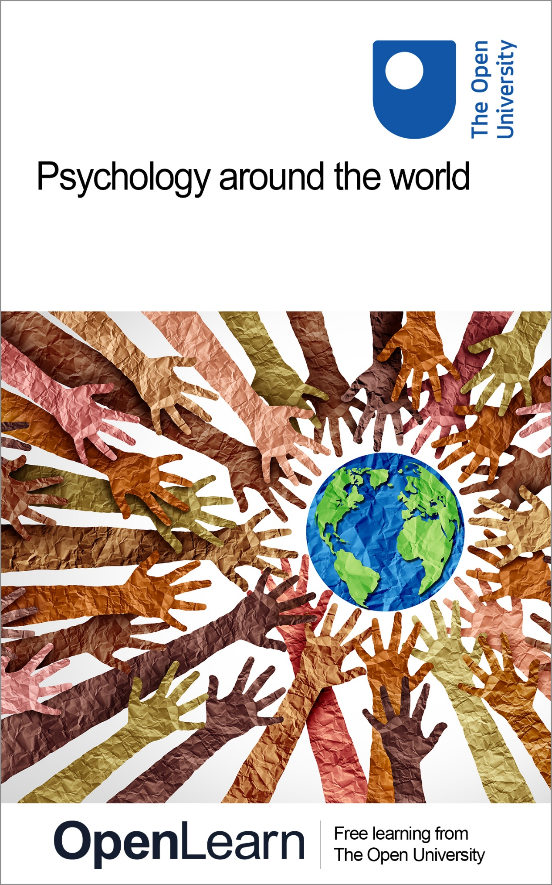

D110_1

Psychology around the world

About this free course
This free course is an adapted extract from the Open University course D110 Exploring psychological worlds: thinking, feeling, doing: www.open.ac.uk/courses/modules/d110.
This version of the content may include video, images and interactive content that may not be optimised for your device.
You can experience this free course as it was originally designed on OpenLearn, the home of free learning from The Open University –
www.open.edu/openlearn/health-sports-psychology/psychology-around-the-world/content-section-0
There you’ll also be able to track your progress via your activity record, which you can use to demonstrate your learning.
First published 2025.
Unless otherwise stated, copyright © 2025 The Open University, all rights reserved.
Intellectual property
Unless otherwise stated, this resource is released under the terms of the Creative Commons Licence v4.0 http://creativecommons.org/licenses/by-nc-sa/4.0/deed.en. Within that The Open University interprets this licence in the following way: www.open.edu/openlearn/about-openlearn/frequently-asked-questions-on-openlearn. Copyright and rights falling outside the terms of the Creative Commons Licence are retained or controlled by The Open University. Please read the full text before using any of the content.
We believe the primary barrier to accessing high-quality educational experiences is cost, which is why we aim to publish as much free content as possible under an open licence. If it proves difficult to release content under our preferred Creative Commons licence (e.g. because we can’t afford or gain the clearances or find suitable alternatives), we will still release the materials for free under a personal end-user licence.
This is because the learning experience will always be the same high quality offering and that should always be seen as positive – even if at times the licensing is different to Creative Commons.
When using the content you must attribute us (The Open University) (the OU) and any identified author in accordance with the terms of the Creative Commons Licence.
The Acknowledgements section is used to list, amongst other things, third party (Proprietary), licensed content which is not subject to Creative Commons licensing. Proprietary content must be used (retained) intact and in context to the content at all times.
The Acknowledgements section is also used to bring to your attention any other Special Restrictions which may apply to the content. For example there may be times when the Creative Commons Non-Commercial Sharealike licence does not apply to any of the content even if owned by us (The Open University). In these instances, unless stated otherwise, the content may be used for personal and non-commercial use.
We have also identified as Proprietary other material included in the content which is not subject to Creative Commons Licence. These are OU logos, trading names and may extend to certain photographic and video images and sound recordings and any other material as may be brought to your attention.
Unauthorised use of any of the content may constitute a breach of the terms and conditions and/or intellectual property laws.
We reserve the right to alter, amend or bring to an end any terms and conditions provided here without notice.
All rights falling outside the terms of the Creative Commons licence are retained or controlled by The Open University.
Head of Intellectual Property, The Open University

Contents
- Introduction
- Learning outcomes
- 1 Does psychology work the same everywhere?
  - 1.1 Are you thinking what I’m thinking?
  - 1.2 Remembering around the world
  - 1.3 Colour perception and language
  - 1.4 Understanding the everyday experiences of infants
- 2 Wellbeing around the world
  - 2.1 Kaupapa Māori psychology: approaches to wellbeing
- 3 WEIRD psychology
  - 3.1 It’s awfully narrow for something so broad
- Conclusion
- References
- Acknowledgements
- Glossary
- Solutions
- Descriptions

Introduction
Welcome to this exciting free OpenLearn course!
In this course you will explore how psychology helps us to understand human thoughts (how people think), emotions (how people feel) and behaviours (what people do) across different societies. This course has been created to demonstrate the fascinating universal and unique ways in which psychology works around the world. You will explore psychological processes, behaviours and practice across diverse cultures and societies.
By the end of this course, you will have expanded your knowledge and understanding of psychology, and how it operates across the globe.
This OpenLearn course is an adapted extract from the Open University course D110 Exploring psychological worlds: thinking, feeling doing. If you enjoy this course, you might want to have a look at the psychology, and psychology-related, qualifications that the OU offers.

Learning outcomes
After studying this course, you should be able to:
- describe how cultural and societal factors shape some core psychological processes, namely how people think, remember and perceive the world
- describe some different cultural approaches to wellbeing
- understand how early life experiences impact infant development, specifically how early visual and auditory experiences shape cognitive and language development in infants
- recognise the historical limitations of early psychological research and how this has affected psychology’s understanding of human behaviour
- appreciate the importance of incorporating diverse cultural perspectives in psychological research.

1 Does psychology work the same everywhere?
The study of psychology helps us to understand why people think, feel and behave in the ways they do. While these are questions which have been addressed by people globally and throughout history, the academic discipline called ‘psychology’ emerged in the late nineteenth century in Europe and North America. This means that many of the core concepts still taught in psychology courses and used in research were developed in these places as well. In recent years, psychologists have been working to better understand the full diversity of human processes, emotions and behaviours.
To better understand global diversity, researchers have worked to distinguish between what is universal and what is shaped by culture. For example, basic emotions like happiness and sadness are universal, but the expression of those emotions varies. In some cultures, openly expressing emotions is encouraged, while in others it is less so. You may well be able to think of examples among people you know or places you’ve been where there are different rules around how acceptable it is to express emotions.
As you work your way through this course, keep in mind that while you will be predominantly exploring differences in psychology around the world, there are aspects of psychology that are universal (i.e. apply generally to people, whatever their cultural background). As humans, many of the ways we think, feel and do things are the same. All people have the capacity to process information, form memories and problem solve, develop cognitive and physical abilities, and experience and learn to cope with stress. People are still able to relate to those from different cultural contexts. Psychologists are still figuring out which aspects of the field are universal, and which vary across different cultures and contexts.
This course may be your first introduction to psychology, or perhaps you have already studied some psychology and are looking to explore differences around the world. Regardless of where you are in your psychology journey, it is important to remember that psychological findings from one part of the world may not apply to another. By exploring similarities and differences in psychology around the world, psychologists can develop better theories, models, treatments and support systems that are inclusive and adaptable.

1.1 Are you thinking what I’m thinking?

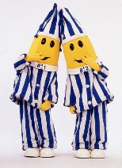
Figure 1 Bananas in Pyjamas was an Australian children’s TV show depicting two Bananas, B1 and B2, who were almost identical in appearance and thinking. The bananas made sense of the events that arose in much the same way, so much so, that they were known for the phrases ‘Are you thinking what I’m thinking B1?’ to which B1 says, ‘I am B2’.
View description - Figure 1 Bananas in Pyjamas was an Australian children’s TV show depicting two Bananas, ...

If people’s brains made sense of all information in exactly the same way, the world would be a very monotonous place. People would be likely to process information about their surroundings in the same manner, meaning unique perspectives and novel thinking would not occur. This would drastically reduce the likelihood of scientific breakthroughs, the creation of works of art, and the world would be rather stagnant! Luckily, while thinking in itself is something that is common to everyone, people don’t actually make sense of the world in an identical way to others. Even B1 and B2 in Figure 1 demonstrated different thinking at times. Part of the reason for this is that there are many factors which influence the way our brains make sense of information. This course will focus on the influence of one of these factors: the influence of the cultures and societies that people live within.
To begin thinking about how culture might shape psychology, you will be introduced below to some research looking at how people perceive the world. This research compares people in the United States to people in East Asia (China, Japan and Korea). This is a very common comparison in this kind of research. This is because these two groups of people are seen as being the most different to each other in several ways that cultures are compared to each other. Comparing these two groups, therefore, is seen as a way to easily see how culture might be impacting the psychological process being studied. Now complete the first activity.

Activity 1

Look at the following image, then write a description in the box below about what you have seen.

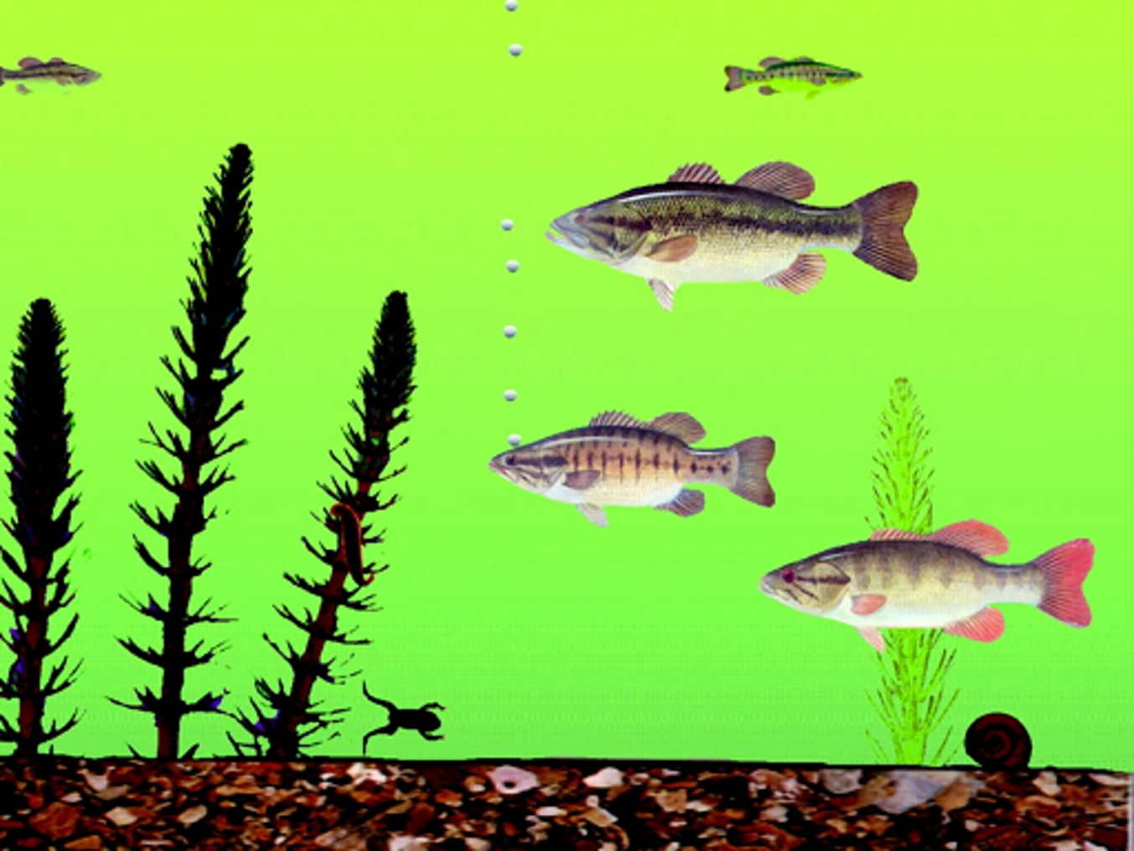
Figure 2 A static example of the Michigan Fish Test from Masuda and Nisbett (2001).

Provide your answer...
View discussion - Activity 1

Masuda and Nisbett identified a difference in the ways that Japanese and US participants perceive the world around them, broadly as a whole defined by relationships or as a set of distinct objects. What’s interesting is that this distinction maps onto differences between how these two cultures tend to approach life more broadly.
A key cultural dimension on which different societies can be placed is the extent to which they are ‘individualist’ or ‘collectivist’. In individualist cultures, people are primarily concerned with the self, and this often takes precedence over the needs of the group to which they belong. People are often seen as independent from others and personal achievements are emphasised and valued. In contrast, collectivist cultures put greater emphasis on the importance of group harmony and success than on individual benefits and achievements. As you may have already guessed, it is rather unlikely that a culture or society can simply be categorised as one or the other. Instead, we can think of individualist and collectivist as sitting on two opposing ends of a continuum, where the US is close to the individualist end and China is close to the collectivist end.

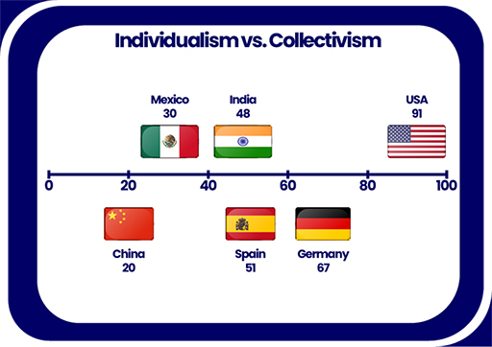
Figure 3 A continuum of individualist vs collectivist cultural dimensions including placements of China, Mexico, Spain, Germany and the US.
View description - Figure 3 A continuum of individualist vs collectivist cultural dimensions including ...

Countries and cultures vary quite a lot on individualism and collectivism. As you can see in Figure 3, the US and China are at extreme ends of the scale. A lot of places are around the middle, and Northern European countries tend to be more individualist than Southern European countries.

Pause for thought
Take five minutes to review your response to Activity 1. Does your description align with the findings of Masuda and Nisbett (2001)? Did you focus on more holistic features of the scene (e.g. relationships between the fish and the background), or did you take a more analytical approach (e.g. describing individual features of the scene in isolation)? Think also about your own cultural background: is it more eastern, western, something in between or entirely different? Did the way you processed the scene fit with what Masuda and Nisbett found (e.g. if your cultural background is western, was your description more analytic; if your cultural background is eastern, was your description more holistic)?

Research like Masuda and Nisbett’s fish experiment has helped to establish that there are some differences in the way that people from different cultures see the world.
In the next section, you will learn a bit more about how some psychologists think these differences emerge. Do these different ways of perceiving the world happen because of the ways people learn to remember things, because of the environments they live in, or because of the language they grow up speaking? Or is it some combination of all of these?

1.2 Remembering around the world
In the next activity you will think about your own memories.

Activity 2

In a few sentences, describe the earliest memory that you feel comfortable recalling for this activity..

Provide your answer...
View discussion - Activity 2

Remembering encapsulates a universal set of processes involving perceiving information, storing that information, and then retrieving it later. This is something that all humans have the capacity to do (except in rare cases, such as severe brain injury). However, what people remember from experiences and events can be shaped by their beliefs and past experiences. For example, autobiographical memories are memories of experiences or events, such as remembering the day you turned 18 or a time you got in trouble at school or work. The memory you described in Activity 2 is an autobiographical memory.
In individualist cultures, autobiographical memories tend to focus on oneself as the lead and often aren’t particularly related to other people; the person describing the memory is the central character. This might include describing a personal achievement or the emotions that were felt when a specific event occurred. In contrast, autobiographical memories in collectivist cultures tend to include social and collective experiences and events, such as the birth of a new family member or a major dispute that happened between colleagues at work. Some findings suggest that people from China tend to have more autobiographical memories for historical events and experiences, such as a political event or a natural disaster than people from the US (Conway et al., 2005).
Findings by Wang (2001) indicate that people in the US tend to recall events and experiences from a slightly younger age than people in China. The age of the earliest reported memory for participants in the US was around 42 months, whereas in China it was 47.5 months. This, of course, does not mean that people in the US have better memories. It merely means that the contrasting focus of memories, as well as different degrees of reminiscing that occur in cultures, can affect the time of earliest memory. Thinking again about the memory you described in Activity 2, can you remember or estimate roughly how old you were when that event occurred?
Cultural background doesn’t only influence how people describe scenes and remember life events. The kind of language people use and the environment that people grow up in can also affect their psychology in surprising ways. The next section explores the relationship between people’s perception of colour and the languages they speak.

1.3 Colour perception and language
As the ‘fish scene’ example illustrated, even when people focus on the same scene, they can still see the world differently depending on their cultural background. Sometimes these differences can be down to the physical environments that people have experienced during their lives.
For example, research has examined colour perception in Norwegian adults born above and below the Arctic Circle. Above the Arctic Circle there is a complete absence of sunlight during the winter months known as mørketid (‘dark time’ in Norwegian), and during the summer months the sun remains above the horizon at night (a period known as the midnattsol or ‘midnight sun’). Laeng et al. (2007) found that those who were born above the Arctic Circle with early experience of mørketid (i.e. experience with purple/indigo shades of twilight during the first few months of life) were better at discriminating different hues of purple and worse at discriminating different hues of green than those born below the Arctic Circle.
In addition, Laeng et al. also found that those who were born above the Arctic Circle and during mørketid performed worse on tests of colour perception than those who were born during midnattsol. These findings suggest that the types of colours people are exposed to in the first few months of life can have a lasting impact on their perception of colour as an adult.
As well as the physical environment, it has been suggested that variations in language can affect how people see colour. Complete Activity 3 to learn more.

Activity 3

The box in Figure 4 shows a coloured block. What colour do you perceive?


Figure 4 Coloured square 1
View description - Figure 4 Coloured square 1

The box below in Figure 5 shows another coloured block. What colour do you perceive?


Figure 5 Coloured square 2.
View description - Figure 5 Coloured square 2.

Provide your answer...
View discussion - Activity 3

Activity 3 demonstrated that what is categorised as a particular colour can vary across languages or cultures. Experience with language therefore influences children’s ability to categorise colour. Children need to learn the names of different colours, and research has suggested that learning the correct terms for different colours is quite a difficult task (Maule, Skelton and Franklin, 2023). The ability to match simple colour terms to the ‘correct’ colour (e.g. matching the word ‘blue’ to the colour blue) isn’t something that children master until around three years of age (Pitchford and Mullen, 2002). One reason children do not achieve this earlier is because it takes children a while to learn the boundaries of each colour. For example, in many languages there is a single term to describe light and dark blue (e.g. English ‘blue’, Mandarin Chinese ‘lan’), but in Mongolian, light blue (‘qinker’) and dark blue (‘huhe’) have different terms to describe them (He et al., 2019) and children need to learn the boundary between the two. This is difficult because the environment can influence the appearance of a colour. Consider, for example, the colour of the fruit in Figure 7. The same fruit bowl is presented under three different lighting conditions, slightly changing the colour. Children, nevertheless, still need to learn that a banana is yellow, even under a blueish light. The ability to perceive the same colour under different lighting conditions is known as colour constancy.

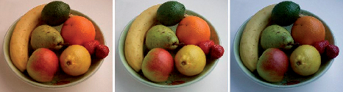
Figure 7 A bowl of fruit under different lighting conditions.
View description - Figure 7 A bowl of fruit under different lighting conditions.

A study by Witzel et al. (2021) looked at the relationship between three- to four-year-old children’s ability to name colours and their ability to perceive a colour as constant under different lighting conditions. To do this, they measured whether children could correctly name different colours (e.g. being able to state ‘This object is red’), and whether they could recognise different types of red even under different lighting conditions (e.g. under green or blue lighting). Witzel et al. found that there was a relationship between performance on the two tasks: children who were better at naming colours were also better at recognising the same colour under different lighting.
Just because two things are related, however, doesn’t mean that one thing causes a change in the other. Witzel et al. speculated about possible reasons for the relationship. One possibility is that, as colour constancy improves with age, this helps children recognise that different types of red all belong to the same colour. Alternatively, children may learn about colour naming through their interactions with other people (e.g. their parent might point out a red apple under bluish light) and this could help children learn about colour constancy. It could also be a completely unrelated perceptual ability that leads to improvements in both colour naming and colour constancy. This exploration of how children learn to perceive and label colours is an ongoing area of psychological research.
Taken together, the research in this section demonstrates that children learn to categorise colour according to appropriate language or cultural conventions, which can differ across those languages and cultures. In addition, there are other perceptual processes, such as learning to recognise colour constancy, which are also related to colour naming.

1.4 Understanding the everyday experiences of infants
In this section you will hear from Linda B. Smith, a Professor at Indiana University in the United States, who discusses her work on the Homeview Project. The project examines how early visual and auditory experiences (e.g. what infants see and hear) help infants break into language.

Activity 4

Watch Video 1 in which developmental psychologist Linda B. Smith discusses the Homeview Project. After watching the video all the way through once, watch it again and answer the questions that follow.

Video content is not available in this format.
Video 1 Linda B. Smith discusses the Homeview Project
View transcript - Video 1 Linda B. Smith discusses the Homeview Project

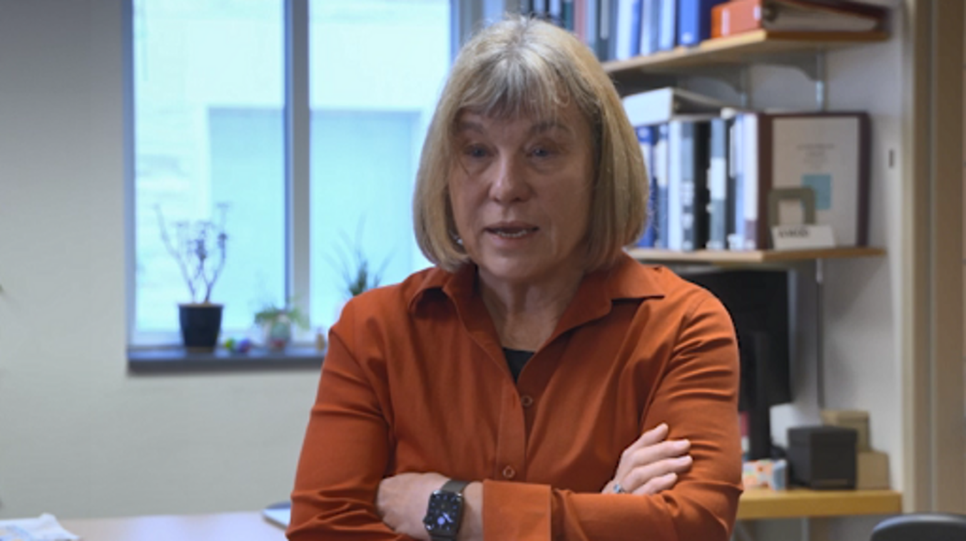

- What are the advantages of using head-mounted cameras for learning about development?
- Why is the ability to hold an object important for learning?
- How has Linda’s work changed the way in which psychologists investigate language development?
- What visual experiences were consistent across the two cultures that Linda examined?

Provide your answer...
View discussion - Activity 4

In this section you have learned about an approach to studying development that aims to understand the everyday experiences of infants. As you move from the foundational experiences of infancy to exploring later stages of life, it is important to consider how cultural differences continue to shape our psychological development. One aspect of particular relevance to psychology (and to related fields, such as counselling and psychotherapy) is how the concepts of wellbeing and happiness are understood within different cultures. While infants’ early experiences set the stage for later development, our understanding of wellbeing encompasses a broad scope that spans an entire lifetime.
In the next section, you will develop your understanding of what it is to ‘live well’, then you will turn your attention to the ways in which different cultures conceptualise and pursue wellbeing.

2 Wellbeing around the world
Defining ‘the good life’ is a question which has vexed philosophers and religious and moral leaders for many centuries. Thousands of self-help books, social media gurus and celebrities continue to promote ways of being, thinking and acting as a sure route to happiness, fulfilment and a healthy life. The advice given can be bewildering and is often contradictory: should a person eat no meat or eat only meat; be grateful or strive for more in life; be constantly busy or make time to be bored; be kind to themselves or be tough on themselves? Should they lift weights, practise yoga, swim in cold water, heat up in the sauna, or none of these?
This range of advice illustrates the difficulty in pinning down one answer to the question of what makes a good life, or of which kinds of practices lead to health and wellbeing. Both ancient Chinese and ancient Greek philosophy, for instance, were deeply interested in defining ‘the good life’. Baggini (2018) points out that both traditions contended with similar questions at around the same time and proposed some similar answers, despite not being in contact with each other. There are some striking similarities between the thoughts of Confucius, who lived around 500 BCE in China, and Aristotle, who lived around 100 years later in Greece.
In both traditions, the road to living well was proposed to be an active one. Living well meant developing and sustaining good habits and acting ethically in the world. People were not presumed to be inherently good or bad but instead were able to become ethical and live well through adopting good habits. This was thought to require self-cultivation, meaning a person taking an active interest in forming the best habits and reflecting on their behaviour and possible areas of improvement. Also common to both traditions was an emphasis on moderation or ‘the doctrine of the mean’, meaning the middle or average. This meant that people were supposed to avoid either excess or deficiency in their lives. An excess might have meant spending too much time on one kind of task and neglecting others or having very heightened emotions. A deficiency could be a lack of motivation, or very low energy. Both traditions advocated for the person to spend some time doing the opposite to bring themselves back to moderation. If someone is very busy and active, for instance, they might spend some time meditating and being very still (Baggini, 2018).
There are, of course, other approaches to the question of the good life. Ancient Indian philosophy, for instance, held that transcendence and spirituality were more centrally important to living well than the Chinese or Greek tradition did. Organised religions also provide frameworks for how to live a good and moral or ethical life (although what counts as ‘moral’ or ‘immoral’ differs between religions and often changes within a religion over time). The range of ideas about living well, however, also poses a problem for psychology researchers who, unlike religious leaders or ancient philosophers, are not seeking to tell people how they ought to live. Instead, the aim of psychological approaches to wellbeing is to measure, describe and theorise wellbeing and the circumstances which enable people to flourish. This has proved to be a difficult task.
Two very influential ways which psychologists have argued that wellbeing can be measured are:
- How people feel about their life: ‘subjective’ wellbeing.
  - This refers to how people evaluate their own lives. It includes measures about life satisfaction, the presence of positive emotions, and the absence of negative emotions. A typical survey question to assess this is ‘how satisfied are you with your life nowadays’? This method gives us insight into a person’s emotional state and overall happiness from their perspective.
- To what extent people’s needs are being met in their life: ‘objective’ wellbeing.
  - A human need is something essential for a person to function well and thrive. At a basic physiological level, hunger indicates a need for food, and shortness of breath a need for oxygen. Beyond these, people also have emotional and practical needs – such as love, belonging, shelter and security – to enable them to live well. Psychologists have developed theories about human needs, but perspectives vary across the sciences. One well-known theory is the ‘hierarchy of needs’ developed by psychologist Abraham Maslow (1943). Maslow organised these needs into a five-tier pyramid which included basic needs like food, water and shelter at the bottom, moving up the pyramid to love and safety, all the way to self-actualisation at the top – achieving one’s potential. Maslow argued that people cannot focus on higher tier needs until the basic needs have been met.
First read the case study of Ceri, and then work through Activity 5 to think more about each of these.

Case study: Ceri
Ceri is a woman in her thirties living in the UK. She has chronic health problems which affect her mobility. Her health and mobility vary and at times she needs to use a wheelchair.
Ceri works from home as a freelancer in the charity sector, meaning that she is in control of the hours she works, and is able to work less during periods of ill health. She is well respected in her field. As well as her paid work, she is entitled to disability support and her home is well adapted for her mobility needs. She lives with her partner and is close to her family, who mainly live nearby. She also has an active social life, and her friends are understanding of the fact that her ability to socialise can vary with her current state of health. She has an adapted car which enables her and her partner to easily travel for trips away.
Ceri feels contented with her life. She sometimes gets frustrated with her health and struggles emotionally when she has prolonged periods of pain and low mobility. At these times she finds her partner and family really help to cheer her up. She also tries to ‘count her blessings’ and not focus on the negative too much.

Activity 5

Read Ceri’s case study and then answer the following questions.
- If you were to ask Ceri in a survey ‘how satisfied are you in your life nowadays?’, what kind of answer do you think she would give?
- Think now about Ceri’s physical, emotional and practical needs. You might think here about emotional needs like purpose, love, belonging and respect. Practically you might think about her need for financial stability, mobility and medical care. What needs of Ceri’s are being met, and what are not?
- What features of Ceri’s life do you think are most responsible for her wellbeing? Think here about qualities of Ceri herself, of the people around her, and of her environment. It may help to think here about what major changes to her life might most affect her wellbeing.

Provide your answer...
View discussion - Activity 5

What this example illustrates is that, to understand individual wellbeing, psychologists have to also understand the full context of a person’s life. Asking about individual feelings can be a good quick measure, but it doesn’t really tell you much about what causes good or poor wellbeing. It also can lead people to see wellbeing as being something that is only to do with an individual – how happy or resilient they are. As you saw with Ceri’s case, however, the full context of the environment which someone lives in helps to create and sustain wellbeing. Practical concerns such as good housing, transport and medical care can be just as important as the individual choices people make about their lives.
A really important context which psychologists are increasingly interested in looking at, is the status or group that someone belongs to in a society. It’s well established that people with higher status tend to have better health and wellbeing (Wang and Geng, 2019). In countries which are living with the legacy of colonialism, for instance, health disparities can be stark between the Indigenous and settler populations (Gracey and King, 2009).
In the next section, you will learn about the approach taken to wellbeing by Māori psychologists in Aotearoa New Zealand.

2.1 Kaupapa Māori psychology: approaches to wellbeing
Before learning about approaches to health and wellbeing developed in Indigenous Māori psychology, read the box below to learn more about Kaupapa Māori research.

Kaupapa Māori research
The Māori are the Indigenous people of what is now known as Aotearoa New Zealand (Aotearoa is the Māori name and New Zealand is the English name). The country was officially colonised by the British in 1840 with the signing of the Treaty of Waitangi. This was an agreement between the British and a majority of Māori chiefs, stating that Māori people would have full citizen rights and be recognised as landowners. The exact meaning of the treaty is contested as the rights granted can be interpreted differently in the English and Māori versions (Rochford, 2004). The fulfilment of this treaty remains a live political issue, as the subsequent century saw Māori people lose much of their land and face suppression of their culture and language. The 1950s onwards saw the emergence of a political movement to improve Māori rights and restore Māori language and culture.
Māori-centred research, theory and practice has developed in several fields in Aotearoa New Zealand from the 1980s onwards, including psychology. Nikora (2007) described how earlier research looking at Māori culture and experience tended to be from an outsider perspective, being about Māori people rather than by them. One danger of this was that Māori experiences were compared to Pākehā (European-heritage New Zealander) norms, and consequently were often seen as deficient or problematic.
A research approach which instead starts with Māori experience and perspectives as the norm and is driven by Māori people is known as Kaupapa Māori research. ‘Kaupapa’ means a set of principles or plan on which to base action, a practical philosophy or an agenda. So, Kaupapa Māori means that the research or practice in question is guided by Māori ways of thinking and being. Kaupapa Māori psychology is a thriving field in several universities in Aotearoa New Zealand.
Kaupapa Māori approaches have been influential in many fields and adopted into government policy and practice in some areas.

Activity 6

Watch Video 2 and then answer the three questions that follow. Note that the speakers in the video use a number of words from te reo Māori, the Māori language. Below are some of the words that are used, with English explanations for what they mean in the context in which they are being used.

Māori | English
Kaupapa | Principles and practices
Whakapapa (pronounced ‘fakapapa’) | Genealogy, family history, connection to ancestors and places where ancestors came from
Iwi | Tribe or people, extended family connections
Mātauranga Māori | Traditional Māori knowledge and cultural ways of thinking
Oriori, waiata, haka | Traditional Māori songs (oriori and waiata) and dances (haka). Oriori in particular are part of storytelling, preserving and passing on Māori culture

Video content is not available in this format.
Video 2 Māori psychology and approaches to wellbeing
View transcript - Video 2 Māori psychology and approaches to wellbeing

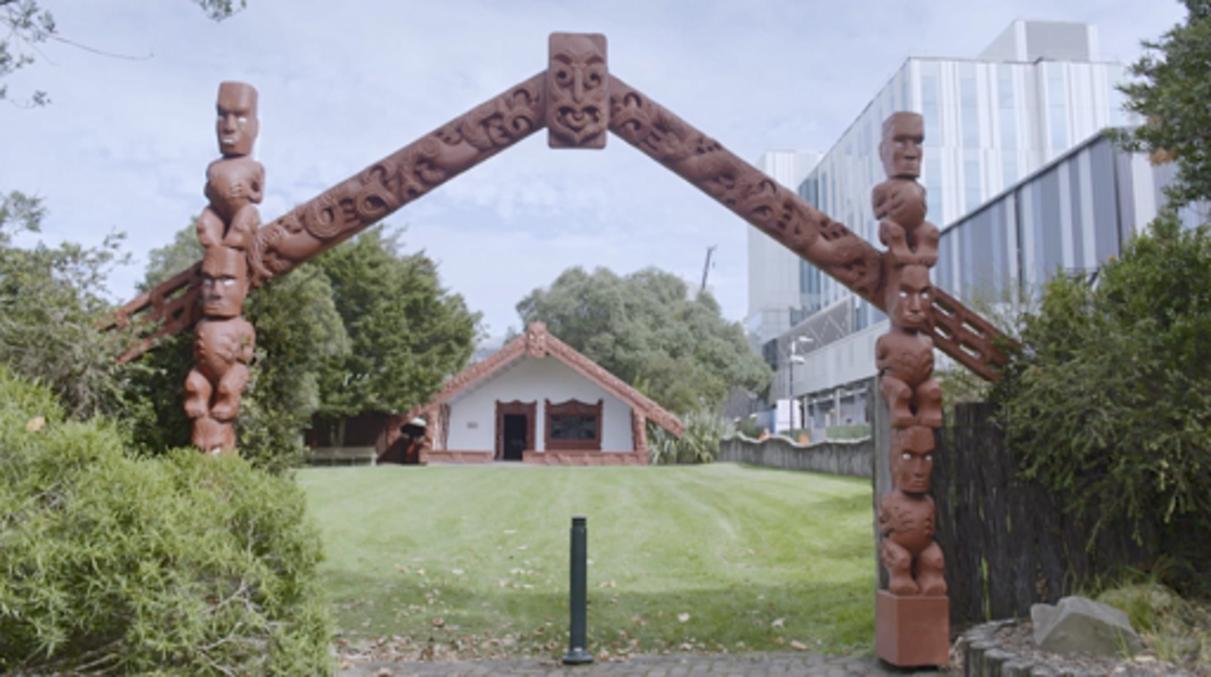

- What is Kaupapa Māori psychology?
- What is the importance of relationships in Kaupapa Māori psychology? You might want to think about some of the Māori words used by the speakers in the video, and how those concepts influence Kaupapa Māori psychology.
- What implications does this approach have for wellbeing, healing and therapy? You might think here about some of the example projects discussed in the video.

Provide your answer...
View discussion - Activity 6

Kaupapa Māori psychology is an example of psychology theory and practice that has been developed from a non-European cultural base. Psychologies from around the world, grown from multiple cultural standpoints, have become more respected in recent years. The discipline is still, however, largely dominated by a European and North American worldview. In the next section you will explore why this is, and what problems it might present for our understanding of human psychology.

3 WEIRD psychology
Psychology as it is researched and practised today has its roots in Europe and North America in the late nineteenth and early twentieth centuries, although with some influence from elsewhere. The late 1800s may seem very recent in human history, and indeed people have been asking ‘psychological’ questions for thousands of years (probably much longer, but we have no written records older than about 5,000 years). However, the modern academic discipline of psychology is very young: only about 150 years old.
An idea of the ‘diversity’ (or, more accurately, the lack of diversity) of psychology in its earliest days can be gleaned from the fact that probably the two most influential early psychologists were both called ‘William’ (sort of). In Germany, Wilhelm Wundt (Wilhelm is the German equivalent of William) set up what was called the first psychology ‘laboratory’ to investigate psychological questions through experimentation. In the United States, William James (William is the English equivalent of Wilhelm) investigated many questions including the nature of emotion, mainly through reflecting on his own experience. Both of these men worked in the late nineteenth century, and can be considered to have set many of the foundations for modern psychology.

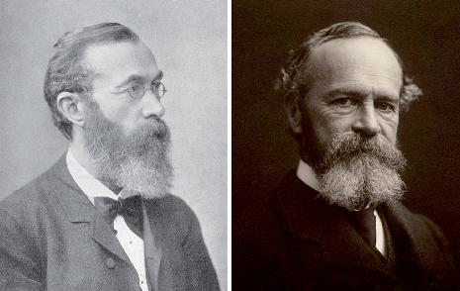
Figure 8 Spot the difference! Wilhelm Wundt (left) and William James (right) were two important early psychologists.
View description - Figure 8 Spot the difference! Wilhelm Wundt (left) and William James (right) were ...

Psychology developed from the ideas of a very narrow set of people: almost exclusively white men in Europe and North America. At the time, women were largely excluded from public life, including academic education, and were not able to gain university degrees, so there were very few women contributing to the early days of the discipline. More women than men now study for psychology degrees in the UK, but this was not always the case. The two Wills were not only men; they were also white, upper class and lived in similar cultures, either Europe or North America (the United States and Canada themselves being former European colonies).

3.1 It’s awfully narrow for something so broad
You may be wondering whether this matters at all and, if so, why it is important. Perhaps early psychology being produced by a narrow range of people is fine, as humans are the same everywhere. Maybe, despite these narrow beginnings, psychology today is far more diverse and is researched by people all over the world. Indeed, as you have learned throughout this course, modern psychologists do come from, and study, a variety of social and cultural contexts. There are, however, still legacies of the narrow beginnings of psychology which persist. Most of the history of psychology has come from a very limited range of people and places, and that is inevitably reflected in the current knowledge base of the discipline.
A study in 2008 looked at the top psychology journals (meaning the most prestigious places to publish psychology studies) and found that 96 per cent of the people who had taken part in the studies reported were from rich, industrialised countries. These countries have around 12 per cent of the world’s population (Arnett, 2008). Henrich, Heine and Norenzayan (2010) describe the majority of people who have taken part in psychology studies as WEIRD, standing for ‘Western, Educated, Industrialised, Rich, Democratic’. ‘Western’ in this context refers to the shared culture of Europe and North America, including people in other parts of the world who also share that culture such as Pākehā in Aotearoa New Zealand. ‘Educated’ refers to the fact that many of the people studied in psychological research are college or university students who, especially in the United States, come disproportionately from white, and relatively wealthy, backgrounds. Even when studies are done on people who did not go to college or university, they typically have had access to formal education during their childhoods in schools. ‘Industrialised’, ‘rich’ and ‘democratic’ refer to the societies in which most psychological research has taken place (even if the people studied are not personally ‘rich’, by the standards of their own society).
These authors, along with many others, have pointed out that much of psychology is therefore based on studying a narrow selection of people who differ from much of the world’s population in ways that may be important (or may not – until we have the data, there is no way to know). A historical assumption that European culture was superior to other places around the world has also been argued to still have an impact on what questions and concepts are seen as worthwhile within psychology (e.g. Oppong, 2019).
These are all live issues in psychology, and will continue to be so for the foreseeable future. Psychology is now becoming global, and in this course you have already learned about some contributions to psychological knowledge from around the world. At the same time, in many topics within psychology, the questions which are still asked were originally defined in this specific historical and geographical context. Psychology is, as mentioned, a relatively young discipline and is still finding its feet in many ways. There are not many settled answers. This makes it an exciting and vibrant discipline to study and research, with plenty to think about. As psychology tries to include more and more perspectives, it is likely that both the kinds of questions asked and the answers found will shift even further in the future.

Activity 7

Rad, Martingano and Ginges (2018) looked to see if anything had changed in psychology publication since the 2000s. They looked at a highly regarded journal Psychological Science. If a researcher is published in a journal like this, their work is seen as high quality and also more likely to influence other researchers. See if you can guess the proportions they found:
United States

20.1%
3.9%
50.8%
11.4%
0.6%
11.9%
1.3%
View answer - Part

Canada, Australia, New Zealand

20.1%
50.8%
1.3%
0.6%
3.9%
11.4%
11.9%
View answer - Part

Europe

20.1%
50.8%
3.9%
0.6%
1.3%
11.4%
11.9%
View answer - Part

Asia

20.1%
11.9%
50.8%
1.3%
3.9%
0.6%
11.4%
View answer - Part

Africa

20.1%
3.9%
11.9%
1.3%
50.8%
0.6%
11.4%
View answer - Part

Latin America

20.1%
11.9%
50.8%
1.3%
3.9%
11.4%
0.6%
View answer - Part

Unknown

20.1%
11.4%
3.9%
11.9%
1.3%
50.8%
0.6%
View answer - Part

In 2014 the world population was 7.3 billion. See if you can guess what percentage of the world population each of the categories represented at that time.
United States

4%
60%
16%
1%
10%
8%
View answer - Part

Canada, Australia, New Zealand

60%
4%
16%
8%
1%
10%
View answer - Part

Europe

60%
10%
1%
16%
8%
4%
View answer - Part

Asia

4%
60%
16%
1%
8%
10%
View answer - Part

Africa

60%
8%
1%
4%
10%
16%
View answer - Part

Latin America

4%
16%
60%
1%
10%
8%
View answer - Part

- Which area has the biggest difference between their population and percentage of psychology studies?
- What does looking at these differences tell you about psychology – how much does this matter?

Provide your answer...
View discussion - Part

If you decide to continue your learning journey in psychology, it is worth bearing in mind that much of the work which has been done so far has been based on this narrow range of people. This does not mean that what you will learn is invalid or wrong, but it does have limitations, as all knowledge and theories do. What psychology has done to date is a start, but only a start, in answering the broad questions which motivate psychologists: what makes people think, feel and act in the ways that they do?

Conclusion
In this free course, you’ve explored how psychology works across diverse cultures and societies. It highlighted how psychological processes, such as thinking, remembering and perceiving, can differ by cultural and societal factors. You learned that our emotional, behavioural and practical responses to things are influenced by cultural and societal factors.
The course outlined how culture, including language differences, can influence how people see the world; how early life experiences affect infant development, and some issues in researching those effects; and how different cultural perspectives can give insights into wellbeing. Additionally, it explained some of the historical limitations of psychological research, particularly its focus on WEIRD (Western, Educated, Industrialised, Rich, Democratic) populations, and emphasised the importance of incorporating diverse cultural perspectives to broaden and enrich our understanding of human behaviour.
This OpenLearn course is an adapted extract from the Open University course D110 Exploring psychological worlds: thinking, feeling doing. If you enjoy this course, you might want to have a look at the psychology, and psychology-related, qualifications that the OU offers.

References
Arnett, J.J. (2008) ‘The neglected 95%: why American psychology needs to become less American’, American Psychologist, 63(7), pp. 602–14. Available at: https://doi.org/10.1037/0003-066X.63.7.602 (Accessed: 20 March 2025).
Baggini, J. (2018) How the world thinks: a global history of philosophy. Granta Books.
Conway, M. A., Wang, Q., Hanyu, K. and Haque, S. (2005) ‘A cross-cultural investigation of autobiographical memory: On the universality and cultural variation of the reminiscence bump’, Journal of cross-cultural psychology, 36(6), pp. 739–49.
Gracey, M. and King, M. (2009) ‘Indigenous health part 1: determinants and disease patterns’, The Lancet, 374(9683), pp. 65–75.
Grandison, A., Davies, I. R. and Sowden, P. (2014) ‘The evolution of GRUE’, Colour studies: a broad spectrum. John Benjamins, pp. 53–66.
He, H., Li, J., Xiao, Q., Jiang, S., Yang, Y. and Zhi, S. (2019) ‘Language and color perception: Evidence from Mongolian and Chinese speakers’, Frontiers in psychology, 10, 551.
Henrich, J., Heine, S. J. and Norenzayan, A. (2010) ‘Most people are not WEIRD’ Nature, 466(7302), p. 29.
Hodgetts, D., Chamberlain, K., Groot, S. and Tankel, Y. (2014) ‘Urban poverty, structural violence and welfare provision for 100 families in Auckland’, Urban Studies, 51(10), pp. 2036–2051.
Laeng, B., Brennen, T., Elden, Å., Paulsen, H. G., Banerjee, A. and Lipton, R. (2007) ‘Latitude-of-birth and season-of-birth effects on human color vision in the Arctic’ Vision Research, 47(12), pp. 1595–1607.
Manatū Hauora Ministry of Health (2017) Māori health models – te whare tapa whā. Available at: www.health.govt.nz/our-work/populations/maori-health/maori-health-models/maori-health-models-te-whare-tapa-wha (Accessed: 8 March 2025).
Maslow, A.H. (1943) ‘A theory of human motivation’, Psychological Review, 50(4), pp. 370–96. Available at: https://doi.org/10.1037/h0054346 (Accessed: 8 March 2025).
Masuda, T. and Nisbett, R. E. (2001) ‘Attending holistically versus analytically: comparing the context sensitivity of Japanese and Americans’, Journal of personality and social psychology, 81(5), p. 922.
Maule, J., Skelton, A. E. and Franklin, A. (2023) ‘The development of color perception and cognition’, Annual Review of Psychology, 74(1), pp. 87–111.
Nikora, L. W. (2007) ‘Maori and psychology: Indigenous psychology in New Zealand’, in Weatherall, A., Wilson, M., Harper, D. and McDowall, J. (eds) Psychology in Aotearoa/New Zealand. Pearson.
Oppong, S. (2019) ‘Overcoming obstacles to a truly global psychological theory, research, and praxis in Africa’, Journal of Psychology in Africa, 29(4), pp. 292–300.
Pitchford, N. J. and Mullen, K. T. (2002) ‘Is the acquisition of basic-colour terms in young children constrained?’, Perception, 31(11), pp. 1349–1370.
Rad, M. S., Martingano, A. J. and Ginges, J. (2018) ‘Toward a psychology of Homo sapiens: Making psychological science more representative of the human population’, Proceedings of the National Academy of Sciences, 115(45), pp. 11401–11405.
Rochford, T. (2004) ‘Whare tapa whā: a Mäori model of a unified theory of health’, Journal of Primary Prevention, 25(1), pp. 41–57. Available at: https://doi.org/10.1023/B:JOPP.0000039938.39574.9e (Accessed: 20 March 2025).
Wang, Q. (2001) ‘Culture effects on adults’ earliest childhood recollection and self-description: implications for the relation between memory and the self’, Journal of Personality and Social Psychology, 81(2), p. 220.
Wang, J. and Geng, L. (2019) ‘Effects of socioeconomic status on physical and psychological health: lifestyle as a mediator’, International journal of environmental research and public health, 16(2), p. 281.
Witzel, C., Flack, Z., Sanchez-Walker, E. and Franklin, A. (2021) ‘Colour category constancy and the development of colour naming’, Vision Research, 187, pp. 41–54.

Acknowledgements
This free course was written by Lydia Devenney, Stacey Heath, Sarah Laurence, Laura McGrath and Jim Turner.
Except for third party materials and otherwise stated (see terms and conditions), this content is made available under a Creative Commons Attribution-NonCommercial-ShareAlike 4.0 Licence.
The material acknowledged below is Proprietary and used under licence (not subject to Creative Commons Licence). Grateful acknowledgement is made to the following sources for permission to reproduce material in this free course:
Images
Course image: wildpixel/Getty Images
Figure 1: Reproduced by permission of the Australian Broadcasting Corporation - Library Sales. Bananas in Pyjamas © ABC.
Figure 2: From Nisbett, R.E. and Masuda, T. (2003) ‘Culture and Point of View’, Proceedings of the National Academy of Sciences, vol. 100, no. 19., p. 11166. Copyright (2003) National Academy of Sciences, U.S.A.
Figure 3: Adapted from Liang, S. (2022) ‘How to understand US cultural differences impacting your business: Hofstede’s 6-D model’, https://www.markentryusa.com/en/how-to-understand-us-cultural-differences-impacting-your-business-hofstedes-6-d-model/
Figure 4: The Open University.
Figure 5: The Open University.
Figure 6: Adapted from Fider, N.A. and Komarova, N.L. (2019) ‘Differences in color categorization manifested by males and females: a quantitative World Color Survey study’, Palgrave Communications 5, article no. 142, p. 8. This file is licensed under the Creative Commons Attribution 4.0 International Licence, https://creativecommons.org/licenses/by/4.0/
Figure 7: From: Online resources to accompany Foundations of Sensation and Perception, edn 4, by George Mather, Copyright © 2022 by Psychology Press. Reproduced by permission of Taylor & Francis Group and published under a CC-BY-NC-ND Creative Commons License (http://creativecommons.org/licenses/by-nc-nd/4.0)
Figure 8: (left) Public Domain https://commons.wikimedia.org/wiki/File:Wilhelm_Wundt.jpg; (right) MS Am 1092 (1185), Series II, 23, Houghton Library, Harvard University.
Audio/visual
Video 1 (images): Dorling Kindersley ltd /Alamy; Vadim Volosciuc /Alamy; Image Source/Alamy; Peter Glass/Alamy; Konstantin Shishkin /Alamy; Martina Hanakova/Alamy; Image Source/Alamy; Tetra Images/Alamy; Hero Images Inc. /Alamy; seyed shekarabi /Alamy; Dmitry Kaminsky /Alamy; Dinodia Photos/Alamy; Peter Horree /Alamy; Michella Burgess/Alamy; Dinodia Photos/Alamy; Hero Images Inc/Alamy; Westend61 GmbH/Alamy.
Video 2 (images): Matthew Micah Wright/Getty Images; Linda Waimarie Nikora; Krista Rossow/Alamy Stock Photo; Chris McLennan/Alamy Stock Photo; Zoonar GmbH/Alamy Stock Photo; Cavan Images/Getty Images; Jan Zammit/Getty Images; Radoslav Cajkovic/Alamy Stock Photo.
Every effort has been made to contact copyright owners. If any have been inadvertently overlooked, the publishers will be pleased to make the necessary arrangements at the first opportunity.
Don't miss out
If reading this text has inspired you to learn more, you may be interested in joining the millions of people who discover our free learning resources and qualifications by visiting The Open University – www.open.edu/openlearn/free-courses.

Glossary
colour constancy
The ability to perceive the same colour under different lighting conditions. For example, perceiving a strawberry as red under blueish light.
Kaupapa Māori research
An approach (e.g. to research or practice) that is guided by Māori ways of thinking and being.

Solutions

Activity 1

Discussion
There are lots of ways you could have described the scene in the image. You may have started with a description of the fish in the foreground, noting their colour and size. Or you might have started by saying that it is an underwater scene, and noting the frogs, fish and seaweed. You may have also said that the frog is swimming away from the seaweed and that three of the fish are swimming towards it. The way in which you describe the scene may well be influenced by your culture.
Masuda and Nisbett (2001) showed the scene above to Japanese and US participants. Participants were shown a clip of the underwater scene and asked to report on what they saw. Japanese participants often started with information about the context, e.g. the background objects or environment and were more likely to report relationships between objects like ‘the frog is swimming away from the seaweed’. However, US participants were more likely to start by giving information about focal objects (e.g. moving fish and other animals) and to describe the physical appearance of the individual objects (e.g. ‘a big, brown and white fish’).
There was a second stage of the experiment that you were not shown. Here, the researchers changed the background to either a different seascape or no background at all. Japanese participants judged focal objects (e.g. the fish) more accurately when in the original background than when presented in a different underwater background or with no background at all. On the other hand, the changing backgrounds didn’t impact the performance of US participants.
The researchers understood this difference as showing that people from East Asia engage in ‘holistic’ thinking. This means that the objects or events are viewed as a whole and, when making sense of an object, the context and the object’s relationship with other objects in the visual field are considered. For example, in the experiment above, the Japanese participants processed moving objects (like the fish) with the environment or background objects, and their attention was distributed across the entire scene. In contrast, US participants seemed to process objects and events in isolation. This is often referred to as ‘analytical’ thinking (breaking things up into parts). For example, in Masuda and Nesbitt’s experiment, American participants were relatively unaffected by the changing background because they were focusing on the features of the fish in the foreground and weren’t paying as much attention to the background.
Back to - Activity 1

Activity 2

Discussion
Obviously, we cannot predict exactly what you have written (we’re psychologists, not mind-readers!). However, there are some things that people commonly report as being among their earliest memories. For example, you may have described the vibrant colours and sounds that you saw and heard at a big celebration, such as a childhood birthday party. Perhaps you remember meeting your teacher on your first day of school or the day you got your first pet. You might describe how those interactions unfolded. For one of the course authors, it was the memory of the excitement of flying to England to visit their grandparents in the summertime. They remember the feeling of the wind as they climbed the steps to the plane, and the colour and texture of their Care Bear teddy, which they brought along in case they encountered any fellow Care Bears in the clouds who might want to chat!
Just like how we process information differently, we can also remember things differently. The type of memories that we have and the age that we have them may be partly explained by the part of the world where we come from.
Back to - Activity 2

Activity 3

Discussion
You may have perceived the first coloured box as blue and the second box as green. In the English language there is a distinction between ‘blue’ and ‘green’. However this distinction is not made in all of the world’s languages. Some languages do not distinguish between ‘blue’ and ‘green’ and instead have an umbrella term, covering both what English speakers would call green and what they would call blue – some researchers have referred to this as ‘grue’ (Grandison, Davies and Sowden, 2014). For example, a dialect of the Otjiherero language spoken by the Himba, a semi-nomadic tribe who live in Namibia, use the term ‘burou’, for both ‘blue’ and ‘green’.
People who speak languages that use a term for ‘grue’, such as burou, may perceive both of the coloured boxes as being different versions of the same colour. Figure 6 shows how the different colours are categorised depending on whether the language has the distinct terms ‘blue’ and ‘green’ or whether the term ‘grue’ is used. To explore how you categorise blue and green relative to the rest of the world, you can check out the activity at the following link: Is my blue your blue?.

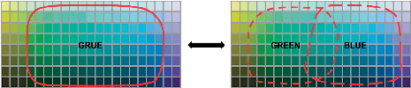
Figure 6 Categorisation of ‘grue’, ‘blue’ and ‘green’.
View description - Figure 6 Categorisation of ‘grue’, ‘blue’ and ‘green’.

Back to - Activity 3

Activity 4

Discussion
- The head-mounted cameras allow researchers to gain insights into what babies actually see, not what adults think they see. They allow researchers to move away from traditional psychology experiments in controlled environments to understand the way in which language is acquired in the course of everyday life
- When infants hold up an object it blocks out the distractors and controls the information that enters their eyes. Linda describes how this optimises the information that infants learn from. Linda also discusses research involving infants and children with developmental disorders. Infants and children who have impairments in their ability to move and hold objects are at a disadvantage as they are unable to create their own experiences from which they can learn (e.g. holding objects and sustaining attention). Seeing the world from the viewpoint of an infant shows where the problems are and how to make a difference.
- Words are learned rapidly. In the past, researchers studying language development would use what Linda referred to as a ‘discrete trial model’, in which infants are presented with an image of an object at the same time as hearing the name of the object. However, seeing an object/event/emotion and hearing a word at the same time isn’t necessarily how words are learned in the context of everyday events. Linda describes how real-world events are complex stories containing many different elements. In order to understand how infants break into language, researchers need to study how words are learned in the context of everyday events.
- Babies under four months old in India and the United States have similar face experiences (for 15 minutes out of every waking hour, they see faces up close and most of the faces belong to three different people). The visual experiences diverged as the infants in each culture got older. Early face experience is important for the development of face perception. For example, having cataracts in the first few months of life can lead to face perception impairments in adulthood. Linda’s findings also suggest that the first few months are particularly important for setting up the perceptual processes used to recognise faces.
Back to - Activity 4

Activity 5

Discussion
You probably thought here that Ceri is someone with high wellbeing. She has a full life, with strong relationships and fulfilling employment. Asking Ceri about her life satisfaction would probably get a reasonably high score. In terms of needs, you might have noted that Ceri is able to get her emotional needs met through her friends, family and partner. Her physical needs are also met through her access to medical care; the adaptations to her house and car; and her financial security from work and benefits.
Thinking about the final question, you may have identified that Ceri’s wellbeing is supported by a mixture of all of these elements. She is able to work, due to her own ability and experience, which is helped by technology enabling her to work from home and to the flexibility of freelancing. A more rigid kind of work which required daily attendance in an office might block Ceri from paid employment. Similarly, her relationships and social life are, in part, made possible by the set-up of her environment and the people around her. Without disability benefits and the adaptations to her house and car, it is possible that Ceri would not be able to live such a full and independent life. Her health is less of a barrier than it could be, due to the adaptations to her environment and the attitudes of her friends and family.
Back to - Activity 5

Activity 6

Discussion
- You may have noted down that Kaupapa Māori psychology is described as being ‘by Māori for Māori’ – an approach to understanding psychology which is rooted in the Māori world view and uses Māori concepts. You may also have noted that Kaupapa Māori psychology is more than a theory; it is also a practical approach to working with people, communities and solving everyday problems. Some issues highlighted in the interviews include homelessness and poverty which Linda Waimarie Nikora describes as ‘survival’.
- You may have noted down that Kaupapa Māori psychology views people as being interconnected with their environment – both with other people and the natural world. The importance of viewing people as interconnected was talked about in terms of respect, meaning a respect for others and the environments in which people live. This in turn was discussed as underpinning a commitment to leaving the world in a better state for the next generation. Several of the Māori words used reflect this, such as the importance of a person’s whakapapa as part of their identity. This includes how Māori introduce themselves to new people, which typically includes saying which iwi they belong to. The sharing of stories, songs, dances and rituals as part of both preserving mātauranga Māori and using them in practice to help people’s wellbeing (e.g. working with grief and loss) also highlights the importance of relationships and a connected way of thinking about people.
- You may have thought about some of the examples given in the video. One is the ‘Family 100’ project (e.g. Hodgetts et al., 2014), where families receiving welfare were given food for a year and were found to thrive. This is given as an example of providing services which are caring rather than punitive. It is also an example of trying to build on people’s strengths and capacities, as discussed by Shiloh Groot. In this case, the approach of the project was to give families sufficient food, rather than to focus on fixing problems which can emerge from not having enough food – such as reduced school attendance. More generally, you may have noted down that this approach sees wellbeing, therapy and healing as happening with other people, and being rooted in relationships with others. This is a way of saying that wellbeing is not only something that individuals have but is a reflection of the strength and health of relationships between people as well.
Back to - Activity 6

Activity 7

Part

Answer
Right:
50.8%
Wrong:
20.1%
3.9%
11.4%
0.6%
11.9%
1.3%
Back to - Part

Part

Answer
Right:
11.9%
Wrong:
20.1%
50.8%
1.3%
0.6%
3.9%
11.4%
Back to - Part

Part

Answer
Right:
20.1%
Wrong:
50.8%
3.9%
0.6%
1.3%
11.4%
11.9%
Back to - Part

Part

Answer
Right:
3.9%
Wrong:
20.1%
11.9%
50.8%
1.3%
0.6%
11.4%
Back to - Part

Part

Answer
Right:
1.3%
Wrong:
20.1%
3.9%
11.9%
50.8%
0.6%
11.4%
Back to - Part

Part

Answer
Right:
0.6%
Wrong:
20.1%
11.9%
50.8%
1.3%
3.9%
11.4%
Back to - Part

Part

Answer
Right:
11.4%
Wrong:
20.1%
3.9%
11.9%
1.3%
50.8%
0.6%
Back to - Part

Part

Answer
Right:
4%
Wrong:
60%
16%
1%
10%
8%
Back to - Part

Part

Answer
Right:
1%
Wrong:
60%
4%
16%
8%
10%
Back to - Part

Part

Answer
Right:
10%
Wrong:
60%
1%
16%
8%
4%
Back to - Part

Part

Answer
Right:
60%
Wrong:
4%
16%
1%
8%
10%
Back to - Part

Part

Answer
Right:
16%
Wrong:
60%
8%
1%
4%
10%
Back to - Part

Part

Answer
Right:
8%
Wrong:
4%
16%
60%
1%
10%
Back to - Part

Part

Discussion
Asia has 60 per cent of the world’s population but only 3.9 per cent of the studies in Psychological Science were carried out with people who live there. The other huge difference is the US, where just over half of studies were carried out despite being only 4 per cent of the world’s population.
You might wonder if these discrepancies matter. Maybe people in India, China and the US are so similar that studies done with US undergraduate students can be generalised to the rest of the world. One issue is that if psychology continues to operate in this way, we will never know if that is true! It may be, but many psychological theories developed in Europe and the US have not been tested elsewhere. For many psychological concepts, it is still an open question as to whether they apply globally and universally. Some may well do, and some almost certainly do not. Some concepts will be somewhere in between, perhaps fitting people from some parts of the world well and others poorly, or perhaps parts of the concept will apply universally and other parts will not.
You may be wondering if this journal is particularly US focused, and that maybe this biased the types of people they studied. Certainly that could be a large part of it, and there are whole areas of psychology which look specifically at cultural variation, where the studies have more varied participants. There are also journals based outside the US, including Asian psychology journals which have increasing influence globally.
Back to - Part

Descriptions

Figure 1 Bananas in Pyjamas was an Australian children’s TV show depicting two Bananas, B1 and B2, who were almost identical in appearance and thinking. The bananas made sense of the events that arose in much the same way, so much so, that they were known for the phrases ‘Are you thinking what I’m thinking B1?’ to which B1 says, ‘I am B2’.
Two characters dressed as bananas wearing pyjamas.
Back to - Figure 1 Bananas in Pyjamas was an Australian children’s TV show depicting two Bananas, B1 and B2, who were almost identical in appearance and thinking. The bananas made sense of the events that arose in much the same way, so much so, that they were known for the phrases ‘Are you thinking what I’m thinking B1?’ to which B1 says, ‘I am B2’.

Figure 3 A continuum of individualist vs collectivist cultural dimensions including placements of China, Mexico, Spain, Germany and the US.
This figure depicts a continuum of two extremes: individualism and collectivism. Countries sit on varied parts of the continuum based on their orientation toward individualism versus collectivism. It ranges from 0 to 100, where higher values indicate a greater tendency toward individualism, and lower values reflect stronger collectivist tendencies.
Back to - Figure 3 A continuum of individualist vs collectivist cultural dimensions including placements of China, Mexico, Spain, Germany and the US.

Figure 4 Coloured square 1
The colour is what English speakers would categorise as blue.
Back to - Figure 4 Coloured square 1

Figure 5 Coloured square 2.
The colour is what English speakers would categorise as green.
Back to - Figure 5 Coloured square 2.

Figure 6 Categorisation of ‘grue’, ‘blue’ and ‘green’.
These are two identical rectangular grids, positioned side by side and linked by a double-headed arrow. Each grid consists of 168 small squares showing minor variations in colour in the blue-green range. In the top left-hand corner pale green fades into yellow, and in the bottom right-hand corner dark blue shades into purple. In the grid on the left a red line is drawn to include all the colours except those at the extreme edges of the rectangle. The area outlined in red is labelled ‘grue’. In the grid on the right, red dotted lines are drawn to include two overlapping areas: the one on the left is labelled ‘green’, and the one on the right is labelled ‘blue’.
Back to - Figure 6 Categorisation of ‘grue’, ‘blue’ and ‘green’.

Figure 7 A bowl of fruit under different lighting conditions.
These are three close-up photographs of the same bowl of fruit, positioned side by side. The fruit includes a banana on the left, a green pear in the centre and an orange on the right. The photo on the left is taken in yellowish lighting, enhancing the colours of the banana and orange. The photo in the centre is taken in natural lighting. And the photo on the right is taken in blueish lighting, making the banana look greenish and the orange appear a dull brown.
Back to - Figure 7 A bowl of fruit under different lighting conditions.

Figure 8 Spot the difference! Wilhelm Wundt (left) and William James (right) were two important early psychologists.
These are two early twentieth-century black and white portrait photographs, positioned side by side. Each of them features an older bearded man in a head-and-shoulders shot, posed in three-quarter profile and facing to the right. Both men are formally dressed in jacket and tie. The one on the left wears glasses and gazes out of the frame. The one on the right turns his head to look directly at the camera.
Back to - Figure 8 Spot the difference! Wilhelm Wundt (left) and William James (right) were two important early psychologists.

Video 1 Linda B. Smith discusses the Homeview Project

Transcript
[MUSIC PLAYING]
[Text on screen: What first got you excited about doing developmental psychology?]
[Text on screen: Linda B. Smith, Professor, Psychology and Cognitive Science]
LINDA SMITH
I want to understand why we’re as smart as we are, why we have the personalities we do, why we have the differences among us. We’re all our own unique little flower. And the only way to understand all that is to look at developmental process.
[Text on screen: Indiana University Bloomington. Cognitive Development Lab.]
LINDA SMITH
We really do, literally, get made in time. And early on, every experience is building, building, building, building the brain. And what happens, let’s say, when you’re in kindergarten very much is the result of the accrued experiences and brain changes that have occurred as a result of those experiences prior to that event.
[Text on screen: What was the thinking behind the Homeview experiment?]
A lot of my work and the real impetus for Homeview 1, which we began with, is concerned with how infants break into language. So infants say their first words at about a year. And then language gets much more sophisticated by 2 years. Then they’re really pretty good by 3 to 4. Even though they say their first words at a year, however, a lot of experiences up to that first birthday create the ability to do that.
So what we wanted to do was really try to understand, at the scale of everyday life, the baby’s role in creating their own experiences, both interacting with objects, playing with them, holding them, dropping them and how those behaviours elicited the naming of objects and talk about objects to the infant.
[Text on screen: How did you set up the Homeview experiment?]
Back in about 2013, I decided that what we needed to do was to actually try to measure everyday experience at the time scales which it happens and at the time scales which affect the brain and affect developmental process. And that’s fractions a second, OK. So that led to the idea of putting wearable sensors on babies – head cameras, head-mounted eye trackers, motion sensors – so that you could get a fine-grained detail of what they do, what happens, OK, what they personally experience from their point of view.
We put head cameras on babies in the home asking for day long recordings of their visual experiences and auditory experiences from their point of view. So you could really try to see the scale of experience, the scale of events that happen in a day.
[MUSIC PLAYING]
[Text on screen: How does understanding more about what babies see from their perspective tell us about language learning?]
Babies break into language by connecting words they hear to perceptual experiences. It could be they connect a word to a sound. They could be connecting a word to a seen object. It could be they connect a word to an emotion. All of those are potential meanings that the person feels that can co-occur with or a word could be about. About 50% of the words in almost all languages – there’s some interesting oddities – but almost all of the world’s languages, about 50% of the first words that babies learn are object names – cup, juice, banana, mama – our names for things, things that you see.
And the thing is that much of the other reason for looking at it is much of language learning of all kinds happens just listening to people talk about whatever is going on, being able to rapidly identify what is being talked about. When the mom says, ‘So what is Snooty the dog doing with your sippy cup?’, OK, they need to be able to find the dog and the sippy cup to even pull out the meaning of that in the moment, right. And that’s what everyday language is about. So being able to rapidly visually identify what’s being talked about is also a key skill in early language learning.
WOMAN
What does the puppy say? Puppies say woof, woof. Woof, woof.
[Text on screen: Why did you ask parents to put cameras on their infants' heads at home for this experiment?]
LINDA SMITH
When you are in a room and you, as an adult, are looking around and you are watching what a baby is doing, one, you see it through the lens of your own eye. You see the behaviour of the mother, the behaviour of the baby. You make inferences. Oh, the baby took that object because the mother showed it to him.
But when you look through the egocentric head camera, right between your eyes, of what the baby sees, baby never saw the mother show that object, OK. It wasn’t in the visual field. You find out that what babies are seeing – what you see at any moment in time – is highly determined on the spatial relation between your eyes, that is your head, and whatever it is you’re looking about.
So as you move your head around, right, you see different things. I can occlude the camera, guys, just by ducking down. You change the whole view. You need to see it from the baby’s point of view. The only visual information that is going to teach about visual objects, about the kinds of categories we talk about – about putting things in, on, under, over, throwing – all these things babies have to learn, the only thing that matters is the information that hits the baby’s eye, not your 3D view of that information, OK.
It’s an enormous insight. It has changed what we know about babies and babies’ learning remarkably. One thing … We don’t do this as adults, but if we want to selectively attend, OK, if I’m interested in something like this cup, you know, I can be sitting out there, and I can look at a distance. There’s my cup. Babies don’t do that. They bring it up. They block out all the distractors. They control their input. And that is really important to their learning, actually holding an object. I’m blocking you out, Jane. OK, you can’t distract me now. I’m like studying my cup.
They control the input – actually optimise it – in ways that we know help for the visual extraction of information and for the duration of time over which they are looking at that information. Gives you time to pick up the visual properties, get them represented robustly and strongly and in memory, and get a name attached to them or other information that a parent may talk about it.
This is really important for understanding, I think, typically developing children. But many developmental disorders – Down’s Syndrome, ADHD, autism – have their disruptions of the sensorimotor systems. And it used to be that they thought, oh, their motor abilities, that’s just some co-morbid thing on the side that’s not relevant. But because the baby’s own behaviour is creating the experiences, the data, for learning, it’s absolutely critical to understand those small bumps.
[Text on screen: Does this have any immediate real world application?]
I have a friend, Cole Galloway, he’s a professor of physical therapy at University of Delaware. And he studies babies with major muscle disorder, motor neuron disorders, major muscle disorders. And these children, you know, they develop very, very slowly. Their social skills are bad. Their communication skills are bad. Their understanding of relations in the world are bad. If you can think about the bumps they’ve got to get over in terms of the typical pathway to creating experiences of learning, he’s helped solve them.
He’s done two amazing things. He, one, makes exoskeletons for these babies, so they can sit stably. That means they can hold … they can make some progress in holding objects and sustaining attention, OK, early, so they can do that at the right time. Get over that bump on the road to, you know, breaking into language. He also has made little motor cars. You know, you can have 2-year-old children in these little, kind of, moving cars. They can move with minimal kinds of body movements. So they actually can be autonomous and interactive in the world.
MAN
You are looking around like I have never seen before.
LINDA SMITH
The whole point I’m trying to make is that, seeing it from the baby’s view, actually shows you where the potential problems are and the potential ways to get in and make a difference in the life of a child.
[Text on screen: Why have you now taken the Homeview experiment to India?]
We are also collecting data, or collected data, using the same procedures in Homeview 1 in a under-resourced fishing village outside Chennai.
And there are a number of reasons to do this. If I just study children in Bloomington, Indiana, I have both geography, spatial layout, context of here. And maybe it’s not universal. Maybe it’s not everybody. There may be many, many, many paths to becoming a successful human being. And Bloomington, Indiana, a college town in the Midwest, may not be, OK, optimal for understanding that.
One of the reasons we were interested in going to India was because we wanted a place, first of all, that was very, very dense in the number of people. And that had related to our work on early experiences of faces. What we had found in the studies in the US, here in Bloomington, was that 15 minutes out of every hour of a baby under 4 months of age visual experiences were the face of an adult close up, two eyes, and that that frequency declined pretty dramatically. So by the time you got to 12 months of age, faces were six, four minutes per hour, waking hour.
That’s really interesting because we know that early face experiences, if for some reason you don’t have them – either because you were born with cataracts that don’t get removed until you’re 4 or 5 months of age, or people hardly ever looked at you in your early months when you were cared for – that you have disruptions in visual perception and in face recognition throughout your life. So the … we have what the visual experiences are in the first three months of phases in babies in the US, and then they decline.
And the other interesting thing about the experiences of the US babies is that 80% of the faces they saw in the first three months were just three faces. Let’s say dad, mom, and grandma. And that’s very interesting because it suggests that the system for recognising any and all faces might be set up by just a few faces. You just need a lot of experiences, visual experiences, early of just three faces, and you’re good, good to go, OK.
But is that really true? Is it sufficient? But do … is it different elsewhere? So we went to this fishing village. It’s very, very dense. Houses are very, very small. Most of life is spent outdoors. And there is minimal electricity. So they have much more bigger light–dark cycles, OK. So the interesting thing is that we found in that study is that the babies … the young babies in that culture have visual experiences – the babies under 4 months – that are pretty much like the babies in Bloomington.
As you get older, it diverges, OK, because you’re spending time out in the street and in these dense communities. Then, the statistics change. But the first four months appear to be tightly constrained. That suggests to us that it’s really about … that what evolution has done is controlled the input of faces to babies.
And really, putting it in everyday terms, it’s done it through love, OK. So the love of the mom, the love of the dad, the love of the, you know, sister or grandma in the family. They just love looking at those babies, and they stick their faces in front of them because they can’t help it, OK. And so that is just really the primary people who are giving the optimal input in those early stages. And that’s probably just built into us, right.
[Text on screen: Do your studies tell us anything about parenting?]
You can measure parent behaviour in interacting with their infants. And what you’ll find is that parents who are what are called responsive – that’s a technical term – responsive to their infants have infants who actually learn better in the context. It predicts overall learning later. And it predicts success in school when you look at this, even in infants as young as 18 months of age, you can predict success at 5 years, OK.
But what makes a parent unresponsive? So should I just say to parents, ‘Be responsive’? No. What makes a parent unresponsive? Stress, anxiety over issues. A parent’s first job is to keep the kid fed, healthy and a roof over their head. And not everybody has those opportunities. Responsivity is deeply, deeply linked to socio-economic status. And any one of us, if we had a sick spouse, a sick child, a bill collector chasing us down, get evicted, we are not responsive in the moment. So I’m not into, like, lecturing parents. There’s other ways to fix those problems, I think.
[Text on screen: Have you had any particularly surprising results?]
There’s been a number of surprises. One big surprise is the issue that babies are directly controlling their visual input and optimising it. So if you look at results from laboratory experiments about what kind of images or video events are easiest for babies to learn, babies actually move their bodies, heads, hands, postures in ways that create what experimental psychologists would say are optimal streams for learning, OK. That’s amazing.
The second thing that is amazing, that I think we are playing a role in shifting in how people think about it, is that people have usually thought about learning in a kind of discrete trial model. That I might … Well, what do I mean by that? Well, experiments, if they wanted to examine how babies learn the word for objects, they would show a picture of an apple and say ‘apple’. They’d show a picture of banana and say ‘banana’. They show a picture of a dog and say ‘dog’.
And the assumption is it’s a co-occurrence of the visual experience with the heard name that matters. But the world doesn’t work like that, and neither do our memory systems. Think about getting dressed in the morning. Mom is trying to get your shoe on. You’re playing with the Cheerio. Your mom takes a Cheerio away because it’s three days old. She puts your other shoe on in an attempt to get you dressed. The dog runs through. Everybody’s distracted for a moment.
What does the naming of objects in that look like? It looks like a narrative. It looks like a story, OK, of events. And what we’ve also discovered is there’s these lots of predictive relations between what’s happening in the physical world, which you can see – the shoe on, the shoe off, the dog, the Cheerio – predictive relations between all those seeming wild little episodes of events in the visual world.
And then the words have relations to each other, predictive relations to each other. What’s happening in time has predictive relations to each other. And the words get very rapidly learned. You might only need one wonderful event with your first taste of pizza, 10 namings of pizza, one wonderful meal at 12 months, where somebody gives you that crust of pizza with a little bit of cheese on it, and you know pizza for the rest of your life. It doesn’t take days.
Back to - Video 1 Linda B. Smith discusses the Homeview Project

Video 2 Māori psychology and approaches to wellbeing

Transcript
[MUSIC PLAYING]
[NON-ENGLISH SINGING]
LINDA WAIMARIE NIKORA
Indigenous psychology or Kaupapa Māori psychology is more holistic in its outlook. It’s more outwards looking into the universe. We’re all part of the universe. And so, it’s more focused on relationships with everything. So that’s our relationships with plants, with fishes, with animals, as well as our relationships with each other as human beings. That doesn’t mean to say that we reject mainstream psychology or Eurocentric psychology. We just simply understand it for what it is. It’s an important knowledge base, and it’s one that can actually complement Indigenous knowledge and our ways of working with people.
SHILOH GROOT
My name is Shiloh Groot. So it’s an interesting way in which Indigenous people in Ontario like to introduce themselves. First, you greet the person that you address to the audience, then you give a context for how you came to be to this world, and then, finally, you introduce yourself. I guess, long story short is I am associated with [NON-ENGLISH SPEECH] for better or worse in peace time and conflict and the best and the worst ways ever possible. If you’re Māori, it tells you a lot about who I am and where I come from. It gives you a strong context to who I am and my place in this world, the relationships I form with other tribes alongside ours. I’m an associate professor in the School of Psychology at the University of Auckland. I have strong research interests in homelessness and precarity; Indigenous world views and communities; sex work; and labour justice. And migration, and how we come to know one another, and how we can create dialogue and solidarity.
LINDA WAIMARIE NIKORA
I’m Linda Waimarie Nikora. [NON-ENGLISH SPEECH]. My tribal groups are Tuhoe, Te Aitanga a Hauiti, which is on a sea-based tribe, and a few other sea-based tribes, [NON-ENGLISH SPEECH] as well. So I’m a professor of Indigenous studies, but formerly a professor of Kaupapa Māori psychology at the University of Waikato.
BRIDGETTE MASTERS-AWATERE
My name is Bridget Masters-Awatere. I come from [NON-ENGLISH SPEECH] regions. So my genealogy connects me to the far North from Ahipara, which is the southern end of the tail in the North Island, all the way up to the very top. And then, on my mother’s side, to the Bay of Plenty, focusing on the Township of Onepu, just outside of Kawerau, and then [NON-ENGLISH SPEECH] connects me all the way through to Lake Taupo region [NON-ENGLISH SPEECH] so that’s where [NON-ENGLISH SPEECH] I’m currently associate professor at the University of Waikato in the School of Psychology.
DARRIN HODGETTS
So I’m Darrin Hodgetts. I grew up in the deep south. So I’m from Mirihiku. I work with Kaupapa Māori psychologists. I mean, I identify as a Pakeha New Zealander or [INAUDIBLE] Pakeha, but I do have family ties into Kai Tahu and I currently work on Mirihiku regeneration and projects down there. But I also embrace all the other aspects of who I am.
[ON-SCREEN TEXT: ‘WHAT IS KAUPAPA MĀORI PSYCHOLOGY?’]
LINDA WAIMARIE NIKORA
Kaupapa Māori psychology is defined by three very, very broad general areas. So the first is survival. We all want to live long lives, and we all want to enjoy those lives. However, as an Indigenous people, we’re faced by challenges of homelessness, food insecurity, having to find shelter, accommodation, having to find employment and ways to actually sustain our families. And those are all survival issues, they impact our health, our wellbeing, and all those areas need to be addressed in order to thrive. So that’s the first area. The second is maintaining our distinctiveness as a culture group. We want to be Māori moving into the future. And we want to take the knowledge of our tipuna and ancestors with us and pass that on to further generations as well. There’s a wealth of learning and knowledge that’s contained within what we call mātauranga Māori, or Māori knowledges. That knowledge is vital for our survival, our wellbeing, etc. The third is around wanting to make for a better world moving into the future. And that’s not just only within our own individual lives but extending out further into the environment, our seas, our waters, our lands, and ensuring that what the next generation inherits is better than what we did.
SHILOH GROOT
Kaupapa Māori psychology, I guess, arose in response to frustration with the individualistic and colonising approach of mainstream psychology that ignored us, would measure us, observe our misery, and would have no interest in engaging in our strengths and capacities and could sometimes behave violently towards us. As Māori, we’ve always had psychological frameworks to understand ourselves, how we relate to one another, the responsibilities we have towards one another, our relationship to the environment. It’s a world view that values continuity, unity. It doesn’t shy away from conflict. There are frameworks for working through conflict, for healing.
DARRIN HODGETTS
What we have in Kaupapa Māori psychology is a view of the self as fundamentally interconnected and related to different contexts and so on. So that becomes all part of it. That becomes this idea that you can’t deal with individuals in isolation. The problems we face aren’t just in your head. They often come from relationships in society. And those can be between people with family and community, but they can also be – particularly in a colonial context like ours, they can be the structures that have been imposed on Māori people. I think, also, this relationality is important because the thing I really like about Kaupapa Māori psychology is it’s by Māori for Māori, but it’s also for everybody else.
LINDA WAIMARIE NIKORA
We’re all part of the universe. All life has life. So that’s everything from the rocks we might encounter, the plant life we might encounter, sea, fishes, even buildings and things that we create. They all have a life. And that life is referred to as mauri, everything has a mauri. Because everything has a mauri it demands respect. So we have to respect our environments that we’re a part of. When we move into the space of respecting our environments and everything that’s in it, we step into the universe in ways that can be healing, therapeutic, and where we’re able to be good citizens in terms of future generations.
[ON-SCREEN TEXT: ‘WHAT IS WHANAUNGATANGA?’]
Whanaungatanga is really about relationality – the ways in which we reside in relationship with each other and the world around us. What that then means is that therapies and wellness can be grown within relationships as opposed to just within an individual. So, for example, if I take my relationship with a child, I can focus on the child being a problem or I can focus on the relationship that I have with the child. We’re walking away from the individual and seeing the individual in context and in relationship with everything that surrounds that particular person.
DARRIN HODGETTS
I think Kaupapa Māori psychology is also part of a broader movement within psychology to not only indigenise but repluralise our discipline because all cultural groups and communities have their own psychology. Kaupapa Māori psychology is actually quite an open psychology, and it’s a psychology that wants to have conversations with other psychologies, be they Eurocentric – there’s no choice in that matter because that’s the dominant approach in the field – but also with all these other psychologists, particularly in the Pacific and the Global South. So when we get PhD students from Vietnam, Indonesia, places like that, they can see themselves in Kaupapa Māori psychology, and they can see themselves developing something similar for themselves. And I think that’s what’s really great about it as an approach.
[ON-SCREEN TEXT: ‘HOW DO YOU WORK AS A KAUPAPA MĀORI PSYCHOLOGIST?’]
BRIDGETTE MASTERS-AWATERE
Everything I do is about centring Māori knowledge as a legitimate source of knowledge. It’s scientific. It’s artistic. It’s creative. It’s history. So it’s recognising all of those aspects of who we are that have been discredited by Western psychology, that whole kind of notion that the only legitimate knowledge is that knowledge that’s been written on pages, that’s been handed down through published books. But actually, Māori have a longstanding knowledge that’s been passed down through our [NON-ENGLISH SPEECH] all of that knowledge. When you understand it and can engage with it appropriately, you can see how that reflects the times that our ancestors were engaging with.
LINDA WAIMARIE NIKORA
We set about a project looking at tangi – Māori ways of death and dying. So in the Māori world, we hold that when we are born, we come from our ancestors. And when we pass, we return to our ancestors. And so that becomes a cycle of life. So in the Māori world, we have some very, very elaborate grief and dying rituals, as is true in lots of other cultural groups. And those rituals are really, really important in terms of healing the breach that’s been formed when a person passes. So that person leaves a gap. How do we negotiate that breach? Secondly, helping to facilitate the journey of the spirit to whatever their next chapter is, and thirdly, putting that community back together again – how do we put that community back together again? So in terms of our tangi rituals, that’s one way in which we achieve that at a community level. And so as a psychologist, the important thing is to focus in on the community-level practices and make sure that those practices are adequately robust to facilitate that transition and that healing process.
DARRIN HODGETTS
Most homeless people in New Zealand come from the precariat, or people from households with insecure jobs or on unemployment benefits that pay unliving wages. They’re unsustainable situations. And what we did is we took the 10,000 heavy users of the food bank. We then selected the most heavy users, 1,000 of them, and then we basically randomly selected 100 and started calling these households. And what we did is we removed food insecurity by giving them free food for 18 months. And we also interacted with them fortnightly. And we just traced their everyday lives. And what we found is all sorts of really interesting things – when you give people food security and some stability in life, children may have been off school for 143 days in one household the year before. When they were part of family 100, those kids were off school for three days. So what we could show is that at the time, welfare was really punitive. But if you showed care and support to households and you resource them, they did well.
[ON-SCREEN TEXT: ‘WHAT HAS BEEN THE IMPACT?’]
BRIDGETTE MASTERS-AWATERE
25 years ago, there was barely any literature. There was barely any research. There was barely any – we weren’t even on the radar in terms of thinking about health and wellbeing from a Māori perspective. So now there’s this whole body of literature. You’ve got the next generation who are expanding and deepening that knowledge. You’ve got it on the radar of policy writers, of ministry research funders. And it’s being built into funding expectations and reporting expectations.
LINDA WAIMARIE NIKORA
The impact of Kaupapa Māori psychology on psychology, on mainstream psychology, has been to demonstrate that there are different ways of being and seeing and standing and living in the world. And if we understand what those ways are, we’re better able to treat with people and to support them in terms of their aspirations.
SHILOH GROOT
I think the impact is immeasurable. Psychology was largely failing us. It was violent in many ways. We had over institutionalisation of our people. We had researchers going in, denigrating our communities, ridiculing our communities, inability to engage with our strengths and our capacities, our own understandings. With all these devastating social issues that were impacting us as a people, that’s all they noted – our misery and what was going wrong for us, to a point where that was almost becoming synonymous with what it means to be Māori. I think Kaupapa Māori revitalised and transformed a lot of that discourse and gave us a pathway towards our own healing that was centred in our own understandings and connected to our own spiritual life worlds.
SINGER: [NON-ENGLISH SINGING]
[APPLAUSE]
Back to - Video 2 Māori psychology and approaches to wellbeing

