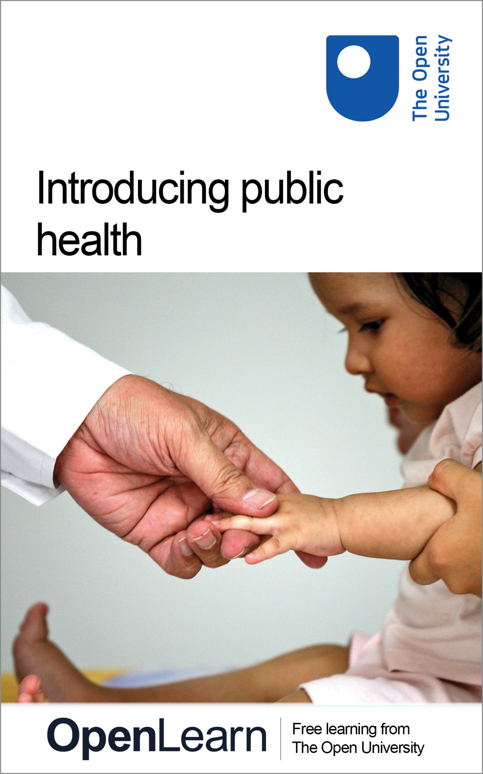

K311_5

Introducing public health

About this free course
This free course is an adapted extract from the Open University course K311 Promoting public health: skills, perspectives and practice www.open.ac.uk/courses/modules/k311.
This version of the content may include video, images and interactive content that may not be optimised for your device.
You can experience this free course as it was originally designed on OpenLearn, the home of free learning from The Open University –
www.open.edu/openlearn/health-sports-psychology/public-health/introducing-public-health/content-section-0
There you’ll also be able to track your progress via your activity record, which you can use to demonstrate your learning.
Copyright © 2017 The Open University
Intellectual property
Unless otherwise stated, this resource is released under the terms of the Creative Commons Licence v4.0 http://creativecommons.org/licenses/by-nc-sa/4.0/deed.en_GB. Within that The Open University interprets this licence in the following way: www.open.edu/openlearn/about-openlearn/frequently-asked-questions-on-openlearn. Copyright and rights falling outside the terms of the Creative Commons Licence are retained or controlled by The Open University. Please read the full text before using any of the content.
We believe the primary barrier to accessing high-quality educational experiences is cost, which is why we aim to publish as much free content as possible under an open licence. If it proves difficult to release content under our preferred Creative Commons licence (e.g. because we can’t afford or gain the clearances or find suitable alternatives), we will still release the materials for free under a personal end-user licence.
This is because the learning experience will always be the same high quality offering and that should always be seen as positive – even if at times the licensing is different to Creative Commons.
When using the content you must attribute us (The Open University) (the OU) and any identified author in accordance with the terms of the Creative Commons Licence.
The Acknowledgements section is used to list, amongst other things, third party (Proprietary), licensed content which is not subject to Creative Commons licensing. Proprietary content must be used (retained) intact and in context to the content at all times.
The Acknowledgements section is also used to bring to your attention any other Special Restrictions which may apply to the content. For example there may be times when the Creative Commons Non-Commercial Sharealike licence does not apply to any of the content even if owned by us (The Open University). In these instances, unless stated otherwise, the content may be used for personal and non-commercial use.
We have also identified as Proprietary other material included in the content which is not subject to Creative Commons Licence. These are OU logos, trading names and may extend to certain photographic and video images and sound recordings and any other material as may be brought to your attention.
Unauthorised use of any of the content may constitute a breach of the terms and conditions and/or intellectual property laws.
We reserve the right to alter, amend or bring to an end any terms and conditions provided here without notice.
All rights falling outside the terms of the Creative Commons licence are retained or controlled by The Open University.
Head of Intellectual Property, The Open University
978 1 47300 050 6 (.kdl)
978 1 47300 145 9 (.epub)

Contents
- Introduction
- Learning Outcomes
- 1 What is public health?
- 2 The shifting focus of public health
- 3 Different perspectives on health
- 4 Influences on health
- 5 Life-course effects
- 6 Scope of public health
- 7 Partnerships between sectors
- 8 Reflections
- Conclusion
- References
- Acknowledgements
- Solutions
- Descriptions

Introduction
This free course, Introducing public health, uses several activities to introduce two important public health issues: factors that influence health and ill-health; and the scope of public health work.
- Factors influencing health, or the ‘wider determinants of health and ill-health’ as they are often called, are complex and contested. Family circumstances, poverty, education, work, housing and environment all impact on our health to some extent.
- Public health has become ‘everybody’s business’ and is undertaken by a wide range of people, not just in the health sector but in other sectors too. It is both ‘multi-professional’ – involving professionals such as police, teachers, housing officers as well as health workers – and ‘inter-sectoral’ – involving different government departments, local government, the voluntary sector, private sector and so on.
Consider how to use your study of this course, for example by recording your ideas in the word document provided. In addition, you can note your ideas in a notebook or in an electronic journal. If you are a public health practitioner you may wish to use your work to help build portfolio evidence of your public health knowledge and skills. If you enjoy this course you can also study other OpenLearn courses on public health:
Level 1: Public health approaches to infectious disease
Level 2: Public health and mental health promotion
This OpenLearn course is an adapted extract from the Open University course K311 Promoting public health: skills, perspectives and practice.

Learning Outcomes
After studying this course, you should be able to:
demonstrate some knowledge and understanding of the wider determinants of health and ill-health
demonstrate some knowledge and understanding of the roles of people and agencies who undertake work in the promotion of public health
demonstrate an awareness of the debates and dilemmas that may arise from the promotion of public health.

1 What is public health?

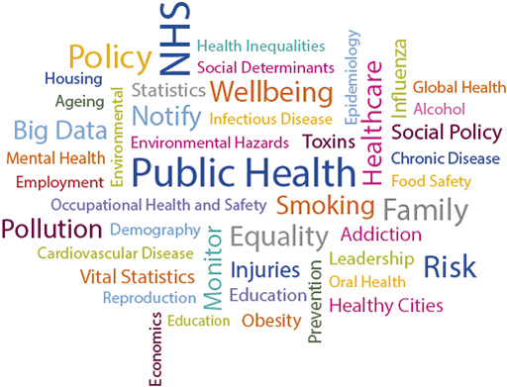
Figure 1 Public health word cloud
View description - Figure 1 Public health word cloud

You’ve probably already heard of ‘public health’ and you’ll have your own views on what the term means. It’s important to reflect on this and to see how your views and understanding might change after this course.

Activity 1: Getting started
Allow 15 mins

Based on your own ideas and experiences, write notes on what you think the scope and focus of public health is in the word document provided.

View discussion - Activity 1: Getting started

2 The shifting focus of public health
Public health is an ever-changing field with a rich history. In Activity 2 you will look more closely at the changing role and scope of public health.

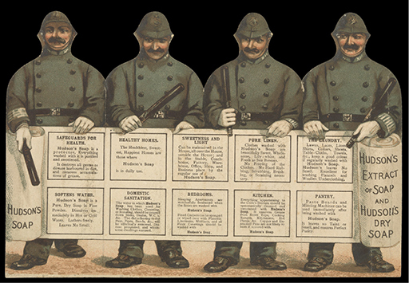
Figure 2 A nineteenth-century soap advertisement promoting public health.
View description - Figure 2 A nineteenth-century soap advertisement promoting public health.

Activity 2: Public health - past and present
Allow 1 hour

Spend about 20 minutes browsing the Public Health interactive timeline from The Health Foundation.
Identify the key public health developments that have impacted on health outcomes through the different periods of history and note them down in the word document provided.

View discussion - Activity 2: Public health - past and present

3 Different perspectives on health
Perspectives of public health are shaped by ideology, including ideas about what is meant by the concept of health.

Activity 3: Thinking about your own health
Allow 45 mins

Take a few minutes to think about your health or the health of someone close to you (such as a friend, family member or partner). Write notes to the questions below in the word document provided. If you’re thinking about somebody else’s health, think about the questions from their perspective.
- How would you describe your health?
- Thinking about your own health compared to ten years ago, would say you are healthier/less healthy/about the same?
- Is your health important to you? Why do you say that?
Now watch the video below in which both public health professionals and members of the public discuss what health means to them. How do the views of professionals like Mary and Joanna differ from the perceptions of members of the public like Bernadette and James? How do your perceptions of health compare?

Video content is not available in this format.
Film 1 Views on health (© The Open University)
View transcript - Film 1 Views on health (© The Open University)

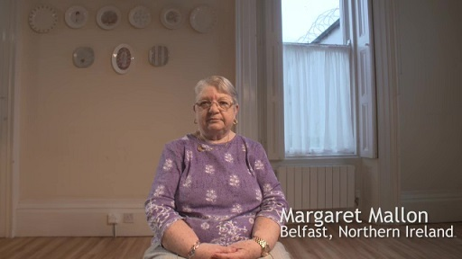

View discussion - Activity 3: Thinking about your own health

Activity 3 reveals that it is hard to arrive at a straightforward definition of health. Over the years different, and often competing, definitions of health have developed. Traditionally health has been defined in terms of disease and death, and this framing remains strong to this day. However, our understanding of health has gradually developed, and now there is the idea that health is not just the absence of disease, but overall physical, mental and social wellbeing. You may also define health as how you feel about yourself and your ability to do and achieve things.
Across countries there is variation in what is counted as public health activity, ranging from public health being concerned with disease prevention in a narrow medical sense, to a broader view of public health tackling wider social causes of health. This variation reflects very different understandings of the meaning of health.

4 Influences on health
In the UK, a broad definition of public health is taken, and efforts to enhance people’s health and wellbeing is seen as an important part of public health activity. In Activity 4 you will consider influences on your own health and wellbeing.

Activity 4: Influences on your health
Allow 30 minutes

In the word document provided, draw a circular diagram with yourself at the centre. Position the factors that influence your health around the circle. If the link to your health is indirect use dotted lines and if there is a direct link use thicker lines. Use distance to denote effect; the closer to you, the stronger the impact.

View discussion - Activity 4: Influences on your health

In the activity above you started to consider influences on health. The Dahlgren and Whitehead rainbow is a well-established description of how influences at different levels (and influences within layers) interact to determine health (Dahlgren and Whitehead, 1993). Figure 3 shows how individual lifestyle factors (Layer 4) are embedded in and influenced by social and community networks (Layer 3), and by living and working conditions (Layer 2). These are, in turn, influenced by the wider socio-economic, cultural and environmental conditions within the country in which individuals live (Layer 1).

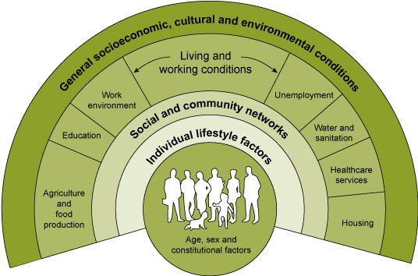
Figure 3 The Dahlgren and Whitehead rainbow
View description - Figure 3 The Dahlgren and Whitehead rainbow

When considering influences on health, you may have focused on immediate factors such as lifestyle. Dahlgren and Whitehead’s rainbow highlights that considering the context of an individual’s life makes it clearer that our lifestyle ‘choices’ can be influenced by wider socio-economic factors. This understanding of the social circumstances that lead to unhealthy behaviour is sometimes referred to as the ‘causes of the causes’.

5 Life-course effects
The influences on health operate throughout the life-course. In the next activity, you’ll consider the importance of taking a life-course perspective in public health.

Activity 5: Public health practitioners discussing the importance of life-course perspective
Allow 20 minutes

Watch Film 2, in which a number of public health workers in Powys, Wales discuss the importance of life-course interventions, and answer the questions below in the word document provided.

Video content is not available in this format.
Film 2 Life-course interventions – health practitioners from Powys, Wales (© The Open University)
View transcript - Film 2 Life-course interventions – health practitioners from Powys, Wales (© The ...

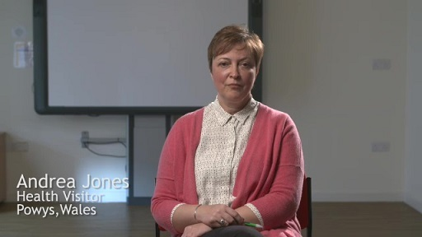

- What period of the life-course do the public health practitioners in Film 2 see as important to have interventions in, and why?
- Who do the practitioners see as important to include in these interventions?

View discussion - Activity 5: Public health practitioners discussing the importance of life-course ...

6 Scope of public health
The activities in Sections 4 and 5 indicated the breadth of public health in the UK today. Indeed, it is usually termed ‘multidisciplinary public health’ to highlight its growing importance to all professions, whether they work in healthcare, social care, the independent or voluntary sector, local government, education or almost any other sector in the UK. Influences on health are often outside the control of the health sector and include factors such as education, housing, employment and climate. Therefore, for public health activity to be successful they require effective partnerships.

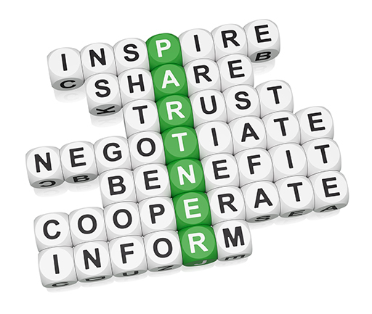
Figure 4 Elements of partnership working
View description - Figure 4 Elements of partnership working

How do we define partnerships in public health? The conventional definition of partnership is deemed to be a joint working arrangement where the partners:
- are otherwise independent bodies with different agendas, but run based on trust;
- agree to cooperate to achieve common goals or outcomes such as reducing inequalities or improving wellbeing;
- create a new organisational structure and governance to achieve the shared goal;
- cooperate, plan and implement a jointly agreed programme, often with joint staff and/or resources (which could come from a third party) and;
- share relevant information, and pool risks and rewards.
These arrangements tend to be formally agreed on (e.g. contracts); however, informal partnerships do exist. Once resources need to be allocated formal agreements become more important (e.g. collaboration agreement).

Activity 6: Public health partnerships types
Allow 45 minutes

The following websites illustrate some of the current government health partnerships in the four nations of the UK (England, Wales, Scotland and Northern Ireland). Choose one and consider the extent to which the partnership meets the criteria of the conventional definition provided above. Try to identify the benefits of the partnership and then write a paragraph in the word document provided on why the partnership may or may not bring about these benefits and whether a partnership is the most appropriate way of achieving these benefits.
- NHS England partnerships and relationships
- A Fairer Healthier Scotland 2017-22
- NHS Wales Shared Services and Partnership
- Northern Ireland Department of Health

View discussion - Activity 6: Public health partnerships types

7 Partnerships between sectors
As stated in Section 4, the wide range of influences on our health means that promotion of public health is not just confined to the health sector alone. Instead, partnership is needed across sectors. An approach to creating public policies that holds this value is ‘Health in All Policies’ (HiAP). In the activity below you will explore what is meant by this concept more.

Activity 7: A definition of HiAP
Allow 45 minutes

With growing interest in population health among researchers, policy makers, the media and the general public, a large quantity of information has become available, and visual representations of information (infographics) are becoming increasingly popular.
- Consider the infographic ‘What is health in all policies’ produced by the World Health Organisation (WHO). Based on this infographic, note down in the word document provided what you think is meant by the term ‘health in all policies’.
- Using your preferred search engine, search for information on ‘health in all policies’. Based on your further reading of the definitions/information on ‘HiAP’, how well do you think the infographic in Part A communicates what HiAP is and why it is important?

View discussion - Activity 7: A definition of HiAP

8 Reflections
In this final section you will consider whether undertaking this course has changed your perspective on what the scope and focus of public health is.

Activity 8: Reflecting on your learning
Allow 20 minutes

Revisit your notes from Activity 1 at the beginning of this course, where you noted your ideas on what the scope and focus of public health was. Has undertaking this course altered your perspective on the meaning of public health? Why is this the case? Note your thoughts down in the word document provided.

We hope that doing this course has broadened your perceptions about the scope and focus of public health and who should be involved in promoting the public’s health. We also hope that it’s generated some questions for you that may inspire you to delve even deeper into this fascinating and important area.

Conclusion
This free course, Introducing public health, provided an introduction to studying public health. It took you through a series of activities designed to develop your approach to study and learning at a distance and helped to improve your confidence as an independent learner.
This OpenLearn course is an adapted extract from the Open University course K311 Promoting public health: skills, perspectives and practice.

References
Dahlgren, G. and Whitehead, M. (1993) Tackling Inequalities in Health: What can we Learn from What has been Tried?, London, King’s Fund.

Acknowledgements
This free course was written by Aravinda Guntapalli and Philippa Waterhouse.
Except for third party materials and otherwise stated (see terms and conditions), this content is made available under a Creative Commons Attribution-NonCommercial-ShareAlike 4.0 Licence.
Grateful acknowledgement is made to the following sources for permission to reproduce material in this free course:
Course image: Alex Proimos in Flickr made available under Creative Commons Attribution-NonCommercial 2.0 Licence.
Figure 2: Wellcome Library, London. This file is licensed under the Creative Commons Attribution Licence http://creativecommons.org/licenses/by/4.0
The material acknowledged below is Proprietary and used under licence (not subject to Creative Commons Licence).
Figure 3: Dahlgren, G. and Whitehead, M. (1991) Policies and Strategies to Promote Social Equity in Health. Institute for Futures Studies
Figure 4: NewAge/123RF.com
Every effort has been made to contact copyright owners. If any have been inadvertently overlooked, the publishers will be pleased to make the necessary arrangements at the first opportunity.
Don't miss out
If reading this text has inspired you to learn more, you may be interested in joining the millions of people who discover our free learning resources and qualifications by visiting The Open University – www.open.edu/openlearn/free-courses.

Solutions

Activity 1: Getting started

Discussion
Public health is difficult to define due to its breadth and depth. There are a range of opinions on what the scope and focus of public health is, and these are often influenced by the values that we hold. Public health in the UK encompasses healthcare, social care, the independent or voluntary sector, local government, education and almost any other sector in the UK. You will learn by the end of this course that public health is an issue for all people too, whether they live alone or in a family. In short, public health is ‘everybody’s business’ and the aim of public health bodies is to improve health and wellbeing at local, regional and national levels. You will get the opportunity to return to your ideas about public health at the end of the course.
Back to - Activity 1: Getting started

Activity 2: Public health - past and present

Discussion
As mentioned in the first activity, public health is all about improving health and wellbeing and preventing disease. The timeline in this activity has provided you with some landmark events in terms of public health in the UK that have contributed to improvements in the health and wellbeing of the UK population at local and national level. For example, the 1601 Poor Law resulted in implementation of local public health measures to improve the health and wellbeing of people who were sick, disabled or mentally ill. Since the 19th century, vaccinations have been used as one of the ways of preventing diseases. Then, following World War II, the National Health Service (NHS) was established to provide universal and free health at the point of delivery, something which could be noted as a turning point for UK public health. Towards the end of the 20th century, health inequalities and chronic health conditions were recognised as public health issues following the launch of the Black Report (a 1980 report on inequalities in health) and the Acheson report (fully titled the Independent Inquiry into Inequalities in Health Report).
Back to - Activity 2: Public health - past and present

Activity 3: Thinking about your own health

Discussion
Bernadette’s definition of health seems to be focused around the presence of disease. In contrast, Mary and Joanna discuss health as wider wellbeing that encompasses mental, physical, emotional and spiritual dimensions. They discuss health as being determined by factors outside the control of the individual, something we shall return to in the next section. James, however, sees his own lifestyle behaviours as being very important to his sense of health.
Back to - Activity 3: Thinking about your own health

Activity 4: Influences on your health

Discussion
How many different influences did you include? Are there any patterns in terms of which factors were connected directly and indirectly? You may have focused on immediate factors such as your age, your genetics or lifestyle factors such as diet and physical activity. You may have started thinking about wider social and economic factors.
If we take housing as an example, housing quality (e.g. damp) can have a direct impact on health. Housing can also have an indirect impact on our health through, for example, influencing our social networks or access to services depending on the areas we live in. You may have started thinking about how broader factors such as economic recession or climate change can also influence health.
Back to - Activity 4: Influences on your health

Activity 5: Public health practitioners discussing the importance of life-course perspective

Discussion
All the public health practitioners in Film 2 consider interventions early in life to be important. Andrea says this is because at this stage the individual is developing rapidly. Shelly considers childhood to be a critical period within which to intervene, since initial health inequality (unfair and adjustable differences in health between groups of people) has the potential to increase as people get older. Earlier life-experiences and life choices can determine individuals’ future pathways, and advantages and disadvantages can accumulate over the life-course. Wendy points out that individuals are exposed to social influences on health even before birth, due to the influence on fetal development from maternal factors such as nutrition during pregnancy.
Film 2 makes it clear that early-life interventions cannot focus on children alone, but need to involve parents as well as the wider community within which children live. Interventions need to tackle the environment and make sure that opportunities and choices exist.
Back to - Activity 5: Public health practitioners discussing the importance of life-course perspective

Activity 6: Public health partnerships types

Discussion
As has been pointed out by various public health researchers and academics, for some health and social services, partnership engagement is no longer simply an option but a requirement. The four websites you accessed as part of this activity provide evidence that supports this argument. The NHS websites for the four nations refer to various levels of partnership.
- NHS England says it partners with local, national and international organisations in order to improve health outcomes in England within its financial possibilities. However, NHS England does not mention any role for communities, community groups or local authorities in this particular partnership. You may feel that community participation is a must in order to improve people’s health.
- NHS Scotland’s ‘fairer, healthier Scotland’ strategy involves partnering with various groups in order to achieve the stated aim of providing longer and healthier lives to people and communities in Scotland. The website indicates that partners include local authorities, community groups, housing associations, the Scottish Government, universities, and health and social care providers.
- NHS Wales sets outs similar strategies to NHS Scotland aimed at reducing health inequalities. NHS Wales has also created NHS Wales Shared Services Partnership (NWSSP), an independent organisation owned by NHS Wales, to provide wide-ranging customer-focused services. This partnership includes various government bodies, with intended benefits including cost reduction, provision of high-quality services, introduction of standard processes and sharing of good practice. However, in the case of certain partners, such as the relocation group, you may be unsure how health promotion could be implemented.
- In 2016, Northern Ireland’s Health Minister set up the territory’s first ‘strategic health partnership forum’, bringing together senior leaders and trade union representatives in health and social care to discuss the strategic direction of health and social care service provision in Northern Ireland. The partnership’s stated aim was to influence policy and further assess the best health delivery options by listening to ‘ideas from grassroots’ wherever possible. The Northern Ireland partnership is very different from the partnerships you’ve seen in the other three nations, given the involvement of union representatives.
Back to - Activity 6: Public health partnerships types

Activity 7: A definition of HiAP

Discussion
You may have noted that the infographic contains key principles of HiAP, such as:
- Health is influenced by areas outside the control of the health sector.
- The need for intersectoral working to tackle health issues.
- The role of the health sector in putting health on the agenda of other sectors.
After reading a bit more about health in all policies, you may have noted that there were certain ideas and principles that may not have been clear in the infographic, such as:
- HiAP also recognises that health can have an impact on key policy areas (e.g. the economy) and this is one reason why it should be a goal for other sectors.
- HiAP is not just about improving population health, it is also about reducing health inequity (avoidable differences in health between groups).
- HiAP is about policy; different sectors should consider the potential negative impacts of their decisions, but also how they can be made health enhancing.
You may have noted that infographics are useful in generating interest in an area, such as this infographic which displays information very visually and through the use of a clear example. This is good for use by the general public, however it does not contain detailed information that may be of use for people like you, who are interested in more detail on the topic.
HiAP is high on the agenda of current public health activity, but there has been many barriers to implementing and achieving its vision. For example, institutions (such as government departments) have very rigid ways of working and don’t often ‘speak to each other’. In addition, there is still a tendency to see health as only the concern of the health and social care sector, when, as we have seen, it is ‘everybody’s business’. Given the current and emerging public health challenges, public health requires greater multisector-working to create a health promoting social context.
Back to - Activity 7: A definition of HiAP

Descriptions

Figure 1 Public health word cloud
This word cloud includes the most important terms related to public health including obesity, smoking, pollution, wellbeing and education.
Back to - Figure 1 Public health word cloud

Figure 2 A nineteenth-century soap advertisement promoting public health.
This figure is a photograph of a nineteenth-century soap advertisement promoting public health with four policemen in the background holding a banner. The banner includes 10 sections on the benefits of the Hudson soap for washing clothes, personal hygiene and sanitation.
Back to - Figure 2 A nineteenth-century soap advertisement promoting public health.

Figure 3 The Dahlgren and Whitehead rainbow
This interactive diagram illustrates the five layers of the social determinants of health. These layers are:
Layer 1: general socio economic, cultural and environmental conditions. The macro-policy environment, which includes structures and policies (for example tax and benefit systems), determines the distribution of income, wealth and levels of poverty in a society and across societies.
Layer 2: living and working conditions include the level of unemployment, the work environment, the home environment, and health services.
Layer 3: the meso-level of social and community relationships includes social networks, the local sense of commonality and cooperation, and the sense of belonging that people feel.
Layer 4: the micro-level of lifestyle factors includes drinking, smoking, diet and levels of physical activity.
Layer 5: the innermost layer includes individual factors such age, gender and constitutional factors.
Back to - Figure 3 The Dahlgren and Whitehead rainbow

Figure 4 Elements of partnership working
The figure is a photograph of alphabet die organised into important terms of partnership such as inspire, share, trust, inform and cooperate.
Back to - Figure 4 Elements of partnership working

Film 1 Views on health (© The Open University)

Transcript
Mary Black
I would define health as a sense of wellbeing. If we ask people to define their health they do not define it in terms of what they cannot do. They define it in a feeling of wellbeing, a feeling of happiness almost. So that is the definition that I would look toward. But that is quite complex, obviously. It’s mental. It’s physical. It’s social. And indeed it’s spiritual.
So those elements create health and wellbeing. And of course the determinants of health, we now know, very clearly lie outside of individual behaviours. They lie in a multitude of factors. So for me health is a feeling of wellbeing. Irrespective of what my physical health may indicate and the limitations I may have physically, I can still be extremely healthy.
Jonna Monaghan
The definition that we use in Healthy Cities right across Europe for health is the WHO definition of health from as long ago as 1948, which says that health is not just the absence of disease. It’s a state of physical, mental and social wellbeing. Health is the result of people’s wider physical and social living conditions. Yes, your genetics, your lifestyle play a role, but those are shaped by other things.
And one that I really quite like, that comes from, again ... from the World Health Organization, from the Ottawa Charter back in 1986 … that says that health is a resource for daily living, not an end in itself. So the idea that if we’re healthy we can live our lives to the full. We can take opportunities, whereas if we’re not healthy in the sense that we have very low aspirations, we don’t feel able to do things, we can’t do that.
Wendy Moss
Good health for a child, I feel, is about making those healthy choices so that families have the full information to do so. Providing information on healthy eating, activities, that … child–adult interaction so that the attachment is there, so that they have social opportunities by playing with their peers. It’s about enabling that environment for that child to thrive and reach its full potential in whatever shape or form that may take.
Margaret Mallon
Having my health, I can be independent. My children don’t have to worry about me. I’m quite capable of looking after myself, because they have their families to look after. They have their work to go to. So they’re there if I need them. But if I can keep myself healthy as long as possible I can, it’s off their shoulders. They don’t have to worry. And that’s the main thing with me.
Bernadette McGreevy
We do come to the groups, and I do try to come in to do whatever is going on and join in as much as we can. But I do have a knee replacement, and I have another knee that is crumbled. And I have arthritis all through my body. And I do have a little heart trouble and asthma. But I try not to get me down, so I try and get on as best I can.
James Johnson
Good health, for me, enables me to be the most productive, connective, useful version of myself that I can be. I notice if my diet is out of balance or if exercise is out of balance that there is an impact on things like energy levels and concentration … so keeping that ... that balance of a healthy way of living is imperative for me to be the best person that I ... or the best version of myself that I can be.
Back to - Film 1 Views on health (© The Open University)

Film 2 Life-course interventions – health practitioners from Powys, Wales (© The Open University)

Transcript
Shelley Davies
Early intervention helps support individuals, families to have better outcomes, better life chances, achieve their potential in life. If we don’t get in early and help with those little additional needs, they can escalate into something else and escalate into something else, by which time we’re up against statutory services which, yes, are high-cost, but also that doesn’t deliver the best outcomes for that individual because they’re having to have much more intrusive intervention.
Andrea Jones
Early interventions are really important with families, particularly from a health visiting perspective really, because we’re working with under-fives. So one of the main changes, really, in the last ten years is the recognition of brain development and the importance of interacting with families to enable them to understand the process of the brain development within the baby and child. And that we know that brain development occurs really rapidly in the first year of life, therefore a lot of our work is done in the first year of life to engage the parents in that process.
Wendy Moss
For me, when I look at early intervention I suppose I’m thinking antenatally, where the baby is developing within the womb, because there’s so much that can be done there around the mother’s health and that impacting on the baby in early life. And where you may have a parent with a mental health issue or postnatal depression, perinatal mental health has a huge impact on that baby in early life. The more that you can do in those very early years to make it the so-called ‘normal’ ... so that any of the public health, healthy-child issues that we’re looking at – maybe childhood obesity – but through weaning parties, giving information to families, so that they can make the best possible choices for their children. More activity – so buggy walks, swimming, whatever, becomes normal everyday life, then provides a healthier outcome for those children as they grow up. And they maybe become used to having activity, used to eating healthily. So as they become adults they make those choices for themselves, as well.
Shelley Davies
It’s no good working with just the child if you’re not working with their environments – their family, their friends. Looking at how we shape the environment to deliver those better outcomes. And then that moves out into the community – again, a family exists within the community, so we need to make sure that our community are focusing on the right things. That it’s a positive place to be. That there’s good opportunities for them to be able to have choices, take the right path. And so we very much do try to take a whole-system, whole-community, approach to early intervention prevention.
Back to - Film 2 Life-course interventions – health practitioners from Powys, Wales (© The Open University)

