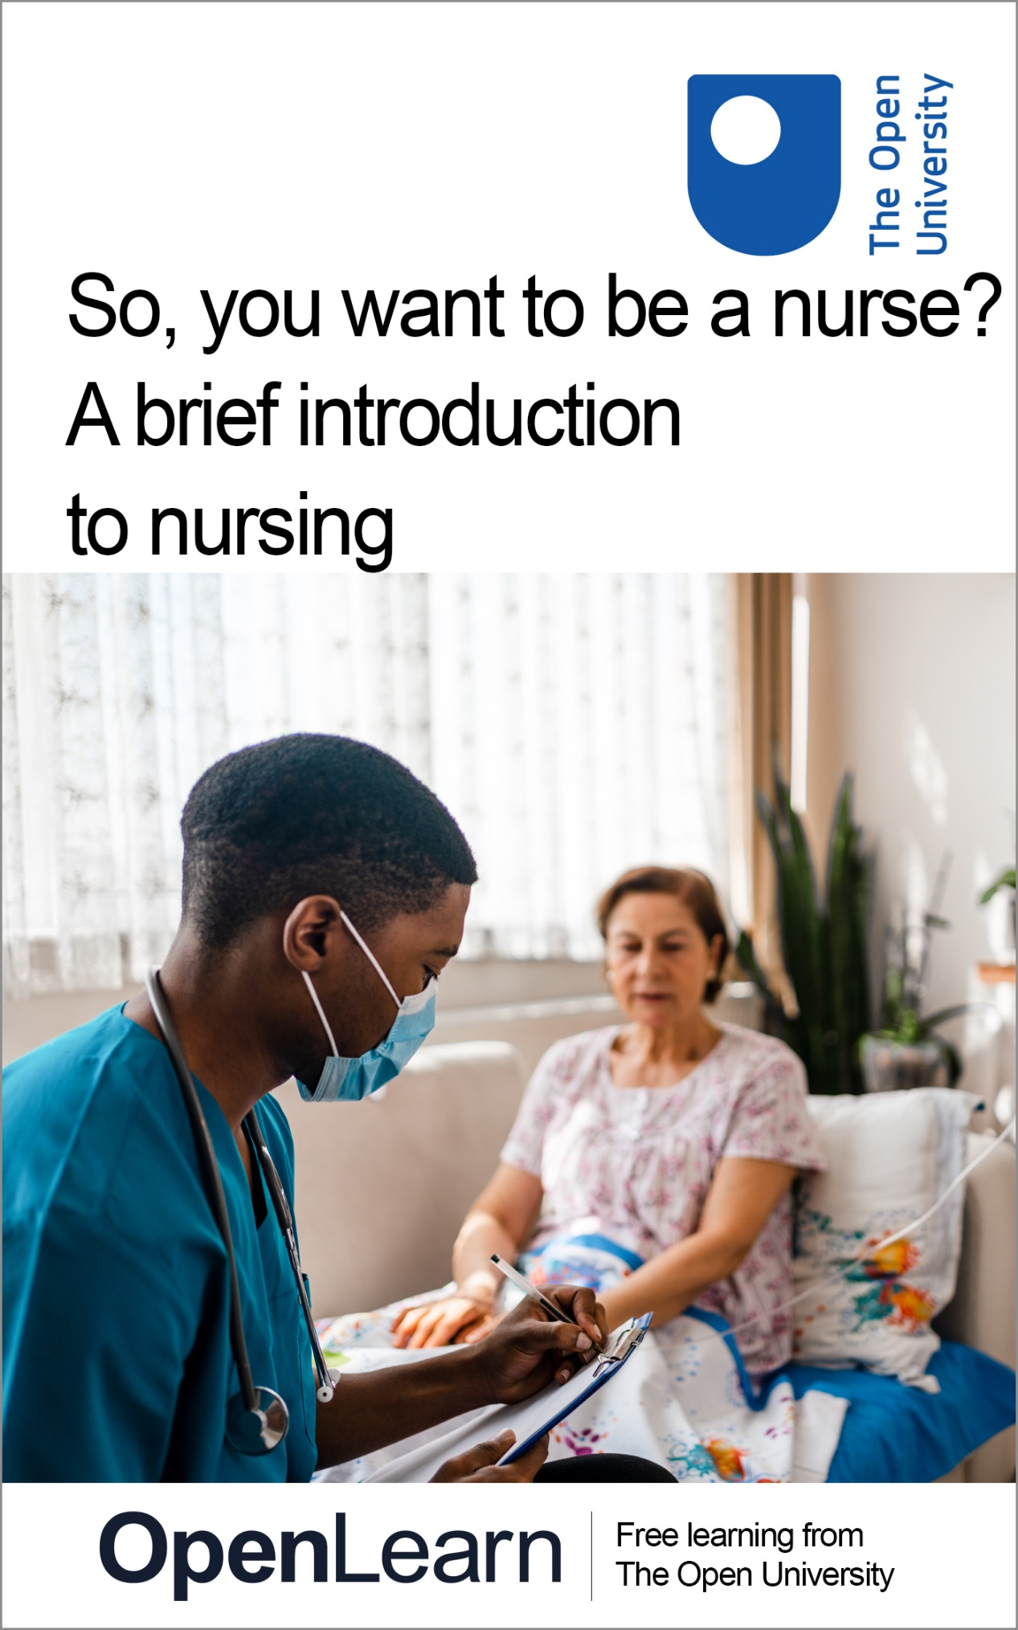

NUR_1

So, you want to be a nurse? A brief introduction to nursing

About this free course
This version of the content may include video, images and interactive content that may not be optimised for your device.
You can experience this free course as it was originally designed on OpenLearn, the home of free learning from The Open University –
So you want to be a nurse? A brief introduction to nursing
There you’ll also be able to track your progress via your activity record, which you can use to demonstrate your learning.
Copyright © 2022 The Open University
Intellectual property
Unless otherwise stated, this resource is released under the terms of the Creative Commons Licence v4.0 http://creativecommons.org/licenses/by-nc-sa/4.0/deed.en_GB. Within that The Open University interprets this licence in the following way: www.open.edu/openlearn/about-openlearn/frequently-asked-questions-on-openlearn. Copyright and rights falling outside the terms of the Creative Commons Licence are retained or controlled by The Open University. Please read the full text before using any of the content.
We believe the primary barrier to accessing high-quality educational experiences is cost, which is why we aim to publish as much free content as possible under an open licence. If it proves difficult to release content under our preferred Creative Commons licence (e.g. because we can’t afford or gain the clearances or find suitable alternatives), we will still release the materials for free under a personal end-user licence.
This is because the learning experience will always be the same high quality offering and that should always be seen as positive – even if at times the licensing is different to Creative Commons.
When using the content you must attribute us (The Open University) (the OU) and any identified author in accordance with the terms of the Creative Commons Licence.
The Acknowledgements section is used to list, amongst other things, third party (Proprietary), licensed content which is not subject to Creative Commons licensing. Proprietary content must be used (retained) intact and in context to the content at all times.
The Acknowledgements section is also used to bring to your attention any other Special Restrictions which may apply to the content. For example there may be times when the Creative Commons Non-Commercial Sharealike licence does not apply to any of the content even if owned by us (The Open University). In these instances, unless stated otherwise, the content may be used for personal and non-commercial use.
We have also identified as Proprietary other material included in the content which is not subject to Creative Commons Licence. These are OU logos, trading names and may extend to certain photographic and video images and sound recordings and any other material as may be brought to your attention.
Unauthorised use of any of the content may constitute a breach of the terms and conditions and/or intellectual property laws.
We reserve the right to alter, amend or bring to an end any terms and conditions provided here without notice.
All rights falling outside the terms of the Creative Commons licence are retained or controlled by The Open University.
Head of Intellectual Property, The Open University
978-1-4730-3664-2 (.kdl)
978-1-4730-3665-9 (.epub)

Contents
- Introduction
- Learning outcomes
- 1 What do you know about nursing in the UK?
- 2 Being a nurse
- 3 Understanding your own values and values in nursing
  - 3.1 Beliefs and values in action in nursing practice
  - 3.2 Six core values of nursing
- 4 Working with other professionals – the role of the multidisciplinary team
- 5 Regulation of nurses in the UK
- 6 The importance of studying nursing
  - 6.1 Nursing theory study
- 7 The role of service users in health care
- 8 The four fields of nursing
  - 8.1 Mental health nursing
  - 8.2 Children’s nursing
  - 8.3 Learning disability nursing
  - 8.4 Adult nursing
  - 8.5 Which field of nursing am I suited to?
- Conclusion
- References
- Acknowledgements
- Solutions

Introduction
This free course, So, you want to be a nurse? A brief introduction to nursing, will give you an insight into nursing in the UK and its place globally.
A worldwide pandemic (COVID-19) has shone a spotlight on health services and those who work within them. This includes nurses who make up the largest occupational group in the health sector. But what does it mean to be a nurse? How do people become Registered Nurses in the UK and what does their education programme look like? What types of roles are nurses in the UK working in and how do you decide if nursing is for you?

View alternative description - Uncaptioned Figure

This course will explore all these things and more. As you work your way through the sections and activities, you will learn more about nursing today and where your place within the family of nursing might be.
This OpenLearn course is produced in association with Open University courses in Nursing and healthcare.

Learning outcomes
After studying this course, you should be able to:
- identify the opportunities and key roles undertaken by nurses in the UK today
- summarise some of the key challenges nurses face and establish what makes a great nurse
- understand the differences between the four fields of nursing and the different ways to become a Registered Nurse in the UK.

1 What do you know about nursing in the UK?
You will start this section with a quiz so you can check your current understanding of nursing and what it entails. Don’t worry if you don’t know the answers to any of the questions, feedback is provided to each.

Activity 1 What do you know about nursing in the UK?

How long does it take to train to become a Registered Nurse in the UK?

Provide your answer...
View answer - Part

Anyone can call themselves a Registered Nurse. True or False?

True
False
View answer - Part

Other than a hospital, where else do nurses work?

Provide your answer...
View answer - Part

In the UK, what percentage of nurses are men?
Do you think it is around:

5%
10%
20%
25%
View answer - Part

In the UK, what percentage of nurses work in hospitals?

23%
45%
56%
80%
View answer - Part

Who was Mary Seacole and what does she mean to the nursing profession?

Provide your answer...
View answer - Part

What are the four fields of nursing in the UK?

Provide your answer...
View answer - Part

As you work through the course, the sections will expand your knowledge about nursing. In Section 2 you will begin with a look at a definition of nursing.

2 Being a nurse
In this section, you will look at a definition of nursing and explore further what it means to be a nurse in the UK and beyond.

Definition of nursing
The International Council of Nurses (2002) defines nursing in the following way:

Nursing encompasses autonomous and collaborative care of individuals of all ages, families, groups and communities, sick or well and in all settings. Nursing includes the promotion of health, prevention of illness, and the care of ill, disabled and dying people. Advocacy, promotion of a safe environment, research, participation in shaping health policy and in patient and health systems management, and education are also key nursing roles.
(International Council of Nurses, 2002)

There are key messages about nursing within this definition, including how the focus in nursing is not just on those who are ill but on maintaining the health of those who are well. This is a key role when working with people, of all ages, who have disabilities or other health conditions. It is also clear from this definition that nurses don’t just work in hospitals but in a variety of settings. Nurses also work in education, research and the building and shaping of health policy.

View alternative description - Uncaptioned Figure

In the quiz in Section 1, you looked at some aspects of what being a nurse in the UK involves, but of course nurses exist all over the world. Although their roles may vary, and they may undertake different types of education to become a nurse compared to those in the UK, the word nurse is recognised globally. According to the World Health Organization’s ‘The State of the World’s Nursing 2020’ report, there are 27.9 million nurses worldwide and the global nursing workforce makes up the largest group of workers in health care (World Health Organization, 2020).
Each country has its own approach to the education of nurses, but the UK is currently the only country that has four ‘fields’ of nursing at the point of qualifying as a Registered Nurse. Many countries have more generic style education and then the nurse will specialise after qualification.
In some countries, the role of the midwife is also included in the role of the nurse and there is not a separate qualification for midwives, however in the UK, midwifery is a separate qualification with a separate educational programme.
The role of the nurse and their education will also reflect how health services are set up in a particular country. For example, in countries where health care is focused on more specialist treatment, then you will find more specialist nurses. As an example, in the UK nurses can study specialist courses after their initial qualification to become Epilepsy Specialist Nurses or Diabetes Specialist Nurses. Additionally, nurses may undertake further qualifications to become District Nurses, School Nurses or Health Visitors in the UK.
Nursing across the world faces some similar challenges, which include a shortage of nurses and of course in recent times, a global pandemic. Many health issues that face populations exist across the world, including nutrition (malnutrition and obesity), child health, sustainable health care, emergency and trauma care and public health in communities. Nurses in many countries also work in conflict zones and deliver care under the most extreme conditions, for example in field hospitals during or following a war or after natural disasters, such as flooding or earthquakes.

Activity 2 International nurses’ day

Each year International Nurses Day celebrates the work of nurses around the world. Watch Video 1 below, which was made for the 2020 celebration.

Video content is not available in this format.
Video 1
View transcript - Video 1

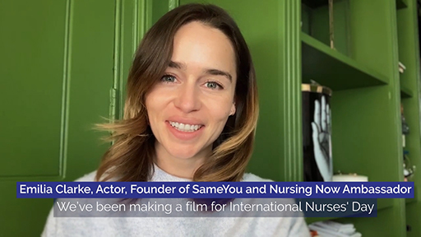
View alternative description - Uncaptioned Figure

What messages did you notice when watching this video?

Provide your answer...
View discussion - Activity 2 International nurses’ day

3 Understanding your own values and values in nursing
Understanding the connection between beliefs, values, attitudes and behaviours is key to understanding where your thoughts, attitudes and behaviours come from both in your personal life and in your life as a nurse. Figure 1 shows the connections between your beliefs, values, attitudes and behaviours.

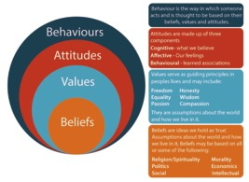
Figure 1 Values and beliefs diagram
View description - Figure 1 Values and beliefs diagram
View alternative description - Figure 1 Values and beliefs diagram

In Figure 1, the four sections overlap each other to suggest that each section has an impact on the other. Our beliefs shape our values, our values shape our attitudes and in turn these all shape our behaviours.

Activity 3 What are my beliefs and values?

In Table 1 below write your responses to the questions, what matters to me? And what is most important to me?

Table 1 My beliefs and values
 | In the world | In my work (paid, unpaid or voluntary) | In my relationships | In myself
What matters to me? | Provide your answer... | Provide your answer... | Provide your answer... | Provide your answer...
What is most important to me? | Provide your answer... | Provide your answer... | Provide your answer... | Provide your answer...

Do the things that matter to you cross over between each category? Often if a value, such as honesty, is important to you in work, it is also important in your relationships. Have a look at the overlaps and what is most important to you. As you work through the next sections, you will see how your beliefs and values impact on nursing practice.

3.1 Beliefs and values in action in nursing practice
Nursing involves many aspects of human interactions including communications, decision making and relationship building. Your beliefs and values are a key feature of who you are as a nurse. In your role as a nurse, you need to understand your beliefs and values so you can ensure you deliver professional, non-judgemental care to those who need it.

Activity 4 Exploring your beliefs
In each scenario below imagine you are the nurse. Reflect on how you feel when reading the scenario, how you think you would react and explore what beliefs your reaction might be based on.

Scenario 1

A patient has been admitted to your ward/unit who is ill but has committed a crime against a child.
In this scenario, do you think the person is deserving of treatment? If you have answered yes or no, then what do you think this tells you about your values and beliefs?

Provide your answer...

Scenario 2

An alcohol and drug-dependent person has been admitted for a liver transplant. You are aware that they have tried on numerous occasions to give up alcohol and drugs, but they have made it clear they intend to go back to this after their treatment.
In this scenario, do you think the person is deserving of treatment? If you have answered yes or no, then what do you think this tells you about your values and beliefs?

Provide your answer...

Scenario 3

A young person has been brought into your care following a suicide attempt. They do not want to be treated and discuss with you ‘wanting to die’.
In this scenario how do you think you would respond? What do you think your reaction tells you about your values and beliefs?

Provide your answer...

Scenario 4

A child with severe learning and physical disabilities is very ill and a discussion needs to take place with the parents around resuscitation options.
In this scenario how do you think you would respond? What do you think your reaction tells you about your values and beliefs?

Provide your answer...
View discussion - Scenario 4

3.2 Six core values of nursing
Nursing is a profession based on a number of key values, but what is a value in the context of nursing?
Nursing values are fundamental beliefs within the profession. They are what the profession means and shape the actions that those within the profession take.
The NHS in England defines six core values, labelled the 6 C’s. These values are fundamental and recognised across the UK.
They are care, compassion, competence, communication, courage and commitment.

Activity 5 Exploring your own values

Watch Video 2 and reflect on your own values by answering the questions that follow. There are no right and wrong answers as these are your values that you would bring to nursing.

Video content is not available in this format.
Video 2
View transcript - Video 2

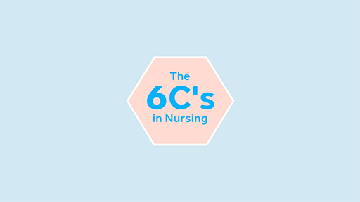
View alternative description - Uncaptioned Figure

Why do you think it is important to treat people with respect and dignity? What does this look like to you?

Provide your answer...

Why do you think people deserve care from those who have the appropriate skills and knowledge?

Provide your answer...

Think of a time when you were communicating well either in a work setting or at home. How did effective communication help in that situation?

Provide your answer...

Think of a time when you have had to be courageous, when maybe you have had to stand up for yourself or someone else. Was this difficult? How did you feel? What do you think you achieved?

Provide your answer...

Reflect on a time in your life (personal or working life) when you have committed to something and there has been a positive outcome. How did it feel?

Provide your answer...
View discussion - Part

Nursing practice in Wales and the ‘Active Offer’
Language is at the heart of effective clinical assessment and safe treatment, and especially so for certain patient groups. The ‘Active Offer’ is a responsibility on health and social care providers in Wales to offer services in Welsh, rather than on the patient or service user to have to request them.
The Welsh language is part of daily life and practice in Wales. Making an ‘Active Offer’ recognises that effective communication is key to meeting the needs of Welsh-speaking patients, as well as ensuring patient safety by way of accurate communication and maintaining respect and dignity towards patients and clients. Everyone can contribute, whether you are a Welsh language learner or completely fluent.
The Welsh Government have a Five Year Plan aimed at improving this area. Your awareness, knowledge, and skills in language sensitivity for patient care could contribute to your competence achievement as a nursing student and can also contribute to your future employability in Wales.

4 Working with other professionals – the role of the multidisciplinary team
Patients often have multiple and sometimes complex needs that need more than one professional discipline involved in their care. In health care, professionals from a range of disciplines work together to form Multidisciplinary Teams or MDTs. NHS England have described multidisciplinary working in their 2015 report as follows.

Multidisciplinary and Multiagency working involves appropriately utilising knowledge, skills and best practice from multiple disciplines and across service provider boundaries, e.g. health, social care or voluntary and private sector providers to redefine, re scope and reframe health and social care delivery issues and reach solutions based on an improved collective understanding of complex patient need(s).
(NHS England, 2015)

View alternative description - Uncaptioned Figure

As identified in the quotation from the NHS England report, multidisciplinary working in health care has the patient at the centre of care; to assess, plan and manage care jointly and effectively. A multidisciplinary team (MDT) in health care will include several professionals from different disciplines. These may vary depending on the service or the client's needs. For example, a community MDT working with an older person who is recuperating after a hip fracture may include a GP, community nurse, occupational therapist, social worker and physiotherapist.

Activity 6 Identifying members of the multidisciplinary team
Below are some examples of patients and their needs. See if you can identify the different professionals a nurse might work with in a multidisciplinary team for each patient.

Patient 1

Martin has had a chronic mental health problem for several years. A while ago he had been an inpatient in a specialist hospital having treatment for a psychotic episode. He takes regular medication that needs reviewing every six months and is registered with his local GP. Martin now lives in a small flat and meets with his community mental health nurse as part of a care plan he has. Martin is unhappy where he is living and struggles with his money and accessing benefits. This can affect his mental health state.

Provide your answer...
View discussion - Patient 1

Patient 2

Nhu is 12 years old and lives with a long-term health condition that affects her mobility and breathing. She is fed through a tube and requires oxygen during the night. Her parents have made adaptations to the home and her bedroom, but as she grows, they are finding it more difficult to help her with her daily activities. Nhu has an older sister who is 15 and who helps her parents to care for Nhu. Nhu has a children's community nurse who visits the family regularly.

Provide your answer...
View discussion - Patient 2

Patient 3

Ademola is 55 and lives at home with his mum. He has a learning disability and some health problems relating to his epilepsy and asthma. He attends a work scheme three days a week, but would also like to do more activities at home and in his local community. Ademola has a community learning disability nurse who visits regularly to support him with his health needs.

Provide your answer...
View discussion - Patient 3

Multidisciplinary working means that decisions about care have input from several professionals as well as the person in need of care. If this is a child that may be the family, but the child's views will also be sought if this is possible. Often families and carers may not actually see the different professionals within the multidisciplinary team working together, but they should notice the positive outcomes of effective MDT working. With chronic health conditions or long-term disability, the patient or their carer may work with many professionals over many years in the form of different MDTs, but the essence of each should be person-centred care.

Activity 7 A parent’s perspective of the multidisciplinary team

In Video 3, you will hear from Hayley who has a daughter who has Down Syndrome. In the video, Hayley talks about the many professionals she has encountered as her daughter grew from a baby to a child. She relates this specifically to learning about what learning disability nurses do. This is a good example of how parents, carers or the patients themselves may not fully understand the role of professionals within the team until they are directly involved in care.
As you watch the video, think about the number of professionals Hayley may have been involved with during her daughter’s early childhood.

Video content is not available in this format.
Video 3
View transcript - Video 3

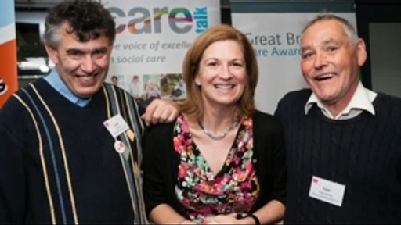
View alternative description - Uncaptioned Figure

Provide your answer...

Being a nurse means being able to work with other professionals and disciplines for the benefit of the patient, but this also requires a set of skills, knowledge and attitudes to be successful.
Which of the following do you think are important skills and knowledge nurses need to work effectively in a multi-professional team?

Communication
Team working
Time management
Understanding the roles of others
Contributing to joint decisions
All of the above
View answer - Part
View discussion - Part

5 Regulation of nurses in the UK
Nursing in the UK is regulated by a body called the Nursing & Midwifery Council (NMC), where all registered nurses, midwives and nursing associates have their details held on a database called the Nursing Register. The NMC not only holds the Register but also produces standards of good practice, and a code of professional practice for nurses and midwives called The Code. Additionally, they produce standards for education that all universities who offer nurse education must adhere to.
A key role of the NMC is to protect the public and to guide nurses and midwives in their professional practice. If a nurse, midwife or nursing associate is not practising safely, the NMC may investigate to ensure the public are protected.

Activity 8 The work of the NMC

First, watch Video 4 about the work of the NMC.

Video content is not available in this format.
Video 4
View transcript - Video 4

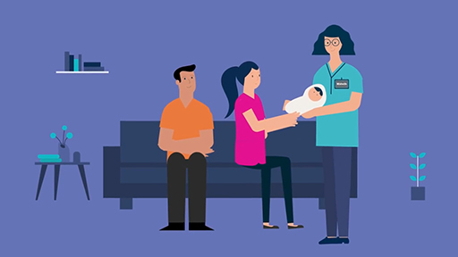
View alternative description - Uncaptioned Figure

Having watched the video, consider why you think it is important to have a regulatory body to protect the public.

Provide your answer...
View discussion - Part

What do you think makes a good nurse?

Provide your answer...
View discussion - Part

Now watch the short animation in Video 5 from the Nursing & Midwifery Council that focusses on one element of The Code.

Video content is not available in this format.
Video 5
View transcript - Video 5

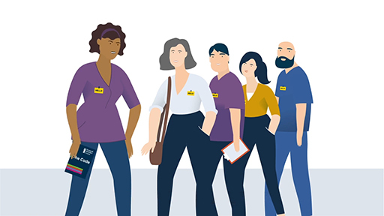
View alternative description - Uncaptioned Figure

Do you think a nurse is a nurse even when they finish their shift at work and go home?
Why do you think it is important that nurses can demonstrate professionalism in both their day-to-day work and outside of work?

Provide your answer...
View discussion - Part

6 The importance of studying nursing
The standards for nursing education are set out by the Nursing & Midwifery Council (NMC), which you learnt about in Section 5. This is so that wherever the student undertakes their course across the UK they meet the same standards. In the UK, when student nurses undertake their courses, they study the theory of nursing, the theory of how to care, and theories of the best way to nurse. This theory element makes up 50 per cent of the course, with the remainder taking place in practice or placement settings so students can learn and develop their nursing skills and knowledge whilst on the job.
The theory element of nursing study may take place at a distance, face to face, or a mixture or blend of both. The subjects studied on nursing courses are specifically applied to care and build the knowledge nurses need to deliver good care.
They include:
- Anatomy and physiology
- Psychology
- Sociology
- Nursing theories
- Politics and social policy.

6.1 Nursing theory study
You will take a look at each of the five subjects covered in nursing theory study in turn next, and consider how each links to nursing practice.

Anatomy and physiology
Anatomy and physiology is the study of not only the structure of the human body but also the functions. It includes an understanding of the disorders associated with each function and structure of the body.

Example

Structure:
The respiratory system

Function:
Respiration including gaseous exchange.

Health condition:
Asthma.
So, this might seem a logical theory to underpin nursing practice, but our wellbeing is also linked to how our minds work so let us have a look at psychology.

Psychology
Psychology is a science that, like other sciences, can be studied outside of nursing. Elements of psychology theory underpin nursing practice. For example, understanding behaviour including health behaviour, emotional responses, communication, self-awareness and decision making.

Example

Psychological theory:
Health behaviour.

Nursing intervention:
Supporting smoking cessation.
Understanding the reasons why people make the choices they do in relation to their health, and the psychological theories behind this, can inform nurses when offering support with behaviours such as smoking cessation.

Sociology
Sociology is also a science often studied as a separate topic, but when applied to nursing it can help nurses to understand many aspects of health. For example, in society, in relation to family dynamics, culture.

Example

Sociological theory:
Labelling theory is an example whereby the label attached to someone then shapes their behaviour and how people around them see them. Labels in nursing might include, sick, disabled or mentally ill.

Nursing intervention:
Offering non-judgemental/anti discriminatory care.
Understanding the nature of labelling and how these labels might change interaction and/or expectations of those who have this label attached can support nursing interventions.

Nursing theory
There are specific theories of nursing that underpin nursing practice. These often relate to models of care and frameworks for the delivery of care.

Example

Theory:
Orem’s self-care theory. This theory identifies aspects of self-care and the importance of the patient having control.

Nursing intervention:
Supporting the patient to manage their own health and wellbeing.

Politics and social policy theory
Nurses work in a political landscape; health is a key aspect of all societies political and social policy agenda. Understanding the context in which nurses work is important for all nurses.

Example

Politics and social theory:
An example might be the development of a new policy for dementia care. This policy will not only shape the development of services for people with dementia, but will also offer guidance for those working in those services.

Nursing intervention:
The nurse working with the person with dementia and their family understands what services might be available now and in the future.

In the next activity, you will look at how a student nurse can go on to apply this theory in a practical situation.

Activity 9 Using classroom learning in practice

In the following case study, Harry is a student nurse in the final year of his nursing course and is visiting a family with his mentor as part of his community placement. As you read, think about some of the theory Harry might have been studying at university to help him to understand his patient's needs.

Harry is visiting Mrs Kowalczyk, an 83-year-old woman who lives with her daughter and their family, a husband and two teenage children. Mrs Kowalczyk recently had a fall and fractured her hip. She has returned from hospital following a hip replacement and is physically healing well. Her daughter tells the nurses that she is worried that her mother is still unsteady when walking and she may need some adaptations to the house so that is it safe. She is happy her mother is living with them, however, has noticed her mother has become very forgetful and has started to speak in her native language, Polish, when she is upset. Mrs Kowalczyk’s daughter also tells them that her children are struggling to understand why their grandmother can’t remember their names and is so confused, and they have started to spend more time round at friends’ houses.

Provide your answer...
View discussion - Activity 9 Using classroom learning in practice

7 The role of service users in health care
Service users are a key part of the NHS. Often in groups, they provide a resource to inform service improvement, and offer their views to make decisions and changes within organisations.
All four UK nations have service users at the heart of their health planning and health services. The role of the carer or service user in the NHS has been growing for over a decade now. This has led to carers and users of health care services having input at all levels, from policy making to advising on service improvements at ward or unit level.
Many services within the NHS have specific routes for service-user involvement through committees, groups and tools like satisfaction surveys and patient feedback.

Activity 10 The voices of carers and service users

Watch Video 6 and reflect on the following questions.
- Why do you think it is important for carers or service users to have a voice?
- How do you think service-user involvement can help nurses to deliver better care?

Video content is not available in this format.
Video 6
View transcript - Video 6

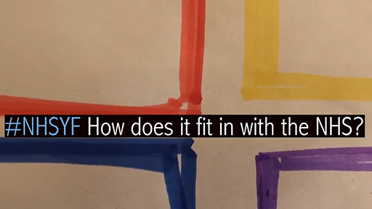
View alternative description - Uncaptioned Figure

Provide your answer...
View discussion - Activity 10 The voices of carers and service users

8 The four fields of nursing
Nursing, as you learnt in Section 1, is made up of four fields: adult, mental health, children’s and learning disability nursing. When you are choosing nursing as a career you will also need to know which field you would like to study.
For many people, their choice of field will be based on past experiences, both personal and work, and what they see themselves doing as a nurse in the future. In this section, you will explore each field of nursing in turn to help you consider which field you may be most suited to.
If you apply to do a nursing course, you will need to be able to demonstrate why you have applied to the field that you have, as well as show an understanding of the other fields of nursing. Even if you think you have decided which field of nursing you are interested in, watching all the videos in the sections that follow will help you to develop an understanding of all of the specialisms.

8.1 Mental health nursing
Mental health nurses work in a range of settings to support people who experience common problems such as depression or anxiety, as well as conditions such as eating disorders, schizophrenia and dementia.

View alternative description - Uncaptioned Figure

Mental health nurses are also focused on supporting mental wellbeing and the promotion of positive mental health. As a mental health nurse, you might work with adults or children and adolescents, in hospitals, clinics, assessment and treatment centres, education, social care settings, or within the home. Sometimes people with mental health problems face discrimination and stigma and, as a mental health nurse, a key part of your role would be to advocate for those that you work with.
Watch Video 7 about mental health nursing produced by the Royal College of Nursing. In the video, Kiran Jnagal speaks about her career in mental health nursing.

Video content is not available in this format.
Video 7
View transcript - Video 7

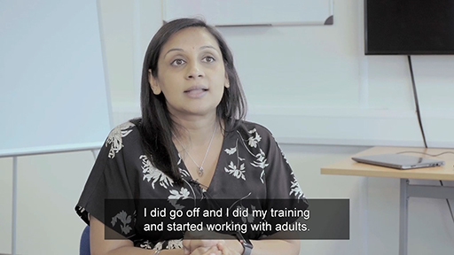
View alternative description - Uncaptioned Figure

8.2 Children’s nursing
Children’s nurses work with children and young people in hospitals, community, schools and clinics, as well as with children and families in their homes and respite care. They nurse children from birth through to adolescence. You may work with healthy children supporting and promoting health, such as tackling childhood obesity, through to children with very complex needs and/or life-limiting disorders. Children’s nurses will work with the whole family to support the child’s health and wellbeing.
Watch this video about children’s nursing, which shows nurses sharing their experiences and values in this field of nursing.

Video content is not available in this format.
Video 8
View transcript - Video 8

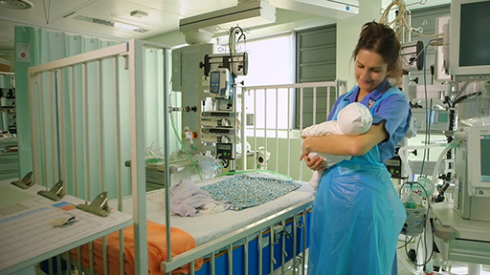
View alternative description - Uncaptioned Figure

8.3 Learning disability nursing
Learning disability nurses may work in any setting where people with a learning disability live, work or learn. This may be in ‘community teams’, residential settings, schools, workplaces, clinics and in hospitals, helping people with a learning disability to access the services they need. Many learning disability nurses work with multidisciplinary teams in local communities, supporting those with a learning disability to live their lives to the full. In this field, nurses could work with children or adults helping them to become as independent as they can be and live fulfilled lives. Often people with learning disabilities are discriminated against and nurses may need to advocate for the people in their care and their families.
Watch Video 9 that shows some of reasons why people might choose learning disability nursing.

Video content is not available in this format.
Video 9
View transcript - Video 9

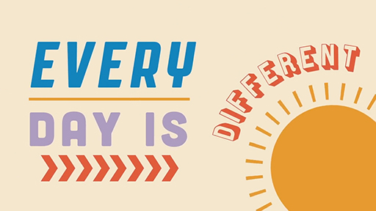
View alternative description - Uncaptioned Figure

8.4 Adult nursing
Adult nursing, which used to be known as general nursing, is the field of nursing the public see portrayed in the media the most. Whether you are watching a hospital drama or a tv programme showing nurses in the community, adult nurses work in a wide variety of settings. Hospitals, clinics, community, prisons, cruise ships, and large businesses are all places where you will find nurses caring for people with a variety of health needs. These needs can vary from minor ailments to chronic and lifelong conditions, as well as palliative care when someone is dying. Like all fields of nursing, adult nurses also focus on maintaining health and wellbeing and promoting health and healthy lifestyles
Watch Video 10 which shows a newly qualified registered nurse working with asylum seekers.

Video content is not available in this format.
Video 10
View transcript - Video 10

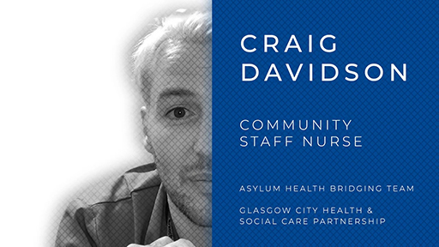
View alternative description - Uncaptioned Figure

8.5 Which field of nursing am I suited to?
Now you have watched videos for each field of nursing, what interests you most about each field and why? Does one field interest you more than the others?
Listen to Audio 1 and hear from Open University students explain what inspired them to want to become a nurse and why they chose to study with The Open University.

Audio content is not available in this format.
Audio 1
View transcript - Audio 1

Conclusion
In this course you have explored nursing in the UK, the four fields of nursing, how nurses train, what they study and how they are regulated. You have also looked at the values that underpin nursing practice and what it means to be a nurse across the globe.
We hope this course has given you the opportunity to find out a little more about nursing and whether you feel it could be the career for you.
You should now be able to:
- identify the opportunities and key roles undertaken by nurses in the UK today
- summarise some of the key challenges nurses face and establish what makes a great nurse
- understand the differences between the four fields of nursing and the different ways to become a Registered Nurse in the UK.
This OpenLearn course is produced in association with Open University courses in Nursing and healthcare.

References
Carmel, L. P. (2017) ‘Experience counts’, Nursing Standard, 32(7), p. 30.
International Council of Nurses (2002) Nursing definitions. Available at: https://www.icn.ch/nursing-policy/nursing-definitions (Accessed: 15 March 2022).
NHS England (2015) MDT Development - Working toward an effective multidisciplinary/multiagency team. Available at: https://www.england.nhs.uk/wp-content/uploads/2015/01/mdt-dev-guid-flat-fin.pdf (Accessed: 15 March 2022).
Nursing & Midwifery Council (2018) The Code: Professional standards of practice and behaviour for nurses, midwives and nursing associates. Available at: https://www.nmc.org.uk/globalassets/sitedocuments/nmc-publications/nmc-code.pdf (Accessed: 15 March 2022).
Nursing & Midwifery Council (2021) Our latest information about nursing and midwifery in the UK. April 2021 – September 2021. Available at: https://www.nmc.org.uk/globalassets/sitedocuments/data-reports/september-2021/nmc-register-september-2021-easyread.pdf (Accessed: 15 March 2022).
World Health Organization (2020) State of the world's nursing 2020: investing in education, jobs and leadership. Geneva: WHO.
Welsh Government (2022) More than just words: Five year plan 2022-27. Available at: https://www.gov.wales/sites/default/files/publications/2022-07/more-than-just-words-action-plan-2022-2027.pdf

Acknowledgements
This free course was written by Dr Nicky Genders. It was first published in April 2022.
Except for third party materials and otherwise stated (see terms and conditions), this content is made available under a Creative Commons Attribution-NonCommercial-ShareAlike 4.0 Licence.
The material acknowledged below and within the course is Proprietary and used under licence (not subject to Creative Commons Licence). Grateful acknowledgement is made to the following sources for permission to reproduce material in this free course:

Images
Course image: Phynart Studio/Getty Images
Introduction: Nurse team in hospital corridor: Sturti/Getty Images
Section 2: Hands holding globe: sasirin pamai/Getty Images
Section 4: Nurse holding patient’s hand: LaylaBird/Getty Images
Section 8.1: Boy talking at therapy: Motortion/Getty Images

Audio/Video
Section 2, Activity 2, Video 1: Courtesy: Nursing and Midwifery Council www.nmc.org.uk https://www.youtube.com/watch?v=WGbT8EKP-2I
Section 4, Activity 7, Video 3: courtesy www.downssideup.com
Section 5, Activity 8, Video 4: Courtesy: Nursing and Midwifery Council https://www.nmc.org.uk/
Section 5, Activity 8, Video 5: Courtesy: Nursing and Midwifery Council https://www.nmc.org.uk/
Section 7, Activity 10, Video 6: NHS England Youth Forum NHS England and NHS Improvement https://www.youtube.com/watch?v=IPrIg12SO-E
Section 8.1, Video 7: courtesy Royal College of Nursing https://www.rcn.org.uk/
Section 8.2, Video 8: courtesy: Royal College of Nursing https://www.rcn.org.uk/
Section 8.3, Video 9: courtesy: Royal College of Nursing https://www.rcn.org.uk/
Section 8.4, Video 10: courtesy Royal College of Nursing https://www.rcn.org.uk/
Every effort has been made to contact copyright owners. If any have been inadvertently overlooked, the publishers will be pleased to make the necessary arrangements at the first opportunity.
Don't miss out
If reading this text has inspired you to learn more, you may be interested in joining the millions of people who discover our free learning resources and qualifications by visiting The Open University – www.open.edu/openlearn/free-courses.

Solutions

Activity 1 What do you know about nursing in the UK?

Part

Answer
Course length can vary depending upon your qualifications and experience. Some universities offer short courses for graduates and longer courses for those who need to study part time or do foundation level study. All education is at degree level in the UK and usually takes between 2 and 6 years to complete, with the average full-time degree being around 3 years.
Back to - Part

Part

Answer
Right:
False
Wrong:
True
In the UK, the title ‘Registered Nurse’ is protected by law and everyone who uses this title has to be registered with the Nursing & Midwifery Council. However, the title ‘nurse’ is not protected so anyone can use it. In Section 5 of this course, you will be looking at the role of regulation and the Nursing & Midwifery Council.
Back to - Part

Part

Answer
Nurses work in a diverse range of workplaces in the UK and across the world. Other than hospitals you will find nurses in health centres and clinics, GP surgeries, schools, prisons, care and nursing homes, on cruise ships, in large businesses, in the community, in people’s homes, in call centres such as 111, in Government and in education. Section 2 of this course explores these different work roles a little further.
Back to - Part

Part

Answer
Right:
10%
Wrong:
5%
20%
25%
The Nursing & Midwifery Council’s data report for 2020/2021 suggests that in the UK just over 10% of those on the nursing register are male (80,500) (Nursing & Midwifery Council, 2021).
Back to - Part

Part

Answer
Right:
56%
Wrong:
23%
45%
80%
According to Carmel (2017), in the UK 56% of nurses work in hospitals.
Back to - Part

Part

Answer
The history of nursing is important to the profession and nursing is a diverse workforce. Mary Seacole was a British-Caribbean nurse who worked at the same time as Florence Nightingale, during the Crimean war. She worked on the front line during the war, offering treatment and rehabilitation to hundreds of soldiers.
Often people have heard of Florence Nightingale, but know very little about the British nurse Mary Seacole and her work. If you would like to know more about Mary Seacole you can read more at the Mary Seacole Trust.
Back to - Part

Part

Answer
There are four fields of nursing in the UK:
- Adult nursing
- Mental health nursing
- Children’s nursing
- Learning disability nursing.
Each one of these fields is its own specialism and has its own standards for education. In Section 8 of this course, you will explore each of the fields in more detail.
Back to - Part

Activity 2 International nurses’ day

Discussion
You may have noticed that the people in the video were from all across the globe and each had their own stories of how nursing had impacted on them personally. The message that there is a global nursing shortage and a call for Governments to respond to this may also have resonated with you.
This video was due to be longer, but as the presenter says the COVID-19 pandemic impacted on nursing across the world. A series of images of nursing then followed showing the many different roles of nurses in many different countries.
Back to - Activity 2 International nurses’ day

Activity 4 Exploring your beliefs

Scenario 4

Discussion
The feedback below looks at how your values and beliefs may have impacted the way you responded to the four scenarios.
Values have a major influence on the actions of practitioners in subtle and less subtle ways. Sometimes you are not aware of your beliefs and how they might shape the way you think about patients. For example, if you believe that people should control their drinking and not expect any help from the NHS if they can’t, then you are likely to believe that the patient in Scenario 2 does not deserve help.
Your personal values and beliefs are integral to your professional socialisation. The values and beliefs you come into nursing with shape your development as a nurse, and your professional socialisation. It is during this time that you learn what it is to be a nurse, how to be non-judgemental and to not allow prejudice to shape your decision making. Although you may truly believe that the person in Scenario 1 does not deserve any form of treatment, health services are there for all and your nursing values suggest you care for everyone.
Often, personal beliefs and values are at the heart of why people choose nursing.
People often say they chose nursing because they wanted to care for others and help others to become as independent as possible. These are beliefs and values about supporting vulnerable and ill people in society. You will also have a set of personal beliefs that might have been shaped by your religious views. In the case of Scenario 3, you may hold a personal belief that suicide is wrong and that might then shape the way you interact with that young person.
Most studies suggest you do not change your basic values and beliefs when encountering scenarios that may challenge your views, but that you do take a particular approach when these beliefs and values conflict with the organisation.
Generally, you hold on to your basic values when you enter into nursing, but you may find times when these personal values are challenged. An example might be that you hold the belief that all life should be protected under any circumstances. It may be that in Scenario 4 where there is a discussion about whether a child is resuscitated this clashes with your personal beliefs and values.
Where too much conflict between your personal beliefs and values occurs, nurses may choose to leave the organisation and even the profession.
Back to - Scenario 4

Activity 5 Exploring your own values

Part

Discussion
Your answers will reflect the values you hold. When universities select students for nursing courses, they often ask questions about your values to find those people whose values align with the values of nursing.
Back to - Part

Activity 6 Identifying members of the multidisciplinary team

Patient 1

Discussion
In addition to the mental health nurse, the MDT supporting Martin may include GP, psychiatrist, social worker, housing officer, occupational therapist and psychologist.
Back to - Patient 1

Patient 2

Discussion
In addition to the community nurse (who may be a children's specialist nurse), the MDT supporting Nhu may include paediatrician, GP, district nurse, physiotherapist, occupational therapist, social worker, housing officer and speech & language therapist.
Back to - Patient 2

Patient 3

Discussion
In addition to the learning disability community nurse, the MDT supporting Ademola may include GP, practice nurse, social worker, occupational therapist, psychiatrist, epilepsy specialist nurse and asthma specialist nurse. There could also be voluntary sector involvement to help Ademola access activities in the community.
Back to - Patient 3

Activity 7 A parent’s perspective of the multidisciplinary team

Part

Answer
Right:
All of the above
Wrong:
Communication
Team working
Time management
Understanding the roles of others
Contributing to joint decisions
Back to - Part

Discussion
If you thought all of these were essential to good team working you were right. These are all skills and knowledge needed to work in teams.
Nurses work in teams but are also individually accountable for their own practice. The next section looks at the work of the regulatory body for nurses in the UK.
Back to - Part

Activity 8 The work of the NMC

Part

Discussion
You may have come up with suggestions such as because nurses are working with vulnerable people or because nurses are on a national register. Both of these are true. The NMC holds a register that all registered nurses (and nurse associates) are part of. In order to protect the public, the NMC monitors the practice of all nurses on the register.
Back to - Part

Part

Discussion
You may have included attributes like honesty and patience, but also specific skills and knowledge. A nurse is a combination of skills, knowledge and attitudes, and these are reflected in The Code (Nursing & Midwifery Council, 2018).
Back to - Part

Part

Discussion
Being a nurse is not just about maintaining professional standards while working. As you saw in Video 5, how nurses behave when they are not in work shapes the confidence the public have in nursing as a profession. For example, imagine a scenario where someone was breaking the law or being cruel or unkind and you found out that person was a nurse. Would you have confidence in them if you knew they might be delivering your care one day?
The Code guides nurses and their professional behaviour whether at work or not.
Back to - Part

Activity 9 Using classroom learning in practice

Discussion
Harry will have been studying a range of subjects on his university course including anatomy and physiology, sociology and psychology. He will have also studied health and safety and will understand how nurses may need to help patients and their families to access different services.
In this scenario, Harry will be using his anatomy and physiology knowledge to understand what has happened to Mrs Kowalczyk’s hip, the surgery and how this is healing. He will also have studied sociology and will be aware of cultural diversity and family dynamics. In addition, from studying psychology, he will have an understanding of health behaviours and the impact of illness on a family not just the patient.
Harry will have studied nursing assessments and dementia and will be aware that the qualified nurse may suggest an assessment to check for dementia. He knows also that the nurse may refer to other professionals, such as the physiotherapist and occupational therapist for assessments on mobility and skills within the home.
These are just a few examples of how Harry will be using his knowledge of the theory to inform his practice as a nurse and understand the decisions he will be making when he is a qualified nurse.
What are your reflections on how Harry has used his knowledge of theories?
Back to - Activity 9 Using classroom learning in practice

Activity 10 The voices of carers and service users

Discussion
The young people in this video have opinions about the health service and how they would like to see it changed and shaped going forward. The forums have enabled this to happen.
For nurses, listening to what patients and service users want, and their experiences of the services, helps to shape and develop good quality care.
Back to - Activity 10 The voices of carers and service users

Figure 1 Values and beliefs diagram

Description
Four circles sat within each other. The inner circle is labelled beliefs. A box to the right describes beliefs. It reads: beliefs are ideas we hold as ‘true’. Assumptions about the world and how we live in it. Beliefs may be based on all or some of the following: religion/spirituality, poliitcs, social, morality, economics, intellectual.
The second circle is labelled values. A box to the right describes values. It reads: Values serves as guiding principles in people’s lives and may include: freedom, honesty, equality, wisdom, passion and compassion. They are assumptions about the world and how we live in it.
The third circle is labelled attitudes. A box to the right describes attitudes. It reads: Attitudes are made up of three components: cognitive - what we believe; affective - our feelings; behavioural - learned associations.
The fourth (largest) circle, which the three other circles sit within is labelled behaviours. A box to the right describes behaviours. It reads: Behaviour is the way in which someone acts and is thought to be based on their beliefs, values and attitudes.
Back to - Figure 1 Values and beliefs diagram

Video 1

Transcript
[MUSIC PLAYING]
EMILIA CLARKE:
We've been making a film for International Nurses Day to recognise the incredible work of nurses and midwives.
ALISSON BECKER:
We all have things to be thankful for.
STEPHEN MCGANN:
I'm thankful to the nurses who took care of my wife when she was seriously ill in hospital last year.
ELIZABETH IRO:
I'm thankful that nurses and midwives are helping us make progress towards health for all throughout the world.
ALISSON BECKER:
I'm thankful for the midwives we had when our children were born.
TEDROS ADHANOM GHEBREYESUS:
2020 is the International Year of the Nurse and the Midwife.
SHEILA TLOU:
Currently, the world faces a shortfall of 9 million nurses and midwives.
ANNETTE KENNEDY:
Millions of people around the world rely on nurses.
EMILIA CLARKE:
There was so much more that could have been said. I was going to talk about how nurses saved my life, twice. But then the COVID-19 pandemic happened and made it impossible for us to continue filming.
Now the message is clearer than ever. We need nurses and midwives now and in the future to ensure access to health for everyone, everywhere. International Nurses Day is the perfect opportunity to say a huge thank you to all the nurses and midwives around the world who work tirelessly, often without thanks, to keep us all safe. It is vital that governments equip nurses and midwives with leadership skills so they can lead and inspire the next generation to save lives. Share your own story, and let's say a huge thank you to nurses and midwives around the world.
Back to - Video 1

Video 2

Transcript
SPEAKER:
Care is central to the work that nurses do. Care we deliver improves the health of individuals and communities. Compassion is the way in which we deliver care based on principles of dignity, respect, and empathy. Competence is the knowledge and skills we hold to deliver safe and effective care that is based on research and evidence.
Communication underpins our caring relationships. Effective communication is essential to team working and safe patient care. Courage is doing the right thing, speaking up when we need to and demonstrating personal strength in moving things forward. Commitment. As nurses, we commit to those in our care, but also to the profession to improve care and enhance the experience of those in our care.
Back to - Video 2

Video 3

Transcript
HAYLEY:
We have two beautiful daughters. The youngest, Nattie, has Down syndrome. But although she's now seven, it's only just recently that I've learned about learning disability nurses surprisingly.
It was only when I attended a British Institute of learning Disability Conference as a mum and a speaker that I did actually first hear about learning disability nurses. I met the inspirational Jim Blair. I sat in the audience and listened. And I learned for the very first time about reasonable adjustments.
I learned about death by indifference about Winterbourne. I learned in detail about disability hate crime. And I sat with fat tears plopping from my cheeks onto my smart, dressed-to-speak skirt.
And I have to say I cried with fear for my five-year-old, at the time, daughter's future. I also cried with gratitude for those individuals charities and organizations who care as deeply about her and her rights and the rights of others with learning disabilities as I do as a parent. For where on Earth would we all be without you.
Until that point in time, we as a family had been supported by an incredible mix of neonatal nurses, consultants, health visitors, portage workers, all mixed in with a few professionals who were more ambivalent and sometimes even those that were hurtful, but we picked our way through and instinctively drew close to those who understood, who got it, if you like. There were a long list of medical angels. The GP whose grandson also had Down syndrome.
The breastfeeding counsellor who got us through expressing a nasogastric tube feeding until Nattie finally got it. The wise midwife who just told me to go in love Nattie, whether we lost her or not, because she needed that love. So many, so many wonderful medical angels.
Back to - Video 3

Video 4

Transcript
[MUSIC PLAYING]
SPEAKER:
We're the Nursing and Midwifery Council, NMC for short. And we help to keep people safe by regulating nurses, midwives, and nursing associates. That means we're in charge of making sure that they're learning and working to the best possible standards so that everyone gets the very best care and support when they need it.
From day one, we tell students what they need to learn and set standards for how they should be taught so that when a student qualifies, they can step into their first job with the right skills and knowledge to care for people safely and effectively. We also keep a register so you can check who's allowed to work as a nurse or midwife in the UK, and as a nursing associate in England. That's currently more than 690,000 people.
You'd expect everyone who is registered with us to meet the right standards and uphold the professional code throughout their entire career, and so do we. That's why we've got a process called revalidation, which has to be completed every three years. This also shows us that people are continuing to learn and develop, and reflecting in their practice.
The professionals on our register work hard to deliver the best possible care, but we know things can occasionally go wrong. Where there are concerns about a nurse, midwife, or nursing associate's practice, we can investigate and take action where needed to protect the patients. This, like everything we do, is all about keeping everyone safe, inspiring professional pride and public trust.
Back to - Video 4

Video 5

Transcript
SPEAKER 1:
Let's talk about professionalism. There's been a central theme throughout this series. It's been about having confidence in your decisions and actions as a professional, especially in difficult circumstances.
But what does professionalism mean? Behavior? Knowledge? Excellence? Integrity? Role modelling?
For a nurse, midwife, or nursing associate, it's all those things and more. Being a registered professional automatically inspires people's trust and confidence in you. But everyone has their own expectations of what a professional should be. So to keep people's trust, you need to live up to their expectations.
The Code emphasizes that you're an ambassador for your profession all the time. Because honesty and excellence aren't just for when you're working. What you see and do, including how you look after your own health and well-being, will shape the way people think about nursing and midwifery.
The other thing about professionalism is that it goes hand in hand with leadership. We don't just mean being a boss. Being a leader is about showing others how to be a force for good, whatever your position.
It means being a role model influencing future generations of nurses, midwives, and nursing associates. They'll look to you and think, wow, that's how I want to be. It's also about being a good follower. That means supporting people in leadership positions who are trying to do the right thing, which can mean taking difficult decisions that aren't always popular.
And it's about being a good team player. Which means recognizing your own strengths and weaknesses and other peoples. Then working together, sharing your skills, and letting others shine. There will always be tough times when your confidence might waver. In those moments, remember that you're part of one of the UK's most trusted professions. And that your professional Code is your friend and guide.
It's a privilege to have people's trust and confidence, and it takes work to keep. Your professionalism is your personal responsibility. Never stop learning, reflecting, or trying to improve. That way, you'll keep delivering kind, safe, and effective care that improves everyone's health and well-being no matter the circumstances.
We hope that, Caring with Confidence-- The Code in Action has helped you to recognize and feel confident about your own professionalism. Thank you for watching.
Back to - Video 5

Video 6

Transcript
GULWALI:
The Youth Forum is a collective voice of young people.
ROWAN:
To use the young people as a vehicle to improve the NHS.
GEORGE:
Trying to make a positive impact on healthcare policy.
TOM:
Representing young people's views and making sure the NHS is accountable to young people.
YASMIN:
Giving young people a voice.
VIKRAM:
Taking their views and then making a good informed judgment to benefit all young people.
JESS:
Young people have a right and a responsibility to be heard.
[MUSIC PLAYING]
VIKRAM:
Definitely can see the NHS Youth Forum sitting right up there with the decision-making boards and really making a true impact across the whole of the NHS.
ROWAN:
I think the Youth Forum can contribute throughout the NHS's structure in a variety of different ways. It's just how we want to utilize that power.
AMY:
I've used a lot of NHS services, and I have quite an inside knowledge which can help to contribute to ways that can be changed and learn from it.
YASMIN:
By posting out little questions like, what do you think of this, how could the NHS be improved, you might be able to engage some dialogue with some young people.
[MUSIC PLAYING]
DAVID:
We will reduce the stigma around teenage mental health.
[MUSIC PLAYING]
NATHAN:
We will amend current guidelines given to doctors and look at training to improve the communication between young people and healthcare professionals.
[MUSIC PLAYING]
JESS:
We will be working with charities such as Brook to destigmatise the use of sexual advise services.
AMY:
Transition work for me is a huge thing, because children don't go straight to adults. There's a gap in-between for young people. You can't expect a child to go straight to adult services without being prepared for it, because they'll be vulnerable at that time. So it's not fair on them. And it's just trying to improve that for me.
[MUSIC PLAYING]
NATHAN:
We are already networking throughout the NHS England, so that they really are understanding what we're here to do.
JOE:
I think Neil-- who is the director of patient experience-- he was really up for it, because he said one of the things they were looking at the moment was getting a lot more feedback from the people they work with, like patients and things. And so he said he was quite excited to be kind of working with young people and get their opinions and get a way of getting their feedback into the system so that we can change things hopefully for the better.
DAVID:
As much as maybe adults might not want to hear what young people have to say, they really do as well, because, in essence, what we say actually helps them make the services even better.
[MUSIC PLAYING]
YASMIN:
I hope that we'll kind of make a mark on the NHS and really shown the adults in the service that young people do have a voice in the NHS and in healthcare.
GULWALI:
In a year's time I would really like to see the Forum making real, real change and making a difference, because there's no point having a Forum without making a change. So, creating awareness, letting young people know that this Forum exists which can take their voices forward to those people who are responsible.
AMY:
Nothing's going to change overnight, but you can start to build an impact. And that's the only way things are going to happen.
[MUSIC PLAYING]
Back to - Video 6

Video 7

Transcript
KIRAN JNAGAL:
I started off in 2004 as a health care assistant in this organization. And absolutely loved it. Never heard of mental health nursing. So this was a really lovely challenge for me.
I slowly then started to work my way around different roles until one of the nurses said, you need to become a mental health nurse. And I thought, Oh, gosh, can I do this. I did go off and went and did my training and started working with adults on acute wards. So I was very fortunate and lucky enough to move up the rankings quite slowly and work my way up to a ward manager.
I was then given the opportunity of being the e-rostering matron, which was again another different challenge for me. And then I had my little girl. So I went off on maternity leave. And on my return, I was asked if I could support the practice development for the nurses in the organization which I applied for and was successful in.
What's really great about this role is that I can be a mum to my young one and also I have another one on the way. But my organisation and workplace is really flexible with me. Attending appointments with my hours which helps me look after my family and actually have a full time job. I didn't have to complete any additional qualifications for the role. My experience of being a nurse and being a ward manager has helped me develop my own leadership style which has allowed me to gain the confidence in delivering programs to nursing staff across the organisation.
As well as doing Shaw CPD courses, when I return from maternity leave, I plan to do my master's in clinical leadership, which I would do here in the organisation. My day varies day to day. Some days are quite administrative where I have to respond to queries, questions that are coming from staff across the organisation. Other days I am facilitating sessions. So having whole days out with staff, and other days I could be on the ward where I'm facilitating effective practice for staff.
The program helps staff to develop their confidence, develop their leadership skills, look at managing themselves in the workplace, and then think about their career in nursing. Being from a Black Asian, and minority ethnic background, it's really important for me to ensure that we are representing the communities that we serve. A lot of the work done by the Workforce Race Equality Standards does show that staff from a BAME background don't progress into senior roles. The program that I run gives people the opportunity to think about themselves, their culture, where does that sit in the workplace, and actually why don't they go in for senior roles. They should be able to think that I can do this. So the program gives them that confidence to say we can do this together.
Another part of my role is to go out back into clinical practice so that I can also retain my own skills. So a couple of days I will be going out onto wards or in the community and spending the day with the team. Personally, I'm really passionate about mental health nursing and practice development. And I am inspired every day by staff and their determination and the roles that they do.
What I most enjoy about my role is being able to support nursing staff in their nursing journey which enables them to deliver the best care for our patients. I'm really lucky being in the position that I'm in and being a senior nurse. Staff can approach me whenever they have any questions or queries. And I can help be their advocate and voice when it's needed.
Being in this role has enabled me to see things from a different perspective. It enables me to translate my experiences, my own leadership through the programs that I help deliver. Working in mental health can be really challenging. But seeing a patient get well, return home in the community makes it all worthwhile.
Back to - Video 7

Video 8

Transcript
[TEXT ON SCREEN]:
NURSE 1: I am there at the beginning of life… I am privileged.
NURSE 2: I negotiate with children… I am creative.
NURSE 3: My work with police and social care safeguards children… I am an advocate.
NURSE 4: I am there to diagnose, plan and treat… I am autonomous.
NURSE 5: I am prepared for anything… I am an innovator.
NURSE 6: I lead the team… I am resourceful.
NURSE 7: I work with families to keep children at home… I am empowering.
NURSE 8: I help hospital feel like home… I am dedicated.
NURSE 9: I am there when young people need support... I am a listener.
NURSE 10: I am passionate about teaching the next generation… I am an educator.
NURSE 11: Four heads are better than one…I am a team player.
NURSE 12: I comfort and care for children… I am compassionate.
I am privileged. I am creative. I am empowering. I am resourceful. I am dedicated. I am compassionate. I am a children’s nurse.
This film was made by the RCN Children and Young People Forums.
With thanks to staff and children at Evelina London Children’s Hospital. And to the member of the RCN Children and Young People Forum Facebook group for ideas and inspiration.
Back to - Video 8

Video 9

Transcript
[MUSIC PLAYING]
SPEAKER:
Did you know that there are over 1.5 million people with learning disabilities in the UK? What is a learning disability? It affects the way a person understands information and how they communicate. It affects people for their whole lives. And those with learning disabilities need a unique approach to care. They need people who think a little differently.
Learning disability nurses have one of the most varied, exciting, and life changing careers in health care. You might think nursing means uniforms and often the same routine, but learning disability nursing is not like that. Every day is different.
Learning disability nurses have to use a huge range of skills and talents. Sometimes they're investigators, trying to discover what's wrong and why. Other times they're activists, championing the rights of the people they support. They're discoverers, finding new imaginative ways to deliver care, and creatives who'll always look at things differently.
Learning disability nurses work with people from all backgrounds, from all ages, in all surroundings, and across many different places. They're a force for social good, often working with the most marginalized and disadvantaged in society.
People with learning disabilities sometimes have needs that are overlooked. But from simple everyday things to setting up life changing support for those in their care, learning disability nurses transform lives, and the UK needs a lot more of them. A lot more people willing to do an amazing job. A lot more people willing to take a different path.
So do you value equality and human rights? Do you want to fight injustice? Can you look deeper than the surface? And do you want to do something different every day? Then look no further. Learning disability nursing, dare to take a different path.
[MUSIC PLAYING]
Back to - Video 9

Video 10

Transcript
CRAIG DAVIDSON:
My name's Craig, and I am a newly registered adult nurse.
[MUSIC PLAYING]
It's currently 6:30 AM. Since becoming a nurse, I've become a bit of a morning person. I'm currently on coffee number one. I work for Glasgow City Health and Social Care Partnership as part of their Asylum Health Bridging Team. We arrange for asylum seekers to be linked with a local GP and any further services that they require. The reason I was so desperate to join this team is because it's undergoing some really exciting changes and because it is completely nurse led.
Now, there's 13 of us in our team. There are five adult nurses. There's our team leader, a charge nurse, and three Band 5 nurses. I'm one of those. We have four mental health nurses in the team. Then we have two nursing support workers and two administrative staff. But yeah, I just wanted to tell you a little bit about my day. And I'm now going to jump in the shower. I can't drive, so I do get public transport into work. So I better get a move on.
It's now 8:30. For anyone that might notice, I have had a slight costume change. We're now on coffee number two, for anyone that is doing caffeine count of the day. So I've come on early just to catch up with some stuff that I didn't manage to complete the day before. So what I've come in to do is to fill in an HC1 form for a couple of the patients that I saw. I've also come in to complete some risk assessments. We complete something called a CRAFT.
It's 9:50 now. So welcome to my lovely clinic room. I am one of the two adult nurses who are running the initial health assessments this morning. We have two appointment slots, and that allows us to have a full hour with the asylum seekers. And that's in order to go through a series of questions. We also carry out baseline observations. We measure their blood sugar. We take a venous blood sample in order to screen for any bloodborne viruses. And we also take in a urinalysis to see if they've got any type of urine infection.
So first, we're sent across a form called an IA. That basically gives us lots of information about the patients. So it's now 12:30. And I've seen both the patients that I was seeing this morning. Both of the gentlemen I saw this morning needed referred to mental health teams. And due to sexual health trauma, one of them needed referred to sexual health services. During COVID, the vast majority of asylum seekers have been placed in hotels. Later on this afternoon, I'm going out to the hotels to do some triaging.
It is now quarter to 2:00, a slight location change. I did that hotel triaging by telephone. So I used language line and are interpreting services to phone these patients to find out what their concerns were. We need to be really adaptable and flexible. No two days are ever the same. I'm off to do something a little bit exciting, so you'll find out about that later.
So it's now 5:45. I'm back at home, back in my civvies, and on my last coffee of the day, I promise. [CHUCKLES] So I was at the Sandyford today. And that's because our team leader has come up with this great idea to create four link nurses-- children and families, maternal health, sexual health, and blood-borne viruses. We're going to rotate this on a four-monthly basis. And this is in order to give all the adult nurses a real chance for continuing professional development, but also in order that we can better understand the services that we refer into.
I'm super excited. It's actually sunny in Scotland. So I'm going to go and have some mindfulness, and some time to myself, and take my little dog out into the garden. It's been the end of a very long day. I've just been out in the garden with my dog, who you can probably hear snoring in the background.
[SNORING]
So the most difficult part of my role, first, I would say, is listening and hearing the emotional trauma that people have been through. We're all humans. That's our commonality. And to hear that suffering and to hear what these people have gone through is truly moving because we, as nurses, we all want to make a difference. We all want life to be better. The most rewarding part is, without a doubt, being able to make that tangible difference.
When I joined the team, I suggested that we listed protected characteristics of sexuality and gender identity, purely because those are reasons that people flee persecution. The day after that was added to the FERO form, I met a lovely couple, a gay couple, who had arrived into the system. And by asking that question and asking their sexuality, they opened up for the first time about it. And I was able to connect them with third sector organizations that exist in Glasgow.
Nursing is such a rewarding career. And I would encourage anyone to get into nursing. I'm proud to be a nurse. Find your people. That's what we've tried to do with the RCN Newly Registered Nurses Network because it can be hard. It can be challenging at times. And we need that peer support network. Thank you, so much, for following my story and for following all my colleagues' stories have shared our day in the life. And thank you for being a nurse and for making a difference.
Back to - Video 10

Audio 1

Transcript
INTERVIEWER:
What inspired you to want to become a nurse?
STUDENT 1:
I never really thought about nursing until my mother was sick. At the time, I was working in insurance and I can just remember watching the palliative team dealing with my mum and how they treated her with so much respect and kindness. I remember watching that and thinking I would love to be able to do that.
STUDENT 2:
Job satisfaction is knowing that I have been able to help someone to move forward with their care or goals, however small it may be.
STUDENT 3:
Growing up with my grandmother and witnessing how her physical illnesses impacted on her mental health encouraged me to chase a career in mental health nursing. I applied for a post as a nursing assistant on an acute psychiatric ward and from then I have never looked back.
STUDENT 4
At primary school, I remember helping to settle in a child a few years younger than myself, he had Down’s syndrome and I once overheard his parents telling my teacher that they had never before seen their son spoken to as an equal by a peer. Even at such a young age I remember how poignant this was and I think this is where my passion stems from. I am passionate about advocating for the rights of people with Learning Disabilities and breaking down barriers to accessing care and services.
STUDENT 5
I knew I wanted to become a Learning Disability Nurse as I enjoyed forming long lasting relationships with my patients, and wanted be a consistent and positive influence on the lives of those I support.
INTERVIEWER
What have you enjoyed about your experience so far?
STUDENT 2
I have really enjoyed the variety in my placements, this has allowed me to think about patient care with different perspectives.
STUDENT 1
I absolutely love the practical side of the course. I love being hands on and meeting people and listening to their stories or journeys. I have loved every day of every placement to date.
STUDENT 3
I have enjoyed many aspects of the nursing program but mostly the flexibility and convenience that comes with distance learning.
INTERVIEWER
Why did you choose to study with The Open University?
STUDENT 3
Academically I was never really fond of the classroom and liked the idea of having a more flexible study plan.
STUDENT 5
The Open University was the perfect provider to study with as the learning is flexible and can mostly be done at whichever time suits me, even if that means signing in to read an article at 3am on a quiet night shift.
STUDENT 2
Studying with the Open University means that you can study from home, and you can fit the study around your life and work.
Back to - Audio 1

Uncaptioned Figure

Alternative description
A nurse holding a clipboard speaking to another member of hospital staff in a corridor.
Back to - Uncaptioned Figure

Uncaptioned Figure

Alternative description
A pair of hands wrapped around a globe.
Back to - Uncaptioned Figure

Uncaptioned Figure

Alternative description
Back to - Uncaptioned Figure

Figure 1 Values and beliefs diagram

Alternative description
Connection between behaviours, attitudes, values and beliefs. Full description in Long description link.
Back to - Figure 1 Values and beliefs diagram

Uncaptioned Figure

Alternative description
Back to - Uncaptioned Figure

Uncaptioned Figure

Alternative description
A close-up of a nurse holding a patient’s hand.
Back to - Uncaptioned Figure

Uncaptioned Figure

Alternative description
Back to - Uncaptioned Figure

Uncaptioned Figure

Alternative description
Back to - Uncaptioned Figure

Uncaptioned Figure

Alternative description
Back to - Uncaptioned Figure

Uncaptioned Figure

Alternative description
Back to - Uncaptioned Figure

Uncaptioned Figure

Alternative description
A teenage boy sat down looking anguished.
Back to - Uncaptioned Figure

Uncaptioned Figure

Alternative description
Back to - Uncaptioned Figure

Uncaptioned Figure

Alternative description
Back to - Uncaptioned Figure

Uncaptioned Figure

Alternative description
Back to - Uncaptioned Figure

Uncaptioned Figure

Alternative description
Back to - Uncaptioned Figure

