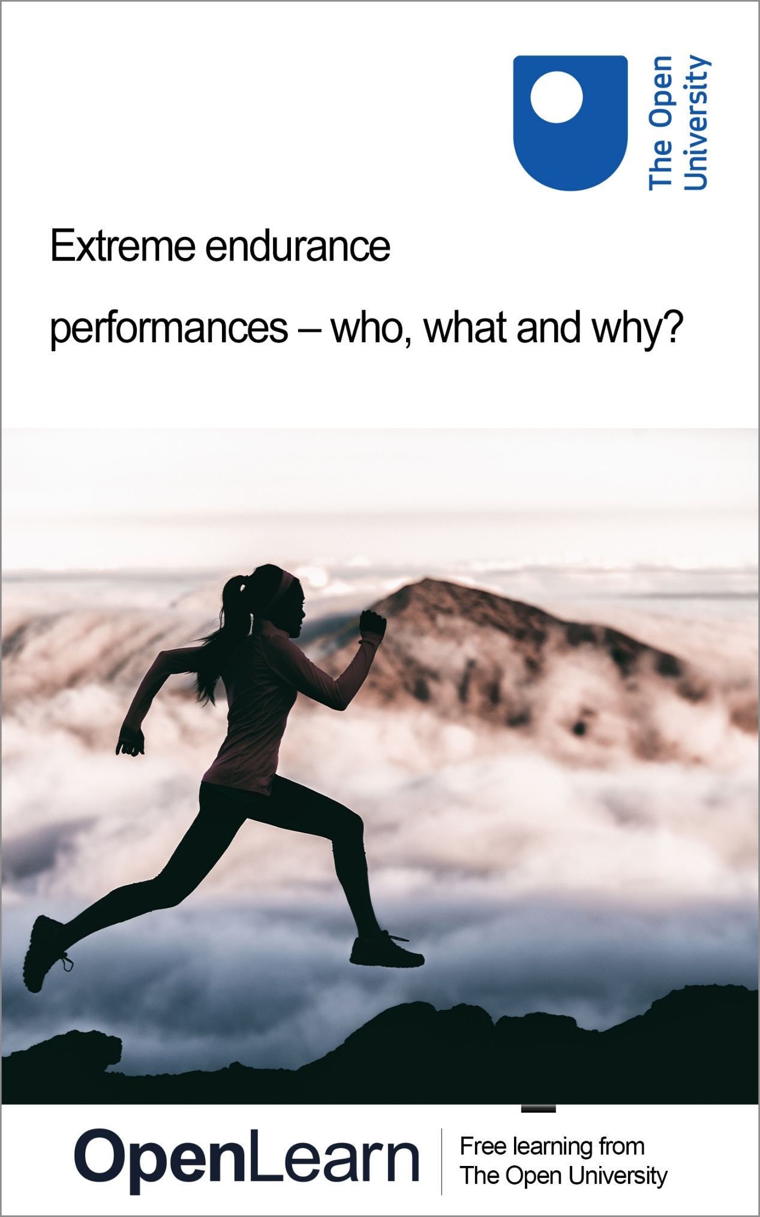

E114_1 Extreme endurance performances – who, what and why?

Extreme endurance performances

About this free course
This free course is an adapted extract from the Open University course E114 Active bodies: introducing the study of sport and exercise https://www.open.ac.uk/courses/modules/e114/ .
This version of the content may include video, images and interactive content that may not be optimised for your device.
You can experience this free course as it was originally designed on OpenLearn, the home of free learning from The Open University – www.open.edu/openlearn/health-sports-psychology/sport-fitness/extreme-endurance-performances---who-what-and-why/content-section-0
There you’ll also be able to track your progress via your activity record, which you can use to demonstrate your learning.
First published 2026.
Unless otherwise stated, copyright © 2026 The Open University, all rights reserved.
Intellectual property
Unless otherwise stated, this resource is released under the terms of the Creative Commons Licence v4.0 http://creativecommons.org/licenses/by-nc-sa/4.0/deed.en. Within that The Open University interprets this licence in the following way: www.open.edu/openlearn/about-openlearn/frequently-asked-questions-on-openlearn. Copyright and rights falling outside the terms of the Creative Commons Licence are retained or controlled by The Open University. Please read the full text before using any of the content.
We believe the primary barrier to accessing high-quality educational experiences is cost, which is why we aim to publish as much free content as possible under an open licence. If it proves difficult to release content under our preferred Creative Commons licence (e.g. because we can’t afford or gain the clearances or find suitable alternatives), we will still release the materials for free under a personal end-user licence.
This is because the learning experience will always be the same high quality offering and that should always be seen as positive – even if at times the licensing is different to Creative Commons.
When using the content you must attribute us (The Open University) (the OU) and any identified author in accordance with the terms of the Creative Commons Licence.
The Acknowledgements section is used to list, amongst other things, third party (Proprietary), licensed content which is not subject to Creative Commons licensing. Proprietary content must be used (retained) intact and in context to the content at all times.
The Acknowledgements section is also used to bring to your attention any other Special Restrictions which may apply to the content. For example there may be times when the Creative Commons Non-Commercial Sharealike licence does not apply to any of the content even if owned by us (The Open University). In these instances, unless stated otherwise, the content may be used for personal and non-commercial use.
We have also identified as Proprietary other material included in the content which is not subject to Creative Commons Licence. These are OU logos, trading names and may extend to certain photographic and video images and sound recordings and any other material as may be brought to your attention.
Unauthorised use of any of the content may constitute a breach of the terms and conditions and/or intellectual property laws.
We reserve the right to alter, amend or bring to an end any terms and conditions provided here without notice.
All rights falling outside the terms of the Creative Commons licence are retained or controlled by The Open University.
Head of Intellectual Property, The Open University

Contents
- Introduction
- Learning outcomes
- 1 Applying a multidisciplinary approach
- 2 What are extreme endurance sports?
- 3 Why people engage in extreme endurance sports
- 4 Understanding the mindset of extreme endurance athletes
- 5 Physiological perspectives on extreme endurance sports
- 6 Socio-cultural perspective on extreme endurance sports
- 7 End-of-course quiz
- Conclusion
- References
- Acknowledgements
- Solutions
- Descriptions

Introduction
In this course you will explore participation in extreme sports and be introduced to the multidisciplinary approach to examining topics. There are many examples of activities that are considered extreme owing to their high-risk nature, such as parkour, base jumping and freestyle skiing. In this course you will focus predominantly on extreme endurance activities – in other words, activities that are considered ‘extreme’ because they push the limits of human endurance, both physically and mentally.


Figure 1
View description - Figure 1

You may hear news stories of people running a marathon every day for a year, cycling across Europe, or swimming across the English Channel. But why do people decide to take on such extreme feats of endurance and to what extent is the body able to support them before reaching exhaustion? Using a multidisciplinary perspective you will explore these questions and reach a better understanding of what the human body is capable of.
This OpenLearn course is an example of level 1 study in Sport and fitness. You might be interested in the related Open University course E114 Active bodies: introducing the study of sport and exercise.

Learning outcomes
After studying this course, you should be able to:
- understand the motivation behind participation in extreme endurance sports
- identify the physical limits of the human body in endurance exercise
- appreciate social factors that may impact on participation in extreme endurance sports
- apply psychological, physiological and sociological perspectives to a topic.

1 Applying a multidisciplinary approach
The introduction to this course highlighted that you will be using a multidisciplinary approach to examine contemporary issues from a variety of perspectives. The three disciplines of study that you will draw on are defined in Box 1.

Box 1 Definitions of disciplines
Sport and exercise physiology is a branch of physiology concerned with how the body adapts physiologically to the short-term stress of exercise or physical activity, and the long-term stress of physical training and competition. For example, a sport physiologist may examine the effect of high amounts of exercise on the systems of the body.
Sport and exercise psychology is the scientific study of behaviour in sport and the application of the principles of psychology to sport and exercise situations. These principles may be applied to enhance performance and improve the quality of a sports performer’s experience.
Sociology of sport and exercise is the study of interactions between sport/exercise, society and culture. For example, a sociological perspective may look at the effect of gender or ethnicity on sport and exercise participation.
(Adapted from Kent, 2007)

You will start your study of extreme endurance sports by assessing what is meant by this term and then applying the discipline of sport and exercise psychology.

2 What are extreme endurance sports?
Extreme endurance sports have become increasingly popular over the past two decades and there are events held across the world in running, swimming and cycling, as well as triathlons. This increased popularity can be attributed to three significant factors (Datta and Bagchi, 2019).
- First, increased economic prosperity for some people, particularly in the Global North, has resulted in increased disposable income and time for participation in these activities.
- Second, this prosperity combined with relatively inexpensive air travel to most parts of the world has made more areas of the world accessible.
- Third, the equipment and clothing necessary for extreme endurance events has become more sophisticated, affordable and available.
That said, many extreme endurance sports are not an option for everyone; the significant financial outlay and time spent away from work commitments can make these activities seem elitist, while they may also not be easily accessible to people with impairments.
There are many examples of extreme sporting activities; for example, World’s Marathons website (2024) advertises 1210 ultra distance running events. But what do we mean by an extreme endurance sport or activity? At what point is endurance defined as extreme? There is no accepted definition of the term ‘extreme endurance sport’, but Townes (2019) describes them as activities that push the limits of human endurance.
Box 2 presents accepted lengths and examples of extreme endurance events.

Box 2 Extreme endurance events
Running – races of between 50 and 100 miles run without a break are accepted as ultra-marathons. However, some races are significantly longer, such as the Badwater Ultramarathon which covers 135 miles run through Death Valley, or the Marathon des Sables, which is a six-day race covering 155 miles through the Moroccan Sahara Desert.
Cycling – extreme endurance events are referred to as ‘ultra-distance cycling’ and this term is reserved for events longer than 100 miles (referred to as a century). These events can be on roads or trails. For example, the Transcontinental Race in Europe is a race of around 4000 km across Europe with a route that varies every year. It takes the winner 8 or 9 days to complete.
Swimming – ultra-distance swimming events are events longer than 10 km. For example, swimming the English Channel, swimming the length of the Amazon River, or swimming from Florida to Cuba.
Triathlon – triathlons are seen as a natural progression from endurance running, cycling and swimming, and a new way to challenge yourself. Ironman events, which consist of 3.8 km swim, 180 km cycle and 42 km run are seen as the gold standard. Well-known events include the Ironman Triathlon in Hawaii and the Norseman Triathlon in Norway.

How do you feel about participating in extreme endurance sports? In Activity 1 you will gauge your attitudes to these activities.

Activity 1 What is your attitude towards extreme endurance sports?
Allow about 10 minutes

Answer the three questions below to assess your attitudes towards extreme endurance events.

Interactive content is not available in this format.

Interactive content is not available in this format.

Interactive content is not available in this format.

View comment - Part

As you may be aware, people become involved in extreme endurance activities for many reasons, such as to feel a sense of achievement in challenging themselves. In the next section you will continue to apply sport and exercise psychology, as well as learning more about people’s motivation and examining some athlete’s experiences.

3 Why people engage in extreme endurance sports

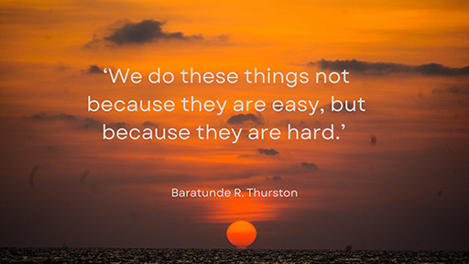
Figure 2
View description - Figure 2

In 2023, Russ Cook took on a challenge to run the length of Africa starting in South Africa and ending in Tunisia. He completed the 10,000 mile run in 352 days having endured robbery at gunpoint, serious food poisoning, back and foot injuries and challenging terrain, such as the Sahara Desert (Poole, 2024). This feat earned him the nickname ‘The Hardest Geezer’. But why did he start on this epic challenge? In a podcast, he explained how he was motivated to raise money for charity, and he did raise more than £1 million. However, his original motivation was to deal with issues of poor mental health, gambling and alcohol addictions (BBC Sport, 2024).
In Activity 2 you will hear from three people, Lowri Morgan, Nick Nicholson and Tim Gardner, who choose to take on extreme endurance challenges. They will explain their own motivations and Greg Roebuck from Monash University will provide an academic’s viewpoint on this key topic within sport and exercise psychology.

Activity 2 Start with the why
Allow about 30 minutes

First, listen to 1 Extreme Sports taken from The Why Factor on BBC World Service. (Open links in a new tab or window by holding down Ctrl [or Cmd on a Mac] when you click on the link.)

Next, answer the following questions.
- What motivating factors do Roebuck and the participants offer for participating in extreme endurance activities?
- What benefits may participants in extreme endurance events gain?

Provide your answer...

View comment - Part

While Dr Roebuck stresses the positive benefits of extreme endurance sports it is important to say that they can also have a downside. For example, the characteristics that make these sports attractive can facilitate behaviours associated with exercise addiction (Nogueira et al., 2018). To be successful at extreme endurance sports requires traits of obsessive passion and dedication that can be predictors of exercise addiction. It is difficult to establish actual figures of exercise addiction as findings from studies vary widely, showing between 3 per cent and 42 per cent of participants in extreme endurance sports exhibiting traits of exercise addiction (Nogueira et al., 2018).
Having looked at the motivation behind extreme endurance sport participation you will continue to explore extreme endurance from a psychological perspective in the next section.

4 Understanding the mindset of extreme endurance athletes
Extreme endurance sports place exceptional psychological demands on athletes, such as being able to manage the pain and discomfort that will inevitably accompany them. There is also the psychological impact of fatigue as the muscular, nervous and cardiorespiratory systems may be working at their limits for prolonged periods of time. Also, owing to the sheer volume of exercise undertaken, sleep deprivation can also be an issue.
Roebuck and colleagues (2018) identified that ultra-endurance runners respond differently to pain when compared to non-runners as they appear to have a higher pain tolerance threshold and lower pain-related anxiety. They are able to use effective pain-coping strategies and employ psychological skills such as positive self-talk, visualisation and challenging negative thoughts (Berger et al., 2024). Ultra-endurance runners have described how they are able to run while fatigued because of their strong drive to explore their physical and psychological limits (Simpson et al., 2014).
A significant psychological trait that ultra-endurance runners possess is that of mental toughness or resilience (the ability to bounce back from setbacks), when compared to non-runners. Mental toughness is seen as a psychological trait that allows athletes to deal with challenges and persist when under pressure and during negative experiences (Lin et al., 2017), so you can appreciate why it is so important in ultra-endurance activities. The importance of mental toughness is further explored in Activity 3 where you will also learn about methods that sport psychologists can use to support extreme endurance athletes.

Activity 3 King of the English Channel
Allow about 20 minutes

First, watch Video 1 The strange appeal of extreme endurance sport, which considers the appeal of extreme endurance sports.

Next, answer the following questions:
- To what does the English Channel swimmer Kevin Murphy attribute his success in crossing the Channel 34 times?
- What techniques do the two sport psychologists use when working with extreme endurance athletes?

Provide your answer...

View comment - Part

As well as setting goals, a technique that sport psychologists can implement with athletes to manage feelings of pain, is to teach athletes to direct their attention to task-relevant cues rather than focus on the discomfort (Lasnier and Durand-Bush, 2023). For example, a cyclist might focus on their technique, leg speed, sensations of breathing, or their race tactics to distract themselves from feelings of pain. Pain is considered to be a subjective experience, and its perceived intensity is not always directly related to the strength of the pain signal sent out (Stevens et al., 2018). Sport psychologists can help their athletes by changing how they perceive and appraise the pain signals they are receiving (Stevens et al., 2018).

Find out more
Find out more information about the psychological demands of extreme endurance sports by reading the article ‘We studied mental toughness in ultra-marathon runners. Mind over matter is real – but won’t take you all the way’ (George, 2020). Reflect on how the article develops some of the ideas covered in this section of the course. As well as mental toughness what other factors are important in successful ultra-distance running?

Having taken a look at a psychological approach to understanding extreme sports, you will now explore aspects of extreme endurance performance by applying the discipline of sport and exercise physiology.

5 Physiological perspectives on extreme endurance sports
During extreme endurance sports the body has significant physiological demands placed on it. Although an ultra-marathon is a race usually between 50 and 100 km without a break, there can be great variability in distances. For example, the Comrades Marathon in South Africa is 90 km, while the Marathon des Sables in the Sahara Desert is 250 km. The Marathon des Sables takes place across 11 days in Morocco. Nine of these days are in the Sahara Desert, running or walking across sand and rocks. In addition to having to cover 250 kilometres, the participants must carry all their food and equipment and sleep overnight in a tent.

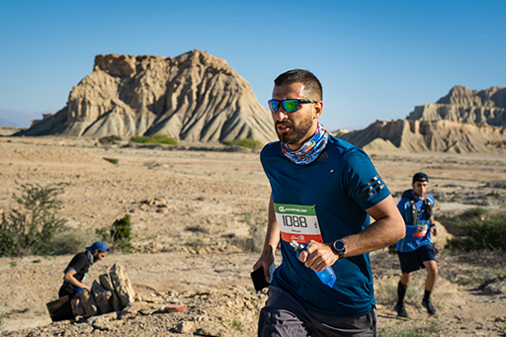
Figure 3
View description - Figure 3

The distance covered and duration of exercise during an ultra-marathon puts immense strain on the muscular, cardiovascular and other body systems and requires a large amount of energy. If a runner is unable to meet the energy needs of the activity they’ll be in a situation where they start to break down their skeletal muscle and fat stores to provide fuel for the body (Knechtle and Nikolaidis, 2018). In this way, the body starts to eat itself and muscle lost to energy production, including to the heart muscle, can significantly impair performance. Dehydration can also be a huge problem, particularly when there are extremes of heat, such as in the Sahara Desert. A runner can lose up to 2.8 litres of sweat an hour and it is a challenge for them to replace this fluid loss while still running and prevent the resulting performance loss (Bottoms, 2021). In Activity 4, Nick Tiller describes the physiological impact of an ultra-marathon.

Activity 4 The cost of extreme endurance sports on the body
Allow about 30 minutes

First, listen to Audio 2 Endurance from Healthcheck on BBC World Service, from 14:51 to 18:40.
Next, note down what Tiller says (from his experience) can happen to the body around 25 miles, 50–60 miles, and after the ultra-endurance event.

Provide your answer...

View comment - Part

The damage to the body caused by extreme endurance sports is generally reversed after a few days (Knechtle and Nikolaidis, 2018), but there is limited research on the long-term health impact on the heart. However, one study from Gajda and colleagues (2020) found that damage to the muscles and liver, as well as inflammation was reversed after 10 days, and that many years of intensive training and ultra-marathon running did not have permanent negative effects on a runner’s heart.

Find out more
To find out more about what running 100 miles a day can do to the human body, you could read the article ‘I ran 100 miles in a day – this is what happened to my body’ (Tiller, 2018), which also includes links to relevant research. Reflect on how the article develops some of the ideas covered in this section of the course. For example, think about the factors that influence the amount of muscle damage caused during ultra-marathon running and how nutritional strategies can support participants in ultra- endurance events.
To find out more about the physical limits of the human body, you could read the BBC Sport article ‘Ultimate limit of human endurance found’ (Gallagher, 2019). Consider the factors that contribute to running economy and why it is important, and the limits on how much energy the body can produce.

6 Socio-cultural perspective on extreme endurance sports

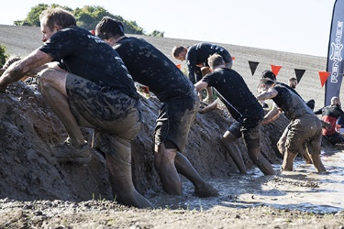
Figure 4 Tough Mudder
View description - Figure 4 Tough Mudder

Participation in extreme endurance sports has risen significantly in the 21st Century. In 2005 there were fewer than 1000 events worldwide with 89,597 finishers, while in 2019 these figures had risen to 7000 events and 682,156 finishers (Berger et al., 2024). However, these types of ultra-endurance events are not necessarily accessible to everyone as they demand significant amounts of time and finance that may be beyond many people.
One type of extreme event that has gained popularity in the UK is the phenomenon that is the Tough Mudder. In Activity 5 you will look at the Tough Mudder website and assess why it may be popular.

Activity 5 Paying money for manufactured suffering
Allow about 20 minutes

Go to Tough Mudder. Explore the website and in particular read the stories of participants in the ‘Learn more’ section. Then answer the following questions:
- What does Tough Mudder involve?
- What do participants say they gain from completing the event?

Provide your answer...
View comment - Activity 5 Paying money for manufactured suffering

There are many different reasons for competing in the Tough Mudder and stories mention sense of achievement, doing something other people don’t, and raising money for charity. One of the founders of Tough Mudder, Will Dean, believes that its success is partly a reaction to our risk-adverse society where people who work at desks seek out these raw experiences. Then they share their achievements on social media (Bailey, 2017).
As well as being a way for people to experience danger in a safe society the success of Tough Mudder can be assessed in other ways and one way is to see it as a means to monetise extreme events. The Tough Mudder brand was valued at over £100m in 2017 and has events across 11 countries. Entry fees are expensive and there is merchandise and clothing available. This shows that people are willing to experience hardship and pain in a commercialised setting.

7 End-of-course quiz
Complete the following informal quiz, which tests your knowledge of the course.

1. Identify which of the following statements shows an application of a sport physiology approach.

Ultramarathon running demands that participants need to be able to withstand significant amounts of pain
Ultramarathon running involves a significant financial outlay in paying for travel and the equipment needed
Ultramarathon running requires elements of both aerobic endurance and the ability to tolerate lactic acid build up
Ultramarathon running is viewed as a socially acceptable way to deal with problems in your personal life
View answer - Part

2. Identify which of the following would be considered to be an extreme endurance event.

An adventure race of 10 km
Swimming event of 15 km
Running event of 42 km
Cycling event of 75 km
View answer - Part

3. Identify which psychological trait is essential for participation in extreme endurance events.

Ability to deal with high levels of stress
Ability to set SMART goals
Ability to tolerate high levels of pain
Ability to develop an exercise addiction
View answer - Part

4. Identify which of the following is NOT an effect of extreme endurance activity.

Potential long-term damage to the heart muscle
Muscle tightness and microtears
Digestive problems such as nausea and cramps
Inflammation due to an increase in oxygen consumption
View answer - Part

Conclusion
In this course you have explored how a topic can be examined using a multidisciplinary approach made up of different disciplines in sports science. In particular, you have seen how sport physiology and sport psychology and, more briefly, sociological perspectives, can highlight different aspects of extreme endurance activities.

Key learning points
The main learning points for this course are:
- A multidisciplinary approach can be applied to provide different perspectives on a topic.
- Extreme endurance activities are those endurance activities that are significantly longer than normally accepted endurance distances.
- People engage in extreme endurance activities for multiple reasons, including finding out how far they can push themselves, or to deal with difficult times in their lives and overcome mental health challenges.
- Extreme endurance athletes may respond to pain differently or use different strategies to manage sensations of pain. They also exhibit high levels of mental toughness and resilience.

This OpenLearn course is an example of level 1 study in Sport and fitness. You might be interested in the related Open University course E114 Active bodies: introducing the study of sport and exercise.
Other OpenLearn courses
Training for endurance in sport and fitness
Developing resilience in sport
Recovery strategies in sport and exercise
Exploring the psychological aspects of sport injury
Supporting female performance in sport and fitness
Motivation and factors affecting motivation
OpenLearn Sport and Fitness Hub

References
BBC (2024) Why smart people do stupid things. 29 August. Available at: https://www.bbc.co.uk/videos/cz4728rdwlvo (Accessed: 13 March 2026).
BBC Sport (2024) ‘Hardest Geezer. Russ Cook.’ Available at: https://www.bbc.co.uk/sport/athletics/68737828 (Accessed: 13 March 2026).
Berger, N.J.A., Best, R., Best, A.W., Lane, A.M., Millet, G.Y., Barwood, M., Marcora, S., Wilson, P. and Bearden, S. (2024) ‘Limits of ultra: towards an interdisciplinary understanding of ultra-endurance running performance’, Sports Medicine, 54, pp. 73–93.
Bottoms, L. (2021) ‘Ultramarathon running: how safe is the sport?’, The Conversation, 9 June. Available at: https://theconversation.com/ultramarathon-running-how-safe-is-the-sport-162108 (Accessed: 13 March 2026).
Datta, S. and Bagchi, D. (eds) (2019) Extreme and rare sports: performance demands, drivers, functional foods, and nutrition. Florida: Taylor & Francis Group.
Gajda, R., Klisiewicz, A., Matsibora, V., Piotrowska-Kownacka, D. and Biernacka, E.K. (2020) ‘Heart of the world’s top ultramarathon runner – not necessarily much different from normal’, Diagnostics, 10(2). Available at: https://www.ncbi.nlm.nih.gov/pmc/articles/PMC7168911/ (Accessed: 13 March 2026).
Gallagher, J. (2019) ‘Ultimate limit of human endurance found’, BBC News, 6 June. Available at: https://www.bbc.co.uk/news/health-48527798 (Accessed: 13 March 2026).
George, K. (2020) ‘We studied mental toughness in ultra-marathon runners. Mind over matter is real – but won’t take you all the way’, The Conversation, 5 November. Available at: https://theconversation.com/we-studied-mental-toughness-in-ultra-marathon-runners-mind-over-matter-is-real-but-wont-take-you-all-the-way-149447 (Accessed: 13 March 2026).
Kent, M. (2007) The Oxford dictionary of sports science and medicine. 3rd edn. Available at: https://www-oxfordreference-com.libezproxy.open.ac.uk/display/10.1093/acref/9780198568506.001.0001/acref-9780198568506 (Accessed: 13 March 2026).
Knechtle, B. and Nikolaidis, P.T. (2018) ‘Physiology and pathophysiology in ultra-marathon running’, Frontiers in Physiology, 9. Available at: https://www.frontiersin.org/journals/physiology/articles/10.3389/fphys.2018.00634/full (Accessed: 13 March 2026).
Lasnier, J. and Durand-Bush, N. (2023) ‘How elite endurance athletes experience and manage exercise-induced pain: implications for mental performance consultants’, Journal of Applied Sport Psychology, 35(5), pp. 817–835.
Lin, Y., Mutz, J., Clough, P.J., and Papageorgiou (2017) ‘Mental toughness and individual differences in learning, educational and work performance, psychological wellbeing, and personality: a systematic review’, Frontiers in Psychology. Available at: https://pubmed.ncbi.nlm.nih.gov/28848466/ (Accessed: 13 March 2026).
Nogueira, A., Molinero, O., Salguero, A. and Marquez, S. (2018) ‘Exercise addiction in practitioners of endurance sports: a literature review’, Frontiers in Psychology, 17(9). Available at: https://www.ncbi.nlm.nih.gov/pmc/articles/PMC6107830/ (Accessed: 13 March 2026).
Poole, H. (2024) ‘Hardest Geezer: British man Russ Cook completes run across Africa’, BBC Sport, 7 April. Available at: https://www.bbc.co.uk/sport/athletics/68737828 (Accessed: 13 March 2026).
Rea, S. (2023) Sports science: a complete introduction. 2nd edn. London: John Murray Press.
Roebuck, G.S., Fitzgerald, P.B., Urquhart, D.M., Ng, S-K., Cicuttini, F.M. and Fitzgibbon, B.M. (2018) ‘The psychology of ultra-marathon runners: a systematic review’, Psychology of Sport and Exercise, 37, pp. 43–58.
Robertson, M. (2021) ‘The science of muscle recovery: how long should you rest between workouts?’ Available at: https://shop.bodybuilding.com/blogs/recovery/the-science-of-muscle-recovery-how-long-should-you-rest-between-workouts (Accessed: 13 March 2026).
Simpson, D., Post, P.G., Young, G. and Jensen, P.R. (2014) ‘It’s not about taking the easy road: the experiences of ultramarathon runners’, Journal of Sport Psychology, 28(20), pp. 176–185.
Stevens, C.J., Mauger, A.R., Hassmen, P. and Taylor, L. (2018) ‘Endurance performance is influenced by perceptions of pain and temperature: theory, applications and safety considerations’, Sports Medicine, 48(3), pp. 524–537.
Tiller, N. (2018) ‘I ran 100 miles in a day – this is what happened to my body’, The Conversation, 24 September. Available at: https://theconversation.com/i-ran-100-miles-in-a-day-this-is-what-happened-to-my-body-101640 (Accessed: 13 March 2026).
Townes, D. (2019) ‘Extreme endurance sports – why not just sports?’, in S. Datta and D. Bagchi (eds) Extreme and rare sports: performance demands, drivers, functional foods and nutrition. Abingdon: CRC Press., pp. 3–8.
Thurston, B. (2012) How to be Black, London: HarperCollins.
World’s Marathons (2024) Full marathons. Available at: https://worldsmarathons.com/s/running/ultra_marathon (Accessed: 13 March 2026).
Zhang, D., Li, J., Miller, R., Batraka, M., Effing, S.M.A., Hossain, F., Bernard, A-C., Marillier, M. and Domnik, N.J. (2021) ‘Are your muscles or your brain making you feel tired after exercise?’, Frontiers for Young Minds. Available at: https://kids.frontiersin.org/articles/10.3389/frym.2021.578431 (Accessed: 13 March 2026).

Acknowledgements
This free course was written by Simon Rea and was first published in April 2026.
OpenLearn editor: Dale Harry
Except for third party materials and otherwise stated (see terms and conditions), this content is made available under a Creative Commons Attribution-NonCommercial-ShareAlike 4.0 Licence.
The material acknowledged below is Proprietary and used under licence (not subject to Creative Commons Licence). Grateful acknowledgement is made to the following sources for permission to reproduce material in this free course:
Images
Course Image: Maridav/Shutterstock
Figure 1: Maridav/Shuttertsock
Figure 2: Photo by Paula Anne: https://www.pexels.com/photo/golden-hour-horizon-2608401/
Figure 3: Photo by Kayvan Mazhar on Unsplash
Figure 4: Simon Bratt/Shutterstock
Every effort has been made to contact copyright owners. If any have been inadvertently overlooked, the publishers will be pleased to make the necessary arrangements at the first opportunity.
Don’t miss out
If reading this text has inspired you to learn more, you may be interested in joining the millions of people who discover our free learning resources and qualifications by visiting The Open University – www.open.edu/openlearn/free-courses.

Solutions

Activity 1 What is your attitude towards extreme endurance sports?

Part

Comment
Once you have answered the questions you might appreciate how your answers may differ significantly from those of other people. You may appreciate how these types of activities are hugely appealing to some people but may be avoided at all costs by others.
Back to - Part

Activity 2 Start with the why

Part

Comment
Along with a sense of achievement and revelling in large challenges, participants can make self-discoveries about their own physical and psychological limits. Roebuck describes how ultra-endurance athletes may have higher levels of the trait of sensation seeking and seek out novel experiences. The participants describe how exploring individual limits can be fun, such as when you get to the point where you think you have nothing left to give but find something inside yourself to keep going. Two participants suggest that they started to run long distances as a response to difficult times in their lives, either so they can work things out while running or to do something for yourself.
Dr Roebuck expands on the idea of running as therapy where participants start by running away from problems but can run towards answers as well. He explains that research shows that extreme endurance exercise, such as ultra-marathons, can lower levels of anxiety. The long-term psychological benefits of extreme endurance events can be that a participant’s mood profile may change as they experience higher levels of energy and vigour and lower levels of negative mood states.
Back to - Part

Activity 3 King of the English Channel

Part

Comment
Kevin Murphy reinforces the importance of mindset by saying that although he was not a great swimmer, or especially fit, he had the mental toughness or willpower to carry on and ‘beat the demons’ which were saying ‘you can’t do this.’
The two sports psychologists mention several psychological techniques such as having an end goal and a series of steps on the journey to achieving that end goal (goal setting), being clear on why you want to achieve the goal and strategies for managing negative thoughts. They also acknowledge the importance of perseverance and keeping going through adversity.
Back to - Part

Activity 4 The cost of extreme endurance sports on the body

Part

Comment
Tiller outlines both the negative effects of extreme endurance running on the body with some positive effects such as improved cardiovascular health, aerobic fitness and quality of life. Three physical impacts he highlights are:
- after 25 miles, muscle soreness develops due to tightness and microtears in the muscles
- after 50 to 60 miles, the digestive system (which is key to rehydration and delivery of energy from food) can shut down, as energy for the working muscles is prioritised by the body. This means that any food or drink consumed stays in the gut, causing symptoms such as nausea and stomach cramps
- at the end of the race, inflammation in the body occurs owing to the oxidative stress caused by the huge amounts of oxygen that have been consumed.
Back to - Part

Activity 5 Paying money for manufactured suffering

Comment
You will have found out that Tough Mudder courses involve tackling obstacles, including one where you have to avoid electric shocks, whilst running 5k or 15k. The aim is not to beat anyone but to challenge your strength, stamina and ‘mental grit’ and also working as a team to clear the obstacles. They are sold as being more interesting than running a marathon where the only challenge is running for a long time.
Back to - Activity 5 Paying money for manufactured suffering

Activity

Part

Answer
Right:
Ultramarathon running requires elements of both aerobic endurance and the ability to tolerate lactic acid build up
Wrong:
Ultramarathon running demands that participants need to be able to withstand significant amounts of pain
Ultramarathon running involves a significant financial outlay in paying for travel and the equipment needed
Ultramarathon running is viewed as a socially acceptable way to deal with problems in your personal life
Back to - Part

Part

Answer
Right:
Swimming event of 15 km
Wrong:
An adventure race of 10 km
Running event of 42 km
Cycling event of 75 km
Back to - Part

Part

Answer
Right:
Ability to tolerate high levels of pain
Wrong:
Ability to deal with high levels of stress
Ability to set SMART goals
Ability to develop an exercise addiction
Back to - Part

Part

Answer
Right:
Potential long-term damage to the heart muscle
Wrong:
Muscle tightness and microtears
Digestive problems such as nausea and cramps
Inflammation due to an increase in oxygen consumption
Back to - Part

Descriptions

Figure 1
A photo showing a runner running along a road that runs through countryside. He is wearing clothing suitable for competing in a triathlon.
Back to - Figure 1

Figure 2
This image shows words on a background of a sunset. The words say ‘We do these things not because they are easy, but because they are hard.’ This is followed by the name ‘Baratunde R. Thurston’.
Back to - Figure 2

Figure 3
The image shows competitors running across a rugged and uneven terrain. There are small hills in the background. The competitors are carrying drinking bottles and other equipment.
Back to - Figure 3

Figure 4 Tough Mudder
Competitors in Tough Mudder climbing over and navigating an obstacle in the course.
Back to - Figure 4 Tough Mudder

