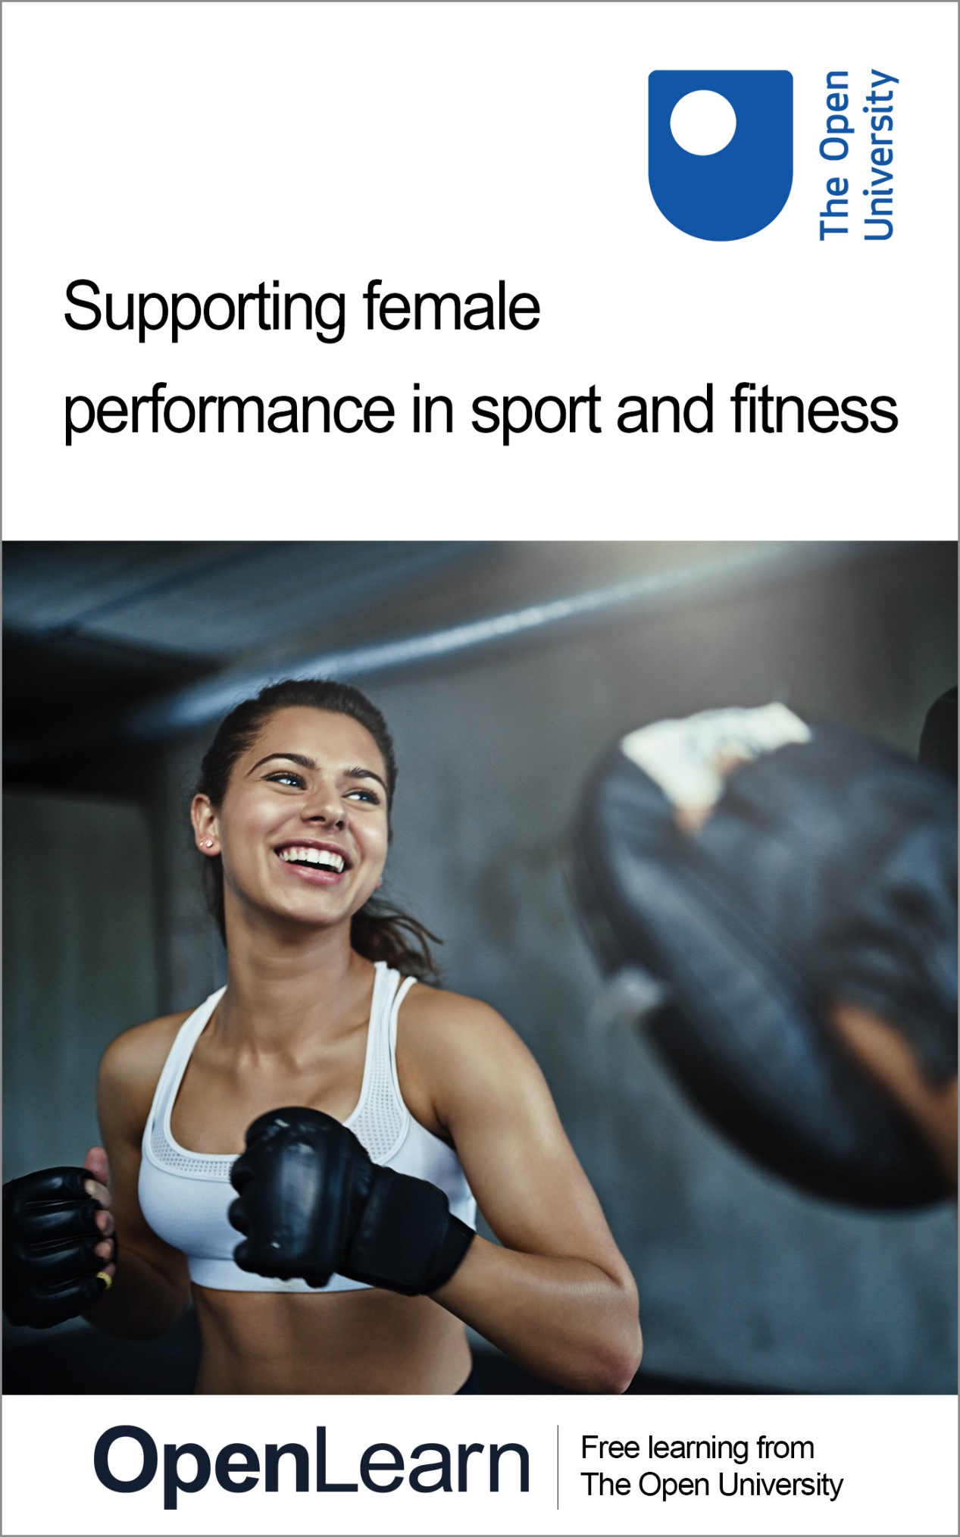

SFPS_1

Supporting female performance in sport and fitness

About this free course
This free course is an adapted extract from the Open University course .
This version of the content may include video, images and interactive content that may not be optimised for your device.
You can experience this free course as it was originally designed on OpenLearn, the home of free learning from The Open University –
There you’ll also be able to track your progress via your activity record, which you can use to demonstrate your learning.
Copyright © 2019 The Open University
Intellectual property
Unless otherwise stated, this resource is released under the terms of the Creative Commons Licence v4.0 http://creativecommons.org/licenses/by-nc-sa/4.0/deed.en_GB. Within that The Open University interprets this licence in the following way: www.open.edu/openlearn/about-openlearn/frequently-asked-questions-on-openlearn. Copyright and rights falling outside the terms of the Creative Commons Licence are retained or controlled by The Open University. Please read the full text before using any of the content.
We believe the primary barrier to accessing high-quality educational experiences is cost, which is why we aim to publish as much free content as possible under an open licence. If it proves difficult to release content under our preferred Creative Commons licence (e.g. because we can’t afford or gain the clearances or find suitable alternatives), we will still release the materials for free under a personal end-user licence.
This is because the learning experience will always be the same high quality offering and that should always be seen as positive – even if at times the licensing is different to Creative Commons.
When using the content you must attribute us (The Open University) (the OU) and any identified author in accordance with the terms of the Creative Commons Licence.
The Acknowledgements section is used to list, amongst other things, third party (Proprietary), licensed content which is not subject to Creative Commons licensing. Proprietary content must be used (retained) intact and in context to the content at all times.
The Acknowledgements section is also used to bring to your attention any other Special Restrictions which may apply to the content. For example there may be times when the Creative Commons Non-Commercial Sharealike licence does not apply to any of the content even if owned by us (The Open University). In these instances, unless stated otherwise, the content may be used for personal and non-commercial use.
We have also identified as Proprietary other material included in the content which is not subject to Creative Commons Licence. These are OU logos, trading names and may extend to certain photographic and video images and sound recordings and any other material as may be brought to your attention.
Unauthorised use of any of the content may constitute a breach of the terms and conditions and/or intellectual property laws.
We reserve the right to alter, amend or bring to an end any terms and conditions provided here without notice.
All rights falling outside the terms of the Creative Commons licence are retained or controlled by The Open University.
Head of Intellectual Property, The Open University
978-1-4730-2973-6 (.kdl)
978-1-4730-2974-3 (.epub)

Contents
- Introduction and guidance
  - Introduction and guidance
  - What is a badged course?
    - How to get a badge
- Session 1: Mind the gap: gender differences in sport science research and its impact on female athletes
  - Introduction
  - 1 Original gamechangers: still breaking barriers
  - 2 It does not have to be this way!
  - 3 The default male in sports science research
  - 4 Why is the female ‘problematic’ in sports science research?
  - 5 Why do we need to study women separately?
  - 6 Why is there a post-puberty dropout?
  - 7 Females being left out of medical research: another example of male bias?
  - 8 This session’s quiz
  - 9 Summary of Session 1
- Session 2: Demystifying the menstrual cycle
  - Introduction
  - 1 Does the menstrual cycle impact on exercising females?
  - 2 What do you need to know about the menstrual cycle?
  - 3 Women’s experiences of their menstrual cycle
  - 4 How does the menstrual cycle impact performance?
  - 5 What does the research say?
  - 6 How can hormones be used to a female athlete’s advantage in exercise?
  - 7 How can tracking cycles help?
  - 8 This session’s quiz
  - 9 Summary of Session 2
- Session 3: Hormonal contraception: a solution or more challenges?
  - Introduction
  - 1 How do hormonal contraceptives work?
  - 2 Why might athletes take hormonal contraceptives?
  - 3 The impact of hormonal contraception on the female and their menstrual cycle
  - 4 What does the research say?
  - 5 Hormonal contraception or natural cycle? An individual choice
  - 6 This session’s quiz
  - 7 Summary of Session 3
- Session 4: Pelvic floor muscles: out of sight and often overlooked
  - Introduction
  - 1 What does pelvic floor dysfunction look like?
  - 2 Introducing the pelvic floor and its muscles
  - 3 Which muscles are we talking about?
  - 4 Athletic performance and pelvic floor dysfunction?
  - 5 What does the research on athletes say?
  - 6 Strong to the core: training the pelvic floor
  - 7 From the pelvic floor to the gym floor
  - 8 This session’s quiz
  - 9 Summary of Session 4
- Session 5: Breast health and choosing the correct breast support
  - Introduction
  - 1 Why is breast health important?
  - 2 Breast anatomy and natural support
  - 3 Breast biomechanics
  - 4 The impact of poor breast support on sports performance
  - 5 Bras and breast support available
  - 6 Getting the right fit
  - 7 Case study: Equestrian sports
  - 8 Practical recommendations for coaches and athletes
  - 9 This session’s quiz
  - 10 Summary of Session 5
- Session 6: Injuries and the female athlete
  - Introduction
  - 1 Female athletes and their susceptibility to specific injuries
  - 2 Why are there so many ACL injuries in female sport?
  - 3 What can be done to protect female athletes against ACL injuries?
  - 4 Reducing injuries among female athletes
  - 5 Sport concussions and the female athlete
  - 6 Why do females fare worse from sport concussions?
  - 7 This session’s quiz
  - 8 Summary of Session 6
- Session 7: Low energy intake and missed periods: the risks
  - Introduction
  - 1 Medals or menstruation? What the athletes say
  - 2 What is the problem?
  - 3 The period is a vital sign of health
  - 4 The impact of RED-S on performance
  - 5 Warning signs of RED-S
  - 6 Preventing RED-S in female athletes
  - 7 The importance of carbohydrates to female athletes
  - 8 Managing athletes and active females experiencing RED-S
  - 9 This session’s quiz
  - 10 Summary of Session 7
- Session 8: Effective support of female athletes
  - Introduction
  - 1 ‘Females are just emotional!’
  - 2 Do female athletes prefer certain styles of coaching?
  - 3 What do female athletes want from their coach?
  - 4 What does research say about the psychology of the female athlete?
  - 5 Final thoughts on coaching female athletes
  - 6 Key learning points from the course
  - 7 This session’s quiz
  - 8 Summary of Session 8
  - Where next?
  - Tell us what you think
- References
- Further reading
- Acknowledgements
- Solutions

Introduction and guidance

Introduction and guidance
This free badged course, Supporting female performance in sport and fitness, lasts 24 hours with eight sessions. You can work through the course at your own pace, so if you have more time one week there is no problem with pushing on to complete a further study session. The eight sessions are linked to ensure a logical flow through the course. They are:
- Mind the gap: gender differences in sport science research and its impact on female athletes
- Demystifying the menstrual cycle
- Hormonal contraception: a solution or new challenges?
- Pelvic floor muscles: out of sight and often overlooked
- Breast health and choosing the correct breast support
- Injuries and the female athlete
- Low energy intake and missed periods: the risks
- Effective support of female athletes
Each session should take you around 3 hours. There are a number of activities throughout the course where you are asked to note down your response. A text box is provided for you to do this, however if you would prefer to record your answers in another way that is fine.
At the end of each session there is also a quiz to help you check your understanding. And, if you want to receive a formal statement of participation, at the end of Sessions 4 and 8 there is a quiz which you need to pass.
Watch the introductory video presented by one of the co-authors, Simon Rea, which explains what the course includes, who it is relevant to and what you will get out of studying it.

Video content is not available in this format.
View transcript - Uncaptioned interactive content

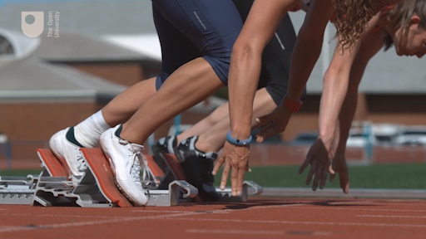

After completing this course, you should be able to:
- understand the physiological and psychological differences between men and women and between individual women
- identify female-specific issues that need to be considered to promote the health, fitness, and wellbeing of female athletes
- recognise the gender gap in research between males and females and its impact on female health and performance.

A note on terminology
The content in this course applies to anyone who identifies as female but is mainly focused on those people who have female genitals, have gone through puberty as a female and have (or had) a menstrual cycle.

Moving around the course
In the ‘Summary’ at the end of each week, you will find a link to the next week. If at any time you want to return to the start of the course, click on ‘Full course description’. From here you can navigate to any part of the course.
It’s also good practice, if you access a link from within a course page (including links to the quizzes), to open it in a new window or tab. That way you can easily return to where you’ve come from without having to use the back button on your browser.
The Open University would really appreciate a few minutes of your time to tell us about yourself and your expectations for the course before you begin, in our optional start-of-course survey. Participation will be completely confidential and we will not pass on your details to others.

What is a badged course?
While studying Supporting female performance in sport and fitness you have the option to work towards gaining a digital badge.
Badged courses are a key part of The Open University’s mission to promote the educational well-being of the community. The courses also provide another way of helping you to progress from informal to formal learning.
Completing a course will require about 24 hours of study time. However, you can study the course at any time and at a pace to suit you.
Badged courses are available on The Open University’s OpenLearn website and do not cost anything to study. They differ from Open University courses because you do not receive support from a tutor, but you do get useful feedback from the interactive quizzes.

What is a badge?
Digital badges are a new way of demonstrating online that you have gained a skill. Colleges and universities are working with employers and other organisations to develop open badges that help learners gain recognition for their skills, and support employers to identify the right candidate for a job.
Badges demonstrate your work and achievement on the course. You can share your achievement with friends, family and employers, and on social media. Badges are a great motivation, helping you to reach the end of the course. Gaining a badge often boosts confidence in the skills and abilities that underpin successful study. So, completing this course could encourage you to think about taking other courses.

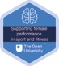

How to get a badge
Getting a badge is straightforward! Here’s what you have to do:
- read each session of the course
- score 50% or more in the two badge quizzes in Session 4 and Session 8.
For all the quizzes, you can have three attempts at most of the questions (for true or false type questions you usually only get one attempt). If you get the answer right first time you will get more marks than for a correct answer the second or third time. Therefore, please be aware that for the two badge quizzes it is possible to get all the questions right but not score 50% and be eligible for the badge on that attempt. If one of your answers is incorrect you will often receive helpful feedback and suggestions about how to work out the correct answer.
For the badge quizzes, if you’re not successful in getting 50% the first time, after 24 hours you can attempt the whole quiz, and come back as many times as you like.
We hope that as many people as possible will gain an Open University badge – so you should see getting a badge as an opportunity to reflect on what you have learned rather than as a test.
If you need more guidance on getting a badge and what you can do with it, take a look at the OpenLearn FAQs. When you gain your badge you will receive an email to notify you and you will be able to view and manage all your badges in My OpenLearn within 24 hours of completing the criteria to gain a badge.
Get started with Session 1.

Session 1: Mind the gap: gender differences in sport science research and its impact on female athletes

Introduction

Real change, enduring change, happens one step at a time.
(Ruth Bader Ginsberg)

The delayed 2020 Olympic Games in Tokyo were the first Games where equal numbers of events and medals were available to females and males. The gap in the number of competitors has started to even out with around 52% athletes competing in male events and 48% in female events. In the 2020s there has been a shift in media coverage of sport with female sports gaining increasing amounts of airtime and coverage online and in the press. Increasingly there are improvements in the language used around female sports, like footballers, cricketers and rugby players not constantly being prefixed by ‘female’ or ‘women’. In cricket the terms ‘batsman’ and ‘batswoman’ have been changed to ‘batters’.

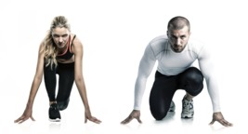
Figure 1 The gap between male and female participation in sport is narrowing.
View description - Figure 1 The gap between male and female participation in sport is narrowing.
View description - Figure 1 The gap between male and female participation in sport is narrowing.

Although progress has been made, significant inequalities remain between male and female sport. One such inequality is a shortage of sports science and medical research using female subjects exclusively.
This first session will celebrate the progress that female athletes have made but it will also shine a light on areas where female sport is lagging behind and the impact that may be having on their health and performance.
By the end of this session, you should be able to:
- understand the benefits of research evidence for both males and females in sport and exercise
- investigate why the majority of sports science research is conducted on males and the impact of this on active females
- identify the gender gap that impacts on female performance and participation in sport and fitness activities.
The Open University would really appreciate a few minutes of your time to tell us about yourself and your expectations for the course before you begin, in our optional start-of-course survey. Participation will be completely confidential and we will not pass on your details to others.

1 Original gamechangers: still breaking barriers

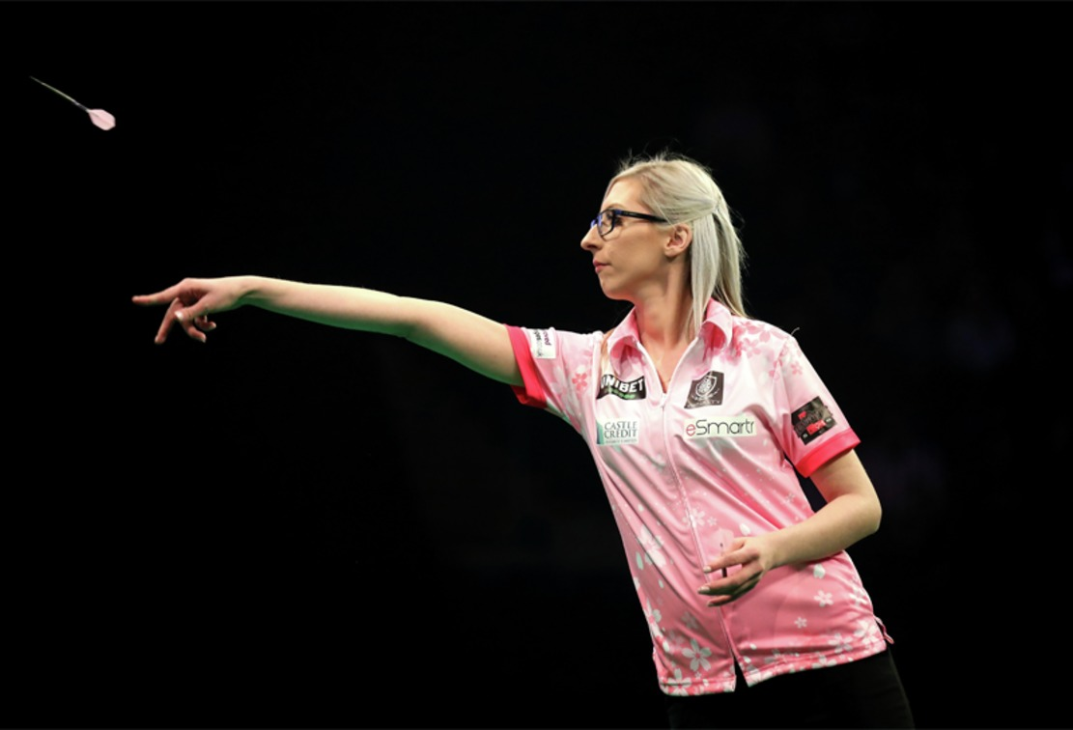
Figure 2 Fallon Sherrock throws in her match against Glen Durrant during the day.
View description - Figure 2 Fallon Sherrock throws in her match against Glen Durrant during the day ...
View description - Figure 2 Fallon Sherrock throws in her match against Glen Durrant during the day ...

In August 2022 the England Lionesses won Euro 2022 to secure the first major senior trophy for an England team since 1966. Their victory was witnessed by an 87,192-strong crowd at Wembley, which is a record for a European Championships, men’s or women’s. This historic event comes on the back of several other ground-breaking achievements by female athletes. In April 2021 Rachel Blackmore created history by becoming the first female jockey to win the Grand National on what was the 173rd running of the event, while in September 2021 Fallon Sherrock became the first woman to reach the final of a Professional Darts Corporation final.
You would be right to think it is about time we started to see women and men competing on an equal footing. However, it has taken until the second decade of the twenty-first century for female England players to be awarded professional contracts in football, rugby union and cricket which has allowed them to play full time and focus on their sport. Although, the campaign to achieve equality in other areas, such as pay and prize money, continues.

Female athletes
When the term ‘athlete’ is used, this means anyone who is active in a sport or fitness pursuit. This encompasses all levels of activity from the person involved in walking for health reasons, someone attending a gym to improve their fitness, up to an elite athlete challenging for gold medals. Some people may not classify themselves as an athlete, or identify as an athlete, but we would still use this term for them if they were active.

The first activity looks at some of the highlights of women’s sport over the last century.

Activity 1 A brief history of achievement by women in sport
Allow about 10 minutes

Watch the video at the link below which highlights some of the milestones of sporting achievement by female athletes since the start of the twentieth century. Then answer the following questions:
- What content in the video made the greatest impact on you and why?
- What reason was given to women to prevent them from playing sport?
You can find the video (with the caption ‘#changethegame - History of women’s sport’) part way down this following article on the BBC website: A game-changing decade for women’s sport.
Text boxes are provided in all activities. You can use these to note down your answers to the questions. Once you click Save, your answers will be stored, and you can return to them at any point to view or amend your response. Your responses will only be visible to you. However, if you would prefer to make notes using pen and paper or a different format you can.

Provide your answer...
View discussion - Activity 1 A brief history of achievement by women in sport

2 It does not have to be this way!

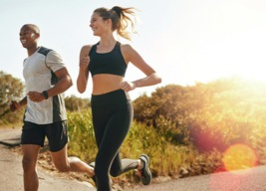
View description - Uncaptioned Figure
View description - Uncaptioned Figure

Sport and society have progressed far beyond these concepts of women being too weak to play sport. Events of the last century have shown that women are equally as capable as men to participate in all sports. However, for women and men to have equal opportunities to fulfil their potential in sport, we must have an equal understanding of women’s and men’s bodies. These differences are often ignored in medical and sport science research as they are seen to increase the complexity of research. Figure 3 shows some of the topics that need to be considered when supporting female athletes who are training for or competing in sport.

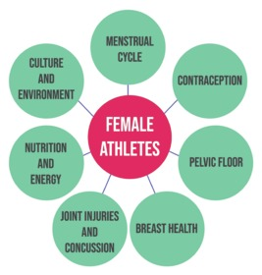
Figure 3 What to consider when training female athletes.
View description - Figure 3 What to consider when training female athletes.
View description - Figure 3 What to consider when training female athletes.

Activity 2 What if?
Allow about 15 minutes

Consider how much more progress would have been made if women and coaches had understood the elements outlined in Figure 3 which represents the contents of this course.

Provide your answer...
View discussion - Activity 2 What if?

Let’s explore how and why these topics have been overlooked for so long.

3 The default male in sports science research

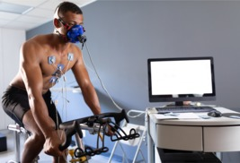
View description - Uncaptioned Figure
View description - Uncaptioned Figure

You’ll start with Dr Emma Ross from The Well HQ explaining the gap that exists between the number of research studies using male and female subjects and why this is so problematic.

Activity 3 How much research is female specific?
Allow about 10 minutes

Watch the video below where Dr Emma Ross explains the number of research studies that are done on females only and the impact it has on female athletes. Then answer the following questions:
- How much sports science research is conducted exclusively on females?
- Why are mixed male and female athlete studies of limited use to female athletes?

Video content is not available in this format.
View transcript - Uncaptioned interactive content

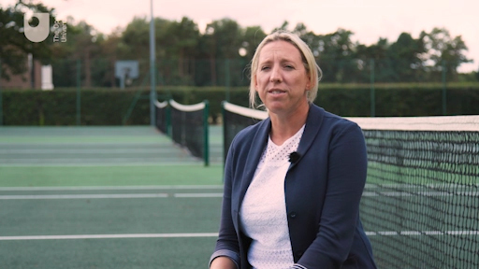

Provide your answer...
View discussion - Activity 3 How much research is female specific?

This limited amount of female-specific research has a serious impact on female performance, as research conducted predominantly on men, or when women most resemble men, is not useful when developing training schedules and maximising female athletic performance.
This focus on male research is referred to as ‘the default male in research’ and it is not a positive situation for females who have a menstrual cycle, periods, breasts and slight differences in the structure of their skeleton. As well as this, females experience the physiological changes across their lifecycle through puberty, fertility, that may include pregnancy and post-natal periods, and finally the menopause.
These physical and physiological differences combined with a reluctance to talk about them, due to a lack of knowledge and understanding as well as their being taboo in some social circles, means that the ‘female part’ of being a female athlete or exerciser is often overlooked. As a result sport and fitness environments are often not optimised for women and limit their chances of positive outcomes.

4 Why is the female ‘problematic’ in sports science research?

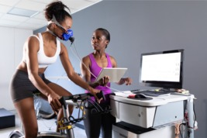
View description - Uncaptioned Figure
View description - Uncaptioned Figure

One of the main objectives of this course is to fill in the knowledge and communication gaps by providing athletes, coaches and trainers with the knowledge they need to support the design and delivery of safe and effective programmes for female athletes. Ideally, with this added knowledge coaches and trainers will feel more confident and less embarrassed to have conversations with female athletes around subjects such as menstruation, breast support and pelvic floor health.
In Activity 4, Dr Emma Ross explains more about why females may be a ‘complication’ to researchers and the impact it can have.

Activity 4 Good excuses for not using females in research
Allow about 10 minutes

Watch the video below where Dr Emma Ross explains why researchers may leave females subjects out of their research. Then answer the following:
- Explain why researching female athletes can make research more time consuming and expensive.

Video content is not available in this format.
View transcript - Uncaptioned interactive content

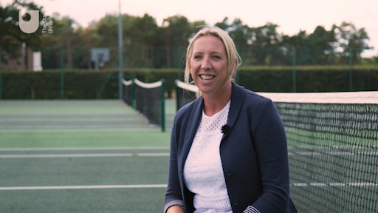

Provide your answer...
View discussion - Activity 4 Good excuses for not using females in research

While research with female subjects may have more variables, it is also incredibly important that we understand more about how these factors impact on active females. This is the only way that we can start to effectively understand female athletes and become able to support their needs properly.

5 Why do we need to study women separately?
Research lacking female participants has many implications for female athletes, not least that we may never know if something that is safe for men is also safe for women. Or it may be that some types of training are more beneficial for women than men.
Dr Stacy Sims is an exercise physiologist who used her own experiences of rowing to ask uncomfortable questions about why female performance can vary significantly on different days. In Activity 5 she explains the impact the menstrual cycle can have on the fuel used by females during exercise and other variations that affect female sporting performance.

Activity 5 Are women the anomaly or is it really the men?
Allow about 15 minutes

Watch the TedTalk below by Dr Stacy Sims as she explains her own experiences of gender differences in performance as an academic and an athlete. Watch from 01:17 (‘I was a cross country runner for most of my life…’) until 06:10 (‘… if we work on skill and development we’ll be fine’). Then answer the following questions:
- What differences does Dr Sims identify between male and female athletes?
- What are the differences between males and females that occur at puberty?

Video content is not available in this format.
View transcript - Uncaptioned interactive content

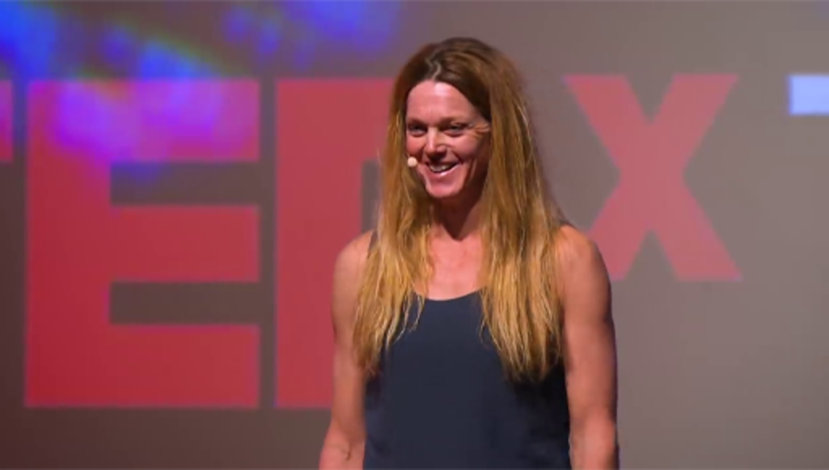

Provide your answer...
View discussion - Activity 5 Are women the anomaly or is it really the men?

You are now going to look at puberty and ask why it is such an important stage for maintaining female sports participation.

6 Why is there a post-puberty dropout?
In the video in the previous section, Dr Sims highlighted the different experiences males and females have at puberty as males become stronger, faster, fitter and more aggressive and well suited to playing sport while the changes females experience can lead to dropout from sport. This is supported by research as by the age of 12 only 8% of females do enough physical activity to benefit their health compared to roughly twice this number for males (Women in Sport, 2016).
Slater and Triggerman (2010) identified that dropout from sport was often due to peer pressure as sport is not viewed as being ‘cool’ or ‘feminine’ with their peers prioritising socialising as being more important than sport. Furthermore, young females often have concerns about their body image and for some sports clothing can accentuate their anxieties. The Sport England campaign This Girl Can was designed to challenge the perception that it is unfeminine or uncool for adolescent females to play sport (Forsyth and Roberts, 2019).

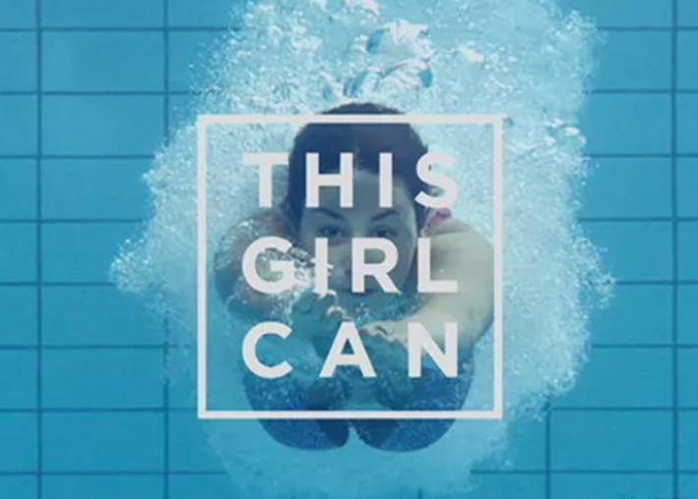
View description - Uncaptioned Figure
View description - Uncaptioned Figure

Dr Sims partly attributes adolescent female dropout from sport after puberty to the effect that increasing levels of hormones have on their coordination and the plateau of fitness gains at this time. Managing periods, dealing with the physical and emotional symptoms of the menstrual cycle and a body that is changing shape are all things which impact on girls’ confidence and their motivation to participate in exercise or sport.
Her partial solution is that at this time when the female body is going through developmental changes, it is a good time to work on skill and technique as this will increase their competence and give them confidence to stay in sport (Sims, 2019).
Up to this point you have looked at the effect that male bias in research has on female sports performance and participation, but it is prevalent too in medical research as you shall discover in the final section.

7 Females being left out of medical research: another example of male bias?

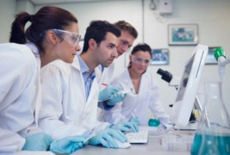
View description - Uncaptioned Figure
View description - Uncaptioned Figure

While females being largely left out of sport science research may prevent them from optimising their performance, being left out of medical research can have serious health impacts. In Activity 6 Dr Alyson McGregor, an emergency medical doctor, looks at the outcomes when medical research is exclusively conducted on men and its results are then applied to women.

Activity 6 The male model as the framework for medical research
Allow about 15 minutes

Watch the TedTalk below by Dr Alyson McGregor as she explains the effects that medicines tested exclusively on males can have on female health. Watch from the start until 04:10 (‘… what else are we missing?’). Then answer the following questions:
- Why do you think medical research uses predominantly male subjects?
- What are the potential health impacts of this practice on women?

Video content is not available in this format.
View transcript - Uncaptioned interactive content

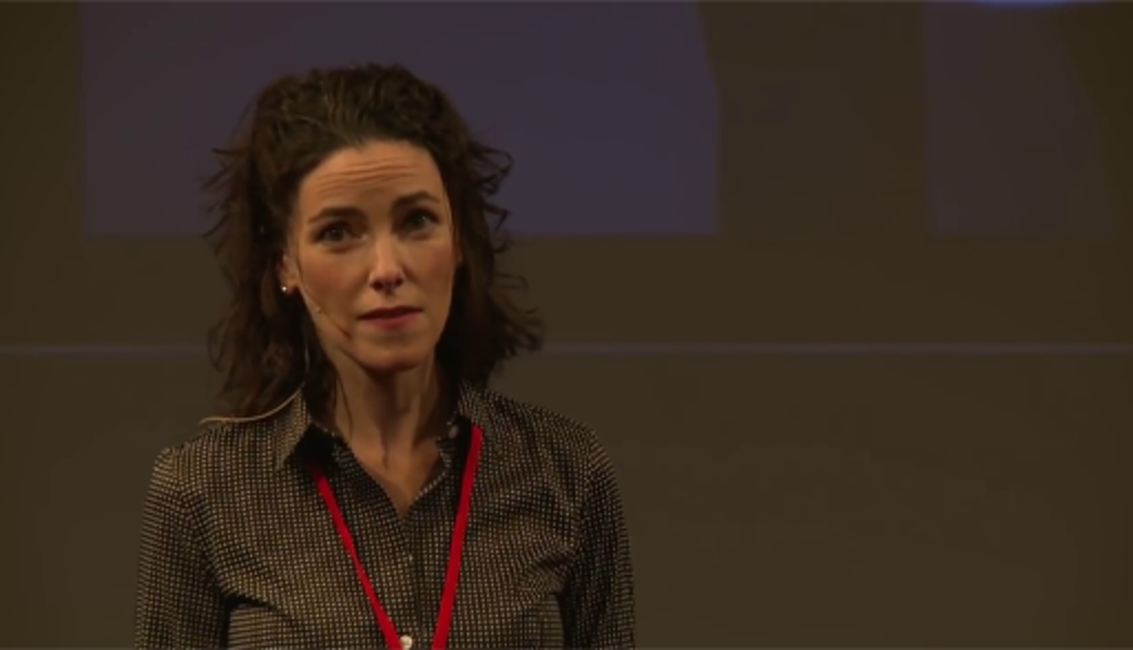

Provide your answer...
View discussion - Activity 6 The male model as the framework for medical research

It is not just women who have a cycle of hormones. Men have a daily cycle where levels of testosterone and cortisol change and this can impact on research findings.
A well-controlled research study would incorporate factors such as testing participants at the same time of day, controlling their exercise, food and drink intake prior to testing. However, for females the influence of the menstrual cycle has to be factored in. This means that testing of female participants would have to take place at the same time of their menstrual cycle (e.g. all participants were tested on day 5 of their menstrual cycle), and if repeated tests were done, they would need to be done at the same time of their cycle.

8 This session’s quiz
Well done – you have reached the end of Session 1. You can now check what you’ve learned this week by taking the end-of-session quiz.
Session 1 practice quiz
Open the quiz in a new or window and come back here when you have finished.

9 Summary of Session 1
You now have an understanding that females have been underrepresented in both sport and medical research due to a range of factors, including the perception that the female menstrual cycle adds a layer of complexity to the research. Male orientated research findings applied to the design of training and nutritional strategies for females are never a perfect fit because they ignore so many factors.
The remaining seven sessions of this course explore what we have considered to be the most important topic areas for you to expand and develop your knowledge and skills in supporting female performance and participation in sport and exercise.
The main learning points of this first session are:
- Only around 6% of research studies in sport science is conducted specifically using female subjects.
- The shortage of research using female subjects impacts on their health and safety as females are more at risk of joint injuries and their reproductive function can be impacted by their nutritional status.
- The presence of the menstrual cycle in females is often viewed as a complication in research as it can impact on reliability of data, as well as making it more costly and time consuming.
- There are significant differences in male and female physiology that need to be considered to enable females to exercise safely and optimise their performance.
- Males and females experience puberty differently as testosterone makes males stronger and faster while oestrogen prepares females for childbearing.
- Changes in females that happen at puberty can make them more susceptible to dropping out of sport.
- Medical research that uses predominantly male subjects can be dangerous to female health as females can produce different responses to treatments and medicines.
In the next session, you will explore the menstrual cycle and how changes in hormones can affect females and their performance in sport and exercise.
You can now go to Session 2.

Session 2: Demystifying the menstrual cycle

Introduction

If men had periods menstruation would become an inevitable boast-worthy, masculine event: men would brag about how long and how much.
(Gloria Steinem, 1978)

At the start of this session you will hear from Manchester City and England footballer, Steph Houghton, about an initiative by the English Institute of Sport (EIS) to increase understanding of female health issues like the menstrual cycle. This shows that progress is being made in addressing female health issues and that it is increasingly being seen as an important topic in optimising performance of female athletes.

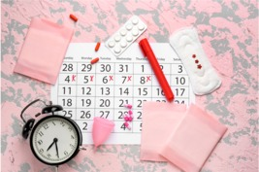
View description - Uncaptioned Figure
View description - Uncaptioned Figure

In this session you will develop your understanding of the menstrual cycle and the hormones involved including exploring the impact it can have on exercising females. You will also see how females can manage symptoms and consider adapting their training accordingly.
By the end of this session, you should be able to:
- understand the physiology of the menstrual cycle and how it can be experienced by women
- identify the potential impact of the menstrual cycle on training and athletic performance
- appreciate how female athletes and coaches can manage menstrual cycle symptoms and optimise performance.
Watch this video where Steph Houghton explains the research collaboration between Manchester City and the EIS: Periods in sport.

1 Does the menstrual cycle impact on exercising females?

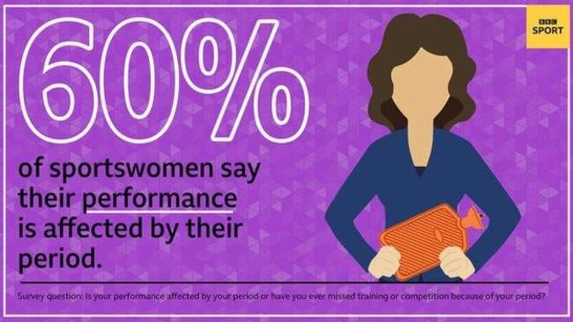
View description - Uncaptioned Figure
View description - Uncaptioned Figure

The BBC Elite British Sportswomen’s Survey (2020) showed that 60% of sportswomen considered that their athletic performance had been affected by their period. This included missing training or competitions due to their period. British Tennis player Heather Watson, cited symptoms of her menstrual cycle as contributing to her early exit from the 2015 Australian Open. However, as is common with many human experiences, the menstrual cycle affects all females differently. For example, Paula Radcliffe broke the World Marathon world record in 2002 on the day her period started.
Clearly women experience their period and their menstrual cycle in different ways as each one’s body is unique, so there cannot be a one-size fits all approach to considering its impact. Recently, with help from social media, conversations around the menstrual cycle have become more common but there is still some discomfort about discussing it. Indeed in some social circles it is even taboo to discuss menstruation.
In the BBC Elite British Sportswomen’s Survey 40% of athletes said they did not feel comfortable discussing their period with their coach. Due to a shortage of knowledge many coaches and fitness trainers may not be having these important conversations with their athletes.
Some females can find that for a number of days each month, symptoms of their cycle such as cramping, bloating and pain impact or prevent their training. If so many days were being lost to a more openly accepted issue such as a knee injury or recurring migraines, then the athlete and those who support her would no doubt be exploring all possible solutions. The silence around periods and the menstrual cycle means that so many athletes still find it impacts their training and performance, when this shouldn’t be the case.
Organisations such as the English Institute of Sport (EIS) and The Well HQ are working hard to increase awareness of these issues. Before looking at the menstrual cycle complete Activity 1 to get you thinking about some the issues around the menstrual cycle.

Activity 1 Menstrual cycle myths and facts
Allow about 10 minutes

Answer True or False to the following statements about the menstrual cycle:
1. Blood loss during a period can cause fainting and reduce aerobic endurance in most females.

True
False
View answer - Part
View discussion - Part

2. Exercising during your period is not recommended for most women.

False
True
View answer - Part
View discussion - Part

3. It is best to do strength training at certain stages of your menstrual cycle.

True
False
View answer - Part
View discussion - Part

4. Women who live or play in teams together will start synchronising their periods.

True
False
View answer - Part
View discussion - Part

5. Regular periods are an indicator of good health.

False
True
View answer - Part
View discussion - Part

2 What do you need to know about the menstrual cycle?
Whether you are a coach, athlete, or fitness trainer it is vital to have some knowledge about the changes that can occur in the female body each month and the effect it can have physiologically and psychologically. The menstrual cycle is explored further in Activity 2.

Activity 2 The menstrual cycle
Allow about 15 minutes

Watch the animation below that introduces you to the basic physiology of the menstrual cycle and hormones involved.

Video content is not available in this format.
View transcript - Uncaptioned interactive content

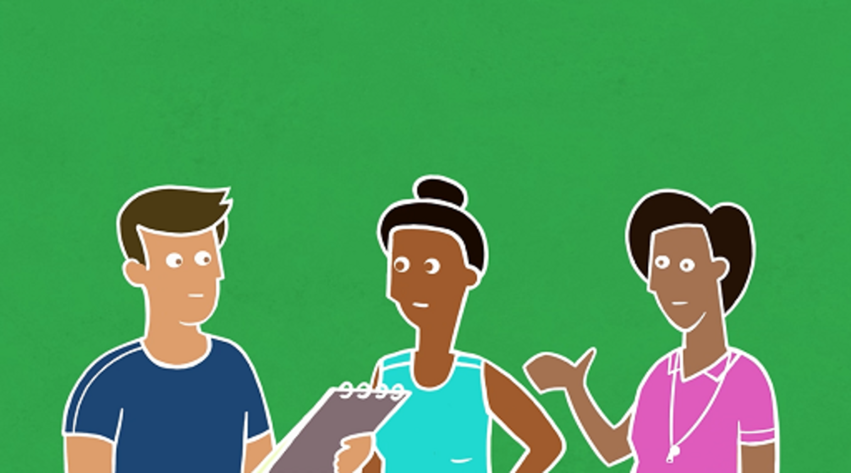

Then match the following to either follicular or the luteal phase of the menstrual cycle.

Follicular
Luteal
Follicular
Luteal
Oestrogen levels reach a peak
Progesterone levels reach a peak
Time between the period and ovulation
Time between ovulation and the period starting
View answer - Activity 2 The menstrual cycle

You can see that the hormones released during the menstrual cycle, oestrogen and progesterone, are produced to support reproduction. These and other hormones are released from glands. Hormones are ‘chemical messengers’ that send messages out to organs and tissues to control health and behaviour. Hormones act to tell you to eat when you are hungry, give you energy when you are stressed and help you sleep at night.
Oestrogen and progesterone do not just control the menstrual cycle, they also contribute to variations in energy, mood, sexual desire, and changes in behaviour across the cycle (Hill, 2019). They also have a role to play in bone health, cardiovascular function and brain health.

3 Women’s experiences of their menstrual cycle

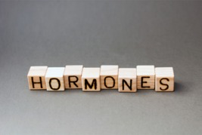
View description - Uncaptioned Figure
View description - Uncaptioned Figure

Finch (2019) explains that each woman will experience their cycle differently and this experience can change over time and even month to month. This is why it is so important that athletes are able to talk about their menstrual cycle with their coach, trainer and support team. In Activity 3 you’ll hear from three coaches who have also been athletes about their experiences of the menstrual cycle and exercise.

Activity 3 Coaches discuss their own experiences
Allow about 15 minutes

Listen to the audio below where Simon Rea interviews three female academics who are colleagues about the impact of their menstrual cycles. Then answer the following questions:
- How do the experiences of the three females differ?
- What benefits do they find from exercise when they experience menstrual symptoms?

Audio content is not available in this format.
View transcript - Uncaptioned interactive content

Provide your answer...
View discussion - Activity 3 Coaches discuss their own experiences

It is not always easy for some women to talk about this aspect of their health with their coach or trainer. It is very personal information to share, and it will depend on the nature of the relationship with their coach or trainer.
Also, Emma Ross (cited in Finch, 2019) points out that because female athletes have fought hard to gain the same opportunities, prize money and the same access to resources in sport as men, they may be reluctant to appear to be ‘different’. Many female athletes want to be seen exclusively as athletes and do not want to be viewed or treated differently because of their reproductive system.
This is why it is so important to reframe the narrative around cycles and periods, in sport and in wider society. As you will discover in this course, a period is a vital sign of health, and a healthy menstrual cycle is reflective of a healthy body and is a positive feature of a female athlete’s physiology. The hormones of the cycle have a positive influence on physical development as well as resilience and psychological health.

4 How does the menstrual cycle impact performance?
As you’ve seen, the primary functions of oestrogen and progesterone are to support reproduction. However, the changing levels of these two hormones across the menstrual cycle have a complex range of effects on the cardiovascular, respiratory, metabolic and muscular systems (McNulty et al., 2020). All these systems play important roles in athletic performance.
Before you look at the research into the impact of these fluctuating hormones on athletic performance, it is useful to explore athlete’s individual experiences. In Activity 4 you’ll hear from 2022 Commonwealth Games 10,000m champion, Eilish McColgan, who is coached by her mother, Liz McColgan-Nuttall, who herself was 10,000m Commonwealth Games champion in 1986 and 1990.

Activity 4 I honestly thought I was dying!
Allow about 15 minutes

Listen to an extract from the Female Athlete Podcast at the link below where Eilish McColgan explains how her performance can be affected by the different stages of her menstrual cycle. Then answer the following questions:
- How has Eilish’s performance been affected by her menstrual cycle?
- What symptoms did she experience?
Eilish McColgan: listen from 24:38 (‘So also on this podcast we like to talk about the menstrual cycle...’) to 30:16 (‘… I can’t do this anymore’).

Provide your answer...
View discussion - Activity 4 I honestly thought I was dying!

In addition to the symptoms Eilish experiences, Sims (2016) identifies bloating, muscle cramps, feeling hotter, stomach upsets, headaches and changes in mood as symptoms that can occur at different stages of the menstrual cycle. Following her success at the Commonwealth Games and European Championships in 2022, Eilish spoke out about how the menstrual cycle should be discussed more: Why is menstruation still a taboo subject?

5 What does the research say?
Any decrement in performance due to fluctuations in hormones is clearly a serious concern for athletes and their coaches. But is Eilish McColgan’s experience typical and most importantly how do fluctuations in hormones impact on performance?

Activity 5 Fluctuating hormones and optimising performance
Allow about 20 minutes

Watch the video where Dr Emma Ross from The Well HQ explains the effect fluctuations in hormone levels have on the body, how they affect performance and how female athletes can use fluctuations in hormones to their advantage. Then answer the following questions:
- How does Emma account for the different experiences that females have during their menstrual cycle?
- What are your two key take away messages from this video?

Video content is not available in this format.
View transcript - Uncaptioned interactive content

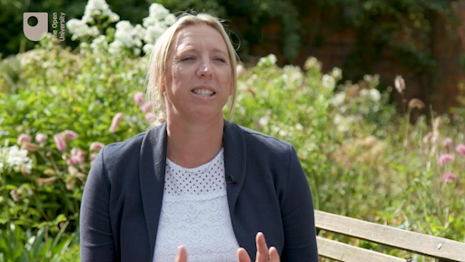

Provide your answer...
View discussion - Activity 5 Fluctuating hormones and optimising performance

To back up what Emma says an analysis by McNulty et al. (2020) that combined the results of 51 studies concluded that exercise performance in women is not significantly affected by any phase of the menstrual cycle. However, there is very little good quality research conducted on how the menstrual cycle impacts on performance. As a result it has not yet been possible to develop evidence-based guidelines for optimising exercise performance for women considering the menstrual cycle (McNulty et al., 2020).

6 How can hormones be used to a female athlete’s advantage in exercise?

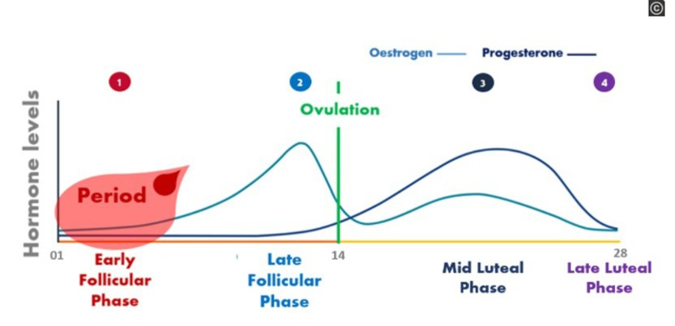
Figure 1 Changes in hormones during four phases of the menstrual cycle.
View description - Figure 1 Changes in hormones during four phases of the menstrual cycle.
View description - Figure 1 Changes in hormones during four phases of the menstrual cycle.

Activity 6 Using hormones to influence training effects
Allow about 20 minutes

Listen to the audio below where Simon Rea explains the fluctuations in oestrogen and progesterone (as outlined in Figure 1) and their impact on training. Then answer the following question:
- What are the key implications for coaches, trainers and athletes?

Audio content is not available in this format.
View transcript - Uncaptioned interactive content

Provide your answer...
View discussion - Activity 6 Using hormones to influence training effects

It must be said again that these are ‘typical’ responses and not all females will experience these variations during their cycle. Some women may not even notice symptoms or need to tailor their training to their cycle.

7 How can tracking cycles help?

View description - Uncaptioned Figure
View description - Uncaptioned Figure

Tracking the menstrual cycle and becoming aware of what your own cycle feels like is an important element of self-care for women (Hill, 2019). This can be done by using a calendar, diary, or a period tracking app. There are apps that an athlete can share with their coach if they have given permission to share data. Cycle tracking has many advantages as Emma Ross pointed out in Activity 4 as if the athlete knows how she may be likely feel in the coming days preparations can be made for this.

Activity 7 Why monitor your menstrual cycle?
Allow about 15 minutes

Listen to another extract from the Female Athlete Podcast where the presenter, Georgie Bruinvels, outlines the benefits of tracking the menstrual cycle. Then answer the following question:
- What benefits may this form of self-awareness bring?
Mapping your menstrual cycle: listen from 17:51 (‘I step back and look at my younger self …’) to 21:17 (‘… using an app to work out better where you are at’).

Provide your answer...
View discussion - Activity 7 Why monitor your menstrual cycle?

Dr Bruinvels has also worked with Chelsea Football Club who have made significant attempts to understand their players’ menstrual cycles and make adjustments where possible to their nutrition, warm up routines, and recovery schedules. When coaching a team sport it becomes more problematic than when coaching an individual, as it is not feasible to tailor training or recovery to menstrual cycles as each player will be at a different stage of their cycle.
In squad environments, the best approach is to ensure that each player has an awareness of her own cycle, and what she might need to do to get the best out of herself on any given day. This requires that each player tracks her cycle, but then also is advised how to manage symptoms and capitalise on her changing physiology.

8 This session’s quiz
Well done – you have reached the end of Session 2. You can now check what you’ve learned this week by taking the end-of-session quiz.
Session 2 practice quiz
Open the quiz in a new or window and come back here when you have finished.

9 Summary of Session 2
You should now have an understanding of the phases of the menstrual cycle and how the changes in hormone levels impact on a female’s energy and mood, as well as their energy levels and motivation for exercise.
The main learning points of this second session are:
- 60% of sportswomen reported that their athletic performance was affected by their period while 40% said they do not feel comfortable discussing their period with their coach.
- The menstrual cycle involves fluctuations in hormones, including oestrogen and progesterone, across a period of between 21–35 days but typically 28 days.
- The menstrual cycle is a vital sign of health as it impacts on reproductive function, energy, mood, bone health and cardiovascular function.
- Due to an individual’s differing level of hormones and their sensitivity to the hormones each female will have a different experience of their cycle.
- Athletic performance, in terms of power, strength and aerobic endurance, are not impacted by the fluctuations in hormones across the menstrual cycle but changing energy levels and symptoms, such as pain and bloating, can affect a female’s ability to exercise and their motivation levels.
- Research suggests that strength and high intensity training are most effective if performed in the follicular phase, which is between days 1–14 of the menstrual cycle.
- Tracking the menstrual cycle is an important means of improving body literacy and preparing for training and athletic performance.
In the next session you will explore hormonal contraception and assess the impact it has on the female and their athletic performance.
You can now go to Session 3.

Session 3: Hormonal contraception: a solution or more challenges?

Introduction

Contraceptives are the greatest life-saving, poverty-ending, women-empowering innovation ever created.
(Melinda Gates, Author and Philanthropist)

Figure 1 Hormonal contraceptive options – the pill, IUS and injection.
View description - Figure 1 Hormonal contraceptive options – the pill, IUS and injection.
View description - Figure 1 Hormonal contraceptive options – the pill, IUS and injection.

Hormonal contraceptives in the form of ‘the pill’ were first made available in the USA in the 1960s. Their use quickly spread around the world. There are now a range of hormonal contraceptives available including the oral contraceptive pill (OCP), intrauterine system (IUS), implants, patches and injection. Hormonal contraception use in the UK is high in the general population at 30% and even more so among athletes. Currently, 50% of (female) athletes use some form of hormonal contraception and 70% have used hormonal contraction at some stage in their athletic career (Martin et al., 2018).
Figure 1 shows three methods of hormonal contraceptives. These methods work by altering the hormonal environment. As you may know there are other non-hormonal methods, such as condoms and the diaphragm, that prevent conception in different ways.
In this session you will look at why athletes may choose to use hormonal contraceptives, how they impact the menstrual cycle and what influence that can have on the performance and health of the athlete. Coaches and trainers benefit from this information since they need to be confident and comfortable in having conversations with their athletes about hormonal contraception.
By the end of this session, you should be able to:
- understand the impact that hormonal contraceptives have on the naturally occurring hormones
- explain the benefits and drawbacks of hormonal contraceptives and their impact on performance.

1 How do hormonal contraceptives work?

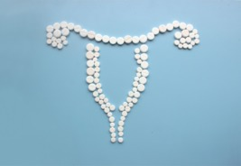
View description - Uncaptioned Figure
View description - Uncaptioned Figure

In Activity 1 you will look at the range of hormonal contraceptives that can be used and how they impact on the menstrual cycle. In this video Emma refers to ‘synthetic’ hormones and these are hormones that are artificially created and then introduced into the body, rather than hormones that are naturally produced by the body. All forms of hormonal contraception involve the introduction of synthetic hormones into the body.

Activity 1 It’s about more than a pill
Allow about 15 minutes

Watch the video below where Dr Emma Ross from The Well HQ introduces different types of hormonal contraception and their impact on the female athlete. Then answer the following questions:
- Why do coaches and trainers need to be more confident when talking about contraception with their athletes?
- What benefit may the Mirena coil have over other methods of oral contraception?

Video content is not available in this format.
View transcript - Uncaptioned interactive content

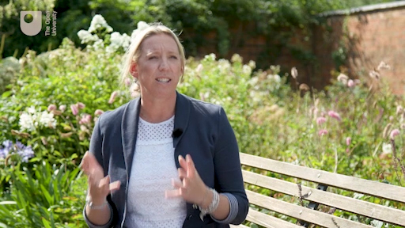

Provide your answer...
View discussion - Activity 1 It’s about more than a pill

You will appreciate that the purpose of hormonal contraceptives is to reduce the risk of pregnancy by preventing ovulation and the development of follicles in the uterus. They also reduce sperm’s ability to swim effectively (motility) and the thickening of the uterus lining. But you may be wondering why introducing more oestrogen and progesterone into the body causes it to stop producing its own hormones and why these synthetic versions do not have the same effect as naturally occurring hormones?

Tricking the brain to sit back and relax – how hormonal contraception works
To understand this you will need to refer back to the menstrual cycle that was covered in Session 2, and the hormonal signals that come from the brain to the ovaries.
Once the egg has been released at ovulation, oestrogen and progesterone are both relatively high during this second half of the cycle (the luteal phase). These high levels of hormones are a signal to the brain to ‘sit back and relax’. What the pill does is trick the brain, every day, into thinking that the body is in the second half of the menstrual cycle, when oestrogen and progesterone remain high. The pill does this by delivering a synthetic version of these hormones. In this way the brain stays in its ‘sit back and relax’ mode through the whole cycle and it does not stimulate ovulation because it thinks it is in the post-ovulatory part of the menstrual cycle.
The primary way the pill prevents pregnancy is by preventing ovulation and as no egg is released it means that the sperm has nothing to fertilise.

2 Why might athletes take hormonal contraceptives?

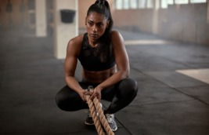
View description - Uncaptioned Figure
View description - Uncaptioned Figure

The 2020 BBC Elite British Sportswomen’s Survey showed that almost 1 in 3 (28%) athletes took a contraceptive pill with the belief that it controls the impact that their period has on their performance. Avoiding pregnancy was the original reason that hormonal contraceptives were developed, but now they are commonly used for other reasons as well. One of these reasons is menstrual management. This and other reasons are discussed in Activity 2.

Activity 2 Menstrual management and other reasons
Allow about 15 minutes

In the video Dr Emma Ross, outlines the reasons that hormonal contraceptives are used and some of the side effects they can have. Watch the video, then answer the following question:
- If you are an athlete, why do you use hormonal contraceptives or if you support an athlete why do you think athletes use hormonal contraceptives?

Video content is not available in this format.
View transcript - Uncaptioned interactive content

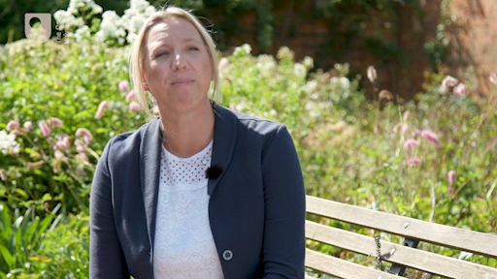

Provide your answer...
View discussion - Activity 2 Menstrual management and other reasons

While menstrual management can be important and effective for athletes, it is also important that women are aware of the potential impact hormonal contraception may have on their performance, physically and psychologically, and to be vigilant for any unwanted side effects such as unwanted weight gain and low mood. There is not a one-size-fits-all best hormonal contraception choice for athletes, and it may take more than one attempt to find what suits them best. Monitoring physical and emotional symptoms when athletes start using hormonal contraception can be a useful way to understand which side effects may be present, and if and how, they impact training and performance.
Hormonal contraceptives have historically been used to treat loss of periods (amenorrhoea) due to disruption of the menstrual cycle. However, this approach actually masks the root cause of menstrual dysfunction, since the re-instigation of a withdrawal bleed is not the same as normal menstruation, yet it can lead athletes to falsely believe that their cycle has been resumed (Elliott-Sale and Hicks, 2019). Hormonal contraceptives will mask the root cause of menstrual dysfunction. It is important to understand what is causing irregular or absent periods and work on restoring a healthy cycle, before considering the use of hormonal contraceptives.

3 The impact of hormonal contraception on the female and their menstrual cycle

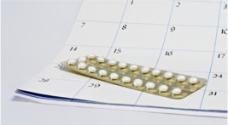
View description - Uncaptioned Figure
View description - Uncaptioned Figure

Oral hormonal contraceptives (the pill) are typically taken over a 28-day period to replicate the length of the idealised menstrual cycle. But there are a variety of different types. Here are some interesting facts you may or may not know.

Did you know?
In some pill preparations this 28-day cycle consists of 21 days when the pills contain synthetic hormones and then 7 placebo pills, which do not contain any synthetic oestrogen or progesterone. During this time when placebo pills are taken, it is common for women to experience what is called a withdrawal bleed.
Did you know that some pill types often lead to no or lighter bleeding?
On the progesterone-only pill, one pill is taken every day for 28 days, but individuals continue straight onto the next 28-day pill packet without a break. About 50% of women find that they don’t bleed at all on this type of contraception, and others have much lighter breakthrough bleeding, because the uterus lining is being kept thin all the time by the effect of the pill.
Older generation progesterone-only pills (also known as the mini pill) have strict criteria where they must be taken within the same 3 hour time slot every day to be effective. However new generation pills have a 12 hour window to take the pill which can be less restrictive and easier to manage if athletes have an unpredictable schedule or lots of travel.
The menstrual cycle is a sign of good fuelling and recovery
For athletes it is really important to understand that the withdrawal bleed experienced by women using hormonal contraception is not a period. Whereas a period can be an indication of good menstrual health, and a healthy menstrual cycle is a sign that athletes are fuelling and recovering well, having a withdrawal bleed cannot offer any of these signs of menstrual health, since the menstrual cycle is suppressed when using hormonal contraception.

The oral contraceptive cycle replaces the menstrual cycle and the symptoms produced by the hormones over a single cycle, but it is not without positive and negative symptoms of its own. Martin et al. (2018) reported roughly equal numbers of positive and negative side effects in hormonal contraceptive users as shown in Figure 2.

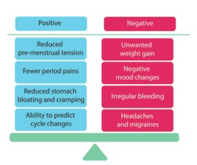
Figure 2 Positive and negative effects of hormonal contraception.

4 What does the research say?

View description - Uncaptioned Figure
View description - Uncaptioned Figure

The use of hormonal contraception provides practical benefits, such as the manipulation of menstrual cycles to prevent bleeding or symptoms at times when the athlete needs to be at peak performance. Also, hormonal contraception pills can be taken ‘back to back’ which means eliminating the 7-day withdrawal bleed. However, because the menstrual cycle is being disrupted the hormonal environment in athletes using contraception is different to those with naturally occurring menstrual cycles. This difference may have an impact on performance and is explored in Activity 3.

Activity 3 Hormonal contraceptives and athletic performance
Allow about 15 minutes

Watch the video where Dr Emma Ross discusses the research conducted into the impact of hormonal contraception on athletic performance. Then answer the following questions:
- What does the research say about athletic performance and hormonal contraception use?
- Why do you think it is so difficult to produce valid research about hormonal contraception use and performance?

Video content is not available in this format.
View transcript - Uncaptioned interactive content

Provide your answer...
View discussion - Activity 3 Hormonal contraceptives and athletic performance

In summary, the relationship between hormonal contraceptive use and performance is not completely clear; however, an analysis of 42 studies showed that oral contraception users might have a slightly poorer endurance performance compared to those with a natural menstrual cycle (Elliott-Sale et al., 2020). The recommendation from Emma Ross was that an individual approach needs to be taken and active females need to find the approach that works best for them.

5 Hormonal contraception or natural cycle? An individual choice

View description - Uncaptioned Figure
View description - Uncaptioned Figure

At the time of writing in 2021 there have been no guidelines produced for athletes about the use of hormonal contraceptives and their influence on athletic performance, because the research shows that any differences in performance are very small (Elliott-Sale et al., 2020). As a result it comes down to individual choice, and each individual athlete experiences of their natural cycle. This would include their reasons for using hormonal contraception and their ability to find one that suits them, physically and emotionally as well as any side effects they may experience.
Information and understanding around contraception empowers women to make informed decisions that are right for them, in the context of their life and their sport. Importantly, hormonal contraception is a medication, and what and how it is used should always be discussed with a healthcare professional, such as a GP. There are good resources and information available online to help women make informed decisions, such as The Lowdown.

6 This session’s quiz
Well done – you have reached the end of Session 3. You can now check what you’ve learned this week by taking the end-of-session quiz.
Session 3 practice quiz
Open the quiz in a new or window and come back here when you have finished.

7 Summary of Session 3
You should now be aware of the different types of hormonal contraception and have an understanding of the impact of hormonal contraception on the body and the influence it may have on athletic performance.
The main learning points of this third session are:
- Hormonal contraceptive methods include the pill, the intrauterine system (IUS), hormone patches, implants and injections.
- Hormonal contraception works by introducing synthetic versions of the hormones oestrogen and progesterone into the body.
- The synthetic hormones in hormonal contraceptives trick the brain into thinking that the body is always in the second half of the menstrual cycle and thus ovulation does not occur.
- Hormonal contraceptives may be taken by athletes for menstrual management to control symptoms such as menstrual bleeding, stomach cramps and bloating.
- Hormonal contraceptives can have significant side effects such as unwanted weight gain and experiencing low moods.
- Hormonal contraception may have a negative impact in aerobic endurance decreasing it by as much as 11% under laboratory conditions but it does not impact on strength.
In the next session you will find out about how issues with pelvic floor muscles can impact on active females and most importantly, what can be done about this.
You can now go to Session 4.

Session 4: Pelvic floor muscles: out of sight and often overlooked

Introduction

Pelvic floor dysfunction is a common and often debilitating set of symptoms that can result in many issues for women.
(Gillian Leng, Chief Executive of NICE)

Every woman has a pelvic floor, yet many people know very little about it. Pelvic floor issues are finally starting to get attention from the media and within sport. Generally speaking, the pelvic floor muscles are usually only discussed in relation to childbirth and ageing, but physical activity can also be a contributing factor to developing pelvic floor dysfunction.
Physical activity brings many physical, social and psychological benefits but pelvic floor health may be the only area of the body where the positive effect of physical activity can be questioned (Bo and Nygaard, 2020). Pelvic floor dysfunction is associated with urinary incontinence (UI), or leakage of urine, and this can be a source of embarrassment and discomfort in the active female. This does not mean that women should stop exercising, far from it, but we can’t ignore pelvic floor issues as they are impacting on the female experience of sport.

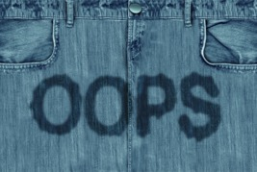
View description - Uncaptioned Figure
View description - Uncaptioned Figure

In this session the often overlooked pelvic floor will be brought into focus, and you will develop an understanding of what the pelvic floor consists of, its role in health and exercise, the factors that affects its function, and how it can be trained and strengthened.
By the end of this session, you should be able to:
- identify the location and function of the pelvic floor muscles
- understand the impact of pelvic floor dysfunction
- apply the principles of pelvic floor training.

1 What does pelvic floor dysfunction look like?
In the figure below you can see some example quotations from women when asked about their pelvic floor.

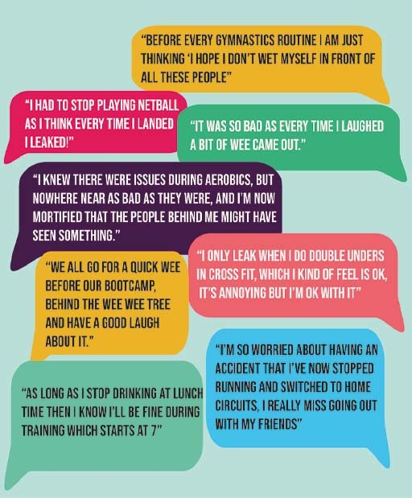
View description - Uncaptioned Figure
View description - Uncaptioned Figure

2 Introducing the pelvic floor and its muscles

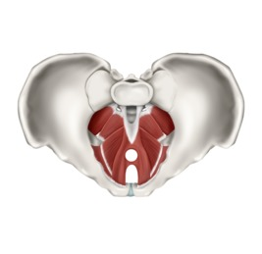
View description - Uncaptioned Figure
View description - Uncaptioned Figure

Understanding where the pelvic floor is and its purpose is of key importance when it comes to working with athletes. By having this knowledge coaches, trainers and athletes are able to understand the causes of dysfunction and be proactive with their programming to help the women they are supporting.
You’ll start with a video to introduce you to the pelvic floor.

Activity 1 What is the pelvic floor and what should it be doing?
Allow about 20 minutes

Watch the video below where Baz Moffat of The Well HQ introduces the pelvic floor, explains its purpose and the signs that it’s not functioning properly to look out for.
Then answer the following questions:
- What role does a healthy pelvic floor play?
- What are the signs that the pelvic floor is not functioning correctly?

Video content is not available in this format.
View transcript - Uncaptioned interactive content

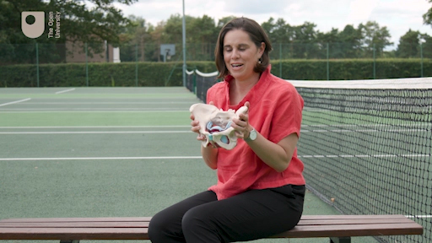

Provide your answer...
View discussion - Activity 1 What is the pelvic floor and what should it be doing?

Urinary incontinence (UI) is also referred to as stress incontinence (SI) due to it being caused by increased stress on the pelvic floor muscles.

3 Which muscles are we talking about?
The pelvic floor is situated inside the pelvis and consists of a group of muscles and ligaments. Because we can’t see them as they are surrounded by larger global muscles around the hips, they seem to get less attention from coaches and trainers. They are also complex in structure as they consist of three layers of muscles that are attached to and integrated with other body systems.
Figure 1 shows the key structures of the pelvis and the pelvic floor.

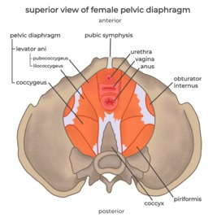
Figure 1 The key structures of the pelvis and the pelvic floor.
View description - Figure 1 The key structures of the pelvis and the pelvic floor.
View description - Figure 1 The key structures of the pelvis and the pelvic floor.

The main pelvic floor muscles are the levator ani and the coccygeus. The purpose of these muscles is to keep us dry by avoiding urine, wind or faecal leakage, they allow us to fully empty our bladders and bowels, and they facilitate sexual function and pleasure.
The pelvic floor has to contract, relax and respond to changes in pressure. In sport, common movements, such as jumping and quickly changing direction, place additional stress on the pelvic floor muscles. Thus gymnasts, trampolinists, basketball and volleyball players are most at risk of pelvic floor dysfunction.
Sometimes when we are lifting heavy weights, we need to use the Valsalva manoeuvre (i.e. exercise is performed while holding the breath). This is necessary to stabilise the body’s core, but it can damage the pelvic floor muscles. This is due to the increased pressure in the abdomen and thus places additional stress onto the pelvic floor muscles. As a result lifting heavy weights can cause stress incontinence or pelvic organ prolapse. A pelvic organ prolapse is when one or more organs within the pelvis moves from their natural position to form a bulge in the vagina.

4 Athletic performance and pelvic floor dysfunction?
Most women will have a pelvic floor that is strong enough for their daily activities; however, it is not uncommon for athletic females to experience problems due to dysfunction of their pelvic floor muscles. This can have serious consequences.
Teixeira et al. (2018) identified that urinary incontinence (UI) can impact on social and mental wellbeing and as a result can cause problems, such as social isolation, low self-esteem, depression and a lower quality of life. They also reported that 20% of women had given up playing sport due to UI. In addition to this there are several risk factors for pelvic floor dysfunction, and these are older age, obesity, childbirth, menopause and exercise (Teixeira et al., 2018). Activity 2 introduces the problems athletes may face around pelvic floor dysfunction.

Activity 2 Pelvic floor health and athletes

Watch the animation below that gives more detail about the pelvic floor, why athletes are prone to pelvic floor dysfunction, and what can be done to restore function to these muscles.

Video content is not available in this format.
View transcript - Uncaptioned interactive content

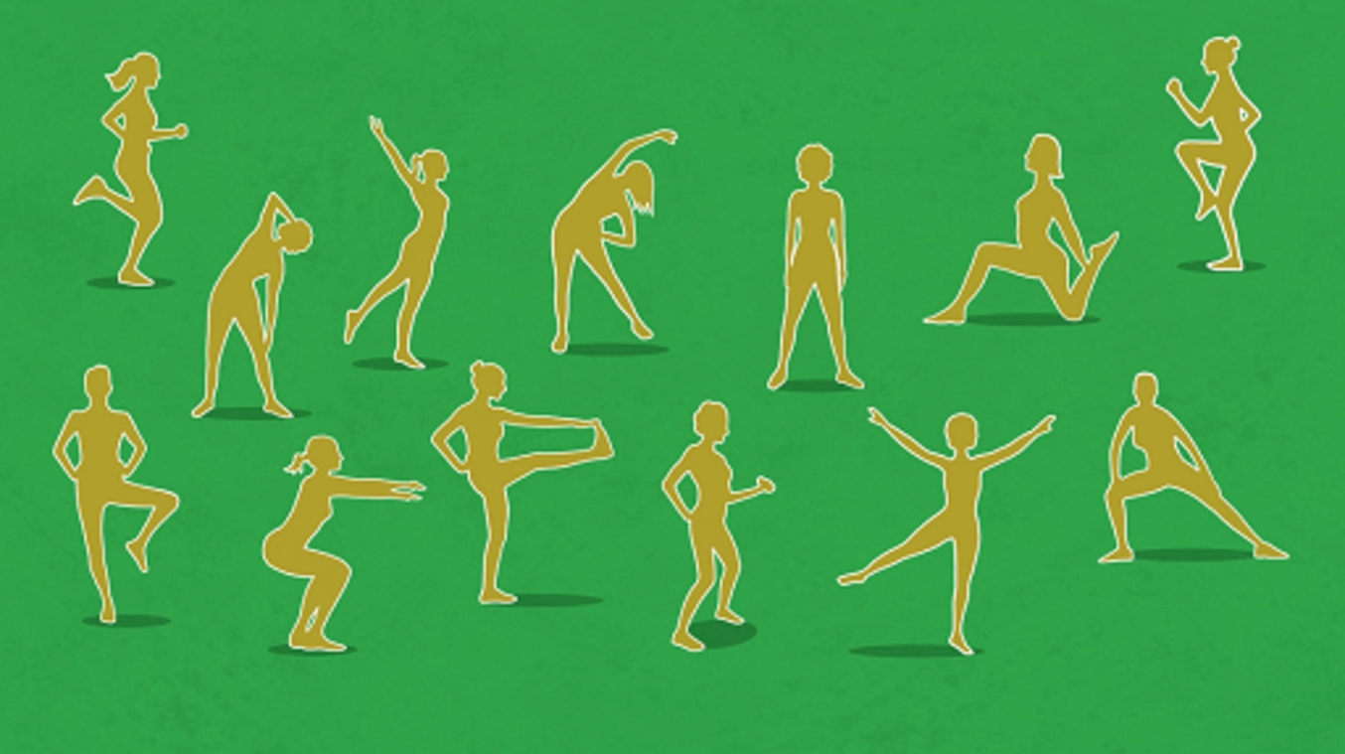

Then answer the following True/False questions.
1. Due to their strong pelvic floor athletes are less likely to experience urinary incontinence.

False
True
View answer - Part
View discussion - Part

2. Pelvic floor muscles run across the pelvis from pubic bone to coccyx.

False
True
View answer - Part
View discussion - Part

3. In both males and females there are two openings in the pelvic floor.

True
False
View answer - Part
View discussion - Part

4. Exercising, sneezing, and coughing will all strengthen the pelvic floor muscles.

False
True
View answer - Part
View discussion - Part

5 What does the research on athletes say?
Pelvic floor dysfunction is predominantly a problem in ‘high impact’ sports which are sports that involve running and jumping. This is because they increase intra-abdominal pressure and exert forces directly onto the pelvic floor (Reis et al., 2011).

How many female athletes experience pelvic floor dysfunction?

36% of female athletes experience urinary incontinence
44% experience stress incontinence
Athletes and active females have up to three times higher rates of urinary incontinence than sedentary women.
(Teixeira et al., 2018)

This figure of 36% may look high, but in reality it is hiding a far worse problem. This figure is taken from research across all sports, whereas actually in some sports figures report that around 80% of female athletes in that sport experience urinary incontinence.

Who is at risk?

Athletes in the following sports reported the highest incidences of urinary incontinence:
- Gymnastics
- Badminton
- Basketball
- Tennis
- Hockey
- Track and field athletics
- Aerobics
(Teixeira et al., 2018)

Bo and Nygaard (2020) proposed the two opposing theories, as introduced in Activity 2, as to why athletes have a higher prevalence of pelvic floor dysfunction:
- Exercise stretches and weakens the pelvic floor because the muscle fibres and ligaments become damaged due to the forces applied on the pelvic floor and the repeated increases in intra-abdominal pressure.
- Exercise causes the pelvic floor muscles to become too strong. These muscles experience hypertrophy (increase in size) and become shorter and tighter. These changes may mean that the muscles no longer have the flexibility required to respond to changes in pressure. Not being able to resist pressure as effectively can lead to an increase prevalence in leaking.
Currently there is insufficient evidence to conclude that a functioning pelvic floor will improve performance; however we can categorically say that a dysfunctional pelvic floor is an unwelcome distraction for athletes and may even stop them from doing the sport or activity they love.

6 Strong to the core: training the pelvic floor

View description - Uncaptioned Figure
View description - Uncaptioned Figure

One of the challenges many women encounter when doing any pelvic floor exercises is that it’s not obvious where they are, or what exercises they should be doing.
In Activity 3 Baz Moffat of The Well HQ, who has taught thousands of women to train their pelvic floor muscles, will instruct you on how you should approach them.

Activity 3 A little effort for a big gain
Allow about 20 minutes

Watch the video below where Baz Moffat will help you to locate your pelvic floor muscles and then show you how to train the muscles for strength and endurance.
Once you have watched the video write down your early impressions of completing these exercises.

Video content is not available in this format.
View transcript - Uncaptioned interactive content

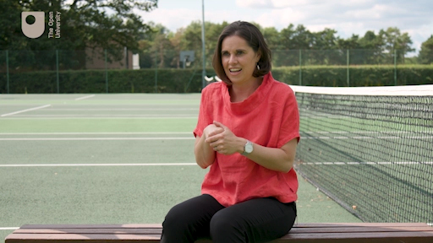

Provide your answer...
View discussion - Activity 3 A little effort for a big gain

It is important to reinforce the message from Baz that locating the pelvic floor muscles by practicing stopping the flow of urine or from stopping yourself breaking wind must only be used as a technique to reassure yourself that you are using the correct muscles.
The reason that we should not use this technique regularly is that our pelvic floors are designed to relax while emptying our bowels and bladder. If we do the opposite of relaxing the muscles by contracting them it can confuse the neural pathways between the brain and the bladder and bowels. This can lead to problems in the future, such as an inability to completely empty your bladder that can increase your risk of a urinary tract infection.

7 From the pelvic floor to the gym floor

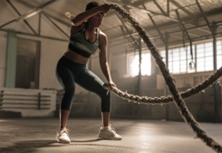
View description - Uncaptioned Figure
View description - Uncaptioned Figure

In the 1940s Dr Arnold Kegel, who was a pioneer in pelvic floor health and exercise, developed a set of exercises which have come to be known as ‘Kegels exercises’. Kegels exercises are associated with the times before and after childbirth but are applicable to any female who has a pelvic floor. They should not be seen as being only relevant to those who are experiencing symptoms of pelvic floor dysfunction. However, as you’ve heard, locating and training the pelvic floor requires a lot of skill and control, and the exercises are very rarely done correctly.
Pelvic floor training can be done in two ways. The exercises can be done in isolation where you focus solely on the pelvic floor muscles, or they can be incorporated into exercises you do in training. This would involve activating the pelvic floor before completing an exercise and focusing on them during the movement.
To complete pelvic floor exercises National Association for Continence and The Mayo Clinic recommend the following:
- Locate the right muscles and practice contracting and relaxing them.
- Start by contracting the muscles for 5 seconds and then relax them for 5 seconds. Gradually work up to contracting and relaxing for 10 seconds.
- To give a full work out complete 10 quick contractions and relaxations, holding for 1-2 seconds and then 10 long hold contractions where you hold for 10 seconds and relax for 10 seconds. This ensures both fast and slow twitch muscle fibres are worked.
- This full work out should initially be completed at least once a day, with the aim being to work up to 3 times a day.
- Athletes should integrate pelvic floor exercises into their core training and strength and conditioning sessions.
There are also pelvic floor trainers available to buy, but the best advice is always to learn how to do your exercises correctly. If you need devices to help keep you motivated, then they may be useful, but they won’t necessarily be any more effective than using your own exercises. There’s also a very useful app called squeezy app, which is NHS recommended and is useful to ensure that the exercises are done regularly.
Finally, if after three to four weeks of diligently doing pelvic floor exercises daily the athlete has noticed that they are making no progress, it is advised that they check in with a specialist women’s health physiotherapist. This can be done via the directory in the squeezy app. This medical help is important so a physiotherapist can make an assessment of what might be preventing the progress, and then individualise a training programme and offer support.
Also, as an active female, if your pelvic floor is overactive and too strong it is advised that you consult a physiotherapist who specialises in pelvic floor health.

8 This session’s quiz
Now it’s time to complete the Session 4 badged quiz. It’s similar to previous quizzes, but this time instead of answering five questions there will be fifteen.
Session 4 compulsory badge quiz
Remember, this quiz counts towards your badge. If you’re not successful the first time, you can attempt the quiz again in 24 hours.
Open the quiz in a new or window and come back here when you have finished.

9 Summary of Session 4
You should now have an understanding of the anatomy of the female pelvic floor, its purpose, and the impact it can have when it does not function correctly. You should also have an understanding of how training can improve its function and why athletes may be more at risk of pelvic floor dysfunction.
The main learning points of this fourth session are:
- The pelvic floor consists of a group of muscles and ligaments that cover the floor of the pelvis between the coccyx and pubic bone.
- Pelvic floor dysfunction can cause urinary incontinence, urge incontinence and pelvic pain.
- Urine leakage can occur when exercise places increased pressure on the pelvic floor and when sneezing, laughing or coughing.
- Exercising females are up to three times more likely to experience urinary incontinence.
- Athletes in sports involving running, jumping and quick changes in direction are most likely to experience urinary incontinence.
- Active females may experience pelvic floor dysfunction due to the increases in the forces applied to the pelvic floor during training or because the pelvic floor muscles become too strong and inflexible.
- Pelvic floor exercises should be done at least once a day by all women and more if you’re experiencing symptons.
- Pelvic floor exercises should involve slow and fast movements to activate all muscle fibre types.
You are now halfway through the course. The Open University would really appreciate your feedback and suggestions for future improvement in our optional end-of-course survey, which you will also have an opportunity to complete at the end of Session 8. Participation will be completely confidential and we will not pass on your details to others.
In the next session, you will explore breast health and the importance of finding correctly fitting breast support.
You can now go to Session 5.

Session 5: Breast health and choosing the correct breast support

Introduction

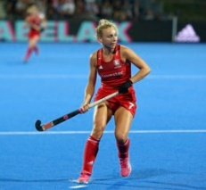
View description - Uncaptioned Figure
View description - Uncaptioned Figure

Everyone feeling comfortable out there on the pitch and in themselves is incredibly important, both as a female in general, but also as a female in sport.
(Hannah Martin, GB hockey)

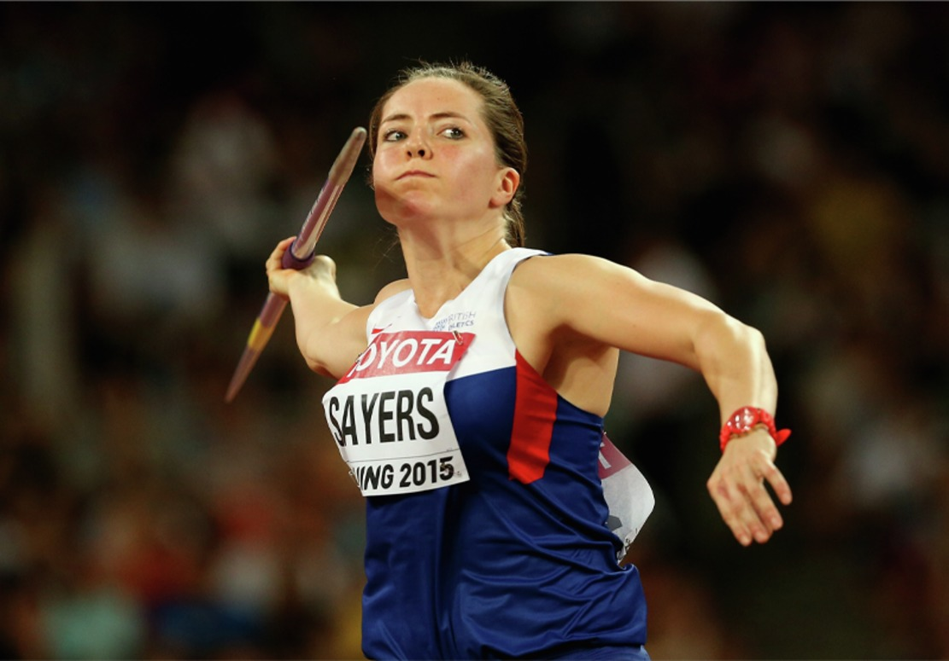
View description - Uncaptioned Figure
View description - Uncaptioned Figure

If I forgot my sports bra, forget it, I just wouldn't compete. That's how integral it is to my performance.
(Goldie Sayers, Javelin)

The need for coaches to better understand the female body is now being recognised, and as the quotes above indicate, the issue of breast health can be a significant factor in sport and exercise participation for women. This session will give an overview of the importance of coaches and trainers in understanding breast health, and will explore the challenges women face and the solutions available.
By the end of this session, you should be able to:
- build coaches’ and trainers’ confidence to address issues of breast health with athletes
- recognise the challenges female athletes face with breast support
- understand breast anatomy and breast biomechanics
- identify breast support needs for different women and different sports.

1 Why is breast health important?
Experiencing breast pain can deter women from participating in sport and exercise, which can be due to discomfort or embarrassment. For example, in a study with 2,000 girls aged 11–17 years, 46% reported that their breasts had some effect on their participation in sports and exercise.
Breast concerns were high with 73% reporting more than one breast-specific concern in sports; with breast bounce being most prevalent (38%) (Scurr et al., 2016). The evidence suggests that many suffer from breast pain and discomfort. For example, Brown et al. (2014) found that 32% of marathon runners experienced breast pain and for 17% of them, it impacted how much training they could do. Finally, poor breast support can impact upon performance. Studies by the Research Group in Breast Health at Portsmouth University have demonstrated that running with insufficient breast support can make exercise feel harder, increase the risk of injuries to the lower limbs, and decrease stride length by 4cm and make running mechanics less economical, which means more energy is used for a given intensity and that can accelerate the onset of fatigue (Research Group in Breast Health, 2021).

Activity 1 What is the problem?
Allow about 15 minutes

Watch the animation below which explains some of the key issues around breast health then answer the questions below.

Video content is not available in this format.
View transcript - Uncaptioned interactive content

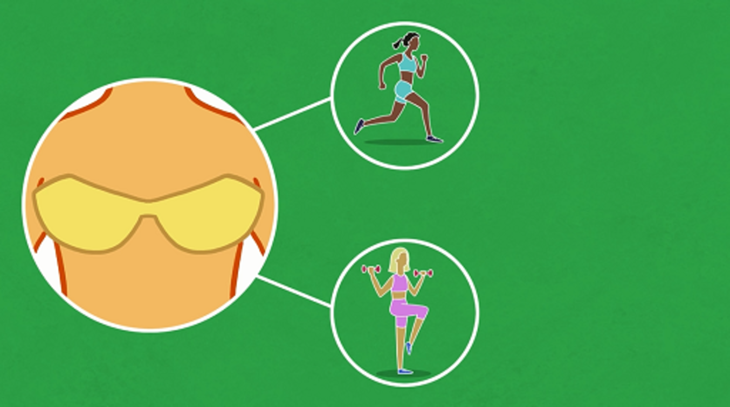

1. There are muscles within the breasts that offer natural support.

False
True
View answer - Part
View discussion - Part

2. Women with larger breasts often experience more discomfort and breast pain.

True
False
View answer - Part
View discussion - Part

3. Intense exercise without the appropriate support can cause permanent damage to the breasts.

True
False
View answer - Part
View discussion - Part

Good breast support has the potential to positively influence both participation and performance in sport and exercise, yet education around breast health and breast support is currently very poor (Brown et al., 2018). By empowering girls and women with knowledge and awareness of breast health and bra fit there are several positive outcomes: body confidence, health and participation in physical activity can all be significantly improved.

2 Breast anatomy and natural support
To further your understanding of the issues surrounding breast health and breast pain it is important to first become familiar with the anatomy of the breast (see Figure 1). Essentially the breast is a mass made up mostly of fatty tissue, with some connective tissue that provides it with a limited support from the inside. This connective tissue is called the Coopers ligaments, although ‘ligaments’ is a very a misleading label. Elsewhere in the body, ligaments attach bone to bone, however Coopers ligaments are not ‘real’ ligaments, but connective tissue that provides some support for the breast mass (Page and Steele, 1999). The third component of the breast is glands, and this is the part that has a job to do. This glandular tissue is the milk glands and ducts which are used for breastfeeding.
The breast is held in place on the chest wall by the skin. Breast sag happens when the skin supporting the breast tissue stretches. This can happen as a result of age, as our skin becomes less elastic, and also as a result of how much the breast moves.

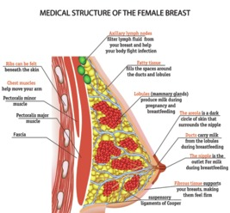
Figure 1 Anatomy of the breast.
View description - Figure 1 Anatomy of the breast.
View description - Figure 1 Anatomy of the breast.

3 Breast biomechanics

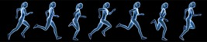
View description - Uncaptioned Figure
View description - Uncaptioned Figure

Now that you know the anatomy of the breast you can start to understand how a breast moves when participating in different activities. With limited internal support and the skin as the only external support the breasts move when the body moves, whether it's walking, running, cycling or dancing, and breasts move most when the activity is high impact, like running and jumping. Each breast itself is, on average, about half a kilogram, and movement of the breast mass during exercise can cause the skin to stretch beyond its natural elastic range and cause permanent damage. Wearing a good fitting sports bra can reduce breast movement by up to 74% when compared to a bare breasted condition (Norris et al., 2021).

Activity 2 How do breasts move during exercise?
Allow about 10 minutes

Watch the video which shows the science used by the Research Group in Breast Health at Portsmouth University to establish the exact movement of the breast during exercise. Then answer the following questions:
- What are the three types of breast movement?
- Which exercise elicits movement in all three dimensions?
- What are some of the negative effects of not wearing the right level of support?

Video content is not available in this format.
View transcript - Uncaptioned interactive content

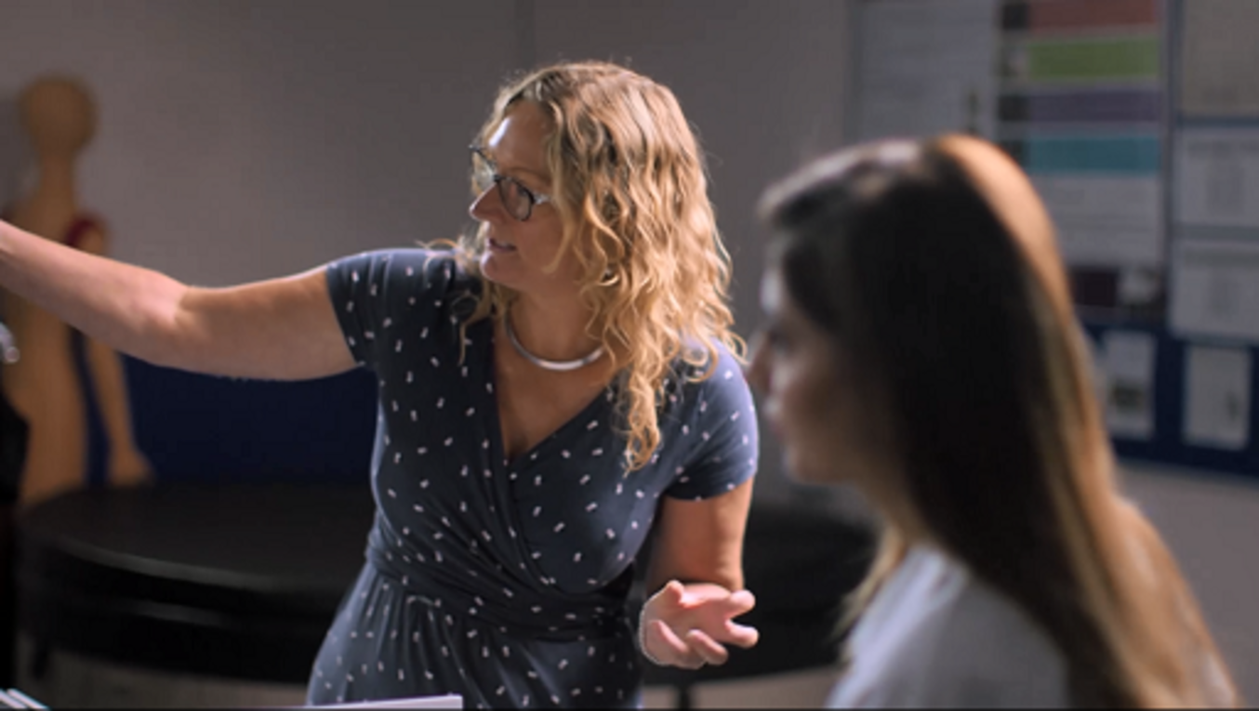

Provide your answer...
View discussion - Activity 2 How do breasts move during exercise?

The way the breast moves and the implications of different movements on the breast can influence the type of support that is required. In the next section you’ll look at the implications of not meeting these requirements for support during sport and exercise.

4 The impact of poor breast support on sports performance

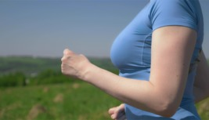
View description - Uncaptioned Figure
View description - Uncaptioned Figure

Poor breast support during sport and exercise not only influences breast health but it may also have a negative effect on performance. Breast support requirements will differ depending on the type of sporting activity you are performing, and across a woman’s life as the breast size changes during adolescence, through pregnancy, and into menopause. Being aware of the requirements for different sports, as well as individual requirements and preferences, is key in maintaining good breast health and optimal breast support.

Activity 3 What impact does poor breast support have on performance?

Listen to the section of the podcast ‘Bounce’ where the panel discuss the impact of breast health and breast support for a variety of sports.
Then watch the animation which identifies the impact that poor breast support can have on performance.
What were the key considerations of breast movement for marathon runners, tennis players and javelin throwers and the type of support required?

Audio content is not available in this format.
View transcript - Uncaptioned interactive content

Video content is not available in this format.
View transcript - Uncaptioned interactive content

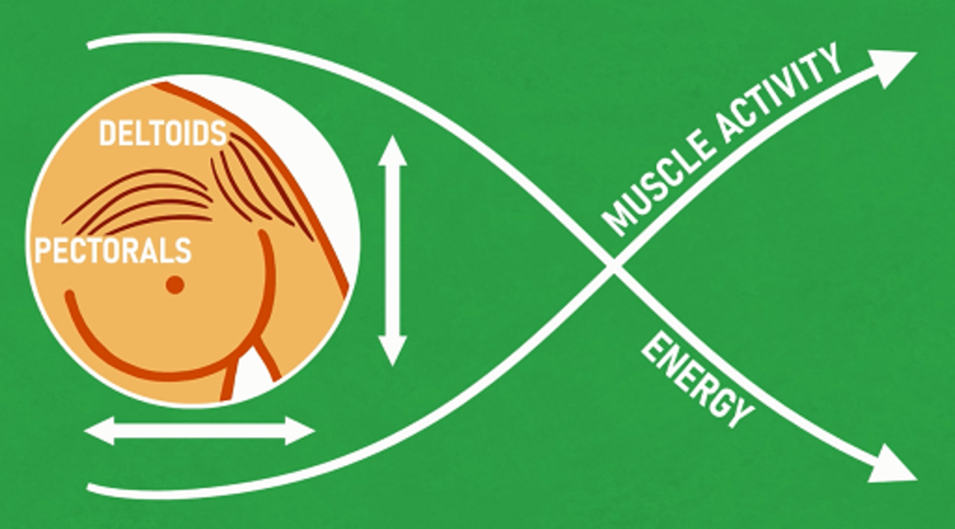

Provide your answer...
View discussion - Activity 3 What impact does poor breast support have on performance?

Additional considerations are, in some sports, also given to the aesthetics of the breast support, for example, in gymnastics or figure skating the underwear must not be visible or interrupt the silhouette of the leotard. The next section looks at the type of bras and breast support available.

5 Bras and breast support available

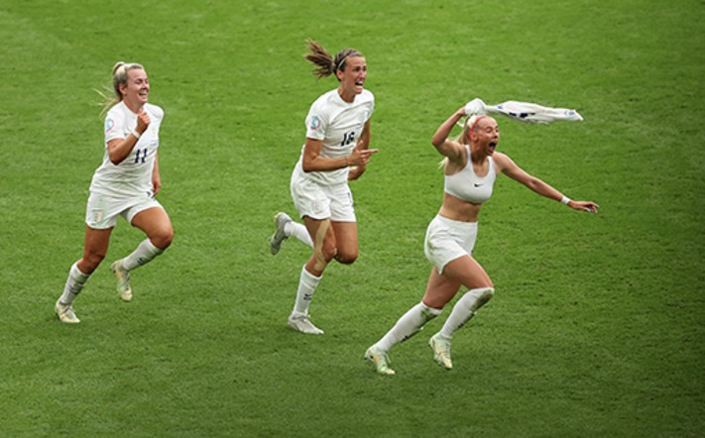
View description - Uncaptioned Figure
View description - Uncaptioned Figure

Research indicates that over 80% of women wear ill-fitting bras (Research Group in Breast Health, 2021) and when it comes to sports bras many women don’t even own one, with 50% of 11–18-year-olds not wearing a sports bra for PE or sport. Yet, wearing inadequate breast support, such as an everyday bra, to participate in sport and exercise can cause permanent damage and negatively impact performance. The importance of the sports bra as essential sports kit has been cited by many sportswomen and was demonstrated in the move by the England Institute for Sport (EIS) to provide GB athletes with bespoke bras for the 2020 Tokyo Olympic and Paralympic games (EIS, 2021). The crucial element here was that athletes were professionally fitted for the right size bra, but also to ensure the athlete wore the right style of sports bra to suit their breast size and sporting movement.

Activity 4 How to select the right sports bra
Allow about 15 minutes

Watch the animation which explores the benefits of a good sports bra and then watch the video showing an experiment involving the three types of sports bra.

Video content is not available in this format.
View transcript - Uncaptioned interactive content

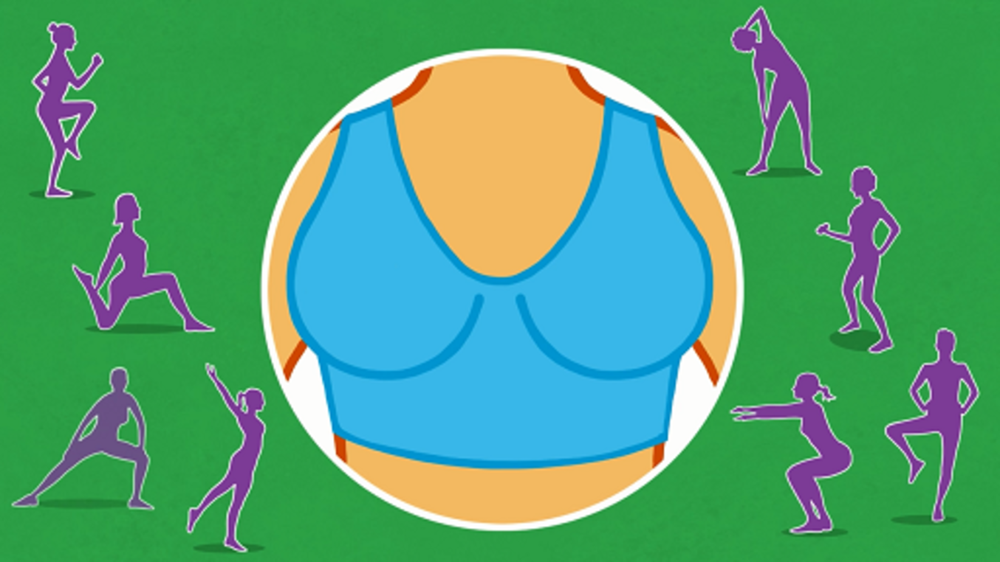

Video content is not available in this format.
View transcript - Uncaptioned interactive content

Then complete the table below to evaluate each type of sports bra:

Type of sports bra | Features | Advantages | Disadvantages | Movement reduction
Compression bra | Crop top style which pulls over the head and compresses breast tissue against chest wall. Suitable for smaller breasted females. | Provide your answer... | Provide your answer... | Provide your answer...
Encapsulation bra | Separates to provide support to each breast individually. Centre part sits flat against chest wall. Beneficial for larger breasted women. | Provide your answer... | Provide your answer... | Provide your answer...
Combination bra | Combines features of compression and encapsulation bras. Supports the breasts separately but also compresses them against the chest wall. | Provide your answer... | Provide your answer... | Provide your answer...

View discussion - Activity 4 How to select the right sports bra

In addition to the three common types of sports bras there are also different features of a sports bra that can impact the effectiveness of the support it provides. A study by Norris et al. (2021) into the characteristics that impacted the effectiveness of sports bras revealed that there were five key features that contributed to greater support:
- an encapsulation style (separates the breasts)
- padded cups
- made from Nylon
- an adjustable under band
- a high neckline.
A summary of their study of how to choose the most effective sports bra for yourself is provided in Figure 2.

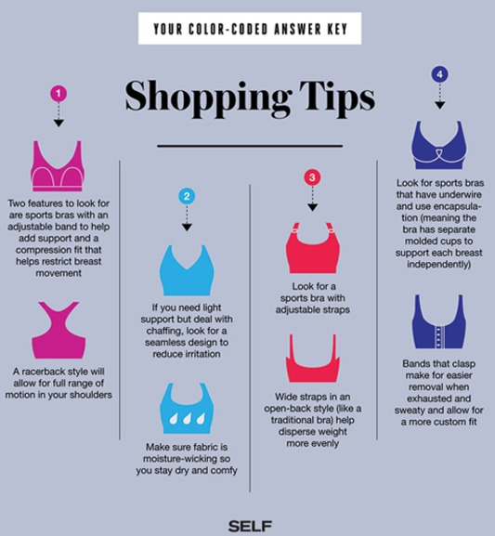
Figure 2 Tips on how to choose the most effective sports bra.
View description - Figure 2 Tips on how to choose the most effective sports bra.
View description - Figure 2 Tips on how to choose the most effective sports bra.

6 Getting the right fit
The University of Portsmouth Breast Health Research Group recommends using a five-point fit technique to evaluate whether the fit of a sports bra is optimal (see Figure 3 below). Using bra size can be misleading since the same size bra can actually come up as different sizes across varying styles and brands. It is much better to establish whether the bra has a good fit, rather than focusing on whether it is a certain size. If you wish to find out more the following video explains the five-point fit guide: Does your bra fit correctly?.

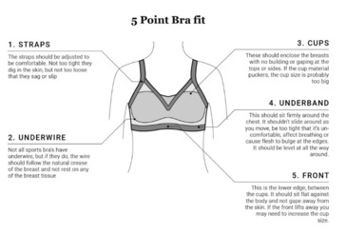
Figure 3 The five-point bra fit guide.
View description - Figure 3 The five-point bra fit guide.
View description - Figure 3 The five-point bra fit guide.

7 Case study: Equestrian sports

You want the whole focus to be on you and your horse. Constantly worrying that your bra straps are falling down is not helpful. I don’t think young girls are aware of breast issues. It could be very, very bad for me if I did ride in a normal bra and I wasn’t aware of that as a young girl.
(Natasha Baker, Paralympic equestrian rider)

Different activities will require different support for the breast and horse riding is an energetic and dynamic activity that can cause excessive breast movement. Despite this, research into breast support and horse riding by Burbage and Cameron (2017) reported that only 35% of women regularly ride in a sports bra. The study also indicated that riders with larger breasts experienced greater breast pain, as did those with higher body mass. Overall, 21% of riders said that breast issues negatively impacted on their performance. One of the aims of this course is to build awareness and education of these issues as a positive step to help women find effective breast support solutions.

Activity 5 Selecting a sports specific sports bra
Allow about 15 minutes

Listen to another section of the podcast ‘Bounce’ where the panel discuss breast health and horse riding with Natasha Baker, a paralympic equestrian rider. Then read the information booklet ‘The Horse Rider’s Guide to Bras’ and consider the benefits of wearing a sports bra for women when riding.

Audio content is not available in this format.
View transcript - Uncaptioned interactive content

Provide your answer...
View discussion - Activity 5 Selecting a sports specific sports bra

8 Practical recommendations for coaches and athletes

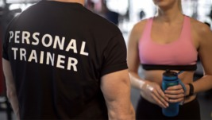
View description - Uncaptioned Figure
View description - Uncaptioned Figure

The key word that appears in many research articles and literature surrounding breast health is ‘education’. It is vital that young girls and women recognise the importance of appropriate breast support when participating in sport and exercise and that it is not considered a taboo or embarrassing subject. Instead, the sports bra should be considered as an essential piece of sports kit featured on a kit list, just like a gum shield or shin guards. Ideally, coaches need to feel confident having conversations about breast support with their athletes.

Activity 6 Advice and guidance
Allow about 15 minutes

Listen to the following section of the podcast ‘Bounce’ where the panel offers some key tips about how to choose appropriate breast support.
Note down any advice you would give to girls, parents and coaches around breast health.

Audio content is not available in this format.
View transcript - Uncaptioned interactive content

Provide your answer...
View discussion - Activity 6 Advice and guidance

Education materials for use in schools are freely available through ‘Treasure your Chest’, a collaborative research group, who have made resources available to empower girls and young women to know more about their breasts.

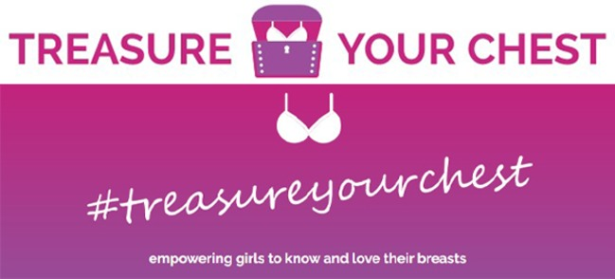
View description - Uncaptioned Figure
View description - Uncaptioned Figure

Parents or guardians have a role to play in educating their daughters and are typically responsible for taking their daughter for a bra fitting. If going for a fitting, parents/guardians should discuss with their daughter what is likely to happen during a fitting to lessen any anxiety or worry. The panel in Activity 5 suggested that when taking their daughter for their first bra they should include fitting for a sports bra. However, it should also be noted that teaching girls how to fit a bra for themselves is really important.
Parents, teachers and coaches can all play an important role in helping girls understand the importance of breast support.

9 This session’s quiz
Well done – you have reached the end of Session 5. You can now check what you’ve learned this session by taking the end-of-session quiz.
Session 5 practice quiz
Open the quiz in a new or window and come back here when you have finished.

10 Summary of Session 5
This session has provided an introduction to the topic of breast health in sport and exercise participation. It has demonstrated that while breast pain and discomfort is commonly thought of as a barrier to sport and exercise, increasing the knowledge and understanding around solutions to these issues can eliminate or reduce their impact.
The main learning points of this fifth session are:
- Breast issues can deter women from participating in sport and exercise.
- Breast pain and discomfort is common, and for women participating in sport and exercise settings it can impact on performance.
- Learning more about breast anatomy and movement of the breast and educating women, coaches and athletes can encourage more women to seek the right support.
- There are three types of sports bra, each suited to different levels of activity, and women should be fitted for the correct type of bra for their needs.
- Getting the right fit of bra is the most important factor in breast support. Education for girls and women should include what elements are important to consider when evaluating bra fit.
In the next session, you will explore the injuries that female athletes are particulary prone to and how to manage the risks of these injuries.
You can now go to Session 6.

Session 6: Injuries and the female athlete

Introduction
As the number of females participating in sport and fitness has increased, trends have been identified in the types of injuries that occur more frequently in female athletes than male athletes. At the start of this session you will hear from Dr Emma Ross, of The Well HQ, explaining which injuries are most common in females and what can be done to help prevent them.
In this session you will be exploring these injuries in more detail and assess their causes as well as what a coach or fitness trainer can do to make the athlete less susceptible to such injuries.
By the end of this session, you should be able to:
- understand why female athletes are more susceptible to specific injuries than male athletes
- appreciate how changes in hormone levels may impact on injury prevalence
- improve awareness of how coaches and trainers can help female athletes to reduce the risk of injury.
There are anatomical, physiological and hormonal factors that can predispose male and female athletes to different types of injuries and varieties in the severity of symptoms. These factors start with hormonal changes that occur at puberty where males experience increases in testosterone that strengthen muscles and make them more effective at supporting joints.
In females the rises in oestrogen levels at puberty cause muscles to become more flexible and joints less stable, increasing the risk of injuries from this stage onwards (Bompa and Carrera, 2015). At the other end of the lifecycle, females experience the menopause where oestrogen levels decline. Since oestrogen plays a role in muscle repair and regeneration (including maintaining bone density), injury risk presents differently in females across their lifespan (Enns and Tiidus, 2010).

1 Female athletes and their susceptibility to specific injuries
While the nature and severity of injuries are dependent on a range of factors, such as the type of activity, playing surfaces, equipment and individual fitness level, there are statistics that indicate that sex is an additional factor as active females are more susceptible to specific injuries. This is explained by Dr Emma Ross from The Well HQ in Activity 1.

Activity 1 Sports injuries and the female athlete
Allow about 15 minutes

Watch the video below where Dr Emma Ross explains which injuries female athletes are most susceptible to, some of the factors that increase the likelihood of these injuries occurring and strategies that can be employed to reduce the risk of sustaining an injury. Then answer the following questions:
- Which injuries are more common in female athletes than in males?
- What role may the menstrual cycle play in increasing the likelihood of injury?
- What strategies may help manage the risk of injury?

Video content is not available in this format.
View transcript - Uncaptioned interactive content

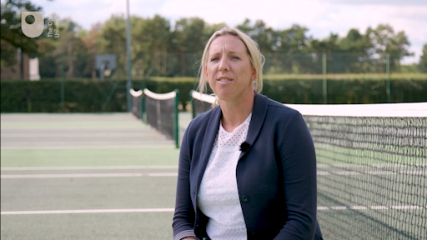

Provide your answer...
View discussion - Activity 1 Sports injuries and the female athlete

2 Why are there so many ACL injuries in female sport?

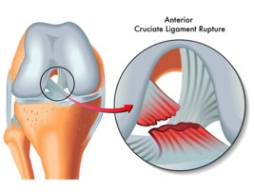
Figure 1 Knee ligaments and ACL tear.
View description - Figure 1 Knee ligaments and ACL tear.
View description - Figure 1 Knee ligaments and ACL tear.

The anterior cruciate ligament (ACL) is one of two ligaments in the centre of the knee joint that help provide stability (see Figure 1). The ACL goes from the back of the femur (thigh bone) to the front of the tibia (shin bone) and limits the forwards movement of the femur. The second ligament, the posterior cruciate ligament (PCL), goes from the front of the tibia to the back of the femur and prevents the knee from bending backwards excessively (hyperextension). They form a cross shape, and this gives them their name ‘cruciate’.
The reasons why female athletes may experience more ACL injuries are complex, but they can partly be explained by changes that happen at puberty.

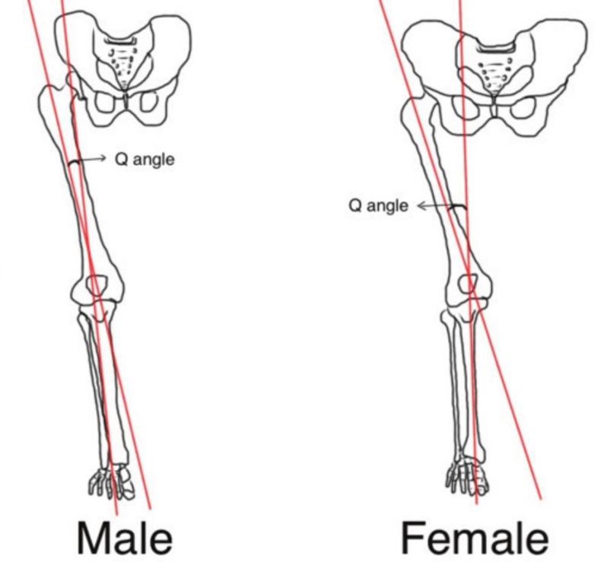
Figure 2 Differing Q-angles in males and females.
View description - Figure 2 Differing Q-angles in males and females.
View description - Figure 2 Differing Q-angles in males and females.

Post-puberty the male and female pelvis will differ as females will develop a broader pelvis to facilitate potential childbearing. This results in an increased angle where the femur connects at the knee joint with the tibia. This is referred to as the Q-angle and is around 16 degrees in females and 11 degrees in males. As well as affecting the way that forces travel through the leg to the knee and ankle it can cause a difference in the way the patella (kneecap) moves during exercise, and as a result females can experience more knee pain than males (Roush and Bay, 2012). This increased Q-angle can make it more difficult to prevent the knee from falling inwards when landing from a jump or turning quickly. If you examine Figure 2 you can see why this might be so.
Stability of the knee is provided by ligaments, such as the ACL, but it is also dependent on the strength of the muscles that control the knee. This includes the quadriceps at the front of the upper leg and hamstrings at the back, but also the gluteal muscles that control the hip. A weakness in gluteal muscles at the hip can result in the knee taking all the strain to prevent its increased range of movement.
There are some other factors that predispose female athletes to ACL injuries:
- Quadriceps dominance – female athletes are more likely to use their quadriceps to control the knee joint than male athletes. Male athletes tend to use strength in the hamstrings and gluteals, as well as the quadriceps, to share the load. The hamstrings will pull the tibia (in the lower leg) backwards to protect the ACL, while the stronger quadriceps in female athletes push the tibia forwards and place additional stress on the ACL (Greene, in Tomas and Whyatt, 2020).
- Ligament dominance – relative to male athletes the female athlete will have less musculature around the knee joint to stabilise it. As a result the ligaments have to take on more stability work and absorb forces placed on the knee joint. This increased load on the ligaments make them more susceptible to injury (Greene, in Tomas and Whyatt, 2020).

3 What can be done to protect female athletes against ACL injuries?
Firstly, in Activity 1 Dr Emma Ross explained why it is important for female athletes to track their menstrual cycle so they can identify the times in their cycle when oestrogen levels are higher, usually around days 9–14 of a typical 28-day cycle, and injury may be more likely. Then the athlete can be prepared and make adaptations to their training or competition schedule if required.
Emma referred to non-contact ACL injuries which is where the force is not applied from an external source, such as during a tackle, or where an external force is placed on the knee joint. ACL injuries in females are most prevalent in sports involving multidirectional movement, such as football, rugby, basketball, hockey and netball, where they may land in risky positions or have to twist and turn quickly (Zumwalt, 2019).
In Activity 2 you will examine whether the increased prevalence of ACL injuries is due more to social or physical factors that determine the physical conditioning of male and females

Activity 2 Are ACL injuries due to social or physical factors?
Allow about 10 minutes

Listen to a section of the podcast at the following link. Listen from 14:25 (‘In a nutshell, why do you think there are so many ACL injuries in women’s football …’) to 16:50 (‘… the biggest thing is the strengthening’): Injury and the female athlete: Injury risk and prevention, impact of the menstrual cycle, removing psychological fear and the consequences of playing catch up (buzzsprout.com)
Listen to the audio clip where Dr Nicole Surdyka, who is a physical therapist working in the rehabilitation and risk reduction of football injuries, explains why the increased prevalence of ACL injuries in female athletes may be due to social factors as much as physical ones.
To what extent do you agree with Dr Surdyka’s argument that it is social factors that are leading to high levels of ACL injury in female athletes.

Provide your answer...
View discussion - Activity 2 Are ACL injuries due to social or physical factors?

4 Reducing injuries among female athletes

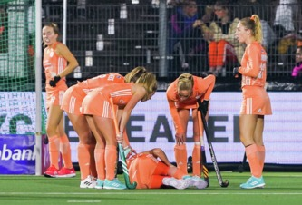
View description - Uncaptioned Figure
View description - Uncaptioned Figure

The claim that social factors may be at the heart of the issue helps suggest a strategy that may contribute to reducing injury prevalence. Fox et al. (2020) suggest that confining women’s injury risk to biological causes (e.g., hormones, anatomy, physiology) misrepresents the root cause of ACL injury, which is likely to be strongly influenced by what they term ‘gendered environmental disparities’ (different experiences in sport and less access to training facilities). Other causes could include women’s teams often being allocated artificial surfaces or poorer grass surfaces than men which can increase ACL injury rates (Braun, Wasterlain and Dragoo, 2013).
Currently not all females are coming to their sport with adequate skill and physical development (Parson, Coen, & Bekker, 2021). This is particularly important in relation to the muscles that support the knee and help to prevent ACL injuries. Improving neuromuscular control, which is teaching the nervous and muscular system to work effectively together, will help muscles to work in groups to move and stabilise joints. In particular it is important to train the neuromuscular system in a way that replicates movement patterns found in any chosen sport and for correct ‘landing techniques’ so that forces can be shared between muscle groups.
An analysis of studies into training for ACL prevention by Webster and Hewett (2018) showed that ACL prevention training programmes could reduce the number of injuries by 50% and non-contact ACLs by 67%. A good injury prevention programme will incorporate many strategies including, strength and conditioning, learning effective movement patterns, learning safe landing techniques, core conditioning and tracking menstrual cycles.

5 Sport concussions and the female athlete

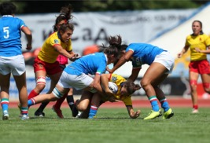
View description - Uncaptioned Figure
View description - Uncaptioned Figure

Concussion is a brain injury that is caused by a blow to the head, or the head being shaken violently. They are particularly prevalent in contact sports such as rugby, hockey and football but are also present in sports where the head can collide with the ground after a fall, such as horse racing and gymnastics.
Research shows that female athletes are almost twice as likely to experience a sport-related concussion than male athletes (Bretzin et al., 2021), sustain more serious concussions, have worse symptoms, and take longer to recover (McGroarty, Brown and Mulcahy, 2020). While we are starting to understand why this is the case, research is in its early stages and we are only starting to see a fuller picture.

Activity 3 Introduction to concussions in sport
Allow about 10 minutes

Listen to the audio clip about what causes a concussion, and the short and longer symptoms of concussion. Then answer the following questions:
- What immediate symptoms may you experience from a blow to the head?
- What longer term effects might you feel from a concussion?

Audio content is not available in this format.
View transcript - Uncaptioned interactive content

Provide your answer...
View discussion - Activity 3 Introduction to concussions in sport

Further information about signs and symptoms of concussion and what to do about them can be found on the NHS website.
For female athletes, concussions can also cause a disruption to the menstrual cycle, including amenorrhea, which is the loss of periods (McGroarty, Brown and Mulcahy, 2020). This is because the menstrual cycle is controlled by the hypothalamus in the brain and its function is disrupted by head injuries. Earlier research by Wunderle et al. (2014) showed that women who experienced concussion during the second half of their menstrual cycle (when progesterone levels are high), suffered worse outcomes than those women experiencing head injury during the first half of their cycle.
These differences are attributed to the disruption to the brain-ovary axis causing progesterone levels to fall rapidly. Research into the menstrual cycle and concussion is still emerging, but tracking when concussions occur in the cycle might be helpful information in the complex evaluation of brain injuries.

6 Why do females fare worse from sport concussions?

View description - Uncaptioned Figure
View description - Uncaptioned Figure

The reasons for the differences in how females and males experience concussion are complex. As Dr Emma Ross explained in Activity 1, females have smaller heads and weaker neck musculature for support (up to 47% weaker than males (Sanderson, 2021)). As a result their skulls when hit can be accelerated more quickly, potentially causing more damage to the brain.
Research by Elizabeth Williams, of Swansea University, has shown that more than 50% of the concussions sustained by female rugby players were due to their head making contact with the ground, while only 4% of concussions in male rugby players were caused in this way (Sanderson, 2021).
In football, female players were more likely to injure themselves while heading the ball, while for male players concussions were more likely to be caused by contact with other players (Bretzin et al., 2021). While male football and rugby players tend to be larger and may create more force it does not fully explain these significant gender differences, and Activity 4 looks into explanations for them.

Activity 4 Rates of concussion in female sports
Allow about 10 minutes

Watch the video in the link below where Elizabeth Williams presents the findings of her pioneering research into concussion in women’s rugby.
Rugby concussion: Swansea University study into protecting women
Then answer the following question:
- What has this research shown and how may it be applied to training for contact sports?

Provide your answer...
View discussion - Activity 4 Rates of concussion in female sports

There are also differences in the structure of nerves within male and female brains. When force is applied to the head forces are transmitted deep inside the brain to the neurons and axons (nerves), which can become damaged, causing inflammation and irreparable damage. Females have smaller axons than males (Dollé et al., 2018). This makes the axons more prone to damage and affects the outcome of a head trauma.
Coaches of female athletes need to be more vigilant than those of male athletes because concussion resulting from contact between the head and the ground are much harder to see happening than those that occur during head-to-head contact. There is evidence that boys are 1.5 times more likely to be immediately removed from the field of play and return to play 2 days sooner than girls with sport-related concussions (Bretzin et al., 2021).
We are continuing to learn more about sport-related concussion in females. It has taken a long time for the consequences of sport related concussion to be taken seriously in men’s sports, such as rugby and football. But we can’t stop here. Best practise for identifying and treating concussion by sex is the really important next step.

7 This session’s quiz
Well done – you have reached the end of Session 6. You can now check what you’ve learned this week by taking the end-of-session quiz.
Session 6 practice quiz
Open the quiz in a new or window and come back here when you have finished.

8 Summary of Session 6
You should now be aware of the two main types of injuries that female athletes are more susceptible to, why this is the case and what can be done to reduce the risk of these injuries.
The main learning points of this sixth session are:
- Female athletes are 4.5 times more likely to experience ACL injuries than male athletes.
- Female athletes experience almost twice as many sport-related concussions than male athletes, have poorer outcomes and take longer to recover.
- The differences in the type and severity of injuries are due to anatomical and physiological differences between males and females but are also related to changes in hormone levels across the menstrual cycle.
- The higher prevalence of ACL injuries in female athletes is partly due to the larger Q-angle (between pelvis and femur) and also the higher quadriceps and ligament dominance in providing knee stability.
- ACL injury risk can be reduced through a specific strength and conditioning programme that increases the stability of the knee through learning correct movement patterns, safe landing techniques and core conditioning.
- Females experience more sport related concussions due to their potentially weaker neck musculature, differences in the structure of the nerves within the brain and differences in how they fall to the ground.
In the next session you will explore the serious impact that low energy intake, caused by athletes not consuming enough calories to meet the energy needs of training, can have on the female athlete.
You can now go to Session 7.

Session 7: Low energy intake and missed periods: the risks

Introduction

When I was losing weight, I felt like a true athlete.
(Bobby Clay, GB International athlete)

View description - Uncaptioned Figure
View description - Uncaptioned Figure

Relative energy deficiency in sport (RED-S) is a condition that occurs when more energy is being used by the body than being taken in over a prolonged period. If you do not have enough energy available for training it can also impact the maintenance of the body’s optimal health. Energy deficiency can lead to a disruption, or loss, of menstrual function and the loss of the important menstrual cycle hormone, oestrogen. This can also impact on bone health and RED-S is often not detected until athletes stop having periods or, worse still, start to experience bone fractures.
The terminology RED-S is a relatively new phenomenon in sports science, with the International Olympic Committee (IOC) introducing the term in a consensus paper in 2014. It was a new name to describe the condition previously known as the ‘Female Athlete Triad’ which linked low energy availability to menstrual cycle disturbances and poor bone health in female athletes. However, knowledge has developed to allow us to understand that relative energy deficiency affects many other aspects including metabolic rate, immunity, protein production, cardiovascular and psychological health. RED-S can affect anyone, not just females.
Athletes in sports that are associated with leanness, such as athletics, gymnastics and figure skating are seen to be more at risk of RED-S (De Souza et al., 2014). However, recreational athletes are more likely to experience RED-S than elite athletes as they undergo less health screening, have less support, and may not even be aware they are energy deficient.
In this session, by examining athletes’ own experiences, you will better understand what effect RED-S has on the body, what causes it, and the coach’s role in guarding against it.
By the end of this session, you should be able to:
- identify the impact of RED-S on body systems
- understand the factors that can cause RED-S
- become more aware of the signs and symptoms of RED-S.

1 Medals or menstruation? What the athletes say
Athletes, either intentionally or unintentionally, can experience RED-S due to a desire to change body composition with the belief that it will improve their performance and increase their chances of success. This is reflected in these quotes from athletes.

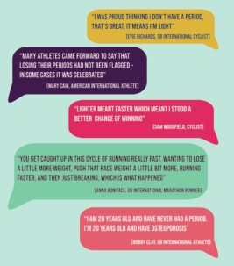
View description - Uncaptioned Figure
View description - Uncaptioned Figure

Bobby Clay’s story

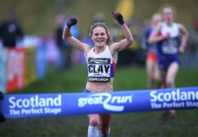
View description - Uncaptioned Figure
View description - Uncaptioned Figure

Bobby Clay was a junior international track and field and cross-country runner who won gold at the 2015 European Junior Championships over 1500m. However, aged 19 she started suffering a series of bone fractures.
Watch the following video clip that tells Bobby’s story:
I believe I’ll be the athlete I once was

Bobby’s story may seem shocking to us, and like the quotes in this section she links speed to lightness which in turn caused her to under fuel her training. In what she calls her osteoporosis nightmare she describes how she was part of a female training group where food was perceived as the enemy. Although she says she has never had an eating disorder she was constantly doing high volumes of training without taking in enough energy through her diet to allow her body to recover, adapt and progress.
In the short term the result of this was low body weight, which she regarded as a competitive advantage. The suppression of her menstrual cycle and the impact of sustained energy deficiency meant that she was physically and psychologically impacted in the long term. This ended her dreams of becoming an internationally successful athlete.

2 What is the problem?
RED-S occurs for several reasons as you shall see, but central to its development is an intentional or unintentional restriction of sufficient energy to effectively fuel training, recovery and health. For some athletes this stems from a belief that restricting the diet and losing weight will improve performance, while for others it is about conforming to socially constructed body image of attractiveness. The third cause is when energy intake restriction happens because of a clinical eating disorder.
But what is the cost of RED-S on the body? In Activity 1 Anna Boniface, an international marathon runner, shares her experiences.

Activity 1 Stress fractures and osteoporosis
Allow about 10 minutes

Listen to the audio clip where Anna Boniface tells her story of how long-term under eating and over training impacted on her body and performance in marathon running.
Then answer the following question:
- What impact did Anna’s overtraining and undereating have on her skeleton?

Audio content is not available in this format.
View transcript - Uncaptioned interactive content

Provide your answer...
View discussion - Activity 1 Stress fractures and osteoporosis

Anna outlines the link between bone health and disruptions to the menstrual cycle. The loss of a regular menstrual cycle (amenorrhea) leads to lower bone mass, less bone strength, and higher rates of fractures among athletes (Elliott-Sale et al., 2018).
What is the relationship between low energy availability and the menstrual cycle? You will explore this in the next section.

3 The period is a vital sign of health

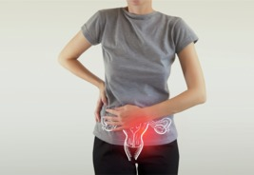
View description - Uncaptioned Figure
View description - Uncaptioned Figure

The changes in hormones that result from RED-S impact on many systems of the body with bone and reproductive health being particularly at risk. In Activity 2 Dr Emma Ross from The Well HQ explains how and why low energy availability will impact on the menstrual cycle, and the reproductive and skeletal systems.

Activity 2 Loss of periods – a red flag to female athletes
Allow about 15 minutes

Watch the video where Dr Emma Ross explains the ‘brain to ovary’ link and how it is affected by low energy availability. Then answer the following questions:
- Why does the brain choose to switch off the menstrual cycle when there is low energy availability?
- Why is the maintenance of bone health so vital to young female athletes?

Video content is not available in this format.
View transcript - Uncaptioned interactive content

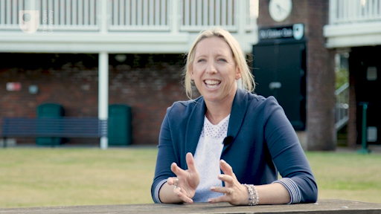

Provide your answer...
View discussion - Activity 2 Loss of periods – a red flag to female athletes

RED-S will affect other body systems as well as the reproductive and skeletal systems. The following figures show the impact of RED-S on other body systems (from Mountjoy et al., 2018).
Cardiovascular system (heart and blood vessels)

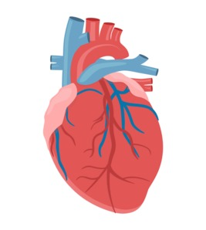
View description - Uncaptioned Figure
View description - Uncaptioned Figure

Impact of RED-S:
- Irregular heart beat
- Lower heart rate
- Lower blood pressure
- Low red blood cell count (anaemia)
Digestive system

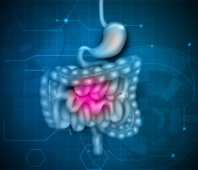
View description - Uncaptioned Figure
View description - Uncaptioned Figure

Impact of RED-S:
- Slower digestive speed
- Increased time food spends in intestines
- Constipation
Immune system

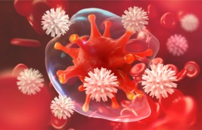
View description - Uncaptioned Figure
View description - Uncaptioned Figure

Impact of RED-S:
- Increased likelihood of illness
- Increased colds and flu
- Increased body aches
- More headaches
Endocrine system, including the thyroid gland

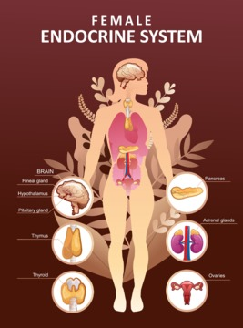
View description - Uncaptioned Figure
View description - Uncaptioned Figure

Impact of RED-S:
- Reduction in rate at which calories are burned
- Increase in the hunger response
As you will see in the next section some of these have a profound impact on physical performance.

4 The impact of RED-S on performance
You have seen in Activity 2 that Anna Boniface had to drop out of a marathon as she developed a stress fracture in her ankle, which highlights the increased risk of injury to the skeletal system. Being lighter, or having low body fat, may decrease the energy expenditure of running or cycling producing a short-term performance benefit.
Having low energy availability interferes with many of the mechanisms needed for optimal performance and impacts on several measures of fitness, as well as psychological measures. This is shown in Figure 2.

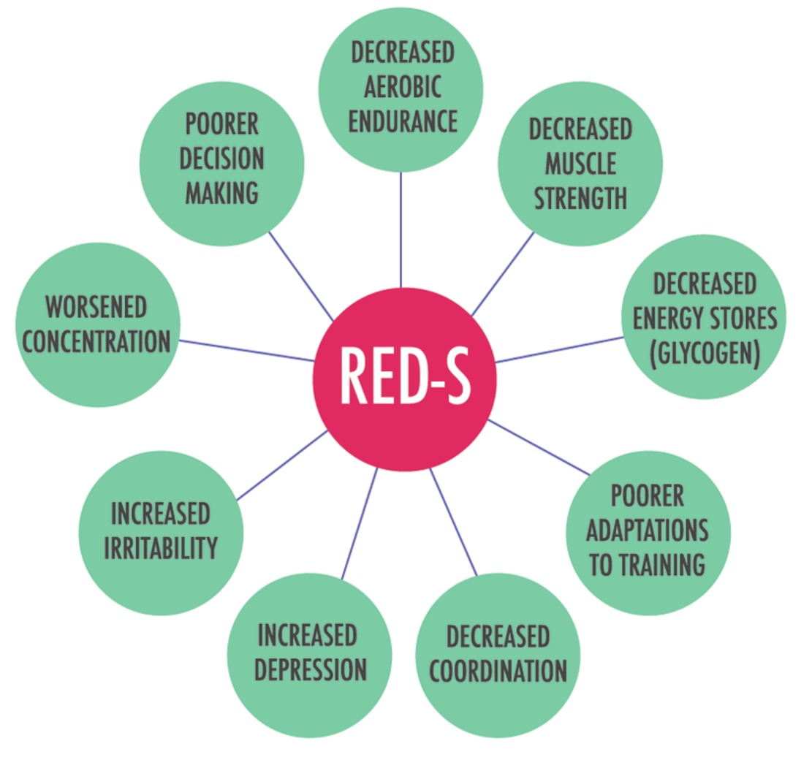
Figure 2 The impact of RED-S.
View description - Figure 2 The impact of RED-S.
View description - Figure 2 The impact of RED-S.

Eating less, or cutting out certain food groups, can lead to the body simply not having enough fuel to sustain itself. For example, endurance activities rely on food in the form of carbohydrates, which provide glycogen to produce energy as well as replenish energy stores afterwards. To build muscle and repair any damage caused by training an individual must consume foods rich in protein. Also fat intake is important as it provides the body with energy, supports cell growth, and helps the body absorb vital nutrients.
Psychological problems, such as depression and irritability, also feature in Figure 2. Mental health issues can be both a contributing cause to RED-S and a result of it. RED-S is not necessarily caused by eating disorders, such as anorexia nervosa, but if an athlete has a high drive for thinness than anorexia can become a contributing factor to its development (Mountjoy et al., 2018). Often RED-S is caused by a poor nutritional strategy where an athlete does not plan their nutrition carefully enough to ensure that they gain enough calories to fuel their training and other daily activities.
Eating disorders, such as anorexia nervosa, can be a contributory factor in low energy availability but it is also a serious mental health problem. It is associated with an intense fear of gaining weight and often a distorted body image where an individual thinks they are overweight no matter how thin they become (NHS, 2021). Beatcharity has resources to help people suffering with eating disorders.

5 Warning signs of RED-S

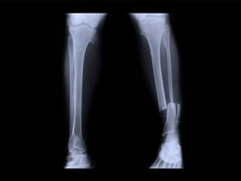
View description - Uncaptioned Figure
View description - Uncaptioned Figure

In the cases of Bobby Clay and Anna Boniface we see that they sustained low fuelling and overtraining for a period of time before experiencing bone fractures. This is partly because the body has stores of fat and glycogen for fuel, and it can break down stored fat and muscle protein to produce additional energy if needed. However, it can only survive in this state for a short time before the body is seriously affected and its systems, particularly the muscular and skeletal systems, become so damaged that they are no longer able to function effectively. This is when injuries start to occur.
The problem for coaches and trainers who support athletes is that they may not have full access to the athletes’ nutritional strategies or knowledge of their menstrual cycles. In many cases an exercising female may not have a coach or trainer who oversees their training and recovery, and lack of nutritional knowledge may cause them to become under-fuelled without even being aware of it.
In Activity 2 Emma Ross explained that the coach has an important role to play by ensuring the athlete arrives to training well fuelled and eats the right foods after training.
The coach needs to be aware of the warning signs of RED-S in athletes:

- irregular or absent periods
- difficulty staying warm in the winter and cool in the summer
- low muscle mass
- pre-occupation with food and eating
- increased prevalence of illnesses and injuries
- decrement in performance
- excessive tiredness and lethargy
- poor recovery from training sessions
- poor sleep patterns
- digestive problems such as constipation or bloating
- perfectionist tendencies
- high levels of anxiety
- becoming withdrawn or reclusive.
(Train Brave, 2021)

6 Preventing RED-S in female athletes
RED-S can be prevented by maintaining energy balance where energy intake matches the energy demands of health, training, recovery, and everything else in an athlete’s life, which might include their job, studies and socialising. Figure 3 gives 5 top tips for getting the correct energy balance.

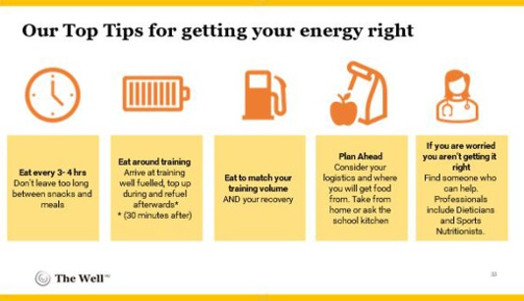
Figure 3 Get your energy right.
View description - Figure 3 Get your energy right.
View description - Figure 3 Get your energy right.

How can a coach support their female athlete?
A healthy athlete is more successful than a broken one
Telling an athlete to ‘eat more’ simply won’t work as it’s about changing behaviour, and sometimes addressing the athlete’s dysfunctional or emotional relationships with food.
As a coach you can ‘celebrate the power of food’. In conversations with athletes you can talk about the power of food as a fuel for performance. You can use coachable moments at the beginning of the session to ensure everyone has arrived well fuelled by asking ‘what did everyone have to fuel up for today’ and again at the end of the session ‘what is everyone going to eat to refuel’.
Use education to teach athletes about what and how to eat. While eating may seem intuitive, eating to fuel sports performance often isn’t and many athletes get it wrong. For example, the timing of energy delivery is just as important as the number of calories consumed. Ensuring that eating matches training volume and that athletes are not training without a pre-training meal or during fasting is important, as is remembering to eat soon after training.
Finally, ensure that athletes stop attaching value to body shape and size. This happens when an athlete looks at another athlete and believes their performance success is directly related to their leanness or believing that leanness will offer them a competitive advantage. It is important to understand that an under fuelled athlete, whilst being lean, is at a competitive disadvantage due to their shortage of energy.
Remarks that a coach or athlete may make, sometimes unconsciously, can serve to fuel a dangerous culture of restricted eating in sport. Athletes come in all shapes and sizes, success isn’t simply down to body size, and a healthy athlete is more successful than a broken one.

7 The importance of carbohydrates to female athletes

View description - Uncaptioned Figure
View description - Uncaptioned Figure

Energy intake is an important consideration to prevent RED-S and in particular carbohydrates are a particularly important source of energy for females around training for the reasons shown in Figure 4.

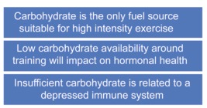
Figure 4 The importance of carbohydrates to the exercising female.
View description - Figure 4 The importance of carbohydrates to the exercising female.
View description - Figure 4 The importance of carbohydrates to the exercising female.

Female hormones are extremely sensitive to nutrient intake and in particular carbohydrates. This is because not providing the body with adequate amounts of carbohydrate can significantly disrupt the production of oestrogen and progesterone (Gastman and Hanan, 2021). As we are aware these hormones are central to the functioning of the menstrual cycle and maintenance of bone health. As such carbohydrate restrictive diets or low carbohydrate high fat (LCHF) diets may not always be suitable for female athletes.
The recommended range for how much carbohydrates an athlete needs is often expressed as a percentage of daily calorie intake, in which case it should be about 55% of total calories but can be up to 75% of total calories for athletes who have a very high training load (Eckerson, 2019). A better way to determine carbohydrate intake need is to calculate it relative to an athlete’s weight.
For exercising females their calorie intake should be between 5–7grams of carbohydrate for every kilogram of body mass. For example, for a 65kg woman, her daily carbohydrate requirement would be around 390g. Research by Gibson et al. (2011) showed that just over 50% of the female football players studied consumed less than 5g of carbohydrate per kg of body mass per day.
It is beyond the scope of this course to provide full nutritional advice but the free course The science of nutrition and healthy eating covers nutrition in detail.

8 Managing athletes and active females experiencing RED-S

View description - Uncaptioned Figure
View description - Uncaptioned Figure

To manage RED-S in athletes it is necessary to address three things – increasing energy intake, reducing training load and allowing adequate recovery time (Scarr, 2019). However, putting interventions in place is harder than it sounds. The athlete will have to be central to the process and be willing and able to change. The coach and fellow athletes can be important when having conversations with the athlete and supporting them.
However, it is likely that professional help will be needed as well. This may be from a doctor or GP who can advise them and ask for blood tests to identify how much damage has occurred to the bones and hormone levels, but more often than not will require input from a sports physician (doctor), a sports nutritionist, and a sport psychologist. Using a team approach to manage RED-S is discussed in Activity 3.

Activity 3 Developing a team approach
Allow about 10 minutes

Listen to the audio clip where Dr Kate Ackerman, a researcher in RED-S, explains an approach to manage RED-S.
Then answer the following question:
- What is Dr Ackerman’s top tip for addressing low energy availability?
Clinical tips from Dr. Kathryn Ackerman on how to manage athletes with low energy availability in BJSM (soundcloud.com): listen from 09:00 (‘Can you give us some of your tips …’) to 10:26 (‘… to make them a better athlete’).

Provide your answer...
View discussion - Activity 3 Developing a team approach

9 This session’s quiz
Well done – you have reached the end of Session 7. You can now check what you’ve learned this week by taking the end-of-session quiz.
Session 7 practice quiz
Open the quiz in a new or window and come back here when you have finished.

10 Summary of Session 7
You should now be aware of what RED-S is, how it is caused and its relation to bone fractures and osteoporosis. You should also appreciate the impact of RED-S on the menstrual cycle and the negative impact it has on important systems of the body. You should know what signs of RED-S to look out for and what steps can be taken to support female athletes experiencing RED-S.
The main learning points of this seventh session are:
- Relative energy deficiency syndrome (RED-S) occurs when the body uses more energy than is being taken on over a prolonged period of time.
- Low energy availability can lead to a disruption in the menstrual cycle, loss of periods, and eventually bone fractures.
- RED-S can also affect the cardiovascular, immune, digestive and endocrine systems.
- RED-S has a range of causes, but it is closely linked to the belief that being lighter will produce a better performance.
- Low energy availability disrupts the menstrual cycle resulting in less oestrogen production and a shortage of oestrogen can affect bone density.
- Low oestrogen levels in females before their menopause is a major risk factor in developing osteoporosis in later life.
- As well as disruptions to the period, other signs of RED-S are a pre-occupation with food and eating, excessive tiredness, poor recovery and a decline in athletic performance.
- RED-S can be prevented by ensuring energy intake matches the demands of an athlete’s training, recovery, and daily activities.
- The treatment of RED-S requires a team approach, including a doctor, sports nutritionist and sport psychologist.
In the next and final session, you will look at effective ways to communicate with female athletes.
You can now go to Session 8.

Session 8: Effective support of female athletes

Introduction

The inability of male coaches to understand how best to engage with female athletes has been determined to be a key barrier to participation, engagement and progression in this population.
(Norman and French, 2013)

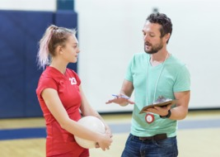
View description - Uncaptioned Figure
View description - Uncaptioned Figure

The coach-athlete or parent-athlete relationship is important in supporting athletes. An ideal coach-athlete relationship is one that is successful in terms of achieving the performance required and is effective in terms of the personal growth and wellbeing of the athlete (Jowett, 2007).
At the time of writing, UK Sport suggest that women currently occupy just 10 per cent of coaching positions in Olympic and Paralympic sport. In sport as a whole, from grassroots level to professional levels, just 30 per cent of coaches are female.
As coaching is a male dominated profession, many female athletes will have male coaches. While there are many successful male coaches of female athletes, any gaps in the skillset of males in support roles to understand how to engage with their female athletes can be a significant barrier to a successful relationship (e.g., Norman and French, 2013). The success and wellbeing of an athlete is dependent on this relationship as Jowett (2017, p. 155) says: ‘how one feels, thinks and behaves affects and is affected by how the other feels, thinks and behaves’.
In this session you will be exploring some concepts that are key to an effective relationship between a coach and a female athlete and to help coaches consider how they can best engage with female athletes.
It must be stated here that every athlete, male or female, is an individual and will have their own specific needs for coaching and support. However, some understanding of general preferences of female athletes for support might help develop communication styles that best suit the female athlete. Research has shown that certain aspects of the coaching environment, like democratic decision making and personalised and positive relationships, are beneficial to improving female athletes’ experiences in sport (Norman, 2016).
By the end of this session, you should be able to:
- appreciate the potential differences in preferred coaching between female and male athletes
- explore how coaches may develop effective relationships with female athletes
- increase awareness of how male coaches can effectively support female athletes.

1 ‘Females are just emotional!’

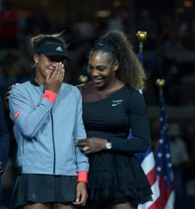
Figure 1 Serena Williams and Naomi Osaka after the 2018 US Open Final.
View description - Figure 1 Serena Williams and Naomi Osaka after the 2018 US Open Final.
View description - Figure 1 Serena Williams and Naomi Osaka after the 2018 US Open Final.

The belief that women are more emotional than men has been called a ‘master stereotype’, meaning it is a widely held and pervasive view across society. Men and women, older and younger individuals, as well as individuals from a range of cultural backgrounds hold the belief that women are more emotional than men (McRae et al., 2008).
The truth is that we are all emotional. Males don’t have ‘fewer’ emotions than females, but the way men and women perceive, process and respond to emotional stimuli can be different.
In the main, women cope with emotions by talking about them. It’s a part of something called ‘emotion focused coping’, where an individual actively does something to manage their emotional response to a stressful situation (Kelly et al., 2008). The tendency in females to want to share emotions to help manage them can sometimes be at odds with the way males like to process or cope with stressors. Men tend to use problem-focused coping strategies where they try to address and ‘fix’ the situation itself.
When a female athlete talks through her emotions about the competition that recently didn’t go to plan, a male in a support role might go into problem-focused mode and will try to fix that athlete’s problem. But the athlete may not want a problem fixed; instead she might want to process her emotions so that she can move on. This often creates a mismatch between how female athletes communicate their emotions and male coaches deal with them.

2 Do female athletes prefer certain styles of coaching?

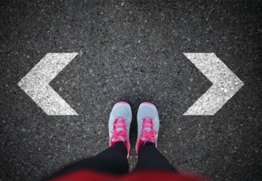
View description - Uncaptioned Figure
View description - Uncaptioned Figure

In all relationships there are decisions to be made, and how these decisions are made and who makes them will be central to a relationship’s success. There are many different styles of coaching and leadership, but two extremes would be described as autocratic and democratic and expressed in Table 1.

Table 1
Autocratic coaching style  ‘My way or the highway’ | Democratic coaching style  ‘Let’s talk about this’
- Coach makes decision without any input from athletes  - Their decision is imposed on the athletes  - The coach has a vision and expects athletes to conform to this vision and how to achieve it  - A win-focused approach | - Coach will seek input from their athletes before coming to a decision  - Coach facilitates the process rather than dictating it  - Athletes can shape their own goals and how to achieve them  - Collaborative approach

In Activity 1 you will explore whether female and male athletes differ in the coaching style that they prefer.

Activity 1 Don’t tell me what to do!
Allow about 15 minutes

Watch the video where Dr Emma Ross from The Well HQ explains the coaching style generally preferred by females. Then answer the following questions:
- What involvement do female athletes tend to prefer to have?
- Does Emma attribute these preferences to differences in the male and female brain?

Video content is not available in this format.
View transcript - Uncaptioned interactive content

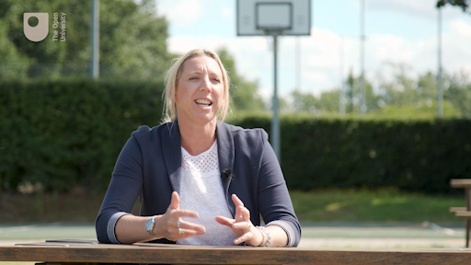

Provide your answer...
View discussion - Activity 1 Don’t tell me what to do!

It should be said that with regard to the psychology of sport and exercise that males and females have much more in common than differences (Roberts, Ferguson and Mosewich, 2019). However, as a coach it is important to be flexible and understand that female and male athletes perhaps appreciate and respond to different coaching styles, as this can have a significant impact on their performance.
You’ll now go back to the coach-athlete relationship and see whether there is a difference in this relationship between male and female athletes.

3 What do female athletes want from their coach?

View description - Uncaptioned Figure
View description - Uncaptioned Figure

Each coach-athlete relationship is unique and has a unique balance as to who makes decisions. Gender may play a role in this relationship and also how an athlete selects their coach if they have a choice. This is explored in Activity 2.

Activity 2 Quality not quantity
Allow about 15 minutes

Watch the video where Dr Emma Ross explains some differences in the coach-athlete relationship between males and females. Then answer the following questions:
- What is claimed to be most valuable to female athletes in the coach-athlete relationship?
- How does this differ from male athletes?

Video content is not available in this format.
View transcript - Uncaptioned interactive content

Provide your answer...
View discussion - Activity 2 Quality not quantity

Emma suggests that the female gains motivation and confidence from the relationship with their coach and this link is explored in the next section.

4 What does research say about the psychology of the female athlete?

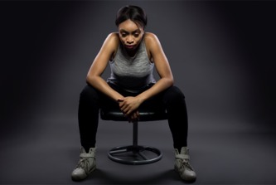
View description - Uncaptioned Figure
View description - Uncaptioned Figure

Research indicates that there are several nuanced gender differences in the psychology of sports performance. Subtle differences in the motivation of female athletes to play sport and how they derive confidence are particularly important in the coach-athlete relationship.
Research summaries

Observations on motivation

- Females generally score high on being motivated by the satisfaction and competence derived from learning new skills and improving their performance (task orientation).
- Males may be more ego-oriented and motivated by competitiveness, and beating other athletes (ego orientation).
- Females tend to define success through self-referenced standards, that is focusing on improving themselves, while males are more likely to use externally referenced standards, that is success in relation to others.
(Roberts, Ferguson and Mosewich, 2019)

This following research into the sources of sport-confidence was conducted on 29 male and 25 female subjects who were active in elite individual sports. These included, for example, karate, judo, badminton, table tennis and cycling. They competed at international level and the age range was between 18 and 51.

Sources of sport-confidence

Female athletes, more so than men, gain self-confidence from an environment that provides:
- opportunities to master skills
- reinforcement from significant others (social support)
- coach’s encouragement and positive feedback/reinforcement
- support to feel comfortable in competitive environments.
(Kingston, Lane and Thomas, 2010)

This research did not seek to understand why these differences may exist and acknowledged that some male athletes may gain support from similar sources.
Female athletes also stressed the need for enjoyment in their sport and fitness activities to a greater extent than male athletes (MacKinnon, 2011). Developing environments and relationships that support the motivation and confidence of female athletes can help them to flourish.

5 Final thoughts on coaching female athletes
Sports coaches, athlete management and athlete support currently use male performance as their default position but throughout this course you have focused on how to take into account the different and diverse needs of active females in sport and fitness.
Having a knowledge and understanding of these specific needs should give you the confidence to engage with female athletes and be able to have conversations about important subjects. Understanding what female athletes need out of the coach-athlete relationship will help too. This is particularly important if it is a male coach working with female athletes.

Activity 3 Do not make assumptions!
Allow about 10 minutes

Listen to the audio clip where Dr Caroline Heaney in conversation with Simon Rea discusses the importance of male coaches having conversations with female athletes they coach. Then answer the following question:
- Why is it important that a male coach discusses subjects such as periods with their female athletes?

Audio content is not available in this format.
View transcript - Uncaptioned interactive content

Provide your answer...
View discussion - Activity 3 Do not make assumptions!

The final word on this is left to Dr Emma Ross who has supported every session in this course.

Video content is not available in this format.
View transcript - Uncaptioned interactive content

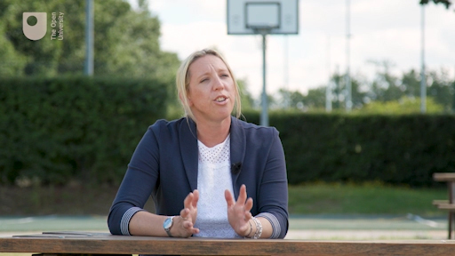

6 Key learning points from the course
Take a moment to reflect on the image below, which features the key learning points you should take from this course.

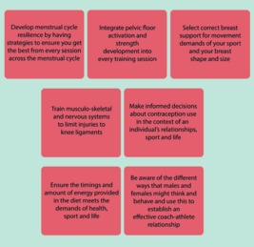
View description - Uncaptioned Figure
View description - Uncaptioned Figure

7 This session’s quiz
It’s now time to complete the Session 8 badged quiz. It is similar to the previous quizzes, but this time, instead of answering 5 questions there will be 15, covering Sessions 5–8.
Session 8 compulsory badge quiz
Remember that the quiz counts towards your badge. If you’re not successful the first time, you can attempt the quiz again in 24 hours.

8 Summary of Session 8
You should now be aware that while there are more similarities than differences between males and females, women tend to process emotions in different ways to men, prefer different styles of coaching and like different amounts of input into the coaching process.
The main learning points of this eighth session are:
- Sports coaching is a male dominated activity with only 30% of coaches being females; this means female athletes often have male coaches.
- Males and females can process their emotions in different ways as females manage emotions by talking things through while men tend to try and find solutions.
- Female athletes generally prefer democratic coaching styles that enable them to have significant input into the decision-making process while men tend to favour autocratic coaching styles.
- The quality of the coach-athlete is very important to the female athlete while male athletes tend to focus on the quality of the coach.
- Female athletes tend to derive success from self-referenced standards while male athletes tend to use more externally referenced sources for success.
- Female athletes can derive confidence from their coach’s encouragement and positive feedback.
Many congratulations on completing this course and we hope you have found some useful knowledge and advice that you can use as an athlete or a coach. This area of study and research is still in its infancy so we would encourage you to keep learning about it through resources that OpenLearn provide and through other sources.

Where next?
If you’ve enjoyed this course you can find more free resources and courses on OpenLearn.
You might be specifically interested in these other badged courses:
- Communication and working relationships in sport and fitness
- Exploring sport coaching and psychology
- Learning from sport burnout and overtraining
- Coaching others to coach
- The athlete’s journey: transitions through sport
- Exploring the psychological aspects of sport injury
There is also a page of sport and fitness courses on OpenLearn as well as a Women in Sport hub where you can explore more resources dedicated to women and get updates on research and knowledge that impacts on females in sport and fitness..
New to University study? You may be interested in our courses on Health and Wellbeing. You might be particularly interested in our BSc (hons) Sport, fitness and coaching.
Making the decision to study can be a big step and The Open University has over 40 years of experience supporting its students through their chosen learning paths. You can find out more about studying with us by visiting our online prospectus.

Tell us what you think
Now you’ve come to the end of the course, we would appreciate a few minutes of your time to complete this short end-of-course survey (you may have already completed this survey at the end of Session 4). We’d like to find out a bit about your experience of studying the course and what you plan to do next. We will use this information to provide better online experiences for all our learners and to share our findings with others. Participation will be completely confidential and we will not pass on your details to others.

References
Cowley, E.S., Olenick, A.A., McNulty, K.L. and Ross, E.Z. (2021) ‘“Invisible women”: the sex data gap in sport and exercise science research’, Women in Sport and Physical Activity Journal, 29(2), pp. 146–51. Available at: https://journals.humankinetics.com/view/journals/wspaj/29/2/article-p146.xml (Accessed: 16 May 2022).
Forsyth, J. and Roberts, C.M. (eds) (2019) The Exercising Female: Science and its Application. Oxon: Routledge.
McGregor, A.J. (2020) Sex Matters: How Male-centric Medicine Endangers Women’s Health and What we can do About it. London: Quercus.
Sims, S. (2019) Women are not Small Men: A Paradigm Shift in the Science of Nutrition. Available at: https://www.ted.com/talks/stacy_sims_women_are_not_small_men_a_paradigm_shift_in_the_science_of_nutrition (Accessed: 16 May 2022)
Slater, A. and Triggermann, M. (2010) ‘Uncool to do sport: a focus group study of adolescent girls’ reasons for withdrawing from physical activity’, Journal of Sport and Exercise, 11, pp. 619–26.
Women in Sport (2016) ‘Women in Sport Girls Strategy, 2016-19 Our Ambition’. Available at: http://www.womeninsport.org/wp-content/uploads/2017/03/Ambitions-for-Girls-2016-Strategy.pdf?x99836 (Accessed: 16 May 2022).
Chisholm, A. (2020) ‘How exercise may change your period’. Available at: https://www.verywellhealth.com/exercise-effects-on-menstruation-4104136 (Accessed: 16 May 2022).
Finch, C. (2019) ‘Female athletes held back and being put at risk by gender data gap’, The Sustainability Report February 2020. Available at: https://sustainabilityreport.com/2020/02/20/female-athletes-held-back-and-being-put-at-risk-by-gender-data-gap/ (Accessed: 24 June 2022)
Hill, M. (2019) Period Power. London: Bloomsbury.
McNulty, K.L., Elliott-Sale, K.J., Dolan, E., Swinton, P.A., Ansdell, P., Goodall, S., Thomas, K. and Hicks, K.M. (2020) ‘The effects of menstrual cycle phase in exercise performance in eumenorrheic women: a systematic review and meta-analysis’, Sports Medicine, 50, pp.1813–1827.
National Health Service (2021) ‘Heavy periods’. Available at: https://www.nhs.uk/conditions/heavy-periods/ (Accessed: 16 May 2022).
Pitchers, G. and Elliott-Sale, K.J. (2019) ‘Considerations for coaches training female athletes’, Training Female Athletes, 55, pp. 19–30.
Ross, E., cited in Finch, C. (2019) ‘Female athletes held back and being put at risk by gender data gap’, The Sustainability Report February 2020. Available at: https://sustainabilityreport.com/2020/02/20/female-athletes-held-back-and-being-put-at-risk-by-gender-data-gap/ (Accessed: 24 June 2022).
Sims, S.T. (2016) Roar. New York: Rodale.
Elliott-Sale, K.J. and Hicks, K.M. (2019) ‘Hormonal-based contraception and the exercising female’ in Forsyth, J. and Roberts, C.M. (eds) The Exercising Female: Science and its Application. Oxon: Routledge.
Elliott-Sale, K.J., McNulty, K.L., Ansdell, P., Hicks, K.M., Thomas, K., Swinton, P.A. and Dolan, E. (2020) ‘The effects of oral contraceptives on exercise performance in women: as systematic review and meta-analysis’, Sports Medicine, 50, pp. 1785–1812.
Martin, D., Sale, C., Cooper, C. and Elliott-Sale, K.J. (2018) ‘Period prevalence and perceived side effects of hormonal contraceptive use and the menstrual cycle in elite athletes’, International Journal of Sports Physiology and Performance, 13(7), pp. 926–32.
Bo, K. and Nygaard, I.E. (2020) ‘Is physical activity good or bad for the female pelvic floor? A narrative review’, Sports Medicine, 50(3), pp. 471–84.
Reis, A.O., Camara, C.N.S., Santos, S.G. and Dias, T.S. (2011) ‘Comparative Study of the Capacity of Pelvic Floor Contraction in Volleyball and Basketball Athletes’, Revista Brasiliera de Medicine do Esporte, 17(2), pp. 97–101.
Teixeira, R.V., Colla, C., Subruzzi, G., Mallman, A. and Paiva, L.L. (2018) ‘Prevalence of urinary incontinence in female athletes: a systematic review with meta-analysis’, International Urogynecology Journal, 29, pp. 197–204.
Brown, N., White, J., Brasher, A. and Scurr, J. (2014) ‘The experience of breast pain (mastalgia) in female runners of the 2012 London Marathon and its effect on exercise behaviour’, British Journal of Sports Medicine, 48(4), pp. 320–25.
Brown, N., Smith, J., Brasher, A., Risius, D., Marczyk, A. and Wakefield‐Scurr, J. (2018) ‘Breast education for schoolgirls; why, what, when, and how?’, The Breast Journal, 24(3), pp. 377–82.
Burbage, J. and Cameron, L. (2017) ‘An investigation into the prevalence and impact of breast pain, bra issues and breast size on female horse riders’, Journal of Sports Sciences, 35(11), pp. 1091–1097.
English Institute of Sport (2021) ‘Innovative sports bras aims to boost health and performance’. Available at: https://www.eis2win.co.uk/article/innovative-sports-bras-aim-to-boost-health-and-performance/ (Accessed: 16 May 2022).
Norris, M., Blackmore, T., Horler, B. and Wakefield-Scurr, J. (2021) ‘How the characteristics of sports bras affect their performance’, Ergonomics, 64(3), pp. 410–25.
Page, K.A. and Steele, J.R. (1999) ‘Breast motion and sports brassiere design: implications for future research’, Sports Med, 27, pp. 205–11.
Research Group in Breast Health (2021) ‘Breast biomechanics and sport performance’. Available at: https://www.port.ac.uk/research/research-centres-and-groups/research-group-in-breast-health#recent%20publication%20highlights (Accessed: 16 May 2022).
Scurr, J., Brown, N., Smith, J., Brasher, A., Risius, D. and Marczyk, A. (2016) ‘The influence of the breast on sport and exercise participation in school girls in the United Kingdom’, Journal of Adolescent Health, 58(2), pp. 167–73.
Bompa, T. and Carrera, M. (2015) Conditioning Young Athletes, Champaign, Il: Human Kinetics.
Braun, H.J., Wasterlain, A.S. and Dragoo, J.L. (2013) ‘The use of PRP in ligament and meniscal healing’, Sports Medicine Arthroscopy Review, 21(4), pp. 206–12.
Bretzin, A.C., Covassin, T., Wiebe, D.J. and Stewart, W. (2021) ‘Association of sex with adolescent soccer concussion incidence and characteristic’. JAMA Network Open, 4(4). Available at: https://jamanetwork.com/journals/jamanetworkopen/fullarticle/2779117 (Accessed: 16 May 2022).
Dollé, J-P., Jaye, A., Anderson, S.A., Ahmadzadeh, H., Shenoy, V.B. and Smith, D.H. (2018) ‘Newfound differences in axonal structure underlie differential outcomes from in vitro traumatic axonal injury’, Experimental Neurology, 300, pp. 121–34.
Enns, D.L. and Tiidus, P.M. (2010) ‘The influence of estrogen on skeletal muscle’, Sports Medicine, 40, pp. 41–58.
Fox, A., Bonacci, J., Hoffman, S., Nimphius, S. and Saunders, N. (2020) ‘Anterior cruciate ligament injuries in Australian football: should women and girls be playing? You’re asking the wrong question’, BMJ Open Sport and Exercise Medicine, 9(6). Available at: https://bmjopensem.bmj.com/content/6/1/e000778 (Accessed: 16 May 2022).
McGroarty, N.K., Brown, S.M. and Mulcahey, M.K. (2020) ‘Sport-related concussion in female athletes: a systematic review’, Orthopaedic Journal of Sports Medicine. 16(8). Available at: https://journals.sagepub.com/doi/10.1177/2325967120932306?icid=int.sj-full-text.citing-articles.3 (Accessed: 16 May 2022).
Parsons, J.L., Coen, S.E. and Bekker, S. (2021) ‘Anterior cruciate ligament injury: towards a gendered environmental approach’, British Journal of Sports Medicine, 55, pp. 984–90.
Roush, J.R. and Bay, R.C. (2012) ‘Prevalence of anterior knee pain in 18–35 year-old females’, International Journal of Sports Therapy, 7(4), pp. 396–401.
Sanderson, K. (2021) ‘Why concussions are worse for women’, Nature. Available at: https://www.nature.com/articles/d41586-021-02089-2 (Accessed: 16 May 2022).
Tomas, F. and Whyatt, K. (2020) ‘FA take ground breaking action to halt ACL injury epidemic in women’s football’, The Daily Telegraph, 20 April. Available at https://www.telegraph.co.uk/womens-sport/2020/04/20/fa-take-groundbreaking-action-halt-acl-injury-epidemic-womens/ (accessed 16 May 2022).
Webster, K.E. and Hewett, T.E. (2018) ‘Meta-analysis of Meta-analyses of Anterior Cruciate Ligament Injury Reduction Programs’, Journal of Orthopaedic Research, 36, pp. 2696–2708.
Wunderle, K., Hoeger, K.M., Wasserman, E. and Bazarian, J.J. (2014) ‘Menstrual phase as a predictor of outcome after mild brain injury in women’, Journal of Head Trauma Rehabilitation, 29(5), pp. 1–8.
Zumwalt, M. (2019) ‘Musculoskeletal injury and the exercising female’ in Forsyth, J. and Roberts, C.M. (eds) The Exercising Female: Science and its Application. Oxon: Routledge.
De Souza, M.J., Nattiv, A., Joy, E., Misra, M., Williams, N.I. and Mallinson, R.J. (2014) ‘Female athlete triad coalition consensus statement on treatment and return to play of the female athlete triad’, British Journal of Sports Medicine, 48(4), p. 289.
Eckerson, J. (2019) ‘Energy and the nutritional needs of the exercising female’ in Forsyth, J. and Roberts, C.M. (eds) The Exercising Female: Science and its Application. Oxon: Routledge.
Elliott-Sale, K.J., Tenforde, A.S., Parziale, A.L., Holzman, B. and Ackerman, K.E. (2018) ‘Endocrine effects of Relative Energy Deficiency in Sport’, International Journal of Sports Nutrition and Exercise Metabolism, 28, pp. 335–49.
Gastman, S. and Hanan, M. (2021) ‘Carbohydrate and female hormones’, Dietetically Speaking. Available at: https://dieteticallyspeaking.com/carbohydrate-and-female-hormones/ (Accessed: 16 May 2022).
Gibson, J.C., Stuart-Hill, L., Martin, S. and Gaul, C. (2011) ‘Nutrition status of junior elite Canadian female football athletes’, International Journal of Sport Nutrition and Exercise Metabolism. 21(6), pp. 507–14.
McGregor, R. (2021) ‘Why do we look to food and training for the answer?,. PowerPoint Presentation. Available at: https://docs.google.com/presentation/d/1L3OqGcEarWmTsjxZYSB93LbnUY5vJGMQ/edit#slide=id.p1 (Accessed 16 May 2022).
Mountjoy, M., Sundgot-Borgen, J.K., Burke, L.M, Ackerman, K.E., Blauwet, C., Constantini, N., Lebrun, C., Lundy, B., Melin, A.K., Meyer, N.L., Sherman, R.T., Tenforde, A.S., Torstveit, M.K. and Budgett, R. (2018) ‘International Olympic Committee (IOC) consensus statement on Relative Energy Deficiency in Sport (RED-S)’: 2018 update, British Journal of Sports Medicine. 52, pp. 687–97.
NHS (2021) ‘Anorexia Nervosa’. NHS Website. Available at: https://www.nhs.uk/mental-health/conditions/anorexia/overview/ (Accessed: 16 May 2022).
Scarr, G. (2019) ‘What all people who work out need to know about RED-S’, Metro News. Available at: https://metro.co.uk/2019/02/27/people-work-need-know-red-s-8761029/. (Accessed: 16 May 2022).
#Train Brave (2021) ‘Risks’. #Train Brave. Available at: https://trainbrave.org/risks/. (Accessed: 16 May 2022).
Jowett, S. (2007) ‘Interdependence analysis and the 3 + 1 Cs in the coach–athlete relationship’ in Jowett, S. and Lavallee, D. (eds) Social Psychology in Sport, Leeds, Human Kinetics, pp. 15–28.
Jowett, S. (2017) ‘Coaching effectiveness: the coach–athlete relationship at its heart’, Current Opinion in Psychology, 16, pp. 154–8.
Kelly, M.M., Tyrka, A.R., Price, L.H. and Carpenter, L.L. (2008) ‘Sex differences in the use of coping strategies: predictors of anxiety and depressive symptoms’, Depression and Anxiety. 25(10) pp. 839–46.
Kingston, K., Lane, A. and Thomas, O. (2010) ‘A temporal examination of elite performers sources of self-confidence’, The Sport Psychologist, 24(3), pp. 313–32.
MacKinnon, V. (2011) ‘Techniques for instructing female athletes in traditionally male sports: A case study of LPGA teaching professionals’, The International Journal of Sport and Society, 2 (1), pp. 75–87.
McRae, K., Ochsner, K.N., Mauss, I.B., Gabrieli, J.J.D. and Gross, J.J. (2008) ‘Gender Differences in Emotion Regulation: An fMRI Study of Cognitive Reappraisal’, Group Processes and Intergroup Relations, 11(2), pp. 143–62.
Norman, L. (2016) ‘Is there a need for coaches to be more gender responsive? A review of the evidence’, International Sport Coaching Journal, 3(2), pp. 192–6.
Norman, L. and French, J. (2013) ‘Understanding how high performance women athletes experience the coach-athlete relationship’, International Journal of Coaching Science, 7, pp. 3–24.
Roberts, C-M., Ferguson L. and Mosewich, A. (2019) ‘The psychology of female sport performance’ in Forsyth, J. and Roberts, C.M. (eds) The Exercising Female: Science and its Application. Oxon: Routledge.

Further reading
Cea-Soriano, L., Garcia Rodriquez, L.A., Machlitt, A. and Wallander, M.A. (2014) ‘Use of prescription contraceptive methods in the UK general population: a primary care study’, International Journal of Obstetrics and Gynaecology, 121, pp. 53–61.
National Women’s Health Network (NWHN) (2021) ‘Health facts; hormonal contraception and blood clot risk’. Available at: https://nwhn.org/hormonal-birth-control-blood-clot-risk/ (Accessed: 16 May 2022).
Pitchers, G. and Elliott-Sale, K.J. (2019) ‘Considerations for coaches training female athletes’, Training Female Athletes, 55, pp. 19–30.

Acknowledgements
This free course was written by Simon Rea and Dr Jessica Pinchbeck from The Open University and Dr Emma Ross from The Well HQ.
Except for third party materials and otherwise stated (see terms and conditions), this content is made available under a Creative Commons Attribution-NonCommercial-ShareAlike 4.0 Licence.
The material acknowledged below and within the course is Proprietary and used under licence (not subject to Creative Commons Licence). Grateful acknowledgement is made to the following sources for permission to reproduce material in this free course:

Images
Course image: © Cecilie_Arcurs/iStock
Session 1
Figure 1: Cara-Foto; Shutterstock.com
Figure 2: Alex Pantling / Staff; Getty Images
Section 2 figure: PeopleImages; Getty Images
Section 3 figure: wavebreakmedia; Shutterstock.com
Section 4 figure: wavebreakmedia; Shutterstock.com
Section 6 figure: Sport England; https://www.nationalarchives.gov.uk/doc/open-government-licence/version/3/
Section 7 figure: ESB Professional; Shutterstock.com
Session 2
Introduction figure: Pixel-Shot; Shutterstock.com
Section 1 figure: BBC Sport
Section 3 figure: OneSideProFoto; Shutterstock.com
Section 7 figure: Kaspars Grinvalds; Shutterstock.com
Session 3
Figure 1: Visual Generation; Shutterstock.com
Section 1 figure: Liliia Lysenko; Shutterstock.com
Section 2 figure: Flamingo Images; Shutterstock.com
Section 3 figure: Jerome Scholler; Shutterstock.com
Section 4 figure: H_Ko; Shutterstock.com
Section 5 figure: ESB Professional; Shutterstock.com
Session 4
Introduction figure: Lightspring; Shutterstock.com
Section 2 figure: Chu KyungMin; Shutterstock.com
Figure 1: Jinnicha; Shutterstock.com
Section 6 figure: Fab_1; Shutterstock.com
Section 7 figure: Jacob Lund; Shutterstock.com
Session 5
Introduction figures: NurPhoto / Contributor; Getty Images; Patrick Smith / Staff; Getty Images
Figure 1: Elen Bushe; Shutterstock.com
Section 3 figure: MattLphotography; Shutterstock.com
Section 4 figure: Ekaterina Vidyasova; Shutterstock.com
Section 5 figure: Julian Finney - The FA / Contributor; Getty Images
Figure 2: taken from: https://www.active.com/Assets/Women/620/Sports+Bra+Infographic.jpg
Figure 3: The Well HQ, 2021, thewell-hq.com
Section 8 figures: Motortion Films; Shutterstock.com; taken from: https://www.treasureyourchest.org/
Session 6
Figure 1: Singapore Medical Clinic
Figure 2: taken from: An anatomic overview to manspreading campaign; Fig. 5; Mustafa Canbolat; Deniz Senol; Furkan Çevirgen; Davut Ozbag
Section 4 figure: BSR Agency / Contributor; Getty Images
Section 5 figure: Oleksandr Osipov; Shutterstock.com
Section 6 figure: Tefi; Shutterstock.com
Session 7
Introduction figure: KeyStock; Shutterstock.com
Section 1 figure: Ian MacNicol / Stringer; Getty Images
Section 3 figures: mi-viri; Getty Images; diluck/Shutterstock.com; Tefi/ Shutterstock.com; Yurchanka Siarhei/ Shutterstock.com; marrishuanna/Shutterstock.com
Section 5 figure: Jarva Jar/ Shutterstock.com
Figure 3: The Well HQ, 2021, thewell-hq.com
Section 7 figure: nehophoto/Shutterstock.com
Figure 4: Trainbrave
Section 8 figure: David Pereiras/Shutterstock.com
Session 8
Introduction figure: FatCamera; Getty Images
Figure 1: lev radin; AP Images
Section 2 figure: themacx; Getty Images
Section 3 figure: Microgen; Shutterstock.com
Section 4 figure: innovatedcaptures; Getty Images

Audio/Video
Session 1
Activity 5: Dr Stacy Sims; TEDxTauranga; https://creativecommons.org/licenses/by-nc-nd/4.0/
Activity 6: Dr Alyson McGregor; TEDxProvidence; https://creativecommons.org/licenses/by-nc-nd/4.0/
Session 5
Activity 2: The Truth About: Getting Fit at Home: © BBC
Activity 3: Bounce: The Story of the Sports Bra: © BBC Radio 5 Live
Activity 4: The Truth About: Getting Fit at Home © BBC
Activity 5: Bounce: The Story of the Sports Bra, © BBC Radio 5 Live
Activity 6: Bounce: The Story of the Sports Bra; © BBC Radio 5 Live
Session 6
Activity 3: Claudia Hammond investigates concussion in sport and asks, will science stop play? Radio 4, BBC, 2015
Session 7
Activity 1: Eating Disorders in Sport; © Radio 5 Live, 2018
Every effort has been made to contact copyright owners. If any have been inadvertently overlooked, the publishers will be pleased to make the necessary arrangements at the first opportunity.
Don't miss out
If reading this text has inspired you to learn more, you may be interested in joining the millions of people who discover our free learning resources and qualifications by visiting The Open University – www.open.edu/openlearn/free-courses.

Solutions

Activity 1 A brief history of achievement by women in sport

Discussion
- There are many things that may have made an impact but the fact that man could walk on the moon in 1969 but it was considered too dangerous for females to play football until 1971 now seems unbelievable. Football for females was banned by the Football Association between 1921 and 1971.
- Female physiology was often held up as a reason why women should not play sport. In the video the presenter says women were seen as being ‘too frail, too delicate, too weak to break records’.
Back to - Activity 1 A brief history of achievement by women in sport

Activity 2 What if?

Discussion
While it is difficult to fully assess the impact that understanding more about females and the factors that impact on their sports performance, it is very likely that with an increased understanding, we would have seen higher participation rates and more rapid improvements in performance.
The safety of female athletes and their health is compromised by the lack of research and knowledge that exists. For example, females’ physical and biomechanical differences to males leave them more at risk of joint injuries and concussions, their reproductive function can be affected by their nutritional status and energy availability, and this is turn impacts on bone health. These topics will be explored in the upcoming sessions.
Back to - Activity 2 What if?

Activity 3 How much research is female specific?

Discussion
- The number of research studies conducted exclusively over a five-year period between 2016 and 2020 showed that 6% of research is female specific. This is almost a 50% increase on the previous five-year period but is still surprisingly low. There are studies that include both make and female subjects but this is still low. According to Cowley et al. (2021) this figure is around 34%.
- The menstrual cycle with its fluctuating hormones creates physiological differences throughout its course so research that will benefit females needs to take these changes into consideration. But it makes research more expensive and time consuming. Many mixed research studies control this by studying females when their hormones are lowest, in the early stages of the menstrual cycle, as this will have less impact on the research findings. However, when a female’s hormones are low their physiology will most resemble men’s physiology, and this limits the value of any research when applied to female athletic performance.
Back to - Activity 3 How much research is female specific?

Activity 4 Good excuses for not using females in research

Discussion
There are additional things that you need to do when effectively researching female athletes. Because the females’ hormones impact on their physiology you need to test them at different stages of their menstrual cycle. Collecting more data increases the time and cost of the study. In addition, you will need to take blood samples to measure hormone levels which again increases cost but also requires specific expertise.
Back to - Activity 4 Good excuses for not using females in research

Activity 5 Are women the anomaly or is it really the men?

Discussion
- Dr Sims identifies that female athletes use differing amounts of fat and carbohydrates as fuel for exercise dependent on which phase of their cycle they are in. Dr Sims explains how men do not experience this variation to the same extent and they also experience fewer differences in how they tolerate heat from day to day. These hormonal differences experienced by women are often seen as limiting factors to performance, but they also offer opportunities, as you shall see in Session 2.
- At puberty, males become stronger and faster due to the increased presence of testosterone and its impact on their muscular system. Females have a very different experience, as oestrogen causes them to lay down more body fat, their hips widen to facilitate childbearing, and they start getting periods that cause fluctuations in hormones, energy and mood.
Interestingly, Dr Sims makes the point that as there slightly more females than males in the world it must be men who are the anomaly, but females are regarded as such because they are more complicated to conduct research on.
Back to - Activity 5 Are women the anomaly or is it really the men?

Activity 6 The male model as the framework for medical research

Discussion
It is quite shocking that most drugs that have been withdrawn are due to their side effects on women. This means women are essentially being used as test subjects in many cases.
- To ensure that research studies can be published the data needs to be reliable. Reliability means that if it you did the test on different days you would get the same results. This works when testing on men as they do not have the same degree of fluctuations in hormone levels that may skew any data. Thus, it becomes easier and cheaper to test men and then assume males and females are alike and will respond to drugs in the same way.
- This practice ignores that females may respond differently to the effect of drugs, such as in the example of Ambien where this sleep aid is metabolised more slowly by women meaning it may still be active when they are driving to work the next day. Although not mentioned in the video, you may be aware that Aspirin is another example of a drug that has different effects on males and females as it protects men against heart attacks but can be harmful to healthy women (McGregor, 2020).
Back to - Activity 6 The male model as the framework for medical research

Activity 1 Menstrual cycle myths and facts

Part

Answer
Right:
False
Wrong:
True
Back to - Part

Discussion
False – on average you will lose about 2-3 tablespoons (45 ml) of blood over the length of a period which will have no impact on aerobic endurance. However, around 10% of females will experience heavy bleeding that may cause them to feel faint or dizzy, or even lead to iron deficiency.
Back to - Part

Part

Answer
Right:
False
Wrong:
True
Back to - Part

Discussion
False – this is a very dated view from the times when menstruating women were regarded as being ‘sick’. Exercise has beneficial effects during the period, like reducing menstrual cramping and period pain (Chisholm, 2020).
Back to - Part

Part

Answer
Right:
True
Wrong:
False
Back to - Part

Discussion
True – there is some truth to this as research is showing that strength gains are increased in the early phase (days 1 to 14) of the menstrual cycle (Pitchers and Elliott-Sale, 2019).
Back to - Part

Part

Answer
Right:
False
Wrong:
True
Back to - Part

Discussion
False – although there is some anecdotal evidence this may happen it is regarded as a myth. The myth developed partly due to a 1971 study which has now been discredited due to the method it used and its results have never been replicated in further studies.
Back to - Part

Part

Answer
Right:
True
Wrong:
False
Back to - Part

Discussion
True – regular menstrual cycles are linked to sexual function, fertility, bone health and cognitive function (Pitchers and Elliott-Sale, 2019). Any disruption to the menstrual cycle may not always be linked to exercise as it can have psychological or physiological causes.
Back to - Part

Activity 2 The menstrual cycle

Answer
The correct matches are:
Follicular
Oestrogen levels reach a peak
Luteal
Progesterone levels reach a peak
Follicular
Time between the period and ovulation
Luteal
Time between ovulation and the period starting
Back to - Activity 2 The menstrual cycle

Activity 3 Coaches discuss their own experiences

Discussion
- All three females experience their cycles in very different ways with Caroline explaining that she experiences no symptoms at all while Candice is more affected. She experiences stomach cramps and bloating as well as psychological symptoms such as being less able to deal with stress and being aware of a low mood. Jess has very specific problems where heavy menstrual bleeding led to low iron levels and feelings of fatigue and aching muscles associated with that.
- Both Candice and Jess explained that menstrual symptoms are slightly alleviated by exercising and that it improves general psychological wellbeing. In particular, Jess refers to how exercise helped to alleviate stomach cramps and the lethargy she experienced during her period.
Back to - Activity 3 Coaches discuss their own experiences

Activity 4 I honestly thought I was dying!

Discussion
- Eilish talks about how her performance dropped significantly when her period was delayed; she recorded times up to 9 seconds slower during this time. In addition to her decrement in performance Eilish also says that the only times she has dropped out of races was due to menstrual symptoms and this has happened twice.
- Eilish clarifies that symptoms can change from one day to the next and on bad days these include heavy legs, stomach cramps and lower back pain.
Back to - Activity 4 I honestly thought I was dying!

Activity 5 Fluctuating hormones and optimising performance

Discussion
- Hormones have receptor sites on cells across the body and affect the brain, gut, blood vessels and muscles causing changing physical and emotional symptoms. However, each female’s levels of hormones and their sensitivity to the effects of hormones will be different. This is the reason why females experience their cycle differently and experience different emotional and physical symptoms.
- You may have different take away messages from these but you may have come up with the following.
Firstly, that the impact of fluctuations in hormones will not affect your physiological capacity to perform. This is in terms of markers of performance, such as strength, power and aerobic endurance that don’t actually change as hormones change across the cycle. However, a female’s performance may be affected by symptoms that affect them physically and emotionally, such as nausea, headaches, bloating and period or back pain.
Secondly, Emma advises that females improve their body literacy by tracking their cycles and understanding when hormones can make them more motivated and energetic and when their symptoms become challenging. This is important because if you can anticipate how you may be going to feel you can be proactive and make a plan for it.
She also talks about the importance of opening up the conversation between female athletes and their coaches and trainers, so that the athletes can explain how their symptoms affect them and what the coach can do to get the best out of them on any given day.
Back to - Activity 5 Fluctuating hormones and optimising performance

Activity 6 Using hormones to influence training effects

Discussion
Understanding the impact of the two hormones is so important when working with women who exercise as it might inform the type of training that is planned, the duration of recovery, or the fuelling requirements around a training session. The coach or trainer needs to be adaptable to consider the potential fluctuation in energy levels and mood of the individual athlete. While research is still in its early stages it is suggesting that athletes should take advantage of the early phase, once menstrual bleeding has stopped, to plan the more intense endurance and strength training sessions that they will do. However, soon after the midpoint of the cycle intensity may need to be reduced with a focus on rest and recovery.
Back to - Activity 6 Using hormones to influence training effects

Activity 7 Why monitor your menstrual cycle?

Discussion
Dr Bruinvels is a very strong advocate of cycle tracking as she sees understanding her body as being an important part of being prepared for training and competition. This proactiveness enables her to make plans and adjustments so she can train and perform on any day. She also explains the value of tracking to assess how factors like stress, nutrition and sleep may be causing variations within a cycle. Dr Bruinvels stresses that until it is proved otherwise she believes that there is no evidence to say you can’t perform at your best on any one day; however, being proactive and having an understanding of small changes in your body during your cycle you should not be held back.
Back to - Activity 7 Why monitor your menstrual cycle?

Activity 1 It’s about more than a pill

Discussion
- Knowing if female athletes are using hormonal contraception can be important for coaches and trainers, since their use can suppress the naturally occurring hormones that control reproduction and create a different physiology within the athlete. Hormonal contraception use may also mask any menstrual problems or disruptions that the athlete is experiencing. While Emma explained two main types of oral contraceptive pill, there are around 12–15 different preparations of the combined pill (containing oestrogen and progesterone) and at least 4 different types of the mini pill (containing progesterone only). These will all contain slightly different amounts of synthetic oestrogen and progesterone and thus will have slightly different effects on the body.
- While most hormonal contraceptives suppress the production of naturally occurring menstrual cycle hormones, the exception is the Mirena coil. In women using this hormonal coil, ovulation and the cyclical release of oestrogen and progesterone can occur, because the delivery of synthetic progesterone is localised directly into the uterus, and it does not circulate more widely around the body. Pregnancy is avoided because the uterus lining remains thin but because the menstrual cycle continues it produces natural peaks and troughs.
Back to - Activity 1 It’s about more than a pill

Activity 2 Menstrual management and other reasons

Discussion
As you have heard hormonal contraceptives are taken for a variety of reasons, including their intended purpose. They are also used to make their cycle more predictable and manage symptoms of the menstrual cycle, such as heavy bleeding and severe period pain. However, often active women may use them for menstrual management. The menstrual cycle can be manipulated for the convenience of sport so an athlete does not experience menstrual symptoms, or can predict when they will bleed, which makes managing their cycle around a big event or competition easier.
Back to - Activity 2 Menstrual management and other reasons

Activity 3 Hormonal contraceptives and athletic performance

Discussion
- Emma explains how research has shown that while measures of strength do not seem to be impacted by the synthetic hormones, aerobic endurance may be. Controlled research under laboratory conditions has shown that aerobic endurance can be decreased by as much as 11%. Although it should be said that not all studies support this finding, and no study has shown how this impact translates into endurance performance in competition.
- Emma explains how the research she quotes was well controlled meaning that the researchers had attempted to control significant variables (things that can change). However, as we identified before, there are many different types of hormonal contraceptive pills and methods, so research design needs to ensure all subjects are using the same method and brand to be valid. This also means that there may be slightly different outcomes for the different hormonal contraceptives.
Back to - Activity 3 Hormonal contraceptives and athletic performance

Activity 1 What is the pelvic floor and what should it be doing?

Discussion
- The role of the pelvic floor is to keep us dry by preventing any leakage of urine, while we are doing whatever activity we want to do. The pelvic floor should also be able to withstand the increase in abdominal pressure caused by laughing, coughing and sneezing. Running and jumping also increase abdominal pressure and should be able to be performed without urine leakage.
- The main sign of pelvic floor dysfunction is leakage, or urinary incontinence, when laughing, coughing, sneezing, or taking part in exercise. However, urge incontinence, where you suddenly need to go and cannot hold on, and pelvic pain are also signs. Fortunately, in most cases dysfunction can be treated or improved through specific exercises.
Back to - Activity 1 What is the pelvic floor and what should it be doing?

Activity 2 Pelvic floor health and athletes

Part

Answer
Right:
False
Wrong:
True
Back to - Part

Discussion
False. Athletes are more likely to experience UI as their pelvic floors can be weakened by high intensity exercise or their overtight pelvic floors can affect their function negatively.
Back to - Part

Part

Answer
Right:
True
Wrong:
False
Back to - Part

Discussion
True. The muscles of the pelvic floor run across the pelvis.
Back to - Part

Part

Answer
Right:
False
Wrong:
True
Back to - Part

Discussion
3. False. Males have two opening in the pelvic floor for the urethra and the anus, but females have an additional opening for the vagina.
Back to - Part

Part

Answer
Right:
False
Wrong:
True
Back to - Part

Discussion
False. All these activities can add to increase pressure on the pelvic floor and cause UI.
Back to - Part

Activity 3 A little effort for a big gain

Discussion
Your initial impression might be that it can be surprising how difficult the exercises are to do correctly because they involve subtle, small movements. As Baz says there is a tendency to just contract everything and even screw up your face with the effort involved, but it is essential not to engage other muscles. It was important that Baz stressed that they should be done every day and at least 10 lifts to be done slowly and 10 lifts to be done quickly. This will ensure all muscle fibres are worked as the pelvic floor contain both slow twitch muscle fibres (for endurance) and fast twitch muscle fibres (for strength and power).
Back to - Activity 3 A little effort for a big gain

Activity 1 What is the problem?

Part

Answer
Right:
False
Wrong:
True
Back to - Part

Discussion
False. The only support to the breast is provided by the Cooper’s ligaments and the skin.
Back to - Part

Part

Answer
Right:
True
Wrong:
False
Back to - Part

Discussion
True. Due to their weight, larger breasts place more stress on the supporting structures and can potentially cause more pain.
Back to - Part

Part

Answer
Right:
True
Wrong:
False
Back to - Part

Discussion
True. Repeated high impact forces without appropriate support can cause irreparable damage to the ligaments and skin that support the breasts.
Back to - Part

Activity 2 How do breasts move during exercise?

Discussion
- In the video Professor Wakefield-Scurr explains how the breast moves in three dimensions: forwards and backwards, side to side and up and down.
- Performing a star jump can cause the breast to move in all three dimensions throughout the movement.
- Performing exercise without the correct support can cause stretching of up to 93% in the breast as well as causing damage to the ligaments that hold up the breast (Cooper’s ligaments).
Back to - Activity 2 How do breasts move during exercise?

Activity 3 What impact does poor breast support have on performance?

Discussion
Scientific analysis of running has shown breasts to move in a figure of 8 and over a third experienced breast pain which impacted their training. Breast pain can be due to movement but also related to hormonal changes linked to the menstrual cycle.
In tennis, the upper body rotation causes a lot of lateral movement from side to side and so a suitable sports bra is one that supports the breast during this type of movement.
For javelin a key concern is the range of arm movement and, therefore, the design of the shoulder straps of the sports bra are of great importance to provide support, without restricting any movement.
Back to - Activity 3 What impact does poor breast support have on performance?

Activity 4 How to select the right sports bra

Discussion

Type of Sports bra | Features | Advantages | Disadvantages | Movement Reduction
Compression | Crop top style which pulls over the head and compresses breast tissue against chest wall. Suitable for smaller breasted females. | Comfortable, suitable for more low impact activities such as yoga. | As it has to be stretchy enough to fit over the shoulder there is a limit to their capability to reduce movement. | Up to 55%.
Encapsulation bra | Separates to provide support to each breast individually. Centre part sits flat against chest wall. Beneficial for larger breasted women. | Offers greater support and reduces movement in all directions. Vital for high impact activities. | Structured form and rigid material can be less comfortable than soft, stretchy fabric used in compression bras. | Up to 73%.
Combination bra | Combines features of compression and encapsulation bras. Supports the breasts separately but also compresses them against the chest wall. | Offers good support but may not control movement during high impact activities, such as running, as well as the encapsulation bra. | It may be less comfortable for females with larger breasts. | Not stated in the video but more than the compression bra and less than the encapsulation bra.

As the animation and video show there are typically three types of sports bra for women to choose from and they should select the bra that is most appropriate for them in terms of how it fits, what they are going to wear it for and how comfortable it feels. It is important to be fitted for a sports bra and ensure that it provides the support that you need.
Back to - Activity 4 How to select the right sports bra

Activity 5 Selecting a sports specific sports bra

Discussion
Wearing a sports bra appropriate for riding is crucial due to the high impact nature of the activity, not only to maintain breast health but also to aid performance. As Natasha described, a poorly fitted sports bra can remove the focus from competition and the task at hand, which can negatively impact on performance. When competing it is important not to have any external distractions such as falling bra straps or breast movement or pain. Comfort is also key in a sports bra, as when comfortable you can focus purely on performance. A correctly fitting sports bra can also aid posture which is another important factor when riding.
Back to - Activity 5 Selecting a sports specific sports bra

Activity 6 Advice and guidance

Discussion
Advice to girls and women should include the importance of wearing a properly fitting sports bra, either by getting a professional fitting, or having the right understanding to evaluate fit yourself. Girls should be discouraged from wearing two bras, as it is a myth that this offers better support, and a properly fitted sports bra should be sufficient.
Also, girls should receive in-school education on sports bras, as with dance and PE forming part of the curriculum, all girls need a sports bra. If all girls are required to wear one as essential PE kit this could alleviate the embarrassment and self-consciousness that some girls experience.
Educating and empowering girls when they are younger is especially important, as girls going through puberty will experience physical changes to their body shape, and breast development. This can be an especially sensitive and vulnerable time for girls in terms of body confidence, and embarrassment about breast development is one reason why girls might not want to engage in physical activity.
Back to - Activity 6 Advice and guidance

Activity 1 Sports injuries and the female athlete

Discussion
- Joint injuries to the ankle and shoulder are more common in female athletes as they have looser joints (joint laxity), which might also be influenced by the menstrual cycle, and also less muscle around these joints. Injuries to the anterior cruciate ligament (ACL) in the knee that are not caused by physical contact with another player are around 4.5 times more likely in female athletes due to the female skeleton, muscle imbalances and poor movement techniques. Female athletes also show higher incidences of concussion, have worse concussion symptoms and take longer to return to play than males. Females may also experience more stress fractures.
- Emma makes the key point that injuries are rarely due to one factor, and it is often when several risk factors align at a given moment to make an injury more likely. In a well-conditioned athlete, we can reduce injury risk, even in light of factors beyond our control, such as the menstrual cycle. However, higher levels of oestrogen, as found just before ovulation, can interfere with the collagen of ligaments making joints looser and less stable with an increased range for movement. This might contribute to injury risk.
- Through cycle tracking, if an athlete develops awareness that there are times in their cycle when they experience pain or injuries, they can develop strategies to proactively manage this risk, such as a more thorough warm up or discussing taping with a physiotherapist.
Back to - Activity 1 Sports injuries and the female athlete

Activity 2 Are ACL injuries due to social or physical factors?

Discussion
Dr Surdyka attributes the high levels of ACL injuries to increasing numbers of females participating in sport without being exposed to effective strength and conditioning programmes beforehand and the differences in activities performed by boys and girls. Historically boys have been generally taught to be more active, so they were more likely to develop the fundamental movement patterns and strength and conditioning that the body needs to protect against injury. However, this does seem to be changing with young females becoming increasingly active and involved in sports specific schemes and training programmes.
Back to - Activity 2 Are ACL injuries due to social or physical factors?

Activity 3 Introduction to concussions in sport

Discussion
- Concussion injuries are caused by a blow to the head and this blow does not necessarily result in a loss of consciousness. However, it may leave you feeling dazed and confused about where you are and what you are doing. You may also find balancing difficult and be lacking coordination. Because it is the brain tissue that is injured you may not see typical signs of injury, such as bleeding or bruising, but that does not mean that these injuries are potentially very serious.
- Long-term dizziness and headaches are tell-tale signs of a concussion. Fatigue, memory loss and nausea are also common symptoms.
Back to - Activity 3 Introduction to concussions in sport

Activity 4 Rates of concussion in female sports

Discussion
The research has shown several things. Perhaps most significant is the different ways that females fall to the ground compared to men. This is reinforced by data from the mouthguards that have been developed to measure forces applied to the head.
The implication of this is that training around how to fall more safely can be developed so that players can learn ways to fall that limit potential damage to the brain.
Back to - Activity 4 Rates of concussion in female sports

Activity 1 Stress fractures and osteoporosis

Discussion
Anna says that she had not had a period for about 8 years and identifies the lowering of the hormone oestrogen as damaging to her bone health. As a result she experienced a stress fracture to her ankle due to reduced bone density (‘thinning’ of the bones). It was also found that she had osteoporosis in her spine which could have led to thinning or fractured vertebrae.
Back to - Activity 1 Stress fractures and osteoporosis

Activity 2 Loss of periods – a red flag to female athletes

Discussion
- While oestrogen is produced by the ovaries, its production and release are controlled by the brain through the brain to ovary axis. The brain switches off the menstrual cycle to conserve energy for other processes that are vital for life. The reproductive system is the only system a woman can lose without risking their life, and a pregnancy will increase the energy demands of the body. As a result the menstrual cycle is disrupted to prevent a pregnancy that could not be sustained, and the period stops. However, this impacts oestrogen levels, and this is a vital hormone in its role in building and maintaining bone strength.
- Maintaining long-term bone health is really important for young female athletes, as the teenage years and twenties are times when the female is building bone to achieve peak bone strength, which occurs by around age 30. From this point on bone density will slowly decline across the lifespan. For women in particular, whose bone health can be impacted significantly by the loss of oestrogen after the menopause, building bone strength in the teens and twenties is vital to achieving a high peak bone density, to offset bone loss throughout later life, and to reduce the risk of osteoporosis and bone fractures.
Back to - Activity 2 Loss of periods – a red flag to female athletes

Activity 3 Developing a team approach

Discussion
Dr Ackerman emphasises the importance of developing a team approach as it is unlikely that a coach will have all the expertise the athlete needs. In particular the team should include a sports nutritionist or dietician and a sport psychologist. The sports nutritionist to advise on how to get sufficient calories back into the body to match how many calories the athlete is using up and the sport psychologist to support them with psychological techniques and manage any stress or anxiety.
Dr Ackerman also stressed it is important to emphasise how lucky the athlete is to have all this support around them to help them become healthy again and back playing the sport they love. This support can include family, friends and fellow athletes as well as the professionals helping them.
Back to - Activity 3 Developing a team approach

Activity 1 Don’t tell me what to do!

Discussion
- Emma explains that research shows that female athletes prefer a democratic relationship with their coach where they co-create the coaching process. They like to explore the rationale behind coaching decisions in comparison to males who she claims, are happier to be told and follow instructions.
- Emma quickly dismisses the view of different male and female brains and explains differences in thoughts and behaviour are shaped by both nature (genetics and biology) and nurture (environment, upbringing, society and education).
Back to - Activity 1 Don’t tell me what to do!

Activity 2 Quality not quantity

Discussion
- For a female athlete the quality of the relationship is important, and this means that the coach must invest time and effort in developing empathy and rapport. For instance, it would help if the coach should take an interest in their wider life and what they have been doing outside of their sport. Although, this is also often true of effective coaches of men’s teams.
- This is claimed to be different for male athletes who perhaps are more interested in the quality of the coach, how well they have done in the past, and how many high-quality athletes they have supported.
Back to - Activity 2 Quality not quantity

Activity 3 Do not make assumptions!

Discussion
Apart from the positive outcomes around performance that can come from these conversations it is part of developing a positive coach-athlete relationship. As Caroline says it is vital for the coach to know everything about their athlete to be able to coach them effectively. Making it an issue that should be dealt with the females in a club could have a negative impact on the coach-athlete relationship.
Back to - Activity 3 Do not make assumptions!

Figure 1 The gap between male and female participation in sport is narrowing.

Description
The image shows two athletes, one male and one female in a sprint start position. They are both looking at the camera and there is a gap between the two athletes.
Back to - Figure 1 The gap between male and female participation in sport is narrowing.

Figure 2 Fallon Sherrock throws in her match against Glen Durrant during the day.

Description
The image shows Fallon Sherrock, a darts player, throwing a dart.
Back to - Figure 2 Fallon Sherrock throws in her match against Glen Durrant during the day.

Uncaptioned Figure

Description
The image shows two runners running on a country road. They are both smiling and enjoying themselves.
Back to - Uncaptioned Figure

Figure 3 What to consider when training female athletes.

Description
The bubble diagram has the term ‘female athletes’ at the centre and then it has links to 7 bubbles that say ‘menstrual cycle’, ‘contraception’, ‘pelvic floor’, ‘breast health’, ‘joint injuries and concussion’, ‘nutrition and energy’ and ‘culture and environment’.
Back to - Figure 3 What to consider when training female athletes.

Uncaptioned Figure

Description
The image shows a man on a cycle ergometer with electrodes on his chest and a mask on his face. He is completing a fitness test.
Back to - Uncaptioned Figure

Uncaptioned Figure

Description
The image shows a woman on a cycle ergometer with electrodes on her chest and a mask on her face. She is completing a fitness test and being shown results by a female tester.
Back to - Uncaptioned Figure

Uncaptioned Figure

Description
The image shows a girl swimming underwater with a logo in the centre of image saying ‘This Girl Can’.
Back to - Uncaptioned Figure

Uncaptioned Figure

Description
The image shows researchers in lab coats looking at a computer screen.
Back to - Uncaptioned Figure

Uncaptioned Figure

Description
The image shows products related to the menstruation – sanitary towels and pads, pills, a calendar and pen, an alarm clock and a cap.
Back to - Uncaptioned Figure

Uncaptioned Figure

Description
The image shows a female holding a hot water bottle and a phrase saying ‘60% of sportswomen say their performance is affected by their period’.
Back to - Uncaptioned Figure

Uncaptioned Figure

Description
The image shows eight wooden blocks lined up, each with one letter on them. The letters spell the word ‘hormones’.
Back to - Uncaptioned Figure

Figure 1 Changes in hormones during four phases of the menstrual cycle.

Description
The image shows a graph with hormone levels on the vertical (y) axis and days 1 – 28 on the horizontal (x) axis. The graph shows the first phase is early follicular phase then the late follicular phase, next is ovulation at 14 days. After ovulation is the mid luteal phase and the late luteal phase. The hormone oestrogen is represented in light blue and it rises up to 12 days before falling around ovulation. It rises again after ovulation to peak at the mid luteal phase and then fall towards the end of the 28 day cycle. The hormone progesterone is represented in dark blue and it stays low up to 12 days before rising around ovulation. It keeps rising again after ovulation to peak at the mid luteal phase and then fall towards the end of the 28 day cycle.
Back to - Figure 1 Changes in hormones during four phases of the menstrual cycle.

Uncaptioned Figure

Description
The image shows an app on a smart phone used to track menstrual cycles.
Back to - Uncaptioned Figure

Figure 1 Hormonal contraceptive options – the pill, IUS and injection.

Description
The image shows an animation of contraceptive products – the Pill, a syringe for an injection and an inter uterine system coil.
Back to - Figure 1 Hormonal contraceptive options – the pill, IUS and injection.

Uncaptioned Figure

Description
The image shows contraceptive pills organised to represent an outline of the uterus and the ovaries.
Back to - Uncaptioned Figure

Uncaptioned Figure

Description
The image shows a female in sportswear holding onto two ropes. She looks tired and deep in thought.
Back to - Uncaptioned Figure

Uncaptioned Figure

Description
The image shows a packet of contraceptive pills on top of a calendar.
Back to - Uncaptioned Figure

Uncaptioned Figure

Description
The image shows a female in a lab coat holding packets of pills.
Back to - Uncaptioned Figure

Uncaptioned Figure

Description
The image shows a female with a puzzled look on her face. Above her is a question mark while over each should are arrows pointing opposite directions indicating that she has an important decision to make.
Back to - Uncaptioned Figure

Uncaptioned Figure

Description
The image shows the front of a pair of denim trousers with the word ‘oops’ written on in liquid to represent urine leakage.
Back to - Uncaptioned Figure

Uncaptioned Figure

Description
The figure shows a series of phrases about urinary incontinence in sport and fitness, as follows: ‘Before every gymnastics routine I am just thinking “I hope I don’t wet myself in front of all these people”’; ‘I had to stop playing netball as I think every time I landed I leaked!’; ‘It was so bad as every time I laughed a bit of wee came out’; ‘I knew there were issues during aerobics, but nowhere near as bad as they were, and I’m not mortified that the people behind me might have seen something’; ‘I only leak when I do double unders in cross fit, which I kind of feel is OK, it’s annoying but I’m OK with it’; ‘We all go for a quick wee before our bootcamp, behind the wee wee tree and have a good laugh about it’; ‘I’m so worried about having an accident that I’ve now stopped running and switched to home circuits, I really miss going out with my friends’; ‘As long as I stop drinking at lunch time then I know I’ll be fine during training which starts at 7’.
Back to - Uncaptioned Figure

Uncaptioned Figure

Description
The image shows a top view of the pelvis with the muscles within the pelvis across the bottom of the pelvis.
Back to - Uncaptioned Figure

Figure 1 The key structures of the pelvis and the pelvic floor.

Description
The image shows a top view of the pelvis with the muscles within the pelvis identified. The pelvic floor muscles across the bottom of the pelvis are identified as the levator ani and the coccygeus.
Back to - Figure 1 The key structures of the pelvis and the pelvic floor.

Uncaptioned Figure

Description
The image shows two females, one of which is lying on her back with her knees bent and other one has one hand behind the back of the female lying down and the other one her knee. She is teaching the female how to train her pelvic floor muscles.
Back to - Uncaptioned Figure

Uncaptioned Figure

Description
The image shows an athletic female working out in a gym. She is completing a battling ropes exercise.
Back to - Uncaptioned Figure

Uncaptioned Figure

Description
The image shows a female hockey player. She is holding a hockey stick across her body and is ready to receive the hockey ball.
Back to - Uncaptioned Figure

Uncaptioned Figure

Description
The image shows the GB international javelin thrower Goldie Sayers. Her right shoulder is extended and she is ready to throw the javelin.
Back to - Uncaptioned Figure

Figure 1 Anatomy of the breast.

Description
The image shows the anatomy of a breast. The breast is shown sitting on the chest muscle and the fatty tissue, Cooper’s ligament and skin are indicated.
Back to - Figure 1 Anatomy of the breast.

Uncaptioned Figure

Description
The image shows a female runner. There are seven images of the runner as she goes through the different phases of the running stride to complete one full step.
Back to - Uncaptioned Figure

Uncaptioned Figure

Description
The image shows a side on view of a female from her chest down to her waist. She is wearing a t-shirt but the image indicates that she has she is wearing an appropriate sports bra
Back to - Uncaptioned Figure

Uncaptioned Figure

Description
The figure shows three England footballers celebrating the winning goal of the 2022 Euros. The goal scorer has taken off her football shirt and it shows that she is wearing a sports bra.
Back to - Uncaptioned Figure

Figure 2 Tips on how to choose the most effective sports bra.

Description
This diagram shows a number of different styles of bra and some accompanying tips on what sort of exercise they are suitable for. Tip 1: Two features to look for are sports bras with an adjustable band to help add support and a compression fit that helps restrict breast movement. A racerback style will allow for full range of motion in your shoulders. Tip 2: If you need light support but deal with chaffing, look for a seamless design to reduce irritation. Make sure fabric is moisture-wicking so you stay dry and comfy. Tip 3: Look for a sports bra with adjustable straps. Wide straps in an open-back style (like a traditional bra) help disperse weight more evenly. Tip 4: Look for sports bras that have underwire and use encapsulation. Bands that clasp make for easier removal when exhausted and sweaty and allow for a more custom fit.
Back to - Figure 2 Tips on how to choose the most effective sports bra.

Figure 3 The five-point bra fit guide.

Description
The image shows the five points to consider when selecting a sports bra. There is a picture of a sports bra with arrows indicating the straps (The straps should be adjusted to be comfortable. Not too tight they dig in the skin but not too loose that they sag or slip), underwire (Not all sports bras have underwire, but if they do, the wire should follow the natural crease of the breast and not rest on any of the breast tissue), cups (There should enclose the breasts with no building or gaping at the tops and sides. If the cup material puckers, the cup size is probably too big), under band (This should sit firmly around the chest. It shouldn’t slide around as you move, be too tight that it’s uncomfortable, affect breathing or cause flesh to bulge at the edges. It should be level all the way around) and the front of the bra (This is the lower edge, between the cups. It should sit flat against the body and not gape away from the skin. If the front lifts away you may need to increase the cup size.
Back to - Figure 3 The five-point bra fit guide.

Uncaptioned Figure

Description
The image shows the back of a personal trainer and the front of their client. We only see them from the neck down to the waist but they are facing each other.
Back to - Uncaptioned Figure

Uncaptioned Figure

Description
This is a graphic with the words ‘Treasure your chest: empowering girls to know and love their breasts’.
Back to - Uncaptioned Figure

Figure 1 Knee ligaments and ACL tear.

Description
The image shows two representations of the knee. On the left is the knee joint where the ends of the two bones, femur and tibia, that form the knee joint are shown. Also shown is the anterior cruciate ligament that attaches to the femur and the tibia. On the right the focus is on the anterior cruciate ligament, and it shows a tear to the anterior cruciate ligament.
Back to - Figure 1 Knee ligaments and ACL tear.

Figure 2 Differing Q-angles in males and females.

Description
The image shows the lower limb anatomy of a male and female with a particular focus on the angle of the femur at the hip joint which is called the Q-angle. The image shows that in the female skeleton the angle between the femur and the hip is much greater than in the male skeleton.
Back to - Figure 2 Differing Q-angles in males and females.

Uncaptioned Figure

Description
The image shows a group of female hockey players wearing orange strips. One of the hockey players is lying injured on the group while three other players lean over her.
Back to - Uncaptioned Figure

Uncaptioned Figure

Description
The image shows action from a rugby match. One player is being tackled by two players from the opposition. The player being tacked is falling head first towards the ground.
Back to - Uncaptioned Figure

Uncaptioned Figure

Description
The image show a representation of the brain on a blue background. There are two circles around the brain and an ECG trace of the heart beat below it.
Back to - Uncaptioned Figure

Uncaptioned Figure

Description
The image shows a female in exercise clothing sitting on an exercise bench in a darkened room. She has her head in her hands.
Back to - Uncaptioned Figure

Uncaptioned Figure

Description
A group of quotations about exercise and body weight, as follows: ‘I was proud thinking I don’t have a period. That’s great, it means I’m light’ - Evie Richards, GB international cyclist; ‘Many athletes came forward to say that losing their periods had not been flagged - in some cases it was celebrated’ - Mary Cain, American international athlete; ‘Lighter meant faster which meant I stood a better chance of winning’ - Sam Woodfield, cyclist; ‘You get caught up in this cycle of running really fast, wanting to lose a little more weight, push that race weight a little more, running faster, and then just breaking, which is what happened’ - Anna Boniface, GB international marathon runner; ‘I am 20 years old and have never had a period. I’m 20 years old and have osteoporosis’ - Bobby Clay, GB international athlete.
Back to - Uncaptioned Figure

Uncaptioned Figure

Description
The image shows the athlete Booby Clay winning a cross country running race. She is about to run through the finish tape and is celebrating by having her hands above her head and smiling.
Back to - Uncaptioned Figure

Uncaptioned Figure

Description
The image shows the upper body of a female with an image of their ovaries and uterus superimposed on their body. They are holding their stomach as if they are in pain or discomfort.
Back to - Uncaptioned Figure

Uncaptioned Figure

Description
The image shows a heart and the blood vessels leaving the heart.
Back to - Uncaptioned Figure

Uncaptioned Figure

Description
The image shows the digestive system including the stomach, small intestine and large intestine.
Back to - Uncaptioned Figure

Uncaptioned Figure

Description
The image represents the activity of the immune system as white blood cells attack a foreign body.
Back to - Uncaptioned Figure

Uncaptioned Figure

Description
The image shows the main glands and organs of the endocrine system that secrete hormones. They are the pancreas, the adrenal glands, the ovaries, the thyroid, the thymus and the pituitary and pineal glands in the brain.
Back to - Uncaptioned Figure

Figure 2 The impact of RED-S.

Description
The image shows a bubble diagram to represent the symptoms of relative energy deficiency in sport (RED-S). The term RED-S is the middle bubble and there are 9 bubbles coming off this central bubble. These 9 bubbles contain the words decreased aerobic endurance, decreased muscle strength, decreased energy stores (glycogen), poorer adaptations to training, decreased coordination, increased depression, increased irritability, worsened concentration, poorer decision making and decreased aerobic endurance.
Back to - Figure 2 The impact of RED-S.

Uncaptioned Figure

Description
The image shows an X-ray of the lower leg. The tibia and fibula bones are seen and on the right leg there are fractures to tibia and fibula bones.
Back to - Uncaptioned Figure

Figure 3 Get your energy right.

Description
The image shows 5 top tips for getting your energy intake right. There are five small images each of which represents a tip. The clock represents the need to eat every 3-4 hours. The battery represents the need to eat before and after training. The petrol pump represents to eat to match your training volume. The apple represents the need to plan ahead so that when you are out of the house you know what you will eat and where the food will come from. The nurse represents the need to find help from a professional if you are worried you are not getting your energy intake correct.
Back to - Figure 3 Get your energy right.

Uncaptioned Figure

Description
The image shows sources of carbohydrate foods. These include bread, pasta, oats, potatoes and rice.
Back to - Uncaptioned Figure

Figure 4 The importance of carbohydrates to the exercising female.

Description
The text reads: Carbohydrate is the only fuel source suitable for high intensity exercise. Low carbohydrate availability around training will impact on hormonal health. Insufficient carbohydrate is related to a depressed immune system.
Back to - Figure 4 The importance of carbohydrates to the exercising female.

Uncaptioned Figure

Description
The image shows four people climbing a wooden obstacles. There are two people at the top of the obstacle who are reaching down with their hands to help the other two people up the obstacle. This image represents the value of team work.
Back to - Uncaptioned Figure

Uncaptioned Figure

Description
The image shows a male coach talking to a female athlete. She is holding a volleyball.
Back to - Uncaptioned Figure

Figure 1 Serena Williams and Naomi Osaka after the 2018 US Open Final.

Description
The image shows two tennis players, Serena Williams, and Naomi Osaka. They are having a private conversation and Naomi Osaka is laughing at something that Serena Williams is saying.
Back to - Figure 1 Serena Williams and Naomi Osaka after the 2018 US Open Final.

Uncaptioned Figure

Description
The image shows the legs and training shoes of a person standing on a road. The road has two arrows painted on, one arrow points to the left and one arrow points to the right.
Back to - Uncaptioned Figure

Uncaptioned Figure

Description
The image shows a male tennis coach working with a female tennis player. The coach is holding the head of the athlete’s racket and directing her through how to play a specific shot.
Back to - Uncaptioned Figure

Uncaptioned Figure

Description
The image shows a female in athletic clothing sitting on a stool. She is leaning forwards and has her hands crossed in front of her. She is deep in thought.
Back to - Uncaptioned Figure

Uncaptioned Figure

Description
The text reads as follows: Develop menstrual cycle resilience by having strategies to ensure you get the best from every session across the menstrual cycle; Integrate pelvic floor activation and strength development into every training session; Select correct breast support for movement demands of your sport and your breast shape and size; Train musculo-skeletal and nervous systems to limit injuries to knee ligaments; Make informed decisions about contraception use in the context of the individual’s relationships, sport and life; Ensure the timings and amount of energy provided in the diet meets the demands of health, sport and life; Be aware of the different ways that males and females might think and behave and use this to establish an effective coach-athlete relationship.
Back to - Uncaptioned Figure

Uncaptioned interactive content

Transcript
SIMON REA
At the moment, males and females are coached in fairly similar ways. But female athletes we find they're supported by coaches, trainers, physiologists, psychologists, nutritionists. But we're using research that's been conducted primarily on male subjects.
Now this is a little bit of a problem because it's assumed that what's effective for male athletes is going to be equally effective for female athletes. And what we really need is more female specific research. And at this moment only about 6% of research is actually related to female athletic performance.
In this course, we're trying to redress this imbalance by looking specifically at female athletic performance and considering what we need to know as a female athlete or somebody who supports female athletes about things that are impacting their performance. Understanding your own body is essential to a female athlete because only then can you make informed decisions about your health, performance, and your well-being.
Being informed means you can work with rather than against your body. The course will be spread across eight sessions and covers subjects like the impacts of the menstrual cycle on performance, how to protect against injuries that females may be more at risk of sustaining, and the importance of breast and pelvic floor health.
It is relevant to all females in sport and fitness from recreational level right up to elite athletes and anyone who supports active females. This course will enable coaches and personal trainers to have informed conversations with their athletes and develop environments and conditions which will enable female athletes to really thrive.
Back to - Uncaptioned interactive content

Uncaptioned interactive content

Transcript
EMMA ROSS
When we look at sport and exercise science research, one of the most surprising bits of data that we see is how little research is actually done on women. So when you look at research that’s done exclusively on females, in 2015, a survey was done that found only 4% of the research done in the top three sport and exercise science journals was done exclusively on females. And that means that things like the menstrual cycle, and breast health, and pelvic health, and injury in women, that’s exclusive to females. And only 4% of the research was being done in those areas.
Now we’ve just done a survey from 2016 to 2020 to see whether the dial has moved at all and actually, it has, but the bad news is very little. So only 6% of research is currently done exclusively on females when you look at sport and exercise science. So when we look at that 6%, it’s not that the other 94% is done exclusively on males, there is a body of research that's done using males and females together in the experiments and the data collection. But unfortunately, that research doesn’t well it doesn’t serve anyone very well but particularly it doesn’t serve females particularly well.
Because it’s not taking into account something like the menstrual cycle, which is where a female’s physiology is going to change as her hormones fluctuate across the cycle. And if you’re not controlling for that as part of your experiment, then the outcomes really aren’t particularly useful. Now, if the researchers have been quite diligent and they are controlling for the time of the menstrual cycle and the female participants, what they tend to do is study the females when their cycle hormones, that’s oestrogen and progesterone, are at the lowest at the beginning of the cycle. Now that’s when females most closely resemble males. And so again, the outcomes aren’t particularly useful when we’re trying to design training and coaching strategies for female athletes.
Back to - Uncaptioned interactive content

Uncaptioned interactive content

Transcript
EMMA ROSS
There’s some really good excuses for not using females in research studies. So for example the menstrual cycle. To account for that, you have to make sure that you’re testing all the females in your study at the same time of the menstrual cycle. Now contrary to popular belief, women don’t sync menstrual cycles however much time they spend together.
So that’s really difficult and it means your experiment takes more time. If you’re really going to understand the female’s response to your study, your intervention, then you would need to look at her across different time points of the menstrual cycle when her hormones are at significantly different levels. And of course that means collecting more data and so it takes more time and that adds more cost.
And again, the menstrual cycle proves challenging because if you’re really going to investigate it properly, you need to measure the levels of the hormones as they fluctuate across the cycle. And that involves biochemistry, and that analysis is expensive. So it’s a good excuse, it takes more time and it costs more.
But it’s not a good enough excuse, because otherwise if we just stick to those rules we’re never going to find out enough about women. And the other thing is that we know that women don’t participate as much in research, they don’t come forward as much. So we need to do better at encouraging women into research studies. And then we need to do a better job of including them in our research design and our research funding, so that the outcomes are really useful for the coaches and athletes.
Back to - Uncaptioned interactive content

Uncaptioned interactive content

Transcript
[MUSIC PLAYING]
[CLAPPING]
STACY SIMS
Hello. So I’m going to start by telling you a little bit of story. And I’m sure that people who already know me might not even know this about me. But when I was a little girl, I was super into princesses, specifically Wonder Woman and Princess Leia. I was a girl that would skip brownies, wear my Underoos and my mom’s boots, just to watch Wonder Woman and feel empowered by her showing her strength, her speed, her skill, talking back-- which I wasn’t allowed to do.
And I really felt empowered by these women because they did not stop when they were told to, they wouldn’t take no for an answer. So I grew up with the ideal that women could do what they wanted to do, as long as they had the drive for it.
AUDIENCE
Yeah!
STACY SIMS
But this ideal was challenged frequently, and still is. I was a cross-country runner for most of my life. But when I got to Purdue University, I decided to join the crew team, for a bit of a change of pace, but also it meant that I was near the water.
And in this group of eight women, we trained hard. We trained on point, we raced hard, we raced with purpose. We did the same training as the men, the same race schedule as the men. Basically, we were training like men.
But there were times when we were flat in the boat, even though we had the same recovery and the same training schedule as the men. And it really started really getting under my skin a bit, going, what’s going on? And at the same time, I was in the undergraduate kinesiology program studying exercise physiology, nutrition. And part of the requirement was to actually be a participant in the labs.
For example-- this is one that I really remember, it sticks out well-- it was me and two guys, and we had to run on a treadmill for two hours one week. And then the next week, do the exact same thing. The first time I did it, I ran and it was awesome. Two hours, no issues whatsoever. No water, just people going, I can’t believe you’re running for two hours on the treadmill.
The following week, first half an hour was OK. But the last hour and a half felt like five years. I was like, what is going on?
And we started looking at the results and it was really interesting to see my results showing that in the first trial, I was using a lot of fat as fuel, which is great because you have an opportunity to go for a long time. But the second trial, I burned through a lot of carbohydrate and then I was having a really difficult time to fuel myself. And I thought that was interesting.
But what was even more interesting is that there was no difference for the guys at all. So I asked. I was like, well, why is this?
And the response was women are an anomaly. So we don’t necessarily study women in sport nutrition or exercise science. And I stopped and I looked, and I looked at myself, and I looked around, and I thought, surely, with 50% or more of the population being female, aren’t the men the anomaly and they don’t know it yet?
[LAUGHTER AND CLAPPING]
So, as an academic and an athlete, I really started asking these questions. I was like, well, why is it that our boat is flat? Maybe it has something to do with the fact there are sex differences from birth that no one talks about. And why is it that women feel a little bit less tolerant to the heat right before their period starts? Oh my gosh, did I just say that word, ‘period’?
[LAUGHTER]
And why is it that after two days of really intense training, feel a little bit flat? So I started asking these questions and these questions were what drove and drive my research all the way through grad school at Massachusetts, PhD at Otago where, in fact, I was asked, why do you want to study women? We don’t know enough about men.
[LAUGHTER]
Research position at Stanford University, same thing. Right now, I’m a senior research scientist at the University of Waikato’s Adams Center of High Performance, and even now I get pushback from physicians, from sports scientists, from doctors, even from athletes. Why do we need to study women separately?
And so, I really say, well, you know why we need to study women separately? Because we have this thing called the menstrual cycle. We also have this thing called an XX, versus an XY. And we are not the same from birth.
So if we think about it really, when does this conversation really need to start? It needs to start at the onset of puberty. And the reasons for that is the onset of puberty, we have this huge shift. We see boys that lean up, they get strong, they get fit, they get fast, they get aggressive.
And then we see girls, and their hips widen, their shoulder angle changes so that we don’t hit our hips when we’re running. We put on a little bit of body fat, we feel ungainly, uncontrolled, and we start to set back a little bit. And it is punctuated by the fact that we get periods. But no one talks about it. And this is one of the reasons girls drop out of sport because no one talks about it.
No one talks about that this is just a temporary change and if we work on skill and development, you’ll be fine. But let’s look at this woman, Marie, comes in with her mom. She’s 15 years old and she's been on top of her game in swimming for a very long time.
But now all of a sudden, she’s starting to feel flat, tired, her times are slowing down. She’s putting on body weight and in response to that, she’s cut her calories. And so I ask her about her period because I’m the period woman.
[LAUGHTER]
And so I ask, how are your cycles? And she mumbles and turns bright red and says, I don’t have to worry about that anymore. And I pause, and I talked to her and I asked her about her coach. She has a male coach who was very successful in his swim program but he doesn’t mutter the word ‘period’.
I ask her about her teammates. They talk about everything except for that time of the month. And so when I tell her that a period is an ergogenic aid and she should actually look to get it, she looks at me funny and goes, but it’s better if I race without it.
So if we were to actually take this conversation and look, and separate out at puberty and have our boys train like boys with the testosterone boost, and then take our girls and train our girls and work more on technique while they navigate through these changing body waters, perhaps the confidence to stay in sport would be there. But it isn’t just at puberty, it’s throughout our lifespan. So right now, we hear all these things about the Keto diet, high intensity interval training, paleo, intermittent fasting. Do all of these things.
But where do we get this information? Social media, Beyoncé, right? Some of the other famous people, do they have degrees? No. Do they know where the original research comes from? No.
If we look closely at that original research, most of it comes from obese, sedentary men who need to lose weight before surgery, and then it is just generalised over to the fitness population. And if we look at how women have been marginalised across it, they’re just assuming that this information is going to work for them as well. But it’s not the case.
So I’ll use an example of someone who usually comes to see me. We’ll say, Mel, she’s 34, 5' 5", 65 kilos, bit overweight. She’s time pressed, has a very high-stress job, but she wants to look to the eye of the future and have kids in a few years. So she’s trying to get healthy.
So she’s doing intermittent fasting and doing high intensity training a few times a week without eating first. She does yoga once a week to calm her mind. And she’s really frustrated because her husband is doing the same thing and he’s leaning up and looking hot, whereas she is getting fatigued and putting on body weight. She’s irritable, she has no focus, she says her periods are becoming a little bit irregular and she’s noticed she’s putting on a lot of belly fat.
So when I talked to her, I was like, well, let’s first track our periods. I know they’re irregular but let’s track what’s going on. Let’s put our mood down, let’s put what you’re doing against your cycle and let’s also change it up so that we’re fueling for what you are doing, so that your body has the fuel it needs to hit those high intensity sessions, get that stress and adapt.
After about a month of doing that, she’s noticed that her focus is back, she has more energy, her belly fat is starting to dissipate and her period actually came back when it was supposed to. So we continue forward and use that period tracker to actually mitigate her training and say, we do high intensity when your physiology allows you to hit those high intensities. Two months later, she’s feeling great, she’s lost weight, her periods are very regular. Taking her own physiology and working with it helped her navigate those waters, having that conversation. But if you think that having that conversation in a perimenopausal woman is difficult, wait till you get to perimenopause and post menopause. Then it’s like, [WHISTLES], tumbleweeds.
[LAUGHTER]
No one talks about it. But I’ll give you an example. Jenny comes to see me. She’s 54, she’s married, she has two teenage daughters. And over the past few years, she’s put on a lot of belly fat and she really wants to lose it and gain lean mass.
She’s starting to get some hot flushes, a couple of other menopausal symptoms. Brain fog is one she complains about. And her physician’s advice is eat more soy and let’s just do low intensity cardiovascular work-- two things she should not be doing.
We need to look to do Plyo work to maintain that bone density, and do some really good resistance training to build that muscle. But yet, with that fluctuation of oestrogen, there are two things that happen. One, hypersensitation of the serotonin in the brain starts to fluctuate. So this causes some brain fog.
We counter that by having some more protein. Protein hits the brain, counters that brain fog, also feed forward to build lean mass because oestrogen is anabolic and when it drops off, we also lose the impetus for building lean mass. By increasing her protein in and around her training, we’re able to mitigate that brain fog and also increase that impetus for lean mass development.
So as we go through it and we look at her training as well, and we match her training with her nutrition and changed it up to do more high intensity work for bone stimulus, more resistance training for lean mass development, she notices after three months that her clothes are looser, she has more stamina, she actually has some arm muscles-- which is awesome. So as we have this conversation, we kind of giggle and laugh. I want everyone in this room to turn and say, women have periods.
[LAUGHTER]
Don’t laugh. Women have periods. That’s right. We need to have that conversation because it starts at puberty. You need to open up that awareness.
The more awareness we have about it, the more awareness we are that women are not small men. We can really work with our physiology, right? Work with our physiology to improve our health outcomes, to improve our performance-- whether that be walking up the mountain, running a fast 5K, or winning Ironman-- whatever your goal is, working with your physiology.
Because if we work with our physiology, knowing that women are women and men are men, knowing that women are not small men, then imagine the outcomes. I would be out of business and the billion dollar fitness industry might only be 10 million. Thank you.
[CLAPPING]
[MUSIC PLAYING]
Back to - Uncaptioned interactive content

Uncaptioned interactive content

Transcript
[MUSIC PLAYING]
[CLAPPING]
ALYSON MCGREGOR
We all go to doctors. And we do so with trust and blind faith that the tests they are ordering, and the medications they’re prescribing are based upon evidence. Evidence that’s designed to help us. However, the reality is that hasn’t always been the case for everyone. What if I told you that the medical science discovered over the past century, has been based on only half the population?
I’m an emergency medicine doctor, I was trained to be prepared in a medical emergency. It’s about saving lives, how cool is that? OK there’s a lot of runny noses and stubbed toes, but no matter who walks through the door to the ER, we order the same tests, we prescribe the same medication without ever thinking about the sex or gender of our patients. Why would we? We were never taught that there were any differences between men and women.
A recent Government Accountability study revealed that 80% of the drugs withdrawn from the market, are due to side effects on women. So let’s think about that for a minute. Why are we discovering side effects on women only after a drug has been released to the market? Do you know that it takes years for a drug to go from an idea, to being tested on cells in a laboratory, to animal studies, to then clinical trials on humans, finally to go through a regulatory approval process to be available for your doctor to prescribe to you?
Not to mention, the millions and billions of dollars of funding it takes to go through that process. So why are we discovering unacceptable side effects on half the population, after that has gone through? What’s happening? Well it turns out that those cells used in that laboratory, they’re male cells. And the animals used in the animal studies, were male animals. And the clinical trials have been performed almost exclusively on men.
How is it that the male model became our framework for medical research? Let’s look at an example that has been popularised in the media, and it has to do with the sleep aid Ambien. Ambien was released on the market over 20 years ago. And since then, hundreds of millions of prescriptions have been written primarily to women, because women suffer more sleep disorders than men. But just this past year, the Food and Drug Administration recommended cutting the dose in half for women only.
Because they just realised that women metabolise the drug at a slower rate than men, causing them to wake up in the morning with more of the active drug in their system. And then they’re drowsy, and they’re getting behind the wheel of the car, and they’re at risk for motor vehicle accidents. And I can’t help but think, as an emergency physician, how many of my patients that I’ve cared for over the years that were involved in a motor vehicle accident, possibly could have been prevented if this type of analysis was performed and acted upon 20 years ago when this drug was first released?
How many other things need to be analysed by gender? What else are we missing? World War II changed a lot of things. And one of them was this need to protect people from becoming victims of medical research without informed consent. So some much needed guidelines or rules were set into place. And part of that, was this desire to protect women of childbearing age from entering into any medical research studies. There was fear, what if something happened to the fetus during this study? Who would be responsible?
And so the scientists at this time, actually thought this was a blessing in disguise. Because let’s face it, men’s bodies are pretty homogeneous. They don’t have the constantly fluctuating levels of hormones that could disrupt clean data they could get if they had only men. It was easier, it was cheaper. Not to mention, at this time there was a general assumption that men and women were alike in every way, apart from their reproductive organs and sex hormones.
So it was decided, medical research was performed on men and the results were later applied to women. What did this do to the notion of women’s health? Women's health became synonymous with reproduction, breasts, ovaries, uterus, pregnancy. It’s this term we now refer to as bikini medicine. And this stayed this way until about the 1980s when this concept was challenged by the medical community and by the public health policy makers, when they realised that by excluding women from all medical research studies we actually did them a disservice.
And that apart from reproductive issues, virtually nothing was known about the unique needs of the female patient. Since that time, an overwhelming amount of evidence has come to light that shows us just how different men and women are in every way. We have this saying in medicine, children are not just little adults. And we say that to remind ourselves that children actually have a different physiology than normal adults.
And it’s because of this, that the medical specialty of Pediatrics came to light. And we now conduct research on children in order to improve their lives. And I know the same thing can be said about women. Women are not just men with boobs and tubes.
[LAUGHTER]
But that they have their own anatomy and physiology that deserves to be studied with the same intensity. Let’s take the cardiovascular system, for example. This area in medicine has done the most to try to figure out why it seems men and women have completely different heart attacks. Heart disease is the number one killer for both men and women, but more women die within the first year of having a heart attack than men.
Men will complain of crushing chest pain, an elephant is sitting on their chest, and we call this typical. Women have chest pain too, but more women than men will complain of just not feeling right, I can’t seem to get enough air in, just so tired lately. And for some reason, we call this atypical. Even though as I mentioned, women do make up half the population.
And so what are some of the evidence to help explain some of these differences? If we look at the anatomy, the blood vessels that surround the heart are smaller in women compared to men. And the way that those blood vessels develop disease is different in women compared to men. And the test that we use to determine if someone’s at risk for a heart attack? Well, they were initially designed, and tested, and perfected in men, and so aren’t as good at determining that in women.
And then if we think about the medications, common medications that we use, like aspirin. We give aspirin to healthy men to help prevent them from having a heart attack, but do you know that if you give aspirin to a healthy woman it’s actually harmful? What this is doing is merely telling us that we are scratching the surface. Emergency medicine is a fast paced business. How many life saving areas of medicine like cancer and stroke are there important differences between men and women that we could be utilising?
Or even, why is it that some people get those runny noses more than others? Or why the pain medication that we give to those stubbed toes work in some and not in others? The Institute of Medicine has said, every cell has a sex. What does this mean? Sex is DNA. Gender is how someone presents themselves in society. And these two may not always match up, as we can see with our trans-gendered population.
But it’s important to realise that from the moment of conception every cell in our bodies, skin, hair, heart and lungs contain our own unique DNA. And that DNA contains the chromosomes that determine whether we become male or female, man or woman. It used to be thought that those sex determining chromosomes pictured here, XY if you’re male, XX if you’re female, merely determined whether you would be born with ovaries or testes.
And it was the sex hormones that those organs produced, where what was responsible for the differences we see in the opposite sex. But we now know that theory was wrong, or it’s at least a little incomplete. And thankfully, scientists like Dr. Paige from the Whitehead Institute who works on the Y chromosome, and Dr. Yang from UCLA, they have found evidence that tells us that those sex determining chromosomes that are in every cell in our bodies continue to remain active for our entire lives.
And could be what’s responsible for the differences we see in the dosing of drugs, or why there are differences between men and women in the susceptibility and severity of diseases. This new knowledge is the game changer. And it’s up to those scientists to continue to find that evidence, but it’s up to the clinicians to start translating this data at the bedside today, right now.
And to help do this, I’m a co-founder of a national organisation called Sex and Gender Women’s Health Collaborative. And we collect all of this data so that it’s available for teaching, and for patient care. And we’re working to bring together the medical educators to the table. That’s a big job. It’s changing the way medical training has been done since its inception, but I believe in them.
I know they’re going to see the value of incorporating the gender lens into the current curriculum. It’s about training the future health care providers correctly. And regionally, I’m a co-creator of a division within the Department of Emergency Medicine here at Brown University, called Sex and Gender in Emergency Medicine. And we conduct the research to determine the differences between men and women in emergent conditions, like heart disease, and stroke, and sepsis, and substance abuse.
But we also believe that education is paramount. We’ve created a 360 degree model of education. We have programs for the doctors, for the nurses, for the students, and for the patients. Because this cannot just be left up to the health care leaders, we all have a role in making a difference. But I must warn you, this is not easy. In fact, it’s hard.
It’s essentially changing the way we think about medicine, and health, and research. It’s changing our relationship to the health care system. But there’s no going back, we now know just enough to know that we weren’t doing it right. Martin Luther King Jr. has said, Change does not roll in on the wheels of inevitability, but comes through continuous struggle. And the first step towards change is awareness.
This is not just about improving medical care for women, this is about personalised, individualised health care for everyone. This awareness has the power to transform medical care for men and women. And from now on, I want you to ask your doctors whether the treatments you’re receiving are specific to your sex and gender. They may not know the answer yet, but the conversation has begun and together we can all learn. Remember, for me and my colleagues in this field, your sex and gender matter. Thank you.
[APPLAUSE]
Back to - Uncaptioned interactive content

Uncaptioned interactive content

Transcript
NARRATOR
Why do sports coaches, athletes, and trainers need to know about the menstrual cycle? Because changes in hormone levels across the menstrual cycle can impact on a female athlete's ability to train, perform, and recover. In some sports, training schedules can be adapted to take advantage of physiological changes that occur across a cycle and maximise the training effects.
A textbook menstrual cycle lasts for 28 days, but can vary from 24 to 35 days. For each individual, its length can even vary by up to eight days each month. The cycle is divided into two halves.
The first half is the follicular phase, and the second half is the luteal phase. The first day of the cycle is when the period begins. At this time, levels of the two main hormones oestrogen and progesterone are low. After the period, oestrogen rises peaking around day 12.
Ovulation where an egg is released from the ovary usually happens around day 14. The luteal phase is the time between ovulation and the time when the period begins again. Progesterone peaks around the mid-luteal phase and oestrogen is also elevated again during this time.
The days before the period are called the premenstrual phase. And women may experience some of the 150 recorded symptoms caused by a rapid drop in hormone levels. All females will have different experiences of the effects of menstrual cycle hormones. Some will experience more or more severe physical and emotional symptoms than others. This also changes from cycle to cycle.
Importantly, the most current evidence shows that performance capacity in terms of endurance, speed, and power are not affected by fluctuations in hormones during the cycle. So on any given day of the cycle, athletes have the full range of performance capacity accessible to them. But it is not always easy to access that capacity as hormonal fluctuations might influence how a woman feels physically or emotionally, and performing can become harder or easier.
That is why it is so important to tune in to how the cycle affects athletes and to build in strategies to help manage days where symptoms could impact performance. Typically, during the first half of the cycle, elevated oestrogen creates a good environment for high Intensity training. Recovery is quicker and motivation to train can be higher. Research shows that when strength training is performed more frequently in the first half of the cycle and less frequently in the second half of the cycle, strength gains are between 14% and 40% greater than when strength training is distributed evenly across the cycle.
During the second half of the cycle, when oestrogen and progesterone are elevated, an athlete's core temperature will start to rise, meaning they can feel warmer during exercise. And as the athlete's metabolism favours using fat as fuel, lower intensity aerobic training is most suitable. High progesterone levels can influence the neurocircuitry of the brain and sometimes affect coordination. But it can also relieve anxiety and promote good sleep making it a good time to build in recovery from training.
These hormone shifts explain why training schedules designed for men may not suit female athletes. For female athletes, understanding their cycle and finding effective strategies to manage symptoms can reduce the number of days off or sessions when the quality of their training is poor. Finally, adapting training schedules to capitalise on the physiology of the cycle can improve fitness gains made and benefit performance.
Back to - Uncaptioned interactive content

Uncaptioned interactive content

Transcript
SIMON REA
Welcome to Candice, Jess, and Caroline, who are fellow academics on the sport and fitness qualification. They are also athletes and mothers to daughters. And today, we’re going to have a discussion about menstrual cycles. Firstly, could you tell us about your own experiences of the menstrual cycle? Do you get symptoms at particular times of the cycle? Jess, could we start with you?
JESS PINCHBECK
Yes, of course, Simon. So as a teenager growing up, I played quite a lot of sport, netball being my main sport. But I didn’t really have any issues at all with my menstrual cycle, in fact, I used to find that being active actually helped any side effects, like tummy cramps or lethargy. It wasn’t actually until later in life after having children that menstruation began to impact on my life with really heavy periods that led to extremely low iron levels.
SIMON REA
So and that left you fatigued and run-down, is that right-- the low iron?
JESS PINCHBECK
Yeah, low iron, it just causes you to feel tired very quickly-- so struggling to do the activities and then also impacted recovery afterwards as well with really aching muscles.
CANDICE LINGAM-WILLGOSS
Yeah, probably a little bit like Jess. I played a lot of sport when I was a child at school. And I went to a boarding school, actually. So I struggled a bit about learning how to manage my menstrual cycle. You know, how do I cope with it when I’m trying to play lots of sport? So I used to get physical symptoms, feel a bit bloated, and get stomach cramps, which just made me feel a bit fed up, really. But also, I used to get some sort of psychological impact from it-- so definitely less able to cope with stress. And I think my mood is generally a bit lower when I have my period.
SIMON REA
Yeah, so whereabouts in the cycle was that? Was it towards the end of the 28 days?
CANDICE LINGAM-WILLGOSS
That would be probably just in the build up to when I would actually get my period and then during that early stages. Towards the end of it, it wasn’t such an issue to me. But yeah, before I would actually get my period and the first couple of days, I used to feel kind of quite low in my mood. Yeah, and I did have some physical symptoms then.
SIMON REA
And same question to Caroline.
CAROLINE HEANEY
OK, so my sport of athletics, I was one of those annoying people that didn’t really have any symptoms. So I felt fairly pretty much the same at any stage of my cycle. And I know that wasn’t the same for everybody because I trained with people who did have difficulties. But I never felt that it had a particular impact on me.
SIMON REA
OK. I wonder if that is quite rare. I guess, every woman’s experience is different. But I wonder if that is rare. I mean, you say that other people in your training group didn’t have the same experience.
CAROLINE HEANEY
Yeah, I mean, I don’t think it’s rare. I think there were other people. Maybe they just didn’t vocalise that they were having difficulties. But there were one or two people that did have issues and others like me who didn’t. But maybe there are people that don’t like to say if they’re struggling.
SIMON REA
Thank you very much to the three of you for sharing your experiences with us. As I think all of us have said, it can be difficult talking about the menstrual cycle. But hopefully, with you all talking about your experiences, it will encourage other people to do the same and feel comfortable discussing their own cycles with their coaches, trainers and partners.
Back to - Uncaptioned interactive content

Uncaptioned interactive content

Transcript
EMMA ROSS
So what’s amazing about the menstrual cycle is that every woman’s experience of it will be different. And that will be in the context of her life, her diet, her lifestyle, her training, her nutrition, the stress she’s under. And if you imagine the fluctuating hormones of the menstrual cycle have receptors on cells all across our body, from our brain, our gut, our bones, our blood vessels, our muscles.
And so when those hormones are up or down, they are affecting us not just as part of our reproductive system, but physically and emotionally all across our body. And our sensitivity to those and the levels of hormones in each woman will be different.
So every woman’s experience of their menstrual cycle will be slightly different from the next. But what we do know is that physiologically, performance isn’t actually affected significantly by those hormonal fluctuations of the menstrual cycle.
So determinants of performance like strength, power, V02 max, that’s aerobic fitness, aren’t actually changed as those hormones change across the cycle, but the story doesn’t end there. We can’t just say performance won’t be affected because what is affected is how a woman feels physically and emotionally so we know that women can suffer symptoms, things like nausea, things like headaches, bloating, period pains, back pain.
And those symptoms will affect how a woman can train and perform on any given day. And actually the ability to manage those symptoms and get the best out of yourself on any given day is a real superpower of understanding your menstrual cycle.
So I think there are two things we can do to ensure that we can perform to the best of our ability on any day of our cycle and not be held back by our menstrual cycle. And one is improving our body literacy. And what that means is tracking your cycle and really understanding your experience of it.
When it’s giving you things that are helpful, like energy and motivation, and when it’s giving you symptoms that are challenging to your performance. And then being able to anticipate when that’s going to happen in your cycle and being proactive to do something about it.
And the second thing is opening up the conversation. And this is harder because we aren’t used to talking about things like periods and menstrual cycles, particularly in sport. But actually opening up the dialogue if you’re an athlete between your trainer or your coach, and allowing them to understand how your cycle is influencing you, and what they can do to help get the best out of you on any given day is a really, really helpful approach.
Back to - Uncaptioned interactive content

Uncaptioned interactive content

Transcript
SIMON REA
The figure here shows a typical menstrual cycle of 28 days, although the cycle can last between 21 and 35 days and can be even longer in teenagers. So these 28 days are broken down into two phases. The first half of the cycle is called the follicular phase, and the second half the luteal phase.
There are four points in the cycle where hormones are at significantly different levels. Day one of the cycle is the first day of the menstrual bleeding, or when the period starts. And during the period, both of the hormones, oestrogen and progesterone, are at their lowest levels.
Oestrogen, which is shown in light blue on the figure, we can see how and it’s low initially. And then around about day 5 to 7, its levels start to rise up to a peak around day 12 before dropping off, and then it rises again a little bit towards the end of the cycle. So its profile goes from low, to high, to medium.
On the other hand, progesterone, which is shown in dark blue on the figure, is low for the whole of the first half of the cycle. But it rises after ovulation, around day 14, up to a peak towards the end of the cycle. So its profile goes low, to medium, to high. And then towards the end of the cycle, levels of both hormones start to fall off quite significantly.
This pattern is really important, as changes in each hormone can make the athlete feel differently and also produce different physiological responses in the body. Oestrogen is regarded as a feel-good hormone, as it increases the levels of another hormone, serotonin, which makes us feel good. And this can improve confidence, mood, and general wellbeing. It can also increase the motivation to exercise and has physiological effects, such as protecting against muscle damage, reducing inflammation in the body, and speeding up recovery time.
Now, because of these benefits, as oestrogen rises to its peak in the first half of the cycle, the physiological environment is considered most favourable for strength training and high-intensity exercise. A small number of studies have shown that if strength training is performed more frequently in the first half of the cycle and less frequently in the second half, the adaptations to this training are between 13% and 20% greater than if strength training is spaced more evenly across the cycle.
In the second half of the cycle where progesterone dominates, the serotonin levels start to drop. And this can for some people cause a change in mood, with the athlete becoming quieter and more introspective. At this point, it can become more difficult to build muscle and develop strength as progesterone, which is a catabolic hormone, meaning that it breaks down muscle. Also, the body is less able to use carbohydrate as a fuel for exercise. And this means that it can become harder to work at higher intensities.
And the body’s core temperature is raised by up to half a degree during the second half of the cycle. But this hasn’t shown to have any significant affect on heat tolerance during exercise. The drop in serotonin can also cause brain fog. And spatial awareness can be affected, which can make coordinated activities more difficult.
However, progesterone does have a big benefit, as it has a calming effect on the brain, meaning that athletes may feel less anxious and may sleep better. At the end of the cycle, the fall in levels of both hormones is the cause of many symptoms, which can be reported during this time, including pain, muscle pain, tiredness, increased anxiety, and irritability. And these symptoms can make training more challenging.
Back to - Uncaptioned interactive content

Uncaptioned interactive content

Transcript
EMMA ROSS
It might seem odd to be talking about hormonal contraception, particularly if you’re a coach or a trainer, someone working with a woman and thinking you’ve got to start discussing her choice of contraception. It’s a very personal choice, and we don’t walk around asking someone if they use contraception, if they use a condom. So why would we ask if a woman was using any other type of hormonal contraception?
But the thing about using synthetic hormones as a method of contraception is that it also affects our physiology. And unlike having the physiology that happens during a natural menstrual cycle, using hormonal contraception suppresses that reproductive cycle of hormones and actually creates a different physiology within the woman. So there are different types of hormonal contraceptive approaches that a woman can use. They can use something that they take daily, like the pill, and this can be a combined pill, which contains oestrogen and progesterone, a synthetic form of those hormones, or the progesterone-only pill. And those are taken daily.
There are also what we call LARCs, Long-Acting Reversible Contraceptives. So those can include the implant, they can include an injection, and they can include a hormonal coil, such as the Mirena coil. And all of those approaches deliver the synthetic dose of hormones that stay in your system a long time, so anywhere between three months and five years, depending on the approach you use.
The interesting thing about using the Mirena coil is that it is delivering a dose of progesterone very locally, at the level of the uterus. It basically keeps the uterus lining thin and avoids pregnancy. But what happens is because that hormone isn’t being delivered across your whole body, your menstrual cycle is actually allowed to tick over in the background. So you have natural peaks and troughs of oestrogen and progesterone when you’re using the Mirena coil.
Back to - Uncaptioned interactive content

Uncaptioned interactive content

Transcript
EMMA ROSS
A female athlete might use hormonal contraception for one of three reasons. So the first for its intended purpose to as a contraceptive and to prevent unwanted pregnancy. A female athlete might use it for what we call menstrual management. So that means making the cycle more predictable, managing any symptoms which might interfere with her training or performing, and even to manage symptoms around a particularly big event or competition.
And the third reason might be because they have particularly debilitating symptoms associated with the hormonal fluctuations of the cycle. And they might be heavy menstrual bleeding, acne, or very debilitating period pain. In a typical menstrual cycle, you have these peaks and troughs as the hormones oestrogen and progesterone fluctuate across the cycle.
But what happens when you’re using hormonal contraceptives is that you are delivering synthetic hormones into your system. And so your body’s own production of oestrogen and progesterone is suppressed and you no longer have a natural menstrual cycle.
Some women won’t have a bleed at all whilst they’re using hormonal contraception and for others they still will have a regular bleed. But it’s important to note that this isn’t actually a period, it’s known as a withdrawal bleed. And the reason that’s important is because the period is a vital sign of health, but this bleed that you have when you’re using hormonal contraception doesn’t actually represent that.
Back to - Uncaptioned interactive content

Uncaptioned interactive content

Transcript
EMMA ROSS
Now we understand that things like strength, power, endurance are not impacted by the hormonal fluctuations across a natural menstrual cycle. And actually largely, the same can be said for women who are using hormonal contraception. Their strength and their power isn't impacted by using hormonal contraception.
With one exception, though that there is some well controlled research which shows that aerobic endurance measured by VO2 max can be decreased in those women using the pill. And the reason that was great research is because it used women as their own controls, they had women who weren't using the pill and they measured their VO2 max.
And then those women started taking the pill and they found that their aerobic endurance was decreased by up to 11%. And I think the important thing to remember here is that using hormonal contraception is a very individual choice. And what's important is to find the right solution and the right strategy that suits you.
Back to - Uncaptioned interactive content

Uncaptioned interactive content

Transcript
BAZ MOFFAT
So this is a female pelvis. And the pelvic floor sits underneath and it attaches to a woman’s pubic bone at the front and comes all the way underneath and attaches to a coccyx at the back. And you can see here that there are-- it looks like two holes, but there are actually three. So there’s the vagina, the urethra, and then there’s the anus at the back.
And what I think is really important, which you can see on this is there’s a lot of muscle around the back passage. So it’s not just all about the front. When you’re learning to connect, we need the whole of the pelvic floor to be involved. A healthy pelvic floor should do what you want your body to be doing.
Now everybody should be able to have a pelvic floor that can hold strength for 10 seconds. So when you’re doing your exercises, you want it to be able to lift for 10 seconds. But then you also want it to be able to keep you dry when you’re doing whatever exercise you’re doing.
So if you walk that’s what you want you keep dry doing that. But if you’re doing park runs or if you’re playing competitive hockey, or netball or a competitive sprinter, then the pelvic floor needs to be able to keep you dry when you’re doing those activities.
So there are certain really obvious things like laughing, coughing, sneezing, which many women will be aware that it affects their pelvic floor. So your pelvic floor should be able to resist the increase in abdominal pressure when you’re laughing, coughing, sneezing. But it should also be able to resist the pressure from below when you’re jumping, landing, running, whatever form that takes. And so a healthy pelvic floor will be able to withstand the pressure that you’re creating within your body.
The main sign of pelvic floor dysfunction is leaking urine. And that might be when you laugh, cough, sneeze, or taking part in sport or exercise. Although it’s not life threatening and it doesn’t feel like an injury, it can really affect women’s enjoyment of sport and many women will give up sport because of this.
The other signs of dysfunction are urge incontinence. It’s not because of impact, it’s because you just can’t hold on any longer and it might be when you arrive home and you put a key in the door and then you just have this irresistible urge to empty your bladder and you don’t quite make it to the toilet.
And other signs of pelvic floor dysfunction may be pain in your pelvis, might be feelings of heaviness, or dragging feelings. But any of these signs are just really clear indications that your pelvic floor is not doing what it should do and you should go and get some help.
Back to - Uncaptioned interactive content

Uncaptioned interactive content

Transcript
NARRATOR
Why does a coach need to be concerned about the pelvic floors of the athletes they coach? Because pelvic floor issues, such as urine leakage affect at least 40% of athletes, and surprisingly, athletes are more affected than the general population.
Athletes in high impact sports like gymnastics and trampolining are most affected due to the increased pressure placed on these muscles. The pelvic floor is a group of muscles and ligaments that run across the pelvis from the pubic bone to the coccyx to form a cradle that supports the bladder, bowel, and uterus.
In males, there are two openings in the pelvic floor, for the urethra and the anus. While females have a third opening for the vagina. The pelvic floor musculature is about 1 centimetre thick, or about the width of your hand. It is these muscles that maintain continence or keep us dry by contracting when we exercise, laugh, sneeze, or cough.
These activities increase pressure on the pelvic floor, and can cause leakage in individuals with pelvic floor dysfunction. Pressure on the pelvic floor increases significantly during pregnancy, because the foetus, placenta, and amniotic fluid add to the weight that needs to be supported.
In addition, the release of the hormone relaxin that enables joints to become looser for childbirth can cause the ligaments in the pelvic floor to become stretched. Childbirth has the greatest impact on the pelvic floor muscles, as when the baby passes through the pelvis, the muscles are stretched and can be significantly damaged. This can lead to complications, such as urinary incontinence after childbirth.
Athletes are prone to pelvic floor dysfunction, but there are two differing theories as to why this is the case. The popular theory is that repeated high impact activities like running and jumping place repeated pressure on the pelvic floor, causing it to become stretched and weak.
The second theory is that high impact exercise has a training effect, and causes a tighter, stronger pelvic floor. The muscle tightness means that the pelvic floor will not have its full range of movement available. Therefore, when increased pressure is placed on the muscles and ligaments, the pelvic floor is unable to respond and resist the additional force.
For an athlete worrying about whether their pelvic floor is going to let them down can take up their mental focus when they should be focusing on their pre-performance routines, and staying relaxed and confident under pressure.
But it does not have to be like this, as pelvic floor muscles can be strengthened through exercises. These exercises help to isolate the pelvic floor muscles, and contract them slowly or rapidly. It takes about 14 days of repetitive training to build up neural pathways between the brain and the pelvic floor muscles to enable you to control them, and about three months of training to increase their size and strength, and regain control.
As knowledge in this area grows, coaches and trainers adopt more progressive approaches where pelvic floor work is becoming an integral part of an athlete's strength and conditioning work, rather than being seen as isolated work done as rehabilitation when dysfunction occurs.
Back to - Uncaptioned interactive content

Uncaptioned interactive content

Transcript
BAZ MOFFAT
Locating your pelvic floor muscles can be a bit tricky because you can’t see them. So when we ask people to do pelvic floor exercises, they often just squeeze everything. They’ll squeeze their face, they’ll squeeze their tummy, they’ll squeeze their glutes in the hope that their pelvic floor is involved somewhere. But the key is to isolate it, to just work the pelvic floor on its own.
And the best way to do that is when you’re on the loo having a wee, attempt to stop yourself from the flow of urine coming out. Now that is only to isolate it and work out where it is. Don’t do that every single time. And the other exercise is to imagine your passing wind and you don’t want to and to stop yourself from doing that. And those are your pelvic floor muscles, and that’s all you need to do is work out where they are.
So we’re going to do an isolated pelvic floor exercise. Do this in lying or sitting or standing. And the most important thing is to be really relaxed. So I want everyone to relax their tummy, have your feet flat on the floor, relaxed face, and then just imagine your start yourself stopping passing wind and just connect with that part with your anus and close it off, and then relax it.
And then I want you to do the same with your vagina. So you’d close it off and then relax and let go. And you notice that I’m able to talk and I’m doing these exercises, but you shouldn’t notice on the outside that this is happening. And that can often be a lot harder than you think.
So once you’ve worked out that connection, you then want to lift up your vagina towards your belly button, and then relax let go, and then lift up the vagina towards the belly button, and then relax let go. And the relax let go can be as hard as the lift, and it will just take quite a lot of time to get used to doing those.
We get asked all the time, how many exercises women should be doing? And every woman should be doing the basic pelvic floor exercises every single day because they have a pelvic floor. So 10 slow lifts and 10 fast lifts every day.
But that’s not enough for an athlete. That’s not enough for a sportswoman. They need to be making sure that they’re integrating their pelvic floor work into their strength and conditioning, and into their core work. And every trainer and every coach needs to really prioritise getting the pelvic floor onto the gym floor.
Back to - Uncaptioned interactive content

Uncaptioned interactive content

Transcript
NARRATOR
Breast pain and breast movement can impact on a woman's participation in sport and exercise, and on their ability to perform optimally in training. For example, women with a D-cup size or above do nearly 40% less high intensity physical activity, and cite their breasts as the main barrier.
Between 20% and 40% of active women report that breast pain interferes with their ability to train. Many of the problems women face during exercise can be alleviated by a well-fitting sports bra. However, up to 50% of women do not wear a sports bra during physical activity, instead selecting a less supportive everyday bra or wear a poorly fitting sports bra that does not provide optimum support and limit breast movement.
Breasts consist of fat and glandular tissue, and they can weigh up to two pounds each. They sit on top of the chest muscles, but these muscles offer them no support. The only support is provided by the Coopers ligaments, and the skin, which is the breast's main supporting structure.
After the age of 30, the skin starts to lose elasticity, and offers less support to the breast tissue. During exercise, movements cause repeated strain on the breasts' weak supporting structures. This is a particular problem in high impact sports that involve running and jumping, as well as horse riding, where the breasts experience repeated rapid loading. These forces can lead to irreversible damage to the ligaments and skin supporting the breasts.
Back to - Uncaptioned interactive content

Uncaptioned interactive content

Transcript
PRESENTER
Professor Joanna Wakefield-Scurr is leading the latest research. She’s going to use motion capture technology to show me exactly what’s happening to our breasts when we exercise.
JOANNA WAKEFIELD-SCURR
What this is showing is how the breast moves in three dimensions. Forwards and backwards. It moves side to side. And then this is how much the breast moves up and down.
PRESENTER
So if you’re working out at home and you’re doing things like star jumps, then you would expect all three types of movements, but it will vary according to which exercise you’re doing.
JOANNA WAKEFIELD-SCURR
Absolutely. And because star jumps really cause a lot of breast movement to occur because your arms are up in the air whilst your body is moving, and then you’ve got the impact on the ground as well. So star jumps are particularly nasty.
[LAUGHTER]
PRESENTER
Perfect excuse to not do star jumps.
In an everyday bra in slow motion, it’s easy to see the problem. Our skin can naturally stretch by around 60% before risk of damage. But Joanna’s team have measured stretching up to 93% on the breasts of women exercising without support. This amount of movement can also damage the ligaments that hold up the breast.
[MUSIC PLAYING]
Back to - Uncaptioned interactive content

Uncaptioned interactive content

Transcript
SPEAKER 1
Boobs move in different ways, as we were just hearing, depending on what sport you do, depending on how big you are. Jo, I mean it’s a vast, vast range.
SPEAKER 2
Absolutely. We see breast movement differs depending on the activity that you’re doing. So, for example, during running, we know from our research that the breasts move in a figure of eight pattern during running. And so the design of a run bra-- of a bra for running-- is to prevent that figure of eight movement. We know during other types of sports, so for example, Hinda was referring to tennis earlier. So we have a lot more upper body rotation occurring. So sports bras for that type of activity would prevent that lateral movement of the breast.
SPEAKER 3
And for Goldie, I mean, she is she is twisting, throwing the javelin. There’s an extension there as well, which is possibly why it has to be personally designed for her and her sport and to enhance a performance, that’s what ended up happening.
SPEAKER 2
Absolutely. And if you look at the shoulder straps, for example-- so in Goldie’s situation, there’s a lot of arm movement occurring on both sides, I guess. And so the design of the shoulder straps is very important to allow that arm movement to occur, that range of motion in the shoulder.
SPEAKER 1
And she’s had back issues as well, so the bra also supports that?
SPEAKER 2:
Yeah, absolutely.
SPEAKER 1
The London Marathon coming up on Sunday, of course, and you might well think, well marathon runners don’t tend to have boobs. And maybe at the top level, they’re not so well endowed in that sense. So why is it still important to wear a sports bra?
SPEAKER 2
We did a study in the 2012 London Marathon, and we surveyed 1,500 women who were running the London Marathon and found that a third of those women experience breast pain. And that breast pain was severe enough to affect their training routine. So we know that breast pain is a real problem.
SPEAKER 1
Wait a minute. We’re talking about breast pain caused by movement? Causing muscular pain or--
SPEAKER 2
Well, there’s a number of different types of breast pain. So one of them can be caused by movement, but there’s also breast pain that’s thought to be hormonally affected, so related to your menstrual cycle. So you could be in a situation where you’ve almost got a double whammy. So you’re at the time point in your cycle where you might be experiencing breast pain, and then you’ve got to go and do a training run and you’ve got the movement of the breast also causing pain. So you can see how breast pain might actually then become a barrier to women exercising.
Back to - Uncaptioned interactive content

Uncaptioned interactive content

Transcript
NARRATOR
There are significant variations in breast size and shape, with larger breasts placing more stress on their supporting structures and potentially causing more pain. The movement of poorly supported breasts can impact sporting performance by increasing muscle activity in the pectorals and deltoids using up valuable energy during exercise. Breast movement also contributes to a less economical running style and a decrease in stride length.
To illustrate the impact of breast movement on running performance, if you had two identical women running a marathon, one in a well-fitting sports bra and one in a poorly fitted sports bra, the woman with the perfectly fitted bra would finish around a mile ahead of the one wearing a poorly fitted bra.
Back to - Uncaptioned interactive content

Uncaptioned interactive content

Transcript
NARRATOR
A well fitted supportive sports bra can benefit all exercising females. Sports bras come in 3 styles differing in function and fit. Firstly, the compression sports bra that presses breast tissue against the chest wall. This is most suitable for females with smaller breasts or for low impact activities. They are usually a highly elasticated crop top style that is put over the head.
Secondly, encapsulation bras will benefit females with larger breasts or for high impact activities. They contain two structured cups to support each breast individually. This type of bra is adjustable, fastened around the underband and often has a secondary racer back fastening.
Thirdly combination bras are designed to encompass features of both types of design as they separate the breasts and support them individually but offer a layer of compression over the top of the cups. When choosing a sports bra, athletes need to consider the demands of their sport and focus on the fit rather than the size.
Back to - Uncaptioned interactive content

Uncaptioned interactive content

Transcript
SPEAKER 1
Sports bras are designed to limit this movement. But with so many styles out there, which should you choose? Our volunteers are going to test three common types. First up, Tina’s testing a compression bra.
SPEAKER 2
This is what a lot of people think of as a sports bra, crop top, pull over the head. The challenge with these types of bras is they have to be stretchy enough to go over your shoulders.
SPEAKER 1
Because they’re stretchy, there’s a limit to how much these bras can reduce movement. How’s that feeling Tina?
SPEAKER 3
It’s comfortable, but I’m not supported.
SPEAKER 1
Not supported? Next, an encapsulation bra. This type supports each breast individually.
SPEAKER 2
So this one fits Tina really nicely. And you can tell it’s a true encapsulation sports bra if the centre part sits flat on the chest wall and separates the breasts completely. So we get that complete separation.
SPEAKER 1
Does that feel any different to the normal, regular bra?
SPEAKER 3
Yeah, I’m a lot more supported.
SPEAKER 1
Our volunteers are also testing the combination bra. This has elements of both the others. It supports the breasts separately, but also compresses them. Joanna’s team have analysed the data to find out which bra was best at reducing movement of the breast. Are you guys ready to hear your results?
SPEAKER 4
Yes, absolutely.
SPEAKER 2
OK, so we’ll start with Tina. The encapsulation bra reduced movement by 70%.
SPEAKER 3
I am absolutely gobsmacked with that.
SPEAKER 1
For all our volunteers, the two bra types which support each breast separately were really effective, reducing movement by up to 73%. In contrast, the crop top-style compression bra provided less support, around 55% for two of our volunteers.
[MUSIC PLAYING]
Back to - Uncaptioned interactive content

Uncaptioned interactive content

Transcript
ALISON
Different sports have different impact. And I’ve been speaking to 2012 double para equestrian gold medalist Natasha Baker. Horseriding is the highest impact sport, currently ninth in the list of participation sports in the UK. 74% of those who do horseriding are women. So a sports bra, absolutely essential for Natasha.
NATASHA
I think I was actually a little bit late on the whole sports bra thing. I always used to ride with a normal bra. And I had numerous problems with my bra straps falling down, the whole bra falling down. And it just wasn’t a very pleasant experience. And so mum took me into, I think, it was a Debenhams somewhere and got fitted for a sports bra. And I think I was probably around 15, 16. And it just totally changed my life really. It was such a dramatic change. Because when you’re competing, you want your whole focus to be on you and your horse and what you’re doing to get the best results. And constantly worrying that your bra straps are falling down, it’s not really very helpful. So you need to be able to have your complete focus. And to be comfortable, first and foremost. You’ve got to be comfortable when you’re doing your performance. And when it relies on you winning a gold medal, you really need to be on top point. And when you’re worrying about other things and your mind’s drifting about things that really are not necessary at all, it’s not helpful. So I think I could have done with it a few years earlier really.
ALISON
Were you and are you aware of breast health issues, as well as getting a sports bra for comfort, just for in terms of protection and safety and looking after your breasts?
NATASHA
Nowhere near enough. I think it’s not put out there enough. And I don’t think, young girls are aware of breast issues. I do a very bouncy sport. I sit on a horse’s back. And they trot around. And it could be very, very, very bad for me if I did ride in a normal bra. And I wasn’t aware of that as a young girl.
ALISON
Can you understand why young girls, when they start developing breasts, might be put off doing sport and getting out there and doing it?
NATASHA
Yeah, I can understand why. It’s a big thing for girls I think to make that plunge and to go out there and buy a sports bra and then find something that really fits there. And I can understand why there is some tension around it. And I think it does help with all of these celebrities that do work out, that post pictures on Facebook and Instagram, promoting the fact that it is attractive to be in a sports bra, there are feminine sports bras out there. And it doesn’t have to be strapped in and boring colours. And there’s so many options out there that anybody can find something that suits them, that suits their sport, and that they find comfortable, and that’s flattering, and that’s feminine, and everything. So I can see why women and girls are a little bit worried about it, but I think that it just needs a little bit more promotion and for them to see that there are things out there. And I do think the celebrities and sports people are doing a great job of promoting that on social media.
ALISON
And they’re making cup sizes bigger and bigger now, so that is a good thing, isn’t it? Because they say that women are getting bigger.
NATASHA
Yeah, absolutely. And I think riding is probably one of the most popular sports, whether it be sports or whether people just fancy going on a ride on holiday or here in the UK. It’s so popular, especially with young girls. And to kind of put that out there that there are all shapes and sizes, you don’t have to be an elite sports person to be able to ride, and sports bras can cater for everybody. I’m not tiny. So it’s nice to have something that is fitted, but still maintains your shape.
HOST
Well, that was Natasha Baker speaking to Alison now. She talks, doesn’t she, about coming to sports bras a bit late Ali, but better late than never, I suppose.
ALISON
Yeah, and what a great role model. I mean, she’s young, she’s in her early 20s. She absolutely recognises the value in terms of her sport, her posture. And she’s emphasising that whole comfort thing, which sometimes, I think, we forget. It’s not about performance necessarily. If you’re not comfortable wearing one, then it doesn’t matter whether you run, skip, jump, whatever. You’ve got to be comfortable, that’s the first priority. And particularly, in horseriding, can you imagine the impact there if you weren’t wearing a sports bra? I mean, how uncomfortable. 74% of people that horse ride are women. If you’re listening and you’re a horse rider, are you wearing a sports bra when you get on the horse? Let us know.
Back to - Uncaptioned interactive content

Uncaptioned interactive content

Transcript
SPEAKER 1
We developed a questionnaire. This questionnaire went out to over 2,000 girls. And the results showed that 46% reported that their breasts had an effect on their participation in sport and exercise. So what we would like to do or what we feel there’s a need for is to educate girls, to empower them to make the right choices about their breast health, whether that is to do with wearing the correct sports bra, how to choose that sports bra, the correct fit. Fit in itself is a huge issue.
SPEAKER 2
So what advice, then, would you give to women, maybe going for the very first sports bra, maybe they’ve never worn one before?
SPEAKER 1
I would definitely advise, if possible, to go and get yourself properly fitted. Fit is the most important issue. And one thing that women don’t do, which we always tell them to do, is jump up and down in the changing room and actually check the level of support. You could go out tomorrow, and you could put two pieces of material together, sew them together, and call that a sports bra. So you need to see for yourself the differences. And there are vast differences in support levels among the bras. Jump up and down in the changing room and check for yourself how supportive that bra is.
SPEAKER 2
What about these women that double bra?
SPEAKER 1
There’s a misconception that by wearing two bras, that it will be more supportive. The reality is that if you buy a properly truly supportive sports bra that fits you correctly, that should be sufficient.
Back to - Uncaptioned interactive content

Uncaptioned interactive content

Transcript
EMMA ROSS
Female athletes are actually much more susceptible to joint injuries than male athletes. They’re about twice as likely to be injured at the ankle or the shoulder, but most significantly there are about 4 1/2 times more likely to suffer a non-contact ACL injury, that’s an injury to the knee joint, than their male counterparts.
And this is so important for us to consider as coaches and athletes because there are things that we can do to lower our injury risk. So we really need to prioritise injury prevention as part of our training strategy. There’s some really interesting emerging evidence about concussion and female athletes.
So female athletes are actually more likely to suffer concussion and they have worse symptoms and a longer return to play than their male counterparts. And partly we think that’s due to the fact that females have a smaller head and a weaker neck, so their neck muscles aren't as strong as males.
And what that means is the acceleration of the head is greater and it’s that acceleration during that whiplash type maneuver, that means that the brain suffers traumatic injury. Injury is really complex. And injuries happen because a number of risk factors align at a given moment to cause an injury.
But we know that one of those risk factors might be the hormones of the menstrual cycle. The evidence at the moment is inconclusive, but there are suggestions that oestrogen influences the laxity or the looseness of our joints. So oestrogen interferes with the collagen of our joints. It makes our joints looser and as such, it means that they’re less stable. And so they might be more prone to injury.
Now we across the cycle there are times when oestrogen is higher than at other times. So in particular before ovulation, just before halfway across the cycle. So we’re waiting to see what the evidence shows in the future, but at the moment we know that time of the cycle might be one of the risk factors involved in injury.
We want to empower women to feel like they can exercise at any time of their menstrual cycle and be able to do exactly what they want to do. And so we shouldn’t take this link between oestrogen and joint laxity and injury as a warning not to exercise at certain times of our cycle. But you might be someone who finds that they have a hamstring tightness or a back niggle that flares up at certain times of the menstrual cycle. That’s why tracking your cycle is great.
But if you are someone who finds that happening then it’s just really important to be aware of it and to find strategies to cope with it. Maybe that’s a different type of warm up, a more thorough warm up, and maybe that’s taping or some work with your physio.
Back to - Uncaptioned interactive content

Uncaptioned interactive content

Transcript
PRESENTER
So what exactly is a concussion? For a start, you don’t have to have been knocked out to sustain one. In fact only 10% of people who are concussed lose consciousness. It’s a brain injury but there’s no blood clot or fracture. The brain’s hardware isn’t damaged but the software is so the brain stops functioning properly and, depending on the individual and the level of damage, it takes time to heal.
TONY BELLI
Typically if you have been concussed there will be a few minutes of feeling dazed and confused. Perhaps if you are playing a game you don’t know who you’re playing, what the score is. You typically have balance problems initially so bit of lack of co-ordination. These symptoms can be very transient so they may be there just for a matter of seconds or a few minutes and they can be easily missed on a pitch.
PRESENTER
Tony Belli is professor of trauma neurosurgery at the University of Birmingham and a consultant at the Queen Elizabeth Hospital in Birmingham. He’s one of the country’s leading experts in head injury.
TONY BELLI
And then typically athletes and people in general who have been concussed start complaining of fatigue and dizziness. Headache is a very common symptom as well. They may realise that actually cognitively they’re not quite right. So they may have problems with their memory, concentration, attention and some people can feel quite nauseated as well
Back to - Uncaptioned interactive content

Uncaptioned interactive content

Transcript
INTERVIEWER
Tell me about the Toronto marathon.
ANNA BONIFACE
So, unfortunately, sports is quite cruel in some ways. So I’d had a bit of pain in my ankle leading up to the race, but I was still able to run. As a marathon runner, you get a lot of little niggles and things. So I just thought it was just another little niggle. So I started the race and it started just to get worse and worse throughout the race. And we were still running quite quick. I was still on for quite a good time. We went through 10 miles in under 60 minutes. But I just remember just all of a sudden the pain really, really suddenly increase, and then I just couldn’t run another step. And I just classically tried to hobble on, but I couldn’t, because the pain was too much and I couldn’t wait there. So I just sat on the curbside. Reminded me of Paula Radcliffe in Athens, just sat there waiting for someone to come and find me.
INTERVIEWER
This should have been the pinnacle of your career, representing your country at an international marathon. And there you are sitting by the curbside at mile 10, unable to go on. How was that?
ANNA BONIFACE
It almost feels that I don’t really justify being able to wear that England vest because I never finished the race. So I’m now quite hesitant to say that I’ve had an international debut, because I feel like it didn’t really happen because I didn’t finish it. So I feel like I have a lot of unfinished business with the England vest.
INTERVIEWER
When you came back to the UK, you had tests done. And what was the outcome?
ANNA BONIFACE
So I saw a sports medicine doctor. She clinically diagnosed me with stress fracture, and then had an MRI which confirm that. Consequently, we also found out that my bone density was reduced, so. Having osteopenia, which is like the precursor to osteoporosis, and some osteoporosis in my spine as well. So it was a bit of a shocking revelation.
INTERVIEWER
And your problems with your spine were linked to RED-S, relative energy deficiency in sport.
ANNA BONIFACE
Yeah. So when I saw my sports medicine doctor, that’s her main diagnosis. And the cause of the stress fracture. So low bone density, stress fractures. One of the big things that’s often associated with it.
INTERVIEWER
And what caused that?
ANNA BONIFACE
For a long period of time, I wasn’t menstruating. So I wasn’t having periods. So it was probably eight years of not having periods. And it’s a really important process. I think people go, oh, wow, you don’t have them. That’s a great thing not to be having to deal with every month. But actually, it’s very important for your bone health as the hormone oestrogen and some other hormones as well are very bone-protective and they help build up your bones, so--
INTERVIEWER
So having your period is actually vital to building the strength of your bones?
ANNA BONIFACE
Well, your hormones are part of that. And obviously, your period is part of a hormone process and a hormone cycle. So your period is more like your barometer to your hormone health. So it’s actually a really good sign to say that, hormonally, you’re quite healthy. So by not having your period, it’s this indicator that your hormones aren’t doing the job that they should do. And that because you’ve not got enough energy, your body’s shutting down one of those processes.
Back to - Uncaptioned interactive content

Uncaptioned interactive content

Transcript

EMMA ROSS
The hormones of the menstrual cycle, even though they are released by the ovary, are actually regulated by the brain. And it’s this brain to ovary signal that can be interrupted when we have low energy availability in the body.
Now, what that means is that we’re not getting the right amount of fuel to meet the demands of our training and our life, and that creates low energy availability. And what that means in a woman’s body is the brain has to decide what do I not need to be working for life to still be able to go on? And the only system that a woman can lose without it risking her ability to sustain her life is her reproductive system.
So the brain switches off our reproductive system because we can’t sustain a pregnancy when we don’t have enough energy available to us. And what that does is not just limit our ability to become pregnant, but it also suppresses those really important hormones that are associated with the menstrual cycle.
When the menstrual cycle is suppressed, it means that periods will stop. And actually this is a real red flag for female athletes because when periods stop, it’s probably a sign that they’re not getting the balance of training, recovery, and fuelling right.
We know that the hormones of the menstrual cycle are absolutely vital, not just for reproduction, but for lots of other systems within our body, like our immune function, our cardiovascular function, our brain function. And so it’s no surprise that when the menstrual cycle hormones are suppressed during periods of low energy availability, that interrupts the function of all of those systems.
One particularly important effect of suppression of the menstrual cycle is the lack of oestrogen and its impact on bone health. And so oestrogen plays a really important role in building bone density and bone strength. And so when we don’t have oestrogen, we can’t build bone strength.
And one of the telltale signs that an athlete is suffering from low energy availability is often bone fractures, because the bone strength has been lost because oestrogen hasn’t been there to help it develop. It’s not just the short-term effects of low energy availability that are important. There are also really significant impacts on the long-term health of an athlete.
For example, when we think about bone health, a woman actually lays down all of her bone density and her bone strength before she’s 30. And from that age onwards, we’re either maintaining or declining in terms of bone strength.
And so we really need to make that peak bone strength as high as possible. And if we haven’t got oestrogen helping us do that in our teens and 20s, that can have significant impact on bone health across our life.
The coach can play a really important role here. So ensuring that athletes arrive to training well fueled, ensuring that they are eating the right things after they've been training or performing, because those things are really important for maintaining good energy availability and avoiding the consequences of energy deficiency.
Back to - Uncaptioned interactive content

Uncaptioned interactive content

Transcript
EMMA ROSS
Research suggests that female athletes tend to prefer a more democratic approach to the coaching process. Now what that means is they want to co-create parts of the coaching process.
They want to explore the reasons behind some of the decisions that a coach is making versus males who might tend to value a more autocratic approach. That is, the coach will tell them what to do and they will follow those instructions.
So understanding what female and male athletes really appreciate in terms of your coaching style can be really helpful in you getting the best out of them. There is really no such thing as a male and a female brain.
And we are all shaped by our genetics and our biology, that’s the nature part. And our environment our upbringing, our education and society, that’s the nurture part. And so we are all beautifully unique. But what the research helps us to understand is where women and men tend on average to differ in how they think and behave.
Back to - Uncaptioned interactive content

Uncaptioned interactive content

Transcript
EMMA ROSS
For a coach to get the best out of their female athletes, the research suggests and the evidence really spans from high performing Olympic level athletes right through to girls participating in sport, that the quality of the relationship between the coach and the athlete is really important to females.
And what that means is that coaches need to invest in that relationship because it means a lot to their athletes and they get confidence and motivation from that. So being interested in their life, in things that are happening outside of the sport, what that athlete has done today or been on holiday.
Really investing in the quality of that personal relationship between coach and athlete is something that will really help support the performance of that female athlete. In male athletes, there tends to be more value placed upon the quality of the coach. So how well has that coach done in the past? How many really good performers has he or her supported?
And the quality of the relationship is of less value but actually for female athletes, the emphasis is placed upon the quality of that relationship between coach and athlete.
Back to - Uncaptioned interactive content

Uncaptioned interactive content

Transcript
SIMON REA
To what extent do you think it’s important that athletes have conversations with their coaches about their periods?
CAROLINE HEANEY
I think it’s really important for athletes to talk to their coaches. But I think it’s part of a bigger conversation. It’s not just about periods. It’s about the bigger conversation of a coach knowing their athlete. So I think, for any coach, you want to know everything you can about your athlete to be able to coach them effectively. And that-- and knowing about their monthly cycle is just one part of that. And I think I’ve always been really open with the coaches I’ve had. And that’s-- I think, what’s important with that is most of my coaches have been male. But I have still been able to have those conversations with them, just because they have been quite comfortable having those conversations, probably because they coached lots of women before me. But I think that’s really important that we don’t think of conversation about periods as a women-only topic and sending girls to talk to the woman in the club about difficulties they’re having. So I think it’s really important that male coaches have those conversations, just as much as female coaches do.
SIMON REA
Yeah, I fully agree. I think it is really important for male coaches to have these conversations as well. And it’s all part of having that-- they need to cultivate that relationship of trust and understanding between themselves and the athlete to allow that to happen.
CAROLINE HEANEY
Yeah, and I think it’s really important, because it obviously varies from sport to sport. But in my sport, most of the coaches are male. And so, if I didn’t feel comfortable talking to male coaches, then I might-- it might hinder my performance. And I think for male coaches, as well, sometimes, they might feel uncomfortable having those conversations. So I think it’s something to be done about educating male coaches to not feel uncomfortable and be able to talk to their athlete about periods, as they would any other aspect of training. So I think, probably, the biggest mistake a coach can make is make assumptions. So you can hear just from talking to the three of us, we’ve all had quite different experiences. And therefore, a coach-- you wouldn’t want a coach to make assumptions about what-- how I might feel at different stage of my cycle and assume that that would be the same as how Candice or Jess is feeling. So I think that’s quite important.
Back to - Uncaptioned interactive content

Uncaptioned interactive content

Transcript
EMMA ROSS
We know that a lot of coach-athlete relationships are male coaches supporting female athletes. And in my experience, we see lots of male coaches who aren’t confident or feel uncomfortable talking about lots of the aspects of female athlete health-- things like the menstrual cycle-- things like breast support or pelvic health. And actually, our message to them really is you don't have to have a lived experience of these things. You just have to have empathy and curiosity in order to support your athlete.
Back to - Uncaptioned interactive content

Figure 1 The gap between male and female participation in sport is narrowing.

Description
The image shows two athletes, one male and one female in a sprint start position. They are both looking at the camera and there is a gap between the two athletes.
Back to - Figure 1 The gap between male and female participation in sport is narrowing.

Figure 2 Fallon Sherrock throws in her match against Glen Durrant during the day.

Description
The image shows Fallon Sherrock, a darts player, throwing a dart.
Back to - Figure 2 Fallon Sherrock throws in her match against Glen Durrant during the day.

Uncaptioned Figure

Description
The image shows two runners running on a country road. They are both smiling and enjoying themselves.
Back to - Uncaptioned Figure

Figure 3 What to consider when training female athletes.

Description
The bubble diagram has the term ‘female athletes’ at the centre and then it has links to 7 bubbles that say ‘menstrual cycle’, ‘contraception’, ‘pelvic floor’, ‘breast health’, ‘joint injuries and concussion’, ‘nutrition and energy’ and ‘culture and environment’.
Back to - Figure 3 What to consider when training female athletes.

Uncaptioned Figure

Description
The image shows a man on a cycle ergometer with electrodes on his chest and a mask on his face. He is completing a fitness test.
Back to - Uncaptioned Figure

Uncaptioned Figure

Description
The image shows a woman on a cycle ergometer with electrodes on her chest and a mask on her face. She is completing a fitness test and being shown results by a female tester.
Back to - Uncaptioned Figure

Uncaptioned Figure

Description
The image shows a girl swimming underwater with a logo in the centre of image saying ‘This Girl Can’.
Back to - Uncaptioned Figure

Uncaptioned Figure

Description
The image shows researchers in lab coats looking at a computer screen.
Back to - Uncaptioned Figure

Uncaptioned Figure

Description
The image shows products related to the menstruation – sanitary towels and pads, pills, a calendar and pen, an alarm clock and a cap.
Back to - Uncaptioned Figure

Uncaptioned Figure

Description
The image shows a female holding a hot water bottle and a phrase saying ‘60% of sportswomen say their performance is affected by their period’.
Back to - Uncaptioned Figure

Uncaptioned Figure

Description
The image shows eight wooden blocks lined up, each with one letter on them. The letters spell the word ‘hormones’.
Back to - Uncaptioned Figure

Figure 1 Changes in hormones during four phases of the menstrual cycle.

Description
The image shows a graph with hormone levels on the vertical (y) axis and days 1 – 28 on the horizontal (x) axis. The graph shows the first phase is early follicular phase then the late follicular phase, next is ovulation at 14 days. After ovulation is the mid luteal phase and the late luteal phase. The hormone oestrogen is represented in light blue and it rises up to 12 days before falling around ovulation. It rises again after ovulation to peak at the mid luteal phase and then fall towards the end of the 28 day cycle. The hormone progesterone is represented in dark blue and it stays low up to 12 days before rising around ovulation. It keeps rising again after ovulation to peak at the mid luteal phase and then fall towards the end of the 28 day cycle.
Back to - Figure 1 Changes in hormones during four phases of the menstrual cycle.

Uncaptioned Figure

Description
The image shows an app on a smart phone used to track menstrual cycles.
Back to - Uncaptioned Figure

Figure 1 Hormonal contraceptive options – the pill, IUS and injection.

Description
The image shows an animation of contraceptive products – the Pill, a syringe for an injection and an inter uterine system coil.
Back to - Figure 1 Hormonal contraceptive options – the pill, IUS and injection.

Uncaptioned Figure

Description
The image shows contraceptive pills organised to represent an outline of the uterus and the ovaries.
Back to - Uncaptioned Figure

Uncaptioned Figure

Description
The image shows a female in sportswear holding onto two ropes. She looks tired and deep in thought.
Back to - Uncaptioned Figure

Uncaptioned Figure

Description
The image shows a packet of contraceptive pills on top of a calendar.
Back to - Uncaptioned Figure

Uncaptioned Figure

Description
The image shows a female in a lab coat holding packets of pills.
Back to - Uncaptioned Figure

Uncaptioned Figure

Description
The image shows a female with a puzzled look on her face. Above her is a question mark while over each should are arrows pointing opposite directions indicating that she has an important decision to make.
Back to - Uncaptioned Figure

Uncaptioned Figure

Description
The image shows the front of a pair of denim trousers with the word ‘oops’ written on in liquid to represent urine leakage.
Back to - Uncaptioned Figure

Uncaptioned Figure

Description
The figure shows a series of phrases about urinary incontinence in sport and fitness, as follows: ‘Before every gymnastics routine I am just thinking “I hope I don’t wet myself in front of all these people”’; ‘I had to stop playing netball as I think every time I landed I leaked!’; ‘It was so bad as every time I laughed a bit of wee came out’; ‘I knew there were issues during aerobics, but nowhere near as bad as they were, and I’m not mortified that the people behind me might have seen something’; ‘I only leak when I do double unders in cross fit, which I kind of feel is OK, it’s annoying but I’m OK with it’; ‘We all go for a quick wee before our bootcamp, behind the wee wee tree and have a good laugh about it’; ‘I’m so worried about having an accident that I’ve now stopped running and switched to home circuits, I really miss going out with my friends’; ‘As long as I stop drinking at lunch time then I know I’ll be fine during training which starts at 7’.
Back to - Uncaptioned Figure

Uncaptioned Figure

Description
The image shows a top view of the pelvis with the muscles within the pelvis across the bottom of the pelvis.
Back to - Uncaptioned Figure

Figure 1 The key structures of the pelvis and the pelvic floor.

Description
The image shows a top view of the pelvis with the muscles within the pelvis identified. The pelvic floor muscles across the bottom of the pelvis are identified as the levator ani and the coccygeus.
Back to - Figure 1 The key structures of the pelvis and the pelvic floor.

Uncaptioned Figure

Description
The image shows two females, one of which is lying on her back with her knees bent and other one has one hand behind the back of the female lying down and the other one her knee. She is teaching the female how to train her pelvic floor muscles.
Back to - Uncaptioned Figure

Uncaptioned Figure

Description
The image shows an athletic female working out in a gym. She is completing a battling ropes exercise.
Back to - Uncaptioned Figure

Uncaptioned Figure

Description
The image shows a female hockey player. She is holding a hockey stick across her body and is ready to receive the hockey ball.
Back to - Uncaptioned Figure

Uncaptioned Figure

Description
The image shows the GB international javelin thrower Goldie Sayers. Her right shoulder is extended and she is ready to throw the javelin.
Back to - Uncaptioned Figure

Figure 1 Anatomy of the breast.

Description
The image shows the anatomy of a breast. The breast is shown sitting on the chest muscle and the fatty tissue, Cooper’s ligament and skin are indicated.
Back to - Figure 1 Anatomy of the breast.

Uncaptioned Figure

Description
The image shows a female runner. There are seven images of the runner as she goes through the different phases of the running stride to complete one full step.
Back to - Uncaptioned Figure

Uncaptioned Figure

Description
The image shows a side on view of a female from her chest down to her waist. She is wearing a t-shirt but the image indicates that she has she is wearing an appropriate sports bra
Back to - Uncaptioned Figure

Uncaptioned Figure

Description
The figure shows three England footballers celebrating the winning goal of the 2022 Euros. The goal scorer has taken off her football shirt and it shows that she is wearing a sports bra.
Back to - Uncaptioned Figure

Figure 2 Tips on how to choose the most effective sports bra.

Description
This diagram shows a number of different styles of bra and some accompanying tips on what sort of exercise they are suitable for. Tip 1: Two features to look for are sports bras with an adjustable band to help add support and a compression fit that helps restrict breast movement. A racerback style will allow for full range of motion in your shoulders. Tip 2: If you need light support but deal with chaffing, look for a seamless design to reduce irritation. Make sure fabric is moisture-wicking so you stay dry and comfy. Tip 3: Look for a sports bra with adjustable straps. Wide straps in an open-back style (like a traditional bra) help disperse weight more evenly. Tip 4: Look for sports bras that have underwire and use encapsulation. Bands that clasp make for easier removal when exhausted and sweaty and allow for a more custom fit.
Back to - Figure 2 Tips on how to choose the most effective sports bra.

Figure 3 The five-point bra fit guide.

Description
The image shows the five points to consider when selecting a sports bra. There is a picture of a sports bra with arrows indicating the straps (The straps should be adjusted to be comfortable. Not too tight they dig in the skin but not too loose that they sag or slip), underwire (Not all sports bras have underwire, but if they do, the wire should follow the natural crease of the breast and not rest on any of the breast tissue), cups (There should enclose the breasts with no building or gaping at the tops and sides. If the cup material puckers, the cup size is probably too big), under band (This should sit firmly around the chest. It shouldn’t slide around as you move, be too tight that it’s uncomfortable, affect breathing or cause flesh to bulge at the edges. It should be level all the way around) and the front of the bra (This is the lower edge, between the cups. It should sit flat against the body and not gape away from the skin. If the front lifts away you may need to increase the cup size.
Back to - Figure 3 The five-point bra fit guide.

Uncaptioned Figure

Description
The image shows the back of a personal trainer and the front of their client. We only see them from the neck down to the waist but they are facing each other.
Back to - Uncaptioned Figure

Uncaptioned Figure

Description
This is a graphic with the words ‘Treasure your chest: empowering girls to know and love their breasts’.
Back to - Uncaptioned Figure

Figure 1 Knee ligaments and ACL tear.

Description
The image shows two representations of the knee. On the left is the knee joint where the ends of the two bones, femur and tibia, that form the knee joint are shown. Also shown is the anterior cruciate ligament that attaches to the femur and the tibia. On the right the focus is on the anterior cruciate ligament, and it shows a tear to the anterior cruciate ligament.
Back to - Figure 1 Knee ligaments and ACL tear.

Figure 2 Differing Q-angles in males and females.

Description
The image shows the lower limb anatomy of a male and female with a particular focus on the angle of the femur at the hip joint which is called the Q-angle. The image shows that in the female skeleton the angle between the femur and the hip is much greater than in the male skeleton.
Back to - Figure 2 Differing Q-angles in males and females.

Uncaptioned Figure

Description
The image shows a group of female hockey players wearing orange strips. One of the hockey players is lying injured on the group while three other players lean over her.
Back to - Uncaptioned Figure

Uncaptioned Figure

Description
The image shows action from a rugby match. One player is being tackled by two players from the opposition. The player being tacked is falling head first towards the ground.
Back to - Uncaptioned Figure

Uncaptioned Figure

Description
The image show a representation of the brain on a blue background. There are two circles around the brain and an ECG trace of the heart beat below it.
Back to - Uncaptioned Figure

Uncaptioned Figure

Description
The image shows a female in exercise clothing sitting on an exercise bench in a darkened room. She has her head in her hands.
Back to - Uncaptioned Figure

Uncaptioned Figure

Description
A group of quotations about exercise and body weight, as follows: ‘I was proud thinking I don’t have a period. That’s great, it means I’m light’ - Evie Richards, GB international cyclist; ‘Many athletes came forward to say that losing their periods had not been flagged - in some cases it was celebrated’ - Mary Cain, American international athlete; ‘Lighter meant faster which meant I stood a better chance of winning’ - Sam Woodfield, cyclist; ‘You get caught up in this cycle of running really fast, wanting to lose a little more weight, push that race weight a little more, running faster, and then just breaking, which is what happened’ - Anna Boniface, GB international marathon runner; ‘I am 20 years old and have never had a period. I’m 20 years old and have osteoporosis’ - Bobby Clay, GB international athlete.
Back to - Uncaptioned Figure

Uncaptioned Figure

Description
The image shows the athlete Booby Clay winning a cross country running race. She is about to run through the finish tape and is celebrating by having her hands above her head and smiling.
Back to - Uncaptioned Figure

Uncaptioned Figure

Description
The image shows the upper body of a female with an image of their ovaries and uterus superimposed on their body. They are holding their stomach as if they are in pain or discomfort.
Back to - Uncaptioned Figure

Uncaptioned Figure

Description
The image shows a heart and the blood vessels leaving the heart.
Back to - Uncaptioned Figure

Uncaptioned Figure

Description
The image shows the digestive system including the stomach, small intestine and large intestine.
Back to - Uncaptioned Figure

Uncaptioned Figure

Description
The image represents the activity of the immune system as white blood cells attack a foreign body.
Back to - Uncaptioned Figure

Uncaptioned Figure

Description
The image shows the main glands and organs of the endocrine system that secrete hormones. They are the pancreas, the adrenal glands, the ovaries, the thyroid, the thymus and the pituitary and pineal glands in the brain.
Back to - Uncaptioned Figure

Figure 2 The impact of RED-S.

Description
The image shows a bubble diagram to represent the symptoms of relative energy deficiency in sport (RED-S). The term RED-S is the middle bubble and there are 9 bubbles coming off this central bubble. These 9 bubbles contain the words decreased aerobic endurance, decreased muscle strength, decreased energy stores (glycogen), poorer adaptations to training, decreased coordination, increased depression, increased irritability, worsened concentration, poorer decision making and decreased aerobic endurance.
Back to - Figure 2 The impact of RED-S.

Uncaptioned Figure

Description
The image shows an X-ray of the lower leg. The tibia and fibula bones are seen and on the right leg there are fractures to tibia and fibula bones.
Back to - Uncaptioned Figure

Figure 3 Get your energy right.

Description
The image shows 5 top tips for getting your energy intake right. There are five small images each of which represents a tip. The clock represents the need to eat every 3-4 hours. The battery represents the need to eat before and after training. The petrol pump represents to eat to match your training volume. The apple represents the need to plan ahead so that when you are out of the house you know what you will eat and where the food will come from. The nurse represents the need to find help from a professional if you are worried you are not getting your energy intake correct.
Back to - Figure 3 Get your energy right.

Uncaptioned Figure

Description
The image shows sources of carbohydrate foods. These include bread, pasta, oats, potatoes and rice.
Back to - Uncaptioned Figure

Figure 4 The importance of carbohydrates to the exercising female.

Description
The text reads: Carbohydrate is the only fuel source suitable for high intensity exercise. Low carbohydrate availability around training will impact on hormonal health. Insufficient carbohydrate is related to a depressed immune system.
Back to - Figure 4 The importance of carbohydrates to the exercising female.

Uncaptioned Figure

Description
The image shows four people climbing a wooden obstacles. There are two people at the top of the obstacle who are reaching down with their hands to help the other two people up the obstacle. This image represents the value of team work.
Back to - Uncaptioned Figure

Uncaptioned Figure

Description
The image shows a male coach talking to a female athlete. She is holding a volleyball.
Back to - Uncaptioned Figure

Figure 1 Serena Williams and Naomi Osaka after the 2018 US Open Final.

Description
The image shows two tennis players, Serena Williams, and Naomi Osaka. They are having a private conversation and Naomi Osaka is laughing at something that Serena Williams is saying.
Back to - Figure 1 Serena Williams and Naomi Osaka after the 2018 US Open Final.

Uncaptioned Figure

Description
The image shows the legs and training shoes of a person standing on a road. The road has two arrows painted on, one arrow points to the left and one arrow points to the right.
Back to - Uncaptioned Figure

Uncaptioned Figure

Description
The image shows a male tennis coach working with a female tennis player. The coach is holding the head of the athlete’s racket and directing her through how to play a specific shot.
Back to - Uncaptioned Figure

Uncaptioned Figure

Description
The image shows a female in athletic clothing sitting on a stool. She is leaning forwards and has her hands crossed in front of her. She is deep in thought.
Back to - Uncaptioned Figure

Uncaptioned Figure

Description
The text reads as follows: Develop menstrual cycle resilience by having strategies to ensure you get the best from every session across the menstrual cycle; Integrate pelvic floor activation and strength development into every training session; Select correct breast support for movement demands of your sport and your breast shape and size; Train musculo-skeletal and nervous systems to limit injuries to knee ligaments; Make informed decisions about contraception use in the context of the individual’s relationships, sport and life; Ensure the timings and amount of energy provided in the diet meets the demands of health, sport and life; Be aware of the different ways that males and females might think and behave and use this to establish an effective coach-athlete relationship.
Back to - Uncaptioned Figure

