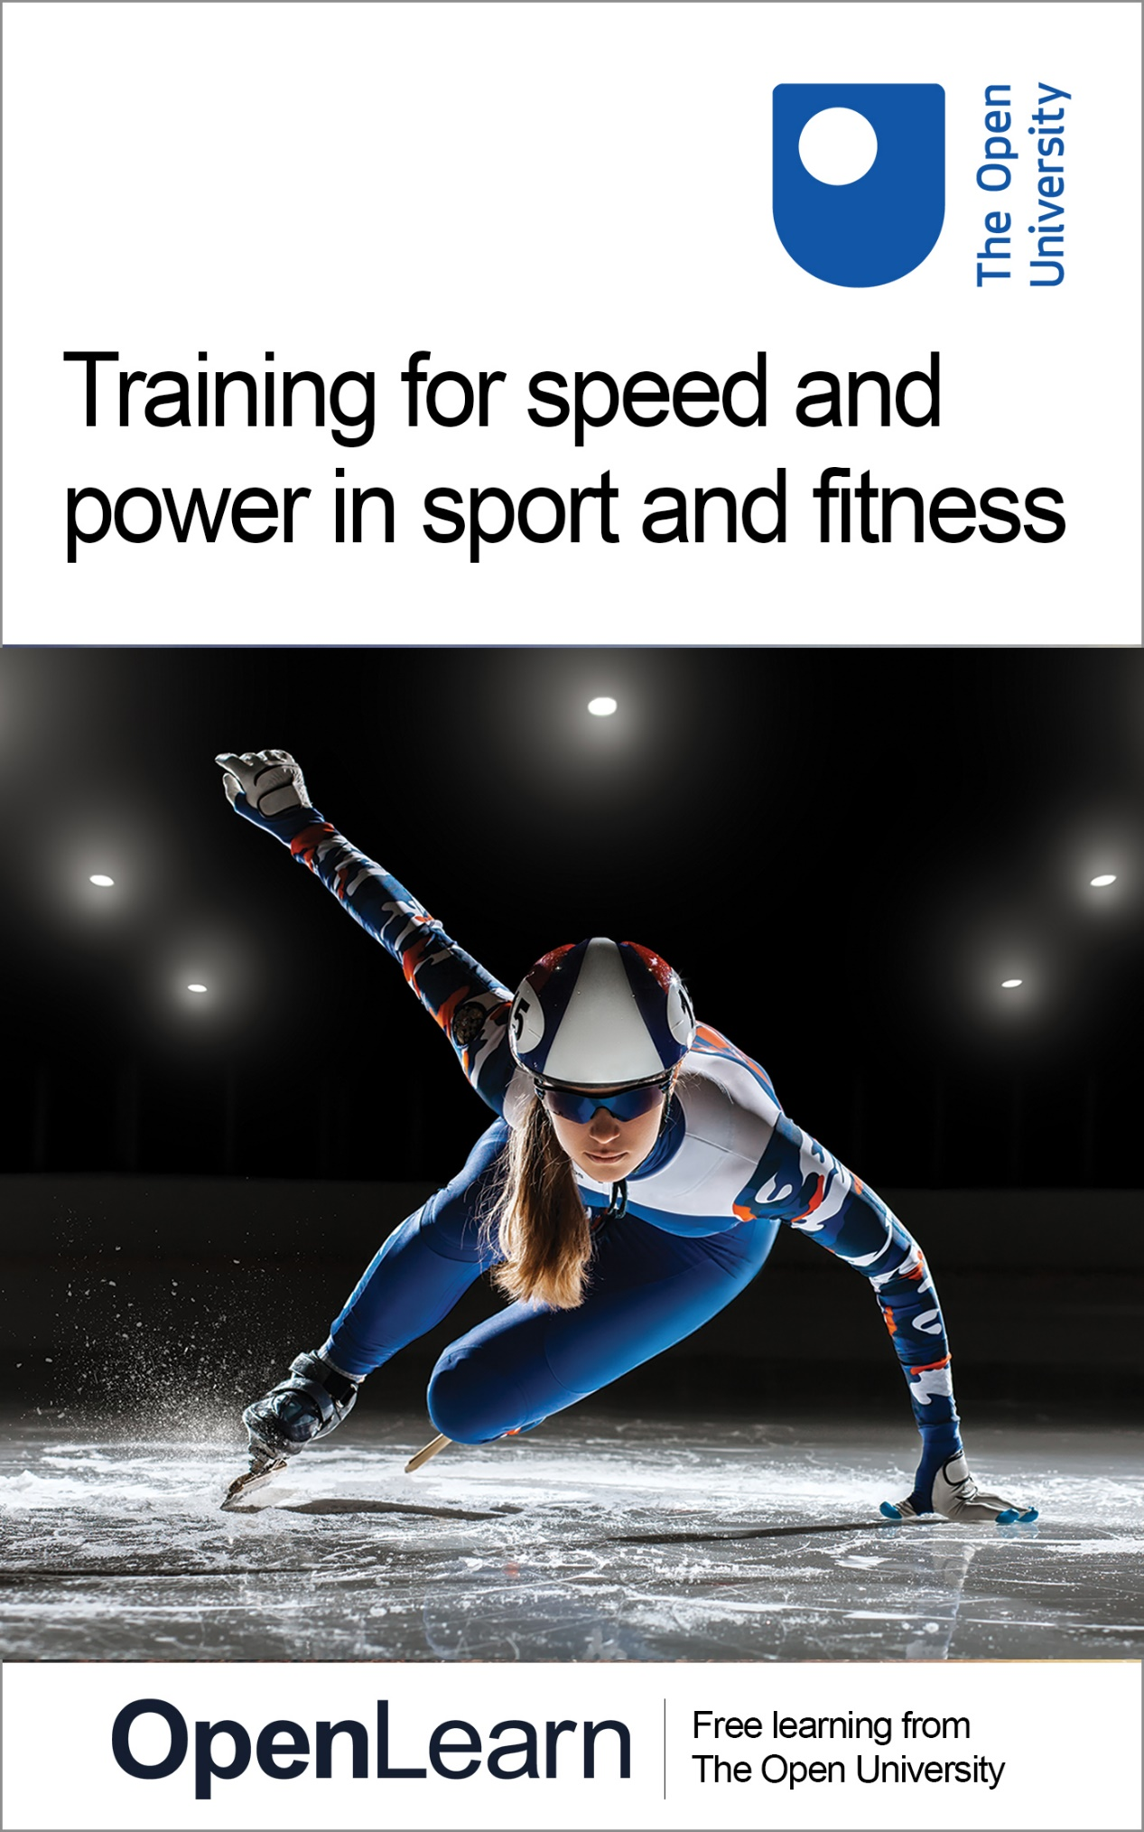

E236_2

Training for speed and power in sport and fitness

About this free course
This free course is an adapted extract from the Open University course E236 Applying sport and exercise sciences to coaching: www.open.ac.uk/courses/modules/e236.
This version of the content may include video, images and interactive content that may not be optimised for your device.
You can experience this free course as it was originally designed on OpenLearn, the home of free learning from The Open University –
www.open.edu/openlearn/health-sports-psychology/training-speed-and-power-sport-and-fitness/content-section-0
There you’ll also be able to track your progress via your activity record, which you can use to demonstrate your learning.
Copyright © 2020 The Open University
Intellectual property
Unless otherwise stated, this resource is released under the terms of the Creative Commons Licence v4.0 http://creativecommons.org/licenses/by-nc-sa/4.0/deed.en_GB. Within that The Open University interprets this licence in the following way: www.open.edu/openlearn/about-openlearn/frequently-asked-questions-on-openlearn. Copyright and rights falling outside the terms of the Creative Commons Licence are retained or controlled by The Open University. Please read the full text before using any of the content.
We believe the primary barrier to accessing high-quality educational experiences is cost, which is why we aim to publish as much free content as possible under an open licence. If it proves difficult to release content under our preferred Creative Commons licence (e.g. because we can’t afford or gain the clearances or find suitable alternatives), we will still release the materials for free under a personal end-user licence.
This is because the learning experience will always be the same high quality offering and that should always be seen as positive – even if at times the licensing is different to Creative Commons.
When using the content you must attribute us (The Open University) (the OU) and any identified author in accordance with the terms of the Creative Commons Licence.
The Acknowledgements section is used to list, amongst other things, third party (Proprietary), licensed content which is not subject to Creative Commons licensing. Proprietary content must be used (retained) intact and in context to the content at all times.
The Acknowledgements section is also used to bring to your attention any other Special Restrictions which may apply to the content. For example there may be times when the Creative Commons Non-Commercial Sharealike licence does not apply to any of the content even if owned by us (The Open University). In these instances, unless stated otherwise, the content may be used for personal and non-commercial use.
We have also identified as Proprietary other material included in the content which is not subject to Creative Commons Licence. These are OU logos, trading names and may extend to certain photographic and video images and sound recordings and any other material as may be brought to your attention.
Unauthorised use of any of the content may constitute a breach of the terms and conditions and/or intellectual property laws.
We reserve the right to alter, amend or bring to an end any terms and conditions provided here without notice.
All rights falling outside the terms of the Creative Commons licence are retained or controlled by The Open University.
Head of Intellectual Property, The Open University

Contents
- Introduction
  - Introduction
- Learning outcomes
- 1 What are speed and power?
- 2 Speed
  - 2.1 The mechanics of speed
  - 2.2 The physiology of speed
  - 2.3 Developing speed: methods
  - 2.4 Speed training in action
- 3 Power
  - 3.1 Power training: physiology and mechanics
  - 3.2 Developing power: plyometric training
  - 3.3 Developing power: weight training
- 4 End-of-course quiz
- Conclusion
- References
- Acknowledgements
- Solutions
- Descriptions

Introduction

Introduction
Welcome to this free course in which you will explore training for speed and power in relation to sport and fitness. Speed and power are separate but closely related components of fitness that are important in a wide range of sports and activities. First, you will consider the mechanics and physiology of speed before looking at training methods to develop speed. You will follow a similar structure in the second half of the course where you will examine the mechanics and physiology of power, then look at training to develop power.
This OpenLearn course is an adapted extract from the Open University course E236 Applying sport and exercise sciences to coaching.

Learning outcomes
After studying this course, you should be able to:
- explain what is meant by the concepts of speed and power
- understand the physiological principles that underpin speed and power
- apply a range of training techniques for speed and power in practice.

1 What are speed and power?
Before you can look at how to train for speed and power you need to understand the definitions, mechanics and physiology of these components of fitness. In Activity 1 you will start by exploring speed and power.

Activity 1 What are speed and power?
Allow 10 minutes for this activity

Watch Video 1 and then reflect on what the words ‘speed’ and ‘power’ mean to you.

Video content is not available in this format.
Video 1 Speed and power
View transcript - Video 1 Speed and power

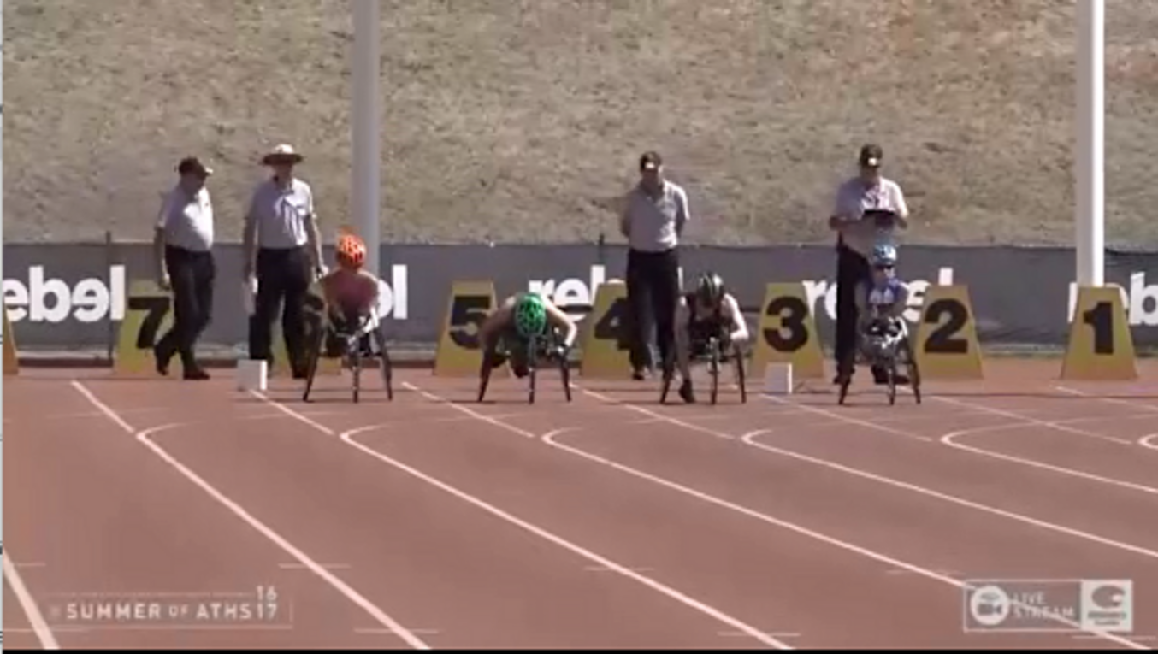

Now answer the following questions and write them in the box below.
- What is speed?
- What is power?
- What sports/activities require speed and power?

Provide your answer...
View discussion - Activity 1 What are speed and power?

Hence training to develop speed and power needs to consider the movements involved in partaking in the sport. You will now consider this: the mechanics and physiology of speed.

2 Speed

Figure 1
View description - Figure 1
View alternative description - Figure 1

In simple terms, speed refers to how quickly an athlete moves. This may relate to movement of the entire body itself from start to finish over a specific distance (as in a 50m sprint swim) or to how quickly an athlete can move a body part (as in throwing a rapid punch in boxing). Speed is also related to the component of agility, when one quickly changes direction (as in making a rapid turn to avoid an opponent in hockey). In the next section you will further your understanding of speed by exploring biomechanical principles.

2.1 The mechanics of speed
In this section you will investigate the biomechanics of speed in order to buttress your understanding of speed and how to develop it.

Activity 2 Speed mechanics
Allow 40 minutes for this activity

Watch Video 2 and have a look at the glossary below in Box 1. Once you’ve watched Video 2 and completed the reading, fill in the gaps in the statements below which describe how these terms can be applied to a sprinter at the start of a race.

Video content is not available in this format.
Video 2 The science of sprinting
View transcript - Video 2 The science of sprinting

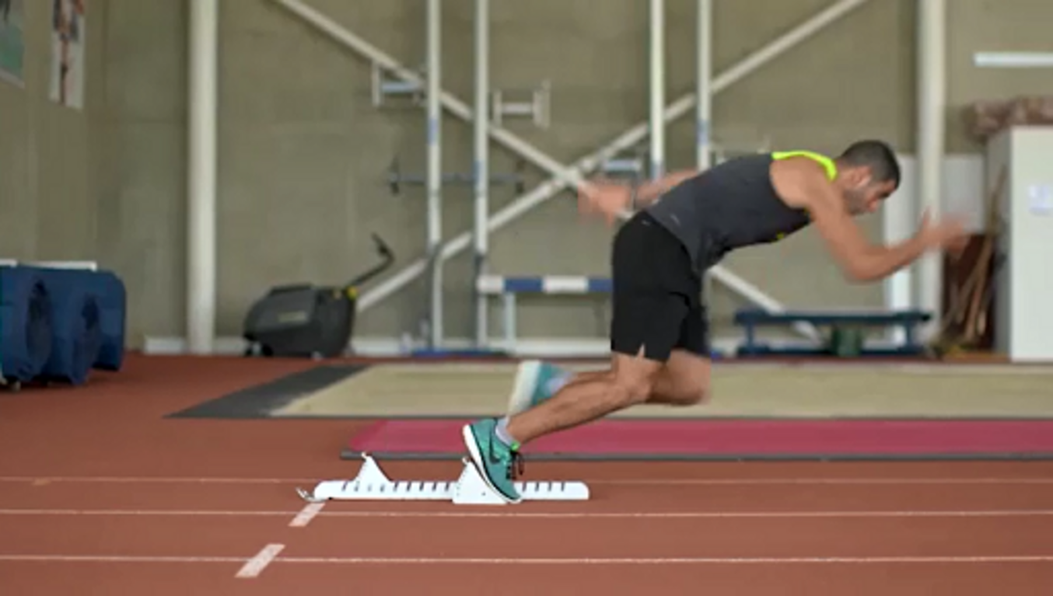

Box 1 Glossary of speed terms
- Velocity: How fast an object (or person) is moving and its direction
- Speed: The rate at which an object (or person) covers a distance
- Impulse: The product of the force generated, and the time required to produce the force (force x time)
- Force: The product of mass and acceleration or a push/pull exerted on one object by another
- Acceleration: The rate at which an object’s velocity changes over time

Use the drop-down menus to select the correct missing word.

Interactive content is not available in this format.

Having explored the biomechanical principles of speed you will now look at the physiology of speed and how this relates to speed training.

2.2 The physiology of speed

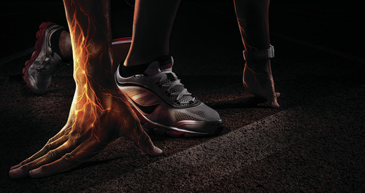
Figure 2
View description - Figure 2
View alternative description - Figure 2

An athlete’s neuromuscular system is vital to sprint performance because it can influence the rate and strength of muscle contraction. Having a greater understanding of the neuromuscular system is important to identify its contribution to speed and its opportunity for development. An overview of the neuromuscular contributions to speed are shown in Table 1.

Table 1 Neurophysiological basis for speed
System/Section | Key learning points and application to a sprinter
Muscular system | The composition of muscle fibre types (i.e. amount of Type 1, IIa and IIx fibres) can dictate speed performance (Jeffreys, 2013). Those with a relatively higher proportion of fast-twitch fibres (Type IIa and Type IIx) have a greater capacity to produce force and develop speed.  While there is a major genetic component underlying whatever proportion of fast- and slow-twitch muscle fibres particular individuals may have, training may also have an effect. For example, endurance training may lead to Type IIa fibres taking on the aerobic characteristics of Type I fibres, reducing the force capacity of the muscle and the ability to generate speed (Jeffreys, 2013).
Nervous system | Sprint training will lead to several adaptations in her neuromuscular system, such as an enhanced neural drive (rate and amplitude of impulses being sent from the nervous system to her muscles).  Increases in neural drive may contribute to increasing a sprinter’s rate of force development and impulse generation, which as you saw in Activity 2 will improve sprinting performance.

This again links back to the principle of specificity: for a training programme to develop speed it needs to include exercises and/or activities that are performed at speed. To develop the neuromuscular system’s contribution to power, heavy weight training and plyometric exercise can be used to develop the capacity of fast twitch muscle fibres and enhance neural drive.
Now that you’ve considered how the physiology of speed may influence training methods used to develop speed, you can move on to look at the application of speed training methods by the strength and conditioning coach.

2.3 Developing speed: methods

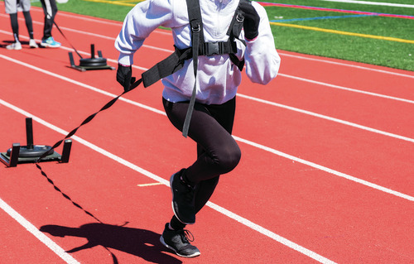
Figure 3
View description - Figure 3
View alternative description - Figure 3

After gaining an understanding of the biomechanics and physiology of speed, you can now turn your attention to the training methods that may be used to develop speed. Plisk (2008) identifies three methods for developing speed: primary, secondary and tertiary methods.
- Primary methods focus on executing sound movement technique in a speciﬁc task. Initially primary methods of developing speed tend to be performed at speeds slower than those used in the real situation to ensure that the mechanics of the movement are correct, progressing to full speed as the individual develops their skills (for example, with a high knee drill).
- Secondary methods involve developing specialist skills in modified conditions and include sprint resistance and sprint assistance methods.
  - Speed resistance methods aim to provide resistance without interrupting movement mechanics. This resistance may come from physical resistance (as with running while pulling a sled or with a parachute).
  - Speed assistance methods aim to facilitate movements at a faster speed than normal (‘over-speed’) and include downhill running and running while being towed.
- Tertiary methods involve developing general skills and abilities and include the development of mobility (as with a dynamic lunge with rotation), strength (as with resistance training) and speed-endurance (as with interval training).

2.4 Speed training in action
In Activity 3 you will watch a short video of speed training in action which will help you consider how a strength and conditioning coach could use different methods with athletes.

Activity 3 Speed training in action
Allow 30 minutes for this activity

Watch Video 3, in which strength and conditioning coach Fiona Scott at the University of Hertfordshire, UK, leads a speed training session for some university athletes and students.

Video content is not available in this format.
Video 3 Fiona Scott: speed training
View transcript - Video 3 Fiona Scott: speed training

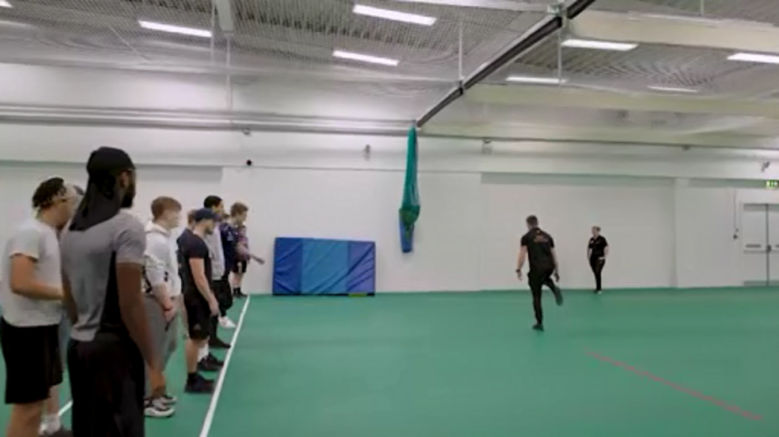

Now answer the following questions:
- What information does the strength and conditioning coach gather to plan speed training sessions?
- What speed training activities are being performed by the athletes and to what extent are they specific to the demands of the sport?
- How does the strength and conditioning coach progress speed training exercises?

Provide your answer...
View discussion - Activity 3 Speed training in action

Speed resistance training, as with the resistance-band sprinting you saw in Video 3, is hypothesised to have various benefits (for example, improving acceleration), but if the loads are not appropriate for the individual that may overly affect the mechanics of running (DeWeese and Nimphuis, 2016). Considerable research has been done on speed resistance training. For example, in a review of the literature Alcaraz et al. (2018) concluded that resisted sled training is an effective method of improving sprint performance. However, there is limited research evidence to support the use of speed assistance and it can lead to negative effects such as an increase in braking forces (DeWeese and Nimphuis, 2016). The strength and conditioning coach should consider the robustness of research evidence supporting whatever methods they use with their athletes.
Having looked at speed training, you will now consider power.

3 Power

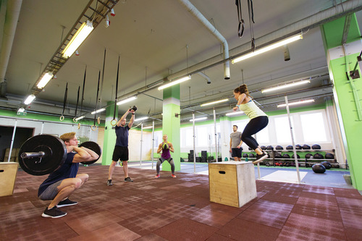
Figure 4
View description - Figure 4
View alternative description - Figure 4

Power is closely related to two components of fitness: strength and speed. Power is effectively the product of strength and speed (Faigenbaum, 2017) and is the ability to execute strong explosive movement at speed. As such, speed, strength and power are often jointly identified in needs analyses as key components of fitness in certain sports and/or activities (such as rugby, weightlifting, sprinting or hammer-throwing).
In this section you will primarily be considering two power training methods (plyometric training and weight training) and the science behind them. Plyometric training refers to explosive jump training that involves fast, powerful movements that are preceded by a stretch or countermovement (Potach and Chu, 2016). Before you consider these power training methods in detail you need to look at the physiology and biomechanics involved.

3.1 Power training: physiology and mechanics

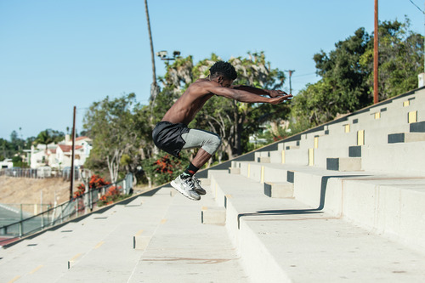
Figure 5
View description - Figure 5
View alternative description - Figure 5

When a muscle is stretched rapidly, the neuromuscular system responds by initiating a concentric muscle contraction to prevent the muscle from being stretched too far and becoming damaged. This is known as the stretch-reflex system. In plyometrics, this means that if a rapid eccentric loading phase is performed before a concentric contraction, a greater and more powerful concentric muscle action will occur. This ‘pre-stretch’ action is known as the stretch shortening cycle and is explained further in Activity 4.

Activity 4 Plyometric mechanics and physiology
Allow 40 minutes for this activity

Watch Video 4, on the stretch-shortening cycle, at the link below. Focus on the section between the start and 02:55. Once you’ve watched Video 4, do the related tasks below.
Video 4: The stretch-shortening cycle

1. Use the drop-down menus to select the correct missing word.

Interactive content is not available in this format.

2. Put the three phases of the stretch-shortening cycle in the order they are performed.

First
Second
Third
Eccentric
Amortisation
Concentric
View answer - Part

Now that you have an understanding of how plyometric training works, in the next section you will investigate some examples of plyometric training.

3.2 Developing power: plyometric training

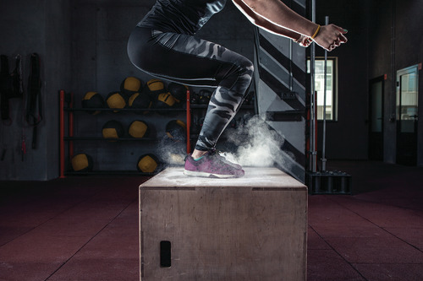
Figure 6
View description - Figure 6
View alternative description - Figure 6

Various studies have found plyometric training to be effective in developing power and improving performance (Stojanović et al., 2017). A wide range of plyometric exercises may be employed to develop power. Potach and Chu (2016) divide these into lower-body, upper-body and trunk exercises. The choice of exercises should depend on various factors, including the unique requirements of the individual (needs analysis), their age and fitness levels. You will consider some examples of plyometric exercises in Activity 5.

Activity 5 Plyometric training in action
Allow 30 minutes for this activity

Watch Video 5, in which a range of plyometric exercises are demonstrated. Then select one exercise that you think would be most appropriate to use with a 200m sprinter and explain why you selected this particular exercise.

Video content is not available in this format.
Video 5 Plyometric exercises
View transcript - Video 5 Plyometric exercises

Provide your answer...
View discussion - Activity 5 Plyometric training in action

Plyometric training provides an effective way to develop functional power and enables the strength and conditioning coach to prescribe functional exercises for the athlete which are specific to that athlete’s sport. In the early training of plyometrics, developing proper technique and balance must be prioritised to minimise the injury risk of the high intensity exercise. In the next section you will look at another method of developing power: weight training.

3.3 Developing power: weight training

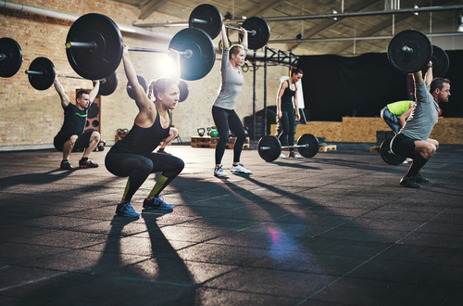
Figure 7
View description - Figure 7
View alternative description - Figure 7

In strength and conditioning, it is important to prescribe the correct intensity/load (i.e. % of repetition maximum (RM), number of repetitions, sets and amount of rest in relation to the training goal to gain maximum results). Table 2 shows that for power, high load and relatively few repetitions are recommended.

Table 2 Training principle recommendations for training goals
Training goal |  | Load  (% of 1RM) | Repetitions | Sets | Rest
Maximal strength |  | ≥ 85 | ≤ 6 | 2–6 | 2–5 minutes
Power | single-effort event | 80–90 | 1–2 | 3–5 | 2–5 minutes
 | multiple-effort event | 75–85 | 3–5
Hypertrophy |  | 67–85 | 6–12 | 3–6 | 30–90 seconds
Muscular endurance |  | ≤ 67 | ≥ 12 | 2–3 | ≤ 30 seconds
Source: Sheppard and Triplett (2016)

A single-effort event is where one maximum-power effort is required (i.e. shot put, high jump, power lifting). A multiple-effort event is one where repeated maximum-power efforts are required (i.e. rugby, volleyball).
For power, the type of exercise is also important to achieve training goals. In this section you will consider some examples of weight-lifting exercises that are suitable for developing power. As you would expect, given the definition of power, such exercises involve fast, explosive movements; you will investigate some of these in Activity 6.

Activity 6 Being explosive in the gym
Allow 10 minutes for this activity

Watch Video 6 in which you will see several weight-lifting exercises designed to develop power. Which exercises would be most appropriate for developing explosive leg power? Watch from 02:32 (‘Once you have a basis of strength …’) to 03:35 (‘… high-velocity power output movement’).
Video 6: Weight-lifting to develop power

Provide your answer...
View discussion - Activity 6 Being explosive in the gym

4 End-of-course quiz
You can now take part in a quiz which is an opportunity to check your learning of some of the main points addressed in this course.

End-of-course quiz

Which two components of fitness create power?

a) Muscular endurance x strength
b) Cardiovascular endurance x speed
c) Strength x speed
d) Anaerobic capacity x agility
View answer - Part

What are the two main training methods for developing power?

a) Plyometric and balance training
b) Plyometric and weight training
c) Plyometric and endurance training
d) Plyometric and core training
View answer - Part

In the stretch shortening cycle, which type of muscle contraction is required initially to create elastic energy?

a) Concentric contraction
b) Eccentric contraction
c) Isometric contraction
d) Isokinetic contraction
View answer - Part

Which of the following is a speed resistance method of speed training?

a) Running downhill
b) Running while being towed
c) Running with a parachute
d) All of the above
View answer - Part

What are the optimal training load, repetitions, sets and rest periods to develop power?

a) ≥85% of 1RM, 1–6 repetitions, 2–6 sets, 2–5 minutes rest between sets
b) 75–90% of 1RM, 1–5 repetitions, 3–5 sets, 2–5 minutes rest between sets
c) 67–85% of 1RM, 6–12 repetitions, 3–6 sets, 30–90 seconds rest between sets
d) ≤67% of 1RM, ≥12 repetitions, 2–3 sets, ≤30 seconds rest between sets
View answer - Part

Conclusion
In this course you’ve investigated speed and power in relation to sport and fitness. The key learning points from the course are that:
- speed and power are key components of fitness in a range of sports and activities
- in simple terms, speed relates to how quickly we move, while power is a combination of strength and speed
- in order to design effective training programmes, you need to understand the mechanics and physiology of speed and power
- speed training methods include speed resistance methods (as with sled-pulling) and speed assistance methods (as with downhill running)
- power training methods include plyometrics and Olympic lifts.
This OpenLearn course is an adapted extract from the Open University course E236 Applying sport and exercise sciences to coaching.
You might interested in another OpenLearn course taken from this Open University course: Training for endurance in sport and fitness.

References
Alcaraz, P.E. et al. (2018) ‘The effectiveness of resisted sled training (RST) for sprint performance: a systematic review and meta-analysis’, Sports Medicine, 48(9), pp. 2143–65.
DeWeese, B.H. and Nimphuis, S. (2016) ‘Program design and technique for speed and agility training’, in Haff, G. G. and Triplett, N. T. (eds) Essentials of strength training and conditioning (4th edn). Leeds: Human Kinetics, pp. 521–57.
Faigenbaum, A. (2017) ‘Exercise prescription for muscular fitness’, in Howley, E. T. (ed.) Fitness professional’s handbook (7th edn). Leeds: Human Kinetics, pp. 257–89.
Jeffreys, I. (2013) ‘The nature of speed’, in Jeffreys, I. (ed.) Developing speed. Leeds: Human Kinetics, pp. 1–18.
Ľubos, G. et al. (2018) ‘Effect of resistance training with parachutes on power and speed development in a group of competitive swimmers’, Journal of Physical Education and Sport, 18(2), pp. 787–91.
Murray, B. and Kenny, W.L. (2016) Practical guide to exercise physiology. Leeds: Human Kinetics.
Plisk, S. S. (2008) ‘Speed, agility, and speed-endurance development’, in Baechle, T. R. and Earle, R.W. (eds) Essentials of strength training and conditioning (3rd edn). Leeds: Human Kinetics, pp. 457–85.
Potach, D.H. and Chu, D.A. (2016) ‘Program design and technique for plyometric training’, in Haff, G.G. and Triplett, N.T. (eds) Essentials of strength training and conditioning (4th edn). Leeds: Human Kinetics, pp. 471–520.
Sheppard, J.M. and Triplett, N.T. (2016) ‘Program design for resistance training’ in Haff, G.G., and Triplett, N.T. (eds) Essentials of Strength Training and Conditioning, 4th edn. Champaign, Il: Human Kinetics, pp. 439-470.
Stojanović, E. et al. (2017) ‘Effect of plyometric training on vertical jump performance in female athletes: a systematic review and meta-analysis’, Sports Medicine, 47(5), pp. 975–86.

Acknowledgements
This free course was written by Simon Penn, Caroline Heaney and Nigel Wright.
Except for third party materials and otherwise stated (see terms and conditions), this content is made available under a Creative Commons Attribution-NonCommercial-ShareAlike 4.0 Licence.
The material acknowledged below is Proprietary and used under licence (not subject to Creative Commons Licence). Grateful acknowledgement is made to the following sources for permission to reproduce material in this free course:
Course image: © Coolakov_com/Shutterstock
Figure 1: © sportpoint/Shutterstock
Figure 2: © Rocksweeper/Shuttersock
Figure 3: © WoodysPhotos/Shutterstock
Figure 4: © Syda Productions/Shutterstock
Figure 5: © Jon Osumi/Shutterstock
Figure 6: © takoburito/iStock
Figure 7: © Flamingo Images/Shutterstock
Video 1: ‘Women 100m wheelchair – 2017 SUMMERofATHS Grand Prix’, used with permission of Athletics Australia
Video 2: ‘Sprinting – science behind the sport’, used with permission from Gillette North America
Video 3: ‘Catch the light’, Audio Network Limited
Video 5: ‘Plyometric exercises – 23 Plyo Variations’, courtesy of Cori Lefkowith, RedefiningStrength.com
Every effort has been made to contact copyright owners. If any have been inadvertently overlooked, the publishers will be pleased to make the necessary arrangements at the first opportunity.
Don't miss out
If reading this text has inspired you to learn more, you may be interested in joining the millions of people who discover our free learning resources and qualifications by visiting The Open University – www.open.edu/openlearn/free-courses.

Solutions

Activity 1 What are speed and power?

Discussion
Speed can be defined as a measure of the rate of motion and is therefore the distance travelled divided by the time taken to travel that distance (Murray and Kenny, 2016). Power is a measure of the rate at which energy is transferred – that is, power is force multiplied by distance divided by time (Murray and Kenny, 2016). So in simple terms speed refers to how quickly we move (for example, from the start to the end of a 100m race), while power is a combination of strength and speed, and refers to the ability to execute strong explosive movement at a fast pace (for instance, as with exploding from the starting blocks). Speed and power are closely related, and both are often important in specific sports or activities.
A needs analysis of your sport or activity will indicate how important speed and power are to you. There is a wide range of sports and activities in which speed and power are important – in some sports such as sprinting or power-lifting, achieving speed and power are the main objectives, whereas in other sports such as rugby or football they are just one aspect of the sport. Speed or power may be required in various parts of the body – for example, in cricket the arm of a bowler needs to be able to travel at speed to deliver the ball, but the legs and the rest of the body also need to move fast in order to enable this.
Back to - Activity 1 What are speed and power?

Activity 3 Speed training in action

Discussion
- Before planning speed sessions, Fiona the strength and conditioning coach will talk to the athlete to confirm their training age and injury history. Then Fiona will perform a needs analysis of both the athlete and their sport to determine the biomechanical, physiological and injury prevention needs.
- In Video 3 you see the coach deliver speed drills (primary method), resistance-band acceleration (secondary method), and plyometric training. Speed resistance and assistance training methods could be useful to any individual who needed to develop speed and therefore could be utilised by individuals from a range of sports. As always, the training principle of specificity should be considered when identifying appropriate speed training exercises. The examples in Video 3 are all running-based and would therefore be appropriate for individuals who wish to develop their running speed (such as sprinters, footballer players, rugby players). Alternative exercises would be more appropriate for those who needed to develop speed in other movements (such as throwers, bowlers, swimmers). For example, L’ubos et al. (2018) found that swimming training with a parachute (speed resistance) improved swimming speed.
- Speed training can be progressed by increasing the volume (the demand that the athlete places on their body), load (resist movement or increase height in plyometrics) or frequency (number of sessions per week) of training.
Back to - Activity 3 Speed training in action

Activity 4 Plyometric mechanics and physiology

Part

Answer
The correct matches are:
First
Eccentric
Second
Amortisation
Third
Concentric
Back to - Part

Activity 5 Plyometric training in action

Discussion
You probably chose your exercise by applying the principle of specificity. In other words, you probably tried to select an exercise that would be relevant to a 200m sprinter. Any of the lower body plyometric exercises with similar movement patterns (i.e. in a sagittal plane), or that work the muscle groups that a 200m sprinter needs to develop (i.e. quadriceps, hamstrings, gastrocnemius) in order to improve her sprint performance would be beneficial.
Back to - Activity 5 Plyometric training in action

Activity 6 Being explosive in the gym

Discussion
In Video 6 you see a variety of exercises being performed, including power cleans, power snatch and squat jumps. What all these exercises have in common is that they’re performed with fast, explosive or jumping movements – so they differ from more traditional weightlifting exercises which tend to be performed more slowly. Explosive exercises require relatively more technical input from a qualified strength and conditioning coach. Weight training exercises to develop power include Olympic lifts (such as snatch, clean and jerk). Squat jumps, the snatch and the clean are very effective at developing explosive leg power for sprinting.
Back to - Activity 6 Being explosive in the gym

End-of-course quiz

Part

Answer
Right:
c) Strength x speed
Wrong:
a) Muscular endurance x strength
b) Cardiovascular endurance x speed
d) Anaerobic capacity x agility
Back to - Part

Part

Answer
Right:
b) Plyometric and weight training
Wrong:
a) Plyometric and balance training
c) Plyometric and endurance training
d) Plyometric and core training
Back to - Part

Part

Answer
Right:
b) Eccentric contraction
Wrong:
a) Concentric contraction
c) Isometric contraction
d) Isokinetic contraction
Back to - Part

Part

Answer
Right:
c) Running with a parachute
Wrong:
a) Running downhill
b) Running while being towed
d) All of the above
Back to - Part

Part

Answer
Right:
b) 75–90% of 1RM, 1–5 repetitions, 3–5 sets, 2–5 minutes rest between sets
Wrong:
a) ≥85% of 1RM, 1–6 repetitions, 2–6 sets, 2–5 minutes rest between sets
c) 67–85% of 1RM, 6–12 repetitions, 3–6 sets, 30–90 seconds rest between sets
d) ≤67% of 1RM, ≥12 repetitions, 2–3 sets, ≤30 seconds rest between sets
Back to - Part

Descriptions

Figure 1
An image of a female disabled sprinter
Back to - Figure 1

Figure 1
An image of a female disabled sprinter
Back to - Figure 1

Figure 2
An image of a hand on the starting line with power in nerves and veins
Back to - Figure 2

Figure 2
An image of a hand on the starting line with power in nerves and veins
Back to - Figure 2

Figure 3
An image of a man sprinting pulling a sled behind him on the running track
Back to - Figure 3

Figure 3
An image of a man sprinting pulling a sled behind him on the running track
Back to - Figure 3

Figure 4
An image of males and females performing a range of power training exercises.
Back to - Figure 4

Figure 4
An image of males and females performing a range of power training exercises.
Back to - Figure 4

Figure 5
An image of a person bounding up steps
Back to - Figure 5

Figure 5
An image of a person bounding up steps
Back to - Figure 5

Figure 6
An image of a person jumping onto a wooden box
Back to - Figure 6

Figure 6
An image of a person jumping onto a wooden box
Back to - Figure 6

Figure 7
Image of men and women performing a snatch lift with a barbell in a gym
Back to - Figure 7

Figure 7
Image of men and women performing a snatch lift with a barbell in a gym
Back to - Figure 7

Video 1 Speed and power

Transcript
[MUSIC PLAYING]
ANNOUNCER 1
And we're going to head down to the track here, the women's 100-metre sprint wheelchair. From the inside, Kiama, Angie Ballard, Robin Lambert, and Eliza Ault-Connell.
ANNOUNCER 2
And that is the women's 100-metres sprint wheelchair.
[MUSIC PLAYING]
[CROWD CHATTER]
ANNOUNCER 1
They're off and rolling now. Eliza Ault-Connell on the outside, and Angie Ballard. We've seen these two girls battle over the two and the 800. It looks like Angie Ballard here way too strong to win a plus 1.5, and she's going to take it out, followed by Connell, and then Lambert, and Kiama Uka there just crossing the line. But Angie Ballard too strong over this 100 metres.
Back to - Video 1 Speed and power

Video 2 The science of sprinting

Transcript
[MUSIC PLAYING]
NARRATOR
We are appealing to your inner geek, as we get out the blocks with the precision science of track sprinting.
DR. NEAL SMITH
The sprint start is all about generating power, so we need to be very quick to leave the blocks. So you'll notice that sprinters will have very short, staccato-like steps at the beginning of a race to try and generate as much force, and the friction that they interact on the ground, as the spikes touch the track surface, to try and propel forwards.
When we multiply force by the amount of time that we spend applying that force, we get something that's called impulse. The greater impulse that we can then generate will mean that we can help to propel our centre of gravity forwards out the blocks as quickly as we possibly can.
From a biomechanics point of view, we need pieces of kit that will help us slow down that technique so we can understand what is happening at every foot contact. We'll use things like three-dimensional motion capture, to help us monitor the movements of the arms and the legs. And we'll also use things like force transducers to try and help us understand the forces under the feet that are generated during the sprint start.
DR. SCOTT WEISS
Not only is it important getting out of the blocks, but you'll see them always keeping their head down to maintain peak velocity. Once peak velocity is hit, you start to see the gaze, and the eyes go up towards the finish line. And that's where they try to maintain that speed.
Back to - Video 2 The science of sprinting

Video 3 Fiona Scott: speed training

Transcript
[MUSIC PLAYING]
FIONA SCOTT: I'm Fiona Scott. I work at the University of Hertfordshire in a S&C department within that called Performance Herts. We deliver to university athletes, as well as external clubs such as Saracens Mavericks, Arsenal Ladies, Women's FC. And then on top of that, we've done workshops in S&C areas and fields, and also lecture. Today we're in the cricket hall, and we are going to be running an acceleration, speed, agility, and plyometric sessions. We often shorten that to an ASAP session.
JACK TYLER: We're going to do a few sets of these. Just take your time to find your co-ordination.
FIONA SCOTT: Coaches Jack and Louis are going to be taking through a mixture of students from the performance sports at the university, from American football, women's football, netball. And then on top of that, we've also got some sport and exercise science students, and they're working towards their S&C module.
JACK TYLER: So with this one, we're just looking to float a bit more in the air.
FIONA SCOTT: Information I gather before planning my speed sessions-- it would very much be who the athletes are, who I'm going to be training. If I don't know too much about the sport, I would always do a needs analysis of it to see what the sport entails. The needs analysis generally encompasses a biomechanical, a physiological, and an injury analysis.
JACK TYLER: Push away, push, push.
FIONA SCOTT: And that gives us a very good understanding of the sporting elements that they require.
JACK TYLER: Tap the ground. Slow it down.
FIONA SCOTT: From just watching the sport, you can get an idea of what movements they need, whether they need to move more horizontally or propel themselves more vertically in say, basketball and netball. And again, that will help give you a priority in the session.
JACK TYLER: We're going to progress on our plyometrics. So we've got two hurdle heights. You can pick which one.
FIONA SCOTT: You'd ask the athletes. You try and get a bit of an understanding of their training age, so not just their training age within their sport, but also their training age within strength and conditioning, which can often be quite low.
Nice, keep that nice.
Injury history, and when we're doing a session where we need people to be fully fit, plyometrics, for example, you need to be injury-free, and you definitely need a very good underlying strength history and remit. With all strength and conditioning training, but especially speed, we see a lot of athletes. And some of the drills are very basic. But you do need to regress and progress drills based on the athletes in front of you, and what they can cope with and what they can manage.
JACK TYLER: Keeping your spacing and imagining you're in a tunnel, you're just going to push and hold.
FIONA SCOTT: There's a multitude of ways to progress drills. One would be by increasing volume, so the demand that the athlete's putting on their body. Another way is by loading, so not necessarily with external weight or anything, but you might resist movement, which takes us into secondary speed drills. Or you might just-- if you're doing plyometrics-- go from a higher height, or increase the forces the athlete's exposed to with each drill.
And I guess the final way would be also frequency as well. Most athletes, when they're starting, once a week would probably be enough to get an improvement. But as athletes get more advanced, they'll have to train more frequently. So it'd be sort of more like two, maybe three times a week. But realistically, with their sporting demands, and trying to fit in everything into a week, probably two.
Make sure you're strong, push into the wall.
One of the hardest things for us as their S&C coaching team is to actually try and periodise their week, and work out when best to fit in their training.
JACK TYLER: We're going to combine our acceleration and change of direction work. Tom can weave to get away from Louis.
[LAUGHTER]
FIONA SCOTT: Sessions-wise, they're quite short. They don't need to be long. And that's because you really want to prioritise quality over quantity. And it can take anywhere from 10 minutes to 30 minutes. If you then add in the other aspects like the plyometric training, like the agility and change directional training, the maximum a session would be is probably an hour. Everything you train wants to be maximum intensity and with good form. So that's what sort of help dictates your rest periods. And you let them rest plenty so that they're ready to go again. And if form dissipates, then that might be the end of a session, or you might just give them longer.
STUDENT: Today, we were just going through some speed and acceleration stuff. It's beneficial to netball, as that is majority of what we do throughout the game.
STUDENT: We've just come to the end of our season now, so this is like prep, really, for next season already.
[LAUGHTER]
FIONA SCOTT: A good outcome we're looking for is that a coach could see the transference to their sport. Nothing would be better to us than hearing a coach come over to us and saying, all that work you're doing in your speed drills is really starting to transfer over and make an improvement to their sporting performance. We only objectively know that by doing fitness tests. But it is always nice to hear the subjective reports.
Back to - Video 3 Fiona Scott: speed training

Video 5 Plyometric exercises

Transcript
[MUSIC PLAYING]
CORI LEFKOWITH
Hey, guys. It's Cori from Redefining Strength. And today we're going to go over some plyometric exercises. Plyometric movements are explosive, powerful movements that you do for short intervals of work, and then you rest after. If you see one we missed or if there's one you really love, comment below, and make sure to subscribe. We're posting new videos each week.
[MUSIC PLAYING]
Back to - Video 5 Plyometric exercises

