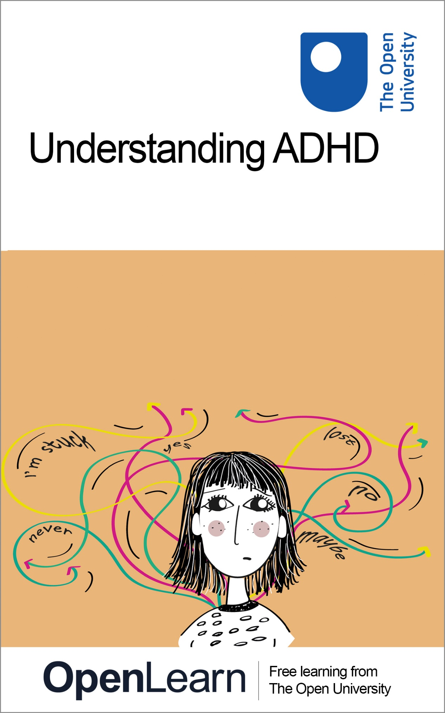

SK298

Understanding ADHD

About this free course
This free course is an adapted extract from the Open University course SK298 Brain, mind and mental healthwww.open.ac.uk/courses/modules/sk298.
This version of the content may include video, images and interactive content that may not be optimised for your device.
You can experience this free course as it was originally designed on OpenLearn, the home of free learning from The Open University – www.open.edu/openlearn/health-sports-psychology/health/understanding-adhd/content-section-0
There you’ll also be able to track your progress via your activity record, which you can use to demonstrate your learning.
Copyright © 2021 The Open University
Intellectual property
Unless otherwise stated, this resource is released under the terms of the Creative Commons Licence v4.0 http://creativecommons.org/licenses/by-nc-sa/4.0/deed.en_GB. Within that The Open University interprets this licence in the following way: www.open.edu/openlearn/about-openlearn/frequently-asked-questions-on-openlearn. Copyright and rights falling outside the terms of the Creative Commons Licence are retained or controlled by The Open University. Please read the full text before using any of the content.
We believe the primary barrier to accessing high-quality educational experiences is cost, which is why we aim to publish as much free content as possible under an open licence. If it proves difficult to release content under our preferred Creative Commons licence (e.g. because we can’t afford or gain the clearances or find suitable alternatives), we will still release the materials for free under a personal end-user licence.
This is because the learning experience will always be the same high quality offering and that should always be seen as positive – even if at times the licensing is different to Creative Commons.
When using the content you must attribute us (The Open University) (the OU) and any identified author in accordance with the terms of the Creative Commons Licence.
The Acknowledgements section is used to list, amongst other things, third party (Proprietary), licensed content which is not subject to Creative Commons licensing. Proprietary content must be used (retained) intact and in context to the content at all times.
The Acknowledgements section is also used to bring to your attention any other Special Restrictions which may apply to the content. For example there may be times when the Creative Commons Non-Commercial Sharealike licence does not apply to any of the content even if owned by us (The Open University). In these instances, unless stated otherwise, the content may be used for personal and non-commercial use.
We have also identified as Proprietary other material included in the content which is not subject to Creative Commons Licence. These are OU logos, trading names and may extend to certain photographic and video images and sound recordings and any other material as may be brought to your attention.
Unauthorised use of any of the content may constitute a breach of the terms and conditions and/or intellectual property laws.
We reserve the right to alter, amend or bring to an end any terms and conditions provided here without notice.
All rights falling outside the terms of the Creative Commons licence are retained or controlled by The Open University.
Head of Intellectual Property, The Open University

Contents
- Introduction
- Learning outcomes
- Session 1: Understanding life with ADHD
  - 1.1 Characteristics and prevalence of ADHD
  - 1.2 Experiencing ADHD
  - 1.3 Diagnosing ADHD
  - 1.4 Risk factors for ADHD
  - Session 1 summary
- Session 2: The neurobiology and management of ADHD
  - 2.1 ADHD and the brain
  - 2.2 Approaches to managing ADHD
  - Session 2 summary
- Conclusion
- References
- Acknowledgements
- Solutions

Introduction
In this course you will be learning about a neurodevelopmental condition called attention deficit hyperactivity disorder or ADHD. A neurodevelopmental condition occurs when childhood development differs from a typical trajectory. In the first session of this course you will cover the prevalence of ADHD and how it is experienced by those who have the condition, followed by how it is diagnosed and the possible risk factors for the condition. In the second session, you will look at some of the changes in the brain in people with ADHD and consider how the condition is managed both with, and without, medication.

Reflecting on your perceptions of ADHD
Allow about 10 minutes

Before you study this topic, it is helpful to reflect on any pre-existing perceptions and beliefs you may have about ADHD. These may come from personal experiences, previous study, or even media coverage. Spend a few minutes now noting down any thoughts that come to mind when you think about a person with ADHD. For example, are they male, female, young or old, and how do they behave? You may wish to use the box provided.

Provide your answer...
View discussion - Reflecting on your perceptions of ADHD

This OpenLearn course is an adapted extract from the Open University course SK298 Brain, mind and mental health.

Learning outcomes
After studying this course, you should be able to:
- define key terms in the field of ADHD
- describe the characteristics of ADHD and how they are used in diagnosis
- describe the patterns of prevalence of ADHD, including the reasons for disparities worldwide
- describe risk factors and brain changes associated with ADHD
- outline key approaches to managing ADHD, with reference to their scientific evidence base.

Session 1: Understanding life with ADHD
ADHD, like other conditions such as autism, is considered to be a neurodevelopmental condition. Neurodevelopmental conditions arise as a result of atypical development of the nervous system during the early stages of life due to the interaction of genetic, neurobiological and environmental influences.
In the following section you will learn more about the characteristics and prevalence of this condition.

1.1 Characteristics and prevalence of ADHD
Atypical development during ADHD results in persistent and developmentally inappropriate levels of:

- inattention
- hyperactivity
- impulsivity.
(APA, 2000)

Of course, individuals without ADHD can still be inattentive, hyperactive and impulsive to some degree but with ADHD, as with other neurodevelopmental conditions such as autism, these behaviours are persistent and represent a divergence from typical cognitive milestones.
Prevalence data (the number of new and continuing cases) indicate that ADHD is the most common of the neurodevelopmental conditions (Hansen et al., 2018).
Estimates of the worldwide prevalence of ADHD are around 6 in 100 children and adolescents and 3 in 100 adults (Spencer et al., 2002; Moffitt et al., 2015).

- What do you notice about prevalence rates in the two age groups?
- Around twice as many children and adolescents have ADHD compared with adults.

This difference in prevalence was initially thought to arise because some children with ADHD simply grew out of their condition. However, it has now been suggested that the two cohorts (i.e. children/adolescents versus adults) may not be the same – so adults with ADHD are not simply children and adolescents with the condition who grow up (Moffitt et al., 2015). At the time of writing this course in 2019-2020, research into ADHD in adults is still in its relatively early stages and therefore it is difficult to draw firm conclusions about this cohort. However, for children and adolescents, much more extensive research has been carried out. The data suggest that prevalence rates of the condition for this age group vary across the world as shown in Figure 1.

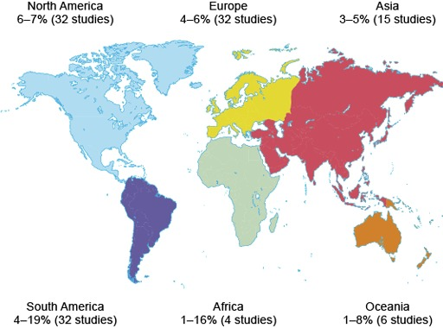
Figure 1 The worldwide estimated prevalence of ADHD in children and adolescents
View description - Figure 1 The worldwide estimated prevalence of ADHD in children and adolescents

- From Figure 1, what do you notice about the number of studies carried out in the different continents?
- There is quite a large difference in the number of studies carried out: North America and Europe, for example, have 32 studies each, while Africa only has 4 studies.

- What impact could this difference have on the interpretation of these data?
- In areas with fewer studies, the prevalence data may not have been replicated. This does not necessarily mean the data are incorrect, but it does mean that they may be deemed less reliable.

Of course, the number of studies is not the only consideration. The size of the study is also important. A large study with 10 000 participants from multiple areas in a country is likely to be more reliable than a study with 100 participants from a single location. There could be practical reasons for the differences in the number or size of studies, such as the amount of funding available for research.
Even where data are available from several countries, as is the case for ADHD, worldwide prevalence rates should be interpreted with caution.

- Why should these data be viewed cautiously (hint: think about the possible effects of available health resources and culture)?
- Some areas of the world, especially low- and middle-income countries (LMIC) have little or no access to diagnostic services, meaning there is no real basis on which to estimate prevalence. There may also be stigma associated with a condition, or different cultural expectations about the ‘typical behaviour’ in different areas around the world that have an impact on prevalence estimates.

The data in Figure 1 hint at a non-standard set of diagnostic criteria being employed in some regions.

- Based on the data in the figure, which countries may not be adopting a standard set of diagnostic criteria?
- There is a greater range in prevalence estimates in the studies conducted in Africa and South America, compared with North America, Europe and Asia. This greater range could indicate a lack of standardised diagnostic criteria.

This issue is not specific to neurodevelopmental conditions; it can be found for a range of mental- and physical-health conditions and therefore caution is needed when considering worldwide prevalence data for any condition.
In children and adolescents, the majority of those diagnosed with ADHD are male, but in adults, both genders are diagnosed with equal frequency (Moffitt et al., 2015). Although the experience of ADHD in adults is extremely interesting, research is in its early stages, therefore the rest of this course will focus on ADHD in children and adolescents.
When trying to understand any condition a good place to start is the experience of the individuals, and those close to them.

1.2 Experiencing ADHD
ADHD can be extremely debilitating, and children diagnosed with the condition are at a higher risk of having learning, behavioural and emotional problems throughout their lives compared to those without the condition (Barkley, 1997; Harpin, 2005). In Activity 1 you will get some insight into how ADHD may be diagnosed and experienced.

Activity 1 Introduction to ADHD in children
Allow about 10 minutes

Watch Video 1 ADHD in children: Nip in the Bud [open this link in a new tab/window so you can easily return to this page after viewing the video] in which Dr Iris Rathwell from the South London and Maudsley NHS Foundation Trust discusses the diagnosis and impact of ADHD in children. Then answer the questions below.
Which key symptom is mentioned in the video and how is this characterised?

Provide your answer...
View discussion - Part

What behaviours are the most detrimental in terms of safety?

Provide your answer...
View discussion - Part

Why is it difficult to spot anxiety and depression in children with ADHD?

Provide your answer...
View discussion - Part

What are the key requirements for a diagnosis of ADHD?

Provide your answer...
View discussion - Part

It is perhaps not surprising that many individuals with ADHD will also have problems related to social functioning (Cantwell, 1996; Wehmeier et al., 2010).
Difficulties with social interactions, both with peers and family members (Flicek, 1992; Barkley, 1997), are often used to provide an assessment of functional impairment, which is a requirement for ADHD diagnosis in addition to the core symptoms of inattention, hyperactivity and impulsivity. The problems with social interaction, as well as the core symptoms of ADHD, can have a substantial impact on family members, especially parents and caregivers.

1.2.1 Impact on parents and caregivers
A recent study by Mofokeng and van der Wath (2017) examined the impact on parents of having a child (or children) with ADHD. This study was a type of study that collected qualitative data. Qualitative data focus on the rich quality of the experience and feelings of individuals without any attempt to quantify this information (turn it into numerical form). This can be collected by others observing an individual or through asking them about their experiences.
There are different methods used in studies that collect qualitative data, but this particular study (Mofokeng and van der Wath, 2017) used the common qualitative technique of interviewing.

Interviewing as a research method
Interviews can be unstructured, structured or somewhere in between – the semi-structured interview. All three types of interview technique can be used in research. Here you will look a little more closely at structured and unstructured interviews:
- In a structured interview, the researcher will ask the same set of questions to all respondents in the same order and will not probe any of the answers further. The questions are typically closed questions (i.e. with yes/no answers) which means answers may lack detail. However, structured interviews are quick to conduct, so data can be collected from a large sample, and exactly the same process can be followed for all participants, leading to increased reliability.
- In an unstructured interview, the researcher may start with a specific set of questions but these would normally be open questions that can be asked in any order. Questions may be omitted or added as the interviewer sees fit in individual interviews and answers can be probed for more detail. Such questioning requires highly skilled interviewers and careful interpretation.
Based on the definitions above, click on the link below and complete the table by dragging the appropriate strengths and weaknesses into each type of interview.

Interactive content is not available in this format.
Table 1 The strengths and weaknesses of different interviewing approaches
View description - Table 1 The strengths and weaknesses of different interviewing approaches

Unlike quantitative research, where the statistical analysis determines to some extent the amount of data that needs to be collected, the amount of data collected in qualitative methods is based on the principle of reaching a saturation point – the point at which no new information is obtained when further data are collected.

The interviews by Mofokeng and van der Wath (2017) centred on one question, ‘What are your experiences as a parent living with a child diagnosed with Attention Deficit Hyperactivity Disorder?’. This was followed up with appropriate probing questions.

- Based on this description and the information in the box above, what kind of interview did they conduct?
- They conducted an unstructured interview because they used an open question and were able to follow this up as appropriate for each participant.

Based on their interviews, Mofokeng and van der Wath (2017) concluded that parents typically experience stress as they struggle to cope with the child’s ADHD and the stigmatising attitudes from family and community members. In Activity 2 you will learn more about the challenges parents face when caring for children with ADHD.

Activity 2 Living with ADHD
Allow about 10 minutes

Watch Video 2 , which is about parenting a child with ADHD, up to 3 mins and 30 secs into the film. This is a long video and it is not necessary to watch all of it at this point in the course. [Open the link in a new tab/window so you can easily return to this page after viewing.]
What does Sam’s mother mention as the hardest thing about living with Sam’s ADHD?

Provide your answer...
View discussion - Part

What risky behaviours does Sam engage in?

Provide your answer...
View discussion - Part

What antisocial behaviours does Sam’s mother mention she has been having trouble with?

Provide your answer...
View discussion - Part

From what you have seen so far, it should have become clear that living with ADHD can be extremely difficult, not only for the individual with the condition but those around them. Adding to this difficulty is the fact that ADHD is rarely found on its own and is often comorbid with other conditions.

1.2.2 ADHD and comorbidities
It is quite common to find that individuals with ADHD are also diagnosed with comorbid conditions. For example, autism is often comorbid with ADHD in children and adolescents, but there are other comorbidities too. The results of a study of 5028 children with ADHD in the US are shown in Figure 2 to illustrate this.

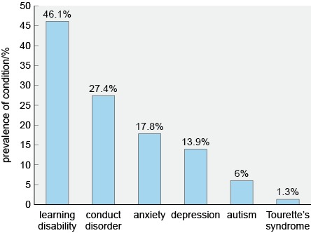
Figure 2 Prevalence of several comorbid conditions in children and adolescents with ADHD (based on Larson et al., 2011).
View description - Figure 2 Prevalence of several comorbid conditions in children and adolescents with ...

You might have heard of many of the conditions shown in Figure 2. The most prevalent comorbid condition shown in the figure is labelled ‘learning disability’. This category includes dyslexia, which can cause difficulties with reading and writing, and dyscalculia, where individuals have difficulty with numerical and mathematical concepts. The second most common comorbid condition is conduct disorder, which you may be less familiar with (although it was also mentioned by Dr Iris Rathwell in Activity 1). This is a condition associated with high levels of antisocial behaviour.

- From Figure 2, can you identify any common features of the comorbid conditions shown?
- They are all related to learning, behaviour or mental health.

In addition to the conditions shown in Figure 2, ADHD can also show comorbidity with physical conditions, for example asthma, obesity, irritable bowel syndrome and insomnia (Matza et al., 2005; Hodgkins et al., 2011).
Comorbid conditions may occur simultaneously but independently, or they may share a causal pathway, meaning they are not entirely independent of each other. So far, there is little understanding of the exact relationship between ADHD and the conditions that are commonly comorbid with it. A better understanding of the relationships can help scientists and healthcare professionals understand and treat the individual conditions and also to develop effective treatment for the two where they co-occur. The presence of comorbidities can also add another layer of complication to diagnosis, which, as you will see in the next section, is already quite complex.

1.3 Diagnosing ADHD
Like other mental health conditions, the Diagnostic and Statistical Manual (DSM) and International Classification of Diseases (ICD) can also be used to diagnose ADHD. The DSM and ICD are regularly updated and at the time of writing (2019-2020), DSM-5 is in use for diagnosing ADHD but ICD-10 is in the process of being revised to become ICD-11. This section focuses on DSM-5 and discusses the expected changes in classification of ADHD between ICD-10 and ICD-11.

1.3.1 Diagnosing ADHD with DSM-5
According to the DSM-5, for ADHD to be diagnosed:
- Symptoms of inattention or hyperactivity/impulsivity (Table 2) must have been present for a minimum of six months.
- The number of symptoms that must be present depends on the age of the individual:
  - for children up to the age of 16, at least six symptoms
  - for adolescents 17 years of age or older and adults, at least five symptoms.
- At least some symptoms must be present before 12 years of age. Note that this contrasts with the previous DSM-IV-TR criterion of symptoms being present at age 7 years which was mentioned by Dr Rathwell in Activity 1.
- Some symptoms must be present in two or more settings, for example, at school and at home.
- There must be evidence that symptoms are reducing the functioning of the individual, for example, at school, socially or in the workplace.
- Other conditions that could cause the same symptoms must first be ruled out.

Table 2 An outline of the diagnostic criteria for ADHD (APA, 2013)
Inattention | Hyperactivity/Impulsivity
Often fails to give close attention to details or makes careless mistakes with work.  Often has trouble holding attention in tasks.  Often does not seem to listen when spoken to directly.  Often does not follow through on instructions, and fails to finish schoolwork, chores.  Often has trouble organising tasks and activities.  Often avoids doing tasks that require mental effort over a long period of time.  Often loses things necessary for tasks and activities.  Is often easily distracted.  Is often forgetful in daily activities. | Often fidgets with/or taps hands or feet, or squirms in seat.  Often leaves seat in situations where it is not allowed.  Often runs about or climbs in situations where it is not appropriate.  Often unable to take part in leisure activities quietly.  Is often ‘on the go’ as if ‘driven by a motor’.  Often talks excessively.  Often blurts out answers before appropriate.  Often has trouble waiting his/her turn.  Often interrupts or intrudes on others.

Recall from Section 1.1 that it has been suggested that adults with ADHD may not simply be the children and adolescents with the condition who grew up.

- Look at the diagnostic criteria listed for DSM-5. Do they allow diagnosis where an individual only develops the symptoms as an adult?
- No, some symptoms must be present as a child for ADHD to be diagnosed. This means that it is not possible to diagnose ADHD if no symptoms were present as a child.

At the time of writing (2019-2020) then, the DSM does not allow for adult onset of ADHD symptoms. However, using the DSM-5 criteria, it is possible that an individual may have had some symptoms as a child but not enough to receive a diagnosis, until other symptoms developed as an adult.

- In this case, what difficulty may occur in identifying the symptoms present as a child?
- It relies on an individual remembering experiences from this age which may not be accurate.

Based on the symptoms presented in Table 2, the DSM-5 differentiates between three different subtypes of ADHD, referred to as ‘presentations’:
- Predominantly inattentive presentation (ADHD-I): symptoms of inattention, but not hyperactivity/impulsivity
- Predominantly hyperactive/impulsive presentation (ADHD-HI): symptoms of hyperactivity/impulsivity, but not inattention
- Combined presentation (ADHD-C): symptoms of both inattention and hyperactivity/impulsivity
The first type of ADHD, the predominantly inattentive presentation, is also sometimes referred to as attention deficit disorder (ADD). However, strictly speaking, ADD is no longer a diagnostic term – it was changed to ADHD in the DSM-IV and therefore, since 1994, healthcare professionals using the DSM have used the term ADHD-I for this presentation type.
The proportion of the different types of ADHD is shown in Figure 3.

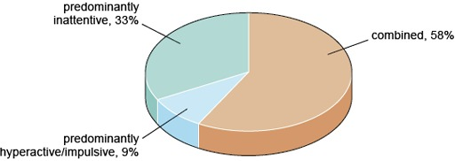
Figure 3 The proportion of different types of ADHD based on a study of 1919 children and adolescents in Italy (Reale et al., 2017).
View description - Figure 3 The proportion of different types of ADHD based on a study of 1919 children ...

- Is it possible to have a diagnosis of ADHD without symptoms of inattention according to DSM-5? Explain your answer using Figure 3.
- Yes, it is possible. An individual can exhibit only symptoms of hyperactivity or impulsivity in which case they would be diagnosed with the predominantly hyperactive/impulsive presentation of ADHD. This is found in around 9% of individuals with ADHD.

1.3.2 Diagnosing ADHD with ICD-10 and ICD-11
ICD-10 does not formally recognise ADHD and instead includes diagnostic criteria for hyperkinetic disorder (HKD). For a diagnosis of HKD to be made an individual must display symptoms of both impaired attention and overactivity, which includes impulsivity. The symptoms must also be present before 6 years of age. As with DSM-5 they must be found in two settings, and other conditions that could cause the same symptoms must first be ruled out.

- From this brief description, which presentation type of ADHD, according to DSM-5, does HKD resemble?
- It is like the combined presentation type because there are symptoms of inattention and hyperactivity/impulsivity.

The lack of recognition of ADHD in the ICD-10 has proved controversial over the years and ICD-11 (preview released in 2018 and due to be adopted in 2022) will now include ADHD as a formal diagnostic category that is very similar to that given in DSM-5. However, rather than requiring some symptoms be present before the age of 12, the broader term of ‘early to mid-childhood’ is given.
ICD-11 also adopts the distinct subtypes of ADHD found in DSM-5 but adds a further two: ‘other specified presentation’ and ‘presentation unspecified’. At the time of writing, the detail of what these two categories are likely to include is unclear.

- What is the possible impact of the change in ICD-11 on reported prevalence? Explain your answer.
- In countries using ICD-10, only the combined presentation of ADHD was formally recognised, and this was under the banner of HKD, so we may expect to see an increase in reported prevalence as ADHD is now reported separately and all categories are included.

Irrespective of which diagnostic system (DSM or ICD) is used, the symptoms of ADHD can vary over time. For example, symptoms of hyperactivity typically reduce with age (Faraone et al., 2006). This means that the specific presentation type may not remain the same for an individual and it may be necessary to re-assess their symptoms at regular intervals.

1.3.3 The diagnostic process
Diagnosing any condition does not simply require identification of symptoms. The whole process of diagnosis is complex and will often begin with a trip to see a GP, who may make a referral to a specialist. In the case of ADHD, the type of specialist someone is referred to depends on their age and the services available locally. This means that some people will be referred to a psychiatrist while others may see a learning disability specialist. When a specialist sees an individual, they will then work through a series of steps to establish a diagnosis as you will see in Activity 3.

Activity 3 Diagnosing ADHD
Allow about 15 minutes

The diagnostic process includes several different stages as shown in Figure 4.

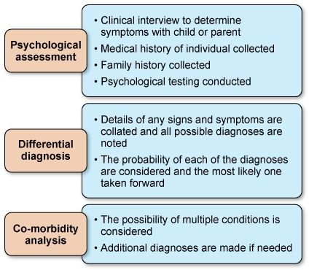
Figure 4 The typical steps required when diagnosing ADHD in children and adolescents
View description - Figure 4 The typical steps required when diagnosing ADHD in children and adolescents ...

Watch Video 3 How is ADHD diagnosed in which Thomas E Brown briefly discusses the difficulty in diagnosing ADHD. As you watch the video make notes of the challenges he mentions. You may like to use the box provided.

Provide your answer...
View discussion - Activity 3 Diagnosing ADHD

You saw in Section 1.1 that variation in prevalence is found according to culture and gender. The next section will explore briefly how these factors impact on diagnosis.

1.3.4 Culture, gender and diagnosis
Research suggests that cultural attitudes towards the interpretation of behaviour can have an impact on diagnosis (APA, 2013). It has been found that perceptions of hyperactivity and attitudes towards appropriate childhood behaviour vary significantly across cultures; for example, there are lower rates of identification of ADHD in African American and Latin American populations in comparison to white populations within the United States (Coker et al., 2016).
Additionally, as mental illness can be a source of shame in some cultures, this can prevent individuals and their families seeking help. Belief that mental illness is a sign of personal weakness may be more common in educationally disadvantaged minority populations, which may also contribute to differences in diagnosis in some areas (Bailey et al., 2014). Irrespective of the exact reasons for differences, it is important that those involved in diagnosis are mindful of the possible impact of culture.
Differences are also reported according to gender. For example, there is a higher worldwide prevalence of ADHD reported in males overall (Polanczyk et al., 2007) but there are differences in presentation types, with females more likely than males to have the inattentive presentation (Biederman et al., 2002). Research shows that females with ADHD have also been shown to be more anxious than boys with ADHD but have less disruptive behaviour and lower rates of hyperactivity (Gaub and Carlson, 1997; Nøvik et al., 2006). However, no gender differences have been seen in impulsivity, peer functioning and academic performance (Gaub and Carlson, 1997). Activity 4 looks more closely at why gender may be an issue in the diagnosis of ADHD.

Activity 4 Diagnosing ADHD
Allow about 20 minutes

Watch Video 4 Interview on ADHD in females in which Dr Aleya Karim explains why females may go undiagnosed with ADHD and the consequences of this [open the link in a new tab/window so you can easily return to this page after viewing]. When you have watched the video, answer the following two questions.
How does Dr Karim explain the presence of the same symptoms in males and females but less diagnosis of ADHD in females?

Provide your answer...
View discussion - Part

What consequences might there be for females with undiagnosed ADHD?

Provide your answer...
View discussion - Part

Culture and gender have been considered separately here, but it is possible that the two may interact. For example, gender differences may also be linked to cultural differences due to gender stereotypes within different cultures. There may also be other factors that have an impact on diagnosis and prevalence.
The next section will turn your attention to risk factors for the condition, the presence or absence of which may also feed into the diagnostic process.

1.4 Risk factors for ADHD
There has been extensive research into the causes and risk factors for ADHD over the last 50 years. Although the picture is still far from clear, some risk factors are now relatively well established.

- What is a risk factor?
- A risk factor is something that shows a strong positive association with a condition, such that people who are exposed to the risk factor have a greater risk, or probability, of developing the condition than people who are not exposed to the risk factor.

Family studies have found that the risk of ADHD among children who have siblings with a diagnosis of ADHD is nine times greater than that of children who have no siblings with a diagnosis of ADHD (Chen et al., 2008).

- What might underlie this increased familial risk?
- It could be conferred by genetic factors or factors associated with the shared family environment.

Several studies have been conducted that control for a range of environmental factors that a family would typically share, including intactness of family, and socioeconomic status, and these have still found higher levels in children with other family members with ADHD (Biederman et al., 1990; 1992).

- What do the results of these studies suggest?
- If environment is controlled for and there is still an increased risk, this suggests a role for genetic factors.

One way to pick these two factors apart further is to use adoption studies, examining families where a child has been adopted. Specifically, the following information must be available:
- Details of the health or diagnosis of specific conditions in the biological parents, obtained from the adoption agency or medical records.
- Details of the health or diagnosis of specific conditions in the child who has been adopted, normally collected by an interview with the child.
- Details about the adoptive family, both in terms of the family environment and any diagnoses of health conditions, normally collected by an interview with a family member.
Using this information, it is possible to compare the similarity between those with a genetic association (biological parent and child) and an environmental association (adoptive parent and child). If there is greater similarity, in terms of expression of ADHD, in biological associates, this indicates a key role for genetics. By contrast, if there is greater similarity in environmental associates, this indicates that the shared environment is critical.
Research has shown that the biological relatives of children with hyperactivity or ADHD are more likely to have hyperactivity or ADHD than adoptive relatives (Cantwell, 1975; Sprich et al., 2000), suggesting that genetic factors are likely to underpin the increased ADHD seen in family members of children with ADHD (Faraone and Larsson, 2019).
As well as family and adoption studies, ADHD has been the subject of several twin studies, where the prevalence of the condition is examined in monozygotic (identical) and dizygotic (non-identical) twins.

- What is the difference between these two types of twins?
- Monozygotic twins are identical in their genetic make-up whereas dizygotic twins are just like other siblings in that they share 50% of their genes.

By looking at the expression of ADHD in twins it is possible to calculate their concordance. Concordance is the probability that a pair of individuals will both have the condition, given that one of them has it.
The extent to which identical twins are more concordant for ADHD than non-identical twins can be used to calculate the heritability of the condition. Heritability is the degree to which variability in a health condition or trait in the population can be accounted for by genetics.
A review of 37 twin studies from across the world found the heritability of ADHD to range from 54% to 98% with the average (or mean) heritability reported as 74%. These figures suggest ADHD is one of the most heritable mental health conditions (Faraone and Larsson, 2019). Unsurprisingly, this high heritability has led to significant research on the genes that may play a role in ADHD, which will be explored in the next section.

1.4.1 Genetics and ADHD
To date, two main methods have been used to identify specific genes that may play a role in ADHD:
- Linkage studies are genome-wide searches to identify any genetic variation that is shared more often than expected among ADHD family members. At present these studies have yet to provide any definitive answers. However, linkage studies can only detect genetic variants that have a large effect on the subject of interest, in this case expression of ADHD. Therefore, the lack of definitive findings from this type of study could mean that no single gene exerts a large impact on expression of ADHD. Instead the genetic component of ADHD could be driven by many genes each exerting a much smaller influence, which in combination have an impact on the expression of ADHD.
- Candidate gene studies allow researchers to choose genes based on neurobiological studies or theoretical considerations and then to directly compare these in different groups of people. This comparison can be done using case-control or family-based studies. In case-control studies the frequency of a gene is looked at in individuals with a condition and those without. In a family-based study, the comparison is between family members, normally parents and their children.
To date, these studies have identified several candidate genes that may be important in ADHD, although each only has a small association with the condition, again supporting the view that ADHD may involve many genes each exerting a small effect (Faraone and Larsson, 2019). Most of the genes identified in these studies are linked to the neurotransmitter dopamine (Gizer et al., 2009) which will be considered later in this course.
Evidence from early genetic studies has indicated that ADHD is unlikely to be caused by a single, or even a few genes, but rather a combination of many genes acting together. Genetic researchers are starting to use genome-wide association studies (GWAS), which look at the entire genome to detect common genetic variants within groups of individuals with the same condition. GWAS look at hundreds of thousands of single nucleotide polymorphisms (SNPs, pronounced snips). A SNP is a change to a single nucleotide in a sequence of DNA.
Early GWAS failed to identify any variants associated with ADHD but a recent meta-analysis (a type of study that pools results across several different studies) of several GWAS has proved more successful.
In this case, the meta-analysis included 20 183 individuals with ADHD and 35 191 control participants, and identified 12 possible SNPs in the genome (Demontis et al., 2017). Interestingly, none of the 12 SNPs identified correspond to the candidate genes found in previous studies. However, the patterns found in the data confirm that the heritability of ADHD is likely to be due to polygenic (multiple gene) effects, each having a very small influence, which in combination can confer a genetic risk for ADHD. Therefore, to date, while studies have not consistently identified specific genes involved in ADHD, there is some consensus on the way in which genetic influence arises.
So far, this section has focused on the genetic risk associated with ADHD, but heritability of ADHD is not 100%, so other factors must play a role. You will now turn your attention to environmental factors.

1.4.2 ADHD and the environment
Because ADHD appears early on in life, there has been particular interest in prenatal environmental risk factors (Sciberras et al., 2017). Numerous things have been proposed as prenatal risk factors, but they do not all carry the same level of risk. They can be compared by examining their relative risk.

Absolute and relative risk
The absolute risk of a condition or disease occurring in an individual is the probability of developing the disease over a particular time period. It can be expressed either as a fraction (e.g. 3 in 100), or as a decimal number (0.03) or as a percentage (3%). Everyone has some level of absolute risk of developing a condition, but the absolute risk will be greater for some people than for others, depending on the presence of various risk factors.
When it comes to working out the effects of risk factors, investigators often use relative risk, which compares the absolute risk of people who have been exposed to a risk factor with the absolute risk of people who have not been exposed to the risk factor. For example, suppose the absolute risk of developing ADHD for a child whose mother smoked during pregnancy is 7 in 100, or 7%, and the absolute risk of developing ADHD for a child whose mother had not smoked is 3 in 100, or 3%. The relative risk of developing ADHD that is attributable to smoking during pregnancy can be calculated by dividing the smoker’s child’s risk (7%) by the non-smoker’s child’s risk (3%), which is 2.3. This means that children of mothers who smoke when pregnant are over twice as likely to develop ADHD as children of mothers who do not smoke when pregnant.

- If the absolute risk of developing ADHD for a child born at full term is 3% and the absolute risk for a child born prematurely is 7.92%, what is the relative risk of premature birth?
- The relative risk can be calculated by dividing 7.92 by 3 to give 2.64. This value means that a baby born prematurely is almost three times more likely to develop ADHD than a baby born at full term.

Various studies examining the relative risk of prenatal risk factors were reviewed and summarised by Sciberras et al. (2017). Those factors with more consistent findings in the research literature are shown in Figure 5.

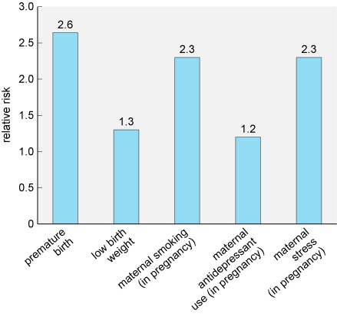
Figure 5 Relative risk of developing ADHD following exposure to several prenatal risk factors (Sciberras et al., 2017).
View description - Figure 5 Relative risk of developing ADHD following exposure to several prenatal ...

The risk factor conferring the greatest risk in Figure 5 is premature birth. Research has shown that this risk appears to increase with the degree of prematurity. For example, if a baby is born at less than 29 weeks the relative risk can increase to 5, meaning they are five times more likely to develop ADHD than babies born at full term.

- Which of the factors shown confers the lowest relative risk?
- The lowest risk is from maternal antidepressant use, which has a relative risk of 1.2.

When reviewing Figure 5, you may have recognised that some of the risk factors may be linked. For example, a premature baby is more likely to weigh less than a full-term baby. However, the researchers were able to take this into account in their analysis and so the figures reflect the risk conferred by each risk factor independently.
It is important to note that none of the risk factors discussed so far have a clear causal connection to ADHD. They are associated with increased risk of developing the condition, but exactly why this happens is unknown. Additionally, not all cases of ADHD can be explained by these accepted risk factors.
The fact that not all cases of ADHD can be explained by the risk factors which, based on research evidence, are generally accepted by the scientific and medical communities means that the search for other risk factors continues. For example, you may have read about concerns that exposure to screen technologies could increase the likelihood of developing ADHD. However, at present, evidence to support screen technology use as a risk factor for ADHD is lacking.
The studies that do exist at the time of writing (2019-2020) include relatively small sample sizes and are correlational studies, which means that they cannot demonstrate causality. An example of one such study conducted with children found that time spent watching television and playing video games was associated with attentional problems, with the video games being more problematic than television (Swing et al., 2010). However, this study relied on self-reported measures of time spent engaging in the activities, which can be unreliable, and only measured ‘attention’, and not ADHD symptoms specifically.
A much larger study by Montagni et al. (2016), conducted with adults without a diagnosis of ADHD, collected self-reported measures of attention and hyperactivity using a standardised scale, the Attention Deficit Hyperactivity Disorder Self-Report Scale (ASRS). They then related this to a self-reported measure of screen time covering the use of smartphones, televisions, computers and tablets. This study found a significant positive association between screen time and attention problems and hyperactivity levels. Compared to the lowest screen time category (never using screens), those in the highest exposure category (more than 8 hours per day) had a relative risk of 1.57.

- Can you identify any limitations of the study in terms of what it can tell us about ADHD from the information provided?
- You could have come up with several different limitations here. For example:
  - The study was conducted with adults without ADHD and it is quite possible that the data may not generalise to adults with ADHD, or to children with or without the condition.
  - The use of self-reporting can be unreliable for various reasons, including people simply misremembering information.
  - The study found only an association, and so it is very important to be aware that this does not prove causality. It is possible that the direction of the relationship is actually the reverse, for example, those who struggle with attention may be more inclined to use screens.

As you have seen in this section, there are several possible genetic and environmental risk factors for ADHD. It is important to note that these risk factors can interact with each other and may confer a greater risk in combination.

Session 1 summary
During this session, you should have gained some insight into what it may be like to live with ADHD, learning about the core characteristics of the condition as well as related difficulties such as impaired social functioning and comorbidity.

Activity 5 Revisiting your perceptions of ADHD
Allow about 10 minutes

At the start of this course you reflected on your perceptions and beliefs about ADHD. Now you are half way through your study of the Understanding ADHD course, take a moment to revisit your earlier reflections and identify an example of where your previous beliefs were consolidated or challenged by what you have learnt. You may wish to use the box provided.

Provide your answer...
View discussion - Activity 5 Revisiting your perceptions of ADHD

You have now examined how ADHD can be diagnosed using two different diagnostic criteria, and some of the challenges that arise in this process. You have also examined some of the genetic, biological and environmental risk factors for the condition. In the next session you will examine the neurobiology and management of ADHD.

Session 2: The neurobiology and management of ADHD
This session will focus on the brain basis of ADHD and examines how ADHD can be managed. To understand the changes that may occur in the brain of somebody with ADHD it is helpful to think about what cognitive functions, or mental processes, are disrupted in the condition.

- What are the two main types of symptom in ADHD?
- Symptoms that relate to attention and to impulsivity/hyperactivity.

This tells us straight away that there is more than one function disrupted in ADHD, and you will learn more about these processes in the next section.

2.1 ADHD and the brain
Cognitive tests indicate that individuals with ADHD exhibit poorer performance in a range of cognitive tasks compared with neurotypical controls (Frazier et al., 2004) and seven different cognitive functions have been found to be disrupted in ADHD (Mueller et al., 2017). These include working memory, response inhibition and cognitive flexibility. Collectively these functions are known as ‘executive functions’.
Working memory refers to an ability to preserve a representation of information over short periods of times (seconds). Response inhibition refers to an ability to suppress actions that are inappropriate for a given task. Finally, cognitive flexibility refers to an ability to switch between tasks without significant loss of performance.
As well as showing impairment in these so-called executive functions, Mueller et al. (2017) suggest that individuals with ADHD show impairments in:
- Selective attention – the ability to preferentially process one stimulus in the presence of other potentially distracting stimuli.
- Sustained attention – the ability to continuously perform a task over a prolonged period without decline in performance.
- Response precision – temporal and/or spatial precision in behavioural responses to stimuli.
- Temporal information processing – the ability to accurately recognise or reproduce time intervals.
To cover the entire brain basis of all of these domains would be a whole course in itself, so this section shall focus on selective attention, where much of the research has been conducted in ADHD.
Selective attention can be driven by two main processes (illustrated in Figure 6):
- in endogenous attention, we wilfully attend to something based on our current goals (e.g. hunger motivating us to seek food)
- in exogenous attention, our attention is drawn to a stimulus based on its characteristics (e.g. the appearance or smell of food).

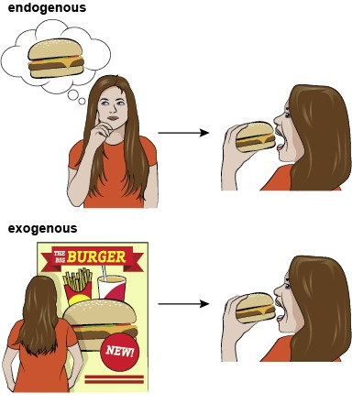
Figure 6 The two main drivers of selective attention: (top) endogenous attention, (bottom) exogenous attention
View description - Figure 6 The two main drivers of selective attention: (top) endogenous attention, ...

- Take a moment to reflect on your selective attention when you are studying this course. Can you think of an example of an endogenous and exogenous driver of attention in this context?
- Hopefully you are driven to focus on the course reading because your goal is to learn more about ADHD. When you are directing your attention to the course reading resources; this is an example of endogenous attention. However, if your phone rings or your email notification pops up, you may direct your selective attention towards those stimuli even though you were not intending to do so. This would be an example of exogenous attention.
In ADHD disruptions may be found to both types of selective attention. For example, an endogenous selective attention impairment might be expressed as a difficulty in attending to the specific voice of a teacher because of disruption by intrusive thoughts. By contrast, an exogenous impairment could be expressed through increased sensitivity to irrelevant but salient (most notable) stimuli, such as loud noises outside the classroom.
Various tasks exist that can assess endogenous and exogenous selective attention in people, as well as non-human primates and rodents. By using these tasks in combination with methods that collect information about the brain, such as structural and functional brain imaging techniques, it is possible to unpick which parts of the brain may be involved in different types of selective attention.

2.1.1 Brain circuits and selective attention
After many years of research, scientists have begun to propose specific circuits involved in endogenous and exogenous selective attention. There is not yet a complete consensus on this, but there is now a good understanding of which structures are likely to be involved, even if the exact role of each brain region is not entirely understood.

Activity 6 Selective attention in the brain
Allow about 15 minutes

Watch Video 5, which describes the structures and circuits thought to be involved in selective attention. As you watch the video, make notes about the brain structures involved in each type of attention. You may need to pause the video or watch it a couple of times. Then answer the questions that follow.

Video content is not available in this format.
Video 5 Selective attention networks in the brain
View transcript - Video 5 Selective attention networks in the brain

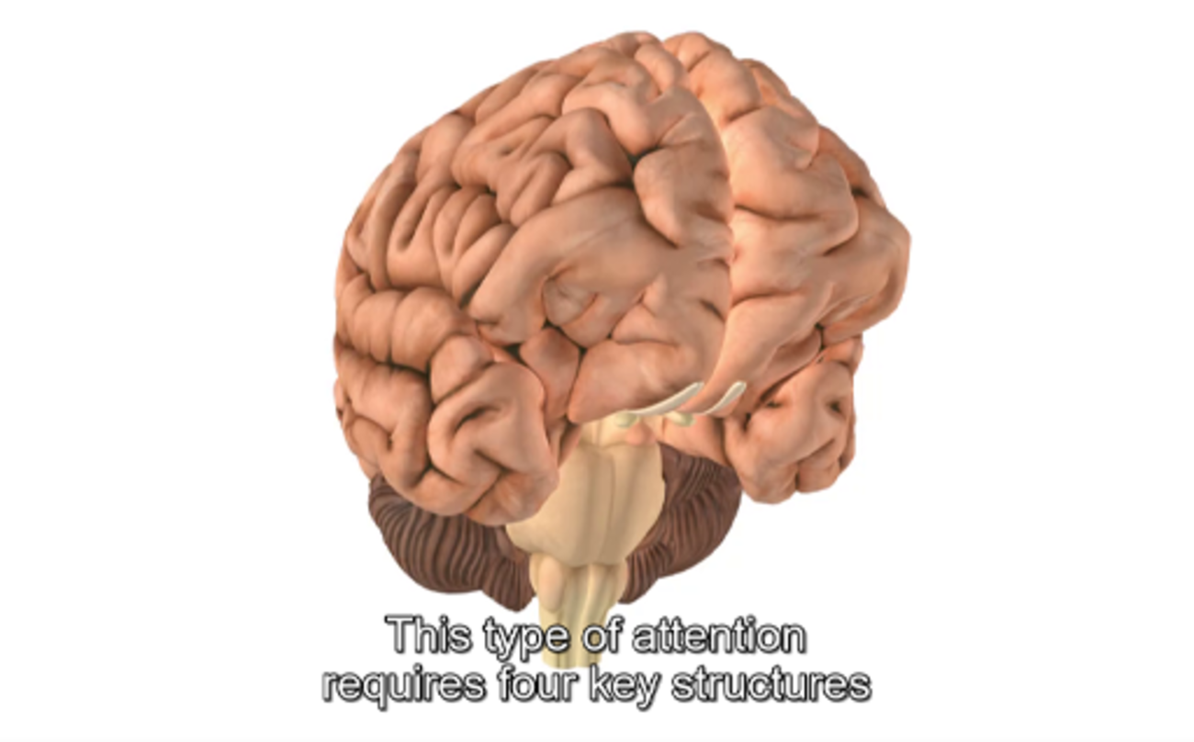

Which type of selective attention is driven by sensory stimuli, for example a flash of light?

Provide your answer...
View answer - Part

What is the key difference between exogenous and endogenous attention, in terms of where the brain circuits begin?

Provide your answer...
View answer - Part

Video 5 showed that there are several structures involved in selective attention, and therefore potentially implicated in the development of ADHD. One structure that has received a lot of attention in ADHD is the prefrontal cortex (PFC), which is a brain region responsible for reasoning, moderating behaviour, planning and decision making. The PFC has been examined using both structural and functional imaging techniques in children, adolescents and adults with ADHD and the results compared with participants of a similar age without ADHD.
Structural studies have consistently shown reductions in the volume of the PFC in individuals with ADHD relative to those without ADHD (Rubia et al., 2014). Furthermore, the reduction in volume correlates with illness severity (Mostofsky et al., 2002). It is suggested that this is due to delayed brain development in ADHD.
Longitudinal studies in the USA have supported this idea showing that, relative to typical controls, individuals with ADHD can show a delay in reaching the peak of cortical thickness and surface area by up to five years (Figure 7).

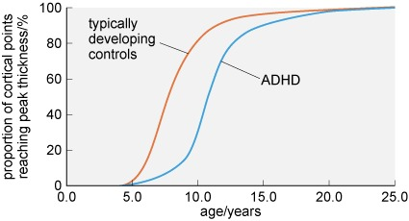
Figure 7 Cortical areas in those with ADHD may not reach peak thickness, indicating full development, until some years after typically developing individuals (adapted from Shaw et al., 2007)
View description - Figure 7 Cortical areas in those with ADHD may not reach peak thickness, indicating ...

- What percentage of cortical areas are fully developed in individuals following a typical trajectory compared with those with ADHD at the age of 10 years?
- At 10 years of age, around 80% of cortical areas have reached peak thickness in typically developing children. This is compared with just 30% in children with ADHD.

Given the emphasis on the PFC in the brains of people with ADHD, you may be unsurprised to know that the frontal cortex, which includes the PFC, is the area which has the greatest delay in development (Shaw et al., 2007; 2013).
As well as delays in brain development, meta-analyses have shown that there are abnormalities in the white matter within the brain, including the PFC regions in the brains of individuals with ADHD. White matter within the brain is so called because it appears white when the brain is dissected. These white areas of the brain are made up of connections between brain cells, known as axons. The abnormalities discussed are thought to be due to a reduction in myelination of these axons (Rubia et al., 2014). Myelination is the name given to the process by which axons become coated in a fatty insulating substance called myelin. One of the functions of this substance is to speed up the conduction of signals between brain cells, so a reduction in myelination will slow down signalling within the brain.
As with reduced brain volume, the reduction in myelination correlates with severity of symptoms; the greater the reduction, the poorer the cognitive performance (Chuang et al., 2013).
Meta-analyses of functional brain imaging studies suggest a reduction in activity within the PFC in the brains of individuals with ADHD (Christakou et al., 2013). Interestingly, the reduced activity can be normalised with medication for the condition (Hart et al., 2012; Rubia et al., 2014), which you will learn more about in Sections 2.2.3 and 2.2.4.

- What is the evidence for alterations to the PFC in the brains of individuals with ADHD?
  - The PFC is reduced in volume and shows reduced activity.
  - The PFC develops more slowly and has altered white matter (meaning signalling will be slower).
  - The structural changes are correlated with symptoms and severity of the condition.
  - Drug treatment for ADHD can normalise PFC activity.

As well as identifying specific brain regions important for attention and ADHD, changes in specific neurotransmitters, the chemical messengers of the brain, have also been identified.

2.1.2 Brain chemistry and ADHD
Many neurotransmitters and pathways are thought to be involved in the development of ADHD symptoms. Focusing again on selective attention, acetylcholine is thought to be the most important neurotransmitter for exogenous attention, while dopamine may preferentially contribute to endogenous attention (Mueller et al., 2017). In line with this, changes in acetylcholine (cholinergic) receptor functioning have been found in the few studies that have investigated this in ADHD (Wallis et al., 2009; Johansson et al., 2013). However, research into dopamine functioning in ADHD has been central to most investigations.
Dopamine, along with serotonin and noradrenalin, is one of the monoamine transmitters. These neurotransmitters are produced by neurons making up relatively small areas within the brain, but the axons of these neurons form pathways sending signals to many other brain regions, so the effects of the neurotransmitter can be quite widespread. Certainly, ADHD is not the only condition that dopamine is thought to be involved in. Other mental health conditions in which dopamine may be involved include addiction and psychosis.
In Activity 7 you will explore neurotransmitter pathways and see how these pathways may be involved in ADHD.

Activity 7 Exploring the monoamine neurotransmitters
Allow about 30 minutes

You should now explore the pathways for the monoamine neurotransmitters dopamine, serotonin, noradrenalin and acetylcholine using the interactive below. Click on each pathway for information about the pathway and structures involved. Make notes about the start and end points of each pathway in order to complete Table 3 that follows.

Interactive content is not available in this format.
View description - Uncaptioned interactive content

Interactive content is not available in this format.
Table 3 (interactive) Origins and end points of neurotransmitter pathways
View description - Table 3 (interactive) Origins and end points of neurotransmitter pathways

Now study Figure 8 (via the interactive link below) which provides an overview of the brain regions and neurotransmitters thought to be involved in the seven cognitive domains impacted in ADHD

Interactive content is not available in this format.
Figure 8 (interactive) The brain structures involved in the different cognitive domains disrupted in ADHD. Click or tap on each domain for a reminder about what it does and to see the circuitry involved. You can also select each brain region for a summary of its function (adapted from Mueller et al., 2017).
View description - Figure 8 (interactive) The brain structures involved in the different cognitive domains ...

You should be able to see from Activity 7 that the involvement of various neurotransmitters and brain regions in ADHD is very complex. At present it is not clear what changes, if any, take place in ADHD for all of the different neurotransmitters and brain regions shown in Figure 8. It is likely that, as for other conditions involving brain functioning, altered connectivity between brain networks underlies some of the changes in brain functioning seen in ADHD. Investigating this altered connectivity is extremely complex and is an active area of research into this condition.
As mentioned previously, much research has focused on the involvement of dopamine and the PFC, which will be looked at in more detail in the next section.

2.1.3 Candidate genes and dopamine
Recall from Session 1 that several candidate genes have been identified as risk factors for ADHD and that these often relate to dopamine. To understand how these might confer risk for ADHD, you need to understand more about the process of neurotransmitter use within the brain (Figure 9).
Neurons send messages to one another by releasing neurotransmitters across gaps between them. These gaps are known as synapses (or synaptic clefts). The signal for a neuron to release neurotransmitter into a synapse is electrical, in the form of an action potential. As shown in Figure 9, the action potential travels along the neuron until it reaches the section close to the synapse where neurotransmitter is stored. Once the neurotransmitter has been released, it can only pass on the communication if it is able to join to receptors located on the neighbouring neuron. You can think of this as being like a key fitting into a lock, where the neurotransmitter is the key, and the receptor is the lock. Once neurotransmitter has crossed the synapse and slotted into the receptors it is released from them to float back into the synaptic cleft (the gap between two neurons).

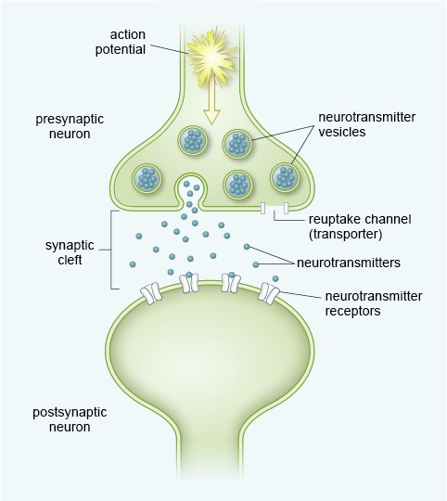
Figure 9 A synapse in the brain showing release of neurotransmitter from the presynaptic neuron that can bind to receptors on the postsynaptic neuron
View description - Figure 9 A synapse in the brain showing release of neurotransmitter from the presynaptic ...

Released neurotransmitter must be removed from the synapse in some way, otherwise the communication signal would not have a discrete end point.
It is known that neurotransmitters can be removed by the process of reuptake, through special reuptake channels (also called transporters) which take the neurotransmitter back into the presynaptic neuron, so it can be released again in future. Neurotransmitter can also be removed by enzymes which break it down. Finally, neurotransmitter can also eventually disperse away from the synapse so that it is no longer near the receptors.
One gene that has been linked to ADHD is the gene that codes for (that is, carries the instructions for cells to build) the dopamine transporter channel. This gene is known as SLC6A3 and it can exist in several forms which differ according to the number of times a specific part of the genetic sequence within the gene is repeated (these are known as ‘repeats’).
Two specific forms of this gene have been associated with ADHD (Madras et al., 2002; Bonvicini et al., 2016):
- The nine-repeat form which has been associated with the condition in adults.
- The ten-repeat form which has been associated with ADHD in children.
In both cases it is thought that having these versions of the gene will result in higher levels of the dopamine transporter channel within the brain (Madras et al., 2002).

- If more dopamine transporter channels are available, what impact will this have on removal of dopamine from the synapse?
- If more dopamine transporter channels are available, dopamine will be removed from the synapse more effectively, meaning it has less chance to bind with receptors.

In addition to the transporter channel, a second candidate gene that may be of importance in ADHD codes for a specific type of dopamine receptor known as D4.
As with SLC6A3, the gene for the D4 receptor, known as DRD4, can exist in several different forms, again varying by the number of repeating sequences. Research suggests that having the longer version increases the risk of having ADHD (Kebir et al., 2009) by around 50%, while having the shorter version may confer a protective effect (Li et al., 2006), reducing the likelihood by around 10%.
The longer versions of DRD4 have been shown to alter dopamine receptor functioning and reduce a neuron’s response to dopamine.

- If the receptor is less responsive to dopamine, what would this mean for the postsynaptic effect of dopamine binding to these receptors?
- The normal effect of dopamine on the postsynaptic neuron would be subdued in the presence of the altered version of the receptor.

In terms of selective attention, the most important area affected by reduced dopamine signalling is the PFC. Figure 10 summarises the steps by which variants in the genes discussed here could result in impaired attention in ADHD. When viewing Figure 10, keep in mind that this shows how just two genes could impact on one area of attention and, therefore, the picture for ADHD as a whole would be much more complex.

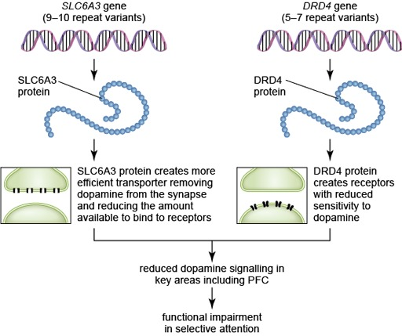
Figure 10 The steps taken from gene alteration to functional changes within the brain in ADHD
View description - Figure 10 The steps taken from gene alteration to functional changes within the ...

As well as specific candidate genes relating to dopamine, one of the biggest indicators that ADHD may have a dopaminergic basis is that the main medications used to treat the condition, which were discovered long before the genetic methods became available, primarily target this neurotransmitter. You will learn more about these treatments in Section 2.2.3, but for now it is important to recognise that the various research studies identifying a role for dopamine in ADHD led to the dopamine theory of ADHD (Levy, 1991). This theory has changed slightly over the years but is still considered important and so shall be considered in the next section.

2.1.4 The dopamine theory of ADHD
The original dopamine theory of ADHD suggested that ADHD was caused by a deficit in dopamine function, resulting in less dopamine, putting the brain in a so-called hypo-dopaminergic state (Levy, 1991). However, later research indicated that not all areas of the brain appeared to have a reduction in dopamine, and in fact, some areas were actually hyper-dopaminergic, meaning there is more dopamine than typically found (Castellanos, 1997). This is possible because the increases and decreases in dopamine functioning occur in different parts of the brain.
Figure 11 shows the three different dopamine pathways within the brain. One pathway runs from the substantia nigra to the dorsal striatum and is known as the nigrostriatal pathway. This pathway is a locomotor pathway. The other pathways both originate in the ventral tegmental area but the connections branch to target two different structures. The first branch of this pathway is known as the mesolimbic pathway, and this one targets the nucleus accumbens in the midbrain. The second branch projects quite widely throughout the prefrontal cortex at the front of the brain, and is known as the mesocortical pathway. These two pathways are involved in motivated behaviour, attention and response inhibition.
Drag and drop the labels onto Figure 11 below to display the main structures involved in dopamine signalling in the brain.

Interactive content is not available in this format.
Figure 11 (interactive) Structures involved in dopamine signalling.
View description - Figure 11 (interactive) Structures involved in dopamine signalling.

Research has indicated that there is a decrease in dopamine functioning in the mesocortical pathway that can have an impact on attention, including selective attention, and an increase in dopamine functioning in the nigrostriatal pathway that can result in symptoms of impulsivity and hyperactivity (Castellanos, 1997).
It is important to recognise that the dopamine theory is not without criticism. Gonon (2009) outlines concerns about the different kinds of evidence presented in favour of the dopamine theory. These are summarised in Table 4.

Table 4 Evidence for the dopamine theory of ADHD has been questioned (from Gonon, 2009)
Type of Evidence | Evidence supporting dopamine theory | Concerns about evidence
Imaging | Reduced activity in areas receiving dopamine | Changes in activity are more complex and may involve multiple systems
Genetics | Certain variants of genes related to the dopamine transporter and dopamine receptor are found to be increased in the brains of people with ADHD | The most robust finding for DRD4 only shows it to be slightly more prevalent in individuals with ADHD than healthy people
Treatment | Effective treatments for ADHD act on the dopamine system | Effective treatments may also act on the noradrenalin system

Based on some of the concerns raised about the dopamine theory of ADHD, Gonon (2009) suggests that the theory is unhelpful because it reduces research into other possible brain changes in ADHD. However, despite this criticism, dopamine is generally accepted as having a very important place in the neurobiological basis of ADHD.
Various approaches for managing ADHD are available, some of which are based on the known biological changes, including changes in dopamine signalling, while others are focused on psychosocial elements of the condition. Some of these management approaches are discussed in the next sections.

2.2 Approaches to managing ADHD
There are a range of approaches to managing ADHD, and the exact approach taken will depend on factors such as access to treatments or interventions, culture and personal choice. Not all individuals with ADHD, or their parents, will want to manage or treat the condition. However, consequences of ADHD are far-reaching. You learnt in Session 1 that those with ADHD have a greater risk of learning, behavioural and emotional problems, and may struggle with social interactions. They also tend to have poorer performance at school and in the workplace (Doggett, 2004). These consequences mean that management of ADHD is a well-established area.
To better understand the range of approaches that are available, this section will look at the guidelines provided by the National Institute for Health and Care Excellence (NICE), a public body that provides national guidance in England. It is important to keep in mind that approaches in other countries, including other areas of the UK, may vary from what is described here.
Figure 12 provides a simplified overview of the NICE guidelines for the management of ADHD. From this figure you should see that for each age group there are several options. The guidelines specify the order in which the approaches should be taken. For example, for preschool children (under 5 years) the first approach should be parent training. An individual will only progress to the next stage if symptoms persist after the intervention or if, as may be the case for medication, the intervention is refused.

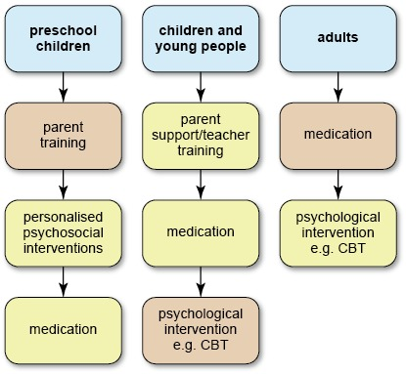
Figure 12 NICE guidelines for the management of ADHD. Notice that approach taken varies by age with children divided into preschool (under 5 years) and older. The pink shaded boxes indicate the approaches we will examine in some detail.
View description - Figure 12 NICE guidelines for the management of ADHD. Notice that approach taken ...

- What do you notice about the use of medication in the different age groups?
- This approach is the last resort for preschool children but the first resort for adults.

The more cautious approach taken with medication in children reflects one of the unknowns about the medication, that is, it's unclear what long-term effects the medication can have in very young children, particularly in terms of growth and development.
Although Figure 12 shows single labels such as ‘parent training’ and ‘medication’ there are multiple different kinds of training or medication available. For example, medication for the condition can use either stimulant or non-stimulant drugs.

2.2.1 Parent training
For children under 5 years of age with ADHD, the first type of intervention that should be offered is group-based parent training. This training aims to provide parents or carers with techniques for managing the behaviour of their children (NICE, 2018). It is hoped that through increased knowledge of the condition and behaviour-management techniques, parents will have greater confidence, and this will improve the parent–child relationship.
Although few rigorous studies evaluating parent training exist, those that do indicate it may have a positive effect on the symptoms of ADHD and that these effects remain up to a year after the training took place (Sonuga-Barke et al., 2001; Jones et al., 2007). You will now look at an example of this type of training by examining the Incredible Years Programme. This was developed by researchers at a Parenting Clinic at the University of Washington (Webster-Stratton and Hancock, 1998) and research suggests it is effective in improving parenting competencies and in reducing disruptive behaviours in children in a long-lasting manner.

Activity 8 The Incredible Years Programme
Allow about 20 minutes

Watch Error! Hyperlink reference not valid. which describes the parent training approach for children with ADHD. Once you have watched the video answer the questions below.

Video content is not available in this format.
Video 6 An overview of the Incredible Years Programme
View transcript - Video 6 An overview of the Incredible Years Programme

What is the key aim of the Incredible Years Programme and how is this achieved?

Provide your answer...
View answer - Part

What perceived benefits of the programme do the parents in the video mention?

Provide your answer...
View answer - Part

Is the programme designed only for parents of children with ADHD?

Provide your answer...
View answer - Part

You will now look in a little more detail at a study by Jones et al. (2007) which tested the effectiveness of this programme. In this study, one group of parents attended group training for 2.5 hours per week for 12 weeks and had weekly phone calls with the trainer. A second group of parents were allocated to a wait list group (not mentioned in the video). This is a form of control in the study. By comparing the effects of the intervention to the effects of no intervention (the wait list) it is possible to be reasonably sure that any changes seen are due to the programme intervention rather than any natural changes over time.
Parents rated their children’s behaviour on the Conners Abbreviated Parent Rating Scale, a 10-item scale designed for use in children aged 3–7 years. This scale requires parents to rate the frequency of particular behaviours on a four-point scale ranging from 0 (not at all) to 3 (very much). The maximum score is therefore 30 for the whole scale.
An example item from the scale is shown below.

Observation | Not at all | Just a little | Pretty much | Very much
Constantly fidgeting | (0) | (1) | (2) | (3)

- Can you think of any problems with using a parent-rated measure such as this?
- Parents may not provide accurate measures. For instance, they may downplay the extent of the behaviours because of the stigma associated with the condition. Alternatively, the experience of managing their child’s behaviour on a daily basis may lead them to overestimate the extent of disruption. Their ratings may also be affected by knowledge of the group they are in, meaning that if they are in the Incredible Years programme group they will know they are receiving training and therefore expect to see an improvement. This expectation may bias their ratings.

To address these concerns, researchers also observed parent–child interactions in the participants’ homes for a 30-minute period.
Some of the results from the study are shown in Figure 13.

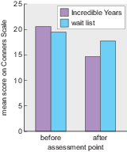
Figure 13 Mean ADHD symptoms scores collected using the Conners Abbreviated Parent Rating Scale before and after 12 weeks of parent training (or the wait list control)
View description - Figure 13 Mean ADHD symptoms scores collected using the Conners Abbreviated Parent ...

The researchers compared the two groups before the intervention. Their statistical analysis revealed that the minor difference shown on the graph was not statistically significant. Statistical significance is an important concept in research studies. It is a way of determining how likely it is that any difference observed is due to chance.
This kind of ‘before intervention’ statistical check is important because it shows the groups can be considered statistically equivalent prior to the intervention. Therefore, if any statistically significant differences are found afterwards this could not be due to the groups being different initially.
The researchers compared the two groups after the parents had received training in the Incredible Years group, or no training as per the wait list group. Their results showed that the difference observed on the graph was statistically significant. The children whose parents received the Incredible Years training had lower scores on the Conners Abbreviated Parent Rating Scale than those in the ‘wait list’ condition.
On the basis of these statistical tests the authors concluded that the Incredible Years intervention was an effective intervention for ADHD.

2.2.2 Cognitive behavioural therapy
For children and adolescents with ADHD, NICE guidelines state that support should be provided to parents and teachers in the first instance. However, if ADHD symptoms persist, it is recommended that medication is provided. For those who benefit from medication but whose symptoms are still causing significant problems in one area, for example, in school or at home, or for those who refuse medication, it is suggested that the medication is combined with cognitive behavioural therapy (CBT), a form of psychological therapy aiming to alter thought processes and behaviours.
CBT is considered the ‘gold standard’ of psychological therapy in the UK and the USA and it dominates in healthcare settings. For example, the National Health Service (NHS) initiative Improving Access to Psychological Therapies (IAPT) principally involves counselling with basic CBT-trained practitioners. However, accessing this therapy via the NHS may be difficult due to limited resource so some individuals seek private sessions. For example, details of private practitioners within the UK can be accessed via the British Association for Behavioural and Cognitive Psychotherapies.
In ADHD management, CBT focuses on establishing structures and routines, and clear rules and expectations for key settings, for example at home and in school or work. It can also be used to help with social skills with peers, problem-solving, active listening skills, and dealing with and expressing feelings.
A key aspect of CBT is cognitive restructuring. This involves identifying, and then changing, negative thoughts. Negative thoughts lead to negative emotions and negative relationships with others. Some examples of negative thought patterns include comparative thinking (making unsuitable comparisons between yourself and others) and thinking in terms of ‘should’ statements (how things should be in an ideal world). Often for a person with ADHD these negative thoughts will focus on their abilities. CBT restructures these thoughts, helping to manage negative emotions, which can improve engagement with the other strategies aimed at establishing structure and routines (mentioned above).
It is possible for CBT to be delivered online rather than in a face-to-face setting. In one study of an internet based six-month modular CBT programme in adults with ADHD, the therapy was found to be significantly more effective than the wait-list control group. The ‘wait-list control group’ refers to participants who remained on a waiting list for treatment that would be received after the study, but who did not receive the CBT during the study (Pettersson et al., 2017).

2.2.3 Medication: stimulant treatment
Recall that medication is an option for individuals of all ages with ADHD. For adults with the condition, medication is the first type of treatment recommended by NICE because evidence suggests that medication is more effective for this age group than other approaches. The first type of medication offered, irrespective of age group, is stimulant or psychostimulant drugs. These are a class of drugs that typically increase the activity of the central nervous system, which includes the brain.
These drugs were first discovered to be effective at reducing ADHD-like symptoms in the 1930s (Bradley, 1937), although the condition was not referred to as ADHD at that time. At low doses psychostimulants can, somewhat counter-intuitively given their name, reduce movement and impulsivity, while also improving cognitive function, including sustained attention and working memory (Solanto, 1998).
The psychostimulants used in the treatment of ADHD are amphetamine and methylphenidate. You may have heard of these under their respective well-known brand names of Adderall® and Ritalin®. Psychostimulants act to increase synaptic levels of the monoamine neurotransmitters.

- Which neurotransmitters mentioned earlier in the course fall in the category of monoamines?
- Dopamine, noradrenalin and serotonin.

Both drugs act on neurotransmitter transporter channels and have a larger effect on dopamine compared with the other two monoamines. They have an intermediate effect on noradrenalin and a relatively small impact on serotonin.

- What is the role of the neurotransmitter transporter channel?
- The transporter channel is normally responsible for removing neurotransmitter from the synapse.

The simplest action is by methylphenidate, which blocks the transporter (or reuptake) channel like a plug in a plug hole, preventing the neurotransmitter reuptake into the presynaptic neuron. This means the neurotransmitter stays in the synapse for longer and is more likely to bind with receptors. This is illustrated for methylphenidate in Video 7.

Video content is not available in this format.
Video 7 The actions of methylphenidate
View transcript - Video 7 The actions of methylphenidate

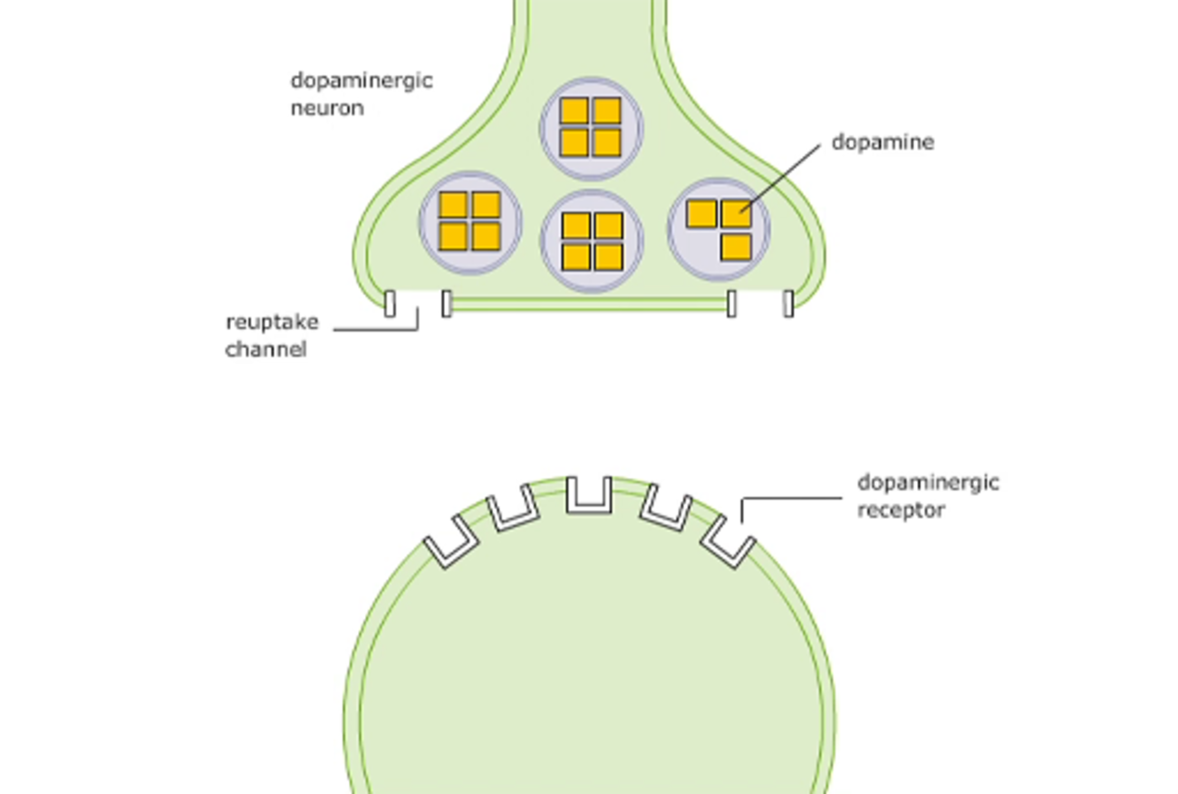

Amphetamine is also able to block the transporter channel, but it has a second action as well, as illustrated in Video 8.

Video content is not available in this format.
Video 8 The actions of amphetamine
View transcript - Video 8 The actions of amphetamine

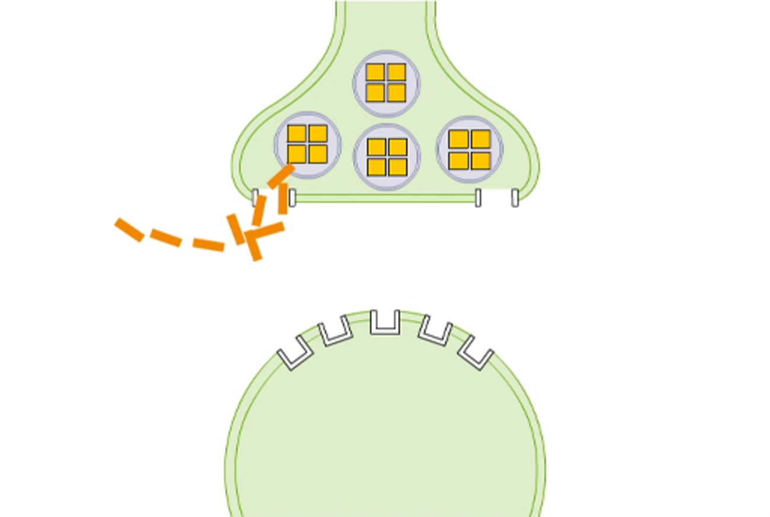

A high percentage of individuals with ADHD will see a reduction in their symptoms with methylphenidate (57%; Newcorn et al., 2008) or amphetamine (82%; Dittmann et al., 2013), as shown in Activity 9.

Activity 9 The impact of Ritalin
Allow about 15 minutes

Watch Video 11 Ritalin/Methylphenidate Review [open this link in a new tab/window so you can easily return to this page after viewing the video] and answer the following questions.
Does the person in the video mention any side effects of Ritalin?

Provide your answer...
View discussion - Part

What other problems does he mention with his experience on the drug?

Provide your answer...
View discussion - Part

Does he feel the drug worked to relieve his ADHD symptoms?

Provide your answer...
View discussion - Part

Despite the effectiveness of psychostimulant treatments for many, in some cases the side effects – which can range from insomnia to psychosis (Mariani and Levin, 2007) – cannot be tolerated, meaning individuals may stop taking the medication, or at least take it differently to how it is prescribed.

- What are some other reasons why individuals might not take their medication as prescribed?
- They may simply forget to take it, or they may not want to take it where others may see them, such as at school or at work, due to the stigma attached to taking medication or having ADHD.

This problem has been partly overcome by the development of long-acting versions of the drug which require fewer doses, meaning that individuals have to take it less often and may not need to take it during the school or working day. Treatment adherence, the extent to which a person takes their medication as recommended, is quite low for psychostimulants. A recent study found that adherence for psychostimulants over a 12-month period ranged from 5.4% to 28.4% in children and adolescents, and from 7.2% to 25.2% in adults (Setyawan et al., 2013). The range of values represents results from the use of different versions of the drugs, for example, longer-acting or shorter-acting versions (Setyawan et al., 2013).
Perhaps unsurprisingly based on these data, complete discontinuation of treatment is quite high for psychostimulant drugs, with 19% of individuals of all ages with ADHD discontinuing treatment with long-acting drugs and 38% discontinuing treatment with short-acting drugs (Lachaine et al., 2012). Various approaches are taken to support better compliance to medication, one of which is outlined in the box below.

Using an app to support treatment adherence
Researchers in Israel recently tested the research question of whether a mobile phone app could help support treatment adherence in children with ADHD (Weisman et al., 2017). They conducted a study with 39 boys and girls with ADHD, receiving psychostimulant medication, and their parents.
For around half of the participants, the parents downloaded and used an app for 8 weeks to remind them to give medication to their children. The remaining group, a control group, did not have any support. The researchers thought that those with the app would show different treatment adherence rates and they measured this by pill counts recorded daily by the parents, converted into a percentage of pills that should have been taken with full adherence to the treatment regime.
The results of the study are shown in Figure 14. After 8 weeks, participants in the group where parents received prompting by the app had statistically significantly higher treatment adherence rates.

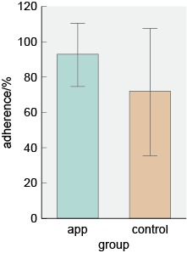
Figure 14 The results of the study after 8 weeks. The bars show mean adherence rates. The lines show a measure of variation around the mean known as the standard deviation.
View description - Figure 14 The results of the study after 8 weeks. The bars show mean adherence rates. ...

- Which of the two groups had the greatest variation around the mean? Explain your choice.
- The control group had the greatest variation because the standard deviation (indicated by the length of the lines) is larger.

As well as difficulties with side effects and potential stigma, treatment with psychostimulants is not always acceptable to the individual or their parents because of their addictive properties.
However, individuals who do not get any benefit from psychostimulant treatment, or who choose not to take it for any reason, may respond to a non-stimulant medication.

2.2.4 Medication: non-stimulant treatment
Non-stimulant drugs are so-called simply to distinguish them from psychostimulants in the treatment of ADHD. The only currently available non-stimulant treatment for ADHD is atomoxetine, which may be better recognised by its brand name Strattera®. It acts on the noradrenalin transporter channel, rather than the dopamine transporter channel as shown in Video 9.

Video content is not available in this format.
Video 9 Non-stimulant treatment
View transcript - Video 9 Non-stimulant treatment

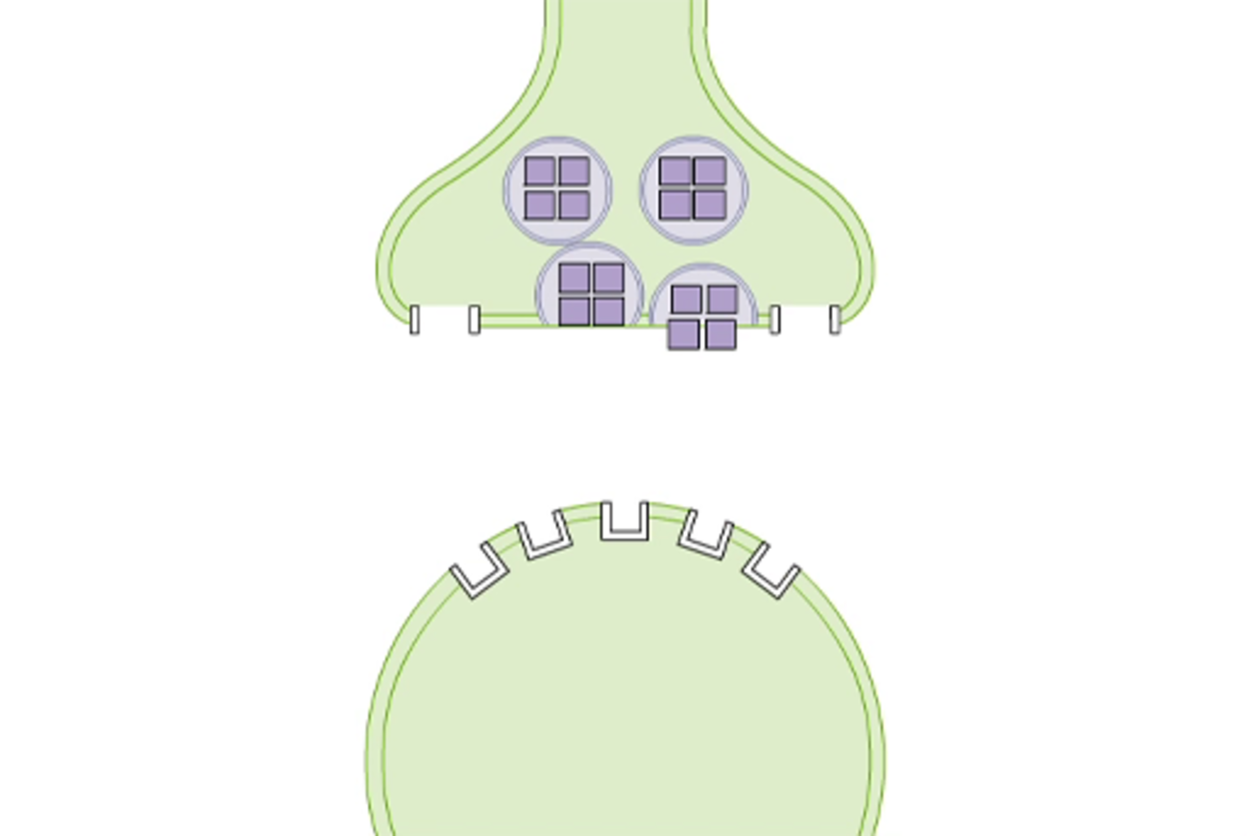
Video 12 The actions of atomoxetine

Atomoxetine is generally well-tolerated and does not have addictive properties in the way that psychostimulants do. However, there are still side effects. These include headaches, nausea and drowsiness, and there have been concerns regarding increased suicidality in individuals using the drug (Virani, 2005).
Furthermore, unlike the rapid response seen with psychostimulants, some people require three to four weeks of atomoxetine treatment before improvements are seen (Virani, 2005). Treatment adherence for atomoxetine is lower than for some psychostimulants, at 20.1% in children and 11.7% in adults (Setyawan et al., 2013).
Despite knowing how the different drug treatments for ADHD act at the synapse, it is not clear exactly how this action results in a reduction of symptoms in ADHD. This is partly because of a lack of studies into the effects of chronic treatment with these drugs, because in ADHD they are given over long periods of time and yet most research has looked at the actions over short periods.

Session 2 summary
This session has focused on identifying changes in the brain that occur with ADHD, and how these might impact on cognition and behaviour. In particular the role of the neurotransmitter dopamine has been highlighted because the ‘dopamine theory of ADHD’ has been a key part of ADHD research, despite the fact that it has also been questioned (you learnt about Gonon’s criticisms from 2009). In addition, the session has also explained how ADHD medication may be affecting the brain, comparing these forms of symptom relief to other forms of ADHD management.

Conclusion
You have now completed your study of the free course Understanding ADHD. Hopefully as you have studied this material you have both challenged and consolidated some of your previously held beliefs about this common neurodevelopmental disorder. You have learnt how ADHD is experienced, diagnosed and managed, but you should also now recognise that there is much still to be understood about the condition. For example, the exact cause is unknown. It is also not yet clear exactly how child and adult forms of ADHD relate to one another, or indeed if they are distinct from each other at all. The exact mechanism of action of current drug treatments to reduce symptoms of ADHD is also not fully understood.
A summary of key learning points from this course:
- ADHD is a common neurodevelopmental condition which affects around 6 in 100 children and adolescents, and around 3 in 100 adults. The condition has three core symptoms: inattention, impulsivity and hyperactivity. It is also associated with difficulties in social interactions and a range of comorbid conditions.
- Diagnosis of ADHD can be made using DSM-5, in which three different presentation types are possible based on the type of core symptoms an individual displays. Symptoms must be present from childhood and found in more than one setting for a minimum of 6 months. It is expected that similar criteria will be found in ICD-11 which will be the first time this diagnostic system has recognised ADHD.
- The search for risk factors for ADHD has been extensive. The condition is known to be highly heritable but genetic studies have yet to reveal a clear genetic basis. Studies indicate multiple genes are likely to be involved. Environmental risk factors also exist, with several prenatal events identified as increasing risk of ADHD.
- The brain basis of ADHD is likely to revolve around the brain circuitry involved in selective attention, including structures such as the prefrontal cortex and a range of neurotransmitters, but most notably dopamine.
- Management of ADHD varies with the age of the individual. Psychosocial and biological treatments are available at all ages, but in younger individuals medication is used with caution because the precise long-term effects on the developing brain are unknown.
This OpenLearn course is an adapted extract from the Open University course SK298 Brain, mind and mental health.

References
American Psychiatric Association (2000) ‘Disorders usually first diagnosed in infancy, childhood, or adolescence’, in Diagnostic and statistical manual of mental disorders, 4th edn, text revision. Washington, DC: American Psychiatric Association.
American Psychiatric Association (2013) Diagnostic and statistical manual of mental disorders, 5th edn. Washington, DC: American Psychiatric Association.
Bailey, R.K., Jaquez-Gutierrez, M.C. and Madhoo, M. (2014) ‘Sociocultural issues in African American and Hispanic minorities seeking care for attention-deficit/hyperactivity disorder’, The primary care companion for CNS disorders, 16(4). doi: 10.4088/PCC.14r01627.
Barkley, R.A. (1997) ‘Behavioral inhibition, sustained attention, and executive functions: constructing a unifying theory of ADHD’, Psychological Bulletin, 121(1), p. 65–94.
Biederman, J., Faraone, S.V., Keenan, K. et al. (1990) ‘Family-genetic and psychosocial risk factors in DSM-III attention deficit disorder’, Journal of the American Academy of Child and Adolescent Psychiatry, 29, pp. 526–533.
Biederman J. , Faraone, S.V., Keenan, K. et al. (1992) ‘Further evidence for family-genetic risk factors in attention deficit hyperactivity disorder. Patterns of comorbidity in probands and relatives in psychiatrically and pediatrically referred samples’, Archives of General Psychiatry, 49, pp. 728–738.
Biederman, J., Mick, E., Faraone, S.V., Braaten, E. et al.(2002) ‘Influence of gender on attention deficit hyperactivity disorder in children referred to a psychiatric clinic’, The American Journal of Psychiatry, 159(1), pp. 36–42.
Bonvicini, C., Faraone, S.V. and Scassellati, C. (2016) ‘Attention-deficit hyperactivity disorder in adults: a systematic review and meta-analysis of genetic, pharmacogenetic and biochemical studies’, Molecular Psychiatry, 21(7), p. 872–84.
Bradley, C. (1937) ‘The behavior of children receiving benzedrine’, The American Journal of Psychiatry, 94, pp. 577–585.
Cantwell, D.P. (1975) ‘Genetics of hyperactivity’, The Journal of Child Psychology and Psychiatry, 16, pp. 261–264.
Cantwell, D.P. (1996) ‘Attention deficit disorder: a review of the past 10 years’, Journal of the American Academy of Child and Adolescent Psychiatry, 35(8), pp. 978–987.
Castellanos, F.X. (1997) ‘Toward a pathophysiology of attention-deficit/hyperactivity disorder’, Clinical Pediatrics, 36, pp. 381–393.
Chen, W., Zhou, K., Sham, P. et al. (2008) ‘DSM-IV combined type ADHD shows familial association with sibling trait scores: a sampling strategy for QTL linkage’, American Journal of Medical Genetics. Part B Neuropsychiatric Genetics, 147B(8), pp. 1450–1460.
Christakou, A., Murphy, C.M., Chantiluke, K. et al. (2013) ‘Disorder-specific functional abnormalities during sustained attention in youth with attention deficit hyperactivity disorder (ADHD) and with autism’, Molecular Psychiatry, 18(2), pp. 236–244.
Chuang, T.C., Wu, M.T., Huang, S.P., Weng, M.J. and Yang, P. (2013) ‘Diffusion tensor imaging study of white matter fiber tracts in adolescent attention-deficit/hyperactivity disorder’, Psychiatry Research: Neuroimaging, 211(2), pp. 186–187.
Coker, T. R., Elliott, M.N., Toomey, S.L. et al. (2016) ‘Racial and ethnic disparities in ADHD diagnosis and treatment’, Pediatrics, 138(3), p. ii.
Demontis, D., Walters, R.K., Martin, J. et al. (2017) ‘Discovery of the first genome-wide significant risk loci for attention deficit/hyperactivity disorder’, Nature Genetics, 51, pp. 63–75. bioRxiv. doi: 10.1101/145581
Dittmann, R.W., Cardo, E., Nagy, P., Anderson, C.S. et al. (2013) ‘Efficacy and safety of lisdexamfetamine dimesylate and atomoxetine in the treatment of attention-deficit/hyperactivity disorder: a head-to-head, randomized, double-blind, phase IIIb study’, CNS Drugs, 27(12), pp. 1081–1092.
Doggett, A. M. (2004) ‘ADHD and drug therapy: is it still a valid treatment?’, Journal of Child Health Care, 8(1), pp. 69–81.
Faraone, S.V. and Larsson, H. (2019) ‘Genetics of attention deficit hyperactivity disorder’, Molecular Psychiatry, 24, pp. 562–575.
Faraone, S. V., Biederman, J. and Mick, E. (2006) ‘The age-dependent decline of attention deficit hyperactivity disorder: a meta-analysis of follow-up studies’, Psychological Medicine, 36(2), pp. 159–165.
Flicek, M. (1992) ‘Social status of boys with both academic problems and attention-deficit hyperactivity disorder’, Journal of Abnormal Child Psychology, 20(4), pp. 353–366.
Frazier, T. W., Demaree, H.A. and Youngstrom, E.A. (2004) ‘Meta-analysis of intellectual and neuropsychological test performance in attention-deficit/hyperactivity disorder’, Neuropsychology, 18(3), pp. 543–555.
Gaub, M. and Carlson, C.L. (1997) ‘Gender differences in ADHD: a meta-analysis and critical review’, Journal of the American Academy of Child and Adolescent Psychiatry, 36(8), pp. 1036–1045.
Gizer, I. R., Ficks, C. and Waldman, I.D. (2009) ‘Candidate gene studies of ADHD: a meta-analytic review’, Human Genetics, 126(1), pp. 51–90.
Gonon, F. (2009) ‘The dopaminergic hypothesis of attention-deficit/hyperactivity disorder needs re-examining’, Trends in Neurosciences, 32(1), pp. 2–8.
Hansen, B. H., Oerbeck, B., Skirbekk, B. et al. (2018) ‘Neurodevelopmental disorders: prevalence and comorbidity in children referred to mental health services’, Nordic Journal of Psychiatry, 72(4), pp. 285–291.
Harpin, V. A. (2005) ‘The effect of ADHD on the life of an individual, their family, and community from preschool to adult life’, Archives of Disease in Childhood, 90(1), i2–i7.
Hart, H., Radua, J., Mataix-Cols, D. and Rubia, K. (2012) ‘Meta-analysis of fMRI studies of timing in attention-deficit hyperactivity disorder (ADHD)’, Neuroscience and Biobehavioral Reviews, 36(10), pp. 2248–2256.
Hodgkins, P. S., Montejano, L.B., Sasané, R. and Huse, D.M. (2011) ‘Cost of illness and comorbidities in adults diagnosed with attention-deficit/hyperactivity disorder: a retrospective analysis’, The Primary Care Companion for CNS Disorders, 13(2).
Johansson, J., Landgren, M., Fernell, E. et al. (2013) ‘Decreased binding capacity (Bmax) of muscarinic acetylcholine receptors in fibroblasts from boys with attention-deficit/hyperactivity disorder (ADHD)’, Attention Deficit and Hyperactivity Disorders, 5(3), pp. 267–271.
Jones, K., Daley, D., Hutchings, J. et al. (2007) ‘Efficacy of the Incredible Years Basic parent training programme as an early intervention for children with conduct problems and ADHD’, Child: Care, Health and Development, 33(6), pp. 749–756.
Kebir, O., Tabbane, K., Sengupta, S. and Joober, R. (2009) ‘Candidate genes and neuropsychological phenotypes in children with ADHD: review of association studies’, Journal of Psychiatry & Neuroscience, 34(2), pp. 88–101.
Lachaine, J., Beauchemin, C., Sasane, R. and Hodgkins, P.S. (2012) ‘Treatment patterns, adherence, and persistence in ADHD: a Canadian perspective’, Postgraduate Medicine, 124(3), pp. 139–148.
Larson, K., Russ, S.A., Kahn, R.S. and Halfon, N. (2011) ‘Patterns of comorbidity, functioning, and service use for US children with ADHD, 2007’, Pediatrics, 127(3), p. 462–470.
Levy, F. (1991) ‘The dopamine theory of attention deficit hyperactivity disorder (ADHD)’, Australian and New Zealand Journal of Psychiatry, 25(2), pp. 277–283.
Li, D., Sham, P.C., Owen M.J. and Lin, H (2006) ‘Meta-analysis shows significant association between dopamine system genes and attention deficit hyperactivity disorder (ADHD)’, Human Molecular Genetics, 15(14), pp. 2276–2284.
Madras, B.K., Miller, G.M. and Fischman, A.J. (2002) ‘The dopamine transporter: relevance to attention deficit hyperactivity disorder (ADHD)’, Behavioural Brain Research, 130(1–2), pp. 57–63.
Mariani, J. J. and Levin, F.R. (2007) ‘Treatment strategies for co-occurring ADHD and substance use disorders’, The American Journal on Addictions, 16(1), pp. 45–56.
Matza, L. S., Paramore, C. and Prasad, M. (2005) ‘A review of the economic burden of ADHD’, Cost Effectiveness and Resource Allocation, 3(1), p. 5.
Moffitt, T.E., Houts, R., Asherson, P. et al. (2015) ‘Is adult ADHD a childhood-onset neurodevelopmental disorder? Evidence from a four-decade longitudinal cohort study’, The American Journal of Psychiatry, 172(10), pp. 967–977.
Mofokeng, M. and van der Wath, A.E. (2017) ‘Challenges experienced by parents living with a child with attention deficit hyperactivity disorder’, Journal of Child Adolescent Mental Health, 29(2), pp. 137–145.
Montagni, I., Guichard, E. and Kurth, T. (2016) ‘Association of screen time with self-perceived attention problems and hyperactivity levels in French students: a cross-sectional study’, BMJ Open, 6(2), e009089.
Mostofsky, S.H., Cooper, K.L., Kates, W.R. et al. (2002) ‘Smaller prefrontal and premotor volumes in boys with attention-deficit/hyperactivity disorder’, Biological Psychiatry, 52(8), pp. 785–794.
Mueller, A., Hong, D. S., Shepard, S. and Moore, T. (2017) ‘Linking ADHD to the neural circuitry of attention’, Trends in Cognitive Sciences, 21(6), pp. 474–488.
National Institute for Health and Care Excellence (NICE) (2018) Attention deficit hyperactivity disorder: diagnosis and management, NICE Guideline 87. Available at: https://www.nice.org.uk/guidance/ng87 (Accessed: 27 September 2019).
Newcorn, J. H., Kratochvil, C. J., Allen, A. J. et al. and Atomoxetine/Methylphenidate Comparative Study Group (2008) ‘Atomoxetine and osmotically released methylphenidate for the treatment of attention deficit hyperactivity disorder: acute comparison and differential response’, The American Journal of Psychiatry, 165(6), pp. 721–730.
Nøvik, T. S., Hervas, A., Ralston, S.J. et al. and ADORE Study Group (2006) ‘Influence of gender on attention-deficit/hyperactivity disorder in Europe – ADORE’, European Child and Adolescent Psychiatry, 15(1), pp. i15–i24.
Pettersson, R., Söderström, S., Edlund-Söderström, K., Nilsson, K.W. (2017) ‘Internet-based cognitive behavioural therapy for adults with ADHD in outpatient psychiatric care: a randomized trial’. Journal of Attention Disorders, 21: 508-521.
Polanczyk, G., De Lima, M. S., Horta, B. L. et al. (2007) ‘The worldwide prevalence of ADHD: a systematic review and metaregression analysis’, The American Journal of Psychiatry, 164(6), pp. 942–948.
Reale, L., Bartoli, B., Cartabia, M. et al. and Lombardy ADHD Group (2017) ‘Comorbidity prevalence and treatment outcome in children and adolescents with ADHD’, European Child & Adolescent Psychiatry, 26(12), pp. 1443–1457.
Rubia, K., Alegría, A. A. and Brinson, H. (2014) ‘Brain abnormalities in attention-deficit hyperactivity disorder: a review’, Revista de Neurologia, 58(1), S3–16.
Sciberras, E., Mulraney, M., Silva, D. and Coghill, D. (2017) ‘Prenatal Risk Factors and the Etiology of ADHD – Review of Existing Evidence’, Current Psychiatry Reports, 19(1), p. 1.
Setyawan, J., Hodgkins, P., Guérin, A. et al. (2013) ‘Comparing treatment adherence of lisdexamfetamine and other medications for the treatment of attention deficit/hyperactivity disorder: a retrospective analysis’, Journal of Medical Economics, 16(7), pp. 962–975.
Shaw, P., Eckstrand, K., Sharp, W. et al. (2007) ‘Attention-deficit/hyperactivity disorder is characterized by a delay in cortical maturation’, Proceedings of the National Academy of Sciences of the United States of America, 104(49), pp. 19649–19654.
Shaw, P., Malek, M., Watson, B.et al. (2013) ‘Trajectories of cerebral cortical development in childhood and adolescence and adult attention-deficit/hyperactivity disorder’, Biological Psychiatry, 74(8), pp. 599–606.
Solanto, M.V. (1998) ‘Neuropsychopharmacological mechanisms of stimulant drug action in attention-deficit hyperactivity disorder: a review and integration’, Behavioural Brain Research, 94(1), pp. 127–152.
Sonuga-Barke, E.J., Daley, D., Thompson, M. et al. (2001) ‘Parent-based therapies for preschool attention-deficit/hyperactivity disorder: a randomized, controlled trial with a community sample’, Journal of the American Academy of Child and Adolescent Psychiatry, 40(4), pp. 402–408.
Spencer, T. J., Biederman, J., Wilens, T. E. and Faraone, S.V. (2002) ‘Overview and neurobiology of attention-deficit/hyperactivity disorder’, The Journal of Clinical Psychiatry, 63 (12), pp. 3–9.
Sprich, S., Biederman, J., Crawford, M.H. et al. (2000) ‘Adoptive and biological families of children and adolescents with ADHD’, Journal of the American Academy of Child and Adolescent Psychiatry, 39(11), pp. 1432–1437.
Swing, E. L., Gentile, D. A., Anderson, C.A. and Walsh, D. A. (2010) ‘Television and video game exposure and the development of attention problems’, Pediatrics, 126(2), pp. 214–221.
Virani, A. (2005) ‘Perspectives in psychopharmacology: spotlight on atomoxetine’, The Canadian Child and Adolescent Psychiatry Review, 14(4), p. 96–98.
Wallis, D., Arcos-Burgos, M., Jain, M. et al.(2009) ‘Polymorphisms in the neural nicotinic acetylcholine receptor α4 subunit (CHRNA4) are associated with ADHD in a genetic isolate’, ADHD Attention Deficit and Hyperactivity Disorders, 1(1), pp. 19–24.
Webster-Stratton, C. and Hancock, L. (1998) ‘Parent training for young children with conduct problems. Content, methods and therapeutic process’, in Schaefer, C.E. (ed.) Handbook of parent training. New York, NY: John Wiley & Sons, pp. 98–152.
Wehmeier, P. M., Schacht, A. and Barkley, R. A. (2010) ‘Social and emotional impairment in children and adolescents with ADHD and the impact on quality of life’, The Journal of Adolescent Health, 46(3), pp. 209–217.
Weisman, O., Schonherz, Y., Harel, T. et al. (2017) ‘Testing the efficacy of a smartphone application in improving medication adherence, among children with ADHD’, European Neuropsychopharmacology, 27(2), S1113.

Acknowledgements
This course was originally written for SK298 by Eleanor Dommett. Adapted for OpenLearn by Claire Rostron and Katherine Leys. It was first published in March 2021.
Except for third party materials and otherwise stated (see terms and conditions), this content is made available under a Creative Commons Attribution-NonCommercial-ShareAlike 4.0 Licence.
The material acknowledged below is Proprietary and used under licence (not subject to Creative Commons Licence). Grateful acknowledgement is made to the following sources for permission to reproduce material in this free course:
Images
Figure 7: ADHD Institute, https://adhd-institute.com/burden-of-adhd/aetiology/neurobiology/
Figure 12: National Institute for Health and Care Excellence NICE
Every effort has been made to contact copyright owners. If any have been inadvertently overlooked, the publishers will be pleased to make the necessary arrangements at the first opportunity.
Don't miss out
If reading this text has inspired you to learn more, you may be interested in joining the millions of people who discover our free learning resources and qualifications by visiting The Open University – www.open.edu/openlearn/free-courses.

Solutions

Reflecting on your perceptions of ADHD

Discussion
When people think of ADHD they generally associate the condition with children rather than adults, and often boys rather than girls. They may think that these children are badly behaved and often will note that they struggle with attention. Some people do not think ADHD is a real condition but rather a label given to badly behaved children, whose bad behaviour is caused by poor parenting. As you work through this topic keep your own beliefs, and those we have just outlined, in mind and reflect on which beliefs may be challenged or confirmed by what you learn.
Back to - Reflecting on your perceptions of ADHD

Activity 1 Introduction to ADHD in children

Part

Discussion
The key symptom is difficulty in maintaining attention. This is characterised by listening difficulties, not following instructions and making careless mistakes in their work. Children may also be distracted and easily bored, have a tendency to daydream, and may not finish tasks.
Back to - Part

Part

Discussion
These behaviours include risk taking, engaging in behaviour without thinking about whether it is safe and having no sense of danger.
Back to - Part

Part

Discussion
It is because the disruptive behaviours become the focus.
Back to - Part

Part

Discussion
Difficulties must be present at home and at school.
Back to - Part

Activity 2 Living with ADHD

Part

Discussion
The energy. Sam is ‘always on the go’ and is impulsive so she’s easily side-tracked from what she is supposed to be doing. This makes her difficult to control from a parental perspective.
Back to - Part

Part

Discussion
She has no concept of danger so climbs trees higher than she should do and runs out onto the road. She is also running away.
Back to - Part

Part

Discussion
She has been stealing and is violent towards her siblings (and sometimes her mother). She doesn’t seem to grasp what socially unacceptable behaviours are.
Back to - Part

Activity 3 Diagnosing ADHD

Discussion
Dr Brown notes that there is no one test to determine ADHD. No medical imaging of the brain, no blood test, no EEG, no computer test. Clinical interview is used where a medical professional who understands ADHD obtains a variety of information from various sources e.g. the child, the parents, teachers. The aim is to understand functioning at school and home. Focus questions are: What is life like? What stressors are there in life? Any other health problems? Is there any known family history of ADHD?
Back to - Activity 3 Diagnosing ADHD

Activity 4 Diagnosing ADHD

Part

Discussion
She suggests that while the symptoms are the same, the expression of them is less disruptive in females. Hyperactivity in young girls, for example, may be expressed as being talkative or helping the teacher. She also mentions that girls are more inattentive which can be a reason for low esteem, as they don’t do well at school.
Back to - Part

Part

Discussion
Dr Karim suggests that they may become anxious, have low self-esteem and may be obsessive. Later in life this may manifest as diagnosable anxiety or depression.
Back to - Part

Activity 5 Revisiting your perceptions of ADHD

Discussion
What you say here will very much depend on your previous beliefs. For example, a belief that ADHD only affects children or males may have been challenged, or a belief that the condition is real and not just a label for ‘bad behaviour’ may have been consolidated.
Back to - Activity 5 Revisiting your perceptions of ADHD

Activity 6 Selective attention in the brain

Part

Answer
This is exogenous attention.
Back to - Part

Part

Answer
The brain circuit for exogenous attention begins in sensory areas such as the visual cortex, whereas the circuit for endogenous attention begins in the prefrontal cortex.
Back to - Part

Activity 8 The Incredible Years Programme

Part

Answer
The key principle is to build the relationship between parents and children. This is achieved through working with parents to support them in developing child-centred behaviours such as play and following the child’s lead. There is also guidance to ensure that parents reinforce positive behaviours in their children.
Back to - Part

Part

Answer
The parents cited feeling less alone because they came together with other parents in similar situations to them. They also felt that it helped them work together as a couple in their parenting and that there were improvements in the child’s behaviour.
Back to - Part

Part

Answer
No, the programme can be for any parent. The video mentions slightly different training approaches for those whose children do not have disruptive behaviour but it is an inclusive programme.
Back to - Part

Activity 9 The impact of Ritalin

Part

Discussion
Yes, he mentions appetite suppression, but he also mentions that Ritalin has fewer side effects than other drugs for ADHD.
Back to - Part

Part

Discussion
He mentions the ‘up and down’ nature of the effects, which means that it is hard to find the correct dose regime.
Back to - Part

Part

Discussion
Yes, he mentions being able to focus more and being more engaged. For example, he felt able to read text books without being distracted. His reading comprehension also improved.
Back to - Part

Figure 1 The worldwide estimated prevalence of ADHD in children and adolescents

Description
This is a map of the world with each continent shown in a different colour. Prevalence estimates are: North America 6-7% from 32 studies; South America 4-19% from 32 studies; Europe 4-6% from 32 studies; Africa 1-16% from 4 studies, Asia 3-5% from 15 studies and Oceania 1-8% from 6 studies.
Back to - Figure 1 The worldwide estimated prevalence of ADHD in children and adolescents

Table 1 The strengths and weaknesses of different interviewing approaches

Description
There is a table with two rows, representing Structured and Unstructured interviews and two columns for strengths and weaknesses, giving four cells in which to drag the following items: unable to probe answers; easy to replicate; extensive interviewer training required; in-depth responses from participants; limited detail in responses from participants; time-consuming; efficient for large samples; quick to conduct; flexible approach to allow exploration.
Back to - Table 1 The strengths and weaknesses of different interviewing approaches

Figure 2 Prevalence of several comorbid conditions in children and adolescents with ADHD (based on Larson et al., 2011).

Description
This is a bar chart with prevalence of condition in percent, from zero to 50%, on the y axis and various conditions along the x axis. These are: learning disability, conduct disorder, anxiety, depression, autism and Tourette’s syndrome. The height of the bars corresponds to the prevalence, which is 46.1% for learning disability, 27.4% for conduct disorder, 17.8% for anxiety, 13.9% for depression, 6% for autism and 1.3% for Tourette’s syndrome.
Back to - Figure 2 Prevalence of several comorbid conditions in children and adolescents with ADHD (based on Larson et al., 2011).

Figure 3 The proportion of different types of ADHD based on a study of 1919 children and adolescents in Italy (Reale et al., 2017).

Description
This is a pie chart showing three ‘slices’ for the three presentation types of ADHD - the biggest slice is for combined ADHD (58%), then 33% for predominantly inattentive and 9% for predominantly hyperactive/impulsive.
Back to - Figure 3 The proportion of different types of ADHD based on a study of 1919 children and adolescents in Italy (Reale et al., 2017).

Figure 4 The typical steps required when diagnosing ADHD in children and adolescents

Description
The diagram shows six panels, three are pink and three are blue. The pink panels are smaller then the blue panels. The first pink panel at the top reads ‘psychological assessment’ and the blue panel positioned next to it is bullet pointed with the following: Clinical interview to determine symptoms with child or parent; Medical history of individual collected; Family history collected; Psychological testing conducted. The second pink panel lower down reads ‘Differential diagnosis’ and the blue panel positioned next to it bullet points the following: Details of any signs and symptoms are collated and all possible diagnoses are noted; The probability of each of the diagnoses are considered and the most likely one taken forward. The pink panel towards the bottom of the diagram reads ‘Co-mobidity analysis’ and the blue panel adjacent bullet points the following: The possibility of multiple conditions is considered; Additional diagnoses are made if needed.
Back to - Figure 4 The typical steps required when diagnosing ADHD in children and adolescents

Figure 5 Relative risk of developing ADHD following exposure to several prenatal risk factors (Sciberras et al., 2017).

Description
This figure shows a bar chart with relative risk on the y-axis and various risk factors on the x-axis. The bars show the relative risk, from zero to 3.0. The risk factors and their relative risk are: premature birth 2.6; low birth weight 1.3; maternal smoking in pregnancy 2.3; maternal antidepressant use in pregnancy 1.2 and maternal stress in pregnancy 2.3.
Back to - Figure 5 Relative risk of developing ADHD following exposure to several prenatal risk factors (Sciberras et al., 2017).

Figure 6 The two main drivers of selective attention: (top) endogenous attention, (bottom) exogenous attention

Description
In the top image, endogenous attention, there is a female thinking about a hamburger on the left and the same female eating a hamburger on the right. The bottom image, exogenous attention, shows a female looking at an advert for a hamburger and the same female eating a hamburger on the right.
Back to - Figure 6 The two main drivers of selective attention: (top) endogenous attention, (bottom) exogenous attention

Figure 7 Cortical areas in those with ADHD may not reach peak thickness, indicating full development, until some years after typically developing individuals (adapted from Shaw et al., 2007)

Description
This shows a line graph with proportion of cortical points reaching peak thickness in percent on the y-axis and age in years (from 0 to 25) on the x-axis. The curve for typically developing controls rises steeply from zero to about 80% from five to ten years of age and then levels off, to reach 100% at about 20 years of age. The line for ADHD rises more slowly to around 30% at 10 years of age, then steeply to about 80% at around 15 years of age and more gradually to 100% by 25 years of age.
Back to - Figure 7 Cortical areas in those with ADHD may not reach peak thickness, indicating full development, until some years after typically developing individuals (adapted from Shaw et al., 2007)

Uncaptioned interactive content

Description
The interactive shows a side view of the brain sliced vertically to show the internal structures and various pathways.
Dopamine pathways: consist of neurons that synthesise, store and release dopamine. There are three principal dopaminergic pathways in the brain. Dopaminergic pathways and dopamine function are of particular interest in the study of ADHD, addictions and psychosis. The mesocortical pathway extends from the ventral tegmental area, a body in the brain stem, to the prefrontal cortex. The mesolimbic pathway extends from the ventral tegmental area to the amygdala and nucleus accumbens, which is located between the PFC and the brain stem. The nigrostriatal pathway extends from the substantia nigra, another body in the brain stem, to the dorsal striatum, which includes the caudate nucleus and putamen.
Serotonin pathways: consist of neurons that synthesise, store and release serotonin. Serotonergic pathways are found widely throughout the brain. Serotonergic neurons play a role in alterations of sleep-waking, as well as emotions and moods. Abnormalities within this system appear to be at the basis of depression. Raphe nuclei, which are nuclei (groups of neuronal cell bodies) within the brain stem, are the location of the cell bodies of serotonergic neurons, which project their axons very widely throughout the brain and spinal cord. Some serotonergic neurons terminate in the prefrontal cortex and some in the hippocampus, which is important in learning and memory, as well as being involved in emotion and mood.
Noradrenalin pathways: consist of neurons that synthesise, store and release noradrenalin. Noradrenergic pathways are found widely throughout the brain and are involved in many brain functions, most notably arousal and reaction to stimuli. The brain stem site of the cell bodies of noradrenergic neurons is the locus coeruleus. Noradrenergic neurons project throughout large areas of the brain and also downwards in the spinal cord. Activation in the descending pathway exerts an effect on organs and tissues involved in the autonomic reaction to stressors. Some noradrenergic neurons terminate in the prefrontal cortex.
Acetylcholine system: consist of neurons that synthesise, store and release acetylcholine. Cholinergic pathways are found widely throughout the brain and are involved in many brain functions including cognition, learning and memory. Cholinergic function is of particular interest in the study of disorders of cognition and memory, such as dementia. The pons is the site in the brain stem of the cell bodies of a group of cholinergic neurons which project their axons to a number of other brain regions and downwards in the spinal cord. The basal forebrain, at the edge of the cortex next to the brain stem, is the site of the cell bodies of a group of cholinergic neurons which project their axons widely throughout the cortex and to the hippocampus, amongst other regions. The hippocampus plays a crucial role in learning and memory. It receives axon terminals of cholinergic neurons with cell bodies in the basal forebrain. If these cholinergic neurons cease to function, as in Alzheimer's disease, the hippocampus is unable to perform its normal function. Cholinergic neurons terminate throughout the cortex. Particularly in areas of the cortex towards the front of the brain, a deficiency of cholinergic activity at these axon terminals is associated with the cognitive impairments seen in Alzheimer's disease.
Back to - Uncaptioned interactive content

Table 3 (interactive) Origins and end points of neurotransmitter pathways

Description
The table has three columns. On the left are neurotransmitters: dopamine – mesocortical pathway; dopamine – mesolimbic pathway; dopamine – nigrostriatal pathway; serotonin; noradrenalin; acetylcholine. The second column is headed ‘site of cell body (origin of pathway)’ and the third column is ‘site of neurotransmitter release (end of pathway)’.
The boxes to be dropped in are: frontal cortex and hippocampus; raphe nuclei; amygdala and nucleus accumbens; prefrontal cortex (two boxes); prefrontal cortex and hippocampus; substantia nigra; ventral tegmental area (two boxes); locus coeruleus; dorsal striatum; basal forebrain.
Back to - Table 3 (interactive) Origins and end points of neurotransmitter pathways

Figure 8 (interactive) The brain structures involved in the different cognitive domains disrupted in ADHD. Click or tap on each domain for a reminder about what it does and to see the circuitry involved. You can also select each brain region for a summary of its function (adapted from Mueller et al., 2017).

Description
Clicking on the function selective attention, the ability to preferentially process one stimulus in the presence of other potentially distracting stimuli, shows that the ventral tegmental area has a direct pathway to the PFC, whilst the basal forebrain links to the sensory cortex. The sensory cortex has reciprocal links with the parietal cortex and the PFC; the parietal cortex has a reciprocal link with the PFC.
Sustained attention, the ability to continuously perform a task over a prolonged period without decline in performance, shows the locus coeruleus and basal forebrain having a pathway to the PFC.
Response precision refers to the temporal and/or spatial precision in behavioural responses to stimuli and only involves the PFC.
Cognitive flexibility, the ability to switch between tasks without significant loss of performance, involves the ventral tegmental area, the basal forebrain, the amygdala, the parietal cortex and the PFC. The basal forebrain links to the PFC and the amygdala. The ventral tegmental area links to the PFC. The parietal cortex has reciprocal links to the PFC.
Working memory, the ability to preserve a representation of information over short periods of time (i.e. seconds), has links from the ventral tegmental area and the locus coeruleus to the PFC.
Temporal information processing is the ability to accurately recognise or reproduce time intervals. It involves a link from the cerebellum to the parietal cortex, which has a two-way link with the PFC.
Response inhibition is the ability to suppress actions that are inappropriate for a given task. The raphe nuclei link to the basal ganglia and to the PFC. The basal ganglia have a two-way link to the PFC.
Back to - Figure 8 (interactive) The brain structures involved in the different cognitive domains disrupted in ADHD. Click or tap on each domain for a reminder about what it does and to see the circuitry involved. You can also select each brain region for a summary of its function (adapted from Mueller et al., 2017).

Figure 9 A synapse in the brain showing release of neurotransmitter from the presynaptic neuron that can bind to receptors on the postsynaptic neuron

Description
At the top is the end of a presynaptic neuron, with an action potential coming down the axon. Neurotransmitter is released from vesicles in the axon terminal into the synaptic cleft. The vesicles merge with the presynaptic membrane to allow this. The neurotransmitter crosses the synaptic cleft and binds to receptors on the cell membrane of the postsynaptic neuron. Some neurotransmitter in the synaptic cleft is reabsorbed by the presynaptic neuron through a reuptake channel in the cell membrane.
Back to - Figure 9 A synapse in the brain showing release of neurotransmitter from the presynaptic neuron that can bind to receptors on the postsynaptic neuron

Figure 10 The steps taken from gene alteration to functional changes within the brain in ADHD

Description
The figure has two sections of a DNA double helix, one on the left representing the SLC6A3 gene (9–10 repeat variants) and one on the right representing the DRD4 gene (5–7 repeat variants). Underneath each is a chain of circles representing the proteins created from expression of these genes – the SLC6A3 protein and the DRD4 protein. SLC6A3 protein creates more efficient transporter, removing dopamine from the synapse and reducing the amount available to bind to receptors. DRD4 protein creates receptors with reduced sensitivity to dopamine. The net result of both is reduced dopamine signalling in key areas, including the PFC, which leads to a functional impairment in selective attention.
Back to - Figure 10 The steps taken from gene alteration to functional changes within the brain in ADHD

Figure 11 (interactive) Structures involved in dopamine signalling.

Description
The figure shows a side view of a slice through the brain. There are two structures located in the midbrain. Arrows lead from the first structure to a structure just behind the front part of the cortex and to several places in the front part of the cortex. Arrows lead from the second structure to an area located under the corpus callosum.
The labels to be dropped into place are the ventral tegmental area, the substantia nigra, the dorsal striatum, the nucleus accumbens and the prefrontal cortex.
Back to - Figure 11 (interactive) Structures involved in dopamine signalling.

Figure 12 NICE guidelines for the management of ADHD. Notice that approach taken varies by age with children divided into preschool (under 5 years) and older. The pink shaded boxes indicate the approaches we will examine in some detail.

Description
The diagram has three pathways. For preschool children the first approach is parent training, followed by personalised psychosocial interventions and finally medication. For children and young people the first approach is parent support and teacher training, then medication and finally psychological intervention e.g. CBT. For adults the steps are medication and then finally psychological intervention e.g. CBT. The pink shaded boxes are parent training, psychological intervention e.g. CBT, and medication.
Back to - Figure 12 NICE guidelines for the management of ADHD. Notice that approach taken varies by age with children divided into preschool (under 5 years) and older. The pink shaded boxes indicate the approaches we will examine in some detail.

Figure 13 Mean ADHD symptoms scores collected using the Conners Abbreviated Parent Rating Scale before and after 12 weeks of parent training (or the wait list control)

Description
The figure is a bar chart with mean score on the Conners Scale on the y-axis and two assessment points of before and after on the x-axis. There are two bars for each assessment point to indicate the group in the Incredible Years program and the group on the wait list. For the before assessment point the score for the Incredible Years group is 20.5 and that for the wait list group is 19. For the after assessment point the score for the Incredible Years group is 15 and that for the wait list group is 18.
Back to - Figure 13 Mean ADHD symptoms scores collected using the Conners Abbreviated Parent Rating Scale before and after 12 weeks of parent training (or the wait list control)

Figure 14 The results of the study after 8 weeks. The bars show mean adherence rates. The lines show a measure of variation around the mean known as the standard deviation.

Description
The bar chart has percentage adherence on the y-axis and two group categories, app and control, on the x-axis. The bar for the app group shows over 90% adherence whereas the bar for the control group shows about 70% adherence. The standard deviation for the app group shows a spread from about 75% to just over 110%; that for the control group shows a spread from about 35% to just under 110%.
Back to - Figure 14 The results of the study after 8 weeks. The bars show mean adherence rates. The lines show a measure of variation around the mean known as the standard deviation.

Video 5 Selective attention networks in the brain

Transcript
VOICEOVER
Selective attention is the ability to process one stimulus in the presence of other potentially distracting stimuli.
For example, you may be studying this topic in a noisy environment, like a cafe, or while the television is on in the background. To stay focused on your work, you have to selectively attend to it.
Selective attention can be driven in two ways, exogenous, or bottom-up; and endogenous, or top-down.
Exogenous attention is driven by sensory stimuli. For example, you may be concentrating on something. When you see a flash of light to the left of you, immediately your attention is attracted to the source of that flash.
This type of attention requires four key structures within the brain to operate.
First, the higher visual cortical structures at the back of the brain sends signals to the temporoparietal junction and the lateral intraparietal area of the cortex. Both structures then project to the prefrontal cortex.
The circuitry involved in endogenous attention is partially shared with exogenous attention. Endogenous attention is selective attention that is driven by internal goals or desires. For example, if I am very hungry, my attention will be driven towards food. Similarly, if you have a TMA deadline coming up, your endogenous attention may be driving you to selectively attend to your studies.
Unlike exogenous attention, which begins in sensory areas, the endogenous attention circuit begins in the prefrontal cortex. The prefrontal cortex sends signals to the lateral intraparietal cortex and higher cortical areas, but also to a structure called the superior colliculus. The superior colliculus, in turn, projects to the visual cortex.
The superior colliculus is a structure that sits on the surface of the midbrain, and it is a structure that is becoming increasingly important in the brain basis of ADHD.
Back to - Video 5 Selective attention networks in the brain

Video 6 An overview of the Incredible Years Programme

Transcript
[MUSIC PLAYING]
NARRATOR
The Incredible Years parent programs are used worldwide to train parents of children from birth to 12 years. There are separate curricula for parents of babies, toddlers, preschoolers, and school-aged children. The programs are composed of 12 to 20 weekly group sessions led by two trained facilitators, using prevention protocols for parents of children without significant behavior issues or treatment protocols for parents whose children have conduct problems or attention deficit hyperactivity disorder.
INSTRUCTOR
You know you're not supposed to hit each other. You're going to have to do a time out.
CAROLYN WEBSTER-STRATTON
The foundation of the program has to do with building the relationships or the attachments between the parents and the children. And we do that through teaching them about how to play with their children, how to follow their lead, how to nurture and love them without really being too directive, too controlling.
CHILD
There.
INSTRUCTOR
That's nice asking, Dorian.
INSTRUCTOR
Whenever you're using the ignore, there's a whole lot of positive for the other behavior that you want instead.
CAROLYN WEBSTER-STRATTON
The attention that's given to the child for that positive behavior is so powerful because children want that attention so much. And usually, they misbehave to get the attention. So now they figure out, oh, if I share I'm going to get my parents' attention. It's powerful.
CAROLINE WHITE
As an effective facilitator, you learn to tailor the program to meet the individual needs of families. And this is a really crucial part to its effectiveness.
NATE YOUNG
One at a time, right?
CHILD 1
I'm going first.
CHILD 2
No. I did.
NATE YOUNG
No?
CHILD 2
You put it on that one.
NATE YOUNG
The first meeting we had, I saw that this is something I need, it's something Charlie needs, and we weren't going to miss it.
ANNIE YOUNG
You get-- you get one warning about that.
It was the right direction for us to head in, because not only did Charlie need support, but we needed support.
ERIC MUELLER
It was interesting being there, seeing that we weren't alone in this. There's all these other parents with children just like mine.
ANNIE YOUNG
In that room, in that safe environment, we all trusted each other. We all liked each other. And we all had something that we could relate to.
REBECCA MUELLER
And then you start seeing the changes. And you go, I don't know why it works, but it works. I'm sold.
ERIN FANNING
[SPEAKING SPANISH] You are coloring so finely.
I think the part about The Incredible Years that was most valuable to me as a parent was the intentionality of time, specifically with your child. And I really saw the difference.
REBECCA MUELLER
We were both on the same page through that. And so it united us as a couple.
ANNIE YOUNG
We gained new skills, too, that we'll use for the rest of our life.
REBECCA MUELLER
It gives you your family back in a complete way.
CAROLINE WHITE
This program is really about positive working relationships, both for families and for professionals working with the program. And it's a collaborative process.
PARENT
I have two boys, eight and 10.
CAROLINE WHITE
Providing you follow those key principles, then I've seen this program work across all cultures and all people from all backgrounds.
INSTRUCTOR
Just follow their lead, and appreciate whatever they are saying.
SAADIA HAMID
The parent response, great. They love those days. And this was the only one thing that to some of these parents opened their mind, and they were extremely happy about it.
CAROLYN WEBSTER-STRATTON
Even if you're a single parent and you're all alone, that just spending time loving my child and playing with my child is a gift. That doesn't cost anything, and can make a huge difference to my child's future. Seeing kids blossom, seeing them grow, seeing them feel confident. It's an incredible privilege.
REBECCA MUELLER
Everybody always says when you have a child, they don't come with a manual. Now, we have the manual. The Incredible Years is the manual. It will strengthen your marriage, it will strengthen your relationship with your children, it will help you raise happy, healthy children who are great contributors to society.
[MUSIC PLAYING]
Back to - Video 6 An overview of the Incredible Years Programme

Video 7 The actions of methylphenidate

Transcript
VOICEOVER
The normal sequence of events at this synapse, in the absence of methylphenidate, begins with an action potential in the dopaminergic neuron, triggering the release of dopamine into the synapse. Dopamine diffuses across the synapse, where it can bind to specific postsynaptic receptors. If enough dopamine binds, an action potential may be elicited in the postsynaptic neuron.
After binding, the dopamine is removed from the synapse via reuptake channels as shown, or breakdown by enzymes. When methylphenidate is present, it blocks the re uptake channels. This prevents released dopamine from being removed from the synapse, thus increasing the probability it will bind to a postsynaptic receptor and have an effect on the postsynaptic neurons firing.
Back to - Video 7 The actions of methylphenidate

Video 8 The actions of amphetamine

Transcript
VOICEOVER
The normal sequence of events at this synapse in the absence of amphetamine begins with an action potential in the dopaminergic neuron triggering the release of dopamine into the synapse. Dopamine diffuses across the synapse, where it can bind to specific postsynaptic receptors. If enough dopamine binds, an action potential may be elicited in the postsynaptic neuron.
After binding, the dopamine is removed from the synapse via reuptake channels as shown. When amphetamine is present, the drug can move into the dopaminergic neuron via the reuptake channels. Once inside the neuron, it can displace dopamine from the vesicles.
This displaced dopamine is then transported into the synapse via the reuptake channel, which normally acts to remove neurotransmitter from the synapse. Once in the synapse, the dopamine is able to bind to postsynaptic receptors. Therefore, in the presence of amphetamine, dopamine may be released, even in the absence of an action potential.
In addition, amphetamine may block the reuptake channel and prevent dopamine from being removed from the synapse increasing the probability it will bind to a postsynaptic receptor and have an effect on the postsynaptic neurons firing. This action can occur when dopamine is released naturally, as well as when dopamine is released following amphetamine-induced displacement from the vesicles.
Back to - Video 8 The actions of amphetamine

Video 9 Non-stimulant treatment

Transcript
VOICEOVER
The normal sequence of events at this synapse, in the absence of atomoxetine, begins with an action potential in the noradrenergic neuron, triggering the release of noradrenalin into the synapse.
Noradrenalin diffuses across the synapse, where it can bind to specific postsynaptic receptors. If enough noradrenalin binds, an action potential may be elicited in the postsynaptic neuron.
After binding, the noradrenalin is removed from the synapse via reuptake channels, as shown, or breakdown by enzymes.
When atomoxetine is present, it blocks the reuptake channels. This prevents released noradrenalin from being removed from the synapse, thus increasing the probability it will bind to a postsynaptic receptor and have an effect on the postsynaptic neurons firing.
Back to - Video 9 Non-stimulant treatment

