K102_2

What do we mean by digital health and social care?

About this free course
This free course is an adapted extract from the Open University course K102 Introducing health and social care: www.open.ac.uk/courses/qualifications/details/k102.
This version of the content may include video, images and interactive content that may not be optimised for your device.
You can experience this free course as it was originally designed on OpenLearn, the home of free learning from The Open University –
www.open.edu/openlearn/health-sports-psychology/innovation-health-and-social-care-social-and-historical/content-section-0
There you’ll also be able to track your progress via your activity record, which you can use to demonstrate your learning.
Copyright © 2021 The Open University
Intellectual property
Unless otherwise stated, this resource is released under the terms of the Creative Commons Licence v4.0 http://creativecommons.org/licenses/by-nc-sa/4.0/deed.en_GB. Within that The Open University interprets this licence in the following way: www.open.edu/openlearn/about-openlearn/frequently-asked-questions-on-openlearn. Copyright and rights falling outside the terms of the Creative Commons Licence are retained or controlled by The Open University. Please read the full text before using any of the content.
We believe the primary barrier to accessing high-quality educational experiences is cost, which is why we aim to publish as much free content as possible under an open licence. If it proves difficult to release content under our preferred Creative Commons licence (e.g. because we can’t afford or gain the clearances or find suitable alternatives), we will still release the materials for free under a personal end-user licence.
This is because the learning experience will always be the same high quality offering and that should always be seen as positive – even if at times the licensing is different to Creative Commons.
When using the content you must attribute us (The Open University) (the OU) and any identified author in accordance with the terms of the Creative Commons Licence.
The Acknowledgements section is used to list, amongst other things, third party (Proprietary), licensed content which is not subject to Creative Commons licensing. Proprietary content must be used (retained) intact and in context to the content at all times.
The Acknowledgements section is also used to bring to your attention any other Special Restrictions which may apply to the content. For example there may be times when the Creative Commons Non-Commercial Sharealike licence does not apply to any of the content even if owned by us (The Open University). In these instances, unless stated otherwise, the content may be used for personal and non-commercial use.
We have also identified as Proprietary other material included in the content which is not subject to Creative Commons Licence. These are OU logos, trading names and may extend to certain photographic and video images and sound recordings and any other material as may be brought to your attention.
Unauthorised use of any of the content may constitute a breach of the terms and conditions and/or intellectual property laws.
We reserve the right to alter, amend or bring to an end any terms and conditions provided here without notice.
All rights falling outside the terms of the Creative Commons licence are retained or controlled by The Open University.
Head of Intellectual Property, The Open University

Contents
- Introduction
- Learning outcomes
- 1 Defining digital health and social care technology
- 2 Policy for digital health and social care
- 3 Why are digital technologies important?
  - 3.1 Advantages of digital health and social care technology
  - 3.2 What are the disadvantages for implementation?
- 4 Types of health and social care technology
  - 4.1 Using technology in health and social care
- Conclusion
- References
- Acknowledgements
- Solutions

Introduction
This free course, What do we mean by digital health and social care?, will focus on digital health and social care technologies.
Digital health technologies encompass a range of innovations and interventions. During this course you will explore the different types of technologies that exist in health and social care and the advantages and disadvantages associated with each of them.
You will access policy and strategy in your region and consider what this means for you as health and social care and service users. Figure 1 provides an illustration of the different types of digital innovations currently available.

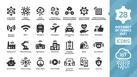
Figure 1 28 Internet of things icons
View description - Figure 1 28 Internet of things icons

This OpenLearn course is an adapted extract from the Open University course K102 Introducing health and social care.

Learning outcomes
After studying this course, you should be able to:
- explain what is meant by digital and health technologies
- evaluate the types of technologies used in health and social care
- identify the policies and digital innovations local to where you live.

1 Defining digital health and social care technology
As Figure 1 (in the Introduction) showed, there are lots of different types of technology, so it might be useful to define what we mean by digital health and social care technology before exploring particular policy in your region. This section will enable you to define the concept of digital health and social care technologies.
In 2019 the Topol Review estimated that by 2039, 90% of jobs will require digital skills (Topol, 2019). Therefore, the digital skills you are learning as you study will be valuable both now and in the future. There are many perspectives about what digital health and social care is, ranging from simple use of electronic records through to more complex artificial intelligence and robotics in surgery.
You will probably have heard a lot of different terms to describe digital health and social care technology. For example, the Digital Health & Care Institute (2018) use the term ‘Health Information Technology’ (HIT), The Welsh Government (2015), National Institute for Health and Care Excellence (NICE) (2019) and King’s Fund (in Macguire et al., 2019) use phrases such as ‘digital technology’, ‘digital health technologies’ (DHT) and ‘digital change’ while NICE (2019) outline quality standards requirements for the use of such technology, including information about how to evidence effectiveness and economic benefits (cost versus benefit).
Figure 2 provides a summary of the different ‘levels’ and ‘purpose’ of digital technology.

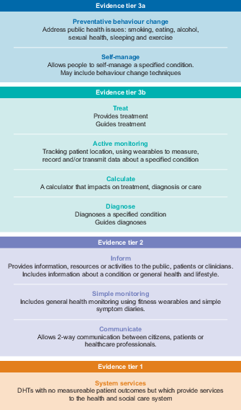
Figure 2 NICE (2019) Evidence Standards framework for digital health technologies.
View description - Figure 2 NICE (2019) Evidence Standards framework for digital health technologie ...

Activity 1 What do you understand by digital health and social care?

The following video was produced by The Health and Social Care Alliance Scotland in 2016 to explain digital health options. You may already receive some of these services. It also invites feedback from viewers. Watch it and then answer the question below.

Video content is not available in this format.
Video 1 What is digital health?
View transcript - Video 1 What is digital health?

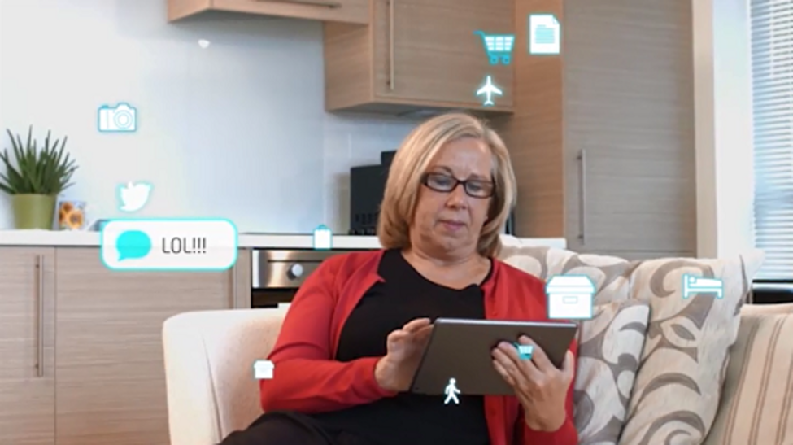

Think about the term ‘digital health and social care technology’ and write down your own definition of this from your own perspective.

Provide your answer...
View discussion - Activity 1 What do you understand by digital health and social care?

2 Policy for digital health and social care
The use of digital health and social care technologies are part of health and social care strategy, both across the United Kingdom and the rest of the world. Figure 3 illustrates some of the different digital health and social care policy and strategy across the UK. Click on the different UK countries to see further information.

Interactive content is not available in this format.
Figure 3 An interactive map of the UK.

Activity 2 Learning about digital health and social care strategy in the UK

In this activity, you will explore digital health policy and how local health and social care sectors are applying this.
- Search online for digital health policy or strategy documents that apply to your geographic location. If you’re not based in the UK, explore one of the UK nations which interests you.
- Choose one of these documents and read the introduction.
- Fill in the table below.
Where you are prompted to provide a full reference of the document you have found, use the title and URL / web address. Identify what kind of resource it is (e.g. if it’s a report, you need to go to the ‘report’ section of this guide and so on).

Title and full reference of document | Provide your answer...
How is digital health technology defined or explained? | Provide your answer...
Why is it being used? | Provide your answer...
Provide at least one example of a digital health technology being proposed. | Provide your answer...

View discussion - Activity 2 Learning about digital health and social care strategy in the UK

3 Why are digital technologies important?
There are a range of advantages and disadvantages of technology in health and social care. For now, this section will look at the advantages.
Imison et al. (2016) suggests that there are seven opportunities for the productivity and quality of care.
- More systematic, high-quality care
- More proactive and targeted care
- Better co-ordinated care
- Improved access to specialist expertise
- Greater patient engagement
- Improved resource management
- System improvement and learning.
Decision support tools for clinical decision making could improve the quality of care, and the use of electronic observations alongside laboratory tests can help to identify patients whose condition is deteriorating and thus improve productivity and care delivery. Remote community monitoring can improve access to services and electronic patient records can enable professionals from different areas of health and social care to access the right information at the right time and improve access to specialist expertise.
Technology can also promote better engagement with service users through the use of online networks and mobile applications. To help staff and managers, electronic rotas and mobile working can help to manage resources more effectively and efficiently. Finally, it is possible to use technology such as simulation in the education of health and care professionals. For example, the University of Derby have an immersive interactive Clinical skills simulation suite that imitates a real ‘hospital ward’ and where students are able to make decisions about care in a ‘safe’ environment.

Activity 3 The potential of digital technology for integrating care

Watch the following video, which discusses ‘the role of technology of care integration’, and make some notes in the box below about what you see as the advantages of electronic records. Understanding the advantages for integrated care will help you later in this course when examining the challenges of implementation and when exploring some of the innovations across the UK.

Video content is not available in this format.
Video 2 Role of technology in care integration
View transcript - Video 2 Role of technology in care integration

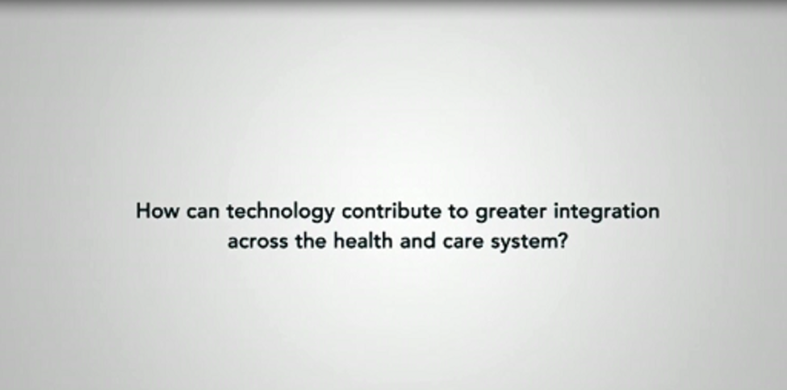

Provide your answer...
View discussion - Activity 3 The potential of digital technology for integrating care

3.1 Advantages of digital health and social care technology
Digital health and social care technologies have had an increasing impact since 2010, and from previous activities in this course you will see that in the UK, both nationally and locally, digital health technologies are now part of policy and strategy moving forward. The advantages of these technologies are wide-ranging and they can help to change and improve health and social care for service users, providers, people and professionals working in these sectors.
The next activity will encourage you to think about your experiences of digital health and social care technology and what advantages there might be.

Activity 4 Advantages of technology to you

Video content is not available in this format.
Video 3 The NHS at 70
View transcript - Video 3 The NHS at 70

As well as providing the potential advantages of digital technology, Imison et al. (2016) also outline the benefits of delivering digital health and social care based on a research project which is outlined in Figure 4, which depicts a summary of the digital landscape, with the patient and service user at the centre of what is done in health and social care.

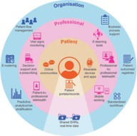
Figure 4 The benefits of digital technologies for patients, professionals and organisations.
View description - Figure 4 The benefits of digital technologies for patients, professionals and or ...

Think about some of the technology, both from the video and in Figure 4 above, and think about when and how you might come into contact with digital health and social care technology. This might be as a service user/patient, in your workplace, education or more widely.

What level is the technology you are thinking of at? Patient, professional or organisational? | Provide your answer...
What type of technology is it? | Provide your answer...
Does it have a positive or negative impact, and who is it impacting upon? | Provide your answer...
Why do you think this? For example, did it make your experience better? Did it result in better quality of care? | Provide your answer...

Now decide whether digital health and social care technology will have a positive or negative impact in the future.

Provide your answer...
View discussion - Activity 4 Advantages of technology to you

3.2 What are the disadvantages for implementation?
In the previous activity, you will have noted some of the advantages of digital health and social care technology. However, there are also disadvantages and challenges to be aware of.
An independent review report (Health Education England, 2019), ‘Preparing the healthcare workforce to deliver a digital future’, outlined some of the legal and ethical implications of digital health technology including patient safety, data governance, respect for human dignity and health inequalities. It is important that ethical principles are kept in mind when introducing the use of digital technology. For example, one of the primary ethical principles is ‘do no harm’, so patient safety needs to be considered before implementing any digital technology. This report also highlights some unintended consequences of digital health and social care, such as the risk of creating new inequalities with some parts of the population unable to access or use such technology.
Imison et al. (2016) further discuss and expand on the reasons why digital technology has been difficult to implement; 88% of UK adults report using the internet but only 2% report electronic engagement with health and care. Some of the barriers to this have been identified through research and experience, such as poorly designed information technology systems, resistance to change, the lack of high quality research evidence to support the implementation of certain technologies and the length of time it takes to start to see benefits of change.
One of the barriers to using digital technology in health care settings is that not everyone chooses to be online because they don’t feel comfortable using the technology or that they are concerned about the privacy and security of their personal information (Topol, 2019). In addition to physical access and privacy concerns, the use of digital technology may also have an impact on vision and posture; e.g. smartphone screens can create ‘glare’ that can impact on sleep.
From a legal and ethical perspective, Topol (2019) also identifies the risks associated with sharing data electronically, the use of biological databases and the systems and processes by which people provide consent for the collection and storage of this data and how this is managed, monitored, accessed and shared.

Activity 5 Disadvantages of being digital

Read the following:
- Bauer, M., Glenn, T., Monteith, S., Bauer, R., Whybrow, P. C. and Geddes, J. (2017) ‘Ethical perspectives on recommending digital technology for patients with mental illness’. Read Table 1 and the section on ‘ethical issues’.
Read through without making any notes. Think about the challenges and disadvantages associated with the use and implementation of health and social care technology. Finally, re-read the relevant section of the article, and highlight or make notes on what these might be for service users, patients, organisations or those who work in health and social care.

Provide your answer...
View discussion - Activity 5 Disadvantages of being digital

4 Types of health and social care technology
There are a range of different types of digital technology that you might already have come across or experienced such as mHealth (mobile health), electronic records, telemedicine, wearables (such as watches that monitor your activity) and simulation. Digital Health and Care Institute (2018) provides a list of commonly employed digital technology, and Figure 6 provides more information about each of these. Click on the headings in the image below to read more.

Interactive content is not available in this format.
Figure 6 Types of health and social care technology

4.1 Using technology in health and social care
You may well have experienced or used digital technology where you live or work; many people use smartphones, mobile apps and you will have been using the internet to access this OpenLearn course. Integrated and electronic patient records are becoming more and more popular and you have seen from the different activities in this course that people are broadening their use of digital technology.
The next activity provides some examples of digital technologies across different parts of the UK; you might have already heard about these, however, some might be completely new to you.

Activity 6 Map of technology of healthcare

Choose one of the UK nations, either the one you live in or one that interests you, and watch the associated video (and associated link if provided).

England

Video content is not available in this format.
Video 4 ChatHealth
View transcript - Video 4 ChatHealth

Wales

Video content is not available in this format.
Video 5 Digital Communities Wales case study: Mental Health Matters
View transcript - Video 5 Digital Communities Wales case study: Mental Health Matters

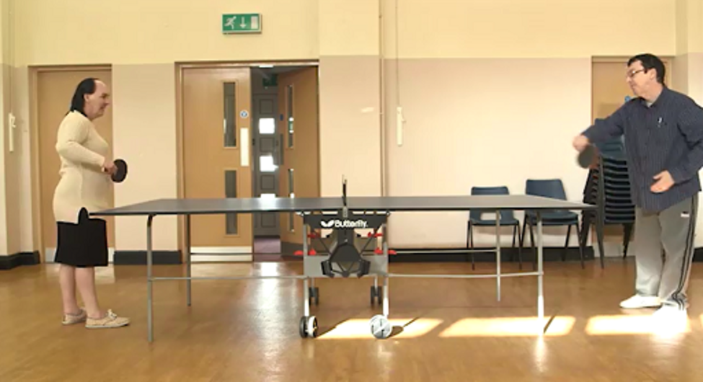

Scotland

Video content is not available in this format.
Video 6 ROAR VR
View transcript - Video 6 ROAR VR

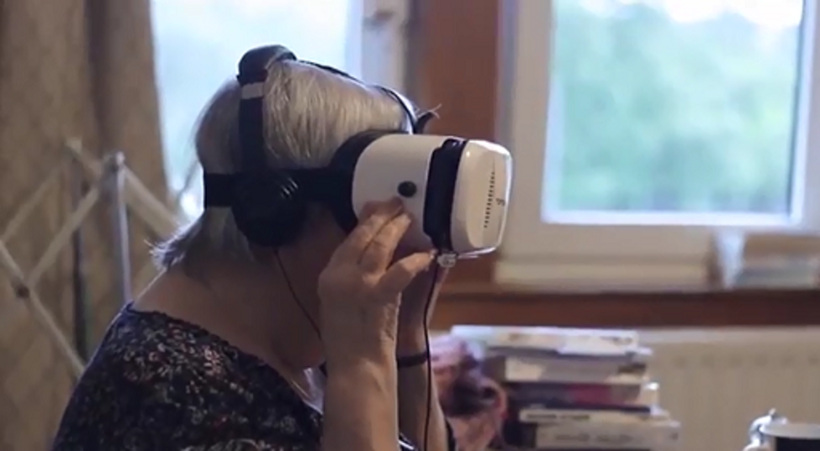

Additional resource: Virtual Reality over the Doorstep

Northern Ireland

Video content is not available in this format.
Video 7 Northern Ireland Electronic Care Record (NIECR)
View transcript - Video 7 Northern Ireland Electronic Care Record (NIECR)

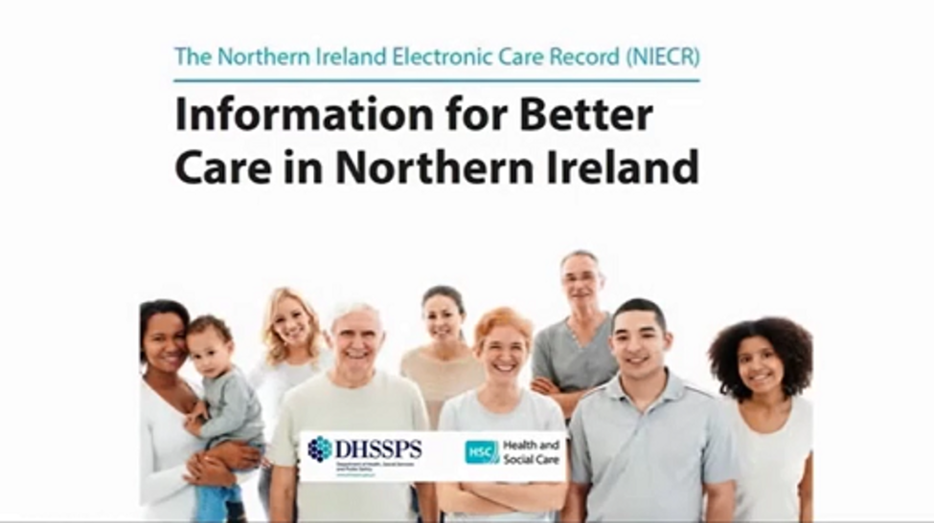

Additional resource: Northern Ireland Electronic Health Record

Part 2

Next, watch the following video.

Video content is not available in this format.
Video 8 DRIFT project
View transcript - Video 8 DRIFT project

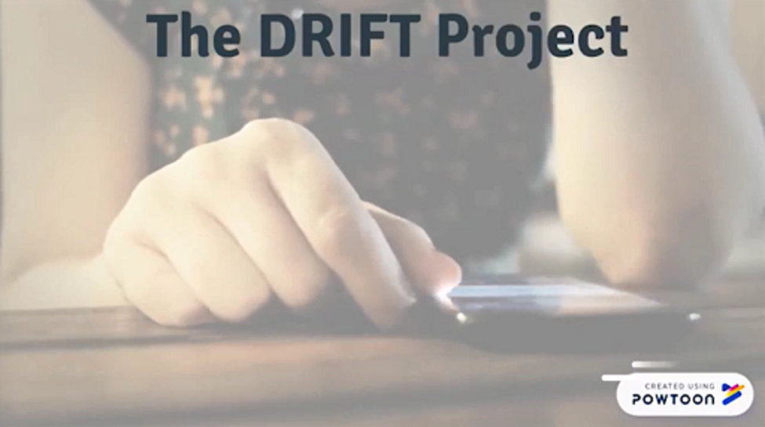

Now choose one of these case studies and write a short summary. In it, you should:
- summarise the technology used
- state a benefit of the technology used
- include a summary sentence that states why you chose this example and if you think it is a worthwhile use of technology.

Provide your answer...
View discussion - Part 2

Conclusion
This free course, What do we mean by digital health and social care?, has defined the concept of digital health and social care technology and encouraged you to explore the strategy and policy in your area. You should now be able to source relevant documents and evidence that are applicable to your location and that tell you about why digital health and social care technology is being used, along with some examples.
You have explored the impact of digital health and social care technology. You should now have explored some of the advantages and disadvantages of such technology and its implementation, and you will have used some skills in reading an academic journal article and taking notes.
This OpenLearn course is an adapted extract from the Open University course K102 Introducing health and social care.

References
Atherton, S., Antley, A., Evans, N., Cernis, E., Lister, R., Dunn, G., Slater, M. and Freeman, D. (2016) ‘Self-confidence and paranoia: an experimental study using an immersive virtual reality social situation’, Behavioural and Cognitive Psychotherapy, 44(1), pp. 56–64.
Bauer, M., Glenn, T., Monteith, S., Bauer, R., Whybrow, P.C. and Geddes, J. (2017) ‘Ethical perspectives on recommending digital technology for patients with mental illness’, International Journal of Bipolar Disorders, 5(6).
Department of Health (2016) eHealth and care strategy. Available at: https://www.health-ni.gov.uk/publications/ehealth-and-care-strategy (Accessed: 19 April 2021).
Digital Health and Care Scotland (2018) Scotland’s digital health and care strategy. enabling, connecting and empowering. Edinburgh: The Scottish Government.
Freeman, D., Haselton, P., Freeman J., Spanlang. B., Kishore, S., Albery, E., Denne, M., Brown, P., Slater, M. and Nickless, A. (2018) ‘Automated psychological therapy using immersive virtual reality for the treatment of fear of heights: a single-blind, parallel-group, randomised controlled trial’, Lancet Psychiatry, 5(8), pp. 625–632.
Health Education England (2019) The Topol Review: Preparing the healthcare workforce to deliver the digital future. Available at: https://topol.hee.nhs.uk/wp-content/uploads/HEE-Topol-Review-2019.pdf (Accessed: 19 April 2021).
Health and Social Care Information Centre (2015) Information and technology for better care: Health and Social Care Information Centre Strategy 2015–2020. Available at: https://assets.publishing.service.gov.uk/government/uploads/system/uploads/attachment_data/file/443353/HSCIC-Strategy-2015-2020-FINAL-310315.pdf/ (Accessed: 19 April 2021).
Imison, C., Castle-Clarke, S., Watson, R. and Edwards, N. (2016) Delivering the benefits of digital health care, Nuffield Trust research report. Available at: https://www.nuffieldtrust.org.uk/files/2017-01/delivering-the-benefits-of-digital-technology-summary-web-final.pdf (Accessed: 19 April 2021).
The King’s Fund (2018) Map of technology and data in health and care. Available at: https://www.kingsfund.org.uk/audio-video/technology-data-case-studies-map (Accessed: 19 April 2021).
Macguire, D., Evans, H., Honeyman, M. and Omojomolo, D. (2018) Digital change in health and social care, The King’s Fund. Available at: https://www.kingsfund.org.uk/publications/digital-change-health-social-care (Accessed: 19 April 2021).
National Institute for Health and Care Excellence (NICE) (2019) Evidence standards framework for digital health technologies. Available at: https://www.nice.org.uk/Media/Default/About/what-we-do/our-programmes/evidence-standards-framework/digital-evidence-standards-framework.pdf (Accessed: 19 April 2021).
NHS (2019) Strategy. Available at: https://digital.nhs.uk/about-nhs-digital/corporate-information-and-documents/our-strategy (Accessed: 19 April 2021).
Patient Access (2019) Patient Access. Available at: https://www.patientaccess.com/ (Accessed: 19 April 2021).
Social Care Institute for Excellence (SCIE) (2015) Technology changing lives: how technology can support the goals of the Care Act. Available at https://www.scie.org.uk/publications/reports/report73-technology-changing-lives.asp (Accessed: 19 April 2021).
Topol, E. (2019) The Topol Review: Preparing the healthcare workforce to deliver the digital future. Available at: https://topol.hee.nhs.uk/wp-content/uploads/HEE-Topol-Review-2019.pdf (Accessed: 19 April 2021).
Welsh Government (2015) A digital health and social care strategy for Wales. Available at: https://gov.wales/sites/default/files/publications/2019-03/informed-health-and-care-a-digital-health-and-social-care-strategy-for-wales.pdf (Accessed: 19 April 2021).

Acknowledgements
This free course was written by Lucy Rai.
Except for third party materials and otherwise stated (see terms and conditions), this content is made available under a Creative Commons Attribution-NonCommercial-ShareAlike 4.0 Licence.
The material acknowledged below is Proprietary and used under licence (not subject to Creative Commons Licence). Grateful acknowledgement is made to the following sources for permission to reproduce material in this free course:

Images
Course image: © Pop Nukoonrat / Dreamstime
Figure 1: © Yuriy Bucharskiy / iStock / Getty Images Plus
Figure 2: Adapted from Evidence Standards Framework for Digital Health Technologies, March 2019, © NICE 2019
Figure 4: The Technology landscape, Delivering the benefits of digital health care, 2016, © Nuffield Trust

Audio-visual
Video 1: Used with permission from Health and Social Care Alliance Scotland (the ALLIANCE)
Video 2: Courtesy of Health Service Journal
Video 3: © BBC
Video 4: Courtesy of Leicestershire Partnership NHS Trust
Video 5: © Crown copyright 2018 http://www.nationalarchives.gov.uk/doc/open-government-licence/version/3/
Video 6: Used with permission from Roar - Connections For Life https://www.roarforlife.org/2017/10/21/vr-over-the-doorstep/
Video 7: Used with permission from Northern Ireland Department of Health
Video 8:
Every effort has been made to contact copyright owners. If any have been inadvertently overlooked, the publishers will be pleased to make the necessary arrangements at the first opportunity.
Don't miss out
If reading this text has inspired you to learn more, you may be interested in joining the millions of people who discover our free learning resources and qualifications by visiting The Open University – www.open.edu/openlearn/free-courses.

Solutions

Activity 1 What do you understand by digital health and social care?

Discussion
Different people will have different definitions that reflect the wider context of digital health and social care. Your definition might have come from your own experience as an individual consumer of health care or from your work. Definitions will probably have included the internet, mobile or smartphone applications, electronic records or even games.
Back to - Activity 1 What do you understand by digital health and social care?

Activity 2 Learning about digital health and social care strategy in the UK

Discussion
You might have used a number of different documents in this activity; these might have been local social care policy, documents relating to the NHS or a national strategy document. Here is an example of a completed table:

Title and full reference of document | Title: Informed Health and Care, A Digital Health and Social Care Strategy for Wales  Welsh Government (2015) Informed Health and Care, A Digital Health and Social Care Strategy for Wales. [Available Online] https://gweddill.gov.wales/docs/dhss/publications/151215reporten.pdf (Accessed 12 August 2019)
How is digital health technology defined or explained? | It is described as digital technology and includes interactive, personalised services such as electronic records, the internet and dedicated web services.
Why is it being used? | - To help manage austerity and increasing demand for services  - To help manage pressures on services  - Introducing new and improved ways of delivering services  - To help people access services and information about their care  - Empowering service users and staff  - Allowing people to manage their own health.
Provide at least one example of a digital health technology being proposed. | Dedicated web service that allows ordering of test, creating and viewing documents and accurate maintenance of records.

Back to - Activity 2 Learning about digital health and social care strategy in the UK

Activity 3 The potential of digital technology for integrating care

Discussion
This video provided some examples of integrated patient records from different parts of the United Kingdom. Digital technologies are essential for progression of integrated care, sharing patient information between different agencies and organisations so that the information is available in the right place at the right time. Integrated digital care records are an example of how this can improve patient care, reduce costs and promote efficiency.
Back to - Activity 3 The potential of digital technology for integrating care

Activity 4 Advantages of technology to you

Discussion
You will have found that digital health and social care technology has a range of advantages for professionals, health and social care workers, patients, service users and services. Figure 5 summarises those from the Digital Health and Care Institute (2018).

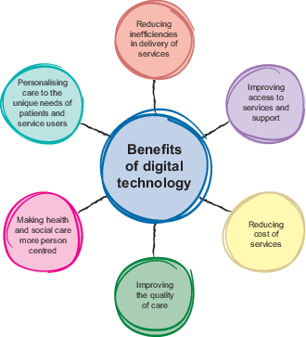
Figure 5 The benefits of digital technologies.
View description - Figure 5 The benefits of digital technologies.

Back to - Activity 4 Advantages of technology to you

Activity 5 Disadvantages of being digital

Discussion
The article shows that there are some significant challenges and disadvantages, particularly for those from vulnerable groups.
The article outlined some of the ethical issues that should be considered when implementing or making the decision to implement technology. The section on ‘ethical issues’ explored 6 areas of concern. Some examples are provided below.
- Issue 1 discussed the issues for medical professionals recommending digital technology to patients if they are not confident in their use. It is important to consider the technology being recommended and individual service user need. It is also noted that professionals should not assume that younger people are more able to use technology.
- Issue 2 discussed whether professionals should ignore when patients use technology, such as using internet searches to find information about their symptoms or potential ‘self’ diagnoses.
Back to - Activity 5 Disadvantages of being digital

Activity 6 Map of technology of healthcare

Part 2

Discussion
When you wrote your summary of the technology you should have been able to identify some of the benefits that it’s providing for people and/or organisations. These are likely to include improved communication, sharing information, improving quality of, access to and the experience of care, efficiency and cost saving.
An example post might look similar to the example below:
DRIFT: Disseminating Research Information using Facebook and Twitter
- This project used the social networks Facebook and Twitter to bring together parents and carers of children and young people with Attention Deficit Hyperactivity Disorder (ADHD). It provided information about research and quality standards on the topic of ADHD and helped patients and the public understand what the research was saying and whether it was of good quality.
- The use of online social networks like this brought together patients from around the world, the project provided useful information and support for parents and carers of children with ADHD.
- This was a useful project because it proved to be an efficient and cost-effective way of reaching a lot of people.
Back to - Part 2

Figure 1 28 Internet of things icons

Description
A list of some of the different digital technologies available: internet of things, digital technology, cloud computing, machine to machine, software defined networking, cyber physical systems, radio frequency identification, wireless network, Wi-Fi, transport, aerospace, autonomous care, health care, wearables, industry 4.0, manufacturing, agriculture, smart city, building management, retail, surveillance, smart home, smart energy, smart meter, smart media, consumer electronics, mobile devices, security.
Back to - Figure 1 28 Internet of things icons

Figure 2 NICE (2019) Evidence Standards framework for digital health technologies.

Description
The figure shows a table with four distinct sections. The top section describes Evidence tier 3a which is Preventative behavioural change (Address public health issues: smoking, eating, alcohol, sexual health, sleeping and exercise) and Self-manage (allows people to self-manage a specified condition. May include behavioural change techniques). The section titled Evidence tier 3b contains Treat (provides or guides treatment) and Active monitoring (tracking patient location, using wearables to measure, record and / or transmit data about a specified condition), Calculate (a calculator that impacts on treatment, diagnosis or care) Diagnose (diagnoses a specified condition, guides diagnoses). The third section illustrates Evidence tier 2, which is Inform (provides information, resources or activities to the public, patients or clinicians. Includes information about a condition or general health and lifestyle). Simple monitoring (includes general health monitoring using fitness wearables and simple symptom diaries), Communicate (allows two way communication between citizens, patients or healthcare professionals). The final section illustrates Evidence tier one; these are Systems services (DHTs with no measurable patient outcomes but which provide services to the health and social care system).
Back to - Figure 2 NICE (2019) Evidence Standards framework for digital health technologies.

Figure 4 The benefits of digital technologies for patients, professionals and organisations.

Description
The figure provides an overview of the future digital health and care landscape. The patient or service user is at its centre, surrounded by the patient facing technologies that provide them with opportunities to manage their health and social care and engage with health care providers. These include: Patient level – Online communities, patient records and shared electronic records; Professional level – vital signs monitoring, decision support and e-prescribing, patient to professional telehealth, mobile working, professional to professional telehealth, shared electronic records and e-learning tools; Organisational level – patient flow management, e-rostering, predictive analytics/risk assessment, shared electronic records, workflows, patient outcomes monitoring and business process support. The electronic records are in a different colour as they straddle all levels of the system as a whole, reflecting the pivotal role it plays in any digital strategy. It is the foundation on which many of the other apps are built. Next are the technologies that provide tools for health and care professionals. These include decision support, the capacity to access other professionals’ expertise, tools to prioritise and manage their clinical workload and tools to identify those patients at greatest risk. Finally are the technologies that support organisations, including tools for business process support, predictive analytics, flow management and e-rostering, which give new resource and clinical management capabilities to health care providers.
Back to - Figure 4 The benefits of digital technologies for patients, professionals and organisations.

Figure 5 The benefits of digital technologies.

Description
This graphic depicts six circles leading out from a larger circle in the centre marked “Benefits of digital technology”; the smaller circles list some of these benefits as follows: reducing inefficiencies, improving access to services and support, reducing costs, improving quality of care, making health and social care person-centred, personalising care to the needs of patients and service users.
Back to - Figure 5 The benefits of digital technologies.

Video 1 What is digital health?

Transcript
NARRATOR
If you're online, the internet can play a big part of your daily life. With a PC, tablet, or smartphone, you really can have the whole world in your hand. You can go shopping, do your banking, buy tickets for travel, get information, or simply keep in touch with family and friends.
There's a lot you can do online when it comes to taking care of your health care, too. From apps to help you boost your well-being to potentially connecting with your GP surgery, the option of booking appointments with your GP or ordering repeat prescriptions will soon be available to more people. And in the future, you'll be able to access a summary of your medical record online along with other services and information perhaps through just one website or app.
Your medical record will be more joined up, bringing together information held by your GP practise, any hospitals you visit, and eventually any social and community care services that you access. The record will also be available to appropriate professionals involved in your care, so they can securely share and see your information whenever this is useful. Joining things up in this way could help improve the support you receive and your health care experience. Having access to your medical record could make you more informed about your health care and about your conditions and help you manage them better.
So what do you think? Do you have any thoughts or ideas on how this could work for you? We'd love to hear from you. So why not get in touch today and find out how you can help shape digital health.
Back to - Video 1 What is digital health?

Video 2 Role of technology in care integration

Transcript
GARY BIRKS
Undoubtedly, technology is key to the success of delivering integrated care. As patients need to move more across the health care boundaries from organisation to organisation, it's key that data can follow them, that the patient record can follow them, both to deliver on increased efficiencies that integrated care will bring, but also to deliver benefits around patient safety and clinical care.
Traditionally, sharing data across health and social care has been constrained both through organisational silos, but also by the silos of technology and data across those health care organisations. For example, sharing data within acute care has typically been successful, but beyond the boundaries of thought, it's actually been quite limited. And now through the needs of an ageing population, it's important that care and the data can move beyond the acute setting.
One way that organisations can better share data within a local care economy is through the development and introduction of an integrated digital care record. An integrated digital care record brings together the patient's data from many different sources from many different care settings to give the clinician the right data at the right time. That means the clinician can make the best decision for the patient and also help deliver the greatest efficiencies for the health economy.
There are some great examples in the NHS of the use of integrated digital care records. In Northern Ireland, for example, the health and social care boards have come together to develop an electronic care record. In Bristol, with the Connecting Care programme, which has brought together some 14 or so health and social care organisations to create a shared care record.
A more recent example is in the west of Scotland, where five health boards who have their own integrated digital care record held within clinical portals are now undertaking a programme of work that allows them to share and give access to each other's clinical portals. One of the benefits of the west of Scotland portal is actually with regards to the efficiency of clinicians finding patient data, and research ahead of the project showed that clinicians spent on average 70 minutes a day looking for patient data across health borders, and it was anticipated a reduction in the time to search for a patient record would create savings of around 20,000 pound per year per clinician.
Beyond the benefits of efficiency, organisations will find that through the use of an integrated digital care record, they'll actually begin to collate more and more data for each of their patients. That data will allow them to be less reactive, to be more proactive, and move along the journey towards population health management.
[MUSIC PLAYING]
The first thing that health care leaders need to do in developing an integrated digital care record is actually to engage all the stakeholders, including their patients, bringing your key stakeholders together to agree on the reasons and the importance of creating an integrated digital care record.
Back to - Video 2 Role of technology in care integration

Video 3 The NHS at 70

Transcript
DR KEVIN FONG: This, in many ways, is what you want from a 21st-century health service-- state-of-the-art technology, delivered the care that you need, where you need it, when you need it, with the right blend of expertise arriving as quickly as humanly possible. But new technology isn't just about shiny new kit. It's also changing how some of us use the NHS day in, day out.
[MUSIC PLAYING]
RYAN WILD: Ryan.
DR KEVIN FONG: Very nice to meet you.
RYAN WILD: Hi. Thanks for seeing me.
DR KEVIN FONG: Thanks very much for coming. Ryan Wild recently signed up to a new NHS online service, GP at hand.
RYAN WILD: I was really having difficulty getting a doctor's appointment. And when I did get an appointment, they kept getting canceled. So I just got really fed up. And I'd seen the advertisements for GP at hand. And I thought I'd give it a try.
[PHONE RINGING]
DR SAMGEE: Hi. Good afternoon. My name's Dr. Samgee. Welcome to GP at hand. How can I help today?
RYAN WILD: Hi there. Yeah, I've been having headaches quite regularly, and I'm a little bit concerned.
DR KEVIN FONG: The app offers online GP consultations around the clock, face-to-face appointments, and a symptom checker.
DR SAMGEE: Take care.
RYAN WILD: Yeah, you too. Thank you. Bye bye.
DR KEVIN FONG: Do you see that service in the same way that I guess some people would see delivery overall?
RYAN WILD: Absolutely.
DR KEVIN FONG: Absolutely suits you in that way?
RYAN WILD: Yeah, absolutely. I mean, I feel that it's a step towards the future.
[MUSIC PLAYING]
DR KEVIN FONG: GP at Hand, initially London based, is a partnership between the NHS and a private tech company Babylon.
ALI PARSA: I can see my GP in five minutes. Now pick up this phone, and call your GP. And see when can you see her. Right? That's the reality. We've made health care accessible for people in London within minute.
SPEAKER 1: It can't be used at the moment by people who are pregnant, people with dementia, people with complex medical diseases.
ALI PARSA: It is the NHS who asked us for a short period of time to start the service to try it on a younger and healthier group and then before they allow it to be opened up to everybody. I think this is the way all of the health care will be delivered in future, at least at the GP level.
DR KEVIN FONG: 28,000 patients have already signed up. But not everyone is happy. To join the app, you have to leave your current GP. And every patient lost means less NHS funding for those surgeries.
JACKIE APPLEBEE: General practice is on a knife edge as it is. And if we're losing sort of our younger, fitter patients, who we rely on to cross-subsidize us to care for our more complex elderly patients, we lose the money for those patients. and then general practice could end up becoming financially unviable, and then they ultimately could close.
DR KEVIN FONG: In a world where we're used to having things at our fingertips and through our mobile devices, why shouldn't health care be the same?
JACKIE APPLEBEE: I can bring somebody in from the waiting room. I can tell by the way they walk in if they're really, really sick. I think you lose that on Skype.
[MUSIC PLAYING]
TECHNICIAN: There will be a flash coming.
DR KEVIN FONG: New technology could also transform the way the NHS diagnoses disease.
TECHNICIAN: Keep close. Don't move.
DR KEVIN FONG: Oh, that's quite a flash.
TECHNICIAN: Yes.
DR KEVIN FONG: You don't want to have a hangover doing this, do you? I'm having a high resolution scan of my retina. Currently, these scans have to be analyzed by a doctor looking for eye diseases that cause blindness. But the huge number of scans means it's hard to prioritize the most urgent cases.
PEARSE KEANE: In the NHS, we see nearly 10 million people per year in hospital eye services, but the problem is that we're really kind of drowning in the number of patients that we have to deal with. So what we're doing is now training an artificial intelligence to look at an OCT scan and diagnose macular degeneration or diabetic eye disease or many other causes of blindness. OK, Richard, I'm going to examine you right now.
DR KEVIN FONG: Working with DeepMind, a British tech company owned by Google, Pearse is developing an algorithm that can analyze thousands of scans and potentially save people's sight.
PEARSE KEANE: OK. You can sit back and relax.
RICHARD: Thank you.
PEARSE KEANE: New technologies, and in particular, artificial intelligence, will really, I think, fundamentally transform many aspects of the NHS. That will lead to new insights and I think new treatments for patients with a range of diseases.
Back to - Video 3 The NHS at 70

Video 4 ChatHealth

Transcript
STUDENT
It allows us to express ourselves in a way that we can express to our friends. And to know that it's confidential makes me open up to other people besides my other friends.
STUDENT
Sometimes you have things that are so embarrassing that you can't talk about. So if you send a message, then you have-- the nurse already knows what you've going to talk about. And then we can just think of ways to get over that and just help. So it's really useful.
STUDENT
You can feel judged by talking to someone face to face. So I think if you can text them it's like they don't actually know who you are.
JANE DAWSON
Hi, my name's Jane Dawson, and I'm a school nurse for the Brixton team, and I'm a chat health ambassador.
KATIE
Hi, my name's Katie. I'm a school nurse in the Hinckley & Bosworth school nursing team. I've been a chat health ambassador now for the last two years.
JANE DAWSON
I do chat health as part of my daily job, but it doesn't stop my day. I can go in and out of all the schools, come back, respond to text messages, and then go out again.
KATIE
Generally, we get about 15 messages a day from young people asking a variety of questions or asking for a variety of advice.
JANE DAWSON
We're informed when we're going to be a chat health ambassadors. So I plan my day to make sure I'm in the office in some points of the day to respond to the text messages. I also go out to my schools and promote the chat health service so young people know how to access it.
KATIE
Chat health allows us to have a pause in what we're doing so we can have supervision with other staff or think about our responses, which enables us to provide a high standard service and also a standardised service as well.
JANE DAWSON
I love the fact that the young people can access this service, and the feedback is just brilliant. They will text you saying, thank you so much for your support. And it just puts a smile on your face knowing that you've helped someone.
STUDENT
Hello, my name's Serita, and I like this website because it makes me fit and healthy.
STUDENT
I like the website because it will make you fit, and I like the characters.
STUDENT
I like your website because it has funny games in it and fun games in it, and it keeps me fit and healthy.
STUDENT
I like the website because it makes me fit and healthy, and I like the logo as well.
STUDENTS
We love Health For Kids!
STUDENT
Website looks really great, and it really looks like they've taken on our advice, and the videos are a really nice touch.
STUDENT
I think that the quizzes are a really entertaining way to get information across to teens.
STUDENT
Today's website launch has been amazing, and I'm very proud to be a part of this wonderful, exciting launch.
STUDENT
I really think the website is really good. And it can really help teenagers who have problems, and it can really help you out.
STUDENT
It looks like it was really well designed, and it can fit bascially every pupose, especially with everything new coming out for it.
STUDENT
You know, being involved in what we have all created as something essential for everyone is to benefit not just us alone. It's to benefit everyone in the UK. So I think that to be good.
STUDENT
Visit health for teens.
[GIGGLING]
Back to - Video 4 ChatHealth

Video 5 Digital Communities Wales case study: Mental Health Matters

Transcript
CERI BISLEY
I'm a community services worker for Mental Health Matters Wales. We're based in Bridgend. We're a charity that supports people with mental health issues in the Bridgend Borough. And we deliver a number of different services, one of which is the well-being centre here.
We try and sort of encourage all of our service users to use the equipment, whether that's the iPads, the tablets, the laptops. If they ask us a question, we say-- perhaps sometimes on purpose-- I don't know that. Should we Google it? Should we have a look? And sometimes I genuinely don't know the answer to the questions. And it's just a way to sort of encourage them to get familiar with the equipment, because that's primarily, isn't it, a lot of the issues.
The equipment we receive from Digital Communities Wales, in total, there's a laptop, a tablet, the iPad, the wireless keyboard, the Bluetooth speakers. And the service users use them in a variety of different ways. Sometimes it is just for shopping or searching the internet. They've used it to register for courses, to look at things. On the NHS websites, they tend to use a lot here, because we encourage-- obviously, it's all about healthy eating, and mindfulness, and well-being, and referring on to other agencies. So they use it for that.
Plus, we've had a couple of service users who have registered with courses in the local further education colleges. And one of our service users regularly does his coursework when he was enrolled on those courses. So he used the computers for that, used Excel and some of the other Microsoft packages.
MAN 1
How I got into this technology was fairly straightforward. I enrolled in a night school in the tech and doing simple spreadsheets, which they teach you. And I also bought comprehensive books in Open University, which I enrolled later on a course, which I managed to pass.
CERI BISLEY
Through Mental Health Matters Wales, through our well-being centres and our community cafes, I guess we reach in excess of 500 service users across the county. And that's Kenfig Hill, Maesteg, Pencoed, Bridgend, and Cefn Glas as well. And certainly high in percentage, I would say probably getting on for 80% of those, wouldn't have access to any other form of equipment, or get online, or anything like that if it wasn't for the equipment that we have here.
We support people in the community with mental health issues. And it is harder at times to engage some of those service users with the world wide web, just by nature of its technology. We do support them and sit with them. It is more difficult, certainly with people with learning disabilities. For them, a lot of the time it's just, they've talked themselves into they can't do it.
And once they realise how easy it is and how straightforward-- certainly when they see the iPads, and how user-friendly it is, you know, because it's all apps, and it's all pictures, they just are blown away by it. It's really exciting actually.
MAN 2
It was like, because I can't call my brother. Because since my brother's abroad, and I don't want my bill to be sky high, so I use social media like Facebook to keep in contact with him.
MAN 1
These people are angels in my sight. And they serve the local community. They do it absolutely free, with no praise or commendation from anyone. They spare their time for the general good of the community.
Back to - Video 5 Digital Communities Wales case study: Mental Health Matters

Video 6 ROAR VR

Transcript
NARRATOR
The trouble with virtual reality and live video streaming is it's wasted on the young. It's great fighting zombies and watching celebrities. But we want to use this tech for something far more exciting.
We want to take the housebound elderly to the theatre, the park, and local events. We are the charity Roar Connections For Life. And we work for the older citizens in Renfrewshire. We run clubs, groups, and activities, including sessions in new technology. We work to enable participants to stay actively engaged in their community and their own lives. Since 2010, we have reached thousands. And today we have over 900 active users.
In 2021, Paisley hopes to be the UK City of Culture, bringing a plethora of new attractions and events to Renfrewshire, which, sadly, many of the housebound elderly will be unable to attend. Roar want to use VR and live video streaming to connect these people to what's happening over their doorsteps. Funding will help us set up a channel to create and present bespoke content specifically aimed at the older housebound in Renfrewshire.
VR films will let them experience local parks and museums. Live streaming will take them to performances. And live video tours with two-way comms will let them take an active part in exhibitions and events. The model can then be replicated in other areas, bringing the experience to thousands. Now isn't that better than zombies and celebrities?
WOMAN
That was very exciting.
Back to - Video 6 ROAR VR

Video 7 Northern Ireland Electronic Care Record (NIECR)

Transcript
[MUSIC PLAYING]
KEN FULLERTON
In these days of the internet, the patients are quite surprised to discover that we have been using bits of paper and posting things between hospitals, that it can take days, sometimes, for records from another hospital to turn up.
For instance, it's not unusual at an outpatient clinic for the patient to turn up, for the doctor to be there, and the notes haven't appeared. Previously, the patient would have had to go home again until we found the notes. Now, the information that we need is all available online. We can see the patient right away, and there's no longer a problem.
DARSHAN KUMAR
Electronic care record gives us information about patients when they have been in the other hospitals. The main thing is, it preventing duplication because we know these tests or investigations have been done, or the patient has been under somebody for the relevant problems. So there's no need to reinvent the wheel or redo all the investigations.
ELIZABETH CONNOLLY
Instead of having to look at multiple different systems, different programmes for clinic letters, different letters for-- or different programmes for labs, different programmes for-- actually, it's all there. You know, it's really, really quick. It just gives you-- you can assess their history really quickly so you-- there's obviously more time with the patient, quicker admissions, quicker in clinic, quicker on the ward.
LAURENCE BURKE
Even before patients arrive with us on the ward, I'm able to get the information from the electronic care record, get all of their relevant previous medical history, find out what conditions they've got, see if the admission is related to a condition that they've already got or already seeing somebody for, or whether it's something new that's shown up. That way, I think we're armed with as much information as we can about the patient.
DAVID PATTON
Hello, this is Dr. David Patton here, one of the emergency medicine registrars.
PAUL TURKINGTON
We're all well practised at following family members, GPs, and nursing homes to get the information you need to collect together a picture of the patient. And I think the ECR is a tool that helps with that. It doesn't replace the need to talk to the patient and the family and all that. But it's a great extra addition to that.
SHANE MCKEE
I would see patients very often in quite a complex care scenario. We see genetic patients so they're maybe seeing a number of different specialists for lots of different things. So if we can see all their information, and all the number of specialists that they're seeing, and when they're seeing them up on the screen, it allows us then to coordinate their care a lot better, to understand their needs, and to see if there are any gaps in their care that perhaps need to be filled in. So it helps us to join up the whole process and make the appointment process itself, which can often be quite long-- we would normally see people for maybe 45 minutes. But it makes that process much more efficient, so we can get a lot more done within that time.
PAUL MCKEAGNEY
My work is as a respiratory consultant. So I have lots of people with chronic diseases. And I work particularly closely with the south and east community teams. So we have a lot of patients who may go between different hospitals. So the system means that I can access records from other hospitals, particularly blood results, sputum results, or actuary reports for my patients who may go to a different hospital. So logging into this one system means that everything is brought together and that I can see what has been done previously to make sure that I'm not duplicating or repeating unnecessary examinations. But it also helps appropriate treatment as well.
TARA HASLETT
I would use the laptop with the MiFi, so I connect into the Trust system. And then that takes me into the ECR. I have a work list, where I have my own patients and one of my colleague's patients on that list.
If I arrive to the house, the patient wasn't there, I can see if they've landed into A&E as well. I can see if they've got a pending outpatient appointment.
NICKY BROWN
Because I cover quite a large geographical area, that I'm not always on base, the fact that I can remotely access ECR from any area within my locality-- if a patient phones me, I can look up their information very speedily, see what their last admission was, what treatments they're on, any allergies, any sort of urgent medication that they have needed. And it just helps me in diagnosing that patient and treating them appropriately to keep them out of hospital.
NATASHA JAMISON
good thing about ECR is that it's web-based, so you can access it via PC, via tablet, via your mobile phone. As long as it's on the secure network, the Trust network, you can access it anywhere, so inside and outside of hospital.
SHANE MCKEE
Patient medical information, of course, is very sensitive, and it's very personal to the patient themselves. So they do need to be reassured that full confidentiality will be maintained, so there's a consent process that we take them through whenever we're opening up their record on the electronic care record.
RUTH GILMARTIN
I'm carrying notes for my pregnancy. This is 2013. It should probably all be computerised so that I don't have to carry around a document to say I'm pregnant, and here are my notes.
NOEL CONLON
To bring everything in under the one umbrella would be a tremendous achievement. To follow your Belfast City Hospital number and be able to immediately go to the A&E and be able to identify on the screen immediately with your history, ancestry, and whatever you're getting treated for in an instant would be undoubtedly a fantastic achievement.
PAMELA O'LOAN
I'm a diabetic with high blood pressure. And sometimes it's very difficult to remember the names of the pills I use. So I think it's a great idea that they would have everything to hand, if you went from one place to another, that you don't have to give the same information to one doctor, another doctor, and another doctor.
KEN FULLERTON
I use it every day. It's the first system I turn on in the morning. I bring it with me when I do ward rounds. I use it whenever I'm in the outpatient clinic. It's been brilliant, a really successful system.
Back to - Video 7 Northern Ireland Electronic Care Record (NIECR)

Video 8 DRIFT project

Transcript
Please note: this video has no audio narration. The following transcript consists of the text that appears during the course of the video.
The DRIFT Project: Disseminating Research Information through Facebook and Twitter
Project Aim: To use social media platforms to engage, listen and inform parents and carers of children with ADHD about healthcare research; Explain how, why and in what circumstance people engage with Facebook and Twitter for this purpose; Explain what type information and media works, why and when to engage, listen and inform patients & the public about research.
It looked like this: [shows screenshot of a poorly laid-out website]
We shared information on Facebook & Twitter about... How do I know the research in the news is ‘credible’? Where do I get advice and support about ADHD? What are clinical guidelines and what do they mean for my child’s care?
We explained what different types of research means for patients
We shared websites, photos and videos to explain research and ADHD as a condition
We brought people together...
Who were they...?
1300 followers over 3 months!
84% women
59% 18-34 years old
30 countries
Back to - Video 8 DRIFT project

