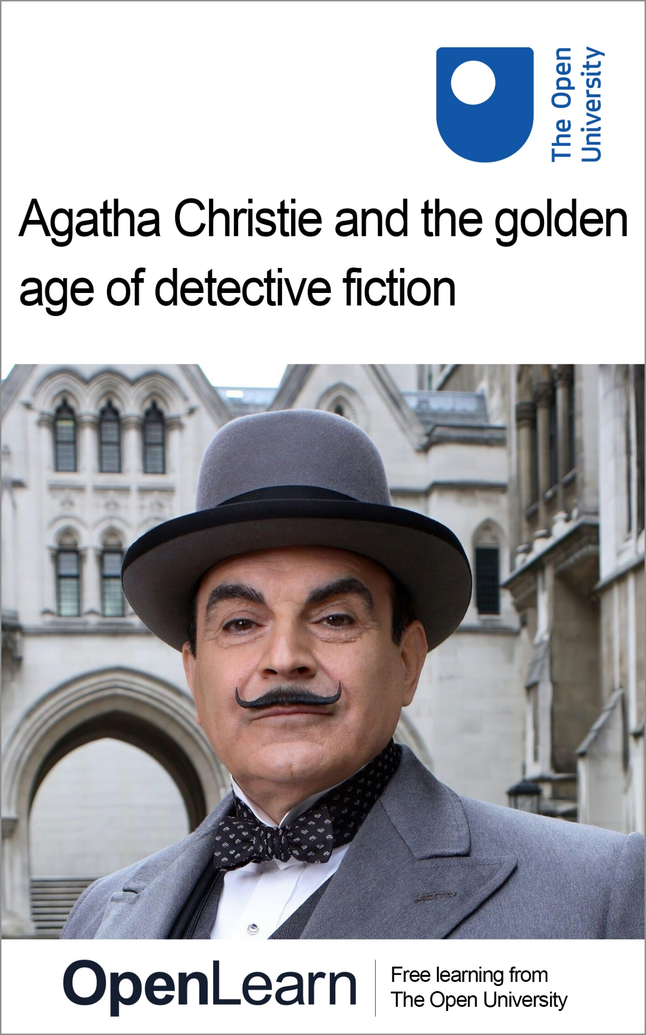

A893_1

Agatha Christie and the golden age of detective fiction

About this free course
This free course is an adapted extract from the Open University course A893 MA English Literature Part 1: www.open.ac.uk/postgraduate/modules/a893.
This version of the content may include video, images and interactive content that may not be optimised for your device.
You can experience this free course as it was originally designed on OpenLearn, the home of free learning from The Open University –
www.open.edu/openlearn/history-the-arts/agatha-christie-and-the-golden-age-detective-fiction/content-section-0
There you’ll also be able to track your progress via your activity record, which you can use to demonstrate your learning.
Copyright © 2023 The Open University
Intellectual property
Unless otherwise stated, this resource is released under the terms of the Creative Commons Licence v4.0 http://creativecommons.org/licenses/by-nc-sa/4.0/deed.en_GB. Within that The Open University interprets this licence in the following way: www.open.edu/openlearn/about-openlearn/frequently-asked-questions-on-openlearn. Copyright and rights falling outside the terms of the Creative Commons Licence are retained or controlled by The Open University. Please read the full text before using any of the content.
We believe the primary barrier to accessing high-quality educational experiences is cost, which is why we aim to publish as much free content as possible under an open licence. If it proves difficult to release content under our preferred Creative Commons licence (e.g. because we can’t afford or gain the clearances or find suitable alternatives), we will still release the materials for free under a personal end-user licence.
This is because the learning experience will always be the same high quality offering and that should always be seen as positive – even if at times the licensing is different to Creative Commons.
When using the content you must attribute us (The Open University) (the OU) and any identified author in accordance with the terms of the Creative Commons Licence.
The Acknowledgements section is used to list, amongst other things, third party (Proprietary), licensed content which is not subject to Creative Commons licensing. Proprietary content must be used (retained) intact and in context to the content at all times.
The Acknowledgements section is also used to bring to your attention any other Special Restrictions which may apply to the content. For example there may be times when the Creative Commons Non-Commercial Sharealike licence does not apply to any of the content even if owned by us (The Open University). In these instances, unless stated otherwise, the content may be used for personal and non-commercial use.
We have also identified as Proprietary other material included in the content which is not subject to Creative Commons Licence. These are OU logos, trading names and may extend to certain photographic and video images and sound recordings and any other material as may be brought to your attention.
Unauthorised use of any of the content may constitute a breach of the terms and conditions and/or intellectual property laws.
We reserve the right to alter, amend or bring to an end any terms and conditions provided here without notice.
All rights falling outside the terms of the Creative Commons licence are retained or controlled by The Open University.
Head of Intellectual Property, The Open University

Contents
- Introduction
- Learning outcomes
- 1 Detective fiction and its origins
- 2 The post-war detective fiction boom: historical and social context
  - 2.1 Rethinking detective fiction
  - 2.2 The author’s life
  - 2.3 Gender and detective fiction
  - 2.4 Christie’s political context
- 3 Structures of detective fiction
  - 3.1 Mahjong: the function of the clue–puzzle narrative
- 4 The Purloined Killer: the role of the reader
- 5 Does Christie break ‘the rules’?
  - 5.1 The rules of detective fiction
- 6 Adaptation and The Murder of Roger Ackroyd
- Conclusion
- References
- Further reading
- Acknowledgements
- Solutions

Introduction
English Literature reached new mass audiences in Britain in the first decades of the twentieth century, as widespread literacy, and a lack of competition from other media – cinema and radio were in their infancy – encouraged commercial diversification and the development of popular genre fiction. When we think of literature as a popular cultural form, Agatha Christie (1890–1976), Britain’s pre-eminent crime fiction author after the First World War, is a landmark figure. In terms of both the volume of sales and translation into other languages (over 100), her work is unparalleled in the history of publishing. As Charles Rzepka puts it, Christie is ‘not only the most prolific and popular author of detective fiction in the twentieth century, but the world’s best-selling writer, ever’ (a record which remains intact at the time of writing) (Rzepka, 2005, p. 156).
In this free course you will focus on one of Christie’s most important works: The Murder of Roger Ackroyd (1926). This novel arguably marks the crossing of a threshold for Christie and for the genre of detective fiction. It was published in a period of literary modernism, during which a highbrow engine of literary innovation was running, ostensibly separate from Christie’s world and her readers, who may be identified as part of the mass reading public outlined above. But there are key connections to draw between the middlebrow world of detective fiction and the formal experimentation that characterised more avant garde literary works in the era. The Murder of Roger Ackroyd certainly makes a case for that. In terms of history and context, Christie brings a British provincialism to the fore which, as you will see, provides a deceptive and disarming setting for the novel. Just beneath the novel’s surface, the aftermath of the ‘Great War’ and evolving attitudes to both reading and writing emerge in surprising and profound ways.
This OpenLearn course is an adapted extract from the Open University course A893 MA English Literature Part 1.
Taken together, the sections that follow offer a multifaceted perspective on Agatha Christie and the ‘golden age’ of crime fiction, and give you some insight into the texts, teaching material and critical approaches you might encounter if you were to study A893. Because A893 incorporates some critical discussion of literary adaptation this course also invites you to think of Christie’s detective fiction in one of its adaptations.

Reading guidance and spoiler alert
If you have chosen to read the suggested set text, Agatha Christie’s The Murder of Roger Ackroyd, you should complete your reading now before continuing. The critical discussion that follows will assume you have read Christie’s novel and are aware of the identity of the killer. Plot spoilers also apply to Edgar Allan Poe’s ‘The Purloined Letter’.

Learning outcomes
After studying this course, you should be able to:
- understand some key aspects of Agatha Christie’s writing
- analyse ‘golden age’ British detective fiction and appreciate its formal and generic features
- contextualise the rise of detective fiction against literary modernism and new commercial developments in middlebrow writing
- reflect on the popularity and continuing adaptation of detective fiction and crime writing.

1 Detective fiction and its origins
The origins of detective fiction are complex. A global view of the genre is certainly possible, taking in many languages and cultures, and stretching a long way into the past. There are, for example, ancient Chinese literary traditions with generic features of the ‘whodunnit’, one strand of which was brought to new prominence by Dutch translator Robert Van Gulik in 1949, with Celebrated Cases of Judge Dee (Dee Goong An).
As the dominant American–European tradition of detective fiction began to take its modern shape in the nineteenth century, it did so by absorbing and distilling many existing genres. The figure most often seen as its key innovator is Edgar Allan Poe (1809–1849), drawing as he did on both the European and American Gothic, supernatural mysteries and the eighteenth century romance tradition while also foregrounding new developments in science, technology and even logic. A new flaneur-like detective emerged in his creation of Auguste Dupin, a pre-Holmesian observer of urban life and crime, most famously outwitting the great and the good in ‘The Purloined Letter’ (1844) with techniques of ‘ratiocination’ (a pre-cursor technique to Sherlock Holmes’s deductive reasoning and Hercule Poirot’s ‘little grey cells’). In an act of playful deception Dupin recovers the letter of the title by switching it with a decoy and leaving it on the filigree card-rack where it had been hiding in plain sight.
The idea of the detective fiction as a game, to be entered into in a spirit of ‘fair play’, is another defining aspect of the modern detective genre. ‘The game’s afoot’ is, of course, famously associated with Arthur Conan Doyle’s brilliant detective, Sherlock Holmes, but the presentation of the act of detection as a kind of game – both between the detective and his adversaries and the author and their readers – began with Poe. Will the apparently infallible protagonist be able to solve the apparently insoluble mystery? Do we as readers have a chance of cracking the case ourselves? Can we at least follow the reasoning and, when the solution is presented, feel a sense of satisfaction in the outcome? These questions are fundamental to the form and technique of what would become known as the clue–puzzle narrative. The ‘setter’ of a puzzle of any kind, of course, be it crossword or riddle, must present the ‘solver’ with a taxing but logically achievable goal. Certain ground rules of fair play must be observed for any puzzle to present a challenge with a satisfying outcome. That type of satisfaction is, essentially, the bread and butter of all successful clue–puzzle stories, from Poe onwards. You will delve deeper into this ludic dimension of the genre later in the course.
In the case of the golden age of detective fiction, this informal contract between writer and readers culminated in the foundation of a ‘Detection Club’ of writers led by Ronald Knox who, in 1928, as a prelude to its formation, created a set of rules which were to function as a kind of contract with the readership – the ‘Ten Commandments of Detection’ outlined in Section 5 (see Horsley, 2010, pp. 40–1). With The Murder of Roger Ackroyd (1926), Agatha Christie pushes the spirit of fair play right to its boundaries by playing on readerly expectations derived from the Sherlock Holmes stories, and particularly those relating to the ‘Watson’ archetype of the baffled but loyal narrator (a role here apparently assumed by Dr Sheppard). By making her narrator the killer in this case, Christie might be said to have violated two of the commandments: firstly an element of number one, stating that the criminal ‘must not be anyone whose thoughts the reader has been allowed to know’ and certainly most of number eight, which states that ‘the “side-kick” of the detective, the Watson, must not conceal from the reader any thoughts which pass through his mind’. Some critics have argued that Christie ‘threatened’ the entire basis of the genre by compromising the narrator. Dorothy L. Sayers, among others, however, defended Christie and argued for her compliance with these and other rules. There are many other contemporary reactions and a longer legacy of discussion over the decades provoked by this, and you will be invited to uncover and explore these during this course.

2 The post-war detective fiction boom: historical and social context
In this section you’ll start to gain some insights into the contexts of detective fiction in the post-First World War era. You’ll learn about Agatha Christie’s life and you’ll think about the significance of detective fiction as a genre written and read, increasingly, by women. You’ll finish this section by thinking about the inter-war political contexts of Christie’s writing.

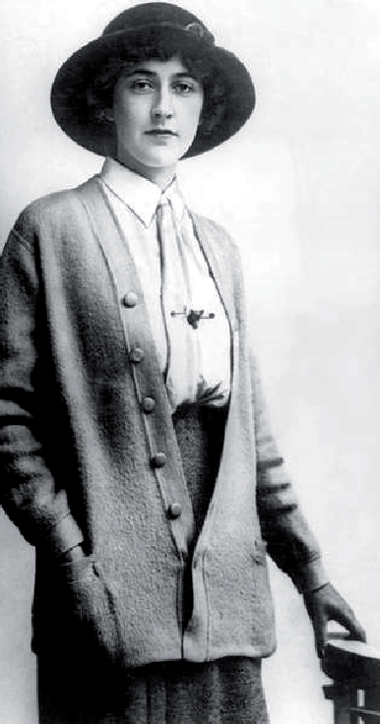
Figure 1 Agatha Christie, 1926.
View description - Figure 1 Agatha Christie, 1926.
View alternative description - Figure 1 Agatha Christie, 1926.

2.1 Rethinking detective fiction
On the surface, with its country house and village setting, Roger Ackroyd might have the appearance of a potboiler in an age where the whodunnit had become an immensely popular but largely disposable form (‘Potboilers’ capitalised on popular literary tastes and trends, with writers generally compromising artistic merit to allow greater speed of composition). The eponymous victim is a ‘new money’ industrialist but also a well-established community figure who is found murdered in a locked room. There is a closed circle of relations and associates with potential motives for the killing. Hercule Poirot, the series detective familiar to the reader, is necessarily on hand to assist the police and in the absence of his established sidekick (Captain Hastings), a local doctor – and our narrator – has stepped in as his confidant and assistant. But the unfolding of the narrative and, especially, the revelation of the killer, elevate the novel to a special status within the genre.
In the age of modernism, whodunnits are perhaps easy to categorise as popular and ‘middlebrow’ fiction. But Maurizio Ascari and others have argued for a ‘Detection of Modernism’ based on claims made by Sayers about the sophistication of the form (Ascari, 2007, p. 170). It is through formal innovation, in fact, that crime fiction is, on the one hand, able to remain popular and satisfying in execution, and, on the other, potentially able to serve and reflect deeper concerns in the years following the cataclysm of the First World War; this is a task often reserved (perhaps simplistically) for the domain of ‘highbrow’ modernist fiction in the 1920s.

2.2 The author’s life
The context of Christie’s life is often brought into discussion, especially in connection with this particular novel. She had married Archibald Christie (1889–1962) in 1914, at the age of 24, and subsequently began to write detective fiction to some acclaim, while also taking up various roles in support of the war effort at home. However, 1926 was a turbulent year for Christie, as she discusses to some degree in her autobiography (Christie, 2017). The details are noteworthy here only because they briefly became part of Roger Ackroyd’s reception. The author herself undeniably lived through experiences that year which might have been lifted from the pages of the genre for which she was becoming a figurehead.
Suffering from a nervous breakdown and apparent amnesia following infidelity on the part of her husband, she was widely reported to have disappeared later that year. This prompted both public concern and media sensationalism, in which journalists and amateur sleuths almost seemed to relish the chance to play the role of the detective. The incident still garners renewed press interest occasionally which recalls (and to some degree recycles) the tone of intrigue and scandal from 1926 (see Turner, 2017 and Jordan, 2019). Suffice to say that such coverage was a sign of Christie’s growing celebrity. It therefore cannot be completely divorced from the sense of notoriety beginning to grow out of her willingness to shock, delight and transgress formal boundaries in her fiction, even while maintaining an eminently accessible, conservative literary style. It also reveals something important about the status of detective fiction authors in the 1920s and the relationship between the texts and their readership (an issue to which you will return).

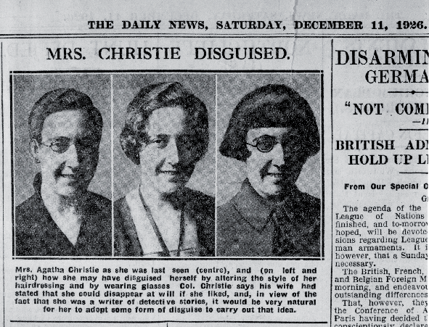
Figure 2 In 1926 The Daily News mocked up images of how Christie might have looked in different disguises.
View description - Figure 2 In 1926 The Daily News mocked up images of how Christie might have looked ...
View alternative description - Figure 2 In 1926 The Daily News mocked up images of how Christie might have looked ...

2.3 Gender and detective fiction
The inter-war years saw the expansion of a female readership across social classes, partly as rise in literacy fostered by the education reforms of the late nineteenth century, but it also saw, for the first time, reading habits reflect the opening of new professional horizons, traditionally thought of as male, on account of the mass mobilisation of the war effort (for a good summary of this within the broader context, see McAleer, 1992, pp. 53–4).
Detection was one such potential horizon, and the demand for detective stories from female readers was particularly strong. Rzepka has noted that the ‘prominence of the New Woman’ as well as the popularity of Conan Doyle’s Sherlock Holmes stories led to a massive increase in female readership for detective fiction and wonders at the lag in demand to see women in the central role of the detective protagonist (Rzepka, 2005, pp. 149, 158). America, which had not lost its young men in the same horrific numbers in the First World War, saw instead the rise in popularity of its homegrown detective for the age – the hardboiled private eye in the growing industry of pulp fiction. If the likes of Dashiell Hammett’s Sam Spade (The Maltese Falcon) or Raymond Chandler’s Philip Marlowe (The Big Sleep) share some of the physical prowess of Sherlock Holmes, their methods, moral frameworks, and social status in many ways make them the antithesis of earlier models of the investigating sleuth.
One obvious advance into the territory of detective fiction, however, was the success of women authors in the post-war period. Alongside important male contemporaries – particularly G. K. Chesterton (the Father Brown stories) and Nicholas Blake (the Nigel Strangeways series) – the golden age of detective fiction was defined in many ways by the work of four women, dubbed the ‘Queens of Crime’: Margery Allingham (1904–1966), Dorothy L. Sayers (1893–1957), Ngaio Marsh (1895–1982) and, of course, Christie herself. All provided important contributions to the genre and helped to carry the private detective archetype beyond the dominant figure of Holmes. Sayers, for example, introduced Lord Peter Wimsey, an aristocratic amateur sleuth with enormous personal wealth, breaking the bohemian mould. Allingham had her version too in the shape of Albert Campion. Christie emerged as supreme among these writers and would remain a dominant force in the genre for decades, propelled initially by the success of her own iteration of the European detective: Hercule Poirot.

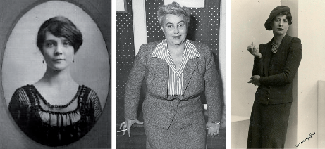
Figure 3 (Left) Dorothy L. Sayers. (Centre) Margery Allingham. (Right) Ngaio Marsh.
View description - Figure 3 (Left) Dorothy L. Sayers. (Centre) Margery Allingham. (Right) Ngaio Marsh. ...
View alternative description - Figure 3 (Left) Dorothy L. Sayers. (Centre) Margery Allingham. (Right) Ngaio Marsh. ...

Poirot is an example of what has traditionally been identified as a ‘feminised’ version of the analytical detective type. Susan Rowland (2010, p. 121) challenges this conceptualisation somewhat. His ‘feminine’ or ‘domesticated’ qualities are on show in Roger Ackroyd and turn out to be crucial to the solution of the crime, including, for example, his interest in the arrangement of furniture in the room where the murder took place and his ability to identify an apron fragment. These qualities, in fact, to some extent laid the groundwork for another wildly popular take on the figure of the detective: that of Miss Jane Marple, who would later feature in 12 of Christie’s novels.

2.4 Christie’s political context
The inter-war period between 1918 and 1939 is also known as one of socially conservative, safe or ‘cosy’ settings in detective fiction. But this is a deceptive impression in relation to Christie. She does specialise in what we might characterise as the provincial, for the most part, and the crimes of the provincial middle classes, generally. But the secrets that come to light – including murder, blackmail, heroin addiction and suicide – are deeply unsettling. As Alison Light frames it, ‘Christie seems to have been uniquely audacious in always being prepared to make respectability itself suspect’ (Light, 2013, p. 94).
Despite this audacity, it is common to encounter disapproval of the apparent social conservativism expressed within Christie’s detective novels, and The Murder of Roger Ackroyd is no exception. Martin Priestman, for example, while noting that the relative affluence of the characters and their comfortable village community provide a ‘satisfyingly manageable’ closed setting ‘demanded by the form’, also criticises the lack of penetration of the harsh social realities of the post-war period or the hard-won rights struggles of the 1920s. It is true that the setting and context seem to be made as innocuous as possible, in political terms: ‘As a woman who had herself found a degree of independence, as a wartime hospital worker and then as a highly successful writer, Christie’, Priestman adds, ‘might at least have been expected to celebrate the increase in women’s rights accompanying the Female Suffrage of 1928’ (Priestman, 1988, p. 21). He is undoubtedly correct about the exigencies of the form. But with the remarkable care and economy involved in the structure of the narrative centred on the murder of a man in cold blood, is this a fair criticism? Did detective fiction enthusiasts look to the Christies of the world to reflect social progress or challenge lingering injustices? Can detective fiction escape political characterisation?
In fact, Roger Ackroyd, like other clue–puzzle narratives apparently striving for ‘sociopolitical neutrality’, has been seen in part as a text reacting to a turbulent moment in British history (Knight, 2004, p. 93). The golden age can be characterised as a reaction, of sorts, to the fracturing of history caused by the ‘Great War’ and the attempt, via the solving of mysteries – particularly violent ones – to enter into a collective act of reassembling what had been lost for a generation of readers (Rzepka, 2005, p. 154). Thus the act of solving a crime is an expression of the ‘ideological motivation to recover, or return to, a previous period characterised by stability and order’ (Scaggs, 2005, p. 47). The ‘domestic scale’ of the setting and events masks what critics have argued is a reaction to the trauma and horrors of the war which only occasionally surface (Horsley, 2010, p. 32). The urbane figure of Lord Wimsey, for example, conceals his own post-traumatic stress, which is only briefly alluded to in the stories (Horsley, 2010, p. 32). Susan Rowland explores the post-trauma angle in her chapter ‘The “Classical” Model of the Golden Age’, referring along the way to other valuable arguments from Gill Plain and Alison Light that detective fiction in the golden age constitutes a ‘literature of convalescence’ (Rowland, 2010). We cannot therefore discount the simplistic but powerful motivation of escapism, always on offer from a genre that seeks to confound expectations while offering a satisfying resolution within reassuringly prescribed limits.

3 Structures of detective fiction
You have now had a chance to think about the inter-war contexts of golden age detective fiction and review key issues such as the role of women in the pioneering development of the genre in this period. In the process you’ve seen how contexts such as the First World War and contemporary social changes in Britain are useful in reading detective fiction. Some critics would argue, however, that the form and distinctive structural rules of detective fiction are just as important as critical reference points, and in the following section you will take a closer look at one aspect of form that came to define crime writing of this period: the clue–puzzle narrative.

3.1 Mahjong: the function of the clue–puzzle narrative
While much has been written about fairness, it is arguably a less important ingredient in crime fiction than the concept of ‘play’ itself. You have already learned about the importance of puzzles and riddles to the genre as a whole. Parlour games are often used as analogies in detective stories. Edgar Allan Poe, for example, makes reference to the marble game ‘even-and-odd’ in ‘The Purloined Letter’, and in the same story his detective Dupin uses the example of a map puzzle game to explain the success of his ‘hiding-in-plain-sight’ tactic. In Poe’s ‘The Murders in the Rue Morgue’ (1841), too, right at the outset, Dupin offers a lengthy disquisition comparing chess with draughts as a way of illustrating the ‘higher powers of the reflective intellect’ (which he counterintuitively believed were best characterised by the latter). These ludic analogies are not merely present to elucidate the method of the detective or the psychology of the villain, however. Games are symbolic, rather, of the genre’s consistent determination to reach out to the potential reader and to create a communitarian response that drives mass readership. In short, the reader is invited not just to read the text but to share in the deductive process of identifying clues and solving the puzzle of the crime.
The clue–puzzle narrative dominated the golden age. The plotting strategies of the form can be contrasted with those of the crime fiction thriller in that the present is largely pedestrian or ‘static’ and concerned with ‘unravelling past events’ just as the crossword solver unpicks the ingenuity of the setter, performed in the past. ‘Whodunnit’ is not merely a genre. It is, as you have seen, a sort of challenge issued by writer to reader (Priestman, 1988, pp. 1–2). The existence of ‘the rules’ underlines the importance of play, or the illusion of play, as quite possibly the most significant factor in the popularity of detective fiction. In this respect, Roger Ackroyd is – occasionally subtly, occasionally less so – a self-aware work. Several characters, including Poirot and Sheppard, make droll metafictional references to the genre of which they are a part: ‘I thought it was always done. It is in detective fiction anyway. The super-detective always has his rooms littered with rubies and pearls and emeralds from grateful Royal clients’ (Christie, 2012, p. 138). Christie is aware, above all, of the extent to which her genre involves – and is to some degree about – we the readers. Our self-awareness is something of a sub-plot in the novel itself and an active element within the author’s ruse.
Chapter 16 of the novel – ‘An Evening at Mah Jong’ – is arguably an allegory of this. It almost feels like an interlude in the narrative, although its timing later turns out to coincide with a crucial moment in Poirot’s deductive scheme. A Qing dynasty-era Chinese invention, mahjong is a tile game played by forming pairs and suits from a random array of tiles. Like the murder mystery, a (closed) circle of ‘players’ is required. British expats in China’s Shanghai Club play quickly, it is noted in the novel, and the English characters are ponderous, though they ‘perform’ their idea of the Chinese pace of play for a while (Christie, 2012, p. 196). Other than this, no real interest is expressed in the culture of origin of the game or in the travels of the Sheppards’ neighbour who professes an intimate knowledge of it. Above all, the players prize the notion of the ‘perfect winning’, which involves calling ‘mahjong’ with your original hand; a feat achieved by Sheppard to the amazement of the other players (Christie, 2012, p. 196).


Figure 4 Assorted mahjong tiles.
View description - Figure 4 Assorted mahjong tiles.
View alternative description - Figure 4 Assorted mahjong tiles.

Like Rummy, the winning strategy in mahjong is based on melding. Melding may only be achieved by drawing and discarding, which, as with Poe’s parlour games, might make this a symbolic representation of both the detective’s method and the novel’s structure. Though neither Sheppard nor Poirot (who is not present) make such a suggestion, the players discuss elements of the case while they play the game, so the allusion is inescapable. Knight argues that ‘Christie’s highly ornate plots make a testing, intricate puzzle and that in itself replicates bourgeois thinking’ (Knight, 1980, p. 117). We see this in the observations of the characters themselves. Many of them profess to be avid detective fiction readers and relish the element of competition it incorporates. One of the players at the table, Caroline Sheppard (the proto-Miss Marple), is the most obvious example of this, prizing success in various challenges available to her in the village setting: the mastery of gossip and secrets, the game of mahjong and the whodunnit puzzle itself. Success in all fields ‘is valued because it implies the unaided personal solving of life problems, dramatizes self-sufficiency and calibrates personal achievement’ (Knight, 1980, p. 117). Ironically, Miss Sheppard is the supreme example of failure in this regard, blind as she is to the true nature of her own brother. Poirot ultimately respects her character, even though she lacks the acumen Christie would later incorporate into the figure of Marple.

4 The Purloined Killer: the role of the reader
What, then, are the consequences of the denouement in the more serious game of cat-and-mouse eventually won by Poirot? The audience/reader emerges once more as the key context for understanding the detective novel. In Poe’s ‘The Purloined Letter’, Dupin’s famous switcheroo allows him to gain possession of the Queen’s letter unnoticed. Poirot’s deliberate positioning of Sheppard as a substitute for his ‘Watson’ (Captain Hastings) is also a switch of a kind which allows the detective to ‘possess’ or keep him in a custody of sorts while he gathers evidence to confirm his theory. Is Sheppard an unreliable narrator? While he is certainly not candid with us, does he actively lie to us at any point? Arguably at least, his dishonesty is based only on omission and not on concealment. His guilt was there in the text for us to discover, theoretically, as the rules of ‘fair play’ require. By his own admission, he is not writing his journal (our narrative) to deceive but, rather, assuming himself to be the victor in the game, to chronicle a defining failure of Hercule Poirot (Christie, 2012, p. 296).
Although there are interesting things to say about them, the cultural context and geographical setting of the detective novel are incidental. The readers themselves in fact provide the more interesting context here. Sheppard the sidekick is, in a sense, the reader’s representative and Christie uses that well-known formal trope as a Trojan Horse to smuggle the killer into the narrative undetected. The reader has in a sense been used as an unwitting ‘vessel’, concealing Sheppard’s true actions within the act of reading itself. Up until the reveal, the murderer and the act of murder were not to be found within the pages, as such. But both were, like Poe’s purloined letter on its filigree card-rack, hidden in plain sight the whole time, even if our own ‘little grey cells’ do not have the wit to detect the deception.
That said, the sidekick and the audience are not the same thing. Sheppard is certainly there for us to identify with, to some degree. But, as per Knox’s ‘rule’, every reader is meant to hope that they possess a measure of deductive acumen that the inductive reasoner does not, even if they would not claim to be the equal of Poirot. Few would be excited by a super-detective who could not delight them with superior gifts, after all. The reader therefore ideally assumes the position between sidekick and detective – slightly better than the former (we chuckle to ourselves when their shortcomings are exposed) but clearly inferior to the latter. In the case of Roger Ackroyd, we stand in between the murderer and detective protagonist. It is a strange and slightly uncomfortable position to find yourself in as a reader: in this case you were not aligned with the sidekick after all, but with the murderer. Sheppard’s failure to deceive Poirot is all his own because the reader was not aware of the deception. The absent Captain Hastings – the ‘Watson’ – was the intended disguise of the murderer, but he turns out instead to have been Poirot’s and Christie’s method of concealment. Poirot has allowed Sheppard to assume that shape partly in order to keep him close, and Christie uses it to ‘encrypt’ the killer’s identity. Both protagonist and author triumph by holding all the cards – by controlling the order of the mahjong tiles. When presented with the ‘perfect winning’, some readers will delight in both the game and Christie’s victory, while those disaffected in defeat are left to bemoan the variant of the rules played. Whatever the reaction, the game played in Roger Ackroyd is a feature of the democratisation of reading as an activity and to some extent of the aspiration to write: two core elements in the enduring popularity of detective fiction.

5 Does Christie break ‘the rules’?

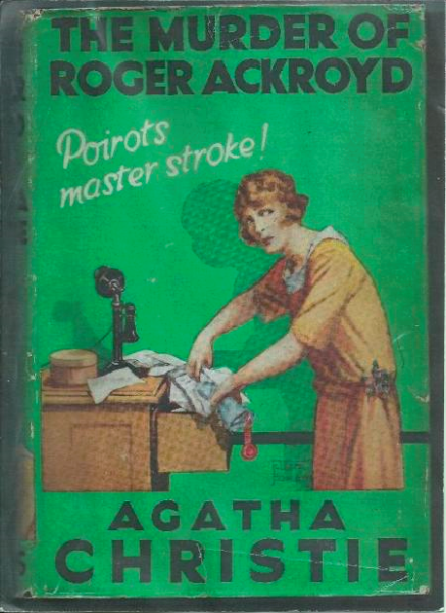
Figure 5 Agatha Christie, The Murder of Roger Ackroyd (London: Collins, 1926).
View description - Figure 5 Agatha Christie, The Murder of Roger Ackroyd (London: Collins, 1926).
View alternative description - Figure 5 Agatha Christie, The Murder of Roger Ackroyd (London: Collins, 1926).

Earlier, when reviewing the origins and development of detective fiction at the start of this course, you considered the implications of ‘the rules’ or the ‘Ten Commandments’ of detective fiction assembled by Ronald Knox in 1929. Endorsed by the famous Detection Club of British mystery novelists, these rules have been hugely influential, not just for notions of ‘fair play’ in the composition of crime narratives but also for the understanding of the creative process behind modern detective fiction. You will now look in more detail at Knox’s schema of rules for writing detective fiction.

5.1 The rules of detective fiction
Content warning: In Rule 5 in the list below, the use of the word ‘Chinaman’ is jarring to a modern reader and clearly not an appropriate term of national or racial identity by modern standards. Knox’s inclusion of it in the decalogue in 1929 reflects contemporary prejudices including a lazy (and usually racist) tendency, promoted by contemporary authors such as Sax Rohmer, to cast characters of Asian origin as villains in crime fiction (see Van Dover, 2010). While Knox’s racialising ban on Chinese characters appears to be an injunction against the unthinking use of racist stereotyping in the plotting of crime fiction, it is ironic when we recall the Chinese origins of detective fiction noted earlier.
The full list of Knox’s ‘Ten Commandments’ is as follows:

- The criminal must be mentioned in the early part of the story, but must not be anyone whose thoughts the reader has been allowed to know.
- All supernatural or preternatural agencies are ruled out as a matter of course.
- Not more than one secret room or passage is allowable.
- No hitherto undiscovered poisons may be used, nor any appliance which will need a long scientific explanation at the end.
- No Chinaman must figure in the story.
- No accident must ever help the detective, nor must he ever have an unaccountable intuition which proves to be right.
- The detective himself must not commit the crime.
- The detective is bound to declare any clues which he may discover.
- The ‘sidekick’ of the detective, the Watson, must not conceal from the reader any thoughts which pass through his mind: his intelligence must be slightly, but very slightly, below that of the average reader.
- Twin brothers, and doubles generally, must not appear unless we have been duly prepared for them.
(quoted in Engelhardt, 2003, p. 19)

Activity 1

In light of the ten ‘rules’ above, consider the following:
- Which of the rules are relevant in relation to The Murder of Roger Ackroyd? You have been given a brief sense of the controversy relating to two of these in particular. What is your view? Does Christie potentially ‘break’ other codes with her device?
- What does the tone of Knox’s list convey, and what does this tell us about detective fiction and its readers?
- Do such ‘rules’ alone tell us anything about history and context? Or do they simply relate to formal expectations of the genre?
- How many of these rules might still usefully apply today?

Provide your answer...
View discussion - Activity 1

6 Adaptation and The Murder of Roger Ackroyd
With the development of cinema in the 1930s and 40s and later the arrival of television, the whodunnit, alongside other subgenres of crime fiction, found new mass media forms. Not all literary genres lend themselves to adaptation, but with their suspenseful plotting, and their dramatic emphasis on character and narrative and (often visual) clues, detective fictions such as Christie’s seemed almost perfectly designed for the big, and small, screen. If you live in the UK, you will be aware of the numerous adaptations of Agatha Christie’s detective fictions that are almost a fixture of UK TV programming, and in the final section of this course, you will look at one of these adaptations from ITV’s series Agatha Christie’s Poirot (1989–2013).

Activity 2

Watch this clip from ‘The Murder of Roger Ackroyd’, adapted for the long-running and highly acclaimed ITV series, Agatha Christie’s Poirot (1989–2013), starring David Suchet. Then, answer the questions that follow.

Video content is not available in this format.
View transcript - Uncaptioned interactive content

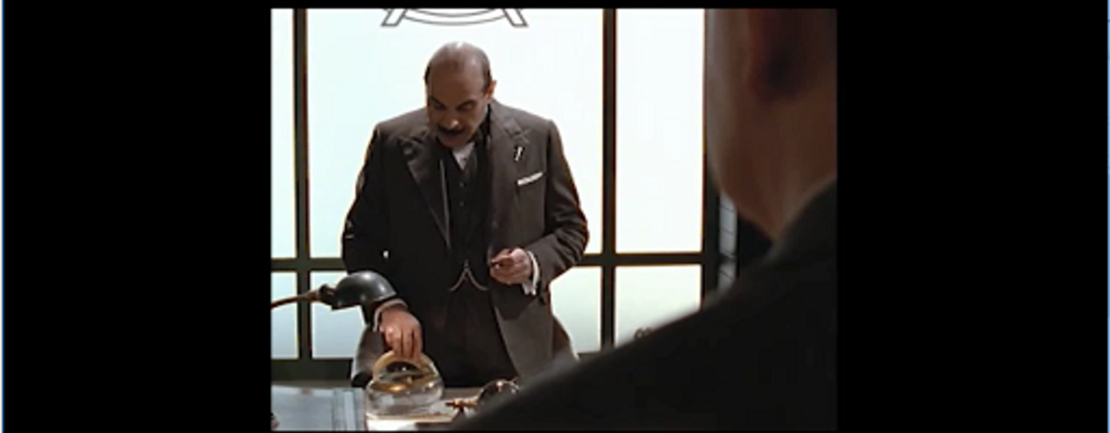

- How successful are the screen writers in adapting a supposedly un-adaptable novel for the small screen, based on this scene and their handling of the killer’s revelation?
- What decisions might they have made differently, in terms of structure, form and characterisation?
- How essential are the period-specific features, as represented in Agatha Christie’s Poirot?
- Can you envisage this story set in a different period or setting? Suggest one possible scenario using a different historical context.

Provide your answer...

Conclusion
In this free course, you have considered the importance of the post-war detective fiction boom of the 1920s, the dawn of the ‘golden age’ of the genre and the importance in particular of Agatha Christie as the leading figure among its female pioneers.
You have examined the ways in which the clue–puzzle narrative dominated, and interrogated notions of the ‘cozy’ and the provincial in Christie’s work, as well as the context of the readers themselves as an active force in the reception and transmission of The Murder of Roger Ackroyd and its controversial experiment with the formal boundaries of clue–puzzle narratives.
In studying this material, you have acquired a detailed milestone in the birth of modern detective fiction. Hopefully you will have picked up skills which allow you to read this kind of fiction in a different way and, perhaps, to experiment with plotting your own. Christie’s strategies are relevant to a wide range of popular fiction (most of the Harry Potter novels are ‘clue puzzle’ whodunnit narratives, after all) and permeate the world of television and film. Now you are part of the Detection Club, you may find yourself applying the old ‘rules’ to familiar stories …
This OpenLearn course is an adapted extract from the Open University course A893 MA English Literature Part 1.

References
Ascari, M. (2007) A Counter-history of Crime Fiction: Supernatural, Gothic, Sensational, Basingstoke: Palgrave Macmillan.
Christie, A. (2012) The Murder of Roger Ackroyd, London: HarperCollins.
Christie, A. (2017) Agatha Christie: An Autobiography, London: HarperCollins.
Engelhardt, S. (2003) The Investigators of Crime in Literature, Marburg: Tectum Verlag.
Hilliard, C. (2006) To Exercise our Talents: The Democratisation of Writing in Britain, Cambridge: Harvard University Press.
Horsley, L. (2010) ‘From Sherlock Holmes to the Present’, in A Companion to Crime Fiction, ed. by Charles J. Rzepka and Lee Horsley, Chichester: Wiley, pp. 28–42.
Jordan, T. (2019) ‘Paper Chase: When the World’s Most Famous Mystery Writer Vanished’, New York Times, 11 June. Available at: https://www.nytimes.com/2019/06/11/books/agatha-christie-vanished-11-days-1926.html (Accessed 13 April 2023).
Knight, S. (1980) Form and Ideology in Crime Fiction, London and Basingstoke: Macmillan.
Knight, S. (2004) Crime Fiction since 1800: Detection, Death, Diversity, Basingstoke: Palgrave Macmillan.
Light, A. (2013) Forever England: Femininity, Literature and Conservatism between the Wars, Abingdon: Routledge.
McAleer, J. (1992) Popular Reading and Publishing in Britain: 1914–1950, Oxford: Clarendon.
Priestman, M. (1988) Crime Fiction: From Poe to the Present, Plymouth: Northcote House.
Rowland, S. (2010) ‘The “Classical” Model of the Golden Age’, in A Companion to Crime Fiction, ed. by Charles J. Rzepka and Lee Horsley, Chichester: Wiley, pp. 117–27.
Rzepka, C.J. (2005) Detective Fiction, Cambridge: Polity Press.
Scaggs, J. (2005) Crime Fiction: The New Critical Idiom, Abingdon and New York: Routledge.
Turner, C. (2017) ‘Mystery of Agatha Christie’s Disappearance is “Solved” as Author Suggests she Considered Suicide over Husband’s Affair’, Daily Telegraph, 8 May. Available at: https://www.telegraph.co.uk/news/2017/05/08/mystery-agatha-christies-disappearance-solved-author-suggests/ (Accessed: 13 April 2023).
Van Dover, J.K. (2010) ‘No Chinaman: Ethnicity and the Detective in the 1920s’, in Making the Detective Story American: Biggers, Van Dine and Hammett and the Turning Point of the Genre, 1925–1930, Jefferson: McFarland, pp. 66–96.

Further reading
General further reading for Agatha Christie
Agatha Christie (2001) Agatha Christie: An Autobiography, London: HarperCollins.
Janet Morgan (2017) Agatha Christie: A Biography, London: HarperCollins.
Critical surveys of detective fiction with coverage of Christie
Janice Allan et al. (eds) (2020) The Routledge Companion to Crime Fiction, Abingdon: Routledge.
Maurizo Ascari (2007) A Counter-history of Crime Fiction: Supernatural, Gothic, Sensational, Basingstoke: Palgrave Macmillan.
Richard Bradford (2015) Crime Fiction: A Very Short Introduction, Oxford: Oxford University Press.
Stephen Knight (2004) Crime Fiction, 1800–2000: Detection, Death, Diversity, Basingstoke: Palgrave Macmillan.
Stephen Knight (1980) Form and Ideology in Crime Fiction, London and Basingstoke: Macmillan.
Martin Priestman (1998) Crime Fiction: From Poe to the Present, Plymouth: Northcote House.
Charles J. Rzepka (2005) Detective Fiction, Cultural History of Literature, Cambridge: Polity Press.
Charles J. Rzepka and Lee Horsley (eds) (2010) A Companion to Crime Fiction, Chichester: Wiley.
John Scaggs (2005) Crime Fiction, Abingdon: Routledge.
Criticism related to The Murder of Roger Ackroyd
Madison J. Davis (2015) ‘Playing by the Rules’, World Literature Today, 89, pp. 29–31
Edmund Wilson (1980) ‘Who Cares Who Killed Roger Ackroyd?’, in Detective Fiction: A Collection of Critical Essays, ed. by Robin W. Winks, New Jersey: Prentice Hall, pp. 35–41.
The golden age of detective fiction
J.K. Van Dover (2010) ‘No Chinaman: Ethnicity and the Detective in the 1920s’, in Making the Detective Story American: Biggers, Van Dine and Hammett and the Turning Point of the Genre, 1925–1930, Jefferson: McFarland, pp. 66–96.
Sandra Engelhardt (2003) The Investigators of Crime in Literature, Marburg: Tectum Verlag.
Alison Light (2013) Forever England: Femininity, Literature and Conservatism between the Wars, Abingdon: Routledge.
Susan Rowland (2001) From Agatha Christie to Ruth Rendell: British Women Writers in Detective and Crime Fiction, Basingstoke: Palgrave Macmillan.

Acknowledgements
This free course was written by Anthony Howell with editorial support and additional content by Alex Tickell.
Except for third party materials and otherwise stated (see terms and conditions), this content is made available under a Creative Commons Attribution-NonCommercial-ShareAlike 4.0 Licence.
The material acknowledged below is Proprietary and used under licence (not subject to Creative Commons Licence). Grateful acknowledgement is made to the following sources for permission to reproduce material in this free course:

Images
Course image: Photo: Album/Alamy.
Figure 1: Photo: Everett Collection/Bridgeman Images.
Figure 2: Photo: Hulton Archive/Getty Images.
Figure 3: (Centre) Photo: ANL/Shutterstock. (Right) Photo: Historic Collection/Alamy.
Figure 4: Photo: 98201138 © Pavel Ermoshkin/Dreamstime.com.
Figure 5: Photo: telescoper.

Audio-visual
Agatha Christie’s Poirot, directed by Andrew Grieve, Produced by Brian Eastman, Peter Hilder and A&E Television Networks
Every effort has been made to contact copyright owners. If any have been inadvertently overlooked, the publishers will be pleased to make the necessary arrangements at the first opportunity.
Don't miss out
If reading this text has inspired you to learn more, you may be interested in joining the millions of people who discover our free learning resources and qualifications by visiting The Open University – www.open.edu/openlearn/free-courses.

Solutions

Activity 1

Discussion
One possible answer to Question 3: The detective story formula was also a challenge presented to budding amateur authors, who were invited to master the various storytelling codes via how-to books and correspondence courses in popular fiction writing in the interwar period (see Hilliard, 2006, pp. 152–3).
Back to - Activity 1

Figure 1 Agatha Christie, 1926.

Description
A black-and-white photograph of Agatha Christie.
Back to - Figure 1 Agatha Christie, 1926.

Figure 2 In 1926 The Daily News mocked up images of how Christie might have looked in different disguises.

Description
This newspaper illustration features three head and shoulders images of the same woman. The accompanying caption indicates that the one in the centre is ‘Mrs. Agatha Christie as she was last seen’. In that image, her hair curls at the sides of her face, and she wears a dress with a square-cut neckline. In the image on the left, the woman’s hair is pulled back behind her head, and she wears glasses and a plain, dark dress. In the image on the right, she wears a dark, bobbed wig with a heavy fringe, thick-lensed glasses and a coat buttoned tightly at the collar.
Back to - Figure 2 In 1926 The Daily News mocked up images of how Christie might have looked in different disguises.

Figure 3 (Left) Dorothy L. Sayers. (Centre) Margery Allingham. (Right) Ngaio Marsh.

Description
Three separate black-and-white images of (from left to right) Dorothy L. Sayers, Margery Allingham and Ngaio Marsh.
Back to - Figure 3 (Left) Dorothy L. Sayers. (Centre) Margery Allingham. (Right) Ngaio Marsh.

Figure 4 Assorted mahjong tiles.

Description
A photograph of several white tiles decorated with black and red symbols.
Back to - Figure 4 Assorted mahjong tiles.

Figure 5 Agatha Christie, The Murder of Roger Ackroyd (London: Collins, 1926).

Description
The front cover of the book ‘The murder of Roger Ackroyd’ by Agatha Christie, featuring an image of a woman and the text ‘Poirot’s master stroke!’.
Back to - Figure 5 Agatha Christie, The Murder of Roger Ackroyd (London: Collins, 1926).

Uncaptioned interactive content

Transcript
HERCULE POIROT: But before I reveal my secret, you must both expound your theories to me. And let us commence with you, James.
JAMES SHEPPARD: Me? Oh no. I can’t show myself up in front of the professionals.
CAROLINE SHEPPARD: I got so fed up with waiting in the car. Are you going to be much longer, James?
JAMES JAPP: JAMES: No. No. Maybe I ought to call it a day.
HERCULE POIROT: No, my dear James. Madame, your brother was just going to tell us his theories about the murderer. Please do come and sit.
CAROLINE SHEPPARD: Well, yes. Yes, of course.
HERCULE POIROT: Merci. So James, tell us what sort of man or woman are we looking for?
JAMES SHEPPARD: Woman? Well, I hardly think it could be a woman.
HERCULE POIROT: And this man, was he also do you think the blackmailer?
JAMES SHEPPARD: Oh, I think he probably had some sort of financial arrangement with Mrs. Ferrars. Yes. Somehow, certainly, he became aware the true cause of Ashley Ferrars’ death. He could even be a detective.
HERCULE POIROT: But perhaps, as a doctor, you would have been also situated most ideal in this part.
JAMES SHEPPARD: Oh, ideally. But the important moment in this case is not the murder of Ashley Ferrars, but the suicide of his widow. Her motives remain unclear. But for whatever reason, she decided to end her life.
Now, this must have placed our murderer in something of a quandary. He knew about her rather distasteful affair with Roger Ackroyd. His difficulty was in knowing whether before she died she had confided in him the identity of the man with whom she had the financial arrangement.
JAMES JAPP: You mean the blackmailer.
JAMES SHEPPARD: This was hardly some common blackmailer, Chief Inspector. He probably saw Roger Ackroyd somewhere around this time, and something in Ackroyd’s manner made him wonder. And in that moment, he decided he could not take a chance.
He was certainly capable of constructing some sort of device to turn a Dictaphone on and off at any time he chose. I don’t imagine he left the choice of weapon as much to chance as it would appear. I believe he had a weapon with him already, when it occurred to him that the dagger which was actually on display at the scene of the crime would cast the net of suspicion even wider. He was already to perform the killing when he had confirmation of his deepest fear.
PARKER: Evening post, sir.
JAMES SHEPPARD: Mrs. Ferrars had indeed confided in Ackroyd, but not in person. She had written him a letter. And Ackroyd opened that letter in his presence and started to read it.
ROGER ACKROYD: My dear. My very dear Roger. I would not tell you the name this afternoon. But I propose to write it to you now. I’m sorry, but I must read this on my own.
JAMES SHEPPARD: At least tell me the name of the man.
ROGER ACKROYD: No, no. I must read it on my own.
JAMES SHEPPARD: Very well.
[GURGLING SCREAM]
HERCULE POIROT: And in that letter, Madame Ferrars had named the blackmailer, had she not?
CAROLINE SHEPPARD: I’ve been reading this book I found in the car, James.
JAMES SHEPPARD: It wasn’t blackmail.
CAROLINE SHEPPARD: Don’t say anymore, James.
HERCULE POIROT: Oh, come now, James. The man had bled Madame Ferrars white.
JAMES SHEPPARD: Dorothy Ferrars was an adulterous, murdering bitch. She lauded it over us. All the money she had, she never worked for it. Nor did her drunk of her husband before her. They were idle, useless persons.
CAROLINE SHEPPARD: Stop it, James.
JAMES SHEPPARD: No! They didn’t know what it was like scrimping and saving year after year, never able to afford a holiday. On call day and night to every idiot with a bilious attack for miles around. You’ve no right to stand in judgement on me.
Blackmail? You call it blackmail? The law wouldn't punish her, would they? So I did.
[SIGHS] Well, there you are. I’ve done your work for you. Sorry, Carol.
Back to - Uncaptioned interactive content

Figure 1 Agatha Christie, 1926.

Alternative description
A black-and-white photograph of Agatha Christie.
Back to - Figure 1 Agatha Christie, 1926.

Figure 2 In 1926 The Daily News mocked up images of how Christie might have looked in different disguises.

Alternative description
This newspaper illustration features three head and shoulders images of the same woman. The accompanying caption indicates that the one in the centre is ‘Mrs. Agatha Christie as she was last seen’. In that image, her hair curls at the sides of her face, and she wears a dress with a square-cut neckline. In the image on the left, the woman’s hair is pulled back behind her head, and she wears glasses and a plain, dark dress. In the image on the right, she wears a dark, bobbed wig with a heavy fringe, thick-lensed glasses and a coat buttoned tightly at the collar.
Back to - Figure 2 In 1926 The Daily News mocked up images of how Christie might have looked in different disguises.

Figure 3 (Left) Dorothy L. Sayers. (Centre) Margery Allingham. (Right) Ngaio Marsh.

Alternative description
Three separate black-and-white images of (from left to right) Dorothy L. Sayers, Margery Allingham and Ngaio Marsh.
Back to - Figure 3 (Left) Dorothy L. Sayers. (Centre) Margery Allingham. (Right) Ngaio Marsh.

Figure 4 Assorted mahjong tiles.

Alternative description
A photograph of several white tiles decorated with black and red symbols.
Back to - Figure 4 Assorted mahjong tiles.

Figure 5 Agatha Christie, The Murder of Roger Ackroyd (London: Collins, 1926).

Alternative description
The front cover of the book ‘The murder of Roger Ackroyd’ by Agatha Christie, featuring an image of a woman and the text ‘Poirot’s master stroke!’.
Back to - Figure 5 Agatha Christie, The Murder of Roger Ackroyd (London: Collins, 1926).

