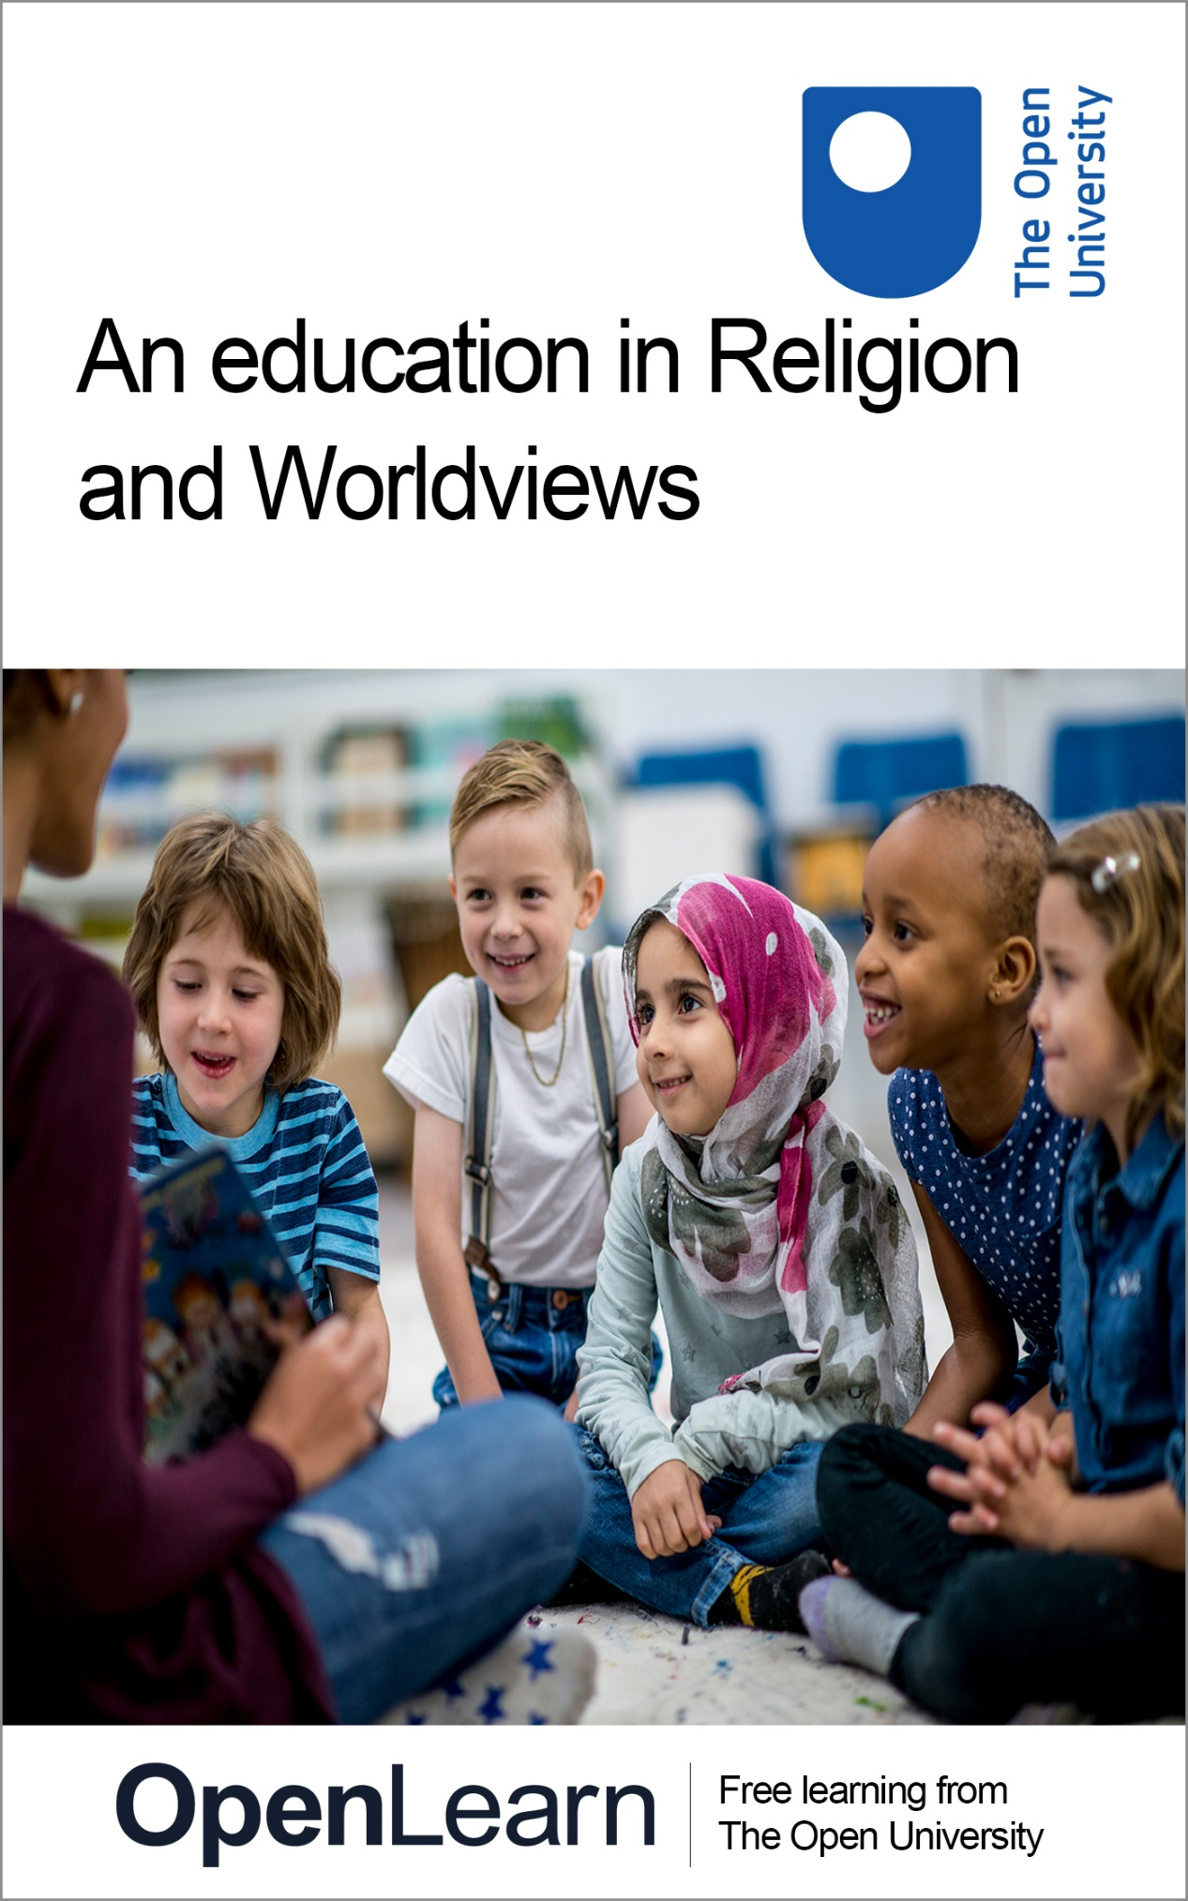

REW_1

An education in Religion and Worldviews

About this free course
Find out more about The Open University’s Religious Studies courses and qualifications: www.open.ac.uk/courses/search-result/religious-studies.
This version of the content may include video, images and interactive content that may not be optimised for your device.
You can experience this free course as it was originally designed on OpenLearn, the home of free learning from The Open University –
www.open.edu/openlearn/history-the-arts/an-education-religion-and-worldviews/content-section-0
There you’ll also be able to track your progress via your activity record, which you can use to demonstrate your learning.
Copyright © 2022 The Open University
Intellectual property
Unless otherwise stated, this resource is released under the terms of the Creative Commons Licence v4.0 http://creativecommons.org/licenses/by-nc-sa/4.0/deed.en_GB. Within that The Open University interprets this licence in the following way: www.open.edu/openlearn/about-openlearn/frequently-asked-questions-on-openlearn. Copyright and rights falling outside the terms of the Creative Commons Licence are retained or controlled by The Open University. Please read the full text before using any of the content.
We believe the primary barrier to accessing high-quality educational experiences is cost, which is why we aim to publish as much free content as possible under an open licence. If it proves difficult to release content under our preferred Creative Commons licence (e.g. because we can’t afford or gain the clearances or find suitable alternatives), we will still release the materials for free under a personal end-user licence.
This is because the learning experience will always be the same high quality offering and that should always be seen as positive – even if at times the licensing is different to Creative Commons.
When using the content you must attribute us (The Open University) (the OU) and any identified author in accordance with the terms of the Creative Commons Licence.
The Acknowledgements section is used to list, amongst other things, third party (Proprietary), licensed content which is not subject to Creative Commons licensing. Proprietary content must be used (retained) intact and in context to the content at all times.
The Acknowledgements section is also used to bring to your attention any other Special Restrictions which may apply to the content. For example there may be times when the Creative Commons Non-Commercial Sharealike licence does not apply to any of the content even if owned by us (The Open University). In these instances, unless stated otherwise, the content may be used for personal and non-commercial use.
We have also identified as Proprietary other material included in the content which is not subject to Creative Commons Licence. These are OU logos, trading names and may extend to certain photographic and video images and sound recordings and any other material as may be brought to your attention.
Unauthorised use of any of the content may constitute a breach of the terms and conditions and/or intellectual property laws.
We reserve the right to alter, amend or bring to an end any terms and conditions provided here without notice.
All rights falling outside the terms of the Creative Commons licence are retained or controlled by The Open University.
Head of Intellectual Property, The Open University

Contents
- Introduction
- Learning outcomes
- 1 What is going on? Why is it important?
- 2 Nobody Stands Nowhere
  - 2.1 Identity tree activity
- 3 The Religion and Worldviews proposal
  - 3.1 What is being proposed?
- 4 An education for life and employment
  - 4.1 Ensuring high-quality RE is taught in schools
  - 4.2 Resources
- Conclusion
- References
- Acknowledgements
- Solutions

Introduction
Religious Education is a statutory requirement for all school children in England. This course explores how the teaching and scholarly community is working to ensure this curriculum remains relevant for the twenty-first century. It is aimed at parents, faith and community group members and all others who might be interested in the purpose and content of Religious Education in schools.
Interested in taking your learning further? You might find it helpful to explore the Open University’s Religious Studies courses and qualifications.

Learning outcomes
After studying this course, you should be able to:
- better understand the reasons and purpose of the national entitlement for Religious Education in schools in England
- consider to what extent the ‘Religion and Worldviews’ proposal could contribute to a rigorous learning experience that promotes social cohesion and productive problem-solving for shared challenges
- understand what can be done to support the provision of good-quality Religious Education teaching in schools.

1 What is going on? Why is it important?

View description - Uncaptioned Figure
View description - Uncaptioned Figure

Did you know that all children in England should be receiving Religious Education (RE) as part of the educational provision in state-funded schools?
According to a recent Ofsted report, good RE teaching should be intellectually challenging and personally enriching, enabling pupils to be able to take an informed and educated position ‘within a diverse multi-religious and multi-secular society’ (Ofsted, 2021).
While it is a statutory requirement, RE provision can be spotty in both quality and time provided to the subject. When it is taught well, many students love it. In a recent survey of current undergraduates (Harvey, 2021a):

- 72% agreed with the statement ‘I enjoyed Religious Education/Religious Studies at secondary school’
and
- 70.8% agreed with the statement ‘I personally learned a lot from Religious Education at secondary school’

While some experiences are glowing:

I think these school lessons are so crucial to teaching morals and values, respect for all people and communities, and it provides us with the foundation frameworks to make life decisions.

Others are not:

[RE was] ‘very unfocussed – not really exploring the roots of faith or the philosophy of major religions – instead just learning some trivia about a few religions’.

When RE is not taught by well-trained and enthusiastic teachers, pupil experiences can also be negative.

Activity 1

Take a minute to reflect on the following questions:
- What are your memories, experiences and/or expectations of Religious Education?
- What are your worst fears?
- What might be the best-case scenario?

Provide your answer...
View discussion - Activity 1

One influential proposal on orienting RE to the needs of twenty-first-century pupils is known as ‘Religion and Worldviews’. This proposal is gaining traction by many of the leading providers of high-quality teaching resources.
The next section of this course will explain a bit more about these proposals for ensuring that English children learn to be:

open-minded, critical participants of public discourse, who make academically informed judgements about important matters of religion and belief which shape the global landscape.
(NATRE, CoRE, RE: Today, n.d.)

How can we ensure the ‘best case scenario’ for Religious Education in schools is likely to be experienced?

2 Nobody Stands Nowhere
At the heart of the proposal for ‘Religion and Worldviews’ is the intention to emphasise the importance of engaging with individuals’ lived experiences. It is a way of framing the subject to emphasise the importance of pupils becoming ‘responsible interpreters’ of information, developing both educated moral judgement as well as critical thinking skills (Cooling et al., 2020).

Activity 2

Now watch the video ‘Nobody Stands Nowhere’ and consider the implications of what it might mean to make this approach central to Religious Education in schools.

Video content is not available in this format.
Nobody Stands Nowhere
View transcript - Nobody Stands Nowhere

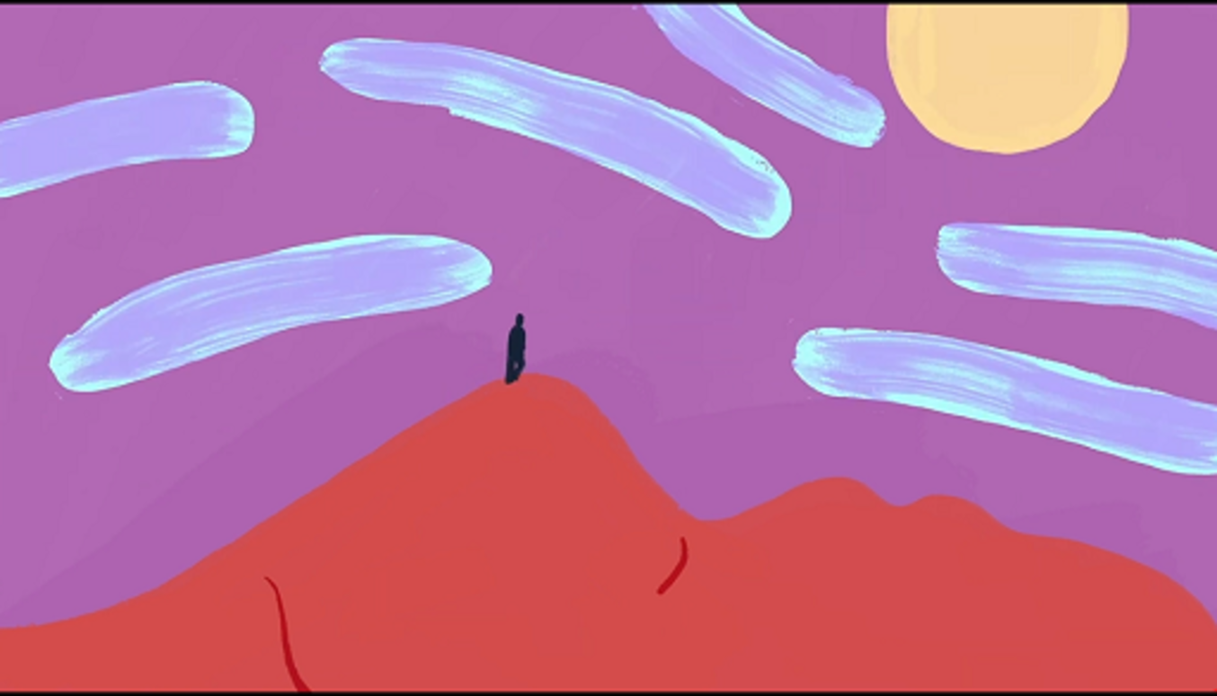

Provide your answer...
View discussion - Activity 2

Attention to religious and non-religious worldviews is a rich and valuable access point for understanding the complexity of navigating moral and social choices in our complex society. As is illustrated well in the animation, ‘where we stand’ is fluid and changing both for individuals and organisations. Understanding how this process works in our own lives and in the social world cannot be simplified into a list of facts to be memorised. Good RE teaches us how to bring parts of our identity which are deeply personal and influential into public discussion with our community.
Our perspective – ‘where we stand’ – is brought into all our decisions whether they be personal, academic or professional. Religious Education is an opportunity to examine this fact head-on and learn how to negotiate ‘where we stand’ and ‘where does truth lie?’ in constructive dialogue with others who stand in different locations.
In the next activity, you are going to consider further our own values, hopes and aspirations – and the roots of these life goals. You will do this through engaging with the metaphor of an ‘identity tree’.

2.1 Identity tree activity

View description - Uncaptioned Figure
View description - Uncaptioned Figure

You’ll now use an activity called the ‘identity tree’ to explore how Religion and Worldviews could be an important anchor for critically understanding why these subjects need to continue to be discussed in a facilitated way in schools. This activity was developed by the Faith and Belief Forum to explore how religious and non-religious beliefs and practices continue to shape our identities today (Faith and Belief Forum, 2022).
Get out a piece of scrap paper or print out this worksheet (open the link in a new window or tab so you can easily return to the course) and start with labelling the leaves of the tree.
Here are some questions to get you started – but you may want to use the leaves to label other important parts of who you are that are not mentioned.
- Which people are important to me?
- What are the places that are important to me?
- Which beliefs, values, ideas are important to me?
- What is my personality like?
- What do I do well and enjoy doing?
- What am I studying?
- What job do I want to do?
- What gender do I identify as?
- What is my sexuality?
- What groups do I belong to?
- What are my hopes for the future?

View description - Uncaptioned Figure
View description - Uncaptioned Figure

Now consider where all these leaves originated – what are the roots of your identity? You can use the prompts below to label the roots which support your tree:
- My religion, beliefs, values come from…
- My personality comes from…
- My hobbies come from…
- My strength and skills come from…
- My appearance comes from…
- My dreams about the future come from…
There will be some aspects of your identity that you have little choice about, these may be physical attributes like your ethnic and religious heritage, genetically determined attributes, as well as early experiences. Others may assume you have certain identities that you do not experience as part of ‘who you are’.
Now that you’ve sketched out your own personal ‘identity tree’ here are some questions to consider:
- What has had the most influence shaping your identity?
- Was there anything that surprised you?
- Do you think your identity would be different if you:
  - Were born into a different country?
  - Were born into a different family?
  - Were born into a different culture?
  - Lived in a different city?
  - Went to a different school?
  - Had different friends?
- Would you have labelled this tree’s leaves and/or roots differently if you did this activity at a different time in your life?
This activity illustrates how our identity is shaped by our history, culture, practices and life experiences. These influence and shape our ideas about right and wrong, how a person should behave and what beliefs and behaviour are unacceptable to us. This exploration does not need to erase the importance of religious identities, community and social context. Indeed understanding the origin and roots of our own values is an important starting point in engaging with groups and organisations who are coming from different perspectives.
So what might the Religion and Worldviews proposal look like in practice?

3 The Religion and Worldviews proposal

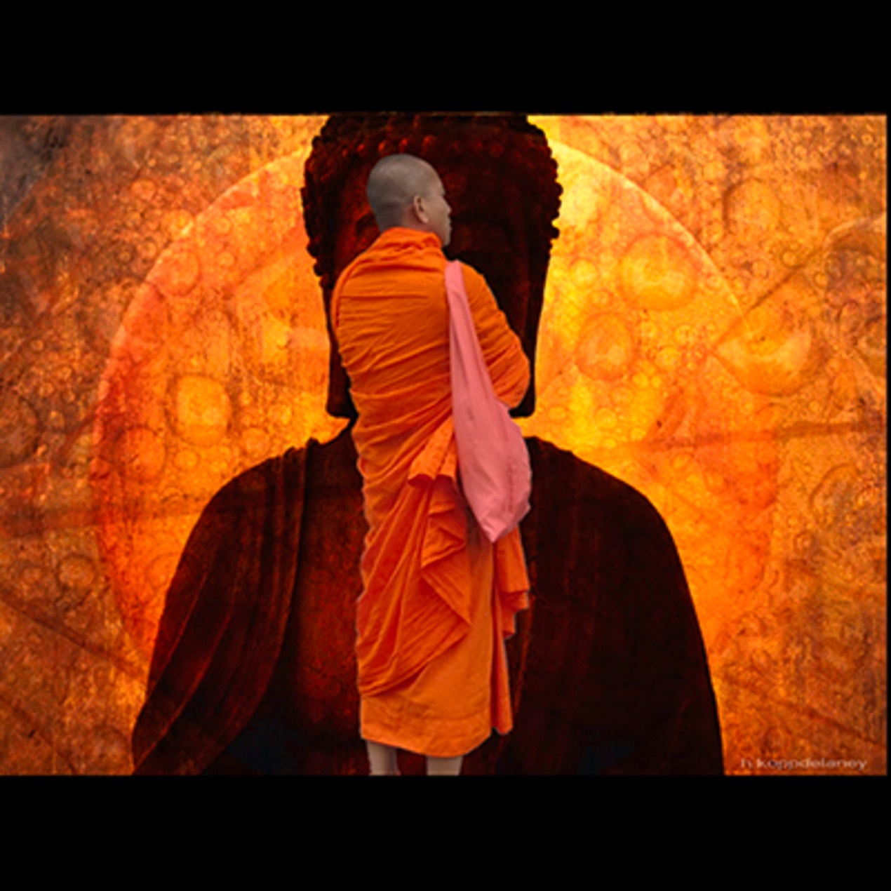
View description - Uncaptioned Figure
View description - Uncaptioned Figure

When the statutory framework for providing universal, state-funded education in England and Wales was drafted in the nineteenth century, it was assumed that attention to children’s moral development was an essential component of schooling. Originally, this assumption was based in a predominantly Christian context. The situation became more complex in the later twentieth century as non-Christian people who were previously subjects of the British Empire immigrated to the United Kingdom. British people also increasingly found other things to do on Sunday mornings than attend church, even as they explored different kinds of spiritual and moral groundings.
Today most people in England and Wales identify as ‘non religious’, but this does not mean that young people are uninterested in exploring their own values and moral framework both inside and outside the classroom (Curtis et al., 2019, p. 5 and Harvey et al., 2021b). In the global context, traditional religious beliefs remain vital motivating factors for making life choices. This makes it more, rather than less, important that Religion and Worldviews are a topic of explicit discussion in schools.

3.1 What is being proposed?
RE can provide a platform for students who come from a traditional religious background to share their experiences and communities, while it can also provide a much-needed framework for non-religious pupils to explore their moral and ethical beliefs and assumptions. The Religion and Worldviews proposal is a way to further these discussions of best practice in RE teaching and making the subject better understood and more effective.

Proposed Religion and Worldviews national entitlement summary

Pupils are entitled to be taught, by well qualified and resourced teachers, knowledge and understanding about:
- what religion is and worldviews are, and how they are studied
- the impact of religion and worldviews on individuals, communities and societies
- the diversity of religious and non-religious worldviews in society
- the concepts, language and ways of knowing that help us organise and make sense of our knowledge and understanding of religion and worldviews; the human quest for meaning, so that they are prepared for life in a diverse world and have space to recognise, reflect on and take responsibility for the development of their own personal worldview.
(NATRE, CoRE, RE: Today, n.d.)

In this subject, pupils develop knowledge and understanding of religious and non-religious traditions, including their diversity and impact on individuals, communities and society. Pupils learn about the different ways in which people study these traditions, as well as building an awareness of and reflecting on their own personal worldview (Wright, 2022).
The way RE operates in schools is open to a lot of local variation. This allows for local school leaders to reflect the diversity of religious and non-religious traditions in the local community. It can also mean that not all students are able to experience the benefits of high-quality RE teaching for their intellectual and personal benefit.
Because it deals with the roots of our personal values and the subject of how we find meaning in our lives, good RE teaching cannot be simply replaced by what is covered in Citizenship or Personal, Social, Health and Economic (PSHE) curriculum.

4 An education for life and employment

View description - Uncaptioned Figure
View description - Uncaptioned Figure

The Religion and Worldviews proposal is a potential container for bringing forward discussions which can aid community cohesion, teaching productive dialogue across different beliefs and backgrounds.
There is no need for complete coherence or agreement about the terms ‘religion’, ‘worldview’ or what should be taught within Religious Education. In fact, learning to work with contested concepts, and dialogue with people’s deeply held sense of identity, is one of the most important aspects of high-quality Religious Education. It also teaches skills that are in high demand in our twenty-first century economy.

Activity 3

Do you think that RE teaches important skills that will help students get jobs and have successful lives after school? Have a look at the following video – do any of the testimonials surprise you?

Video content is not available in this format.
My future. My career. My RE.
View transcript - My future. My career. My RE.

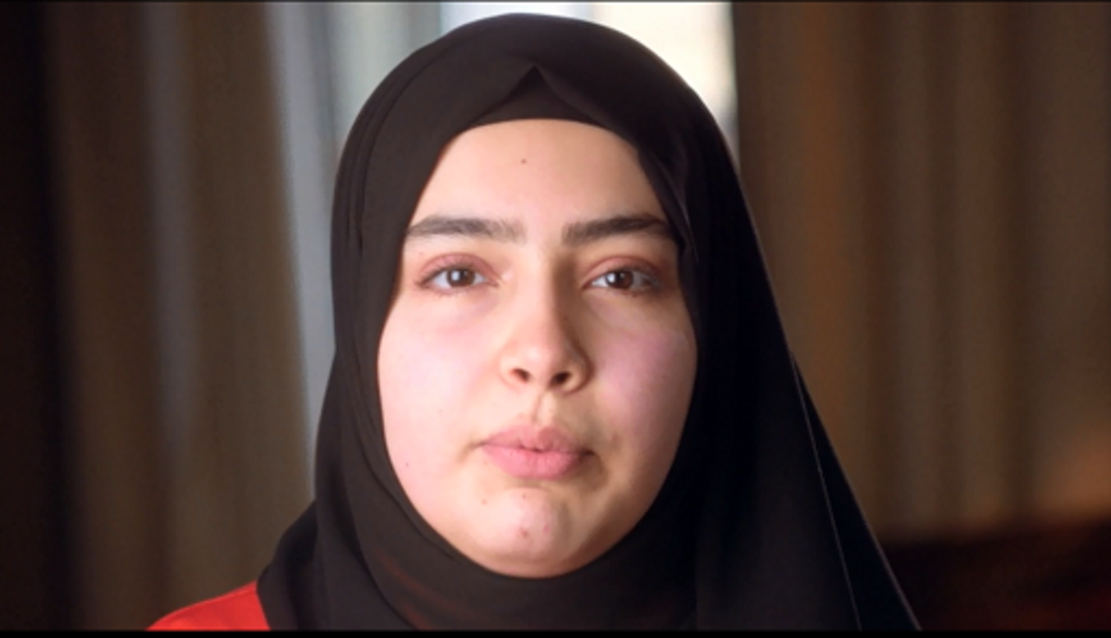

Provide your answer...
View discussion - Activity 3

Developing highly valued skills for employment is also true for university students who study Theology & Religious Studies (TRS) or related subjects like Religion, Philosophy & Ethics. Those with degrees in these fields are highly employable; there are a selection of testimonials from recent graduates on the TRS(UK) website (open the tab in a new window or tab so you can easily come back to the course).
In our rapidly changing world, skills of understanding and communicating are becoming ever more essential and valuable in the workplace. While some aspects of employment are becoming animated by artificial intelligence, the need for critical thinking and making educated and sensitive moral judgement remains with each individual. These are the skills that high quality Religious Education in schools prepares its pupils to apply outside of the classroom.

4.1 Ensuring high-quality RE is taught in schools

View description - Uncaptioned Figure
View description - Uncaptioned Figure

Old assumptions about content and relevance of the subject do not necessarily reflect current realities. According to a recent representative survey most people in England believe that Religious Education in schools should:
- help young people gain a better understanding of their own beliefs (69%)
- foster the mutual understanding of different beliefs among young people (71%)
- provide young people with the opportunity to learn more about other people, beliefs, worldviews and cultures (73%)
- encourage young people to openly discuss their beliefs with others (69%)
- help young people critically evaluate their own beliefs (65%)
- help young people critically evaluate the beliefs of others (65%).
A clear majority see Religious Education in schools as offering important civic and social benefits; as well as similar respondents affirming that RE should be reflecting the diversity of religious and non-religious perspectives that are part of public discourse today (Wright, 2022).
However, there are different challenges in local contexts in ensuring the national entitlement for a high-quality education in religion and worldviews can be met. There are also some shared national challenges.
After considering some of the possible barriers to ensuring every child in English state-funded schools has a quality experience of Religious Education, you will be provided with some resources to help encourage this outcome in your own context.

Activity 4

There are quite a few challenges in ensuring that all students receive their statutory entitlement to good quality RE. Can you think of what some of these challenges might be?

Provide your answer...
View discussion - Activity 4

If you want to do more to ensure that the RE provision in schools is high quality, there are simple things you can do and lots of resources to help you. Some of these are listed on the next page.
Good quality RE is not about absolute agreement or consensus, but it is about valuing dialogue and mutual respect and preparing our children to be better able to face future challenges in our diverse and interconnected world.

4.2 Resources
- Have you wanted to get involved with the teaching of religion in your child’s school, but didn’t know how to go about it?
- Are you part of a local group which demonstrates how different worldviews can work together to promote better understanding and wellbeing for all in the local community?
- Or perhaps you’re a teacher or subject lead who wants to involve community groups in the teaching of Religion and Worldviews in your school, but you’re unsure how to approach the conversation – or you’re looking to reduce parent withdrawals.
Emerging from our research project in partnership with the Faith and Belief Forum and Inform, the resource packs below are designed for three different groups, tailored to your needs. Each contains information on the Worldviews recommendation, what good religious education looks like, how you can get involved in (or bring diverse perspectives into) religious education in schools, and how you can equip yourself and get involved in the wider movement advocating for a balanced and diverse RE.
Follow the links below to access the resource packs:
- Religion and Worldviews in schools: A resource pack for teachers and subject leaders
- Religion and Worldviews in schools: A resource pack for parents
- Religion and Worldviews in schools: A resource pack for community groups (religious and non-religious)

Conclusion
Hopefully this course has given you a chance to reflect on the benefits of well-considered teaching in Religious Education. Improving understanding of Religion and Worldviews in the contemporary world benefits everyone.
When taught skilfully, the study of religion has a unique potential to create intelligent reflection on the structure of our own moral compass and how to act with integrity in a challenging, changing world. Most of the world still identifies with religious beliefs and practices. Therefore, good education in Religion and Worldviews is also an excellent preparation for engaging with diverse, multicultural publics, providing skills which are highly valued in a growing number of occupations.
Interested in taking your learning further? You might find it helpful to explore the Open University’s Religious Studies courses and qualifications.
This OpenLearn course was sponsored by Culham St Gabriel’s Trust as part of a collaborative partnership grant between the Faith and Belief Forum, The Open University’s Religious Studies Department and Inform entitled ‘Promoting the Exploration of Religion and Worldviews in Schools (2021–2022)’.

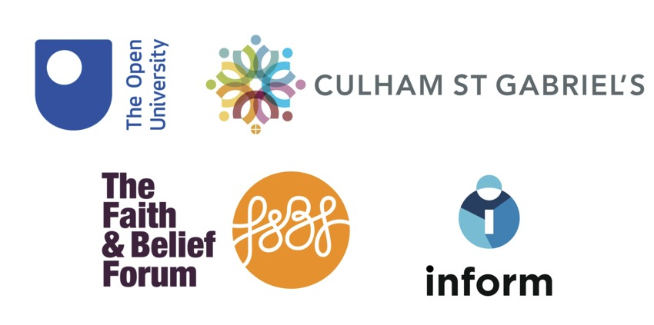

References
All Party Parliamentary Group for Religion in the Media (APPG-RM) (2021) Learning to Listen: Inquiry into Religious Literacy in Print and Broadcast Media. Available at: https://www.dioceseofnorwich.org/app/uploads/2021/05/APPGLearningtoListen1204212.pdf (Accessed: 14 April 2022).
Cooling, T., Bowie, B. and Panjwani, F. (2020) ‘Worldviews in Religious Education’, Theos and Canterbury Christchurch University. Available at: https://www.theosthinktank.co.uk/research/2020/10/21/worldviews-in-religious-education (Accessed: 14 April 2022).
Curtice, J., Clery, E., Perry, J., Phillips, M. and Rahim, N. (eds) (2019) British Social Attitudes: The 36th Report, London: The National Centre for Social Research. Available at: https://www.bsa.natcen.ac.uk/media/39363/bsa_36.pdf (Accessed: 14 April 2022).
Dent, K. (2021) ‘Jewish speaker: Meet John and hear him talk about his Jewish faith’, Faith and Belief Forum. Available at: https://faithbeliefforum.org/aiovg_videos/jewish-speaker-meet-john-and-hear-him-talk-about-his-jewish-faith/ (Accessed: 14 April 2022).
Department of Education (DoE) (2019) Guidance: English Baccalaureate (EBacc), 20 August. Available at: https://www.gov.uk/government/publications/english-baccalaureate-ebacc/english-baccalaureate-ebacc
Downe, E. (2021) ‘Nobody Stands Nowhere’. Video created in partnership with Culham St Gabriel’s Trust and Canterbury Christ Church University. Available at: https://youtu.be/AFRxKF-Jdos (Accessed: 14 April 2022).
Faith and Belief Forum (2022) ‘Identity lesson plan 1: What is Identity?’ Available at: https://faithbeliefforum.org/resources/school-ks3-lesson-plans/ (Accessed: 14 April 2022).
Harvey, S., Newcombe, S., Alderton, C., Ark, A., Champain, P. and Lockley-Scott, A. (2022) ‘Insight Report: Promoting the Exploration of Religion and Worldviews in Schools – Fostering Coherency and Diversity’. Available at: https://faithbeliefforum.org/wp-content/uploads/2022/05/Insights-Report-Final.pdf (Accessed: 14 April 2022).
Harvey, S. (2021a) ‘Baseline Report 1 – Setting the Context’, Promoting the Exploration of Religion and Worldviews in Schools – Fostering Coherency and Diversity. Available at: https://inform.ac/wp-content/uploads/2021/10/Baseline-Report-1-Setting-the-Context.pdf (Accessed: 14 April 2022).
Harvey, S., Newcombe, S., Steindinger, S., Forrester, R. and Shahzad, F. (2021b) ‘Baseline Report 2 - Public Perception: Student and Teacher Views’, Promoting the Exploration of Religion and Worldviews in Schools – Fostering Coherency and Diversity. Available at: https://inform.ac/wp-content/uploads/2021/12/Baseline-Report-2-Public-Perception-Student-and-Teacher-Views1.pdf (Accessed: 14 April 2022).
Lewin, D. (2020) ‘Religion, reductionism and pedagogical reduction’, in G. Biesta and P. Hannam (eds) Religion and Education: The Forgotten Dimensions of Religious Education, Brill Academic Publishers, pp. 48–65.
NATRE, CoRE, RE: Today (n.d.) ‘A National Plan for RE in England Summary’. Available at: https://www.natre.org.uk/uploads/Free%20Resources/A%20National%20Plan%20for%20RE%20-%20CoRE%20summary%20final%20with%20headers.pdf (Accessed: 14 April 2022).
Ofsted (2021) ‘Research review series: religious education’, 21 May, HMSO. Available at: https://www.gov.uk/government/publications/research-review-series-religious-education/research-review-series-religious-education#contents (Accessed: 14 April 2022).
Orchard, J. (2020) ‘Does RE still matter?’, Journal of Religious Education 68, pp. 271–87.
Pennington, M. (2020) ‘Cohesive Societies: Faith and Belief’, Faith and Belief Forum and the British Academy. Available at: https://www.thebritishacademy.ac.uk/publications/cohesive-societies-faith-and-belief/ (Accessed: 14 April 2022).
Robertson, D., Tuckett, J. and Schmidt, B. (2021) ‘BASR Response to the 2019 British Academy Report, Theology and Religious Studies Provision in UK Higher Education’. Available at: https://basrblog.files.wordpress.com/2021/02/basr_response_final.pdf (Accessed: 14 April 2022).
TrueTube (2018) ‘My Future. My Career. My RE.’ Available at: https://www.truetube.co.uk/resource/my-future-my-career-my-re/ (Accessed: 14 April 2022).
Williams, A., McKeown, S., Orchard, J. and Wright, K. (2019) ‘Promoting positive community relations: what can RE learn from social psychology and the shared space project?’, Journal of Beliefs & Values 40:2, pp. 215–27.
Wright, K. (2022) ‘Public perception of religion and worldviews education’, Journal for the Study of Spirituality, 12(1), pp. 68–77.

Acknowledgements
This free course was written by Suzanne Newcombe with important input from Carrie Alderton, Amy Ark, Phil Champain, Sarah Harvey, Anna Lockley-Scott and Kathryn Wright.
This OpenLearn course was sponsored by Culham St Gabriel’s Trust as part of collaborative partnership grant between the Faith and Belief Forum, The Open University’s Religious Studies Department and Inform entitled “Promoting the Exploration of Religion and Worldviews in Schools (2021-2022).”
Except for third party materials and otherwise stated (see terms and conditions), this content is made available under a Creative Commons Attribution-NonCommercial-ShareAlike 4.0 Licence.
The material acknowledged below is Proprietary and used under licence (not subject to Creative Commons Licence). Grateful acknowledgement is made to the following sources for permission to reproduce material in this free course:

Images
Course image: © FatCamera / iStockphoto / Getty Images
Section 1 image: © gradyreese / iStockphoto / Getty Images
Section 2.1 image (first): © nzeissig / iStockphoto / Getty Images
Section 2.1 image (second): © DrPAS / iStockphoto / Getty Images
Section 3 image: courtesy Hartwig HKD
Section 4 image: © sturti / iStockphoto / Getty Images
Section 4.1 image: © Wavebreakmedia / iStockphoto / Getty Images

Logos
The Open University © The Open University
Culham St Gabriel’s Trust https://www.cstg.org.uk/
The Faith and Belief Forum https://faithbeliefforum.org/wp-content/themes/threeff/images/logo_primary.svglief
Inform: https://inform.ac/

Audio-visual
‘Nobody Stands Nowhere’: Film by Emily Downe, created in partnership with Culham St Gabriel’s Trust and Canterbury Christ Church University. Courtesy also Theos Think Tank
‘My future. My career. My RE’: courtesy TrueTube https://www.truetube.co.uk/
Every effort has been made to contact copyright owners. If any have been inadvertently overlooked, the publishers will be pleased to make the necessary arrangements at the first opportunity.
Don't miss out
If reading this text has inspired you to learn more, you may be interested in joining the millions of people who discover our free learning resources and qualifications by visiting The Open University – www.open.edu/openlearn/free-courses.

Solutions

Activity 1

Discussion
We each have a uniquely personal association with the word and experience of ‘religion’ and how religious ideas and practices were taught to us. These two things – our personal associations with religious and non-religious beliefs and how they were taught to us can be difficult to tease out from each other. Some of these experiences might be positive, drawing our attention to a sense of meaning and purpose for our lives and how we are connected with our family, community, and the world around us. However, other experiences of religion and Religious Education might be less than positive.
Back to - Activity 1

Activity 2

Discussion
This film was designed to illustrate the importance of the idea that ‘nobody stands nowhere’. Exploring in a sensitive and evidence-based way where we and others ‘stand’ is the fundamental reframing of Religious Education recommended by the Religion and Worldview proposal.
As Professor Trevor Cooling explains, because everyone has a worldview, the ‘risk that certain views will be allowed irresponsibly to influence education is a risk for everyone – not just those with a religious affiliation – and we therefore need to ask what responsible influence looks like in education, rather than trying to exclude the influence of worldviews altogether’ (Cooling et al., 2020).
Back to - Activity 2

Activity 3

Discussion
The services sector makes up 80% of the UK economy, and this is only expected to grow in the future. Good quality RE in schools can be a vital preparation for jobs in all sorts of areas including the NHS; the civil service; youth and social work, advertising, investment and banking, law, politics, business, the creative industries, the charity sector and NGOs, publishing and journalism, and education (Robertson et al., 2021).
Back to - Activity 3

Activity 4

Discussion
There are a number of challenges for the provision of good RE teaching in schools. Some of these include issues of ‘perception’ including:
- negative public perception of religion in general
- people of faith fearing their tradition will be weakened by RE teaching
- misunderstanding of RE as seeking to convert their children
- assumption that RE is a non-academic and unimportant subject
- assumption that RE does not directly contribute to future employment prospects.
Other challenges are more structural such as:
- a lack of specialist teachers and a lack of support and funding teacher training
- the time allocated to RE in the curriculum and, often, its conflation into other subjects such as PHSE, as well as some schools not teaching it at all
- the unique status of RE as a non-national curriculum subject, instead determined by Locally Agreed Syllabuses
- the exclusion of RE from the English Baccalaureate (EBacc), the subjects the government considers ‘keep young people’s options open for further study and future careers’ (DoE, 2019).
Back to - Activity 4

Uncaptioned Figure

Description
A photograph of a teacher teaching a group of students.
Back to - Uncaptioned Figure

Uncaptioned Figure

Description
An image of a large tree.
Back to - Uncaptioned Figure

Uncaptioned Figure

Description
An image of a tree and its roots.
Back to - Uncaptioned Figure

Uncaptioned Figure

Description
An image of a Buddhist Monk.
Back to - Uncaptioned Figure

Uncaptioned Figure

Description
A photograph of a group of medical professionals.
Back to - Uncaptioned Figure

Uncaptioned Figure

Description
A photograph of a teacher with a group of children.
Back to - Uncaptioned Figure

Nobody Stands Nowhere

Transcript
[MUSIC PLAYING]
NARRATOR
What is your view of the world? How do you see things? What makes you who you are? On what do you base your decisions? Why did you react like that? Do you believe in God or a higher power? Or do you see the world as a cocktail of chance and accident?
Everyone has a worldview, whether religious or not. Each individual sees the world through a certain lens. It may be shaped by your upbringing, surroundings, or religion. And it can change as you move through life. Worldview can be both personal and organised. It is your attitudes and deeply held beliefs. It shapes how you live.
It’s important to think about your own worldview. Where do you think truth lies? What about the worldviews of those around you? Do you understand them? They may not be as similar to yours as you expect. Or, perhaps, your worldviews will be more alike.
Some people may feel that life is about success and improvement, being the best you can be. And some think it’s about helping the most vulnerable in society. Others may believe belonging to a group is vital for finding meaning, while another treasures belonging to the Earth in all its beauty. And still, most of us will not see the world through only one lens but rather through a blend of multiple visions.
In an increasingly pluralistic society, understanding the world around us means realising that there is no neutral perspective. Nobody stands nowhere. Do you know where you stand? And why?
[MUSIC PLAYING]
Back to - Nobody Stands Nowhere

My future. My career. My RE.

Transcript
[MUSIC PLAYING]
SENA
Hi, I'm Sena Guvercin and I study law at Oxford Brookes University, and I love it.
OLLIE
I'm Ollie Silverton, and I work in the sports media industry. I travel around the world making viral videos.
MO
My name is Mo Ahmed. I'm a crew manager with the London Fire Brigade. It's the best job in the world.
SENA
RE isn't a boring subject where you just have to sit down and learn about different religions. It's just studying to understand different perspectives and learning how to respect them, which kind of opens doors to all sorts of careers.
OLLIE
Studying RE definitely helps me understand how religious beliefs influence different countries and cultures and this helps me in my day to day job whenever I'm travelling.
MO
At school, I studied RE. It's given me a great understanding of all the different communities that we serve. If you've got a real good understanding of cultures and religions, then it can only help you to be a better firefighter.
SENA
To study law, I believe the main essential skill would be to debate. And I don't think I would have learned how to do that if I hadn't studied RE.
MO
I know there are people alive today that wouldn't be if it wasn't for the work of all my colleagues within the brigade.
SENA
I am really happy that I studied RE in school, because RE was the main subject that pushed me towards University. Now I'm on my way to becoming a lawyer. And that is a big dream come true for me.
OLLIE
My job is amazing. It really doesn't feel like work most of the time, which sounds like something I shouldn't say, but that's the beauty of it. I absolutely love what I do.
Back to - My future. My career. My RE.

Uncaptioned Figure

Description
A photograph of a teacher teaching a group of students.
Back to - Uncaptioned Figure

Uncaptioned Figure

Description
An image of a large tree.
Back to - Uncaptioned Figure

Uncaptioned Figure

Description
An image of a tree and its roots.
Back to - Uncaptioned Figure

Uncaptioned Figure

Description
An image of a Buddhist Monk.
Back to - Uncaptioned Figure

Uncaptioned Figure

Description
A photograph of a group of medical professionals.
Back to - Uncaptioned Figure

Uncaptioned Figure

Description
A photograph of a teacher with a group of children.
Back to - Uncaptioned Figure

