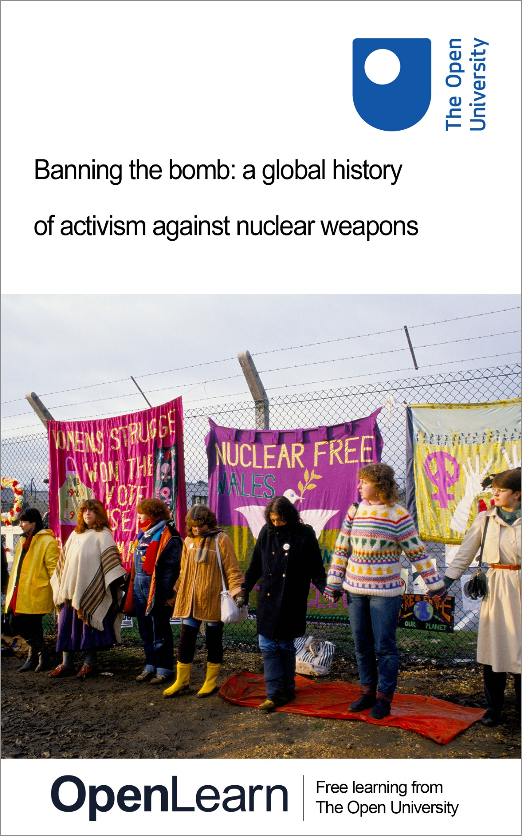

NUC_1

Banning the bomb: a global history of activism against nuclear weapons

About this free course
This free course is an adapted extract from the Open University course .
This version of the content may include video, images and interactive content that may not be optimised for your device.
You can experience this free course as it was originally designed on OpenLearn, the home of free learning from The Open University –
There you’ll also be able to track your progress via your activity record, which you can use to demonstrate your learning.
First published 2024.
Unless otherwise stated, copyright © 2024 The Open University, all rights reserved.
Intellectual property
Unless otherwise stated, this resource is released under the terms of the Creative Commons Licence v4.0 http://creativecommons.org/licenses/by-nc-sa/4.0/deed.en. Within that The Open University interprets this licence in the following way: www.open.edu/openlearn/about-openlearn/frequently-asked-questions-on-openlearn. Copyright and rights falling outside the terms of the Creative Commons Licence are retained or controlled by The Open University. Please read the full text before using any of the content.
We believe the primary barrier to accessing high-quality educational experiences is cost, which is why we aim to publish as much free content as possible under an open licence. If it proves difficult to release content under our preferred Creative Commons licence (e.g. because we can’t afford or gain the clearances or find suitable alternatives), we will still release the materials for free under a personal end-user licence.
This is because the learning experience will always be the same high quality offering and that should always be seen as positive – even if at times the licensing is different to Creative Commons.
When using the content you must attribute us (The Open University) (the OU) and any identified author in accordance with the terms of the Creative Commons Licence.
The Acknowledgements section is used to list, amongst other things, third party (Proprietary), licensed content which is not subject to Creative Commons licensing. Proprietary content must be used (retained) intact and in context to the content at all times.
The Acknowledgements section is also used to bring to your attention any other Special Restrictions which may apply to the content. For example there may be times when the Creative Commons Non-Commercial Sharealike licence does not apply to any of the content even if owned by us (The Open University). In these instances, unless stated otherwise, the content may be used for personal and non-commercial use.
We have also identified as Proprietary other material included in the content which is not subject to Creative Commons Licence. These are OU logos, trading names and may extend to certain photographic and video images and sound recordings and any other material as may be brought to your attention.
Unauthorised use of any of the content may constitute a breach of the terms and conditions and/or intellectual property laws.
We reserve the right to alter, amend or bring to an end any terms and conditions provided here without notice.
All rights falling outside the terms of the Creative Commons licence are retained or controlled by The Open University.
Head of Intellectual Property, The Open University

Contents
- Introduction and guidance
  - Introduction
  - Learning outcomes
  - Moving around the course
- Session 1: Why do people oppose nuclear weapons?
  - Introduction
  - 1 The horrors of nuclear
  - 2 The impact of nuclear weapons development
  - 3 The cost of nuclear weapons
  - 4 Summary of Session 1
- Session 2: How have citizens mobilised against nuclear weapons?
  - Introduction
  - 1 Anti-nuclear activism after 1945
  - 2 The Euromissile Crisis and anti-nuclear activism in the UK in the early 1980s
  - 3 Nuclear colonialism: anti-nuclear activism and national independence
  - 4 Summary of Session 2
- Session 3: How have anti-nuclear activists cooperated across national boundaries?
  - Introduction
  - 1 Transnational activism during the Euromissile Crisis
  - 2 The role of hibakusha as a global crossroads
  - 3 South Africa and the World Campaign
  - 4 Summary of Session 3
- Session 4: How have governments responded to anti-nuclear activism?
  - Introduction
  - 1 Opposing anti-nuclear activism
  - 2 Government cooperation with anti-nuclear activists
  - 3 Summary of Session 4
- Session 5: What has anti-nuclear activism achieved?
  - Introduction
  - 1 The Euromissile Crisis and the end of the Cold War
  - 2 Nuclear weapons free zones (NWFZ)
  - 3 Summary of Session 5
- Session 6: Nuclear arms control and the Treaty on the Prohibition of Nuclear Weapons
  - Introduction
  - 1 The Non-Proliferation Treaty
  - 2 The Treaty on the Prohibition of Nuclear Weapons (TPNW)
  - 3 Anti-nuclear activism today
  - 4 Summary of Session 6
  - 5 Course conclusion
  - References
  - Further resources
  - Where next?
  - Acknowledgements
- Solutions
- Descriptions

Introduction and guidance

Introduction
Nuclear weapons have been used in war twice, when the Americans dropped atomic bombs on the Japanese cities of Hiroshima and Nagasaki in August 1945 at the end of the Second World War, and more than 2,000 times in nuclear tests. The scale of destruction brought about by these weapons, and the rapid increase in both the number and the power of nuclear weapons in the following years, has prompted deep fears about their potential future use. While the end of the Cold War offered brief relief from such anxieties, in recent years, more countries have developed nuclear weapons and today nine nuclear weapons states are modernising their arsenals. With Russian President Vladimir Putin’s repeated threats of nuclear conflict since the Russian invasion of Ukraine in February 2022, among other nuclear-armed threats, the potential use of nuclear weapons seems greater now than at any point since the Cold War.
In this free course you will learn about the global anti-nuclear movement that has worked for decades to prevent the use of nuclear weapons, with the ultimate aim of abolishing them altogether. You will see how opposition to nuclear weapons has been an important cause on every continent. Beginning in 1945, this course will equip you with knowledge of the nature of anti-nuclear activism until the present day.
Since 1945, the issue of nuclear weapons has mobilised citizens from a broad range of backgrounds from around the world. Churches and other religious organisations, trade unions and political parties have played a significant role in opposing nuclear armaments. From the 1950s onwards, environmental and feminist groups have also been central actors. Those with specific expertise, including scientists, academics and physicians, have also been instrumental. Indeed, policymakers, politicians and even world leaders can be counted among anti-nuclear activists. The very diversity of the movement highlights that anyone can be an activist and can work to oppose nuclear weapons.
The course is divided into six sessions, and each session should take you around one hour to complete.
In Session 1, you’ll learn about the destructive capabilities of nuclear weapons and why people have mobilised against them.
In Session 2, you’ll see what forms of activism citizens have engaged in to oppose nuclear weapons.
In Session 3, you’ll learn how activists have cooperated across national borders to work for a world free of nuclear weapons.
In Session 4, you’ll explore how different governments have responded to anti-nuclear activism.
In Session 5, you’ll assess the impact of anti-nuclear activism and see what changes have been brought about by citizens mobilising against nuclear weapons.
In Session 6, you’ll learn more about the United Nations Treaty on the Prohibition of Nuclear Weapons (TPNW), one of the most important and most successful anti-nuclear campaigns in the world today.
This course has been produced as part of an AHRC-funded project on ‘Global histories of anti-nuclear activism’, with nine partner institutions in seven countries across five continents. This course was produced collaboratively by The Open University and the International Campaign to Abolish Nuclear Weapons (ICAN), winner of the 2017 Nobel Peace Prize.



Before you get started we would really appreciate a few minutes of your time to tell us about your expectations for this course, in our optional start-of-course survey. Participation will be completely confidential and we will not pass your details onto others.

Learning outcomes
After studying this course, you should be able to:
- understand the different forms of activism used to oppose nuclear weapons since 1945
- learn how anti-nuclear activism has different in different countries and regions
- navigate newly digitised primary sources to gain a deeper understanding of anti-nuclear activism.

Moving around the course
In the ‘Summary’ at the end of each session, you will find a link to the next one. If at any time you want to return to the start of the course, click on ‘Full course description’. From here you can navigate to any part of the course. Alternatively, use the week links at the top of every page of the course.
It’s also good practice, if you access a link from within a course page to open it in a new window or tab. That way you can easily return to where you’ve come from without having to use the back button on your browser.
You can now go to Session 1.

Session 1: Why do people oppose nuclear weapons?

Introduction
In this session, you’ll explore why citizens around the world have opposed and continue to oppose nuclear weapons.
You’ll hear from a survivor of the nuclear bombing of Hiroshima, before exploring the impact of the development and testing of nuclear weapons, as well as the budgetary implications of producing nuclear weapons.
Before you get started we would really appreciate a few minutes of your time to tell us about your expectations for this course, in our optional start-of-course survey. Participation will be completely confidential and we will not pass your details onto others.

1 The horrors of nuclear

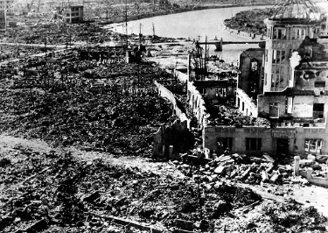
Figure 1 Hiroshima after the atomic bombing of 6 August 1945. Virtually all the buildings in central Hiroshima were destroyed; the surviving building on the right is now the Hiroshima Peace Memorial.
View description - Figure 1 Hiroshima after the atomic bombing of 6 August 1945. Virtually all the buildings ...
View alternative description - Figure 1 Hiroshima after the atomic bombing of 6 August 1945. Virtually all the buildings ...

Nuclear weapons have been used in war on two occasions. On 6 August 1945, during the Second World War, the United States dropped an atomic bomb on the Japanese city of Hiroshima, destroying the city and killing an estimated 100,000 to 140,000 people, the vast majority of whom were civilians. This was followed by a second nuclear attack on the city of Nagasaki on 9 August 1945, which killed an estimated 40,000 to 80,000 people. While the Second World War had seen large-scale bombing campaigns targeting civilians, the sheer scale of destruction unleashed by a single bomb on each occasion showed that nuclear weapons were categorically different from conventional bombs.
Survivors of these two nuclear attacks are known as hibakusha. Their first-hand experiences of witnessing and surviving the devastation caused by nuclear weapons are unique, and an invaluable resource for understanding the horrors of nuclear war. By sharing their stories and working to ensure nuclear weapons are never used again, the hibakusha have been among the most important actors in the global anti-nuclear movement.

Activity 1

Listen to the recording of Keiko Ogura, a hibakusha who was just eight years old when an atomic bomb was dropped on her city, Hiroshima. Then answer the questions below.

Audio content is not available in this format.
View transcript - Uncaptioned interactive content

- How did Keiko Ogura survive the atomic bombing?
- What part of her description of the bombing did you find most striking?

Provide your answer...
View discussion - Activity 1

As devastating as the destruction witnessed on 6 and 9 August was, these nuclear attacks caused many further victims over the following months and years. The levels of radiation unleashed by the bombs caused radiation sickness, cancer, leukaemia, and other fatal illnesses among survivors. Among them was Sadako Sasaki, who was just two years old when she survived the nuclear attack on Hiroshima. She later developed leukaemia as a result of the radiation from the bomb and died at the age of 12. In hospital, she folded origami paper cranes (orizuru), which have since become a symbol of peace.
The bombs dropped on Hiroshima and Nagasaki were among the very first nuclear weapons ever made. Since 1945, the power of nuclear weapons has increased dramatically. In 1954, the Americans tested a nuclear weapon at Bikini Atoll in the South Pacific that was roughly one thousand times more powerful than the bomb dropped on Hiroshima just nine years earlier. As devastating as the nuclear attacks of 1945 were, nuclear weapons today would be vastly more destructive.

2 The impact of nuclear weapons development

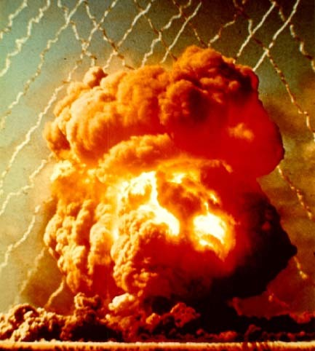
Figure 2 A British nuclear test carried out at Maralinga, Australia, in 1956. The blast pictured here was roughly one thousand times more powerful than that of the bomb dropped on Hiroshima in 1945.
View description - Figure 2 A British nuclear test carried out at Maralinga, Australia, in 1956. The ...
View alternative description - Figure 2 A British nuclear test carried out at Maralinga, Australia, in 1956. The ...

While the actual use of nuclear weapons in warfare causes untold destruction, the development of nuclear weapons has also had severe consequences for many communities. Uranium mining, essential for gathering the raw materials required to produce some types of nuclear weapons, exposes miners to exceptionally high levels of radiation, which has resulted in untold numbers of illness and deaths. The uranium used in the bomb dropped on Hiroshima came from mines as far afield as Congo and Canada, with the mining carried out by indigenous people who subsequently suffered from a range of health issues.
The testing of nuclear weapons has also affected millions of individuals around the world. Nuclear fallout and dangerously high radiation levels emanating from nuclear tests affect individuals at the time of the tests and contaminate the areas for years afterwards.

Activity 2

Watch this video of Ibba Bobaker, who represents those affected by French nuclear tests carried out in Algeria between 1961 and 1966. Then answer the question below.

Video content is not available in this format.
View transcript - Uncaptioned interactive content

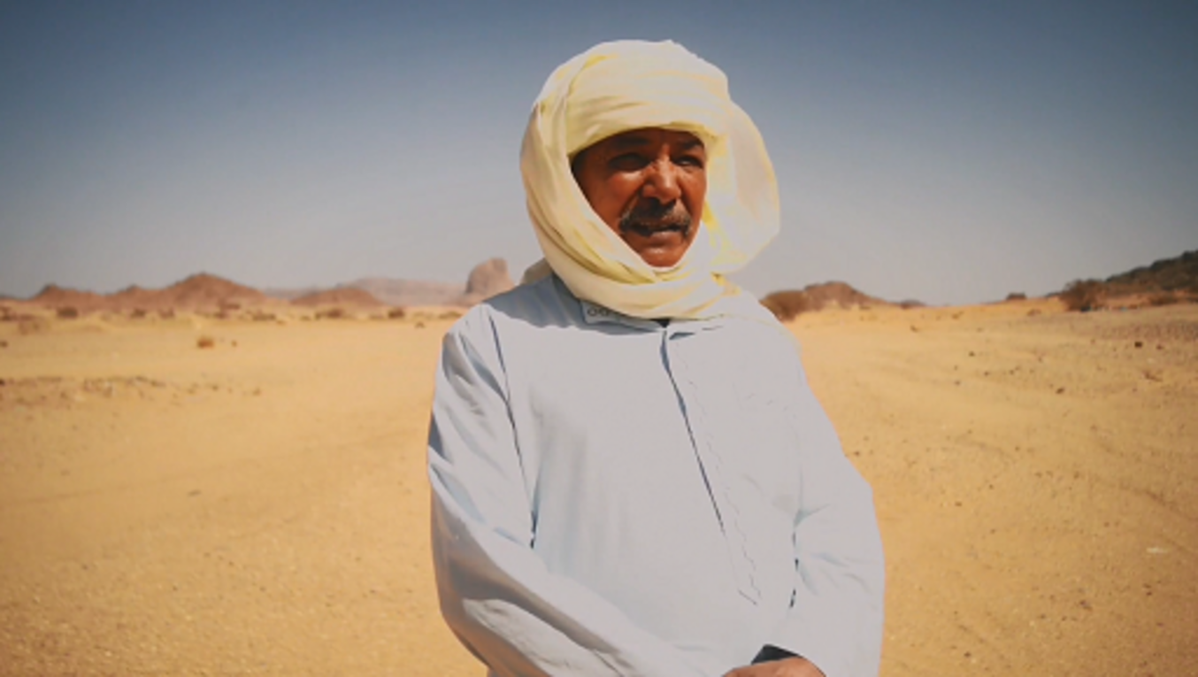

- What were some of the consequences of the French nuclear testing in Algeria on the communities living there?

Provide your answer...
View discussion - Activity 2

Activity 3

Look at the map below, showing the location of nuclear explosions between 1945 and 2017, then answer the questions below.

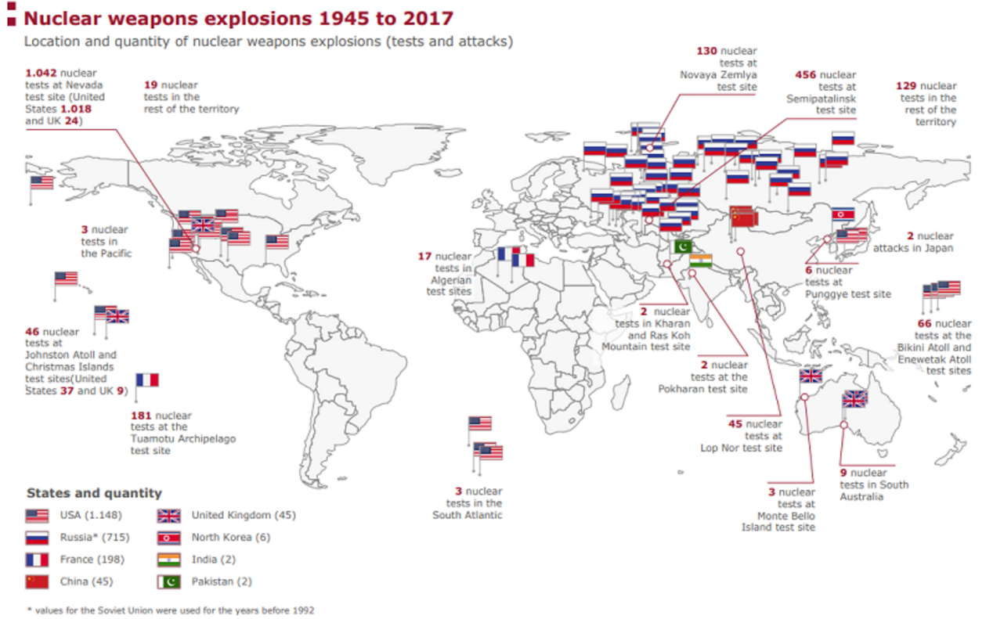
Figure 3 Map showing where the thousands of nuclear weapons explosions since 1945 have taken place in the world. Along with Israel, the eight countries listed here make up the nine nuclear weapons states in the world today.
View description - Figure 3 Map showing where the thousands of nuclear weapons explosions since 1945 ...
View alternative description - Figure 3 Map showing where the thousands of nuclear weapons explosions since 1945 ...

- Which countries are responsible for most of the nuclear explosions since 1945?
- What strikes you most about the location of these nuclear explosions?

Provide your answer...
View discussion - Activity 3

Nuclear tests have often been carried out in areas populated by marginal or indigenous communities. While French nuclear tests were carried out in the Sahara Desert in Algeria and then in French Polynesia, the British conducted nuclear tests in Australia, affecting indigenous communities there. In China, nuclear tests have been carried out in Xinjiang (at the Lop Nor test site), affecting the Uighur population disproportionately, while Soviet nuclear tests in Semipalatinsk, Kazakhstan and American tests in Nevada and the Marshall Islands similarly affected marginalised communities. Clearly, even though only two nuclear weapons have been used in warfare, their development and testing has had devastating effects on individuals and communities.

3 The cost of nuclear weapons
Beyond the direct impact of nuclear weapons on individuals, a further reason why many people oppose these weapons is their astronomical cost. In 2023, the nine nuclear-armed countries in the world spent a staggering $91 billion (USD) on nuclear weapons – or $173,884 every minute. At a time when many national governments are facing budgetary pressures, these sums spent on nuclear weapons represent billions of dollars of public funds that could otherwise be diverted to areas such as healthcare and education.

Table 1 The spending on nuclear weapons for the year 2023
Country | Amount spent on nuclear weapons in 2023 (in USD)
United States | $51.5 billion
China | $11.9 billion
Russia | $8.3 billion
United Kingdom | $8.1 billion
France | $6.1 billion
India | $2.7 billion
Israel | $1.1 billion
Pakistan | $1 billion
North Korea | $856 million
TOTAL | $91.4 billion
(ICAN, 2024, p. 11)

4 Summary of Session 1
In this session, you have explored some of the reasons why individuals may choose to oppose nuclear weapons. The horrors of nuclear war, as witnessed in Hiroshima and Nagasaki, are central to motivating anti-nuclear activism. The impact of nuclear weapons development and testing, which has disproportionately affected marginalised and indigenous communities, is a further factor. Finally, you learned about the economic costs of nuclear weapons, and how this is a further argument against them.
Having learned why individuals might choose to oppose nuclear weapons, you’ll now move on to the next session, where you’ll explore what types of action anti-nuclear activists have taken.
You can now go to Session 2.

Session 2: How have citizens mobilised against nuclear weapons?

Introduction
In this session, you’ll learn about how citizens have mobilised against nuclear weapons since 1945.
First, you’ll see how anti-nuclear activism developed in the years following the atomic bombing of Hiroshima and Nagasaki in 1945. Next, you’ll explore one of the most intense periods of anti-nuclear activism in the UK and elsewhere in Europe in the early 1980s. Then you’ll learn more about nuclear colonialism and how in many parts of the world, such as Polynesia, opposition to nuclear weapons has been closely related to calls for greater national independence.

1 Anti-nuclear activism after 1945
Activism against nuclear weapons began soon after the end of the Second World War, as details became more widely known of the devastation caused by the atomic bombings of Hiroshima and Nagasaki in August 1945. Further impetus was provided by nuclear testing in the Pacific region. In 1954, an American nuclear test at Bikini Atoll caused the crew of a Japanese fishing boat, the Lucky Dragon, to suffer radiation poisoning, resulting in the death of one sailor. This brought attention to the dangers posed by nuclear weapons testing, as nuclear fallout affected those living in the regions destined to be test grounds, with indigenous communities being particularly affected. This led to what is sometimes known as the first wave of anti-nuclear activism, as citizens in the Pacific and around the world mobilised against nuclear weapons testing. This included public demonstrations, such as peace marches, as well as coordinated letter-writing and lobbying campaigns to influence policymakers.
The Cuban Missile Crisis of October 1962, in which the United States and the Soviet Union came close to triggering a nuclear war, further raised public awareness of the dangers of nuclear weapons. In 1963, this led to the signing of the Partial Test Ban Treaty by the United States, the Soviet Union and the United Kingdom, which banned testing nuclear weapons in the atmosphere, under water, or in outer space. In much of the world, this arms control breakthrough, followed by a period of increased dialogue and cooperation between the opposing sides in the Cold War known as détente, resulted in a reduction in anti-nuclear activity by the late 1960s.

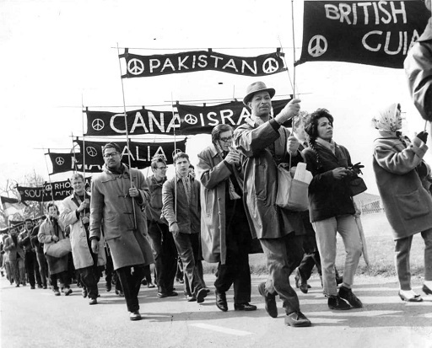
Figure 1 A march organised by the British Campaign for Nuclear Disarmament (CND) in 1962. From 1958, the CND organised annual marches at Easter from Aldermaston, Berkshire (where the UK’s Atomic Weapons Research Establishment was located) to London.
View description - Figure 1 A march organised by the British Campaign for Nuclear Disarmament (CND) ...
View alternative description - Figure 1 A march organised by the British Campaign for Nuclear Disarmament (CND) ...

2 The Euromissile Crisis and anti-nuclear activism in the UK in the early 1980s
A second and even larger wave of anti-nuclear activism emerged in the late 1970s and peaked in the early 1980s. In Western Europe, this was chiefly triggered by the 1979 decision by the North Atlantic Treaty Organisation (NATO) to deploy hundreds of new American nuclear weapons in five Western European countries: the Federal Republic of Germany, the United Kingdom, Italy, the Netherlands and Belgium. Opposition to the deployment of these ‘Euromissiles’ surged in the early 1980s, as citizens feared such an escalation in the nuclear arms race would make nuclear war more likely.

Figure 2 A demonstration in Bonn, then capital of the Federal Republic of Germany, in October 1981 against the planned deployment of ‘Euromissiles’ in the country. This demonstration attracted roughly 300,000 participants, and similar demonstrations across Western Europe included comparable numbers of protesters.
View description - Figure 2 A demonstration in Bonn, then capital of the Federal Republic of Germany, ...
View alternative description - Figure 2 A demonstration in Bonn, then capital of the Federal Republic of Germany, ...

Activity 1

Watch this video featuring activists, policymakers and historians discussing what forms of action took place in the UK during the ‘Euromissile Crisis’ of the early 1980s, then answer the questions below.

Video content is not available in this format.
View transcript - Uncaptioned interactive content

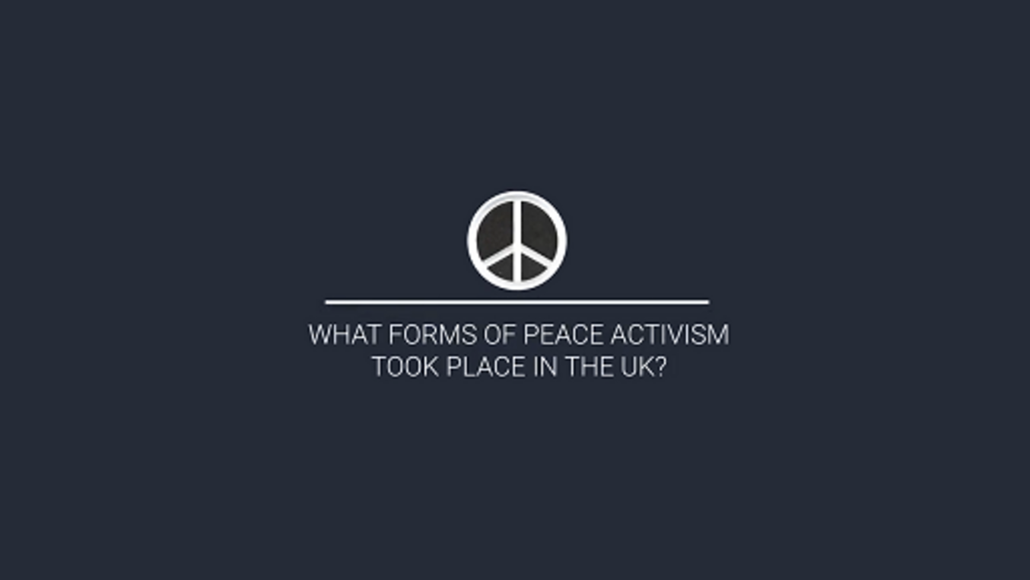

- What form did activism take in the UK in the early 1980s?
- How did activism differ across the UK?

Provide your answer...
View discussion - Activity 1

The late 1970s and early 1980s saw the emergence of new forms of anti-nuclear activism. Especially striking were ‘die-ins’, in which groups of activists would fall to the ground and play dead, drawing attention to the deadly effects of nuclear weapons. Another iconic form of action was peace camps, in which activists would remain at a particular site (often a military base where nuclear weapons were deployed) for months or years at a time. The Greenham Common Women’s Peace Camp in Berkshire, England, was established in 1981 and remained at the site until 2000. The period also saw massive anti-nuclear demonstrations as well as less visible forms of activism such as letter-writing and public education campaigns.
The peace movement was a heterogeneous phenomenon encompassing a broad spectrum of autonomous activists and youth movements, but also institutions such as political parties, trade unions and churches. Beyond those involved in the anti-nuclear campaign in some way, popular culture reflected the pervasive anxieties of the very real possibility of a nuclear war that could lead to the end of humanity. Pop music from this period saw artists ranging from ABBA, Metallica, Queen, and Sting to Nena reflecting these fears of nuclear war in their lyrics. Nuclear weapons and the possibility of nuclear annihilation were a prominent topic in films, television, video games, comic books and board games. Along with the widespread anti-nuclear activism seen across many countries, these cultural outputs reveal just how ubiquitous fears of the dangers of nuclear weapons were during this period.

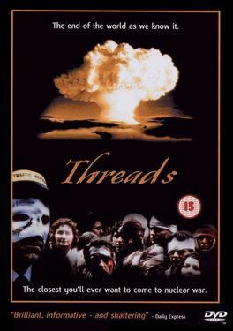
Figure 3 A poster advertising the BBC film Threads, produced in 1984. The film depicts the horrifying consequences of a nuclear attack on the British city of Sheffield.
View description - Figure 3 A poster advertising the BBC film Threads, produced in 1984. The film depicts ...
View alternative description - Figure 3 A poster advertising the BBC film Threads, produced in 1984. The film depicts ...

In addition to fears that these new ‘Euromissiles’ would make nuclear war more likely, many citizens felt that the imposition of new American nuclear weapons on their country’s soil undermined national sovereignty. As a result, anti-Americanism was often a feature of anti-nuclear protest in Europe in the early 1980s.
In the next section, you’ll see how the themes of anti-nuclear activism and national sovereignty interacted in other parts of the world.

3 Nuclear colonialism: anti-nuclear activism and national independence
While anti-nuclear protests surged across much of Western Europe in the early 1980s, one country in the region was apparently immune from large-scale protests: France. One explanation for this lack of a large anti-nuclear movement in France is that the country was not being asked to deploy new nuclear weapons on its territory – unlike the UK or West Germany, for example. Equally importantly, France had (and has) its own nuclear weapons, which were championed by politicians across the political spectrum as a guarantor of France’s national sovereignty. In other words, while the arrival of American nuclear weapons on British or German soil was seen by many to be a challenge to national sovereignty, the fact that the French state had its own nuclear deterrent was by contrast presented as a way of defending national sovereignty. While anti-nuclear activism certainly existed in France in the early 1980s, it never approached the scale of what was seen elsewhere in NATO at the time.
While metropolitan France saw relatively little anti-nuclear protest, another part of France saw an important rise in anti-nuclear activism in the early 1980s: French Polynesia, an overseas French territory.

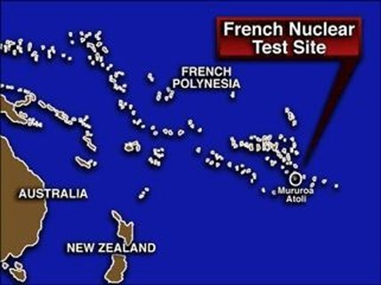
Figure 4 Map indicating the location of the French nuclear tests.
View description - Figure 4 Map indicating the location of the French nuclear tests.
View alternative description - Figure 4 Map indicating the location of the French nuclear tests.

When it first developed its own nuclear weapons, France had conducted a series of nuclear tests in the Sahara Desert in Algeria. Following Algeria’s independence in 1962, however, France sought a new testing site for its nuclear weapons and chose French Polynesia, specifically the Mururoa Atoll. France refused to join the 1963 Partial Test Ban Treaty and between 1966 and 1974 France conducted a series of atmospheric nuclear tests. From 1974 until 1996, it continued with underground nuclear tests, with at least 175 tests taking place in French Polynesia by 1996.
The impact of these tests is now well documented, and the nuclear fallout and increased radiation levels contaminated Polynesian populations of different atolls, as well as French soldiers stationed in French Polynesia. This is an example of nuclear colonialism, whereby a country with nuclear weapons tests these weapons in what is to them a peripheral territory, affecting marginalised and indigenous communities disproportionately. So committed was the French Government to the tests that they authorised the sinking of an NGO ship, the Rainbow Warrior, which was protesting against the tests, killing one Greenpeace crew member.
These nuclear tests overseen by the French state mobilised anti-nuclear activism among Polynesians. In 1973, an estimated 5000 people marched against the nuclear tests. Given that the entire population of French Polynesia at the time was about 130,000, the number of activists corresponds to nearly 4 per cent of the total population. Importantly, anti-nuclear activists’ demands to stop the nuclear testing was increasingly tied to growing calls for self-determination. By the early 1980s, the anti-nuclear cause was increasingly related to the anti-colonial one, with a peaceful and anti-nuclear dimension becoming a crucial part of Polynesian identity. However, while the question of Polynesian independence remained a divisive one, opposition to the nuclear tests became more widely shared among Polynesians.

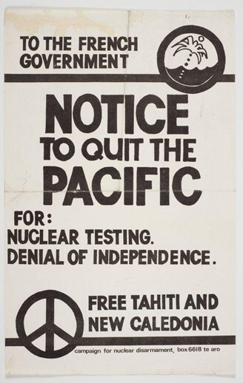
Figure 5 This poster, produced in the early 1980s by the New Zealand-based Campaign for Nuclear Disarmament, highlights the link between nuclear testing and national sovereignty.
View description - Figure 5 This poster, produced in the early 1980s by the New Zealand-based Campaign ...
View alternative description - Figure 5 This poster, produced in the early 1980s by the New Zealand-based Campaign ...

While anti-nuclear activism in French Polynesia became linked to calls for greater national self-determination, the French nuclear tests also mobilised activists around the world, and indeed in metropolitan France. Campaigners across the South Pacific worked together to achieve the 1985 Treaty of Rarotonga, establishing the South Pacific as a nuclear weapons free zone. In Session 3, you’ll learn more about this kind of cross-border or transnational cooperation in opposing nuclear weapons.

4 Summary of Session 2
In this session, you learned about some of the different forms of action taken to oppose nuclear weapons. In the UK in the early 1980s, this included large-scale demonstrations and peace camps, as well as less visible forms such as letter-writing campaigns, public education, and lobbying politicians. You then explored anti-nuclear activism in French Polynesia, where nuclear tests were carried out from 1966 to 1996, and the merging of anti-nuclear and anti-colonial protests.
In the next session, you’ll explore how activists have worked together across borders to oppose nuclear weapons.
You can now go to Session 3.

Session 3: How have anti-nuclear activists cooperated across national boundaries?

Introduction
In this session, you’ll explore examples of how anti-nuclear activism crosses national borders as activists cooperate to effect change. First, you’ll learn about cross-country cooperation on a specific campaign, considering the Euromissile Crisis in Western Europe in the 1980s and how Western activists sought to engage with citizens on the other side of the Iron Curtain. Next, you’ll explore the role of the hibakusha, survivors of the nuclear attacks on Hiroshima and Nagasaki, and how they have impacted anti-nuclear activism around the world. Finally, you’ll learn about the World Campaign against South Africa’s nuclear weapons during apartheid, and how this campaign took place internationally given that protest was curtailed within South Africa itself.
Taken together, these cases highlight how anti-nuclear activists have worked together beyond and across national boundaries in opposing nuclear weapons.

1 Transnational activism during the Euromissile Crisis
As you saw in Session 2, the planned deployment of new American nuclear weapons in five Western European countries in the early 1980s prompted citizens to come together to protest against what many considered to be an escalation that would make nuclear war more likely. While groups emerged at local or national levels, they often worked together across national boundaries, sharing best practices, publications, and inviting speakers from different countries. The Dutch Inter-Church Peace Council, for example, produced materials intended to be used by activists in other European countries as well to oppose nuclear weapons. Innovations in one place – for example, the creation of a women’s peace camp in Greenham Common in Berkshire, England – inspired activists elsewhere, with peace camps springing up from Comiso, Sicily to Cold Lake, Alberta. This exchange of ideas across national boundaries has long been central to anti-nuclear activism.

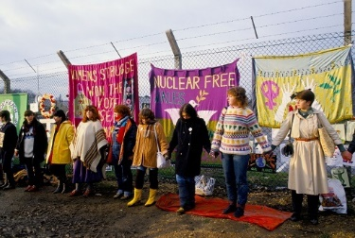
Figure 1 Greenham Common Women’s Peace Camp, which inspired similar peace camps in many other countries.
View description - Figure 1 Greenham Common Women’s Peace Camp, which inspired similar peace camps in ...
View alternative description - Figure 1 Greenham Common Women’s Peace Camp, which inspired similar peace camps in ...

In the early 1980s, two of the most important anti-nuclear organisations were the UK-based Campaign for Nuclear Disarmament (CND) and European Nuclear Disarmament (END). While the former was a well-established organisation that had worked for the elimination of nuclear weapons in Britain since 1958, END was launched in the UK in the early 1980s and advocated cross-border cooperation across all of Europe to rid the continent of nuclear weapons. Both groups reached out to activists in other NATO member states in Western Europe and also to interlocutors on the other side of the Iron Curtain in the Soviet bloc.

Activity 1

In this video, activists from CND and END, as well as historians of this period, discuss how these British-based organisations worked across national boundaries to promote nuclear disarmament. Watch the video and then answer the question below.

Video content is not available in this format.
View transcript - Uncaptioned interactive content

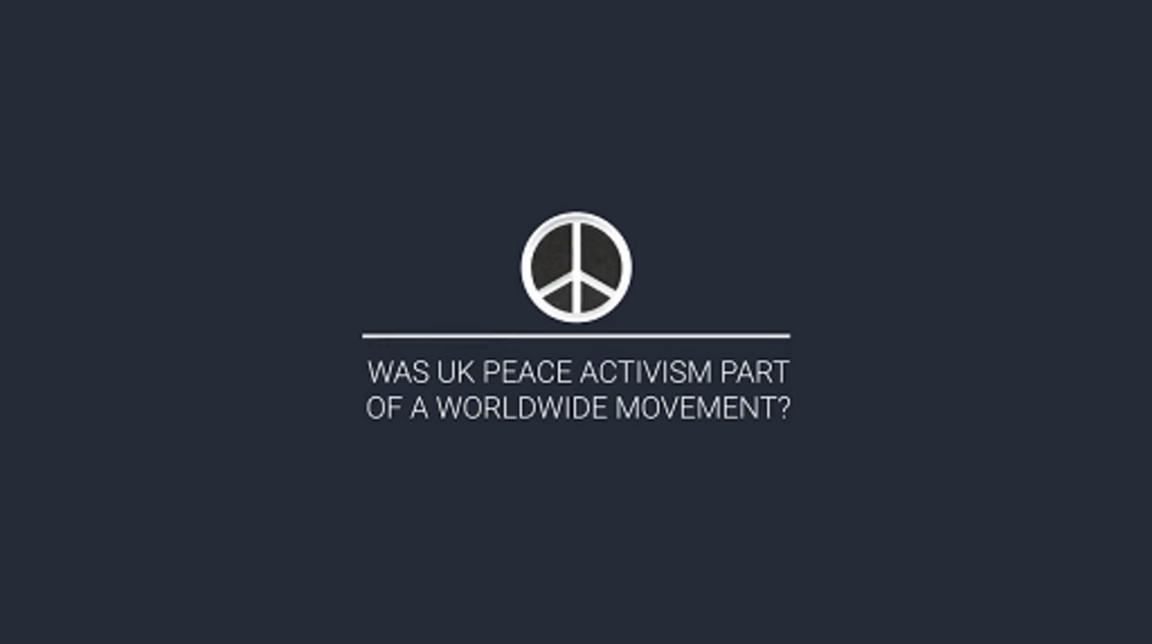

- How did anti-nuclear activists in Britain engage in dialogue with those in the Soviet Union and Eastern Europe during the Cold War?

Provide your answer...
View discussion - Activity 1

In the campaign against the ‘Euromissiles’, activists understood that working with partners in other countries was mutually beneficial and even essential to advance their cause. Despite the challenges in working with partners on the other side of the Iron Curtain, this dialogue proved to be vitally important, as you will see in Session 5.

2 The role of hibakusha as a global crossroads
Hibakusha – survivors of the atomic bombings in Hiroshima and Nagasaki – have long played a vital role in raising awareness of the horrors of nuclear weapons. By sharing their first-hand experiences, hibakushas’ voices provide a unique first-hand account, as you heard in Session 1. Hibakusha have also had an invaluable impact on anti-nuclear activism far beyond Japan. In 1975, for example, a group of hibakusha including Setsuko Thurlow organised an exhibition on the atomic bombings at the Toronto Public Library, which helped trigger the development of a significant anti-nuclear movement in Canada. In 1984, Takashi Morita co-founded a hibakusha organisation based in Sao Paulo to share the stories of hibakusha in Brazil and to raise awareness of the devastating consequences of nuclear weapons. Growing awareness of hibakushas’ experiences also inspired Europeans protesting against Euromissiles to devise the campaign slogan ‘no Euroshima!’.

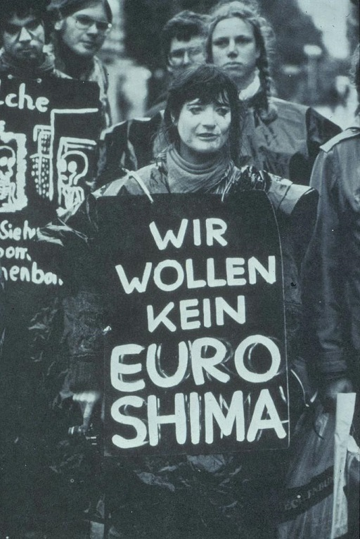
Figure 2 An anti-nuclear activist in Bonn, Germany in 1981 with a sign declaring ‘We do not want a Euroshima’.
View description - Figure 2 An anti-nuclear activist in Bonn, Germany in 1981 with a sign declaring ...
View alternative description - Figure 2 An anti-nuclear activist in Bonn, Germany in 1981 with a sign declaring ...

While survivors from Hiroshima and Nagasaki have played an important part in shaping anti-nuclear activism around the world, the cities of Hiroshima and Nagasaki have also become important sites of dialogue and education about nuclear issues. In recent years, representatives of communities harmed by nuclear weapons – particularly of indigenous communities disproportionately affected by nuclear tests – have travelled to Hiroshima to participate in the annual Peace Memorial Day ceremony marking the anniversary of the 6 August 1945 bombing. This has become an important site for victims of nuclear testing to share their stories, highlighting how communities around the world have been adversely affected by nuclear weapons. Anti-nuclear activists from around the world also attend this annual ceremony, which has become a central meeting place for those working for a nuclear weapons-free world.

3 South Africa and the World Campaign
In September 1979, in what was known as the Vela Incident, it was suspected that a nuclear test took place in the South African territory of the Prince Edward Islands, providing evidence that the country was secretly developing nuclear weapons. During the apartheid era (1948–1994), however, anti-nuclear activism within South Africa was incredibly difficult, as the regime did not tolerate public demonstrations against the state or its (secret) nuclear weapons programme. One rare exception was a small protest organised in Cape Town in 1983. A group of five protesters wore gas masks and carried a fake coffin through Greenmarket Square to protest the construction of a nuclear power station in Koeberg, outside of Cape Town, partially due to fears that this would contribute to the regime’s nuclear weapons programme. Within minutes, however, the demonstration was forcibly ended by the police and most participants arrested. Figure 3 shows this rare example of anti-nuclear protest within South Africa.

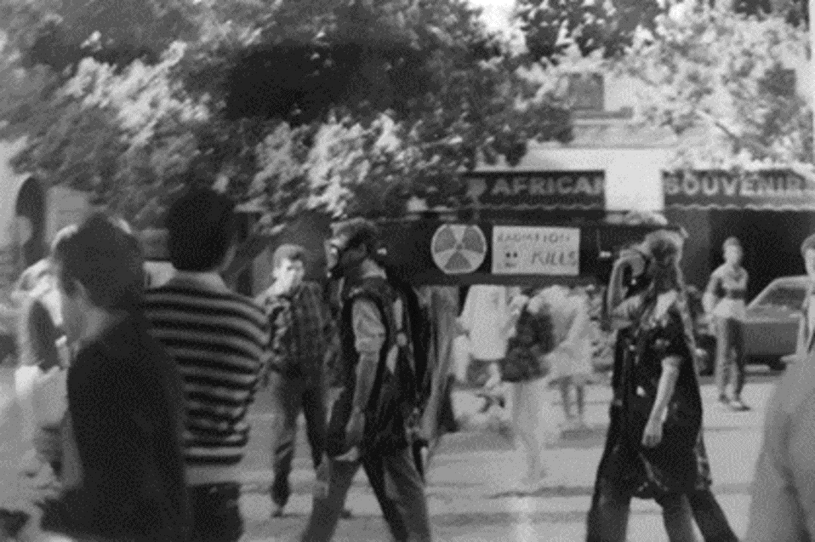
Figure 3 An anti-nuclear protest in Greenmarket Square, Cape Town, 1983.
View description - Figure 3 An anti-nuclear protest in Greenmarket Square, Cape Town, 1983.
View alternative description - Figure 3 An anti-nuclear protest in Greenmarket Square, Cape Town, 1983.

Given the challenges of anti-nuclear activism within the country, international and transnational activism became crucial to opposing South Africa’s nuclear weapons programme. Significant activism against the apartheid regime took place internationally, and so too did activism against the regime’s nuclear weapons.
The Anti-Apartheid Movement (AAM) was an organisation created in 1959 to oppose South Africa’s racist regime. In 1979, the AAM launched the World Campaign Against Military and Nuclear Collaboration with South Africa, which worked with partners around the world to dissuade governments from providing South Africa with weapons or technologies that could be used for its nuclear weapons programme. It also ran a targeted campaign against what it called ‘the apartheid bomb’, seeking to raise awareness and to mobilise international action against Pretoria.

Activity 2

Watch this extract of a speech by interview with Abdul Minty, who set up and led the World Campaign Against Military and Nuclear Collaboration with South Africa. In this speech, recorded in 2023, he explains his activities in the aftermath of the 1979 Vela Incident. Then answer the questions below.

Video content is not available in this format.
View transcript - Uncaptioned interactive content



- What did the World Campaign do with the information it received regarding South African military and nuclear activities?
- According to Minty, why was an arms embargo so important?

Provide your answer...
View discussion - Activity 2

As part of the World Campaign, the AAM collaborated with national anti-nuclear organisations to oppose South Africa’s nuclear weapons. In the UK, the CND, which was mainly focused on preventing the deployment of Cruise missiles in the country and the government’s acquisition of the Trident system, organised joint events with the AAM and the World Campaign against the ‘apartheid bomb’. You can see a poster from one such event, organised in Exeter, England, in 1982, in Figure 4.

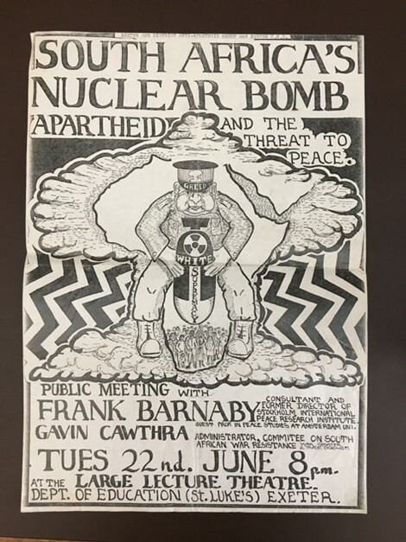
Figure 4 Poster advertising an event co-organised by the Anti-Apartheid Movement and the CND in Exeter, England, in June 1982.
View description - Figure 4 Poster advertising an event co-organised by the Anti-Apartheid Movement ...
View alternative description - Figure 4 Poster advertising an event co-organised by the Anti-Apartheid Movement ...

The World Campaign continued its work throughout the 1980s. In 1989, the South African leader F.W. de Klerk cancelled the country’s nuclear weapons programme. South Africa became the first – and to date the only – country to have developed its own nuclear weapons and then to unilaterally dismantle them. Since then, successive South African governments have been active in supporting nuclear disarmament, playing a key role in establishing the African Nuclear Weapons Free Zone (also known as the Treaty of Pelindaba) in 1996, and signing the Treaty on the Prohibition of Nuclear Weapons (TPNW) in 2017.

4 Summary of Session 3
In this session, you have explored some of the ways in which anti-nuclear activism cuts across national borders. During the Euromissile Crisis of the early 1980s, Western activists sought interlocutors on the other side of the Iron Curtain to work towards the abolition of nuclear weapons in Europe. You then learned about the important global role of the hibakusha in raising awareness of the dangers of nuclear weapons and how Hiroshima has become an important global crossroads for victims of nuclear technologies. Finally, looking at the case of South Africa, you examined how anti-nuclear activists unable to protest within the country mounted a World Campaign to end the ‘apartheid bomb’, and how South Africa ultimately dismantled its nuclear weapons unilaterally and became an important champion for nuclear disarmament on the world stage.
In the next session, you will explore some of the different ways in which governments have responded to, and engaged with, anti-nuclear activism.
You can now go to Session 4.

Session 4: How have governments responded to anti-nuclear activism?

Introduction
Since 1945, anti-nuclear activists and organisations have emerged as important non-state actors in the struggle against nuclear weapons. One of the central aims of anti-nuclear activism has been to effect meaningful changes in the policies of national governments, where decisions concerning nuclear weapons are generally made.
In this session, you’ll learn how different national governments have responded to anti-nuclear activists, with stances ranging from adversarial to cooperative.

1 Opposing anti-nuclear activism
In many countries, particularly under non-democratic regimes, mounting anti-nuclear activism was incredibly difficult, if not impossible. In Session 3 you saw how the obstacles to opposing nuclear weapons within South Africa under the apartheid regime led Abdul Minty and his collaborators to mobilise internationally by mounting the World Campaign.
In the Soviet Union, the ruling Communist Party established the Soviet Peace Committee, which was an official organisation directed by the Party. Genuine grassroots activism by Soviet citizens, however, was actively curtailed by the state. In 1982, an important group of Russian activists created the Moscow Trust Group, which called for immediate steps towards nuclear disarmament and greater dialogue between East and West. The government was quick to shut down this group. Its members were subject to intimidation and arrest by the state authorities, while several were confined in asylums.
While public protests critical of state policy were not feasible in countries such as the Soviet Union, they thrived in liberal democracies such as the United Kingdom. Nevertheless, the government of Prime Minister Margaret Thatcher (1979–1990) resorted to a range of means to counter the anti-nuclear movement in Britain, whose anti-nuclear demonstrations regularly attracted crowds in the hundreds of thousands.

Activity 1

Watch this video, which features activists, policymakers and historians reflecting on how the British government and the ruling Conservative Party responded to anti-nuclear activism in the UK in the 1980s. After you’ve watched the video, answer the question below.

Video content is not available in this format.
View transcript - Uncaptioned interactive content

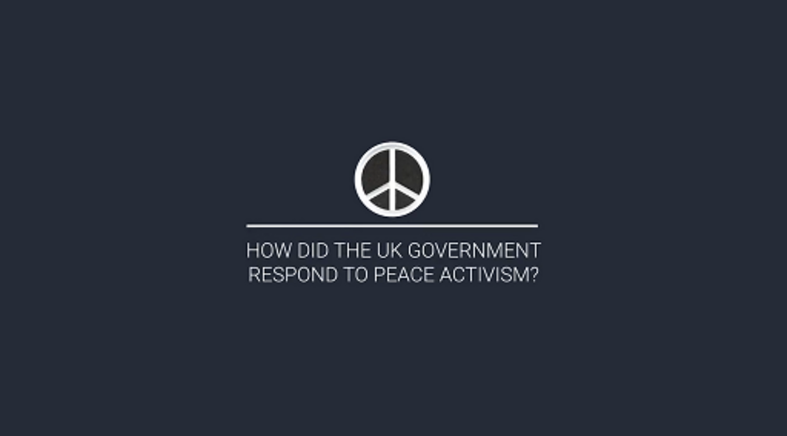

- How did the ruling Conservative Party try to discredit anti-nuclear activists in the 1980s?

Provide your answer...
View discussion - Activity 1

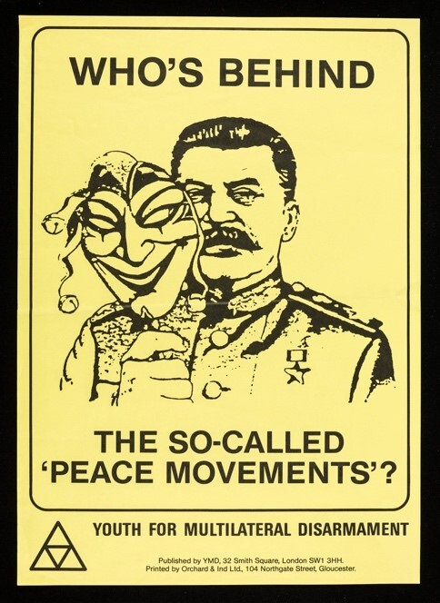
Figure 1 This poster was among the many produced by groups set up by the Conservative Party to discredit the anti-nuclear movement ahead of the 1983 general election in the UK. Depicting former Soviet leader Joseph Stalin (who died in 1953) holding a mask, the implication is that anti-nuclear activists were in fact Communists or were at least being manipulated by the Soviet Union to serve that country’s interests rather than Britain’s.
View description - Figure 1 This poster was among the many produced by groups set up by the Conservative ...
View alternative description - Figure 1 This poster was among the many produced by groups set up by the Conservative ...

While this example shows the lengths to which the UK government and the Conservative Party went to try to bring anti-nuclear activism into disrepute, this engagement was spurred by the wide popularity of calls for nuclear disarmament, with opinion polls in the early 1980s suggesting that a majority of Britons opposed the deployment of Cruise missiles in the UK. This also highlights the challenges faced by anti-nuclear activists, particularly in nuclear-armed states with governments who did not want to revisit their existing policies on nuclear weapons.

2 Government cooperation with anti-nuclear activists
While the UK government had an adversarial relationship with anti-nuclear activists, this was by no means the case in all countries. In some cases, activists and civil society groups cooperated fruitfully with policymakers and governments, resulting in new policies and even international initiatives for nuclear disarmament.
One example is the Six Nation Initiative (also known as the Five Continent Initiative). On 22 May 1984, against the backdrop of the nuclear arms race and heightened tensions between the United States and the Soviet Union, six world leaders came together to call for concrete measures to reduce tensions and nuclear weapons. Raúl Alfonsín of Argentina, Indira Gandhi of India, Miguel de la Madrid of Mexico, Julius Nyerere of Tanzania, Olof Palme of Sweden, and Andreas Papandreou of Greece made the following proposal:

We urge, as a necessary first step, the United States and the Soviet Union, as well as the United Kingdom, France and China, to halt all testing, production and deployment of nuclear weapons and their delivery systems, to be immediately followed by substantial reductions in nuclear forces … This first step must be followed by a continuing programme of arms reductions leading to general and complete disarmament … The essential goal must be to reduce and then eliminate the risk of war between nations.

The initiative originated among a group of anti-nuclear activists including New Zealander Nicholas Dunlop, Canadian Douglas Roche, and Icelandic MP Ólafur Ragnar Grímsson. Keen to work across national boundaries and to have activists and politicians work together, they approached several world leaders to take part in the initiative, with six ultimately agreeing by the spring of 1984.

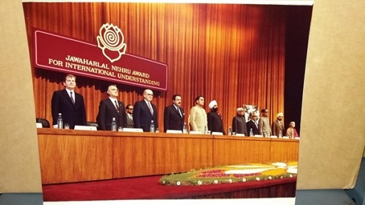
Figure 2 A photo of the world leaders involved in the Six Nation Initiative, pictured here receiving an award for their work towards nuclear disarmament. Andreas Papandreou Foundation (APF), box 4, The Four Continent Peace Initiative, 22 May 1984
View description - Figure 2 A photo of the world leaders involved in the Six Nation Initiative, pictured ...
View alternative description - Figure 2 A photo of the world leaders involved in the Six Nation Initiative, pictured ...

Activity 2

Watch this video of then President of Argentina Raúl Alfonsín accepting a peace award for the 1984 Six Nation Initiative, then answer the question below.

Video content is not available in this format.
View transcript - Uncaptioned interactive content

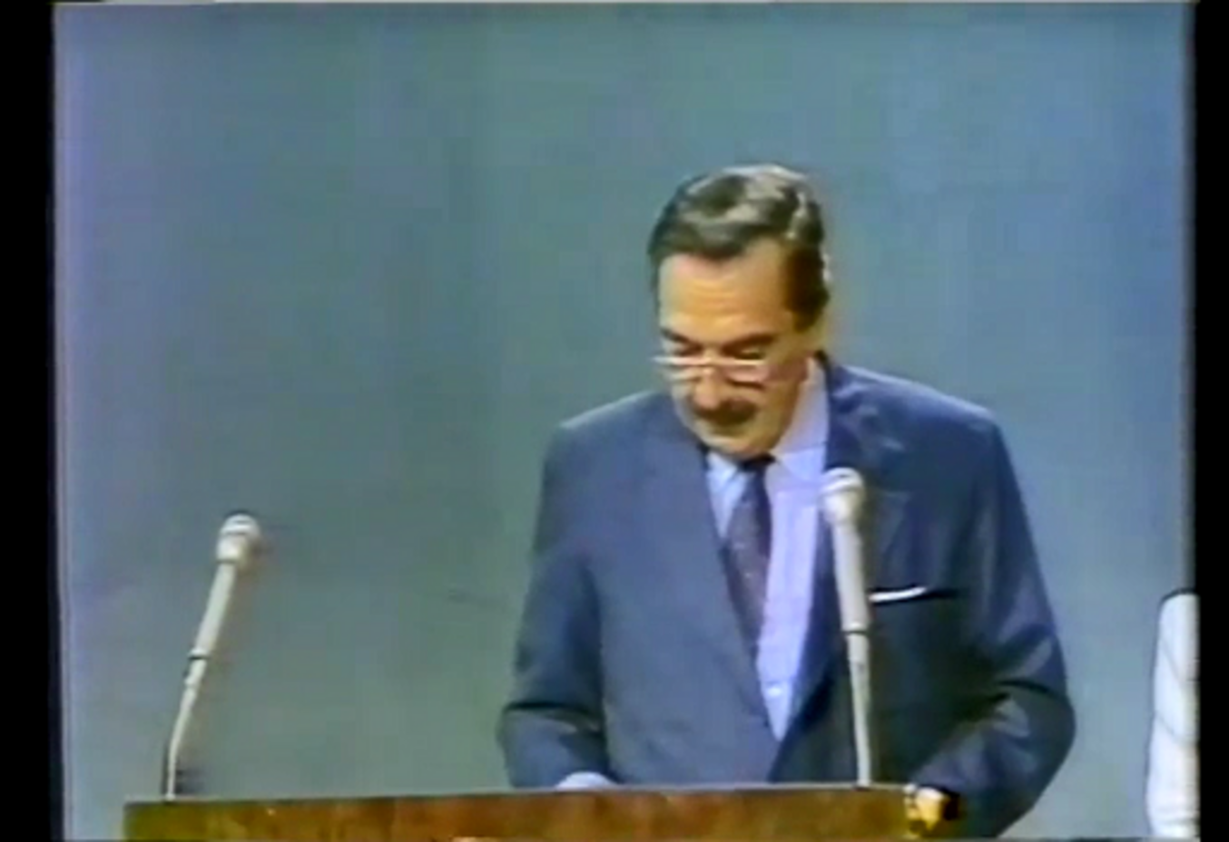

- According to President Alfonsín, how can the leaders of six non-nuclear countries influence the governments of nuclear-weapons states towards disarmament?

Provide your answer...
View discussion - Activity 2

While the Six Nation Initiative did not immediately succeed in bringing about a nuclear freeze or securing general disarmament, it was nevertheless an important example of world leaders from different parts of the world cooperating with other each and with anti-nuclear activists from around the world to push for nuclear disarmament.

3 Summary of Session 4
In this session, you have learned how different governments have responded to anti-nuclear activists and calls for nuclear disarmament. You saw how in some cases, large-scale activism simply was not feasible, as in apartheid South Africa or the Soviet Union. In democracies where anti-nuclear activists can share their message freely, they have sometimes been targeted by the ruling party or government, as you saw in the case of the UK in the 1980s. Conversely, the relationship between grassroots activists and political leaders can be very constructive, as you saw with the example of the Six Nation Initiative. This range of government responses can also be seen with more recent initiatives such as the Treaty on the Prohibition of Nuclear Weapons (TPNW), which has been championed by some governments and rejected by others.
In the next session you’ll explore what impact anti-nuclear activists have had on policymakers.
You can now go to Session 5.

Session 5: What has anti-nuclear activism achieved?

Introduction
In this session, you will engage with a central question for anyone interested in activism: What has anti-nuclear activism achieved? This remains a hotly debated question, with some claiming that anti-nuclear activism has had only a marginal impact, and others arguing that anti-nuclear activists contributed to ending the Cold War.
In this session, you will focus on two cases. First, you’ll look at anti-nuclear activism in the UK in the 1980s and consider its impact on policymakers and international affairs. Then you’ll learn about Nuclear Weapons Free Zones (NWFZ), which have effectively banned nuclear weapons from entire continents.

1 The Euromissile Crisis and the end of the Cold War
As you have seen, the early 1980s marked a highpoint of anti-nuclear activism in Western Europe, spurred on by the planned deployment of ‘Euromissiles’ in five European countries. While millions of citizens participated in anti-nuclear activism by attending demonstrations, wearing badges, or lobbying their elected representatives, their impact on policymakers and their achievements remain debated among academics, activists and policymakers.

Activity 1

Watch this video, featuring peace activists, policymakers and historians reflecting on the impact of the UK peace movement of the 1980s. Then answer the questions below.

Video content is not available in this format.
View transcript - Uncaptioned interactive content

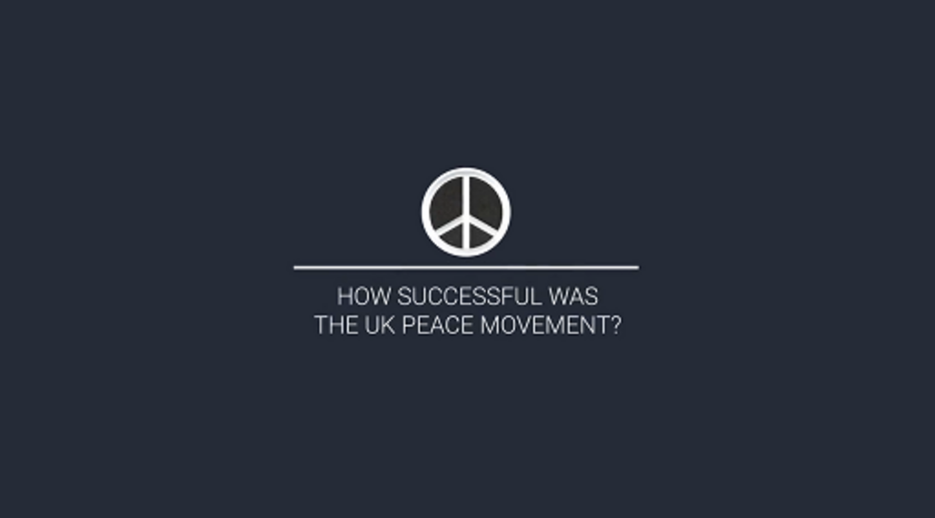

- How far was the UK peace movement successful in preventing Cruise missiles from being deployed in the UK?
- Beyond its impact on specific policies, what impact did the anti-nuclear movement have on policymakers in the UK?

Provide your answer...
View discussion - Activity 1

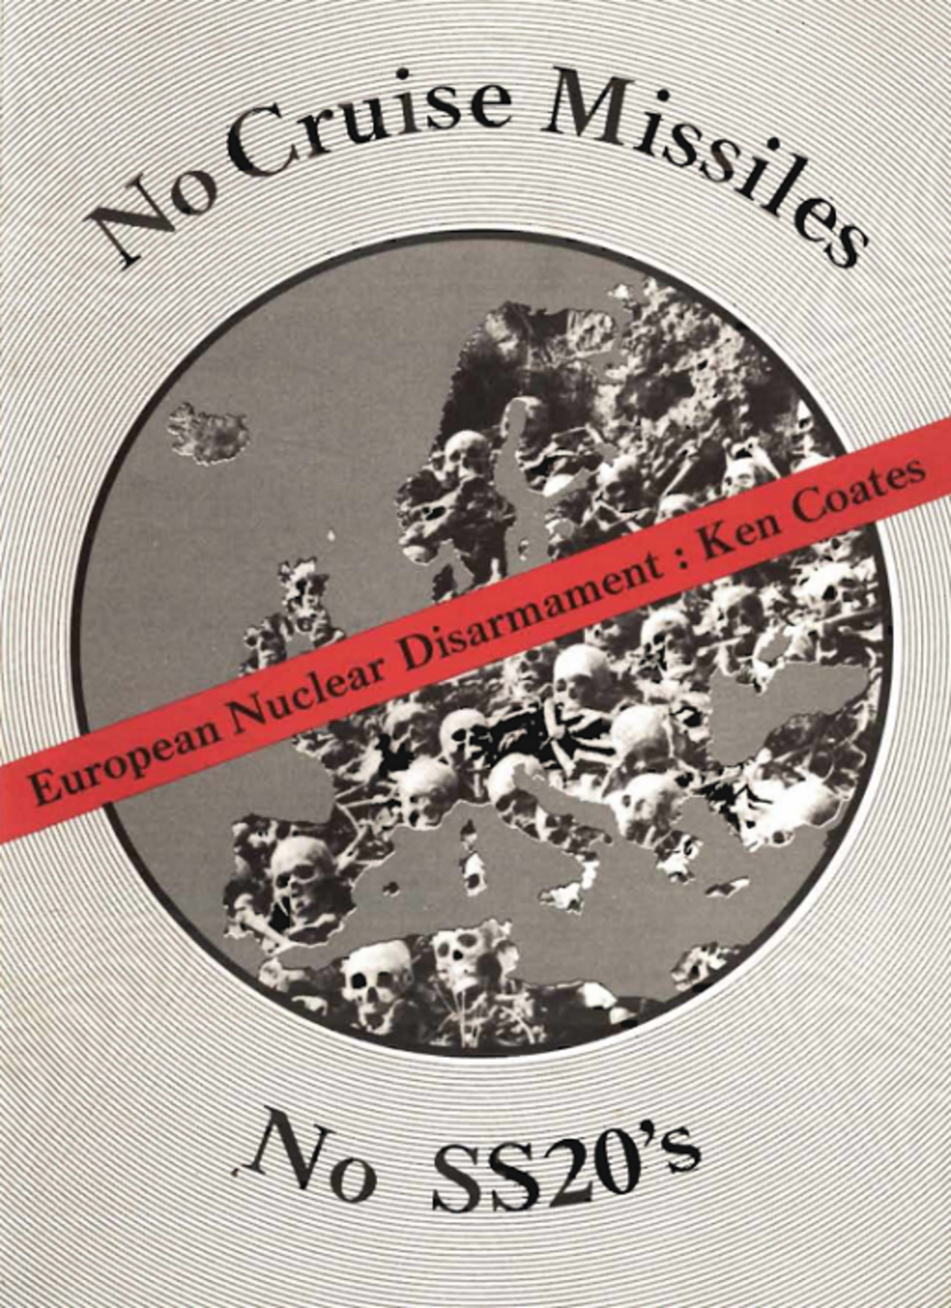
Figure 1 The cover of a 1980 pamphlet written by Ken Coates, one the leaders of European Nuclear Disarmament (END), calling for the elimination of INF on both sides of the Iron Curtain.
View description - Figure 1 The cover of a 1980 pamphlet written by Ken Coates, one the leaders of European ...
View alternative description - Figure 1 The cover of a 1980 pamphlet written by Ken Coates, one the leaders of European ...

The 1987 INF Treaty was a landmark agreement that paved the way to the end of the Cold War. Signed by US President Ronald Reagan and Soviet premier Mikhail Gorbachev, the treaty abolished an entire class of nuclear weapons, known as intermediate-range nuclear forces (INF), which included the ‘Euromissiles’ recently deployed in Western Europe. As a result, these nuclear weapons were removed from Europe, and the treaty led to further nuclear arms agreements between the superpowers.
The role of anti-nuclear activism in bringing about the INF Treaty and the end of the Cold War continues to be debated among historians, activists and policymakers. The origins of the INF Treaty can be traced to a proposal made by President Reagan in 1981, when he suggested ‘the zero option’ to the Soviet Union. In short, if the Soviets were to remove their recently-deployed INF, the Americans would cancel their planned deployment of the ‘Euromissiles’.
Western European governments had come under increasing pressure from the surging anti-nuclear movements in their countries and public opinion more broadly for NATO to advance a negotiating position that might prevent the need to deploy the ‘Euromissiles’. Now these European leaders in turn put pressure on the Reagan administration to advance a credible arms control position.
One source for this American proposal was indeed the international anti-nuclear movement, which had called precisely for the removal of Soviet SS-20s and the cancellation of the planned deployment of Cruise and Pershing by NATO (as you can see in Figure 1). The ‘zero option’ was initially rejected by the Soviets in 1981, but the changing political situation after the arrival of Mikhail Gorbachev in the Kremlin meant that the idea was revived and provided the foundation for the historic 1987 treaty. Thus, even though anti-nuclear activists had been unable to prevent the deployment of the ‘Euromissiles’ in the early 1980s, their actions and ideas ultimately contributed to the significant reduction of nuclear weapons in Europe later that decade.

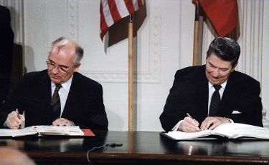
Figure 2 Soviet leader Mikhail Gorbachev and US President Ronald Reagan signing the INF Treaty in 1987. The superpowers agreed to eliminate INF from Europe, resulting in the removal of the ‘Euromissiles’ that had sparked so much opposition.
View description - Figure 2 Soviet leader Mikhail Gorbachev and US President Ronald Reagan signing the ...
View alternative description - Figure 2 Soviet leader Mikhail Gorbachev and US President Ronald Reagan signing the ...

2 Nuclear weapons free zones (NWFZ)
One central aim of anti-nuclear activism has been the creation of extensive nuclear weapons free zones. The idea is to establish a region, including several countries, in which the deployment, testing or use of nuclear weapons is prohibited. In 1967, governments from across Latin America and the Caribbean signed the Treaty of Tlatelolco, establishing a NWFZ stretching from the US-Mexican border to the southern tip of South America. The initiative was driven by Mexican diplomats, particularly Alfonso García Robles, a committed peace and anti-nuclear activist who received the Nobel Peace Prize in 1982 for his achievements. This was the first NWFZ covering inhabited territory, and it provided a model for future NWFZs around the world.

Activity 2

Click on the map below to see which parts of the world are nuclear weapons free zones.
The map is unavailable in this format, please see the OpenLearn course online to view it.

African politicians and civil society have long played a leading role in the struggle against nuclear weapons. Initial activities focused on opposing French nuclear tests carried out in Algeria between 1960 and 1966, with nuclear fallout affecting communities in Algeria and neighbouring countries. In Session 2, you encountered the term ‘nuclear colonialism’. In Africa, activism against nuclear weapons was often closely related to the struggle for decolonisation and national independence. Similarly, opposition across Africa to the apartheid regime in South Africa increasingly involved opposition to the ‘apartheid bomb’, the nuclear weapons developed by the regime. South Africa was the only African country to develop nuclear weapons, and in 1989 the government in Pretoria decided to dismantle these weapons. In 1996, the Treaty of Pelindaba was signed, establishing a NWFZ covering the entirety of Africa. While the treaty was signed in Cairo, it took its name from the main site of the South African nuclear weapons programme, highlighting the historic denuclearisation of South Africa and the entire continent.

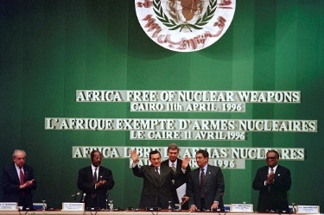
Figure 3 African leaders signing the Treaty of Pelindaba in Cairo in 1996, agreeing to the creation of the African NWFZ.
View description - Figure 3 African leaders signing the Treaty of Pelindaba in Cairo in 1996, agreeing ...
View alternative description - Figure 3 African leaders signing the Treaty of Pelindaba in Cairo in 1996, agreeing ...

Since the signing of the Treaty of Pelindaba, African policymakers, activists and civil society have played a leading role in advocating nuclear disarmament, including the Treaty on the Prohibition of Nuclear Weapons (TPNW), which you’ll learn more about in Session 6.

3 Summary of Session 5
In this session, you have explored how anti-nuclear and peace activists contributed to the removal of some nuclear weapons from Europe and to the end of the Cold War, particularly by influencing the 1987 INF Treaty. You have also seen how activists, broadly defined including diplomats and policymakers as well as civil society, have helped create nuclear weapons free zones covering much of the world.
In Session 6, the final session of this course, you will learn more about one of the biggest successes of the anti-nuclear movement: the Treaty on the Prohibition of Nuclear Weapons.
You can now go to Session 6.

Session 6: Nuclear arms control and the Treaty on the Prohibition of Nuclear Weapons

Introduction
In this session, you’ll learn more about the work of anti-nuclear activists and governments to stop the spread of nuclear weapons, also known as nuclear proliferation.
First, you’ll explore earlier efforts to limit the spread of nuclear weapons, specifically with the Non-Proliferation Treaty (NPT). Then, you’ll turn to the more recent work of the NGO the International Campaign to Abolish Nuclear Weapons (ICAN) and their success in bringing about the Treaty on the Prohibition of Nuclear Weapons (TPNW), which makes nuclear weapons illegal. You’ll end this session by reflecting on the ongoing role of activists and how individuals can get involved in anti-nuclear activism today.

1 The Non-Proliferation Treaty
For decades, the cornerstone of the international disarmament and non-proliferation regime has been the structures of the Non-Proliferation Treaty (NPT). This landmark international treaty, signed in 1968 and entering into force two years later, aimed to prevent the spread of nuclear weapons, while providing safeguards and inspection regimes. Since then, 191 countries have signed the treaty, including the five who had nuclear weapons at the time: the US, the USSR, France, the UK and China. The NPT sought to prevent further countries from developing nuclear weapons. At the same time, the existing nuclear weapons states agreed to gradually reduce their own nuclear stockpiles and to work towards nuclear disarmament.

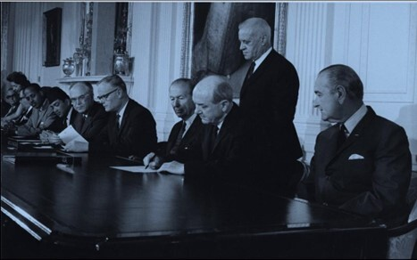
Figure 1 President Lyndon Johnson looks on as Secretary Dean Rusk signs the NPT, July 1968, Washington.
View description - Figure 1 President Lyndon Johnson looks on as Secretary Dean Rusk signs the NPT, ...
View alternative description - Figure 1 President Lyndon Johnson looks on as Secretary Dean Rusk signs the NPT, ...

Over the years, however, the limitations of the NPT have become apparent. Contrary to the Treaty’s objectives, four countries have since progressively developed nuclear weapons of their own: India, Israel, Pakistan and North Korea. (As you have seen, South Africa, while not an NPT member at the time, developed its own nuclear weapons before disarming and joining the NPT as a non-nuclear armed country.) There is also widespread resentment that the treaty’s hierarchical and undemocratic structure serves to enshrine the ‘nuclear haves’ and permanently resign all other countries to being ‘nuclear have-nots’, a division that has even been likened to ‘nuclear apartheid’. Furthermore, the original five nuclear weapons states have made scant progress towards getting rid of their own nuclear weapons and working towards nuclear disarmament.
Indeed, in the twenty-first century countries such as China are rapidly expanding their nuclear arsenal despite being a signatory to the NPT, while others continue to modernise theirs. With rising international tensions and irresponsible rhetoric from leaders of nuclear weapons states, recent years have seen a revival of nuclear anxieties around the world and renewed efforts by activists to rid the world of nuclear weapons once and for all. As the following table shows, despite attempts to limit, if not remove entirely, the threat that nuclear weapons pose to the world, the number of countries who own them has increased.

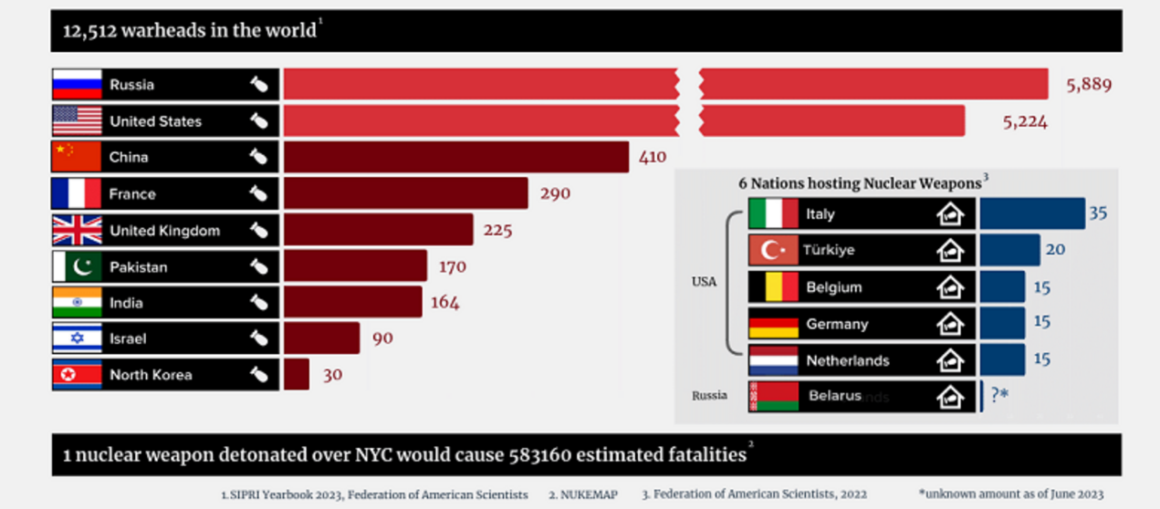
Figure 2 A table showing which countries have nuclear weapons and the size of their respective nuclear arsenals as of 2023.
View description - Figure 2 A table showing which countries have nuclear weapons and the size of their ...
View alternative description - Figure 2 A table showing which countries have nuclear weapons and the size of their ...

2 The Treaty on the Prohibition of Nuclear Weapons (TPNW)
It was in this context that the International Campaign to Abolish Nuclear Weapons was launched in 2006. The result of extensive international cooperation among activists and NGOs, the International Campaign to Abolish Nuclear Weapons (ICAN) is now comprised of over 700 partner organisations in well over 100 countries around the world. It has focused on the humanitarian threat posed by nuclear weapons, and its central mission has been to encourage governments to sign, ratify and adhere to the TPNW.
The TPNW clearly prohibits the development, testing, production, stationing or use of nuclear weapons. Unlike the NPT, the treaty applies equally to all signatory countries, in theory resolving the tension between nuclear ‘haves’ and ‘have-nots’ of the earlier treaty. It also builds on the NWFZ treaties you learned about in Session 5, expanding some of these provisions to the entire world. The TPNW was adopted by the UN in 2017 and entered into force in 2021. The TPNW is now a binding international law and as a result, nuclear weapons are illegal. As of 2024, 93 states have signed the treaty, with 70 of these taking the next step and ratifying the TPNW, demonstrating the widespread global support for nuclear disarmament. Problematically, none of the nuclear weapons states have signed the TPNW.
Take a look at the following chart which highlights the main differences between the 1968 NPT and the 2017 TPNW.
Table 1 explains some of the key differences between the NPT and the TPNW.

Table 1 The key differences between the NPT and the TPNW.
The NPT (1968): | The TPNW (2017):
Prohibits five of the nine nuclear-armed states – China, France, Russia, the UK, and the US – from transferring their nuclear weapons to anyone else or assisting other states to acquire nuclear weapons. | Prohibits a wide range of activities relating to nuclear weapons, including their use, threatened use, development, testing, manufacture, and possession, as well as assistance with any of those activities.
Prohibits all other parties from manufacturing or otherwise acquiring nuclear weapons. | Establishes a legal framework for the verified, time-bound elimination of nuclear-weapon programmes and the removal of foreign-owned nuclear weapons from the territory of parties.
Facilitates the exchange of equipment, materials, and scientific and technological information for the ‘peaceful uses of nuclear energy’, subject to safeguard agreements. | Reinforces and extends the NPT requirement for safeguards to ensure that nuclear materials and technology are not used for weapons.
Requires all parties to ‘pursue negotiations in good faith on effective measures relating to the cessation of the nuclear arms race and to nuclear disarmament’ (without specifying what those measures must be or imposing any timeline). | Establishes a legal framework for assisting victims of the use and testing of nuclear weapons, and for the remediation of contaminated environments.
(Source: ICAN, 2023, p. 3)

Activity 1

In 2017, ICAN was awarded the prestigious Nobel Peace Prize ‘for its work to draw attention to the catastrophic humanitarian consequences of any use of nuclear weapons and for its ground-breaking efforts to achieve a treaty-based prohibition of such weapons’.
Watch this video featuring ICAN’s Executive Director at the time, Beatrice Fihn, after receiving the Nobel Peace Prize, and then answer the questions below.

Video content is not available in this format.
View transcript - Uncaptioned interactive content



- What motivated ICAN to take action against nuclear weapons?
- What are the next steps towards nuclear disarmament described in the speech?

Provide your answer...
View discussion - Activity 1

As you heard in Beatrice Fihn’s speech, the International Campaign to Abolish Nuclear Weapons includes anyone interested in the issue and willing to work towards a world free of nuclear weapons. As a result of ‘going local’ and individuals putting pressure on their governments to sign and ratify the TPNW, the treaty entered into force in 2021 – a landmark achievement in the history of anti-nuclear activism.

3 Anti-nuclear activism today
The TPNW marks an important milestone in the decades-long struggle to abolish nuclear weapons. However, none of the powers that have nuclear weapons have to date signed the treaty. There is still more work to be done. What are the next steps in the campaign and, if you’re interested in this issue, how could you get involved?

Activity 2

Watch this video from Melissa Parke, the Executive Director of ICAN, and answer the question below.

Video content is not available in this format.
View transcript - Uncaptioned interactive content



- How can you, as an individual, take action against nuclear weapons?

Provide your answer...
View discussion - Activity 2

Perhaps the greatest challenge facing anti-nuclear activism is that the existing nuclear weapons states and some of their allies have so far failed to sign the treaty. The signature and ratification of the TPNW by these countries would help make nuclear disarmament a reality and remains the focus of current and future campaigning by international activists.

4 Summary of Session 6
In this session, you have learned about earlier attempts to prevent the proliferation of nuclear weapons, particularly through the Non-Proliferation Treaty. You also explored how the limitations of this treaty gave rise to a new campaign, which resulted in the United Nations Treaty of the Prohibition of Nuclear Weapons, which has declared nuclear weapons illegal. Finally, you learned about anti-nuclear activism today, and how you can be involved.

5 Course conclusion
Hopefully you have enjoyed this OpenLearn course. Now that you’ve completed it, you should have a much deeper knowledge of how activists and citizens have mobilised to oppose nuclear weapons in different parts of the world. You learned why people have opposed nuclear weapons, what forms of action they engaged in, and how they cooperated across national borders. You also learned how different governments responded to anti-nuclear activism, what impact activists have had, and about the ongoing campaign regarding the Treaty on the Prohibition of Nuclear Weapons.
Before completing this course, we would like to invite you to complete an end-of-course survey. Your answers will be completely anonymous – we will have no way of knowing who wrote which comments – but they will enable us to measure the impact of this course and to improve it based on your feedback.

References
ICAN (2024) Surge: 2023 Global Nuclear Weapons Spending. Available at: https://assets.nationbuilder.com/ican/pages/4079/attachments/original/1718371132/Spending_Report_2024_Singles_Digital.pdf?1718371132 (Accessed: 25 June 2024).
ICAN (2013) How the TPNW Complements, Reinforces, and Builds On the NPT. Available at: https://assets.nationbuilder.com/ican/pages/3204/attachments/original/1679360844/Briefing_Note_on_NPT-TPNW_Complementarity.pdf?16793608 (Accessed: 3 July 2024).

Further resources
This course has been produced as part of an AHRC-funded project on ‘Global histories of anti-nuclear activism’, in collaboration with nine partner institutions in seven countries across five continents. You can learn more about this project and the other resources and publications we are producing by visiting the project website.
To learn more about ICAN’s activities, you can explore their website.

Where next?
If you’ve enjoyed this course you can find more free resources and courses on OpenLearn.
New to University study? You may be interested in our courses in History or International Studies.
Making the decision to study can be a big step and The Open University has over 40 years of experience supporting its students through their chosen learning paths. You can find out more about studying with us by visiting our online prospectus.

Acknowledgements
This free course was written by Luc-André Brunet and Eirini Karamouzi.
Except for third party materials and otherwise stated (see terms and conditions), this content is made available under a Creative Commons Attribution-NonCommercial-ShareAlike 4.0 Licence.
The material acknowledged below is Proprietary and used under licence (not subject to Creative Commons Licence). Grateful acknowledgement is made to the following sources for permission to reproduce material in this free course:
Introduction and guidance
Images
Course image: Homer Sykes / Alamy Stock Photo
ICAN logo: https://www.icanw.org/
Session 1
Images
Figure 1: INTERFOTO / Alamy Stock Photo
Figure 2: https://en.wikipedia.org/wiki/British_nuclear_tests_at_Maralinga#/media/File:Buffalo_R4_001.jpg
Figure 3: https://warpp.info/en/m6/infographics/nuclear-weapons-explosions-1945-to-2018/https://www.creativecommons.org/licenses/by-nc/4.0/deed.en
Audio/Video
Activity 1 audio: talking about Hiroshima 6.8.1945. The recording is from December 2023 during a conference co-organised by the The Open University, University of Sheffield and the Hiroshima Peace Institute at Hiroshima City University (Japan) with the latter hosting the event.
Activity 2 video: courtesy ICAN https://www.icanw.org/
Session 2
Images
Figure 1: courtesy CNDUK https://cnduk.org/peoples-history-of-cnd-aldermaston-and-the-early-radicalism/
Figure 2: Photographer : Bogaerts, Rob / Anefo Copyright holder: National Archives Material : https://creativecommons.org/publicdomain/zero/1.0/deed.en
Figure 3: DVD cover of BBC film Threads (1984) https://en.wikipedia.org/wiki/Threads_%281984_film%29
Figure 4: http://edition.cnn.com/WORLD/Newsbriefs/9509/9-13/
Figure 5: Campaign for Nuclear Disarmament (N.Z.); publisher; 1980s; New Zealand
Audio/Video
Activity 1 video: What forms of peace activism took place in the UK courtesy London School of Economics https://www.lse.ac.uk/
Session 3
Images
Figure 1: Homer Sykes / Alamy Stock Photo
Figure 2: https://www.reddit.com/r/HistoryPorn/comments/1agogcs/antinuclear_demonstration_in_bonn_germany_we_dont/
Figure 3: Photo: courtesy Mike Kantey
Figure 4: Poster advertising an event co-organised by the Anti Apartheid Movement CND in Exeter, England June 1982
Audio/Video
Activity 1 video: Was UK peace activism part of a worldwide movement? Courtesy: LSE https://www.lse.ac.uk/
Activity 2 video: from The Future ReImagined, session 2, 22 September 2023, featuring Ambassador Abdul Minty at University of Johannesburg
Session 4
Images
Figure 1: poster by Youth Multilateral Disarmament https://www.lse.ac.uk/ideas/Assets/Documents/project-docs/cnd-archives/004-0001.pdf
Figure 2: Andreas Papandreou Foundation (APF), box 4, The Four Continent Peace Initiative, 22 May 1984
Audio/Video
Activity 1 video: How did the UK Government respond to peace activism? Courtesy: London School of Economics and Political Science https://www.lse.ac.uk/
Activity 2 video: BEYOND WAR AWARD - 1985 - Five Continent Peace Initiative by Beyond War Foundation (clip 40.00-42.50) https://archive.org/details/BeyondWarAward-1985 - https://creativecommons.org/public-domain/cc0/
Session 5
Images
Figure 1: Courtesy The Bertrand Russell Peace Foundation Ltd, Ken Coates, European Nuclear Disarmament. https://www.russfound.org/END/EuropeanNuclearDisarmament.html
Figure 2: USA Government - Public Domain
Figure 3: AMR NABIL / Stringer / via Getty Images
Audio/Video
Activity 1 video: How successful was the UK peace movement? Courtesy: LSE https://www.lse.ac.uk/
Session 6
Images
Figure 1: President Lyndon B. Johnson looks on as Secretary of State Dean Rusk signs the NPT, July 1, 1968, Washington. Photo: National Archives LB306-PSD-68-2055 https://www.state.gov/wp-content/uploads/2019/03/NPT-in-Pictures.pdf
Figure 2: Table showing countries with nuclear weapons in Which countries have nuclear weapons? https://www.icanw.org/
Tables
Table 1: The key differences between the NPT and the TPNW in ICAN (2013) (p. 3) How the TPNW Complements, Reinforces, and Builds On the NPT.
Audio/Video
Activity 1 video: Beatrice Fihn. Courtesy: ICAN https://www.icanw.org/
Every effort has been made to contact copyright owners. If any have been inadvertently overlooked, the publishers will be pleased to make the necessary arrangements at the first opportunity.
Don't miss out
If reading this text has inspired you to learn more, you may be interested in joining the millions of people who discover our free learning resources and qualifications by visiting The Open University – www.open.edu/openlearn/free-courses.

Solutions

Activity 1

Discussion
- Keiko Ogura did not go to school on 6 August, as there had been an air raid siren the previous evening. The students who did go to her school, which was closer to where the bomb was dropped, were killed by the blast.
- There is no single correct answer to this question. Keiko Ogura describes how the city was destroyed and was burning, how injured survivors had to be left behind, and how following the attack the city was covered by a black, radioactive rain. Her description provides a moving, first-hand account of the effects of nuclear weapons.
Back to - Activity 1

Activity 2

Discussion
- The nuclear tests contaminated the region with unsafe levels of radiation. This has led to serious illnesses such as cancer and leukaemia within the community.
Back to - Activity 2

Activity 3

Discussion
- The United States and Russia/the Soviet Union account for the vast majority of nuclear explosions since 1945. Today, these two countries have by far the largest arsenals of nuclear weapons.
- There are a number of different things that may have struck you looking at this map. You may have remarked on the geographical spread of nuclear explosions, with South America being the only continent where nuclear weapons have not been detonated. You may also have noticed that, outside of Russia, there have been no nuclear explosions in Europe, as the UK and France have tested their nuclear weapons elsewhere, particularly in the Pacific. The map also shows how some specific sites have been subjected to numerous nuclear explosions, which have exposed local populations to extreme and sustained levels of radiation.
Back to - Activity 3

Activity 1

Discussion
- Perhaps the two most visible forms of anti-nuclear activism were large public demonstrations, such as those in Hyde Park or in Trafalgar Square in London, and the Women’s Peace Camp set up at Greenham Common, one of the two military bases in the UK where the new ‘Euromissiles’ were to be deployed. Additional activities included letter-writing campaigns, public education and lobbying Members of Parliament.
- In the UK, the focus of anti-nuclear activism in England and Wales was mainly on the Cruise missiles which were to be stationed in southern England. In Scotland, however, there was a greater emphasis on opposing the UK government’s nuclear weapons systems – Polaris, and then Trident – which were deployed on submarines based at Clyde Naval Base, near Glasgow. These issues resonated differently in different parts of the UK, leading to more targeted local campaigns.
Back to - Activity 1

Activity 1

Discussion
- There were two main groups within the Soviet bloc with whom British anti-nuclear organisation engaged. On the one hand there were formal Peace Committees, which were effectively controlled by the ruling Communist Party in each country. On the other hand, there were dissidents, who were critical of the regimes in Eastern Europe. While these two groups were at odds with each other within the Eastern bloc, Western anti-nuclear activists engaged with both to work towards nuclear disarmament.
Back to - Activity 1

Activity 2

Discussion
- The World Campaign received numerous reports of various military and nuclear developments in South Africa. Yet many of these were false, and some were even planted by those hostile to the Anti-Apartheid Movement’s work. Minty and his colleagues had to assess each claim and only publicise accounts that they believed to be true. Ultimately, this proved successful, and the World Campaign was able to build up considerable credibility by revealing developments which proved to be accurate while avoiding making false claims.
- The apartheid regime rested on police and military force, making its defence budget unsustainably large. Minty argued that if an effective arms embargo against South Africa were implemented, the apartheid regime itself would collapse. As this embargo was put in place increasingly effectively in the 1980s, Minty argues this resulted in the end of the apartheid regime and the transition to democracy in South Africa in the 1990s.
Back to - Activity 2

Activity 1

Discussion
- The UK government as well as groups set up by the Conservative Party attacked anti-nuclear activists as being controlled by Communists and the Soviet Union, being anti-British, and compared nuclear disarmament to the ill-fated appeasement of Nazi Germany in the 1930s. The ruling Conservative Party aimed to tarnish anti-nuclear activists and thereby maintain the government’s existing policies on nuclear weapons.
Back to - Activity 1

Activity 2

Discussion
- Alfonsín argues that he and the other five national leaders have reason on their side. Moreover, he suggests that their voices are joined by those of hundreds of millions, referring to the importance of citizens around the world calling for nuclear disarmament.
Back to - Activity 2

Activity 1

Discussion
- In the short term, the anti-nuclear movement was unsuccessful in preventing Cruise missiles from being deployed in the UK. In the medium term, however, the movement’s goal was achieved, as the 1987 INF Treaty resulted directly in the removal of the Cruise missiles that were deployed in England in 1983.
- Beyond specific policies, such as the deployment of Cruise missiles, the anti-nuclear movement gave voice to widely shared anxieties around nuclear weapons and the possibility of war in the 1980s. This forced the UK Government to explain its defence policies and to justify its decisions in order to engage with the arguments of anti-nuclear activists and to try to convince the public of the merits of the Government’s policies.
Back to - Activity 1

Activity 1

Discussion
- Beatrice Fihn explains that those involved in ICAN had lost patience with the lack of progress towards nuclear abolition, despite commitments such as those in the 1968 NPT to work towards nuclear disarmament. She also cites the importance of the hibakusha, who have worked for decades to ensure nuclear weapons are never used again.
- Beatrice Fihn explains that, following the adoption of the TPNW in 2017, the next step is to ‘go local’ to ensure individual national governments sign and ratify the treaty. She encourages citizens to put pressure on their representatives so that their country signs and ratifies the TPNW.
Back to - Activity 1

Activity 2

Discussion
- The success of the TPNW depends on widespread support and implementation. Individual citizens such as yourself can take action by reaching out to your elected officials urging them to ensure your country signs and ratifies the TPNW. You can organise events in your community to raise awareness of the issue, and speak to banks and companies to encourage them to divest from companies building nuclear weapons.
Back to - Activity 2

Descriptions

Figure 1 Hiroshima after the atomic bombing of 6 August 1945. Virtually all the buildings in central Hiroshima were destroyed; the surviving building on the right is now the Hiroshima Peace Memorial.
A black-and-white photograph of the aftermath of the atomic bombing of Hiroshima.
Back to - Figure 1 Hiroshima after the atomic bombing of 6 August 1945. Virtually all the buildings in central Hiroshima were destroyed; the surviving building on the right is now the Hiroshima Peace Memorial.

Figure 1 Hiroshima after the atomic bombing of 6 August 1945. Virtually all the buildings in central Hiroshima were destroyed; the surviving building on the right is now the Hiroshima Peace Memorial.
A black-and-white photograph of the aftermath of the atomic bombing of Hiroshima.
Back to - Figure 1 Hiroshima after the atomic bombing of 6 August 1945. Virtually all the buildings in central Hiroshima were destroyed; the surviving building on the right is now the Hiroshima Peace Memorial.

Figure 2 A British nuclear test carried out at Maralinga, Australia, in 1956. The blast pictured here was roughly one thousand times more powerful than that of the bomb dropped on Hiroshima in 1945.
A photograph of a large blast.
Back to - Figure 2 A British nuclear test carried out at Maralinga, Australia, in 1956. The blast pictured here was roughly one thousand times more powerful than that of the bomb dropped on Hiroshima in 1945.

Figure 2 A British nuclear test carried out at Maralinga, Australia, in 1956. The blast pictured here was roughly one thousand times more powerful than that of the bomb dropped on Hiroshima in 1945.
A photograph of a large blast.
Back to - Figure 2 A British nuclear test carried out at Maralinga, Australia, in 1956. The blast pictured here was roughly one thousand times more powerful than that of the bomb dropped on Hiroshima in 1945.

Figure 3 Map showing where the thousands of nuclear weapons explosions since 1945 have taken place in the world. Along with Israel, the eight countries listed here make up the nine nuclear weapons states in the world today.
A map of the world. The following locations are noted: the USA; Russia; France, China, United Kingdom, North Korea, India and Pakistan.
Back to - Figure 3 Map showing where the thousands of nuclear weapons explosions since 1945 have taken place in the world. Along with Israel, the eight countries listed here make up the nine nuclear weapons states in the world today.

Figure 3 Map showing where the thousands of nuclear weapons explosions since 1945 have taken place in the world. Along with Israel, the eight countries listed here make up the nine nuclear weapons states in the world today.
A map of the world. The following locations are noted: the USA; Russia; France, China, United Kingdom, North Korea, India and Pakistan.
Back to - Figure 3 Map showing where the thousands of nuclear weapons explosions since 1945 have taken place in the world. Along with Israel, the eight countries listed here make up the nine nuclear weapons states in the world today.

Figure 1 A march organised by the British Campaign for Nuclear Disarmament (CND) in 1962. From 1958, the CND organised annual marches at Easter from Aldermaston, Berkshire (where the UK’s Atomic Weapons Research Establishment was located) to London.
A black-and-white photograph of a protest march.
Back to - Figure 1 A march organised by the British Campaign for Nuclear Disarmament (CND) in 1962. From 1958, the CND organised annual marches at Easter from Aldermaston, Berkshire (where the UK’s Atomic Weapons Research Establishment was located) to London.

Figure 1 A march organised by the British Campaign for Nuclear Disarmament (CND) in 1962. From 1958, the CND organised annual marches at Easter from Aldermaston, Berkshire (where the UK’s Atomic Weapons Research Establishment was located) to London.
A black-and-white photograph of a protest march.
Back to - Figure 1 A march organised by the British Campaign for Nuclear Disarmament (CND) in 1962. From 1958, the CND organised annual marches at Easter from Aldermaston, Berkshire (where the UK’s Atomic Weapons Research Establishment was located) to London.

Figure 2 A demonstration in Bonn, then capital of the Federal Republic of Germany, in October 1981 against the planned deployment of ‘Euromissiles’ in the country. This demonstration attracted roughly 300,000 participants, and similar demonstrations across Western Europe included comparable numbers of protesters.
A photograph of a ,large group of people at a demonstration.
Back to - Figure 2 A demonstration in Bonn, then capital of the Federal Republic of Germany, in October 1981 against the planned deployment of ‘Euromissiles’ in the country. This demonstration attracted roughly 300,000 participants, and similar demonstrations across Western Europe included comparable numbers of protesters.

Figure 2 A demonstration in Bonn, then capital of the Federal Republic of Germany, in October 1981 against the planned deployment of ‘Euromissiles’ in the country. This demonstration attracted roughly 300,000 participants, and similar demonstrations across Western Europe included comparable numbers of protesters.
A photograph of a ,large group of people at a demonstration.
Back to - Figure 2 A demonstration in Bonn, then capital of the Federal Republic of Germany, in October 1981 against the planned deployment of ‘Euromissiles’ in the country. This demonstration attracted roughly 300,000 participants, and similar demonstrations across Western Europe included comparable numbers of protesters.

Figure 3 A poster advertising the BBC film Threads, produced in 1984. The film depicts the horrifying consequences of a nuclear attack on the British city of Sheffield.
A poster advertising the film Threads.
Back to - Figure 3 A poster advertising the BBC film Threads, produced in 1984. The film depicts the horrifying consequences of a nuclear attack on the British city of Sheffield.

Figure 3 A poster advertising the BBC film Threads, produced in 1984. The film depicts the horrifying consequences of a nuclear attack on the British city of Sheffield.
A poster advertising the film Threads.
Back to - Figure 3 A poster advertising the BBC film Threads, produced in 1984. The film depicts the horrifying consequences of a nuclear attack on the British city of Sheffield.

Figure 4 Map indicating the location of the French nuclear tests.
A map showing the location of the French nuclear tests to the east of Australia, New Zealand and French Polynesia.
Back to - Figure 4 Map indicating the location of the French nuclear tests.

Figure 4 Map indicating the location of the French nuclear tests.
A map showing the location of the French nuclear tests to the east of Australia, New Zealand and French Polynesia.
Back to - Figure 4 Map indicating the location of the French nuclear tests.

Figure 5 This poster, produced in the early 1980s by the New Zealand-based Campaign for Nuclear Disarmament, highlights the link between nuclear testing and national sovereignty.
A poster with the following text: To the French government. Notice to quit the Pacific. For: nuclear testing. Denial of independence. Free Tahiti and New Caledonia.
Back to - Figure 5 This poster, produced in the early 1980s by the New Zealand-based Campaign for Nuclear Disarmament, highlights the link between nuclear testing and national sovereignty.

Figure 5 This poster, produced in the early 1980s by the New Zealand-based Campaign for Nuclear Disarmament, highlights the link between nuclear testing and national sovereignty.
A poster with the following text: To the French government. Notice to quit the Pacific. For: nuclear testing. Denial of independence. Free Tahiti and New Caledonia.
Back to - Figure 5 This poster, produced in the early 1980s by the New Zealand-based Campaign for Nuclear Disarmament, highlights the link between nuclear testing and national sovereignty.

Figure 1 Greenham Common Women’s Peace Camp, which inspired similar peace camps in many other countries.
A photograph of a group of women standing hand in hand in front of a number of protest signs.
Back to - Figure 1 Greenham Common Women’s Peace Camp, which inspired similar peace camps in many other countries.

Figure 1 Greenham Common Women’s Peace Camp, which inspired similar peace camps in many other countries.
A photograph of a group of women standing hand in hand in front of a number of protest signs.
Back to - Figure 1 Greenham Common Women’s Peace Camp, which inspired similar peace camps in many other countries.

Figure 2 An anti-nuclear activist in Bonn, Germany in 1981 with a sign declaring ‘We do not want a Euroshima’.
A black-and-white photograph of a woman holding a sign in a protest.
Back to - Figure 2 An anti-nuclear activist in Bonn, Germany in 1981 with a sign declaring ‘We do not want a Euroshima’.

Figure 2 An anti-nuclear activist in Bonn, Germany in 1981 with a sign declaring ‘We do not want a Euroshima’.
A black-and-white photograph of a woman holding a sign in a protest.
Back to - Figure 2 An anti-nuclear activist in Bonn, Germany in 1981 with a sign declaring ‘We do not want a Euroshima’.

Figure 3 An anti-nuclear protest in Greenmarket Square, Cape Town, 1983.
A black-and-white photograph of a protest.
Back to - Figure 3 An anti-nuclear protest in Greenmarket Square, Cape Town, 1983.

Figure 3 An anti-nuclear protest in Greenmarket Square, Cape Town, 1983.
A black-and-white photograph of a protest.
Back to - Figure 3 An anti-nuclear protest in Greenmarket Square, Cape Town, 1983.

Figure 4 Poster advertising an event co-organised by the Anti-Apartheid Movement and the CND in Exeter, England, in June 1982.
A poster with the following text: South Africa’s nuclear bomb apartheid and the threat to peace.
Back to - Figure 4 Poster advertising an event co-organised by the Anti-Apartheid Movement and the CND in Exeter, England, in June 1982.

Figure 4 Poster advertising an event co-organised by the Anti-Apartheid Movement and the CND in Exeter, England, in June 1982.
A poster with the following text: South Africa’s nuclear bomb apartheid and the threat to peace.
Back to - Figure 4 Poster advertising an event co-organised by the Anti-Apartheid Movement and the CND in Exeter, England, in June 1982.

Figure 1 This poster was among the many produced by groups set up by the Conservative Party to discredit the anti-nuclear movement ahead of the 1983 general election in the UK. Depicting former Soviet leader Joseph Stalin (who died in 1953) holding a mask, the implication is that anti-nuclear activists were in fact Communists or were at least being manipulated by the Soviet Union to serve that country’s interests rather than Britain’s.
A poster with the following text: Who’s behind the so-called peace movements?
Back to - Figure 1 This poster was among the many produced by groups set up by the Conservative Party to discredit the anti-nuclear movement ahead of the 1983 general election in the UK. Depicting former Soviet leader Joseph Stalin (who died in 1953) holding a mask, the implication is that anti-nuclear activists were in fact Communists or were at least being manipulated by the Soviet Union to serve that country’s interests rather than Britain’s.

Figure 1 This poster was among the many produced by groups set up by the Conservative Party to discredit the anti-nuclear movement ahead of the 1983 general election in the UK. Depicting former Soviet leader Joseph Stalin (who died in 1953) holding a mask, the implication is that anti-nuclear activists were in fact Communists or were at least being manipulated by the Soviet Union to serve that country’s interests rather than Britain’s.
A poster with the following text: Who’s behind the so-called peace movements?
Back to - Figure 1 This poster was among the many produced by groups set up by the Conservative Party to discredit the anti-nuclear movement ahead of the 1983 general election in the UK. Depicting former Soviet leader Joseph Stalin (who died in 1953) holding a mask, the implication is that anti-nuclear activists were in fact Communists or were at least being manipulated by the Soviet Union to serve that country’s interests rather than Britain’s.

Figure 2 A photo of the world leaders involved in the Six Nation Initiative, pictured here receiving an award for their work towards nuclear disarmament. Andreas Papandreou Foundation (APF), box 4, The Four Continent Peace Initiative, 22 May 1984
A photo of several world leaders standing behind a desk.
Back to - Figure 2 A photo of the world leaders involved in the Six Nation Initiative, pictured here receiving an award for their work towards nuclear disarmament. Andreas Papandreou Foundation (APF), box 4, The Four Continent Peace Initiative, 22 May 1984

Figure 2 A photo of the world leaders involved in the Six Nation Initiative, pictured here receiving an award for their work towards nuclear disarmament. Andreas Papandreou Foundation (APF), box 4, The Four Continent Peace Initiative, 22 May 1984
A photo of several world leaders standing behind a desk.
Back to - Figure 2 A photo of the world leaders involved in the Six Nation Initiative, pictured here receiving an award for their work towards nuclear disarmament. Andreas Papandreou Foundation (APF), box 4, The Four Continent Peace Initiative, 22 May 1984

Figure 1 The cover of a 1980 pamphlet written by Ken Coates, one the leaders of European Nuclear Disarmament (END), calling for the elimination of INF on both sides of the Iron Curtain.
A pamphlet cover with the following text: No cruise missiles: European nuclear disarmament. No SS20s.
Back to - Figure 1 The cover of a 1980 pamphlet written by Ken Coates, one the leaders of European Nuclear Disarmament (END), calling for the elimination of INF on both sides of the Iron Curtain.

Figure 1 The cover of a 1980 pamphlet written by Ken Coates, one the leaders of European Nuclear Disarmament (END), calling for the elimination of INF on both sides of the Iron Curtain.
A pamphlet cover with the following text: No cruise missiles: European nuclear disarmament. No SS20s.
Back to - Figure 1 The cover of a 1980 pamphlet written by Ken Coates, one the leaders of European Nuclear Disarmament (END), calling for the elimination of INF on both sides of the Iron Curtain.

Figure 2 Soviet leader Mikhail Gorbachev and US President Ronald Reagan signing the INF Treaty in 1987. The superpowers agreed to eliminate INF from Europe, resulting in the removal of the ‘Euromissiles’ that had sparked so much opposition.
A photograph of Gorbachev and Reagan signing the INF Treaty.
Back to - Figure 2 Soviet leader Mikhail Gorbachev and US President Ronald Reagan signing the INF Treaty in 1987. The superpowers agreed to eliminate INF from Europe, resulting in the removal of the ‘Euromissiles’ that had sparked so much opposition.

Figure 2 Soviet leader Mikhail Gorbachev and US President Ronald Reagan signing the INF Treaty in 1987. The superpowers agreed to eliminate INF from Europe, resulting in the removal of the ‘Euromissiles’ that had sparked so much opposition.
A photograph of Gorbachev and Reagan signing the INF Treaty.
Back to - Figure 2 Soviet leader Mikhail Gorbachev and US President Ronald Reagan signing the INF Treaty in 1987. The superpowers agreed to eliminate INF from Europe, resulting in the removal of the ‘Euromissiles’ that had sparked so much opposition.

Figure 3 African leaders signing the Treaty of Pelindaba in Cairo in 1996, agreeing to the creation of the African NWFZ.
A photograph of several African leaders on a stage.
Back to - Figure 3 African leaders signing the Treaty of Pelindaba in Cairo in 1996, agreeing to the creation of the African NWFZ.

Figure 3 African leaders signing the Treaty of Pelindaba in Cairo in 1996, agreeing to the creation of the African NWFZ.
A photograph of several African leaders on a stage.
Back to - Figure 3 African leaders signing the Treaty of Pelindaba in Cairo in 1996, agreeing to the creation of the African NWFZ.

Figure 1 President Lyndon Johnson looks on as Secretary Dean Rusk signs the NPT, July 1968, Washington.
A photograph of several politicians sitting at a desk.
Back to - Figure 1 President Lyndon Johnson looks on as Secretary Dean Rusk signs the NPT, July 1968, Washington.

Figure 1 President Lyndon Johnson looks on as Secretary Dean Rusk signs the NPT, July 1968, Washington.
A photograph of several politicians sitting at a desk.
Back to - Figure 1 President Lyndon Johnson looks on as Secretary Dean Rusk signs the NPT, July 1968, Washington.

Figure 2 A table showing which countries have nuclear weapons and the size of their respective nuclear arsenals as of 2023.
From top to bottom the countries in the table are: Russia, United States, China, France, United Kingdom, Pakistan, India, Israel, North Korea.
Back to - Figure 2 A table showing which countries have nuclear weapons and the size of their respective nuclear arsenals as of 2023.

Figure 2 A table showing which countries have nuclear weapons and the size of their respective nuclear arsenals as of 2023.
From top to bottom the countries in the table are: Russia, United States, China, France, United Kingdom, Pakistan, India, Israel, North Korea.
Back to - Figure 2 A table showing which countries have nuclear weapons and the size of their respective nuclear arsenals as of 2023.

Uncaptioned interactive content

Transcript
KEIKO OGURA
So there was a study in the high school girls’ day road. And what I want to say is what happened. First, in the morning, we did not know anything. But my father said you shouldn’t go to school today. He said, ‘I have a kind of feeling, strange feeling, today something will happen’. My father said so. Because previous night, on the 5th, around midnight, all of a sudden, there was a siren, you see? So we were so much afraid. ‘What’s that?’ We rushed to the shelter. That was around midnight. Nothing happened.
Usually, we heard some sound, far away place, no sound. ‘What’s that?’ we wondered. But we tried to sleep. And then again, 30 minutes later, another warning. We rushed to the shelter. Such a thing happened towards the morning, another warning, and so. And then later, I learned so many bomber, B-29, passed above Hiroshima. Didn’t drop any bomb. So we were so much alert and afraid, but nothing happened. So what happened in the centre of the city, in the bunker? And the soldiers, commanders, and the girls were waiting to release the air raid warning. But by and by, many airplanes came, just passed by. ‘Oh, America pilots didn't want to drop bomb on Hiroshima.’ Like that. Pilot. But people thought so. And when actually Enola Gay was above Hiroshima, there was no commander, but the girls and a low-rank soldier. They did not know what to do. Girls were screaming. There were around 30 girls. ‘What shall we do? Above Hiroshima-- already B-29.’ It happened.
And then, without warning, the bomb was released. In the morning, Father said, so I was behind the Japanese storage. All of a sudden, there was a flash, blinding flash. Everything didn’t have colour. Then, soon after that, that was so fast, the blast attacked. I couldn’t believe or stand. I felt like I was in the midst of a tornado or a typhoon. And then I was beaten on the road, blown on the road, and became unconscious. When I opened my eyes, everywhere was just dark. I couldn’t understand. ‘Oh, I slept. How many hours? It’s already evening’ I thought. But actually, it was not. And then no sound at all. First sound was my little brother’s cry. So hearing that, ‘Oh, my house must be this way’. So I started to go back.
This is what I saw. I was surprised. Instantly, everywhere was destroyed, and the roof tiles were scattered. But in front of me, there was one barn or cottage of the farmer. The roof was burning. That was at the original flash. Flammable things started to burn. That straw roof of the farmer’s cottage caught fire, and then the burning. And then that means in the centre part, soon by the original flash-- and then the clothes caught fire. And you saw many people fleeing with burning clothes. All of a sudden, it happened. And then, soon after that, blast came. And then, a certain time after the city-- there was no fire. My friend-- she was in the bunker. Miraculously, she could survive in the military base. She came out and saw the whole city. ‘The city must be burning first. But that time, there was no fire’, she said. Maybe 10 minutes or 20 minutes after that, everywhere-- khaki colour, just like rocks or rubbish and so on.
And then, that time, people tried to flee from under the building. So people try to-- mother, parents try to pull their children under the crushed down building. And the people, so many people tried to leave the city. But secondary, the big fire started here and there, over there. City started to burn again. And they even-- our family were caught under the crushed-down building asking for help. They are still alive and asking for help. But people left their beloved people.
That made all of the survivors feel guilty. So we were told, ask, Do you hate Americans or British people so? To tell the truth, so many of Hiroshima people, before they blame the enemy, they blame themselves. Yes.
Why I left? They were still alive, clinging our legs and so on, ‘Help! Help!’ But they couldn’t help. Fire reached, and they left. And then this is the reality. And then what happened? I returned home. And then, the room faces at the centre part of the city, all broken. And the ceiling was blown up, and hundreds, thousands of pieces of glass stuck on the wall. And my father was, at that time, in this room. But he was so lucky. He was between widely open glass doors behind the big pine tree. He was saved. And then, miraculously, he was not hurt at all. He started to work for cremation and so on. Through the evening, many people reached. And then, like my uncle, on his back, over 20 pieces of glass stuck on. And the bleeding came. Many people came to my house. I stepped out, and the black rain started to fall. I couldn’t understand what this meant. And then already, before and after, and junior high school students were working, as you see.
And my brother-- this is a piece of leverage now. Before that, this-- that wasn’t like that. And my brother and Nishu-- and then he was working on the road the previous day on the 5th. But on the 6th, he was not. Then he could survive. On the 6th, over 323, I heard, students from his school, first-year students, were working. Nobody could survive. All of the students died. And out of 10,000, around 7,000 students died at the hostels. This is before and after. And then, this is within this mould, there was a bunker where I was talking about 15-years-old girls. And they were rotated and the working 24 hours, one time around 30 girls. And then, 24 hours, they were working outside of the bunker. Other group was waiting outside of the bunker. They died. My friend was operator with the receiver. And then she was working. She could survive, miraculously, and told me what happened there. This is after work.
Back to - Uncaptioned interactive content

Uncaptioned interactive content

Transcript
IBBA BOBAKER
Ibba Bobaker. Secretary General of the Association of Victims of Nuclear Explosions tawriret. This association was founded for our relatives and families who were affected by the radiation of the French nuclear explosions from 1961 to 1966. After France left these contaminated sites, left radioactive waste scattered in the area and then put up a barbed wire fence. But the fence, due to time, was stolen by farmers and used in their agricultural land, even the waste that remained taken by the residents of the area and restored their homes. And that’s what caused them cancers, breast cancer, leukemia, lung cancer, all kinds of cancers known in our region, and our parents didn’t know that these substances produce radiation that damages the body. And they thought it was the remnants of the iron and gold mine that the French spread after independence, the mining company came to our region and brought specialists from Russia, Romania and neighbouring countries who educated the people of the region about the seriousness of the waste. From the effects of the nuclear bomb and the atomic bomb, and despite all this, we started messaging France to ask for their rights to retire, but the French were ducking and every time they argued something, for example, come to France and every lawyer or some personally. And he has various diseases and even health care is not available and hospitals do not specialised in cancers this is the motive in the establishment of the association and we asked in many meetings on the issue of nuclear explosions because they are very dangerous and dangerous that these radiations will be lost in our region for up to 24,000 years and billions of years and remain in rocks, plants and groundwater. We asked the state to take care of this crime carried out by France. And add it to the textbooks so that the youth of future generations will study it as a crime against humanity committed by the French in our region.
Back to - Uncaptioned interactive content

Uncaptioned interactive content

Transcript
[MUSIC PLAYING]
KATE HUDSON
A lot of seeing these activities that were well known were the big national demonstrations, huge rallies in Hyde Park, for example. But there were loads and loads of local demonstrations and rallies across the country throughout this period. It was almost like people were on permanent mobilisation alert, so to speak. So there was all that going on. And then at the same time, there was a huge wave towards direct action. And the direct action was focused on the military bases. The most famous one, of course, is Greenham Common Women’s Peace Camp, because it was a women’s peace camp. And it caught the headlines. And they had very innovative and bold campaigning methods, let’s say, dancing on the silos, and breaking in through the fences, and embracing the base. But there were lots of other peace camps, mixed peace camps, other places. So Molesworth, for example. Greenham and Molesworth were the places where the cruise missiles were coming to. There was a peace camp there. And many other bases as well.
BRUCE KENT
Well, seeing these action is never very, very much. Partly its publicity, its education, pamphlets, literature. Its films or videos. In fact, Peter Watkins, his film for the BBC, called The War Game, was an absolute standard in groups around the country.
[LAUGHS]
FILM CLIP
At this distance, the heatwave is sufficient to cause melting of the upturned eyeball.
BRUCE KENT
If nobody’s seen it, they ought to go and have a look at it. That was the thing with public education. And then every once in a while, we would have some demonstration of some sort. And very often in London, sometimes in Trafalgar Square. But outward expression of what we were doing was quite important to our position and things.
LUC-ANDRE BRUNET
The CND was consistent in opposing both the acquisition of Trident and the deployment of cruise missiles throughout this period. But clearly those messages resonated to differing extents in different parts of the UK. So the cruise missiles were to be stationed at two military bases, one in Berkshire, one in Cambridgeshire. And so, consequently, opposition to cruise resonated much more strongly, say, in the south of England, whereas opposition to Trident was much more important in Scotland. So the Clyde Naval Base is where initially the Polaris, the precursor to Trident, was based. And then, of course, Trident would be based there subsequently. So as a result, CND activities in Scotland tended to be much more focused on opposition to Trident, whereas the anti-cruise message featured much more prominently in England as well as Wales.
MARY KALDOR
Well, I think END was, in a way, the intellectual wing. In a way, the movement, certainly in this country and perhaps all over Europe, was inspired by E. P. Thompson’s pamphlet Protest and Survive. But I think E.P. Thompson, an idea-- and Ken Coates and I was part of it --was that in the past, anti-nuclear campaigns were very easily dealt with by the establishment, because you could accuse them of being Pro-Soviet. And also that unilateralism was only about Britain. So we wanted to make it clear that we were both unilateralist and multilateralist. We didn’t care how you got rid of nuclear weapons. And we wanted it from the whole of Europe. And we wanted to make it clear that we were not just an anti-nuclear movement, we were an anti-cold war movement. And so from the beginning, we tried to make links with dissidents in eastern Europe. So in April 1980, the END appeal was launched. And it just collected thousands of signatures from all over Europe, including Olof Palme, Vaclav Havel, the Czech jazz-- actually Vaclav Havel signed later, but the Czech jazz section signed straight away. And so it became, in a way, the literature of the movement.
EIRINI KARAMOUZI
What is interesting about this transnational movement of peace and mobilisation that we’re talking about, and we’re discussing it as a Pan-European phenomena, is because the style of activism was really global, even when the framing of the message was quite local or regional. So in the UK, for example, we know that the main message was unilateral, nuclear disarmament. In the Nordic states was about nuclear free zones. In places like Spain and Greece was about membership of NATO and removal of bases. But despite these differences in framing, what was interesting is that these activists were emulating each other in terms of how to communicate their message, because it had to be low cost, but it had to be truly effective. So what happened is that they were looking at each other, either by, let’s take the example of Greenham Common. The air base, the women’s camp proved to be really an inspirational example for other peace camps in Comiso, in Italy. Or in Australia, where they were creating this feminised space for self-action and dissent against nuclear activity. But also at the same time, because it was so successful in countries like the United States, nuclear freeze, or in the in the United Kingdom, the CND campaign, the activists really learned how to get their message across. And the way to do that was through the same tactics, demonstrations, sit-ins, human chains across bases, peace camps, all of them with the hope and idea to really affect public opinion, and make them motivated to get interested, and put the topic on the political agenda.
RICHARD MOTTRAM
Well, I think, when you see the world that the government were operating in, there was growing concern, which the peace movement picked up on about the risks of nuclear war, and indeed what nuclear war would look like if it occurred. So there were TV programmes and so on. And the peace movement piggybacked on this growing concern, and amplified it, and tried to develop it. And to develop in two directions. One, to stop the deployment of cruise in this country, and two, to try and stop the decision to modernise the UK’S independent deterrent.
Back to - Uncaptioned interactive content

Uncaptioned interactive content

Transcript
[MUSIC PLAYING]
EIRINI KARAMOUZI
Britain was a huge part of this Pan-European phenomena. We have to remember, first of all, that in the 1980s, it was truly a transnational community of activists, because they were able to take advantage of the technological and media revolutions of the 60s and the 70s. But Britain was so vital in getting the message across the continent, because, first of all, it had these two big organisations. One of them was the CND, the Campaign for Nuclear Disarmament, which had a long history of peace mobilisation. But also, it had END. END was the European Nuclear Disarmament scheme that was created in 1981, partly from CND members, but also from prominent intellectuals, with the most popular one being E. P. Thompson. So END created these forums and different schemes that really elevated transnational activism across Western Europe, but also between East and West. So Britain was really at the forefront in terms of institutional and grassroots activism, but also it was exporting visual representations of nuclear anxiety. It was truly throughout British nuclear culture that activists led to emulate how to protest, how to think about, how to imagine nuclear annihilation.
KATE HUDSON
Well, we always-- and Bruce Kent is very interesting on this, because he actually did a number of peace walks across Europe, from West to East, or East to West, or whatever. So did a lot of sort of outreach to ordinary people on both sides of the divide. But CND was always open to talking to any organisation, including so-called official peace organisations. We never had the view that they’re not real, it’s just some propaganda thing from the East. We always wanted to talk with everybody, and that was the position we took. So the END initiative wasn’t a CND initiative, it was linked to CND. But it was an independent initiative, because it had a focus on linking human rights in Eastern Europe to the question of nuclear disarmament. And that’s not what CND was or is about. We are for nuclear disarmament, and that’s it. And once you start getting into no, but you also have to do this, that and the other, then it dilutes the message and the breadth of people that you can get involved.
MARY KALDOR
CND as a whole was much more reluctant to talk to dissidents, was much more interested in talking to peace committees. And a lot of them did behave as fellow travellers. And I think that’s another point to be aware of. We were under enormous pressure from the Soviet bloc. I was arrested in Prague. I was thrown out of East Germany. In 19-- I can’t remember which year it was --Andreas Papandreou of Greece invited all the peace committees and the peace movements to come together. And we were really threatened by the peace committees, who said, you’re encouraging our dissidents, we will do the same. And they had all sorts of Marxist, Leninist troublemakers who turned up at meetings and tried to destroy what we were doing.
BRUCE KENT
What was the END’s relationship with other organisations? Well, we tried to build them up. And we tried to build up, particularly make contacts with people in the Communist bloc. Because what’s the point? You can’t ever make peace without something the other side. But we had to. We were well aware that they were there largely because the governments concerned authorised them and supported them. And so we did quite a lot with some of the so-called dissidents in the Soviet Union and in East Germany. In fact, I did a walk once in 1986, I think, from Warsaw to Brussels. And I walked through all of Poland. And it was very interesting, because the Poles thought I was pro-Communist, and the Western lot thought I was anti-West. So we did our best to keep up relationship.
PIERS LUDLOW
Well, I think the British situation has a unique twist shared only with the French in so far as the British considered themselves as a nuclear state, a state with nuclear weapons of its own. Now, strictly speaking, those weapons were actually produced by the Americans and had to be bought. And therefore, it was somewhat different from the French who produced their own. But the British felt that the possession of nuclear power gave them a top table status that they might not otherwise have. And therefore, there is a British twist to this debate in as much as it’s also about Britain’s wider position in the world, etc. But having said that, the Euromissile debate, the debate about whether a new generation of weapons are necessary, about the morality or otherwise of nuclear deterrence, about the potential consequences of war, particularly in a highly-populated and crowded a continent as Europe, all of those debates were Pan-European debates, even global debates, not really specifically very British. And therefore, there was a great deal of intra-communication between the very transnational peace movements that really did operate between countries and across borders as much as they operated within national entities. So, yes, there are national specificities in the British case, so I wouldn’t want to say it’s exactly the same as the situation in Germany or whatever. But nevertheless, there are very, very clear connections, including the participation, for instance, of anti-nuclear activists in manifestations and demonstrations across borders, something like the European Movement for Nuclear Disarmament, END, its activists would go to a demonstration in Germany, and then they would march in the Netherlands, and then they would march in Britain, etc. So there really was a common campaign, particularly over the Euro missiles.
Back to - Uncaptioned interactive content

Uncaptioned interactive content

Transcript
ABDUL MINTY
Well, first of all, the Vela incident itself was showing that, confirming again what we had been saying. Remember, many Western countries were not supporting us, were against us, were attacking us, and so on. And then, when this kind of information came out, they couldn’t attack us in the same way. And they didn’t. And we then built up more support in those countries and political parties, trade unions, churches, and so on. So we all realise the danger of the apartheid law clearly. Vela confirmed that what we believed for long and said so-- that we were right. People said we were not right. We were wrong. South Africa was only-- I was told by numerous foreign ministers, France, Germany, and Italy, that South Africa is only interested in peaceful nuisance. And so when this happened, we had to take a wider context and say, look, South Africa relies on police and military. And South Africa, at that time, 1980, didn’t have enough money for defence. So a defence force that has to rely on mirage planes that are very old would not be a very secure defence force. And so we had already stopped many aircraft going to South Africa. South Africa later made a copy of the mirage with the help from the French. But that was different to the original old ones. So we argued that if we effectively stopped all arms to South Africa, the regime will collapse. Many people challenged us. It can’t be true. How can a whole regime collapse? We said because it relies on the police and the military as its main instrument of government. And that is what it does in the neighbourhood as well. And so we need all-round sanctions if we can. But if an effective arms embargo is implemented, we didn’t mention nuclear in that context, you can collapse the apartheid regime because it will have no capacity to fight these wars. And it was involved in a number of wars in the region. So this is what one of the things we said. We had some other experiences, which I think is important to mention. You see, in our work, we’d hear from somebody who works in a factory in Britain or Germany that South Africa has ordered X, Y, Z, and this is a military item. We would have to decide whether we go public with that. But we also had to do our research because our credibility would be involved. So we’ve got a lot of false information as well. One was even a printed letterhead of an American company claiming that that letter was supposed to be a letter to a South African military, telling them, we will supply you with these things. Others were, we will look into this for you. Different kinds of material. We didn’t publish any of that. But they were all--
SPEAKER
Dissident?
ABDUL MINTY
Yes, aimed to discredit us. But what is important to remember at that time, is very difficult to convey today, at that time, if we were found to have one bit of inaccurate information, our entire credibility would crumble on everything. That was the amount of hostility we had from the West. Total. So we had to be very careful and to know what was planted, what was unreliable, and where it was deliberately intended to damage our reputation. And yet, we couldn’t lose a chance if something was being supplied to expose it and to stop it. It was a very, very difficult period. But at least the anti-apartheid movement and others connected with us trusted me with it, that I could make these judgements. So we checked things when it came and didn’t come and didn’t extend on things that were not really worth doing. Now you see, in 87, when we had the Commonwealth Committee on Sanctions, Canada was the chairman. So the Canadian foreign minister invited me, and met me, and I gave evidence to him. And I said to him that if you are able to have an effective arms embargo, the apartheid regime will end. And he looked at me in astonishment, can’t be wrong. ‘Are you sure?’ ‘Yes, I'm sure.’ So then he had 12 officials. He had invited me to Canada to give information on the arms embargo. And he said I could bring 12 officials. I only had one secretary working in my office, so I couldn’t bring 12. There’s only me and no 12 people who can come. So he confronted me with 12 officials. We went through a lot of issues. We were able to tighten various aspects of the Canadian embargo, which was not being effective. But we got across this thing. And then he was very interested in developing this idea that had put forward or elaborating further on it that if you had an arms embargo, you could actually cripple the apartheid regime. And so this gave us a lot of credibility that we could actually put things across. And in the end, if you look at 1990, this is actually what happened. South Africa lost, decided that either it had a hot war in the region which it couldn’t win in South Africa, or it gave up apartheid and decided to give up apartheid. So it was an analysis at the time which people didn’t want to believe, but later on, it was found that we were not very far from the mark.
Back to - Uncaptioned interactive content

Uncaptioned interactive content

Transcript
[MUSIC PLAYING]
RICHARD MOTTRAM
The government faced quite an interesting challenge in relation both to CND and to, for example, the Greenham Common Peace women, because CND was led by people who were actually rather effective leaders, had considerable personal charm, were clever. I’m thinking here of Joan Ruddock and Bruce Kent, these sorts of people. And they represented a serious challenge, therefore, to government if it was going to deal with the arguments they were putting forward. And in relation to the Greenham Common Peace camp and so on, here you had a group of women who were naturally the sort of people most people would sympathise with. They were genuine sort of citizen protesters. And the government had the challenge, how could it deal with the intellectual arguments as well as the visual arguments? And that occupied a lot of government time because this was also a political-- this was both a strategic issue and also a political issue. And it came together because in 1983, there was going to be a general election, and there was partisan differences between the Conservatives and the Labour Party over these key issues. So for the government, this became a very, very big priority. And in fact, in the 1983 election, I think defence was the third most salient issue, which is a very unusual situation.
LUC-ANDRE BRUNET
By the early 1980s, however, it had become clear that the CND’s message was resonating with millions of citizens across the UK. And so the UK government and actually more specifically, the Conservative Party, resorted to other means to try and challenge the CND’s arguments. So the there was an organisation called the Coalition for Peace through Security, which was set up in the early 1980s and had strong ties with the Conservative government. The young Conservatives also set up a group called Youth for Multilateral Disarmament. And both of these groups issued a series of publications, posters, pamphlets, and so on, which engaged with the CND’s arguments to differing degrees. But really, they sought to discredit what the CND and the UK Peace Movement more broadly was arguing for. So they tended to depict the CND, typically, as a communist front, as really a front of the Soviet Union. And that if the UK were to back the CND’s position, it would actually be serving the Soviet interests rather than the British interests. And in some of their publications, they also likened the peace movement of the early 1980s to the pacifist movement in the inter-war period, particularly the policy of appeasement towards Nazi Germany. So I think all of these cumulatively did play a role in starting to discredit some of the CND’s arguments, at least in the eyes of some voters in the UK. And this was particularly crucial in the lead up to the 1983 general election.
BRUCE KENT
The UK government with CND was discreetly and politely hostile. If they could say anything unpleasant about us, they would do that, anything to marginalise us. In fact, they picked on one phrase, one word in many UN documents, ‘unilateral and multilateral’. Now if you look up the UN documents, the different steps towards disarmament, multilateral, unilateral, bilateral, general, and so on. But they were made as contrasting enemies. So if you were a multilateralist, believed in treaties, you didn’t believe in independent action. Nevertheless, the arms race went up by independent action, but it was a government split. So people would say to me, I’m a multilateralist, I’m not one of yours. That was the most effective bit. But that was sheer propaganda. There were also some very filthy things that went on as well, really disgusting abuse. I remember one right-wing think tank who put out documents saying that we were CND, Communists, Neutralists and Defeatists. That was a that was their slogan. And the people who authored that are now in Westminster parliament now today.
MARY KALDOR
Well, it was extremely critical. I mean, I think I had my passport disappeared and reappeared in a brown envelope. My address book disappeared. Both Edward and Thompson and me had big investigations into our tax affairs, which we both thought was because of silly mistakes. You always make silly mistakes. I forgot to declare something, but actually, the odd thing was it happened at exactly the same time.
KATE HUDSON
The government overall, but presumably the MOD had the most direct impact. I think it was noticed really that their initial approach towards CND in around in 1980 where the big demos first started after the announcement in 79 to kind of try and sideline CND and starve it of media coverage and attention, thinking that that was the way to do it. And that didn’t work. Because if something is so big and kind of popular, so to speak, from the people, then you can’t just silence it in that way. So after that, into the early 1980s, there was a concerted effort to kind of smear CND. And the main way in which that was done was by trying to suggest that it had funding from the Soviet Union. And then they produced materials at the time where CND meant Communist, Neutralists and Defeatists, and all this kind of things. So it was very much to try and suggest that we weren’t British, we didn’t love our country, we weren’t patriotic. We were agents of a foreign power, leaving Britain wide open to attack and all that kind of stuff. None of which, of course, was true at all.
MATTHEW JONES
The government’s view of CND is essentially that they are almost stooges of the Soviet Union, that they are naive followers of a line which will only give advantages to the Soviet Union in the Cold War and would lead to measures for disarmament, unilateral disarmament in the UK, which will give the Soviet Union very, very decisive advantages in the Cold War, in the second Cold War, which is emerging in the early 1980s. And that’s seen in government attempts to brand CND activists as essentially stooges of the Soviet Union rather than people who are genuine idealists or committed to a particular view of the way that they would see a safer world emerging, a safer, more peaceful and secure world emerging.
Back to - Uncaptioned interactive content

Uncaptioned interactive content

Transcript
[APPLAUSE]
RAUL ALFONSIN:
[SPEAKING SPANISH]
INTERPRETER:
The prize we have been generously awarded enables us to unite as one, even though we are very far apart. It is perhaps a symbol that in spite of distance, we are together in a common enterprise. The defence of our most fundamental right, the right to live.
Nowadays, we only have it as a conditional right. In a few minutes, the decision of a few men can take it away from us forever. Those few men who can decide in minutes our extermination are no doubt intelligent and full of goodwill. It is preposterous that men of goodwill should feel compelled to play with the life or death of us all.
There are those who think it is not very realistic to wish to change reality. The discord and mistrust that led to this absurd situation, we are told, have always existed and always will exist. But if we had never fought to change reality, we would still live in caves.
And if today discord and mistrust have led us to the brink of the abyss, to promote concord and trust is not an illusion but a necessity. We said in Delhi that we did not have the might to prohibit the nuclear holocaust, but we did have reason on our side and our voices to prevent it.
We said that if our voices joined each other by millions, by tens of millions, by hundreds of millions of voices, our being right will change reality. The best prize that we received today is that we have all been allowed to put our voices together. Many others will certainly join them, and we will thus recover our right to live. Thank you.
[APPLAUSE]
Back to - Uncaptioned interactive content

Uncaptioned interactive content

Transcript
LUC-ANDRE BRUNET
Well, if we think that the CND throughout this period-- it opposed trident. It opposed cruise. It opposed the UK’s participation in the Star Wars, the strategic defense initiative of Ronald Reagan. And yet, in all of these areas, the UK government pursued precisely the policy that the CND was advocating against. So in that sense, the CND wasn’t successful in changing the mind of the Conservative government in the 1980s. But I think, nevertheless, the peace movement and the CND, in particular, were important in that they really articulated the kinds of anxieties and fears that were being felt by millions of people across the UK. And by giving a voice to these anxieties, I think it forced the government to address these to some extent. Even if it didn’t change the government’s mind, it nonetheless forced the government to justify what they were doing, to engage in this conversation, to try to convince the British people that their course of action was better than the alternative being advocated by the peace movement.
BRUCE KENT
I think that the CND can claim some success. First of all, that we actually still exist, and we’re an interesting force in the country, and we still are. That’s important. I think that a lot of the language about cruise missiles, with the help of the Greenham Common Women, was inspired by CND. And actually, the cruise missiles were removed. And I think that had something-- because we were saying you can’t fight wars with nuclear weapons, and cruise missiles were there to be used in war. If deterrence ever fails, nuclear weapons will come into their own, said the document. So I think we did. We helped to keep the issue on the agenda. And I think we helped to move some of the big charities like Christian Aid and Oxfam. They wouldn’t campaign on our things, but at least they were aware. You can’t talk about poverty in the world without talking about militarisation and so on. It’s still going. It’s quite a healthy organisation. It hasn’t won yet, but I think we’re moving much closer to being winning as a result of some of the things that have happened recently.
EIRINI KARAMOUZI
Well, if you think about impact on policy agenda, it probably wasn’t much of a success. If you take the UK, there was never a policy change on nuclear proliferation. The 1983 elections, for example, was a huge failure for the Labour Party, that had, at that point, embraced unilateral disarmament. But one of the things that I think successful for this peace movement and for the UK was that, especially in the 1980s, it kept the topic on the top of the political agenda. In 1983, issues of nuclear policy were second in importance for the population. And that was partly because of the intense campaigning that was taking place through CND and other grassroots organisations that were keep on pressuring policy makers to really kind of interact. And also, we have to understand how difficult that task is because CND and every peace movement has to campaign on an issue that is quite exclusively discussed at the executive. There were even sparse parliamentary debates on the issue. So being able to penetrate that kind of exclusivity and bring a spotlight on it, I thought, was a huge success in the 1980s despite its quite weak policy outcomes.
MATTHEW JONES
The peace movement in the early 1980s, really, I think, it influenced the policy of the UK government in several different ways, several different important ways. It made it essential for the Conservative government to explain its policies, defence policies, far, far more clearly and transparently in some ways, to the British people. I think it had to be more candid about what its approaches were. It became more offensive as well, in a sense of the information strategies. It became much more keen to try to tarnish and accuse the peace movement and CND of being really in the pockets of Moscow, really, and playing Moscow’s game in the issues about deployment of cruise and Pershing missiles to Western Europe. So you can see it does have an influence on the way the UK government reacts in a public relations sphere. The UK government-- also, they’ve become more defensive about its policies, I would say, in a private fashion. If one looks at the papers that are now available for the period, you can see the UK government is concerned about the rising feeling of opposition to nuclear weapons. It’s concerned that this might become a much more widespread feeling amongst the general population and might act to undermine its defence policies if it doesn’t handle the issue effectively and well. So for example, if he doesn’t handle the protests that are taking place around Greenham Common effectively, by the peace camps around Greenham Common.
KATE HUDSON
In many respects, it was very successful. Obviously, it’s very hard to exactly quantify things, and to know. So for example, the INF Treaty, the Intermediate-Range Nuclear Forces Treaty, which was signed later in the 1980s, and then all the cruise missiles were eventually withdrawn from Europe, and the base was closed down at Greenham Common. So what kind of impact? What kind of role did we play in achieving that when it was-- took place in the context of the ending of the Cold War? It’s hard exactly to quantify the role that we played, but I think, I’m absolutely certain that we did play a role in that because we contributed to really not only raising public awareness about the issue, but articulating a mass desire for peace. And I think it’s that desire for peace, which became enacted, as it were, through many of the changes that led to the end of the Cold War.
MARY KALDOR
I think we were incredibly successful. And I think the story of how the peace movement ended the Cold War has never been properly told. Everyone thinks we failed. And in one sense, we did fail, that there are still nuclear weapons in Europe. But I think where we succeeded was, first of all, the INF agreement in 1987, which banned all intermediate weapons from Europe. Now, the story of how that happened is never usually told. It’s usually argued that Reagan put pressure on Gorbachev. Actually, what happened was that, first of all, Reagan, and I was told this actually by Richard Burt, Reagan’s nuclear advisor, decided to propose the ‘Zero Option’, which was to get rid of all intermediate missiles in Europe. And that was more or less. And, in fact, I was told that they got that idea from our banners, which said ‘No SS, No Pues, No Cruise, No Pershing, No SS-20’. And they thought they’d been really clever because the Russians had many more intermediate nuclear weapons than the West did. So the Russians would never accept it. So the ‘Zero Option’ was proposed by them. When Gorbachev came to power, we had been arguing-- our big argument was, look, there’s-- we have enough nuclear weapons to kill people several times over. You don’t need all these nuclear weapons. You can still have a deterrent at a much lower level. In fact, you can have a deterrent with conventional weapons. And that was an argument that Gorbachev took up. He called it ‘reasonable sufficiency’. And actually, I know that the people around Gorbachev read the END Journal.
RICHARD MOTTRAM
It’s an interesting question how far the peace movement influenced UK policies in the 1980s, and beyond actually. On one level, quite clearly, they failed in their strategic goals. Their strategic goals were to stop the cruise missile deployment and to stop the modernisation of the British independent deterrent. Both of those went ahead. But of course, actually, in the medium term, cruise didn’t go ahead because we struck an arms control deal with the Soviet Union. And you could argue that they contributed to the sense of the validity and importance of pursuing the arms control dimension. And secondly, I think that the focus that they brought and others brought to say the scale of the UK nuclear deterrent may have influenced some of the governments in a largely subliminal way, the way in which the machine thought about what was necessary and the conscious efforts that kept on a repeated basis being made to reduce the scale of the UK nuclear deterrent as international circumstances allowed. So to that extent, you could say they lost the two big strategic arguments in the short term, but they did have some influence in the medium and long term.
Back to - Uncaptioned interactive content

Uncaptioned interactive content

Transcript
[APPLAUSE]
BEATRICE FIHN
You might be looking at us here on stage from out there in the crowd or back home on your television or computer. And I don’t really blame you for thinking, who are these people?
[CHUCKLING]
We are not celebrities. We’re certainly not musicians. Although, Oslo has really made us feel like pop stars here, I think, these days.
[CHUCKLING]
We are the campaigners who make up this large family that is ICAN. We are citizens. We are activists. We are brothers and sisters, mothers and fathers. We are, quite simply, people who are shocked that even after seven decades, nuclear weapons are still threatening all of us. And frankly, we got sick of waiting. We are done waiting for politicians to act on promises they made decades ago to get rid of these weapons of mass destruction.
We are done waiting for the leaders of a handful of countries to break the chains of nuclear oppression, to stop holding us all hostage. We are done waiting and worrying that men with big bombs and fragile egos will blow us all up, that they will poison our water and precious earth.
[CHEERS AND APPLAUSE]
The clock is ticking. And if they do not abolish their nuclear weapons, these weapons will be used. We are done waiting for our luck to run out. We know the humanitarian cost. We know the suffering that these weapons of mass destruction would be if they were used in conflict again or even by accident, something that is more and more likely as each day goes by. We cannot allow that to happen.
So we got together, we organised, we turned our frustration into action, and we reminded the world that just as scary as they are, nuclear weapons are just that, weapons. They made them. They control them, which means that they can also destroy them. And we ordinary people organised and took action. And we found each other.
We found allies. We brought together civil society, campaigners, academics, doctors, faith leaders, and faith communities. And yes, we even brought together some bold politicians. Anyone who has agreed that we must end these weapons before they end us were welcome. And, of course, we listened to the guiding voices of those forgotten victims of nuclear testing.
And we listened to the wisdom of the survivors of nuclear war, the witnesses to the attacks on Hiroshima and Nagasaki, the fearless Hibakusha.
[CHEERS AND APPLAUSE]
And they told us, as Setsuko Thurlow told us yesterday, keep pushing. Don’t give up. They have fought for 72 years to make sure that nobody suffers the fate that befell on their families and friends, their beautiful cities. And when we wavered, when we thought that odds were impossible, when the powerful said over and over again, it’s not realistic, stop it, it’s time to give up, the Hibakusha simply said, keep pushing, and we did. And together--
[CHEERS AND APPLAUSE]
And together, these people made the impossible possible. The historic treaty to ban nuclear weapons was adopted in July at the United Nations. It provides a clear framework, a clear road to a world without nuclear weapons. We are done waiting for them to act on past promises. We are done waiting for an invitation to the negotiating table. We are done waiting for permission to stand up, speak up, and protect all that we hold dear.
And today, I have some good news. Yeah, it might seem dark. It might seem like we are close to the nightmare of nuclear war, but we are actually closer than ever to the ending of nuclear curse. The UN Nuclear Ban Treaty is a light in a dark moment. If we keep pushing forward, we will see the end of nuclear weapons. And yesterday, we launched something big, bigger than we have ever done before.
With 1,000 cranes made by children from Hiroshima, we launched a 1,000 day fund. We are going to use that fund to support campaigners working to get the treaties signed and ratified in their countries. We are going local to accelerate the entry into force of this treaty and, ultimately, the end of nuclear weapons.
[CHEERS AND APPLAUSE]
And that’s really where you all come in. Wherever you are, you have a part to play in this story. The impact of these weapons do not obey national borders. And because the consequences affect us all, it is our right to demand that they are abolished. You all have the right to live on this earth free of nuclear weapons. It is vital that people in each country put pressure on their representatives to sign the nuclear ban treaty and to ratify it.
And think about that now. It is now up to the politicians who represent you, the parliamentarians, the MPs, the senators to make this treaty a legal force. Your voice will be heard, it will matter, and it’s needed now. If you are ready to join us, if you are ready to help these people write the final chapter of this story, go to nuclearban.org right now and join this movement.
And we will connect you with these incredible campaigners up here on stage and so many more people and organisations around the world right where you live. So who is ICAN? I’m ICAN. All of these people are ICAN. All the people around the world are ICAN. And if you believe that we must end nuclear weapons before they end us, if you believe we can, we really can, we’ll end this long nuclear nightmare through the power of people, then you are ICAN.
[CHEERS AND APPLAUSE]
We, these people, are coming for these weapons. And to the world leaders, if you are not with us, then get out of the way.
[CHEERS AND APPLAUSE]
We are ICAN. We choose the end of nuclear weapons, and we are done waiting. Thank you. Thank you.
[APPLAUSE]
Back to - Uncaptioned interactive content

Uncaptioned interactive content

Transcript
MELISSA PARKE
Hi everyone. My name is Melissa Parke. And it’s a pleasure to address you as the executive director of the International Campaign to Abolish Nuclear Weapons, or ICAN. Our mission at its core is straightforward, yet profoundly urgent: to rid the world of nuclear weapons. As long as nuclear weapons exist, billions of lives hang in the balance. The threat of nuclear annihilation looms large, casting a shadow over our collective future. But at ICAN, we believe that we have the power to eradicate that shadow. ICAN’s work is rooted in the belief that a world without nuclear weapons is not only possible, but imperative. Our campaign has been relentless in highlighting the catastrophic humanitarian and environmental consequences of any use of nuclear weapons, and in advocating for the UN treaty on the prohibition of nuclear weapons, or TPNW, a landmark agreement adopted by the United Nations in 2017. This treaty is a beacon of hope, a testament to what can be achieved when humanity comes together in pursuit of a common goal. But our work is far from over. While the TPNW represents a crucial step forward, its success ultimately depends on widespread support and implementation. And that’s where each and every one of you come in. There are countless ways to get involved in our campaign, whether it’s through grassroots activism, political advocacy, or simply spreading awareness, your voice matters. By joining forces with ICAN, you become part of a global movement that is pushing for change at the highest levels. But let me be clear, this is not just about policy or politics. At its heart, this campaign is about the future of humanity and our beautiful planet. It’s about ensuring that future generations inherit a world free from the spector of nuclear destruction. So I urge you, each and every one of you, to take action. Reach out to your elected officials, organise events in your communities, speak to your banks and financial institutions to say they must divest from nuclear weapons. Use your voice to speak out against the dangers of nuclear weapons. Check out our website at icanw.org and our social media channels, @nuclearban, to find out more about how to get involved. Together, we can build a safer, more peaceful world. Together, we can consign nuclear weapons to the dustbin of history where they belong. But it starts with each of us here and now. Thank you.
Back to - Uncaptioned interactive content

