A111_1

Discovering music: the blues

About this free course
This free course is an adapted extract from the Open University course A111 Discovering the arts and humanities: www.open.ac.uk/courses/modules/a111.
This version of the content may include video, images and interactive content that may not be optimised for your device.
You can experience this free course as it was originally designed on OpenLearn, the home of free learning from The Open University –
www.open.edu/openlearn/history-the-arts/discovering-music-the-blues/content-section-0
There you’ll also be able to track your progress via your activity record, which you can use to demonstrate your learning.
Copyright © 2019 The Open University
Intellectual property
Unless otherwise stated, this resource is released under the terms of the Creative Commons Licence v4.0 http://creativecommons.org/licenses/by-nc-sa/4.0/deed.en_GB. Within that The Open University interprets this licence in the following way: www.open.edu/openlearn/about-openlearn/frequently-asked-questions-on-openlearn. Copyright and rights falling outside the terms of the Creative Commons Licence are retained or controlled by The Open University. Please read the full text before using any of the content.
We believe the primary barrier to accessing high-quality educational experiences is cost, which is why we aim to publish as much free content as possible under an open licence. If it proves difficult to release content under our preferred Creative Commons licence (e.g. because we can’t afford or gain the clearances or find suitable alternatives), we will still release the materials for free under a personal end-user licence.
This is because the learning experience will always be the same high quality offering and that should always be seen as positive – even if at times the licensing is different to Creative Commons.
When using the content you must attribute us (The Open University) (the OU) and any identified author in accordance with the terms of the Creative Commons Licence.
The Acknowledgements section is used to list, amongst other things, third party (Proprietary), licensed content which is not subject to Creative Commons licensing. Proprietary content must be used (retained) intact and in context to the content at all times.
The Acknowledgements section is also used to bring to your attention any other Special Restrictions which may apply to the content. For example there may be times when the Creative Commons Non-Commercial Sharealike licence does not apply to any of the content even if owned by us (The Open University). In these instances, unless stated otherwise, the content may be used for personal and non-commercial use.
We have also identified as Proprietary other material included in the content which is not subject to Creative Commons Licence. These are OU logos, trading names and may extend to certain photographic and video images and sound recordings and any other material as may be brought to your attention.
Unauthorised use of any of the content may constitute a breach of the terms and conditions and/or intellectual property laws.
We reserve the right to alter, amend or bring to an end any terms and conditions provided here without notice.
All rights falling outside the terms of the Creative Commons licence are retained or controlled by The Open University.
Head of Intellectual Property, The Open University

Contents
- Introduction
- Learning outcomes
- 1 ‘Feeling blue’
- 2 What makes a tradition?
- 3 Covers and continuing traditions
- 4 Defining the blues
- 5 A short history of the blues
- 6 Blues in urban Chicago
- 7 Blues styles and the blues tradition
- 8 Blues and the early history of the recording industry
- 9 The limitations of technology
- 10 The impact of recordings
- 11 Blues lyrics and the expressive voice
- 12 Musical techniques
  - 12.1 The blues scale
  - 12.2 Chords and primary chords
  - 12.3 12-bar blues
  - 12.4 Primary chords: building blocks of tradition
- 13 Check your learning
- Conclusion
- Glossary
- References
- Acknowledgements
- Solutions

Introduction
This free course, Discovering music: the blues, will introduce you to a musical tradition with roots in the nineteenth century but is still relevant to making music today. You will learn about how the lyrics of blues songs reflect the social environment in which they were created, and about the musical techniques that underpin the structures of blues songs. You do not need to play an instrument, to sing or have any prior musical knowledge to be able to complete this course.
This OpenLearn course is an adapted extract from the Open University course A111 Discovering the arts and humanities.

Learning outcomes
After studying this course, you should be able to:
- describe the historical context of the blues
- explain the nature of typical blues lyrics
- recognise a blues scale
- understand the concept of primary chords
- understand the 12-bar blues structure.

1 ‘Feeling blue’
The phrase ‘feeling blue’ is one we have probably all heard, even if we don’t use it ourselves. The word blue is often associated with feelings of sadness or melancholy. In this course you will be investigating a type of music dating from the early twentieth century known as the blues. You will use the blues to think about what constitutes a musical tradition, considering its history and how it has been performed as well as some of the technical elements of blues music.

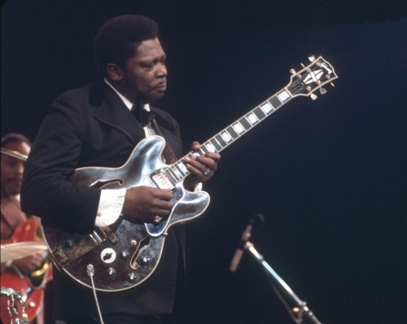
Figure 1 B. B. King performing c.1968. Photo Michael Ochs Archives/Getty Images (via Britannica Image Quest)
View description - Figure 1 B. B. King performing c.1968. Photo Michael Ochs Archives/Getty Images (via ...

Before you start, take a couple of minutes to reflect on what you already know about the blues and about musical traditions. If you do an internet search using blues as a search term, you are likely to find lists of the ten most famous blues singers which will include B. B. King (see Figure 1), but also references to ‘blues rock’ and ‘rhythm and blues’. So what do we mean when we put the words ‘blues’ and ‘tradition’ together? What do you think ‘tradition’ means in relation to music? How have you encountered the word ‘tradition’ in your own experience of listening to, talking about or perhaps even performing music? Do you know any specific songs that you think might be examples of blues?

2 What makes a tradition?
Consider for a moment the music of the Beatles: a band that in the 1960s achieved an iconic status. A band like the Beatles may need little introduction, but their place, and indeed the place of their music in a tradition, may be quite hard to pin down. If you are familiar with the Beatles, you may know that they have continued to influence popular music today and therefore that they might be thought of as ‘traditional’. Indeed, one meaning of tradition is that it is something that is handed down and becomes a point of reference or implied authority. The use of a particular group of instruments for a particular type of music may also place it in a tradition, so a singer, lead guitar, bass guitar and drums might be considered traditional for a rock band. Sometimes the word tradition is used to imply something that is not new. If you had been asked about musical tradition in 1964 when the song ‘Can’t buy me love’ was released, you would probably not have even thought of the Beatles as their music would have been ‘of the moment’. Today we can look back at more than half a century of rock and roll music, but does that mean it is a tradition?

Figure 2 The music of the Beatles
View description - Figure 2 The music of the Beatles

Although the music of the Beatles was very much of its time, it was also deeply reliant on earlier musical styles and practices and in particular on the blues. ‘Can’t buy me love’ is a good example. In musical terms, you could say that it draws on earlier traditions. In this course you are going to unpack what the blues tradition means by investigating some of the music that was so attractive to the Beatles, the Rolling Stones, Eric Clapton, Led Zeppelin and many other famous bands of the 1960s and 1970s.

3 Covers and continuing traditions
You’ll start with the singer who wrote the song that gave the Rolling Stones their name – Muddy Waters. Muddy toured Great Britain in 1958 and was a major influence on British music in the decades that followed. Although the Rolling Stones were influenced by and directly used Muddy Waters’ music in creating their songs, many of the songs that Muddy sang were not new. ‘Catfish Blues’, the song with the lyrics that gave the Rolling Stones their name, for example, was recorded by Robert Petway in 1941. Petway in turn had learned it from earlier blues singers and it is difficult to trace how far back this song goes.

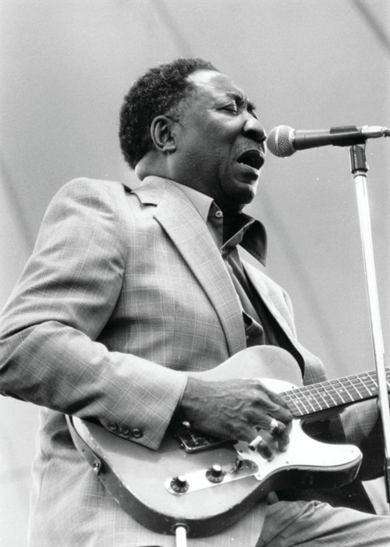
Figure 3 Muddy Waters c.1979. Photo by Keystone/Getty Images (via Britannica Image Quest)
View description - Figure 3 Muddy Waters c.1979. Photo by Keystone/Getty Images (via Britannica Image ...

Activity 1

Listen to these two brief extracts to compare how these two singers approached the same song.

Audio content is not available in this format.
Audio 1 Robert Petway

Audio content is not available in this format.
Audio 2 Muddy Waters

View discussion - Activity 1

In discussing and comparing two versions of the same song, you may have thought about calling one a cover version of the other. Covering a song is one way in which we can see the continuity of musical traditions: a specific song is set apart as having enough importance to be copied or imitated. In this case, the Rolling Stones heard the song sung by Muddy Waters who heard it sung by Robert Petway who heard it sung by someone else. Each musician has reversioned and put his own stamp on it. There are many other ways besides covers in which musicians interact with a tradition, some of which you will look at later. Before you see how tradition applies to the blues, you need to make sure you know what we mean by the blues.

4 Defining the blues
In the early decades of the twentieth century, many blues musicians interacted with other musicians playing and singing in a variety of styles. A lot of blues music was not written down, and when later asked about it, many musicians did not use the word ‘blues’ to describe it. As a result the blues has become confused with the early history of jazz, ragtime and gospel music.

Figure 4 Playing the blues
View description - Figure 4 Playing the blues

However, to talk about the blues in an academic way we need a definition. The term ‘blues’ means different things to different people, so defining it is problematic. Alyn Shipton, a scholar of jazz and popular music, has defined the term blues as ‘an African-American song form, derived from late nineteenth-century ballads and field hollers, plus elements of spiritual and gospel music’. However he also notes that ‘there is evidence of the word being used for a much longer period to denote the melancholy state of mind that underlies a vast number of blues lyrics’ (Shipton, 2001, p. 41).
This formal definition contrasts with how blues singer Booker White defines the blues, as White focuses on the emotional aspects of the music: ‘Well sure, blues is a feeling! But you can write the truth with the blues… You see, I tell you, you gotta feed your mind with something all the time, you think about something all the time. Sometimes you can have a good feelin’, sometimes you have a bad feelin’. But now in the blues line, it’s always being up on somebody you love or somebody that quits you’ (Oakley, 1987 (1976), p. 46). An even tighter description relies entirely on the type of musical structures used in blues music (Wald, 2012). For the purposes of this course these elements will be drawn together to define the blues as an African-American song form that tends to make use of a set of straightforward musical structures (discussed later) and whose lyrics often emphasise subjective responses to love and loss.

5 A short history of the blues
The blues emerged from the oppressed, economically disadvantaged African-American communities in the rural southern states of America in the years following the American Civil War (1861–1865). Blues singers were descendants of slaves and elements of their music reach back to African origins. This course offers just a brief introduction, and only affords a glimpse of the complexities of music that is deeply rooted in social and political history.
Many of the best known blues musicians came from the southern states of America, and some would argue that the Mississippi delta was the birthplace of the blues. This area had a greater concentration of black people than any other part of the country, and an economy based largely on cotton farming which meant that this was also an area in which segregation and social isolation of black people through lack of economic opportunity was deeply entrenched.

Box 1 Slavery in America
Although the international slave trade ended in 1807, in America slavery continued. The northern states of America had declared slavery illegal at the time of the American War of Independence (1775–1783) but the southern states ignored the abolition and slavery continued until after the Civil War (1861–1865) when it was abolished in the whole of the USA with the ratification of the thirteenth Amendment in December 1865.

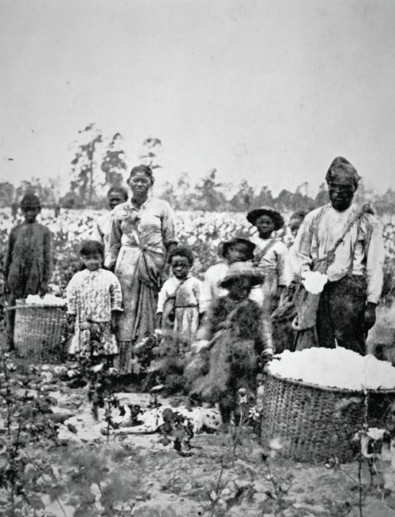
Figure 5 Slave family picking cotton in the fields near Savannah, c.1860s (stereograph photo) (via Britannica Image Quest).
View description - Figure 5 Slave family picking cotton in the fields near Savannah, c.1860s (stereograph ...

The musical sources of the blues included religious songs, broadly called spirituals, which were songs on Christian themes that frequently also addressed aspects of the lives of slaves. The Church often became a focus point in poor rural communities. Black people could access some measure of education in church schools and acquire status as community leaders in the church. Church services became a source of strength and a place of shared experiences while also providing an outlet for emotions, especially through song.
Other important sources for blues songs were the work songs and field hollers from the days of slavery and ballads and dances from music hall-type entertainments. Gathering together to listen to music and also to dance created communities with a strong sense of identity. Music provided a channel for expressing every possible emotion from shared joys to communal desperation. It cemented the community while at the same time, for those who had talent, it was also a means of earning a living.
The careers of early blues musicians were defined in part by gender. The famous female singers tended to stay within their home communities and often had a matriarchal role within it. They worked in clubs, speakeasies and bars and often teamed up with male colleagues who acted as accompanists or band leaders. Bessie Smith, for example, worked alongside Louis Armstrong who is better known as one of the great early jazz pioneers. The male singers often became migrant workers, moving from the plantations of the Mississippi delta to larger towns and cities such as Memphis, St. Louis and Chicago, often living in very tough conditions and subject to racial segregation and abuse. In these displaced communities, singing and dancing became a means of maintaining a collective identity and voicing emotions. Migrant musicians tended to accompany themselves on guitar rather than piano because of its portability. The original delta blues continued to be part of the southern culture, but as musicians became more mobile, the blues were transformed for new communities.
The large-scale migration of black workers from the southern states to the northern cities – often referred to as the Great Migration – created pockets of densely populated and very poor black communities within the urban areas of the cities. Prior to the Great Depression of the 1930s, many of the migrant agricultural labourers found themselves jobs in city factories, but these were poorly paid. However, they took their sense of community with them and a more dynamic version of the blues emerged, making use of the new technology of electric amplification. Chicago is often credited as the home of the urban blues, and, with its burgeoning recording industry, the city’s vibrant musical environment became a draw for jazz, blues and other musicians.

6 Blues in urban Chicago
The poet Langston Hughes who was part of the so-called Harlem Renaissance movement also worked as a journalist. He wrote movingly of how the musicians in urban environments evoked their distant home communities through song. At the same time, he captured both the advent of electrification of music-making with the invention of amplification; and the racial tensions in the white owned night clubs where the black performers worked.

Activity 2

Read this extract from an article written by Langston Hughes for the newspaper, the Chicago Defender. Do you think this article is presenting a positive or negative view of musical life in Chicago?
Reading 1 Langston Hughes, ‘Music at year’s end’

View discussion - Activity 2

7 Blues styles and the blues tradition
As the blues spread into urban areas and further from the isolated agricultural communities in which it first emerged, musicians adapted their singing and playing in response to their new audiences and to reflect the different communities in which they were living and working. Modern studies of the blues identify a range of different styles of blues: delta blues, country blues, down-home blues, urban blues, harmonica blues and so on. Some of these terms such as country blues and down-home blues are interchangeable, but others are indicative of different approaches to singing or playing the blues. The records of Blind Lemon Jefferson, for example, were advertised as ‘down-home’, whereas Sonny Boy Williamson worked in the urban environment of Chicago. In the study of music, it is important to note the difference in meaning between the terms style, genre and tradition. A musical tradition may include many different styles and genres.

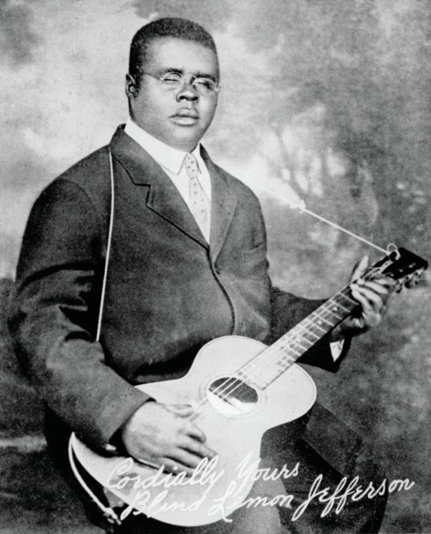
Figure 6 Clarence ‘Blind Lemon’ Jefferson with guitar in 1928. Signed photograph. Lebrecht Music and Arts/Universal Images Group (via Britannica Image Quest)
View description - Figure 6 Clarence ‘Blind Lemon’ Jefferson with guitar in 1928. Signed photograph. ...

Listen to these two extracts focusing on the character of the voices, the instruments used and the way in which the voice interacts with them

Audio content is not available in this format.
Audio 3 Blind Lemon Jefferson

Audio content is not available in this format.
Audio 4 Sonny Boy Williamson

Both singers use their voices to evoke strong emotions rather than pretty tunes. Jefferson accompanies himself on the guitar, punctuating his vocal phrases and driving the rhythms. There are no other instruments and the singer’s voice is the primary element in the song. Even when instruments are introduced, the players try to imitate the sound of the voice or create call and response patterns in which the instruments are played in between the vocal phrases. Sonny Boy Williamson was famous in creating a ‘harmonica blues’ style, interjecting wailing and moaning harmonica melodies in his songs. In many of his songs he alternates between voice and harmonica using his breath to create highly expressive bends and slides on the instrument that match those of his voice. The addition of piano, drums and guitar creates a sophisticated sound and a strong sense of pulse and metre, but the voice is still at foreground.

8 Blues and the early history of the recording industry
In many ways, what we know about the sound of early blues is influenced by the recordings that have come down to us. Earlier in this course, you heard an extract from an early recording of Robert Petway. Recordings such as this have given us access to music that was passed down by one musician to another by listening and learning by ear. This kind of tradition is known as an oral or aural tradition (oral meaning by mouth and aural by ear) as it was not written down using any kind of musical notation.

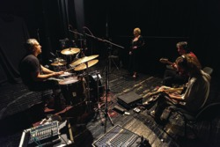
Figure 7 Recording in the studio
View description - Figure 7 Recording in the studio

Box 2 Oral traditions
Oral musical traditions that are closely related to a single community affirm a sense of group identity and cultural unity. These traditions are sometimes called ‘folk music’. The blues were a unique form of expression in economically depressed and socially marginalised black American communities and so could be called an African-American folk music.

Before access to recordings, songs were often learned in an informal way, one musician listening and copying another, or by working together in community gatherings. In the process of musicians interacting with each other, songs evolved. Lyrics might be adjusted to fit a new situation, melodies might be embellished and changed to suit a singer’s personal vocal style or to fit new words. Playing techniques - whether the guitar or harmonica – were copied and adapted. These were not ‘cover’ versions as we understand them today, but complete reworkings of songs, perhaps only keeping some element of the lyrics or the tune, just as Muddy Waters did with ‘Catfish blues’. This is not to say that blues songs were never written down. There was in fact a significant amount of music printed from around 1910 and the relationship between what was recorded, what was written down and published and what was performed is a complex one. Recording enabled blues singers to reach a wider audience than their immediate community or audiences at live gigs. Once a song had been recorded it could become the source for material for other musicians and bands to copy or appropriate for their own use. Oral traditions and recording therefore have a complicated relationship with respect to the development of blues. The mix of the new mass media of recording and the aurality of traditional communities of blues musicians ensured rapid and widespread dissemination of songs.

9 The limitations of technology
The trouble with early recording is that the technology was very limited, and therefore the musicians were constrained in what they could do in order to have a usable commercial recording. The musicians had to gather around a large horn microphone, often in unrealistic playing positions (see Figure 8), so what was recorded could not possibly reflect accurately what the live sound might have been like. Even with the comparatively small groups of musicians involved in recording early blues, there were still many pitfalls. For instance, blues was a tradition that lent itself to extemporisation; songs could change from performance to performance and lyrics could often be made up on the spot. Recording fixed a particular version of a song, and the limitations of early recording formats meant that commercial recordings tended to be on the short side. Studying sound recordings as a source does need some caution as a result.

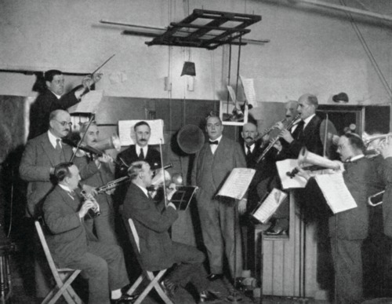
Figure 8 Photo dating from 1921 of musicians around a recording horn illustrating the unrealistic playing positions. The conductor, Joe Batten, is on a stool and a mirror is used so that musicians can see each other. Lebrecht Music and Arts/Universal images group via Britannica Image Quest).
View description - Figure 8 Photo dating from 1921 of musicians around a recording horn illustrating ...

10 The impact of recordings
As the major blues artists were black, there was also a social dimension to the recording industry that split the market and the producers along racial lines. Specific record producers emerged who recorded black musicians for a market dominated by the black population. This did not of course mean that the artists were any better treated or better paid. The advent of electrical recording in the mid-1920s had a significant impact on the quality of recordings. Popular music and jazz were the first to benefit from the improvements.

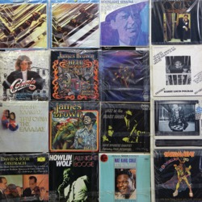
Figure 9 Some vinyl records album covers
View description - Figure 9 Some vinyl records album covers

In the 1960s white British rock bands discovered recordings of the great blues singers. The Beatles, the Rolling Stones, Eric Clapton, Led Zeppelin and many others appropriated elements of the blues and in so doing, drove the emergence of rock. Now, many musicians are doing cover versions of the blues songs they have heard on record. One might argue that these dilute the essence of the blues. A different argument is that a new generation is discovering the blues, and this in itself is preserving the tradition. However, there is also a political dimension to the argument, namely that white singers appropriated music from poor black musicians and benefitted financially from it, sometimes without acknowledging their sources.

11 Blues lyrics and the expressive voice
The expressive use of the voice is a key element of the blues, and the recorded legacy of blues contains all sorts of examples of expressive vocal techniques. The voice also delivers a text. We refer to song texts as lyrics, but we might also see them as a form of poetry. Telling a story through vocal performance is an enduring feature of all blues songs. Blues singers adapted older styles of singing and the kind of narratives and structures they used. Ballads for example, have the same music repeated over and over for each verse, and each verse adds to the unfolding story. Hymns have a similar structure, repeating the same music for each verse, but with texts that deliver a religious message rather telling a story.

Activity 3

You listened to a brief extract of Blind Lemon Jefferson’s ‘Hangman’s blues’ in Section 6. Now read the lyrics, noting the subject matter and the structure.

Hangman’s blues
Hangman’s rope is so tough and strong
Oh, the hangman’s rope is so tough and strong
They gonna hang me because I done something wrong
I wanna tell you the gallis [gallows], Lord’s a fearful sight
I wanna tell you the gallis, Lord’s a fearful sight
Hang me in the mornin’ and cut me down at night
While a mean ol’ hangman is waitin’ to tighten up that noose
Oh, the mean ol’ hangman is waitin’ to tighten up that noose
Lord, I’m so scared, I’m trembling in my shoes
Jury heard my case and they said my hand was red
Heard my case and said my hand was red
And judge, he sentenced me, be hanging till I’m dead
They crowd 'round the courthouse and the time is going fast
Oh, they crowd 'round the courthouse and the time is going fast
Soon a good-for-nothin’ killer is gonna breathe his last
Lord, I’m almost dyin’, gasping for my breath
Lord, I’m almost dyin’, gasping for my breath
And a triflin’ woman waiting to celebrate my death
(Blind Lemon Jefferson)

View discussion - Activity 3

Jefferson’s song could be understood as a cautionary tale, but it relates to the harshness of the criminal justice system. Capital punishment was a reality in the USA at this time, and black people were discriminated against. While the lyrics don’t mention the crime, the death sentence is indicated by the reference to the gallows (‘gallis’) and the audience of the time would have been well aware of the categories of wrongdoing that would be punishable by death. This is typical of the sort of social comment one might expect in a blues song. Blind Lemon was an itinerant singer performing wherever he could find paying work. Many of his songs paint an image of a world of liquor, women and outlaws. The subject matter of his songs did not necessarily arise from his own personal experience but were part of a shared experience familiar to his audience
The structure of the lyrics of ‘Hangman’s blues’ can be represented by the letters AAB. In this song, A is the repeating line and B is the new one. In performance, the singer repeats the first line, sometimes with slight lyrical and/or melodic variation, but always in a way that maintains the final word. The AAB pattern is a very typical structure in blues lyrics. A simple variation of it has rhyming words rather than repeating words for the A lines, creating what is known as a rhyming couplet. This pair of lines is followed by a single line that can be used as a refrain. The important thing to remember about this verse structure is its three-line format as it fits the musical structures of the blues.
Love, sex and betrayal are common themes in blues lyrics, but songs may also contain elements of bitter social or political comment. Urban blues in particular feature topics of love, separation from loved ones, betrayal, law and injustice, poverty and survival. These black musicians were rooted in segregated and economically depressed areas whether in rural agricultural communities or overcrowded city slums and their life experiences were often harrowing. They had to deal with poverty, hunger, lack of employment, political marginalisation and unjust judicial systems.
Imagery in the lyrics of country blues or down-home blues may draw on experience in rural farming environments with references to nature, but these are used metaphorically, for example, comparing ones troubles with the falling rain. The separation of couples due to the economic necessity of finding work often put men into urban environments and left women to make a living as best they could in rural communities. Female singers recount stories relating to their lives trying to keep their families together as they face the effects of poverty, illness and inequality. Victoria Spivey’s ‘TB blues’, Ma Rainey’s ‘Booze and blues’ and ‘Farewell Daddy blues’ are all raw, even graphic accounts of life from a woman’s perspective. However, there is often a tension between connections in the lyrics to lived lives and contexts on one hand and an element of imagining and invention on the other. ‘Hangman’s blues’ is a case in point as the narrative implies personal experience, but it is clearly imagined as the singer is not dead but telling the tale.
Song writers also created ballads that celebrated real and fictional characters who were in some way anti-heroes, and lived lives that were played out in the margins of society, just as they too were living in a marginalised community. Political events too, sparked reactions. The decision in 1936 of the American Congress to pay a bonus to veterans of the First World War evoked a range of responses, many focusing on unfairness and inequality, while the bombing of Pearl Harbour in the Second World War was likewise a source for lyrics.

12 Musical techniques
Now that you have learned about the context and content of blues songs, in this section you will be introduced to two technical elements of the Blues. W. C. Handy, the composer of ‘Memphis blues’, one of the first blues pieces to be written down and published as sheet music in 1912, wrote about his inspiration for this piece sometime later. He described how he had heard singing in the plantations and had noted down what he heard – a plaintive melody which suggested a repetitive chord sequence. These two elements, a melody that is melancholy, wistful or sad and a specific pattern of chords, are fundamental to the blues, whether in the form of dance music or the more familiar songs and you will now examine them in more detail.

12.1 The blues scale
The reason for the plaintive, melancholy melodies is the type of scale used in this music. Scales are fundamental to all music. We hear snippets of scales all around us in phone ring tones, elevator tones, airport tannoy systems, games sound effects and so on, so the sound of them will be familiar. Before continuing, watch this video which explains step by step what scales are and how they are used in blues music.

Video content is not available in this format.
Video 1
View transcript - Video 1

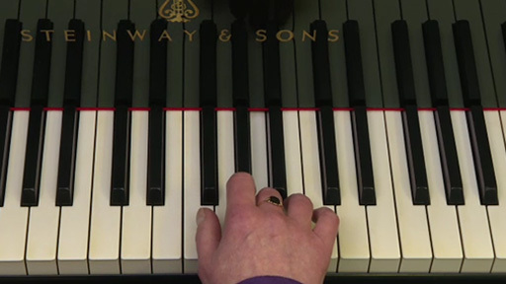

Although it may look and sound like the major scale has fewer notes than the blues scale, remember that blue notes are alternative ways of playing or singing a note rather than extra notes. If you draw the analogy of a note being like a colour on an artist’s palette, the blue notes introduce subtle shades of a colour rather than a new colour. In the video you saw a graphic illustration of the notes of a major scale and the notes of the blues scale which looked like this:

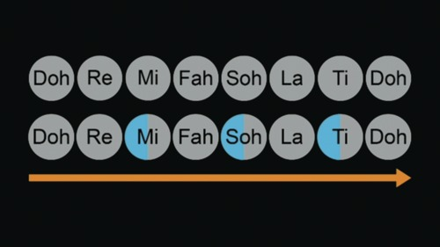
View description - Uncaptioned Figure

You do not need to read music notation to be able to understand scales, but if you are curious as to how these scales might be written down, they look like this. The major scale, shown here shown with Doh as the note C, is correctly described as a C major scale.

Major scale
View description - Major scale

The blues scale you heard on the video with the third, fifth and seventh notes lowered, or more correctly, flattened, looks like this. Here the blue notes are circled.

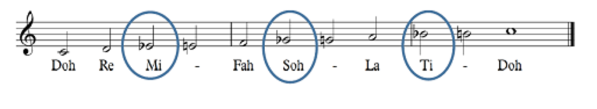
Major scale, with circles
View description - Major scale, with circles

Activity 4

To help you become more familiar with blue notes and the blues scale, listen to this extract from Crazy Blues sung by Mamie Smith. Note the slides or bends on the words ‘crazy’, ‘since, ‘baby’ and ‘went’. These are examples of the singer making expressive use of the blue notes.

Audio content is not available in this format.
Audio 5 Mamie Smith

You may need to listen to songs like ‘Crazy blues’ several times to practise listening for blue notes. They are part of the expressive idiom of blues singing, and sometimes difficult to isolate. Listen out for ‘bends’, ‘slides’ and places where singers approach notes indirectly as these are probably around ‘blue’ notes.

12.2 Chords and primary chords
Accompanying the wistful or plaintive melodies, the second element that W.C. Handy wrote about was a repetitive chord sequence. This is another complex-sounding concept, but you don’t need to be a musician to understand it. A chord is simply two or more notes sounding simultaneously. We use the word harmony to describe generically how musical sounds fit together. The video in the previous section introduced you to scales. In that section you focused on the melody, that is, what the singer was doing. Now you are going to turn to the accompanying instruments and focus on harmony and the way in which chords are used. The next video will explain what chords are and how they are constructed. Watch it now before progressing to the next section.

Video content is not available in this format.
Video 2
View transcript - Video 2

There are many types of chords and many types of scale. You only need to be familiar with the concept of chords that have been explained here in order to understand the fundamental structures of the blues. Before you move on to the next section, review your understanding of chords by studying this graphic representation of the primary chords which you saw these briefly in the video.

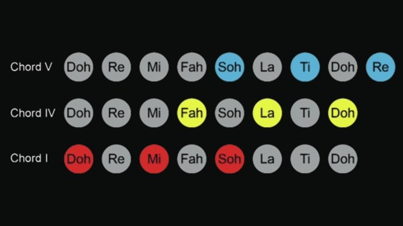
View description - Uncaptioned Figure

Take some time now to review how the notes of each chord relate to each other and how each chord fits into the major scale that you heard in video 1. If you have access to a musical instrument you could have a go at creating some of these sounds yourself. Note that all the graphics illustrating the primary chords here and in the videos use the same primary colours so chord I will be red, chord IV will be yellow and chord V will be blue. In the video you learned about primary chords in the key of C. In practice, Doh is not always the note C but chord I is always constructed in the same way regardless of the note on which the scale starts, so these colours will remain unchanged, even though you may be listening to music in a different key.

12.3 12-bar blues
As already mentioned, blues composer W.C. Handy claimed to have noticed a repetitive chord sequence in the plantation song that inspired him. The chord pattern that Handy noted down is a succession of primary chords in a specific order. It is now known as 12-bar blues and it is a structure understood by all jazz and popular musicians. It is not the only structure used in blues songs and there are many variants of it, but all of them contain the same basic ingredients.
When we listen to music often what strikes us first is the rhythm. If you tap your foot or nod your head, you are feeling a beat. In any music, beats are grouped, usually into twos, threes or fours and each group of two, three or four beats is called a bar. The 12-bar blues is defined by the order of the three primary chords and the way they are grouped by rhythm. Blues music is in common or 4/4 time, that is, each bar has four beats, usually at a moderate speed. The blues pattern takes up 12 bars of music (12 x 4 beats), and fits neatly with the common three-line verse structure of the lyrics as the 12 bars can be divided into three 4 bar sections. At its simplest, each verse finishes with the end of the 12-bar sequence, and the sequence is repeated for each verse of the lyrics.
Watch this video, which explains how the 12-bar blues structure works.

Video content is not available in this format.
Video 3
View transcript - Video 3

In the video you saw a graphic representation of the 12-bar blues sequence. Look at it again now, to remind yourself of the pattern. If you have access to a musical instrument, you could try it out yourself.

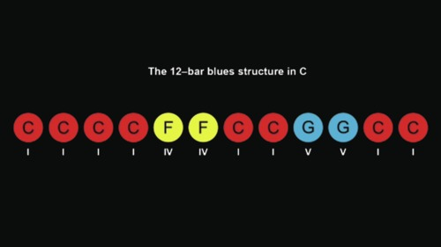
View description - Uncaptioned Figure

As you will have seen from the video, this chord pattern became an important element in the foundation of jazz and of later styles of popular music including rhythm and blues and rock and roll. Many pieces of music that today we might recognise as typical rock and roll songs or ‘jazz standards’ use structures that are derived from the blues. If you would like to build a playlist of music that uses 12-bar blues, start with Bill Haley’s ‘Rock around the clock’, Duke Ellington’s ‘C-jam blues’, Louis Armstrong’s ‘West end blues’, Johnny Cash’s ‘Folsom prison blues’ and Robert Johnson’s ‘Sweet home Chicago’. These are just some examples that will give you an idea of how versatile the 12-bar blues structure is. Keep the graphic handy so you can follow the pattern of chords as you listen to these songs. This will help you become more familiar with how it sounds and help you to recognise it in other songs you listen to.

12.4 Primary chords: building blocks of tradition
You have now learned about some fundamental elements of music as well as a little bit about the history of the blues. The 12-bar blues demonstrates how the three primary chords are used to create a musical structure. Although the materials making up the primary chords are simple, they are some of the basic building blocks of music and they can form the basis of quite extended pieces. Primary chords are a bit like fundamental elements of a language such as nouns and verbs. You may not be aware of using them or hearing them, but without using them nothing quite makes sense. The music of Mozart for example, although it is distant in time from the blues, similarly makes use of primary chords to create its characteristic sounds and structures.

Figure 10 Playing the blues
View description - Figure 10 Playing the blues

Primary chords and the scale patterns from which they are derived are fundamental to the musical language of the Western tradition. Without these three chords, the sense of progression through music, of beginning, middle and end, would be lost. The term Western tradition is another important use of the term tradition in the study of music. The Western tradition includes jazz, popular music, art music, blues and European and American folk music. Indian classical music, Chinese music and many other musical traditions from around the world do not use these scale and chord patterns, which sets them apart from the Western tradition.
One further element of the music that you have studied thus far is repetition. You have encountered repeated chord structures, repeated rhyme patterns in lyrics, and repeated melodies for different verses of lyrics. Repetition is an important part of music that helps us to recognise structures at many levels. Like primary chords, repetition is fundamental in the Western tradition. We recognise the familiar, build on it, change it and interact with it, thus aligning or breaking with, tradition.

13 Check your learning
Have a go at the following quiz to check what you have learned.

Select all the statements below that are true.

The blues scale is a special scale with lots of notes.
Blue notes are usually the third, fifth and seventh notes of the scale.
Chords are made up of four notes sounding simultaneously.
Chords are two or more notes sounding simultaneously.
Primary chords relate to the scales on which they are based
Delta blues and urban blues used primary chords.
The order of chords in the 12-bar blues is I-IV-V-I.
Blues lyrics often use three-line verses to fit the 12-bar blues pattern.
Blues songs are always ballads.
View answer - Activity

Conclusion
At the beginning of this free course, Discovering music: the blues, it was suggested that a musical tradition was a cultural glue that gave a community a sense of identity and unity, and that a tradition could be used as a point of reference by others. You have learned that the defining characteristics of the blues may include a performance style with a particular vocal quality, lyrics expressing feelings about personal situation, and underlying musical techniques including specific ways in which scales and chords are used. These underlying structures include formulations of chords that have been used in music for several centuries. The chords themselves do not define the blues, or indeed any type of music, but the specific way in which those chords are used is a defining characteristic. In music, the terms style and tradition are easily confused. In this course, different blues styles (delta blues, down-home blues etc.) have been described, but these all fit within the blues tradition because they all reference the same musical idiom in different ways.
Another element of a musical tradition is that it exists over a long period of time and constantly reinvents itself, becoming a recognisable point of reference, not just for the generations of musicians that follow but also for musicians in other styles and traditions. Cover versions are just one way in which musicians align themselves with tradition. More importantly, musical techniques may be borrowed and reworked in a way that engages with a new audience. You will find elements of the blues in music as diverse as that of Ravel, Gershwin, Miles Davis, Queen and the Rolling Stones.
Music emerging in economically depressed and marginalised communities in the early twenty-first century has parallels with the way early blues developed in its social environment. While hip-hop and rap music tends to be harmonically and melodically static, artists such as Kanye West and Jay-Z have used samples extracted from blues songs as the basis for new music. The lyrics too, are similar to early blues, commenting on personal situations, unjust societies and disillusionment with the urban environments in which the musicians live.
An important point is that music does not exist in isolation. It is deeply connected to the environment in which it is created, performed and listened to. The blues emerged at a particular time, in a particular place as a response to social and economic conditions. Those conditions were very different from the environment in which Mozart’s music emerged just as they were different from conditions today. However, blues music remains an important influence in Western popular music.
This OpenLearn course is an adapted extract from the Open University course A111 Discovering the arts and humanities. Take a look at the trailer for this Open University course:

Video content is not available in this format.
View transcript - Uncaptioned interactive content

Glossary
Bar
A fixed number of beats (2, 3, 4) defined by metre.
Ballad
A narrative song in which all the verses are sung to the same tune, often with a repeating refrain.
Beat
The basic pulse underlying a piece of music.
Blues notes
The characteristic notes of the scale, usually the third, fifth and seventh, that are flattened (lowered) in blues music.
Call and response
A song in which a single voice ‘calls out’ a short phrase which is answered by a group of voices, often in harmony. It is common in African choral music where the call may be varied and freely improvised while the response may be repetitive.
Chord
Two or more notes sounded simultaneously. In Western music the notes sounded operate in relationship to a scale.
Cover
A recording of a song by someone other than the original performer. Covers may be straightforward copies or radical re-workings of songs.
Field holler/holler
Improvised work songs sung solo, often echoed by other workers.
Genre
A class, type or category of music that behaves according to specific conventions.
Gospel
A type of song that emerged in the America Protestant Evangelical movement from the 1850s onwards that describes personal religious experience.
Harmony
The combining of notes simultaneously.
Jazz
A type of music that emerged in the early twentieth century. Many of its melodic and harmonic elements are drawn from blues, but it is characterised by flexible and syncopated rhythms and improvisation.
Melody
The correct term for a tune.
Metre
The division of pulse into groups of 2, 3, 4 or more beats.
Pulse
The beat underlying a piece of music.
Ragtime
A popular style of music dating from the 1890s-1920s, usually performed on a piano. The ‘ragged’ rhythms to which its name refers are created by a steady left hand pulse and syncopated (off-beat) rhythms in the right hand.
Scale
A sequence of pitches, ascending or descending by step.
Spiritual
A type of African-American sacred song that developed from Christian and West African religious rituals during the eighteenth century. Spirituals later became the foundation of Gospel song .
Style
Music characteristic of an individual, time period, geographical location, society or social function; a way of doing something.
Tempo
The speed at which a piece of music is played, i.e. the speed of the pulse.
Timbre
The character of the musical sound of an instrument or voice.

References
Cole, R. (2018) ‘Mastery and masquerade in the transatlantic blues revival’, Journal of the Royal Musical Association, vol. 143, pp. 173–210.
Goldmine (2001) ‘Interview with Brian May part 2 (Extended versions and B-sides)’ [Online]. Available at https://www.brianmay.com/brian/magsandpress/goldmine0801/goldmine0801b.html (accessed 16 March 2019).
Middleton, R. (2007) ‘O Brother, Let’s Go down Home: loss, nostalgia and the blues’, Popular Music, vol. 26, no. 1, Special Issue on the Blues in Honour of Paul Oliver (January), pp. 47–64. Also available online at http://www.jstor.org/stable/4500299 (accessed 16 March 2019).
Moore, A. (ed.) (2002) The Cambridge Companion to Blues and Gospel Music, Cambridge, Cambridge University Press.
Mumma, G., Rye, H., Kernfeld, B. and Sheridan, C. (2003) ‘Recording. ii History of jazz recording’, Grove Music Online.
Oakley, G. (1987) The Devil’s Music: A History of the Blues, New York, Da capo. (First edition 1976).
Oliver, P. (2001) ‘Blues’, Grove Music Online.
Oliver, P. (2014) ‘Field holler’, Grove Music Online.
Shipton, A. (2001) A New History of Jazz, London and New York, Continuum.
Wald, E. (2012) ‘Blues’, Grove Music Online.

Acknowledgements
This free course was written by Naomi Barker. It was first published in May 2019.
Except for third party materials and otherwise stated (see terms and conditions), this content is made available under a Creative Commons Attribution-NonCommercial-ShareAlike 4.0 Licence.
The material acknowledged below is Proprietary and used under licence (not subject to Creative Commons Licence). Grateful acknowledgement is made to the following sources for permission to reproduce material in this free course:

Text
Langston Hughes: Langston Hughes and the Chicago Defender: Essays on Race, Politics and Culture 1942-1962 (University of Illinois Press). Used by permission.

Images
Course image: Kurt Wittman / Omni-Photo Communications, Inc. / Universal Images Group
Figure 1 Photo Michael Ochs Archives/Getty Images (via Britannica Image Quest)
Figure 2 © Martin Wahlborg/iStock
Figure 3 Photo by Keystone/Getty Images (via Britannica Image Quest)
Figure 4 © mediaphotos/iStock
Figure 5 c.1860s (stereograph photo) (via Britannica Image Quest).
Figure 6 Lebrecht Music and Arts/Universal Images Group (via Britannica Image Quest)
Figure 7 © Slavica/iStock
Figure 8 Lebrecht Music and Arts/Universal images group via Britannica Image Quest).
Figure 9 © dimitris_k/iStock
Figure 10 © Rawpixel/iStock

Audio-visual
Videos 1, 2 and 3 © The Open University
Every effort has been made to contact copyright owners. If any have been inadvertently overlooked, the publishers will be pleased to make the necessary arrangements at the first opportunity.
Don't miss out
If reading this text has inspired you to learn more, you may be interested in joining the millions of people who discover our free learning resources and qualifications by visiting The Open University – www.open.edu/openlearn/free-courses.

Solutions

Activity 1

Discussion
Petway’s performance of ‘Catfish Blues’ uses only a straightforward, repetitive strummed guitar accompaniment. The focus of the song is entirely on Petway. It is almost as if he is telling a story with a guitar accompaniment. The strummed chords create a strong pulse but in places the guitar holds the same chord for long stretches of time, making it feel almost static. In Muddy Waters’ version too, the voice is dominant. Muddy’s gravelly, sometimes raucous voice is very expressive, telling the story through song. Although the tempo is moderate, the beat is strongly emphasised because, unlike Petway, Muddy uses piano, and drums give the repeated chords more rhythmic drive and energy.
Back to - Activity 1

Activity 2

Discussion
Hughes eloquently describes the night-club scene, making it sound modern and quite attractive. However, he also suggests that the singer Memphis Minnie evokes in her audience strong feelings of homesickness and longing for the rural landscapes of rural Mississippi and Louisiana. The vibrancy of the urban community is played off against the sadness and yearning for home.
Back to - Activity 2

Activity 3

Discussion
Jefferson’s song is a narrative about crime and capital punishment. The singer describes his feelings about having done something wrong, facing a judge and jury, and then seeing the hangman’s rope on the gallows while a woman celebrates his death. The verses each have two lines that are almost identical, followed by a third which is different.
Back to - Activity 3

Activity

Answer
Right:
Blue notes are usually the third, fifth and seventh notes of the scale.
Feedback
Correct. These are the usual notes that are altered to become ‘blue’ notes, but occasionally the fourth or sixth note may be altered too.
Chords are two or more notes sounding simultaneously.
Feedback
Correct, two or more notes sounding simultaneously form a chord.
Primary chords relate to the scales on which they are based
Feedback
Correct, the primary chords appear on the first, fourth and fifth notes of a scale. Doh is counted as I, fa as IV and soh as V.
Delta blues and urban blues used primary chords.
Feedback
Correct, almost all Western music uses primary chords in some way.
Blues lyrics often use three-line verses to fit the 12-bar blues pattern.
Feedback
Correct, the three-line rhyme scheme AAB is the most common verse form.
Wrong:
The blues scale is a special scale with lots of notes.
Feedback
The blues scale is a scale in which some notes may be altered. This doesn’t change the number of notes in the scale.
Chords are made up of four notes sounding simultaneously.
Feedback
Although a collection of four notes sounding simultaneously is a chord, correctly a chord comprises two or more notes sounding simultaneously.
The order of chords in the 12-bar blues is I-IV-V-I.
Feedback
The correct order is I-IV-I-V-I.
Blues songs are always ballads.
Feedback
Blues songs may be ballads, telling a story in a number of verses following a similar structure, but they are certainly not always ballads.
Back to - Activity

Figure 1 B. B. King performing c.1968. Photo Michael Ochs Archives/Getty Images (via Britannica Image Quest)

Description
This is a photograph of B. B. King playing the guitar on stage.
Back to - Figure 1 B. B. King performing c.1968. Photo Michael Ochs Archives/Getty Images (via Britannica Image Quest)

Figure 2 The music of the Beatles

Description
This is an image showing a number of records by the Beatles.
Back to - Figure 2 The music of the Beatles

Figure 3 Muddy Waters c.1979. Photo by Keystone/Getty Images (via Britannica Image Quest)

Description
This is a photograph of Muddy Waters singing into a microphone on stage.
Back to - Figure 3 Muddy Waters c.1979. Photo by Keystone/Getty Images (via Britannica Image Quest)

Figure 4 Playing the blues

Description
This is a photograph of a man playing a guitar.
Back to - Figure 4 Playing the blues

Figure 5 Slave family picking cotton in the fields near Savannah, c.1860s (stereograph photo) (via Britannica Image Quest).

Description
This is a photograph from the 1860s of a family standing in a cotton field.
Back to - Figure 5 Slave family picking cotton in the fields near Savannah, c.1860s (stereograph photo) (via Britannica Image Quest).

Figure 6 Clarence ‘Blind Lemon’ Jefferson with guitar in 1928. Signed photograph. Lebrecht Music and Arts/Universal Images Group (via Britannica Image Quest)

Description
This is a photograph of Blind Lemon Jefferson holding a guitar.
Back to - Figure 6 Clarence ‘Blind Lemon’ Jefferson with guitar in 1928. Signed photograph. Lebrecht Music and Arts/Universal Images Group (via Britannica Image Quest)

Figure 7 Recording in the studio

Description
This is a photograph of a group of musicians recording in a music studio.
Back to - Figure 7 Recording in the studio

Figure 8 Photo dating from 1921 of musicians around a recording horn illustrating the unrealistic playing positions. The conductor, Joe Batten, is on a stool and a mirror is used so that musicians can see each other. Lebrecht Music and Arts/Universal images group via Britannica Image Quest).

Description
This is a photograph of a group of musicians in a recording studio.
Back to - Figure 8 Photo dating from 1921 of musicians around a recording horn illustrating the unrealistic playing positions. The conductor, Joe Batten, is on a stool and a mirror is used so that musicians can see each other. Lebrecht Music and Arts/Universal images group via Britannica Image Quest).

Figure 9 Some vinyl records album covers

Description
This is a montage of a number of records.
Back to - Figure 9 Some vinyl records album covers

Uncaptioned Figure

Description
This shows the notes of the blues scale.
Back to - Uncaptioned Figure

Major scale

Description
This shows the notes of the major scale.
Back to - Major scale

Major scale, with circles

Description
This shows the notes of the major scale with some notes circled.
Back to - Major scale, with circles

Uncaptioned Figure

Description
This shows the primary chords.
Back to - Uncaptioned Figure

Uncaptioned Figure

Description
This shows the 12-bar blues structure in C.
Back to - Uncaptioned Figure

Figure 10 Playing the blues

Description
This is a photograh showing a person's hands playing the piano.
Back to - Figure 10 Playing the blues

Video 1

Transcript
NAOMI BARKER
Scales are the building blocks of music. You've almost certainly heard scales in your day to day life, even if you have no musical experience. Segments of scales are used as mobile phone ringtones, sound effects in games, on Tannoy systems, in television commercials, and so on. A scale described in musical terms is a set of notes, or to use the more correct term, pitches, arranged like a ladder in steps from low to high, like this.
[MUSIC PLAYING]
Each step of the ladder may be identified by letters of the alphabet or given a name or syllable to represent it. I'm going to use a song that you may be familiar with to illustrate the concept of scale. The song Do, Re, Mi from The Sound of Music. In this song, Maria is teaching the children of the von Trapp family to sing by first teaching them about scales. To quote from the show, let's start at the very beginning.
[MUSIC - "DO-RE-MI"]
VOICE
Do, a deer, a female deer. Re, a drop of golden sun. Mi, a name I call myself. Fa, a long, long way to run. So, a needle pulling thread. La, a note to follow so. Ti, a drink with jam and bread, that would bring us back to do.
NAOMI BARKER
A scale may be graphically represented like this, reading up the ladder from the bottom to top. But music is normally read from left to right, like words. So perhaps it would be better to present it like this. The notes of a scale operate in a sort of family relationship with each other with do as their point of reference. If you've ever heard the phrase, in the key of, this refers to the family relationship around a specific do, such as C. Thus, in the key of C, refers to the do, re, mi sequence starting from the note C, like this.
[MUSIC PLAYING]
There are many types of scale. But the type I'm talking about here, and which is represented in these graphics, is called a major scale. The main reason why blues melodies sound different from other tunes is the way the musicians alter certain notes of the scale on which a song is based. You might hear these as bends or slides, or notes that just sound out of place and that distort the more normal scale patterns. As this kind of alteration happens fairly predictably on the same degrees of the scale, for example, on mi, musicians have coined the term "blues scale" to describe the pattern of notes that a singer or instrumentalist might use. In the blues scale, several of the notes, usually, though not always mi, so, and ti, are lowered or flattened, to use the correct musical term. These are often referred to as blue notes. These blue notes do not replace the ordinary notes of the scale but are used alongside them. So sometimes you will hear the normal note, sometimes the blue note, and sometimes they may both be used and can create a sliding effect. If we represent the blues scale as a ladder and compare it with the major scale, it looks something like this. While it looks like there are more notes in the blues scale than the major scale, this is a way of representing the sound of sliding or bending notes in the melody. They are really variations of a single note, like this.
[MUSIC PLAYING]
One easy way to understand scales is to try and sing them to feel where the notes lie in your voice. Singing can also help you hear the sound more closely in your head. You don't need to be a singer or to have done this before, and it doesn't matter what it sounds like. Just start on a note that feels comfortable and sing notes that are progressively higher. As you sing up the scale, you may feel the sound tightening as you go up or relaxing as you come down. Try sliding your voice between notes, both up and down. If you have a phone app that can play sound, you could also try it out on this and experiment with those sounds. The more you hear different types of scales, the easier it gets to spot them while listening to music.
Back to - Video 1

Video 2

Transcript
NAOMI BARKER
A chord is simply two or more notes sounded simultaneously. I can put my hands on the piano and play three or four notes together at random, like this.
[MUSIC PLAYING]
And that sound could be called a chord. But for chords to make musical sense, they are constructed in relation to a scale. In this demonstration, the chords that we're going to be concerned with are constructed from a major scale, the do, re, mi pattern that you're becoming familiar with.
[MUSIC PLAYING]
Each chord is composed of notes from the scale that line next door but one to each other. So a chord starting on do comprises the notes do, mi, and sol. And on the piano, it looks and sounds like this.
[MUSIC PLAYING]
If I move to a different starting note, let's say fa, and do the same thing, playing notes that are next door but one to each other, the notes are now fa, la, and do.
[MUSIC PLAYING]
You'll remember from the song that the sequence of do, re, mi ends by going back to do and restarting. So this fa chord uses a do that is higher than the one we started on, like this.
[MUSIC PLAYING]
Now, if I want to play a chord on sol, it also overlaps a note from the do chord because it starts on sol, the top node of the do chord. It's made up of the notes, sol, ti, and re, and also takes us into the repetition of the do, re, mi pattern that is higher than the one we started on. On the keyboard, it looks and sounds like this.
[MUSIC PLAYING]
In any scale, these three chords are known as the primary chords. And so I've chosen to use primary colours to illustrate them. As a musical shorthand, these three chords are represented by the Roman numerals I, IV, and V, as they start on the first, fourth, and fifth notes of the scale, respectively. That is, on do, fa, and sol. Now, instead of using do, re, mi, I'm going to use letters of the alphabet to identify the notes. You're already familiar with the concept of a major scale. The simplest major scale starts on the note C. That means the note we've been calling do is C, and the do, mi, sol pattern will be C, E, G.
[MUSIC PLAYING]
We call this a C chord. A chord starting on fa would start on F.
[MUSIC PLAYING]
And a chord starting on sol would be on the note G.
[MUSIC PLAYING]
All of these chords made up of notes from the C scale can be said to be in the key of C. The notes comprising a chord can be manipulated in an almost infinite variety of ways. But however complicated they might sound, they are simply fancy ways of doing things with the three notes that make up that chord. A C chord like this--
[MUSIC PLAYING]
--or like this--
[MUSIC PLAYING]
--or like this--
[MUSIC PLAYING]
--is still just a C chord. There are many, many types of chords and many types of scale. These primary chords are just the beginning. However, they are also the chords that are important for understanding how blues songs are structured.
Back to - Video 2

Video 3

Transcript
NAOMI BARKER
In this film, I'm going to show you how the 12 bar blues structure works. A 12 bar blues is created by using the 3 primary chords, chord I, chord IV, and chord V, in a specific order. We can call this a chord sequence. In the 12 bar blues sequence, the way these chords are repeated and grouped is defined by metre, that is, the number of beats in each bar. Blues music is usually in common time, which means that there are 4 beats to a bar. For a 12 bar blues, we need 12 bars of music. So that is 12 times 4 beats. The 12 bar blues sequence can be used in any key, but to make it easy, I'm going to show you how a 12 bar blues works in the key of C. Remember, this means that do is C. So on the keyboard, chord I is a C chord, like this.
[MUSIC PLAYING]
Chord IV is an F chord, like this.
[MUSIC PLAYING]
And chord V is a G chord, like this.
[MUSIC PLAYING]
Let me play those again.
[MUSIC PLAYING]
This graphic shows how the three primary chords are split up over the 12 bars that form the 12 bar blues sequence. As you can see, the 12 bar blues starts with 4 bars of chord I. As I'm playing with in C major, that means 4 bars of a C chord. Then we have 2 bars of chord IV, that is an F chord, before going back to the C chord, and so on. I'm going to start counting 4 and placing the chords in the pattern of the blues while I continue to count out the beats.
[MUSIC PLAYING]
1 2, 3, 4. 2, 2, 3, 4. 3, 2, 3, 4. 4, 2, 3, 4. 5, 2, 3, 4. 6, 2, 3, 4. 7, 2, 3, 4. 8, 2, 3, 4. 9, 2, 3, 4. 10, 2, 3, 4. 11, 2, 3, 4. 12, 2, 3, 4. Now, this doesn't sound very exciting because all I'm doing is playing simple chords and not creating any rhythms or melody around them. If I start adding rhythms and silences, you can see how the pattern can quickly become more interesting.
[MUSIC PLAYING]
To show you how this works in practise, let's take a section of Rock Around the Clock by Bill Haley and the Comets. This is not a blues song, but many, many rock and roll songs, popular songs, and jazz pieces, use this structure. The verses of this song follow the 12 bar blues pattern. First, listen to this extract while I start you off counting the beats during the introduction. The tempo is fast, so it's easy to lose track. I'll stop counting where the blues pattern starts. I want you to keep your counting going so that you get the feel of how the words fit with the rhythm.
[MUSIC - BILL HALEY AND THE COMETS, "ROCK AROUND THE CLOCK"]
1, 2, 3 4. 1, 2, 3, 4. 1, 2, 3, 4. 1, 2, 3 4. 1, 2, 3, 4. 1, 2, 3, 4. 1, 2, 3, 4. 1, 2, 3, 4.
VOICE
Put your glad rags on, join me hon. We'll have some fun when the clock strikes 1:00. We're going to rock around the clock tonight, we're going to rock, rock, rock till broad daylight. We're going to rock, going to rock around the clock tonight.
NAOMI BARKER
Now you have an idea of the tempo. Let's focus on the chord structure in the verse. The words, glad rags, mark the first bar of the pattern and the start of the 4 bars of chord I. The 2 bars of chord IV start at the words, going to rock, and then it moves back to chord I at, rock, rock, rock. In the last line, the words, rock, going to rock, take chord V, and the verse ends with a return to chord I on the syllable, night, of tonight. I've colour coded the lyrics here so that you can focus your listening in the right places. Listen now, paying close attention to the chord changes. You may find it helpful to hone in on the bass part as this moves more slowly from one bar to the next. I don't expect you to be an expert in following a 12 bar blues structure after only one or two hearings. You may like to pause and replay this a few times to make sure you're really comfortable with the principles of how the pattern works.
[MUSIC - BILL HALEY AND THE COMETS, "ROCK AROUND THE CLOCK TONIGHT"]
Back to - Video 3

Uncaptioned interactive content

Transcript
[MUSIC PLAYING]
SPEAKER 1
This idea of stillness in the midst of a turbulent and fluctuating world, I just thought it was a sort of miracle.
SPEAKER 2
We're in the heart of a very bustling city. There are a lot of temptations, I suppose. So because of that challenge, actually, I learned a lot about myself.
SPEAKER 3
I'm an artist who is using a very old idea, old images looked at as new art.
SPEAKER 4
I'm performing possibly the most famous story ever written.
SPEAKER 5
I do not believe in God. I do not believe in the church. But this is more than that. It's something sacred - not holy.
SPEAKER 6
There's a wonderful metaphor for humanity, that it will cast in the same mould, but will vary different.
Back to - Uncaptioned interactive content

