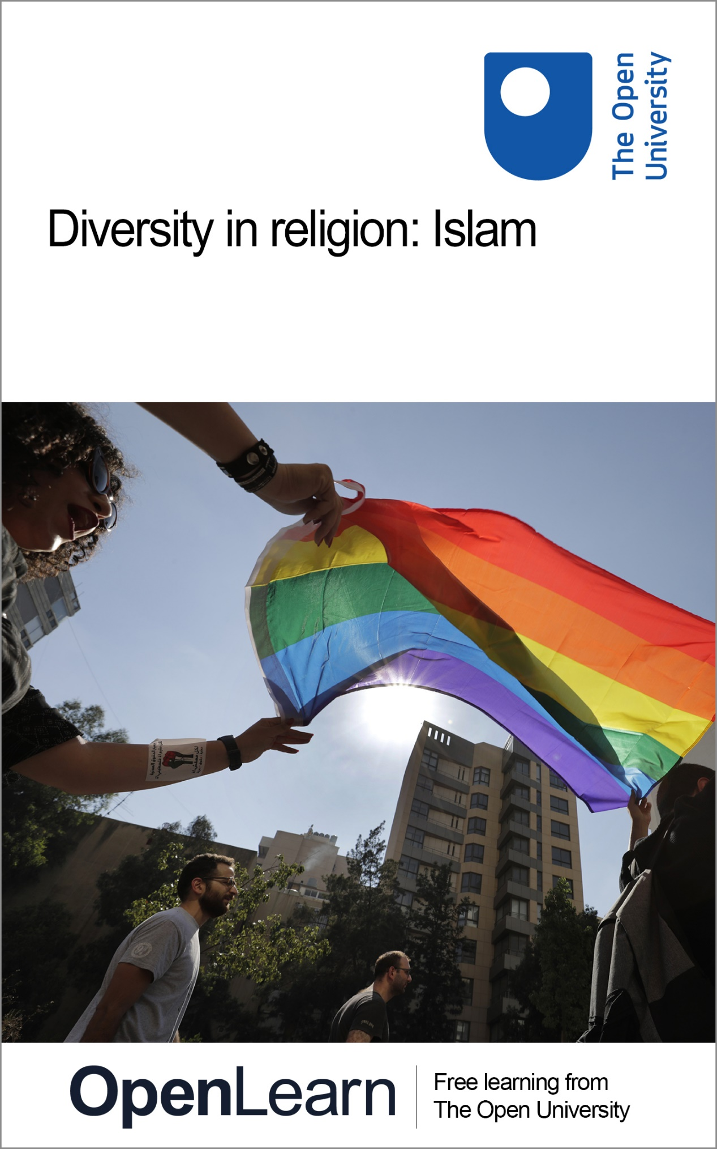

**REL\_2**

**Diversity in religion: Islam**

**About this free course**

Find out more about The Open University’s Religious Studies courses and qualifications: [www.open.ac.uk/courses/search-result/religious-studies](https://www.open.ac.uk/courses/search-result/religious-studies?utm_source=google&utm_campaign=ou&utm_medium=ebook). .

This version of the content may include video, images and interactive content that may not be optimised for your device.

You can experience this free course as it was originally designed on OpenLearn, the home of free learning from The Open University –

[www.open.edu/openlearn/history-the-arts/diversity-religion-islam/content-section-0](https://www.open.edu/openlearn/history-the-arts/diversity-religion-islam/content-section-0?utm_source=openlearn&utm_campaign=ol&utm_medium=ebook)

There you’ll also be able to track your progress via your activity record, which you can use to demonstrate your learning.

Copyright © 2023 The Open University

**Intellectual property**

Unless otherwise stated, this resource is released under the terms of the Creative Commons Licence v4.0 <http://creativecommons.org/licenses/by-nc-sa/4.0/deed.en_GB>. Within that The Open University interprets this licence in the following way: [www.open.edu/openlearn/about-openlearn/frequently-asked-questions-on-openlearn](http://www.open.edu/openlearn/about-openlearn/frequently-asked-questions-on-openlearn). Copyright and rights falling outside the terms of the Creative Commons Licence are retained or controlled by The Open University. Please read the full text before using any of the content.

We believe the primary barrier to accessing high-quality educational experiences is cost, which is why we aim to publish as much free content as possible under an open licence. If it proves difficult to release content under our preferred Creative Commons licence (e.g. because we can’t afford or gain the clearances or find suitable alternatives), we will still release the materials for free under a personal end-user licence.

This is because the learning experience will always be the same high quality offering and that should always be seen as positive – even if at times the licensing is different to Creative Commons.

When using the content you must attribute us (The Open University) (the OU) and any identified author in accordance with the terms of the Creative Commons Licence.

The Acknowledgements section is used to list, amongst other things, third party (Proprietary), licensed content which is not subject to Creative Commons licensing. Proprietary content must be used (retained) intact and in context to the content at all times.

The Acknowledgements section is also used to bring to your attention any other Special Restrictions which may apply to the content. For example there may be times when the Creative Commons Non-Commercial Sharealike licence does not apply to any of the content even if owned by us (The Open University). In these instances, unless stated otherwise, the content may be used for personal and non-commercial use.

We have also identified as Proprietary other material included in the content which is not subject to Creative Commons Licence. These are OU logos, trading names and may extend to certain photographic and video images and sound recordings and any other material as may be brought to your attention.

Unauthorised use of any of the content may constitute a breach of the terms and conditions and/or intellectual property laws.

We reserve the right to alter, amend or bring to an end any terms and conditions provided here without notice.

All rights falling outside the terms of the Creative Commons licence are retained or controlled by The Open University.

Head of Intellectual Property, The Open University

# Contents

* [Introduction](#Introduction1)
* [Learning outcomes](#LearningOutcomes1)
* [1 Attitudes to male same-sex relationships in Islam tradition](#Session1)
* [2 Internal diversity in contemporary Islam](#Session2)
* [Conclusion](#Session3)
* [What next?](#Session4)
* [References](#References1)
* [Further reading](#FurtherReading1)
* [Acknowledgements](#Acknowledgements1)
* [Solutions](#Solutions1)

## Introduction

Religions are internally diverse; they encompass all aspects of human culture and behaviour; they are dynamic and changing. Harvard University professor, Diane Moore, has emphasised that we need to be aware of these three qualities in order to help us to understand religion (Religion and Public Life, 2022).

In order to consider the diversity of Muslim attitudes to same-sex relationships, you will watch a two-part interview with Dr Shanon Shah, author of The Making of a Gay Muslim: Religion, Sexuality and Identity in Malaysia and Britain.

Interested in taking your learning further? You might find it helpful to explore the Open University’s [Religious Studies courses and qualifications](https://www.open.ac.uk/courses/search-result/religious-studies).

Start of Box

**Resources for teachers**

There are discussion questions, a classroom activity and mini research project suggested at the end of this course.

End of Box

## Learning outcomes

After studying this course, you should be able to:

* understand the range of attitudes towards same-sex relationships among Muslims
* recognise change and diversity in Islam and in religion in general.

## 1 Attitudes to male same-sex relationships in Islam tradition

What do you think is the Islamic teaching regarding sexual preference?

As you think about this question, ask yourself where your ideas about this topic might have come from – from a newspaper or magazine article, a book, your social media feeds, or somewhere else?

Start of Activity

**Activity 1**

Start of Question

Watch this interview with Dr Shanon Shah and make a few notes about the main points.

Start of Media Content

Video content is not available in this format.

[View transcript - Uncaptioned interactive content](" \l "Session1_Transcript1)

Start of Figure

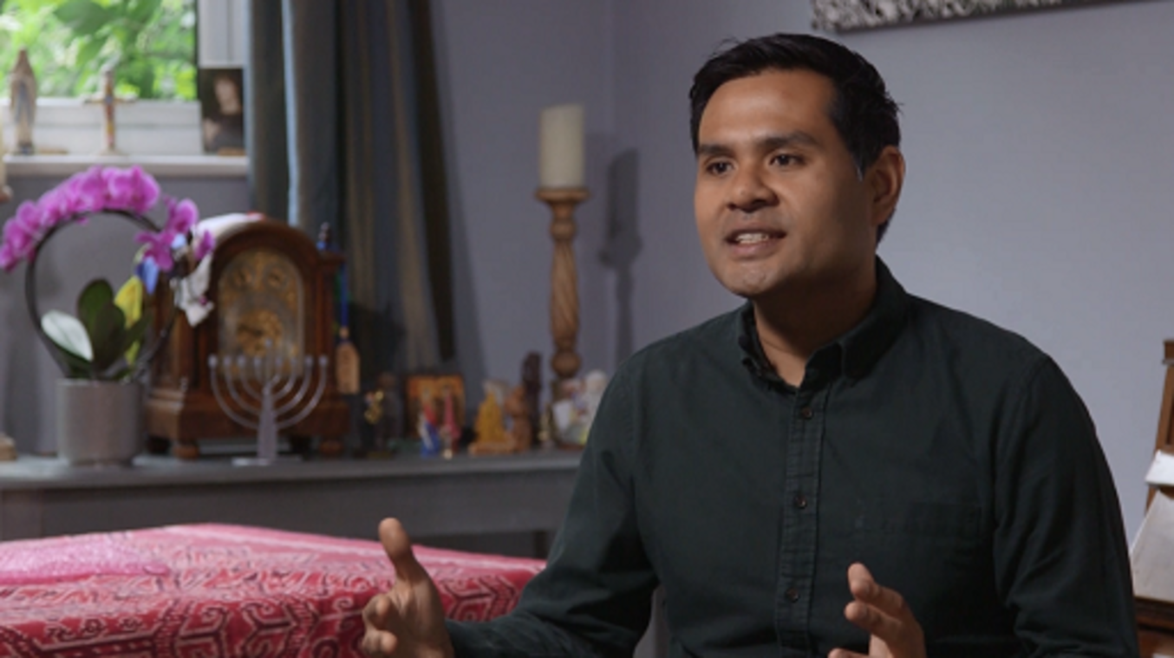

End of Figure

End of Media Content

End of Question

*Provide your answer...*

[View discussion - Activity 1](" \l "Session1_Discussion1)

End of Activity

In practice, before the nineteenth century it seems that extreme punishments were rarely inflicted on men who had sexual relationships with other men. Often what Kecia Ali, author of a book on sexual ethics and Islam, calls ‘don’t ask, don’t tell’ norms prevailed, and provided those engaging in them were reasonably discrete, such relations were tolerated and those participating in them were not prosecuted (2016, p. 107). If it did come to a court case, in practice judges often imposed milder punishments, and governments often introduced their own legal codes which prescribed much more lenient penalties.

## 2 Internal diversity in contemporary Islam

Lesbianism has rarely been illegal in Muslim-majority countries. But things have changed for men since the early nineteenth century. There are two main reasons for this.

Firstly, during the European ‘Age of Empire’, in many colonised countries, particularly those under British rule, laws criminalising sexual relations between men were introduced. These laws often remained in force when the Europeans left (Ahmadi, 2012, pp. 555–9; A.L., 2018).

Secondly, as you have seen, although Muslim legal traditions mostly accepted that sexual relationships between men were wrong, in practice they were often tolerated. In the later twentieth century, the gay rights movement developed in the West and Western governments began to decriminalise same-sex relations. This made it possible for some governments in Muslim-majority countries, Iran for example, to demonstrate their commitment to what they claimed were Islamic values (and thus win popular support) by criminalising men who engaged in same-sex relations.

As a result, in a number of Muslim-majority countries it is against the law for men to have sex with other men, and those who do may be punished by imprisonment and flogging and in some cases even the death penalty. But in other countries, Egypt for instance, same-sex relations are not actually illegal. However, police may harass and arrest gay men (and women). While ISIS was in control of northern Syria (2014–2019) some men suspected of being gay were thrown from buildings or stoned to death.

Many Muslim-majority countries, however, do not criminalise male sexual relationships, among them Turkey and Indonesia (apart from the province of Aceh in northern Sumatra where special rules apply).

This is just one example of the obvious point that Muslims do not necessarily all think and act alike.

Start of Activity

**Activity 2**

Start of Question

As you watch this second extract from the interview with Dr Shah, take a few notes about the main points.

Start of Media Content

Video content is not available in this format.

[View transcript - Uncaptioned interactive content](" \l "Session2_Transcript1)

Start of Figure



End of Figure

End of Media Content

End of Question

*Provide your answer...*

[View discussion - Activity 2](" \l "Session2_Discussion1)

End of Activity

You will recall the three characteristics of religion identified by Diane Moore with which this course began – religious traditions are internally diverse, they encompass all aspects of human culture and behaviour, and are dynamic and changing. You have seen that is true in the case of Islam.

## Conclusion

From the very early days of Islam, a central feature has been the ideal of ‘engaging in lawful behaviour’. This means acting in religiously-approved ways in all areas of life, not just as regards worship but also as regards to diet, trade and sexual relationships (among other things). This is a good example of the way that religions can encompass all aspects of culture and behaviour.

Religions are also internally diverse, and an important feature of Muslim legal tradition has been the way it has developed a range of opinions and attitudes about all sorts of topics and issues. So for example, although the Islamic legal experts usually condemned male same-sex relations (and were largely silent about female same-sex ones), they did not always do so. Nor did they agree about the punishments that might be imposed on those who engaged in prohibited behaviours. In any case engaging in same-sex relations was not usually seen as a particular problem in Muslim-majority societies; men who were taken to court under these charges were not usually severely punished.

In the nineteenth century, however, things began to change. The British Empire in particular introduced laws criminalising same-sex activities in most of the countries it ruled. These laws were often inherited by the successor states. In some Muslim-majority countries governments began to persecute gay men to show that they were standing up for what they claimed were Islamic values.

As a result in some Muslim-majority countries male same-sex relations remain illegal and harsh punishments are sometimes imposed on those who engage in them. In others, however, gay people are not criminalised, and in recent years more liberally-minded Muslims have begun to challenge these restrictions and to call for more freedom generally and more democratic government, which they regard as being fully compatible with Islam.

Like all religions, Islam is dynamic and changing.

Start of Box

**Questions for discussion**

* Can you think of any other controversial issues on which Muslims may not speak with one voice?
* To what extent do you think internal diversity is found in other religious groups?

End of Box

Start of Box

**Classroom activity**

* Take an issue which might be controversial at your school, such as an aspect of the dress code or attendance policy or rules governing the use of mobile phones.
  + How far does there seem to be diversity of opinion on this subject within the classroom?
  + Would consulting the school rules help us to understand what pupils and staff actually think and how they behave?
  + Are there differences in opinion on controversial issues in your school? If so, might we compare this to the way we find a range of views on controversial issues in religious contexts?

End of Box

Start of Box

**Mini research project**

* You might want to identify some of the different types of government to be found in the Muslim-majority world today. Countries you might want to compare and contrast include Egypt, Indonesia, Malaysia, Morocco, Turkey, Somalia and Saudi Arabia.
* Explore further the diversity within Islam. You might focus on:
  + the differences between Sunni and Shi’a Muslims, or the beliefs and practices of Sufi Muslims
  + the diversity of Muslims within a non-Muslim-majority country, such as Britain.

End of Box

## Useful organisations

[Hidayah LGBTQI+](https://hidayahlgbt.com/) is a charity which provides support and welfare for LGBTQI+ Muslims. It also promotes social justice and education to counter discrimination, prejudice and injustice, and offers confidential email, social meetings and educational material.

The [Inclusive Mosque Initiative](https://inclusivemosque.org) is ‘an intersectional feminist mosque devoted to creating safer spaces for marginalised Muslims … including women, nonbinary and queergender people’.

## What next?

Check out the [Religious Studies content on offer from OpenLearn](https://www.open.edu/openlearn/history-the-arts/all-content?filter=date/grid/76/all/all/all/all).

Interested in taking your learning further? You might find it helpful to explore the Open University’s [Religious Studies courses and qualifications](https://www.open.ac.uk/courses/search-result/religious-studies).

## References

A.L. (2018) ‘How homosexuality became a crime in the Middle East’, The Economist. 6 June. Available at: <https://www.economist.com/open-future/2018/06/06/how-homosexuality-became-a-crime-in-the-middle-east> (Accessed: 8 November 2022).

Ahmadi, S. (2012) ‘Islam and homosexuality: religious dogma, colonial rule, and the quest for belonging’, Journal of Civil Rights and Economic Development, 26(3), pp. 537–63.

Ali, K. (2016) Sexual Ethics and Islam Feminist Reflections on Qur’an, Hadith, and Jurisprudence, One World, Chapter 5.

Arnaldez, R. (2012) ‘Ibn Ḥazm’, Encyclopaedia of Islam, second edn, edited by P. Bearman, Th. Bianquis, C.E. Bosworth, E. van Donzel and W.P. Heinrichs.

Religion in Public Life (2022) ‘Core principles’, Harvard Divinity School. Available at: <https://rpl.hds.harvard.edu/what-we-do/our-approach/core-principles> (Accessed: 6 October 2022).

Shah, S. (2018) The Making of a Gay Muslim: Religion, Sexuality and Identity in Malaysia and Britain, Palgrave Macmillan.

## Further reading

In addition to Dr Shah’s The Making of a Gay Muslim: Religion, Sexuality and Identity in Malaysia and Britain, Palgrave Macmillan (2018), if you want to explore the issues raised further you might look at for example:

Adang, C. (2003) ‘Ibn Hazm on homosexuality. a case-study of Zahiri Legal Methodology’, Al-Qantara 24(1), pp. 5–31.

Afsaruddin, A. (2015) Contemporary Issues in Islam, Edinburgh University Press, Chapters 3 and 4.

Ali, K. (2016) Sexual Ethics and Islam Feminist Reflections on Qur’an, Hadith, and Jurisprudence, One World, Chapter 5.

An-Na‘im, A.A. (2008) Islam and the Secular State Negotiating the Future of Shari‘a, Harvard University Press, Chapter 1.

Arnaldez, R. (2012) ‘Ibn Ḥazm’, Encyclopaedia of Islam, second edn, edited by P. Bearman, Th. Bianquis, C.E. Bosworth, E. van Donzel and W.P. Heinrichs.

Brinley Bruton, F. (2018) ‘Saudi cleric Salman al-Awda called for reform. Now he’s in solitary confinement’, NBC News, 27 January. Available at: <https://www.nbcnews.com/news/mideast/saudi-cleric-salman-al-awda-called-reform-now-he-s-n840916> (Accessed 12 January 2023).

Fiegenbaum, J.W. (n.d.) ‘Ibn Hazm’, Britannica. Available at: <https://www.britannica.com/biography/Ibn-Hazm> (Accessed 12 January 2023).

Jung, D. (2011) Orientalists, Islamists and the Global Public Sphere, Equinox.

[Diane Moore’s Religious Literacy Project at Harvard University](https://rlp.hds.harvard.edu/)

[Everything you need to know about being gay in Muslim countries](https://www.theguardian.com/world/2016/jun/21/gay-lgbt-muslim-countries-middle-east)

## Acknowledgements

This free course was written by Hugh Beattie.

Except for third party materials and otherwise stated (see [terms and conditions](http://www.open.ac.uk/conditions)), this content is made available under a [Creative Commons Attribution-NonCommercial-ShareAlike 4.0 Licence](http://creativecommons.org/licenses/by-nc-sa/4.0/deed.en_GB).

The material acknowledged below is Proprietary and used under licence (not subject to Creative Commons Licence). Grateful acknowledgement is made to the following sources for permission to reproduce material in this free course:

## Images

Course image: © Hassan Ammar; AP Images

Every effort has been made to contact copyright owners. If any have been inadvertently overlooked, the publishers will be pleased to make the necessary arrangements at the first opportunity.

**Don't miss out**

If reading this text has inspired you to learn more, you may be interested in joining the millions of people who discover our free learning resources and qualifications by visiting The Open University – [www.open.edu/openlearn/free-courses](http://www.open.edu/openlearn/free-courses?LKCAMPAIGN=ebook_&MEDIA=ol).

## Solutions

## Activity 1

#### Discussion

As regards-same sex relationships, Dr Shah explains that there was no reference in the traditional Muslim sources of authority to homosexuality as such, and no word in the Qur’an (nor incidentally in the Hebrew religious texts or the Christian Gospels) that can be translated as homosexuality. The word itself is a modern one.

It’s worth pointing out here that although Dr Shah doesn’t say so in the video, in his book he explains that drawing on the stories in the Bible, the Qur’an itself refers at a number of points to the story of Lot and God’s destruction of his people by hurling ‘stones of baked clay … layer upon layer’ (Q. 11:82) on their town (Shah, 2018). It’s usually argued that this was a punishment for the fact that the men had engaged in forbidden sexual activity.

Going back to the video, Dr Shah also makes some helpful points about the development of Muslim legal traditions. Muslims wanted to live in a religiously-lawful way, and over the centuries Muslim legal experts discussed a great range of issues, including sexual relationships. He also explains that in Islamic legal tradition there has traditionally been room to accommodate local cultural norms, so that it has been, as he puts it, ‘contextual’.

These legal experts’ discussions were encapsulated in fatwas, legal opinions, issued by individual experts. Often the experts did not agree with each other, and so their opinions differed. Nevertheless some opinions or interpretations have become more influential and widely accepted, and others may be difficult to find. When it came to sex, the majority view did come to be that the only legitimate sexual relationship was between a married man and his wife (or wives) (and also between a man and female slaves). The four main Sunni legal schools agreed that sexual relationships between men were sinful, and three of them argued that they should be subject to capital punishment.

But the legal experts did not all agree with this. Dr Shah gives the example of the Iberian or Andalusian scholar Ibn Hazm (994–1064 CE). A ‘poet, historian, jurist, philosopher and theologian’, Ibn Hazm has been described as ‘one of the greatest thinkers of Arabo-Muslim civilization’ (Arnaldez, 2012, p. 1). Dr Shah explains that he had what were quite tolerant views on same-sex relationships, arguing that they were only a problem if they led to social disruption. If you are interested in learning more about Ibn Hazm there are some resources listed in the Further reading list at the end of this course.

[Back to - Activity 1](" \l "Session1_Activity1)

## Activity 2

#### Discussion

1. Dr Shah draws attention to Islam’s diversity. Today and in the past, he suggests, Islam has been practised by people living in different cultures, so that for example, beyond the core practices and beliefs, Muslims have had a range of views about politics, how societies should be governed (and the way they practised their religion differed somewhat from one region to another).
2. He explains that ‘progressive Muslims’ are ‘fed up’ with the authoritarianism of many Muslim-majority states, and are asserting their right to interpret Islam for themselves, and taking advantage of new technologies and social media to challenge Muslim religious and political authorities.
3. He suggests that this is a difficult task because many Muslim-majority states are not very democratic. Here he draws attention to the example of the influential Saudi Arabian religious scholar Salman al-Ouda who was jailed by the government in 2017 and at the time of writing (2022) remains in prison.
4. He argues that this authoritarianism is not due to Islam itself – for him it’s not religion that makes these states undemocratic and intolerant.

Dr Shah makes it clear that the relationship between Islam and democracy is a complicated one. Muslims around the world do not speak with one voice on this issue. Some argue that democracy as practised in ‘the West’ is unIslamic, but many others support democratic government and believe it is fully compatible with their religion.

If you are interested in learning more about Salman al-Ouda, also known as Salman al-Awda, there is a resource listed in the Further reading list at the end of this course.

[Back to - Activity 2](" \l "Session2_Activity1)

# Uncaptioned interactive content

## Transcript

SHANON SHAH

Talking about homosexuality and religion, we cannot ignore the necessity of having these spaces where you can have open discussions about a lot of things, not just sexuality. I suppose the running thread throughout all my work, whether in Malaysia and the UK, is an interest in clashing identities. So that’s quite personal for me, being gay and Muslim, but I’m also interested in other clashes. I’m in a civil partnership with an openly gay Anglican priest who has had to negotiate those clashes as well, as a gay man who’s also an ordained Christian minister.

It was a huge aha moment for me to discover that there is no equivalent term for homosexuality in the Qur’an. The Qur’an is a seventh century text in Arabic. Homosexuality, or indeed homosexual, is a modern coinage. It’s a nineteenth century coinage. So similarly you wouldn’t find a direct translation for homosexuality in the Hebrew scriptures or in the gospels, in the epistles. What we find in these ancient texts is prohibitions against certain sorts of behaviours.

Now in the Muslim case, so much of what it means to be a good, practicing, observant Muslim is about engaging in lawful behaviour, whether it’s in trade, or dietary laws, or prayers, or relationships with people, including sexual relationships. So there’s this idea of what is a lawful sexual relationship. And, traditionally, it has always been that it has to be through a marriage between a man and a woman, so any kind of act that doesn’t fall within this definition is unlawful. So it’s not about whether it’s homosexual or not.

Historically, a lot of this discussion is captured in Muslim legal texts. So opinions that were given by traditional jurists, which take the form of fatwas, which is basically a legal opinion. But they also are discussed in different medical texts among Muslim medics in literature, in dream interpretations. But, of course, the texts that Muslims rely upon most authoritatively were the legal texts, but we have to remember that a lot of these legal texts also dealt with exceptions. They dealt with exceptional circumstances and they also disagreed. For example, if they agreed that a particular act was wrong, they would disagree on the consequences on why it was wrong.

In Muslim cultures, a lot of public attitudes towards certain issues, such as sexual relations and so on, are based on conversations that people have that they link back to authoritative figures and this is what happens in Muslim legal texts. But, of course, people get creative with this and sometimes culturally they - there are provisions within Muslim jurisprudence to accommodate what is generally acceptable in the surrounding culture.

And this was especially important when Islam spread out of the Arabian Peninsula into the Indian subcontinent, into Africa, into Southeast Asia, and so on. So there was that flexibility to accommodate what was going on around you. So Islamic jurisprudence is also contextual and I think that’s something that’s lost in the discussion about it nowadays. It seems like it’s a frozen, rigid artefact whereas, historically, it was quite dynamic and you were allowed to ask new questions depending on new situations that you encountered.

What I’ve realised, the deeper I engage with my faith tradition as a Muslim, is that there is actually a diverse range of opinions and attitudes within Islam historically and also in the contemporary world about a range of issues - homosexuality just being one of them. But there is a problem of access to these interpretations and there is a problem of what is the interpretation that gains currency in certain Muslim states that are endorsed by different Muslim governments. So these, I have encountered more relaxed or inclusive interpretations of sexuality, but they’re very difficult to find because they’ve either been censored or they haven’t gained authoritative status. But if you look hard enough, they are there.

There was, I think eleventh century Andalusian scholar called Ibn Hazm - this is when Spain and Portugal, what we now know as Iberia, were Muslim as well - who had quite progressive views on sexual relations, including same sex relations. And his idea was as long as they’re not publicly disruptive then why punish them? Only if they are publicly disruptive do we punish them and that was considered very lenient. And so that’s a discovery that had to be made through lots and lots of reading because that’s not an opinion that’s readily available.

[Back to - Uncaptioned interactive content](" \l "Session1_MediaContent1)

# Uncaptioned interactive content

## Transcript

SHANON SHAH

There was a campaign in Indonesia once by a group of progressive Muslims with the strap line Islam [SPEAKING NON-ENGLISH] which translates in English as ‘Islam has many colours’. We can talk about different Islams or when we talk about Islam there is also a way to celebrate its vast diversity, culturally, ideologically, doctrinally. And I think that’s always been there historically.

What’s changing now is a lot of people who identify as progressive Muslims are starting to organise and mobilise politically, and they’re taking advantage of new technologies, and they challenge traditional authority structures in a way that’s quite unprecedented. Having said that, it’s very difficult to get into the traditional authority structures.

There is a Saudi Arabian scholar - very influential, I think he’s called Salman al-Ouda - who had what were for a Saudi, quite progressive views on a lot of things, including homosexuality. He’s just been sentenced to death by the regime. And you find this repeatedly in different Muslim regimes that are not entirely democratic.

So I don’t know if it’s about Islam. I don’t think it’s about Islam per se, it’s about political power. It’s about a lack of democratic space. But the more I speak to progressive Muslims in Malaysia and in the UK, I think the more Muslims that I know now are getting fed up with these kinds of authoritarian manoeuvres against different ideas amongst Muslims.

[Back to - Uncaptioned interactive content](" \l "Session2_MediaContent1)